Invasive Pneumococcal Disease Surveillance, 1 January to 31 March 2019
Rachael Corvisy and the Enhanced Invasive Pneumococcal Disease Surveillance Working Group, for the Communicable Diseases Network Australia

Summary
The number of notified cases of invasive pneumococcal disease (IPD) in the first quarter of 2019 was lower than the previous quarter, but greater than the first quarter of 2018. Following the July 2011 replacement of the 7-valent pneumococcal conjugate vaccine (7vPCV) in the childhood immunisation program with the 13-valent pneumococcal conjugate vaccine (13vPCV), there was an initial relatively rapid decline in disease due to the additional six serotypes covered by the 13vPCV across all age groups; however, more recently this decline is no longer evident. Over this period the number of cases due to the eleven serotypes additionally covered by the 23-valent pneumococcal polysaccharide vaccine (23vPPV), and also those serotypes not covered by any available vaccine, has been increasing steadily across all age groups (Figure 1).

Key points
IPD exhibits seasonal variations with incidence increasing over the winter months in temperate countries. In the first quarter of 2019, there were 279 cases of IPD reported to the National Notifiable Disease Surveillance System (NNDSS). Compared with the previous quarter (n=449), this represented a substantial decrease (38%) in the number of cases. However, compared with the number of cases reported in the same quarter in 2018 (n=246), there were 13% more cases this quarter (Table 1). In the first quarter of 2019, the most common pneumococcal serotype causing IPD continued to be serotype 3 (15%; 42/279), followed by 19F (8%; 21/279) and 9N (6%; 17/279) (Table 2).
Among non-Indigenous Australians this quarter, the number of notified cases continued to be highest in children aged less than 5 years and in older adult age groups, especially those aged 50 years and older (Table 3). Among Indigenous Australians, notifications were relatively evenly distributed across age groups. The proportion of cases reported as Indigenous Australians this quarter (11%; 32/279) was slightly higher than the proportion in the previous quarter (9%; 42/449), but lower than the first quarter of 2018 (14%; 34/246) (Table 1).
Children aged less than 5 years comprised 17% (48/279) of all cases reported in this quarter, which was slightly higher than in the fourth quarter in 2018 (13%; 60/449) and similar to the first quarter of 2018 (18%; 44/246). Serotype information was available for 29 (60%) of the cases aged less than 5 years this quarter. Just over half of these cases (59%; 17/29) had a serotype included in the 13vPCV, which was similar to the previous quarter (58%; 29/50) and a slight increase on the first quarter of 2018 (48%; 37/77) (Figure 2). The most frequent serotypes among cases aged less than 5 years this quarter were serotype 19F (28%; 8/29) and 3 (21%; 6/29), both of which are included in the 13vPCV. Of the 17 cases aged less than 5 years with 13vPCV serotypes, 9 cases were fully vaccinated and considered to be 13vPCV failures. These 13vPCV failures were due to serotypes 3 (n=5) and 19F (n=4) (Table 4).
Among Indigenous Australians aged 50 years and over, there were 9 cases of IPD reported this quarter. Of those cases with a reported serotype (n=8), 3 (38%) were due to a serotype included in the 23vPPV, and overall there was no particular serotype dominant this quarter (Figure 3). The proportion of cases with a reported serotype that were due to a serotype included in the 23vPPV is almost halved from the proportion reported last quarter (72%; 13/18), and in the first quarter of 2018 (71%; 10/14).
Among non-Indigenous Australians aged 65 years and over there were 84 cases of IPD reported this quarter. The number of notified cases of IPD in this population group was almost 50% lower than the number of cases reported in the previous quarter (n=166) and 11% lower than the number reported in the first quarter of 2018 (n=93). Of those cases with a reported serotype (n=76), 61% (46/76) were due to a serotype included in the 23vPPV (Figure 4). This was similar to the proportions in the previous quarter (63%; 101/161) and the first quarter of 2018 (56%; 46/82). For this quarter, serotype 3 (n=12) was the most common serotype reported for this population group, followed by serotypes 19F (n=8) and 6C (n=6). Serotypes 3 and 19F are included in the 23vPPV.
During this quarter there were 13 deaths attributed to a variety of IPD serotypes. Eight (62%) of the cases had a serotype covered by currently available pneumococcal vaccines, four were due to a non-vaccine serotype, and one was reported as being untyped. One of the reported deaths this quarter was reported in an Indigenous Australian. The median age of those cases reported to have died this quarter was 72 years (range 0 to 87 years).

Notes
The data in this report are provisional and subject to change as laboratory results and additional case information become available. More detailed data analysis of IPD in Australia and surveillance methodology are described in the IPD annual report series published in Communicable Diseases Intelligence.
In Australia, pneumococcal vaccination is recommended as part of routine immunisation for children, individuals with specific underlying conditions associated with increased risk of IPD and older Australians. More information on the scheduling of the pneumococcal vaccination can be found on the Immunise Australia Program website (www.immunise.health.gov.au).
In this report, a ‘vaccine failure’ is reported when a child aged less than 5 years is diagnosed with IPD due to a serotype found in the 13vPCV and they have received 3 primary scheduled doses of 13vPCV at least 2 weeks prior to disease onset with at least 28 days between doses of vaccine.
There are currently two pneumococcal vaccines available in Australia via the National Immunisation Program, each targeting multiple serotypes (13vPCV and 23vPPV). Note that in this report serotype analysis is generally grouped according to vaccine composition, both historic and current (Table 5).
Follow-up of all notified cases of IPD is undertaken in all states and territories except New South Wales and Victoria which conduct targeted follow-up of notified cases aged under 5 years, and 50 years or over for enhanced data. Follow-up of notified cases of IPD in Queensland is undertaken in all areas except Metro South and Gold Coast Public Health Units which conduct targeted follow-up of notified cases for those aged under 5 years only. However, in these areas where targeted case follow-up is undertaken, some enhanced data may also be available outside these targeted age groups.

Acknowledgements
Report prepared with the assistance of Ms Kate Pennington and Mr Mark Trungove on behalf of the Enhanced Invasive Pneumococcal Disease Surveillance Working Group.
Enhanced Invasive Pneumococcal Disease Surveillance Working Group contributors to this report include (in alphabetical order): Frank Beard (NCIRS), Heather Cook (NT and secretariat), Lucinda Franklin (Vic.), Carolien Giele (WA), Robin Gilmour (NSW), Michelle Harlock (Tas.), Ben Howden (Microbiological Diagnostic Unit, University of Melbourne), Sanjay Jayasinghe (NCIRS), Vicki Krause (NT and chair), Shahin Oftadeh (Centre for Infectious Diseases and Microbiology Laboratory Services, NSW Health Pathology), Sue Reid (ACT), Vitali Sintchenko (Centre for Infectious Diseases and Microbiology- Public Health, Westmead Hospital), Helen Smith (Queensland Health Forensic and Scientific Services), Janet Strachan (Vic.), Hannah Vogt (SA), Angela Wakefield (Qld).

Author details

Corresponding author
Karla Lister
Director
Communicable Disease Epidemiology Surveillance Section
Office of Health Protection
Chief Medical Officer Group
Health Protection Policy Branch
Australian Government Department of Health
Telephone: 02 6289 3248
Email: epi@health.gov.au

Table 1: Notified cases of invasive pneumococcal disease, Australia, 1 January to 31 March 2019, by Indigenous status, serotype completeness and state or territory
Indigenous status | ACT | NSW | NT |  | Qld | SA | Tas | Vic | WA | Total 1st qtr 2019 |  | Total 4th qtr 2018 | Total 1st qtr 2018
Indigenous | 0 | 3 |  | 9 | 7 | 3 | 0 | 3 | 7 |  | 32 | 42 | 34
Non-Indigenous | 4 | 60 |  | 1 | 41 | 29 | 2 | 68 | 21 |  | 226 | 374 | 190
Not stated / Unknown | 0 | 21 |  | 0 | 0 | 0 | 0 | 0 | 0 |  | 21 | 33 | 22
Total | 4 | 84 |  | 10 | 48 | 32 | 2 | 71 | 28 |  | 279 | 449 | 246
Indigenous status completenessª (%) | 100 | 75 |  | 100 | 100 | 100 | 100 | 100 | 100 |  | 92 | 93 | 91
Indigenous status completeness in targeted groups^{a,b} (%) | 100 | 85 |  | 100 | 100 | 100 | 100 | 100 | 100 |  | 96 | 97 | 96
Serotype completeness^{c} (%) | 100 | 81 |  | 100 | 96 | 50 | 50 | 92 | 79 |  | 83 | 92 | 83
a Indigenous status completeness is defined as the reporting of a known Indigenous status, excluding the reporting of not stated or unknown Indigenous status.
b Targeted groups for follow-up by almost all jurisdictions and public health units are cases aged less than 5 years and 50 years and over.
c Serotype completeness is the proportion of all cases of invasive pneumococcal disease that were reported with a serotype or reported as non-typable. Incomplete serotype data can occur in cases when (i) no isolate was available as diagnosis was by polymerase chain reaction and no molecular typing was attempted or was not possible due to insufficient genetic material; (ii) the isolate was not referred to the reference laboratory or was not viable; (iii) typing was pending at the time of reporting, or no serotype was reported by the notifying jurisdiction to the National Notifiable Diseases Surveillance System.

Table 2: Distribution of serotypes causing invasive pneumococcal disease in notified cases, Australia, 1 January to 31 March 2019, by age group
 | Age groups
Vaccine type and serotype | Under 5 | 5–64 | 65+ | Serotype totalª
7vPCV
4 | 0 | 4 | 0 | 4
14 | 0 | 1 | 2 | 3
19F | 8 | 5 | 8 | 21
18C | 1 | 2 | 0 | 3
13vPCV non-7vPCV
3 | 6 | 24 | 12 | 42
19A | 2 | 4 | 2 | 8
7F | 0 | 4 | 0 | 4
23vPPV non-13vPCV
8 | 1 | 9 | 2 | 12
10A | 0 | 4 | 0 | 4
11A | 1 | 5 | 4 | 10
12F | 0 | 5 | 0 | 5
9N | 1 | 12 | 4 | 17
22F | 0 | 1 | 2 | 12
15B | 1 | 0 | 3 | 4
17F | 0 | 0 | 3 | 3
33F | 0 | 2 | 0 | 2
Non-vaccine type
15A | 0 | 5 | 0 | 5
31 | 0 | 0 | 3 | 3
38 | 0 | 0 | 0 | 2
21 | 1 | 0 | 1 | 2
23B | 2 | 8 | 5 | 15
6C | 1 | 5 | 6 | 12
23A | 0 | 1 | 3 | 4
24F | 0 | 2 | 2 | 4
35B | 0 | 2 | 2 | 4
15C | 0 | 1 | 2 | 3
22A OR 22F | 0 | 1 | 2 | 3
16F | 1 | 1 | 0 | 2
18A | 0 | 2 | 0 | 2
Other
Other serotypesª | 3 | 12 | 11 | 15
Unknown^{b} | 19 | 23 | 7 | 49
Total | 48 | 145 | 86 | 279
a Serotypes that only occur in less than 5 cases per quarter are grouped as ‘Other’ and include ‘non-typable’ isolates this quarter.
b ‘Serotype unknown’ includes those serotypes reported as ‘no isolate’, ‘not referred’, ‘not viable’, ‘typing pending’ and ‘untyped’.

Table 3: Notified cases of invasive pneumococcal disease, Australia, 1 January to 31 March 2019, by Indigenous status and age group
Age group | Indigenous status |  |  | Total
Age group | Indigenous | Non-Indigenous | Not reportedª | Total
00–04 | 5 | 41 | 2 | 48
05–09 | 2 | 10 | 1 | 13
10–14 | 2 | 1 | 0 | 3
15–19 | 2 | 3 | 0 | 5
20–24 | 2 | 4 | 0 | 6
25–29 | 1 | 6 | 1 | 8
30–34 | 1 | 8 | 1 | 10
35–39 | 1 | 8 | 4 | 13
40–44 | 5 | 12 | 4 | 21
45–49 | 2 | 7 | 2 | 11
50–54 | 4 | 8 | 0 | 12
55–59 | 3 | 19 | 0 | 22
60–64 | 0 | 21 | 0 | 21
65–69 | 0 | 22 | 1 | 23
70–74 | 1 | 15 | 2 | 18
75–79 | 0 | 16 | 1 | 17
80–84 | 0 | 9 | 1 | 10
85+ | 1 | 16 | 1 | 18
Total | 32 | 226 | 21 | 279
a Not reported is defined as not stated, blank or unknown Indigenous status.
Table 4: Characteristics of 13vPCV failures in children aged less than 5 years, Australia, 1 January to 31 March 2019
Age | Indigenous status | Serotype | Clinical category | Risk factor(s)
1 year | Non-Indigenous | 19F | Bacteraemia | Chronic illness
1 year | Non-Indigenous | 3 | Pneumonia and other (pleural effusion) | No risk factor identified
2 years | Non-Indigenous | 3 | Pneumonia | No risk factor identified
2 years | Non-Indigenous | 19F | Meningitis | No data available
2 years | Non-Indigenous | 3 | Unknown | No data available
2 years | Non-Indigenous | 19F | Pneumonia | No data available
3 years | Non-Indigenous | 19F | Bacteraemia | Childcare attendee
3 years | Non-Indigenous | 3 | Pneumonia | Childcare attendee
3 years | Non-Indigenous | 3 | No data provided | No data available

Table 5: Streptococcus pneumoniae serotypes targeted by pneumococcal vaccines
Serotypes | 7-valent pneumococcal conjugate vaccine (7vPCV) | 10-valent pneumococcal conjugate vaccine (10vPCV) | 13-valent pneumococcal conjugate vaccine (13vPCV) | 23-valent pneumococcal polysaccharide vaccine (23vPPV)
1 |  | ✓ | ✓ | ✓
2 |  |  |  | ✓
3 |  |  | ✓ | ✓
4 | ✓ | ✓ | ✓ | ✓
5 |  | ✓ | ✓ | ✓
6A |  |  | ✓
6B | ✓ | ✓ | ✓ | ✓
7F |  | ✓ | ✓ | ✓
8 |  |  |  | ✓
9N |  |  |  | ✓
9V | ✓ | ✓ | ✓ | ✓
10A |  |  |  | ✓
11A |  |  |  | ✓
12F |  |  |  | ✓
14 | ✓ | ✓ | ✓ | ✓
15B |  |  |  | ✓
17F |  |  |  | ✓
18C | ✓ | ✓ | ✓ | ✓
19A |  |  | ✓ | ✓
19F | ✓ | ✓ | ✓ | ✓
20 |  |  |  | ✓
22F |  |  |  | ✓
23F | ✓ | ✓ | ✓ | ✓
33F |  |  |  | ✓

Figure 1: Notifications of invasive pneumococcal disease, Australia, 1 January 2002 to 31 March 2019, by vaccine serotype group
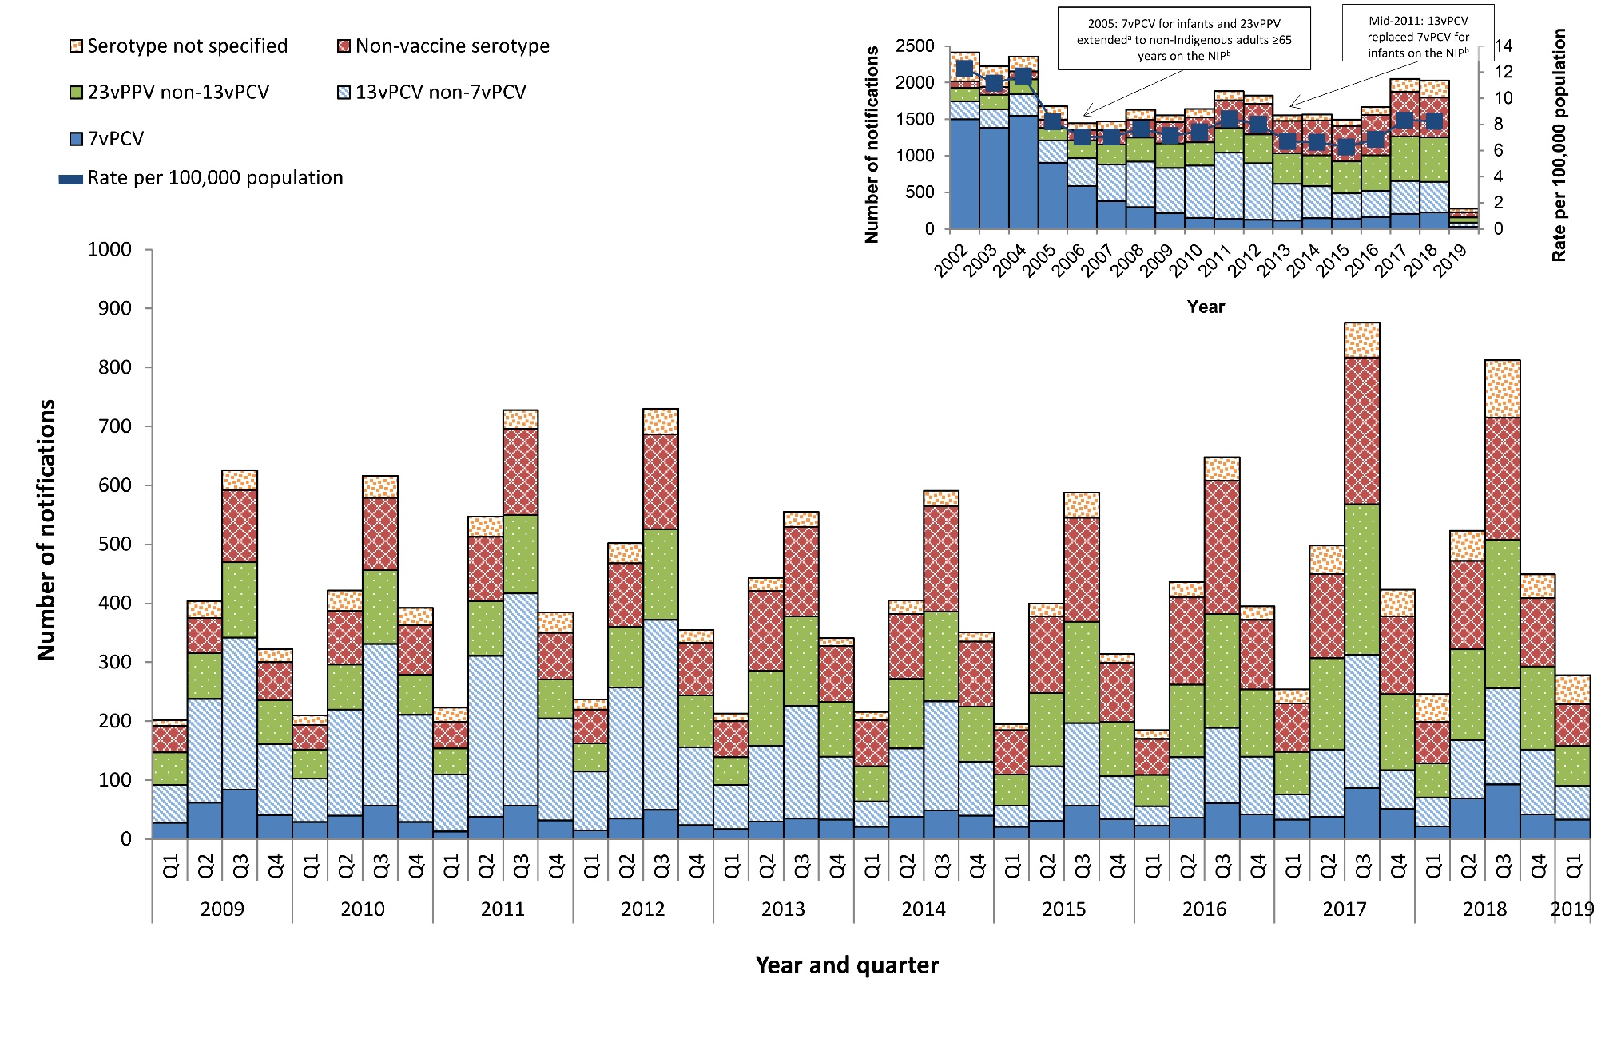
a In 1999, the 23vPPV was funded for all Indigenous Australians aged 50 years and over, as well as younger Indigenous Australian adults with risk factors.
b NIP - National Immunisation Program.

Figure 2: Notifications and annual ratesª of invasive pneumococcal disease in children aged less than 5 years, Australia, 1 January 2009 to 31 March 2019, by vaccine serotype group
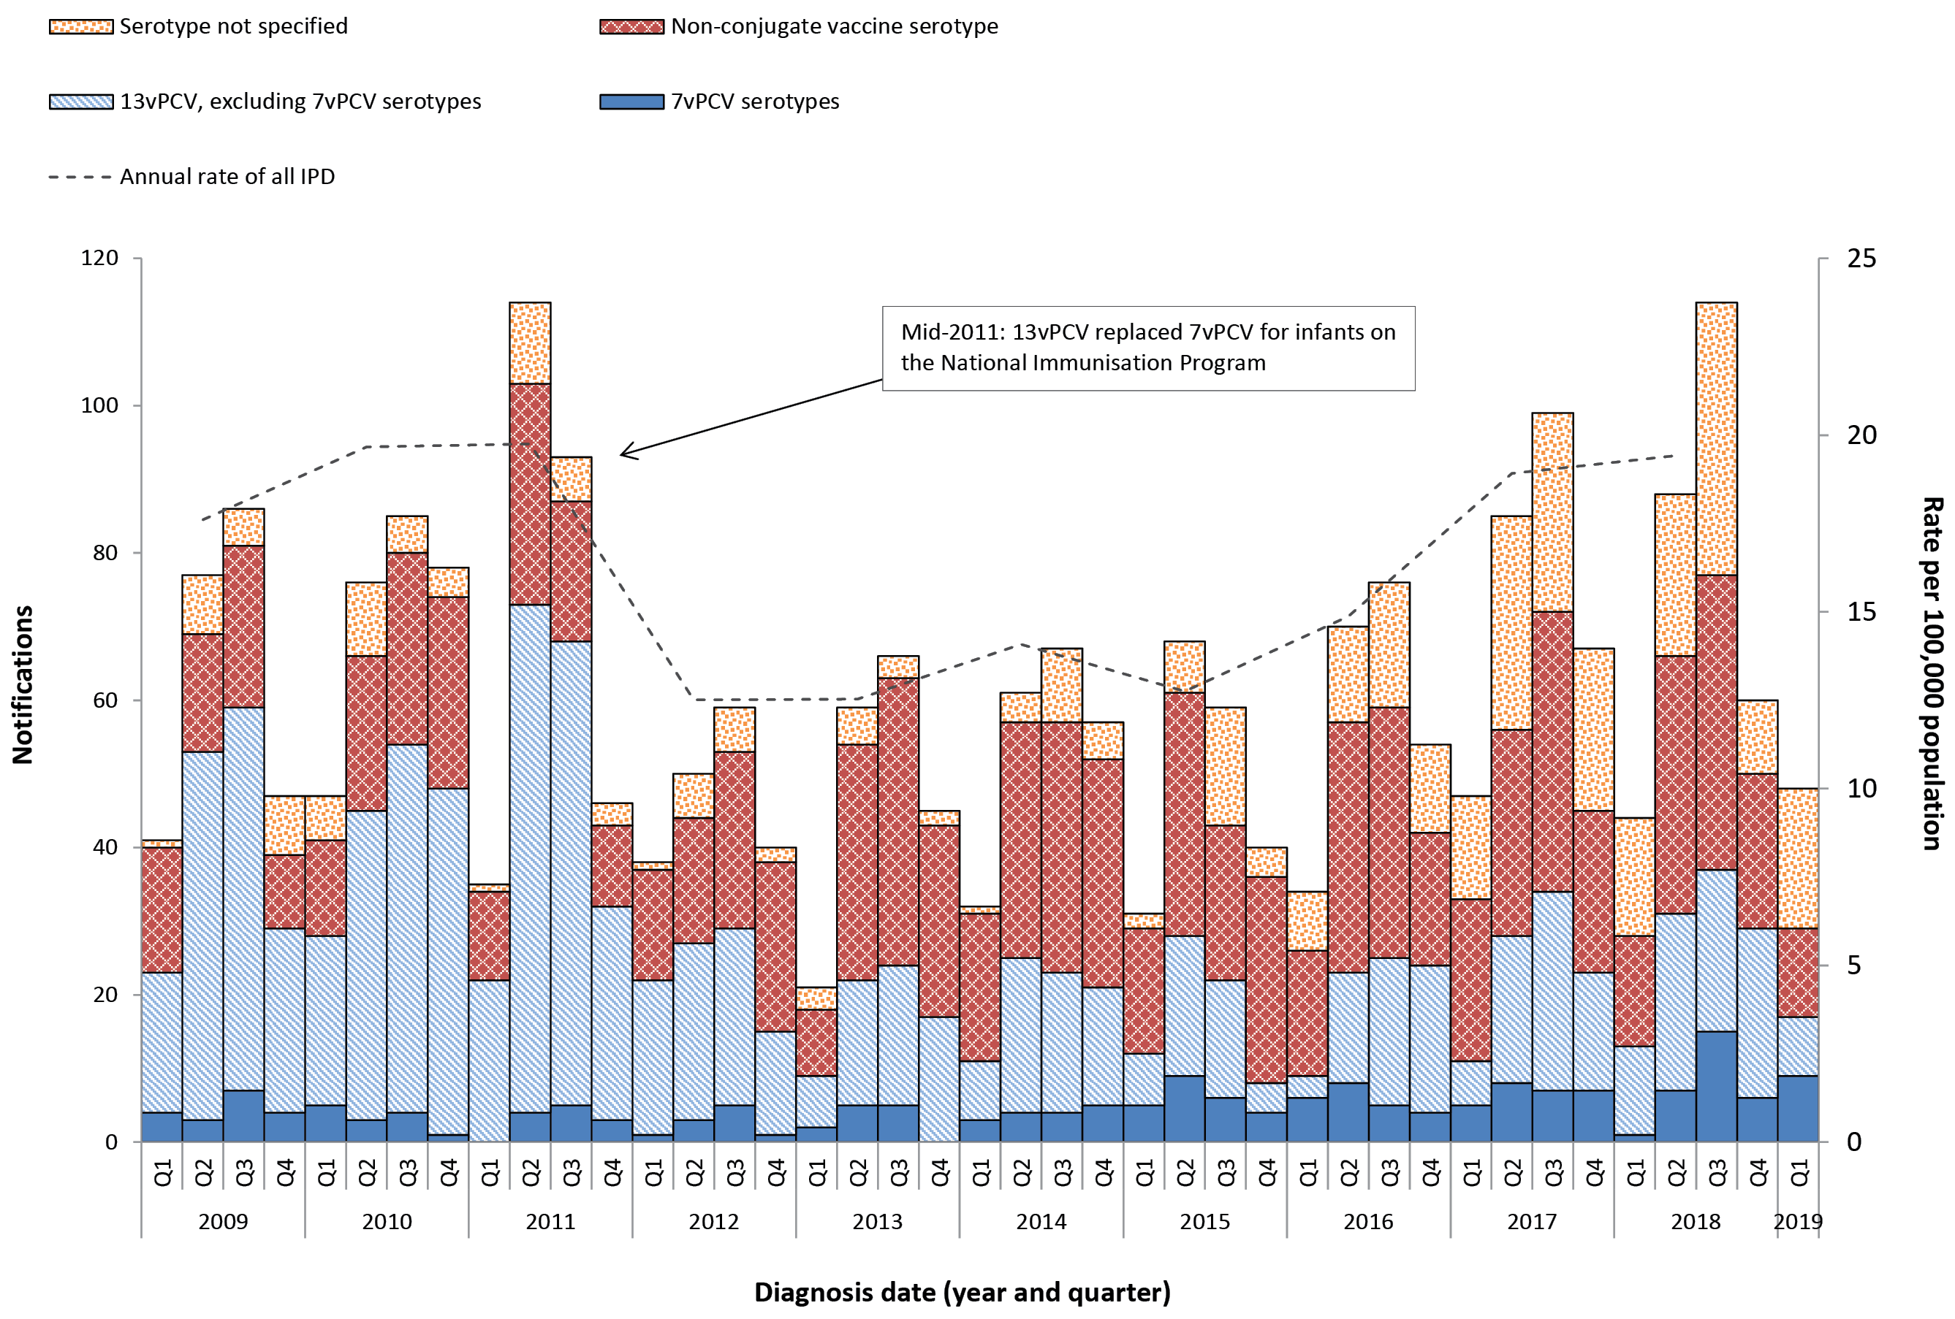
* Annual rates are shown on quarter 2.

Figure 3: Notifications and annual ratesª of all invasive pneumococcal disease in Indigenous Australians aged 50 years or over, Australia, 1 January 2009 to 31 March 2019, by vaccine serotype group
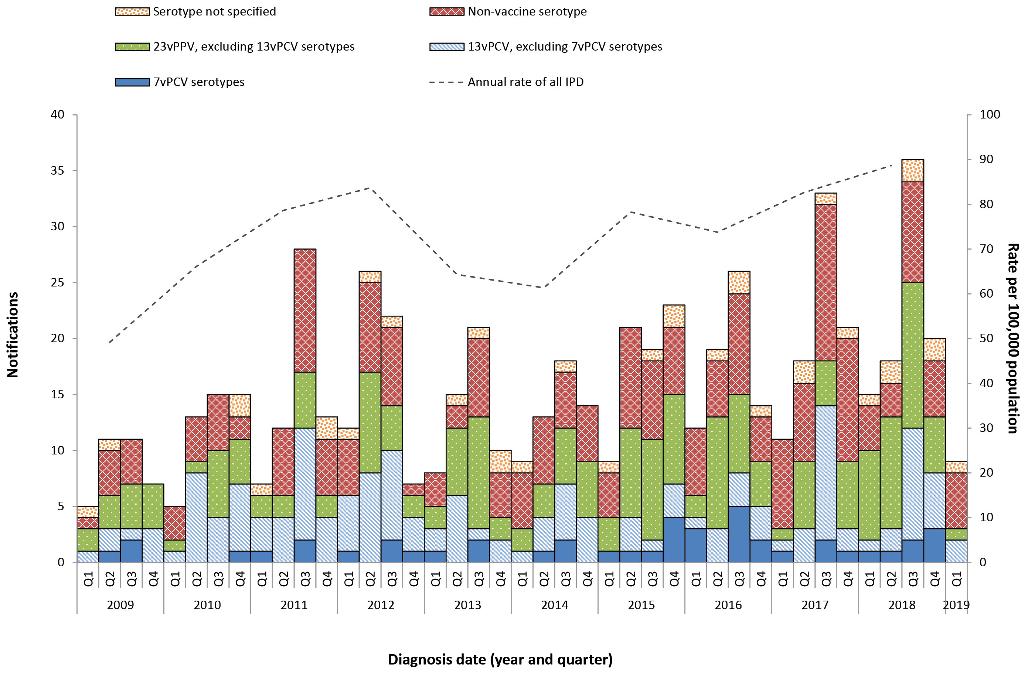
a Annual rates are shown on quarter 2.

Figure 4: Notifications and annual ratesª of all invasive pneumococcal disease in non-indigenous Australiansb aged 65 years or over, Australia, 1 January 2009 to 31 March 2019, by vaccine serotype group
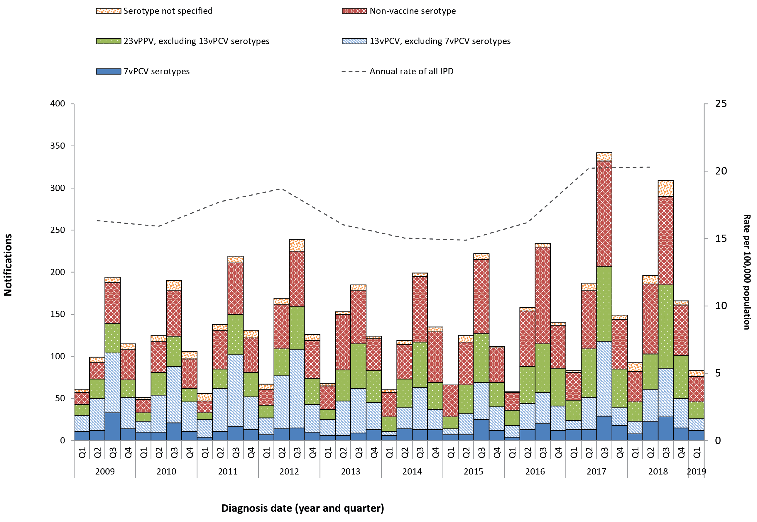
a Annual rates are shown on quarter 2.
b Non-Indigenous Australians includes cases reported with as non-Indigenous, not stated, blank or unknown.

Communicable Diseases Intelligence
ISSN: 2209-6051 Online

Communicable Diseases Intelligence (CDI) is a peer-reviewed scientific journal published by the Office of Health Protection, Department of Health. The journal aims to disseminate information on the epidemiology, surveillance, prevention and control of communicable diseases of relevance to Australia.

Editor: Cindy Toms
Deputy Editor: Simon Petrie
Design and Production: Kasra Yousefi
Editorial Advisory Board: David Durrheim, Mark Ferson, John Kaldor, Martyn Kirk and Linda Selvey

Website: http://www.health.gov.au/cdi

Contacts
Communicable Diseases Intelligence is produced by:
Health Protection Policy Branch, Office of Health Protection, Australian Government Department of Health
GPO Box 9848, (MDP 6) CANBERRA ACT 2601

Email: cdi.editor@health.gov.au

Submit an Article
You are invited to submit your next communicable disease related article to the Communicable Diseases Intelligence (CDI) for consideration. More information regarding CDI can be found at: http://health.gov.au/cdi.
Further enquiries should be directed to: cdi.editor@health.gov.au.

This journal is indexed by Index Medicus and Medline.

Creative Commons Licence - Attribution-NonCommercial-NoDerivatives CC BY-NC-ND
© 2019 Commonwealth of Australia as represented by the Department of Health
This publication is licensed under a Creative Commons Attribution-NonCommercial-NoDerivatives 4.0 International Licence from https://creativecommons.org/licenses/by-nc-nd/4.0/legalcode (Licence). You must read and understand the Licence before using any material from this publication.

Restrictions
The Licence does not cover, and there is no permission given for, use of any of the following material found in this publication (if any):
- the Commonwealth Coat of Arms (by way of information, the terms under which the Coat of Arms may be used can be found at www.itsanhonour.gov.au);
- any logos (including the Department of Health’s logo) and trademarks;
- any photographs and images;
- any signatures; and
- any material belonging to third parties.

Disclaimer
Opinions expressed in Communicable Diseases Intelligence are those of the authors and not necessarily those of the Australian Government Department of Health or the Communicable Diseases Network Australia. Data may be subject to revision.

Enquiries
Enquiries regarding any other use of this publication should be addressed to the Communication Branch, Department of Health, GPO Box 9848, Canberra ACT 2601, or via e-mail to: copyright@health.gov.au

Communicable Diseases Network Australia
Communicable Diseases Intelligence contributes to the work of the Communicable Diseases Network Australia.
http://www.health.gov.au/cdna

Based on data extracted from the National Notifiable Diseases Surveillance System (NNDSS) on 1 May 2019. Due to the dynamic nature of the NNDSS, data on this extract is subject to retrospective revision and may vary from data reported in published NNDSS reports and reports of notification data by states and territories.
Non-Indigenous Australians includes cases reported with an Indigenous status of non-Indigenous, not stated, blank or unknown.

