Invasive Pneumococcal Disease Surveillance, 1 October to 31 December 2017
Kate Pennington and the Enhanced Invasive Pneumococcal Disease Surveillance Working Group, for the Communicable Diseases Network Australia

Summary
The number of notified cases of invasive pneumococcal disease (IPD) in the fourth quarter of 2017 was substantially less than the previous quarter, but slightly greater than the fourth quarter of 2016. Following the July 2011 replacement of the 7-valent pneumococcal conjugate vaccine (7vPCV) in the childhood immunisation program with the 13-valent pneumococcal conjugate vaccine (13vPCV), there was an initial relatively rapid decline in disease due to the additional 6 serotypes covered by the 13vPCV across all age groups, however in 2017 this decline is no longer evident. Additionally, over this period the number of cases due to the eleven serotypes additionally covered by the 23-valent pneumococcal polysaccharide vaccine (23vPPV) and also those serotypes not covered by any available vaccine has been increasing steadily across all age groups (Figure 1).
Keywords: Invasive pneumococcal disease; Australia; Epidemiology; IPD

Figure 1: Notifications of invasive pneumococcal disease, Australia, 1 January 2002 to 31 December 2017, by vaccine serotype group, year and quarter
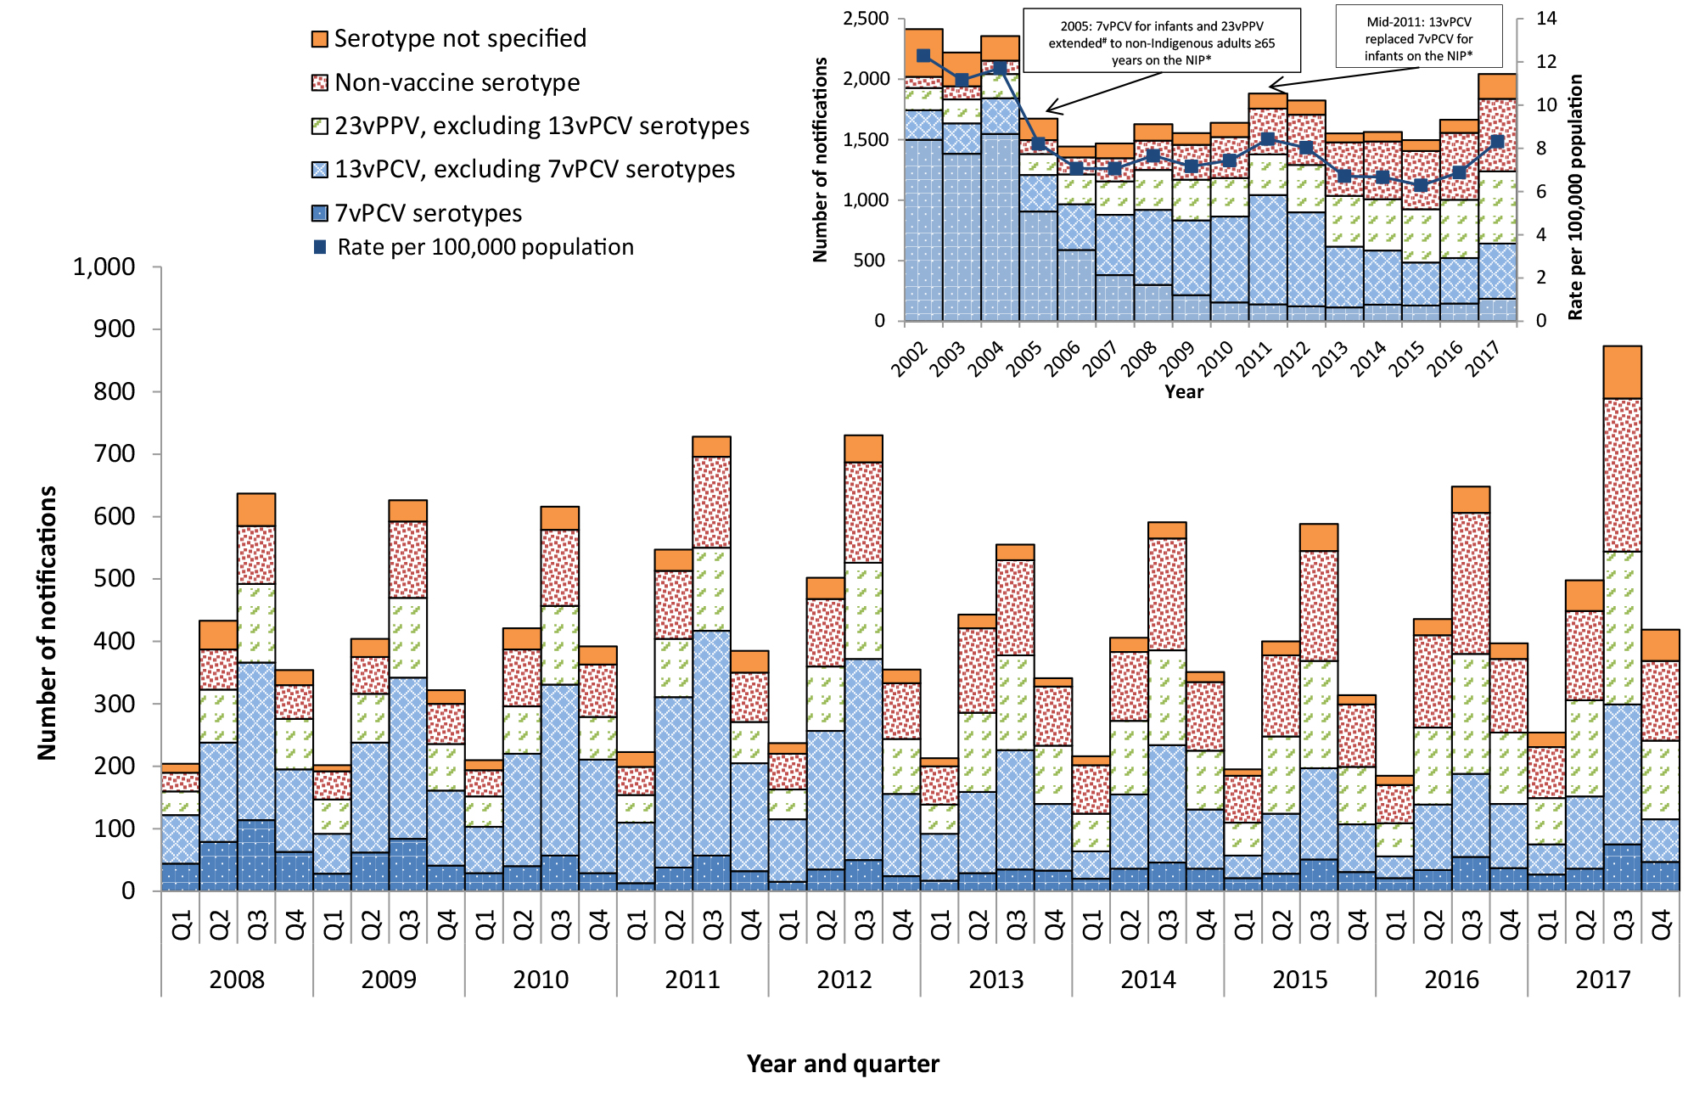

Key points
For the 2017 calendar year, there were 2,044 notified cases of IPD, which was 22% higher when compared with 2016 (n=1,666). The higher levels of IPD observed over the 2017 calendar year, particularly in quarters 2 and 3, may potentially have been influenced by the increased seasonal influenza activity levels that have also been observed over this period.
In the fourth quarter of 2017, there were 415 cases of IPD reported to the National Notifiable Disease Surveillance System (NNDSS). Compared with the number of cases notified in the previous quarter (n=873), this represented a substantial decrease in cases (52%), and compared to the same quarter in 2016 (n=397) there was a 5% increase in the number of cases (Table 1). In the fourth quarter of 2017, the most common pneumococcal serotypes causing IPD were 3 (8.9%), 22F (7.7%) and 9N (5.1%) (Table 2).
Table 1: Notified cases of invasive pneumococcal disease, Australia, 1 October to 31 December 2017, by Indigenous status, serotype completeness and state or territory
Indigenous status | ACT | NSW | NT | Qld | SA | Tas | Vic | WA | Total 4th qtr 2017 | Total 3rd qtr 2017 | Total 4th qtr 2016 | Year to date 2017
Indigenous | 0 | 5 | 14 | 16 | 9 | 1 | 0 | 14 | 59 | 97 | 45 | 228
Non-Indigenous | 9 | 97 | 0 | 43 | 33 | 11 | 83 | 18 | 294 | 670 | 310 | 1,577
Not stated / Unknown | 0 | 38 | 0 | 0 | 1 | 0 | 23 | 0 | 62 | 106 | 42 | 239
Total | 9 | 140 | 14 | 59 | 43 | 12 | 106 | 32 | 415 | 873 | 397 | 2,044
Indigenous status completeness* (%) | 100 | 73 | 100 | 100 | 98 | 100 | 78 | 100 | 85 | 88 | 89 | 88
Indigenous status completeness in targeted groups *† (%) | 100 | 81 | 100 | 100 | 97 | 100 | 89 | 100 | 90 | 93 | 96 | 94
Serotype completeness ‡ (%) | 100 | 86 | 86 | 93 | 63 | 75 | 89 | 91 | 86 | 92 | 96 | 93
* Indigenous status completeness is defined as the reporting of a known Indigenous status, excluding the reporting of not stated or unknown Indigenous status.
† Targeted groups for followup by almost all jurisdictions and public health units are cases aged less than 5 years and 50 years and over.
‡ Serotype completeness is the proportion of all cases of invasive pneumococcal disease that were reported with a serotype or reported as non-typable. Incomplete serotype data can occur in cases when (i) no isolate was available as diagnosis was by polymerase chain reaction and no molecular typing was attempted or was not possible due to insufficient genetic material; (ii) the isolate was not referred to the reference laboratory or was not viable; (iii) typing was pending at the time of reporting, or no serotype was reported by the notifying jurisdiction to the National Notifiable Diseases Surveillance System.

Table 2: Distribution of serotypes causing invasive pneumococcal disease in notified cases, Australia, 1 October to 31 December 2017, by age group
Serotype | Vaccine type | Age groups |  |  | Serotype total
Serotype | Vaccine type | Under 5 years | 5-64 years | Over 65 years | Serotype total
3 | 13vPCV non-7vPCV | 9 | 14 | 14 | 37
22F | 23vPPV non-13vPCV | 3 | 14 | 15 | 32
9N | 23vPPV non-13vPCV | 1 | 13 | 7 | 21
19F | 7vPCV | 3 | 8 | 9 | 20
23A | Non-vaccine type | - | 8 | 12 | 20
19A | 13vPCV non-7vPCV | 5 | 8 | 6 | 19
8 | 23vPPV non-13vPCV | 1 | 9 | 5 | 15
10A | 23vPPV non-13vPCV | 1 | 9 | 4 | 14
23B | Non-vaccine type | 2 | 7 | 5 | 14
11A | 23vPPV non-13vPCV | 1 | 5 | 6 | 12
6C | Non-vaccine type | - | 5 | 7 | 12
31 | Non-vaccine type | - | 7 | 4 | 11
16F | Non-vaccine type | 1 | 3 | 7 | 11
35B | Non-vaccine type | - | 5 | 6 | 11
14 | 7vPCV | 1 | 5 | 3 | 9
15A | Non-vaccine type | - | 4 | 5 | 9
33F | 23vPPV non-13vPCV | - | 5 | 4 | 9
4 | 7vPCV | - | 6 | 1 | 7
12F | 23vPPV non-13vPCV | 1 | 3 | 3 | 7
15B | 23vPPV non-13vPCV | 3 | - | 4 | 7
17F | 23vPPV non-13vPCV | - | 4 | 3 | 7
35F | Non-vaccine type | - | 2 | 5 | 7
15C | Non-vaccine type | 1 | 2 | 3 | 6
7F | 13vPCV non-7vPCV | - | 4 | 2 | 6
38 | Non-vaccine type | - | 2 | 3 | 5
20 | 23vPPV non-13vPCV | 1 | 2 | - | 3
34 | Non-vaccine type | - | 2 | 1 | 3
18C | 7vPCV | - | 1 | 2 | 3
7C | Non-vaccine type | 1 | - | 2 | 3
Other | - | 4 | 8 | 3 | 15
Unknown | - | 26 | 27 | 7 | 60
Total |  | 65 | 192 | 158 | 415
* Serotypes that only occur in less than 5 cases per quarter are grouped as ‘Other’ and include ‘non-typable’ isolates this quarter.
† ‘Serotype unknown’ includes those serotypes reported as ‘no isolate’, ‘not referred’, ‘not viable’, ‘typing pending’ and ‘untyped’.

Among non-Indigenous Australians this quarter, the number of notified cases continued to be highest in children aged less than 5 years and older adult age groups, especially those aged 60 years or older (Table 3). Among Indigenous Australians, notifications tended to be highest among children aged less than 5 years and adults aged 45 to 49 years, as well as those aged 65 years and over. The proportion of cases reported as Indigenous Australians this quarter (14%; 59/415) was higher compared to the proportion observed in the previous quarter (11%; 97/873) and also in the fourth quarter of 2016 (11%; 45/397) (Table 1).
Table 3: Notified cases of invasive pneumococcal disease, Australia, 1 October to 31 December 2017, by Indigenous status and age group
Age group | Indigenous status |  |  | Total
Age group | Indigenous | Non-Indigenous | Not reported* | Total
00-04 | 12 | 51 | 2 | 65
05-09 | 1 | 11 | 2 | 14
10-14 | 1 | 3 | 2 | 6
15-19 | 0 | 1 | 0 | 1
20-24 | 0 | 1 | 0 | 1
25-29 | 5 | 4 | 1 | 10
30-34 | 3 | 9 | 5 | 17
35-39 | 5 | 7 | 8 | 20
40-44 | 3 | 5 | 8 | 16
45-49 | 9 | 7 | 4 | 20
50-54 | 3 | 15 | 2 | 20
55-59 | 3 | 23 | 2 | 28
60-64 | 3 | 28 | 8 | 39
65-69 | 2 | 26 | 4 | 32
70-74 | 5 | 25 | 2 | 32
75-79 | 1 | 24 | 0 | 25
80-84 | 3 | 16 | 7 | 26
85+ | 0 | 38 | 5 | 43
Total | 59 | 294 | 62 | 415
* Not reported is defined as not stated, blank or unknown Indigenous status.

In children aged less than 5 years, there were 65 cases of IPD reported, representing 16% (65/415) of all cases reported in this quarter. The proportion of cases notified in this age group was higher in this reporting period when compared with the previous quarter (11%; 97/873), and similar compared to the proportion reported in the fourth quarter of 2016 (14%; 54/397). Of those cases aged less than 5 years with a known serotype reported this quarter (n=39), 46% (18/39) were due to a serotype included in the 13vPCV, compared to 47% (34/72) of cases in the previous quarter and 57% (24/42) in the fourth quarter of 2016 (Figure 2). Of the 18 cases with 13vPCV serotypes in the fourth quarter of 2017, 7 cases were in fully vaccinated children aged less than 5 years and considered to be 13vPCV failures. These 13vPCV failures were due to serotypes 3 (n=6) and 19A (n=1) (Table 4). During this quarter the main serotypes affecting children aged less than 5 years were 3 (23%; 9/39) and 19A (13%; 5/39) (Table 2). Both of these serotypes are included in the 13vPCV.
Table 4: Characteristics of 13vPCV failures in children aged less than 5 years, Australia, 1 October to 31 December 2017
Age | Indigenous status | Serotype | Clinical category | Risk factor(s)
1 year | Non-Indigenous | 3 | Pneumonia and other (pleural effusion) | No data available
1 year | Non-Indigenous | 19A | Other sterile site | No data available
1 year | Non-Indigenous | 3 | Pneumonia | No risk factor identified
3 years | Non-Indigenous | 3 | Pneumonia and other (pleural empyema) | No data available
3 years | Non-Indigenous | 3 | Pneumonia | Other
4 years | Indigenous | 3 | Other (pleural empyema) | Other
4 years | Indigenous | 3 | Pneumonia | Premature (<37 weeks gestation)
Figure 2: Notifications and annual rates* of invasive pneumococcal disease in children aged less than 5 years, Australia, 1 January 2008 to 31 December 2017, by vaccine serotype group
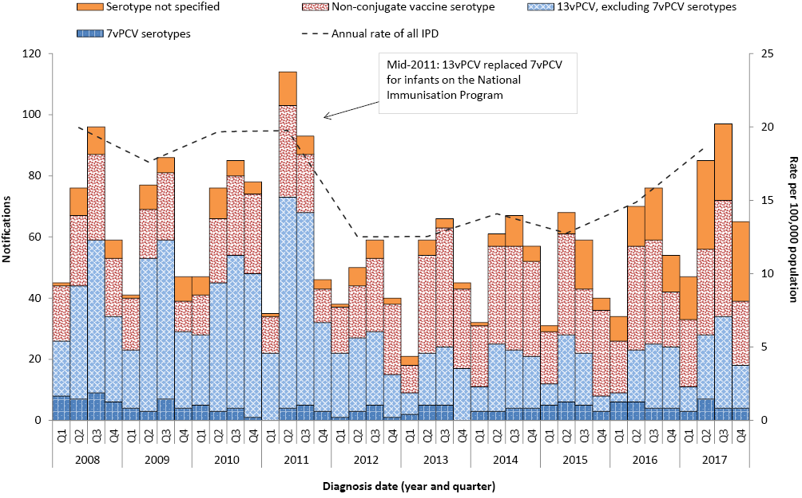* Annual rates are shown on quarter 2.
Among Indigenous Australians aged 50 years and over, there were 20 cases of IPD reported this quarter. Of those cases with a reported serotype (n=19), 9 (47%) were due to a serotype included in the 23vPPV, and overall there was no particular serotype dominant (Figure 3). The number of notified cases of IPD in this population group was lower than the number of cases reported in the previous quarter (n=33), but higher than the number reported in the fourth quarter of 2016 (n=14).
Figure 3: Notifications and annual rates* of all invasive pneumococcal disease in Indigenous Australians aged 50 years or over, Australia, 1 January 2008 to 31 December 2017, by vaccine serotype group
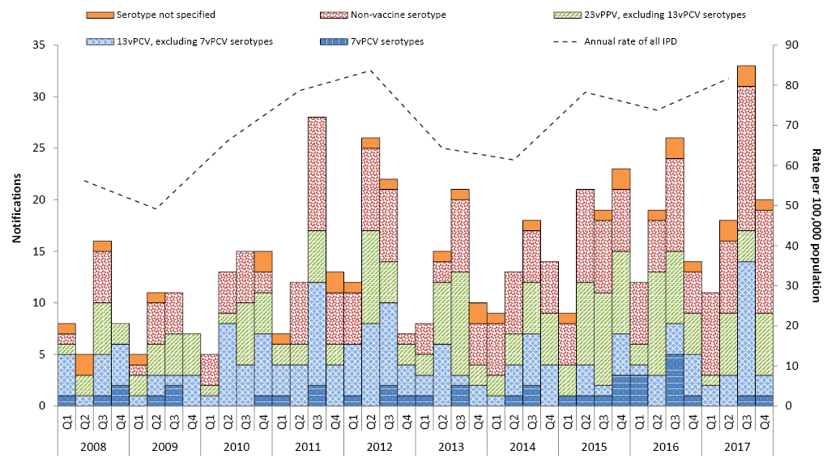
* Annual rates are shown on quarter 2.
Among non-Indigenous Australians aged 65 years and over there were 147 cases of IPD reported this quarter. The number of notified cases of IPD in this population group were 56% lower compared with the number of cases reported in the previous quarter (n=341) and similar to the number reported in the fourth quarter of 2016 (n=142). Of those cases with a reported serotype (n=140), almost 60% (83/140) were due to a serotype included in the 23vPPV (Figure 4), which was less than the proportion in the previous quarter (62%; 198/319) and also the fourth quarter of 2016 (63%; 86/137). For this quarter, serotypes 3 (n=14), 22F (n=14) and 23A (n=12) were the most common serotypes for this population group. All of these serotypes, except 23A, are included in the 23vPPV.
During this quarter, there were 27 deaths attributed to a variety of IPD serotypes, with serotypes 22F (n=4) and 3 (n=3) being the most common. Almost all of the reported deaths (85%; n=23) occurred in non-Indigenous Australians. The median age of those cases reported to have died this quarter was 73 years (range 0 to 96 years).

Notes
The data in this report are provisional and subject to change as laboratory results and additional case information become available. More detailed data analysis of IPD in Australia and surveillance methodology are described in the IPD annual report series published in Communicable Diseases Intelligence.
In Australia, pneumococcal vaccination is recommended as part of routine immunisation for children, individuals with specific underlying conditions associated with increased risk of IPD and older Australians. More information on the scheduling of the pneumococcal vaccination can be found on the Immunise Australia Program website (www.immunise.health.gov.au).
In this report, a ‘vaccine failure’ is reported when a child aged less than 5 years is diagnosed with IPD due to a serotype found in the 13vPCV and they have received 3 primary scheduled doses of 13vPCV at least 2 weeks prior to disease onset with at least 28 days between doses of vaccine.
There are 3 pneumococcal vaccines available in Australia, each targeting multiple serotypes (Table 5). Note that in this report serotype analysis is generally grouped according to vaccine composition.
Figure 4: Notifications and annual rates* of all invasive pneumococcal disease in non-indigenous Australians# aged 65 years or over, Australia, 1 January 2008 to 31 December 2017, by vaccine serotype group
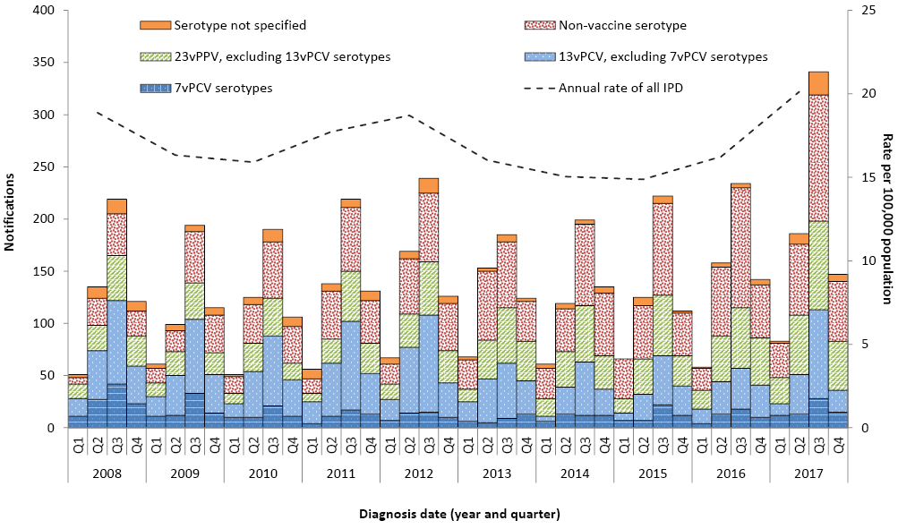
* Annual rates are shown on quarter 2.
# Non-Indigenous Australians includes cases reported with as non-Indigenous, not stated, blank or unknown.

Table 5: Streptococcus pneumoniae serotypes targeted by pneumococcal vaccines
Serotypes | 7-valent pneumococcal conjugate vaccine (7vPCV) | 10-valent pneumococcal conjugate vaccine (10vPCV) | 13-valent pneumococcal conjugate vaccine (13vPCV) | 23-valent pneumococcal polysaccharide vaccine (23vPPV)
1 |  | * | * | *
2 |  |  |  | *
3 |  |  | * | *
4 | * | * | * | *
5 |  | * | * | *
6A |  |  | *
6B | * | * | * | *
7F |  | * | * | *
8 |  |  |  | *
9N |  |  |  | *
9V | * | * | * | *
10A |  |  |  | *
11A |  |  |  | *
12F |  |  |  | *
14 | * | * | * | *
15B |  |  |  | *
17F |  |  |  | *
18C | * | * | * | *
19A |  |  | * | *
19F | * | * | * | *
20 |  |  |  | *
22F |  |  |  | *
23F | * | * | * | *
33F |  |  |  | *
*Based on data extracted from the National Notifiable Diseases Surveillance System (NNDSS) on 18 April 2018. Due to the dynamic nature of the NNDSS, data on this extract is subject to retrospective revision and may vary from data reported in published NNDSS reports and reports of notification data by states and territories.

Follow-up of all notified cases of IPD is undertaken in all states and territories except New South Wales and Victoria who conduct targeted follow-up of notified cases aged under 5 years, and 50 years or over for enhanced data. Follow-up of notified cases of IPD in Queensland is undertaken in all areas except Metro South and Gold Coast Public Health Units who conduct targeted follow-up of notified cases for those aged under 5 years only. However, in these areas where targeted case follow-up is undertaken, some enhanced data may also be available outside these targeted age groups.

Acknowledgements
Report prepared with the assistance of Mr Mark Trungove and Ms Rachael Corvisy on behalf of the Enhanced Invasive Pneumococcal Disease Surveillance Working Group.
Enhanced Invasive Pneumococcal Disease Surveillance Working Group contributors to this report include (in alphabetical order): Frank Beard (NCIRS), Heather Cook (NT and secretariat), Lucinda Franklin (Vic.), Carolien Giele (WA), Robin Gilmour (NSW), Michelle Harlock (Tas.), Ben Howden (Microbiological Diagnostic Unit, University of Melbourne), Sanjay Jayasinghe (NCIRS), Vicki Krause (Chair), Shahin Oftadeh (Centre for Infectious Diseases and Microbiology Laboratory Services, NSW Health Pathology), Sue Reid (ACT), Vitali Sintchenko (Centre for Infectious Diseases and Microbiology- Public Health, Westmead Hospital), Helen Smith (Queensland Health Forensic and Scientific Services), Janet Strachan (Vic.), Hannah Vogt (SA), Angela Wakefield (Qld).

Author details

Corresponding author
Kate Pennington, Communicable Disease Epidemiology and Surveillance Section, Office of Health Protection, Australian Government Department of Health, GPO Box 9484, MDP 14, Canberra, ACT 2601. Telephone: +61 2 6289 2725. Facsimile: +61 2 6289 1070. Email: epi@health.gov.au
Communicable Diseases Intelligence
ISSN: 2209-6051 Online

Communicable Diseases Intelligence (CDI) is a peer-reviewed scientific journal published by the Office of Health Protection, Department of Health. The journal aims to disseminate information on the epidemiology, surveillance, prevention and control of communicable diseases of relevance to Australia.

Editor: Cindy Toms
Deputy Editor: Phil Wright
Editorial and Production Staff: Leroy Trapani and Kasra Yousefi
Editorial Advisory Board: David Durrheim, Mark Ferson, John Kaldor and Martyn Kirk

Website: http://www.health.gov.au/cdi

Contacts
Communicable Diseases Intelligence is produced by:
Health Protection Policy Branch, Office of Health Protection, Australian Government Department of Health
GPO Box 9848, (MDP 6) CANBERRA ACT 2601

Email: cdi.editor@health.gov.au

Submit an Article
You are invited to submit your next communicable disease related article to the Communicable Diseases Intelligence (CDI) for consideration. More information regarding CDI can be found at: http://health.gov.au/cdi.
Further enquiries should be directed to: cdi.editor@health.gov.au.

This journal is indexed by Index Medicus and Medline.

Creative Commons Licence - Attribution-NonCommercial-NoDerivatives CC BY-NC-ND
© 2019 Commonwealth of Australia as represented by the Department of Health
This publication is licensed under a Creative Commons Attribution-NonCommercial-NoDerivatives 4.0 International Licence from https://creativecommons.org/licenses/by-nc-nd/4.0/legalcode (Licence). You must read and understand the Licence before using any material from this publication.

Restrictions
The Licence does not cover, and there is no permission given for, use of any of the following material found in this publication (if any):
- the Commonwealth Coat of Arms (by way of information, the terms under which the Coat of Arms may be used can be found at www.itsanhonour.gov.au);
- any logos (including the Department of Health’s logo) and trademarks;
- any photographs and images;
- any signatures; and
- any material belonging to third parties.

Disclaimer
Opinions expressed in Communicable Diseases Intelligence are those of the authors and not necessarily those of the Australian Government Department of Health or the Communicable Diseases Network Australia. Data may be subject to revision.

Enquiries
Enquiries regarding any other use of this publication should be addressed to the Communication Branch, Department of Health, GPO Box 9848, Canberra ACT 2601, or via e-mail to: copyright@health.gov.au

Communicable Diseases Network Australia
Communicable Diseases Intelligence contributes to the work of the Communicable Diseases Network Australia.
http://www.health.gov.au/cdna

Based on data extracted from the National Notifiable Diseases Surveillance System (NNDSS) on 18 April 2018. Due to the dynamic nature of the NNDSS, data on this extract is subject to retrospective revision and may vary from data reported in published NNDSS reports and reports of notification data by states and territories.

