Communicable Diseases Intelligence, Year 2023, Volume 47
https://doi.org/10.33321/cdi.2023.47.24
Publication date: 27/4/2023
http://health.gov.au/cdi

Using silent area analysis to inform a COVID-19 public health response in Hunter New England, regional New South Wales
Michelle Butler, Benjamin Elton, David Durrheim

Abstract
In 2020 and 2021, in the context of nationwide efforts to suppress SARS CoV-2 virus transmission while awaiting a vaccine, public health teams were responsible for finding and isolating all cases and quarantining their contacts. The success of this strategy required very high case ascertainment and thus, by inference, ready access to PCR testing, even in large rural areas such as Hunter New England in New South Wales.
‘Silent area’ analysis entailed the scheduled regular comparison of case and testing rates at local-government-area resolution against larger area and state-wide rates. This analysis provided an easily understood metric for identifying areas with lower testing rates, and for direction of surging of local testing capacity in such areas, by the local health district in partnership with public health services and private laboratory services. Complementary intensive community messaging was also utilised to promote increased testing in identified areas.
Keywords: Silent areas; SARS CoV-2; COVID-19; population; testing rates

Background
Hunter New England (HNE) is one of 15 health districts in New South Wales (NSW). It serves a regional/rural population of close to 950,000 people across 132,000 square kilometres. Almost seven percent of the population identify as Aboriginal or Torres Strait Islander and 18% of the population were born overseas. The local health district (LHD) encompasses 25 local government areas (LGAs) including the ‘major city’ and ‘inner regional’ areas of Newcastle and Lake Macquarie (Figure 1).

Figure 1: The location of the Hunter New England Local Health District (HNELHD) within New South Wales
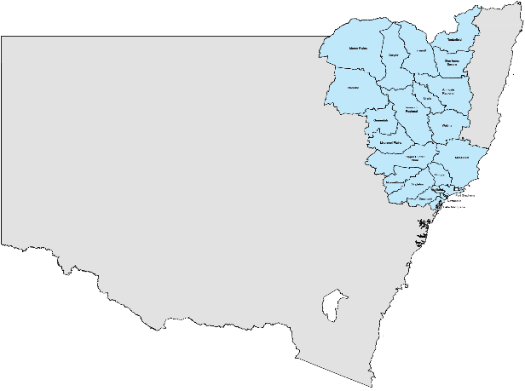
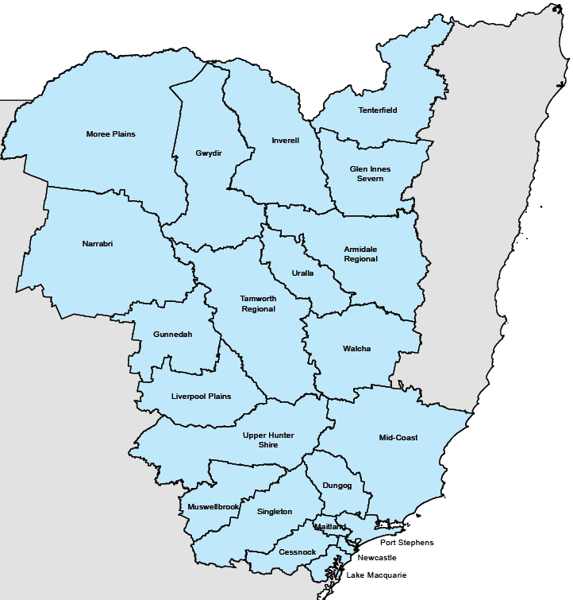
The first HNE coronavirus disease 2019 (COVID-19) case was identified on 6 March 2020. The case infected a number of their family members whose places of residence were spread between two LGAs: the Mid Coast LGA (coastal but classified as outer regional/remote) and Newcastle LGA (coastal but classified as inner regional) (Figure 1). It was immediately apparent that this disease would not only be focused in population-dense metropolitan areas.
Of the first 30 cases identified in HNE, 14 were in Lake Macquarie and Newcastle LGAs (inner regional) with the other 16 spread across five LGAs that were classified as outer regional or rural (Figure 2). These regional and rural LGAs are large expanses of land with relatively small populations. They are often serviced by community health services and multipurpose services rather than hospitals.
Figure 2: Locations of the first 30 cases of COVID-19 in HNELHD based on local government area (LGA)
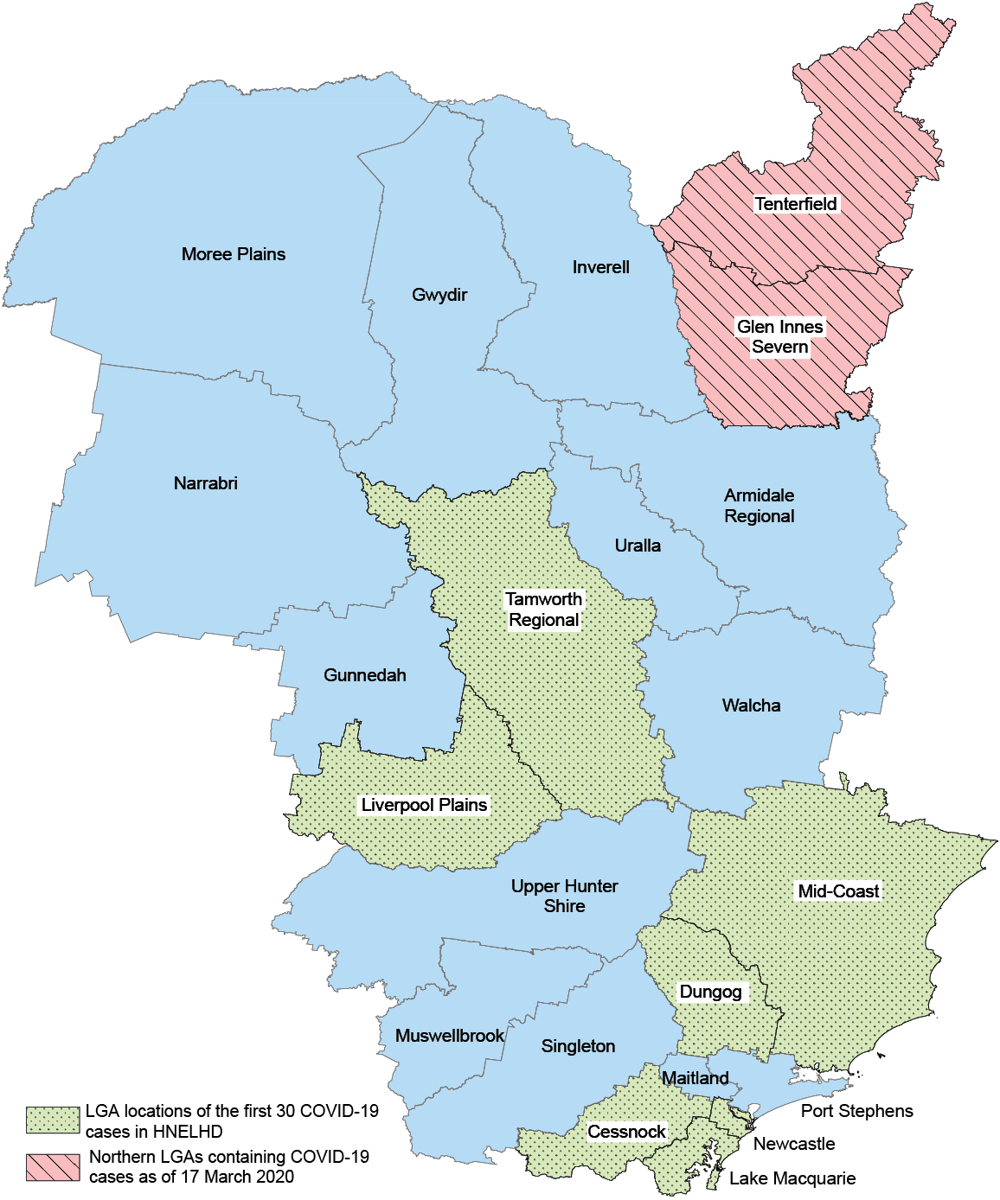

By 17 March 2020, within two weeks of the first HNE case detection, COVID-19 had reached the most northern rural LGAs (Tenterfield and Glen Innes Severn; Figure 2).
Due to the large size of HNELHD and the distribution of existing health services, access to testing and treatment for COVID-19 was going to prove difficult in outer regional, rural and remote areas; as such, careful and constant surveillance of these areas was needed so resources could be moved and increased in the areas that needed them most.
Team members from HNE have previously contributed to enhancing acute flaccid paralysis (AFP) surveillance in Australia, a backbone to poliomyelitis surveillance. This entailed applying the World Health Organization (WHO) AFP detection rate threshold at LGA level across Australia to identify areas that were ‘silent’ for AFP detection.¹ It was thought that the same principle might be applied to COVID-19 surveillance and detection, as with the focus on attempting to eliminate/maximally suppress COVID-19 in NSW, it was imperative that all cases were identified early so they could be isolated and their contacts quarantined.

Methods
Community members in HNE were encouraged to be tested if experiencing any COVID-19 compatible symptoms. This raised questions about access to testing in outer regional, rural and remote areas. The COVID-19 surveillance and detection process could not afford to miss more than a few cases to best suppress the transmission of SARS-CoV-2. Equitable access to medical care also relied on timely and complete case detection.
A silent area analysis was introduced to evaluate testing rates in HNELHD.
HNE’s LGAs are administratively grouped into health service sectors for health service provision and this was the first resolution level for analysis (Figure 3). Within each such sector, testing rates per 100,000 population were compared to NSW average testing rates. Where sector testing rates fell below the NSW overall average testing rate, a more granular analysis was conducted to identify local ‘silent areas’. Sector level in HNE was still too large a geographic and population area to pinpoint areas requiring enhanced testing efforts, hence there was a need for more granular analysis.

Figure 3: Map showing division of HNELHD into health service sectors
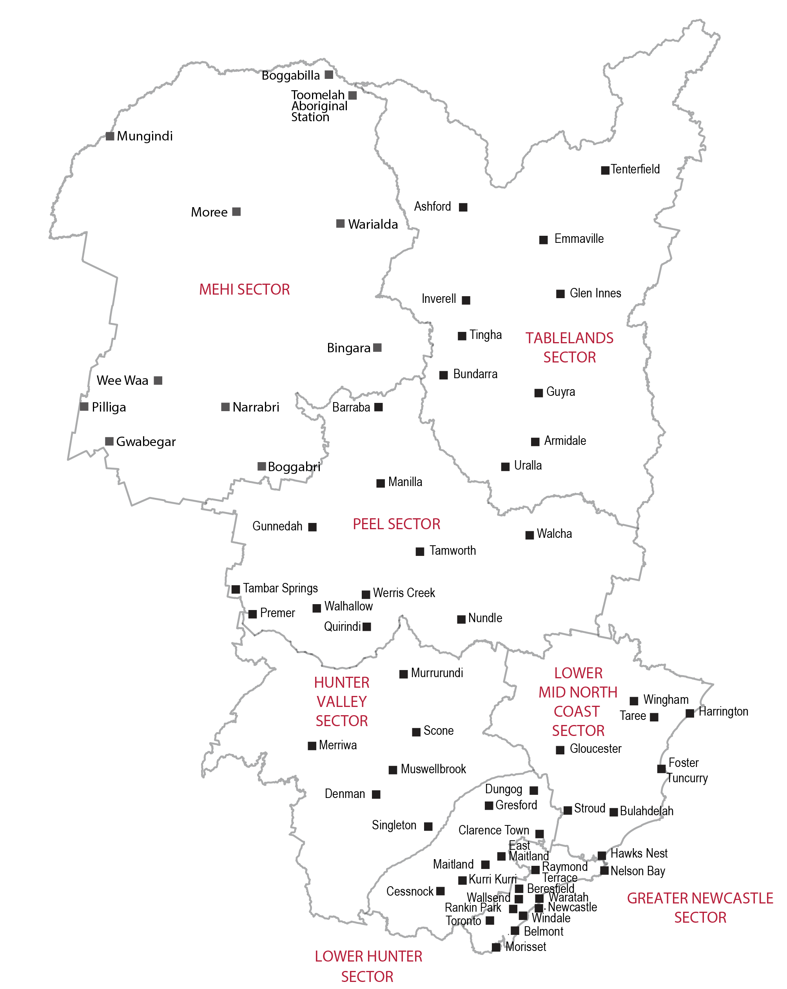

Once a sector was identified as falling short of the NSW testing rate, the testing rates for all LGAs within that sector were calculated. Once a particular ‘silent’ LGA was identified, then the demographics of those being tested compared to the NSW and HNE rates would be explored. Confidence in the accuracy of postcode population data was low and thus finer geographical resolution could not be investigated. Under-representation by age-group or ethnic group prompted in-depth discussion between the local Incident Command System team, including public health, medical services, Aboriginal Health and communications, on how to best surge and promote local testing in the ‘silent area’ to increase representative testing.
This analysis was conducted routinely every Monday and Thursday throughout 2020. In 2021, it was continued until negative test results were no longer captured in the NSW dataset on 16 December 2021.
Ethics was not required as this was analysis of data collected under the Public Health Act 2010 to help inform the public health pandemic response.

Results
Between 1 February 2020 and 10 September 2020 (the period of maximal suppression/elimination focus within NSW), there was a strong correlation between testing rates and case rates (Pearson r = 0.982), supporting the need to ensure optimal testing rates to find cases. The results presented here are illustrative of this approach and include this entire time range; but in real time, we considered weekly, fortnightly and monthly time frames for public health action.
Table 1 shows that during this entire time period, testing rates ranged between 14,000 and 28,000 per 100,000 population across the seven HNE sectors. In six of the seven sectors, testing rates were below the NSW average (highlighted in red), despite the similarity of the overall HNE rate (24,040/100,000 population) to the overall NSW rate (24,778/100,000 population). These sectors were then considered in finer detail.
Table 1: Example of testing rates for HNE sectors and NSW, 1 February 2020 – 10 September 2020
Sector | Cases | Tested & excluded | Total tested | 2019 population | Tests per 100,000 residents | Percent positive | Cases per 100,000 residents
Greater Newcastle | 161 | 124,011 | 124,172 | 444,953 | 27,907 | 0.13% | 36
Hunter Valley | 8 | 12,332 | 12,340 | 54,018 | 22,844 | 0.06% | 15
Lower Hunter | 60 | 37,647 | 37,707 | 154,574 | 24,394 | 0.16% | 39
Lower Mid North Coast | 40 | 15,265 | 15,305 | 93,836 | 16,310 | 0.26% | 43
Mehi | 1 | 4,499 | 4,500 | 31,749 | 14,174 | 0.02% | 3
Peel | 16 | 18,579 | 18,595 | 86,259 | 21,557 | 0.09% | 19
Tablelands | 13 | 12,032 | 12,045 | 69,146 | 17,420 | 0.11% | 19
Total (all HNE sectors) | 299 | 224,365 | 224,664 | 934,535 | 24,040 | 0.13% | 32
Total (all NSW LGAs) | 3,999 | 2,000,828 | 2,004,281 | 8,088,791 | 24,778 | 0.20% | 49

Using Hunter Valley sector, with a testing rate of 22,844/100,000 residents as an example, we considered the rates in the three LGAs making up this sector (Table 2).

Table 2: Example of testing rates for local government areas (LGAs) in the Hunter Valley sector and NSW, 1 February 2020 – 10 September 2020
Sector | Local government area | Cases | Tested & excluded | Total tested | 2019 population | Tests per 100,000 residents | Percent positive | Cases per 100,000 residents
Hunter Valley | Muswellbrook (A) | 1 | 3,189 | 3,190 | 16,377 | 19,479 | 0.03% | 6
Hunter Valley | Singleton (A) | 5 | 6,360 | 6,365 | 23,461 | 27,130 | 0.08% | 21
Hunter Valley | Upper Hunter Shire (A) | 2 | 2,783 | 2,785 | 14,180 | 19,640 | 0.07% | 14
Total  (all HNE sectors) |  | 299 | 224,365 | 224,664 | 934,535 | 24,040 | 0.13% | 32
Total (all NSW LGAs) |  | 3,999 | 2,000,828 | 2,004,281 | 8,088,791 | 24,778 | 0.20% | 49

The LGA-level analysis showed that the LGA with the largest population in the Hunter Valley sector was testing above the NSW average rate while the two less-populous LGAs tested below the NSW average rate. The ABS remoteness classification² indicated that Singleton was primarily ‘inner regional’, with both Muswellbrook and Upper Hunter Shire primarily ‘outer regional’. Similarly in the Lower Hunter sector, testing rates were minimally lower than NSW despite a relatively high case rate in comparison to the rest of HNE, which usually prompts greater testing. Once again one LGA, Maitland, concealed much lower testing rates in other local LGAs in the sector (Table 3).
Table 3: Example of testing rates for local government areas (LGAs) in the Lower Hunter Sector, 1 February 2020 – 10 September 2020
Sector | Local government area | Cases | Tested & excluded | Total tested | 2019 population | Tests per 100,000 residents | Percent positive | Cases per 100,000 residents
Lower Hunter | Cessnock (C) | 24 | 10,602 | 10,262 | 59,985 | 17,108 | 0.23% | 40
Lower Hunter | Dungog (A) | 5 | 1,546 | 1,551 | 9,423 | 16,460 | 0.32% | 53
Lower Hunter | Maitland (C) | 31 | 25,499 | 25,530 | 85,166 | 29,977 | 0.12% | 36
Total  (all HNE sectors) |  | 299 | 224,365 | 224,664 | 934,535 | 24,040 | 0.13% | 32
Total (all NSW LGAs) |  | 3,999 | 2,000,828 | 2,004,281 | 8,088,791 | 24,778 | 0.20% | 49

Discussion
Maps have proven vital for visualizing the COVID-19 pandemic, from identifying local disease and vaccination patterns to understanding global trends.³ At local level, their utility for public communication and directing clinical surge has also been recognised.⁴ In HNE, when local under-testing (‘silent’) areas were identified, engagement with private pathology providers resulted in prompt deployment of further testing options and prompted active community testing messages targeted to promote existing and new testing services.
The data used in this analysis was not probability-based with carefully designed statistical analysis. Instead, the analysis was a regular data-driven process from routinely available data that helped inform decisions on when and where to add testing facilities (hospital, pop-up clinics, mobile testing), with these decisions able to be defended if questioned. It facilitated delving into the attributes of smaller area population testing rates and permitted crafting of the appropriate messaging and selection of message bearers or media forms for promoting testing.
Our application of this practical tool at local level ensured that lower testing rates in smaller populations were not ‘hidden’ by larger population centres, while its simplicity facilitated communication and an immediate public health response.

Author details
Michelle Butler¹ GradDipMedStat, BSc (statistics)
Benjamin Elton¹ GradCertAnalytics, BPsych (Hons)
Dr David Durrheim^{1,2} DrPH, MPH&TM, MBChB, FACTM, FAFPHM, FAAHMS
- Population Health, Hunter New England Local Health District
- Newcastle University, Newcastle

Corresponding author
Michelle Butler
Health Protection, Population Health, Hunter New England Local Health District, Wallsend 2287, New South Wales, Australia
Phone: 0404 020 081
Email: michelle.butler@health.nsw.gov.au

References
- Butler M, Paterson BJ, Martin N, Hobday L, Thorley B, Durrheim DN. ‘Silent’ and ‘noisy’ areas: acute flaccid paralysis surveillance at subnational level, Australia, 2001-2015. Int Health. 2017;9(3):1904. doi: https://doi.org/10.1093/inthealth/ihx007.
- Australian Bureau of Statistics (ABS). 1270.0.55.005 – Australian Statistical Geography Standard (ASGC): Volume 5 – Remoteness Structure, July 2016. [Webpage.] Canberra: ABS; 16 March 2018. [Accessed on 24 November 2022.] Available from: https://www.abs.gov.au/AUSSTATS/abs@.nsf/Lookup/1270.0.55.005Main+Features1July%202016.
- Curtis AJ, Ajayakumar J, Curtis J, Brown S. Spatial syndromic surveillance and COVID-19 in the U.S.: local cluster mapping for pandemic preparedness. Int J Environ Res Public Health. 2022;19(15):8931. doi: https://doi.org/10.3390/ijerph19158931.
- Hertelendy AJ, Goniewicz K, Khorram-Manesh A. The COVID-19 pandemic: how predictive analysis, artificial intelligence and GIS can be integrated into a clinical command system to improve disaster response and preparedness. Am J Emerg Med. 2021;45:671–2. doi: https://doi.org/10.1016/j.ajem.2020.10.049.

Communicable Diseases Intelligence
ISSN: 2209-6051 Online

Communicable Diseases Intelligence (CDI) is a peer-reviewed scientific journal published by the Office of Health Protection, Department of Health and Aged Care. The journal aims to disseminate information on the epidemiology, surveillance, prevention and control of communicable diseases of relevance to Australia.

Editor: Emily Harper
Deputy Editor: Simon Petrie
Design and Production: Kasra Yousefi
Editorial Advisory Board: David Durrheim, Mark Ferson, Clare Huppatz, John Kaldor, Martyn Kirk, Meru Sheel and Steph Williams

Website: http://www.health.gov.au/cdi

Contacts
CDI is produced by the Office of Health Protection, Australian Government Department of Health and Aged Care, GPO Box 9848, (MDP 6) CANBERRA ACT 2601

Email: cdi.editor@health.gov.au

Submit an Article
You are invited to submit your next communicable disease related article to the Communicable Diseases Intelligence (CDI) for consideration. More information regarding CDI can be found at: http://health.gov.au/cdi.
Further enquiries should be directed to: cdi.editor@health.gov.au.

This journal is indexed by Index Medicus and Medline.

Creative Commons Licence - Attribution-NonCommercial-NoDerivatives CC BY-NC-ND
© 2023 Commonwealth of Australia as represented by the Department of Health and Aged Care
This publication is licensed under a Creative Commons Attribution-NonCommercial-NoDerivatives 4.0 International Licence from https://creativecommons.org/licenses/by-nc-nd/4.0/legalcode (Licence). You must read and understand the Licence before using any material from this publication.

Restrictions
The Licence does not cover, and there is no permission given for, use of any of the following material found in this publication (if any):
- the Commonwealth Coat of Arms (by way of information, the terms under which the Coat of Arms may be used can be found at www.itsanhonour.gov.au);
- any logos (including the Department of Health and Aged Care’s logo) and trademarks;
- any photographs and images;
- any signatures; and
- any material belonging to third parties.

Disclaimer
Opinions expressed in Communicable Diseases Intelligence are those of the authors and not necessarily those of the Australian Government Department of Health and Aged Care or the Communicable Diseases Network Australia. Data may be subject to revision.

Enquiries
Enquiries regarding any other use of this publication should be addressed to the Communication Branch, Department of Health and Aged Care, GPO Box 9848, Canberra ACT 2601, or via e-mail to: copyright@health.gov.au

Communicable Diseases Network Australia
Communicable Diseases Intelligence contributes to the work of the Communicable Diseases Network Australia.
http://www.health.gov.au/cdna

