Communicable Diseases Intelligence, Year 2023, Volume 47
https://doi.org/10.33321/cdi.2023.47.22
Publication date: 27/4/2023
http://health.gov.au/cdi

Cohorting children in a childcare setting: a strategy to reduce SARS-CoV-2 Delta transmission, August-September 2021
Yasmin Lisson, Alexandra Marmor, Algreg Gomez, Robyn Hall, Amy Elizabeth Parry, Rose Wright, Aparna Lal

Abstract

Background
Childcare centres can be high-risk settings for SARS-CoV-2 transmission due to age, vaccination status, and infection control challenges. We describe the epidemiology and clinical characteristics of a childcare SARS-CoV-2 Delta outbreak. When the outbreak occurred, little was known about the transmission dynamics of SARS-CoV-2 ancestral and Delta strains among children. Vaccinations for coronavirus disease 2019 (COVID-19) were not mandatory for childcare staff, and children (< 12 years) were ineligible.

Methods
A retrospective cohort design of childcare attendees was used to investigate age-cohorts exposure and transmission of SARS-CoV-2. We defined a case as a person who tested positive to SARS-CoV-2; we defined a close contact as a person who attended the childcare during 16–20 August 2021. Childcare centre exposures were defined by three cohorts: younger children (0–< 2.5 years) with designated staff; older children (2.5–5 years) with designated staff; and a staff-only group that moved between both age cohorts. We calculated the number and proportion of SARS‐CoV‐2 Delta infections, symptom profile and severity in children and adults, secondary attack rates, and relative risks (RR) with 95% confidence intervals (CIs) to compare age-cohort exposures and SARS-CoV-2 infection.

Results
There were 38 outbreak cases that tested positive to SARS-CoV-2 Delta infection, comprising one primary case, 11 childcare attendees and 26 household members. Child attendees were in two non-interacting groups, 0–< 2.5 years and 2.5–5 years, with designated staff, separate rooms, and independent ventilation. The greatest risk of infection to childcare attendees was in the < 2.5 years age cohort which had a secondary attack rate of 41% and were five times more likely to be infected with SARS-CoV-2 (RR = 5.73; 95% CI: 1.37–23.86; p ≤ 0.01). No identified transmission (n = 0/21) occurred in the ≥ 2.5 years age cohort.

Conclusion
Young children play an important role in SARS-CoV-2 Delta transmission to their peers and staff in childcare settings and to household members. Cohorting may be effective at limiting the propagation of SARS-CoV-2 in childcare settings. These findings highlight a need for multi-layered mitigation strategies and implementation support to manage respiratory infection control challenges at childcares. If prevention measures are not in place, this may facilitate ongoing transmission in these settings and into the broader community.
Keywords: COVID-19; SARS-CoV-2; outbreak, child, childcare, control measures; risk factors; transmission; cohorting; ECEC

Introduction
Transmission of severe acute respiratory syndrome coronavirus 2 (SARS-CoV-2) in early childhood education and care centres has been observed in Australia and internationally,^{1–8} with the highest transmission occurring among staff.^{5–8} Prior to the circulation of the SARS-CoV-2 Delta variant, international evidence suggested that children were infrequently identified as primary cases and that they did not play a major role in driving spread.^{1,9,10}
On 12 August 2021, after more than a year without local transmission of SARS-CoV-2 in the Australian Capital Territory (ACT), a case was detected in the community and notified to ACT Health Directorate (ACT Health). This led to the enactment of a coronavirus disease 2019 (COVID-19) public health lockdown directive in the ACT, including stay-at-home orders, mask mandates and the closure of all non-essential services.¹¹ The early childhood education and care (ECEC) sector in the ACT remained open to the children of essential workers and vulnerable families during the ensuing lockdown period. At the time of this outbreak there was limited evidence characterising child-to-child and child-to-adult SARS-CoV-2 transmission at ECEC centres.
Due to lockdown restrictions, there were reduced numbers of attendees and a reduction in staffing capacity at the ECEC centre; for this reason, children were assigned to one of two physically separated classroom cohorts depending on the age group to which they belonged. At the time, ECEC centre public health and social measures were predominantly focused on hand and respiratory hygiene; mask usage for those > 12 years old; and frequent cleaning and disinfection of surfaces. Little could be done in this environment to minimise close physical contact and social mixing between adults and children. When this outbreak occurred, there was relatively low SARS-CoV-2 incidence and vaccination coverage in the population; children less than 12 years of age in Australia were ineligible to be vaccinated against COVID-19; ECEC staff vaccinations were not mandatory; and the vaccine booster program had not been implemented at this time.¹²
ACT Health was notified of a cluster of COVID-19 cases among Canberra residents who attended an ECEC centre during 16–20 August 2021. The centre was immediately closed. The primary case for this cluster attended the ECEC centre whilst infectious and symptomatic over a period of four-days. Genomic sequencing confirmed that the primary case was infected with the B.1.617.2 (Delta) variant of SARS-CoV-2.
Here, we describe a retrospective cohort study of the 38 outbreak cases and contacts of this cluster. This report outlines the outbreak investigation, epidemiological characteristics, and the risk factors related to cohort exposure; it also examines patterns of spread of SARS-CoV-2 Delta within the ECEC centre, the role of prevention measures in place to mitigate transmission, and the symptom profiles of children and adults in these settings.

Methods

Study design
A retrospective cohort study was conducted, of people who attended the ECEC centre during 16–20 August 2021, to investigate the effect of exposure (i.e., contact for any amount of time) to three ECEC centre cohorts.
A close contact was defined as attending the ECEC centre during 16–20 August 2021, where transmission was demonstrated to have occurred. Close contacts were subject to 14 days of quarantine after their last exposure date and were required to test immediately (day 0), and on day 5 and 13 of quarantine, or if they developed COVID-19 symptoms. Secondary contacts were defined as having extensive and/or ongoing exposure to the close contact (e.g., living in the same household) and were subject to quarantine for 14 days and testing if they developed COVID-19 symptoms.
Outbreak cases were defined as follows: The primary case was an individual responsible for transmitting SARS-CoV-2 to others (i.e., primary case to close contacts and secondary contacts). A childcare-acquired case was a close contact and defined by a positive SARS-CoV-2 reverse transcription quantitative-polymerase chain reaction (RT-qPCR) assay. A household-acquired case was a secondary contact and defined by a positive RT-qPCR test for SARS-CoV-2. The infectious period was defined as 48 hours before symptoms developed until two weeks after symptom onset. Serial interval was estimated using the time from first exposure to a symptomatic case (or specimen collection date in asymptomatic cases) to symptom onset in corresponding close contacts and secondary contacts. Symptoms were self-reported, and parents/guardians reported on behalf of children. Vaccination status was verified with the Australian Immunisation Register. Adults were defined as 18 years or older and children were 0–17 years. Please see supplementary material (Appendix A) for further definitions.
The ECEC centre exposures were defined by three cohorts: younger children (0–< 2.5 years) with designated staff; older children (2.5–5 years) with designated staff; and a staff-only group (roaming staff) that moved between both age cohorts. Cohorting by age group at the ECEC centre was a precautionary measure implemented prior to the outbreak to limit interaction and mixing of children. However, some staff (roaming staff) worked across more than one room. The ECEC centre building design enabled the physical separation of the two child-cohorts into different areas, with each room having independent ventilation. The staff at the ECEC centre utilised hand hygiene practices; were required to maintain physical distance from each other (not from the children); and mask usage was recommended but not well adhered to. Toys and high-touch surfaces were disinfected daily.

Epidemiological data collection and analysis
We collected case data through telephone interviews using a standard questionnaire. We extracted de-identified line-list data from REDCap into Microsoft Excel 365 and analysed using StataSE 17 (TX: StataCorp). Data were analysed descriptively, using counts, proportions, medians, and ranges. We used univariable analysis to examine age-cohort exposure among those who were ill compared with those who were not, and generated relative risks (RR) and 95 % confidence intervals (CI). We considered p values less than 0.05 to be statistically significant. A NodeXL social network map was used to visualise epidemiological links between cases and contacts. Secondary attack rates were calculated for three childcare exposure groups and for each household. Secondary attack rates for each group were defined as the proportion of all ECEC centre attendees or household residents with SARS-CoV-2 infection with one primary case per group.

Genomic investigation
Whole genomic sequencing (WGS) was conducted at the Schwessinger Laboratory at the Australian National University, on samples with complete and partial SARS-CoV-2 genomes, using Nanopore technology. All outbreak cases that underwent WGS were the B1.167.2 Pangolin lineage otherwise known as the Delta variant of SARS-CoV-2.

Ethical considerations
The outbreak investigation was undertaken in accordance with the ACT Public Health Act 1997 as part of the declared COVID-19 ACT Public Health Emergency response.¹³ The Australian National University Human Research Ethics Committee has a waiver of consent for research performed as part of an outbreak investigation under Protocol 2017/909.

Results

Outbreak epidemiology
A total of 100 close contacts and secondary contacts were identified and tested for SARS-CoV-2 during this outbreak investigation (Table 1). In addition to the primary case, there were 55 ECEC centre close contacts (34 students, 21 staff) and 44 secondary household contacts. In addition to the primary case (for which the ECEC centre was not their source of infection), a further 37 cases were linked to the outbreak between 22 August and 8 September 2021; eleven were childcare-acquired and 26 household-acquired (Table 1). The biphasic epidemic curve (Figure 1) highlights the initial spread from the primary case to others at the ECEC centre, followed by a second peak showing subsequent household transmission. Illness onset occurred between 16 August and 7 September 2021, with a median serial interval of 4 days (range 3–12 days).
Table 1: Case count, demographics, and close contact summary, Australian Capital Territory, August–September 2021
Characteristic | Total  n (%) | Primary case  n | Childcare–acquired  n (%) | Household–acquired  n (%)
Total | 38 (100) | 1 | 11 (29) | 26 (68)
Sex
Female | 18 (47) | 1 | 9 (50) | 8 (44)
Male | 20 (53) | – | 2 (10) | 18 (90)
Age group category
Children (< 18 years) | 17 (45) | 1 | 6 (35) | 10 (21)
Adults (≥ 18 years) | 21 (55) | — | 5(24) | 16 (76)
Median age | 26 | — | 2 | 28
Minimum age | 0 | — | 0 | 0
Maximum age | 45 | — | 39 | 41
Indigenous status
Aboriginal and Torres Strait Islander people | — | — | — | —
Non-Indigenous people | 38 (100) | 1 | 11 (29) | 26 (68)
Country of birth
Australia | 26 (68) | 1 | 7 (18) | 18 (47)
Overseas | 12 (32) | — | 4 (11) | 8 (21)
Close contact summary
Close contact: cases and non-cases | 100 (100) | 1 | 55 (55) | 44 (44)

All sequences in this outbreak fell within the dominant genomic lineage circulating in the ACT (named ACT.19) and were the B.1.617.2 (Delta) variant Pangolin lineage (Figure 2). In this outbreak, thirty-two samples underwent WGS; a further six samples were unable to be sequenced. Minor diversification was observed by single nucleotide polymorphisms (SNPs), and most were within three SNPs of the primary case’s sequence. This very close genome relatedness supports the observation of a single introduction by a primary case into this ECEC setting (Figure 2).
The investigation identified the primary case, a child, who acquired their infection from a pre-symptomatic parent who was in contact with an infectious case during essential work. The parent of the primary case was the index case for this outbreak but has since been excluded from the cohort due to directionality of transmission. The primary case attended the ECEC centre on four days during their infectious period and whilst symptomatic between 16 to 20 August 2021. Transmission occurred between the primary case, six children and five adults at the ECEC. This observation was supported by their attendance at the ECEC centre during the infectious period (of the primary case) and by the genomic relatedness of viral specimens (Figure 2).
Figure 1: Epidemic curve of COVID-19 cases associated with the childcare outbreak (n = 38), by place of acquisition and date of symptom onset,^{a,b} Australian Capital Territory, August–September 2021
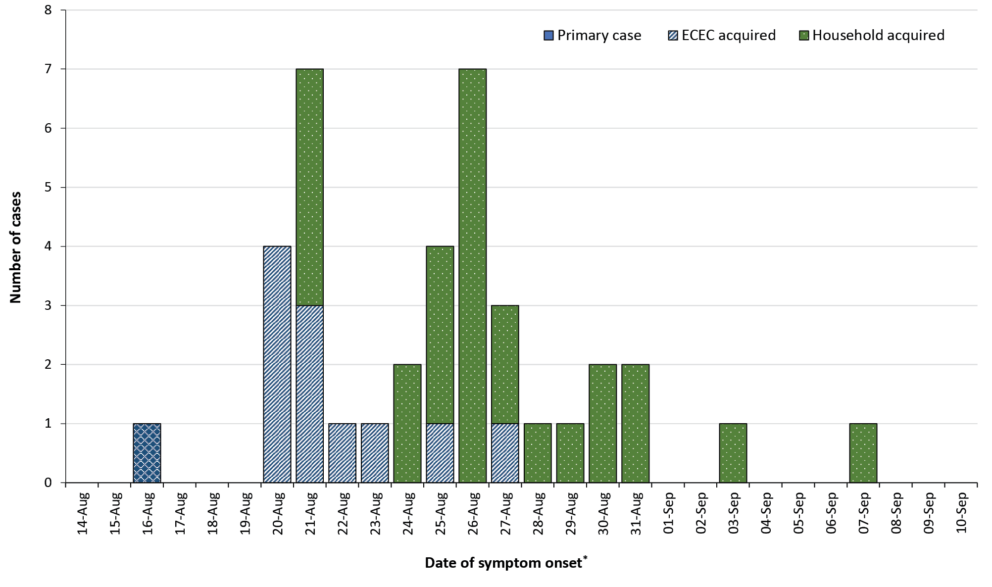
a Specimen collection date was used for two cases that remained asymptomatic throughout their infection.
b The outbreak duration was 23 days. The outbreak was closed 14 days after notification of the last case (7 September) on 21 September 2021.
Of note, four childcare-acquired cases also attended the centre during their infectious period, but our investigation did not determine whether they transmitted SARS-CoV-2 to others. Males accounted for approximately half of all cases, and 70% of transmissions occurred in the household setting (Table 1, Figure 1). There were 12 children and adults associated with ‘in-ECEC centre’ transmission, comprising one primary case and 11 secondary cases (Table 1). A total of 13 households were associated with the outbreak, with a median of four residents per household (range: 3–12 residents). Spread of the virus occurred in 92% of households (n = 12/13). The secondary attack rate in households for this outbreak was 58% (n = 26/45).

Figure 2: A phylogenetic tree of SARS-CoV-2 isolates sequenced from outbreak cases (n = 32), Australian Capital Territory, August–September 2021
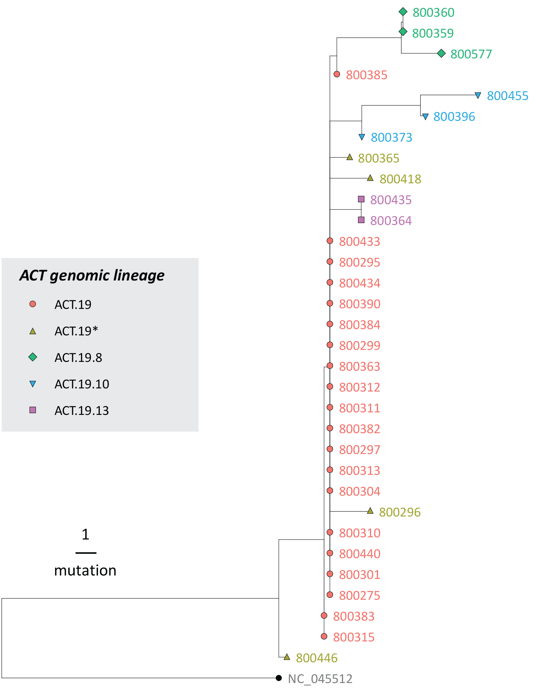
Figure 2 Legend: From this outbreak, a phylogeny was inferred from the 32 available SARS-CoV-2 genomes, and this was used to explore genetic clustering and relationships between cases. The phylogenetic tree is rooted on the Wuhan-1 reference genome (GenBank accession NC_045512). All sequences were highly related at the nucleotide level; most were within three single nucleotide polymorphisms (SNPs) of the primary case’s sequence. Some cases (ACT.19.8 and ACT.19.10) showed more diversification (up to 8 SNPs).

Clinical epidemiology

Symptoms and outcomes
There were no hospitalisations or deaths associated with this outbreak of COVID-19. Ninety-five percent (n = 36/38) reported at least one symptom over the 14-day follow-up period; two children were asymptomatic. The most common symptoms reported were runny or blocked nose, cough, lethargy, altered or loss of taste or smell, headache, and fever > 37.5 °C (Figure 3). Adults reported a wider range of symptoms (n = 8; range 2–13) than did children (n = 5; range 1–11). Adults also reported more severe symptoms such as chest pain and shortness of breath than did the younger cases, although one child with an unknown comorbidity experienced shortness of breath. A higher proportion of adults reported gastrointestinal symptoms of nausea/vomiting and diarrhoea (each 24%; n = 5/21) than did children (0% and 12% [n = 2/17] respectively), although a greater proportion of children experienced abdominal pain (29%; n = 5/17) than did adults (5%; n = 1/21) (Figure 3).
Figure 3: COVID-19 symptoms reported in children and adults associated with the childcare outbreak (n = 36),ª Australian Capital Territory, August-September 2021
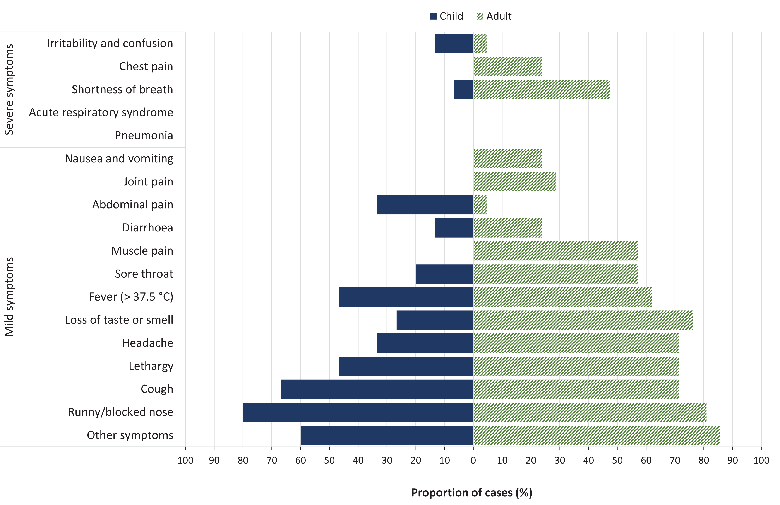
a Two cases were asymptomatic throughout their infection and were excluded from this figure

Vaccination status
During this outbreak, 71% (n = 71/100) of close and secondary contacts were unvaccinated against COVID-19 and the vaccination status for 15% (n = 15/100) was unknown. Of the age-eligible cases, 73% (n = 16/22) were unvaccinated; five (n = 5/22; 23%) were partially vaccinated (two with effective first doses of vaccine); and one was double vaccinated. This double-vaccinated individual represents a single breakthrough infection for this outbreak, with prolonged exposure to a symptomatic child (2-year-old) in a household setting.

Transmission dynamics in ECEC centre cohorts
During 16–20 August 2021, 35 children and 21 staff attended the ECEC centre. In this ECEC centre there were three distinct cohorts of attendees: two cohorts of children and designated staff, namely a younger group (0–< 2.5 years, n = 22) and an older group (2.5–5 years, n = 21), and a cohort of roaming staff. Within the first two cohorts, there was no interaction between children in different cohorts; their activity rooms were in physically separate locations within the building, and each room operated individual reverse cycle air-conditioning units. These two cohorts did not share common spaces and maintained separate eating, sleeping, bottle preparation, toilet facilities and outdoor play areas. The third cohort, the roaming group of staff (n = 7) worked in both the younger and older age-cohorts to support learning and staff breaks. Cohorting measures were not applied to adults at the ECEC centre, as they physically interacted and shared access to the common areas: the breakroom, a locker-room, and one toilet facility.
A social and household network analysis of the identified cases and secondary contacts (n = 58) highlights ‘in-ECEC centre’ transmission from the primary case to childcare-acquired cases in the younger age-cohort and to the staff cohort (Figure 4). The outer ring in this diagram represents transmission to household-acquired cases.
The primary case was in the younger (0–< 2.5 year) cohort with designated staff. The secondary attack rate for all attendees in this cohort was 41% (n = 9/22) (Table 2) and all secondary cases had a likely exposure to the primary case during the child’s infectious period. The attack rate for designated staff in this cohort was 57% (n = 4/7); this was higher than the attack rate in children in the younger cohort (33%; n = 5/15). Risk of infection in people that attended the younger cohort was five times the risk compared with people who did not attend this cohort (RR = 5.73; 95% CI: 1.37–23.86; p < 0.01) (Table 2).
Table 2: Secondary attack rates and relative risk ª of COVID-19 for the ECEC centre with known exposure to cohort groups, Australian Capital Territory, August-September 2021 (n = 50)^{b}
 | Exposed |  |  | Unexposed ª
Cohort | Childcare-acquired cases | Childcare close contacts (non-cases) | AR% | Childcare-acquired cases | Childcare close contacts (non-cases) | RR | p value | 95% CI
Younger age cohort (age 0–< 2.5 years) | 9 | 13 | 41% | 2 | 26 | 5.73 | < 0.01 | 1.37–23.86
Roaming staff^{C} | 2 | 5 | 29% | 9 | 34 | 1.37 | 0.641 | 0.37–5.05
Older age cohort (age 2.5–5 years) | 0 | 21 | 0% | 11 | 18 | — | — | —
a Reference categories for each relative risk are individuals who did not belong to the identified cohort and who are accordingly considered unexposed to that cohort.
b Total observations exclude 5 close contacts with unknown cohort exposure.
c Roaming staff is a staff-only group that moved between both of the age cohorts.
No ‘in-ECEC centre’ transmission was identified among the attendees in the older cohort (2.5–5 years). Four household-acquired cases were identified within the older cohort; these cases likely acquired their infection at home from siblings or a parent (i.e., staff member) who attended the younger cohort during the outbreak period. This inference of transmission in the household setting is supported by cases in the older cohort having no direct exposure to the primary case, by the timing of their symptom onset, and by genomic analysis confirming two cases shared the same genomic sequence with their family member (genomic evidence was not available for two of the four cases in the older cohort).
Two cases were identified in the roaming staff cohort. One of these individuals reported comforting and holding the primary case during the primary case’s infectious period; this individual worked only one shift and it was their only identified exposure. The secondary attack rate in the roaming staff cohort was 29% (n = 2/7). Roaming staff were at reduced risk of becoming a case, compared with attendees in the younger cohort; however, this risk of transmission was not statistically significant (RR = 1.37; 95% CI: 0.37–5.05; p = 0.641) (Table 2).
Figure 4. Social and household network analysis of a SARS-CoV-2 outbreak of cases and their secondary contacts (n = 58), Australian Capital Territory, August-September 2021
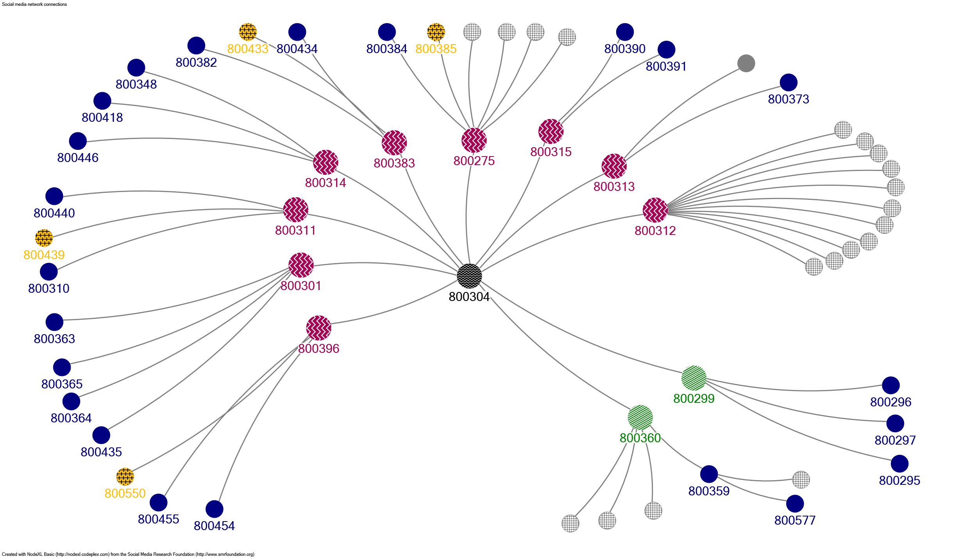
Figure 4 Legend: Schematic overview of the social and household network analysis of cases and secondary contacts (n = 58), with outbreak-ID code. This diagram highlights ‘in ECEC centre’ transmission from the primary case (black circle) to childcare-acquired cases in the younger age-cohort (pink circles) and the roaming staff cohort (green circles). The outer ring in this diagram represents transmission to household-acquired cases (blue circles: household contacts only & yellow circles: older-age cohort/household contact) and depicts non-cases among household contacts (grey circles).
 | Primary case
 | Childcare-acquired case: age cohort (0–< 2.5 years)
 | Childcare-acquired case: roaming staff
 | Household-acquired case & age cohort (2.5–5 years)
 | Non-cases: secondary household contacts
 | Household-acquired case

Discussion
Frequent and close interactions among unvaccinated children, who are too young to consciously practice physical distancing or maintain respiratory etiquette, likely contributed to high transmission of COVID-19 in this outbreak. Key findings included: children are important drivers in transmission; adults report more severe symptoms; outbreaks can occur where minimal prevention measures are in place; and the preventive measure of cohorting children may have been effective in limiting propagation of SARS-CoV-2.
Our results are consistent with recent studies which have shown that children are capable of transmitting SARS-CoV-2 to other children and adults,^{2,14,15} and that young children have a greater likelihood of transmitting SARS-CoV-2 to household contacts.^{16,17} Our results give further weight to evidence that sharing an enclosed indoor environment with an infectious individual is high-risk for SARS-CoV-2 transmission.^{3,15,18} In this ECEC centre, we observed high secondary attack rates among the younger attendees, with transmission facilitated by time, lack of masks, and close contact.^{3,19} However, attack rates were higher in staff than in children, a finding which is supported by other research, showing that adults report increased SARS-CoV-2 transmission and susceptibility.^{5,20,21}
A young child was identified as the primary case. This highlights that young, unvaccinated children can be significant sources of SARS-CoV-2 transmission in educational settings. At the time of the outbreak described here, few studies on previous ancestral SARS-CoV-2 strains had demonstrated that children had comparable incidence rates to adults,²² or that children were capable of infecting others regardless of symptom presence or severity.²³ It is well understood, in Australia and internationally, that new variants with enhanced transmissibility continue to result in more frequent transmission and high attack rates in ECEC centres ^{24–26} and other educational settings.^{27,28} Our investigation further reinforces these findings. Australia has shown that high vaccination coverage may have been a factor in reduced SARS-CoV-2 transmission in schools when students returned to face-face learning; however, vaccine eligibility is still limited to those ≥ 5 years of age, and to younger at-risk groups.²⁹ A nuanced understanding of factors that drive infectivity and transmission among children is needed, as these will have important implications for childcare policies.
In this outbreak, adults were more likely to experience severe disease than children. Consistent with the existing literature, children have milder illness; are more likely to have asymptomatic disease; and are at a lower risk of hospitalisation than are adults.^{6,21,30,31} Our study described most children with mild, symptomatic, non-specific disease. However, there are increasingly more clinical paediatric SARS‐CoV‐2 Delta and B.1.1.529 (Omicron) variant studies, highlighting that new variants are affecting younger populations with an increase in severe clinical manifestations and hospitalisation.³² Identifying SARS-CoV-2 infections among children early on and differentiating these from other respiratory infections will be critical in reducing outbreaks in ECEC settings and preventing a more severe illness in other vulnerable children and adult caregivers.
We provide evidence that indicates cohorting may be an effective strategy to reduce the propagation of an outbreak within a similar setting. We saw no ‘in-ECEC centre’ transmission within the attendees of the older cohort. Our results are in line with the United States Centers for Disease Control and Prevention (CDC) 2021 recommendation that cohorting strategies are necessary to limit the spread of SARS-CoV-2 between groups in child care centres and similar settings, particularly in areas with community transmission.³³
We also demonstrate that SARS-CoV-2 was more likely to be introduced into this educational setting due to few prevention strategies. This was confirmed by the attendance of symptomatic children and staff, by low staff vaccination coverage, and by inconsistent mask usage and unmasked interactions with children. In addition, there were site-specific limitations whereby staff did not have access to separate bathrooms or breakrooms and no enhancements were made to introduce outdoor ventilation. Limitations of the ECEC centre and non-adherence to preventive measures may have contributed to the rapid spread of SARS-CoV-2 in this setting.
Current research emphasises that ECEC centres should focus efforts on the control of transmission routes, close contact, fomite and airborne transmission.³⁴ This should be done by: limiting movement of staff; having designated staff in each classroom; smaller class sizes; twice-daily cleaning of items (i.e., toys/books); air filtering and regular natural ventilation; where feasible, moving activities outside; and undertaking family-member grouping during community transmission of SARS-CoV-2.^{3,33,34} Importantly, CDC (2022) have demonstrated that following COVID-19 vaccination requirements, the consistent use of face masks or respirators (N95/KN95s), screening testing, and cohorting will enable the early detection, isolation, and quarantine of individuals.^{15,33,35}
As this was an outbreak at one ECEC centre, these results cannot be generalised. The unintended benefit of this small population size, however, was that all cases were interviewed, with initial interviews occurring within one day of the notification of a positive result. Therefore, cases may have been more likely to remember details of their exposure history, and with whom they interacted. This was also supported by ECEC centre attendance documentation. We were unable to determine what role unmasking played in the staff breakroom, and we were not able to establish whether there were multiple episodes of transmission within the younger cohort.
This outbreak involved SARS‐CoV‐2 Delta transmission in a ECEC setting. Analysis of this outbreak identified the source for this cluster as a young child who attended the ECEC centre during their infectious period. We found that children younger than 2.5 years are important drivers of transmission to other children and adults. Our study highlights that cohorting can be an effective control measure to reduce the spread of SARS-CoV-2 in unvaccinated ECEC settings. We demonstrated that the lack of multiple prevention strategies in a low prevalence setting, including vaccination coverage of eligible people, universal mask usage and pre-screening testing, can introduce and lead to rapid spread SARS-CoV-2 in ECEC settings and subsequently to households. These findings reinforce the critical need to emphasise multi-layered mitigation strategies and implementation support to manage respiratory and enteric infection control challenges in ECEC settings.

Author details
Yasmin K Lisson: Master of Applied Epidemiology Scholar,^{1, 4}
Ms Alexandra Marmor: Surveillance Coordinator and Epidemiologist,²
Mr Algreg Gomez: Master of Applied Epidemiology Scholar,^{1, 2}
Dr Robyn Hall: Epidemiologist, ^{2, 3}
Ms Amy Elizabeth Parry: PhD Candidate,¹
Ms Rose Wright: Epidemiologist,⁴
Associate Prof. Aparna Lal: Senior Fellow, ¹
- National Centre for Epidemiology and Population Health, Australian National University, Acton, Australian Capital Territory, Australia
- ACT Health, Woden, Australian Capital Territory, Australia
- Research School of Biology, The Australian National University, Acton, Australian Capital Territory, Australia
- Commonwealth Scientific and Industrial Research Organisation Health & Biosecurity, Acton, Australian Capital Territory, Australia
- Australian Government Department of Health and Aged Care, Woden, Australian Capital Territory, Australia

Corresponding author
Yasmin Lisson
National Centre for Epidemiology and Population Health, Australian National University, Acton, Australian Capital Territory, Australia
Phone: 02 6289 3579
Email address: Yasmin.lisson@health.gov.au

References
- Haag L, Blankenburg J, Unrath M, Grabietz J, Kahre E, Galow L et al. Prevalence and transmission of severe acute respiratory syndrome coronavirus type 2 in childcare facilities: a longitudinal study. J Pediatr. 2021;237:136–42. doi: https://doi.org/10.1016/j.jpeds.2021.07.054.
- Loenenbach A, Markus I, Lehfeld AS, An der Heiden M, Haas W, Kiegele M et al. SARS-CoV-2 variant B.1.1.7 susceptibility and infectiousness of children and adults deduced from investigations of childcare centre outbreaks, Germany, 2021. Euro Surveill. 2021;26(21):2100433. doi: https://doi.org/10.2807/1560-7917.ES.2021.26.21.2100433.
- Phillips B, Browne DT, Anand M, Bauch CT. Model-based projections for COVID-19 outbreak size and student-days lost to closure in Ontario childcare centres and primary schools. Sci Rep. 2021;11(1):6402. doi: https://doi.org/10.1038/s41598-021-85302-6.
- Soto JC, Barakat M, Hutter JA, Kiely M, Moreira S, Shapiro BJ et al. Outbreak investigation of SARS-CoV-2 transmission in an emergency childcare centre. Can J Public Health. 2021;112(4):566–75. doi: https://doi.org/10.17269/s41997-021-00544-1.
- Li A, Moore K, Bowthorpe L, Sousa J, Guan TH. Limited propagation of SARS-CoV-2 among children in a childcare center, Canada, 2021. Emerg Infect Dis. 2022;28(1):259–62. doi: https://doi.org/10.3201/eid2801.211811.
- Macartney K, Quinn HE, Pillsbury AJ, Koirala A, Deng L, Winkler N et al. Transmission of SARS-CoV-2 in Australian educational settings: a prospective cohort study. Lancet Child Adolesc Health. 2020;4(11):807–16. doi: https://doi.org/10.1016/S2352-4642(20)30251-0.
- National Centre for Immunisation Research and Surveillance (NCIRS). COVID-19 in schools and early childhood education and care services –the experience in NSW: 16 June to 31 July 2021. Sydney: New South Wales Government Department of Health (NSW Health); NCIRS; 8 September 2021. [Accessed in September 2021.] Available from: https://www.ncirs.org.au/sites/default/files/2021-09/NCIRS%20NSW%20Schools%20COVID_Summary_8%20September%2021_Final.pdf.
- Nakel J, Robitaille A, Günther T, Rosenau L, Czech-Sioli M, Plenge-Bönig A et al. Comparing susceptibility and contagiousness in concurrent outbreaks with a non-VOC and the VOC SARS-CoV-2 variant B.1.1.7 in daycare centers in Hamburg, Germany. Int J Hyg Environ Health. 2022;240:113928. doi: https://doi.org/10.1016/j.ijheh.2022.113928.
- Gudbjartsson DF, Helgason A, Jonsson H, Magnusson OT, Melsted P, Norddahl GL et al. Spread of SARS-CoV-2 in the Icelandic population. N Engl J Med. 2020;382(24):2302–15. doi: https://doi.org/10.1056/NEJMoa2006100.
- Soriano-Arandes A, Gatell A, Serrano P, Biosca M, Campillo F, Capdevila R et al. Household severe acute respiratory syndrome coronavirus 2 transmission and children: a network prospective study. Clin Infect Dis. 2021;73(6):e1261–9. doi: https://doi.org/10.1093/cid/ciab228.
- Australian Capital Territory Legislation Register. Public Health (Lockdown Restrictions) Emergency Direction 2021 (No 1). [Legislation.] Canberra: Australian Capital Territory Government; 12 August 2021. [Accessed in December 2021.] Available from: https://www.legislation.act.gov.au/ni/2021-480/.
- Australian Technical Advisory Group on Immunisation (ATAGI). Australian Technical Advisory Group on Immunisation (ATAGI): Clinical guidance on use of COVID-19 vaccine in Australia (v7.4). [Superseded document no longer available.] Canberra: Australian Government Department of Health and Aged Care; 29 October 2021.
- Australian Capital Territory Legislation Register. Public Health Act 1997. [Legislation.] Canberra: Australian Capital Territory Government; 1997. Available from: https://www.legislation.act.gov.au/a/1997-69.
- Okarska-Napierała M, Mańdziuk J, Kuchar E. SARS-CoV-2 cluster in nursery, Poland. Emerg Infect Dis. 2021;27(1):317–9. doi: https://doi.org/10.3201/eid2701.203849.
- Moschovis PP, Yonker LM, Shah J, Singh D, Demokritou P, Kinane TB. Aerosol transmission of SARS‐CoV‐2 by children and adults during the COVID‐19 pandemic. Pediatr Pulmonol. 2021;56(6):1389–94. doi: https://doi.org/10.1002/ppul.25330.
- Paul LA, Daneman N, Schwartz KL, Science M, Brown KA, Whelan M et al. Association of age and pediatric household transmission of SARS-CoV-2 infection. JAMA Pediatr. 2021;175(11):1151–8. doi: https://doi.org/10.1001/jamapediatrics.2021.2770.
- Silverberg SL, Zhang BY, Li SNJ, Burgert C, Shulha HP, Kitchin V et al. Child transmission of SARS-CoV-2: a systematic review and meta-analysis. BMC Pediatr. 2022;22(1):172. doi: https://doi.org/10.1186/s12887-022-03175-8.
- Qian H, Miao T, Liu L, Zheng X, Luo D, Li Y. Indoor transmission of SARS-CoV-2. Indoor Air. 2021;31(3):639–45. doi: https://doi.org/10.1111/ina.12766.
- Hall CB, Douglas RG. Modes of transmission of respiratory syncytial virus. J Pediatr. 1981;99(1):100–3. doi: https://doi.org/10.1016/s0022-3476(81)80969-9.
- Mehta NS, Mytton OT, Mullins EWS, Fowler TA, Falconer CL, Murphy OB et al. SARS-CoV-2 (COVID-19): what do we know about children? A systematic review. Clin Infect Dis. 2020;71(9):2469–79. doi: https://doi.org/10.1093/cid/ciaa556.
- Davies NG, Klepac P, Liu Y, Prem K, Jit M, Eggo RM et al. Age-dependent effects in the transmission and control of COVID-19 epidemics. Nat Med. 2020;26(8):1205–11. doi: https://doi.org/10.1038/s41591-020-0962-9.
- Dawood FS, Porucznik CA, Veguilla V, Stanford JB, Duque J, Rolfes MA et al. Incidence rates, household infection risk, clinical characteristics of SARS-CoV-2 infection among children and adults in Utah and New York City, New York. JAMA Pediatr. 2022;176(1):59–67. doi: https://doi.org/10.1001/jamapediatrics.2021.4217.
- Yonker LM, Boucau J, Regan J, Choudhary MC, Burns MD, Young N et al. Virologic features of severe acute respiratory syndrome coronavirus 2 infection in children. J Infect Dis. 2021. doi: https://doi.org/10.1093/infdis/jiab509.
- Ehrhardt J, Ekinci A, Krehl H, Meincke M, Finci I, Klein J et al. Transmission of SARS-CoV-2 in children aged 0 to 19 years in childcare facilities and schools after their reopening in May 2020, Baden-Württemberg, Germany. Euro Surveill. 2020;25(36):2001587. doi: https://doi.org/10.2807/1560-7917.ES.2020.25.36.2001587.
- Roberts RJ, Brooker A, Lakshman R. Outbreak of SARS-CoV-2 in a children’s nursery in the United Kingdom. Pediatr Infect Dis J. 2021;40(12):e455–8. doi: https://doi.org/10.1097/INF.0000000000003362.
- NCIRS. COVID-19 in schools and early childhood education and care services –the experience in NSW: 16 June to 17 September 2021. Sydney: NSW Health; NCIRS; 18 February 2022. [Accessed in February 2022.] Available from: https://www.ncirs.org.au/sites/default/files/2022-02/NCIRS_NSW_Schools_COVID_Summary_Term%203%202021_Report_18-02-2022_FINAL_0.pdf.
- Altarawneh HN, Chemaitelly H, Hasan MR, Ayoub HH, Qassim S, AlMukdad S et al. Protection against the omicron variant from previous SARS-CoV-2 infection. N Engl J Med. 2022;386(13):1288–90. doi: https://doi.org/10.1056/NEJMc2200133.
- Baumgarte S, Hartkopf F, Hölzer M, von Kleist M, Neitz S, Kriegel M et al. Investigation of a limited but explosive COVID-19 outbreak in a German secondary school. Viruses. 2022;14(1):87. doi: https://doi.org/10.3390/v14010087.
- NCIRS. COVID-19 in schools and early childhood education and care services –the experience in NSW: 18 October 2021 to 17 December 2021. Sydney: NSW Health; NCIRS; 18 February 2022. [Accessed in February 2022.] Available from: https://www.ncirs.org.au/sites/default/files/2022-02/NCIRS_NSW_Schools_COVID_Summary_Term_4_2021_Report%20-%2024-02-2022_Final.pdf.
- Martins MM, Prata-Barbosa A, da Cunha A. Update on SARS-CoV-2 infection in children. Paediatr Int Child Health. 2021;41(1):56–64. doi: https://doi.org/10.1080/20469047.2021.1888026.
- Nikolopoulou GB, Maltezou HC. COVID-19 in children: where do we stand? Arch Med Res. 2022;53(1):1–8. doi: https://doi.org/10.1016/j.arcmed.2021.07.002.
- Khemiri H, Ayouni K, Triki H, Haddad-Boubaker S. SARS-CoV-2 infection in pediatric population before and during the Delta (B.1.617.2) and Omicron (B.1.1.529) variants era. Virol J. 2022;19(1):144. doi: https://doi.org/10.1186/s12985-022-01873-4.
- Centers for Disease Control and Prevention (CDC). COVID-19 Guidance for Operating Early Care and Education/Child Care Programs. [Internet.] Atlanta: United States Government Department of Health and Human Services, CDC; 2021. [Accessed in November 2021.] Available from: https://www.cdc.gov/coronavirus/2019-ncov/community/schools-childcare/child-care-guidance.html#cohorting.
- Kim C, Yu J, Lee YG, Kim J, Bae S. Identifying behavior of long-distance virus transmission and mitigation performance from a COVID-19 outbreak of a daycare center. Environ Res. 2022;212(Pt B):113318. doi: https://doi.org/10.1016/j.envres.2022.113318.
- Van Naarden Braun K, Drexler M, Rozenfeld RA, Deener-Agus E, Greenstein R, Agus M et al. Multicomponent strategies to prevent SARS-CoV-2 transmission — nine overnight youth summer camps, United States, June–August 2021. MMWR Morb Mortal Wkly Rep. 2021;70(40):1420–4. doi: https://doi.org/10.15585/mmwr.mm7040e1.

Appendix A: Supplementary material
COVID-19 in childcare: Evidence of spread and effective preventative measures to limit SARS-CoV-2 delta transmission

Definition of symptoms
Severe illness was defined as experiencing any of the following symptoms consistent with COVID-19 illness: shortness of breath; confusion/irritability; chest pain; pneumonia; and acute respiratory syndrome. Mild illness was defined as experiencing any symptoms consistent with COVID-19 illness in the absence of those defined as severe. Asymptomatic illness was defined as the absence of any symptoms consistent with COVID-19 illness.

Definition of vaccination status
Vaccination status at the time was defined as follows. Double vaccinated: individuals who had received two doses more than 14 days prior to their diagnosis. Partially vaccinated: individuals who had received one dose more than 21 days prior to their diagnosis (also known as an effective first vaccination dose), or 1 dose less than 21 days prior to their diagnosis, or 2 doses less than 14 days, prior to their diagnosis. Unvaccinated: individuals who had not received any doses of SARS-CoV-2 vaccination. A breakthrough COVID-19 case was an individual who tested positive to SARS-CoV-2 RT-qPCR test, who had received two doses more than 14 days prior to their illness onset.

Details of interviews
Trained case interviewers conducted interviews shortly after diagnosis and prompts were used to assist with recall. Epidemiological, demographic, clinical, and laboratory data were recorded using the ACT Health REDCap (Research Electronic Data Capture) database. All cases (including their parents/guardians) were followed up until 14 days after their last exposure date.
Centre level data were collected regarding: attendance dates of staff and children to determine student cohorting information; COVID-safe policies and procedures; and any activities and behaviours that may have contributed to or mitigated transmission. The manager and director of the ECEC centre provided verbal descriptions of the COVID-19 public health and social measures in place at the time of the outbreak. Additional interviews were conducted with staff cases to determine movements around the centre, activities, and interactions with identified cases.

Communicable Diseases Intelligence
ISSN: 2209-6051 Online

Communicable Diseases Intelligence (CDI) is a peer-reviewed scientific journal published by the Office of Health Protection, Department of Health and Aged Care. The journal aims to disseminate information on the epidemiology, surveillance, prevention and control of communicable diseases of relevance to Australia.

Editor: Emily Harper
Deputy Editor: Simon Petrie
Design and Production: Kasra Yousefi
Editorial Advisory Board: David Durrheim, Mark Ferson, Clare Huppatz, John Kaldor, Martyn Kirk, Meru Sheel and Steph Williams

Website: http://www.health.gov.au/cdi

Contacts
CDI is produced by the Office of Health Protection, Australian Government Department of Health and Aged Care, GPO Box 9848, (MDP 6) CANBERRA ACT 2601

Email: cdi.editor@health.gov.au

Submit an Article
You are invited to submit your next communicable disease related article to the Communicable Diseases Intelligence (CDI) for consideration. More information regarding CDI can be found at: http://health.gov.au/cdi.
Further enquiries should be directed to: cdi.editor@health.gov.au.

This journal is indexed by Index Medicus and Medline.

Creative Commons Licence - Attribution-NonCommercial-NoDerivatives CC BY-NC-ND
© 2023 Commonwealth of Australia as represented by the Department of Health and Aged Care
This publication is licensed under a Creative Commons Attribution-NonCommercial-NoDerivatives 4.0 International Licence from https://creativecommons.org/licenses/by-nc-nd/4.0/legalcode (Licence). You must read and understand the Licence before using any material from this publication.

Restrictions
The Licence does not cover, and there is no permission given for, use of any of the following material found in this publication (if any):
- the Commonwealth Coat of Arms (by way of information, the terms under which the Coat of Arms may be used can be found at www.itsanhonour.gov.au);
- any logos (including the Department of Health and Aged Care’s logo) and trademarks;
- any photographs and images;
- any signatures; and
- any material belonging to third parties.

Disclaimer
Opinions expressed in Communicable Diseases Intelligence are those of the authors and not necessarily those of the Australian Government Department of Health and Aged Care or the Communicable Diseases Network Australia. Data may be subject to revision.

Enquiries
Enquiries regarding any other use of this publication should be addressed to the Communication Branch, Department of Health and Aged Care, GPO Box 9848, Canberra ACT 2601, or via e-mail to: copyright@health.gov.au

Communicable Diseases Network Australia
Communicable Diseases Intelligence contributes to the work of the Communicable Diseases Network Australia.
http://www.health.gov.au/cdna

