Communicable Diseases Intelligence, Year 2023, Volume 47
https://doi.org/10.33321/cdi.2023.47.61
Publication date: 19/10/2023
http://health.gov.au/cdi

Australian vaccine preventable disease epidemiological review series: tetanus 2003–2019
Eliora SG Morris, Aditi Dey, Kaitlyn Vette, Harunor Rashid, Nicholas Wood, Frank Beard

Abstract

Background
We examined trends in tetanus notification, hospitalisation and death data from 2003–2019 to assess the impact of adult tetanus booster recommendations in Australia.

Methods
Tetanus notifications and deaths from the National Notifiable Diseases Surveillance System; hospitalisations from the Australian Institute of Health and Welfare National Hospital Morbidity Database; and deaths from the Australian Coordinating Registry were analysed by age group, sex, Aboriginal and Torres Strait Islander status and state/territory. Annual rates were calculated using Australian Bureau of Statistics mid-year estimated resident populations from 2003–2019 as denominators. To assess the impact of a recommended booster dose of reduced antigen content diphtheria–tetanus–acellular pertussis (dTpa) vaccine for adults aged ≥ 65 years, notification, hospitalisation and death rates of tetanus per 100,000 population were compared pre (2003–2012) and post (2013–2019) the recommendation’s introduction.

Results
There were 63 notifications of tetanus from 2003–2019 with an average annual incidence rate of 0.02/100,000. Similar to previous studies, the burden of tetanus in the Australian population continues to disproportionately affect the elderly, with those aged ≥ 65 years encompassing 63% (40/63) of notifications and 100% (11/11) of the deaths observed in this timeframe. Following the introduction of a recommendation for those aged ≥ 65 years to receive a dTpa booster, average annual notification and hospitalisation rates in those aged ≥ 65 years were significantly lower (notifications: 0.11/100,000 in 2003–2012 and 0.05/100,000 in 2013–2019, p = 0.01; hospitalisations: 0.24/100,000 in 2003–2012 and 0.10/100,000 in 2013–2019, p = 0.01]). The average annual death rate was similar in the two periods (0.002/100,000), although based on small numbers.

Conclusions
The findings of this analysis suggest a positive impact from the 2013 recommendation. However, the burden is still disproportionately higher in those aged ≥ 65 years and strategies to improve vaccination coverage in older Australians are recommended.
Keywords: booster vaccination; epidemiology; immunisation; tetanus; vaccine preventable disease

Introduction
Tetanus is a disease caused by a toxin produced by the bacterium Clostridium tetani, the spores of which are ubiquitous in soil, dust and animal waste.¹ The spores persist in soil for months to years and are remarkably hardy: they are resistant to boiling and to a number of disinfectants.² When spores are inoculated into the body, often through a contaminated puncture wound, the bacteria can grow anaerobically at the wound site producing tetanospasmin toxin. Tetanus is characterised by muscle spasms, often starting around the neck and jaw (‘lockjaw’) and then progressively affecting other parts of the body, resulting in difficulty swallowing and breathing. Even with optimal treatment, the case fatality rate is around 10%.³ Neonatal and obstetrical tetanus is extremely rare in developed countries but is still prevalent in developing countries where vaccination coverage is low and birthing practices are non-sterile.⁴
Tetanus-containing vaccines have been used in Australia since the 1920s. Currently tetanus, given in combination vaccines, is included on the National Immunisation Program (NIP) as an initial three-dose schedule for infants, with booster doses at 18 months and 4 years, and at 12–13 years of age via school-based immunisation programs. Booster doses are also recommended for adults aged ≥ 50 years (since 2000, replacing the previous recommendation for boosters every ten years) and ≥ 65 years (since March 2013), if not vaccinated in the previous decade.^{5,6}
The last two published reports on the epidemiology of tetanus in Australia, covering the periods 1993–2002⁷ and 1993–2010,⁸ showed low overall incidence but disproportionate rates among Australians aged ≥ 65 years. In this study, we aimed to examine trends in tetanus notifications, hospitalisations, and deaths over the period 2003–2019, to update epidemiological knowledge of tetanus in Australia and to explore whether changed vaccination recommendations for older adults have impacted morbidity and mortality rates in this age group.

Methods
Three sources of epidemiological surveillance data were used: notification data from the National Notifiable Diseases Surveillance System (NNDSS); hospitalisation data from the Australian Institute of Health and Welfare (AIHW) National Hospital Morbidity Database (NHMD); and death data from the Australian Coordinating Registry (ACR).

Notifications
In Australia, tetanus is a notifiable disease in each state and territory. The case definition for a confirmed tetanus case requires either definitive laboratory evidence (isolation of C. tetani from a wound in a compatible clinical setting and prevention of positive tetanospasm in mouse test from such an isolate using specific tetanus antitoxin) or clinical evidence (clinically compatible illness without other apparent cause).⁹ Tetanus notification data from 1 January 2003 to 31 December 2019 were analysed in this report, with notifications reported by date of onset.

Hospitalisations
The AIHW NHMD receives patient admission data from all public and private hospitals in Australia. Hospitalisations with admission dates between 1 January 2003 and 31 December 2019 were included in this study. The International Classification of Diseases, tenth revision, Australian Modification (ICD-10-AM) codes of A33 (tetanus neonatorum), A34 (obstetrical tetanus) and A35 (other tetanus) were examined.
Admission year was the preferred variable included in the analysis. However, in the data provided, length of stay for tetanus hospitalisations was capped at 30 days with admission month and year redacted for any admissions with length of stay ≥ 30 days, so separation year was used for these hospitalisations.

Deaths
Death data were available from the ACR for 2007–2019. Only deaths where tetanus was listed as the underlying cause were examined. Deaths among tetanus notifications to NNDSS were also described.

Population estimates
Tetanus incidence was calculated using Australian Bureau of Statistics mid-year estimated resident populations from 2003–2019 as denominators and was represented as annual rates or average annual rates per 100,000 total population. Rates among population subgroups, including age, sex, or geographical areas, were also calculated using mid-year resident populations for these subgroups.

Pre- and post-2013 comparisons
To assess the impact of the recommendation for a diphtheria-tetanus-pertussis (dTpa) booster dose for adults aged ≥ 65 years, notification rates, hospitalisation rates (using AIHW NHMD data) and death rates (using NNDSS data) of tetanus per 100,000 population were compared pre (2003–2012) and post (2013–2019) recommendation.

Data analysis
Data analysis was undertaken on IBM® SPSS Statistics 28 and Microsoft® Excel for Mac version 16.49. Incidence rate ratios (IRR) were calculated to compare notification rates pre and post the vaccination recommendation change, and to compare notification rates and hospitalisation rates by age group; 95% confidence intervals (95% CI) and p values were calculated for IRR using EpiBasic (University of Aarhus, Denmark).¹⁰

Ethics approval
Ethics approval for this project was provided by the Australian Capital Territory Health Department (ACT Health) Human Research Ethics Committee (HREC: 2020/ETH02028) along with site specific assessment approval (LNRSSA: 2020/STE03546).

Results

Notifications
There were 63 notifications of tetanus between 2003 and 2019 (Figure 1) with an annual notification rate ranging between 0.01 and 0.03 per 100,000 population, with average annual incidence of 0.02 per 100,000 (Figure 2).

Figure 1: Number of tetanus notifications and principal diagnosis hospitalisations, Australia, 2003–2019
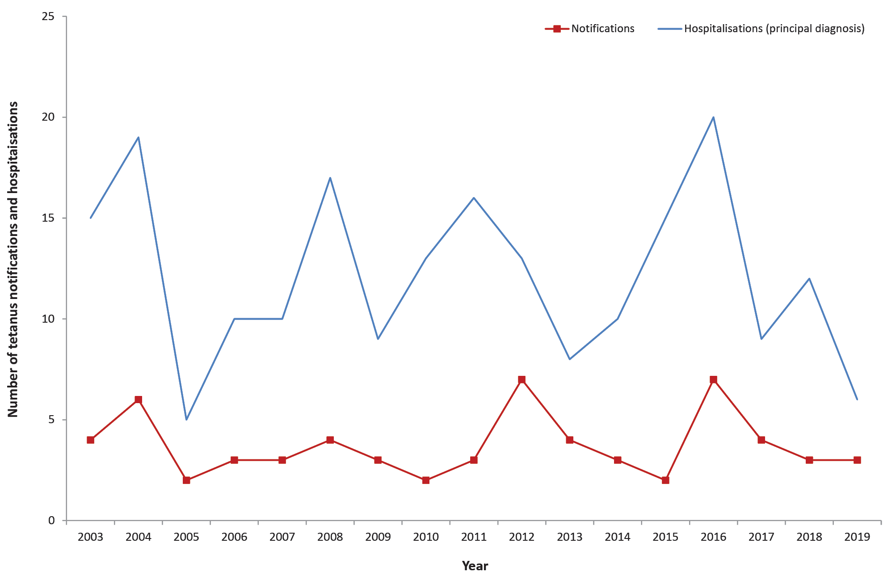
Figure 2: Tetanus notification and principal diagnosis hospitalisation rates by age group, Australia, 2003–2019
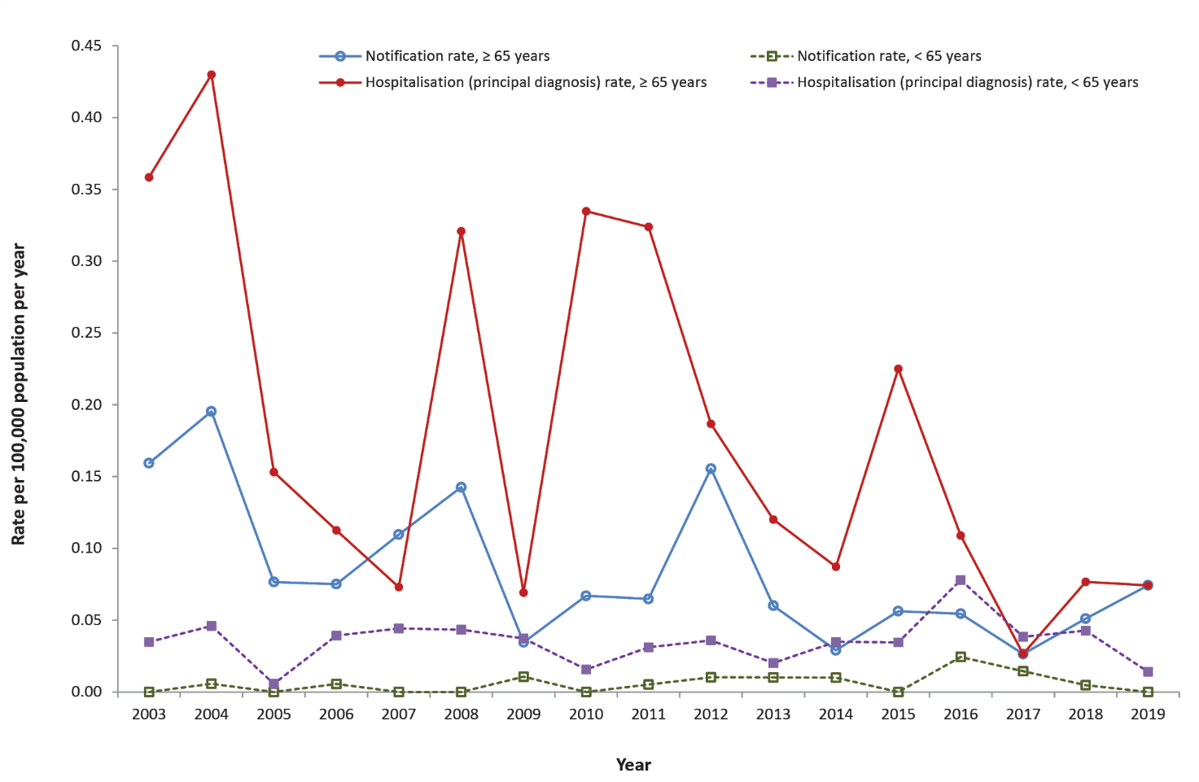

Hospitalisations
Between 2003 and 2019, there were 207 hospitalisations with tetanus recorded as the principal diagnosis, with an annual hospitalisation rate ranging between 0.02 and 0.10 per 100,000 population, and with an average annual hospitalisation rate of 0.05 per 100,000 (Figure 2). There were no recorded cases of tetanus neonatorum (ICD code A33). There was one case of obstetrical tetanus (ICD code A34), recorded in a woman of non-childbearing age, which was considered likely to be a coding error and was thus excluded from the analysis.

Notifications and hospitalisations by state/territory
The average annual notification rate per 100,000 population over the 2003–2019 period ranged from 0.00 in the Australian Capital Territory and Northern Territory to 0.16 in Tasmania (Table 1). The average annual tetanus hospitalisation (principal diagnosis) rate per 100,000 over the 2003–2019 period ranged from 0.00 in the Australian Capital Territory to 0.17 in Western Australia (Table 1).
Table 1: Average annual tetanus notification and principal diagnosis hospitalisation rates per 100,000 population by jurisdiction, Australia, 2003–2019
Jurisdiction | Number of notifications | Average annual notification rate  (per 100,000 population per year) | Number of hospitalisations  (principal diagnosis) | Average annual hospitalisation rate  (per 100,000 population per year)
Australian Capital Territory | 0 | 0 | 0 | 0.00
New South Wales | 19 | 0.03 | 59 | 0.10
Northern Territory | 0 | 0 | 1–4ª | 0.05
Queensland | 11 | 0.03 | 55 | 0.15
South Australia | 2 | 0.02 | 17 | 0.12
Tasmania | 7 | 0.16 | 1–4ª | 0.07
Victoria | 17 | 0.04 | 35 | 0.07
Western Australia | 7 | 0.04 | 34 | 0.17
Australia | 63 | 0.02 | 204^{b} | 0.05
a To comply with the AIHW’s data release condition that hospitalisation counts < 5 be suppressed in published reports, counts between 1 and 4 are reported as a range.
b Jurisdiction (state or territory) was not specified for 1–4 hospitalisations.

Notifications and hospitalisations by age and gender
Tetanus notification and hospitalisation rates were higher among adults aged ≥ 65 years than among younger age groups (Figure 3). Almost three-quarters of notifications were in adults aged ≥ 50 years (45/63; 71%); 63% of notifications (n = 40/63) were in adults aged ≥ 65 years; and 60% of notifications (n = 38/63) were in adults aged ≥ 70 years (Table 2). The distribution of age among hospitalisations for tetanus was slightly younger than for notifications, with approximately half of hospitalisations in adults aged ≥ 50 years (115/207; 56%); 44% in adults aged ≥ 65 years (92/207); and 41% in adults aged ≥ 70 years (84/207).
Males and females made up 49% and 51%, respectively, of both notifications and hospitalisations. Females made up the majority of notifications in those aged ≥ 50 years (n = 26/45; 57%), while males comprised the majority of notifications aged < 50 years (n = 13/18; 72%) (Figure 3).
For children aged < 5 years, one notification and 1–4 hospitalisations were recorded. The notified case was recorded as unvaccinated.
Table 2: Tetanus notifications and principal diagnosis hospitalisations by age group, Australia, 2003–2019
Data source | Number and proportion of notifications and hospitalisations
Data source | < 50 years |  | 50–64 years |  | 65–69 years |  | ≥ 70 years |  | Total
Data source | n | % | n | % | n | % | n | % | n
Notifications | 17 | 27 | 5 | 8 | 3 | 5 | 38 | 60 | 63
Hospitalisations | 92 | 44 | 23 | 11 | 8 | 4 | 84 | 41 | 207
Table 3: Tetanus notification rate per 100,000 and incidence rate ratio by age group, pre and post recommendation of a dTpa booster for adults aged ≥ 65 years
Age group (years) | 2003–2012  (per 100,000 population per year) | 2013–2019  (per 100,000 population per year) | IRR (95% CI)ª
≥ 65 | 0.11 | 0.05 | 0.47 (0.25–0.91)
< 65 | 0.004 | 0.009 | 2.36 (0.94–5.93)
All ages | 0.02 | 0.02 | 0.88 (0.53–1.45)
a IRR: incidence rate ratio; 95% CI: 95% confidence interval.
Table 4: Tetanus principal diagnosis hospitalisation rate per 100,000 and incidence rate ratio by age group, pre and post recommendation of a dTpa booster for adults aged ≥ 65 years
Age group (years) | 2003–2012  (per 100,000 population per year) | 2013–2019  (per 100,000 population per year) | IRR (95% CI)ª
≥ 65 | 0.24 | 0.10 | 0.43 (0.27–0.68)
< 65 | 0.03 | 0.04 | 1.13 (0.78–1.63)
All ages | 0.06 | 0.05 | 0.78 (0.59–1.04)
a IRR: incidence rate ratio; 95% CI: 95% confidence interval.

Figure 3: Average annual rates, of (a) notification and (b) principal diagnosis hospitalisation, by age group and sex, Australia, 2003–2019
a. Notification rates by age group and sexª
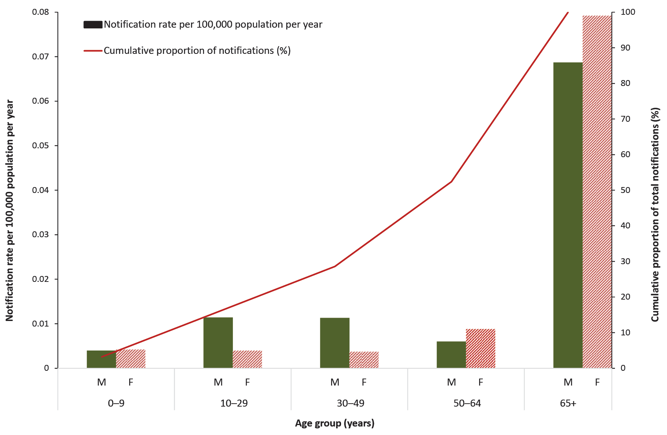
a F: female; M: male.
b. Principal diagnosis hospitalisations by age group and sexª

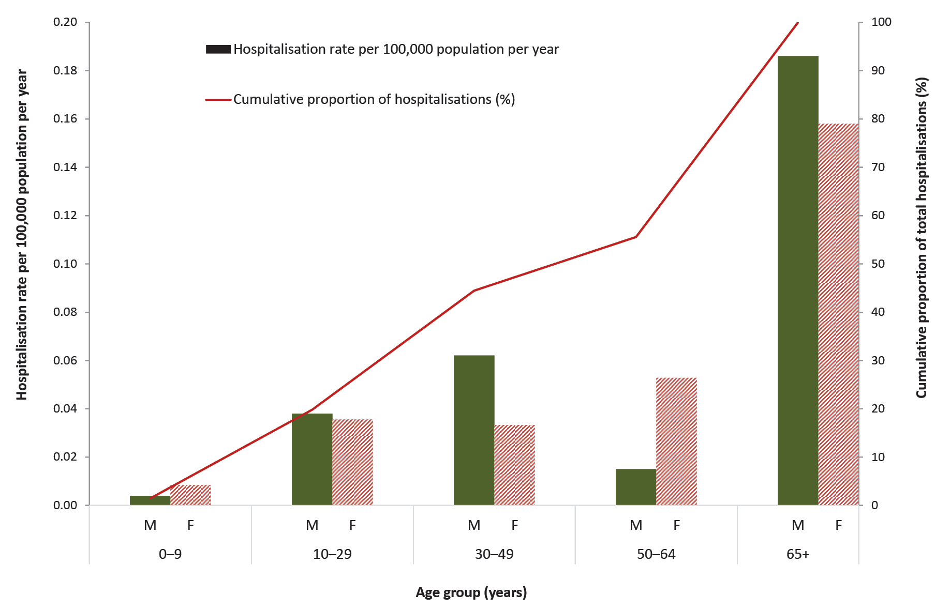
a F: female; M: male.

Notifications and hospitalisations by Indigenous status
There were no recorded notifications in Aboriginal and Torres Strait Islander people between 2003 and 2019. Six hospitalisations were recorded in Aboriginal and Torres Strait Islander people over the same period.

Severe morbidity and mortality
We were unable to calculate median length of stay in any meaningful manner due to the 30-day length-of-stay hospitalisation cap. There were 17 hospitalisations with tetanus as the principal diagnosis that had stays of at least 30 days.
During 2003–2019, eight tetanus notifications in NNDSS data were recorded as having died from the disease, resulting in a case fatality rate of 13% (8/63) and a mean annual death rate of 0.002 per 100,000 population. All those who died were aged 75 years or older.
Between 2007 and 2019 there were 11 deaths with tetanus recorded as the underlying cause in ACR-provided death data, all aged ≥ 75 years.
AIHW hospitalisation data from 2003–2019 recorded ten deaths with tetanus as the primary/underlying cause, all in adults aged ≥ 75 years.

Notifications, hospitalisations and deaths pre and post recommendation of booster vaccination
Between the 2003–2012 and 2013–2019 periods there were significant decreases in rates among adults aged ≥ 65 years, in both the average annual tetanus notification rate (from 0.11 to 0.05 per 100,000 population per year; p = 0.01) and the hospitalisation (principal diagnosis) rate (from 0.24 to 0.10 per 100,000 population per year; p = 0.01) (Table 3, Table 4). While there was an increase in the notification and hospitalisation rate in people aged < 65 years across the two periods, this was not statistically significant.
Of the eight tetanus deaths reported among NNDSS notifications during the study period, five occurred between 2003–2012 and three occurred between 2013–2019. The mean annual death rate was the same in both periods (0.002 per 100,000 population per year).

Vaccination status
The vaccination status of notified tetanus cases was recorded for 70% of notifications (44/63). Only 25% (11/44) had proof of prior vaccination, with only one person having proof of the full five-dose childhood vaccination schedule, and one additional person having proof of a three-dose childhood vaccination schedule. No case had documented evidence of tetanus vaccination within the ten years prior to contracting tetanus. One case recorded as having died had one dose of vaccine recorded, which was administered over 50 years prior to disease.

Discussion
Tetanus is rare in Australia, with an average annual notification rate over the 2003–2019 period of 0.02 per 100,000 population, and an average annual hospitalisation rate of 0.05 per 100,000 population. These rates are approximately half those reported in the 1993-2002 period (0.04 and 0.09 per 100,000 population per year, respectively),⁷ and are similar to those in other developed countries (0.01 per 100,000 population per year in England [2001–2014]¹¹ and the United States of America [2001–2008];¹² 0.02 per 100,000 population per year in Canada [1995–2019];¹³ and 0.02–0.03 per 100,000 population per year in the European Economic Union/Area [2012–2018]).^{14–18}
Almost two thirds of notifications and half of the hospitalisations over the 2003–2019 period were in adults aged ≥ 65 years, similar to the 1993–2002 period.⁷ Incidence of tetanus in developed countries is consistently much higher in older adults,^{11–18} likely due to a combination of lower vaccine coverage and waning immunity. In Australia, although tetanus-containing vaccines were available through state/territory-funded programs from the 1950s, with a nationally funded schedule from 1975, coverage was suboptimal, reaching approximately 70% among children in the mid-1990s.^{19,20} Following the introduction of the ‘Seven Point Plan’ in 1997,^{19,21} coverage improved considerably, with the primary course of tetanus-containing vaccine by 1 year of age achieving over 90% coverage since 2003 and reaching 95% by 2019.^{22,23} An adolescent booster dose of diphtheria-tetanus vaccine (dT) has been recommended at 15 years of age since 1982, with school vaccination programs in place in some jurisdictions since 1994 and an adolescent dTpa booster dose funded on the NIP from 2004,¹² with 85% coverage by 15 years of age in 2019.^{23,24} Consistent with these historical coverage figures, a national serosurvey in 2007 showed that 96–98% of individuals in age groups < 50 years had protective levels of antitoxin against tetanus, but only 83% in age groups between 50 and 84 years.⁸ Serosurveys from other developed countries have demonstrated similar results, with lower tetanus immunity levels observed in older adults.^{25–28}
These findings informed the 2013 Australian recommendation for a dTpa booster vaccination for adults aged ≥ 65 years (additional to the booster already recommended at 50 years), although this was also driven by high pertussis hospitalisation rates in older adults.²⁹ We found both notification and hospitalisation rates to be significantly lower (approximately half) in Australian adults aged ≥ 65 years in the 2013–2019 period than in the 2003–2012 period, while rates in those aged < 65 years across these periods were not significantly different, suggesting an impact of the 2013 recommendation. There was no clear impact on deaths across the two periods, but this was based on small numbers. While decreased incidence in older adults is a welcome finding, rates remain much higher than in younger age groups, and all 11 deaths due to tetanus during 2007–2019 were in adults aged ≥ 75 years. Most of these deaths were likely preventable given the availability of a highly effective vaccine.³⁰ As tetanus is unique among vaccine preventable diseases in being acquired solely from environmental sources, vaccination does not provide herd protection, so maintaining high vaccine coverage at all recommended age points is the primary strategy to minimise morbidity and mortality. There are no published data regarding adult tetanus vaccination uptake in Australia; however, uptake is likely to be suboptimal, as also found in the United States of America (USA),³¹ particularly given that the recommended adult booster doses are not funded by the NIP. Promoting awareness of the recommendation among public and providers may increase uptake and may further reduce the tetanus incidence and severity, and coverage should be monitored now that whole-of-life coverage data are available on the Australian Immunisation Register (AIR) from 2016.
However, while the estimated half-life of tetanus antibody response to vaccination is 14 years,³² suggesting the need for repeated booster vaccination, tetanus is rare in individuals who have received five or more previous doses of vaccine and death is rare in those who have received at least three doses.^{33,34} Recommendations for adult booster doses vary widely, with some countries such as the USA and Canada recommending boosters every ten years,^{13,35} while the World Health Organization (WHO) recommends only childhood and adolescent boosters.³⁴ Although the WHO recommendation is likely influenced by programmatic feasibility in lower and middle income countries, some developed countries such as the United Kingdom also do not recommend routine adult booster doses (booster doses are only recommended for individuals with tetanus-prone wounds whose last tetanus vaccine dose was received more than ten years ago),³⁶ yet maintain low rates of disease.¹¹ A large-scale retrospective study found no significant difference in overall tetanus incidence between developed countries with and without adult vaccination programs.³⁷ However, there are also concerns regarding reliance on a wound-based vaccination approach, given that medical care is not always sought for tetanus-prone wounds; that tetanus boosters are not always administered where indicated; and that tetanus is severe, usually resulting in hospitalisation and potentially fatal.³⁰
Our study has some limitations. We found the tetanus hospitalisation rate between 2003 and 2019 to be 3.3-fold higher than the notification rate, which is likely due to a combination of factors including under-reporting of notifications, multiple hospital admissions for individual cases and coding errors. While we were unable to assess for multiple admissions, a previous Australian study which used data matching to exclude multiple admissions estimated an under-notification rate of 75% for the 1993–2011 period.⁸ Death data from ACR was from a shorter period than notification and hospitalisation data (2007–2019 as opposed to 2003–2019). Our notification data did not contain method of diagnosis; however, it is likely that most were clinical diagnoses given the complexity and difficulty of laboratory diagnosis for tetanus. Vaccination status was absent for around a third of tetanus notifications. Given the AIR is now whole-of-life, vaccination data in adults should become more complete over time. We were also unable to accurately determine median length of hospital stay, an important indicator of severe morbidity, due to the 30-day cap in hospitalisation data.

Conclusions
Although tetanus is rare in Australia and rates have decreased, there remains a significant burden of morbidity and mortality falling disproportionately on older adults. While there is debate internationally about the need for and frequency of adult tetanus boosters, dT booster vaccination at 50 years of age and dTpa booster vaccination for those aged ≥ 65 years, as recommended in the Australian Immunisation Handbook,⁵ should be promoted to optimise protection, not just against tetanus, but also diphtheria and pertussis.

Acknowledgements
We thank the Australian Coordinating Registry, state and territory registries of births, deaths and marriages, state and territory coroners, and the National Coronial Information System for providing access to cause-of-death data. We acknowledge Australian states and territories through the Communicable Diseases Network Australia for release of data from the National Notifiable Diseases Surveillance System, and the Australian Institute of Health and Welfare for the data provided from the National Hospital Morbidity Database.
NCIRS is supported by the Australian Government Department of Health and Aged Care, the New South Wales Ministry of Health, and The Sydney Children’s Hospitals Network.

Author details
Eliora SG Morris,¹ Aditi Dey,^{1,2} Kaitlyn Vette,¹ Harunor Rashid,^{1,2} Nicholas Wood, ^{1,2} Frank Beard^{1,2}
- Faculty of Medicine and Health, The University of Sydney, New South Wales, Australia
- National Centre for Immunisation Research and Surveillance, Westmead, New South Wales, Australia

Corresponding author
A/Prof Frank Beard
National Centre for Immunisation Research and Surveillance, Kids Research at The Children’s Hospital at Westmead, Cnr Hawkesbury Road and Hainsworth Street, Westmead, Locked Bag 4001, Westmead NSW 2145, Australia
Phone: 02 98451433
Email: frank.beard@health.nsw.gov.au

References
- Farrar JJ, Yen LM, Cook T, Fairweather N, Binh N, Parry J et al. Tetanus. J Neurol Neurosurg Psychiatry. 2000;69(3):292–301. doi: https://doi.org/10.1136/jnnp.69.3.292.
- Yen LM, Thwaites CL. Tetanus. Lancet. 2019;393(10181):1657–68. doi: https://doi.org/10.1016/s0140-6736(18)33131-3.
- Tiwari TSP, Moro PL, Acosta AM. Tetanus. In Hall E, Wodi AP, Hamborsky J, Morelli V, Schillie S, eds. Epidemiology and Prevention of Vaccine-Preventable Diseases (the ‘Pink Book’) (14th edition). Washington DC: Centers for Disease Control and Prevention, Public Health Foundation, 2021.
- Thwaites CL, Beeching NJ, Newton CR. Maternal and neonatal tetanus. Lancet. 2015;385(9965):362–70. doi: https://doi.org/10.1016/s0140-6736(14)60236-1.
- Australian Government Department of Health and Aged Care. Australian Immunisation Handbook. [Website.] Canberra: Australian Government Department of Health and Aged Care, Australian Technical Advisory Group on Immunisation (ATAGI); 2022. Available from: https://immunisationhandbook.health.gov.au/.
- National Centre for Immunisation Research and Surveillance (NCIRS). Significant events in diphtheria, tetanus and pertussis vaccination practice in Australia. Sydney: NCIRS; July 2018. [Accessed on 27 July 2021.] Available from: https://www.ncirs.org.au/sites/default/files/2018-11/Diphtheria-tetanus-pertussis-history-July-2018.pdf.
- Quinn HE, McIntyre PB. Tetanus in the elderly--an important preventable disease in Australia. Vaccine. 2007;25(7):1304–9. doi: https://doi.org/10.1016/j.vaccine.2006.09.084.
- Lu X, Quinn HE, Menzies RI, Hueston L, McIntyre PB et al. Tetanus immunity and epidemiology in Australia, 1993–2010. Infect Disord Drug Targets. 2020;20(3):330–40. doi: https://doi.org/10.2174/1871526518666181005111405.
- Australian Government Department of Health and Aged Care. Tetanus – Surveillance case definition. [Webpage.] Canberra: Australian Government Department of Health and Aged Care; 1 July 2016. [Accessed on 27 June 2021.] Available from: https://www.health.gov.au/resources/publications/tetanus-surveillance-case-definition.
- Juul S, Frydenberg M, Hansen S. EpiBasic. [Computer program.] Aarhus: The University of Aarhus; August 2019. Available from: https://ph.medarbejdere.au.dk/undervisning/software.
- Collins S, Amirthalingam G, Beeching NJ, Chand MA, Godbole G, Ramsay ME et al. Current epidemiology of tetanus in England, 2001–2014. Epidemiol Infect. 2016;144(16):3343–53. doi: https://doi.org/10.1017/s095026881600128x.
- Centers for Disease Control and Prevention. Tetanus surveillance --- United States, 2001–2008. MMWR Morb Mortal Wkly Rep. 2011;60(12):365–9.
- Salem N, Huang G, Squires SG, Salvadori MI, Li YA. Epidemiology of tetanus in Canada, 1995–2019. Can J Public Health. 2023;114(3):432–40. doi: https://doi.org/10.17269/s41997-022-00732-7.
- European Centre for Disease Prevention and Control (ECDC). Tetanus – annual epidemiological report for 2018. Solna: ECDC; 3 December 2020. Available from: https://www.ecdc.europa.eu/en/publications-data/tetanus-annual-epidemiological-report-2018.
- ECDC. Tetanus – annual epidemiological report for 2017. Solna: ECDC; 28 June 2019. Available from: https://www.ecdc.europa.eu/en/publications-data/tetanus-annual-epidemiological-report-2017.
- ECDC. Tetanus – annual epidemiological report for 2016. Solna: ECDC; 29 August 2018. Available from: https://www.ecdc.europa.eu/en/publications-data/tetanus-annual-epidemiological-report-2016.
- ECDC. Tetanus – annual epidemiological report for 2015. Solna: ECDC; 29 November 2017. Available from: https://www.ecdc.europa.eu/en/publications-data/tetanus-annual-epidemiological-report-2015.
- ECDC. Tetanus – annual epidemiological report 2016 [2014 data]. Solna: ECDC; 19 September 2016. Available from: https://www.ecdc.europa.eu/en/publications-data/tetanus-annual-epidemiological-report-2016-2014-data.
- Parliament of Australia. House of Representatives Official Hansard. Thirty-eighth parliament first session—third period. No. 211, 1997. [Hansard.] Canberra: Parliament of Australia, House of Representatives Official Hansard; Tuesday, 25 February 1997; pp. 1163–84.
- Australian Institute of Health and Welfare (AIHW). Tetanus in Australia. Canberra: Australian Government, AIHW; 13 November 2018. Available from: https://www.aihw.gov.au/getmedia/f877a2da-23e3-4516-948f-df05ca7ceb43/aihw-phe-236_Tetanus.pdf.aspx.
- NCIRS. Significant events in immunisation policy and practice in Australia. Sydney: NCIRS; July 2020. [Accessed on 2 February 2023.] Available from: https://ncirs.org.au/sites/default/files/2020-07/Immunisation-policy-and-practice-Australia-1%20July%202020_Final%20for%20web.pdf.
- Hull B, Deeks S, Menzies R, McIntyre P. Immunisation coverage annual report, 2007. Commun Dis Intell Q Rep. 2009;33(2):170–87.
- Hull B, Hendry A, Dey A, Macartney K, Beard F. Immunisation Coverage Annual Report 2019. Commun Dis Intell (2018). 2021;45. doi: https://doi.org/10.33321/cdi.2021.45.18 10.33321/cdi.2020.45.18.
- Hull B, Hendry A, Dey A, Brotherton J, Macartney K, Beard F. Annual immunisation coverage report 2020. Commun Dis Intell (2018). 2022;46. doi: https://doi.org/10.33321/cdi.2022.46.60.
- Liang JL, Tiwari T, Moro P, Messonnier NE, Reingold A, Sawyer M et al. Prevention of pertussis, tetanus, and diphtheria with vaccines in the United States: recommendations of the Advisory Committee on Immunization Practices (ACIP). MMWR Recomm Rep. 2018;67(2):1–44. doi: https://doi.org/10.15585/mmwr.rr6702a1.
- Wagner KS, White JM, Andrews NJ, Borrow R, Stanford E, Newton E et al. Immunity to tetanus and diphtheria in the UK in 2009. Vaccine. 2012;30(49):7111–7. doi: https://doi.org/10.1016/j.vaccine.2012.09.029.
- Steens A, Mollema L, Berbers GAM, van Gageldonk PGM, van der Klis FR, de Melker HE. High tetanus antitoxin antibody concentrations in the Netherlands: a seroepidemiological study. Vaccine. 2010;28(49):7803–9. doi: https://doi.org/10.1016/j.vaccine.2010.09.036.
- Weir R, Jennings L, Young S, Brunton C, Murdoch D. National serosurvey of vaccine preventable diseases. Report to the Ministry of Health. Wellington: New Zealand Government Ministry of Health (Manatū Hauora); 2 May 2009. Available from: https://www.health.govt.nz/publication/national-serosurvey-vaccine-preventable-diseases.
- Pillsbury A, Quinn HE, McIntyre PB. Australian vaccine preventable disease epidemiological review series: pertussis, 2006–2012. Commun Dis Intell Q Rep. 2014;38(3):E179–94.
- Roper MH, Wassilak SGF, Scobie HM, Ridpath AD, Orenstein WA. 58 – Tetanus toxoid. In Plotkin SA, Orenstein WA, Offit PA, Edwards KM, eds. Plotkin’s Vaccines (7th edition). Amsterdam: Elsevier, 2018;1052–79.e18. doi: https//doi.org/10.1016/B978-0-323-35761-6.00058-4.
- Hung MC, Williams WW, Lu PJ, Woods LO, Koppaka R, Lindley MC. Vaccination coverage among adults in the United States, National Health Interview Survey, 2017. [Webpage.] Atlanta: United States Government, Centers for Disease Control and Prevention; 8 February 2018. Available from: https://www.cdc.gov/vaccines/imz-managers/coverage/adultvaxview/pubs-resources/NHIS-2017.html#.
- Hammarlund E, Thomas A, Poore EA, Amanna IJ, Rynko AE, Mori M et al. Durability of vaccine-induced immunity against tetanus and diphtheria toxins: a cross-sectional analysis. Clin Infect Dis. 2016;62(9):1111–18. doi: https://doi.org/10.1093/cid/ciw066.
- Gardner P. Issues related to the decennial tetanus-diphtheria toxoid booster recommendations in adults. Infect Dis Clin North Am. 2001;15(1):143–53. doi: https://doi.org/10.1016/s0891-5520(05)70272-5.
- World Health Organization. Tetanus vaccines: WHO position paper – February 2017. Wkly Epidemiol Rec. 2017;92(6):53–76.
- Havers FP, Moro PL, Hunter P, Hariri S, Bernstein H. Use of tetanus toxoid, reduced diphtheria toxoid, and acellular pertussis vaccines: updated recommendations of the Advisory Committee on Immunization Practices — United States, 2019. MMWR Morb Mortal Wkly Rep. 2020;69:77–83. doi: https://doi.org/10.15585/mmwr.mm6903a5.
- UK Health Security Agency. Tetanus: The Green Book, Chapter 30. London: Government of the United Kingdom, UK Health Security Agency; 1 June 2022. Available from: https://www.gov.uk/government/publications/tetanus-the-green-book-chapter-30.
- Slifka AM, Park B, Gao L, Slifka MK. Incidence of tetanus and diphtheria in relation to adult vaccination schedules. Clin Infect Dis. 2020;72(2):285–92. doi: https://doi.org/10.1093/cid/ciaa017.

Communicable Diseases Intelligence
ISSN: 2209-6051 Online

Communicable Diseases Intelligence (CDI) is a peer-reviewed scientific journal published by the Office of Health Protection, Department of Health and Aged Care. The journal aims to disseminate information on the epidemiology, surveillance, prevention and control of communicable diseases of relevance to Australia.

Editor: Christina Bareja
Deputy Editor: Simon Petrie
Design and Production: Kasra Yousefi
Editorial Advisory Board: David Durrheim, Mark Ferson, Clare Huppatz, John Kaldor, Martyn Kirk, Meru Sheel and Steph Williams

Website: http://www.health.gov.au/cdi

Contacts
CDI is produced by the Office of Health Protection, Australian Government Department of Health and Aged Care, GPO Box 9848, (MDP 6) CANBERRA ACT 2601

Email: cdi.editor@health.gov.au

Submit an Article
You are invited to submit your next communicable disease related article to the Communicable Diseases Intelligence (CDI) for consideration. More information regarding CDI can be found at: http://health.gov.au/cdi.
Further enquiries should be directed to: cdi.editor@health.gov.au.

This journal is indexed by Index Medicus and Medline.

Creative Commons Licence - Attribution-NonCommercial-NoDerivatives CC BY-NC-ND
© 2023 Commonwealth of Australia as represented by the Department of Health and Aged Care
This publication is licensed under a Creative Commons Attribution-NonCommercial-NoDerivatives 4.0 International Licence from https://creativecommons.org/licenses/by-nc-nd/4.0/legalcode (Licence). You must read and understand the Licence before using any material from this publication.

Restrictions
The Licence does not cover, and there is no permission given for, use of any of the following material found in this publication (if any):
- the Commonwealth Coat of Arms (by way of information, the terms under which the Coat of Arms may be used can be found at www.itsanhonour.gov.au);
- any logos (including the Department of Health and Aged Care’s logo) and trademarks;
- any photographs and images;
- any signatures; and
- any material belonging to third parties.

Disclaimer
Opinions expressed in Communicable Diseases Intelligence are those of the authors and not necessarily those of the Australian Government Department of Health and Aged Care or the Communicable Diseases Network Australia. Data may be subject to revision.

Enquiries
Enquiries regarding any other use of this publication should be addressed to the Communication Branch, Department of Health and Aged Care, GPO Box 9848, Canberra ACT 2601, or via e-mail to: copyright@health.gov.au

Communicable Diseases Network Australia
Communicable Diseases Intelligence contributes to the work of the Communicable Diseases Network Australia.
http://www.health.gov.au/cdna

To comply with the AIHW’s data release condition that hospitalisation counts < 5 be suppressed in published reports, counts between 1 and 4 are reported as a range.

