Communicable Diseases Intelligence, Year 2023, Volume 47
https://doi.org/10.33321/cdi.2023.47.62
Publication date: 19/10/2023
http://health.gov.au/cdi

Using notifications data to increase hepatitis C testing and treatment rates in Queensland
Morris Carpenter, Linda A Selvey, Stephen B Lambert, Robert Kemp

Abstract
Australia’s goal of eliminating hepatitis C by 2030 requires increases in uptake of and access to testing and treatment. As hepatitis C is a notifiable condition, health departments have access to information about people exposed to the hepatitis C virus (HCV), including the details of notifying clinicians who ordered their diagnostic pathology tests. Hepatitis C RNA testing confirms active infection that requires treatment, whereas a positive antibody test result only indicates prior exposure to the virus.
We undertook a pilot project in Queensland to follow up hepatitis C notifications with clinicians, aiming to increase HCV-RNA testing and treatment uptake. For all individuals with a first-time hepatitis C notification in Queensland between 3 November 2020 and 28 May 2021, we sought information regarding hepatitis C RNA testing from laboratories, excluding those cases diagnosed in prisons.
Cases who did not have RNA testing identified as part of or after their initial diagnostic tests were followed up via their notifying clinician. Interviews with selected clinicians were undertaken to improve our understanding of the follow-up process.
There were 769 new hepatitis C notifications during our study period: 244 had no subsequent RNA test identified and were followed up for this study. Of these, 134 cases were lost to follow-up; 26 were already being effectively case managed; 22 reported previous treatment and no further risk; and 62 were eligible for HCV-RNA testing. Twenty-six cases subsequently started hepatitis C treatment. Thirty-four percent of notifications that required follow-up resulted from testing initially requested in hospital settings.
Following up hepatitis C notifications can result in increased treatment rates; however, the process was resource-intensive and often failed to result in further contact between clinicians and patients. Our findings also highlight the importance of supporting better continuity of care between hospitals and community settings.
Keywords: Hepatitis C; HCV; RNA testing; notifications; direct-acting antivirals; treatment

Introduction
Highly effective direct acting antivirals (DAA) for the treatment of hepatitis C virus (HCV) infection have made the elimination of HCV possible.¹ In line with the World Health Organization’s strategy, Australia has the goal of eliminating viral hepatitis as a public health threat by 2030.^{2,3} In March 2016, DAA treatment was subsidised and became available to patients through the Pharmaceutical Benefits Scheme in Australia.⁴ As of December 2021, there were 99,735 people in Australia who had received DAA hepatitis C treatment; that number is around 53% of the people estimated to be living with hepatitis C in 2015.⁵
HCV testing usually involves initial testing for HCV antibodies (HCV-AB), and if positive, this is followed by a test for HCV ribonucleic acid (HCV-RNA).The increasing availability of point of care HCV-RNA testing among people at high risk of HCV infection means that HCV-RNA testing may be done without a preceding HCV-AB test. ⁶
In Australia, HCV testing and treatment is available in the community in a range of settings including general practice (GP), sexual health services, and some specialised health services such as alcohol and other drugs treatment services, and clinics specifically for people who inject drugs.
There is limited evidence on the effectiveness of following up HCV notifications to link patients to treatment in Australia. To address this gap, we followed up notifications of hepatitis C with notifying clinicians to obtain further information about testing and treatment, to request case updates on their patients’ HCV status, and to provide links to resources and services that could support further HCV testing and treatment.

Methods
HCV infection is a notifiable condition in Queensland under the Public Health Act 2005 and its subordinate regulation 2018.⁷ All HCV-AB positive and HCV-RNA positive results are notifiable by pathology laboratories to the Queensland Government Department of Health (Queensland Health). HCV notifications are stored in the Notifiable Conditions System (NoCS) managed by Queensland Health’s Communicable Diseases Branch. Notifications data from NoCS were accessed for this project. Each week from 3 November 2020 to 28 May 2021, all first-time notifications of individuals with positive HCV test results in Queensland were reviewed, four weeks in arrears (Figure 1). Notification data include the name and date of birth of the person tested, as well as the name and contact details of the clinician who ordered the test (the notifying clinician). All notifications were included in the study, except results from HCV testing undertaken while individuals were incarcerated. Prisoners were excluded as they were engaged with care through prisoner health services, and there was no scope to expand this activity.

Figure 1: Project protocol procedure for following up new HCV notifications
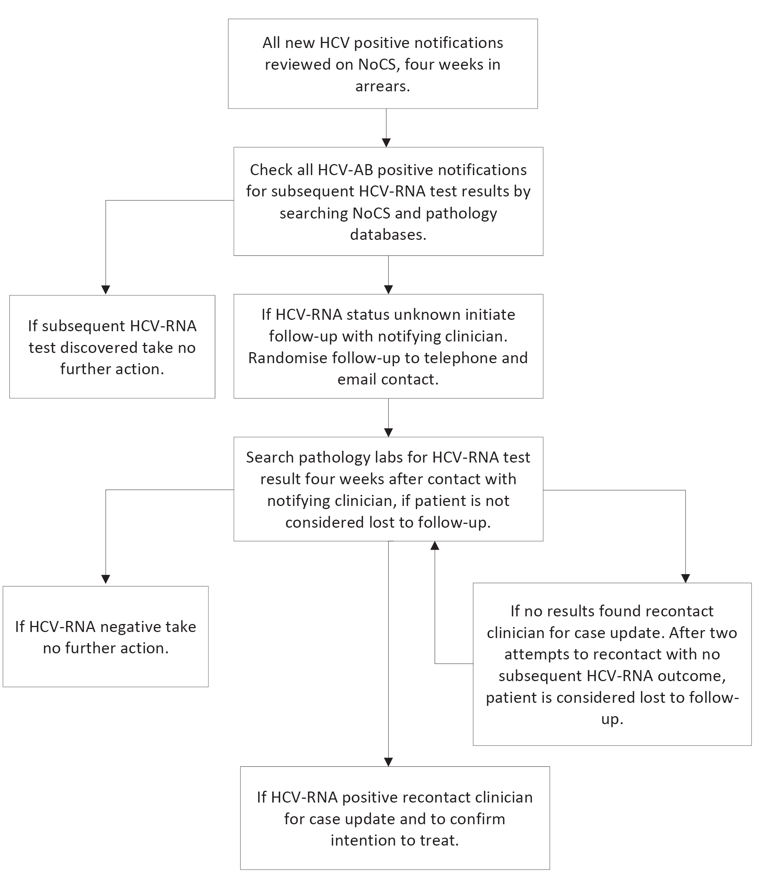
Four weeks after a positive HCV-AB test notification was reported to NoCS, Queensland pathology laboratory databases were searched to ascertain whether a subsequent HCV-RNA test had been undertaken on or after the date of the initial HCV-AB positive test. Cases with no record of subsequent HCV-RNA testing were followed up via their notifying clinicians, who were randomly assigned to be contacted by either telephone or email, to establish which method of communication facilitated the higher response rate within the limited resources of the pilot project. Notifying clinicians in the email group were sent a questionnaire on a fillable PDF file (Appendix A.1). The others were telephoned and asked the same questions. If hospital-based clinicians reported that they had informed the patient’s GP of the positive HCV-AB test result, follow-up was continued with the GP (Appendix A.2).
If notifying clinicians indicated that an HCV-RNA test had, or would be, requested, pathology laboratory databases were again searched for HCV-RNA test results four weeks after follow-up communication. If no results were found, notifying/managing clinicians were recontacted for a case update. After two attempts to recontact notifying/managing clinicians with no subsequent HCV-RNA outcome, patients were considered lost to follow-up. If HCV-RNA positive test results were found, notifying clinicians were recontacted to confirm intention to treat.
Toward the end of the study, notifying clinicians were purposively sampled and 17 were invited to participate in a semi-structured telephone interview (Appendix B.1–B.3) to discuss HCV testing and treatment and the role of the notifications system; one turned down the request and 16 agreed to participate. Our sample reflected the range and location of clinicians followed-up throughout the project. A thematic analysis was conducted on the qualitative data,⁸ which were coded and collated using NVivo 12 (QSR International Pty Ltd., 2018).
Ethics approval to evaluate the project was granted by Darling Downs Hospital and Health Service (DDHHS) Human Research Ethics Committee (HREC), reference number: HREA/2020/QTDD/66248. A waiver of consent for the project was granted by DDHHS HREC to use de-identified data gathered from Queensland Health’s NoCS for project evaluation. Quantitative data were de-identified prior to analysis.

Results
Between 3 November 2020 and 28 May 2021, there were 1,162 new HCV notifications reported to NoCS in Queensland; 393 (34%) were from people who were incarcerated and were excluded from further follow-up activity. The remaining 769 notifications came from tests requested by GPs, hospital doctors, and other health providers, including Aboriginal Medical Services, sexual health services, and alcohol and other drugs services.
Of the 769 cases, 315 (41%) tested HCV-RNA negative at the time of or after notification; 210 (27%) tested HCV-RNA positive at the time of or after notification; and 244 (32%) had no subsequent HCV-RNA test identified (Figure 2).

Figure 2: New HCV case notifications in Queensland, 3 November 2020 – 28 May 2021, that resulted in follow up and subsequent testing and treatment
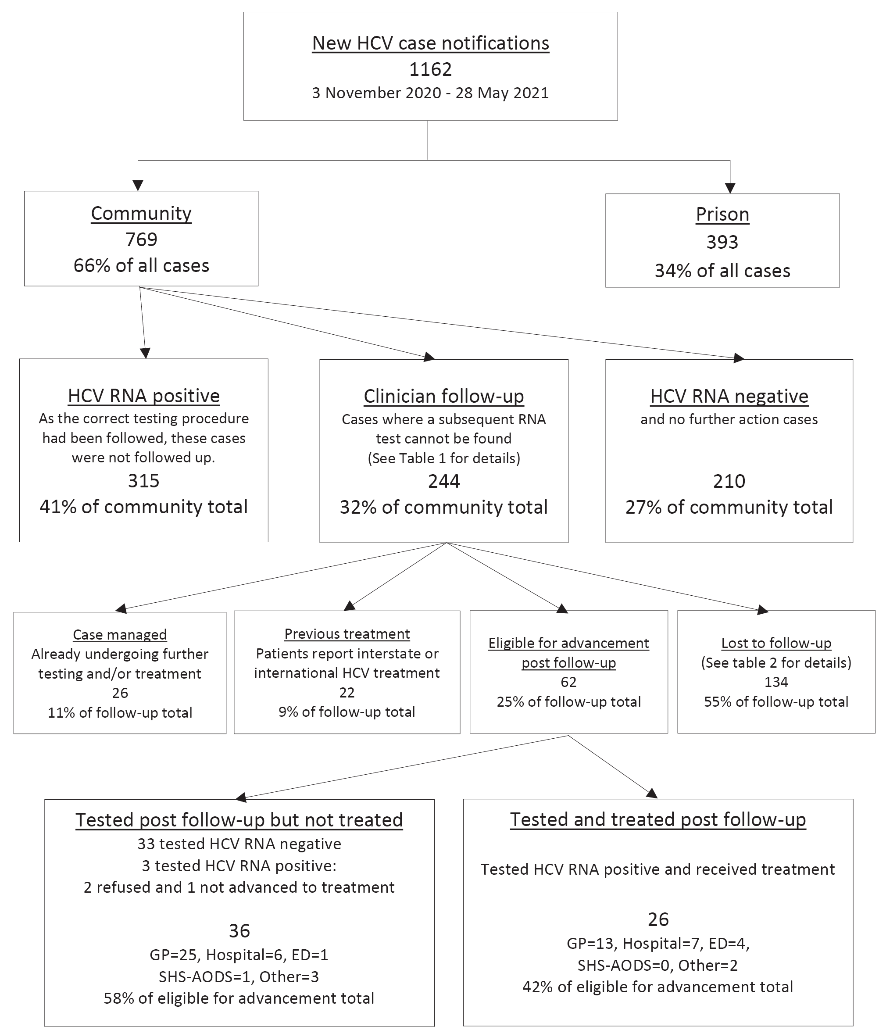
Of the 244 cases that were followed up, 83 (34%) were tested in hospital wards, out-patients or emergency departments (Table 1). The majority of cases (55%) were lost to follow-up (Table 2); the remaining 110 cases were successfully followed up. Of those who were followed up, 62 (56%) had not progressed to treatment at the time of initial contact and were eligible for further testing and, if necessary, treatment. Of these, 29 tested HCV-RNA positive, 26 of whom were prescribed treatment (Figure 2).
Table 1: Source of notifications requiring follow-up
Notification source | Cases n (%)
General practice | 143 (58.6)
Hospital | 49 (20.1)
Emergency departments | 34 (13.9)
Sexual health services, alcohol and other drugs services | 7 (2.9)
Other medical specialists ª | 11 (4.5)
Total | 244
a ‘Other medical specialists’ includes private endocrinologists, private gastroenterology clinics, private haematology clinics, private fertility clinics, medicals for immigration visas, and outpatient mental health services.
Table 2: Reason for loss to follow-up
Reason | Cases n (%)
Patients did not re-present to clinic ª | 64 (47.8)
Patients could not be contacted after follow-up ^{b} | 53 (39.6)
No clinician response after second reminder ^{c} | 10 (7.5)
Lost to follow-up for other reason ^{d} | 7 (5.2)
Total | 134
a Clinics had already attempted and failed to recall patients before follow-up.
b At point of follow-up, patients hadn’t re-presented to clinics; after follow-up, clinicians or clinics made attempts to contact patients but were unable to do so.
c Clinician did not respond to Queensland Health’s attempts at contact.
d GP named by patient during hospital admission was not current, or patient deceased before Queensland Health follow-up actions.
Phone calls were the most effective way of contacting GPs, while email appeared to be better for hospital doctors. Many GPs used personal email addresses, and follow-up questionnaires were often sent to general clinic email addresses. All 65 GPs initially contacted by telephone were spoken to, but four of the 65 initially contacted by email were never successfully reached. It was difficult and time-consuming to contact hospital and emergency department doctors by telephone because of shift patterns and changing rosters, and because they frequently did not have ready access to patient records during the phone call. Hospital doctors usually completed the fillable PDF files electronically and emailed them back themselves from their hospital email addresses. For hospital and emergency department clinicians, four of the 40 contacted by telephone were never reached, and two of the 42 contacted by email never replied.
Searching the pathology laboratory databases for individual patient records was time consuming. The three main pathology laboratories used in Queensland could be searched with online access to their databases. Occasionally, other laboratories were contacted by telephone to check for results, and telephone waiting times were sometimes exacerbated during the coronavirus disease 2019 (COVID-19) pandemic. The project officer spent two days every week working on the HCV notifications data and follow-ups: one day searching pathology databases for test results, and the other in attempting to contact the notifying/managing clinicians.

Qualitative results
Fifteen doctors and one nurse practitioner participated in telephone interviews, which were conducted between 27 August and 30 September 2021 (Table 3).
Table 3: Details of clinicians participating in telephone interviews
Clinicians | N | Details
General practitioners | 6 | Three general practitioners in group practices
General practitioners | 6 | Two general practitioners working in Aboriginal Medical Services
General practitioners | 6 | One general practitioner working at a homeless and low socioeconomic status specialist outreach service in Brisbane
Hospital and emergency department doctors | 7 | Three emergency department directors from large metropolitan hospitals in south east Queensland
Hospital and emergency department doctors | 7 | Two emergency department directors from regional Queensland hospitals
Hospital and emergency department doctors | 7 | One resident/senior house officer at an emergency department in regional Queensland
Hospital and emergency department doctors | 7 | One infectious diseases director at a large metropolitan hospital in south east Queensland
Alcohol and other drugs services and sexual health service | 3 | Two sexual health services directors/consultants in regional Queensland
Alcohol and other drugs services and sexual health service | 3 | One alcohol and other drugs service nurse practitioner in regional Queensland

Although clinicians in both community and hospital settings reported trying to contact individuals to inform them of a positive HCV result, patients were sometimes uncontactable. Clinicians reported that some HCV positive patients had complex lifestyles or had competing issues in their lives that they prioritised above a health condition such as HCV:
Generally, this group of people don’t have a GP, which makes it even harder. So you look on the system, often they’re slightly more likely to not pick up their phone or have a disconnected number, so you can’t get on to them and then they don’t have a GP on the system, which then gets stuck there. (Senior house officer in regional emergency department)
Challenges to follow-up also occured with patients of community-based services:
I’ve only met her three or four times and each time we’ve talked about her hepatitis C and I’ve arranged investigations which she then hasn’t got done… I don’t know what, what has happened to that patient actually. She’s not returned back to the clinic. (GP in a regional town)
Hospital and emergency department clinicians sometimes tried to inform a patient’s GP of a positive HCV-AB test result if they could not reach a patient; the direct communication channels or record sharing systems between hospitals and GPs were limited to telephones, faxes, emails, discharge summaries (for inpatients only) and letter writing. Requests to GPs to follow up with further HCV-RNA testing could only be made if patients had provided GP details at the time of hospital admission.
Poor communication between hospital doctors and GPs could also be a barrier to follow-up care after diagnosis:
Believe it or not, there’s very poor communication systems from within our electronic record back to the GP... Generally, their discharge letter will be given to the patient, unless they’re admitted. If they’re admitted there’s an electronic discharge summary that will be transmitted directly back to their GP, but if they’re non-admitted emergency department patients they will just get what’s called a statement of attendance, and that’s given to the patient. (Emergency department director in regional Queensland)
Hospital shift work was also a barrier if initial attempts to contact a GP or a patient had not been successful:
The patient should be called, and the GP should be contacted, or the patient should be told, “You have this positive result. You need to follow up with your GP”… If they have a voicemail with their name on it, I will leave a message… I guess the problem then is if they call back on a day when I’m not on shift… I’ll try two to three times before I give up. (Senior house officer in regional emergency department)
Given the high proportion of notified cases without subsequent HCV-RNA tests, we asked doctors working in the hospital setting why they tested their patients for HCV. General hepatitis screening and needlestick injuries from tested patients were commonly reported reasons, as well as having several patients presenting to emergency departments who reported injecting drugs. When testing because of a needlestick injury, the purpose of testing was to protect the healthcare worker rather than the patient, and the test was not done with patient follow-up in mind.
The time taken for HCV-AB and HCV-RNA test results to be processed by pathology laboratories was another barrier to follow-up in hospital settings, as patients were often discharged or transferred before their initial HCV-AB result was known. In these cases, the only information available to a requesting clinician for follow-up with a patient were the contact details entered at intake, or recorded from previous admissions, which may not be correct or up to date.
Pathology labs were responsible for reporting test results to the requesting doctor, who in turn had responsibility for following up results. However, the name of the requesting doctor on the pathology form was not always the same as the clinician who had ordered the test, who may have had little if any contact with the patient:
The junior medical staff will run the emergency department routinely. They’ll be the ones that mostly see the patients. But they’ll order under the name of the consultant. So the consultant for the shift or the director of the department will be the name on the form. (Director of infectious diseases)
Many clinicians across different health service sectors agreed that it would be useful to know if an HCV-AB positive test result was the first time a patient had tested positive, as that would make them prioritise follow-up testing and treatment more vigorously. An emergency departments director from regional Queensland said “I think if that was a first positive notification, it certainly highlights that a lot more to the clinician reading that. So I think in that case, they will push further for the follow-up.”

Discussion
Of the 769 new HCV notifications received by Queensland Health during the project period (excluding incarcerated individuals), 244 were eligible for follow-up actions with notifying clinicians. Sixty-two of those were tested for HCV-RNA after the follow-ups, and 26 were subsequently prescribed treatment. Although most patients with chronic HCV can be treated in general practice with pan-genotypic direct-acting antivirals,⁹ some of the clinicians who were interviewed discussed how being made aware of a first-time diagnosis would emphasise the importance of progressing patients through the correct care cascade for HCV testing and treatment.
Thirty-four percent of the cases who were followed up had HCV testing initiated in hospitals. This was an unexpected finding that may be related to the fact that we only followed up cases who did not have a documented HCV-RNA test after their antibody test, and the challenges associated with managing further HCV testing, and if necessary, treatment, in hospital settings. More work is needed to improve follow-up of individuals initially tested in hospitals and emergency departments, to ensure they have the opportunity for further testing and treatment in a community setting.
This project followed up new notifications (for all individuals not already recorded as HCV positive on the notifications system) four weeks in arrears; this increased the difficulty in reaching inpatients, notified from the hospital system, who had already been discharged. The Coordinated Hepatitis response to Enhance the Cascade of Care by optimising existing Surveillance systems (CHECCS) pilot project was conducted in Victoria in 2021 and 2022,¹⁰ and followed up and supported notifying clinicians of individuals newly diagnosed with HCV who had no evidence of follow-up testing or treatment.¹⁰ The CHECCS project also made initial follow-up phone calls four weeks after the date of HCV notification and found hospital clinicians were challenging to engage with, because the delay meant that junior medical staff with no ongoing connection to patients had often rotated to other departments a month later. As a result of this, several months after the initiation of the CHECCS project, the team in Victoria shifted follow-up of hospital cases to occur immediately after notification rather than wait four weeks. In addition, consistent with our findings, the team found that written requests were more successful for obtaining necessary project data than was attempting follow-up phone calls to hospital clinicians alone.¹⁰
The major challenge with the roll-out of similar follow-up projects is the time and resources required to search the pathology databases to determine which cases were eligible for follow-up. An alternative strategy would have been to contact the notifying clinicians of all new notifications, but a previous study found that almost all patients who had an HCV-RNA test before notification follow-up had been linked to treatment.¹¹ There is currently no requirement for pathology laboratories to report negative HCV-RNA test results. It is worth considering whether the current Australian case definition for HCV notification is still fit for purpose. If the notification requirements for HCV notifications in Australia were changed to require notification of all HCV-RNA test results, positive and negative, then the task of determining who had received a positive HCV-AB test, but had not yet taken a subsequent HCV-RNA test, would be a much easier and more efficient process as we approach elimination.¹⁰ Alternatively, making a positive HCV-RNA test result the only HCV notification criterion, rather than a positive HCV-AB test result, would make a significant difference to the way that HCV notifications data could be efficiently used by health departments in their efforts to contribute to Australia’s goal of eliminating HCV by 2030. However, this could only be done if reflexive HCV-RNA testing was routinely done, requiring changes to Medicare Benefits Scheme funding and pathology protocols. There are other advantages to reflexive testing; individuals are not required to make more than one trip to a pathology lab to assess their HCV-RNA status, and drawing blood once is also better for people who may have poor venous access or an aversion to needles.¹⁰
A large proportion of eligible cases (55%) in our study were recorded as lost to follow-up (Table 2), and the majority of these (87%) had not re-presented to clinicians following HCV-AB testing. Following up these notifications did not result in any progression to further testing and treatment. A randomised controlled trial, of active case management to support GPs and/or patients for further testing and treatment, did not find any difference between intervention and standard care.¹² This supports our finding that loss to follow-up is a more significant issue than is clinicians’ understanding of the HCV care cascade. Our findings point to the need for other strategies to support patients testing positive for hepatitis C, so as to address the barriers to them receiving further testing and treatment. These strategies can include peer navigation and support, reflex HCV-RNA testing, and accessible testing and treatment services.³
Further research is needed to establish whether a disconnect in continuity of care between hospitals, emergency departments, and GPs is a factor in addressing the follow-up of first-time HCV notifications. Previous research has identified that the key elements of a discharge summary from emergency departments are discharge diagnosis, treatment received in hospital, results of investigations and the follow-up required.¹³ However, continuity of HCV case management between hospitals and general practitioners may be impacted because first-time positive HCV-AB tests sometimes result from incidental testing, rather than from investigations undertaken to diagnose the patients’ main reasons for presenting to hospitals or emergency departments. Wimsett et al¹³ found that too much information can sometimes impact the quality of discharge summaries, such as listing all results from laboratory tests. In addition, if the patient was discharged from an emergency department or ward before HCV test results were returned, their GP would not have been informed of the positive test result, even if they had received a discharge summary.
This project had some limitations. The resource-intensive nature of the work, and dealing with multiple pathology laboratories and information technology systems, meant that some results may not have been identified. It is also unclear from our work whether there were a higher proportion of cases notified from hospitals that had not been subsequently tested for HCV-RNA, than those that had received appropriate testing after their initial positive HCV-AB test results. This project also excluded incarcerated individuals.
The follow-up of 769 eligible new HCV notifications in Queensland resulted in 26 individuals (3%) being engaged in care and progressing to treatment. The project was resource intensive and required two days per week of dedicated time. Telephone contact is the best form of follow-up communication for GPs, while emails are more efficient for hospital and emergency department doctors. The high proportion of notifications followed up who were initially tested in hospital and emergency department settings points to the importance of developing strategies to reach and support patients who are tested in these settings. These challenges demonstrate the need to streamline access to testing data and improved communication systems to ensure we can maximise engagement with care, testing and treatment following an initial positive HCV-AB result. The data and skills are available to accelerate HCV elimination, but their implementation is being hampered by complex system barriers.

Acknowledgements
The authors gratefully acknowledge the contribution of the Eliminate Hepatitis C Australia Partnership (EC Australia) Executive Committee and Advisory Committee members and the EC Australia Project Team to this work. We would particularly like to acknowledge the support of Professor Mark Stoové, Dr Jacqui Richmond, and Dr Tafireyi Marukutira at the Burnet institute in implementing this project. This project was funded by EC Australia. EC Australia is a national partnership, funded by the Paul Ramsay Foundation and coordinated by the Burnet Institute.

Author contributions
All authors designed the project, LAS and MC designed the project evaluation. MC wrote the manuscript. All authors reviewed drafts of the manuscript and approved the final version. The authors declare no competing interests.

Declaration of funding
This project was funded by the Eliminate Hepatitis C Australia Partnership (EC Australia). EC Australia is a national partnership, funded by the Paul Ramsay Foundation and coordinated by the Burnet Institute.

Author details
Morris Carpenter,¹ PhD, Senior Research Fellow
Linda A Selvey,¹ PhD, Associate Professor
Stephen B Lambert,^{2,3} PhD, Senior Medical Officer
Robert Kemp,² Principal Public Health Officer
- School of Public Health, Faculty of Medicine, The University of Queensland, Herston, Queensland 4006.
- Communicable Diseases Branch, Queensland Public Health and Scientific Services, Queensland Health.
- National Centre for Immunisation Research and Surveillance, Westmead, New South Wales 2145.

Corresponding author
Morris Carpenter PhD
Address: School of Public Health, Faculty of Medicine, The University of Queensland, 288 Herston Road, Herston, Queensland 4006
Telephone: 0499 849 809
Email: m.carpenter@uq.edu.au

References
- Scott N, Iser DM, Thompson AJ, Doyle JS, Hellard ME. Cost-effectiveness of treating chronic hepatitis C virus with direct-acting antivirals in people who inject drugs in Australia. J Gastroenterol Hepatol. 2016;31(4):872–82. doi: https://doi.org/10.1111/jgh.13223.
- World Health Organization (WHO). Global health sector strategy on viral hepatitis 2016–2021. Towards ending viral hepatitis. Geneva: WHO; June 2016. [Accessed on 5 August 2017.] Available from: https://apps.who.int/iris/handle/10665/246177.
- Australian Government Department of Health and Aged Care. Fifth National Hepatitis C Strategy, 2018-2022. Canberra: Australian Government Department of Health and Aged Care; 2018. Available from: https://www.health.gov.au/sites/default/files/documents/2022/06/fifth-national-hepatitis-c-strategy-2018-2022.pdf.
- Dore GJ, Hajarizadeh B. Elimination of hepatitis C virus in Australia: laying the foundation. Infect Dis Clin North Am. 2018;32(2):269–79. doi: https://doi.org/10.1016/j.idc.2018.02.006.
- The Kirby Institute. Monitoring hepatitis C treatment uptake in Australia: Issue 12, July 2022. Sydney: University of New South Wales, the Kirby Institute; 2022. Available from: https://www.kirby.unsw.edu.au/research/reports/monitoring-hepatitis-c-treatment-uptake-australia-issue-12-july-2022.
- Grebely J, Markus C, Causer LM, Silk D, Comben S, Lloyd AR et al. A national programme to scale-up decentralised hepatitis C point-of-care testing and treatment in Australia. Lancet Gastroenterol Hepatol. 2023;8(3):204–7. doi: https://doi.org/10.1016/S2468-1253(22)00355-7.
- Queensland State Government, Office of the Queensland Parliamentary Counsel. Public Health Act 2005. [Legislation.] Brisbane: Queensland Health; 2005. Available from: https://www.legislation.qld.gov.au/view/html/inforce/current/act-2005-048.
- Braun V, Clarke V. Using thematic analysis in psychology. Qual Res Psychol. 2006;3(2):77–101. doi: https://doi.org/10.1191/1478088706qp063oa.
- Muller K, Hasan M. Treating chronic hepatitis C in general practice. Aust J Gen Pract. 2021;50(10):697–701. doi: https://doi.org/10.31128/AJGP-06-21-6029.
- WHO Collaborating Centre for Viral Hepatitis. CHECCS pilot program: evaluation report November 2022. Melbourne: the Peter Doherty Institute for Infection and Immunity; November 2022. Available from: https://www.doherty.edu.au/uploads/content_doc/CHECCS_Evaluation_Report_Final_webNov2022.pdf
- Selvey C, Fitzgerald TL, Sisnowski J, Sheppeard V. Use of routine notifications data to support DAA treatment uptake in New South Wales. [Conference presentation.] Prepared for the 12th Australasian Viral Hepatitis Conference, 16–18 August 2020. Sydney: New South Wales Government, NSW Health, Health Protection NSW; 2020. Available from: https://az659834.vo.msecnd.net/eventsairaueprod/production-ashm-public/fb06cd01413f4011afaf6c652e40af54.
- Marukutira T, Moore K, Hellard M, Richmond J, Turner K, Pedrana A et al. Active case management to connect hepatitis C notifications to care and treatment in Australia (CONNECT study), a randomised controlled trial. J Hepatol. July 2022 2022;77(1):S541–2. doi: :https://doi.org/10.1016/S0168-8278(22)01406-4.
- Wimsett J, Harper A, Jones P. Review article: Components of a good quality discharge summary: a systematic review. Emerg Med Australas. 2014;26(5):430–8. doi: https://doi.org/10.1111/1742-6723.12285.

Appendix A: Questionnaires sent to clinicians/general practitioners
Appendix A.1: Questionnaire for clinicians
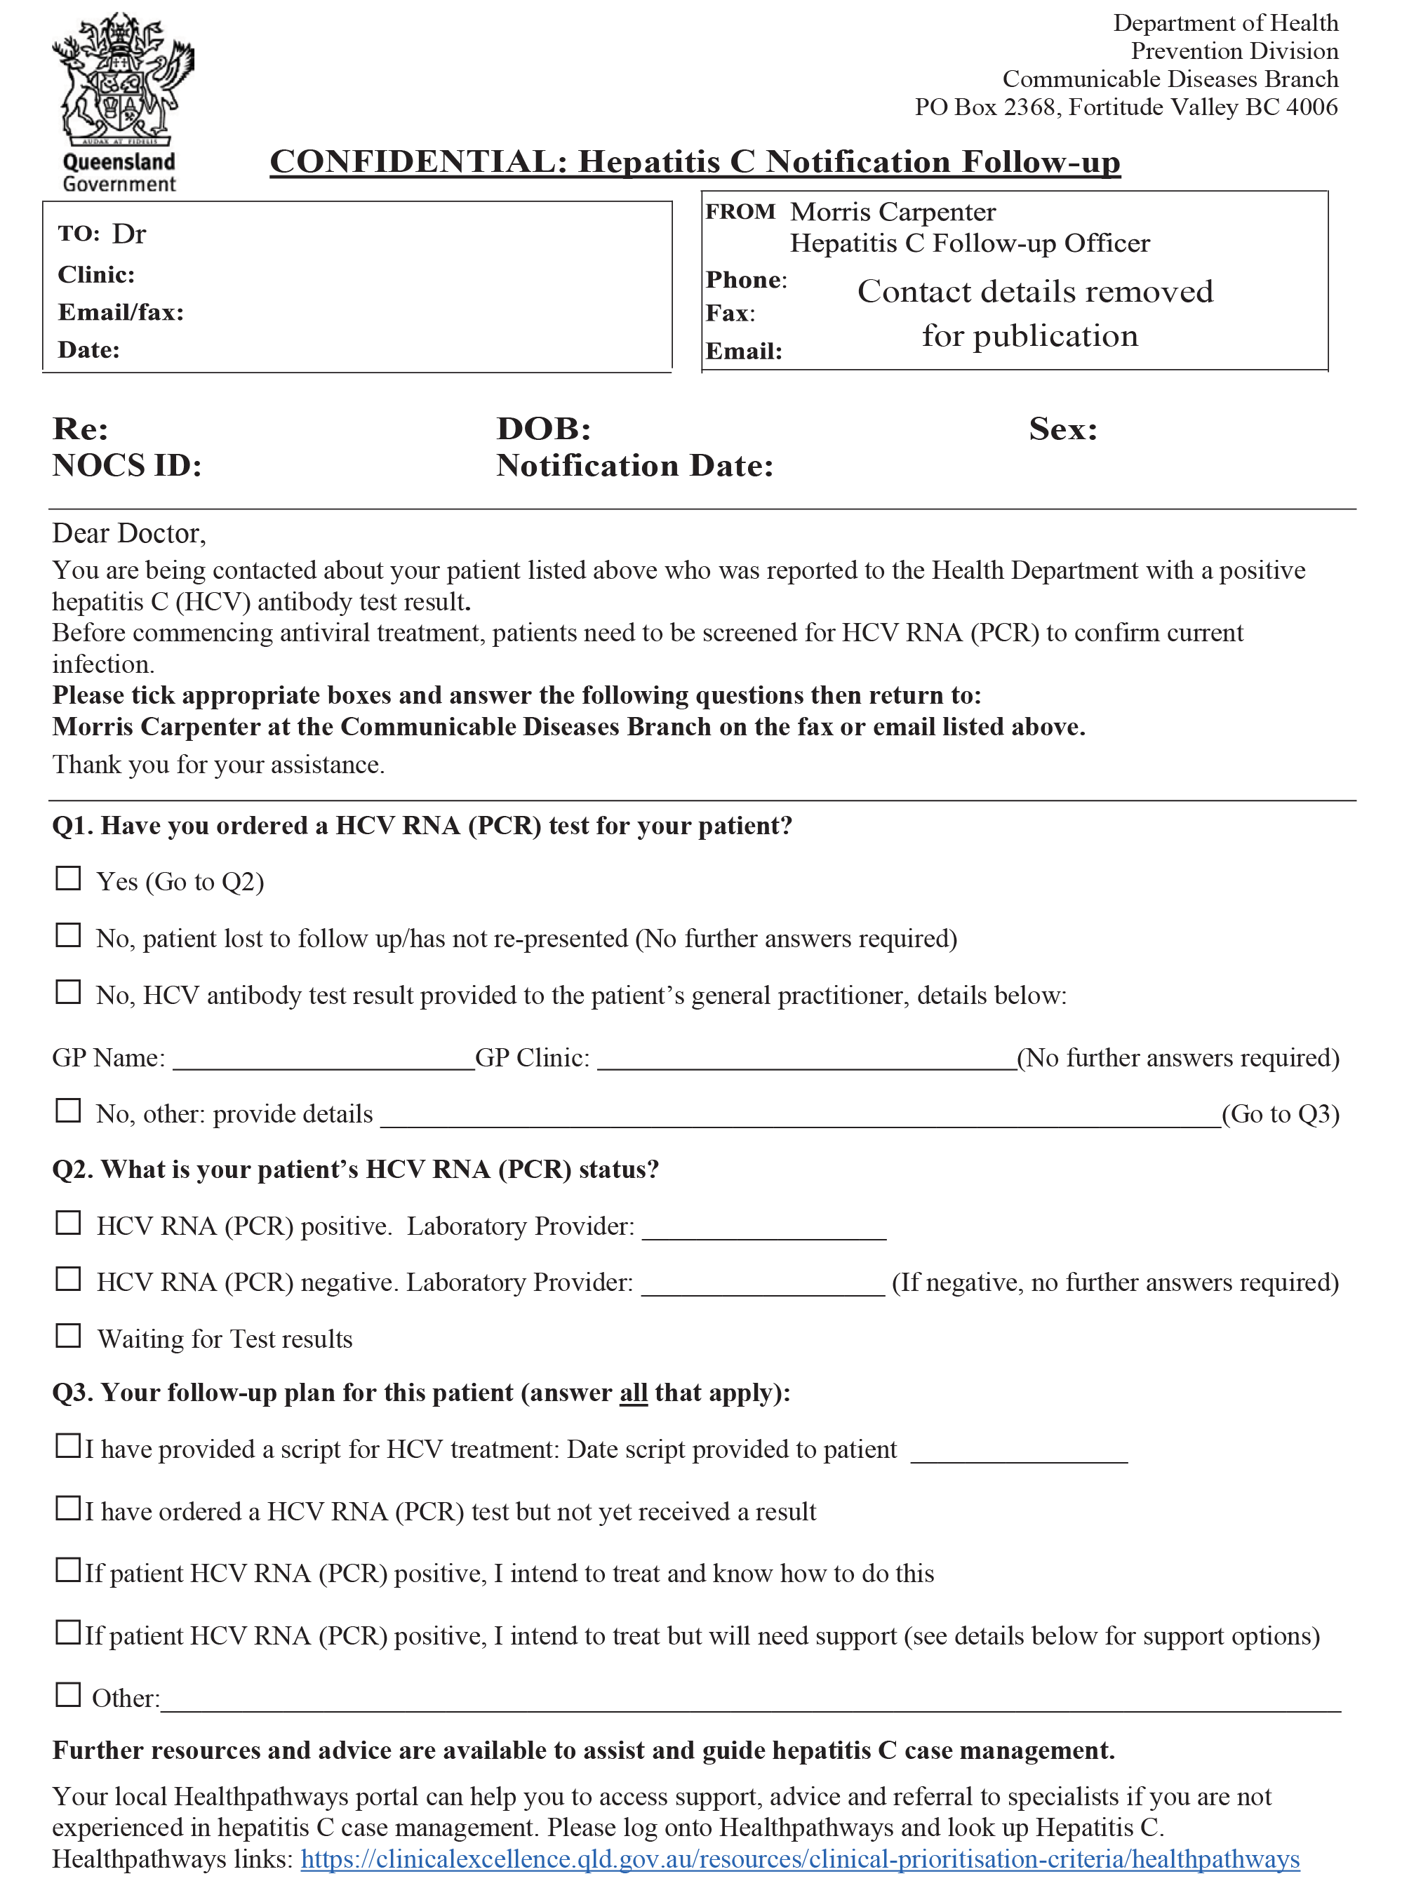
Appendix A.2: Questionnaire for general practitioners
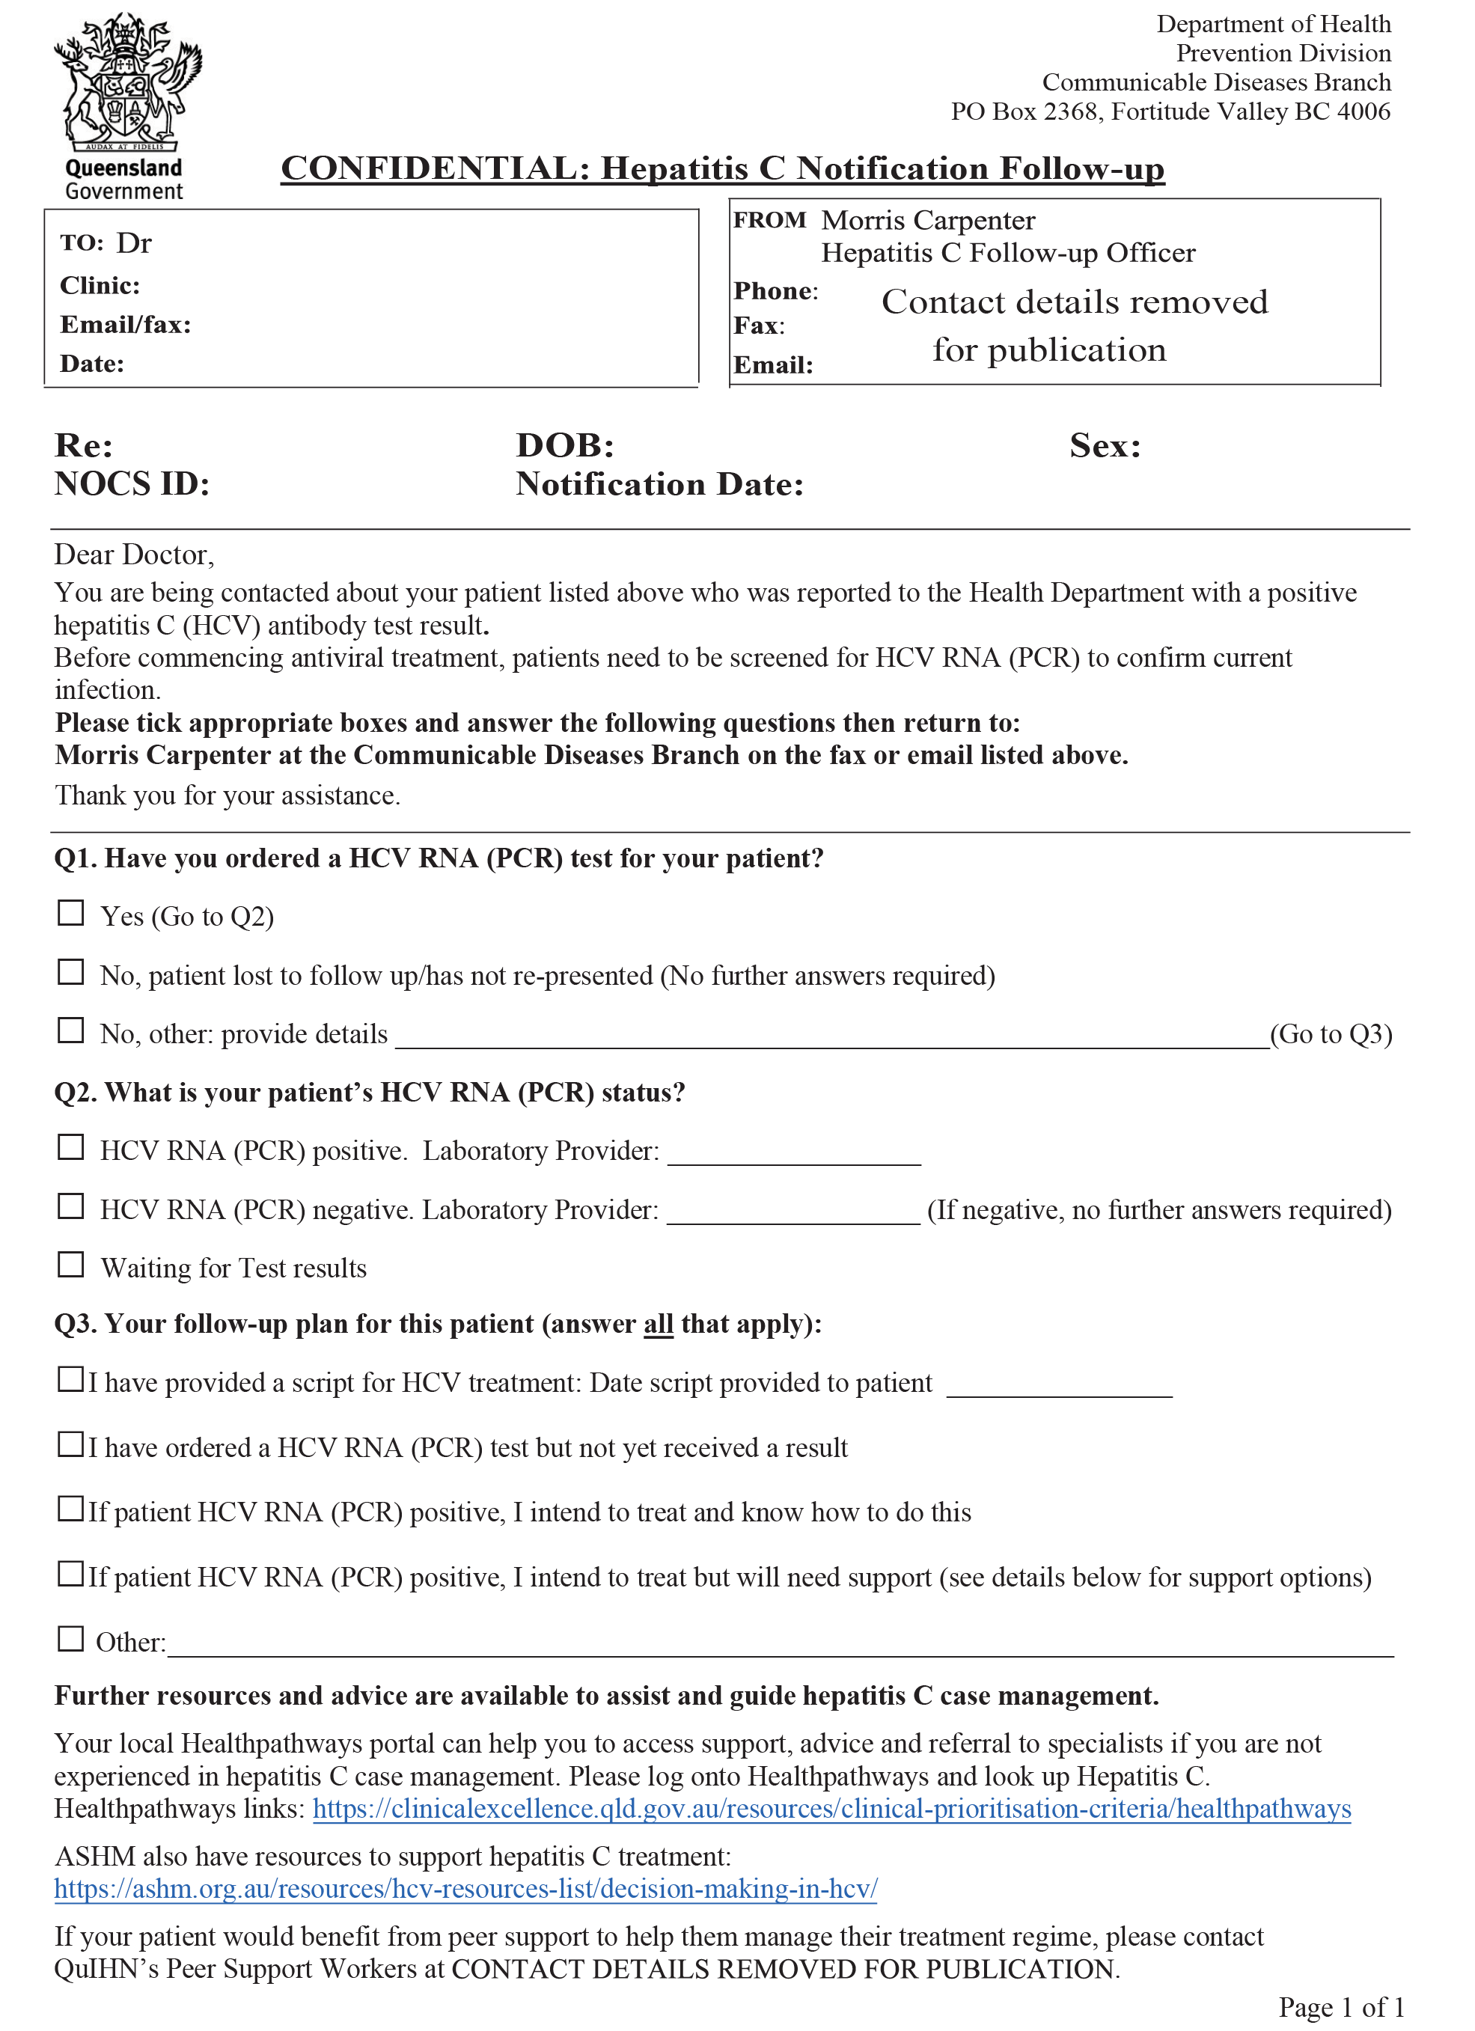

Appendix B: Scripts followed in semi-structured telephone interviews with invited clinicians/general practitioners
Appendix B.1: Interview guide for hospital clinicians
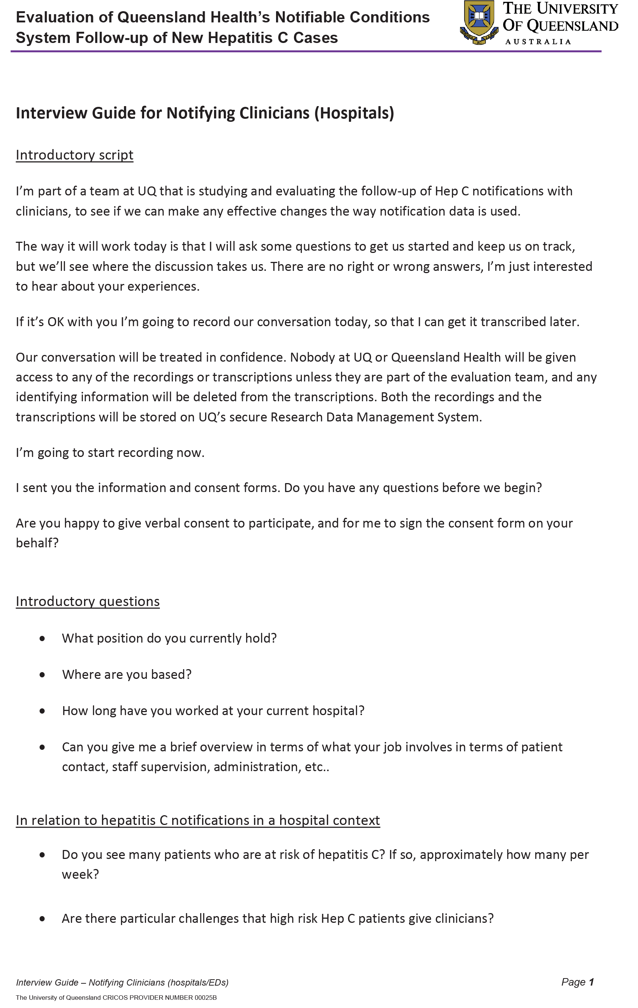
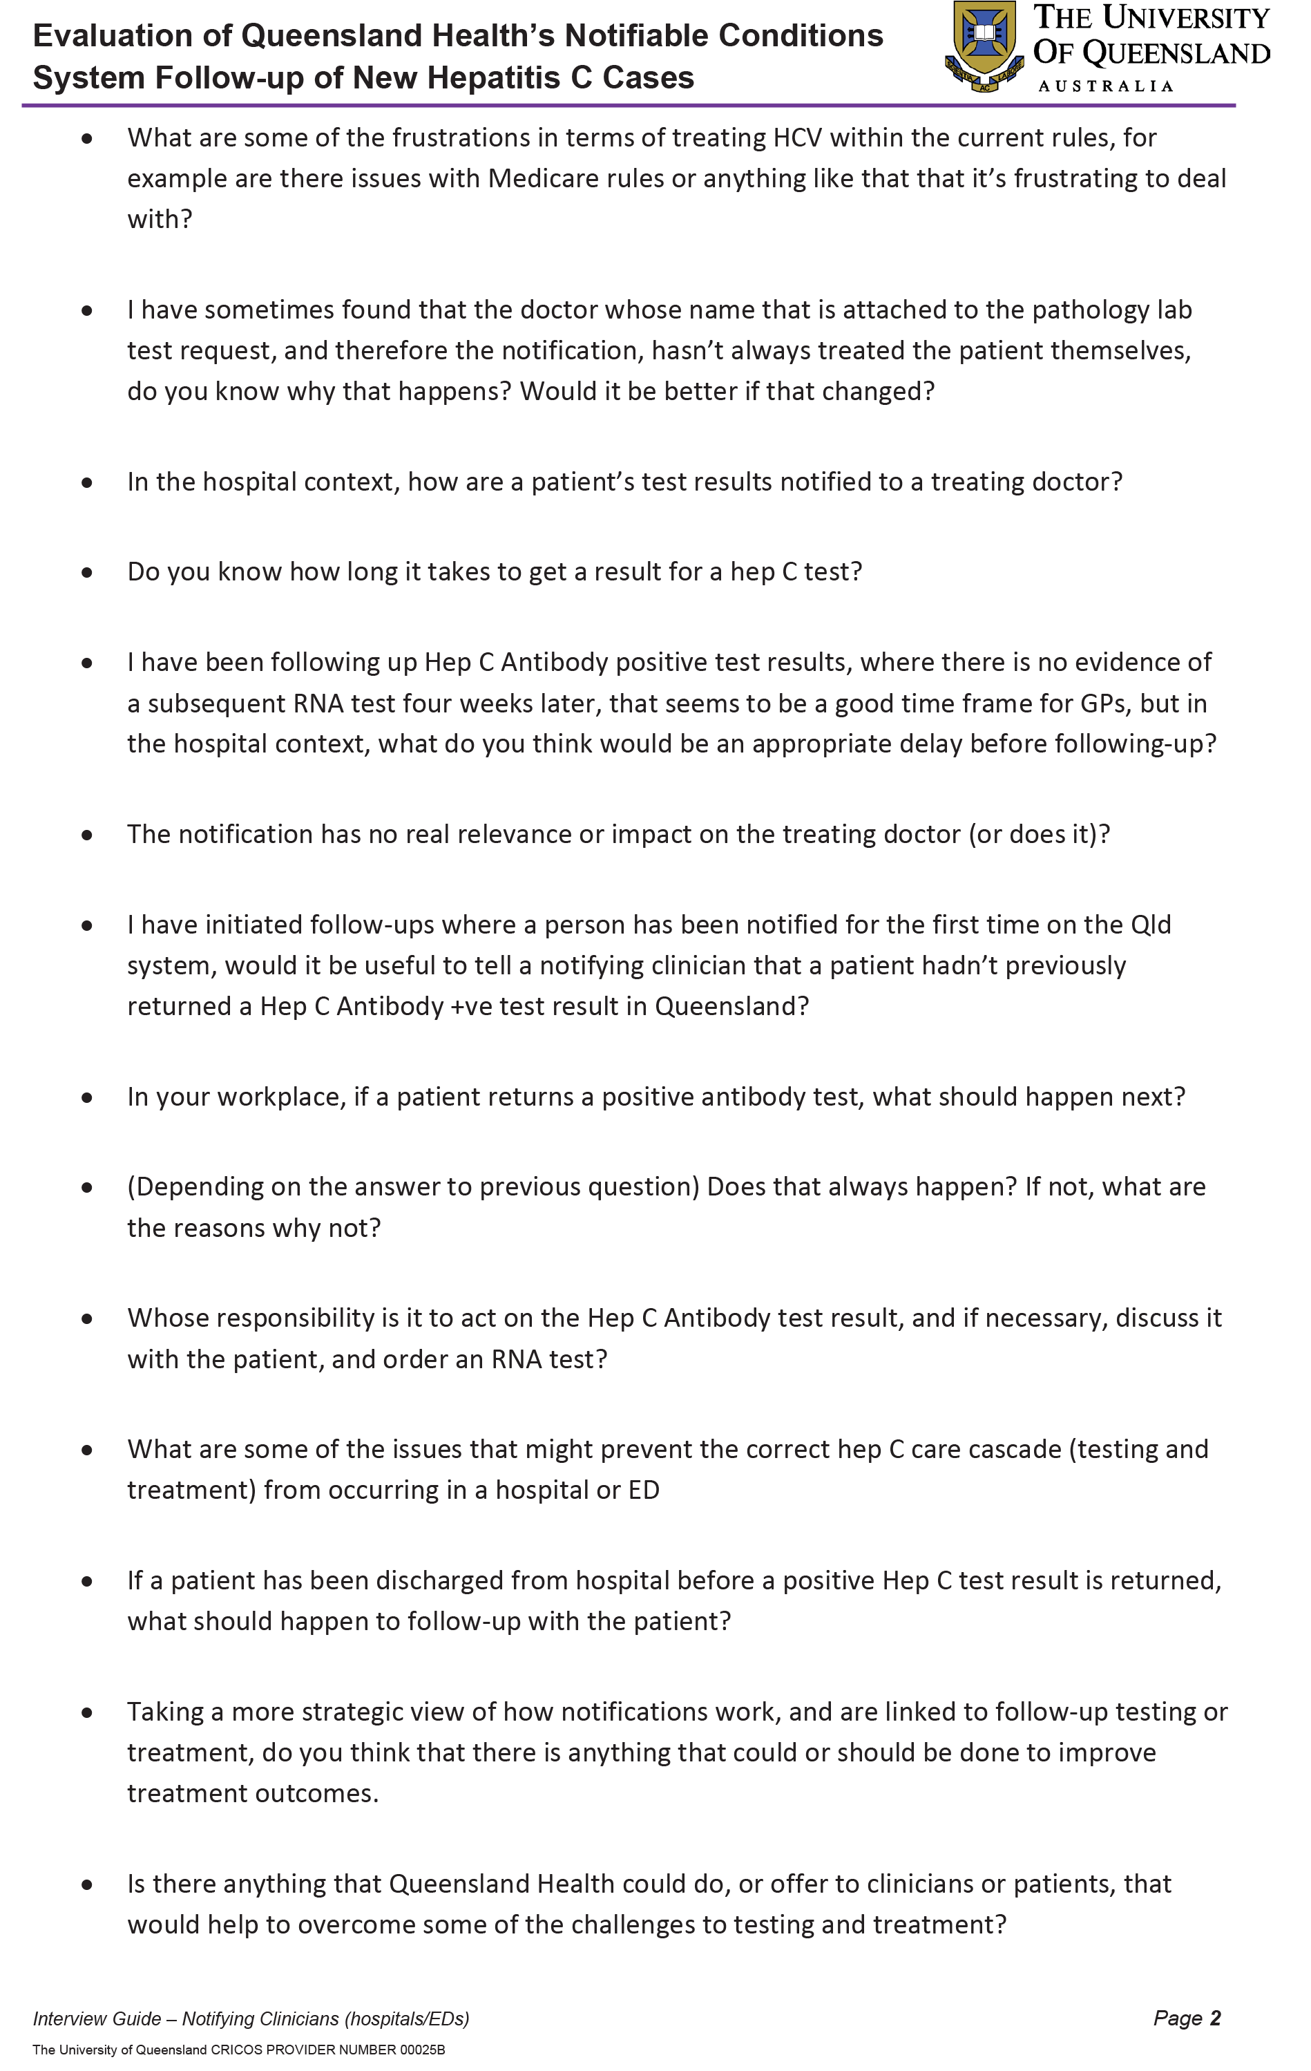

Appendix B.2: Interview guide for emergency department clinicians
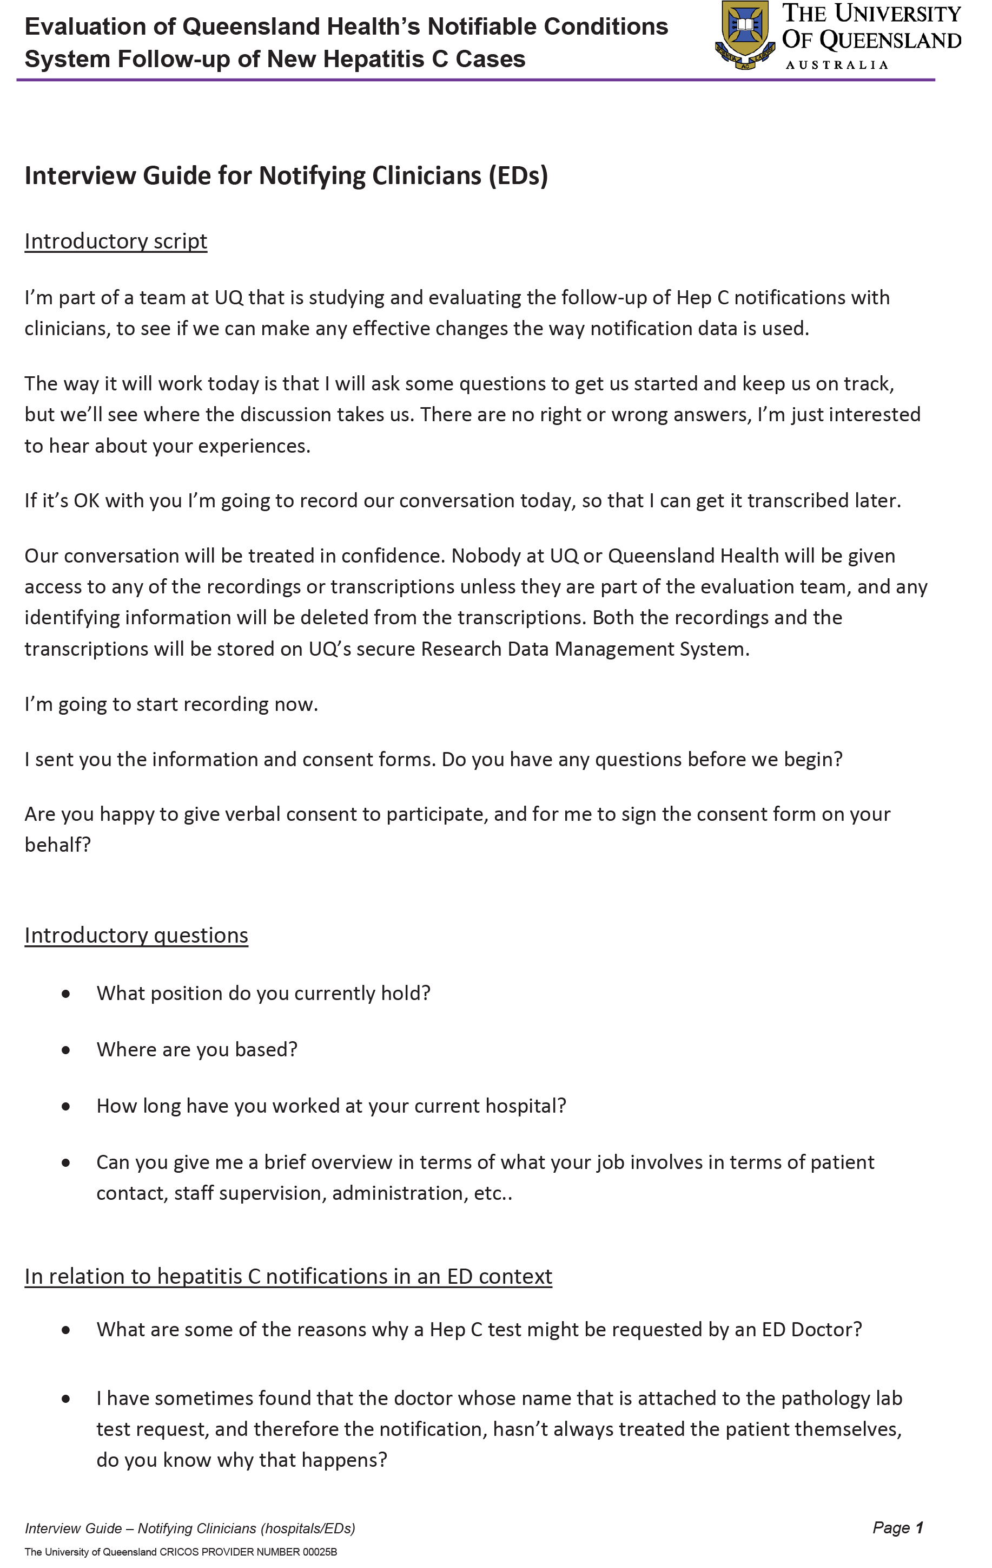
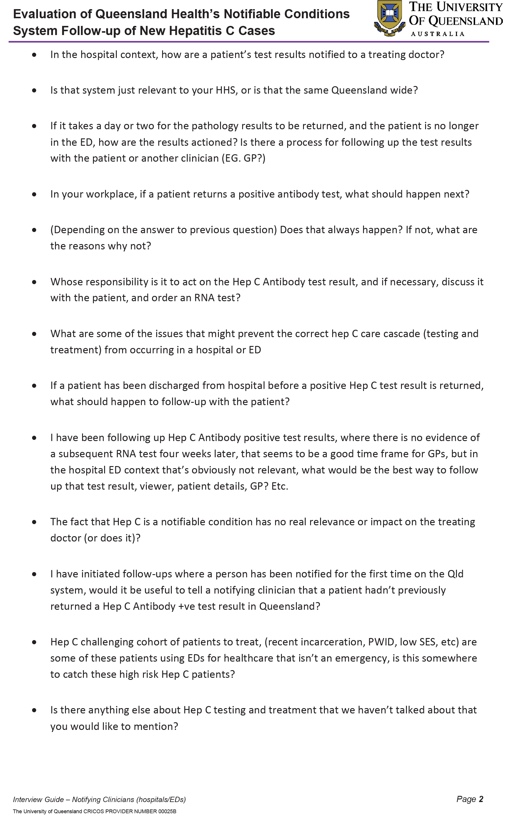

Appendix B.3: Script for general practitioners
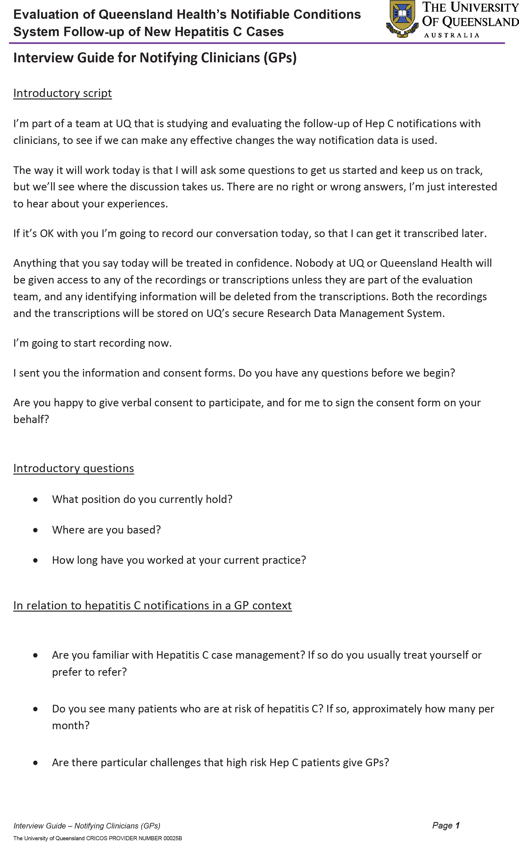
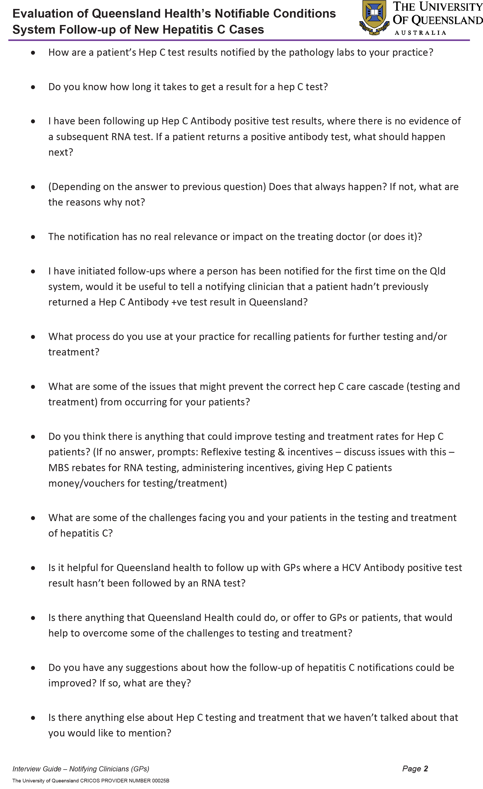

Communicable Diseases Intelligence
ISSN: 2209-6051 Online

Communicable Diseases Intelligence (CDI) is a peer-reviewed scientific journal published by the Office of Health Protection, Department of Health and Aged Care. The journal aims to disseminate information on the epidemiology, surveillance, prevention and control of communicable diseases of relevance to Australia.

Editor: Christina Bareja
Deputy Editor: Simon Petrie
Design and Production: Kasra Yousefi
Editorial Advisory Board: David Durrheim, Mark Ferson, Clare Huppatz, John Kaldor, Martyn Kirk, Meru Sheel and Steph Williams

Website: http://www.health.gov.au/cdi

Contacts
CDI is produced by the Office of Health Protection, Australian Government Department of Health and Aged Care, GPO Box 9848, (MDP 6) CANBERRA ACT 2601

Email: cdi.editor@health.gov.au

Submit an Article
You are invited to submit your next communicable disease related article to the Communicable Diseases Intelligence (CDI) for consideration. More information regarding CDI can be found at: http://health.gov.au/cdi.
Further enquiries should be directed to: cdi.editor@health.gov.au.

This journal is indexed by Index Medicus and Medline.

Creative Commons Licence - Attribution-NonCommercial-NoDerivatives CC BY-NC-ND
© 2023 Commonwealth of Australia as represented by the Department of Health and Aged Care
This publication is licensed under a Creative Commons Attribution-NonCommercial-NoDerivatives 4.0 International Licence from https://creativecommons.org/licenses/by-nc-nd/4.0/legalcode (Licence). You must read and understand the Licence before using any material from this publication.

Restrictions
The Licence does not cover, and there is no permission given for, use of any of the following material found in this publication (if any):
- the Commonwealth Coat of Arms (by way of information, the terms under which the Coat of Arms may be used can be found at www.itsanhonour.gov.au);
- any logos (including the Department of Health and Aged Care’s logo) and trademarks;
- any photographs and images;
- any signatures; and
- any material belonging to third parties.

Disclaimer
Opinions expressed in Communicable Diseases Intelligence are those of the authors and not necessarily those of the Australian Government Department of Health and Aged Care or the Communicable Diseases Network Australia. Data may be subject to revision.

Enquiries
Enquiries regarding any other use of this publication should be addressed to the Communication Branch, Department of Health and Aged Care, GPO Box 9848, Canberra ACT 2601, or via e-mail to: copyright@health.gov.au

Communicable Diseases Network Australia
Communicable Diseases Intelligence contributes to the work of the Communicable Diseases Network Australia.
http://www.health.gov.au/cdna

