Communicable Diseases Intelligence, Year 2023, Volume 47
https://doi.org/10.33321/cdi.2023.47.60
Publication date: 17/10/2023
http://health.gov.au/cdi

COVID-19 Australia: Epidemiology Report 78
Reporting period ending 27 August 2023
COVID-19 Epidemiology and Surveillance Team

Summary

Four-week reporting period (31 July – 27 August 2023)
Case definitions for confirmed and probable cases are in accordance with the coronavirus disease 2019 (COVID-19) Series of National Guidelines for Public Health Units (SoNG).
Trends – Nationally, case notifications have stabilised since the end of the fifth Omicron wave in mid-August 2023. In the four-week period 31 July – 27 August 2023, there were 9,083 confirmed and 11,849 probable cases of COVID-19 reported in Australia to the National Notifiable Diseases Surveillance System (NNDSS). In the most recent reporting fortnight, a total of 10,628 confirmed and probable cases were notified (an average of 759 cases per day), compared to 10,304 in the previous fortnight.
Age group – Overall, notification rates among all age groups have stabilised following the end of the fifth Omicron wave in mid-August 2023. In the current reporting period, 31 July – 27 August 2023, the highest notification rate was observed among adults aged 90 years and over, whilst the lowest rates were among young people and children aged 19 years or less. For the entire Omicron wave to date (15 December 2021 – 27 August 2023), the highest notification rate has been in adults aged 20 to 29 years.
Aboriginal and Torres Strait Islander people – In the reporting period 31 July – 27 August 2023, there were 639 new cases notified in Aboriginal and Torres Strait Islander people. In the Omicron wave to date (15 December 2021 – 27 August 2023), there have been 421,010 cases notified among Aboriginal and Torres Strait Islander people, representing 3.7% of all cases (421,010/11,361,995) during this period.
Severity – During the fifth Omicron wave, the number of cases with severe illness (defined as those admitted to ICU or died) peaked at 340 severe cases per week (in the week ending 28 May 2023); this was lower than the number of cases with severe illness observed in previous Omicron waves. The overall crude case fatality rate from the start of the Omicron wave to date is 0.18%, which is lower than the crude rate during the Delta wave (0.71%).
Virology – For samples collected in the four-week period 31 July – 27 August 2023, all sequences uploaded to AusTrakka were assigned against Omicron or recombinants consisting of Omicron lineages. This represents a 53% decrease in the number of sequences compared to the previous reporting period. In this reporting period, of the 251 sequences uploaded to AusTrakka during 31 July – 27 August 2023, most (89.6%) were recombinant or recombinant sub-lineages; 9.6% were BA.2.75 sub-sub lineages; and two sequences (0.8%) were BA.1 or BA.1 sub-lineage.
Acute respiratory illness – Based on self-reported FluTracking data, there has been an overall increase in the incidence of both ‘fever and cough’ and ‘runny nose and sore throat’ symptoms in the community since late January 2023. Over the current period, the proportion of ‘fever and cough’ has increased to a weekly average of 1.4% and is now similar to the proportion observed during the same period in 2022. The proportion of ‘runny nose and sore throat’ has increased since late July 2023 to a weekly average of 1.5%, with proportions of this symptom profile now slightly higher than those observed in 2022 for the same period.
International situation – According to the World Health Organization (WHO), as of 27 August 2023, over 770 million COVID-19 cases and over 6.9 million deaths have been reported globally since the start of the pandemic, with a global case fatality rate (CFR) of approximately 0.90%. At the WHO regional level, the number of newly reported cases in the four-week period to 27 August 2023 increased across three of the five reporting WHO regions: the European Region (+39%), the Western Pacific Region (+52%), and the Eastern Mediterranean Region (+113%).
Keywords: SARS-CoV-2; novel coronavirus; coronavirus disease 2019; COVID-19; acute respiratory disease; epidemiology; Australia
This reporting period covers the four-week period 31 July – 27 August 2023. Within this period, data for each week is compared. The previous reporting period was the preceding four weeks (3–30 July 2023).¹ The focus of this report is on the epidemiological situation in Australia since the beginning of the Omicron wave. For the purposes of this report, 15 December 2021 is used as a proxy for the beginning of this wave. This date was chosen as from this date onward, most sequenced strains from cases were Omicron. Readers are encouraged to consult prior reports in this series for information on the epidemiology of coronavirus disease 2019 (COVID-19) in Australia.
Methods of data analysis in these reports have periodically changed over the course of this reporting series to date. Please refer to the Technical Supplement for details of such changes, and for definitions of terminology.²
From Report #72 onward, and unless specified otherwise, all data from the National Notifiable Diseases Surveillance System (NNDSS) have been extracted using ‘diagnosis date’ rather than ‘notification received date’ (see the Technical Supplement for definitions). Due to COVID-19 reporting changes in several states and territories, the use of ‘diagnosis date’ now provides a more consistent and accurate method for describing transmission trends in Australia.
The case data provided includes both confirmed cases and probable cases reported to the NNDSS, as defined in accordance with the COVID-19 series of national guidelines (SoNG).³ For the purposes of this report, only probable cases from 5 January 2022 are included. Since 1 July 2023, Victoria has ceased collecting and reporting data on probable COVID-19 cases.
From Report #71 onward, population data for Aboriginal and Torres Strait Islander people was updated (from 2016) and is now based on Australian Bureau of Statistics (ABS) Estimated Resident Population (ERP) as at 2021. There has been an increase of 185,600 Aboriginal and Torres Strait Islander people (23.2%) since the previous ERP (June 2016). Therefore, notification rate comparisons with reports prior to #71 should be undertaken with caution.
Due to the dynamic nature of data in the NNDSS, numbers may be subject to revision and may vary from numbers previously reported and from case notifications released by states and territories.

Background and data sources
See the Technical Supplement for general information on COVID-19 including modes of transmission, common symptoms, and severity.²

Activity

COVID-19 trends

(NNDSS)
Since the beginning of the pandemic to 27 August 2023, jurisdictions in Australia have reported 11,605,432 COVID-19 cases to the NNDSS. Nationally, case notifications have stabilised since the end of the fifth Omicron wave in mid-August 2023 (Figure 1).
Figure 1: Confirmed and probable weekly COVID-19 notified cases by date of onset, Australia, 29 November 2021 – 27 August 2023 ^{a,b,c}
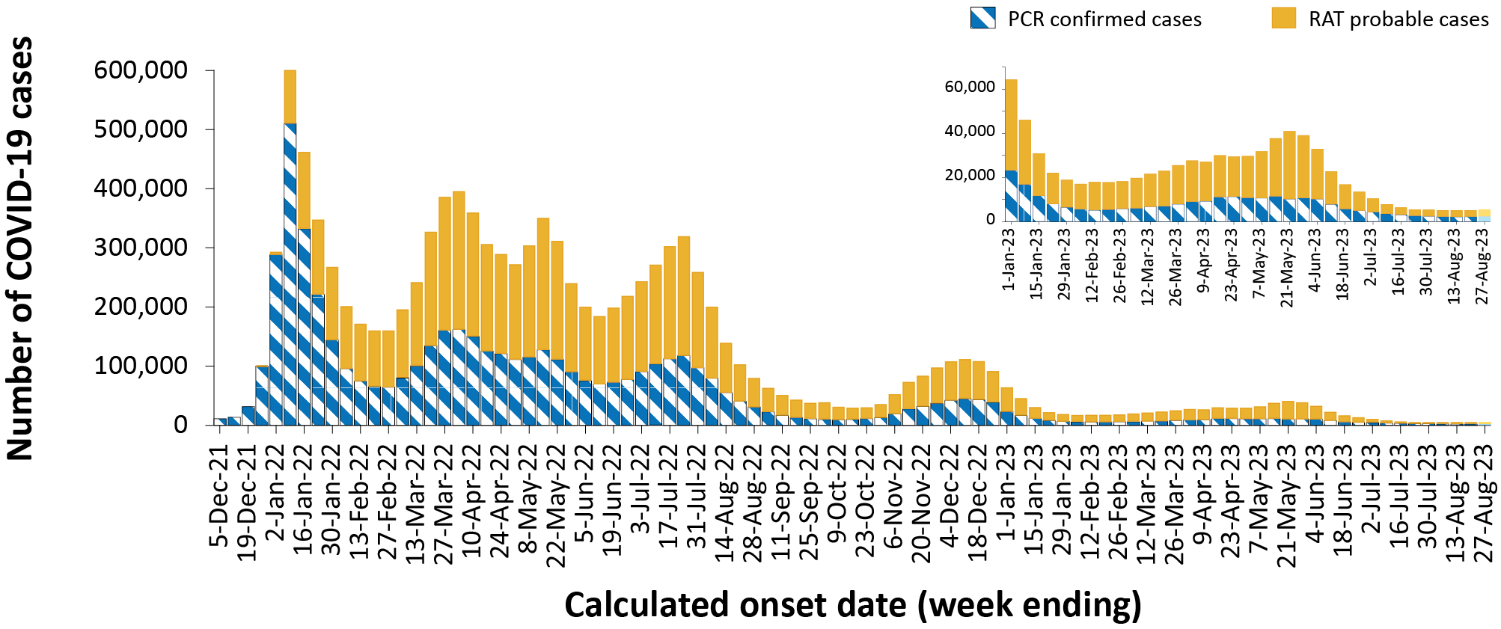
a Source: NNDSS extract from 26 September 2023 for cases with an illness onset from 29 November 2021 to 27 August 2023.
b Inset graph displays trends from 26 December 2022 to 27 August 2023.
c Since 1 July 2023, Victoria has ceased collecting and reporting data on probable COVID-19 cases.
In the four-week period 31 July – 27 August 2023, there were 9,083 confirmed and 11,849 probable cases of COVID-19 reported in Australia to the NNDSS (Table 1). In the most recent reporting fortnight, a total of 10,628 confirmed and probable cases were notified (an average of 759 cases per day), compared to 10,304 in the previous fortnight (an average of 736 cases per day).

Table 1: Confirmed and probable COVID-19 cases by jurisdiction and date of illness onset, Australia, 15 December 2021 – 27 August 2023 ^{a,b,c}
Jurisdiction | Reporting period |  |  |  |  | Current Omicron wave
Jurisdiction | 31 July–13 August 2023 |  |  | 14–27 August 2023 |  |  |  | 15 December 2021–27 August 2023
Jurisdiction | Confirmed | Probable | Total | Confirmed | Probable |  | Total | Confirmed | Probable | Total
ACT | 83  (22.4%) | 287  (77.6%) | 370 | 98  (29.0%) | 240  (71.0%) |  | 338 | 132,808  (54.5%) | 110,986  (45.5%) | 243,794
NSW | 1,626  (40.7%) | 2,374  (59.3%) | 4,000 | 1,868  (44.0%) | 2,375  (56.0%) |  | 4,243 | 2,148,816  (56.2%) | 1,677,391  (43.8%) | 3,826,207
NT | 30  (41.7%) | 42  (58.3%) | 72 | 50  (45.0%) | 61  (55.0%) |  | 111 | 24,700  (22.8%) | 83,826  (77.2%) | 108,526
Qld | 1,121  (50.0%) | 1,119  (50.0%) | 2,240 | 925  (46.7%) | 1,057  (53.3%) |  | 1,982 | 695,585  (40.1%) | 1,039,070  (59.9%) | 1,734,655
SA | 346  (33.9%) | 676  (66.1%) | 1,022 | 341  (30.7%) | 768  (69.3%) |  | 1,109 | 528,839  (56.5%) | 406,507  (43.5%) | 935,346
Tas. | 67  (16.5%) | 340  (83.5%) | 407 | 98  (17.2%) | 471  (82.8%) |  | 569 | 66,808  (22.0%) | 237,131  (78.0%) | 303,939
Vic. ^{d} | 865  (99.5%) | 4  (0.5%) | 869 | 1,003  (99.5%) | 5  (0.5%) |  | 1,008 | 1,097,772  (38.7%) | 1,737,617  (61.3%) | 2,835,389
WA | 306  (23.1%) | 1,018  (76.9%) | 1,324 | 256  (20.2%) | 1,012  (79.8%) |  | 1,268 | 502,051  (36.5%) | 872,088  (63.5%) | 1,374,139
Australia | 4,444  (43.1%) | 5,860  (56.9%) | 10,304 | 4,639  (43.6%) | 5,989  (56.4%) |  | 10,628 | 5,197,379  (45.7%) | 6,164,616  (54.3%) | 11,361,995
a Source: NNDSS extract from 26 September 2023 for cases with an illness onset from 15 December 2021 to 27 August 2023.
b ACT: Australian Capital Territory; NSW: New South Wales; NT: Northern Territory; Qld: Queensland; SA: South Australia; Tas.: Tasmania; Vic.: Victoria; WA: Western Australia.
c Since 1 July 2023, cases are classified based on jurisdiction of residence. This does not necessarily reflect the place where the disease was acquired or where the case presented. Please note prior to this, cases were classified based on the jurisdiction where they tested positive in.
d Since 1 July 2023, Victoria has ceased collecting and reporting data on probable COVID-19 cases.
As the pandemic has progressed, the proportion of cases reported through surveillance mechanisms has decreased and there are many different sub-lineages of virus circulating simultaneously. Additionally, increases in other measures of disease activity, such as the numbers of people admitted to hospital, intensive care units (ICU) or having died, often lag weeks behind increases in infections in the community. This has made assessing the start of a new wave more complex, with the determination often now only possible several weeks after the wave has commenced.
Since the emergence of the Omicron variant in Australia, there have been five distinct waves of transmission, defined by the predominant Omicron subvariant circulating (Figure 1). The first wave, driven by the BA.1 subvariant, occurred from mid-December 2021 to February 2022, with a peak in cases observed in early January 2022. From March 2022, the BA.2 subvariant was the predominant strain; in this second Omicron wave, there was a primary peak in early April and a secondary peak in late May 2022. In early July 2022, BA.5 (including sub-lineages) became the predominant subvariant detected in Australia, driving a third wave of transmission which peaked in the week ending 24 July 2022. A fourth wave of transmission commenced in late October 2022, driven by a combination of existing and newly emerging Omicron subvariants. This wave peaked during the week ending 11 December 2022. A fifth Omicron wave of transmission, similarly driven by a combination of existing and newly emerging recombinant Omicron subvariants, was signalled by an increasing trend in hospitalisations from mid-March 2023, leading to a peak in notifications in the week ending 21 May 2023 (Figure 1). Since this time, several measures including case notifications and severity indicators have stabilised, signalling the end of the fifth Omicron wave in mid-August 2023.
Due to a reduction in case ascertainment in all jurisdictions, including changes in testing and reporting requirements, reported case numbers are an underestimate of disease incidence in the community.

Demographic features

(NNDSS)
Overall, notification rates among all age groups have stabilised following the end of the fifth Omicron wave in mid-August 2023 (Figure 2). The highest notification rates were in adults aged 60 years and over (Figure 2). In the current reporting period, 31 July – 27 August 2023, the highest notification rate was observed among adults aged 90 years and over, whilst the lowest rates were among young people and children aged 19 years or less (Appendix A, Table A.1). For the entire Omicron wave to date (15 December 2021 – 27 August 2023), the highest notification rate has been in adults aged 20 to 29 years (Appendix A, Table A.1). For this age group, the weekly notification rate peaked in the week ending 9 January 2022 at approximately 5,800 cases per 100,000 population (not shown).
Figure 2: Confirmed and probable COVID-19 notification rates for ten-year age groups by date of onset, Australia, 26 December 2022 – 27 August 2023 ^{a,b}
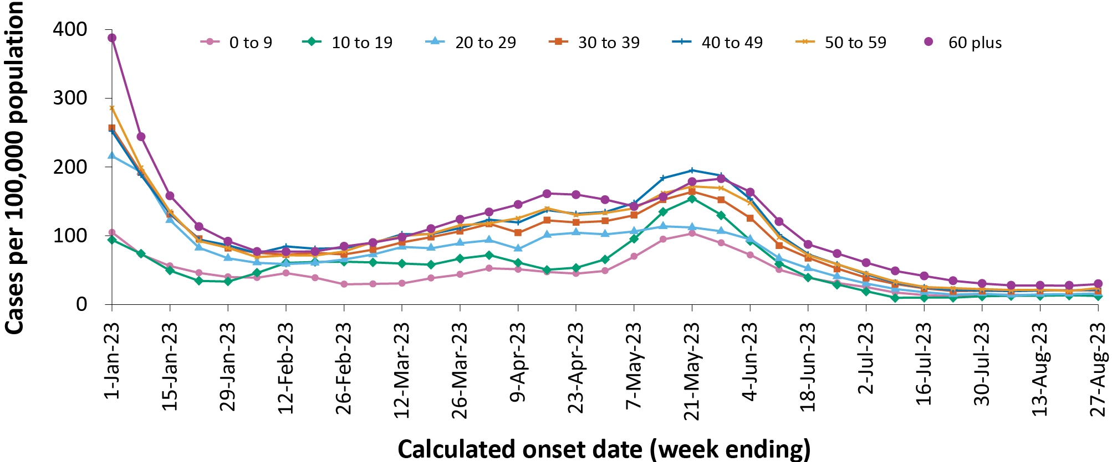
a Source: NNDSS extract from 26 September 2023 for cases with an illness onset from 26 December 2022 to 27 August 2023.
b Population data based on Australian Bureau of Statistics (ABS) Estimated Resident Population (ERP) as at June 2022.

Aboriginal and Torres Strait Islander persons

(NNDSS)
Overall, since the start of the pandemic, Aboriginal and Torres Strait Islander status is unknown for approximately 13.1% of COVID-19 notifications in NNDSS. Therefore, the number of cases classified as Aboriginal and Torres Strait Islander people is likely an under-representation. During the reporting period, there were 639 new cases notified among Aboriginal and Torres Strait Islander people (Table 2). In the Omicron wave to date (15 December 2021 – 27 August 2023), notifications among Aboriginal and Torres Strait Islander people have comprised 3.7% of all cases (421,010/11,361,995).

Table 2: Confirmed and probable cases of COVID-19 among Aboriginal and Torres Strait Islander peoples by jurisdiction and date of onset, Australia, 1 January 2020 – 27 August 2023 ^{a,b,c}
Jurisdiction ^{b} | Reporting period  31 July – 27 August 2023 | Omicron to date  15 December 2021 –  27 August 2023 | Delta  16 June – 14 December 2021 | Pandemic to date  1 January 2020 –  27 August 2023
ACT | 9 | 4,287 | 240 | 4,531
NSW | 243 | 138,832 | 7,724 | 146,627
NT | 26 | 26,530 | 94 | 26,625
Qld | 219 | 112,423 | 19 | 112,465
SA | 27 | 24,027 | 3 | 24,035
Tas. | 42 | 17,309 | 1 | 17,322
Vic. | 5 | 36,350 | 1,939 | 38,385
WA | 68 | 61,252 | – | 61,254
Australia | 639 | 421,010 | 10,020 | 431,244
a Source: NNDSS extract from 26 September 2023 for cases with an illness onset from 1 January 2020 to 27 August 2023.
b ACT: Australian Capital Territory; NSW: New South Wales; NT: Northern Territory; Qld: Queensland; SA: South Australia; Tas: Tasmania; Vic: Victoria; WA: Western Australia.
c Since 1 July 2023, cases are classified based on jurisdiction of residence. This does not necessarily reflect the place where the disease was acquired or where the case presented. Please note that, prior to this, cases were classified based on the jurisdiction in which they tested positive.
Table 3: COVID-19 cases among Aboriginal and Torres Strait Islander people by area of remoteness, Australia, 15 December 2021 – 27 August 2023ª
Jurisdiction ^{b,c} | Major city | Inner regional | Outer regional | Remote ^{d}
ACT | 4,238 | 35 | 12 | 1
NSW | 74,492 | 44,945 | 15,481 | 3,144
NT | 74 | 20 | 8,308 | 17,222
Qld | 43,836 | 25,894 | 31,130 | 11,413
SA | 13,022 | 2,580 | 5,018 | 3,251
Tas. | 206 | 10,572 | 6,088 | 298
Vic. | 20,719 | 11,725 | 3,849 | 19
WA | 32,081 | 4,448 | 7,667 | 16,410
Australia | 188,668 | 100,219 | 77,553 | 51,758
a Source: NNDSS extract from 26 September 2023 for cases with an illness onset from 15 December 2021 to 27 August 2023. Excludes cases with an overseas place of residence, and where place of residence is unknown.
b ACT: Australian Capital Territory; NSW: New South Wales; NT: Northern Territory; Qld: Queensland; SA: South Australia; Tas.: Tasmania; Vic.: Victoria; WA: Western Australia.
c Since 1 July 2023, cases are classified based on jurisdiction of residence. This does not necessarily reflect the place where the disease was acquired or where the case presented. Please note that, prior to this, cases were classified based on the jurisdiction in which they tested positive.
d ‘Remote’ here also includes areas classified as ‘very remote’.
Of the COVID-19 cases notified among Aboriginal and Torres Strait Islander people from 15 December 2021 to date, and where location of residence was known, 54.9% (229,530/418,198) lived in a regional or remote area (Table 3). Most cases reported in outer regional and remote areas since the start of the Omicron wave were diagnosed by rapid antigen test (RAT), at 71.4% (55,390/77,553) and 72.4% (37,471/51,758), respectively. It should be noted that the reliance on RATs for diagnosing COVID-19 is greater in regional and remote areas than in major cities, resulting in a larger under-representation of cases in regional and remote areas than in major cities, due to the changes in reporting requirements of positive RATs.
Nationally, there have been 425 COVID-19 associated deaths reported in Aboriginal and Torres Strait Islander people from the start of the pandemic to 27 August 2023. This comprises 141 from New South Wales; 128 from Queensland; 58 from the Northern Territory; 53 from Western Australia; 25 from South Australia; 16 from Victoria; and two each from the Australian Capital Territory and Tasmania. Additionally, 731 Aboriginal and Torres Strait Islander cases have been admitted to ICUs nationally. The overall population rate of severe COVID-19 cases (measured as those who were admitted to ICU or died) in Aboriginal and Torres Strait Islander people during the fifth Omicron wave (11.3 per 100,000 population) was lower than the rate observed during the fourth Omicron wave (14.2 per 100,000 population; Table 4). It should be noted that ICU status in NNDSS is likely incomplete.
Table 4: Age-specific rates of COVID-19 cases by highest level of illness severity (admitted to ICU and/or died) in Aboriginal and Torres Strait Islander people, Australia, 1 January 2020 to 13 August 2023ª
Age group (years) | Fifth Omicron wave  1 March – 13 August 2023 ^{b} | Fourth Omicron wave  24 October 2022 – 28 February 2023 | Omicron wave to date  15 December 2021  – 27 August 2023 | Pandemic to date  1 January 2020  – 27 August 2023
0–9 | 0.9 | 4.7 | 21.4 | 22.3
10–19 | 2.4 | 1.4 | 19.3 | 24.2
20–29 | 2.4 | 3.0 | 42.9 | 52.0
30–39 | 3.2 | 10.5 | 52.4 | 67.7
40–49 | 7.1 | 9.1 | 99.8 | 122.0
50–59 | 26.2 | 29.6 | 200.5 | 235.8
60 + | 76.9 | 86.3 | 522.2 | 566.5
All | 11.3 | 14.2 | 96.0 | 110.0
a Rate per 100,000 population for the given time period. Aboriginal and Torres Strait Islander population data is based on the Australian Bureau of Statistics (ABS) Estimated Resident Population (ERP) as at 2021.
b The fifth Omicron wave ended on 13 August 2023

Severity

(NNDSS, FluCAN, SPRINT-SARI)
Given the delay between illness onset and severe illness, and to provide a more accurate assessment of severity, cases with an onset in the last two weeks of the reporting period have been excluded from analyses on severe illness (defined as cases admitted to ICU and/or died) and on the proportion of cases admitted to ICU or died.
Following the emergence of the Omicron variant, the number of cases with severe illness peaked in mid-January 2022, at over 1,200 severe cases per week (data not shown). Since this time there have been subsequent smaller peaks in severe illness, in the week ending 24 July 2022 at 900 severe cases per week (data not shown) and in the week ending 18 December 2022 at close to 520 severe cases per week. During the fifth Omicron wave, the number of cases with severe illness increased to approximately 340 severe cases per week in the week ending 28 May 2023, followed by a gradual decrease (Figure 3).

Figure 3: COVID-19 cases, deaths and ICU admissions, Australia, by date of onset, Australia, 24 October 2022 – 27 August 2023 ^{a,b}
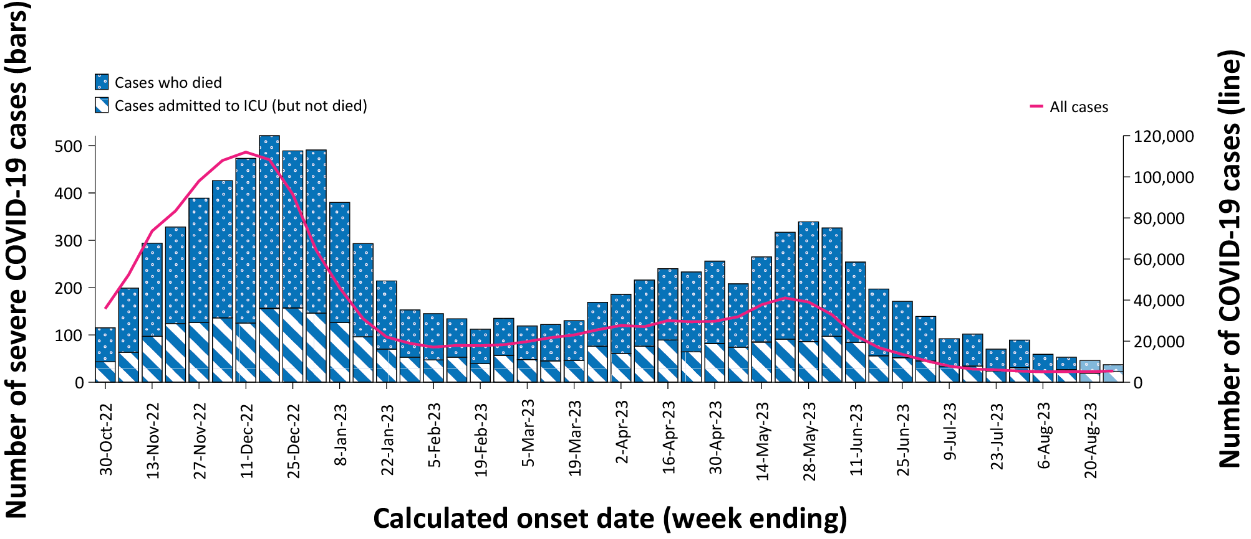
a Source: NNDSS extract from 26 September 2023 for cases with an illness onset from 24 October 2022 to 27 August 2023.
b The shaded bars at the right represent the most recent two reporting weeks and should be interpreted with caution, as cases with an illness onset in these weeks may not have yet developed severe disease.
Rates of severe illness were highest in older age groups, particularly those aged 60 years and older (Figure 4). Among this age group, there have been three notable peaks in severe illness since the emergence of Omicron: in the week ending 16 January 2022 (17.6 cases per 100,000 population; not shown), in the week ending 24 July 2022 (13.7 cases per 100,000 population; not shown) and in the week ending 18 December 2022 (7.6 cases per 100,000 population). Throughout the fifth Omicron wave (1 March – 13 August 2023), the highest rate of severe illness among those aged 60 years and older was observed in the week ending 28 May 2023 at 5.1 cases per 100,000 population. In comparison, rates of severe illness in younger age groups have remained relatively low and stable throughout earlier Omicron waves, not surpassing three cases per 100,000 population per week over that period (Figure 4).

Figure 4: Age-specific rates of COVID-19 cases admitted to ICU or died, by date of onset, Australia, 24 October 2022 to 13 August 2023 ^{a,b}
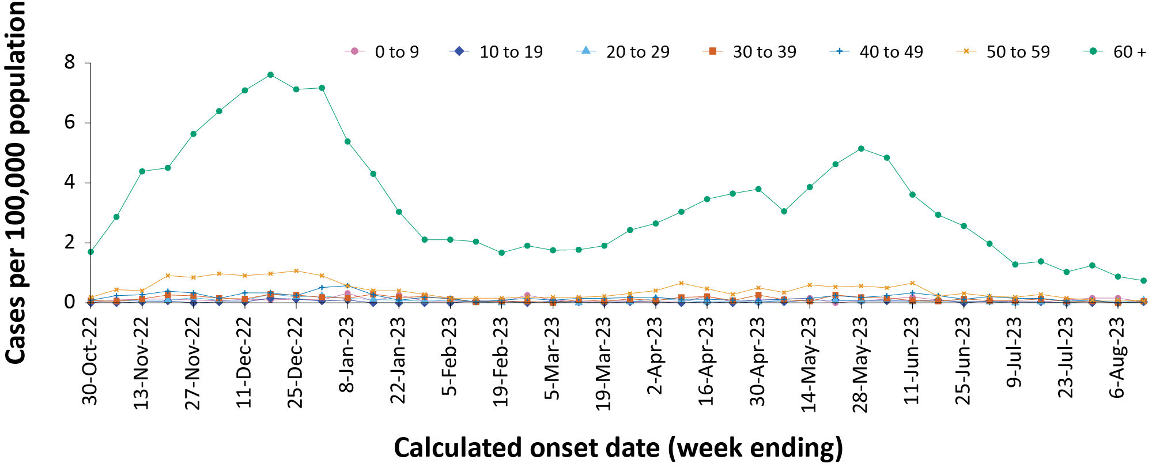
a Source: NNDSS extract from 26 September 2023 for cases with an illness onset from 24 October 2022 to 13 August 2023; cases with an illness onset in the last two weeks (14–27 August 2023) were excluded to account for the delay between onset and development of severe illness.
b Population data based on Australian Bureau of Statistics (ABS) Estimated Resident Population (ERP) as at June 2022.

Hospitalisation and ICU admissions

Influenza Complications Alert Network—FluCAN
Between 15 December 2021 and 27 August 2023, there were 17,097 hospital admissions with confirmed COVID-19 reported at Influenza Complications Alert Network (FluCAN) sentinel sites, including 5.6% (960/17,097) admitted directly to ICU (Figure 5). During the four-week reporting period (31 July – 27 August 2023), there were 87 hospital admissions with COVID-19 reported at FluCAN sentinel sites, with 12.6% (11/87) admitted directly to ICU. The proportion of COVID-19 ICU admissions in the year-to-date (1 January to 27 August 2023) was 5.6% (202/3,626) compared with 6.2% (636/10,224) for the same period in 2022.

Figure 5: Weekly trends for patients admitted with confirmed COVID-19 to FluCAN sentinel hospitals, Australia, 13 December 2021 – 27 August 2023ª
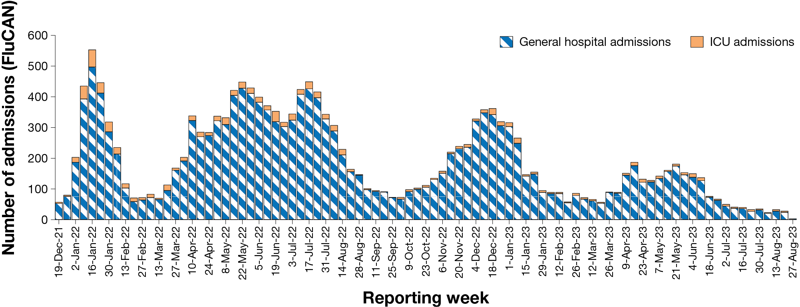
a Source: FluCAN.⁴

Short Period Incidence Study of Severe Acute Respiratory Infection—SPRINT-SARI
Between 15 December 2021 and 27 August 2023, there were 6,039 COVID-19 cases admitted to ICUs participating in the sentinel surveillance system Short Period Incidence Study of Severe Acute Respiratory Infection (SPRINT-SARI)⁵ (Table 5). Of those captured by SPRINT-SARI, 62.1% (3,752 /6,039) of patients were discharged home, 12.9% (780/6,039) died in ICU and 5.3% (318/6,039) died within the general hospital ward, with an overall in-hospital mortality rate of 18.2%.
Table 5: Patient outcomes for adult COVID-19 cases (aged greater than or equal to 18 years), Australia, 15 December 2021 – 27 August 2023 ª
Outcomes | Current reporting period  31 July – 27 August 2023  (n = 53) | Omicron wave to date  15 December 2021 – 27 August 2023  (n = 6,039)
Patient status
Ongoing care in ICU | 15 (28.3%) | 31 (0.5%)
Ongoing care in hospital ward ^{b} | 12 (22.6%) | 70 (1.2%)
Transfer to other hospital/facility | 0 (0%) | 397 (6.6%)
Transfer to rehabilitation | 0 (0%) | 578 (9.6%)
Discharged home | 23 (43.4%) | 3,752 (62.1%)
Mortality – ICU | 3 (5.7%) | 780 (12.9%)
Mortality – hospital ward | 0 (0%) | 318 (5.3%)
Unknown | 0 (0%) | 88 (1.5%)
Missing ^{c} | 0 (0%) | 25 (0.4%)
a Source: SPRINT-SARI.⁵
b Patients who were admitted in ICU/hospital wards with no discharge information for less than 90 days were assumed to have ongoing care in the hospital.
c Patients who were admitted to ICU/hospital wards for more than 90 days with no discharge information were treated as ‘missing data’.
In the four-week reporting period (31 July – 27 August 2023), there were 53 adult patients with COVID-19 (29 males, 24 females; median age: 64 years; interquartile range: 48–75 years) admitted to ICU reported at SPRINT-SARI sentinel sites (Table 5).
Since the start of the Omicron wave (15 December 2021) to 27 August 2023, for patients admitted to SPRINT-SARI sentinel sites with COVID-19 (n = 6,039), the median length of stay in ICU was 3.4 days (range: 0–88.9 days), the median length of stay in hospital was 10.9 days (range: 0.1–89.2 days) and the median duration of mechanical ventilation was 4.1 days (range: < 0.1–82.0 days).
During the four-week reporting period (31 July – 27 August 2023), for adult patients admitted to SPRINT-SARI sentinel sites with COVID-19 (n = 53), the median length of stay in ICU was 2.7 days (range: 0–14.3 days); the median length of stay in hospital was 9.1 days (range: 0.6–27.3 days); and the median duration of mechanical ventilation was 5.2 days (range: 0.4–10.5 days).

Risk factors for severe disease
Comorbidity data extracted from SPRINT-SARI reflect the sickest patients with COVID-19 who are managed in ICU; data are therefore not generalisable to all cases. In adult patients admitted to ICU with COVID-19 during 31 July – 27 August 2023, where comorbidity information was available, the most prevalent comorbidities were, chronic cardiac disease (28.3%) and chronic immunosuppression (24.5%), followed by chronic pulmonary disease (20.8%) (Figure 6). Of those adult patients admitted to ICU during the four-week reporting period, for whom comorbidity data was known, 43.4% of adult ICU patients (23/53) had three or more comorbidities.
Figure 6: Prevalence of comorbidities for COVID-19 cases among admitted adult ICU patients (aged greater than or equal to 18 years), Australia, 31 July – 27 August 2023 ^{a,b}
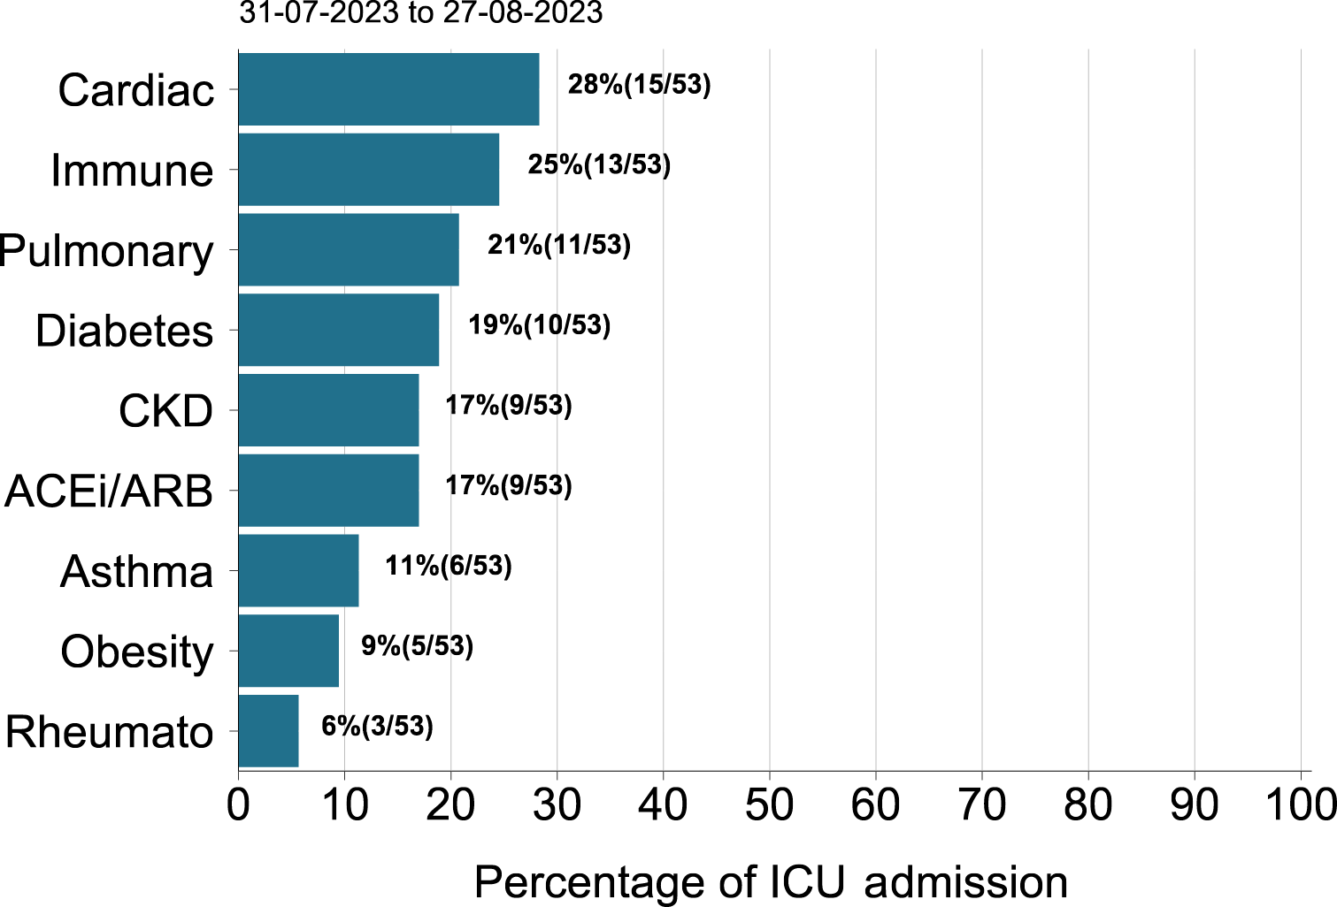
a Source: SPRINT-SARI. Only includes adult cases (≥ 18 years old) and excludes those with missing data on comorbidities or where comorbidity is unknown.
b Abbreviated comorbidities defined as: Cardiac: chronic cardiac disease; ACEi/ARB: past use of ACE inhibitor or A2 Blocker; CKD: chronic kidney disease; Pulmonary: chronic pulmonary disease (not including asthma); Immune: chronic immunosuppression; and Rheumato: rheumatologic disorder.

Paediatric Inflammatory Multisystem Syndrome – Temporally Associated with SARS-CoV-2

Paediatric Active Enhanced Disease Surveillance
Since the start of the pandemic to 27 August 2023, there have been 185 cases of paediatric inflammatory multisystem syndrome – temporally associated with SARS-CoV-2 (PIMS-TS) reported to the Paediatric Active Enhanced Disease Surveillance network (PAEDS), with no new cases reported in the last four weeks, and a total of 19 cases reported since the start of 2023 (Figure 7). The majority of PIMS-TS cases to date have occurred in those aged 5 to < 12 years (52%; 97/185), followed by those aged 6 months to < 5 years (28%; 51/185). To date, there have been no PIMS-TS associated deaths.
Figure 7: PIMS-TS cases reported to PAEDS, by sample month and level of care required, Australia, 1 June 2021 – 27 August 2023 ª
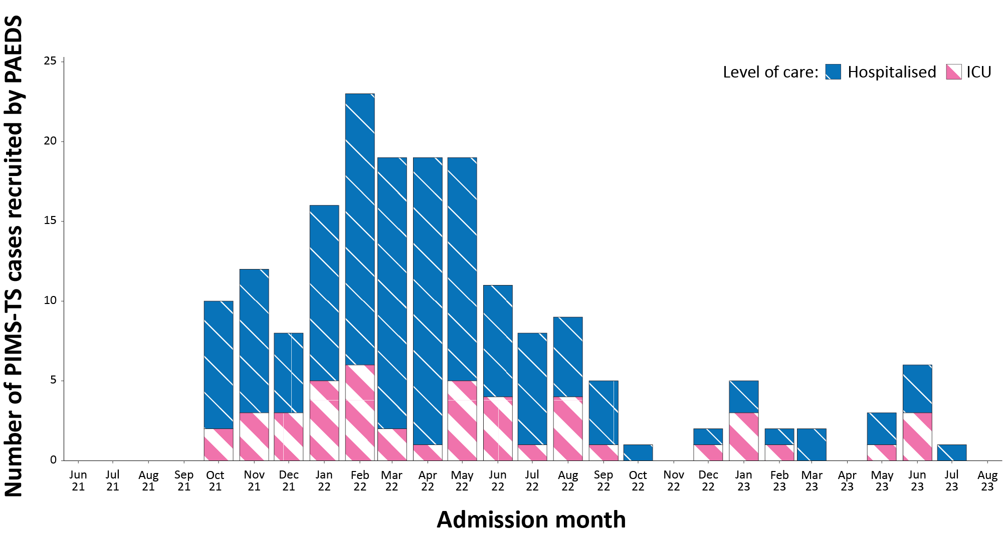
a Source: PAEDS.

COVID-19 deaths
Throughout the fifth Omicron wave (1 March 2023 to 13 August 2023), there have been 3,116 COVID-19-associated deaths notified. In total, there have been 23,061 COVID-19-associated deaths reported in NNDSS since the start of the pandemic (Table 6). The overall crude case fatality rate from the start of the Omicron wave to date is 0.18%, which is lower than the crude case fatality rate for the Delta wave (0.71%) (Table 7).

Table 6: Deaths associated with COVID-19 by reporting period, Australia, 1 January 2020 – 27 August 2023 ^{a,b,c,d}
Jurisdiction ^{c} | Fifth Omicron wave ^{d}  1 March – 13 August 2023 | Fourth Omicron wave  24 October 2022 – 28 February 2023 | Omicron wave to date  15 December 2021 – 27 August 2023 | Pandemic to date  1 January 2020 – 27 August 2023
ACT | 46 (1.5%) | 38 (1.0%) | 263 (1.3%) | 279 (1.2%)
NSW | 1,075 (34.5%) | 1,065 (29.1%) | 6,966 (33.5%) | 7,679 (33.3%)
NT | 13 (0.4%) | 18 (0.5%) | 109 (0.5%) | 110 (0.5%)
Qld | 518 (16.6%) | 509 (13.9%) | 3,353 (16.1%) | 3,361 (14.6%)
SA | 235 (7.5%) | 321 (8.8%) | 1,664 (8.0%) | 1,669 (7.2%)
Tas. | 54 (1.7%) | 63 (1.7%) | 294 (1.4%) | 307 (1.3%)
Vic. | 958 (30.7%) | 1,357 (37.1%) | 6,855 (33.0%) | 8,384 (36.4%)
WA | 217 (7.0%) | 291 (7.9%) | 1,263 (6.1%) | 1,272 (5.5%)
Australia | 3,116 (100.0%) | 3,662 (100.0%) | 20,767 (100.0%) | 23,061 (100.0%)
a Source: NNDSS, extract from 26 September 2023 for deaths with an illness onset date to 27 August 2023.
b Deaths are categorised into time periods using date of death. Deaths with a missing date of death are classified using date of illness onset.
c ACT: Australian Capital Territory; NSW: New South Wales; NT: Northern Territory; Qld: Queensland; SA: South Australia; Tas.: Tasmania; Vic.: Victoria; WA: Western Australia.
d The fifth Omicron wave ended on 13 August 2023.
Table 7: COVID-19 associated case fatality rates among cases notified to NNDSS, by age group and date of onset, 1 January 2020 to 13 August 2023 ^{a,b,c,d}
Age group (years) | Omicron to date  15 December 2021 – 13 August 2023 | Delta  16 June – 14 December 2021 | Pandemic to date  1 January 2020 – 13 August 2023
0–9 | < 0.05% | < 0.05% | < 0.05%
10–19 | < 0.05% | < 0.05% | < 0.05%
20–29 | < 0.05% | < 0.05% | < 0.05%
30–39 | < 0.05% | 0.06% | < 0.05%
40–49 | < 0.05% | 0.18% | < 0.05%
50–59 | < 0.05% | 0.65% | 0.05%
60 + | 1.09% | 6.13% | 1.20%
Unknown | < 0.05% | 0.00% | < 0.05%
Australia | 0.18% | 0.71% | 0.20%
a Source: NNDSS, extract from 26 September 2023 for deaths with an illness onset date to 13 August 2023.
b To account for the lag between illness onset and the development of severe illness, cases with an onset date in the last two weeks have been excluded from calculations of the case fatality rate.
c A value of 0.00% indicates that no COVID-19 associated fatalities occurred during the indicated period for the specified age group.
d Crude case fatality rates which reflect number of deaths as a proportion of reported COVID-19 cases during specific periods. Note, the current crude case fatality rates are likely overestimated due to changes in case ascertainment and increased underreporting of non-severe cases.

Genomic surveillance and virology

(Communicable Disease Genomics Network, AusTrakka and jurisdictional sequencing laboratories)

Variants of concern (VOC)
AusTrakka⁶ is actively monitoring and reporting on one lineage and its associated sub- and sub-sub-lineages, currently designated as a variant of concern (VOC) by international organisations, including the World Health Organization (WHO): Omicron (B.1.1.529). The Omicron variant displays a characteristic set of mutations which differentiate the lineage from previously circulating VOCs. Further information on variants and their mutations is available in the Technical Supplement.²
There have been five major sub-lineages defined under B.1.1.529: BA.1, BA.2, BA.3, BA.4 and BA.5, and a large number of sub-lineages, including recombinants, under these; all are designated Omicron. Unlike previous periods in Australia’s COVID-19 waves, where one or two dominant lineages were the main driver of disease, there is currently significant diversity in the range of sub-sub-lineages circulating within Australia. During this reporting period, more than 200 unique lineages have been identified, and it is likely that there are more that are not being characterised through whole genome sequencing. This diversity of circulating lineages has sometimes been referred to as a ‘variant soup’. Many of these circulating lineages will die out without causing a significant disease burden, but others appear to have stronger growth potential.

Variants of interest and variants under monitoring
The Communicable Diseases Genomics Network (CDGN) VOC working group tracks notable SARS-CoV-2 variants, including:
- two variants of interest (VOI), XBB.1.5 and XBB.1.16; and
- the following variants under monitoring (VUMs) and their descendent lineages: BA.2.75 and BA.2.75.2 (including CH*), BQ.1 and BQ.1.1*, and recombinants XBB* (in particular XBB.1.9.1* and XBB.1.9.2*), and XBF*.
This report uses the variants of interest (VOI) classification for lineages with possible evidence for epidemiological, pathological or immunological features of concern. This is consistent with CDGN usage and with the WHO use of the term.^{7,8} Variants under monitoring (VUM) are other lineages with early observations of potential significance, but little to no evidence of current concern. In this report, details are included of Omicron subvariants under monitoring as designated by the WHO.

AusTrakka SARS-CoV-2 genomic epidemiology
From 31 July to 27 August 2023, there were 251 sequences uploaded to AusTrakka, with the most recent collection date of 22 August 2023. This represents a 53% decrease in the number of sequences compared to the previous reporting period. All sequences uploaded during this reporting period have been assigned to sub-lineages within B.1.1.529 (Omicron) or to recombinants consisting of one or more Omicron sub-lineages.
Of the 251 sequences uploaded to AusTrakka between 31 July and 27 August 2023:
- 89.6%, (225/251) were recombinant or recombinant sub-lineages;
- 9.6% (24/251) were BA.2.75 sub-sub lineages; and
- 0.8% (2/251) were BA.1 or BA.1 sub-lineages (Figure 8).

Figure 8: Omicron sub-lineage in Australia since 1 January 2023 by sample collection date, showing (A) proportions and (B) count per week ^{a,b,c}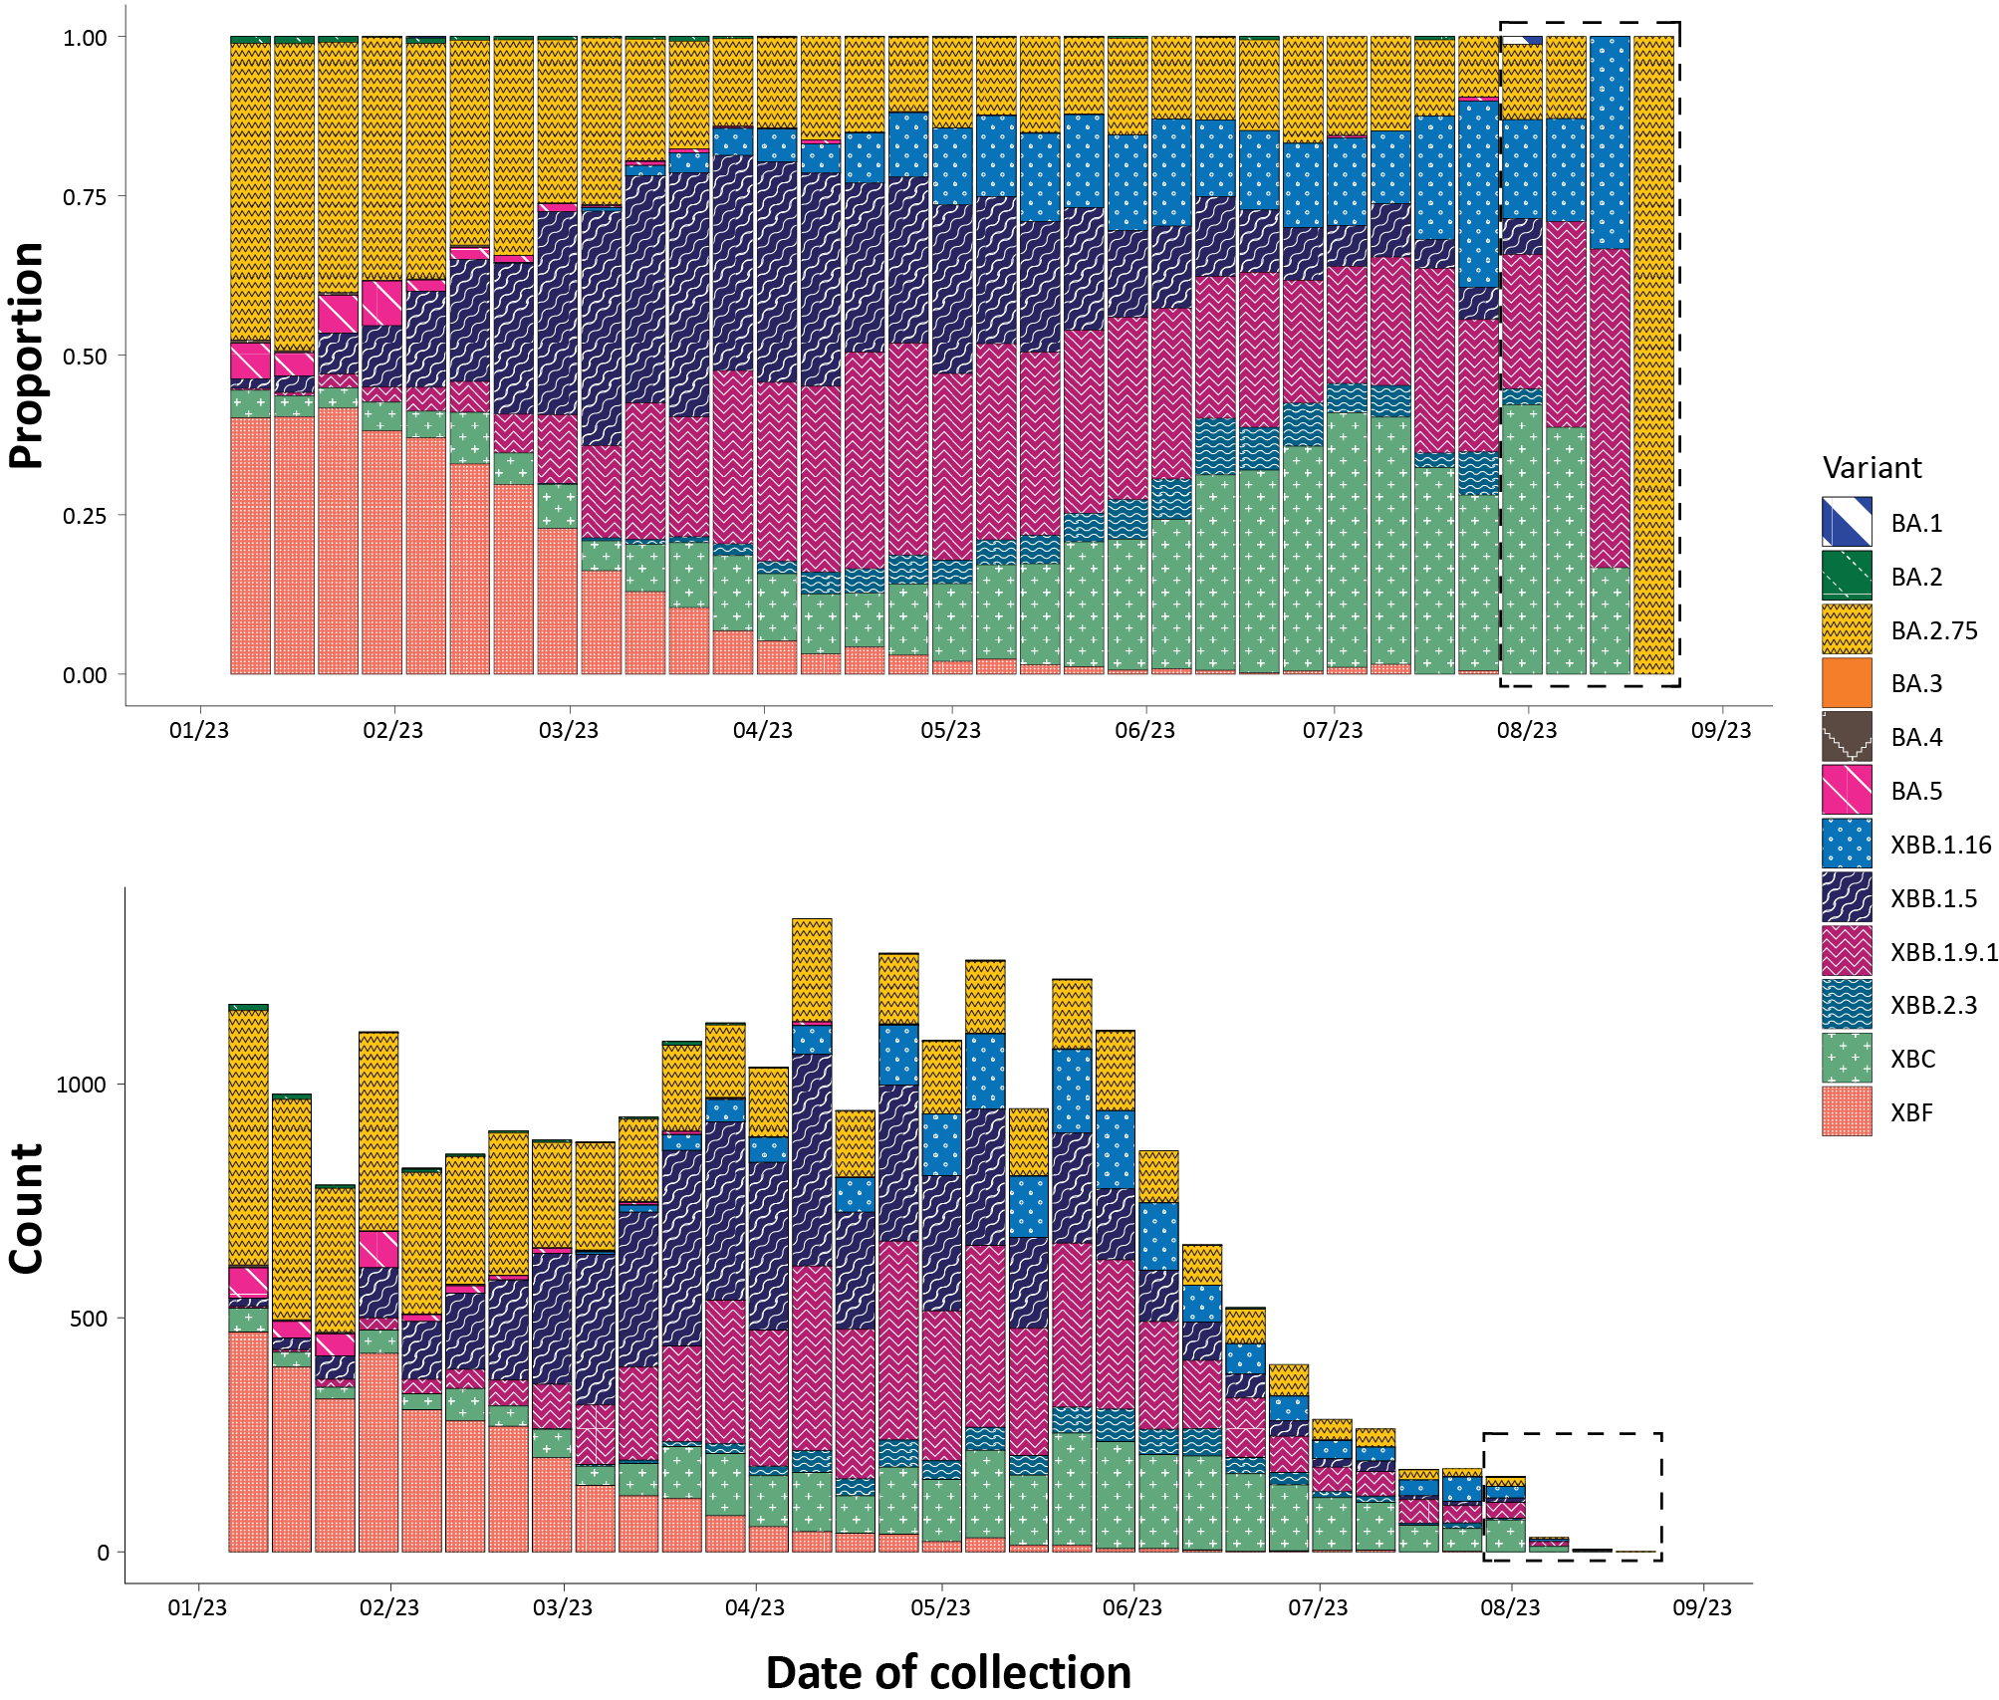
a Sequences in Austrakka aggregated by epidemiological week.
b The dashed box indicates the distribution of sequences collected within the reporting period.
c Proportions in Figure 8A may not be representative when sequence numbers are small; refer to Figure 8B. Data for earlier epidemiological weeks may change between reporting periods as sequences with older collection dates are uploaded. These numbers are not equivalent to number of cases, as there are many cases which may not be sequenced. Non-VOI and non-VUM Omicron sub-lineages have been collapsed into parent lineages BA.1, BA.2, BA.3, BA.4 and BA.5.
No BA.3, BA.4 or BA.5 Omicron sub-lineages were identified.
From 1 July 2023, jurisdictional sequencing strategies for SARS-CoV-2 have changed. Some jurisdictions have ceased SARS-CoV-2 sequencing, while other jurisdictions have reduced the number of SARS-CoV-2 cases being sequenced. For jurisdictions which are continuing SARS-CoV-2 genomic surveillance, SARS-CoV-2 cases which are likely to be prioritised for sequencing include ICU or hospitalised cases, high-risk cases, or cases of clinical significance. As a result, these changes are likely to affect the representativeness of the distribution of SARS-CoV-2 sub-lineages across Australia.
Case numbers and sequencing proportion are primarily based on polymerase chain reaction (PCR) results only, as RATs do not allow for sequencing. Since late 2022, the rates of PCR for testing and subsequent referrals of positive PCR samples to sequencing laboratories have decreased significantly, resulting in changes to sequencing strategies across the country.
The Australian SARS-CoV-2 genome sequences in AusTrakka identified as VOCs, VOIs or VUMs are highlighted in Table 8. The VOIs and VUMs where the proportion has increased compared to the previous reporting period are highlighted in orange, those that have remained stable are highlighted in blue, while those where proportions have decreased are highlighted in green.
In the reporting period to 27 August 2023, the VOI XBB.1.5 accounted for just 3.6% of sequences uploaded to AusTrakka, down from 4.9% in the previous period ending 30 July 2023. XBB.1.16 has also decreased, from 30.5% of sequences in July down to 20.7% for August (Table 8). In comparison, the recently added EG.5 (XBB.1.9.2.5) has increased from 5.9%, in the period ending 30 July, to 10.8% in this reporting period. Among the VUMs, the proportion of XBB.1.9.1, XBB.1.9.2 + sub-lineages has increased, while the proportion of newly added XBC sequences in this reporting period (32.3%) is comparable to that recorded in the previous 28-day period (36.4%) (Table 8). The proportion of BA.2.75 sub-lineages (including CH1.1) has seen a small decrease (Table 8).
The WHO has recently listed BA.2.86 as a VUM; however, no BA.2.86 sequences have been identified in the AusTrakka dataset (Table 8).

Table 8: Australian SARS-CoV-2 genome sequences in AusTrakka, identified as variants of concern, variants of interest or variants under monitoring and proportion of positive cases sequenced for the current and previous reporting periods, and since 23 January 2020 ^{a,b,c}
Variant category | Measure | Reporting period  31 July – 27 August 2023 | Previous reporting period  3 July – 30 July 2023 | Total sequences to date  23 January 2020 – 27 August 2023
Variants of concern (VOC) | BA.1 | 2 (0.8%) | 0 (0%) | 26,272 (16.6%)
Variants of concern (VOC) | BA.2 (excluding BA.2.75) | 0 (0%) | 0 (0%) | 41,469 (26.2%)
Variants of concern (VOC) | BA.2.75 | 24 (9.6%) | 77 (14.6%) | 14,409 (9.1%)
Variants of concern (VOC) | BA.3 | 0 (0%) | 0 (0%) | 3 (< 0.1%)
Variants of concern (VOC) | BA.4 | 0 (0%) | 0 (0%) | 5,052 (3.2%)
Variants of concern (VOC) | BA.5 | 0 (0%) | 1 (0.2%) | 43,201 (27.3%)
Variants of concern (VOC) | Total recombinants | 225 (89.6%) | 450 (85.2%) | 27,867 (17.6%)
Variants of concern (VOC) | Total VOC | 251 (100.0%) | 528 (100.0%) | 158,247 (100.0%)
Variants of interest (VOI) | XBB.1.5 + sub-lineages | 9 (3.6%) | 26 (4.9%) | 5,423 (3.4%)
Variants of interest (VOI) | XBB.1.16 | 52 (20.7%) | 108 (30.5%) | 3,728 (2.4%)
Variants under  monitoring (VUM) | XBB + all sub-lineages | 123 (49.0%) | 254 (48.1%) | 17,281 (10.9%)
Variants under  monitoring (VUM) | XBB.1.9.1, XBB.1.9.2  + sub-lineages | 47 (18.7%) | 78 (14.8%) | 5,085 (3.2%)
Variants under  monitoring (VUM) | XBB.2.3 ^{d} | 4 (1.6%) | — | 1,190 (0.8%)
Variants under  monitoring (VUM) | XBF | 0 (0%) | 3 (0.57%) | 6,556 (4.1%)
Variants under  monitoring (VUM) | XBC ^{d} | 81 (32.3%) | 192 (36.4%) | 3,729 (2.4%)
Variants under  monitoring (VUM) | BA.2.86 ^{d} | 0 (0%) | — | 0 (0%)
Omicron BA.2 | BA.2.75 + sub-lineages | 24 (9.6%) | 77 (14.6%) | 14,409 (9.1%)
Omicron BA.2 | CH.1.1 + sub-lineages (BA.2.75.1.1) | 24 (9.6%) | 77 (14.6%) | 4,321 (2.7%)
a All lineages have been designated as variants of concern (VOC), variants of interest (VUI) or variants under monitoring (VUM) in Australia, by the CDGN VOC working group.
b Sequencing of samples from cases identified in the reporting period may be in process at the time of reporting. Remaining unsequenced samples may be due to jurisdictional sequencing strategy, or where samples have been deemed unsuitable for sequencing (typically because viral loads were too low for sequencing to be successful).
c Proportional changes compared to the previous 28-day period are highlighted by the following colours: green boxes indicate a decrease; orange boxes indicate an increase and blue boxes indicate no change/stable.
d Newly added to the VOC/VUM/VOI list.

Acute respiratory illness

(FluTracking, ASPREN)
Based on self-reported FluTracking data,⁹ there has been an overall increase in the incidence of respiratory illness, ‘fever and cough’ and ‘runny nose and sore throat’ symptoms, in the community since late January 2023. The proportion of ‘fever and cough’ peaked in the week ending 4 June 2023 at 2.4% and decreased to a weekly average of 1.4% in the current four-week reporting period and is now similar to the proportion observed during the same period in 2022 (Figure 9). The proportion of ‘runny nose and sore throat’ has increased since late July 2023 to a weekly average of 1.5% in the current four-week reporting period. The proportion of ‘runny nose and sore throat’ is now slightly higher than the proportion observed in 2022 for the same period (Figure 10).
Figure 9: Weekly trends in fever and cough amongst FluTracking survey participants (age-standardised) compared to the average of the previous five years, Australia, 1 January 2020 – 27 August 2023 ª
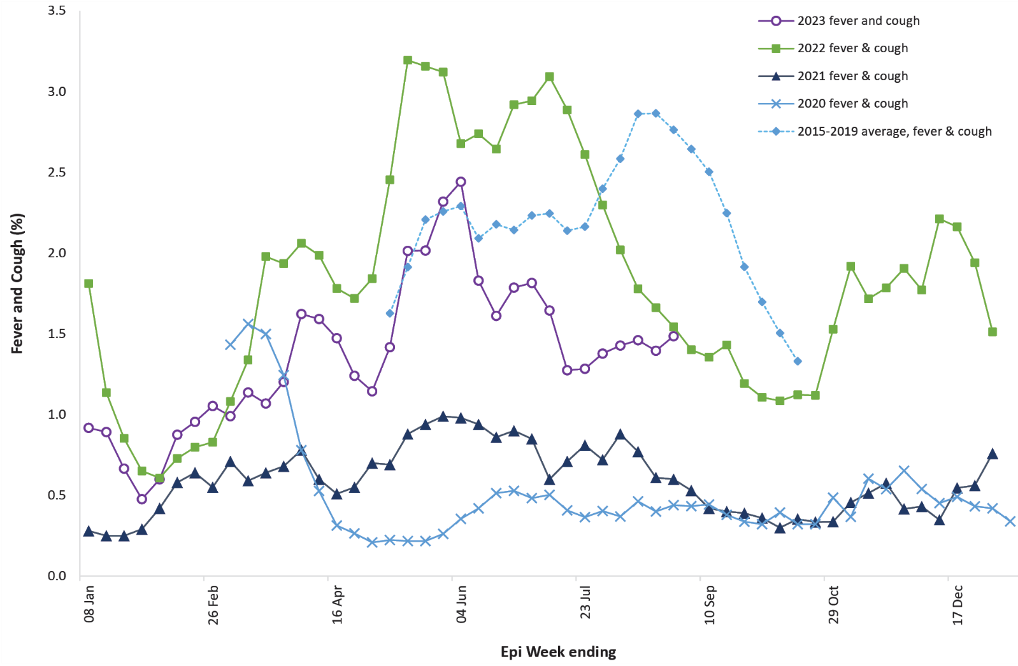
a In years prior to 2020, FluTracking was activated during the main Influenza season from May to October. A historical average beyond the week ending 11 October is therefore not available. In 2020, FluTracking commenced ten weeks early to capture data for COVID-19.

Figure 10: Weekly trends in runny nose and sore throat symptoms amongst FluTracking survey participants (age-standardised), Australia, 29 March 2020 – 27 August 2023 ª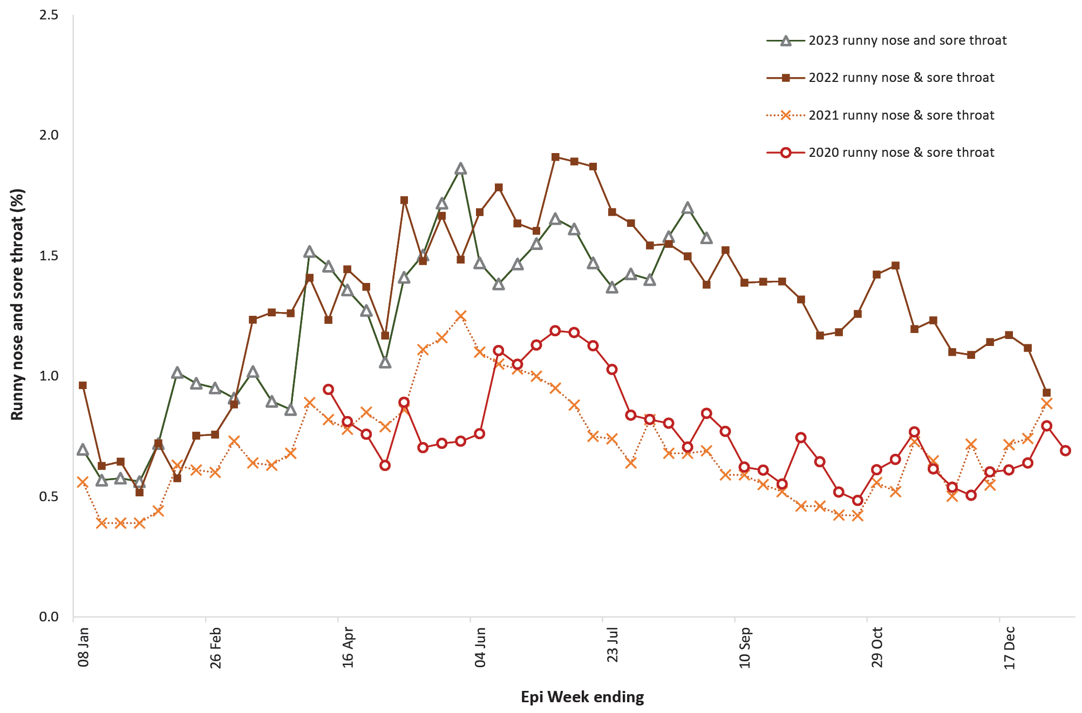
a Data on runny nose and sore throat were only collected systematically after 29 March 2020, therefore a historical average for this symptom profile is unavailable.
Over the reporting period, FluTracking data indicated that 9.7% of participants with ‘fever and cough’ were tested for SARS-CoV-2 with a PCR test and 67.1% were tested using a RAT (noting that in some instances RATs will be followed up by a PCR test for the same case). Of those with ‘runny nose and sore throat’, 23.2% were tested for SARS-CoV-2 using a PCR test and 8.5 % were tested using a RAT. In the current reporting period, the percent positivity for ‘fever and cough’ symptoms decreased for PCR (5.5%) and increased for RAT (15.5%) compared to the previous reporting period. For ‘runny nose and sore throat’ symptoms, the percent positivity increased for both PCR (5.1%) and RAT (2.9%). Note that participants with one set of symptoms are not excluded from having the other. It is important to acknowledge that there may be legitimate reasons why people did not get tested, including barriers to accessing testing. Symptoms reported to FluTracking are not specific to COVID-19 and may also be due to infections with other respiratory pathogens and to chronic diseases, such as asthma.
Since the start of 2023 to 27 August 2023, of those presenting to sentinel ASPREN sites with influenza-like illness who were tested for respiratory viruses, 63.3% (704/1,120) tested positive for a respiratory virus, similar to the previous four-week period. Among those positive, the most common viruses detected were rhinovirus (32.4%; 228/704), followed by influenza A (20.0%; 141/704), influenza B (14.6%; 103/704) and RSV (10.5%; 74/704).

COVID-19 trends by WHO region
Current trends in reported COVID-19 cases are an underestimate of the true number of global infections due to the reduction in testing and reporting in many countries. From 7 August 2023, the Regions of the Americas ceased reporting COVID-19 cases and deaths updates to WHO, which will impact the global interpretation. Data presented in this section may be incomplete and should, therefore, be interpreted with caution.
As of 27 August 2023, over 770 million COVID-19 cases and over 6.9 million deaths have been reported globally since the start of the pandemic, with a global case fatality rate (CFR) of approximately 0.90%.¹⁰
At the WHO regional level, the number of newly reported cases in the four-week period to 27 August 2023 increased across three of the five WHO regions: the European Region (+39%), the Western Pacific Region (+52%), and the Eastern Mediterranean Region (+113%); while case numbers decreased in two WHO regions: the African Region (-76%), and the South-East Asia Region (-48%) (Table 9). The number of newly reported deaths within the 28-day period has decreased across three regions: the African Region (-73%), the South-East Asia Region (-51%), and the European Region (-43%); while death numbers increased in two WHO regions: the Eastern Mediterranean Region (+33%), and the Western Pacific Region (+9%) (Table 9).¹⁰
Table 9: Newly reported and cumulative COVID-19 cases and deaths, by WHO Region, reported in the four-week period to 27 August 2023 ^{a,b}
WHO Region | Cumulative cases | New cases reported in the last 4 weeks | Change in new cases in the last 4 weeks ^{b} | Cumulative deaths | New deaths reported in the last 4 weeks | Change in new deaths in the last 4 weeks ^{b}
Western Pacific | 206,823,836 | 1,298,782 | +52% | 416,682 | 1,092 | +9%
Europe | 275,912,918 | 104,681 | +39% | 2,247,113 | 682 | -43%
South-East Asia | 61,201,773 | 3,780 | -48% | 806,661 | 54 | -51%
Eastern Mediterranean | 23,388,656 | 3,139 | +113% | 351,395 | 28 | +33%
Americas | 193,210,684 | 1,122 | N/A ^{c} | 2,958,886 | 28 | N/A ^{c}
Africa | 9,547,082 | 746 | -76% | 175,423 | 4 | -73%
Global | 770,085,713 | 1,412,250 | +38% | 6,956,173 | 1,888 | -50%
a Source: World Health Organization Coronavirus (COVID-19) Dashboard,11 accessed 29 September 2023, for data until 27 August 2023.
b Percent change in the number of newly confirmed cases/deaths in the most recent four-week period compared to the four weeks prior.
c From 7 August 2023, the Regions of the Americas ceased reporting COVID-19 cases and deaths updates to WHO.

Acknowledgements
We thank public health staff from incident emergency operations centres and public health units in state and territory health departments, and the Australian Government Department of Health and Aged Care, along with state and territory public health laboratories. We thank those who have provided data from surveillance systems, such as Commonwealth respiratory clinics, ASPREN, FluTracking, FluCAN, PAEDS, SPRINT-SARI, the Communicable Disease Genomics Network, AusTrakka and jurisdictional sequencing laboratories.

Author details

Corresponding author
COVID-19 Epidemiology and Surveillance Team
Australian Government Department of Health and Aged Care, GPO Box 9484, MDP 14, Canberra, ACT 2601.
Email: epi.coronavirus@health.gov.au

References
- COVID-19 National Incident Room Surveillance Team. COVID-19 Australia: Epidemiology Report 77: Reporting period ending 30 July 2023. Commun Dis Intell (2018). 2023;47. doi: https://doi.org/10.33321/cdi.2023.47.58.
- COVID-19 National Incident Room Surveillance Team. Technical supplement. COVID-19 Australia: Epidemiology reporting. Commun Dis Intell (2018). 2021;45. doi: https://doi.org/10.33321/cdi.2021.45.2.
- Australian Government Department of Health and Aged Care. Coronavirus (COVID-19) – CDNA National Guidelines for Public Health Units. [Internet.] Canberra: Australian Government Department of Health and Aged Care; 14 October 2022. [Accessed on 9 November 2022.] Available from: https://www.health.gov.au/resources/publications/coronavirus-covid-19-cdna-national-guidelines-for-public-health-units.
- FluCAN (The Influenza Complications Alert Network). FluCAN (Influenza surveillance). [Webpage.] Melbourne: Monash Health, FluCAN. [Accessed on 30 June 2023.] Available from: https://monashhealth.org/services/monash-infectious-diseases/research/influenza-research/flucan-influenza-surveillance-2/.
- Australian and New Zealand Intensive Care Research Centre (ANZIC-RC). SPRINT-SARI: Short period incidence study of severe acute respiratory infection. [Internet.] Melbourne: Monash University, ANZIC-RC; 2020. Available from: https://www.monash.edu/medicine/sphpm/anzicrc/research/sprint-sari.
- Communicable Diseases Genomics Network (CDGN). AusTrakka. [Website.] Melbourne: CDGN; 2020. Available from: https://www.cdgn.org.au/austrakka.
- World Health Organization (WHO). Updated working definitions and primary actions for SARS-CoV-2 variants. Geneva: WHO; 15 March 2023. [Accessed on 26 September 2023.] Available from: https://www.who.int/publications/m/item/updated-working-definitions-and-primary-actions-for--sars-cov-2-variants.
- WHO. Tracking SARS-CoV-2 variants. [Webpage.] Geneva: WHO; 17 August 2023. [Accessed on 23 August 2023.] Available from: https://www.who.int/activities/tracking-SARS-CoV-2-variants.
- Dalton C, Durrheim D, Fejsa J, Francis L, Carlson S, d’Espaignet ET et al. Flutracking: a weekly Australian community online survey of influenza-like illness in 2006, 2007 and 2008. Commun Dis Intell Q Rep. 2009;33(3):316–22.
- WHO. Weekly epidemiological update on COVID-19 – 1 September 2023. [Internet.] Geneva: WHO; 1 September 2023. [Accessed on 29 September 2023.] Available from: https://www.who.int/publications/m/item/weekly-epidemiological-update-on-covid-19---1-september-2023.
- WHO. WHO Coronavirus Disease (COVID-19) dashboard. [Internet.] Geneva: WHO; 2021. Available from: https://covid19.who.int/.

Appendix A: Supplementary figures and tables
Table A.1: COVID-19 cases and rates per 100,000 population, by age group, sex, and date of onset, Australia, 15 December 2021 – 27 August 2023 ^{a,b,c,d}
Age group (years) | Four-week reporting period |  |  |  |  |  | Entire ‘Omicron’ wave to date
Age group (years) | 31 July – 27 August 2023 |  |  |  |  |  | 15 December 2021 – 27 August 2023
Age group (years) | Cases |  |  | Rate per 100,000 population |  |  | Cases |  |  | Rate per 100,000 population
Age group (years) | Male | Female | People ^{d} | Male | Female | People ^{d} | Male | Female | People ^{d} | Male | Female | People ^{d}
0–9 | 900 | 756 | 1,686 | 56.1 | 49.9 | 54.0 | 518,423 | 492,292 | 1,131,359 | 32,298.5 | 32,472.4 | 36,248.3
10–19 | 759 | 795 | 1,585 | 46.5 | 51.7 | 50.0 | 653,920 | 694,779 | 1,485,253 | 40,065.0 | 45,143.9 | 46,836.0
20–29 | 709 | 1,345 | 2,131 | 40.3 | 79.7 | 61.8 | 792,673 | 968,982 | 1,887,518 | 45,005.1 | 57,423.5 | 54,730.9
30–39 | 1,017 | 1,939 | 3,014 | 54.1 | 101.1 | 79.3 | 815,707 | 1,018,704 | 1,981,676 | 43,354.0 | 53,120.4 | 52,159.9
40–49 | 958 | 1,875 | 2,867 | 58.3 | 111.5 | 86.3 | 677,303 | 858,771 | 1,657,923 | 41,228.3 | 51,086.5 | 49,880.0
50–59 | 921 | 1,767 | 2,725 | 58.7 | 109.1 | 85.5 | 549,428 | 682,145 | 1,319,766 | 35,045.7 | 42,132.4 | 41,413.6
60–69 | 975 | 1,439 | 2,450 | 72.1 | 99.8 | 87.7 | 398,513 | 461,724 | 914,164 | 29,455.0 | 32,027.1 | 32,711.5
70–79 | 1,062 | 1,039 | 2,127 | 109.4 | 99.2 | 105.4 | 254,783 | 259,881 | 539,786 | 26,255.8 | 24,804.0 | 26,746.9
80–89 | 750 | 798 | 1,557 | 186.4 | 160.2 | 172.9 | 115,424 | 130,786 | 255,892 | 28,680.6 | 26,256.6 | 28,415.0
90 + | 230 | 447 | 680 | 303.3 | 321.8 | 316.7 | 30,034 | 55,659 | 88,521 | 39,603.9 | 40,069.0 | 41,221.6
a Source: NNDSS, extract from 26 September 2023 for notifications to 27 August 2023.
b Population data based on Australian Bureau of Statistics (ABS) Estimated Resident Population (ERP) as at June 2022.
c Excludes cases where age was unknown.
d Total cases includes those where sex was unknown and those classified as X, i.e., persons who reported their sex as another term, other than male or female.

Communicable Diseases Intelligence
ISSN: 2209-6051 Online

Communicable Diseases Intelligence (CDI) is a peer-reviewed scientific journal published by the Office of Health Protection, Department of Health and Aged Care. The journal aims to disseminate information on the epidemiology, surveillance, prevention and control of communicable diseases of relevance to Australia.

Editor: Christina Bareja
Deputy Editor: Simon Petrie
Design and Production: Kasra Yousefi
Editorial Advisory Board: David Durrheim, Mark Ferson, Clare Huppatz, John Kaldor, Martyn Kirk, Meru Sheel and Steph Williams

Website: http://www.health.gov.au/cdi

Contacts
CDI is produced by the Office of Health Protection, Australian Government Department of Health and Aged Care, GPO Box 9848, (MDP 6) CANBERRA ACT 2601

Email: cdi.editor@health.gov.au

Submit an Article
You are invited to submit your next communicable disease related article to the Communicable Diseases Intelligence (CDI) for consideration. More information regarding CDI can be found at: http://health.gov.au/cdi.
Further enquiries should be directed to: cdi.editor@health.gov.au.

This journal is indexed by Index Medicus and Medline.

Creative Commons Licence - Attribution-NonCommercial-NoDerivatives CC BY-NC-ND
© 2023 Commonwealth of Australia as represented by the Department of Health and Aged Care
This publication is licensed under a Creative Commons Attribution-NonCommercial-NoDerivatives 4.0 International Licence from https://creativecommons.org/licenses/by-nc-nd/4.0/legalcode (Licence). You must read and understand the Licence before using any material from this publication.

Restrictions
The Licence does not cover, and there is no permission given for, use of any of the following material found in this publication (if any):
- the Commonwealth Coat of Arms (by way of information, the terms under which the Coat of Arms may be used can be found at www.itsanhonour.gov.au);
- any logos (including the Department of Health and Aged Care’s logo) and trademarks;
- any photographs and images;
- any signatures; and
- any material belonging to third parties.

Disclaimer
Opinions expressed in Communicable Diseases Intelligence are those of the authors and not necessarily those of the Australian Government Department of Health and Aged Care or the Communicable Diseases Network Australia. Data may be subject to revision.

Enquiries
Enquiries regarding any other use of this publication should be addressed to the Communication Branch, Department of Health and Aged Care, GPO Box 9848, Canberra ACT 2601, or via e-mail to: copyright@health.gov.au

Communicable Diseases Network Australia
Communicable Diseases Intelligence contributes to the work of the Communicable Diseases Network Australia.
http://www.health.gov.au/cdna

