COVID-19 Australia: Epidemiology Report 53
Reporting period ending 24 October 2021
COVID-19 National Incident Room Surveillance Team

Summary
Trends – The daily average of 2,195 cases for this reporting period was similar to the previous fortnight’s daily average of 2,158 cases. There were 30,727 cases of coronavirus disease 2019 (COVID-19) reported this fortnight, bringing the 2021 cumulative case count to 130,980 cases.
Local cases – More than 99% (30,693/30,727) of COVID-19 cases reported this fortnight are known to be locally acquired (including cases under initial investigation). The majority of these cases were reported in Victoria (84%; 25,742/30,693), followed by New South Wales (15%; 4,580/30,693).
Clusters and high-risk settings – As at 24 October 2021, there had been 67,910 locally-acquired cases in New South Wales, including 501 deaths, since the first case of the Sydney Metropolitan outbreak was reported on 16 June 2021. Genomic testing showed that the outbreak’s primary case was infected with the ‘Delta’ SARS-CoV-2 variant of concern (B.1.617.2). Several cases in other states had also been linked to this cluster. The fortnightly number of new locally-acquired cases reported in New South Wales continued to decrease, with 4,580 locally-acquired cases reported this reporting period, compared to 9,242 locally-acquired cases reported in the previous reporting period. At the end of this reporting period, new case numbers were reducing in south-western and western Sydney and increasing case numbers were being seen in some regional and remote areas, particularly in the Hunter New England, Mid-North Coast and Albury-Wodonga regions.
As at 24 October 2021, there were 58,798 cases, including 229 deaths, associated with the Victorian outbreaks since the first cases were reported on 5 August 2021. These primary cases involved the Delta variant and were closely associated with the current New South Wales and recent July 2021 Victorian outbreaks. The size of the Victorian outbreak continued to increase during the reporting period, with 25,742 locally acquired cases reported this fortnight compared to 20,441 in the previous fortnight. Most new cases in the outbreak were across several parts of Greater Melbourne; however, there was a considerable increase in the number of cases identified in regional and remote residents in the past few weeks.
As at 24 October 2021, a total of 1,595 cases, including eight deaths, had been reported as part of the Australian Capital Territory outbreak. The primary case in the outbreak was reported on 12 August 2021 and was infected with the Delta variant. The number of new cases in the Australian Capital Territory during this reporting period (361) was lower than in the previous reporting period (463).
Aboriginal and Torres Strait Islander persons – During the reporting period, 1,152 new cases were notified in Aboriginal and Torres Strait Islander people, of whom 762 were from New South Wales; 320 were from Victoria; and 67 were from the Australian Capital Territory. To date in 2021, there have been 6,084 cases and 13 deaths reported among Aboriginal and Torres Strait Islander people. Of locally-acquired cases notified in Aboriginal and Torres Strait Islander people in 2021, thirty-three percent (2,013/6,079) lived in a regional or remote area.
Overseas cases – There were 34 overseas-acquired cases this reporting period, with the largest numbers of cases reported in Queensland (29%; 10/34) and New South Wales (26%; 9/34).
Severity – In 2021, based on the highest level of severity reported for cases with an illness onset up to 10 October 2021, 0.7% of cases were reported to have died, 1.4% of cases required intensive care and a further 10.4% required admission to hospital, noting that cases may be hospitalised for reasons other than clinical COVID-19 related care. Given the delay between illness onset and severe illness, cases with an onset in the last two weeks were excluded from the analysis on severity. During the reporting period, 180 new COVID-19-associated deaths were notified.
Vaccinations – As at 24 October 2021, there had been 34,364,950 doses of COVID-19 vaccine administered in Australia. Nationally, 17,899,161 people aged 16 years or over (86.8%) had received at least one dose, including 15,140,516 people aged 16 and over (73.4%) who were fully vaccinated.
Keywords: SARS-CoV-2; novel coronavirus; 2019-nCoV; coronavirus disease 2019; COVID-19; acute respiratory disease; epidemiology; Australia
This reporting period covers the two-week period 11–24 October 2021, with data for this period compared to that from the previous two-week reporting period (27 September – 10 October 2021).¹ The focus of this report is on the epidemiological situation in Australia since the beginning of 2021. Readers are encouraged to consult prior reports in this series for information on the epidemiology of cases in Australia in 2020.
Acute respiratory illness, testing, public health response measures, virology and the international situation are reported in detail on a four-weekly basis and are not included in this report. The latest information on these topics can be found in Epidemiology Report 52;¹ state and territory health websites; the weekly situation reports of the World Health Organization (WHO); and the Department of Health’s current situation and case numbers webpage.
From report 46 onward, and unless otherwise specified, tabulated data and data within the text are extracted from the National Interoperable Notifiable Diseases Surveillance System (NINDSS) based on ‘notification received date’ rather than ‘diagnosis date’ (see the Technical Supplement for definitions).² As a case’s diagnosis date can be several days prior to the date of its notification, there is potential for newly-notified cases to be excluded from the case count in the current reporting period when reporting by ‘diagnosis date’. Using ‘notification received date’ ensures that the case count for the reporting period better reflects the number of newly-notified cases. As the graphs presented in this report, based on NINDSS data, reflect a larger time period (i.e. year to date and entire pandemic), these will continue to be based on diagnosis date to enable a more accurate understanding of infection risk and local transmission.

Background and data sources
See the Technical Supplement for general information on COVID-19 including modes of transmission, common symptoms and severity.²

Activity

COVID-19 trends

(NINDSS and jurisdictional reporting to NIR)
The number of cases reported this fortnight was similar to the number reported in the previous fortnight. A total of 30,727 cases were notified in this two-week reporting period (an average of 2,195 cases per day), compared to 30,218 cases (an average of 2,158 cases per day) in the previous reporting period. The majority of cases occurred in Victoria (84%; 25,750/30,727), followed by New South Wales (15%; 4,589/30,727) (Table 1).
Table 1: COVID-19 notifications by jurisdiction and source of acquisition, with a notification received date of 11–24 October 2021ª
Source^{b} | ACT | NSW | NT | Qld | SA | Tas. | Vic. | WA | Australia
Overseas | 0 | 9 | 2 | 10 | 3 | 0 | 8 | 2 | 34
Locally acquired – acquired within jurisdiction of notification | 357 | 4,576 | 0 | 0 | 1 | 0 | 11,237 | 0 | 16,171
Locally acquired – acquired interstate | 4 | 1 | 5 | 1 | 2 | 1 | 0 | 0 | 14
Under initial investigation | 0 | 3 | 0 | 0 | 0 | 0 | 14,505 | 0 | 14,508
Missing source of acquisition | 0 | 0 | 0 | 0 | 0 | 0 | 0 | 0 | 0
Total | 361 | 4,589 | 7 | 11 | 6 | 1 | 25,750 | 2 | 30,727
a Source: NINDSS, extract from 26 October 2021 for notifications to 24 October 2021.
b ACT: Australian Capital Territory; NSW: New South Wales; NT: Northern Territory; Qld: Queensland; SA: South Australia; Tas.: Tasmania; Vic.: Victoria; WA: Western Australia.
In the year to date, from 1 January 2021 to 24 October 2021, there have been 130,980 COVID-19 cases reported nationally. Until the week ending 20 June 2021, the number of weekly cases diagnosed this year had been below 180 cases per week. Since then, cases have increased and there have been over 1,000 cases diagnosed each week since the week ending 25 July 2021 and over 10,000 cases diagnosed each week since the week ending 5 September 2021. In the latest fortnight, case numbers remained at approximately 15,000 per week in the first week, before dropping to approximately 10,000 in the most recent week, noting that this most recent week is likely an underestimate as additional cases may be identified in the coming week that have a diagnosis date in this period (Figure 1). The current peak in 2021 is over 15,000 cases per week, which occurred in the week ending 3 October 2021. This peak considerably surpasses the two distinct peaks experienced in March and July of 2020, when new cases diagnosed per week reached approximately 2,700 and 3,000, respectively (Figure 2). Cumulatively, since the beginning of the epidemic in Australia, there have been 159,393 COVID-19 cases reported in Australia.

Figure 1: COVID-19 notified cases by source of acquisition and diagnosis date, 28 December 2020 – 24 October 2021^{a,b}
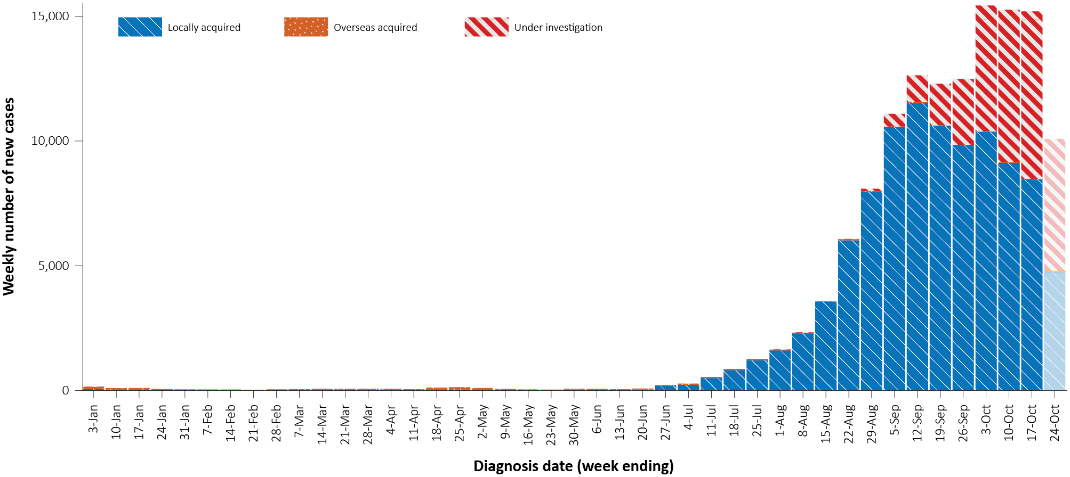
a Source: NINDSS, extract from 26 October 2021 for notifications to 24 October 2021.
b The lighter bar at the right represents the most recent reporting week and should be interpreted with caution as additional cases may be identified in the coming week that have a diagnosis date during this period.
Figure 2: COVID-19 notified cases by source of acquisition and diagnosis date, 2 March 2020 – 24 October 2021^{a,b}
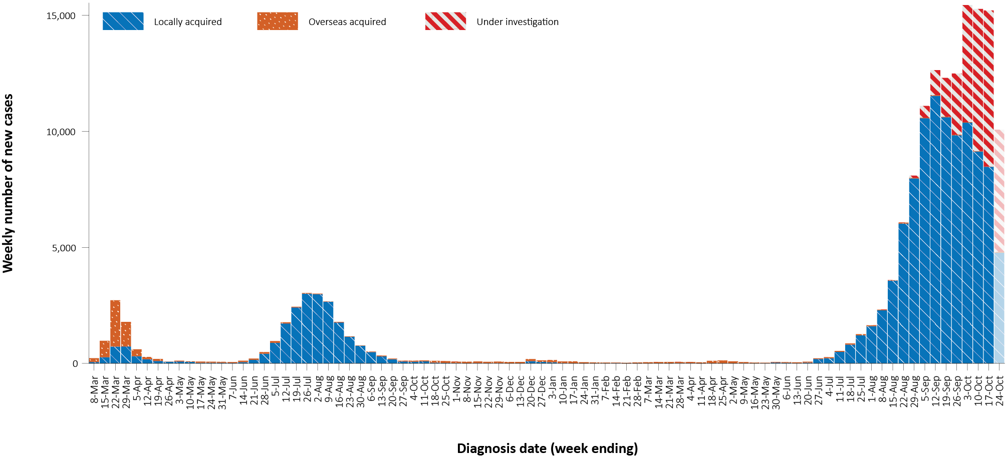
a Source: NINDSS, extract from 26 October 2021 for notifications to 24 October 2021.
b The lighter bar at the right represents the most recent reporting week and should be interpreted with caution as additional cases may be identified in the coming week that have a diagnosis date during this period.

Table 2: Locally-acquired COVID-19 case numbers and rates per 100,000 population by jurisdiction and reporting period, Australia, with a notification received date from 1 January to 24 October 2021
Jurisdiction | Reporting period | Reporting period | Cases this year
Jurisdiction | 11—24 October 2021 | 27 September –  10 October 2021 | 1 January – 24 October 2021
Jurisdiction | Number of cases^{b} | Number of cases^{b} | Number of cases^{b} | Rate per 100,000 population^{c}
ACT | 361 | 463 | 1,595 | 369.8
NSW | 4,580 | 9,242 | 67,668 | 828.5
NT | 5 | 0 | 17 | 6.9
Qld | 1 | 11 | 254 | 4.9
SA | 3 | 8 | 42 | 2.4
Tas. | 1 | 1 | 3 | 0.6
Vic. | 25,742 | 20,441 | 59,513 | 888.7
WA | 0 | 0 | 18 | 0.7
Australia | 30,693 | 30,166 | 129,110 | 502.4
a Source: NINDSS, extract from 26 October 2021 for notifications to 24 October 2021.
b This total includes cases under initial investigation and excludes overseas acquired cases and with a missing source of acquisition. In reports prior to report 51, cases under initial investigation were excluded from this total.
c Population data based on Australian Bureau of Statistics (ABS) Estimated Resident Population (ERP) as at June 2020. The ABS June 2020 ERP was ACT: 431,325; NSW: 8,168,893; NT: 246,283; Qld: 5,176,044; SA: 1,770,494; Tas.: 540,781; Vic.: 6,696,630; WA: 2,663,976; Australia: 25,698,093.

Source of acquisition

(NINDSS)
In this reporting period, > 99% of cases notified (30,693/30,727) were considered to be acquired within Australia (including cases under initial investigation), comprising 53% (16,171) cases acquired within the reporting jurisdiction, 47% (14,508/30,693) cases under initial investigation and 14 interstate-acquired cases; < 1% of cases (34/30,727) were overseas acquired (Table 1). Victoria reported the majority of locally-acquired cases (84%; 25,742/30,693) in this fortnight, followed by New South Wales (15%; 4,580/30,693) and the Australian Capital Territory (1%; 361/30,693). All locally-acquired cases in the Northern Territory, Queensland and Tasmania during the reporting period were acquired interstate. Western Australia did not report any locally-acquired cases.
For 2021 to date, Victoria had the highest notification rate for locally-acquired cases with 888.7 notifications per 100,000 population, followed by New South Wales with a rate of 828.5 notifications per 100,000 population and the Australian Capital Territory with a rate of 369.8 notifications per 100,000 population (Table 2).
In the reporting period, Queensland reported the largest number of overseas-acquired cases (29%; 10/34), followed by New South Wales (26%; 9/34) and Victoria (22%; 8/34) (Table 1). In the past 28 days (27 September to 24 October 2021), thirty-six percent (31/86) of confirmed overseas-acquired cases reported to the NINDSS had an unknown country of acquisition. Cases acquired at sea (40%; 22/55) were the most frequent of those with an identified country of acquisition in the past 28 days, followed by cases acquired in the United Kingdom (9%; 5/55) and Pakistan (7%; 4/55). The number of cases acquired in different countries is influenced by travel patterns of returning Australians, travel restrictions, and the prevalence of COVID-19 in the country of travel.

Demographic features

(NINDSS)
In this reporting period, the largest proportion of cases occurred in those aged 20 to 29 years (19%; 5,745/30,727). For this year, the highest rate of infection has been in those aged 20 to 29 years with a rate of 754.8 infections per 100,000 population (Figure 3; Appendix A, Table A.1). Adults aged 70 to 79 years have had the lowest rate of infection this year.
Figure 3: Cumulative COVID-19 cases for the calendar year to date, by age group and sex, Australia, with a diagnosis date of 1 January 2021 – 24 October 2021ª
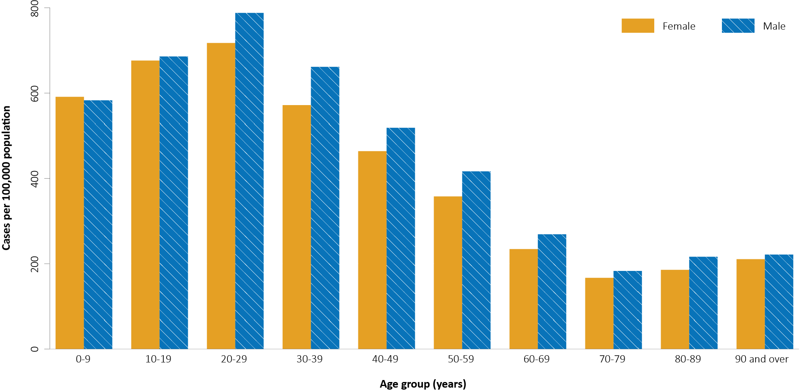
a Source: NINDSS, extract from 26 October 2021 for notifications to 24 October 2021.
In 2021, notification rates were higher among males than females in most age groups, though rates were similar among males and females in those aged 0 to 19 years and were also similar in those over 90 years old (Figure 3; Appendix A, Table A.1). The median age of cases in this reporting period was 30 years (range: 0 to 101 years; interquartile range, IQR: 16 to 45 years).

Aboriginal and Torres Strait Islander persons

(NINDSS)
During the reporting period, there were 1,152 new cases notified in Aboriginal and Torres Strait Islander people, with 762 from New South Wales, 320 from Victoria, 67 from the Australian Capital Territory and three from the Northern Territory. Since the beginning of 2021, there have been 6,084 confirmed cases of COVID-19 notified in Aboriginal and Torres Strait Islander people, representing 5% (6,084/130,980) of all confirmed cases this year. Of the locally-acquired cases notified in Aboriginal and Torres Strait Islander people in 2021, thirty-three percent (2,013/6,079) resided in a regional or remote area (Table 3).
Table 3: Confirmed cases of COVID-19 among Aboriginal and Torres Strait Islander peoples by place of acquisition and area of remoteness, 1 January – 24 October 2021ª
Jurisdiction | Locally acquired, Australiaª |  |  |  |  |  | Overseas acquired | Total
Jurisdiction | Major city | Inner regional | Outer regional | Remote | Overseas resident | Unknown | Overseas acquired | Total
ACT | 184 | 0 | 0 | 0 | 0 | 0 | 0 | 184
NSW | 3,503 | 1,111 | 309 | 342 | 5 | 49 | 1 | 5,347
NT | 0 | 0 | 3 | 0 | 0 | 0 | 0 | 3
Qld | 3 | 0 | 1 | 0 | 0 | 0 | 3 | 7
SA | 0 | 0 | 0 | 0 | 0 | 0 | 0 | 0
Tas. | 0 | 1 | 0 | 0 | 0 | 0 | 0 | 1
Vic. | 295 | 120 | 126 | 0 | 0 | 0 | 0 | 541
WA | 0 | 0 | 0 | 0 | 0 | 0 | 1 | 1
Australia | 4,012 | 1,232 | 439 | 342 | 5 | 49 | 5 | 6,084
a Source: NINDSS, extract from 26 October 2021 for notifications to 24 October 2021.
b ‘Locally acquired’ includes cases under initial investigation. Note, in reports prior to report 52, ‘locally acquired’ excluded cases under initial investigation.
c ‘Remote’ here also includes areas classified as ‘very remote’.
The majority of cases reported in Aboriginal and Torres Strait Islander people in 2021 have been associated with the Sydney metropolitan and western regional outbreaks in New South Wales. There have been 5,345 locally acquired cases reported in Aboriginal and Torres Strait Islander people in New South Wales since 16 June 2021 when the Sydney metropolitan outbreak began. Since the start of the pandemic, there have been 13 COVID-19 associated deaths in Aboriginal and Torres Strait Islander people, all of which were associated with the current outbreaks in New South Wales. There has also been an increasing number of cases in Victoria in recent weeks, particularly in regional areas. In total, there have been 541 locally acquired Aboriginal and Torres Strait Islander cases reported in Victoria since the start of the outbreak on 5 August 2021, with 45% (246/541) of these cases occurring in regional residents.
Cumulatively, since the beginning of the epidemic in Australia, there have been 6,233 cases in Aboriginal and Torres Strait Islander people, representing approximately 4% (6,233/159,393) of all confirmed cases in Australia. Indigenous status was unknown for approximately 19% of confirmed cases (29,926/159,393), with the majority of these associated with more recently-reported cases, especially in Victoria and New South Wales.
Up to 24 October 2021, it has been 0 days since the last locally-acquired Aboriginal and Torres Strait Islander case was diagnosed and 99 days since the last overseas-acquired Aboriginal and Torres Strait Islander case was diagnosed. To date, the majority of Aboriginal and Torres Strait Islander cases were reported as locally acquired (95%; 5,926/6,233), with 37 cases that were overseas acquired and 270 cases under investigation (most of which are known to be locally-acquired). The median age of locally-acquired Aboriginal and Torres Strait Islander cases is 21 years old (range 0 to 99 years, IQR: 10 to 35 years), while the median age of overseas-acquired cases is 40 years old (range 7 to 75 years; IQR: 27 to 57 years). Overall, the distribution among males and females was similar at 49% (3,067/6,219) and 51% (3,152/6,219) of cases, respectively, where the denominator is the cases for which sex was known.
Give the delay between onset and severe illness, cases with an onset in the last two weeks were excluded from the following analysis on severity. In 2021, based on the highest level of severity reported for cases with an illness onset up to 10 October, 0.2% of cases in Aboriginal and Torres Strait Islander people were reported to have died, 1.2% of cases required intensive care and a further 10.4% required admission to hospital (Table 4). Note that hospitalisation data in NINDSS should be interpreted with caution: hospitalisation is not always reflective of severe illness, as cases may be hospitalised for reasons other than clinical COVID-19 related care; additionally, hospitalisation and ICU status in NINDSS is likely incomplete.
Table 4: COVID-19 cases in Aboriginal and Torres Strait Islander people by age group and highest level of illness severity, 1 January 2021 – 10 October 2021ª
Age group | Count |  |  |  |  | % of total cases by age group
Age group | Not severe^{b} | Hospitalised only | ICU | Died | Total cases | Hospitalised only | ICU | Died
Age group | Not severe^{b} | (not ICU or died) | (but not died) | Died | Total cases | (not ICU or died) | (but not died) | Died
0–4 | 584 | 31 | 0 | 0 | 615 | 5.0% | 0.0% | 0.0%
5–11 | 777 | 23 | 1 | 0 | 801 | 2.9% | 0.1% | 0.0%
12–15 | 426 | 18 | 2 | 0 | 446 | 4.0% | 0.4% | 0.0%
16–17 | 199 | 15 | 2 | 0 | 216 | 6.9% | 0.9% | 0.0%
18–29 | 1,085 | 137 | 9 | 0 | 1,231 | 11.1% | 0.7% | 0.0%
30–39 | 652 | 104 | 9 | 0 | 765 | 13.6% | 1.2% | 0.0%
40–49 | 422 | 86 | 10 | 2 | 520 | 16.5% | 1.9% | 0.4%
50–59 | 260 | 60 | 13 | 4 | 337 | 17.8% | 3.9% | 1.2%
60–69 | 81 | 42 | 9 | 2 | 134 | 31.3% | 6.7% | 1.5%
70–79 | 18 | 14 | 4 | 2 | 38 | 36.8% | 10.5% | 5.3%
80–89 | 1 | 2 | 0 | 2 | 5 | 40.0% | 0.0% | 40.0%
90+ | 1 | 1 | 0 | 0 | 2 | 50.0% | 0.0% | 0.0%
Unknown | 0 | 0 | 0 | 0 | 0 | 0.0% | 0.0% | 0.0%
Total | 4,506 | 533 | 59 | 12 | 5,110 | 10.4% | 1.2% | 0.2%
a Source: NINDSS, extract from 26 October 2021. Includes cases notified from 1 January 2021, with an illness onset up to 10 October 2021. Cases with an illness onset in the last two weeks (11 to 24 October 2021) were excluded to account for the delay between onset and development of severe illness.
b ‘Not severe’ includes all cases that were not hospitalised, admitted to ICU or died.

Vaccinations

(Department of Health)
As of 24 October 2021, a total of 34,364,950 doses of COVID-19 vaccine had been administered (Table 5), including 1,103,510 doses provided to aged care and disability residents. Nationally, 17,899,161 people aged 16 years or over (86.8%) had received at least one dose. This includes 15,140,516 people aged 16 and over (73.4%) who were fully vaccinated (Table 5). Among people aged 12–15 years, 793,696 people (63.8%) had received at least one dose, including 428,747 (34.5%) who were fully vaccinated.
Table 5: Total number of vaccinations administered, by jurisdiction, Australia, 24 October 2021ª
Jurisdiction | Total number of doses administered | Percentage of people aged 16 and over who have had at least one dose^{b} | Percentage of people aged 16 and over who are fully vaccinated
ACT | 855,730 | >95% | 87.9%
NSW | 12,114,895 | 93.1% | 85.0%
NT | 308,836 | 73.7% | 61.3%
Qld | 5,878,029 | 75.2% | 60.7%
SA | 2,092,321 | 79.3% | 62.5%
Tas. | 717,621 | 87.1% | 72.1%
Vic. | 9,421,011 | 90.6% | 74.7%
WA | 2,976,507 | 76.2% | 59.6%
Aged care and disability facilities^{c} | 1,103,510 | NA | NA
Primary care^{d} | 19,023,314 | NA | NA
Total | 34,364,950 | 86.8% | 73.4%
a Source: Australian Government Department of Health website.³
b Includes people who are fully vaccinated.
c Commonwealth vaccine doses administered in aged care and disability facilities.
d Commonwealth vaccine doses administered in primary care settings.

Clusters and outbreaks

Sydney Metropolitan Outbreak and New South Wales Regional Outbreak – New South Wales
In total, as at 24 October 2021, there had been 67,910 locally-acquired cases in New South Wales, including 501 deaths, reported following notification of the outbreak’s first case on 16 June 2021. Genomic testing results showed that the first case was infected with the Delta SARS-CoV-2 variant of concern (B.1.617.2); however, the sequence did not match cases from the Victorian Delta variant outbreak that occurred from May to June 2021. This sequence had not been seen in Australia previously, but matched one from the United States of America.
Overall, the number of new locally-acquired cases (including cases under initial investigation) continued to decrease this fortnight, with 4,580 cases reported this reporting period, compared to 9,242 such cases reported in the previous reporting period. Following the initial start of the outbreak in south-east Sydney, the largest number of new cases were subsequently reported among residents of south-western and western Sydney, with cases also reported in residents of regional and remote areas in New South Wales, particularly in western New South Wales. At the end of the most recent reporting period, case numbers were reducing in metropolitan areas, while increasing case numbers were being seen in regional and remote areas, particularly the Hunter New England, Mid-North Coast and Albury-Wodonga regions.

Metropolitan Melbourne and Victorian Regional Outbreak – Victoria
As at 24 October 2021, there had been 58,798 locally-acquired cases, including 229 deaths, reported in Victoria since two unlinked cases were reported on 5 August 2021. The size of the Victorian outbreak continued to increase during the reporting period, with 25,742 locally-acquired cases (including cases under initial investigation) reported in Victoria this fortnight, compared to 20,441 in the previous fortnight. Investigations into the source of the outbreak were ongoing, but genomic testing had determined that these outbreaks involved the Delta variant and were genomically closely associated with recent clusters in New South Wales and the previous two seeding events in Victoria from July 2021.
Most new cases in the outbreak were across several parts of Greater Melbourne. There was a considerable increase in the number of cases identified in regional and remote residents in the past few weeks, with 2,209 locally acquired or under investigation cases reported to the NINDSS in the reporting period, compared with 941 such cases in the previous reporting period.

Canberra – Australian Capital Territory
As at 24 October 2021, a total of 1,595 cases had been reported in the Australian Capital Territory’s outbreak, including eight deaths. The first case in the Territory’s outbreak, which was the first locally-acquired case in the Australian Capital Territory in over a year, was reported on 12 August 2021 and was confirmed to have the Delta variant. The source of infection remained under investigation at the end of this reporting period, though it was genomically related to the Sydney Metropolitan Outbreak. The number of new locally-acquired cases (including cases under initial investigation) in the Australian Capital Territory during this reporting period (361) was lower than the number in the previous reporting period (463).

Severity

(NINDSS, SPRINT-SARI)

Hospitalisation and intensive care unit admission
Given the delay between illness onset and severe illness, to provide a more accurate assessment of the highest level of severity, cases with an onset in the last two weeks were excluded from the analysis. In 2021, based on the highest level of severity reported for cases with an illness onset up to 10 October 2021, 0.7% of cases were reported to have died; 1.4% of cases required intensive care; and a further 10.4% required admission to hospital (Table 6). The majority of hospitalisations in 2021 were associated with the current outbreak in New South Wales. Note that hospitalisation data in NINDSS should be interpreted with caution: hospitalisation is not always reflective of severe illness, as cases may be hospitalised for reasons other than clinical COVID-19 related care; additionally, hospitalisation and intensive care unit (ICU) status in NINDSS is likely incomplete.

Table 6: COVID-19 cases by age group and highest level of illness severity, 1 January 2021 – 10 October 2021ª
Age group | Count |  |  |  |  | % of cases
Age group | Not severe^{b} | Hospitalised only | ICU | Died | Total cases | Hospitalised only | ICU | Died
Age group | Not severe^{b} | (not ICU or died) | (not died) | Died | Total cases | (not ICU or died) | (not died) | Died
0–4 | 6,848 | 386 | 5 | 0 | 7,239 | 5.3% | 0.1% | 0.0%
5–11 | 10,184 | 279 | 4 | 0 | 10,467 | 2.7% | 0.0% | 0.0%
12–15 | 6,220 | 235 | 5 | 1 | 6,461 | 3.6% | 0.1% | 0.0%
16–17 | 3,418 | 132 | 9 | 0 | 3,559 | 3.7% | 0.3% | 0.0%
18–29 | 24,837 | 1,922 | 130 | 7 | 26,896 | 7.1% | 0.5% | 0.0%
30–39 | 16,500 | 2,018 | 222 | 10 | 18,750 | 10.8% | 1.2% | 0.1%
40–49 | 11,000 | 1,790 | 274 | 25 | 13,089 | 13.7% | 2.1% | 0.2%
50–59 | 7,760 | 1,561 | 368 | 74 | 9,763 | 16.0% | 3.8% | 0.8%
60–69 | 3,763 | 1,192 | 299 | 114 | 5,368 | 22.2% | 5.6% | 2.1%
70–79 | 1,402 | 800 | 141 | 180 | 2,523 | 31.7% | 5.6% | 7.1%
80–89 | 493 | 528 | 26 | 207 | 1,254 | 42.1% | 2.1% | 16.5%
90+ | 125 | 117 | 0 | 71 | 313 | 37.4% | 0.0% | 22.7%
Age unknown | 1 | 0 | 0 | 0 | 1 | 0.0% | 0.0% | 0.0%
Total | 92,551 | 10,960 | 1,483 | 689 | 105,683 | 10.4% | 1.4% | 0.7%
a NINDSS, extract from 26 October 2021. Includes cases notified from 1 January 2021, with an illness onset up to 10 October 2021; cases with an illness onset in the last two weeks (11 to 24 October 2021) were excluded to account for the delay between onset and development of severe illness.
b ‘Not severe’ includes all cases that were not hospitalised, admitted to ICU or died.
In the year to date to 24 October 2021, there were 1,630 COVID-19 cases admitted to ICUs participating in the sentinel surveillance system, Short Period Incidence Study of Severe Acute Respiratory Infection (SPRINT-SARI),⁴ with 227 of these admitted during this reporting period (11–24 October 2021).

Risk factors for severe disease
The proportion of cases who were admitted to hospital generally increased as a person’s age increased (Table 6).
Comorbidity data extracted from SPRINT-SARI reflect the sickest patients with COVID-19 managed in ICU; data are therefore not generalisable to all cases (Table 7). In patients admitted to ICU with COVID-19 since 1 February 2021, the most prevalent comorbidity was obesity (a body mass index of > 30 or weight over 120 kg), followed by diabetes. Of those adult patients admitted to ICU this year for whom comorbidity data was known, 63% (819/1,296) had at least one comorbidity; 37% (477/1,296) of patients had none of the listed comorbidities recorded.
Table 7: Comorbidities for adult COVID-19 cases (aged greater than or equal to 18 years) amongst those admitted to ICU, Australia, 1 February 2021 – 24 October 2021ª
Comorbidity | ICU casesª (n = 1,296) (%)
Cardiac disease (n = 1,285) | 137 (11)
Chronic respiratory condition (n = 1,286) ^{b} | 191 (15)
Diabetes (n = 1,280) | 378 (30)
Obesity (n = 1,251) | 422 (34)
Chronic renal disease (n = 1,283) | 63 (5)
Chronic neurological condition (n = 1,285) | 38 (3)
Malignancy (n = 1,286) | 37 (3)
Chronic liver disease (n = 1,285) | 31 (2)
Immunosuppression (n = 1,285) | 42 (3)
Number of specified comorbidities (n = 1,296) ^{a,b,c}
One or more | 819 (63)
Two or more | 344 (27)
Three or more | 123 (9)
No comorbidities | 477 (37)
a Source: SPRINT-SARI. Only includes adult cases (≥ 18 years old) and excludes those with missing data on comorbidities or where comorbidity is unknown.
b Includes asthma.
c Includes chronic respiratory conditions, cardiac disease (excluding hypertension), immunosuppressive condition/therapy, diabetes, obesity, liver disease, renal disease and neurological disorder.

COVID-19 deaths
In the past two weeks, there were 180 deaths associated with COVID-19: 123 in Victoria; 55 in New South Wales; and two in the Australian Capital Territory. This brings the total number of COVID-19 associated deaths in 2021 to 741 (Table 8).

Table 8: Deaths associated with COVID-19 by reporting period, Australia, 1 January 2020 – 24 October 2021ª
Reporting period | Number of deaths^{b}
Reporting period 11–24 October 2021 | 180
Year to date (2021) 1 January – 24 October 2021 | 741
Epidemic to date 1 January 2020 – 24 October 2021 | 1,649
a Source: NINDSS, extract from 26 October 2021 for notifications to 24 October 2021.

Acknowledgements
We thank public health staff from incident emergency operations centres and public health units in state and territory health departments, and the Australian Government Department of Health, along with state and territory public health laboratories.

Author details

Corresponding author
COVID-19 National Incident Room Surveillance Team
Australian Government Department of Health, GPO Box 9484, MDP 14, Canberra, ACT 2601.
Email: epi.coronavirus@health.gov.au

References
- COVID-19 National Incident Room Surveillance Team. COVID-19 Australia: Epidemiology Report 52: Reporting period ending 10 October 2021. Commun Dis Intell (2018). 2021;45. doi: https://doi.org/10.33321/cdi.2021.45.55.
- COVID-19 National Incident Room Surveillance Team. Technical supplement. COVID-19 Australia: Epidemiology reporting. Commun Dis Intell (2018). 2021;45. doi: https://doi.org/10.33321/cdi.2021.45.2.
- Australian Government Department of Health. Vaccination numbers and statistics. [Internet.] Canberra: Australian Government Department of Health; 2021. [Accessed on 26 October 2021.] Available from: https://www.health.gov.au/initiatives-and-programs/covid-19-vaccines/numbers-statistics.
- Australian and New Zealand Intensive Care Research Centre (ANZIC-RC). SPRINT-SARI: Short period incidence study of severe acute respiratory infection. [Internet.] Melbourne: Monash University; 2020. Available from: https://www.monash.edu/medicine/sphpm/anzicrc/research/sprint-sari.

Appendix A: Supplementary figures and tables
Table A.1: COVID-19 cases and rates per 100,000 population, by age group, sex and diagnosis date Australia, 24 October 2021^{a,b}
Age group | This reporting period |  |  |  |  |  | This year^{c}
Age group | 11–24 October 2021 |  |  |  |  |  | 1 January – 24 October 2021
Age group | Cases |  |  | Rate per 100,000 population |  |  | Cases |  |  | Rate per 100,000 population
Age group | Male | Female | People | Male | Female | People | Male | Female | People | Male | Female | People
0–9 | 2,396 | 2,317 | 4,747 | 146 | 150 | 149 | 9,541 | 9,162 | 18,803 | 582.9 | 591.8 | 590.4
10–19 | 2,385 | 2,322 | 4,740 | 150 | 155 | 154 | 10,884 | 10,142 | 21,107 | 686.3 | 675.8 | 683.8
20–29 | 3,007 | 2,711 | 5,745 | 163 | 153 | 159 | 14,492 | 12,751 | 27,313 | 787.4 | 717.2 | 754.8
30–39 | 2,783 | 2,676 | 5,488 | 150 | 141 | 146 | 12,275 | 10,868 | 23,207 | 661.0 | 571.7 | 617.5
40–49 | 1,965 | 1,870 | 3,849 | 121 | 112 | 117 | 8,460 | 7,721 | 16,224 | 518.8 | 463.5 | 492.2
50–59 | 1,410 | 1,421 | 2,842 | 93 | 89 | 91 | 6,338 | 5,715 | 12,093 | 416.2 | 357.7 | 387.5
60–69 | 843 | 866 | 1,718 | 65 | 62 | 64 | 3,516 | 3,251 | 6,788 | 269.1 | 233.9 | 251.7
70–79 | 474 | 457 | 933 | 52 | 47 | 50 | 1,664 | 1,615 | 3,295 | 182.5 | 166.9 | 175.3
80–89 | 226 | 275 | 503 | 61 | 58 | 60 | 801 | 878 | 1,688 | 216.0 | 185.3 | 199.8
90 and over | 55 | 101 | 157 | 75 | 73 | 74 | 162 | 291 | 454 | 221.3 | 210.6 | 214.8
a Source: NINDSS, extract from 26 October 2021 for notifications up to 24 October 2021. Excludes cases where age or sex data is missing.
b Population data based on Australian Bureau of Statistics (ABS) Estimated Resident Population (ERP) as at June 2020.
c Note the change to focus on rates in this year only. For cumulative rates since the beginning of the epidemic in Australia, readers are encouraged to consult previous reports.

Communicable Diseases Intelligence
ISSN: 2209-6051 Online

Communicable Diseases Intelligence (CDI) is a peer-reviewed scientific journal published by the Office of Health Protection and Response, Department of Health. The journal aims to disseminate information on the epidemiology, surveillance, prevention and control of communicable diseases of relevance to Australia.

Editor: Jennie Hood
Deputy Editor: Simon Petrie
Design and Production: Kasra Yousefi
Editorial Advisory Board: David Durrheim, Mark Ferson, John Kaldor, Martyn Kirk and Linda Selvey

Website: http://www.health.gov.au/cdi

Contacts
CDI is produced by the Office of Health Protection and Response, Australian Government Department of Health, GPO Box 9848, (MDP 6) CANBERRA ACT 2601

Email: cdi.editor@health.gov.au

Submit an Article
You are invited to submit your next communicable disease related article to the Communicable Diseases Intelligence (CDI) for consideration. More information regarding CDI can be found at: http://health.gov.au/cdi.
Further enquiries should be directed to: cdi.editor@health.gov.au.

This journal is indexed by Index Medicus and Medline.

Creative Commons Licence - Attribution-NonCommercial-NoDerivatives CC BY-NC-ND
© 2021 Commonwealth of Australia as represented by the Department of Health
This publication is licensed under a Creative Commons Attribution-NonCommercial-NoDerivatives 4.0 International Licence from https://creativecommons.org/licenses/by-nc-nd/4.0/legalcode (Licence). You must read and understand the Licence before using any material from this publication.

Restrictions
The Licence does not cover, and there is no permission given for, use of any of the following material found in this publication (if any):
- the Commonwealth Coat of Arms (by way of information, the terms under which the Coat of Arms may be used can be found at www.itsanhonour.gov.au);
- any logos (including the Department of Health’s logo) and trademarks;
- any photographs and images;
- any signatures; and
- any material belonging to third parties.

Disclaimer
Opinions expressed in Communicable Diseases Intelligence are those of the authors and not necessarily those of the Australian Government Department of Health or the Communicable Diseases Network Australia. Data may be subject to revision.

Enquiries
Enquiries regarding any other use of this publication should be addressed to the Communication Branch, Department of Health, GPO Box 9848, Canberra ACT 2601, or via e-mail to: copyright@health.gov.au

Communicable Diseases Network Australia
Communicable Diseases Intelligence contributes to the work of the Communicable Diseases Network Australia.
http://www.health.gov.au/cdna

https://www.health.gov.au/news/health-alerts/novel-coronavirus-2019-ncov-health-alert#local-outbreak-information.
https://www.who.int/emergencies/diseases/novel-coronavirus-2019/situation-reports/.
https://www.health.gov.au/news/health-alerts/novel-coronavirus-2019-ncov-health-alert/coronavirus-covid-19-current-situation-and-case-numbers.
Previously known as the National Notifiable Diseases Surveillance System (NNDSS).
Almost all cases under initial investigation are known to be locally acquired. Therefore, case numbers and rates of locally-acquired cases reported in this section include cases under initial investigation. The inclusion of cases under initial investigation among jurisdictional locally-acquired case totals differs from the data analysis in reports prior to and including report 50, and represents also a minor change in practice from report 51, in which cases missing a source of acquisition were also included among cases considered to be locally acquired. Accordingly, comparison of locally-acquired case numbers and case rates from this report with values tabulated in previous reports should be undertaken with care.

