
2026 • Volume 50 • cdc.gov.au/cdi • Epub date: 20.10.2026 • doi.org/10.33321/cdi.2026.50.066

Nirsevimab provides age-specific protection against RSV hospitalisation in the first year of life: a population-level study in Queensland, Australia
Asmaa El-Heneidy, Keith Grimwood, Mohana Rajmokan, Ashish C Shrestha, Stephen B Lambert, Robert S Ware
© 2026 Commonwealth of Australia as represented by the Australian Centre for Disease Control
ISSN: 2209-6051 Online
This journal is indexed by Index Medicus and Medline.
Creative Commons Licence
This publication is licensed under a Creative Commons Attribution-NonCommercial-NoDerivatives 4.0 International Licence (Licence). You must read and understand the Licence before using any material from this publication.
Restrictions
The Licence does not cover, and there is no permission given for, use of any of the following material found in this publication (if any):
- the Commonwealth Coat of Arms (by way of information, the terms under which the Coat of Arms may be used can be found on the Department of Prime Minister and Cabinet website);
- any logos (including the Australian Centre for Disease Control’s logo) and trademarks;
- any photographs and images;
- any signatures; and
- any material belonging to third parties.
Disclaimer
Opinions expressed in Communicable Diseases Intelligence are those of the authors and not necessarily those of the Australian Government or the Australian Centre for Disease Control. Data may be subject to revision.
Enquiries
Enquiries regarding any other use of this publication should be addressed to the CDI Editor.
About CDI
Communicable Diseases Intelligence (CDI) is a peer-reviewed scientific journal published by the Australian Centre for Disease Control.
The journal aims to disseminate information on the epidemiology, surveillance, prevention and control of communicable diseases of relevance to Australia and the near region.
Editor: Dr Elise Firman • Deputy Editor: Simon Petrie • Design and Production: Lisa Thompson
Editorial Advisory Board: David Durrheim, Mark Ferson, Clare Huppatz, John Kaldor, Martyn Kirk and Meru Sheel
Submit an Article
Guidelines for authors and details on how to submit your publication is available on our website, or by email to the
CDI Editor.
Contact us
Communicable Diseases Intelligence (CDI)
Australian Centre for Disease Control
PO Box 795, Canberra ACT 2601, Australia
Website: cdc.gov.au/cdi
Email: cdi.editor@cdc.gov.au

Abstract
Nirsevimab, a long-acting monoclonal antibody with activity against respiratory syncytial virus (RSV), was introduced into the Queensland paediatric RSV prevention program in 2024. Using Queensland Notifiable Conditions Register (NoCS) data, we found that the infant cohort eligible for the nirsevimab program had lower RSV hospitalisation rates than comparable pre-program cohorts. The population-level impact of nirsevimab was greatest during the first month of life (incidence rate ratio [IRR]: 0.22; 95% confidence interval [95% CI]: 0.16–0.31; representing a 78% reduction in hospitalisation rate), with its magnitude gradually declining thereafter until nine months of age (IRR: 0.77; 95% CI: 0.62–0.96; a 23% reduction), following which the impact of nirsevimab on hospitalisation rate, with increasing age of the infant or child, was no longer statistically significant. An interrupted time-series analysis demonstrated an immediate 63% reduction in RSV hospitalisations following nirsevimab’s introduction (IRR: 0.37; 95% CI: 0.23–0.60), showing a substantial population-level impact of the program in Queensland, Australia.
Keywords: respiratory syncytial virus; RSV; nirsevimab; vaccine effectiveness; interrupted time-series; population-level impact; hospitalisation; age-specific protection; Queensland

Introduction
Respiratory syncytial virus (RSV) is a leading global cause of hospitalisations in infants.¹ Australian RSV hospitalisation rates are highest amongst infants aged 0 –< 6 months.² In Queensland, a publicly funded RSV prevention program, using the monoclonal antibody nirsevimab (Beyfortus, Sanofi/AstraZeneca), was implemented for infants from 15 April 2024, providing free and year-round immunisation to all infants as soon as practicable after birth.³ Infants not immunised in hospital could access a dose through primary care up until eight months of age. A catch-up program extended eligibility to all infants born on or after 1 February 2024 who were less than eight months of age. Infants aged 8–19 months who were born at less than 32 weeks’ gestation, or who had specified complex medical conditions, remained eligible until 31 October 2024. Estimated nirsevimab coverage, during May to November 2024 inclusive, was 70–80%.^{4,5} From 1 December 2024, pregnant women in Queensland became eligible year-round for free RSV vaccination (Abrysvo, Pfizer) after 28 weeks’ gestation.⁶ From this date, nirsevimab was recommended for infants born to women who had not received the RSV vaccine, or who had received it less than two weeks before birth; and for those with conditions associated with a high risk of severe RSV disease, where nirsevimab can be administered at 8 –< 24 months of age prior to their second RSV season.⁷
A community-level Queensland study reported a 64% reduction in RSV-positive polymerase chain reaction assay tests among infants aged 0 –< 3 months following nirsevimab introduction,⁴ but did not quantify reductions in hospitalisations. Here we evaluate the population-level impact of the nirsevimab-only phase of Queensland's RSV prevention program on RSV hospitalisation, using age-specific, month-by-month analyses among infants aged 0 –< 12 months.

Methods
Queensland is a state in the north-east of Australia, spanning the Tropic of Capricorn and covering 1,727,000 square kilometres. In Queensland, the RSV season differs geographically, typically peaking between December and May in the tropical north and between March and August in the subtropical south, with circulation continuing year-round.^{8–10} RSV became a notifiable condition in Queensland on 1 July 2021.¹¹
Laboratory confirmed RSV hospitalisations were obtained from the Queensland Notifiable Conditions Register (NoCS) from 1 January 2022 to 31 October 2025, including birthdate, public hospital admission status and notification date. Hospitalisation rates were calculated using Queensland monthly registered live births.¹²
Infants born between 1 April 2019 and 30 November 2024 were included in the following cohorts, based on nirsevimab birth-dose eligibility and age:
- the post-nirsevimab cohort comprised infants aged 0 –< 12 months, born from 1 May to 30 November 2024, who were eligible for nirsevimab and representing infants born during the post-implementation period. As this cohort was born entirely after program commencement, all were eligible to receive nirsevimab as a birth dose rather than through the catch-up pathway;
- the pre-nirsevimab cohort comprised infants aged 0 –< 12 months, born from 1 February 2021 to 31 March 2024; this group provided a historical comparison group prior to nirsevimab program implementation; and
- nirsevimab-ineligible children aged 24 –< 36 months, born from 1 April 2019 to 30 November 2023, who were outside the age range eligible for the nirsevimab program. This cohort was used to assess whether changes in RSV hospitalisation following program implementation were specific to the age group targeted by nirsevimab. Eligibility dates were chosen to exclude children born after the maternal RSV vaccination became publicly funded on 1 December 2024.
The primary outcome was age-specific RSV hospitalisation, reported as incidence rates per 1,000 births by month of age (0 –< 12 months). Although the nirsevimab program commenced on 15 April 2024, we used 1 May 2024 as the start of the post-nirsevimab period, and 31 March 2024 as the end of the pre-nirsevimab period, because the primary outcome was calculated by month of age and expressed as incidence rates per 1,000 births. Using complete calendar-month birth cohorts allowed consistent monthly denominators to be calculated and avoided inclusion of a partial birth month. Infants born in April 2024 were excluded from both cohorts because they could not be reliably classified as pre- or post-birth-dose eligible, given the program's mid-month commencement on 15 April 2024. Accordingly, this birth month comprised a mixture of potentially exposed and unexposed infants. Including these individuals in either cohort could have resulted in exposure misclassification, thereby introducing bias into the estimated hospitalisation rates and the assessed impact of the nirsevimab program.
Poisson generalised linear models with log-link were fitted with the natural logarithm of livebirths as an offset. Cohort (pre-nirsevimab/post-nirsevimab) and age in months were included with an interaction term, and a quadratic age term accounted for non linearity. Harmonic terms were utilised to control for seasonality, and calendar year was included as a fixed effect. A Pearson chi-squared scale parameter was used to account for overdispersion. Results are presented as incidence rate ratios (IRRs) with 95% confidence intervals (95% CI). A separate model was fitted in nirsevimab-ineligible children aged 24 –< 36 months, to examine whether observed reductions were specific to eligible ages. As a secondary analysis, an interrupted time-series (ITS) design using Poisson generalised linear models assessed the population-level impact of nirsevimab on RSV hospitalisations in infants aged 0 –< 12 months. As a sensitivity analysis, we additionally excluded the first six months of 2022 (1 January to 30 June 2022 inclusive), representing the early post-notification period, to assess the potential influence of changes in notification ascertainment on the estimated pre-nirsevimab trend and counterfactual. Averted hospitalisations were estimated as the difference between the model-predicted counterfactual rate (i.e., the projected rate if pre-intervention trends had continued in the absence of the nirsevimab program) and the model-fitted rate. This difference was multiplied by the relevant birth-cohort denominator to estimate the number of hospitalisations averted each month. Analyses were performed using Stata v14.2 (StataCorp, College Station, TX). The Griffith University Human Research Ethics Committee approved this study (2024/787).

Results
Overall, 4,446 laboratory-confirmed RSV hospitalisations were recorded amongst infants aged 0 –< 12 months between 1 January 2022 and 31 October 2025. Determination of pre- and post-nirsevimab cohort RSV hospitalisation rates, by age, allowed calculation of the age-dependent incidence rate ratio due to nirsevimab. The nirsevimab program offered the greatest population-level impact on RSV hospitalisations in the first month of life (IRR: 0.22; 95% CI: 0.16–0.31; corresponding to a 78% reduction in the RSV hospitalisation rate in this age group) and declined steadily to nine months of age (IRR: 0.77; 95% CI: 0.62–0.96; corresponding to a 23% reduction in this age group); at ages greater than nine months, the reductions in RSV hospitalisation rate were no longer statistically significant (Figure 1; Table 1). RSV hospitalisation rates among nirsevimab ineligible children aged 24 –< 36 months (n = 1,360) showed no corresponding change between the pre- and post-nirsevimab periods (IRR range: 1.01–1.02) (Figure 1).
Figure 1: Age-specific incidence rate ratios (IRR) for the post-nirsevimab vs pre-nirsevimab implementation cohorts, for respiratory syncytial virus (RSV) hospitalisation in (A) infants aged 0 –< 12 months, and (B) nirsevimab ineligible children aged 24 –< 36 months,^{a,b,c,d,e} Queensland, Australia
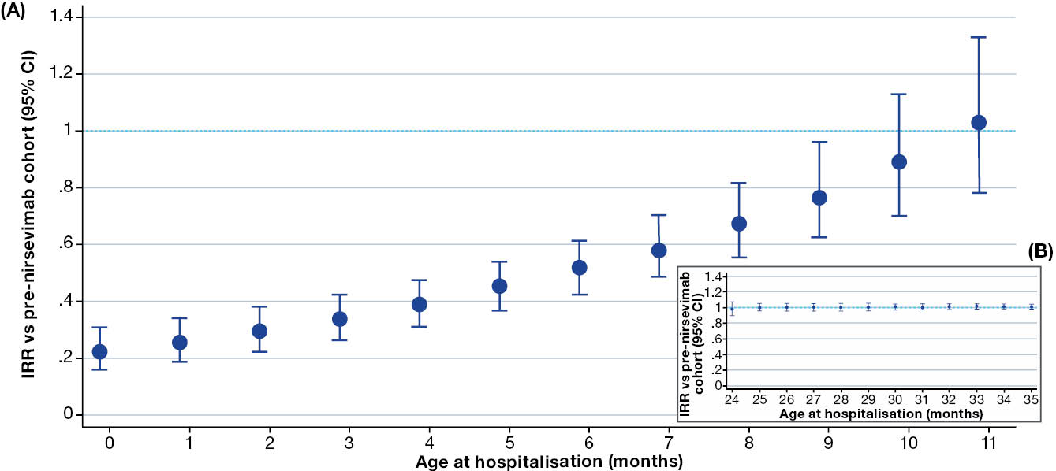
a RSV hospitalisations were identified from the Queensland Notifiable Conditions Register (NOCS) dated 1 January 2022 – 31 October 2025.
b For the ages 0 –< 12 months, the post-nirsevimab implementation cohort comprises infants with a birth date of 1 May – 30 November 2024; the pre-nirsevimab cohort comprises infants with a birth date of 1 February 2021 – 31 March 2024.
c For the ages 24 –< 36 months, the post- and pre-nirsevimab implementation cohorts are nirsevimab-ineligible children with a birth date of 1 April 2019 – 30 November 2023.
d IRRs are adjusted for age, seasonality (harmonic terms), and calendar year (secular trend).
e 95% CI: 95% confidence interval.
Table 1: Age-specific respiratory syncytial virus (RSV) hospitalisation incidence rate ratio, for the post-nirsevimab vs pre-nirsevimab implementation cohorts, in infants aged 0 –< 12 months,^{a,b} Queensland, Australia
Age (months) | Post- vs. pre-nirsevimab cohort hospitalisation
Age (months) | Adjusted IRR^{c,d} | 95% CI^{d,e}
< 1 | 0.22 | 0.16–0.31
1 | 0.25 | 0.19–0.34
2 | 0.29 | 0.23–0.38
3 | 0.33 | 0.27–0.43
4 | 0.39 | 0.31–0.48
5 | 0.44 | 0.36–0.54
6 | 0.51 | 0.42–0.61
7 | 0.58 | 0.49–0.70
8 | 0.67 | 0.55–0.82
9 | 0.77 | 0.62–0.96
10 | 0.89 | 0.70–1.12
11 | 1.01 | 0.77–1.33
a RSV hospitalisations were identified from the Queensland Notifiable Conditions Register (NOCS) dated 1 January 2022 – 31 October 2025.
b Post-nirsevimab cohort: infants with birth dates during 1 May – 30 November 2024; pre-nirsevimab cohort: infants with birth dates during 1 February 2021 – 31 March 2024.
c IRR: incidence rate ratio, adjusted for age, seasonality (harmonic terms), and calendar year (secular trend).
d Bold items indicate significant results.
e 95% CI: 95% confidence interval.
Prior to nirsevimab’s introduction, the RSV hospitalisation rates amongst infants aged 0 –< 12 months showed an increasing monthly trend by ITS analysis (IRR: 1.04; 95% CI: 1.02–1.05), likely reflecting RSV rebound following curtailment of the public health control measures which had been introduced in the wake of the coronavirus disease 2019 (COVID-19) pandemic. Following nirsevimab’s introduction, an immediate 63% reduction in RSV hospitalisation rates was observed (IRR: 0.37; 95% CI: 0.23–0.60). The post-introduction slope change (IRR: 0.99; 95% CI: 0.94–1.04; Table 2 and Figure 2), suggests a near-flat trajectory following the initial step-change reduction.
An estimated 1,240 RSV hospitalisations were averted during the 18-month period from 1 May 2024 to 31 October 2025 in Queensland infants aged 0 –< 12 months, born between 1 May and 30 November 2024 (Figure 3). In a sensitivity analysis excluding 1 January to 30 June 2022, the pre-nirsevimab trend was attenuated (IRR = 1.02, 95% CI: 0.99–1.03; p = 0.06), while the immediate reduction remained statistically significant, although attenuated (IRR = 0.51, 95% CI: 0.36–0.71; p < 0.001), with an estimated 882 hospitalisations averted (Table 2 and Figure 2).
Table 2: Interrupted time-series (ITS) results for the respiratory syncytial virus (RSV) hospitalisation incidence rate ratio, for the post-nirsevimab vs pre-nirsevimab implementation cohorts, in infants aged 0 –< 12 months,^{a,b} Queensland, Australia
Parameter | Primary ITS^{c,d,e} (1 January 2022 – 31 October 2025) |  | Sensitivity ITS^{c,d,e} (1 July 2022 – 31 October 2025)
Parameter | Adjusted IRR | 95% CI | Adjusted IRR | 95% CI
Pre-nirsevimab trend | 1.04 | 1.02–1.05 | 1.02 | 0.99–1.03
Immediate level change | 0.37 | 0.23–0.60 | 0.51 | 0.36– 0.71
Gradual effect, per month | 0.99 | 0.94–1.04 | 1.00 | 0.97–1.03
a RSV hospitalisations were identified from the Queensland Notifiable Conditions Register (NOCS) dated 1 January 2022 – 31 October 2025.
b Post-nirsevimab implementation cohort comprises infants with a birth date of 1 May – 30 November 2024; pre-nirsevimab implementation cohort comprises infants with a birth date of 1 February 2021 – 31 March 2024.
c IRR: incidence rate ratio, adjusted for seasonality and secular trend.
d Bold items indicate significant results.
e 95% CI: 95% confidence interval.
Figure 2: Primary (A) and sensitivity (B) interrupted time-series (ITS) analyses for respiratory syncytial virus (RSV) hospitalisation incidence rate ratios, for the post-nirsevimab vs pre-nirsevimab implementation cohorts, in infants aged 0 –< 12 months,^{a,b,c,d,e} Queensland, Australia
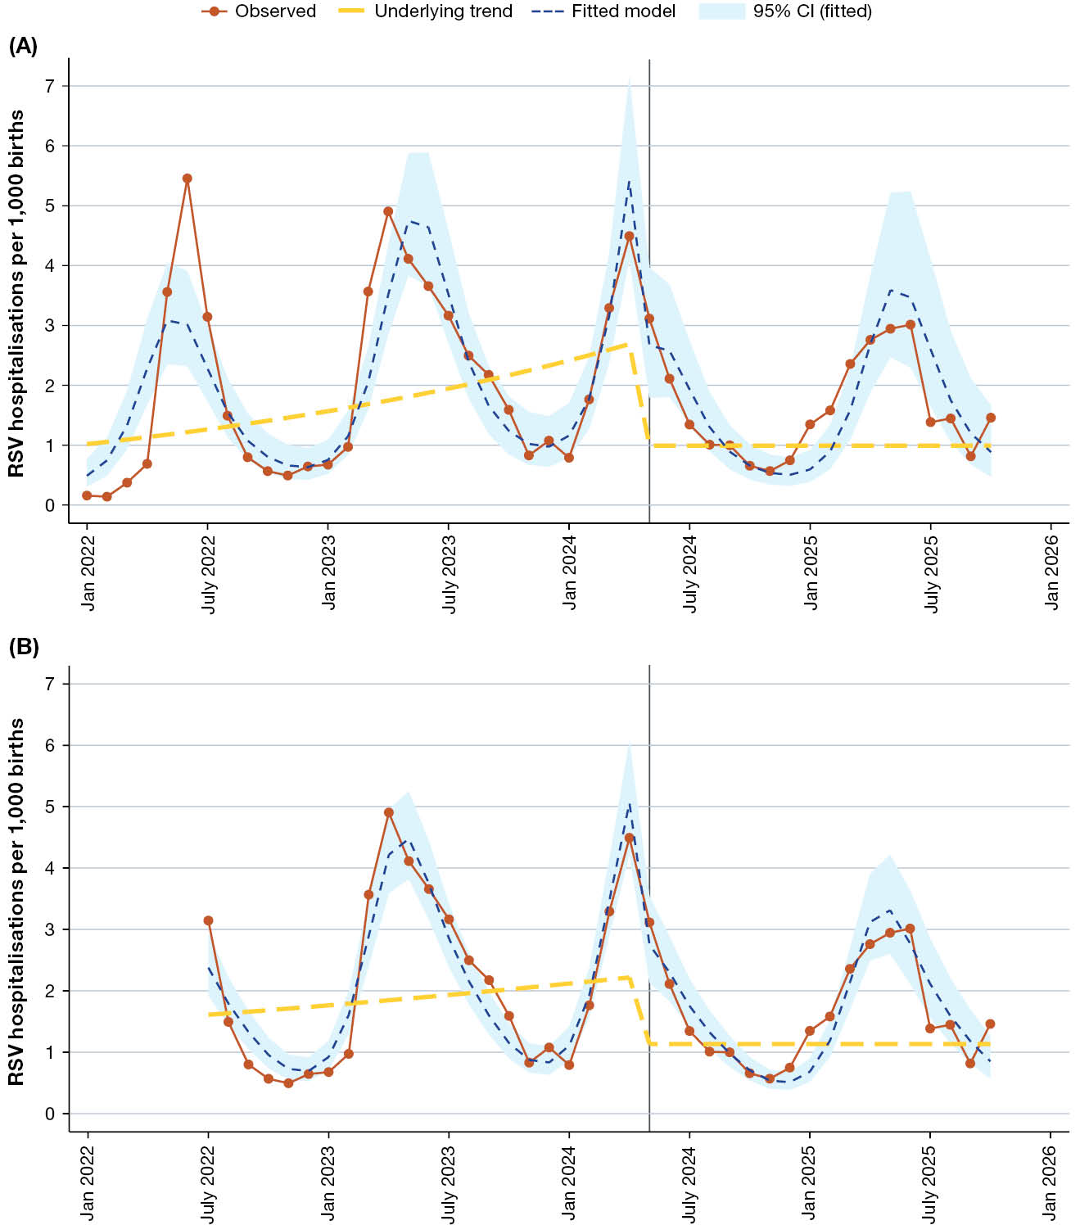
a RSV hospitalisations were identified from the Queensland Notifiable Conditions Register (NOCS) dated 1 January 2022 – 31 October 2025.
b The primary ITS analysis (A) included monthly RSV hospitalisation rates per 1,000 live births during the period 1 January 2022 to 31 October 2025. The sensitivity ITS analysis (B) excluded the observations for 1 January – 30 June 2022, to assess the potential influence of the early post-notification period on the estimated pre-nirsevimab trend and counterfactual.
c Post-nirsevimab cohort comprises infants with a birth date of 1 May – 30 November 2024; pre-nirsevimab cohort comprises infants with a birth date of 1 February 2021 – 31 March 2024.
d The vertical line on each chart indicates the start of the post-nirsevimab analysis period (1 May 2024); the program itself commenced on 15 April 2024, with April 2024 births excluded.
e 95% CI: 95% confidence interval.
Figure 3: Calculated monthly averted respiratory syncytial virus (RSV) hospitalisations associated with nirsevimab among infants aged 0–<12 months,^{a,b,c} 1 May 2024 – 31 October 2025, Queensland, Australia
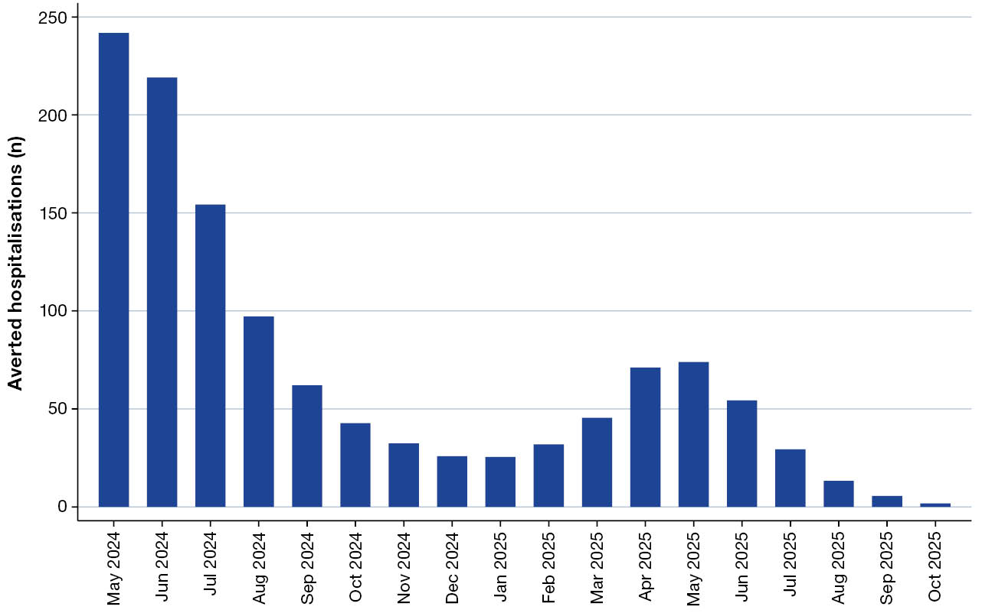
a RSV hospitalisations were identified from the Queensland Notifiable Conditions Register (NOCS) dated 1 January 2022 – 31 October 2025.
b Post-nirsevimab cohort comprises infants with a birth date of 1 May – 30 November 2024.
c Averted hospitalisations were calculated as described within the text.

Discussion
This study demonstrated a significant real-world population-level impact of nirsevimab on RSV hospitalisation in Queensland infants. The greatest population-level reduction in RSV hospitalisations was observed during the first months of life, with the magnitude of the reduction progressively diminishing with increasing age. This gradual age-specific decline in population-level impact is biologically plausible given the pharmacokinetic profile of nirsevimab;¹³ although, as individual dosing dates were not available to us, this pattern reflects population-level impact rather than individual-level waning. The clinical and public health value of this study lies in quantifying the magnitude of this population-level impact month-by-month during the first year of life. This may have implications for program planning, including the timing of nirsevimab administration and strategies to protect infants at highest risk of RSV hospitalisation under routine program conditions in Australia.
Clinical trials using nirsevimab demonstrate high efficacy (77–83%) against RSV hospitalisation following a single dose, with protection sustained across a single RSV season, consistent with its prolonged half life and pharmacokinetic profile.¹³ However, trials are not able to demonstrate how protection varies by age in real-world settings, and effectiveness has generally been reported at the seasonal level rather than across finer age intervals. Early Australian studies using individual-level test negative or cohort designs have similarly reported high overall effectiveness during the first RSV season.^{14,15} In contrast, our study reports population-level impact using an ecological design, in a setting with an estimated nirsevimab coverage of 70–80%.^{4,5} Our findings are broadly consistent with a recent report from New South Wales (NSW),¹⁶ which demonstrated a 43% reduction in RSV hospitalisations in infants less than six months of age following implementation of a statewide RSV prevention program. The NSW analysis assessed population-level program impact reflecting combined maternal RSV vaccination and nirsevimab, while our Queensland cohort was born before maternal RSV vaccination became available under the National Immunisation Program and received nirsevimab only, providing an estimate of its standalone population-level impact. The observed reduction in our study (63% among infants aged 0 –< 12 months) extends the age range over which the population-level impact of nirsevimab has been described, including beyond the first six months of life reported in the NSW study. Our findings also provide additional insights by quantifying the population-level impact of nirsevimab across months of age in the first-year of life, offering a more detailed characterisation of the pattern of protection observed under program conditions. The absence of corresponding changes in RSV hospitalisation rates among nirsevimab ineligible children aged 24 –< 36 months supports the interpretation that the age specific patterns observed among infants reflect nirsevimab associated protection rather than changes in healthcare-seeking behaviour or secular trends in RSV epidemiology.
This study has several strengths. Statewide surveillance data provide complete capture of laboratory-confirmed RSV hospitalisations, including during the peak RSV season, in Queensland. A major strength of our study is using two complementary analytical methods. The primary age-specific analysis assessed whether the population-level reduction in RSV hospitalisations varied by age, while the secondary ITS estimated changes in population-level RSV hospitalisation rates following the introduction of nirsevimab.
However, several limitations should be noted. First, the population-level impact of nirsevimab may have been underestimated in our analyses. RSV detection is influenced by clinician testing practices, and the pre-nirsevimab cohort included infants born after 1 February 2024 as well as high-risk infants, with both groups eligible for catch-up vaccination. Second, in the absence of information about dose timing, we were unable to specifically assess any impact on the population-level duration of protection caused by those doses given in the community after discharge from hospital. Third, individual level immunisation data were not available; therefore, our findings reflect the impact of the program’s introduction rather than the individual effectiveness of the monoclonal antibody. Fourth, the steep pre-program trend likely reflects temporary post-COVID dynamic effects upon RSV,¹⁷ as well as potential changes in case ascertainment following the inclusion of RSV as a notifiable condition in Queensland in July 2021. Although the counterfactual was conservatively specified and a sensitivity analysis excluding the early post-notification period yielded consistent findings, absolute averted hospitalisations should be interpreted with caution. Finally, the analysis was restricted to government-funded hospital admission data. Admissions occurring in private hospitals were not captured because these data are not routinely available to NoCS, which may result in incomplete ascertainment of hospital admissions. However, according to national data from the Australian Institute of Health and Welfare, public hospitals account for approximately 92% of all emergency-driven acute admissions.¹⁸ Given the acute nature of RSV hospitalisations in infants, excluding private hospital admissions is unlikely to substantially affect our estimates.
Here we have demonstrated the population-level impact of the nirsevimab program. Our findings have implications for the ongoing evaluation of RSV prevention strategies, particularly in settings with prolonged or unpredictable RSV seasons, where the timing of RSV activity may not align consistently with a fixed seasonal administration schedule. In such settings, consideration of the timing of nirsevimab delivery relative to periods of greatest RSV risk may be particularly important to ensure protection during periods when infants are at highest risk of hospitalisation.

Funding sources
None.

Declaration of interests
AE, KG and RSW have received funding from Sanofi-Aventis Australia, and AstraZeneca Australia through a collaboration grant for unrelated work. KG is a recipient of several Australian National Health and Medical Research Council and Medical Research Future Fund grant awards, none of which are related to the subject of this study. He has received lecture fees from Sanofi-Aventis Australia Pty Ltd.

Author contributions
Conceptualisation: AE, KG, SBL, RSW; collected and provided the data: MR, ACS; methodology: AE and RSW; software: AE; formal analysis: AE, writing-initial draft: AE; writing-review and editing: KG, MR, SBL and RSW. All authors approved the final manuscript as submitted and agree to be accountable for all aspects of the work.

Author details
Dr Asmaa El-Heneidy,^{1,2}
Prof. Keith Grimwood,²
Ms Mohana Rajmokan,³
Dr Ashish C Shrestha,³
Assoc/Prof. Stephen B Lambert,^{4,5}
Prof. Robert S Ware,^{1,2,6}
- Griffith Biostatistics Unit, Griffith University, Gold Coast QLD 4215, Australia
- School of Medicine and Dentistry, Griffith University, Gold Coast, QLD 4215, Australia
- Public Health Intelligence Branch, Queensland Health, Brisbane QLD 4006, Australia
- Child Health Research Centre, The University of Queensland, South Brisbane, QLD 4101, Australia
- National Centre for Immunisation Research and Surveillance, Westmead, NSW 2145, Australia
- Wesley Research Institute, Brisbane QLD 4066, Australia.

Corresponding author
Dr Asmaa El-Heneidy
Griffith Biostatistics Unit, Griffith Health, Griffith University, Southport, QLD 4215, Australia.
Phone: +61 416 662 548
Email: a.el-heneidy@griffith.edu.au

References
- Li Y, Wang X, Blau DM, Caballero MT, Feikin DR, Gill CJ et al. Global, regional, and national disease burden estimates of acute lower respiratory infections due to respiratory syncytial virus in children younger than 5 years in 2019: a systematic analysis. Lancet. 2022;399(10340):2047–64. doi: https://doi.org/10.1016/S0140-6736(22)00478-0.
- Self A, Van Buskirk J, Clark J, Cochrane JE, Knibbs L, Cass-Verco J et al. Respiratory syncytial virus disease morbidity in Australian infants aged 0 to 6 months: a systematic review with narrative synthesis. BMC Public Health. 2023;23(1):2560. doi: https://doi.org/10.1186/s12889-023-17474-x.
- Queensland Government. Free RSV immunisation program launches today for newborn babies. [Media release.] Brisbane: Queensland Government; 15 April 2024. [Accessed on 1 September 2026.] Available from: https://statements.qld.gov.au/statements/100114.
- El-Heneidy A, Grimwood K, Robson JM, Vilaylath CV, Cherian SG, Lambert SB et al. Impact of nirsevimab on respiratory syncytial virus PCR test positivity in young infants: a community-level observational study in Queensland, Australia. J Paediatr Child Health. 2026;62(4):614–20. doi: https://doi.org/10.1111/jpc.70317.
- Roughan W, Cavanagh-Ochiai B, Barnekow D, Lottkowitz K, Schafer K, Camadoo L et al. Infant respiratory syncytial virus (RSV) immunisation coverage in an Australian regional area, 1 May 2024 – 31 October 2025. Commun Dis Intell (2018). 2026;50. doi: https://doi.org/10.33321/cdi.2026.50.031.
- Queensland State Government Department of Health (Queensland Health). Queensland Paediatric Respiratory Syncytial Virus (RSV) Prevention Programme: Update and Programme Impact. Brisbane: Queensland Health Immunisation Unit; August 2025. [Accessed on 27 April 2026.] Available from: https://www.health.qld.gov.au/__data/assets/pdf_file/0027/1462590/qld-paediatric-rsv-impact-results.pdf.
- Australian Technical Advisory Group on Immunisation (ATAGI). Neonates and infants aged <8 months whose mothers were not vaccinated at least 2 weeks before giving birth, or who are at increased risk of severe disease, are recommended to receive passive immunisation with a long-acting RSV-specific monoclonal antibody. [Media release.] Canberra: Australian Government Department of Health, Disability and Ageing, Australian Immunisation Handbook; 12 May 2026. [Accessed on 1 September 2026.] Available from: https://immunisationhandbook.health.gov.au/recommendations/neonates-and-infants-aged.
- Morley C, Grimwood K, Maloney S, Ware RS. Meteorological factors and respiratory syncytial virus seasonality in subtropical Australia. Epidemiol Infect. 2018;146(6):757–62. doi: https://doi.org/10.1017/S0950268818000614.
- Butler J, Gunnarsson R, Traves A, Marshall H. Severe respiratory syncytial virus infection in hospitalized children less than 3 years of age in a temperate and tropical climate. Pediatr Infect Dis J. 2019;38(1):6–11. doi: https://doi.org/10.1097/INF.0000000000002026.
- Paynter S, Ware RS, Sly PD, Weinstein P, Williams G. Respiratory syncytial virus seasonality in tropical Australia. Aust N Z J Public Health. 2015;39(1):8–10. doi: https://doi.org/10.1111/1753-6405.12347.
- Queensland Health. Notifiable conditions reports: technical notes. [Webpage.] Brisbane: Queensland Health; 30 April 2026. [Accessed on 9 September 2026.] Available from: https://www.health.qld.gov.au/clinical-practice/guidelines-procedures/diseases-infection/surveillance/reports/notifiable/technical-notes.
- Queensland State Government. Open data portal. Births by month. [Webpage.] Brisbane: Queensland State Government; 2026. [Accessed on 17 March 2026.] Available from: https://www.data.qld.gov.au/dataset/births-by-month.
- Hammitt LL, Dagan R, Yuan Y, Baca Cots M, Bosheva M, Madhi SA et al. Nirsevimab for prevention of RSV in healthy late-preterm and term infants. N Engl J Med. 2022;386(9):837–46. doi: https://doi.org/10.1056/NEJMoa2110275.
- Wadia U, Moore HC, Richmond PC, Levy A, Bell L, Pienaar C et al. Effectiveness of nirsevimab in preventing RSV-hospitalisation among young children in Western Australia 2024. J Infect. 2025;90(4):106466. doi: https://doi.org/10.1016/j.jinf.2025.106466.
- Blyth CC, Wadia U, Britton PN, Carr J, Clark JE, Crawford NW et al. Respiratory syncytial virus epidemiology and effectiveness of infant nirsevimab: 2024 results from the Australian Sentinel Hospital Network (FluCAN-PAEDS). Euro Surveill. 2026;31(2):2500275. doi: https://doi.org/10.2807/1560-7917.ES.2026.31.2.2500275.
- Amin J, Ellis SL, Lambeth C, Gugushef J, Selvey C. Impact of the 2025 New South Wales respiratory syncytial virus prevention program on infant notifications and hospitalisations: a population-based analysis. Med J Aust. 2026;224(6):e70222. doi: https://doi.org/10.5694/mja2.70222.
- Rice E, Oakes DB, Holland C, Moore HC, Blyth CC. Respiratory syncytial virus in children: epidemiology and clinical impact post-COVID-19. Curr Opin Infect Dis. (2023);36(6):522–8. doi: https://doi.org/10.1097/QCO.0000000000000967.
- Australian Institute of Health and Welfare (AIHW). Admitted patient care 2023–24: data tables. [Webpage.] Canberra: AIHW2025. [Accessed on 1 July 2026.] Available from: https://www.aihw.gov.au/reports-data/myhospitals/sectors/admitted-patient-care.

