
2026 • Volume 50 • cdc.gov.au/cdi • Epub date: 20.10.2026 • doi.org/10.33321/cdi.2026.50.065

Epidemiology of malaria in the Torres Strait Islands, Australia, 2000-2025 and the public health response to three recent outbreaks
C Bowers, D Pourmarzi, J Hanson, A Hempenstall, P Dugdale, C Cashman, A Fauid, G Ehlers, J Davis, D Peniyamina, L Stephens, C Taunton
© 2026 Commonwealth of Australia as represented by the Australian Centre for Disease Control
ISSN: 2209-6051 Online
This journal is indexed by Index Medicus and Medline.
Creative Commons Licence
This publication is licensed under a Creative Commons Attribution-NonCommercial-NoDerivatives 4.0 International Licence (Licence). You must read and understand the Licence before using any material from this publication.
Restrictions
The Licence does not cover, and there is no permission given for, use of any of the following material found in this publication (if any):
- the Commonwealth Coat of Arms (by way of information, the terms under which the Coat of Arms may be used can be found on the Department of Prime Minister and Cabinet website);
- any logos (including the Australian Centre for Disease Control’s logo) and trademarks;
- any photographs and images;
- any signatures; and
- any material belonging to third parties.
Disclaimer
Opinions expressed in Communicable Diseases Intelligence are those of the authors and not necessarily those of the Australian Government or the Australian Centre for Disease Control. Data may be subject to revision.
Enquiries
Enquiries regarding any other use of this publication should be addressed to the CDI Editor.
About CDI
Communicable Diseases Intelligence (CDI) is a peer-reviewed scientific journal published by the Australian Centre for Disease Control.
The journal aims to disseminate information on the epidemiology, surveillance, prevention and control of communicable diseases of relevance to Australia and the near region.
Editor: Dr Elise Firman • Deputy Editor: Simon Petrie • Design and Production: Lisa Thompson
Editorial Advisory Board: David Durrheim, Mark Ferson, Clare Huppatz, John Kaldor, Martyn Kirk and Meru Sheel
Submit an Article
Guidelines for authors and details on how to submit your publication is available on our website, or by email to the
CDI Editor.
Contact us
Communicable Diseases Intelligence (CDI)
Australian Centre for Disease Control
PO Box 795, Canberra ACT 2601, Australia
Website: cdc.gov.au/cdi
Email: cdi.editor@cdc.gov.au

Contents
Abstract 4
Background 4
Methods 4
Results 4
Discussion and conclusion 4
Background 5
Methods 7
Epidemiology of malaria, 2000–2025 7
Malaria outbreaks, 2023 and 2025 7
Ethics 9
Results 10
Malaria cases notified in the Torres Strait, 1 January 2000 to 31 December 2025 10
Public health response to three malaria outbreaks in the Torres Strait, 2023 to 2025 13
Discussion 16
Conclusion 18
Acknowledgments 19
Author details 20
References 21
Appendix A 25

Abstract

Background
Australia was declared malaria free in 1981. However, the proximity of Australia’s Torres Strait region to malaria-endemic Papua New Guinea (PNG), and the presence of the Anopheles mosquito across Northern Australia, means there is an ongoing risk of malaria for many Australian residents. This paper describes the epidemiology of malaria in the Torres Strait region between 2000 and 2025 and reports the public health response to three malaria outbreaks between 2023 and 2025.

Methods
Case data from 1 January 2000 to 31 December 2025 were extracted from the Queensland Notifiable Conditions System to describe the epidemiology of malaria in the Torres Strait. The public health responses to each of the three recent outbreaks were reported against the Queensland Health Public Health Unit Guidelines for Malaria.

Results
During the period 2000–2013, there were 171 cases of malaria reported in the Torres Strait region. Of these, 89 (52%) were positive for Plasmodium falciparum and 82 (48%) for P. vivax. Of cases during this period, 130 (76%) were imported from PNG; 13 (8%) were acquired in Australia; and 28 (16%) had an unknown place of acquisition. After a nine-year period without any confirmed malaria cases in the region, eight cases were reported across three outbreaks between 2023 and 2025. In all six of the outbreak cases in which a species could be confirmed, P. vivax was identified. The three outbreaks were managed effectively in partnership with local leaders, and included active case finding and vector control activities.

Discussion and conclusion
The public health response successfully halted transmission of malaria during three separate outbreaks in the Torres Strait Islands. However, there is an ongoing local risk due to the high incidence of malaria in PNG and cross-border movement under the Torres Strait Treaty. Ongoing collaboration with PNG stakeholders and enhanced local surveillance are essential to minimise the future importation of malaria, and other potentially life-threatening pathogens, into mainland Australia.
Keywords: malaria; outbreak; First Nations health; public health; Aboriginal and Torres Strait Islander people

Background
Malaria is caused by protozoan parasites of the Plasmodium genus and is transmitted by Anopheles mosquitoes.¹ At least six species of Plasmodium infect humans: P. falciparum; P. vivax; P. ovale curtisi and ovale wallikeri; P. malariae; and P. knowlesi.^{2, 3} P. falciparum and P. vivax are responsible for 95% of global malaria cases, with P. falciparum causing more than 95% of malaria deaths.¹
Australia was certified as free of endemic malaria by the World Health Organization in 1981.⁴ However, the Anopheles mosquito vector is present in Australia. The Anopheles farauti sensu lato mosquito is endemic in North Queensland, between Townsville and the Torres Strait Islands, and this region remains receptive to malaria transmission.⁵ The last outbreak of locally acquired malaria in mainland Australia occurred in North Queensland in 2002.⁶
The Torres Strait Islands are a group of 31 islands located between mainland Australia and Papua New Guinea (PNG) (Figure 1). Residents of the Torres Strait Islands often have close family and cultural ties to PNG. Under the Torres Strait Treaty, residents of villages in the Torres Strait and PNG can move freely throughout the region for traditional activities in the Torres Strait Protected Zone.⁷ Movement under the Torres Strait Treaty was suspended when the Australian border with PNG was closed from 22 March 2020 to 21 December 2022 due to the COVID-19 pandemic.⁸ Three islands across the Torres Strait, the top western cluster, are at particularly high risk of imported malaria cases due to their proximity to PNG, where malaria is endemic:⁹ Saibai Island, 4 km from the PNG mainland, with a population of 340 people; Boigu Island, 6 km from the PNG mainland, with a population of 200 people; and Dauan Island, 11 km from the PNG mainland, with a population of 130 people.^{10–12} Saibai and Boigu Islands are low-lying and prone to seasonal flooding, with extensive swampland areas, while Dauan Island has a steep granite peak surrounded by coastal lowland.^{10–12}
Here we describe the epidemiology of malaria in the Torres Strait between 1 January 2000 and 31 December 2025, and report the response to three recent malaria outbreaks which occurred during the period 2023–2025.
Figure 1: Map of the Torres Strait Islands,ª Australia
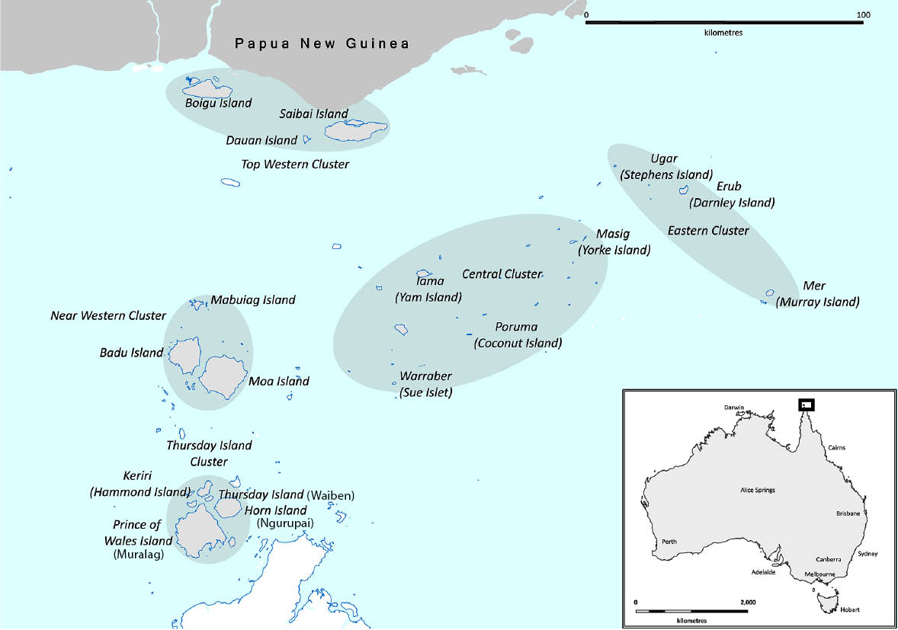
a Image credit: this map has been provided by Torres and Cape Hospital and Health Service and permission for use has been granted.

Methods

Epidemiology of malaria, 2000–2025
Malaria has been a notifiable condition in Australia since 1991.¹³ We extracted confirmed and probable malaria cases, with a residential address in the Torres Strait Islands or PNG and an onset date between 1 January 2000 and 31 December 2025, from the Notifiable Conditions System (NoCS) in Queensland. Available demographic (age, sex, residential location and report location), laboratory (nature of test, result and species), clinical (requirement for hospitalisation) and epidemiological (place of acquisition and case classification) data were reviewed. Locally acquired cases were defined as cases who were diagnosed with malaria in the Torres Strait Island region and who reported no overseas travel in the previous three months (a standard NoCS case investigation question). Details of previous malaria infection and extended travel history were not consistently available in NoCS. Additionally, detailed demographic and clinical data were not consistently available before 2023. All requests for malaria testing in the Torres Strait Islands between 1 January 2000 and 31 December 2025 were extracted from the Pathology Queensland Information System (AUSLAB), which records all laboratory testing in the state’s public health system.

Malaria outbreaks, 2023 and 2025

Case definitions
Responses to the three most recent malaria outbreaks in Australia were described in accordance with the Queensland Health Public Health Unit Guidelines for Malaria.¹⁴ The Torres and Cape Public Health Unit (TCPHU) successfully advocated for the probable malaria case definition to be added to the Guidelines on 1 April 2023,¹⁴ and this was used to define outbreak cases (Box 1). Confirmed and probable cases were reported to NoCS at the time of each outbreak.

Data sources
The outbreak cases and public health response were retrospectively described using TCPHU line lists and NoCS. Laboratory results were cross-checked with AUSLAB, while treatment and hospitalisations were cross-checked with the patients’ electronic medical record.

Box 1: Outbreak case definitions
Outbreak cases were those that met the confirmed or probable case definition, reported no overseas travel during the exposure period and spent some, or all, of their exposure period on Saibai or Boigu Islands respectively, and reported onset between:
- 1 July and 18 September 2023 [Boigu Island 2023 outbreak];
- 1 July and 18 September 2023 [Saibai Island 2023 outbreak]; or
- 17 April and 13 July 2025 [Saibai Island 2025 outbreak].
Confirmed case
- detection and specific identification of malaria parasites by microscopy on blood film with confirmation of species by the Queensland Public Health Reference Laboratory; or
- detection of Plasmodium species by nucleic acid testing.
Probable case
- detection and specific identification of malaria parasites by microscopy at a non-reference laboratory (Pathology Queensland laboratory); or
- a positive result with a rapid antigen, immunodiagnostic or immunochromatography test.

Active case finding and testing
Active case finding was conducted during each outbreak response. To support this, the local population for each outbreak was determined from active patient medical records, with the list reviewed by local clinic staff to identify those not currently on the island. Paper-based forms were developed to screen household contacts of cases and community residents for malaria symptoms and to collect information about any overseas travel within the prior three months. Household contacts were asked to visit the clinic and were offered blood specimen collection for laboratory testing. Residents reporting current or recent malaria symptoms were also invited to the clinic for blood specimen collection for laboratory testing. To expedite commencement of treatment, symptomatic household contacts and residents were offered a rapid diagnostic test (RDT) at the clinic, which returned results within 15 minutes. More information about the active case finding strategy is outlined in Appendix A, Figure A.1.
The Abbott BinaxNOW™ RDT was used at the point-of-care during the outbreaks. The screening test targets the P. falciparum histidine rich protein-2 (PfHRP2) antigen and a pan-malarial antigen found in P. falciparum, P. vivax, P. malariae and P. ovale.¹⁵
Blood samples for laboratory testing were sent for Giemsa-stained thick and thin blood films and loop-mediated isothermal amplification (LAMP) (Alethia®, Meridian Bioscience) testing at the Thursday Island Hospital laboratory (~150 km and a 40-minute charter flight and 15-minute ferry from the top western cluster islands) and the Cairns Hospital laboratory (~900 km and a five-hour trip with two connecting flights from the islands). Positive laboratory specimens were then forwarded to the Public and Environmental Health Reference Laboratory (PEHRL) in Brisbane (~1,400 km and a 2.5 hour flight from Cairns) for confirmatory microscopy and polymerase chain reaction (PCR) testing. The Plasmodium species was determined by microscopy, or from PCR if microscopy was non-diagnostic.¹⁶ The RDT was used to report the species when microscopy was non-diagnostic and when PCR was not performed.

Ethics
The report was granted an ethics exemption by the Far North Queensland Human Research Ethics Committee and received ethics approval from the Australian National University Human Research Ethics Committee (Protocol 2017/909).

Results

Malaria cases notified in the Torres Strait, 1 January 2000 to 31 December 2025

2000–2013
A total of 171 cases of malaria were notified among Torres Strait Island and PNG residents in the Torres Strait Islands between 2000 and 2013. Of these, 89 (52%) were positive for P. falciparum and 82 (48%) for P. vivax (Figure 2a). Of the 171 cases, 130 (76%) were acquired in PNG; 13 (8%) in Australia; and 28 (16%) in Torres Strait Island residents with an unknown place of acquisition (Figure 2b). The median age was 24 years (interquartile range: 14–35 years) and 72 cases (42%) were female. One case required hospitalisation, with no deaths recorded.

2014–2022
No cases were notified between 2014 and 2022 (Figure 2a). Malaria testing declined during this period; however a small number of tests were conducted each year (Figure 2b).

2023–2025
Between 2023 and 2025, there were 30 cases reported. Of these, 22 cases (73%) were acquired in PNG and eight cases (27%) were acquired in Australia, with all eight Australia-acquired outbreak cases described in the next section. Of the 30 cases, 17 (57%) were positive for P. vivax; ten (33%) were RDT positive for non-falciparum malaria; one was positive for P. falciparum; one was positive for P. malariae; and one did not have a species identified (Figure 2a). The median age was 32 years (interquartile range 13–45 years) and 14 cases (47%) were female. Four cases (13%) were hospitalised, with no deaths recorded. Malaria testing increased across the region from 2023 (Figure 2b).
Of the 22 imported cases, nine presented to Boigu Island (five in 2023 and four in 2025); seven presented to Saibai Island (three in 2023, two each in 2024 and 2025); two presented to Masig Island (2023); two to Dauan Island (2024); one to Mer Island (2025); and one to Mabuiag Island (2025) (Figure 3).
Since the introduction, on 1 April 2023, of the probable case definition, 9/28 notified malaria cases (32%) have been classified as probable, meaning they were positive on RDT without laboratory confirmation. All nine probable cases were imported, with six not having a blood specimen collected for laboratory testing in Australia; two testing negative on microscopy (without PCR confirmation); and one returning a nondiagnostic laboratory result due to a degraded specimen. Probable cases were referred to the Mabudawan Health Centre in PNG for ongoing treatment in line with the Torres Strait Treaty.
Figure 2a: Annual malaria notifications in the Torres Strait Islands, by Plasmodium species, 1 January 2000 to 31 December 2025 (includes residents of the Torres Strait Islands and Papua New Guinea)
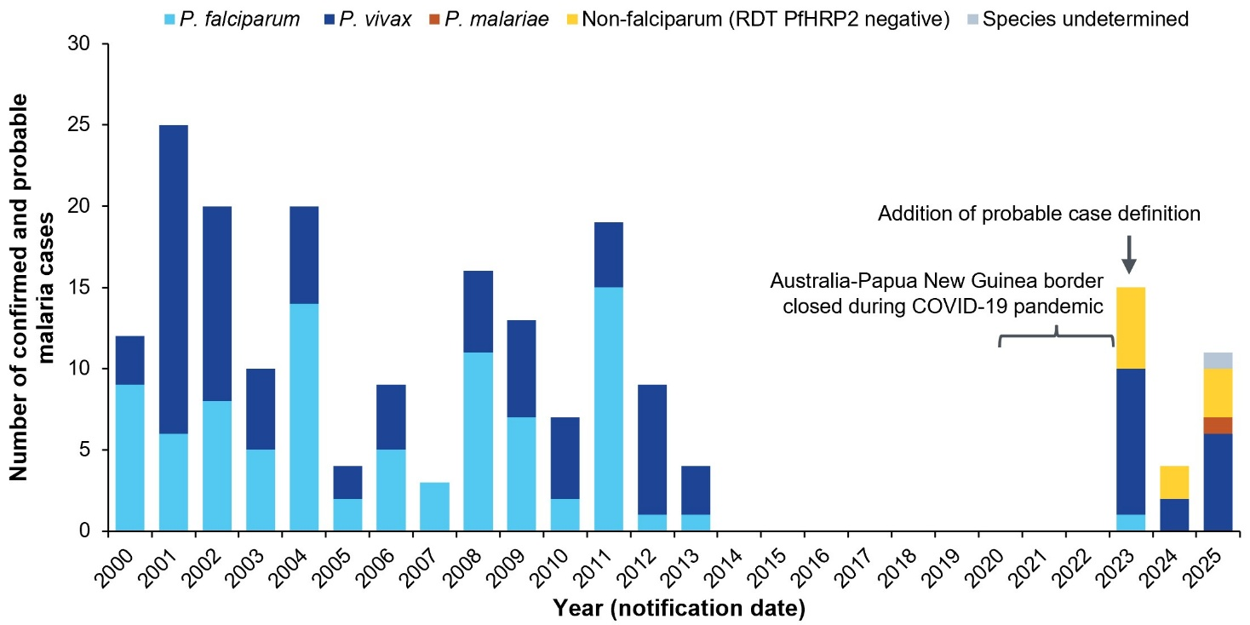
Figure 2b: Annual number of malaria tests and notifications by place of acquisition in the Torres Strait Islands, 1 January 2000 to 31 December 2025 (includes residents of the Torres Strait Islands and Papua New Guinea)
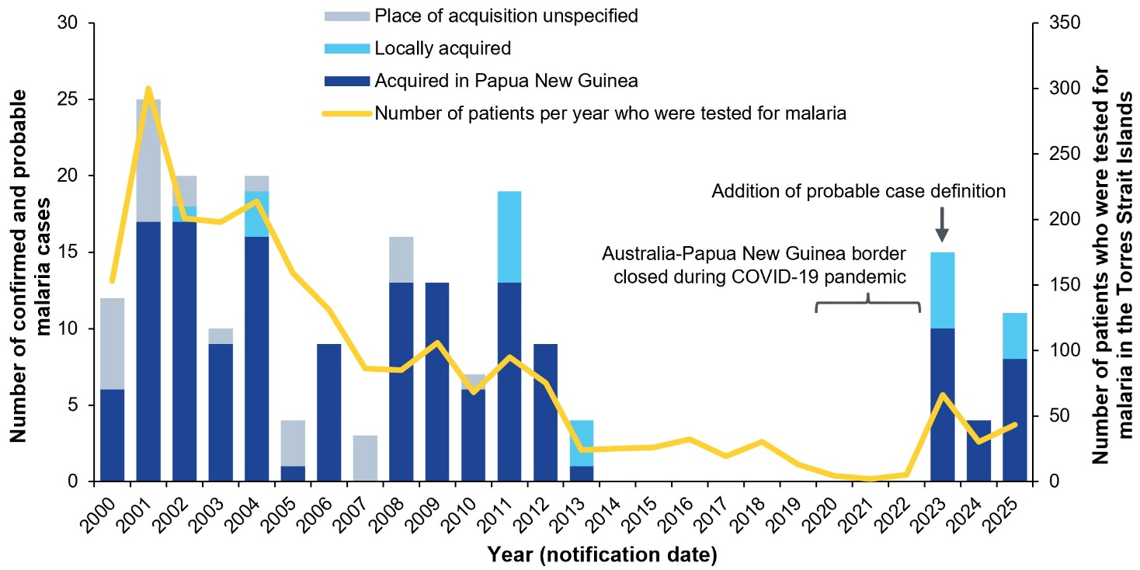
Figure 3: Malaria notifications, by month, on Boigu and Saibai Islands during recent outbreak years (Boigu Island: 2023; Saibai Island: 2023 and 2025),ª stratified by place of acquisition
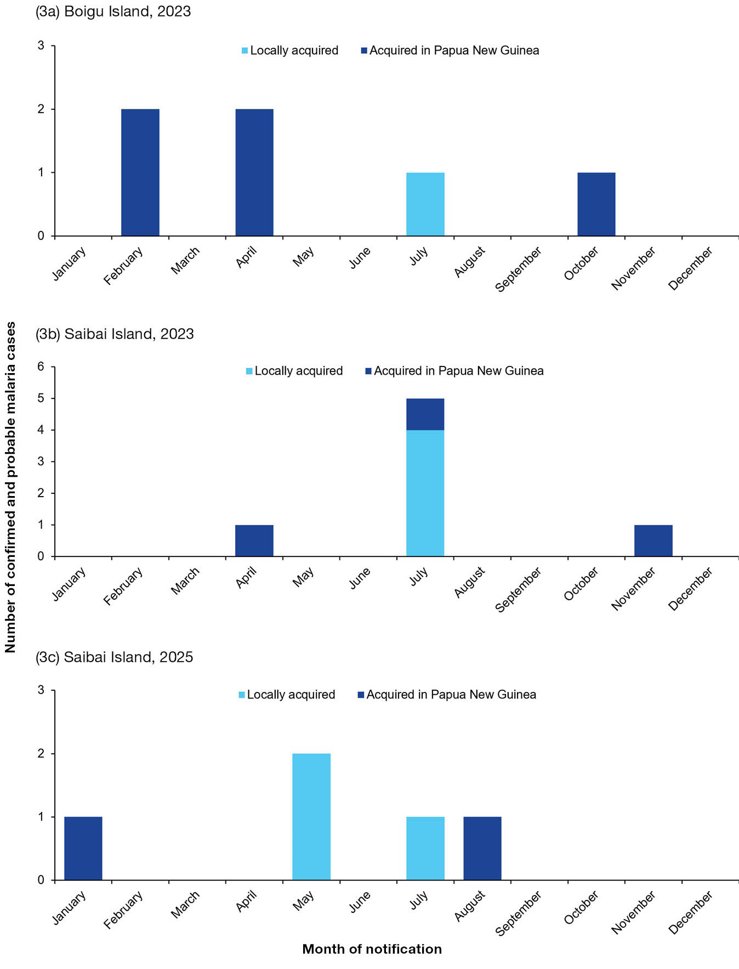
a On Boigu Island in 2023, three imported cases were P. vivax and two were RDT positive for non-falciparum malaria. On Saibai Island in 2023, one imported case was P. vivax and two were RDT positive for non-falciparum malaria. On Saibai Island in 2025, one imported case was P. vivax and one was RDT positive for non-falciparum malaria. For speciation of locally acquired cases, please see text and Table 1.

Public health response to three malaria outbreaks in the Torres Strait, 2023 to 2025

Pre-outbreak preparation
After the detection of five imported malaria cases to Saibai and Boigu Islands in early 2023, the TCPHU collaborated with local primary healthcare services to preposition resources and implement readiness measures. Several education sessions about malaria testing and management were provided to local clinicians. To support timely diagnosis and treatment, malaria RDTs and artemether-lumefantrine medications were deployed to the primary health care clinics (PHCCs) of the islands that had received PNG visitors since the border reopened after the COVID-19 pandemic.

Description of outbreak cases
A total of eight locally acquired, confirmed cases were identified across the three outbreaks between 2023 and 2025 (Table 1). The median time from symptom onset to case detection was 6 days (range: 4–41 days). The median age was 25 years (range: 11–49 years). In six of the eight locally acquired cases, P. vivax was detected as the infecting species, with the species unable to be determined in 2/8 cases due to sample degradation. Two cases reported no previous travel to PNG and five cases reported no travel to PNG in the preceding three months. One case reported a prior malaria infection acquired in PNG some years ago; however, the specific year, species, and treatment received were not able to be ascertained.
All cases reported at least two malaria symptoms (fever, headache, chills and/or nausea), with 7/8 reporting fever and 5/8 reporting chills and nausea. Three cases were hospitalised for a median of four days (range: 2–4 days), with no deaths, acute complications or relapses reported. Seven cases received artemether-lumefantrine and one received atovaquone-proguanil treatment within a median of one day of blood specimen collection (range: -2 to 21 days) (Table 1). All cases returned normal glucose-6-phosphate dehydrogenase (G6PD) enzyme levels and received primaquine within a median of 8 days of G6PD testing (range: 1–23 days). There was no recurrence among cases who received primaquine treatment.
Of 790 people present on the three islands at the time of each outbreak, 478 (61%) were screened, with 14/478 (3%) reporting symptoms, 10/14 (71%) were tested (four did not present to the clinic) and 3/10 (30%) were confirmed as malaria cases. The remaining five outbreak cases self-presented to health services. Across the three outbreaks, one non-symptomatic household contact declined testing, and one resident declined screening and testing. No household contacts of the eight cases tested positive to malaria.

Outbreak response
On 7 July 2023, the TCPHU was notified of a positive P. vivax case in a Boigu Island resident with no previous overseas travel. The TCPHU declared an outbreak in response to the confirmed case of locally transmitted malaria.¹⁴
A response team arrived within four days of the notification and included a Public Health Medical Officer, a Public Health Nurse, a Cross Border Communications Officer and Vector Control Officers. The public health response included active case finding, education and vector control activities and was led by local Torres Strait Island Health Workers in partnership with the visiting public health staff and Torres Strait Island Regional Council (TSIRC). This collaboration enabled culturally considered engagement, including adapting response activities during periods of Sorry News.
The response provided education to households and the local primary school in English and Yumplatok (Torres Strait Creole). Mosquito repellent containing diethyltoluamide (DEET) or picaridin and ‘Stop the Bite’ information leaflets were handed out within the community (Appendix A, Figure A.2). Radio and media messages were broadcast in English during the response to remind residents across the Torres Strait to take precautions against mosquito bites. Vector control staff conducted harbourage spraying with a residual pyrethroid insecticide around houses, shops, community areas and nearby vegetation, starting with the residence of the case and expanding outwards.
On 15 July 2023, another locally acquired P. vivax case was detected on neighbouring Saibai Island. A second outbreak was declared, and a similar outbreak response conducted. No locally acquired cases were notified during 2024. On 18 May 2025, a locally acquired case was detected on Saibai Island, and a third response implemented.

Outbreak closure
The outbreaks closed after two P. vivax incubation periods (maximum extrinsic period of 10 days and maximum intrinsic period of 18 days) had passed with no additional locally acquired cases identified. The first outbreak closed after 73 days, the second after 65 days and the third after 56 days.
Table 1: Characteristics of malaria outbreak confirmed cases, Torres Strait Islands, Australia 2023–2025
Outbreakª | Case detection method^{b} | Interval between symptom onset and notification (days) | Results of testing^{c,d} |  |  |  |  |  | Hospitalised | Interval between outbreak declaration and case detection (days) | Treatment received^{e} | Interval between BSC and treatment (days)^{f,g}
Outbreakª | Case detection method^{b} | Interval between symptom onset and notification (days) | RDT | LAMP | Microscopy | PCR | Species | Parasite count /µL
1 | SR | 6 | Pos. | — | Pos. | — | P. vivax | 15,000 | Yes | 0 | AL | 0
2 | SR | 6 | Pos. | — | Neg. | Pos. | P. vivax | N/A | No | 0 | AL | -2
2 | ACF | 4 | Neg. | — | Pos. | — | P. vivax | 900 | No | 7 | AL | 1
2 | ACF | 5 | Neg. | — | Pos. | Pos. | P. vivax | 260 | Yes | 7 | AL | 2
2 | SR | 6 | — | — | Pos. | Pos. | P. vivax | 16,000 | No | 13 | AP | 1
3 | SR | 5 | Pos. | Pos. | Pos. | — | NFM | 8,200 | No | 0 | AL | -1
3 | ACF | 41 | — | Pos. | Neg. | — | ND | N/A | No | 10 | AL | 21
3 | SR | 15 | — | — | Pos. | — | P. vivax | 11,000 | Yes | 58 | AL | 0
a Outbreaks are identified as: 1: Boigu Island (2023); 2: Saibai Island (2023); 3: Saibai Island (2025).
b SR: self-report; ACF: active case finding.
c RDT: rapid diagnostic test; LAMP: loop-mediated isothermal amplification testing; PCR: polymerase chain reaction; NFM: non-falciparum malaria (PfHRP2 negative).
d Pos.: positive; Neg.: negative; N/A: not applicable; ND: not detected; –: not tested.
e All cases received primaquine after glucose-6-phosphate dehydrogenase (G6PD) testing, and either artemether–lumefantrine (AL) or atovaquone–proguanil (AP) as shown here.
f BSC: blood specimen collection.
g Two cases commenced treatment upon positive rapid diagnostic test, prior to blood specimen collection for laboratory testing.

Discussion
After almost a decade without detection of any locally acquired or imported cases of malaria in the Torres Strait, three separate outbreaks occurred between 2023 and 2025. A robust, locally led public health response successfully halted transmission of malaria during each outbreak. However, ongoing vigilance is necessary. The rising incidence of malaria in PNG, and of P. falciparum in particular, means there is an increased risk of importation and local transmission in the Australian Torres Strait Islands.¹⁸
The number of malaria cases in PNG increased by 163% from 346,431 cases in 2015 to 910,747 cases in 2024.¹⁹ In 2024, PNG accounted for almost 90% of all estimated malaria cases in the Western Pacific Region and, importantly, 77% of these PNG cases were P. falciparum.²⁰ In 2023, the community prevalence of P. falciparum was estimated to be 2.4% in PNG’s Western Province, a region which includes all 13 PNG villages that are part of the Torres Strait Treaty.²¹ Between 2023 and 2025, just one of the 30 notified cases in the Torres Strait were confirmed as P. falciparum. This may be explained by the often severe clinical complications of P. falciparum infection, which may reduce the likelihood of travel to an Australian PHCC and subsequent detection.^{2,21} However, the potentially fatal infection remains a real risk for local Torres Strait residents who have little or no acquired immunity.²²
The absence of malaria notifications between 2014 and 2022 may be at least partly explained by the lower incidence in PNG during this period.²³ However, the number of tests conducted by Australian clinicians in the Torres Strait declined over the same period, highlighting the importance of ongoing vigilance. Reopening of the border coincided with commencement of enhanced TCPHU surveillance activities, which may also have increased the ascertainment of malaria cases from 2023.
Since the border reopened after the COVID-19 pandemic, there has been an increase in the movement of Australian and PNG residents across the Torres Strait Protected Zone.⁸ Movements are likely to rise further following the 2025 Defence Treaty between Australia and PNG.²⁴ This movement may increase the risk to Australians of several diseases which are highly prevalent in PNG, including malaria, dengue,²⁵ tuberculosis,²⁶ typhoid, Japanese encephalitis,²⁷ and HIV.²⁸ The successful strategies that underpinned our approach to the malaria outbreaks may also prove beneficial in detecting and responding to other outbreaks of similarly imported pathogens in the region. Continued collaboration with PNG health stakeholders remains vital to prevent and manage cross-border disease transmission.
Environmental factors may also increase the risk of malaria transmission in the Torres Strait in the future. Warming temperatures shorten the Plasmodium parasite’s extrinsic incubation period and may extend the length of the transmission season.^{29–31} The social determinants of health have an impact on the incidence of malaria and other tropical diseases in Australia.^{32–34} This emphasises the importance of evidence-based approaches to manage local mosquito-borne disease risk, which include the optimisation of water drainage and waste collection, and housing design that prevents mosquitoes from entering and biting occupants.³⁵
Our public health response to the 2023 and 2025 outbreaks was based on a successful response to a malaria outbreak in the region in 2011.⁵ The success of the recent outbreak responses can be attributed to several factors. Firstly, three out of eight outbreak cases were detected through active case finding and these cases may not have otherwise presented to health services. This is an important aspect of the response to P. vivax outbreaks in non-endemic regions, as infections can be mild and can relapse without appropriate treatment to eradicate hypnozoites, which can result in ongoing transmission.³⁶ Secondly, in locations where blood specimens can take several days to reach a laboratory, the use of rapid point-of-care tests expedited case detection, treatment and response. Thirdly, comprehensive vector control disrupted mosquito breeding. Lastly, and most importantly, local Torres Strait Island leaders and health workers with a knowledge of the local language and customs enabled a response which engaged residents through individual conversations and community events. Embedding First Nations leadership into the outbreak response ensures local community needs are identified and addressed, reducing public health risk.³⁷ This approach has been replicated in response to incursions of COVID-19 and dengue in the Torres Strait region.^{38,39}
The most likely source of each outbreak was an undetected imported infection from PNG. However, another explanation is that the outbreaks occurred after relapse of a prior untreated or inadequately treated infection, or a known imported infection with a longer than usual incubation period.^{36,40} Alternatively, P. vivax may have been introduced by windborne migration of infected Anopheles mosquitoes from PNG.⁴¹ Regardless of the source, early case detection and vector control remain essential to minimise transmission during malaria outbreaks.
A key challenge identified during each outbreak was the diagnostic sensitivity of the RDTs and microscopy.¹⁶ While RDTs can diagnose severe, life-threatening P. falciparum under time-sensitive circumstances, they have lower sensitivity for cases of non-severe, non-falciparum malaria.^{42,43} Positive RDT results for species other than P. falciparum are useful, as demonstrated in our report; however, false negatives are expected.^{42–44} While microscopy can be highly sensitive, the diagnostic performance depends on the operator, and low parasite density may lead to false negative results.¹⁶
Despite the dedicated public health responses, it was not possible to screen and test all residents for malaria. Some cases may have been missed as part of the unscreened population. Communities in the Torres Strait Islands are highly mobile, and some individuals may not have been present on the island at the time of case finding activities. There is a need for ongoing community messaging so that potential cases who are symptomatic present to the clinic for prompt testing, diagnosis and treatment.

Conclusion
After nine years without malaria in the Torres Strait Islands, there were three separate outbreaks between 2023 and 2025. The TCPHU public health response successfully halted transmission of malaria in each outbreak; however, sustained surveillance is essential. There is an ongoing risk of malaria importation and transmission in the region due to increasing prevalence in PNG and the cross-border movement of people under the Torres Strait Treaty. Ongoing collaboration with PNG health stakeholders, mosquito-proof housing design and culturally-considered community messaging are needed to minimise the risk of future malaria outbreaks and to prevent the spread of other diseases to mainland Australia.

Acknowledgments
The authors would like to sincerely thank Saibai Island and Boigu Island residents, TSIRC representatives and PHCCs for their partnership and support throughout the responses. We also thank Torres and Cape Hospital and Health Service Environmental Health Technician Santoi Thaiday and TSIRC Environmental Health Worker Jacob Akiba for their efforts during the responses. The corresponding author is supported by the Australian Field Epidemiology Training Program (FETP) Master of Philosophy in Applied Epidemiology scholarship at the Australian National University.

Author details
C Bowers,^{1,2}
D Pourmarzi,²
J Hanson,^{3,4}
A Hempenstall,^{1,5}
P Dugdale,¹
C Cashman,¹
A Fauid,³
G Ehlers,³
J Davis,³
D Peniyamina,¹
L Stephens,¹
C Taunton.¹
- Torres and Cape Hospital and Health Service, Cairns, Queensland, Australia.
- National Centre for Epidemiology and Population Health, Australian National University, Canberra, ACT, Australia.
- Cairns and Hinterland Hospital and Health Service, Cairns, Queensland, Australia.
- Kirby Institute, University of New South Wales, Sydney, NSW, Australia.
- College of Medicine and Dentistry, James Cook University, Cairns, Queensland, Australia.

Corresponding author
Claire Bowers
Torres and Cape Hospital and Health Service, 88 Abbott Street, Cairns, Queensland 4870
Telephone: +61 438 755 738
Email: claire.bowers@anu.edu.au, claire.bowers@health.qld.gov.au

References
- Crutcher JM, Hoffman SL. Chapter 83. Malaria. [Online resource.] In Baron S, ed. Medical Microbiology (4th edition). Galveston: University of Texas Medical Branch at Galveston; 1996. Available from: https://www.ncbi.nlm.nih.gov/books/NBK8584/.
- Zekar L, Sharman T. Plasmodium falciparum Malaria. [Online resource.] Treasure Island, Florida: StatPearls LLC Ltd.; 8 August 2023. Available from: https://www.ncbi.nlm.nih.gov/books/NBK555962/.
- Poespoprodjo JR, Douglas NM, Ansong D, Kho S, Anstey NM. Malaria. Lancet. 2023;402(10419):2328–45. doi: https://doi.org/10.1016/S0140-6736(23)01249-7.
- World Health Organization (WHO). Global Malaria Programme. [Webpage.] Geneva: WHO; 15 July 2025. [Accessed on 16 July 2025.] Available from: https://www.who.int/teams/global-malaria-programme/elimination/countries-and-territories-certified-malaria-free-by-who.
- Preston-Thomas A, Gair RW, Hosking KA, Devine GJ, Donohue SD. An outbreak of Plasmodium falciparum malaria in the Torres Strait. Commun Dis Intell Q Rep. 2012;36(2):180–5. doi: https://doi.org/10.33321/cdi.2012.36.13.
- Hanna JN, Ritchie SA, Eisen DP, Cooper RD, Brookes DL, Montgomery BL. An outbreak of Plasmodium vivax malaria in Far North Queensland, 2002. Med J Aust. 2004;180(1):24–8. doi: https://doi.org/10.5694/j.1326-5377.2004.tb05769.x.
- Australian Government Department of Foreign Affairs and Trade (DFAT). The Torres Strait Treaty. [Internet.] Canberra: DFAT; 2024. [Accessed on 7 April 2025.] Available from: https://www.dfat.gov.au/geo/torres-strait/the-torres-strait-treaty.
- Australian Border Force. Protecting the Torres Strait from COVID-19: Operation Overarch concludes. [Media release.] Canberra: Australian Border Force; 21 December 2022. [Accessed on 3 October 2025.] Available from: https://www.abf.gov.au/newsroom-subsite/Pages/Protecting-the-Torres-Strait-from-COVID-19-Operation-Overarch-concludes-21-12-2022.aspx.
- Cleary E, Hetzel MW, Clements ACA. A review of malaria epidemiology and control in Papua New Guinea 1900 to 2021: progress made and future directions. Front Epidemiol. 2022;2:980795. doi: https://doi.org/10.3389/fepid.2022.980795.
- Torres Strait Island Regional Council (TSIRC). Saibai. [Webpage.] Cairns: TSIRC; 2026. [Accessed on 20 Feburary 2026.] Available from: https://tsirc.qld.gov.au/communities/saibai/.
- TSIRC. Boigu. [Webpage.] Cairns: TSIRC; 2026. [Accessed on 20 Feburary 2026.] Available from: https://tsirc.qld.gov.au/communities/boigu/.
- TSIRC. Dauan. [Webpage.] Cairns: TSIRC; 2026. [Accessed on 14 March 2026.] Available from: https://tsirc.qld.gov.au/communities/dauan/.
- Gibney KB, Cheng AC, Hall R, Leder K. An overview of the epidemiology of notifiable infectious diseases in Australia, 1991–2011. Epidemiol Infect. 2016;144(15):3263–77. doi: https://doi.org/10.1017/s0950268816001072.
- Queensland State Government Department of Health (Queensland Health). Queensland Health Guidelines for Public Health Units: Malaria. [Internet.] Brisbane: Queensland Health; September 2023. [Accessed on 27 April 2026.] Available from: https://www.health.qld.gov.au/cdcg/index/malaria.
- Abbott Diagnostics Scarborough Incorporated. BinaxNow Malaria Product Insert. [Webpage.] Scarborough: Abbott Diagnostics Scarborough Incorporated; September 2024. [Accessed on 1 July 2026.]
- Wongsrichanalai C, Barcus MJ, Muth S, Sutamihardja A, Wernsdorfer WH. A review of malaria diagnostic tools: microscopy and rapid diagnostic test (RDT). Am J Trop Med Hyg. 2007;77(6 Suppl):119–127. doi: https://doi.org/10.4269/ajtmh.2007.77.119.
- WHO. Global malaria program: nucleic acid amplification-based diagnostics. [Webpage.] Geneva: WHO; 2023. [Accessed on 5 August 2025.] Available from: https://www.who.int/teams/global-malaria-programme/case-management/diagnosis/nucleic-acid-amplification-based-diagnostics.
- Asia Pacific Leaders Malaria Alliance (APLMA). Malaria in Papua New Guinea: Current Landscape and A Strengthened Push Towards Elimination. [Webpage.] Singapore: APLMA; 26 June 2026. [Accessed on 23 July 2026.] Available from: https://www.aplma.org/blog/malaria-in-papua-new-guinea-current-landscape-and-a-strengthened-push-towards-elimination.
- APLMA. The Asia Pacific Leaders’ Malaria Elimination Roadmap: A 10-year Review of Progress (2015–2024). [Report.] Singapore: APLMA; 28 October 2025. [Accessed on 5 August 2025.]
- WHO. World malaria report 2024: addressing inequity in the global malaria response. Geneva: WHO; 11 December 2024. [Accessed on 5 August 2025.] Available from: https://www.who.int/teams/global-malaria-programme/reports/world-malaria-report-2024.
- Giduthuri J, Timbi D, Kualawi M, Are C, Micha M, Philemon G et al, for the Papua New Guinea Institute of Medical Research. Papua New Guinea Malaria Indicator Survey 2022–2023: final report on malaria prevention, infection prevalence, and treatment seeking. [Online report.] Geneva: CERN/European Organization for Nuclear Research, Zenodo; December 2023. doi: https://doi.org/10.5281/zenodo.10630065.
- Gonzales SJ, Reyes RA, Braddom AE, Batugedara G, Bol S, Bunnik EM. Naturally acquired humoral immunity against Plasmodium falciparum malaria. Front Immunol. 2020;11:594653. doi: https://doi.org/10.3389/fimmu.2020.594653.
- WHO. Malaria incidence (per 1000 population at risk). [Webpage.] Geneva: WHO; 8 March 2024. [Accessed on 23 July 2026.].
- Prime Minister of Australia, Prime Minister of Papua New Guinea. Joint communique – Papua New Guinea and Australia on a Mutual Defence Treaty. [Media release.] Canberra: Australian Government Department of Prime Minister and Cabinet; 17 September 2025. [Accessed on 10 November 2025.] Available from: https://www.pm.gov.au/media/joint-communique-papua-new-guinea-and-australia-mutual-defence-treaty.
- McBride WJH. Deaths associated with dengue haemorrhagic fever: the first in Australia in over a century. Med J Aust. 2005;183(1):35–7.
doi: https://doi.org/10.5694/j.1326-5377.2005.tb06889.x.
- Wilson M, Weston J, Mullen A, Knight T, Simpson G. Tuberculosis in Far North Queensland, Australia: a retrospective clinical audit. Intern Med J. 2019;49(3):333–8. doi: https://doi.org/10.1111/imj.13994.
- Hanson JP, Taylor CT, Richards AR, Smith IL, Boutlis CS. Japanese encephalitis acquired near Port Moresby: implications for residents and travellers to Papua New Guinea. Med J Aust. 2004;181(5):282–3. doi: https://doi.org/10.5694/j.1326-5377.2004.tb06274.x.
- The Joint United Nations Programme on HIV/AIDS Asia Pacific. National HIV crisis declared in Papua New Guinea. [Press release.] Port Moresby: The Joint United Nations Programme on HIV/AIDS Asia Pacific; 26 June 2025. [Accessed on 23 July 2026.] Available from: https://unaids-ap.org/2025/06/26/national-hiv-crisis-declared-in-papua-new-guinea/.
- Fischer L, Gültekin N, Kaelin MB, Fehr J, Schlagenhauf P. Rising temperature and its impact on receptivity to malaria transmission in Europe: a systematic review. Travel Med Infect Dis. 2020;36:101815. doi: https://doi.org/10.1016/j.tmaid.2020.101815.
- Fatima SH, Zaidi F, Rafiq J, Bhandari D, Ali A, Bi P. Impact of temperatures on malaria incidence in vulnerable regions of Pakistan: empirical evidence and future projections. Epidemiol Infect. 2025;153:e33. doi: https://doi.org/10.1017/s0950268825000111.
- Colón-González FJ, Sewe MO, Tompkins AM, Sjödin H, Casallas A, Rocklöv J et al. Projecting the risk of mosquito-borne diseases in a warmer and more populated world: a multi-model, multi-scenario intercomparison modelling study. Lancet Planet Health. 2021;5(7):e404–14. doi: https://doi.org/10.1016/S2542-5196(21)00132-7.
- Fairhead LJ, Smith S, Sim BZ, Stewart AGA, Stewart JD, Binotto E et al. The seasonality of infections in tropical Far North Queensland, Australia: a 21-year retrospective evaluation of the seasonal patterns of six endemic pathogens. PLOS Glob Public Health. 2022;2(5):e0000506. doi: https://doi.org/10.1371/journal.pgph.0000506.
- Hanson J, Smith S, Stewart J, Horne P, Ramsamy N. Melioidosis–a disease of socioeconomic disadvantage. PLoS Negl Trop Dis. 2021;15(6):e0009544. doi: https://doi.org/10.1371/journal.pntd.0009544.
- Merga H, Degefa T, Birhanu Z, Tadele A, Lee MC, Yan G et al. Urban malaria in sub-Saharan Africa: a scoping review of epidemiologic studies. Malar J. 2025;24(1):131. doi: https://doi.org/10.1186/s12936-025-05368-9.
- Fox T, Furnival-Adams J, Chaplin M, Napier M, Olanga EA. House modifications for preventing malaria. Cochrane Database Syst Rev. 2022;10(10):CD013398. doi: https://doi.org/10.1002/14651858.CD013398.pub4.
- Chu CS, White NJ. Management of relapsing Plasmodium vivax malaria. Expert Rev Anti Infect Ther. 2016;14(10):885–900. doi: https://doi.org/10.1080/14787210.2016.1220304.
- Crooks K, Law C, Taylor K, Brett K, Murray P, Kolhkagen J et al. Embedding Aboriginal cultural governance, capacity, perspectives and leadership into a local Public Health Unit Incident Command System during COVID-19 in New South Wales, Australia. BMJ Glob Health. 2023;8(7):e012709. doi: https://doi.org/10.1136/bmjgh-2023-012709.
- Hawthorn L, Matysek R, Neville J, Gibson I, Taunton C, Thomas R et al. A mixed-methods evaluation: COVID Care in the Home, a public health response to the first omicron wave across the Torres and Cape region, Queensland. Aust N Z J Public Health. 2024;48(2):100147. doi: https://doi.org/10.1016/j.anzjph.2024.100147.
- Hempenstall A, Pyke A, Taunton C, Sabatino U, Kaigey S, Pickering E et al. An outbreak of dengue virus type 3 on Mer Island in the Torres Strait, Australia in 2024. Commun Dis Intell (2018). 2024;48. doi: https://doi.org/10.33321/cdi.2024.48.63.
- Brasil P, de Pina Costa A, Pedro RS, da Silveira Bressan C, da Silva S, Tauil PL et al. Unexpectedly long incubation period of Plasmodium vivax malaria, in the absence of chemoprophylaxis, in patients diagnosed outside the transmission area in Brazil. Malar J. 2011;10(1):122. doi: https://doi.org/10.1186/1475-2875-10-122.
- Huestis DL, Dao A, Diallo M, Sanogo ZL, Samake D, Yaro AS et al. Windborne long-distance migration of malaria mosquitoes in the Sahel. Nature. 2019;574(7778):404–8. doi: https://doi.org/10.1038/s41586-019-1622-4.
- Kavanaugh MJ, Azzam SE, Rockabrand DM. Malaria rapid diagnostic tests: literary review and recommendation for a quality assurance, quality control algorithm. Diagnostics (Basel). 2021;11(5):768. doi: https://doi.org/10.3390/diagnostics11050768.
- McMorrow ML, Aidoo M, Kachur SP. Malaria rapid diagnostic tests in elimination settings—can they find the last parasite? Clin Microbiol Infect. 2011;17(11):1624–31. doi: https://doi.org/10.1111/j.1469-0691.2011.03639.x.
- Golden A, Slater HC, Jang IK, Walke S, Phan TT, Bizilj GT et al. Analytical sensitivity analysis and clinical impact modeling of Rapigen rapid diagnostic tests for malaria. Am J Trop Med Hyg. 2024;111(5):956–66. doi: https://doi.org/10.4269/ajtmh.24-0003.

Appendix A
Figure A.1: Active case finding strategy of three malaria outbreaks combined, Torres Strait Islands, 2023–2025
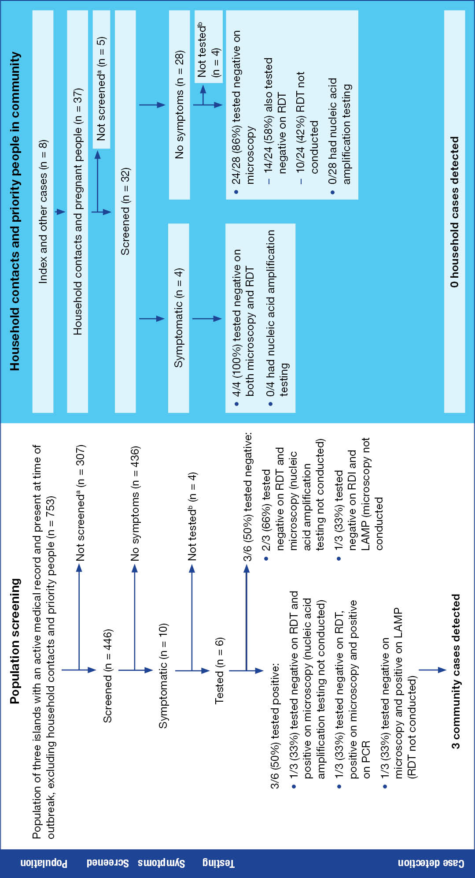
a Resident not screened due to decline, resident could not be located for screening or were the index or other cases.
b Resident declined testing or did not present to local clinic.

Figure A.2: ‘Stop the Bite’ information leaflet, Torres and Cape Hospital and Health Service, 2023–2025
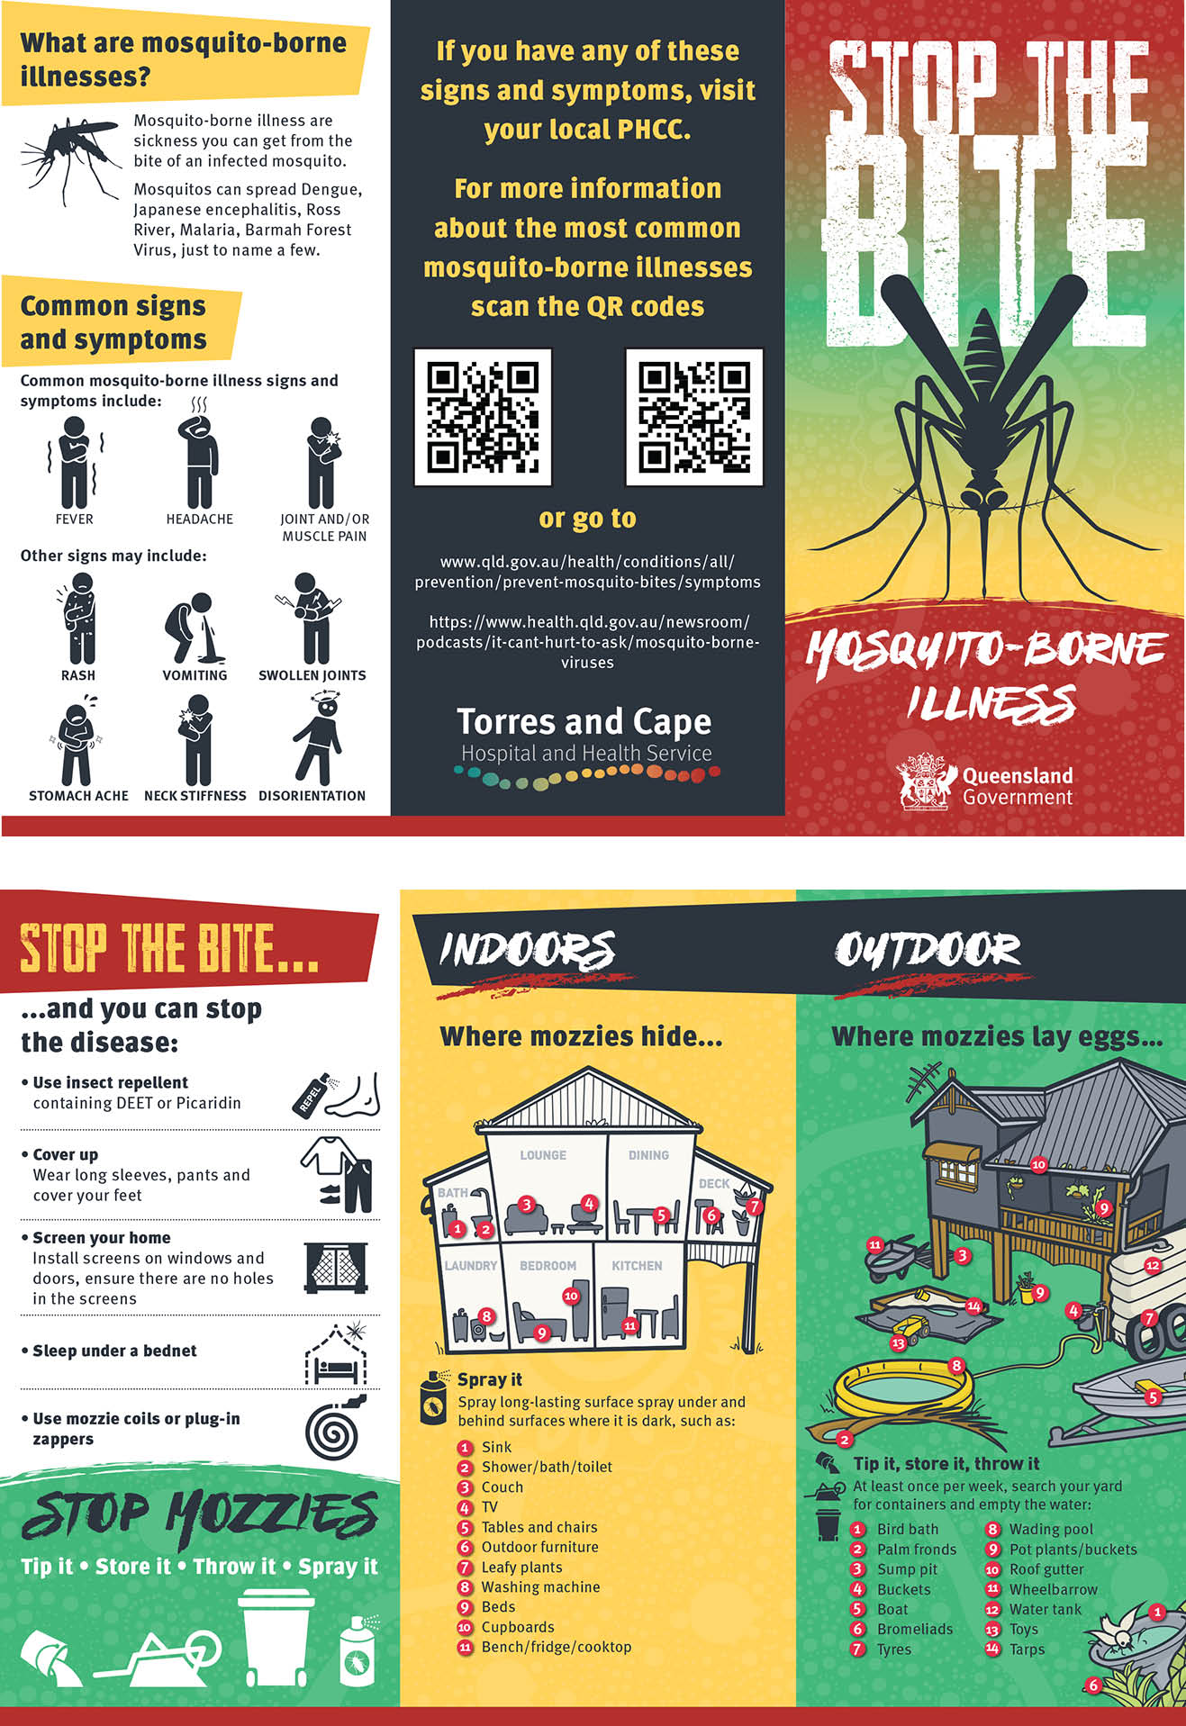

Of the latter five cases, two reported travel to PNG eight months and ten years prior to their respective outbreaks.

