
2026 • Volume 50 • cdc.gov.au/cdi • Epub date: 20.10.2026 • doi.org/10.33321/cdi.2026.50.061

Australian Rotavirus Surveillance Program: Annual Report, 2025
Sarah Thomas, Ruth Phang, Nada Bogdanovic-Sakran, Turgut E Aktepe, Julie E Bines, Celeste M Donato on behalf of the Australian Rotavirus Surveillance Program
© 2026 Commonwealth of Australia as represented by the Australian Centre for Disease Control
ISSN: 2209-6051 Online
This journal is indexed by Index Medicus and Medline.
Creative Commons Licence
This publication is licensed under a Creative Commons Attribution-NonCommercial-NoDerivatives 4.0 International Licence (Licence). You must read and understand the Licence before using any material from this publication.
Restrictions
The Licence does not cover, and there is no permission given for, use of any of the following material found in this publication (if any):
- the Commonwealth Coat of Arms (by way of information, the terms under which the Coat of Arms may be used can be found on the Department of Prime Minister and Cabinet website);
- any logos (including the Australian Centre for Disease Control’s logo) and trademarks;
- any photographs and images;
- any signatures; and
- any material belonging to third parties.
Disclaimer
Opinions expressed in Communicable Diseases Intelligence are those of the authors and not necessarily those of the Australian Government or the Australian Centre for Disease Control. Data may be subject to revision.
Enquiries
Enquiries regarding any other use of this publication should be addressed to the CDI Editor.
About CDI
Communicable Diseases Intelligence (CDI) is a peer-reviewed scientific journal published by the Australian Centre for Disease Control.
The journal aims to disseminate information on the epidemiology, surveillance, prevention and control of communicable diseases of relevance to Australia and the near region.
Editor: Dr Elise Firman • Deputy Editor: Simon Petrie • Design and Production: Lisa Thompson
Editorial Advisory Board: David Durrheim, Mark Ferson, Clare Huppatz, John Kaldor, Martyn Kirk and Meru Sheel
Submit an Article
Guidelines for authors and details on how to submit your publication is available on our website, or by email to the
CDI Editor.
Contact us
Communicable Diseases Intelligence (CDI)
Australian Centre for Disease Control
PO Box 795, Canberra ACT 2601, Australia
Website: cdc.gov.au/cdi
Email: cdi.editor@cdc.gov.au

Contents
Abstract 5
Introduction 6
Methods 8
Results 11
Sample description 11
Demographics of the sample population 12
Temporal trends across 2025 14
Genotype distribution of rotavirus positive samples 18
Discussion and conclusion 21
Acknowledgments 24
Author details 25
References 28

List of figures
Figure 1: National Rotavirus Reference Centre workflow diagram reflecting the number of rotavirus positive stool samples received from 1 January to 31 December 2025, Australia 11
Figure 2: Number of analysed wildtype and vaccine-like samples with respect to number of National Notifiable Diseases Surveillance System (NNDSS) rotavirus notifications, 1 January to 31 December 2025, Australia 14
Figure 3: National Notifiable Diseases Surveillance System (NNDSS) rotavirus notifications per 100,000 population by jurisdiction annually between 2018 and 2025, Australia 15
Figure 4: National Notifiable Diseases Surveillance System (NNDSS) rotavirus notifications per 100,000 population by jurisdiction, 1 January to 31 December 2025, Australia 16

List of tables
Table 1: Number of rotavirus samples provided by each collaborating laboratory, Australia,
2025 10
Table 2: Age distribution of wildtype rotavirus gastroenteritis cases referred to the National Rotavirus Reference Centre, Australia, 1 January to 31 December 2025 12
Table 3: Age distribution of samples referred to the National Rotavirus Reference Centre found to have a vaccine-like VP7 gene identified, Australia, 1 January to 31 December 2025 13
Table 4: Rotavirus G and P genotype distribution observed across jurisdictions during the period 1 January to 31 December 2025, Australia 17
Table 5: Unusual genotypes and genotype combinations observed during the period 1 January to 31 December 2025, Australia 20

Abstract
This report from the Australian Rotavirus Surveillance Program (ARSP) describes the circulating rotavirus genotypes identified in children and adults during the period 1 January to 31 December 2025. In 2025, the ARSP saw a continuation of a high burden of rotavirus disease in the Australian population. During this period, 2,419 faecal specimens were referred to the National Rotavirus Reference Centre (NRRC) for rotavirus G- and P-genotype analysis; of these samples, 2,288 were confirmed as rotavirus positive. This represents the highest number of referred samples and the highest number of positive samples recorded in a single surveillance year in the NRRC's more than 20-year history. Of the 2,288 samples confirmed rotavirus positive, 2,071 (90.5%) were identified as wildtype rotavirus; 215 (9.4%) were identified as the Rotarix vaccine-like strain; and two G1P[8] samples could not be confirmed as wildtype or vaccine-like due to inadequate sequence quality. The equine-like G3P[8] variant was the dominant genotype nationally (87.7%; n = 1,816/2,071). Other genotypes were identified at low frequencies, including wildtype G1P[8] (0.3%; n = 6/2,071), G2P[4] (2.0%; n = 42/2,071), G3P[8] (2.4%; n = 50/2,071), G8P[8] (0.5%; n = 10/2,071), G9P[4] (0.3%; n = 6/2,071), G9P[8] (2.2%; n = 46/2,071) and G12P[8] (0.3%; n = 6/2,071). Genotype distribution was consistent nationally, with equine-like G3P[8] the dominant genotype in all jurisdictions. Consistent with observations in recent years, a small number of samples with unusual genotypes were identified (3.7%; n = 77/2,071). Of these unusual genotypes, the most frequently detected was equine-like G3P[6] which accounted for 26.0% of unusual samples (n = 20/74) and 1.0% of all positive wildtype samples (n = 20/2,071).
The high number of rotavirus positive samples received by the program reflected the notifications for rotavirus disease reported to the National Notifiable Diseases Surveillance Service (NNDSS). Across Australia, 9,520 notifications were recorded, which is the second highest annual total reported since rotavirus became nationally notifiable in 2018. Outbreaks were reported in the Northern Territory, Western Australia and Queensland.
The ability to monitor the genotypes of rotavirus strains causing disease across ages and jurisdictions provides important data to aid in assessing the performance of the national rotavirus vaccination program and to inform public health interventions during outbreaks. The ARSP also provides important data to monitor annual variations in genotypes circulating in the population. Understanding the diversity of genotypes in circulation and the emergence of variants provides important context for any changes observed in disease epidemiology in the community. The ARSP provides diagnostic laboratories with valuable feedback on laboratory data quality by reporting incidences of wildtype, vaccine-like, and/or false positive rotavirus results.
Keywords: rotavirus; gastroenteritis; genotype; surveillance; Australia; vaccine; equine-like G3P[8]

Introduction
Globally, Group A rotavirus infections were identified as the cause of 128,500 deaths and 258 million episodes of diarrhoea among children < 5 years of age in 2016.¹ To address this burden, there are now four WHO pre-qualified rotavirus vaccines introduced nationally or regionally into the routine Immunisation Programs of over 131 countries: these vaccines are Rotarix [GSK, Belgium], RotaTeq [Merck, United States of America], Rotavac [Bharat Biotech, India], and RotaSIIL [Serum Institute of India, India].^{2–5}
In Australia, rotavirus vaccines were first introduced into the routine infant immunisation schedule in the Northern Territory in 2006 and then nationally on 1 July 2007, with the decision on vaccine choice, Rotarix [GSK] or RotaTeq [Merck], initially made at the state or territory level. RotaTeq was administered in Queensland, South Australia, and Victoria, whereas Rotarix was administered in the Australian Capital Territory, New South Wales, the Northern Territory, and Tasmania. Western Australia initially administered Rotarix and changed to RotaTeq in May 2009. On 1 July 2017, all states and territories that administered RotaTeq changed to Rotarix, making national vaccine administration uniform across all jurisdictions in Australia.^{6,7}
Following the introduction of rotavirus vaccines in 2007, there was a significant reduction in rotavirus-coded and non-rotavirus-coded acute gastroenteritis hospitalisations of children ≤ 5 years of age.^{3–5} Several post-licensure studies have shown that rotavirus vaccines are safe and effective and associated with significant reduction in the rotavirus burden of disease in Australia.^{3–5} Within the first six years of vaccine introduction, an estimated 77,000 hospitalisations were prevented, 90% of which were in children ≤ 5 years of age, with indications of herd protection occurring in older age groups.⁵ Compared to the pre-vaccine era (2002–2006), the mean annual hospitalisation rate/100,000 population for rotavirus-coded gastroenteritis, in children < 5 years of age, decreased in the vaccine era (2008-2019) by 85%.⁸ The most recent reports of vaccine coverage from 2024 reported 88.5% two-dose rotavirus vaccine coverage in all children, and coverage of 82.8% in Aboriginal and Torres Strait Islander children.⁹
In Australia, rotavirus gastroenteritis has been a notifiable disease since 2010, with all states and territories reporting through the National Notifiable Diseases Surveillance System (NNDSS) with national representation since 2018.¹⁰ The NNDSS monitors the reports of rotavirus disease across each jurisdiction monthly and according to age cohorts. Over the past decade, the clinical presentations of rotavirus disease have followed a pattern of a low baseline incidence across months punctuated by outbreaks, particularly notable in regional areas. In 2021, outbreaks were reported in Western Australia and the Northern Territory in September and continued through to December, as many parts of Australia emerged from a prolonged period of social distancing due to coronavirus disease 2019 (COVID-19) restrictions.¹¹ The increased rate of rotavirus notifications observed in 2021 persisted into 2022 and continued throughout 2023 and 2024.^{12–14}
Since 1999, the Australian Rotavirus Surveillance Program (ARSP) has characterised rotavirus genotypes causing severe disease in Australian children ≤ 5 years of age.⁶ From 2010 onwards, surveillance was extended to children ≥ 5 years of age and to adults. The ARSP receives rotavirus positive samples from collaborating laboratories across all states and territories which have screened samples for rotavirus positivity. Positive samples are then sent from jurisdictional collaborating laboratories to the National Rotavirus Reference Centre (NRRC) in Melbourne for confirmatory testing and genotyping.
Rotavirus genotypes are defined by a binary classification system based on the two outer capsid proteins, VP7 (G, glycoprotein) and VP4 (P, protease-sensitive).¹⁵ Globally, there are five common genotype combinations identified in humans: G1P[8], G2P[4], G3P[8], G4P[8], and G9P[8], although G8P[8] and G12P[8] have also been described as globally important genotypes in recent years.¹⁶⁻¹⁸ Additionally, whole genome classification assigns genotypes to each of the 11 genes: Gx-P[x]-Ix-Rx-Cx-Mx-Ax-Nx-Tx-Ex-Hx, denoting the VP7-VP4-VP6-VP1-VP2-VP3-NSP1-NSP2-NSP3-NSP4-NSP5/6 genes.¹⁹ The majority of human rotavirus genomes fall under two genotype constellations: Wa-like (genogroup 1: G1/3/4/9/12-P[8]-I1-R1-C1-M1-A1-N1-T1-E1-H1), and DS-1-like (genogroup 2: G2-P[4]-I2-R2-C2-M2-A2-N2-T2-E2-H2).¹⁹ A third genogroup, AU-1-like, is also detected in humans, however less frequently (genogroup 3: G3-P[9]-I3-R3-C3-M3-A3-N3-T3-E3-H3).¹⁹ Numerous mechanisms contribute to rotavirus diversity including genetic drift, reassortment and zoonotic transmission. The segmented genome allows for reassortment both within and between human and animal strains, leading to the emergence of novel strains and unusual genotype combinations.²⁰
The genotype data provided by the ARSP has revealed changes in rotavirus genetic diversity, as well as temporal and geographic fluctuations.^{6,21} Furthermore, differences in genotype diversity and dominance were observed when comparing vaccines by jurisdictions, suggesting that RotaTeq and Rotarix exerted different immunological pressures on circulating rotavirus strains in Australia.^{6,21} The continued surveillance and characterisation of rotavirus genotypes circulating in Australia will provide important insights into whether changes in vaccine immunisation programs could impact virus epidemiology and alter genotype diversity, which could have ongoing consequences for the success of current and future vaccination programs.
This report describes the G- and P- genotype distribution of rotavirus strains causing severe gastroenteritis in Australia for the period 1 January to 31 December 2025.

Methods
Faecal samples were tested for the presence of rotavirus by quantitative polymerase chain reaction (qPCR) or enzyme immunoassay (EIA) by collaborating laboratories Australia-wide. Positive samples were frozen and sent to the NRRC, Melbourne, together with available metadata including date of collection (DOC); date of birth (DOB); sex; postcode; and the qPCR cycle threshold (Ct) values generated by the collaborating laboratory (where possible). Specimens were received from the following 12 collaborating centres located in the Australian Capital Territory, New South Wales, the Northern Territory, Queensland, South Australia, Tasmania, Victoria, and Western Australia (Table 1).
Upon receipt by the NRRC, samples were allocated a unique laboratory code and entered into the ARSP database (Microsoft Excel and REDCap). Samples were stored at -30 °C until analysed.
Viral RNA was extracted from 10–20% faecal extracts using the QIAamp Viral RNA mini extraction kit (QIAGEN), according to the manufacturer’s instructions, with the exception of eluting in 50 µL of nuclease-free water. Rotavirus G- and P- genotypes were determined using an in-house hemi-nested multiplex RT-PCR assay. The first-round RT-PCR reactions were performed using the One Step RT-PCR kit (QIAGEN), in conjunction with VP7 (VP7F/VP7R) or VP4 (VP4F/VP4R) conserved primers.^{22,23} The second-round genotyping PCR reactions were conducted using specific oligonucleotide primers for G types G1, G2, G3, G4, G8, and G9, or P types P[4], P[6], P[8], P[9], P[10], and P[11].^{22–25} The G- and P- genotype was determined using agarose gel electrophoresis of second-round PCR products. Samples failing to generate a second-round PCR amplicon, or with inconclusive results, were further tested by VP6-specific RT-PCR using the Superscript III One-Step RT-PCR System with Platinum Taq DNA Polymerase (Invitrogen) and primers Rot3 and Rot5 as described previously.^{26,27}
Sanger sequencing was used to determine the VP7 and/or VP4 nucleotide sequence for PCR non-typeable samples. The current set of primers used in the second-round G-typing protocol cannot detect genotypes to equine-like G3, G12, and unusual rotavirus strains. Due to non-specific binding of the G9 primer to equine-like G3 strains, all G9 samples were further characterised using equine-like G3 primers as described previously.²⁸ The VP7 gene of any sample which was negative by equine-like G3 PCR (potentially G9) was sequenced. All non-typeable P[8] samples were further characterised using G12 specific primers as described previously.²⁹ The VP7 gene of each G1P[8] sample was sequenced to determine if wildtype or Rotarix vaccine-like strain was detected. Samples which had no first-round PCR amplicon were re-amplified using the Superscript III One-Step RT-PCR System with Platinum Taq DNA Polymerase (Invitrogen), in conjunction with VP7 (Beg9/End9) or VP4 (Con2/Con3) primers, as described previously.^{25,27,30} The generated VP7 and VP4 amplicons were purified using the Wizard SV Gel and PCR Clean-Up System (Promega), according to the manufacturer’s protocol with the exception of eluting in 30 mL of nuclease-free water. Purified DNA and oligonucleotide primers (VP7F/VP7R, VP4F/VP4R, Beg9/End9, or Con2/Con3) were sent to the Australian Genome Research Facility (AGRF), Melbourne, and sequenced using an ABI PRISM BigDye Terminator Cycle Sequencing Reaction Kit (Applied Biosystems) in an Applied Biosystems 3730xl DNA Analyzer (Applied Biosystems). Electropherograms were visually analysed and edited using Geneious Prime 2026.1.2. Genotype assignment was determined using BLAST and Rotavirus A Genotyping Tool Version 0.1.
Table 1: Number of rotavirus samples provided by each collaborating laboratory, Australia, 2025
Healthcare facility | Department | Jurisdictionª | n
Canberra Hospital | Microbiology Department | ACT | 22
Prince of Wales Hospital | Serology, Virology and OTDS Laboratories (SAViD) — Randwick | NSW | 72
The Children’s Hospital, Westmead | Infectious Diseases and Microbiology Department | NSW | 63
Douglass Hanly Moir Pathology | Infectious Serology Department | NSW | 29
Liverpool Hospital, Liverpool | Department of Microbiology and Infectious Diseases | NSW | 107
Royal Darwin Hospital | Territory Pathology | NT | 272
Royal Brisbane & Women’s Hospital, Herston | Pathology Queensland Central | Qld | 653
SA Pathology, Adelaide | Microbiology and Infectious Diseases Laboratory | SA | 361
Royal Hobart Hospital, Hobart | Molecular Medicine, Pathology Services | Tas. | 23
Monash Medical Centre, Clayton | Department of Microbiology | Vic. | 128
Royal Children’s Hospital, Parkville | Laboratory Services | Vic. | 87
PathWest Laboratory Medicine, Nedlands | QEII Microbiology Department | WA | 602
a ACT: Australian Capital Territory; NSW: New South Wales; NT: Northern Territory; Qld: Queensland; SA: South Australia; Tas.: Tasmania; Vic.: Victoria; WA: Western Australia.

Results

Sample description
A total of 2,419 specimens, determined to be rotavirus positive by collaborating laboratories, were referred to the NRRC during the period 1 January to 31 December 2025 (Figure 1). A subset of samples (n = 131) was not analysed further due to: being a duplicate sample (n = 68); missing sample (not received; n = 2); or not confirmed as rotavirus positive by VP6 PCR analysis by NRRC methods (n = 61).
A total of 2,288 samples were successfully genotyped. Samples were then classified as wildtype (no vaccine VP7 gene identified) or vaccine-like (Rotarix vaccine VP7 gene identified), based on genotype and the analysis of the top BLAST hits of any G1 VP7 sequence.
Figure 1: National Rotavirus Reference Centre workflow diagram reflecting the number of rotavirus positive stool samples received from 1 January to 31 December 2025, Australia
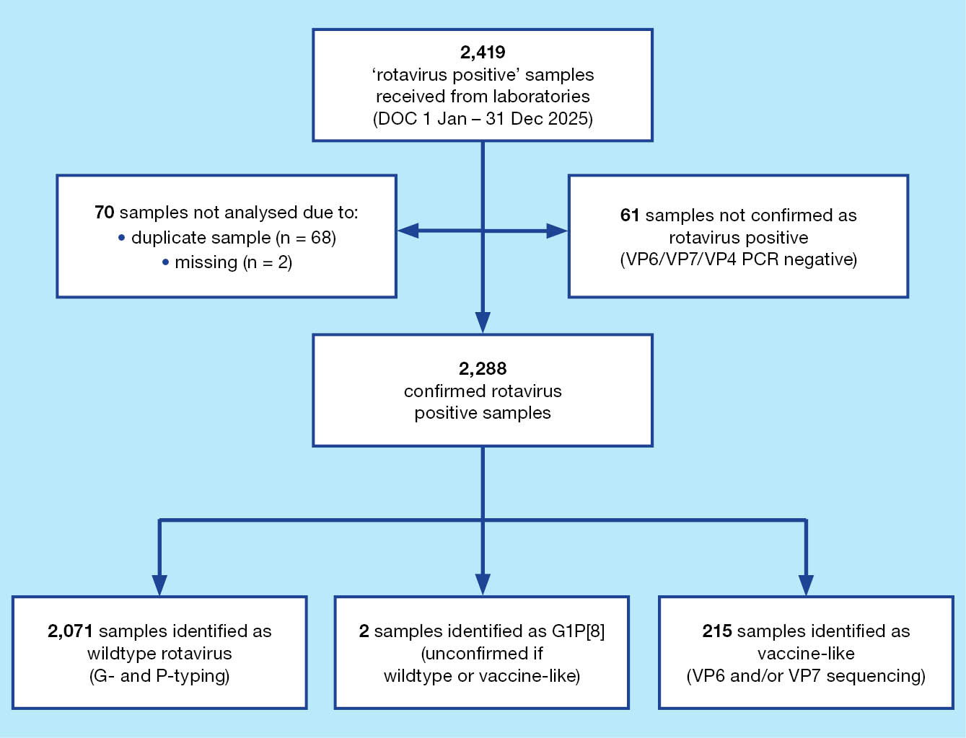

Demographics of the sample population

Age distribution of wildtype rotavirus samples
Of the 2,071 samples confirmed as wildtype, 1,065 (51.4%) were collected from children < 5 years of age, and 1,006 (48.6%) were obtained from children ≥ 5 years of age and from adults (Table 2).
Table 2: Age distribution of wildtype rotavirus gastroenteritis cases referred to the National Rotavirus Reference Centre, Australia, 1 January to 31 December 2025
Age (months) | Age (years) | n | % of total | % < 5 years of age
0–6 | — | 161 | 7.8 | 15.1
7–12 | ≤ 1 | 172 | 8.3 | 16.2
13–24 | 1 –≤ 2 | 340 | 16.4 | 31.9
25–36 | 2 –≤ 3 | 208 | 10.0 | 19.5
37–48 | 3 –≤ 4 | 118 | 5.7 | 11.1
49–59 | 4 –< 5 | 66 | 3.2 | 6.2
Subtotal | — | 1,065 | 51.4 | 100.0
60–120 | 5 –≤ 10 | 207 | 10.0 | —
121–240 | 10 –≤ 20 | 129 | 6.2 | —
241–960 | 20 –≤ 80 | 605 | 29.2 | —
961+ | > 80 | 65 | 3.1 | —
Subtotal | — | 1,006 | 48.6 | —
Total | — | 2,071 | 100.0 | —

Age distribution of rotavirus vaccine-like samples
All G1P[8] samples (n = 223) were analysed by VP7 sequencing to identify vaccine-like or wildtype strains. Overall, 221 samples were successfully sequenced, of which 215 were Rotarix vaccine-like and six were wildtype strains. Two samples genotyped as G1P[8] could not be determined as wildtype or vaccine-like due to repeated failed attempts to generate adequate sequencing results.
Of the samples found to have a vaccine-like VP7 gene, 95.3% (n = 205/215) were from the 0–6 months age group (Table 3), reflecting the time when infants may receive a rotavirus vaccine according to the National Immunisation Program schedule. Samples with vaccine-like VP7 genes were also found in infants (8 months (n = 1) and 14 months of age (n = 1)). The eight vaccine-like samples detected in individuals ≥ 5 years of age were from individuals 6, 10, 25, 35, 53, 71, 75 and 87 years old (Table 3).
Table 3: Age distribution of samples referred to the National Rotavirus Reference Centre found to have a vaccine-like VP7 gene identified, Australia, 1 January to 31 December 2025
Age (months) | Age (years) | n | % of total | % < 5 years of age
0–6 | — | 205 | 95.3 | 99.0
7–12 | ≤ 1 | 1 | 0.5 | 0.5
13–24 | 1 –≤ 2 | 1 | 0.5 | 0.5
25–36 | 2 –≤ 3 | 0 | 0.0 | 0.0
37–48 | 3 –≤ 4 | 0 | 0.0 | 0.0
49–59 | 4 –< 5 | 0 | 0.0 | 0.0
Subtotal | — | 207 | 96.3 | 100.0
60–120 | 5 –≤ 10 | 1 | 0.5 | —
121–240 | 10 –≤ 20 | 1 | 0.5 | —
241–960 | 20 –≤ 80 | 5 | 2.3 | —
961+ | > 80 | 1 | 0.5 | —
Subtotal | — | 8 | 3.7 | —
Total | — | 215 | 100.0 | —

Temporal trends across 2025

National trends of rotavirus positive samples – categorised as wildtype and vaccine-like strains
Wildtype and vaccine-like rotavirus positive samples received by the NRRC were analysed by date of collection (DOC: month) and compared with monthly national rotavirus notifications reported to the NNDSS (Figure 2). Overall, the temporal trend in samples received by the NRRC broadly reflected national notification patterns reported by the NNDSS.
Wildtype samples and NNDSS notifications were moderately elevated in January and then remained relatively low and stable from February to June, with the lowest numbers observed in May. From July onwards, a marked increase was observed in both the number of samples received by the NRRC and the notifications reported by the NNDSS. Wildtype samples peaked between July and September, remaining elevated through October before gradually declining towards December. Similarly, NNDSS notifications increased sharply from July, peaked in October and remained high through November and December.
The increase in NNDSS notifications observed between September and October was mirrored by the sustained high number of wildtype samples received by the NRRC. Vaccine-like samples remained consistently low throughout the year, with no clear seasonal association observed (Figure 2).
Figure 2: Number of analysed wildtype and vaccine-like samples with respect to number of National Notifiable Diseases Surveillance System (NNDSS) rotavirus notifications, 1 January to 31 December 2025, Australia
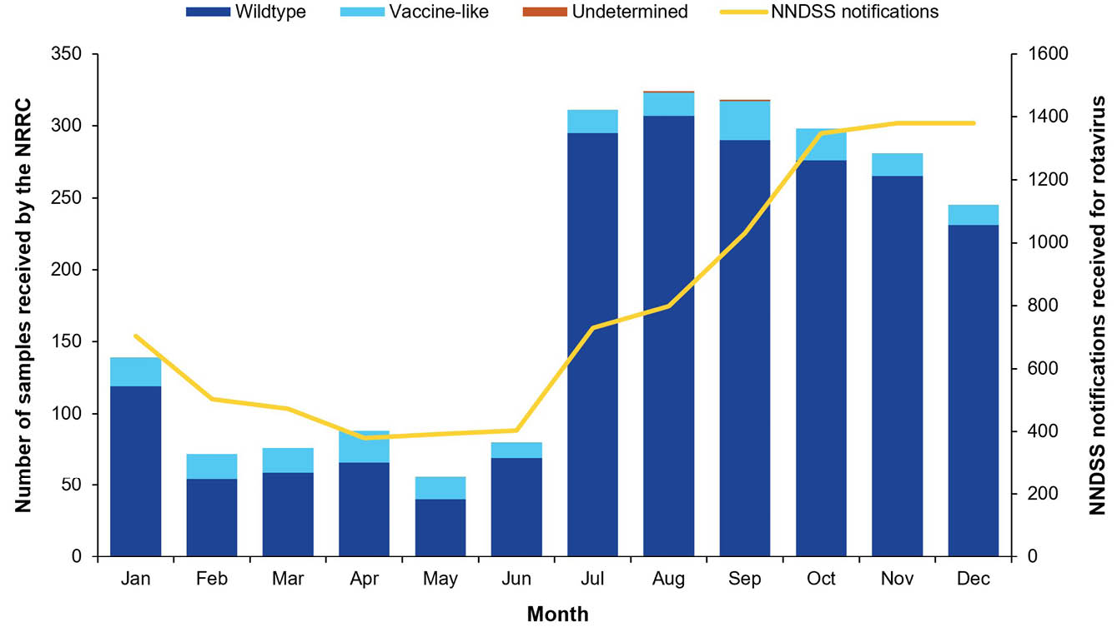

Seasonal trends of wildtype rotavirus positive samples across jurisdictions
Rotavirus positive specimens were received from all states and territories for the 2025 surveillance period. The highest number of wildtype samples for this surveillance period were from Queensland (25.9%; n = 536/2,071) and Western Australia (24.7%; n = 511/2,071), followed by South Australia (15.4%; n = 319/2,071); New South Wales (11.9%; n = 246/2,071); the Northern Territory (10.8%; n = 224/2,071); Victoria (9.7%; n = 201/2,071); the Australian Capital Territory (0.8%; n = 17/2,071); and Tasmania (0.8%; n = 17/2,071) (Table 4).
State-based notification reports per 100,000 population suggested differing patterns of rotavirus activity across the country in 2025 (Figure 3).¹⁰ The Northern Territory had the highest cumulative annual notification reports per 100,000 population at 121.0, followed by South Australia at 57.0; Western Australia at 43.9; New South Wales at 39.0; Queensland at 28.0; the Australian Capital Territory at 27.0; Victoria at 23.0; and Tasmania at 11.0. The continuing high burden of disease in 2025, compared to recent years, was highlighted when reviewing the annual notification data per 100,000 population since 2018. The notifications for 2025 were amongst the highest observed for the Northern Territory and Western Australia, and the second highest across the years 2018–2025 for the Australian Capital Territory, New South Wales, South Australia, Victoria, and Tasmania (Figure 3).
Figure 3: National Notifiable Diseases Surveillance System (NNDSS) rotavirus notifications per 100,000 population by jurisdiction annually between 2018 and 2025, Australia
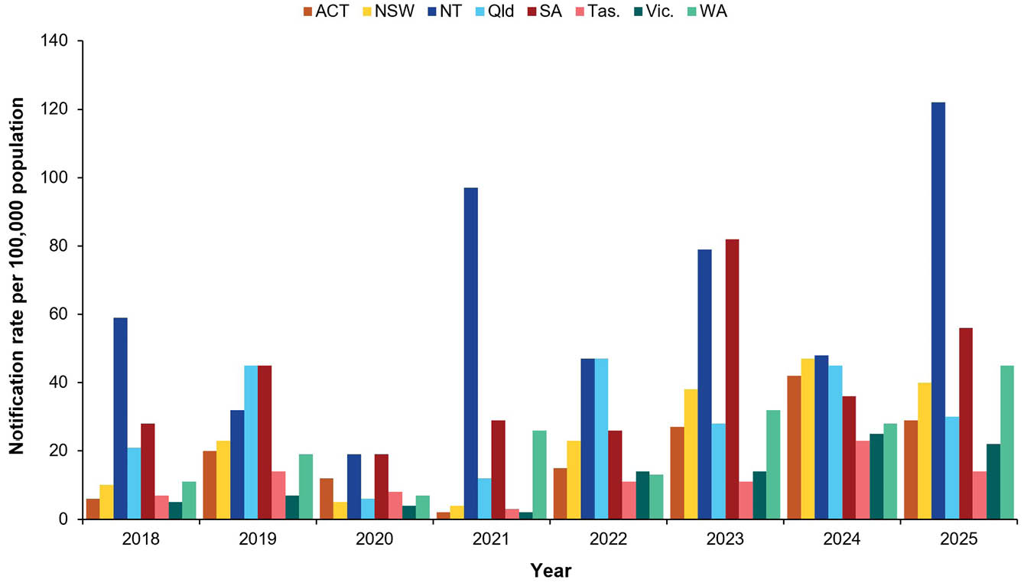
The magnitude of rotavirus notification peaks varied across Australian jurisdictions; however, the temporal patterns were relatively consistent, with most states and territories recording higher notification rates in the latter half of the year (Figure 4). The Northern Territory reported a bimodal pattern with a small increase in March followed by a pronounced and sustained peak between July and September, with the highest monthly notification rate nationally observed in August. Western Australia also exhibited a bimodal pattern, with elevated notification rates in July and a smaller secondary peak between October and December.
The Australian Capital Territory and New South Wales demonstrated increasing notification rates from September onwards, with notifications remaining elevated through October and November. South Australia recorded relatively consistent notification rates throughout the year, with moderate increases observed in September to December. Notification rates in Queensland were stable during quarters 1 and 2, followed by a gradual increase from July, peaking in September and sustained until December.
In Tasmania, notification rates were generally low and stable across the year, with increasing rates in quarter 4. Similarly, Victoria also maintained relatively stable rates throughout quarters 1–3, followed by a small increase during quarter 4.
Figure 4: National Notifiable Diseases Surveillance System (NNDSS) rotavirus notifications per 100,000 population by jurisdiction, 1 January to 31 December 2025, Australia
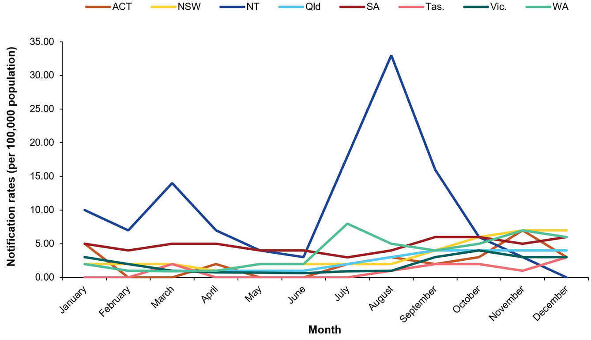
Table 4: Rotavirus G and P genotype distribution observed across jurisdictions during the period 1 January to 31 December 2025, Australia
Jurisdiction^{a,b} | Age (years) | Total | G1P[8] |  | G2P[4] |  | G3P[8] |  | Eq G3P[8]^{c} |  | G8P[8] |  | G9P[4] |  | G9P[8] |  | G12P[8] |  | Mixed |  | Other^{d} |  | Non-type^{e}
Jurisdiction^{a,b} | Age (years) | n | n | % | n | % | n | % | n | % | n | % | n | % | n | % | n | % | n | % | n | % | n | %
ACT | < 5 | 13 | 0 | 0.0 | 0 | 0.0 | 0 | 0.0 | 13 | 100.0 | 0 | 0.0 | 0 | 0 | 0 | 0.0 | 0 | 0.0 | 0 | 0.0 | 0 | 0.0 | 0 | 0.0
ACT | ≥ 5 | 4 | 0 | 0.0 | 0 | 0.0 | 0 | 0.0 | 3 | 75.0 | 0 | 0.0 | 0 | 0 | 1 | 25.0 | 0 | 0.0 | 0 | 0.0 | 0 | 0.0 | 0 | 0.0
NSW | < 5 | 119 | 1 | 0.8 | 2 | 1.7 | 0 | 0.0 | 108 | 90.8 | 0 | 0.0 | 3 | 2.5 | 0 | 0.0 | 3 | 2.5 | 0 | 0.0 | 2 | 1.7 | 0 | 0.0
NSW | ≥ 5 | 127 | 0 | 0.0 | 1 | 0.8 | 4 | 3.1 | 114 | 89.8 | 0 | 0.0 | 0 | 0.0 | 4 | 3.1 | 0 | 0.0 | 1 | 1.0 | 3 | 2.4 | 0 | 0.0
NT | < 5 | 160 | 0 | 0.0 | 0 | 0.0 | 0 | 0.0 | 154 | 96.3 | 0 | 0.0 | 0 | 0.0 | 1 | 0.6 | 0 | 0.0 | 0 | 0.0 | 1 | 0.6 | 4 | 2.5
NT | ≥ 5 | 64 | 0 | 0.0 | 0 | 0.0 | 0 | 0.0 | 58 | 90.6 | 0 | 0.0 | 0 | 0.0 | 1 | 1.6 | 0 | 0.0 | 2 | 3.0 | 1 | 1.6 | 2 | 3.1
Qld | < 5 | 234 | 0 | 0.0 | 13 | 5.6 | 7 | 3.0 | 207 | 88.5 | 0 | 0.0 | 0 | 0.0 | 2 | 0.9 | 1 | 0.4 | 0 | 0.0 | 2 | 0.9 | 2 | 0.9
Qld | ≥ 5 | 302 | 2 | 0.7 | 15 | 5.0 | 10 | 3.3 | 238 | 78.8 | 3 | 1.0 | 0 | 0.0 | 13 | 4.3 | 1 | 0.3 | 0 | 0.0 | 20 | 6.6 | 0 | 0.0
SA | < 5 | 133 | 0 | 0.0 | 1 | 0.8 | 2 | 1.5 | 121 | 91.0 | 6 | 4.5 | 0 | 0.0 | 0 | 0.0 | 0 | 0.0 | 0 | 0.0 | 3 | 2.3 | 0 | 0.0
SA | ≥ 5 | 186 | 1 | 0.5 | 6 | 3.2 | 3 | 1.6 | 152 | 81.7 | 0 | 0.0 | 3 | 1.61 | 9 | 4.8 | 0 | 0.0 | 0 | 0.0 | 12 | 6.5 | 0 | 0.0
Tas. | < 5 | 6 | 0 | 0.0 | 0 | 0.0 | 0 | 0.0 | 4 | 66.7 | 0 | 0.0 | 0 | 0.0 | 0 | 0.0 | 1 | 16.7 | 0 | 0.0 | 1 | 16.7 | 0 | 0.0
Tas. | ≥ 5 | 11 | 0 | 0.0 | 0 | 0.0 | 1 | 9.1 | 7 | 63.6 | 0 | 0.0 | 0 | 0.0 | 2 | 18.2 | 0 | 0.0 | 0 | 0.0 | 1 | 9.1 | 0 | 0.0
Vic. | < 5 | 83 | 1 | 1.2 | 0 | 0.0 | 0 | 0.0 | 78 | 94.0 | 0 | 0.0 | 0 | 0.0 | 0 | 0.0 | 0 | 0.0 | 0 | 0.0 | 3 | 3.6 | 1 | 1.2
Vic. | ≥ 5 | 118 | 1 | 0.8 | 3 | 2.5 | 5 | 4.2 | 96 | 81.4 | 1 | 0.8 | 0 | 0.0 | 4 | 3.4 | 0 | 0.0 | 0 | 0.0 | 7 | 5.9 | 1 | 0.8
WA | < 5 | 317 | 0 | 0.0 | 0 | 0.0 | 7 | 2.2 | 303 | 95.6 | 0 | 0.0 | 0 | 0.0 | 1 | 0.3 | 0 | 0.0 | 0 | 0.0 | 5 | 1.6 | 1 | 0.3
WA | ≥ 5 | 194 | 0 | 0.0 | 1 | 0.5 | 11 | 5.7 | 160 | 82.5 | 0 | 0.0 | 0 | 0.0 | 8 | 4.1 | 0 | 0.0 | 0 | 0.0 | 13 | 6.7 | 1 | 0.5
Subtotal | < 5 | 1,065 | 2 | 0.2 | 16 | 1.5 | 16 | 1.5 | 988 | 92.8 | 6 | 0.6 | 3 | 0.3 | 4 | 0.4 | 5 | 0.5 | 0 | 0.0 | 17 | 1.6 | 8 | 0.8
Subtotal | ≥ 5 | 1,006 | 4 | 0.4 | 26 | 2.6 | 34 | 3.4 | 828 | 82.3 | 4 | 0.4 | 3 | 0.3 | 42 | 4.2 | 1 | 0.1 | 3 | 0.3 | 57 | 5.7 | 4 | 0.4
Total | — | 2,071 | 6 | 0.3 | 42 | 2.0 | 50 | 2.4 | 1,816 | 87.7 | 10 | 0.5 | 6 | 0.3 | 46 | 2.2 | 6 | 0.3 | 3 | 0.1 | 74 | 3.6 | 12 | 0.6
a Samples sorted based on sample location, not collection location.
b ACT: Australian Capital Territory; NSW: New South Wales; NT: Northern Territory; Qld: Queensland; SA: South Australia; Tas.: Tasmania; Vic.: Victoria; WA: Western Australia.
c Equine-like G3P[8].
d Other: unusual and rarely detected genotypes, as detailed in Table 5.
e Specimen where G or P genotype was not determined.

Genotype distribution of rotavirus positive samples

Rotavirus G and P genotype distribution patterns
Genotype analysis was performed on all 2,071 confirmed wildtype rotavirus positive samples (Table 4). The lack of genotype diversity was notable for the second consecutive year, with equine-like G3P[8] again detected as the dominant genotype nationally (87.7%; n = 1,816/2,071). Equine-like G3P[8] was the dominant genotype in all jurisdictions, accounting for 94.1% of samples in the Australian Capital Territory; 90.2% in New South Wales; 94.6% in the Northern Territory; 83.0% in Queensland; 85.6% in South Australia; 64.7% in Tasmania; 86.6% in Victoria; and 90.6% in Western Australia. Age distribution had only a minor impact on genotype distribution, with equine-like G3P[8] remaining the dominant genotype both in children aged < 5 years (92.8%; n = 988/1,065) and in individuals aged ≥ 5 years (82.3%; n = 828/1,006) across all jurisdictions.
Given the overwhelming predominance of equine-like G3P[8], most other genotypes were detected in decreased frequencies compared to previous years. Human G3P[8] was a dominant national genotype in 2023, accounting for 42.6% of samples (n = 662/1,554) before declining substantially in 2024 to 4.8% (n = 77/1,610).^{13,14} In 2025, the frequency of human G3P[8] continued to decrease, representing 2.4% of samples nationally (n = 50/2,071), although it remained the second-most common genotype overall, and was the second-most common genotype in Victoria and Western Australia and second-equal most common genotype in New South Wales. Human G3P[8] accounted for 1.5% of samples from children aged < 5 years (n = 16/1,065) and 3.4% of samples from individuals aged ≥ 5 years (n = 34/1,006).
In contrast, G9P[8] was the only minority genotype to be detected at a higher frequency in 2025 than in 2024, when it accounted of 0.4% of samples.¹⁴ Although G9P[8] (2.2%; n = 46/2,071) was identified in a slightly lower proportion than human G3P[8] of samples overall, it was the second-most common or second-equal most common genotype in five jurisdictions (the Australian Capital Territory, New South Wales, the Northern Territory, South Australia and Tasmania) compared with human G3P[8] that was second- (or second-equal) most common in three jurisdictions. Interestingly, G9P[8] was mostly detected in the population ≥ 5 years of age (n = 42/46).
Wildtype G1P[8] continues to be infrequently detected, representing 0.3% of samples (n = 6/2,071); it was detected in only two samples in the population < 5 years of age, and in four samples in those aged ≥ 5 years. G2P[4] also continued to have a reduced detection rate, having accounted for 2.1% of all wildtype specimens analysed in 2024 (n = 34/1,610) and 2.0% of wildtype samples nationally (n = 42/2,071) in 2025.¹⁴ In 2024, G8P[8] accounted for 2.9% of wildtype samples nationally (n = 46/1,610) and was the second-most common genotype in the Australian Capital Territory and Victoria.¹⁴ In 2025, detection decreased to only 0.5% (n = 10/2,071).
G9P[4] continued to decline in frequency. Having peaked in 2022, when it accounted for 22.3% of samples (n = 249/1,119),¹² it represented only 2.1% of samples in 2023 (n = 32/1,554) and 0.6% in 2024 (n = 9/1,610).^{13,14} In 2025, G9P[4] accounted for only 0.3% of samples (n = 6/2,071) and was detected exclusively in children aged < 5 years from New South Wales.
G12P[8] has also decreased in prevalence since 2022, when it was the dominant genotype detected, accounting for 28.2% of samples (n = 315/1,119).¹² Detection declined to 6.4% in 2023 (n = 100/1,554) and 0.5% in 2024 (n = 8/1,610) before further decreasing to 0.3% of samples in 2025 (n = 6/2,071).^{12–14}

Unusual genotypes and genotype combinations observed
Certain rotavirus genotypes, including G1P[8], G2P[4], G3P[8], G9P[8], G8P[8] and G12P[8] represent the most commonly detected genotypes globally.^{16–18} Unusual genotypes may be detected that represent reassortment events between commonly circulating strains, minor variants, or sporadic zoonotic transmissions. Unusual genotypes were identified in 74 samples in 2025, representing 3.6% of all genotyped samples analysed (Tables 4 and 5).
In 2025, a marked increase in equine-like G3P[6] was observed in both the < 5 years and ≥ 5 years age groups. This genotype was the most frequently identified unusual strain (n = 20) (Table 5), compared with only a single case detected in 2024.¹⁴ Equine-like G3P[6] was identified across multiple jurisdictions, including New South Wales, Queensland, South Australia, Victoria, and Western Australia. Equine-like G3P[4] were also detected. Given the high circulation of the equine-like G3P[8] variant and increased opportunity for reassortment events, the increased detection of these variants is not unexpected. However, it is unclear whether they represent distinct reassortment events, or if there is sustained low-level circulation of reassortant variants.
Similar to observations in 2024, G2P[8] was the second-most frequently identified unusual genotype (n = 9) in 2025 and was detected in New South Wales, Queensland, and Western Australia, suggesting low-level national circulation of this reassortant strain. G3P[4] has fluctuated over recent years from a peak of 21 samples in 2019 and was identified in nine samples in 2025 from Queensland, South Australia, and Western Australia.⁷
The highly unusual G11 genotype continued to be detected in 2025, consistent with the number reported in 2024, with two G11P[25] cases identified in Victoria that were not geographically or temporally linked. The 2024 cases were all from adult males in Queensland, whereas the cases in 2025 were in children 4 and 7 years of age.
Two G11P[8] cases were also identified in 2025, from an elderly individual in Victoria and a young child in Tasmania. This genotype has not been previously reported in Australia. Another genotype identified for the first time was G21P[14], which was detected from a hospitalised adult in Western Australia. A single G10P[1] case was also identified; this genotype also has not previously been detected in Australian surveillance.
Many genotype combinations were detected as a single sample or in low numbers, including G1P[4]; canine/feline-like G3P[3]; G3P[6]; canine/feline-like G3P[8]; G3P[9]; G6P[9]; G6P[14]; G8P[1]; G8P[14]; and G9P[6], which have been reported infrequently over time.
Table 5: Unusual genotypes and genotype combinations observed during the period 1 January to 31 December 2025, Australia
Genotype | Total
G1P[4] | 3
G2P[8] | 9
G3P[3] canine-feline | 1
G3P[4] | 9
G3P[6] | 2
G3P[8] canine-feline | 1
G3P[9] | 5
Equine G3P[4] | 2
Equine G3P[6] | 20
G6P[9] | 5
G6P[14] | 3
G8P[1] | 1
G8P[14] | 4
G9P[6] | 3
G10P[1] | 1
G11P[8] | 2
G11P[25] | 2
G21P[14] | 1
Total | 74

Discussion and conclusion
This ARSP Report describes the distribution of rotavirus genotypes identified in Australia for the period 1 January to 31 December 2025. This marks 18 years since the national introduction of rotavirus vaccines (Rotarix [GSK] and RotaTeq [Merck]) into the National Immunisation Program for all Australian infants, and the eighth year since the exclusive use of Rotarix across all jurisdictions.^{6,31,32} Of the 2,419 samples submitted as rotavirus positive by collaborating laboratories across all states and territories, a total of 2,349 were tested by the NRRC, with 70 samples excluded due to being a duplicate of a tested sample or the sample was missing. In total, 94.6% (n = 2,288/2,419) of samples submitted were confirmed to be rotavirus positive by the NRRC. This provides acknowledgement and confidence that laboratories are accurately identifying rotavirus.
The total of 2,419 samples sent in 2025 from collaborating laboratories is the highest number of samples received by the NRRC to date, and represents an increase compared to 2024, when 2,118 samples were received. In July 2025, an outbreak was reported in Darwin and Katherine by the Northern Territory Centre for Disease Control. It was notable that in the Katherine region, 65% of cases were reported in children aged < 5 years. Of these cases, 30% of children were not fully vaccinated.³³ A widespread outbreak was also reported in Western Australia in July, impacting communities in Halls Creek, remote communities in East Kimberley, Fitzroy Valley, Derby and Broome.³⁴ Reports of the outbreak in the Kimberley region noted 217 cases, 63% of which occurred in children < 2 years of age and 24% in children 2–5 years of age. Highlighting the severity of the outbreak, 72% of cases required hospitalisation and 70% of those hospitalised were < 2 years of age.³⁵ Community alerts notifying increased cases were also reported in Townsville and Mount Isa regions in Queensland in September, where cases numbers doubled compared to recent years.³⁶
Historically, the dominant genotype detected in any year accounted for 27.6–52.0% of annual samples, reflecting the dynamic co-circulation of genotypes nationally. The 2024 surveillance period was notable as it was the first time a single genotype (equine-like G3P[8]) had predominated to this extent in Australia. The dominance of equine-like G3P[8] continued in 2025. This sustained predominance of a single genotype across two consecutive years is highly unusual. Typically, geographic differences are also observed, with genotype distributions differing between jurisdictions. In recent years, when high rates of community cases and outbreaks were reported in multiple jurisdictions, differences in genotype distributions were observed. For example, multiple outbreaks were recorded across Australia due to diverse genotypes in 2017, including G2P[4] (the Northern Territory, Western Australia, and South Australia); equine-like G3P[8] (New South Wales); and G8P[8] (New South Wales and Victoria).³² Differences in genotype distributions have also been noted between the population < 5 years and ≥ 5 years of age.²¹ These nuanced differences in epidemiology were lacking in 2024 and 2025, due to the overwhelming dominance of equine-like G3P[8] in all jurisdictions and across all ages.
G3 strains are recognised to exhibit considerable diversity, as this genotype is endemic in humans as well as a range of host species, such as cats, dogs, rabbits, goats, lambs, pigs, horses, cows, and rodents.³⁷ Certain G3 variants have crossed the species barrier into humans, including canine-like and feline-like G3P[3], G3P[6] and G3P[9] strains, which have become established as minor human variants and are thus sporadically detected in many countries.^{38–41}
Equine-like G3P[8] represents a zoonotic variant that has become established in the human population following reassortment events between equine-like G3 strains and endemic human strains. Australia was one of the first countries to report the emergence of this variant and it has spread globally over the past decade.²⁸ Equine-like G3P[8] has been reported in high frequencies in a number of countries, including Brazil where it accounted for 84% and 65% of samples genotyped in 2018 and 2019, respectively.⁴² Equine-like G3P[8] was also reported as a predominant genotype in Indonesia between 2015–2016.⁴³ Recent reports from Belgium have noted the re-emergence and dominance of this variant between 2022 and 2023, and vaccinated individuals were significantly overrepresented among patients infected with this genotype compared to other genotypes.⁴⁴
The equine-like G3P[8] variant had not been reported as the predominant genotype nationally in Australia prior to 2024. Equine-like G3P[8] was first detected in 2013, accounting for 15.0% of samples genotyped, and differentiation between human and equine-like G3P[8] was routinely conducted from 2015 onwards. Detection has varied over the last decade: 13.2% in 2015, 19% in 2016, peaking at 25% in 2017, associated with an outbreak in New South Wales. Detection was subsequently low in 2018 and 2019, representing 5% and 5.7% of samples respectively, before re-emerging in 2020, accounting for 19% of samples. However, this surveillance period was significantly impacted by the COVID-19 pandemic. Detection was again low in 2021 and 2022, at 1.2% and 1.3% respectively, before re-emerging in 2023 at 29.3% and ultimately reaching the unprecedented detection rate of 80.6% in 2024. This cyclical pattern may suggest that the re-emergence of this genotype is driven by the accumulation of immunologically naïve people in the population. In 2024, equine-like G3P[8] was detected at similar rates across age categories. It is notable that in 2025, equine-like G3P[8] accounted for 92.8% of wildtype samples in the population < 5 years of age, compared to 82.3% in the population ≥ 5 years of age. This is largely driven by the higher detection rate of unusual strains in the older age groups, likely due to their more diverse exposure potential e.g. travel, farming, camping, etc. During 2013 to 2017, when both Rotarix and RotaTeq vaccines were used in Australia, genotype data was stratified based on jurisdiction and the vaccine used: the equine-like G3P[8] was more commonly detected in jurisdictions using Rotarix than in those using RotaTeq.^{6,21}
Current genotyping methods do not accurately detect the equine-like G3 variant. The current G9 primer used in the hemi-nested multiplex RT-PCR method incorrectly binds to equine-like G3 strains. Secondary testing via specific primers for the equine-like G3 variant, or sequence analysis, is required to differentiate between equine-like G3 and G9 strains. This issue of mis-priming is notable, as it may lead to the inaccurate reporting of G9 strains, secondary confirmation of equine-like G3 via single-plex genotyping assays, or reliance on sequencing, which is costly and labour-intensive. Thus, differentiation between equine-like G3P[8] and other G3P[8] strains is not routinely done in all settings, which makes it difficult to ascertain the accurate global distribution of the equine-like variant. Given the global circulation of equine-like G3P[8] strains, there have been minor differences detected in strains harbouring the equine-like VP7 G3 gene, with different genome constellations circulating endemically in some regions. It would be of great benefit to conduct full genome sequencing on the strains circulating in 2024 and 2025 to establish whether they represent the original variant detected in 2013, which may have circulated endemically across the intervening years, or whether this peak was seeded by a variant introduced from globally circulating variants.
As reported in prior years, a small number of unusual genotypes were detected in 2025. Whilst most of these unusual genotypes were sporadically detected as a single occurrence or in small numbers, characterisation of these strains can provide insights into the diversity of strains circulating in the population. Over time, genotypes that have been considered rare or unusual have emerged as more dominant genotypes. Rare genotypes can also give indications of variants that may circulate in particular geographic regions at low frequencies, which then emerge in new regions. For instance, the highly unusual G11 genotype was identified again in 2025. Two G11P[25] cases were identified in Victoria in children 4 and 7 years of age. In 2024, four G11P[25] samples were identified in Queensland, all from adults. The only G11 identified in Australia prior to 2024 was a G11P[25] sample identified in a four-year-old in 2022 from Victoria.¹² Two G11P[8] cases were also identified in 2025, from an elderly individual in Victoria and a young child in Tasmania. G11 strains are proposed to have porcine origins and are rarely detected in humans, with reports primarily from Pakistan, India, Nepal and Bangladesh, and an outbreak in older children in Korea.^{45–48} Equine-like G3P[6] was the most frequently identified unusual genotype in 2025. Whole genome sequencing would be beneficial to determine the origins if this variant and the genes derived from the equine-like G3P[8] strain. Another genotype identified for the first time was G21P[14], which was detected from a hospitalised adult in Western Australia. P[14] strains have been sporadically detected in Australia, but not in combination with G21.^{49,50} A single G10P[1] sample was also identified: this genotype has not previously been detected in Australian surveillance.
In conclusion, in this 2025 Annual Rotavirus Surveillance Report, we describe the incidence of both wildtype and vaccine-like rotavirus strains detected in Australia for the period of 1 January to 31 December 2025. During this period, 2,419 faecal specimens were referred to the NRRC, which is the highest number of samples processed at the NRRC over the past 20+ years of operation. A high burden of disease was reported across many jurisdictions, with 9,520 notifications to NNDSS. This is the second-highest reported notification rate since rotavirus became nationally notifiable in 2018. Outbreaks were reported in the Northern Territory, Queensland and Western Australia. Equine-like G3P[8] was the dominant genotype nationally, representing 87.7% of rotavirus-positive samples. It is highly unusual to detect the sustained predominance of a single genotype across two consecutive years, as has been observed in 2024 and now 2025. Documenting genotype distribution and changes over time is key to understanding vaccine performance and herd immunity across different age groups and jurisdictions. Consistent with observations in prior years, a small number of unusual genotypes were identified. In 2025, the Australian Rotavirus Surveillance Program was strongly supported by a network of collaborating laboratories, with the aim to provide accurate surveillance data to support the public health response and vaccination programs.

Acknowledgments
The Australian Rotavirus Surveillance Program is supported by a Service Contract from the Australian Centre for Disease Control (Reference ID: HEALTH/D24-1546688).
The Murdoch Children’s Research Institute (MCRI) is supported by the Victorian Government’s Operational Infrastructure Support program.
We thank H Tran for providing technical assistance.
Rotavirus positive specimens were collected from numerous centres throughout Australia. We acknowledge and appreciate the significant time and effort involved in the collection, storage, packaging, compiling data and forwarding of specimens.

Author details
Mrs Sarah Thomas, Senior Research Assistant¹
Ms Ruth Phang, Research Assistant¹
Mrs Nada Bogdanovic-Sakran, Research Assistant¹
Dr Turgut E Atkepe, Research Officer¹
Prof. Julie E Bines, Group Leader^{1,2,3}
Dr Celeste M Donato, Senior Research Officer^{1,2}
and the Australian Rotavirus Surveillance Group
- Enteric Diseases, Murdoch Children’s Research Institute, Parkville, Victoria
- Department of Paediatrics, University of Melbourne, Parkville, Victoria
- Department of Gastroenterology and Clinical Nutrition, Royal Children’s Hospital, Parkville, Victoria

Corresponding author
Dr Celeste Donato
Murdoch Children's Research Institute
The Royal Children's Hospital, 50 Flemington Road, Parkville, Victoria 3052 Australia
Email: celeste.donato@mcri.edu.au

The Australian Rotavirus Surveillance Program involves:
National Rotavirus Reference Centre
Mrs Sarah Thomas; Coordinator Australian Rotavirus Surveillance Program, Senior Research Assistant, Enteric Diseases, MCRI
Ms Ruth Phang, Research Assistant, Enteric Diseases, MCRI
Mrs Nada Bogdanovic-Sakran, Research Assistant, Enteric Diseases, MCRI
Dr Turgut E Atkepe, Research Officer, Enteric Diseases, MCRI
Prof. Julie E Bines, Director, Australian Rotavirus Surveillance Program; Leader, Enteric Diseases, MCRI; Department of Paediatrics, University of Melbourne; Department of Gastroenterology and Clinical Nutrition, Royal Children’s Hospital
Dr Celeste M Donato, Senior Research Officer, Enteric Diseases, MCRI; Department of Paediatrics, University of Melbourne
Australian Capital Territory
Assoc Prof K Kennedy, S Bradbury and members of the Microbiology Department, Canberra Hospital
New South Wales
Dr S Hamilton, Dr Z Naing, Ms B Wong, Prof W Rawlinson and members of the Serology, Virology and OTDS Laboratories (SAViD), NSW Health Pathology, Prince of Wales Hospital
Dr A Outhred, Dr A Howard-Jones, J Ramos, L Lomeda, I Tam, and members of Infectious Diseases and Microbiology Department, Children's Hospital at Westmead
Dr M Wehrhahn, and members of Douglass Hanly Moir Pathology, New South Wales
F Jozwiak, J Merif and members of the Department of Microbiology and Infectious Diseases, Liverpool Hospital, Liverpool
Northern Territory
Dr R Baird, K Freeman, J Harbidge, G Cramp, and members of Territory Pathology, Royal Darwin Hospital, Tiwi
Queensland
Dr C Bletchly, Dr R Gupta and department members, Pathology Queensland Central
South Australia
Dr L Papanicolas, M Turra, T Lumb, and members of the Microbiology and Infectious Diseases Laboratory, SA Pathology, Adelaide
Tasmania
Assoc. Prof. Louise Cooley, J Maskell, and members of Molecular Medicine, Pathology Services, Royal Hobart Hospital, Hobart
Victoria
Dr T Korman, K Cisera, D Kotsanas, and members of the Department of Microbiology, Monash Medical Centre, Clayton
K Rautenbacher, P Adamopoulos, and members of Laboratory Services, Royal Children’s Hospital, Parkville
Western Australia
Dr D Speers, D Bradford, D Tennant, L Rinsma, and members of QEII Microbiology Department, PathWest Laboratory Medicine WA, Perth

References
- Troeger C, Khalil IA, Rao PC, Cao S, Blacker BF, Ahmed T et al. Rotavirus vaccination and the global burden of rotavirus diarrhea among children younger than 5 years. JAMA Pediatr. 2018;172(10):958–65. doi: https://doi.org/10.1001/jamapediatrics.2018.1960.
- International Vaccine Access Center (IVAC). VIEW-hub by IVAC. Rotavirus vaccine (Rota). [Webpage.] Baltimore: Johns Hopkins Bloomberg School of Public Health, IVAC; 2026. [Accessed on 12 May 2026.] Available from: https://view-hub.org/vaccine/rota.
- Buttery JP, Lambert SB, Grimwood K, Nissen MD, Field EJ, Macartney KK et al. Reduction in rotavirus-associated acute gastroenteritis following introduction of rotavirus vaccine into Australia's National Childhood vaccine schedule. Pediatr Infect Dis J. 2011;30(1 Suppl):S25–9. doi: https://doi.org/10.1097/INF.0b013e3181fefdee.
- Macartney KK, Porwal M, Dalton D, Cripps T, Maldigri T, Isaacs D et al. Decline in rotavirus hospitalisations following introduction of Australia's national rotavirus immunisation programme. J Paediatr Child Health. 2011;47(5):266–70.
doi: https://doi.org/10.1111/j.1440-1754.2010.01953.x.
- Reyes JF, Wood JG, Beutels P, Macartney K, McIntyre P, Menzies R et al. Beyond expectations: post-implementation data shows rotavirus vaccination is likely cost-saving in Australia. Vaccine. 2017;35(2):345–52. doi: https://doi.org/10.1016/j.vaccine.2016.11.056.
- Roczo-Farkas S, Kirkwood CD, Cowley D, Barnes GL, Bishop RF, Bogdanovic-Sakran N et al. The impact of rotavirus vaccines on genotype diversity: a comprehensive analysis of 2 decades of Australian surveillance data. J Infect Dis. 2018;218(4):546–54. doi: https://doi.org/10.1093/infdis/jiy197.
- Thomas S, Donato CM, Roczo-Farkas S, Hua J, Bines JE. Australian Rotavirus Surveillance Program: Annual Report, 2019. Commun Dis Intell (2018). 2021;45. doi: https://doi.org/10.33321/cdi.2021.45.4.
- Dey A, Jackson J, Wang H, Lambert SB, McIntyre P, Macartney K et al. Australia's rotavirus immunisation program: Impact on acute gastroenteritis and intussusception hospitalisations over 13 years. Vaccine. 2025;52:126789. doi: https://doi.org/10.1016/j.vaccine.2025.126789.
- Hull B, Hendry A, Macartney K, Beard F. Annual immunisation coverage report 2024. Commun Dis Intell (2018). 2026;50. doi: https://doi.org/10.33321/cdi.2026.50.023.
- Australian Centre for Disease Control (Australian CDC). National Communicable Disease Surveillance Dashboard. [Website.] Canberra: Australian CDC; 2026. [Accessed on 12 May 2026.] Available from: https://nindss.health.gov.au/pbi-dashboard/.
- Roczo-Farkas S, Thomas S, Bogdanovic-Sakran N, Donato CM, Lyons EA, Bines J et al. Australian Rotavirus Surveillance Program: Annual Report, 2021. Commun Dis Intell (2018). 2022;46. doi: https://doi.org/10.33321/cdi.2022.46.75.
- Donato CM, Roczo-Farkas S, Thomas S, Bogdanovic-Sakran N, Lyons E, Bines JE. Australian Rotavirus Surveillance Program: Annual Report, 2022. Commun Dis Intell (2018). 2024;48. doi: https://doi.org/10.33321/cdi.2024.48.27.
- Thomas S, Bogdanovic-Sakran N, Donato CM, Sriraman A, Pavlic D, Bines J et al. Australian Rotavirus Surveillance Program Annual Report, 2023. Commun Dis Intell (2018). 2025;49. doi: https://doi.org/10.33321/cdi.2025.49.027.
- Thomas S, Bogdanovic-Sakran N, Pavlic D, Bines J, Donato C. Australian Rotavirus Surveillance Program: Annual Report, 2024. Commun Dis Intell (2018). 2025;49. doi: https://doi.org/10.33321/cdi.2025.49.048.
- Desselberger U. Rotaviruses. Virus Res. 2014;190:75–96. doi: https://doi.org/10.1016/j.virusres.2014.06.016.
- Bányai K, László B, Duque J, Steele AD, Nelson EA, Gentsch JR et al. Systematic review of regional and temporal trends in global rotavirus strain diversity in the pre rotavirus vaccine era: insights for understanding the impact of rotavirus vaccination programs. Vaccine. 2012;30(Suppl 1):A122–30. doi: https://doi.org/10.1016/j.vaccine.2011.09.111.
- Dóró R, László B, Martella V, Leshem E, Gentsch J, Parashar U et al. Review of global rotavirus strain prevalence data from six years post vaccine licensure surveillance: is there evidence of strain selection from vaccine pressure? Infect Genet Evol. 2014;28:446–61. doi: https://doi.org/10.1016/j.meegid.2014.08.017.
- Kondo K, Tsugawa T, Ono M, Ohara T, Fujibayashi S, Tahara Y et al. Clinical and molecular characteristics of human rotavirus G8P[8] outbreak strain, Japan, 2014. Emerg Infect Dis. 2017;23(6):968–72. doi: https://doi.org/10.3201/eid2306.160038.
- Matthijnssens J, Ciarlet M, McDonald SM, Attoui H, Bányai K, Brister JR et al. Uniformity of rotavirus strain nomenclature proposed by the Rotavirus Classification Working Group (RCWG). Arch Virol. 2011;156(8):1397–413. doi: https://doi.org/10.1007/s00705-011-1006-z.
- Iturriza-Gómara M, Isherwood B, Desselberger U, Gray J. Reassortment in vivo: driving force for diversity of human rotavirus strains isolated in the United Kingdom between 1995 and 1999. J Virol. 2001;75(8):3696–705. doi: https://doi.org/10.1128/JVI.75.8.3696-3705.2001.
- Donato CM, Roczo-Farkas S, Kirkwood CD, Barnes GL, Bines JE. Rotavirus disease and genotype diversity in older children and adults in Australia. J Infect Dis. 2022;225(12):2116–26. doi: https://doi.org/10.1093/infdis/jiaa430.
- Simmonds MK, Armah G, Asmah R, Banerjee I, Damanka S, Esona M et al. New oligonucleotide primers for P-typing of rotavirus strains: strategies for typing previously untypeable strains. J Clin Virol. 2008;42(4):368–73. doi: https://doi.org/10.1016/j.jcv.2008.02.011.
- Gómara MI, Cubitt D, Desselberger U, Gray J. Amino acid substitution within the VP7 protein of G2 rotavirus strains associated with failure to serotype. J Clin Microbiol. 2001;39(10):3796–8. doi: https://doi.org/10.1128/JCM.39.10.3796-3798.2001.
- Gentsch JR, Glass RI, Woods P, Gouvea V, Gorziglia M, Flores J et al. Identification of group A rotavirus gene 4 types by polymerase chain reaction. J Clin Microbiol. 1992;30(6):1365–73. doi: https://doi.org/10.1128/jcm.30.6.1365-1373.1992.
- Gouvea V, Glass RI, Woods P, Taniguchi K, Clark HF, Forrester B et al. Polymerase chain reaction amplification and typing of rotavirus nucleic acid from stool specimens. J Clin Microbiol. 1990;28(2):276–82. doi: https://doi.org/10.1128/jcm.28.2.276-282.1990.
- Donato CM, Ch'ng LS, Boniface KF, Crawford NW, Buttery JP, Lyon M et al. Identification of strains of RotaTeq rotavirus vaccine in infants with gastroenteritis following routine vaccination. J Infect Dis. 2012;206(3):377–83. doi: https://doi.org/10.1093/infdis/jis361.
- Elschner M, Prudlo J, Hotzel H, Otto P, Sachse K. Nested reverse transcriptase-polymerase chain reaction for the detection of group A rotaviruses. J Vet Med B Infect Dis Vet Public Health. 2002;49(2):77–81. doi: https://doi.org/10.1046/j.1439-0450.2002.00510.x.
- Cowley D, Donato CM, Roczo-Farkas S, Kirkwood CD. Emergence of a novel equine-like G3P[8] inter-genogroup reassortant rotavirus strain associated with gastroenteritis in Australian children. J Gen Virol. 2016;97(2):403–10. doi: https://doi.org/10.1099/jgv.0.000352.
- Banerjee I, Ramani S, Primrose B, Iturriza-Gomara M, Gray JJ, Brown DW et al. Modification of rotavirus multiplex RT-PCR for the detection of G12 strains based on characterization of emerging G12 rotavirus strains from South India. J Med Virol. 2007;79(9):1413–21. doi: https://doi.org/10.1002/jmv.20872.
- Roczo-Farkas S, Kirkwood CD, Bines JE, Enteric Virus Group. Australian Rotavirus Surveillance Program: Annual Report, 2016. Commun Dis Intell Q Rep. 2017;41(4):E455–71. doi: https://doi.org/10.33321/cdi.2017.41.48.
- Australian Government Department of Health, Disability and Ageing. Clinical update: ATAGI advice on Rotarix® to replace RotaTeq®. [Press release.] Canberra: Australian Government Department of Health, Disability and Ageing; 11 January 2018. [Accessed on 12 May 2026.] Available from: https://www.health.gov.au/sites/default/files/atagi-advice-on-rotarix-to-replace-rotateq.pdf.
- Roczo-Farkas S, Cowley D, Bines JE, the Australian Rotavirus Surveillance Group. Australian Rotavirus Surveillance Program: Annual Report, 2017. Commun Dis Intell (2018). 2019;43. doi: https://doi.org/10.33321/cdi.2019.43.28.
- Northern Territory Government Department of Health (NT Health). Public Health Alert: Rotavirus in the NT. Darwin: NT Health, Centre for Disease Control; 31 July 2025. [Accessed on 12 May 2026.] Available from: https://health.nt.gov.au/health-alerts/2022-health-alert-documents/health-alert-rotavirus-31072025.pdf.
- Government of Western Australia, Shire of Derby/West Kimberley. Rotavirus Gastro Outbreak in the Region – Important Health Message. [Press release.] Derby/Fitzroy Crossing: Shire of Derby/West Kimberley; 28 July 2025. [Accessed on 12 May 2026.] Available from: https://www.sdwk.wa.gov.au/news/rotavirus-gastro-outbreak-in-the-region-important-health-message/435.
- Haenga M, Kimberley Population Health Unit. Kimberley Rotavirus Outbreak. [Press release.] Perth: Government of Western Australia, WA Country Health Service; 13 November 2025. [Accessed on 12 May 2026.] Available from: https://www.health.wa.gov.au/~/media/Corp/Documents/Health-for/Immunisation/Immunisation-education/2025/November/1-v6FinalKimberleyRotavirusOutbreakJune2025-CDCDImmsUpdate13th-Nov2025.pdf
- Queensland State Government, Western Queensland Primary Health Network (WQPHN). Rotavirus Infections. [Press release.] Winton: WQPHN; 11 September 2025. [Accessed on 12 May 2026.] Available from: https://www.wqphn.com.au/news/rotavirus-infections.
- Martínez-Laso J, Román A, Rodriguez M, Cervera I, Head J, Rodríguez-Avial I et al. Diversity of the G3 genes of human rotaviruses in isolates from Spain from 2004 to 2006: cross-species transmission and inter-genotype recombination generates alleles. J Gen Virol. 2009;90(Pt 4):935–43. doi: https://doi.org/10.1099/vir.0.007807-0.
- Cao M, Yuan F, Zhang W, Wang X, Ma J, Ma X et al. Genomic analysis of two rare human G3P[9] rotavirus strains in Ningxia, China. Infect Genet Evol. 2023;116:105518. doi: https://doi.org/10.1016/j.meegid.2023.105518.
- Mijatovic-Rustempasic S, Roy S, Sturgeon M, Rungsrisuriyachai K, Esona MD, Degroat D et al. Full-genome sequence of a rare human G3P[9] rotavirus strain. Genome Announc. 2014;2(2):e00143-14. doi: https://doi.org/10.1128/genomeA.00143-14.
- Grant L, Esona M, Gentsch J, Watt J, Reid R, Weatherholtz R et al. Detection of G3P[3] and G3P[9] rotavirus strains in American Indian children with evidence of gene reassortment between human and animal rotaviruses. J Med Virol. 2011;83(7):1288–99. doi: https://doi.org/10.1002/jmv.22076.
- Jeong S, Than VT, Lim I, Kim W. Whole-genome analysis of a rare human Korean G3P rotavirus strain suggests a complex evolutionary origin potentially involving reassortment events between feline and bovine rotaviruses. PLoS One. 2014;9(5):e97127. doi: https://doi.org/10.1371/journal.pone.0097127.
- Gutierrez MB, Fialho AM, Maranhão AG, Malta FC, Andrade J, Assis RMS et al. Rotavirus A in Brazil: molecular epidemiology and surveillance during 2018–2019. Pathogens. 2020;9(7):515. doi: https://doi.org/0.3390/pathogens9070515.
- Utsumi T, Wahyuni RM, Doan YH, Dinana Z, Soegijanto S, Fujii Y et al. Equine-like G3 rotavirus strains as predominant strains among children in Indonesia in 2015–2016. Infect Genet Evol. 2018;61:224–8. doi: https://doi.org/10.1016/j.meegid.2018.03.027.
- Karataş M, Bloemen M, Cuypers L, Wollants E, Van Ranst M, Matthijnssens J. 14 years of rotavirus A surveillance: unusual dominance of equine-like G3P[8] genotype with DS-1-like genotype constellation after the pandemic, Belgium, 2009 to 2023. Euro Surveill. 2025;30(12):2400442. doi: https://doi.org/10.2807/1560-7917.ES.2025.30.12.2400442.
- Ali S, Khan S, Khan SN, Rauf M, Khan MF, Majid A et al. Molecular detection and prevalence of Rotavirus with acute gastroenteritis among the children of rural and urban areas. Braz J Biol. 2021;83:e244365. doi: https://doi.org/10.1590/1519-6984.244365.
- Banerjee I, Iturriza-Gomara M, Rajendran P, Primrose B, Ramani S, Gray JJ et al. Molecular characterization of G11P[25] and G3P[3] human rotavirus strains associated with asymptomatic infection in South India. J Med Virol. 2007;79(11):1768–74. doi: https://doi.org/10.1002/jmv.20988.
- Chawla-Sarkar M, Banerjee A, Lo M, Mitra S, Okamoto K, Deb A et al. A decade-long temporal analyses of human group-A rotavirus among children with gastroenteritis: prevaccination scenario in West Bengal, eastern India. J Med Virol. 2020;92(8):1334–42. doi: https://doi.org/10.1002/jmv.25712.
- Chae SJ, Jung S, Cho SR, Choi W, Lee DY. Outbreak associated with Rotavirus G11,P[25] in Korea in 2018. Infect Chemother. 2020;52(4):616–20. doi: https://doi.org/10.3947/ic.2020.52.4.616.
- Cowley D, Donato CM, Roczo-Farkas S, Kirkwood CD. Novel G10P[14] rotavirus strain, northern territory, Australia. Emerg Infect Dis. 2013;19(8):1324–7. doi: https://doi.org/10.3201/eid.1908.121653.
- Donato CM, Manuelpillai NM, Cowley D, Roczo-Farkas S, Buttery JP, Crawford NW et al. Genetic characterization of a novel G3P[14] rotavirus strain causing gastroenteritis in 12 year old Australian child. Infect Genet Evol. 2014;25:97–109. doi: https://doi.org/10.1016/j.meegid.2014.04.009.

https://www.geneious.com.
http://blast.ncbi.nlm.nih.gov/Blast.cgi.
https://www.rivm.nl/mpf/typingtool/rotavirusa/.

