
2026 • Volume 50 • cdc.gov.au/cdi • Epub date: 29.09.2026 • doi.org/10.33321/cdi.2026.50.058

Surveillance for severe influenza, COVID-19, and RSV in patients admitted to sentinel Australian hospitals in 2025: the Influenza Complications Alert Network (FluCAN) and the Paediatric Active Enhanced Disease Surveillance (PAEDS) system
Hannah J Morgan, Dominic E Dwyer, Mark Holmes, Louis Irving, Megan Rees, Stephen Vincent, Fabian Chiong, Ian Marr, Tony M Korman, Caroline Bartolo, Louise Cooley, Simon Bowler, Jen Kok, Naomi Runnegar, Daniel M Fatovich, Grant Waterer, Kristine Macartney, Nigel Crawford, Karen Bellamy, Jeremy Carr, Helen S Marshall, Julia E Clark, Joshua R Francis, Brendan McMullan, Philip N Britton, Nicholas Wood, Tom Kotsimbos, Paul Kelly, Christopher C Blyth, Allen C Cheng
© 2026 Commonwealth of Australia as represented by the Australian Centre for Disease Control
ISSN: 2209-6051 Online
This journal is indexed by Index Medicus and Medline.
Creative Commons Licence
This publication is licensed under a Creative Commons Attribution-NonCommercial-NoDerivatives 4.0 International Licence (Licence). You must read and understand the Licence before using any material from this publication.
Restrictions
The Licence does not cover, and there is no permission given for, use of any of the following material found in this publication (if any):
- the Commonwealth Coat of Arms (by way of information, the terms under which the Coat of Arms may be used can be found on the Department of Prime Minister and Cabinet website);
- any logos (including the Australian Centre for Disease Control’s logo) and trademarks;
- any photographs and images;
- any signatures; and
- any material belonging to third parties.
Disclaimer
Opinions expressed in Communicable Diseases Intelligence are those of the authors and not necessarily those of the Australian Government or the Australian Centre for Disease Control. Data may be subject to revision.
Enquiries
Enquiries regarding any other use of this publication should be addressed to the CDI Editor.
About CDI
Communicable Diseases Intelligence (CDI) is a peer-reviewed scientific journal published by the Australian Centre for Disease Control.
The journal aims to disseminate information on the epidemiology, surveillance, prevention and control of communicable diseases of relevance to Australia and the near region.
Editor: Dr Elise Firman • Deputy Editor: Simon Petrie • Design and Production: Lisa Thompson
Editorial Advisory Board: David Durrheim, Mark Ferson, Clare Huppatz, John Kaldor, Martyn Kirk and Meru Sheel
Submit an Article
Guidelines for authors and details on how to submit your publication is available on our website, or by email to the
CDI Editor.
Contact us
Communicable Diseases Intelligence (CDI)
Australian Centre for Disease Control
PO Box 795, Canberra ACT 2601, Australia
Website: cdc.gov.au/cdi
Email: cdi.editor@cdc.gov.au

Contents
Abstract 6
Introduction 6
Methods 6
Results 6
Discussion 7
Introduction 8
Methods 9
Results 11
Influenza 11
COVID-19 19
Respiratory syncytial virus 27
Discussion 31
Acknowledgments 34
Author details 35
References 38
Appendix A: Supporting information 41
Indicators of activity: bed capacity at each hospital 41
Indicators of disease: peak incidence of disease at each hospital 42

List of figures
Figure 1: Date of admission of hospitalised patients with confirmed influenza admitted to
FluCAN–PAEDSª sentinel hospitals, 1 January – 31 December 2025, Australia, by week^{b} and
type 14
Figure 2: Peak incidence of confirmed influenza (per 100 hospital beds per week) by jurisdiction,ª for hospitalised patients admitted to FluCAN–PAEDS^{b} sentinel hospitals, 1 January – 31 December 2025, Australia 15
Figure 3: Estimated vaccine effectiveness against hospitalisation with confirmed influenza, in patients admitted to FluCAN–PAEDSª sentinel hospitals, 1 January – 31 December 2025,
Australia 18
Figure 4: Weekly influenza hospital admissions and H3N2 subclade K detections during the 2025 influenza season, in patients admitted to FluCAN–PAEDSª sentinel hospitals, 1 January – 31 December 2025, Australia 19
Figure 5: Date of admission of hospitalised patients with confirmed coronavirus disease 2019 (COVID-19) admitted to FluCAN–PAEDSª sentinel hospitals, 1 January – 31 December 2025, Australia, by week^{b} and age group 22
Figure 6: Peak incidence of confirmed coronavirus disease 2019 (COVID-19), per 100 hospital beds per week, by jurisdiction,ª for hospitalised patients admitted to FluCAN–PAEDS^{b} sentinel hospitals, 1 January – 31 December 2025, Australia 23
Figure 7: Coronavirus disease 2019 (COVID-19) vaccine effectiveness in adults ≥ 65 years of age or with risk factors (RF) that recommend vaccination, by time since last vaccine dose, for hospitalised patients admitted to FluCAN–PAEDSª sentinel hospitals, 1 January – 31 December 2025, Australia 26
Figure 8: Date of admission of hospitalised patients with confirmed respiratory syncytial virus (RSV) admitted to FluCAN–PAEDSª sentinel hospitals, 1 January – 31 December 2025, Australia, by week^{b} and age group 29
Figure 9: Peak incidence of confirmed respiratory syncytial virus (RSV), per 100 hospital beds per week, by jurisdiction,ª for hospitalised patients admitted to FluCAN–PAEDS^{b} sentinel hospitals, 1 January – 31 December 2025, Australia 29
Figure A.1: Peak incidence of confirmed respiratory disease, per 100 hospital beds per week, for (a) influenza, (b) coronavirus disease 2019 (COVID-19) and (c) respiratory syncytial virus (RSV), by hospital,ª 1 January – 31 December 2025, Australia 42

List of tables
Table 1: Demographic characteristics of hospitalised patients with confirmed influenza admitted to FluCAN–PAEDSª sentinel hospitals, 1 January – 31 December 2025, Australia 12
Table 2: Risk factors, severity and outcomes in hospitalised patients with confirmed influenza admitted to FluCAN–PAEDSª sentinel hospitals, 1 January – 31 December 2025, Australia 13
Table 3: Comparison of intensive care unit (ICU) admission and pneumonia by influenza type/subtype, for patients hospitalised with influenza and admitted to FluCAN–PAEDSª sentinel hospitals, 1 January – 31 December 2025, Australia 16
Table 4: Factors associated with intensive care unit (ICU) admission, in patients hospitalised with influenza and admitted to FluCAN–PAEDSª sentinel hospitals, 1 January – 31 December 2025, Australia 16
Table 5: Estimated influenza vaccine coverage among influenza test negative recruited patients (controls) admitted to FluCAN–PAEDSª sentinel hospitals, 1 January – 31 December 2025, Australia 17
Table 6: Demographic characteristics of hospitalised patients with confirmed coronavirus disease 2019 (COVID-19) admitted to FluCAN–PAEDSª sentinel hospitals, 1 January – 31 December 2025, Australia 20
Table 7: Risk factors, severity and outcomes in hospitalised patients with confirmed coronavirus disease 2019 (COVID-19) admitted to FluCAN–PAEDSª sentinel hospitals, 1 January – 31 December 2025, Australia 21
Table 8: Factors associated with intensive care unit (ICU) admission, in patients hospitalised with coronavirus disease 2019 (COVID-19) and admitted to FluCAN–PAEDSª sentinel hospitals, 1 January – 31 December 2025, Australia 24
Table 9: Estimated coronavirus disease 2019 (COVID-19) vaccine coverage among COVID-19 test negative recruited patients (controls) admitted to FluCAN–PAEDSª sentinel hospitals, 1 January – 31 December 2025, Australia 25
Table 10: Risk factors, severity and outcomes in hospitalised patients with confirmed respiratory syncytial virus (RSV) admitted to FluCAN–PAEDSª sentinel hospitals, 1 January – 31 December 2025, Australia 27
Table A.1: Bed capacity of FluCAN–PAEDSª sentinel hospitals 41

Abstract

Introduction
Influenza, coronavirus disease 2019 (COVID-19) and respiratory syncytial virus (RSV) are common acute respiratory infections and are a cause of significant morbidity and mortality. This report summarises the epidemiology of hospitalisations with laboratory-confirmed influenza, COVID-19 and RSV in 2025 in an Australian sentinel surveillance system.

Methods
The Influenza Complications Alert Network (FluCAN) and the Paediatric Active Enhanced Disease Surveillance (PAEDS) are collaborative sentinel hospital-based surveillance programs that operate at 23 sites across all jurisdictions in Australia. Influenza, COVID-19 and RSV patients were defined as those hospitalised due to an acute respiratory infection at the sentinel hospitals with virus confirmation by nucleic acid detection.

Results
In 2025, there were 8,749 hospitalisations of patients with influenza; 3,501 with COVID-19; and 5,105 with RSV reported at the 23 sentinel hospitals.
Of patients hospitalised with influenza, 4,397 (50.3%) were children (< 16 years of age); 697 (8.0%) were Aboriginal and/or Torres Strait Islander people; and 5,020 (57.4%) had chronic comorbidities. The mean length of hospital stay for patients with influenza was 4.4 days (median: 2 days). Influenza hospital admissions peaked nationally in epidemiological week 28. Influenza vaccine effectiveness against hospitalisation with any influenza type/subtype was estimated at 43% (95% confidence interval [95% CI]: 39–48%) and was highest for influenza B (75% [95% CI: 69–80%]), and lowest for influenza A H3N2 including subclade K (30.5% [95% CI: 15.0–43.2%]).
Of patients hospitalised with COVID-19, 1,057 (30.2%) were children (< 16 years of age); 230 (6.6%) were Aboriginal and/or Torres Strait Islander people; and 2,544 (72.7%) had chronic comorbidities. The mean length of hospital stay for patients with COVID-19 was 7 days (median: 3 days). COVID-19 hospital admissions peaked nationally in week 26. In adults ≥ 75 years of age, the relative risk of hospitalisation was 40% (95% CI: 25–52%) lower in those who had received a COVID-19 vaccine within 180 days, compared to those vaccinated > 1 year prior to admission.
Of patients hospitalised with RSV, 1,551 (30.4%) were infants (< 1 year of age) and 3,723 (72.9%) were young children (< 5 years of age); 348 (6.8%) were Aboriginal and/or Torres Strait Islander people; and 2,110 (41.3%) had chronic comorbidities. The mean length of hospital stay for patients with RSV was 3.5 days (median: 2 days). There was a peak in activity in week 28.

Discussion
Since 2022, influenza, RSV and COVID-19 have co-circulated. In 2025, disease severity—as indicated by average length of stay and proportions admitted to intensive care—was similar in patients hospitalised with any of the three pathogens. Assessment of vaccine effectiveness demonstrated protection against influenza hospitalisation and short-term protection against hospitalisation with COVID-19 in older people.
Keywords: influenza; public health surveillance; influenza vaccine; COVID-19 vaccine; vaccination coverage; coronavirus

Introduction
Influenza, severe acute respiratory syndrome coronavirus 2 (SARS-CoV-2) and respiratory syncytial virus (RSV) are now common viral pathogens associated with a significant burden of disease globally and in Australia.^{1–3} Prior to the coronavirus disease 2019 (COVID-19) pandemic resulting from SARS-CoV-2 transmission, influenza was reported to cause the highest burden of all the vaccine preventable diseases.^{4,5} Influenza has been estimated to cause up to 12,000 hospital admissions annually within Australia based on administrative data, with the highest rates in children < 5 years and adults ≥ 65 years of age; approximately 1–2 per 1,000 people in those age groups were hospitalised within influenza in each of 2015 and 2016.⁶ Although COVID-19 is still associated with substantial morbidity and mortality, widespread immunity—due to infection and the COVID-19 vaccination program, as well as the dominance of the Omicron variant—has resulted in less severe disease and attenuated impacts on the healthcare system than earlier pandemic waves. Nevertheless, COVID-19 remains a significant contributor to hospitalisations, particularly in older adults and in clinically vulnerable populations. RSV is also a leading cause of acute lower respiratory infection, particularly among infants and young children, and is increasingly recognised as an important cause of severe disease and hospitalisation in older adults and those with comorbidities. The recent introduction of RSV prevention strategies, including long-acting monoclonal antibodies for infants (Beyfortus™, nirsevimab) and maternal RSV vaccination during pregnancy (Abrysvo), is expected to influence the epidemiology and severity of RSV-associated hospitalisations in the coming years.⁷
After significant disruptions to the routine seasonal pattern of influenza and RSV observed during the COVID-19 pandemic in 2020–2021, seasonal influenza and RSV activity resumed to pre-pandemic patterns in 2022.^{8–10} Since 2022, the epidemiology of respiratory viruses in Australia has shifted to a seasonal pattern of co-circulation of influenza, SARS-CoV-2 and RSV.
Changes to respiratory virus surveillance systems, including an increased use of at-home rapid antigen tests for influenza, SARS-CoV-2 and RSV, have increased the importance of established sentinel surveillance systems in primary care and hospitals. Such systems can provide consistent and high-quality data to monitor trends of severe disease due to influenza, COVID-19 and RSV, and to explore vaccine effectiveness against hospitalisation. In this report, we describe the epidemiology of hospitalisations in Australia due to influenza, COVID-19 and RSV in a sentinel surveillance system in 2025. We also estimate vaccine coverage, and effectiveness against hospitalisation with influenza and COVID-19.

Methods
The Influenza Complications Alert Network (FluCAN) is a national hospital-based sentinel surveillance system with the capacity to activate data collection for new infections such as COVID-19.^{10,11} Since 2011, the participating sites (‘surveillance hospitals’) have been Canberra Hospital (Australian Capital Territory: ACT); North Canberra Hospital (ACT); Westmead Hospital (New South Wales: NSW); Children’s Hospital at Westmead (NSW); Alice Springs Hospital (Northern Territory: NT); Mater Hospital (Queensland: Qld); Princess Alexandra Hospital (Qld); Cairns Base Hospital (Qld); Royal Adelaide Hospital (South Australia: SA); Royal Hobart Hospital (Tasmania: Tas.); The Alfred Hospital (Victoria: Vic.); Royal Melbourne Hospital (Vic.); Monash Medical Centre (Vic.); University Hospital Geelong (Vic.); Royal Perth Hospital (Western Australia: WA); and Perth Children’s Hospital (WA). In 2025, John Hunter Hospital (NSW) did not participate in sentinel surveillance due to staffing issues. Since 2018, additional specialist paediatric hospitals collaborating in the Paediatric Active Enhanced Diseases Surveillance (PAEDS) network—the paediatric ward of the Royal Darwin Hospital (NT); Queensland Children’s Hospital (Qld); Women’s and Children’s Hospital (SA); Monash Children’s Hospital (Vic.); and Royal Children’s Hospital (Vic.)—have also contributed data. Additionally, Sydney Children’s Hospital (NSW) joined in 2025. Data have been collected for hospitalised COVID-19 patients in this network of sentinel hospitals since 2020, and for hospitalised RSV patients since 2024. Research ethical approval has been obtained at all participating sites and at Monash University.
An influenza, COVID-19 or RSV case was defined as a patient admitted to hospital for an acute respiratory infection (ARI) with influenza, SARS-CoV-2 or RSV as confirmed by nucleic acid testing (NAT). Surveillance was conducted for the full calendar year for all three pathogens. Data from a sample of patients (five paediatric patients per week at paediatric hospitals, and five adult patients at other hospitals), who were admitted with an acute respiratory infection but who tested negative for influenza, SARS-CoV-2 and RSV, were collected as controls. Admission or transfer to an intensive care unit (ICU) included patients managed in a high dependency unit (HDU). The onset date was defined as the date of admission, except for patients where the date of the test was more than 7 days after admission: in such cases, the onset date was the date of the test and infection was considered to be healthcare-associated. The presentation delay was defined as the time from onset of illness to admission to hospital. The presence of risk factors and comorbidities was ascertained from the patient’s medical record. We classified the 2025 COVID-19 patients into two waves, based on the increase in patient numbers concurrent with published data on changes in genomic variants of SARS-CoV-2.¹² These periods were defined as mixed XEC–KP.3–LP.8.1 (1 January 2025 – 1 May 2025) and mixed NB.1.8.1–XFG–PE.1.4 (2 May 2025 – 31 December 2025). Admissions as a proportion of overnight hospital beds were estimated using bed counts as reported by each participating site.
More detailed analyses were conducted for influenza and COVID-19, with RSV analyses ongoing. We examined factors associated with ICU admission due to influenza and COVID-19 using multivariable regression. Factors independently associated with ICU admission were determined using a logistic regression model with no variable selection process, as all included factors were plausibly related to ICU admission. We further modelled factors associated with length of influenza or COVID-19 hospital stay using a negative binomial regression, where the exponential of the regression coefficient represents the relative increase in hospital length of stay. Vaccine coverage for influenza and COVID-19 was estimated from the proportion of vaccinated individuals in test-negative controls in each age group, stratified by the presence of chronic comorbidities.
Vaccine effectiveness for influenza and COVID-19 was estimated from the adjusted odds ratio of vaccination in cases vs. controls, with the odds ratio calculated from a conditional logistic regression, stratified by month, and adjusted for age group, the presence of chronic comorbidities, pregnancy and Aboriginal and/or Torres Strait Islander ethnicity.¹³

Results

Influenza
During the period 1 January to 31 December 2025, there were 8,749 patients admitted to FluCAN–PAEDS hospitals with laboratory-confirmed influenza. Of 8,738 patients where a single influenza strain was identified, 1,470 were due to influenza B; of the 7,252 where an influenza A subtype was identified, 3,147 were A/H1N1; 960 were A/H3N2 (including 351 cases of subclade K); and 3,145 were A unsubtyped (Table 1).
Of the 8,749 confirmed patients, 4,397 (50.3%) were children (< 16 years of age); 697 (8.1%) were Aboriginal and/or Torres Strait Islander persons; 5,020 (57.4%) had chronic comorbidities; and 52 (0.6%) were pregnant (Table 1; Table 2). Of all influenza patients, 692 (7.9%) were admitted to ICU, of whom 519 (75.0%) were admitted directly to ICU, while an additional 173 patients (25.0%) were admitted initially to a general ward before later transfer to ICU (Table 2).
Table 1: Demographic characteristics of hospitalised patients with confirmed influenza admitted to FluCAN–PAEDSª sentinel hospitals, 1 January – 31 December 2025, Australia
Category | Characteristic | Influenza type/subtype
Category | Characteristic | A/H1N1/09 |  | A/H3N2 |  | A/H3N2/K |  | A/unknown |  | B |  | Multiple |  | Total
Category | Characteristic | n | % | n | % | n | % | n | % | n | % | n | % | n | %
Total | — | 3,147 | — | 960 | — | 351 | — | 3,145 | — | 1,470 | — | 11 | — | 8,749 | —
Age group | < 6 months | 110 | 3.5 | 37 | 3.9 | 13 | 3.7 | 75 | 2.4 | 41 | 2.8 | 1 | 9.1 | 264 | 3.0
Age group | 6–59 months | 667 | 21.2 | 234 | 24.4 | 94 | 26.8 | 751 | 23.9 | 366 | 24.9 | 5 | 45.5 | 2,023 | 23.1
Age group | 5–15 years | 445 | 14.1 | 289 | 30.1 | 96 | 27.4 | 613 | 19.5 | 759 | 51.6 | 4 | 36.4 | 2,110 | 24.1
Age group | 16–64 years | 813 | 25.8 | 177 | 18.4 | 74 | 21.1 | 759 | 24.1 | 243 | 16.5 | 1 | 9.1 | 2,001 | 22.9
Age group | 65+ years | 1,112 | 35.3 | 223 | 23.2 | 74 | 21.1 | 947 | 30.1 | 61 | 4.1 | 0 | 0.0 | 2,351 | 26.9
Sex | Male | 1,663 | 52.8 | 511 | 53.2 | 190 | 54.1 | 1,624 | 51.6 | 745 | 50.7 | 5 | 45.5 | 4,558 | 52.1
Sex | Female | 1,482 | 47.1 | 449 | 46.8 | 161 | 45.9 | 1,520 | 48.3 | 724 | 49.3 | 6 | 54.5 | 4,187 | 47.9
Chronic comorbidities | — | 2,046 | 65.0 | 506 | 52.7 | 172 | 49.0 | 1,844 | 58.6 | 608 | 41.4 | 6 | 54.5 | 5020 | 57.4
Pregnancy | — | 16 | 0.5 | 6 | 0.6 | 2 | 0.6 | 12 | 0.4 | 18 | 1.2 | 0 | 0.0 | 52 | 0.6
Ethnicity | Aboriginal and/ or Torres Strait Islander person | 209 | 6.6 | 62 | 6.5 | 28 | 8.0 | 346 | 11.0 | 78 | 5.3 | 0 | 0.0 | 697 | 8.0
Jurisdiction^{b} | ACT | 405 | 12.9 | 54 | 5.6 | 24 | 6.8 | 335 | 10.7 | 61 | 4.1 | 1 | 9.1 | 856 | 9.8
Jurisdiction^{b} | NSW | 581 | 18.5 | 277 | 28.9 | 116 | 33.1 | 392 | 12.5 | 419 | 28.5 | 3 | 27.3 | 1,672 | 19.1
Jurisdiction^{b} | NT | 90 | 2.9 | 66 | 6.9 | 34 | 9.7 | 244 | 7.8 | 22 | 1.5 | 0 | 0.0 | 423 | 4.8
Jurisdiction^{b} | Qld | 335 | 10.6 | 79 | 8.2 | 32 | 9.1 | 507 | 16.1 | 148 | 10.1 | 1 | 9.1 | 1,085 | 12.4
Jurisdiction^{b} | SA | 66 | 2.1 | 3 | 0.3 | 0 | 0 | 695 | 22.1 | 151 | 10.3 | 1 | 9.1 | 916 | 10.5
Jurisdiction^{b} | Tas. | 271 | 8.6 | 27 | 2.8 | 13 | 3.7 | 17 | 0.5 | 49 | 3.3 | 0 | 0.0 | 364 | 4.2
Jurisdiction^{b} | Vic. | 1,017 | 32.3 | 391 | 40.7 | 104 | 29.6 | 790 | 25.1 | 494 | 33.6 | 3 | 27.3 | 2,695 | 30.8
Jurisdiction^{b} | WA | 382 | 12.1 | 63 | 6.6 | 28 | 8.0 | 165 | 5.2 | 126 | 8.6 | 2 | 18.2 | 738 | 8.4
a FluCAN: Influenza Complications Alert Network; PAEDS: Paediatric Active Enhanced Disease Surveillance.
b ACT: Australian Capital Territory; NSW: New South Wales; NT: Northern Territory; Qld: Queensland; SA: South Australia; Tas.: Tasmania; Vic.: Victoria; WA: Western Australia.

Table 2: Risk factors, severity and outcomes in hospitalised patients with confirmed influenza admitted to FluCAN–PAEDSª sentinel hospitals, 1 January – 31 December 2025, Australia
Category | Characteristic | Admitted to intensive care unit (ICU)?
Category | Characteristic | No |  | Yes |  | Total
Category | Characteristic | n | % | n | % | n | %
Total patients | — | 8,057 | — | 692 | — | 8,749 | —
Age group | < 6 months | 240 | 3.0 | 24 | 3.5 | 264 | 3.0
Age group | 6–59 months | 1,915 | 23.8 | 108 | 15.6 | 2,023 | 23.1
Age group | 5–15 years | 1,978 | 24.6 | 132 | 19.1 | 2,110 | 24.1
Age group | 16–64 years | 1,752 | 21.7 | 249 | 36.0 | 2,001 | 22.9
Age group | 65+ years | 2,172 | 27.0 | 179 | 25.9 | 2,351 | 26.9
Sex | Female | 3,875 | 48.1 | 312 | 45.1 | 4,187 | 47.9
Ethnicity | Aboriginal | 572 | 7.2 | 59 | 8.7 | 631 | 7.3
Ethnicity | Torres Strait Islander (TSI) | 19 | 0.2 | 6 | 0.9 | 25 | 0.3
Ethnicity | Aboriginal and TSI | 34 | 0.4 | 7 | 1.0 | 41 | 0.5
Ethnicity | Neither Aboriginal nor TSI | 7,327 | 92.0 | 608 | 89.1 | 7,935 | 91.8
Clinical details | Pregnancy | 49 | 0.6 | 3 | 0.4 | 52 | 0.6
Clinical details | Received influenza vaccine | 1,981 | 29.7 | 141 | 25.4 | 2,122 | 29.4
Clinical details | In-hospital mortality | 113 | 1.6 | 42 | 8.1 | 155 | 2.1
Clinical details | Resident of nursing home | 288 | 3.6 | 7 | 1.0 | 295 | 3.4
Pre-existing morbidity | Chronic comorbidities | 4,531 | 56.2 | 489 | 70.7 | 5,020 | 57.4
Pre-existing morbidity | Cardiac disease | 1,465 | 18.2 | 184 | 26.6 | 1,649 | 18.8
Pre-existing morbidity | Chronic respiratory illness | 1,776 | 22.0 | 243 | 35.1 | 2,019 | 23.1
Pre-existing morbidity | Immunosuppressed | 744 | 9.2 | 72 | 10.4 | 816 | 9.3
Pre-existing morbidity | Chronic neurological disease | 1,021 | 12.7 | 116 | 16.8 | 1,137 | 13.0
Pre-existing morbidity | Chronic liver disease | 237 | 2.9 | 36 | 5.2 | 273 | 3.1
Pre-existing morbidity | Chronic renal disease | 616 | 7.6 | 65 | 9.4 | 681 | 7.8
Pre-existing morbidity | Diabetes | 1,045 | 13.0 | 120 | 17.3 | 1,165 | 13.3
Functional status prior to admission | Not restricted | 1,918 | 52.3 | 221 | 53.3 | 2,139 | 52.4
Functional status prior to admission | Mild restriction | 663 | 18.1 | 80 | 19.3 | 743 | 18.2
Functional status prior to admission | Self-caring with ADLs,^{b} but needing other assistance | 632 | 17.2 | 72 | 17.3 | 704 | 17.2
Functional status prior to admission | Limited | 350 | 9.5 | 27 | 6.5 | 377 | 9.2
Functional status prior to admission | Bed-bound | 59 | 1.6 | 11 | 2.7 | 70 | 1.7
Functional status prior to admission | Unknown | 48 | 1.3 | 4 | 1.0 | 52 | 1.3
Influenza type/subtype | A/H1N1/09 | 2,892 | 35.9 | 255 | 36.8 | 3,147 | 36.0
Influenza type/subtype | A/H3N2 | 898 | 11.1 | 62 | 9.0 | 960 | 11.0
Influenza type/subtype | A/H3N2/K | 336 | 4.2 | 15 | 2.2 | 351 | 4.0
Influenza type/subtype | A/unknown | 2,880 | 35.7 | 265 | 38.3 | 3,145 | 35.9
Influenza type/subtype | B | 1,360 | 16.9 | 110 | 15.9 | 1,470 | 16.8
Influenza type/subtype | Multiple | 11 | 0.1 | 0 | 0.0 | 11 | 0.1
a FluCAN: Influenza Complications Alert Network; PAEDS: Paediatric Active Enhanced Disease Surveillance.
b ADLs: activities of daily living.

Incidence of hospital admissions with influenza
In 2025, the peak incidence of admissions with confirmed influenza nationally was in week 28 (Figure 1). Peak weekly admissions per 100 hospital beds was as early as week 28 in New South Wales, Tasmania and Victoria, and as late as week 52 in South Australia (Figure 2; hospital bed count available in Appendix A, Table A.1). The number of peak weekly admissions per 100 hospital beds varied significantly between hospitals and was highest at Alice Springs Hospital (NT) and the Women’s and Children’s Hospital (SA) (Appendix A, Figure A.1).
Figure 1: Date of admission of hospitalised patients with confirmed influenza admitted to FluCAN–PAEDSª sentinel hospitals, 1 January – 31 December 2025, Australia, by week^{b} and type
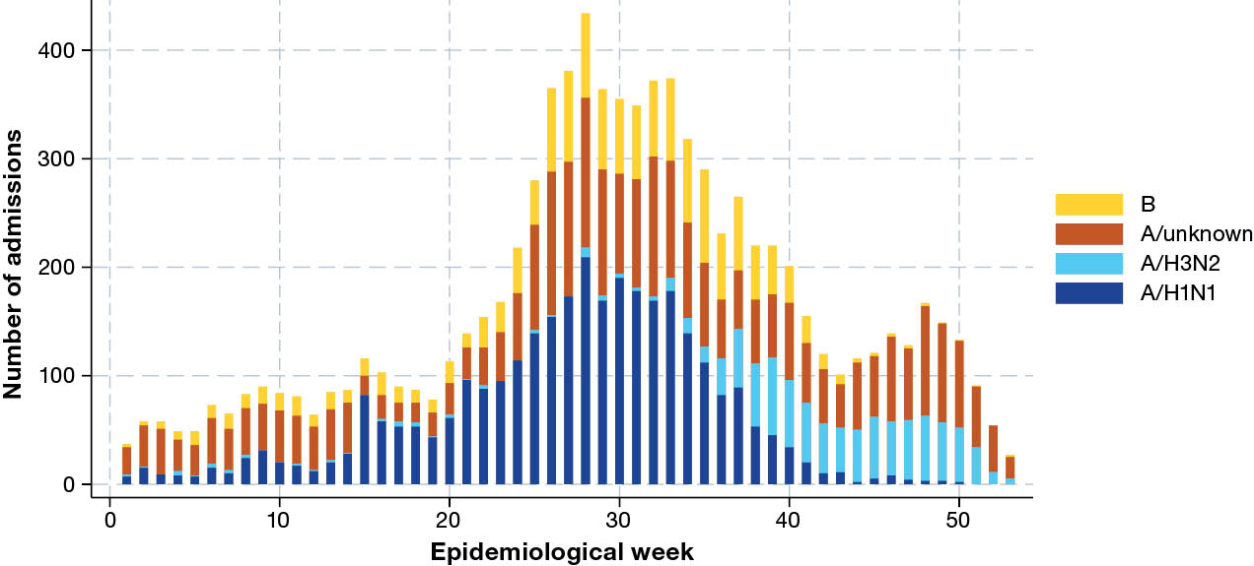
a FluCAN: Influenza Complications Alert Network; PAEDS: Paediatric Active Enhanced Disease Surveillance.
b Representing date of admission or date of influenza diagnosis if diagnosed > 7 days after admission.
Figure 2: Peak incidence of confirmed influenza (per 100 hospital beds per week) by jurisdiction,ª for hospitalised patients admitted to FluCAN–PAEDS^{b} sentinel hospitals, 1 January – 31 December 2025, Australia
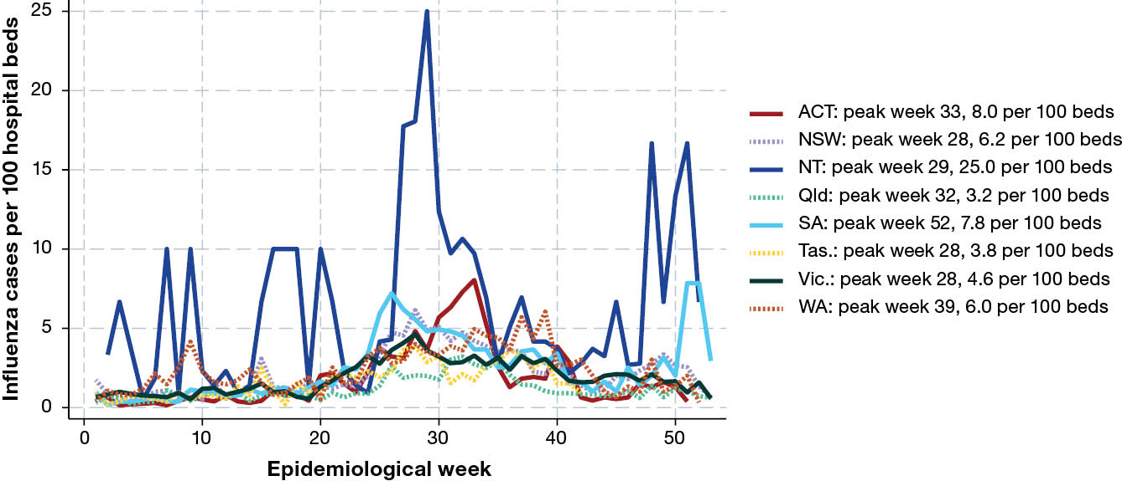
a ACT: Australian Capital Territory; NSW: New South Wales; NT: Northern Territory; Qld: Queensland; SA: South Australia; Tas.: Tasmania; Vic.: Victoria; WA: Western Australia.
b FluCAN: Influenza Complications Alert Network; PAEDS: Paediatric Active Enhanced Disease Surveillance.

Presentation and management
Of all patients hospitalised with influenza, 366 patients did not have a date of onset of illness documented and 322 patients had healthcare-associated influenza. Where the duration of symptoms was known, the median duration of symptoms prior to admission was 3 days (interquartile range [IQR]: 1–5 days).
Radiological evidence of pneumonia was present in 1,148 patients (13.1%). The proportion of patients with pneumonia was lower in children (< 16 years of age; n = 337 [7.6%]) than in adults aged less than 65 (n = 377 [36.1%]) and adults aged 65 years and older (n = 434 [37.1%])). A higher proportion of patients with pneumonia were admitted to ICU (n = 315 [27.4%]) than those without pneumonia (n = 377 [4.9%]). The proportion of hospitalised patients admitted to ICU did not vary significantly by influenza type or subtype (Table 3).
Table 3: Comparison of intensive care unit (ICU) admission and pneumonia by influenza type/subtype, for patients hospitalised with influenza and admitted to FluCAN–PAEDSª sentinel hospitals, 1 January – 31 December 2025, Australia
Category | Influenza type/subtype
Category | A/H1N1/09 |  | A/H3N2 |  | A/H3N2/K |  | A/unknown |  | B |  | Multiple |  | Total
Category | n | % | n | % | n | % | n | % | n | % | n | % | n | %
Total | 3,148 | — | 960 | — | 351 | — | 3,145 | — | 1,470 | — | 11 | — | 8,749 | —
ICU | 255 | 8.10 | 62 | 6.46 | 15 | 4.27 | 265 | 8.43 | 110 | 7.48 | 0 | 0.0 | 692 | 7.91
Pneumonia | 454 | 14.43 | 86 | 8.96 | 25 | 7.12 | 460 | 14.63 | 142 | 9.66 | 3 | 27.27 | 1,148 | 13.12
a FluCAN: Influenza Complications Alert Network; PAEDS: Paediatric Active Enhanced Disease Surveillance.
Table 4: Factors associated with intensive care unit (ICU) admission, in patients hospitalised with influenza and admitted to FluCAN–PAEDSª sentinel hospitals, 1 January – 31 December 2025, Australia
Category | Characteristic | OR^{b} | 95% CI^{c} | p value
Sex | Male | 1.03 | 0.93–1.15 | 0.508
Age group (years) | 0–15 | 0.53 | 0.44–0.63 | < 0.0001
Age group (years) | 16–64 | 1.3 | 1.06–1.59 | 0.011
Age group (years) | 65–79 | 0.69 | 0.58–0.83 | < 0.0001
Age group (years) | 80+ | 0.35 | 0.27–0.45 | < 0.0001
Medical comorbidities | — | 1.84 | 1.62–2.08 | < 0.0001
Ethnicity | Aboriginal and/or Torres Strait Islander person | 0.97 | 0.92–1.03 | 0.363
Pregnancy | — | 0.25 | 0.09–0.71 | 0.009
Restricted functional status | — | 1.14 | 0.98–1.34 | 0.089
Resident of nursing home | — | 0.71 | 0.51–0.99 | 0.04
Influenza type/subtype | A/H1N1 | 1 | — | ref.^{d}
Influenza type/subtype | A/H3 | 0.87 | 0.65–1.17 | 0.361
Influenza type/subtype | A/unknown | 1.1 | 0.92–1.33 | 0.218
Influenza type/subtype | B | 1.13 | 0.89–1.44 | 0.332
a FluCAN: Influenza Complications Alert Network; PAEDS: Paediatric Active Enhanced Disease Surveillance.
b OR: odds ratio.
c 95% CI: 95% confidence interval associated with odds ratio.
d ref.: reference value.
Of all patients with confirmed influenza, 692 patients (7.9%) were admitted into ICU (Table 2); the risk of ICU admission was highest in adults aged < 65 years (12.4%), and was lower in children (5.8%) and in adults aged 65 years and older (7.6%; Table 4). Additionally, patients with medical comorbidities were more likely to be admitted to ICU (Table 4). Hospital length of stay was shorter in younger age groups (relative length of stay [LOS] vs. adults ≥ 65 years: children < 16 years: 0.27 [95% CI: 0.16–0.45]; adults 16–64 years 0.64 [95% CI: 0.33–0.84]), and longer for those with medical comorbidities (relative LOS: 1.6 [95% CI: 1.2–2.0]) and those who were admitted into intensive care (relative LOS: 2.7 [95% CI: 1.8–4.3]). Pregnant patients had a lower severity of illness when compared to non-pregnant female patients 16–50 years of age: 3/52 pregnant patients (5.8%) were admitted to ICU compared with 12.1% of non-pregnant female patients in the 16–50 year age group.
Of all 8,749 patients with confirmed influenza, 4,170 patients (47.7%) were known to have received oseltamivir; antiviral use was lower in children (23.1%) than in adults aged 16–64 years (67.4%) and adults aged 65 years and older (76.9%). Of patients who received oseltamivir, 2,342 patients (56.2%) received oseltamivir within 48 hours of the onset of illness and 1,828 patients (43.8%) received oseltamivir more than 48 hours after onset. The length of hospital stay was similar in those who received early antivirals (mean: 6.6 days; standard deviation [SD]: 14.9 days; median: 3 days; IQR: 2–7 days) vs. later antivirals (mean: 5.5 days; SD: 11.1 days; median: 3 days; IQR: 2–6 days).

Outcome
Of the 7,353 patients with known length of stay, the mean length of hospital stay was 4.4 days (SD: 10.7) and the median was 2 days (IQR: 1–4). Admission to ICU was associated with a mean hospital length of stay of 12.2 days (SD: 19.4; median: 7; IQR: 4–15) compared to those not admitted to ICU with a mean hospital length of stay of 3.9 days (SD: 9.6; median: 2; IQR: 1–4). Of the 7,522 patients where hospital mortality status was documented, 155 patients died (2.1%); of these, 42 deaths occurred in patients admitted to ICU, and 113 deaths in those not admitted to ICU.

Influenza vaccine coverage and effectiveness
Total estimated influenza vaccine coverage was 62.0% (915/1,413) in the patients aged 65 years and over, and 39.5% (485/1,227) in adults under age 65 with medical comorbidities. In children with medical comorbidities, estimated vaccine coverage was 34.1% (444/1,303) in children 6 months to < 5 years of age, and 30.1% (124/412) in children 5 years of age and above (Table 5).
Table 5: Estimated influenza vaccine coverage among influenza test negative recruited patients (controls) admitted to FluCAN–PAEDSª sentinel hospitals, 1 January – 31 December 2025, Australia
Age group | No comorbidities | Comorbidities | Total
6–59 months | 30.9% | 34.1% | 32.1%
5–15 years | 19.3% | 30.1% | 26.8%
16–64 years | 25.8% | 39.5% | 36.5%
65+ years | 62.3% | 65.0% | 64.8%
Total | 31.1% | 44.6% | 39.1%
a FluCAN: Influenza Complications Alert Network; PAEDS: Paediatric Active Enhanced Disease Surveillance.
Estimated vaccine effectiveness against hospitalisation with influenza was 43.3% (95% CI: 38.6–47.7%). Vaccine effectiveness was higher against hospitalisation with influenza B (74.5% [95% CI: 68.6–79.2%]) compared to influenza A/H1N1 (43.0% [95% CI: 35.9–49.3%]) and influenza A/H3N2 (30.5% [95% CI: 15.0–43.2%]). Vaccine effectiveness against hospitalisation with influenza was higher in children (60.9% [95% CI: 55.1–66.0%]) than in adults (27.8% [95% CI: 14.7–39.0%]; Figure 3).
Figure 3: Estimated vaccine effectiveness against hospitalisation with confirmed influenza, in patients admitted to FluCAN–PAEDSª sentinel hospitals, 1 January – 31 December 2025, Australia
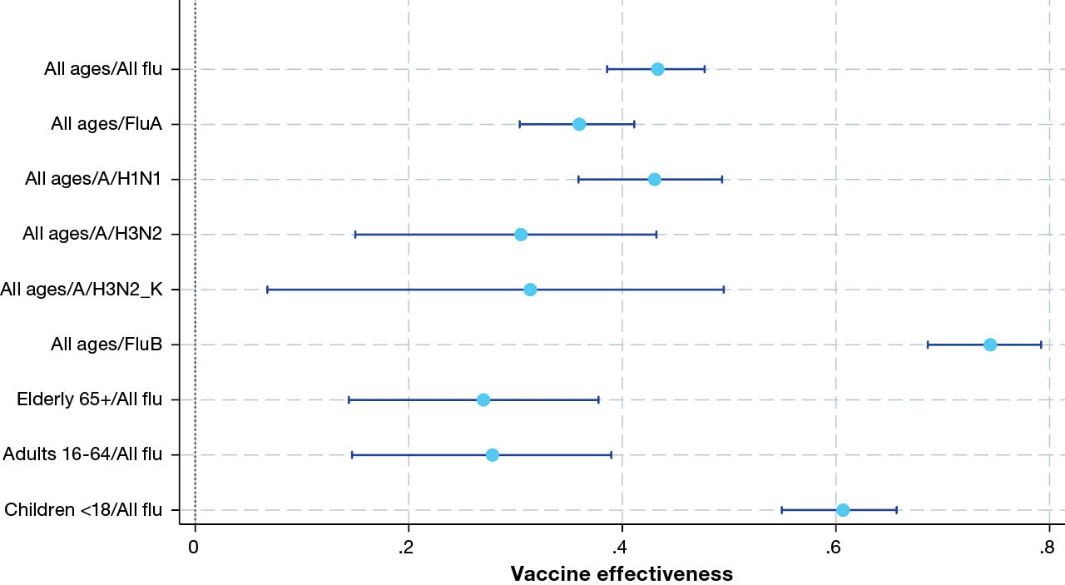
a FluCAN: Influenza Complications Alert Network; PAEDS: Paediatric Active Enhanced Disease Surveillance.

Influenza A H3N2 subclade K summary
Influenza A H3N2 subclade K (A/H3N2/K) was first detected in Australia in August 2025 and became the dominant variant that drove the unusual early summer wave.¹⁴
During the period 1 January to 31 December 2025, there were 351 patients admitted to FluCAN–PAEDS hospitals with laboratory-confirmed A/H3N2/K. The peak incidence of A/H3N2/K admissions was in week 40, twelve weeks later than the total peak incidence of influenza admissions (Figure 4).
Of these 351 confirmed patients, 203 (57.8%) were children (< 16 years of age); 28 (8.0%) were Aboriginal and/or Torres Strait Islander persons; 172 (49.0%) had chronic comorbidities, and two (0.6%) were pregnant. Of all patients with A/H3N2/K, 15 (4.3%) were admitted to ICU.
Of the 194 patients for whom the duration of symptoms was known, the median duration of symptoms prior to admission was 2 days (IQR: 1–3 days). Radiological evidence of pneumonia was present in 25 patients (7.1%). The proportion of patients with pneumonia was higher in adults aged less than 65 years of age (n = 13; 17.6%) than in children (< 16 years of age; n = 6; 3.0%) and in adults aged 65 years and older (n = 6; 8.1%). Of all patients, 15 (4.3%) were admitted into ICU, and 161 (45.9%) were known to have received oseltamivir. Of the 283 patients with known length of stay, the mean length of hospital stay was 2.7 days (median: 1 day; IQR: 1–3 days). Of the 283 patients where hospital mortality status was documented, five patients died (1.7%). A comparison between A/H3N2/K and other influenza types/subtypes can be found in Table 1 and Table 3.
Estimated vaccine effectiveness against hospitalisation with influenza A H3N2 subclade K was 31.4% (95% CI: 6.7–49.5%), similar to the overall influenza A H3N2 vaccine effectiveness, 30.5% (95% CI: 15.0–43.2%).
Figure 4: Weekly influenza hospital admissions and H3N2 subclade K detections during the 2025 influenza season, in patients admitted to FluCAN–PAEDSª sentinel hospitals, 1 January – 31 December 2025, Australia
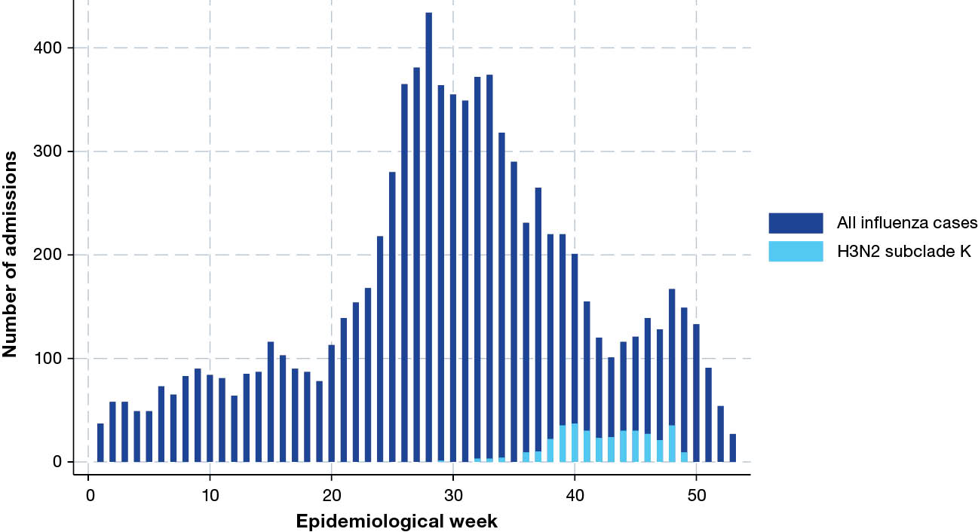
a FluCAN: Influenza Complications Alert Network; PAEDS: Paediatric Active Enhanced Disease Surveillance.

COVID-19
During 2025, there were 3,501 patients admitted to FluCAN hospitals with laboratory-confirmed COVID-19. Of these confirmed patients, 1,057 (30.2%) were children (< 16 years of age); 230 (6.6%) were Aboriginal and/or Torres Strait Islander people; and 2,544 (72.7%) had chronic comorbidities (Table 6; Table 7). There were 17 pregnant patients (0.5%) hospitalised with
COVID-19. Of all FluCAN-PAEDS patients hospitalised with laboratory-confirmed COVID-19, 276 were admitted to ICU (7.9%), of whom 198 (71.7%) were admitted directly to ICU, and an additional 78 (28.3%) were admitted initially to a general ward before later transfer to ICU (Table 7).
Table 6: Demographic characteristics of hospitalised patients with confirmed coronavirus disease 2019 (COVID-19) admitted to FluCAN–PAEDSª sentinel hospitals, 1 January – 31 December 2025, Australia
Category | Characteristic | Dominant SARS-CoV-2 variants
Category | Characteristic | Mixed XEC–KP.3–LP.8.1 period (1 January – 1 May 2025) |  | Mixed NB.1.8.1–XFG–PE.1.4 period (2 May – 31 December 2025) |  | Total
Category | Characteristic | n | % | n | % | n | %
Total | — | 1,259 | — | 2,242 | — | 3,501 | —
Age group | < 6 months | 123 | 9.8 | 216 | 9.6 | 339 | 9.7
Age group | 6–59 months | 178 | 14.1 | 307 | 13.7 | 485 | 13.9
Age group | 5–15 years | 76 | 6.0 | 157 | 7.0 | 233 | 6.7
Age group | 16–64 years | 265 | 21.0 | 460 | 20.5 | 725 | 20.7
Age group | 65+ years | 617 | 49.0 | 1,102 | 49.2 | 1,719 | 49.1
Sex | Male | 702 | 55.8 | 1,168 | 52.1 | 1,870 | 53.4
Sex | Female | 557 | 44.2 | 1,073 | 47.9 | 1,630 | 46.6
Sex | Other | 0 | 0.0 | 1 | 0.0 | 1 | 0.0
Chronic comorbidities | — | 930 | 73.9 | 1,614 | 72.0 | 2,544 | 72.7
Pregnancy | — | 8 | 0.6 | 9 | 0.4 | 17 | 0.5
Ethnicity | Aboriginal and/or Torres Strait Islander person | 107 | 8.5 | 123 | 5.5 | 230 | 8.3
Jurisdiction^{b} | ACT | 112 | 8.9 | 329 | 14.7 | 441 | 12.6
Jurisdiction^{b} | NSW | 230 | 18.3 | 395 | 17.6 | 625 | 17.9
Jurisdiction^{b} | NT | 49 | 3.9 | 54 | 2.4 | 103 | 2.9
Jurisdiction^{b} | Qld | 185 | 14.7 | 274 | 12.2 | 459 | 13.1
Jurisdiction^{b} | SA | 173 | 13.7 | 256 | 11.4 | 429 | 12.3
Jurisdiction^{b} | Tas. | 47 | 3.7 | 59 | 2.6 | 106 | 3.0
Jurisdiction^{b} | Vic. | 294 | 23.4 | 613 | 27.3 | 907 | 25.9
Jurisdiction^{b} | WA | 169 | 13.4 | 262 | 11.7 | 431 | 12.3
a FluCAN: Influenza Complications Alert Network; PAEDS: Paediatric Active Enhanced Disease Surveillance.
b ACT: Australian Capital Territory; NSW: New South Wales; NT: Northern Territory; Qld: Queensland; SA: South Australia; Tas.: Tasmania; Vic.: Victoria; WA: Western Australia.

Table 7: Risk factors, severity and outcomes in hospitalised patients with confirmed coronavirus disease 2019 (COVID-19) admitted to FluCAN–PAEDSª sentinel hospitals, 1 January – 31 December 2025, Australia
Category | Characteristic | Admitted to intensive care unit (ICU)?
Category | Characteristic | No |  | Yes |  | Total
Category | Characteristic | n | % | n | % | n | %
Total patients | — | 3,225 | — | 276 | — | 3,501 | —
Age group | < 6 months | 314 | 9.7 | 25 | 9.1 | 339 | 9.7
Age group | 6–59 months | 448 | 13.9 | 37 | 13.4 | 485 | 13.9
Age group | 5–15 years | 207 | 6.4 | 26 | 9.4 | 233 | 6.7
Age group | 16–64 years | 639 | 19.8 | 86 | 31.2 | 725 | 20.7
Age group | 65+ years | 1,617 | 50.1 | 102 | 37 | 1,719 | 49.1
Sex | Female | 1,507 | 46.7 | 123 | 44.6 | 1,630 | 46.6
Ethnicity | Aboriginal | 177 | 5.6 | 28 | 10.4 | 205 | 6
Ethnicity | Torres Strait Islander (TSI) | 8 | 0.3 | 1 | 0.4 | 9 | 0.3
Ethnicity | Aboriginal and TSI | 16 | 0.5 | 0 | 0 | 16 | 0.5
Ethnicity | Neither Aboriginal nor TSI | 2,952 | 93.5 | 238 | 88.8 | 3,190 | 93.2
Clinical details | Pregnancy | 17 | 0.5 | 0 | 0 | 17 | 0.5
Clinical details | Received COVID-19 vaccine within last 12 months | 472 | 14.6 | 34 | 12.3 | 506 | 14.5
Clinical details | In-hospital mortality | 72 | 2.6 | 19 | 9.0 | 91 | 3.1
Clinical details | Resident of nursing home | 219 | 6.8 | 5 | 1.8 | 224 | 6.4
Pre-existing morbidity | Chronic comorbidities | 2,334 | 72.4 | 210 | 76.1 | 2,544 | 72.7
Pre-existing morbidity | Cardiac disease | 1,015 | 31.5 | 90 | 32.6 | 1,105 | 31.6
Pre-existing morbidity | Chronic respiratory illness | 796 | 24.7 | 88 | 31.9 | 884 | 25.2
Pre-existing morbidity | Immunosuppressed | 484 | 15.0 | 33 | 12.0 | 517 | 14.8
Pre-existing morbidity | Chronic neurological disease | 702 | 21.8 | 55 | 19.9 | 757 | 21.6
Pre-existing morbidity | Chronic liver disease | 128 | 4.0 | 13 | 4.7 | 141 | 4.0
Pre-existing morbidity | Chronic renal disease | 424 | 13.1 | 32 | 11.6 | 456 | 13.0
Pre-existing morbidity | Diabetes | 658 | 20.4 | 56 | 20.3 | 714 | 20.4
Functional status prior to admission | Not restricted | 739 | 33.8 | 81 | 43.8 | 820 | 34.6
Functional status prior to admission | Mild restriction | 486 | 22.3 | 29 | 15.7 | 515 | 21.7
Functional status prior to admission | Self-caring with ADLs,^{b} but needing other assistance | 545 | 25.0 | 47 | 25.4 | 592 | 25.0
Functional status prior to admission | Limited | 325 | 14.9 | 16 | 8.6 | 341 | 14.4
Functional status prior to admission | Bed-bound | 62 | 2.8 | 5 | 2.7 | 67 | 2.8
Functional status prior to admission | Unknown | 27 | 1.2 | 7 | 3.8 | 34 | 1.4
a FluCAN: Influenza Complications Alert Network; PAEDS: Paediatric Active Enhanced Disease Surveillance.
b ADLs: activities of daily living.

Incidence of hospital admissions with COVID-19
In 2025, there was one peak of COVID-19 at sentinel hospitals, with the highest number of weekly patients in week 26 (Figure 5). Peak weekly admissions per 100 hospital beds was as early as week 2 in Tasmania, and as late as week 44 in the Northern Territory (Figure 6). Peak weekly admissions per 100 hospital beds varied significantly between hospitals and was consistently low (< 10 per week per 100 hospital beds) but was highest at Canberra Hospital (ACT), Royal Darwin Hospital (NT), Women’s and Children’s Hospital (SA), and Royal Perth Hospital (WA) (Appendix A, Figure A.1).
Figure 5: Date of admission of hospitalised patients with confirmed coronavirus disease 2019 (COVID-19) admitted to FluCAN–PAEDSª sentinel hospitals, 1 January – 31 December 2025, Australia, by week^{b} and age group
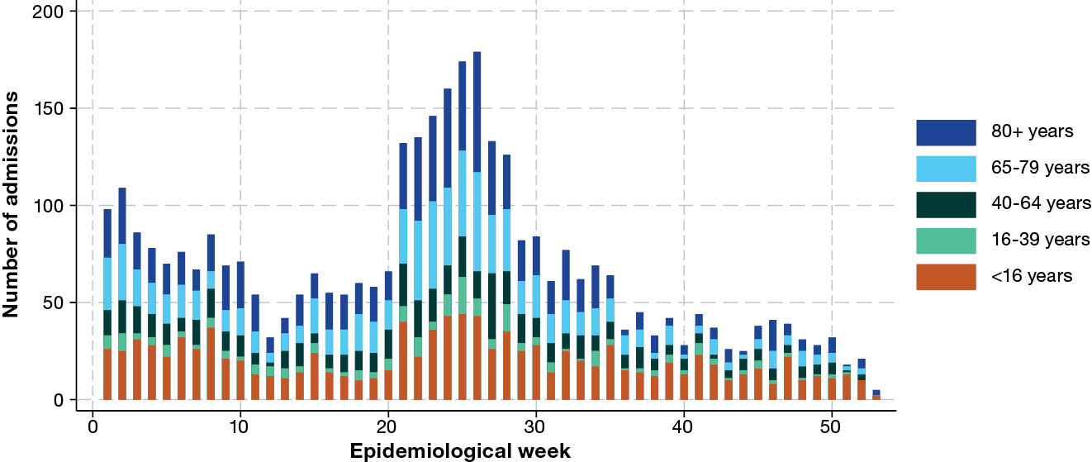
a FluCAN: Influenza Complications Alert Network; PAEDS: Paediatric Active Enhanced Disease Surveillance.
b Representing date of admission or date of COVID-19 diagnosis if diagnosed > 7 days after admission.
Figure 6: Peak incidence of confirmed coronavirus disease 2019 (COVID-19), per 100 hospital beds per week, by jurisdiction,ª for hospitalised patients admitted to FluCAN–PAEDS^{b} sentinel hospitals, 1 January – 31 December 2025, Australia
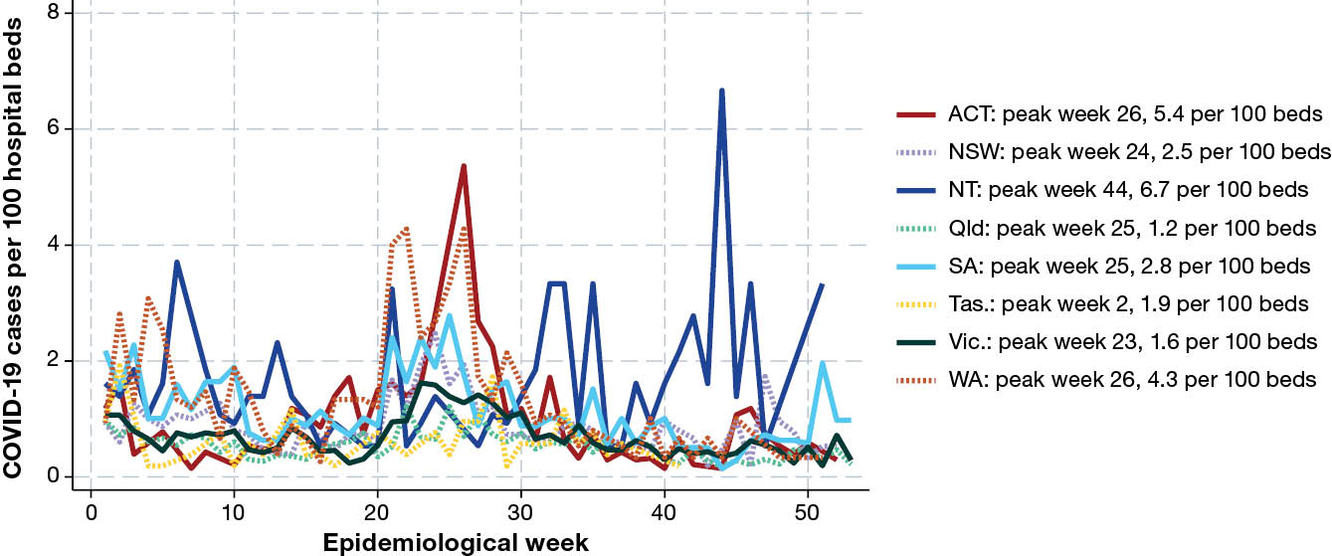
a ACT: Australian Capital Territory; NSW: New South Wales; NT: Northern Territory; Qld: Queensland; SA: South Australia; Tas.: Tasmania; Vic.: Victoria; WA: Western Australia.
b FluCAN: Influenza Complications Alert Network; PAEDS: Paediatric Active Enhanced Disease Surveillance.

Presentation and management
Of all patients hospitalised with COVID-19, there were 83 (2.4%) who did not have a date of onset of illness documented; for 442 patients (12.6%), COVID-19 was healthcare-associated. Where the duration of symptoms was known, the median duration of symptoms prior to admission was 2 days (IQR: 1–3 days).
Radiological evidence of pneumonia was present in 404 patients with confirmed COVID-19 (11.5%). The proportion of patients with pneumonia was lower in children (< 16 years; 4.3%) than in non-elderly adults (< 65 years; 12.0%) and in adults aged 65 years and older (15.8%). A higher proportion of patients with pneumonia were admitted to ICU (24.3%) than those without pneumonia (10.4%). Of all patients with COVID-19, 276 (7.9%) were admitted into ICU (Table 7). The risk of ICU admission was lower in the elderly (≥ 80 years) (Table 8). Hospital length of stay was longer in older patients (relative LOS vs. adults 16–64 years: children < 16 years: 0.46; 95% CI: 0.34–0.66), and in those who were admitted into intensive care (relative LOS: 2.10; 95% CI: 1.36–3.20).
Table 8: Factors associated with intensive care unit (ICU) admission, in patients hospitalised with coronavirus disease 2019 (COVID-19) and admitted to FluCAN–PAEDSª sentinel hospitals, 1 January – 31 December 2025, Australia
Category | Characteristic | OR^{b} | 95% CI^{c} | p value
Sex | Male | 1.09 | 0.85–1.41 | 0.481
Age group (years) | 0–15 | 0.82 | 0.54–1.25 | 0.358
Age group (years) | 16–64 | 0.81 | 0.47–1.40 | 0.455
Age group (years) | 65–79 | 0.75 | 0.52–1.08 | 0.129
Age group (years) | 80+ | 0.21 | 0.13–0.35 | < 0.0001
Medical comorbidities | — | 1.37 | 0.99–1.90 | 0.051
Ethnicity | Aboriginal and/or Torres Strait Islander person | 0.90 | 0.77–1.03 | 0.132
Restricted functional status | — | 0.80 | 0.58–1.12 | 0.196
Resident of nursing home | — | 1.25 | 0.92–1.70 | 0.146
a FluCAN: Influenza Complications Alert Network; PAEDS: Paediatric Active Enhanced Disease Surveillance.
b OR: odds ratio.
c 95% CI: 95% confidence interval associated with odds ratio.
Of all patients hospitalised with COVID-19, 1661 patients (47.4%) were known to have received one or more COVID-19 antivirals. Of these, 1,144 patients were reported to have received remdesivir; 156 patients received molnupiravir (Lagevrio); and 401 patients received nirmatrelvir/ritonavir (Paxlovid). No patients received a monoclonal antibody in 2025. Of patients who received antivirals, 977 patients (58.8%) received antivirals within 48 hours of the onset of illness and 684 patients (41.2%) received antivirals more than 48 hours after onset. The length of hospital stay was longer in those who received COVID-19 antivirals (mean: 8.8 days; SD: 9.4 days; median: 5 days; IQR: 3–12 days) vs. no antivirals (mean: 6.2 days; SD: 16.6 days; median: 2 days; IQR: 1–5 days).

Outcome
Of the 2,825 patients with known length of stay, the mean length of hospital stay was 7 days (SD: 13.7 days) and the median LOS was 3 days (IQR: 2–9 days). Admission to ICU was associated with a mean hospital length of stay of 14.5 days (SD: 29.7 days; median: 8 days; IQR: 4–17 days) compared to those not admitted to ICU (mean: 6.9 days; SD: 11.5 days; median: 3 days; IQR: 2–8 days). Of the 2,275 patients for whom hospital mortality status was documented, 91 patients (3.1%) died; of these, 19 deaths occurred in patients admitted to ICU, and 72 deaths in those not admitted to ICU. One death was reported in a child < 16 years of age; details are being explored in further analyses.

COVID-19 vaccine coverage and effectiveness
From COVID-19 negative control patients, we estimated that 27.9% of adults aged 65 years and older, and 9.8% of younger adults (18–64 years of age) with medical comorbidities, had received a COVID-19 vaccine within the previous 12 months, as per recommendations. We estimated that 20.7% of adults aged 75 years and older had received a COVID-19 vaccine within the previous six months, as per recommendations (Table 9).
Table 9: Estimated coronavirus disease 2019 (COVID-19) vaccine coverage among
COVID-19 test negative recruited patients (controls) admitted to FluCAN–PAEDSª sentinel hospitals, 1 January – 31 December 2025, Australia
Vaccination category | Age group | No comorbidities | Comorbidities | Total
Most recent vaccine within past 12 months | 6–59 months | 0% | 0% | 0%
Most recent vaccine within past 12 months | 5–17 years | 0% | 0% | 0%
Most recent vaccine within past 12 months | 18–64 years | 4.9% | 11.2% | 9.8%
Most recent vaccine within past 12 months | 65–74 years | 24.3% | 25.1% | 25.0%
Most recent vaccine within past 12 months | 75+ years | 18.8% | 34.5% | 32.6%
Most recent vaccine within past 6 months | 65–74 years | 14.9% | 15.0% | 15.0%
Most recent vaccine within past 6 months | 75+ years | 10.9% | 21.9% | 20.7%
a FluCAN: Influenza Complications Alert Network; PAEDS: Paediatric Active Enhanced Disease Surveillance.
In adults aged 75 years and older, the estimated relative risk of hospitalisation was 40% (95% CI: 25–52%) lower in those who had received a COVID-19 vaccine within six months and 26% (95% CI: 11–39%) in those who had received a COVID-19 vaccine within 12 months prior to admission, compared to those who were unvaccinated or had received a vaccine > 1 year prior. Although point estimates suggested effectiveness in adults aged 65–74 years, there was insufficient statistical evidence to demonstrate a protective effect (Figure 7).
Figure 7: Coronavirus disease 2019 (COVID-19) vaccine effectiveness in adults ≥ 65 years of age or with risk factors (RF) that recommend vaccination, by time since last vaccine dose, for hospitalised patients admitted to FluCAN–PAEDSª sentinel hospitals, 1 January – 31 December 2025, Australia
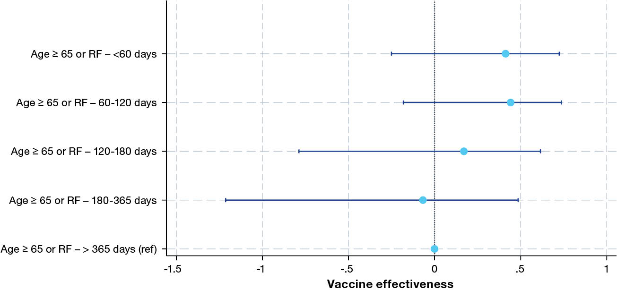
a FluCAN: Influenza Complications Alert Network; PAEDS: Paediatric Active Enhanced Disease Surveillance.

Respiratory syncytial virus
During 2025, there were 5,105 patients admitted to FluCAN hospitals with laboratory-confirmed RSV. Of these confirmed patients, 4,036 (79.1%) were children less than 5 years of age: 1,551 (30.4%) were infants under 1 year old; 1,269 (24.9%) were children aged 1 to 2 years, and 903 (17.7%) were children aged 2 to 3 years. Of all patients, 384 (7.5%) were Aboriginal and/or Torres Strait Islander people; 2254 (44.2%) had chronic comorbidities; and eight (0.2%) were pregnant (Table 10). Of all patients with RSV, 386 (7.6%) were admitted to ICU, of whom 279 (72.3%) were admitted directly to ICU, and an additional 107 patients (27.7%) were admitted initially to a general ward before later transfer to ICU.
Table 10: Risk factors, severity and outcomes in hospitalised patients with confirmed respiratory syncytial virus (RSV) admitted to FluCAN–PAEDSª sentinel hospitals, 1 January – 31 December 2025, Australia
Category | Characteristic | Admitted to intensive care unit (ICU)?
Category | Characteristic | No |  | Yes |  | Total
Category | Characteristic | n | % | n | % | n | %
Total patients | — | 4,719 | — | 386 | — | 5,105 | —
Age group | 0–11 months | 1,414 | 30.0 | 137 | 35.5 | 1,551 | 30.4
Age group | 12–23 months | 1,212 | 25.7 | 57 | 14.8 | 1,269 | 24.9
Age group | 24–59 months | 853 | 18.1 | 50 | 13.0 | 903 | 17.7
Age group | 5–17 years | 277 | 5.9 | 36 | 9.3 | 313 | 6.1
Age group | 18–64 years | 294 | 6.2 | 50 | 13.0 | 344 | 6.7
Age group | 65+ years | 669 | 14.2 | 56 | 14.5 | 725 | 14.2
Sex | Female | 2,170 | 46.0 | 201 | 52.1 | 2,355 | 46.1
Ethnicity | Aboriginal and/or Torres Strait Islander person | 337 | 7.1 | 47 | 12.2 | 384 | 7.5
Clinical details | Pregnancy | 8 | 0.2 | 0 | 0.0 | 8 | 0.2
Clinical details | In-hospital mortality | 36 | 0.8 | 14 | 3.6 | 50 | 1.0
Clinical details | Chronic comorbidities (all ages) | 1,894 | 43.3 | 216 | 61.7 | 2,110 | 44.6
Pre-existing morbidity (infant: prematurity) | Extremely premature (< 28 weeks) | 46 | 4.2 | 15 | 12.4 | 61 | 5.0
Pre-existing morbidity (infant: prematurity) | Very premature (28–32 weeks) | 67 | 6.1 | 9 | 7.4 | 76 | 6.2
Pre-existing morbidity (infant: prematurity) | Moderately premature (32–37 weeks) | 257 | 23.3 | 31 | 25.6 | 288 | 23.6
Pre-existing morbidity (infant: prematurity) | Not premature (> 37 weeks) | 506 | 46.0 | 43 | 35.5 | 549 | 44.9
Pre-existing morbidity (infant: prematurity) | Unknown | 225 | 20.4 | 23 | 19.0 | 248 | 20.3
Pre-existing morbidity (infant: general) | Chronic comorbidities | 1,121 | 32.4 | 123 | 50.0 | 1,244 | 33.6
Pre-existing morbidity (infant: general) | Chronic respiratory illness | 435 | 39.5 | 52 | 43.3 | 487 | 39.9
Pre-existing morbidity (infant: general) | Diabetes | 10 | 0.9 | 0 | 0.0 | 10 | 0.8
Pre-existing morbidity (infant: general) | Chronic liver disease | 10 | 0.9 | 1 | 0.8 | 11 | 0.9
Pre-existing morbidity (infant: general) | Immunosuppressed | 83 | 7.6 | 5 | 4.2 | 88 | 7.2
Pre-existing morbidity (infant: general) | Cardiac disease | 109 | 9.9 | 29 | 24.2 | 138 | 11.3
Pre-existing morbidity (infant: general) | Chronic neurological disease | 157 | 14.3 | 34 | 28.3 | 191 | 15.7
Pre-existing morbidity (infant: general) | Chronic renal disease | 59 | 5.4 | 6 | 5.0 | 65 | 5.3
Pre-existing morbidity (infant: general) | Malignancy | 70 | 6.4 | 3 | 2.5 | 73 | 6.0
Pre-existing morbidity (adult: general) | Chronic comorbidities | 773 | 84.1 | 93 | 89.4 | 866 | 84.7
Pre-existing morbidity (adult: general) | Cardiac disease | 364 | 39.6 | 40 | 38.5 | 404 | 39.5
Pre-existing morbidity (adult: general) | Chronic respiratory illness | 388 | 42.2 | 56 | 53.8 | 444 | 43.4
Pre-existing morbidity (adult: general) | Immunosuppressed | 175 | 19.0 | 17 | 16.3 | 192 | 18.8
Pre-existing morbidity (adult: general) | Chronic neurological disease | 200 | 21.8 | 17 | 16.3 | 217 | 21.2
Pre-existing morbidity (adult: general) | Chronic liver disease | 38 | 4.1 | 2 | 1.9 | 40 | 3.9
Pre-existing morbidity (adult: general) | Chronic renal disease | 174 | 18.9 | 11 | 10.6 | 185 | 18.1
Pre-existing morbidity (adult: general) | Diabetes | 236 | 25.7 | 33 | 31.7 | 269 | 26.3
Pre-existing morbidity (adult: general) | Malignancy | 164 | 21.4 | 17 | 18.3 | 181 | 21.1
a FluCAN: Influenza Complications Alert Network; PAEDS: Paediatric Active Enhanced Disease Surveillance.

Incidence of hospital admissions with RSV
In 2025, the peak incidence of admissions with confirmed RSV nationally was in week 28 (Figure 8). Peak weekly admissions per 100 hospital beds was as early as week 20 in New South Wales, and as late as week 48 in the Northern Territory (Figure 9). Peak weekly admissions per 100 hospital beds varied significantly between hospitals, and was high (> 20 per week per 100 hospital beds) at Monash Children’s Hospital (Vic.), The Women’s and Children’s Hospital (SA), and Royal Darwin Hospital (NT) (Appendix A, Figure A.1).
Figure 8: Date of admission of hospitalised patients with confirmed respiratory syncytial virus (RSV) admitted to FluCAN–PAEDSª sentinel hospitals, 1 January – 31 December 2025, Australia, by week^{b} and age group
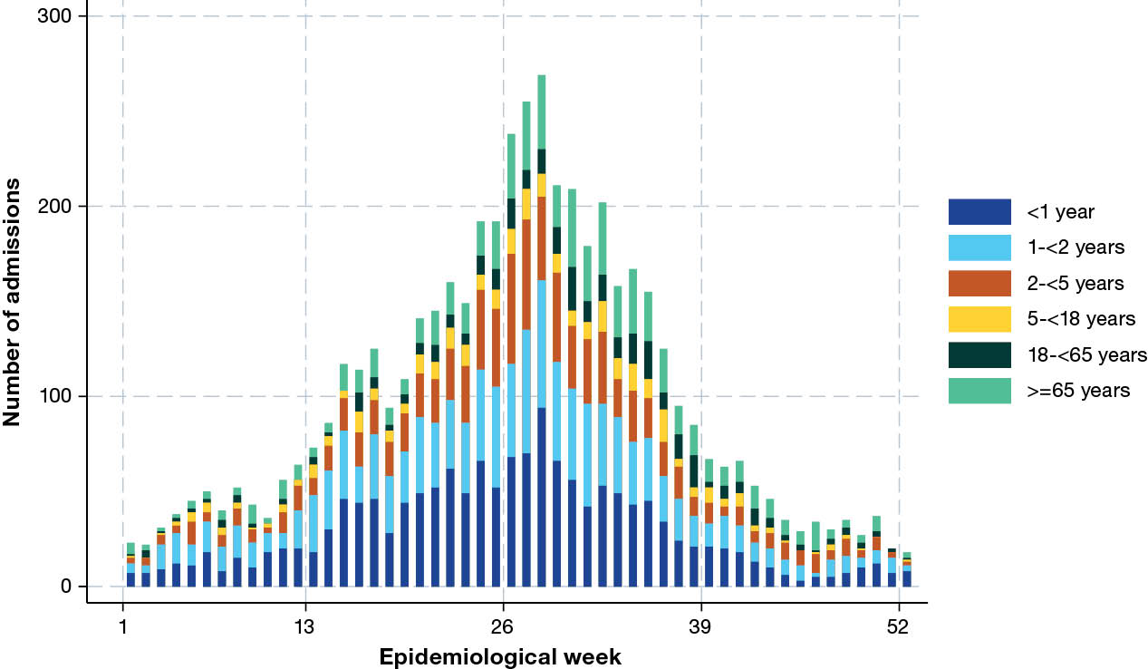
a FluCAN: Influenza Complications Alert Network; PAEDS: Paediatric Active Enhanced Disease Surveillance.
b Representing date of admission or date of RSV diagnosis if diagnosed > 7 days after admission.
Figure 9: Peak incidence of confirmed respiratory syncytial virus (RSV), per 100 hospital beds per week, by jurisdiction,ª for hospitalised patients admitted to FluCAN–PAEDS^{b} sentinel hospitals, 1 January – 31 December 2025, Australia
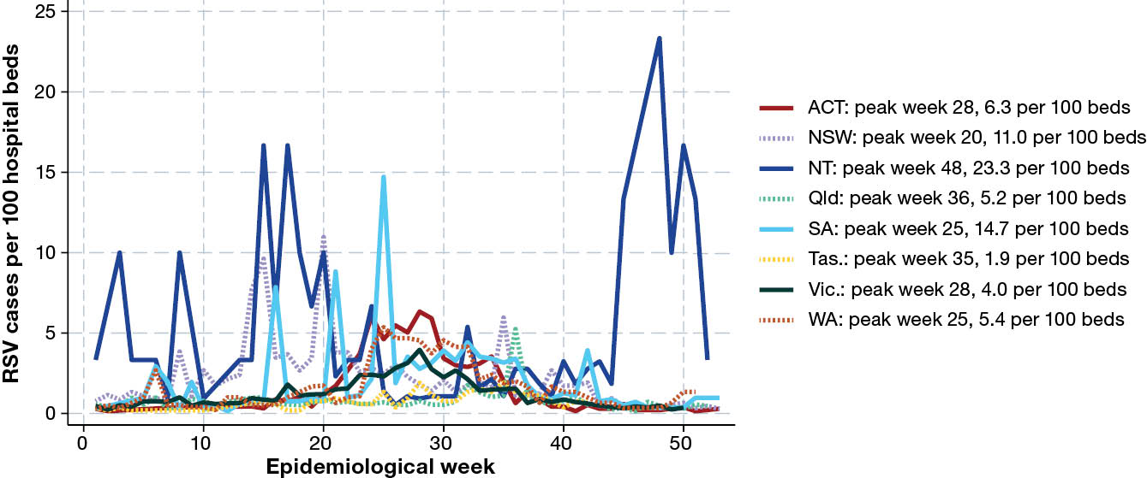
a ACT: Australian Capital Territory; NSW: New South Wales; NT: Northern Territory; Qld: Queensland; SA: South Australia; Tas.: Tasmania; Vic.: Victoria; WA: Western Australia.
b FluCAN: Influenza Complications Alert Network; PAEDS: Paediatric Active Enhanced Disease Surveillance.

Presentation and management
Of all patients hospitalised with RSV, 91 patients (1.8%) did not have a date of onset of illness documented; 150 patients had healthcare-associated RSV. Where the duration of symptoms was known, the median duration of symptoms prior to admission was 3 days (IQR: 2–4 days).
Of all patients with laboratory-confirmed RSV, 386 (7.6%) were admitted into ICU; the risk of ICU admission was highest in infants aged less than 1 year (8.8%), children aged 5–17 years (11.5%), and adults aged 18–64 years (14.5%). Pneumonia or consolidation was reported in 637 patients with confirmed RSV (12.5%). The proportion of patients with pneumonia or consolidation increased with age (< 0–11 months: 7.2%; 12–23 months: 12.8%; 24–59 months: 13.4%; 5–17 years: 13.7%; 18–64 years: 19.5%; 65 years and older: 20.2%). A higher proportion of patients with pneumonia or consolidation were admitted to ICU (18.5%) than those without pneumonia or consolidation (7.6%).

Outcome
Of the 4,450 patients with known length of stay, the mean length of hospital stay was 3.5 days (SD: 5.9 days) and the median was 2 days (IQR: 1–4 days). Admission to ICU was associated with a mean hospital length of stay of 9.3 days (SD: 10.8 days; median: 6 days; IQR: 4–11 days) compared to those not admitted to ICU (mean: 3.1 days; SD: 5.1 days; median: 2 days; IQR: 1–3 days). The mean hospital length of stay increased as age increased (0–11 months: 2.8 days; 12–23 months: 2.3 days; 24–59 months: 2.5 days; 5–17 years: 4.8 days; 18–64 years: 6.0 days; 65 years and older: 7.1 days). Of the 4,518 patients for whom hospital mortality status was documented, 50 patients died (1.1%); of these, 14 deaths (14/386; 4.5%) occurred in patients admitted to ICU, and 36 deaths (36/4,719; 0.9%) in those not admitted to ICU. The proportion of death increased with age, with no deaths under the age of 5 years; two deaths (0.7%) in patients aged 5–17 years; seven deaths (2.4%) in patients aged 18—64 years; and 41 deaths (6.7%) in patients aged 65 years and older.

Nirsevimab and maternal vaccination coverage in infants born since April 2025
Of all 1,374 patients born after 1 April 2025, the nirsevimab status was reported for 1,253 (90.3%) patients; 101 patients (8.1%) had a recorded dose. Of all 1,374 patients born after 1 April 2025, 203 (14.8%) were born to mothers who received maternal RSV vaccination.

Discussion
In 2025, we have documented over 8,500 laboratory confirmed hospitalisations with influenza; over 3,500 COVID-19 hospitalisations; and over 5,000 patients hospitalised with RSV in 23 sentinel surveillance hospitals across Australia. Influenza activity was high, with three distinct waves beginning early with H1N1, followed by B, and ending with a late wave of H3N2 subclade K. COVID-19 appears to have settled into a similar seasonal pattern to influenza and RSV with a large peak in week 26 (cf. the influenza and RSV peaks in week 28). This is in contrast to previous years typically characterised by two distinct COVID-19 waves, in winter and summer.
The higher number of children with influenza and RSV represents a combination of the participation of the majority of specialist paediatric hospitals in this sentinel surveillance system, and epidemiological differences in disease severity (particularly for RSV). In contrast, the majority of COVID-19 hospitalisations were in older adults. The proportion of hospitalised patients in ICU was similar between all three respiratory viruses. However, the overall length of hospital stay remains longer for COVID-19. Admissions to intensive care for both COVID-19 and influenza were lowest in children (where disease was mostly mild), while admissions to intensive care for RSV were highest in children, particularly in infants less than 1 year of age.
Vaccine coverage estimates for both influenza and COVID-19 vaccines are based on control patients (without influenza and COVID-19) recruited at a constant rate during the year. Influenza vaccine coverage in FluCAN–PAEDS is also likely to differ from population estimates, as hospitalised patients have a different risk profile and propensity to be vaccinated. However, the observed vaccine coverage in adults 65 years and older reported in this study (65%) is similar to end of season coverage reported from the Australian Immunisation Register (AIR) in 2025 (60.5%).¹⁵ Similarly, coverage in children aged 6 months to 5 years was 32.1% in test negative children in FluCAN–PAEDS, and 25.7% based on the AIR.¹⁵ Influenza vaccine coverage for all risk groups is similar to 2024 and appears to have fallen compared to earlier 2020–2023.^{15,16}
Overall influenza vaccine effectiveness was moderate at around 40%, slightly lower than the earlier mid-season estimate. This decline likely reflects the increased circulation of H3N2 subclade K later in the season and waning protection over time. Vaccine effectiveness was highest against influenza B (around 75%) and remained moderate against A/H1N1 (around 40%). Protection against A/H3N2 overall (including subclade K) was lowest, and was a marked reduction on 2024 (around 30%). The higher influenza vaccine effectiveness in children is consistent with previous studies.
Pooled estimates from eight southern hemisphere countries with data until September 2025 estimated the interim influenza vaccine effectiveness against hospitalisation at 50.4% (95% CI: 33.2–67.7), with higher estimates for Influenza B virus (62.3%) than for influenza A (45.4%).¹⁷ A large study in England found reduced reactivity of influenza A subclade K viruses, but still found evidence of vaccine effectiveness.¹⁸ Data from the same study and from an interim report by the Centres for Disease Control and Prevention in the United States identified large differences in vaccine effectiveness against hospitalisation by age group, with 63–78% effectiveness in children and 41–55% effectiveness in adults.¹⁹ These estimates support our findings where much larger effectiveness was observed following influenza B compared to influenza A, and in children compared to adults.
The 2025 southern hemisphere vaccine had a single strain change from the 2024 formulation, with A/Croatia/10136RV/2023 included as the H3 component. This strain, also included in northern hemisphere vaccines in 2025/26, was antigenically distinct from the subclade K strains that circulated in late 2025 in southern and northern hemispheres.¹⁴ Despite this, vaccine effectiveness against subclade K in this and other studies was still moderate.²⁰
Australia achieved a high coverage of primary two-dose COVID-19 vaccination in 2022, with serological surveys in late 2022 suggesting almost universal exposure to SARS-CoV-2 antigen through vaccination or natural infection.²¹ In 2025, a dose of a COVID-19 vaccine every six months was recommended for adults ≥ 75 years of age; a single dose every 12 months was recommended for adults 65–74 years and with medical comorbidities; and a single dose was made available for other adults.²²
COVID-19 vaccine coverage for post-primary doses has generally been poor and is likely to reflect both the decreasing marginal effectiveness as well as general community fatigue with messaging. Methods to estimate COVID-19 vaccine effectiveness are not as well established as for influenza, and statistical power is lower once estimates are stratified by interval since last dose, so estimates should be interpreted with caution. National statistics based on AIR reported, in October 2025, that 31.1% of adults aged 75 years and older had received a COVID-19 vaccine dose within the last 6 months,²³ higher than the 20.7% observed among test negative patients in FluCAN–PAEDS. Population coverage for COVID-19 vaccines within the prior 12 months was reported as 27% in patients aged 65–74 years and 43.6% in adults aged 75 years and over, slightly higher than the 25.0% and 32.6% respectively reported in FluCAN–PAEDS.²³ These figures are not directly comparable, as the FluCAN–PAEDS estimates represent an average over the year, and hospitalised patients are likely to differ from the general population based on risk and propensity to be vaccinated. However, it is reassuring that the reported FluCAN–PAEDS coverage estimates for both influenza and COVID-19 vaccines are broadly similar to reported population coverage.
The burden of hospitalisation for COVID-19 related illness in 2025 (n = 3,501) is substantially lower than previous years (2024: n = 5,969; 2023: n = 6,092). However, COVID-19 remains a significant burden on the healthcare system with a longer median length of stay than influenza or RSV. Effectiveness estimates in younger age groups were imprecise. A reduction in COVID-19 vaccine effectiveness on previous years may be explained by the complexity of co-circulating COVID-19 variants in Australia since mid-2024, which can make it difficult to accurately predict which variant will predominate and to develop vaccines accordingly. COVID-19 vaccine effectiveness is more difficult to compare across different countries due to heterogeneity in circulating variants and prior exposure, as well as to differences in study definitions and methods. However, our estimates are broadly similar to those of other studies. A 2025 study from the United States of America reported vaccine receipt within the prior 4 months in adults ≥ 65 years as associated with a 45% reduction in the risk of hospitalisation.²⁴
While data on the timing of antivirals for influenza and COVID-19 were incomplete, the finding that a significant proportion of patients received antivirals more than 2 days after the onset of illness reflects unavoidable delays in presentation. The differences in length of stay cannot be interpreted as a lack of effectiveness, as there are likely to be systematic differences in the group that received antivirals compared to others. The majority of COVID-19 patients who received antivirals were treated with the intravenous antiviral remdesivir, in contrast to the more commonly used oral antiviral nirmatrelvir in the community.
RSV was first included in the FluCAN–PAEDS sentinel surveillance system in 2024, in part due to a desire to conduct effectiveness studies following the introduction of infant long-acting monoclonal antibody (Nirsevimab) and maternal vaccination (Abrysvo).²⁵ Bespoke Nirsevimab and maternal vaccination effectiveness studies are ongoing and are not included in this report; however, independent studies conducted provide reassuring Nirsevimab effectiveness estimates of > 80%.^{26,27} Coverage estimates vary widely by jurisdiction due to their differences in recommendations and timing of Nirsevimab and in the availability of maternal vaccination.
In 2025, the influenza and RSV hospitalisation peaks coincided, both occurring in week 28. Approximately 30% of patients hospitalised with RSV were infants under one year of age, and another approximately 25% were in children between one and two years of age. This age distribution is well supported by literature which highlights the contribution of prematurity on lung development and RSV severity.²⁸ However, despite the predominance in the younger cohort, RSV patients had a shorter length of stay and a lower proportion of ICU admission than those with influenza and COVID-19. Further, there were no deaths associated with RSV in children aged < 5 years.
The FluCAN–PAEDS surveillance system has several limitations. First, this study utilises a sentinel system, and hospitals represented in this study may not be representative of other hospitals not included in the system. This includes the potential overrepresentation of children in the data due to the inclusion of the majority of specialist paediatric hospitals in Australia. Second, patient ascertainment of influenza, COVID-19 and RSV hospitalisations are dependent on clinician-directed testing practices. Although multiplex respiratory PCR testing is now widely used across participating sites, not all admitted patients with compatible illness are tested, which may result in under ascertainment. Third, there were limitations in enrolment of control patients due to lower numbers of eligible patients (test-negative admitted patients) and high patient loads, which may have introduced unknown selection biases that were unaccounted for in this study.
In summary, FluCAN–PAEDS surveillance in 23 sentinel Australian hospitals, representing approximately 10,500 hospital beds nationally, detected over 17,000 hospitalisations with influenza, COVID-19 and RSV in 2025. This represented a higher influenza burden and lower COVID-19 burden than in 2024. A similar proportion of patients admitted with influenza, COVID-19 and RSV were managed in ICU, although the length of stay of patients with COVID-19 was longer. Vaccine effectiveness against severe influenza varied widely by type/subtype but was similar to historical estimates; COVID-19 vaccination was associated with a modest and transient protection against hospitalisation with COVID-19 in high-risk older adults.

Acknowledgments
We thank Rachel Kinsomore, Matilda Clark, Debbie Ryan, Alexandra Hinchcliff (Alice Springs Hospital); Sussan Conway, Kathryn Neilson, Natalie Grainer (Cairns Base Hospital); Manju Bagale, Reshmi Senanyake, Caitlin Isbel, Vanessa Fallace, Phillip Dumbell (Canberra Hospital); Carmen De Groot (Barwon Health); Sally Liu, Jamison Duggan, Monica Guest (Royal Melbourne Hospital); Janette Taylor, Ying Li, Shirisha Sriramoju (Westmead Hospital); Julia Burgon, Ashitha Kurian, Jasmine Kainth, Alexander Abela, Carmen Cordova Rodriguez, Jane Vieceli, Erin Chidlow (Royal Adelaide Hospital); Samantha Wood, Janine Abbott, Sophie Damianopoulos, Katherine Mackie (Royal Perth Hospital); Karen Bellamy (Monash Medical Centre); Courtney Butler (Princess Alexandra Hospital); Maddy Simson, Ashleigh Pollock, Stevie Anderson, Melissa Finney, Merrina Navin (The Mater Hospital); Katherine Faupula, Maria Lopez (North Canberra Hospital); Susan Wagg (Royal Hobart Hospital); Janine Roney, Jill Garlick, Virginia Cable, Esha Tamrakar (The Alfred Hospital); Guillian Hunter, Madison Bellamy (Monash Children’s Hospital); Carolyn Finucane, Joanne Harvey, Catherine Pienaar (Perth Children’s Hospital); Alissa McMinn (Royal Children’s Hospital, Melbourne); Sonia Dougherty, Natasha Doran, Sara Cook (Queensland Children’s Hospital); Emma Carey, Laura Rost, Kathy Meredith (Children’s Hospital at Westmead); Erica Martin (Sydney Children’s Hospital); Natascha D’Angelo (Women and Children’s Hospital, Adelaide); and Laura Francis (Royal Darwin Hospital).
We acknowledge the support of the Australian Centre for Disease Control for funding this system.

Author details
Dr Hannah J Morgan,¹
Prof. Dominic E Dwyer,²
Prof. Mark Holmes,³
Prof. Louis Irving,⁴
A/Prof. Megan Rees,⁵
Dr Stephen Vincent,⁶
Dr Fabian Chiong,⁷
Dr Ian Marr,⁸
Prof. Tony M Korman,⁹
Dr Caroline Bartolo,¹⁰
A/Prof. Louise Cooley,¹¹
A/Prof. Simon Bowler,¹²
Dr Jen Kok,¹³
Dr Naomi Runnegar,¹⁴
Prof. Daniel M Fatovich,¹⁵
Prof. Grant Waterer,¹⁶
Prof. Kristine Macartney,¹⁷
Prof. Nigel Crawford,¹⁸
Karen Bellamy,¹⁹
Dr Jeremy Carr,²⁰
Prof. Helen S Marshall,²¹
A/Prof. Julia E Clark,²²
Prof. Joshua R Francis,²³
A/Prof. Brendan McMullan,²⁴
A/Prof. Philip Britton,²⁵
Prof. Nicholas Wood,²⁵
A/Prof. Tom Kotsimbos,²⁶
Prof. Paul Kelly,²⁷
Prof. Christopher C Blyth,²⁸
Prof. Allen Cheng,²⁹
- Epidemiology Research Fellow, Monash Health and School of Clinical Sciences, Monash University
- Clinical Professor, University of Sydney and Westmead Hospital
- Professor, Adelaide University; Respiratory and Sleep Medicine Specialist, Royal Adelaide Hospital
- Professor and Respiratory Physician, Royal Melbourne Hospital and University of Melbourne
- Head of Unit for Respiratory Medicine and Sleep Disorders, Royal Melbourne Hospital and University of Melbourne
- Respiratory Physician, Cairns Base Hospital
- Infectious Diseases Physician, Department of Infectious Diseases, Canberra Health Services and Australian National University
- Head of Infectious Diseases, Canberra Health Services and Australian National University
- Adjunct Clinical Professor, Monash University Monash University and Monash Health
- Infectious Disease Physician, University Hospital Geelong, Barwon Health and Deakin University
- Director of Microbiology, Royal Hobart Hospital
- Associate Professor, Mater Health
- Medical Virologist, Centre for Infectious Diseases and Microbiology Laboratory Services, NSW Health Pathology-Institute of Clinical Pathology and Medical Research, Westmead Hospital
- Infectious Diseases Physician and Clinical Microbiologist, Princess Alexandra Hospital
- Professor of Emergency Medicine, University of Western Australia; Director of Research, East Metropolitan Health Service
- Professor of Medicine, University of Western Australia; Director of Clinical Services, Royal Perth Hospital
- Director, National Centre for Immunisation Research and Surveillance (NCIRS) within Kids Research, Children’s Hospital at Westmead
- Director of SAEFVIC, Murdoch Children's Research Institute; Head of Immunisation Service, Royal Children’s Hospital, Melbourne
- Nurse Practitioner, Monash Health
- Head, Paediatric Infectious Diseases, Monash Health
- Professor in Vaccinology, Adelaide University; Medical Director of VIRTU, Women’s and Children’s Health Network
- Director of Infection Management and Prevention, Queensland Children’s Hospital
- Paediatric Infectious Disease Physician, Royal Darwin Hospital, Menzies School of Health Research, Charles Darwin University
- Paediatric Infectious Disease Physician and Microbiologist, Sydney Children’s Hospital and University of New South Wales
- Paediatric Infectious Diseases Physician, Children’s Hospital at Westmead and University of Sydney
- Head of Respiratory Medicine Laboratory, Monash University; Specialist Respiratory and Transplant Physician, Alfred Hospital
- Founder and Principal, PK Public Health Advisory; Professor, College of Law, Governance and Policy, Australian National University
- Professor of Paediatrics, University of Western Australia, The Kids Research Institute Australia, Perth Children’s Hospital and PathWest Laboratory Medicine
- Program Director, Medical Specialties, Monash Health and Professor, School of Clinical Sciences and School of Public Health and Preventive Medicine, Monash University

Corresponding author
Professor Allen Cheng
Infectious Diseases, Monash Health, 246 Clayton Road, Clayton 3168, Victoria, Australia
Phone: +61 3 9594 4564
Email: allen.cheng@monash.edu

References
- Iuliano AD, Roguski KM, Chang HH, Muscatello DJ, Palekar R, Tempia S et al. Estimates of global seasonal influenza-associated respiratory mortality: a modelling study. Lancet. 2018;391(10127):1285–300. doi: https://doi.org/10.1016/S0140-6736(17)33293-2.
- Msemburi W, Karlinsky A, Knutson V, Aleshin-Guendel S, Chatterji S, Wakefield J. The WHO estimates of excess mortality associated with the COVID-19 pandemic. Nature. 2023;613(7942):130–7. doi: https://doi.org/10.1038/s41586-022-05522-2.
- Li Y, Wang X, Blau DM, Caballero MT, Feikin DR, Gill CJ et al. Global, regional, and national disease burden estimates of acute lower respiratory infections due to respiratory syncytial virus in children younger than 5 years in 2019: a systematic analysis. Lancet. 2022;399(10340):2047–64. doi: https://doi.org/10.1016/S0140-6736(22)00478-0.
- Australian Institute of Health and Welfare (AIHW). The burden of vaccine preventable diseases in Australia. Canberra: AIHW; 1 November 2019. Available from: https://www.aihw.gov.au/reports/immunisation/the-burden-of-vaccine-preventable-diseases/summary.
- Patel C, Dey A, Wang H, McIntyre P, Macartney K, Beard F. Summary of national surveillance data on vaccine preventable diseases in Australia, 2016-2018 final report. Commun Dis Intell (2018). 2022;46. doi: https://doi.org/10.33321/cdi.2022.46.28.
- AIHW. Influenza in Australia. [Fact sheet.] Canberra: AIHW; 13 November 2018. Available from: https://www.aihw.gov.au/getmedia/2623df7f-794f-4712-94e4-65442323784e/aihw-phe-236_influenza.pdf.aspx.
- Australian Government Department of Health, Disability and Ageing. Respiratory syncytial virus (RSV) vaccine. [Webpage.] Canberra: Australian Government Department of Health, Disability and Ageing; 2025. Available from: https://www.health.gov.au/topics/immunisation/vaccines/respiratory-syncytial-virus-rsv-vaccine.
- Sullivan SG, Carlson S, Cheng AC, Chilver MB, Dwyer DE, Irwin M et al. Where has all the influenza gone? The impact of COVID-19 on the circulation of influenza and other respiratory viruses, Australia, March to September 2020. Euro Surveill. 2020;25(47):2001847. doi: https://doi.org/10.2807/1560-7917.ES.2020.25.47.2001847.
- Dhanasekaran V, Sullivan S, Edwards KM, Xie R, Khvorov A, Valkenburg SA et al. Human seasonal influenza under COVID-19 and the potential consequences of influenza lineage elimination. Nat Commun. 2022;13(1):1721. doi: https://doi.org/10.1038/s41467-022-29402-5.
- Begum H, Dwyer DE, Holmes M, Irving L, Simpson G, Senenayake S et al. Surveillance for severe influenza and COVID-19 in patients admitted to sentinel Australian hospitals in 2020: the Influenza Complications Alert Network (FluCAN). Commun Dis Intell (2018). 2022;46. doi: https://doi.org/10.33321/cdi.2022.46.13.
- Kelly PM, Kotsimbos T, Reynolds A, Wood-Baker R, Hancox B, Brown SGA et al. FluCAN 2009: initial results from sentinel surveillance for adult influenza and pneumonia in eight Australian hospitals. Med J Aust. 2011;194(4):169–74.
doi: https://doi.org/10.5694/j.1326-5377.2011.tb03764.x.
- New South Wales State Government Department of Health (NSW Health). NSW Respiratory Surveillance Report – week ending 6 December 2025. Sydney: NSW Health; 7 December 2025. Available from: https://www.health.nsw.gov.au/Infectious/covid-19/Documents/respiratory-surveillance-20251206.pdf.
- Jackson ML, Nelson JC. The test-negative design for estimating influenza vaccine effectiveness. Vaccine. 2013;31(17):2165–8. doi: https://doi.org/10.1016/j.vaccine.2013.02.053.
- Dapat C, Peck H, Jelley L, Diefenbach-Elstob T, Slater T, Hussain S et al. Extended influenza seasons in Australia and New Zealand in 2025 due to the emergence of influenza A(H3N2) subclade K viruses. Euro Surveill. 2025;30(49):2500894.
doi: https://doi.org/10.2807/1560-7917.ES.2025.30.49.2500894.
- National Centre for Immunisation Research and Surveillance (NCIRS). All persons: 2025 (YTD) influenza vaccination coverage by age group and state/territory. [Internet.] Sydney: Sydney Children’s Hospitals Network; 2025. Available from: https://ncirs.org.au/influenza-vaccination-coverage-data/all-persons-2025-ytd-influenza-vaccination-coverage-age-group.
- Hull B, Hendry A, Macartney K, Beard F. Annual Immunisation Coverage Report 2024. Commun Dis Intell (2018). 2026;50. doi: https://doi.org/10.33321/cdi.2026.50.023.
- Russ S, Nogareda F, Regan AK, Benedetti E, Pasinovich M, Voto C et al. Interim effectiveness estimates of 2025 Southern Hemisphere influenza vaccines in preventing influenza-associated outpatient and hospitalized illness – eight Southern Hemisphere countries, March–September 2025. MMWR Morb Mortal Wkly Rep. 2025;74(36):570–8. doi: https://doi.org/10.15585/mmwr.mm7436a3.
- Kirsebom FC, Thompson C, Talts T, Kele B, Whitaker HJ, Andrews N et al. Early influenza virus characterisation and vaccine effectiveness in England in autumn 2025, a period dominated by influenza A(H3N2) subclade K. Euro Surveill. 2025;30(46):2500854. doi: https://doi.org/10.2807/1560-7917.ES.2025.30.46.2500854.
- Zambon M, Hayden FG. Influenza A(H3N2) subclade K virus: threat and response. JAMA. 2026;335(4):307–10. doi: https://doi.org/10.1001/jama.2025.25903.
- Separovic L, Sabaiduc S, Zhan Y, Kaweski SE, Olsha R, Hasso M et al. Interim 2025/26 influenza vaccine effectiveness estimates with immuno-epidemiological considerations for A(H3N2) subclade K protection, Canada, January 2026. Euro Surveill. 2026;31(5):2600068. doi: https://doi.org/10.2807/1560-7917.ES.2026.31.5.2600068.
- Australian COVID-19 Serosurveillance Network. Seroprevalence of SARS-CoV-2-specific antibodies among Australian blood donors: Round 3 update. Sydney: University of New South Wales, Kirby Institute; 3 November 2022. Available from: https://kirby.unsw.edu.au/sites/default/files/COVID19-Blood-Donor-Report-Round3-Aug-Sep-2022.pdf.
- Australian Government Department of Health, Disability and Ageing, Australian Technical Advisory Group on Immunisation (ATAGI). ATAGI statement on the administration of COVID-19 vaccines in 2024. Canberra: Australian Government Department of Health, Disability and Ageing; 1 March 2024. Available from: https://www.health.gov.au/resources/publications/atagi-statement-on-the-administration-of-covid-19-vaccines-in-2024.
- Australian Government Department of Health, Disability and Ageing. COVID-19 vaccination – vaccination data – 12 December 2024. Canberra: Australian Government Department of Health, Disability and Ageing; 12 December 2024. Available from: https://www.health.gov.au/resources/publications/covid-19-vaccination-vaccination-data-12-december-2024.
- Link-Gelles R, Chickery S, Webber A, Ong TC, Rowley EAK, DeSilva MB et al. Interim estimates of 2024–2025 COVID-19 vaccine effectiveness among adults aged ≥18 years - VISION and IVY networks, September 2024 – January 2025. MMWR Morb Mortal Wkly Rep. 2025;74(6):73–82. doi: https://doi.org/10.15585/mmwr.mm7406a1.
- Blyth CC, Wadia U, Britton PN, Carr J, Clark JE, Crawford NW et al. Respiratory syncytial virus epidemiology and effectiveness of infant nirsevimab: 2024 results from the Australian Sentinel Hospital Network (FluCAN–PAEDS). Euro Surveill. 2026;31(2):2500275. doi: https://doi.org/10.2807/1560-7917.ES.2026.31.2.2500275.
- Wadia U, Moore HC, Richmond PC, Levy A, Bell L, Pienaar C et al. Effectiveness of nirsevimab in preventing RSV-hospitalisation among young children in Western Australia 2024. J Infect. 2025;90(4):106466. doi: https://doi.org/10.1016/j.jinf.2025.106466.
- Wadia U, Richmond PC, Britton PN, Carr J, Clark JE, Crawford NW et al. Impact and effectiveness of Australia’s 2025 hybrid RSV immunisation program: results from the PAEDS-FluCAN Network. [Preprint.] Amsterdam: Elsevier, Social Science Research Network (SSRN); 16 March 2026.
- Welliver RC. Review of epidemiology and clinical risk factors for severe respiratory syncytial virus (RSV) infection. J Pediatr. 2003;143(5 Suppl):112–7.
doi: https://doi.org/10.1067/s0022-3476(03)00508-0.

Appendix A: Supporting information

Indicators of activity: bed capacity at each hospital
Data on testing and total admissions is only collected in aggregated form (number of tests per week at each hospital) and no data are available by age group or other factors. Reporting was not complete.
The 23 surveillance hospitals in the FluCAN–PAEDS system have 10,521 overnight beds (Table A.1), and account for 15.6% of the Australian national acute public hospital bed capacity of 67,300 in 2023–2024.
Table A.1: Bed capacity of FluCAN–PAEDSª sentinel hospitals
Hospital | Jurisdiction^{b} | Beds
Canberra | ACT | 676
North Canberra | ACT | 256
Children’s at Westmead | NSW | 340
John Hunter | NSW | 618
Sydney Children’s | NSW | 180
Westmead | NSW | 975
Alice Springs | NT | 186
Royal Darwin | NT | 30
Cairns | Qld | 582
Mater | Qld | 660
Princess Alexandria | Qld | 740
Queensland Children's | Qld | 324
Royal Adelaide | SA | 689
Women's and Children's | SA | 102
Alfred | Vic. | 693
Geelong | Vic. | 639
Monash | Vic. | 667
Monash Children's | Vic. | 184
Royal Melbourne | Vic. | 371
Royal Children's | Vic. | 340
Royal Hobart | Tas. | 521
Perth Children’s Hospital | WA | 298
Royal Perth | WA | 450
a FluCAN: Influenza Complications Alert Network; PAEDS: Paediatric Active Enhanced Disease Surveillance.
b ACT: Australian Capital Territory; NSW: New South Wales; NT: Northern Territory; Qld: Queensland; SA: South Australia; Tas.: Tasmania; Vic.: Victoria; WA: Western Australia.

Indicators of disease: peak incidence of disease at each hospital
Peak incidence of confirmed Influenza, COVID-19 and RSV admissions varied widely by hospital (Figure A.1).
Figure A.1: Peak incidence of confirmed respiratory disease, per 100 hospital beds per week, for (a) influenza, (b) coronavirus disease 2019 (COVID-19) and (c) respiratory syncytial virus (RSV), by hospital,ª 1 January – 31 December 2025, Australia
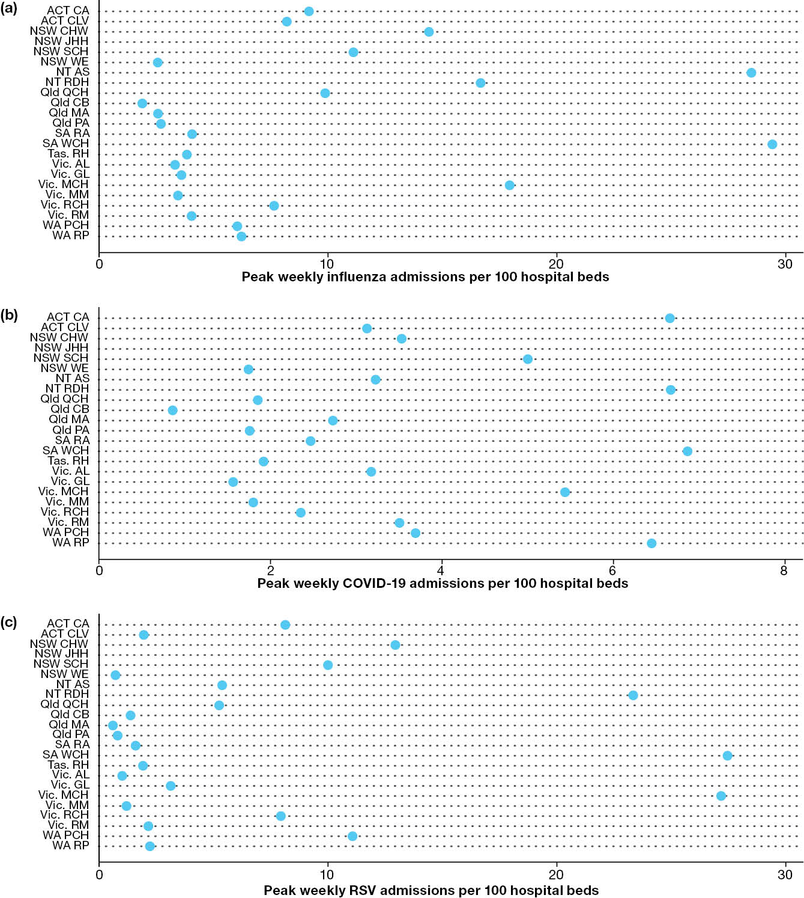
a CA: Canberra Hospital; CLV: North Canberra Hospital; CHW: Children’s Hospital at Westmead; JHH: John Hunter Hospital; SCH: Sydney Children’s Hospital; WE: Westmead Hospital; AS: Alice Springs Hospital; RDH: Royal Darwin Hospital; QCH: Queen’s Children Hospital; CB: Cairns Base Hospital; MA: Mater Hospital; PA: Princess Alexandra Hospital; RA: Royal Adelaide; WCH: Women’s and Children’s Hospital; RH: Royal Hobart Hospital; AL: The Alfred Hospital; GL: University Hospital Geelong; MCH: Monash Children’s Hospital; MM: Monash Medical Centre; RCH: Royal Children’s Hospital; RM: Royal Melbourne; PCH: Perth Children’s Hospital; RP: Royal Perth Hospital.

Source: https://www.aihw.gov.au/hospitals/topics/hospital-resources/public-hospital-beds.

