
2026 • Volume 50 • cdc.gov.au/cdi • Epub date: 29.09.2026 • doi.org/10.33321/cdi.2026.50.040

Summary of National Surveillance Data on Vaccine Preventable Diseases in Australia, 2019–2022
Joanne Jackson, Nicole Sonneveld, Han Wang, Fariha Binte Hossain, Aditi Dey, Stephen Lambert, Frank Beard
© 2026 Commonwealth of Australia as represented by the Australian Centre for Disease Control
ISSN: 2209-6051 Online
This journal is indexed by Index Medicus and Medline.
Creative Commons Licence
This publication is licensed under a Creative Commons Attribution-NonCommercial-NoDerivatives 4.0 International Licence (Licence). You must read and understand the Licence before using any material from this publication.
Restrictions
The Licence does not cover, and there is no permission given for, use of any of the following material found in this publication (if any):
- the Commonwealth Coat of Arms (by way of information, the terms under which the Coat of Arms may be used can be found on the Department of Prime Minister and Cabinet website);
- any logos (including the Australian Centre for Disease Control’s logo) and trademarks;
- any photographs and images;
- any signatures; and
- any material belonging to third parties.
Disclaimer
Opinions expressed in Communicable Diseases Intelligence are those of the authors and not necessarily those of the Australian Government or the Australian Centre for Disease Control. Data may be subject to revision.
Enquiries
Enquiries regarding any other use of this publication should be addressed to the CDI Editor.
About CDI
Communicable Diseases Intelligence (CDI) is a peer-reviewed scientific journal published by the Australian Centre for Disease Control.
The journal aims to disseminate information on the epidemiology, surveillance, prevention and control of communicable diseases of relevance to Australia and the near region.
Editor: Dr Elise Firman • Deputy Editor: Simon Petrie • Design and Production: Lisa Thompson
Editorial Advisory Board: David Durrheim, Mark Ferson, Clare Huppatz, John Kaldor, Martyn Kirk and Meru Sheel
Submit an Article
Guidelines for authors and details on how to submit your publication is available on our website, or by email to the
CDI Editor.
Contact us
Communicable Diseases Intelligence (CDI)
Australian Centre for Disease Control
PO Box 795, Canberra ACT 2601, Australia
Website: cdc.gov.au/cdi
Email: cdi.editor@cdc.gov.au

Contents
Executive summary 11
Background 11
Trends in VPD epidemiology in the 2019–2022 period 11
Abbreviations 16
Introduction 18
Methods and limitations 20
Scope of VPDs included 20
Data sources 20
Analyses 21
Main limitations 22
1. COVID-19 24
Notifications 24
Hospitalisations 25
Deaths 25
Discussion 26
2. Diphtheria 32
Notifications 32
Hospitalisations 33
Deaths 34
Discussion 34
3. Haemophilus influenzae type b disease 39
Notifications 39
Hospitalisations and deaths 40
Discussion 40
4. Hepatitis A 44
Notifications 44
Hospitalisations 45
Deaths 45
Discussion 46
5. Hepatitis B 51
Newly-acquired hepatitis B notifications 51
Unspecified hepatitis B notifications 52
Acute hepatitis B hospitalisations 53
Acute hepatitis B deaths 53
Discussion 54
6. Influenza 60
Notifications 60
Hospitalisations 61
Deaths 62
Discussion 62
7. Invasive meningococcal disease 68
Notifications 68
Hospitalisations and deaths 69
Discussion 70
8. Invasive pneumococcal disease 73
Notifications 73
Discussion 75
9. Japanese encephalitis virus infection 79
Notifications 79
Hospitalisations and deaths 80
Discussion 80
10. Measles 83
Notifications 83
Hospitalisations 84
Deaths 85
Discussion 85
11. Mumps 90
Notifications 90
Hospitalisations 91
Deaths 91
Discussion 92
12. Pertussis 97
Notifications 97
Hospitalisations 98
Deaths 99
Discussion 99
13. Poliomyelitis 104
Notifications 104
Hospitalisations and deaths 104
Discussion 104
14. Q fever 106
Notifications 106
Hospitalisations 107
Deaths 107
Discussion 108
15. Rotavirus 113
Notifications 113
Hospitalisations 114
Deaths 115
Discussion 115
16. Rubella 120
Notifications 120
Hospitalisations 121
Deaths 121
Congenital Rubella Syndrome (CRS) 121
Discussion 122
17. Tetanus 127
Notifications 127
Hospitalisations 127
Deaths 128
Discussion 128
18. Varicella 133
Notifications 133
Hospitalisations 133
Deaths 134
Discussion 134
19. Zoster 138
Notifications 138
Hospitalisations 138
Deaths 139
Discussion 139
Acknowledgments 144
Author details 145
References 146
Appendix A: Supplementary information 172
A.1 Detailed methods and limitations 172
A.2 JEV and COVID-19 vaccine recommendations 191
A.3 Charts of historical national notification data: selected vaccine preventable diseases 195

List of figures
Figure 1: Coronavirus disease 2019 (COVID-19) notifications and hospitalisations for all ages,^{a,b} Australia, 2020–2022, by month of diagnosis or admission 31
Figure 2: Coronavirus disease 2019 (COVID-19) monthly hospitalisation rate,^{a,b} Australia,
2020–2022, by age group 31
Figure 3: Diphtheria notifications and hospitalisations for all ages,^{a,b} Australia, 2001–2022, by year of diagnosis or admission 38
Figure 4: Number of diphtheria notifications by site of infection, and diphtheria notification rate,ª Australia, 2013–2022 38
Figure 5: Haemophilus influenzae type b invasive disease notifications for all ages,ª Australia, 1993–2022, by month of diagnosis 43
Figure 6: Haemophilus influenzae type b invasive disease notification rate,^{a,b} Australia, 2013–2022, by age group for the groups < 1, 1–4 and 5–14 years 43
Figure 7: Hepatitis A notifications and hospitalisations for all ages,^{a,b} Australia, 1993–2022, by month of diagnosis or admission 50
Figure 8: Newly-acquired hepatitis B notifications and acute hepatitis B hospitalisations for all ages,^{a,b,c} Australia, 1997–2022, by month of diagnosis or admission 59
Figure 9: Newly-acquired hepatitis B notification rates,ª Australia, 2013–2022, by age group 59
Figure 10: Influenza notifications and hospitalisations for all ages,^{a,b} Australia, 2001–2022, by month of diagnosis or admission 67
Figure 11: Influenza notification rate,ª Australia, 2013–2022, by age group 67
Figure 12: Invasive meningococcal disease notifications for all ages,^{a,b} Australia, 1993–2022, by month of diagnosis 72
Figure 13: Invasive meningococcal disease notification rates,ª Australia, 2013–2022, by serogroup 72
Figure 14: Invasive pneumococcal disease notifications for all ages,ª Australia, 2001–2022, by month of diagnosis 78
Figure 15: Invasive pneumococcal disease notification rates,ª Australia, 2013–2022, by Aboriginal and Torres Strait Islander status, and overall 78
Figure 16: Japanese encephalitis virus (JEV) infection notifications for all ages,ª Australia, 2013–2022, by month of diagnosis 82
Figure 17: Japanese encephalitis virus (JEV) infection notification rate,ª Australia, 2013–2022 82
Figure 18: Measles notifications and hospitalisations for all ages,^{a,b} Australia, 1993–2022, by month of diagnosis or admission 89
Figure 19: Measles notification rate,ª Australia, 2013–2022, by age group 89
Figure 20: Mumps notifications and hospitalisations for all ages,^{a,b} Australia, 1993–2022, by month of diagnosis or admission 96
Figure 21: Mumps notification rates,ª Australia, 2013–2022, by Aboriginal and Torres Strait Islander status, and overall 96
Figure 22: Pertussis notifications and hospitalisations for all ages,^{a,b} Australia, 1993–2022, by month of diagnosis or admission 103
Figure 23: Pertussis notification and hospitalisation rates,^{a,b} Australia, 2013–2022, by age group for the groups < 6 months, 6 –11 months, and 1–4 years 103
Figure 24: Q fever notifications and hospitalisations for all ages,^{a,b} Australia, 1993–2022, by month of diagnosis or admission 112
Figure 25: Q fever notification rates,ª Australia, 2013–2022, by age group (≥ 1 year) 112
Figure 26: Rotavirus notifications and hospitalisations for all ages,^{a,b,c} Australia, 1993–2022, by month of diagnosis or admission 119
Figure 27: Rubella notifications and hospitalisations for all ages,^{a,b,c} Australia, 1993–2022, by month of diagnosis or admission 126
Figure 28: Tetanus notifications and hospitalisations for all ages,^{a,b} Australia, 1998–2022, by year of diagnosis or admission 132
Figure 29: Varicella hospitalisations for all ages, Australia,^{a,b} July 1993 – June 2022, by month of admission 137
Figure 30: Varicella hospitalisations,^{a,b} Australia, 2013–2022, by age group 137
Figure 31: Zoster hospitalisations for all ages,^{a,b} Australia, 1993–2022, by month of admission 143
Figure 32: Zoster hospitalisation rates,^{a,b} Australia, 2013–2022, by age group 143
Figure A.1: Coronavirus disease 2019 (COVID-19) vaccine approvals, phases of COVID-19 vaccine rollout and third/booster dose recommendations³¹⁷ 192
Figure A.2: Notifications of diphtheria, 1917 to 2022,^{a,b} Australia 195
Figure A.3: Notifications of Haemophilus influenzae type b, 1991 to 2022,ª Australia 195
Figure A.4: Notifications of hepatitis A, 1952 to 2022,^{a,b} Australia 196
Figure A.5: Notifications of measles, 1917 to 2022,^{a,b} Australia 196
Figure A.6: Notifications of meningococcal disease (invasive), 1949 to 2022,^{a,b} Australia 197
Figure A.7: Notifications of mumps, 1932 to 2022,^{a,b} Australia 197
Figure A.8: Notifications of pertussis, 1917 to 2022,^{a,b} Australia 198
Figure A.9: Notifications of poliomyelitis, 1917 to 2022,^{a,b} Australia 198
Figure A.10: Notifications of rubella, 1942 to 2022,^{a,b} Australia 199
Figure A.11: Notifications of tetanus, 1922 to 2022,^{a,b} Australia 199

List of tables
Table S.1: Notifications, hospitalisations and deaths for vaccine preventable diseases, Australia,ª current versus previous reporting period (2019–2022 vs 2016–2018) 14
Table 1: Coronavirus disease 2019 (COVID-19) notifications in Australia, by age group, sex, Aboriginal and Torres Strait Islander status and state/territory,ª 2020–2022 28
Table 2: Coronavirus disease 2019 (COVID-19) hospitalisations and deaths in Australia, by age group, sex, Aboriginal and Torres Strait Islander status and state/territory,ª 2020–2022 29
Table 3: Diphtheria notifications in Australia, by age group, sex, Aboriginal and Torres Strait Islander status and state/territory,ª 2019–2022 35
Table 4: Diphtheria hospitalisations and deaths in Australia, by age group, sex, Aboriginal and Torres Strait Islander status and state/territory,ª 2019–2022 36
Table 5: Haemophilus influenzae type b invasive disease notifications in Australia, by age group, sex, Aboriginal and Torres Strait Islander status and state/territory,ª 2019–2022 42
Table 6: Hepatitis A notifications in Australia, by age group, sex, Aboriginal and Torres Strait Islander status and state/territory,ª 2019–2022 47
Table 7: Hepatitis A hospitalisations and deaths in Australia, by age group, sex, Aboriginal and Torres Strait Islander status and state/territory,ª 2019–2022 48
Table 8: Newly-acquired and unspecified hepatitis B notifications in Australia, by age group, sex, Aboriginal and Torres Strait Islander status and state/territory,ª 2019–2022 55
Table 9: Acute hepatitis B hospitalisations and deaths in Australia, by age group, sex, Aboriginal and Torres Strait Islander status and state/territory,ª 2019–2022 57
Table 10: Influenza notifications in Australia, by age group, sex, Aboriginal and Torres Strait Islander status and state/territory,ª 2019–2022 64
Table 11: Influenza hospitalisations and deaths in Australia, by age group, sex, Aboriginal and Torres Strait Islander status and state/territory,ª 2019–2022 65
Table 12: Invasive meningococcal disease (IMD) notifications in Australia, by age group, sex, Aboriginal and Torres Strait Islander status and state/territory,ª Australia, 2019–2022 71
Table 13: Invasive pneumococcal disease notifications in Australia, by age group, sex, Aboriginal and Torres Strait Islander status and state/territory,ª 2019–2022 76
Table 14: S. pneumoniae serotypes associated with invasive pneumococcal disease notifications by Aboriginal and Torres Strait Islander status, age group and whether contained in available pneumococcal vaccines,ª Australia, 2019–2022 77
Table 15: Japanese encephalitis virus (JEV) notifications in Australia, by age group, sex, Aboriginal and Torres Strait Islander status and state/territory,ª 2019–2022 81
Table 16: Measles notifications in Australia, by age group, sex, Aboriginal and Torres Strait Islander status and state/territory,ª 2019–2022 86
Table 17: Measles hospitalisations and deaths in Australia, by age group, sex, Aboriginal and Torres Strait Islander status and state/territory,ª 2019–2022 87
Table 18: Mumps notifications in Australia, by age group, sex, Aboriginal and Torres Strait Islander status and state/territory,ª 2019–2022 93
Table 19: Mumps hospitalisations and deaths in Australia, by age group, sex, Aboriginal and Torres Strait Islander status and state/territory,ª 2019–2022 94
Table 20: Pertussis notifications in Australia, by age group, sex, Aboriginal and Torres Strait Islander status and state/territory,ª 2019–2022 100
Table 21: Pertussis hospitalisations and deaths in Australia, by age group, sex, Aboriginal and Torres Strait Islander status and state/territory,ª 2019–2022 101
Table 22: Q fever notifications in Australia, by age group, sex, Aboriginal and Torres Strait Islander status and state/territory,ª 2019–2022 109
Table 23: Q fever hospitalisations and deaths in Australia, by age group, sex, Aboriginal and Torres Strait Islander status and state/territory,ª 2019–2022 110
Table 24: Rotavirus notifications in Australia, by age group, sex, Aboriginal and Torres Strait Islander status and state/territory,^{a,b} 2019–2022 116
Table 25: Rotavirus hospitalisations and deaths in Australia, by age group, sex, Aboriginal and Torres Strait Islander status and state/territory,ª 2019–2022 117
Table 26: Rubella notifications in Australia, by age group, sex, Aboriginal and Torres Strait Islander status and state/territory,ª 2019–2022 123
Table 27: Rubella hospitalisations and deaths in Australia, by age group, sex, Aboriginal and Torres Strait Islander status and state/territory,ª 2019–2022 124
Table 28: Tetanus notifications in Australia, by age group, sex, Aboriginal and Torres Strait Islander status and state/territory,ª 2019–2022 129
Table 29: Tetanus hospitalisations and deaths in Australia, by age group, sex, Aboriginal and Torres Strait Islander status and state/territory,ª 2019–2022 130
Table 30: Varicella hospitalisations and deaths in Australia, by age group, sex, Aboriginal and Torres Strait Islander status and state/territory,ª 2019–2022 135
Table 31: Zoster hospitalisations and deaths in Australia, by age group, sex, Aboriginal and Torres Strait Islander status and state/territory,ª 2019–2022 141
Table A.1: Variables obtained from the three data sources used in this Summary of National Surveillance Data on Vaccine Preventable Diseases in Australia report, 2019–2022 175
Table A.2: Surveillance case definition for notifications, International Classification of Diseases, Tenth Revision, Australian Modification (ICD-10-AM) and International Classification of Diseases, Tenth Revision (ICD-10) codes used to define hospitalisations and deaths, respectively, by vaccine preventable disease 182
Table A.3: Age-standardised notification, hospitalisation and mortality rates, and age-standardised rate ratios comparing rates in Aboriginal and Torres Strait Islander persons with rates among other people, 2019–2022, by vaccine preventable disease 186
Table A.4: National Immunisation Program schedule,^{a,b} 2022 189

Executive summary

Background
This summary report on vaccine preventable diseases (VPDs) in Australia is the latest in a series of multi-year surveillance reports that bring together the three most important national sources of routinely-collected data on VPDs (notifications, hospitalisations and deaths) and serve as a resource to support surveillance and control of VPDs in Australia. This report focuses on the four-year period 1 January 2019 to 31 December 2022, with longer term trends also presented. Two VPDs are included for the first time: coronavirus disease 2019 (COVID-19) and Japanese encephalitis virus (JEV) infection.
Notifications, hospitalisations and deaths for this reporting period (2019–2022), compared to the previous three-year period (2016–2018), are summarised in Table S.1 below.

Trends in VPD epidemiology in the 2019–2022 period
COVID-19 was the most commonly notified VPD in the 2019–2022 period, and the most common VPD coded for in the hospitalisation data. Following the onset of the COVID-19 pandemic in early 2020, Australia implemented a range of public health measures, including travel restrictions, lockdowns and social distancing. As well as the resultant virtual elimination of COVID-19 for most of Australia for much of 2020 and 2021, there were substantial reductions in the incidence of some other VPDs.
Prior to the COVID-19 pandemic, influenza had the highest notification and hospitalisation rates of any VPD in Australia, with the greatest number of influenza notifications in a single year occurring in 2019. However, following the implementation of pandemic-related public health measures, there were few influenza notifications in 2020 and 2021, before resurgence in April 2022 after restrictions were largely lifted. Influenza was the second most commonly notified VPD in the 2019–2022 period, and the second most commonly reported cause of hospitalisation. The highest rates of influenza-related hospitalisation were in children aged < 1 year and adults aged ≥ 65 years. Hospitalisation rates among Aboriginal and Torres Strait Islander peoples were higher across all age groups; the age-standardised influenza hospitalisation rate among Aboriginal and Torres Strait Islander peoples in 2019–2022 was 3.4 times higher than the rate in other Australians, and the age-standardised death rate was 2.3 times higher.
Rotavirus was the third most commonly notified VPD in the 2019–2022 period, and the fourth most commonly reported cause of hospitalisation. The overall rotavirus hospitalisation rate was 45% lower in 2019–2022 than in 2016–2018, continuing the decline seen since the introduction of rotavirus vaccine on the national immunisation program (NIP) in July 2007. Rotavirus notification rates were highest in infants aged < 1 year. Rotavirus notification and hospitalisation rates in children aged < 5 years were approximately twice as high in Aboriginal and Torres Strait Islander children as in other Australians.
Pertussis was the fourth most commonly notified VPD in the 2019–2022 period, and the sixth most commonly reported cause of hospitalisation. Pertussis notification and hospitalisation rates were approximately 70% lower in 2019–2022 than in 2016–2018, and lower between 2020 and 2022 than at any other time over the past three decades. This was largely due to the public health measures implemented during the COVID-19 pandemic, although changes to the vaccination schedule may also have contributed. Maternal pertussis immunisation programs are likely responsible for the particularly marked decreases seen in notification and hospitalisation rates in infants aged less than 6 months since 2015. Pertussis notification rates were highest in the 5–14 years age group, whilst hospitalisation rates were highest in infants aged < 1 year. The age-standardised pertussis hospitalisation rate among Aboriginal and Torres Strait Islander peoples in 2019–2022 was 2.3 times higher than the rate in other Australians.
Zoster (shingles) was the third most common cause of hospitalisation in the 2019–2022 period. The overall zoster hospitalisation rate was 9% lower in 2019–2022 than in 2016–2018, likely due to the inclusion of zoster vaccine on the NIP in November 2016 for adults aged 70–79 years. Time trend analyses by age group showed a 36% decline in the zoster hospitalisation rate in adults aged ≥ 65 years between 2016 and 2022. The age-standardised zoster hospitalisation rate among Aboriginal and Torres Strait Islander peoples in 2019–2022 was 1.6 times higher than among others.
Varicella (chickenpox) was the fifth most common cause of hospitalisation in the 2019–2022 period. The varicella hospitalisation rate was 18% lower in 2019–2022 than in 2016–2018, likely due to both the ongoing impacts of the NIP-funded (since 2005) varicella vaccination program and COVID-19 pandemic-related public health measures. The age-standardised varicella hospitalisation rate among Aboriginal and Torres Strait Islander peoples in 2019–2022 was 1.5 times higher than the rate among others.
Invasive pneumococcal disease (IPD) was the fifth most commonly notified VPD in the 2019–2022 period, with the highest notification rates reported in children aged < 5 years and adults aged ≥ 65 years. IPD rates declined in Australia in 2020 and 2021, due to COVID-19 pandemic-related public health measures and the resultant decline in circulating respiratory viruses associated with increased risk of IPD. However, rates returned to near pre-pandemic levels in 2022 and, among Aboriginal and Torres Strait Islander peoples, to higher than pre-pandemic levels, resuming an upward trend observed since 2016. The age-standardised notification rate among Aboriginal and Torres Strait Islander peoples in 2019–2022 was 7.7 times higher than the rate among other Australians. Vaccine serotypes accounted for three-quarters of IPD notifications and non-vaccine serotypes for the other quarter.
The invasive meningococcal disease (IMD) notification rate was 61% lower in the 2019–2022 period than in 2016–2018. The 2016–2018 period was characterised by outbreaks of serogroup W and Y IMD, with targeted state- and territory-funded meningococcal ACWY vaccination programs implemented from late 2016 onwards leading to declines in 2018 and 2019. The inclusion on the NIP of a dose of meningococcal ACWY vaccine at 12 months of age (from 2018) and for adolescents (from 2019) likely further contributed to the suppression of serogroup W and Y IMD in the 2019–2022 period. Implementation of COVID-19 pandemic-related public health measures also likely contributed to lower incidence, with notification rates of serogroup B IMD decreasing in 2020 and 2021 before returning to pre-pandemic levels in 2022. The age-standardised IMD notification rate among Aboriginal and Torres Strait Islander peoples in 2019–2022 was 4.9 times higher than the rate among others.
The notification rate of invasive Haemophilus influenzae type b (Hib) disease remained low in 2019–2022, similar to 2016–2018, demonstrating the success of the longstanding universal childhood Hib vaccination program. The age-standardised Hib notification rate among Aboriginal and Torres Strait Islander peoples in 2019–2022 was 15.8 times higher than the rate among other Australians, although based on small numbers of cases.
Measles notification and hospitalisation rates remained relatively low in the 2019–2022 period. The number of measles notifications in 2019 (284) was the highest since 2014, likely due to a global surge in cases. There were no cases of measles reported in 2021, likely due to pandemic-related public health measures, particularly travel restrictions, and only seven in 2022.
Mumps notification and hospitalisation rates were 87% and 41% lower, respectively, in the 2019–2022 period than in 2016–2018, with the annual number of mumps notifications in 2021 the lowest since national surveillance of mumps began in 1993. No mumps outbreaks occurred during the 2019–2022 period, unlike the 2016–2018 period when there were large outbreaks predominantly in Aboriginal and Torres Strait Islander adolescents and young adults in remote communities.
Rubella notification and hospitalisation rates remained low in 2019–2022, consistent with maintenance of Australia’s rubella elimination status, and with no notifications of congenital rubella syndrome.
Hepatitis A notification rates in 2019–2022 were 55% lower than in 2016–2018, with rates remaining lower among Aboriginal and Torres Strait Islander peoples than in others, in the context of the NIP-funded (since 2005) vaccination program for Aboriginal and Torres Strait Islander children in Western Australia, the Northern Territory, South Australia and Queensland. Two-thirds of hepatitis A cases were acquired overseas.
Rates of newly-acquired hepatitis B notifications, and of acute hepatitis B hospitalisations, were approximately 30% lower in 2019–2022 than in 2016–2018, continuing an ongoing decline and demonstrating the success of the longstanding universal childhood hepatitis B vaccination program and associated targeted programs in Australia. This report is the first in the series to report unspecified hepatitis B notifications, the majority of which likely represent chronic hepatitis B infections. The notification rate of unspecified hepatitis B was lower in 2019–2022 than in 2016–2018. While the success of vaccination programs, both in Australia and overseas, may have had an impact, under-ascertainment of cases during the COVID-19 pandemic may have also contributed to this.
Diphtheria notification and hospitalisation rates remained low in the 2019–2022 period, similar to 2016–2018. In 2022 there was a high number of cases (n = 24) in Aboriginal and Torres Strait Islander people, associated with an outbreak in North Queensland.
Tetanus notification and hospitalisation rates remained low in the 2019–2022 period, similar to 2016–2018, with the majority of notifications and hospitalisations, and all deaths, among adults aged ≥ 65 years. Tetanus (and diphtheria)-containing vaccine booster doses are recommended (not NIP-funded) in older adults, but coverage is suboptimal.
There were no acute poliomyelitis notifications in 2019–2022.
Q fever notification and hospitalisation rates in the 2019–2022 period were similar to 2016–2018, with the highest rates in adults aged 50–64 years. Q fever vaccination is recommended (not NIP-funded) for at-risk groups, but coverage is suboptimal.
The first cases of Japanese encephalitis virus (JEV) infection on the Australian mainland since 1998 were reported in 2022, with 45 of the 49 cases of JEV infection in 2021 (retrospectively identified and recorded in NNDSS) and 2022 acquired in Australia.
Table S.1: Notifications, hospitalisations and deaths for vaccine preventable diseases, Australia,ª current versus previous reporting period (2019–2022 vs 2016–2018)
Disease | Notifications |  |  | Hospitalisations (principal diagnosis) |  |  | Deaths (underlying cause)
Disease | Average annual rate^{b} | Average annual rate^{b} | Rate ratio (95% CI)^{c} | Average annual rate^{b} | Average annual rate^{b} | Rate ratio (95% CI)^{c} | Average annual rate^{b} | Average annual rate^{b} | Rate ratio (95% CI)^{c}
Disease | 2016–2018 | 2019–2022 | Rate ratio (95% CI)^{c} | 2016–2018 | 2019–2022 | Rate ratio (95% CI)^{c} | 2016–2018 | 2019–2022 | Rate ratio (95% CI)^{c}
COVID-19 | NA^{d} | 14,089.12e | — | NA^{d} | NA^{e} | — | NA^{d} | 15.36e | —
Diphtheria | 0.04 | 0.05 | 1.46 (0.09–2.41) | 0.01 | 0.01 | 1.12 (0.45–2.93) | 0.001 | 0 | —
Haemophilus influenzae type b | 0.07 | 0.07 | 1.03 (0.71–1.50) | NR^{f} | NR^{f} | — | NR^{f} | NR^{f} | —
Hepatitis A | 1.08 | 0.49 | 0.45 (0.40–0.50) | 0.61 | 0.33 | 0.53 (0.46–0.61) | 0.001 | 0.001 | 0.72 (0.01–56.38)
Hepatitis B (newly-acquired/acute) | 0.61 | 0.43 | 0.69 (0.61–0.79) | 0.37 | 0.26 | 0.71 (0.60–0.85) | 0.07 | 0.02 | 0.20 (0.10–0.36)
Influenza^{g} | 543.88 | 554.30 | 1.02 (1.02–1.02) | 74.46 | 58.28 | 0.78 (0.77–0.79) | 2.57 | 1.39 | 0.54 (0.50–0.58)
JEV infection | NA^{d} | 0.05 | — | NA^{d} | NA^{d} | — | NA^{d} | 0.006 | —
Measles | 0.38 | 0.31 | 0.80 (0.68–0.94) | 0.19 | 0.12 | 0.65 (0.51–0.86) | 0 | 0.001 | —
Invasive meningococcal disease | 1.24 | 0.48 | 0.39 (0.35–0.43) | NR^{f} | NR^{f} | — | NR^{f} | NR^{f} | —
Mumps | 3.05 | 0.39 | 0.13 (0.11–0.14) | 0.44 | 0.26 | 0.59 (0.50–0.69) | 0.003 | 0.003 | 1.08 (0.12–12.90)
Pertussis | 60.9 | 16.09 | 0.30 (0.30–0.31) | 1.41 | 0.38 | 0.27 (0.24–0.30) | 0.007 | 0.003 | 0.43 (0.07–2.22)
Invasive pneumococcal disease | 7.78 | 6.3 | 0.80 (0.78–0.83) | NR^{f} | NR^{f} | — | NR^{f} | NR^{f} | —
Q fever | 2.11 | 1.98 | 0.95 (0.89–1.02) | 0.74 | 0.74 | 0.99 (0.88–1.10) | 0.004 | 0.006 | 1.44 (0.31–8.88)
Rotavirus | NA^{d,h} | 16.45 | — | 3.04 | 1.67 | 0.55 (0.52–0.59) | 0.003 | 0.004 | 1.44 (0.21–15.88)
Rubella | 0.05 | 0.03 | 0.69 (0.41–1.14) | 0.01 | 0.003 | 0.41 (0.07–1.93) | 0.001 | 0 | —
Tetanus | 0.02 | 0.01 | 0.67 (0.29–1.53) | 0.06 | 0.04 | 0.70 (0.44–1.11) | 0.005 | 0.001 | 0.18 (0.00–1.81)
Varicella | NA^{d} | NA^{d} | — | 1.85 | 1.52 | 0.82 (0.76–0.88) | 0.06 | 0.07 | 1.15 (0.77–1.73)
Zoster | NA^{d} | NA^{d} | — | 13.38 | 12.2 | 0.91 (0.89–0.94) | 0.13 | 0.20 | 1.61 (1.25–2.07)
a Poliomyelitis is not presented in the table. There were no notifications of poliomyelitis and no deaths with acute poliomyelitis as the underlying cause of death in both 2016–2018 and
2019–2022. Acute poliomyelitis hospitalisations are likely to represent misclassification, miscoding or other data related issues.
b Rate per 100,000 population per year.
c Rate ratio = (average annual rate in 2019–2022) / (average annual rate in 2016–2018). 95% CI: 95% confidence interval. Please note the following when interpreting rate ratios:
- Rate ratio > 1: the average annual rate ratio was higher in the current reporting period (2019–2022) than in the previous reporting period (2016–2018).
- Rate ratio < 1: the average annual rate ratio was lower in the current reporting period than in the previous reporting period.
- Rate ratio = 1: the average annual rate ratio was the same in the current reporting period as in the previous reporting period.
- A rate ratio with a 95% confidence interval that overlaps with 1 is considered not statistically significant.
d NA: not applicable, because data is unavailable for the reporting period.
e COVID-19 notifications, and deaths occurred in the years 2020, 2021 and 2022 only. Due to coding rules, COVID-19 was never the principal diagnosis for a hospitalisation.
f NR: not reported, due to limitations of hospitalisation and/or death data.
g Minimum estimates as notifications, hospitalisations and deaths grossly underestimate influenza-related cases.
h Rotavirus became nationally notifiable in July 2018, therefore notification rates for 2016–2018 are not available.

Abbreviations
ABS Australian Bureau of Statistics
ACR Australian Coordinating Registry
ACT Australian Capital Territory
AFP Acute flaccid paralysis
AIHW Australian Institute of Health and Welfare
CDINS Communicable Disease Incident of National Significance
CDNA Communicable Diseases Network Australia
CI Confidence interval
COD URF Cause of Death Unit Record File
COVID-19 Coronavirus disease 2019
CRS Congenital rubella syndrome
DTPa Diphtheria-tetanus-acellular pertussis
HAV Hepatitis A virus
HBV Hepatitis B virus
Hib Haemophilus influenzae type b
ICD-10 The International Statistical Classification of Diseases and Related Health Problems, Tenth Revision
ICD-10-AM The International Statistical Classification of Diseases and Related Health Problems, Tenth Revision, Australian Modification
ICU Intensive care unit
IMD Invasive meningococcal disease
IPD Invasive pneumococcal disease
IQR Interquartile range
JEV Japanese encephalitis virus
NCIRS National Centre for Immunisation Research and Surveillance
NCIS National Coronial Information System
NHMD National Hospital Morbidity Database
NIP National Immunisation Program
NNDSS National Notifiable Diseases Surveillance System
NP Not published
NSW New South Wales
NT Northern Territory
MMR Measles mumps rubella
MMRV Measles mumps rubella varicella
MVA-BN Modified vaccinia Ankara-Bavarian Nordic
OPV oral polio vaccine
PCV Pneumococcal conjugate vaccine
PRP-OMP polyribosylribitol phosphate-outer membrane protein conjugate
Qld Queensland
RR Rate ratio
SA South Australia
SACC Standard Australian Classification of Countries
Tas Tasmania
VAPP Vaccine-associated paralytic poliomyelitis
VAPV Vaccine-derived poliovirus
Vic Victoria
VPD Vaccine preventable disease
VZV Varicella zoster virus
WA Western Australia
WHO World Health Organization

Introduction
The National Centre for Immunisation Research and Surveillance (NCIRS) has published summary reports on vaccine preventable diseases (VPDs) in Australia since 2000.^{1–6} These reports serve as a national resource to support surveillance and control of VPDs in Australia, particularly VPDs targeted by the National Immunisation Program (NIP).
In addition to these summary VPD reports, which use a standard structure across all VPDs, and similar but more comprehensive reports focusing on VPDs and vaccination coverage in Aboriginal and Torres Strait Islander peoples,^{7–9} a rolling series of epidemiologic reviews provides more detailed data for individual VPDs. Epidemiologic reviews which feature data relevant to this report include measles, diphtheria, tetanus and hepatitis B.^{10–13}
The National Immunisation Program (NIP) schedule in 2022 is summarised in Appendix A, Table A.4. Changes in the NIP between 2019 and 2022 are listed below:
- Meningococcal ACWY conjugate vaccine funded for adolescents aged 14–16 years, delivered through a school-based program; and for adolescents aged 15–19 years, delivered through primary care providers (2019).
- Aboriginal and Torres Strait Islander children and adolescents aged 5–14 years funded for influenza vaccine (all Aboriginal and Torres Strait Islander people aged ≥ 6 months now eligible for funded annual influenza vaccine) (2019).
- Meningococcal B vaccine funded for people of all ages with asplenia, hyposplenia and complement deficiency and for those undergoing treatment with eculizumab (2020).
- Meningococcal B vaccine funded for all Aboriginal and Torres Strait Islander children aged < 12 months. Catch-up available for all Aboriginal and Torres Strait Islander children up to 23 months of age for three years, until 30 June 2023 (2020).
- Monovalent Hib vaccine funded for people of all ages with functional or anatomical asplenia if the person was not vaccinated in infancy or was incompletely vaccinated (2020).
- Pneumococcal schedule expanded for Aboriginal and Torres Strait Islander children living in the Northern Territory, Queensland, South Australia and Western Australia from 13vPCV at 2, 4, 6 and 12 months of age (3+1) to include an additional dose of 23vPPV at 4 years of age and a second dose 5–10 years later (2020).
- A single dose of 13vPCV funded for non-Indigenous adults aged ≥ 70 years replacing the previously funded dose of 23vPPV aged ≥ 65 years (2020).
- Doses of 13vPCV and 23vPPV funded for specific risk conditions for individuals aged from 6 months (2020).
- A single dose of 13vPCV funded for Aboriginal and Torres Strait Islander adults aged ≥ 50 years, followed by a dose of 23vPPV 12 months later and a second dose of 23vPPV 5–10 years after that (2020).
- Scheduled ages for funded hepatitis A vaccination (2 doses) for Aboriginal and Torres Strait Islander children in the Northern Territory, Queensland, South Australia and Western Australia changed to 18 months and 4 years (2020).
- All children aged 6–59 months funded for influenza vaccine (2020).
- First enhanced quadrivalent influenza vaccine (adjuvanted) funded nationally for adults aged ≥ 65 years (2020).
Recommendations and eligibility for non-NIP funded vaccines for Japanese encephalitis virus (JEV) and changes that occurred between 2019 and 2022 are presented in Appendix A, section A.2. Details on key coronavirus disease 2019 (COVID-19) vaccine approvals, phases of COVID-19 vaccine rollout and third/booster dose recommendations are presented in Appendix A, section A.2.

Methods and limitations
This summary report of national surveillance data on vaccine preventable diseases (VPDs) in Australia focuses on analysis of the years 2019 to 2022, with longer term trends presented. For the full methodology used in this report, refer to Appendix A, section A.1.

Scope of VPDs included
This report includes VPDs listed in the Australian Immunisation Handbook that are currently (or have been previously) covered under national or state/territory-funded immunisation programs, with some exceptions. Human papillomavirus is excluded due to specialised data monitoring conducted under the National Cervical Screening Program and reported elsewhere.¹⁴ Tuberculosis is excluded as notifications are comprehensively reported on elsewhere by the National Tuberculosis Advisory Committee.¹⁵ VPDs where vaccination in Australia is predominantly privately funded/travel-related — yellow fever, rabies, cholera, and typhoid — are not included. Mpox was excluded due to ongoing updates to notification data during the preparation of this report, which rendered the analyses inaccurate, but will be considered for inclusion in the next report.

Data sources
Notification data were obtained from the Australian National Notifiable Diseases Surveillance System (NNDSS), which collates de-identified information on all cases of notifiable diseases recorded by the states and territories. The surveillance case definitions for notifiable diseases (Appendix A, section A.1, ‘Definitions’), endorsed by the Communicable Diseases Network Australia, have been implemented by all jurisdictions since 2004.¹⁶ Notification data for all included VPDs with a diagnosis date during 1 January 2013 to 21 December 2022 were extracted from the NNDSS in June 2023, except for COVID-19, diphtheria and JEV infection. Data for the latter two VPDs were extracted in November 2023, and COVID-19 data were extracted in October 2024. Analyses in this report focus on notification data with a diagnosis date between 1 January 2019 and 31 December 2022. Data for the period 1 January 2013 – 31 December 2018 were used for ten-year trend analyses and have been updated from those data published in previous reports.^{5,6} For notification data prior to 2013, presented for longer-term trends, previously published data were used.⁶
Records of hospital episodes of care (henceforth referred to as hospitalisations) were obtained from the Australian Institute of Health and Welfare National Hospital Morbidity Database (AIHW NHMD). Hospitalisations were included based on the occurrence of VPD-specific International Statistical Classification of Diseases and Related Health Problems, 10th Revision, Australian Modification (ICD-10-AM) codes in the principal diagnosis field or in one of the first 19 additional diagnosis fields (Appendix A, Table A.2). Hospitalisation data from the AIHW NHMD were not included in this report for the following VPDs: Haemophilus influenzae type b, invasive meningococcal disease, invasive pneumococcal disease and JEV infection (Appendix A, Table A.2). Hospitalisation data for the period 1 July 2001 to 30 June 2022 were used for analyses in this report, with a focus on hospitalisations within the period 1 January 2019 to 30 June 2022. For hospitalisation data prior to July 2001, presented for longer-term trends, previously published data were used.⁶
We obtained Cause of Death Unit Record File (COD URF) mortality data from the Australian Coordinating Registry (ACR) for deaths occurring in the period 1 January 2019 to 31 December 2022 with VPD-specific International Statistical Classification of Diseases and Related Health Problems, 10th Revision (ICD-10) codes (Appendix A, Table A.2) recorded either as the underlying cause of death or one of the associated causes of death. We included ACR mortality data for all included VPDs in this report, except for Haemophilus influenzae type b, invasive meningococcal disease, and invasive pneumococcal disease (Appendix A, Table A.2). Deaths recorded in the NNDSS are reported in some disease chapters for which ACR death data are not included.

Analyses
Notification, hospitalisation and death rates were calculated using the number of notifications (from NNDSS), hospitalisations (from AIHW NHMD) and deaths (from ACR) as the numerator, and the mid-year estimated resident populations as released by the Australian Bureau of Statistics (ABS) on 15th June 2023 as the denominator.¹⁷ The Aboriginal and Torres Strait Islander population used is the projected population at 30 June of a given year based on the 2016 Census.¹⁸ The ‘other’ population was calculated as the estimated resident population minus the projected Aboriginal and Torres Strait Islander population. Rates are presented as annual rates and average annual rates over 2019–2022 per 100,000 population per year, overall, and by age group, sex, Aboriginal and Torres Strait Islander status, and state/territory (except for deaths). The hospitalisation rates for the year 2022 are annualised, as we only received hospital episodes for the period 1 January to 30 June 2022.
Rate ratios (RRs) for average annual notification and hospitalisation rates in this reporting period (2019–2022), compared with the previous period (2016–2018), were calculated and presented with 95% confidence intervals (95% CIs). Where relevant, additionally, rate ratios are provided comparing rates in 2019–2022 to 2016–2018 in certain age groups, and rates in males to females. Age-standardised rate ratios comparing the average annual notification, hospitalisation and/or death rate among Aboriginal and Torres Strait Islander peoples to that among other people were calculated, where possible. We used the direct method of age-standardisation and standardised to the 2001 Australian Census population.¹⁹ Age-standardised rates are provided in Appendix A, Table A.3.
The median and interquartile range (IQR) were used to describe the length of hospital stay, as these data are not normally distributed. Proportions are used to describe categorical data.
Completeness of Aboriginal and Torres Strait Islander status was assessed for notification data for each VPD by calculating the proportion of notifications where Aboriginal and Torres Strait Islander status was not stated, or was blank, to the total number of notifications. Due to poor completeness of Aboriginal and Torres Strait Islander status, notification data by Aboriginal and Torres Strait Islander status are not reported for influenza and unspecified hepatitis B, and for pertussis and rotavirus notifications are reported only for the < 5 years age group. Aboriginal and Torres Strait Islander status completeness was not assessed for hospitalisation and death data.
Vaccination status of notified cases was assessed and classified into one of the following: vaccination status unknown (‘Followed up – information not available’, ‘Not followed up – information not sought’, or both variables left blank); ineligible for vaccination (based on birth month and year or age at diagnosis, where applicable); unvaccinated; vaccinated but single dose received < 14 days prior to diagnosis; fully vaccinated for age with further detailed information regarding doses received unavailable; partially vaccinated for age with further detailed information regarding doses received unavailable; and vaccinated with one/two/three/four/five relevant vaccine doses. If more than one dose was provided, any dose received < 14 days prior to the diagnosis date was not counted towards the dose number received. Detailed vaccination status analyses are not presented for invasive pneumococcal disease, due to the complexity and timing of the pneumococcal vaccination schedule. Therefore, for invasive pneumococcal disease, cases are categorised as vaccination status unknown, unvaccinated, and vaccinated with at least one pneumococcal vaccine dose, only. For certain VPDs, vaccination status was assessed in specific subgroups, namely: cases born in May 2000 or later for newly-acquired and unspecified hepatitis B notifications; by age group (< 18 months or ≥ 18 months) for Haemophilus influenzae type b disease; by serogroup for invasive meningococcal disease; for children < 5 years only for pertussis; for women of childbearing age (15–44 years) separately for rubella. For COVID-19, vaccination status was not assessed for this report.

Main limitations
- National surveillance case definitions of notifiable conditions were implemented by each state and territory by 2004, with case definitions prior to this time varying by jurisdiction. Surveillance case definitions have been updated since 2004, although documentation of all changes is not publicly available.
- Notification data only represent those cases who presented to a healthcare professional, were diagnosed with a VPD, and notified to the relevant health authority. COVID-19 notification data also includes cases who self-tested using a rapid antigen test and reported their positive result to the relevant health authority (probable cases). The proportion of true cases that is notified likely differs by VPD and may also have changed over time, in the context of awareness campaigns and changing testing practices.
- The NNDSS is a dynamic dataset subject to retrospective revision. The data presented in this report were accurate at the date of data extraction.
- Multiple issues exist within the vaccination status variables within the NNDSS data, and as such, these data should be interpreted with caution. Firstly, vaccination status is unknown for a considerable proportion of notifications for some diseases, limiting the interpretability of these data. Additionally, two different sets of variables are used to classify vaccination status, with accuracy of these unknown.
- The NHMD records episodes of care, which start upon admission to a hospital, and end when a patient is discharged or transferred from the facility, or dies. A patient who is transferred between two hospitals would be captured twice. Re-admissions are also separate episodes. Where the word hospitalisation is used in this report, this refers to an episode of care as described above.
- If a hospital episode of care lasted for more than 30 days, NCIRS received the length of stay as ‘> 30’. We set these lengths of stay at 31 days, in order to be able to analyse these data. The total number of bed days presented for a VPD are an underestimate of the true number of bed days when the length of stay is reported as > 30 for one or more hospitalisations.
- The ICD-10-AM codes used to define hospitalisations and the ICD-10 codes used to define deaths due to the included VPDs may be affected by random and systematic errors, resulting in a different code assigned to a hospitalisation/death than the true disease or condition responsible for the hospital episode or death. Regional and temporal variations in coding practices may impact the occurrence of these errors.²⁰ In addition, admission practices and laboratory testing practices may also impact hospitalisation data.²¹
- Crude notification, hospitalisation and death rates are provided in tables within each disease chapter. These rates are not adjusted for difference in population structure between categories (e.g. between jurisdictions). Age-standardised rates for analyses by Aboriginal and Torres Strait Islander status were calculated and are provided in Appendix A, Table A.3. Rate ratios comparing rates between Aboriginal and Torres Strait Islander peoples and others are age-standardised.
- In each of the notification, hospitalisation and death datasets, issues with regard to correct identification of Aboriginal and Torres Strait Islander status exist; in the notification data, completeness of this variable is suboptimal for some VPDs. As such, the reported rates may underestimate the true incidence of VPDs among Aboriginal and Torres Strait Islander peoples.
- The 2022 hospitalisation rate is annualised, as data for only the first six months of 2022 were available at the time of analysis. The 2022 hospitalisation rate presented in this report may therefore be an underestimate or overestimate of the true 2022 hospitalisation rate. This is particularly important to consider when interpreting data on seasonal diseases.
- Comparison between the notification, hospitalisation and death data should be made with caution, since these datasets differ in their purpose for data collection, reporting mechanisms and accuracy.
- Rate ratios with wide confidence intervals should be interpreted with caution, as they indicate very small numbers of cases with low underlying rates (typically < 0.1 per 100,000 population per year). These rate ratios are subject to wide fluctuations with very small changes in the numbers of cases.

1. COVID-19

Background
Coronavirus disease 2019 (COVID-19) is caused by the severe acute respiratory syndrome coronavirus 2 (SARS-CoV-2) virus.²² The virus generally infects the lining of the upper respiratory tract, causing a mild to moderate respiratory illness.²³ However, in some people, SARS-CoV-2 may also infect the lower respiratory tract, lead to a strong systemic immune response and cause severe illness.²³ Complications associated with COVID-19 are varied and may be pulmonary, cardiac, neurologic, haematologic, immunologic and infectious in nature.^{24–26} Severe or complicated COVID-19 is more common in the elderly, in people with underlying medical conditions, and in pregnant people.^{27,28} Additionally, some people may experience symptoms for an extended period of time (generally > 3 months after disease onset), termed post-COVID-19 condition, or long COVID.²⁹

Notifications
- A total of 10,896,550 notifications of COVID-19 were reported during the 2020–2022 period, of which 10,327,789 (94.8%) occurred in 2022 (Table 1). The highest monthly number of notifications (1,809,725) was observed in January 2022 (Figure 1).
- In 2022, a probable case definition was added to the COVID-19 surveillance case definition; 4,641,366 (44.9%) cases in 2022 were confirmed, 5,686,377 (55.1%) probable, with NULL for the remaining 46 (< 0.01%) notifications. Confirmation status (confirmed or probable case status) was not reported for cases in 2020 and 2021.
- The average annual COVID-19 notification rate for the 2020–2022 period was 14,089.12 per 100,000 population per year, with the highest rate in 2022 at 39,713.80 per 100,000 population per year (Table 1).
- In each of the three years between 2020 and 2022, the COVID-19 notification rate was highest in the age groups 15–24 and 25–49 years (Table 1). In 2020, the notification rate was lowest in children 1–4 years of age, and in 2021 and 2022 in the age group ≥ 65 years.
- The average annual COVID-19 notification rate between 2020 and 2022 was lower in males than in females (RR: 0.89; 95% CI: 0.88–0.89).
- Aboriginal and Torres Strait Islander status was known for 9,522,444 COVID-19 notifications (87.4%) over the 2020–2022 period, with 411,258 notifications (3.8%) reported as Aboriginal and Torres Strait Islander. The age-standardised notification rate ratio among Aboriginal and Torres Strait Islander people compared to other people was 1.11 (95% CI: 1.10–1.11) (Appendix A, Table A.3).
- The COVID-19 notification rate in 2020 was highest in Victoria at 313.36 per 100,000 population with rates in all other states and territories < 63 per 100,000 population (Table 1). The highest notification rates in 2021 occurred in New South Wales and Victoria at 3,468.58 and 3,045.27 per 100,000 population per year, respectively; and in 2022 in Tasmania and the Australian Capital Territory at 48,977.52 and 48,391.79 per 100,000 population per year, respectively. The average annual COVID-19 notification rate over 2020–2022 was lowest in Queensland at 10,316.37 per 100,000 population per year.

Hospitalisations
- There were 269,703 hospitalisations with COVID-19 in any diagnosis field between 2020–2022, equating to an average annual hospitalisation rate of 419.20 per 100,000 population per year (Table 2). In the eleventh edition of the ICD-10-AM, COVID-19-specific codes were not to be used in the primary diagnosis position, and as such we are unable to report primary diagnosis COVID-19 hospitalisations. Considering the coding rules, hospitalisations with a COVID-19 code in the second or third position are likely attributable to COVID-19. There were 128,345 such hospitalisations (47.6%) in 2020–2022. The proportion of hospitalisations with COVID-19 in the second or third diagnosis position was 51.3% in 2020 (3,302/6,432); 44.7% in 2021 (28,779/64,367); and 48.4% in 2022 (96,264/198,904).
- Any diagnosis COVID-19 hospitalisations accounted for at least 1,673,112 bed days. The exact length of stay was unknown (i.e. reported as > 30 days) for 4,957 hospitalisations (1.8%). The median length of stay was 5 days (IQR: 1–8 days). Median length of stay was highest in 5–14-year-old children at 7 days (IQR: 3–12 days).
- In 2020, the hospitalisation rate was highest in adults ≥ 65 years, but in 2021 and 2022 the rate was highest in infants < 1 year of age (Table 2). The highest monthly hospitalisation rate was observed in these two age groups in January 2022 (Figure 2); the hospitalisation rate per 100,000 population in that month was 751.06 for infants < 1 year and 470.19 for adults ≥ 65 years. These rates were driven by very high numbers of hospitalisations in Queensland.
- On average over 2020–2022, the COVID-19 hospitalisation rate was lower in males than females; RR = 0.87 (95% CI: 0.87–0.88).
- The age-standardised COVID-19 hospitalisation rate was higher among Aboriginal and Torres Strait Islander people than other people; RR = 2.78 (95% CI: 2.74–2.83) (Appendix A, Table A.3).
- The average annual COVID-19 hospitalisation rate was highest in Queensland and lowest in Western Australia, at 731.03 and 94.27 per 100,000 population per year, respectively (Table 2).

Deaths
- During 2020–2022, there were 14,702 deaths with COVID-19 as the underlying or an associated cause of death, of which 11,881 (80.8%) had COVID-19 as the underlying cause of death. This equates to average annual mortality rates of 19.01 and 15.36 per 100,000 population per year, respectively.
- Mortality rates with COVID-19 as the underlying cause of death were highest in each year between 2020 and 2022 in adults aged ≥ 65 years at 20.70 per 100,000 in 2020, 25.36 per 100,000 in 2021 and 202.92 per 100,000 population per year in 2022 (Table 2).
- On average over 2020–2022, the mortality rate with COVID-19 as the underlying cause of death was higher in males than in females; RR = 1.26 (95% CI: 1.22–1.31).
- The age-standardised mortality rate with COVID-19 as the underlying cause of death was not statistically different among Aboriginal and Torres Strait Islander people than among others; RR = 1.11 (95% CI: 0.94–1.29) (Appendix A, Table A.3).

Discussion
The COVID-19 pandemic was the most significant global event in the 2019–2022 period under review in this report, disrupting all aspects of daily life. The disease was first identified in Wuhan, China, in December 2019,³⁰⁻³² and after rapid global spread, COVID-19 was declared a pandemic by the World Health Organization (WHO) on 11 March 2020.³³ In 2020 and 2021, the pandemic is estimated to have caused 15.9 million excess deaths globally, either directly or indirectly.³⁴
Prior to the availability of vaccination against COVID-19 and in the absence of effective treatments, Australia and its states and territories used effective^{35–37} non-pharmaceutical interventions, such as the closure of international and state borders, quarantine and lockdowns, use of masks and physical distancing to suppress community transmission of SARS-CoV-2.^{38,39} The number of monthly COVID-19 notifications and hospitalisations remained low throughout 2020 and the first half of 2021, and the seroprevalence of SARS-CoV-2-specific antibodies was estimated to be < 1% in this period.^{40,41} The timing and extent of measures implemented differed by state or territory, explaining in part the jurisdictional differences in COVID-19 notification and hospitalisation rates in this period. Local availability of testing and decisions around case hospitalisation, including hospitalisation of asymptomatic people or people with mild disease for quarantine purposes, may also have contributed to this.
The year 2021 was marked by the rapid roll-out of COVID-19 vaccines in a phased approach (Appendix A, section A.2), and the increase of COVID-19 in Australia following incursions of the highly infectious Delta variant of SARS-CoV-2 from June 2021 onwards and the relaxation of mitigation measures in the last quarter of 2021.³⁹ The notification rate in this year was lowest among people aged ≥ 65 years, whereas the COVID-19 mortality rate was highest in this age group. Hospitalisation rates were highest in people < 15 years of age. The reason for the latter finding is likely multifactorial; some of the paediatric admissions may have been social or precautionary in nature, and most children were not yet eligible for COVID-19 vaccination (Appendix A, section A.2).
At the start of 2022, primary course vaccination coverage in the ≥ 16-year population had reached 91.5%,⁴² and Australia transitioned to living with COVID-19, with mitigation measures, including the closure of international borders, further reduced or stopped.³⁹ This transition coincided with the arrival of the Omicron variant of SARS-CoV-2 and resulted in widespread and high levels of COVID-19 in 2022 (particularly in January 2022), with higher notification, hospitalisation and death rates than in 2020 and 2021. The COVID-19 death rate increased, particularly in the ≥ 65-year age group, and was approximately eight times higher in 2022 than 2021. COVID-19-related mortality among older adults is likely the most important contributor to the increased overall mortality rate in 2021 and 2022 compared to 2020,⁴³ with COVID-19 being the third leading cause of death in 2022.⁴⁴ Boosters of COVID-19 vaccine remain an important effective measure against COVID-19 mortality in people aged ≥ 65 years.^{45,46}
Over the 2020–2022 period, the age-standardised COVID-19 hospitalisation rate was almost three times higher in Aboriginal and Torres Strait Islander peoples than in others. This summary report did not assess potential reasons for this finding; these may include interrelated reasons such as social determinants of health,^{47,48} and a higher prevalence of comorbid conditions associated with more severe COVID-19.^{48,49}
Table 1: Coronavirus disease 2019 (COVID-19) notifications in Australia, by age group, sex, Aboriginal and Torres Strait Islander status and state/territory,ª 2020–2022
Category | Characteristic | Year of diagnosis
Category | Characteristic | 2020 |  | 2021 |  | 2022 |  | 2020–2022
Category | Characteristic | n | Rate^{b} | n | Rate^{b} | n | Rate^{b} | n | Av. rate^{c}
Total | — | 29,119 | 113.53 | 539,642 | 2,100.97 | 10,327,789 | 39,713.80 | 10,896,550 | 14,089.12
Age group (years) | < 1 | 153 | 51.60 | 4,435 | 1,484.36 | 102,655 | 33,609.55 | 107,243 | 11,906.13
Age group (years) | 1–4 | 600 | 48.45 | 18,202 | 1,504.02 | 360,970 | 29,953.90 | 379,772 | 10,393.93
Age group (years) | 5–14 | 1,724 | 53.50 | 63,088 | 1,947.23 | 1,327,679 | 40,842.39 | 1,392,491 | 14,336.47
Age group (years) | 15–24 | 4,501 | 141.07 | 119,628 | 3,856.34 | 1,502,850 | 47,399.26 | 1,626,979 | 17,192.23
Age group (years) | 25–49 | 12,410 | 138.84 | 232,971 | 2,619.95 | 4,251,932 | 47,456.23 | 4,497,313 | 16,787.06
Age group (years) | 50–64 | 4,944 | 108.07 | 67,315 | 1,454.51 | 1,668,953 | 35,671.23 | 1,741,212 | 12,543.25
Age group (years) | ≥ 65 | 4,768 | 113.85 | 33,687 | 780.84 | 1,101,374 | 24,832.21 | 1,139,829 | 8,810.42
Sex | Male | 14,190 | 111.48 | 269,537 | 2,114.11 | 4,412,381 | 34,185.33 | 4,696,108 | 12,234.14
Sex | Female | 14,823 | 114.72 | 267,327 | 2,066.53 | 5,102,189 | 38,953.05 | 5,384,339 | 13,821.98
Aboriginal and Torres Strait Islander status | Aboriginal and Torres Strait Islander | 193 | 22.33 | 18,125 | 2,055.94 | 392,940 | 43,691.94 | 411,258 | 15,547.68
Aboriginal and Torres Strait Islander status | Other | 28,926 | 116.71 | 521,517 | 2,102.57 | 9,934,849 | 39,571.30 | 10,485,292 | 14,037.46
Jurisdiction^{d} | ACT | 162 | 36.41 | 6,390 | 1,412.13 | 221,075 | 48,391.79 | 227,627 | 16,808.28
Jurisdiction^{d} | NSW | 5,046 | 62.21 | 280,853 | 3,468.58 | 3,368,111 | 41,246.90 | 3,654,010 | 14,991.79
Jurisdiction^{d} | NT | 80 | 32.33 | 711 | 286.52 | 103,176 | 41,234.28 | 103,967 | 13,940.37
Jurisdiction^{d} | Qld | 1,295 | 25.07 | 31,617 | 606.18 | 1,586,957 | 29,827.24 | 1,619,869 | 10,316.37
Jurisdiction^{d} | SA | 613 | 34.24 | 18,616 | 1,032.73 | 849,451 | 46,642.38 | 868,680 | 16,044.61
Jurisdiction^{d} | Tas. | 247 | 44.30 | 1,632 | 287.71 | 279,668 | 48,977.52 | 281,547 | 16,602.31
Jurisdiction^{d} | Vic. | 20,729 | 313.36 | 199,399 | 3,045.27 | 2,621,339 | 39,561.62 | 2,841,467 | 14,358.94
Jurisdiction^{d} | WA | 947 | 34.91 | 424 | 15.42 | 1,298,012 | 46,537.94 | 1,299,383 | 15,747.38
a Data source: National Notifiable Diseases Surveillance System.
b Rates provided are the number of notifications per 100,000 population per year.
c Average annual rate per 100,000 population per year.
d ACT: Australian Capital Territory; NSW: New South Wales; NT: Northern Territory; Qld: Queensland; SA: South Australia; Tas.: Tasmania; Vic.: Victoria; WA: Western Australia.
Table 2: Coronavirus disease 2019 (COVID-19) hospitalisations and deaths in Australia, by age group, sex, Aboriginal and Torres Strait Islander status and state/territory,ª 2020–2022
Category | Characteristic | Hospitalisation count and rate:^{b,c} any diagnosis field^{d} |  |  |  |  |  |  |  | Death count and rate^{b,e,f}
Category | Characteristic | Year of admission |  |  |  |  |  |  |  | Year of death
Category | Characteristic | 2020 |  | 2021 |  | 2022^{g,h} |  | 2020–2022 |  | 2020 |  | 2021 |  | 2022^{g,h} |  | 2020–2022
Category | Characteristic | n | Rate | n | Rate | n | Rate | n | Av. rate^{i} | n | Rate | n | Rate | n | Rate | n | Av. rate^{i}
Total | — | 6,432 | 25.08 | 64,367 | 250.60 | 198,904 | 1529.70 | 269,703 | 419.20 | 906 | 3.53 | 1,351 | 5.26 | 9,624 | 37.01 | 11,881 | 15.36
Age group (years) | < 1 | 33 | 11.13 | 1,617 | 541.20 | 7,066 | 4626.86 | 8,716 | 1165.21 | 0 | 0.00 | 1–5 | 0.67 | 1–5 | 0.65 | 1–5 | 0.44
Age group (years) | 1–4 | 63 | 5.09 | 4,925 | 406.95 | 7,584 | 1258.67 | 12,572 | 412.03 | 0 | 0.00 | 0 | 0.00 | 8 | 0.66 | 8 | 0.22
Age group (years) | 5–14 | 117 | 3.63 | 13,447 | 415.05 | 13,533 | 832.61 | 27,097 | 335.05 | 0 | 0.00 | 0 | 0.00 | 1–5 | 0.09 | 1–5 | 0.03
Age group (years) | 15–24 | 443 | 13.88 | 6,869 | 221.43 | 14,552 | 917.93 | 21,864 | 277.53 | 0 | 0.00 | 1–5 | 0.13 | NP | 0.35 | 15 | 0.16
Age group (years) | 25–49 | 1,794 | 20.07 | 18,934 | 212.93 | 54,941 | 1226.40 | 75,669 | 339.16 | 1–5 | 0.04 | NP | 0.75 | 134 | 1.50 | 205 | 0.77
Age group (years) | 50–64 | 1,327 | 29.01 | 8,632 | 186.52 | 30,769 | 1315.28 | 40,728 | 352.86 | NP | 0.77 | 184 | 3.98 | 466 | 9.96 | 685 | 4.93
Age group (years) | ≥ 65 | 2,655 | 63.40 | 9,943 | 230.47 | 70,456 | 3177.08 | 83,054 | 774.78 | 867 | 20.70 | 1,094 | 25.36 | 9,000 | 202.92 | 10,961 | 84.72
Sex | Male | 3,062 | 24.06 | 32,241 | 252.88 | 89,394 | 1385.18 | 124,697 | 390.51 | 440 | 3.46 | 800 | 6.27 | 5,343 | 41.40 | 6,583 | 17.15
Sex | Female | 3,370 | 26.08 | 32,108 | 248.21 | 109,432 | 1670.93 | 144,910 | 447.17 | 466 | 3.61 | 551 | 4.26 | 4,281 | 32.68 | 5,298 | 13.60
Aboriginal and Torres Strait Islander status | Aboriginal and Torres Strait Islander | 63 | 7.29 | 3,867 | 438.64 | 16,931 | 3765.20 | 20,861 | 950.18 | 0 | 0.00 | 21 | 2.38 | 151 | 16.79 | 172 | 6.50
Aboriginal and Torres Strait Islander status | Other | 6,369 | 25.70 | 60,500 | 243.91 | 181,973 | 1449.63 | 248,842 | 400.44 | 906 | 3.66 | 1,330 | 5.36 | 9,473 | 37.73 | 11,709 | 15.68
Jurisdiction^{j,k} | ACT | 17 | 3.82 | 308 | 68.07 | 1,226 | 536.73 | 1,551 | 137.76 | — | — | — | — | — | — | — | —
Jurisdiction^{j,k} | NSW | 1,136 | 14.01 | 42,833 | 528.99 | 45,654 | 1118.19 | 89,623 | 441.70 | — | — | — | — | — | — | — | —
Jurisdiction^{j,k} | NT | 33 | 13.34 | 118 | 47.55 | 2,625 | 2098.16 | 2,776 | 447.25 | — | — | — | — | — | — | — | —
Jurisdiction^{j,k} | Qld | 1,110 | 21.49 | 4,532 | 86.89 | 89,697 | 3371.75 | 95,339 | 731.03 | — | — | — | — | — | — | — | —
Jurisdiction^{j,k} | SA | 245 | 13.68 | 434 | 24.08 | 14,434 | 1585.11 | 15,113 | 335.58 | — | — | — | — | — | — | — | —
Jurisdiction^{j,k} | Tas. | 61 | 10.94 | 14 | 2.47 | 1,861 | 651.82 | 1,936 | 137.27 | — | — | — | — | — | — | — | —
Jurisdiction^{j,k} | Vic. | 3,554 | 53.73 | 15,230 | 232.60 | 34,551 | 1042.90 | 53,335 | 323.72 | — | — | — | — | — | — | — | —
Jurisdiction^{j,k} | WA | 80 | 2.95 | 9 | 0.33 | 6,375 | 457.13 | 6,464 | 94.27 | — | — | — | — | — | — | — | —
a Data sources: Australian Institute for Health and Welfare National Hospital Morbidity Database for hospitalisation data, and Australian Coordinating Registry for death data.
b Rates provided are the number of hospitalisations or deaths per 100,000 population per year.
c To comply with the AIHW’s data release condition that hospitalisation counts < 5 be suppressed in published reports, counts between 1 and 4 are reported as a range; other cell counts may be reported as NP (not published) to avoid potential for back calculation of counts < 5.
d Hospitalisations with the specific disease code in any diagnosis field.
e Deaths where the disease code was the underlying cause of death only.
f To comply with the Australian Coordinating Registry’s data release condition that death counts < 6 be suppressed in published reports, counts between 1 and 5 are reported as a range; other cell counts may be reported as NP (not published) to avoid potential for back calculation of counts < 6.
g Hospitalisations with admission date between 1 January and 30 June 2022.
h Hospitalisation rates for 2022 have been annualised.
i Average annual rate per 100,000 population per year.
j ACT: Australian Capital Territory; NSW: New South Wales; NT: Northern Territory; Qld: Queensland; SA: South Australia; Tas.: Tasmania; Vic.: Victoria; WA: Western Australia.
k To comply with the Australian Coordinating Registry’s data release condition that only national death counts and rates be reported, death counts and rates are not presented by state/territory.

Figure 1: Coronavirus disease 2019 (COVID-19) notifications and hospitalisations for all ages,^{a,b} Australia, 2020–2022, by month of diagnosis or admission
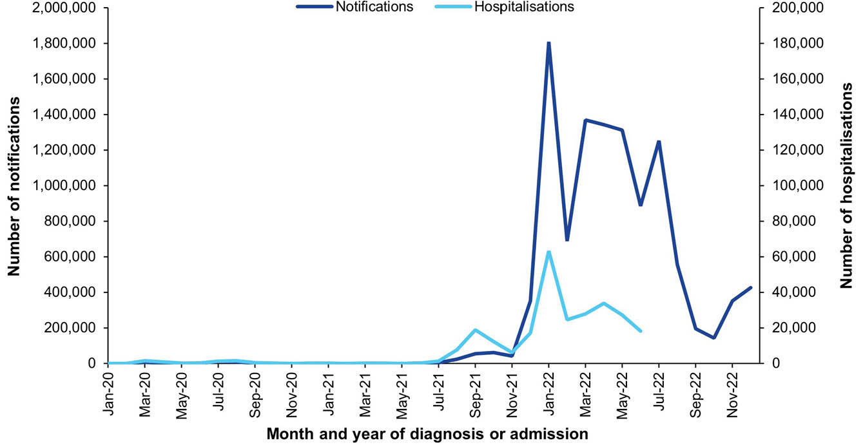
a Data sources: National Notifiable Diseases Surveillance System for notifications and Australian Institute for Health and Welfare National Hospital Morbidity Database for hospitalisation data.
b Hospitalisations for which the month of admission was between 1 January 2020 and 30 June 2022 and with COVID-19 in any diagnosis field. Hospitalisations with missing month of admission are excluded from this figure.
Figure 2: Coronavirus disease 2019 (COVID-19) monthly hospitalisation rate,^{a,b} Australia, 2020–2022, by age group
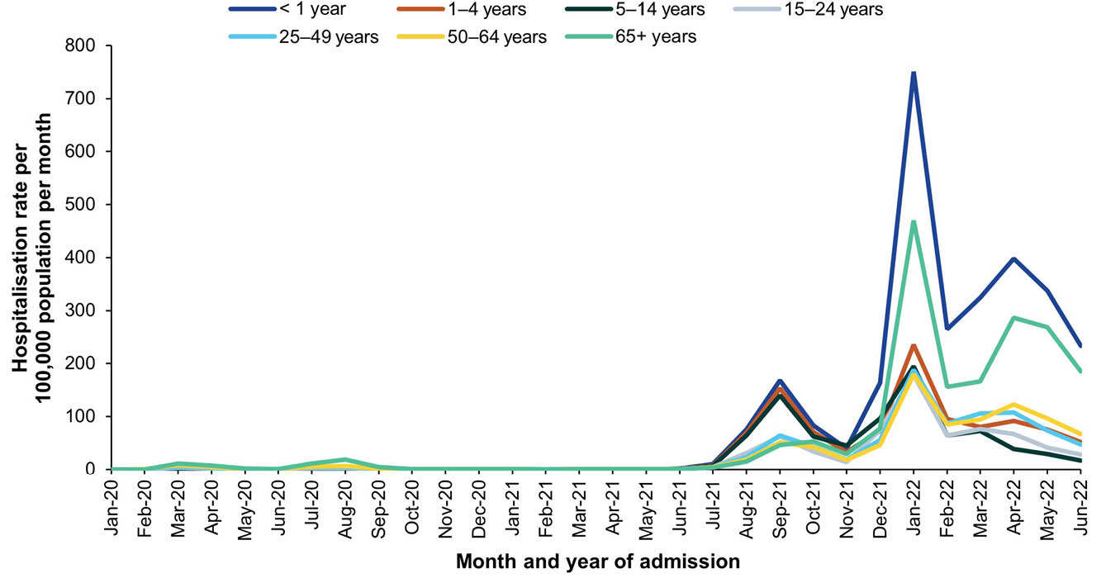
a Data source: Australian Institute for Health and Welfare National Hospital Morbidity Database for hospitalisation data.
b Hospitalisations for which the month of admission was between 1 January 2020 and 30 June 2022 and with COVID-19 in any diagnosis field. Hospitalisations with missing month of admission are excluded from this figure.

2. Diphtheria

Background
Diphtheria is caused by toxin-producing strains of the bacteria Corynebacterium diphtheriae and Corynebacterium ulcerans.⁵⁰ C. diphtheriae is transmitted predominantly from human to human by respiratory droplets or by direct contact with lesions.⁵¹ C. ulcerans is transmitted from animals, either through direct contact with respiratory droplets or through direct contact with, or consumption of, unpasteurised milk.^{52,53} Respiratory diphtheria is characterised by a sore throat, fever, swelling of the neck, and a membrane that forms over the back of the throat, resulting in breathing and swallowing difficulties.⁵⁰ The toxin can also cause cardiac, neurological and renal complications.^{51,54} Case fatality rates vary between 5% and more than 20%, depending on vaccination and access to treatment.⁵¹ Cutaneous diphtheria typically presents as a non-healing ulcerative lesion. Complications can occur in cutaneous diphtheria but are rare.⁵⁰

Notifications
- A total of 55 notifications of diphtheria were reported during the 2019–2022 period (Table 3).
- The average annual diphtheria notification rate for the 2019–2022 period was 0.05 per 100,000 population per year, not significantly different to the average annual notification rate of 0.04 per 100,000 population per year between 2016–2018 (RR: 1.46; 95% CI: 0.09–2.41).
- The majority of the cases were cutaneous (n = 47/55; 85.5%), with 6/55 cases (10.9%) pharyngeal and 2/55 (3.6%) with unknown site of infection. One pharyngeal case was a child aged 1–4 years; the remaining five pharyngeal cases were > 15 years old.
- Fifty cases (90.9%) were due to infection with C. diphtheriae, with five (9.1%) due to C. ulcerans.
- Aboriginal and Torres Strait Islander status was reported for all 55 notifications (100%) of diphtheria during 2019–2022, with 34 (61.8%) being reported in Aboriginal and Torres Strait Islander people. Twenty-four of the 34 cases in Aboriginal and Torres Strait people were reported in 2022.
- The diphtheria notification rate among Aboriginal and Torres Strait Islander people was more than 34 times that in others in the 2019–2022 period (age-standardised RR: 34.56; 95% CI: 19.13–63.14; Appendix A, Table A.3).

Ten-year trends
- The diphtheria notification rate was ≤ 0.01 per 100,000 population per year between 2013 and 2015, with 2 or 3 cases reported in these years (Figure 4). For the period 2016–2021, there were between 7 and 11 diphtheria notifications reported per year, with notification rates between 0.03 and 0.04 per 100,000 population per year. In 2022, there were 31 diphtheria notifications, the highest number recorded since 2001 (Figure 3), equating to a notification rate of 0.12 per 100,000 population.
- In the 10-year period between 2013 and 2022, there were 89 diphtheria notifications; 77 (86.5%) were recorded as cutaneous diphtheria, 10 (11.2%) as pharyngeal diphtheria and 2 (2.2%) with an unknown site of infection. Pharyngeal diphtheria was not recorded in 2013, 2014, 2017 or 2019.

Vaccination status
- Of the 55 notifications during 2019–2022, vaccination data were unavailable for 10.9% of cases (n = 6): 3 blank, 2 followed up with no further information, and 1 not followed up. Of the 49 notifications with vaccination data available, 7 (14.3%) had received no vaccine doses (including one child aged 1–4 years); 8 (16.3%) received one dose; 5 (10.2%) received 2 doses; 5 (10.2%) received 3 doses; 6 (12.2%) received 4 doses; and 17 (34.7%) received at least 5 doses of a diphtheria containing vaccine.
- Of notifications in those aged 0–14 years (n = 14), eight cases (57.1%) had three or four vaccine doses recorded; one was < 4 years old and not eligible for their fifth dose. Two cases (14.3%) were unvaccinated at the time of diagnosis; both were aged 1–4 years.

Place of acquisition
- A total of 10 diphtheria notifications (18.2%) had an unknown place of acquisition recorded.
- Of those with a known place of acquisition (n = 45), thirty-four notifications (75.6%) were recorded as diphtheria acquired within Australia and 11 (24.4%) in a country other than Australia. The majority of these (7/11; 63.6%) were recorded as having been acquired from a country in Oceania (Vanuatu, n = 4; Papua New Guinea, n = 2; and Solomon Islands, n = 1).

Hospitalisations
- There were 43 hospitalisations with diphtheria in any diagnosis field between 1 January 2019 and 30 June 2022, of which 11 (25.6%) had diphtheria as the principal diagnosis (Table 4). This equates to hospitalisation rates of 0.05 per 100,000 population per year and 0.01 per 100,000 population per year, respectively.
- The rates for hospitalisation with diphtheria in any diagnosis field and as principal diagnosis only were similar in the 2019–2022 period to the 2016–2018 period; rate ratios were 0.81 (95% CI: 0.54–1.23) for all-diagnoses diphtheria hospitalisations and 1.11 (95% CI: 0.45–2.93) for hospitalisations with diphtheria as principal diagnosis.

Principal diagnosis only
- During 2019–2022, hospitalisations with diphtheria as the principal diagnosis accounted for 73 hospital bed days. The exact length of stay was known for 100% of hospitalisations, as all were ≤ 30 days. The median length of stay was 5 days overall (IQR: 1–11 days), and highest in adults aged 25–49 years (6 days; IQR: 3–12 days) and 50–64 years (6 days; IQR: 1–11 days).
- Of the 11 hospitalisations with diphtheria as the principal diagnosis, 1–5 were among Aboriginal and Torres Strait Islander people.
- No diphtheria hospitalisations occurred in the Australian Capital Territory, the Northern Territory, Tasmania or Western Australia.

Deaths
- Between 1–5 deaths coded with diphtheria as associated cause of death and no deaths with diphtheria as underlying cause of death occurred in the 2019–2022 period.

Discussion
The incidence of diphtheria continues to be low at 0.05 per 100,000 population per year for the 2019–2022 period. However, there has been an increase in the number of notifications over the past two decades, with no cases notified in the 2002–2011 period, 7 in the 2012–2015 period, 27 in the 2016–2018 period and 55 in 2019–2022.^{6,13} The rate of diphtheria notifications was 34 times higher in Aboriginal and Torres Strait Islander peoples than in other people, a higher rate ratio than previously reported.^{6,8} This was attributable to an outbreak of diphtheria in 2022, primarily in Aboriginal and Torres Strait Islander communities in North Queensland.⁵⁵
A high proportion (75.6%) of diphtheria notifications were locally acquired in Australia in the 2019–2022 period, higher than reported in 2016–2018 (12/42, 28.6%). Although public health measures implemented during the pandemic, particularly international border closures,⁵⁶ would have reduced importation of diphtheria by travellers, the increase in number of diphtheria notifications, with the majority acquired in Australia, should continue to be monitored. Nevertheless, for travellers to endemic countries or countries where health services are difficult to access, recommendation of a booster dose of diphtheria-toxoid vaccine remains important.⁵⁷
Vaccination coverage is high in Australia, with 93.6% coverage of 4 or 5 doses of a diphtheria-toxoid vaccine in children aged 5 years in 2022.⁵⁸ Additionally, 83.8% of adolescents turning 14 in 2022 had received an adolescent dose of a diphtheria-containing vaccine.⁵⁸ Although a quarter of diphtheria notifications were in children aged 0–14 years, a high proportion had not completed the five-dose childhood schedule of diphtheria-toxoid vaccine, or were unvaccinated. The majority of notifications in the 2019–2022 period occurred in people aged ≥ 15 years (74.5%). Immunity to diphtheria wanes with increasing age, leaving many adults susceptible to infection.^{59–62} While adults ≥ 50 years are recommended to have a diphtheria-toxoid booster dose if they have not received a booster dose in the past 10 years,⁵⁷ coverage of the diphtheria-toxoid vaccines was suboptimal in 2024, at 30.1%.⁶³ It is important that all individuals remain up-to-date with diphtheria vaccinations, and that vigilant surveillance continues to monitor any further increases in diphtheria notifications.

Table 3: Diphtheria notifications in Australia, by age group, sex, Aboriginal and Torres Strait Islander status and state/territory,ª 2019–2022
Category | Characteristic | Year of diagnosis
Category | Characteristic | 2019 |  | 2020 |  | 2021 |  | 2022 |  | 2019–2022
Category | Characteristic | n | Rateb | n | Rate^{b} | n | Rate^{b} | n | Rate^{b} | n | Av. rate^{b,c}
Total | — | 7 | 0.03 | 10 | 0.04 | 7 | 0.03 | 31 | 0.12 | 55 | 0.05
Age group (years) | < 1 | 0 | 0 | 0 | 0 | 0 | 0 | 1 | 0.33 | 1 | 0.08
Age group (years) | 1–4 | 0 | 0 | 1 | 0.08 | 0 | 0 | 2 | 0.17 | 3 | 0.06
Age group (years) | 5–14 | 2 | 0.06 | 1 | 0.03 | 1 | 0.03 | 6 | 0.18 | 10 | 0.08
Age group (years) | 15–24 | 0 | 0 | 3 | 0.09 | 1 | 0.03 | 7 | 0.22 | 11 | 0.09
Age group (years) | 25–49 | 1 | 0.01 | 4 | 0.04 | 3 | 0.03 | 8 | 0.09 | 16 | 0.04
Age group (years) | 50–64 | 3 | 0.07 | 0 | 0 | 1 | 0.02 | 6 | 0.13 | 10 | 0.05
Age group (years) | ≥ 65 | 1 | 0.02 | 1 | 0.02 | 1 | 0.02 | 1 | 0.02 | 4 | 0.02
Sex | Male | 5 | 0.04 | 5 | 0.04 | 4 | 0.03 | 13 | 0.10 | 27 | 0.05
Sex | Female | 2 | 0.02 | 5 | 0.04 | 3 | 0.02 | 18 | 0.14 | 28 | 0.05
Aboriginal and Torres Strait Islander status | Aboriginal and Torres Strait Islander | 0 | 0 | 4 | 0.46 | 3 | 0.34 | 24 | 2.67 | 31 | 0.89
Aboriginal and Torres Strait Islander status | Other | 7 | 0.03 | 6 | 0.02 | 4 | 0.02 | 7 | 0.03 | 24 | 0.02
Jurisdiction^{d} | ACT | 0 | 0 | 0 | 0 | 0 | 0 | 0 | 0 | 0 | 0
Jurisdiction^{d} | NSW | 1 | 0.01 | 0 | 0 | 0 | 0 | 4 | 0.05 | 5 | 0.02
Jurisdiction^{d} | NT | 0 | 0 | 0 | 0 | 0 | 0 | 0 | 0 | 0 | 0
Jurisdiction^{d} | Qld | 5 | 0.10 | 9 | 0.17 | 5 | 0.10 | 25 | 0.47 | 44 | 0.21
Jurisdiction^{d} | SA | 0 | 0 | 1 | 0.06 | 2 | 0.11 | 0 | 0 | 3 | 0.04
Jurisdiction^{d} | Tas. | 0 | 0 | 0 | 0 | 0 | 0 | 0 | 0 | 0 | 0
Jurisdiction^{d} | Vic. | 1 | 0.02 | 0 | 0 | 0 | 0 | 1 | 0.02 | 2 | 0.01
Jurisdiction^{d} | WA | 0 | 0 | 0 | 0 | 0 | 0 | 1 | 0.04 | 1 | 0.01
a Data source: National Notifiable Diseases Surveillance System.
b Rates provided are the number of notifications per 100,000 population per year.
c Average annual rate per 100,000 population per year.
d ACT: Australian Capital Territory; NSW: New South Wales; NT: Northern Territory; Qld: Queensland; SA: South Australia; Tas.: Tasmania; Vic.: Victoria; WA: Western Australia.
Table 4: Diphtheria hospitalisations and deaths in Australia, by age group, sex, Aboriginal and Torres Strait Islander status and state/territory,ª 2019–2022
Category | Characteristic | Hospital count and rate: year of admission^{b,c} |  |  |  |  |  |  |  |  |  |  |  |  |  |  |  |  |  |  |  | Deaths^{d,e}
Category | Characteristic | Any diagnosis field^{f} |  |  |  |  |  |  |  |  |  | Prinicpal diagnosis^{g} |  |  |  |  |  |  |  |  |  | Year of  death
Category | Characteristic | 2019 |  | 2020 |  | 2021 |  | 2022^{h,i} |  | 2019–2022 |  | 2019 |  | 2020 |  | 2021 |  | 2022^{h,i} |  | 2019–2022 |  | 2019–2022
Category | Characteristic | n | Rate | n | Rate | n | Rate | n | Rate | n | Av. rate^{k} | n | Rate | n | Rate | n | Rate | n | Rate | n | Av. rate^{k} | n | Av. rate^{k}
Total | — | 12 | 0.05 | 13 | 0.05 | 9 | 0.04 | 9 | 0.07 | 43 | 0.05 | 1–4 | 0.004 | 1–4 | 0.02 | 1–4 | 0.01 | 1–4 | 0.02 | 11 | 0.01 | 0 | 0
Age group (years) | < 1 | 1–4 | 0.33 | 0 | 0 | 0 | 0 | 0 | 0 | 1–4 | 0.08 | 0 | 0 | 0 | 0 | 0 | 0 | 0 | 0 | 0 | 0 | — | —
Age group (years) | 1–4 | 0 | 0 | 1–4 | 0.16 | 0 | 0 | 1–4 | 0.17 | 1–4 | 0.08 | 0 | 0 | 1–4 | 0.16 | 0 | 0 | 1–4 | 0.17 | 1–4 | 0.08 | — | —
Age group (years) | 5–14 | 0 | 0 | 1–4 | 0.03 | 1–4 | 0.03 | 0 | 0 | 1–4 | 0.02 | 0 | 0 | 0 | 0 | 0 | 0 | 0 | 0 | 0 | 0 | — | —
Age group (years) | 15–24 | 1–4 | 0.06 | 1–4 | 0.03 | 0 | 0 | 0 | 0 | 1–4 | 0.02 | 0 | 0 | 1–4 | 0.03 | 0 | 0 | 0 | 0 | 1–4 | 0.01 | — | —
Age group (years) | 25–49 | 1–4 | 0.03 | 1–4 | 0.04 | 1–4 | 0.04 | 5 | 0.11 | 16 | 0.06 | 1–4 | 0.01 | 1–4 | 0.01 | 1–4 | 0.02 | 1–4 | 0.02 | 5 | 0.02 | — | —
Age group (years) | 50–64 | 1–4 | 0.04 | 1–4 | 0.04 | 1–4 | 0.02 | 1–4 | 0.04 | 6 | 0.04 | 0 | 0 | 0 | 0 | 1–4 | 0.02 | 1–4 | 0.04 | 1–4 | 0.02 | — | —
Age group (years) | ≥ 65 | 1–4 | 0.10 | 1–4 | 0.07 | 1–4 | 0.07 | 1–4 | 0.09 | 12 | 0.08 | 0 | 0 | 0 | 0 | 0 | 0 | 0 | 0 | 0 | 0 | — | —
Sex | Male | 6 | 0.05 | 5 | 0.04 | NP | 0.05 | NP | 0.08 | 23 | 0.05 | 1–4 | 0.01 | 1–4 | 0.01 | 1–4 | 0.02 | 1–4 | 0.03 | 6 | 0.02 | — | —
Sex | Female | 6 | 0.05 | 8 | 0.06 | 1–4 | 0.02 | 1–4 | 0.06 | 20 | 0.05 | 0 | 0 | 1–4 | 0.02 | 1–4 | 0.02 | 1–4 | 0.02 | 6 | 0.01 | — | —
Aboriginal and Torres Strait Islander status | Aboriginal and Torres Strait Islander | 1–4 | 0.24 | 1–4 | 0.23 | 1–4 | 0.11 | NP | 1.33 | 11 | 0.49 | 0 | 0 | 0 | 0 | 0 | 0 | 1–4 | 0.67 | 1–4 | 0.17 | — | —
Aboriginal and Torres Strait Islander status | Other | 10 | 0.04 | 11 | 0.04 | NP | 0.03 | 1–4 | 0.02 | 32 | 0.04 | 1–4 | 0.004 | 1–4 | 0.02 | 1–4 | 0.01 | 0 | 0 | NP | 0.01 | — | —
Jurisdiction^{k,l} | ACT | 0 | 0 | 0 | 0 | 0 | 0 | 0 | 0 | 0 | 0 | 0 | 0 | 0 | 0 | 0 | 0 | 0 | 0 | 0 | 0 | — | —
Jurisdiction^{k,l} | NSW | 1–4 | 0.01 | 1–4 | 0.02 | 1–4 | 0.02 | 1–4 | 0.07 | 8 | 0.03 | 0 | 0 | 0 | 0 | 0 | 0 | 1–4 | 0.02 | 1–4 | 0.01 | — | —
Jurisdiction^{k,l} | NT | 0 | 0 | 1–4 | 0.40 | 0 | 0 | 0 | 0 | 1–4 | 0.10 | 0 | 0 | 0 | 0 | 0 | 0 | 0 | 0 | 0 | 0 | — | —
Jurisdiction^{k,l} | Qld | 6 | 0.12 | 6 | 0.12 | 1–4 | 0.02 | NP | 0.19 | 18 | 0.11 | 1–4 | 0.02 | 1–4 | 0.06 | 0 | 0 | 1–4 | 0.08 | 6 | 0.04 | — | —
Jurisdiction^{k,l} | SA | 0 | 0 | 1–4 | 0.11 | 1–4 | 0.17 | 0 | 0 | 5 | 0.07 | 0 | 0 | 0 | 0 | 1–4 | 0.11 | 0 | 0 | 1–4 | 0.03 | — | —
Jurisdiction^{k,l} | Tas. | 0 | 0 | 0 | 0 | 1–4 | 0.18 | 0 | 0 | 1–4 | 0.04 | 0 | 0 | 0 | 0 | 0 | 0 | 0 | 0 | 0 | 0 | — | —
Jurisdiction^{k,l} | Vic. | 1–4 | 0.06 | 1–4 | 0.03 | 1–4 | 0.02 | 0 | 0 | 7 | 0.03 | 0 | 0 | 1–4 | 0.02 | 0 | 0 | 0 | 0 | 1–4 | 0.004 | — | —
Jurisdiction^{k,l} | WA | 1–4 | 0.04 | 0 | 0 | 0 | 0 | 1–4 | 0.07 | 1–4 | 0.03 | 0 | 0 | 0 | 0 | 0 | 0 | 0 | 0 | 0 | 0 | — | —
a Data sources: Australian Institute for Health and Welfare National Hospital Morbidity Database for hospitalisation data, and Australian Coordinating Registry for death data.
b Rates provided are the number of hospitalisations or deaths per 100,000 population per year.
c To comply with the AIHW’s data release condition that hospitalisation counts < 5 be suppressed in published reports, counts between 1 and 4 are reported as a range; other cell counts may be reported as NP (not published) to avoid potential for back calculation of counts < 5.
d Deaths where the disease code was the underlying cause of death only.
e To comply with the Australian Coordinating Registry’s data release condition that death counts < 6 be suppressed in published reports, counts between 1 and 5 are reported as a range; other cell counts may be reported as NP (not published) to avoid potential for back calculation of counts < 6.
f Hospitalisations with the specific disease code in any diagnosis field.
g Hospitalisations with the specific disease code in the principal diagnosis field only.
h Hospitalisations with admission date between 1 January and 30 June 2022.
i Hospitalisation rates for 2022 have been annualised.
j Average annual rate per 100,000 population per year.
k ACT: Australian Capital Territory; NSW: New South Wales; NT: Northern Territory; Qld: Queensland; SA: South Australia; Tas.: Tasmania; Vic.: Victoria; WA: Western Australia.
l To comply with the Australian Coordinating Registry’s data release condition that only national death counts and rates be reported, death counts and rates are not presented by state/territory.

Figure 3: Diphtheria notifications and hospitalisations for all ages,^{a,b} Australia, 2001–2022, by year of diagnosis or admission
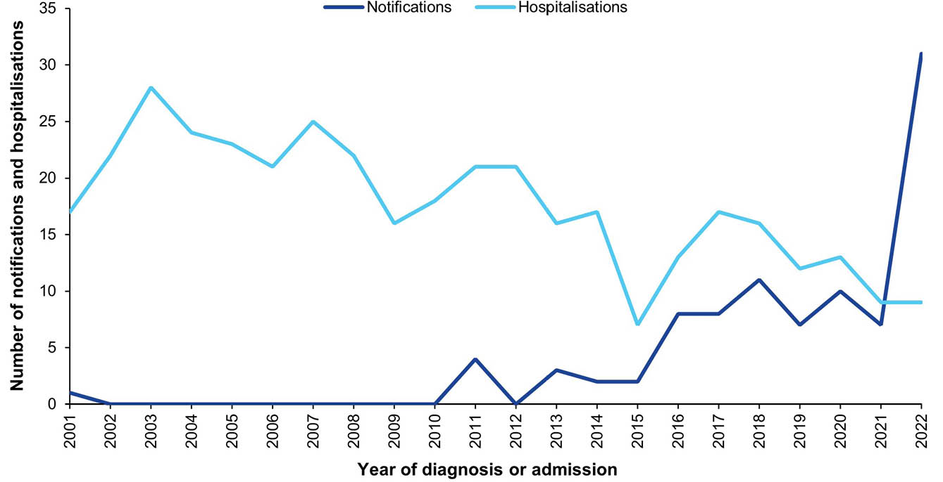
a Data sources: National Notifiable Diseases Surveillance System for notification data and the Australian Institute for Health and Welfare National Hospital Morbidity Database for hospitalisation data.
b Hospitalisations for which the year of admission was between 2001 and 2022 and with diphtheria in any diagnosis field. Hospitalisation data for 2022 included hospitalisations from 1 January to 30 June only. Hospitalisations with missing year of admission are excluded from this figure.
Figure 4: Number of diphtheria notifications by site of infection, and diphtheria notification rate,ª Australia, 2013–2022
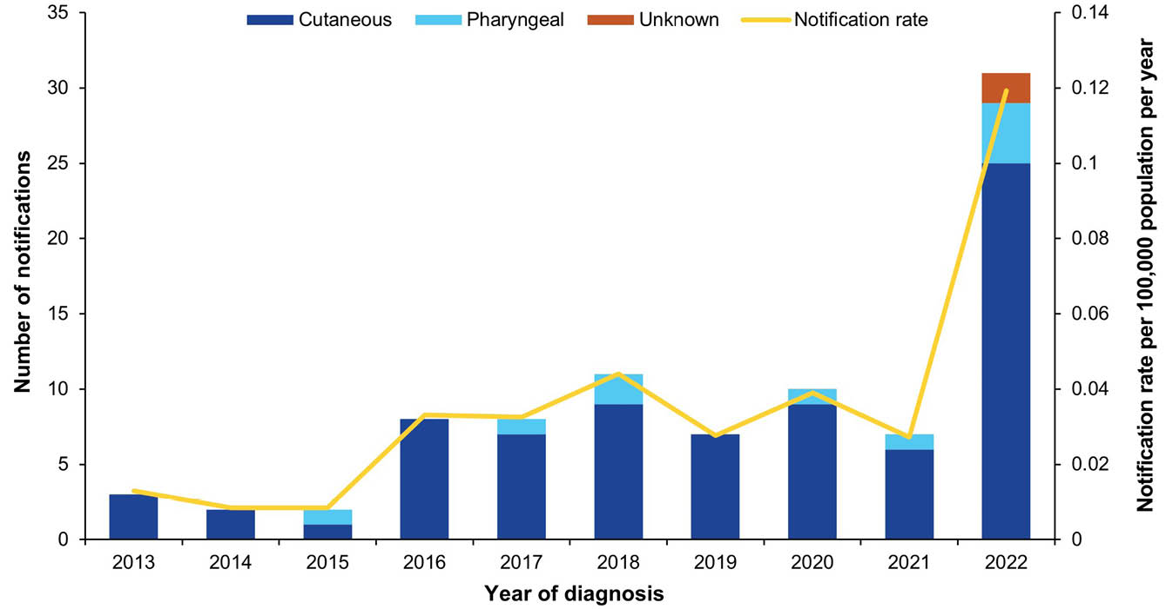
a Data source: National Notifiable Diseases Surveillance System.

3. Haemophilus influenzae type b disease

Background
Hib disease is caused by the gram-negative bacterium Haemophilus influenzae, serotype b. It is a commensal organism in the nasopharynx,^{64–66} but can cause invasive disease and can lead to epiglottitis^{67,68} and meningitis, with neurological sequelae such as deafness in approximately one-fifth to one-third of survivors.⁶⁹ Other manifestations of invasive Hib disease are pneumonia (with bacteraemia or empyema); septic arthritis; cellulitis; osteomyelitis; and septicaemia.⁶⁹

Notifications
- A total of 73 cases of invasive Haemophilus influenzae type b (Hib) disease were notified in the 2019–2022 period (Table 5). There was a substantial decline in Hib disease in Australia in the 1990s, with relatively stable monthly case numbers since (Figure 5).
- The average annual notification rate of invasive Hib disease was 0.07 per 100,000 population per year in 2019–2022, which is similar to the rate in the 2016–2018 period; RR = 1.03 (95% CI: 0.71–1.50).
- The notification rate among children 1–14 years of age remained low and relatively stable over the 2013–2022 period (Figure 6). The notification rate was highest among infants < 1 year of age each year in the 2019–2022 period (Table 5). The rate in the < 1-year age group was more variable over the 2013–2022 period than for other paediatric age groups (Figure 6), reflecting generally small case numbers. There was no statistically significant difference in the notification rate between the 2019–2022 period and the 2016–2018 period among children: RR = 1.07 (95% CI: 0.50–2.37) for infants < 1 year of age; RR = 0.91 (95% CI: 0.38–2.25) for children 1–4 years of age; and RR = 0.83 (95% CI: 0.24–2.99) for children 5–14 years of age.
- No cases of invasive Hib disease were notified in the Australian Capital Territory and Tasmania in the period 2019–2022 (Table 5). The highest annual average notification rate in the 2019–2022 period was observed in the Northern Territory (1.11 per 100,000 population per year).
- Aboriginal and Torres Strait Islander status was reported for all 73 notified cases (100%), with 27 reported as Aboriginal and Torres Strait Islander (37%). The age-standardised notification rate ratio among Aboriginal and Torres Strait Islander people compared to others was 15.84 (95% CI: 8.80–27.39) in the 2019–2022 period (Appendix A, Table A.3).

Vaccination status
- Among the 73 notified cases, 32 (44%) were born before 1988 and not eligible for Hib vaccination.
- Of the 41 cases eligible for vaccination, three (7%) were unvaccinated. Two of the unvaccinated cases were under the age of 12 months, and one case was between 12 and < 18 months of age. One child < 12 months (2%) received a single dose of Hib-containing vaccine in the 14 days prior to diagnosis.
- There were 21 vaccinated cases less than 18 months of age. Of these, 10 (48%) had received three Hib-containing vaccine doses; two (10%) had received two vaccine doses; and eight (38%) had received one vaccine dose. One (5%) had insufficient vaccine information recorded to determine the number of doses received.
- Six cases were between 12 to < 18 months of age, all of whom had received a three-dose primary course.
- There were 16 vaccinated cases ≥ 18 months of age. Nine of these cases (56%) had received a three-dose primary course and booster dose at age ≥ 12 months, and three cases (19%) had received a full two-dose PRP-OMP primary course and a booster at age ≥ 18 months. Two cases (13%) had received a three-dose primary course, but no booster dose. One case (6%) had received one primary course dose only. Vaccination information was insufficient to determine the number of doses received for the other case (6%).

Hospitalisations and deaths
- Hospitalisation data for invasive Hib disease are unavailable, as ICD-10-AM codes for invasive Haemophilus influenzae disease are not type-specific.
- Mortality data for invasive Hib disease are available from the “died of disease” variable in NNDSS only, as ICD-10 codes for invasive Haemophilus influenzae disease in the ACR mortality dataset are not type-specific.
- Two notified Hib cases (3%) were reported to have died due to the disease. One case was an infant who had received one dose of Hib-containing vaccine, and the other case an adult aged ≥ 65 years who was not eligible for Hib-containing vaccination. Neither case was an Aboriginal or Torres Strait Islander person.

Discussion
Since the introduction of Hib-containing vaccines on the NIP in 1993, the incidence and burden of invasive Hib disease in Australia have declined substantially,^{70–72} consistent with the international experience.^{73,74} Across all age groups, the invasive Hib disease notification rate in Australia remained stable in the 2019–2022 period, which included the 2020–2021 COVID-19 pandemic years, compared to 2016–2018.⁶ This absence of an apparent effect of the pandemic-associated non-pharmaceutical measures on the incidence of invasive Hib disease has also been observed elsewhere.⁷⁵ The notification rate of invasive Hib disease remains considerably higher (16-fold in 2019–2022) among Aboriginal and Torres Strait Islander peoples than among other people, although based on relatively small numbers of cases.
In July 2018, the NIP-funded booster dose of Hib-containing vaccine changed from a combined Hib and meningococcal C vaccine at 12 months to a monovalent Hib vaccine at 18 months of age.⁷⁶ Seven invasive Hib disease cases in the 2019–2022 period (10%) were between 12 to < 18 months of age at time of the notification, six of whom received a full primary course. This compares to 17 cases 12 to < 18 months of age (5%) in the 2000–2017 period, of whom five had received a full primary course and six had received an additional booster dose.⁷² Ongoing monitoring of invasive Hib disease incidence in the 12 to < 18 months age group is required to ensure the change in timing of the booster does not result in an increase in invasive Hib disease in this age group.

Table 5: Haemophilus influenzae type b invasive disease notifications in Australia, by age group, sex, Aboriginal and Torres Strait Islander status and state/territory,ª 2019–2022
Category | Characteristic | Year of diagnosis
Category | Characteristic | 2019 |  | 2020 |  | 2021 |  | 2022 |  | 2019–2022
Category | Characteristic | n | Rate^{b} | n | Rate^{b} | n | Rate^{b} | n | Rate^{b} | n | Av. rate^{b,c}
Total | — | 22 | 0.09 | 19 | 0.07 | 19 | 0.07 | 13 | 0.05 | 73 | 0.07
Age group (years) | < 1 | 6 | 1.98 | 3 | 1.01 | 7 | 2.34 | 2 | 0.66 | 18 | 1.50
Age group (years) | 1–4 | 3 | 0.24 | 4 | 0.32 | 3 | 0.25 | 3 | 0.25 | 13 | 0.27
Age group (years) | 5–14 | 4 | 0.13 | 2 | 0.06 | 1 | 0.03 | 0 | 0 | 7 | 0.05
Age group (years) | 15–24 | 0 | 0 | 1 | 0.03 | 0 | 0 | 1 | 0.03 | 2 | 0.02
Age group (years) | 25–49 | 0 | 0 | 1 | 0.01 | 2 | 0.02 | 2 | 0.02 | 5 | 0.01
Age group (years) | 50–64 | 4 | 0.09 | 3 | 0.07 | 3 | 0.07 | 2 | 0.04 | 12 | 0.07
Age group (years) | ≥ 65 | 5 | 0.12 | 5 | 0.12 | 3 | 0.07 | 3 | 0.07 | 16 | 0.09
Sex | Male | 9 | 0.07 | 12 | 0.09 | 8 | 0.06 | 6 | 0.05 | 35 | 0.07
Sex | Female | 13 | 0.10 | 7 | 0.05 | 11 | 0.09 | 7 | 0.05 | 38 | 0.07
Aboriginal and Torres Strait Islander status | Aboriginal and Torres Strait Islander | 7 | 0.83 | 8 | 0.93 | 5 | 0.57 | 7 | 0.78 | 27 | 0.77
Aboriginal and Torres Strait Islander status | Other | 15 | 0.06 | 11 | 0.04 | 14 | 0.06 | 6 | 0.02 | 46 | 0.05
Jurisdiction^{d} | ACT | 0 | 0 | 0 | 0 | 0 | 0 | 0 | 0 | 0 | 0
Jurisdiction^{d} | NSW | 11 | 0.14 | 6 | 0.07 | 9 | 0.11 | 2 | 0.02 | 28 | 0.09
Jurisdiction^{d} | NT | 3 | 1.22 | 3 | 1.21 | 2 | 0.81 | 3 | 1.20 | 11 | 1.11
Jurisdiction^{d} | Qld | 4 | 0.08 | 6 | 0.12 | 4 | 0.08 | 3 | 0.06 | 17 | 0.08
Jurisdiction^{d} | SA | 1 | 0.06 | 1 | 0.06 | 0 | 0 | 2 | 0.11 | 4 | 0.06
Jurisdiction^{d} | Tas. | 0 | 0 | 0 | 0 | 0 | 0 | 0 | 0 | 0 | 0
Jurisdiction^{d} | Vic. | 1 | 0.02 | 0 | 0 | 3 | 0.05 | 2 | 0.03 | 6 | 0.02
Jurisdiction^{d} | WA | 2 | 0.08 | 3 | 0.11 | 1 | 0.04 | 1 | 0.04 | 7 | 0.06
a Data source: National Notifiable Diseases Surveillance System.
b Rates provided are the number of notifications per 100,000 population per year.
c Average annual rate per 100,000 population per year.
d ACT: Australian Capital Territory; NSW: New South Wales; NT: Northern Territory; Qld: Queensland; SA: South Australia; Tas.: Tasmania; Vic.: Victoria; WA: Western Australia.

Figure 5: Haemophilus influenzae type b invasive disease notifications for all ages,ª Australia, 1993–2022, by month of diagnosis
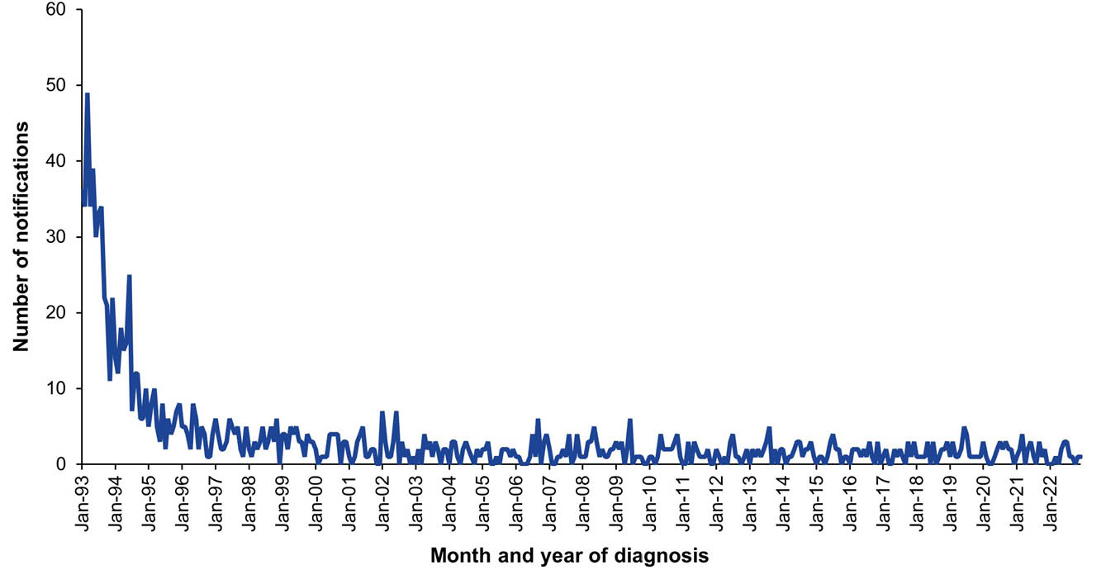
a Data source: National Notifiable Diseases Surveillance System.
Figure 6: Haemophilus influenzae type b invasive disease notification rate,^{a,b} Australia, 2013–2022, by age group for the groups < 1, 1–4 and 5–14 years
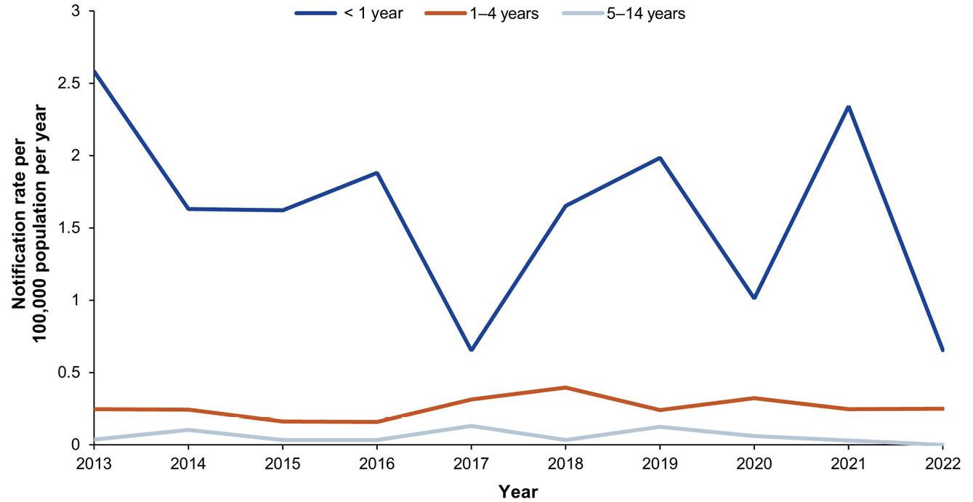
a Data source: National Notifiable Diseases Surveillance System.
b Notifications for which the diagnosis was between 1 January 2013 and 31 December 2022.

4. Hepatitis A

Background
Hepatitis A is caused by the hepatitis A virus (HAV) and is an acute inflammatory disease of the liver. Hepatitis A symptoms can be mild or severe and may include fever, loss of appetite, malaise, nausea, abdominal discomfort, jaundice and dark urine.⁷⁷ Infection with HAV in young children is usually asymptomatic or mild without jaundice. In adults, hepatitis A is symptomatic in 70–95% of cases.⁷⁸

Notifications
- A total of 502 hepatitis A notifications were reported during the 2019–2022 period (Table 6), with a median of 9 (ranging from 0 to 34) per month (Figure 7).
- The average annual hepatitis A notification rate for the 2019–2022 period was 0.49 per 100,000 population per year; this was less than half the average annual notification rate of 1.08 per 100,000 population per year during 2016–2018 (RR: 0.45; 95% CI: 0.40–0.50).
- There were no hepatitis A notifications reported in infants aged < 1 years during 2019–2022 (Table 6). The highest average annual hepatitis A notification rates were observed in the 5–14 and 15–24 year age groups (0.92 per 100,000 and 0.74 per 100,000 population per year, respectively).
- Aboriginal and Torres Strait Islander status was reported for 453 of the 502 hepatitis A notifications (90.2%) during 2019–2022, with three cases (0.6%) reported in Aboriginal and Torres Strait Islander people.

Ten-year trends
- The hepatitis A notification rate was less than 1.0 per 100,000 population per year for the 2013–2022 period, except in 2018 (1.74 per 100,000 population). The lowest rate was in 2021 (0.10 per 100,000 population per year).

Vaccination status
- Of the 502 notifications, vaccination data were unavailable for 51.2% of cases (257/502, of which 181 were blank, 66 followed up but no information available, and 10 not followed up). Of the 245 notifications with vaccination data available, 226 (92.2%) had received no vaccine doses and 9 (3.7%) received one dose of hepatitis A vaccine within 14 days of their diagnosis date. Ten notified cases (4.1%) received one dose of hepatitis A vaccine 14 days or more before their diagnosis date.

Place of acquisition
- A total of 46 hepatitis A notifications (9.2%) had an unknown place of acquisition recorded. Of those with a known place of acquisition (n = 456), one hundred and forty-four notifications (31.5%) were recorded as hepatitis A acquired within Australia and 312 (68.4%) in a country other than Australia. One hundred and eighty-six (59.6%) of these hepatitis A infections were acquired in Southern and Central Asia (including 105 from India, 64 from Pakistan and 12 from Bangladesh); 26 (8.3%) were acquired in North Africa and the Middle East (including 14 from Lebanon and 5 from Iraq); 24 (7.7%) were acquired in South-East Asia (including 11 from Indonesia); and 24 (7.7%) in Oceania and Antarctica (including 11 from Fiji and 6 from Papua New Guinea).
- The proportion of notifications recorded as hepatitis A acquired from a country other than Australia differed by year: 63.1% in 2019; 70.5% in 2020; 47.6% in 2021; and 80.5% in 2022.

Hospitalisations
- There were 885 hospitalisations with hepatitis A in any diagnosis field between 1 January 2019 and 30 June 2022, of which 291 (32.9%) had hepatitis A as the principal diagnosis (Table 7). This equates to average annual hospitalisation rates of 0.98 per 100,000 population per year and 0.33 per 100,000 population per year, respectively.
- The rates for hospitalisation with hepatitis A in any diagnosis field and as principal diagnosis only were both lower in the 2019–2022 period than in the 2016–2018 period; rate ratios were 0.63 (95% CI: 0.58–0.69) for all-diagnoses hepatitis A hospitalisations and 0.53 (95% CI: 0.46–0.61) for hospitalisations with hepatitis A as the principal diagnosis.

Principal diagnosis only
- There were no hospitalisations with hepatitis A as the principal diagnosis in the < 1 year age group during 2019–2022 (Table 7). Hospitalisation rates were < 0.4 per 100,000 population per year in all other age groups.
- During 2019–2022, hospitalisations with hepatitis A as the principal diagnosis accounted for a minimum of 1,070 hospital bed days. The exact length of stay was unknown (i.e. reported as > 30 days) for 1–4 hospitalisations (0.3%). The median length of stay was 3 days (IQR: 2–5 days) overall, and highest among adults aged ≥ 65 years (median 4 days, IQR: 2–6 days).

Deaths
- Eight deaths were coded with hepatitis A as associated cause of death and between 1–5 deaths with hepatitis A as underlying cause of death between 2019 and 2022. No deaths in Aboriginal and Torres Strait Islander people were coded as due to hepatitis A in the period.

Discussion
The incidence of hepatitis A in Australia declined in the early 2000s⁹ and has remained low over the past two decades due to increasing levels of immunity as a result of vaccine uptake as well as migration to Australia of individuals from high endemicity countries.^{79–81} Hepatitis A notification rates were lower in 2019–2022 than in 2016–2018, likely reflecting the uptake of privately funded hepatitis A vaccine in travellers; the implementation of state-funded vaccination programs for at-risk populations following hepatitis A outbreaks in 2018 among men who have sex with men;^{82,83} and only one reported foodborne outbreak.⁸⁴ Additionally, a reduction of imported cases from returned travellers and other people arriving from overseas, due to travel restrictions during the COVID-19 pandemic (2020–2021), is likely to have resulted in a decrease in the number of imported hepatitis A cases. Despite this, a large proportion of hepatitis A cases (70.5% in 2020 and 80.5% in 2022) continued to be acquired overseas, and travellers should be encouraged to receive hepatitis A vaccine if they are travelling to an endemic country.⁵⁷
The availability of hepatitis A vaccine on the NIP, for Aboriginal and Torres Strait Islander children in the Northern Territory, Queensland, South Australia and Western Australia since 2005, has contributed to the sustained low hepatitis A rates, particularly among Aboriginal and Torres Strait Islander peoples.⁸ During 2019–2022, the crude hepatitis A notification rate was lower among Aboriginal and Torres Strait Islander peoples than for others, although age-standardised rates could not be calculated due to the small number of cases.

Table 6: Hepatitis A notifications in Australia, by age group, sex, Aboriginal and Torres Strait Islander status and state/territory,ª 2019–2022
Category | Characteristic | Year of diagnosis
Category | Characteristic | 2019 |  | 2020 |  | 2021 |  | 2022 |  | 2019–2022
Category | Characteristic | n | Rate^{b} | n | Rate^{b} | n | Rate^{b} | n | Rate^{b} | n | Av. rate^{b,c}
Total | — | 247 | 0.98 | 86 | 0.34 | 25 | 0.10 | 144 | 0.55 | 502 | 0.49
Age group (years) | < 1 | 0 | 0 | 0 | 0 | 0 | 0 | 0 | 0 | 0 | 0
Age group (years) | 1–4 | 13 | 1.04 | 5 | 0.40 | 3 | 0.25 | 11 | 0.91 | 32 | 0.65
Age group (years) | 5–14 | 45 | 1.42 | 13 | 0.40 | 5 | 0.15 | 55 | 1.69 | 118 | 0.92
Age group (years) | 15–24 | 53 | 1.64 | 11 | 0.34 | 4 | 0.13 | 26 | 0.82 | 94 | 0.74
Age group (years) | 25–49 | 101 | 1.14 | 48 | 0.54 | 8 | 0.09 | 41 | 0.46 | 198 | 0.56
Age group (years) | 50–64 | 25 | 0.56 | 7 | 0.15 | 4 | 0.09 | 8 | 0.17 | 44 | 0.24
Age group (years) | ≥ 65 | 10 | 0.25 | 2 | 0.05 | 1 | 0.02 | 3 | 0.07 | 16 | 0.09
Sex | Male | 149 | 1.18 | 60 | 0.47 | 19 | 0.15 | 81 | 0.63 | 309 | 0.61
Sex | Female | 98 | 0.77 | 26 | 0.20 | 6 | 0.05 | 63 | 0.48 | 193 | 0.37
Aboriginal and Torres Strait Islander status | Aboriginal and Torres Strait Islander | 1 | 0.12 | 1 | 0.12 | 1 | 0.11 | 0 | 0 | 3 | 0.09
Aboriginal and Torres Strait Islander status | Other | 246 | 1.00 | 85 | 0.34 | 24 | 0.10 | 144 | 0.57 | 499 | 0.50
Jurisdiction^{d} | ACT | 5 | 1.15 | 0 | 0 | 1 | 0.22 | 1 | 0.22 | 7 | 0.39
Jurisdiction^{d} | NSW | 60 | 0.75 | 18 | 0.22 | 9 | 0.11 | 37 | 0.45 | 124 | 0.38
Jurisdiction^{d} | NT | 4 | 1.62 | 0 | 0 | 0 | 0 | 1 | 0.40 | 5 | 0.50
Jurisdiction^{d} | Qld | 25 | 0.49 | 15 | 0.29 | 10 | 0.19 | 29 | 0.55 | 79 | 0.38
Jurisdiction^{d} | SA | 14 | 0.79 | 3 | 0.17 | 0 | 0 | 2 | 0.11 | 19 | 0.26
Jurisdiction^{d} | Tas. | 3 | 0.55 | 0 | 0 | 0 | 0 | 4 | 0.70 | 7 | 0.31
Jurisdiction^{d} | Vic. | 112 | 1.71 | 44 | 0.67 | 4 | 0.06 | 56 | 0.85 | 216 | 0.82
Jurisdiction^{d} | WA | 24 | 0.90 | 6 | 0.22 | 1 | 0.04 | 14 | 0.50 | 45 | 0.41
a Data source: National Notifiable Diseases Surveillance System.
b Rates provided are the number of notifications per 100,000 population per year.
c Average annual rate per 100,000 population per year.
d ACT: Australian Capital Territory; NSW: New South Wales; NT: Northern Territory; Qld: Queensland; SA: South Australia; Tas.: Tasmania; Vic.: Victoria; WA: Western Australia.
Table 7: Hepatitis A hospitalisations and deaths in Australia, by age group, sex, Aboriginal and Torres Strait Islander status and state/territory,ª 2019–2022
Category | Characteristic | Hospital count and rate: year of admission^{b,c,d} |  |  |  |  |  |  |  |  |  |  |  |  |  |  |  |  |  |  |  | Deaths^{e,f}
Category | Characteristic | Any diagnosis field^{g} |  |  |  |  |  |  |  |  |  | Prinicpal diagnosis^{h} |  |  |  |  |  |  |  |  |  | Year of  death
Category | Characteristic | 2019 |  | 2020 |  | 2021 |  | 2022^{i,j} |  | 2019–2022 |  | 2019 |  | 2020 |  | 2021 |  | 2022^{i,j} |  | 2019–2022 |  | 2019–2022
Category | Characteristic | n | Rate | n | Rate | n | Rate | n | Rate | n | Av. rate^{k} | n | Rate | n | Rate | n | Rate | n | Rate | n | Av. rate^{k} | n | Av. rate^{k}
Total | — | 400 | 1.58 | 208 | 0.81 | 160 | 0.62 | 117 | 0.90 | 885 | 0.98 | 161 | 0.64 | 59 | 0.23 | 28 | 0.11 | 43 | 0.33 | 291 | 0.33 | 1–5 | 0.001
Age group (years) | < 1 | 0 | 0 | 0 | 0 | 0 | 0 | 0 | 0 | 0 | 0 | 0 | 0 | 0 | 0 | 0 | 0 | 0 | 0 | 0 | 0 | 0 | 0
Age group (years) | 1–4 | 5 | 0.40 | 1–4 | 0.08 | 1–4 | 0.17 | 1–4 | 0.50 | 11 | 0.29 | 5 | 0.40 | 1–4 | 0.08 | 1–4 | 0.17 | 1–4 | 0.33 | 10 | 0.24 | 0 | 0
Age group (years) | 5–14 | 20 | 0.63 | 1–4 | 0.06 | NP | 0.28 | 12 | 0.74 | 43 | 0.43 | 16 | 0.50 | 1–4 | 0.06 | NP | 0.25 | 12 | 0.74 | 38 | 0.39 | 0 | 0
Age group (years) | 15–24 | 35 | 1.08 | 12 | 0.38 | 1–4 | 0.06 | 1–4 | 0.25 | 53 | 0.45 | 32 | 0.99 | 6 | 0.19 | 1–4 | 0.03 | 1–4 | 0.13 | 41 | 0.34 | 0 | 0
Age group (years) | 25–49 | 137 | 1.55 | 94 | 1.05 | 37 | 0.42 | 34 | 0.76 | 302 | 0.94 | 72 | 0.81 | 33 | 0.37 | 9 | 0.10 | 13 | 0.29 | 127 | 0.39 | 0 | 0
Age group (years) | 50–64 | 64 | 1.43 | 32 | 0.70 | 41 | 0.89 | 25 | 1.07 | 162 | 1.02 | 14 | 0.31 | 10 | 0.22 | 1–4 | 0.09 | NP | 0.43 | 38 | 0.26 | 0 | 0
Age group (years) | ≥ 65 | 139 | 3.45 | 67 | 1.60 | 69 | 1.60 | 39 | 1.76 | 314 | 2.08 | 22 | 0.55 | 7 | 0.17 | 1–4 | 0.09 | 1–4 | 0.18 | 37 | 0.24 | 1–5 | 0.006
Sex | Male | 204 | 1.62 | 113 | 0.89 | 82 | 0.64 | 56 | 0.87 | 455 | 1.00 | 93 | 0.74 | 39 | 0.31 | 18 | 0.14 | 21 | 0.33 | 171 | 0.38 | 1–5 | 0.002
Sex | Female | 196 | 1.54 | 95 | 0.74 | 78 | 0.60 | 61 | 0.93 | 430 | 0.95 | 68 | 0.53 | 20 | 0.15 | 10 | 0.08 | 22 | 0.34 | 120 | 0.27 | 0 | 0
Aboriginal and Torres Strait Islander status | Aboriginal and Torres Strait Islander | 12 | 1.42 | 11 | 1.27 | 8 | 0.91 | 5 | 1.11 | 36 | 1.17 | 1–4 | 0.35 | 1–4 | 0.35 | 1–4 | 0.34 | 1–4 | 0.44 | 11 | 0.37 | 0 | 0
Aboriginal and Torres Strait Islander status | Other | 388 | 1.58 | 197 | 0.79 | 152 | 0.61 | 112 | 0.89 | 849 | 0.97 | NP | 0.65 | NP | 0.23 | NP | 0.10 | NP | 0.33 | 280 | 0.32 | 1–5 | 0.001
Jurisdiction^{l,m} | ACT | NP | 1.38 | 0 | 0 | 0 | 0 | 1–4 | 0.44 | 7 | 0.45 | 0 | 0 | 0 | 0 | 0 | 0 | 1–4 | 0.44 | 1–4 | 0.11 | — | —
Jurisdiction^{l,m} | NSW | 128 | 1.59 | 64 | 0.79 | 52 | 0.64 | 34 | 0.83 | 278 | 0.96 | 41 | 0.51 | 14 | 0.17 | 12 | 0.15 | 10 | 0.24 | 77 | 0.27 | — | —
Jurisdiction^{l,m} | NT | 8 | 3.24 | 1–4 | 0.40 | 1–4 | 0.81 | 0 | 0 | 11 | 1.11 | 1–4 | 0.81 | 0 | 0 | 1–4 | 0.40 | 0 | 0 | 1–4 | 0.30 | — | —
Jurisdiction^{l,m} | Qld | 54 | 1.06 | 31 | 0.60 | 21 | 0.40 | 16 | 0.60 | 122 | 0.66 | 22 | 0.43 | 8 | 0.15 | 7 | 0.13 | 9 | 0.34 | 46 | 0.26 | — | —
Jurisdiction^{l,m} | SA | 27 | 1.53 | 7 | 0.39 | 12 | 0.67 | NP | 0.66 | 52 | 0.81 | NP | 0.45 | 1–4 | 0.06 | 0 | 0 | 0 | 0 | 9 | 0.13 | — | —
Jurisdiction^{l,m} | Tas. | 1–4 | 0.73 | 1–4 | 0.18 | 0 | 0 | 0 | 0 | 5 | 0.22 | 1–4 | 0.37 | 0 | 0 | 0 | 0 | 0 | 0 | 1–4 | 0.09 | — | —
Jurisdiction^{l,m} | Vic. | 146 | 2.23 | 84 | 1.27 | 60 | 0.92 | 47 | 1.42 | 337 | 1.46 | 67 | 1.02 | 26 | 0.39 | 7 | 0.11 | 17 | 0.51 | 117 | 0.51 | — | —
Jurisdiction^{l,m} | WA | 17 | 0.64 | 13 | 0.48 | 12 | 0.44 | 11 | 0.79 | 53 | 0.59 | 9 | 0.34 | NP | 0.22 | 1–4 | 0.04 | NP | 0.36 | 21 | 0.24 | — | —
a Data sources: Australian Institute for Health and Welfare National Hospital Morbidity Database for hospitalisation data, and Australian Coordinating Registry for death data.
b Rates provided are the number of hospitalisations or deaths per 100,000 population per year.
c To comply with the AIHW’s data release condition that hospitalisation counts < 5 be suppressed in published reports, counts between 1 and 4 are reported as a range; other cell counts may be reported as NP (not published) to avoid potential for back calculation of counts < 5.
d Year of separation used if year of admission was missing.
e Deaths where the disease code was the underlying cause of death only.
f To comply with the Australian Coordinating Registry’s data release condition that death counts < 6 be suppressed in published reports, counts between 1 and 5 are reported as a range; other cell counts may be reported as NP (not published) to avoid potential for back calculation of counts < 6.
g Hospitalisations with the specific disease code in any diagnosis field.
h Hospitalisations with the specific disease code in the principal diagnosis field only.
i Hospitalisations with admission date between 1 January and 30 June 2022.
j Hospitalisation rates for 2022 have been annualised.
k Average annual rate per 100,000 population per year.
l ACT: Australian Capital Territory; NSW: New South Wales; NT: Northern Territory; Qld: Queensland; SA: South Australia; Tas.: Tasmania; Vic.: Victoria; WA: Western Australia.
m To comply with the Australian Coordinating Registry’s data release condition that only national death counts and rates be reported, death counts and rates are not presented by state/territory.

Figure 7: Hepatitis A notifications and hospitalisations for all ages,^{a,b} Australia, 1993–2022, by month of diagnosis or admission
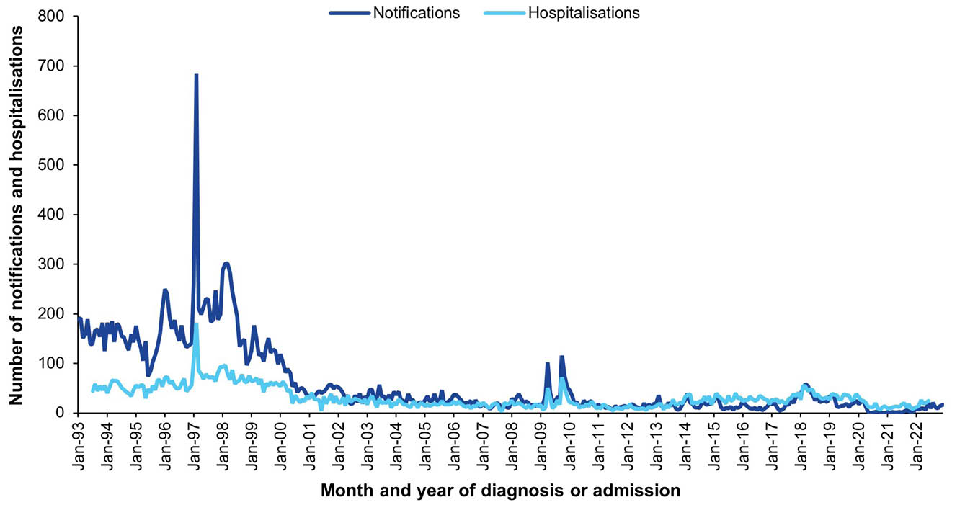
a Data sources: National Notifiable Diseases Surveillance System for notification data and the Australian Institute for Health and Welfare National Hospital Morbidity Database for hospitalisation data.
b Hospitalisations for which the month of admission was between 1 July 1993 and 30 June 2022 and with hepatitis A in any diagnosis field. Hospitalisations with missing month of admission are excluded from this figure.

5. Hepatitis B

Background
Hepatitis B is caused by the hepatitis B virus (HBV), a blood-borne virus transmitted through contact with infected bodily fluids (e.g. during sexual contact, from contaminated needles, or by mother-to-child transmission).⁸⁵ The acute infection with HBV can be asymptomatic (in 90% of children < 5 years and half to two-thirds of older children and adults), or present with general malaise, loss of appetite, fever, jaundice and abdominal pain.^{85,86} Rarely (in 0.5–1% of infected adults), the acute infection leads to fulminant liver failure.⁸⁵
Approximately 90% of infected infants and 5% of infected adults develop chronic HBV infection, which causes the largest HBV-related burden.^{85,87} Chronic hepatitis B may, over decades, lead to liver fibrosis and cirrhosis, and to hepatocellular carcinoma.⁸⁵

Newly-acquired hepatitis B notifications
- A total of 437 cases of newly-acquired hepatitis B were notified in the 2019–2022 period (Table 8). The monthly number of notifications has reduced considerably since the early 2000s (Figure 8).
- The average annual newly-acquired hepatitis B notification rate was 0.43 per 100,000 population per year. This was significantly lower than in the 2016–2018 period, when the average annual rate was 0.61 per 100,000 population per year (RR: 0.69; 95% CI: 0.61–0.79).
- Over the 2019–2022 period, the average annual notification rate was highest in the age groups 25–49 and 50–64 years, at 0.74 and 0.55 per 100,000 population per year, respectively.
- The newly-acquired hepatitis B notification rate was higher in males than in females, with an average male to female rate ratio of 1.58 (95% CI: 1.30–1.92).
- Aboriginal and Torres Strait Islander status was known in 94.1% of all notifications in 2019–2022. The age-standardised notification rate was higher among Aboriginal and Torres Strait Islander people than in others (RR: 5.46; 95% CI: 4.09–7.19) (Appendix A, Table A.3).
- Queensland reported the highest number of notifications in 2019–2022 (n = 178; 40.7%), and the Northern Territory reported the highest average annual notification rate (1.31 per 100,000 population per year).

Ten-year trends
- The newly-acquired hepatitis B notification rate was substantially higher in people aged 25–49 years than in other age groups in 2013 (1.45 per 100,000 population per year), and subsequently declined over the 2013–2022 decade to 0.45 per 100,000 population per year in 2022 (Figure 9). In 2022, the rate remained highest in the 25–49-year age group.
- A decline in notification rate was also seen in the age groups 15–24 years and ≥ 65 years. The 50–64-year age group experienced an increase in notification rate between 2013 and 2016, and a subsequent decline.
- Notification rates remained < 0.2 per 100,000 population per year among children aged 1–14 years, with rates more variable (due to small numbers) among infants aged < 1 year.

Vaccination status
- Vaccination status was unavailable for 308 notifications (70.5%); 305 were blank, two were followed up but information was not available, and one was not followed up.
- Of the 129 notifications with a known vaccination status, 97 (75.2%) were unvaccinated. One (0.8%) was recorded as fully vaccinated for age, and one (0.8%) as partially vaccinated for age, with no further detailed information available about the number of doses received. Six (1.4%) had received one dose, 4 (0.9%) two doses, 15 (3.4%) three doses and 5 (1.1%) four doses of hepatitis B vaccine.
- Among the 11 cases born on or after 1 May 2000, at which point universal hepatitis B vaccination was included on the NIP, vaccination status was unavailable for one case (9%; blank). One (9%) was unvaccinated, one (9%) had received one dose, four (36%) had received three doses, and three (27%) had received four doses. The remaining notified case was recorded as fully vaccinated for age, without further detailed information available about the number of doses received.

Unspecified hepatitis B notifications
- A total of 20,242 cases of unspecified hepatitis B (the majority of which likely represent chronic hepatitis B) were notified in the 2019–2022 period (Table 8).
- The average annual unspecified hepatitis B notification rate was 19.71 per 100,000 population per year. This is significantly lower than in the 2016–2018 period, when the average annual rate was 24.08 per 100,000 population per year (RR: 0.82; 95% CI: 0.80–0.84).
- Over the 2019–2022 period, the average annual notification rate was highest in the age groups 25–49 and 50–64 years at 34.10 and 24.81 per 100,000 population per year, respectively.
- The unspecified hepatitis B notification rate was higher in males than in females, with an average male to female rate ratio of 1.16 (95% CI: 1.13–1.19).
- Aboriginal and Torres Strait Islander status was known in 59.3% of all notifications in 2019–2022. Notification rates by Aboriginal and Torres Strait Islander status are not provided due to low completeness.
- New South Wales and the Northern Territory reported the highest average annual unspecified hepatitis B notification rate over 2019–2022, at 24.23 and 24.08 per 100,000 population per year, respectively.

Vaccination status
- There were 19,894 (98.3%) unspecified hepatitis B notifications with unknown vaccination status (19,870 blank; 17 followed up, information not available; 7 not followed up).
- Of the 348 cases with known vaccination status, 217 (62.4%) were unvaccinated (n = 210) or had not received a dose at least 14 days prior to diagnosis (n = 7). The remaining 131 cases (37.6%) had received at least one dose of hepatitis B vaccine 14 days or more before diagnosis.
- Among the 460 cases of notified unspecified hepatitis B born on or after 1 May 2000, vaccination status was unavailable for 407 (88.5%: 398 blank, 7 followed up but without available information, 2 not followed up).
- Of the 53 cases with known vaccination status, 10 (18.9%) were unvaccinated (n = 6) or had received a dose in the 14 days prior to diagnosis (n = 4), and 43 (81.1%) received at least one dose of hepatitis B vaccine 14 days or more before diagnosis.

Acute hepatitis B hospitalisations

Principal diagnosis only
- Only data for principal diagnosis acute hepatitis B hospitalisations are presented in this report, of which there were 248 between 1 January 2019 and 30 June 2022.
- The hospitalisation rate was 0.26 per 100,000 population per year (Table 9). This was lower than the average annual hospitalisation rate of 0.37 per 100,000 population per year in the 2016–2018 period (RR: 0.71; 95% CI: 0.60–0.85).
- Principal diagnosis acute hepatitis B hospitalisations accounted for a minimum of 1,279 bed days in 2019–2022. The exact length of stay was unknown (i.e. reported as > 30 days) for 1–4 hospitalisations (0.8%). The median length of stay was 4 days (IQR: 2–7 days). People 25–49 years of age accounted for most bed days (714 days), and people 50–64 years of age had the highest median length of stay at 6 days (IQR: 2–9 days).
- Aboriginal and Torres Strait Islander peoples had a higher age-standardised hospitalisation rate than other people; RR = 5.00 (95% CI: 3.33–7.23) (Appendix A, Table A.3).

Acute hepatitis B deaths
- There were 420 deaths with acute hepatitis B as the underlying or an associated cause of death in the 2019–2022 period, of which 15 (0.02 per 100,000 population per year) had acute hepatitis B as the underlying cause of death (Table 9).
- All deaths with acute hepatitis B as the underlying cause occurred in people aged 25 years or older, with 6 (40.0%) occurring in the ≥ 65-year age group.

Discussion
The continued decline in the newly-acquired hepatitis B notification rate and acute hepatitis B hospitalisation rate demonstrate the ongoing success of the universal hepatitis B vaccination program, which has resulted in marked reductions in notifications and hospitalisations in adolescents and young adults, in particular, since 2000.¹¹ This report is the first in the “Summary of National Surveillance Data on Vaccine Preventable Diseases in Australia” series to report the unspecified hepatitis B notification rate, which has declined since 2016–2018. While the Australian and global vaccination programs would have contributed to this decline, reduced ascertainment during the COVID-19 pandemic may have also been a factor, with a slight increase observed in 2022 compared to 2021.
Some key successes have been made towards hepatitis B elimination in Australia. Vaccination coverage of three doses of hepatitis B-containing vaccine, assessed at 24 months of age, has remained > 95% since 2015.⁵⁸ Besides the substantial decline in newly-acquired hepatitis B incidence,¹¹ the prevalence of chronic hepatitis B has reduced among populations eligible for universal vaccination, including Aboriginal and Torres Strait Islander peoples and migrants from high prevalence countries.^{88–90} Due to the availability of antiviral treatment, liver morbidity and mortality due to hepatitis B infection have also declined considerably in the past decades.⁹¹
However, currently, Australia will not reach WHO hepatitis B elimination targets by 2030.^{92–94} Improved identification of HBV-positive mothers in perinatal records^{95–97} and provision of prophylaxis to their babies,^{96–98} and enhanced surveillance of both newly-acquired and unspecified hepatitis B notifications to more accurately identify transmission pathways and modifiable risk factors,⁹⁹ might aid in eliminating local acquisition of hepatitis B. Additionally, improved screening,¹⁰⁰ including consideration of universal screening of adults,^{101,102} is required to improve chronic hepatitis B case ascertainment. Timely¹⁰³ and equitable access to innovative, and culturally and linguistically appropriate, care^{104–108} is required to improve engagement in care, initiation of and adherence to antiviral treatment.

Table 8: Newly-acquired and unspecified hepatitis B notifications in Australia, by age group, sex, Aboriginal and Torres Strait Islander status and state/territory,ª 2019–2022
Category | Characteristic | Notification count and rate: year of diagnosis^{b}
Category | Characteristic | Newly-acquired hepatitis B |  |  |  |  |  |  |  |  |  | Unspecified hepatitis B^{c}
Category | Characteristic | 2019 |  | 2020 |  | 2021 |  | 2022 |  | 2019–2022 |  | 2019 |  | 2020 |  | 2021 |  | 2022 |  | 2019–2022
Category | Characteristic | n | Rate | n | Rate | n | Rate | n | Rate | n | Av. rate^{d} | n | Rate | n | Rate | n | Rate | n | Rate | n | Av. rate^{d}
Total | — | 164 | 0.65 | 125 | 0.49 | 83 | 0.32 | 65 | 0.25 | 437 | 0.43 | 5,629 | 22.22 | 4,954 | 19.31 | 4,644 | 18.08 | 5,015 | 19.28 | 20,242 | 19.71
Age group (years) | < 1 | 1 | 0.33 | 0 | 0 | 1 | 0.33 | 0 | 0 | 2 | 0.17 | 4 | 1.32 | 2 | 1.34 | 4 | 1.34 | 10 | 3.27 | 20 | 1.66
Age group (years) | 1–4 | 0 | 0 | 0 | 0 | 0 | 0 | 1 | 0.08 | 1 | 0.02 | 6 | 0.48 | 1 | 0.08 | 1 | 0.08 | 2 | 0.17 | 10 | 0.20
Age group (years) | 5–14 | 0 | 0 | 1 | 0.03 | 0 | 0 | 0 | 0 | 1 | 0.01 | 39 | 1.23 | 19 | 0.59 | 13 | 0.40 | 13 | 0.40 | 84 | 0.65
Age group (years) | 15–24 | 14 | 0.43 | 13 | 0.41 | 4 | 0.13 | 2 | 0.06 | 33 | 0.26 | 410 | 12.67 | 307 | 9.62 | 248 | 7.99 | 248 | 7.82 | 1,213 | 9.55
Age group (years) | 25–49 | 106 | 1.20 | 72 | 0.81 | 46 | 0.52 | 40 | 0.45 | 264 | 0.74 | 3,549 | 40.12 | 2,968 | 33.20 | 2,775 | 31.21 | 2,859 | 31.91 | 12,151 | 34.10
Age group (years) | 50–64 | 33 | 0.74 | 26 | 0.57 | 25 | 0.54 | 17 | 0.36 | 101 | 0.55 | 1,103 | 24.57 | 1,139 | 24.90 | 1,097 | 23.70 | 1,219 | 26.05 | 4,558 | 24.81
Age group (years) | ≥ 65 | 10 | 0.25 | 13 | 0.31 | 7 | 0.16 | 5 | 0.11 | 35 | 0.21 | 518 | 12.84 | 514 | 12.27 | 506 | 11.73 | 664 | 14.97 | 2,202 | 12.98
Sex | Male | 106 | 0.84 | 80 | 0.63 | 42 | 0.33 | 38 | 0.29 | 266 | 0.52 | 3,017 | 23.99 | 2,562 | 20.13 | 2,501 | 19.62 | 2,664 | 20.64 | 10,744 | 21.08
Sex | Female | 58 | 0.45 | 45 | 0.35 | 41 | 0.32 | 27 | 0.21 | 171 | 0.33 | 2,588 | 20.29 | 2,374 | 18.37 | 2,127 | 16.44 | 2,330 | 17.79 | 9,419 | 18.21
Aboriginal and Torres Strait Islander status^{c} | Aboriginal and Torres Strait Islander | 25 | 2.95 | 27 | 3.12 | 5 | 0.57 | 9 | 1.00 | 66 | 1.89 | — | — | — | — | — | — | — | — | — | —
Aboriginal and Torres Strait Islander status^{c} | Other | 139 | 0.57 | 98 | 0.40 | 78 | 0.31 | 56 | 0.22 | 371 | 0.37 | — | — | — | — | — | — | — | — | — | —
Jurisdiction^{e} | ACT | 0 | 0 | 1 | 0.22 | 1 | 0.22 | 0 | 0 | 2 | 0.11 | 85 | 19.51 | 78 | 17.53 | 70 | 15.47 | 88 | 19.26 | 321 | 17.93
Jurisdiction^{e} | NSW | 17 | 0.21 | 12 | 0.15 | 10 | 0.12 | 5 | 0.06 | 44 | 0.14 | 2,148 | 26.69 | 1,928 | 23.77 | 1,724 | 21.29 | 2,057 | 25.19 | 7,857 | 24.23
Jurisdiction^{e} | NT | 3 | 1.22 | 7 | 2.83 | 0 | 0 | 3 | 1.20 | 13 | 1.31 | 80 | 32.45 | 85 | 34.35 | 32 | 12.90 | 42 | 16.79 | 239 | 24.08
Jurisdiction^{e} | Qld | 57 | 1.12 | 53 | 1.03 | 39 | 0.75 | 29 | 0.55 | 178 | 0.86 | 887 | 17.43 | 792 | 15.33 | 717 | 13.75 | 774 | 14.55 | 3,170 | 15.25
Jurisdiction^{e} | SA | 5 | 0.28 | 2 | 0.11 | 2 | 0.11 | 0 | 0 | 9 | 0.13 | 304 | 17.20 | 264 | 14.75 | 198 | 10.98 | 192 | 10.54 | 958 | 13.34
Jurisdiction^{e} | Tas. | 6 | 1.10 | 2 | 0.36 | 0 | 0 | 0 | 0 | 8 | 0.36 | 61 | 11.13 | 55 | 9.86 | 77 | 13.57 | 62 | 10.86 | 255 | 11.37
Jurisdiction^{e} | Vic. | 53 | 0.81 | 28 | 0.42 | 24 | 0.37 | 16 | 0.24 | 121 | 0.46 | 1,636 | 25.03 | 1,252 | 18.93 | 1,288 | 19.67 | 1,381 | 20.84 | 5,557 | 21.11
Jurisdiction^{e} | WA | 23 | 0.86 | 20 | 0.74 | 7 | 0.25 | 12 | 0.43 | 62 | 0.57 | 428 | 16.09 | 500 | 18.43 | 538 | 19.57 | 419 | 15.02 | 1,885 | 17.28
a Data source: National Notifiable Diseases Surveillance System.
b Rates provided are the number of notifications per 100,000 population per year.
c Aboriginal and Torres Strait Islander status not reported for unspecified hepatitis B notifications due to low completeness.
d Average annual rate per 100,000 population per year.
e ACT: Australian Capital Territory; NSW: New South Wales; NT: Northern Territory; Qld: Queensland; SA: South Australia; Tas.: Tasmania; Vic.: Victoria; WA: Western Australia.
Table 9: Acute hepatitis B hospitalisations and deaths in Australia, by age group, sex, Aboriginal and Torres Strait Islander status and state/territory,ª 2019–2022
Category | Characteristic | Hospitalisation count and rate:^{b,c} principal diagnosis only^{d} |  |  |  |  |  |  |  |  |  | Deaths^{f,g}
Category | Characteristic | Year of admission^{e} |  |  |  |  |  |  |  |  |  | Year of death
Category | Characteristic | 2019 |  | 2020 |  | 2021 |  | 2022^{h,i} |  | 2019–2022 |  | 2019–2022
Category | Characteristic | n | Rate | n | Rate | n | Rate | n | Rate | n | Av. rate^{j} | n | Av. rate^{j}
Total | — | 99 | 0.39 | 72 | 0.28 | 53 | 0.21 | 24 | 0.18 | 248 | 0.26 | 15 | 0.02
Age group (years) | < 1 | 0 | 0 | 0 | 0 | 0 | 0 | 0 | 0 | 0 | 0 | 0 | 0
Age group (years) | 1–4 | 1–4 | 0.08 | 0 | 0 | 0 | 0 | 0 | 0 | 1–4 | 0.02 | 0 | 0
Age group (years) | 5–14 | 0 | 0 | 0 | 0 | 1–4 | 0.03 | 0 | 0 | 1–4 | 0.01 | 0 | 0
Age group (years) | 15–24 | NP | 0.22 | 6 | 0.19 | 1–4 | 0.06 | 0 | 0 | 15 | 0.12 | 0 | 0
Age group (years) | 25–49 | 68 | 0.77 | 46 | 0.51 | 30 | 0.34 | 11 | 0.25 | 155 | 0.47 | 1–5 | 0.01
Age group (years) | 50–64 | 15 | 0.33 | 13 | 0.28 | 17 | 0.37 | 8 | 0.34 | 53 | 0.33 | 1–5 | 0.03
Age group (years) | ≥ 65 | NP | 0.20 | 7 | 0.17 | 1–4 | 0.07 | 5 | 0.23 | 23 | 0.16 | 6 | 0.04
Sex | Male | 66 | 0.52 | 53 | 0.42 | 34 | 0.27 | 18 | 0.28 | 171 | 0.37 | 8 | 0.02
Sex | Female | 33 | 0.26 | 19 | 0.15 | 19 | 0.15 | 6 | 0.17 | 77 | 0.16 | 7 | 0.01
Aboriginal and Torres Strait Islander status | Aboriginal and Torres Strait Islander | 12 | 1.42 | 11 | 1.27 | NP | 0.57 | 1–4 | 0.67 | 31 | 0.97 | 1–5 | 0.03
Aboriginal and Torres Strait Islander status | Other | 87 | 0.36 | 61 | 0.25 | NP | 0.19 | NP | 0.17 | 217 | 0.24 | NP | 0.01
Jurisdiction^{k,l} | ACT | 0 | 0 | 0 | 0 | 1–4 | 0.66 | 1–4 | 0.44 | 1–4 | 0.28 | — | —
Jurisdiction^{k,l} | NSW | 28 | 0.35 | 23 | 0.28 | 9 | 0.11 | 8 | 0.20 | 68 | 0.23 | — | —
Jurisdiction^{k,l} | NT | 1–4 | 1.22 | 1–4 | 0.81 | 0 | 0 | 1–4 | 0.80 | 6 | 0.71 | — | —
Jurisdiction^{k,l} | Qld | 23 | 0.45 | 22 | 0.43 | 15 | 0.29 | 6 | 0.23 | 66 | 0.35 | — | —
Jurisdiction^{k,l} | SA | 1–4 | 0.11 | 1–4 | 0.11 | 1–4 | 0.06 | 0 | 0 | 5 | 0.07 | — | —
Jurisdiction^{k,l} | Tas. | 1–4 | 0.37 | 0 | 0 | 0 | 0 | 1–4 | 0.35 | 1–4 | 0.18 | — | —
Jurisdiction^{k,l} | Vic. | 29 | 0.44 | 15 | 0.23 | 19 | 0.29 | 6 | 0.18 | 69 | 0.28 | — | —
Jurisdiction^{k,l} | WA | 6 | 0.23 | 8 | 0.29 | NP | 0.22 | 1–4 | 0.07 | 21 | 0.20 | — | —
a Data sources: Australian Institute for Health and Welfare National Hospital Morbidity Database for hospitalisation data, and Australian Coordinating Registry for death data.
b Rates provided are the number of hospitalisations or deaths per 100,000 population per year.
c To comply with the AIHW’s data release condition that hospitalisation counts < 5 be suppressed in published reports, counts between 1 and 4 are reported as a range; other cell counts may be reported as NP (not published) to avoid potential for back calculation of counts < 5.
d Hospitalisations with the specific disease code in the principal diagnosis field only.
e Year of separation used if year of admission was missing.
f Deaths where the disease code was the underlying cause of death only.
g To comply with the Australian Coordinating Registry’s data release condition that death counts < 6 be suppressed in published reports, counts between 1 and 5 are reported as a range; other cell counts may be reported as NP (not published) to avoid potential for back calculation of counts < 6.
h Hospitalisations with admission date between 1 January and 30 June 2022.
i Hospitalisation rates for 2022 have been annualised.
j Average annual rate per 100,000 population per year.
k ACT: Australian Capital Territory; NSW: New South Wales; NT: Northern Territory; Qld: Queensland; SA: South Australia; Tas.: Tasmania; Vic.: Victoria; WA: Western Australia.
l To comply with the Australian Coordinating Registry’s data release condition that only national death counts and rates be reported, death counts and rates are not presented by state/territory.
Figure 8: Newly-acquired hepatitis B notifications and acute hepatitis B hospitalisations for all ages,^{a,b,c} Australia, 1997–2022, by month of diagnosis or admission
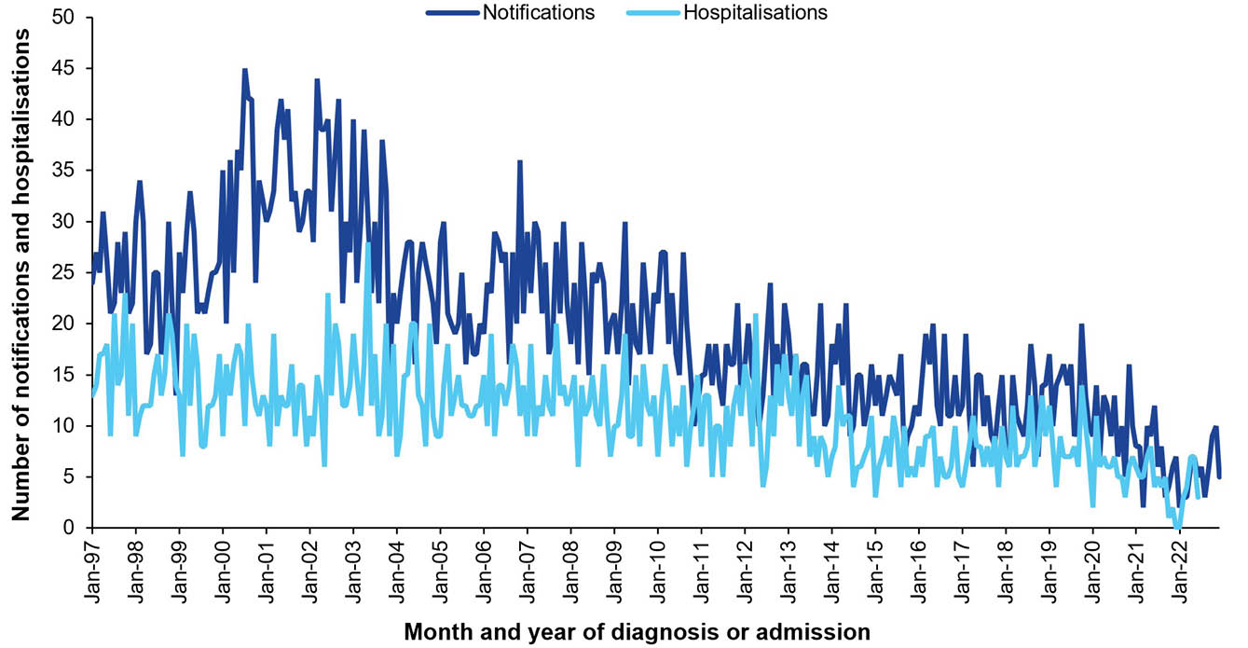
a Data sources: National Notifiable Diseases Surveillance System for notifications and Australian Institute for Health and Welfare National Hospital Morbidity Database for hospitalisation data.
b Notifications for which the month of notification was between 1 January 1997 and 31 December 2022, as newly-acquired hepatitis B only became notifiable in all states and territories in 1996.
c Hospitalisations for which the month of admission was between 1 January 1997 and 30 June 2022, and with acute hepatitis B in the principal diagnosis field only. Hospitalisations with missing month of admission are excluded from this figure.
Figure 9: Newly-acquired hepatitis B notification rates,ª Australia, 2013–2022, by age group
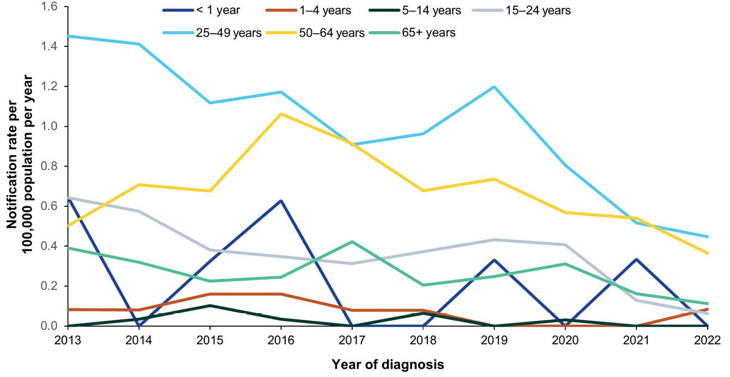
a Data source: National Notifiable Diseases Surveillance System.

6. Influenza

Background
Influenza viruses, predominantly influenza type A (H1N1 and H3N2) and type B, cause annual epidemics of respiratory disease, primarily spread by droplet transmission.¹⁰⁹ Clinical presentation of influenza disease is indistinguishable from other respiratory infections. Symptoms include fever, cough, malaise, myalgia, sore throat and headache.¹⁰⁹ Complications of influenza include pneumonia, stroke, cardiovascular events and exacerbation of chronic medical conditions.^{110,111} Complications and death due to influenza are more common in people aged 65 years and older; in children younger than 5 years old; in Aboriginal and Torres Strait Islander peoples; in pregnant persons; and in people with chronic medical conditions.^{110,112}

Notifications
- A total of 569,131 notifications of influenza (laboratory confirmed) were reported during the 2019–2022 period (Table 10); the majority of cases (96.1%) were notified in 2019 and 2022.
- The average annual influenza notification rate for the 2019–2022 period was 554.30 per 100,000 population per year, higher than the average annual notification rate of 543.88 per 100,000 population per year between 2016 and 2018 (RR: 1.02; 95% CI: 1.02–1.02) (Table 10).
- Aboriginal and Torres Strait Islander status was reported for 283,691 of the 569,131 influenza notifications (49.8%) during 2019–2022. Completeness of Aboriginal and Torres Strait Islander status in influenza notifications ranged from 97.9% in the Northern Territory and 85.3% in Western Australia to 3.3% in Tasmania and 5.9% in Victoria. Completeness was modest in the Australian Capital Territory (51.6%), New South Wales (53.2%), Queensland (66.3%) and South Australia (66.7%). Due to low completeness of reporting of Aboriginal and Torres Strait Islander status in several jurisdictions, notification rates of influenza for Aboriginal and Torres Strait Islander peoples are not presented in this report.

Ten-year trends
- The influenza notification rate varied markedly by year, with the highest notification rates in 2019 (313,659 notifications; 1,238.05 per 100,000 population); 2017 (251,342 notifications; 1,022.02 per 100,000 population); and 2022 (233,371 notifications; 897.39 per 100,000 population). The lowest influenza rate was in 2021 (751 notifications; 2.92 per 100,000 population) (Figure 11).
- Seasonal peaks in influenza notifications were observed in all years from 2001 to 2022, except for 2020 and 2021 (Figure 10). The magnitude of seasonal peaks varied, with a generally increasing trend over the 22-year period. Peaks in notifications were typically observed between July and September (Figure 10). However, there was increased interseasonal activity in both 2018/2019 and 2019/2020.
- The highest number of annual influenza notifications in the 10-year period from 2013 to 2022 was in 2019, when the season began earlier (in April) and lasted longer than usual, with a lower monthly peak than in 2017 and 2022. The highest number of monthly notifications reported in in the 10-year period was in June 2022, when 111,292 notifications were reported (Figure 10).
- Notification rates were highest in 1–4-year-olds in all years in the 2013–2022 period, except in 2015 (highest in 5–14-year-olds) and 2021 (highest in < 1-year olds).

Influenza type and subtype
- The majority of notifications in the 2019–2022 period were typed as influenza A (80.0%), fluctuating over the years at 76.6% in 2019, 87.1% in 2020, 74.4% in 2021 and 83.9% in 2022. The bulk of the remaining notifications were influenza B (13.5% for 2019–2022), with the exception of notifications in 2022, when 15.5% were untyped.
- Of the influenza A notifications that were subtyped (28,244/455,091; 6.2%), A/H3N2 was dominant in 2019 (78.3% vs 21.7% A/H1N1), 2021 (84.3% vs 15.7% A/H1N1) and 2022 (80.4% vs 19.6% A/H1N1), while A/H1N1 was more common in 2020 (87.0% vs 13.0% A/H3N2).

Hospitalisations
- There were 76,150 hospitalisations with influenza in any diagnosis field between 1 January 2019 and 30 June 2022, of which 49,605 (65.1%) had influenza as the principal diagnosis (Table 11). This equates to hospitalisation rates of 90.38 per 100,000 population per year and 58.28 per 100,000 population per year, respectively.
- The rates for hospitalisation with influenza in any diagnosis field and as principal diagnosis only were both lower in the 2019–2022 period than in the 2016–2018 period; rate ratios were 0.74 (95% CI: 0.73–0.75) for all-diagnoses influenza hospitalisations and 0.78 (95% CI: 0.77–0.79) for hospitalisations with influenza as principal diagnosis.

Principal diagnosis only
- The highest average annual rate of hospitalisation with influenza as the principal diagnosis was in infants aged < 1 year (197.82 per 100,000 population per year), followed by adults aged ≥ 65 years (144.95 per 100,000 population per year) and children aged 1–4 years (109.90 per 100,000 population per year) (Table 9).
- The hospitalisation rate in Aboriginal and Torres Strait Islander people was higher than in other people (age-standardised RR: 3.36; 95% CI: 3.26–3.47).
- During 2019–2022, hospitalisations with influenza as the principal diagnosis accounted for a minimum of 145,597 hospital bed days. The exact length of stay was unknown (i.e. reported as > 30 days) for 176 hospitalisations (0.4%). The median length of stay was 2 days (IQR: 1–4 days), and was highest among adults aged ≥ 65 years (4 days; IQR: 1–7 days).

Deaths
- There were 1,776 deaths coded with influenza as underlying or associated cause of death during 2019–2022. Of these, 1,426 (80.3%) were coded with influenza as the underlying cause of death (Table 11).
- The average annual death rate with influenza as the underlying cause of death in the 2019–2022 period was 1.39 per 100,000 population per year (Table 11).
- The highest average annual death rate was in adults aged ≥ 65 years (7.18 per 100,000 population per year), while the rate was 0.73 per 100,000 population per year or less in all other age groups (Table 11). No deaths occurred in infants aged < 1 year.
- The rate of death with influenza as the underlying cause was more than two times higher in Aboriginal and Torres Strait Islander people than in others (age-standardised RR: 2.27; 95% CI: 1.63–3.05) (Appendix A, Table A.3).

Discussion
Prior to the COVID-19 pandemic, influenza had the highest notification and hospitalisation rates of any vaccine preventable disease in Australia.⁶ In 2019, there were 313,659 notifications of influenza, the most notifications ever reported in a single year.¹¹³ Influenza notification rates were significantly lower in 2020 and 2021. This was consistent with the implementation of non-pharmaceutical interventions, such as mask wearing, social distancing, school closures and international border closures, in response to the pandemic.^{114–116} However, with the easing of these interventions, influenza activity resurged in April 2022. Worldwide, the B/Yamagata lineage of the influenza virus has not been detected since April 2020, and is likely extinct.¹¹⁷ In 2023, the WHO recommended removing the B/Yamagata component from seasonal influenza vaccines, reducing them from quadrivalent to trivalent formulations.¹¹⁸
Although influenza testing has increased significantly over the past decade,¹¹⁹ influenza notification rates substantially underestimate true incidence, due to many people either not seeking healthcare or not being tested for influenza. This may be further exacerbated by the introduction of nasal self-tests for use at home in 2022,¹²⁰ for which positive influenza results are not reported to the NNDSS.
Aboriginal and Torres Strait Islander status was reported in fewer than 50% of influenza notifications in 2019–2022. This was an improvement from the 2016–2018 period (completeness, 33%),⁶ with a notable increase in completeness of this field in New South Wales (from 8% to 53%). Improving the reporting of Aboriginal and Torres Strait Islander status in influenza notifications is essential for accurate reporting of burden of disease, to inform measures to reduce burden and improve health outcomes.^{8,121}
Influenza hospitalisation rates were lower in 2019–2022 than in the 2016–2018 period,⁶ due to the virtual absence of disease in 2020 and 2021. The highest hospitalisation rate was in children aged < 1 year, although no deaths were reported in this age group. Children aged ≥ 6 months to 5 years are eligible to receive an influenza vaccine under the NIP.⁵⁷ However, coverage of influenza vaccination in this age group decreased from 45.2% in 2020¹²² to 34.1% in 2022.⁵⁸ It is important to increase the uptake of influenza vaccination to prevent severe influenza disease in young children.^{112,123} In addition, influenza vaccination in pregnancy (maternal vaccination) has been funded on the NIP from July 2018⁵⁷ and is the best protection for infants aged < 6 months who are too young to be vaccinated against influenza, with protection facilitated via transplacental antibody transfer. Maternal influenza vaccination coverage rates in Australia are suboptimal, ranging between 35% and 75% in a review of jurisdictional and multi-jurisdictional studies over the 2016–2021 period, and are about 20% lower for Aboriginal and Torres Strait Islander women than for other women.¹²⁴
Hospitalisation and mortality rates in 2019–2022 were high among adults aged ≥ 65 years, and were higher among Aboriginal and Torres Strait Islander peoples than among other people. Influenza vaccination is available on the NIP for all adults aged ≥ 65 years, and for all Aboriginal and Torres Strait Islander peoples aged ≥ 6 months.⁵⁷ However, while influenza vaccination coverage increases with increasing age, with 67.5% of adults aged 65–74 years vaccinated in 2022, and 73.0% vaccinated in the ≥ 75 years age group, it is considerably lower in younger adults and generally suboptimal.⁵⁸ Increasing the uptake of influenza vaccine across the board, particularly in priority groups, is essential to reduce disease burden.

Table 10: Influenza notifications in Australia, by age group, sex, Aboriginal and Torres Strait Islander status and state/territory,ª 2019–2022
Category | Characteristic | Year of diagnosis
Category | Characteristic | 2019 |  | 2020 |  | 2021 |  | 2022 |  | 2019–2022
Category | Characteristic | n | Rate^{b} | n | Rate^{b} | n | Rate^{b} | n | Rate^{b} | n | Av. rate^{b,c}
Total | — | 313,659 | 1,238.05 | 21,350 | 83.24 | 751 | 2.92 | 233,371 | 897.39 | 569,131 | 554.30
Age group (years) | < 1 | 4,567 | 1,510.48 | 235 | 79.25 | 18 | 6.02 | 3,629 | 1,188.15 | 8,449 | 702.27
Age group (years) | 1–4 | 31,784 | 2,539.32 | 1,644 | 132.74 | 58 | 4.79 | 25,955 | 2,153.79 | 59,441 | 1,211.73
Age group (years) | 5–14 | 68,126 | 2,144.21 | 2,857 | 88.66 | 39 | 1.20 | 60,845 | 1,871.73 | 131,867 | 1,023.01
Age group (years) | 15–24 | 35,964 | 1,111.73 | 1,884 | 59.05 | 78 | 2.51 | 37,067 | 1,169.08 | 74,993 | 590.57
Age group (years) | 25–49 | 87,790 | 992.31 | 7,839 | 87.70 | 218 | 2.45 | 68,533 | 764.90 | 164,380 | 461.26
Age group (years) | 50–64 | 37,091 | 826.36 | 3,883 | 84.88 | 165 | 3.57 | 20,596 | 440.21 | 61,735 | 336.06
Age group (years) | ≥ 65 | 48,303 | 1,197.65 | 3,007 | 71.80 | 175 | 4.06 | 16,746 | 377.56 | 68,231 | 402.06
Sex | Male | 144,963 | 1,152.58 | 10,215 | 80.25 | 379 | 2.97 | 109,056 | 844.92 | 264,613 | 519.23
Sex | Female | 167,994 | 1,316.82 | 11,076 | 85.72 | 369 | 2.85 | 123,832 | 945.41 | 303,271 | 586.46
Aboriginal and Torres Strait Islander status^{d} | Aboriginal and Torres Strait Islander | — | — | — | — | — | — | — | — | — | —
Aboriginal and Torres Strait Islander status^{d} | Other | — | — | — | — | — | — | — | — | — | —
Jurisdiction^{e} | ACT | 4,254 | 976.29 | 205 | 46.08 | 8 | 1.77 | 2,141 | 468.65 | 6,608 | 369.17
Jurisdiction^{e} | NSW | 116,458 | 1,447.27 | 7,238 | 89.24 | 137 | 1.69 | 116,377 | 1,425.19 | 240,210 | 740.93
Jurisdiction^{e} | NT | 1,738 | 704.90 | 282 | 113.97 | 81 | 32.64 | 4,794 | 1,915.92 | 6,895 | 694.81
Jurisdiction^{e} | Qld | 68,170 | 1,339.60 | 6,046 | 117.04 | 298 | 5.71 | 44,440 | 835.26 | 118,954 | 572.15
Jurisdiction^{e} | SA | 27,092 | 1,532.88 | 1,536 | 85.79 | 38 | 2.11 | 12,092 | 663.96 | 40,758 | 567.54
Jurisdiction^{e} | Tas. | 3,139 | 572.98 | 167 | 29.95 | 41 | 7.23 | 2,940 | 514.87 | 6,287 | 280.21
Jurisdiction^{e} | Vic. | 69,571 | 1,064.22 | 4,664 | 70.51 | 111 | 1.70 | 36,591 | 552.24 | 110,937 | 421.39
Jurisdiction^{e} | WA | 23,237 | 873.69 | 1,212 | 44.68 | 37 | 1.35 | 13,996 | 501.80 | 38,482 | 352.69
a Data source: National Notifiable Diseases Surveillance System.
b Rates provided are the number of notifications per 100,000 population per year.
c Average annual rate per 100,000 population per year.
d Notification rates by Aboriginal and Torres Strait Islander status are not reported for influenza due to low completeness of this field in the NNDSS.
e ACT: Australian Capital Territory; NSW: New South Wales; NT: Northern Territory; Qld: Queensland; SA: South Australia; Tas.: Tasmania; Vic.: Victoria; WA: Western Australia.
Table 11: Influenza hospitalisations and deaths in Australia, by age group, sex, Aboriginal and Torres Strait Islander status and state/territory,ª 2019–2022
Category | Characteristic | Hospital count and rate: year of admission^{b,c,d} |  |  |  |  |  |  |  |  |  |  |  |  |  |  |  |  |  |  |  | Deaths^{e,f}
Category | Characteristic | Any diagnosis field^{g} |  |  |  |  |  |  |  |  |  | Prinicpal diagnosis^{h} |  |  |  |  |  |  |  |  |  | Year of  death
Category | Characteristic | 2019 |  | 2020 |  | 2021 |  | 2022^{i,j} |  | 2019–2022 |  | 2019 |  | 2020 |  | 2021 |  | 2022^{i,j} |  | 2019–2022 |  | 2019–2022
Category | Characteristic | n | Rate | n | Rate | n | Rate | n | Rate | n | Av. rate^{k} | n | Rate | n | Rate | n | Rate | n | Rate | n | Av. rate^{k} | n | Av. rate^{k}
Total | — | 53,956 | 212.97 | 4,402 | 17.16 | 1,147 | 4.47 | 16,645 | 128.01 | 76,150 | 90.38 | 35,877 | 141.61 | 2,905 | 11.33 | 593 | 2.31 | 10,230 | 78.68 | 49,605 | 58.28 | 1,426 | 1.39
Age group (years) | < 1 | 1,385 | 458.07 | 102 | 34.40 | 130 | 43.51 | 677 | 443.30 | 2,294 | 246.95 | 1,113 | 368.11 | 69 | 23.27 | 92 | 30.79 | 553 | 362.11 | 1,827 | 197.82 | 0 | 0
Age group (years) | 1–4 | 3,103 | 247.91 | 261 | 21.07 | 157 | 12.97 | 1,704 | 282.80 | 5,225 | 141.25 | 2,549 | 203.65 | 208 | 16.79 | 100 | 8.26 | 1,267 | 210.28 | 4,124 | 109.90 | 9 | 0.18
Age group (years) | 5–14 | 3,095 | 97.41 | 199 | 6.18 | 35 | 1.08 | 1,813 | 111.54 | 5,142 | 53.96 | 2,372 | 74.66 | 158 | 4.90 | 17 | 0.52 | 1,198 | 73.71 | 3,745 | 38.35 | NP | 0.06
Age group (years) | 15–24 | 2,926 | 90.45 | 217 | 6.80 | 48 | 1.55 | 1,578 | 99.54 | 4,769 | 49.98 | 2,106 | 65.10 | 160 | 5.01 | 27 | 0.87 | 899 | 56.71 | 3,192 | 32.22 | 1–5 | 0.04
Age group (years) | 25–49 | 8,709 | 98.44 | 962 | 10.76 | 149 | 1.68 | 3,548 | 79.20 | 13,368 | 47.47 | 5,788 | 65.42 | 667 | 7.46 | 65 | 0.73 | 1,916 | 42.77 | 8,436 | 29.05 | 52 | 0.15
Age group (years) | 50–64 | 7,579 | 168.85 | 829 | 18.12 | 156 | 3.37 | 2,237 | 95.62 | 10,801 | 70.97 | 4,836 | 107.74 | 548 | 11.98 | 72 | 1.56 | 1,312 | 56.08 | 6,768 | 43.98 | 134 | 0.73
Age group (years) | ≥ 65 | 27,159 | 673.39 | 1,832 | 43.75 | 472 | 10.94 | 5,088 | 229.43 | 34,551 | 233.58 | 17,113 | 424.31 | 1,095 | 26.15 | 220 | 5.10 | 3,085 | 139.11 | 21,513 | 144.95 | 1,218 | 7.18
Sex | Male | 24,602 | 195.61 | 2,145 | 16.85 | 550 | 4.31 | 7,469 | 115.73 | 34,766 | 82.87 | 16,618 | 132.13 | 1,446 | 11.36 | 295 | 2.31 | 4,776 | 74.01 | 23,135 | 54.77 | 614 | 1.20
Sex | Female | 29,353 | 230.08 | 2,257 | 17.47 | 597 | 4.62 | 9,173 | 140.06 | 41,380 | 97.76 | 19,258 | 150.95 | 1,459 | 11.29 | 298 | 2.30 | 5,452 | 83.25 | 26,467 | 61.72 | 812 | 1.57
Aboriginal and Torres Strait Islander status | Aboriginal and Torres Strait Islander | 3,079 | 363.44 | 290 | 33.56 | 114 | 12.93 | 2,206 | 490.58 | 5,689 | 226.07 | 2,068 | 244.10 | 178 | 20.60 | 65 | 7.37 | 1,328 | 295.33 | 3,639 | 142.23 | 46 | 1.32
Aboriginal and Torres Strait Islander status | Other | 50,877 | 207.77 | 4,112 | 16.59 | 1,033 | 4.16 | 14,439 | 115.02 | 70,461 | 85.60 | 33,809 | 138.07 | 2,727 | 11.00 | 528 | 2.13 | 8,902 | 70.91 | 45,966 | 55.32 | 1,380 | 1.39
Jurisdiction^{l,m} | ACT | 749 | 171.90 | 44 | 9.89 | 14 | 3.09 | 140 | 61.29 | 947 | 60.73 | 509 | 116.82 | 27 | 6.07 | 6 | 1.33 | 86 | 37.65 | 628 | 39.89 | — | —
Jurisdiction^{l,m} | NSW | 16,948 | 210.62 | 1,355 | 16.71 | 342 | 4.22 | 5,756 | 140.98 | 24,401 | 93.02 | 10,380 | 129.00 | 786 | 9.69 | 170 | 2.10 | 3,406 | 83.42 | 14,742 | 55.98 | — | —
Jurisdiction^{l,m} | NT | 806 | 326.90 | 136 | 54.97 | 40 | 16.12 | 859 | 686.60 | 1,841 | 272.08 | 569 | 230.78 | 95 | 38.40 | 15 | 6.04 | 503 | 402.05 | 1,182 | 169.80 | — | —
Jurisdiction^{l,m} | Qld | 13,425 | 263.81 | 1,141 | 22.09 | 222 | 4.26 | 4,111 | 154.53 | 18,899 | 110.67 | 9,430 | 185.31 | 822 | 15.91 | 130 | 2.49 | 2,713 | 101.98 | 13,095 | 76.03 | — | —
Jurisdiction^{l,m} | SA | 3,998 | 226.21 | 198 | 11.06 | 94 | 5.21 | 775 | 85.11 | 5,065 | 81.32 | 2,625 | 148.52 | 147 | 8.21 | 55 | 3.05 | 499 | 54.80 | 3,326 | 53.26 | — | —
Jurisdiction^{l,m} | Tas. | 852 | 155.52 | 52 | 9.33 | 33 | 5.82 | 204 | 71.45 | 1,141 | 59.95 | 507 | 92.55 | 35 | 6.28 | 14 | 2.47 | 104 | 36.43 | 660 | 34.05 | — | —
Jurisdiction^{l,m} | Vic. | 12,278 | 187.81 | 1,011 | 15.28 | 157 | 2.40 | 4,129 | 124.63 | 17,575 | 82.44 | 8,706 | 133.17 | 711 | 10.75 | 83 | 1.27 | 2,516 | 75.94 | 12,016 | 55.20 | — | —
Jurisdiction^{l,m} | WA | 4,365 | 164.12 | 381 | 14.04 | 242 | 8.80 | 545 | 39.08 | 5,533 | 55.70 | 2,757 | 103.66 | 221 | 8.15 | 118 | 4.29 | 321 | 23.02 | 3,417 | 34.26 | — | —
a Data sources: Australian Institute for Health and Welfare National Hospital Morbidity Database for hospitalisation data, and Australian Coordinating Registry for death data.
b Rates provided are the number of hospitalisations or deaths per 100,000 population per year.
c To comply with the AIHW’s data release condition that hospitalisation counts < 5 be suppressed in published reports, counts between 1 and 4 are reported as a range; other cell counts may be reported as NP (not published) to avoid potential for back calculation of counts < 5.
d Year of separation used if year of admission was missing.
e Deaths where the disease code was the underlying cause of death only.
f To comply with the Australian Coordinating Registry’s data release condition that death counts < 6 be suppressed in published reports, counts between 1 and 5 are reported as a range; other cell counts may be reported as NP (not published) to avoid potential for back calculation of counts < 6.
g Hospitalisations with the specific disease code in any diagnosis field.
h Hospitalisations with the specific disease code in the principal diagnosis field only.
i Hospitalisations with admission date between 1 January and 30 June 2022.
j Hospitalisation rates for 2022 have been annualised.
k Average annual rate per 100,000 population per year.
l ACT: Australian Capital Territory; NSW: New South Wales; NT: Northern Territory; Qld: Queensland; SA: South Australia; Tas.: Tasmania; Vic.: Victoria; WA: Western Australia.
m To comply with the Australian Coordinating Registry’s data release condition that only national death counts and rates be reported, death counts and rates are not presented by state/territory.

Figure 10: Influenza notifications and hospitalisations for all ages,^{a,b} Australia, 2001–2022, by month of diagnosis or admission
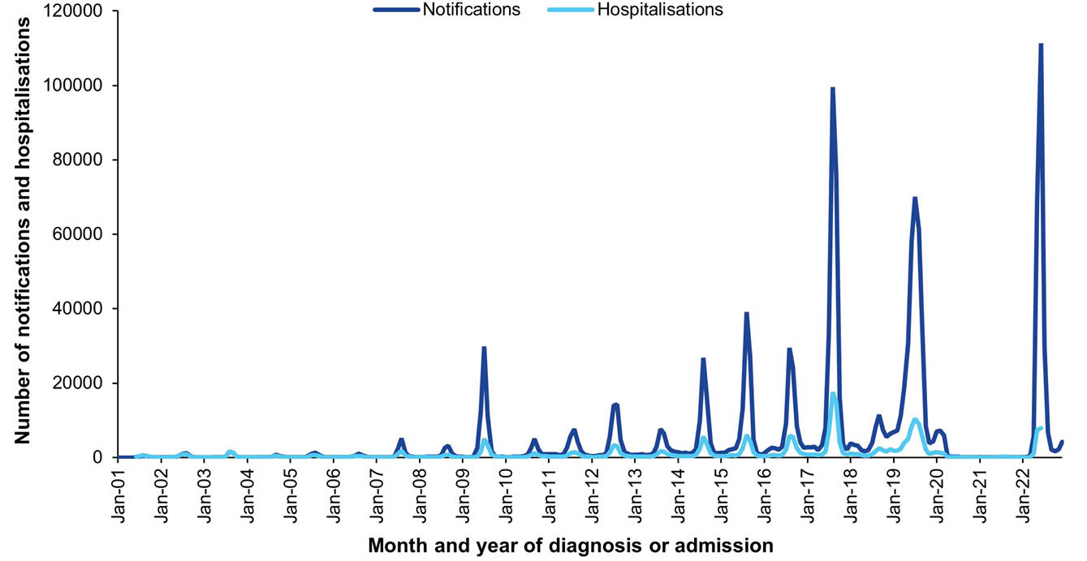
a Data sources: National Notifiable Diseases Surveillance System for notification data and the Australian Institute for Health and Welfare National Hospital Morbidity Database for hospitalisation data.
b Hospitalisations for which the month of admission was between 1 July 2001 and 30 June 2022 and with influenza in any diagnosis field. Hospitalisations with missing month of admission are excluded from this figure.
Figure 11: Influenza notification rate,ª Australia, 2013–2022, by age group
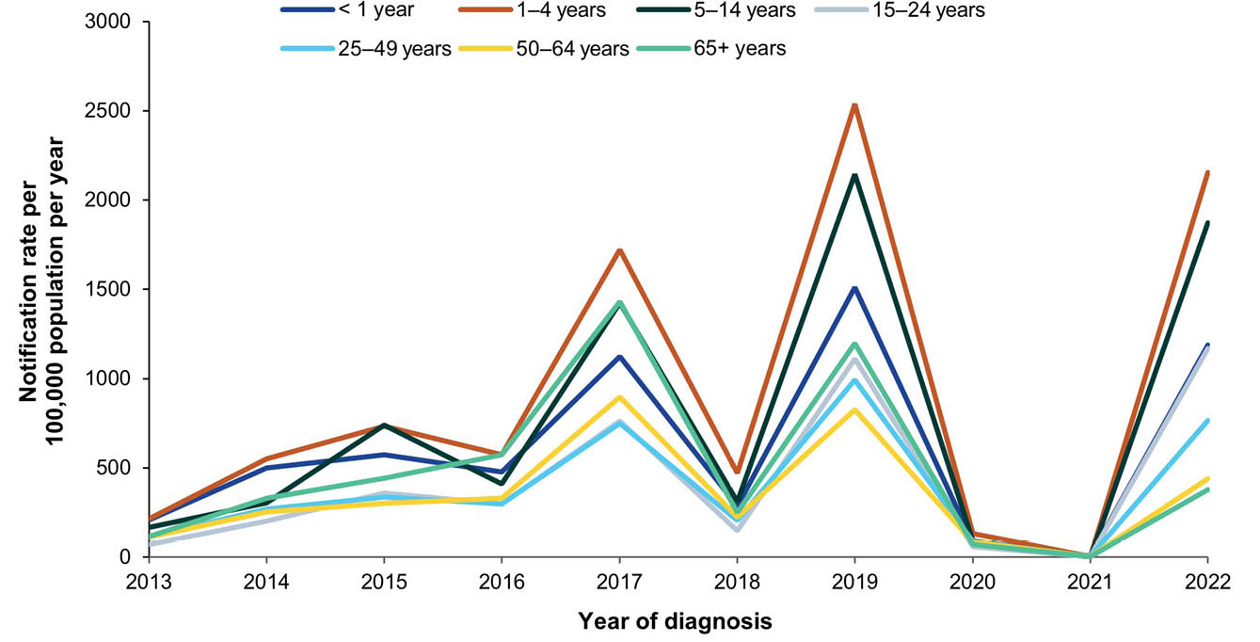
a Data source: National Notifiable Diseases Surveillance System.

7. Invasive meningococcal disease

Background
Invasive meningococcal disease (IMD) is caused by the bacterium Neisseria meningitidis. In humans, IMD is most frequently caused by N. meningitidis serogroups A, B, C, W and Y.^{125,126}
The most common clinical manifestations of IMD are acute meningitis and septicaemia,^{125,126} with atypical presentations such as pneumonia and septic arthritis more frequently seen in serogroup W IMD.^{127,128}
The case fatality rate can be up to 30% of notified cases depending on access to healthcare,¹²⁹ and up to 40% of survivors develop long-term sequelae such as cognitive deficits, hearing loss, seizures, skin scarring and limb amputations, with significant impact on quality of life.^{130–134}

Notifications
- A total of 495 cases of invasive meningococcal disease (IMD) were notified in the 2019–2022 period (Table 12), with 206 (41.6%) of these notified in 2019. Invasive meningococcal disease notifications increased throughout the 1990s until the early 2000s, and subsequently decreased (Figure 12). Monthly number of notifications increased again after 2015, peaking in 2017, after which numbers decreased again (Figure 12).
- The average annual IMD notification rate was 0.48 per 100,000 population per year in the 2019–2022 period. This is significantly lower than the 1.24 per 100,000 population per year notification rate in the 2016–2018 period; RR = 0.39 (95% CI: 0.35–0.43).
- In each year from 2019 to 2022, the IMD notification rate was highest in infants aged < 1 year, with an average annual rate of 5.65 per 100,000 population per year in this age group (Table 12).
- Aboriginal and Torres Strait Islander status was known in 484 (97.8%) of 495 notified cases, with 19.2% (n = 95) reported as Aboriginal and Torres Strait Islander. The IMD notification rate was significantly higher in Aboriginal and Torres Strait Islander people than in other people; age-standardised RR = 4.89 (95% CI: 3.81–6.24) (Appendix A, Table A.3).
- Notification rates were highest in the Northern Territory in 2019–2021, but not in 2022, when the notification rate was highest in South Australia (Table 12).

Ten-year trends
- During 2013–2015, the serogroup B IMD notification rate was higher than the rates for other serogroups (Figure 13). Serogroup W and Y IMD notification rates peaked in 2017 (0.57 and 0.30 per 100,000 population per year, respectively), with the serogroup W IMD notification rate approximately equal to the serogroup B IMD notification rate in that year (0.56 per 100,000 population per year). After 2017, serogroup B, W and Y IMD notification rates declined, with rates for serogroups C, W and Y remaining low at < 0.07 per 100,000 population per year over the 2020–2022 period. The serogroup B IMD notification rate reached a nadir in 2021 (0.14 per 100,000 population per year) and subsequently more than doubled in 2022 (0.40 per 100,000 population per year).

Vaccination status
- Vaccination status was unavailable for 80 of 495 notified cases (16.2%: 43 blank, 15 followed up but no information available and 22 not followed up).
- Of the 415 cases with vaccination status available, 240 (57.8%) were unvaccinated. Three cases (0.7%) had received a meningococcal vaccine within 14 days prior to or after their IMD diagnosis.
- Of 252 serogroup B notifications with known vaccination status, 236 (93.7%) had not received any meningococcal B vaccine dose; nine (3.6%) had received one dose; and seven (2.8%) had received two doses.
- There were 67 serogroup W notifications with known vaccination status. All but one of these (98.5%) were unvaccinated against serogroup W (i.e. had received no meningococcal ACWY vaccine). The remaining case (1.5%) had received one dose.
- Of 69 serogroup Y notifications with vaccination status available, 67 (97.1%) were unvaccinated against this serogroup. The remaining two cases (2.9%) had received one dose of meningococcal ACWY vaccine.
- There were seven serogroup C notifications with known vaccination status, of which five (71.4%) had received no meningococcal C vaccine dose, and two (28.6%) had received one dose of meningococcal C-containing vaccine.
- There were 24 notifications for which serogroup was unavailable. Twelve (50.0%) had not received any meningococcal vaccine, 11 (45.8%) had received one dose (7 meningococcal C, and 4 ACWY), and one (4.2%) had received two doses (one meningococcal C and one ACWY). None had received a meningococcal B vaccine.

Hospitalisations and deaths
- Detailed hospitalisation data based on the AIHW NHMD are not presented in this report as there are known limitations with these data. We are unable to assess whether episodes are transfers of care or readmissions, which, while true for all diseases, is particularly common among IMD admissions. Additionally, we do not have information available on the serogroup causing the admission.
- It is assumed that virtually all the notified cases of IMD were hospitalised due to the severity of the disease, although information on hospitalisation was not available to corroborate this. One hundred and ninety-four of 495 cases notified to NNDSS (39.2%) were admitted to the Intensive Care Unit (ICU), with 271 (54.7%) not admitted to ICU, and ICU admission status unknown for the remaining 30 cases (6.1%).
- Twenty-seven notified IMD cases (5.5%) were recorded in NNDSS as having died of the disease, with information regarding death due to disease missing for the remaining cases.

Discussion
The approximately 60% reduction in the IMD notification rate in 2019–2022 compared to 2016–2018 is likely multifactorial. Firstly, the 2016–2018 period was characterised by multiple outbreaks of serogroup W and Y IMD.^{128,135,136} Effective, targeted state- and territory-funded meningococcal ACWY vaccination programs were implemented from late 2016 onwards in response to these outbreaks and resulted in declines in IMD notification rates in 2018 and 2019.^{137,138} In July 2018, a dose of meningococcal ACWY vaccine at 12 months of age was included on the NIP, and in April 2019 a dose was also funded under the NIP for adolescents 14–16 years delivered through a school-based program, with a catch-up program for 15–19-year-old adolescents through primary care providers,¹³⁷ contributing to the sustained suppression of serogroups W and Y IMD in the 2019–2022 period. Secondly, the state-funded meningococcal B vaccination program for South Australian infants 6 weeks to 12 months of age, with catch-up for children 12 months to < 4 years of age commencing in October 2018 and expansion to include South Australian Year 10 students with catch-up program for Year 11 students and people aged 17 to 21 years of age in 2019, as well as the inclusion of a three-dose course of this vaccine for all Aboriginal and Torres Strait Islander children < 12 months of age on the NIP in July 2020 with catch-up program for those < 24 months,¹³⁷ may have contributed to the reduction in serogroup B IMD notification rates. Lastly, as observed internationally,^{139–142} implementation of non-pharmacological interventions in response to the COVID-19 pandemic also appears to have had a substantial impact on incidence of all IMD serogroups.
The absence of a post-pandemic increase of serogroup W and Y IMD may be due to the relatively high coverage achieved by national meningococcal ACWY vaccination programs. In 2022, in Australia, coverage of the infant meningococcal ACWY vaccine was estimated to be 94.7% at 24 months of age, and that of the adolescent dose 78.8% among people turning 19 years of age.⁵⁸ Close monitoring of serogroup A, C, W and Y invasive meningococcal disease incidence and meningococcal ACWY vaccination coverage should continue to ensure any resurgence is identified and mitigated.
A resurgence of serogroup B IMD was observed in Australia in 2022, at which point pandemic-related mitigation measures had been ceased or relaxed, and the influenza season, often associated with increased IMD incidence,^{143,144} returned. This is similar to what has been observed in the United Kingdom and France, where the greatest increase in serogroup B IMD occurred in adolescents and young adults.^{145,146} Serogroup B IMD incidence should be closely monitored, and equitable¹⁴⁷ expansion of meningococcal B vaccination on the NIP could be considered.

Table 12: Invasive meningococcal disease (IMD) notifications in Australia, by age group, sex, Aboriginal and Torres Strait Islander status and state/territory,ª Australia, 2019–2022
Category | Characteristic | Year of diagnosis
Category | Characteristic | 2019 |  | 2020 |  | 2021 |  | 2022 |  | 2019–2022
Category | Characteristic | n | Rate^{b} | n | Rate^{b} | n | Rate^{b} | n | Rate^{b} | n | Av. rate^{b,c}
Total | — | 206 | 0.81 | 90 | 0.35 | 74 | 0.29 | 125 | 0.48 | 495 | 0.48
Age group (years) | < 1 | 30 | 9.92 | 16 | 5.40 | 10 | 3.35 | 12 | 3.93 | 68 | 5.65
Age group (years) | 1–4 | 22 | 1.76 | 11 | 0.89 | 6 | 0.50 | 15 | 1.24 | 54 | 1.10
Age group (years) | 5–14 | 12 | 0.38 | 8 | 0.25 | 8 | 0.25 | 16 | 0.49 | 44 | 0.34
Age group (years) | 15–24 | 50 | 1.55 | 19 | 0.60 | 19 | 0.61 | 42 | 1.32 | 130 | 1.02
Age group (years) | 25–49 | 27 | 0.31 | 12 | 0.13 | 13 | 0.15 | 22 | 0.25 | 74 | 0.21
Age group (years) | 50–64 | 28 | 0.62 | 11 | 0.24 | 8 | 0.17 | 11 | 0.24 | 58 | 0.32
Age group (years) | ≥ 65 | 37 | 0.92 | 13 | 0.31 | 10 | 0.23 | 7 | 0.16 | 67 | 0.39
Sex^{d} | Male | 104 | 0.83 | 36 | 0.28 | 32 | 0.25 | 76 | 0.59 | 248 | 0.49
Sex^{d} | Female | 101 | 0.79 | 53 | 0.41 | 42 | 0.32 | 49 | 0.37 | 245 | 0.47
Aboriginal and Torres Strait Islander status | Aboriginal and Torres Strait Islander | 38 | 4.49 | 19 | 2.20 | 15 | 1.70 | 23 | 2.56 | 95 | 2.72
Aboriginal and Torres Strait Islander status | Other | 168 | 0.69 | 71 | 0.29 | 59 | 0.24 | 102 | 0.41 | 400 | 0.40
Jurisdiction^{e} | ACT | 1 | 0.23 | 1 | 0.22 | 0 | 0.00 | 2 | 0.44 | 4 | 0.22
Jurisdiction^{e} | NSW | 59 | 0.73 | 22 | 0.27 | 23 | 0.28 | 36 | 0.44 | 140 | 0.43
Jurisdiction^{e} | NT | 6 | 2.43 | 2 | 0.81 | 2 | 0.81 | 1 | 0.40 | 11 | 1.11
Jurisdiction^{e} | Qld | 46 | 0.90 | 27 | 0.52 | 14 | 0.27 | 36 | 0.68 | 123 | 0.59
Jurisdiction^{e} | SA | 27 | 1.53 | 5 | 0.28 | 12 | 0.67 | 14 | 0.77 | 58 | 0.81
Jurisdiction^{e} | Tas. | 6 | 1.10 | 3 | 0.54 | 2 | 0.35 | 3 | 0.53 | 14 | 0.62
Jurisdiction^{e} | Vic. | 36 | 0.55 | 19 | 0.29 | 11 | 0.17 | 14 | 0.21 | 80 | 0.30
Jurisdiction^{e} | WA | 25 | 0.94 | 11 | 0.41 | 10 | 0.36 | 19 | 0.68 | 65 | 0.60
a Data source: National Notifiable Diseases Surveillance System.
b Rates provided are the number of notifications per 100,000 population per year.
c Average annual rate per 100,000 population per year.
d Sex was neither male nor female for two notified cases in the 2019–2022 period.
e ACT: Australian Capital Territory; NSW: New South Wales; NT: Northern Territory; Qld: Queensland; SA: South Australia; Tas.: Tasmania; Vic.: Victoria; WA: Western Australia.

Figure 12: Invasive meningococcal disease notifications for all ages,^{a,b} Australia, 1993–2022, by month of diagnosis
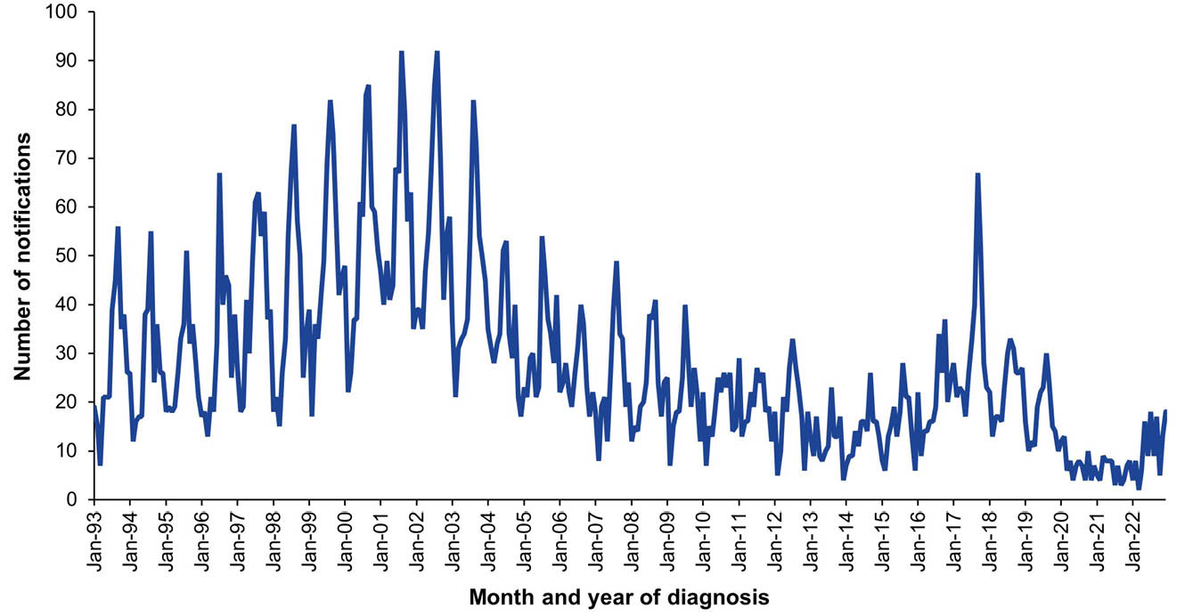
a Data source: National Notifiable Diseases Surveillance System.
b Notifications for which the month of notification was between 1 January 1993 and 31 December 2022.
Figure 13: Invasive meningococcal disease notification rates,ª Australia, 2013–2022, by serogroup
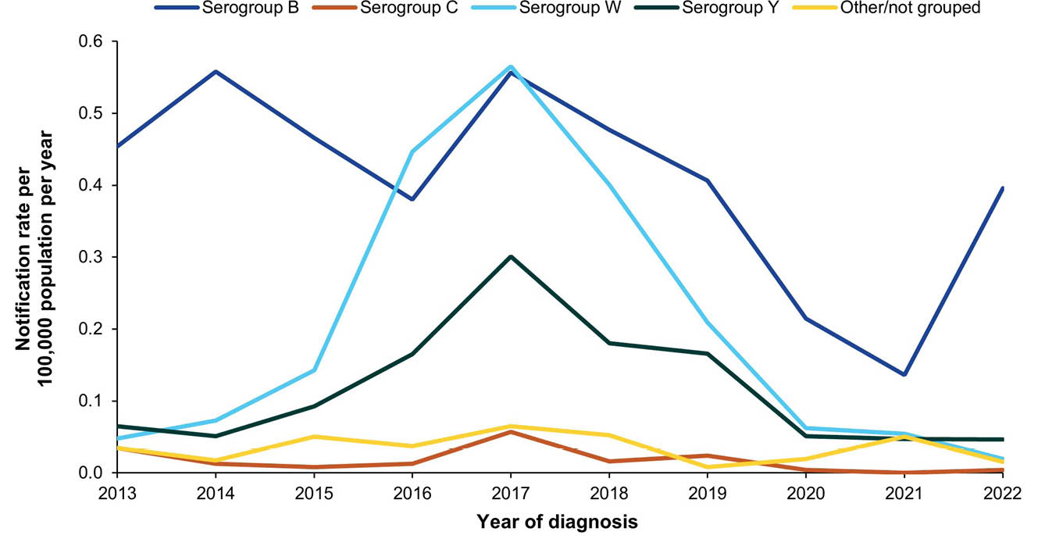
a Data source: National Notifiable Diseases Surveillance System.

8. Invasive pneumococcal disease

Background
Invasive pneumococcal disease (IPD) is an acute and often severe disease caused by the bacterium Streptococcus pneumoniae, commonly termed pneumococcus, of which there are 100 known serotypes.¹⁴⁸ S. pneumoniae frequently colonises the upper respiratory tract and is a common cause of diseases such as middle ear infection and pneumonia.¹⁴⁹ IPD occurs when the bacterium infects normally sterile body sites such as blood, cerebrospinal fluid and pleural fluid. IPD most commonly presents as septicaemia, bacteraemic pneumonia, meningitis and osteomyelitis.¹⁴⁹ The burden of IPD is highest in young children, older adults, Aboriginal and Torres Strait Islander peoples and people with medical risk conditions.⁵⁷

Notifications
- A total of 6,417 notifications of IPD were reported during the 2019–2022 period (Table 13). A monthly average of 133.7 IPD cases were notified during 2019–2022, similar to the monthly average of 127.8 during 2001–2018 (Figure 14).
- The average annual IPD notification rate for the 2019–2022 period was 6.25 per 100,000 population per year, 19% lower than the average annual notification rate of 7.78 per 100,000 population per year during 2016–2018 (RR: 0.80; 95% CI: 0.78–0.83).
- Aboriginal and Torres Strait Islander status was reported for 6,100 of the 6,417 notified cases of IPD (95.1%) during 2019–2022, with 1,061 (16.5%) reported as Aboriginal and Torres Strait Islander people. The IPD notification rate was significantly higher among Aboriginal and Torres Strait Islander people (30.38 per 100,000 population per year) than among others in the 2019–2022 period (age-standardised RR: 7.67; 95% CI: 7.14–8.23; Appendix A, Table A.3).

Ten-year trends
- Overall IPD notification rates were below 7.00 per 100,000 population per year between 2013 and 2016, increasing to above 8.00 per 100,000 population per year between 2017 and 2019 (Figure 15). Rates declined to 4.28 and 5.19 per 100,000 population per year in 2020 and 2021, respectively, before increasing to 7.15 per 100,000 population per year in 2022.
- The annual rate among Aboriginal and Torres Strait Islander people also declined in 2020 and 2021, reaching a low of 24.27 per 100,000 population in 2021, before increasing to 35.69 per 100,000 population in 2022.

IPD serotype
- For the period 2019–2022, the S. pneumoniae serotype was known for 5,667 IPD notifications (88.3%). Of the known serotypes, serotypes 3 (16.2%), 19F (7.8%), 22F (7.5%), 8 (6.5%) and 19A (5.7%) were the five most frequently reported, accounting for 43.6% of all known serotypes.
- In Aboriginal and Torres Strait Islander people (n = 975), the five most common serotypes were 8 (18.9%), 3 (9.7%), 12F (6.7%), 4 (6.3%) and 19F (4.2%), accounting for 45.8% of all known serotypes.
- Of the 5,667 notifications in which serotype was known, 2,034 (35.9%) were serotypes contained in the 13-valent pneumococcal conjugate vaccine (PCV13); 597 (10.5%) were serotypes contained in the 15-valent but not 13-valent vaccine (PCV15-nonPCV13); 964 (17.0%) in the 20-valent but not in the 15-valent pneumococcal conjugate vaccine (PCV20-nonPCV15); 402 were contained in the 23-valent pneumococcal polysaccharide vaccine (PPV23) but not in PCV20 (PPV23-nonPCV20); and 1,670 (29.5%) were not contained in any of the above vaccines (non-vaccine types) (Table 14).
- In Aboriginal and Torres Strait Islander people, the most common serotypes were PCV13 serotypes (316, 29.8%) and PCV20-nonPCV15 serotypes (312, 29.4%) (Table 14). For others, the most common serotypes were PCV13 serotypes (32.1%) and non-vaccine serotypes (26.5%).
- Serotypes contained in the 21-valent PCV recently approved for use in adults in the United States, which includes eight serotypes not contained in other pneumococcal vaccines, accounted for 4,176 of the 5,667 cases (73.7%) in which serotype was known. In the 3,280 notifications for adults aged ≥ 50 years where serotype was known, PCV21 serotypes accounted for 2,421 (73.8%). For adults aged ≥ 70 years, PCV21 serotypes accounted for 1,103 (71.9%) of the 1,533 notifications where serotype was known.

Vaccination status
- As the types and schedules of pneumococcal vaccines available have changed frequently over time, and as the infecting serotype is important to assessing the potential of a vaccine to have prevented disease, only limited data on vaccination status are reported here.
- Of the 6,417 notifications, vaccination status was available for 4,978 (77.6%). At least one dose of pneumococcal vaccine had been received by 2,587 cases (52.0%); 2,354 cases (47.3%) were unvaccinated; and 37 (0.7%) had received a pneumococcal vaccine in the 14 days prior to their diagnosis.
- For children aged < 5 years (n = 1,100), vaccination status was available for 1,079 (98.1%). At least one dose of pneumococcal vaccine had been received by 983 children (91.1%); 83 (7.7%) were unvaccinated; and 13 (1.2%) had received a pneumococcal vaccine in the 14 days prior to IPD diagnosis.
- For adults aged ≥ 50 years (n = 3,518), vaccination status was available for 2,777 (78.9%). At least one dose of pneumococcal vaccine had been received by 1,027 cases (37.0%); 1,731 (62.3%) were unvaccinated; and 19 (0.7%) had received a pneumococcal vaccine in the 14 days prior to IPD diagnosis.

Discussion
IPD remains a significant public health burden in Australia, and globally, despite the impacts on disease following the introduction of pneumococcal conjugate vaccines (PCVs) in 2001, particularly in children.^{150,151} IPD rates declined in Australia in 2020 and 2021, as in many other countries, due to COVID-19 pandemic-related public health measures and the concurrent decline in circulating respiratory viruses associated with increased risk of IPD.^{75,152–154} However, overall rates returned to near pre-pandemic levels in 2022, and among Aboriginal and Torres Strait Islander peoples to higher than pre-pandemic levels, resuming an upward trend observed since 2016.
While the current PCVs have had an impact on IPD epidemiology, serotype replacement has occurred^{155,156} with non-vaccine types now accounting for approximately one-quarter of notifications in Australia. Further, cases of vaccine-serotype disease in vaccinated people occur.¹⁵⁷ PCV13 is less effective against serotypes 3, 19A and 19F than against other serotypes contained in the vaccine, and these serotypes persist as important causes of IPD in Australia despite high levels of vaccination coverage.^{155,157} During 2019–2022, serotypes 3, 19A and 19F accounted for 29.7% of all notifications in which a serotype was known, and for 45.8% of known-serotype notifications in children aged < 5 years. Those serotypes are also associated with the majority of complicated pneumonia in Australian children, with non-PCV13 serotypes accounting for most bacteraemia and meningitis.¹⁵¹
The 15- and 20-valent PCVs have now been approved for use in Australian children although not currently included on the NIP; PCV15 includes serotypes not in PCV13 (22F, 33F). These serotypes accounted for 7.1% of disease in children aged < 5 years between 2019 and 2022, and for 11.2% in Aboriginal and Torres Strait Islander children. The serotypes that are not in PCV13 or PCV15 but are in PCV20 (8, 10A, 11A, 12F, 15B) accounted for 9.8% of serotypes in this age group, and 16.0% in Aboriginal and Torres Strait Islander children. The introduction of higher valency vaccines necessitates ongoing surveillance of circulating serotypes as a public health priority,¹⁵⁵ as well as maintaining high and timely coverage of pneumococcal vaccines in children.
The burden of IPD in adults remains a challenge.¹⁵⁸ PCV13 is now funded for all adults aged ≥ 70 years; for all Aboriginal and Torres Strait Islander adults aged ≥ 50 years; and for all adults ≥ 18 years with specific medical conditions that increase the risk of IPD;⁵⁷ however, uptake remains suboptimal.^{158,159} International data suggest the impact of PCV13 and PPV23 on adult pneumococcal disease is plateauing¹⁶⁰ and strategies to reduce disease may include broader serotype coverage through higher valency PCVs. The use of higher valency PCVs such as PCV21 in older adults may increase protection against common serotypes causing IPD; however, further efforts to address suboptimal vaccine coverage in adults are needed.
The varying effectiveness of vaccines against circulating serotypes, and the frequency of non-vaccine serotypes, means reducing IPD burden will not be achieved by vaccines alone. It requires ongoing efforts to reduce other risk factors for disease such as smoking, alcohol use, prematurity and household crowding.^{161,162} Further, as influenza infection increases the risk for IPD,¹⁶³ improving the uptake of influenza vaccine in at-risk populations is needed.

Table 13: Invasive pneumococcal disease notifications in Australia, by age group, sex, Aboriginal and Torres Strait Islander status and state/territory,ª 2019–2022
Category | Characteristic | Year of diagnosis
Category | Characteristic | 2019 |  | 2020 |  | 2021 |  | 2022 |  | 2019–2022
Category | Characteristic | n | Rate^{b} | n | Rate^{b} | n | Rate^{b} | n | Rate^{b} | n | Av. rate^{b,c}
Total | — | 2,125 | 8.39 | 1,099 | 4.28 | 1,334 | 5.19 | 1,859 | 7.15 | 6,417 | 6.25
Age group (years) | < 1 | 75 | 24.81 | 53 | 17.87 | 76 | 25.44 | 76 | 24.88 | 280 | 23.27
Age group (years) | 1–4 | 242 | 19.33 | 123 | 9.93 | 198 | 16.36 | 257 | 21.33 | 820 | 16.72
Age group (years) | 5–14 | 112 | 3.53 | 48 | 1.49 | 67 | 2.07 | 129 | 3.97 | 356 | 2.76
Age group (years) | 15–24 | 64 | 1.98 | 30 | 0.94 | 41 | 1.32 | 61 | 1.92 | 196 | 1.54
Age group (years) | 25–49 | 375 | 4.24 | 254 | 2.84 | 264 | 2.97 | 354 | 3.95 | 1,247 | 3.50
Age group (years) | 50–64 | 484 | 10.78 | 226 | 4.94 | 255 | 5.51 | 380 | 8.12 | 1,345 | 7.32
Age group (years) | ≥ 65 | 773 | 19.17 | 365 | 8.72 | 433 | 10.04 | 602 | 13.57 | 2,173 | 12.81
Sex | Male | 1,111 | 8.83 | 575 | 4.52 | 708 | 5.55 | 973 | 7.54 | 3,367 | 6.61
Sex | Female | 1,014 | 7.95 | 522 | 4.04 | 626 | 4.84 | 884 | 6.75 | 3,046 | 5.89
Aboriginal and Torres Strait Islander status | Aboriginal and Torres Strait Islander | 272 | 32.11 | 254 | 29.39 | 214 | 24.27 | 321 | 35.69 | 1,061 | 30.38
Aboriginal and Torres Strait Islander status | Other | 1,853 | 7.57 | 845 | 3.41 | 1,120 | 4.52 | 1,538 | 6.13 | 5,356 | 5.40
Jurisdiction^{d} | ACT | 37 | 8.49 | 13 | 2.92 | 21 | 4.64 | 19 | 4.16 | 90 | 5.03
Jurisdiction^{d} | NSW | 698 | 8.67 | 329 | 4.06 | 378 | 4.67 | 553 | 6.77 | 1,958 | 6.04
Jurisdiction^{d} | NT | 54 | 21.90 | 45 | 18.19 | 46 | 18.54 | 66 | 26.38 | 211 | 21.26
Jurisdiction^{d} | Qld | 359 | 7.05 | 216 | 4.18 | 255 | 4.89 | 352 | 6.62 | 1,182 | 5.69
Jurisdiction^{d} | SA | 183 | 10.35 | 115 | 6.42 | 161 | 8.93 | 174 | 9.55 | 633 | 8.81
Jurisdiction^{d} | Tas. | 37 | 6.75 | 14 | 2.51 | 38 | 6.70 | 26 | 4.55 | 115 | 5.13
Jurisdiction^{d} | Vic. | 507 | 7.76 | 187 | 2.83 | 250 | 3.82 | 441 | 6.66 | 1,385 | 5.26
Jurisdiction^{d} | WA | 250 | 9.40 | 180 | 6.63 | 185 | 6.73 | 228 | 8.17 | 843 | 7.73
a Data source: National Notifiable Diseases Surveillance System.
b Rates provided are the number of notifications per 100,000 population per year.
c Average annual rate per 100,000 population per year.
d ACT: Australian Capital Territory; NSW: New South Wales; NT: Northern Territory; Qld: Queensland; SA: South Australia; Tas.: Tasmania; Vic.: Victoria; WA: Western Australia.
Table 14: S. pneumoniae serotypes associated with invasive pneumococcal disease notifications by Aboriginal and Torres Strait Islander status, age group and whether contained in available pneumococcal vaccines,ª Australia, 2019–2022
Aboriginal and Torres Strait Islander status | Age group (years) | Serotype category
Aboriginal and Torres Strait Islander status | Age group (years) | PCV13 |  | PCV15–nonPCV13 |  | PCV20–nonPCV15 |  | PPV23–nonPCV20 |  | Non-vaccine |  | Unknown
Aboriginal and Torres Strait Islander status | Age group (years) | n | % | n | % | n | % | n | % | n | % | n | %
Aboriginal and Torres Strait Islander | < 1 | 11 | 25.0 | 4 | 9.1 | 6 | 13.6 | 0 | 0 | 11 | 25.0 | 12 | 27.3
Aboriginal and Torres Strait Islander | 1–4 | 17 | 21.0 | 11 | 13.6 | 14 | 17.3 | 2 | 2.5 | 19 | 23.5 | 18 | 22.2
Aboriginal and Torres Strait Islander | 5–14 | 19 | 25.0 | 4 | 5.3 | 23 | 30.3 | 3 | 3.9 | 18 | 23.7 | 9 | 11.8
Aboriginal and Torres Strait Islander | 15–24 | 31 | 36.9 | 1 | 1.2 | 33 | 39.3 | 5 | 6.0 | 10 | 11.9 | 4 | 4.8
Aboriginal and Torres Strait Islander | 25–49 | 146 | 34.9 | 14 | 3.3 | 127 | 30.4 | 17 | 4.1 | 91 | 21.8 | 23 | 5.5
Aboriginal and Torres Strait Islander | 50–64 | 59 | 24.1 | 16 | 6.5 | 79 | 32.2 | 8 | 3.3 | 69 | 28.2 | 14 | 5.7
Aboriginal and Torres Strait Islander | ≥ 65 | 33 | 29.2 | 8 | 7.1 | 30 | 26.5 | 4 | 3.5 | 32 | 28.3 | 6 | 5.3
Aboriginal and Torres Strait Islander | Total | 316 | 29.8 | 58 | 5.5 | 312 | 29.4 | 39 | 3.7 | 250 | 23.6 | 86 | 8.1
Other | < 1 | 58 | 24.6 | 21 | 8.9 | 27 | 11.4 | 4 | 1.7 | 54 | 22.9 | 72 | 30.5
Other | 1–4 | 264 | 35.7 | 42 | 5.7 | 61 | 8.3 | 12 | 1.6 | 140 | 18.9 | 220 | 29.8
Other | 5–14 | 119 | 42.5 | 15 | 5.4 | 20 | 7.1 | 4 | 1.4 | 60 | 21.4 | 62 | 22.1
Other | 15–24 | 34 | 30.4 | 11 | 9.8 | 26 | 23.2 | 11 | 9.8 | 14 | 12.5 | 16 | 14.3
Other | 25–49 | 320 | 38.6 | 87 | 10.5 | 147 | 17.7 | 71 | 8.6 | 128 | 15.4 | 76 | 9.2
Other | 50–64 | 348 | 31.6 | 140 | 12.7 | 161 | 14.6 | 107 | 9.7 | 271 | 24.6 | 73 | 6.6
Other | ≥ 65 | 575 | 27.9 | 223 | 10.8 | 210 | 10.2 | 154 | 7.5 | 753 | 36.6 | 145 | 7.0
Other | Total | 1,718 | 32.1 | 539 | 10.1 | 652 | 12.2 | 363 | 6.8 | 1,420 | 26.5 | 664 | 12.4
a Data source: National Notifiable Diseases Surveillance System.
Figure 14: Invasive pneumococcal disease notifications for all ages,ª Australia, 2001–2022, by month of diagnosis
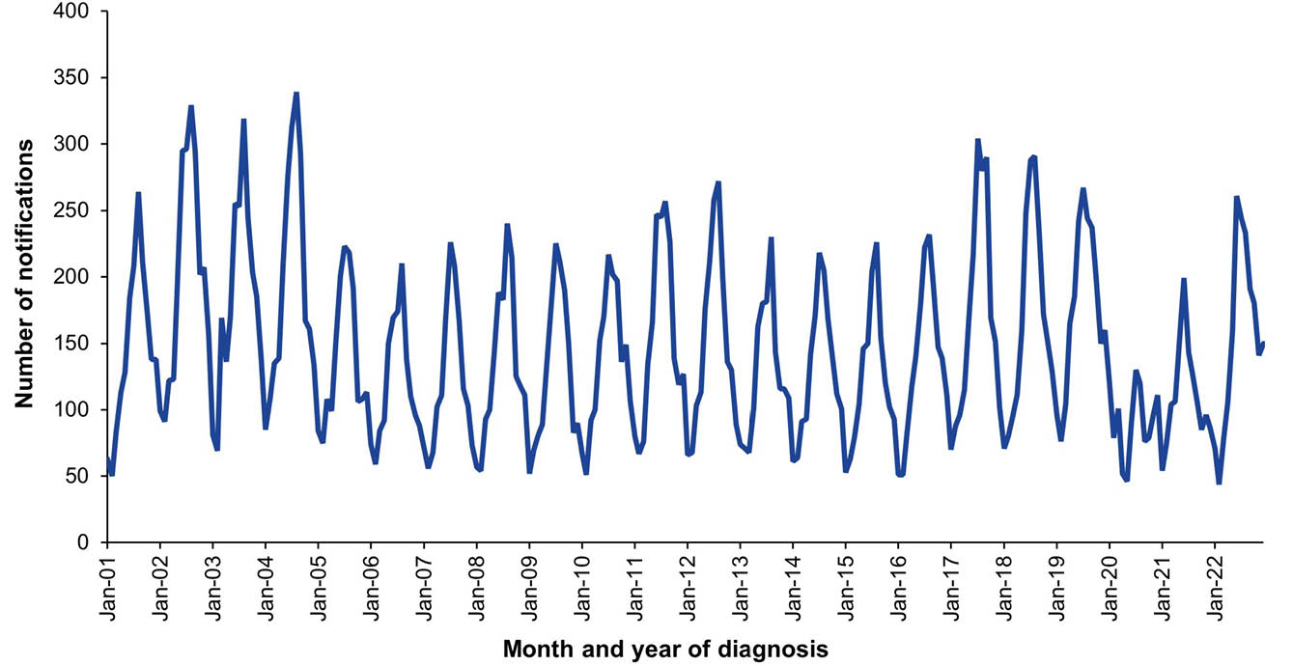
a Data source: National Notifiable Diseases Surveillance System.
Figure 15: Invasive pneumococcal disease notification rates,ª Australia, 2013–2022, by Aboriginal and Torres Strait Islander status, and overall
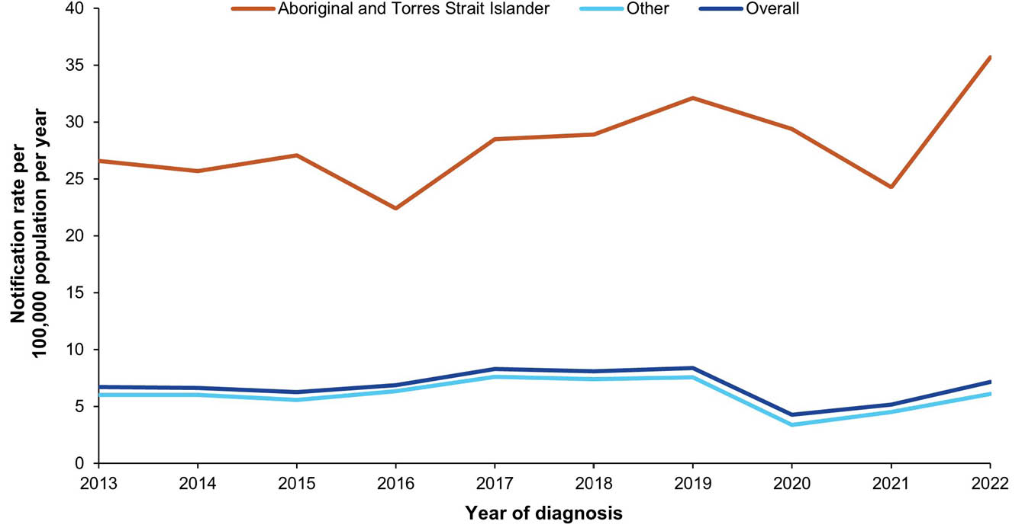
a Data source: National Notifiable Diseases Surveillance System.

9. Japanese encephalitis virus infection

Background
Japanese encephalitis virus (JEV) is a flavivirus transmitted by Culex mosquitoes between water birds, who maintain the virus, and pigs, who are important amplifying hosts for transmission to humans.^{164,165} Although most JEV infections in humans are asymptomatic or accompanied by a non-specific mild illness, acute encephalitis occurs in 0.1–1% of infected people.¹⁶⁶ The case fatality rate among those with encephalitis can be as high as 30%, and 30–50% of survivors develop long-term neurological sequalae.¹⁶⁶ JEV is endemic in the regions of South-East Asia and the Western Pacific, where it causes substantial morbidity and mortality.¹⁶⁴ In endemic areas, JEV primarily affects children, whilst JEV infection is more likely to affect adults when the virus enters a new area, or in travellers visiting endemic areas.¹⁶⁶

Notifications
- A total of 49 notifications of JEV infection were reported during the 2019–2022 period, with the majority (n = 41; 83.7%) reported in 2022 (Table 15).
- The average annual JEV infection notification rate for the 2019–2022 period was 0.05 per 100,000 population per year (Table 15).
- The highest average annual JEV infection notification rate was observed in the ≥ 65 years age group (0.12 per 100,000 population per year).
- There were more JEV infection notifications in males than females, with an average male to female rate ratio of 2.30 (95% CI: 1.22–2.54).
- No JEV infection notifications were reported during the 2019–2022 period in the Australian Capital Territory, in Tasmania, or in Western Australia.
- Aboriginal and Torres Strait Islander status was reported for 47 of the 49 notifications (95.9%) of JEV infections during 2019–2022. The average annual JEV infection notification rate in Aboriginal and Torres Strait Islander people was 0.11 per 100,000 population per year, and in 2022 the rate was 0.33 per 100,000 population per year (Table 15).

Ten-year trends
- There were a total of 17 JEV infection notifications from 2013 to 2021, resulting in zero or low notification rates of < 0.02 per 100,000 population per year during this time period (Figure 16 and Figure 17). In 2022, 41 JEV infection notifications were reported, with a notification rate of 0.16 per 100,000 population per year for this year.

Vaccination status
- Of the 49 notifications between 2019 and 2022, vaccination data were available for 10 cases (20.4%), all of whom had not received any JEV vaccine.

Place of acquisition
- All 49 JEV infection notifications had a known place of acquisition recorded.
- The four cases notified in 2019 and 2020 were recorded as acquired in Thailand (n = 2) and Indonesia (n = 2). All remaining JEV infection cases notified with diagnosis date in 2021 (n = 4) and 2022 (n = 41) were recorded as acquired in Australia.

Hospitalisations and deaths
- Hospitalisation data for JEV infections were not available for this report period.
- Seven deaths with JEV as underlying or associated cause of death were reported between 2019 and 2022. All deaths occurred in adults aged over 40 years of age.

Discussion
Prior to 2021, JEV was not endemic in Australia, with episodic activity restricted to Far North Queensland, and only one case on mainland Australia (Cape York).^{167,168} Following the identification of human cases of JEV infection in 2022 (with cases from 2021 retrospectively identified and recorded in NNDSS) throughout the eastern and southern states of Australia,¹⁶⁹ the Acting Chief Medical Officer of Australia declared JEV infection a Communicable Disease Incident of National Significance on 4 March 2022.¹⁷⁰ Throughout 2022, JEV was also detected in numerous piggeries and feral pigs across Queensland, New South Wales, Victoria, South Australia and the Northern Territory.¹⁶⁷ JEV genotype IV, previously thought to be restricted to Indonesia,^{167,171,172} was found in infected people and in multiple piggeries spread throughout a wide geographic area of southeast Australia, presenting a risk to a population that would have had little to no exposure to any of the five JEV genotypes.
The notification rates in the 2019–2022 period represent people tested for JEV infection, and are likely to substantially underestimate true incidence, as most JEV disease is mild or asymptomatic.¹⁶⁴ Seroprevalence studies in Australia are important to understand the epidemiology and impact of JEV infection in Australia. Results from seroprevalence studies in 2022 throughout regional NSW and Victoria showed JEV immunoglobulin G (IgG) seropositivity of between 3.3% and 8.7%.^{173,174} The Australian population is largely immunologically naïve to the JEV virus. Therefore, effective surveillance of JEV, vaccination against JEV in high-risk populations, and mosquito management strategies are important to minimise the risk and scale of future outbreaks in Australia.

Table 15: Japanese encephalitis virus (JEV) notifications in Australia, by age group, sex, Aboriginal and Torres Strait Islander status and state/territory,ª 2019–2022
Category | Characteristic | Year of diagnosis
Category | Characteristic | 2019 |  | 2020 |  | 2021 |  | 2022 |  | 2019–2022
Category | Characteristic | n | Rate^{b} | n | Rate^{b} | n | Rate^{b} | n | Rate^{b} | n | Av. rate^{b,c}
Total | — | 3 | 0.01 | 1 | 0.004 | 4 | 0.02 | 41 | 0.16 | 49 | 0.05
Age group (years) | < 1 | 0 | 0 | 0 | 0 | 0 | 0 | 1 | 0.33 | 1 | 0.08
Age group (years) | 1–4 | 0 | 0 | 0 | 0 | 0 | 0 | 0 | 0 | 0 | 0
Age group (years) | 5–14 | 0 | 0 | 0 | 0 | 0 | 0 | 2 | 0.06 | 2 | 0.02
Age group (years) | 15–24 | 0 | 0 | 0 | 0 | 0 | 0 | 2 | 0.06 | 2 | 0.02
Age group (years) | 25–49 | 1 | 0.01 | 1 | 0.01 | 2 | 0.02 | 7 | 0.08 | 11 | 0.03
Age group (years) | 50–64 | 1 | 0.02 | 0 | 0 | 0 | 0 | 11 | 0.24 | 12 | 0.07
Age group (years) | ≥ 65 | 1 | 0.02 | 0 | 0 | 2 | 0.05 | 18 | 0.41 | 21 | 0.12
Sex | Male | 2 | 0.02 | 1 | 0.01 | 3 | 0.02 | 28 | 0.22 | 34 | 0.07
Sex | Female | 1 | 0.01 | 0 | 0 | 1 | 0.01 | 13 | 0.10 | 15 | 0.03
Aboriginal and Torres Strait Islander status | Aboriginal and Torres Strait Islander | 0 | 0 | 0 | 0 | 1 | 0.11 | 3 | 0.33 | 4 | 0.11
Aboriginal and Torres Strait Islander status | Other | 3 | 0.01 | 1 | 0.004 | 3 | 0.01 | 38 | 0.15 | 45 | 0.05
Jurisdiction^{d} | ACT | 0 | 0 | 0 | 0 | 0 | 0 | 0 | 0 | 0 | 0
Jurisdiction^{d} | NSW | 0 | 0 | 0 | 0 | 0 | 0 | 14 | 0.17 | 14 | 0.04
Jurisdiction^{d} | NT | 0 | 0 | 0 | 0 | 1 | 0.40 | 1 | 0.40 | 2 | 0.20
Jurisdiction^{d} | Qld | 3 | 0.06 | 0 | 0 | 1 | 0.02 | 4 | 0.08 | 8 | 0.04
Jurisdiction^{d} | SA | 0 | 0 | 1 | 0.06 | 0 | 0 | 10 | 0.55 | 11 | 0.15
Jurisdiction^{d} | Tas. | 0 | 0 | 0 | 0 | 0 | 0 | 0 | 0 | 0 | 0
Jurisdiction^{d} | Vic. | 0 | 0 | 0 | 0 | 2 | 0.03 | 12 | 0.18 | 14 | 0.05
Jurisdiction^{d} | WA | 0 | 0 | 0 | 0 | 0 | 0 | 0 | 0 | 0 | 0
a Data source: National Notifiable Diseases Surveillance System.
b Rates provided are the number of notifications per 100,000 population per year.
c Average annual rate per 100,000 population per year.
d ACT: Australian Capital Territory; NSW: New South Wales; NT: Northern Territory; Qld: Queensland; SA: South Australia; Tas.: Tasmania; Vic.: Victoria; WA: Western Australia.

Figure 16: Japanese encephalitis virus (JEV) infection notifications for all ages,ª Australia, 2013–2022, by month of diagnosis
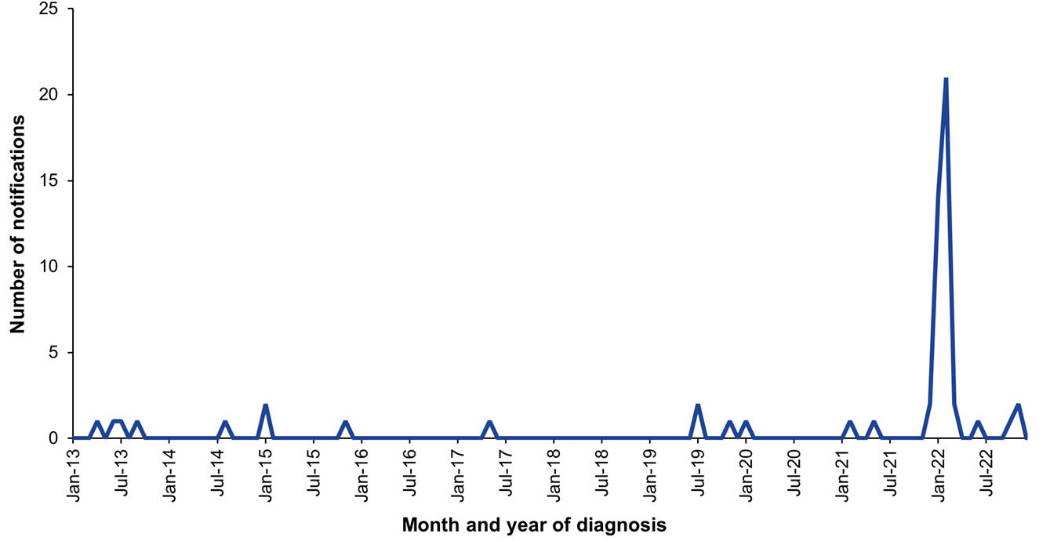
a Data source: National Notifiable Diseases Surveillance System.
Figure 17: Japanese encephalitis virus (JEV) infection notification rate,ª Australia, 2013–2022
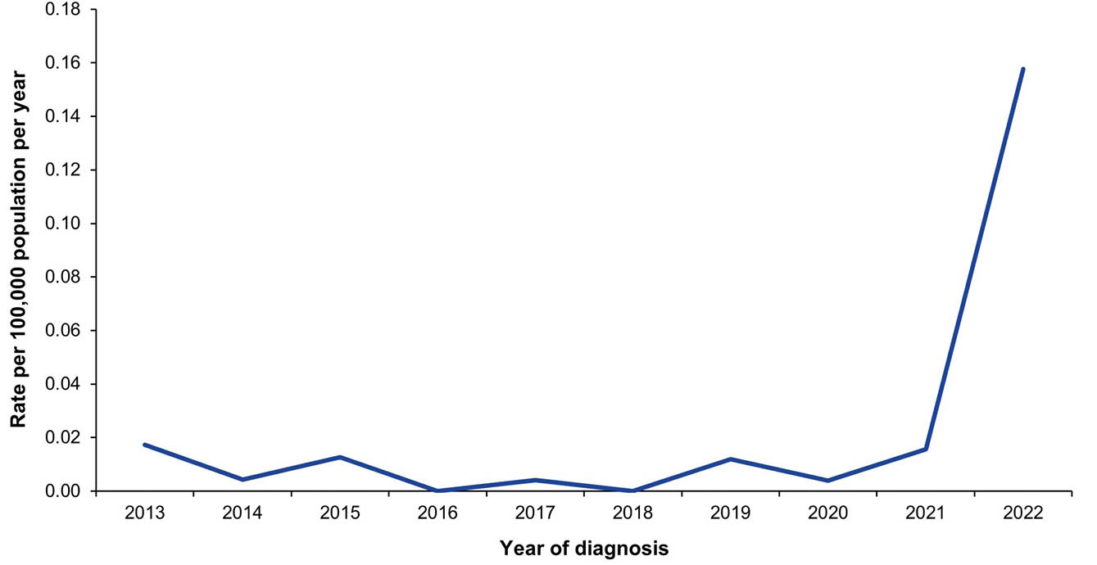
a Data source: National Notifiable Diseases Surveillance System.

10. Measles

Background
Measles is an acute and highly infectious disease caused by a morbillivirus.¹⁷⁵ The virus is transmitted by respiratory droplets and causes disease that is characterised by a prodromal fever, cough, coryza, conjunctivitis, and Koplik spots in the mouth, before the onset of a maculopapular rash.^{175,176} A person is contagious from up to seven days before, and up to four days following the appearance of the rash.^{175,177} Complications of measles include otitis media, pneumonia, encephalitis, subacute sclerosing panencephalitis and death.¹⁷⁶

Notifications
- A total of 316 notifications of measles were reported during the 2019–2022 period (Table 16). The majority of the notifications occurred in 2019 (n = 284; 89.9%). There were 25 measles notifications in 2020, no notifications in 2021, and seven in 2022 (Figure 18).
- The average annual measles notification rate for the 2019–2022 period was 0.31 per 100,000 population per year. This was significantly lower than the average annual notification rate of 0.38 per 100,000 population per year for 2016–2018 (RR: 0.80; 95% CI: 0.68–0.94).
- The average annual measles notification rate for the 2019–2022 period was highest in infants aged < 1 year (2.33 per 100,000 population per year).
- The Northern Territory had the highest measles notification rate in 2019 (12.57 per 100,000 population) and in the overall 2019–2022 period (3.12 per 100,000 population per year). No measles cases were reported in the Northern Territory in 2020, 2021 or 2022.
- Aboriginal and Torres Strait Islander status was reported for 309 of the 316 notifications of cases (97.8%), with 1.9% (n = 6) reported as Aboriginal and Torres Strait Islander people.

Ten-year trends
- The measles notification rate was highest among infants aged < 1 year in all years during 2013–2022, except in 2021 when there were no notifications in any age group (Figure 19). Notification rates among infants < 1 year were highest in 2014 and 2019, at 9.47 and 6.95 per 100,000 population per year, respectively. Notification rates in four other age groups (1–4 years, 5–14 years, 15–24 years, 25–49 years) also peaked in 2014 and 2019.
- Notification rates in adults aged 50–64 years were ≤ 0.13 per 100,000 population per year during the ten-year period 2013–2022. In adults aged ≥ 65 years, only one notification of measles occurred in the 2019–2022 period (in 2019), with a notification rate for that year of 0.02 per 100,000 population.

Vaccination status
- Of the 316 notifications between 2019 and 2022, vaccination status was unavailable for 28.2% of cases (n = 89): 58 blank; 5 followed up but no information available; and 26 not followed up. Of the 227 notifications with vaccination data available, 129 (56.8%) had received no vaccine doses; 19 (8.4%) were aged < 1 year and hence not eligible for the first measles-containing vaccine dose on the NIP; and two (0.9%) were born prior to the measles vaccine being available and recommended for children at 12–23 months of age (born prior to 1967). Eighteen (7.9%) received one dose of measles-containing vaccine in the 14 days prior to their diagnosis; 39 (17.2%) had received one dose 14 days or more before their diagnosis date; and 41 (18.1%) had received two doses.

Place of acquisition
- Of the 316 measles notifications, 314 (99.4%) had a place of acquisition recorded.
- Of the notifications with a known place of acquisition, a total of 184 notifications (58.6%) were recorded as measles acquired within Australia and 130 (41.4%) in a country other than Australia. Measles was recorded as having been acquired in South-East Asia in 70 of the 314 cases (22.3%) including 22 in the Philippines, 16 in Thailand and 13 in Vietnam; 21 cases (6.7%) were acquired in New Zealand; and 11 (3.5%) in Samoa.
- In 2019, the proportion of notifications that were recorded as measles acquired outside of Australia was 39.4% (112/284; 1 case with no data available). In 2020, this proportion was 48% (12/25; 1 case with no data available) and in 2022 this proportion was 100% (7/7).

Hospitalisations
- There were 153 hospitalisations with measles in any diagnosis field between 1 January 2019 and 30 June 2022, of which 127 (83.0%) had measles as the principal diagnosis (Table 17). This equates to hospitalisation rates of 0.15 per 100,000 population per year and 0.12 per 100,000 population per year, respectively.
- The rates for hospitalisation with measles in any diagnosis field and as principal diagnosis only were both lower in the 2019–2022 period than in the 2016–2018 period; rate ratios were 0.67 (95% CI: 0.54–0.85) for all-diagnoses measles hospitalisations and 0.65 (95% CI: 0.51–0.86) for hospitalisations with measles as principal diagnosis.

Principal diagnosis only
- There were 1–4 hospitalisations in 2021 and no hospitalisations in 2022 with measles as the principal diagnosis.
- The principal diagnosis measles hospitalisation rate was highest in the < 1 year age group (1.16 per 100,000 population per year). There were no hospitalisations with measles as the principal diagnosis in adults aged ≥ 65 years during 2019–2022.
- During 2019–2022, hospitalisations with measles as the principal diagnosis accounted for 384 hospital bed days. The exact length of stay was known for all hospitalisations. The median length of stay was 3 days (IQR: 1–4 days).

Deaths
- Between 1–5 deaths coded with measles as underlying or associated cause of death were reported between 2019 and 2022, with an average annual rate of 0.003 per 100,000 population per year (Table 17). Deaths only occurred in adults aged ≥ 50 years.
- No deaths in Aboriginal and Torres Strait Islander people were reported as due to measles in the period.

Discussion
The incidence of measles remains low, with a large proportion of cases (41%) acquired outside Australia. This continues to support the maintenance of elimination of endemic measles transmission in Australia, first verified by the WHO in 2014.¹⁷⁸ Despite the low rates in the overall period, 2019 had the highest number of notifications in Australia since 2014, likely due to an increase in imported cases from Australia’s Asia-Pacific neighbours where large outbreaks had occurred in a setting of a global surge of measles cases.^{12,179–182} There were no measles notifications during the COVID-19 pandemic affected year of 2021, likely due to the public health measures implemented, particularly international border closures.⁵⁶
Although Australia has relatively high childhood vaccination coverage of measles vaccine, with 92.7% of children aged two years in 2022 having received two doses of a measles-containing vaccine,⁵⁸ there remain people susceptible to measles infection. This includes infants aged < 1 year, who are not yet eligible under the NIP for an initial dose of measles vaccine, due at 12 months of age, and who had the highest measles notification and hospitalisation rates over the 2019–2022 period. There is an increased risk of measles outbreaks in Australia following the resumption of international travel and pandemic-related disruption to immunisation activities in many countries, which has contributed to large measles outbreaks across the world.^{183–185} Priorities in Australia continue to be vigilant surveillance and rapid public health response to measles cases, in addition to continued high two-dose measles vaccination coverage, and to ensuring people travelling overseas are fully vaccinated for measles.⁵⁷

Table 16: Measles notifications in Australia, by age group, sex, Aboriginal and Torres Strait Islander status and state/territory,ª 2019–2022
Category | Characteristic | Year of diagnosis
Category | Characteristic | 2019 |  | 2020 |  | 2021 |  | 2022 |  | 2019–2022
Category | Characteristic | n | Rate^{b} | n | Rate^{b} | n | Rate^{b} | n | Rate^{b} | n | Av. rate^{b,c}
Total | — | 284 | 1.12 | 25 | 0.10 | 0 | 0 | 7 | 0.03 | 316 | 0.31
Age group (years) | < 1 | 21 | 6.95 | 6 | 2.02 | — | — | 1 | 0.33 | 28 | 2.33
Age group (years) | 1–4 | 12 | 0.96 | 0 | 0 | — | — | 1 | 0.08 | 13 | 0.27
Age group (years) | 5–14 | 22 | 0.69 | 3 | 0.09 | — | — | 1 | 0.03 | 26 | 0.20
Age group (years) | 15–24 | 83 | 2.57 | 4 | 0.13 | — | — | 0 | 0 | 87 | 0.69
Age group (years) | 25–49 | 139 | 1.57 | 12 | 0.13 | — | — | 2 | 0.02 | 153 | 0.43
Age group (years) | 50–64 | 6 | 0.13 | 0 | 0 | — | — | 2 | 0.04 | 8 | 0.04
Age group (years) | ≥ 65 | 1 | 0.02 | 0 | 0 | — | — | 0 | 0 | 1 | 0.01
Sex | Male | 180 | 1.43 | 16 | 0.13 | — | — | 2 | 0.02 | 198 | 0.39
Sex | Female | 104 | 0.82 | 9 | 0.07 | — | — | 5 | 0.04 | 118 | 0.23
Aboriginal and Torres Strait Islander status | Aboriginal and Torres Strait Islander | 5 | 0.59 | 1 | 0.12 | — | — | 0 | 0 | 6 | 0.17
Aboriginal and Torres Strait Islander status | Other | 279 | 1.14 | 24 | 0.10 | — | — | 7 | 0.03 | 310 | 0.31
Jurisdiction^{d} | ACT | 2 | 0.46 | 0 | 0 | — | — | 0 | 0 | 2 | 0.11
Jurisdiction^{d} | NSW | 62 | 0.77 | 11 | 0.14 | — | — | 1 | 0.01 | 74 | 0.23
Jurisdiction^{d} | NT | 31 | 12.57 | 0 | 0 | — | — | 0 | 0 | 31 | 3.12
Jurisdiction^{d} | Qld | 74 | 1.45 | 6 | 0.12 | — | — | 0 | 0 | 80 | 0.38
Jurisdiction^{d} | SA | 4 | 0.23 | 0 | 0 | — | — | 0 | 0 | 4 | 0.06
Jurisdiction^{d} | Tas. | 1 | 0.18 | 0 | 0 | — | — | 0 | 0 | 1 | 0.04
Jurisdiction^{d} | Vic. | 58 | 0.89 | 4 | 0.06 | — | — | 6 | 0.09 | 68 | 0.26
Jurisdiction^{d} | WA | 52 | 1.96 | 4 | 0.15 | — | — | 0 | 0 | 56 | 0.51
a Data source: National Notifiable Diseases Surveillance System.
b Rates provided are the number of notifications per 100,000 population per year.
c Average annual rate per 100,000 population per year.
d ACT: Australian Capital Territory; NSW: New South Wales; NT: Northern Territory; Qld: Queensland; SA: South Australia; Tas.: Tasmania; Vic.: Victoria; WA: Western Australia.
Table 17: Measles hospitalisations and deaths in Australia, by age group, sex, Aboriginal and Torres Strait Islander status and state/territory,ª 2019–2022
Category | Characteristic | Hospital count and rate: year of admission^{b,c,d} |  |  |  |  |  |  |  |  |  |  |  |  |  |  |  |  |  |  |  | Deaths^{e,f}
Category | Characteristic | Any diagnosis field^{g} |  |  |  |  |  |  |  |  |  | Prinicpal diagnosis^{h} |  |  |  |  |  |  |  |  |  | Year of  death
Category | Characteristic | 2019 |  | 2020 |  | 2021 |  | 2022^{i,j} |  | 2019–2022 |  | 2019 |  | 2020 |  | 2021 |  | 2022^{i,j} |  | 2019–2022 |  | 2019–2022
Category | Characteristic | n | Rate | n | Rate | n | Rate | n | Rate | n | Av. rate^{k} | n | Rate | n | Rate | n | Rate | n | Rate | n | Av. rate^{k} | n | Av. rate^{k}
Total | — | 129 | 0.51 | 15 | 0.06 | NP | 0.03 | 1–4 | 0.02 | 153 | 0.15 | 113 | 0.45 | NP | 0.05 | 1–4 | 0.004 | 0 | 0 | 127 | 0.12 | 1–5 | 0.001
Age group (years) | < 1 | NP | 3.64 | 1–4 | 1.01 | 0 | 0 | 0 | 0 | 14 | 1.16 | NP | 3.64 | 1–4 | 1.01 | 0 | 0 | — | — | 14 | 1.16 | 0 | 0
Age group (years) | 1–4 | 12 | 0.96 | 1–4 | 0.16 | 1–4 | 0.25 | 0 | 0 | 17 | 0.35 | 9 | 0.72 | 1–4 | 0.08 | 1–4 | 0.08 | — | — | 11 | 0.22 | 0 | 0
Age group (years) | 5–14 | NP | 0.19 | 0 | 0 | 0 | 0 | 0 | 0 | NP | 0.05 | 5 | 0.16 | 0 | 0 | 0 | 0 | — | — | 5 | 0.04 | 0 | 0
Age group (years) | 15–24 | 28 | 0.87 | 1–4 | 0.13 | 1–4 | 0.06 | 0 | 0 | 34 | 0.27 | NP | 0.80 | 1–4 | 0.13 | 0 | 0 | — | — | 30 | 0.24 | 0 | 0
Age group (years) | 25–49 | 64 | 0.72 | NP | 0.06 | 1–4 | 0.02 | 0 | 0 | 71 | 0.20 | 57 | 0.64 | 5 | 0.06 | 0 | 0 | — | — | 62 | 0.17 | 0 | 0
Age group (years) | 50–64 | 7 | 0.16 | 1–4 | 0.02 | 0 | 0 | 1–4 | 0.09 | 10 | 0.07 | 5 | 0.11 | 0 | 0 | 0 | 0 | — | — | 5 | 0.03 | 1–5 | 0.01
Age group (years) | ≥ 65 | 1–4 | 0.02 | 0 | 0 | 0 | 0 | 0 | 0 | 1–4 | 0.01 | 0 | 0 | 0 | 0 | 0 | 0 | — | — | 0 | 0.00 | 0 | 0
Sex | Male | 74 | 0.59 | NP | 0.05 | 1–4 | 0.03 | 1–4 | 0.03 | 86 | 0.17 | 66 | 0.52 | NP | 0.05 | 1–4 | 0.01 | — | — | 73 | 0.14 | 0 | 0
Sex | Female | 54 | 0.42 | NP | 0.07 | 1–4 | 0.02 | 0 | 0 | 66 | 0.13 | 46 | 0.36 | NP | 0.05 | 0 | 0 | — | — | 53 | 0.10 | 1–5 | 0.002
Aboriginal and Torres Strait Islander status | Aboriginal and Torres Strait Islander | 8 | 0.94 | 1–4 | 0.12 | 0 | 0 | 1–4 | 0.22 | 10 | 0.31 | NP | 0.83 | 1–4 | 0.12 | 0 | 0 | — | — | 8 | 0.23 | 0 | 0
Aboriginal and Torres Strait Islander status | Other | 121 | 0.49 | NP | 0.06 | NP | 0.03 | 1–4 | 0.01 | 143 | 0.15 | NP | 0.43 | 12 | 0.05 | 1–4 | 0.004 | — | — | 119 | 0.12 | 1–5 | 0.001
Jurisdiction^{l,m} | ACT | 1–4 | 0.46 | 0 | 0 | 0 | 0 | 0 | 0 | 1–4 | 0.11 | 1–4 | 0.23 | 0 | 0 | 0 | 0 | — | — | 1–4 | 0.06 | — | —
Jurisdiction^{l,m} | NSW | 26 | 0.32 | 6 | 0.07 | 1–4 | 0.02 | 1–4 | 0.02 | 35 | 0.11 | 20 | 0.25 | 6 | 0.07 | 0 | 0 | — | — | 26 | 0.08 | — | —
Jurisdiction^{l,m} | NT | NP | 6.08 | 0 | 0 | 1–4 | 0.81 | 0 | 0 | 17 | 1.71 | 14 | 5.68 | 0 | 0 | 1–4 | 0.40 | — | — | 15 | 1.51 | — | —
Jurisdiction^{l,m} | Qld | 42 | 0.83 | 1–4 | 0.06 | 1–4 | 0.04 | 0 | 0 | 47 | 0.23 | 38 | 0.75 | 1–4 | 0.06 | 0 | 0 | — | — | 41 | 0.20 | — | —
Jurisdiction^{l,m} | SA | 1–4 | 0.06 | 1–4 | 0.06 | 0 | 0 | 0 | 0 | 1–4 | 0.03 | 1–4 | 0.06 | 1–4 | 0.06 | 0 | 0 | — | — | 1–4 | 0.03 | — | —
Jurisdiction^{l,m} | Tas. | 1–4 | 0.18 | 1–4 | 0.18 | 0 | 0 | 0 | 0 | 1–4 | 0.09 | 1–4 | 0.18 | 0 | 0 | 0 | 0 | — | — | 1–4 | 0.04 | — | —
Jurisdiction^{l,m} | Vic. | 19 | 0.29 | 1–4 | 0.05 | 1–4 | 0.02 | 1–4 | 0.03 | 24 | 0.09 | NP | 0.26 | 1–4 | 0.03 | 0 | 0 | — | — | 19 | 0.07 | — | —
Jurisdiction^{l,m} | WA | NP | 0.45 | 1–4 | 0.04 | 0 | 0 | 0 | 0 | 13 | 0.12 | NP | 0.41 | 1–4 | 0.04 | 0 | 0 | — | — | 12 | 0.11 | — | —
a Data sources: Australian Institute for Health and Welfare National Hospital Morbidity Database for hospitalisation data, and Australian Coordinating Registry for death data.
b Rates provided are the number of hospitalisations or deaths per 100,000 population per year.
c To comply with the AIHW’s data release condition that hospitalisation counts < 5 be suppressed in published reports, counts between 1 and 4 are reported as a range; other cell counts may be reported as NP (not published) to avoid potential for back calculation of counts < 5.
d Year of separation used if year of admission was missing.
e Deaths where the disease code was the underlying cause of death only.
f To comply with the Australian Coordinating Registry’s data release condition that death counts < 6 be suppressed in published reports, counts between 1 and 5 are reported as a range; other cell counts may be reported as NP (not published) to avoid potential for back calculation of counts < 6.
g Hospitalisations with the specific disease code in any diagnosis field.
h Hospitalisations with the specific disease code in the principal diagnosis field only.
i Hospitalisations with admission date between 1 January and 30 June 2022.
j Hospitalisation rates for 2022 have been annualised.
k Average annual rate per 100,000 population per year.
l ACT: Australian Capital Territory; NSW: New South Wales; NT: Northern Territory; Qld: Queensland; SA: South Australia; Tas.: Tasmania; Vic.: Victoria; WA: Western Australia.
m To comply with the Australian Coordinating Registry’s data release condition that only national death counts and rates be reported, death counts and rates are not presented by state/territory.

Figure 18: Measles notifications and hospitalisations for all ages,^{a,b} Australia, 1993–2022, by month of diagnosis or admission
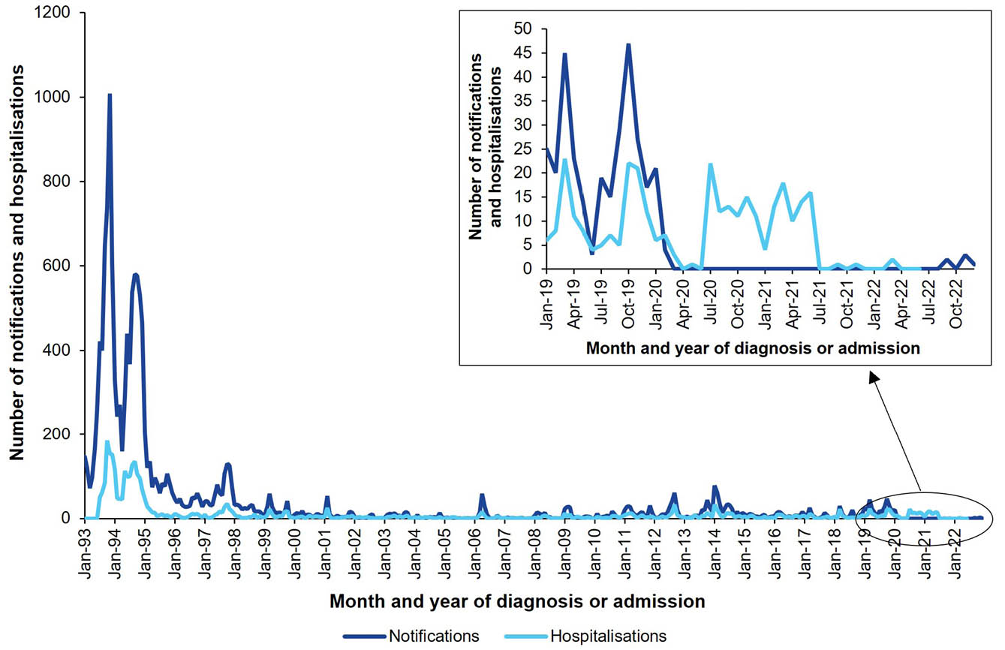
a Data sources: National Notifiable Diseases Surveillance System for notification data and the Australian Institute for Health and Welfare National Hospital Morbidity Database for hospitalisation data
b Hospitalisations for which the month of admission was between 1 July 1993 and 30 June 2022 and with measles in any diagnosis field. Hospitalisations with missing month of admission are excluded from this figure.
Figure 19: Measles notification rate,ª Australia, 2013–2022, by age group
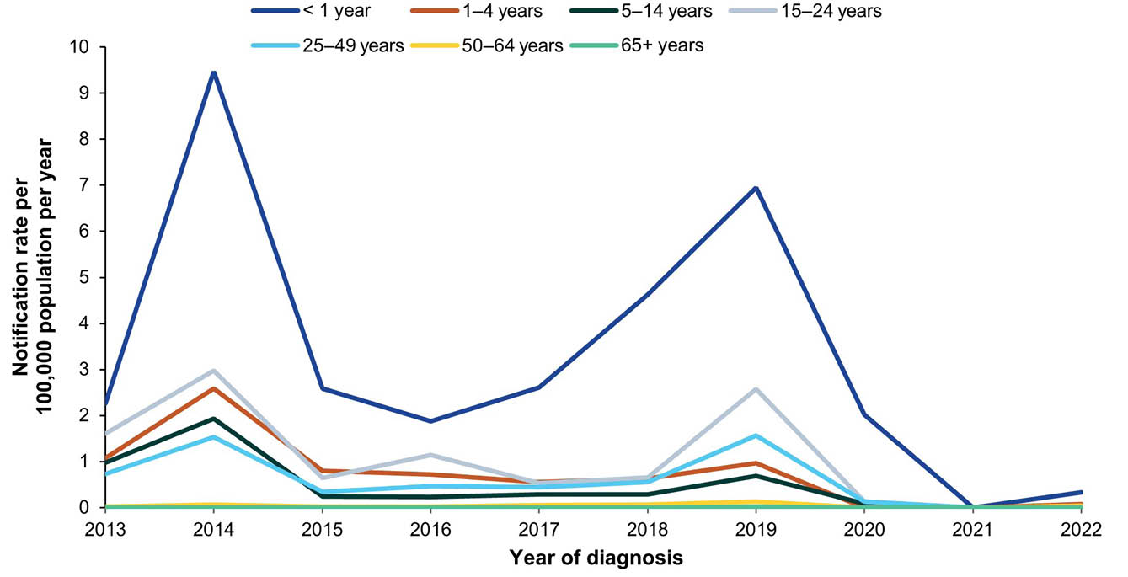
a Data source: National Notifiable Diseases Surveillance System.

11. Mumps

Background
Mumps is an acute viral disease caused by a paramyxovirus. Classical clinical disease is characterised by fever and painful swelling and inflammation of salivary glands, most commonly the parotid.¹⁸⁶ About a third of cases are subclinical.¹⁸⁶ Complications of mumps can include aseptic meningitis (up to 10%), epididymoörchitis (< 10% of postpubertal males in post-vaccine era) and hearing loss.¹⁸⁷

Notifications
- A total of 395 notifications of mumps were reported during the 2019–2022 period (Table 18). A monthly average of 8.2 mumps cases were notified during 2019–2022, lower than the monthly average of 62.5 during 2016–2018 (Figure 20).
- The average annual mumps notification rate for the 2019–2022 period was 0.39 per 100,000 population per year, almost eight times lower than the average annual notification rate of 3.05 per 100,000 population per year for 2016–2018 (RR: 0.13; 95% CI: 0.11–0.14).
- Aboriginal and Torres Strait Islander status was reported for 359 of the 395 notifications (90.9%) of mumps during 2019–2022. There was no significant difference in the mumps notification rate among Aboriginal and Torres Strait Islander people compared to others in the 2019–2022 period (age-standardised RR: 1.16; 95% CI: 0.69–1.89; Appendix A, Table A.3).

Ten-year trends
- The mumps notification rate was below 1.0 per 100,000 population per year in 2013 and 2014, increasing between 2015 and 2018, with the peak notification rate reported in 2016 (3.32 per 100,000 population per year; Figure 21). During the 2016–2018 period, the notification rate in Aboriginal and Torres Strait Islander people rose significantly higher than the rate in others (68.9 per 100,000 population per year vs 1.1 per 100,000 population per year, in 2016; Figure 21).
- From 2019, overall annual notification rates returned to below 1.0 per 100,000 per year, with 2021 recording the lowest rate of 0.08 per 100,000 population per year.

Vaccination status
- Of the 395 notifications during 2019–2022, vaccination data were unavailable for 184 (46.6%: 171 blank; 9 followed up but information not available; and 4 not followed up). Of the remaining 211 notifications, 81 (38.4%) had received no vaccine doses, of whom 43 were born prior to the mumps vaccine being recommended for children at 12 months of age (i.e., born prior to 1983). Among the 130 who were recorded as vaccinated, 49/211 (23.2%) were recorded as fully vaccinated for age, eight (3.8%) as partially vaccinated for age, 19 (9.0%) had received one dose and 54 (25.6%) two doses.

Place of acquisition
- A total of 144 mumps notifications (36.5%) had an unknown place of acquisition recorded.
- Of those with a known place of acquisition (n = 251), two hundred and three notifications (80.9%) were recorded as mumps acquired within Australia and 48 (19.1%) in a country other than Australia. Twenty-one of these mumps infections were recorded as having been acquired in South Asia (including 8 from India, 4 in Indonesia and 5 in Pakistan); five were acquired in the United Kingdom and five in Ireland.

Hospitalisations
- There were 294 hospitalisations with mumps in any diagnosis field between 1 January 2019 and 30 June 2022, of which 233 (79.3%) had mumps as the principal diagnosis (Table 19). This equates to hospitalisation rates of 0.33 per 100,000 population per year and 0.26 per 100,000 population per year, respectively.
- The rates for hospitalisation with mumps in any diagnosis field and as principal diagnosis only were both lower in the 2019–2022 period than in the 2016–2018 period; rate ratios were 0.58 (95% CI: 0.50–0.67) for all-diagnoses mumps hospitalisations and 0.59 (95% CI: 0.50–0.69) for hospitalisations with mumps as principal diagnosis.

Principal diagnosis only
- During 2019–2022, hospitalisations with mumps as the principal diagnosis accounted for a minimum of 717 hospital bed days. The exact length of stay was unknown (i.e. reported as > 30 days) for 1/233 hospitalisations (0.4%). The median length of stay was 1 day overall (IQR: 1–3 days), but higher among infants < 1 years (5 days; IQR: 2–6.5 days), adults aged ≥ 65 years (4 days; IQR: 1–10 days) and children aged 1–4 years (1.5 days; IQR: 1–2 days).

Deaths
- Between 1–5 deaths coded with mumps as underlying or associated cause of death were reported between 2019 and 2022. No deaths in Aboriginal and Torres Strait Islander people were reported as due to mumps in the period.

Discussion
Mumps notification and hospitalisation rates were low during this reporting period. During the COVID-19 pandemic affected year of 2021, the annual number of mumps notifications was the lowest since national surveillance of mumps began in 1993, likely related to the public health measures implemented in response to the pandemic.¹⁸⁸ Unlike the 2016–2018 period, no outbreaks occurred during the 2019–2022 period.
There are several contributors to ongoing mumps transmission and outbreaks in Australia. The mumps component of MMR vaccine has lower effectiveness compared to the measles and rubella vaccine components, contributed to by waning immunity^{189–191} and by the potential for immune escape due to a mismatch between vaccine and wild-type strains.^{192,193} Australian guidelines recommend a third dose of a mumps-containing vaccine for adolescents and adults at risk of acquiring mumps during an outbreak to maintain protection.⁵⁷ While a third dose of mumps-containing vaccine is not recommended at the general population level, evidence suggests a third dose is of benefit in outbreak control.^{194–196}

Table 18: Mumps notifications in Australia, by age group, sex, Aboriginal and Torres Strait Islander status and state/territory,ª 2019–2022
Category | Characteristic | Year of diagnosis
Category | Characteristic | 2019 |  | 2020 |  | 2021 |  | 2022 |  | 2019–2022
Category | Characteristic | n | Rate^{b} | n | Rate^{b} | n | Rate^{b} | n | Rate^{b} | n | Av. rate^{b,c}
Total | — | 174 | 0.69 | 154 | 0.60 | 20 | 0.08 | 47 | 0.18 | 395 | 0.39
Age group (years) | < 1 | 0 | 0 | 1 | 0.34 | 0 | 0 | 0 | 0 | 1 | 0.08
Age group (years) | 1–4 | 20 | 1.60 | 10 | 0.81 | 1 | 0.08 | 9 | 0.75 | 40 | 0.82
Age group (years) | 5–14 | 19 | 0.60 | 11 | 0.34 | 3 | 0.09 | 9 | 0.28 | 42 | 0.33
Age group (years) | 15–24 | 28 | 0.87 | 36 | 1.13 | 0 | 0 | 6 | 0.19 | 70 | 0.55
Age group (years) | 25–49 | 64 | 0.72 | 67 | 0.75 | 7 | 0.08 | 11 | 0.12 | 149 | 0.42
Age group (years) | 50–64 | 22 | 0.49 | 14 | 0.31 | 7 | 0.15 | 6 | 0.13 | 49 | 0.27
Age group (years) | ≥ 65 | 21 | 0.52 | 15 | 0.36 | 2 | 0.05 | 6 | 0.14 | 44 | 0.26
Sex | Male | 85 | 0.68 | 89 | 0.70 | 3 | 0.02 | 27 | 0.21 | 204 | 0.40
Sex | Female | 89 | 0.70 | 65 | 0.50 | 17 | 0.13 | 20 | 0.15 | 191 | 0.37
Aboriginal and Torres Strait Islander status | Aboriginal and Torres Strait Islander | 12 | 1.42 | 4 | 0.46 | 1 | 0.11 | 3 | 0.33 | 20 | 0.57
Aboriginal and Torres Strait Islander status | Other | 162 | 0.66 | 150 | 0.61 | 19 | 0.08 | 44 | 0.18 | 375 | 0.38
Jurisdiction^{d} | ACT | 0 | 0 | 13 | 2.92 | 2 | 0.44 | 0 | 0 | 15 | 0.84
Jurisdiction^{d} | NSW | 61 | 0.76 | 54 | 0.67 | 5 | 0.06 | 27 | 0.33 | 147 | 0.45
Jurisdiction^{d} | NT | 1 | 0.41 | 5 | 2.02 | 1 | 0.40 | 0 | 0 | 7 | 0.71
Jurisdiction^{d} | Qld | 50 | 0.98 | 34 | 0.66 | 6 | 0.12 | 12 | 0.23 | 102 | 0.49
Jurisdiction^{d} | SA | 8 | 0.45 | 13 | 0.73 | 4 | 0.22 | 3 | 0.17 | 28 | 0.39
Jurisdiction^{d} | Tas. | 4 | 0.73 | 0 | 0 | 0 | 0 | 0 | 0 | 4 | 0.18
Jurisdiction^{d} | Vic. | 17 | 0.26 | 25 | 0.38 | 1 | 0.02 | 4 | 0.06 | 47 | 0.18
Jurisdiction^{d} | WA | 33 | 1.24 | 10 | 0.37 | 1 | 0.04 | 1 | 0.04 | 45 | 0.41
a Data source: National Notifiable Diseases Surveillance System.
b Rates provided are the number of notifications per 100,000 population per year.
c Average annual rate per 100,000 population per year.
d ACT: Australian Capital Territory; NSW: New South Wales; NT: Northern Territory; Qld: Queensland; SA: South Australia; Tas.: Tasmania; Vic.: Victoria; WA: Western Australia.
Table 19: Mumps hospitalisations and deaths in Australia, by age group, sex, Aboriginal and Torres Strait Islander status and state/territory,ª 2019–2022
Category | Characteristic | Hospital count and rate: year of admission^{b,c,d} |  |  |  |  |  |  |  |  |  |  |  |  |  |  |  |  |  |  |  | Deaths^{e,f}
Category | Characteristic | Any diagnosis field^{g} |  |  |  |  |  |  |  |  |  | Prinicpal diagnosis^{h} |  |  |  |  |  |  |  |  |  | Year of  death
Category | Characteristic | 2019 |  | 2020 |  | 2021 |  | 2022^{i,j} |  | 2019–2022 |  | 2019 |  | 2020 |  | 2021 |  | 2022^{i,j} |  | 2019–2022 |  | 2019–2022
Category | Characteristic | n | Rate | n | Rate | n | Rate | n | Rate | n | Av. rate^{k} | n | Rate | n | Rate | n | Rate | n | Rate | n | Av. rate^{k} | n | Av. rate^{k}
Total | — | 115 | 0.45 | 75 | 0.29 | 62 | 0.24 | 42 | 0.32 | 294 | 0.33 | 92 | 0.36 | 59 | 0.23 | 48 | 0.19 | 34 | 0.26 | 233 | 0.26 | 1–5 | 0.003
Age group (years) | < 1 | 1–4 | 0.99 | 1–4 | 0.67 | 1–4 | 1.34 | 1–4 | 0.65 | 10 | 0.91 | 1–4 | 0.66 | 1–4 | 0.67 | 1–4 | 1.00 | 1–4 | 0.65 | 8 | 0.75 | 0 | 0
Age group (years) | 1–4 | 15 | 1.20 | 1–4 | 0.32 | 7 | 0.58 | NP | 0.83 | 31 | 0.73 | 11 | 0.88 | 1–4 | 0.24 | 6 | 0.50 | 1–4 | 0.66 | 24 | 0.57 | 0 | 0
Age group (years) | 5–14 | NP | 0.28 | 5 | 0.16 | 7 | 0.22 | 1–4 | 0.25 | 25 | 0.22 | NP | 0.28 | 5 | 0.16 | 6 | 0.19 | 1–4 | 0.25 | 24 | 0.22 | 0 | 0
Age group (years) | 15–24 | 11 | 0.34 | 8 | 0.25 | NP | 0.16 | NP | 0.32 | 29 | 0.27 | 9 | 0.28 | 5 | 0.16 | 5 | 0.16 | 5 | 0.32 | 24 | 0.23 | 0 | 0
Age group (years) | 25–49 | 35 | 0.40 | 27 | 0.30 | 9 | 0.10 | 9 | 0.20 | 80 | 0.25 | 28 | 0.32 | 22 | 0.25 | 7 | 0.08 | 8 | 0.18 | 65 | 0.20 | 0 | 0
Age group (years) | 50–64 | 16 | 0.36 | 8 | 0.17 | 10 | 0.22 | 5 | 0.21 | 39 | 0.24 | 14 | 0.31 | 8 | 0.17 | NP | 0.15 | 1–4 | 0.17 | 33 | 0.20 | 0 | 0
Age group (years) | ≥ 65 | 26 | 0.64 | 21 | 0.50 | 20 | 0.46 | 13 | 0.59 | 80 | 0.55 | 19 | 0.47 | 14 | 0.33 | 14 | 0.32 | 8 | 0.36 | 55 | 0.37 | 1–5 | 0.02
Sex | Male | 55 | 0.44 | 38 | 0.30 | 23 | 0.18 | 17 | 0.26 | 133 | 0.29 | 46 | 0.37 | 31 | 0.24 | 19 | 0.15 | 14 | 0.22 | 110 | 0.24 | 1–5 | 0.002
Sex | Female | 60 | 0.47 | 37 | 0.29 | 39 | 0.30 | 25 | 0.38 | 161 | 0.36 | 46 | 0.36 | 28 | 0.22 | 29 | 0.22 | 20 | 0.31 | 123 | 0.28 | 1–5 | 0.004
Aboriginal and Torres Strait Islander status | Aboriginal and Torres Strait Islander | 6 | 0.71 | 5 | 0.58 | 1–4 | 0.45 | 1–4 | 0.67 | 18 | 0.60 | 1–4 | 0.24 | 5 | 0.58 | 1–4 | 0.23 | 1–4 | 0.44 | 11 | 0.37 | 0 | 0
Aboriginal and Torres Strait Islander status | Other | 109 | 0.45 | 70 | 0.28 | NP | 0.23 | NP | 0.31 | 276 | 0.32 | NP | 0.37 | 54 | 0.22 | NP | 0.19 | NP | 0.25 | 222 | 0.26 | 1–5 | 0.003
Jurisdiction^{l,m} | ACT | 1–4 | 0.23 | 1–4 | 0.22 | 0 | 0 | 1–4 | 0.44 | 1–4 | 0.22 | 1–4 | 0.23 | 1–4 | 0.22 | 0 | 0 | 1–4 | 0.44 | 1–4 | 0.22 | — | —
Jurisdiction^{l,m} | NSW | 34 | 0.42 | 22 | 0.27 | 27 | 0.33 | 14 | 0.34 | 97 | 0.34 | 23 | 0.29 | 17 | 0.21 | 20 | 0.25 | 7 | 0.17 | 67 | 0.23 | — | —
Jurisdiction^{l,m} | NT | 1–4 | 1.22 | 1–4 | 0.81 | 1–4 | 0.40 | 0 | 0 | 6 | 0.60 | 1–4 | 0.81 | 1–4 | 0.81 | 0 | 0 | 0 | 0 | 1–4 | 0.40 | — | —
Jurisdiction^{l,m} | Qld | 19 | 0.37 | 12 | 0.23 | NP | 0.12 | 1–4 | 0.11 | 40 | 0.21 | 16 | 0.31 | 11 | 0.21 | 1–4 | 0.08 | 1–4 | 0.11 | 34 | 0.18 | — | —
Jurisdiction^{l,m} | SA | 6 | 0.34 | 1–4 | 0.22 | 1–4 | 0.11 | 1–4 | 0.11 | 13 | 0.19 | 1–4 | 0.23 | 1–4 | 0.17 | 1–4 | 0.06 | 1–4 | 0.11 | 9 | 0.14 | — | —
Jurisdiction^{l,m} | Tas. | 1–4 | 0.37 | 1–4 | 0.18 | 1–4 | 0.35 | 0 | 0 | NP | 0.22 | 1–4 | 0.18 | 1–4 | 0.18 | 1–4 | 0.35 | 0 | 0 | 1–4 | 0.18 | — | —
Jurisdiction^{l,m} | Vic. | 40 | 0.61 | 27 | 0.41 | 22 | 0.34 | 23 | 0.69 | 112 | 0.51 | 36 | 0.55 | 22 | 0.33 | 19 | 0.29 | 22 | 0.66 | 99 | 0.46 | — | —
Jurisdiction^{l,m} | WA | 8 | 0.30 | NP | 0.18 | 1–4 | 0.07 | 0 | 0 | 15 | 0.14 | 7 | 0.26 | 1–4 | 0.04 | 1–4 | 0.07 | 0 | 0 | 10 | 0.09 | — | —
a Data sources: Australian Institute for Health and Welfare National Hospital Morbidity Database for hospitalisation data, and Australian Coordinating Registry for death data.
b Rates provided are the number of hospitalisations or deaths per 100,000 population per year.
c To comply with the AIHW’s data release condition that hospitalisation counts < 5 be suppressed in published reports, counts between 1 and 4 are reported as a range; other cell counts may be reported as NP (not published) to avoid potential for back calculation of counts < 5.
d Year of separation used if year of admission was missing.
e Deaths where the disease code was the underlying cause of death only.
f To comply with the Australian Coordinating Registry’s data release condition that death counts < 6 be suppressed in published reports, counts between 1 and 5 are reported as a range; other cell counts may be reported as NP (not published) to avoid potential for back calculation of counts < 6.
g Hospitalisations with the specific disease code in any diagnosis field.
h Hospitalisations with the specific disease code in the principal diagnosis field only.
i Hospitalisations with admission date between 1 January and 30 June 2022.
j Hospitalisation rates for 2022 have been annualised.
k Average annual rate per 100,000 population per year.
l ACT: Australian Capital Territory; NSW: New South Wales; NT: Northern Territory; Qld: Queensland; SA: South Australia; Tas.: Tasmania; Vic.: Victoria; WA: Western Australia.
m To comply with the Australian Coordinating Registry’s data release condition that only national death counts and rates be reported, death counts and rates are not presented by state/territory.

Figure 20: Mumps notifications and hospitalisations for all ages,^{a,b} Australia, 1993–2022, by month of diagnosis or admission
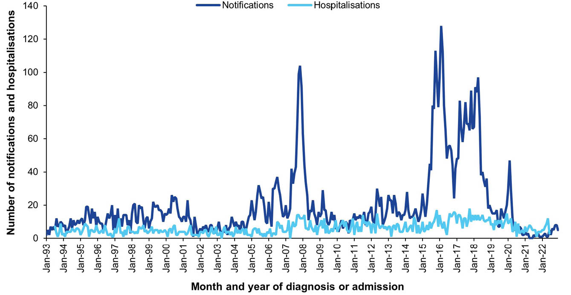
a Data sources: National Notifiable Diseases Surveillance System for notification data and the Australian Institute for Health and Welfare National Hospital Morbidity Database for hospitalisation data.
b Hospitalisations for which the month of admission was between 1 July 1993 and 30 June 2022 and with mumps in any diagnosis field. Hospitalisations with missing month of admission are excluded from this figure.
Figure 21: Mumps notification rates,ª Australia, 2013–2022, by Aboriginal and Torres Strait Islander status, and overall
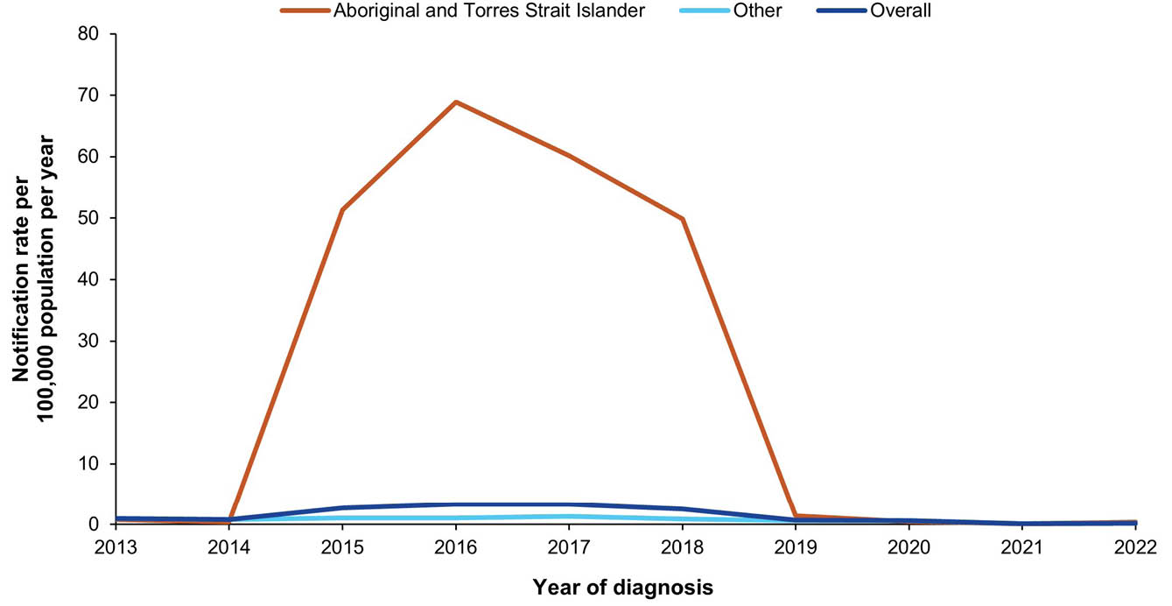
a Data source: National Notifiable Diseases Surveillance System.

12. Pertussis

Background
Pertussis, or whooping cough, is caused by the Bordetella pertussis bacterium and is characterised by a catarrhal stage followed by a paroxysmal cough that may last for weeks to months.¹⁹⁷ The typical paroxysms are severe, may lead to apnoea, and are followed by a crowing or high-pitched inspiratory whoop and sometimes by vomiting.^{198,199} These typical paroxysms are more common in unvaccinated children compared to adolescents, adults, and people who are vaccinated.^{197,199,200}
Pneumonia is the most common complication and cause of pertussis-related deaths, with other complications including encephalopathy and seizures.^{197–199} Infants are at the highest risk of complications.^{197,199}

Notifications
- A total of 16,516 cases of pertussis were notified in the 2019–2022 period (Table 20), of which 12,028 (73%) were notified in 2019. Large outbreaks, typically occurring every 3–5 years, were not observed in this period (Figure 22).
- The average annual pertussis notification rate was 16.09 per 100,000 population per year. This was significantly lower than in the 2016–2018 period, when the average annual rate was 60.9 per 100,000 population per year (RR: 0.30; 95% CI: 0.30–0.31).
- Over the 2019–2022 period, average annual notification rates were highest in children < 15 years of age (Table 20). The notification rate was highest in the age group 5–14 years in 2019 and 2020, and in the 1–4-year age group in 2021 and 2022.
- The pertussis notification rate was lower among males than females each year in the 2019–2022 period (Table 20); the average male to female RR was 0.85 (95% CI: 0.83–0.88).
- Aboriginal and Torres Strait Islander status was known in 68.4% of all notifications in 2019–2022, and in 89.6% of notifications in children aged < 5 years. Among children < 5 years of age, the age-specific notification rate was higher in Aboriginal and Torres Strait Islander children than in other children (RR: 1.42; 95% CI: 1.20–1.67).
- In 2019, the pertussis notification rate was highest in Tasmania (103.86 per 100,000 population per year) followed by New South Wales (78.72 per 100,000 population per year). Notification rates in all jurisdictions decreased in 2020–2022, with Victoria reporting the highest notification rate in 2022 (3.89 per 100,000 population per year) and Tasmania the lowest (0.53 per 100,000 population per year; Table 20).

Ten-year trends
- The pertussis notification rate was higher among children aged < 6 months than among those aged 6–11 months or 1–4 years between 2013 and 2015, but was similar across these age groups from 2016 onwards (Figure 23). Notification rates approximately halved between 2016 and 2019 in children < 5 years of age and reduced to < 5% of the 2019 rate by 2021.

Vaccination status
- Vaccination status was unavailable for 10,226 cases (61.9%: 9,782 blank; 438 followed up but information not available; and 6 not followed up). Of the remaining 6,290 cases, 679 (10.8%) were unvaccinated, 26 (0.4%) had received one pertussis-containing vaccine dose within 14 days before or after their diagnosis, and 5,585 (88.8%) had received at least 1 pertussis-containing vaccine dose 14 days or more prior to the diagnosis date.
- Vaccination status was more complete for children < 5 years of age; among all 1,839 notified cases of pertussis in this age group, vaccination status was unavailable for 191 cases (10.4%: 172 blank; 19 followed up but information not available). Of 1,648 cases with a known vaccination status, 17 (1.0%) were < 6 weeks of age at diagnosis and ineligible for pertussis-containing vaccine; 9 (0.5%) had received a pertussis-containing vaccine dose in the 14 days prior to diagnosis; and 175 (10.6%) were unvaccinated. Eight hundred and thirty-three (50.5%) were recorded as fully vaccinated for age and 67 (4.1%) as partially vaccinated for age, without further information available about the number of doses received. Of the remaining 547 cases, 35 (6.4%) had received one pertussis-containing vaccine dose 14 days or more prior to diagnosis, 45 (8.2%) two doses, 179 (32.7%) three doses, 266 (48.6%) four doses, and 22 (4.0%) five doses.

Hospitalisations
- There were 739 hospitalisations with pertussis in any diagnosis field between 1 January 2019 and 30 June 2022, of which 380 (51.4%) had pertussis as the principal diagnosis (Table 21). This equates to hospitalisation rates of 0.75 per 100,000 population per year and 0.38 per 100,000 population per year, respectively.
- The rates for hospitalisation with pertussis in any diagnosis field and as principal diagnosis only were lower in the 2019–2022 period than in the 2016–2018 period; rate ratios were 0.30 (95% CI: 0.28–0.33) for all-diagnoses pertussis hospitalisations and 0.27 (95% CI: 0.24–0.30) for hospitalisations with pertussis as principal diagnosis.

Principal diagnosis only
- During 2019–2022, hospitalisations with pertussis as the principal diagnosis accounted for a minimum of 1,145 hospital bed days (there were 1–4 hospitalisations with length of stay > 30 days for which we did not receive exact length of stay), with a median length of stay of 2 days (IQR: 1–4 days). The median length of stay was highest in adults aged ≥ 65 years (4 days; IQR: 1–6 days).
- The majority of principal-diagnosis pertussis hospitalisations in the 2019–2022 period occurred in 2019 (244/380; 64.2%; Table 21).
- Principal-diagnosis pertussis hospitalisation rates were considerably higher in the < 1-year age group than in any other age group in each year during 2019–2022 (Table 21). Within this age group, over 2013–2022, hospitalisation rates were higher in the < 6-month age group than in infants 6–11 months, with the disparity decreasing over time (Figure 23).
- Principal-diagnosis pertussis hospitalisation rates were also relatively high in the ≥ 65-year age group, at an average annual rate of 0.41 per 100,000 population per year between 2019 and 2022 (Table 21).
- The hospitalisation rate in Aboriginal and Torres Strait Islander people was higher than in other people (age-standardised RR: 2.28; 95% CI: 1.58–3.25).

Deaths
- There were 9 deaths with pertussis as the underlying or an associated cause of death, and between 1–5 deaths with an underlying cause of pertussis in the period 2019–2022, equating to an average annual mortality rate of 0.01 and 0.003 per 100,000 population per year, respectively. All deaths with pertussis as the underlying cause of death occurred in people aged ≥ 65 years.

Discussion
Rates of pertussis notifications and hospitalisations in the 2019–2022 period were approximately 70% lower than in the 2016–2018 period.⁶ Non-pharmaceutical interventions implemented as part of the COVID-19 pandemic response were likely largely responsible for the decline in pertussis incidence,²⁰¹ with cases lower in 2020–2022 than in any other period over the prior three decades. The decline in rates may have also been contributed to by ongoing effects of changes to the vaccination schedule,²⁰² such as reintroduction of the 18-month diphtheria-tetanus-acellular pertussis (DTPa) vaccine booster dose in 2016 and maternal pertussis vaccination programs, funded by all states and territories by 2015 and included on the NIP in July 2018.²⁰³ These maternal pertussis vaccination programs likely resulted in the marked reduction in pertussis hospitalisation rates among infants aged < 6 months.
A resurgence of pertussis following the COVID-19 pandemic has been observed globally,^{204,205} including in Australia, in 2024.¹¹³ This highlights the need for high coverage of, and equitable access to, maternal pertussis vaccination,^{124,206,207} an effective measure against severe pertussis in the most vulnerable young infants.^{208,209} Further strategies to minimise the burden of pertussis include improving timely administration of the DTPa vaccine primary series and 18-month booster dose for all children,^{58,210,211} and consideration of inclusion of the recommended adult pertussis-containing booster vaccinations on the NIP, particularly for those with underlying health conditions.^{212–214} In 2023, only one-fifth of adults aged 50 years and older were up-to-date for pertussis vaccination.⁶³ Improved data quality, particularly improved completeness of Aboriginal and Torres Strait Islander status among adolescent and adult notified cases, is required to facilitate evidence-based recommendations and public health interventions.¹²¹

Table 20: Pertussis notifications in Australia, by age group, sex, Aboriginal and Torres Strait Islander status and state/territory,ª 2019–2022
Category | Characteristic | Year of diagnosis
Category | Characteristic | 2019 |  | 2020 |  | 2021 |  | 2022 |  | 2019–2022
Category | Characteristic | n | Rate^{b} | n | Rate^{b} | n | Rate^{b} | n | Rate^{b} | n | Av. rate^{b,c}
Total | — | 12,028 | 47.48 | 3,460 | 13.49 | 550 | 2.14 | 478 | 1.84 | 16,516 | 16.09
Age group (years) | < 1 | 335 | 110.80 | 74 | 24.96 | 7 | 2.34 | 9 | 2.95 | 425 | 35.33
Age group (years) | 1–4 | 1,017 | 81.25 | 318 | 25.68 | 43 | 3.55 | 36 | 2.99 | 1,414 | 28.83
Age group (years) | 5–14 | 4,980 | 156.74 | 999 | 31.00 | 53 | 1.64 | 52 | 1.60 | 6,084 | 47.20
Age group (years) | 15–24 | 1,195 | 36.94 | 405 | 12.69 | 51 | 1.64 | 45 | 1.42 | 1,696 | 13.36
Age group (years) | 25–49 | 2,424 | 27.40 | 910 | 10.18 | 197 | 2.22 | 151 | 1.69 | 3,682 | 10.33
Age group (years) | 50–64 | 1,194 | 26.60 | 441 | 9.64 | 107 | 2.31 | 80 | 1.71 | 1,822 | 9.92
Age group (years) | ≥ 65 | 877 | 21.74 | 313 | 7.47 | 92 | 2.13 | 105 | 2.37 | 1,387 | 8.17
Sex | Male | 5,517 | 43.87 | 1,589 | 12.48 | 216 | 1.69 | 208 | 1.61 | 7,530 | 14.78
Sex | Female | 6,491 | 50.88 | 1,854 | 14.35 | 331 | 2.56 | 268 | 2.05 | 8,944 | 17.30
Aboriginal and Torres Strait Islander status | Aboriginal and Torres Strait Islander | 228 | 120.60 | 65 | 34.14 | 4 | 2.08 | 5 | 2.57 | 302 | 39.42
Aboriginal and Torres Strait Islander status | Other | 3,785 | 126.96 | 879 | 29.65 | 65 | 2.22 | 60 | 2.05 | 4,789 | 40.56
Jurisdiction^{d} | ACT | 271 | 62.19 | 51 | 11.46 | 11 | 2.43 | 8 | 1.75 | 341 | 19.05
Jurisdiction^{d} | NSW | 6,334 | 78.72 | 1,322 | 16.30 | 42 | 0.52 | 82 | 1.00 | 7,780 | 24.00
Jurisdiction^{d} | NT | 36 | 14.60 | 15 | 6.06 | 4 | 1.61 | 3 | 1.20 | 58 | 5.84
Jurisdiction^{d} | Qld | 1,767 | 34.72 | 490 | 9.49 | 99 | 1.90 | 54 | 1.01 | 2,410 | 11.59
Jurisdiction^{d} | SA | 285 | 16.13 | 287 | 16.03 | 32 | 1.78 | 39 | 2.14 | 643 | 8.95
Jurisdiction^{d} | Tas. | 569 | 103.86 | 68 | 12.20 | 6 | 1.06 | 3 | 0.53 | 646 | 28.79
Jurisdiction^{d} | Vic. | 2,218 | 33.93 | 1,102 | 16.66 | 309 | 4.72 | 258 | 3.89 | 3,887 | 14.76
Jurisdiction^{d} | WA | 548 | 20.60 | 125 | 4.61 | 47 | 1.71 | 31 | 1.11 | 751 | 6.88
a Data source: National Notifiable Diseases Surveillance System.
b Rates provided are the number of notifications per 100,000 population per year.
c Average annual rate per 100,000 population per year.
d ACT: Australian Capital Territory; NSW: New South Wales; NT: Northern Territory; Qld: Queensland; SA: South Australia; Tas.: Tasmania; Vic.: Victoria; WA: Western Australia.
Table 21: Pertussis hospitalisations and deaths in Australia, by age group, sex, Aboriginal and Torres Strait Islander status and state/territory,ª 2019–2022
Category | Characteristic | Hospital count and rate: year of admission^{b,c,d} |  |  |  |  |  |  |  |  |  |  |  |  |  |  |  |  |  |  |  | Deaths^{e,f}
Category | Characteristic | Any diagnosis field^{g} |  |  |  |  |  |  |  |  |  | Prinicpal diagnosis^{h} |  |  |  |  |  |  |  |  |  | Year of  death
Category | Characteristic | 2019 |  | 2020 |  | 2021 |  | 2022^{i,j} |  | 2019–2022 |  | 2019 |  | 2020 |  | 2021 |  | 2022^{i,j} |  | 2019–2022 |  | 2019–2022
Category | Characteristic | n | Rate | n | Rate | n | Rate | n | Rate | n | Av. rate^{k} | n | Rate | n | Rate | n | Rate | n | Rate | n | Av. rate^{k} | n | Av. rate^{k}
Total | — | 429 | 1.69 | 197 | 0.77 | 77 | 0.30 | 36 | 0.28 | 739 | 0.75 | 244 | 0.96 | 95 | 0.37 | 31 | 0.12 | 10 | 0.08 | 380 | 0.38 | 1–5 | 0.003
Age group (years) | < 1 | 113 | 37.37 | 38 | 12.82 | 10 | 3.35 | 8 | 5.24 | 169 | 14.71 | 89 | 29.44 | 35 | 11.80 | NP | 2.01 | 1–4 | 1.96 | 133 | 11.30 | 0 | 0
Age group (years) | 1–4 | 45 | 3.60 | 20 | 1.61 | 18 | 1.49 | 6 | 1.00 | 89 | 1.94 | 20 | 1.60 | 11 | 0.89 | NP | 0.50 | 1–4 | 0.33 | 39 | 0.84 | 0 | 0
Age group (years) | 5–14 | 39 | 1.23 | 20 | 0.62 | NP | 0.15 | 1–4 | 0.06 | 65 | 0.51 | 25 | 0.79 | NP | 0.34 | 1–4 | 0.09 | 0 | 0 | 39 | 0.30 | 0 | 0
Age group (years) | 15–24 | 16 | 0.49 | 7 | 0.22 | 1–4 | 0.03 | 1–4 | 0.13 | 26 | 0.22 | 5 | 0.15 | 1–4 | 0.09 | 0 | 0.00 | 1–4 | 0.13 | 10 | 0.09 | 0 | 0
Age group (years) | 25–49 | 60 | 0.68 | 30 | 0.34 | 6 | 0.07 | 6 | 0.13 | 102 | 0.30 | 38 | 0.43 | 10 | 0.11 | NP | 0.07 | 1–4 | 0.02 | 55 | 0.16 | 0 | 0
Age group (years) | 50–64 | 49 | 1.09 | 23 | 0.50 | NP | 0.28 | 1–4 | 0.04 | 86 | 0.47 | 24 | 0.53 | NP | 0.20 | 1–4 | 0.09 | 0 | 0 | 37 | 0.20 | 0 | 0
Age group (years) | ≥ 65 | 107 | 2.65 | 59 | 1.41 | 24 | 0.56 | 12 | 0.54 | 202 | 1.26 | 43 | 1.07 | 16 | 0.38 | NP | 0.14 | 1–4 | 0.09 | 67 | 0.41 | 1–5 | 0.02
Sex | Male | 213 | 1.69 | 92 | 0.72 | 43 | 0.34 | 17 | 0.26 | 365 | 0.75 | 121 | 0.96 | 41 | 0.32 | NP | 0.13 | 1–4 | 0.06 | 182 | 0.36 | 1–5 | 0.004
Sex | Female | 215 | 1.69 | 105 | 0.81 | 34 | 0.26 | 19 | 0.29 | 373 | 0.76 | 122 | 0.96 | 54 | 0.42 | NP | 0.12 | NP | 0.09 | 197 | 0.39 | 1–5 | 0.002
Aboriginal and Torres Strait Islander status | Aboriginal and Torres Strait Islander | 36 | 4.25 | 15 | 1.74 | 1–4 | 0.11 | NP | 1.11 | 57 | 1.78 | 23 | 2.71 | NP | 1.50 | 0 | 0 | 1–4 | 0.67 | 39 | 1.20 | 0 | 0
Aboriginal and Torres Strait Islander status | Other | 393 | 1.60 | 182 | 0.73 | NP | 0.31 | NP | 0.25 | 682 | 0.72 | 221 | 0.90 | NP | 0.33 | 31 | 0.12 | NP | 0.06 | 341 | 0.35 | 1–5 | 0.003
Jurisdiction^{l,m} | ACT | 1–4 | 0.92 | 1–4 | 0.45 | 0 | 0 | 0 | 0 | 6 | 0.34 | 1–4 | 0.92 | 1–4 | 0.45 | 0 | 0 | 0 | 0 | NP | 0.34 | — | —
Jurisdiction^{l,m} | NSW | 203 | 2.52 | 82 | 1.01 | 46 | 0.57 | 13 | 0.32 | 344 | 1.10 | 100 | 1.24 | 40 | 0.49 | NP | 0.21 | 1–4 | 0.07 | 160 | 0.50 | — | —
Jurisdiction^{l,m} | NT | NP | 2.03 | 1–4 | 1.21 | 0 | 0 | 0 | 0 | 8 | 0.81 | 1–4 | 1.22 | 1–4 | 0.40 | 0 | 0 | 0 | 0 | 1–4 | 0.40 | — | —
Jurisdiction^{l,m} | Qld | 83 | 1.63 | 30 | 0.58 | 13 | 0.25 | 6 | 0.23 | 132 | 0.66 | 59 | 1.16 | 15 | 0.29 | NP | 0.15 | 1–4 | 0.04 | 83 | 0.40 | — | —
Jurisdiction^{l,m} | SA | 26 | 1.47 | 13 | 0.73 | NP | 0.39 | 1–4 | 0.22 | 48 | 0.70 | 13 | 0.74 | NP | 0.39 | 1–4 | 0.17 | 0 | 0 | 23 | 0.32 | — | —
Jurisdiction^{l,m} | Tas. | 14 | 2.56 | 1–4 | 0.72 | 0 | 0 | 1–4 | 0.35 | 19 | 0.89 | NP | 1.28 | 1–4 | 0.18 | 0 | 0 | 0 | 0 | 8 | 0.36 | — | —
Jurisdiction^{l,m} | Vic. | 74 | 1.13 | 59 | 0.89 | 10 | 0.15 | 11 | 0.33 | 154 | 0.63 | 46 | 0.70 | 26 | 0.39 | 1–4 | 0.05 | NP | 0.15 | 80 | 0.32 | — | —
Jurisdiction^{l,m} | WA | 16 | 0.60 | 1–4 | 0.11 | 1–4 | 0.04 | 1–4 | 0.22 | 23 | 0.24 | 12 | 0.45 | 1–4 | 0.11 | 0 | 0 | 1–4 | 0.07 | 16 | 0.16 | — | —
a Data sources: Australian Institute for Health and Welfare National Hospital Morbidity Database for hospitalisation data, and Australian Coordinating Registry for death data.
b Rates provided are the number of hospitalisations or deaths per 100,000 population per year.
c To comply with the AIHW’s data release condition that hospitalisation counts < 5 be suppressed in published reports, counts between 1 and 4 are reported as a range; other cell counts may be reported as NP (not published) to avoid potential for back calculation of counts < 5.
d Year of separation used if year of admission was missing.
e Deaths where the disease code was the underlying cause of death only.
f To comply with the Australian Coordinating Registry’s data release condition that death counts < 6 be suppressed in published reports, counts between 1 and 5 are reported as a range; other cell counts may be reported as NP (not published) to avoid potential for back calculation of counts < 6.
g Hospitalisations with the specific disease code in any diagnosis field.
h Hospitalisations with the specific disease code in the principal diagnosis field only.
i Hospitalisations with admission date between 1 January and 30 June 2022.
j Hospitalisation rates for 2022 have been annualised.
k Average annual rate per 100,000 population per year.
l ACT: Australian Capital Territory; NSW: New South Wales; NT: Northern Territory; Qld: Queensland; SA: South Australia; Tas.: Tasmania; Vic.: Victoria; WA: Western Australia.
m To comply with the Australian Coordinating Registry’s data release condition that only national death counts and rates be reported, death counts and rates are not presented by state/territory.

Figure 22: Pertussis notifications and hospitalisations for all ages,^{a,b} Australia, 1993–2022, by month of diagnosis or admission
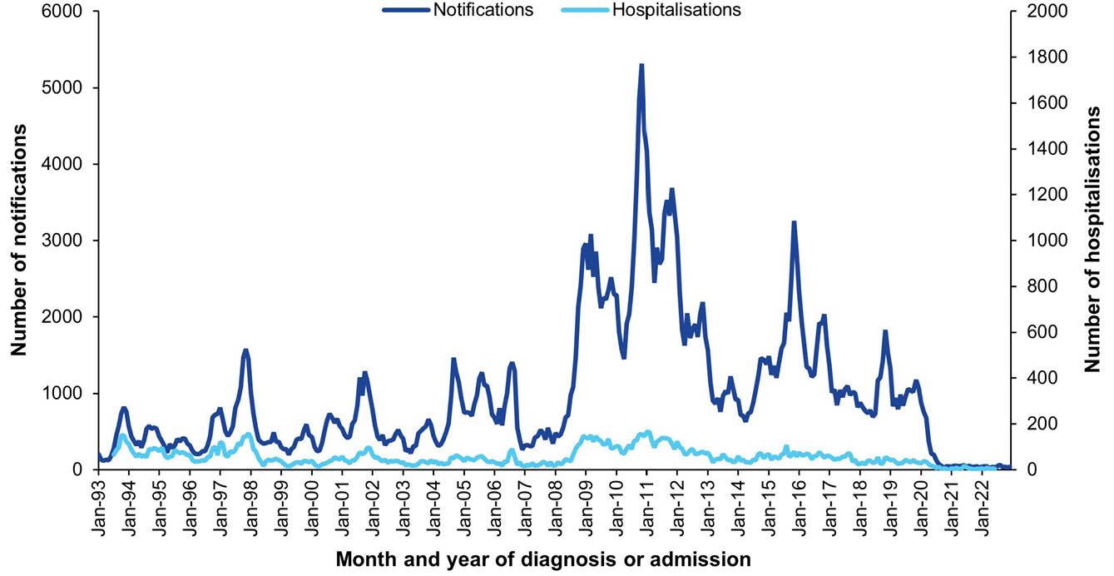
a Data sources: National Notifiable Diseases Surveillance System for notifications and Australian Institute for Health and Welfare National Hospital Morbidity Database for hospitalisation data.
b Hospitalisations for which the month of admission was between 1 July 1993 and 30 June 2022 and with pertussis in any diagnosis field. Hospitalisations with missing month of admission are excluded from this figure.
Figure 23: Pertussis notification and hospitalisation rates,^{a,b} Australia, 2013–2022, by age group for the groups < 6 months, 6 –11 months, and 1–4 years
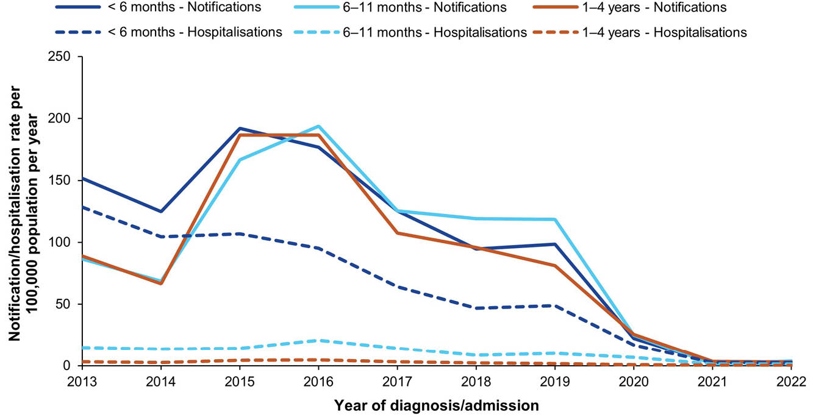
a Data sources: National Notifiable Diseases Surveillance System for notifications and Australian Institute for Health and Welfare National Hospital Morbidity Database for hospitalisation data.
b Hospitalisations for which the month of admission was between 1 January 2013 and 30 June 2022 and with pertussis in the principal diagnosis field only. Year of separation used if year of admission was missing.

13. Poliomyelitis

Background
Poliomyelitis, or polio, is caused by a virus that has three serotypes (type 1, type 2 and type 3), transmitted predominantly through the faecal-oral route, infecting the gastrointestinal tract.²¹⁵ This infection is asymptomatic in most cases.^{215,216} However, rarely, infection may spread to the nervous system and cause aseptic meningitis (1–5%) or acute flaccid paralysis (AFP; < 1%).^{215,216}
Acute flaccid paralysis may also be due to a Sabin-like virus, i.e. similar to that used in the Sabin live attenuated oral poliovirus vaccine (OPV); it is then termed vaccine-associated paralytic poliomyelitis (VAPP).²¹⁷ In addition, the attenuated viruses may mutate if long-term replication occurs following OPV vaccination and may develop into vaccine-derived polioviruses (VDPV).²¹⁷ This may occur in immunocompromised people or in areas with low coverage and high person-to-person transmission.

Notifications
- There were no notifications of acute poliomyelitis between 2019 and 2022.

Hospitalisations and deaths
- There were 26 hospital admissions with acute poliomyelitis in any diagnosis field between 1 January 2019 and 30 June 2022, of which 10 had acute poliomyelitis as the principal diagnosis for the admission.
- There were no deaths with acute poliomyelitis as the underlying cause of death.

Discussion
The Western Pacific region, including Australia, was declared polio free in October 2000.^{218,219} To monitor polio-free status, the WHO has set several surveillance indicators, including detection of at least one AFP case per 100,000 population per year in children under 15 years of age.²²⁰ In Australia, AFP surveillance occurs through the Australian Paediatric Surveillance Unit, to which clinicians provide a monthly report card of various rare medical conditions, including AFP, and through the Paediatric Active Enhanced Disease Surveillance System, performing active case finding at eight sentinel paediatric hospitals.^{221–224} This is supplemented by environmental surveillance (i.e. testing of sewage for poliovirus) and non-polio enterovirus surveillance, which aims to detect imported poliovirus among untyped enteroviruses.²²⁵ In the 2019–2022 period, at least one AFP case per 100,000 population per year was detected, meeting the WHO surveillance indicator.^{221–224} All 258 AFP cases reported in the 2019–2022 period were reviewed by the Polio Expert Panel, a subcommittee of the Communicable Diseases Network Australia, and deemed non-polio AFP.^{221–224} The absence of notified cases of acute poliomyelitis to NNDSS in this report is in line with these findings. Considering this, the 26 acute poliomyelitis hospitalisations in this report likely represent misclassification, miscoding or other data-related issues.
The Global Polio Eradication Initiative is a public-private partnership between governments and non-governmental organisations aiming to eradicate polio.²²⁶ Globally, wild poliovirus types 2 and 3 were declared eradicated in 2015 and 2019, respectively.²²⁷ As of mid-2024, type 1 wild poliovirus remains endemic in two countries only, Afghanistan and Pakistan.²²⁸ The lowest number of global cases ever recorded occurred in 2021. However, in 2021 and 2022, confirmed cases occurred outside of the endemic areas, namely in Malawi and Mozambique.²²⁸ Outbreaks of VDPV, particularly type 2, increased over the 2019–2022 period, with environmental detection of VPDV2 occurring in settings where OPV is not in use and inactivated poliovirus vaccine coverage is high, and a reported case of poliomyelitis due to VPDV2 in New York.^{229–231} These events, as well as the 2018 VDPV1 outbreak in Papua New Guinea,²³² highlight the importance of maintaining high vaccine coverage and strong clinical and environmental surveillance systems in Australia.

14. Q fever

Background
Q fever is an infection caused by the bacterium Coxiella burnetii.²³³ Q fever is a zoonotic infection where the bacterium is transmitted from animals, or their contaminated environments, to humans.²³³ People are infected by inhaling aerosols or dust contaminated by infected animal faeces, urine, milk or birth products. While 20–80% of infections are asymptomatic,²³⁴ symptoms can include fever, chills/sweats/ severe headache, photophobia, weakness, nausea, muscle aches and cough. Pneumonia and hepatitis can occur. Chronic diseases such as endocarditis and Q fever fatigue syndrome can develop from one month up to several years after the initial infection.²³³ Approximately 1% of acute Q fever cases will result in death if not treated.

Notifications
- A total of 2,033 notifications of Q fever were reported during the 2019–2022 period (Table 22). A monthly average of 42.4 Q fever cases were notified during 2019–2022, similar to the monthly average number of notifications of 38.8 during 2002–2018 (Figure 24).
- The average annual Q fever notification rate for the 2019–2022 period was 1.98 per 100,000 population per year, similar to the average annual notification rate of 2.11 per 100,000 population per year for 2016–2018 (RR: 0.95; 95% CI: 0.89–1.02).
- Males accounted for 73.2% of the 2,033 notifications during the 2019–2022 period, with a male to female rate ratio of 2.78 (95% CI: 2.52–3.07).
- Q fever notification rates were highest in Queensland and New South Wales, with average annual rates of 4.60 and 2.64 per 100,000 population per year, respectively.
- Aboriginal and Torres Strait Islander status was reported for 1,861 of the 2,033 Q fever notifications (91.5%) during 2019–2022. The Q fever notification rate among Aboriginal and Torres Strait Islander people was 3.01 per 100,000 per year and the crude notification rate for other people was 1.94 per 100,000 per year (age-standardised RR: 2.13; 95% CI: 1.72–2.62; Appendix A, Table A.3).

Ten-year trends
- During 2013–2022, Q fever trends for persons aged ≥ 1 year varied by age group (Figure 25). Notification rates were highest for those aged 50–64 years (3.24–4.57 per 100,000 population per year).
- For children aged 5–14 years, the lowest number of notifications over the 10-year period was reported in 2021, with cases only notified in Queensland. Conversely, 2021 had the highest number of Q fever notifications in adults aged 50–64 years (n = 206), with 186 of those (90.3%) in Queensland and New South Wales.

Vaccination status
- Of the 2,033 notifications between 2019 and 2022, vaccination data were unavailable for 44.3% of cases (n= 900: 898 blank; one followed up with no information available; one not followed up). Of the 1,133 notifications with vaccination data available, 1,126 (99.4%) had received no vaccine doses. This includes 20 children aged < 15 year who are not eligible for Q fever vaccine. One case received a Q fever vaccine in the 14 days prior to their diagnosis.
- All but one of the six vaccinated cases were aged ≥ 25 years. Time since vaccination was known for four vaccinated cases, with two having been vaccinated in the 12 months prior to onset of disease.

Hospitalisations
- There were 960 hospitalisations with Q fever in any diagnosis field between 1 January 2019 and 30 June 2022, of which 671 (69.9%) had Q fever as the principal diagnosis (Table 23). This equates to hospitalisation rates of 1.07 per 100,000 population per year and 0.74 per 100,000 population per year, respectively.
- Hospitalisation rates with Q fever in any diagnosis field and as principal diagnosis only were the same as for the 2016–2018 period; rate ratios were 1.00 (95% CI: 0.91–1.10) for all-diagnoses Q fever hospitalisations and 0.99 (95% CI: 0.88–1.10) for hospitalisations with Q fever as principal diagnosis.

Principal diagnosis only
- During 2019–2022, hospitalisations with Q fever as the principal diagnosis accounted for a minimum of 3,678 hospital bed days. The exact length of stay was unknown (i.e. reported as > 30 days) for six hospitalisations (0.9%). The median length of stay was 4 days (IQR: 2–7 days). The median length of stay was highest for those aged ≥ 65 years (6 days; IQR: 3–9 days) and lowest for those aged 15–24 years (2 days; IQR: 1–4).
- During 2019–2022, the age-standardised rate ratio for hospitalisations with Q fever as the principal diagnosis in Aboriginal and Torres Strait Islander people compared to others was 2.73 (95% CI: 1.95–3.71).

Deaths
- There were 17 deaths reported with Q fever as the underlying or associated cause of death during 2019–2022, of which six had Q fever as the underlying cause of death (0.01 per 100,000 population per year). All deaths with Q fever as the underlying cause occurred in adults aged ≥ 65 years. No Q fever deaths were reported in Aboriginal and Torres Strait Islander people.

Discussion
Overall, Q fever notification rates in Australia in 2019–2022 were similar to those in the 2016–2018 period. There was no clear impact of the COVID-19 pandemic, despite some variation by age in 2021 for which the reasons are unclear. Q fever notifications underestimate infection and disease rates due to the asymptomatic nature of many acute infections, the fact that signs and symptoms are non-specific, and that diagnosis relies on clinicians suspecting Q fever, and ordering appropriate tests.²³⁵ While occupational contact with domestic ruminants (cattle, sheep, goats) is a common source of C. burnetii infection,²³³ the bacterium has an extensive range of hosts including domestic pets (dogs and cats) and native animals.²³⁶ Windborne spread of contaminated dust can occur over several kilometres,^{236,237} exposing those living in otherwise low-risk environments.²³⁸ Increases in Q fever notifications in urban areas of Queensland have been reported and thought to be associated with development in previously agricultural areas.²³⁹ Serological studies in New South Wales and Queensland also suggest that Q fever infection rates in urban areas are similar to rural areas.^{240,241} As urbanisation increases in regional Australia, improving awareness and management of Q fever amongst health professionals in those areas, and expansion of the number of registered Q fever vaccination providers, is required.²⁴² Ongoing efforts are also required to inform and educate individuals and communities at risk.
An effective Q fever vaccine is recommended, but currently is not funded on the NIP, for people aged ≥ 15 years who are at risk of infection.⁵⁷ Prior to April 2024, Q fever vaccination recording occurred in the Q Fever Register managed by the Australian Meat Processor Corporation. Vaccination data have since been moved to the AIR. The lack of national data on Q fever vaccine uptake in the at-risk population in Australia is a limitation to monitoring of the vaccine’s impact on disease. Targeted studies have shown that vaccine uptake in high-risk groups is variable but generally suboptimal, particularly for those not offered vaccines as part of their training (e.g. veterinarians) or through their workplace (e.g. abattoir workers).^{243–245} Further, Q fever notifications have gradually been increasing since the cessation of the National Q Fever Management Program in 2006 that covered the costs of screening and vaccination in certain high-risk groups and led to a decline in Q fever notifications.²⁴⁶ This suggests declines in vaccine uptake in recommended groups may be occurring, given reported barriers to vaccination such as the time and cost related to vaccination.²⁴⁷ Ongoing strategies to increase awareness of Q fever and the benefits of vaccination across the broad range of groups at risk of disease, as well as supporting access to screening and vaccination, are required.

Table 22: Q fever notifications in Australia, by age group, sex, Aboriginal and Torres Strait Islander status and state/territory,ª 2019–2022
Category | Characteristic | Year of diagnosis
Category | Characteristic | 2019 |  | 2020 |  | 2021 |  | 2022 |  | 2019–2022
Category | Characteristic | n | Rate^{b} | n | Rate^{b} | n | Rate^{b} | n | Rate^{b} | n | Av. rate^{b,c}
Total | — | 570 | 2.25 | 456 | 1.78 | 547 | 2.13 | 460 | 1.77 | 2,033 | 1.98
Age group (years) | < 1 | 0 | 0 | 0 | 0 | 0 | 0 | 0 | 0 | 0 | 0
Age group (years) | 1–4 | 2 | 0.16 | 3 | 0.24 | 3 | 0.25 | 3 | 0.25 | 11 | 0.22
Age group (years) | 5–14 | 9 | 0.28 | 10 | 0.31 | 2 | 0.06 | 10 | 0.31 | 31 | 0.24
Age group (years) | 15–24 | 57 | 1.76 | 34 | 1.07 | 36 | 1.16 | 31 | 0.98 | 158 | 1.24
Age group (years) | 25–49 | 191 | 2.16 | 171 | 1.91 | 180 | 2.02 | 168 | 1.88 | 710 | 1.99
Age group (years) | 50–64 | 179 | 3.99 | 148 | 3.24 | 206 | 4.45 | 147 | 3.14 | 680 | 3.70
Age group (years) | ≥ 65 | 132 | 3.27 | 90 | 2.15 | 120 | 2.78 | 101 | 2.28 | 443 | 2.61
Sex | Male | 429 | 3.41 | 321 | 2.52 | 401 | 3.15 | 338 | 2.62 | 1,489 | 2.92
Sex | Female | 141 | 1.11 | 135 | 1.04 | 146 | 1.13 | 122 | 0.93 | 544 | 1.05
Aboriginal and Torres Strait Islander status | Aboriginal and Torres Strait Islander | 25 | 2.95 | 23 | 2.66 | 29 | 3.29 | 28 | 3.11 | 105 | 3.01
Aboriginal and Torres Strait Islander status | Other | 545 | 2.23 | 433 | 1.75 | 518 | 2.09 | 432 | 1.72 | 1,928 | 1.94
Jurisdiction^{d} | ACT | 2 | 0.46 | 0 | 0 | 0 | 0 | 1 | 0.22 | 3 | 0.17
Jurisdiction^{d} | NSW | 250 | 3.11 | 197 | 2.43 | 219 | 2.70 | 189 | 2.31 | 855 | 2.64
Jurisdiction^{d} | NT | 2 | 0.81 | 0 | 0 | 1 | 0.40 | 2 | 0.80 | 5 | 0.50
Jurisdiction^{d} | Qld | 235 | 4.62 | 220 | 4.26 | 271 | 5.20 | 231 | 4.34 | 957 | 4.60
Jurisdiction^{d} | SA | 13 | 0.74 | 9 | 0.50 | 18 | 1.00 | 6 | 0.33 | 46 | 0.64
Jurisdiction^{d} | Tas. | 9 | 1.64 | 0 | 0 | 0 | 0 | 2 | 0.35 | 11 | 0.49
Jurisdiction^{d} | Vic. | 52 | 0.80 | 25 | 0.38 | 35 | 0.53 | 24 | 0.36 | 136 | 0.52
Jurisdiction^{d} | WA | 7 | 0.26 | 5 | 0.18 | 3 | 0.11 | 5 | 0.18 | 20 | 0.18
a Data source: National Notifiable Diseases Surveillance System.
b Rates provided are the number of notifications per 100,000 population per year.
c Average annual rate per 100,000 population per year.
d ACT: Australian Capital Territory; NSW: New South Wales; NT: Northern Territory; Qld: Queensland; SA: South Australia; Tas.: Tasmania; Vic.: Victoria; WA: Western Australia.
Table 23: Q fever hospitalisations and deaths in Australia, by age group, sex, Aboriginal and Torres Strait Islander status and state/territory,ª 2019–2022
Category | Characteristic | Hospital count and rate: year of admission^{b,c,d} |  |  |  |  |  |  |  |  |  |  |  |  |  |  |  |  |  |  |  | Deaths^{e,f}
Category | Characteristic | Any diagnosis field^{g} |  |  |  |  |  |  |  |  |  | Prinicpal diagnosis^{h} |  |  |  |  |  |  |  |  |  | Year of  death
Category | Characteristic | 2019 |  | 2020 |  | 2021 |  | 2022^{i,j} |  | 2019–2022 |  | 2019 |  | 2020 |  | 2021 |  | 2022^{i,j} |  | 2019–2022 |  | 2019–2022
Category | Characteristic | n | Rate | n | Rate | n | Rate | n | Rate | n | Av. rate^{k} | n | Rate | n | Rate | n | Rate | n | Rate | n | Av. rate^{k} | n | Av. rate^{k}
Total | — | 242 | 0.96 | 253 | 0.99 | 327 | 1.27 | 138 | 1.06 | 960 | 1.07 | 168 | 0.66 | 169 | 0.66 | 244 | 0.95 | 90 | 0.69 | 671 | 0.74 | 6 | 0.01
Age group (years) | < 1 | 0 | 0 | 0 | 0 | 0 | 0 | 0 | 0 | 0 | 0 | 0 | 0 | 0 | 0 | 0 | 0 | 0 | 0 | 0 | 0 | 0 | 0
Age group (years) | 1–4 | 1–4 | 0.16 | 1–4 | 0.16 | 1–4 | 0.25 | 0 | 0 | 7 | 0.14 | 1–4 | 0.16 | 1–4 | 0.16 | 1–4 | 0.25 | 0 | 0 | 7 | 0.14 | 0 | 0
Age group (years) | 5–14 | NP | 0.28 | NP | 0.22 | NP | 0.15 | 5 | 0.31 | 26 | 0.24 | 1–4 | 0.06 | 1–4 | 0.12 | 1–4 | 0.06 | 1–4 | 0.12 | 10 | 0.09 | 0 | 0
Age group (years) | 15–24 | 19 | 0.59 | 13 | 0.41 | 13 | 0.42 | 6 | 0.38 | 51 | 0.45 | 14 | 0.43 | 10 | 0.31 | 10 | 0.32 | NP | 0.32 | 39 | 0.35 | 0 | 0
Age group (years) | 25–49 | 68 | 0.77 | 78 | 0.87 | 102 | 1.15 | 31 | 0.69 | 279 | 0.87 | 53 | 0.60 | 59 | 0.66 | 79 | 0.89 | 19 | 0.42 | 210 | 0.64 | 0 | 0
Age group (years) | 50–64 | 62 | 1.38 | 77 | 1.68 | 99 | 2.14 | 45 | 1.92 | 283 | 1.79 | 40 | 0.89 | 49 | 1.07 | 74 | 1.60 | 37 | 1.58 | 200 | 1.29 | 0 | 0
Age group (years) | ≥ 65 | 82 | 2.03 | 76 | 1.81 | 105 | 2.43 | 51 | 2.30 | 314 | 2.15 | 57 | 1.41 | 45 | 1.07 | 76 | 1.76 | 27 | 1.22 | 205 | 1.37 | 6 | 0.04
Sex | Male | 178 | 1.42 | 186 | 1.46 | 242 | 1.90 | 93 | 1.44 | 699 | 1.55 | 127 | 1.01 | 129 | 1.01 | 181 | 1.42 | 64 | 0.99 | 501 | 1.11 | 1–5 | 0.01
Sex | Female | 64 | 0.50 | 67 | 0.52 | 85 | 0.66 | 45 | 0.69 | 261 | 0.59 | 41 | 0.32 | 40 | 0.31 | 63 | 0.49 | 26 | 0.40 | 170 | 0.38 | 1–5 | 0.002
Aboriginal and Torres Strait Islander status | Aboriginal and Torres Strait Islander | 15 | 1.77 | 14 | 1.62 | 23 | 2.61 | 11 | 2.45 | 63 | 2.12 | 11 | 1.30 | 9 | 1.04 | 17 | 1.93 | 6 | 1.33 | 43 | 1.40 | 0 | 0
Aboriginal and Torres Strait Islander status | Other | 227 | 0.93 | 239 | 0.96 | 304 | 1.23 | 127 | 1.01 | 897 | 1.03 | 157 | 0.64 | 160 | 0.65 | 227 | 0.92 | 84 | 0.67 | 628 | 0.72 | 6 | 0.01
Jurisdiction^{l,m} | ACT | 0 | 0 | 0 | 0 | 1–4 | 0.22 | 0 | 0 | 1–4 | 0.06 | 0 | 0 | 0 | 0 | 0 | 0 | 0 | 0 | 0 | 0 | — | —
Jurisdiction^{l,m} | NSW | 100 | 1.24 | 111 | 1.37 | 119 | 1.47 | 45 | 1.10 | 375 | 1.30 | 71 | 0.88 | 80 | 0.99 | 87 | 1.07 | 31 | 0.76 | 269 | 0.93 | — | —
Jurisdiction^{l,m} | NT | 1–4 | 0.81 | 1–4 | 0.40 | 0 | 0 | 0 | 0 | 1–4 | 0.30 | 1–4 | 0.81 | 1–4 | 0.40 | 0 | 0 | 0 | 0 | 1–4 | 0.30 | — | —
Jurisdiction^{l,m} | Qld | 110 | 2.16 | 118 | 2.28 | 178 | 3.41 | 83 | 3.12 | 489 | 2.75 | 80 | 1.57 | 77 | 1.49 | 133 | 2.55 | 52 | 1.95 | 342 | 1.90 | — | —
Jurisdiction^{l,m} | SA | 9 | 0.51 | NP | 0.45 | 11 | 0.61 | 1–4 | 0.11 | 29 | 0.42 | 1–4 | 0.23 | 1–4 | 0.22 | 9 | 0.50 | 1–4 | 0.11 | 18 | 0.26 | — | —
Jurisdiction^{l,m} | Tas. | 0 | 0 | 0 | 0 | 0 | 0 | 0 | 0 | 0 | 0 | 0 | 0 | 0 | 0 | 0 | 0 | 0 | 0 | 0 | 0 | — | —
Jurisdiction^{l,m} | Vic. | 15 | 0.23 | 11 | 0.17 | 14 | 0.21 | 7 | 0.21 | 47 | 0.21 | 8 | 0.12 | 7 | 0.11 | NP | 0.17 | 1–4 | 0.12 | 30 | 0.13 | — | —
Jurisdiction^{l,m} | WA | 1–4 | 0.15 | 1–4 | 0.15 | 1–4 | 0.07 | 1–4 | 0.07 | 11 | 0.11 | 1–4 | 0.08 | 0 | 0 | 1–4 | 0.07 | 1–4 | 0.07 | NP | 0.05 | — | —
a Data sources: Australian Institute for Health and Welfare National Hospital Morbidity Database for hospitalisation data, and Australian Coordinating Registry for death data.
b Rates provided are the number of hospitalisations or deaths per 100,000 population per year.
c To comply with the AIHW’s data release condition that hospitalisation counts < 5 be suppressed in published reports, counts between 1 and 4 are reported as a range; other cell counts may be reported as NP (not published) to avoid potential for back calculation of counts < 5.
d Year of separation used if year of admission was missing.
e Deaths where the disease code was the underlying cause of death only.
f To comply with the Australian Coordinating Registry’s data release condition that death counts < 6 be suppressed in published reports, counts between 1 and 5 are reported as a range; other cell counts may be reported as NP (not published) to avoid potential for back calculation of counts < 6.
g Hospitalisations with the specific disease code in any diagnosis field.
h Hospitalisations with the specific disease code in the principal diagnosis field only.
i Hospitalisations with admission date between 1 January and 30 June 2022.
j Hospitalisation rates for 2022 have been annualised.
k Average annual rate per 100,000 population per year.
l ACT: Australian Capital Territory; NSW: New South Wales; NT: Northern Territory; Qld: Queensland; SA: South Australia; Tas.: Tasmania; Vic.: Victoria; WA: Western Australia.
m To comply with the Australian Coordinating Registry’s data release condition that only national death counts and rates be reported, death counts and rates are not presented by state/territory.

Figure 24: Q fever notifications and hospitalisations for all ages,^{a,b} Australia, 1993–2022, by month of diagnosis or admission
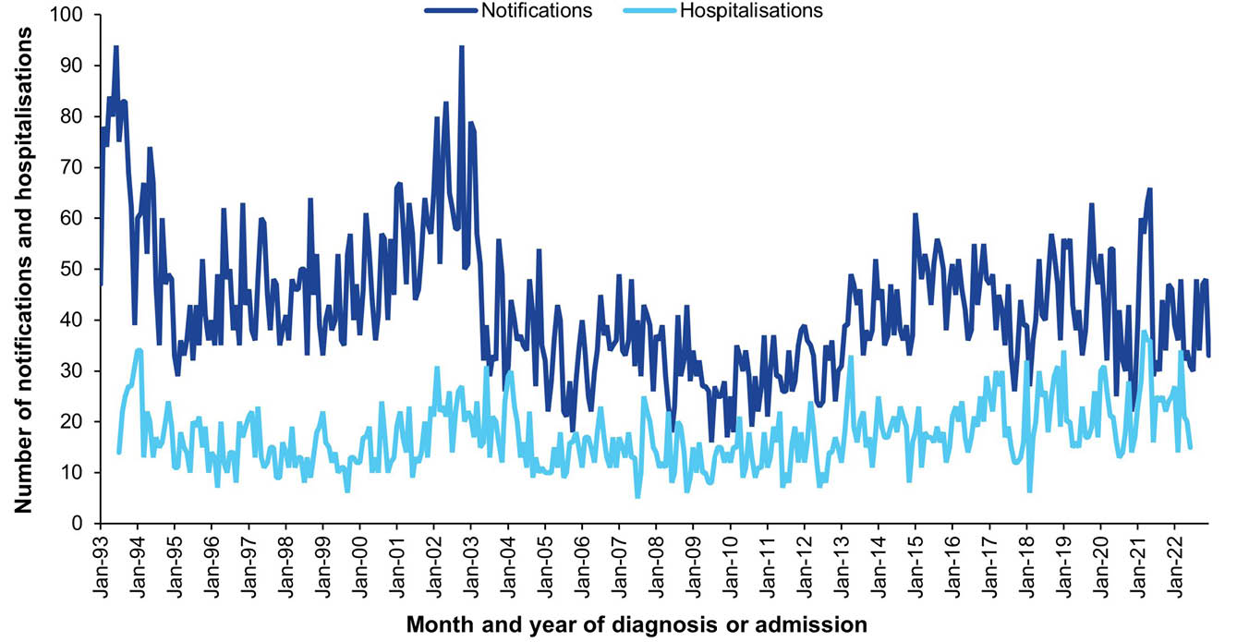
a Data sources: National Notifiable Diseases Surveillance System for notification data and the Australian Institute for Health and Welfare National Hospital Morbidity Database for hospitalisation data.
b Hospitalisations for which the month of admission was between 1 July 1993 and 30 June 2022 and with Q fever in any diagnosis field. Hospitalisations with missing month of admission are excluded from this figure.
Figure 25: Q fever notification rates,ª Australia, 2013–2022, by age group (≥ 1 year)
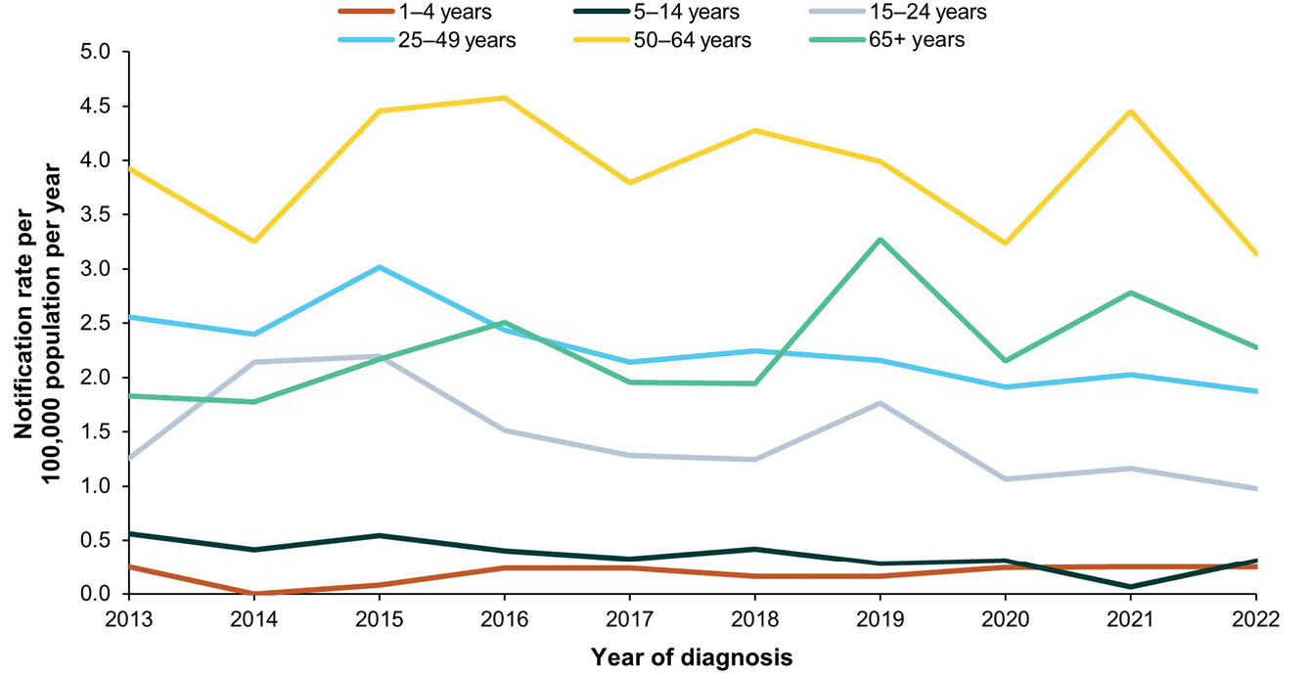
a Data source: National Notifiable Diseases Surveillance System.

15. Rotavirus

Background
Rotavirus is the major cause of acute gastroenteritis in infants and young children and is primarily spread by faecal-oral transmission.²⁴⁸ The most common symptoms of rotavirus infection are watery diarrhoea, fever and vomiting, usually lasting up to five days.^{248,249} Infection with rotavirus can cause asymptomatic or mild disease but can also cause severe gastroenteritis with dehydration requiring hospitalisation.^{248,250} Infection can occur in any age group; however, severe disease is most common among children aged 3 months to 2 years.²⁴⁹

Notifications
- A total of 16,893 notifications of rotavirus were reported during the 2019–2022 period (Table 24).
- The average annual rotavirus notification rate for the 2019–2022 period was 16.45 per 100,000 population per year.
- Rotavirus notifications have only been recorded as per the national case definition since 1 January 2017; rotavirus became a nationally notifiable disease in July 2018. Therefore, rotavirus notification rates in 2019–2022 could not be meaningfully compared to those in the 2016–2018 period.
- The lowest annual notification rate was reported in 2020. The all-age annual notification rate decreased by 73.3% between 2019 and 2020. The percent decrease in notification rate between 2019 and 2020 was similar in all age groups (between 70.9% and 86.7% reduction) except in the < 1 year age group, where the notification rate decreased by 32.4%.
- The average annual rotavirus notification rate for the 2019–2022 period was highest in infants aged < 1 year (386.59 per 100,000 population per year), followed by children aged 1–4 years (83.17 per 100,000 population per year).
- Aboriginal and Torres Strait Islander status was reported for 12,968 of the 16,893 notifications (76.8%). Completeness of the Aboriginal and Torres Strait Islander field was highest in rotavirus notifications in the < 1 year (88.6%) and 1–4 years (81.3%) age groups, and < 75% in the remaining age groups.
- Notification rates by Aboriginal and Torres Strait Islander status are presented for children aged < 5 years only (Table 24). In the 2019–2022 period, the notification rate in this age group was higher in Aboriginal and Torres Strait Islander children than in other children (RR: 1.81; 95% CI: 1.69–1.93).

Vaccination status
- Of the 16,893 notifications between 2019 and 2022, 136 (0.8%) were younger than 6 weeks old and therefore were not old enough to have received at least one dose of rotavirus vaccine, and 6,584 (39.0%) were born prior to rotavirus vaccine being on the NIP and therefore not eligible to receive it.
- Of the 10,173 notified cases who were eligible to have received at least one rotavirus vaccine dose (born in, or later than, 2007), vaccination status was unavailable for 18.3% (n = 1,858); 1,204 were blank; eight were followed up but no information available; and 646 not followed up.
- Of the 8,315 notifications with vaccination data available, 757 (9.3%) had received no vaccine doses; 1,000 (12.0%) had received one dose of rotavirus vaccine within 14 days prior to their diagnosis; 1,623 (19.5%) had received one dose 14 days or more before the diagnosis date; and 4,935 (59.4%) had received 2 or 3 doses.

Hospitalisations
- There were 2,583 hospitalisations with rotavirus in any diagnosis field between 1 January 2019 and 30 June 2022, of which 1,620 (62.7%) had rotavirus as the principal diagnosis (Table 25). This equates to hospitalisation rates of 2.69 per 100,000 population per year and 1.67 per 100,000 population per year, respectively.
- The rates for hospitalisation with rotavirus in any diagnosis field and as principal diagnosis only were both lower in the 2019–2022 period than in the 2016–2018 period; rate ratios were 0.51 (95% CI: 0.49–0.54) for all-diagnoses rotavirus hospitalisations and 0.55 (95% CI: 0.52–0.59) for hospitalisations with rotavirus as principal diagnosis.
- Monthly hospitalisations with rotavirus in any diagnosis field peaked every year in August–October between 1993 and 2007 (Figure 26), with the highest number of hospitalisations in August 1999 (n = 1,174). From 2008, the peak number of notifications per year decreased, with the highest number of hospitalisations in the 2008–2022 period in September 2017 (n = 392).

Principal diagnosis only
- The principal diagnosis rotavirus hospitalisation rate was highest in the < 1 year age group (35.16 per 100,000 population per year), followed by children aged 1–4 years (9.05 per 100,000 population per year) and adults aged ≥ 65 years (2.17 per 100,000 population per year) (Table 25).
- During 2019–2022, hospitalisations with rotavirus as the principal diagnosis accounted for a minimum of 4,595 hospital bed days. The exact length of stay was unknown (i.e. reported as > 30 days) for 1–4 hospitalisations. The median length of stay was 2 days overall (IQR: 1–3 days), and highest among adults aged ≥ 65 years (4 days; IQR: 2–6 days).
- The age-standardised rotavirus hospitalisation rate ratio comparing the rate among Aboriginal and Torres Strait Islander people to others was 2.27 (95% CI: 1.95–3.71).

Deaths
- Eight deaths coded with rotavirus as underlying or associated cause of death were reported during 2019–2022 with an average annual rate of 0.008 per 100,000 population per year; 1–5 of these deaths were coded with rotavirus as the underlying cause of death. All deaths occurred in adults 75 years and older.
- 1–5 deaths in Aboriginal and Torres Strait Islander people were reported with rotavirus as the underlying cause of death.

Discussion
Following the introduction of rotavirus vaccine on the NIP in July 2007, a reduction in rotavirus hospitalisations, particularly in children aged < 5 years, was observed.^{251–255} The decline in rotavirus hospitalisations has continued, with rates in the 2019–2022 period half of those in 2016–2018.⁶ The low hospitalisation rate in 2022, however, is likely an underestimate due to annualising the rate using data to June 2022 only, with the peak number of hospitalisations likely to have occurred in the second half of the year.
National rotavirus notification rates across a full reporting period are included for the first time in this report, following rotavirus becoming a nationally notifiable disease from 1 July 2018. In 2019, there were 6,178 rotavirus notifications reported in Australia, with an annual notification rate of 24.39 per 100,000 population. Notifications of rotavirus were 73% lower in 2020 than in 2019, likely a result of COVID-19 pandemic-related restrictions reducing opportunities for transmission. The annual rotavirus notification rate in 2022 (24.86 per 100,000 population per year) returned to a similar level to that in 2019.
Children aged < 1 year had the highest notification rates during 2019–2022. However, in the context of high rotavirus vaccine coverage (90.5% for two doses in 12-month-olds in 2022),⁵⁸ these rates may be overestimates due to potential rotavirus vaccine virus shedding in vaccinated infants which has been shown to occur in up to 80% of first dose recipients, with standard diagnostic PCR tests unable to distinguish between wild-type and vaccine strains of rotavirus.^{256–258}
Rotavirus notification rates in children aged < 5 years and all-age hospitalisation rates were 1.8 times and 2.3 times as high, respectively, among Aboriginal and Torres Strait Islander people compared with others. Even higher rate ratios for both notifications and hospitalisations have been observed in Aboriginal and Torres Strait Islander infants aged 6–11 months compared to other infants.⁸ This may be due to a number of factors, such as the significantly higher burden among Aboriginal and Torres Strait Islander peoples prior to rotavirus vaccine introduction, and lower rotavirus vaccine effectiveness in Aboriginal and Torres Strait Islander infants.^{254,255,259,260} In addition, two-dose coverage of rotavirus vaccine in Aboriginal and Torres Strait Islander children aged 12 months is 7% lower than in other children.⁵⁸ Increasing timeliness of rotavirus vaccination is particularly important for increasing coverage, due to the restrictions on the upper age limit for vaccinations (second dose by 25 weeks), limiting the opportunity for catch-up vaccination.⁵⁷

Table 24: Rotavirus notifications in Australia, by age group, sex, Aboriginal and Torres Strait Islander status and state/territory,^{a,b} 2019–2022
Category | Characteristic | Year of diagnosis
Category | Characteristic | 2019 |  | 2020 |  | 2021 |  | 2022 |  | 2019–2022
Category | Characteristic | n | Rate^{c} | n | Rate^{c} | n | Rate^{c} | n | Rate^{c} | n | Av. Rate^{c,d}
Total | — | 6,178 | 24.39 | 1,673 | 6.52 | 2,578 | 10.04 | 6,464 | 24.86 | 16,893 | 16.45
Age group (years) | < 1 | 1,246 | 412.10 | 826 | 278.56 | 1,107 | 370.51 | 1,472 | 481.94 | 4,651 | 386.59
Age group (years) | 1–4 | 1,700 | 135.82 | 244 | 19.70 | 537 | 44.37 | 1,599 | 132.69 | 4,080 | 83.17
Age group (years) | 5–14 | 632 | 19.89 | 109 | 3.38 | 181 | 5.59 | 730 | 22.46 | 1,652 | 12.82
Age group (years) | 15–24 | 261 | 8.07 | 75 | 2.35 | 78 | 2.51 | 327 | 10.31 | 741 | 5.84
Age group (years) | 25–49 | 997 | 11.27 | 204 | 2.28 | 285 | 3.21 | 1,098 | 12.25 | 2,584 | 7.25
Age group (years) | 50–64 | 457 | 10.18 | 62 | 1.36 | 139 | 3.00 | 429 | 9.17 | 1,087 | 5.92
Age group (years) | ≥ 65 | 885 | 21.94 | 153 | 3.65 | 251 | 5.82 | 809 | 18.24 | 2,098 | 12.36
Sex | Male | 3,020 | 24.01 | 875 | 6.87 | 1,258 | 9.87 | 3,094 | 23.97 | 8,247 | 16.18
Sex | Female | 3,151 | 24.70 | 789 | 6.11 | 1,319 | 10.20 | 3,362 | 25.67 | 8,621 | 16.67
Aboriginal and Torres Strait Islander status (children < 5 years only) | Aboriginal and Torres Strait Islander | 268 | 280.73 | 88 | 90.94 | 307 | 311.76 | 298 | 296.09 | 961 | 245.56
 | Other | 2,678 | 183.61 | 982 | 68.28 | 1,337 | 94.79 | 2,773 | 196.68 | 7,770 | 135.91
Jurisdiction^{e} | ACT | 85 | 19.51 | 53 | 11.91 | 11 | 2.43 | 67 | 14.67 | 216 | 12.07
Jurisdiction^{e} | NSW | 1,830 | 22.74 | 434 | 5.35 | 354 | 4.37 | 1,894 | 23.19 | 4,512 | 13.92
Jurisdiction^{e} | NT | 80 | 32.45 | 48 | 19.40 | 241 | 97.12 | 117 | 46.76 | 486 | 48.97
Jurisdiction^{e} | Qld | 2,300 | 45.20 | 309 | 5.98 | 601 | 11.52 | 2,522 | 47.40 | 5,732 | 27.57
Jurisdiction^{e} | SA | 801 | 45.32 | 342 | 19.10 | 522 | 28.96 | 474 | 26.03 | 2,139 | 29.78
Jurisdiction^{e} | Tas. | 76 | 13.87 | 46 | 8.25 | 19 | 3.35 | 64 | 11.21 | 205 | 9.14
Jurisdiction^{e} | Vic. | 488 | 7.46 | 252 | 3.81 | 114 | 1.74 | 957 | 14.44 | 1,811 | 6.88
Jurisdiction^{e} | WA | 518 | 19.48 | 189 | 6.97 | 716 | 26.04 | 369 | 13.23 | 1,792 | 16.42
a Data source: National Notifiable Diseases Surveillance System.
b For Aboriginal and Torres Strait Islander status, notification rates are presented for children aged < 5 years only.
c Rates provided are the number of notifications per 100,000 population per year.
d Average annual rate per 100,000 population per year.
e ACT: Australian Capital Territory; NSW: New South Wales; NT: Northern Territory; Qld: Queensland; SA: South Australia; Tas.: Tasmania; Vic.: Victoria; WA: Western Australia.
Table 25: Rotavirus hospitalisations and deaths in Australia, by age group, sex, Aboriginal and Torres Strait Islander status and state/territory,ª 2019–2022
Category | Characteristic | Hospital count and rate: year of admission^{b,c,d} |  |  |  |  |  |  |  |  |  |  |  |  |  |  |  |  |  |  |  | Deaths^{e,f}
Category | Characteristic | Any diagnosis field^{g} |  |  |  |  |  |  |  |  |  | Prinicpal diagnosis^{h} |  |  |  |  |  |  |  |  |  | Year of  death
Category | Characteristic | 2019 |  | 2020 |  | 2021 |  | 2022^{i,j} |  | 2019–2022 |  | 2019 |  | 2020 |  | 2021 |  | 2022^{i,j} |  | 2019–2022 |  | 2019–2022
Category | Characteristic | n | Rate | n | Rate | n | Rate | n | Rate | n | Av. rate^{k} | n | Rate | n | Rate | n | Rate | n | Rate | n | Av. rate^{k} | n | Av. rate^{k}
Total | — | 1,482 | 5.85 | 355 | 1.38 | 563 | 2.19 | 183 | 1.41 | 2,583 | 2.69 | 974 | 3.84 | 206 | 0.80 | 344 | 1.34 | 96 | 0.74 | 1,620 | 1.67 | 1–5 | 0.004
Age group (years) | < 1 | 313 | 103.52 | 125 | 42.16 | 186 | 62.25 | 80 | 52.38 | 704 | 65.17 | 182 | 60.19 | 61 | 20.57 | 106 | 35.48 | 37 | 24.23 | 386 | 35.16 | 0 | 0
Age group (years) | 1–4 | 349 | 27.88 | 52 | 4.20 | 118 | 9.75 | 28 | 4.65 | 547 | 11.72 | 269 | 21.49 | 35 | 2.83 | 90 | 7.44 | 25 | 4.15 | 419 | 9.05 | 0 | 0
Age group (years) | 5–14 | 145 | 4.56 | NP | 0.96 | 39 | 1.20 | NP | 0.55 | 224 | 1.81 | 119 | 3.75 | 22 | 0.68 | 30 | 0.93 | 8 | 0.49 | 179 | 1.45 | 0 | 0
Age group (years) | 15–24 | 45 | 1.39 | NP | 0.44 | 15 | 0.48 | 1–4 | 0.25 | 78 | 0.65 | 32 | 0.99 | NP | 0.28 | 11 | 0.35 | 1–4 | 0.19 | 55 | 0.46 | 0 | 0
Age group (years) | 25–49 | 125 | 1.41 | 37 | 0.41 | 46 | 0.52 | 14 | 0.31 | 222 | 0.66 | 72 | 0.81 | NP | 0.26 | 30 | 0.34 | 1–4 | 0.09 | 129 | 0.37 | 0 | 0
Age group (years) | 50–64 | 106 | 2.36 | 19 | 0.42 | 35 | 0.76 | 16 | 0.68 | 176 | 1.05 | 66 | 1.47 | 7 | 0.15 | 20 | 0.43 | 5 | 0.21 | 98 | 0.56 | 0 | 0
Age group (years) | ≥ 65 | 399 | 9.89 | 77 | 1.84 | 124 | 2.87 | 32 | 1.44 | 632 | 3.91 | 234 | 5.80 | 49 | 1.17 | 57 | 1.32 | 14 | 0.63 | 354 | 2.17 | 1–5 | 0.02
Sex | Male | 736 | 5.85 | 185 | 1.45 | 280 | 2.20 | 89 | 1.38 | 1,290 | 2.71 | 478 | 3.80 | 108 | 0.85 | 168 | 1.32 | 48 | 0.74 | 802 | 1.67 | 1–5 | 0.004
Sex | Female | 746 | 5.85 | 170 | 1.32 | 283 | 2.19 | 94 | 1.44 | 1,293 | 2.68 | 496 | 3.89 | 98 | 0.76 | 176 | 1.36 | 48 | 0.73 | 818 | 1.67 | 1–5 | 0.004
Aboriginal and Torres Strait Islander status | Aboriginal and Torres Strait Islander | 142 | 16.76 | 37 | 4.28 | 118 | 13.38 | 22 | 4.89 | 319 | 9.76 | 81 | 9.56 | 16 | 1.85 | 75 | 8.51 | 8 | 1.78 | 180 | 5.38 | 1–5 | 0.03
Aboriginal and Torres Strait Islander status | Other | 1,340 | 5.47 | 318 | 1.28 | 445 | 1.79 | 161 | 1.28 | 2,264 | 2.44 | 893 | 3.65 | 190 | 0.77 | 269 | 1.08 | 88 | 0.70 | 1,440 | 1.54 | 1–5 | 0.003
Jurisdiction^{l,m} | ACT | 5 | 1.15 | 1–4 | 0.22 | 1–4 | 0.22 | 0 | 0 | 7 | 0.39 | 1–4 | 0.92 | 1–4 | 0.22 | 1–4 | 0.22 | 0 | 0 | 6 | 0.34 | — | —
Jurisdiction^{l,m} | NSW | 401 | 4.98 | 106 | 1.31 | 62 | 0.77 | 49 | 1.20 | 618 | 2.06 | 297 | 3.69 | 64 | 0.79 | 30 | 0.37 | 22 | 0.54 | 413 | 1.34 | — | —
Jurisdiction^{l,m} | NT | 35 | 14.20 | 24 | 9.70 | 66 | 26.60 | 6 | 4.80 | 131 | 13.81 | NP | 6.08 | NP | 4.45 | 36 | 14.51 | 1–4 | 2.40 | 65 | 6.85 | — | —
Jurisdiction^{l,m} | Qld | 624 | 12.26 | 53 | 1.03 | 150 | 2.88 | 55 | 2.07 | 882 | 4.51 | 382 | 7.51 | 26 | 0.50 | 87 | 1.67 | 29 | 1.09 | 524 | 2.66 | — | —
Jurisdiction^{l,m} | SA | 150 | 8.49 | 65 | 3.63 | 106 | 5.88 | 32 | 3.51 | 353 | 5.36 | 96 | 5.43 | 51 | 2.85 | 71 | 3.94 | 20 | 2.20 | 238 | 3.59 | — | —
Jurisdiction^{l,m} | Tas. | 30 | 5.48 | NP | 3.95 | NP | 0.88 | 0 | 0 | 57 | 2.54 | 19 | 3.47 | NP | 2.15 | 1–4 | 0.71 | 0 | 0 | 35 | 1.56 | — | —
Jurisdiction^{l,m} | Vic. | 130 | 1.99 | 48 | 0.73 | 23 | 0.35 | 14 | 0.42 | 215 | 0.87 | 93 | 1.42 | 29 | 0.44 | NP | 0.24 | NP | 0.18 | 144 | 0.57 | — | —
Jurisdiction^{l,m} | WA | 96 | 3.61 | 32 | 1.18 | 147 | 5.35 | 26 | 1.86 | 301 | 3.00 | 64 | 2.41 | 10 | 0.37 | 96 | 3.49 | 15 | 1.08 | 185 | 1.83 | — | —
a Data sources: Australian Institute for Health and Welfare National Hospital Morbidity Database for hospitalisation data, and Australian Coordinating Registry for death data.
b Rates provided are the number of hospitalisations or deaths per 100,000 population per year.
c To comply with the AIHW’s data release condition that hospitalisation counts < 5 be suppressed in published reports, counts between 1 and 4 are reported as a range; other cell counts may be reported as NP (not published) to avoid potential for back calculation of counts < 5.
d Year of separation used if year of admission was missing.
e Deaths where the disease code was the underlying cause of death only.
f To comply with the Australian Coordinating Registry’s data release condition that death counts < 6 be suppressed in published reports, counts between 1 and 5 are reported as a range; other cell counts may be reported as NP (not published) to avoid potential for back calculation of counts < 6.
g Hospitalisations with the specific disease code in any diagnosis field.
h Hospitalisations with the specific disease code in the principal diagnosis field only.
i Hospitalisations with admission date between 1 January and 30 June 2022.
j Hospitalisation rates for 2022 have been annualised.
k Average annual rate per 100,000 population per year.
l ACT: Australian Capital Territory; NSW: New South Wales; NT: Northern Territory; Qld: Queensland; SA: South Australia; Tas.: Tasmania; Vic.: Victoria; WA: Western Australia.
m To comply with the Australian Coordinating Registry’s data release condition that only national death counts and rates be reported, death counts and rates are not presented by state/territory.

Figure 26: Rotavirus notifications and hospitalisations for all ages,^{a,b,c} Australia, 1993–2022, by month of diagnosis or admission
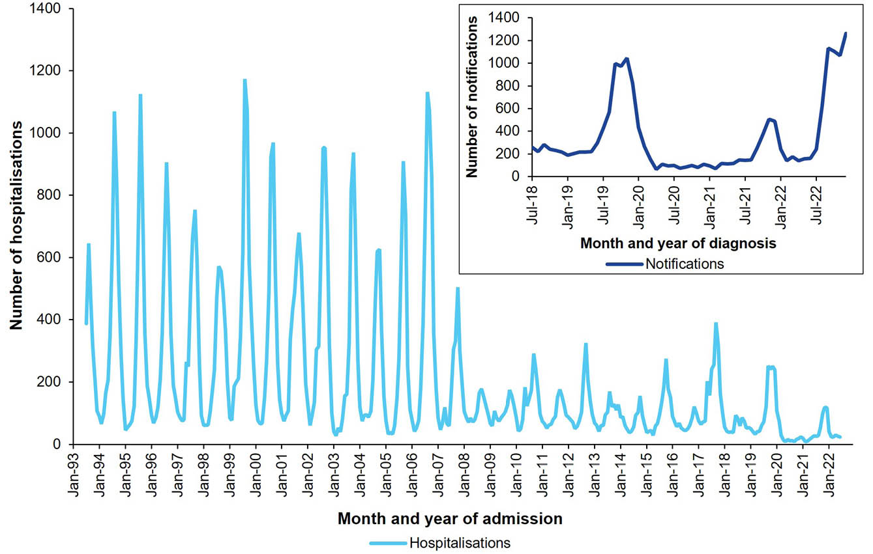
a Data sources: National Notifiable Diseases Surveillance System for notification data and the Australian Institute for Health and Welfare National Hospital Morbidity Database for hospitalisation data.
b Inset graph shows rotavirus notifications where the month of diagnosis was between 1 July 2018 and 31 December 2022.
c Hospitalisations for which the month of admission was between 1 July 1993 and 30 June 2022 and with rotavirus in any diagnosis field. Hospitalisations with missing month of admission are excluded from this figure.

16. Rubella

Background
Rubella
Rubella, or German measles, is a viral infection transmitted via direct contact with saliva or via respiratory droplets, with an incubation period of 14–23 days.²⁶¹ Generally, the infection is mild, causing lymphadenopathy, a prodrome of fever, malaise and conjunctivitis, and subsequently a maculopapular rash.²⁶¹ Complications are more common among adults, and include encephalitis, thrombocytopenia and arthritis, the latter affecting mostly women.²⁶¹
Congenital Rubella Syndrome (CRS)
Primary rubella infection during pregnancy may lead to spontaneous abortion, stillbirth, neonatal death and congenital rubella syndrome (CRS).²⁶² This syndrome, first recognised in Australia,²⁶³ is characterised by multiple birth defects, including deafness, cataracts, cardiac defects, microcephaly and intellectual disability.²⁶¹ The risk of CRS is estimated to be as high as 90% if the infection is acquired in the first ten weeks of pregnancy.²⁶⁴

Notifications
- A total of 30 cases of rubella (25 confirmed and 5 probable) were notified in the 2019–2022 period (Table 26); the majority (n = 20) were reported in 2019. The annual number of rubella notifications has remained low since the early 2000s (Figure 27).
- The average annual notification rate of rubella was 0.03 per 100,000 population per year in 2019–2022, which is similar to the rate in the 2016–2018 period (0.05 per 100,000 per year; RR: 0.69; 95% CI: 0.41–1.14).
- One confirmed case of rubella was notified in an infant < 1 year of age (average annual notification rate 0.08 per 100,000 per year), with the remainder in people aged ≥ 15 years at rates of 0.05 per 100,000 per year or less in each of the age groups.

Vaccination status
- Of the 30 rubella cases, 14 occurred in women of childbearing age (15–44 years). Vaccination status was missing for nine women of childbearing age (all blank; 64%), and 13 of the other 16 cases (81.3%: 11 blank; one followed up without any information available: and one not followed up).
- Of the eight cases with known vaccination status, two women of childbearing age (40.0%) and two of the other cases (66.7%), one of whom was < 1 year of age, were unvaccinated.
- Three women of childbearing age (60.0%) had received rubella-containing vaccine; one received one dose of MMR-II, one received two doses of an unspecified rubella vaccine, and for one case the only information provided was that they were fully vaccinated for their age. Among the other cases, only one (33.3%) was reported to have received one dose of MMR-II.

Hospitalisations
- In the 1 January 2019 to 30 June 2022 period, there were 17 hospitalisations with rubella in any diagnosis field, with 1–4 hospitalisations having rubella as the principal diagnosis for the admission, corresponding to average annual rates of 0.02 and 0.003 per 100,000 population per year, respectively (Table 27).
- Hospitalisation rates in 2019–2022 were similar to those in 2016–2018. The rate ratio was 0.87 (95% CI: 0.42–1.85) for hospitalisations with rubella in any diagnosis field, and 0.41 (95% CI: 0.07–1.93) for principal-diagnosis rubella hospitalisations.

Principal diagnosis only
- During 2019–2022, principal-diagnosis rubella hospitalisations had a median length of stay of 2 days (IQR not provided to avoid potential for back calculation).
- Principal-diagnosis rubella hospitalisations occurred exclusively in 2019, among males ≥ 5 years of age.

Deaths
- There were 1–5 deaths (average annual rate 0.001 per 100,000 population per year) with rubella as an associated cause of death during 2019–2022, and no deaths with rubella as the underlying cause of death in the 2019–2022 period.

Congenital Rubella Syndrome (CRS)
- There were no notifications of CRS in the 2019–2022 period.
- There were 32 hospitalisations with CRS in any diagnosis field between 1 January 2019 – 30 June 2022, of which 1–4 were hospitalisations for which the principal diagnosis was CRS. This corresponds to average annual hospitalisation rates of 0.04 and 0.003 per 100,000 population per year, respectively.
- Hospitalisations with CRS in any diagnosis field occurred in people < 5 years or ≥ 25 years only. Principal CRS hospitalisations occurred in people aged ≥ 50 years only.
- In the 2019–2022 period, 23 deaths (average annual rate 0.02 per 100,000 per year) had CRS as an underlying or associated cause of death, of which 1–5 deaths (average annual rate 0.004 per 100,000 per year) were reported with CRS as the underlying cause of death. Deaths with CRS as the underlying cause occurred exclusively in people aged ≥ 50 years.

Discussion
- Rubella notification and hospitalisation rates in this 2019–2022 period remained low and stable, consistent with Australia’s rubella elimination status, certified by the WHO in 2018.²⁶⁵ Rubella elimination was achieved through universal, targeted and catch-up vaccination programs leading to sustained high levels of vaccination coverage^{58,268} and rubella immunity.²⁶⁷ The COVID-19 pandemic has impacted vaccination coverage and timeliness, including for MMR/MMRV vaccine doses,^{58,268} although two-dose coverage at 5 years of age remained high at 96.3% in 2022.⁵⁸
- The absence of notifications of CRS is consistent with the Australian Paediatric Surveillance Unit reports for 2019 to 2022.^{221–224} Hospitalisations coded for CRS likely represent care required for long-term sequelae of CRS, or miscoding and other data related issues, given that most hospitalisations were among adults aged ≥ 25 years and no CRS cases were notified in the period.

Table 26: Rubella notifications in Australia, by age group, sex, Aboriginal and Torres Strait Islander status and state/territory,ª 2019–2022
Category | Characteristic | Year of diagnosis
Category | Characteristic | 2019 |  | 2020 |  | 2021 |  | 2022 |  | 2019–2022
Category | Characteristic | n | Rate^{b} | n | Rate^{b} | n | Rate^{b} | n | Rate^{b} | n | Av. rate^{b,c}
Total | — | 20 | 0.08 | 3 | 0.01 | 4 | 0.02 | 3 | 0.01 | 30 | 0.03
Age group (years) | < 1 | 1 | 0.33 | 0 | 0 | 0 | 0 | 0 | 0 | 1 | 0.08
Age group (years) | 1–4 | 0 | 0 | 0 | 0 | 0 | 0 | 0 | 0 | 0 | 0
Age group (years) | 5–14 | 0 | 0 | 0 | 0 | 0 | 0 | 0 | 0 | 0 | 0
Age group (years) | 15–24 | 6 | 0.19 | 0 | 0 | 0 | 0 | 0 | 0 | 6 | 0.05
Age group (years) | 25–49 | 11 | 0.12 | 3 | 0.03 | 2 | 0.02 | 2 | 0.02 | 18 | 0.05
Age group (years) | 50–64 | 2 | 0.04 | 0 | 0 | 2 | 0.04 | 0 | 0 | 4 | 0.02
Age group (years) | ≥ 65 | 0 | 0 | 0 | 0 | 0 | 0 | 1 | 0.02 | 1 | 0.01
Sex | Male | 8 | 0.06 | 1 | 0.01 | 1 | 0.01 | 2 | 0.02 | 12 | 0.02
Sex | Female | 12 | 0.09 | 2 | 0.02 | 3 | 0.02 | 1 | 0.01 | 18 | 0.03
Aboriginal and Torres Strait Islander status | Aboriginal and Torres Strait Islander | 1 | 0.12 | 0 | 0 | 0 | 0 | 0 | 0 | 1 | 0.03
Aboriginal and Torres Strait Islander status | Other | 19 | 0.08 | 3 | 0.01 | 4 | 0.02 | 3 | 0.01 | 29 | 0.03
Jurisdiction^{d} | ACT | 0 | 0 | 0 | 0 | 0 | 0 | 0 | 0 | 0 | 0
Jurisdiction^{d} | NSW | 9 | 0.11 | 1 | 0.01 | 1 | 0.01 | 0 | 0 | 11 | 0.03
Jurisdiction^{d} | NT | 0 | 0 | 0 | 0 | 0 | 0 | 0 | 0 | 0 | 0
Jurisdiction^{d} | Qld | 4 | 0.08 | 0 | 0 | 0 | 0 | 0 | 0 | 4 | 0.02
Jurisdiction^{d} | SA | 0 | 0 | 1 | 0.06 | 0 | 0 | 0 | 0 | 1 | 0.01
Jurisdiction^{d} | Tas. | 0 | 0 | 0 | 0 | 0 | 0 | 0 | 0 | 0 | 0
Jurisdiction^{d} | Vic. | 6 | 0.09 | 0 | 0 | 0 | 0 | 2 | 0.03 | 8 | 0.03
Jurisdiction^{d} | WA | 1 | 0.04 | 1 | 0.04 | 3 | 0.11 | 1 | 0.04 | 6 | 0.05
a Data source: National Notifiable Diseases Surveillance System.
b Rates provided are the number of notifications per 100,000 population per year.
c Average annual rate per 100,000 population per year.
d ACT: Australian Capital Territory; NSW: New South Wales; NT: Northern Territory; Qld: Queensland; SA: South Australia; Tas.: Tasmania; Vic.: Victoria; WA: Western Australia.
Table 27: Rubella hospitalisations and deaths in Australia, by age group, sex, Aboriginal and Torres Strait Islander status and state/territory,ª 2019–2022
Category | Characteristic | Hospital count and rate: year of admission^{b,c,d} |  |  |  |  |  |  |  |  |  |  |  |  |  |  |  |  |  |  |  | Deaths^{e,f}
Category | Characteristic | Any diagnosis field^{g} |  |  |  |  |  |  |  |  |  | Prinicpal diagnosis^{h} |  |  |  |  |  |  |  |  |  | Year of  death
Category | Characteristic | 2019 |  | 2020 |  | 2021 |  | 2022^{i,j} |  | 2019–2022 |  | 2019 |  | 2020 |  | 2021 |  | 2022^{i,j} |  | 2019–2022 |  | 2019–2022
Category | Characteristic | n | Rate | n | Rate | n | Rate | n | Rate | n | Av. rate^{k} | n | Rate | n | Rate | n | Rate | n | Rate | n | Av. rate^{k} | n | Av. rate^{k}
Total | — | 6 | 0.02 | 1–4 | 0.02 | 5 | 0.02 | 1–4 | 0.02 | 17 | 0.02 | 1–4 | 0.01 | 0 | 0 | 0 | 0 | 0 | 0 | 1–4 | 0.003 | 0 | 0
Age group (years) | < 1 | 0 | 0 | 0 | 0 | 0 | 0 | 0 | 0 | 0 | 0 | 0 | 0 | — | — | — | — | — | — | 0 | 0 | — | —
Age group (years) | 1–4 | 0 | 0 | 0 | 0 | 0 | 0 | 0 | 0 | 0 | 0 | 0 | 0 | — | — | — | — | — | — | 0 | 0 | — | —
Age group (years) | 5–14 | 1–4 | 0.03 | 0 | 0 | 0 | 0 | 0 | 0 | 1–4 | 0.01 | 1–4 | 0.03 | — | — | — | — | — | — | 1–4 | 0.01 | — | —
Age group (years) | 15–24 | 1–4 | 0.03 | 1–4 | 0.09 | 0 | 0 | 0 | 0 | 1–4 | 0.04 | 0 | 0 | — | — | — | — | — | — | 0 | 0 | — | —
Age group (years) | 25–49 | 1–4 | 0.05 | 1–4 | 0.01 | 5 | 0.06 | 1–4 | 0.05 | 12 | 0.04 | 1–4 | 0.03 | — | — | — | — | — | — | 1–4 | 0.01 | — | —
Age group (years) | 50–64 | 0 | 0 | 0 | 0 | 0 | 0 | 0 | 0 | 0 | 0 | 0 | 0 | — | — | — | — | — | — | 0 | 0 | — | —
Age group (years) | ≥ 65 | 0 | 0 | 0 | 0 | 0 | 0 | 0 | 0 | 0 | 0 | 0 | 0 | — | — | — | — | — | — | 0 | 0 | — | —
Sex | Male | 1–4 | 0.02 | 0 | 0 | 0 | 0 | 0 | 0 | 1–4 | 0.01 | 1–4 | 0.02 | — | — | — | — | — | — | 1–4 | 0.01 | — | —
Sex | Female | 1–4 | 0.02 | 1–4 | 0.03 | 5 | 0.04 | 1–4 | 0.03 | NP | 0.03 | 0 | 0 | — | — | — | — | — | — | 0 | 0 | — | —
Aboriginal and Torres Strait Islander status | Aboriginal and Torres Strait Islander | 0 | 0 | 1–4 | 0.12 | 0 | 0 | 0 | 0 | 1–4 | 0.03 | 0 | 0 | — | — | — | — | — | — | 0 | 0 | — | —
Aboriginal and Torres Strait Islander status | Other | 6 | 0.03 | 1–4 | 0.01 | 5 | 0.02 | 1–4 | 0.02 | NP | 0.02 | 1–4 | 0.01 | — | — | — | — | — | — | 1–4 | 0.003 | — | —
Jurisdiction^{l,m} | ACT | 0 | 0 | 0 | 0 | 0 | 0 | 0 | 0 | 0 | 0 | 0 | 0 | — | — | — | — | — | — | 0 | 0 | — | —
Jurisdiction^{l,m} | NSW | 1–4 | 0.04 | 1–4 | 0.01 | 1–4 | 0.04 | 1–4 | 0.02 | 8 | 0.03 | 1–4 | 0.01 | — | — | — | — | — | — | 1–4 | 0.004 | — | —
Jurisdiction^{l,m} | NT | 0 | 0 | 0 | 0 | 0 | 0 | 0 | 0 | 0 | 0 | 0 | 0 | — | — | — | — | — | — | 0 | 0 | — | —
Jurisdiction^{l,m} | Qld | 1–4 | 0.02 | 1–4 | 0.02 | 0 | 0 | 1–4 | 0.04 | 1–4 | 0.02 | 1–4 | 0.02 | — | — | — | — | — | — | 1–4 | 0.01 | — | —
Jurisdiction^{l,m} | SA | 1–4 | 0.06 | 1–4 | 0.06 | 1–4 | 0.06 | 0 | 0 | 1–4 | 0.05 | 0 | 0 | — | — | — | — | — | — | 0 | 0 | — | —
Jurisdiction^{l,m} | Tas. | 0 | 0 | 0 | 0 | 1–4 | 0.18 | 0 | 0 | 1–4 | 0.05 | 0 | 0 | — | — | — | — | — | — | 0 | 0 | — | —
Jurisdiction^{l,m} | Vic. | 1–4 | 0.02 | 1–4 | 0.02 | 0 | 0 | 0 | 0 | 1–4 | 0.01 | 1–4 | 0.02 | — | — | — | — | — | — | 1–4 | 0.004 | — | —
Jurisdiction^{l,m} | WA | 0 | 0 | 0 | 0 | 0 | 0 | 0 | 0 | 0 | 0 | 0 | 0 | — | — | — | — | — | — | 0 | 0 | — | —
a Data sources: Australian Institute for Health and Welfare National Hospital Morbidity Database for hospitalisation data, and Australian Coordinating Registry for death data.
b Rates provided are the number of hospitalisations or deaths per 100,000 population per year.
c To comply with the AIHW’s data release condition that hospitalisation counts < 5 be suppressed in published reports, counts between 1 and 4 are reported as a range; other cell counts may be reported as NP (not published) to avoid potential for back calculation of counts < 5.
d Year of separation used if year of admission was missing.
e Deaths where the disease code (P06.0, P06.8 or P06.9) was the underlying cause of death only.
f To comply with the Australian Coordinating Registry’s data release condition that death counts < 6 be suppressed in published reports, counts between 1 and 5 are reported as a range; other cell counts may be reported as NP (not published) to avoid potential for back calculation of counts < 6.
g Hospitalisations with the specific disease code (P06.0, P06.8 or P06.9) in any diagnosis field.
h Hospitalisations with the specific disease code (P06.0, P06.8 or P06.9) in the principal diagnosis field only.
i Hospitalisations with admission date between 1 January and 30 June 2022.
j Hospitalisation rates for 2022 have been annualised.
k Average annual rate per 100,000 population per year.
l ACT: Australian Capital Territory; NSW: New South Wales; NT: Northern Territory; Qld: Queensland; SA: South Australia; Tas.: Tasmania; Vic.: Victoria; WA: Western Australia.
m To comply with the Australian Coordinating Registry’s data release condition that only national death counts and rates be reported, death counts and rates are not presented by state/territory.

Figure 27: Rubella notifications and hospitalisations for all ages,^{a,b,c} Australia, 1993–2022, by month of diagnosis or admission
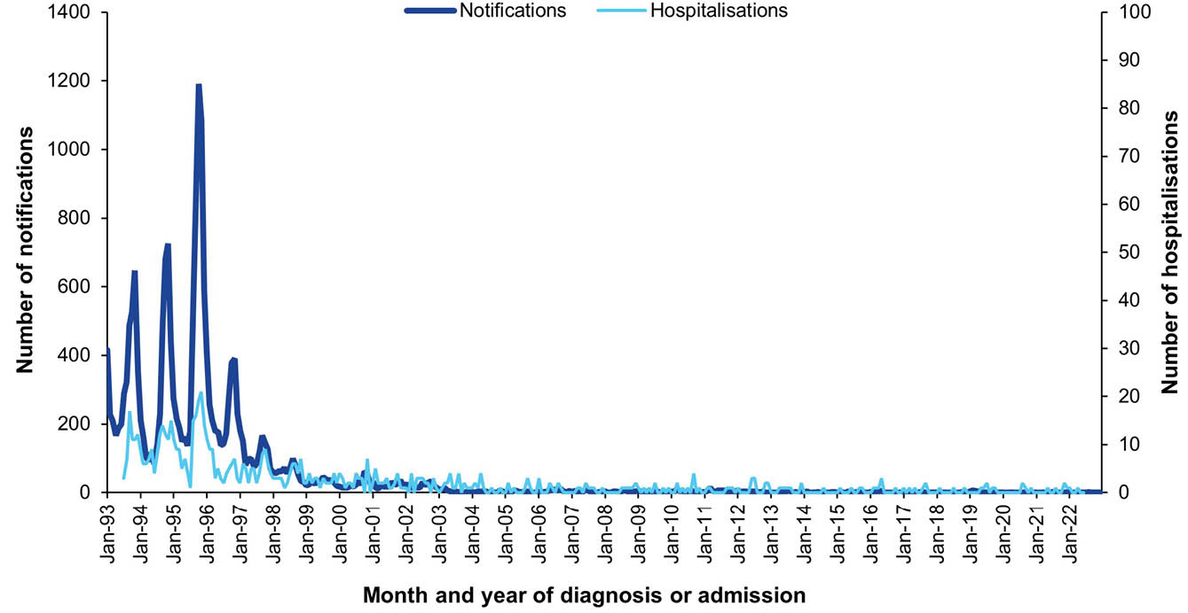
a Data sources: National Notifiable Diseases Surveillance System for notifications, and Australian Institute for Health and Welfare National Hospital Morbidity Database for hospitalisation data.
b Hospitalisations for which the month of admission was between 1 July 1993 and 30 June 2022. Hospitalisations with missing month of admission are excluded from this figure.
c Hospitalisations with the specific disease code in any of the diagnostic field positions.

17. Tetanus

Background
Tetanus is caused by an exotoxin of the Clostridium tetani bacterium, the spores of which are found in soil, dust and animal waste.²⁶⁹ Spores are inoculated into the body though a contaminated wound, and the bacteria can grow anaerobically at the wound site, producing the toxin.²⁶⁹ Tetanus is not transmissible from human to human. The disease is characterised by painful muscle contractions, primarily of the neck and jaw muscles (‘lockjaw’) which can progressively affect other parts of the body.²⁷⁰ Reported case-fatality rates vary between 25% and 70% overall, but can be higher in infants and the elderly.²⁷¹

Notifications
- A total of 13 notifications of tetanus were reported during the 2019–2022 period (Table 28).
- The average annual tetanus notification rate for the 2019–2022 period was 0.01 per 100,000 population per year, similar to the average annual notification rate of 0.02 per 100,000 population per year between 2016–2018 (RR 0.67; 95% CI: 0.29–1.53).
- Ten of the 13 tetanus notifications (76.9%) were in adults aged ≥ 65 years, with the average annual notification rate in this age group of 0.06 per 100,000 population per year. No tetanus notifications were reported in children aged < 5 years or in adults aged 25–64 years.
- Aboriginal and Torres Strait Islander status was reported for 12 of the 13 tetanus notifications (92.3%) during 2019–2022. There were no tetanus notifications reported in Aboriginal and Torres Strait Islander people.
- The annual number of tetanus notifications has remained low and relatively stable over the last 20 years, with between 1 and 9 cases reported yearly (Figure 28).

Vaccination status
- Of the 13 notifications between 2019 and 2022, vaccination data were available for 84.6% of cases (11/13); two notifications were blank. Of the 11 notifications with vaccination data available, seven (63.6%) had received no vaccine doses, one (9.1%) received a dose after the diagnosis date and one (9.1%) was vaccinated with no further information on number of doses received. The remaining two had received five doses, with the last dose being 19 years prior to diagnosis in both cases.

Hospitalisations
- There were 59 hospitalisations with tetanus in any diagnosis field between 1 January 2019 and 30 June 2022, of which 35 (59.3%) had tetanus as the principal diagnosis (Table 29). This equates to hospitalisation rates of 0.07 per 100,000 population per year and 0.04 per 100,000 population per year, respectively.
- The rates for hospitalisation with tetanus in any diagnosis field and as principal diagnosis only were not significantly different in the 2019–2022 period from those in the 2016–2018 period; rate ratios were 0.90 (95% CI: 0.62–1.32) for all-diagnoses tetanus hospitalisations and 0.70 (95% CI: 0.44–1.11) for hospitalisations with tetanus as principal diagnosis.

Principal diagnosis only
- During 2019–2022, hospitalisations with tetanus as the principal diagnosis accounted for a minimum of 372 hospital bed days. The exact length of stay was unknown (i.e. reported as > 30 days) for six hospitalisations (17.1%). The median length of stay was 5 days (IQR: 1–21 days) overall, but higher among adults aged ≥ 65 years (14 days) and children aged 5–14 years (19.5 days).
- There were no hospitalisations with tetanus as the principal diagnosis in children aged < 5 years. Seventeen hospitalisations (48.6%) were among adults aged ≥ 65 years (Table 29).
- No hospitalisations with a principal tetanus diagnosis were recorded as occurring in Aboriginal and Torres Strait Islander people.

Deaths
- 1–5 deaths coded with tetanus as underlying or associated cause of death were reported during 2019–2022, with an average annual mortality rate of 0.001 per 100,000 population per year where tetanus was the underlying cause of death (Table 29).
- All deaths occurred in adults aged ≥ 65 years. No deaths in Aboriginal and Torres Strait Islander people were reported as due to tetanus in the period.

Discussion
In the 2019–2022 period, tetanus notification and hospitalisation rates were low and similar to the 2016–2018 period.⁸ Hospitalisation rates were threefold higher than notification rates, as in previous reports, likely due to a combination of factors, such as under-notification of tetanus cases by hospitals; multiple hospital admissions or interhospital transfers for individual cases; and coding errors in the hospitalisation dataset.^{6,10}
The majority of tetanus notifications and hospitalisations in the 2019–2022 period, and all deaths, were among adults aged ≥ 65 years. In Australia, adults aged ≥ 50 years are recommended a booster dose of tetanus-containing vaccine if their last dose was more than 10 years previously.⁵⁷ However, coverage is suboptimal (estimated to be 30% in 2024).⁶³ Increasing awareness of the recommendations for older adults among the public and primary care providers may increase uptake and decrease tetanus burden.

Table 28: Tetanus notifications in Australia, by age group, sex, Aboriginal and Torres Strait Islander status and state/territory,ª 2019–2022
Category | Characteristic | Year of diagnosis
Category | Characteristic | 2019 |  | 2020 |  | 2021 |  | 2022 |  | 2019–2022
Category | Characteristic | n | Rate^{b} | n | Rate^{b} | n | Rate^{b} | n | Rate^{b} | n | Av. rate^{b,c}
Total | — | 3 | 0.01 | 7 | 0.03 | 2 | 0.01 | 1 | 0.004 | 13 | 0.01
Age group (years) | < 1 | 0 | 0 | 0 | 0 | 0 | 0 | 0 | 0 | 0 | 0
Age group (years) | 1–4 | 0 | 0 | 0 | 0 | 0 | 0 | 0 | 0 | 0 | 0
Age group (years) | 5–14 | 0 | 0 | 0 | 0 | 1 | 0.03 | 0 | 0 | 1 | 0.01
Age group (years) | 15–24 | 0 | 0 | 1 | 0.03 | 1 | 0.03 | 0 | 0 | 2 | 0.02
Age group (years) | 25–49 | 0 | 0 | 0 | 0 | 0 | 0 | 0 | 0 | 0 | 0
Age group (years) | 50–64 | 0 | 0 | 0 | 0 | 0 | 0 | 0 | 0 | 0 | 0
Age group (years) | ≥ 65 | 3 | 0.07 | 6 | 0.14 | 0 | 0 | 1 | 0.02 | 10 | 0.06
Sex | Male | 1 | 0.01 | 4 | 0.03 | 2 | 0.02 | 1 | 0.01 | 8 | 0.02
Sex | Female | 2 | 0.02 | 3 | 0.02 | 1 | 0.01 | 0 | 0 | 5 | 0.01
Aboriginal and Torres Strait Islander status | Aboriginal and Torres Strait Islander | 0 | 0 | 0 | 0 | 0 | 0 | 0 | 0 | 0 | 0
Aboriginal and Torres Strait Islander status | Other | 3 | 0.01 | 7 | 0.03 | 2 | 0.01 | 1 | 0.004 | 13 | 0.01
Jurisdiction^{d} | ACT | 0 | 0 | 0 | 0 | 0 | 0 | 0 | 0 | 0 | 0
Jurisdiction^{d} | NSW | 1 | 0.01 | 0 | 0 | 0 | 0 | 0 | 0 | 1 | 0.003
Jurisdiction^{d} | NT | 0 | 0 | 0 | 0 | 0 | 0 | 0 | 0 | 0 | 0
Jurisdiction^{d} | Qld | 1 | 0.02 | 5 | 0.10 | 0 | 0 | 0 | 0 | 6 | 0.03
Jurisdiction^{d} | SA | 1 | 0.06 | 0 | 0 | 0 | 0 | 0 | 0 | 1 | 0.01
Jurisdiction^{d} | Tas. | 0 | 0 | 0 | 0 | 0 | 0 | 0 | 0 | 0 | 0
Jurisdiction^{d} | Vic. | 0 | 0 | 1 | 0.02 | 1 | 0.02 | 1 | 0.02 | 3 | 0.01
Jurisdiction^{d} | WA | 0 | 0 | 1 | 0.04 | 1 | 0.04 | 0 | 0 | 2 | 0.02
a Data source: National Notifiable Diseases Surveillance System.
b Rates provided are the number of notifications per 100,000 population per year.
c Average annual rate per 100,000 population per year.
d ACT: Australian Capital Territory; NSW: New South Wales; NT: Northern Territory; Qld: Queensland; SA: South Australia; Tas.: Tasmania; Vic.: Victoria; WA: Western Australia.
Table 29: Tetanus hospitalisations and deaths in Australia, by age group, sex, Aboriginal and Torres Strait Islander status and state/territory,ª 2019–2022
Category | Characteristic | Hospital count and rate: year of admission^{b,c,d} |  |  |  |  |  |  |  |  |  |  |  |  |  |  |  |  |  |  |  | Deaths^{e,f}
Category | Characteristic | Any diagnosis field^{g} |  |  |  |  |  |  |  |  |  | Prinicpal diagnosis^{h} |  |  |  |  |  |  |  |  |  | Year of  death
Category | Characteristic | 2019 |  | 2020 |  | 2021 |  | 2022^{i,j} |  | 2019–2022 |  | 2019 |  | 2020 |  | 2021 |  | 2022^{i,j} |  | 2019–2022 |  | 2019–2022
Category | Characteristic | n | Rate | n | Rate | n | Rate | n | Rate | n | Av. rate^{k} | n | Rate | n | Rate | n | Rate | n | Rate | n | Av. rate^{k} | n | Av. rate^{k}
Total | — | 13 | 0.05 | 20 | 0.08 | 17 | 0.07 | 9 | 0.07 | 59 | 0.07 | NP | 0.03 | 11 | 0.04 | 11 | 0.04 | NP | 0.02 | 35 | 0.04 | 1–5 | 0.001
Age group (years) | < 1 | 0 | 0 | 0 | 0 | 1–4 | 0.33 | 0 | 0 | 1–4 | 0.08 | 0 | 0 | 0 | 0 | 0 | 0 | 0 | 0 | 0 | 0 | 0 | 0
Age group (years) | 1–4 | 0 | 0 | 0 | 0 | 0 | 0 | 0 | 0 | 0 | 0 | 0 | 0 | 0 | 0 | 0 | 0 | 0 | 0 | 0 | 0 | 0 | 0
Age group (years) | 5–14 | 0 | 0 | 0 | 0 | 1–4 | 0.06 | 0 | 0 | 1–4 | 0.02 | 0 | 0 | 0 | 0 | 1–4 | 0.06 | 0 | 0 | 1–4 | 0.02 | 0 | 0
Age group (years) | 15–24 | 1–4 | 0.09 | 1–4 | 0.06 | 1–4 | 0.13 | 1–4 | 0.13 | 11 | 0.10 | 1–4 | 0.03 | 1–4 | 0.03 | 1–4 | 0.10 | 1–4 | 0.06 | 6 | 0.06 | 0 | 0
Age group (years) | 25–49 | 1–4 | 0.01 | 7 | 0.08 | 1–4 | 0.02 | 1–4 | 0.07 | 13 | 0.04 | 1–4 | 0.01 | 1–4 | 0.03 | 1–4 | 0.01 | 1–4 | 0.02 | 6 | 0.02 | 0 | 0
Age group (years) | 50–64 | 1–4 | 0.04 | 0 | 0 | 0 | 0 | 1–4 | 0.13 | 5 | 0.04 | 1–4 | 0.02 | 0 | 0 | 0 | 0 | 1–4 | 0.13 | 1–4 | 0.04 | 0 | 0
Age group (years) | ≥ 65 | 7 | 0.17 | NP | 0.26 | 8 | 0.19 | 1–4 | 0.05 | 27 | 0.16 | 5 | 0.12 | 7 | 0.17 | 5 | 0.12 | 0 | 0 | 17 | 0.10 | 1–5 | 0.01
Sex | Male | 1–4 | 0.02 | 9 | 0.07 | 9 | 0.07 | NP | 0.11 | 28 | 0.07 | 1–4 | 0.02 | 6 | 0.05 | NP | 0.05 | 1–4 | 0.05 | 18 | 0.04 | 0 | 0
Sex | Female | NP | 0.08 | 11 | 0.09 | 8 | 0.06 | 1–4 | 0.03 | 31 | 0.06 | NP | 0.05 | 5 | 0.04 | 1–4 | 0.03 | 1–4 | 0.03 | 17 | 0.04 | 1–5 | 0.002
Aboriginal and Torres Strait Islander status | Aboriginal and Torres Strait Islander | 0 | 0 | 0 | 0 | 0 | 0 | 0 | 0 | 0 | 0 | 0 | 0 | 0 | 0 | 0 | 0 | 0 | 0 | 0 | 0 | 0 | 0
Aboriginal and Torres Strait Islander status | Other | 13 | 0.05 | 20 | 0.08 | 17 | 0.07 | 9 | 0.07 | 59 | 0.07 | 8 | 0.03 | 11 | 0.04 | 11 | 0.04 | 5 | 0.04 | 35 | 0.04 | 1–5 | 0.001
Jurisdiction^{l,m} | ACT | 0 | 0 | 1–4 | 0.22 | 0 | 0 | 0 | 0 | 1–4 | 0.06 | 0 | 0 | 1–4 | 0.22 | 0 | 0 | 0 | 0 | 1–4 | 0.06 | — | —
Jurisdiction^{l,m} | NSW | 1–4 | 0.05 | 1–4 | 0.04 | 1–4 | 0.02 | 1–4 | 0.10 | 13 | 0.05 | 1–4 | 0.02 | 0 | 0 | 1–4 | 0.01 | 1–4 | 0.05 | 5 | 0.02 | — | —
Jurisdiction^{l,m} | NT | 0 | 0 | 0 | 0 | 0 | 0 | 1–4 | 0.80 | 1–4 | 0.20 | 0 | 0 | 0 | 0 | 0 | 0 | 1–4 | 0.80 | 1–4 | 0.20 | — | —
Jurisdiction^{l,m} | Qld | 1–4 | 0.02 | 11 | 0.21 | 1–4 | 0.08 | 1–4 | 0.11 | 19 | 0.11 | 1–4 | 0.02 | 8 | 0.15 | 1–4 | 0.04 | 1–4 | 0.08 | 13 | 0.07 | — | —
Jurisdiction^{l,m} | SA | 1–4 | 0.06 | 0 | 0 | 5 | 0.28 | 1–4 | 0.11 | 7 | 0.11 | 0 | 0 | 0 | 0 | 1–4 | 0.11 | 0 | 0 | 1–4 | 0.03 | — | —
Jurisdiction^{l,m} | Tas. | 1–4 | 0.18 | 0 | 0 | 0 | 0 | 0 | 0 | 1–4 | 0.04 | 1–4 | 0.18 | 0 | 0 | 0 | 0 | 0 | 0 | 1–4 | 0.04 | — | —
Jurisdiction^{l,m} | Vic. | 1–4 | 0.06 | 1–4 | 0.05 | 1–4 | 0.03 | 0 | 0 | 9 | 0.03 | 1–4 | 0.03 | 0 | 0 | 1–4 | 0.03 | 0 | 0 | 1–4 | 0.02 | — | —
Jurisdiction^{l,m} | WA | 1–4 | 0.04 | 1–4 | 0.07 | 1–4 | 0.15 | 0 | 0 | 7 | 0.06 | 1–4 | 0.04 | 1–4 | 0.07 | 1–4 | 0.15 | 0 | 0 | 7 | 0.06 | — | —
a Data sources: Australian Institute for Health and Welfare National Hospital Morbidity Database for hospitalisation data, and Australian Coordinating Registry for death data.
b Rates provided are the number of hospitalisations or deaths per 100,000 population per year.
c To comply with the AIHW’s data release condition that hospitalisation counts < 5 be suppressed in published reports, counts between 1 and 4 are reported as a range; other cell counts may be reported as NP (not published) to avoid potential for back calculation of counts < 5.
d Year of separation used if year of admission was missing.
e Deaths where the disease code was the underlying cause of death only.
f To comply with the Australian Coordinating Registry’s data release condition that death counts < 6 be suppressed in published reports, counts between 1 and 5 are reported as a range; other cell counts may be reported as NP (not published) to avoid potential for back calculation of counts < 6.
g Hospitalisations with the specific disease code in any diagnosis field.
h Hospitalisations with the specific disease code in the principal diagnosis field only.
i Hospitalisations with admission date between 1 January and 30 June 2022.
j Hospitalisation rates for 2022 have been annualised.
k Average annual rate per 100,000 population per year.
l ACT: Australian Capital Territory; NSW: New South Wales; NT: Northern Territory; Qld: Queensland; SA: South Australia; Tas.: Tasmania; Vic.: Victoria; WA: Western Australia.
m To comply with the Australian Coordinating Registry’s data release condition that only national death counts and rates be reported, death counts and rates are not presented by state/territory.

Figure 28: Tetanus notifications and hospitalisations for all ages,^{a,b} Australia, 1998–2022, by year of diagnosis or admission
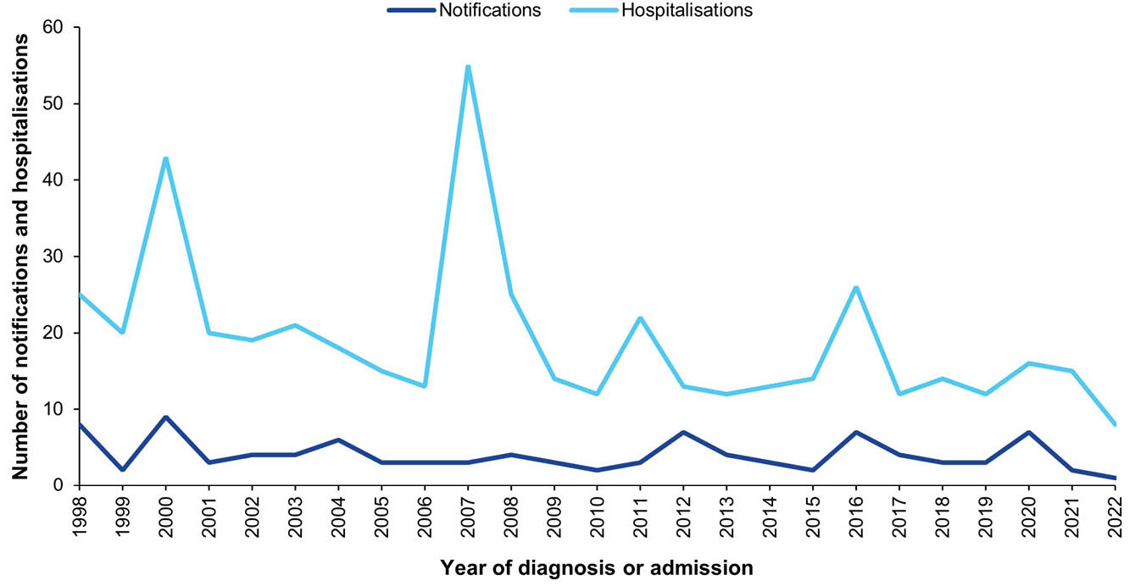
a Data sources: National Notifiable Diseases Surveillance System for notification data and the Australian Institute for Health and Welfare National Hospital Morbidity Database for hospitalisation data.
b Hospitalisations for which the year of admission was between 1998 and 2022 and with tetanus in any diagnosis field. Hospitalisation data for 2022 included hospitalisations from 1 January to 30 June only. Hospitalisations with missing year of admission are excluded from this figure.

18. Varicella

Background
Varicella, or chickenpox, is caused by primary infection with the varicella-zoster virus (VZV), a DNA virus in the herpesvirus family. This virus is transmitted via the respiratory route and is highly contagious.^{272,273} Clinically, varicella is characterised by a distinct rash and fever, which develops after an average incubation period of 14–16 days.²⁷³ While it is generally mild, it can be severe and life-threatening, particularly in infants, adults, immunocompromised and pregnant individuals.^{273,274} Complications include secondary bacterial infections of the skin, pneumonia, encephalitis and meningitis.²⁷³ Primary VZV infection during pregnancy may result in congenital varicella syndrome, characterized by ocular and neurological abnormalities and dermatomal skin lesions, or, if acquired in the last four weeks of pregnancy, neonatal varicella.²⁷⁵

Notifications
- In the 2019–2022 period, there was a total of 128,139 varicella-zoster virus (VZV) infection notifications in Australia, noting that VZV infection is not a notifiable disease in New South Wales where 31.4% of the Australian population reside.
- Of these notifications, 11,444 (8.9%) were varicella notifications. Almost half (48.5%) of the VZV infection notifications were not further specified as either varicella or zoster (shingles). Given these limitations, further reporting on VZV infection notifications is not included in this report.

Hospitalisations
- The number of monthly varicella hospitalisations has greatly reduced since 2007 (Figure 29).
- There were 2,742 hospitalisations with varicella in any diagnosis field between 1 January 2019 and 30 June 2022, of which 1,405 (51.2%) had varicella as the principal diagnosis (Table 30). This equates to average annual hospitalisation rates of 2.98 per 100,000 population per year and 1.52 per 100,000 population per year, respectively.
- The rates for hospitalisations with varicella in any diagnosis field, and as principal diagnosis only, were both lower in the 2019–2022 period than in the 2016–2018 period; rate ratios were 0.85 (95% CI: 0.81–0.90) for all-diagnoses varicella hospitalisations, and 0.82 (95% CI: 0.76–0.88) for hospitalisations with varicella as the principal diagnosis.

Principal diagnosis only
- During 2019–2022, hospitalisations with varicella as the principal diagnosis accounted for a minimum of 7,790 bed days; 20 hospitalisations (1.4%) had a length of stay > 30 days with exact length of stay unknown. Median length of stay was 3 days (IQR: 1–7 days), similar to the 2016–2018 period. Adults aged ≥ 65 years had the longest median length of stay: 6 days (IQR: 3–13 days).
- The highest average annual varicella hospitalisation rates over the 2019–2022 period were observed in infants < 1 year of age at 7.07 per 100,000 per year, and in adults aged ≥ 65 years at 2.64 per 100,000 per year (Table 30).
- Over the decade 2013–2022, varicella hospitalisation rates generally decreased over time in age groups up to 14 years of age, whereas rates remained largely stable in older age groups (Figure 30).
- Varicella hospitalisation rates were lower in 2019–2022 than in 2016–2018 in the age groups 1–4 years (RR: 0.59; 95% CI: 0.42–0.82), 5–14 years (RR: 0.67; 95% CI: 0.50–0.91), 25–49 years (RR: 0.87; 95% CI: 0.76–0.99) and ≥ 65 years (RR: 0.80; 95% CI: 0.70–0.92). Varicella hospitalisation rates remained similar across the two periods in the age groups < 1 year, 15–24 years, and 50–64 years.
- The age-standardised varicella hospitalisation rate ratio, comparing the rate among Aboriginal and Torres Strait Islander people to others, was 1.46 (95% CI: 1.08–1.92).

Deaths
- During 2019–2022, there were 67 deaths with varicella as the underlying or an associated cause of death. There were 29 deaths with varicella as the underlying cause of death, equating to a death rate of 0.03 per 100,000 population per year (Table 30).
- The varicella death rate was highest in people ≥ 65 years (0.16 per 100,000 per year).

Discussion
A single dose of varicella vaccine, documented to have moderate to high effectiveness against hospitalisation,^{276,277} was introduced onto the NIP in late 2005 and has significantly reduced the burden of severe varicella in Australia. The lower overall varicella hospitalisation rate observed in 2019–2022 compared to 2016–2018 likely demonstrates a combination of the ongoing impact of the NIP-funded varicella vaccination program and the impact of public health measures implemented in response to the COVID-19 pandemic.^{115,188}
Notwithstanding the success of the current varicella vaccination program, varicella outbreaks will occur more frequently in the setting of a one-dose vaccination program than a two-dose program.²⁷⁸ While breakthrough infections are generally mild in vaccinated cases,²⁷⁹ varicella outbreaks increase the risk of severe varicella in those not yet vaccinated (e.g. infants < 18 months of age) or unable to be vaccinated (e.g. immunocompromised individuals). Universal two-dose varicella vaccination is effective in further reducing varicella outbreaks and severe disease.^{280,281} In Australia, two doses of varicella-containing vaccine are recommended, but a second dose is not currently funded on the NIP.⁵⁷ To further reduce the burden of varicella in Australia, inclusion of a second dose of varicella-containing vaccine on the NIP, or targeted immunisation programs for people at higher risk of infection or severe disease (e.g. Aboriginal and Torres Strait Islander peoples,⁸ or migrants from countries without a universal varicella program)^{282,283} could be considered.

Table 30: Varicella hospitalisations and deaths in Australia, by age group, sex, Aboriginal and Torres Strait Islander status and state/territory,ª 2019–2022
Category | Characteristic | Hospital count and rate: year of admission^{b,c,d} |  |  |  |  |  |  |  |  |  |  |  |  |  |  |  |  |  |  |  | Deaths^{e,f}
Category | Characteristic | Any diagnosis field^{g} |  |  |  |  |  |  |  |  |  | Prinicpal diagnosis^{h} |  |  |  |  |  |  |  |  |  | Year of  death
Category | Characteristic | 2019 |  | 2020 |  | 2021 |  | 2022^{i,j} |  | 2019–2022 |  | 2019 |  | 2020 |  | 2021 |  | 2022^{i,j} |  | 2019–2022 |  | 2019–2022
Category | Characteristic | n | Rate | n | Rate | n | Rate | n | Rate | n | Av. rate^{k} | n | Rate | n | Rate | n | Rate | n | Rate | n | Av. rate^{k} | n | Av. rate^{k}
Total | — | 855 | 3.37 | 795 | 3.10 | 773 | 3.01 | 319 | 2.45 | 2,742 | 2.98 | 462 | 1.82 | 405 | 1.58 | 381 | 1.48 | 157 | 1.21 | 1,405 | 1.52 | 29 | 0.03
Age group (years) | < 1 | 35 | 11.58 | 22 | 7.42 | 21 | 7.03 | 12 | 7.86 | 90 | 8.48 | 28 | 9.26 | 16 | 5.40 | 17 | 5.69 | 12 | 7.86 | 73 | 7.07 | 0 | 0
Age group (years) | 1–4 | 36 | 2.88 | 27 | 2.18 | 27 | 2.23 | 11 | 1.83 | 101 | 2.28 | 22 | 1.76 | 14 | 1.13 | 19 | 1.57 | 5 | 0.83 | 60 | 1.33 | 0 | 0
Age group (years) | 5–14 | 39 | 1.23 | 36 | 1.12 | 31 | 0.96 | 15 | 0.92 | 121 | 1.06 | 26 | 0.82 | 23 | 0.71 | 21 | 0.65 | 9 | 0.55 | 79 | 0.68 | 0 | 0
Age group (years) | 15–24 | 55 | 1.70 | 48 | 1.50 | 39 | 1.26 | 15 | 0.95 | 157 | 1.35 | 38 | 1.17 | 34 | 1.07 | 31 | 1.00 | 8 | 0.50 | 111 | 0.94 | 0 | 0
Age group (years) | 25–49 | 236 | 2.67 | 208 | 2.33 | 181 | 2.04 | 85 | 1.90 | 710 | 2.23 | 162 | 1.83 | 132 | 1.48 | 124 | 1.39 | 50 | 1.12 | 468 | 1.45 | 0 | 0
Age group (years) | 50–64 | 126 | 2.81 | 132 | 2.89 | 132 | 2.85 | 52 | 2.22 | 442 | 2.69 | 53 | 1.18 | 81 | 1.77 | 49 | 1.06 | 28 | 1.20 | 211 | 1.30 | 1–5 | 0.01
Age group (years) | ≥ 65 | 328 | 8.13 | 322 | 7.69 | 342 | 7.93 | 129 | 5.82 | 1,121 | 7.37 | 133 | 3.30 | 105 | 2.51 | 120 | 2.78 | 45 | 2.03 | 403 | 2.64 | NP | 0.16
Sex | Male | 425 | 3.38 | 401 | 3.15 | 390 | 3.06 | 163 | 2.53 | 1,379 | 3.02 | 263 | 2.09 | 214 | 1.68 | 199 | 1.56 | 82 | 1.27 | 758 | 1.65 | 19 | 0.04
Sex | Female | 430 | 3.37 | 394 | 3.05 | 383 | 2.96 | 156 | 2.38 | 1,363 | 2.94 | 199 | 1.56 | 191 | 1.48 | 182 | 1.41 | 75 | 1.15 | 647 | 1.51 | 10 | 0.02
Aboriginal and Torres Strait Islander status | Aboriginal and Torres Strait Islander | 38 | 4.49 | 40 | 4.63 | 30 | 3.40 | 13 | 2.89 | 121 | 3.84 | 16 | 1.89 | 21 | 2.43 | 17 | 1.93 | 6 | 1.33 | 60 | 1.89 | 1–5 | 0.03
Aboriginal and Torres Strait Islander status | Other | 817 | 3.34 | 755 | 3.05 | 743 | 3.00 | 306 | 2.44 | 2,621 | 2.95 | 446 | 1.82 | 384 | 1.55 | 364 | 1.47 | 144 | 1.15 | 1,345 | 1.51 | NP | 0.03
Jurisdiction^{l,m} | ACT | 14 | 3.21 | 11 | 2.47 | NP | 1.55 | 1–4 | 1.31 | 35 | 2.12 | 8 | 1.84 | 10 | 2.25 | 1–4 | 0.88 | 1–4 | 0.88 | 24 | 1.45 | — | —
Jurisdiction^{l,m} | NSW | 258 | 3.21 | 259 | 3.19 | 248 | 3.06 | 101 | 2.47 | 866 | 2.98 | 135 | 1.68 | 122 | 1.50 | 115 | 1.42 | 46 | 1.13 | 418 | 1.43 | — | —
Jurisdiction^{l,m} | NT | 19 | 7.71 | 14 | 5.66 | 8 | 3.22 | NP | 4.80 | 47 | 5.34 | 9 | 3.65 | 7 | 2.83 | 1–4 | 1.61 | 1–4 | 3.20 | 24 | 2.82 | — | —
Jurisdiction^{l,m} | Qld | 189 | 3.71 | 193 | 3.74 | 193 | 3.70 | 64 | 2.41 | 639 | 3.38 | 92 | 1.81 | 95 | 1.84 | 95 | 1.82 | 26 | 0.98 | 308 | 1.61 | — | —
Jurisdiction^{l,m} | SA | 65 | 3.68 | 73 | 4.08 | 54 | 3.00 | 28 | 3.07 | 220 | 3.45 | 34 | 1.92 | 33 | 1.84 | 28 | 1.55 | 16 | 1.76 | 111 | 1.77 | — | —
Jurisdiction^{l,m} | Tas. | 15 | 2.74 | 19 | 3.41 | 23 | 4.05 | 11 | 3.85 | 68 | 3.52 | 11 | 2.01 | 12 | 2.15 | 12 | 2.12 | 7 | 2.45 | 42 | 2.18 | — | —
Jurisdiction^{l,m} | Vic. | 205 | 3.14 | 166 | 2.51 | 169 | 2.58 | 61 | 1.84 | 601 | 2.51 | 117 | 1.79 | 92 | 1.39 | 82 | 1.25 | 35 | 1.06 | 326 | 1.37 | — | —
Jurisdiction^{l,m} | WA | 71 | 2.67 | 54 | 1.99 | 68 | 2.47 | 43 | 3.08 | 236 | 2.56 | 45 | 1.69 | 30 | 1.11 | 38 | 1.38 | 19 | 1.36 | 132 | 1.38 | — | —
a Data sources: Australian Institute for Health and Welfare National Hospital Morbidity Database for hospitalisation data, and Australian Coordinating Registry for death data.
b Rates provided are the number of hospitalisations or deaths per 100,000 population per year.
c To comply with the AIHW’s data release condition that hospitalisation counts < 5 be suppressed in published reports, counts between 1 and 4 are reported as a range; other cell counts may be reported as NP (not published) to avoid potential for back calculation of counts < 5.
d Year of separation used if year of admission was missing.
e Deaths where the disease code was the underlying cause of death only.
f To comply with the Australian Coordinating Registry’s data release condition that death counts < 6 be suppressed in published reports, counts between 1 and 5 are reported as a range; other cell counts may be reported as NP (not published) to avoid potential for back calculation of counts < 6.
g Hospitalisations with the specific disease code in any diagnosis field.
h Hospitalisations with the specific disease code in the principal diagnosis field only.
i Hospitalisations with admission date between 1 January and 30 June 2022.
j Hospitalisation rates for 2022 have been annualised.
k Average annual rate per 100,000 population per year.
l ACT: Australian Capital Territory; NSW: New South Wales; NT: Northern Territory; Qld: Queensland; SA: South Australia; Tas.: Tasmania; Vic.: Victoria; WA: Western Australia.
m To comply with the Australian Coordinating Registry’s data release condition that only national death counts and rates be reported, death counts and rates are not presented by state/territory.

Figure 29: Varicella hospitalisations for all ages, Australia,^{a,b} July 1993 – June 2022, by month of admission
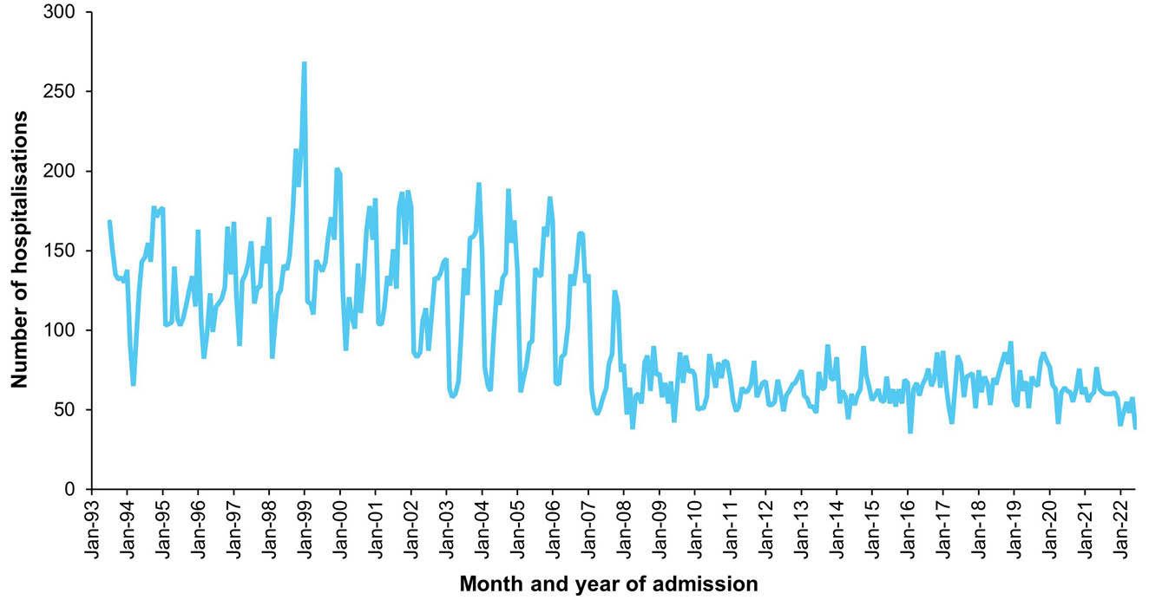
a Data source: Australian Institute of Health and Welfare National Hospital Morbidity Database.
b Hospitalisations with the specific disease code in any of the diagnostic field positions. Hospitalisations with missing month of admission are excluded from this figure.
Figure 30: Varicella hospitalisations,^{a,b} Australia, 2013–2022, by age group
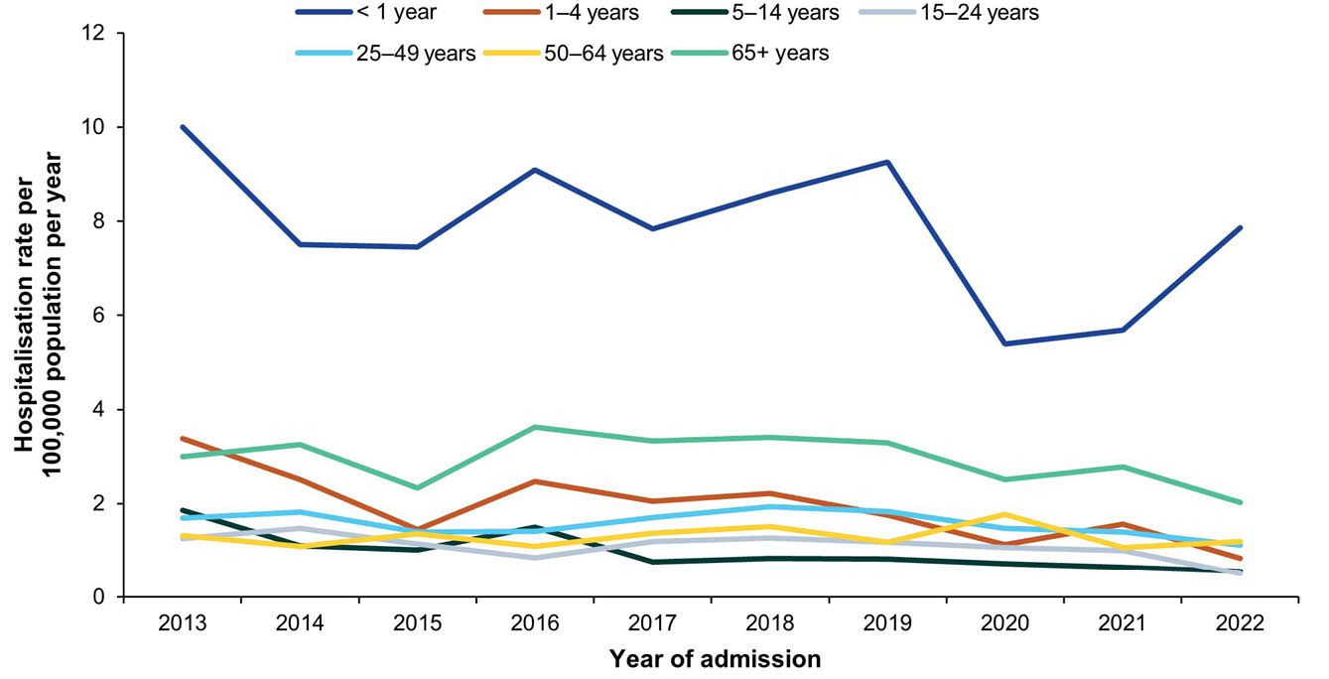
a Data source: Australian Institute of Health and Welfare National Hospital Morbidity Database.
b Hospitalisations with the specific disease code in the principal diagnostic field. Year of separation used if year of admission was missing.

19. Zoster

Background
Herpes zoster (shingles) is caused by the reactivation of the varicella-zoster virus (VZV) in a person who previously had varicella (chickenpox).²⁸⁴ VZV lays dormant in the sensory nerve ganglia and reactivation can occur due to a decline in virus-specific immunity, most commonly due to ageing, immunocompromising conditions or immunosuppressive treatment.²⁸⁵ The incidence of herpes zoster increases with age, with the lifetime risk of shingles of 50% for adults who live to 80 years of age.^{285–288} Herpes zoster infections are characterised by a unilateral vesicular rash in a dermatomal distribution. Although acute and self-limiting in most cases, herpes zoster can be followed by post-herpetic neuralgia which can be a chronic and debilitating condition.²⁸⁵ Other complications of zoster can include occult neoplasia, vasculitis and bacterial superinfection of the lesions.^{284,285}

Notifications
- In the 2019–2022 period, there were a total of 128,139 varicella-zoster virus (VZV) infection notifications in Australia, noting that VZV infection is not a notifiable disease in New South Wales, where 31.4% of the Australian population reside.
- Of these notifications, 54,547 (42.6%) were zoster notifications. Almost half (48.5%) of the VZV infection notifications were not further specified as either varicella (chickenpox) or zoster (shingles). Given the high proportion of unspecified VZV infection notifications, further reporting on zoster notifications is not included in this report.

Hospitalisations
- There were 26,566 hospitalisations with zoster in any diagnosis field between 1 January 2019 and 30 June 2022, of which 11,168 (42.0%) had zoster as the principal diagnosis (Table 31). This equates to hospitalisation rates of 29.25 per 100,000 population per year and 12.22 per 100,000 population per year, respectively.
- The rates for hospitalisation with zoster in any diagnosis field and as principal diagnosis only were significantly lower in the 2019–2022 period than in the 2016–2018 period; rate ratios were 0.90 (95% CI: 0.88–0.92) for all-diagnoses zoster hospitalisations and 0.91 (95% CI: 0.89–0.94) for hospitalisations with zoster as principal diagnosis.
- The number of hospitalisations with zoster in any diagnosis field gradually increased from 1993, but appeared to decline slightly, with wide variation between months, from August 2016 (Figure 31).

Principal diagnosis only
- The rate for hospitalisations with zoster as the principal diagnosis was highest among adults ≥ 65 years (Table 31; Figure 32). Rates in this age group increased from 58.31 per 100,000 in 2013 to 65.52 per 100,000 in 2016, before decreasing to 41.67 per 100,000 in 2022. The average annual rate of hospitalisations with zoster as the principal diagnosis was lowest among children aged 1–4 years (0.29 per 100,000 per year), infants < 1 year (0.42 per 100,000 per year) and children aged 5–14 (0.57 per 100,000 per year) (Table 31).
- During 2019–2022, hospitalisations with zoster as the principal diagnosis accounted for a minimum of 60,255 hospital bed days. The exact length of stay was unknown (i.e. reported as > 30 days) for 196 hospitalisations (1.8%). The median length of stay was 3 days overall (IQR: 1–7 days), and highest among adults aged ≥ 65 years (4 days; IQR: 1–8 days).
- The age-standardised zoster hospitalisation rate ratio, comparing the rate among Aboriginal and Torres Strait Islander people to others, was 1.55 (95% CI: 1.38–1.74) (Appendix A, Table A.3).

Deaths
- During 2019–2022, there were 551 deaths coded with zoster as underlying or associated cause of death reported, of which 208 (37.7%) were recorded with zoster being the underlying cause (Table 31).
- The rate for deaths with zoster the underlying cause was significantly higher in the 2019–2022 period than in the 2016–2018 period (RR: 1.61; 95% CI: 1.25–2.07).
- Most deaths coded with zoster as the underlying cause were among adults aged ≥ 65 years.
- There were no deaths with zoster as the underlying cause reported in Aboriginal and Torres Strait Islander people in the 2019–2022 period.

Discussion
In November 2016, a single dose of a live attenuated zoster vaccine (Zostavax) was added to the NIP for people aged 70 years, with a catch-up program for people aged 71 to 79 years.²⁸⁹ The national zoster vaccine coverage rate in adults turning 71 years old in 2022 was 41.3%,⁵⁸ with large variation between jurisdictions (21.6–52.6%). Despite relatively low coverage rates, the burden of zoster has decreased in the age group eligible for vaccination.^{290–292} The lower hospitalisation rates in the 2019–2022 period than in the 2016–2018 period are likely due to a continued decrease in zoster incidence in NIP-eligible age groups.
Deaths with zoster recorded as the underlying cause were 1.6 times higher in 2019–2022 than in the 2016–2018 period. The discrepancy between the decrease in hospitalisation rate and increase in death rate may reflect the impact of the COVID-19 pandemic on delays in seeking, and access to, healthcare which could have led to an increase in the case fatality rate.^{293,294}
Age-standardised rates of hospitalisations with zoster as the principal diagnosis were significantly higher in Aboriginal and Torres Strait Islander people compared with others. This is consistent with previous studies demonstrating higher age-specific zoster hospitalisation rates in Aboriginal and Torres Strait Islander peoples in age groups < 70 years of age who were ineligible for the Zostavax vaccine.^{8,295} A two-dose schedule of a non-live vaccine (Shingrix) replaced Zostavax on the NIP from 1 November 2023, available for a wider age-eligible cohort, including all people aged 65 years and over and Aboriginal and Torres Strait Islander peoples 50 years and over.⁵⁷ Additionally, because Shingrix does not contain live virus, it is funded for people aged 18 years and over with select immunocompromising conditions,⁵⁷ who are most vulnerable to zoster complications and in whom Zostavax was contraindicated. The expanded eligible cohort for the zoster vaccine, in addition to the higher effectiveness of Shingrix,²⁹⁶ should further reduce the burden of zoster in Australia.

Table 31: Zoster hospitalisations and deaths in Australia, by age group, sex, Aboriginal and Torres Strait Islander status and state/territory,ª 2019–2022
Category | Characteristic | Hospital count and rate: year of admission^{b,c,d} |  |  |  |  |  |  |  |  |  |  |  |  |  |  |  |  |  |  |  | Deaths^{e,f}
Category | Characteristic | Any diagnosis field^{g} |  |  |  |  |  |  |  |  |  | Prinicpal diagnosis^{h} |  |  |  |  |  |  |  |  |  | Year of  death
Category | Characteristic | 2019 |  | 2020 |  | 2021 |  | 2022^{i,j} |  | 2019–2022 |  | 2019 |  | 2020 |  | 2021 |  | 2022^{i,j} |  | 2019–2022 |  | 2019–2022
Category | Characteristic | n | Rate | n | Rate | n | Rate | n | Rate | n | Av. rate^{k} | n | Rate | n | Rate | n | Rate | n | Rate | n | Av. rate^{k} | n | Av. rate^{k}
Total | — | 7,912 | 31.23 | 7,478 | 29.15 | 7,714 | 30.03 | 3,462 | 26.63 | 26,566 | 29.25 | 3,304 | 4.48 | 3,202 | 12.48 | 3,283 | 12.78 | 1,379 | 10.61 | 11,168 | 12.22 | 208 | 0.20
Age group (years) | < 1 | 1–4 | 0.33 | 6 | 2.02 | 1–4 | 0.33 | 1–4 | 1.31 | 10 | 1.00 | 0 | 0.00 | 5 | 1.69 | 0 | 0.00 | 0 | 0.00 | 5 | 0.42 | 0 | 0
Age group (years) | 1–4 | NP | 0.72 | 7 | 0.57 | 1–4 | 0.33 | 1–4 | 0.66 | 24 | 0.57 | 1–4 | 0.24 | 1–4 | 0.32 | 1–4 | 0.25 | 1–4 | 0.33 | 12 | 0.29 | 0 | 0
Age group (years) | 5–14 | 30 | 0.94 | 30 | 0.93 | 37 | 1.14 | 16 | 0.98 | 113 | 1.00 | NP | 0.60 | NP | 0.56 | NP | 0.71 | NP | 0.43 | 67 | 0.57 | 0 | 0
Age group (years) | 15–24 | 102 | 3.15 | 122 | 3.82 | 114 | 3.67 | 42 | 2.65 | 380 | 3.32 | 51 | 1.58 | 61 | 1.91 | 61 | 1.97 | 20 | 1.26 | 193 | 1.68 | 0 | 0
Age group (years) | 25–49 | 803 | 9.08 | 817 | 9.14 | 848 | 9.54 | 354 | 7.90 | 2,822 | 8.91 | 410 | 4.63 | 396 | 4.43 | 447 | 5.03 | 188 | 4.20 | 1,441 | 4.57 | 0 | 0
Age group (years) | 50–64 | 1,314 | 29.27 | 1,196 | 26.14 | 1,235 | 26.69 | 539 | 23.04 | 4,284 | 26.25 | 600 | 13.37 | 563 | 12.31 | 601 | 12.99 | 238 | 10.17 | 2,002 | 12.19 | 1–5 | 0.01
Age group (years) | ≥ 65 | 5,653 | 140.16 | 5,300 | 126.56 | 5,475 | 126.91 | 2,505 | 112.96 | 18,933 | 126.33 | 2,221 | 55.07 | 2,155 | 51.46 | 2,148 | 49.79 | 924 | 41.67 | 7,448 | 49.33 | NP | 1.22
Sex | Male | 3,301 | 26.25 | 3,246 | 25.50 | 3,223 | 25.28 | 1,481 | 22.95 | 11,251 | 24.98 | 1,340 | 10.65 | 1,392 | 10.94 | 1,240 | 9.73 | 597 | 9.25 | 4,569 | 10.14 | 68 | 0.13
Sex | Female | 4,611 | 36.14 | 4,232 | 32.75 | 4,491 | 34.72 | 1,981 | 30.25 | 15,315 | 33.45 | 1,964 | 15.39 | 1,810 | 14.01 | 2,043 | 15.79 | 782 | 11.94 | 6,599 | 14.27 | 140 | 0.27
Aboriginal and Torres Strait Islander status | Aboriginal and Torres Strait Islander | 164 | 19.36 | 222 | 25.69 | 224 | 25.41 | 97 | 21.57 | 707 | 23.02 | 75 | 8.85 | 92 | 10.65 | 112 | 12.70 | 31 | 6.89 | 310 | 9.76 | 0 | 0.00
Aboriginal and Torres Strait Islander status | Other | 7,748 | 31.64 | 7,256 | 29.28 | 7,490 | 30.20 | 3,365 | 26.81 | 25,859 | 29.46 | 3,229 | 13.19 | 3,110 | 12.55 | 3,171 | 12.78 | 1,348 | 10.74 | 10,858 | 12.31 | 208 | 0.21
Jurisdiction^{l,m} | ACT | 112 | 25.70 | 103 | 23.15 | 125 | 27.62 | 50 | 21.89 | 390 | 24.58 | 52 | 11.93 | 45 | 10.11 | 69 | 15.25 | 17 | 7.44 | 183 | 11.17 | — | —
Jurisdiction^{l,m} | NSW | 2,527 | 31.40 | 2,277 | 28.07 | 2,393 | 29.55 | 1,020 | 24.98 | 8,217 | 28.49 | 931 | 11.57 | 864 | 10.65 | 937 | 11.57 | 346 | 8.47 | 3,078 | 10.56 | — | —
Jurisdiction^{l,m} | NT | 86 | 34.88 | 74 | 29.91 | 81 | 32.64 | 39 | 31.17 | 280 | 32.15 | 28 | 11.36 | 38 | 15.36 | 41 | 16.52 | 13 | 10.39 | 120 | 13.40 | — | —
Jurisdiction^{l,m} | Qld | 1,805 | 35.47 | 1,670 | 32.33 | 1,771 | 33.95 | 838 | 31.50 | 6,084 | 33.29 | 784 | 15.41 | 711 | 13.76 | 768 | 14.72 | 344 | 12.93 | 2,607 | 14.19 | — | —
Jurisdiction^{l,m} | SA | 516 | 29.20 | 586 | 32.73 | 485 | 26.91 | 242 | 26.58 | 1,829 | 28.84 | 197 | 11.15 | 243 | 13.57 | 180 | 9.99 | 100 | 10.98 | 720 | 11.42 | — | —
Jurisdiction^{l,m} | Tas. | 145 | 26.47 | 196 | 35.15 | 153 | 26.97 | 86 | 30.12 | 580 | 29.68 | 57 | 10.40 | 72 | 12.91 | 56 | 9.87 | 39 | 13.66 | 224 | 11.72 | — | —
Jurisdiction^{l,m} | Vic. | 2,041 | 31.22 | 1,839 | 27.80 | 1,992 | 30.42 | 869 | 26.23 | 6,741 | 28.91 | 956 | 14.62 | 918 | 13.88 | 925 | 14.13 | 384 | 11.59 | 3,183 | 13.55 | — | —
Jurisdiction^{l,m} | WA | 636 | 23.91 | 706 | 26.02 | 687 | 24.99 | 293 | 21.01 | 2,322 | 23.97 | 274 | 10.30 | 298 | 10.98 | 304 | 11.06 | 124 | 8.89 | 1,000 | 10.30 | — | —
a Data sources: Australian Institute for Health and Welfare National Hospital Morbidity Database for hospitalisation data, and Australian Coordinating Registry for death data.
b Rates provided are the number of hospitalisations or deaths per 100,000 population per year.
c To comply with the AIHW’s data release condition that hospitalisation counts < 5 be suppressed in published reports, counts between 1 and 4 are reported as a range; other cell counts may be reported as NP (not published) to avoid potential for back calculation of counts < 5.
d Year of separation used if year of admission was missing.
e Deaths where the disease code was the underlying cause of death only.
f To comply with the Australian Coordinating Registry’s data release condition that death counts < 6 be suppressed in published reports, counts between 1 and 5 are reported as a range; other cell counts may be reported as NP (not published) to avoid potential for back calculation of counts < 6.
g Hospitalisations with the specific disease code in any diagnosis field.
h Hospitalisations with the specific disease code in the principal diagnosis field only.
i Hospitalisations with admission date between 1 January and 30 June 2022.
j Hospitalisation rates for 2022 have been annualised.
k Average annual rate per 100,000 population per year.
l ACT: Australian Capital Territory; NSW: New South Wales; NT: Northern Territory; Qld: Queensland; SA: South Australia; Tas.: Tasmania; Vic.: Victoria; WA: Western Australia.
m To comply with the Australian Coordinating Registry’s data release condition that only national death counts and rates be reported, death counts and rates are not presented by state/territory.

Figure 31: Zoster hospitalisations for all ages,^{a,b} Australia, 1993–2022, by month of admission
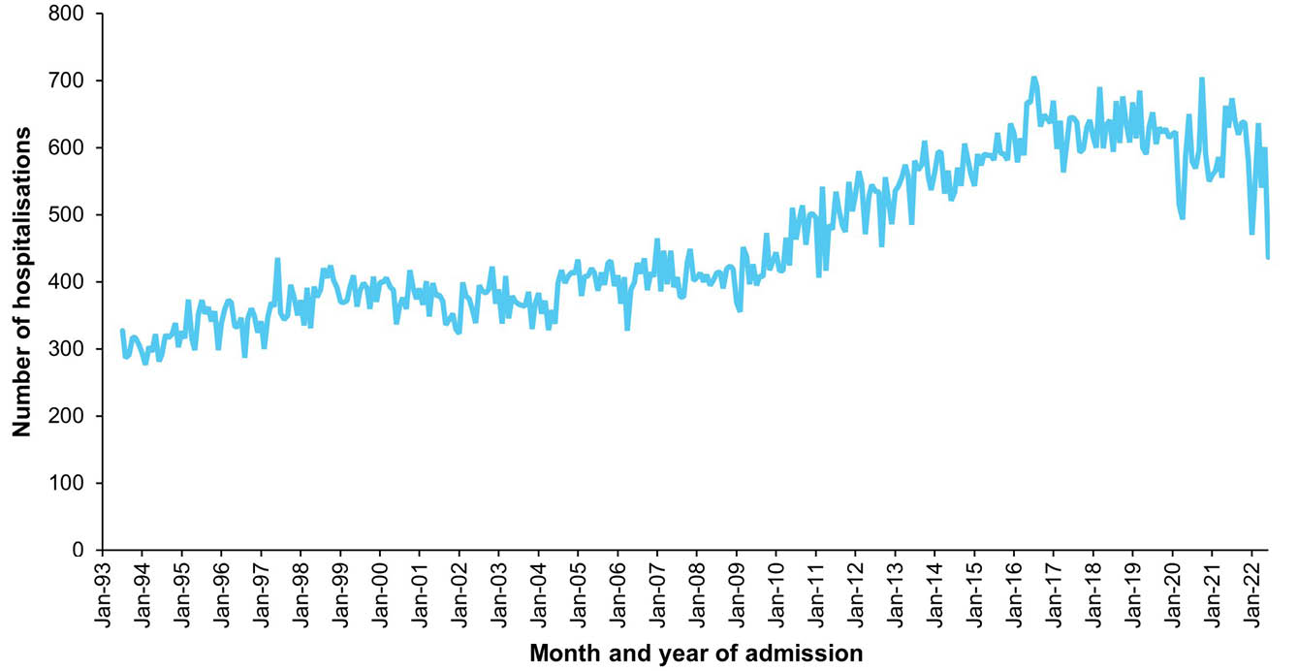
a Data source: Australian Institute for Health and Welfare National Hospital Morbidity Database.
b Hospitalisations for which the month of admission was between 1 July 1993 and 30 June 2022 and with zoster in any diagnosis field. Hospitalisations with missing month of admission are excluded from this figure.
Figure 32: Zoster hospitalisation rates,^{a,b} Australia, 2013–2022, by age group
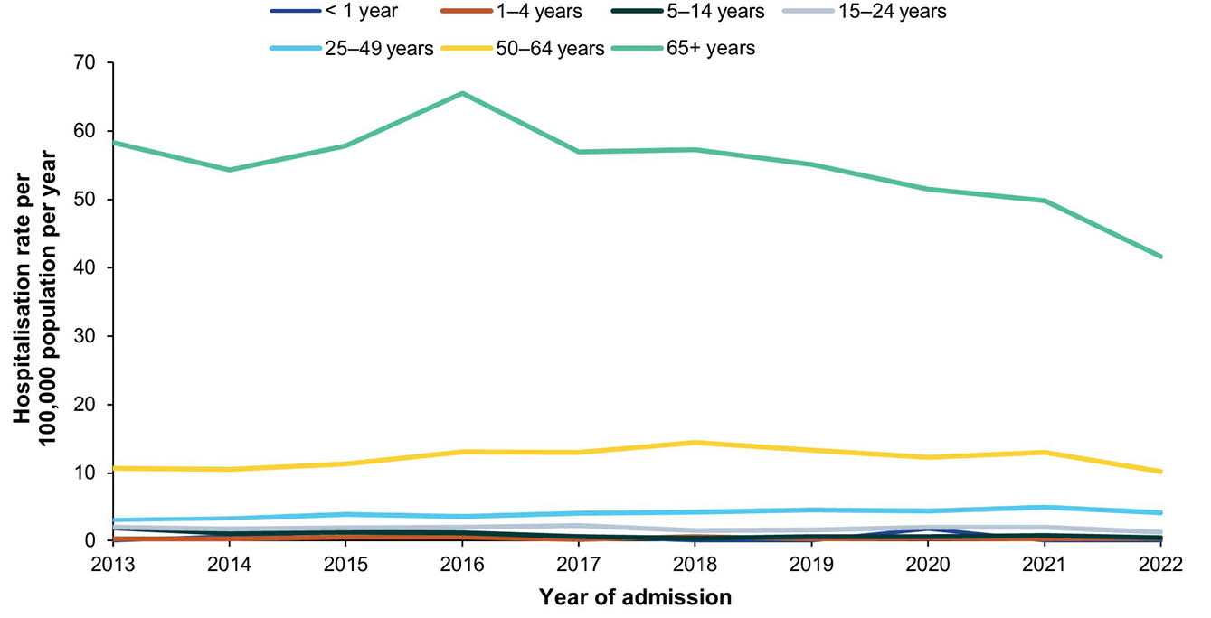
a Data source: Australian Institute for Health and Welfare National Hospital Morbidity Database.
b Hospitalisations for which the admission was between 1 July 2013 and 30 June 2022 and with zoster in the principal diagnosis field only. Year of separation used if year of admission was missing.

Acknowledgments
This report was undertaken by the National Centre for Immunisation Research and Surveillance (NCIRS), under the funding agreement between NCIRS and the Australian Government Department of Health, Disability and Ageing. NCIRS wishes to acknowledge the following individuals and organisations for their assistance with and contribution to this report:
Provision of data
The Communicable Disease Epidemiology and Surveillance Section, Health Protection Policy and Surveillance Branch, Interim Australian Centre for Disease Control, Australian Government Department of Health and Aged Care, and the Communicable Diseases Network Australia, for data from the National Notifiable Diseases Surveillance System.
The Australian Institute of Health and Welfare for data from the National Hospital Morbidity Database.
The Australian Coordinating Registry, state and territory registries of births, deaths and marriages, state and territory coroners, and the National Coronial Information System for cause of death data.
Librarianship support
Dr Catherine King (NCIRS)
Writing assistance and technical editing
Kerry-Ann O’Grady (NCIRS)

Author details
Joanne Jackson,¹
Nicole Sonneveld,^{1,2}
Han Wang,¹
Fariha Binte Hossain,¹
Aditi Dey,^{1,2}
Stephen Lambert,¹
Frank Beard^{1,2}
- National Centre for Immunisation Research and Surveillance, Westmead, New South Wales, Australia
- University of Sydney, New South Wales, Australia

Corresponding author
Joanne Jackson
National Centre for Immunisation Research and Surveillance, Westmead, New South Wales, Australia
email: joanne.jackson1@health.nsw.gov.au

References
- Brotherton J, McIntyre P, Puech M, Wang H, Gidding H, Hull B et al. Vaccine preventable diseases and vaccination coverage in Australia 2001 to 2002. Commun Dis Intell Q Rep. 2004;28(Suppl 2):vii–S116. doi: https://doi.org/10.33321/cdi.2004.28.65.
- Brotherton J, Wang H, Schaffer A, Quinn H, Menzies R, Hull B et al. Vaccine preventable diseases and vaccination coverage in Australia, 2003 to 2005. Commun Dis Intell Q Rep. 2007;31(Suppl):S1–152. doi: https://doi.org/10.33321/cdi.2007.31.25.
- Chiu C, Dey A, Wang H, Menzies R, Deeks S, Mahajan D et al. Vaccine preventable diseases in Australia, 2005 to 2007. Commun Dis Intell Q Rep. 2010;34(Supp):S1–167. doi: https://doi.org/10.33321/cdi.2010.34.48.
- Dey A, Knox S, Wang H, Beard FH, McIntyre PB. Summary of National Surveillance Data on Vaccine Preventable Diseases in Australia, 2008–2011. Commun Dis Intell Q Rep. 2016;40(Suppl):S1–70. doi: https://doi.org/10.33321/cdi.2016.40.11.
- Dey A, Wang H, Beard F, Macartney K, McIntyre P. Summary of national surveillance data on vaccine preventable diseases in Australia, 2012–2015. Commun Dis Intell (2018). 2019;43. doi: https://doi.org/10.33321/cdi.2019.43.58.
- Patel C, Dey A, Wang H, McIntyre P, Macartney K, Beard F. Summary of National Surveillance Data on Vaccine Preventable Diseases in Australia, 2016–2018 Final Report. Commun Dis Intell (2018). 2022;46. doi: https://doi.org/10.33321/cdi.2022.46.28.
- Ioannides S, Beard F, Larter N, Clark K, Wang H, Hendry A et al. Vaccine Preventable Diseases and Vaccination Coverage in Aboriginal and Torres Strait Islander People, Australia, 2011–2015. Commun Dis Intell (2018). 2019;43. doi: https://doi.org/10.33321/cdi.2019.43.36.
- Jackson J, Sonneveld N, Rashid H, Karpish L, Wallace S, Whop L et al. Vaccine Preventable Diseases and Vaccination Coverage in Aboriginal and Torres Strait Islander People, Australia, 2016–2019. Commun Dis Intell (2018). 2023;47. doi: https://doi.org/10.33321/cdi.2023.47.32.
- Naidu L, Chiu C, Habig A, Lowbridge C, Jayasinghe S, Wang H et al. Vaccine preventable diseases and vaccination coverage in Aboriginal and Torres Strait Islander people, Australia 2006–2010. Commun Dis Intell Q Rep. 2013;37(Suppl):S1–95. doi: https://doi.org/10.33321/cdi.2013.37.64.
- Morris ESG, Dey A, Vette K, Rashid H, Wood N, Beard F. Australian vaccine preventable disease epidemiological review series: tetanus 2003–2019. Commun Dis Intell (2018). 2023;47. doi: https://doi.org/10.33321/cdi.2023.47.61.
- Sonneveld N, Jackson J, Dey A, Lambert SB, Clark KK, Cowie BC et al. Australian vaccine preventable disease epidemiological review series: Hepatitis B, 2000–2019. Commun Dis Intell (2018). 2024;48. doi: https://doi.org/10.33321/cdi.2024.48.44.
- Winkler NE, Dey A, Quinn HE, Pourmarzi D, Lambert S, McIntyre P et al. Australian vaccine preventable disease epidemiological review series: measles, 2012–2019. Commun Dis Intell (2018). 2022;46. doi: https://doi.org/10.33321/cdi.2022.46.38.
- Winkler NE, Dey A, Quinn HE, Pourmarzi D, Lambert S, McIntyre P et al. Australian vaccine preventable disease epidemiological review series: diphtheria 1999–2019. Commun Dis Intell (2018). 2022;46. doi: https://doi.org/10.33321/cdi.2022.46.42.
- Australian Institute of Health and Welfare (AIHW). National Cervical Screening Program monitoring report 2024. Canberra: Australian Government, AIHW; 3 December 2024. Available from: https://www.aihw.gov.au/reports/cancer-screening/ncsp-monitoring-2024/summary.
- Bright A, Denholm J, Coulter C, Waring J, Stapledon R. Tuberculosis notifications in Australia, 2015–2018. Commun Dis Intell (2018). 2020;44. doi: https://doi.org/10.33321/cdi.2020.44.88.
- Australian Government Department of Health, Disability and Ageing. CDNA surveillance case definitions. [Webpage.] Canberra: Australian Government Department of Health, Disability and Ageing; 29 May 2022. [Accessed on 16 October 2024.] Available from: https://www.health.gov.au/resources/collections/cdna-surveillance-case-definitions#a.
- Australian Bureau of Statistics (ABS). National, state and territory population. Reference period: December 2022. [Webpage.] Canberra: ABS; 16 June 2023. [Accessed on 4 October 2024.] Available from: https://www.abs.gov.au/statistics/people/population/national-state-and-territory-population/dec-2022.
- ABS. Estimates and Projections, Aboriginal and Torres Strait Islander Australians. Reference period: 2006 to 2031. [Webpage.] Canberra: ABS; 11 July 2019. [Accessed on 4 October 2024.] Available from: https://www.abs.gov.au/statistics/people/aboriginal-and-torres-strait-islander-peoples/estimates-and-projections-aboriginal-and-torres-strait-islander-australians/2006-2031.
- AIHW. Principles on the use of direct age-standardisation in administrative data collections: for measuring the gap between Indigenous and non-Indigenous Australians. Canberra: Australian Government, AIHW; 7 October 2011. Available from: https://www.aihw.gov.au/reports/indigenous-australians/principles-on-the-use-of-direct-age-standardisatio.
- Michel JL, Cheng D, Jackson TJ. Comparing the coding of complications in Queensland and Victorian admitted patient data. Aust Health Rev. 2011;35(3):245–52. doi: https://doi.org/10.1071/AH09783.
- AIHW. Variation in hospital admission policies and practices: Australian hospital statistics. Canberra: Australian Government, AIHW; 27 November 2017. Available from: https://www.aihw.gov.au/reports/hospitals/variation-hospital-admission-policies-practices/formats.
- Perlman S, Denison MR. Chapter 17 – Coronavirus Vaccines. In Orenstein W, Offit P, Edwards KM, Plotkin S, eds. Plotkin's Vaccines. (Eighth edition). Philadelphia: Elsevier, 2023;248–57.e9. doi: https://doi.org/10.1016/B978-0-323-79058-1.00017-7.
- Hu B, Guo H, Zhou P, Shi ZL. Characteristics of SARS-CoV-2 and COVID-19. Nat Rev Microbiol. 2021;19(3):141–54. doi: https://doi.org/10.1038/s41579-020-00459-7.
- Bhatia KS, Sritharan HP, Chia J, Coifani J, Nour D, Chui K et al. Cardiac complications in patients hospitalised with COVID-19 in Australia. Heart Lung Circ. 2021;30(12):1834–40. doi: https://doi.org/10.1016/j.hlc.2021.08.001.
- Cini C, Neto AS, Burrell A, Udy A, SPRINT-SARI Australia investigators. Inter-hospital transfer and clinical outcomes for people with COVID-19 admitted to intensive care units in Australia: an observational cohort study. Med J Aust. 2023;218(10):474–81. doi: https://doi.org/10.5694/mja2.51917.
- Wurzel D, McMinn A, Hoq M, Blyth CC, Burgner D, Tosif S et al. Prospective characterisation of SARS-CoV-2 infections among children presenting to tertiary paediatric hospitals across Australia in 2020: a national cohort study. BMJ Open. 2021;11(11):e054510. doi: https://doi.org/10.1136/bmjopen-2021-054510.
- Wu C, Chen X, Cai Y, Xia J, Zhou X, Xu S et al. Risk factors associated with acute respiratory distress syndrome and death in patients with coronavirus disease 2019 pneumonia in Wuhan, China. JAMA Intern Med. 2020;180(7):934–43. doi: https://doi.org/10.1001/jamainternmed.2020.0994.
- Rasmussen SA, Jamieson DJ. COVID-19 and Pregnancy. Infect Dis Clin North Am. 2022;36(2):423–33. doi: https://doi.org/10.1016/j.idc.2022.01.002.
- Soriano JB, Murthy S, Marshall JC, Relan P, Diaz JV. A clinical case definition of post-COVID-19 condition by a Delphi consensus. Lancet Infect Dis. 2022;22(4):e102–7. doi: https://doi.org/10.1016/S1473-3099(21)00703-9.
- Wu F, Zhao S, Yu B, Chen YM, Wang W, Song ZG et al. A new coronavirus associated with human respiratory disease in China. Nature. 2020;579(7798):265–9. doi: https://doi.org/10.1038/s41586-020-2008-3.
- Zhou P, Yang XL, Wang XG, Hu B, Zhang L, Zhang W et al. A pneumonia outbreak associated with a new coronavirus of probable bat origin. Nature. 2020;579(7798):270–3. doi: https://doi.org/10.1038/s41586-020-2012-7.
- World Health Organization. (WHO). WHO Statement regarding cluster of pneumonia cases in Wuhan, China. [Online statement.] Geneva: WHO; 9 January 2020. [Accessed on 14 November 2024.] Available from: https://www.who.int/china/news/detail/09-01-2020-who-statement-regarding-cluster-of-pneumonia-cases-in-wuhan-china.
- WHO. WHO Director-General's opening remarks at the media briefing on COVID-19 – 11 March 2020. [Online statement.] Geneva: WHO; 11 March 2020. [Accessed on 14 November 2024.] Available from: https://www.who.int/director-general/speeches/detail/who-director-general-s-opening-remarks-at-the-media-briefing-on-covid-19---11-march-2020.
- Schumacher AE, Kyu HH, Aali A, Abbafati C, Abbas J, Abbasgholizadeh R et al. Global age-sex-specific mortality, life expectancy, and population estimates in 204 countries and territories and 811 subnational locations, 1950–2021, and the impact of the COVID-19 pandemic: a comprehensive demographic analysis for the Global Burden of Disease Study 2021. Lancet. 2024;403(10440):1989–2056.
doi: https://doi.org/10.1016/S0140-6736(24)00476-8.
- Milazzo A, Giles L, Parent N, McCarthy S, Laurence C. The impact of non-pharmaceutical interventions on COVID-19 cases in South Australia and Victoria. Aust N Z J Public Health. 2022;46(4):482–7. doi: https://doi.org/10.1111/1753-6405.13249.
- Shearer FM, McCaw JM, Ryan GE, Hao T, Tierney NJ, Lydeamore M et al. Estimating the impact of test–trace–isolate–quarantine systems on SARS-CoV-2 transmission in Australia. Epidemics. 2024;47:100764. doi: https://doi.org/10.1016/j.epidem.2024.100764.
- Hall RN, Jones A, Crean E, Marriott V, Pingault N, Marmor A et al. Public health interventions successfully mitigated multiple incursions of SARS-CoV-2 Delta variant in the Australian Capital Territory. Epidemiol Infect. 2023;151:e30. doi: https://doi.org/10.1017/S0950268823000201.
- Bush M, Hutchinson A, Bouchoucha SL, Bennett CM. Mapping Australia's COVID-19 quarantine cohort journeys. Infect Dis Health. 2024;29(4):233–42. doi: https://doi.org/10.1016/j.idh.2024.07.001.
- Australian Government Department of the Prime Minister and Cabinet. COVID-19 Response Inquiry Report. Canberra: Australian Government Department of the Prime Minister and Cabinet; 29 October 2024. Available from: https://www.pmc.gov.au/resources/covid-19-response-inquiry-report.
- Koirala A, Gidding HF, Vette K, Macartney K, PAEDS Serosurvey Group. The seroprevalence of SARS-CoV-2-specific antibodies in children, Australia, November 2020 – March 2021. Med J Aust. 2022;217(1):43–5. doi: https://doi.org/10.5694/mja2.51542.
- Vette KM, Machalek DA, Gidding HF, Nicholson S, O’Sullivan MVN, Carlin JB et al. Seroprevalence of severe acute respiratory syndrome coronavirus 2-specific antibodies in Australia after the first epidemic wave in 2020: a national survey. Open Forum Infect Dis. 2022;9(3):ofac002. doi: https://doi.org/10.1093/ofid/ofac002.
- Australian Government Operation COVID Shield. COVID-19 Vaccine Roll-out: 03 January 2022. [Webpage.] Canberra: Australian Government Department of Health, Disability and Ageing; 3 January 2022. [Accessed on 14 November 2024.] Available from: https://www.health.gov.au/sites/default/files/documents/2022/01/covid-19-vaccine-rollout-update-3-january-2022.pdf.
- Australian Bureau of Statistics. Deaths, Australia. Reference period: 2022. [Webpage.] Canberra: ABS; 27 September 2023. [Accessed on 5 December 2024.] Available from: https://www.abs.gov.au/statistics/people/population/deaths-australia/2022.
- ABS. COVID-19 first infectious disease in top 5 causes of death since 1970. [Media release.] Canberra: ABS; 27 September 2023. [Accessed on 5 October 2024.] Available from: https://www.abs.gov.au/media-centre/media-releases/covid-19-first-infectious-disease-top-5-causes-death-1970.
- Liu B, Stepien S, Dobbins T, Gidding H, Henry D, Korda R et al. Effectiveness of COVID-19 vaccination against COVID-19 specific and all-cause mortality in older Australians: a population based study. Lancet Reg Health West Pac. 2023;40:100928. doi: https://doi.org/10.1016/j.lanwpc.2023.100928.
- Liu B, Stepien S, Sharma K, Macartney K. Effectiveness of bivalent COVID-19 boosters against COVID-19 mortality in people aged 65 years and older, Australia, November 2022 to May 2023. Euro Surveill. 2023;28(47):2300603. doi: https://doi.org/10.2807/1560-7917.ES.2023.28.47.2300603.
- Follent D, Paulson C, Orcher P, O’Neill B, Lee D, Briscoe K et al. The indirect impacts of COVID-19 on Aboriginal communities across New South Wales. Med J Aust. 2021;214(5):199–200.e1. doi: https://doi.org/10.5694/mja2.50948.
- Yashadhana A, Pollard-Wharton N, Zwi AB, Biles B. Indigenous Australians at increased risk of COVID-19 due to existing health and socioeconomic inequities. Lancet Reg Health West Pac. 2020;1:100007. doi: https://doi.org/10.1016/j.lanwpc.2020.100007.
- Griffee MJ, Thomson DA, Fanning J, Rosenberger D, Barnett A, White NM et al. Race and ethnicity in the COVID-19 Critical Care Consortium: demographics, treatments, and outcomes, an international observational registry study. Int J Equity Health. 2023;22(1):260. doi: https://doi.org/10.1186/s12939-023-02051-w.
- Acosta AM, Wharton M. Chapter 21 – Diphtheria Toxoid. In Orenstein W, Offit P, Edwards KM, Plotkin S, eds. Plotkin's Vaccines. (Eighth edition). Philadelphia: Elsevier, 2023;298–310.e8. doi: https://doi.org/10.1016/B978-0-323-79058-1.00021-9.
- Truelove SA, Keegan LT, Moss WJ, Chaisson LH, Macher R, Azman AS et al. Clinical and epidemiological aspects of diphtheria: a systematic review and pooled analysis. Clin Infect Dis. 2020;71(1):89–97. doi: https://doi.org/10.1093/cid/ciz808.
- Slinko VG, Guglielmino CJ, Uren AM, Smith JKG, Neucom D, Smoll NR et al. Several confirmed and probable zoonotic cases of toxigenic Corynebacterium ulcerans, Queensland, Australia. Commun Dis Intell (2018). 2023;47. doi: https://doi.org/10.33321/cdi.2023.47.53.
- Wagner KS, White JM, Lucenko I, Mercer D, Crowcroft NS, Neal S et al. Diphtheria in the postepidemic period, Europe, 2000–2009. Emerg Infect Dis. 2012;18(2):217–25. doi: https://doi.org/10.3201/eid1802.110987.
- United States Centers for Disease Control and Prevention (US CDC). Diphtheria. [Webpage.] Atlanta: United States Government Department of Health and Human Services, US CDC; 2022. [Accessed on 10 October 2024.] Available from: https://www.cdc.gov/diphtheria/index.html.
- Hempenstall A, Short J, Marquardt T, Fisher V, Johnson J. Clinician alert: toxigenic diphtheria cases across North Queensland are on the rise. Med J Aust. 2023;218(5):238. doi: https://doi.org/10.5694/mja2.51858.
- Parliament of Australia, Senate Select Committee on COVID-19. Appendix 2: Timeline of key decisions and milestones. [Webpage.] Canberra: Parliament of Australia; 2022. [Accessed on 9 September 2024.]
- Australian Government Department of Health, Disability and Ageing; Australian Technical Advisory Group on Immunisation (ATAGI). Australian Immunisation Handbook. [Online resource.] Canberra: Australian Government Department of Health, Disability and Ageing; 2022. Available from: immunisationhandbook.health.gov.au.
- Hull B, Hendry A, Dey A, Brotherton J, Macartney K, Beard F. Annual Immunisation Coverage Report 2022. Commun Dis Intell (2018). 2025;49. doi: https://doi.org/10.33321/cdi.2025.49.023.
- Hasselhorn HM, Nubling M, Tiller FW, Hofmann F. Factors influencing immunity against diphtheria in adults. Vaccine. 1998;16(1):70–5.
doi: https://doi.org/10.1016/s0264-410x(97)00148-5.
- Liu D, Cheng X, Wei S, Yuan L, Chen C, Yao K. Decline of serologic immunity to diphtheria, tetanus and pertussis with age suggested a full life vaccination in mainland China. Hum Vaccin Immunother. 2021;17(6):1757–62. doi: https://doi.org/10.1080/21645515.2020.1840253.
- Maple PA, Jones CS, Wall EC, Vyseb A, Edmunds WJ, Andrews NJ et al. Immunity to diphtheria and tetanus in England and Wales. Vaccine. 2000;19(2–3):167–73. doi: https://doi.org/10.1016/s0264-410x(00)00184-5.
- McQuillan GM, Kruszon-Moran D, Deforest A, Chu SY, Wharton M. Serologic immunity to diphtheria and tetanus in the United States. Ann Intern Med. 2002;136(9):660–6. doi: https://doi.org/10.7326/0003-4819-136-9-200205070-00008.
- Hendry AJ, Quinn HE, Macartney K, Beard FH. Tetanus, pertussis, and diphtheria vaccination coverage in older adults, Australia, 2023: analysis of Australian Immunisation Register data. Med J Aust. 2024;221(4):224–5. doi: https://doi.org/10.5694/mja2.52389.
- Howard AJ, Dunkin KT, Millar GW. Nasopharyngeal carriage and antibiotic resistance of Haemophilus influenzae in healthy children. Epidemiol Infect. 1988;100(2):193–203. doi: https://doi.org/10.1017/s0950268800067327.
- McVernon J, Howard AJ, Slack MP, Ramsay ME. Long-term impact of vaccination on Haemophilus influenzae type b (Hib) carriage in the United Kingdom. Epidemiol Infect. 2004;132(4):765–7. doi: https://doi.org/10.1017/s0950268804002122.
- Jacups SP, Morris PS, Leach AJ. Haemophilus influenzae type b carriage in Indigenous children and children attending childcare centers in the Northern Territory, Australia, spanning pre- and post-vaccine eras. Vaccine. 2011;29(16):3083–8. doi: https://doi.org/10.1016/j.vaccine.2010.09.030.
- Gilbert GL, Johnson PD, Clements DA. Clinical manifestations and outcome of Haemophilus influenzae type b disease. J Paediatr Child Health. 1995;31(2):99–104. doi: https://doi.org/10.1111/j.1440-1754.1995.tb00755.x.
- Wood N, Menzies R, McIntyre P. Epiglottitis in Sydney before and after the introduction of vaccination against Haemophilus influenzae type b disease. Intern Med J. 2005;35(9):530–5. doi: https://doi.org/10.1111/j.1445-5994.2005.00909.x.
- Fitzwater SP, Kahn GD, Chandran A, Santosham M. Chapter 25 – Haemophilus influenzae Type b Vaccines. In Orenstein W, Offit P, Edwards KM, Plotkin S, eds. Plotkin's Vaccines. (Eighth edition). Philadelphia: Elsevier, 2023;348–64.e9.
doi: https://doi.org/10.1016/B978-0-323-79058-1.00025-6.
- Menzies RI, Bremner KM, Wang H, Beard FH, McIntyre PB. Long-term trends in invasive Haemophilus influenzae type B disease among Indigenous Australian children following use of PRP-OMP and PRP-T vaccines. Pediatr Infect Dis J. 2015;34(6):621–6. doi: https://doi.org/10.1097/INF.0000000000000681.
- Wang H, Deeks S, Glasswell A, McIntyre P. Trends in invasive Haemophilus influenzae type B disease in Australia, 1995–2005. Commun Dis Intell Q Rep. 2008;32(3):316–25. doi: https://doi.org/10.33321/cdi.2008.32.32.
- Maguire JE, Beard F, Méder K, Dey A, Macartney K, McIntyre P. Australian vaccine preventable disease epidemiological review series: invasive Haemophilus influenzae type b disease, 2000–2017. Commun Dis Intell (2018). 2020;44. doi: https://doi.org/10.33321/cdi.2020.44.11.
- McIntyre PB, O'Brien KL, Greenwood B, van de Beek D. Effect of vaccines on bacterial meningitis worldwide. Lancet. 2012;380(9854):1703–11.
doi: https://doi.org/10.1016/S0140-6736(12)61187-8.
- Wahl B, O'Brien KL, Greenbaum A, Majumder A, Liu L, Chu Y et al. Burden of Streptococcus pneumoniae and Haemophilus influenzae type b disease in children in the era of conjugate vaccines: global, regional, and national estimates for 2000–15. Lancet Glob Health. 2018;6(7):e744–57. doi: https://doi.org/10.1016/S2214-109X(18)30247-X.
- Shaw D, Abad R, Amin-Chowdhury Z, Bautista A, Bennett D, Broughton K et al. Trends in invasive bacterial diseases during the first 2 years of the COVID-19 pandemic: analyses of prospective surveillance data from 30 countries and territories in the IRIS Consortium. Lancet Digit Health. 2023;5(9):e582–93. doi: https://doi.org/10.1016/S2589-7500(23)00108-5.
- National Centre for Immunisation Research and Surveillance (NCIRS). Significant events in Haemophilus influenzae type b vaccination practice in Australia. Sydney: Sydney Children’s Hospitals Network; February 2024. [Accessed on 6 March 2024.]
- Walsh NM, Soeters HM, Nelson NP, Khudyakov Y, Weng MK. Chapter 26 – Hepatitis A Vaccines. In Orenstein W, Offit P, Edwards KM, Plotkin S, eds. Plotkin's Vaccines. (Eighth edition). Philadelphia: Elsevier, 2023;365–88.e15.
doi: https://doi.org/10.1016/B978-0-323-79058-1.00026-8.
- Lednar WM, Lemon SM, Kirkpatrick JW, Redfield RR, Fields ML, Kelley PW. Frequency of illness associated with epidemic hepatitis A virus infections in adults. Am J Epidemiol. 1985;122(2):226–33. doi: https://doi.org/10.1093/oxfordjournals.aje.a114093.
- Ali H, Regan DG, Guy RJ, Robertson P, Watchirs-Smith L, McNulty AM et al. Increasing hepatitis A immunity in men who have sex with men in Sydney, 1996–2012. Vaccine. 2015;33(38):4745–7. doi: https://doi.org/10.1016/j.vaccine.2015.01.090.
- Heywood AE, Newall AT, Gao Z, Wood JG, Breschkin A, Nicholson S et al. Changes in seroprevalence to hepatitis A in Victoria, Australia: a comparison of three time points. Vaccine. 2012;30(42):6020–6. doi: https://doi.org/10.1016/j.vaccine.2012.07.058.
- Jayasundara D, Hui BB, Regan DG, Heywood AE, MacIntyre CR, Wood JG. Quantifying the population effects of vaccination and migration on hepatitis A seroepidemiology in Australia. Vaccine. 2017;35(39):5228–34. doi: https://doi.org/10.1016/j.vaccine.2017.08.022.
- Burrell S, Vodstrcil LA, Fairley CK, Kilner A, Cradshaw CS, Chen MY et al. Hepatitis A vaccine uptake among men who have sex with men from a time-limited vaccination programme in Melbourne in 2018. Sex Transm Infect. 2020;96(2):110–4. doi: https://doi.org/10.1136/sextrans-2019-054132.
- NCIRS. Significant events in hepatitis A vaccination practices in Australia. Sydney: Sydney Children’s Hospitals Network; November 2025. [Accessed on 2 July 2026.]
- O'Neill C, Franklin N, Edwards A, Martin T, O’Keefe J, Jackson K et al. Hepatitis A outbreak in Australia linked to imported Medjool dates, June–September 2021. Commun Dis Intell (2018). 2022;46. doi: https://doi.org/10.33321/cdi.2022.46.68.
- Van Damme P, Ward JW, Shouval D, Zanetti A. Chapter 25 – Hepatitis B Vaccines. In Plotkin SA, Orenstein WA, Offit PA, Edwards KM, eds. Plotkin's Vaccines. (Seventh edition.) Amsterdam: Elsevier, 2018;342–74.e17.
doi: https://doi.org/10.1016/B978-0-323-35761-6.00025-0.
- McMahon BJ, Alward WL, Hall DB, Heyward WL, Bender TR, Francis DP et al. Acute hepatitis B virus infection: relation of age to the clinical expression of disease and subsequent development of the carrier state. J Infect Dis. 1985;151(4):599–603. doi: https://doi.org/10.1093/infdis/151.4.599.
- Edmunds WJ, Medley GF, Nokes DJ, Hall AJ, Whittle HC. The influence of age on the development of the hepatitis B carrier state. Proc Biol Sci. 1993;253(1337):197–201. doi: https://doi.org/10.1098/rspb.1993.0102.
- He WQ, Duong MC, Gidding H, MacLachlan J, Wood J, Kaldor JM et al. Trends in chronic hepatitis B prevalence in Australian women by country of birth, 2000 to 2016. J Viral Hepat. 2020;27(1):74–80. doi: https://doi.org/10.1111/jvh.13202.
- Graham S, MacLachlan JH, Gunaratnam P, Cowie BC. Chronic hepatitis B prevalence in Australian Aboriginal and Torres Strait Islander people before and after implementing a universal vaccination program: a systematic review and meta-analysis. Sex Health. 2019;16(3):201–11. doi: https://doi.org/10.1071/SH18150.
- Dyda A, McGregor S, Binks P, Davies J, Tong SYC, Krause V et al. Hepatitis B prevalence in women giving birth in the Northern Territory, Australia, 2005–2015. Commun Dis Intell (2018). 2022;46. doi: https://doi.org/10.33321/cdi.2022.46.62.
- Shah SHBU, Alavi M, Hajarizadeh B, Matthews GV, Martinello M, Danta M et al. Trends in decompensated cirrhosis and hepatocellular carcinoma among people with a hepatitis B notification in New South Wales. JHEP Rep. 2022;4(10):100552. doi: https://doi.org/10.1016/j.jhepr.2022.100552.
- Howell J, Pedrana A, Cowie BC, Doyle J, Getahun A, Ward J et al. Aiming for the elimination of viral hepatitis in Australia, New Zealand, and the Pacific Islands and Territories: where are we now and barriers to meeting World Health Organization targets by 2030. J Gastroenterol Hepatol. 2019;34(1):40–8. doi: https://doi.org/10.1111/jgh.14457.
- McCulloch K, Romero N, MacLachlan J, Allard N, Cowie B. Modeling progress toward elimination of hepatitis B in Australia. Hepatology. 2020;71(4):1170–81. doi: https://doi.org/10.1002/hep.30899.
- McCulloch K, Romero N, Allard N, MacLachlan JH, Cowie BC. Modelling jurisdictional disparities in the cascade of care for chronic hepatitis B in Australia: impact of treatment uptake on mortality. Aust N Z J Public Health. 2023;47(1):100011. doi: https://doi.org/10.1016/j.anzjph.2022.100011.
- Deng L, Reekie J, Hayen A, Kong M, Kaldor JM, Ward J et al. Comparison of recording of hepatitis B infection in the NSW Perinatal Data Collection with linked hepatitis B notifications. Public Health Res Pract. 2017;27(5):e2751745. doi: https://doi.org/10.17061/phrp2751745.
- Shen EX, Lambert SB, Malo JA, Bennett S, Sheridan SL, Vasant BR et al. Perinatal immunoprophylaxis in babies born to hepatitis B virus-positive mothers in Queensland Australia: a data linkage study. Vaccine. 2019;37(22):2884–8. doi: https://doi.org/10.1016/j.vaccine.2019.04.052.
- Deng HM-A, Romero N, Allard N, Rowe S, Yussf N, Cowie B. Uptake of perinatal immunoprophylaxis for infants born to women with a record of hepatitis B in Victoria (2009–2017). Vaccine. 2023;41(10):1726–34. doi: https://doi.org/10.1016/j.vaccine.2023.01.045.
- Sullivan RP, Davies J, Binks P, McKinnon M, Dhurrkay RG, Hosking K et al. Preventing early childhood transmission of hepatitis B in remote Aboriginal communities in northern Australia. Int J Equity Health. 2022;21(1):186. doi: https://doi.org/10.1186/s12939-022-01808-z.
- MacLachlan JH, Romero N, Higgins N, Coutts R, Chan R, Stephens N et al. Epidemiology of chronic hepatitis B and C in Victoria, Australia: insights and impacts from enhanced surveillance. Aust N Z J Public Health. 2020;44(1):59–64.
doi: https://doi.org/10.1111/1753-6405.12934.
- Jacob R, Prince DS, Pipicella JL, Nguyen A, Bagatella M, Alvaro F et al. Routine screening of emergency admissions at risk of chronic hepatitis (SEARCH) identifies and links hepatitis B cases to care. Liver Int. 2023;43(1):60–8. doi: https://doi.org/10.1111/liv.15414.
- Xiao Y, Hellard ME, Thompson AJ, Seaman C, Howell J, Scott N. The cost-effectiveness of universal hepatitis B screening for reaching WHO diagnosis targets in Australia by 2030. Med J Aust. 2023;218(4):168–73. doi: https://doi.org/10.5694/mja2.51825.
- Allard NL, MacLachlan JH, Tran L, Yussf N, Cowie BC. Time for universal hepatitis B screening for Australian adults. Med J Aust. 2021;215(3):103–5.e1. doi: https://doi.org/10.5694/mja2.51114.
- Sievert K, Liddle R, Tan A, Arachchi N, Valaydon Z, Allard N. Promoting hospital and primary care collaboration for timely and effective care for chronic hepatitis B in western Melbourne. Aust Health Rev. 2020;44(4):521–6. doi: https://doi.org/10.1071/AH19135.
- Hosking K, De Santis T, Vintour-Cesar E, Wilson PM, Bunn L, Gurriwiwi GG et al. “Putting the power back into community”: a mixed methods evaluation of a chronic hepatitis B training course for the Aboriginal health workforce of Australia’s Northern Territory. PLoS One. 2024;19(1):e0288577. doi: https://doi.org/10.1371/journal.pone.0288577.
- Hla TK, Bukulatjpi SM, Binks P, Gurriwiwi GG, Dhurrkay RG, Davies J et al. A “one stop liver shop” approach improves the cascade-of-care for Aboriginal and Torres Strait Islander Australians living with chronic hepatitis B in the Northern Territory of Australia: results of a novel care delivery model. Int J Equity Health. 2020;19(1):64. doi: https://doi.org/10.1186/s12939-020-01180-w.
- Taye BW, Valery PC, Liddle B, Woodward AJ, Sackey D, Williams S et al. Fitting health care to people: understanding and adapting to the epidemiology and health literacy of people affected by viral hepatitis from culturally and linguistically diverse migrant backgrounds. J Immigr Minor Health. 2022;24(5):1196–205.
doi: https://doi.org/10.1007/s10903-021-01305-5.
- Hosking K, Binks P, De Santis T, Wilson PM, Gurruwiwi GG, Bukulatjpi SM et al. Evaluating a novel model of hepatitis B care, Hep B PAST, in the Northern Territory of Australia: results from a prospective, population-based study. Lancet Reg Health West Pac. 2024;48:101116. doi: https://doi.org/10.1016/j.lanwpc.2024.101116.
- Xiao Y, Wallace J, Ahad M, van Gemert C, Thompson AJ, Doyle J et al. Assessing the feasibility, acceptability and impacts of an education program on hepatitis B testing uptake among ethnic Chinese in Australia: results of a randomised controlled pilot study. BMC Public Health. 2021;21(1):1861. doi: https://doi.org/10.1186/s12889-021-11916-0.
- Patel MM, Grohskopf LA, Sambhara S, Belser JA, Katz JM, Fry AM. Chapter 33 – Inactivated and Recombinant Influenza Vaccines. In Orenstein W, Offit P, Edwards KM, Plotkin S, eds. Plotkin's Vaccines. (Eighth edition). Philadelphia: Elsevier, 2023;514–51.e31. doi: https://doi.org/10.1016/B978-0-323-79058-1.00033-5.
- Rothberg MB, Haessler SD, Brown RB. Complications of viral influenza. Am J Med. 2008;121(4):258–64. doi: https://doi.org/10.1016/j.amjmed.2007.10.040.
- Warren-Gash C, Blackburn R, Whitaker H, McMenamin J, Hayward AC. Laboratory-confirmed respiratory infections as triggers for acute myocardial infarction and stroke: a self-controlled case series analysis of national linked datasets from Scotland. Eur Respir J. 2018;51(3):1701794. doi: https://doi.org/10.1183/13993003.01794-2017.
- Norman DA, Cheng AC, Macartney KK, Moore HC, Danchin M, Seale H et al. Influenza hospitalizations in Australian children 2010–2019: the impact of medical comorbidities on outcomes, vaccine coverage, and effectiveness. Influenza Other Respir Viruses. 2022;16(2):316–27. doi: https://doi.org/10.1111/irv.12939.
- Australian Government Department of Health, Disability and Ageing; National Notifiable Disease Surveillance System. National Communicable Disease Surveillance Dashboard. [Online resource.] Canberra: Australian Government Department of Health, Disability and Ageing; 2024. [Accessed on 12 September 2024.] Available from: https://nindss.health.gov.au/pbi-dashboard/.
- Adegbija O, Walker J, Smoll N, Khan A, Graham J, Khandaker G. Notifiable diseases after implementation of COVID-19 public health prevention measures in Central Queensland, Australia. Commun Dis Intell (2018). 2021;45. doi: https://doi.org/10.33321/cdi.2021.45.11.
- Bhatt P, Strachan J, Easton M, Franklin L, Drewett G. Effect of COVID-19 restrictions and border closures on vaccine preventable diseases in Victoria, Australia, 2020–2021. Commun Dis Intell (2018). 2022;46. doi: https://doi.org/10.33321/cdi.2022.46.29.
- O'Neill GK, Taylor J, Kok J, Dwyer DE, Dilcher M, Hua H et al. Circulation of influenza and other respiratory viruses during the COVID-19 pandemic in Australia and New Zealand, 2020–2021. Western Pac Surveill Response J. 2023;14:1–9. doi: https://doi.org/10.5365/wpsar.2023.14.3.948.
- Dhanasekaran V, Sullivan S, Edwards KM, Xie R, Khorov A, Valkenburg SA et al. Human seasonal influenza under COVID-19 and the potential consequences of influenza lineage elimination. Nat Commun. 2022;13(1):1721. doi: https://doi.org/10.1038/s41467-022-29402-5.
- WHO. Recommended composition of influenza virus vaccines for use in the 2024 southern hemisphere influenza season. [Meeting report.] Geneva: WHO; 29 September 2023. [Accessed on 16 October 2024.] Available from: https://www.who.int/publications/m/item/recommended-composition-of-influenza-virus-vaccines-for-use-in-the-2024-southern-hemisphere-influenza-season.
- Sheppeard V, Gilmour R, Tobin S. Record number of influenza tests in 2019, not a "mutant flu crisis". Med J Aust. 2019;211(7):333e1. doi: https://doi.org/10.5694/mja2.50321.
- Therapeutic Goods Administration (TGA). First combination COVID-19 and influenza self-tests approved for Australia. [Media release.] Canberra: Australian Government Department of Health, Disability and Ageing; 7 September 2022. [Accessed on 12 September 2024.] Available from: https://www.tga.gov.au/news/media-releases/first-combination-covid-19-and-influenza-self-tests-approved-australia.
- Beard F, Molnar E, Jackson J, Vette K, Clark K, Dey A et al. Evaluation of Indigenous status completeness in vaccine preventable disease notification data in the NNDSS. Commun Dis Intell (2018). 2025;49. doi:https://doi.org/10.33321/cdi.2025.49.029.
- Hull B, Hendry A, Dey A, Brotherton J, Macartney K, Beard F. Annual Immunisation Coverage Report 2020. Commun Dis Intell (2018). 2022;46. doi: https://doi.org/10.33321/cdi.2022.46.60.
- Li-Kim-Moy J, Yin JK, Blyth CC, Kesson A, Booy R, Cheng AC et al. Influenza hospitalizations in Australian children. Epidemiol Infect. 2017;145(7):1451–60. doi: https://doi.org/10.1017/S0950268816003381.
- McRae JE, McHugh L, King C, Beard FH, Blyth CC, Danchin MH et al. Influenza and pertussis vaccine coverage in pregnancy in Australia, 2016–2021. Med J Aust. 2023;218(11):528–41. doi: https://doi.org/10.5694/mja2.51989.
- McNamara LA, Pollard AJ, Harrison LH. Chapter 39 – Meningococcal Capsular Group A, C, W, and Y Conjugate Vaccines. In Orenstein W, Offit P, Edwards KM, Plotkin S, eds. Plotkin's Vaccines. (Eighth edition). Philadelphia: Elsevier, 2023;664–89.e12. doi: https://doi.org/10.1016/B978-0-323-79058-1.00039-6.
- Stephens DS, Granoff DM, Pollard AJ, Harrison LH. Chapter 40 – Meningococcal Vaccines Directed at Capsular Group B. In Orenstein W, Offit P, Edwards KM, Plotkin S, eds. Plotkin's Vaccines. (Eighth edition). Philadelphia: Elsevier, 2023;690–710.e7. doi: https://doi.org/10.1016/B978-0-323-79058-1.00040-2.
- Bertrand-Gerentes I, Fanchon L, Coste F, Glover RE, Guiddir T, Taha MK. Range of clinical manifestations caused by invasive meningococcal disease due to serogroup W: a systematic review. Infect Dis Ther. 2023;12(10):2337–51.
doi: https://doi.org/10.1007/s40121-023-00869-z.
- Sudbury EL, O'Sullivan S, Lister D, Varghese D, Satharasinghe K. Case manifestations and public health response for outbreak of meningococcal W disease, Central Australia, 2017. Emerg Infect Dis. 2020;26(7):1355–63. doi: https://doi.org/10.3201/eid2607.181941.
- Wang B, Santoreneos R, Giles L, Haji Ali Afzali H, Marshall H. Case fatality rates of invasive meningococcal disease by serogroup and age: a systematic review and meta-analysis. Vaccine. 2019;37(21):2768–82. doi: https://doi.org/10.1016/j.vaccine.2019.04.020.
- Wang B, Clarke M, Thomas N, Howell S, Afzani HHA, Marshall H. The clinical burden and predictors of sequelae following invasive meningococcal disease in Australian children. Pediatr Infect Dis J. 2014;33(3):316–8. doi: https://doi.org/10.1097/INF.0000000000000043.
- Viner RM, Booy R, Johnson H, Edmunds WJ, Hudson L, Bedford H et al. Outcomes of invasive meningococcal serogroup B disease in children and adolescents (MOSAIC): a case-control study. Lancet Neurol. 2012;11(9):774–83.
doi: https://doi.org/10.1016/S1474-4422(12)70180-1.
- Strifler L, Morris SK, Dang V, Tu HAT, Minhas RS, Jamieson FB et al. The health burden of invasive meningococcal disease: a systematic review. J Pediatric Infect Dis Soc. 2015;5(4):417–30. doi: https://doi.org/10.1093/jpids/piv065.
- Deng L, Barton B, Lorenzo J, Rashid H, Dastouri F, Booy R. Longer term outcomes following serogroup B invasive meningococcal disease. J Paediatr Child Health. 2021;57(6):894–902. doi: https://doi.org/10.1111/jpc.15350.
- McMillan M, McDonough J, Angliss M, Buttery J, Saunders L, Mathew SM et al. Exploring the health-related quality of life and the lived experience of adolescents following invasive meningococcal disease. Healthcare (Basel). 2024;12(11):1075. doi: https://doi.org/10.3390/healthcare12111075.
- Hart J, Dowse GK, Porter M, Speers DJ, Keil AD, Bew JD et al. Obstetric and neonatal invasive meningococcal disease caused by Neisseria meningitidis serogroup W, Western Australia, Australia. Emerg Infect Dis. 2024;30(2):368–71. doi: https://doi.org/10.3201/eid3002.230639.
- Birrell MT, Strachan J, Holmes NE, Stevens K, Howden BP, Franklin LJ et al. Clinical manifestations of invasive meningococcal disease in Victoria with the emergence of serogroup W and serogroup Y Neisseria meningitidis. Intern Med J. 2021;51(3):390–7. Available from: https://onlinelibrary.wiley.com/doi/abs/10.1111/imj.14771. doi: https://doi.org/10.1111/imj.14771.
- NCIRS. Significant events in meningococcal vaccination practice in Australia. Sydney: Sydney Children’s Hospitals Network; July 2020. [Accessed on 2 July 2026.]
- Ewe K, Fathima P, Effler P, Giele C, Richmond P. Impact of meningococcal ACWY vaccination program during 2017–18 epidemic, Western Australia, Australia. Emerg Infect Dis. 2024;30(2):270–8. doi: https://doi.org/10.3201/eid3002.230144.
- Alderson MR, Arkwright PD, Bai X, Black S, Borrow R, Caugant DA et al. Surveillance and control of meningococcal disease in the COVID-19 era: a Global Meningococcal Initiative review. J Infect. 2022;84(3):289–96. doi: https://doi.org/10.1016/j.jinf.2021.11.016.
- Brueggemann AB, Jansen van Rensburg MJ, Shaw D, McCarthy ND, Jolley KA, Maiden MCJ et al. Changes in the incidence of invasive disease due to Streptococcus pneumoniae, Haemophilus influenzae, and Neisseria meningitidis during the COVID-19 pandemic in 26 countries and territories in the Invasive Respiratory Infection Surveillance Initiative: a prospective analysis of surveillance data. Lancet Digit Health. 2021;3(6):e360–70. doi: https://doi.org/10.1016/S2589-7500(21)00077-7.
- Stein-Zamir C, Shoob H, Abramson N, Valinsky L, Jaffe J, Maimoun D et al. Invasive disease due to Neisseria meningitidis: surveillance and trends in Israel prior to and during the COVID-19 pandemic. Microorganisms. 2023;11(9):2212. doi: https://doi.org/10.3390/microorganisms11092212.
- Steens A, Knol MJ, Freudenburg-de Graaf W, de Melker HE, van der Ende A, van Sorge NM. Pathogen- and type-specific changes in invasive bacterial disease epidemiology during the first year of the COVID-19 pandemic in the Netherlands. Microorganisms. 2022;10(5):972. doi: https://doi.org/10.3390/microorganisms10050972.
- Robert George C, Booy R, Nissen MD, Lahra MM. The decline of invasive meningococcal disease and influenza in the time of COVID-19: the silver linings of the pandemic playbook. Med J Aust. 2022;216(10):504–7. doi: https://doi.org/10.5694/mja2.51463.
- Salomon A, Berry I, Tuite AR, Drews S, Hatchette T, Jamieson F et al. Influenza increases invasive meningococcal disease risk in temperate countries. Clin Microbiol Infect. 2020;26(9):1257.e1–7. doi: https://doi.org/10.1016/j.cmi.2020.01.004.
- Clark SA, Campbell H, Ribeiro S, Bertran M, Walsh L, Walker A et al. Epidemiological and strain characteristics of invasive meningococcal disease prior to, during and after COVID-19 pandemic restrictions in England. J Infect. 2023;87(5):385–91. doi: https://doi.org/10.1016/j.jinf.2023.09.002.
- Taha S, Hong E, Denizon M, Falguières M, Terrade A, Deghmane AE et al. The rapid rebound of invasive meningococcal disease in France at the end of 2022. J Infect Public Health. 2023;16(12):1954–60. doi: https://doi.org/10.1016/j.jiph.2023.10.001.
- Taha MK, Martinon-Torres F, Köllges R, Bonanni P, Safadi MAP, Booy R et al. Equity in vaccination policies to overcome social deprivation as a risk factor for invasive meningococcal disease. Expert Rev Vaccines. 2022;21(5):659–74. doi: https://doi.org/10.1080/14760584.2022.2052048.
- Geno KA, Gilbert GL, Song JY, Skovsted IC, Klugman KP, Jones C et al. Pneumococcal capsules and their types: past, present, and future. Clin Microbiol Rev. 2015;28(3):871–99. doi: https://doi.org/10.1128/CMR.00024-15.
- O'Brien KL, Wolfson LJ, Watt JP, Henkle E, Deloria-Knoll M, McCall N et al. Burden of disease caused by Streptococcus pneumoniae in children younger than 5 years: global estimates. Lancet. 2009;374(9693):893–902.
doi: https://doi.org/10.1016/S0140-6736(09)61204-6.
- Klugman KP, Malley R, Whitney CG. Chapter 47 – Pneumococcal Conjugate Vaccine and Pneumococcal Common Protein Vaccines. In Orenstein W, Offit P, Edwards KM, Plotkin S, eds. Plotkin's Vaccines. (Eighth edition). Philadelphia: Elsevier, 2023;826–68.e18. doi: https://doi.org/10.1016/B978-0-323-79058-1.00047-5.
- Phuong LK, Cheung A, Templeton T, Abebe T, Ademi Z, Buttery J et al. Epidemiology of childhood invasive pneumococcal disease in Australia: a prospective cohort study. Arch Dis Child. 2024;110(1):52–8. doi: https://doi.org/10.1136/archdischild-2024-327497.
- Dagan R, van der Beek BA, Ben-Shimol S, Greenberg D, Shemer-Avni Y, Weinberger DM et al. The COVID-19 pandemic as an opportunity for unravelling the causative association between respiratory viruses and pneumococcus-associated disease in young children: a prospective study. EBioMedicine. 2023;90:104493. doi: https://doi.org/10.1016/j.ebiom.2023.104493.
- Rybak A, Levy C, Angoulvant F, Auvrignon A, Gembara P, Danis K et al. Association of nonpharmaceutical interventions during the COVID-19 pandemic with invasive pneumococcal disease, pneumococcal carriage, and respiratory viral infections among children in France. JAMA Netw Open. 2022;5(6):e2218959. doi: https://doi.org/10.1001/jamanetworkopen.2022.18959.
- Williams PCM, Howard-Jones A, Butters C, Koirala A, Britton PN, Duguid R et al. Clinical and epidemiologic profile of invasive pneumococcal disease in Australian children following the relaxation of nonpharmaceutical interventions against SARS-CoV-2. Pediatr Infect Dis J. 2023;42(9):e341–2. doi: https://doi.org/10.1097/INF.0000000000003972.
- Homaira N, Strachan R, Quinn H, Beggs S, Bhuiyan M, Bowen A et al. Real world impact of 13vPCV in preventing invasive pneumococcal pneumonia in Australian children: a national study. Vaccine. 2023;41(1):85–91. doi: https://doi.org/10.1016/j.vaccine.2022.11.006.
- Izurieta P, Bahety P, Adegbola R, Clarke C, Hoet B. Public health impact of pneumococcal conjugate vaccine infant immunization programs: assessment of invasive pneumococcal disease burden and serotype distribution. Expert Rev Vaccines. 2018;17(6):479–93. doi: https://doi.org/10.1080/14760584.2018.1413354.
- Mungall BA, Hoet B, Nieto Guevara J, Soumahoro L. A systematic review of invasive pneumococcal disease vaccine failures and breakthrough with higher-valency pneumococcal conjugate vaccines in children. Expert Rev Vaccines. 2022;21(2):201–14. doi: https://doi.org/10.1080/14760584.2022.2012455.
- Grant LR, Slack MPE, Theilacker C, Vojicic J, Dion S, Reinert RR et al. Distribution of serotypes causing invasive pneumococcal disease in older adults from high-income countries and impact of pediatric and adult vaccination policies. Vaccine. 2023;41(38):5662–9. doi: https://doi.org/10.1016/j.vaccine.2023.08.001.
- Binte Hossain F, Muscatello D, Jayasinghe S, Jonnagaddala J, Liu B. Uptake of pneumococcal vaccines in older Australian adults before and after universal public funding of PCV13. Vaccine. 2024;42(12):3084–90. doi: https://doi.org/10.1016/j.vaccine.2024.04.012.
- Nakashima K, Fukushima W. Strategies for pneumococcal vaccination in older adults in the coming era. Hum Vaccin Immunother. 2024;20(1):2328963. doi: https://doi.org/10.1080/21645515.2024.2328963.
- Hjuler T, Wohlfahrt J, Simonsen J, Kaltoft MS, Koch A, Kamper-Jørgensen M et al. Perinatal and crowding-related risk factors for invasive pneumococcal disease in infants and young children: a population-based case-control study. Clin Infect Dis. 2007;44(8):1051–6. doi: https://doi.org/10.1086/512814.
- Schoenmakers MC.J, Hament JM, Fleer A, Aerts PC, van Dijk H, Kimpen JLL et al. Risk factors for invasive pneumococcal disease. Rev Medical Microbiol. 2002;13(1):29–36.
- Berry I, Tuite AR, Salomon A, Drews S, Harris AD, Hatchette T et al. Association of influenza activity and environmental conditions with the risk of invasive pneumococcal disease. JAMA Netw Open. 2020;3(7):e2010167. doi: https://doi.org/10.1001/jamanetworkopen.2020.10167.
- Halstead SB, Hills SL, Marfin AA, Solomon T. Chapter 35 – Japanese Encephalitis Vaccines. In Orenstein W, Offit P, Edwards KM, Plotkin S, eds. Plotkin's Vaccines. (Eighth edition). Philadelphia: Elsevier, 2023;577–607.e11.
doi: https://doi.org/10.1016/B978-0-323-79058-1.00035-9.
- Impoinvil DE, Baylis M, Solomon T. Japanese encephalitis: on the One Health agenda. Curr Top Microbiol Immunol. 2013;365:205–47. doi: https://doi.org/10.1007/82_2012_243.
- Campbell GL, Hills SL, Fischer M, Jacobson JA, Hoke CH, Hombach JM et al. Estimated global incidence of Japanese encephalitis: a systematic review. Bull World Health Organ. 2011;89(10):766–74, 74A–74E. doi: https://doi.org/10.2471/BLT.10.085233.
- Mackenzie JS, Williams DT, van den Hurk AF, Smith DW, Currie BJ. Japanese encephalitis virus: the emergence of genotype IV in Australia and its potential endemicity. Viruses. 2022;14(11):2480. doi: https://doi.org/10.3390/v14112480.
- McGuinness SL, Lau CL, Leder K. The evolving Japanese encephalitis situation in Australia and implications for travel medicine. J Travel Med. 2023;30(2):taad029. doi: https://doi.org/10.1093/jtm/taad029.
- Waller C, Tiemensma M, Currie BJ, Williams DT, Baird RW, Krause VL. Japanese encephalitis in Australia – a sentinel case. N Engl J Med. 2022;387(7):661–2. doi: https://doi.org/10.1056/NEJMc2207004.
- Australian Government Department of Health, Disability and Ageing. Japanese encephalitis virus situation declared a Communicable Disease Incident of National Significance. [Media release.] Canberra: Australian Government Department of Health, Disability and Ageing; 4 March 2022. [Accessed on 5 December 2024.] Available from: https://www.health.gov.au/news/japanese-encephalitis-virus-situation-declared-a-communicable-disease-incident-of-national-significance.
- Chen WR, Rico-Hesse R, Tesh RB. A new genotype of Japanese encephalitis virus from Indonesia. Am J Trop Med Hyg. 1992;47(1):61–9. doi: https://doi.org/10.4269/ajtmh.1992.47.61.
- Schuh AJ, Guzman H, Tesh RB, Barrett AD. Genetic diversity of Japanese encephalitis virus isolates obtained from the Indonesian archipelago between 1974 and 1987. Vector Borne Zoonotic Dis. 2013;13(7):479–88. doi: https://doi.org/10.1089/vbz.2011.0870.
- Baldwin Z, Hueston L, Roberts-Witteveen A, Stanley P, Sheel M, Winkler N et al. The seroprevalence of antibodies to Japanese encephalitis virus in five New South Wales towns at high risk of infection, 2022: a cross-sectional serosurvey. Med J Aust. 2024;220(11):561–5. doi: https://doi.org/10.5694/mja2.52320.
- Marsland MJ, Thomson TN, O'Brien HM, Peach E, Bellette J, Humphreys N et al. Serosurvey for Japanese encephalitis virus antibodies following an outbreak in an immunologically naive population, Victoria, 2022: a cross-sectional study. Med J Aust. 2024;220(11):566–72. doi: https://doi.org/10.5694/mja2.52344.
- Moss WJ. Measles. Lancet. 2017;390(10111):2490–502.
doi: https://doi.org/10.1016/S0140-6736(17)31463-0.
- Moss WJ, Strebel PM. Chapter 38 – Measles Vaccines. In Orenstein W, Offit P, Edwards KM, Plotkin S, eds. Plotkin's Vaccines. (Eighth edition). Philadelphia: Elsevier, 2023;629–63.e19. doi: https://doi.org/10.1016/B978-0-323-79058-1.00038-4.
- Hübschen JM, Gouandjika-Vasilache I, Dina J. Measles. Lancet. 2022;399(10325):678–90. doi: https://doi.org/10.1016/S0140-6736(21)02004-3.
- Gidding HF, Martin NV, Stambos V, Tran T, Dey A, Dowse GK et al. Verification of measles elimination in Australia: application of World Health Organization regional guidelines. J Epidemiol Glob Health. 2016;6(3):197–209. doi: https://doi.org/10.1016/j.jegh.2015.12.004.
- Auckland Regional Public Health Service (ARPHS). Measles outbreak in Auckland. [Webpage.] Auckland: ARPHS; 2019. [Accessed on 9 September 2024.] Available from: https://www.arphs.health.nz/health-professional-advice-and-alerts/measles-outbreak-in-auckland-34-cases-at-1-may/.
- Alexander KE, Wickens M, Fletcher-Lartey SM. Measles elimination in Australia: hard won, easily lost. Aust J Gen Pract. 2020;49(3):112–4.
doi: https://doi.org/10.31128/AJGP-11-19-5147.
- Craig AT, Heywood AE, Worth H. Measles epidemic in Samoa and other Pacific islands. Lancet Infect Dis. 2020;20(3):273–5. doi: https://doi.org/10.1016/S1473-3099(20)30053-0.
- Williamson KM, Merritt T, Durrheim DN. Australia: an island in a sea of measles. Med J Aust. 2020;213(3):101–3.e1. doi: https://doi.org/10.5694/mja2.50650.
- Durrheim DN, Andrus JK, Tabassum S, Bashour H, Githanga D, Pfaff G. A dangerous measles future looms beyond the COVID-19 pandemic. Nat Med. 2021;27(3):360–1. doi: https://doi.org/10.1038/s41591-021-01237-5.
- Torjesen I. Measles outbreaks likely as covid pandemic leaves millions of world's children unvaccinated, WHO warns. BMJ. 2021;375:n2755. doi: https://doi.org/10.1136/bmj.n2755.
- Minta AA, Ferrari M, Antoni S, Portnoy S, Sbarra A, Lambert B et al. Progress toward measles eimination – worldwide, 2000–2022. MMWR Morb Mortal Wkly Rep. 2023;72(46):1262–8. doi: https://doi.org/10.15585/mmwr.mm7246a3.
- Hviid A, Rubin S, Mühlemann K. Mumps. Lancet. 2008;371(9616):932–44. doi: https://doi.org/10.1016/S0140-6736(08)60419-5.
- Rubin SA. Chapter 41 – Mumps Vaccines. In Orenstein W, Offit P, Edwards KM, Plotkin S, eds. Plotkin's Vaccines. (Eighth edition). Philadelphia: Elsevier, 2023;663–88.e11. doi: https://doi.org/10.1016/B978-0-323-79058-1.00041-4.
- Storen R, Corrigan N. COVID-19: a chronology of state and territory government announcements (up until 30 June 2020). Canberra: Parliament of Australia, Department of Parliamentary Services; 22 October 2020. [Accessed on 19 June 2024.] Available from: https://www.aph.gov.au/About_Parliament/Parliamentary_departments/Parliamentary_Library/Research/Chronologies/2020-21/COVID-19StateTerritoryGovernmentAnnouncements.
- Di Pietrantonj C, Rivetti A, Marchione P, Debalini MG, Demicheli V. Vaccines for measles, mumps, rubella, and varicella in children. Cochrane Database Syst Rev. 2021;11(11):CD004407. doi: https://doi.org/10.1002/14651858.CD004407.pub5.
- Eriksen J, Davidkin I, Kafatos G, Andrews N, Barbara C, Cohen D et al. Seroepidemiology of mumps in Europe (1996–2008): why do outbreaks occur in highly vaccinated populations? Epidemiol Infect. 2013;141(3):651–66. doi: https://doi.org/10.1017/S0950268812001136.
- McLean HQ, Fiebelkorn AP, Temte JL, Wallace GS. Prevention of measles, rubella, congenital rubella syndrome, and mumps, 2013: summary recommendations of the Advisory Committee on Immunization Practices (ACIP). MMWR Recomm Rep. 2013;62(RR-04):1–34. Available from: https://www.cdc.gov/mmwr/preview/mmwrhtml/rr6204a1.htm.
- Gokhale DV, Brett TS, He B, King AA, Rohani P. Disentangling the causes of mumps reemergence in the United States. Proc Natl Acad Sci U S A. 2023;120(3):e2207595120. doi: https://doi.org/10.1073/pnas.2207595120.
- Rubin SA, Link MA, Sauder CJ, Zhang C, Ngo L, Rima BK et al. Recent mumps outbreaks in vaccinated populations: no evidence of immune escape. J Virol. 2012;86(1):615–20. doi: https://doi.org/10.1128/JVI.06125-11.
- Cardemil CV, Dahl RM, James L, Wannemuehler K, Gary HE, Shah M et al. Effectiveness of a third dose of MMR vaccine for mumps outbreak control. N Engl J Med. 2017;377(10):947–56. doi: https://doi.org/10.1056/NEJMoa1703309.
- Guo A, Leung J, Ayers T, Fields VS, Safi H, Waters C et al. Mumps vaccine effectiveness of a 3rd dose of measles, mumps, rubella vaccine in school settings during a mumps outbreak—Arkansas, 2016–2017. Public Health Pract (Oxf). 2023;6:100404. doi: https://doi.org/10.1016/j.puhip.2023.100404.
- Walker J, Adegbija O, Smoll N, Khan A, Whicker J, Carroll H et al. Epidemiology of mumps outbreaks and the impact of an additional dose of MMR vaccine for outbreak control in regional Queensland, Australia, 2017–2018. Commun Dis Intell (2018). 2021;45. doi: https://doi.org/10.33321/cdi.2021.45.67.
- Edwards KM, Decker MD. Chapter 44 – Pertussis Vaccines. In Plotkin SA, Orenstein WA, Offit PA, Edwards KM, eds. Plotkin's Vaccines. (Seventh edition.) Amsterdam: Elsevier, 2018;711–61.e16. doi: https://doi.org/10.1016/B978-0-323-35761-6.00043-2.
- Heininger U, Klich K, Stehr K, Cherry JD. Clinical findings in Bordetella pertussis infections: results of a prospective multicenter surveillance study. Pediatrics. 1997;100(6):e10. doi: https://doi.org/10.1542/peds.100.6.e10.
- Havers FP, Moro PL, Hariri S, Skoff T. Pertussis. In Hall E, Wodi AP, Hamborsky J, Morelli V, Schillie S, eds. Epidemiology and Prevention of Vaccine-Preventable Diseases (the ‘Pink Book’) (14th edition). Washington DC: United States Centers for Disease Control and Prevention, Public Health Foundation, 2021.
- Postels-Multani S, Schmitt HJ, Wirsing von König CH, Bock HL, Bogaerts H. Symptoms and complications of pertussis in adults. Infection. 1995;23(3):139–42. doi: https://doi.org/10.1007/BF01793853.
- van der Kooi S, Beard F, Dey A, McIntyre P, Imai C, Amin J. Pertussis notifications decline in Australia during COVID-19 non-pharmaceutical interventions, 2020–2021. Commun Dis Intell (2018). 2024;48. doi: https://doi.org/10.33321/cdi.2024.48.24.
- Marshall KS, Quinn HE, Pillsbury AJ, Maguire JE, Lucas RM, Dey A et al. Australian vaccine preventable disease epidemiological review series: pertussis, 2013–2018. Commun Dis Intell (2018). 2022;46. doi: https://doi.org/10.33321/cdi.2022.46.3.
- NCIRS. Significant events in diphtheria, tetanus and pertussis vaccination practice in Australia. Sydney: Sydney Children’s Hospitals Network; April 2024. [Accessed on 20 June 2024.]
- European Centre for Disease Prevention and Control (ECDC). Rapid risk assessment: Increase of pertussis cases in the EU/EEA: 8 May 2024. Stockholm: ECDC; 8 May 2024. [Accessed on 20 June 2024.]
- Smout E, Mellon D, Rae M. Whooping cough rises sharply in UK and Europe. BMJ. 2024;385:q736. doi: https://doi.org/10.1136/bmj.q736.
- McHugh L, D'Antoine HA, Sarna M, Binks MJ, Moore HC, Andrews RM et al. The effectiveness of maternal pertussis vaccination for protecting Aboriginal and Torres Strait Islander infants against infection, 2012–2017: a retrospective cohort study. Med J Aust. 2024;220(4):196–201. doi: https://doi.org/10.5694/mja2.52220.
- McHugh L, Regan AK, Sarna M, Moore HC, Van Buynder P, Pereira G et al. Inequity of antenatal influenza and pertussis vaccine coverage in Australia: the Links2HealthierBubs record linkage cohort study, 2012–2017. BMC Pregnancy Childbirth. 2023;23(1):314. doi: https://doi.org/10.1186/s12884-023-05574-w.
- Regan AK, Moore HC, Binks MJ, McHugh L, Blyth CC, Pereira G et al. Maternal pertussis vaccination, infant immunization, and risk of pertussis. Pediatrics. 2023;152(5):e2023062664. doi: https://doi.org/10.1542/peds.2023-062664.
- Quinn HE, Comeau JL, Marshall HS, Elliott EJ, Crawford NW, Blyth CC et al. Pertussis disease and antenatal vaccine effectiveness in Australian children. Pediatr Infect Dis J. 2022;41(3):180–5. doi: https://doi.org/10.1097/INF.0000000000003367.
- Jayasundara D, Randall D, Sheridan S, Sheppeard V, Liu B, Richmond PC et al. Estimating the excess burden of pertussis disease in Australia within the first year of life, that might have been prevented through timely vaccination. Int J Epidemiol. 2023;52(1):250–9. doi: https://doi.org/10.1093/ije/dyac175.
- Staff M, Nyinawingeri A, Denniss K, Ingleton A, Jeffs J, Corben P. Pertussis morbidity in children 12–59 months of age: a NSW Public Health Network study. Pediatr Infect Dis J. 2019;38(6):553–8. doi: https://doi.org/10.1097/INF.0000000000002234.
- Pearce R, Chen J, Chin KL, Guignard A, Latorre LA, MacIntyre CR et al. Population-based study of pertussis incidence and risk factors among persons > 50 Years of age, Australia. Emerg Infect Dis. 2024;30(1):105–15. doi: https://doi.org/10.3201/eid3001.230261.
- Hoe Nam L, Chiu CH, Heo JY, Ip M, Jung KS, Menzies R et al. The need for pertussis vaccination among older adults and high-risk groups: a perspective from advanced economies of the Asia Pacific region. Expert Rev Vaccines. 2021;20(12):1603–17. doi: https://doi.org/10.1080/14760584.2021.1990759.
- Leong RNF, Wood JG, Liu B, McIntyre PB, Newall AT. High healthcare resource utilisation due to pertussis in Australian adults aged 65 years and over. Vaccine. 2020;38(19):3553–9. doi: https://doi.org/10.1016/j.vaccine.2020.03.021.
- Estivariz CF, Burns CC, Macklin GR. Chapter 50 – Poliovirus Vaccine – Live. In Orenstein W, Offit P, Edwards KM, Plotkin S, eds. Plotkin's Vaccines. (Eighth edition). Philadelphia: Elsevier, 2023;914–68.e17. doi: https://doi.org/10.1016/B978-0-323-79058-1.00050-5.
- Estivariz CF, Link-Gelles R, Shimabukuro T. Poliomyelitis. In Hall E, Wodi AP, Hamborsky J, Morelli V, Schillie S, eds. Epidemiology and Prevention of Vaccine-Preventable Diseases (the ‘Pink Book’) (14th edition). Washington DC: United States Centers for Disease Control and Prevention, Public Health Foundation, 2021.
- World Health Organization (WHO). Polio vaccines: WHO position paper – June 2022. Wkly Epidemiol Rec. 2022;97(25):277–300. Geneva: WHO; 24 June 2022. Available from: https://www.who.int/publications/i/item/WHO-WER9725-277-300.
- Adams T. Farewell to polio in the Western Pacific. Bull World Health Organ. 2000;78(12):1375. Available from: https://pmc.ncbi.nlm.nih.gov/articles/PMC2560664/.
- D'Souza RM, Kennett M, Watson C. Australia declared polio free. Commun Dis Intell Q Rep. 2002;26(2):253–60. doi: https://doi.org/10.33321/cdi.2002.26.22.
- Global Polio Eradication Initiative. Surveillance Indicators. [Webpage.] Geneva: WHO; 1 May 2024. [Accessed on 30 May 2024.] Available from: https://polioeradication.org/what-we-do/surveillance-indicators/.
- Teutsch SM, Nunez CA, Morris A, Eslick GD, Berkhout A, Novakovic D et al. Australian Paediatric Surveillance Unit (APSU) annual surveillance report 2021. Commun Dis Intell (2018). 2022;46. doi: https://doi.org/10.33321/cdi.2022.46.66.
- Teutsch SM, Nunez CA, Morris A, Eslick GD, Elliott EJ. Australian Paediatric Surveillance Unit (APSU) annual surveillance report 2022. Commun Dis Intell (2018). 2023;47. doi: https://doi.org/10.33321/cdi.2023.47.46.
- Teutsch SM, Nunez CA, Morris A, Eslick GD, Khandaker G, Berkhout A et al. Australian Paediatric Surveillance Unit (APSU) annual surveillance report 2020. Commun Dis Intell (2018). 2021;45. doi: https://doi.org/10.33321/cdi.2021.45.59.
- Teutsch SM, Nunez CA, Morris A, McGregor S, King J, Brotherton JM et al. Australian Paediatric Surveillance Unit (APSU) annual surveillance report 2019. Commun Dis Intell (2018). 2020;44. doi: https://doi.org/10.33321/cdi.2020.44.60.
- Kaye M, Hobday L, Ibrahim A, Bruggink L, Thorley B. Australian National Enterovirus Reference Laboratory annual report, 2022. Commun Dis Intell (2018). 2023;47. doi: https://doi.org/10.33321/cdi.2023.47.35.
- Global Polio Eradication Initiative. Who We Are. [Webpage.] Geneva: WHO. [Accessed on 29 August 2024.] Available from: https://polioeradication.org/who-we-are/.
- Global Polio Eradication Initiative. The Virus. [Webpage.] Geneva: WHO; 7 October 2016. [Accessed on 3 June 2024.] Available from: https://polioeradication.org/polio-today/polio-prevention/the-virus/.
- Global Polio Eradication Initiative. Global Wild Poliovirus 2018–2024. Geneva: WHO; 22 May 2024. [Accessed on 3 June 2024.] Available from: https://polioeradication.org/wp-content/uploads/2024/05/weekly-polio-analyses-WPV-20240521.pdf.
- Hill M, Bandyopadhyay AS, Pollard AJ. Emergence of vaccine-derived poliovirus in high-income settings in the absence of oral polio vaccine use. Lancet. 2022;400(10354):713–5. doi: https://doi.org/10.1016/S0140-6736(22)01582-3.
- New York State Department of Health. New York State Department of Health and Rockland County Department of Health Alert the Public to A Case of Polio In the County. [Press release.] Albany (NY): New York State Department of Health; 21 July 2022. Available from: https://health.ny.gov/press/releases/2022/2022-07-21_polio_rockland_county.htm.
- WHO. Detection of circulating vaccine derived polio virus 2 (cVDPV2) in environmental samples– the United Kingdom of Great Britain and Northern Ireland and the United States of America. [Online news item.] Geneva: WHO; 14 September 2022. Available from: https://www.who.int/emergencies/disease-outbreak-news/item/2022-DON408.
- Bauri M, Wilkinson AL, Ropa B, Feldon K, Snider CJ, Anand A et al. Notes from the field: circulating vaccine-derived poliovirus type 1 and outbreak response – Papua New Guinea, 2018. MMWR Morb Mortal Wkly Rep. 2019;68(5):119–20. doi: https://doi.org/10.15585/mmwr.mm6805a6.
- Parker NR, Barralet JH, Bell AM. Q fever. Lancet. 2006;367(9511):679–88. doi: https://doi.org/10.1016/S0140-6736(06)68266-4.
- Million M, Raoult D. Recent advances in the study of Q fever epidemiology, diagnosis and management. J Infect. 2015;71(Suppl 1):S2–9. doi: https://doi.org/10.1016/j.jinf.2015.04.024.
- Gidding HF, Peng CQ, Graves S, Massey PD, Nguyen C, Stenos J et al. Q fever seroprevalence in Australia suggests one in twenty people have been exposed. Epidemiol Infect. 2020;148:e18. doi: https://doi.org/10.1017/S0950268820000084.
- Tozer SJ, Lambert SB, Strong CL, Field HE, Sloots TP, Nissen MD. Potential animal and environmental sources of Q fever infection for humans in Queensland. Zoonoses Public Health. 2014;61(2):105–12. doi: https://doi.org/10.1111/zph.12051.
- Tissot-Dupont H, Amadei MA, Nezri M, Raoult D. Wind in November, Q fever in December. Emerg Infect Dis. 2004;10(7):1264–9. doi: https://doi.org/10.3201/eid1007.030724.
- Tan T, Heller J, Firestone S, Stevenson M, Wiethoelter A. A systematic review of global Q fever outbreaks. One Health. 2024;18:100667. doi: https://doi.org/10.1016/j.onehlt.2023.100667.
- Roughan M, Hodge E, Khan A, Chor J. Evolving epidemiology of Q fever in Wide Bay. Commun Dis Intell (2018). 2023;47. doi: https://doi.org/10.33321/cdi.2023.47.36.
- Gidding HF, Faddy HM, Durrheim DN, Graves SR, Nguyen C, Hutchinson P et al. Seroprevalence of Q fever among metropolitan and non-metropolitan blood donors in New South Wales and Queensland, 2014–2015. Med J Aust. 2019;210(7):309–15. doi: https://doi.org/10.5694/mja2.13004.
- Tozer SJ, Lambert SB, Sloots TP, Nissen MD. Q fever seroprevalence in metropolitan samples is similar to rural/remote samples in Queensland, Australia. Eur J Clin Microbiol Infect Dis. 2011;30(10):1287–93. doi: https://doi.org/10.1007/s10096-011-1225-y.
- Hutchinson P, Ostini R. Southern Queensland general practitioners' knowledge and attitudes towards Q fever and behaviours in the management of the disease. Aust J Gen Pract. 2024;53(5):321–5. doi: https://doi.org/10.31128/AJGP-10-22-6598.
- Mathews KO, Norris JM, Phalen D, Malikides N, Savage C, Sheehy PA et al. Factors associated with Q fever vaccination in Australian wildlife rehabilitators. Vaccine. 2023;41(1):201–10. doi: https://doi.org/10.1016/j.vaccine.2022.10.082.
- Gunther MJ, Heller J, Hayes L, Hernandez-Jover M. Dairy goat producers' understanding, knowledge and attitudes towards biosecurity and Q-fever in Australia. Prev Vet Med. 2019;170:104742. doi: https://doi.org/10.1016/j.prevetmed.2019.104742.
- Sellens E, Norris JM, Dhand NK, Heller J, Hayes L, Gidding HF et al. Q fever knowledge, attitudes and vaccination status of Australia's veterinary workforce in 2014. PLoS One. 2016;11(1):e0146819. doi: https://doi.org/10.1371/journal.pone.0146819.
- Gidding HF, Wallace C, Lawrence GL, McIntyre PB. Australia's national Q fever vaccination program. Vaccine. 2009;27(14):2037–41. doi: https://doi.org/10.1016/j.vaccine.2009.02.007.
- Rahaman MR, Marshall H, Milazzo A, Crabb D, Bi P. Q fever prevention and vaccination: Australian livestock farmers' knowledge and attitudes to inform a One Health approach. One Health. 2021;12:100232. doi: https://doi.org/10.1016/j.onehlt.2021.100232.
- Crawford SE, Ramani S, Tate JE, Parashar UD, Svensson L, Hagbom M et al. Rotavirus infection. Nat Rev Dis Primers. 2017;3:17083. doi: https://doi.org/10.1038/nrdp.2017.83.
- Tate JE, Cortese MM, Offit PA, Parashar UD. Chapter 53 – Rotavirus Vaccines. In Orenstein W, Offit P, Edwards KM, Plotkin S, eds. Plotkin's Vaccines. (Eighth edition). Philadelphia: Elsevier, 2023;1005–24.e11. doi: https://doi.org/10.1016/B978-0-323-79058-1.00053-0.
- Gurwith M, Wenman W, Hinde D, Feltham S, Greenberg H. A prospective study of rotavirus infection in infants and young children. J Infect Dis. 1981;144(3):218–24. doi: https://doi.org/10.1093/infdis/144.3.218.
- Buttery JP, Lambert SB, Grimwood K, Nissen MD, Field EJ, Macartney KK et al. Reduction in rotavirus-associated acute gastroenteritis following introduction of rotavirus vaccine into Australia's National Childhood vaccine schedule. Pediatr Infect Dis J. 2011;30(1 Suppl):S25–9. doi: https://doi.org/10.1097/INF.0b013e3181fefdee.
- Dey A, Wang H, Menzies R, Macartney K. Changes in hospitalisations for acute gastroenteritis in Australia after the national rotavirus vaccination program. Med J Aust. 2012;197(8):453–7. doi: https://doi.org/10.5694/mja12.10062.
- Macartney KK, Porwal M, Dalton D, Cripps T, Maldigri T, Isaacs D et al. Decline in rotavirus hospitalisations following introduction of Australia's national rotavirus immunisation programme. J Paediatr Child Health. 2011;47(5):266–70.
doi: https://doi.org/10.1111/j.1440-1754.2010.01953.x.
- Middleton BF, Danchin M, Fathima P, Bines JE, Macartney K, Snelling TL. Review of the health impact of the oral rotavirus vaccine program in children under 5 years in Australia: 2006–2021. Vaccine. 2023;41(3):636–48. doi: https://doi.org/10.1016/j.vaccine.2022.12.008.
- Ward K, Dey A, Menzies R, Mahajan D, Hull B, Macartney K et al. Evaluation of the National Rotavirus Immunisation Program. Final report. Sydney: Sydney Children’s Hospitals Network, NCIRS; April 2011. Available from: https://www.ncirs.org.au/sites/default/files/2018-11/NCIRS-Rotavirus-Evaluation-FINAL-REPORT.pdf.
- Phua KB, Quak SH, Lee BW, Emmanuel SC, Goh P, Han HH et al. Evaluation of RIX4414, a live, attenuated rotavirus vaccine, in a randomized, double-blind, placebo-controlled phase 2 trial involving 2464 Singaporean infants. J Infect Dis. 2005;192(Suppl 1):S6–16. doi: https://doi.org/10.1086/431511.
- Roczo-Farkas S, Thomas S, Bogdanovic-Sakran N, Donato CM, Lyons EA, Bines J. Australian Rotavirus Surveillance Program: Annual Report, 2021. Commun Dis Intell (2018). 2022;46. doi: https://doi.org/10.33321/cdi.2022.46.75.
- Salinas B, Pérez Schael I, Linhares AC, Ruiz Palacios GM, Guerrero ML, Yarzábal JP et al. Evaluation of safety, immunogenicity and efficacy of an attenuated rotavirus vaccine, RIX4414: a randomized, placebo-controlled trial in Latin American infants. Pediatr Infect Dis J. 2005;24(9):807–16. doi: https://doi.org/10.1097/01.inf.0000178294.13954.a1.
- Snelling TL, Andrews RM, Kirkwood CD, Culvenor S, Carapetis JR. Case-control evaluation of the effectiveness of the G1P[8] human rotavirus vaccine during an outbreak of rotavirus G2P[4] infection in central Australia. Clin Infect Dis. 2011;52(2):191–9. doi: https://doi.org/10.1093/cid/ciq101.
- Middleton BF, Danchin M, Quinn H, Ralph AP, Pingault N, Jones M et al. Retrospective case-control study of 2017 G2P[4] rotavirus epidemic in rural and remote Australia. Pathogens. 2020;9(10):790. doi: https://doi.org/10.3390/pathogens9100790.
- Reef SE, Plotkin SA. Chapter 54 – Rubella Vaccines. In Orenstein W, Offit P, Edwards KM, Plotkin S, eds. Plotkin's Vaccines. (Eighth edition). Philadelphia: Elsevier, 2023;1025–56.e19. doi: https://doi.org/10.1016/B978-0-323-79058-1.00054-2.
- Thompson KM, Simons EA, Badizadegan K, Reef SE, Cooper LZ. Characterization of the risks of adverse outcomes following rubella infection in pregnancy. Risk Anal. 2016;36(7):1315–31. doi: https://doi.org/10.1111/risa.12264.
- Gregg NM. Congenital cataract following German measles in the mother. 1941. Epidemiol Infect. 1991;107(1):iii–xiv. doi: https://doi.org/10.1017/s0950268800048627.
- Miller E, Cradock-Watson J, Pollock T. Consequences of confirmed maternal rubella at successive stages of pregnancy. Lancet. 1982;320(8302):781–4. doi: https://doi.org/10.1016/s0140-6736(82)92677-0.
- WHO. Singapore wipes out measles; Australia, Brunei Darussalam and Macao SAR (China) eliminate rubella. [Media release.] Geneva: WHO; 31 October 2018. [Accessed on 2 May 2024.] Available from: https://www.who.int/westernpacific/news/item/31-10-2018-singapore-wipes-out-measles-australia-brunei-darussalam-and-macao-sar-(china)-eliminate-rubella.
- Hull BP, Beard FH, Hendry AJ, Dey A, Macartney K. ‘No jab, no pay’: catch-up vaccination activity during its first two years. Med J Aust. 2020;213(8):364–9. doi: https://doi.org/10.5694/mja2.50780.
- Glynn-Robinson A, Knapp JK, Durrheim DN. How Australia's measles control activities have catalyzed rubella elimination. Int J Infect Dis. 2022;114:72–8. doi: https://doi.org/10.1016/j.ijid.2021.11.003.
- Hull B, Hendry A, Dey A, Brotherton J, Macartney K, Beard F et al. Annual Immunisation Coverage Report 2021. Commun Dis Intell (2018). 2023;47. doi: https://doi.org/10.33321/cdi.2023.47.47.
- Yen LM, Thwaites CL. Tetanus. Lancet. 2019;393(10181):1657–68. doi: https://doi.org/10.1016/S0140-6736(18)33131-3.
- Hassel B. Tetanus: pathophysiology, treatment, and the possibility of using botulinum toxin against tetanus-induced rigidity and spasms. Toxins (Basel). 2013;5(1):73–83. doi: https://doi.org/10.3390/toxins5010073.
- Scobie HM, Khetsuriani N, Tohme RA, et al. Chapter 59 – Tetanus Toxoid. In Orenstein W, Offit P, Edwards KM, Plotkin S, eds. Plotkin's Vaccines. (Eighth edition). Philadelphia: Elsevier, 2023;1117–41.e16. doi: https://doi.org/10.1016/B978-0-323-79058-1.00059-1.
- Leclair JM, Zaia JA, Levin MJ, Congdon RG, Goldmann DA. Airborne transmission of chickenpox in a hospital. N Engl J Med. 1980;302(8):450–3. doi: https://doi.org/10.1056/NEJM198002213020807.
- Nagel MA, Gershon AA, Mahalingam R, Niemeyer CS, Bubak AN. Chapter 63 – Varicella Vaccines. In Orenstein W, Offit P, Edwards KM, Plotkin S, eds. Plotkin's Vaccines. (Eighth edition). Philadelphia: Elsevier, 2023;1215–50.e17.
doi: https://doi.org/10.1016/B978-0-323-79058-1.00063-3.
- Meyer PA, Seward JF, Jumaan AO, Wharton M. Varicella mortality: trends before vaccine licensure in the United States, 1970–1994. J Infect Dis. 2000;182(2):383–90. doi: https://doi.org/10.1086/315714.
- Forrest JM, Mego S, Burgess MA. Congenital and neonatal varicella in Australia. J Paediatr Child Health. 2000;36(2):108–13. doi: https://doi.org/10.1046/j.1440-1754.2000.00474.x.
- Quinn HE, Gidding HF, Marshall HS, Booy R, Elliott EJ, Richmond P et al. Varicella vaccine effectiveness over 10 years in Australia; moderate protection from 1-dose program. J Infect. 2019;78(3):220–5. doi: https://doi.org/10.1016/j.jinf.2018.11.009.
- Sheridan SL, Quinn HE, Hull BP, Ware RS, Grimwood K, Lambert SB. Impact and effectiveness of childhood varicella vaccine program in Queensland, Australia. Vaccine. 2017;35(27):3490–7. doi: https://doi.org/10.1016/j.vaccine.2017.05.013.
- Marin M, Meissner HC, Seward JF. Varicella prevention in the United States: a review of successes and challenges. Pediatrics. 2008;122(3):e744–51. doi: https://doi.org/10.1542/peds.2008-0567.
- Seward JF, Marin M, Vázquez M. Varicella vaccine effectiveness in the US vaccination program: a review. J Infect Dis. 2008;197(Suppl 2):S82–9. doi: https://doi.org/10.1086/522145.
- Leung J, Lopez AS, Blostein J, Thayer N, Zipprich J, Clayton A et al. Impact of the US two-dose varicella vaccination pProgram on the epidemiology of varicella outbreaks: data from nine states, 2005–2012. Pediatr Infect Dis J. 2015;34(10):1105–9. doi: https://doi.org/10.1097/INF.0000000000000821.
- Marin M, Lopez AS, Melgar M, Dooling K, Curns AT, Leung J. Decline in severe varicella disease during the United States varicella vaccination program: hospitalizations and deaths, 1990–2019. J Infect Dis. 2022;226(Suppl 4):S407–15. doi: https://doi.org/10.1093/infdis/jiac242.
- Dyda A, Broome A, Rawlinson W, Mahimbo A, Saha A, Kefalas B et al. Measles, mumps, rubella and varicella antibodies among international and domestic university students. J Travel Med. 2024;31(1):taae004. doi: https://doi.org/10.1093/jtm/taae004.
- Walker J, Teutsch S, Morris A, Eslick GD, Al Imam MH, Khan A et al. Active prospective national surveillance for congenital and neonatal varicella in Australia shows potential prevention opportunities. Vaccine X. 2023;13:100278. doi: https://doi.org/10.1016/j.jvacx.2023.100278.
- Patil A, Goldust M, Wollina U. Herpes zoster: a review of clinical manifestations and management. Viruses. 2022;14(2):192. doi: https://doi.org/10.3390/v14020192.
- Levin MJ. Chapter 66 – Zoster Vaccines. In Orenstein W, Offit P, Edwards KM, Plotkin S, eds. Plotkin's Vaccines. (Eighth edition). Philadelphia: Elsevier, 2023;1334–49.e7. doi: https://doi.org/10.1016/B978-0-323-79058-1.00066-9.
- Brisson M, Edmunds WJ, Law B, Gay NJ, Walld R, Brownell M et al. Epidemiology of varicella zoster virus infection in Canada and the United Kingdom. Epidemiol Infect. 2001;127(2):305–14. doi: https://doi.org/10.1017/s0950268801005921.
- Schmader K. Herpes zoster in older adults. Clin Infect Dis. 2001;32(10):1481–6. doi: https://doi.org/10.1086/320169.
- Thomas SL, Hall AJ. What does epidemiology tell us about risk factors for herpes zoster? Lancet Infect Dis. 2004;4(1):26–33. doi: https://doi.org/10.1016/s1473-3099(03)00857-0.
- NCIRS. Significant events in zoster vaccination practice in Australia. Sydney: Sydney Children’s Hospitals Network; March 2025. [Accessed on 2 July 2026.]
- Marsland MJ, Glynn-Robinson A, Gang RF, Strachan J. The impact of the National Shingles Vaccination Program on the epidemiology of herpes zoster among adults ≥ 60 years in Victoria, Australia. Commun Dis Intell (2018). 2023;47. doi: https://doi.org/10.33321/cdi.2023.47.56.
- Phakey S, Rogers SL, Hall AJ, Lim LL. Reduction in herpes zoster antiviral use since the introduction of the live-attenuated zoster vaccine on Australia's national immunisation program: a population-based study from 1994 to 2019. Infect Dis Ther. 2023;12(2):711–26. doi: https://doi.org/10.1007/s40121-022-00749-y.
- Shrestha AC, Field E, Rajmokan M, Lambert SB. Assessing the impact of chickenpox and shingles vaccination using intermittent enhanced surveillance in Queensland, Australia. Vaccine. 2023;41(50):7539–47. doi: https://doi.org/10.1016/j.vaccine.2023.11.015.
- Irigoyen-Mansilla VM, Gil-Prieto R, Gea-Izquierdo E, Barrio-Fernández JL, Hernández-Barrera V, Gil-de-Miguel A. Hospitalization burden related to herpes zoster infection during the COVID-19 pandemic in Spain (2020–2021). Hum Vaccin Immunother. 2023;19(2):2256047. doi: https://doi.org/10.1080/21645515.2023.2256047.
- Podubinski T, Townsin L, Thompson SC, Tynan A, Argus G. Experience of healthcare access in Australia during the first year of the COVID-19 pandemic. Int J Environ Res Public Health. 2021;18(20):10687. doi: https://doi.org/10.3390/ijerph182010687.
- Sheel M, Beard FH, Dey A, Macartney K, McIntyre PB. Rates of hospitalisation for herpes zoster may warrant vaccinating Indigenous Australians under 70. Med J Aust. 2017;207(9):395–6. doi: https://doi.org/10.5694/mja16.01468.
- Huang YA, Li-Kim-Moy J, Jayasinghe S, Chiu C, Macartney K, Liu B et al. ATAGI Targeted Review 2022: vaccination for prevention of herpes zoster in Australia. Commun Dis Intell (2018). 2023;47. doi: https://doi.org/10.33321/cdi.2023.47.21.
- Public Health Committee, National Health Medical Research Council (NHMRC). Surveillance case definitions: endorsed at the 115th Session of NHMRC, Adelaide, June 1993. Canberra: NHMRC; March 1994.
- CDNA Surveillance Case Definitions Woking Group. Notifiable diseases, Australia, 2004. Commun Dis Intell Q Rep. 2004;28(1):1–5. doi: https://doi.org/10.33321/cdi.2004.28.1.
- AIHW. Admitted patient care 2021–22: Appendix information. Canberra: Australian Government, AIHW; 2023. Available from: https://www.aihw.gov.au/getmedia/9cfaab58-b491-4b26-803a-7b829997d35b/admitted-patient-care-2021-22-appendices.pdf.
- New South Wales State Government (NSW Government). HealthStats NSW: Hospital statistics in NSW. [Webpage.] Sydney: NSW Government; 2024. [Accessed on 17 October 2024.] Available from: https://www.healthstats.nsw.gov.au/page/Hospitalisation-description.
- ABS. Feature article: which population to use for age standardisation? [Online document.] Canberra: ABS; 26 September 2013. [Accessed on 4 October 2024.]
- Dobson AJ, Kuulasmaa K, Eberle E, Scherer J. Confidence intervals for weighted sums of Poisson parameters. Stat Med. 1991;10(3):457–62. doi: https://doi.org/10.1002/sim.4780100317.
- Independent Health and Aged Care Pricing Authority. (IHACPA). How to classify COVID-19: Guidance for data analysts using ICD-10-AM Eleventh Edition. Sydney: IHACPA; 15 December 2022.
- AIHW. Admitted patient care 2019-20. 3: Who used these services? [Downloadable resource.] Canberra: Australian Government, AIHW; 14 December 2021. [Accessed on 17 October 2024.] Available from: https://www.aihw.gov.au/reports-data/myhospitals/content/data-downloads.
- AIHW. Admitted patient care 2020-21. 3: Who used admitted patient services? [Downloadable resource.] Canberra: Australian Government, AIHW; 1 June 2022. [Accessed on 17 October 2024.] Available from: https://www.aihw.gov.au/reports-data/myhospitals/content/data-downloads.
- AIHW. Admitted patient care 2021-22. 3: Who used admitted patient services? [Downloadable resource.] Canberra: Australian Government, AIHW; 31 May 2023. [Accessed on 17 October 2024.] Available from: https://www.aihw.gov.au/reports-data/myhospitals/content/data-downloads.
- AIHW. Indigenous identification in hospital separations data; quality report. Canberra: Australian Government, AIHW; 1 May 2013. Available from: https://www.aihw.gov.au/reports/indigenous-australians/indigenous-identification-in-hospital-separations/contents/table-of-contents.
- ABS. Causes of Death, Australia methodology. (Reference period: 2022). Deaths of Aboriginal and Torres Strait Islander people. [Webpage.] Canberra: ABS; 27 September 2023. [Accessed on 4 October 2024.] Available from: https://www.abs.gov.au/methodologies/causes-death-australia-methodology/2022#deaths-of-aboriginal-and-torres-strait-islander-people.
- NCIRS. History of immunisation in Australia. [Webpage.] Sydney: Sydney Children’s Hospitals Network; 2024. [Accessed on 5 December 2024.] Available from: https://ncirs.org.au/health-professionals/history-immunisation-australia.
- Government of South Australia Department of Health (SA Health). Japanese encephalitis virus (JEV) vaccine. [Webpage.] Adelaide: SA Health; 2024. [Accessed on 5 December 2024.] Available from: https://www.sahealth.sa.gov.au/wps/wcm/connect/public+content/sa+health+internet/conditions/infectious+diseases/japanese+encephalitis/access+to+japanese+encephalitis+virus+vaccine.
- Government of Western Australia Department of Health (WA Health). Japanese encephalitis. [Webpage.] Perth: WA Health; 25 October 2023. [Accessed on 5 December 2024.] Available from: https://www.healthywa.wa.gov.au/Articles/J_M/Japanese-encephalitis.
- Northern Territory Government. Free Japanese encephalitis vaccine. [Webpage.] Darwin: Northern Territory Government; 2024. [Accessed on 5 December 2024.] Available from: https://nt.gov.au/wellbeing/healthy-living/immunisation/free-japanese-encephalitis-vaccine.
- NSW Government Department of Health (NSW Health). Japanese encephalitis virus (JEV) vaccination. [Webpage.] Sydney: NSW Health; 2023. [Accessed on 5 December 2024.] Available from: https://www.health.nsw.gov.au/Infectious/jev/Pages/vaccination.aspx.
- Queensland State Government. Japanese encephalitis. [Webpage.] Brisbane: Queensland State Government; 2024. [Accessed on 5 December 2024.] Available from: https://www.qld.gov.au/health/condition/infections-and-parasites/viral-infections/japanese-encephalitis.
- Tasmania State Government Department of Health (Tasmania Health). Japanese Encephalitis virus (JEV). [Webpage.] Hobart: Tasmania Health; 14 September 2022. [Accessed on 5 December 2024.] Available from: https://www.health.tas.gov.au/publications/japanese-encephalitis-virus.
- Victoria State Government Department of Health (Victoria Health). Japanese encephalitis. [Webpage.] Melbourne: Victoria Health; 2024. [Accessed on 5 December 2024.] Available from: https://www.health.vic.gov.au/infectious-diseases/japanese-encephalitis.
- NCIRS. Significant events in COVID-19 vaccination practice in Australia. Sydney: Sydney Children’s Hospitals Network; November 2025. [Accessed on 2 July 2026.]
- Hall R. Notifiable diseases surveillance, 1917 to 1991. Commun Dis Intell. 1993;17(11):226-236. doi: https://doi.org/10.33321/cdi.1993.17.01.

Appendix A: Supplementary information

A.1 Detailed methods and limitations
This summary report of national surveillance data on vaccine preventable diseases in Australia focuses on the years 2019 to 2022, with longer term trend data presented.

Data sources

National Notifiable Diseases Surveillance System
In Australia, each state and territory Health Department collects data on notifiable diseases, including most vaccine preventable diseases (VPDs), under the respective public health legislation. The National Notifiable Diseases Surveillance System (NNDSS) collates de-identified information on all cases of notifiable diseases recorded by the Australian states and territories, and has been in its current form since 1991. The NNDSS is coordinated by the Digital Solutions Section, Strategy and Operations Division, within the Australian Centre for Disease Control.
Notification criteria used by states and territories were initially based on the 1994 National Health and Medical Research Council case definitions.²⁹⁷ The Communicable Diseases Network Australia (CDNA) endorsed a new set of national surveillance case definitions in 2003,¹⁶ which were implemented by all states and territories in 2004.²⁹⁸ Various updates to these surveillance case definitions have been made since 2004, but documentation of changes in case definitions is no longer readily available. Links to the current surveillance case definitions for the VPDs included in this report can be found in Table A.2. The lack of available information on the extent of variation in case definitions between jurisdictions prior to 2004 and extent of subsequent changes is one of the limitations of this report.
An additional limitation of notification data in general is that only a proportion of disease cases are represented in the data. Healthcare-seeking behaviour, testing practices and under-reporting influence this proportion, which varies between VPDs and may vary over time, for example with availability of more sensitive diagnostic tests and changes in testing guidelines. Notifiable diseases which are predominantly diagnosed clinically require notification by clinicians, which may lead to greater under-reporting compared to those predominantly diagnosed by laboratory testing. Additionally, rapid antigen tests for at-home coronavirus disease 2019 (COVID-19) testing became available from late 2021, and although positive results could be notified to the relevant health authority from early 2022, an unknown proportion were not reported.
From the NNDSS, data for the period 1 January 2013 to 31 December 2022 were extracted in June 2023 for all included VPDs, excepting COVID-19, diphtheria, and Japanese encephalitis virus (JEV) infection. Data for the latter two VPDs were extracted in November 2023, and COVID-19 data were extracted in October 2024. The NNDSS is a dynamic dataset subject to retrospective revision. The data presented in this report are accurate as at the date of data extraction. Disease notification data for cases with a date of diagnosis between 1 January 2019 and 31 December 2022 are included in the analyses presented in this report, except for COVID-19 (January 2020 to December 2022). Data for the period 2013 to 2018, where available, have been updated from those used in previous reports and the updated data used for trend analyses. For data prior to 2013, existing published data were used.^{3–6} Variables extracted from the NNDSS are presented in Table A.1.

Australian Institute for Health and Welfare National Hospital Morbidity Database
The Australian Institute of Health and Welfare (AIHW) National Hospital Morbidity Database (NHMD) records hospitalisations which are based on episodes of care. Episodes of care start upon admission to a hospital and end when the type of care a patient receives changes (e.g. from acute care to rehabilitation care or palliative care); when a patient is discharged or transferred from the hospital; or when a patient dies.^{299,300} This means that if a transfer between two hospitals occurs, this would result in two episodes of care being recorded in the NHMD. Re-admissions are also separate episodes within the AIHW NHMD. The National Centre for Immunisation Research and Surveillance (NCIRS) is not able to link episodes of care to create a sequence of episodes for a single patient. In this report, where the term hospitalisation is used, this represents one hospital episode of care. While most VPDs result in a single episode of care, severe cases, particularly in regional and remote areas, may require transfer to tertiary hospitals, and some VPDs may result in longer-term complications requiring readmissions. Thus, the rates presented may be an overestimation of the true hospitalisation rate. The degree by which presenting numbers and rates of hospital episodes may overestimate the number and rate of hospitalisations varies by VPD.
Hospitalisation data was obtained from the AIHW NHMD for the period 1 July 2001 to 30 June 2022. Analyses included in this report include hospital episodes between 1 January 2019 and 30 June 2022, except for 10-year trend analyses, which include hospital episodes between 1 January 2013 and 30 June 2022. For data prior to July 2001, existing published data were used. Hospitalisation data were analysed for all VPDs included in this report, except for Haemophilus influenzae type b, invasive meningococcal disease, invasive pneumococcal disease and JEV infection. Episodes of care containing VPD-specific International Statistical Classification of Diseases and Related Health Problems, 10th Revision, Australian Modification (ICD-10-AM) codes in the principal diagnosis field, or in one of the first 19 additional diagnosis fields, were included in this report. The disease codes used for analysis are presented in Table A.2. Hospitalisation data for Haemophilus influenzae type b, invasive meningococcal disease and invasive pneumococcal disease are not included in this report as these are difficult to define using ICD-10-AM codes: the codes for Haemophilus influenzae are not specific to type b, and codes for meningococcal or pneumococcal disease may also represent non-invasive disease. Additionally, overestimation of hospitalisations is a particular concern for these diseases, as they are more likely to lead to transfers and readmissions. For JEV infection, data were unavailable to NCIRS at the time of data analysis.
The disease or condition coded for in the principal diagnosis field is the diagnosis recorded as chiefly responsible for the episode of care. Diseases or conditions coded for in the additional diagnosis fields co-exist with the principal diagnosis or arise during the episode of care and are only included if the disease or condition affects patient management.²⁹⁹ As only the first 20 diagnosis fields are received by NCIRS, it is possible that hospital episodes with an ICD-10-AM code for the VPD included in diagnosis fields 21 to 50 are missed. The relevance of additional diagnosis codes, compared to the principal diagnosis code, is difficult to gauge. For hepatitis B, only hospitalisations with acute hepatitis B coded as the principal diagnosis are included, consistent with the approach taken in previous reports.^{4–6}
Random or systematic errors may result in the ICD-10-AM code assigned to an episode of care differing from the true disease or condition responsible for or addressed during the episode. While logical validations of the ICD-10-AM coded data are performed by AIHW, national standards for auditing coded data are not available.²⁹⁹ These audits are performed at state/territory or hospital level, as are coding quality improvement interventions. Regional and temporal variations in record coding, as well as in hospital access, admission practices and laboratory testing practices, may also impact hospitalisation data.

Australian Coordinating Registry
Cause of Death Unit Record File (COD URF) mortality data was obtained from the Australian Coordinating Registry (ACR). The Queensland Registry of Births, Deaths and Marriages is the ACR for COD URF data and coordinates the approval and release of COD URF files on behalf of the data custodians: Australian Registrars of Births, Deaths and Marriages; State/Chief Coroners; and the National Coronial Information System (NCIS). Mortality data was obtained for all VPDs for the period 1 January 2019 to 31 December 2022, with the exception of Haemophilus influenzae type b disease, invasive meningococcal disease and invasive pneumococcal disease. Data were extracted based on VPD-specific International Statistical Classification of Diseases and Related Health Problems, 10th Revision (ICD-10) codes (Table A.2) recorded either as the underlying cause of death or an associated cause of death. Deaths recorded in the NNDSS are reported in disease chapters for which ACR death data are not included.
Most of the limitations pertaining to AIHW NHMD data based on ICD-10-AM coding are also applicable to ICD-10 coded mortality data.
Table A.1: Variables obtained from the three data sources used in this Summary of National Surveillance Data on Vaccine Preventable Diseases in Australia report, 2019–2022
NNDSSª | AIHW NHMD^{b} | ACR^{c}
Diagnosis date | Admission month and year | Date of death
Birth month and year | Separation year | Age (in years)
Onset age (in years, calculated) | Age group (in years) | Sex
Onset age (in weeks if age < 2 years)^{d} | Age (in months if < 5 years) | Aboriginal and Torres Strait Islander status
Sex | Sex | Underlying cause of death
Aboriginal and Torres Strait Islander status | Aboriginal and Torres Strait Islander status | Associated cause of death 2–20
State or territory sending the notification | Residence state | —
Place of acquisition^{e} | Length of stay (in days)^{f} | —
Vaccine type 1–5^{g} | Principal diagnosis | —
Vaccination date 1–5^{g} | Additional diagnosis 2–20 | —
Vaccination status^{h} | — | —
Serogroup/serotype/subtype^{i} | — | —
Site of infection^{j} | — | —
Organism name^{j} | — | —
Confirmation status^{k} | — | —
ICU admission^{l} | — | —
Died of disease^{m} | — | —
a NNDSS: National Notifiable Diseases Surveillance System.
b AIHW: Australian Institute of Health and Welfare; NHMD: National Hospital Morbidity Database.
c ACR: Australian Coordinating Registry.
d For the following diseases only: pertussis.
e For the following diseases only: diphtheria, hepatitis A, Japanese encephalitis virus infection, measles, mumps
f Length of stay was provided in days up to 30 days and as > 30 days for longer hospital episodes.
g Unavailable for influenza.
h Unavailable for influenza and invasive pneumococcal disease.
i For the following diseases only: influenza, invasive meningococcal disease, invasive pneumococcal disease
j For the following diseases only: diphtheria.
k For the following diseases only: COVID-19, rubella
l For the following diseases only: invasive meningococcal disease.
m For the following diseases only: Haemophilus influenzae type b, invasive meningococcal disease, invasive pneumococcal disease.

Definitions

Month and year
For notification data, month and year of notification were based on diagnosis date. Diagnosis date is a derived field defined as the onset date, if known, or otherwise the earliest of the specimen date, notification date or notification received date.
Within the AIHW NHMD data, we received year of admission only if the length of stay was 30 days or less. We received separation year for all hospital episodes. As such, for all analyses by year, admission year was used if available; or, if not available, separation year was used. For analyses using month and year of admission, only those hospital episodes that had both month and year of admission available were included.
Only the year of death was used for analyses of mortality data.

Age group
Within the notification data, age was provided to NCIRS as a calculated field based on the difference between the date of birth and date of diagnosis. If there was a discrepancy between the calculated age and age in weeks variables, age in weeks took precedence. For example, a notified case with a calculated age of 1 year and age in weeks of 49, was classified as < 1 year. As age in weeks was not available for people aged ≥ 2 years, we were not able to verify the calculated onset age, and some degree of misclassification may exist.
Within the hospitalisation data, age was provided in age groups < 1 year, 1–4 years, 5-year age groups up to 60–64 years, and 5-year age groups up to ≥ 80 years for non-Indigenous people or ≥ 65 years for Aboriginal and Torres Strait Islander peoples. Additionally, age in months was provided for children who were aged < 5 years.
In the death data, the age provided was that at date of death, in years.
Using data from these three datasets, the following age groups were created for analysis: < 1 year, 1–4 years, 5–14 years, 15–24 years, 25–49 years, 50–64 years, and ≥ 65 years. For pertussis, the additional age groups < 6 months and 6 –11 months were created based on the provided age in weeks variable in the notification data and age in months variable in the hospitalisation data.

Sex
In the NNDSS data, sex was provided as male, female, indeterminate or blank/not stated.
In the AIHW NHMD data, sex was provided as male, female, or not stated/inadequately described, intersex or indeterminate.
For the death data, sex was classified as male or female.
Only those classified as male or female in each of the datasets were included in the analyses by sex.

Aboriginal and Torres Strait Islander status
In the notification data provided to NCIRS, Aboriginal and Torres Strait Islander status is classified as: Aboriginal but not Torres Strait Islander origin; Torres Strait Islander but not Aboriginal origin; Aboriginal and Torres Strait Islander origin; not Indigenous or not stated/blank. For this report, the former three categories were classified as ‘Aboriginal and Torres Strait Islander’, and the categories not Indigenous and not stated/blank as ‘other’.
Within the AIHW NHMD data, Aboriginal and Torres Strait Islander status was provided as Aboriginal or Torres Strait Islander origin; neither Aboriginal nor Torres Strait Islander origin; or not stated/inadequately described (for the period July 2020 to June 2022 only). Prior to July 2020, the category not stated/inadequately described was combined with the category neither Aboriginal nor Torres Strait Islander origin prior to NCIRS receiving these data. For this report, the category Aboriginal or Torres Strait Islander origin was classified as ‘Aboriginal and Torres Strait Islander’, and the latter two categories were combined to form the category ‘other’.
In the mortality data, Aboriginal and Torres Strait Islander status was defined as Aboriginal; Torres Strait Islander; both Aboriginal and Torres Strait Islander; non-Indigenous; or not stated. For the purposes of this report, Aboriginal, Torres Strait Islander and both Aboriginal and Torres Strait Islander were included in the category ‘Aboriginal and Torres Strait Islander’, and non-Indigenous and not stated were included in the category ‘other’.

State or territory
In the NNDSS data, we did not receive information regarding residence of the notified case. Rather, we received the state or territory which sent the notification.
The AIHW NHMD data contains residence state or territory, defined as the state or territory in which the person usually resides. For Queensland records, residence state is only provided if that state is either Queensland or New South Wales; residence state or territory is classified as ‘other’ in all other cases. This variable is also classified as ‘other’ for overseas residents; people residing in other Australian territories; not elsewhere classified; no fixed address; or state of residence is not reported.
Analyses using state or territory used the above-described variables, and observations were only included if the state or territory was the Australian Capital Territory, New South Wales, the Northern Territory, Queensland, South Australia, Tasmania, Victoria or Western Australia. Observations with state or territory ‘other’ or unknown were not included.
To comply with the Australian Coordinating Registry’s data release condition that only national death counts and rates be presented in published reports, death data are not analysed by state and territory in this report.

Place of acquisition (notifications)
Place of acquisition was available in the notification data for select VPDs only, namely: diphtheria; hepatitis A; Japanese encephalitis virus infection; measles; and mumps, recorded using the Australian Bureau of Statistics (ABS) Standard Australian Classification of Countries (SACC), and, if country of acquisition was Australia, a four-digit standard Australian postcode. For this report, only the SACC codes were used, classified as either Australia or overseas; or for overseas acquisition by SACC major group (Oceania and Antarctica; North-West Europe; Southern and Eastern Europe; North Africa and the Middle East; South-East Asia; North-East Asia; Southern and Central Asia; Americas; Sub-Saharan Africa) or individual country, as appropriate.

Vaccination status (notifications)
Within the notification data extracted from NNDSS, with the exception of influenza, NCIRS receives different variables relating to vaccination status. For most diseases and jurisdictions, NCIRS receives the new variables vaccine type (or brand) and vaccination date for up to five vaccine doses relevant to the VPD provided to the case. The vaccine type variable for the first dose recorded could also be classified as ‘no vaccine given’; ‘followed up – information not available’; ‘not followed up – information not sought’; or blank. In addition, NCIRS receives the older variables vaccination status, classified as ‘fully vaccinated for age for this disease’, ‘partially vaccinated for age for this disease’ or blank; and date of last vaccination.
Using the new vaccine type variables and the old vaccination status variable, in combination with birth month and year or age in weeks/months, if relevant, we classified cases into one of the following: vaccination status unknown (‘followed up – information not available’, ‘not followed up – information not sought’, or both variables left blank); ineligible for vaccination (based on birth month and year or age at diagnosis, where applicable); unvaccinated; vaccinated but single dose received < 14 days prior to diagnosis; fully vaccinated for age with further detailed information regarding doses received unavailable; partially vaccinated for age with further detailed information regarding doses received unavailable; and vaccinated with one/two/three/four/five relevant vaccine doses. If date of vaccination was unavailable in the new vaccination variables, we assumed vaccination had occurred at least 14 days prior to date of diagnosis. If more than one dose was provided, any dose received < 14 days prior to the diagnosis date was not counted towards the dose number received. The exception to this was invasive pneumococcal disease, where cases were categorised as vaccination status unknown; unvaccinated; and vaccinated with at least one pneumococcal vaccine dose, due to the complexity of vaccine types and vaccination recommendations. Vaccination data for COVID-19 were incomplete and/or erroneous at the time of extraction and are therefore not presented in this report.
For certain VPDs, vaccination status was assessed in specific subgroups, namely: cases born in May 2000 or later for newly-acquired and unspecified hepatitis B notifications; by age group (< 18 months or ≥ 18 months) for Haemophilus influenzae type b disease; by age group (< 5 years and ≥ 50 years) for invasive pneumococcal disease; by serogroup for invasive meningococcal disease; for children < 5 years only for pertussis; and, for women of childbearing age (15–44 years) separately for rubella.
For many conditions, a substantial proportion of the total notifications have an unknown vaccination status, limiting the interpretation of these data.

Serogroup, type, subtype and serotype (notifications)
For certain notifiable conditions, we received serogroup or subtype of the infectious agent causing the infection. For invasive meningococcal disease notifications we received serogroup; for influenza notifications we received type and subtype; and for invasive pneumococcal disease we received serotype.

Site of infection (notifications)
For notifications of diphtheria we received site of infection (pharyngeal or cutaneous).

Organism name (notifications)
For notifications of diphtheria we received organism name (Corynebacterium diphtheriae or Corynebacterium ulcerans).

Confirmation status (notifications)
The confirmation status of a notification is defined based on the relevant CDNA surveillance case definition and categorised as either confirmed or, for some conditions only, probable. We only analysed confirmation status for COVID-19 and rubella.

ICU admission (notifications)
The variable ICU admission was received for invasive meningococcal disease notification data only. This variable is defined as: ‘whether the case was admitted to an ICU’. This includes high-dependency units. This variable was provided to us in the categories: yes, no or unknown.

Died of disease (notifications)
The died of disease field in the notification data was only used if ACR death data were not reported for the VPD. This was the case for Haemophilus influenzae type b disease, invasive meningococcal disease and invasive pneumococcal disease. Died of disease in the NNDSS is defined as ‘patient died of the notifiable disease/condition or it was a contributing factor’.
For all other VPDs, the ACR cause of death data ICD-10 codes were used to identify deaths with the VPD as the underlying or an associated cause, as described above.

Length of hospital stay (hospital episodes)
In the AIHW NHMD data, length of stay is defined as ‘the number of days the patient was admitted for an episode of care’. We were provided with length of stay in single days up to and including 30, and all stays longer than 30 days were provided as ‘> 30’. In order to analyse these data, all hospital episodes with length of stay greater than 30 days were set at 31 days. While the median length of stay (and interquartile range) was not affected by this, the total number of bed days presented in this report are an underestimate of the true total number of bed days.

Analyses
We calculated notification, hospitalisation and death rates using the number of notifications (from NNDSS), hospital episodes (from AIHW NHMD) and deaths (from ACR) as the numerator, and the mid-year estimated resident populations as released by the Australian Bureau of Statistics (ABS) on 15 June 2023 as the denominator.¹⁷ The Aboriginal and Torres Strait Islander population used is the projected population at 30 June of a given year based on the 2016 Census.¹⁸ The ‘other’ population was calculated as the estimated resident population minus the projected Aboriginal and Torres Strait Islander population. We calculated the hospitalisation rate where any of the VPD-specific ICD-10-AM codes were present in the principal or any of the 19 following additional diagnosis fields and where one of the VPD-specific codes was present in the principal diagnosis field only. Similarly, we provide death data for deaths where any of the VPD-specific ICD-10 codes were given as the underlying cause of death or any of the 19 following associated causes of death, and where one of the codes is present as the underlying cause of death only. Rates are presented as annual rates and average annual rates over 2019–2022 per 100,000 population per year, overall, and by age group (as described above), sex, Aboriginal and Torres Strait Islander status, and state/territory (except for deaths). The hospitalisation rates for the year 2022 are annualised, as we only received hospital episodes for the period 1 January – 30 June 2022. The 2022 hospitalisation rate may therefore be an overestimate or underestimate of the true hospitalisation rate in 2022, particularly for rare and seasonal diseases. Within each disease chapter, all notification, hospitalisation and death rates are provided as crude rates (i.e. not adjusted for differences in population structure between categories), in addition to the number of notifications, hospitalisations and deaths in each year and subpopulation. Comparison between the notification, hospitalisation and death data should be made with caution since these datasets differ in their purpose for data collection and reporting mechanisms.
AIHW has restrictions on release of data that could potentially identify cases. Fewer than five (but not zero) hospitalisations in the period of interest are reported as a range from 1–4 rather than the actual number. The ACR also has restrictions on release of data that could potentially identify cases. Where there were fewer than six (but not zero) deaths in the period of interest, this is reported as a range from 1–5. In addition, hospitalisation and death data are not provided for some subgroups to remove potential for back calculation of other numbers reported as a range. As the ACR also has a data release condition that only national death counts and rates be reported, death counts and rates are not presented by state/territory.
Rate ratios were calculated for average annual notification and hospitalisation rates in this reporting period (2019–2022) compared with the previous period (2016–2018). Where relevant, rate ratios are provided comparing the average annual notification rate in 2019–2022 to 2016–2018 in certain age groups, and comparing the average annual notification and/or hospitalisation rate in males to females. We also calculated an age-standardised rate ratio comparing the average annual rate among Aboriginal and Torres Strait Islander peoples to that among other people, where appropriate (i.e. where at least 20 events occurred in each population), using the direct method of age-standardisation and standardising to the 2001 Australian Census population.^{19,301} Age-standardised rates are provided in Table A.3, with 95% confidence intervals calculated using the method described by Dobson et al.³⁰² Rate ratios with wide confidence intervals should be interpreted with caution, as they indicate very small numbers of cases with low underlying rates (typically < 0.1 per 100,000). These rate ratios are subject to wide fluctuations with very small changes in the numbers of cases.
The median and interquartile range were used to describe the length of hospital stay, as these data are not normally distributed.
Proportions are used to describe categorical data. We present the proportion of hospitalisations where the specific disease code was present in the principal diagnosis field. For COVID-19 hospitalisations, we use a proxy to assess hospitalisations due to COVID-19 on the basis of the coding rules, namely the occurrence of COVID-19 specific codes in diagnosis field 2 or 3.³⁰³
Completeness of Aboriginal and Torres Strait Islander status was assessed for notification data for each VPD by calculating the proportion of notifications where Aboriginal and Torres Strait Islander status was not stated/blank. Due to issues with completeness of this field, notification data by Aboriginal and Torres Strait Islander status are not reported at all for influenza and unspecified hepatitis B, and only for the < 5 years age group for pertussis and rotavirus, as per previous practice.⁶ As we did not receive the number of hospital episodes with Aboriginal and Torres Strait Islander status not stated/inadequately described for the period January 2019 to June 2020, we were unable to assess completeness of this variable in the AIHW NHMD data. Using published AIHW data, the proportion of hospital episodes with unknown Aboriginal and Torres Strait Islander status was low (2.2% in 2019/2020 financial year; 2.4% in 2020/2021 financial year; and 2.3% in 2021/2022 financial year).^{304–306} A 2013 AIHW report estimated that in the 2011/2012 financial year, an estimated 88% of Aboriginal and Torres Strait Islander patients were correctly identified in public hospital records.³⁰⁷ Completeness of Aboriginal and Torres Strait Islander status in the ACR death data is high (> 99%) for all deaths,³⁰⁸ although there are some concerns regarding the accuracy of these data, and we did not assess separately by VPD. The notification, hospitalisation and death rates presented in this report may underestimate the true incidence of VPDs among Aboriginal and Torres Strait Islander peoples.

Table A.2: Surveillance case definition for notifications, International Classification of Diseases, Tenth Revision, Australian Modification (ICD-10-AM) and International Classification of Diseases, Tenth Revision (ICD-10) codes used to define hospitalisations and deaths, respectively, by vaccine preventable disease
Vaccine preventable disease with linked notification case definition | ICD-10-AM/  ICD-10 codes | Definition
COVID-19 | U07.1 | COVID-19, virus identified
COVID-19 | U07.2 | COVID-19, virus not identified
COVID-19 | U10.9ª | Multisystem inflammatory syndrome associated with COVID-19, unspecified
Diphtheria | A36 | Diphtheria
Diphtheria | A36.0 | Pharyngeal diphtheria
Diphtheria | A36.1 | Nasopharyngeal diphtheria
Diphtheria | A36.2 | Laryngeal diphtheria
Diphtheria | A36.3 | Cutaneous diphtheria
Diphtheria | A36.8 | Other diphtheria
Diphtheria | A36.9 | Diphtheria, unspecified
Haemophilus influenzae type b (Hib) disease |  | This report does not include AIHW NHMD hospitalisation data nor ACR death data for Hib disease.
Hepatitis A | B15 | Acute hepatitis A
Hepatitis A | B15.0 | Hepatitis A with hepatic coma
Hepatitis A | B15.9 | Hepatitis A without hepatic coma
Hepatitis B | B16 | Acute hepatitis B
Hepatitis B | B16.0 | Acute hepatitis B with delta agent (coinfection) with hepatic coma
Hepatitis B | B16.1 | Acute hepatitis B with delta agent (coinfection) without hepatic coma
Hepatitis B | B16.2 | Acute hepatitis B without delta agent with hepatic coma
Hepatitis B | B16.9 | Acute hepatitis B without delta agent without hepatic coma
Influenza | J09 | Influenza due to identified zoonotic or pandemic influenza virus
Influenza | J10 | Influenza due to other identified influenza virus
Influenza | J10.0 | Influenza with pneumonia, other influenza virus identified
Influenza | J10.1 | Influenza with other respiratory manifestations, other influenza virus identified
Influenza | J10.8 | Influenza with other manifestations, other influenza virus identified
Influenza | J11 | Influenza, virus not identified
Influenza | J11.0 | Influenza with pneumonia, virus not identified
Influenza | J11.1 | Influenza with other respiratory manifestations, virus not identified
Influenza | J11.8 | Influenza with other manifestations, virus not identified
Japanese encephalitis virus infection | A83.0 | Japanese encephalitis
Measles | B05 | Measles
Measles | B05.0 | Measles complicated by encephalitis
Measles | B05.1 | Measles complicated by meningitis
Measles | B05.2 | Measles complicated by pneumonia
Measles | B05.3 | Measles complicated by otitis media
Measles | B05.4 | Measles with intestinal complications
Measles | B05.8 | Measles with other complications
Measles | B05.9 | Measles without complications
Invasive meningococcal disease |  | This report does not include AIHW NHMD hospitalisation data nor ACR death data for invasive meningococcal disease.
Mumps | B26 | Mumps
Mumps | B26.0 | Mumps orchitis
Mumps | B26.1 | Mumps meningitis
Mumps | B26.2 | Mumps encephalitis
Mumps | B26.3 | Mumps pancreatitis
Mumps | B26.8 | Mumps with other complications
Mumps | B26.9 | Mumps without complication
Pertussis | A37 | Whooping cough
Pertussis | A37.0 | Whooping cough due to Bordetella pertussis
Pertussis | A37.1 | Whooping cough due to Bordetella parapertussis
Pertussis | A37.8 | Whooping cough due to other Bordetella species
Pertussis | A37.9 | Whooping cough, unspecified
Pneumococcal disease |  | This report does not include AIHW NHMD hospitalisation data nor ACR death data for pneumococcal disease.
Poliomyelitis | A80 | Acute poliomyelitis
Poliomyelitis | A80.0 | Acute paralytic poliomyelitis, vaccine associated
Poliomyelitis | A80.1 | Acute paralytic poliomyelitis, wild virus, imported
Poliomyelitis | A80.2 | Acute paralytic poliomyelitis, wild virus, indigenous
Poliomyelitis | A80.3 | Acute paralytic poliomyelitis, other and unspecified
Poliomyelitis | A80.4 | Acute nonparalytic poliomyelitis
Poliomyelitis | A80.9 | Acute poliomyelitis, unspecified
Q fever | A78 | Q fever
Rotavirus | A08.0 | Rotaviral enteritis
Rubella  Rubella congenital | B06 | Rubella (German measles)
Rubella  Rubella congenital | B06.0 | Rubella with other neurological complications
Rubella  Rubella congenital | B06.8 | Rubella with other complications
Rubella  Rubella congenital | B06.9 | Rubella without complications
Rubella  Rubella congenital | P35.0 | Congenital rubella syndrome
Tetanus | A33 | Tetanus neonatorum
Tetanus | A34 | Obstetrical tetanus
Tetanus | A35 | Other tetanus
Varicella | B01 | Varicella (chickenpox)
Varicella | B01.0 | Varicella meningitis
Varicella | B01.1 | Varicella encephalitis
Varicella | B01.2 | Varicella pneumonia
Varicella | B01.8 | Varicella with other complications
Varicella | B01.9 | Varicella without complication
Zoster | B02 | Zoster (herpes zoster)
Zoster | B02.0 | Zoster encephalitis
Zoster | B02.1 | Zoster meningitis
Zoster | B02.2 | Zoster with other nervous system involvement
Zoster | B02.3 | Zoster ocular disease
Zoster | B02.7 | Disseminated zoster
Zoster | B02.8 | Zoster with other complications
Zoster | B02.9 | Zoster without complication
Zoster | G53.0 | Postzoster neuralgia
Zoster | G53.1 | Multiple cranial nerve palsies in infectious and parasitic diseases classified elsewhere
a U10.9 is present in ICD-10 only.
Table A.3: Age-standardised notification, hospitalisation and mortality rates, and age-standardised rate ratios comparing rates in Aboriginal and Torres Strait Islander persons with rates among other people, 2019–2022, by vaccine preventable disease
Disease | Aboriginal and Torres Strait Islander status | Notifications |  | Hospitalisations |  | Deaths
Disease | Aboriginal and Torres Strait Islander status | Rate  (95% CI)^{a,b} | Rate ratio  (95% CI)^{b} | Rate  (95% CI)^{a,b} | Rate ratio  (95% CI)^{b} | Rate  (95% CI)^{a,b} | Rate ratio  (95% CI)^{b}
COVID-19^{c} | Aboriginal and Torres Strait Islander people | 15,933.36  (15,880.98–15,985.85) | 1.11 (1.10–1.11) | 1,056.57  (1,040.85–1,072.45) | 2.78 (2.74–2.83) | 12.77 (10.87–14.89) | 1.11 (0.94–1.29)
COVID-19^{c} | Other people | 14,416.37  (14,407.56–14,425.19) | 1.11 (1.10–1.11) | 379.74  (378.22–381.26) | 2.78 (2.74–2.83) | 11.54 (11.33–11.75) | 1.11 (0.94–1.29)
Diphtheria | Aboriginal and Torres Strait Islander people | 0.79 (0.52–1.14) | 34.56 (19.13–63.14) | —^{d} | —^{d} | —^{e} | —^{e}
Diphtheria | Other people | 0.02 (0.01–0.03) | 34.56 (19.13–63.14) | —^{d} | —^{d} | —^{e} | —^{e}
Haemophilus influenzae type b infections | Aboriginal and Torres Strait Islander people | 0.73 (0.44–1.12) | 15.84 (8.80–27.39) | —^{f} | —^{f} | —^{f} | —^{f}
Haemophilus influenzae type b infections | Other people | 0.05 (0.03–0.06) | 15.84 (8.80–27.39) | —^{f} | —^{f} | —^{f} | —^{f}
Hepatitis A | Aboriginal and Torres Strait Islander people | —^{d} | —^{d} | —^{d} | —^{d} | —^{g} | —^{g}
Hepatitis A | Other people | —^{d} | —^{d} | —^{d} | —^{d} | —^{g} | —^{g}
Newly-acquired/ acute hepatitis B | Aboriginal and Torres Strait Islander people | 2.05 (1.56–2.63) | 5.46 (4.09–7.19) | 1.20 (0.82–1.70) | 5.00 (3.33–7.23) | —^{d} | —^{d}
Newly-acquired/ acute hepatitis B | Other people | 0.38 (0.34–0.42) | 5.46 (4.09–7.19) | 0.24 (0.21–0.27) | 5.00 (3.33–7.23) | —^{d} | —^{d}
Unspecified hepatitis B | Aboriginal and Torres Strait Islander people | —^{h} | —^{h} | —^{f} | —^{f} | —^{f} | —^{f}
Unspecified hepatitis B | Other people | —^{h} | —^{h} | —^{f} | —^{f} | —^{f} | —^{f}
Influenza | Aboriginal and Torres Strait Islander people | —^{h} | —^{h} | 170.59  (165.39–175.91) | 3.36 (3.26–3.47) | 2.41 (1.74–3.25) | 2.27 (1.63–3.05)
Influenza | Other people | —^{h} | —^{h} | 50.74 (50.31–51.18) | 3.36 (3.26–3.47) | 1.06 (1.01–1.12) | 2.27 (1.63–3.05)
Japanese encephalitis virus infection | Aboriginal and Torres Strait Islander people | —^{d} | —^{d} | —^{f} | —^{f} | —^{d} | —^{d}
Japanese encephalitis virus infection | Other people | —^{d} | —^{d} | —^{f} | —^{f} | —^{d} | —^{d}
Measles | Aboriginal and Torres Strait Islander people | —^{d} | —^{d} | —^{d} | —^{d} | —^{g} | —^{g}
Measles | Other people | —^{d} | —^{d} | —^{d} | —^{d} | —^{g} | —^{g}
Invasive meningococcal disease | Aboriginal and Torres Strait Islander people | 2.04 (1.62–2.53) | 4.89 (3.81–6.24) | —^{f} | —^{f} | —^{f} | —^{f}
Invasive meningococcal disease | Other people | 0.42 (0.38–0.46) | 4.89 (3.81–6.24) | —^{f} | —^{f} | —^{f} | —^{f}
Mumps | Aboriginal and Torres Strait Islander people | 0.45 (0.26–0.70) | 1.16 (0.69–1.89) | —^{d} | —^{d} | —^{g} | —^{g}
Mumps | Other people | 0.39 (0.35–0.43) | 1.16 (0.69–1.89) | —^{d} | —^{d} | —^{g} | —^{g}
Pertussis | Aboriginal and Torres Strait Islander people | —^{i} | —^{i} | 0.83 (0.58–1.14) | 2.28 (1.58–3.25) | —^{g} | —^{g}
Pertussis | Other people | —^{i} | —^{i} | 0.36 (0.32–0.40) | 2.28 (1.58–3.25) | —^{g} | —^{g}
Invasive pneumococcal disease | Aboriginal and Torres Strait Islander people | 38.04 (35.61–40.58) | 7.67 (7.14–8.23) | —^{d} | —^{d} | —^{d} | —^{d}
Invasive pneumococcal disease | Other people | 4.96 (4.82–5.10) | 7.67 (7.14–8.23) | —^{d} | —^{d} | —^{d} | —^{d}
Poliomyelitis | Aboriginal and Torres Strait Islander people | —^{j} | —^{j} | —^{d} | —^{d} | —^{e} | —^{e}
Poliomyelitis | Other people | —^{j} | —^{j} | —^{d} | —^{d} | —^{e} | —^{e}
Q fever | Aboriginal and Torres Strait Islander people | 3.90 (3.15–4.77) | 2.13 (1.72–2.62) | 1.78 (1.28–2.40) | 2.73 (1.95–3.71) | —^{g} | —^{g}
Q fever | Other people | 1.83 (1.75–1.91) | 2.13 (1.72–2.62) | 0.65 (0.61–0.70) | 2.73 (1.95–3.71) | —^{g} | —^{g}
Rotavirus | Aboriginal and Torres Strait Islander people | —^{i} | —^{i} | 3.57 (3.05–4.16) | 2.27 (1.92–2.68) | —^{d} | —^{d}
Rotavirus | Other people | —^{i} | —^{i} | 1.57 (1.49–1.66) | 2.27 (1.92–2.68) | —^{d} | —^{d}
Rubella | Aboriginal and Torres Strait Islander people | —^{d} | —^{d} | —^{d} | —^{d} | —^{d} | —^{d}
Rubella | Other people | —^{d} | —^{d} | —^{d} | —^{d} | —^{d} | —^{d}
Tetanus | Aboriginal and Torres Strait Islander people | —^{k} | —^{k} | —^{l} | —^{l} | —^{g} | —^{g}
Tetanus | Other people | —^{k} | —^{k} | —^{l} | —^{l} | —^{g} | —^{g}
Varicella | Aboriginal and Torres Strait Islander people | —^{m} | —^{m} | 2.11 (1.56–2.76) | 1.46 (1.08–1.92) | —^{d} | —^{d}
Varicella | Other people | —^{m} | —^{m} | 1.45 (1.37–1.52) | 1.46 (1.08–1.92) | —^{d} | —^{d}
Zoster | Aboriginal and Torres Strait Islander people | —^{m} | —^{m} | 15.50 (13.81–17.34) | 1.55 (1.38–1.74) | —^{g} | —^{g}
Zoster | Other people | —^{m} | —^{m} | 10.00 (9.82–10.18) | 1.55 (1.38–1.74) | —^{g} | —^{g}
a Age-standardised notification rate per 100,000 population per year.
b 95% CI: 95% confidence interval.
c COVID-19: coronavirus disease 2019.
d Fewer than 20 events occurred in one or both populations; hence, age-standardisation not performed.
e No deaths occurred with this vaccine-preventable disease as underlying cause in 2019–2022.
f Not included in this report.
g No deaths with this vaccine-preventable disease as underlying cause occurred among Aboriginal and Torres Strait Islander people in 2019–2022.
h Indigenous status completeness < 70%; hence, this condition was not assessed by Aboriginal and Torres Strait Islander status.
i Due to low completeness of Aboriginal and Torres Strait Islander status for notifications of this vaccine-preventable disease overall, only age-specific rates among children < 5 years are provided.
j No notifications occurred with this vaccine-preventable disease in 2019–2022.
k No notifications were recorded with this vaccine-preventable disease among Aboriginal and Torres Strait Islander people in 2019–2022.
l No principal diagnosis hospitalisations with this vaccine-preventable disease occurred among Aboriginal and Torres Strait Islander people in 2019–2022.
m Detailed notification data for this vaccine preventable disease are not included in this report.
Table A.4: National Immunisation Program schedule,^{a,b} 2022
Category | Age | Vaccine
Children | Birth | Hep B
Children | 2 months | Hep B | DTPa | Hib | Polio |  |  | MenB^{c} |  | 13vPCV | Rotavirus
Children | 4 months | Hep B | DTPa | Hib | Polio |  |  | MenB^{c} |  | 13vPCV | Rotavirus
Children | 6 months | Hep B | DTPa | Hib | Polio |  |  | MenB^{c} |  | 13vPCV^{d}
Children | 12 months |  |  |  |  | MMR |  | Men ACWY |  | 13vPCV
Children | 18 months |  | DTPa |  |  |  | MMRV |  | Hep A^{e}
Children | 24 months
Children | 48 months |  | DTPa |  | Polio |  |  |  | Hep A^{e} | 23vPPV^{f}
Children | 6–59 months |  |  |  |  |  |  |  |  |  |  | Flu^{g}
Adolescents | 9–14 years |  |  |  |  |  |  |  |  | 23vPPV^{f}
Adolescents | 12–15 years |  | dTpa |  |  |  |  |  |  |  |  |  | HPV
Adolescents | 14–19 years |  |  |  |  |  |  | Men ACWY
Adolescents | 10–19 years |  |  |  |  |  |  |  |  |  |  | Flu^{g}
Adults | 20–49 years |  |  |  |  |  |  |  |  |  |  | Flu^{g}
Adults | ≥ 50 years |  |  |  |  |  |  |  |  | 13vPCV / 23vPPV^{h} |  | Flu^{g}
Adults | ≥ 65 years |  |  |  |  |  |  |  |  |  |  | Flu^{g}
Adults | Pregnant women (any age) |  | dTpa^{i} |  |  |  |  |  |  |  |  | Flu^{j}
Adults | 70 years |  |  |  |  |  | HZ^{k} |  |  | 13vPCV^{l}
People with medical risk conditions | All ages |  |  |  |  |  |  | MenB / Men ACWY^{m}
People with medical risk conditions | ≥ 6 months |  |  |  |  |  |  |  |  |  |  | Flu^{n}
People with medical risk conditions | < 12 months |  |  |  |  |  |  |  |  | 13vPCV / 23vPPVº
People with medical risk conditions | ≥ 12 months |  |  |  |  |  |  |  |  | 13vPCV / 23vPPVº
People with medical risk conditions | ≥ 5 years |  |  | Hib^{p}
a Abbreviations: Hep B: hepatitis B; DTPa: diphtheria–tetanus–pertussis (acellular) – paediatric formulation; Hib: Haemophilus influenzae type b; IPV: inactivated polio vaccine; 13vPCV: 13-valent pneumococcal conjugate vaccine; Flu: influenza; MMR: measles-mumps-rubella; Men ACWY: meningococcal ACWY conjugate vaccine; MenB: meningococcal B vaccine; MMRV: measles-mumps-rubella-varicella; dTpa: diphtheria–tetanus–pertussis (acellular) – adolescent/adult formulation; HPV: human papilloma virus; 23vPPV: 23-valent pneumococcal polysaccharide vaccine; HZ: herpes zoster.
b References 58, 309.
c Aboriginal and Torres Strait Islander children only (since July 2020) receive a dose of meningococcal B vaccine at 2, 4 and 12 months of age, with an additional dose at 6 months of age for those with specific medical risk conditions.
d Aboriginal and Torres Strait Islander children living in the Northern Territory, Western Australia, Queensland and South Australia, and children with specified underlying medical conditions that predispose them to invasive pneumococcal disease.
e Aboriginal and Torres Strait Islander children – doses at 18 months and 4 years of age in the Northern Territory, Western Australia, Queensland and South Australia.
f Medically at-risk children and Aboriginal and Torres Strait Islander children living in the Northern Territory, South Australia, Queensland and Western Australia.
g Annual vaccination – all Aboriginal and Torres Strait Islander peoples aged over 6 months; other adults aged ≥ 65 years.
h Aboriginal and Torres Strait Islander adults aged ≥ 50 years and all adults aged ≥ 65 years. 13vPCV vaccine replaced 23vPPV vaccine in mid-2020.
i During the third trimester of pregnancy.
j At any stage of pregnancy.
k A single dose of HZ vaccine is funded for adults aged 70 years (with catch up for 71–79 year olds to 2021) who have not previously received a dose of HZ vaccine.
l A 13vPCV vaccine for non-Indigenous elderly adults from mid-2020.
m All people aged 12 months and over with specific medical risk conditions should receive 2 doses of both vaccines. The exact number of doses required depends on the brand of vaccine used and the person's age when they begin the vaccination course.
n People aged ≥ 6 months with specific medical conditions are recommended to receive annual influenza vaccination.
o Anyone ≥ 12 months with a risk condition should receive one dose of 13vPCV at diagnosis, one dose of 23vPPV either 12 months later or at age 4 (whichever is later), and a second dose of 23vPPV at least 5 years after the first dose.
p People ≥ 5 years of age with functional or anatomical asplenia should receive the Hib vaccine if they were not fully vaccinated as young children.

A.2 JEV and COVID-19 vaccine recommendations

Japanese encephalitis virus (JEV) vaccine recommendations and eligibility criteria for free vaccine⁵⁷

Recommendations
Vaccination against JEV is not funded under the National Immunisation Program (NIP); however, it is strongly recommended for the following groups:
- Laboratory workers handling live Japanese encephalitis virus or infected specimens.
- Travellers spending one month or more in rural or outdoor areas of JEV-endemic regions of Asia or Papua New Guinea where JEV transmission is ongoing.
- People living or working on the outer islands of the Torres Strait during the wet season (December to May). This also applies to non-residents who plan to stay for a total of 30 days or more during this period.

Eligibility for free vaccine
Free vaccination is available for priority groups, such as those at higher risk, through specific state and territory programs. These priority groups generally include:
- Individuals who live or work in designated high-risk areas (Local Government Areas), especially those frequently engaged in outdoor activities that increase the risk of mosquito bites.
- People experiencing homelessness or living in conditions with inadequate mosquito protection, such as tents, caravans, or dwellings without insect screens.
- Workers involved in outdoor flood recovery efforts, particularly those spending prolonged time outdoors.
- Individuals involved in industries related to piggeries, abattoirs, pork rendering, or veterinary services for pigs.
- Personnel involved in mosquito surveillance, environmental health, or research labs handling JEV.
For more details on recommendations by specific states and territories can be found on the relevant health department websites.^{310–316}

Changes to the recommendation and vaccination schedule (2019–2022)
2022
- JEV vaccination recommended in individuals aged ≥ 2 months in high-risk settings (as advised by the jurisdictional public health authorities).
- Booster dose (of either Imojev or JEspect) recommended for individuals at risk of JEV infection (where more than one year has passed since their primary JEV vaccine course). Booster dose not required for people having evidence that they received a dose of live attenuated JEV vaccine (Imojev) when they were aged ≥ 18 years.
Figure A.1: Coronavirus disease 2019 (COVID-19) vaccine approvals, phases of COVID-19 vaccine rollout and third/booster dose recommendations³¹⁷
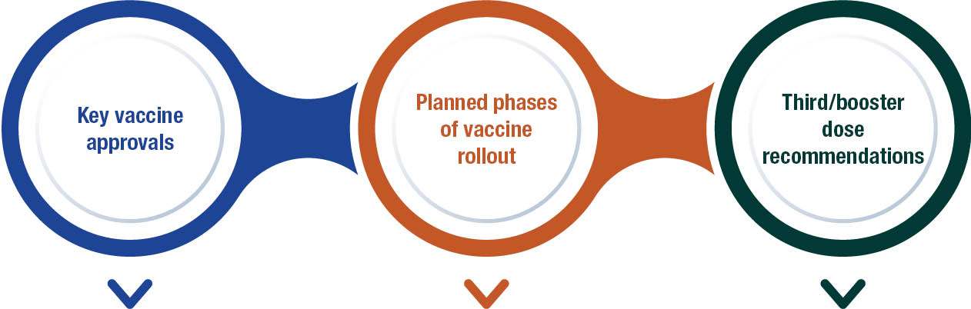
KEY VACCINE APPROVALS
Pfizer (Comirnaty)
- Provisionally registered for individuals aged ≥ 16 years in January 2021.
- Age extended to ≥ 12 years in July 2021, to ≥ 5 years in December 2021, and to ≥ 6 months in September 2022.
- Primary schedule: two doses, 21 days apart.
Moderna (Spikevax)
- Provisionally registered for individuals aged ≥ 18 years in August 2021.
- Age extended to ≥ 12 years in September 2021, and to ≥ 6 months in July 2022.
- Primary schedule: two doses, 28 days apart.
AstraZeneca (Vaxzevria)
- Provisionally registered for individuals aged ≥ 18 years in February 2021.
- Recommended use limited to individuals aged ≥ 50 years from April 2021 due to risk of thrombosis with thrombocytopaemia syndrome (TTS).
- Recommendation further updated to limit use to individuals aged ≥ 60 years from June 2021.
- Primary schedule: two doses, 4–12 weeks apart.
Novavax (Nuvaxovid)
- Provisionally registered for individuals aged ≥ 18 years in January 2022.
- Age extended to ≥ 12 years in July 2022.
- Primary schedule: two doses, 21 days apart.
PLANNED PHASES OF VACCINE ROLLOUT
Phase 1
- Initial rollout prioritised quarantine and border, healthcare, and aged care workers, and subsequently other high-risk workers,
- Aged care and disability residents,
- People aged ≥ 70 years,
- Aboriginal and Torres Strait Islander adults ≥ 55 years; and
- Younger adults with underlying medical conditions (early 2021).
Phase 2
- Expanded to individuals aged ≥ 50 years,
- Aboriginal and Torres Strait Islander people aged ≥ 18 years; and
- Subsequently, all individuals ≥ 16 years (mid-2021).
Phase 3
- Expanded to adolescents aged 12–15 years in the second half of 2021,
- Children aged 5–11 years in early 2022, and;
- Children aged 6–59 months with severe immunocompromise, disability or complex/multiple health conditions in mid-2022.
THIRD/BOOSTER DOSES RECOMMENDATIONS
Third primary course dose:
- Recommended for severely immunocompromised individuals, 2–6 months after the second dose (October 2021).
- Severely immunocompromised children aged 5–11 years, 2–6 months after their second dose (January 2022).
Booster doses:
- Recommended for immunocompetent individuals aged ≥ 18 years, 6 months after completing the primary course (October 2021).
- Interval between completion of primary course and booster dose shortened from 6 months to 4 months (December 2021).
- Recommended for adolescents aged 16–17 years (February 2022).
- Additional winter booster dose recommended for adults aged ≥ 65 years, residents of aged care and disability facilities, immunocompromised individuals, and Aboriginal and Torres Strait Islander people aged ≥ 50 years (March 2022).
- Additional winter booster dose also recommended for people 16–64 years with certain medical conditions or disability (May 2022).
- Booster dose recommended for individuals 12–15 years with severe immunocompromise, disability or complex/multiple health conditions (June 2022).
- A second booster recommended for individuals aged ≥ 50 years, with an option for those aged 30–49 years (July 2022).
- Booster dose recommended for children aged 5–11 years with severe immunocompromise, disability or complex/multiple health conditions (October 2022).

A.3 Charts of historical national notification data: selected vaccine preventable diseases
Figure A.2: Notifications of diphtheria, 1917 to 2022,^{a,b} Australia
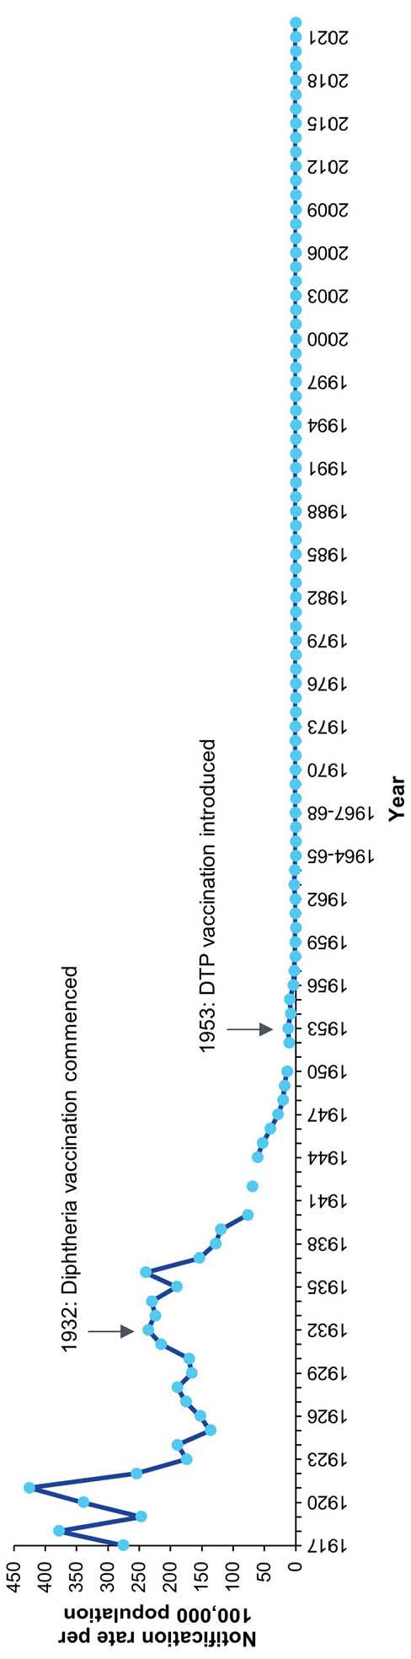
a Source: Hall R.³¹⁸
b Data are reported by calendar year for 1917–1963 and 1970–2022 and by financial year for 1963/1964–1969/1970.
Figure A.3: Notifications of Haemophilus influenzae type b, 1991 to 2022,ª Australia
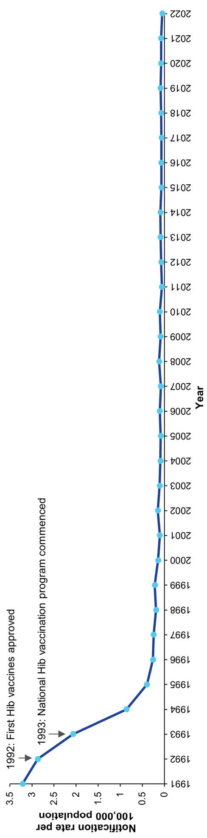
a Source: National Notifiable Diseases Surveillance System; Hall R.³¹⁸
Figure A.4: Notifications of hepatitis A, 1952 to 2022,^{a,b} Australia
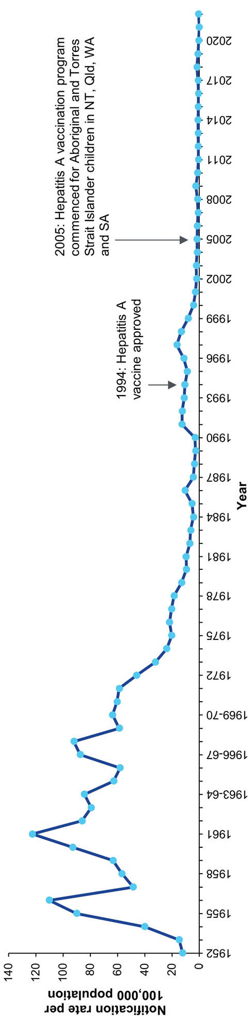
a Source: National Notifiable Diseases Surveillance System; Hall R.³¹⁸
b Data are reported by calendar year for 1952–1963 and 1970–2022 and by financial year for 1963/1964–1969/1970.
Figure A.5: Notifications of measles, 1917 to 2022,^{a,b} Australia
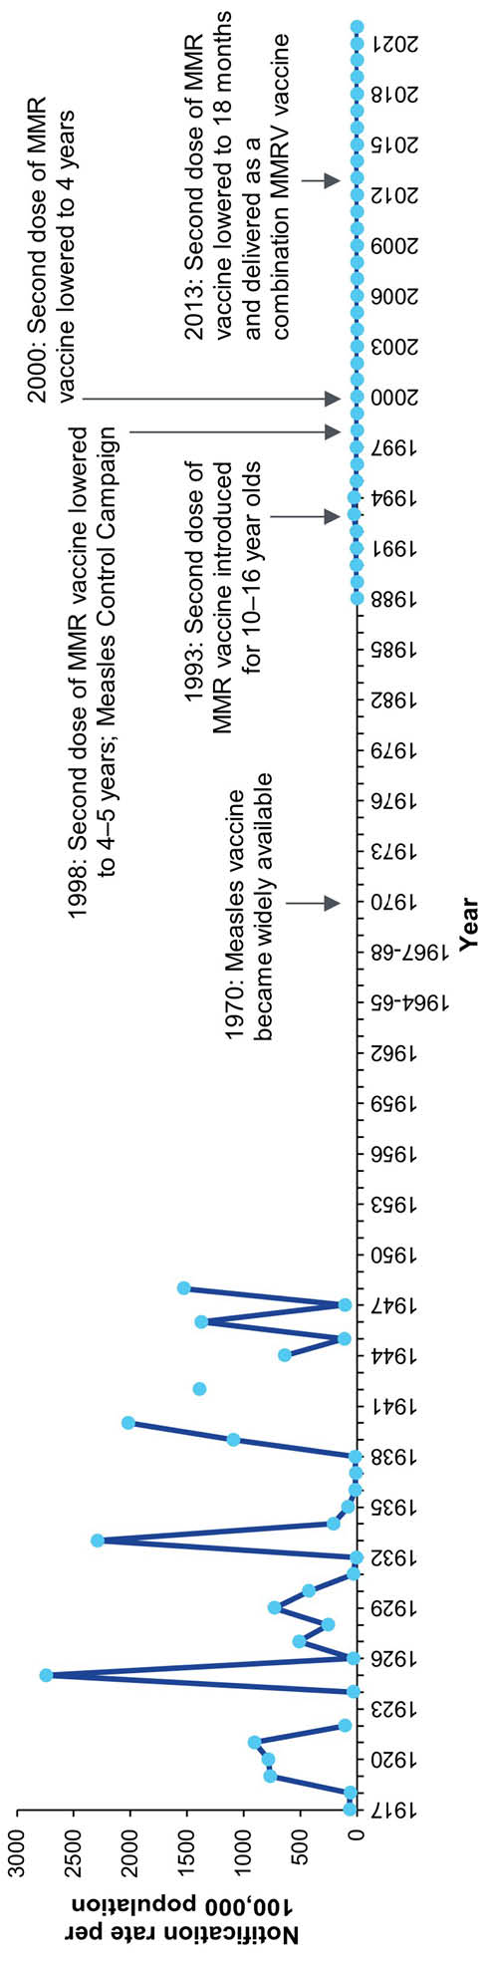
a Source: National Notifiable Diseases Surveillance System; Hall R.³¹⁸
b Data are reported by calendar year for 1917–1963 and 1970–2022 and by financial year for 1963/1964–1969/1970.
Figure A.6: Notifications of meningococcal disease (invasive), 1949 to 2022,^{a,b} Australia
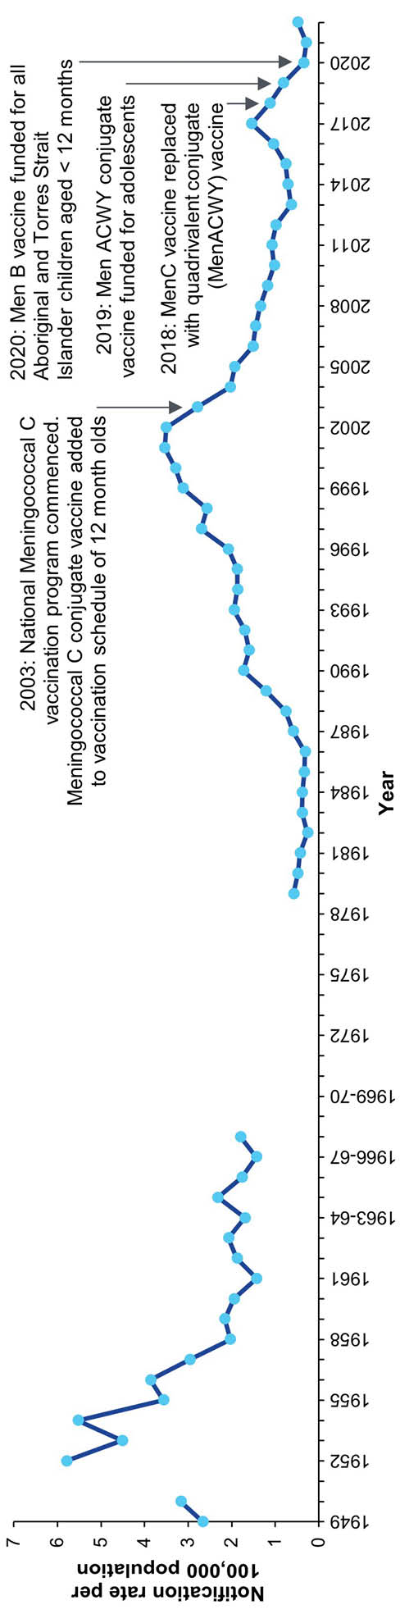
a Source: National Notifiable Diseases Surveillance System; Hall R.³¹⁸
b Data are reported by calendar year for 1949–1963 and 1970–2022 and by financial year for 1963/1964–1969/1970.
Figure A.7: Notifications of mumps, 1932 to 2022,^{a,b} Australia
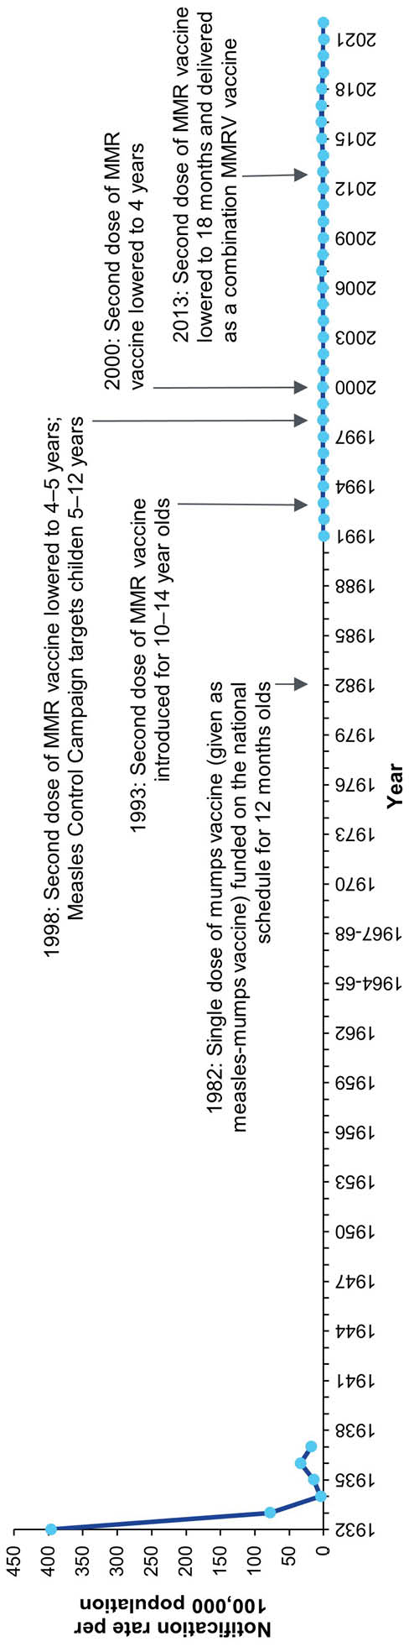
a Source: National Notifiable Diseases Surveillance System; Hall R.³¹⁸
b Data are reported by calendar year for 1932–1963 and 1970–2022 and by financial year for 1963/1964–1969/1970.
Figure A.8: Notifications of pertussis, 1917 to 2022,^{a,b} Australia
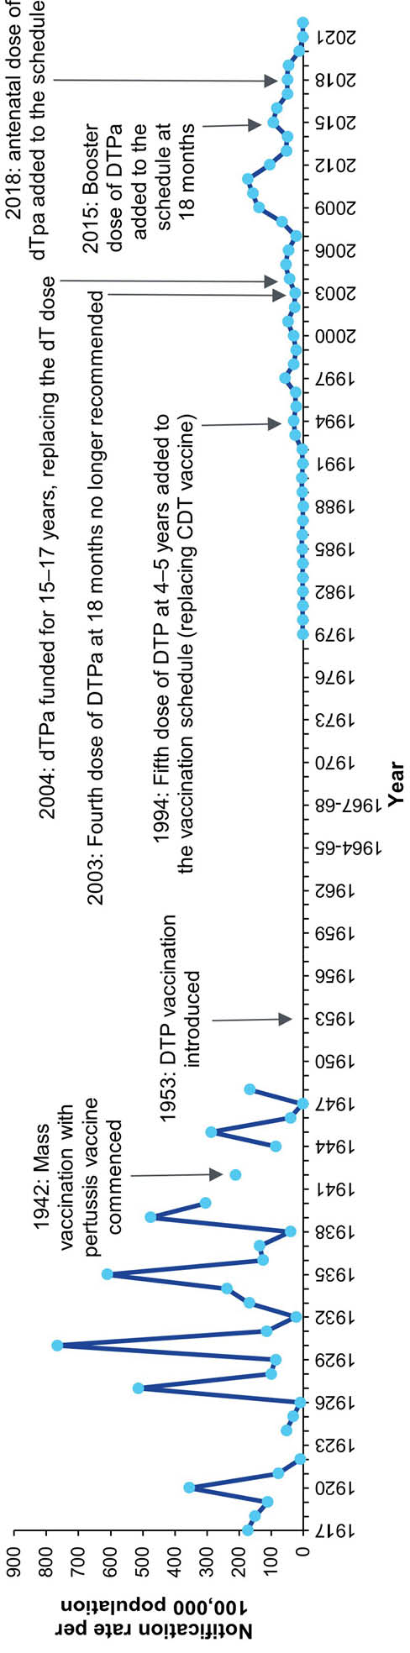
a Source: National Notifiable Diseases Surveillance System; Hall R.³¹⁸
b Data are reported by calendar year for 1917–1963 and 1970–2022 and by financial year for 1963/1964–1969/1970.
Figure A.9: Notifications of poliomyelitis, 1917 to 2022,^{a,b} Australia
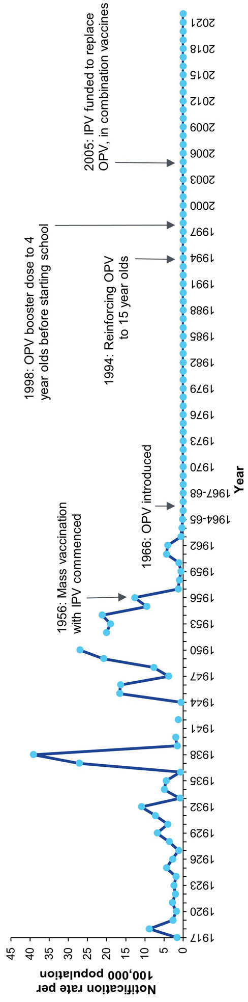
a Source: National Notifiable Diseases Surveillance System; Hall R.³¹⁸
b Data are reported by calendar year for 1917–1963 and 1970–2022 and by financial year for 1963/1964–1969/1970.
Figure A.10: Notifications of rubella, 1942 to 2022,^{a,b} Australia
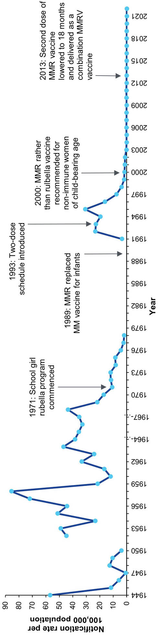
a Source: National Notifiable Diseases Surveillance System; Hall R.³¹⁸
b Data are reported by calendar year for 1942–1963 and 1970–2022 and by financial year for 1963/1964–1969/1970.
Figure A.11: Notifications of tetanus, 1922 to 2022,^{a,b} Australia
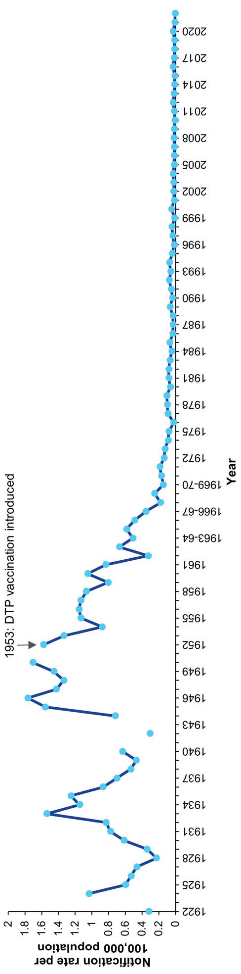
a Source: National Notifiable Diseases Surveillance System; Hall R.³¹⁸
b Data are reported by calendar year for 1922–1963 and 1970–2022 and by financial year for 1963/1964–1969/1970.

For COVID-19 only, the average annual rate calculated is for 2020–2022 per 100,000 population per year.

