
2026 • Volume 50 • cdc.gov.au/cdi • Epub date: 29.09.2026 • doi.org/10.33321/cdi.2026.50.022

Report of the National Influenza Surveillance Scheme, 2022–2023
Jenna Hassall, Tracy Tsang, Lauren Kutzner, Lauren Welsh, Suzie Whitehead
© 2026 Commonwealth of Australia as represented by the Australian Centre for Disease Control
ISSN: 2209-6051 Online
This journal is indexed by Index Medicus and Medline.
Creative Commons Licence
This publication is licensed under a Creative Commons Attribution-NonCommercial-NoDerivatives 4.0 International Licence (Licence). You must read and understand the Licence before using any material from this publication.
Restrictions
The Licence does not cover, and there is no permission given for, use of any of the following material found in this publication (if any):
- the Commonwealth Coat of Arms (by way of information, the terms under which the Coat of Arms may be used can be found on the Department of Prime Minister and Cabinet website);
- any logos (including the Australian Centre for Disease Control’s logo) and trademarks;
- any photographs and images;
- any signatures; and
- any material belonging to third parties.
Disclaimer
Opinions expressed in Communicable Diseases Intelligence are those of the authors and not necessarily those of the Australian Government or the Australian Centre for Disease Control. Data may be subject to revision.
Enquiries
Enquiries regarding any other use of this publication should be addressed to the CDI Editor.
About CDI
Communicable Diseases Intelligence (CDI) is a peer-reviewed scientific journal published by the Australian Centre for Disease Control.
The journal aims to disseminate information on the epidemiology, surveillance, prevention and control of communicable diseases of relevance to Australia and the near region.
Editor: Dr Elise Firman • Deputy Editor: Simon Petrie • Design and Production: Lisa Thompson
Editorial Advisory Board: David Durrheim, Mark Ferson, Clare Huppatz, John Kaldor, Martyn Kirk and Meru Sheel
Submit an Article
Guidelines for authors and details on how to submit your publication is available on our website, or by email to the
CDI Editor.
Contact us
Communicable Diseases Intelligence (CDI)
Australian Centre for Disease Control
PO Box 795, Canberra ACT 2601, Australia
Website: cdc.gov.au/cdi
Email: cdi.editor@cdc.gov.au

Contents
Abstract 6
Introduction 7
Surveillance methods 8
Data sources 8
Results 11
National notifications of laboratory-confirmed influenza 11
Geographic spread 13
Age and sex profile 17
Aboriginal and Torres Strait Islander status 18
Virus type and subtype 19
Virology 22
Influenza-like illness – national online community survey (FluTracking) 23
Influenza-like illness consultations from sentinel general practice surveillance systems 25
Morbidity – FluCAN 28
Mortality 31
Discussion and conclusion 32
Acknowledgments 35
Author details 36
References 37

List of figures
Figure 1: Laboratory-confirmed influenza notifications by year and month of diagnosis overlaid with public health and social measures introduced in response to the coronavirus disease 2019 (COVID-19) pandemic, Australia, 2017–2023 12
Figure 2a: Laboratory-confirmed influenza notifications by state or territoryª and week of diagnosis, Australia, 2022 15
Figure 2b: Laboratory-confirmed influenza notifications by state or territoryª and week of diagnosis, Australia, 2023 16
Figure 3: Age-specific notification rates of laboratory-confirmed influenza by 5-year age group and sex,^{a,b} Australia, 2022–2023 17
Figure 4: Age-specific notification rates of laboratory-confirmed influenza by diagnosis year,ª Australia, 2017–2019 and 2022–2023 18
Figure 5: Proportion of laboratory-confirmed influenza by type and subtype,ª Australia,
2017–2019 and 2022–2023 19
Figure 6: Age standardised percentage of FluTracking participants reporting fever and cough, Australia, by week of survey,ª April to October 2017–2019 and January to
December 2022–2023 24
Figure 7: Age standardised percentage of FluTracking participants reporting time off work or normal duties due to fever and cough symptoms by week of survey,ª Australia, April to October 2017–2019 and January to December 2022–2023 25
Figure 8: Unweighted rate of influenza-like illness (ILI) reported from Australian Sentinel Practices Research Network (ASPREN) sentinel general practice sites by week of consultation, Australia,ª 2017–2019 and 2022–2023 26
Figure 9a: Number of patients admitted with laboratory-confirmed influenza at Influenza Complications Alert Network / Paediatric Active Enhanced Disease Surveillance (FluCAN-PAEDS) sentinel hospital sites by week of admission and influenza subtype,ª Australia, 4 April to 31 October 2022 28
Figure 9b: Number of patients admitted with laboratory-confirmed influenza at Influenza Complications Alert Network / Paediatric Active Enhanced Disease Surveillance (FluCAN-PAEDS) sentinel hospital sites by week of admission and influenza subtype,ª Australia, 4 April to 31 October 2023 29

List of tables
Table 1: Notifications and notification rates of laboratory-confirmed influenza by state or territory,^{a,b} Australia, 2022–2023 13
Table 2: Laboratory-confirmed influenza notifications and age-specific notification rates by type/subtype, year and age group,^{a,b} Australia, 2017–2019 and 2022–2023 21
Table 3: All Australian samples received by the World Health Organization Collaborating Centre for Reference and Research on Influenza (WHO CCRRI) by subtype/lineage, Australia,
2022–2023^{a,b} 22
Table 4: Summary of virological surveillance activities conducted by Australian Sentinel Practices Research Network (ASPREN) sentinel general practice sites,ª Australia, 2022–2023 27
Table 5: Demographic characteristics, influenza type/subtype and outcomes of patients admitted with laboratory-confirmed influenza at Influenza Complications Alert Network / Paediatric Active Enhanced Disease Surveillance (FluCAN/PAEDS) sentinel hospital sites, Australia, 4 April to 31 October 2022–2023 30

Abstract
This report describes influenza surveillance activities in Australia in 2022 to 2023. Data were extracted from several sources constituting the National Influenza Surveillance Scheme.
Following the relaxation of public health and social measures which had been applied in Australia in response to the coronavirus disease 2019 (COVID-19) pandemic in 2020 and 2021, the influenza seasons in 2022 and 2023 were characterised by high activity overall, with 1.4 and 1.8 times the number of laboratory-confirmed influenza notifications than those of the 2015–2019 pre-pandemic five-year mean, respectively. There were differences in the timing of the 2022 and 2023 influenza seasons compared to most pre-pandemic years, with earlier season starts and earlier peaks (approximately six to eight weeks earlier than in pre-pandemic years). There was also considerable variation in the timing of peak influenza activity between the states and territories, particularly in 2023. Notification rates were highest in the 5–9 years age group, with rates in this age group about two and a half times as high in 2022 and three times as high in 2023 as the overall notification rate in the corresponding years.
Influenza A(unsubtyped) comprised most notifications in 2022 and 2023. Of the remaining samples, influenza A(H3N2) was dominant in 2022; however, in 2023, there was substantial circulation of influenza B, which predominantly affected children and younger adults, and of A(H1N1).
Sentinel surveillance supports the assessment that both the 2022 and 2023 influenza seasons were characterised by early, high activity. High notification rates were also reflected in increased sentinel hospital admissions with confirmed influenza in 2023, particularly among children. The burden placed on sentinel hospitals due to people admitted with influenza was moderate in 2022 but high in 2023. Severity, measured through the proportion of patients admitted to sentinel hospital intensive care units, was moderate in both years and consistent with historical estimates. Influenza was recorded as the underlying cause of death in 0.16% of all deaths that occurred in 2022, and 0.24% of all deaths in 2023.
Overall, the 2022 influenza season had high activity with low-to-moderate severity, while 2023 had high activity with moderate severity.
Keywords: influenza; surveillance; influenza-like-illness; sentinel surveillance

Introduction
Influenza or ‘the flu’ is a common, infectious respiratory disease. Influenza viruses spread from person to person by aerosolised droplets, commonly produced when an infected person coughs or sneezes. Typical symptoms usually begin around two days after being infected and include a sudden onset of fever, cough, headache, myalgia, fatigue, sore throat, and a runny nose.^{1,2} Most people recover within a few days without needing medical care; however, influenza can cause severe illness, hospitalisations for pneumonia and other complications, or death, particularly in high-risk groups.² Individuals most at risk of severe influenza include young children; people who are pregnant; older people (those of age 65 years and over); people with chronic illnesses; and people who are immunocompromised. Vaccination is the best way to prevent influenza and its complications.²
Influenza types A, B, and C are known to cause respiratory illness in humans. Influenza A and B viruses cause seasonal epidemics, while type C is detected less frequently and is usually associated with mild infections.¹ There are two forms of influenza reported globally: epidemic (seasonal or interpandemic) caused by types A and B, and sporadic pandemics caused by type A viruses.^{1,2} Influenza A viruses are further classified into subtypes based on the combinations of the haemagglutinin (HA) and neuraminidase (NA) viral surface proteins. The influenza B viruses are further classified into lineages rather than subtypes.¹
In temperate climates, seasonal influenza epidemics occur mainly during winter, while in tropical and sub-tropical regions, influenza may occur throughout the year resulting in multiple peaks in a season or extended periods of activity.² In temperate regions of Australia, the influenza season usually occurs from April or May to the end of October, with notifications historically peaking in August. However, influenza activity varies from year to year. Australia experienced moderate influenza seasons from 2011 to 2016, mild activity in 2018, and high influenza activity in 2017 and 2019, with the 2019 season having the highest number of influenza notifications since the 2009 influenza pandemic.^{3,4} In years prior to 2020 (with the exception of 2008 and 2015), influenza A has been the predominant type circulating in Australia. The prevalence of influenza subtypes A(H1N1)pdm09 and A(H3N2) has alternated over time, with each becoming the most frequently identified subtype at different periods.^{3,4}
In 2020–2021, a range of public health and social measures (PHSMs) were instituted across Australia to reduce the importation and spread of coronavirus disease 2019 (COVID-19). These measures effectively interrupted influenza circulation during this time.^{5–7} Laboratory-confirmed influenza notifications in 2020–2021 were the lowest reported to the National Notifiable Diseases Surveillance System (NNDSS) since influenza became nationally notifiable in 2001. Very low influenza activity was also observed in community sentinel surveillance systems in 2020–2021.⁸ As influenza activity was atypically low and not representative of normal seasonal patterns in 2020–2021, these years are generally not included in historical analyses or in the five-year mean utilised in this annual report.
Data are reported from each state or territory health department to the NNDSS. In Australia, the epidemiology of influenza is further informed by a number of different complementary systems based in the community, primary care, hospitals and laboratories, as well as by data from the Australian Bureau of Statistics which includes officially reported deaths. This report provides an overview of these national influenza surveillance data from 1 January 2022 to 31 December 2023.

Surveillance methods
Data for this report were based on the following influenza surveillance sources:
- notifications of laboratory-confirmed influenza required by legislation in all states and territories, and notified to the NNDSS;
- subtype and lineage data of circulating influenza viruses, provided by the World Health Organization Collaborating Centre for Reference and Research on Influenza (WHO CCRRI);
- consultation rates for influenza-like illness (ILI) and respiratory virus detection in sentinel general practices, provided by the Australian Sentinel Practices Research Network (ASPREN);
- weekly percentages of participants reporting fever and cough and absence from work or normal duties, from the online community survey FluTracking;
- hospitalised cases of influenza from 22 sentinel hospitals across Australia, through the Influenza Complications Alert Network (FluCAN); and
- mortality data from the Australian Bureau of Statistics (ABS).
Healthdirect Australia data on ILI trends are not presented in this report due to the establishment and operation of the National Coronavirus Helpline during 2020 and 2021. The National Coronavirus Helpline provided COVID-19 health advice, and as a result diverted people with ILI away from Healthdirect telephone and online services.

Data sources

NNDSS
In 2022–2023, laboratory-confirmed influenza was a notifiable disease under state and territory legislation in all jurisdictions. Notifications were sent to NNDSS for national collation, analyses and reporting. In this report, data were analysed by the date of diagnosis, which is the earliest of the dates of symptom onset, specimen collection, or case notification. Age, sex, Indigenous status, virus subtype, the jurisdiction of residence, hospitalisation, and other outcomes, are included in NNDSS notifications where data are available.

WHO CCRRI
The WHO CCRRI are located in Melbourne (Australia), Beijing (China), Tokyo (Japan), London (the United Kingdom), and Atlanta (the United States of America), and are part of the WHO Global Influenza Surveillance and Response System (WHO GISRS). The WHO Collaborating Centres are responsible for analysing influenza viruses collected through an international surveillance network involving 142 national influenza centres across 115 countries.⁹ The Melbourne centre analyses viruses received from Australia and from laboratories in the Asia-Pacific Region. Virus isolates are analysed antigenically, and a geographically and temporally representative number of viruses, together with any strains demonstrating uncharacteristic reactions during antigenic characterisation, are further analysed by genetic sequencing of the viral HA and NA genes.
Virological, serological, and epidemiological data form the basis from which the WHO makes recommendations in February (for the northern hemisphere) and in September (for the southern hemisphere) on which strains should be included in the influenza vaccine for the following influenza season. The WHO vaccine recommendations are made in the context of strains that are antigenically 'like' laboratory reference strains that are named according to a standard nomenclature for influenza viruses. This nomenclature is based on the virus type, place of isolation, sequential number, year of isolation, and the subtype of the HA and NA genes (for influenza A). National and regional committees (such as the Australian Influenza Vaccine Committee) then translate the WHO recommendations into actual virus strains acceptable to regulatory authorities and vaccine manufacturers.

Sentinel general practice surveillance
Sentinel general practice (GP) surveillance schemes for influenza monitor clinical consultations for ILI, defined as any presentation with fever, cough and fatigue, and collect swabs from patients with ILI to inform virological surveillance of influenza. In Australia, ASPREN, a network of sentinel GPs, collects ILI data from over 300 providers across all states and territories. ASPREN reports ILI rates throughout the year, and provides annual vaccine effectiveness estimates and data to the WHO CCRRI.

FluTracking
FluTracking is a community-based surveillance system that monitors the transmission, impact and severity of respiratory illness in the community. It involves volunteer participants from across Australia completing an online weekly survey, which collects data on symptoms, absence from work or normal duties, healthcare presentation, self-reported testing, and annual influenza,
COVID-19, and RSV vaccination. Prior to 2020, FluTracking surveys were conducted from April to mid-October each year. In 2020, to assist with COVID-19 surveillance, FluTracking began survey collection earlier (commencing in mid-February) and expanded surveillance to year-round, with its survey continuing beyond mid-October 2020. Surveys were also modified to include COVID-19 specific questions including collection of COVID-19 vaccination status. Changes to the FluTracking survey questions are outlined in Appendix A of the FluTracking 2020–2022 report.^{10,11}

FluCAN-PAEDS
The Influenza Complications Alert Network (FluCAN) and the Paediatric Active Enhanced Disease Surveillance (PAEDS) system are national hospital-based sentinel surveillance systems reporting data from 17 surveillance hospitals and five paediatric system sites (22 sentinel hospital sites in total). FluCAN-PAEDS collects detailed clinical and laboratory information from all patients hospitalised at participating sites with a laboratory-confirmed diagnosis of influenza to determine the burden of disease requiring hospitalisation associated with influenza, and to estimate the effectiveness of the influenza vaccine against hospitalisation with influenza. In addition, FluCAN-PAEDS also provides annual vaccine effectiveness estimates to the Global Influenza Vaccine Effectiveness (GIVE) Collaboration. Vaccine effectiveness was estimated from the adjusted odds ratio of vaccination in cases, as compared to controls. This was estimated from a logistic regression adjusting for age group, medical comorbidities, pregnancy and Indigenous status, with the analysis stratified by state and week.

Mortality
Mortality data are compiled by the ABS from information provided by the state and territory Registrars of Births, Deaths and Marriages. The tenth revision of the International Classification of Diseases and Related Health Problems (ICD-10) was utilised to code and estimate influenza deaths. In this report, deaths with an underlying cause of influenza (ICD-10 codes J09–J11) or pneumonia (ICD-10 J12–J18) are presented. The expanded range of codes, J09–J18, correlates with previous versions of ICD-10 codes J10–J11.

Results
The 2022 and 2023 influenza seasons commenced approximately six to eight weeks earlier than observed in most pre-pandemic years, with increased activity commencing in April and March respectively. In 2022, notifications peaked in June and decreased rapidly in July. In 2023, activity also peaked in June; however, notifications remained elevated across October to December (Figure 1). Most sentinel data sources tracked below or similar to trends seen in previous years during the main seasonal period, despite the early onset and differing season lengths.

National notifications of laboratory-confirmed influenza
There were 233,451 and 289,153 laboratory-confirmed influenza cases notified to the NNDSS in 2022 and 2023, respectively (compared to 313,470 cases in 2019 and 58,869 cases in 2018). Notifications in 2022 and 2023 were 1.4 times and 1.8 times as high as the five-year mean number of notifications (n = 163,003) for 2015–2019, respectively.
In 2022, influenza notifications increased sharply from April to a peak of 29,621 notifications per week in mid-June, followed by a sharp decline in July with influenza notifications returning to interseasonal levels by September 2022. There was a minor increase in December 2022 with notifications remaining slightly elevated, but still at low interseasonal levels, for the 2022–2023 interseasonal period. Compared to previous seasons, the 2022 influenza season was relatively short, lasting for about 15 weeks (Figure 1).
In 2023, a clear increasing trend for influenza notifications began from March. The increasing trend was not as steep or pronounced as in 2022 and notifications rose to a peak of 18,217 notifications per week in late June. The June peak was followed by a decreasing trend from July to September, which was not as pronounced as the 2022 decrease. The 2023 season was also characterised by extended activity. Between October and December, influenza notifications remained elevated well above historical interseasonal levels, with an average of 3,600 notifications per week, almost three times as high as the five-year mean for the corresponding period in 2015–2019. The 2023 season lasted for approximately 29 weeks, which is consistent with pre-pandemic years such as 2019 (24–25 weeks). The number of influenza notifications reported to the NNDSS in 2023 was the second highest since influenza became nationally notifiable in 2001, following the highest number of influenza notifications observed in 2019 (n = 313,470).
The seasonal peak of influenza notifications in 2022 and 2023 occurred approximately six to eight weeks earlier than in pre-pandemic years when the season peak usually occurred in mid-August, except for the 2019 season which also peaked earlier. In both 2022 and 2023, the numbers of notifications from May to June were consistently higher than in the corresponding months of previous years (Figure 1).
Figure 1: Laboratory-confirmed influenza notifications by year and month of diagnosis overlaid with public health and social measures introduced in response to the coronavirus disease 2019 (COVID-19) pandemic, Australia, 2017–2023
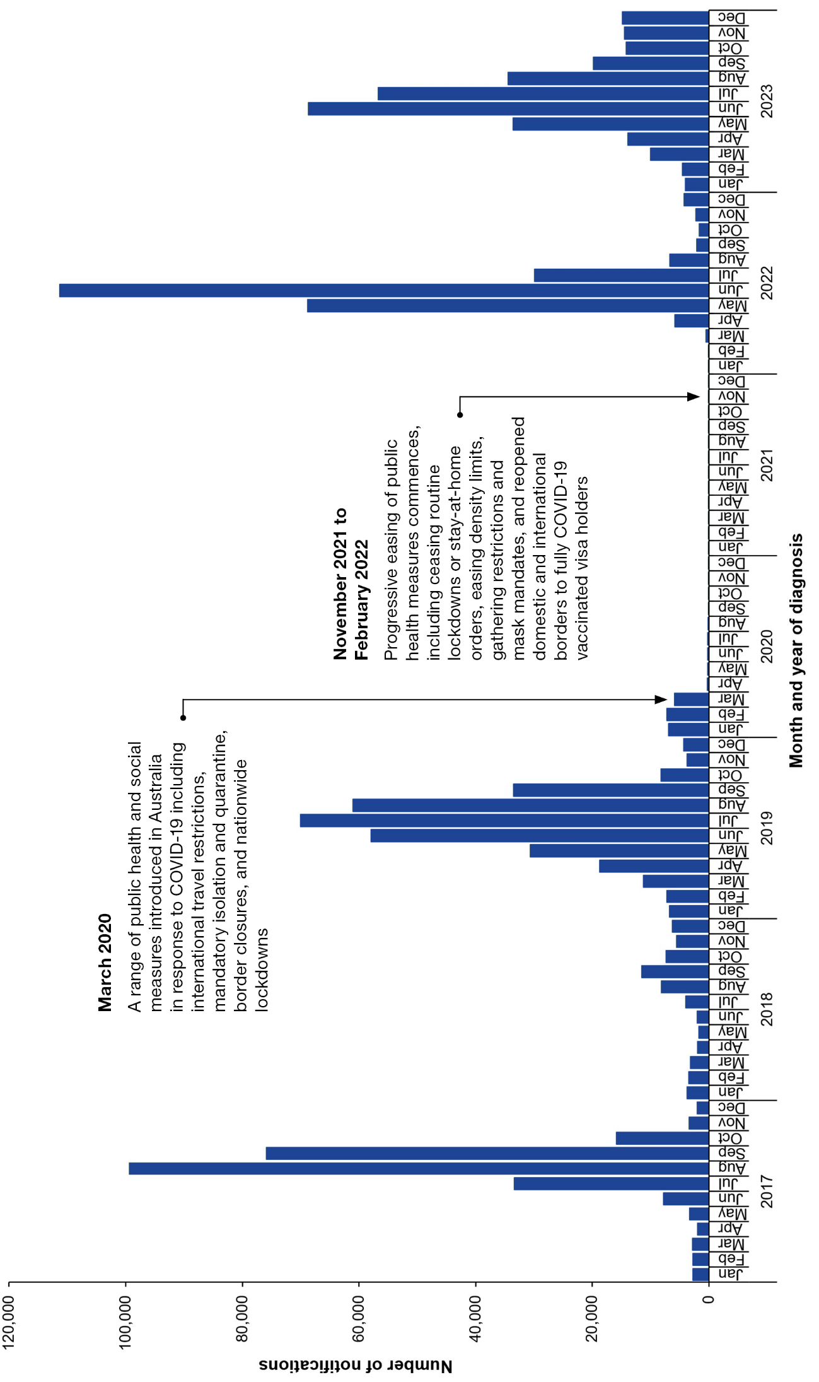

Geographic spread
The largest proportions of laboratory-confirmed influenza notifications in 2022 and 2023 were reported by Australia's most populous states, which typically report higher case numbers. In 2022, laboratory-confirmed influenza notifications from New South Wales (49.8%), Queensland (19.0%) and Victoria (15.7%) made up the largest proportion of notified cases. Similarly in 2023, the largest proportion of laboratory-confirmed influenza notifications were from New South Wales (36.2%), Queensland (25.7%) and Victoria (19.4%) (Table 1).
However, when adjusted for population size, the laboratory-confirmed influenza notification rates ranged from 463 cases per 100,000 population in the Australian Capital Territory to 1,916 cases per 100,000 population in the Northern Territory in 2022. In contrast, in 2023, laboratory-confirmed influenza notification rates ranged from 622 cases per 100,000 population in Tasmania to 1,361 cases per 100,000 population in Queensland (Table 1).
The national notification rate was lower in 2022 (897 cases per 100,000 population) than in 2023 (1,085 cases per 100,000 population), representing a 21.0% increase from 2022 to 2023 (Table 1).
Table 1: Notifications and notification rates of laboratory-confirmed influenza by state or territory,^{a,b} Australia, 2022–2023
Jurisdiction | 2022 |  |  | 2023
Jurisdiction | Notification | % | Rate | Notification | % | Rate
ACT | 2,114 | 0.9 | 463 | 4,106 | 1.4 | 880
NSW | 116,371 | 49.8 | 1,425 | 104,648 | 36.2 | 1,254
NT | 4,794 | 2.1 | 1,916 | 2,776 | 1.0 | 1,097
Qld | 44,436 | 19.0 | 835 | 74,346 | 25.7 | 1,361
SA | 12,092 | 5.2 | 664 | 22,366 | 7.7 | 1,207
Tas. | 2,981 | 1.3 | 522 | 3,567 | 1.2 | 622
Vic. | 36,600 | 15.7 | 552 | 56,154 | 19.4 | 824
WA | 14,063 | 6.0 | 504 | 21,190 | 7.3 | 735
Australia | 233,451 | 100 | 897 | 289,153 | 100 | 1,085
a Notification rate per 100,000 population. Population data are based on the Australian Bureau of Statistics Estimated Resident Population (ERP) for 2022 and 2023, respectively.
b ACT: Australian Capital Territory; NSW: New South Wales; NT: Northern Territory; Qld: Queensland; SA: South Australia; Tas.: Tasmania; Vic.: Victoria; WA: Western Australia.
The 2022 and 2023 influenza seasons differed in both timing and geographic distribution of activity. While influenza activity in 2022 was characterised by a sharp, early winter peak, 2023 showed extended activity and more geographical differences in distribution.
In 2022, most states and territories observed a short, sharp season with elevated laboratory-confirmed influenza notifications between early May and late July with an early winter peak. Notifications peaked earliest in Victoria (6,030 notifications per week in late May), with most other states and territories peaking in June. Notifications peaked the latest in Western Australia at 2,125 notifications per week in mid-July. There was limited activity outside the main winter peak (Figure 2a).
In 2023, most states and territories observed a longer influenza season, with broader peak periods and ongoing laboratory-confirmed notifications throughout the year. Notifications peaked earliest in Victoria in early June (2,819 notifications per week), followed by Western Australia (1,585 notifications per week) and Queensland (5,421 notifications per week). All other jurisdictions peaked in July except in the Northern Territory (Figure 2b). The Northern Territory had a small rise in notifications in early April (101 notifications per week), relatively low activity across the winter months, followed by a larger peak of 150 notifications per week in mid-November (Figure 2b). Many jurisdictions had extended plateaux in notifications across late winter and spring.
Figure 2a: Laboratory-confirmed influenza notifications by state or territoryª and week of diagnosis, Australia, 2022
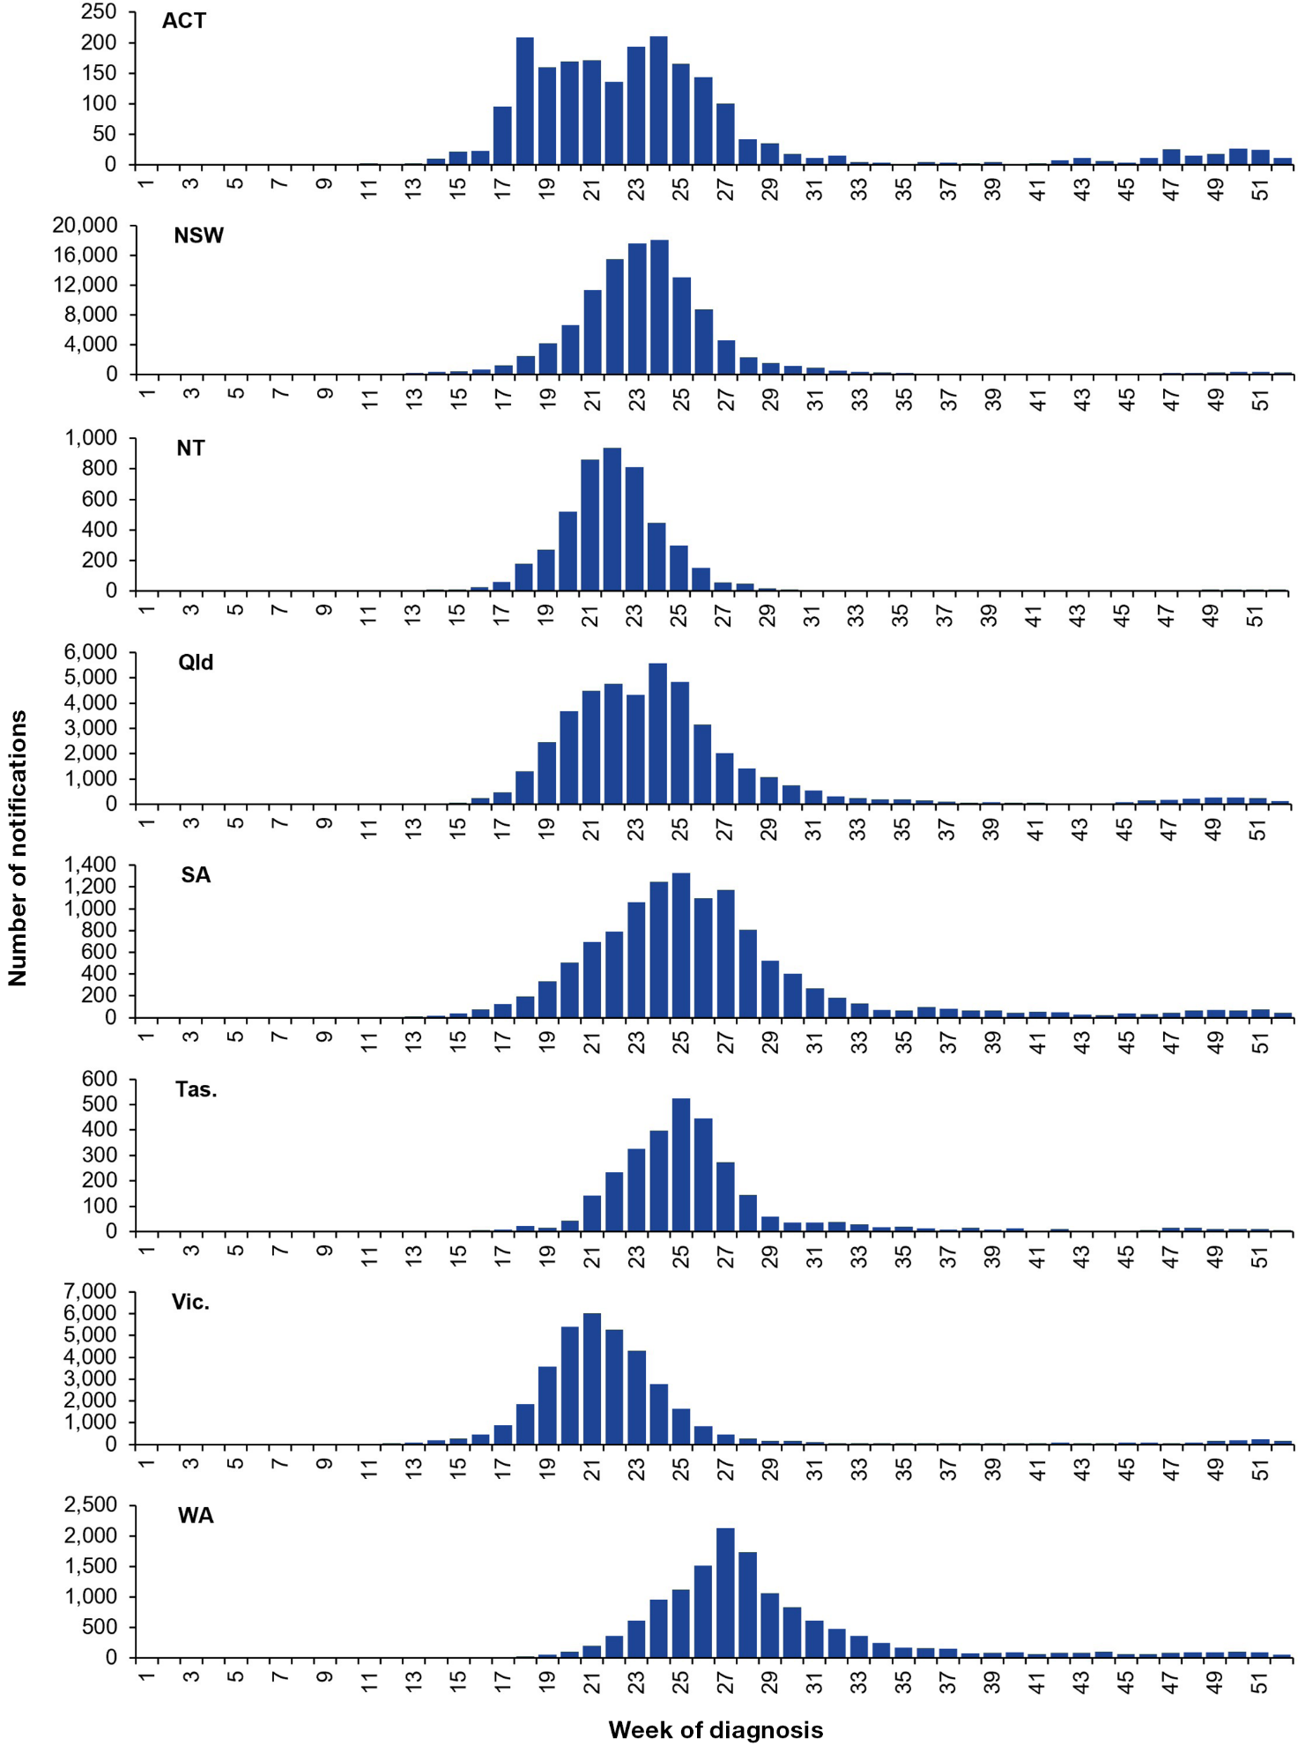
a ACT: Australian Capital Territory; NSW: New South Wales; NT: Northern Territory; Qld: Queensland; SA: South Australia; Tas.: Tasmania; Vic.: Victoria; WA: Western Australia.
Figure 2b: Laboratory-confirmed influenza notifications by state or territoryª and week of diagnosis, Australia, 2023
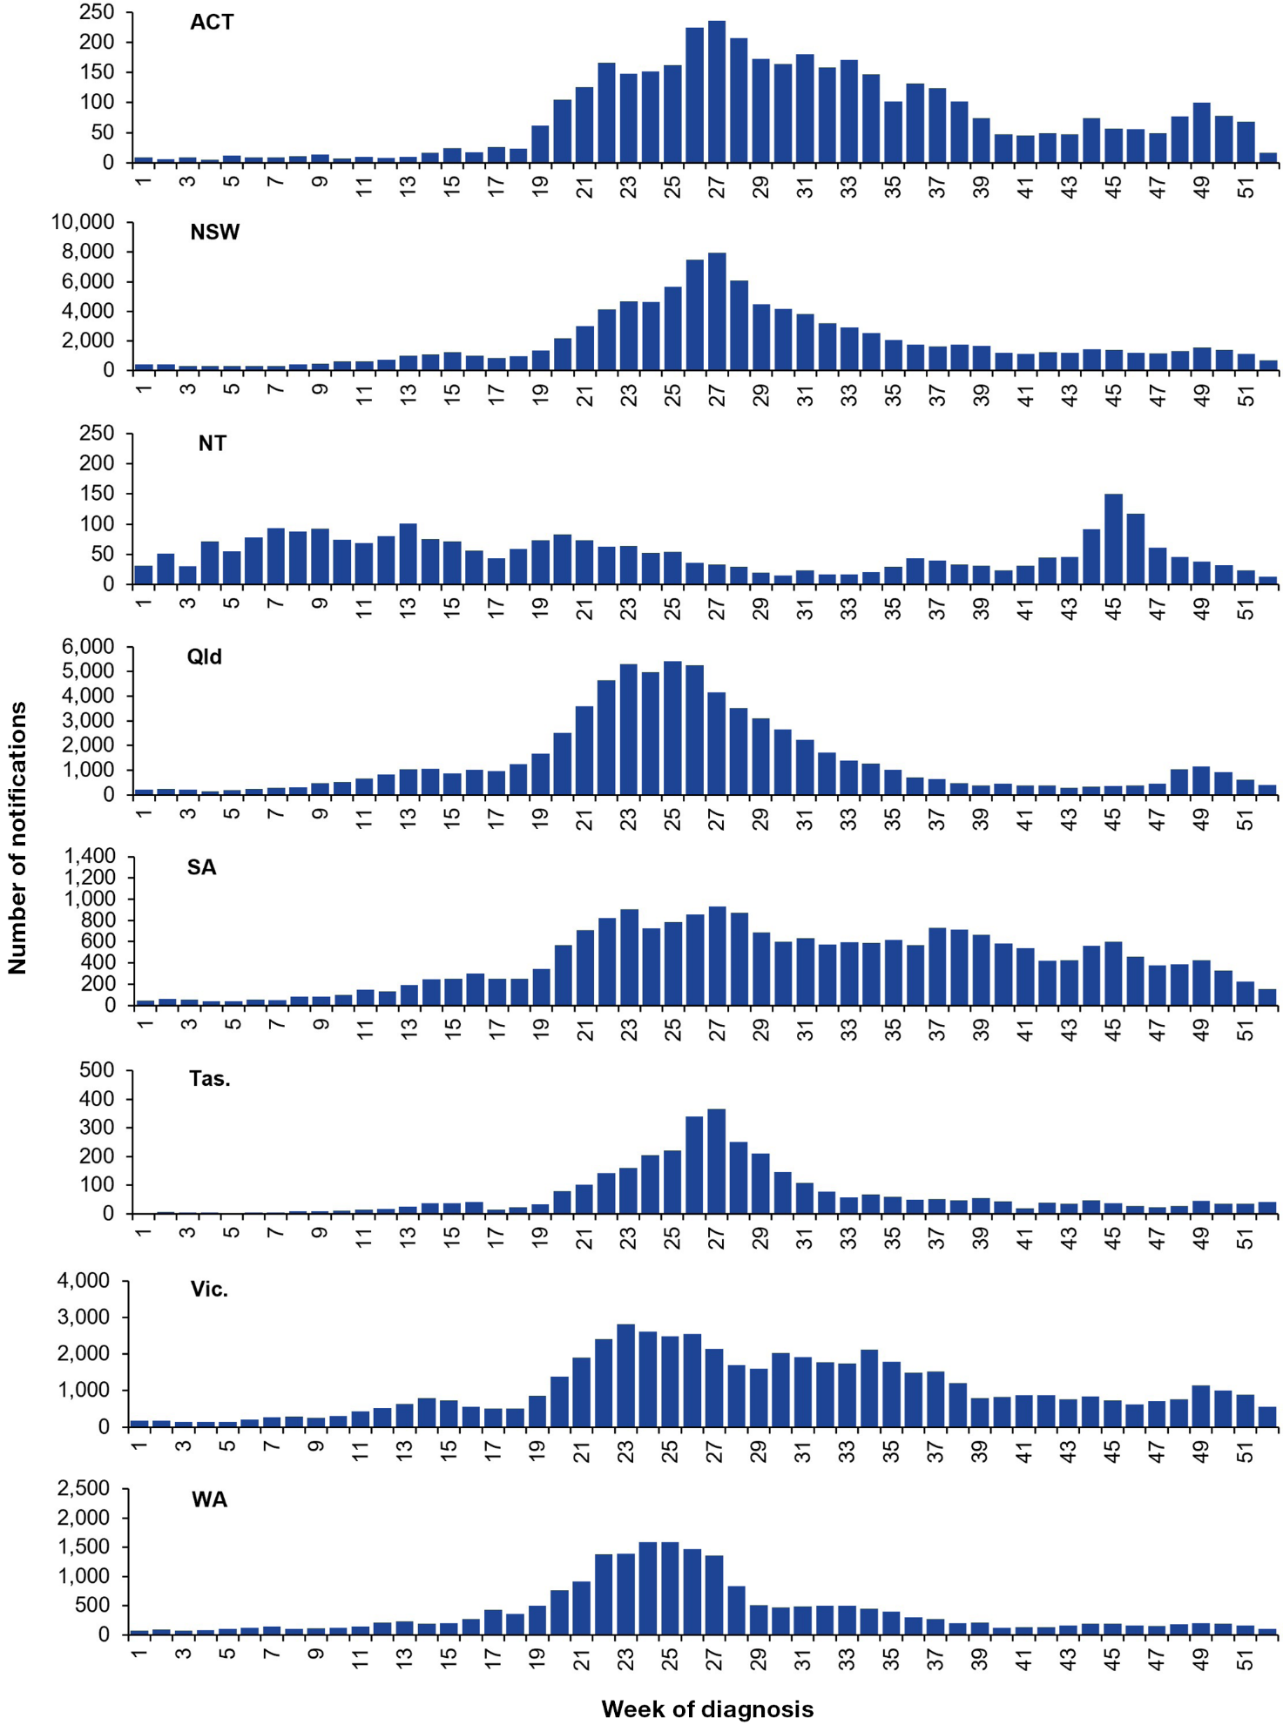
a ACT: Australian Capital Territory; NSW: New South Wales; NT: Northern Territory; Qld: Queensland; SA: South Australia; Tas.: Tasmania; Vic.: Victoria; WA: Western Australia.

Age and sex profile
Age-specific notification rates for laboratory-confirmed influenza notified to the NNDSS in 2022–2023 are shown in Figure 3. The highest notification rates in both years were observed in children aged 5–9 years (2,252 cases per 100,000 population in 2022 and 3,245 cases per 100,000 population in 2023), which were respectively 2.5 and 3 times as high as the overall notification rates in the corresponding years (897 cases per 100,000 population in 2022 and 1,085 cases per 100,000 population in 2023).
Overall, influenza notifications by sex were approximately equal for both males (47%; n = 109,114) and females (53%; n = 123,911) in 2022 and in 2023 (males 48%; n = 138,897; females 52%; n = 149,891). Age-specific notification rates were higher in males across most age groups under 15 years than in females of the same age, while notification rates were slightly higher in females across most older age groups (Figure 3).
Figure 3: Age-specific notification rates of laboratory-confirmed influenza by 5-year age group and sex,^{a,b} Australia, 2022–2023
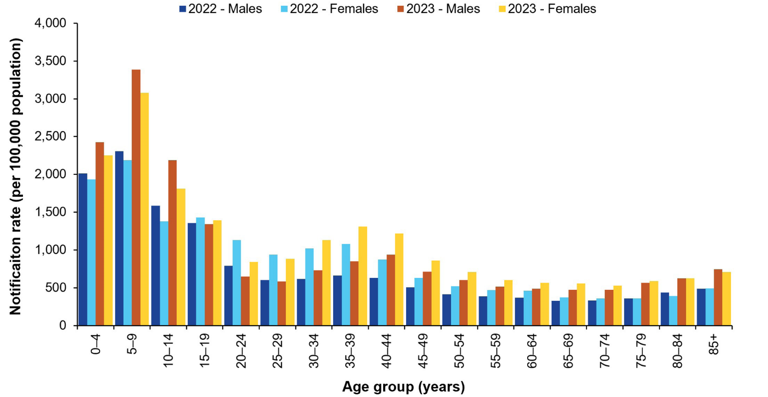
a Excludes 20 notifications with unknown age in 2022 and 50 notifications with unknown age in 2023.
b Excludes 408 notifications with unknown or non-binary gender in 2022 and 327 notifications with unknown or non-binary gender in 2023.
Figure 4 shows age-specific influenza notification rates for key age groups from 2017–2023, excluding the years 2020 and 2021 due to the atypical influenza circulation during those years. Notification rates increased across all age groups in 2023 compared with 2022, with the largest absolute increases occurring in children (those aged 0–4 years and 5–9 years).
Across 2017–2019 and 2022–2023, influenza notification rates were consistently highest in children (those aged 0–4 years and 5–9 years), with particularly elevated rates in 2019, 2022 and 2023 (Figure 4). Notification rates in children aged 0–4 years and 5–9 years remained elevated in 2022 but were lower than the corresponding notification rates in 2019. In 2023, notification rates in these age groups increased considerably, reaching 2,338 cases per 100,000 population for those aged 0–4 years and 3,245 cases per 100,000 population for those aged 5–9 years, exceeding rates observed in previous years. This may reflect increased transmission or susceptibility in younger age groups following suppression of influenza circulation during the initial COVID-19 pandemic period.
Notification rates among those aged 10–19 years increased slightly in 2022 and 2023 compared to 2019 but did not exceed 1,649 cases per 100,000 population in either year (Figure 4). In 2022 and 2023, notification rates among adults aged 20–64 years and among those aged 65 years and over decreased relative to the earlier peaks in 2017 and 2019. Notification rates among adults remained comparatively low and stable, not exceeding 780 cases per 100,000 population in 2022, and 549 cases per 100,000 population in 2023 (Figure 4).
Figure 4: Age-specific notification rates of laboratory-confirmed influenza by diagnosis year,ª Australia, 2017–2019 and 2022–2023
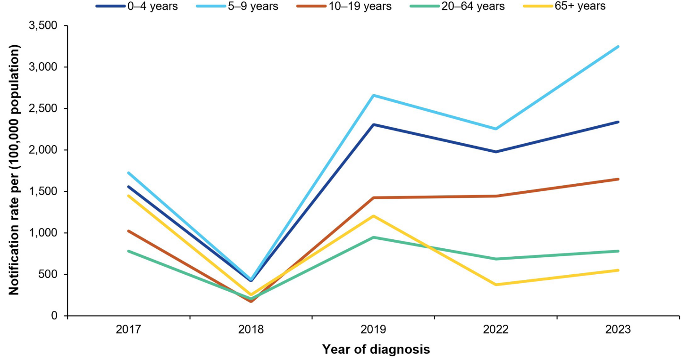
a Excludes 87 notifications with unknown age (two in 2017, five in 2018, ten in 2019, 20 in 2022 and 50 in 2023).

Aboriginal and Torres Strait Islander status
The completeness and reliability of Indigenous status data is low across most Australian jurisdictions, affecting the accuracy and representativeness of these estimates. In 2022 and 2023 respectively, of the total laboratory-confirmed influenza notifications, 53.9% (n = 125,728) and 56.5% (n = 163,449) had Indigenous status recorded.
In 2022, of laboratory-confirmed influenza notifications with Indigenous status recorded, 10.4% (n = 13,076) identified as an Aboriginal and Torres Strait Islander person. In 2023, of laboratory-confirmed influenza notifications with Indigenous status recorded, 9.2% (n = 15,037) identified as an Aboriginal and Torres Strait Islander person. Influenza notification rates were 1.8 times higher in 2022, and 1.7 times higher in 2023, among those who identified as Aboriginal and Torres Strait Islander people than among non-Indigenous Australians.

Virus type and subtype
In 2022, of laboratory-confirmed influenza notifications, 84.9% were influenza A [79.9% influenza A(unsubtyped); 4.0% A(H3N2); and 1.0% A(H1N1)pdm09]; 0.6% were influenza B; and 14.5% were untyped (Figure 5, Table 2). The high proportion of untyped influenza notifications in 2022 is likely influenced by several factors including increased influenza testing volumes relative to the pre-pandemic period; ongoing laboratory demand due to COVID-19; increased use of diagnostic assays (including multiplex respiratory panels) that do not distinguish influenza type; and other laboratory capacity constraints. In 2022, mixed influenza type A and B infections accounted for 0.1% of influenza notifications (n = 348) (Figure 5, Table 2).
In contrast, in 2023, influenza A accounted for a lower proportion of total influenza notifications at 63.0% [59.8% influenza A(unsubtyped); 0.8% A(H3N2); and 2.5% A(H1N1)pdm09], and there was a substantial increase in the proportion of influenza B (35.9%) compared to 2022 (Figure 5, Table 2). Compared with pre-pandemic years (2017–2019), the proportion of influenza B notifications in 2023 was considerably higher than in 2018 (20.0%) and 2019 (23.2%), but slightly less than in 2017 (38.1%) (Figure 5). In 2023, mixed influenza type A and B infections accounted for 0.5% of influenza notifications (n = 1,363) (Figure 5, Table 2).
There were no infections with influenza C reported across 2022–2023. Subtyping practices, including the number of specimens subtyped, may vary between years, impacting comparisons between years.
Figure 5: Proportion of laboratory-confirmed influenza by type and subtype,ª Australia, 2017–2019 and 2022–2023
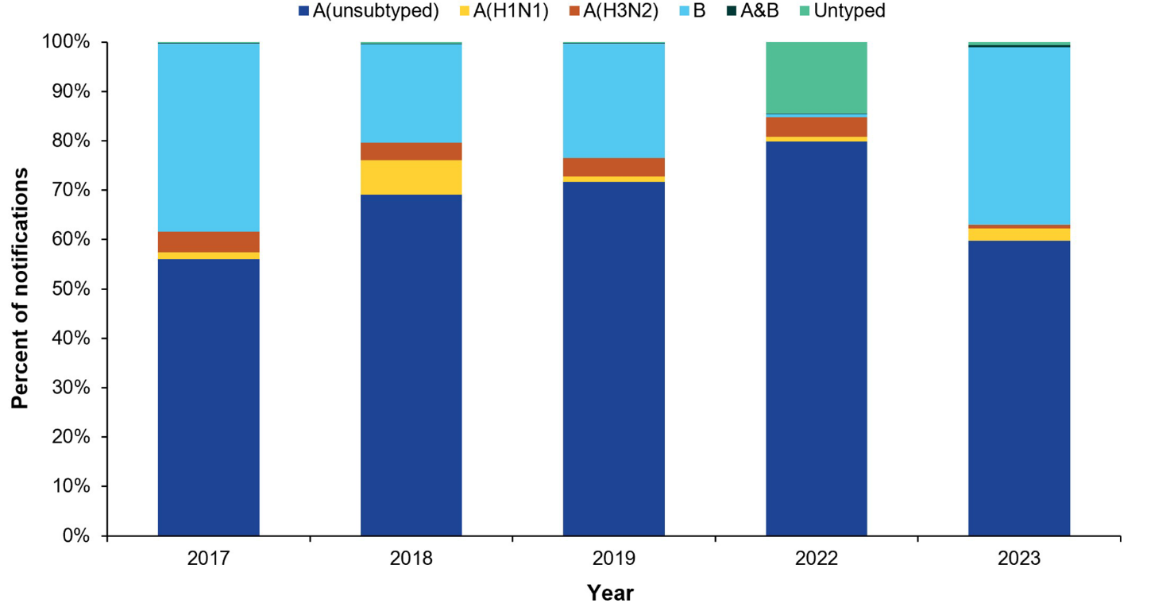
a Excludes three influenza C notifications (two in 2018 and one in 2019).
The age-specific notification rates of influenza A were higher than the corresponding rates of influenza B in all age groups in 2022 and 2023, except in 2023 among children aged 10–19 years where influenza B notification rates were higher than influenza A (Table 2).
In 2022, across all age groups, notifications were almost entirely influenza A with low numbers of influenza B and very low influenza B notification rates. In 2023, influenza B contributed a substantially larger number of notifications in most age groups, particularly in children, while influenza A remained dominant in adults aged 65 years and over (Table 2).
Across all age groups, most influenza A notifications remained unsubtyped; however, among typed influenza A notifications, the relative distribution of A(H1N1)pdm09 increased and A(H3N2) decreased in 2023 compared with 2022 (Table 2).
Table 2: Laboratory-confirmed influenza notifications and age-specific notification rates by type/subtype, year and age group,^{a,b} Australia, 2017–2019 and 2022–2023
Year | Age group (years) | Influenza type/subtype |  |  |  |  | Notification rate influenza A | Notification rate influenza B | Notification rate  (Total)
Year | Age group (years) | A(H1N1)pdm09 | A(H3N2) | A(unsubtyped) | B | A and B | Notification rate influenza A | Notification rate influenza B | Notification rate  (Total)
2017 | 0–4 | 728 | 903 | 16,035 | 7,761 | 17 | 1,122 | 493 | 1,616
2017 | 5–9 | 503 | 557 | 11,903 | 13,777 | 32 | 816 | 868 | 1,686
2017 | 10–19 | 221 | 809 | 13,871 | 15,096 | 33 | 504 | 511 | 1,016
2017 | 20–64 | 1,694 | 4,278 | 64,604 | 43,737 | 75 | 480 | 298 | 779
2017 | ≥ 65 | 298 | 3,989 | 34,253 | 15,439 | 35 | 1,017 | 408 | 1,426
2018 | 0–4 | 731 | 141 | 5,235 | 738 | 2 | 391 | 47 | 438
2018 | 5–9 | 505 | 94 | 5,015 | 1,247 | 2 | 350 | 78 | 428
2018 | 10–19 | 285 | 177 | 3,157 | 1,406 | 2 | 120 | 47 | 167
2018 | 20–64 | 2,096 | 959 | 20,952 | 6,250 | 27 | 161 | 42 | 203
2018 | ≥ 65 | 421 | 719 | 6,374 | 2,127 | 12 | 192 | 54 | 247
2019 | 0–4 | 435 | 1,095 | 27,066 | 7,975 | 37 | 1,840 | 513 | 2,356
2019 | 5–9 | 314 | 652 | 23,372 | 18,289 | 36 | 1,506 | 1,131 | 2,639
2019 | 10–19 | 218 | 1,009 | 25,700 | 16,250 | 34 | 881 | 532 | 1,414
2019 | 20–64 | 1,771 | 4,992 | 107,957 | 27,413 | 113 | 761 | 182 | 944
2019 | ≥ 65 | 548 | 4,083 | 40,791 | 2,681 | 15 | 1,126 | 66 | 1,193
2022 | 0–4 | 463 | 1,114 | 24,208 | 146 | 33 | 1,704 | 10 | 1,716
2022 | 5–9 | 490 | 908 | 28,735 | 169 | 67 | 1,869 | 10 | 1,884
2022 | 10–19 | 234 | 1,687 | 37,166 | 225 | 83 | 1,232 | 7 | 1,242
2022 | 20–64 | 894 | 4,551 | 82,196 | 677 | 62 | 573 | 4 | 578
2022 | ≥ 65 | 178 | 1,113 | 14,120 | 85 | 5 | 348 | 2 | 350
2023 | 0–4 | 1,163 | 254 | 23,078 | 10,627 | 203 | 1,615 | 701 | 2,329
2023 | 5–9 | 1,147 | 188 | 27,766 | 22,402 | 413 | 1,807 | 1,391 | 3,223
2023 | 10–19 | 715 | 326 | 22,543 | 29,616 | 340 | 722 | 907 | 1,639
2023 | 20–64 | 2,950 | 1,103 | 77,845 | 39,280 | 379 | 521 | 250 | 774
2023 | ≥ 65 | 1,188 | 367 | 21,562 | 1,772 | 28 | 507 | 39 | 546
a Notification rate per 100,000 population.
b Excludes 36,965 untyped notifications (585 in 2017, 149 in 2018, 560 in 2019, 33,823 in 2022, and 1,848 in 2023); three influenza C notifications (two in 2018 and one in 2019); and 87 notifications where age was not reported (two in 2017, five in 2018, ten in 2019, 20 in 2022, and 50 in 2023).

Virology

Samples received and tested
The WHO CCRRI received a total of 11,134 Australian influenza virus samples collected between 1 January and 31 December 2022, and 11,988 Australian influenza virus samples collected between 1 January and 31 December 2023 (Table 3). This represented 4.8% of the 233,451 laboratory-confirmed influenza notifications reported to the NNDSS in 2022, and 4.1% of the 289,153 laboratory-confirmed influenza notifications reported to the NNDSS in 2023.
In 2022, influenza A(H3N2) viruses comprised 49.7% (n = 5,535) of viruses that were typed by the WHO CCRRI, followed by influenza A(H1N1)pdm09 (11.3%; n = 1,253) and influenza B (1.4%; n = 152; consisting of 1.0% B/Victoria lineage and 0.4% B/unknown lineage). In 2023, influenza B viruses comprised 37.5% (n = 4,495; consisting of 26.9% B/Victoria lineage and 10.6% B/unknown lineage) of viruses that were typed by the WHO CCRRI, followed by influenza A(H1N1)pdm09 (36.4%; n = 4,360) and influenza A(H3N2) (10.5%; n = 1,264). The virological surveillance trends observed in 2022 and 2023 were consistent with those observed in the notification data during the same time.
There were no samples of B/Yamagata lineage viruses detected in either 2022 or 2023 (Table 3). The last influenza B/Yamagata virus characterised in Australia was in a sample from 2020.
Table 3: All Australian samples received by the World Health Organization Collaborating Centre for Reference and Research on Influenza (WHO CCRRI) by subtype/lineage, Australia, 2022–2023^{a,b}
Influenza type/subtype | 2022 |  | 2023
Influenza type/subtype | n | % | n | %
A(H1N1)pdm09 | 1,253 | 11.3 | 4,360 | 36.4
A(H3N2) | 5,535 | 49.7 | 1,264 | 10.5
A(unsubtyped) | 4,188 | 37.6 | 1,854 | 15.5
A(mixed subtype) | 0 | — | 3 | < 0.05
B/Victoria | 108 | 1.0 | 3,224 | 26.9
B/unknown lineage | 44 | 0.4 | 1,271 | 10.6
Mixed type (A/B) | 0 | — | 12 | 0.1
a Samples collected between 1 January 2022 and 31 December 2023.
b Excludes six false positive results in 2022.
The 2022 southern hemisphere egg-based seasonal influenza vaccine included an A/Victoria/2570/2019 (H1N1)pdm09-like virus; an A/Darwin/9/2021 (H3N2)-like virus; a B/Austria/1359417/2021-like (B/Victoria lineage) virus; and a B/Phuket/3073/2013-like (B/Yamagata lineage) virus. The 2022 cell-based influenza vaccine included an A/Wisconsin/588/2019 (H1N1)pdm09-like virus; an A/Darwin/6/2021 (H3N2)-like virus; a B/Austria/1359417/2021-like (B/Victoria lineage) virus; and a B/Phuket/3073/2013-like (B/Yamagata lineage) virus. The 2023 southern hemisphere egg-based seasonal influenza vaccine included an A/Sydney/5/2021 (H1N1) pdm09-like virus; an A/Darwin/9/2021 (H3N2)-like virus; a B/Austria/1359417/2021 (B/Victoria lineage)-like virus; and a B/Phuket/3073/2013 (B/Yamagata lineage)-like virus. The 2023 cell-based influenza vaccine included an A/Sydney/5/2021 (H1N1) pdm09-like virus; an A/Darwin/6/2021 (H3N2)-like virus; a B/Austria/1359417/2021-like (B/Victoria lineage) virus; and a B/Phuket/3073/2013-like (B/Yamagata lineage) virus. For more information on the seasonal influenza vaccines available in 2022 and 2023 in Australia, refer to the statements on the administration of seasonal influenza vaccines in 2022 and 2023 released by the Australian Technical Advisory Group on Immunisation.^{12,13}
In 2022, the WHO CCRRI conducted antigenic characterisation by haemagglutination inhibition (HI) assays on 3,758 influenza virus isolates. Of those, 87.8% (699/796) of influenza A(H1N1)pdm09 isolates; 94.6% (2,752/2,908) of influenza A(H3N2) isolates; and 98.1% (53/54) of influenza B/Victoria isolates were antigenically similar to the corresponding vaccine components. In 2023, the WHO CCRRI conducted antigenic characterisation by HI assays on 5,923 influenza virus isolates. Of those, 98.2% (3,050/3,107) of influenza A(H1N1)pdm09 isolates; 80.9% (673/832) of influenza A(H3N2) isolates; and 99.2% (1,969/1,984) of influenza B/Victoria isolates were antigenically similar to the corresponding vaccine components.
Viruses received by the WHO CCRRI were also tested for their sensitivity to the neuraminidase inhibitors oseltamivir and zanamivir. In 2022, no influenza A(H3N2) samples tested (0/1,866) demonstrated highly reduced inhibition to oseltamivir or zanamivir; 0.25% of the influenza A(H1N1)pdm09 samples tested (2/794) demonstrated highly reduced inhibition to oseltamivir, as defined by a ≥ 100-fold shift in IC₅₀ in a neuraminidase inhibition assay. No B/Victoria samples tested (0/54) demonstrated highly reduced inhibition to zanamivir or oseltamivir, corresponding to a ≥ 50-fold shift in IC₅₀ in a neuraminidase inhibition assay.
In 2023, no influenza A(H3N2) samples tested (0/717) demonstrated highly reduced inhibition to oseltamivir or zanamivir; 0.36% of the influenza A(H1N1)pdm09 samples tested (7/1,954) demonstrated highly reduced inhibition to oseltamivir. No B/Victoria samples tested (0/1,272) demonstrated highly reduced inhibition to oseltamivir or zanamivir.

Influenza-like illness – national online community survey (FluTracking)

Participants and survey timing
A total of 90,257 participants completed at least one survey in 2022, equivalent to 284 participants per 100,000 population.¹⁰ In 2023, a 16.8% decrease in participation was observed, with 75,078 participants (238 per 100,000 population) completing at least one survey.¹¹ The highest proportions of FluTracking participants in 2022 and 2023 were in the 40–64 years age group (42.8% and 41.1% respectively) and most participants were female.^{10,11} The proportion of participants who identified as an Aboriginal and Torres Strait Islander person was 1.3% (n = 1,147) in 2022 and 1.1% (n = 847) in 2023, compared to 3.8% of the Australian population who identify as an Aboriginal and Torres Strait Islander person.^{10,11}

Percentage of participants with ILI symptoms (fever and cough)
Of participants who completed at least one survey during 2022, new fever and cough was reported by 35.6% (compared with 29.1% in 2019). Of participants who completed at least one survey during 2023, new fever and cough was reported by 26.9%, representing a 24.4% decrease compared with 2022.
Among FluTracking participants, an early rise in fever and cough activity was observed in February 2022. Peak activity occurred in mid-May, with the percentage of participants with fever and cough reaching 3.2%, followed by a secondary peak in early July at 3.1% (Figure 6). Fever and cough activity remained elevated and well above the five-year mean, with the percentage of participants with fever and cough remaining over 2% per week until early August. Fever and cough activity declined and remained below the five-year mean between mid-August and October, before increasing again from late October 2022 (Figure 6). In 2023, fever and cough activity among FluTracking participants was generally lower than in 2022, 2019 and 2017. Fever and cough activity reached a brief peak in early June at 2.4%, followed by a sharp decline with activity remaining below the five-year mean from early July onwards (Figure 6).
Figure 6: Age standardised percentage of FluTracking participants reporting fever and cough, Australia, by week of survey,ª April to October 2017–2019 and January to December 2022–2023
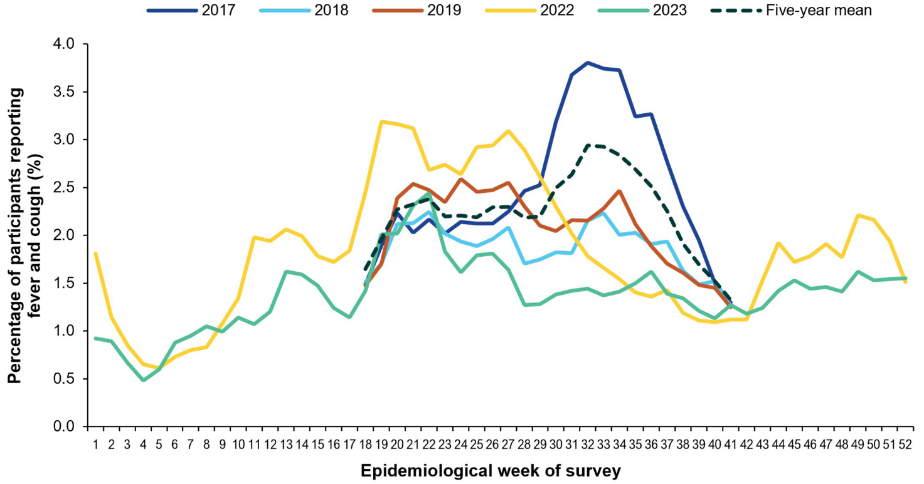
a Prior to 2020, FluTracking was activated during the main influenza season from May to October. A historical average outside of these months is not available. In addition, as 2020 and 2021 are excluded when comparing the current season to historical periods, the five-year average includes 2015–2019.

Burden of illness among participants with ILI symptoms
In 2022 and 2023, the peak weekly percentage of FluTracking participants taking time off work or normal duties due to fever and cough was 2.8% and 2.0%, respectively. The peak occurred slightly earlier in 2022 in late May, compared to early June in 2023 (Figure 7). Similar to fever and cough activity, the weekly percentage of participants taking time off work or normal duties was consistently above 2% between early May and late July 2022. In 2023, the weekly percentage of participants taking time off work or normal activities remained above 1.5% between mid-May and early June (Figure 7). From July to October 2023, the percentage of participants taking time off work or normal duties was lower than the five-year mean (Figure 7).
Of those FluTracking participants who completed at least one survey, the percentage of participants seeking medical attention for fever and cough symptoms was lower in 2023 (40.6%; n = 8,201) than in 2022 (49.9%; n = 16,040).¹¹ Only a small percentage of participants with ILI tested for influenza by polymerase chain reaction (PCR) test, with 13.8% (n = 4,446) in 2022 and 11.5% (n = 2,333) testing in 2023. The percentage of participants with fever and cough that tested positive for influenza by PCR in 2023 (3.6%; n = 725) was higher than in 2022 (2.5%; n = 792).¹¹
Figure 7: Age standardised percentage of FluTracking participants reporting time off work or normal duties due to fever and cough symptoms by week of survey,ª Australia, April to October 2017–2019 and January to December 2022–2023
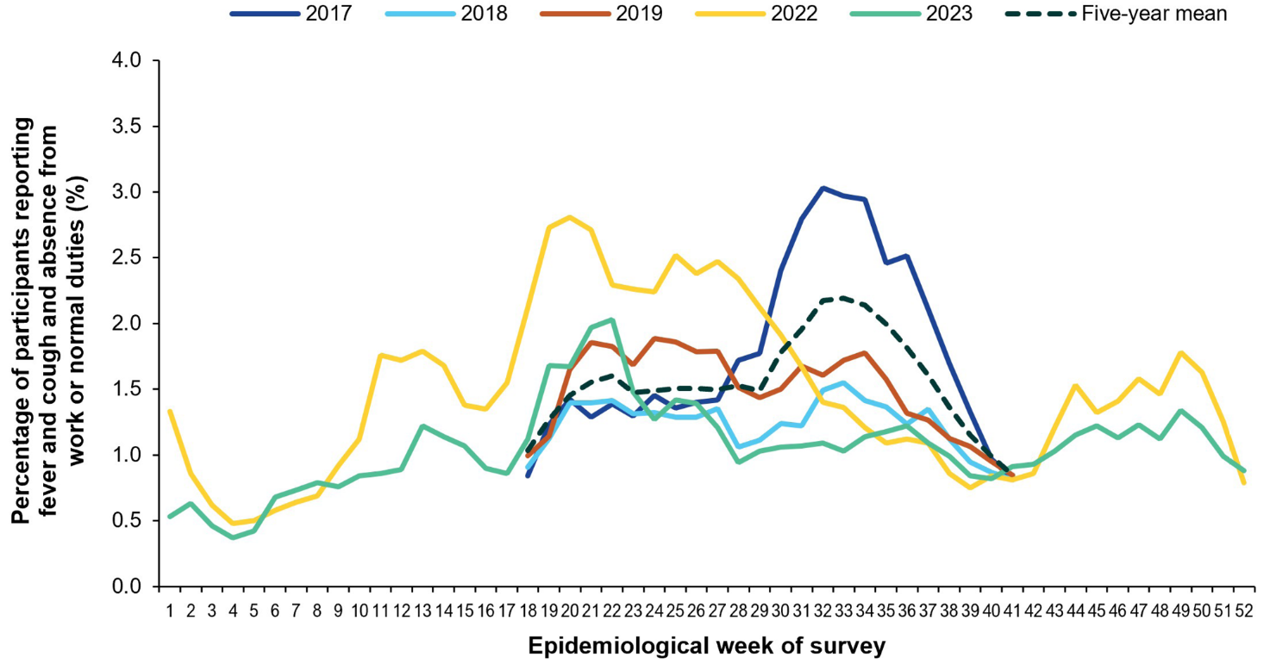
a Prior to 2020, FluTracking was activated during the main influenza season from May to October. A historical average outside of these months is not available. In addition, as 2020 and 2021 are excluded when comparing the current season to historical periods, the five-year average includes 2015–2019.

Influenza-like illness consultations from sentinel general practice surveillance systems
In 2022, there were 2,821 ILI notifications (3.5 ILI notifications per 1,000 consultations) from ASPREN sentinel general practices (unpublished data).¹⁴ In 2023, there were 4,400 ILI notifications (4.4 ILI notifications per 1,000 consultations), representing a 56% increase from 2022 to 2023 (unpublished data). Telehealth remained a common mechanism of consultation in 2022 and 2023, representing 15% and 11% of all sentinel general practice consultations, respectively, compared with 14% in 2021.^{14,15}
In 2022, ILI rates increased sharply from early May and peaked in late June at 12.4 ILI notifications per 1,000 consultations before rapidly declining and, in general, remaining below the five-year mean (Figure 8). In 2023, ILI notifications followed a similar trend to 2022, reaching a peak of 9.5 ILI notifications per 1,000 consultations in late June before declining (Figure 8). The peak in ILI notification per 1,000 consultations aligns with the peak in laboratory-confirmed influenza notifications to the NNDSS which occurred in mid-June in 2022 and late June in 2023. In both 2022 and 2023, peaks in ILI rates were lower and earlier than the five-year mean, which peaked at 15.5 notifications per 1,000 consultations in mid-August (Figure 8).
Consistent with previous years, the magnitude and timing of the peak ILI rates in 2022 and 2023 varied across states and territories. Due to sparse data, the Northern Territory (in 2022 and 2023) and Victoria (in 2022) were excluded from jurisdictional comparisons. In 2022, slightly earlier activity was observed in New South Wales, Queensland and Western Australia, while there was broader, sustained activity in South Australia and Tasmania.^{14,16} In 2023, ILI activity increased across most jurisdictions from May onwards followed by lower but persistent activity into the later weeks of the year.¹⁵
Figure 8: Unweighted rate of influenza-like illness (ILI) reported from Australian Sentinel Practices Research Network (ASPREN) sentinel general practice sites by week of consultation, Australia,ª 2017–2019 and 2022–2023
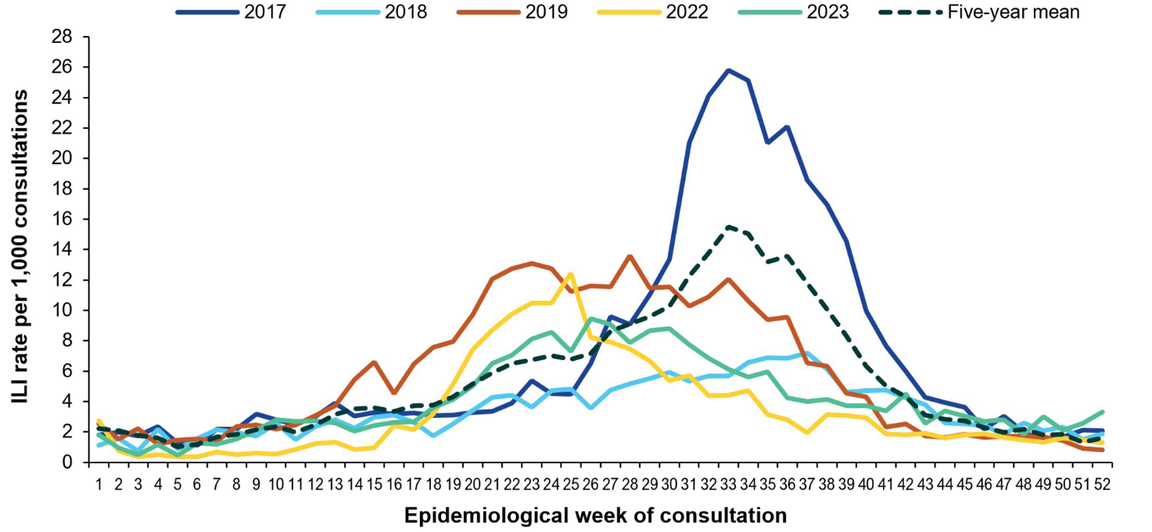
a The years 2020 and 2021 are excluded when comparing the current season to historical periods, therefore the five-year average includes the years 2015–2019.
Table 4 provides a summary of the 2022 to 2023 swab testing conducted by ASPREN sentinel general practice sites. In 2022, of general practice attendees with an ILI, 29.1% (n = 820) were swabbed for respiratory viruses. Of those tested, 16.7% (n = 137) were positive for influenza, with the majority of these being influenza A(H3N2) (82.5%; n = 113/137) (Table 4). In 2023, 39.2% (n = 1,725) of patients presenting with an ILI were swabbed for respiratory viruses. Of those tested, 19.2% (n = 332) were positive for influenza, with the largest proportion of these being influenza A(H1N1)pdm09 (43.1%; n = 143/332) (Table 4). Of positive influenza B samples, most were B/Victoria (87.4%, n = 111); there were no B/Yamagata lineages (Table 4).
Table 4: Summary of virological surveillance activities conducted by Australian Sentinel Practices Research Network (ASPREN) sentinel general practice sites,ª Australia, 2022–2023
 | 2022 | 2023
Number of swabs processed | 820 | 1,725
Number of samples positive for influenza | 137 | 332
Number of samples positive for influenza A | 137 | 205
Number of samples positive for influenza A(H3N2) | 113 | 57
Number of samples positive for influenza A(H1N1)pdm09 | 21 | 143
Number of samples positive for influenza B | — | 127
Number of samples positive for influenza B/Victoria | — | 111
Number of samples positive for influenza B/Yamagata | — | —
Number of samples positive for influenza B unknown lineages | — | 16
a With the closure of many drive-through and respiratory clinics in 2022, many coronavirus disease 2019 (COVID-19) cases were diverted to general practice. While most general practice sites had resumed swabbing, many practices had a mixed protocol for seeing influenza-like illness (ILI) patients, depending on the patients’ symptoms and whether they were at high risk of having contracted COVID-19. In these cases, ILI patients were recorded on the system (via telehealth consult) but referred to respiratory clinics for testing. This was reflected in decreased swab testing in 2022 compared to previous years.
In 2022, the median age of general practice attendees with ILI who were positive for influenza was 27 years, which was younger than the median age observed in 2019 (35 years).^{14,16} In 2023, the median age was 29 years.¹⁵ In 2022 and 2023, the majority of general practice attendees with ILI who were tested for respiratory viruses were in the 20 to 49 years age group. There were no influenza B detections in 2022; however, in 2023, 49.6% of those who tested positive for influenza B were aged 5–19 years.^{14,15} This is consistent with the literature which reports influenza B/Victoria to predominate in children.^{17,18}
In 2022, compared to unvaccinated individuals, vaccinated individuals were 54% less likely (95% confidence interval [95% CI]: 8–78) to present to a general practitioner with influenza. The vaccine was most effective in adults aged 18–64 years at 69% (95% CI: 25–89).^{14,16} Due to small sample size, VE by influenza type/subtype was not available for 2022. In 2023, compared to unvaccinated individuals, vaccinated individuals were 58% less likely (95% CI: 41–70) to present to a general practitioner with influenza. The calculated VE varied by subtype, with higher protection against influenza B (70%; 95% CI: 48–83) compared to influenza A(H1N1)pdm09 (46%; 95% CI: 14–67). The VE was highest in children aged 17 years and under (70%; 95% CI: 45–84).^{15,16}

Morbidity – FluCAN
Between 4 April and 31 October 2022, there were 2,499 patients admitted with laboratory-confirmed influenza to the 22 FluCAN-PAEDS sentinel hospitals and specialist paediatric hospitals. During the same period in 2023, there were 4,170 patients admitted to the sentinel hospitals, a 66.9% increase compared to 2022 (Table 5). While the number of patients admitted with influenza in 2023 was considerably more than in 2022, it was similar to the number of patients admitted in 2019 (n = 4,154).¹⁹
In 2022, the peak in weekly sentinel hospital admissions was earlier than in previous years, at 232 admissions per week in late May (Figure 9a), and slightly earlier than the peak in laboratory-confirmed influenza notifications to the NNDSS. The majority of admissions in 2022 were due to influenza A (99.4%; n = 2,484) (Figure 9a; Table 5).
In 2023, weekly sentinel hospital admissions peaked in early July at 307 admissions per week, similar to the late June peak in laboratory-confirmed influenza notifications to the NNDSS (Figure 9b). The majority of admissions in 2023 were due to influenza A (64.0%; n = 2,670), but there was a larger proportion of influenza B (35.6%; n = 1,486) than in 2022 (Figure 9b; Table 5).
Figure 9a: Number of patients admitted with laboratory-confirmed influenza at Influenza Complications Alert Network / Paediatric Active Enhanced Disease Surveillance (FluCAN-PAEDS) sentinel hospital sites by week of admission and influenza subtype,ª Australia, 4 April to 31 October 2022
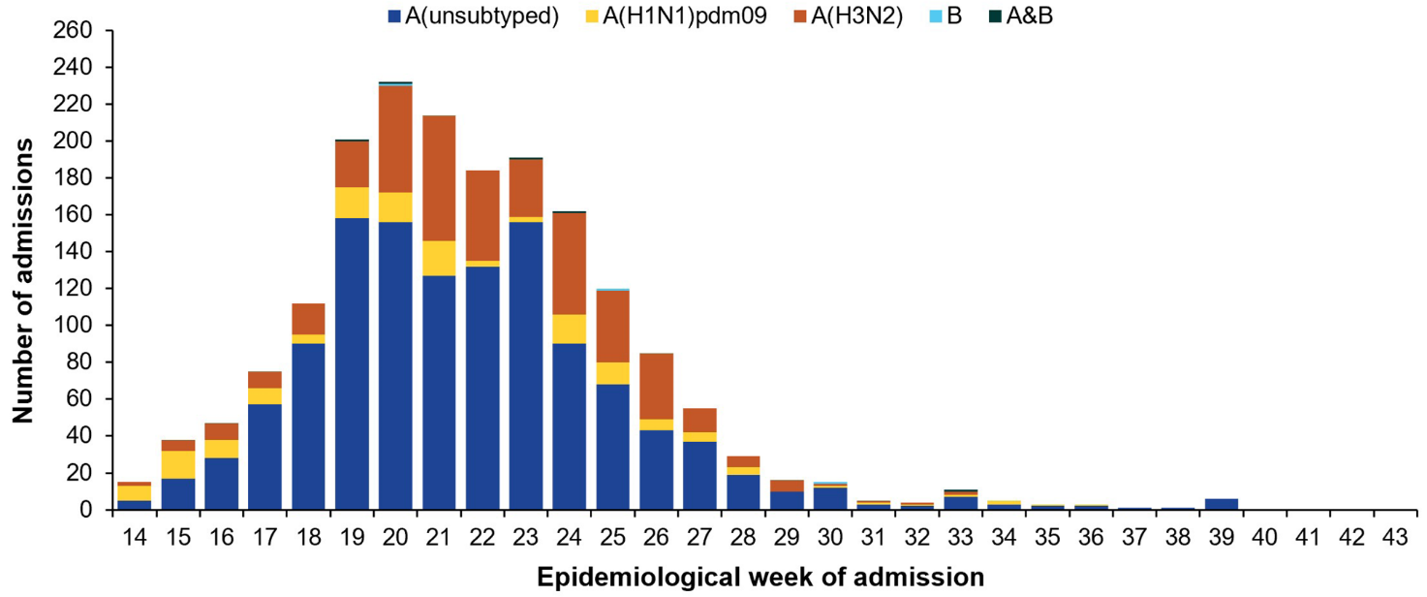
a Excludes 669 cases where date of admission was unavailable (325 with influenza A(unsubtyped); 113 with influenza A(H1N1)pdm09; 224 with influenza A(H3N2); six with influenza B; and one with influenza A & B co-infection).
Figure 9b: Number of patients admitted with laboratory-confirmed influenza at Influenza Complications Alert Network / Paediatric Active Enhanced Disease Surveillance (FluCAN-PAEDS) sentinel hospital sites by week of admission and influenza subtype,ª Australia, 4 April to 31 October 2023
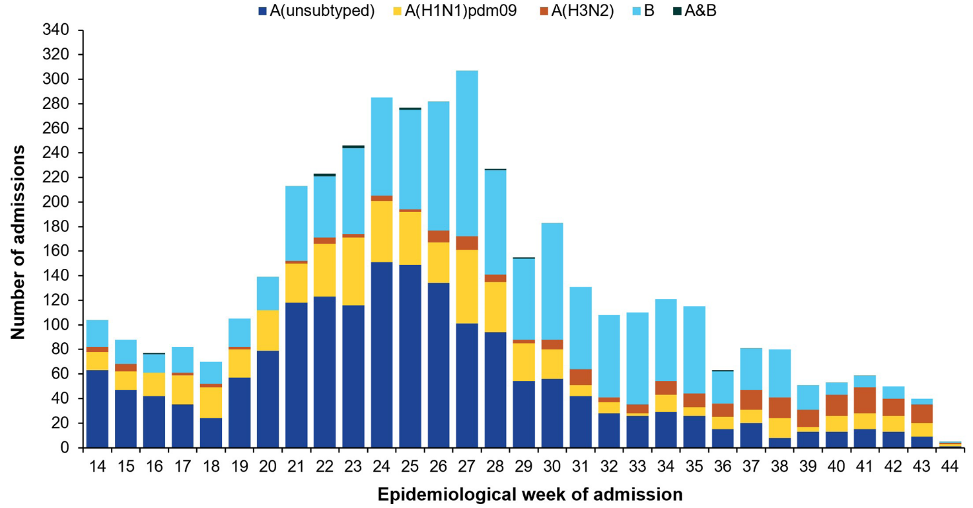
a Excludes 40 cases where date of admission was unavailable (ten with influenza A(unsubtyped); 13 with influenza A(H1N1)pdm09; 11 with influenza A(H3N2); and six with influenza B).
Demographic characteristics, risk factors, and outcomes of these hospitalised patients are provided in Table 5. There was a slightly higher proportion of children aged 16 years and under in 2023 compared to 2022, likely due to the notable increase in influenza B, which is known to result in more severe infections among children compared with adults. Aboriginal and Torres Strait Islander peoples represented a higher proportion of influenza admissions in 2022 (15.2%; n = 379) than in 2023 (8.1%; n = 336) (Table 5). Of patients with known length of stay, the mean length of hospital stay was similar in 2022 and 2023, at 3.6 days and 3.7 days, respectively.
Estimated vaccine effectiveness against hospitalisation with influenza was higher in 2023 than in 2022. In 2022, of the 2,309 patients for whom influenza vaccination status was known, 20.3% (n = 468) were vaccinated. Compared to unvaccinated individuals, vaccinated individuals were 52.1% (95% CI: 39.3–62.2) less likely to be hospitalised due to influenza in 2022. In 2023, of the 3,930 patients for whom influenza vaccination status was known, 16.5% (n = 650) were vaccinated. Compared to unvaccinated individuals, vaccinated individuals were 66.1% (95% CI: 60.2–71.1) less likely to be hospitalised due to influenza.
Table 5: Demographic characteristics, influenza type/subtype and outcomes of patients admitted with laboratory-confirmed influenza at Influenza Complications Alert Network / Paediatric Active Enhanced Disease Surveillance (FluCAN/PAEDS) sentinel hospital sites, Australia, 4 April to 31 October 2022–2023
Category | Characteristic | 2022 |  | 2023
Category | Characteristic | n | % | n | %
Total hospitalised | — | 2,499 | — | 4,170 | —
Influenza type/subtype | A(H1N1)pdm09 | 269 | 10.8 | 868 | 20.8
Influenza type/subtype | A(H3N2) | 658 | 26.3 | 137 | 3.3
Influenza type/subtype | A(unsubtyped) | 1,557 | 62.3 | 1,664 | 39.9
Influenza type/subtype | B | 9 | 0.4 | 1,486 | 35.6
Influenza type/subtype | Multiple strains | 6 | 0.2 | 13 | 0.3
Age group (years) | < 16 | 1,465 | 58.6 | 2,761 | 66.2
Age group (years) | 16–64 | 608 | 24.3 | 836 | 20.0
Age group (years) | 65+ | 425 | 17.0 | 570 | 13.7
Sex | Female | 1,241 | 49.7 | 1,961 | 47.0
Sex | Male | 1,258 | 50.3 | 2,209 | 53.0
Pregnancy status | Pregnant | 31 | 1.2 | 31 | 0.7
Indigenous status | Aboriginal and Torres Strait Islander | 379 | 15.2 | 336 | 8.1
Indigenous status | Non-Indigenous | 2,120 | 84.8 | 3,834 | 91.9
Jurisdictionª | ACT | 73 | 2.9 | 69 | 1.7
Jurisdictionª | NSW | 541 | 21.6 | 655 | 15.7
Jurisdictionª | NT | 158 | 6.3 | 133 | 3.2
Jurisdictionª | Qld | 158 | 6.3 | 686 | 16.5
Jurisdictionª | SA | 59 | 2.4 | 273 | 6.5
Jurisdictionª | Tas. | 114 | 4.6 | 186 | 4.5
Jurisdictionª | Vic. | 835 | 33.4 | 1,542 | 37.0
Jurisdictionª | WA | 268 | 10.7 | 626 | 15.0
Outcome | Intensive care unit (ICU) admissions | 185 | 7.4 | 312 | 7.5
Outcome | Died in hospital^{b,c} | 31 | 1.4 | 44 | 1.1
a ACT: Australian Capital Territory; NSW: New South Wales; NT: Northern Territory; Qld: Queensland; SA: South Australia; Tas.: Tasmania; Vic.: Victoria; WA: Western Australia.
b In 2022, of the 2,277 patients where hospital mortality status was documented, 31 patients died (1.4%); of these, eight deaths (26%) occurred in patients admitted to ICU, and 23 deaths (74%) in those not admitted to ICU.
c In 2023, of the 3,990 patients where hospital mortality status was documented, 44 patients died (1.1%); of these, 21 deaths (48%) occurred in patients admitted to ICU, and 23 deaths (52%) in those not admitted to ICU.

Mortality
Mortality from a primary influenza infection is rare, and most of the deaths attributed to influenza occur from complications including pneumonia, obstructive airways disease and sudden cardiac failure. These occur predominantly in identified at-risk groups such as adults aged 65 years and over and children under six months of age, or people with chronic medical conditions.

Influenza mortality data reported to the NNDSS
The completeness and reliability of deaths data notified to the NNDSS is low, affecting the accuracy of these estimates. For this reason, the number of influenza-associated deaths reported to the NNDSS does not represent the true mortality associated with this disease.
In 2022 and 2023, of the total laboratory-confirmed influenza notifications, 30.3% (n = 70,635) and 35.5% (n = 102,749) respectively had death status recorded. A total of 355 influenza-associated deaths were reported to the NNDSS in 2022, representing a case fatality rate (CFR) of 0.15%. A total of 474 influenza-associated deaths were reported to the NNDSS in 2023, representing a CFR of 0.16%. The CFR in both 2022 and 2023 remained below the five-year mean CFR for 2015–2019 which was 0.31%. Total deaths increased between 2022 and 2023, though this is expected when there are higher case numbers as occurred in 2023.
Influenza-associated deaths predominantly occurred among older age groups in both years, but the age distribution shifted younger in 2023. In 2022 and 2023 respectively, adults aged 70 years and over accounted for 75.5% (n = 268) and 63.7% (n = 302) of all influenza-associated deaths. In 2023, the proportional contribution of the younger age groups increased substantially with 10.5% of deaths (n = 50) among adults aged 20–49 years, compared to 1.7% of deaths (n = 6) in the same age group in 2022. A similar trend occurred among children aged 0–19 years, with 1.4% of deaths (n = 5) occurring among this age group in 2022, compared with 3.8% of deaths (n = 18) in 2023.
In 2022 and 2023, a large proportion of the reported influenza-associated deaths were notified by New South Wales (38.9% in 2022; 23.8% in 2023), Queensland (25.9% in 2022; 31.4% in 2023) and Victoria (23.7% in 2022; 25.7% in 2023), Australia’s most populous states.

Australia Bureau of Statistics (ABS) death data
Influenza (ICD-10 codes J09–J11) was the underlying cause of death for 311 persons in 2022 (0.16% of all 191,463 deaths that occurred in 2022) and 430 persons in 2023 (0.24% of all 182,839 deaths that occurred in 2023).²⁰ While the number of deaths with influenza as an underlying cause increased from 2022 to 2023, both years recorded fewer deaths than in 2019 (n = 1,072) and 2017 (n = 1,272) which were recent high-mortality years for influenza.²⁰
Influenza deaths are linked to the severity of influenza seasons, which can drive changes in leading cause of death rankings each year. When grouped, influenza or pneumonia (ICD-10 codes J09–J18) was the eighteenth leading cause of death in 2022 and seventeenth leading cause of death in 2023, with influenza or pneumonia the underlying cause of death for 2,776 persons in 2022 and for 2,886 persons in 2023.²⁰

Discussion and conclusion
The impact and severity of influenza are difficult to quantify due to the nature of the illness and limitations in surveillance systems. Influenza surveillance in Australia is supported by a network of data sources and systems, each varying in their capacity to detect true cases of influenza and accurately reflect the burden of disease. The interpretation of surveillance data is subject to limitations, including under-ascertainment, variability in testing practices, and differences in healthcare-seeking behaviour across jurisdictions and age groups.
Based on available data, the 2022 and 2023 influenza seasons in Australia were considered high activity and low to moderate severity overall. Laboratory-confirmed influenza notifications in 2022 were lower than reported in 2019 and 2017, but higher than in other pre-pandemic years and around 1.4 times the five-year mean. Laboratory-confirmed influenza notifications in 2023 were 1.8 times the five-year mean and higher than the number of notifications observed in all pre-pandemic years except 2019. In 2022 and 2023, there appear to have been subtle differences in the timing of the influenza seasons than in most pre-pandemic years, with earlier season starts and earlier peaks.^{3,4}
Australia’s 2022 influenza season began unusually early and peaked about eight weeks earlier than in pre-pandemic years, when influenza notifications typically peaked in mid-August.^{3,4} The rapid and early increase in influenza notifications in 2022 is likely due to several factors. Across late 2021 to February 2022, many states and territories progressively relaxed public health and social measures, including the cessation of routine lockdowns or stay-at-home orders; the easing of density limits, gathering restrictions and mask mandates; and the reopening of domestic and international borders to fully COVID-19 vaccinated visa holders.^{8,21} There was an accumulated immunity debt from minimal community exposure to influenza during 2020–2021 which is thought to have contributed to higher susceptibility, particularly among children.^{8,22} In addition, vaccination coverage in April and May 2022 was lower compared to previous years.²³ This strong resurgence of influenza in 2022 is consistent with the trends in resurgence of respiratory infections observed in other countries including the United Kingdom, the United States of America and the People’s Republic of China, after the relaxation of their public health and social measures, particularly during the first winter.^{22,24,25}
Australia’s 2023 influenza season also began unusually early but was prolonged, more closely resembling pre-pandemic seasonal patterns,³ and resulted in the second highest total annual notifications, likely driven by a combination of epidemiological and testing factors. Greater use of multiplex diagnostic panels, which test for multiple respiratory pathogens including influenza, may have improved ascertainment and may have contributed to increased influenza notifications in recent years. Pandemic-related changes in health-seeking behaviour, including increased testing, have likely further increased notifications. Despite improvements in case ascertainment driven by changes in testing practices and health-seeking behaviour, notified influenza cases likely continue to underestimate the true burden of infection. This reflects the reliance of surveillance data on healthcare presentation, testing and reporting, as well as the limitations of rapid antigen and point-of-care tests, including lower sensitivity compared with molecular methods.²⁶
Consistent with previous years, the highest rates of laboratory-confirmed influenza notifications in 2022 and 2023 were observed in children aged 0–4 and 5–9 years. In 2022, notification rates among these age groups were far higher than in other age groups, and exceeded rates seen in previous years.^{3,4} These trends likely reflect limited pre-existing population immunity among children following minimal community exposure to influenza during 2020–2021.²² In addition, in 2023, there was substantial circulation of A(H1N1) and influenza B which predominantly affect children and younger adults.^{17,18} In contrast to the short and temporally aligned epidemic in 2022, influenza activity in 2023 was more prolonged and geographically heterogeneous, with broader peaks and extended periods of activity in several jurisdictions. While less distinct seasonality, including multiple or off-season peaks, is typical in tropical regions such as the Northern Territory,²⁷ the more diffuse and extended patterns observed across temperate jurisdictions in 2023 indicate less predictable seasonality overall. This may reflect changes in population immunity, population mobility and contact patterns following pandemic-related disruptions, co-circulation of other respiratory viruses, differences in testing practices and ascertainment, and potential contributions from the circulating strain characteristics.²⁸
Sentinel surveillance supports the assessment that both the 2022 and 2023 influenza seasons were characterised by early, high activity, with peaks occurring earlier than the pre-pandemic five-year mean. Based on data from hospital-based sentinel systems, the burden placed on hospitals (or impact on hospitals) due to people admitted with influenza was moderate in 2022 but high in 2023 (consistent with 2019), likely driven by the predominance of A(H1N1)pdm09 and influenza B in 2023. In 2022 and 2023, severity, measured through the proportion of influenza patients admitted to sentinel hospital intensive care units, was at the lower end of historical figures, which ranged from 7.4% in 2015 to 11.9% in 2014.^{3,4} By this measure, the 2022 and 2023 seasons are of a similar severity to that seen in previous moderate severity seasons like 2019.⁴
While hospital admissions can be measured relatively easily, measuring deaths due to influenza is more complicated. Influenza can lead to secondary bacterial infections, like pneumonia, which can in turn lead to hospitalisation and death, particularly among older people. When this happens, it can be difficult to link death directly to an earlier influenza infection as follow-up of influenza cases is not a requirement for notification. The number of influenza associated deaths was lower than in recent high mortality years, further supporting the assessments of 2022 and 2023 as seasons with low to moderate severity and moderate severity respectively. However, when grouped, influenza and pneumonia were in the top 20 leading causes of death across Australia in both years.²⁰ This highlights the serious impact influenza can have on health, even when not directly recorded as the cause of death, and reinforces the importance of preventative measures and vaccination.
The numbers and distribution of hospitalisations and deaths reported across 2022–2023 were broadly consistent with influenza notification trends and the dominant circulating strains each year. Despite extensive circulation of A(H3N2) in 2022 – which is typically associated with higher mortality among older people²⁹ – severity may have been mitigated by several factors, including reduced exposure among older adults due to sustained residential aged care measures, continued precautionary measures such as mask-wearing following COVID-19, and higher influenza vaccination coverage.^{23,30} In 2023, moderate severity may be explained by the predominance of A(H1N1)pdm09 and influenza B, which tend to disproportionately affect children and younger adults rather than older individuals at higher risk of severe outcomes.^{17,18} However, as only a small proportion of samples were subtyped compared to the total number of tests performed, this may influence the apparent distribution of influenza subtypes and thus may affect interpretation of these results.¹ One other notable change to circulating influenza viruses since the COVID-19 pandemic has been the absence of the influenza B/Yamagata lineage viruses, which have not been detected in Australian samples after March 2020.³¹
Of influenza viruses characterised by the WHO CCRRI in 2022 and 2023, antigenic characterisation showed high similarity between circulating strains and vaccine components, and resistance to neuraminidase inhibitors was rare, with only isolated cases showing reduced sensitivity to oseltamivir. Based on data generated during the 2023 southern hemisphere influenza season, at their technical meeting in 2023, the WHO recommended the following influenza virus strains for inclusion in the quadrivalent 2024 southern hemisphere influenza vaccine:
Egg-based vaccines
- an A/Victoria/4897/2022 (H1N1)pdm09-like virus;
- an A/Thailand/8/2022 (H3N2)-like virus;
- a B/Austria/1359417/2021 (B/Victoria lineage)-like virus; and
- a B/Phuket/3073/2013 (B/Yamagata lineage)-like virus.
Cell- or recombinant-based vaccines
- an A/Wisconsin/67/2022 (H1N1)pdm09-like virus;
- an A/Massachusetts/18/2022 (H3N2)-like virus;
- a B/Austria/1359417/2021 (B/Victoria lineage)-like virus; and
- a B/Phuket/3073/2013 (B/Yamagata lineage)-like virus.³²
Final estimated vaccine effectiveness against general practice presentation with influenza was 54% in 2022 and 58% in 2023, while vaccine effectiveness against hospitalisation was 52% in 2022 and 66% in 2023. These estimates showed that the seasonal influenza vaccines provided moderate protection against severe disease and are consistent with previous years.^{3,4} Differences in vaccine effectiveness between general practice presentation and hospitalisation may reflect differences in affected populations and the potential attenuation of illness severity by vaccination.
Overall, multiple data sources consistently indicate that the 2022 and 2023 influenza seasons were characterised by early activity, with 2022 reflecting high activity and low severity, and 2023 high activity and moderate severity. Following the COVID-19 pandemic period, influenza has re-emerged with earlier onset and peak activity, greater interseasonal variability, and less predictable seasonality, rather than a return to pre-pandemic norms. This reinforces the importance of earlier preparedness and vaccination, adaptive surveillance systems, and ongoing assessment of seasonal timing and severity.

Acknowledgments
The authors wish to acknowledge and thank the following for their work and contributions to this report: state and territory health departments and laboratories, FluTracking, the Australian Sentinel Practices Research Network (ASPREN), the Influenza Complications Alert Network (FluCAN), the World Health Organisation Collaborating Centre for Reference and Research on Influenza (WHO CCRRI), the Australian Bureau of Statistics and the National Respiratory Infections Surveillance Committee (NRISC; previously the National Influenza Surveillance Committee).

Author details
Ms Jenna Hassall, Epidemiologist and a/g Assistant Director,¹
Ms Tracy Tsang, Epidemiologist and Assistant Director,¹
Ms Lauren Kutzner, Epidemiologist,¹
Ms Lauren Welsh, Epidemiologist,¹
Ms Suzie Whitehead, Epidemiologist,¹
- Public Health Division, Australian Centre for Disease Control, Canberra, Australian Capital Territory, Australia

Corresponding author
Suzie Whitehead
Public Health Division, Australian Centre for Disease Control, PO Box 795, Canberra ACT 2601, Australia
Email: respiratory.surveillance@cdc.gov.au

References
- Paules C, Subbarao K. Influenza. Lancet. 2017;390(10095):697–708.
doi: https://doi.org/10.1016/S0140-6736(17)30129-0.
- World Health Organization (WHO). Influenza (seasonal). [Online fact sheet.] Geneva: WHO; 28 February 2025. Available from: https://www.who.int/news-room/fact-sheets/detail/influenza-(seasonal).
- Communicable Diseases Epidemiology Surveillance Section. Report of the National Influenza Surveillance Scheme, 2011 to 2018. Commun Dis Intell (2018). 2022;46. doi: https://doi.org/10.33321/cdi.2022.46.12.
- Hassall J, Kutzner L, Whitehead S, Tsang T, Hogarth F, St George S. Report of the National Influenza Surveillance Scheme, 2019. Commun Dis Intell (2018). 2026;50. doi: https://doi.org/10.33321/cdi.2026.50.020.
- Bonacina F, Boëlle PY, Colizza V, Lopez O, Thomas M, Poletto C. Global patterns and drivers of influenza decline during the COVID-19 pandemic. Int J Infect Dis. 2023;128:132–9. doi: https://doi.org/10.1016/j.ijid.2022.12.042.
- Bright A, Glynn-Robinson AJ, Kane S, Wright R, Saul N. The effect of COVID-19 public health measures on nationally notifiable diseases in Australia: preliminary analysis. Commun Dis Intell (2018). 2020;44. doi: https://doi.org/10.33321/cdi.2020.44.85.
- Sullivan SG, Carlson S, Cheng AC, Chilver MB, Dwyer DE, Irwin M et al. Where has all the influenza gone? The impact of COVID-19 on the circulation of influenza and other respiratory viruses, Australia, March to September 2020. Euro Surveill. 2020;25(47):2001847. doi: https://doi.org/10.2807/1560-7917.ES.2020.25.47.2001847.
- Whitehead S, Hassall J, Kutzner L, Tsang T, Singhal S. Report of the National Influenza Surveillance Scheme, 2020–2021. Commun Dis Intell (2018). 2026;50. doi: https://doi.org/10.33321/cdi.2026.50.021.
- World Health Organization (WHO) Collaborating Centre for Reference and Research on Influenza (CCRRI). WHO GISRS Surveillance; WHO Global Influenza Surveillance and Response System (GISRS) Surveillance and Vaccine Development. [Webpage.] Melbourne: WHO CCRRI; 2025. Available from: http://www.influenzacentre.org/Centre_Activities_WHO_GISRS_Surveillance.html.
- Kerr AG, Carlson SJ, Baldwin Z, Innes RJ, Howard ZL, Bennett M et al. FluTracking: Weekly online community-based surveillance of respiratory illness in Australia, 2020–2022 Report. Commun Dis Intell (2018). 2025;49. doi: https://doi.org/10.33321/cdi.2025.49.024.
- Kerr A, Kerr S, Adams S, McKenzie T, Boettiger D, Dalton C. FluTracking: Weekly online community-based surveillance of respiratory illness in Australia, 2023 Report. Commun Dis Intell (2018). 2025;49. doi: https://doi.org/10.33321/cdi.2025.49.037.
- Australian Technical Advisory Group on Immunisation (ATAGI). ATAGI advice on seasonal influenza vaccines in 2022. [Webpage.] Canberra: Australian Government Department of Health, Disability and Ageing; 25 March 2022. [Accessed on 19 May 2026.] Available from: https://www.health.gov.au/resources/publications/atagi-advice-on-seasonal-influenza-vaccines-in-2022.
- ATAGI. ATAGI advice on seasonal influenza vaccines in 2023. [Webpage.] Canberra: Australian Government Department of Health, Disability and Ageing; 28 February 2023. [Accessed on 19 May 2026.] Available from: https://www.health.gov.au/resources/publications/atagi-advice-on-seasonal-influenza-vaccines-in-2023.
- Chilver M, Stocks N. The Australian Sentinel Practices Research Network Annual Surveillance Report 2022. [Unpublished manuscript/report]. Adelaide: University of Adelaide, Australian Sentinel Practices Research Network (ASPREN); 2022.
- Chilver M, Blakeley D, Ahsani Z, Stocks N. The Australian Sentinel Practices Research Network Annual Surveillance Report 2023. [Unpublished manuscript/report]. Adelaide: University of Adelaide, ASPREN; 2023.
- Chilver M, Ahsani Z, Sullivan SG, Edwards J, Dueger E, Turra M et al. Evaluating the role of self-collected home swab data in enhancing influenza vaccine effectiveness estimates in general practice. Vaccine. 2026;69:127994. doi: https://doi.org/10.1016/j.vaccine.2025.127994.
- Panatto D, Signori A, Lai PL, Gasparini R, Amicizia D. Heterogeneous estimates of influenza virus types A and B in the elderly: results of a meta-regression analysis. Influenza Other Respir Viruses. 2018;12(4):533–43. doi: https://doi.org/10.1111/irv.12550.
- Skowronski DM, Chambers C, De Serres G, Sabaiduc S, Winter AL, Dickinson JA et al. Age-related differences in influenza B infection by lineage in a community-based sentinel system, 2010–2011 to 2015–2016, Canada. J Infect Dis. 2017;21(6):697–702. doi: https://doi.org/10.1093/infdis/jix393.
- Cheng AC, Dwyer DE, Holmes M, Irving LB, Simpson G, Senanayake S et al. Influenza epidemiology in patients admitted to sentinel Australian hospitals in 2019: the Influenza Complications Alert Network (FluCAN). Commun Dis Intell (2018). 2022;46. doi: https://doi.org/10.33321/cdi.2022.46.14.
- Australian Bureau of Statistics. Causes of Death, Australia. Reference period: 2023. [Webpage]. Canberra: Australian Bureau of Statistics; 10 October 2024. Available from: https://www.abs.gov.au/statistics/health/causes-death/causes-death-australia/2023.
- Andrews K, Morrison S, Hunt G, Tehan D. Reopening to tourists and other international travellers to secure our economic recovery. [Media statement.] Canberra: Australian Government, Home Affairs portfolio; 7 February 2022. Available from: https://minister.homeaffairs.gov.au/KarenAndrews/Pages/reopening-to-tourists-and-other-international-travellers-to-secure-our-economic-recovery.aspx.
- Chen L, Guo Y, López-Güell K, Ma J, Dong Y, Xie J et al. Immunity debt for seasonal influenza after the COVID-19 pandemic and as a result of nonpharmaceutical interventions: an ecological analysis and cohort study. Adv Sci (Weinh). 2025;12(20):e2410513. doi: https://doi.org/10.1002/advs.202410513.
- National Centre for Immunisation Research and Surveillance (NCIRS). All persons: 2020–2026 (YTD) influenza vaccination coverage, Australia. [Webpage.] Sydney: Sydney Children’s Hospitals Network, NCIRS; 2026. Available from: https://ncirs.org.au/influenza-vaccination-coverage-data/all-persons-2020-2026-ytd-influenza-vaccination-coverage.
- Bardsley M, Morbey RA, Hughes HE, Beck CR, Watson CH, Zhao H et al. Epidemiology of respiratory syncytial virus in children younger than 5 years in England during the COVID-19 pandemic, measured by laboratory, clinical, and syndromic surveillance: a retrospective observational study. Lancet Infect Dis. 2023;23(1):56–66.
doi: https://doi.org/10.1016/S1473-3099(22)00525-4.
- WHO. Disease Outbreak News: Upsurge of respiratory illnesses among children – Northern China. [Media release.] Geneva: WHO; 23 November 2023. Available from: https://www.who.int/emergencies/disease-outbreak-news/item/2023-DON494.
- Therapeutic Goods Administration (TGA). Clinical performance evaluation and risk management of seasonal influenza rapid antigen tests. [Webpage.] Canberra: Australian Government Department of Health, Disability and Ageing, TGA; 1 March 2021. Available from: https://www.tga.gov.au/resources/guidance/clinical-performance-evaluation-and-risk-management-seasonal-influenza-rapid-antigen-tests.
- Hirve S, Newman LP, Paget J, Azziz-Baumgartner E, Fitzner J, Bhat N et al. Influenza seasonality in the tropics and subtropics - when to vaccinate? PloS One. 2016;11(4):e0153003. doi: https://doi.org/10.1371/journal.pone.0153003.
- Lu C, Barr IG, Lambert S, Mengersen K, Wang L, Yang W et al. Shifts in seasonal influenza patterns in Australia during and after COVID-19: a comprehensive analysis. J Infect Public Health. 2025;18(1):102620. doi: https://doi.org/10.1016/j.jiph.2024.102620.
- Langer J, Welch VL, Moran MM, Cane A, Lopez SMC, Srivastava A et al. High clinical burden of influenza disease in adults aged ≥ 65 Years: can we do better? A systematic literature review. Adv Ther. 2023;40(4):1601–27. doi: https://doi.org/10.1007/s12325-023-02432-1.
- Australian Bureau of Statistics. Household Impacts of COVID-19 Survey. Reference period: April 2022. [Webpage.] Canberra: Australian Bureau of Statistics; 17 May 2022. Available from: https://www.abs.gov.au/statistics/people/people-and-communities/household-impacts-covid-19-survey/apr-2022.
- Caini S, Meijer A, Nunes MC, Henaff L, Zounon M, Boudewijns B et al. Probable extinction of influenza B/Yamagata and its public health implications: a systematic literature review and assessment of global surveillance databases. Lancet Microbe. 2024;5(8):100851. doi: https://doi.org/10.1016/S2666-5247(24)00066-1.
- WHO. Recommended composition of influenza virus vaccines for use in the 2024 southern hemisphere influenza season. [Meeting report.] Geneva: WHO; 29 September 2023. Available from: https://www.who.int/publications/m/item/recommended-composition-of-influenza-virus-vaccines-for-use-in-the-2024-southern-hemisphere-influenza-season.

