
2026 • Volume 50 • cdc.gov.au/cdi • Epub date: 25.08.2026 • doi.org/10.33321/cdi.2026.50.054

Report on influenza viruses received and tested by the Melbourne WHO Collaborating Centre for Reference and Research on Influenza during 2025
Vishma Ramji Varsani, Jessica E Miller, Tanya R Diefenbach-Elstob, James Barnes, Nikita Deshpande, Maha Khairbak, Olivia Lay, Cleve Rynehart, Sally Soppe, Clyde Dapat, Yi-Mo Deng, Saira Hussain, Heidi Peck, Ian G Barr, Patrick Reading
© 2026 Commonwealth of Australia as represented by the Australian Centre for Disease Control
ISSN: 2209-6051 Online
This journal is indexed by Index Medicus and Medline.
Creative Commons Licence
This publication is licensed under a Creative Commons Attribution-NonCommercial-NoDerivatives 4.0 International Licence (Licence). You must read and understand the Licence before using any material from this publication.
Restrictions
The Licence does not cover, and there is no permission given for, use of any of the following material found in this publication (if any):
- the Commonwealth Coat of Arms (by way of information, the terms under which the Coat of Arms may be used can be found on the Department of Prime Minister and Cabinet website);
- any logos (including the Australian Centre for Disease Control’s logo) and trademarks;
- any photographs and images;
- any signatures; and
- any material belonging to third parties.
Disclaimer
Opinions expressed in Communicable Diseases Intelligence are those of the authors and not necessarily those of the Australian Government or the Australian Centre for Disease Control. Data may be subject to revision.
Enquiries
Enquiries regarding any other use of this publication should be addressed to the CDI Editor.
About CDI
Communicable Diseases Intelligence (CDI) is a peer-reviewed scientific journal published by the Australian Centre for Disease Control.
The journal aims to disseminate information on the epidemiology, surveillance, prevention and control of communicable diseases of relevance to Australia and the near region.
Editor: Dr Elise Firman • Deputy Editor: Simon Petrie • Design and Production: Lisa Thompson
Editorial Advisory Board: David Durrheim, Mark Ferson, Clare Huppatz, John Kaldor, Martyn Kirk and Meru Sheel
Submit an Article
Guidelines for authors and details on how to submit your publication is available on our website, or by email to the
CDI Editor.
Contact us
Communicable Diseases Intelligence (CDI)
Australian Centre for Disease Control
PO Box 795, Canberra ACT 2601, Australia
Website: cdc.gov.au/cdi
Email: cdi.editor@cdc.gov.au

Contents
Abstract 5
Introduction 6
Methods 7
Virus isolation 7
Antigenic analysis 7
Genetic analysis 8
Antiviral drug susceptibility testing 9
Candidate vaccine strains 9
Results 10
A(H1N1)pdm09 viruses 13
A(H3N2) viruses 15
Influenza B viruses 17
Discussion 19
Acknowledgments 21
Author details 22
References 23
Appendix A: Supplementary material 28

List of figures
Figure 1: Geographic distribution of influenza laboratories sending viruses to the Melbourne WHO Collaborating Centre for Reference and Research on Influenza (the Centre) in 2025 10
Figure 2: Number of samples received at the Melbourne WHO Collaborating Centre for Reference and Research on Influenza (the Centre) during 2025,ª by week of sample receipt 11
Figure 3: Phylogenetic tree of haemagglutinin (HA) genes of A(H1N1)pdm09 viruses received by the Melbourne WHO Collaborating Centre for Reference and Research on Influenza (the Centre)ª during 2025 14
Figure 4: Phylogenetic tree of haemagglutinin (HA) genes of A(H3N2) viruses received by the Melbourne WHO Collaborating Centre for Reference and Research on Influenza (the Centre)ª during 2025 16
Figure 5: Phylogenetic tree of haemagglutinin (HA) genes of B/Victoria-lineage viruses received by the Melbourne WHO Collaborating Centre for Reference and Research on Influenza (the Centre)ª during 2025 18

List of tables
Table 1: Southern hemisphere influenza vaccine reference strains used for reporting purposes by the Melbourne WHO Collaborating Centre for Reference and Research on Influenza (the Centre), 2025 8
Table 2: Antigenic analysis of viruses received by the Melbourne WHO Collaborating Centre for Reference and Research on Influenza (the Centre) in 2025, by geographic region of origin 12

Abstract
As part of its role in the World Health Organization (WHO) Global Influenza Surveillance and Response System (GISRS), the WHO Collaborating Centre for Reference and Research on Influenza in Melbourne (the Centre) received 13,817 human influenza-positive samples during 2025. Viruses were analysed for their antigenic, genetic, and antiviral susceptibility properties. Selected viruses were propagated in qualified cells or embryonated hens’ eggs for potential use in seasonal influenza virus vaccines. Of the 13,817 samples received or processed, influenza A(H1N1)pdm09 viruses predominated, accounting for 46.1% of samples, compared to 21.2% for A(H3N2) viruses and 19.5% for influenza B viruses; one influenza C virus was received. Among viruses analysed at the Centre, the majority of A(H1N1)pdm09 (> 99%) and influenza B (98%) viruses were antigenically similar to their respective WHO recommended vaccine strains for the Southern Hemisphere in 2025. In contrast, only 43% of A(H3N2) viruses were antigenically similar to their respective WHO recommended vaccine strains. Of 3,307 samples tested for susceptibility to the neuraminidase inhibitors oseltamivir and zanamivir, 37 A(H1N1)pdm09 viruses showed highly reduced inhibition by oseltamivir and no influenza viruses tested showed highly reduced inhibition by zanamivir. Of 5,080 samples with sequencing of the polymerase acidic (PA) gene, no genetic markers associated with highly reduced susceptibility to baloxavir marboxil were identified.
Keywords: influenza; vaccine; GISRS; surveillance; laboratory; annual report; WHO

Introduction
The WHO Collaborating Centre for Reference and Research on Influenza in Melbourne (the Centre) is part of the World Health Organization (WHO) Global Influenza Surveillance and Response System (GISRS). GISRS is a global network of laboratories that was established in 1952 to monitor changes in influenza viruses circulating in the human population, with the aim of reducing the impact of influenza through the use of vaccines and antiviral drugs.^{1,2} The Centre in Melbourne, designated by WHO in 1992, is one of five Collaborating Centres, with the others located in Atlanta, Beijing, London, and Tokyo. These Centres monitor antigenic and genetic changes in circulating human influenza viruses and contribute to the WHO biannual recommendations on which influenza strains should be included in the vaccine for the upcoming influenza season in the northern or southern hemisphere. This report summarises the results of virological surveillance activities undertaken at the Centre in Melbourne during 2025. Following the sharp reduction in influenza activity and laboratory-confirmed influenza notifications to the Australian National Notifiable Diseases Surveillance System (NNDSS) during the COVID-19 pandemic in 2020–2021, influenza activity substantially increased in 2022–2024 and record high numbers of notifications have been reported in each subsequent year.^{3–5}
Two types of influenza viruses (A and B) cause significant disease in humans. Influenza A viruses are further classified into subtypes based on their haemagglutinin (HA) and neuraminidase (NA) surface proteins. Globally, there are currently two influenza A subtypes circulating in the human population: A(H1N1)pdm09 and A(H3N2). Influenza B viruses have been classified into lineages rather than subtypes, based on the genetic and antigenic features of the viral HA protein. Prior to the COVID-19 pandemic, there were two distinct co-circulating lineages: B/Victoria/2/1987 (B/Victoria lineage) and B/Yamagata/16/1988 (B/Yamagata lineage). However, no confirmed cases of B/Yamagata viruses have been reported globally since March 2020, and it has been postulated that during the COVID-19 pandemic this lineage may have become extinct.⁶ Influenza C viruses are also detected each year from humans, but these viruses do not cause severe disease and are not a major focus of influenza surveillance. Highly pathogenic avian influenza (HPAI) viruses, including A(H5N1), cause severe disease in wild birds and poultry and have been associated with sporadic infections in humans with various levels of severity. Most reported cases of human infection have occurred in people who have had close contact with infected birds and no sustained human-to-human transmission has been reported.

Methods
The Centre receives influenza-positive samples for surveillance purposes from submitting laboratories predominantly in Australia as well as other countries in the Asia-Pacific region. This report includes all surveillance samples received by the Centre in 2025, noting that a small number of viruses collected in 2024 were therefore also included. Repeat samples of any type from the same person, when known, are not included in reported numbers.

Virus isolation
All original influenza-positive clinical specimens (that were not supplied in inactivation media) and viral isolates were passaged in cell culture, using Madin-Darby Canine Kidney (MDCK) cells for A(H1N1)pdm09 and influenza B viruses, and MDCK-SIAT-1 cells for A(H3N2) and untyped influenza A viruses.⁷ A subset of influenza-positive original clinical samples were also directly inoculated into eggs and/or into a qualified cell line (MDCK 33016PF) to generate potential influenza candidate vaccine viruses.

Antigenic analysis
The antigenic properties of influenza viral isolates were analysed using the haemagglutination inhibition (HI) assay as previously described,⁸ and a subset of A(H1N1)pdm09 and A(H3N2) viruses were additionally analysed by the focus reduction assay (FRA). HI assays were performed manually or using the TECAN Freedom EVO200 robot platform which incorporates a camera (SciRobotics, Kfar Saba, Israel) and imaging software (FluHemaTM) for analysis. In HI assays, viruses were tested for their ability to agglutinate red blood cells (RBC) in the presence of post-infection ferret antisera, raised against several reference viruses, which has undergone treatment with receptor-destroying enzyme (RDE) prior to use in HI assays. Turkey RBCs were used for A(H1N1)pdm09 and B viruses; guinea pig RBCs were used for A(H3N2) viruses. Isolates were identified as antigenically similar to the reference strain if the test sample had a titre that was no more than fourfold lower than the titre of the homologous reference strain. In 2025, results were reported with reference to the viruses that were recommended for inclusion in the 2025 southern hemisphere influenza vaccine, or with reference to a like virus in cases where the recommended virus was not available (Table 1). In recent years (including 2025), HI assays involving A(H3N2) viruses have been performed in the presence of 20 nM oseltamivir carboxylate (OC) to reduce non-specific binding of the NA protein.⁹
Table 1: Southern hemisphere influenza vaccine reference strains used for reporting purposes by the Melbourne WHO Collaborating Centre for Reference and Research on Influenza (the Centre), 2025
Subtype/lineage | 2025 cellª | 2025 egg
A(H1N1)pdm09 | A/Victoria/4897/2022 (H1N1pdm09)-like | A/Victoria/4897/2022 (H1N1pdm09)-like
A(H3N2) | A/Croatia/10136RV/2023 (H3N2)-like | A/Croatia/10136RV/2023 (H3N2)-like
B/Victoria-lineage | B/Austria/1359417/2021 (B/Victoria lineage)-like | B/Austria/1359417/2021 (B/Victoria lineage)-like
B/Yamagata-lineage | B/Phuket/3073/2013 (B/Yamagata lineage)-like | B/Phuket/3073/2013 (B/Yamagata lineage)-like
a Cell-propagated like-reference viruses A/Victoria/4897/2022 (A(H1N1)pdm09) and A/Croatia/10136RV/2023 (A(H3N2) were used in haemagglutination inhibition (HI) and virus neutralisation assays in place of the WHO-recommended cell-based vaccine strains A/Wisconsin/67/2022 and A/District of Columbia/27/2023, respectively.
In addition, the FRA, a virus neutralisation assay which is more sensitive than the HI assay (and does not require binding to RBCs), was used to analyse a subset of A(H1N1)pdm09 and A(H3N2) viruses. The FRA utilised the same ferret antisera as the HI assay and was performed as previously described, but with a 1.2% Avicell RC591 (IMCD Mulgrave, Australia) overlay replacing carboxymethyl cellulose.

Genetic analysis
For influenza-positive samples that failed to grow in MDCK cells, real-time reverse transcription polymerase chain reaction (RT-PCR) was performed to determine the influenza subtype/lineage using the CDC Influenza Virus Real-Time RT-PCR kit.^{10,11} A subset of influenza viruses (virus isolates and/or original clinical specimens) underwent genetic analysis by next generation sequencing (NGS) of viral RNA, usually HA, NA and polymerase acidic (PA) genes, as well as the matrix protein (MP) gene for influenza A viruses. Whole genome sequencing (WGS) was performed by NGS on a smaller subset of viruses.
For sequencing, RNA was extracted from isolates or original clinical specimens using either a manual QIAGEN QIAamp Viral RNA kit or the automated QIAGEN QIAXtractor platform. Samples were sequenced using multi-fragment RT-PCR (mRT-PCR) for either WGS or targeted sequencing of the HA, NA, MP, and PA genes for influenza A, or the HA, NA, and PA genes for influenza B, using the SuperScriptIV one-step RT-PCR System (ThermoFisher) with primer sets as described previously.^{12,13} NGS was conducted using an Illumina iSeq 100 or ONT MinION Mk1b system according to the manufacturer’s recommendations. Sequence data was analysed using an adaption of the IRMA pipeline.^{12,14} Phylogenetic analyses were performed using the Augur pipeline,¹⁵ and trees constructed using IQ-TREE 2,¹⁶ with 1,000 bootstrap replicates and generalised-time reversible (GTR) model, and visualised using ggtree.¹⁷
HA clade nomenclature was determined using the Nextclade tool, version 3.13.2.¹⁸ Some laboratories performed NGS on their submitted viruses and these results, when provided, are included in the analyses.

Antiviral drug susceptibility testing
Circulating viruses were tested phenotypically for their susceptibility to the currently used neuraminidase inhibitors oseltamivir (Tamiflu) and zanamivir (Relenza). Virus isolates were tested for antiviral susceptibility using a fluorescence-based neuraminidase inhibition (NAI) assay with the substrate 2’-(4-methylumbelliferyl)-α-D-N-acetylneuraminic acid (MUNANA). The susceptibility of test viruses to the antiviral drugs was measured in terms of the drug concentration needed to reduce the influenza neuraminidase enzymatic activity by 50% (IC₅₀) and compared to a reference IC₅₀ value which is the median IC₅₀ of viruses of the respective type/subtype/lineage known to be susceptible to NAI. NAI assays were performed as previously described,¹⁹ either manually or with the incorporation of a robotic platform by TECAN EVO200 and Infinite 200 Pro for liquid handling and fluorescence measurements, respectively (Tecan Australia). For reporting purposes, highly-reduced susceptibility of influenza A viruses has been defined by WHO as a ≥ 100-fold increase in IC₅₀ compared to the reference IC₅₀ value.²⁰ For influenza B viruses, highly-reduced susceptibility is defined as a ≥ 50-fold increase in IC₅₀ values compared to the reference IC₅₀ value.²⁰ However, it should be noted that the relationship between the IC₅₀ value and the clinical effectiveness of a neuraminidase inhibitor is not fully understood and a small or moderate reduction in inhibition may not be clinically significant.
Viruses showing highly reduced inhibition by either oseltamivir or zanamivir underwent genetic analysis via NGS to determine the presence of amino acid substitutions in the NA protein likely to be associated with reduced inhibition by neuraminidase inhibitors. For example, a change from histidine to tyrosine at position 275 (H275Y) of the NA protein of A(H1N1)pdm09 viruses is known to significantly reduce inhibition by oseltamivir, as does the H273Y NA substitution in B viruses.²¹ Genetic evidence of reduced susceptibility to baloxavir marboxil was identified via NGS of the PA gene, as well as by analysis of external sequence data provided by submitting laboratories. Sequencing data was screened for antiviral resistance marker I38T, which is a key marker of clinically relevant resistance to baloxavir.²¹

Candidate vaccine strains
The viruses used to produce human influenza vaccines are required by regulatory authorities to be isolated and passaged in embryonated hens’ eggs or qualified cell lines, directly from human clinical respiratory samples.^{22–24} The Centre has undertaken primary isolation of selected viruses from clinical samples directly into eggs, using previously described methods.²⁵ Briefly, the viruses were inoculated into the amniotic cavity of embryonated eggs and once virus growth was established, isolates were passaged in the allantoic cavity until a sufficient titre (as determined by haemagglutination of turkey or guinea pig RBC) was obtained. For A(H1N1)pdm09 and A(H3N2) viruses, eggs were incubated at 35 °C for three days, whereas eggs inoculated with influenza B viruses were incubated at 33 °C for three days. In addition, selected clinical samples were inoculated into the qualified cell line MDCK 33016PF (Seqirus Limited, Holly Springs, North Carolina, United States of America)²⁶ and incubated at 35 °C for three days, with viral growth monitored by haemagglutination of turkey or guinea pig RBC. These isolates were then analysed by HI assay, real time RT-PCR and/or genetic sequencing using the methods described above.

Results
During 2025, the Centre received 13,817 samples (including 13,209 clinical specimens; 319 virus isolates; 288 specimen and isolate pairs; and one tissue sample) from 44 laboratories in 22 countries (Figure 1). Australian laboratories sent the highest number of samples to the Centre (n = 11,797; 85.4%), followed by laboratories in Brunei (n = 325; 2.4%) and Timor-Leste (n = 248; 1.8%). Of the 13,817 samples received, 12,746 (92.2%) were collected in 2025, with the majority received between May and December (n = 9,990/12,746; 78.4%). Figure 2 depicts the weekly temporal distribution of samples received by the Centre in 2025, by type and subtype/lineage, for those samples where subtype/lineage were known. From January to September, among typed and subtyped influenza viruses, A(H1N1)pdm09 virus detections predominated, followed by B/Victoria viruses; A(H3N2) viruses were detected at low levels. In September, A(H3N2) virus detections rapidly increased and from October to December 2025, A(H3N2) virus detections predominated, while A(H1N1)pdm09 and B/Victoria viruses were detected at low levels. No influenza B samples were identified as B/Yamagata viruses.
Figure 1: Geographic distribution of influenza laboratories sending viruses to the Melbourne WHO Collaborating Centre for Reference and Research on Influenza (the Centre) in 2025
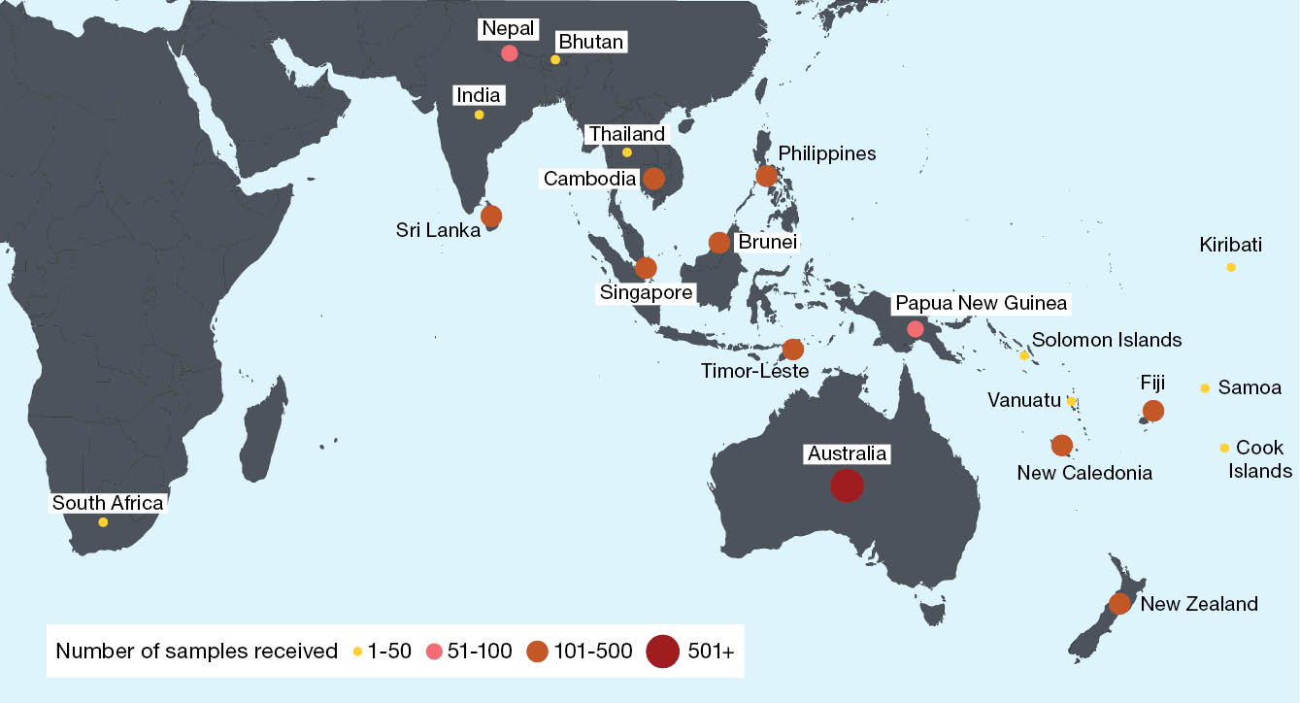
Figure 2: Number of samples received at the Melbourne WHO Collaborating Centre for Reference and Research on Influenza (the Centre) during 2025,ª by week of sample receipt
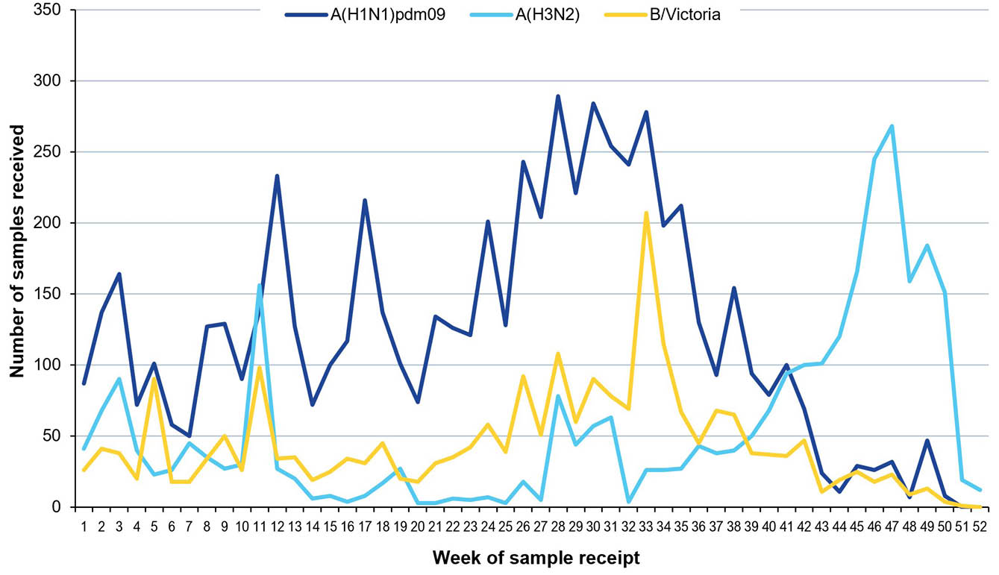
a Samples received before Sunday 5 January 2025 (n = 7) were excluded.
Virus isolation and re-passaging were attempted for 11,791 of the samples received (85.3%), yielding 7,840 isolates and an overall isolation rate of 66.5%. Among the viruses for which type and subtype/lineage could be confirmed, isolation rates by cell propagation were 74.9% (4,119/5,499) for A(H1N1)pdm09; 81.2% (2,232/2,745) for A(H3N2); and 70.1% (1,472/2,100) for B/Victoria viruses.
A total of 7,263 viral isolates were successfully characterised by HI assay and compared to the 2025 cell-propagated reference viruses (Table 2). In addition, real-time RT-PCR was attempted on 3,620 samples to determine their type/subtype or lineage. Of the samples for which antigenic or genetic analysis was attempted (n = 11,083), influenza A(H1N1)pdm09 viruses predominated, comprising 49.4% (n = 5,475) of viruses received and analysed, followed by A(H3N2) with 23.9% (n = 2,645) and B/Victoria with 19.8% (n = 2,191). One influenza C virus was also received and confirmed using real-time RT-PCR.²⁷ Sequence was determined for the HA genes of 5,236 viruses, and full genome sequences of 453 viruses were obtained using NGS.
Table 2: Antigenic analysis of viruses received by the Melbourne WHO Collaborating Centre for Reference and Research on Influenza (the Centre) in 2025, by geographic region of origin
Region | A(H1N1)pdm09ª reference strain:  A/Victoria/4897/2022 (cell) |  | A(H3N2)ª reference strain: A/Croatia/10136RV/2023 (cell) |  | B/Victoria reference strain: B/Austria/1359417/2021 (cell) |  | B/Yamagata reference strain: B/Phuket/3073/2013 (cell)
Region | Like | Low reactor (%) | Like | Low reactor (%) | Like | Low reactor (%) | Like | Low reactor (%)
Africa | 2 | 0 (0) | 25 | 2 (7.4) | 1 | 0 (0) | — | —
Australasia | 3,347 | 18 (0.5) | 498 | 1,094 (68.7) | 1,094 | 26 (2.3) | — | —
South Asia | 37 | 0 (0) | 65 | 3 (4.4) | 43 | 0 (0) | — | —
South East Asia | 251 | 0 (0) | 208 | 79 (27.5) | 125 | 0 (0) | — | —
South Pacific | 107 | 0 (0) | 136 | 82 (37.6) | 20 | 0 (0) | — | —
Total | 3,744 | 18 (0.4) | 932 | 1,260 (57.5) | 1,283 | 26 (2.0) | — | —
a A small number of A(H1N1)pdm09 and A(H3N2) virus isolates that were obtained could not be analysed by HI assay due to low haemagglutination assay (HA) titre in turkey red blood cells (for A(H1N1)pdm09) or guinea pig red blood cells in the presence of oseltamivir (for A(H3N2)).

A(H1N1)pdm09 viruses
Of the 3,762 A(H1N1)pdm09 isolates analysed by HI assay using ferret antisera in 2025, the majority (99.5%; n = 3,744) were antigenically similar to the cell-propagated vaccine reference strain A/Victoria/4897/2022 (Table 2).
A total of 38 A(H1N1)pdm09 viruses were analysed using FRA. The FRA indicated that two of these viruses (5.3%) showed greater than fourfold difference in titre compared to the cell-propagated reference strain A/Victoria/4897/2022, while none had a greater than fourfold difference in titre compared to the egg-propagated reference strain A/Victoria/4897/2022.
Sequencing by the Centre was attempted on 2,489 influenza A(H1N1)pdm09 viruses, with results obtained for 2,404 (96.6%). Sequencing and phylogenetic analysis of HA genes from 2,845 viruses (including viruses sequenced externally) showed that the majority of A(H1N1)pdm09 viruses received during 2025 and able to be sequenced were classified into subclades D.3.1 (n = 2,205; 77.5%) and C.1.9.3 (n = 434; 15.3%) (Figure 3), compared to the 2025 southern hemisphere vaccine reference strain, A/Wisconsin/67/2022 (subclade C.1.1). The relative proportions of the different A(H1N1)pdm09 subclades for all samples collected in 2025 from Australia are shown in Appendix A, Figure A.1.
Twenty-two A(H1N1)pdm09 viruses were inoculated into eggs for isolation of candidate vaccine viruses, with 11 (50.0%) successfully isolated. These included six isolates from subclade D.3.1, three from subclade C.1.9.3, and two from subclade D.3. Forty-one A(H1N1)pdm09 viruses were inoculated into the qualified cell line MDCK 33016PF, of which 21 (51.2%) grew successfully, consisting of ten from subclade D.3, two from subclade D.3.1, two from subclade C.1.9, and seven from subclade C.1.9.3.
Of the 1,859 A(H1N1)pdm09 viruses tested in the NAI assay, 37 viruses (30 from Australia; three from Singapore; two from New Caledonia; one from Fiji; and one from Thailand) exhibited highly reduced inhibition by oseltamivir, all carrying the NA-H275Y substitution known to cause highly reduced inhibition to oseltamivir, while remaining sensitive to zanamivir. No viruses exhibited highly reduced inhibition by zanamivir. Furthermore, no viruses were identified with genetic evidence of highly reduced susceptibility to baloxavir marboxil (based on sequencing of the PA gene of 2,429 viruses, including viruses sequenced externally).
Figure 3: Phylogenetic tree of haemagglutinin (HA) genes of A(H1N1)pdm09 viruses received by the Melbourne WHO Collaborating Centre for Reference and Research on Influenza (the Centre)ª during 2025
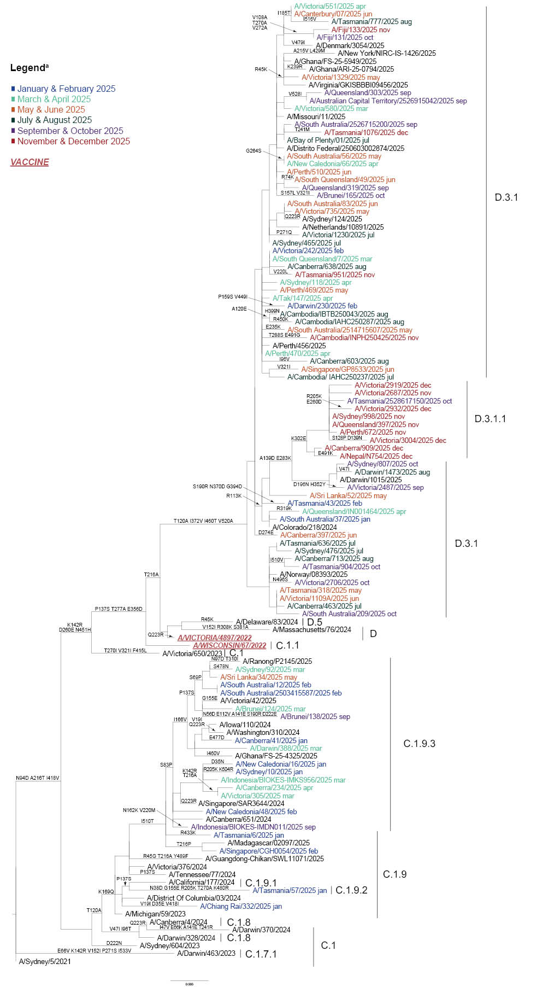
a Viruses from 2025 sequenced at the Centre are coloured according to the month in which they were collected.

A(H3N2) viruses
Antigenic analysis of 2,192 A(H3N2) isolates using the HI assay showed that 42.5% (n = 932) were antigenically similar to the cell-propagated reference strain A/Croatia/10136RV/2023 (Table 2).
A total of 45 A(H3N2) viruses were analysed using FRA. The FRA indicated that two of these viruses (4.4%) showed greater than fourfold difference in titre compared to the cell-propagated reference strain A/Croatia/10136RV/2023, while 23 (51.1%) had a greater than fourfold difference in titre compared to the egg-propagated reference strain A/Croatia/10136RV/2023.
Sequencing by the Centre was attempted on the HA genes of 1,558 A(H3N2) viruses, with 1,525 (97.9%) yielding results. Phylogenetic analysis of the HA genes of 1,752 viruses received by the Centre (including viruses sequenced externally) classified the majority of circulating viruses as subclade K (n = 902; 51.5%); J.2 (n = 389; 22.2%); J.2.2 (n = 220; 12.6%); and J.2.4 (n = 201; 11.5%) (Figure 4), with the 2025 southern hemisphere vaccine reference strain, A/District of Columbia/27/2023, being a subclade J.2 virus. The relative proportions of the different A(H3N2) subclades for all samples collected in 2025 from Australia are shown in Appendix A, Figure A.1.
Thirty-six influenza A(H3N2) viruses were inoculated into eggs, with 17 (47.2%) successfully isolated, including six from subclade J.2; three from subclade J.2.2; seven from subclade J.2.4; and one from subclade K. Seventy-two A(H3N2) viruses were inoculated into the qualified cell line MDCK 33016PF, of which 36 (50.0%) grew successfully, including thirteen from subclade J.2; two from subclade J.2.1; three from subclade J.2.2; one from subclade J.2.3; seven from subclade J.2.4; one from subclade J.2.5; and nine from subclade K.
None of the 882 A(H3N2) viruses tested in the NAI assay showed highly reduced inhibition by oseltamivir or zanamivir. No viruses were identified with genetic evidence of highly reduced susceptibility to baloxavir marboxil (based on sequencing of the PA gene of 1,626 viruses, including viruses sequenced externally).
Figure 4: Phylogenetic tree of haemagglutinin (HA) genes of A(H3N2) viruses received by the Melbourne WHO Collaborating Centre for Reference and Research on Influenza (the Centre)ª during 2025
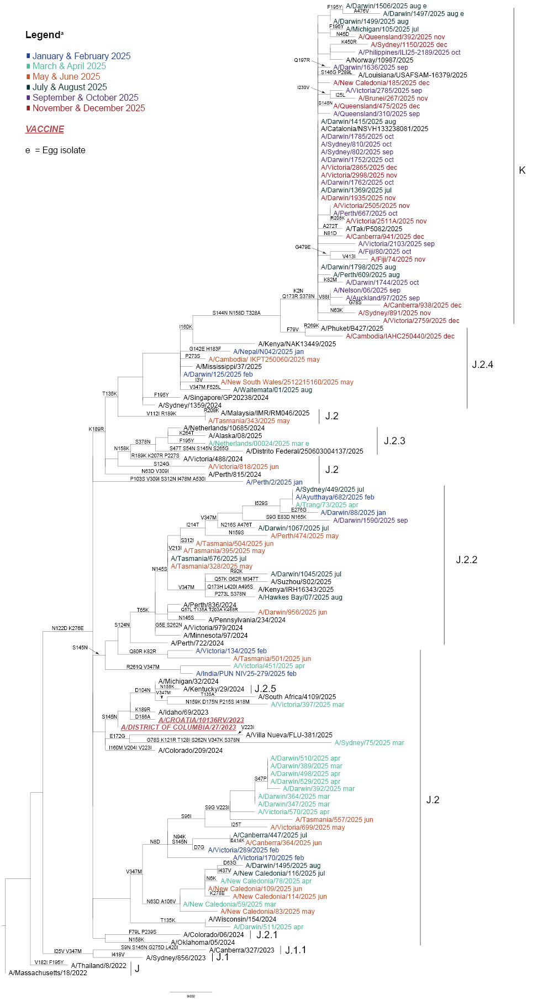
a Viruses from 2025 sequenced at the Centre are coloured according to the month in which they were collected.

Influenza B viruses
A total of 1,309 B/Victoria viruses were characterised by HI assay (Table 2), with 98.0% (n = 1,283) found to be antigenically similar to the cell-propagated B/Austria/1359417/2021 vaccine virus (Table 2).
Sequencing by the Centre was attempted on 1,140 B/Victoria viruses, with 1,049 (92.0%) yielding results. Phylogenetic analysis on the HA genes of 1,158 viruses (including viruses sequenced externally) classified the majority of circulating B/Victoria viruses received by the Centre as subclade C.5.6 (n = 683; 58.9%), followed by subclade C.5.7 (n = 258; 22.3%), compared to the 2025 southern hemisphere vaccine reference strain B/Austria/1359417/2021 (subclade C). A small number of viruses were classified as subclade C.3.1 and showed reduced reactivity to antisera raised to the 2025 vaccine strain (Figure 5). The relative proportions of the different influenza B virus subclades for all samples collected in 2025 from Australia are shown in Appendix A, Figure A.1.
Five B/Victoria viruses were inoculated into eggs, of which four (80.0%) were successfully isolated: three from subclade C.5.6 and one from subclade C.3.1. Sixteen B/Victoria viruses were inoculated into the qualified cell line MDCK 33016PF, of which 12 (75%) grew successfully: four from subclade C.3.1; two from subclade C.5.1; two from subclade C.5.6; one from subclade C.5.6.1; and three from subclade C.5.7.
None of the 566 A(H3N2) viruses tested with the NAI assay showed highly reduced inhibition by oseltamivir or zanamivir. No viruses were identified with genetic evidence of highly reduced susceptibility to baloxavir marboxil (based on sequencing of the PA gene of 1,025 viruses, including viruses sequenced externally).
Figure 5: Phylogenetic tree of haemagglutinin (HA) genes of B/Victoria-lineage viruses received by the Melbourne WHO Collaborating Centre for Reference and Research on Influenza (the Centre)ª during 2025
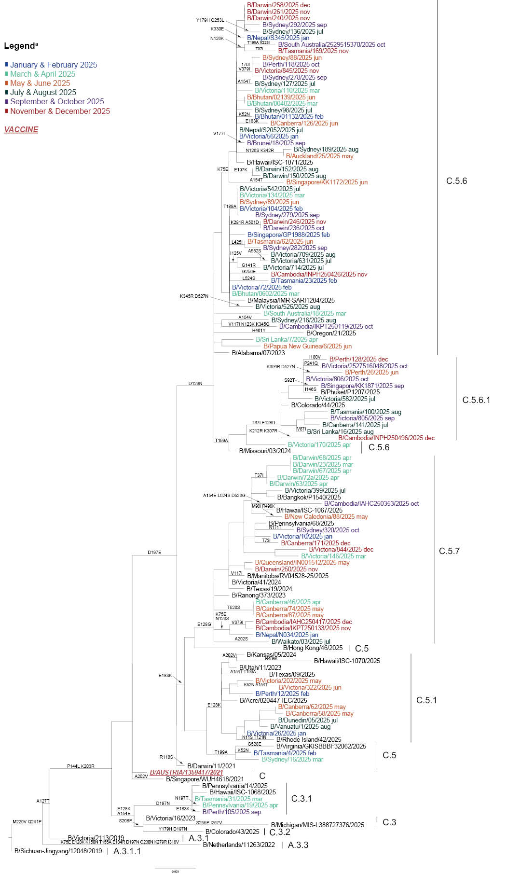
a Viruses from 2025 sequenced at the Centre are coloured according to the month in which they were collected.

Discussion
During 2025, the Centre received one of its highest numbers of samples (n = 13,817); this was an increase on the number of samples received in 2024 (n = 12,180), but fewer than the number received in 2023 (n = 15,014).^{28–51} In Australia, the 2025 influenza season marked the third year where influenza activity returned to or exceeded pre-pandemic levels following the global reduction in influenza activity observed during the COVID-19 pandemic in 2020/2021.^{4,48,50,52} The high number of samples received at the Centre correlated with the record number of laboratory-confirmed influenza notifications (n = 502,932) to the NNDSS during the 2025 Australian influenza season.³ The number of influenza notifications in 2025 was 38% more than the number recorded in 2024 (n = 365,589), and 74% more than in 2023 (n = 289,154).^{5,53,54} The 2025 Australian influenza season was characterised by low and stable activity early in the year, with increased notifications from May, peaking in July and declining through to September. However, this was followed by an unusual second increase in notifications from October that extended the season until the end of the year. The number of influenza notifications per week remained elevated for a longer period of time in 2025 than in previous years.^{53,54} This activity was reflected in the timing of samples received by the Centre, with 62% of samples collected in 2025 received at the Centre during the April to September period and 24% of samples collected in 2025 received at the Centre during the October to December period.
Geographically, most notifications of laboratory-confirmed influenza were made in New South Wales (n = 187,151), which had the highest annual influenza notification rate in 2025 (2,206 cases per 100,000 population).³ Lower numbers of influenza notifications were made in Queensland (n = 99,927) and Victoria (n = 119,328) for the same period, with annual influenza notification rates of 1,789 and 1,709 cases per 100,000 population, respectively.^{3,54} In general, the first peak of influenza activity occurred during the June–August period in all jurisdictions, followed by a second peak in November due to increased circulation of viruses in the influenza A(H3N2) subclade K which first emerged in August 2025 and which predominated from October through to December.^{3,55,56}
Throughout 2025, global surveillance data reported to FluNet showed that influenza A virus detections outnumbered influenza B across all WHO regions.⁵⁷ Similarly in Australia in 2025, influenza A was the predominant circulating virus reported to the NNDSS, followed by influenza B.⁵⁴ This is consistent with samples received by the Centre from sites across Australia, where A(H3N2) and A(H1N1)pmd09 accounted for the majority of viruses analysed.
The highest notification rates in Australia were observed among children (4,531 notifications per 100,000 population among those aged 5–9 years; 3,889 per 100,000 population among those aged 0–4 years; and 3,082 per 100,000 population among those aged 10–14 years), while the lowest notification rates were among adults aged 25–29 years (939 per 100,000 population).^{3,58} Overall notification rates increased across all age groups in 2025 compared to 2024, except for adults aged 25–29 years for whom the notification rate decreased from 988 per 100,000 in 2024 to 939 per 100,000 in 2025.^{3,53,58} There were 1,745 deaths involving influenza reported to the Australian Bureau of Statistics Provisional Mortality Statistics for 2025.⁵⁹
Antigenic analysis of A(H1N1)pdm09 viruses indicated that the majority of viruses (99%) were antigenically similar to the cell-propagated like-vaccine strain A/Victoria/4897/2022 (subclade C.1.1). Most circulating A(H1N1)pdm09 viruses received by the Centre were in subclade D.3.1 (77.5%), followed by subclade C.1.9.3 (15.3%). Genetic diversity was evident among the A(H1N1)pdm09 viruses characterised, and the recommended vaccine strain for the Southern Hemisphere in 2026 was therefore updated to an A/Missouri/11/2025-like virus (subclade D.3.1) for egg-, cell-, or recombinant-protein-based vaccines.
Forty-three percent of A(H3N2) viruses received by the Centre were antigenically like the cell-propagated like-vaccine reference strain A/Croatia/10136RV/2023, belonging to subclade J.2. Most circulating A(H3N2) viruses received at the Centre were in subclade K (51.5%), followed by subclade J.2 (22.2%) and subclade J.2.2 (12.6%). Genetic diversity was evident among A(H3N2) viruses characterised, and the recommended vaccine strain for the Southern Hemisphere in 2026 was therefore updated to an egg-based A/Singapore/GP20238/2024-like virus and a cell- or recombinant-protein-based A/Sydney/1359/2024-like virus (subclade J.2.4).
Ninety-eight percent of B/Victoria viruses were antigenically like the cell-propagated vaccine reference strain B/Austria/1359417/2021 (subclade C). Most circulating B/Victoria viruses received by the Centre belonged to subclade C.5.6 (59%), followed by subclade C.5.7 (22.3%). The recommended B/Victoria-lineage vaccine strain for the Southern Hemisphere remained unchanged for 2026. Globally, no B/Yamagata viruses have been detected since March 2020, and it is assumed that this strain is now extinct.^{6,60–62}
Seasonal influenza viruses continue to evolve, and an effective universal vaccine has not yet been developed. As such, influenza surveillance and regular updating of seasonal influenza vaccines remain essential. The work performed at the Centre in Melbourne contributes to the ongoing efforts of the WHO GISRS to better control the disease burden of influenza, and to provide effective countermeasures, such as vaccines, to reduce the impact of influenza on the human population.

Acknowledgments
The authors would like to thank all the National Influenza Centres and other contributing laboratories who sent influenza-positive samples to the Centre during 2025. The Melbourne WHO Collaborating Centre for Reference and Research on Influenza is supported by the Australian Government Department of Health, Disability and Ageing.

Author details
Ms Vishma Ramji Varsani, Data and Communication Officer,¹
Dr Jessica E Miller, Head – Epidemiology,¹
Dr Tanya R Diefenbach-Elstob, Epidemiologist,¹
Mr James Barnes, Medical Scientist,¹
Ms Nikita Deshpande, Medical Scientist,¹
Ms Maha Khairbak, Medical Scientist,¹
Ms Olivia Lay, Medical Scientist,¹
Mr Cleve Rynehart, Medical Scientist,¹
Ms Sally Soppe, Medical Scientist,¹
Dr Clyde Dapat, Head – Bioinformatics,¹
Dr Yi-Mo Deng, Head – Genetic analysis,¹
Dr Saira Hussain, Head – Antiviral drug sensitivity,¹
Ms Heidi Peck, Head – Serology,¹
Prof Ian G Barr, Deputy Director,¹
Prof Patrick Reading, Director¹
- WHO Collaborating Centre for Reference and Research on Influenza, 792 Elizabeth Street, Melbourne VIC 3001, Australia

Corresponding author
Dr Jessica E Miller
WHO Collaborating Centre for Reference and Research on Influenza, 792 Elizabeth Street, Melbourne VIC 3001, Australia
email: jessica.miller@influenzacentre.org
Phone: +61 3 9342 9300

References
- Hay AJ, McCauley JW. The WHO global influenza surveillance and response system (GISRS)—a future perspective. Influenza Other Respir Viruses. 2018;12(5):551–7. doi: https://doi.org/10.1111/irv.12565.
- Monto AS. Reflections on the global influenza surveillance and response system (GISRS) at 65 years: an expanding framework for influenza detection, prevention and control. Influenza Other Respir Viruses. 2018;12(1):10–2. doi: https://doi.org/10.1111/irv.12511.
- Australian Centre for Disease Control (Australian CDC). National Notifiable Disease Surveillance System: National Communicable Disease Surveillance Dashboard. [Online resource.] Canberra: Australian CDC; 2025. [Accessed on 28 April 2025.] Available from: https://nindss.health.gov.au/pbi-dashboard/.
- Sullivan SG, Carlson S, Cheng AC, Chilver MB, Dwyer DE, Irwin M et al. Where has all the influenza gone? The impact of COVID-19 on the circulation of influenza and other respiratory viruses, Australia, March to September 2020. Euro Surveill. 2020;25(47):2001847. doi: https://doi.org/10.2807/1560-7917.ES.2020.25.47.2001847.
- Miller J, Diefenbach-Elstob T, Wordsworth R, Deshpande N, Soppe S, Dharmakumara J et al. Report on influenza viruses received and tested by the Melbourne WHO Collaborating Centre for Reference and Research on Influenza during 2024. Commun Dis Intell (2018). 2026;50. doi: https://doi.org/10.33321/cdi.2026.50.014.
- Koutsakos M, Wheatley AK, Laurie K, Kent SJ, Rockman S. Influenza lineage extinction during the COVID-19 pandemic? Nat Rev Microbiol. 2021;19(12):741-2. doi: https://doi.org/10.1038/s41579-021-00642-4.
- Oh DY, Barr IG, Mosse JA, Laurie KL. MDCK-SIAT1 cells show improved isolation rates for recent human influenza viruses compared to conventional MDCK cells. J Clin Microbiol. 2008;46(7):2189–94. doi: https://doi.org/10.1128/JCM.00398-08.
- Hobson D, Curry RL, Beare AS, Ward-Gardner A. The role of serum haemagglutination-inhibiting antibody in protection against challenge infection with influenza A2 and B viruses. J Hyg (Lond). 1972;70(4):767–77. doi: https://doi.org/10.1017/s0022172400022610.
- Lin YP, Gregory V, Collins P, Kloess J, Wharton S, Cattle N et al. Neuraminidase receptor binding variants of human influenza A(H3N2) viruses resulting from substitution of aspartic acid 151 in the catalytic site: a role in virus attachment? J Virol. 2010;84(13):6769–81. doi: https://doi.org/10.1128/JVI.00458-10.
- Shu B, Wu KH, Emery S, Villanueva J, Johnson R, Guthrie E et al. Design and performance of the CDC real-time reverse transcriptase PCR swine flu panel for detection of 2009 A (H1N1) pandemic influenza virus. J Clin Microbiol. 2011;49(7):2614–9. doi: https://doi.org/10.1128/JCM.02636-10.
- Shu B, Kirby MK, Davis WG, Warnes C, Liddell J, Liu J et al. Multiplex real-time reverse transcription PCR for influenza A virus, influenza B virus, and severe acute respiratory syndrome coronavirus 2. Emerg Infect Dis. 2021;27(7):1821–30. doi: https://doi.org/10.3201/eid2707.210462.
- Zhou B, Deng YM, Barnes JR, Sessions OM, Chou TW, Wilson M et al. Multiplex reverse transcription-PCR for simultaneous surveillance of influenza A and B viruses. J Clin Microbiol. 2017;55(12):3492–501. doi: https://doi.org/10.1128/JCM.00957-17.
- Zhou B, Donnelly ME, Scholes DT, St George K, Hatta M, Kawaoka Y et al. Single-reaction genomic amplification accelerates sequencing and vaccine production for classical and swine origin human influenza A viruses. J Virol. 2009;83(19):10309–13. doi: https://doi.org/10.1128/JVI.01109-09.
- Shepard SS, Meno S, Bahl J, Wilson MM, Barnes J, Neuhaus E. Viral deep sequencing needs an adaptive approach: IRMA, the iterative refinement meta-assembler. BMC Genomics. 2016;17(1):708. doi: https://doi.org/10.1186/s12864-016-3030-6.
- Hadfield J, Megill C, Bell SM, Huddleston J, Potter B, Callender C et al. Nextstrain: real-time tracking of pathogen evolution. Bioinformatics. 2018;34(23):4121–3. doi: https://doi.org/10.1093/bioinformatics/bty407.
- Minh BQ, Schmidt HA, Chernomor O, Schrempf D, Woodhams MD, von Haeseler A et al. IQ-TREE 2: new models and efficient methods for phylogenetic inference in the genomic era. Mol Biol Evol. 2020;37(5):1530–4. doi: https://doi.org/10.1093/molbev/msaa015.
- Yu G. Using ggtree to visualize data on tree-like structures. Curr Protoc Bioinformatics. 2020;69(1):e96. doi: https://doi.org/10.1002/cpbi.96.
- Aksamentov I, Cornelius R, Hodcroft EB, Neher RA. Nextclade: clade assignment, mutation calling and quality control for viral genomes. J Open Source Softw. 2021;6(67):3773. doi: https://doi.org/10.21105/joss.03773.
- Hurt AC, Besselaar TG, Daniels RS, Ermetal B, Fry A, Gubareva L et al. Global update on the susceptibility of human influenza viruses to neuraminidase inhibitors, 2014–2015. Antiviral Res. 2016;132:178–85. doi: https://doi.org/10.1016/j.antiviral.2016.06.001.
- World Health Organization (WHO) Global Influenza Programme. Laboratory methodologies for testing the antiviral susceptibility of influenza viruses: Neuraminidase inhibitor (NAI). [Webpage.] Geneva: WHO; 2023. [Accessed on 29 March 2023.] Available from: https://www.who.int/teams/global-influenza-programme/laboratory-network/quality-assurance/antiviral-susceptibility-influenza/neuraminidase-inhibitor.
- Hussain S, Meijer A, Govorkova EA, Dapat C, Gubareva LV, Barr IG et al. Global update on the susceptibilities of influenza viruses to neuraminidase inhibitors and the cap-dependent endonuclease inhibitor baloxavir, 2020–2023. Antiviral Res. 2025;241:106217. doi: https://doi.org/10.1016/j.antiviral.2025.106217.
- Gerdil C. The annual production cycle for influenza vaccine. Vaccine. 2003;21(16):1776–9. doi: https://doi.org/10.1016/s0264-410x(03)00071-9.
- Stöhr K, Bucher D, Colgate T, Wood J. Influenza virus surveillance, vaccine strain selection, and manufacture. Methods Mol Biol. 2012;865:147–62.
doi: https://doi.org/10.1007/978-1-61779-621-0_9.
- Weir JP, Gruber MF. An overview of the regulation of influenza vaccines in the United States. Influenza Other Respir Viruses. 2016;10(5):354–60. doi: https://doi.org/10.1111/irv.12383.
- WHO Global Influenza Surveillance Network. Manual for the laboratory diagnosis and virological surveillance of influenza. Geneva: WHO; I January 2011. Available from: https://www.who.int/publications/i/item/manual-for-the-laboratory-diagnosis-and-virological-surveillance-of-influenza.
- Roth B, Mohr H, Enders M, Garten W, Gregersen JP. Isolation of influenza viruses in MDCK 33016PF cells and clearance of contaminating respiratory viruses. Vaccine. 2012;30(3):517–22. doi: https://doi.org/10.1016/j.vaccine.2011.11.063.
- Jelley L, Levy A, Deng YM, Spirason N, Lang J, Buettner I et al. Influenza C infections in Western Australia and Victoria from 2008 to 2014. Influenza Other Respir Viruses. 2016;10(6):455–61. doi: https://doi.org/10.1111/irv.12402.
- Curran M, Hampson A. National influenza surveillance 1997. Commun Dis Intell. 1998;22(5):69–74. doi: https://doi.org/10.33321/cdi.1998.22.14.
- Halliday L, Roberts L, Hampson A. Annual report of the National Influenza Surveillance Scheme, 1998. Commun Dis Intell. 1999;23(7):185–92. doi: https://doi.org/10.33321/cdi.1999.23.25.
- Thomson J, Lin M, Hampson A. Annual report of the National Influenza Surveillance Scheme, 1999. Commun Dis Intell. 2000;24(6):145–52. doi: https://doi.org/10.33321/cdi.2000.24.22.
- Firestone SM, Barr IG, Roche PW, Walker JC. Annual report of the National Influenza Surveillance Scheme, 2005. Commun Dis Intell Q Rep. 2006;30(2):189–200. doi: https://doi.org/10.33321/cdi.2006.30.14.
- Li J, Hampson A, Roche PW, Yohannes K, Spencer JD. Annual report of the National Influenza Surveillance Scheme, 2004. Commun Dis Intell Q Rep. 2005;29(2):125–36. doi: https://doi.org/10.33321/cdi.2005.29.11.
- Roche P, Spencer J, Hampson A. Annual report of the National Influenza Surveillance Scheme, 2001. Commun Dis Intell Q Rep. 2002;26(2):204–13. doi: https://doi.org/10.33321/cdi.2002.26.15.
- Roche P, Spencer J, Merianos A, Hampson A. Annual report of the National Influenza Surveillance Scheme, 2000. Commun Dis Intell Q Rep. 2001;25(3):107–12. doi: https://doi.org/10.33321/cdi.2001.25.22.
- Yohannes K, Roche P, Hampson A, Miller M, Spencer J. Annual report of the National Influenza Surveillance Scheme, 2003. Commun Dis Intell Q Rep. 2004;28(2):160–8. doi: https://doi.org/10.33321/cdi.2004.28.12.
- Yohannes K, Roche P, Spencer J, Hampson A. Annual report of the National Influenza Surveillance Scheme, 2002. Commun Dis Intell Q Rep. 2003;27(2):162–72. doi: https://doi.org/10.33321/cdi.2003.27.40.
- O'Brien K, Barr IG. Annual report of the National Influenza Surveillance Scheme, 2006. Commun Dis Intell Q Rep. 2007;31(2):167–79. doi: https://doi.org/10.33321/cdi.2007.31.12.
- Owen R, Barr IG, Pengilley A, Liu C, Paterson B, Kaczmarek M et al. Annual report of the National Influenza Surveillance Scheme, 2007. Commun Dis Intell Q Rep. 2008;32(2):208–26. doi: https://doi.org/10.33321/cdi.2008.32.19.
- Kaczmarek M, Owen R, Barr IG. Annual report of the National Influenza Surveillance Scheme, 2008. Commun Dis Intell Q Rep. 2010;34(1):8–22. doi: https://doi.org/10.33321/cdi.2010.34.2.
- Pennington K, Owen R, Mun J. Annual report of the National Influenza Surveillance Scheme, 2009. Commun Dis Intell Q Rep. 2017;41(4):E383–454. doi: https://doi.org/10.33321/cdi.2017.41.47.
- Gavin K, Owen R, Barr IG. Annual report of the National Influenza Surveillance Scheme, 2010. Commun Dis Intell Q Rep. 2017;41(4):E348–68. doi: https://doi.org/10.33321/cdi.2017.41.45.
- Sullivan SG, Chow MK, Barr IG, Kelso A. Influenza viruses received and tested by the Melbourne WHO Collaborating Centre for Reference and Research on Influenza annual report, 2014. Commun Dis Intell Q Rep. 2015;39(4):E602–11. doi: https://doi.org/10.33321/cdi.2015.39.57.
- Leung VK, Deng YM, Kaye M, Buettner I, Lau H, Leang SK et al. Annual report on influenza viruses received and tested by the Melbourne WHO Collaborating Centre for Reference and Research on Influenza in 2016. Commun Dis Intell (2018). 2019;43. doi: http://doi.org/10.33321/cdi.2019.43.3.
- Leung VK, Spirason N, Lau H, Buettner I, Leang SK, Chow MK. Influenza viruses received and tested by the Melbourne WHO Collaborating Centre for Reference and Research on Influenza annual report, 2015. Commun Dis Intell Q Rep. 2017;41(2):E150–60. doi: https://doi.org/10.33321/cdi.2017.41.20.
- Peck H, Moselen J, Brown SK, Triantafilou M, Lau H, Grau M et al. Report on influenza viruses received and tested by the Melbourne WHO Collaborating Centre for Reference and Research on Influenza in 2019. Commun Dis Intell (2018). 2021;45. doi: https://doi.org/10.33321/cdi.2021.45.43.
- Roe M, Kaye M, Iannello P, Lau H, Buettner I, Tolosa MX et al. Report on influenza viruses received and tested by the Melbourne WHO Collaborating Centre for Reference and Research on Influenza in 2017. Commun Dis Intell (2018). 2019;43. doi: https://doi.org/10.33321/cdi.2019.43.25.
- Price OH, Spirason N, Rynehart C, Brown SK, Todd A, Peck H et al. Report on influenza viruses received and tested by the Melbourne WHO Collaborating Centre for Reference and Research on Influenza in 2018. Commun Dis Intell (2018). 2020;44. doi: https://doi.org/10.33321/cdi.2020.44.16.
- O’Neill G, Aziz A, Kuba M, Brown SK, Lau H, Soppe S et al. Report on influenza viruses received and tested by the Melbourne WHO Collaborating Centre for Reference and Research on Influenza during 2020–2021. Commun Dis Intell (2018). 2022;46. doi: https://doi.org/10.33321/cdi.2022.46.63.
- Communicable Disease Epidemiology and Surveillance Section. Report of the National Influenza Surveillance Scheme, 2011 to 2018. Commun Dis Intell (2018). 2022;46. doi: https://doi.org/10.33321/cdi.2022.46.12.
- Diefenbach-Elstob TR, Chanthalavanh P, Bobbitt ME, Brown SK, Rynehart C, Spirason N et al. Report on influenza viruses received and tested by the Melbourne WHO Collaborating Centre for Reference and Research on Influenza during 2022. Commun Dis Intell (2018). 2023;47. doi: https://doi.org/10.33321/cdi.2023.47.43.
- Diefenbach-Elstob TR, Lay O, Zakis T, Deshpande N, Soppe S, Peck H et al. Report on influenza viruses received and tested by the Melbourne WHO Collaborating Centre for Reference and Research on Influenza during 2023. Commun Dis Intell (2018). 2025;49. doi: https://doi.org/10.33321/cdi.2025.49.028.
- WHO Global Influenza Programme. Influenza Update N° 384: 04 January 2021, based on data up to 20 December 2020. Geneva: WHO; 4 January 2021. Available from: https://cdn.who.int/media/docs/default-source/influenza/influenza-updates/2020/2021_01_04_surveillance_update_384.pdf.
- Whitehead S, Welsh L, Donovan A, Bilgin G, Nguyen N, Trenorden C et al. 2024 Annual Australian Respiratory Surveillance Report. Commun Dis Intell (2018). 2026;50. doi: https://doi.org/10.33321/cdi.2026.50.013.
- Australian CDC. Australian Respiratory Surveillance Report – 1 to 28 December 2025. Canberra: Australian CDC; 9 January 2026. Available from: https://www.cdc.gov.au/resources/publications/australian-respiratory-surveillance-report-1-28-december-2025.
- WHO. Disease outbreak news. Seasonal influenza – global situation. [Media release.] Geneva: WHO; 10 December 2025. Available from: https://www.who.int/emergencies/disease-outbreak-news/item/2025-DON586.
- Dapat C, Peck H, Jelley L, Diefenbach-Elstob T, Slater T, Hussain S et al. Extended influenza seasons in Australia and New Zealand in 2025 due to the emergence of influenza A(H3N2) subclade K viruses. Euro Surveill. 2025;30(49):2500894.
doi: https://doi.org/10.2807/1560-7917.ES.2025.30.49.2500894.
- WHO Global Influenza Surveillance and Response System (WHO GISRS). FluNet Chart: Global influenza virological surveillance data visualization. [Online resource.] Geneva: WHO; 2026. Available from: https://worldhealthorg.shinyapps.io/flunetchart/.
- Australian Bureau of Statistics. National, state and territory population. Reference period: September 2025. [Webpage.] Canberra: Australian Bureau of Statistics: 19 March 2026. Available from: https://www.abs.gov.au/statistics/people/population/national-state-and-territory-population/sep-2025.
- Australian Bureau of Statistics. Deaths due to acute respiratory infections in Australia. Reference period: April 2026. [Webpage.] Canberra: Australian Bureau of Statistics; 29 May 2026. Available from: https://www.abs.gov.au/statistics/health/causes-death/deaths-due-acute-respiratory-infections-australia/apr-2026.
- Dhanasekaran V, Sullivan S, Edwards KM, Xie R, Khvorov A, Valkenburg SA et al. Human seasonal influenza under COVID-19 and the potential consequences of influenza lineage elimination. Nat Commun. 2022;13(1):1721. doi: https://doi.org/10.1038/s41467-022-29402-5.
- Paget J, Caini S, Del Riccio M, van Waarden W, Meijer A. Has influenza B/Yamagata become extinct and what implications might this have for quadrivalent influenza vaccines? Euro Surveill. 2022;27(39):2200753. doi: https://doi.org/10.2807/1560-7917.ES.2022.27.39.2200753.
- WHO. Recommendations announced for influenza vaccine composition for the 2026 southern hemisphere influenza season. [Media release.] Geneva: WHO; 26 September 2025. Available from: https://www.who.int/news/item/26-09-2025-recommendations-announced-for-influenza-vaccine-composition-for-the-2026-southern-hemisphere-influenza-season.

Appendix A: Supplementary material
Figure A.1: Relative proportions of influenza virus haemagglutinin (HA) subclade sequences derived from influenza samples submitted to the Melbourne WHO Collaborating Centre for Reference and Research on Influenza (the Centre) with collection dates in 2025 from Australia, as well as other 2025 influenza viruses sequenced by external Australian laboratories that have been submitted to GISAIDª
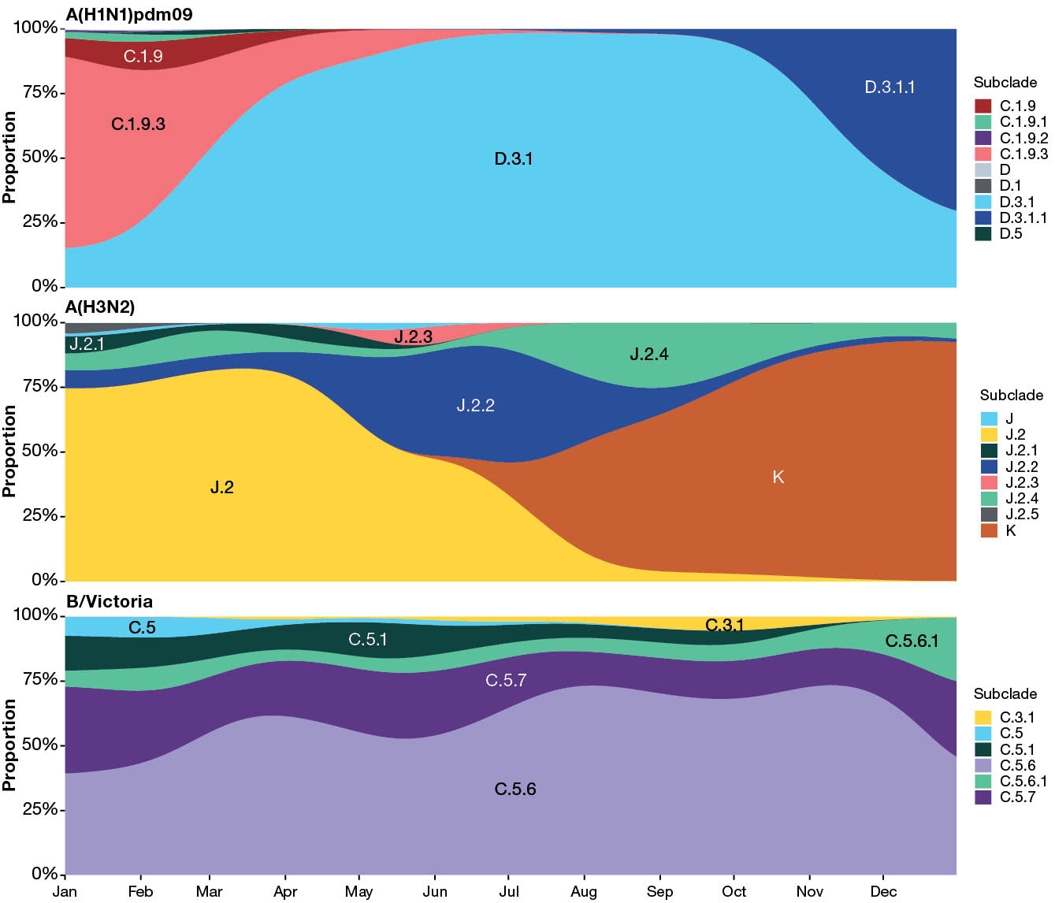
a GISAID: Global Initiative on Sharing All Influenza Data.

