
2026 • Volume 50 • cdc.gov.au/cdi • Epub date: 25.08.2026 • doi.org/10.33321/cdi.2026.50.053

Early use of genomics to guide acquisition investigation of Salmonella Typhi
Rehana Di Rico, Jelena Traljic, Clarissa Moreira, Su Ann Ho, Min-Ho Jung, Jane McAllister, Nicole Hughes, Jake A Lacey, Norelle L Sherry, Claire L Gordon, Annaliese van Diemen

Abstract

Background
As most Salmonella Typhi (S. Typhi) cases notified to public health units in Australia are acquired overseas, a case without recent travel raises concerns of local transmission. We describe a case of S. Typhi in a hospital inpatient without recent travel, where early use of genomic sequencing suggested remote acquisition from Chile in the 1980s, with chronic asymptomatic carriage. This facilitated the stand-down of a complex acquisition investigation.

Case
A notification of S. Typhi on stool culture was received for a female aged over 90 years living in Melbourne, Australia in October 2023. She had been hospitalised for three weeks (unrelated illness) and transferred into a residential aged care facility (RACF) six days prior to the result being known. She was asymptomatic and the sample was collected due to a recent ward gastroenteritis outbreak.

Investigation
Epidemiological investigation identified the case had emigrated to Australia in 1981 from Chile. Recent typhoid-like illness, overseas travel or contact with travellers from endemic areas were excluded. Subsequent genomic sequencing identified the isolate was multilocus sequence type 2 and did not cluster with any strains isolated in Victorian or international databases, most closely clustering with historical South American strains, with potential in-host changes over time.

Management
The case was presumed infectious throughout their hospital stay, with chronic carriage. There were 18 contacts, of whom 14 provided screening samples and were negative. Antibiotic case clearance was not recommended by the treating clinician due to patient comorbidity, treatment toxicity risks and unlikely treatment success without gallbladder removal. Enhanced infection control measures were instituted in the RACF (e.g. private bathroom, contact precautions for personal care, no food preparation). No additional cases were reported after two incubation periods (60 days).

Conclusion
Early genomic sequencing enhanced the efficiency of the public health investigation by rapidly confirming overseas acquisition and chronic carriage, obviating the need for extensive local upstream investigation.
Keywords: typhoid; genomics; public health; infection prevention and control; aged care

Background
Salmonella Typhi is not endemic in Australia and most cases are acquired overseas.^{1,2} The purpose of the public health response in Australia is to determine the source of infection and prevent onward transmission. The incubation period is typically 8–14 days (range: 3–60 days). Cases are considered infectious if bacteria are present in stool, and some cases become chronic carriers.
On 16 October 2023, the North Eastern Public Health Unit (NEPHU) received a laboratory notification from the Microbiological Diagnostic Unit Public Health Laboratory (MDU-PHL) of a confirmed case of Salmonella Typhi detected in a faecal sample from a female aged over 90 years. The case lived with her family prior to being admitted to hospital on 18 September for stroke management. She was transferred to a rehabilitation facility on 24 September. On 9 October, the case passed a green-coloured formed stool. The case did not report systemic illness, fever, malaise or headache. Prompted by staff vigilance due to a recent norovirus outbreak, a faecal sample was collected on 10 October. Before the results were received, the case was transferred to a residential aged care facility for permanent nursing care.
In lieu of a clear onset of acute symptoms, the date of the green-coloured stool was used as symptom onset for initial investigation. The case had been in a hospital setting for the 14-day incubation period. Looking back further to 60 days, the case had spent nearly one third of this time in health services, with the remainder confined to her home. The case reported no overseas travel in the past five years, and no contact with known cases of Salmonella Typhi, returned travellers from endemic countries, or unwell people.
Given these findings, an urgent investigation was initiated to explore the possibility of undetected local transmission, particularly in the sensitive setting of a healthcare facility. As the case did not exhibit symptoms consistent with typhoid at the time of sample collection, chronic carriage was also considered.
Ethics approval was not required as per Austin Health's Research Office. Informed consent for publication was obtained from the case's next of kin.

Epidemiological and genomic investigations
A multidisciplinary incident management team was convened on 17 October 2023, comprising public health clinicians from local and state departments, geriatric and infectious diseases clinicians, infection prevention and control teams and MDU-PHL staff.
The investigation included assessment of both upstream sources of infection and downstream individuals at risk of infection (Figure 1). Household contacts and patients who had shared a bathroom with the case were considered the highest-risk groups and faecal screening samples were requested. Hospital staff were not considered contacts as appropriate standard precautions had been used.
Figure 1: Epidemiological investigation plan, Salmonella Typhi acquisition investigation,ª Melbourne, Australia, 2023
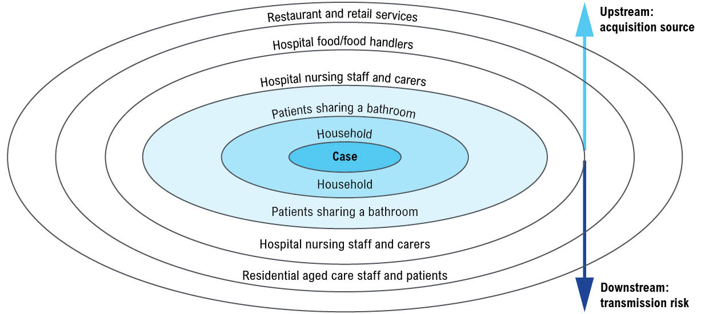
a Shaded area represents contacts deemed at high risk, with faecal sample screening requested.
Review of statewide epidemiology identified 12 typhoid cases in the 60 days prior to this case’s notification. All were associated with overseas travel, with no epidemiological links to the current case, indicating that acquisition from hospital or a retail food source was unlikely.
During the case interview, it was noted that the case had emigrated from Chile to Australia in 1981. Investigation revealed a significant typhoid epidemic had occurred in Chile around this time, with over 70,000 cases over a ten-year period.³ The case did not recall a past typhoidal illness and reported that they and their family were all vaccinated for typhoid prior to migration.
An in-home carer—originally from India, a typhoid-endemic country—had provided care from July 2023 until hospital admission. The carer was overseas for the duration of the investigation. Although a faecal sample could not be obtained, their employer was able to confirm there had been no recent illness, sick leave, other travel, and no other employer.
Given the working theory of chronic carriage, genomic sequencing was prioritised to inform the investigation. MDU-PHL completed genomic analysis within 7–10 days of receiving the sample (Figure 2). The isolate was confirmed as multilocus sequence type (MLST)-2 (senterica_achmann_2) and did not cluster with any sequences from Victorian or publicly available international databases on the National Center for Biotechnology Information’s sequence read archive (pathogen detection portal ID PDT001981732.1).⁴ Phylogenetic analysis shows the isolate most closely clustered with historical strains from Chile which were associated with chronic carriage,⁵ supporting the hypothesis of chronic carriage with potential acquisition during the Chilean typhoid epidemic and with potential in-host changes over time (Figure 2). This early genomic sequencing facilitated the stand-down of a potentially complex local acquisition investigation.

Infection prevention and case management
The case had previously been living independently but was now, post-stroke, requiring nursing assistance for personal care and continence, increasing the risk of faecal oral transmission. A plan for ongoing management of a chronic carrier within a sensitive setting was required, balancing the public health versus the individual risks. It was decided not to attempt antibiotic clearance due to treatment toxicities, frailty and low likelihood of success without gall bladder removal for the case.
The case was distressed at having been kept in isolation during the investigation and so it was deemed appropriate for them to be able to move freely around their residential home. Faecal screening was conducted for 14 of the 18 identified close contacts, including 11 co-residents and three household contacts. All returned negative results for Salmonella Typhi.
Residential aged care staff were advised to implement enhanced personal protective equipment for activities involving toileting and personal care, but routine use was not deemed necessary. Vaccination of staff against typhoid was not recommended. The facility was advised to house the case in a single room with a private bathroom and, as far as practicable, to avoid shared bathroom use or involvement in food preparation activities. No specific environmental cleaning requirements beyond standard protocols were recommended.

Conclusion
Chronic carriage should be considered in typhoid case investigations, as carriers are asymptomatic and a potential reservoir for infection. This is increasingly relevant in the context of rising migration from typhoid-endemic countries. Early access to genomic sequencing can guide public health investigations, distinguishing chronic carriage from local transmission, with the latter requiring significantly more investigation. Antibiotic clearance is complex in chronic carriage and requires specialist input and risk assessment. This case highlighted the importance of a tailored and proportionate public health response, and the need for multidisciplinary collaboration to ensure that the delivery of this response was timely, effective, and coordinated.
Figure 2: Maximum-likelihood phylogenetic tree of Salmonella enterica serovar Typhi,ª Melbourne, Australia, 2023
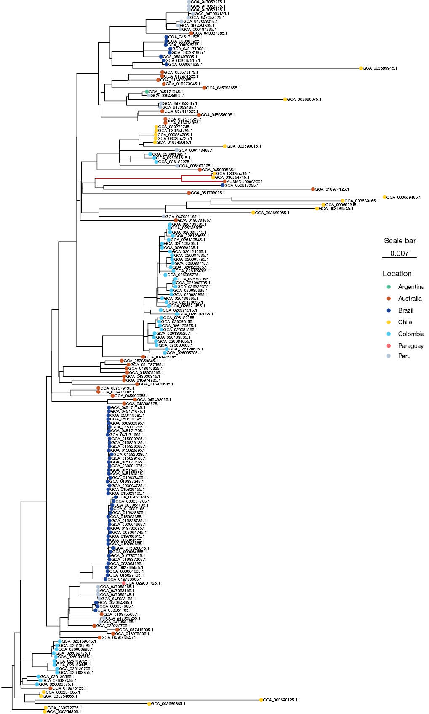
a Tree shows Victorian case (highlighted in red) pictured in relation to genome sequences from South America and key representative Victorian genomes (one representative per cluster). Tree was inferred using IQTree v2.1.4-beta with GTR+F+G4 model with 1000 bootstraps from a core genome alignment using the Victoria case as a reference genome. The genetic distances between the Victorian case and the Chilean genome sequences (red branch) suggest they belonged to the same ancestral group but were not very closely related (i.e. not direct or local transmission). All other Victorian isolates were not genomically related to the Victorian case (not pictured).

Author details
Rehana Di Rico,^{1,8,9}
Jelena Traljic,¹
Clarissa Moreira,¹
Su Ann Ho,^{2,3}
Min-Ho Jung,⁴
Jane McAllister,⁴
Nicole Hughes,⁴
Jake A Lacey,^{5,7}
Norelle L Sherry,^{5,6}
Claire L Gordon,^{1,6,7}
Annaliese van Diemen^{1,10}
- North Eastern Public Health Unit, Austin Health, Heidelberg, Victoria, Australia
- Infection Prevention and Control, St Vincent’s Health, Fitzroy, Victoria, Australia
- Department of Infectious Diseases, St Vincent's Hospital Melbourne, Melbourne, Victoria, Australia
- Community and Public Health Division, Victorian Department of Health, Melbourne, Victoria, Australia
- Microbiological Diagnostic Unit Public Health Laboratory, Department of Microbiology & Immunology at the Peter Doherty Institute for Infection & Immunity, University of Melbourne, Melbourne, Victoria, Australia
- Department of Infectious Diseases & Immunology, Austin Health, Heidelberg, Victoria, Australia
- Department of Microbiology and Immunology, University of Melbourne at the Peter Doherty Institute for Infection and Immunity, Melbourne, Victoria, Australia
- Department of Rehabilitation, Epworth Monash Rehabilitation Medicine Unit (EMReM), Melbourne, Victoria, Australia
- Grampians Public Health Unit, Grampians Health, Mt Helen, Victoria, Australia
- Department of Infectious Diseases, The Peter Doherty Institute for Infection and Immunity, The University of Melbourne, Victoria, Australia

Corresponding author
Claire L Gordon,
Level 7, Harold Stokes Building, 145 Studley Road, Heidelberg, PO Box 5555, Victoria, 3084 Australia
email: Claire.Gordon@austin.org.au

References
- Ingle DJ, Andersson P, Valcanis M, Wilmot M, Easton M, Lane C et al. Genomic epidemiology and antimicrobial resistance mechanisms of imported typhoid in Australia. Antimicrob Agents Chemother. 2021;65(12):e0120021. doi: https://doi.org/10.1128/AAC.01200-21.
- Forster DP, Leder K. Typhoid fever in travellers: estimating the risk of acquisition by country. J Travel Med. 2021;28(8):taab150. doi: https://doi.org/10.1093/jtm/taab150.
- Marco C, Delgado I, Vargas C, Muñoz X, Bhutta ZA, Ferreccio C. Typhoid fever in Chile 1969–2012: analysis of an epidemic and its control. Am J Trop Med Hyg. 2018;99(3 Suppl):26–33. doi: https://doi.org/10.4269/ajtmh.18-0125.
- Dyson ZA, Cerdeira L, Sharma V, Carey ME, Holt KE. The TyphiNET data visualisation dashboard: unlocking Salmonella Typhi genomics data to support public health. Genome Med. 2025;17(1):51. doi: https://doi.org/10.1186/s13073-025-01470-4.
- Lagos RM, Sikorski MJ, Hormazábal JC, Fernandez A, Duarte S, Pasetti MF et al. Detecting residual chronic Salmonella Typhi carriers on the road to typhoid elimination in Santiago, Chile, 2017–2019. J Infect Dis. 2024;230(2):e254–67. doi: https://doi.org/10.1093/infdis/jiad585.
© 2026 Commonwealth of Australia as represented by the Australian Centre for Disease Control
ISSN: 2209-6051 Online
This journal is indexed by Index Medicus and Medline.
Creative Commons Licence
This publication is licensed under a Creative Commons Attribution-NonCommercial-NoDerivatives 4.0 International Licence (Licence). You must read and understand the Licence before using any material from this publication.
Restrictions
The Licence does not cover, and there is no permission given for, use of any of the following material found in this publication (if any):
- the Commonwealth Coat of Arms (by way of information, the terms under which the Coat of Arms may be used can be found on the Department of Prime Minister and Cabinet website);
- any logos (including the Australian Centre for Disease Control’s logo) and trademarks;
- any photographs and images;
- any signatures; and
- any material belonging to third parties.
Disclaimer
Opinions expressed in Communicable Diseases Intelligence are those of the authors and not necessarily those of the Australian Government or the Australian Centre for Disease Control. Data may be subject to revision.
Enquiries
Enquiries regarding any other use of this publication should be addressed to the CDI Editor.
About CDI
Communicable Diseases Intelligence (CDI) is a peer-reviewed scientific journal published by the Australian Centre for Disease Control.
The journal aims to disseminate information on the epidemiology, surveillance, prevention and control of communicable diseases of relevance to Australia and the near region.
Editor: Dr Elise Firman • Deputy Editor: Simon Petrie • Design and Production: Lisa Thompson
Editorial Advisory Board: David Durrheim, Mark Ferson, Clare Huppatz, John Kaldor, Martyn Kirk and Meru Sheel
Submit an Article
Guidelines for authors and details on how to submit your publication is available on our website, or by email to the
CDI Editor.
Contact us
Communicable Diseases Intelligence (CDI)
Australian Centre for Disease Control
PO Box 795, Canberra ACT 2601, Australia
Website: cdc.gov.au/cdi
Email: cdi.editor@cdc.gov.au

