
2026 • Volume 50 • cdc.gov.au/cdi • Epub date: 25.08.2026 • doi.org/10.33321/cdi.2026.50.020

Report of the National Influenza Surveillance Scheme, 2019
Jenna Hassall, Lauren Kutzner, Suzie Whitehead, Tracy Tsang, Freya Hogarth, Siobhan St George
© 2026 Commonwealth of Australia as represented by the Australian Centre for Disease Control
ISSN: 2209-6051 Online
This journal is indexed by Index Medicus and Medline.
Creative Commons Licence
This publication is licensed under a Creative Commons Attribution-NonCommercial-NoDerivatives 4.0 International Licence (Licence). You must read and understand the Licence before using any material from this publication.
Restrictions
The Licence does not cover, and there is no permission given for, use of any of the following material found in this publication (if any):
- the Commonwealth Coat of Arms (by way of information, the terms under which the Coat of Arms may be used can be found on the Department of Prime Minister and Cabinet website);
- any logos (including the Australian Centre for Disease Control’s logo) and trademarks;
- any photographs and images;
- any signatures; and
- any material belonging to third parties.
Disclaimer
Opinions expressed in Communicable Diseases Intelligence are those of the authors and not necessarily those of the Australian Government or the Australian Centre for Disease Control. Data may be subject to revision.
Enquiries
Enquiries regarding any other use of this publication should be addressed to the CDI Editor.
About CDI
Communicable Diseases Intelligence (CDI) is a peer-reviewed scientific journal published by the Australian Centre for Disease Control.
The journal aims to disseminate information on the epidemiology, surveillance, prevention and control of communicable diseases of relevance to Australia and the near region.
Editor: Dr Elise Firman • Deputy Editor: Simon Petrie • Design and Production: Lisa Thompson
Editorial Advisory Board: David Durrheim, Mark Ferson, Clare Huppatz, John Kaldor, Martyn Kirk and Meru Sheel
Submit an Article
Guidelines for authors and details on how to submit your publication is available on our website, or by email to the
CDI Editor.
Contact us
Communicable Diseases Intelligence (CDI)
Australian Centre for Disease Control
PO Box 795, Canberra ACT 2601, Australia
Website: cdc.gov.au/cdi
Email: cdi.editor@cdc.gov.au

Contents
Abstract 6
Introduction 7
Surveillance methods 8
Data sources 8
Results 11
National notifications of laboratory-confirmed influenza 11
Geographic spread 13
Age and sex profile 15
Aboriginal and Torres Strait Islander status 16
Virus type and subtype 16
Virology 19
Influenza-like illness – national online community survey (FluTracking) 20
Influenza-like illness calls – Healthdirect Australia 21
Influenza-like illness consultations from sentinel general practitioner surveillance systems 22
Morbidity – FluCAN 24
Mortality 27
Discussion and conclusion 28
Acknowledgments 31
Author details 32
References 33

List of figures
Figure 1: Laboratory-confirmed influenza notifications by year and month of diagnosis, Australia, 2015–2019 12
Figure 2: Laboratory-confirmed influenza notifications by state or territory and week of diagnosis,^{a,b} Australia, 2019 14
Figure 3: Age-specific notification rates of laboratory-confirmed influenza by five-year age group and sex,ª Australia, 2019 15
Figure 4: Age-specific notification rates of laboratory-confirmed influenza by age groupª and diagnosis year, Australia, 2015–2019 16
Figure 5: Proportion of laboratory-confirmed influenza by type and subtype,ª Australia, 2015–2019 17
Figure 6: Percentage of FluTracking participants reporting new fever and cough, Australia, by week of survey, April to October, 2015–2019 20
Figure 7: Percentage of FluTracking participants reporting time off work or normal duties due to fever and cough symptoms by week of survey, Australia, 2015–2019 21
Figure 8: Proportion of calls to Healthdirect related to influenza-like illness (ILI) by week of call, Australia,ª 2015–2019 22
Figure 9: Unweighted rate of influenza-like illness (ILI) reported from Australian Sentinel Practices Research Network (ASPREN) sentinel general practice sites by week of consultation, Australia, 2015–2019 23
Figure 10: Number of patients admitted with laboratory-confirmed influenza at Influenza Complications Alert Network (FluCAN) sentinel hospital sites by week of admission and influenza subtype, Australia, 2019 24

List of tables
Table 1: Notifications and notification ratesª of laboratory-confirmed influenza by state or territory,^{b} Australia, 2019 13
Table 2: Laboratory-confirmed influenza notifications and age-specific notification ratesª by influenza type/subtype, year and age group,^{b} Australia, 2017–2019 18
Table 3: All Australian samples received at the World Health Organization Collaborating Centre for Reference and Research on Influenza, Melbourne (WHO CCRRI), by subtype/lineage,ª Australia, 2019 19
Table 4: Summary of virological surveillance activities conducted by Australian Sentinel Practices Research Network (ASPREN) sentinel general practice sites,ª Australia, 2019 23
Table 5: Demographic characteristics, influenza type/subtype and outcomes of patients admitted with laboratory-confirmed influenza at Influenza Complications Alert Network (FluCAN) sentinel hospital sites, Australia, 2019 26

Abstract
This report describes influenza surveillance activities in Australia in 2019. Data were extracted from several sources constituting the National Influenza Surveillance Scheme.
The 2019 influenza season in Australia was characterised by high activity overall, with 2.8 times as many laboratory-confirmed influenza notifications as the five-year mean value. There were an unusually high number of notifications reported in the 2018–2019 interseasonal period; an earlier peak in influenza notifications; and prolonged activity after the peak of the season compared to previous years. There was considerable variation in the timing of peak influenza activity between states and territories; however, this was not unexpected given climatic differences. Notification rates were highest in the 0–4 and 5–9 year age groups, and about 2.1 times higher in these age groups than the overall notification rate. The age-specific notification rates of influenza A were higher than the corresponding rates of influenza B in all age groups in 2019; however, the age-specific notification rate of influenza B was considerably higher among those aged 0–15 years compared to other age groups. In 2019, of laboratory-confirmed influenza notifications, 76.6% were influenza A (71.6% influenza A(unsubtyped), 3.9% A(H3N2) and 1.1% A(H1N1)pdm09) and 23.2% were influenza B.
Similar trends were observed across many sentinel surveillance systems for influenza, with each sentinel system showing increased activity during the interseasonal period and earlier peak activity in 2019. High notification rates were reflected in an increase in sentinel hospital admissions with confirmed influenza. The burden placed on hospitals due to people admitted with influenza was high; however, severity (measured through the proportion of patients admitted directly to intensive care units) was moderate. Influenza was recorded as the underlying cause of death for fewer than 1% of all deaths that occurred in 2019.
Keywords: influenza; surveillance; influenza-like illness; sentinel surveillance

Introduction
Influenza or ‘the flu’ is a common, infectious respiratory disease. Influenza viruses spread from person to person by aerosolised droplets, commonly produced when an infected person coughs or sneezes. Typical symptoms usually begin around two days after being infected and include a sudden onset of fever, cough, headache, myalgia, fatigue, sore throat and a runny nose.¹ Most people recover within a few days without needing medical care; however, influenza can cause severe illness, hospitalisations for pneumonia and other complications, or death, particularly in high-risk groups.¹ Individuals most at risk of severe influenza include young children, people who are pregnant, the elderly (65 years and older), people with chronic illnesses and people who are immunocompromised. Vaccination is the best way to prevent influenza and its complications.¹
Influenza types A, B, and C are known to cause respiratory illness in humans.² Influenza A and B viruses cause seasonal epidemics, while influenza type C is detected less frequently and is usually associated with mild infections. There are two forms of influenza reported globally: epidemic (seasonal or interpandemic) caused by type A and B, and sporadic pandemics caused by type A viruses.² Influenza A viruses are further classified into subtypes based on the combinations of the haemagglutinin (HA) and neuraminidase (NA) viral surface proteins. The influenza B viruses are further classified into lineages rather than subtypes.
In temperate climates, seasonal influenza epidemics occur mainly during winter, while in tropical and sub-tropical regions, influenza may occur throughout the year resulting in multiple peaks in a season or extended periods of activity.¹ In temperate regions of Australia, the influenza season usually occurs from April or May to the end of October, with notifications historically peaking in August. However, influenza activity varies from year to year. Australia experienced moderate influenza seasons between 2011 to 2016, high activity in 2017—the highest levels of activity since the 2009 pandemic year—and a mild season in 2018.³ In years prior to 2019 (with the exception of 2008 and 2015), influenza A has been the predominant type circulating in Australia. The prevalence of influenza subtypes A(H1N1) and A(H3N2) has alternated over time, with each becoming the most frequently identified subtype at different periods.³
Laboratory-confirmed influenza has been a nationally notifiable disease in all Australian states and territories since 2001. Data are reported from each state or territory health department to the National Notifiable Diseases Surveillance System (NNDSS). In Australia, the epidemiology of influenza is further informed by several complementary surveillance systems based in the community, primary care, hospitals and laboratories, as well as by data from the Australian Bureau of Statistics which includes officially reported deaths. This report provides an overview of national influenza surveillance data for the period 1 January – 31 December 2019.

Surveillance methods
Data for this report were based on the following influenza surveillance sources:
- notifications of laboratory-confirmed influenza required by legislation in all states and territories, and notified to the NNDSS;
- subtype and strain data of circulating influenza viruses provided by the World Health Organization Collaborating Centre for Reference and Research on Influenza (WHO CCRRI);
- consultation rates for influenza-like illness (ILI) and respiratory virus detection in sentinel general practices – provided by the Australian Sentinel Practices Research Network (ASPREN) and the Victorian Sentinel Practice Influenza Network (VicSPIN);
- rates of ILI and absence from work from the online community survey FluTracking;
- community ILI trends from Healthdirect Australia;
- hospitalised cases of influenza from 17 sentinel hospitals across Australia through the Influenza Complications Alert Network (FluCAN); and
- mortality data from the Australian Bureau of Statistics (ABS).

Data sources

NNDSS
In 2019, laboratory-confirmed influenza was a notifiable disease under state and territory legislation in all jurisdictions. Notifications were sent to NNDSS for national collation, analyses and reporting. In this report, data were analysed by the date of diagnosis, which is the earliest of the dates of symptom onset, specimen collection, or case notification. Age, sex, Indigenous status, virus subtype, the jurisdiction of residence, death and other outcomes, are included in NNDSS notifications where data are available.

WHO CCRRI
The WHO Collaborating Centres are located in Melbourne (Australia), Beijing (China), Tokyo (Japan), London (the United Kingdom), and Atlanta (the United States of America), and are part of the WHO Global Influenza Surveillance and Response System (WHO GISRS). The WHO Collaborating Centres are responsible for analysing influenza viruses collected through an international surveillance network involving 142 national influenza centres across 115 countries.⁴ The Melbourne centre analyses viruses received from Australia and laboratories in the Asia-Pacific Region. Virus isolates are analysed antigenically, and then a geographically and temporally representative number of viruses, together with any strains demonstrating uncharacteristic reactions during antigenic characterisation, are further analysed by genetic sequencing of the viral HA and NA genes.
Virological, serological and epidemiological data form the basis from which the WHO makes recommendations in February (for the Northern Hemisphere) and in September (for the Southern Hemisphere) on which strains should be included in the influenza vaccine for the following influenza season. The WHO vaccine recommendations are made in the context of strains that are antigenically ‘like’ laboratory reference strains that are named according to a standard nomenclature for influenza viruses. National and regional committees (such as the Australian Influenza Vaccine Committee) then translate the WHO recommendations into actual virus strains acceptable to regulatory authorities and vaccine manufacturers.

Sentinel general practice surveillance
Sentinel general practice surveillance schemes for influenza monitor clinical consultations for ILI, defined as any presentation with fever, cough and fatigue, and collect swabs from patients with ILI to inform virological surveillance of influenza. In Australia, there are two sentinel GP programs: ASPREN, a network of sentinel general practices, which collects de-identified ILI data from over 300 providers across all states and territories, and the Victorian Infectious Diseases Reference Laboratory (VIDRL)-operated Victorian Sentinel Practice Influenza Network (VicSPIN), which operates solely in Victoria. ASPREN reports ILI rates throughout the year, while VicSPIN reports from early May to late October. In addition, ASPREN and VicSPIN reporters swab test a subset of ILI patients for a panel of respiratory pathogens which include influenza and RSV. These data are used to provide annual vaccine effectiveness estimates to the Global Influenza Vaccine Effectiveness Movement and data to the WHO CCRRI.

FluTracking
FluTracking is a community-based surveillance system led by the Hunter New England Local Health District, in collaboration with the University of Newcastle and the Hunter Medical Research Institute. FluTracking monitors the transmission and severity of ILI in the community. It involves volunteer participants from across Australia completing an online weekly survey, which collects data on ILI symptoms, absence from work or normal duties, healthcare presentation, self-reported testing and annual influenza vaccination.

Healthdirect
Healthdirect provides free, 24-hour health triage advice and information services by telephone and online. Data collected include demographic details of the patient, presenting issues, diagnosis and final triage disposition. Selected diagnoses (fever and cough) are used to monitor community level ILI trends. In 2019, Victoria and Queensland operated their own nurse triage helplines (NURSE-ON-CALL and 13-HEALTH); therefore, Healthdirect helpline data is not representative of these two states.

FluCAN
FluCAN is a national hospital-based sentinel surveillance system reporting data from 17 surveillance hospitals and five paediatric system sites (22 hospital sites in total). FluCAN collects detailed clinical and laboratory information from all patients hospitalised at participating sites with a laboratory-confirmed diagnosis of influenza, to determine the burden of disease requiring hospitalisation associated with influenza, and to estimate the effectiveness of the influenza vaccine against hospitalisation with influenza. In addition, FluCAN provides annual vaccine effectiveness estimates to the Global Influenza Vaccine Effectiveness Movement and data to the WHO CCRRI.

Mortality
Deaths data was compiled by the ABS from information provided by the state and territory Registrars of Births, Deaths and Marriages. The 10th revision of the International Classification of Diseases and Related Health Problems (ICD-10) was used to code and estimate influenza deaths. In this report, deaths for 2019 with an underlying cause of influenza and pneumonia (ICD-10 J09–J18) are presented. ICD-10 code J09 was introduced in July 2009. The expanded range of codes, J09–J18, correlates with previous versions of ICD-10 codes J10–J11.

Results
The 2019 influenza season commenced earlier than in previous years. There was increased activity in the interseasonal period, with considerable increases in notifications across most states and territories in April, followed by a prolonged influenza season (Figure 1). Most sentinel data sources were tracking below or similar to trends seen in previous years during the main seasonal period, despite the early, extended 2019 season. An unusually high number of notifications reported in the 2018–2019 interseasonal period and prolonged activity throughout 2019 contributed to the highest number of laboratory-confirmed influenza notifications to the NNDSS since influenza became nationally notifiable in 2001.

National notifications of laboratory-confirmed influenza
In 2019, there were 313,470 laboratory-confirmed influenza cases notified to the NNDSS. This was 2.8 times higher than the five-year mean number of notifications (n = 113,855). The 2019 notifications represent the highest number of influenza notifications to the NNDSS since influenza became nationally notifiable in 2001, surpassing the previous highest number of influenza notifications occurring in 2017 (n = 251,290). Nationally, influenza notifications gradually increased from March to a peak of 18,482 notifications per week in early July, followed by a decreasing trend with influenza notifications almost returning to interseasonal levels by October (Figure 1). The peak of influenza notifications occurred about six weeks earlier than in preceding years (usually mid-August). The number of notifications each month from January to June was consistently higher than the corresponding monthly numbers in previous years. The 2019 season was also characterised by extended activity, with elevated influenza notifications from April to October, compared with shorter seasons in previous years (Figure 1).
Figure 1: Laboratory-confirmed influenza notifications by year and month of diagnosis, Australia, 2015–2019
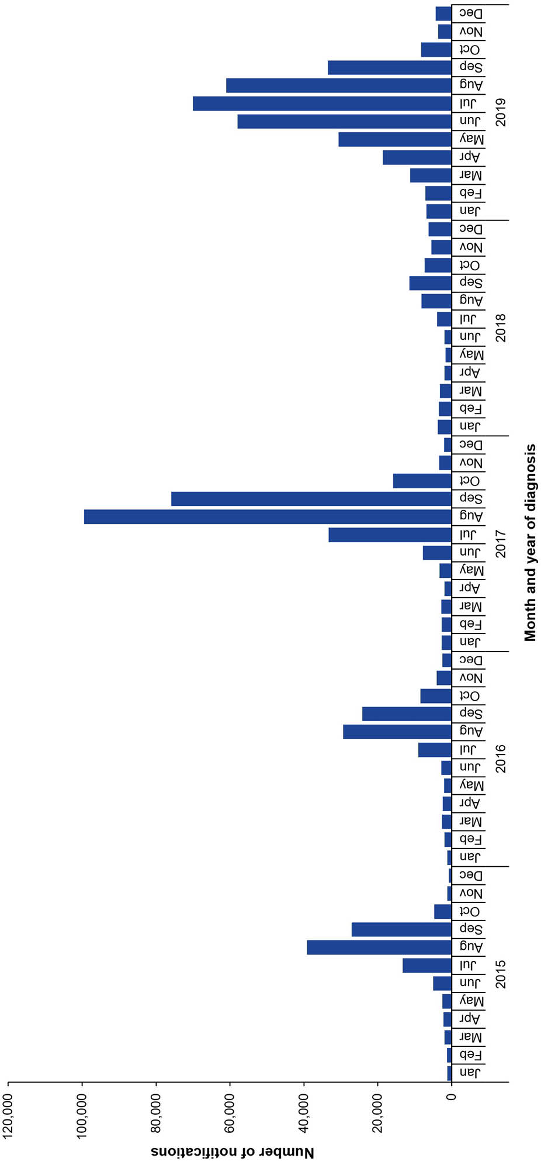

Geographic spread
In 2019, the largest proportions of laboratory-confirmed influenza notifications were reported by New South Wales (37.1%), Victoria (22.2%), and Queensland (21.7%), as Australia’s most populous states, which typically report higher case numbers (Table 1). However, when adjusted for population size, South Australia recorded the highest notification rate with 1,533 cases per 100,000 population, followed by New South Wales with 1,447 cases per 100,000 population (Table 1). The national notification rate was 1,237 cases per 100,000 population (Table 1).
Table 1: Notifications and notification ratesª of laboratory-confirmed influenza by state or territory,^{b} Australia, 2019
Jurisdiction | Notifications | % | Rate
ACT | 4,072 | 1.3 | 935
NSW | 116,446 | 37.1 | 1,447
NT | 1,738 | 0.6 | 705
Qld | 68,171 | 21.7 | 1,340
SA | 27,092 | 8.6 | 1,533
Tas. | 3,137 | 1.0 | 573
Vic. | 69,571 | 22.2 | 1,064
WA | 23,243 | 7.4 | 874
Australia | 313,470 | 100 | 1,237
a Notification rate per 100,000 population.
b ACT: Australian Capital Territory; NSW: New South Wales; NT: Northern Territory; Qld: Queensland; SA: South Australia; Tas.: Tasmania; Vic.: Victoria; WA: Western Australia.
There was some variation between states and territories in the timing of the peak of influenza notifications. Influenza notifications peaked earlier in the Northern Territory (92 cases per week in April) and South Australia (1,862 cases per week in May), and later in Queensland (4,492 cases per week in August) and Tasmania (180 cases per week in August) compared to other states and territories where a peak was observed in June or July (Figure 2). In addition, some states and territories (the Australian Capital Territory, Tasmania and to a lesser extent the Northern Territory) observed multiple peaks or periods of increased activity throughout the year. Western Australia experienced the most typical influenza season with a sharp seasonal increase and short peak in notifications occurring between late May and early July (Figure 2).
Figure 2: Laboratory-confirmed influenza notifications by state or territory and week of diagnosis,^{a,b} Australia, 2019
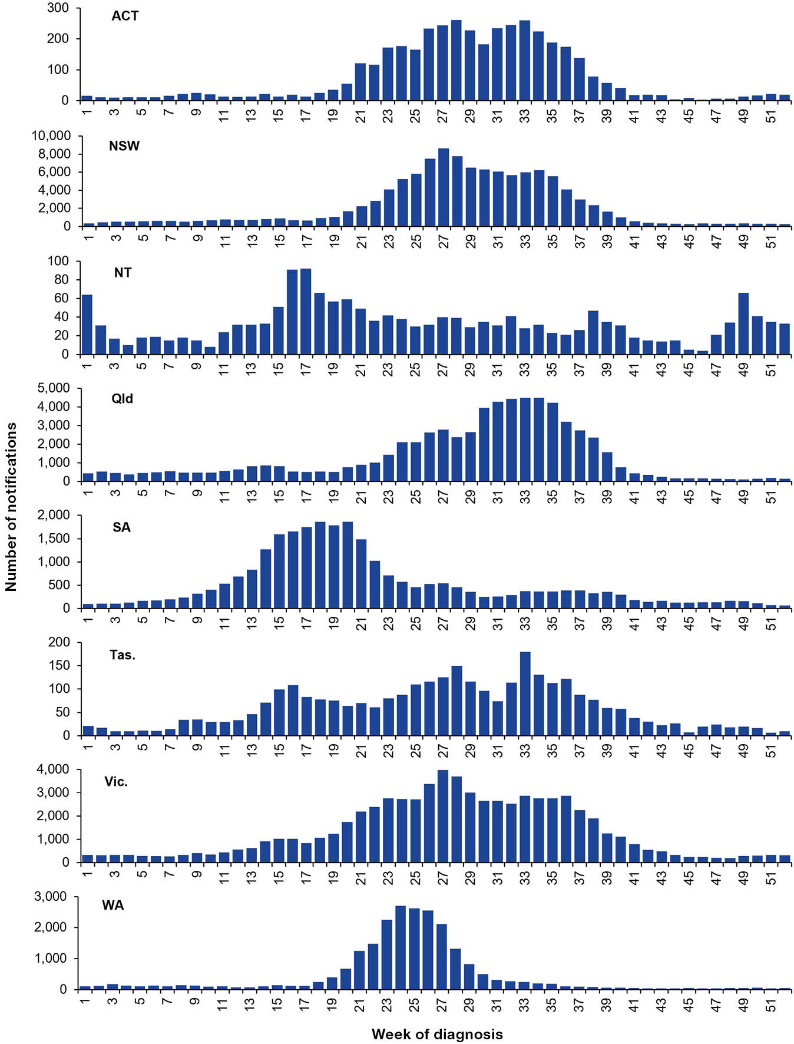
a y-axis varies between jurisdictions.
b ACT: Australian Capital Territory; NSW: New South Wales; NT: Northern Territory; Qld: Queensland; SA: South Australia; Tas.: Tasmania; Vic.: Victoria; WA: Western Australia.

Age and sex profile
Age-specific notification rates for laboratory-confirmed influenza notified to the NNDSS in 2019 are shown in Figure 3. The highest notification rates were observed in children aged 5–9 years (2,653 cases per 100,000 population), rates in this age group were around 2.1 times higher than the overall notification rate (1,237 cases per 100,000 population for all ages). Influenza notification rates remained relatively low and stable among those aged 20–79 years; however, rates were elevated for those aged 80 years and over (Figure 3).
Overall, influenza notifications in 2019 were similar for both males (46%; n = 144,797) and females (54%; n = 167,851); however, notification rates were higher in females than in males across most age groups except in those aged 0–15 years (Figure 3).
Figure 3: Age-specific notification rates of laboratory-confirmed influenza by five-year age group and sex,ª Australia, 2019
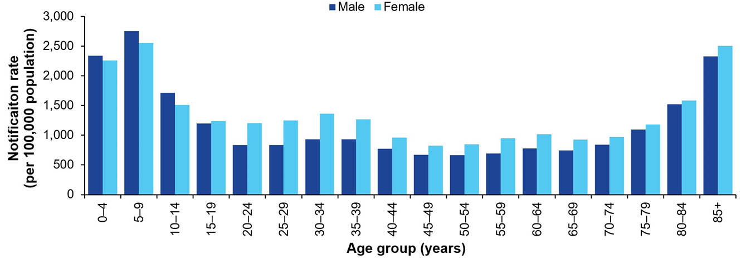
a Excludes 29 notifications with unknown age and 798 notifications with unknown sex.
Figure 4 shows age-specific influenza notification rates for key age groups from 2015 to 2019. Throughout 2015 to 2019, notification rates were highest in children (those aged 0–4 years and 5–9 years), with the exception of 2016 when influenza notification rates were highest among older adults (those aged 65 years and over; Figure 4). In 2019, influenza notification rates increased substantially in children (those aged 0–4 years and 5–9 years) compared to previous years (up to 2,600 cases per 100,000 population in these age groups in 2019). Notification rates among other age groups remained comparatively low and stable (not exceeding 1,212 cases per 100,000 population; Figure 4).
Figure 4: Age-specific notification rates of laboratory-confirmed influenza by age groupª and diagnosis year, Australia, 2015–2019
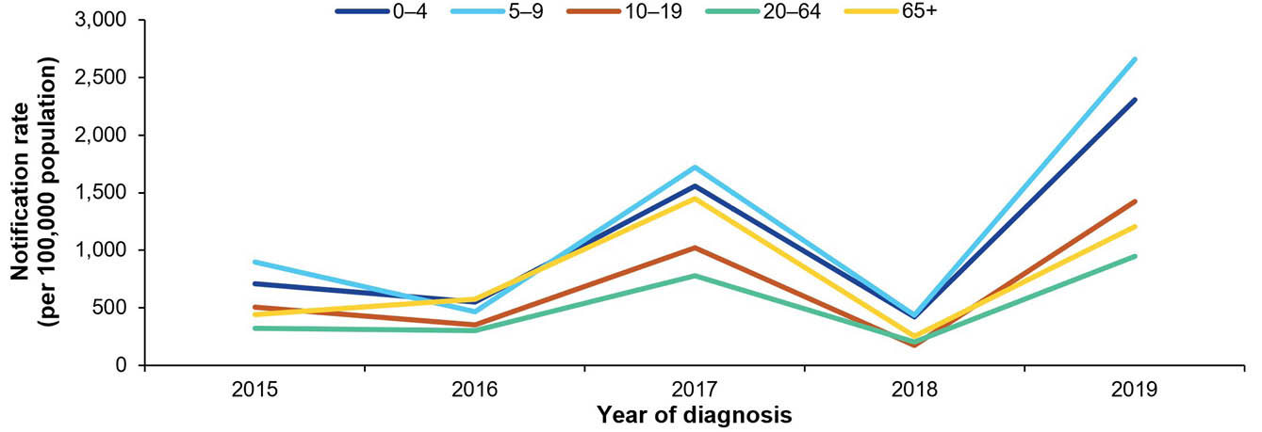
a Excludes 68 notifications with unknown age.

Aboriginal and Torres Strait Islander status
The completeness and reliability of Indigenous status data was low across most Australian jurisdictions, affecting the accuracy and representativeness of these estimates. In 2019, only 45.5% (n = 142,631) of the total laboratory-confirmed influenza notifications had Indigenous status recorded. Data completeness was highest in the Northern Territory and Western Australia (> 80% complete) followed by Queensland and South Australia (> 60% complete).
Of laboratory-confirmed influenza notifications with Indigenous status recorded, 6.1% (n = 8,687) identified as an Aboriginal and Torres Strait Islander person. In 2019, the influenza notification rate was 1.9 times higher among those who identified as Aboriginal and Torres Strait Islander people than among non-Indigenous Australians.

Virus type and subtype
In 2019, of laboratory-confirmed influenza notifications, 76.6% were influenza A and 23.2% were influenza B. Of those that were influenza A, 93.5% were unsubtyped; 5.0% were A(H3N2); and 1.4% were A(H1N1)pdm09 (Figure 5, Table 2). While the proportion of most influenza types/subtypes remained relatively consistent compared to 2018, the proportion of influenza A(H1N1)pdm09 was considerably lower (1.1% of all notifications in 2019 and 7.1% of all notifications in 2018; Figure 5). However, subtyping practices, including the number of specimens subtyped, may vary between years, impacting comparisons between years. In 2019, mixed influenza type A and B infections accounted for fewer than 1% (n = 626) of notifications and typing data were not available for 163 notified cases in 2019 (Table 2). Infection with influenza C was rare, with only one notification reported in 2019.
The age-specific notification rates of influenza A were higher than the corresponding rates of influenza B in all age groups in 2019; however, the age-specific notification rate of influenza B was considerably higher among school aged children (those aged 5–9 years and 10–19 years) than among other age groups (Table 2).
Figure 5: Proportion of laboratory-confirmed influenza by type and subtype,ª Australia, 2015–2019
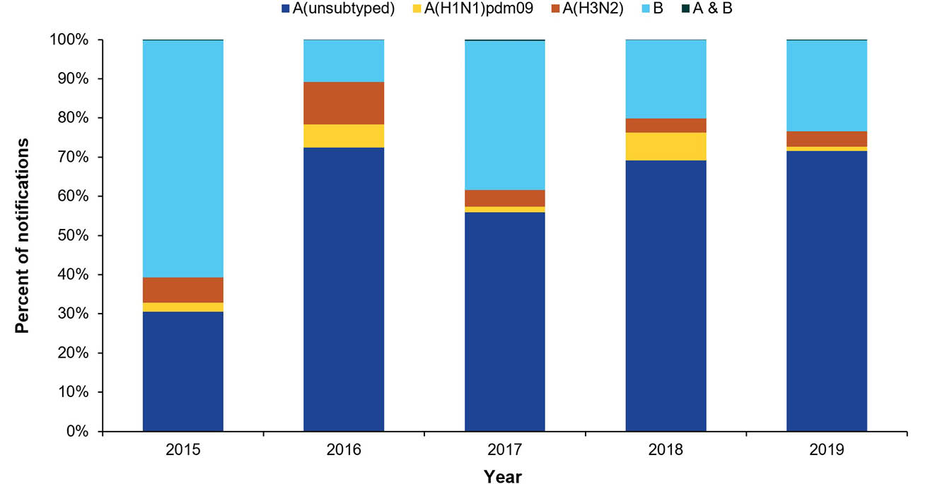
a Excludes 185 untyped notifications and eight influenza C notifications.
Table 2: Laboratory-confirmed influenza notifications and age-specific notification ratesª by influenza type/subtype, year and age group,^{b} Australia, 2017–2019
Year | Age group (years) | Influenza type/subtype |  |  |  |  | Notification rate influenza A | Notification rate influenza B | Notification rate  (Total)
Year | Age group (years) | A(H1N1)pdm09 | A(H3N2) | A(unsubtyped) | B | A and B | Notification rate influenza A | Notification rate influenza B | Notification rate  (Total)
2017 | 0–4 | 715 | 913 | 15,193 | 7,621 | 68 | 1,068 | 484 | 1,557
2017 | 5–9 | 528 | 599 | 12,351 | 13,752 | 125 | 849 | 866 | 1,723
2017 | 10–19 | 224 | 808 | 13,911 | 15,172 | 98 | 506 | 513 | 1,022
2017 | 20–64 | 1,699 | 4,382 | 64,261 | 43,694 | 244 | 479 | 297 | 778
2017 | ≥ 65 | 310 | 4,120 | 34,654 | 15,579 | 135 | 1,032 | 411 | 1,447
2018 | 0–4 | 694 | 130 | 5,031 | 703 | 4 | 375 | 45 | 420
2018 | 5–9 | 549 | 101 | 5,089 | 1,231 | 2 | 358 | 77 | 434
2018 | 10–19 | 302 | 166 | 3,198 | 1,423 | 3 | 122 | 47 | 169
2018 | 20–64 | 2,135 | 964 | 22,542 | 6,228 | 37 | 172 | 42 | 214
2018 | ≥ 65 | 519 | 758 | 6,423 | 2,169 | 29 | 197 | 55 | 253
2019 | 0–4 | 427 | 1,101 | 26,385 | 7,838 | 92 | 1,796 | 504 | 2,306
2019 | 5–9 | 357 | 689 | 23,585 | 18,228 | 126 | 1,524 | 1,128 | 2,659
2019 | 10–19 | 225 | 1,038 | 25,744 | 16,378 | 93 | 884 | 536 | 1,423
2019 | 20–64 | 1,849 | 5,086 | 107,830 | 27,480 | 265 | 761 | 182 | 945
2019 | ≥ 65 | 573 | 4,203 | 40,936 | 2,699 | 50 | 1,133 | 67 | 1,202
a Notification rate per 100,000 population.
b Excludes 365 untyped notifications, three influenza C notifications and 34 notifications where age was not reported.

Virology

Samples received and tested
The WHO CCRRI received 7,006 Australian samples collected during the period 1 January – 31 December 2019 (Table 3). This represented 2.2% of the 313,470 laboratory-confirmed influenza notifications reported to the NNDSS in 2019. Influenza A(H3N2) viruses comprised 47.8% (n = 3,351) of viruses that were received by the WHO CCRRI, followed by influenza A(H1N1)pdm09 (22.6%; n = 1,580) and influenza B (18.7%; n = 1,313; consisting of 52.8% B/Victoria lineage, 44.7% B/unknown lineage and just 2.5% B/Yamagata lineage; Table 3). These results are similar to 2017 when influenza A(H3N2) was predominant.³ The lower proportion of influenza A(H1N1)pdm09 samples in 2019 is consistent with the decreased proportion of influenza A(H1N1)pdm09 observed in notification data.
Table 3: All Australian samples received at the World Health Organization Collaborating Centre for Reference and Research on Influenza, Melbourne (WHO CCRRI), by subtype/lineage,ª Australia, 2019
Influenza type/subtype | n | %
A(H1N1)pdm09 | 1,580 | 22.6
A(H3N2) | 3,351 | 47.8
A(unsubtyped) | 752 | 10.7
A(mixed subtype) | 4 | 0.1
B/Victoria | 693 | 9.9
B/Yamagata | 33 | 0.5
B/unknown lineage | 587 | 8.4
Mixed type (A/B) | 6 | 0.1
a Samples collected during the period 1 January – 31 December 2019.
The 2019 southern hemisphere seasonal influenza vaccine included an A/Michigan/45/2015 (H1N1)pdm09-like virus; an A/Switzerland/8060/2017 (H3N2)-like virus; a B/Phuket/3073/2013-like virus (B/Yamagata/16/88 lineage); and a B/Colorado/06/2017-like virus (B/Victoria/2/87 lineage). For more information on the seasonal influenza vaccines available in 2019 in Australia, refer to the statement on the administration of seasonal influenza vaccines in 2019 released by the Australian Technical Advisory Group on Immunisation (ATAGI).⁵
The WHO CCRRI conducted antigenic characterisation by haemagglutination inhibition (HI) assays on 2,963 influenza virus isolates. Of those, 96.3% (922/957) of influenza A(H1N1)pdm09 isolates, 78.6% (1,227/1,562) of influenza A(H3N2) isolates, 89.2% (372/417) of influenza B/Victoria isolates, and 100% (27/27) of influenza B/Yamagata were antigenically similar to the corresponding vaccine components.
Viruses received by the WHO CCRRI were also tested for their sensitivity to the neuraminidase inhibitors oseltamivir and zanamivir. Of the influenza A(H1N1)pdm09 samples tested, 0.1% (n = 1) demonstrated highly reduced inhibition to oseltamivir, and 0.1% (n = 1) demonstrated highly reduced inhibition to zanamivir, as defined by a ≥ 100-fold shift in the half-maximal inhibitory concentration (IC₅₀) in a neuraminidase assay. Of the B/Victoria samples, 0.2% (n = 1) demonstrated highly reduced inhibition to zanamivir, corresponding to a ≥ 50-fold shift in IC₅₀ in a neuraminidase inhibition assay. These results indicate that a very small number of the virus strains that were tested showed resistance to neuraminidase inhibitors.

Influenza-like illness – national online community survey (FluTracking)

Participants
A total of 52,801 participants completed at least one FluTracking survey in 2019, which represented a participation rate of 208 respondents per 100,000 population. The highest proportion of FluTracking participants were in the 50–64 years age group (30.0%), followed by the 35–49 years age group (22.1%). During 2019, more participants were female (59.7%; n = 31,096). The proportion of participants who identified as an Aboriginal and Torres Strait Islander person was 1.7% (n = 856), compared to 3.3% of the Australian population who identify as an Aboriginal and Torres Strait Islander person.

Percentage of participants with ILI symptoms (new fever and cough)
Of participants who completed at least one survey during 2019, new fever and cough was reported by 29.1% (compared with 26.9% in 2018). An early rise in ILI activity was observed from May 2019 onwards, with peak activity occurring about two months earlier than in previous years (Figure 6). More than 2% of participants reported new fever and cough each week from late May to early July, with the percentage of participants with fever and cough peaking at 2.2% in mid-June. From late July to October, ILI activity was lower than the five-year mean. ILI activity was elevated for several weeks in 2019 but did not reach a distinct peak as observed in previous years (Figure 6).
Figure 6: Percentage of FluTracking participants reporting new fever and cough, Australia, by week of survey, April to October, 2015–2019
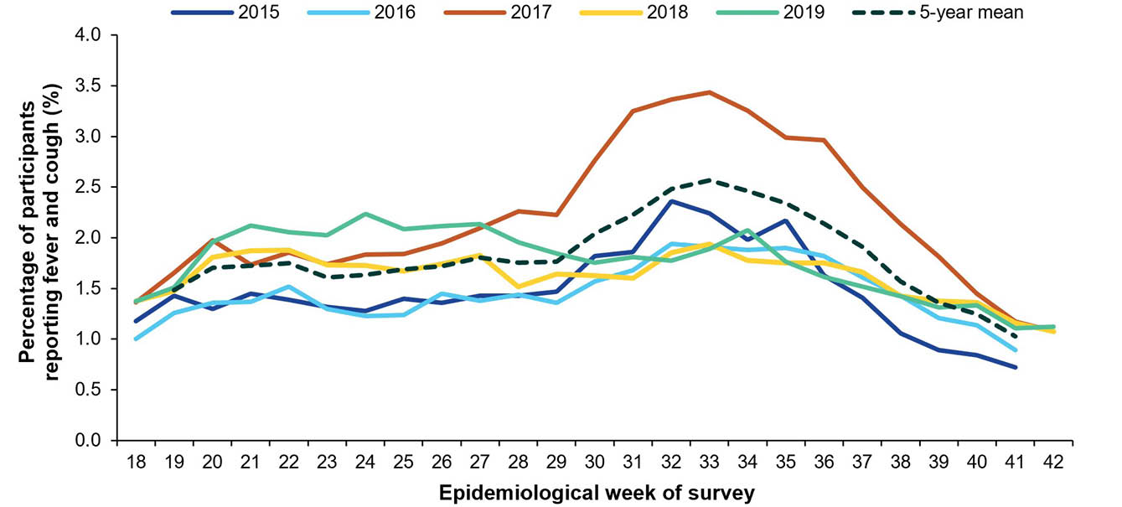

Burden of illness among participants with ILI symptoms
The peak weekly percentage of participants taking time off work or normal duties was 1.3% in 2019, compared to 1.1% in 2018 and 2.4% in 2017 (Figure 7). The weekly percentage of participants taking time off work or normal duties was elevated between May and July, peaking at 1.6% of participants in mid-June 2019. While the peak of participants taking time off work or normal duties occurred two months earlier in 2019 than in previous years, the 2019 peak was not distinct (Figure 7). From July to October, the weekly percentage of participants taking time off work or normal duties was considerably lower than the five-year mean (Figure 7).
The percentage of participants seeking care for ILI symptoms was higher in 2019 (45.0%; n = 6,902) than in 2018 (40.8%; n = 5,060), but similar to 2017 (45.3%; n = 5,381). Likewise, the percentage of participants with ILI that reported testing positive for influenza in 2019 (4.9%; n = 754) was also higher than 2018 (1.1%; n = 135) but similar to 2017 (4.1%; n = 483).
Figure 7: Percentage of FluTracking participants reporting time off work or normal duties due to fever and cough symptoms by week of survey, Australia, 2015–2019
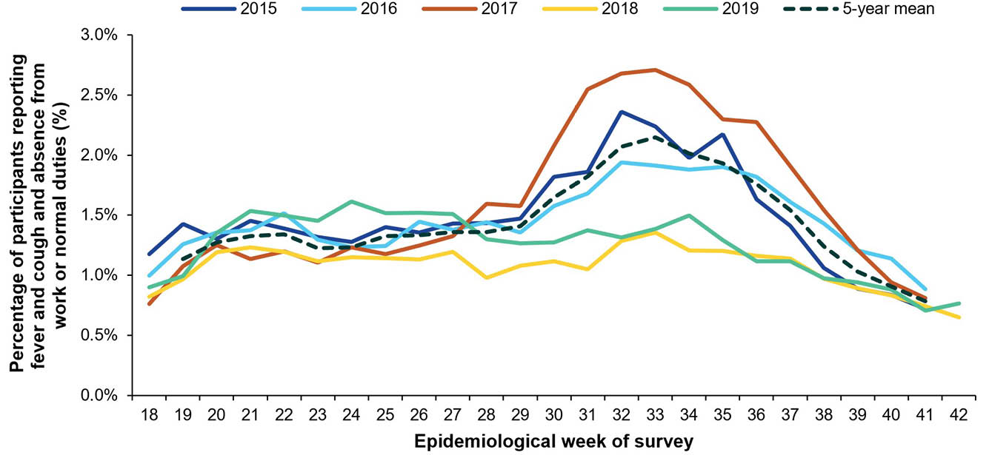

Influenza-like illness calls – Healthdirect Australia
In 2019, there were 40,505 calls made to the Healthdirect Australia helpline which were related to ILI, comprising 6.6% of total calls. The proportion of calls related to ILI gradually increased from the beginning of 2019 and reached a peak of 12.5% of total calls per week in early July (Figure 8). The peak proportion of calls related to ILI was higher than in 2018 but occurred at a similar time (8.25% of calls related to ILI in early July 2018), whereas the 2019 peak occurred much earlier compared to the peaks for 2015–2017 (11.35% in late August 2017, 9.5% in mid-September 2016 and 10.4% in late August 2015). For most of 2019, the proportion of calls related to ILI was higher than the five-year mean (Figure 8).
Figure 8: Proportion of calls to Healthdirect related to influenza-like illness (ILI) by week of call, Australia,ª 2015–2019
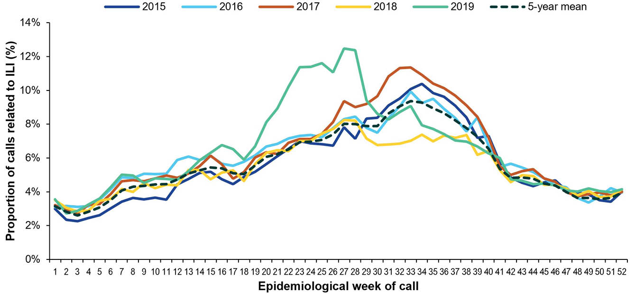
a In 2019, the Healthdirect helpline operated in all states and territories except Queensland and Victoria; therefore, ILI trends will not be representative of Queensland and Victoria and may be underrepresented nationally.

Influenza-like illness consultations from sentinel general practitioner surveillance systems
In 2019, there were 6,944 ILI notifications from sentinel general practitioners, representing an overall rate of 6.2 ILI notifications per 1,000 consultations. During 2019, ILI rates increased gradually through March and peaked nine weeks earlier than in 2018 at 14 ILI notifications per 1,000 consultations per week in early July 2019, followed by a gradual decreasing trend from August to September (Figure 9). The peak in ILI notification rates per 1,000 consultations aligns with the peak in laboratory-confirmed influenza notifications to the NNDSS, which also occurred in early July. ILI notification rates remained above baseline levels for approximately 13 weeks in 2019, about three weeks longer than the five-year mean (Figure 9).
In 2019, consistent with previous years, the magnitude and timing of the peak ILI notification rates varied across states and territories. Early activity was apparent in the Northern Territory, South Australia, Victoria and Western Australia, whereas activity appeared to be lower in the Australian Capital Territory and Tasmania compared to other states and territories.
Figure 9: Unweighted rate of influenza-like illness (ILI) reported from Australian Sentinel Practices Research Network (ASPREN) sentinel general practice sites by week of consultation, Australia, 2015–2019
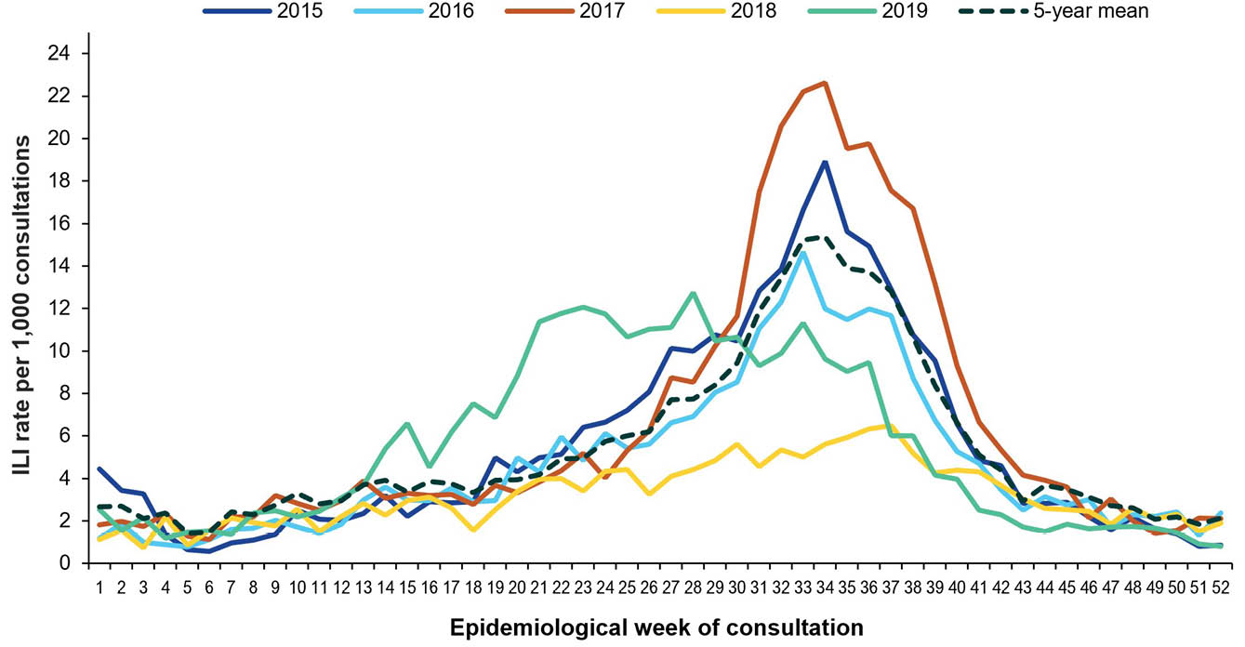
Table 4 provides a summary of the 2019 swab testing conducted by ASPREN sentinel general practice sites across all eight states and territories. Of the 6,944 general practice attendees with ILI, 46.0% (n = 3,192) were swabbed for respiratory viruses. Of those persons with ILI who were tested, 31.6% (n = 1,008) were positive for influenza, of which 79.0% (n = 796) were influenza A and 21.0% (n = 212) influenza B (Table 4). Of positive influenza A samples, the majority were A(H3N2) (82.8%; n = 659), followed by A(H1N1)pdm09 (14.4%; n = 115). Of positive influenza B samples, most were B/Victoria (61.3%; n = 130); there were no B/Yamagata samples typed (Table 4).
Table 4: Summary of virological surveillance activities conducted by Australian Sentinel Practices Research Network (ASPREN) sentinel general practice sites,ª Australia, 2019
Characteristic | n
Number of swabs processed | 3,192
Number of samples positive for influenza | 1,008
Number of samples positive for influenza A | 796
Number of samples positive for influenza A(H3N2) | 659
Number of samples positive for influenza A(H1N1)pdm09 | 115
Number of samples positive and influenza A(unsubtyped) | 22
Number of samples positive for influenza B | 212
Number of samples positive for influenza B/Victoria | 130
Number of samples positive for influenza B/Yamagata | 0
Number of samples positive for influenza B (unknown lineages) | 82
a Virological surveillance data from VicSPIN general practice sites are not included in Table 4 and therefore virological samples may be less representative for Victoria.
The median age of general practice attendees with ILI who were positive for influenza was 35 years, which was younger than the median age observed in 2018 (38 years). In 2019, the median age of general practice attendees testing positive for influenza B (22 years) was lower than for influenza A (39 years). This is consistent with the literature, which reports influenza B/Victoria to predominate in children.⁶ More females (57%; n = 1,819) than males (43%; n = 1,373) with ILI were selected for virological testing, and of those who tested positive for influenza, 52.8% (n = 532) were female and 47.2% were male (n = 476). The majority of general practice attendees with ILI who were tested for respiratory viruses were in the working age group (20–64 years), which is consistent with previous years.⁷
Virological surveillance data from VicSPIN general practice sites are not included in Table 4 as VicSPIN has since been discontinued; however, the VicSPIN virological results are included in estimates of vaccine effectiveness. Compared to unvaccinated individuals, vaccinated individuals were 46% (95% confidence interval [95% CI]: 36–55%) less likely to present to a general practitioner with an ILI and test positive for influenza. Disaggregated influenza vaccine effectiveness estimates for 2019 are provided in the ASPREN annual report.⁷

Morbidity – FluCAN
From 1 April to 31 October 2019, a total of 4,154 patients were admitted with laboratory-confirmed influenza to the 22 sentinel surveillance hospitals. The number of patients admitted with influenza was considerably more than in 2018 (n = 769) but less than in 2017 (n = 4,259). Weekly hospitalisations peaked at 244 admissions per week in early July, in line with the peak in laboratory-confirmed influenza notifications to the NNDSS (Figure 10). The majority of hospitalisations were with influenza A (85.1%; n = 3,537; Figure 10; Table 5). The proportion of hospitalisations each week with influenza B increased later in the season (Figure 10).
Figure 10: Number of patients admitted with laboratory-confirmed influenza at Influenza Complications Alert Network (FluCAN) sentinel hospital sites by week of admission and influenza subtype, Australia, 2019
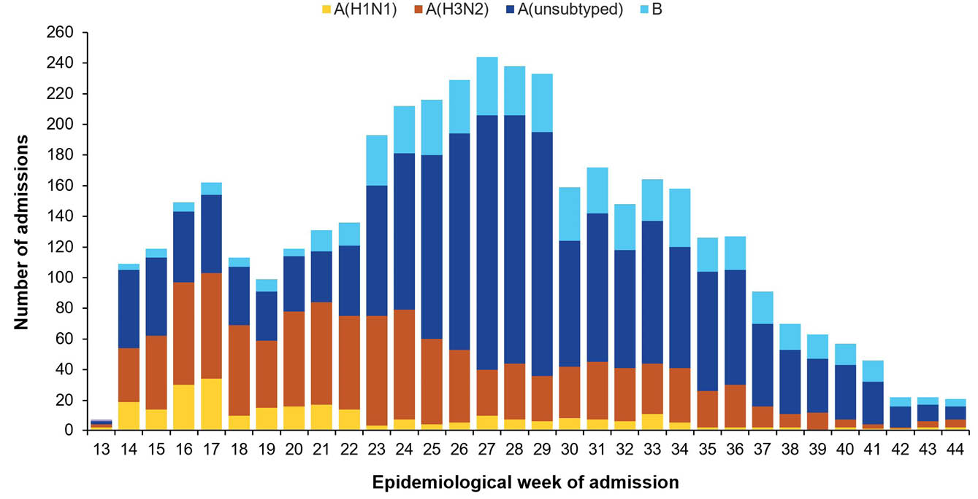
Demographic characteristics, risk factors, and outcomes of these hospitalised patients are provided in Table 5. Of the 4,154 patients admitted with confirmed influenza, 44.5% (n = 1,850) were older adults (≥ 65 years of age) and 21.3% (n = 883) were children (< 16 years of age). Aboriginal and Torres Strait Islander persons accounted for 7.7% of patients admitted with influenza (n = 319/4,154; Table 5). In addition, 72.7% of patients admitted with influenza (n = 3,023/4,154) had chronic comorbidities.
The mean length of hospital stay for all patients was 4.9 days. Of the 4,154 patients admitted with confirmed influenza, 7.8% (n = 323) were admitted to intensive care, comprising of 259 patients admitted directly to intensive care and a further 64 transferred to intensive care after their initial admission to a general ward. By comparison, 10.0% of patients with influenza at sentinel hospitals were admitted to intensive care in 2018 and 11.6% in 2017.³ Of the 3,956 patients where hospital mortality status was known, 2.8% of patients (n = 111/3,956) died in hospital (Table 5).
Of the 3,458 patients for whom influenza vaccination status was known, 47.9% (n = 1,658) were vaccinated. Compared to unvaccinated individuals, vaccinated individuals were 43% (95% CI: 36–49%) less likely to be hospitalised due to influenza. Disaggregated influenza vaccine effectiveness estimates for 2019 are provided in the FluCAN annual report.⁸
Table 5: Demographic characteristics, influenza type/subtype and outcomes of patients admitted with laboratory-confirmed influenza at Influenza Complications Alert Network (FluCAN) sentinel hospital sites, Australia, 2019
Category | Characteristic | 2019
Category | Characteristic | n | %
Total hospitalised | — | 4,154 | —
Influenza type/subtype | A(H1N1)pdm09 | 266 | 6.4
Influenza type/subtype | A(H3N2) | 1,140 | 27.4
Influenza type/subtype | A(unsubtyped) | 2,131 | 51.3
Influenza type/subtype | B | 617 | 14.9
Age group (years) | < 16 | 883 | 21.3
Age group (years) | 16–49 | 828 | 19.9
Age group (years) | 50–64 | 593 | 14.3
Age group (years) | 65–79 | 920 | 22.1
Age group (years) | 80+ | 930 | 22.4
Sex | Female | 2,099 | 50.5
Sex | Male | 2,055 | 49.5
Pregnancy status | Pregnant | 69 | 1.7
Indigenous status | Aboriginal and Torres Strait Islander | 319 | 7.7
Indigenous status | Non-Indigenous | 3,835 | 92.3
Jurisdictionª | ACT | 610 | 14.7
Jurisdictionª | NSW | 947 | 22.8
Jurisdictionª | NT | 155 | 3.7
Jurisdictionª | Qld | 303 | 7.3
Jurisdictionª | SA | 369 | 8.9
Jurisdictionª | Tas. | 245 | 5.9
Jurisdictionª | Vic. | 1,057 | 25.4
Jurisdictionª | WA | 468 | 11.3
Outcome | Intensive care admissions | 323 | 7.8
Outcome | Died in hospital^{b} | 111 | 2.7
a ACT: Australian Capital Territory; NSW: New South Wales; NT: Northern Territory; Qld: Queensland; SA: South Australia; Tas.: Tasmania; Vic.: Victoria; WA: Western Australia.
b Hospital mortality status was missing for 198 patients.

Mortality
Mortality from a primary influenza infection is rare, and most of the deaths attributed to influenza occur from complications including pneumonia, obstructive airway diseases and sudden cardiac failure. These deaths occur predominantly in identified at-risk groups such as adults aged 65 years and older; children under six months of age; or people with chronic medical conditions.

Influenza mortality data reported to the NNDSS
The completeness and reliability of deaths data notified to the NNDSS is low, affecting the accuracy of these estimates. For this reason, the number of influenza-associated deaths reported to the NNDSS does not represent the true mortality associated with this disease.
In 2019, of the total laboratory-confirmed influenza notifications, 38.4% (n = 120,412) had death status recorded. A total of 961 influenza-associated deaths were reported to the NNDSS in 2019, representing a case fatality rate (CFR) of 0.31%. This is consistent with the five-year mean CFR (0.31%) but lower than the CFR observed in 2017 (0.47%).³ People in the oldest age group were most impacted, with 57% of the total influenza-associated deaths in 2019 occurring among adults aged 85 years and over. A large proportion of the reported influenza-associated deaths were notified by New South Wales (35.5%), Queensland (25.9%) and Victoria (12.9%), Australia’s most populous states.

ABS cause of death data
Influenza (ICD-10 codes J09–J11) was the underlying cause of death for 1,080 persons in 2019 (0.6% of all 169,301 deaths that occurred in 2019). The number of deaths with influenza as an underlying cause in 2019 was considerably higher than in 2018 (n = 149) likely associated with the lower number of influenza notifications in 2018; however, the number of deaths in 2019 was lower than in 2017 (n = 1,272). The severity of influenza seasons can drive changes in leading cause of death rankings each year. In 2019, the overall age standardised rate of influenza deaths was 3.2 per 100,000 population. The age standardised death rate was slightly higher in males, with 3.3 per 100,000 population, compared to females at 3.1 per 100,000 population.⁹
When grouped, influenza and pneumonia (ICD-10 codes J09–J18) were the ninth leading cause of death in 2019, with influenza or pneumonia the underlying cause of death for 4,124 persons.⁹ The median age of influenza and pneumonia deaths in 2019 was 88.8 years of age.⁹

Discussion and conclusion
The impact and severity of influenza are difficult to quantify due to the nature of the illness and limitations in surveillance systems. Influenza surveillance in Australia is supported by a network of data sources and systems, each varying in their capacity to detect true cases of influenza and accurately reflect the burden of disease. The interpretation of surveillance data presented in this report is subject to limitations, including under-ascertainment, variability in testing practices and differences in healthcare-seeking behaviour across jurisdictions and age groups.
Based on available data, the 2019 influenza season in Australia was considered high activity but moderate severity overall in comparison with previous seasons. Laboratory-confirmed influenza notifications were around 2.8 times the five-year mean, largely due to an unusually higher number of notifications reported in the 2018–2019 interseasonal period (usually November in the previous year to March or April of the following year), and to prolonged activity following the peak of the season in 2019 compared to previous years. It is important to note that testing for influenza has increased over time, which may have contributed to the higher number of notifications observed in recent years. Increased use of multiplex panels, which simultaneously test for multiple respiratory pathogens, including influenza, may also have contributed to the rise in notifications by improving detection rates.
The early, prolonged activity seen in 2019 may have been due to low population immunity following a mild 2018 influenza season. In addition, very high media attention relating to the extent and severity of the 2019 influenza season may have led to increased awareness or concern among Australians, and therefore, more people being tested and diagnosed as a result. Likewise, there have been changes in health-seeking behaviour and increased testing for respiratory viruses over time, which may have contributed to a higher number of notifications.
Consistent with previous years, the highest rates of laboratory-confirmed influenza notifications in 2019 were seen in children (aged 0–4 and 5–9 years) and older adults (those aged 65 years and over). However, in 2019, the notification rates among children aged 0–4 and 5–9 years were far higher than in other age groups, or than in the 0–4 years and 5–9 years age groups in previous years. It is likely there was very little pre-existing population immunity among children in 2019 due to a very mild 2018 season. In addition, there was a high proportion of influenza B, to which children are more susceptible.⁶ As per previous seasons, there was notable variation in the timing of the peak of influenza notifications between states and territories. It is not uncommon for influenza notifications to peak at different times between states and territories due to differences in climate, population dispersion and how transient populations are.
Sentinel data sources indicated the 2019 season had moderate to high activity, which occurred earlier than observed in previous seasons and for an extended period. In addition, peak activity occurred earlier across many sentinel data sources than observed in previous years. These trends were largely consistent with laboratory-confirmed influenza notification data. That said, from July to October 2019, among FluTracking survey participants, self-reported ILI was equal to or lower than observed in previous years and the self-reported burden of illness was not particularly high given the increased activity.
Based on data from hospital-based sentinel systems, the burden placed on hospitals (or impact on hospitals) due to people admitted with influenza was high in 2019; however, severity (measured through the proportion of patients admitted directly to intensive care units) was moderate.¹⁰ The proportion of patients with influenza at sentinel hospitals admitted to intensive care in 2019 was at the lower end of historical figures which range from 7.4% in 2015 to 11.9% in 2014.³ By this measure, the 2019 season was of a similar severity to that seen in previous moderate severity seasons.
While hospital admissions can be measured relatively easily, measuring deaths due to influenza is more complicated. Influenza can lead to secondary bacterial infections, like pneumonia, which can in turn lead to hospitalisation and death, particularly among older people. When this happens, it can be difficult to link death directly to an earlier influenza infection, as follow-up of influenza cases is not a requirement for notification. The number of influenza associated deaths notified to the NNDSS and the number of death registrations with influenza as an underlying cause of death were both lower in 2019 than in 2017 (a year with a comparable number of case notifications); this further supports the assessment of 2019 as a season with moderate severity. However, when grouped, influenza and pneumonia were the ninth leading cause of death in 2019.⁹ This highlights the serious impact influenza can have on health, even when not directly recorded as the cause of death, and reinforces the importance of preventative measures and vaccination.
The 2019 season was predominantly attributed to influenza A, which accounted for 76.6% of all laboratory-confirmed influenza notifications, followed by 23.2% influenza B. Of influenza A viruses with subtyping available, influenza A(H3N2) predominated, which may have contributed to increased notification rates among older adults who are more susceptible to influenza A(H3N2). However, as only a small proportion of samples were subtyped compared to the total number of tests performed, this may influence the apparent distribution of influenza subtypes and thus underlying limitations may affect interpretation of these results.²
Of influenza viruses characterised by the WHO CCRRI, antigenic characterisation showed high similarity between circulating strains and vaccine components and resistance to neuraminidase inhibitors was rare, with only isolated cases showing reduced sensitivity to oseltamivir or zanamivir. Based on data generated during the 2019 southern hemisphere influenza season, at their technical meeting in 2019, the WHO recommended the following influenza virus strains for inclusion in the quadrivalent influenza vaccine for use in the 2020 southern hemisphere influenza season:
- an A/Brisbane/02/2018 (H1N1)pdm09-like virus
- an A/South Australia/34/2019 (H3N2)-like virus
- a B/Washington/02/2019-like (B/Victoria lineage) virus
- a B/Phuket/3073/2013-like (B/Yamagata lineage) virus.¹¹
The B/Phuket/3073/2013-like (B/Yamagata lineage) virus was not included in the trivalent influenza vaccine for use in the 2020 southern hemisphere influenza season.¹¹
Final estimated vaccine effectiveness against general practice presentation in 2019 was 46% (95% CI: 36–55%). Effectiveness varied by subtype, with higher protection against influenza B (64%; 95% CI: 48–75%) and influenza A(H1N1)pdm09 (62%; 95% CI: 39–77%), and lower protection against influenza A(H3N2) (37%; 95% CI: 24–48%) which predominated in 2019. Final estimated vaccine effectiveness against hospitalisation was 43% (95% CI: 36–49%), with slightly higher protection against influenza A(H1N1)pdm09 (69%; 95% CI: 55–79%), and lower protection against influenza B (45%; 95% CI: 31–56%) and influenza A(H3N2) (34%; 95% CI: 20–46%). These estimates are consistent with previous years, with vaccine effectiveness against general practice presentation estimated at 68% in 2018 and 33% in 2017, and vaccine effectiveness against hospitalisation estimated at 58% in 2018 and 16% in 2017. Differences in vaccine effectiveness between general practice presentation and hospitalisation may reflect differences in affected populations and the potential attenuation of illness severity by vaccination.
Overall, all data sources consistently showed early and prolonged trends in elevated influenza activity and support the characterisation of the 2019 influenza season as a high activity, moderate severity season.

Acknowledgments
The authors wish to acknowledge and thank the staff and participants from the surveillance systems who contribute data for national influenza surveillance across Australia : state and territory health departments and laboratories, FluTracking, Healthdirect Australia, the Australian Sentinel Practices Research Network (ASPREN), the Victorian Sentinel Practice Influenza Network (VicSPIN), the Influenza Complications Alert Network (FluCAN), the World Health Organisation Collaborating Centre for Reference and Research on Influenza (WHO CCRRI), the Australian Bureau of Statistics and the National Respiratory Infections Surveillance Committee (NRISC; previously the National Influenza Surveillance Committee).

Author details
Ms Jenna Hassall, Epidemiologist and a/g Assistant Director,¹
Ms Lauren Kutzner, Epidemiologist,¹
Ms Suzie Whitehead, Epidemiologist,¹
Ms Tracy Tsang, Epidemiologist and Assistant Director,¹
Ms Freya Hogarth, Epidemiologist,²
Ms Siobhan St George, Epidemiologist and a/g Director,¹
- Public Health Division, Australian Centre for Disease Control, Canberra, Australian Capital Territory, Australia
- Communicable Diseases and Epidemiology Section, Australian Department of Health, Disability and Ageing, Canberra, Australian Capital Territory, Australia

Corresponding author
Suzie Whitehead
Public Health Division, Australian Centre for Disease Control, PO Box 795, Canberra ACT 2601, Australia
Email: respiratory.surveillance@cdc.gov.au

References
- World Health Organization (WHO). Influenza (seasonal). [Online fact sheet.] Geneva: WHO; 28 February 2025. Available from: https://www.who.int/news-room/fact-sheets/detail/influenza-(seasonal).
- Paules C, Subbarao K. Influenza. Lancet. 2017;390(10095):697–708. doi: https://doi.org/10.1016/S0140-6736(17)30129-0.
- Communicable Diseases Epidemiology Surveillance Section. Report of the National Influenza Surveillance Scheme, 2011 to 2018. Commun Dis Intell (2018). 2022;46. doi: https://doi.org/10.33321/cdi.2022.46.12.
- WHO Collaborating Centre for Reference and Research on Influenza (CCRRI). WHO GISRS Surveillance; WHO Global Influenza Surveillance and Response System (GISRS) Surveillance and Vaccine Development. [Webpage.] Melbourne: WHO CCRRI; 2025. Available from: http://www.influenzacentre.org/Centre_Activities_WHO_GISRS_Surveillance.html.
- Australian Technical Advisory Group on Immunisation (ATAGI). Statement on the administration of seasonal influenza vaccines in 2019. Canberra: Australian Government Department of Health, Disability and Ageing; April 2019. [Accessed on 19 August 2025.] Available from: https://www.health.gov.au/sites/default/files/atagi-advice-on-seasonal-influenza-vaccines-in-2019_0.pdf.
- Owusu D, Hand J, Tenforde MW, Feldstein LR, DaSilva J, Barnes J et al. Early season pediatric influenza B/Victoria virus infections associated with a recently emerged virus subclade – Louisiana, 2019. MMWR Morb Mortal Wkly Rep. 2020;69(2):40–3. doi: https://doi.org/10.15585/mmwr.mm6902e1.
- Chilver M, Sullivan S, Stocks N. Surveillance of Influenza-like Illness through Sentinel General Practices Project. [Contractually specified disease surveillance program.] Adelaide: University of Adelaide, Australian Sentinel Practice Research Network; 2019. [Not available online.]
- Cheng AC, Dwyer DE, Holmes M, Irving LB, Simpson G, Senanayake S et al. Influenza epidemiology in patients admitted to sentinel Australian hospitals in 2019: the Influenza Complications Alert Network (FluCAN). Commun Dis Intell (2018). 2022;46. doi: https://doi.org/10.33321/cdi.2022.46.14.
- Australian Bureau of Statistics (ABS). Causes of Death, Australia: Reference period 2019. [Webpage.] Canberra: ABS; 23 October 2020. Available from: https://www.abs.gov.au/statistics/health/causes-death/causes-death-australia/2019.
- National Influenza Surveillance Committee. 2019 Influenza Season in Australia: A summary from the National Influenza Surveillance Committee. Canberra: Australian Government Department of Health, disability and Ageing; 30 June 2021. Available from: https://www.health.gov.au/sites/default/files/documents/2022/10/aisr-2019-national-influenza-season-summary.pdf.
- WHO. Recommended composition of influenza virus vaccines for use in the 2020 southern hemisphere influenza season. Geneva: WHO; 27 September 2019. Available from: https://www.who.int/publications/m/item/recommended-composition-of-influenza-virus-vaccines-for-use-in-the-2020-southern-hemisphere-influenza-season.

