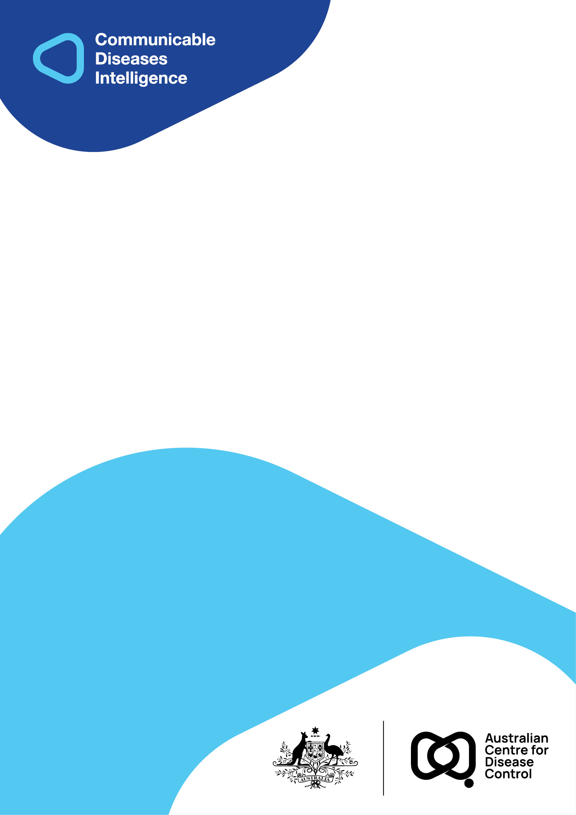
2026 • Volume 50 • cdc.gov.au/cdi • Epub date: 21.07.2026 • doi.org/10.33321/cdi.2026.50.045

Tuberculosis notifications in Australia, 2019–2020
Dharshi Thangarajah, Justin Waring, Justin Denholm, and Tatiana Gonzales, on behalf of the National Tuberculosis Advisory Committee, for the Communicable Diseases Network Australia and the Australian Mycobacterium Reference Laboratory Network
© 2026 Commonwealth of Australia as represented by the Australian Centre for Disease Control
ISSN: 2209-6051 Online
This journal is indexed by Index Medicus and Medline.
Creative Commons Licence
This publication is licensed under a Creative Commons Attribution-NonCommercial-NoDerivatives 4.0 International Licence (Licence). You must read and understand the Licence before using any material from this publication.
Restrictions
The Licence does not cover, and there is no permission given for, use of any of the following material found in this publication (if any):
- the Commonwealth Coat of Arms (by way of information, the terms under which the Coat of Arms may be used can be found on the Department of Prime Minister and Cabinet website);
- any logos (including the Australian Centre for Disease Control’s logo) and trademarks;
- any photographs and images;
- any signatures; and
- any material belonging to third parties.
Disclaimer
Opinions expressed in Communicable Diseases Intelligence are those of the authors and not necessarily those of the Australian Government or the Australian Centre for Disease Control. Data may be subject to revision.
Enquiries
Enquiries regarding any other use of this publication should be addressed to the CDI Editor.
About CDI
Communicable Diseases Intelligence (CDI) is a peer-reviewed scientific journal published by the Australian Centre for Disease Control.
The journal aims to disseminate information on the epidemiology, surveillance, prevention and control of communicable diseases of relevance to Australia and the near region.
Editor: Dr Elise Firman • Deputy Editor: Simon Petrie • Design and Production: Lisa Thompson
Editorial Advisory Board: David Durrheim, Mark Ferson, Clare Huppatz, John Kaldor, Martyn Kirk and Meru Sheel
Submit an Article
Guidelines for authors and details on how to submit your publication is available on our website, or by email to the
CDI Editor.
Contact us
Communicable Diseases Intelligence (CDI)
Australian Centre for Disease Control
PO Box 795, Canberra ACT 2601, Australia
Website: cdc.gov.au/cdi
Email: cdi.editor@cdc.gov.au

Contents
Abstract 6
Introduction 7
Methods 8
Results 10
Tuberculosis notifications 2019–2020 10
Geographic distribution 13
Tuberculosis in the Australian-born population 14
Tuberculosis in the overseas-born population 16
Age and sex distribution 21
Selected risk factors for tuberculosis 24
Tuberculosis and HIV testing history 27
Anatomical site of disease 28
Laboratory-confirmed cases 29
Drug-resistant tuberculosis in Australia 31
Treatment outcomes 32
Pre-migration health screening 37
TB elimination 38
Discussion 39
Acknowledgments 41
Author details 42
References 43

List of figures
Figure 1: Notification rates of tuberculosis, Australia, 1960–2020 12
Figure 2: Notification rates of tuberculosis in Australia, 2019–2020 compared with the
five-year mean rate,ª by state or territory 13
Figure 3: Notified cases and rate of tuberculosis in Australia, 2009–2020, by population
subgroup 15
Figure 4: Notified cases of tuberculosis in the overseas-born population in Australia,
2019–2020, by residency statusª and number of years from arrival to diagnosis 20
Figure 5: Notifications of tuberculosis in Australia, 2019–2020, by age, sex, and place of birth 21
Figure 6: Notified cases and rate of tuberculosis in children < 15 years, Australia in 2009–2020,
by population subgroup 23

List of tables
Table 1: Notifications of tuberculosis (TB) in Australia, 2014–2020, by state and territory and
year 10
Table 2: Notified cases and rates of tuberculosis (TB) in Australia, 2019–2020, by state and territory and case classification 11
Table 3: Notified tuberculosis (TB) cases classified as recurrent infection, 2019–2020, by treatment history 11
Table 4: Notified cases and rates of tuberculosis, Australia, 2019–2020,ª by population subgroup and state or territory 14
Table 5: Notified cases and rates of tuberculosis (TB) in Australia for frequently reported countries of birth, 2019–2020, by residency status 17
Table 6: Notified cases of tuberculosis among overseas-born people in Australia, 2019–2020, by residency status and state or territoryª 19
Table 7: Notification rates of tuberculosis, Australia, 2019–2020, by population subgroup and age group 22
Table 8: Notified cases of tuberculosis (TB), Australia, 2019–2020, by population subgroup and selected risk factorsª 25
Table 9: Notified cases of tuberculosis, Australia, 2019–2020, by population subgroup and human immunodeficiency virus (HIV) testing history 27
Table 10: Notified cases of tuberculosis in Australia, 2019–2020, by site of disease and case classification 28
Table 11: Notifications of extrapulmonary tuberculosis (TB) in Australia, 2019–2020, by specific site of disease and case classification 29
Table 12: Notified cases of tuberculosis, Australia, 2019–2020, by diagnostic method 30
Table 13: Notified cases of tuberculosis with drug susceptibility testing (DST) results available, Australia, 2019–2020, by drug susceptibility profile 31
Table 14: All notified cases of tuberculosis, including multidrug-resistant tuberculosis, Australia, 2018–2020, by population subgroup and treatment outcome 33
Table 15: Notified cases of multidrug-resistant tuberculosis only, Australia, 2018–2020, by population subgroup and treatment outcome 35
Table 16: Number of cases and case rates of tuberculosis (TB) identified through offshore pre-migration screening process, Australia, 2019–2020 37
Table 17: Australia milestonesª to achieve tuberculosis (TB) elimination 38

Abstract
In 2020, the National Notifiable Diseases Surveillance System received 1,618 tuberculosis (TB) notifications, representing a notification rate of 6.3 per 100,0000 population. In 2019, there were 1,505 TB notifications, with a rate of 5.9 per 100,000 population. Australia has achieved and maintained good TB control since the mid-1980s, sustaining a low annual TB incidence rate of approximately five to six cases per 100,000 population.
The number of multi-drug-resistant TB (MDR-TB) cases notified in Australia is lower than global rates, with approximately 2% of TB notifications per year classified as MDR-TB. In Australia, overseas-born people represent the majority of TB cases, accounting for 92% and 90% of TB notifications in 2020 and 2019, respectively. In 2020 and 2019, Aboriginal and Torres Strait Islander people recorded TB rates approximately four times higher than the Australian-born non-Indigenous population.
Whilst Australia has achieved and maintained excellent control of TB, sustained effort is required to reduce local rates further, especially among Aboriginal and Torres Strait Islander populations, and to contribute to the World Health Organization’s goal to end the global TB epidemic by 2035.
Keywords: Australia; tuberculosis; Mycobacterium tuberculosis; communicable disease surveillance; epidemiology; annual report

Introduction
Globally, tuberculosis (TB) remains a major public health issue.¹ In Australia, there is a low and stable TB incidence rate, which has been maintained through robust and high-quality TB control over the last three decades.^{2–4} However, Australia’s proximity to high TB incidence countries and its large migrant intake means that continued vigilance is required to sustain and improve on Australia’s low TB burden.
At the sixty-seventh World Health Assembly (WHA) in May 2014, the Australian Government endorsed the new Global strategy and targets for tuberculosis prevention, care and control after 2015, also known as the World Health Organization (WHO) post-2015 global TB strategy.⁵ The post-2015 global TB strategy’s goal is to end the global TB epidemic by 2035; the strategy sets targets to reduce TB incidence by 90% and TB deaths by 95% worldwide by this time.⁶
Australia is well positioned to achieve TB elimination, through universal health coverage and rigorous surveillance and governance frameworks. Australia’s immigration policy requires routine pre-arrival TB health examinations depending on age and risk of TB in the country of origin.⁷ During this process, individuals are screened for TB disease; a smaller subset are screened for TB infection. To meet the health requirement for a visa, people must be free from TB disease; people with TB disease require treatment before a visa can be granted.⁸ Those found at risk of developing TB disease are required to sign a health undertaking agreement to contact the migration medical services within 28 days of arrival in Australia.^{7,8} As observed in other low-incidence countries with positive net migration rates, reducing domestic incidence rates will continue to be a challenge for TB control programs. It is likely that the greatest reduction in Australia’s TB incidence rates will be achieved through the improvement of TB control globally, with prioritisation of the Western Pacific and South-East Asian regions.
Surveillance of TB in Australia is overseen by the National Tuberculosis Advisory Committee (NTAC), a subcommittee of the Communicable Diseases Network Australia (CDNA). NTAC has the key role of providing strategic, expert advice to CDNA, and subsequently the Australian Government, on a coordinated national approach to TB control. NTAC also develops and reviews nationally agreed policy and guidelines for the control of TB in Australia. NTAC’s strategic plan 2021–2025 has emphasised that a critical component of strengthening TB control is the continued prioritisation and timely reporting of national surveillance data.⁹
This report describes the epidemiology of notified cases of TB in Australia in 2019 and 2020 and includes some discussion on the factors that impact the control of TB in Australia. Reporting of TB notifications in Australia ensures that Australia’s TB control progress can be monitored and provides evidence for the development of new TB control strategies.

Methods
TB is a nationally notifiable disease in Australia and is monitored using the National Notifiable Disease Surveillance System (NNDSS). Medical practitioners, laboratories, and other health professionals are required under state and territory public health legislation to report cases of TB to jurisdictional health authorities. The National Health Security Act 2007 provides the legislative basis for the national notification of communicable diseases and authorises the exchange of health information between the Australian Government and state and territory governments. State and territory health departments transfer these notifications regularly to the NNDSS. The primary responsibility for public health action resulting from a notification resides with state and territory health departments.
The Tuberculosis Data Quality Working Group (TBDQWG), a working group of NTAC, has representation from states and territories, the Australian Government, and the Australian Mycobacterium Reference Laboratory Network (AMRLN). It ensures routine and timely reporting of trends and emerging issues in TB. The TBDQWG is also responsible for maintaining national consistency and currency in data standards and systems for TB surveillance that are relied upon to produce this report.
With the exception of pre-migration screening data, all data presented in this report represent a point-in-time analysis of notified cases of TB in Australia. This report presents data extracted from NNDSS in July 2024. Due to the dynamic nature of the NNDSS, data in this report may vary from data reported in other NNDSS reports and reports of TB notifications at the state or territory level. Detailed notes on case definition, data collection, quality control and the categorisation of population subgroups are available in the 2007 annual report.¹⁰ Data were cleaned and analysed using Stata/SE 17.0 (StataCorp, Texas, USA). Microsoft Excel was used to create graphs and to calculate notification rates.
In accordance with the Torres Strait Treaty, some Torres Strait Islander people and coastal people from Papua New Guinea (PNG) are allowed free movement (without passports or visas) within the northern Torres Strait Islands of Australia and PNG. This free movement is to allow for traditional activities to take place and does not include visits for health treatment.¹¹ However, at times, PNG nationals present with TB to Queensland health care clinics in the Torres Strait. In these instances, patients meeting the Australian national case definitions for TB are notified in Australia and identified in the NNDSS as ‘Residents of the Torres Strait Protection Zone (TSPZ) accessing medical care in Queensland’. Such patients are referred to PNG TB medical services for supervised treatment, provided they are well enough to travel safely.¹¹
This report presents data analysed by date of diagnosis, a derived field within the NNDSS. The methodology for date of diagnosis for TB changed in January 2014 and was applied to all notifications. The diagnosis date for TB is now equivalent to the notification received date, whereas previously the diagnosis date represented the onset date or, where the date of onset was not known, the earliest of the specimen collection date, the notification date, or the notification received date.
Notification rates were calculated using population data published by the Australian Bureau of Statistics (ABS). Overall population rates were calculated using mid-year estimated resident population (ERP) data described by ABS National, state and territory population data. Rates by country of birth were calculated using mid-year ERP data as described by ABS Australia's Population by Country of Birth data. Rates for population subgroups (i.e., overseas-born, Australian-born Aboriginal and Torres Strait Islander, and Australian-born non-Indigenous), by age and by state and territory, were calculated using mid-year ERP data as described by ABS Australia's Population by Country of Birth data and ABS Estimates and Projections, Aboriginal and Torres Strait Islander Australians data. Country of birth data at the state and territory level was only available for census years. Therefore, the overseas-born population at the state and territory level were calculated by applying the 2021 census Australian-born to overseas-born population ratios, for each state and territory, to 2019 and 2020 ERP data.
The pre-migration screening data represent a calendar year analysis of TB cases detected through the offshore pre-migration screening process. Cases of TB identified through this process are not included in the NNDSS, as they are identified prior to entry to Australia. Pre-migration screening data are provided by the Australian Government Department of Home Affairs.

Results

Tuberculosis notifications 2019–2020
There were 1,618 notifications of TB (6.3 cases per 100,000 population) reported to the NNDSS in 2020, compared with 1,505 cases (5.9 cases per 100,000 population) in 2019 (Table 1). From 2019 to 2020, the absolute number of notifications increased by 8%, while the TB notification rate increased by 6% (Table 2).
Case classification (new or recurrent case) was reported for > 99% of all cases in each year: 1,616 cases in 2020, and 1,501 in 2019. Of those cases with a reported case classification, 95% were classified as a new case in both 2020 (n = 1,537) and 2019 (n = 1,430; Table 2). Recurrent TB was reported in 79 cases in 2020 and 71 cases in 2019, with most cases across the two-year period (67% in 2020; 70% in 2019) having a treatment history of full or partial treatment overseas (Table 3).
Table 1: Notifications of tuberculosis (TB) in Australia, 2014–2020, by state and territory and year
Jurisdiction^{b} | 2014 | 2015 | 2016 | 2017 | 2018 | 2019 | 2020 | Five-year mean^{c} | Rangeª
 |  |  |  |  |  |  |  |  | Lower | Upper
ACT | 30 | 16 | 24 | 24 | 34 | 17 | 36 | 23 | 16 | 36
NSW | 475 | 443 | 534 | 543 | 509 | 590 | 625 | 524 | 443 | 625
NT | 29 | 27 | 22 | 21 | 19 | 28 | 27 | 23 | 19 | 29
Qld | 166 | 181 | 182 | 189 | 196 | 194 | 181 | 188 | 166 | 196
SA | 48 | 85 | 86 | 74 | 82 | 71 | 87 | 80 | 48 | 87
Tas. | 9 | 13 | 9 | 10 | 8 | 11 | 23 | 10 | 8 | 23
Vic. | 444 | 352 | 363 | 445 | 448 | 456 | 501 | 413 | 352 | 501
WA | 139 | 131 | 143 | 132 | 136 | 138 | 138 | 136 | 131 | 143
Australia | 1,340 | 1,248 | 1,363 | 1,438 | 1,432 | 1,505 | 1,618 | 1,397 | 1,248 | 1,618
a Lower and upper range TB notification values for each jurisdiction may be for years other than those of the Australia-wide lower and upper ranges; therefore, they do not sum to the respective Australia-wide lower and upper range values.
b ACT: Australian Capital Territory; NSW: New South Wales; NT: Northern Territory; Qld: Queensland; SA: South Australia; Tas.: Tasmania; Vic.: Victoria; WA: Western Australia.
c Five-year mean for the period 2015 to 2019.
Table 2: Notified cases and rates of tuberculosis (TB) in Australia, 2019–2020, by state and territory and case classification
Year | Jurisdiction^{e} | New cases^{a,b} |  | Recurrent cases^{b,c} |  | Total cases^{b,d}
Year | Jurisdiction^{e} | n | Rate | n | Rate | n | Rate
2020 | ACT | 32 | 7.2 | 4 | 0.9 | 36 | 8.1
2020 | NSW | 591 | 7.3 | 33 | 0.4 | 625 | 7.7
2020 | NT | 24 | 9.7 | 3 | 1.2 | 27 | 10.9
2020 | Qld | 176 | 3.4 | 5 | 0.1 | 181 | 3.5
2020 | SA | 81 | 4.5 | 6 | 0.3 | 87 | 4.9
2020 | Tas. | 23 | 4.1 | 0 | 0.0 | 23 | 4.1
2020 | Vic. | 477 | 7.2 | 23 | 0.3 | 501 | 7.6
2020 | WA | 133 | 4.9 | 5 | 0.2 | 138 | 5.1
2020 | Australia | 1,537 | 6.0 | 79 | 0.3 | 1,618 | 6.3
2019 | ACT | 16 | 3.7 | 1 | 0.2 | 17 | 3.9
2019 | NSW | 560 | 7.0 | 28 | 0.3 | 590 | 7.3
2019 | NT | 25 | 10.1 | 3 | 1.2 | 28 | 11.4
2019 | Qld | 180 | 3.5 | 14 | 0.3 | 194 | 3.8
2019 | SA | 70 | 4.0 | 1 | 0.1 | 71 | 4.0
2019 | Tas. | 10 | 1.8 | 1 | 0.2 | 11 | 2.0
2019 | Vic. | 433 | 6.6 | 21 | 0.3 | 456 | 7.0
2019 | WA | 136 | 5.1 | 2 | 0.1 | 138 | 5.2
2019 | Australia | 1,430 | 5.6 | 71 | 0.3 | 1,505 | 5.9
a A ‘new case’ is defined as a case who had never been treated for TB or had been treated previously for less than one month.
b n: number of notifications in this category, for the identified jurisdiction and year; Rate: rate per 100,000 population per year, for the identified jurisdiction.
c A ‘recurrent case’ is defined as person who is diagnosed with TB and has been previously treated (full or partial) for tuberculosis in Australia or overseas, including people who experience reinfection.
d Total case numbers include six cases without a case classification (two in 2020 and four in 2019).
e ACT: Australian Capital Territory; NSW: New South Wales; NT: Northern Territory; Qld: Queensland; SA: South Australia; Tas.: Tasmania; Vic.: Victoria; WA: Western Australia.
Table 3: Notified tuberculosis (TB) cases classified as recurrent infection, 2019–2020, by treatment history
Year | Treatment history | Notifications  (n) | Percentage of recurrent cases (%)ª
2020 | Recurrent infection following full treatment only in Australia | 20 | 25
2020 | Recurrent infection following partial treatment only in Australia | 6 | 8
2020 | Recurrent infection following full or partial treatment overseas | 53 | 67
2020 | Total recurrent cases^{b} | 79 | 100
2019 | Recurrent infection following full treatment only in Australia | 18 | 25
2019 | Recurrent infection following partial treatment only in Australia | 3 | 4
2019 | Recurrent infection following full or partial treatment overseas | 50 | 70
2019 | Total recurrent cases^{b} | 71 | 100
a Totals may not add up to 100% due to rounding.
b A ‘recurrent case’ is defined as a person who is diagnosed with TB and has been previously treated (full or partial) for TB in Australia or overseas, including people who experience reinfection.
Since the 1960s, TB incidence in Australia has decreased over time, stabilising from 1986 onwards with minor fluctuations to date. The decline of TB incidence began during the 1960s following the implementation of the Australian Tuberculosis Campaign and the introduction of improved diagnostics, a vaccine, and treatments.¹² From 2011 to 2020, the rate of TB in Australia ranged from 5.2 per 100,000 population in 2015, to 6.3 per 100,000 population in 2020. There has been a steady decrease in the TB notification rate from 2011 to 2015, with the rate increasing steadily from 2015 to 2020 (Figure 1).
Figure 1: Notification rates of tuberculosis, Australia, 1960–2020
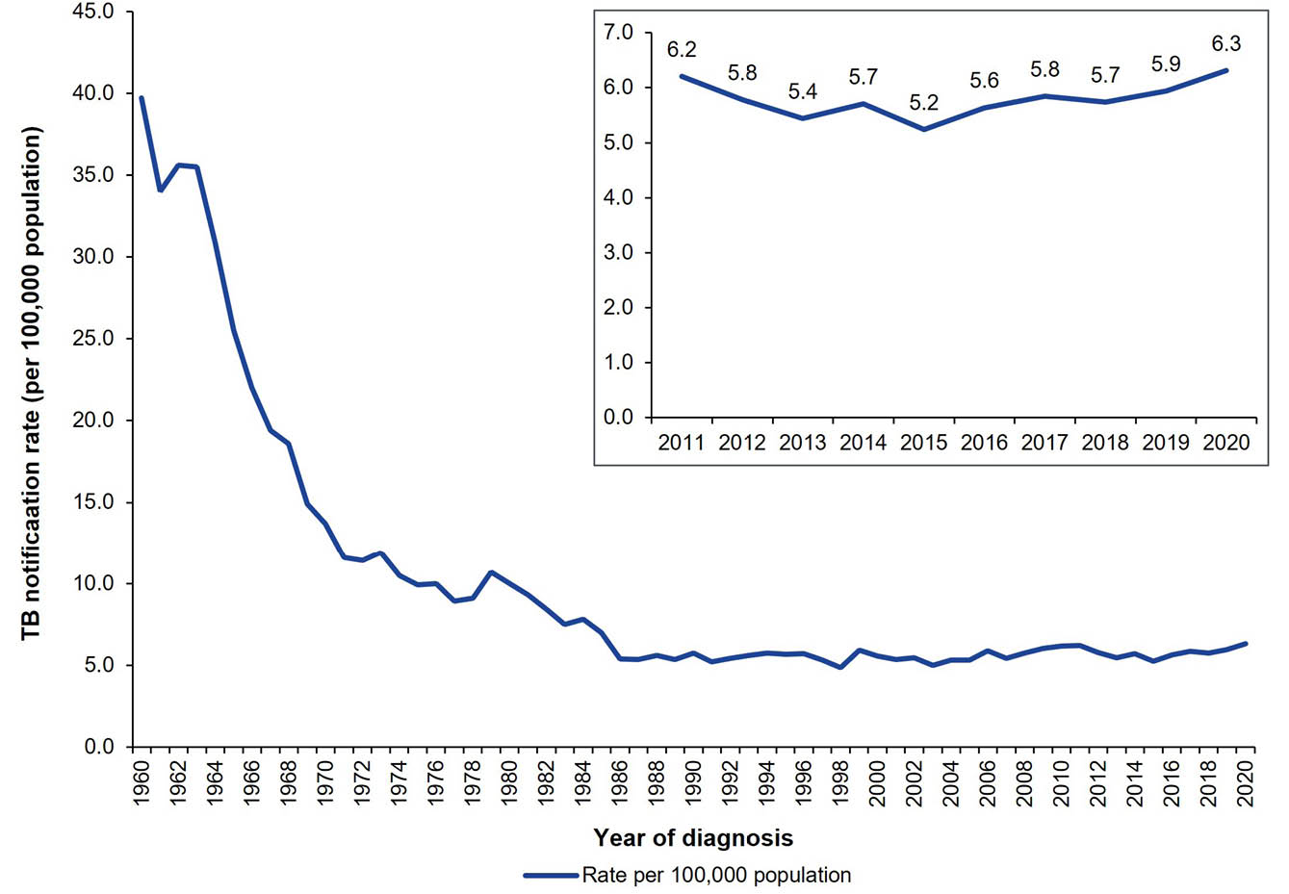

Geographic distribution
In 2020, the Australian Capital Territory, New South Wales, the Northern Territory, South Australia, Tasmania, and Victoria, all recorded a rate increase compared with the previous five-year mean (2015–2019). Tasmania recorded a rate of 4.1 per 100,000 population (n = 22); this was twice the previous five-year mean rate (1.9 per 100,000 population). Queensland and Western Australia both recorded decreased rates of TB in 2020, with reductions of 8% and 3% respectively (Figure 2).
In 2019, the greatest increases in rate, compared with the previous five-year mean (2014–2018), were observed in the Northern Territory and New South Wales, with increases of 18% and 13%, respectively (Figure 2). Notably, the Australian Capital Territory recorded a 38% decrease in rate to 3.9 per 100,000 population in 2019 from the five-year mean (6.3 per 100,000 population).
Figure 2: Notification rates of tuberculosis in Australia, 2019–2020 compared with the five-year mean rate,ª by state or territory
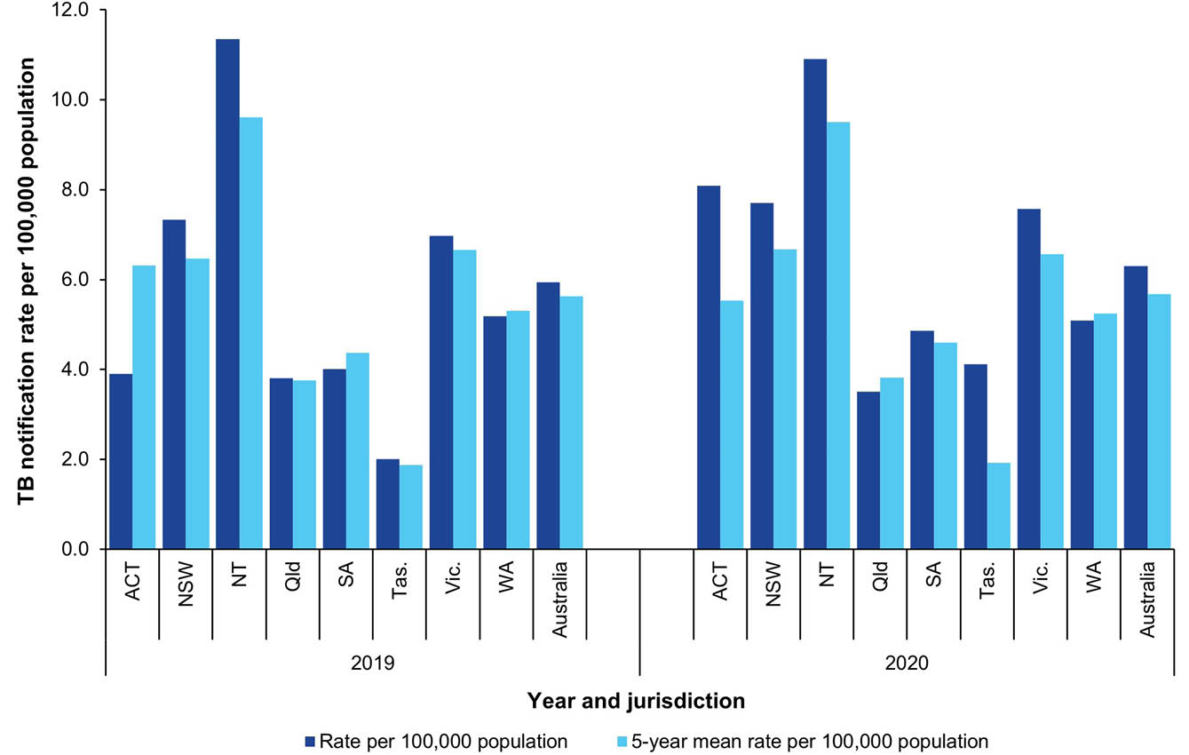
a ‘Five-year mean rate’ refers to the mean (average) rate of the five years preceding the reference year (i.e. 2014–2018 for notifications in 2019; 2015–2019 for notifications in 2020).

Tuberculosis in the Australian-born population
In 2020, the rate of TB in the Australian-born non-Indigenous population was 0.6 per 100,000 population, and the rate in the Australian-born Aboriginal and Torres Strait Islander population was 2.7 per 100,000 population (Table 4). These rates are similar to the rates reported in 2019.
In 2020 and 2019, the rate of TB in Australian-born Aboriginal and Torres Strait Islander people was 4.2 and 3.7 times the rate of TB in the Australian-born non-Indigenous population, respectively (Table 4).
Since 2009, the rate of TB in the Australian-born non-Indigenous population has ranged from 0.6 to 0.9 per 100,000 population per year, with the rate decreasing from 0.8 in 2018 to 0.6 in 2020 (Figure 3). The rate of TB in the Australian-born Aboriginal and Torres Strait Islander population ranged from 2.6 to 7.5 per 100,000 population per year since 2009, with the lowest rates observed in 2019 and 2020.
Table 4: Notified cases and rates of tuberculosis, Australia, 2019–2020,ª by population subgroup and state or territory
Year | Jurisdiction^{c} | Australian-born Aboriginal and Torres Strait Islander^{b} |  | Australian-born  non-Indigenous^{b} |  | Overseas-born^{b}
Year | Jurisdiction^{c} | n | Rate | n | Rate | n | Rate
2020 | ACT | 0 | 0.0 | 3 | 1.0 | 33 | 24.9
2020 | NSW | 6 | 1.8 | 47 | 0.9 | 572 | 22.7
2020 | NT | 7 | 9.3 | 0 | 0.0 | 20 | 33.9
2020 | Qld | 8 | 3.0 | 11 | 0.3 | 162 | 12.9
2020 | SA | 0 | 0.0 | 4 | 0.3 | 82 | 18.2
2020 | Tas. | 0 | 0.0 | 1 | 0.2 | 22 | 24.2
2020 | Vic. | 3 | 3.9 | 33 | 0.7 | 465 | 22.2
2020 | WA | 2 | 1.7 | 11 | 0.7 | 125 | 13.5
2020 | Australia | 26 | 2.7 | 110 | 0.6 | 1,481 | 19.7
2019 | ACT | 0 | 0.0 | 1 | 0.3 | 16 | 12.3
2019 | NSW | 2 | 0.6 | 39 | 0.7 | 546 | 21.9
2019 | NT | 10 | 13.4 | 1 | 0.9 | 17 | 28.9
2019 | Qld | 11 | 4.2 | 19 | 0.5 | 164 | 13.3
2019 | SA | 1 | 2.0 | 6 | 0.5 | 62 | 14.0
2019 | Tas. | 0 | 0.0 | 1 | 0.2 | 10 | 11.2
2019 | Vic. | 1 | 1.3 | 38 | 0.9 | 414 | 20.0
2019 | WA | 0 | 0.0 | 17 | 1.0 | 121 | 13.3
2019 | Australia | 25 | 2.6 | 122 | 0.7 | 1,350 | 18.2
a Excludes one notification in 2020 (unknown Aboriginal and Torres Strait Islander status) and eight notifications in 2019 (five with unknown country of birth; three with unknown Aboriginal and Torres Strait Islander status).
b n: number of notifications in this category, for the identified jurisdiction and year; Rate: rate per 100,000 population per year, for the identified jurisdiction.
c ACT: Australian Capital Territory; NSW: New South Wales; NT: Northern Territory; Qld: Queensland; SA: South Australia; Tas.: Tasmania; Vic.: Victoria; WA: Western Australia.
Figure 3: Notified cases and rate of tuberculosis in Australia, 2009–2020, by population subgroup
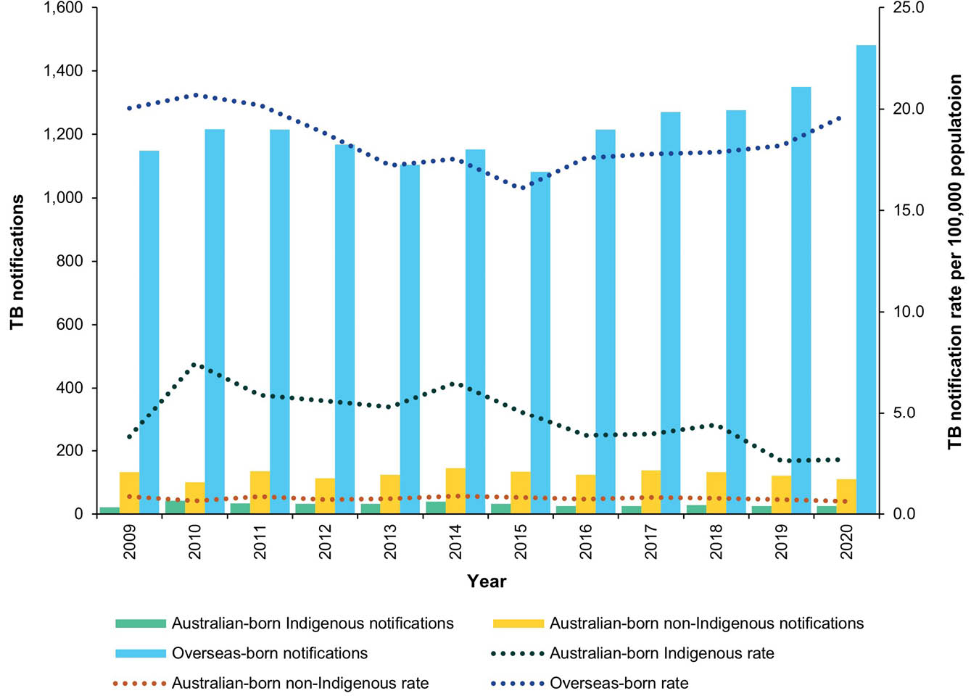

Tuberculosis in the overseas-born population
Country of birth information was reported for all cases (100%; 1,618/1,618) in 2020 and for 99% of cases (1,501/1,505) in 2019. Among cases with country of birth reported, 92% of cases in 2020 (1,481/1,618) and 90% of cases in 2019 (1,350/1,501) were overseas-born (Table 5). In 2020, the rate of TB in the overseas-born population was 19.7 per 100,000 population, an increase of 8% from the rate in 2019 (18.2 per 100,000 population). Consistent with previous trends, in 2020 and 2019, the rate of TB in the overseas-born population was 31 and 25 times the rate in the Australian-born non-Indigenous population, respectively (Figure 3).

Country of birth
In 2020 and 2019, the top five most frequently reported countries of birth for TB cases were India, the Philippines, Vietnam, Nepal, and China. During this period, these five countries contributed more than half of all overseas-born cases (61% in 2020 and 57% in 2019; Table 5).
In 2020, the highest estimated rates of TB cases in Australia, among the frequently reported countries of birth, were in those born in Bhutan (265 per 100,000 population), Nepal (110 per 100,000 population), and Myanmar (82 per 100,000 population). In 2019, the highest estimated rates were in those born in Sudan (106 per 100,000 population), Myanmar (98 per 100,000 population), and Nepal (92 per 100,000 population; Table 5).

Residency status
Residency status was available for 98% (1,449/1,481) and 97% (1,306/1,350) of overseas-born TB cases reported in 2020 and 2019, respectively. Residency status is self-reported at the time of diagnosis and is not verified against migration records.
During the two-year period, most overseas-born cases with a residency status were reported as permanent residents: 53% in 2020 (769/1,449) and 56% in 2019 (726/1,306; Table 6). Overseas students were the second-most-reported overseas-born residency status category: 22% in 2020 (316/1,449) and 20% in 2019 (258/1,306). The proportions of overseas-born cases reported as a visitor, refugee/humanitarian, and ‘other’, were similar in 2020 and 2019.

Time between arrival in Australia and diagnosis
Data on year of arrival were available for 99% of overseas-born cases in 2020 (1,475/1,481) and 99% in 2019 (1,339/1,350). Among overseas-born cases, the median number of years from arrival to diagnosis was four years in 2020 and 2019 (Figure 4). The majority of overseas-born international students (87% in 2020 and 90% in 2019) were diagnosed within four years of arrival in Australia. This is higher than the proportion of overseas-born permanent residents diagnosed within four years of arrival (20% in 2020 and 19% in 2019).
Table 5: Notified cases and rates of tuberculosis (TB) in Australia for frequently reported countries of birth, 2019–2020, by residency status
Year | Country of birth | Residency status |  |  |  | ERP^{b} | Rate^{c} | WHO TB incidence rate^{d}
Year | Country of birth | Total notificationsª | International students | Permanent residents | Other | ERP^{b} | Rate^{c} | WHO TB incidence rate^{d}
2020 | India | 378 | 102 | 168 | 95 | 724,060 | 52 | 197
2020 | Philippines | 171 | 17 | 104 | 49 | 308,380 | 55 | 544
2020 | Nepal | 146 | 79 | 25 | 41 | 132,400 | 110 | 226
2020 | Vietnam | 120 | 10 | 80 | 29 | 275,920 | 43 | 170
2020 | China (excluding SARs and Taiwan)^{e} | 95 | 12 | 55 | 27 | 638,990 | 15 | 58
2020 | Indonesia | 71 | 15 | 34 | 22 | 94,930 | 75 | 301
2020 | Myanmar, The Republic of the Union of | 34 | 2 | 23 | 8 | 41,530 | 82 | 306
2020 | Malaysia | 33 | 6 | 12 | 15 | 178,760 | 18 | 91
2020 | Pakistan | 30 | 12 | 13 | 2 | 97,080 | 31 | 257
2020 | Bhutan | 29 | 16 | 2 | 11 | 10,960 | 265 | 164
2020 | Afghanistan | 28 | 1 | 17 | 7 | 63,010 | 44 | 183
2020 | Cambodia | 25 | 1 | 20 | 3 | 41,500 | 60 | 279
2020 | Thailand | 22 | 6 | 11 | 4 | 89,060 | 25 | 146
2020 | Sri Lanka | 19 | 5 | 11 | 3 | 142,690 | 13 | 63
2020 | Kenya | 18 | 6 | 9 | 2 | 25,230 | 71 | 58
2020 | Other overseas-born | 262 | 26 | 185 | 46 | — | — | —
2020 | Total overseas-born | 1,481 | 316 | 769 | 364 | — | — | —
2020 | Australian-born | 137 | — | — | — | — | — | —
2020 | Unknown country of birth | 0 | — | — | — | — | — | —
2020 | Total | 1,618 | — | — | — | — | — | —
2019 | India | 271 | 52 | 134 | 75 | 665,400 | 41 | 202
2019 | Philippines | 159 | 14 | 94 | 47 | 294,160 | 54 | 554
2019 | Vietnam | 121 | 11 | 89 | 17 | 268,070 | 45 | 176
2019 | Nepal | 110 | 74 | 12 | 21 | 119,060 | 92 | 238
2019 | China (excluding SARs and Taiwan)^{e} | 105 | 21 | 62 | 19 | 661,460 | 16 | 58
2019 | Indonesia | 63 | 22 | 20 | 20 | 91,030 | 69 | 312
2019 | Myanmar, The Republic of the Union of | 39 | 2 | 21 | 16 | 39,770 | 98 | 322
2019 | Thailand | 28 | 7 | 15 | 5 | 86,070 | 33 | 150
2019 | Papua New Guinea | 26 | 5 | 8 | 13 | 33,850 | 77 | 432
2019 | Afghanistan | 25 | 0 | 19 | 4 | 60,730 | 41 | 189
2019 | Bangladesh | 24 | 6 | 8 | 9 | 53,560 | 45 | 221
2019 | Cambodia | 21 | 1 | 17 | 3 | 40,030 | 52 | 287
2019 | Malaysia | 21 | 4 | 5 | 11 | 177,510 | 12 | 92
2019 | Sudan | 20 | 0 | 18 | 2 | 18,940 | 106 | 67
2019 | Sri Lanka | 18 | 2 | 13 | 2 | 137,480 | 13 | 64
2019 | Other overseas-born | 299 | 37 | 191 | 58 | — | — | —
2019 | Total overseas-born | 1,350 | 258 | 726 | 322 | — | — | —
2019 | Australian-born | 151 | — | — | — | — | — | —
2019 | Unknown country of birth | 4 | — | — | — | — | — | —
2019 | Total | 1,505 | — | — | — | — | — | —
a Total includes cases reported with an unknown or not reported a residency status (32 cases in 2020; 48 cases in 2019).
b ERP: estimated resident population by country of birth; 2020 and 2019 population data is sourced from the Australian Bureau of Statistics ERP by country of birth as at 30 June, 1996 to 2023 dataset (Reference period: June 2023). Available from: https://www.abs.gov.au/statistics/people/population/australias-population-country-birth/jun-2023.
c Rate: rate per 100,000 population per year, for the indicated ERP.
d TB incidence rate per 100,000 population per year, extracted from the World Bank Indicators derived from the World Health Organization (WHO) Global Tuberculosis Report.
e SAR: special administrative region.
Table 6: Notified cases of tuberculosis among overseas-born people in Australia, 2019–2020, by residency status and state or territoryª
Year | Residency status | ACT | NSW | NT | Qld | SA | Tas. | Vic. | WA | Australia
 |  |  |  |  |  |  |  |  |  | n | %^{b}
2020 | Permanent resident | 13 | 309 | 14 | 71 | 19 | 4 | 267 | 72 | 769 | 53
2020 | Overseas student | 9 | 132 | 1 | 34 | 12 | 7 | 96 | 25 | 316 | 22
2020 | Other^{c} | 6 | 70 | 4 | 25 | 1 | 0 | 41 | 15 | 162 | 11
2020 | Visitor | 5 | 51 | 1 | 18 | 13 | 5 | 47 | 12 | 152 | 10
2020 | Refugee | 0 | 6 | 0 | 10 | 15 | 4 | 9 | 1 | 45 | 3
2020 | Unauthorised person^{d} | 0 | 1 | 0 | 1 | 0 | 0 | 1 | 0 | 3 | < 1
2020 | Resident of the Torres Strait Treaty Zone accessing TB treatment in Queensland | N/A | N/A | N/A | 2 | N/A | N/A | N/A | N/A | 2 | < 1
2020 | Unknown or not reported | 0 | 3 | 0 | 1 | 22 | 2 | 4 | 0 | 32 | —
2020 | Total overseas-born cases | 33 | 572 | 20 | 162 | 82 | 22 | 465 | 125 | 1,481 | 100
2019 | Permanent resident | 5 | 295 | 10 | 76 | 7 | 4 | 254 | 75 | 726 | 56
2019 | Overseas student | 6 | 120 | 3 | 26 | 8 | 3 | 77 | 15 | 258 | 20
2019 | Other^{c} | 2 | 53 | 0 | 27 | 0 | 1 | 43 | 14 | 140 | 11
2019 | Visitor | 2 | 54 | 3 | 14 | 9 | 1 | 28 | 13 | 124 | 9
2019 | Refugee | 1 | 12 | 0 | 15 | 8 | 1 | 9 | 2 | 48 | 4
2019 | Unauthorised person^{d} | 0 | 1 | 1 | 1 | 0 | 0 | 0 | 2 | 5 | < 1
2019 | Resident of the Torres Strait Treaty Zone accessing TB treatment in Queensland | N/A | N/A | N/A | 5 | N/A | N/A | N/A | N/A | 5 | < 1
2019 | Unknown or not reported | 0 | 11 | 0 | 0 | 30 | 0 | 3 | 0 | 44 | —
2019 | Total overseas-born cases | 16 | 546 | 17 | 164 | 62 | 10 | 414 | 121 | 1,350 | 100
a ACT: Australian Capital Territory; NSW: New South Wales; NT: Northern Territory; Qld: Queensland; SA: South Australia; Tas.: Tasmania; Vic.: Victoria; WA: Western Australia.
b Percentage shown excludes cases with Residency Status reported as ‘Unknown’ or not reported.
c ‘Other’ includes a person not defined by any of these data fields.
d ‘Unauthorised person’ includes unlawful non-citizen and illegal foreign fisher.

Figure 4: Notified cases of tuberculosis in the overseas-born population in Australia, 2019–2020, by residency statusª and number of years from arrival to diagnosis
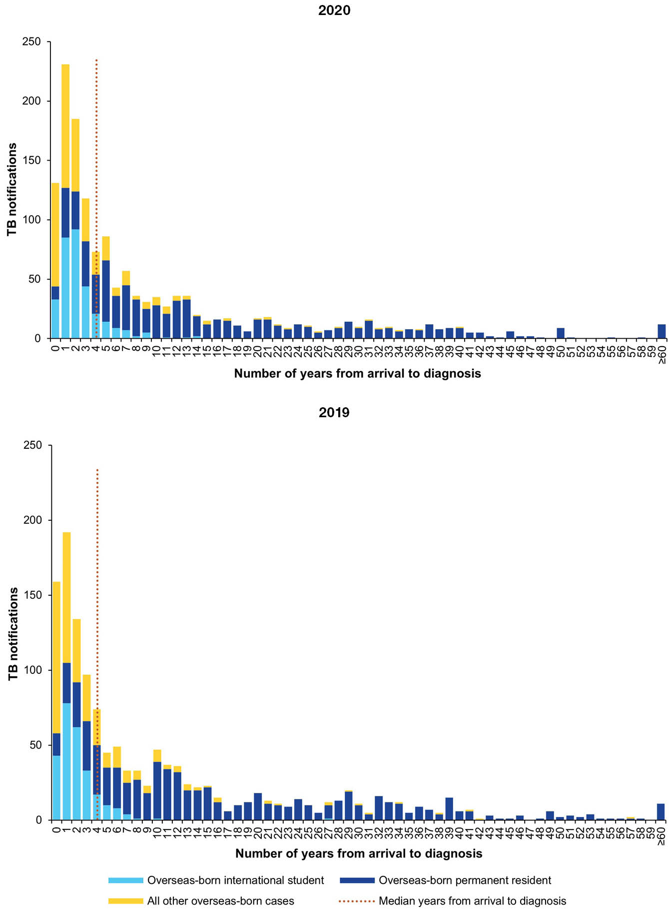
a ‘All other overseas-born cases’ include those for whom residency status is unknown.

Age and sex distribution
Age and sex were reported for all but one TB case each in 2020 and 2019. Overall, there were more males than females with TB, with males accounting for 53% of cases in 2020 and 2019. There was a higher proportion of males among Australian-born and overseas-born TB cases (Figure 5). As observed in previous years, the TB notification rate was highest among young adults aged 25–34 years (2020: 12.4 per 100,000 population and 2019: 11.8 per 100,000 population); this was driven by the high numbers of overseas-born cases in this age group among females and males (Table 7 and Figure 5). Among Australian-born Aboriginal and Torres Strait Islander people, TB rates were highest in those aged 55 years and older, while among Australian-born non-Indigenous people, the highest rates were in those aged 20–24 years and 65 years and older (Table 7).
Figure 5: Notifications of tuberculosis in Australia, 2019–2020, by age, sex, and place of birth
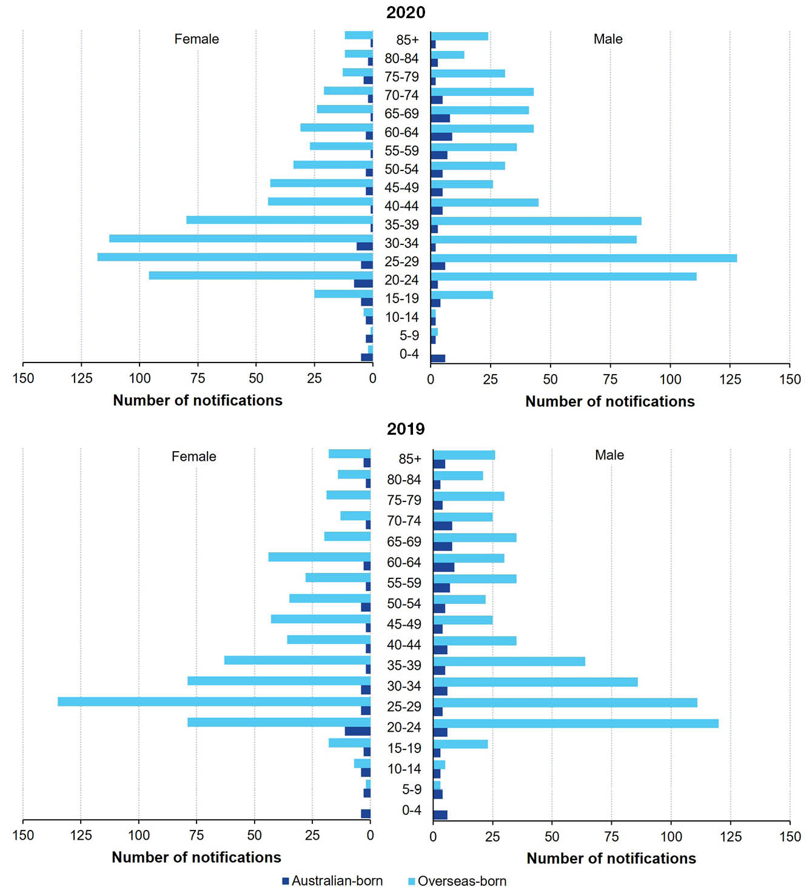
Table 7: Notification rates of tuberculosis, Australia, 2019–2020, by population subgroup and age group
Year | Age group (years) | Australian-born Aboriginal and Torres Strait Islanderª |  | Australian-born  non-Indigenousª |  | Overseas-bornª |  | Total^{a,b}
Year | Age group (years) | n | Rate | n | Rate | n | Rate | n | Rate
2020 | 0–4 | 1 | 0.9 | 10 | 0.7 | 2 | 3.6 | 13 | 0.8
2020 | 5–9 | 0 | 0.0 | 5 | 0.4 | 4 | 2.6 | 9 | 0.6
2020 | 10–14 | 1 | 0.9 | 4 | 0.3 | 6 | 3.0 | 11 | 0.7
2020 | 15–19 | 2 | 2.1 | 7 | 0.6 | 51 | 19.5 | 60 | 4.0
2020 | 20–24 | 1 | 1.2 | 10 | 0.9 | 208 | 42.5 | 219 | 12.8
2020 | 25–34 | 5 | 3.5 | 15 | 0.7 | 445 | 31.8 | 465 | 12.3
2020 | 35–44 | 4 | 3.8 | 6 | 0.3 | 258 | 18.8 | 268 | 7.7
2020 | 45–54 | 4 | 4.1 | 12 | 0.6 | 135 | 12.3 | 151 | 4.6
2020 | 55–64 | 5 | 7.1 | 14 | 0.7 | 137 | 12.9 | 157 | 5.2
2020 | 65+ | 3 | 6.0 | 27 | 1.1 | 235 | 14.9 | 265 | 6.3
2020 | Total | 26 | 2.7 | 110 | 0.6 | 1,481 | 19.3 | 1,618 | 6.3
2019 | 0–4 | 0 | 0.0 | 10 | 0.7 | 0 | 0.0 | 10 | 0.6
2019 | 5–9 | 0 | 0.0 | 7 | 0.5 | 5 | 3.2 | 12 | 0.7
2019 | 10–14 | 1 | 0.9 | 6 | 0.5 | 12 | 6.0 | 19 | 1.2
2019 | 15–19 | 1 | 1.1 | 5 | 0.4 | 41 | 14.8 | 47 | 3.1
2019 | 20–24 | 2 | 2.4 | 15 | 1.3 | 200 | 38.4 | 218 | 12.5
2019 | 25–34 | 3 | 2.2 | 15 | 0.7 | 411 | 29.1 | 429 | 11.4
2019 | 35–44 | 5 | 4.9 | 10 | 0.5 | 198 | 15.1 | 214 | 6.3
2019 | 45–54 | 5 | 5.2 | 10 | 0.5 | 125 | 11.5 | 141 | 4.4
2019 | 55–64 | 4 | 5.9 | 14 | 0.8 | 137 | 13.5 | 158 | 5.4
2019 | 65+ | 4 | 8.5 | 30 | 1.2 | 221 | 14.6 | 257 | 6.4
2019 | Total | 25 | 2.6 | 122 | 0.7 | 1,350 | 17.9 | 1,505 | 5.9
a n: number of notifications in this category, for the identified age group and year; Rate: rate per 100,000 population per year, for the identified age group.
b Total includes one ‘incomplete’ notification in 2020 (unknown Aboriginal and Torres Strait Islander status) and eight such notifications in 2019 (five with unknown country of birth; three with unknown Aboriginal and Torres Strait Islander status).

Tuberculosis in children aged < 15 years
Children aged < 15 years contributed 2–3% of all TB cases across the two-year period: 2% in 2020 (33/1,618; Table 7) and 3% in 2019 (41/1,505; Table 7). Australian-born non-Indigenous children represented more than half the total cases in the < 15 years age group in both reporting years: 58% in 2020 (19/33) and 56% in 2019 (23/41).
Among Australian-born non-Indigenous children aged < 15 years, the most frequently reported risk factors were having one or more parents born in a high-risk country (47%: 9/19 in 2020; and 61%: 14/23 in 2019) and having household or other close contact with TB (53%: 10/19 in 2020; and 39%: 9/23 in 2019). Of overseas-born children aged < 15 years, the most frequently reported risk factor was ‘past travel to or residence for at least 3 months in a high-risk country’ (92%: 11/12 in 2020; and 76%: 13/17 in 2019). Note that more than one risk factor may be reported for each notified case of TB.
The number of TB cases in Australian-born Aboriginal and Torres Strait Islander children aged < 15 years has remained relatively stable from 2016 (n = 1) to 2020 (n = 2) (Figure 6). The rate among Australian-born non-Indigenous children in this age group decreased from 0.9 per 100,000 population in 2017 (n = 34) to 0.5 per 100,000 population in 2020 (n = 19). Among overseas-born children aged < 15 years, the rate of TB has ranged from 2.9 to 8.8 per 100,000 population since 2009, with the lowest rates observed in 2019 and 2020 (Figure 6).
Figure 6: Notified cases and rate of tuberculosis in children < 15 years, Australia in 2009–2020, by population subgroup
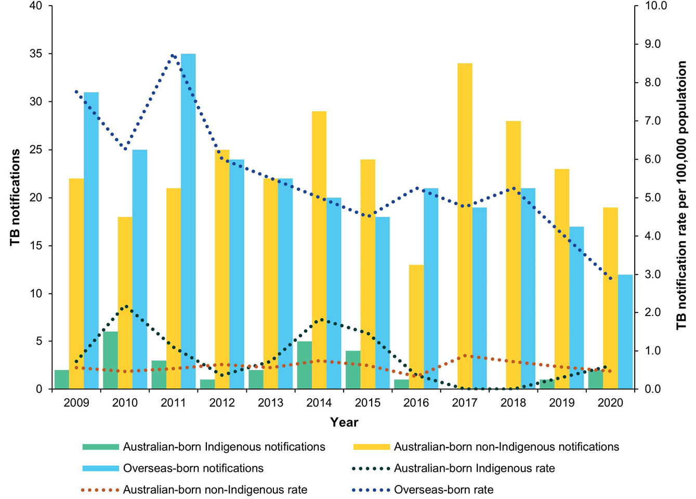

Selected risk factors for tuberculosis
Selected risk factor data were provided for 99% and 98% of cases reported in 2020 and 2019, respectively (1,611/1,618 in 2020; and 1,486/1,505 in 2019). Of cases assessed for risk factors, the most frequently reported risk factor was ‘past travel to or residence in a high-risk country’, accounting for 85% of cases in 2020 (1,375/1,611) and 81% of cases in 2019 (1,200/1,486; Table 8).
In 2020 and 2019, ‘past travel to or residence in a high-risk country’ was the most frequently reported risk factor among overseas-born cases (91% in 2020; and 86% in 2019) and Australian-born non-Indigenous cases (34% in 2020; and 36% in 2019), while having a ‘household member or close contact with TB’ was the most frequently reported risk factor among Australian-born Aboriginal and Torres Strait Islander cases (42% in 2020; and 68% in 2019).
There were 116 and 78 cases with TB who were currently or had ever worked in a health care setting in Australia or overseas in 2020 and 2019, respectively. Of these cases, over half were reportedly working in a health care setting in Australia at the time of or within 12 months of diagnosis (51%: 59/116 in 2020; and 56%: 44/78 in 2019). Of the cases reportedly working in a health care setting in Australia at the time of diagnosis or within 12 months of diagnosis, 64% (38/59) in 2020 and 50% (22/44) in 2019 were reported to have pulmonary disease (including pulmonary and other sites).

Table 8: Notified cases of tuberculosis (TB), Australia, 2019–2020, by population subgroup and selected risk factorsª
Year | Risk factor^{b} | Australian-born Aboriginal and Torres Strait Islander | Australian-born non-Indigenous | Overseas-born | Total
 |  |  |  |  | n | %
2020 | Household or other close contact with TB | 11 | 24 | 183 | 218 | 14
2020 | Ever resided in a correctional facility | 3 | 3 | 3 | 9 | 1
2020 | Ever resided in an aged care facility | 0 | 0 | 8 | 8 | 0
2020 | Ever employed in an institution^{c,d} | 1 | 0 | 15 | 16 | 1
2020 | Currently^{e} or ever^{c} employed in health industry in Australia or overseas | 2 | 9 | 105 | 116 | 7
2020 | Ever homeless | 5 | 2 | 11 | 18 | 1
2020 | Past travel to or residence in a high-risk country | 1 | 36 | 1,338 | 1,375 | 85
2020 | Chest X-ray suggestive of old untreated TB | 1 | 2 | 70 | 73 | 5
2020 | Currently receiving immunosuppressive therapy | 1 | 11 | 39 | 51 | 3
2020 | Australian-born child with one or more parents born in a high-risk country | 0 | 11 | 0 | 11 | 1
2020 | None of the above risk factors | 5 | 26 | 79 | 110 | 7
2020 | Total cases assessed for risk factors | 26 | 107 | 1,478 | 1,611 | 100
2019 | Household or other close contact with TB | 17 | 25 | 180 | 222 | 15
2019 | Ever resided in a correctional facility | 4 | 3 | 9 | 16 | 1
2019 | Ever resided in an aged care facility | 0 | 2 | 3 | 5 | <1
2019 | Ever employed in an institution^{c,d} | 0 | 0 | 10 | 10 | 1
2019 | Currently^{e} or ever^{c} employed in health industry in Australia or overseas | 1 | 3 | 74 | 78 | 5
2019 | Ever homeless | 5 | 1 | 7 | 13 | 1
2019 | Past travel to or residence in a high-risk country | 1 | 43 | 1,156 | 1,200 | 81
2019 | Chest X-ray suggestive of old untreated TB | 0 | 3 | 80 | 83 | 6
2019 | Currently receiving immunosuppressive therapy | 1 | 9 | 51 | 61 | 4
2019 | Australian-born child with one or more parent born in a high-risk country | 0 | 14 | 3 | 17 | 1
2019 | None of the above risk factors | 4 | 35 | 102 | 141 | 9
2019 | Total cases assessed for risk factors | 25 | 120 | 1,341 | 1,486 | 100
a Excludes cases with no reported risk factors and unknown country of birth.
b More than one risk factor may be reported for each notified case of TB.
c ‘Ever employed’ excludes employment in the last 12 months.
d ‘Institution’ is defined as a correctional facility, aged care facility, or homeless shelter.
e ‘Currently employed’ is defined as currently working or worked in the last 12 months.

Tuberculosis and HIV testing history
Human immunodeficiency virus (HIV) testing history of notified cases of TB was reported for 99% of cases in 2020 (1,602/1,618) and 99% in 2019 (1,491/1,505). Of TB cases with a reported known HIV testing history, 93% of cases in 2020 (1,495/1,602) and 91% of cases in 2019 (1,359/1,491) had a known HIV status. Of those cases with a known HIV status, 1% of 2020 cases (20/1,495) and 2% of 2019 cases (24/1,359) were HIV positive (Table 9).
Table 9: Notified cases of tuberculosis, Australia, 2019–2020, by population subgroup and human immunodeficiency virus (HIV) testing history
Year | HIV testing history | Australian-born Aboriginal and Torres Strait Islander | Australian-born non-Indigenous | Overseas-born | Totalª
2020 | HIV positive | 1 | 0 | 19 | 20
2020 | HIV negative | 25 | 90 | 1,359 | 1,475
2020 | HIV tested, result unknown | 0 | 0 | 2 | 2
2020 | Not tested^{b} | 0 | 17 | 88 | 105
2020 | Total – known HIV testing history | 26 | 107 | 1,468 | 1,602
2020 | Total – unknown HIV testing history | 0 | 3 | 13 | 16
2020 | Total | 26 | 110 | 1,481 | 1,618
2019 | HIV positive | 0 | 4 | 20 | 24
2019 | HIV negative | 24 | 93 | 1,212 | 1,335
2019 | HIV tested, result unknown | 0 | 1 | 11 | 12
2019 | Not tested^{b} | 1 | 23 | 95 | 120
2019 | Total – known HIV testing history | 25 | 121 | 1,338 | 1,491
2019 | Total – unknown HIV testing history | 0 | 1 | 12 | 14
2019 | Total | 25 | 122 | 1,350 | 1,505
a Excludes one notification in 2020 (unknown Aboriginal and Torres Strait Islander status) and eight notifications in 2019 (five with unknown country of birth, and three with unknown Aboriginal and Torres Strait Islander status).
b ‘Not tested’ includes those who refused testing.

Anatomical site of disease
All cases in 2019 and 2020 had a reported anatomical site of TB disease. Pulmonary disease was most common; reported in 62% of cases (1,003/1,618) in 2020 and 63% of cases (945/1,505) in 2019. Of those cases, 80% in both 2020 (803/1,003) and 2019 (760/945) were reported as having pulmonary disease only (Table 10).
Extrapulmonary disease was reported in 50% of cases in both 2020 (815/1,618) and 2019 (745/1,505), of which extrapulmonary only disease was reported in 75% of cases in both years (615/815 in 2020; and 560/745 in 2019). The most frequently reported extrapulmonary site of disease across the two years was the lymph nodes (55% in 2020; 48% in 2019); the proportion of recurrent cases reporting lymph nodes was 63% in 2020, an increase from 41% in 2019. The number of miliary/disseminated TB notifications among cases was 54 in 2020, increased from 29 in 2019 (Table 11).

Children aged < 15 years
In children aged < 15 years, pulmonary disease was reported in 67% of cases (22/33) in 2020 and 63% (26/41) in 2019, of which most were pulmonary only disease (86% in 2020; 73% in 2019). Extrapulmonary disease was reported in 42% of cases (14/33) in 2020 and 54% (22/41) in 2019. Of extrapulmonary cases, the most frequently reported extrapulmonary site of disease was the lymph nodes (36%, 5/14 in 2020; 41%, 9/22 in 2019). Meningeal TB was reported in three cases in 2020 and in two cases in 2019. Miliary/disseminated TB was reported in three cases in 2020 and one case in 2019.
Table 10: Notified cases of tuberculosis in Australia, 2019–2020, by site of disease and case classification
Year | Site | New cases | Recurrent cases | Unknown case classification | Total
 |  |  |  |  | n | %
2020 | Pulmonary only | 753 | 49 | 1 | 803 | 50
2020 | Pulmonary plus other sitesª | 187 | 13 | 0 | 200 | 12
2020 | Extrapulmonary only | 597 | 17 | 1 | 615 | 38
2020 | Total cases | 1,537 | 79 | 2 | 1,618 | 100
2019 | Pulmonary only | 716 | 42 | 2 | 760 | 50
2019 | Pulmonary plus other sitesª | 181 | 4 | 0 | 185 | 12
2019 | Extrapulmonary only | 533 | 25 | 2 | 560 | 37
2019 | Total cases | 1,430 | 71 | 4 | 1,505 | 100
a Includes anatomical sites from pulmonary cases with other sites of infection.
Table 11: Notifications of extrapulmonary tuberculosis (TB) in Australia, 2019–2020, by specific site of disease and case classification
Year | Extrapulmonary siteª | New cases | Relapse cases | Unknown case classification | Total
 |  |  |  |  | n | %
2020 | Pleural | 110 | 2 | 0 | 112 | 14
2020 | Lymph nodes | 426 | 19 | 1 | 446 | 55
2020 | Bone/joint | 60 | 3 | 0 | 63 | 8
2020 | Genito/urinary | 29 | 1 | 0 | 30 | 4
2020 | Miliary/disseminated | 53 | 1 | 0 | 54 | 7
2020 | Meningeal | 16 | 1 | 0 | 17 | 2
2020 | Peritoneal | 53 | 0 | 0 | 53 | 7
2020 | Other | 132 | 3 | 0 | 135 | 17
2020 | Total cases reporting extrapulmonary sites^{b} | 784 | 30 | 1 | 815 | 100
2019 | Pleural | 104 | 1 | 0 | 105 | 14
2019 | Lymph nodes | 343 | 12 | 1 | 356 | 48
2019 | Bone/joint | 46 | 5 | 0 | 51 | 7
2019 | Genito/urinary | 34 | 0 | 0 | 34 | 5
2019 | Miliary/disseminated | 26 | 3 | 0 | 29 | 4
2019 | Meningeal | 23 | 1 | 0 | 24 | 3
2019 | Peritoneal | 50 | 1 | 0 | 51 | 7
2019 | Other | 153 | 8 | 1 | 162 | 22
2019 | Total cases reporting extrapulmonary sites^{b} | 714 | 29 | 2 | 745 | 100
a Includes extrapulmonary only, and pulmonary plus other sites
b More than one extrapulmonary site may be reported for each notified case of TB and therefore the sum may not add up to the total or 100%.

Laboratory-confirmed cases
Laboratory-confirmed TB accounted for 81% of all TB cases in 2020 (1,306/1,618) and 2019 (1,213/1,505), with all other cases diagnosed through clinical and radiological evidence only. In 2020 and 2019, culture positive cases (sputum and other specimens) accounted for 89% of laboratory-confirmed cases (1,166/1,306 in 2020; 1,082/1,213 in 2019). All remaining laboratory-confirmed cases were diagnosed by nucleic acid testing only (Table 12).
Among cases notified with pulmonary disease, 86% (860/1,003) were laboratory-confirmed in 2020, and 89% (841/945) in 2019. Of laboratory-confirmed cases with pulmonary disease, 69% (593/860) were sputum culture positive in 2020; and 70% (586/841) in 2019. The remaining laboratory-confirmed pulmonary cases were culture positive on a specimen other than sputum (23% in 2020; 24% in 2019), or nucleic acid testing positive only (8% in 2020; 7% in 2019).
Of the extrapulmonary-only cases, 73% (446/615) and 66% (372/560) were laboratory confirmed in 2020 and 2019, respectively. Of those, 84% of cases in 2020 (375/446) and 80% in 2019 (297/372) were culture positive.

Children aged < 15 years
In 2020, thirty-six percent of TB cases in children aged < 15 years (12/33) were laboratory-confirmed, compared with 61% of cases (25/41) in 2019. Of laboratory-confirmed cases, 33% (4/12) and 60% (15/25) of cases in 2020 and 2019, respectively, were reported with pulmonary disease.
Of the extrapulmonary-only cases in children aged < 15 years, 73% (8/11) in 2020 and 67% (10/15) in 2019 were laboratory confirmed.
Table 12: Notified cases of tuberculosis, Australia, 2019–2020, by diagnostic method
Year | Diagnostic method | nª | %^{b}
2020 | Sputum culture positive and sputum microscopy positive | 299 | 23
2020 | Sputum culture positive (sputum microscopy negative) | 279 | 21
2020 | Sputum culture positive (sputum microscopy not done or unknown) | 19 | 1
2020 | Other culture positive^{c} | 569 | 44
2020 | Nucleic acid testing positive only^{d} | 140 | 11
2020 | Total laboratory-confirmed | 1,306 | 100
2020 | Clinically diagnosed | 312 | —
2020 | Total cases | 1,618 | —
2019 | Sputum culture positive and sputum microscopy positive | 305 | 25
2019 | Sputum culture positive (microscopy negative) | 275 | 23
2019 | Sputum culture positive (microscopy not done or unknown) | 11 | 1
2019 | Other culture positive^{c} | 491 | 40
2019 | Nucleic acid testing positive only^{d} | 131 | 11
2019 | Total laboratory-confirmed | 1,213 | 100
2019 | Clinically diagnosed | 292 | —
2019 | Total cases | 1,505 | —
a Number of notifications in indicated category.
b Percentage of laboratory-confirmed cases.
c Other culture positive with no sputum culture positive result.
d Cases with a positive nucleic acid test result without a positive culture result.

Drug-resistant tuberculosis in Australia
Drug susceptibility test (DST) results were available for 98% of 2020 (1,139/1,166) and 99% of 2019 (1,067/1,082) culture positive TB cases. Of cases where DST results were available, 86% and 87% of 2020 and 2019 notifications, respectively, were fully susceptible to anti-TB drugs tested (Table 13). Rifampicin mono-resistance was reported for 0.4% of cases with DST results (5/1,139) in 2020 and 0.3% (3/1,067) in 2019. Isoniazid mono-resistance was more common than rifampicin mono-resistance and was reported in 6% of cases with DST results in 2020 (74/1,139) and 7% of cases with DST results (80/1,067) in 2019 (Table 13).
In 2020, there were 21 cases of multidrug-resistant TB (MDR-TB; 2%; 21/1,139) and 23 MDR-TB cases (2%: 23/1,067) in 2019. There were no extensively drug-resistant TB (XDR-TB) cases reported in 2020, and one XDR-TB case reported in 2019 (Table 13). The majority of Australia’s MDR-TB cases were reported in the overseas-born population, with 96% of MDR-TB cases in 2020 (20/21) and 92% (22/24) of MDR-TB/XDR-TB cases in 2019 reported in overseas-born people. The most frequently reported country of birth for MDR-TB cases in 2020 was India (29%, 6/21), and in 2019, the most frequently reported country of birth was China (19%, 7/24).
Table 13: Notified cases of tuberculosis with drug susceptibility testing (DST) results available, Australia, 2019–2020, by drug susceptibility profile
Year | DST profile | nª | %^{b}
2020 | Fully susceptible^{c} | 997 | 86
2020 | Mono-resistance to rifampicin^{d} | 5 | < 1
2020 | Mono-resistance to isoniazid^{d} | 74 | 6
2020 | MDR-TB^{e} | 21 | 2
2020 | XDR-TB^{f} | 0 | 0
2020 | Other mono or poly resistance not specified above | 42 | 4
2020 | No resistance information | 27 | 2
2020 | Total culture confirmed cases | 1,166 | 100
2019 | Fully susceptible^{c} | 941 | 87
2019 | Mono-resistance to rifampicin^{d} | 3 | < 1
2019 | Mono-resistance to isoniazid^{d} | 80 | 7
2019 | MDR-TB^{e} | 23 | 2
2019 | XDR-TB^{f} | 1 | < 1
2019 | Other mono or poly resistance not specified above | 19 | 2
2019 | No resistance information | 15 | 1
2019 | Total culture confirmed cases | 1,082 | 100
a Number of notifications in indicated category.
b Percentage of culture confirmed cases.
c Not resistant to anything tested (no known resistance).
d Mono-resistance is a case that is resistant to only the specified first-line drug, and no known resistance to any other first-line drugs.
e MDR-TB: Multidrug-resistant tuberculosis. Resistance to at least isoniazid and rifampicin but not XDR-TB.
f XDR-TB: Extensively drug-resistant tuberculosis. Resistance to isoniazid and rifampicin, and any of the fluoroquinolones, and to at least one of the three injectable second-line drugs (kanamycin, capreomycin, amikacin).

Treatment outcomes
Treatment outcomes for the 2018, 2019 and 2020 TB notification cohorts are included in this report.
Among cases where outcome was reported, ‘completed treatment’ or ‘cured’ was reported in 90% of cases (1,451/1,617) in 2020; in 87% of cases (1,306/1,497) in 2019; and in 87% of cases (1,244/1,429) in 2018. Nineteen (19) cases (1%; 19/1,617) were reported to have died from TB in 2020; 25 cases (2%) in 2019; and 25 cases (2%) in 2018. Deaths due to TB were predominately of people who were overseas-born (Table 14). Treatment failure was reported in < 1% of cases from 2018 to 2020 (1/1,617 in 2020; 0/1,497 in 2019; 0/1,429 in 2018).

MDR-TB treatment outcomes
Where treatment outcome was reported among MDR-TB cases, ‘treatment completion’ or ‘cured’ was reported in 95% of cases in 2020 (20/21), 88% in 2019 (21/24), and 81% in 2018 (21/26) (Table 15). In the period 2018 to 2020, one MDR-TB case died of TB in 2019. All remaining MDR-TB cases were transferred out of Australia.
Table 14: All notified cases of tuberculosis, including multidrug-resistant tuberculosis, Australia, 2018–2020, by population subgroup and treatment outcome
Year | Treatment outcome | Australian-born Aboriginal and Torres Strait Islander |  | Australian-born non-Indigenous |  | Overseas-born |  | Totalª
Year | Treatment outcome | n | % | n | % | n | % | n | %
2020 | Cured | 1 | 4 | 7 | 6 | 74 | 5 | 82 | 5
2020 | Completed treatment | 18 | 69 | 98 | 89 | 1,253 | 85 | 1,369 | 85
2020 | Interrupted treatment^{b} | 0 | 0 | 0 | 0 | 6 | < 1 | 6 | < 1
2020 | Died of tuberculosis | 3 | 12 | 0 | 0 | 16 | 1 | 19 | 1
2020 | Died of other causes | 2 | 8 | 2 | 2 | 33 | 2 | 37 | 2
2020 | Lost to follow-up^{c} | 2 | 8 | 1 | 1 | 23 | 2 | 26 | 2
2020 | Treatment failed^{d} | 0 | 0 | 0 | 0 | 1 | < 1 | 1 | < 1
2020 | Transferred out of Australia | 0 | 0 | 0 | 0 | 58 | 4 | 58 | 4
2020 | Still under treatment | 0 | 0 | 1 | 1 | 13 | 1 | 14 | 1
2020 | Not followed up, outcome unknown | 0 | 0 | 1 | 1 | 4 | < 1 | 5 | < 1
2020 | Total^{e} | 26 | 100 | 110 | 100 | 1,481 | 100 | 1,617 | 100
2019 | Cured | 1 | 4 | 5 | 4 | 92 | 7 | 98 | 7
2019 | Completed treatment | 18 | 72 | 100 | 82 | 1,090 | 81 | 1,208 | 81
2019 | Interrupted treatment^{b} | 0 | 0 | 0 | 0 | 6 | < 1 | 6 | < 1
2019 | Died of tuberculosis | 0 | 0 | 4 | 3 | 21 | 2 | 25 | 2
2019 | Died of other causes | 3 | 12 | 7 | 6 | 30 | 2 | 40 | 3
2019 | Lost to follow-up^{c} | 3 | 12 | 5 | 4 | 32 | 2 | 40 | 3
2019 | Treatment failed^{d} | 0 | 0 | 0 | 0 | 0 | 0 | 0 | 0
2019 | Transferred out of Australia | 0 | 0 | 0 | 0 | 75 | 6 | 75 | 5
2019 | Still under treatment | 0 | 0 | 0 | 0 | 2 | < 1 | 2 | < 1
2019 | Not followed up, outcome unknown | 0 | 0 | 1 | 1 | 2 | < 1 | 3 | < 1
2019 | Total^{e} | 25 | 100 | 122 | 100 | 1,350 | 100 | 1,497 | 100
2018 | Cured | 2 | 7 | 4 | 3 | 64 | 5 | 70 | 5
2018 | Completed treatment | 20 | 69 | 109 | 83 | 1,045 | 82 | 1174 | 82
2018 | Interrupted treatment^{b} | 0 | 0 | 0 | 0 | 1 | < 1 | 1 | < 1
2018 | Died of tuberculosis | 1 | 3 | 2 | 2 | 22 | 2 | 25 | 2
2018 | Died of other causes | 1 | 3 | 8 | 6 | 33 | 3 | 42 | 3
2018 | Lost to follow-up^{c} | 3 | 10 | 4 | 3 | 16 | 1 | 23 | 2
2018 | Treatment failed^{d} | 0 | 0 | 0 | 0 | 0 | 0 | 0 | 0
2018 | Transferred out of Australia | 0 | 0 | 1 | 1 | 77 | 6 | 78 | 5
2018 | Still under treatment | 0 | 0 | 1 | 1 | 9 | < 1 | 10 | 1
2018 | Not followed up, outcome unknown | 2 | 7 | 2 | 2 | 2 | < 1 | 6 | < 1
2018 | Total^{e} | 29 | 100 | 131 | 100 | 1,269 | 100 | 1,429 | 100
a Excludes one notification in 2020 (unknown Aboriginal and Torres Strait Islander status), eight notifications in 2019 (five with unknown country of birth; three with unknown Aboriginal and Torres Strait Islander status), and three notifications in 2018 (unknown country of birth).
b ‘Interrupted treatment’ is defined as treatment interrupted for two months or more but completed.
c ‘Lost to follow up’ is defined as treatment that did not start or was interrupted for two consecutive months or more.
d ‘Treatment failed’ is defined as sputum culture positive at five months or later during treatment.
e Totals may not add up to 100% due to rounding.
Table 15: Notified cases of multidrug-resistant tuberculosis only, Australia, 2018–2020, by population subgroup and treatment outcome
Year | Treatment outcome | Australian-born Aboriginal and Torres Strait Islander |  | Australian-born non-Indigenous |  | Overseas-born |  | Totalª
Year | Treatment outcome | n | % | n | % | n | % | n | %
2020 | Cured | 0 | — | 0 | 0 | 0 | 0 | 0 | 0
2020 | Completed treatment | 0 | — | 1 | 100 | 19 | 95 | 20 | 95
2020 | Interrupted treatment^{b} | 0 | — | 0 | 0 | 0 | 0 | 0 | 0
2020 | Died of tuberculosis | 0 | — | 0 | 0 | 0 | 0 | 0 | 0
2020 | Died of other causes | 0 | — | 0 | 0 | 0 | 0 | 0 | 0
2020 | Lost to follow-up^{c} | 0 | — | 0 | 0 | 0 | 0 | 0 | 0
2020 | Treatment failed^{d} | 0 | — | 0 | 0 | 0 | 0 | 0 | 0
2020 | Transferred out of Australia | 0 | — | 0 | 0 | 1 | 5 | 1 | 5
2020 | Still under treatment | 0 | — | 0 | 0 | 0 | 0 | 0 | 0
2020 | Not followed up, outcome unknown | 0 | — | 0 | 0 | 0 | 0 | 0 | 0
2020 | Total^{e} | 0 | — | 1 | 100 | 20 | 100 | 21 | 100
2019 | Cured | 0 | — | 0 | 0 | 1 | 4 | 1 | 4
2019 | Completed treatment | 0 | — | 1 | 100 | 19 | 83 | 20 | 83
2019 | Interrupted treatment^{b} | 0 | — | 0 | 0 | 0 | 0 | 0 | 0
2019 | Died of tuberculosis | 0 | — | 0 | 0 | 1 | 4 | 1 | 4
2019 | Died of other causes | 0 | — | 0 | 0 | 0 | 0 | 0 | 0
2019 | Lost to follow-up^{c} | 0 | — | 0 | 0 | 0 | 0 | 0 | 0
2019 | Treatment failed^{d} | 0 | — | 0 | 0 | 0 | 0 | 0 | 0
2019 | Transferred out of Australia | 0 | — | 0 | 0 | 2 | 9 | 2 | 8
2019 | Still under treatment | 0 | — | 0 | 0 | 0 | 0 | 0 | 0
2019 | Not followed up, outcome unknown | 0 | — | 0 | 0 | 0 | 0 | 0 | 0
2019 | Total^{e} | 0 | — | 1 | 100 | 23 | 100 | 24 | 100
2018 | Cured | 1 | 25 | 0 | 0 | 3 | 16 | 4 | 15
2018 | Completed treatment | 3 | 75 | 3 | 100 | 11 | 38 | 17 | 65
2018 | Interrupted treatment^{b} | 0 | 0 | 0 | 0 | 0 | 0 | 0 | 0
2018 | Died of tuberculosis | 0 | 0 | 0 | 0 | 0 | 0 | 0 | 0
2018 | Died of other causes | 0 | 0 | 0 | 0 | 0 | 0 | 0 | 0
2018 | Lost to follow-up^{c} | 0 | 0 | 0 | 0 | 0 | 0 | 0 | 0
2018 | Treatment failed^{d} | 0 | 0 | 0 | 0 | 0 | 0 | 0 | 0
2018 | Transferred out of Australia | 0 | 0 | 0 | 0 | 5 | 26 | 5 | 19
2018 | Still under treatment | 0 | 0 | 0 | 0 | 0 | 0 | 0 | 0
2018 | Not followed up, outcome unknown | 0 | 0 | 0 | 0 | 0 | 0 | 0 | 0
2018 | Total^{e} | 4 | 100 | 3 | 100 | 19 | 100 | 26 | 100
a Excludes one notification in 2019 (unknown Aboriginal and Torres Strait Islander status).
b ‘Interrupted treatment’ is defined as treatment interrupted for two months or more but completed.
c ‘Lost to follow up’ is defined as treatment that did not start or was interrupted for two consecutive months or more.
d ‘Treatment failed’ is defined as sputum culture positive at five months or later during treatment.
e Totals may not add up to 100% due to rounding.

Pre-migration health screening
The Australian Migration Act 1958 and Migration Regulations 1994 stipulate that most visa applicants need to meet Public Interest Criteria (PIC). The health-related PICs (4005 and 4007) stipulate that visa applicants must be free from TB and/or must not be a public health threat or danger to the Australian community, and must not have a disease or condition that would pose a significant cost burden to the Australian community, or could prejudice the access of Australian residents to services in short supply.
The only medical condition that, in itself, prevents the grant of a visa as prescribed in the Migration Regulations 1994 is TB disease. If an applicant is found to have TB disease, they must demonstrate that they have satisfactorily completed a full course of treatment, and an Australian Medical Officer of the Commonwealth (MOC) must be satisfied that they are not a threat to public health before they can be considered for the grant of a visa.
The Australian Migration Program experienced significant disruption in 2020 due to the coronavirus disease 2019 (COVID-19) pandemic. International border restrictions, in addition to lockdowns and restrictions of movement in countries across the globe, impacted the operations of overseas panel clinics and resulted in a significant reduction in offshore Immigration Medical Examinations (IMEs) conducted in 2020.
Table 16: Number of cases and case rates of tuberculosis (TB) identified through offshore pre-migration screening process, Australia, 2019–2020
Yearª | Number of cases^{b} | Case detection rate^{c}
2020 | 396 | 146 per 100,000 IME caseload
2019 | 626 | 95 per 100,000 IME caseload
a Note that the COVID-19 pandemic caused substantial disruption to Australia’s borders and impacted the 2020 Migration Programs.
b The number of cases includes cases newly diagnosed through the pre-migration screening process and cases that were already on treatment for TB at the time of screening.
c Estimated rate per 100,000 immigration medical examinations (IME).
In 2020, there was a 37% decrease in the number of TB cases detected through offshore pre-migration screening compared with 2019. Despite this, the TB case detection rate per 100,000 IMEs increased by 54% in 2020 compared with 2019 (Table 16). The highest rate of TB detected through offshore pre-migration screening in 2020 was in the 60–64 years and 65–69 years age-groups (both 313 per 100,000 IME caseload), while the 90–94 years (240 per 100,000 IME caseload) and 65–69 years age groups (219 per 100,000 IME caseload) had the highest TB rates in 2019. Consistent with previous years, cases from the Philippines and India accounted for 40% of all TB cases detected in visa applicants in 2020 (the Philippines: 108/397; India: 50/397) and 34% in 2019 (the Philippines: 155/626; India: 59/626).
Of TB cases detected through offshore pre-migration screening in 2020, temporary visa applicants accounted for 78% (310/397); the remaining 22% were permanent visa applicants (87/397). In 2019, temporary visa applicants represented 83% of TB cases (518/626) detected through offshore screening; the other 17% (108/626) were permanent visa applicants. The higher number of TB cases within the temporary visa program likely reflects the higher number of visa applications and IMEs associated with this visa program. In 2020, the Student and Visitor visa programs accounted for 83% of TB cases identified within the temporary visa program, and 65% of all TB cases detected within offshore screening, with a similar trend in 2019. Partner visas accounted for 23% of total offshore TB cases identified within the permanent program in 2020 and 24% in 2019.
Of the TB cases identified through IME in 2020, ninety-six percent (381/397) were identified with pulmonary TB only; 4% (16/397) had pulmonary and extra pulmonary TB. Of the TB cases identified through IME in 2019 with TB infection type recorded (568/656), ninety-one percent (517/568) were identified with pulmonary only TB, and 9% (51/568) had pulmonary and extrapulmonary TB. In 2020, sixty percent of TB cases were tested for drug sensitivity (236/397). Some form of drug resistance was observed in 5% of TB cases that underwent resistance testing (21/397). Multi-drug resistant TB was identified in 7 of the 21 cases. These are consistent with proportions reported for 2019 cases. In 2020, MDR-TB was identified in applicants from five countries: Bhutan, India, Nepal, the Philippines, and Vietnam. MDR-TB cases in 2019 were identified in applicants from Brazil, China, India, the Philippines, Thailand, Uganda, the United Kingdom, and Vietnam.

TB elimination
The rate of TB in Australia in 2019–2020 continues to remain low and stable.
Together with a relatively small number of other countries where TB incidence is < 10 per 100,000 population, Australia is in a position where TB elimination, defined as <1 case per million population, may be feasible by 2050, acknowledging that there is an ongoing risk of imported cases from countries with high TB incidence (Table 17). However, as the TB incidence rate has remained between 5 and 6 per 100,000 for the last 35 years, maintaining current surveillance and response strategies will not be sufficient to reduce the rate to the 2035 targets. Additional funding, personnel and equipment will be necessary to decrease rates of TB in Australia. These strategies must prioritise the health needs of the Aboriginal and Torres Strait Islander and overseas-born people.
Further information on Australia’s Strategic Plan for Control of TB can be found in The Strategic Plan for Control of Tuberculosis in Australia, 2021–2025.⁹
Table 17: Australia milestonesª to achieve tuberculosis (TB) elimination
Goal | Observed incidence |  | Milestone | Targets
Goal | 2015 | 2020 | 2020 | 2035 | 2050
To reduce overall TB incidence rate in Australia | 5.3 per 100,000 population | 6.3 per 100,000 population | 3.1 per  100,000 population | < 1 per 100,000 population | < 1 per  million population^{c}
To reduce the rate of TB in Indigenous Australians | 4.8 per 100,000 population | 2.7 per 100,000 population | 1.6 per  100,000 population | < 1 per 1 million population^{c} | —
To reduce the rate of TB in Australian-born non-Indigenous Australians | 0.8 per 100,000 population | 0.6 per 100,000 population | Maintain  pre-elimination rates^{b} | < 1 per  million population^{c} | —
a The proposed annual reductions have been set to achieve the World Health Organization (WHO) elimination targets for low-incidence countries.
b The pre-elimination rate is < 1 case per 100,000 population.
c This is the identified WHO elimination target.

Discussion
Australia continues to report a relatively low and stable incidence of TB. Slight increases in the number of cases and incidence rate of TB in Australia are in the context of increasing migration to Australia, particularly from high TB incidence countries. As in previous years, over 90% of notifications are immigrants, largely from countries of both high migration to Australia and high TB prevalence (e.g. India, the Philippines, Vietnam, Nepal). Characteristically they are often young adults and have arrived in the last 5 years. Overseas tertiary students remain an important group, contributing 20% of notifications.
Three key groups act as indicators of TB control within Australia. Firstly, Aboriginal and Torres Strait Islander people, while contributing a small number of notifications (~2% of the total), continue to suffer TB at an incidence rate approximately four times the rate seen in non-Indigenous Australian-born people.
The second marker of TB control is incidence of TB in children (less than 15 years), as their age implies recent acquisition of the infection. The number of notifications is low (2–3% total) with a low incidence rate. However, more than half are Australian-born, usually the children and close contacts of recent migrants, and therefore again indicating local transmission.
A third indicator group of TB control is the number of recurrent cases of TB that were treated previously in Australia. There were between 20 and 30 such notifications in each of 2020 and 2019, representing about a third of recurrent TB and 1–1.5% of all notifications. This report does not examine whether these cases were likely due to reinfection or relapse, or whether prior treatment was adequate.
People notified with TB, and who have worked in health care, remain an important group. The 116 and 78 health care workers (HCWs) notified with TB in 2020 and 2019 respectively represent 5–8% of notifications, a proportion similar to recent years. At the time of TB diagnosis, just over half were working in Australian healthcare settings or had done so in the 12 months before diagnosis and more than half of these had pulmonary TB. In addition, TB disease in healthcare settings represents a risk of transmission of TB to patients, many vulnerable with comorbidities, but also to other HCWs.
Antimicrobial resistance is a growing concern globally. Australia continues to report a stable, low proportion of drug-resistant cases and most are relatively easily treated isoniazid mono-resistance. MDR-TB continues to make up less than 2.5% of notifications and XDR-TB was only reported once in these two years.
TB was successfully treated (cured or completed satisfactory treatment) in a very high proportion of notifications; nearly 90% of notifications in each of the 3 years reported here, or approximately 96% of assessable cases (not counting cases that died of a cause other than TB, were transferred out of Australia, or had no outcome data for another reason). The case fatality rate remains very low at 1–2%.
Screening for TB and treatment of the cases detected in the country of origin prior to migration remains an effective and valuable exercise. In 2019, there were 626 such cases of TB detected, which possibly would have otherwise entered Australia with pulmonary TB. The number detected fell significantly to 397 in 2020, which is considered a consequence of the disruption caused by the COVID-19 pandemic. However, the detection rate as a function of case load in both years was high. This reflects the prevalence of TB in the countries from where migrants are applying for a visa, but also indicates that the process and procedure for screening is effective. The countries where most of these cases are detected are the same as those with the most notifications diagnosed onshore in Australia and are also the highest volume origins of immigration (e.g. India and the Philippines). A much higher proportion of cases diagnosed pre-migration are applying for temporary, rather than permanent, residency visas (approximately 80%), so successful treatment of these cases not only benefits Australia, but potentially the home country to which these migrants may eventually return. Ongoing work correlating pre-migration screening outcomes with post-migration follow up is aimed to further strengthen this activity.
In the Strategic Plan for Control of TB in Australia, 2016–2020, milestones were set based on annual incidence reductions to achieve the WHO’s elimination targets for low-incidence countries like Australia. There was a small decline in incidence overall, as well as in both Indigenous and non-Indigenous Australian-born people, but at the end of 2020 the reported rates are well short of the milestones. These targets were ambitious and, as noted in the text, achieving elimination is likely to continue to be significantly hampered by migration from countries with high TB prevalence where Australian TB control programs have limited influence. Nonetheless, it is recognised that maintaining current control strategies is only likely to lead to the same stable rate of 5–6 per 100,000 population seen for the preceding 35 years, and further reduction in TB incidence requires additional resources for enhanced public health activity. The subsequent Strategic Plan (2021–2025) stepped away from elimination targets but proposed additional activities aiming to improve control of TB in Australia. These activities included increased harmonisation of practice and monitoring within and between jurisdictions, and greater capacity for inter-jurisdictional collaboration in TB programmatic interventions, such as useful exchange of data, training and resources. It is anticipated that these activities will promote and strengthen capacity for regional engagement.

Acknowledgments
National Tuberculosis Advisory Committee members (in alphabetical order, as of November 2025): Simone Barry, Chris Coulter, Justin Denholm, Ellen Donnan, Vikas Goyal, Alison Keed, Vicki Krause, Alison Ratcliff, Vitali Sintchenko, Marianne Turner, Justin Waring (past member), and the NTAC Secretariat from the Australian Centre for Disease Control.
Tuberculosis Data Quality Working Group members (in alphabetical order, as of November 2025): Karen Banda, Michelle Brigham, Paul Collins, Katie Dale, Catriona Furlong, Maria Globan, Tatiana Gonzales, Brenda Kamau, Alison Keed, Vicki Krause, Sarah Lynar, Alexandra Marmor, Cynthia Mathew, Daniel Miller, Byron Minas, Bridget O’Connor, Patrick Peacock, Jennifer Pett, Liz Stephenson, Stefan Stirzaker, Ee Laine Tay, Dharshi Thangarajah, Maddy Whelan, Caitlin Wilshin.
Department of Home Affairs: Nathan Poore.
Australian Centre for Disease Control: Yasmin Lisson, Stefan Stirzaker, Daniel Miller, Paul Collins.
The Australian Mycobacterium Reference Laboratory Network: SA Pathology, Royal Adelaide Hospital, South Australia; Pathology Queensland, Herston Hospitals Complex, Herston, Queensland; Victorian Infectious Diseases Reference Laboratory, North Melbourne, Victoria; PathWest Laboratory Medicine, QEII Medical Centre, Nedlands, Western Australian; and the Institute of Clinical Pathology and Medical Research, NSW Health Pathology, Westmead, New South Wales.
The data on which this report is based is the work of many people in addition to those noted above. We thank the public health laboratories, State and Territory communicable disease control units, public health units, staff in State and Territory TB control programs and the Department of Home Affairs.

Author details
Dharshi Thangarajah¹
Justin Waring²
Justin Denholm³
Tatiana Gonzales¹
- Public Health Division, Australian Centre for Disease Control, Canberra, ACT
- Royal Perth Hospital, Perth, WA
- Victorian Tuberculosis Program, Melbourne Health, Melbourne, VIC

Corresponding author
Email: ntac.secretariat@health.gov.au

References
- World Health Organization (WHO). Global tuberculosis report 2021. Geneva: WHO; 14 October 2021. Available from: https://www.who.int/publications/i/item/9789240037021.
- Toms C, Stapledon R, Waring J, Douglas P, National Tuberculosis Advisory Committee for the Communicable Diseases Network Australia. Tuberculosis notifications in Australia, 2012 and 2013. Commun Dis Intell Q Rep. 2015;39(2):217–35. doi: https://doi.org/10.33321/cdi.2015.39.21.
- Toms C, Stapledon R, Coulter C, Douglas P. Tuberculosis notifications in Australia, 2014. Commun Dis Intell Q Rep. 2017;41(3):E243–59. doi: https://doi.org/10.33321/cdi.2017.41.35.
- Bright A, Denholm J, Coulter C, Waring J, Stapledon R. Tuberculosis notifications in Australia, 2015–2018. Commun Dis Intell (2018). 2020;44. doi: https://doi.org/10.33321/cdi.2020.44.88.
- WHO. Global strategy and targets for tuberculosis prevention, care and control after 2015 (WHA67.1). Geneva: WHO; 21 May 2014. [Accessed in July 2022.] Available from: https://apps.who.int/iris/handle/10665/162760.
- WHO. Department for HIV, Tuberculosis, Hepatitis and Sexually Transmitted Infections: The End TB Strategy. [Webpage.] Geneva: WHO; 16 August 2015. [Accessed in July 2022]. Available from: https://www.who.int/teams/global-tuberculosis-programme/the-end-tb-strategy.
- Australian Government Department of Home Affairs. Health: Threats to public health. [Webpage.] Canberra: Australian Government Department of Home Affairs; 1 July 2022. [Accessed in September 2022.] Available from: https://immi.homeaffairs.gov.au/help-support/meeting-our-requirements/health/threats-to-public-health.
- Australian Government Department of Home Affairs. Health: Health undertaking. [Webpage.] Canberra: Australian Government Department of Home Affairs; 2 July 2025. [Accessed in March 2026.] Available from: https://immi.homeaffairs.gov.au/help-support/meeting-our-requirements/health/health-undertaking.
- National Tuberculosis Advisory Committee for the Communicable Diseases Network Australia. The strategic plan for control of tuberculosis in Australia, 2021–2025. Commun Dis Intell (2018). 2022;46. doi: https//doi.org/10.33321/cdi.2022.46.48.
- Barry C, Konstantinos A, National Tuberculosis Advisory Committee. Tuberculosis notifications in Australia, 2007. Commun Dis Intell Q Rep. 2009;33(3):304–15. doi: https://doi.org/10.33321/cdi.2009.33.33.
- Department of Foreign Affairs and Trade (DFAT). Guidelines for traditional visitors travelling under the Torres Strait Treaty. [Webpage.] Canberra: DFAT; 2022. [Accessed in July 2022.] Available from: https://www.dfat.gov.au/geo/torres-strait/guidelines-for-traditional-visitors-travelling-under-the-torres-strait-treaty.
- National Health and Medical Research Council (NHMRC). History of tuberculosis control in Australia: case study. Canberra: NHMRC; 7 April 2020. [Accessed on 25 July 2022.] Available from: https://www.nhmrc.gov.au/about-us/resources/impact-case-studies/history-tuberculosis-control-australia.

The date the notification of the disease was received by the Communicable Disease Section of the Health Authority (i.e., the date the notification was received by the state or territory health department).
https://www.abs.gov.au/statistics/people/population/national-state-and-territory-population/dec-2023 (Reference period December 2023; released 13 June 2024).
https://www.abs.gov.au/statistics/people/population/australias-population-country-birth/jun-2023 (Reference period June 2023; released 24 April 2024).
https://www.abs.gov.au/statistics/people/aboriginal-and-torres-strait-islander-peoples/estimates-and-projections-aboriginal-and-torres-strait-islander-australians/2011-2031 (Reference period 2011 to 2031; released 24 July 2024).

