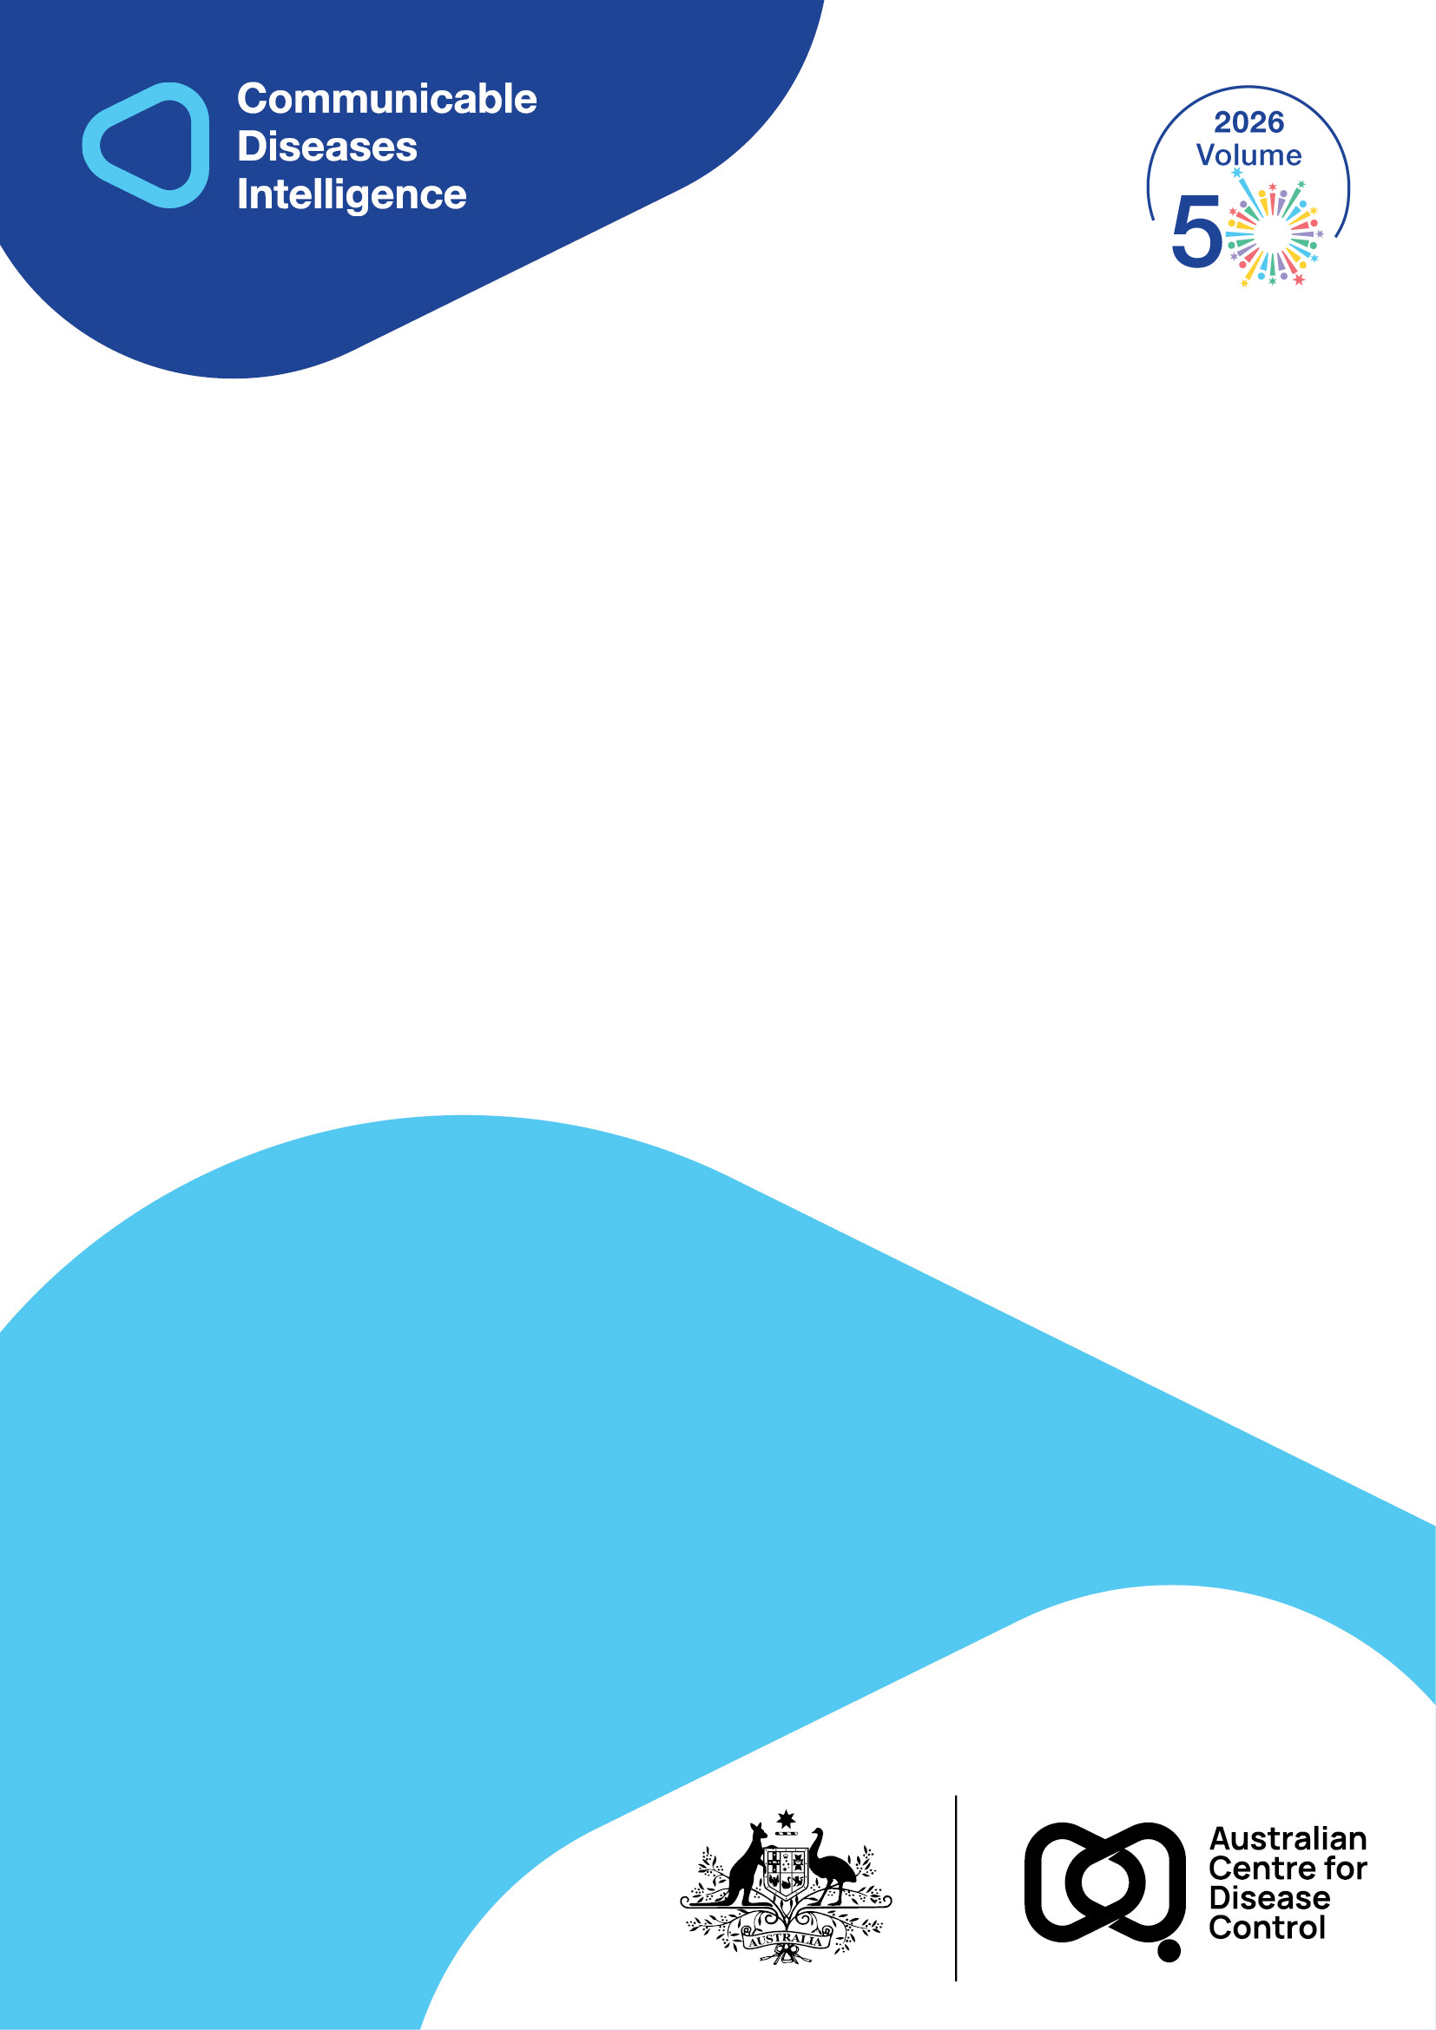
2026 • Volume 50 • cdc.gov.au/cdi • Epub date: 21.07.2026 • doi.org/10.33321/cdi.2026.50.044

Australian Trachoma Surveillance Report 2024
Alison Jaworski, Carleigh Cowling, Gordana C Popovic, Absar Noorul, Sergio Sandler, Susana Vaz Nery, John Kaldor
© 2026 Commonwealth of Australia as represented by the Australian Centre for Disease Control
ISSN: 2209-6051 Online
This journal is indexed by Index Medicus and Medline.
Creative Commons Licence
This publication is licensed under a Creative Commons Attribution-NonCommercial-NoDerivatives 4.0 International Licence (Licence). You must read and understand the Licence before using any material from this publication.
Restrictions
The Licence does not cover, and there is no permission given for, use of any of the following material found in this publication (if any):
- the Commonwealth Coat of Arms (by way of information, the terms under which the Coat of Arms may be used can be found on the Department of Prime Minister and Cabinet website);
- any logos (including the Australian Centre for Disease Control’s logo) and trademarks;
- any photographs and images;
- any signatures; and
- any material belonging to third parties.
Disclaimer
Opinions expressed in Communicable Diseases Intelligence are those of the authors and not necessarily those of the Australian Government or the Australian Centre for Disease Control. Data may be subject to revision.
Enquiries
Enquiries regarding any other use of this publication should be addressed to the CDI Editor.
About CDI
Communicable Diseases Intelligence (CDI) is a peer-reviewed scientific journal published by the Australian Centre for Disease Control.
The journal aims to disseminate information on the epidemiology, surveillance, prevention and control of communicable diseases of relevance to Australia and the near region.
Editor: Dr Elise Firman • Deputy Editor: Simon Petrie • Design and Production: Lisa Thompson
Editorial Advisory Board: David Durrheim, Mark Ferson, Clare Huppatz, John Kaldor, Martyn Kirk and Meru Sheel
Submit an Article
Guidelines for authors and details on how to submit your publication is available on our website, or by email to the
CDI Editor.
Contact us
Communicable Diseases Intelligence (CDI)
Australian Centre for Disease Control
GPO Box 795, Canberra ACT 2601, Australia
Website: cdc.gov.au/cdi
Email: cdi.editor@cdc.gov.au

Contents
Abstract 4
Introduction 5
Methods 6
Communities at risk of trachoma 6
Screening coverage 6
Trachoma prevalence 6
Facial cleanliness 7
Antibiotic distribution and coverage 7
Trachomatous trichiasis 7
Results 8
Communities at risk of trachoma 8
Screening coverage 9
Trachoma prevalence 9
Facial cleanliness 11
Antibiotic distribution and coverage 11
Trachomatous trichiasis 12
Discussion 14
Conclusion 15
Acknowledgments 16
Ethics statement 16
Funding statement 16
Author details 17
References 18

Abstract
Trachoma is the world’s leading infectious cause of preventable blindness and is linked to poor living conditions. In Australia, trachoma has remained a public health problem in remote Indigenous communities in northern, central, and western regions. To seek formal validation by the World Health Organization (WHO) of the elimination of trachoma as a public health problem, Australia has needed to maintain levels of overall trachoma prevalence below 5% in children for at least two years in each formerly endemic state or territory. Australia must also demonstrate that the prevalence of previously undiagnosed trachomatous trichiasis (TT), the severe advanced blinding stage caused by repeated infection, remains below 0.2% in people aged 15 years and over. Australia first reached elimination thresholds in 2022, with 2024 the final year of pre-validation monitoring. In 2024, screening staff assessed trachoma according to WHO grading criteria in 86 communities. Overall prevalence of trachoma was 2.1% in the Northern Territory; 0% in South Australia; and 1.3% in Western Australia. Only nine previously unknown TT cases were reported throughout the Northern Territory, Queensland, South Australia and Western Australia. Based on 2024 surveillance data, Australia is eligible to apply for validation of elimination as a public health problem. Maintaining this achievement will require ongoing improvements to remote housing and environmental conditions; supporting communities to manage remaining disease pockets or risk of resurgence; and continuing accessible TT diagnosis and surgery pathways to address long-term disease impacts. Indigenous leadership is critical to ensure local ownership and accountability to communities.
Keywords: trachoma; SAFE control strategy; surveillance; elimination

Introduction
Trachoma is the leading cause of preventable infectious blindness globally.¹ Infection with ocular strains of the bacterium Chlamydia trachomatis (C. trachomatis) leads to follicular conjunctivitis in the upper eyelid (trachomatous inflammation – follicular or TF) or pronounced conjunctival inflammation (trachomatous inflammation – intense or TI). Repeated episodes of infection can lead to scarring and distortion of the eyelid, causing trachomatous trichiasis (TT), where the upper eyelashes turn inward to scratch the cornea. The resulting damage to the cornea is the main pathway by which trachoma results in vision loss and blindness.^{2,3}
C. trachomatis is predominantly spread by infected ocular and nasal secretions, either directly person to person (e.g. conveyance on fingers), or indirectly via fomites (e.g. shared towels, pillowcases, face cloths).² Trachoma is linked to poor living conditions, including overcrowding and inadequate water and sanitation facilities to prevent transmission.^{4,5} Children under 10 years of age generally have the highest prevalence of trachoma and are the main reservoir of infection.⁶
The World Health Organization (WHO) has set technical benchmarks for the elimination of trachoma as a public health problem: that is, the reduction in trachoma prevalence to such a level that it no longer contributes significantly to morbidity at the population level.^{7,8} This involves maintaining a prevalence of TF of less than 5% in children in each formerly endemic evaluation unit (Australian state/territory jurisdiction) for a period of at least two years.⁹ Countries must also demonstrate a prevalence of TT ‘unknown to the health system’ (i.e., cases not previously identified among persons who have formerly received, refused or are awaiting surgical treatment to correct the condition) of less than 0.2% in persons aged 15 years or older.⁷ Through the Alliance for the Global Elimination of Trachoma, WHO advocates the SAFE strategy for trachoma control. The SAFE strategy elements are: surgery to correct TT; antibiotic treatment for C. trachomatis infection; facial cleanliness; and environmental improvements to reduce transmission intensity.¹⁰
Australia is the only high-income country where trachoma has still been considered a public health problem. It has primarily remained in remote and very remote Indigenous communities in the Northern Territory, South Australia and Western Australia.^{11,12} New South Wales and Queensland were endorsed as non-endemic for trachoma in 2017 and 2022 respectively.
Australia initiated the National Trachoma Management Program in 2006. States and territories with areas currently or recently at risk of trachoma receive funding from the Australian Government to deliver control programs. Programs must be conducted in accordance with the Communicable Diseases Network Australia National Guidelines for the Public Health Management of Trachoma in Australia (CDNA guidelines),¹³ which are based on the SAFE strategy. The National Trachoma Surveillance and Control Reference Group (NTSCRG), formed in 2011, provides technical guidance and a nationally integrated approach. The NTSCRG membership includes representatives from federal and jurisdictional government health, housing and environmental health units; Aboriginal Community Controlled Health Services; epidemiological and public health experts; and key non-governmental partners with expertise in Aboriginal and Torres Strait Islander health. The Australian Government also funds the National Trachoma Surveillance and Reporting Unit (NTSRU) which is responsible for data collection, analysis, and annual reporting of surveillance and SAFE activities in collaboration with relevant jurisdictions and health services. This report presents data covering the period from 1 January 2024 to 31 December 2024.

Methods

Communities at risk of trachoma
A community is defined as a specific geographic location where people reside and where there is at least one school. Communities are classified by state/territory health departments as ‘at risk’ of trachoma if, at least once within the past five years, prevalence of TF and/or TI was 5% or more in screened children aged 5–9 years.¹³

Screening coverage
Annual screening of at-risk communities is recommended where sufficient resources are available. An update to the CDNA guidelines, published in 2014, provides the option for screening at-risk communities biannually (every 2 years), with jurisdictions instead able to allocate resources for environmental health improvement activities or antibiotic control according to the local epidemiological context.
Screening coverage is defined as the proportion of estimated resident children aged 5–9 years who were screened. Estimated resident populations in each community are derived by health programs using Australian Bureau of Statistics census data and/or enrolment lists from schools and health clinics, supplemented by local advice on movement into and out of communities. CDNA guidelines set a minimum target of 85% of resident children aged 5–9 years to be screened for trachoma.¹³
Whilst WHO guidance for trachoma control focuses on children aged 1–9 years,¹⁴ the target group for surveillance activities in Australia since 2006 has been children aged 5–9 years.¹³ Previous research has found no evidence that, in Australia, trachoma prevalence in children aged 1–4 years is higher than in those aged 5–9 years.¹⁵ Children aged 1–4 years or 10–14 years may, however, be examined opportunistically during screening activities.

Trachoma prevalence
WHO’s simplified grading criteria define active trachoma as TF, characterised by the presence of five or more follicles ≥ 0.5 mm in diameter in the central part of the upper tarsal conjunctiva; and/or TI, characterised by inflammatory thickening of the upper tarsal conjunctiva obscuring more than half of the normal deep tarsal vessels.¹⁶ Screening staff undertake trachoma grader training based on the Tropical Data training system, an international consortium that supports the conduct of trachoma prevalence surveys in accordance with WHO recommendations.¹⁷
Two prevalence figures are presented in this report. Observed prevalence is calculated using only the data from at-risk communities requiring and receiving screening during 2024. This measure is used to guide future screening activity; the denominator changes yearly as the number of communities judged as no longer at risk of trachoma generally increases over time. Overall prevalence is calculated by combining observed prevalence from at-risk communities screened during the calendar year, estimated prevalence from communities that were not screened that year but still considered at risk, and the most recent observed prevalence carried forward from formerly at-risk communities. Overall prevalence provides a more stable measure of prevalence change over time and is used to assess Australia’s progress towards validation criteria.

Facial cleanliness
During trachoma screening, children are also examined for clean faces, defined as the absence of nasal and ocular discharge. Improving facial cleanliness is considered to reduce infection transmission and auto-reinfection.¹⁰ CDNA guidelines set a target of at least 85% of children in a community at any one time to have a clean face.¹³

Antibiotic distribution and coverage
Trachoma is treated by a single dose of the antibiotic azithromycin. Alongside treatment of active cases and household contacts, targeted community-wide treatment is recommended in communities where prevalence is 5% or over and where there is no obvious case clustering.¹³ Treatment coverage is defined as the proportion of active cases plus household/community contacts requiring treatment (according to CDNA guidelines) who received azithromycin. Mass drug administration of azithromycin to the entire population in a region or district, as common for the control of trachoma internationally, is not undertaken in Australia.¹⁴

Trachomatous trichiasis
TT is defined as where at least one eyelash from the upper eyelid touches the eyeball, or where there is evidence of recent removal of in-turned eyelashes from the upper eyelid.¹⁶ In November 2018, the fourth global scientific meeting on trachoma amended the definition of TT to exclude trichiasis affecting only the lower eyelid, due to the potential for misclassification.¹⁸ As such, TT temporal patterns are not quantified in this report.
WHO recommends that TT prevalences are generated from multistage cluster random sampling that allows an estimate for the whole of population within the evaluation unit.¹⁹ Due to the relatively small number of locations in which trachoma has remained a public health risk in Australia, population-wide assessments of TT at the state/territory level have not been considered appropriate. In Australia, TT screening is linked to current and former trachoma endemic regions, and is undertaken through visiting regional optometrist service assessments; during trachoma screening programs; and opportunistically in the Aboriginal And Torres Strait Islander Peoples Health Assessment (Medicare Benefits Schedule [MBS] Item 715). TT is reported as the crude proportion among Indigenous persons screened. This is likely to over-estimate the true population level prevalence of TT in Australian jurisdictions, as non-Indigenous persons and Indigenous persons who resided outside remote areas during childhood do not have the same exposure risk.

Results

Communities at risk of trachoma
Jurisdictions designated 72 remote Indigenous communities as at risk of trachoma and requiring screening in 2024. However, two jurisdictions (the Northern Territory and South Australia) undertook additional screening as part of evidence confirmation for final-year dossier validation at the recommendation of the NTSRU. Thirteen communities previously removed from the at-risk register with population linkages to current at-risk communities, as well as five at-risk communities not due for screening in 2024 under CDNA guidelines, were included. This gives a total of 90 at-risk communities requiring screening in 2024. For the purposes of simplicity, results from these communities that would not normally require screening in 2024 are counted as at-risk communities and included in 2024 results (Table 1).
In addition, seven at-risk communities not due for screening under CDNA guidelines were identified in Western Australia, which did not undertake any additional screening in 2024, bringing the overall number of at-risk communities to 97.
Even including the additional communities screened in 2024, the number of communities that are at risk of trachoma in Australia has declined over time in all jurisdictions. Between 2014 and 2024, the number of at-risk communities fell by 38% in the Northern Territory (78 in 2014 to 48 in 2024); by 24% in South Australia (21 in 2014 to 16 in 2024); and by 50% in Western Australia (66 in 2014 to 33 in 2024). Queensland and New South Wales did not require screening for active trachoma in 2024 (Figure 1).
Figure 1: Number of communities designated as at risk for trachoma by jurisdiction,ª Australia, 2014–2024
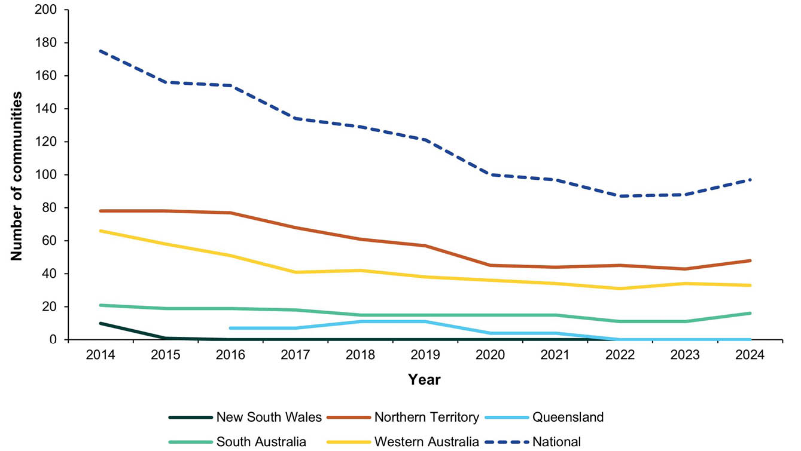
a 2024 data points include additional communities identified by selected jurisdictions for evidence confirmation screening as part of final-year dossier validation surveillance.

Screening coverage
In 2024, the proportion of communities that received screening (96%; 86/90) was slightly higher than in the previous year (91%; 67/74). Within screened communities, 1,885 of an estimated 2,119 resident children aged 5–9 years (89%) were screened for trachoma. Screening coverage at the jurisdictional level was fairly consistent, at 87% in the Northern Territory; 91% in South Australia; and 92% in Western Australia (Table 1).
Table 1: Trachoma screening coverage and prevalence in Indigenous children 5–9 years of age by jurisdiction,ª Australia, 2024
Category | Jurisdictionª
Category | NT | SA | WA | Total
Communities at risk of trachoma^{b} | 48 | 16 | 33 | 97
Requiring screening | 48 | 16 | 26 | 90
Not requiring screening | 0 | 0 | 7 | 7
Communities screened | 45 | 15 | 26 | 86
Estimated resident population^{c} | 1,309 | 490 | 320 | 2,119
Children screened for trachoma | 1,144 | 446 | 295 | 1,885
Trachoma screening coverage (%) | 87 | 91 | 92 | 89
Children with active trachoma | 56 | 0 | 12 | 68
Observed trachoma prevalence (%) | 4.9 | 0 | 4.1 | 3.6
Overall trachoma prevalence (%) | 2.1 | 0 | 1.3 | 1.5
a NT: Northern Territory; SA: South Australia; WA: Western Australia.
b As defined by each jurisdiction, including additional communities identified for evidence confirmation screening as part of final-year validation surveillance.
c Indigenous children 5–9 years of age.

Trachoma prevalence
In 2024, there were 68 cases of active trachoma reported in children aged 5–9 years, an 8.1% decline from the 74 cases reported in 2023. Cases in 2024 were reported either in the Northern Territory or Western Australia, with 82% of all trachoma cases identified in the Northern Territory. No active trachoma cases were reported in South Australia.
The overall prevalence of trachoma in Indigenous children 5–9 years among all current and former at-risk communities nationally decreased slightly from 1.8% in 2023 to 1.5% in 2024 (Figure 2). Between 2023 to 2024, overall prevalence declined in both the Northern Territory (2.3% to 2.1%) and Western Australia (1.6% to 1.3%), and remained at 0% in South Australia.
Figure 2: Overall trachoma prevalence in Indigenous children aged 5–9 years by jurisdiction,ª Australia, 2014–2024
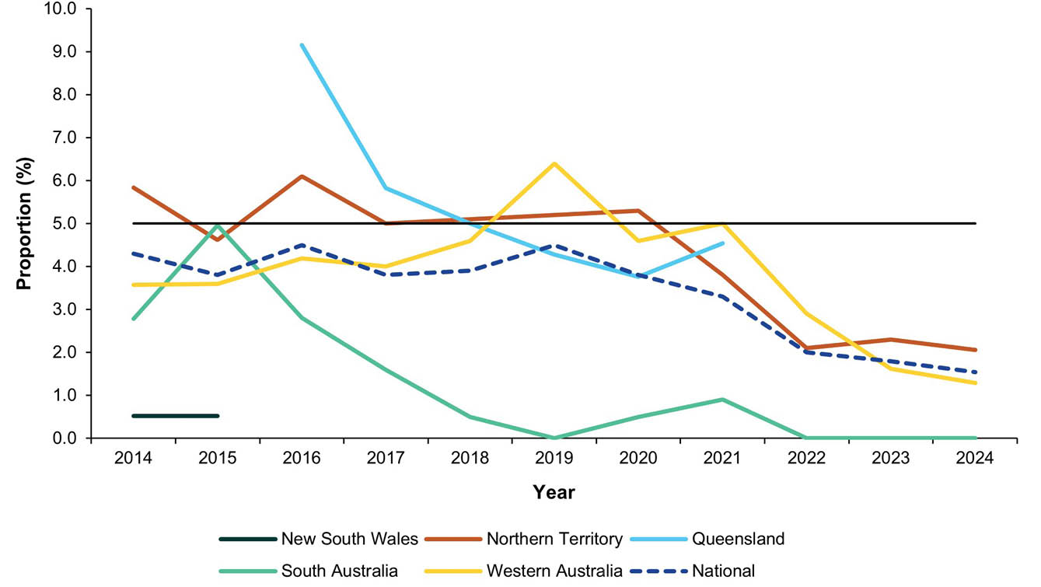
a The horizontal black line shows the 5% trachoma prevalence threshold required to be maintained in each formerly endemic jurisdiction for at least two successive years, as one of the criteria set by WHO for validation of elimination of trachoma as a public health problem.
At least one case of trachoma was reported among children aged 5–9 years in 29% (25/86) of communities screened in 2024 (Table 2). The proportion of screened communities reporting any trachoma has been declining since 2020, when trachoma was reported in 71% (67/94) of communities screened. A similar pattern has been seen in the proportion of screened communities reporting endemic levels of trachoma (≥ 5% observed prevalence), which has declined from 59% (55/94) in 2020 to 21% (18/86) in 2024. A small number of communities screened in 2024 (6% or 5/86) reported hyperendemic trachoma (≥ 20% prevalence). The size of communities (an average of 24 children per community were examined in 2024) should be considered in interpretations of observed screened prevalence.
Table 2: Number and proportion of screened at-risk communities according to the level of observed trachoma prevalence in Indigenous children aged 5–9 years Australia, 2020–2024
Year | 2020 |  | 2021 |  | 2022 |  | 2023 |  | 2024
Communities screened | 94 |  | 82 |  | 79 |  | 67 |  | 86
Prevalence | n | (%) | n | (%) | n | (%) | n | (%) | n | (%)
≥ 20% | 17 | (18%) | 10 | (12%) | 10 | (13%) | 5 | (7%) | 5 | (6%)
10 – < 20% | 27 | (29%) | 18 | (22%) | 12 | (15%) | 8 | (12%) | 8 | (9%)
5 – < 10% | 11 | (12%) | 13 | (16%) | 9 | (11%) | 4 | (6%) | 5 | (6%)
> 0 – < 5% | 12 | (13%) | 13 | (16%) | 4 | (5%) | 2 | (3%) | 7 | (8%)
0% | 27 | (29%) | 28 | (34%) | 44 | (56%) | 48 | (72%) | 61 | (71%)

Facial cleanliness
In 2024, a total of 1,984 children aged 5–9 years in at-risk communities were examined for clean faces during trachoma screening activities. The total proportion of clean faces in children screened nationally in 2024 was 79%, with jurisdictional proportions of 76% in the Northern Territory; 89% in South Australia; and 76% in Western Australia. Since 2014, clean face proportions have tended to fluctuate around or below the target of 85% at the jurisdictional level in the Northern Territory and South Australia, whilst proportions have generally risen within the last 7 years in Western Australia (Figure 3).
Figure 3: Proportion of screened Indigenous children aged 5–9 years who had a clean face by jurisdiction, Australia, 2014–2024
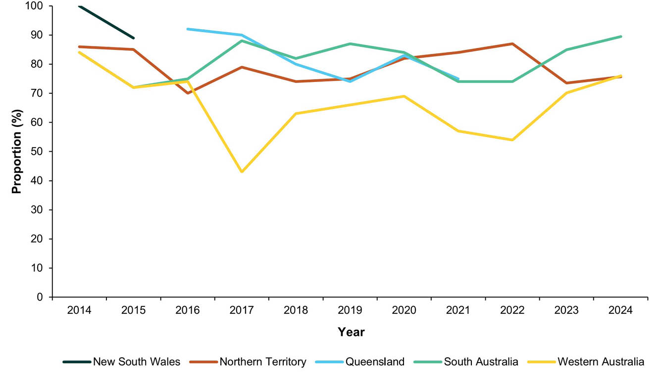

Antibiotic distribution and coverage
Antibiotic distribution took place in all 25 communities that required treatment according to the CDNA guidelines (Table 3). Treatment coverage for all cases detected in screening activities was 96% (69/72), slightly under the treatment coverage rate of 99% (73/74) in 2023. Coverage for community members requiring treatment under CDNA guidelines was 53% (1,605/3,032), notably lower than 81% (1,604/1,970) in 2023.
Jurisdictional trachoma programs delivered 1,674 doses of azithromycin in 2024, nearly identical to the 1,677 doses distributed in 2023. As in previous years, the majority of antibiotic doses were distributed in the Northern Territory (Figure 4).
Table 3: Azithromycin treatment for trachoma by jurisdiction,ª Australia, 2024
Category | NT | WA | Total
Communities requiring treatment | 18 | 7 | 25
Communities receiving treatment | 18 | 7 | 25
Household-based treatment | 12 | 7 | 19
Community-wide treatment | 6 | 0 | 6
Cases requiring treatment for active trachoma^{b} | 60 | 12 | 72
Cases who received treatment for active trachoma | 57 | 12 | 69
Estimated community contacts requiring treatment^{c} | 2,938 | 94 | 3,032
Community contacts who received treatment | 1,525 | 80 | 1,605
Estimated overall treatment coverage – cases and contacts (%) | 53 | 87 | 54
a NT: Northern Territory; WA: Western Australia.
b Cases identified in children aged 0–14 years in screening programs.
c As per CDNA guidelines.
Figure 4: Number of doses of azithromycin administered for the treatment of trachoma by jurisdiction, Australia, 2014–2024
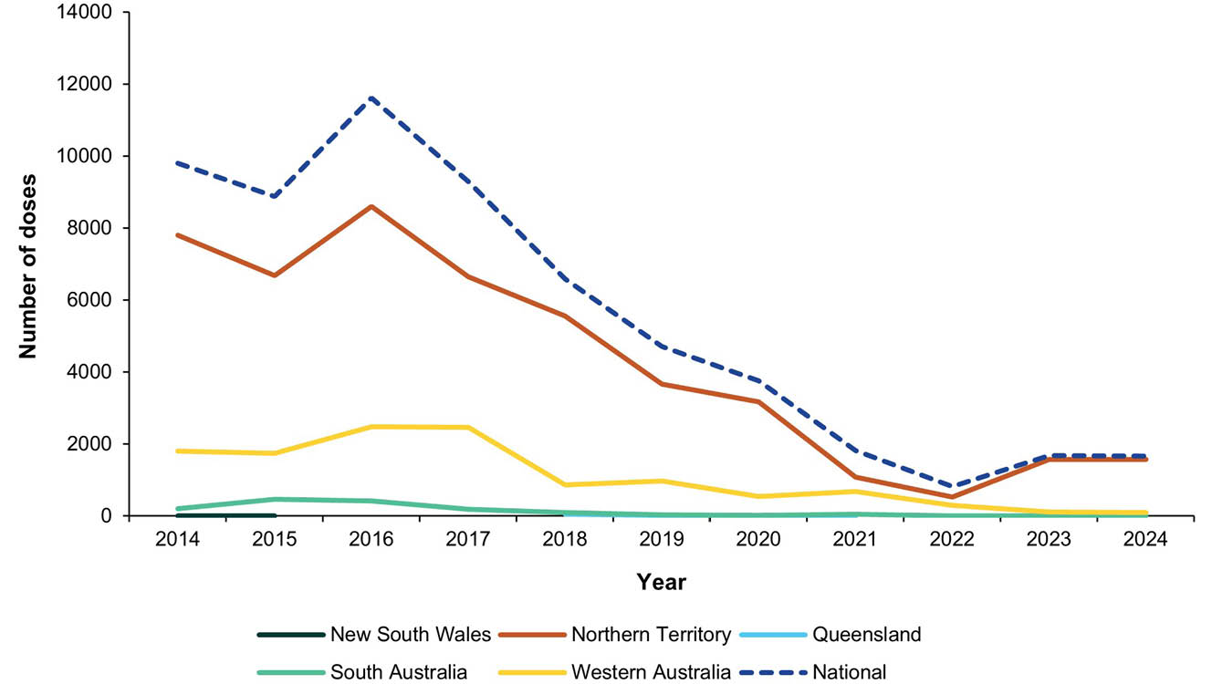

Trachomatous trichiasis
A total of 18,931 people aged 15 years and older were reported to have been screened for TT in the Northern Territory, Queensland, South Australia and Western Australia, with nine cases ‘unknown to the health system’ identified in 2024. The total proportion of TT in screened people aged 15 years and older was 0.05%, and in those aged 40 years and older was 0.09%. By jurisdiction, the proportion of TT in screened persons was 0.03% in the Northern Territory; 0.3% in Queensland; 0.3% in South Australia; and 0% in Western Australia. A total of six people from two jurisdictions were reported to have had TT surgery (Figure 5).
Figure 5: Number and proportion of trachomatous trichiasis (TT) casesª in Indigenous persons aged 15 years and over screened and surgery cases by jurisdiction, Australia, 2014–2024
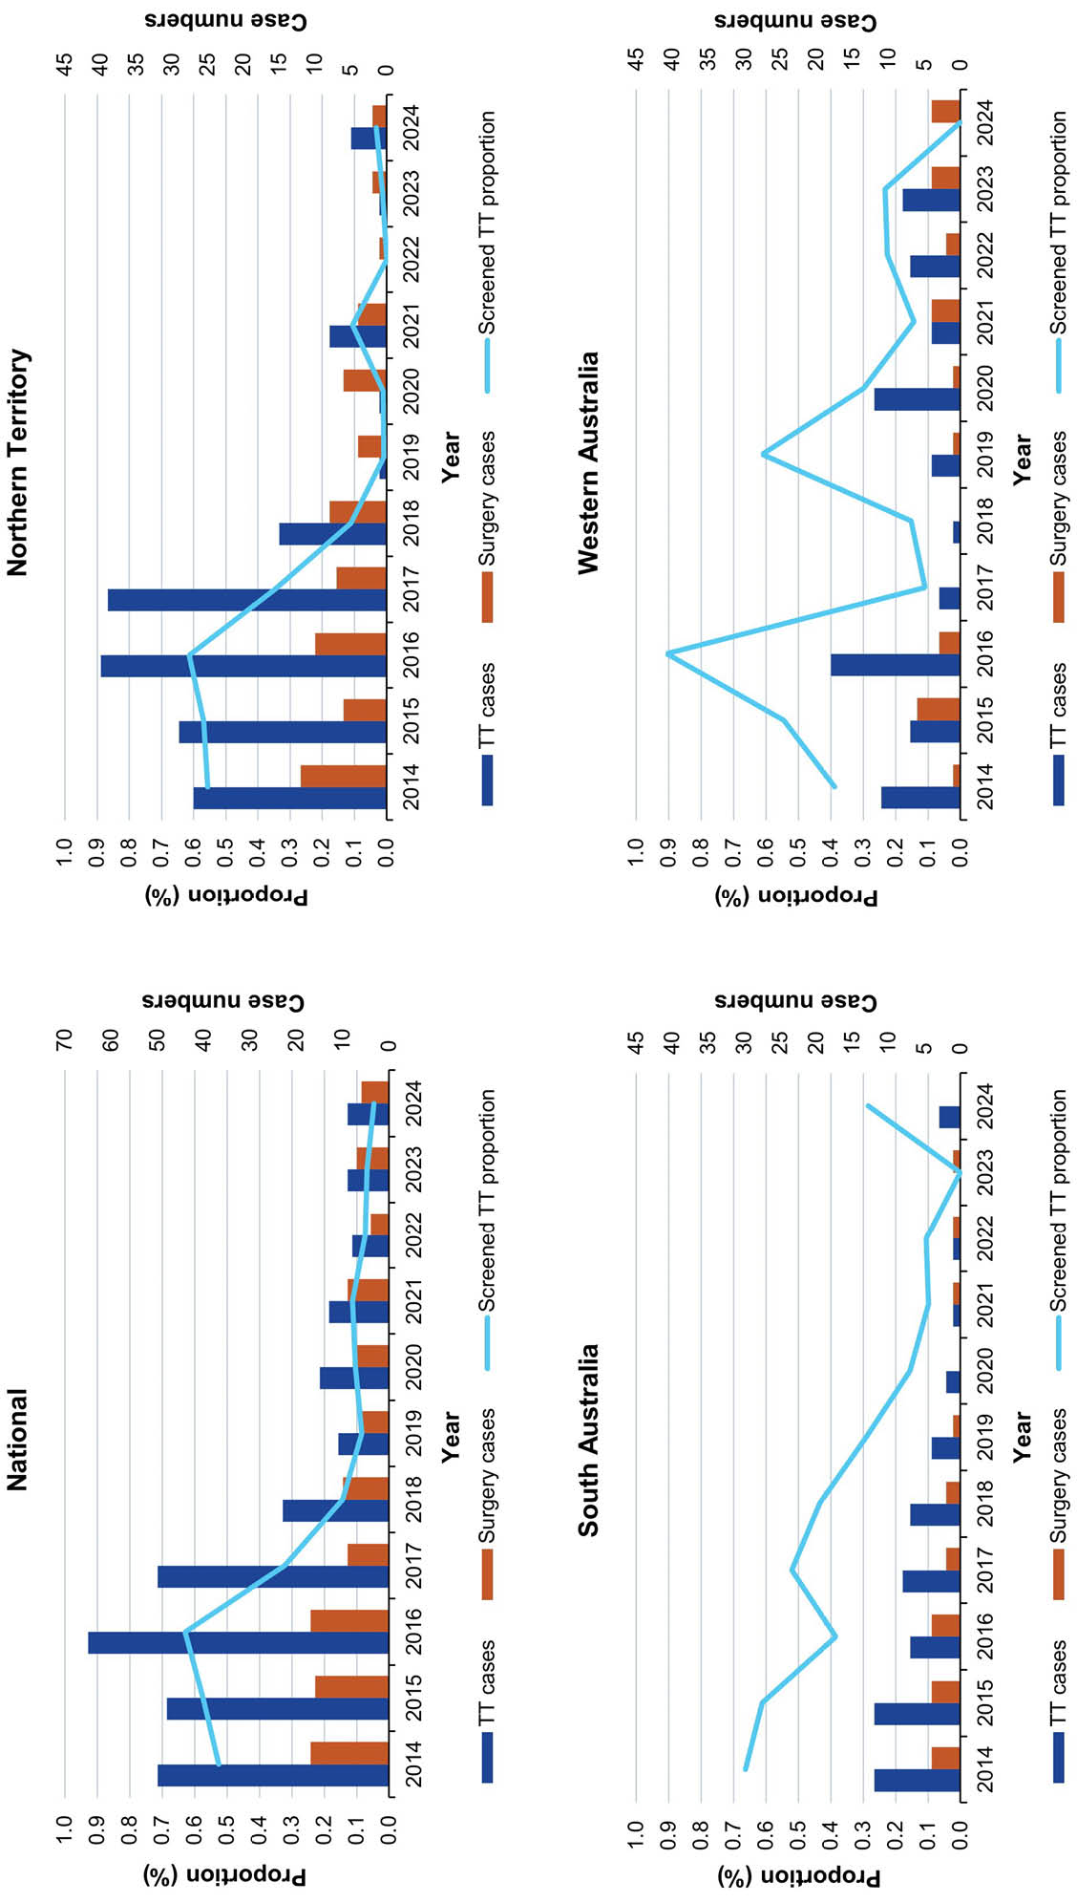
a TT cases identified are those ‘unknown to the health system’. Surgery cases may include TT cases identified in previous years. Data is not reported separately for Queensland as only 3 TT cases have been reported in this jurisdiction. Trachoma mapping in New South Wales did not include TT screening.

Discussion
Data from Australia’s trachoma control programs demonstrates that in 2024, prevalences remain below thresholds set by the WHO for validation of elimination as a public health problem. As such, Australia is eligible to apply for formal recognition of this status.
With the receipt of 2024 surveillance data, the NTSCRG agreed in June 2025 to also endorse South Australia’s re-classification as free of endemic trachoma. No cases of active trachoma have been reported in South Australia since 2022, whilst total cumulative screened prevalence of previously unidentified TT cases was 0.1% during 2022–2024. South Australia joins New South Wales and Queensland in no longer requiring active trachoma screening as per CDNA guidelines. Strong mechanisms for the identification of TT and referral for surgical management will nevertheless need to continue through both primary healthcare and specialist outreach programs, as TT is a slowly progressing condition and blindness can occur many years after C. trachomatis transmission has waned or ceased.
‘Elimination as a public health problem’, as defined by WHO, does not equate to the complete absence of new infections. Trachoma prevalence remains well above 5% in several communities and indicates both ongoing risk and the potential for resurgence of infection elsewhere. Post-validation, ongoing surveillance and management activities will need to continue. Close community partnerships will be indispensable to develop initiatives that meet local needs and that are acceptable long-term. In particular, maintaining elimination of trachoma as a public health problem requires strengthening health-promoting environments. This includes improving the provision of appropriate housing in remote areas and enhancing ongoing maintenance of home health hardware, water and sanitation facilities. Multisector collaborative action involving community-controlled organisations, the Aboriginal environmental health workforce, other environmentally-attributable disease programs (e.g. ear, skin, dental health), and housing providers will support joined-up approaches and sustainability.

Conclusion
As Australia moves towards recognition of elimination of trachoma as a public health problem, ongoing action is needed to ensure that this achievement is maintained, and that all remote communities are able to enjoy equal access to the necessary conditions which prevent disease transmission. Environmental health improvements have health benefits that go beyond trachoma control but require a multi-sectoral effort. Crucially, future strategies must be conducted under the guidance and with the direct involvement of the affected communities.

Acknowledgments
The authors would like to thank all jurisdictions that contribute to the Australian Trachoma Surveillance Reports, including Northern Territory Department of Health Central Australia Public Health Unit, Katherine West Health Board, Queensland Health Communicable Diseases Branch, South Australia Health Eyre and Far North Local Health Network, Aboriginal Health Council of South Australia, Nganampa Health Council, Western Australia Country Health Service Population Health Units, Aboriginal Health Council of Western Australia, and Western New South Wales Local Health District Population Health Unit.

Ethics statement
The collection, analysis, and reporting of Australia’s jurisdictional trachoma surveillance data is approved by UNSW Sydney Human Research Ethics Committee (Committee B), number: HC200882.

Funding statement
Australia’s trachoma surveillance program and the National Trachoma Surveillance and Reporting Unit are funded by the Commonwealth Department of Health, Disability and Ageing (AusTender CN3790302).

Author details
Alison Jaworski,¹
Carleigh Cowling,¹
Gordana C Popovic,²
Absar Noorul,¹
Sergio Sandler,¹
Susana Vaz Nery,¹
John Kaldor¹
- The Kirby Institute, UNSW Sydney, Australia
- Stats Central, Mark Wainwright Analytical Centre, UNSW Sydney, Australia

Corresponding author
Alison Jaworski
Email: a.jaworski@kirby.unsw.edu.au
Kirby Institute
Bidjigal Country
Level 6, Wallace Wurth Building
UNSW Sydney NSW 2052 Australia

References
- World Health Organization (WHO), WHO Alliance for the Global Elimination of Trachoma. Progress report on elimination of trachoma, 2024–2025. Wkly Epidemiol Rec. 2025;100(29,30):285–302. Available from: https://iris.who.int/server/api/core/bitstreams/79341f32-9fdf-463f-8f4f-7f449d96d781/content.
- Solomon AW, Burton MJ, Gower EW, Harding-Esch EM, Oldenburg CE, Taylor HR et al. Trachoma. Nat Rev Dis Primers. 2022;8(1):32. doi: https://doi.org/10.1038/s41572-022-00359-5.
- Gambhir M, Basáñez MG, Burton MJ, Solomon AW, Bailey RL, Holland MJ et al. The development of an age-structured model for trachoma transmission dynamics, pathogenesis and control. PLoS Negl Trop Dis. 2009;3(6):e462. doi: https://doi.org/10.1371/journal.pntd.0000462.
- Habtamu E, Wondie T, Aweke S, Tadesse Z, Zerihun M, Zewdie Z et al. Trachoma and relative poverty: a case-control study. PLoS Negl Trop Dis. 2015;9(11):e0004228. doi: https://doi.org/10.1371/journal.pntd.0004228.
- Stocks ME, Ogden S, Haddad D, Addiss DG, McGuire C, Freeman MC. Effect of water, sanitation, and hygiene on the prevention of trachoma: a systematic review and meta-analysis. PLoS Med. 2014;11(2):e1001605. doi: https://doi.org/10.1371/journal.pmed.1001605.
- Solomon AW, Holland MJ, Burton MJ, West SK, Alexander ND, Aguirre A et al. Strategies for control of trachoma: observational study with quantitative PCR. Lancet. 2003;362(9379):198–204. doi: https://doi.org/10.1016/S0140-6736(03)13909-8.
- WHO. Ending the neglect to attain the Sustainable Development Goals: a road map for neglected tropical diseases 2021–2030. Geneva: WHO; 28 January 2021. Available from: https://www.who.int/publications/i/item/9789240010352.
- Bodimeade C, Marks M, Mabey D. Neglected tropical diseases: elimination and eradication. Clin Med (Lond). 2019;19(2):157–60. doi: https://doi.org/10.7861/clinmedicine.19-2-157.
- WHO. Validation of elimination of trachoma as a public health problem. Geneva: WHO; 4 June 2016. Available from: https://www.who.int/publications/i/item/who-htm-ntd-2016.8.
- Kuper H, Solomon AW, Buchan J, Zondervan M, Foster A, Mabey D. A critical review of the SAFE strategy for the prevention of blinding trachoma. Lancet Infect Dis. 2003;3(6):372–81. doi: https://doi.org/10.1016/s1473-3099(03)00659-5.
- Taylor H. Trachoma: A Blinding Scourge from the Bronze Age to the Twenty-first Century. East Melbourne: Australian Centre for Eye Research; 2008.
- Mak DB, O'Neill LM, Herceg A, McFarlane H. Prevalence and control of trachoma in Australia, 1997–2004. Commun Dis Intell Q Rep. 2006;30(2):236–47. doi: https://doi.org/10.33321/cdi.2006.30.21.
- Australian Centre for Disease Control (Australian CDC), Communicable Diseases Network Australia (CDNA). CDNA national guidelines for the public health management of trachoma. Canberra: Australian CDC, CDNA; 31 January 2014. Available from: https://www.cdc.gov.au/resources/publications/trachoma-cdna-national-guidelines-public-health-units.
- WHO. Trachoma control: a guide for programme managers. Geneva: WHO; 20 July 2006. Available from: https://www.who.int/publications/i/item/9241546905.
- The National Trachoma Surveillance and Reporting Unit. Australian Trachoma Surveillance Report 2021. Sydney: University of New South Wales, The Kirby Institute, WHO Collaborating Centre in Neglected Tropical Diseases; 2022. Available from: https://www.kirby.unsw.edu.au/sites/default/files/documents/TRACHOMA_2021.pdf.
- Solomon AW, Kello AB, Bangert M, West SK, Taylor HR, Tekeraoi R et al. The simplified trachoma grading system, amended. Bull World Health Organ. 2020;98(10):698–705. doi: https://doi.org/10.2471/BLT.19.248708.
- Harding-Esch EM, Burgert-Brucker CR, Jimenez C, Bakhtiari A, Willis R, Bejiga MD et al. Tropical Data: approach and methodology as applied to trachoma prevalence surveys. Ophthalmic Epidemiol. 2023;30(6):544–60. doi: https://doi.org/10.1080/09286586.2023.2249546.
- WHO. Report of the 4th global scientific meeting on trachoma: Geneva, 27–29 November 2018. Geneva: WHO; 4 June 2019. Available from: https://www.who.int/publications/i/item/who-htm-ntd-pct-2019.03.
- Solomon AW, Bella ALF, Negussu N, Willis R, Taylor HR. How much trachomatous trichiasis is there? A guide to calculating district-level estimates. Community Eye Health. 2019;31(104):S5–8. Available from: https://pmc.ncbi.nlm.nih.gov/articles/PMC6390516/pdf/jceh_31_104_S5.pdf.

For consistency with previous reports, the term ‘Indigenous’ is used respectfully throughout this document to refer to the collective of individual people from different Aboriginal and Torres Strait Islander Nations across Australia. The terms ‘Aboriginal’ or ‘Torres Strait Islander’ have been retained in discussion of relevant program, policy or organisational names.

