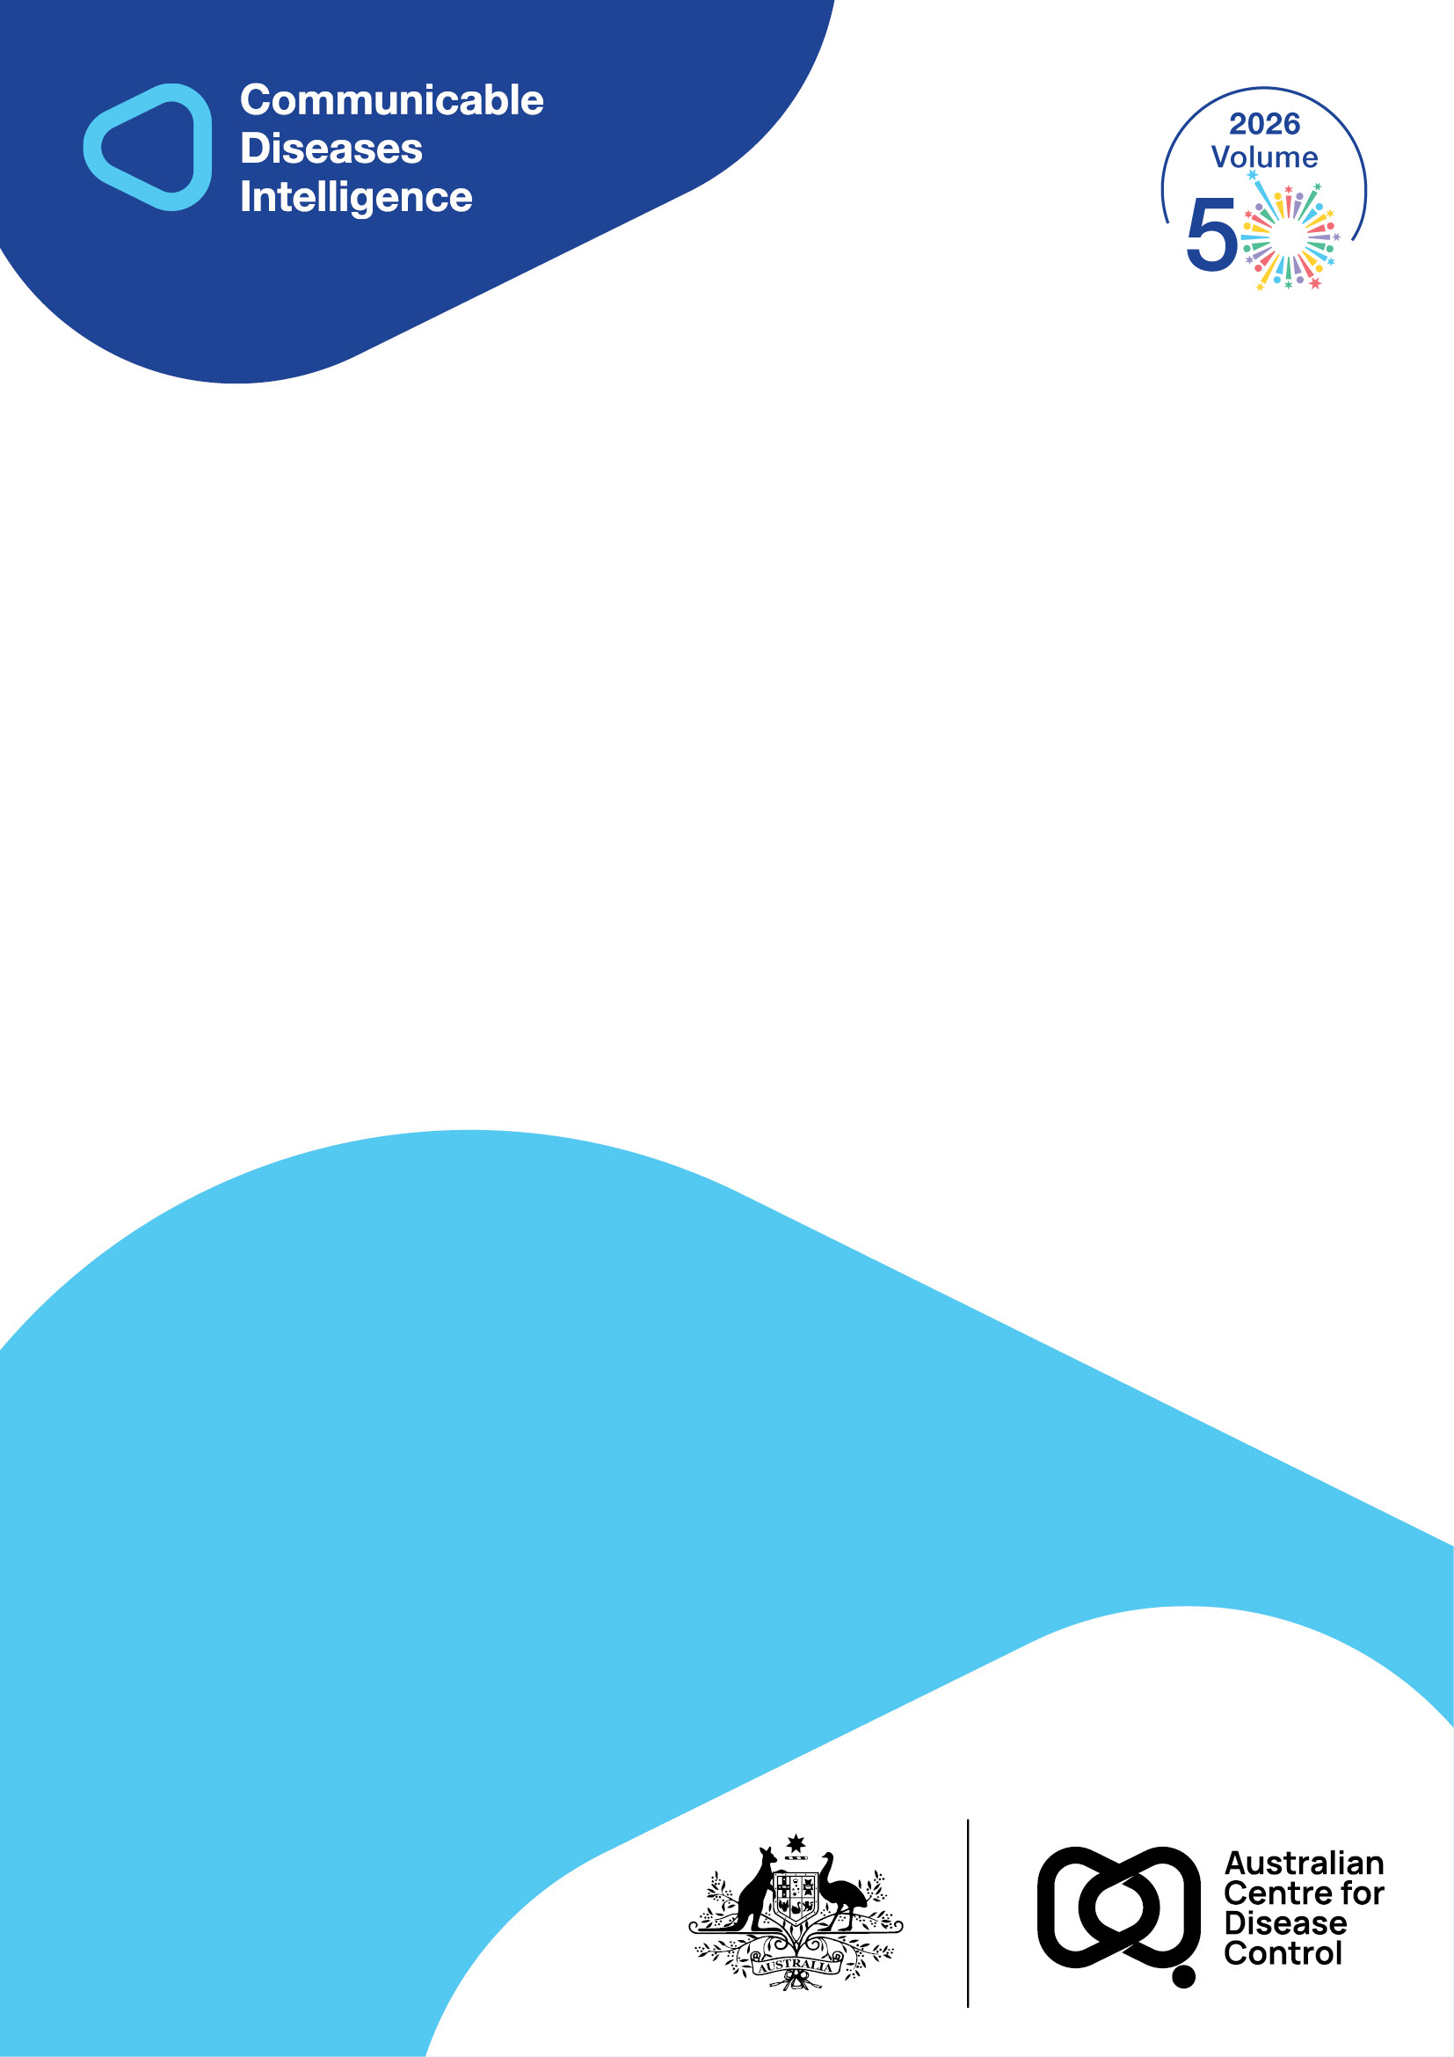
2026 • Volume 50 • cdc.gov.au/cdi • Epub date: 16.06.2026 • doi.org/10.33321/cdi.2026.50.039

The Strategic Plan for Tuberculosis Elimination and Equity in Australia 2026–2030
The National Tuberculosis Advisory Committee, on behalf of the Communicable Diseases Network Australia
© 2026 Commonwealth of Australia as represented by the Australian Centre for Disease Control
ISSN: 2209-6051 Online
This journal is indexed by Index Medicus and Medline.
Creative Commons Licence
This publication is licensed under a Creative Commons Attribution-NonCommercial-NoDerivatives 4.0 International Licence (Licence). You must read and understand the Licence before using any material from this publication.
Restrictions
The Licence does not cover, and there is no permission given for, use of any of the following material found in this publication (if any):
- the Commonwealth Coat of Arms (by way of information, the terms under which the Coat of Arms may be used can be found on the Department of Prime Minister and Cabinet website);
- any logos (including the Australian Centre for Disease Control’s logo) and trademarks;
- any photographs and images;
- any signatures; and
- any material belonging to third parties.
Disclaimer
Opinions expressed in Communicable Diseases Intelligence are those of the authors and not necessarily those of the Australian Government or the Australian Centre for Disease Control. Data may be subject to revision.
Enquiries
Enquiries regarding any other use of this publication should be addressed to the CDI Editor.
About CDI
Communicable Diseases Intelligence (CDI) is a peer-reviewed scientific journal published by the Australian Centre for Disease Control.
The journal aims to disseminate information on the epidemiology, surveillance, prevention and control of communicable diseases of relevance to Australia and the near region.
Editor: Dr Elise Firman • Deputy Editor: Simon Petrie • Design and Production: Lisa Thompson
Editorial Advisory Board: David Durrheim, Mark Ferson, Clare Huppatz, John Kaldor, Martyn Kirk and Meru Sheel
Submit an Article
Guidelines for authors and details on how to submit your publication is available on our website, or by email to the
CDI Editor.
Contact us
Communicable Diseases Intelligence (CDI)
Australian Centre for Disease Control
GPO Box 798, CANBERRA ACT 2601
Website: cdc.gov.au/cdi
Email: cdi.editor@cdc.gov.au

Contents
Executive summary 4
The TB situation in Australia 5
Impact of the 2021–2025 Strategic Plan for TB control in Australia 6
Strategic plan overview 8
Theme 1 – Strengthen existing programs for TB management 9
Theme 2 – Build groundwork for redressing inequity in TB outcomes 13
Implementing this Strategy 17
Conclusion 18
Author details 19
References 20

Executive summary
The Strategic Plan for Tuberculosis Elimination and Equity in Australia, 2026–2030 (the strategic plan) will maintain and strengthen key elements of Australia’s tuberculosis (TB) control and prevention, with an additional key priority theme of addressing inequity in TB surveillance and outcomes. It is intended that the twin priority themes, each with areas for focus, will allow for the next five years of Australian TB programmatic responses to result in improved and equitable care for all people affected by TB. This strategic plan also emphasises progress toward TB pre-elimination in Australia, aiming to achieve pre-elimination, particularly in the Australian-born Aboriginal and Torres Strait Islander population, by 2030.
Theme 1: Strengthen existing programs for TB management
This theme includes five aspects of Australia’s TB programmatic activity with identified opportunities for building on systems already in operation. These are:
- post-migration services for TB diagnosis and management;
- TB surveillance and reporting;
- development of the healthcare workforce;
- whole genome sequencing and bioinformatic analysis; and
- improving access to tailored treatment through therapeutics and drug monitoring.
Theme 2: Build groundwork for redressing inequity in TB outcomes
This theme recognises the disparity in TB risk and outcomes experienced by Aboriginal and Torres Strait Islander peoples and communities, and aims to build on frameworks established during previous strategic planning periods for future improvements in outcomes.
This theme also aims to improve Australia’s capacity for monitoring and evaluation of aspects of TB management not currently captured within national reporting, including:
- in relation to life-stage (pregnancy);
- long-term physical (post-TB disease); and
- material impact (financial and housing) of TB.

The TB situation in Australia
Australia has achieved and maintained good TB control since the mid-1980s, sustaining a low annual TB incidence rate of approximately five to six cases per 100,000 population. Despite a rising number of people migrating to Australia, TB incidence has continued to be stable (Figure 1).¹ The number of multi-drug-resistant TB (MDR-TB) cases notified in Australia remains low, with approximately two percent of TB notifications per year classified as MDR-TB. Typically, fewer than two percent of TB diagnoses occur in people living with human immunodeficiency virus (HIV).
In 2024, the annual rate of TB in the Australian-born non-Indigenous population was 0.7 per 100,000 population, and the rate in the Australian-born Aboriginal and Torres Strait Islander population was 3.8 per 100,000 population. In Aboriginal and Torres Strait Islander communities, there is recognised ongoing community transmission and substantial impact on those affected.
Figure 1: Notified cases and rate of tuberculosis, Australia, 2001 to 2024,ª by population subgroup
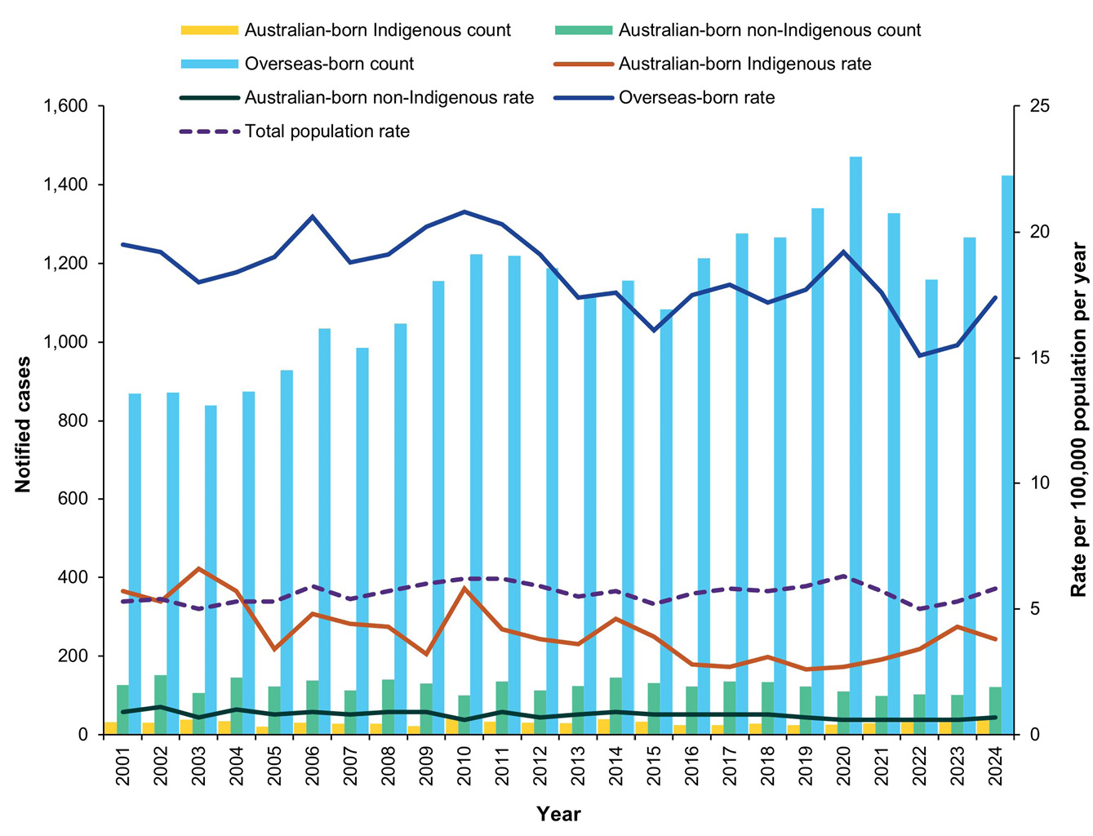
a Data extracted from the National Notifiable Diseases Surveillance System (NNDSS) on 16 June 2025. Due to the dynamic nature of the NNDSS, data in this extract are subject to retrospective revision and may vary from data reported in published NNDSS reports and reports of notification data by states and territories.

Impact of the 2021–2025 Strategic Plan for TB control in Australia
The Strategic Plan for Control of TB in Australia 2021–2025 focused on TB elimination (incidence of < 1 case/million population per year) and incidence reduction targets and included a number of goals aligned with supporting progress towards these ends.²
Table 1: Australia’s progress towards TB elimination
Goal | 2015 | 2020 | 2024 | 2030 (target)
To reduce the overall TB incidence rate in Australia | 5.3 per 100,000 | 6.3 per 100,000 | 5.9 per 100,000 | 4.8 per 100,000
To achieve pre-elimination of TB in Australian-born Aboriginal and Torres Strait Islander population | 4.8 per 100,000 | 3.0 per 100,000 | 3.8 per 100,000 | ≤ 1 per 100,000
To maintain pre-elimination of TB in Australian-born non-Indigenous population | 0.8 per 100,000 | 0.7 per 100,000 | 0.7 per 100,000 | ≤ 1 per 100,000
During 2021–2025, there has been successful development of a number of key guidelines and policy documents to support optimal and harmonised TB management in Australia. These include TB workforce training,³ management of MDR-TB disease and infection, and revised national contact tracing standards. The National Tuberculosis Advisory Committee (NTAC) also completed a comprehensive revision of public health guidelines for the management of TB, including diagnosis and management of infection and disease, and prevention of disease in high risk groups, published as national guidelines for public health units.⁴ NTAC also expanded its membership to include key stakeholders from the Department of Foreign Affairs and Trade, and the National Aboriginal and Torres Strait Islander Health Protection committee, bringing important expertise and focus on areas of key activity in Australia’s TB control and management.
An important area of considerable development during the previous strategic plan is the whole-genome sequencing (WGS) of Mycobacterium tuberculosis. Prior to the strategic plan, WGS was largely performed ad hoc and for individual care in some reference laboratories.⁵ NTAC and other key stakeholders identified WGS as a key need for effective TB management and developed standards of practice, implementation guidelines and public health thresholds for action, which have paralleled the establishment of advanced genomics as a routine part of TB diagnostic assessment in Australia. These have been substantial accomplishments, laying the groundwork for national cluster evaluation and public health responses for development in the strategic plan.
While progress is welcome, there are significant limitations in meeting TB elimination objectives. Most centrally, the 2025 TB incidence thresholds for progress towards elimination are unlikely to be met given current trends. The ongoing control of TB transmission in Australia is a critical priority now and for the future, particularly with continued and increasing migration from high-incidence settings. It is therefore recognised that progress to zero TB transmission and TB elimination goals is unlikely without further technological advancement (such as effective vaccine development), and substantial programmatic investment in high-incidence global regions beyond the scope of this strategic document.
Key accomplishments in the control of TB in Australia, 2021–2025
- Development and publication of a national position statement on the use of WGS for TB in Australia;
- Completion of a national review of TB mortality, and implementation of ongoing monitoring of TB deaths;
- Revision and publication of a revised TB public health management guidance (TB SoNG);
- Establishment of permanent representation from the Department of Foreign Affairs and Trade and the National Aboriginal and Torres Strait Islander Health Protection subcommittee on NTAC; and
- Introduction of pre-migration TBI screening for health care workers.

Strategic plan overview
The overall emphasis of the last decade for Australia’s TB control has been on incidence reduction towards TB elimination.⁶ This emphasis has been in line with global priorities, and has led to significant structural and programmatic improvements in Australia. However, a substantial focus on incidence reduction over a sustained period has, by design, concentrated on the groups from which the largest number of cases of TB arise, including settings such as household contacts where the risk of local transmission is the highest. While critical to maintain such efforts, exclusive focus on reducing the number of TB cases risks overlooking the smaller number of individuals and communities who are at disproportionate risk of worse outcomes and associated programmatic responses. Such outcomes may be reflected in increased risk of transmission, but also in diverse impacts including long-term physical, social or financial outcomes.
Broadly speaking, this strategic plan aims to have a substantial focus on equity and explicitly highlight not just the maintenance and further strengthening of TB services, but also opportunities to identify and improve support for those people and groups who are at risk of greatest holistic burden associated with TB disease and infection. This includes improved access to therapies and better engagement with general practice as illustrated across focus areas. This aligns with the 2030 vision of the Western Pacific Regional Framework to End TB, calling for ‘[an] equity lens to ensure that everyone benefits equally from regional progress towards better health’.⁷ Low incidence countries such as Australia can progress toward TB pre-elimination with effective TB management.⁸
This document therefore presents two broad themes for national programmatic emphasis that will endeavour to achieve TB pre-elimination in Australia, including targets for monitoring, evaluation and improvement. The twin priority themes, Strengthen existing programs for TB management and Build groundwork for redressing inequity in TB outcomes, each with areas for focus, will allow for the next five years of Australia’s TB public health responses to result in improved and equitable care for all people affected by TB.
NTAC will continue to lead with advice on the prevention and management of TB in Australia with reporting to the Communicable Diseases Network Australia, and overarching oversight from the Australian Health Protection Committee (AHPC). Input will also be sought from other AHPC subcommittees as appropriate.

Theme 1 – Strengthen existing programs for TB management
This theme includes five aspects of Australia’s TB programmatic activity with identified opportunities for building on systems already in operation:
- post-migration services for TB diagnosis and management;
- TB surveillance and reporting;
- development of the healthcare workforce;
- WGS and bioinformatic analysis; and
- improving access to tailored treatment through therapeutics and drug monitoring.

Focus area: Post-migration TB services
Post-migration TB services are well-recognised as being critical to the success of TB programs in Australia, given the high proportion of cases arising following migration from high TB incidence settings.⁹ In the last decade, pre-migration medical assessments have advanced considerably, including additional testing for TB infection (TBI) in children and healthcare workers.¹⁰ However, the Australian jurisdictional healthcare system varies in terms of structure and reporting, and there are potentially important differences with regards to migration patterns, accessibility of services, testing and follow up practices, and TB-associated outcomes. In particular, the introduction of TBI testing for some migrants has not been accompanied by a systematic national management plan for risk stratification, monitoring and treatment support.
Given the number of TB cases in Australia from recently arrived migrants, a review of post-migration services and outcomes is critical to ensure continued control of TB in Australia. This review will incorporate multi-stakeholder input, including qualitative engagement with affected individuals and communities, and aim to develop a national standard for post-migration services relating to TB infection and disease. This standard will also include an implementation plan, considering funding, logistic and workforce requirements.
Goals associated with a nationally consistent post-migration TB service
1. Review and identify gaps and commonalities in jurisdictional migration services, testing, reporting and outcomes.
2. Develop nationally agreed best-practice recommendations for post-migration service operations and reporting.
3. Implement systematic national monitoring of post-migration review and TB related outcomes.

Focus area: Workforce
Workforce development has been a recognised priority for Australia. With a relatively small numbers of TB cases nationally, constant attention is required to ensure that sufficient and well-trained healthcare workers (HCW) are available to ensure high-quality care.
Previous NTAC policy documents have emphasised the importance of HCW training and maintenance of TB programmatic expertise.¹¹ In light of increasing proportions of the Australian population recognised to be at some risk of future TB disease, the need to provide effective community HCW support, including models of care and training for general practitioners and nurse practitioners in addressing TBI, is evident.¹² NTAC will work in partnership with key stakeholders, including training organisations to understand training opportunities for TB workforce development. Important elements of workforce development in the strategic plan are also captured in relation to post-migration services and developing responses to TB in Aboriginal and Torres Strait Islander communities.
Goals associated with workforce development
1. Identify key stakeholders for TB management in primary care settings.
2. Develop a model of care with national guidance for primary care (including general practice, nurse practitioner and Aboriginal health workers) in the diagnosis and management of TBI.
3. Review models of care for post-migration service and TB management in Aboriginal and Torres Strait Islander people and assess additional workforce requirements.
4. Explore options for improved training and professional development opportunities for the TB workforce.

Focus area: Collect, analyse and report on TB epidemiology
Australia has robust systems of communicable disease data notification and reporting. Enhancements in the form of regular reporting, rapid access to data and ensuring Aboriginal Community Controlled Health services are included in key stakeholders groups requiring access to these data should be recognised. While this should take the form of routine and up to date formal epidemiological reports, alternative methods of rapid access to data (including updates on key events, dashboards for contextualised TB information based on Aboriginal data sovereignty principle and decision-support) must also be considered. Given the recent establishment of the Australian Centre for Disease Control (CDC), NTAC will work with the Australian CDC to develop timely data collection and reporting to support population level strategic decision making.
Goal associated with collection, analysis and reporting on TB epidemiology
1. Enhance national reporting of TB including through timely publication of annual TB reports by the Australian CDC, ensuring the principles of Aboriginal data sovereignty are maintained.

Focus area: Whole genome sequencing
Whole genome sequencing is now routinely performed as a part of reference laboratory practice in all Australian jurisdictions, with focus in previous strategic plans and NTAC guidance documents.¹³ During the life of the strategic plan, it is a priority to optimise the public health responses based on WGS analyses, particularly in relation to apparent clustering and possible local transmission.¹⁴ This includes working with laboratory partners to establish routine reporting of WGS analysis at a national level, and developing consensus models of suitable approaches to investigating potential transmission events within and between jurisdictions. Given NTAC’s role in national surveillance and monitoring, the strategic plan also emphasises the use of WGS in epidemiological review and reporting.
Goals associated with strengthening of national public health responses to TB through WGS
1. Develop and trial a template for the routine reporting of TB WGS for cluster analysis, including formal definitions for inter and intra-jurisdictional clusters and outbreaks of national significance.
2. Develop a framework for routine national review of genomic epidemiology, including consensus models for responding to apparent inter- and intra-jurisdictional TB transmission on the basis of WGS analysis.
3. Review the impact of TB WGS on Australian public health responses over the previous five years.
4. Work with partners, including the Communicable Diseases Genomics Network, to improve healthcare worker and public health understanding of WGS interpretation.

Focus area: Access to therapeutics and drug monitoring
Optimising TB drug therapy in Australia includes both timely access to medications and support for individualisation of therapy for best outcomes. Currently, while all medications are provided free by jurisdictional TB services, access to medications, including fixed-dose combinations widely used globally for active TB and TBI, varies nationally and has regulatory barriers to expanded use. During the strategic plan, NTAC will work through clear governance arrangements as detailed earlier in this plan with key stakeholders to improve timely access to best practice therapy for TB, particularly for individuals and communities at risk of poor outcomes, including Aboriginal and Torres Strait Islander people and affected communities.
Therapeutics and drug monitoring (TDM) for TB therapy has been increasingly recognised as valuable for improving treatment outcomes and guiding optimal therapeutic choices including dosing.¹⁵ However, use of TDM has not been historically widespread in Australia and has not been included in most treatment standards for drug-susceptible or, until recently, MDR-TB.¹⁶ Although pathology testing for TB drug levels is increasingly available, consistent guidance is not available to support clinician decision-making with regards to optimal drug choices and dosing. While individual TB outcomes from treatment remain good, opportunities to improve treatment success and reduce relapse exist, particularly where TB disease affects those with altered drug metabolism (such as in children, pregnancy, diabetes, renal failure and/or HIV infection and treatment).
Goals associated with better access to therapeutics and drug monitoring
1. Update Australian recommendations on therapeutics for TB and TBI.
2. Develop a consensus Australian recommendation on the use of TDM for optimal TB treatment.
3. Establish pathways for routine access to medications to support effective management of TB and TBI, including fixed-drug combination therapy.
4. NTAC to work through CDNA and AHPC to improve access to and awareness of TB medicines, particularly for TBI.

Theme 2 – Build groundwork for redressing inequity in TB outcomes
This theme recognises the need for public health responses to address the disparity in TB risk and outcomes experienced by Aboriginal and Torres Strait Islander people and communities, and aims to build on frameworks established previously to achieve and improve outcomes.
TB disease outcomes, including within Australia, are inequitable, with some individuals and population groups disproportionately affected. This does not simply occur in terms of increased risk of infection or disease acquisition, but also with regards to the physical, psychological, material and population impact of TB disease and diagnosis, and the impact of factors such as social determinants, population health, rurality, comorbidity, nutrition and mental health and access to care and outcomes. Previous work in Australia has highlighted the importance of factors such as HIV infection and alcohol use on TB treatment outcomes, but there remain important gaps in understanding and monitoring the holistic impact of TB in Australia.¹⁷
This theme area also aims to improve Australia’s capacity to monitor and evaluate aspects of management not currently captured within national reporting, including in relation to life-stage (pregnancy), long-term physical (post-TB disease) and material (financial and housing) impacts of TB.

Focus area: Reduce the impact of TB on Aboriginal and Torres Strait Islander communities
For Aboriginal and Torres Strait Islander communities, TB is related to compounding disadvantage, and social services and health system failure, all of which are a consequence of colonisation. Aboriginal and Torres Strait Islander peoples and communities are more likely to be exposed to TB in the context of poor quality housing and poverty, develop active disease, and experience delayed and worse treatment outcomes.¹⁶
The overall aim of this focus area is to eliminate local transmission of TB in Aboriginal and Torres Strait Islander communities, and achieve pre-elimination benchmarks in parity with Australian-born non-Indigenous Australians by 2030, as a milestone toward full elimination. Substantial investment in housing and health care access is required to redress this inequity.
While there are many features of culturally safe TB responses that apply in any setting, models for TB infection and disease prevention and management need to be tailored, agile and developed in partnership with Aboriginal and Torres Strait Islander communities to ensure they are acceptable and effective. This includes ensuring that all healthcare workers providing TB services to Aboriginal and Torres Strait Islander people and communities across Australia have undertaken appropriate cultural training.
Stronger collaboration and partnership with Aboriginal and Torres Strait Islander people and organisations, including Aboriginal Community Controlled Health Organisations (ACCHOs) that are known to and trusted by affected communities can ensure cultural and clinical responses are integrated to support effective responses. Contact tracing practices should incorporate active listening to cultural knowledge and wisdom, to ensure a thorough assessment of potential disease transmission and timely action. This supports priority reforms 1 to 4 in the National Agreement on Closing the Gap.
Goals associated with reduction of TB's impact on Aboriginal and Torres Strait Islander communities
1. Eliminate local TB transmission in Aboriginal and Torres Strait Islander communities through culturally appropriate systems to prevent, detect and treat TB infection and disease.
2. Develop new guidelines outlining the TB response models for Aboriginal and Torres Strait Islander people to support culturally safe and effective TB prevention and care. This model should include a focus on local workforce capacity, partnership with the ACCHO sector, engagement with other screening and healthcare programs and the role of primary health care services, and should emphasise that Aboriginal and Torres Strait Islander people should be employed at all levels of the TB response.
3. Review national and jurisdictional TB policies, including clinical and public health guidelines, to ensure they identify and respond to the needs of Aboriginal and Torres Strait Islander people.

Focus area: Quantify the burden of perinatal TB
In 2024, the World Health Organization included estimates of TB in pregnancy in the Global TB Report for the first time, noting that improving data collection was particularly important. While it is recognised globally that pregnancy and the post-partum period is associated with an increased risk of TB disease, no systematic national data collection occurs.¹⁸ There is also increasing consideration of associations between TB and artificial reproductive technology (ART), including the contribution of unrecognised TB to infertility and the potential value of systematic assessment during ART evaluation for women at increased risk of TB.¹⁹ Strengthening such monitoring and evaluation would allow opportunities for early intervention to improve maternal and neonatal health and TB outcomes, and may support the development of targeted testing and treatment models for active TB and/or TBI.
Goals associated with quantifying the burden of perinatal TB
1. Review of TB occurring in association with pregnancy, ART and the post-partum period in Australia, to guide NTAC’s consideration of resources to support optimal care and outcomes.
2. Develop a national approach to collection of data relating to pregnancy and post-partum TB for addition to routine TB surveillance.
3. Work with stakeholders to develop best-practice guidelines for TB in pregnancy, the post-partum period and ART.

Focus area: Quantify the long-term impact of TB and its treatment in Australia
Post-TB disease (that is, the range of persistent physical impact which may follow microbiological cure) has been relatively neglected within systems established to manage TB as a public health concern.²⁰ Following microbiological cure, programs have frequently ceased longitudinal follow up, with limited data collection regarding the long-term impact of TB disease. However, while Mycobacterium tuberculosis may have been eliminated, residual impact from tissue damage may persist, with increasing recognition of the long-term impact that previous disease may have. In the absence of systemic consideration, little high-quality evidence exists to quantify the long-term impact of TB diagnosis and treatment in Australia.
Goals associated with quantifying the long-term impact of TB and its treatment in Australia
1. Develop a consensus recommendation on end-of-treatment assessment for post-TB sequelae and systems for monitoring post-TB disease.
2. Undertake data-linkage to assess the long-term mortality and morbidity impact of TB following successful treatment in Australia.

Focus area: Financial impact of TB in Australia
TB is frequently described as a condition of poverty, but in Australia there is a perception that the financial impact of TB is not relevant given the availability of free TB treatment and social support systems in operation. Although TB treatment without cost to the individual is an essential component of accessible services, it is likely that a diagnosis of TB is also associated with a variety of burdensome direct and indirect costs and loss of opportunity, particularly given the disproportionate risk of TB in Australian residents without access to Medicare or other services with restricted eligibility.
More broadly, ensuring equitable access to healthcare services for the diagnosis and management of TB is essential, and NTAC considers that addressing and mitigating financial barriers to care is a key element in strengthening services.
Goals associated with quantifying and reducing the financial burden associated with TB in Australia
1. Review the financial impact of TB in Australia, and explore the different costs borne by, and associated with, TB in priority population groups and sub-groups.
2. Consider additional actions to reduce financial impact of TB in Australia, with an emphasis on the most affected communities and population groups.

Implementing this Strategy
A detailed implementation plan is outside the scope of the strategic plan. However, a broad recognition of the TB policy landscape in which this will occur is valuable, with detailed implementation and evaluation of individual elements to be developed with key stakeholders iteratively over the life of this plan. Such activities must include consideration of appropriate resourcing, including support for coordinated interjurisdictional activities, to achieve TB elimination and equity of impact across Australia.
TB services in Australia are delivered primarily at a jurisdictional level, with state and territory TB programs having primary responsibility for implementation of activities. The strategic plan includes a variety of elements which are national in their scope and which require collective action for consensus policy development, detailed planning, implementation and evaluation.
Coordination and oversight of jurisdictional and interjurisdictional approaches to implementing the elements of the strategic plan will occur through NTAC, CDNA and AHPC, working in partnership with key stakeholders in Aboriginal and Torres Strait Islander health, migration services, primary care and other areas of clinical and public health practice. Recognising the breadth of expertise in qualitative and quantitative research across Australia, research activities aligned with and supporting accomplishment of elements of the strategic plan will also be encouraged and incorporated.

Conclusion
The impact of TB can be severe and experienced disproportionately. Control of Australia’s TB epidemic remains at risk without additional resourcing to strengthen clinical and public services, especially to minimise disproportionate burden. Over the next five years, the strategic plan will aim to maintain and strengthen clinical and public health services while enhancing our capacity to monitor and engage with the holistic long-term impact TB has on individuals and communities.
While the primary focus of this document is on management of TB within Australia, substantial progress towards elimination cannot be achieved without significant improvements in regional and global TB epidemiology. The main challenges to ending the TB epidemic in the region are socio-economic inequality that increase TB vulnerability and health system weaknesses, limited resources, and funding for national TB programs, resulting in severe limitations on patient access to quality TB diagnosis and care. Global TB management, particularly within the Asia Pacific region, is critical to the epidemiology of TB in Australia; there is therefore a requirement for continued advocacy for efforts to improve these programs and the provision of Australian political and material support for global TB and associated health system strengthening.
The strategic plan targets high-priority and emerging issues, aiming to achieve pre-elimination for all Australian-born people by 2030. Maintenance of a robust epidemiological surveillance system will ensure emergent concerns can be identified early and appropriate programmatic action taken. In other contexts, such emergent challenges have included increased transmission in prisons and other congregate settings, resistance to new and repurposed drugs, and increases in cross-border transmission events. Australia’s public health response must be prepared to quickly identify and pivot to respond to new and emerging factors, now and in the future.

Author details
The National Tuberculosis Advisory Committee, on behalf of the Communicable Diseases Network Australia

Corresponding author
Professor Justin T Denholm
Victorian Tuberculosis Program, Peter Doherty Institute of Infection and Immunity, 792 Elizabeth Street, Melbourne Victoria 3055, Australia
Email: justin.denholm@mh.org.au
Phone: +61 3 9342 9428

References
- Trauer JM, Williams B, Laemmle-Ruff I, Horyniak D, Soares Caplice LV, McBryde ES et al. Tuberculosis in migrants to Australia: outcomes of a national screening program. Lancet Reg Health West Pac. 2021;10:100135. doi: https://doi.org/10.1016/j.lanwpc.2021.100135.
- National Tuberculosis Advisory Committee (NTAC). The Strategic Plan for Control of Tuberculosis in Australia, 2021–2025. Commun Dis Intell (2018). 2022;46. doi: https://doi.org/10.33321/cdi.2022.46.48.
- Donnan EJ, NTAC. Tuberculosis workforce policy and development framework in Australia. Commun Dis Intell (2018). 2025;49. doi: https://doi.org/10.33321/cdi.2025.49.009.
- Australian Centre for Disease Control (Australian CDC), Communicable Diseases Network Authority (CDNA). Tuberculosis – CDNA National Guidelines for Public Health Units. [Webpage.] Canberra: Australian CDC; 1 March 2022. Available from: https://www.cdc.gov.au/resources/publications/cdna-national-guidelines-tuberculosis.
- Gurjav U, Outhred AC, Jelfs P, McCallum N, Wang Q, Hill-Cawthorne GA et al. Whole genome sequencing demonstrates limited transmission within identified Mycobacterium tuberculosis clusters in New South Wales, Australia. PloS One. 2016;11(10):e0163612. doi: https://doi.org/10.1371/journal.pone.0163612.
- NTAC. The Strategic Plan for Control of Tuberculosis in Australia, 2016–2020: Towards Disease Elimination. Commun Dis Intell (2018). 2019;43. doi: https://doi.org/10.33321/cdi.2019.43.10.
- World Health Organization (WHO). Western Pacific regional framework to end TB: 2021–2030. Geneva: WHO; 2 March 2022. Available from: https://www.who.int/publications/i/item/9789290619703.
- WHO. Towards tuberculosis elimination: an action framework in low-incidence countries. Geneva: WHO; 18 March 2014. Available from: https://www.who.int/publications/i/item/9789241507707.
- Bright A, Denholm JT, Coulter C, Waring J, Stapledon R. Tuberculosis notifications in Australia, 2015–2018. Commun Dis Intell (2018). 2020;44. doi: https://doi.org/10.33321/cdi.2020.44.88.
- Laemmle-Ruff I, Graham SM, Williams B, Horyniak D, Majumdar SS, Paxton GA et al. Detecting Mycobacterium tuberculosis infection in children migrating to Australia. Emerg Infect Dis. 2022;28(9):1833–41. doi: https://doi.org/10.3201/eid2809.212426.
- NTAC. Essential components of a tuberculosis control program within Australia. Commun Dis Intell Q Rep. 2014;38(4):E397–400. doi: https://doi.org/10.33321/cdi.2014.38.64.
- Dale KD, Trauer JM, Dodd PJ, Houben RMGJ, Denholm JT. Estimating the prevalence of latent tuberculosis in a low-incidence setting: Australia. Eur Respir J. 2018;52(6):1801218. doi: https://doi.org/10.1183/13993003.01218-2018.
- Donnan EJ, Marais BJ, Coulter C, Waring J, Bastian I, Williamson DA et al. The use of whole genome sequencing for tuberculosis public health activities in Australia: a joint statement of the National Tuberculosis Advisory Committee and Communicable Diseases Genomics Network. Commun Dis Intell (2018). 2023;47. doi: https://doi.org/10.33321/cdi.2023.47.8.
- Denholm J, Coulter C, Bastian I. Defining a tuberculosis cluster or outbreak. Commun Dis Intell Q Rep. 2016;40(3):E356–9. doi: https://doi.org/10.33321/cdi.2016.40.37.
- Alffenaar JW, Akkerman OW, Kim HY, Tiberi S, Migliori GB. Precision and personalized medicine and anti-TB treatment: is TDM feasible for programmatic use? Int J Infect Dis. 2020;92:S5–9. doi: https://doi.org/10.1016/j.ijid.2020.01.041.
- Stapledon R, Donnan EJ, NTAC. Australian recommendations for the management of drug-resistant tuberculosis, 2023. Commun Dis Intell (2018). 2023;47. doi: https://doi.org/10.33321/cdi.2023.47.48.
- Coorey NJ, Kensitt L, Davies J, Keller E, Sheel M, Chani K et al. Risk factors for TB in Australia and their association with delayed treatment completion. Int J Tuberc Lung Dis. 2022;26(5):399–405. doi: https://doi.org/10.5588/ijtld.21.0111.
- Morton AJ, Roddy Mitchell A, Melville RE, Hui L, Tong SY, Dunstan SJ et al. Mycobacterium tuberculosis infection in pregnancy: a systematic review. PLoS Glob Public Health. 2024;4(11):0003578. doi: https://doi.org/10.1371/journal.pgph.0003578.
- Garg RK, Malhotra HS, Suresh V, Garg R, Jain A, Gupta S et al. Tuberculosis following in vitro fertilization: a systematic review of case reports, case series, and cohort studies. medRxiv. 2024. doi: https://doi.org/10.1101/2024.10.20.24315846.
- Menzies NA, Quaife M, Allwood BW, Byrne AL, Coussens AK, Harries AD et al. Lifetime burden of disease due to incident tuberculosis: a global reappraisal including post-tuberculosis sequelae. Lancet Glob Health. 2021;9(12):e1679–87.
doi: https://doi.org/10.1016/S2214-109X(21)00367-3.

A pre-elimination setting is defined as 1 per 100 000, and TB elimination is defined as one in 1 million, TB incidence per year.

