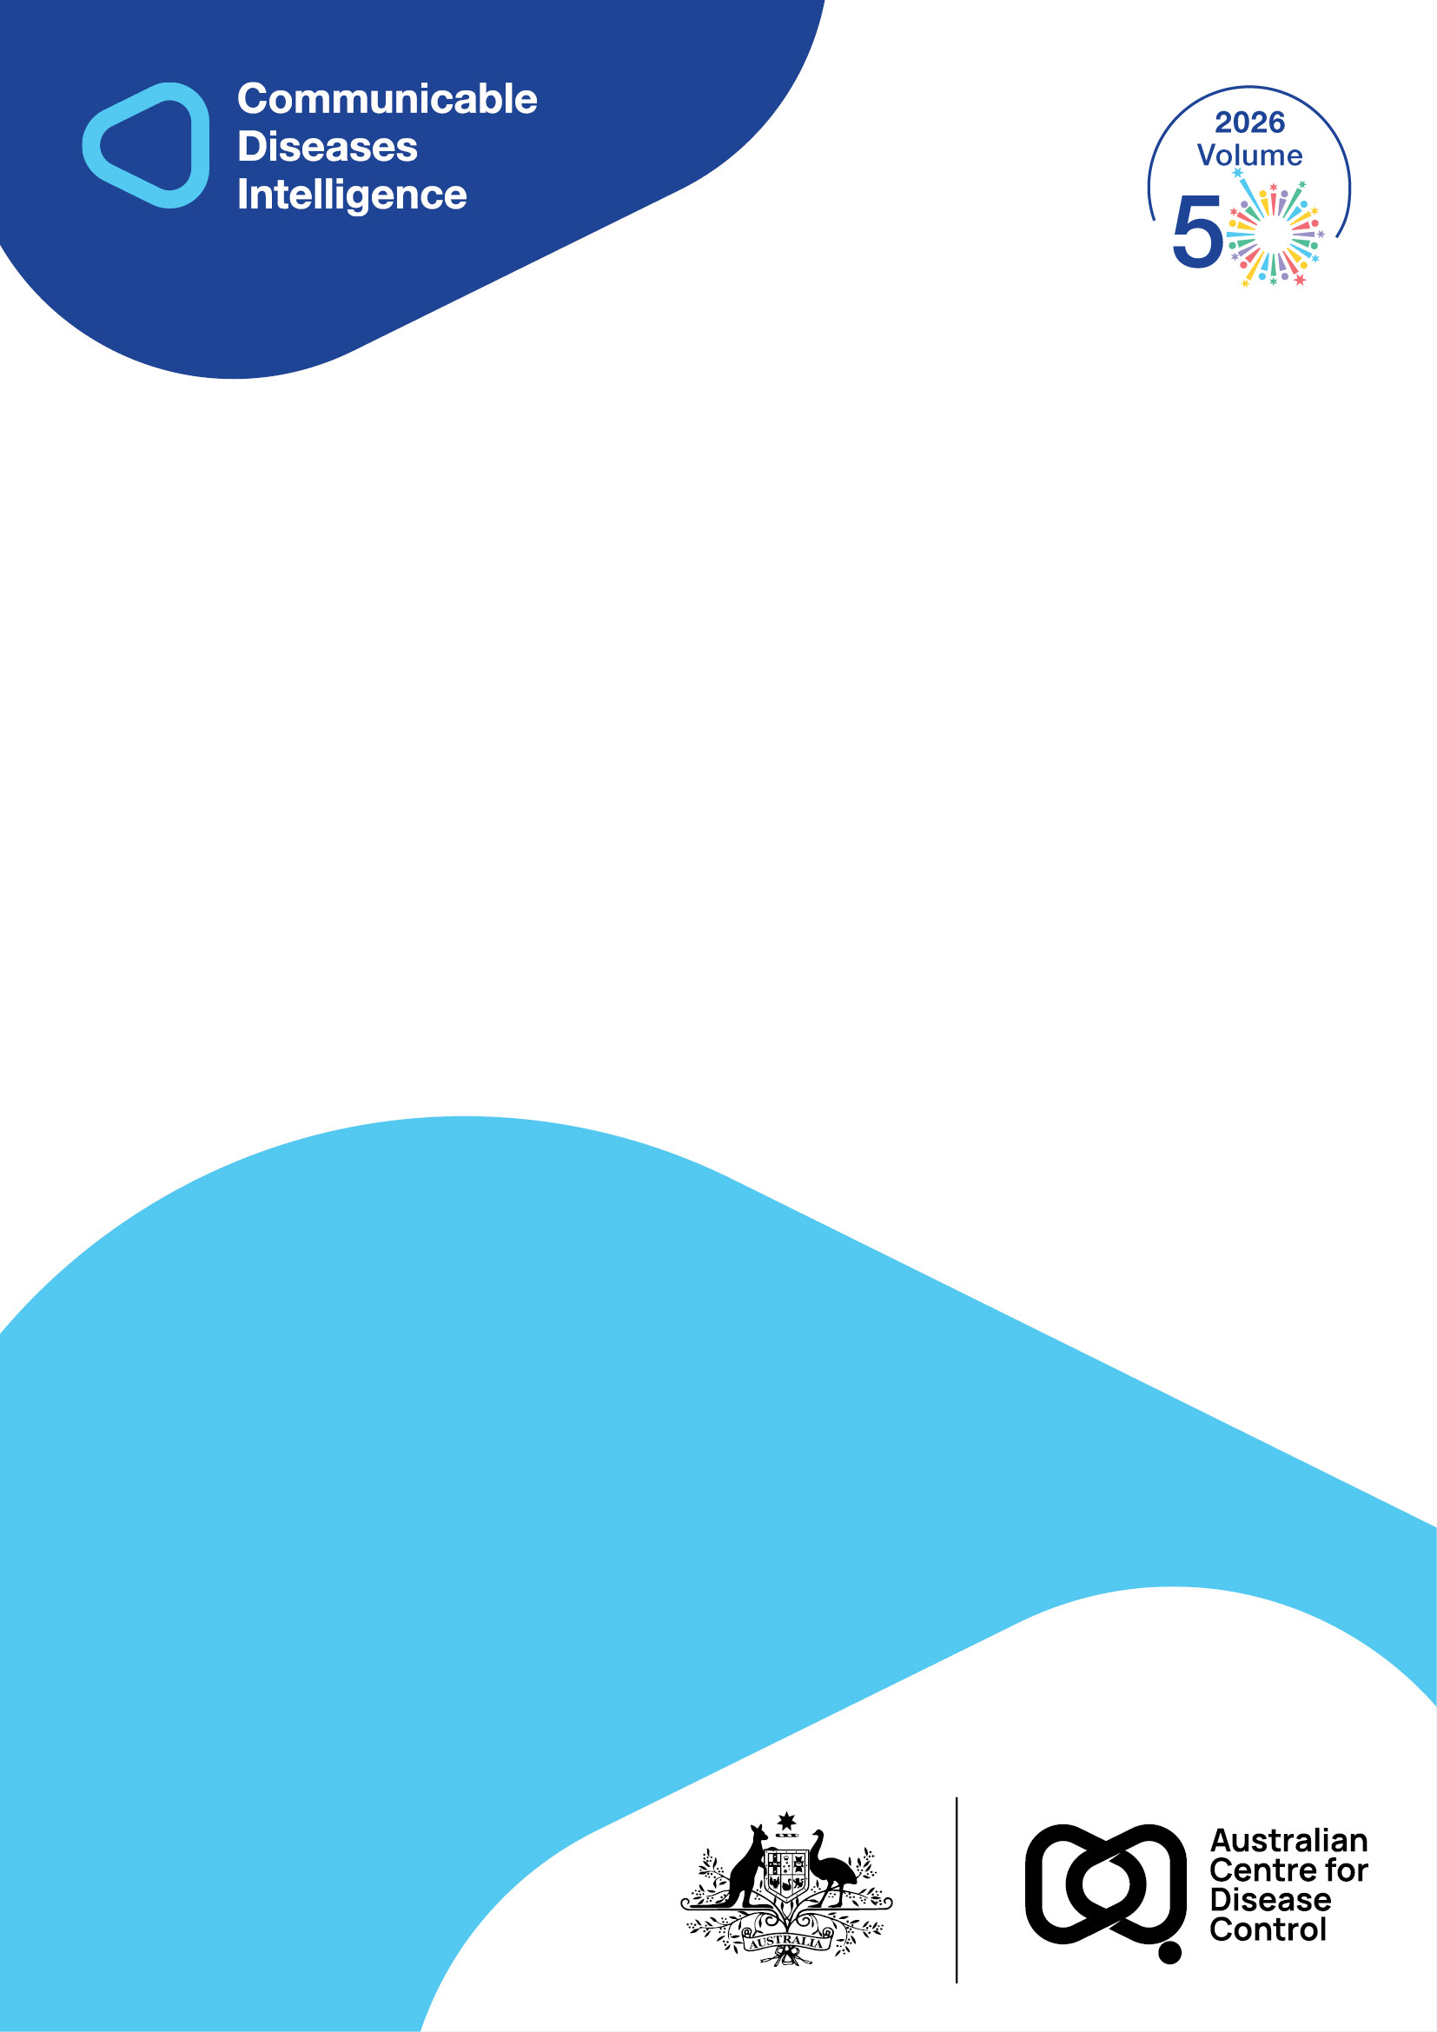
2026 • Volume 50 • cdc.gov.au/cdi • Epub date: 16.06.2026 • doi.org/10.33321/cdi.2026.50.038

An atlas of common Salmonella serotypes from routinely notified human cases in the Northern Territory of Australia, 2005–2024
Anthony DK Draper, Martyn D Kirk, Samantha Colquhoun, Kathryn Glass, Kelly Lomas, Kimberley McMahon, Joshua R Francis, Jennifer Yan, Vicki L Krause
© 2026 Commonwealth of Australia as represented by the Australian Centre for Disease Control
ISSN: 2209-6051 Online
This journal is indexed by Index Medicus and Medline.
Creative Commons Licence
This publication is licensed under a Creative Commons Attribution-NonCommercial-NoDerivatives 4.0 International Licence (Licence). You must read and understand the Licence before using any material from this publication.
Restrictions
The Licence does not cover, and there is no permission given for, use of any of the following material found in this publication (if any):
- the Commonwealth Coat of Arms (by way of information, the terms under which the Coat of Arms may be used can be found on the Department of Prime Minister and Cabinet website);
- any logos (including the Australian Centre for Disease Control’s logo) and trademarks;
- any photographs and images;
- any signatures; and
- any material belonging to third parties.
Disclaimer
Opinions expressed in Communicable Diseases Intelligence are those of the authors and not necessarily those of the Australian Government or the Australian Centre for Disease Control. Data may be subject to revision.
Enquiries
Enquiries regarding any other use of this publication should be addressed to the CDI Editor.
About CDI
Communicable Diseases Intelligence (CDI) is a peer-reviewed scientific journal published by the Australian Centre for Disease Control.
The journal aims to disseminate information on the epidemiology, surveillance, prevention and control of communicable diseases of relevance to Australia and the near region.
Editor: Dr Elise Firman • Deputy Editor: Simon Petrie • Design and Production: Lisa Thompson
Editorial Advisory Board: David Durrheim, Mark Ferson, Clare Huppatz, John Kaldor, Martyn Kirk and Meru Sheel
Submit an Article
Guidelines for authors and details on how to submit your publication is available on our website, or by email to the
CDI Editor.
Contact us
Communicable Diseases Intelligence (CDI)
Australian Centre for Disease Control
GPO Box 798, CANBERRA ACT 2601
Website: cdc.gov.au/cdi
Email: cdi.editor@cdc.gov.au

Contents
Abstract 4
Introduction 5
Methods 6
Ethics 6
Results 7
Discussion 9
Conclusion 11
Author details 12
References 13
Appendix A 18

Abstract
Salmonella infections cost Australian society an estimated 140 million Australian Dollars (AUD) per year circa 2019. Salmonellosis is caused by Salmonella enterica, with over 2,500 serotypes of S. enterica identified. Knowledge of the epidemiology of Salmonella serotypes may facilitate traceback from strains detected in human cases to identify the cause of local and multijurisdictional outbreaks and to implement control measures. We analysed cases of human salmonellosis notified in the Northern Territory (NT), Australia, between 1 January 2005 and 31 December 2024. We calculated the incidence of salmonellosis for all locally acquired infections according to the NT location where the infection was most likely acquired. We mapped the geographical distribution of the 25 most frequently notified Salmonella serotypes to Statistical Areas Level 2. There were 8,706 salmonellosis cases acquired in the NT: Salmonella Saintpaul (1,047 notifications) was the most frequently notified serotype, followed by S. Virchow (948 notifications); S. Typhimurium (822 notifications); S. Ball (578 notifications); and S. Lansing (460 notifications). While S. Typhimurium was ubiquitous in the NT, S. Saintpaul, S. Virchow and S. Hvittingfoss showed distinct geographic patterns. Our atlas makes key epidemiological information about common NT Salmonella serotypes readily available, which may be useful for developing hypotheses during outbreak investigations; for facilitating traceback of suspected food vehicles; and for implementing control strategies more rapidly.
Keywords: Salmonella; salmonellosis; Salmonella Saintpaul; Salmonella Virchow; Salmonella Hvittingfoss; Salmonella Ball; Salmonella Muenchen; foodborne disease; OzFoodNet; geographic information system (GIS) mapping

Introduction
Salmonella enterica subspecies enterica is a gram-negative bacillus of the genus Salmonella.¹ There have been over 2,500 serotypes (serovars) of S. enterica identified.² The diseases caused by serotypes Salmonella Typhi and S. Paratyphi are known as typhoid and paratyphoid fever, respectively.³ Salmonellosis refers to the diseases caused by the other (i.e. nontyphoidal) Salmonella serotypes, which more commonly present as gastroenteritis.³
Salmonella bacteria are found in the gastrointestinal tracts of animals including birds, reptiles, amphibians and mammals.³ A person typically becomes ill 6–72 hours after ingesting the bacteria, which may be through direct or indirect contact with a contaminated environment, or through the ingestion of contaminated water or food, where the latter is typically raw or undercooked meat or eggs, or contaminated raw fruits or vegetables.³ Salmonellosis causes a considerable burden on Australian society in the form of lost productivity, costs associated with pain and suffering, direct healthcare costs and premature mortality. The annual cost of salmonellosis in Australia was estimated at approximately 140 million Australian Dollars (AUD) per year circa 2019.⁴ Within Australia, salmonellosis is a notifiable condition both in the Northern Territory (NT)⁵ and nationally;⁶ it is a disease under surveillance by the OzFoodNet network, a network of epidemiologists in each Australian jurisdiction who conduct surveillance on enteric diseases.⁷ There has been an OzFoodNet site in the NT since 2003. The NT typically observes rates of salmonellosis four to five times higher than the rest of Australia,⁸ with approximately half of notified cases in children aged < 5 years old. It is likely that most of these infections are acquired from the environment,^{9,10} which is an important source of sporadic infection in the NT. Salmonella Virchow, S. Lansing, S. Saintpaul, S. Ball, S. Hvittingfoss, S. Reading, S. Muenchen, S. Weltevreden, and Salmonella subspecies I ser 16:l,v:- are all considered environmental serotypes in the NT.^{11–16} The NT OzFoodNet site has published regular reports which include brief annual summaries of the epidemiology of salmonellosis in the NT,^{11–28} as well as other epidemiological studies^{29–31} and case reports.^{32,33}
When specific Salmonella serotypes are detected in human cases during outbreaks in Australia, knowledge and documentation of the historical epidemiology may be useful in hypothesis generation while investigating cases or outbreaks, and may facilitate traceback of foods to a particular location in order to identify the cause of an outbreak and implement control measures. Fresh produce grown in the NT has been previously implicated in salmonellosis outbreaks in other parts of Australia, including outbreaks of S. Saintpaul³⁴ and S. Hvittingfoss³⁵ (commonly isolated serotypes in the NT) both associated with rockmelons (cantaloupes) grown in the NT. There have also been local outbreaks associated with food produced in the NT such as wild hunted turtle,³⁶ wild hunted kangaroo,³⁷ and cordial contaminated with environmental Salmonella.³⁸ The OzFoodNet NT site has also published the results of numerous salmonellosis outbreaks that have occurred in the NT since 2003 (Appendix A, Table A.1).
The Northern Territory Notifiable Disease System (NTNDS) is a surveillance system which records case information of notifiable conditions in the NT.
This study used routinely collected surveillance data from the NTNDS to describe the geographical distribution of common Salmonella serovars in the NT during 2005–2024. We mapped the most commonly notified Salmonella serotypes in the NT to serve as a tool for rapid and accurate hypothesis generation and traceback during foodborne disease outbreaks across Australia.

Methods
Methods of surveillance and data analysis are published elsewhere.⁴⁶ In brief, data were extracted from the NTNDS on all salmonellosis notifications in the NT with a diagnosis date (earliest of onset date, specimen collection date or notification date) between 1 January 2005 and 31 December 2024.
We used Stata 17.0 (StataCorp) to calculate the incidence (over 20 years) of salmonellosis according to the NT location (e.g. suburb or locality) where the infection was most likely acquired. Place acquired was defined as the NTNDS variable ‘place infected’, which describes the known location of infection as determined by previously completed routine case follow-up. In the NT, follow-up is generally restricted to cases aged > 5 years and performed by trained staff at the NT Centre for Disease Control. Where ‘place infected’ was missing, place of residence was used as a proxy. All interstate or international residents with no defined ‘place infected’ in the NT were excluded, as were those notifications where ‘place infected’ was an overseas or interstate location.
We used Quantum GIS (QGIS) 3.38 to map the geographical distribution of the 25 most frequently notified Salmonella serotypes to Statistical Areas Level 2 (SA2s)⁴⁷ according to place acquired. These maps are presented in Appendix A for this article, as Maps A.1 to A.25.

Ethics
We obtained ethical approval from the Human Research Ethics Committee (HREC) of the NT Department of Health and Menzies School of Health Research (2025-5121), and the HREC of the Australian National University (H/2025/0127).

Results
There were 9,628 notifications of salmonellosis in the twenty-year study period; 449 notifications (4.7%) likely acquired their infection overseas and a further 473 notifications (4.9%) were either overseas or interstate residents with no defined place infected in the NT and were thus excluded. Of the 8,706 notifications whose infection was acquired in the NT, 53% were aged < 5 years of age. Salmonella Saintpaul (1,047 notifications) was the most frequently notified serotype, followed by S. Virchow (948 notifications); S. Typhimurium (822 notifications); S. Ball (578 notifications); and S. Lansing (460 notifications; Table 1). Together these five serotypes accounted for 44.3% of all NT acquired salmonellosis notifications during the study period.
The geographical distribution of the most frequently notified locally acquired Salmonella serotypes can be found in Maps A.1–A.25. Salmonella Typhimurium was ubiquitous in the NT, while S. Saintpaul, S. Virchow and S. Hvittingfoss showed distinct geographic patterns in the northern parts of the NT. S. Hvittingfoss cases were highly clustered in the SA2 of Katherine.
Table 1: Commonly notified locally acquired Salmonella serotypes in the Northern Territory of Australia, 2005–2024 (n = 8,706)
Serotype | Notifications | Percentage of all notifications (%) | Map, in supplementary material
S. Saintpaul | 1,047 | 12.0 | Map A.1
S. Virchow | 948 | 10.9 | Map A.2
S. Typhimurium | 822 | 9.4 | Map A.3
S. Ball | 578 | 6.6 | Map A.4
S. Lansing | 460 | 5.3 | Map A.5
S. subspecies I ser 16:l,v:- | 300 | 3.4 | Map A.6
S. Chester | 239 | 2.7 | Map A.7
S. Weltevreden | 223 | 2.6 | Map A.8
S. Anatum | 196 | 2.3 | Map A.9
S. Hvittingfoss | 185 | 2.1 | Map A.10
S. Muenchen | 175 | 2.0 | Map A.11
S. Aberdeen | 169 | 1.9 | Map A.12
S. Reading | 159 | 1.8 | Map A.13
S. Litchfield | 153 | 1.8 | Map A.14
S. Infantis | 134 | 1.5 | Map A.15
S. Paratyphi B bv Java | 132 | 1.5 | Map A.16
S. Havana | 123 | 1.4 | Map A.17
S. Mgulani | 104 | 1.2 | Map A.18
S. Senftenberg | 91 | 1.0 | Map A.19
S. Chailey | 90 | 1.0 | Map A.20
S. Newport | 90 | 1.0 | Map A.21
S. Poona | 88 | 1.0 | Map A.22
S. Zanzibar | 87 | 1.0 | Map A.23
S. Kinondoni | 74 | 0.8 | Map A.24
S. Enteritidis | 51 | 0.6 | Map A.25
All other Salmonella serotypes | 1,988 | 22.8 | —
Total | 8,706 | 100 | —

Discussion
Salmonellosis is common in the NT, with a large proportion of cases aged < 5 years who probably acquire their infection from a contaminated environment.^{9,10,29} This atlas of common Salmonella serotypes in the NT shows the geographic distribution of human cases as a proxy for the environmental distribution in the NT. It may be used as a tool in the investigation of salmonellosis outbreaks in Australia to formulate hypotheses, particularly during multijurisdictional outbreaks where the serotype is one that is common in the NT or where food production and distribution patterns may suggest a food produced in the NT. It is important, though, to understand the national epidemiology of Salmonella serotypes and their distribution across other jurisdictions in Australia while formulating hypotheses.
An example of how this atlas could have been utilised is during a multijurisdictional outbreak of S. Hvittingfoss which occurred in Australia in 2016 and was associated with a single rockmelon grower in the Katherine region of NT.^{48,49} There were 144 cases of S. Hvittingfoss in total, notified across every jurisdiction in Australia except the NT as all affected product was sold interstate. Initial epidemiological investigations suggested rockmelons and food-traceback activities were conducted in multiple states and territories concurrently. If the investigators had access to the geographical distribution map of S. Hvittingfoss in the NT (Appendix A, Map A.10), they would have quickly identified that the Katherine region is a hotspot for S. Hvittingfoss. This evidence could have led to quicker hypothesis generation, faster traceback and faster removal of the risk to public health.
There are some limitations to consider when using this atlas. Firstly, the maps are an estimated location of exposure to salmonellosis only and assume that the exposure has occurred in the same SA2 location that the person resides in. Secondly, the maps do not account for food exposures where foods have been imported into the NT from interstate or overseas; this is shown by the map of S. Typhimurium where human cases occur across the NT. In Australia, chicken and eggs have been shown to be the predominant sources of human infection with S. Typhimurium;^{50,51} accordingly, NT cases or outbreaks involving this serotype are not likely environmental in origin. Conversely, other serotypes which are common in the NT showed distinct geographical patterns which likely reflect their presence in the environment at different locations. Thirdly, we have included all cases of notified salmonellosis, not just those aged < 5 years. The sustained high rates of salmonellosis in the NT across all age groups shows that Salmonella are ubiquitous in the NT environment, but it is more likely that some adults have acquired their infection from food, rather than the environment where they live. Fourth, we are unable to distinguish outbreak cases from sporadic cases due to the nature of the surveillance data; however, outbreak-related cases are likely to be a small proportion compared to sporadic cases due to the small number of salmonellosis outbreaks reported in the NT (Appendix A, Table A.1); it is likely that health seeking behaviour and case notification is higher in outbreak cases than in sporadic cases, especially as investigators may facilitate case-finding and sample submission.
Finally, this atlas is formulated on surveillance data from notified human cases of salmonellosis. This atlas does not use data on Salmonella that is detected through veterinary sampling, environmental sampling or through food testing, which would increase our understanding of environmental distribution of Salmonella. Future surveillance and research of salmonellosis in the NT should occur with a focus on data integration through a One Health approach. Furthermore, it is estimated that for every laboratory notification of salmonellosis there are another seven cases in the community that are not detected.⁵²
Another limitation is that the data presented in this paper and maps is limited to the 20 years analysed. Future epidemiology may not always correspond to this historical data, so geographical trends in serovar incidence should be continually and routinely analysed over time.

Conclusion
This atlas of common Salmonella serotypes notified in the NT provides useful epidemiological data to public health units, outbreak investigators, food authorities and food safety agencies in Australia. It makes key information about the geographical distribution of these common serotypes readily available to support hypotheses during outbreak investigations, facilitating the traceback of suspected food vehicles, the judicious allocation of resources to targeted areas, and the implementation of control strategies more rapidly. This atlas should not be used in isolation; it should augment knowledge acquired from previous published outbreak investigations and should be used in conjunction with knowledge about food supply chains and with other sources of data and interpretive advice. The Australia Centre for Disease Control should consider routinely mapping diseases in a national interoperable disease surveillance database, especially those with an environmental or zoonotic transmission route. Geographic distribution of serovars should be routinely and systematically analysed over time to identify trends.

Author details
Anthony DK Draper,^{1,2,3}
Martyn D Kirk,²
Samantha Colquhoun,²
Kathryn Glass,²
Kelly Lomas,¹
Kimberley McMahon,¹
Joshua R Francis,^{3,4}
Jennifer Yan,^{3,4}
Vicki L Krause¹
- Centre for Disease Control, Northern Territory Government Department of Health, Darwin, Northern Territory, Australia
- National Centre for Epidemiology and Population Health, College of Law, Governance and Policy, Australian National University, Canberra, Australian Capital Territory, Australia
- Global and Tropical Health Division, Menzies School of Health Research, Charles Darwin University, Bidau Lecidere, Dili, Timor-Leste
- Department of Paediatrics, Royal Darwin Hospital, Darwin, Northern Territory, Australia

Corresponding author
Anthony Draper
Northern Territory Centre for Disease Control, PO Box 45096, Casuarina NT 0811, Australia
Telephone: +61 8 8922 7635
Facsimile: +61 8 8922 8310
Email: anthony.draper@nt.gov.au

References
- Salmonella. In: Hocking AD, ed. Foodborne Microorganisms of Public Health Significance. 6th ed. Waterloo, New South Wales: Australian Institute of Food Science and Technology (NSW Branch) Food Microbiology Group; 2003.
- Grimont PAD, Weill FX. Antigenic formulae of the Salmonella serovars: 2007; 9th edition. Paris: WHO Collaborating Center for Reference and Research on Salmonella, Institut Pasteur; 2007. Available from: https://www.pasteur.fr/sites/default/files/veng_0.pdf.
- Parry CM. Salmonellosis. In: Heymann DL, ed. Control of Communicable Diseases Manual. 21st ed. Washington DC: APHA Press, 2022.
- Glass K, McLure A, Bourke S, Cribb DM, Kirk MD, March J et al. The cost of foodborne illness and its sequelae in Australia circa 2019. Foodborne Pathog Dis. 2023;20(10):419–26. doi: https://doi.org/10.1089/fpd.2023.0015.
- Northern Territory Government Department of Health (NT Health). Notifiable diseases in the NT. Darwin: NT Health; 2023. [Accessed on 26 February 2025.] Available from: https://health.nt.gov.au/__data/assets/pdf_file/0005/1130387/notifiable-diseases-to-be-reported-in-the-nt.pdf.
- Australian Government Department of Health, Disability and Ageing. List of nationally notifiable diseases. [Webpage.] Canberra: Australian Government Department of Health, Disability and Ageing; 2024. [Accessed on 26 February 2025.] Available from: https://www.health.gov.au/topics/communicable-diseases/nationally-notifiable-diseases/list.
- Australian Government Department of Health, Disability and Ageing. OzFoodNet network. [Webpage.] Canberra: Australian Government Department of Health, Disability and Ageing; 2024. [Accessed on 27 February 2025.] Available from:
https://www.health.gov.au/our-work/ozfoodnet-network.
- Australian Government Department of Health, Disability and Ageing. National Notifiable Disease Surveillance System – National Communicable Disease Surveillance Dashboard. [Webpage.] Canberra: Australian Government Department of Health, Disability and Ageing; 2025. [Accessed on 28 February 2025.] Available from:
https://nindss.health.gov.au/pbi-dashboard/.
- Williams S. What is environmental Salmonella? N T Dis Control Bull. 2005;12(4):22–4. Available from: https://digitallibrary.health.nt.gov.au/nthealthserver/api/core/bitstreams/df9838b8-4d5b-46e5-8292-d96f26fac67b/content.
- Williams S, Patel M, Markey P, Muller R, Benedict S, Ross I et al. Salmonella in the tropical household environment--everyday, everywhere. J Infect. 2015;71(6):642–8. doi: https://doi.org/10.1016/j.jinf.2015.09.011.
- Draper ADK, Boyd RH. Enteric disease in the Northern Territory in 2019 – a brief summary. N T Dis Control Bull. 2020;27(1):16–25. Available from: https://digitallibrary.health.nt.gov.au/nthealthserver/api/core/bitstreams/2467ab56-1d25-49fa-8cbe-0e3a108d32e0/content.
- Draper ADK. Enteric disease in the Northern Territory in 2020 – the pandemic sees reduction in person-to-person gastrointestinal diseases. N T Dis Control Bull. 2021;28(1):3–10. Available from: https://digitallibrary.health.nt.gov.au/nthealthserver/api/core/bitstreams/ed78c925-3afd-4c18-b6e0-ca2821633b93/content.
- Draper ADK. Enteric disease infections in the Northern Territory in 2021. N T Dis Control Bull. 2021;29(1):18–26. Available from: https://digitallibrary.health.nt.gov.au/nthealthserver/api/core/bitstreams/f86538b9-0cfc-4290-bb43-efc41cfa2490/content.
- Draper ADK, McMahon KE. Enteric disease infections in the Northern Territory in 2022. N T Dis Control Bull. 2023;30(1):3–10. Available from: https://digitallibrary.health.nt.gov.au/nthealthserver/api/core/bitstreams/a93710a6-942c-45ed-981c-68833fb40b33/content.
- Draper ADK & McMahon KE. OzFoodNet in the Northern Territory in 2023; a post-pandemic increase in viral gastroenteritis outbreaks and a record year overall for gastrointestinal outbreak investigations and for typhoid fever notifications. N T Dis Control Bull. 2024;31(1):3–13. Available from: https://digitallibrary.health.nt.gov.au/nthealthserver/api/core/bitstreams/43da77de-f72b-4ccc-8960-c273d1f2080c/content.
- Draper ADK. The epidemiology of enteric diseases and gastrointestinal disease outbreaks in the Northern Territory in 2024. N T Dis Control Bull. 2025;32(1)3–13. Available from: https://digitallibrary.health.nt.gov.au/nthealthserver/api/core/bitstreams/46ad971a-2f7e-42cb-853f-6d667fb222de/content.
- Dempsey K. Enteric diseases in the Northern Territory, first quarter report, January–March 2003. N T Dis Control Bull. 2003;10(2):36–7. Available from: https://digitallibrary.health.nt.gov.au/nthealthserver/api/core/bitstreams/6cf90dae-fa50-4206-b5fb-235790ce07fd/content.
- Dempsey K. Enteric diseases in the Northern Territory, July-September 2003. N T Dis Control Bull. 2003;10(4):21–3. Available from: https://digitallibrary.health.nt.gov.au/nthealthserver/api/core/bitstreams/d335298a-e922-49e5-8a15-4dfbf5596b24/content.
- Dempsey K. OzFoodNet highlights for 2003. N T Dis Control Bull. 2004;11(1):29–31. Available from: https://digitallibrary.health.nt.gov.au/nthealthserver/api/core/bitstreams/39a5a04d-f13e-4e91-9d83-9751efa3d729/content.
- Dempsey K. Enteric diseases in the Northern Territory, January–March 2004. N T Dis Control Bull. 2004;11(2):47–9. Available from: https://digitallibrary.health.nt.gov.au/nthealthserver/api/core/bitstreams/48198261-3267-44b7-9247-66c595583fb3/content.
- Dempsey K. Enteric diseases in the Northern Territory, April – June 2024. N T Dis Control Bull. 2004;11(3):39–41. Available from: https://digitallibrary.health.nt.gov.au/nthealthserver/api/core/bitstreams/e8439bd6-4add-48aa-bbeb-29941c641ed8/content.
- Binns P, Markey P. Northern Territory OzFoodNet highlights for 2005. N T Dis Control Bull. 2006;13(2):37–40. Available from: https://digitallibrary.health.nt.gov.au/nthealthserver/api/core/bitstreams/93d7770e-2456-45d9-891d-b1f558aa0795/content.
- Harlock M. The Northern Territory OzFoodNet site – a summary of 2008. N T Dis Control Bull. 2009;16(1):11–3. Available from: https://digitallibrary.health.nt.gov.au/nthealthserver/api/core/bitstreams/03ba2bcd-26cc-4c8f-ab6a-2c0b6203cb99/content.
- Harlock M. A look at enteric disease in the NT during 2011 from the OzFoodNet perspective. N T Dis Control Bull. 2012;19(3):14–8. Available from https://digitallibrary.health.nt.gov.au/nthealthserver/api/core/bitstreams/dd5c0b34-6d9b-45ed-aa72-4148579d998a/content.
- Draper ADK. Enteric disease in the Northern Territory in 2012. N T Dis Control Bull. 2013;20(2):18–23. Available from: https://digitallibrary.health.nt.gov.au/nthealthserver/api/core/bitstreams/07554075-96cd-4790-a749-fdbfb2448bef/content.
- Draper ADK. Enteric disease in the Northern Territory in 2015. N T Dis Control Bull. 2016;23(1):17–25. Available from: https://digitallibrary.health.nt.gov.au/nthealthserver/api/core/bitstreams/6d0d851d-350b-4d89-83d0-3d829420fd75/content.
- Draper ADK. A summary of enteric disease in the Northern Territory in 2016. N T Dis Control Bull. 2017;24(1):23–31. Available from: https://digitallibrary.health.nt.gov.au/nthealthserver/api/core/bitstreams/a5dca3b8-7a53-493b-8950-b749d1221fc9/content.
- Draper ADK. A snapshot of enteric disease in the Northern Territory in 2018. N T Dis Control Bull. 2019;26(1):14–20. Available from: https://digitallibrary.health.nt.gov.au/nthealthserver/api/core/bitstreams/39bd7283-ae49-4cf5-a6a4-aa6083f15c4e/content.
- Williams S, Markey P, Harlock M, Binns P, Gaggin J, Patel M. Individual and household-level risk factors for sporadic salmonellosis in children. J Infect. 2016;72(1):36–44. doi: https://doi.org/10.1016/j.jinf.2015.09.014.
- Hamilton NJ, Draper ADK, Baird R, Wilson A, Ford T, Francis JR. Invasive salmonellosis in paediatric patients in the Northern Territory, Australia, 2005–2015. J Paediatr Child Health. 2021;57(9):1397–401. doi: https://doi.org/10.1111/jpc.15473.
- Xie O, Markey PG, Draper ADK, Krause VL. Physical distancing and non-respiratory notifiable diseases in the Northern Territory, March–May 2020. Commun Dis Intell (2018). 2020;44. doi: https://doi.org/10.33321/cdi.2020.44.90.
- Williams S. Salmonella Paratyphi B var Java in a child and their pet turtle. N T Dis Control Bull. 2007;14(3):24–7. Available from: https://digitallibrary.health.nt.gov.au/nthealthserver/api/core/bitstreams/5be8893a-4bf5-4324-8a55-8c172fb5bcac/content.
- Draper ADK. An unusual case of salmonellosis following a motorcycle accident. N T Dis Control Bull. 2020;27(3):1–4. Available from: https://digitallibrary.health.nt.gov.au/nthealthserver/api/core/bitstreams/cd9cc25d-d6cd-4f79-a7ce-f5d4cc13cfcf/content.
- Ward T, Schobben X, Clements N, Le P, Schmitt D, Luthy C. Salmonella species in fresh produce – an emerging food safety issue for the NT. N T Dis Control Bull. 2007;14(3):20–2. Available from: https://digitallibrary.health.nt.gov.au/nthealthserver/api/core/bitstreams/5be8893a-4bf5-4324-8a55-8c172fb5bcac/content.
- New South Wales Government Food Authority (NSW Food Authority). Salmonella linked to NT rockmelon grower. [Media release.] Sydney: NSW Food Authority; 3 August 2016. [Accessed on 28 February 2025.] Available from: https://www.foodauthority.nsw.gov.au/news/departmental-media-releases/salmonella-nt-rockmelon-grower.
- Draper ADK, James CL, Pascall JE, Shield KJ, Langrell J, Hogg A. An outbreak of Salmonella Muenchen after consuming sea turtle, Northern Territory, Australia, 2017. Commun Dis Intell Q Rep. 2017;41(4):E290–4. doi: https://doi.org/10.33321/cdi.2017.41.39.
- Draper ADK, Gerrell J, McKay S, Forrester J, Ordonez A, Meumann E et al. An outbreak of Salmonella Muenchen gastroenteritis after consuming wild hunted kangaroo, Northern Territory, Australia, 2024. Commun Dis Intell (2018). 2025;49. doi: https://doi.org/10.33321/cdi.2025.49.010.
- Draper ADK, Morton CN, Heath JN, Lim JA, Markey PG. An outbreak of Salmonella Saintpaul gastroenteritis after attending a school camp in the Northern Territory, Australia. Commun Dis Intell Q Rep. 2017;41(1):E10–5. doi: https://doi.org/10.33321/cdi.2017.41.3.
- Dempsey K, Campbell L. Gastroenteritis outbreak due to Salmonella. N T Dis Control Bull. 2003;10(4):17–8. Available from: https://digitallibrary.health.nt.gov.au/nthealthserver/api/core/bitstreams/d335298a-e922-49e5-8a15-4dfbf5596b24/content.
- Dempsey K, Markey P, Gaffney R, Klessa B. Outbreak of gastroenteritis due to Salmonella Typhimurium phage-type 135 linked to consumption of meat rolls and sandwiches at a food outlet. N T Dis Control Bull. 2003;10(2):33–4. Available from: https://digitallibrary.health.nt.gov.au/nthealthserver/api/core/bitstreams/6cf90dae-fa50-4206-b5fb-235790ce07fd/content.
- Harlock M, Roper K, Markey P, Fearnley, Clements N, Le P, Schmitt D, Schobben X. An investigation of a cluster of Salmonella Oslo cases. N T Dis Control Bull. 2007;14(3):16–20. Available from: https://digitallibrary.health.nt.gov.au/nthealthserver/api/core/bitstreams/5be8893a-4bf5-4324-8a55-8c172fb5bcac/content.
- Davis S, Harlock M, Markey P. An investigation into an outbreak of Salmonella Typhimurium phage type 9 associated with a Darwin restaurant. N T Dis Control Bull. 2008;15(3):13–8. Available from: https://digitallibrary.health.nt.gov.au/nthealthserver/api/core/bitstreams/ec3b45be-c3f5-4acb-bf88-70211d92f9c6/content.
- Wallace P, Kirk MD, Munnoch SA, Gunn J, Stafford RJ, Kelly PM. An outbreak of Salmonella Litchfield on a car rally, Northern Territory, 2009. Commun Dis Intell Q Rep. 2010;34(2):124–6. doi: https://doi.org/10.33321/cdi.2010.34.18.
- Draper ADK, Morton CN, Heath JN, Lim JA, Schiek AI, Davis S et al. An outbreak of salmonellosis associated with duck prosciutto at a Northern Territory restaurant. Commun Dis Intell Q Rep. 2017;41(1):E16–20. doi: https://doi.org/10.33321/cdi.2017.41.4.
- Garton L, Markey P, Morton C, Heath J, Roper K, Draper ADK. Was it the bean sprouts? Investigating an outbreak of Salmonella Saintpaul associated with ready-to-eat meals in the Darwin region, April 2016. N T Dis Control Bull. 2017;24(4):16–22. Available from: https://digitallibrary.health.nt.gov.au/nthealthserver/api/core/bitstreams/f0caeaad-33f9-4a4b-bd21-5a7c15553206/content.
- Draper ADK, Kirk MD, Colquhoun S, Glass K, Lomas K, McMahon K et al. Hyperendemic salmonellosis in the Northern Territory of Australia over a twenty-year period, 2005–2024: an epidemiological analysis using routine human surveillance data. Foodborne Pathog Dis. 2026:15353141261430302. doi: https://doi.org/10.1177/15353141261430302.
- Australian Bureau of Statistics. Statistical Area Level 2. Australian Statistical Geography Standard (ASGS) Edition 3. Reference period: July 2021 – June 2026. [Webpage.] Canberra: Australian Bureau of Statistics; 20 July 2021. [Accessed on 27 March 2025.] Available from: https://www.abs.gov.au/statistics/standards/australian-statistical-geography-standard-asgs-edition-3/jul2021-jun2026/main-structure-and-greater-capital-city-statistical-areas/statistical-area-level-2.
- OzFoodNet Working Group. Monitoring the incidence and causes of disease potentially transmitted by food in Australia: annual report of the OzFoodNet network, 2016. Commun Dis Intell (2018). 2021;45. doi: https://doi.org/10.33321/cdi.2021.45.52.
- New South Wales Government Department of Health (NSW Health). Avoid recalled rockmelon after Salmonella outbreak: NSW Health. [Media release.] Sydney: NSW Health; 3 August 2016. [Accessed on 12 November 2025.]
- Fearnley EJ, Lal A, Bates J, Stafford R, Kirk MD, Glass K. Salmonella source attribution in a subtropical state of Australia: capturing environmental reservoirs of infection. Epidemiol Infect. 2018;146(15):1903–8. doi: https://doi.org/10.1017/S0950268818002224.
- Moffatt CRM, Musto J, Pingault N, Miller M, Stafford R, Gregory J et al. Salmonella Typhimurium and outbreaks of egg-associated disease in Australia, 2001 to 2011. Foodborne Pathog Dis. 2016;13(7):379–85. doi: https://doi.org/10.1089/fpd.2015.2110.
- Hall G, Yohannes K, Raupach J, Becker N, Kirk M. Estimating community incidence of Salmonella, Campylobacter, and Shiga toxin-producing Escherichia coli infections, Australia. Emerg Infect Dis. 2008;14(10):1601–9. doi: https://doi.org/10.3201/eid1410.071042.

Appendix A
Table A.1: Published salmonellosis outbreaks, Northern Territory (NT), Australia, from the NT OzFoodNet site since 2003 by aetiology, likely source and year
Year | Aetiologyª | Likely source | Reference
2003 | Salmonella (untyped) | Quail | 39
2003 | S. Typhimurium PT135 | Undercooked meat rolls and sandwiches | 40
2007 | S. Oslo | Unknown | 41
2008 | S. Typhimurium PT9 | Unknown (likely cross contamination from eggs) | 42
2009 | S. Litchfield | Barramundi fillets | 43
2014 | S. Saintpaul | Cordial | 38
2015 | S. Typhimurium | Duck prosciutto | 44
2016 | S. Saintpaul | Bean sprouts | 45
2017 | S. Muenchen | Wild hunted turtle | 36
2024 | S. Muenchen | Wild hunted kangaroo | 37
a PT: phage-type.
Map A.1: Salmonella Saintpaul notifications in the Northern Territory, Australia by Statistical Areas Level 2, 2005–2024
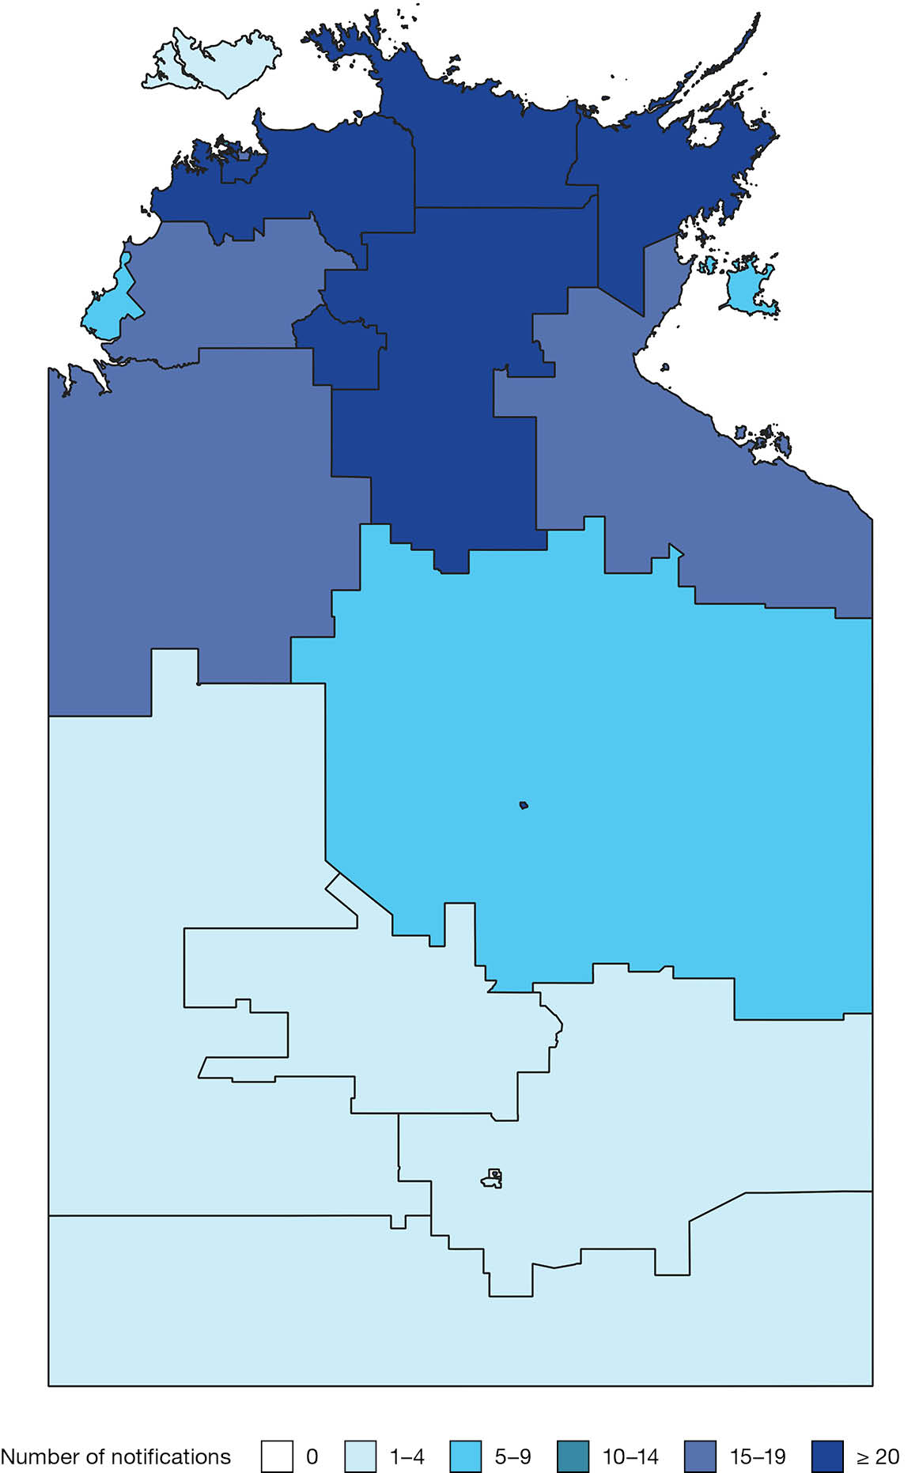
Map A.2: Salmonella Virchow notifications in the Northern Territory, Australia by Statistical Areas Level 2, 2005–2024
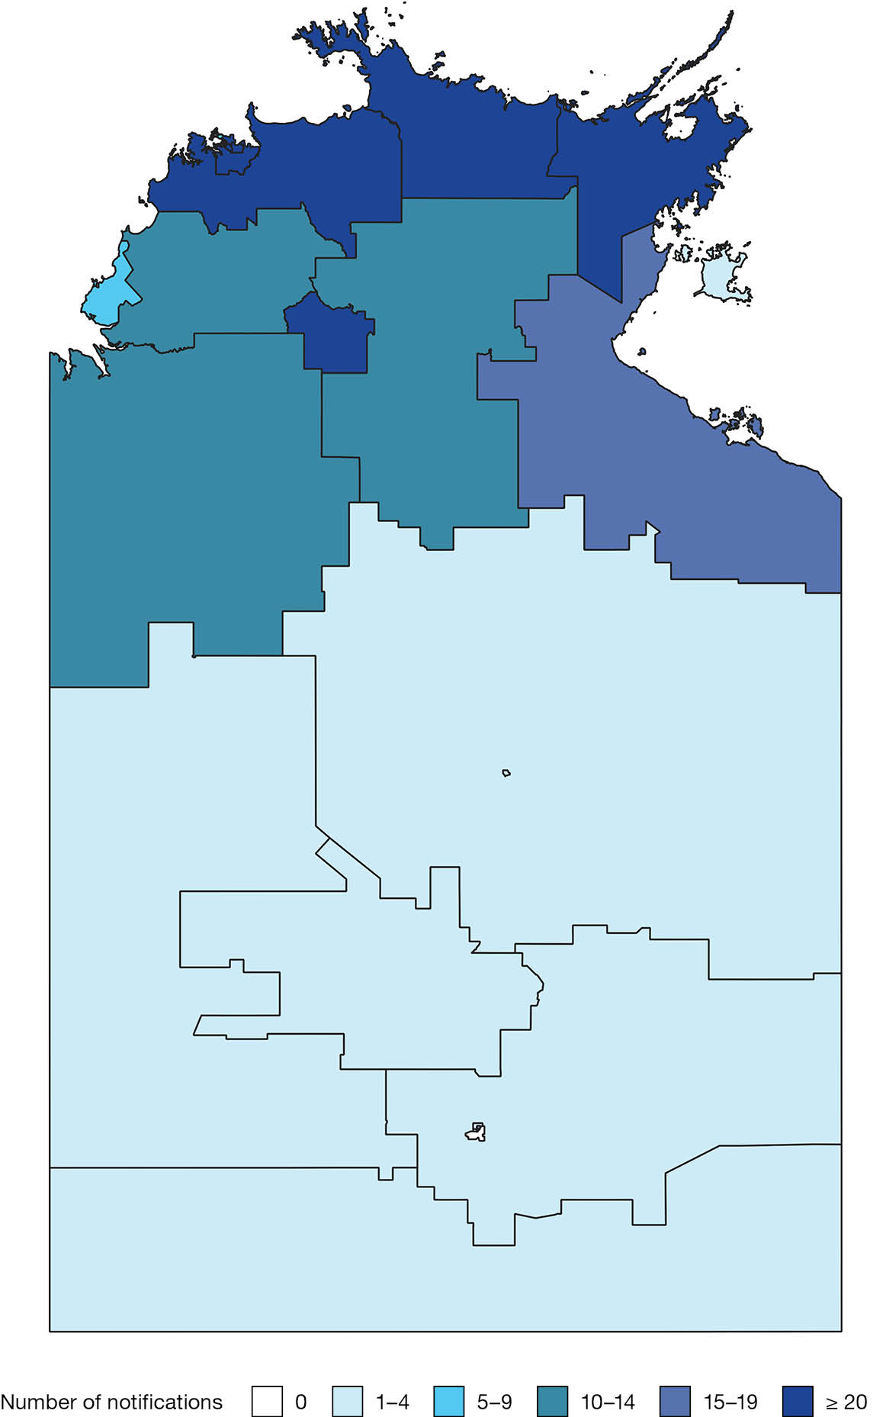
Map A.3: Salmonella Typhimurium notifications in the Northern Territory, Australia by Statistical Areas Level 2, 2005–2024
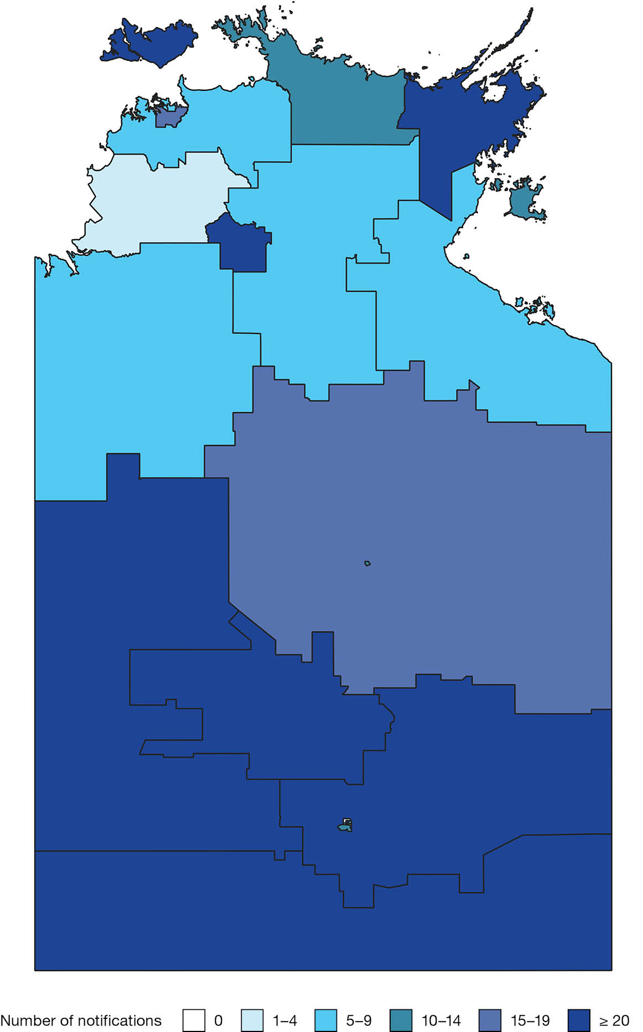
Map A.4: Salmonella Ball notifications in the Northern Territory, Australia by Statistical Areas Level 2, 2005–2024
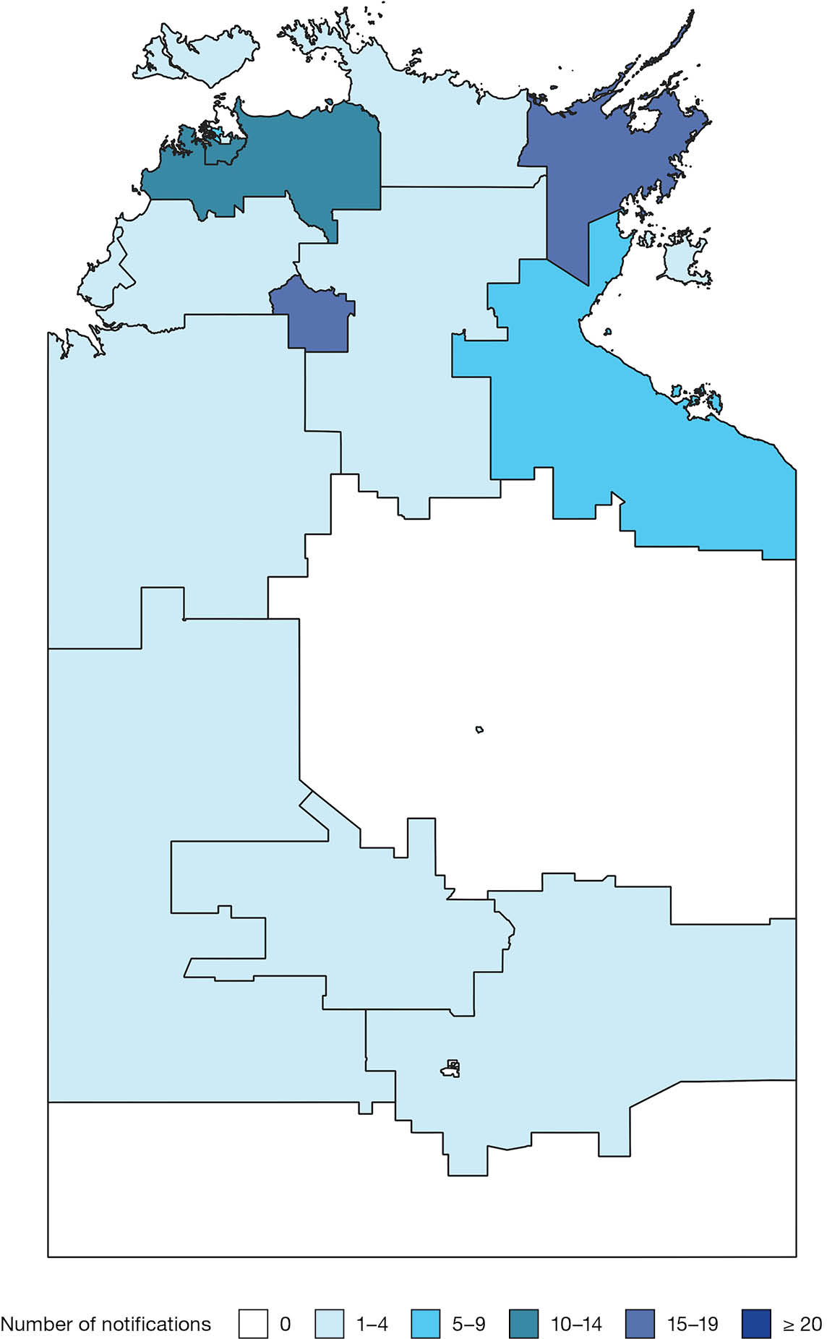
Map A.5: Salmonella Lansing notifications in the Northern Territory, Australia by Statistical Areas Level 2, 2005–2024
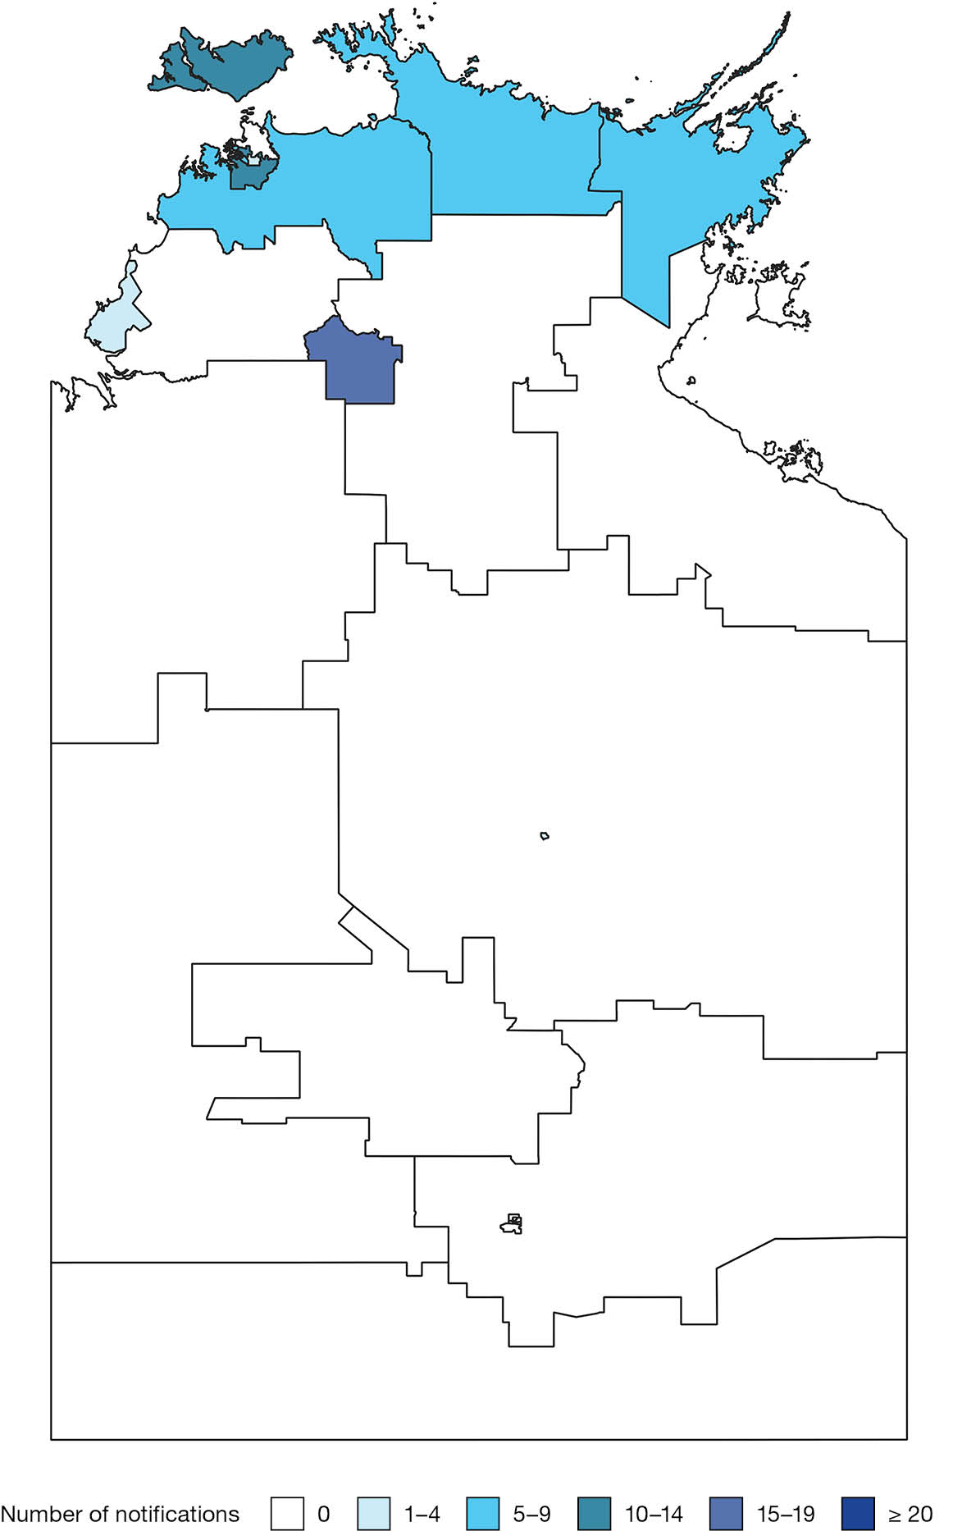
Map A.6: Salmonella subspecies 1 ser 16:l:v;- notifications in the Northern Territory, Australia by Statistical Areas Level 2, 2005–2024
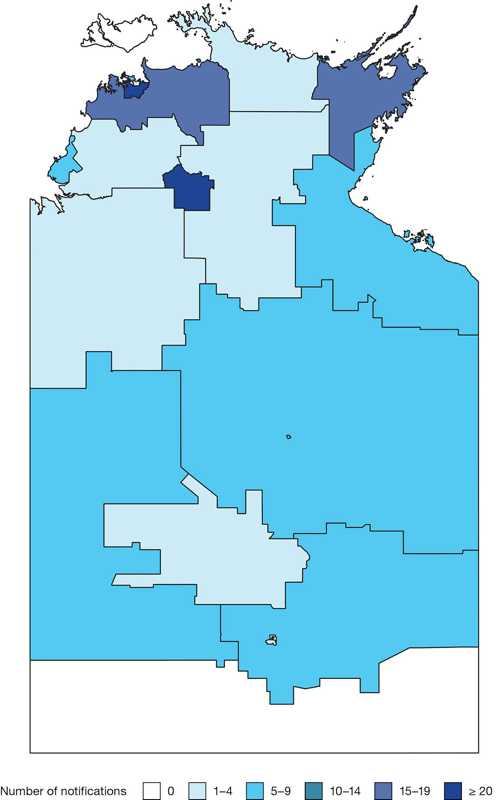
Map A.7: Salmonella Chester notifications in the Northern Territory, Australia by Statistical Areas Level 2, 2005–2024
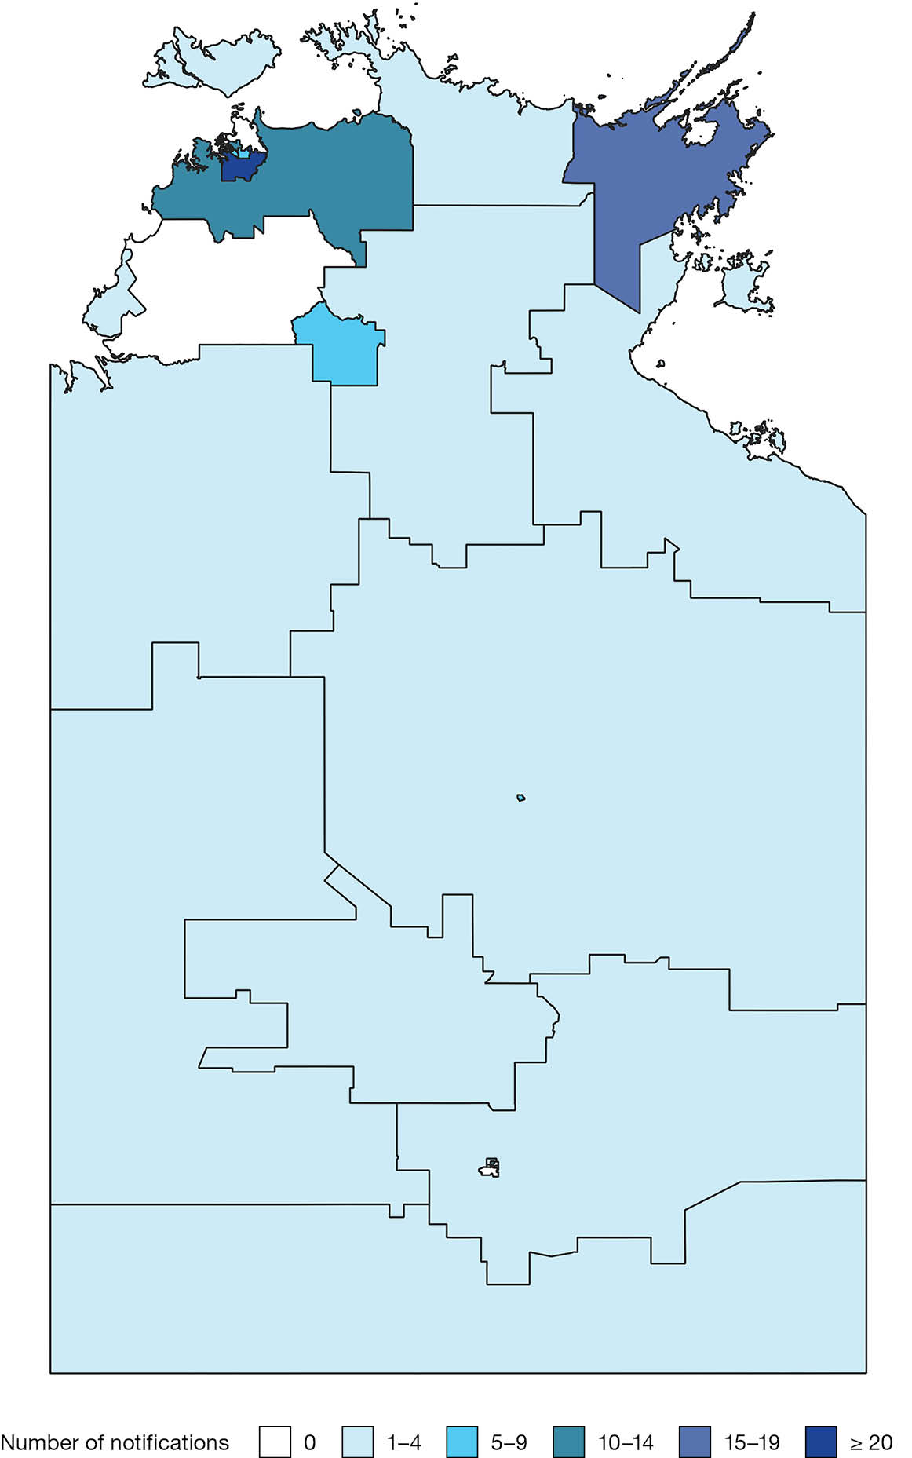
Map A.8: Salmonella Weltevreden notifications in the Northern Territory, Australia by Statistical Areas Level 2, 2005–2024
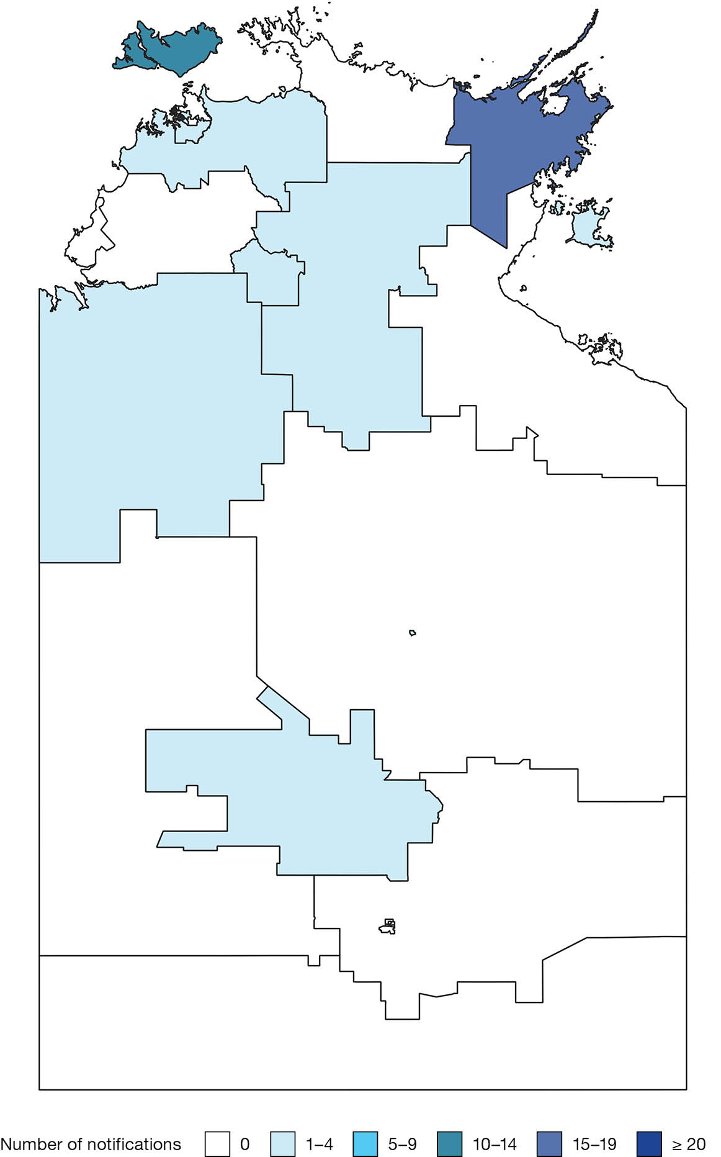
Map A.9: Salmonella Anatum notifications in the Northern Territory, Australia by Statistical Areas Level 2, 2005–2024
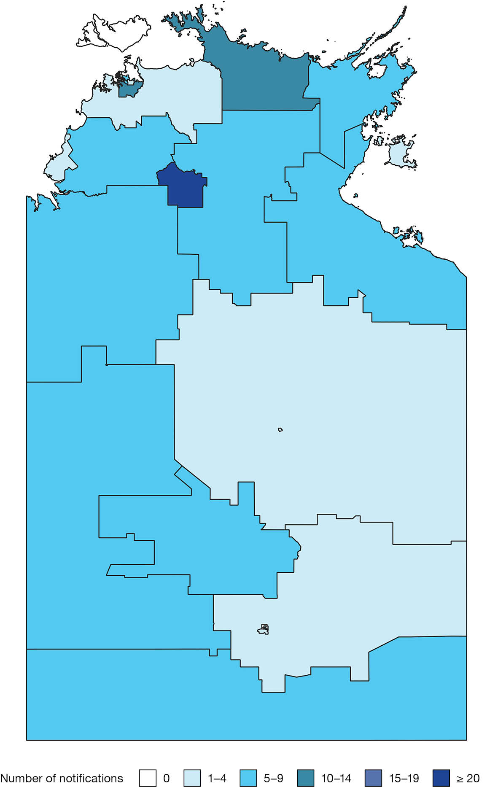
Map A.10: Salmonella Hvittingfoss notifications in the Northern Territory, Australia by Statistical Areas Level 2, 2005–2024
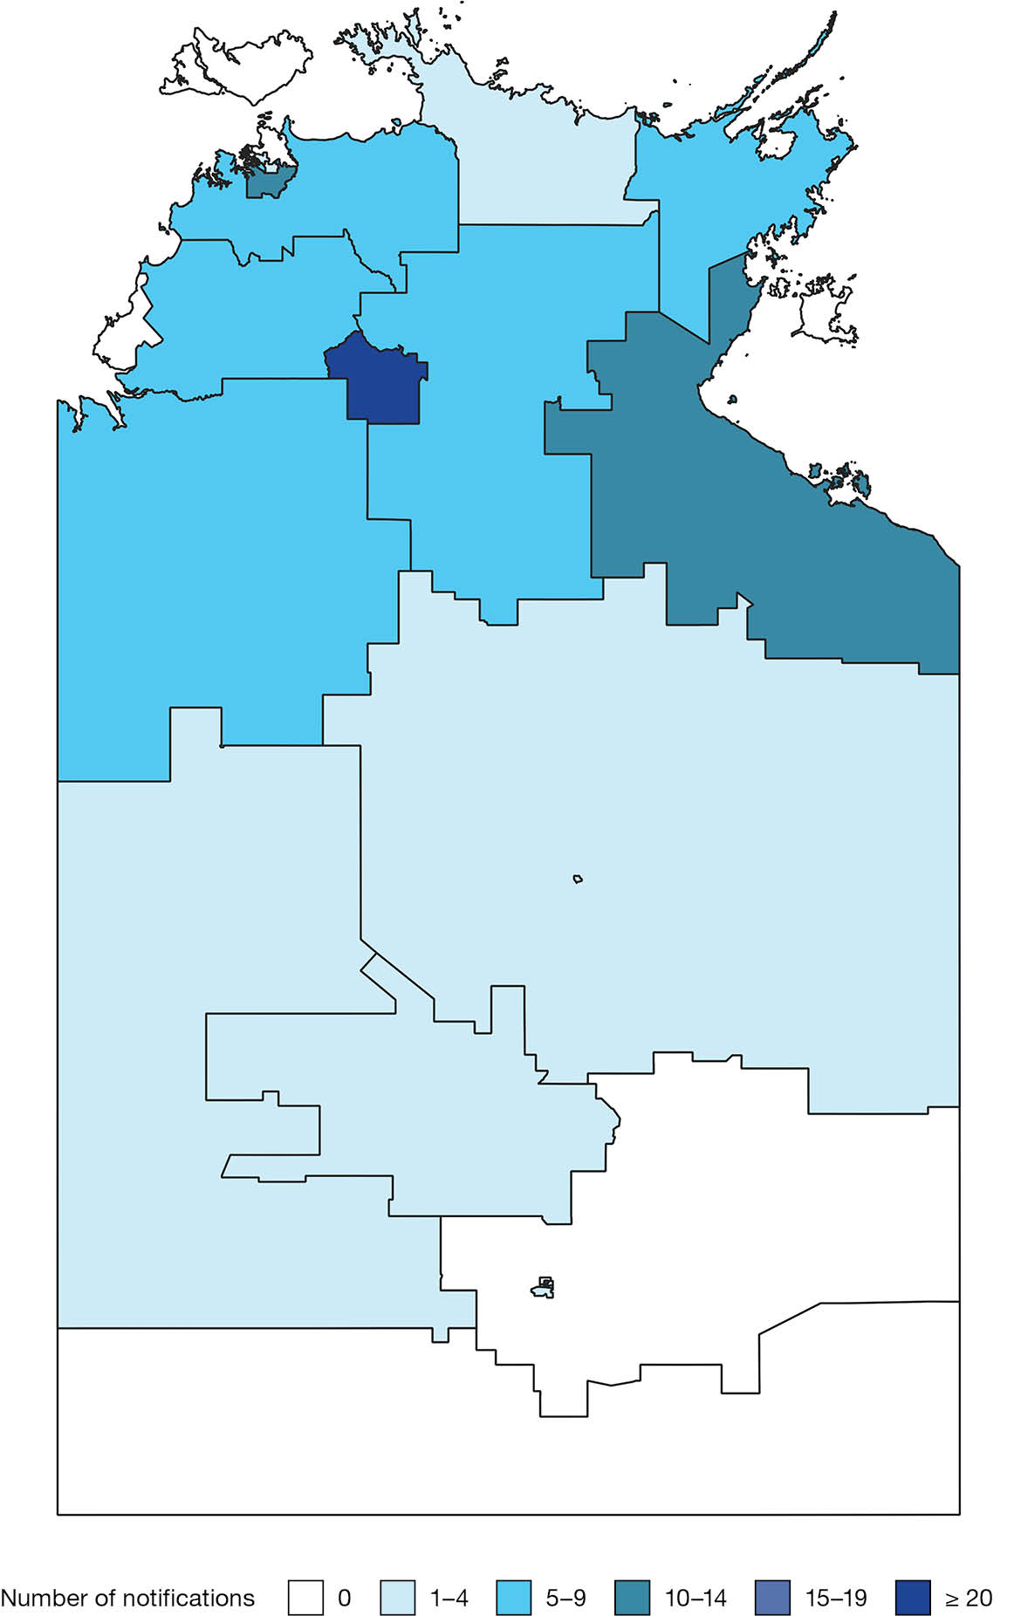
Map A.11: Salmonella Muenchen notifications in the Northern Territory, Australia by Statistical Areas Level 2, 2005–2024
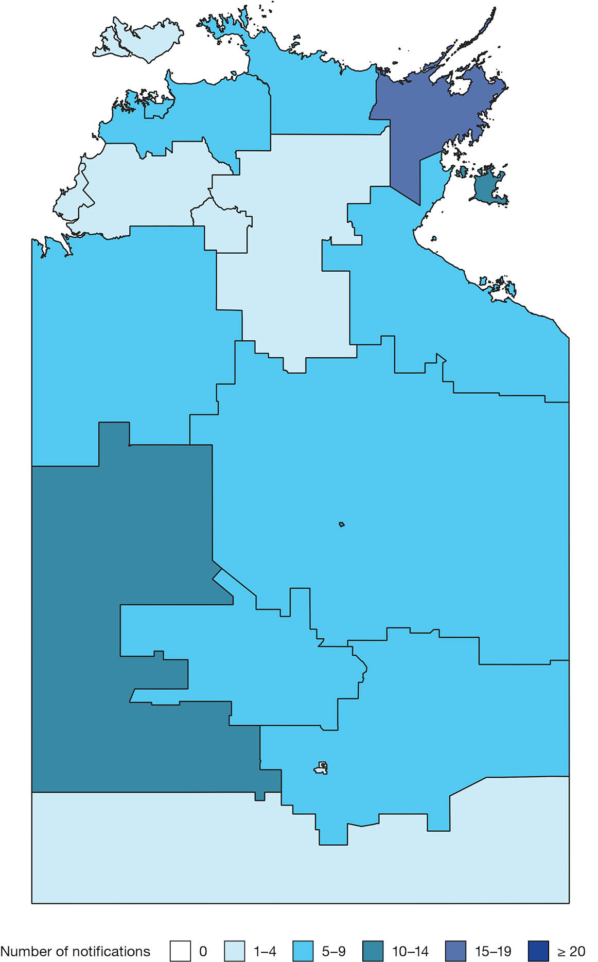
Map A.12: Salmonella Aberdeen notifications in the Northern Territory, Australia by Statistical Areas Level 2, 2005–2024
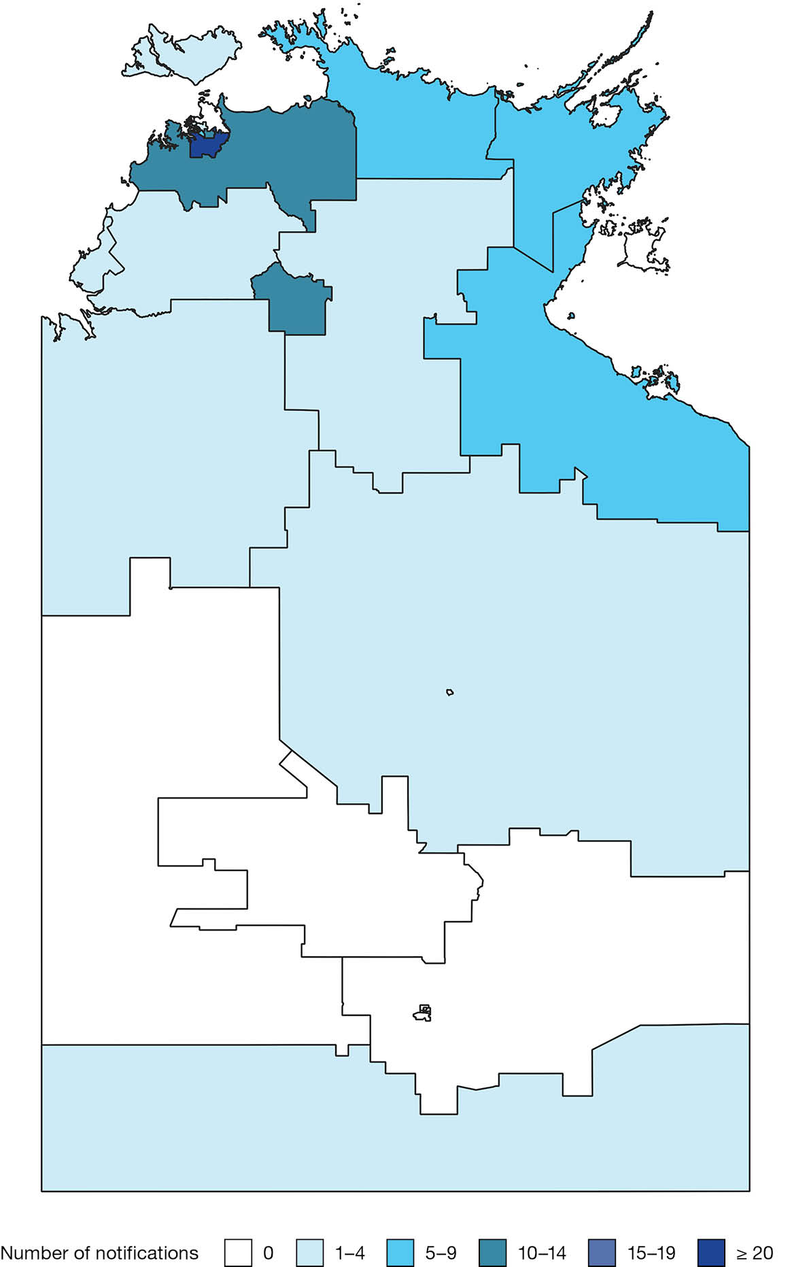
Map A.13: Salmonella Reading notifications in the Northern Territory, Australia by Statistical Areas Level 2, 2005–2024
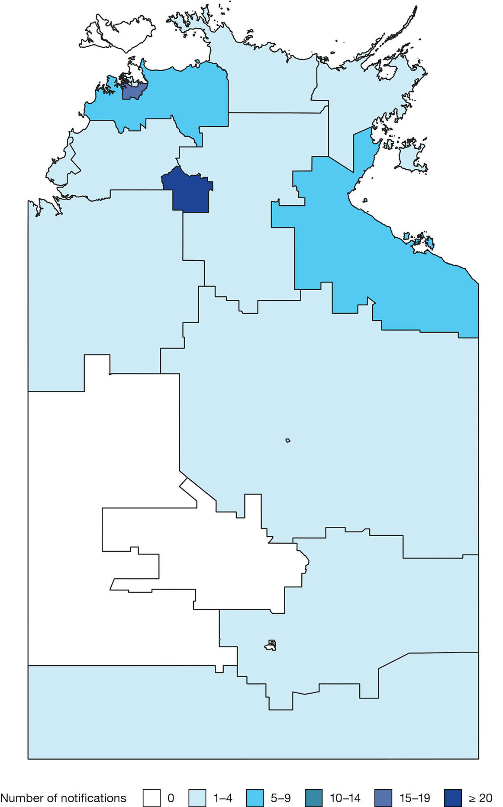
Map A.14: Salmonella Litchfield notifications in the Northern Territory, Australia by Statistical Areas Level 2, 2005–2024
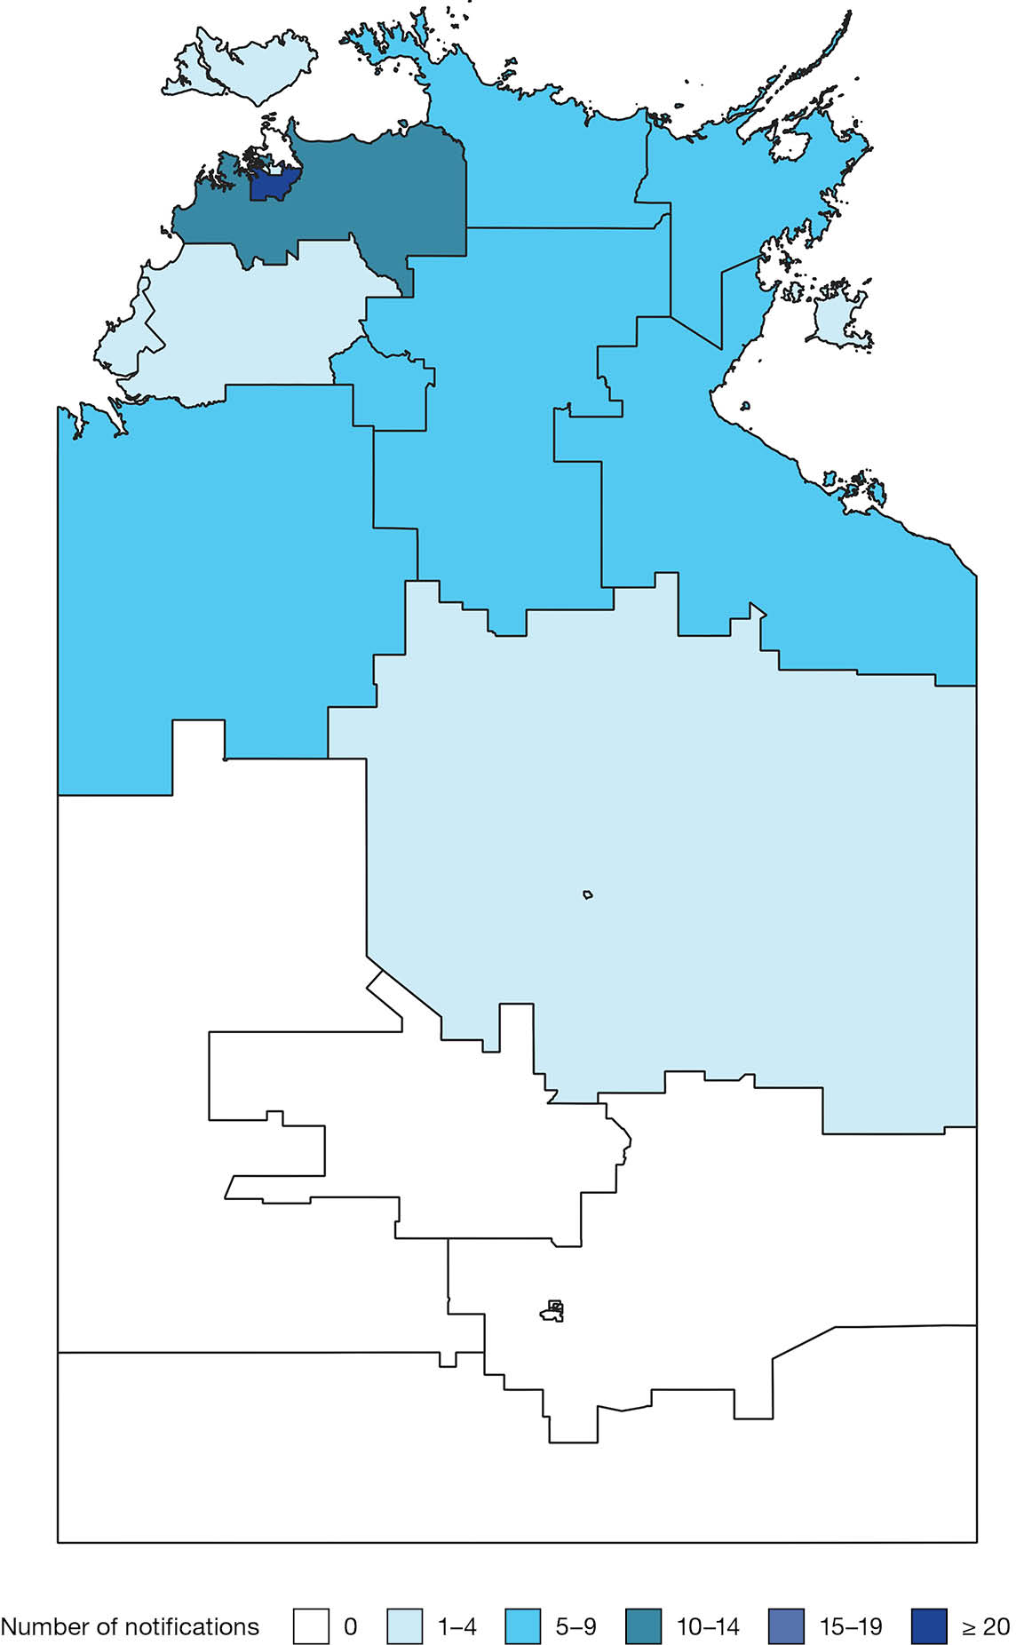
Map A.15: Salmonella Infantis notifications in the Northern Territory, Australia by Statistical Areas Level 2, 2005–2024
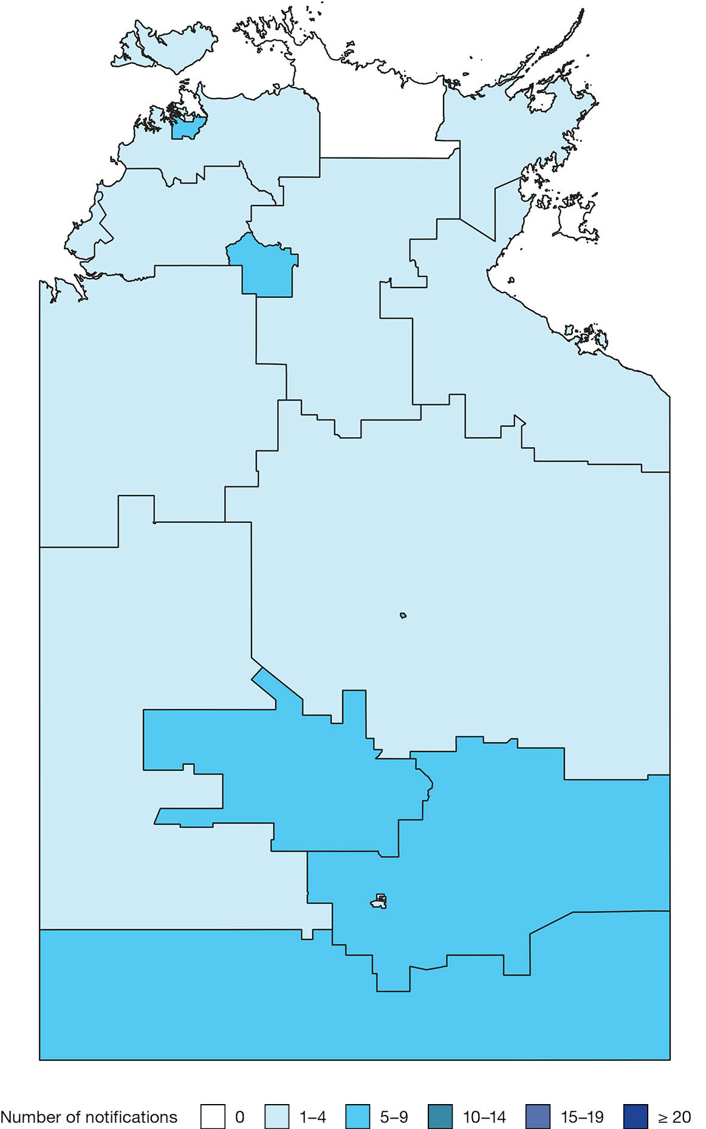
Map A.16: Salmonella Paratyphi B bv Java notifications in the Northern Territory, Australia by Statistical Areas Level 2, 2005–2024
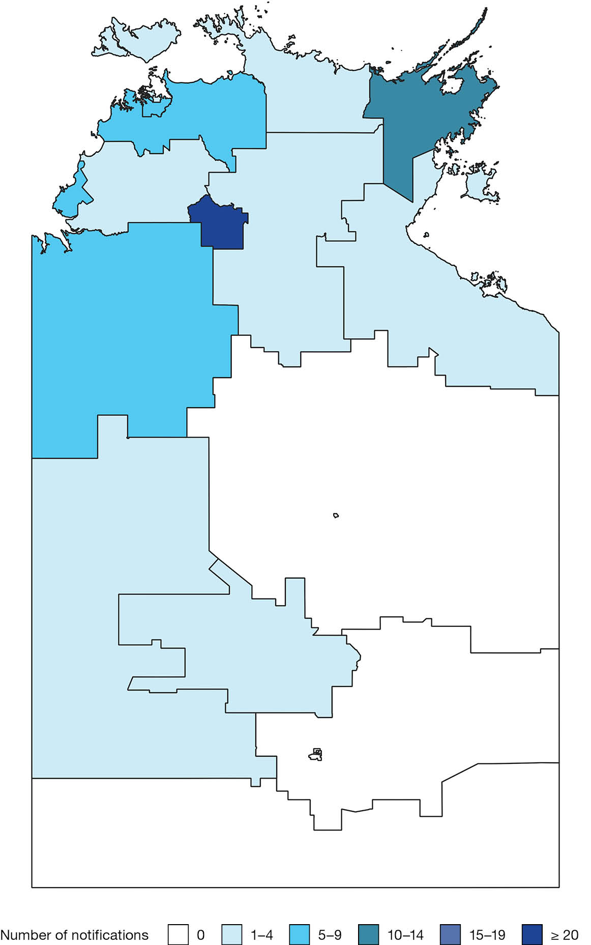
Map A.17: Salmonella Havana notifications in the Northern Territory, Australia by Statistical Areas Level 2, 2005–2024
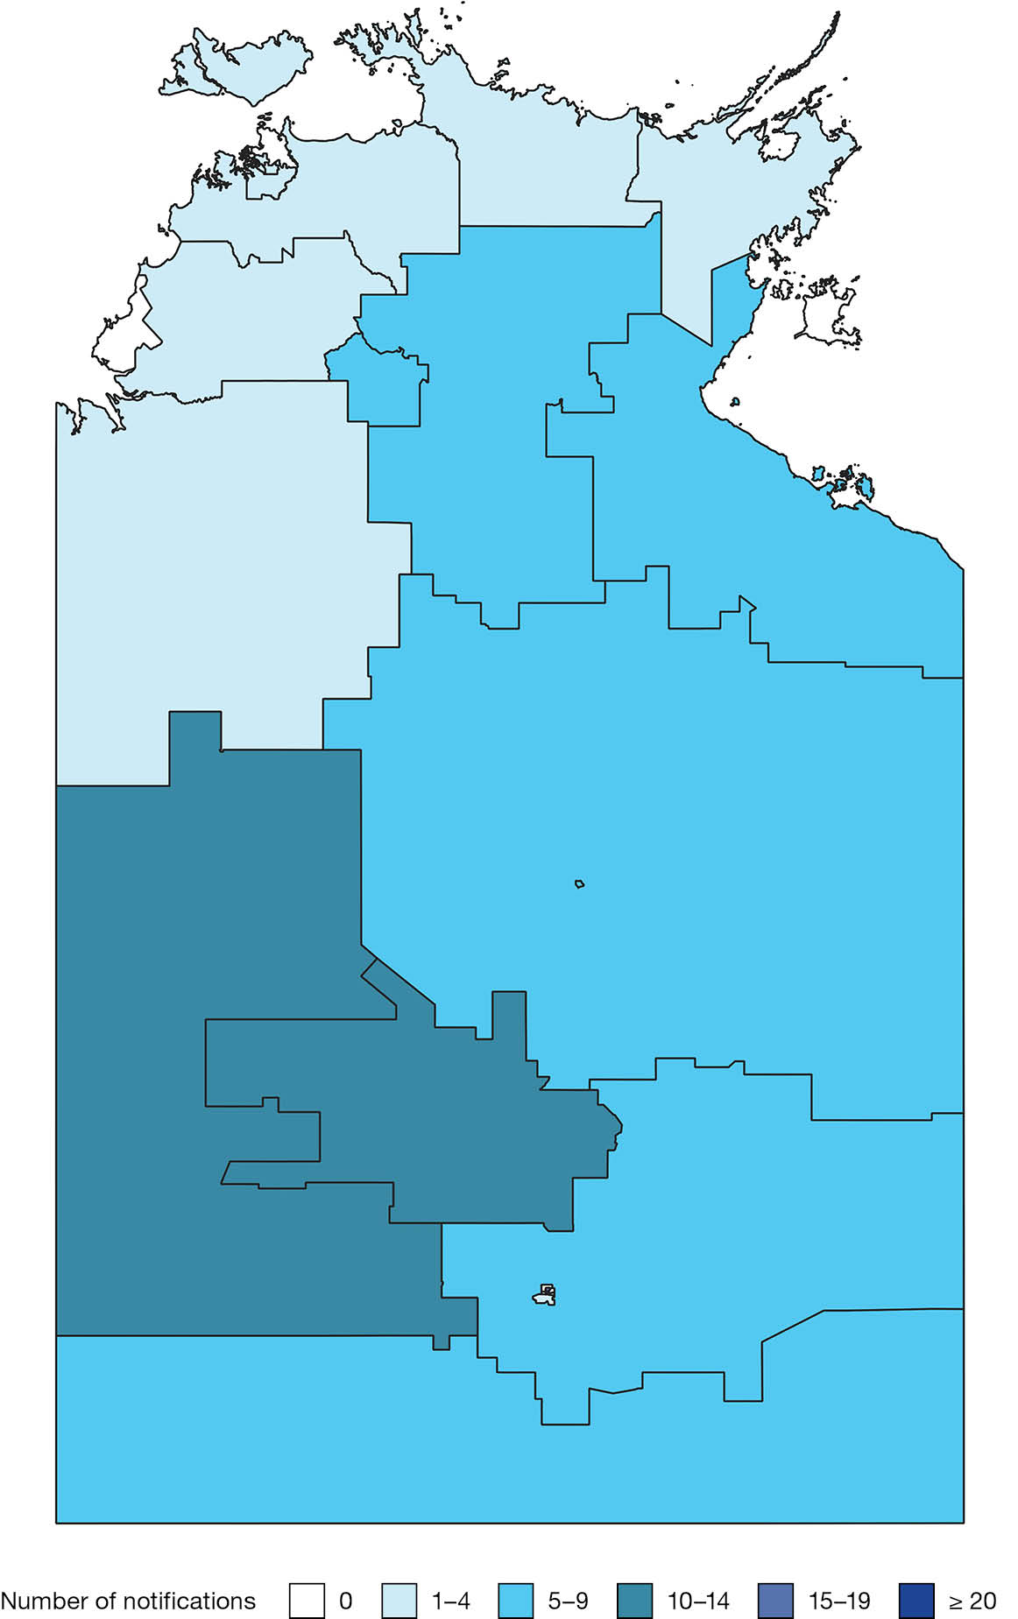
Map A.18: Salmonella Mgulani notifications in the Northern Territory, Australia by Statistical Areas Level 2, 2005–2024
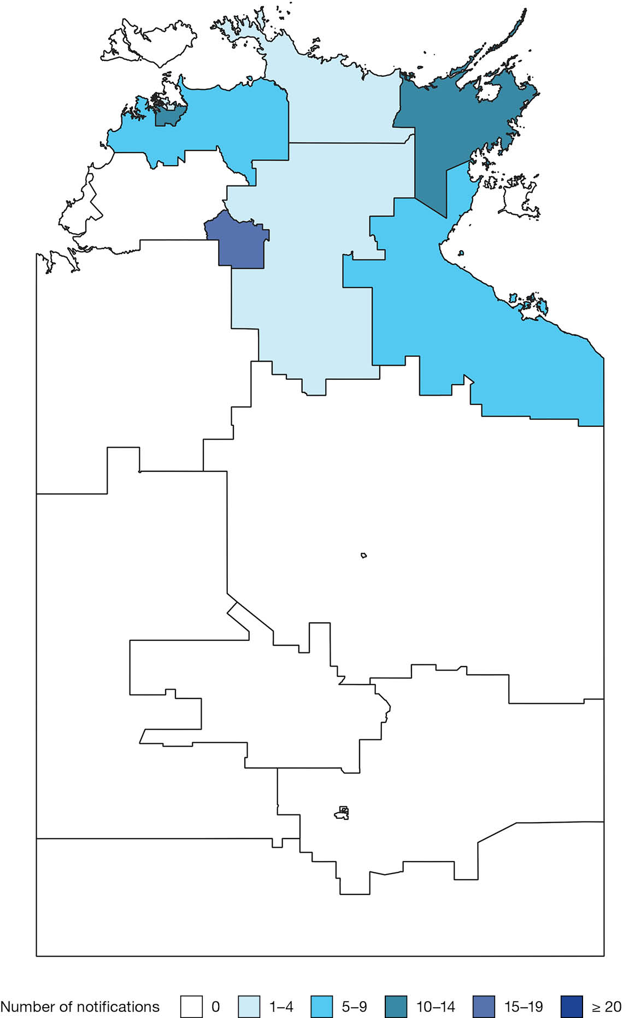
Map A.19: Salmonella Senftenberg notifications in the Northern Territory, Australia by Statistical Areas Level 2, 2005–2024
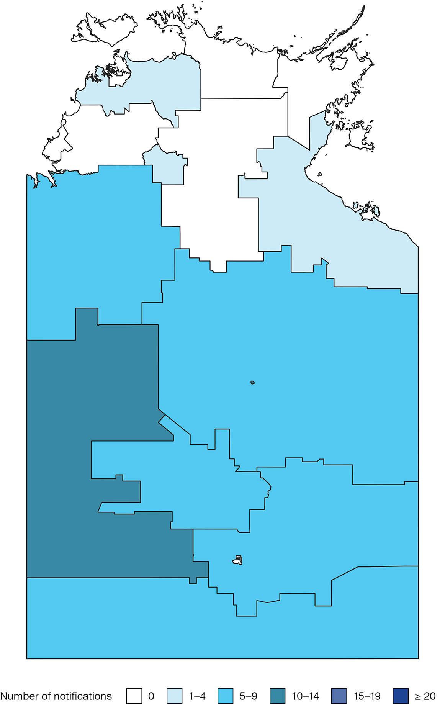
Map A.20: Salmonella Chailey notifications in the Northern Territory, Australia by Statistical Areas Level 2, 2005–2024
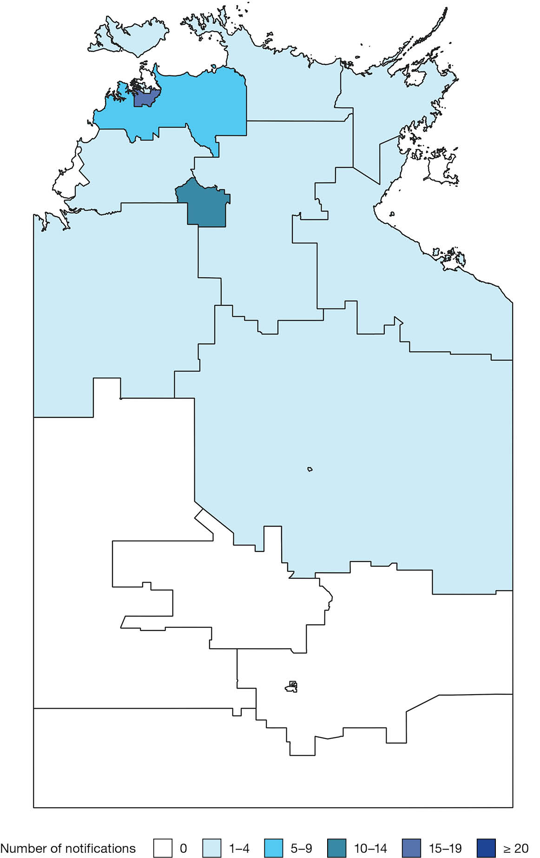
Map A.21: Salmonella Newport notifications in the Northern Territory, Australia by Statistical Areas Level 2, 2005–2024
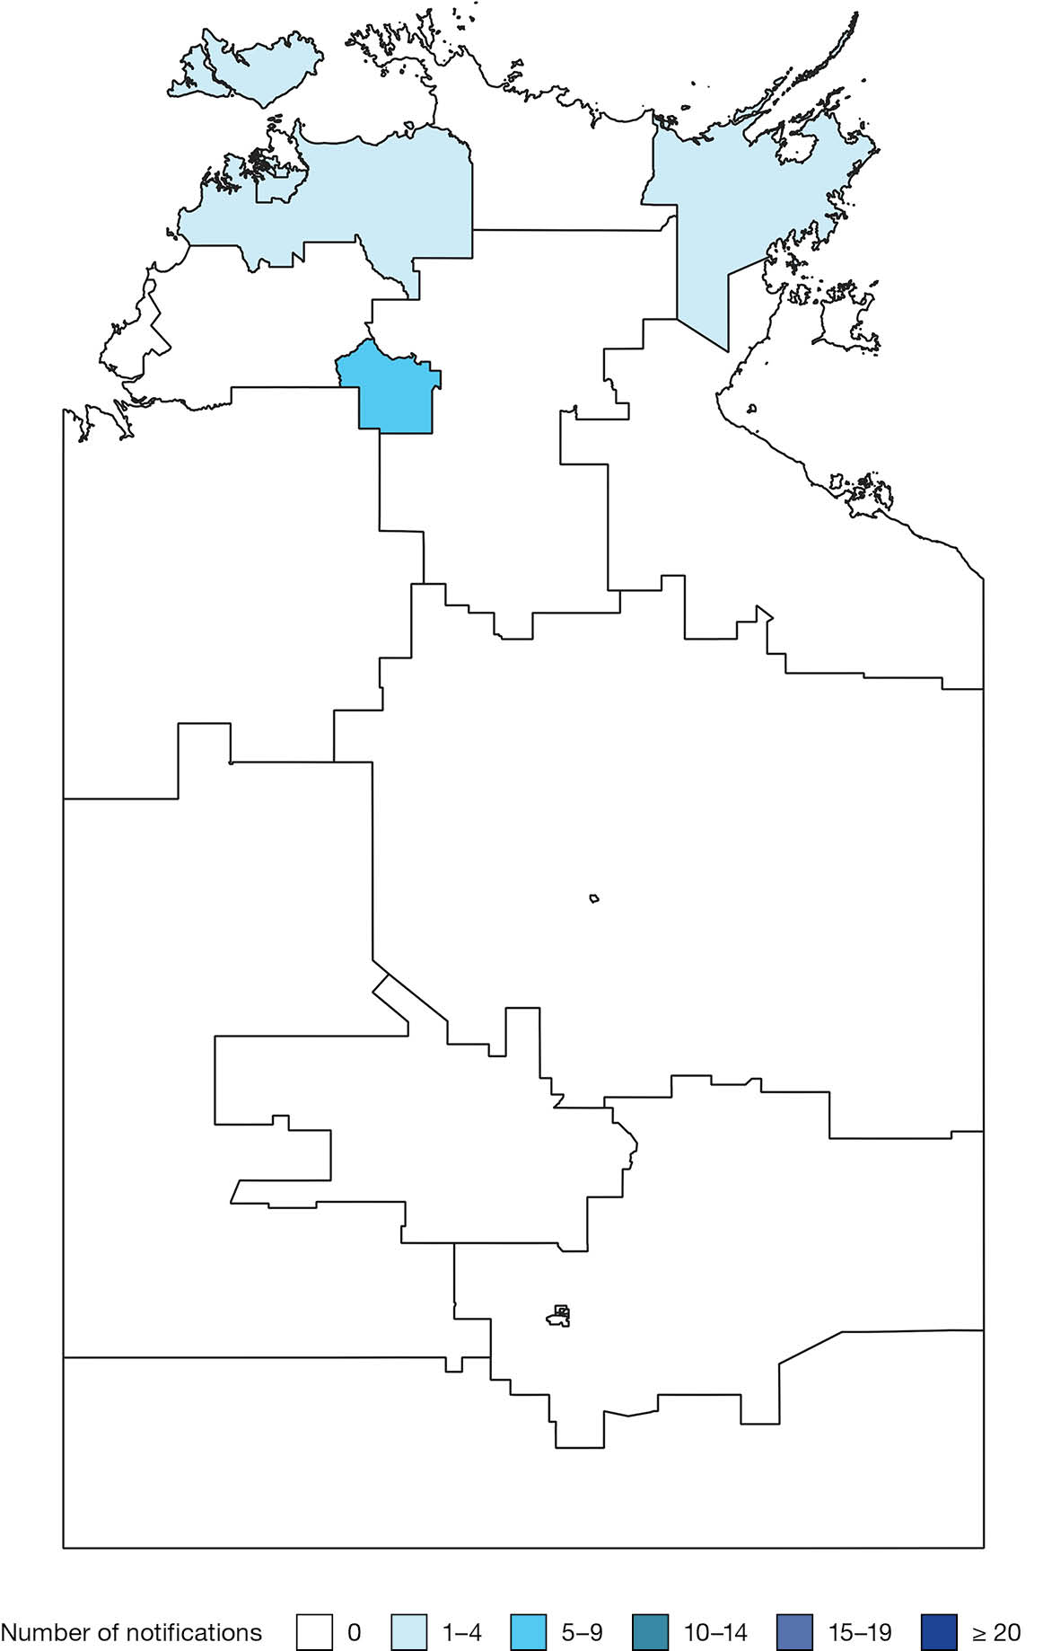
Map A.22: Salmonella Poona notifications in the Northern Territory, Australia by Statistical Areas Level 2, 2005–2024
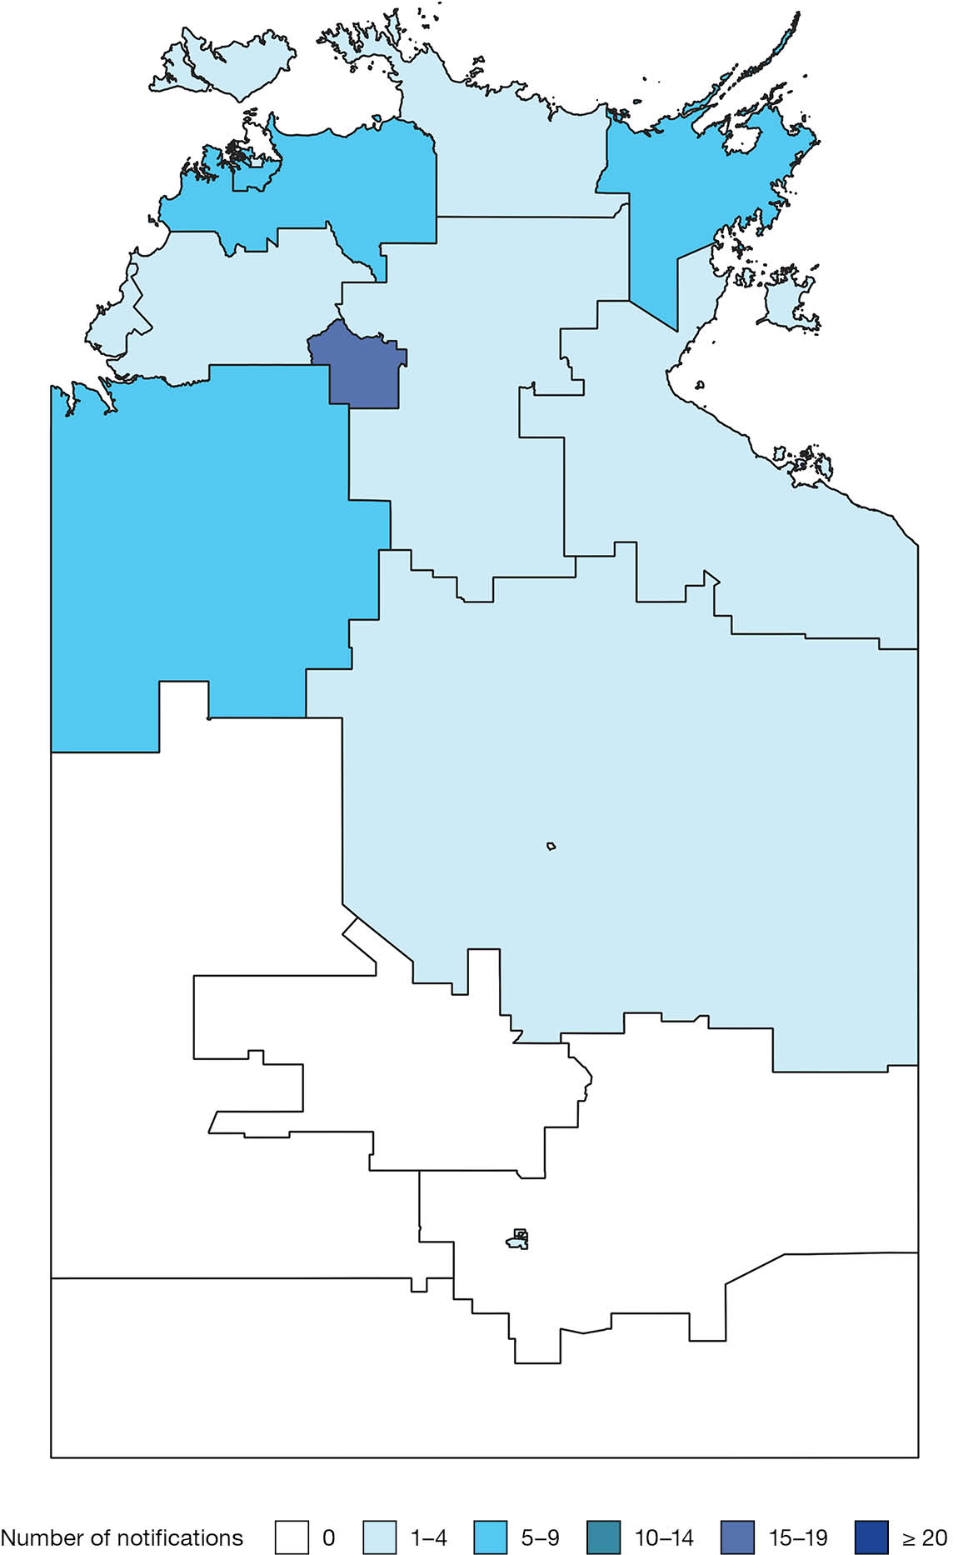
Map A.23: Salmonella Zanzibar notifications in the Northern Territory, Australia by Statistical Areas Level 2, 2005–2024
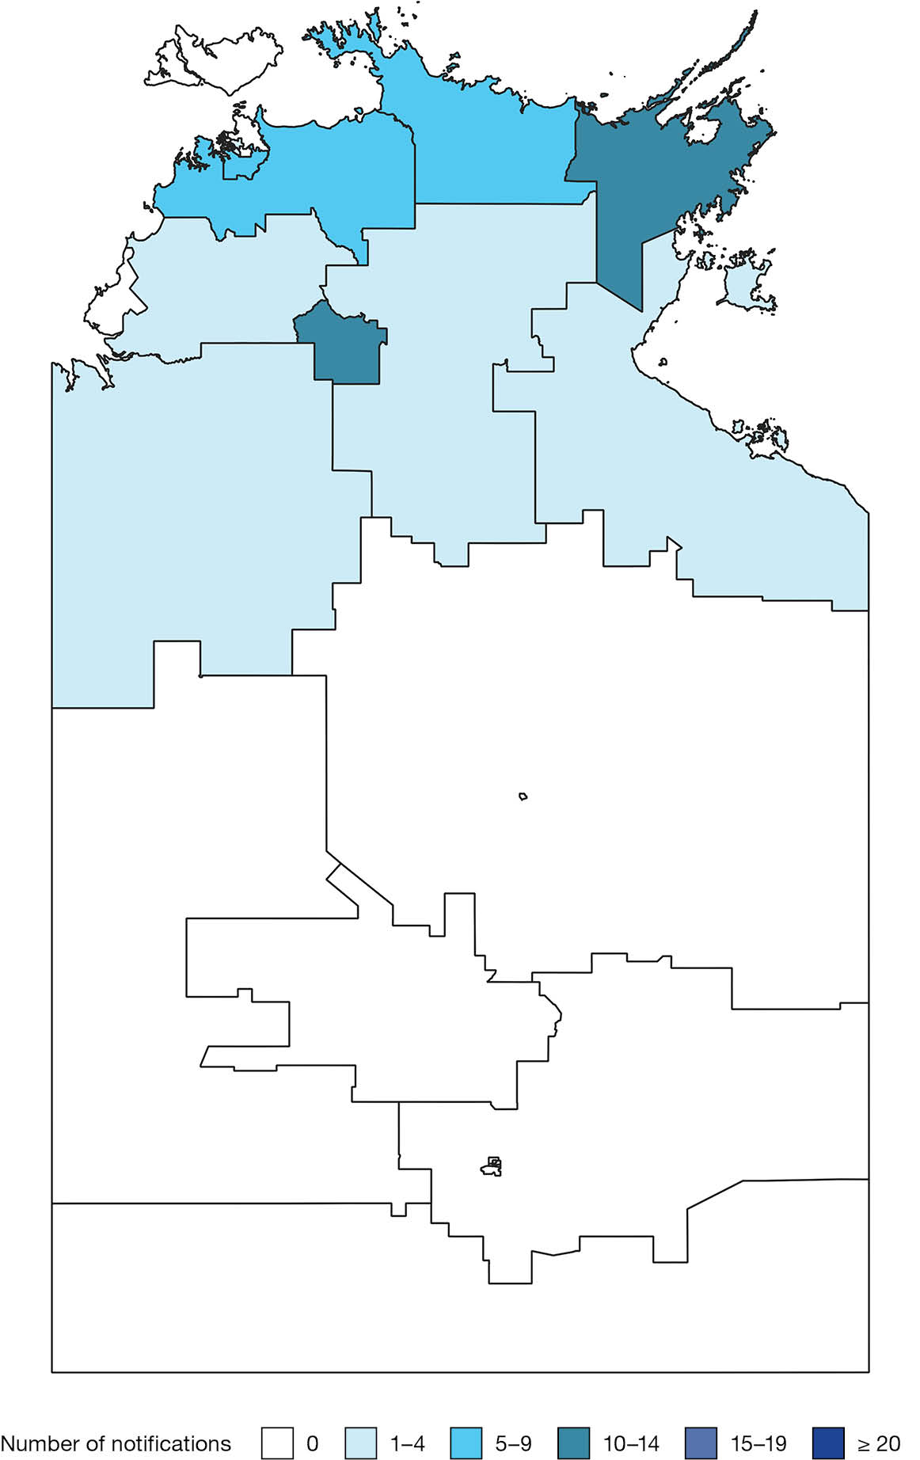
Map A.24: Salmonella Kinondoni notifications in the Northern Territory, Australia by Statistical Areas Level 2, 2005–2024
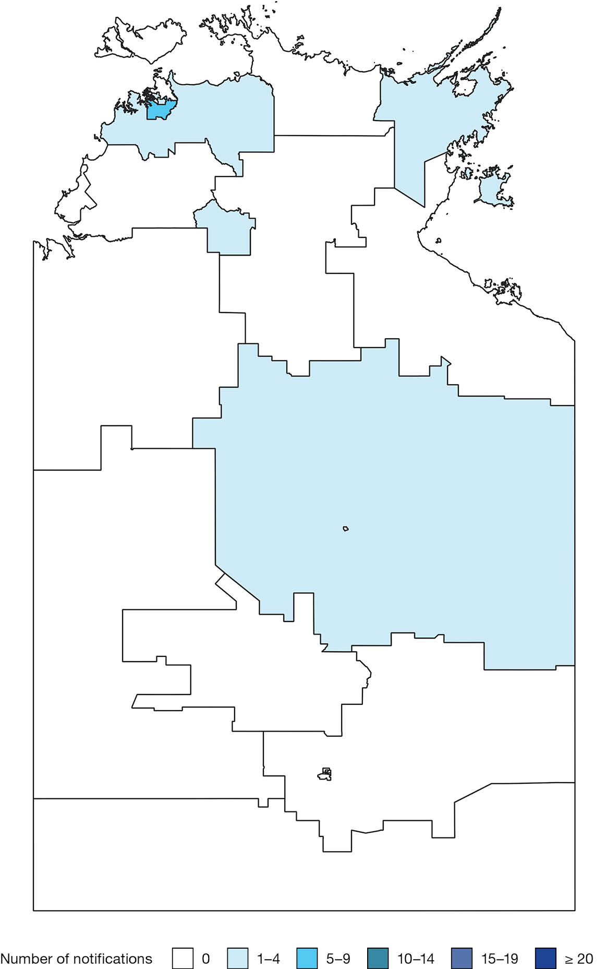
Map A.25: Salmonella Enteritidis notifications in the Northern Territory, Australia by Statistical Areas Level 2, 2005–2024
