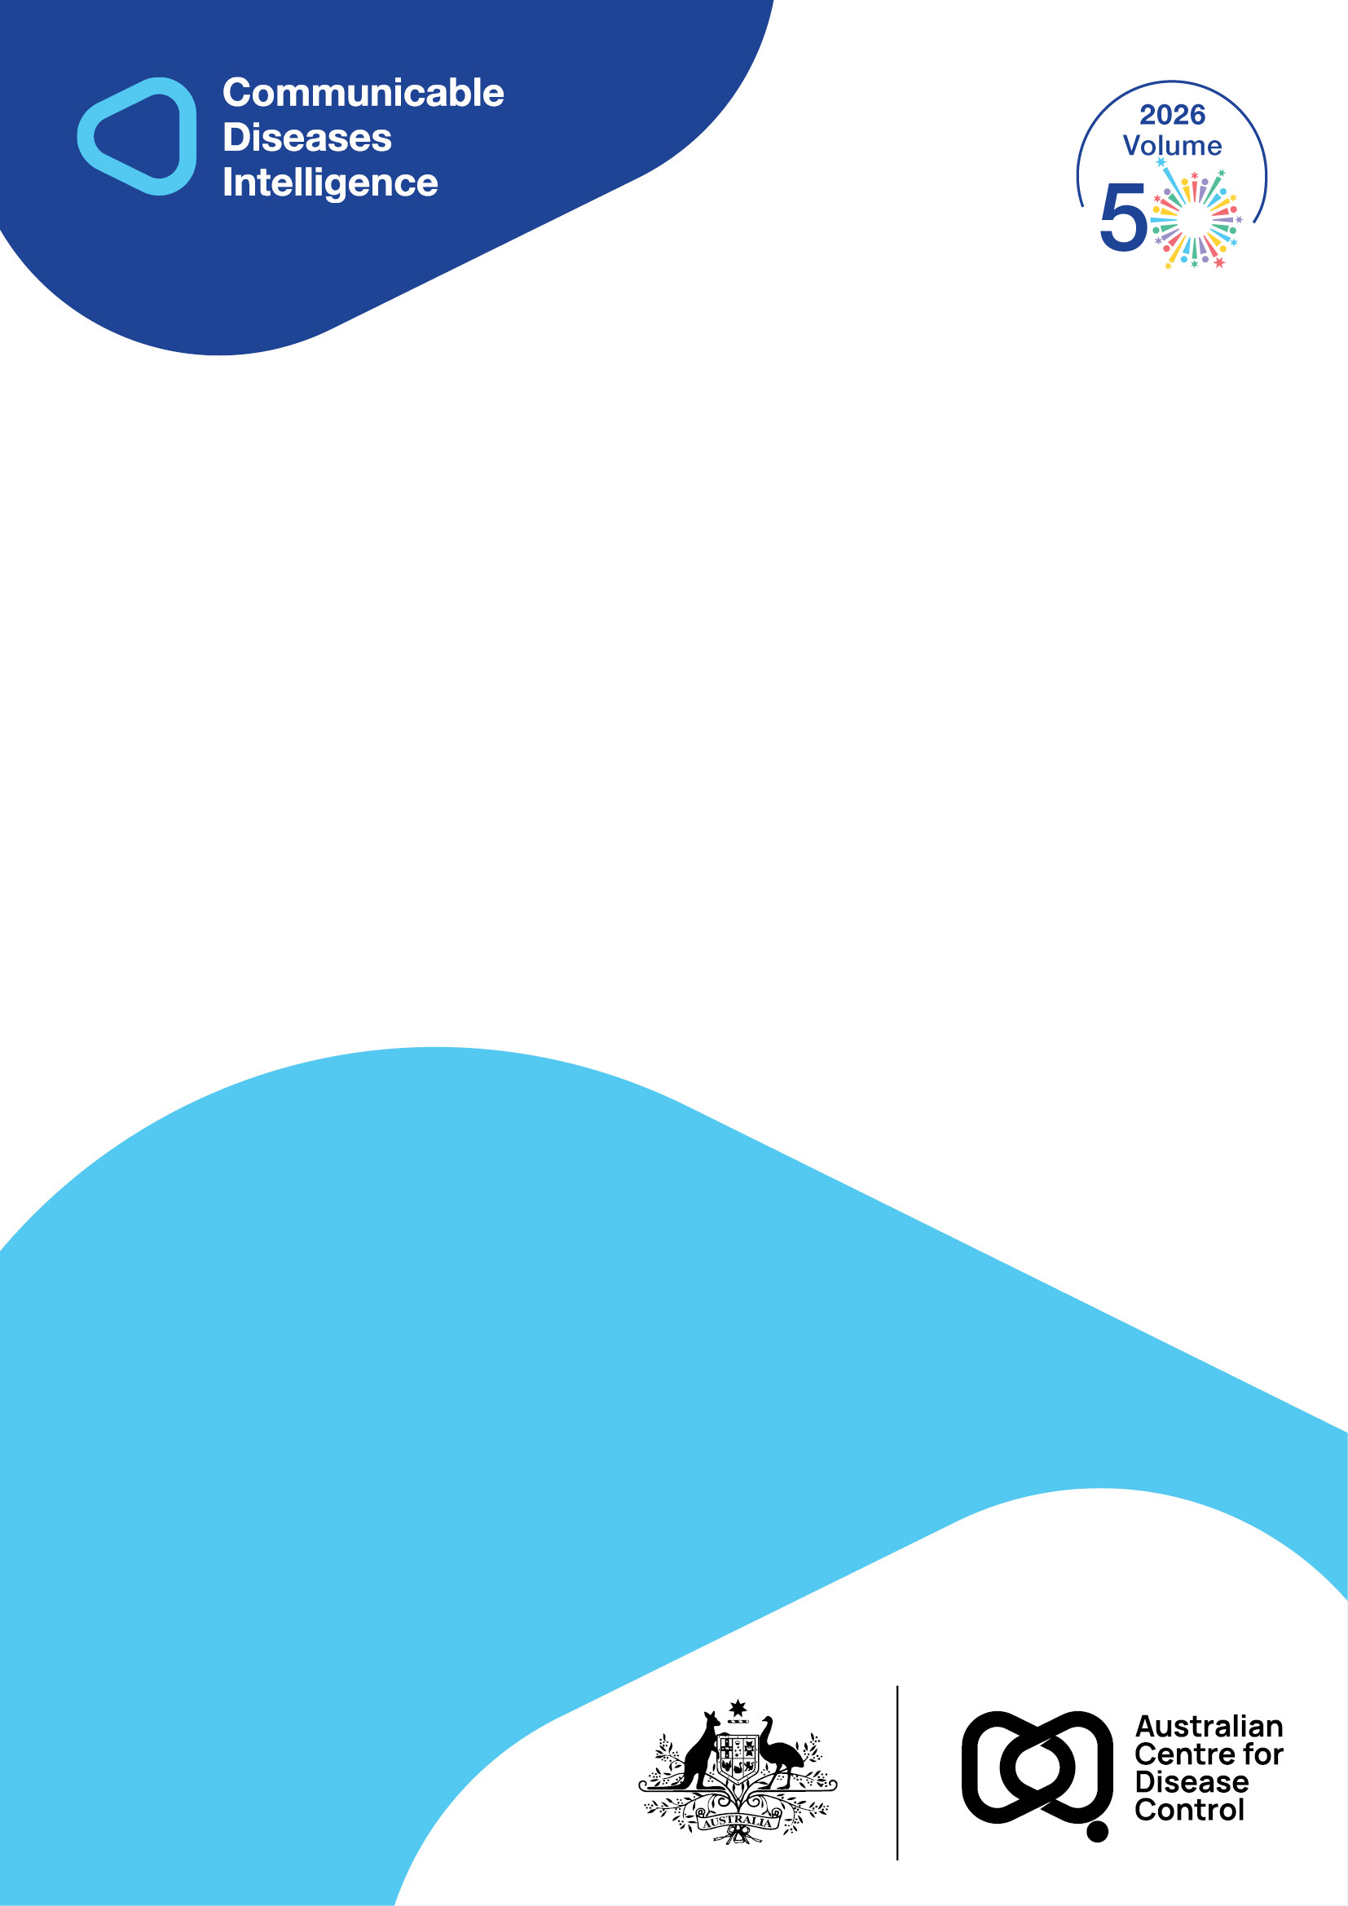
2026 • Volume 50 • cdc.gov.au/cdi • Epub date: 16.06.2026 • doi.org/10.33321/cdi.2026.50.030

An outbreak of Salmonella Waycross related to sandpit contamination in a Gold Coast childcare centre, Queensland, Australia, 2024
Heshani Rupasinghe, Kate E Alexander, Fiona May, Victoria Marriott, Amanda Robinson, Fiona Vosti, Tracy Bladen, Sharon Jurd, Rikki MA Graham, Brett Heron, Gino Micalizzi, Trudy Graham, Robert Bell, Candice Colbran
© 2026 Commonwealth of Australia as represented by the Australian Centre for Disease Control
ISSN: 2209-6051 Online
This journal is indexed by Index Medicus and Medline.
Creative Commons Licence
This publication is licensed under a Creative Commons Attribution-NonCommercial-NoDerivatives 4.0 International Licence (Licence). You must read and understand the Licence before using any material from this publication.
Restrictions
The Licence does not cover, and there is no permission given for, use of any of the following material found in this publication (if any):
- the Commonwealth Coat of Arms (by way of information, the terms under which the Coat of Arms may be used can be found on the Department of Prime Minister and Cabinet website);
- any logos (including the Australian Centre for Disease Control’s logo) and trademarks;
- any photographs and images;
- any signatures; and
- any material belonging to third parties.
Disclaimer
Opinions expressed in Communicable Diseases Intelligence are those of the authors and not necessarily those of the Australian Government or the Australian Centre for Disease Control. Data may be subject to revision.
Enquiries
Enquiries regarding any other use of this publication should be addressed to the CDI Editor.
About CDI
Communicable Diseases Intelligence (CDI) is a peer-reviewed scientific journal published by the Australian Centre for Disease Control.
The journal aims to disseminate information on the epidemiology, surveillance, prevention and control of communicable diseases of relevance to Australia and the near region.
Editor: Dr Elise Firman • Deputy Editor: Simon Petrie • Design and Production: Lisa Thompson
Editorial Advisory Board: David Durrheim, Mark Ferson, Clare Huppatz, John Kaldor, Martyn Kirk and Meru Sheel
Submit an Article
Guidelines for authors and details on how to submit your publication is available on our website, or by email to the
CDI Editor.
Contact us
Communicable Diseases Intelligence (CDI)
Australian Centre for Disease Control
GPO Box 798, CANBERRA ACT 2601
Website: cdc.gov.au/cdi
Email: cdi.editor@cdc.gov.au

Abstract
Salmonella Waycross is a serovar with limited published literature on its reservoirs and epidemiology. In April 2024, the Gold Coast Public Health Unit (GCPHU) identified an outbreak of S. Waycross at a childcare centre in Queensland, Australia, following notifications of acute enterocolitis in children under five years of age. Whole-genome sequencing linked two confirmed cases to environmental contamination in the centre’s sandpit. The multi-disciplinary investigation highlights the potential for non-foodborne transmission of Salmonella in childcare settings, emphasising the importance of environmental surveillance in enteric outbreaks. The outbreak response led to the removal of contaminated sand and implementation of enhanced infection control measures in line with national guidelines. These findings contribute to the understanding of S. Waycross epidemiology and illustrate the potential for persistence and transmission of the contaminant in outdoor play environments. More broadly, the investigation adds to growing evidence that sandpits can act as transmission pathways for enteric infections. It reinforces the importance of basic prevention practices, such as hand hygiene after sandpit use, and supports the need to consider additional evidence-based strategies to reduce the risk of sandpit-related illness in children.
Keywords: salmonellosis; Salmonella Waycross; outbreak; childcare centre

Background and methods
Salmonellosis occurs worldwide and is often classified as a foodborne illness that presents as an acute enterocolitis.¹ Human cases are often sporadic,¹ and the incidence of infection is highest in infants and young children.² There are over 2,500 identified serovars of Salmonella, many of which have known animal and/or environmental reservoirs. The onset of disease symptoms occurs 6–72 hours (usually 12–36 hours) after ingestion/exposure.³ Large outbreaks associated with contaminated food are well documented, while non-foodborne outbreaks are less common.⁴ Notable non-foodborne outbreaks associated with sand include S. Paratyphi B biovar Java associated with playground sand in New South Wales,⁵ and S. Typhimurium associated with playground sand internationally.^{6,7} Sandpits have also been implicated in non-Salmonella transmission pathways in the past.^{8,9} The national guideline for preventing disease in childcare recognises that sandpits may become a potential source of infection when contaminated with pathogens through wildlife and domestic animal faeces, and outlines basic infection control measures.¹⁰ However, there are no systems in place to monitor compliance with these recommendations or to conduct active sandpit surveillance.
Given the established potential for environmental reservoirs of Salmonella including sand, less-understood serovars like S. Waycross warrant further attention during public health investigation. S. Waycross was first identified in 1947,¹¹ yet there is limited understanding of this serovar’s reservoirs and epidemiology. There have been no reports of foodborne outbreaks attributed to S. Waycross. In Africa, it has been isolated in fish, likely contaminated from the water; and in beef, likely contaminated during slaughtering.^{12–14} In Guam, the same strain of S. Waycross isolated in human cases was found in soil samples collected around case homes and in refuse material collected from vacuum cleaners used in case homes, generating the hypothesis that these infections could be the result of outdoor environmental contamination brought into homes on footwear.^{15,16} Locally, a Queensland source attribution modelling study suggested a link between S. Waycross and nuts, via transmission from the environment rather than through consumption,¹⁷ and it was found in vacuum cleaner dust in a small outbreak in a Residential Aged Care Home on the Gold Coast.¹⁸ While no common source has been identified, routine surveillance data shows notifications of S. Waycross in humans in Queensland have continued to increase, from 82 in 2019 to 155 in 2023.¹⁸ To date, there are no detailed reports in the literature of S. Waycross outbreaks with an identified animal or environmental source.

Outbreak detection
On 9 March 2024, a two-year-old boy (Child 1) developed enterocolitis requiring hospitalisation and was diagnosed with salmonellosis. On 5 April 2024, an 11-month-old girl (Child 2) developed enterocolitis and was also diagnosed with salmonellosis but did not require hospitalisation. Both children attended the same Gold Coast childcare centre. On 17 April 2024, Child 1’s mother notified the Gold Coast Public Health Unit (GCPHU), expressing concern that the common source of infection was cold meats served at the childcare centre. At this time, typing of Child 1’s sample had confirmed S. Waycross, while Child 2’s sample typing was still pending. On 22 April 2024, Salmonella isolated from Child 2 was also typed as S. Waycross and GCPHU declared an outbreak investigation and formed an Outbreak Management Team (OMT). The OMT comprised of GCPHU’s epidemiology, environmental health, medical and nursing teams; the Queensland OzFoodNet team (members of the national collaborative network of epidemiologists conducting enhanced surveillance into foodborne disease); and specialist staff from the state reference laboratory.

Case finding
In Queensland, childcare centres are encouraged to notify their local Public Health Unit (PHU) if there are two or more cases of gastroenteritis among children or staff over a period of one to three days. This is considered the clinical definition of a potential gastrointestinal illness outbreak.¹⁰ The childcare centre is asked to exclude symptomatic children; to request parents/guardians of symptomatic children see a clinician to organise faecal testing; to consider potential food or environmental sources; and to review their cleaning practices and products. Upon GCPHU’s outbreak declaration, the childcare centre attended by Child 1 and Child 2 was contacted to notify of the potential outbreak and standard advice was provided. The childcare centre denied any retrospective cases of acute gastroenteritis that would have met the clinical definition outlined above, and were encouraged to report any prospective cases in either children or staff.
Additional case finding was conducted with the support of Queensland OzFoodNet. Epidemiologists checked notification data for all S. Waycross-positive individuals of childcare age with a residential postcode in the same area as the childcare centre. This identified an eight-month-old girl (Child 3) with enterocolitis symptoms and an onset date of 19 April 2024. Interview with the parent of Child 3 identified that the child attended the same childcare centre. The childcare centre was contacted periodically and did not report any further cases of acute gastroenteritis with an onset date after the outbreak was declared.

Ethics
This investigation was conducted as part of operational public health unit work and under the Queensland Public Health Act (2005) in response to an acute threat to public health. Ethics approval was not required.

Description of outbreak
The outbreak was declared on 22 April 2024 and was closed on 27 May 2024 after the source was identified, no new cases were found and all public health actions were complete. There were two confirmed cases (Child 1 and Child 3) and one case who was excluded (Child 2) after additional information (sequence type) was obtained (see case definitions, Box 1). The onset dates of the two confirmed cases were respectively 9 March and 19 April 2024.
Box 1: Case definitions
Confirmed case: A person with a culture positive faecal specimen identified as S. Waycross with whole-genome-sequencing (WGS) showing genetic relatedness (cgMLST cluster type 17725) to another human or environmental sample linked to the same childcare centre.
Probable case: A person with a culture positive faecal specimen identified as S. Waycross that has not undergone WGS, who attends the same childcare centre.
Suspected case: A person symptomatic with enterocolitis (nausea, vomiting and/or diarrhoea) who attends the same childcare centre, either with no faecal specimen collected OR with a positive faecal specimen for Salmonella where serovar could not be typed.
Exclusion criteria: A person with S. Waycross was excluded if WGS identified a sequence type unrelated to others isolated at the same childcare centre.

Public health response
On 23 April, an Environmental Health Officer (EHO) conducted an inspection of the childcare centre. The childcare centre cares for 75–100 children per day and is organised by age into Nursery, Junior Kindy, Senior Kindy and Kindergarten. Child 1 attended the Junior Kindy room and Child 3 attended the Nursery room. The EHO inspection and sampling plan was informed by the OMT, considered previous local experience with S. Waycross, and aimed to test an evidence-based local hypothesis that environmental contamination associated with household pest excreta may contribute to transmission. The initial priority was to consider a potential environmental source with a food or water play source considered less likely, as these have not been associated with S. Waycross previously. The EHO reviewed infection control, cleaning and pest management practices at the childcare centre, and collected environmental samples. Samples were collected from vacuum cleaner dust, sandpits, debris from synthetic grass, rubber asphalt and hard surfaces, including playgrounds and eating tables. Both the childcare centre vacuum cleaner and a clean PHU vacuum cleaner was used to collect dust. The PHU vacuum cleaner was sanitised and swabbed before use in each area. The sandpits were both outdoors, approximately 2.0 m × 1.5 m, fenced, uncovered, partially shaded, and with no overhanging trees. The childcare centre was located in a residential area bordering parkland and a small waterway. A standardised method was created to sample the two childcare sandpits. Each sandpit was divided up into a grid of nine squares, and an autoclave spoonful of sand was collected from the surface two centimetres in the middle of each square, as the OMT decided this would be the depth small children would routinely be exposed to during play. These collections were submitted as a larger composite sample for each sandpit. All environmental samples were submitted to the Public and Environmental Health Reference Laboratories (PEHRL) in Brisbane, Queensland.
On 30 April, Salmonella was detected in the environmental samples from both sandpits, while the other environmental samples were negative. The same day, an EHO advised the childcare centre to close both sandpits until all sand was replaced. The EHO also provided advice on sandpit maintenance to reduce the risk of infection, in line with national guidelines for preventing infectious diseases in childcare centres.¹⁰ Typing revealed S. Waycross in the 'Nursery' sandpit, while S. Birkenhead was detected in the 'Junior Kindy' sandpit. The ‘Nursery’ sandpit was in heavy use while the ‘Junior Kindy’ sandpit was not in use prior to and during the declared outbreak. Despite the ‘Junior Kindy’ sandpit not being used, local S. Birkenhead notifications were reviewed for completeness and all notifications were considered unlikely to be relevant to the outbreak. Therefore the case definitions were unchanged.
The PEHRL then conducted WGS on S. Waycross specimens for the three human and two environmental samples relevant to this investigation and compared results to all sequenced S. Waycross samples in Queensland for the period 2018–2024.¹⁹ Routine sequencing of S. Waycross has been done by the PEHRL since 2024. WGS found that the S. Waycross detected in the ‘Nursery’ sandpit and from Child 1 and Child 3 had between zero and three core genome Multilocus Sequence Typing (cgMLST) allele differences, suggesting a high level of genetic relatedness. Child 1 and 3 were considered confirmed cases. While it was unconfirmed if the cases played in the ‘Nursery’ sandpit, this was considered highly likely. The S. Waycross detected in the Child 2 sample was genetically dissimilar, with 20–23 cgMLST allele differences, and was excluded as an outbreak case.
Figure 1: Neighbour joining tree of Whole Genome Sequencing (WGS) results during a Salmonella Waycross outbreak at childcare centre in the Gold Coast, Queensland, Australia in 2024
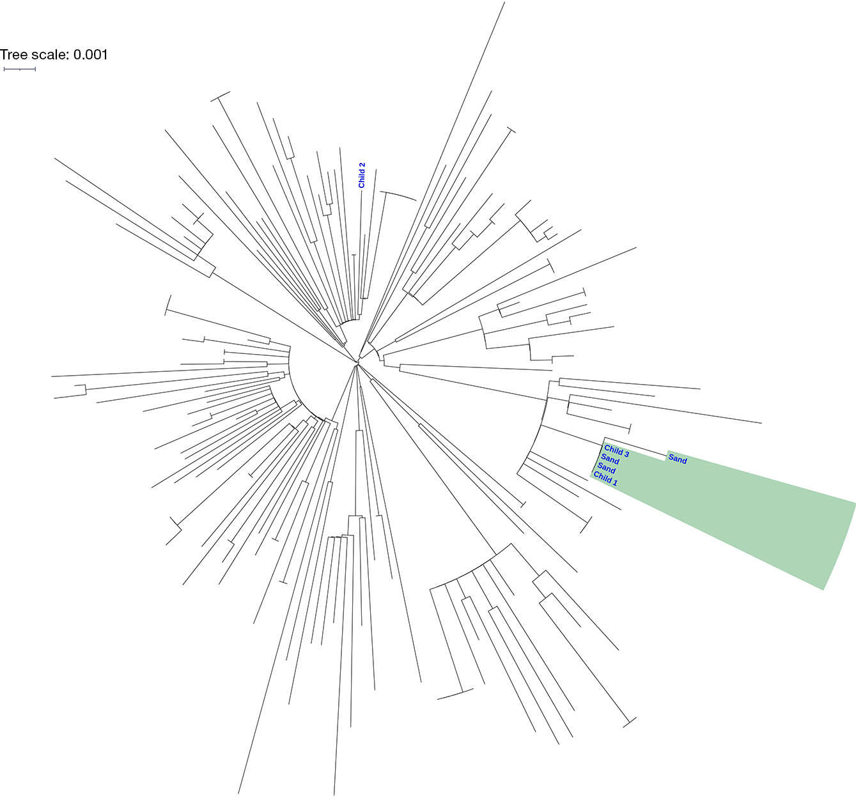

Discussion and conclusion
This outbreak investigation highlights the potential for non-foodborne transmission of enteric infections in childcare settings, reinforcing the importance of infection control measures and environmental surveillance. The identification of S. Waycross in the nursery sandpit and its genetic relatedness to isolates from confirmed cases suggests environmental contamination as part of the transmission pathway. Sandpits have been implicated in communicable disease transmission pathways in the past including for salmonellosis,^{5–9} and the national guideline for preventing disease in childcare recognises sandpits as a potential source of infection.¹⁰ The guideline outlines the importance of hand hygiene, appropriate sandpit cleaning protocols, and expected maintenance. This includes covering sandpits when not in use to prevent contamination from animals; and raking daily and digging deeply monthly to provide sun exposure to below-surface-level layers of sand.¹⁰ Adherence to these recommendations is not routinely audited. While the sandpit was considered part of the transmission pathway, the original contamination source remains unclear. Potential sources of Salmonella, such as wildlife or environmental factors have been considered in the literature,^{5,20} but were not definitively identified in this outbreak. Lastly, while infection control recommendations were provided to the childcare centre, adherence to these measures over time was not monitored, leaving room for uncertainty regarding long-term prevention.
Childcare centres in Queensland, Australia are encouraged to notify their local PHU if there are two or more cases of gastroenteritis among children or staff over a period of one to three days.¹⁰ These guidelines are based on point-source or person-to-person transmission. The onset dates of the unwell children in this outbreak would not have met this notification threshold, as they were more indicative of ongoing environmental transmission. Without community reporting, an index of suspicion, prompt serotyping, local epidemiological knowledge, adequate specimen collection, genome sequencing, and a swift public health response, this environmental source might have been overlooked. Despite these strengths, the investigation had several limitations. First, this outbreak may have underestimated the total number of cases; mild infections could have gone undetected, particularly in children who did not require medical assessment or did not have a faecal sample collected.²¹ Additionally, the source of Child 2’s infection remains unclear. Child 2 may have acquired S. Waycross from their home environment; from an undetected strain in the childcare; or from a source in the wider community.¹⁷ Finally, the direction of transmission of the three WGS linked isolates (two children and one sand sample) cannot be confirmed. We describe the most parsimonious explanation that the sandpit was the transmission source for both linked human cases, with the bacteria persisting in the sandpit over this time, but it is possible that either child contaminated the sand and that the common source was unrelated. However, fewer than one case per week of S. Waycross is notified across the Gold Coast, and no other cases in the Queensland comparative samples were identified with the same WGS type, so it is most likely that the contaminated sandpit at the childcare centre was the link for these cases.
This outbreak report underscores the need for continued consideration of non-foodborne Salmonella outbreaks and the potential for environmental contamination in childcare centres. While previous literature has documented the role of sand in Salmonella outbreaks involving other serovars, this study contributes novel insights into the epidemiology of S. Waycross and into the potential for persistence and transmission in outdoor play environments. Routine WGS of human specimens, enhanced case surveillance alongside investigation of community sandpits, sandpit suppliers, and potential environmental or wildlife contributors, may further inform public health guidance, surveillance and response efforts. Importantly, this outbreak highlights the value of reinforcing basic prevention measures—such as hand hygiene after sandpit use—as simple yet effective strategies to reduce infection risk.

Author details
Heshani Rupasinghe,¹
Kate E Alexander,¹
Fiona May,¹
Victoria Marriott,¹
Amanda Robinson,¹
Fiona Vosti,¹
Tracy Bladen,¹
Sharon Jurd,¹
Rikki MA Graham,²
Brett Heron,²
Gino Micalizzi,²
Trudy Graham,²
Robert Bell,³
Candice Colbran¹
- Public Health Unit, Gold Coast Hospital and Health Service, Queensland, Australia
- Public and Environmental Health Reference Laboratories, Queensland, Australia
- OzFoodNet, Public Health Intelligence Branch, Population Health Division, Queensland, Australia

Corresponding author
Dr. Heshani Rupasinghe
Gold Coast Public Health Unit
PO Box 318, Nerang, Queensland, Australia 4211
Phone: +61 7 5667 3200
Email: shanirupasinghe@hotmail.com

References
- Queensland Government Department of Health (Queensland Health). Salmonella infection: Queensland Health guidelines for public health units. [Webpage.] Brisbane: Queensland Health; February 2010. [Accessed in January 2025.] Available from: https://www.health.qld.gov.au/cdcg/index/salmonella.
- Australian Government Department of Health and Aged Care. National Notifiable Diseases Surveillance System (NNDSS) data visualisation tool. [Webpage.] Canberra: Australian Government Department of Health and Aged Care; 11 December 2022. [Accessed in January 2025.] Available from: https://www.health.gov.au/resources/apps-and-tools/national-notifiable-diseases-surveillance-system-nndss-data-visualisation-tool.
- World Health Organisation (WHO). Salmonella (non-typhoidal). [Online factsheet.] Geneva: WHO; 20 February 2018. [Accessed in February 2025.] Available from: https://www.who.int/news-room/fact-sheets/detail/salmonella-(non-typhoidal).
- OzFoodNet Working Group. Monitoring the incidence and causes of disease potentially transmitted by food in Australia: annual report of the OzFoodNet network, 2017. Commun Dis Intell (2018). 2022;46. doi: https://doi.org/10.33321/cdi.2022.46.59.
- Staff M, Musto J, Hogg G, Janssen M, Rose K. Salmonellosis outbreak traced to playground sand, Australia, 2007–2009. Emerg Infect Dis. 2012;18(7):1159–62. doi: https://doi.org/10.3201/eid1807.111443.
- Lucerón CO, Meixeira AP, Sanz IA, Deleyto VC, León SH, Ruiz LG. Notes from the field: an outbreak of Salmonella Typhimurium associated with playground sand in a preschool setting – Madrid, Spain, September–October 2016. MMWR Morb Mortal Wkly Rep. 2017;66(9):256–7. doi: https://doi.org/10.15585/mmwr.mm6609a3.
- Doorduyn Y, Van Den Brandhof WE, Van Duynhoven YT, Wannet WJ, Van Pelt W. Risk factors for Salmonella Enteritidis and Typhimurium (DT104 and non-DT104) infections in The Netherlands: predominant roles for raw eggs in Enteritidis and sandboxes in Typhimurium infections. Epidemiol Infect. 2006;134(3):617–26. doi: https://doi.org/10.1017/S0950268805005406.
- Morosetti G, Lorenzi G, Trevisiol K, Toson M, Blasior P, Stenico A et al. Are sandpits in the Municipality of Bolzano safe playgrounds for children? A survey of potentially zoonotic pathogens. Int J Infect Dis. 2018;73(Suppl.):389. doi: https://doi.org/10.1016/j.ijid.2018.04.4295.
- Chatziprodromidou IP, Chatziantoniou S, Vantarakis G, Vantarakis A. Risk factor analysis of children's exposure to microbial pathogens in playgrounds. Risk Anal. 2022;42(2):334–43. doi: https://doi.org/10.1111/risa.13752.
- National Health and Medical Research Council (NHMRC). Staying healthy: preventing infectious diseases in early childhood education and care services. (6th ed). Canberra: Australian Government, NHMRC; 2024.
- Seligmann E, Saphra I. A new Salmonella type: Salmonella waycross. J Bacteriol. 1948;55(4):561–3. doi: https://doi.org/10.1128/jb.55.4.561-563.1948.
- Hounmanou YMG, Baniga Z, García V, Dalsgaard A. Salmonella Salamae and S. Waycross isolated from Nile perch in Lake Victoria show limited human pathogenic potential. Sci Rep. 2022;12(1):4229. doi: https://doi.org/10.1038/s41598-022-08200-5.
- Traoré O, Nyholm O, Siitonen A, Bonkoungou IJ, Traoré AS, Barro N et al. Prevalence and diversity of Salmonella enterica in water, fish and lettuce in Ouagadougou, Burkina Faso. BMC Microbiol. 2015;15:151. doi: https://doi.org/10.1186/s12866-015-0484-7.
- Stevens A, Kaboré Y, Perrier-Gros-Claude JD, Millemann Y, Brisabois A, Catteau M et al. Prevalence and antibiotic-resistance of Salmonella isolated from beef sampled from the slaughterhouse and from retailers in Dakar (Senegal). Int J Food Microbiol. 2006;110(2):178–86. doi: https://doi.org/10.1016/j.ijfoodmicro.2006.04.018.
- Haddock RL, Delon PJ. Salmonella surveillance in Guam. Southeast Asian J Trop Med Public Health. 1980;11(1):48–54.
- Haddock RL, Gangarosa EJ, Nocon FA, Murlin AM. Observations on the ecology of Salmonella waycross and Salmonella typhimurium on Guam. Asia Pac J Public Health. 1991;5(3):256–61. doi: https://doi.org/10.1177/101053959100500312.
- Fearnley EJ, Lal A, Bates J, Stafford R, Kirk MD, Glass K. Salmonella source attribution in a subtropical state of Australia: capturing environmental reservoirs of infection. Epidemiol Infect. 2018;146(15):1903–8. doi: https://doi.org/10.1017/S0950268818002224.
- Public Health Intelligence Branch. Enhancing Foodborne Disease Surveillance Across Australia: OzFoodNet Annual Report 2023 Queensland. Brisbane: Queensland Health; April 2024. Available from: https://www.health.qld.gov.au/__data/assets/pdf_file/0029/1415468/foodborne-disease-surv-report-2023.pdf.
- Zhou Z, Charlesworth J, Achtman M. HierCC: a multi-level clustering scheme for population assignments based on core genome MLST. Bioinformatics. 2021;37(20):3645–6. doi: https://doi.org/10.1093/bioinformatics/btab234.
- Munck N, Smith J, Bates J, Glass K, Hald T, Kirk MD. Source attribution of Salmonella in macadamia nuts to animal and environmental reservoirs in Queensland, Australia. Foodborne Pathog Dis. 2020;17(5):357–64. doi: https://doi.org/10.1089/fpd.2019.2706.
- Hall G, Kirk MD, Becker N, Gregory JE, Unicomb L, Millard G et al. Estimating foodborne gastroenteritis, Australia. Emerg Infect Dis. 2005;11(8):1257–64. doi: https://doi.org/10.3201/eid1108.041367.

