
2026 • Volume 50 • cdc.gov.au/cdi • Epub date: 26.05.2026 • doi.org/10.33321/cdi.2026.50.037

An outbreak of measles linked to healthcare services in Far North Queensland, 2025
Tonia Marquardt, Simon Smith, Juliet Esmonde, Matthew O’Bryan, Lucy Thallon, Alireza Zahedi, Trent Yarwood, Jacqueline Murdoch

Abstract
In September 2025, Cairns experienced its largest measles outbreak since 1997. An imported case from Indonesia subsequently transmitted to 11 secondary cases, including four hospital staff. No further transmission was identified despite identification of nearly 1,500 contacts. Most of the cases (11/12; 91.6%) reported or demonstrated prior vaccination or immunity. This outbreak demonstrates the continued potential for re-emergence of measles in a setting with validated elimination status; the outbreak resulted in disruption to healthcare staff and services. Australian healthcare services should consider use of measles serology and booster vaccination doses among susceptible healthcare workers to reduce the risk of future similar outbreaks.
Keywords: public health; outbreak; measles; healthcare services; vaccination

Background
There has been a vaccine available for measles, a highly infectious human disease, since 1968.¹ Australia eliminated sustained community transmission of measles in 2014 through high vaccine coverage,² but sporadic cases and outbreaks still occur and require urgent public health responses to prevent ongoing transmission. In September 2025, the Cairns Public Health Unit (CPHU) responded to an outbreak of 12 measles cases.

Outbreak detection
On 2 September 2025, CPHU was informed of a suspected measles case at Cairns Hospital Emergency Department (ED). The patient—who had received two documented doses of measles vaccine as a child—had travelled recently from Indonesia to Cairns and was staying at a backpacker hostel. They were admitted to hospital for supplemental oxygen and isolated in airborne precautions. Measles infection was confirmed by polymerase chain reaction testing (PCR), leading to the implementation of a public health response following national guidelines.³
Eleven subsequent cases were confirmed by PCR (see Figure 1).³ All secondary cases had epidemiological links to the index case; four cases were staying or working at the backpacker hostel, and seven were linked to two hospital ED visits (see Figure 2). Four of the cases linked to the hospital visits were among hospital staff. No onward transmission was identified from the secondary cases.
Figure 1: Epidemic curve of measles cases, by symptom onset, Cairns outbreak, Queensland, Australia,ª August–September 2025
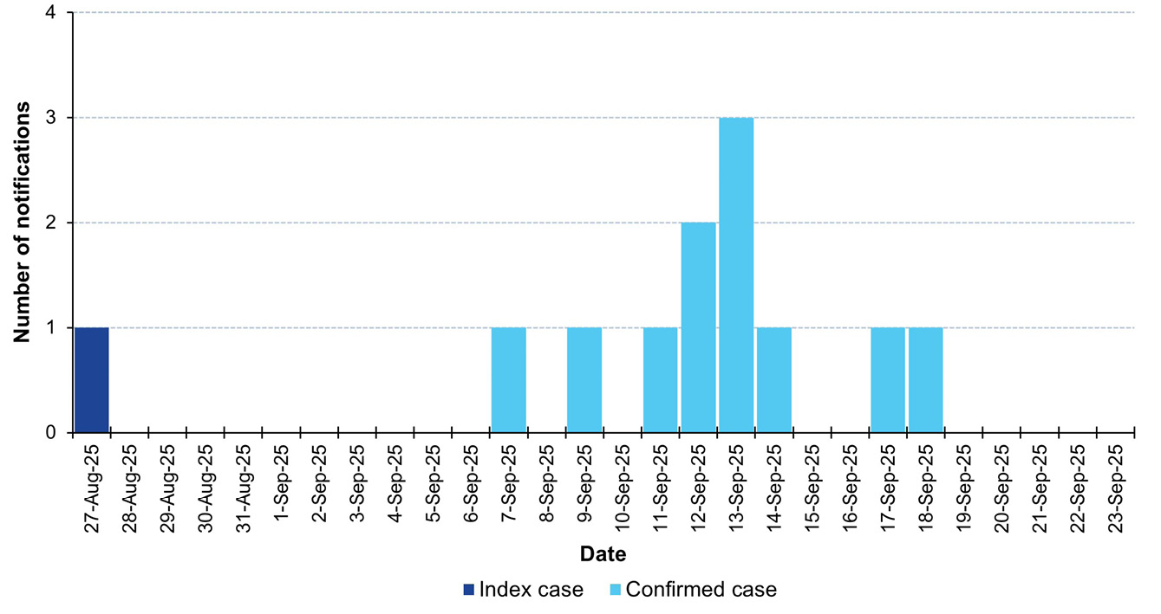
a All secondary cases had a standard incubation period with symptom onset 10–16 days after first exposure to the index case.
Figure 2: Transmission links, Cairns measles outbreak, Queensland, Australia, August–September 2025
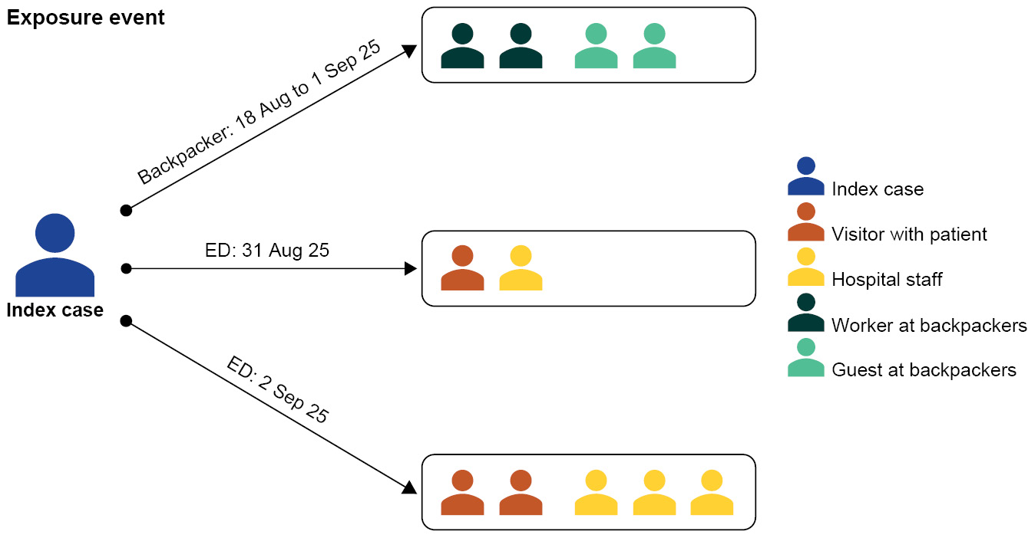

Case demographics
The mean age of the twelve cases was 29 years, with eleven aged between 18 and 34 years; 10/12 were female. One case identified as a First Nations Australian.

Vaccination
Most cases (11/12; 91.6%) indicated likely immunity; seven had two documented doses of measles vaccination, one had documented serological immunity and three advised of complete childhood vaccination overseas. Only one case was identified as unvaccinated; they received a single vaccine dose six days after initial exposure.

Clinical features
The mean time from prodrome to rash onset was 2.2 days (range: 0–4 days). The only atypical feature from some cases was description of a pruritic rash which was likened to sunburn. Three cases were admitted to hospital. No cases reported ongoing complications.

Laboratory results
Serology was performed in eight cases (Table 1). Among three vaccinated cases, there was evidence suggestive of secondary vaccine failure, with high IgG titres (> 300) and negative IgM on early testing,^{4,5} although avidity testing was not done to confirm.^{6,7} A further four vaccinated cases with non-reactive or no serology results had relatively higher PCR cycle threshold (Ct) values on throat swabs (> 30 cycles), possibly reflecting a lower viral burden than those with lower Ct values.⁸ The lowest Ct values were in the index case (no serology was performed).
Table 1: Patient demographics, vaccination status, and laboratory results of confirmed measles cases during the Cairns outbreak, Queensland, Australia,ª August–September 2025
Year of birth | Age (years) | Vaccination |  | Day of test | PCR cycle threshold^{b,c} |  | Serology^{d}
Year of birth | Age (years) | Number of doses | Years | (from rash onset) | Urine | Nasopharyngeal swab | IgM | IgG
1969 | 56 | Serology (2015); reactive | — | 4 | ND | 36.6 | Neg | > 300.0
1991 | 34 | 2 | Verbal | 2 | ND | 30.2 | — | —
1992 | 33 | 2 | Verbal | 2 | — | 28 | — | —
1994 | 31 | Unvaccinated | — | -2e | 31 | 21 | Neg | NR
1995 | 30 | 2 | 1996; 2000 | 0 | 22.6 | 24.6 | Neg | > 300.0
1997 | 28 | 2 | 1998; 2002 | 1 | 31.6 | 32.9 | Neg | 44.5
1998 | 26 | 2 | 1999; 2003 | 1 | ND | 37.9 | — | —
1999 | 26 | 2 | 2000; 2003 | 1 | 30.8 | 22.7 | 1.1 | 80.7
2001 | 23 | 2 | 2002; 2002 | 1 | 16 | 20 | — | —
2003 | 22 | 2 | 2004; 2007 | 1 | 29.9 | 26.9 | Neg | > 300.0
2004 | 20 | 2 | (seen) | 1 | 31 | 35 | Neg | NR
2006 | 18 | 2 | Verbal | 1 | 19 | 26 | — | NR
a Genomics: all samples were sequenced and clustered within a distinct subclade of MV genotype D8 forming a closely related group exhibiting high sequence similarity. An analysis for any genetic variation across the viral genome was also done, with particular attention to the hemagglutinin (H) gene, which encodes the antigenic protein targeted by neutralising antibodies. Sequences were compared against reference strains and previously characterised variants to identify any potential mutations associated with altered antigenicity or reduced vaccine effectiveness. No such mutations were observed in the sequences analysed.
b PCR: polymerase chain reaction.
c ND: not determined.
d IgM: immunoglobulin M; IgG: immunoglobulin G; Neg: negative; NR: non-reactive.
e Case was tested two days prior to rash onset.

Public health response
This outbreak required extensive work in contact tracing, communication, coordination and documentation throughout the region and state. Contact tracing led to three cases being identified amongst symptomatic contacts.
Expert Advisory Groups helped facilitate decision making and an Incident Management Team (IMT) was convened for the response to the outbreak. Multiple clinician alerts and public communications were disseminated.
The backpacker hostel supported isolation accommodation, vaccination and messaging to potentially affected populations. Over 125 suspect cases reported from across the Cairns region had samples tested. Case investigation identified 48 venues as potential exposure sites, and 1,481 contacts were identified for communication about exposure risk and possible intervention if susceptible. Contact tracing methodologies, including the use of messaging apps and SMSs, were employed to expand reach and to facilitate ‘snowball’ communication to additional contacts not listed at venues (e.g. visitors to hospital). Normal Human Immunoglobulin (NHIg) was recommended for 17 people, including eight neonates linked to a maternity ward exposure.

Discussion
This measles outbreak occurred in regional Australia following an imported case at a time of increasing global circulation of the disease.² This was the largest measles outbreak in the area in almost 30 years and highlighted the potential for introduction and onward transmission, including within healthcare settings, in an elimination context.⁹ The index case had documentation of two vaccinations. They had lower Ct values than the other cases in the outbreak and transmitted to multiple people; without further serology and avidity testing, it is not possible to be definitive about possible primary or secondary vaccine failure.^{5,8} Most of the secondary cases showed some evidence of potential immunity, which may explain why no onward transmission was identified.^{4,5}
In a population with high vaccine coverage, it is likely that some cases will occur amongst immunised people.^{5,9,10} As seen in this outbreak with no second generation of cases, immunised people who get measles are less likely to continue transmission.⁴ Whilst the relatively narrow age range of the cases here could be partly influenced by the social links for transmission, it may also reflect a lack of immunity in specific birth cohorts that are no longer exposed to measles in an elimination context.^{11,12} Previous serosurveys in Australia have identified lower antibody levels in young adult groups, possibly indicative of waning immunity or of non-immunity.^{13,14} This is particularly significant as the 20 to 34 year old age group represents an increasing proportion of healthcare staff.¹⁵
Measles is now a rare condition in Australia and early symptoms are non-specific. This can cause delays in recognition for people presenting to hospital, leading to exposure risks to other patients, visitors and staff. Healthcare workers have a 2-to-19-fold higher risk of exposure to measles than the general public.¹⁶ Infected hospital staff can lead to disruption of clinical services and to a need for interventions for vulnerable people, even if the risk of onward transmission is considered low.^{3,4,10}
Some countries have advocated for systematic testing and booster doses of measles vaccine to healthcare staff in the context of outbreak risks such as seen here, whilst others have modified the public health approach for secondary vaccine failure cases.^{10,17} This outbreak highlights the potential for measles introduction, and the impact of control measures associated with a healthcare setting in Australia. At a time when antibody levels may be waning in healthcare worker cohorts,⁵ and when overall vaccination coverage is declining, the ongoing risk of reintroduction and onward transmission of measles in Australia must be recognised. Healthcare services should consider introducing measles serology screening and/or booster vaccination among healthcare workers to reduce the impact of future outbreaks.

Ethics
This report is endorsed for publication without the need for HREC review. Ref:2003OR per FNQ HREC.

Author details
Tonia Marquardt,^{1,3,*}
Simon Smith,²
Juliet Esmonde,¹
Matthew O’Bryan^{1,5}
Lucy Thallon,¹
Alireza Zahedi,¹
Trent Yarwood,^{2,4,5}
Jacqueline Murdoch^{1,4}
- Cairns Public Health Unit, Cairns and Hinterland Hospital & Health Service, Cairns, Queensland, Australia
- Cairns Hospital, Cairns and Hinterland Hospital & Health Service, Cairns, Queensland, Australia
- National Centre for Immunisation Research and Surveillance, Sydney, New South Wales, Australia
- School of Public Health, James Cook University, Townsville, Queensland, Australia
- Rural Clinical School, University of Queensland, Herston, Queensland, Australia

Corresponding author
Dr Tonia Marquardt
Cairns Public Health Unit, L7, William McCormack Building, 5b Sheridan St, Cairns, Qld 4870, Australia
Email: tonia.marquardt@health.qld.gov.au
Phone: +61 7 4226 5555

References
- National Centre for Immunisation Research and Surveillance (NCIRS). Significant events in measles, mumps and rubella vaccination practice in Australia. Sydney: Sydney Children’s Hospitals Network, NCIRS; September 2025. [Accessed on 4 February 2026.] Available from: https://ncirs.org.au/media/1148.
- Gidding HF, Martin NV, Stambos V, Tran T, Dey A, Dowse GK et al. Verification of measles elimination in Australia: application of World Health Organization regional guidelines. J Epidemiol Glob Health. 2016;6(3):197–209. doi: https://doi.org/10.1016/j.jegh.2015.12.004.
- Australian Centre for Disease Control (Australian CDC). Measles – CDNA National Guidelines for Public Health Units. Canberra: Australian CDC; 1 May 2019. [Accessed on 4 February 2026.] Available from: https://www.cdc.gov.au/resources/publications/measles-cdna-national-guidelines-public-health-units.
- Tranter I, Smoll N, Lau CL, Williams DL, Neucom D, Barnekow D et al. Onward virus transmission after measles secondary vaccination failure. Emerg Infect Dis. 2024;30(9):1747–54. doi: https://doi.org/10.3201/eid3009.240150.
- Fappani C, Gori M, Canuti M, Terraneo M, Colzani D, Tanzi E et al. Breakthrough infections: a challenge towards measles elimination? Microorganisms. 2022;10(8):1567. doi: https://doi.org/10.3390/microorganisms10081567.
- Mercader S, Garcia P, Bellini WJ. Measles virus IgG avidity assay for use in classification of measles vaccine failure in measles elimination settings. Clin Vaccine Immunol. 2012;19(11):1810–7. doi: https://doi.org/10.1128/CVI.00406-12.
- Elbert G, Biscayart C, López Yunes M, Avaro MM, Czech A, Pontoriero A et al. Measles outbreak in the context of post-elimination phase in individuals with prior evidence of immunity. Secondary immune response or re-infections? Int J Infect Dis. 2018;73(2):21–2. doi: https://doi.org/10.1016/j.ijid.2018.04.3473.
- Sundell N, Dotevall L, Wahllof M, Andersson M, Lindh M, Wahlberg T et al. Measles outbreak in Gothenburg urban area, Sweden, 2017 to 2018: low viral load in breakthrough infections. Euro Surveill. 2019;24(17):1900114.
doi: https://doi.org/10.2807/1560-7917.ES.2019.24.17.1900114.
- Hagan JE, Crooke SN, Gunregjav N, Sowers SB, Mercader S, Hickman CJ et al. Breakthrough measles among vaccinated adults born during the post-Soviet transition period in Mongolia. Vaccines. 2024;12(6):695. doi: https://doi.org/10.3390/vaccines12060695.
- Government of the United Kingdom Health Security Agency (UK Health Security Agency). National measles guidelines. [Webpage.] London: UK Health Security Agency; 25 July 2024. [Accessed on 4 February 2026.] Available from: https://www.gov.uk/government/publications/national-measles-guidelines.
- Bianchi FP, Mascipinto S, Stefanizzi P, De Nitto S, Germinario C, Tafuri S. Long-term immunogenicity after measles vaccine vs. wild infection: an Italian retrospective cohort study. Hum Vaccines Immunother. 2021;17(7):2078–84. doi: https://doi.org/10.1080/21645515.2020.1871296.
- Robert A, Suffel AM, Kucharski AJ. Long-term waning of vaccine-induced immunity to measles in England: a mathematical modelling study. Lancet Public Health. 2024;9(10):e766–75. doi: https://doi.org/10.1016/S2468-2667(24)00181-6.
- Gidding HF, Quinn HE, Hueston L, Dwyer DE, McIntyre PB. Declining measles antibodies in the era of elimination: Australia’s experience. Vaccine. 2018;36(4):507–13. doi: https://doi.org/10.1016/j.vaccine.2017.12.002.
- Williamson KM, Faddy H, Nicholson S, Stambos V, Hoad V, Butler M et al. A cross-sectional study of measles-specific antibody levels in Australian blood donors—implications for measles post-elimination countries. Vaccines. 2024;12(7):818. doi: https://doi.org/10.3390/vaccines12070818.
- Australian Institute of Health and Welfare (AIHW). Health workforce. [Web article.] Canberra: AIHW; 2 July 2024. [Accessed on 4 February 2026.] Available from: https://www.aihw.gov.au/reports/workforce/health-workforce.
- Fiebelkorn AP, Seward JF, Orenstein WA. A global perspective of vaccination of healthcare personnel against measles: systematic review. Vaccine. 2014;32(38):4823–39. doi: https://doi.org/10.1016/j.vaccine.2013.11.005.
- Han SB, Park SH, Yi Y, Ji SK, Jang SH, Park MH et al. Measles seroprevalence among healthcare workers in South Korea during the post-elimination period. Hum Vaccines Immunother. 2021;17(8):2517–21. doi: https://doi.org/10.1080/21645515.2021.1888623.
© 2026 Commonwealth of Australia as represented by the Australian Centre for Disease Control
ISSN: 2209-6051 Online
This journal is indexed by Index Medicus and Medline.
Creative Commons Licence
This publication is licensed under a Creative Commons Attribution-NonCommercial-NoDerivatives 4.0 International Licence (Licence). You must read and understand the Licence before using any material from this publication.
Restrictions
The Licence does not cover, and there is no permission given for, use of any of the following material found in this publication (if any):
- the Commonwealth Coat of Arms (by way of information, the terms under which the Coat of Arms may be used can be found on the Department of Prime Minister and Cabinet website);
- any logos (including the Australian Centre for Disease Control’s logo) and trademarks;
- any photographs and images;
- any signatures; and
- any material belonging to third parties.
Disclaimer
Opinions expressed in Communicable Diseases Intelligence are those of the authors and not necessarily those of the Australian Government or the Australian Centre for Disease Control. Data may be subject to revision.
Enquiries
Enquiries regarding any other use of this publication should be addressed to the CDI Editor.
About CDI
Communicable Diseases Intelligence (CDI) is a peer-reviewed scientific journal published by the Australian Centre for Disease Control.
The journal aims to disseminate information on the epidemiology, surveillance, prevention and control of communicable diseases of relevance to Australia and the near region.
Editor: Dr Elise Firman • Deputy Editor: Simon Petrie • Design and Production: Lisa Thompson
Editorial Advisory Board: David Durrheim, Mark Ferson, Clare Huppatz, John Kaldor, Martyn Kirk and Meru Sheel
Submit an Article
Guidelines for authors and details on how to submit your publication is available on our website, or by email to the
CDI Editor.
Contact us
Communicable Diseases Intelligence (CDI)
Australian Centre for Disease Control
GPO Box 798, CANBERRA ACT 2601
Website: cdc.gov.au/cdi
Email: cdi.editor@cdc.gov.au

