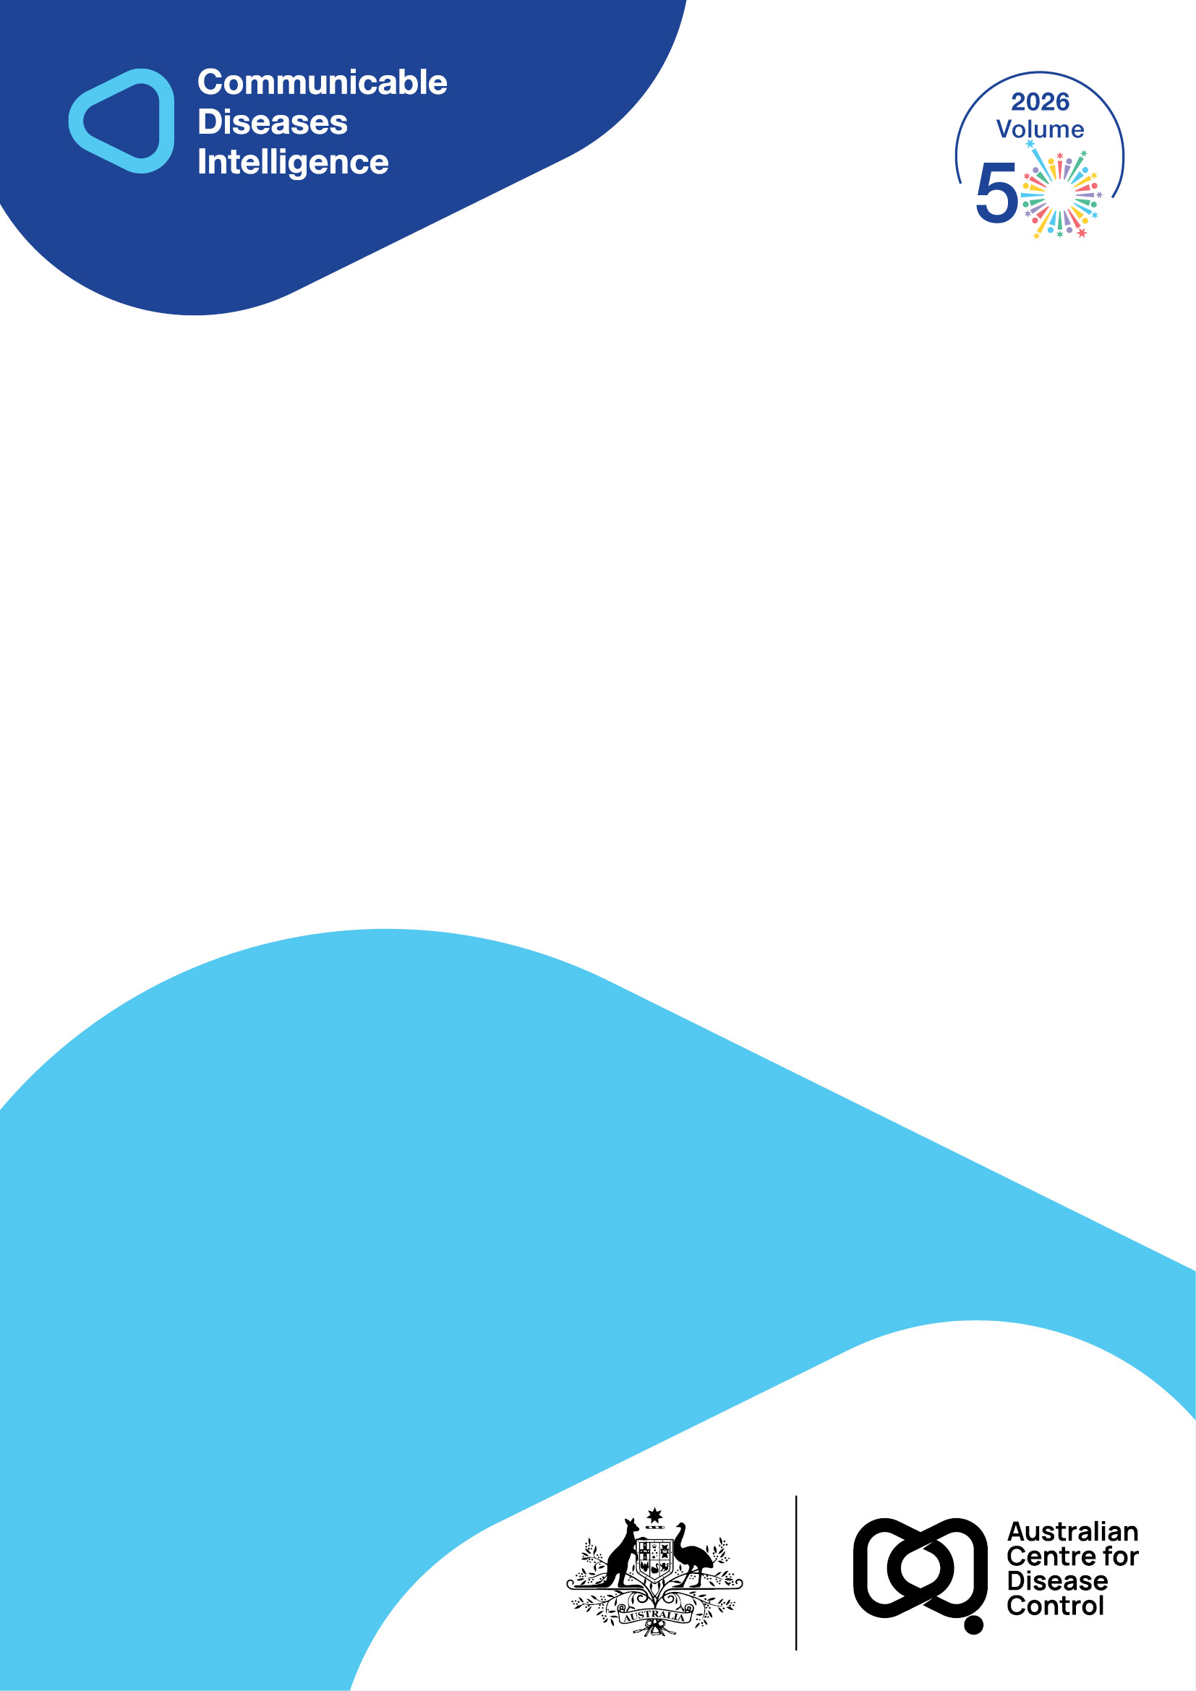
2026 • Volume 50 • cdc.gov.au/cdi • Epub date: 26.05.2026 • doi.org/10.33321/cdi.2026.50.033

ATAGI 2025 Annual Statement on Immunisation
Katrina Nicolopoulos, Saskia van der Kooi, Clayton Chiu, Alexandra Hendry, Kristine K Macartney, Katherine Gibney, Katie Flanagan, Michelle L Giles, Nigel W Crawford
© 2026 Commonwealth of Australia as represented by the Australian Centre for Disease Control
ISSN: 2209-6051 Online
This journal is indexed by Index Medicus and Medline.
Creative Commons Licence
This publication is licensed under a Creative Commons Attribution-NonCommercial-NoDerivatives 4.0 International Licence (Licence). You must read and understand the Licence before using any material from this publication.
Restrictions
The Licence does not cover, and there is no permission given for, use of any of the following material found in this publication (if any):
- the Commonwealth Coat of Arms (by way of information, the terms under which the Coat of Arms may be used can be found on the Department of Prime Minister and Cabinet website);
- any logos (including the Australian Centre for Disease Control’s logo) and trademarks;
- any photographs and images;
- any signatures; and
- any material belonging to third parties.
Disclaimer
Opinions expressed in Communicable Diseases Intelligence are those of the authors and not necessarily those of the Australian Government or the Australian Centre for Disease Control. Data may be subject to revision.
Enquiries
Enquiries regarding any other use of this publication should be addressed to the CDI Editor.
About CDI
Communicable Diseases Intelligence (CDI) is a peer-reviewed scientific journal published by the Australian Centre for Disease Control.
The journal aims to disseminate information on the epidemiology, surveillance, prevention and control of communicable diseases of relevance to Australia and the near region.
Editor: Dr Elise Firman • Deputy Editor: Simon Petrie • Design and Production: Lisa Thompson
Editorial Advisory Board: David Durrheim, Mark Ferson, Clare Huppatz, John Kaldor, Martyn Kirk and Meru Sheel
Submit an Article
Guidelines for authors and details on how to submit your publication is available on our website, or by email to the
CDI Editor.
Contact us
Communicable Diseases Intelligence (CDI)
Australian Centre for Disease Control
GPO Box 798, CANBERRA ACT 2601
Website: cdc.gov.au/cdi
Email: cdi.editor@cdc.gov.au

Contents
Summary 4
Immunisation landscape in Australia in 2024 5
Key immunisation highlights 5
Ongoing challenges 5
Key developments in immunisation strategies and evaluation 6
National Immunisation Strategy for Australia 2025–2030 6
Health Technology Assessment Policy and Methods Review 6
COVID-19 Response Inquiry Report 7
Immunisation issues in Australia in 2024 8
Emerging and re-emerging vaccine-preventable diseases 8
Prevention and control of other vaccine-preventable diseases 10
Highlights of immunisation coverage of other vaccine-preventable diseases 14
Immunisation policy and practice across Australia 18
Changes to the National Immunisation Program in 2024 18
Expanded pharmacist vaccination program 18
No-fault vaccine compensation scheme 18
Major additions or updates to the Australian Immunisation Handbook in 2024 19
New vaccines and potential vaccination programs 20
Combination vaccines for respiratory viruses and other immunisation products under development 20
Vaccine safety 21
Recombinant herpes zoster vaccine Shingrix 21
Respiratory syncytial virus vaccine use in older adults and pregnant women and nirsevimab use in infants 21
Therapeutic Goods Administration statement on misinformation about mRNA vaccines 22
Challenges and priorities for immunisation in Australia in 2025 and beyond 23
Key challenges for preventing and controlling vaccine-preventable diseases through immunisation 23
Acknowledgments 25
Author details 26
References 27
Appendix A: About ATAGI 32
The Australian Technical Advisory Group on Immunisation (ATAGI) 2025 Annual Statement on Immunisation is the fifth publication in this series. It highlights the key successes, trends and challenges in the use of vaccines and control of vaccine preventable diseases (VPDs) in Australia in 2024. It also signals ATAGI’s priority advice on actions to address key issues for 2025 and beyond.

Summary
Key challenges for prevention and control of vaccine preventable diseases (VPDs) in Australia, in 2025 and beyond, include maintaining high-quality assessment of vaccines; monitoring the impact of new programs; responding to emerging and re-emerging VPDs; and understanding key drivers of declining vaccination coverage. Ongoing priority actions for ATAGI for 2025 include providing advice on equity and accessibility of vaccines to improve coverage; monitoring vaccine coverage trends, epidemiology and impacts of schedule changes; and reviewing frameworks and evidence for new vaccines, building evidence for emerging products, and monitoring vaccines under development.

Immunisation landscape in Australia in 2024

Key immunisation highlights
Three processes critical in shaping Australia’s future immunisation strategies, policies and programs were developed in 2024: the National Immunisation Strategy for Australia 2025–2030 (NIS 2025–2030); the Health Technology Assessment Policy and Methods Review report; and the national coronavirus disease 2019 (COVID-19) Response Inquiry Report. Key areas identified for improvement include vaccination coverage, equitable access, pandemic preparedness, assessment and appraisal of vaccines, and transparent and actionable use of data, including linked datasets for analyses of vaccine impact.
Two new respiratory syncytial virus (RSV) vaccines and a long-acting RSV monoclonal antibody were introduced in Australia, which will help prevent severe RSV disease in both infants and older people. The funding for free shingles vaccination under the National Immunisation Program (NIP), using the recombinant herpes zoster vaccine Shingrix, was expanded to include people aged ≥ 18 years who are immunocompromised with moderate to high risk of severe infection or complications from shingles.¹
An updated COVID-19 vaccine formulation was also made available during 2024, which assisted in protecting people in Australia against the most common circulating COVID-19 variants. The COVID 19 vaccination program also started the transition from a pandemic response approach to become one that is integrated with a national vaccination program for controlling important vaccine-preventable respiratory viral diseases.

Ongoing challenges
A key focus since 2024 has been preparing for and/or managing emerging or re-emerging vaccine-preventable disease (VPD) threats – such as measles, mpox, pertussis, and potentially highly pathogenic avian influenza (HPAI) in humans – that continue to present challenges in Australia.
Vaccination coverage remains generally very high in Australia by global standards, but modest declines in coverage have occurred in most age groups for the past few years for several vaccines, including those funded under the NIP. There are also challenges associated with people accessing vaccination within the recommended timeframes.

Key developments in immunisation strategies and evaluation
The National Immunisation Strategy for Australia 2025–2030; the Health Technology Assessment Policy and Methods Review report; and the COVID-19 Response Inquiry Report were all developed in 2024.^{2–4} These are critical in shaping the development and decision-making processes of Australia-wide immunisation strategies, policies and programs.

National Immunisation Strategy for Australia
2025–2030
The NIS 2025–2030 builds on two previous national immunisation strategies (2013 to 2018 and 2019 to 2024).⁴ The NIS 2025–2030 aims to reduce the impact of VPDs to achieve a healthier Australia through safe, effective and equitable immunisation across the lifespan. The six priority areas are:
- to improve access to immunisation, with a focus on equity for Aboriginal and Torres Strait Islander people and other priority populations;
- to build trust, understanding and acceptance of immunisation in communities;
- to use data more effectively to target immunisation strategies and monitor performance;
- to strengthen the immunisation workforce;
- to harness new technologies to respond to the evolving communicable disease and vaccine landscape; and
- to implement sustainable reform in vaccine program governance, program delivery and accountability.
Development of the NIS 2025–2030 occurred throughout 2024, and the strategy was published in June 2025.⁴

Health Technology Assessment Policy and Methods Review
The Health Technology Assessment Policy and Methods Review report,² released in September 2024, makes several recommendations that are relevant for the policy and methods for assessment of health technologies, which include vaccines, for government funding in Australia. Many of the general recommendations have significant implications for the assessment framework and the methods used to assess evidence. Two recommendations specifically refer to the assessment pathway for listing vaccines on the NIP:
- Recommendation 11. Proportionate appraisal pathway to align ATAGI assessments with the level of risk and complexity of the product:
Restructure the current appraisal pathway for listing a vaccine on the NIP so that the assessment processes are in line with the level of risk–benefit and complexity of a vaccine submission.
- Recommendation 12. Proactive vaccine assessment pathway:
Develop a proactive vaccine assessment pathway that allows how new products or changes to the vaccine program could impact disease burden to be considered. This would include independent modelling where appropriate.
The Australian Government established the Health Technology Assessment Review Implementation Advisory Group in November 2024 to co-design a draft government response to the Health Technology Assessment Policy and Methods Review.⁵

COVID-19 Response Inquiry Report
The national COVID-19 Response Inquiry Report,³ released to the Australian Government in October 2024, identified nine recommendations on how to effectively respond to a pandemic. The report also identified several short- and medium-term actions to be implemented ahead of the next pandemic, including:
- reviewing the COVID-19 vaccination claims scheme, with the aim to guide future use of similar indemnity schemes in a national health emergency;
- continuing to invest in monitoring and evaluation of the long-term impacts of COVID-19, including vaccination adverse events;
- developing a national strategy to rebuild community trust in vaccines and increase vaccination rates;
- improving data collection, sharing, linkage and analytic capability for an effective, targeted and proportionate response to a national health emergency; and
- finalising the establishment of the Australian Centre for Disease Control (CDC).

Immunisation issues in Australia in 2024

Emerging and re-emerging vaccine-preventable diseases
In 2024, emerging and re-emerging VPDs, such as mpox, pertussis and HPAI in humans, remained risks in Australia. Although measles has been eliminated as an endemic disease in Australia since 2014, there remains a significant risk of outbreaks following importation into Australia through Australian and international travellers. Since 2022, there has been an ongoing resurgence of measles across all regions of the world, including in some countries in the Asia–Pacific region.
ATAGI continues to monitor the epidemiology of emerging and re-emerging VPDs here and overseas. ATAGI also re-assesses vaccine coverage in relevant age or population groups in Australia as needed and prepares advice to respond to changing risks and scenarios.
Source of notification data for this statement
Notification data were extracted from the National Notifiable Diseases Surveillance System for notifications with a diagnosis date between 1 January and 31 December 2024.
Pandemic-adjusted five-year mean
Some of the data presented in this statement refer to a pandemic-adjusted five-year mean. This statistic uses notification data from the five years before (2017 to 2019) and after (2022 to 2023) the peak of public health constraints applied to control SARS-CoV-2 transmission during the COVID-19 pandemic (2020 to 2021). This adjusts for the substantially lower notifications of many VPDs during 2020 and 2021 and allows more meaningful comparisons of epidemiological data.

Measles
Measles cases increased in 2024 (n = 57) compared with 2023 (n = 26). Of total measles notifications in 2024, most (40 of 57; 70%) were acquired overseas; the remaining cases (17 of 57; 30%) were acquired in Australia through known links to infected travellers.
In 2024, no measles-associated deaths were notified.

Mpox (formerly known as monkeypox)
Mpox initially emerged in Australia in 2022, when 144 cases were notified, before a decline in 2023 to 26 cases. However, mpox case notifications increased again from the second quarter in 2024, peaking in September. For all of 2024, a total of 1,412 cases were notified, and no deaths were reported. Unlike in 2022, the great majority of notified cases (93%) in 2024 were acquired in Australia.
In 2024, no cases of the new, potentially more transmissible clade Ib mpox strain were detected in Australia.⁶ However, this variant has been causing increasing cases in some African countries since 2023,⁷ leading the World Health Organization to declare a public health emergency of international concern in August 2024.⁸
People at a high risk of being exposed to mpox have been encouraged to take actions to reduce their risk of exposure to the virus and to get vaccinated, as outlined in the new mpox chapter in the Australian Immunisation Handbook.⁹ In 2024, ATAGI has twice updated the clinical guidance on the use of vaccines for the prevention of mpox,¹⁰ providing more detailed and expanded advice about mpox vaccination tailored to the emerging epidemiologic situation. In the latest version of the clinical guidance (version 3.0, published in December 2024), an expanded list of groups at high risk of mpox exposure, and recommended to receive mpox vaccination, was provided, including travellers in some situations.

Pertussis
The resurgence of pertussis notifications began in late 2023 and continued in 2024, especially from March to late June and in New South Wales and Queensland. The number of notifications of pertussis in 2024 (n = 56,919) was 7.2 times higher than the pandemic-adjusted five-year mean (n = 7,956), and exceeded notifications reported in previous years, including 2015 (n = 22,572), 2016 (n = 20,119) and the years from 2009 to 2011 (which ranged from 30,183 to 38,748 per year) when there were large pertussis outbreaks in Australia.
In 2024, the notification rates were highest in children aged 10 to 14 years (1,207 cases per 100,000 population); children aged 5 to 9 years (801 cases per 100,000 population); infants aged 6 to 11 months (401 cases per 100,000 population); and young infants aged < 6 months (347 cases per 100,000 population). Among the notified pertussis cases in 2024, there were two reported deaths of infants (aged < 12 months) and three deaths of people aged ≥ 65 years.
To protect young infants, who have the highest morbidity and mortality from pertussis infection compared with other age groups, ATAGI emphasises the importance of maternal pertussis vaccination during pregnancy (recommended at between 20 and 32 weeks gestation for every pregnancy), and timely completion of pertussis vaccination according to the recommended childhood and adolescent schedule. The Australian Immunisation Handbook also recommends older adults receive pertussis-containing vaccines.

Pandemic preparedness in the context of avian influenza in humans
Globally, there have been ongoing outbreaks of HPAI in birds and many species of mammals. In Australia, outbreaks of H7 strains of HPAI in poultry have occurred intermittently.¹¹ The H5 strain that has been occurring overseas had not been detected in any animal species in Australia in or before 2024. Humans are occasionally infected with HPAI, but no zoonotic infections acquired in Australia have been reported in humans. ATAGI continues to monitor avian influenza epidemiology in Australia and overseas,¹² in collaboration with the Australian CDC,¹³ as well as the development of vaccine candidates against HPAI, and continues to provide advice as required.

Prevention and control of other vaccine-preventable diseases
Cases of some other VPDs increased in 2024 compared with 2023, and some increases in incidence, such as for influenza, were substantial in comparison with the low incidence seen during the peak years of public health constraints applied in response to the COVID 19 pandemic. This section highlights the most notable changes in VPD epidemiology, vaccination policies or vaccination coverage.

Influenza
There were 365,589 notifications of laboratory-confirmed influenza in 2024; this was 1.6 times the pandemic-adjusted five-year mean and higher than the 289,154 notifications in 2023. Among children aged 5 to 9 years, children aged < 5 years, and adults aged ≥ 65 years, there were respectively 3,240, 3,314 and 944 notifications per 100,000 population. Of the total notifications in 2024, 96% were influenza A (93% unsubtyped; 1% H1N1; 2% H3N2); 4% were influenza B; and less than 1% were influenza A and B co-infections or untyped. Based on vaccine effectiveness estimates from sentinel surveillance systems in the Annual Australian Respiratory Surveillance Report – 2024,¹⁴ vaccination with the 2024 seasonal influenza vaccine reduced the likelihood of:
- influenza with symptoms that warrant visiting a general practitioner attendance, by 56%; and
- being hospitalised with influenza, by 55%.
Effective prevention of influenza in the community relies on attaining high influenza vaccination coverage before the influenza season begins (generally around July each year). For 2024, the national influenza vaccine coverage by 30 June remained suboptimal for all age groups. Additionally, influenza vaccine coverage at 30 June 2024 was lower than that at the same time point in 2022 and slightly lower than that at the same time point in 2023 for every age group for all of Australia and for First Nations people (Figures 1 and 2).
Children aged < 5 years have the highest rate of influenza hospitalisation. Those in this age group who are aged ≥ 6 months are recommended to receive NIP-funded influenza vaccine. However, despite their eligibility for NIP-funded influenza immunisation, vaccination coverage in this age group was suboptimal and has substantially declined since 2020. By 30 June 2024, a total of 21.1% of children in this age group had received at least one dose of influenza vaccine, compared with 23.0% at the same time point in 2023 (see Figure 1). For First Nations children in this age group, coverage was 14.1% by 30 June in 2024, compared with 14.8% at the same time point in 2023 (see Figure 2).
The lowest influenza vaccination coverage was in children aged 5 to <15 years (see Figures 1 and 2), noting healthy children in this age group are not on the NIP for funded influenza vaccines. However, this age group plays an important role in transmission of influenza in the community. Vaccination in this age group can provide both direct protection to vaccine recipients and indirect (herd) protection to those who are unvaccinated.¹⁵
In 2024, Western Australia and Queensland temporarily funded influenza vaccination for people who were not NIP-eligible.^{16,17} Other jurisdictions such as New South Wales and Victoria continued to fund influenza vaccination for some at-risk groups in addition to those covered under the NIP, such as public sector healthcare workers.
Figure 1: Influenza vaccination coverage (%) by 30 June of each year, by age group,^{a,b} Australia, 2020 to 2024
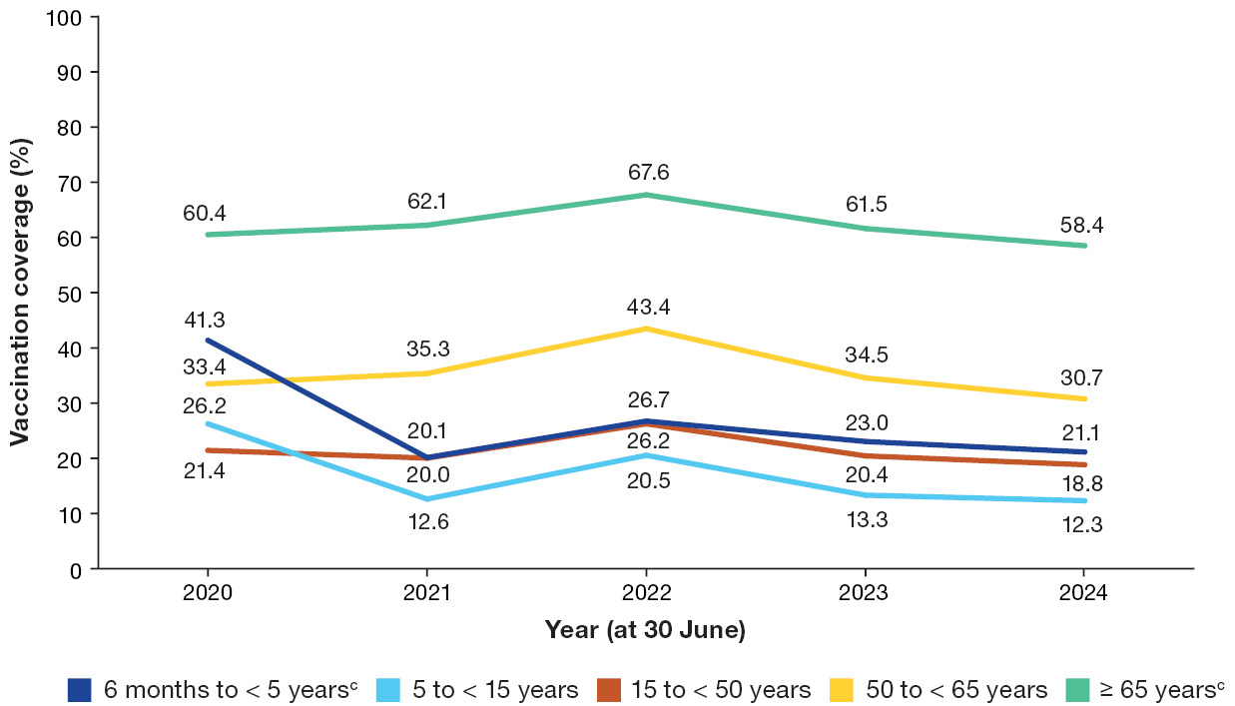
a Analysis done by the National Centre for Immunisation Research and Surveillance (NCIRS) using Australian Immunisation Register (AIR) data.
b Mandatory reporting of influenza vaccination to the AIR was implemented from March 2021.
c Influenza vaccination in this age group is funded through the National Immunisation Program (NIP) for all Australians.
Figure 2: Influenza vaccination coverage (%) by 30 June of each year, by age group, First Nations people,^{a,b} Australia, 2020 to 2024
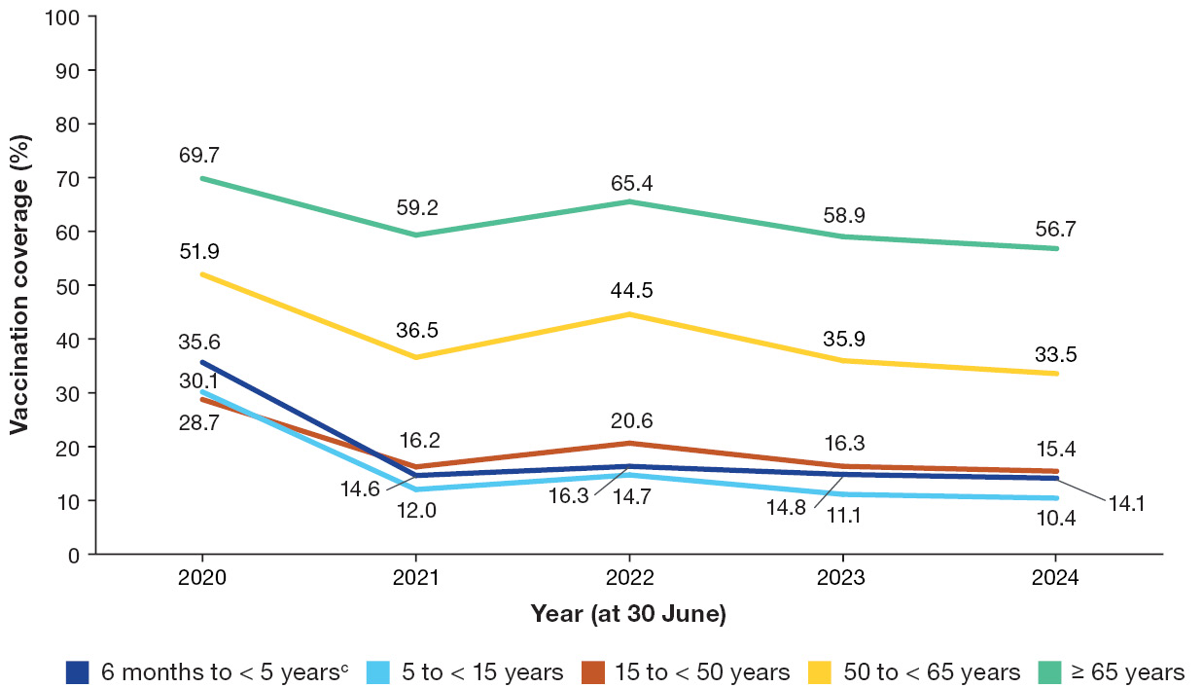
a Analysis done by the National Centre for Immunisation Research and Surveillance (NCIRS) using Australian Immunisation Register (AIR) data.
b Mandatory reporting of influenza vaccination to the AIR was implemented from March 2021.
c Influenza vaccination is funded through the National Immunisation Program (NIP) for all First Nations people aged ≥ 6 months.

Respiratory syncytial virus
RSV infection was added to the National Notifiable Disease List in July 2021 and became a notifiable disease in all states and territories in September 2022.¹⁴ There were 175,918 notifications of RSV infections in 2024 compared with 128,123 notifications in 2023. Across the age spectrum, notification rates for RSV were highest for infants aged < 12 months and children aged 1 to 4 years (8,715 and 4,999 per 100,000 population, respectively) and adults aged ≥ 85 years (1,194 per 100,000 population).
Since 2023, the Therapeutic Goods Administration (TGA) has assessed three new RSV vaccines for use in adults, and a long-acting monoclonal antibody preparation (nirsevimab [Beyfortus, by Sanofi]) for prevention of RSV disease in infants. The three RSV vaccines for use in adults are:
- Arexvy,¹⁸ by GSK, a protein subunit vaccine that was approved in January 2024 for use in older adults aged ≥ 60 years;
- Abrysvo,¹⁹ by Pfizer, a protein subunit vaccine that was approved in March 2024 for use in older adults aged ≥ 60 years, and in pregnant women to protect newborn infants; and
- mRESVIA,²⁰ by Moderna, an mRNA vaccine that was assessed in 2024 and approved in March 2025 for use in older adults aged ≥ 60 years.
ATAGI provided clinical advice on the use of Arexvy to prevent illness and severe complications associated with RSV in older adults and guidance on the use of nirsevimab for the prevention of severe RSV disease in infants in early 2024. Recommendations and clinical practice guidelines on the use of Abrysvo, in addition to the statements on Arexvy and nirsevimab, were subsequently incorporated into the new RSV chapter in the Australian Immunisation Handbook.²¹
Early in 2024, several states and territories introduced and funded nirsevimab programs to prevent severe RSV disease in infants, with different eligibility criteria:
- Western Australia and Queensland implemented nirsevimab access for all newborn infants and medically at-risk children;^{22,23} and
- New South Wales, the Australian Capital Territory, Tasmania and the Northern Territory implemented access for high-risk infants.^{24–26}
In November 2024, the Minister for Health and Ageing announced that pregnant women would have free access under the NIP to Abrysvo from 28 weeks gestation, as recommended by ATAGI, ahead of the 2025 RSV season.²⁷ Providing maternal RSV vaccination through the NIP is complemented by the nirsevimab programs of states and territories to eligible infants (predominantly infants whose mothers did not receive RSV vaccine during pregnancy at least two weeks before giving birth or infants who have a high-risk condition), which will help to prevent severe RSV disease in all infants and medically at-risk young children in Australia.
In 2024, RSV vaccination for older adults was not funded under the NIP.

COVID-19
The number of notifications of laboratory-confirmed COVID-19 (n = 301,602) was 9% lower in 2024 than in 2023 (n = 331,623). Notification rates were highest in those aged ≥ 70 years (3,216 per 100,000 population). The rates for those aged 65 to 69 years and those aged < 5 years were 1,288 per 100,000 population and 1,607 per 100,000 population, respectively, noting that severe COVID-19 occurs much more commonly in older adults than in young children.
In 2024, the national COVID-19 vaccination program started the transition from a pandemic response approach to become one that is integrated with a national vaccination program for controlling important vaccine-preventable respiratory viral diseases.
The Omicron XBB.1.5–based COVID-19 vaccine formulations were granted full registration in Australia in October and December 2023 and were the main vaccines used in 2024. The Omicron JN.1–based COVID-19 vaccine formulations were under evaluation by the TGA in 2024, with COMIRNATY JN.1 (bretovameran) granted full registration in October 2024.²⁸
The proportion of adults who received at least one dose of COVID-19 vaccine decreased in 2024 compared with 2023. Coverage was highest among adults aged ≥ 75 years and lowest among adults aged 18 to < 50 years for both calendar years (see Table 1). This is consistent with the differences in age-based recommendations in the updated ATAGI statement on the administration of COVID-19 vaccines in 2024.²⁹
Table 1: Proportion (%) of adults who received at least one dose of coronavirus disease 2019 (COVID-19) vaccine in a calendar year, by age group,^{a,b} Australia, 2023 and 2024
Age group | 2023 (%) | 2024 (%)
18–49 years | 6.6 | 2.3
50–64 years | 19.1 | 9.1
65–74 years | 41.2 | 24.9
75+ years | 52.3 | 36.5
a Australian Immunisation Register (AIR) data as at 4 February 2024 (for proportions receiving vaccine in 2023) and at 2 February 2025 (for proportions receiving vaccine in 2024).
b These data include adults with Supplementary Identification Numbers (SINs) and Personal Identification Numbers (PINs) because people do not need to be eligible for Medicare registration to receive a COVID-19 vaccine. The SINPIN variable in the AIR is used to distinguish whether someone is Medicare-registered (if they have a PIN) or not (if they have a SIN).

Highlights of immunisation coverage of other vaccine-preventable diseases

Childhood vaccines
Fully vaccinated coverage for children continued to decrease in 2024 at all three age milestones (aged 12, 24 and 60 months) (see Figure 3). The largest decrease was in those aged 12 months, with coverage dropping by 3.2 percentage points since 2020. Coverage at age 24 months decreased to less than 90% for the first time since 2016. Coverage at age 60 months remained higher than for the other age milestones.
Figure 3: Fully vaccinated coverage (%) for children at milestone ages 12, 24 and 60 months,^{a,b} Australia, 2020 to 2024
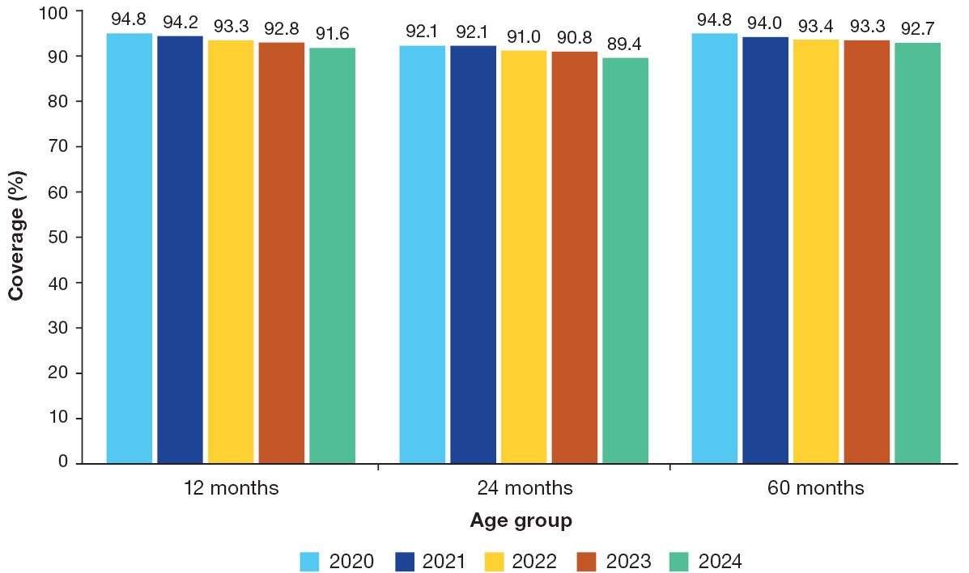
a Data analysis by National Centre for Immunisation Research and Surveillance (NCIRS) using Australian Immunisation Register (AIR) data.
b Definitions for fully vaccinated coverage at ages 12, 24 and 60 months are in the Annual Immunisation Coverage Report, 2023.³⁰
In terms of timely uptake, a number of routine childhood vaccines decreased slightly in 2024 compared with 2023, following a modest progressive general decline over three consecutive years, and remained lower than before the COVID-19 pandemic (see Figures 4 and 5). A marker of on-time vaccination in young children is the measurement of coverage within 30 days after the scheduled age of 4 months for the second dose of DTPa-containing vaccine (DTPa-2) and the scheduled age of 12 months for the first dose of MMR-containing vaccine (MMR-1).
Figure 4: On-time vaccination coverage (%) for non-Indigenous children, for (a) DTPa-containing vaccine (second dose) and (b) MMR-containing vaccine (first dose),^{a,b} Australia, 2020 to 2024
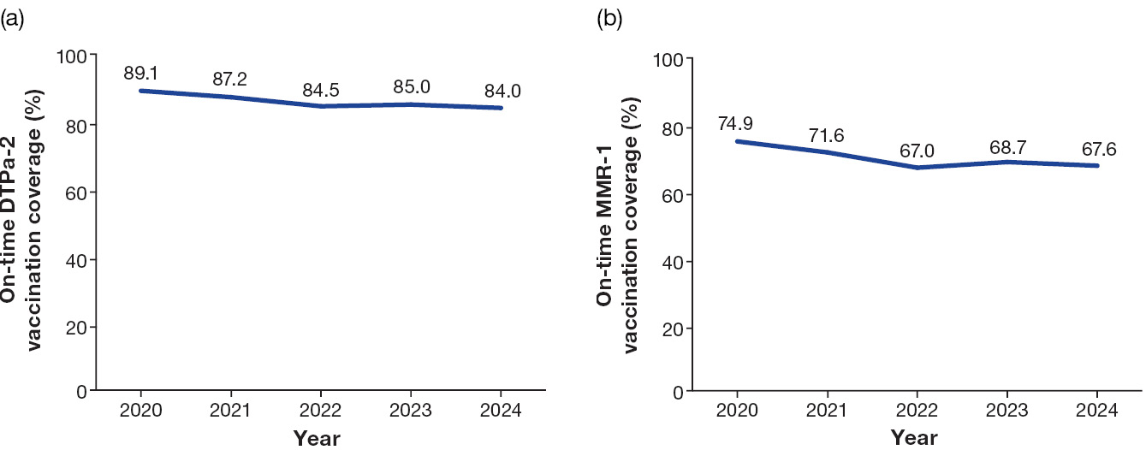
a Data analysis by National Centre for Immunisation Research and Surveillance (NCIRS) using Australian Immunisation Register (AIR) data.
b On-time vaccination is within 30 days of the scheduled age (DTPa-2 is due at 4 months of age and MMR-1 is due at 12 months of age).
Figure 5: On-time vaccination coverage (%) for First Nations children, for (a) DTPa-containing vaccine (second dose) and (b) MMR-containing vaccine (first dose),^{a,b} Australia, 2020 to 2024
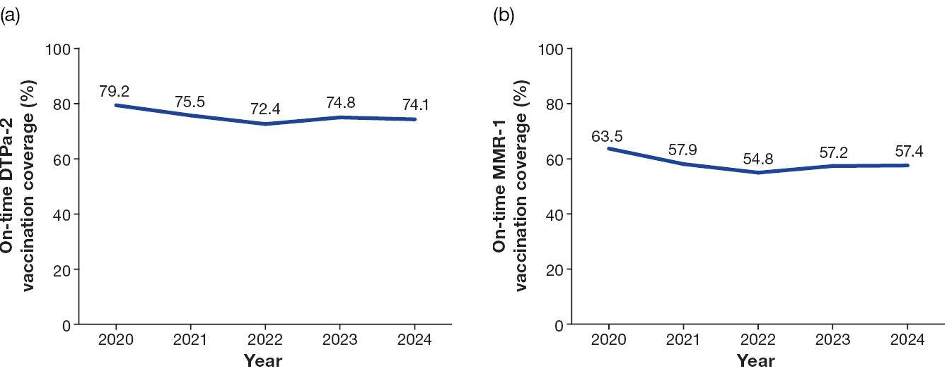
a Data analysis by National Centre for Immunisation Research and Surveillance (NCIRS) using Australian Immunisation Register (AIR) data.
b On-time vaccination is within 30 days of the scheduled age (DTPa-2 is due at 4 months of age and MMR-1 is due at 12 months of age).

Adolescent vaccines
Adolescent vaccines are mainly delivered through school-based immunisation programs.³⁰

Human papillomavirus vaccine
The human papillomavirus (HPV) vaccination schedule under the NIP changed from two doses to one dose in 2023. From 2024, all Australian jurisdictions deliver HPV vaccination through the school-based vaccination program at year 7, after South Australia transitioned from delivery at year 8 to year 7 (noting that delivery included both year 7 and year 8 students in 2024) to align with other jurisdictions.
Coverage of at least one dose of HPV vaccine among adolescents turning 15 years of age showed a continual and progressive decline in 2024 compared with previous years. In 2024, coverage by 15 years of age among all adolescent females and males was 5.5 and 7.0 percentage points lower than in 2020, respectively (see Figure 6). Coverage for adolescent First Nations females and males was 11.1 and 13.8 percentage points lower than in 2020, respectively (see Figure 7).
Factors contributing to this decline likely include vaccine acceptance issues; absenteeism; access issues due to school closures during the COVID-19 pandemic; and other programmatic issues including less opportunity to receive vaccination through school-based vaccination program delivery due to the change in the HPV vaccine schedule from a two-dose schedule to a one-dose schedule from early 2023.³¹ Work is underway to better understand and address these issues.
Additionally, it is of concern that the coverage levels for these populations fell short of both the national strategic target of 90% of all eligible people being vaccinated against HPV by 2030,³² and the World Health Organization target of 90% coverage for females for attaining elimination of cervical cancer.
Figure 6: Human papillomavirus (HPV) vaccine coverage (%) of at least one dose among all adolescents 15 years of age,ª Australia, 2020 to 2024
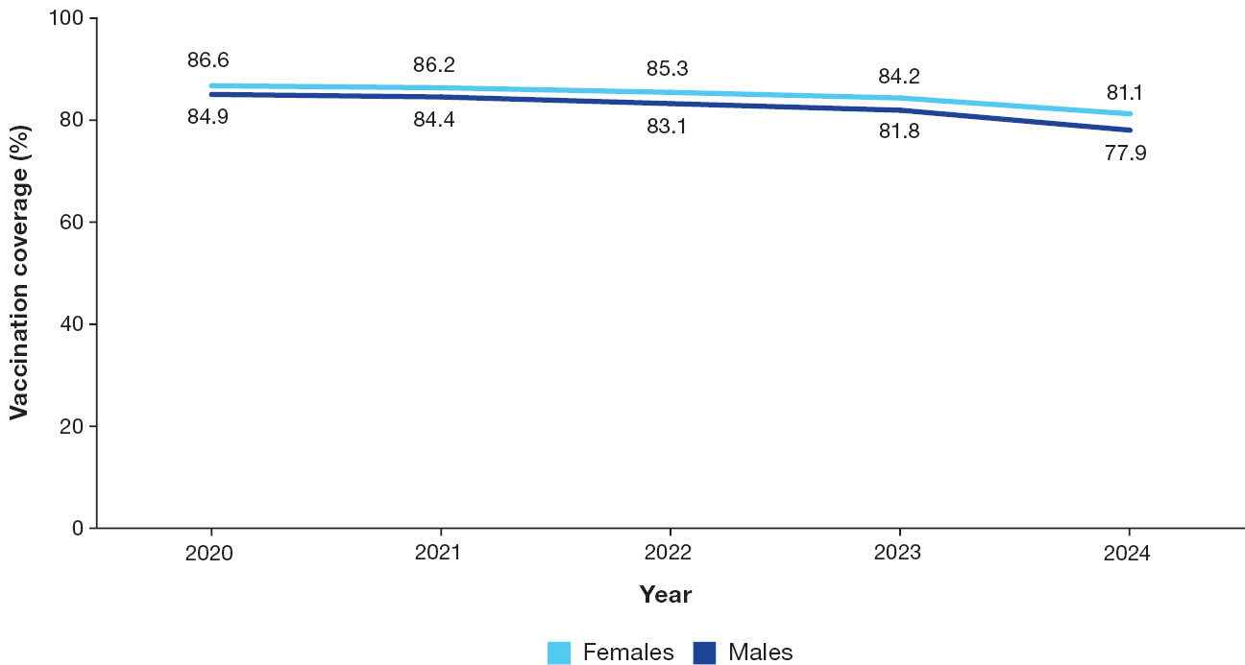
a Data analysis by National Centre for Immunisation Research and Surveillance (NCIRS) using Australian Immunisation Register (AIR) data.
Figure 7: Human papillomavirus (HPV) vaccine coverage (%) of at least one dose among First Nations adolescents 15 years of age,ª Australia, 2020 to 2024
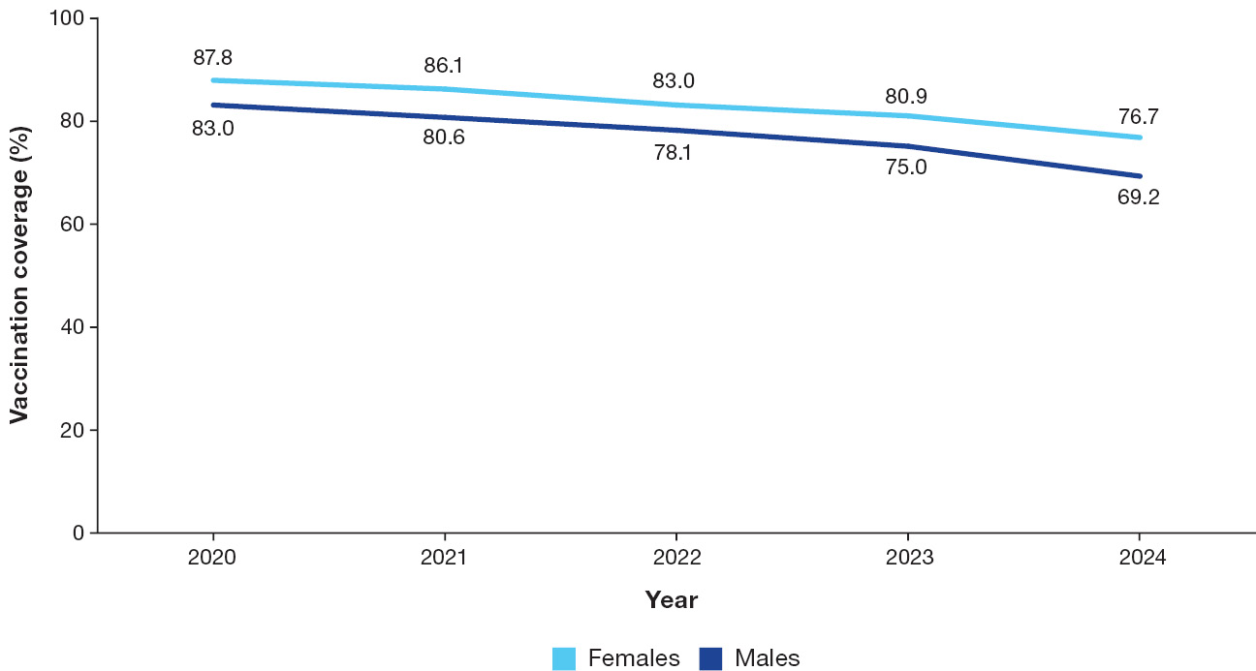
a Data analysis by National Centre for Immunisation Research and Surveillance (NCIRS) using Australian Immunisation Register (AIR) data.

Vaccines for older adults

Zoster (herpes zoster) vaccine
On 1 November 2023, the recombinant vaccine Shingrix (two-dose course) replaced the live attenuated vaccine Zostavax on the NIP for protection against herpes zoster. The eligible age was also lowered to ≥ 50 years for First Nations people and ≥ 65 years for other people. Adults aged ≥ 18 years who are immunocompromised were also included in the program in 2024, noting that Shingrix is safe for use for people at high risk within this age group, whereas Zostavax was contraindicated for use.
In 2024, totals of 34.2% of adults ≥ 65 years of age who were eligible for NIP-funded Shingrix, and 13.9% of First Nations adults aged 50 to 64 years who were eligible, received at least one dose of Shingrix vaccine.

Pneumococcal vaccine
Since July 2020, the NIP offers free pneumococcal conjugate vaccine for eligible older adults, which includes all adults aged ≥ 70 years and First Nations people aged ≥ 50 years. The coverage of a single dose in all adults who turned 71 years of age progressively increased from 7.8% in 2020 to 23.9% in 2021; 33.8% in 2022; 37.6% in 2023; and 38.6% in 2024. The introduction of mandatory reporting of administration of NIP vaccines from mid-2021 likely contributed to some of these observed increases in coverage.

Immunisation policy and practice across Australia

Changes to the National Immunisation Program in 2024
In July 2024, the meningococcal ACWY conjugate vaccine MenQuadfi replaced Nimenrix on the NIP schedule for adolescents aged 14 to 16 years and people aged 15 to 19 years on catch-up programs.³³ Nimenrix will continue to be available through the NIP for children aged 12 months and for people with medical risk conditions.
In September 2024, NIP eligibility for Shingrix vaccination was expanded to include all people aged ≥ 18 years who are immunocompromised due to an underlying health condition and or immunomodulatory/immunosuppressive treatments associated with moderate to high risk of severe infection or complications from shingles.³⁴

Expanded pharmacist vaccination program
The National Immunisation Program Vaccination in Pharmacy (NIPVIP) program started in January 2024, and allows community pharmacies to administer NIP vaccines to eligible people aged ≥ 5 years without any out-of-pocket costs.³⁵ The program, funded through the NIP, was expanded in April 2024 to include off-site administration of NIP vaccines in aged care facilities and specialist disability accommodation. The vaccines that pharmacists can administer depend on the state or territory legislation.³⁶
As the national funding for the NIPVIP expands, ATAGI considers it essential to monitor and evaluate key aspects of this policy and program, especially those aspects that improve equitable access to vaccination services for various populations.

No-fault vaccine compensation scheme
The COVID-19 Vaccine Claims Scheme ended on 30 September 2024.³⁷ The scheme allowed people to claim compensation for injuries resulting from diagnosed clinical conditions likely to be caused by a TGA-approved COVID-19 vaccine or its administration. Such serious injuries are very rare. As proposed in the NIS 2025–2030, this period offers an opportunity to explore the feasibility of a no-fault compensation scheme that covers all vaccines on the NIP.⁴

Major additions or updates to the Australian Immunisation Handbook in 2024
The mpox chapter was added, and was subsequently updated to remove the age restriction in initial mpox vaccination recommendations.
The RSV chapter was added. This chapter consolidated and followed on from previous ATAGI clinical guidance statements to provide updated information on recommendations and guidance for use of RSV immunisation products. Recommendations include use of RSV vaccines in adults and pregnant women, and use of long-acting RSV monoclonal antibodies in infants and young children.
The zoster (herpes zoster) chapter was updated, to reflect expansion of eligibility for NIP-funded Shingrix vaccine to include people aged ≥ 18 years with moderate to severe immunocompromise. The new table, on risk conditions and immunosuppressive therapies for zoster vaccination and eligibility for NIP funding, outlines the major risk categories and funding status.
The section on vaccination for people who are immunocompromised was updated, to include new vaccine recommendations relevant for this special population group. Additional updates in this section have been published in 2025.
Readers are advised to regularly check for updated guidelines on the online Australian Immunisation Handbook.

New vaccines and potential vaccination programs
The TGA registered three new vaccines in 2024 (see Table 2).
Table 2: New vaccines and immunisation products registered with the Therapeutic Goods Administration (TGA),ª Australia, 2024
Vaccine brand name | Description | Protection against | Eligible population for use
Arexvy | Recombinant RSV protein vaccine | Lower respiratory tract disease caused by RSV | Adults aged ≥ 60 years
Abrysvo | Recombinant RSV protein vaccine | Lower respiratory tract disease caused by RSV | Adults aged ≥ 60 years
Abrysvo | Recombinant RSV protein vaccine | Lower respiratory tract disease caused by RSV | Pregnant women between 24 and 36 weeks gestation, for the prevention of lower respiratory tract disease caused by RSV in infants from birth through to 6 months of age
COMIRNATY JN.1 | mRNA COVID-19 vaccine | COVID-19 caused by SARS-CoV-2 | People aged ≥ 6 months
a For more information on the current status of COVID-19 vaccines in Australia, see the TGA COVID-19 vaccines regulatory status.²⁸

Combination vaccines for respiratory viruses and other immunisation products under development
Combination mRNA vaccines that target several respiratory viruses in a single vaccine are under development. Examples include combination influenza and COVID-19 vaccines, and combination RSV and human metapneumovirus (hMPV) vaccines.
ATAGI continues to monitor the development of these and many other vaccines and immunisation products, such as:
- multiple candidates of pneumococcal vaccines with extended valency, some of which include more than 30 serotypes;
- additional long-acting monoclonal antibodies for the prevention of severe RSV disease in infants;
- vaccines against group B Streptococcus disease; and
- vaccines against cytomegalovirus (CMV) disease.

Vaccine safety
The TGA has overall responsibility for vaccine safety surveillance in Australia and oversees both active and passive vaccine safety surveillance activities. ATAGI continues to work closely with the TGA to advise on and promote the safe use of all vaccines.
No major new vaccine safety issues were identified in 2024. Noteworthy updates on safety information regarding the recombinant herpes zoster vaccine, RSV vaccine and mRNA COVID-19 vaccines are summarised below.

Recombinant herpes zoster vaccine Shingrix
The recombinant protein subunit (non-live) herpes zoster vaccine Shingrix has been on the NIP since November 2023. No serious safety concerns with Shingrix were identified from preliminary AusVaxSafety data (current to 31 December 2024) from more than 120,000 vaccine recipients in Australia.³⁸ Fewer than 1% of people who received Shingrix on its own and fewer than 1% of people who received Shingrix with another vaccine reported visiting a doctor or the emergency department in the days after vaccination.
In October 2024, the TGA issued a statement recognising Guillain–Barré syndrome (GBS), a neurological condition, as a very rare adverse event after Shingrix vaccination.³⁹ Post-marketing data among adults aged ≥ 65 years from the United States suggested an increased risk of occurrence of GBS within 42 days after Shingrix vaccination, estimated at 3 additional cases per million doses administered over the expected baseline rate. As at 18 September 2024, the TGA had received 13 reports of GBS after Shingrix vaccination. No deaths were reported.

Respiratory syncytial virus vaccine use in older adults and pregnant women and nirsevimab use in infants
The recombinant RSV protein vaccine Arexvy was registered with the TGA in January 2024 and is available by private prescription. No serious safety concerns were identified from preliminary AusVaxSafety data (current to 31 January 2025) from more than 2,400 adults aged ≥ 60 years who had received Arexvy.⁴⁰ Fewer than 1% of these adults reported visiting a doctor or the emergency department in the days after vaccination.
AusVaxSafety did not report in 2024 on the use of the Abrysvo RSV vaccine among pregnant individuals and older adults, due to its very limited use that year. Reporting is occurring from 2025 onwards. Clinical trials showed that between pregnant women who received Abrysvo and those who received placebo, there was little to no difference in the rates of serious adverse events among these women or their pregnancy outcomes, or serious adverse events in infants born to these women.⁴¹ Ongoing monitoring for select adverse events of special interest, including any differences in rates of preterm birth after vaccination – which were observed in one phase 3 clinical trial site in a non-high-income country – will continue as real-world usage increases.
AusVaxSafety conducted active safety surveillance of nirsevimab at participating sites in New South Wales and Queensland during the 2024 winter season.⁴² Active safety surveillance was also undertaken in the Western Australian RSV immunisation program for infants.⁴³ No safety signals occurred; however, available numbers were limited, and safety monitoring continues.

Therapeutic Goods Administration statement on misinformation about mRNA vaccines
In October 2024, the TGA released a statement that refuted misleading claims about excessive levels of DNA in COVID-19 mRNA vaccines.⁴⁴ The statement outlined the limitations in the methods and potential flaws in the interpretation of the scientific data that underpinned these claims, and also emphasised the importance of ongoing vaccine safety monitoring. Additionally, in November 2024, the TGA released a statement on its independent testing of mRNA vaccines for residual DNA and endotoxins, which showed that the approved vaccines used in Australia are within the safe limit.⁴⁵

Challenges and priorities for immunisation in Australia in 2025 and beyond

Key challenges for preventing and controlling vaccine-preventable diseases through immunisation
This document highlights the key successes, trends and challenges in the use of vaccines and control of VPDs in Australia in 2024. Major policy developments were established in 2024, including the National Immunisation Strategy 2025–2030, the Health Technology Assessment Policy and Methods Review, and the COVID-19 Response Inquiry Report. These initiatives aim to improve access to vaccines, strengthening data use, and enhance preparedness for future pandemics.
ATAGI provided clinical advice on the use of two new RSV vaccines for older adults and a long-acting monoclonal antibody for infants, and on updated COVID-19 vaccines to protect against the most common circulating variants.
Key challenges remain, particularly in maintaining community confidence in Australia’s vaccination program and in improving uptake of vaccines across all recommended age groups and risk groups. In 2024, vaccination coverage for several routine childhood and adolescent vaccines continued to decline, and influenza coverage was suboptimal, especially among young children and First Nations people. ATAGI continues to monitor these trends and provide policy advice to address coverage declines, emerging disease threats, and barriers to timely vaccination.
ATAGI commenced work on recommendations for several other vaccines. This included adding new chapters on RSV and mpox and updating recommendations for zoster and for people who are immunocompromised in the Australian Immunisation Handbook. ATAGI continued to assess and provide advice on the best strategies for preventing and controlling other VPDs, including influenza, pneumococcal disease and COVID-19.
For 2025 and beyond, the key challenges for prevention and control of VPDs can be summarised as follows:
- maintaining high-quality, efficient assessment of vaccines and other immunisation products, including through disease modelling where relevant, to support development of immunisation policies and impactful, cost-effective and equitable programs that maximise disease prevention in the population;
- monitoring the impact of new vaccine introductions: for example, Australia’s approach to RSV prevention in infants in 2025, with a world-leading combined maternal and infant immunisation program;
- maintaining rapid vaccine-related policy advice for emerging and re-emerging VPDs, such as measles, mpox and Japanese encephalitis, in collaboration with key stakeholders;
- understanding the key drivers of declining vaccination coverage for a number of vaccines, and recommending evidence-informed policy and program measures to mitigate the trend;
- ensuring that policies consider barriers to immunisation and address equitable access to NIP-funded vaccines in diverse settings and populations, especially those with increased risks of VPDs;
- ensuring equitable access to NIP-funded vaccines for First Nations communities and developing immunisation policies that reflect the diverse experiences of First Nations communities across Australia, including through incorporating feedback from representative groups such as the National Aboriginal and Torres Strait Islander Health Protection (NATSIHP) subcommittee of the Australian Health Protection Committee (AHPC); and
- acquiring and using timely and accurate data on the epidemiology of VPDs, the impacts of immunisation programs and the immunisation coverage of populations with increased risks of VPDs, to ensure the best-informed approaches to immunisation policy.
ATAGI’s ongoing priority actions and specific priorities for 2025 are:
- to continue working on advice on the ongoing priorities of equity and accessibility of vaccines to improve coverage in all populations including special populations, maintaining the Australian Immunisation Handbook, and scoping and horizon scanning;
- to advise on a national maternal and infant RSV immunisation program rollout;
- to review frameworks for evaluation of new products, including surveillance and development of the evidence base for new vaccines, such as CMV and hMPV;
- to continue to monitor the decreasing coverage trends of some vaccines to inform potential additional strategies for controlling these VPDs in Australia;
- to monitor development of vaccines in the pipeline, monitoring and evaluation of VPD disease prevention and control methods, and social and behavioural insights to inform immunisation policy, practice and recommendations;
- to continue to monitor epidemiology and availability of vaccine products and advice around an optimal schedule, particularly for RSV and pneumococcal disease;
- to monitor impacts of schedule changes on vaccine coverage and disease epidemiology – for example, the change to a one-dose HPV schedule in 2023;
- to provide further advice on the transition from quadrivalent influenza vaccine (QIV) to trivalent influenza vaccine (TIV) for the influenza vaccination program, in the context of the global absence of the influenza B/Yamagata lineage;
- to prepare for providing advice on use of vaccines for prevention and control of outbreaks or pandemics of HPAI in humans, as required;
- to continue to recommend a review of the feasibility of establishing a vaccine compensation scheme that covers all NIP-funded vaccines, taking into account the experience of the COVID-19 Vaccine Claims Scheme and international best practice;
- to collaborate with key stakeholders and other committees to provide a streamlined approach for appraisal of vaccines for developing immunisation policies and evaluation of vaccination programs; and
- to maintain, and if possible extend, engagement with the national immunisation technical advisory groups (NITAGs) of key overseas countries to enhance sharing of experience and lessons learnt with respect to developing immunisation policies and programs, such as those on RSV, pneumococcal disease or influenza – this includes working with regional NITAGs, such as the recently established NITAG in New Zealand.⁴⁶

Acknowledgments
The authors wish to thank the following additional ATAGI members for their contributions:
Prof. Allen Cheng, Mr Tom Clayton, Dr Sarah McGuiness, Prof. Paul Kelly, Dr Alan Leeb, Ms Karen Bellamy, A/Prof. Penelope Burns, Ms Kristy Cooper, Prof. Margaret Danchin, Dr Julia Marshall, A/Prof. Benjamin Teh, Ms Diane Walsh, Dr Rosalind Webby, and Prof. James Wood.
The authors also wish to thank the Health Protection Policy and Surveillance Division and the Communicable Disease Network Australia for notification data provided and Frank Beard and Brynley Hull from the National Centre for Immunisation and Research Coverage, Evaluation and Surveillance team.

Author details
Katrina Nicolopoulos,¹*
Saskia van der Kooi,¹*
Clayton Chiu,^{1,2}
Alexandra Hendry,¹
Kristine K Macartney,^{1,2,3}
A/Prof. Katherine Gibney,^{3,4,5}
Prof. Katie Flanagan,^{3,6,7,8}
Michelle L Giles,^{3,5,9}
Nigel W Crawford^{3,10,11}
- National Centre for Immunisation Research and Surveillance, Children’s Hospital at Westmead, Sydney, New South Wales, Australia
- Discipline of Child and Adolescent Health, Sydney Medical School, University of Sydney, New South Wales, Australia
- Australian Technical Advisory Group on Immunisation, Department of Health, Australian Government, Canberra, Australian Capital Territory, Australia
- Victorian Infectious Diseases Service, The Royal Melbourne Hospital, Victoria, Australia
- Department of Infectious Diseases, University of Melbourne, Melbourne, Victoria, Australia
- Centre for Infectious Diseases and Microbiology, Westmead Hospital, Sydney, New South Wales, Australia
- School of Medicine, University of Tasmania, Hobart, Tasmania, Australia
- School of Health and Biomedical Science, RMIT, Melbourne, Victoria, Australia
- Department of Obstetrics and Gynaecology, Monash University, Melbourne, Victoria, Australia
- Department of General Paediatrics, Royal Children’s Hospital, Melbourne, Victoria, Australia
- Infection and Immunity, Murdoch Children’s Research Institute and University of Melbourne, Victoria, Australia

Corresponding author
Australian Technical Advisory Group on Immunisation (ATAGI) secretariat, Immunisation Branch, Australian Government Department of Health, Disability and Ageing, GPO Box 9848 – MDP 13, Canberra ACT 2601
Email: atagi.secretariat@health.gov.au
* Katrina Nicolopoulos and Saskia van der Kooi contributed equally to this publication.

References
- Australian Government Department of Health, Disability and Ageing. National Immunisation Program – Shingles vaccination – Program advice for health professionals. [Internet.] Canberra: Australian Government Department of Health, Disability and Ageing; 12 November 2024. Available from: https://www.health.gov.au/resources/publications/national-immunisation-program-shingles-vaccination-program-advice-for-health-professionals.
- Australian Government Department of Health, Disability and Ageing. Health Technology Assessment Policy and Methods Review – Final report. Canberra: Australian Government Department of Health, Disability and Ageing; 10 September 2024. Available from: https://www.health.gov.au/resources/publications/health-technology-assessment-policy-and-methods-review-final-report.
- Australian Government Department of the Prime Minister and Cabinet. COVID-19 Response Inquiry Report. Canberra, Australia: Australian Government Department of the Prime Minister and Cabinet; 29 October 2024. Available from: https://www.pmc.gov.au/resources/covid-19-response-inquiry-report.
- Australian Government, Australian Centre for Disease Control (Australian CDC). National Immunisation Strategy for Australia 2025–2030. Canberra: Australian CDC; 12 May 2025. Available from: https://www.cdc.gov.au/resources/publications/national-immunisation-strategy-australia-2025-2030.
- Australian Government Department of Health, Disability and Ageing. Broad expertise to lead health technology assessment reform. [Media release.] Canberra: Australian Government Department of Health, Disability and Ageing; 20 November 2024. Available from: https://www.health.gov.au/ministers/the-hon-mark-butler-mp/media/broad-expertise-to-lead-health-technology-assessment-reform.
- Australian CDC. First mpox clade Ib confirmed in Australia. [Media release.] Canberra: Australian CDC; 16 May 2025. Available from: https://www.cdc.gov.au/newsroom/news-and-articles/first-mpox-clade-ib-confirmed-australia.
- Africa Centres for Disease Control and Prevention (Africa CDC). Africa CDC Declares Mpox A Public Health Emergency of Continental Security, Mobilizing Resources Across the Continent. [News release.] Addis Ababa: Africa CDC; 13 August 2024. Available from: https://africacdc.org/news-item/africa-cdc-declares-mpox-a-public-health-emergency-of-continental-security-mobilizing-resources-across-the-continent/.
- World Health Organization (WHO). WHO Director-General declares mpox outbreak a public health emergency of international concern. [News release.] Geneva: WHO; 14 August 2024. Available from: https://www.who.int/news/item/14-08-2024-who-director-general-declares-mpox-outbreak-a-public-health-emergency-of-international-concern.
- Australian Government Department of Health, Disability and Ageing; Australian Immunisation Handbook. Mpox (previously known as monkeypox). [Webpage.] Canberra: Australian Government Department of Health, Disability and Ageing; 16 May 2024. Available from: https://immunisationhandbook.health.gov.au/contents/vaccine-preventable-diseases/mpox-previously-known-as-monkeypox.
- Australian Government Department of Health, Disability and Ageing. ATAGI Clinical Guidance on the use of vaccines for the prevention of Mpox. [Webpage.] Canberra: Australian Government Department of Health, Disability and Ageing; 20 December 2024. Available from: https://www.health.gov.au/resources/publications/atagi-clinical-guidance-on-the-use-of-vaccines-for-the-prevention-of-mpox.
- Queensland State Government Department of Primary Industries (Queensland DPI). Outbreaks of avian influenza (bird flu). [Internet.] Brisbane: Queensland DPI; 17 February 2025. Available from: https://www.dpi.qld.gov.au/business-priorities/biosecurity/animal-biosecurity-welfare/animal-health-pests-diseases/reportable/avian-influenza-bird-flu.
- Australian Government Department of Health, Disability and Ageing. ATAGI 107th meeting bulletin – 15 and 16 August 2024. [Webpage.] Canberra: Australian Government Department of Health, Disability and Ageing; 16 September 2024. Available from: https://www.health.gov.au/resources/publications/atagi-107th-meeting-bulletin-15-and-16-august-2024.
- Australian CDC. Bird flu (avian influenza). [Webpage.] Canberra: Australian CDC; 19 January 2026. Available from: https://www.cdc.gov.au/topics/bird-flu.
- Hassall J, Whitehead S, Welsh L, Donovan A, Bilgin G, Nguyen N et al. 2024 Annual Australian Respiratory Surveillance Report. Commun Dis Intell (2018). 2026;50. doi: https://doi.org/10.33321/cdi.2026.50.013.
- Yin JK, Heywood AE, Georgousakis M, King C, Chiu C, Isaacs D et al. Systematic review and meta-analysis of indirect protection afforded by vaccinating children against seasonal influenza: implications for policy. Clin Infect Dis. 2017;65(5):719–28. doi: https://doi.org/10.1093/cid/cix420.
- Government of Western Australia Department of Health (WA Health). Influenza immunisation. [Webpage.] Perth: WA Health; 5 September 2025. Available from: https://www.health.wa.gov.au/articles/f_i/influenza-immunisation-program.
- Queensland Government Department of Health (Queensland Health). 2025 Free Flu Vaccination Program. [Webpage.] Brisbane: Queensland Health; 3 March 2025. Available from: https://www.health.qld.gov.au/clinical-practice/guidelines-procedures/diseases-infection/immunisation/service-providers/2025-free-flu-vaccination-program.
- Australian Government Department of Health, Disability and Ageing; Therapeutic Goods Administration (TGA). Arexvy: Australian Prescription Medicine Decision Summary. [Webpage.] Canberra: TGA; 22 January 2024. Available from: https://www.tga.gov.au/resources/auspmd/arexvy.
- TGA. Abrysvo (RSV vaccine): Australian Prescription Medicine Decision Summary. [Webpage.] Canberra: TGA; 22 May 2024. Available from: https://www.tga.gov.au/resources/auspmd/abrysvo-rsv-vaccine.
- TGA. mRESVIA respiratory syncytial virus F protein mRNA (nucleoside modified), 50 micrograms in 0.5 mL, suspension for injection, prefilled syringe. (411450). [Webpage.] Canberra: TGA; 28 March 2025. Available from: https://www.tga.gov.au/resources/artg/411450.
- Australian Government Department of Health, Disability and Ageing; Australian Immunisation Handbook. Respiratory syncytial virus (RSV). [Webpage.] Canberra: Australian Government Department of Health, Disability and Ageing; 27 June 2024. Available from: https://immunisationhandbook.health.gov.au/contents/vaccine-preventable-diseases/respiratory-syncytial-virus-rsv.
- WA Health. 2025 WA Respiratory Syncytial Virus (RSV) Infant and Maternal Immunisation Program. [Webpage.] Perth: WA Health; 31 October 2025. Available from: https://www.health.wa.gov.au/articles/n_r/2025-wa-respiratory-syncytial-virus-rsv-infant-and-maternal-immunisation-program.
- Queensland Health. Respiratory Syncytial Virus (RSV): Queensland Paediatric RSV Prevention Program. [Webpage.] Brisbane: Queensland Health; 16 January 2025. Available from: https://www.health.qld.gov.au/clinical-practice/guidelines-procedures/diseases-infection/immunisation/schedule/paediatric-rsv-prevention-program#section__queensland-paediatric-rsv-prevention-program.
- New South Wales Government Department of Health (NSW Health). NSW RSV Preventation Program - Frequently asked questions for health professional. [Webpage.] Sydney: NSW Health; 2 April 2025. Available from: https://www.health.nsw.gov.au/immunisation/pages/nirsevimab-professionals.aspx#who.
- Tasmanian Government Department of Health (Tasmania Health). Communicable Disease Prevention Unit Bulletin: Respiratory Syncytial Virus (RSV) Immunisation Update. [Newsletter.] Hobart: Tasmania Health; 16 August 2024. Available from: https://www.health.tas.gov.au/newsletters/communicable-disease-prevention-unit-bulletin#:~:text=Respiratory%20Syncytial%20Virus%20(RSV)%20Immunisation%20Update.
- Northern Territory Government Department of Health (NT Health). Immunisation program: Respiratory Syncytial Virus (RSV). [Webpage.] Darwin: NT Health; 2025. Available from: https://health.nt.gov.au/professionals/centre-for-disease-control/immunisation-program/respiratory-syncytial-virus-rsv.
- Australian Government Department of Health, Disability and Ageing. World-leading approach to protect babies from RSV. Media release.] Canberra: Australian Government Department of Health, Disability and Ageing; 10 November 2024. Available from: https://www.health.gov.au/ministers/the-hon-mark-butler-mp/media/world-leading-approach-to-protect-babies-from-rsv.
- TGA. COVID-19 vaccines regulatory status. [Webpage.] Canberra: TGA; 24 July 2025. Available from: https://www.tga.gov.au/products/medicines/prescription-medicines/application-and-market-authorisation/covid-19-vaccine-information-sponsors-industry/covid-19-vaccines-regulatory-status.
- Australian Government Department of Health, Disability and Ageing. ATAGI statement on the administration of COVID-19 vaccines in 2024. [Webpage.] Canberra: Australian Government Department of Health, Disability and Ageing; 1 March 2024. Available from: https://www.health.gov.au/resources/publications/atagi-statement-on-the-administration-of-covid-19-vaccines-in-2024.
- Hull B, Hendry A, McCartney K, Beard F. Annual Immunisation Coverage Report 2023. Commun Dis Intell (2018). 2026;50. doi: https://doi.org/10.33321/cdi.2026.50.001.
- Australian Government Department of Health, Disability and Ageing. Changes to HPV vaccine dose schedule for young Australians. [Webpage.] Canberra: Australian Government Department of Health, Disability and Ageing; 6 February 2023. Available from: https://www.health.gov.au/news/changes-to-hpv-vaccine-dose-schedule-for-young-australians.
- Australian Government Department of Health, Disability and Ageing. National Strategy for the Elimination of Cervical Cancer in Australia. [Webpage.] Canberra: Australian Government Department of Health, Disability and Ageing; 17 November 2023. Available from: https://www.health.gov.au/resources/publications/national-strategy-for-the-elimination-of-cervical-cancer-in-australia.
- Australian Government Department of Health, Disability and Ageing. National Immunisation Program (NIP) Meningococcal ACWY changes from 1 July 2024. [Webpage.] Canberra: Australian Government Department of Health, Disability and Ageing; 1 July 2024. Available from: https://www.health.gov.au/news/national-immunisation-program-nip-meningococcal-acwy-changes-from-1-july-2024.
- Australian Government Department of Health, Disability and Ageing. National Immunisation Program – Shingles vaccination – Program advice for health professionals. Canberra: Australian Government Department of Health, Disability and Ageing; 12 November 2024. Available from: https://www.health.gov.au/resources/publications/national-immunisation-program-shingles-vaccination-program-advice-for-health-professionals.
- Pharmacy Programs Administrator (PPA). Program Rules: National Immunisation Program Vaccinations in Pharmacy (NIPVIP) Program. Australian Government Department of Health, Disability and Ageing, PPA; September 2025. Available from: https://www.ppaonline.com.au/wp-content/uploads/2023/11/NIPVIP-Program-Rules.pdf.
- National Centre for Immunisation Research and Surveillance (NCIRS). Vaccination from community pharmacy – at a glance. Sydney: Sydney Children’s Hospitals Network, NCIRS; March 2025. Available from: https://ncirs.org.au/fact-sheets-faqs/vaccines-from-community-pharmacy.
- Australian Government Department of Health, Disability and Ageing. COVID-19 Vaccine Claims Scheme. [Webpage.] Canberra: Australian Government Department of Health, Disability and Ageing; 8 October 2024. Available from: https://www.health.gov.au/our-work/covid-19-vaccine-claims-scheme#updates-to-the-scheme.
- AusVaxSafety. Shingrix. [Webpage.] Sydney: Sydney Children’s Hospitals Network, NCIRS. Available from: https://ausvaxsafety.org.au/vaccine-safety-data/shingrix.
- TGA. Shingrix vaccine and very rare risk of Guillain-Barré Syndrome. [Webpage.] Canberra: TGA; 29 October 2024. Available from: https://www.tga.gov.au/news/safety-updates/shingrix-vaccine-and-very-rare-risk-guillain-barre-syndrome.
- AusVaxSafety. Arexvy RSV vaccine safety data – older adults. [Webpage.] Sydney: Sydney Children’s Hospitals Network, NCIRS. Available from: https://ausvaxsafety.org.au/rsv-vaccines/arexvy-rsv-vaccine-safety-data-older-adults.
- Kampmann B, Madhi SA, Munjal I, Simões EAF, Pahud BA, Llapur C et al. Bivalent prefusion F vaccine in pregnancy to prevent RSV illness in infants. N Engl J Med. 2023;388(16):1451–64. doi: https://doi.org/10.1056/NEJMoa2216480.
- AusVaxSafety. Nirsevimab. [Webpage.] Sydney: Sydney Children’s Hospitals Network, NCIRS. Available from: https://ausvaxsafety.org.au/vaccine-safety-data/nirsevimab.
- Carcione D, Spencer P, Pettigrew G, Leeb A, Drake-Brockman C, Ford T et al. Active post-marketing safety surveillance of nirsevimab administered to children in Western Australia, April–July 2024. Pediatr Infect Dis J. 2025;44(5):e174–6. doi: https://doi.org/10.1097/INF.0000000000004715.
- TGA. Addressing misinformation about excessive DNA in the mRNA vaccines. [Media release.] Canberra: TGA; 18 October 2024. Available from: https://www.tga.gov.au/news/media-releases/addressing-misinformation-about-excessive-dna-mrna-vaccines.
- Australian Government Therapeutic Goods Administration. Summary report of residual DNA and endotoxin on COVID-19 mRNA vaccines conducted by TGA Laboratories. [Webpage.] Canberra: TGA; 7 November 2024. Available from: https://www.tga.gov.au/resources/publication/tga-laboratory-testing-reports/summary-report-residual-dna-and-endotoxin-covid-19-mrna-vaccines-conducted-tga-laboratories.
- Aotearoa New Zealand Government Ministry of Health – Manatū Hauora (NZ Ministry of Health). National Immunisation Technical Advisory Group (NITAG). [Internet.] Wellington: NZ Ministry of Health; 27 June 2024. Available from: https://www.health.govt.nz/information-releases/national-immunisation-technical-advisory-group-nitag.
- Australian Government Department of Health, Disability and Ageing. ATAGI strategic intent. [Webpage.] Canberra: Australian Government Department of Health, Disability and Ageing; 10 September 2020. Available from: https://www.health.gov.au/resources/publications/atagi-strategic-intent.

Appendix A: About ATAGI
The Australian Technical Advisory Group on Immunisation (ATAGI) advises the Minister for Health and Ageing on the National Immunisation Program (NIP) and other immunisation issues.
ATAGI’s vision is to protect the Australian population from vaccine-preventable diseases (VPDs). This is shown in ATAGI’s strategic intent.⁴⁷
ATAGI’s purpose is to provide evidence-based advice to the Minister for Health and other key policymakers on immunisation policies, immunisation programs, and future research priorities. This includes identifying and prioritising gaps in the immunisation landscape to improve the impact of immunisation programs; to raise confidence in immunisation programs, as well as in the vaccines used in the programs; and to boost equity in access to, and outcomes of, immunisation programs.
The National Centre for Immunisation Research and Surveillance (NCIRS) provides technical support to ATAGI and the Australian Government Department of Health, Disability and Ageing. ATAGI works with NCIRS to develop and publish the Australian Immunisation Handbook.

https://immunisationhandbook.health.gov.au/contents/vaccine-preventable-diseases/mpox-previously-known-as-monkeypox.
https://immunisationhandbook.health.gov.au/contents/vaccine-preventable-diseases/respiratory-syncytial-virus-rsv.
https://immunisationhandbook.health.gov.au/contents/vaccine-preventable-diseases/zoster-herpes-zoster.
https://immunisationhandbook.health.gov.au/resources/tables/table-risk-conditions-and-immunosuppressive-therapies-for-zoster-vaccination-and-eligibility-for-nip-funding.
https://immunisationhandbook.health.gov.au/contents/vaccination-for-special-risk-groups/vaccination-for-people-who-are-immunocompromised.
https://immunisationhandbook.health.gov.au.

