
2026 • Volume 50 • cdc.gov.au/cdi • Epub date: 26.05.2026 • doi.org/10.33321/cdi.2026.50.013

2024 Annual Australian Respiratory Surveillance Report
Jenna Hassall, Suzie Whitehead, Lauren Welsh, Ash Donovan, Gizem Bilgin, Nga Nguyen, Caitlin Trenorden, Siobhan St George
© 2026 Commonwealth of Australia as represented by the Australian Centre for Disease Control
ISSN: 2209-6051 Online
This journal is indexed by Index Medicus and Medline.
Creative Commons Licence
This publication is licensed under a Creative Commons Attribution-NonCommercial-NoDerivatives 4.0 International Licence (Licence). You must read and understand the Licence before using any material from this publication.
Restrictions
The Licence does not cover, and there is no permission given for, use of any of the following material found in this publication (if any):
- the Commonwealth Coat of Arms (by way of information, the terms under which the Coat of Arms may be used can be found on the Department of Prime Minister and Cabinet website);
- any logos (including the Australian Centre for Disease Control’s logo) and trademarks;
- any photographs and images;
- any signatures; and
- any material belonging to third parties.
Disclaimer
Opinions expressed in Communicable Diseases Intelligence are those of the authors and not necessarily those of the Australian Government or the Australian Centre for Disease Control. Data may be subject to revision.
Enquiries
Enquiries regarding any other use of this publication should be addressed to the CDI Editor.
About CDI
Communicable Diseases Intelligence (CDI) is a peer-reviewed scientific journal published by the Australian Centre for Disease Control.
The journal aims to disseminate information on the epidemiology, surveillance, prevention and control of communicable diseases of relevance to Australia and the near region.
Editor: Dr Elise Firman • Deputy Editor: Simon Petrie • Design and Production: Lisa Thompson
Editorial Advisory Board: David Durrheim, Mark Ferson, Clare Huppatz, John Kaldor, Martyn Kirk and Meru Sheel
Submit an Article
Guidelines for authors and details on how to submit your publication is available on our website, or by email to the
CDI Editor.
Contact us
Communicable Diseases Intelligence (CDI)
Australian Centre for Disease Control
PO Box 795, Canberra ACT 2601, Australia
Website: cdc.gov.au/cdi
Email: cdi.editor@cdc.gov.au

Contents
Abstract 7
Summary 8
Introduction 10
Methods and data considerations 11
National Notifiable Diseases Surveillance System (NNDSS) 11
ABS Provisional Mortality Statistics 15
Australian Immunisation Register (AIR) 16
FluTracking 17
Australian Sentinel Practices Research Network (ASPREN) 18
Influenza Complications Alert Network (FluCAN) 19
Short Period Incidence Study of Severe Acute Respiratory Infection (SPRINT-SARI) Australia 20
Critical Health Resource Information System (CHRIS) 21
Sentinel laboratories 21
AusTrakka 22
WHO Collaborating Centre for Reference and Research on Influenza 23
Findings 24
Community surveillance 24
Primary care surveillance 36
Hospital-based surveillance 39
Mortality surveillance 50
Laboratory surveillance 52
Vaccine coverage, effectiveness and match 56
Future directions 58
Healthdirect 58
Mortality surveillance 58
Priority populations 58
Vaccine coverage and effectiveness 58
Wastewater surveillance 59
Acknowledgments 60
Author details 61
References 62
Appendix A 66

List of figures
Figure 1: Communicable diseases notifiable fraction 12
Figure 2: Age-standardised proportion of survey participants reporting new fever and cough symptoms compared with the five-year average by year and week of survey, Australia, January 2022 to December 2024^{a,b} 25
Figure 3: Proportion of survey participants reporting new fever and cough symptoms plus three or more days off work or normal duties or seeking medical advice/care for fever and cough symptoms by year and week of survey, Australia, January 2022 to December 2024^{a,b,c} 26
Figure 4: Notified laboratory-confirmed COVID-19 cases by year and week of diagnosis, Australia, January 2022 to December 2024ª 28
Figure 5: Notification rates per 100,000 population for COVID-19 cases by state or territory and week of diagnosis, Australia, January to December 2024ª 29
Figure 6a: Notified influenza cases compared with the five-year average by year and week of diagnosis, Australia, January 2022 to December 2024^{a,b} 30
Figure 6b: Notified influenza cases compared with the five-year average by influenza subtype, year, week of diagnosis, Australia, January 2022 to December 2024^{a,b} 30
Figure 7: Notification rates per 100,000 population for influenza cases by state or territory and week of diagnosis, Australia, January to December 2024ª 31
Figure 8: Notified influenza cases by influenza subtype, jurisdiction, and week of diagnosis, Australia, January to December 2024^{a,b} 33
Figure 9: Notified RSV cases by year and week of diagnosis, Australia, January 2022 to December 2024^{a,b} 34
Figure 10: Notification rates per 100,000 population for RSV cases by state or territory and week of diagnosis, Australia, January to December 2024ª 35
Figure 11: Rate of influenza-like-illness per 1,000 consultations per week at sentinel general practice sites compared with the five-year average by year and week of consultation, Australia, January 2022 to December 2024^{a,b} 36
Figure 12: Number of samples tested for respiratory pathogens among people with influenza-like illness attending sentinel general practice sites by respiratory pathogen, week of specimen collection and year, Australia, January 2022 to December 2024^{a,b} 38
Figure 13: Total number of patients (children and adults) admitted with a severe acute respiratory infection to sentinel hospitals by disease, year, and week of admission, Australia, January 2022 to December 2024^{a,b,c} 40
Figure 14: Number of patients admitted with severe acute respiratory infections to a sentinel intensive care by disease, year, and week of admission, Australia, January 2022 to December 2024^{a,b,c} 44
Figure 15: Number of patients admitted with severe acute respiratory infections to a sentinel intensive care by age group and disease, Australia, January to December 2024^{a,b} 45
Figure 16: Average number of COVID-19 cases in intensive care and the average number of intensive care staff unavailable to work due to COVID-19 exposure or illness by week of report, Australia, January 2022 to December 2024^{a,b,c,d} 48
Figure 17: Average number of COVID-19 cases in intensive care and the average number of intensive care staff unavailable to work due to COVID-19 exposure or illness by jurisdiction and week of report, Australia, January to December 2024^{a,b,c,d} 49
Figure 18: Number of deaths involving (both due to and with) acute respiratory infections by month, year and respiratory infection, Australia, 1 January 2023 to 31 December 2024^{a,b,c,d} 51
Figure 19: Number of tests positive (bars) and test positivity (line) for specimens tested by sentinel laboratories by week of report and pathogen, Australia, January to December 2024^{a,b,c,d} 53
Figure 20a: SARS-CoV-2 Omicron sub-lineage sequences by sample collection date, showing the proportions of sequences per week, Australia, January to December 2024^{a,b,c,d} 54
Figure 20b: SARS-CoV-2 Omicron sub-lineage sequences by sample collection date, showing the count of sequences per week, Australia, January to December 2024^{a,b,c,d} 54

List of tables
Table 1: Indigenous status percentage of data completeness in laboratory-confirmed notified cases by diagnosis date, Australia, 1 January 2022 to 31 December 2024ª 13
Table 2: Notified cases and notification rate per 100,000 population by disease, five-year age group, and jurisdiction, Australia, 1 January to 31 December 2024^{a,b} 27
Table 3: Notified influenza cases by influenza subtype and diagnosis year, Australia, 1 January 2022 to 31 December 2024ª 32
Table 4: Demographic characteristics and outcomes for children admitted with a severe acute respiratory infection to a sentinel hospital by disease, Australia, 1 January to 31 December 2024^{a,b} 41
Table 5: Demographic characteristics and outcomes for adults admitted with a severe acute respiratory infection to a sentinel hospital by disease, Australia, 1 January to 31 December 2024^{a,b} 43
Table 6: Demographic characteristics and outcomes of patients admitted with severe acute respiratory infections to a sentinel intensive care by disease, Australia, 1 January to 31 December 2024^{a,b} 46
Table 7: Australian influenza viruses typed by haemagglutination inhibition assay, by jurisdiction, 1 January to 31 December 2024^{a,b,c} 55
Table A.1: Notified cases and notification rate per 100,000 population by disease, five-year age group, and jurisdiction, Australia, 1 January to 31 December 2023^{a,b} 66
Table A.2: Notified cases and notification rate per 100,000 population by disease, five-year age group, and jurisdiction, Australia, 1 January to 31 December 2022^{a,b} 67

Abstract
In 2024, coronavirus disease 2019 (COVID-19), influenza, and respiratory syncytial virus (RSV) were nationally notifiable in Australia. The states and territories reported 302,250 COVID-19, 365,589 influenza, and 175,918 RSV notifications to the National Notifiable Diseases Surveillance System. Influenza and RSV notifications increased between 2023 and 2024; however, COVID-19 notifications decreased. Trends in test positivity from sentinel laboratories were generally reflective of the trends in case notifications. The weekly proportion of new ‘fever and cough’ symptoms in the community remained stable between 2023 and 2024. In contrast, influenza-like-illness notification rates for consultations at sentinel general practice sites in 2024 were higher than in previous years, reflecting increased activity in case notifications. In 2024, there were fewer sentinel hospital admissions with COVID-19 or influenza than in 2023 or 2022, and the proportion of patients admitted directly to intensive care remained low and stable. In contrast, there were more sentinel intensive care admissions for severe acute respiratory infections overall in 2024 than in 2023; however, there were fewer intensive care admissions with COVID-19 than in previous years. In 2024, deaths involving influenza and RSV increased compared to 2023, whereas deaths involving COVID-19 decreased. However, COVID-19 remains the leading cause of acute respiratory infection mortality. All three acute respiratory infections are more likely to cause death in older age groups than in younger age groups. Overall, information from Australia’s national acute respiratory infection surveillance systems indicates there was high acute respiratory infection activity with moderate severity but a lower burden on health system utilisation in 2024.
Keywords: acute respiratory disease; influenza like illness (ILI); severe acute respiratory infection (SARI); SARS-CoV-2; COVID-19; influenza; RSV; surveillance; epidemiology; Australia

Summary
Overall, information from Australia’s national acute respiratory infection surveillance systems indicates there was high acute respiratory infection activity with moderate severity but a lower burden on health system utilisation in 2024.
In the community: The weekly proportion of FluTracking participants with new fever and cough symptoms in 2024 was similar in magnitude to 2023 and the five-year historical average; however, the July 2024 peak occurred four weeks later than the 2023 peak. Roughly half of survey participants with new fever and cough symptoms in a given week in 2024 reported taking three or more days off work or normal duties, which is consistent with previous years.
In 2024, Australia recorded 302,250 laboratory-confirmed COVID-19 notifications to the NNDSS, fewer than in 2023 or 2022. All jurisdictions experienced two distinct peaks of COVID-19 notifications in January and June. In 2024, Australia recorded 365,589 influenza notifications to the NNDSS, the highest number of influenza notifications reported to the NNDSS. Most jurisdictions experienced consistent influenza notification trends, with notifications increasing from April to a prolonged peak in early July. In 2024, Australia recorded 175,918 RSV notifications to the NNDSS, more than in 2023. Trends in RSV notifications varied greatly between jurisdictions, with peaks occurring at different times between April and September 2024.
In general practice: In 2024, influenza-like-illness consultation rates at sentinel general practice sites peaked in early July and early August, with higher and more sustained rates than in previous years, reflecting increased activity in case notifications. Rhinovirus, influenza, and SARS-CoV-2 were the most commonly detected respiratory infections in people with influenza-like-illness who were tested.
In hospitals: There were fewer sentinel hospital admissions with COVID-19 or influenza in 2024 than in 2023 or 2022. The proportion of severe acute respiratory infection patients admitted directly to intensive care remained low and stable across 2024, though was slightly higher in adults (17 years and older) than in children (16 years and younger). More adults were admitted to a sentinel hospital with COVID-19 than with influenza or RSV. The opposite was true for children, with more children admitted with influenza or RSV than with COVID-19.
In contrast, there were more sentinel intensive care admissions for severe acute respiratory infections in 2024 than in 2023; however, there were fewer admissions with COVID-19 than in previous years. Admissions to sentinel intensive care units with COVID-19 or influenza were mostly among older adults, while admissions with human metapneumovirus (hMPV), rhinovirus, or RSV were more common in children. The in-hospital mortality rate for severe acute respiratory infections was 10.2% (slightly lower than in 2023), with most deaths occurring in patients aged 60 years or over.
Deaths: In 2024, deaths involving influenza and RSV increased compared to 2023, whereas deaths involving COVID-19 decreased. However, COVID-19 remains the leading cause of acute respiratory infection mortality and caused more deaths than influenza and RSV across all jurisdictions. All three acute respiratory infections are more likely to cause death in older age groups than in younger age groups.

In laboratories: Trends in test positivity from sentinel laboratories were generally reflective of the trends in case notifications. SARS-CoV-2 JN.1 and associated sub-lineages, including KP.2 and KP.3, were the dominant variants for most 2024, until late December when there was an approximately equal number of JN.1 and XEC sequences. Influenza A(H1N1) and influenza A(H3N2) were the two main influenza subtypes co-circulating in 2024. Currently, there are no data available on circulating RSV subtypes.
Vaccine coverage, effectiveness and match: The 2024 influenza vaccine was estimated to reduce the risk of general practice attendance and hospitalisation with influenza by 55% for those who were vaccinated. The relatively high influenza vaccine effectiveness in 2024 is likely due to a good match between circulating influenza virus and vaccine strains, which is important to prevent infections and severe disease. Influenza vaccine coverage rates were lower in 2024 than in 2023 or 2022.

Introduction
The 2024 Annual Australian Respiratory Surveillance Report is a report on the surveillance and epidemiology of acute respiratory infections in Australia in 2024, with a focus on the nationally notifiable conditions coronavirus disease 2019 (COVID-19), influenza, and respiratory syncytial virus (RSV). This inaugural Annual Australian Respiratory Surveillance Report replaces the Australian Influenza Surveillance Report End of Season Summary, the National Influenza Surveillance Scheme Annual Reports, and represents the first national annual reporting for COVID-19 and RSV.
Communicable disease surveillance in Australia operates at the national, jurisdictional, and local levels, and no one system provides a complete picture of the epidemiology of acute respiratory illnesses in Australia. Instead, surveillance systems collect information that together builds a picture of the distribution and burden of disease from acute respiratory illnesses in Australia. These surveillance systems are based in the community, primary care, hospitals, and laboratories to capture information about different people, places, and levels of severity. All surveillance systems have strengths and limitations, so they need to be used in combination to provide comprehensive information for public health decision-making.¹ In this annual report, notifiable diseases data and civil registration systems data are used alongside information from sentinel surveillance systems.

Methods and data considerations
Each data source included in this annual report captures different information. The methods, data considerations, strengths and limitations of each data source are presented here, to demonstrate how each source contributes to the overall picture of acute respiratory illness epidemiology in Australia.
Surveillance data in this annual report are presented by date of event (report, diagnosis, admission, or death). Tables include surveillance data for a full calendar year (1 January to 31 December). However, to support comparisons of trends over time, surveillance data underlying the figures in this annual report are presented using the International Organization for Standardization (ISO) week date system, with weeks defined as seven-day periods which begin on a Monday and end on a Sunday. As such, ISO weeks often cross calendar years. Unless stated otherwise in the figure titles, 2024 data are from 1 January to 29 December 2024 (ISO weeks 1–52 of 2024), 2023 data are from 2 January to 31 December 2023 (ISO weeks 1–52 of 2023), and 2022 data are from 3 January 2022 to 1 January 2023 (ISO weeks 1–52 of 2022).

National Notifiable Diseases Surveillance System (NNDSS)
Australia is a federation of six states: New South Wales (NSW), Queensland (Qld), South Australia (SA), Tasmania (Tas.), Victoria (Vic.), and Western Australia (WA); and two territories: the Australian Capital Territory (ACT) and the Northern Territory (NT). Each state and territory health department collects notifications of communicable diseases under their respective public health legislations. Methods of surveillance vary between states and territories, each having different requirements for notification by medical practitioners, laboratories and hospitals.
The National Health Security Act 2007 provides a legislative framework for the exchange of health information, including personal data, between jurisdictions and the Australian Government, and provides for the establishment of the National Notifiable Diseases List which specifies the diseases about which personal information can be provided.^{2,3} The National Health Security Agreement formalises surveillance and reporting systems, enabling states and territories to forward de-identified data for communicable diseases on the National Notifiable Diseases List to the Australian Government Department of Health, Disability and Ageing for national surveillance.⁴
The NNDSS core dataset requires the following mandatory data fields for case notification: a unique record reference number; the notifying state or territory; the disease code; confirmation status; and the date when the jurisdictional health department was notified (notification received date). In addition, core data fields are supplied where available, including but not limited to: date of birth; age at onset; sex; Indigenous status; death status; and disease onset date. Where relevant, enhanced surveillance information including the serogroups/subtypes of organisms isolated and the hospitalisation or immunisation status of the case are notified. Follow up of all cases for diseases with a large volume of notifications and/or not requiring specific case-based public health action is not a requirement of notification; therefore, enhanced surveillance data are often unavailable.
Notification rates for each notifiable disease were calculated using 2024 population data available in the December 2024 estimated resident population supplied by the Australian Bureau of Statistics (ABS).⁵ All rates are represented as the rate per 100,000 population unless stated otherwise.

Notes on interpretation
Case notifications in this annual report are based on data from each state and territory, notified to the NNDSS, and extracted on 5 March 2025. Due to the dynamic nature of surveillance data, data in this report may vary from data reported in other national reports, including the NNDSS annual reports, or other state and territory reports.
Analyses in this report were based on the date of disease diagnosis variable. The date of diagnosis variable for most diseases is the true onset date variable for a notified case if known, otherwise it is the earliest of the following dates: the specimen collection date; the notification date; or the notification received date.
In the NNDSS:
- true onset date represents, or approximates, the earliest date the case exhibited symptoms:
- specimen date represents the date when the first laboratory specimen was taken;
- notification date represents the date when a health professional signed the notification form, or when the laboratory issued the results; and
- notification received date represents the date the notification of the disease was first received by the communicable disease section of the health authority.
When referring to the NNDSS notification data throughout the report, the terms ‘cases’ or ‘notified cases’ are used to identify individuals for whom ‘notification’ of a condition has been received by the NNDSS. These notified cases can only represent a proportion (the ‘notified fraction’) of the total incidence of a disease in the community (Figure 1) and this has to be considered when interpreting NNDSS notification data. The notified fraction varies by jurisdiction, over time, and by disease. This caveat is particularly relevant to acute respiratory infections, many of which are now tested by a rapid antigen test (RAT), for which positive results are not notified to a health authority and therefore are not notified to the NNDSS. This means that only a fraction of acute respiratory infections are notified to the NNDSS and included in this annual report.
Figure 1: Communicable diseases notifiable fraction
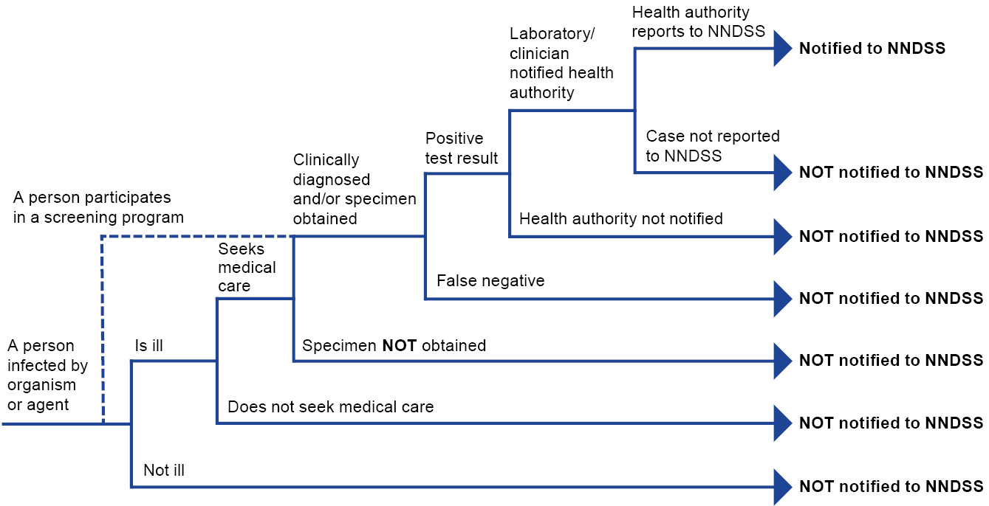
The completeness and reliability of particular data fields such as Indigenous status, hospitalisation or immunisation status, or deaths status has varied over time. This is because these data fields are sourced in different ways by state and territories based on their local surveillance system capabilities, definitions, priorities, and needs. These indicators are usually obtained from clinical notifications, and completeness varies by disease, and by state and territory. This reflects differences in notification requirements (e.g., depending on the jurisdiction, some diseases are primarily or completely notified by pathology laboratories rather than clinicians) and the fact that it is not possible to follow up all cases for diseases with a large volume of notifications and/or not requiring specific case-based public health action.
In 2009, Communicable Diseases Network Australia (CDNA) set Indigenous status target thresholds of 95% completeness for 18 priority diseases and 80% completeness for the remainder of the notifiable diseases (including influenza) as part of its ‘Closing the Gap’ strategy. The Indigenous status target thresholds for data completeness have not been reviewed since
COVID-19 and RSV became nationally notifiable.
The Indigenous status data completeness was assessed, reported as the proportion of complete notifications, and is summarised in Table 1. The percentage of data completeness was defined as:
Percentage of data completeness
= (total notifications – missing or unknown) / total notifications × 100
Indigenous status was defined by the following nationally accepted criteria:⁶
1 = Indigenous – (Aboriginal but not Torres Strait Islander origin);
2 = Indigenous – (Torres Strait Islander but not Aboriginal origin);
3 = Indigenous – (Aboriginal and Torres Strait Islander origin);
4 = not Indigenous – (not Aboriginal or Torres Strait Islander origin); and
9 = not stated.
As this assessment of completeness relates to the ability of the data to describe the characteristics of notified cases, ‘unknown’ or ‘not stated’ responses were considered incomplete.
Table 1: Indigenous status percentage of data completeness in laboratory-confirmed notified cases by diagnosis date, Australia, 1 January 2022 to 31 December 2024ª
Respiratory virus | Indigenous status completeness | Year
Respiratory virus | Indigenous status completeness | 2022 | 2023 | 2024
SARS-CoV-2 | Total notifications | 4,632,556 | 341,646 | 302,250
SARS-CoV-2 | Unknown or incomplete notifications | 700,879 | 116,312 | 126,202
SARS-CoV-2 | Percent complete | 84.9% | 66.0% | 58.2%
Influenza | Total notifications | 233,455 | 289,154 | 365,589
Influenza | Unknown or incomplete notifications | 108,218 | 126,364 | 174,215
Influenza | Percent complete | 53.6% | 56.3% | 52.3%
RSV | Total notifications | 95,960 | 128,123 | 175,918
RSV | Unknown or incomplete notifications | 59,600 | 62,716 | 91,783
RSV | Percent complete | 37.9% | 51.1% | 47.8%
a Source: National Notifiable Diseases Surveillance System (NNDSS), extracted on 5 March 2025.
In 2024, Indigenous status was complete for 58% of COVID-19 cases, 52% of influenza cases and 48% of RSV cases (Table 1). Across jurisdictions, data completeness of Indigenous status was 8–99% for COVID-19; 0–99% for influenza; and 0–99% for RSV. Interpreting notified case data by Indigenous status, when notification data are so incomplete, risks making incorrect interpretations and conclusions about the health and wellbeing of Aboriginal and Torres Strait Islander people. In Australia, a strength-based approach to health and wellbeing for Aboriginal and Torres Strait Islander peoples is the focus, and deficits which can have a negative impact on health outcomes are not emphasised.^{1,7} Therefore, no analyses of notified cases by Indigenous status are presented in this annual report.
Changes in surveillance practices may have been introduced in some jurisdictions and not in others, and must be taken into consideration when comparing data between jurisdictions. These include changes in case definitions; changes in reporting practices; changes in testing practices and screening programs; the use of less invasive and more sensitive diagnostic tests; periodic awareness campaigns; and the use of other public health and social measures.
In addition, the COVID-19 pandemic had considerable impacts on circulating acute respiratory infections and acute respiratory illness surveillance systems. Some COVID-19 related public health and social measures likely resulted in a true decrease in acute respiratory illnesses across 2020 and 2021. As data from these years may reduce five-year averages and affect analyses of usual seasonal trends, 2020 and 2021 are excluded when comparing the current respiratory season to historical periods. Where referenced in this report, the five-year average refers to the average of data from the years 2017–2019 and 2022–2023.

Notes on case definitions
Each notifiable disease is governed by a national surveillance case definition for reporting to the NNDSS. These case definitions were agreed by CDNA and were used by all jurisdictions for the first time in 2005. In 2024, the COVID-19 national surveillance case definition was updated on 1 July to remove the requirement to notify probable cases (those positive by rapid antigen test [RAT]).
In addition, seven jurisdictions had ceased collecting and notifying self-reported RAT results to the NNDSS prior to the change in the surveillance case definition: Vic. ceased on 1 July 2023, Qld on 1 September 2023, NSW on 1 October 2023, WA on 9 October 2023, the NT on 21 October 2023, the ACT on 22 December 2023, and Tas. on 12 April 2024. For these reasons, analyses of notified cases of COVID-19 in this report are based on laboratory-confirmed COVID-19 cases notified to the NNDSS and do not include probable COVID-19 cases.
Further details on all Australian national notifiable diseases and case definitions are available online.⁸

ABS Provisional Mortality Statistics
Deaths involving acute respiratory infections in this annual report are based on data from the ABS Provisional Mortality Statistics released on 28 February 2025 unless otherwise stated.⁹
The Provisional Mortality Statistics are preliminary death counts by date of occurrence for Australia. In Australia, the registration of deaths is the responsibility of individual state and territory Registrars of Births, Deaths and Marriages. It should be noted that legislative requirements for registering a death differ across jurisdictions and this can impact on the timeliness of registration and reporting. When a death occurs, it is either certified by a doctor using a Medical Certificate of Cause of Death or referred to a coroner. Other information about the death is supplied via the Death Registration Form. Registrars require information from both sources to complete a death registration. Registrars then provide this information to the ABS for processing, coding and compilation into aggregate statistics. Registrars report all deaths that were registered in a month at the start of the following month.¹⁰
The International Classification of Diseases (ICD) is the international standard classification for epidemiological purposes and is designed to promote international comparability in the collection, processing, classification, and presentation of causes of death statistics. The ICD 10th revision is used for Australian causes of death statistics.¹⁰ Deaths involving acute respiratory infections in this annual report have been coded to ICD-10 codes. All deaths involving (both due to and with) COVID-19 in this report have been coded to ICD-10 codes U07.1–U07.2, U10.9 or U09.9. All deaths involving (both due to and with) influenza in this report have been coded to ICD-10 codes J09–J11. All deaths involving (both due to and with) RSV in this report have been coded to ICD-10 codes J12.1, J20.5, J21.0, or B97.4.⁹ Further information can be found in the Provisional Mortality Statistics methodology reports.¹⁰

Notes on interpretation
All death registrations data presented in this annual report are provisional and subject to change. It is expected that numbers of deaths due to these causes will increase for more recent time periods as more death registrations are received by the ABS.
The Provisional Mortality Statistics data in this report are not comparable with data reported in Deaths, Australia, Causes of Death, Australia, or other data sources such as notifications of deaths from surveillance systems and do not provide official estimates of excess mortality.

Australian Immunisation Register (AIR)
Influenza vaccine coverage data in this annual report are based on data from the AIR, a national register that records vaccines given to all people in Australia, with data extracted on 6 October 2024.
The register was initially established in 1996 as the Australian Childhood Immunisation Register using demographic data for all Medicare enrolled children aged < 7 years. In 2016, the Australian Childhood Immunisation Register expanded to become the AIR, to record vaccinations given from birth to death to all people in Australia. Participation in the AIR is ‘opt-out’, so it constitutes a nearly complete population register for Australian residents.¹¹
Immunisation data are transferred to the register when a recognised Australian-based immunisation provider supplies details of an eligible vaccination. This occurs predominantly via general medical practice management software or via direct data entry on the register website. Healthcare practitioners are able to access immunisation data from the register, enabling them to provide preventative patient care by ensuring that individuals receive necessary vaccines as per national and local immunisation schedules.
Mandatory reporting to the register was introduced for COVID-19 vaccines from 20 February 2021, for influenza vaccines from 1 March 2021, and for all vaccines given to people of any age under the National Immunisation Program from 1 July 2021.¹¹
Influenza vaccination coverage was calculated using the number of Medicare registered people in the relevant age group with at least one dose of influenza vaccine recorded in the AIR in the report year as the numerator and the total number of people registered on the AIR in each relevant age group as the denominator. Vaccination numerators were based on age at vaccination and age group denominators based on age at 1 July of the report year (i.e., 2024). If a person becomes end-dated (deceased or permanently left Australia) within the report year, they are excluded from the number of persons vaccinated and therefore coverage measures. Vaccine coverage is expressed as the proportion of complete immunisation by particular age groups. Vaccine coverage data in this annual report may differ slightly from coverage estimates published elsewhere, due to differences in calculation methodologies and/or different data extraction dates.

FluTracking
Self-reported respiratory illness and testing behaviours in this annual report are based on data voluntarily reported through weekly surveys conducted by FluTracking, with data extracted on 19 March 2025.
In 2024, approximately 50,000 people completed a FluTracking survey each week in Australia. FluTracking provides consistent community level surveillance of respiratory illness activity in all jurisdictions and over time, as data are not biased by health-seeking behaviour, clinician testing practices or differences in jurisdictional surveillance methods.¹²
Across all years, a participant was defined as anyone who had a survey submitted by themselves or on their behalf. For fever and cough percentage calculations, the numerator includes all participants who completed a survey for the current week and reported new fever and cough symptoms, and the denominator includes all participants who completed a survey for that week. All participants were asked to enter the results of any severe acute respiratory syndrome coronavirus 2 (SARS-CoV-2) RAT or polymerase chain reaction (PCR) tests, or any influenza PCR tests performed. Participants may be represented in both SARS-CoV-2 RAT or PCR proportions.¹³
Participants who reported time off work or normal duties, or who sought medical advice/care at any time while reporting new fever and cough symptoms were recorded in the same survey week of the report of new fever and cough symptoms.¹³

Notes on interpretation
FluTracking uses the direct method for age standardisation, which combines data from different age groups to get an overall picture.¹³ Participants are given the option to opt-out over the summer period and as a result there is a reduced sample size from October to April.
Aboriginal and Torres Strait Islander status has been included in the FluTracking registration survey since 2012. The percentage of participants who identified as Aboriginal and Torres Strait Islander are underrepresented in the FluTracking data, compared with the Australian population.¹²

Australian Sentinel Practices Research Network (ASPREN)
Influenza-like-illness (ILI) and community virological trends in this annual report are based on data from ASPREN, a year-round, nationally representative network of sentinel general practices sites, with data extracted on 26 February 2025.
In 2024, over 450 general practitioners and nurse practitioners from 225 sentinel sites across all jurisdictions reported presentations of defined medical conditions each week. Defined medical conditions monitored in 2024 included ILI, gastroenteritis, chickenpox, and shingles. Participating practitioners are required to report the total number of patients seen weekly (i.e., weekly consultations) as well as notifying when they see a patient fitting the relevant case definition. ILI was defined as an acute respiratory infection with fever (patient reported or measured) and cough with an onset within the last seven days, aligning with the World Health Organization (WHO) surveillance case definition for ILI.¹⁴
Consistent with international general practice surveillance systems, rates are reported as the number of ILI notifications per 1,000 consultations per week.
Virological surveillance at sentinel general practice sites provides insight into the prevalence of respiratory viruses circulating in the community. A systematic sample of ILI patients (i.e. the first three patients presenting with an ILI, plus all ILI patients aged ≤ 5 years or ≥ 65 years) were invited by the practitioner to participate in virological surveillance activities. Nasal respiratory swabs were taken by practitioners and samples were sent to SA Pathology in Adelaide, SA. Respiratory swab samples were tested for viral and bacterial respiratory pathogens via a multiplex real-time reverse transcription polymerase chain reaction (RT-PCR) assay using SA Pathology’s in-house primers and were subtyped using SA Pathology’s genomic sequencing approach.
All positive influenza samples are sent to the WHO Collaborating Centre for Reference and Research on Influenza, and data are used to guide national and international influenza vaccine strain selection. In addition, data are used to calculate community-based vaccine effectiveness (VE) estimates. To estimate VE against general practice attendance with influenza, data on patients with ILI who were tested for respiratory pathogens are used in a test-negative observational study. In this design, VE estimates are 1 minus the odds ratio of vaccination in positive patients compared to test negative control patients.

Notes on interpretation
Changes in the health-seeking behaviour at sentinel general practices sites due to the availability of telehealth and respiratory clinics may have resulted in fewer presentations to general practice in recent years, potentially underestimating the number of ILI notifications per week compared to pre-COVID-19 pandemic years. Similarly, changes to virological swabbing practices at sentinel general practice sites, due to the availability of telehealth and respiratory clinics, may result in a lower number of swabs being taken in recent years. Therefore, comparisons to pre-COVID-19 pandemic seasons should be interpreted with caution.
Overall, virological surveillance was representative; however, at a jurisdictional level SA is overrepresented, while swabs from the NT are underrepresented.

Influenza Complications Alert Network (FluCAN)
Hospital admissions (not including emergency department presentations without subsequent hospital admission) in this annual report are based on data from FluCAN, a sentinel hospital-based surveillance program, with data extracted on 13 March 2025.
In 2024, twenty-two sentinel hospital sites across all jurisdictions reported detailed clinical and laboratory information about hospital admissions with COVID-19, influenza or RSV infections. An acute respiratory infection was laboratory confirmed by PCR. Surveillance was conducted from April to December for influenza and RSV, and for the full calendar year for COVID-19. Data from a sample of patients who were admitted with an acute respiratory infection, but who tested negative for influenza, were collected as controls for vaccine effectiveness estimates.
Date of admission is used for all patient analyses, except where the patient acquired their infection in hospital. For patients who acquired their infection in hospital (defined as the date of onset > 7 days after date of admission), date of onset is used.
In addition, data are used to calculate hospital-based VE estimates. To estimate VE against hospitalisation with influenza, data from all participating sentinel hospital sites are used in a test-negative incidence density observational study. In this design, VE is estimated as 1 minus the odds ratio of vaccination in case patients compared to test-negative control patients.

Notes on interpretation
It is important to note these sentinel hospital data reflect patients with severe acute respiratory illnesses who are hospitalised or admitted to intensive care with PCR confirmed infection; data are therefore not generalisable.
Surveillance for sentinel hospital admissions with influenza and RSV did not begin until 1 April 2024. The data in this annual report are reflective of sentinel hospital admissions with influenza or RSV from 1 April to 31 December 2024. Comparisons to previous seasons (when surveillance was conducted over a different portion of the calendar year) should be interpreted with caution.
The Paediatric Active Enhanced Disease Surveillance (PAEDS) network contributes data on paediatric admissions (those aged 16 years or under) at sentinel hospital sites. This provides enhanced surveillance of these at-risk populations. Consequently, children are overrepresented in the data and the age distribution may not reflect the age distribution of hospitalisations nationally. For this reason, children and adults admitted to sentinel hospitals are reported on separately in this annual report.
Some jurisdictions (Vic.) are overrepresented amongst participating sentinel hospital sites. The majority of sentinel hospital sites are in major cities, therefore, hospital admissions in regional and remote areas are underrepresented.

Short Period Incidence Study of Severe Acute Respiratory Infection (SPRINT-SARI) Australia
Intensive care admissions in this annual report are based on data from SPRINT-SARI Australia, a sentinel intensive care based surveillance system and research network, with data extracted on 26 February 2025.
In 2024, approximately 76 sentinel intensive care sites across all jurisdictions contributed data on the demographics, clinical characteristics, interventions, and outcomes for patients admitted to a participating intensive care with a severe acute respiratory infection. These participating intensive care sites include intensive care units and high dependency units managed by an intensive care team. Data are entered into an internationally standardised case report form by the research coordinator at the participating site. Whenever possible, patient transfers were aggregated into one record.¹⁵
In response to the COVID-19 pandemic, SPRINT-SARI Australia commenced in early 2020. During 2020–2022, SPRINT-SARI Australia collected data on patients admitted with COVID-19. From late 2022, data collection began for patients with a primary admission to intensive care for the management of acute respiratory failure (or complication) and a PCR confirmed viral severe acute respiratory infection such as influenza, parainfluenza or RSV.¹⁵ Date of admission is used for all patient analyses.

Notes on interpretation
It is important to note these sentinel intensive care data reflect the sickest patients with severe acute respiratory infections who are admitted to intensive care; data are therefore not generalisable.
Surveillance for sentinel hospital admissions with other viral severe acute respiratory infections did not begin until late 2022. Comparisons to previous seasons should be interpreted with caution.
There are a range of diagnostic testing procedures utilised across public and private hospitals within Australia. Diagnostic testing can be by nucleic acid amplification tests (NAATs), including PCR tests, or immunoassays (rapid antigen tests). Each sentinel site will use these diagnostic methods variably and there are multiple manufacturers. SPRINT-SARI does not specify which diagnostic testing method should be utilised, as this is the domain for the participating hospital site (local policy) and treating clinicians. For this reason, virological data from SPRINT-SARI should be interpreted with caution.

Critical Health Resource Information System (CHRIS)
COVID-19 occupancy and staff unavailability data in this annual report are based on data from CHRIS, a real-time system that monitors intensive care activity, capacity, and resourcing, extracted on 5 March 2025.
In 2024, CHRIS received data from all 191 adult and paediatric intensive care units (over 2,300 intensive care beds) across all jurisdictions. This includes public and private intensive care units. Intensive care staff enter data twice daily, providing real-time data on intensive care activity and capacity.¹⁶ Date of report is used for all analyses.

Notes on interpretation
Average number of ventilated and non-ventilated COVID-19 cases in intensive care includes only active COVID-19 cases (those in isolation) and does not include cleared COVID-19 cases.
Unavailable intensive care staff include both medical and nursing staff. Staff unavailability should be interpreted with caution, as hospitals may have varying policies on when staff can return to work after having COVID-19 or having been exposed to COVID-19. Staff unavailability will be underestimated in NSW as most public hospitals in NSW do not report staff unavailability.

Sentinel laboratories
The number of laboratory tests undertaken, positive results, and the detected viruses in this annual report are based on data from sentinel laboratories, as of 5 March 2025.
Sentinel laboratories are a surveillance network of laboratories that collect data on diagnostic respiratory pathogen testing. Sentinel laboratories are not intended to capture all diagnostic testing occurring; rather, sentinel laboratories aim to provide a representative sample of people tested for respiratory viruses in Australia.
In 2024, sentinel laboratories included SA (SA Pathology) and Tasmania (Hobart Pathology, Launceston Pathology, North West Pathology, and Royal Hobart Hospital Pathology), and the National Influenza Centres. In Australia, the National Influenza Centres are:
- Institute of Clinical Pathology and Medical Research in NSW;
- PathWest Laboratory Medicine in WA; and
- Victorian Infectious Diseases Reference Laboratory in Vic.
The National Influenza Centres are designated institutions that collect virus specimens in their country and perform preliminary analysis. The National Influenza Centres then forward representative clinical specimens and isolated viruses to the WHO Collaborating Centre for Reference and Research on Influenza for advanced antigenic and genetic analysis. The National Influenza Centres form an important part of the WHO Global Influenza Surveillance and Response System.¹⁷

Notes on interpretation
Sentinel laboratory testing data are influenced by jurisdictional and laboratory testing practices and should be interpreted with caution.

AusTrakka
SARS-CoV-2 sequencing data in this annual report are based on data from AusTrakka, Australia’s national genomics surveillance platform for SARS-CoV-2, extracted on 24 February 2025.
In 2024, public health laboratories in NSW, Qld, SA, Tas., Vic., and WA uploaded genomic sequences and agreed epidemiological metadata to AusTrakka on a dedicated server for nationally aggregated genomics analysis and visualisation of sequences.¹⁸ Sequences in AusTrakka are aggregated by week and reported based on date of sample collection, not date of sequencing.
AusTrakka defines SARS-CoV-2 genomic lineages using the Phylogenetic Assignment of Named Global Outbreak (Pango) lineage nomenclature.¹⁹ Lineages and sub-lineage classifications are continuously defined, and lineage classification may change retrospectively as new sequences are added and lineages diversify over time. Sub-sub-lineage designations may change with updates to Pangolin, USHER, and NextClade lineage calling software used by AusTrakka. For this reason, numbers and proportions of sub-lineages may not align with those presented in other reports.
From July 2023, AusTrakka has used the WHO designations for any variant of concern, variant of interest, or variant under monitoring designations.²⁰ AusTrakka determines variants of concern from a viral sequence by using the NextClade Pangolin software and scorpio algorithm, which assigns a sequence to a Pangolin constellation (the presence of a set of characteristic mutations for each variant of concern lineage). Non-variant of concern lineages are determined using the Pangolin software PangoLEARN.¹⁹ This approach aligns with the WHO position on variant of concern classification and interpretation.

Notes on interpretation
The number of sequences presented in the AusTrakka data are not equivalent to the number of notified cases, as not all notified cases are sequenced and there may be duplicates in the AusTrakka data.
Only samples with laboratory-definitive evidence of SARS-CoV-2 are eligible for sequencing. Not all samples will be suitable for sequencing, especially those samples with low amounts of viral nucleic acid (i.e., high PCR cycle thresholds) such as those collected from cases late in their disease episode (common in returned travellers) or those subjected to storage at suboptimal conditions, causing viral nucleic acid degradation. This may affect the representativeness of samples.
SARS-CoV-2 sequencing methodology and protocols vary between jurisdictions. SARS-CoV-2 samples likely to be prioritised for sequencing include those from cases who are hospitalised, admitted to intensive care, or cases of clinical significance. This may affect the representativeness of samples.

WHO Collaborating Centre for Reference and Research on Influenza
Influenza virus characterisations in this annual report are based on data from Australia’s WHO Collaborating Centre for Reference and Research on Influenza (the Centre) as of 5 March 2025.
In Australia, the Centre is hosted by the Victorian Infectious Diseases Reference Laboratory. The role of the Centre is to obtain, isolate, and preserve representative viruses from cases of influenza, and to characterise their antigenic, genetic, and drug sensitivity properties. The Centre forms an important part of the WHO Global Influenza Surveillance and Response System.²¹

Findings
The 2024 Annual Australian Respiratory Surveillance Report is structured by surveillance settings, including communities, general practice, hospitals, and laboratories. Priority populations, such as children, older adults, and, Aboriginal and Torres Strait Islander people are highlighted where data are available. This approach allows us to understand how acute respiratory illnesses impact different people and places.

Community surveillance
Community surveillance monitors respiratory illnesses in the community, providing information on the number of people reporting respiratory symptoms, testing practices, and the impact of respiratory illnesses. Community surveillance includes notification data obtained from laboratory tests for infections. Infections that are diagnosed and notified are only a subset of the total number of infections occurring in the community.
In 2024, the age-standardised proportion of FluTracking participants reporting new fever and cough symptoms per week gradually increased between January and June to a peak in late June (2.6% of participants reporting new fever and cough symptoms per week). Following the June peak, the age-standardised proportion of participants reporting new fever and cough symptoms per week decreased from July to December, with trends towards the end of 2024 similar to the pattern observed in the same period in 2023 (Figure 2).
In 2024, the peak of participants reporting new fever and cough symptoms was similar in magnitude to 2023 and the five-year average; however, the 2024 peak occurred four weeks later than the June 2023 peak. In contrast, the trends in the proportion of participants reporting new fever and cough symptoms per week were quite different in 2022. The peak proportion of participants reporting new fever and cough symptoms was much higher, and the first peak occurred seven weeks earlier in 2022, with 3.2% of participants reporting new fever and cough symptoms per week in mid-May (Figure 2).
In 2024, among Aboriginal and Torres Strait Islander FluTracking participants, the proportion of participants reporting new fever and cough symptoms per week peaked higher and earlier (4.3% per week in early June) than in the overall cohort. The trend among Aboriginal and Torres Strait Islander participants should be interpreted with care as Aboriginal and Torres Strait Islander populations are underrepresented in the data.
In 2024, rapid antigen testing for SARS-CoV-2 declined among participants with new fever and cough symptoms (68.5% [19,932/29,081] in 2024 and 77.1% [20,581/26,689] in 2023); however, RAT use remained considerably more common than use of a PCR test (13.9% [4,055/29,081] in 2024 and 11.7% [3,128/26,689] in 2023). Self-reported SARS-CoV-2 RAT positivity was higher in 2024 (37.6%; 7,487/19,932) than in 2023 (35.9%; 7,396/20,581), whereas self-reported SARS-CoV-2 PCR positivity was lower in 2024 (16.4%; 667/4,055) than in 2023 (21.3%; 667/3,128).
Figure 2: Age-standardised proportion of survey participants reporting new fever and cough symptoms compared with the five-year average by year and week of survey, Australia, January 2022 to December 2024^{a,b}
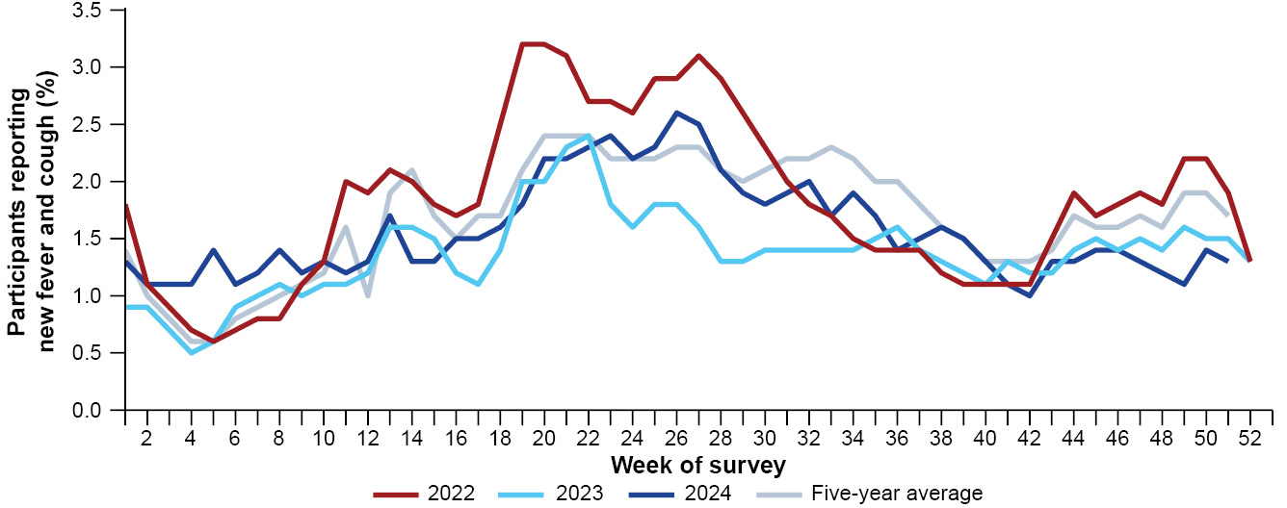
a Source: FluTracking, extracted on 19 March 2025.
b In years prior to 2020, FluTracking was activated during the main influenza season from May to October. A historical average outside of these months is not available. In addition, as the years 2020 and 2021 are excluded when comparing the current season to historical periods, the five-year average includes the years 2017 to 2019 and 2022 to 2023.
In 2024, of survey participants with new fever and cough symptoms, 18.4% (5,365/29,081) used a PCR test to test for influenza and self-reported influenza PCR positivity was 23.4% (1,257/5,365). The 2024 weekly influenza PCR testing and positivity percentages may be overestimated, as some participants may have reported results from RATs in this data. In 2025, FluTracking will explicitly collect data on influenza RATs.
In 2024, the proportion of participants with new fever and cough taking three or more days off work or normal duties ranged within 44.2–57.9% per week (Figure 3). The proportion of participants with new fever and cough taking three or more days off work or normal duties has remained at approximately 50% since 2022 (Figure 3). In contrast, the proportion of participants seeking medical advice for fever and cough decreased from 59.0% in January 2022 to less than 30% in January 2023. The proportion of participants seeking medical advice for fever and cough remained less than 35% per week for most of 2024 until increasing to 47.7% per week in early December (Figure 3).
In 2024, there was an overall 11.5% decrease in COVID-19 cases notified to the NNDSS, a 26.4% increase in influenza cases, and a 37.3% increase in RSV cases compared with the respective number of notified cases for each condition in 2023 (Table 2; Appendix A, Tables A.1 and A.2).
In 2024, there were 302,250 laboratory-confirmed COVID-19 cases, which is 11.5% less than the 341,646 laboratory-confirmed COVID-19 cases in 2023, and 93.5% less than the 4,632,556 laboratory-confirmed COVID-19 cases in 2022 (Table 2; Appendix A, Tables A.1 and A.2). Historical comparisons should be interpreted with caution due to decreased case ascertainment and considerable changes in surveillance practices in all jurisdictions across the pandemic.
Figure 3: Proportion of survey participants reporting new fever and cough symptoms plus three or more days off work or normal duties or seeking medical advice/care for fever and cough symptoms by year and week of survey, Australia, January 2022 to December 2024^{a,b,c}
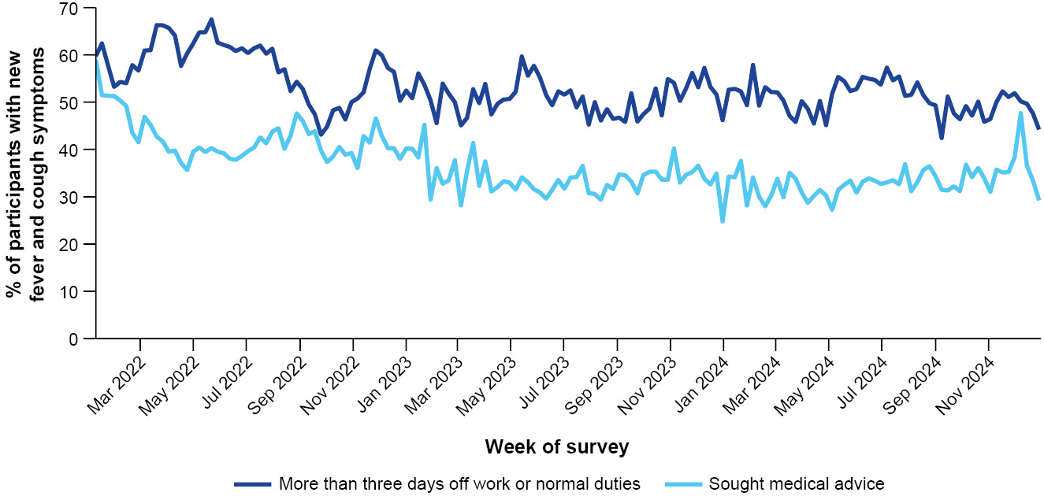
a Source: FluTracking, extracted on 19 March 2025.
b Includes those who sought medical advice from a general practitioner, Aboriginal and Torres Strait Islander Health Clinic, COVID-19 Test Centre/Drive-through, emergency department, or who were admitted to hospital.
c COVID-19 Test Centre/Drive-through option was removed from survey questions on 6 June 2024, as this is approximately consistent with when COVID-19 Test Centre/Drive-through centres ceased to operate in Australia.
Table 2: Notified cases and notification rate per 100,000 population by disease, five-year age group, and jurisdiction, Australia, 1 January to 31 December 2024^{a,b}
Category | Value | COVID-19 |  | Influenza |  | RSV
Category | Value | Notified cases | Notification rate | Notified cases | Notification rate | Notified cases | Notification rate
Age group (years) | 0–4 | 24,431 | 1,619 | 50,000 | 3,314 | 86,937 | 5,762
Age group (years) | 5–9 | 7,286 | 452 | 52,193 | 3,240 | 14,351 | 891
Age group (years) | 10–14 | 7,646 | 457 | 33,792 | 2,018 | 7,508 | 448
Age group (years) | 15–19 | 9,401 | 565 | 22,666 | 1,363 | 3,977 | 239
Age group (years) | 20–24 | 10,044 | 561 | 17,618 | 985 | 2,902 | 162
Age group (years) | 25–29 | 12,612 | 632 | 19,729 | 988 | 3,335 | 167
Age group (years) | 30–34 | 15,223 | 747 | 22,043 | 1,081 | 4,285 | 210
Age group (years) | 35–39 | 16,468 | 830 | 23,929 | 1,206 | 4,272 | 215
Age group (years) | 40–44 | 15,936 | 860 | 21,436 | 1,157 | 3,703 | 200
Age group (years) | 45–49 | 14,601 | 897 | 16,613 | 1,020 | 3,643 | 224
Age group (years) | 50–54 | 15,640 | 925 | 15,737 | 931 | 4,523 | 268
Age group (years) | 55–59 | 15,065 | 983 | 13,604 | 887 | 4,465 | 291
Age group (years) | 60–64 | 16,199 | 1,056 | 13,146 | 857 | 5,192 | 338
Age group (years) | 65–69 | 17,132 | 1,260 | 10,705 | 787 | 5,004 | 368
Age group (years) | 70+ | 104,280 | 3,121 | 32,347 | 968 | 21,803 | 653
Jurisdiction | ACT | 4,659 | 983 | 4,837 | 1,020 | 2,742 | 578
Jurisdiction | NSW | 128,933 | 1,520 | 161,534 | 1,904 | 73,693 | 869
Jurisdiction | NT | 2,821 | 1,106 | 3,303 | 1,295 | 1,725 | 676
Jurisdiction | Qld | 71,245 | 1,275 | 79,798 | 1,428 | 42,668 | 764
Jurisdiction | SA | 18,920 | 1,007 | 22,762 | 1,212 | 12,130 | 646
Jurisdiction | Tas. | 5,112 | 888 | 4,072 | 708 | 2,913 | 506
Jurisdiction | Vic. | 54,563 | 782 | 72,174 | 1,034 | 30,773 | 441
Jurisdiction | WA | 15,997 | 539 | 17,109 | 577 | 9,274 | 313
 | Total | 302,250 | 1,111 | 365,589 | 1,344 | 175,918 | 647
a Source: National Notifiable Diseases Surveillance System (NNDSS), extracted on 5 March 2025.
b Total includes cases with missing age.
In 2024, there were two distinct peaks of COVID-19 cases, which occurred in January and June. Following a slight increase in the number of notified cases in late 2023, a peak of 10,435 cases per week occurred in early January 2024. COVID-19 cases then decreased until late March, before increasing to a second peak of 11,079 cases per week in early June. Following the June peak, notified cases declined until early October, then gradually increased week-on-week until late December (Figure 4), similar to the increase observed in this period in 2023.
The current transmission patterns within Australia differ from the initial phases of the pandemic when multiple waves occurred each year (2020–2022), driven by one or two dominant SARS-CoV-2 sub-lineages. Across 2023–2024, COVID-19 transmission patterns have fluctuated with the seasons appearing to have summer peaks in late December and early January but also winter peaks typically in June (Figure 4). Due to limited years of SARS-CoV-2 circulation without extensive pandemic interventions affecting SARS-CoV-2 transmission, it is not yet clear if a distinct seasonal pattern will emerge for COVID-19.²²
In 2024, COVID-19 notification rates were highest in people aged 70 years or over, likely due to higher case ascertainment from targeted testing strategies for populations at risk of severe disease or who live in a high-risk setting such as a residential aged care home (Table 2).
Figure 4: Notified laboratory-confirmed COVID-19 cases by year and week of diagnosis, Australia, January 2022 to December 2024ª
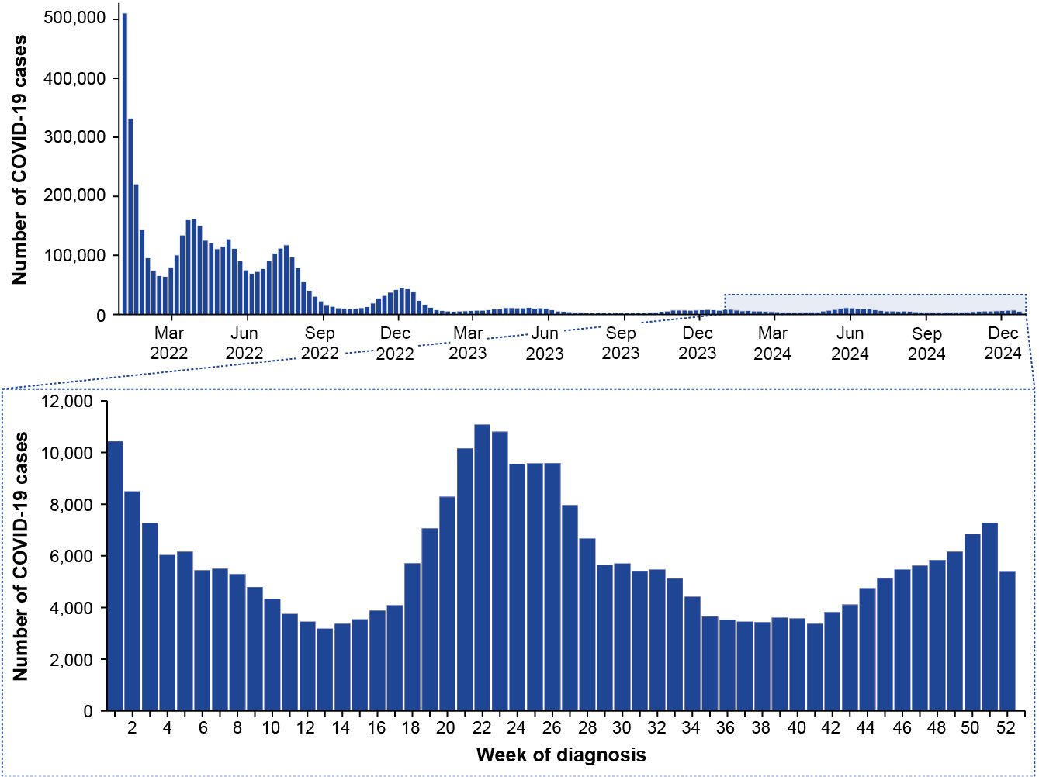
a Source: National Notifiable Diseases Surveillance System (NNDSS), extracted on 5 March 2025.
In 2024, COVID-19 notification rates were highest in NSW (1,520 cases per 100,000 population), followed by Qld (1,275 cases per 100,000 population); notification rates were lowest in WA (539 cases per 100,000 population) (Table 2). In 2024, COVID-19 notification trends over time were largely consistent across jurisdictions, with some minor variations (Figure 5). Most jurisdictions experienced a peak in notification rates in late May or early June, with a prolonged peak observed in NSW across early June to early July (60 cases per 100,000 population per week). In contrast, Qld experienced a peak in notification rates in December (42 cases per 100,000 population per week; Figure 5).
Figure 5: Notification rates per 100,000 population for COVID-19 cases by state or territory and week of diagnosis, Australia, January to December 2024ª
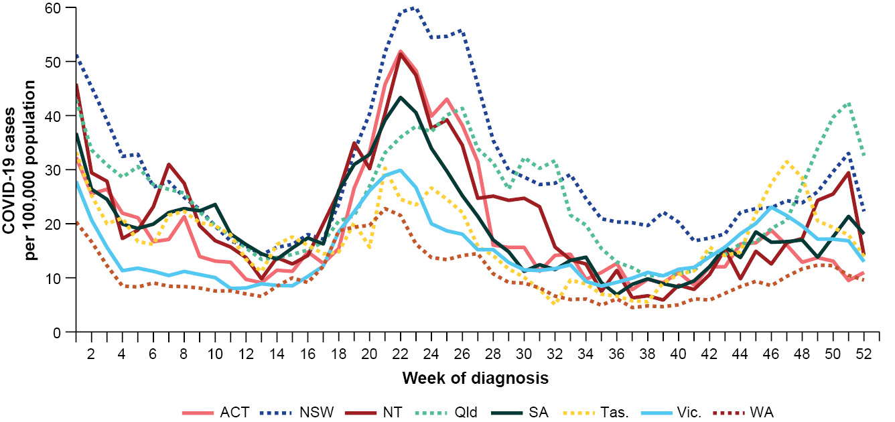
a Source: National Notifiable Diseases Surveillance System (NNDSS), extracted on 5 March 2025.
In 2024, there were 365,589 influenza cases, which is 26.4% more than the 289,154 influenza cases in 2023, and 56.6% more than the 233,455 influenza cases in 2022 (Table 2; Appendix A, Tables A.1 and A.2). The number of influenza cases in 2024 is the highest annual number of influenza cases notified to the NNDSS.²³
Following a slight increase in the number of influenza cases in late 2023, notified cases in 2024 remained low and stable from January until late April, before increasing to a peak of 28,453 cases per week in early July. Following the July peak, notified cases declined slightly and then plateaued at approximately 20,000–21,000 cases per week across mid-July to mid-August before decreasing again and remaining at low interseasonal levels until December (Figure 6a; Figure 6b).
In 2024, influenza cases generally remained above the five-year average from January through to early September. The peak in influenza cases occurred at a similar time in 2023 and 2024 (July), both of which were later than the peak observed in 2022 (June), which began earlier than observed in other recent years. In addition, the number of influenza cases per week remained elevated for a longer period of time in 2024 than in previous years (Figure 6a; Figure 6b).
In 2024, influenza notification rates were highest in children aged 0–4 years and 5–9 years (Table 2).
In 2024, influenza notification rates were highest in NSW (1,904 cases per 100,000 population), followed by Qld (1,428 cases per 100,000 population); notification rates were lowest in WA (577 cases per 100,000 population; Table 2).
Figure 6a: Notified influenza cases compared with the five-year average by year and week of diagnosis, Australia, January 2022 to December 2024^{a,b}
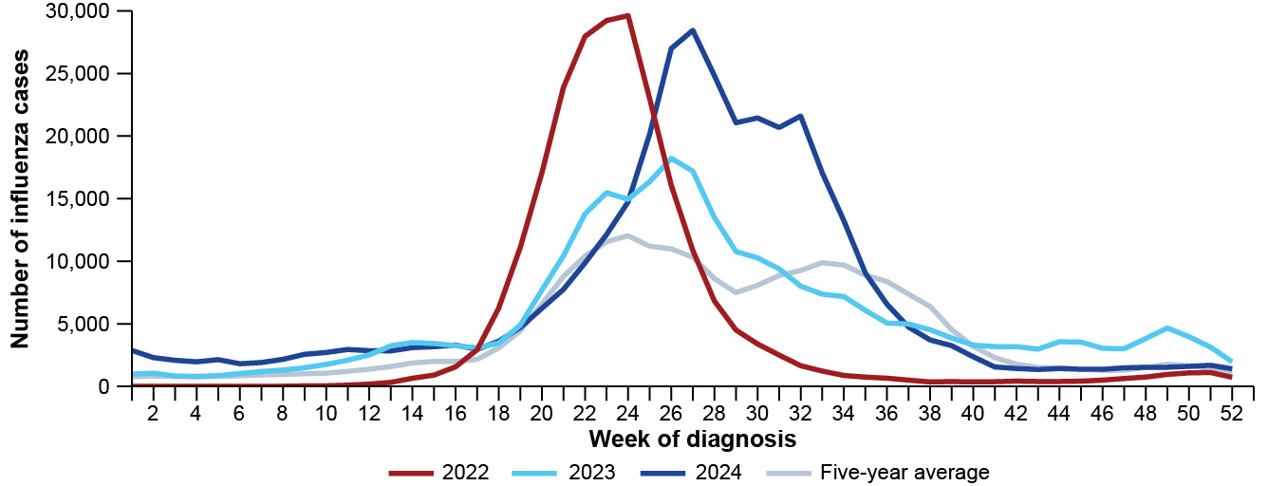
a Source: National Notifiable Diseases Surveillance System (NNDSS), extracted on 5 March 2025.
b As the years 2020 and 2021 are excluded when comparing the current season to historical periods, the five-year average includes the years 2017 to 2019 and 2022 to 2023.
Figure 6b: Notified influenza cases compared with the five-year average by influenza subtype, year, week of diagnosis, Australia, January 2022 to December 2024^{a,b}
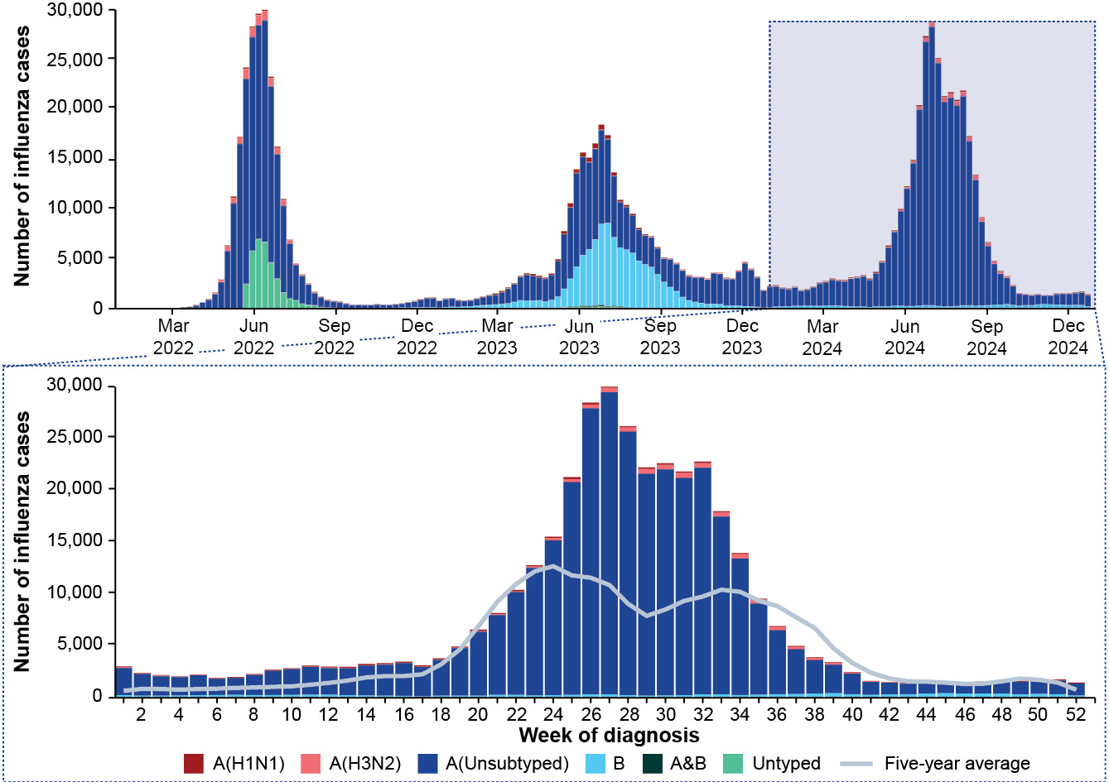
a Source: National Notifiable Diseases Surveillance System (NNDSS), extracted on 5 March 2025.
b As the years 2020 and 2021 are excluded when comparing the current season to historical periods, the five-year average includes the years 2017 to 2019 and 2022 to 2023. Please refer to the Methods and data considerations section for interpretation of the five-year average.
Figure 7: Notification rates per 100,000 population for influenza cases by state or territory and week of diagnosis, Australia, January to December 2024ª
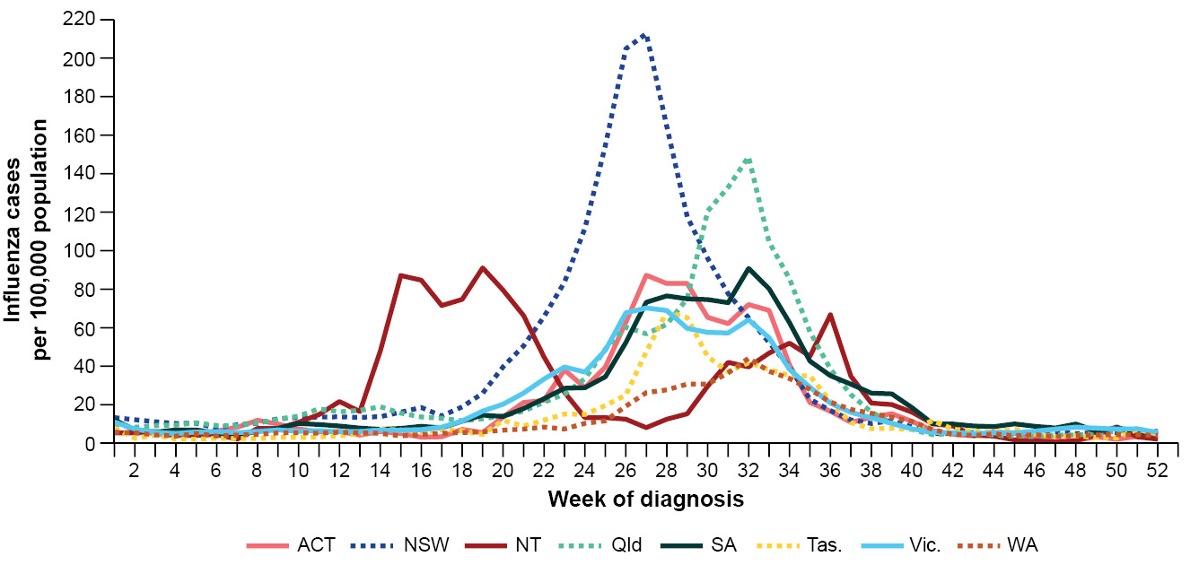
a Source: National Notifiable Diseases Surveillance System (NNDSS), extracted on 5 March 2025.
In 2024, most jurisdictions experienced consistent notification trends over time; however, influenza notification rates in NSW and the NT differed considerably from those in other jurisdictions (Figure 7). The NT experienced two distinct peaks in 2024; the first prolonged peak occurred from mid-April to mid-May at 89 cases per 100,000 population per week and the second, smaller peak occurred in early September at 51 cases per 100,000 population per week. In tropical and subtropical regions, like the NT, it is not uncommon for influenza seasonality to be less distinct, with some tropical and subtropical regions experiencing year-round circulation, multiple peaks, or extended periods of activity.²⁴ In contrast, NSW experienced a rapid increase in notification rates from late April to a single defined peak that occurred in mid-July at 209 cases per 100,000 population per week and was followed by rapid decline in notifications. Notification rates in other jurisdictions generally began to increase in May, with a peak in notification rates that occurred later (August) and was lower compared with NSW (Figure 7).
In 2024, most influenza cases (92.8%) were influenza A(Unsubtyped), while 4.0% were influenza B; 2.1% were influenza A(H3N2); 1.1% were influenza A(H1N1); and there were 130 influenza A&B co-detections (Table 3). In 2024, there were a higher proportion of influenza A(H3N2) cases (2.1%) than influenza A(H1N1) cases (1.1%), whereas the opposite trend occurred in 2023. In contrast, there were a considerably lower proportion of influenza B cases (4.0%) in 2024, compared with 2023 (35.9%; Table 3).
Table 3: Notified influenza cases by influenza subtype and diagnosis year, Australia, 1 January 2022 to 31 December 2024ª
Influenza subtype | 2022 | 2023 | 2024
A(H1N1) | 2,256 (1.0%) | 7,169 (2.5%) | 4,016 (1.1%)
A(H3N2) | 9,369 (4.0%) | 2,239 (0.8%) | 7,652 (2.1%)
A(Unsubtyped) | 186,453 (79.9%) | 172,828 (59.8%) | 339,147 (92.8%)
A&B | 250 (0.1%) | 1,363 (0.5%) | 130 (< 0.05%)
B | 1,303 (0.6%) | 103,707 (35.9%) | 14,520 (4.0%)
Untyped | 33,824 (14.5%) | 1,848 (0.6%) | 124 (< 0.05%)
Total | 233,455 (100.0%) | 289,154 (100.0%) | 365,589 (100.0%)
a Source: National Notifiable Diseases Surveillance System (NNDSS), extracted on 5 March 2025.
In 2024, across all jurisdictions, influenza A(Unsubtyped) accounted for the majority of notified cases. After influenza A(Unsubtyped), influenza B accounted for the highest proportion of influenza cases in the ACT (1.9%; 92/4,837), NSW (3.1%; 5,087/161,534), SA (10.5%; 2,393/22,762) and Vic. (5.5%; 3,976/72,174). In contrast, after influenza A(Unsubtyped), influenza A(H3N2) accounted for the highest proportion of influenza cases in Qld (2.8%; 2,244/79,798), Tas. (7.7%; 312/4,072) and WA (16.1%; 2,748/17,109). In the NT, the proportion of influenza A(H3N2), influenza A(H1N1) and influenza B subtypes were low and approximately equal (Figure 8). Trends in influenza subtypes should be interpreted with caution as there are jurisdictional differences in the proportion and selection of influenza samples that undergo typing.
Figure 8: Notified influenza cases by influenza subtype, jurisdiction, and week of diagnosis, Australia, January to December 2024^{a,b}
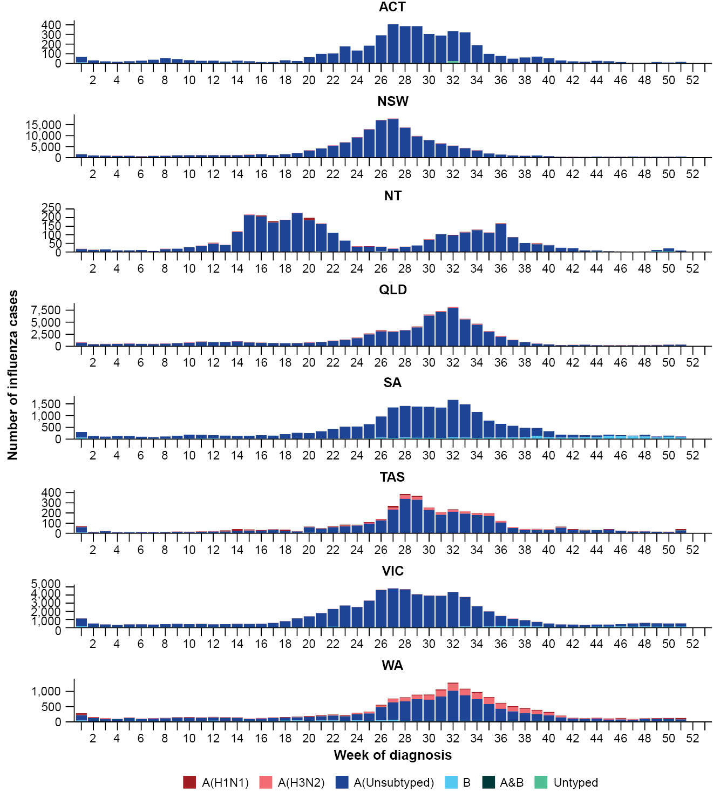
a Source: National Notifiable Diseases Surveillance System (NNDSS), extracted on 5 March 2025.
b Axis varies between jurisdictions.
In 2024, there were 175,918 RSV cases, which is 37.3% more than the 128,123 RSV cases reported in 2023 (Table 2; Appendix A, Tables A.1 and A.2). Although RSV became a nationally notifiable disease in July 2021, notification data was only received from all states and territories from 1 September 2022. For this reason, RSV notification trends in 2022 are not compared with later years, and 2022 notification trends should be interpreted with caution as they are unlikely to be complete or representative.
In 2024, RSV notifications increased steadily from the start of the year to a peak of 7,386 notifications per week in late May, similar to the timing of the peak in 2023. Following the May peak, notifications declined slowly between June and November to low interseasonal levels, followed by a slight increase until late December (Figure 9).
In 2024, RSV notification rates were considerably higher in children aged 0–4 years than in other age groups (Table 2).
Figure 9: Notified RSV cases by year and week of diagnosis, Australia, January 2022 to December 2024^{a,b}
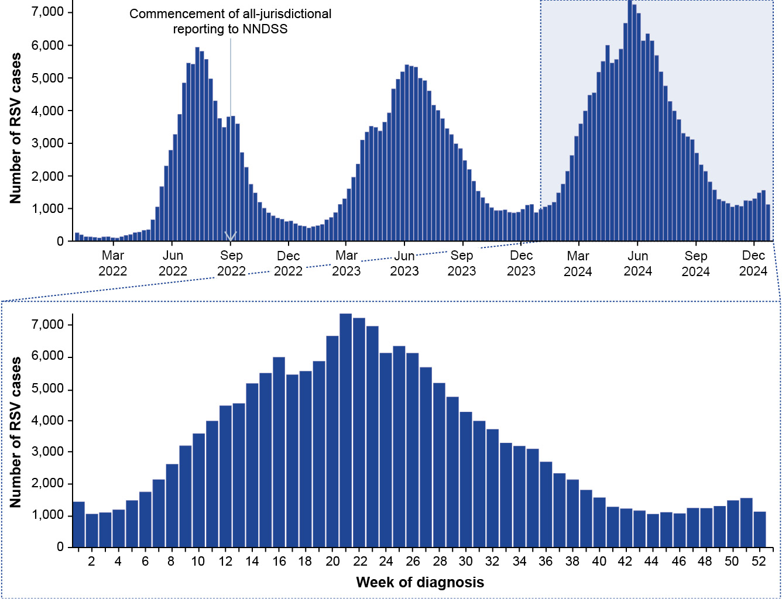
a Source: National Notifiable Diseases Surveillance System (NNDSS), extracted on 5 March 2025.
b RSV was added to the National Health Security (National Notifiable Disease List) Instrument 2018 in July 2021. Following this, some jurisdictions began notifying RSV cases to the NNDSS; however, RSV notification data was only received from all states and territories from 1 September 2022 and comprehensive national notification data became available after this point. For this reason, RSV notification trends in 2022 should be interpreted with caution, as they are unlikely to be complete or representative.
In 2024, RSV notification rates were highest in NSW (869 cases per 100,000 population), followed by Qld (764 cases per 100,000 population); notification rates were lowest in WA (313 cases per 100,000 population; Table 2). As observed in 2023, in 2024 RSV notification trends varied greatly between jurisdictions, with most jurisdictions experiencing a peak in notification rates at different times of the year (Figure 10).
NSW and the NT experienced a first peak in notifications in April, while the ACT, NSW (second peak), Qld and Vic. peaked across May. SA and Tas. experienced a peak in July, followed by WA in mid-August. Lasty, the NT experienced a second, smaller peak in November (Figure 10). The ACT (47 cases per 100,000 population) and SA (45 cases per 100,000 population) experienced considerably higher, but less prolonged peaks in notification rates compared with other jurisdictions such as NSW and Qld. WA experienced a much later and lower peak in notification rates (20 cases per 100,000 population per week) compared with other jurisdictions (Figure 10). The low notification rates in WA, and to a lesser extent in Qld, may be in part due to the 2024 RSV Infant Immunisation Programs in these states. In 2024, there were a lower number of notified cases among infants (< 6 months) in Qld and WA, and among young children (6 months to < 12 months) in WA, compared with the number of notified cases in these age groups and states in 2023.
Figure 10: Notification rates per 100,000 population for RSV cases by state or territory and week of diagnosis, Australia, January to December 2024ª
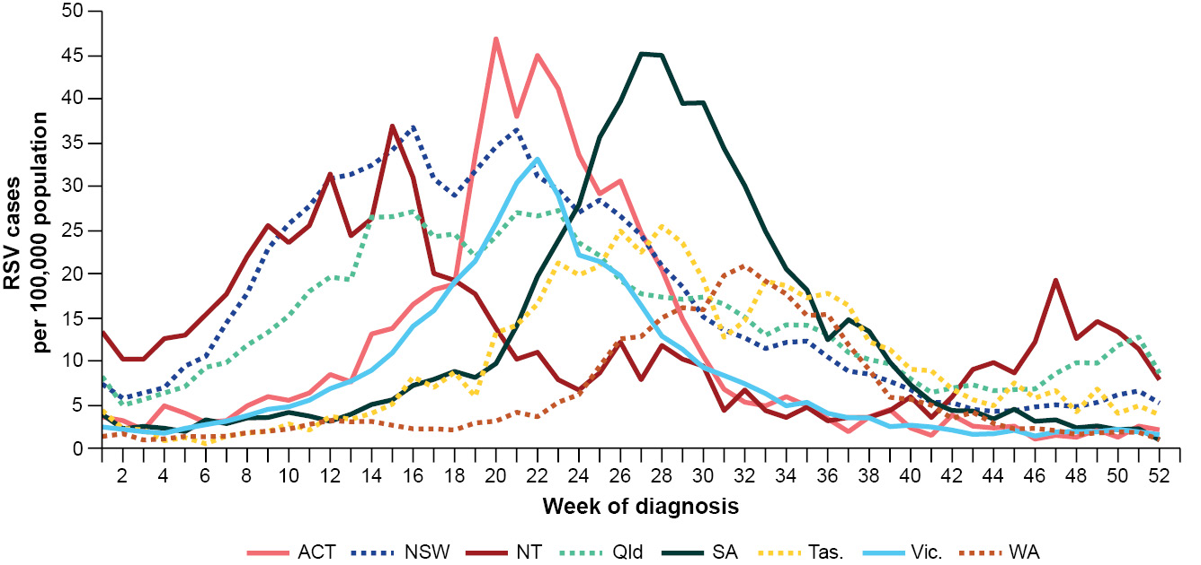
a Source: National Notifiable Diseases Surveillance System (NNDSS), extracted on 5 March 2025.

Primary care surveillance
Primary care surveillance monitors the number and characteristics of people who present to their general practitioner with influenza-like-illness; this surveillance provides insights on the different respiratory pathogens that are causing illness in the community.
In 2024, the rate of influenza-like-illness (ILI) consultations at sentinel general practice sites gradually increased between January and early May (from approximately three to five ILI notifications per 1,000 consultations per week), followed by a steeper increase throughout May and June. There was a sustained peak of ILI rates across late June to early August (approximately 12–13 ILI notifications per 1,000 consultations per week), followed by a gradual decline in ILI rates until mid-December when an uptick was observed (Figure 11).
Across 2024, the rate of ILI notifications per 1,000 consultations at sentinel general practice sites was higher than for the corresponding weeks of the five-year average (Figure 11). In 2024, there were more ILI consultations (6.1 ILI notifications per 1,000 consultations per year) than in 2023 (4.1 ILI notifications per 1,000 consultations per year) or 2022 (3.4 ILI notifications per 1,000 consultations per year; Figure 11). The increase in ILI rates aligns with the increased activity observed in case notifications this year.
In 2024, the season was longer, and the peak of ILI rates was generally higher and more sustained than in previous years. In 2024, a double peak in ILI rates occurred across early July (12.8 ILI notifications per 1,000 consultations per year) and early August (13.4 ILI notifications per 1,000 consultations per year). In contrast, influenza-like-illness consultation rates were lower in 2023 though peaked at a similar time, and in 2022 the peak was slightly earlier (June) but almost as high as in July 2024 (Figure 11).
Figure 11: Rate of influenza-like-illness per 1,000 consultations per week at sentinel general practice sites compared with the five-year average by year and week of consultation, Australia, January 2022 to December 2024^{a,b}
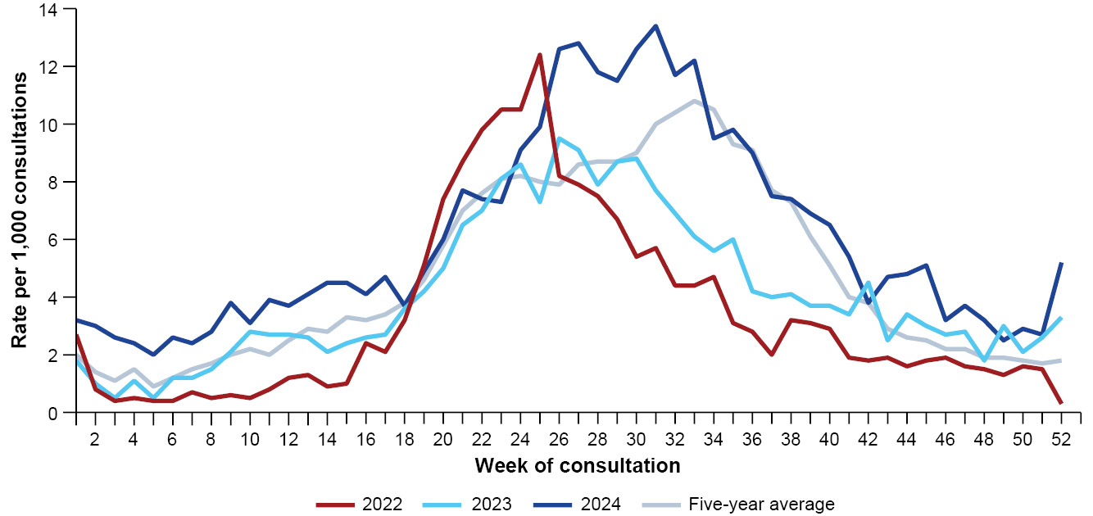
a Source: Australian Sentinel Practices Research Network (ASPREN), extracted on 26 February 2025.
b The years 2020 and 2021 are excluded when comparing the current season to historical periods when influenza virus has circulated without public health restrictions. As such, the five-year average includes the years 2017 to 2019 and 2022 to 2023.
In 2024, more people attending a sentinel general practice with ILI, who were then tested, were positive for a respiratory pathogen (61.0%; 1,666/2,729), than in 2023 (59.3%; 1,025/1,729). In 2024, rhinovirus was most commonly detected (34.0%; 566/1,666), followed by influenza (23.9%; 398/1,666); SARS-CoV-2 (13.1%; 219/1,666); RSV (8.9%; 148/1,666); and human metapneumovirus (hMPV) (8.8%; 146/1,666).
The number of samples tested in 2024 was higher than in either 2022 or 2023 (Figure 12). Several factors likely contributed to the overall increase in the number of samples tested in 2024, compared to previous years, including:
- variations in severity of acute respiratory infections;
- changes in the health-seeking behaviour and testing practices at sentinel general practices sites due to the availability of telehealth and respiratory clinics across 2020–2022; and
- increased number of participating sentinel general practice sites in recent years.
Following rhinovirus, influenza was the most commonly detected respiratory pathogen in each year of 2022–2024. While rhinovirus positivity usually remains relatively constant throughout the year, influenza positivity follows seasonal trends.²⁴ In 2024, influenza positivity peaked at 31.9% per week in late July, compared to 40.9% per week in June 2023 and 48.3% per week in May 2022 (Figure 12).
There was an overall increase in the number of samples positive for Mycoplasma pneumoniae and Bordetella pertussis (pertussis) across 2024, compared with previous years when very few samples were positive for either pathogen (Figure 12). The trend for pertussis should be interpreted with caution, as the influenza-like-illness case definition is not designed to be sensitive for pertussis.
Figure 12: Number of samples tested for respiratory pathogens among people with influenza-like illness attending sentinel general practice sites by respiratory pathogen, week of specimen collection and year, Australia, January 2022 to December 2024^{a,b}
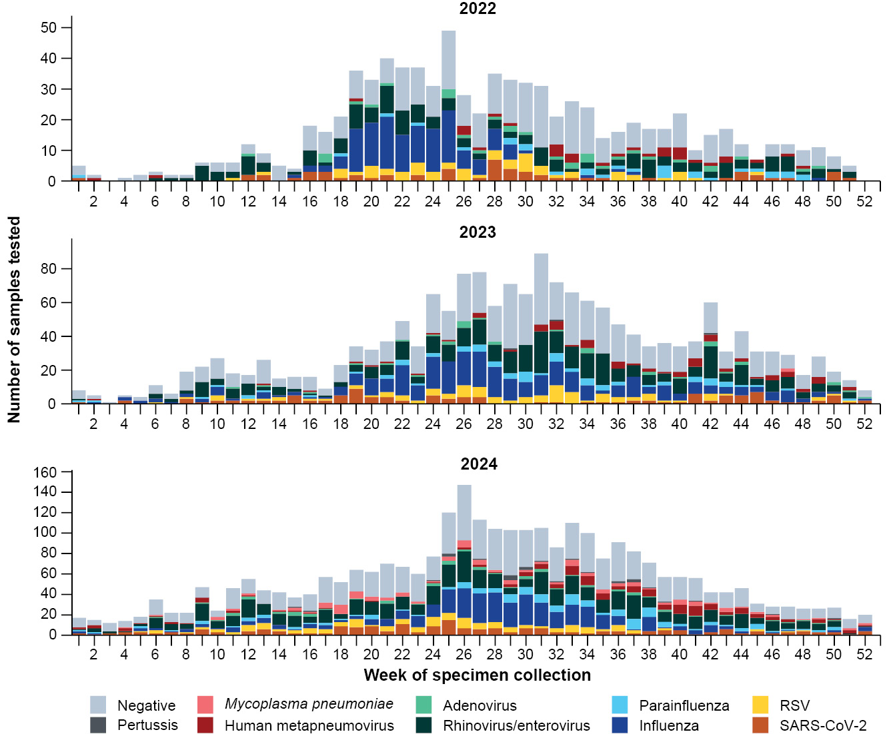
a Source: Australian Sentinel Practices Research Network (ASPREN), extracted on 26 February 2025.
b Axis varies between years.

Hospital-based surveillance
Hospital-based surveillance monitors persons with more severe illness who have been admitted to hospital for their respiratory illness (severe acute respiratory infections). Hospital-based surveillance also measures the ability of the health system to cope with the number of severe acute respiratory infection admissions to ensure delivery of safe, timely and quality health care.
In 2024, weekly admissions to FluCAN sentinel hospitals with COVID-19 gradually decreased from January to late March, before increasing to a peak of 206 admissions per week in late May. Following the peak in late May, there was an overall decreasing trend with the number of weekly admissions not exceeding 100 admissions per week from late July to early November. From early November weekly admissions to sentinel hospitals with COVID-19 remained above 100 admissions per week for the remainder of 2024 (Figure 13).
In 2024, there were fewer weekly admissions to sentinel hospitals with COVID-19 than in 2022 and 2023. Admission patterns followed a similar trend each year, with the number of weekly admissions generally elevated in January and then again in May and June (though there was a sustained increase in weekly admissions across May to July 2022; Figure 13). Several factors likely contributed to the overall decrease in the number of weekly admissions to sentinel hospitals with COVID-19 over time, including:
- increased immunity from vaccination and previous infections contributing to reduced severity of infection;
- early access to antivirals and other interventions preventing many cases from becoming severe;
- decreased intrinsic severity of circulating variants; and
- decreased number of overall COVID-19 cases.
In 2024, surveillance for admissions to sentinel hospitals with influenza began in April. From April, weekly admissions to sentinel hospitals with influenza increased to a peak of 334 admissions per week in mid-July. Following the peak in mid-July, there was an overall decreasing trend in the number of weekly admissions, not exceeding 50 admissions per week from late September to December (Figure 13).
In 2024, most (96.6%; 4,548/4,709) patients admitted to sentinel hospitals with influenza were admitted with influenza A, while 3.4% (159/4,709) were admitted with influenza B. Most admissions with influenza A were influenza A(H3N2) (43.3%; 1,968/4,548), followed by influenza A(Unsubtyped) (28.9%; 1,315/4,548), and influenza A(H1N1) (27.8%; 1,265/4,548).
From April to October 2024, there were fewer weekly admissions to sentinel hospitals with influenza than in the same period in 2023 and 2022. From April to October, the peak number of weekly admissions to sentinel hospitals with influenza was similar across 2022–2024; however, the peaks occurred later and were more prolonged in 2023 and 2024 (July) compared with 2022 (May) (Figure 13).
- Surveillance for influenza hospitalisations in sentinel hospitals was seasonal prior to April 2024, when year-round surveillance commenced. Therefore, data before April and after October for any year are not available for comparison.
Figure 13: Total number of patients (children and adults) admitted with a severe acute respiratory infection to sentinel hospitals by disease, year, and week of admission, Australia, January 2022 to December 2024^{a,b,c}
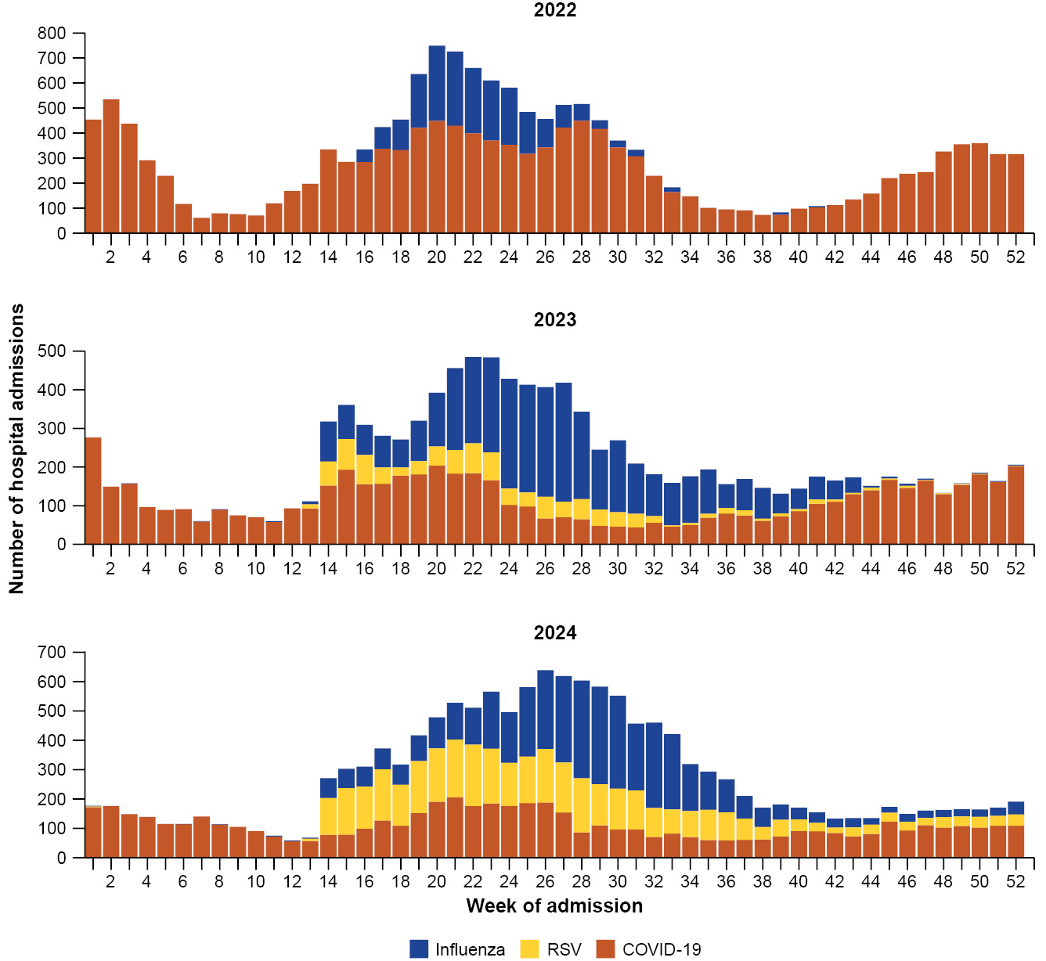
a Source: Influenza Complications Alert Network (FluCAN), extracted on 13 March 2025.
b Axis varies between years.
c Surveillance for COVID-19 hospitalisations in sentinel hospitals has been conducted year-round. Surveillance for influenza hospitalisations in sentinel hospitals was seasonal prior to April 2024 when year-round surveillance commenced. Therefore, data before April and after October for any year are not available for comparison. Surveillance for RSV hospitalisations in sentinel hospitals was piloted in 2023 but not implemented in full until April 2024. Therefore, data from 2023 should be interpreted with caution and earlier years of data are not available for comparison.
In 2024, surveillance for admissions to sentinel hospitals with RSV began in April. From April, weekly admissions to sentinel hospitals with RSV increased to a peak of 209 admissions per week in late May, and then again to a smaller peak of 184 admissions per week in mid-July. Following the mid-July peak, the number of weekly admissions was slow to decline, but from early September onwards it remained low and stable, not exceeding 75 admissions per week (Figure 13).
- Surveillance for RSV hospitalisations in sentinel hospitals was piloted in 2023 but not implemented in full until April 2024. Therefore, comparisons are not made between 2024 and 2023.
In 2024, considerably more children (those aged 16 years and younger) were admitted to FluCAN sentinel hospitals with RSV or influenza than with COVID-19 (Table 4). In 2024, most children admitted to sentinel hospitals were aged six months to four years of age; however, children admitted to sentinel hospitals with influenza tended to be older than children admitted with
COVID-19 or RSV (Table 4).
In 2024, more children admitted to sentinel hospitals with COVID-19 were admitted directly to intensive care, in comparison to children with influenza or RSV. The proportion of children admitted directly to intensive care was otherwise low. Children admitted to sentinel hospitals with COVID-19 or RSV had a longer length of hospital stay than those admitted with influenza (Table 4).
Table 4: Demographic characteristics and outcomes for children admitted with a severe acute respiratory infection to a sentinel hospital by disease, Australia, 1 January to 31 December 2024^{a,b}
Category | Value | COVID-19 (N = 1,601) | Influenza (N = 2,329) | RSV (N = 3,404)
Age (years) | Median [IQR]^{c} | 1 [0–4] | 4 [1–8] | 1 [0–2]
Age group (years) | < 6 months | 550 (34.4%) | 175 (7.5%) | 958 (28.1%)
Age group (years) | 6 months – 4 years | 668 (41.7%) | 1,071 (46.0%) | 2,184 (64.2%)
Age group (years) | 5–16 years | 383 (23.9%) | 1,083 (46.5%) | 262 (7.7%)
Indigenous status | Aboriginal and Torres Strait Islander | 112 (7.0%) | 168 (7.2%) | 204 (6.0%)
Length of hospital stay (days)^{d} | Median [IQR]^{c} | 2 [1–3] | 1 [1–3] | 2 [1–3]
Patient admission location^{e} | Admitted to hospital ward | 1,482 (92.6%) | 2,221 (95.4%) | 3,254 (95.6%)
Patient admission location^{e} | Admitted to intensive care directly | 118 (7.4%) | 108 (4.6%) | 150 (4.4%)
Discharge status | Alive | 1,489 (93.0%) | 2,264 (97.2%) | 3,194 (93.8%)
Discharge status | Died | 6 (0.4%) | 6 (0.3%) | 4 (0.1%)
Discharge status | Incomplete/missing | 106 (6.6%) | 59 (2.5%) | 206 (6.1%)
a Source: Influenza Complications Alert Network (FluCAN), extracted on 13 March 2025.
b Surveillance for sentinel hospital admissions with influenza and RSV did not begin until April 2024, as such the data provided here are reflective of sentinel hospital admissions with influenza and RSV from 1 April to 31 December 2024. Surveillance for sentinel hospital admissions with COVID-19 was conducted from 1 January to 31 December 2024.
c IQR: interquartile range.
d For patients who are still in hospital, data may not be complete; therefore, these data are not included in the length of stay or discharge status. In addition, length of stay data excludes patients that acquired their infection in hospital.
e Admission location reflects the initial admission ward. Some patients may be initially admitted to general ward then later admitted to intensive care and this is not reflected here. Does not include patients with missing admission location; therefore, the sum of admission location specific totals above may not equal the total number of patients.
In 2024, most children were discharged alive. Sadly, there were a small number of deaths among children admitted to sentinel hospitals with a severe acute respiratory infection (Table 4). The proportion of deaths among children admitted to sentinel hospitals in 2024 was similar to the proportion observed in 2023 (0.3% [7/2,213] for COVID-19 in 2023 and 0.3% [9/2,791] for influenza in 2023); however, the number of deaths was slightly less in 2024 than in 2023 (Table 4).
The Paediatric Active Enhanced Disease Surveillance (PAEDS) network carries out enhanced sentinel hospital surveillance for some acute respiratory infections or conditions in children. PAEDS data for acute respiratory infections in children are presented in the Australian Respiratory Surveillance Reports within the Influenza Complications Alert Network (FluCAN) data for sentinel hospitals. For additional information on COVID-19 in children, paediatric inflammatory multisystem syndrome (PIMS-TS) following COVID-19, influenza in children, or RSV in children please visit the PAEDS webpages and dashboards.
In 2024, considerably more adults (those aged 17 years and over) were admitted to FluCAN sentinel hospitals with COVID-19 (4,205) than were admitted with influenza (2,378) or with RSV (587; Table 5). In 2024, most adults admitted to sentinel hospitals were aged 65 years or over; however, adults admitted to sentinel hospitals with influenza tended to be younger than adults admitted with COVID-19 or RSV (Table 5).
In 2024, higher proportions of adults admitted to sentinel hospitals with influenza or RSV identified as an Aboriginal and Torres Strait Islander person than did adults admitted with COVID-19.
In 2024, higher proportions of adults admitted to sentinel hospitals with influenza or RSV were admitted directly to intensive care than was the case for adults admitted to sentinel hospitals with COVID-19. The proportion of adults admitted directly to intensive care was otherwise low. Adults admitted to sentinel hospitals with COVID-19 had a longer length of hospital stay than did those with influenza or RSV (Table 5).
In 2024, there was a slightly higher proportion of deaths among adults admitted to sentinel hospitals with COVID-19 or RSV, than with influenza; however, most adults were discharged alive (Table 5). The number and proportion of deaths among adults admitted to sentinel hospitals in 2024 was slightly lower than observed in 2023 (viz., 4.4% [171/3,889] for COVID-19 in 2023 and 2.5% [35/2,378] for influenza in 2023) (Table 5).
Table 5: Demographic characteristics and outcomes for adults admitted with a severe acute respiratory infection to a sentinel hospital by disease, Australia, 1 January to 31 December 2024^{a,b}
Category | Value | COVID-19 (N = 4,205) | Influenza (N = 2,378) | RSV (N = 587)
Age (years) | Median [IQR]^{c} | 75 [63–84] | 62 [45–77] | 72 [57–82]
Age group (years) | 17–64 years | 1,129 (26.8%) | 1,267 (53.3%) | 207 (35.3%)
Age group (years) | 65 years and over | 3,076 (73.2%) | 1,111 (46.7%) | 380 (64.7%)
Age group (years) | Aboriginal and Torres Strait Islander | 156 (3.7%) | 258 (10.8%) | 64 (10.9%)
Indigenous status | Median [IQR]^{c} | 5 [2–9] | 3 [2–6] | 4 [2–8]
Length of hospital stay (days)^{d} | Admitted to hospital ward | 3,981 (94.7%) | 2,196 (92.3%) | 537 (91.5%)
Patient admission location^{e} | Admitted to intensive care directly | 224 (5.3%) | 182 (7.7%) | 50 (8.5%)
Patient admission location^{e} | Alive | 3,592 (85.4%) | 2,155 (90.6%) | 497 (84.7%)
Discharge status | Died | 189 (4.5%) | 74 (3.1%) | 25 (4.3%)
Discharge status | Incomplete/missing | 424 (10.1%) | 149 (6.3%) | 65 (11.1%)
Discharge status | Median [IQR]^{c} | 75 [63–84] | 62 [45–77] | 72 [57–82]
a Source: Influenza Complications Alert Network (FluCAN), extracted on 13 March 2025.
b Surveillance for sentinel hospital admissions with influenza and RSV did not begin until April 2024, as such the data provided here are reflective of sentinel hospital admissions with influenza and RSV from 1 April to 31 December 2024. Surveillance for sentinel hospital admissions with COVID-19 was conducted from 1 January to 31 December 2024.
c IQR: interquartile range.
d For patients who are still in hospital, data may not be complete; therefore, these data are not included in the length of stay or discharge status. In addition, length of stay data excludes patients that acquired their infection in hospital.
e Admission location reflects the initial admission ward. Some patients may be initially admitted to general ward then later admitted to intensive care and this is not reflected here. Does not include patients with missing admission location; therefore, the sum of admission location specific totals above may not equal the total number of patients.
In 2024, more patients were admitted to a SPRINT-SARI sentinel intensive care site with a severe acute respiratory infection (n = 4,228) than in 2023 (n = 3,301) (Figure 14). This trend should be interpreted with caution, and comparisons between 2022 and later years should not be undertaken as surveillance for non-COVID-19 severe acute respiratory infections at sentinel intensive care sites did not begin until late 2022.
In 2024, most admissions to sentinel intensive care sites were with COVID-19 (n = 1,384), followed by rhinovirus (n = 1,031) and influenza (n = 861). There were 549 admissions with RSV (Table 6). In 2024, some patients (5.3%; 225/4,228) had co-infections of multiple respiratory pathogens; therefore, the sum of pathogen-specific totals may not equal the total number of patients (Table 6).
In 2024, there were fewer admissions to sentinel intensive care sites with COVID-19 (n = 1,384) than in 2023 (n = 1,772) or 2022 (n = 5,028; Figure 14). Several factors likely contributed to the decrease in the number of admissions to sentinel intensive care units with COVID-19 over time, including:
- increased immunity from vaccination and previous infections contributing to reduced severity of infection;
- early access to antivirals and other interventions preventing many cases from becoming severe;
- decreased intrinsic severity of circulating variants; and
- decreased number of overall COVID-19 cases.
In 2024, there were more admissions to SPRINT-SARI sentinel intensive care sites with influenza (n = 861) than in 2023 (n = 556). Likewise, in 2024 there were more admissions to sentinel intensive care sites with RSV (n = 549) than in 2023 (n = 418; Figure 14).
Figure 14: Number of patients admitted with severe acute respiratory infections to a sentinel intensive care by disease, year, and week of admission, Australia, January 2022 to December 2024^{a,b,c}
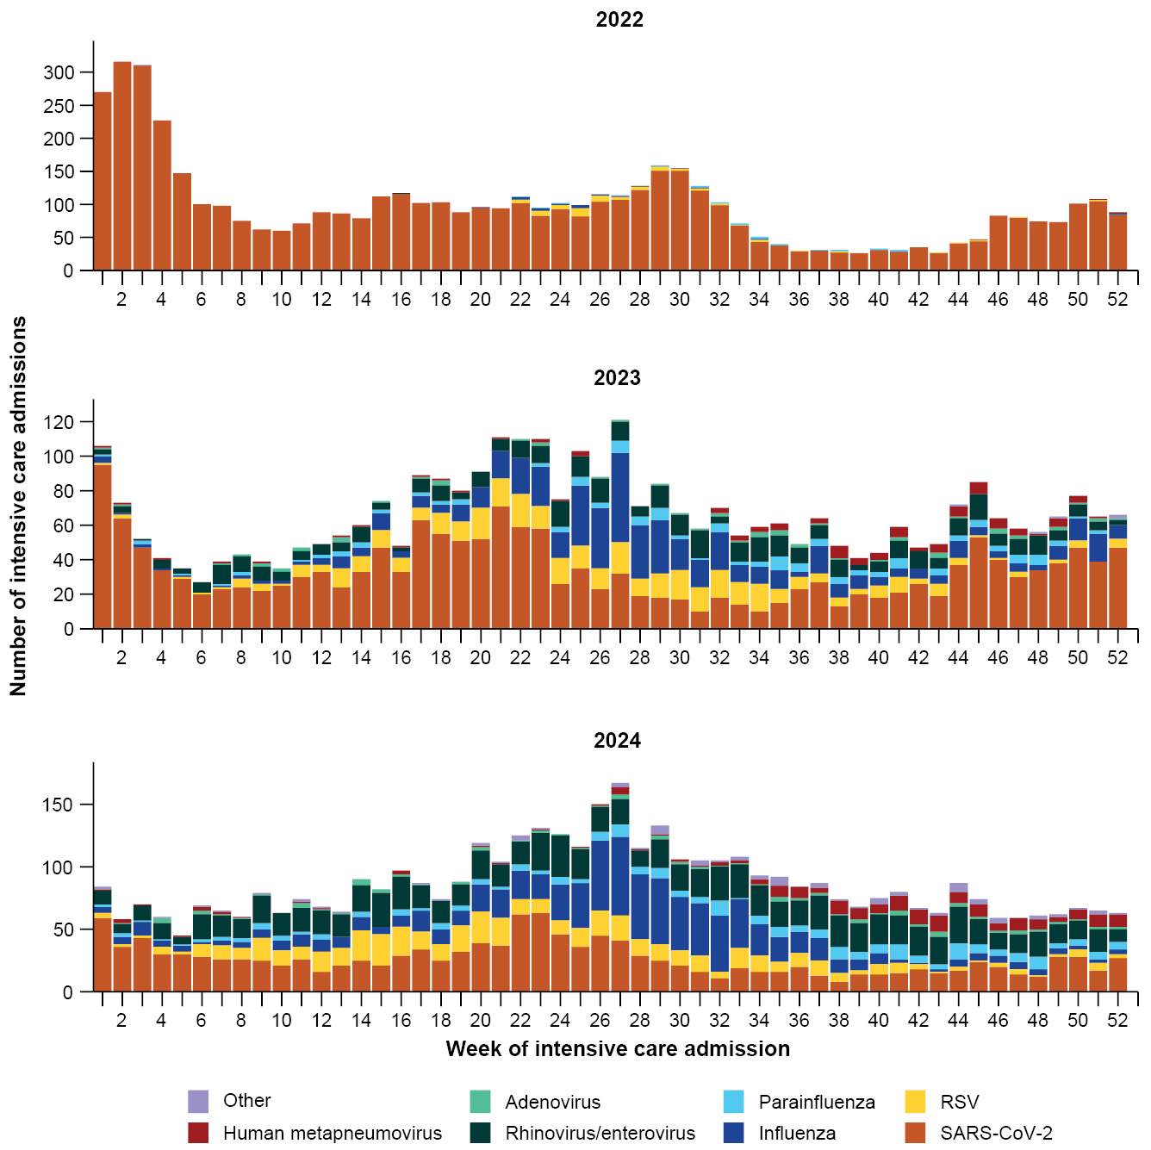
a Source: Short Period Incidence Study of Severe Acute Respiratory Infection (SPRINT-SARI) Australia, extracted on 26 February 2025.
b Axis varies between years.
c Surveillance for non-COVID-19 severe acute respiratory infections in sentinel intensive care units did not begin in full until 2023. Therefore, data for non-COVID-19 severe acute respiratory infections in 2022 should be interpreted with care.
In 2024, admissions to sentinel intensive care with COVID-19 or influenza were generally among older age groups (Figure 15; Table 6). In contrast, admissions with hMPV, rhinovirus, or RSV were among younger people, particularly children aged 0–9 years and 10–19 years (Figure 15; Table 6).
In 2024, a higher proportion of admissions to a sentinel intensive care sites with severe acute respiratory infections were male.
Figure 15: Number of patients admitted with severe acute respiratory infections to a sentinel intensive care by age group and disease, Australia, January to December 2024^{a,b}
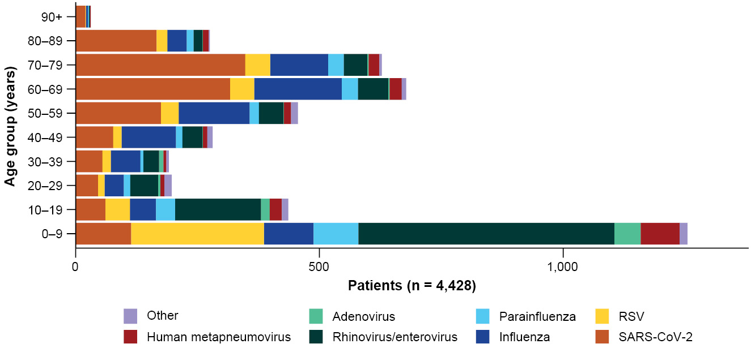
a Source: Short Period Incidence Study of Severe Acute Respiratory Infection (SPRINT-SARI) Australia, extracted on 26 February 2025.
b The age distribution of severe acute respiratory infection intensive care admissions may not reflect the age distribution of all patients admitted with a severe acute respiratory infection nationally.
A smaller proportion of admissions to a sentinel intensive care with COVID-19 identified as an Aboriginal and Torres Strait Islander person than did people with other severe acute respiratory infections (Table 6).
In 2024, the length of intensive care stay for people admitted to a sentinel intensive care was similar across infections, ranging from two days for rhinovirus to four days for hMPV or influenza (Table 6). In 2024, most patients admitted to a sentinel intensive care with a severe acute respiratory infection were discharged home or transferred to another hospital facility such as an in-patient rehabilitation facility (Table 6).
Sadly, there were 431 deaths in patients admitted to sentinel intensive care with a severe acute respiratory infection, an in-hospital mortality rate for 2024 of 10.2% (431/4,228; Table 6). Most deaths (71.2%; 307/431) were in patients aged 60 years or over. In comparison, the in-hospital mortality rate was slightly higher in 2023 (11.8%; 390/3,301). The trends in deaths disaggregated by infection were similar between 2024 and 2023.
Table 6: Demographic characteristics and outcomes of patients admitted with severe acute respiratory infections to a sentinel intensive care by disease, Australia, 1 January to 31 December 2024^{a,b}
Category | Value | COVID-19 (N = 1,384) | hMPV (N = 205) | Influenza (N = 861) | Parainfluenza (N = 267) | Rhinovirus (N = 1,031) | RSV  (N = 549) | Other (N = 187)
Age (years) | Median [IQR]^{c} | 65 [48–75] | 16 [5–64] | 54 [32–66] | 20 [4–66] | 9 [3–30] | 8 [2–57] | 16 [3–43]
Sex | Female | 583 (42.1%) | 92 (44.9%) | 401 (46.6%) | 125 (46.8%) | 466 (45.2%) | 268 (48.8%) | 86 (46.0%)
Sex | Male | 801 (57.9%) | 113 (55.1%) | 460 (53.4%) | 142 (53.2%) | 565 (54.8%) | 281 (51.2%) | 101 (54.0%)
Indigenous status | Aboriginal and Torres Strait Islander | 68 (4.9%) | 20 (9.8%) | 69 (8.0%) | 23 (8.6%) | 91 (8.8%) | 62 (11.3%) | 13 (7.0%)
Indigenous status | Non-Indigenous | 1,316 (95.1%) | 185 (90.2%) | 792 (92.0%) | 244 (91.4%) | 940 (91.2%) | 487 (88.7%) | 174 (93.0%)
Invasive mechanical ventilation | Number receiving (%) | 466 (33.7%) | 65 (31.7%) | 335 (38.9%) | 98 (36.7%) | 320 (31.0%) | 137 (25.0%) | 72 (38.5%)
Invasive mechanical ventilation | Duration in days, median [IQR]^{c} | 3 [1–8] | 4 [1–8] | 5 [2–10] | 4 [1–7] | 3 [1–7] | 4 [2–7] | 3 [2–8]
Length of intensive care stay (days) | Median [IQR]^{c} | 3 [2–6] | 4 [2–8] | 4 [2–8] | 3 [2–6] | 2 [1–5] | 3 [2–5] | 3 [2–6]
Length of hospital stay (days) | Median [IQR]^{c} | 9 [5–17] | 8 [4–14] | 8 [5–15] | 7 [4–14] | 6 [3–13] | 6 [4–12] | 7 [4–12]
Patient outcome | Ongoing care in intensive care | 7 (0.5%) | 1 (0.5%) | 6 (0.7%) | 1 (0.4%) | 1 (0.1%) | 1 (0.2%) | 1 (0.5%)
Patient outcome | Ongoing care in hospital ward^{d} | 10 (0.7%) | 1 (0.5%) | 8 (0.9%) | — | 11 (1.1%) | 1 (0.2%) | 3 (1.6%)
Patient outcome | Transfer to other hospital or facility, including rehabilitation | 251 (18.1%) | 23 (11.2%) | 118 (13.7%) | 24 (9.0%) | 112 (10.9%) | 63 (11.5%) | 16 (8.6%)
Patient outcome | Discharged home | 894 (64.6%) | 161 (78.5%) | 630 (73.2%) | 216 (80.9%) | 852 (82.6%) | 450 (82.0%) | 156 (83.4%)
Patient outcome | Died in hospital^{e} | 212 (15.3%) | 18 (8.8%) | 97 (11.3%) | 26 (9.7%) | 52 (5.0%) | 32 (5.8%) | 9 (4.8%)
Patient outcome | Missing^{f} | 10 (0.7%) | 1 (0.5%) | 2 (0.2%) | — | 3 (0.3%) | 2 (0.4%) | 2 (1.1%)
a Source: Short Period Incidence Study of Severe Acute Respiratory Infection (SPRINT-SARI) Australia, extracted on 26 February 2025.
b Note that 225 patients had co-infections of respiratory pathogens; therefore, the sum of pathogen-specific totals above may not equal the total number of severe acute respiratory infection patients. For patients whom are still receiving treatment in intensive care data may not be complete; therefore, data are not included in the duration of ventilation or length of intensive care stay.
c IQR: interquartile range.
d Patients who have been admitted in intensive care/hospital wards with no discharge information for less than 90 days have been assumed to have ongoing care in the hospital.
e Death may not necessarily represent a death due to the infection.
f Patients who have no outcome entered or have been admitted for more than 90 days with no discharge information have been treated as missing.
In 2024, there were fewer COVID-19 cases in intensive care across Australia than in 2023 or 2022. The number of ventilated cases has consistently remained low and stable compared with non-ventilated cases over time (Figure 16). Several factors likely contributed to the overall decrease in the number of COVID-19 cases in intensive care over time, including:
- increased immunity from vaccination and previous infections contributing to reduced severity of infection;
- early access to antivirals and other interventions preventing many cases from becoming severe;
- decreased intrinsic severity of circulating variants; and
- decreased number of overall COVID-19 cases.
In 2024, there were more intensive care staff unavailable to work due to COVID-19 exposure or illness across Australia than in 2023, but fewer staff unavailable than in 2022 (Figure 16).
Across all jurisdictions in 2024, there was a greater number of COVID-19 cases in intensive care across January to June than in the latter half of the year. The number of COVID-19 cases in intensive care peaked in March in the NT and Vic., whereas other jurisdictions experienced a peak in June or July (Figure 17). In 2024, the number of intensive care staff unavailable to work fluctuated across most jurisdictions, with only SA and Tas. experiencing a clear peak in staff unavailable (Figure 17).
Figure 16: Average number of COVID-19 cases in intensive care and the average number of intensive care staff unavailable to work due to COVID-19 exposure or illness by week of report, Australia, January 2022 to December 2024^{a,b,c,d}
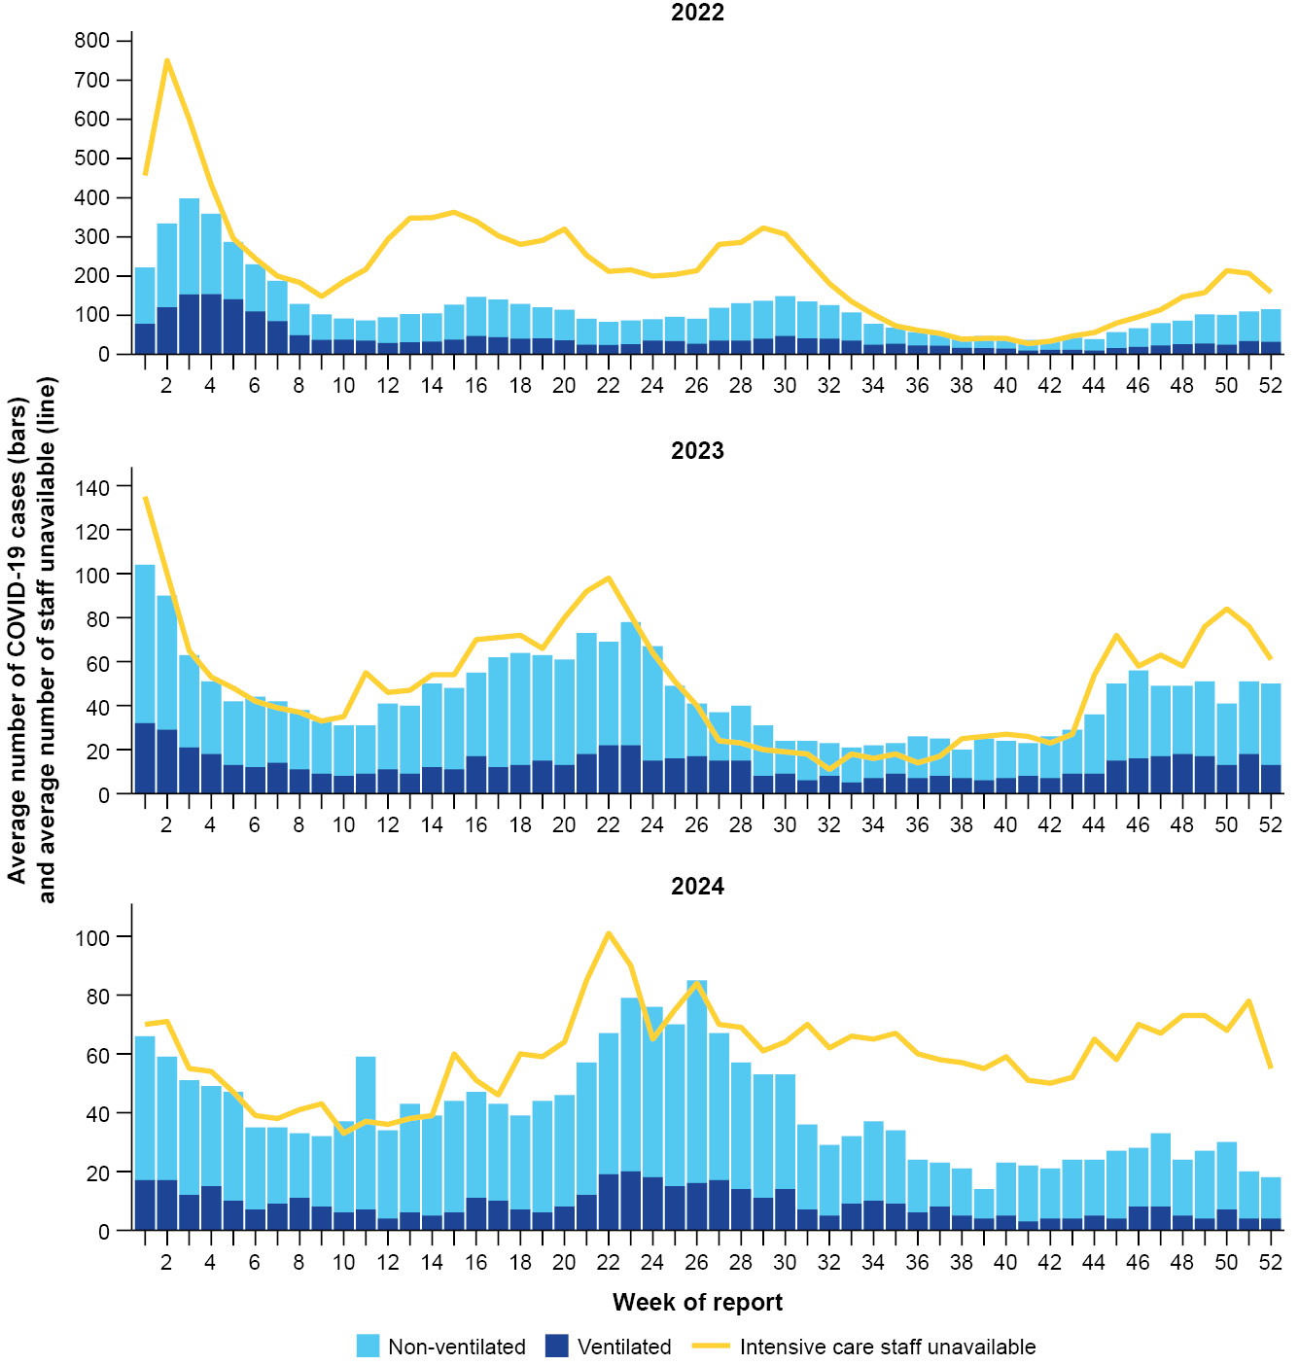
a Source: Critical Health Resource Information System (CHRIS), extracted on 5 March 2025.
b Axis varies between years.
c Average number of ventilated and non-ventilated COVID-19 cases in intensive care includes only active COVID-19 cases (those in isolation) and does not include cleared COVID-19 cases.
d Intensive care staff include both medical and nursing staff. Staff unavailability will be underestimated in NSW as most public hospitals in NSW do not report staff unavailability.
Figure 17: Average number of COVID-19 cases in intensive care and the average number of intensive care staff unavailable to work due to COVID-19 exposure or illness by jurisdiction and week of report, Australia, January to December 2024^{a,b,c,d}
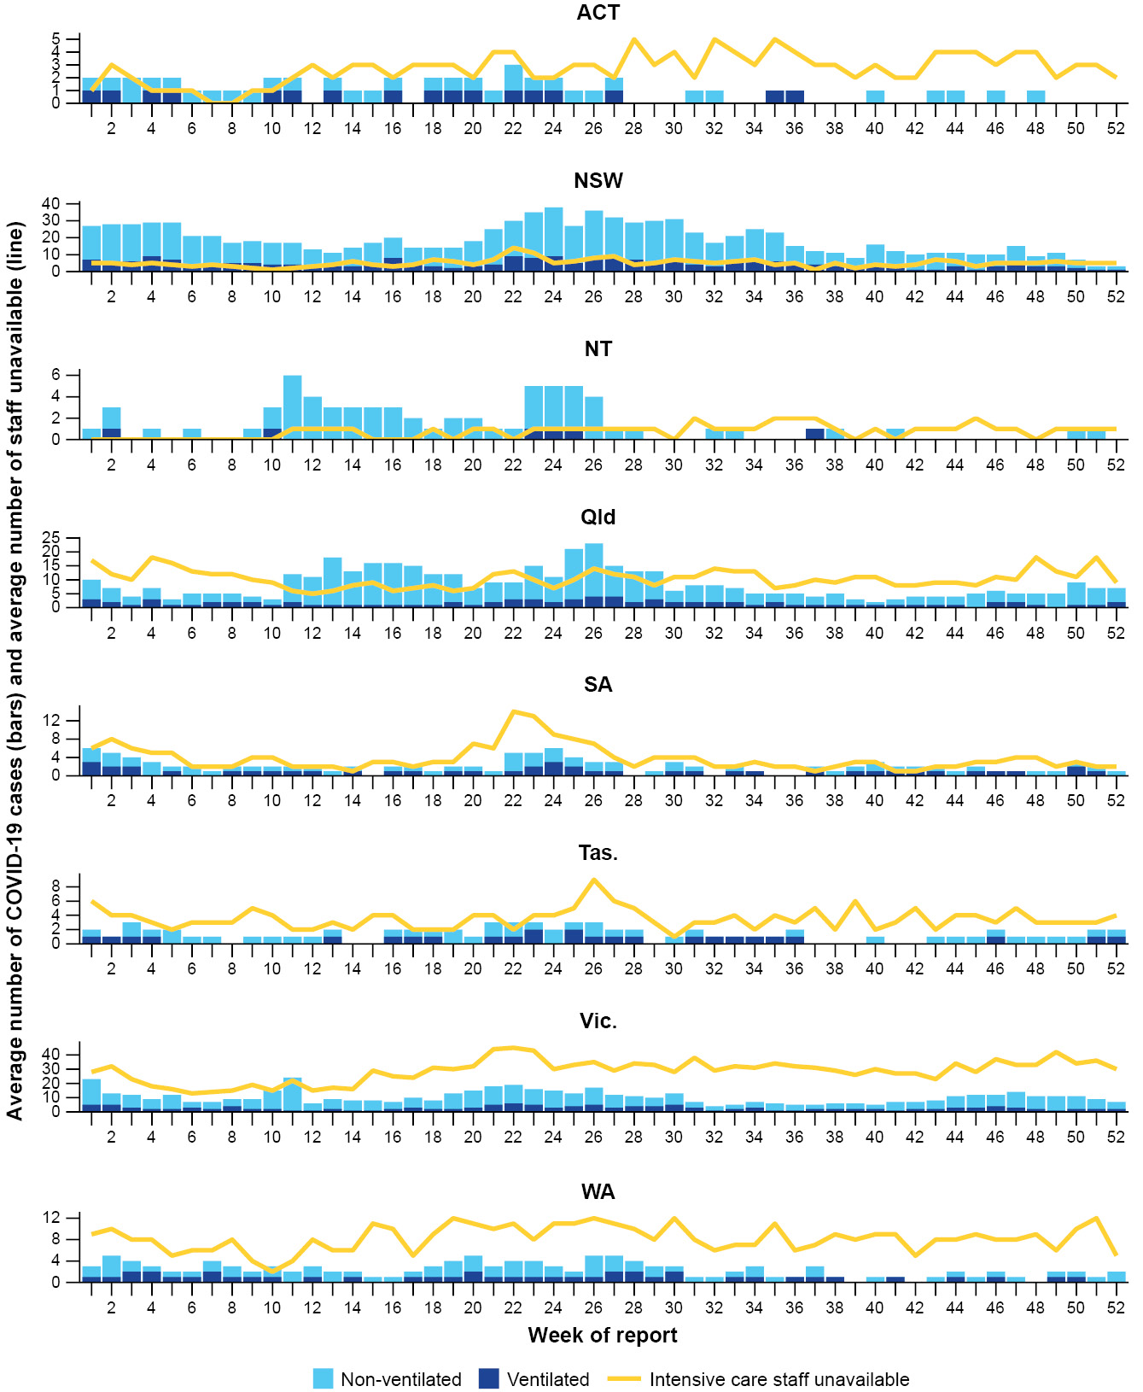
a Source: Critical Health Resource Information System (CHRIS), extracted on 5 March 2025.
b Axis varies between jurisdictions.
c Average number of ventilated and non-ventilated COVID-19 cases in intensive care includes only active COVID-19 cases (those in isolation) and does not include cleared COVID-19 cases.
d Intensive care staff include both medical and nursing staff. Staff unavailability will be underestimated in NSW as most public hospitals in NSW do not report staff unavailability.

Mortality surveillance
Death registrations reported to the Australian Bureau of Statistics can provide information on the scale and severity of disease associated with acute respiratory infections. Deaths involving acute respiratory infections are where the death is directly due to the infection (the virus has caused terminal complications such as pneumonia) or the person has died with the infection (a person has died from another cause, but the infection still contributed significantly to death). People are more likely to die due to COVID-19 or influenza rather than with COVID-19 or influenza. The opposite is true for RSV: people are more likely to die with RSV (where the infection was a significant contributor to death).²⁵
COVID-19 has been the leading cause of acute respiratory infection mortality across 2022–2024.²⁵ In 2024, there were 4,953 deaths involving COVID-19, which is 19.5% lower than the 6,154 deaths involving COVID-19 in 2023. The trend in the number of deaths involving COVID-19 over time was similar between 2023 and 2024; however, there was a higher number of deaths in June, July and August of 2024 than during the same period in 2023 (Figure 18).
In 2024, there were 1,002 deaths involving influenza, which is 67.7% higher than the 599 deaths involving influenza in 2023. This is largely due to a 61% increase in the number of deaths with influenza (where influenza was mentioned as a contributory cause) in 2024 than in 2023. This likely explains why an increasing trend in death registrations was observed in 2024, but a decreasing number of deaths was observed in sentinel surveillance systems which are not as sensitive for deaths with an infection.
The number of deaths involving influenza in 2024 was considerably fewer than historical deaths in some years, with 1,656 deaths involving influenza in 2017 and 1,314 deaths in 2019. The trend in the number of deaths involving influenza during the interseasonal periods was similar between 2023 and 2024; however, there was a much higher number of deaths in July and August of 2024 (and to a lesser extent in June and September) than in the same period in 2023 (Figure 18). However, for context, the number of deaths in July and August 2024 was comparable to those in 2019 (n = 195 in July 2019 and n = 196 in August 2019), and much lower than the number of deaths in August (n = 420) and September (n = 503) in 2017, when the influenza season commenced later in the year.²⁵
In 2024, there were 462 deaths involving RSV, which is 21.1% higher than the 374 deaths involving RSV in 2023. The overall pattern in the number of deaths involving RSV over time was similar between 2023 and 2024; however, there was a higher number of deaths from January to June of 2024 than during the same period in 2023 (Figure 18).
All three of these acute respiratory infections are more likely to cause death in older age groups than in younger age groups. More males have died from COVID-19 than have females across 2023–2024. The reverse has been true for influenza and RSV.
As the most populous state, NSW generally records the highest numbers of deaths for acute respiratory infections; however, Qld has recorded the highest number of deaths due to RSV in 2024. COVID-19 has caused more deaths than influenza and RSV across 2023–2024 in all jurisdictions.
For Aboriginal and Torres Strait Islander people who died due to an acute respiratory disease:
- COVID-19 caused more deaths than both influenza and RSV across each year in 2022–2024;
- the mortality rate for COVID-19- and influenza-related mortality for Aboriginal and Torres Strait Islander people was higher than non-Indigenous people across each year in 2022–2024; and
- the mortality rate for influenza-related mortality is higher in both Aboriginal and Torres Strait Islander and non-Indigenous people in 2024 compared to 2023 and 2022.
Figure 18: Number of deaths involving (both due to and with) acute respiratory infections by month, year and respiratory infection, Australia, 1 January 2023 to 31 December 2024^{a,b,c,d}
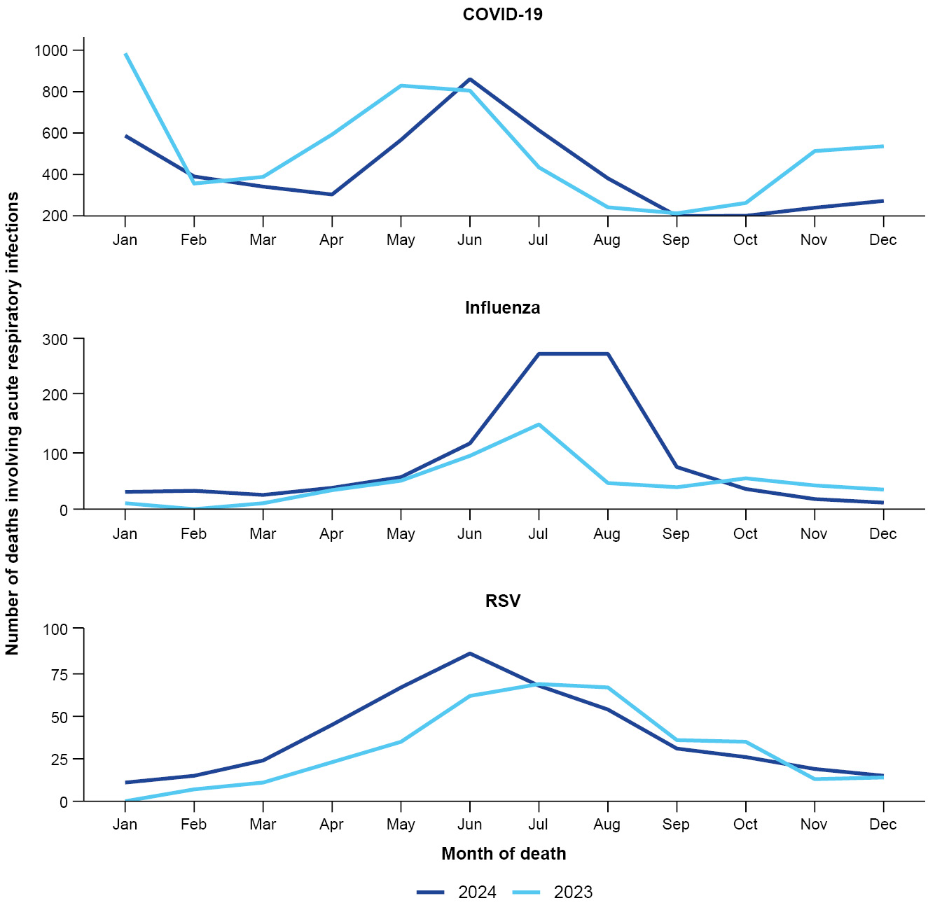
a Source: Australian Bureau of Statistics, Provisional Mortality Statistics, January–November 2024, released 28 February 2025.
b Note: the number of provisional deaths involving RSV in January 2023 were not published due to low numbers of provisional deaths.
c Axis varies between acute respiratory infections.
d Data is provisional and subject to change. It can take several weeks for death registrations to be reported, processed, coded, validated, and tabulated. Therefore, the data shown here may be incomplete, and will likely not include all deaths that occurred during a given time. Data includes all deaths (both doctor and coroner certified) that occurred and were registered by 31 January 2025.

Laboratory surveillance
Sentinel laboratory surveillance monitors and characterises respiratory pathogens to provide information on what pathogens are circulating, and on potential changes in the pathogens that might affect their infectiousness, severity, ability to evade vaccine and/or infection-acquired immunity, or resistance to antivirals.
In 2024, there were two peaks in SARS-CoV-2 test positivity: the first peak occurred early January at 8.8% test positivity per week; and the second, smaller peak occurred in early June at 7.5% test positivity per week. The peaks in SARS-CoV-2 test positivity aligned with increased COVID-19 case notifications observed during the summer of 2023–2024 and winter of 2024 (Figure 4; Figure 19). In 2024, influenza test positivity gradually increased from January to a peak of 17.3% per week in early July, aligning with observed increased influenza case notifications (Figure 6a; Figure 6b; Figure 19). In 2024, RSV test positivity gradually increased from January to a peak at 5.5% in early July, which was later than the peak in RSV case notifications observed in mid-May (Figure 9; Figure 19). This trend is likely reflective of the variable geographical trends in RSV activity in jurisdictions which contribute sentinel laboratory data, with SA, Tas., and WA (all sentinel laboratories) experiencing later peaks in RSV case notifications (July) than those of NSW and Vic. (Figure 10).
In 2024, there were 14,998 SARS-CoV-2 sequences uploaded to AusTrakka with dates of collection in 2024. These sequences were from NSW, Qld, SA, Tas., Vic. and WA. All sequences were assigned to the B.1.1.529 (Omicron) lineage or to recombinants consisting of one or more Omicron sub-lineages (Figure 20a; Figure 20b). In 2024:
- 86.54% of sequences (12,980/14,998) were from the BA.2 lineage, 12,811 of which belonged to JN.1 and associated sub-lineages;
- 13.44% of sequences (2,016/14,998) were recombinant or recombinant sub-lineages; and
- 0.01% of sequences (2/14,998) were from the BA.5 lineage.
JN.1 and associated sub-lineages, including KP.2 and KP.3, represented the dominant variants for most of 2024. From late August 2024, the proportion of XEC sequences increased, leading to an approximately equal proportion of JN.1 (and JN.1 sub-lineages) and XEC sequences by December 2024 (Figure 20a).
The WHO have identified certain sub-sub-lineages and recombinants as variants under monitoring or variants of interest because of their epidemiological, genomic, or clinical features of concern. Select variants under monitoring or variants of interest are highlighted below due to their relevance in the Australian context.
On 3 May 2024, JN.1.7, JN.1.18, KP.2, and KP.3 were designated as variants under monitoring. At the time of this report, JN.1.7 is no longer listed as a variant under monitoring by the WHO.²⁰ In 2024 there were 88 JN.1.7 sequences, 138 JN.1.18 sequences, 839 KP.2 sequences and 5,504 KP.3 sequences identified in AusTrakka.
On 28 June 2024, LB.1 was designated as a variant under monitoring. There is limited evidence of increased transmissibility and potential for infection even in vaccinated people.²⁶ In 2024 there were 299 LB.1 sequences identified in AusTrakka. On 19 July 2024, KP.3.1.1 was designated as a variant under monitoring. There is limited evidence to suggest that KP.3.1.1 may exhibit greater infectivity and immune evasion.²⁷ In 2024 there were 2,270 KP.3.1.1 sequences identified in AusTrakka.
Figure 19: Number of tests positive (bars) and test positivity (line) for specimens tested by sentinel laboratories by week of report and pathogen, Australia, January to December 2024^{a,b,c,d}
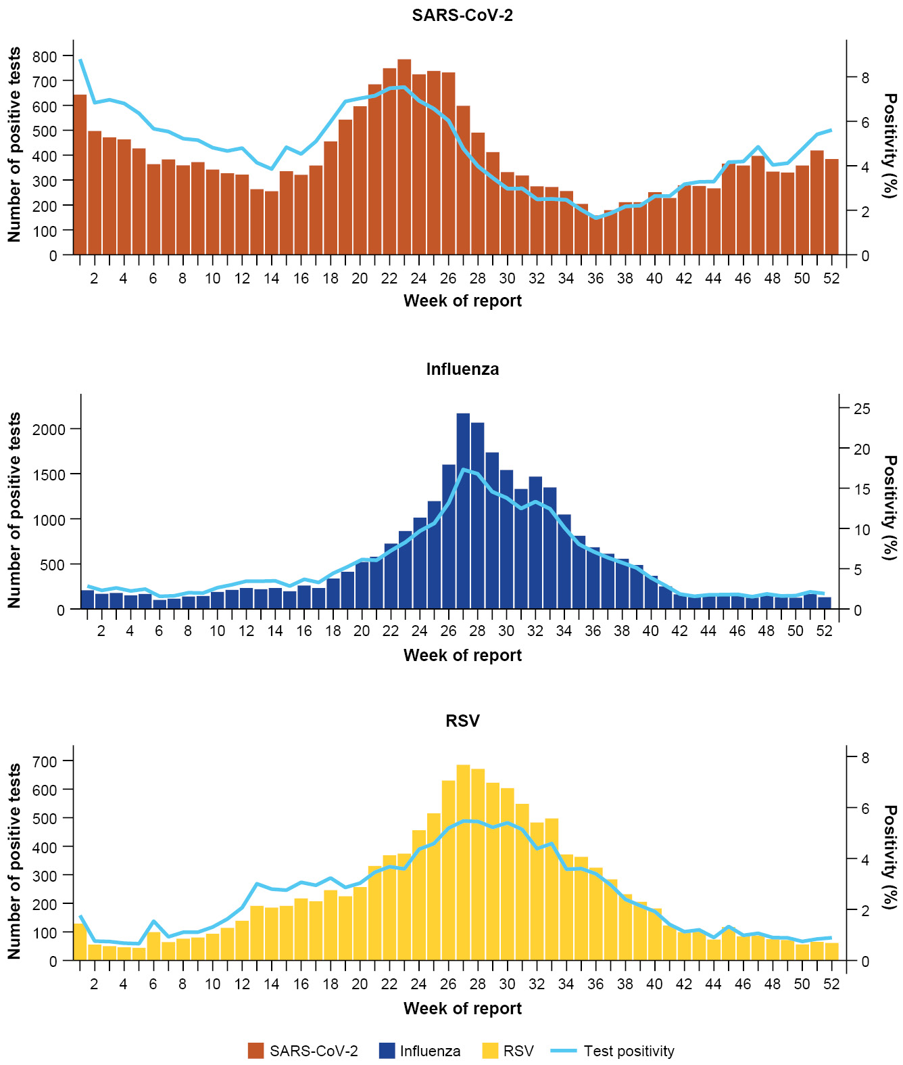
a Source: Sentinel laboratories, including National Influenza Centres, as at 5 March 2025.
b Axis varies between acute respiratory infections.
c Number of specimens tested excludes data from WA as testing denominator data are different for the three pathogens in WA.
d A small minority of total samples from Vic. are tested only by respiratory panel (influenza, parainfluenza, adenovirus, human metapneumovirus, seasonal coronaviruses, RSV, and some picornaviruses) but not for SARS-CoV-2. These minority samples include only forensic materials; all other samples are tested by respiratory panel and SARS-CoV-2 assay.
Figure 20a: SARS-CoV-2 Omicron sub-lineage sequences by sample collection date, showing the proportions of sequences per week, Australia, January to December 2024^{a,b,c,d}
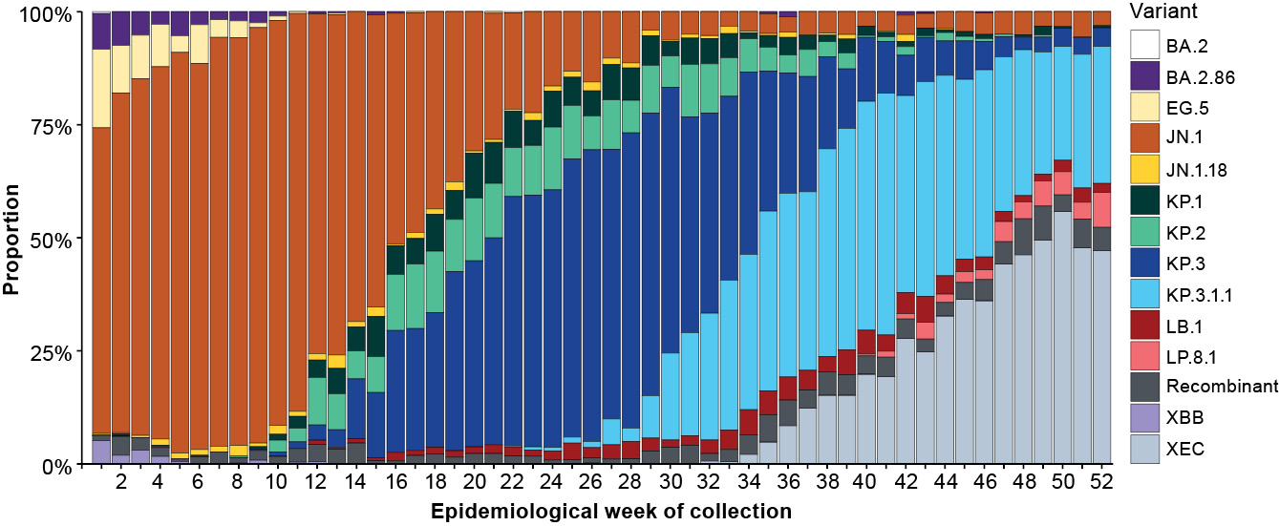
a Source: AusTrakka, extracted on 24 February 2025.
b Some sub-sub-lineages are shown alongside their parent lineage but not included in the parent lineage totals. For instance, KP.2 and KP.3 are sub-sub-lineages of JN.1, so the total of JN.1 sequences will be higher than shown in the corresponding colour alone and should include the KP.2 and KP.3 totals.
c Sequences in AusTrakka are aggregated by week and reported based on date of sample collection, not date of sequencing.
d Proportions in Figure 20a may not be representative when sequence numbers are small; refer to Figure 20b. Data for earlier weeks may change between reporting periods as sequences with older collection dates are uploaded. These numbers are not equivalent to number of cases, as there are many cases which may not be sequenced. Non variant of interest and non variant under monitoring Omicron sub-lineages have been collapsed into parent lineages BA.1, BA.2, BA.3, BA.4 and BA.5.
Figure 20b: SARS-CoV-2 Omicron sub-lineage sequences by sample collection date, showing the count of sequences per week, Australia, January to December 2024^{a,b,c,d}
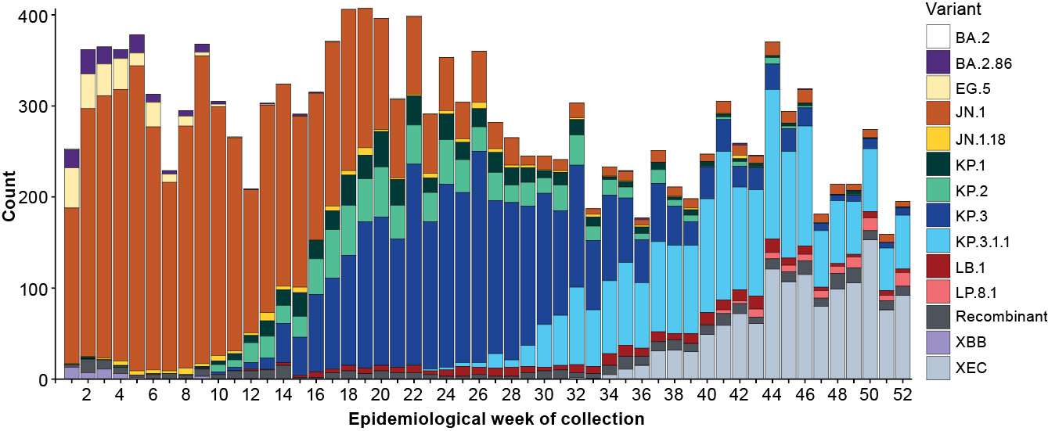
a Source: AusTrakka, extracted on 24 February 2025.
b Some sub-sub-lineages are shown alongside their parent lineage, but not included in the parent lineage totals. For instance, KP.2 and KP.3 are sub-sub-lineages of JN.1, so the total of JN.1 sequences will be higher than shown in the corresponding colour alone and should include the KP.2 and KP.3 totals.
c Sequences in AusTrakka are aggregated by week and reported based on date of sample collection, not date of sequencing.
d Data for earlier weeks may change between reporting periods as sequences with older collection dates are uploaded. These numbers are not equivalent to number of cases, as there are many cases which may not be sequenced. Non variant of interest and non variant under monitoring Omicron sub-lineages have been collapsed into parent lineages BA.1, BA.2, BA.3, BA.4 and BA.5.
On 24 September 2024, XEC (a recombinant between KS.1.1 [JN.1.13.1.1.1] and KP.3.3) was designated as a variant under monitoring. There is limited evidence to indicate that XEC may have some growth advantage over other circulating variants.²⁸ In 2024 there were 1,225 XEC sequences identified in AusTrakka.
In 2024, the WHO Collaborating Centre for Reference and Research on Influenza (the Centre) antigenically characterised 3,920 influenza viruses from Australia, of which 45.8% (1,794/3,920) were influenza A(H1N1); 46.9% (1,838/3,920) were influenza A(H3N2); and 7.3% (288/3,920) were influenza B/Victoria (Table 7). In 2024, there were no influenza B/Yamagata viruses characterised by the Centre (Table 7).
The B/Yamagata lineage was last identified in Australia in a sample typed by the Centre in 2020,²⁹ and some experts believe the lineage could now potentially be extinct globally.³⁰ While there have been sporadic reports of influenza B/Yamagata viruses detected after 2020, these could potentially have been misreported and are not known to have been confirmed by genomic sequencing, so should be interpreted with caution.³¹
In 2024, highly reduced inhibition to Oseltamivir was demonstrated by 1.0% (11/1,151) of the influenza A(H1N1) samples tested and 0.1% (1/1,227) of the influenza A(H3N2) samples tested. None of the samples tested demonstrated reduced inhibition to Zanamivir.
Table 7: Australian influenza viruses typed by haemagglutination inhibition assay, by jurisdiction, 1 January to 31 December 2024^{a,b,c}
Strain | ACT | NSW | NT | Qld | SA | Tas. | Vic. | WA | Total
A(H1N1) | 108 | 251 | 400 | 81 | 47 | 201 | 598 | 108 | 1,794
A(H3N2) | 125 | 276 | 402 | 103 | 83 | 134 | 543 | 172 | 1,838
B/Victoria lineage | 20 | 22 | 22 | 10 | 41 | 14 | 114 | 45 | 288
B/Yamagata lineage | 0 | 0 | 0 | 0 | 0 | 0 | 0 | 0 | 0
Total | 253 | 549 | 824 | 194 | 171 | 349 | 1,255 | 325 | 3,920
a Source: World Health Organization (WHO) Collaborating Centre for Reference and Research on Influenza, extracted on 5 March 2025.
b Viruses tested by the WHO Collaborating Centre for Reference and Research on Influenza are not necessarily a random sample of all those in the community.
c Jurisdiction indicates the residential location for the individual tested, not the location of the submitting laboratory.

Vaccine coverage, effectiveness and match
Vaccine coverage, effectiveness and match for acute respiratory infections are monitored from several data sources in Australia. As noted in the Future Directions section, the interim Australian CDC is working on expanding the vaccine coverage and effectiveness reporting included in the Australian Respiratory Surveillance Report series. Until the inclusion of these updated data, COVID-19 vaccine advice and information on the number of administered COVID-19 vaccine doses remain available on the Department of Health, Disability and Ageing web pages.³² Advice for influenza³³ and RSV³⁴ vaccines is also available.

Vaccine coverage
Influenza virus strains change year to year, so annual vaccination before the peak of the influenza season will provide Australians with the best protection against influenza and its complications. The seasonal influenza vaccine is recommended for everyone aged 6 months and over. In Australia, the influenza vaccine is available for free under the National Immunisation Program for people most at risk of severe influenza infection, including:
- Aboriginal and Torres Strait Islander people aged 6 months and over;
- children aged 6 months to under 5 years;
- pregnant people;
- people aged 65 years and over; and
- people aged 6 months and over who have medical conditions that mean they have a higher risk of severe infection.³³
In 2024 (up to 6 October 2024), estimated influenza vaccine coverage in the Australian population was 30.1%, which is lower than in 2021 (31.1%), 2022 (38.4%) and 2023 (32.1%). Across age groups, influenza vaccine coverage was much higher in those aged 65 years and over (61.1%) than in those aged 5–64 years (22.7%), or in those aged 6–59 months (26.1%). While coverage rates for those aged 65 years and over remain higher than in other age groups, there has been a decline in coverage rates from 2023 to 2024. In 2024 (up to 6 October 2024), estimated influenza vaccine coverage varied between jurisdictions, ranging from 24.8% in the NT to 38.3% in the ACT.
In 2024 (up to 6 October 2024), estimated influenza vaccine coverage for Aboriginal and Torres Strait Islander populations (22.6%) was lower than for the total Australian population (30.1%). In 2024, estimated influenza vaccine coverage for Aboriginal and Torres Strait Islander populations was slightly lower than in 2023 (24.5%). Across age groups for Aboriginal and Torres Strait Islander populations, influenza vaccine coverage was much higher in those aged 65 years and over (60.9%) than in those aged 5–64 years (19.9%), or in those aged 6–59 months (19.3%). While coverage rates for those aged 65 years and over remain higher compared to other age groups, there has been a decline in coverage rates from 2023 to 2024. In 2024 (up to 6 October 2024), estimated influenza vaccine coverage among Aboriginal and Torres Strait Islander populations varied between jurisdictions, ranging from 18.1% in WA to 32.8% in the NT.

Vaccine effectiveness
Vaccine effectiveness is the reduction in risk of influenza and its complications in those vaccinated, compared to those not vaccinated. Vaccine effectiveness is typically between 40–60%,³⁵ which means that vaccinated individuals are roughly 40–60% less likely to get influenza or severe influenza than unvaccinated people. Vaccine effectiveness varies from season to season depending on the antigenic similarity (or match) between vaccine strains and circulating strains of influenza, and on pre-existing immunity in the population.
In 2024, Australian studies suggested vaccinated people were about 55% less likely to attend general practice or be hospitalised with influenza than unvaccinated people.
Final estimated vaccine effectiveness against general practice attendance was 56% (95% confidence interval [95% CI]: 40–68). Estimated vaccine effectiveness differed against general practice attendance for those with influenza A(H1N1) (65%; 95% CI: 37–82) and influenza A(H3N2) (49%; 95% CI: 26–65); however, for both influenza A(H1N1) or A(H3N2), vaccine effectiveness appeared to be highest in adults aged 65 years and over. Final estimated vaccine effectiveness against hospitalisation was 55% (95% CI: 50–60) and was similar for influenza A(H1N1) and influenza A(H3N2).
Vaccine effectiveness was not able to be estimated against influenza B due to low circulation of influenza B during the 2024 season (and therefore small numbers of general practice attendance or hospitalisations with influenza B).
The 2024 estimates are higher than interim vaccine effectiveness estimates in 2019 and 2022,^{36,37} but lower than the interim estimates in 2023 (64–68%).³⁸ The relatively high vaccine effectiveness in 2024 is likely due to a good match between circulating and vaccine strains and an earlier season with less opportunity for immunological waning after vaccination.

Vaccine match
In 2024, proportions of 98.6% of influenza A(H1N1) isolates (1,769/1,794); 86.1% of influenza A(H3N2) isolates (1,583/1,838); and 100% of influenza B/Victoria lineage isolates characterised (288/288) were antigenically similar to the corresponding 2024 vaccine components. The 2024 influenza vaccine match was similar to the match observed in 2023.
The high level of antigenic similarity between influenza virus isolates and influenza vaccine components indicates that the 2024 influenza vaccine was well-matched to the circulating strains of the influenza virus, which is important for the effectiveness of the influenza vaccine in preventing influenza infections and severity of infection.

2024 Australian Influenza Vaccines Composition
In 2024, all southern hemisphere seasonal influenza vaccines registered for use in Australia were quadrivalent influenza vaccines. In 2024, the influenza virus strains included in egg-based quadrivalent influenza vaccines in Australia were:
- A/Victoria/4897/2022 (H1N1)pdm09-like virus;
- A/Thailand/8/2022 (H3N2)-like virus;
- B/Austria/1359417/2021 (B/Victoria lineage)-like virus; and
- B/Phuket/3073/2013 (B/Yamagata lineage)-like virus.
In 2024, the influenza virus strains included in cell-based quadrivalent influenza vaccines in Australia were:
- A/Wisconsin/67/2022 (H1N1)pdm09-like virus;
- A/Massachusetts/18/2022 (H3N2)-like virus;
- B/Austria/1359417/2021 (B/Victoria lineage)-like virus; and
- B/Phuket/3073/2013 (B/Yamagata lineage)-like virus.

Future directions

Healthdirect
The interim Australian CDC is working with partners Healthdirect to expand the reporting of health interactions that represent trends in acute respiratory illness in the community and how this influences healthcare utilisation from 2025 onwards. Including additional data from Healthdirect in the Australian Respiratory Surveillance Reports will provide an enhanced picture of acute respiratory illness trends and healthcare utilisation in the community.

Mortality surveillance
The interim Australian CDC has previously reported on deaths associated with COVID-19, influenza and RSV notified to the NNDSS. Over time, the completeness, representativeness and timeliness of the NNDSS notification data for deaths associated with these acute respiratory infections has decreased, making it difficult to accurately report mortality trends over time. As the NNDSS notification data are likely to be an underestimate and do not represent the true mortality associated with these acute respiratory infections, the interim Australian CDC has transitioned to ABS Provisional Mortality Statistics for surveillance of deaths involving acute respiratory infections from 2025 onwards. The ABS Provisional Mortality Statistics are nationally representative, and there is standardisation in the collection, processing, classification, and presentation of causes of death statistics. Mortality surveillance using the ABS Provisional Mortality Statistics is consistent with our Australian National Surveillance Plan for COVID-19, Influenza and RSV.¹

Priority populations
The interim Australian CDC, in collaboration with the National Respiratory Infections Surveillance Committee, is aiming to enhance surveillance and reporting for priority populations including Aboriginal and Torres Strait Islander people; infants and young children; older Australians and aged care facility residents; people with serious health conditions; people from culturally and linguistically diverse backgrounds; and people with a disability. These groups are a priority for surveillance and response as they may be at higher risk of COVID-19, influenza, or RSV infection and/or severe disease.¹

Vaccine coverage and effectiveness
The interim Australian CDC, in collaboration with the National Immunisation Division of the Department of Health, Disability and Ageing, and the National Centre for Immunisation Research and Surveillance, is aiming to enhance vaccine reporting in the Australian Respiratory Surveillance Reports. Starting in 2025, these reports will include vaccine coverage data for COVID-19 and influenza; RSV immunisation doses for monoclonal antibodies and vaccines; and work towards reporting vaccine effectiveness estimates for COVID-19 and RSV. Improved vaccine reporting is essential for making informed decisions on resource allocation, planning vaccination campaigns, and ultimately reducing the incidence and severity of acute respiratory infections in the population.

Wastewater surveillance
The interim Australian CDC is in the process of establishing a National Wastewater Surveillance Program as a key recommendation of the COVID-19 Response Inquiry. The program will be governed by the interim Australia CDC in consultation with jurisdictions and will be piloted for three years with ongoing evaluation. The program is planned to include sentinel surveillance of current national priority pathogens of pandemic or epidemic potential such as SARS-CoV-2, influenza, RSV, and poliovirus. Once the program is established, surveillance data for acute respiratory infections could be included in the Australian Respiratory Surveillance Reports.

Acknowledgments
This annual report was prepared by Jenna Hassall, Suzie Whitehead, Lauren Welsh, Ash Donovan, Gizem Bilgin, Nga Nguyen, Caitlin Trenorden, and Siobhan St George on behalf of the interim Australian Centre for Disease Control.
We thank the staff, patients, and participants from all of the surveillance systems who contribute data for acute respiratory illness surveillance across Australia. In particular, we thank those sentinel surveillance systems for their input to this annual report, such as FluTracking, ASPREN, FluCAN-PAEDS, SPRINT-SARI, CHRIS, the Communicable Disease Genomics Network, AusTrakka, WHO Collaborating Centre for Reference and Research on Influenza and jurisdictional sequencing laboratories. We thank the state and territory health departments collect and report notifications of communicable diseases to the NNDSS for national analyses.
We thank the National Respiratory Infections Surveillance Committee for their contributions to this annual report.

Author details
Ms Jenna Hassall, Epidemiologist and a/g Assistant Director, Health Protection Policy and Surveillance Division, Interim Australian Centre for Disease Control, Australian Government Department of Health, Disability and Ageing
Ms Suzie Whitehead, Epidemiologist, Health Protection Policy and Surveillance Division, Interim Australian Centre for Disease Control, Australian Government Department of Health, Disability and Ageing
Ms Lauren Welsh, Epidemiologist, Health Protection Policy and Surveillance Division, Interim Australian Centre for Disease Control, Australian Government Department of Health, Disability and Ageing
Ms Ash Donovan, Epidemiologist, Health Protection Policy and Surveillance Division, Interim Australian Centre for Disease Control, Australian Government Department of Health, Disability and Ageing
Dr Gizem Bilgin, Analyst, Health Protection Policy and Surveillance Division, Interim Australian Centre for Disease Control, Australian Government Department of Health, Disability and Ageing
Dr Nga Nguyen, Analyst, Health Protection Policy and Surveillance Division, Interim Australian Centre for Disease Control, Australian Government Department of Health, Disability and Ageing
Ms Caitlin Trenorden, Epidemiologist and a/g Director, Health Protection Policy and Surveillance Division, Interim Australian Centre for Disease Control, Australian Government Department of Health, Disability and Ageing
Ms Siobhan St George, Epidemiologist and a/g Director, Health Protection Policy and Surveillance Division, Interim Australian Centre for Disease Control, Australian Government Department of Health, Disability and Ageing

Corresponding author
Jenna Hassall
Respiratory Diseases Section, Public Health Division, Australian Centre for Disease Control, GPO Box 798, Canberra ACT 2601
Email: respiratory.surveillance@cdc.gov.au

References
- Australian Government Department of Health, Disability and Ageing, Interim Australian Centre for Disease Control (ACDC). Australian National Surveillance Plan for COVID-19, Influenza, and RSV. Canberra: Australian Government Department of Health, Disability and Ageing, ACDC; 24 April 2024. Available from: https://www.health.gov.au/resources/publications/australian-national-disease-surveillance-plan-for-covid-19-influenza-and-rsv.
- Australian Government Register of Legislation. National Health Security Act 2007. [Legislation.] Canberra: Australian Government; 2007. Available from: https://www.legislation.gov.au/C2007A00174.
- Australian Government Register of Legislation. National Health Security (National Notifiable Disease List) Instrument 2018. Canberra: Australian Government; 2018. Available from: https://www.legislation.gov.au/F2018L00450.
- Australian Government Department of Health, Disability and Ageing. National Health Security Agreement. [Webpage.] Canberra: Australian Government Department of Health, Disability and Ageing; November 2011. Available from: https://www.health.gov.au/resources/publications/national-health-security-agreement.
- Australian Bureau of Statistics. National, state and territory population. Reference period: June 2024. [Webpage.] Canberra: Australian Bureau of Statistics; 12 December 2024. Available from: https://www.abs.gov.au/statistics/people/population/national-state-and-territory-population/jun-2024.
- Australian Institute of Health and Welfare (AIHW), Metadata Online Registry. Person—Indigenous status, code N: Identifying and definitional attributes. [Webpage.] Canberra: AIHW; 2025. Available from: https://meteor.aihw.gov.au/content/602543.
- Fogarty W, Lovell M, Langenberg J, Heron MJ. Deficit discourse and strengths-based approaches: changing the narrative of Aboriginal and Torres Strait Islander health and wellbeing. Melbourne/Narrm: The Lowitja Institute; 2018. Available from: https://www.lowitja.org.au/resource/deficit-discourse-strengths-based/.
- Australian Government Department of Health, Disability and Ageing. CDNA surveillance case definitions. [Webpage.] Canberra: Australian Government Department of Health, Disability and Ageing; 29 May 2022. Available from: https://www.health.gov.au/resources/collections/cdna-surveillance-case-definitions.
- Australian Bureau of Statistics. Deaths due to COVID-19, influenza and RSV in Australia – 2022 – January 2025. Acute respiratory disease mortality in Australia. [Webpage.] Canberra: Australian Bureau of Statistics; 28 February 2025. Available from: https://www.abs.gov.au/articles/deaths-due-covid-19-influenza-and-rsv-australia-2022-january-2025.
- Australian Bureau of Statistics. Provisional Mortality Statistics methodology. [Webpage.] Canberra: Australian Bureau of Statistics; 2024. Available from: https://www.abs.gov.au/methodologies/provisional-mortality-statistics-methodology.
- National Centre for Immunisation Research and Surveillance (NCIRS). History of immunisation in Australia. [Webpage.] Sydney: Sydney Children’s Hospital Network; 2025. Available from: https://ncirs.org.au/health-professionals/history-immunisation-australia.
- Carlson SJ, Innes RJI, Howard ZL, Baldwin Z, Butler M, Dalton CB. FluTracking: weekly online community-based surveillance of influenza-like illness in Australia, 2019 Annual Report. Commun Dis Intell (2018). 2023;47. doi: https://doi.org/10.33321/cdi.2023.47.14.
- FluTracking. Methods for calculating Fever and Cough Incidence. [Webpage.] Newcastle: FluTracking. Available from: https://info.flutracking.net/methods/.
- World Health Organization (WHO). Global Influenza Programme: WHO surveillance case definitions for ILI and SARI. [Webpages.] Geneva: WHO; January 2014. Available from: https://www.who.int/teams/global-influenza-programme/surveillance-and-monitoring/case-definitions-for-ili-and-sari.
- Australian and New Zealand Intensive Care Research Centre (ANZIC-RC). SPRINT-SARI (Australia). [Webpage.] Melbourne: Monash University, ANZIC-RC; 2025. Available from: https://www.monash.edu/medicine/sphpm/anzicrc/research/sprint-sari.
- Pilcher D, Coatsworth NR, Rosenow M, McClure J. A national system for monitoring intensive care unit demand and capacity: the Critical Health Resources Information System (CHRIS). Med J Aust. 2021;214(7):297–8.e1. doi: https://doi.org/10.5694/mja2.50988.
- WHO. Global Influenza Programme: National Influenza Centres. [Webpage.] Geneva: WHO; 2025. Available from: https://www.who.int/initiatives/global-influenza-surveillance-and-response-system/national-influenza-centres.
- Communicable Diseases Genomics Network (CDGN). AUSTRAKKA: Real-time pathogen genomics surveillance. Overview. [Internet]. Melbourne: CDGN; 2024. Available from: https://www.cdgn.org.au/austrakka.
- Rambaut A, Holmes EC, O’Toole Á, Hill V, McCrone JT, Ruis C et al. A dynamic nomenclature proposal for SARS-CoV-2 lineages to assist genomic epidemiology. Nat Microbiol. 2020;5(11):1403–7. doi: https://doi.org/10.1038/s41564-020-0770-5.
- WHO. Tracking SARS-CoV-2 variants. [Webpage.] Geneva: WHO; 14 April 2025. Available from: https://www.who.int/activities/tracking-SARS-CoV-2-variants.
- WHO. Global influenza surveillance and response system (GISRS): WHO Collaborating Centres. [Webpage.] Geneva: WHO; 2025. Available from: https://www.who.int/initiatives/global-influenza-surveillance-and-response-system/who-collaboration-center-erl.
- Townsend JP, Hassler HB, Lamb AD, Sah P, Alvarez Nishio A, Nguyen C et al. Seasonality of endemic COVID-19. mBio. 2023;14(6):e0142623. doi: https://doi.org/10.1128/mbio.01426-23.
- Australian Government Department of Health, Disability and Ageing, National Notifiable Disease Surveillance System. National Communicable Disease Surveillance Dashboard. [Webpage.] Canberra: Australian Government Department of Health, Disability and Ageing; 2025. Available from: https://nindss.health.gov.au/pbi-dashboard/.
- Lu C, Barr IG, Lambert S, Mengersen K, Wang L, Yang W et al. Shifts in seasonal influenza patterns in Australia during and after COVID-19: a comprehensive analysis. J Infect Public Health. 2025;18(1):102620. doi: https://doi.org/10.1016/j.jiph.2024.102620.
- Australian Bureau of Statistics. Deaths due to COVID-19, influenza and RSV in Australia – 2022 – November 2024. Acute respiratory disease mortality in Australia. [Webpage.] Canberra: Australian Bureau of Statistics; 18 December 2024. Available from: https://www.abs.gov.au/articles/deaths-due-covid-19-influenza-and-rsv-australia-2022-november-2024.
- Kaku Y, Yo MS, Tolentino JE, Uriu K, Okumura K, Ito J et al. Virological characteristics of the SARS-CoV-2 KP.3, LB.1, and KP.2.3 variants. Lancet Infect Dis. 2024;24(8):e482–3. doi: https://doi.org/10.1016/S1473-3099(24)00415-8.
- Kaku Y, Uriu K, Okumura K, Ito J Sato K. Virological characteristics of the SARS-CoV-2 KP.3.1.1 variant. Lancet Infect Dis. 2024;24(10):e609.
doi: https://doi.org/10.1016/S1473-3099(24)00505-X.
- WHO Technical Advisory Group on Virus Evolution. Risk evaluation of for SARS-CoV-2 Variant Under Monitoring: XEC. Geneva: WHO; 2024. Available from: https://www.who.int/docs/default-source/coronaviruse/09122024_xec_ire.pdf.
- Australian Government Department of Health, Disability and Ageing. National 2020 Influenza Season Summary. Canberra: Australian Government Department of Health; 10 October 2022. Available from: https://www.health.gov.au/resources/publications/aisr-2020-national-influenza-season-summary.
- Barr IG, Subbarao K. Implications of the apparent extinction of B/Yamagata-lineage human influenza viruses. NPJ Vaccines. 2024;9(1):219.
doi: https://doi.org/10.1038/s41541-024-01010-y.
- Caini S, Meijer A, Nunes MC, Henaff L, Zounon M, Boudewijns B et al. Probable extinction of influenza B/Yamagata and its public health implications: a systematic literature review and assessment of global surveillance databases. Lancet Microbe. 2024;5(8):100851. doi: https://doi.org/10.1016/S2666-5247(24)00066-1.
- Australian Government Department of Health, Disability and Ageing. COVID-19 vaccines. [Webpage.] Canberra: Australian Government Department of Health, Disability and Ageing; 28 May 2024. Available from: https://www.health.gov.au/our-work/covid-19-vaccines.
- Australian Government Department of Health, Disability and Ageing. Influenza (flu) vaccine. [Webpage.] Canberra: Australian Government Department of Health, Disability and Ageing; 29 April 2025. Available from: https://www.health.gov.au/topics/immunisation/vaccines/influenza-flu-vaccine.
- Australian Government Department of Health, Disability and Ageing. Respiratory syncytial virus (RSV) vaccine. [Webpage.] Canberra: Australian Government Department of Health, Disability and Ageing; 10 April 2025. Available from: https://www.health.gov.au/topics/immunisation/vaccines/respiratory-syncytial-virus-rsv-vaccine.
- Trombetta CM, Kistner O, Montomoli E, Viviani S, Marchi S. Influenza viruses and vaccines: the role of vaccine effectiveness studies for evaluation of the benefits of influenza vaccines. Vaccines. 2022;10(5):714. doi: https://doi.org/10.3390/vaccines10050714.
- Australian Government Department of Health, Disability and Ageing. National 2022 Influenza Season Summary. Canberra: Australian Government Department of Health, Disability and Ageing; 20 December 2022. Available from: https://www.health.gov.au/resources/publications/aisr-2022-national-influenza-season-summary.
- Australian Government Department of Health, Disability and Ageing. 2019 Influenza Season in Australia; A summary from the National Influenza Surveillance Committee. Canberra: Australian Government Department of Health, Disability and Ageing; 10 September 2021. Available from: https://www.health.gov.au/resources/publications/aisr-2019-national-influenza-season-summary.
- Australian Government Department of Health, Disability and Ageing. Australian Influenza Surveillance Report – 2023 End of Season Summary. Canberra: Australian Government Department of Health, Disability and Ageing; 21 December 2023. Available from: https://www.health.gov.au/resources/publications/aisr-2023-national-influenza-season-summary.

Appendix A
Table A.1: Notified cases and notification rate per 100,000 population by disease, five-year age group, and jurisdiction, Australia, 1 January to 31 December 2023^{a,b}
Category | Value | COVID-19 |  | Influenza |  | RSV
Category | Value | Notified cases | Notification rate | Notified cases | Notification rate | Notified cases | Notification rate
Age group (years) | 0–4 | 20,551 | 1,362 | 35,436 | 2,349 | 64,850 | 4,298
Age group (years) | 5–9 | 6,420 | 399 | 52,250 | 3,243 | 6,774 | 420
Age group (years) | 10–14 | 6,544 | 391 | 32,887 | 1,964 | 3,168 | 189
Age group (years) | 15–19 | 9,150 | 550 | 21,010 | 1,263 | 2,739 | 165
Age group (years) | 20–24 | 13,553 | 757 | 12,135 | 678 | 2,196 | 123
Age group (years) | 25–29 | 17,503 | 877 | 13,382 | 670 | 2,613 | 131
Age group (years) | 30–34 | 19,757 | 969 | 17,928 | 879 | 3,238 | 159
Age group (years) | 35–39 | 19,797 | 998 | 20,544 | 1,035 | 2,987 | 151
Age group (years) | 40–44 | 18,296 | 988 | 18,405 | 994 | 2,470 | 133
Age group (years) | 45–49 | 16,845 | 1,035 | 12,765 | 784 | 2,583 | 159
Age group (years) | 50–54 | 19,019 | 1,125 | 10,873 | 643 | 3,326 | 197
Age group (years) | 55–59 | 19,265 | 1,256 | 8,584 | 560 | 3,766 | 246
Age group (years) | 60–64 | 21,339 | 1,391 | 7,881 | 514 | 4,320 | 282
Age group (years) | 65–69 | 21,306 | 1,567 | 6,713 | 494 | 4,156 | 306
Age group (years) | 70+ | 112,126 | 3,356 | 18,311 | 548 | 18,910 | 566
Jurisdiction | ACT | 5,353 | 1,129 | 4,106 | 866 | 2,055 | 433
Jurisdiction | NSW | 165,369 | 1,949 | 104,648 | 1,233 | 46,584 | 549
Jurisdiction | NT | 3,197 | 1,253 | 2,776 | 1,088 | 599 | 235
Jurisdiction | Qld | 57,548 | 1,030 | 74,346 | 1,331 | 28,792 | 515
Jurisdiction | SA | 32,884 | 1,751 | 22,366 | 1,191 | 12,175 | 648
Jurisdiction | Tas. | 4,987 | 867 | 3,568 | 620 | 2,137 | 371
Jurisdiction | Vic. | 53,225 | 762 | 56,154 | 804 | 25,239 | 362
Jurisdiction | WA | 19,083 | 644 | 21,190 | 715 | 10,542 | 356
 | Total | 341,646 | 1,256 | 289,154 | 1,063 | 128,123 | 471
a Source: National Notifiable Diseases Surveillance System (NNDSS), extracted on 5 March 2025.
b Total includes cases with missing age.
Table A.2: Notified cases and notification rate per 100,000 population by disease, five-year age group, and jurisdiction, Australia, 1 January to 31 December 2022^{a,b}
Category | Value | COVID-19 |  | Influenza |  | RSV
Category | Value | Notified cases | Notification rate | Notified cases | Notification rate | Notified cases | Notification rate
Age group (years) | 0–4 | 204,948 | 13,584 | 29,899 | 1,982 | 48,147 | 3,191
Age group (years) | 5–9 | 223,101 | 13,849 | 36,313 | 2,254 | 6,485 | 403
Age group (years) | 10–14 | 244,506 | 14,602 | 24,397 | 1,457 | 3,114 | 186
Age group (years) | 15–19 | 277,795 | 16,706 | 21,364 | 1,285 | 2,812 | 169
Age group (years) | 20–24 | 395,778 | 22,117 | 15,681 | 876 | 2,358 | 132
Age group (years) | 25–29 | 428,054 | 21,446 | 14,059 | 704 | 2,609 | 131
Age group (years) | 30–34 | 412,697 | 20,238 | 15,768 | 773 | 3,077 | 151
Age group (years) | 35–39 | 391,873 | 19,745 | 16,576 | 835 | 2,899 | 146
Age group (years) | 40–44 | 341,967 | 18,464 | 12,856 | 694 | 2,222 | 120
Age group (years) | 45–49 | 311,066 | 19,106 | 9,242 | 568 | 2,219 | 136
Age group (years) | 50–54 | 296,914 | 17,567 | 7,768 | 460 | 2,641 | 156
Age group (years) | 55–59 | 259,156 | 16,903 | 6,598 | 430 | 2,764 | 180
Age group (years) | 60–64 | 230,384 | 15,014 | 6,208 | 405 | 2,940 | 192
Age group (years) | 65–69 | 173,506 | 12,762 | 4,570 | 336 | 2,745 | 202
Age group (years) | 70+ | 431,961 | 12,930 | 12,137 | 363 | 8,919 | 267
Jurisdiction | ACT | 124,029 | 26,159 | 2,114 | 446 | 1,421 | 300
Jurisdiction | NSW | 1,827,548 | 21,540 | 116,371 | 1,372 | 5,971 | 70
Jurisdiction | NT | 22,448 | 8,800 | 4,794 | 1,879 | 1,296 | 508
Jurisdiction | Qld | 628,541 | 11,251 | 44,436 | 795 | 29,702 | 532
Jurisdiction | SA | 487,574 | 25,962 | 12,092 | 644 | 9,538 | 508
Jurisdiction | Tas. | 62,017 | 10,779 | 2,986 | 519 | 4,035 | 701
Jurisdiction | Vic. | 989,752 | 14,177 | 36,599 | 524 | 32,342 | 463
Jurisdiction | WA | 490,647 | 16,547 | 14,063 | 474 | 11,655 | 393
 | Total | 4,632,556 | 17,028 | 233,455 | 858 | 95,960 | 353
a Source: National Notifiable Diseases Surveillance System (NNDSS), extracted on 5 March 2025.
b Total includes cases with missing age.

