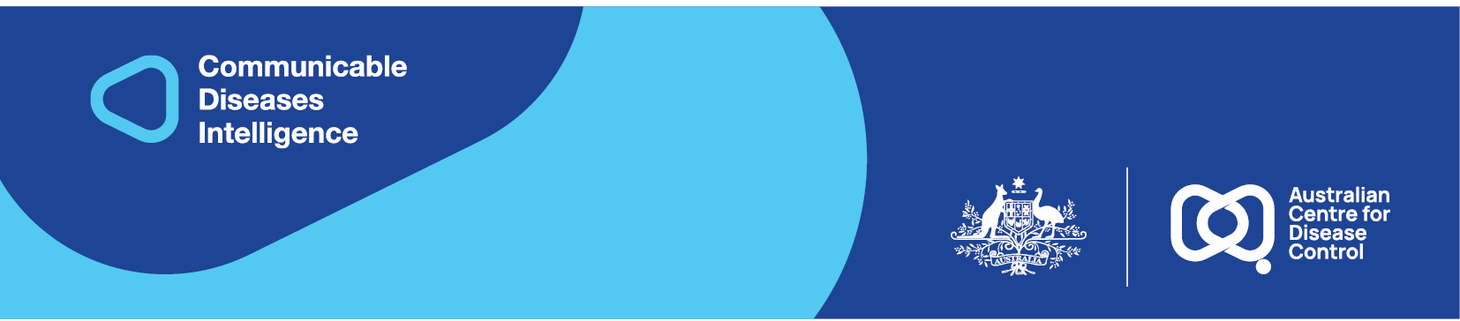
2026 • Volume 50 • cdc.gov.au/cdi • Epub date: 26.05.2026 • doi.org/10.33321/cdi.2026.50.031

Infant respiratory syncytial virus (RSV) immunisation coverage in an Australian regional area, 1 May 2024 – 31 October 2025
William H Roughan, Brett Cavanagh-Ochiai, Donna Barnekow, Kaylene Lottkowitz, Keppel Schafer, Laxmi Camadoo, Nicolas R Smoll

Abstract
The recent introduction in Australia of respiratory syncytial virus (RSV) immunisations — nirsevimab (neonatal) and Abrysvo (antenatal) — offers potential to reduce the RSV burden in infants. A retrospective cohort study included all infants born at Sunshine Coast University Hospital between 1 May 2024 and 31 October 2025. Of 5,116 infants, 71.7% (3,669/5,116) received valid RSV immunisation: 45.2% through nirsevimab only and 26.4% through antenatal Abrysvo only. During May–December 2024, RSV coverage was achieved exclusively through neonatal nirsevimab. Following Abrysvo's introduction in January 2025, a progressive shift in immunisation composition occurred: among RSV-vaccinated infants, the proportion protected through nirsevimab alone fell from 100% in December 2024 to 13.5% by October 2025, while those protected by Abrysvo alone rose correspondingly from 0% to > 85.0%. Overall RSV coverage remained stable throughout the study period (66.2–77.9%) and throughout the transition period January–October 2025 (66.2–74.9%). Coverage was comparable to Australian and United States estimates but lagged European benchmarks. Abrysvo's introduction maintained rather than improved population-level protection. These findings highlight the need to investigate barriers to RSV immunisation uptake to optimise infant protection.
Keywords: immunisation; vaccination; immunisation coverage; respiratory syncytial virus; RSV; paediatrics; public health

Background
Respiratory syncytial virus (RSV) is a leading cause of morbidity and mortality among children globally.¹ Infants up to 6 months of age are at particularly high risk of developing severe disease requiring hospitalisation, intensive care unit admission or respiratory support.¹ Two primary RSV prevention strategies have recently been introduced and approved by the Therapeutic Goods Administration to address this burden: maternal vaccination with Abrysvo (Pfizer) and infant immunisation with nirsevimab.²
Abrysvo is a single maternal dose RSV vaccine that can protect infants against severe RSV disease for up to 6 months via maternal-neonatal passive antibody transfer.^{3,4} It is recommended for administration between 28 and 36 weeks of pregnancy.³ The efficacy of Abrysvo in preventing medically attended severe RSV-associated lower respiratory tract illness was over 80% in the first 90 days after birth.⁴
Nirsevimab is the first long-acting monoclonal antibody for RSV approved in Australia.⁵ It is administered as a single dose and is recommended in Queensland for all neonates not protected by Abrysvo.³ The efficacy of nirsevimab in preventing medically attended RSV-associated lower respiratory tract illness in the 150 days after the injection was 74.5%.⁶ Both Abrysvo and nirsevimab demonstrate favourable safety profiles in clinical trials and real-world use.^{4,7–9}
Nirsevimab was first approved in Australia in November 2023 and Queensland was one of the two Australian states to roll out year-round immunisations from 15 April 2024. Early uptake data suggest challenges with implementation. Western Australian data found that only 71% of eligible infants (21,922/30,920) received nirsevimab before or during the 2024 RSV season.¹⁰ This immunisation uptake still reduced infant RSV hospital admission rates by 57%, with estimated savings of $AUD6.2–6.9 million.¹⁰ Following the recent introduction in Queensland of the maternal Abrysvo vaccine in December 2024, and introduction on the National Immunisation Program from 3 February 2025, contemporaneous RSV immunisation coverage data in Australia is lacking. The introduction of Abrysvo has made such estimates more complex, as neonates must be linked with the vaccination status of their mother.
Vaccine coverage rates in the Sunshine Coast region (Queensland, Australia) are amongst the lowest in Queensland.^{11,12} For example, a 2024 report found that only 74.6% of two-year-olds in the Noosa Hinterland had received their first dose of the measles-mumps-rubella vaccine, compared to the national average of 94%.¹² The reasons for lower vaccination rates are only starting to become understood. A study on the Sunshine Coast population found that distrust in governments, conspiratorial thinking, magical beliefs about health and psychological reactance are important drivers of anti-vaccination beliefs.¹¹ However, that study was not focused on understanding the barriers and enablers to vaccination specific to people in the peripartum period. As such, estimating immunisation coverage of the recently introduced RSV immunisations in our population is an important first step to identifying potential areas for improvement.

Methods
Sunshine Coast University Hospital (SCUH) is a 745 bed tertiary level teaching hospital that services the Sunshine Coast and Gympie regions in Queensland, Australia and provides the majority of maternity and neonatal services for the region. A retrospective cohort study was conducted to assess RSV immunisation coverage among all infants born at SCUH from 1 May 2024 to 31 October 2025 (18 months).
Abrysvo immunisation was considered valid if administered between 28 and 36 weeks of gestation and at least 14 days prior to delivery. Nirsevimab immunisation was considered valid if administered prior to hospital discharge following birth.
A comprehensive linked data system was established to integrate neonatal birthing and immunisation records with maternal vaccination history. Birth records were gathered from the SCUH birth register and the Health-Based Corporate Information System (HBCIS) to link maternal-neonatal dyads. To gather nirsevimab administration data, infant Unit Record Numbers (URNs) were linked to integrated electronic Medical Record (ieMR) vaccination records through the Discern Reporting Portal. Unmatched records underwent manual resolution through birth register correction.
Data quality issues were systematically resolved. The SCUH birth register, maintained through manual entry in a busy clinical environment and not directly integrated with hospital patient record systems, contained errors in approximately 10% of records (incorrect patient identifiers or dates of birth), preventing standard matching. These records were resolved using weighted score matching integrating multiple data points across sources, with remaining unmatched records manually resolved against corrected birth register entries. Approximately 16% of mothers had AIR residential addresses outside the Sunshine Coast Hospital and Health Service catchment; Queensland-wide AIR data were matched to the birth register to resolve these cases. AIR vaccine data entry errors for Abrysvo were identified and corrected through a comprehensive weekly error detection program cross-referencing vaccine codes, batch numbers, and immunisation guidelines. Deaths, patients born elsewhere and transferred to SCUH for neonatal care, and babies born at SCUH and transferred to other hospitals for neonatal care were manually excluded from the dataset.
Total RSV immunisation coverage was calculated as the number of infants with valid RSV immunisation (via Abrysvo and/or nirsevimab) divided by the total number of live births during the study period. For reporting purposes, infants were classified into three mutually exclusive categories: nirsevimab only; Abrysvo only; and both, with monthly counts suppressed where n ≤ 5.
The Metro North Ethics Committee (Queensland Health) approved this study (EX/2026/MNH/128449).

Results
Our cohort comprised 5,116 infants born at SCUH during the study period (1 May 2024 to 31 October 2025). Overall, 3,669/5,116 infants (71.7%) were immunised against RSV. Of these, 2,311 infants (45.2% of all births) received nirsevimab only; 1,349 (26.4%) were covered by valid antenatal Abrysvo only; and nine infants received both forms of RSV protection (0.2%, will not be reported due to cell suppression rules).
RSV immunisation coverage remained relatively stable throughout the study period, ranging from 66.2% to 77.9%, with the highest coverage recorded in November 2024 (77.9%) and the lowest in October 2025 (66.2%). However, the composition of RSV immunisation underwent a marked programmatic transition (Figure 1).
During the first eight months of the study (May 2024 to December 2024), RSV coverage was achieved exclusively through neonatal nirsevimab administration, with no Abrysvo administration recorded. Following the introduction of antenatal Abrysvo in January 2025, the composition of RSV immunisation shifted progressively and markedly. Among RSV-vaccinated infants, the proportion protected through nirsevimab alone fell from 100% in December 2024 to 13.5% by October 2025, while the proportion protected through Abrysvo alone rose correspondingly from 0% to > 85.0% over the same period. Despite this fundamental shift in the predominant immunisation pathway, overall RSV coverage remained stable throughout January–October 2025 (range 66.2–74.9%), indicating that the programmatic transition did not disrupt population-level protection.
Figure 1: Neonatal RSV immunisation coverage with nirsevimab or Abrysvo as a percentage of total births at Sunshine Coast University Hospital, Queensland, Australia, stratified by month, May 2024 – October 2025
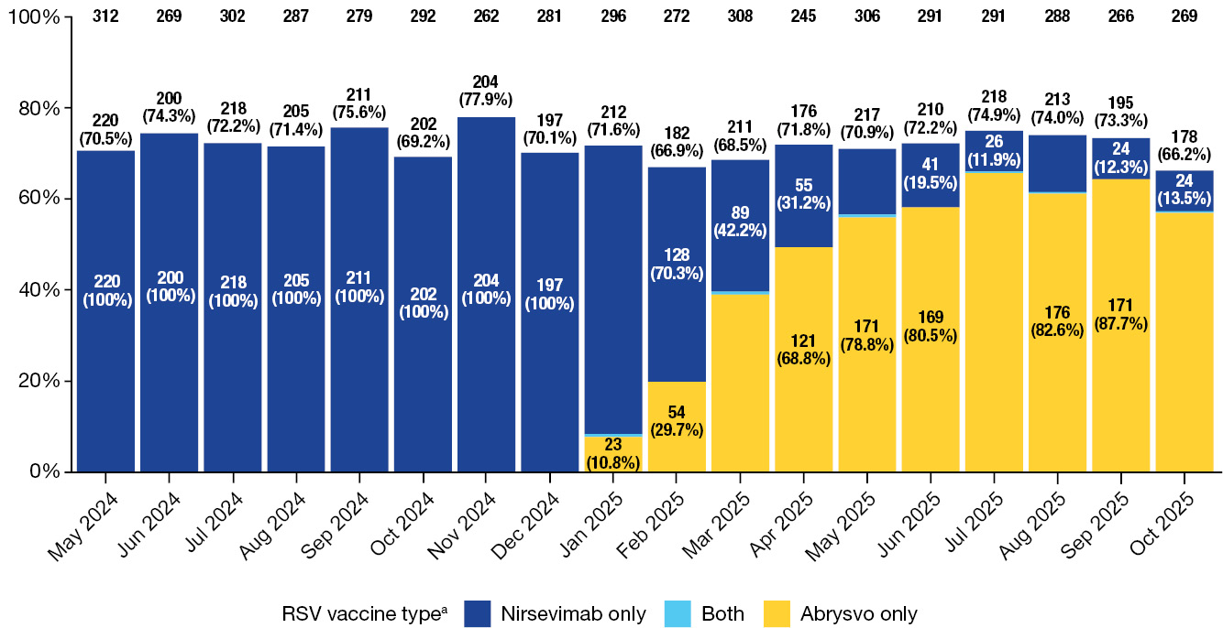
a Bars show individual vaccine coverage; total RSV coverage = nirsevimab and/or Abrysvo. Numbers in bars show nirsevimab or Abrysvo count and percentage contribution to coverage; numbers above bars show total RSV coverage. The nirsevimab or Abrysvo count is not shown for some months in January–October 2025, to prevent back-calculation of low counts
(1–5 cases in month) covered by both immunisation methods. Monthly birth totals are provided along the top of the chart.

Discussion
This study investigated RSV immunisation coverage rates amongst 5,116 infants born at Sunshine Coast University Hospital in Queensland, Australia from 1 May 2024 to 31 October 2025. Overall, we found that 71.7% of all neonates (3,669/5,116) were immunised against RSV through either nirsevimab or antenatal Abrysvo. During the first eight months of the study period, RSV immunisation was achieved exclusively through neonatal nirsevimab administration, with no Abrysvo administration recorded. Following the introduction of Abrysvo in January 2025, there was a progressive shift in the composition of RSV immunisation toward antenatal maternal vaccination. Among RSV-vaccinated infants, the proportion protected through nirsevimab alone fell from 100% in December 2024 to 13.5% by October 2025, while the proportion protected through Abrysvo alone rose from 0% to > 85.0% over the same period. Despite this substantial transition in immunisation strategy, overall RSV coverage remained stable throughout the study period (range 66.2–77.9%), indicating that the introduction of maternal vaccination maintained rather than improved population-level protection.
Our RSV immunisation coverage rate (71.7%) is essentially identical to previous estimates from Western Australia (71%) and the United States (72%).^{10,13} European estimates appear significantly higher, with estimates from France, Luxembourg and Spain in a range of 80–90%.^{14–16} By improving immunisation rates, we may reduce RSV related morbidity and mortality. For example, an Australian study with a 71% RSV immunisation uptake rate found a 57% reduction in RSV-related hospitalisations,¹⁰ while a Spanish study with a 90% immunisation uptake rate achieved an 86.9% reduction in RSV-related hospitalisations.¹⁷ Further research into the factors contributing to the differences in immunisation coverage between countries and regions is required to guide public health-based immunisation uptake strategies. Considering that RSV immunisations can be independently administered in Australia by many different health practitioners, including nurses, midwives, obstetricians, paediatricians, general practitioners and pharmacists, future research should incorporate this multidisciplinary team.
A strength of our study was that we linked data between mothers and newborns from multiple vaccination data sources. RSV immunisation is unique, as infants who are protected by maternal RSV vaccination with Abrysvo do not routinely require nirsevimab, making our novel maternal-neonatal data linkage approach crucial for accurate immunisation coverage estimation. However, considering that our data was compiled from a single site, external validity is likely to be limited to other similar populations.

Conclusion
In conclusion, 71.7% of infants (3,669/5,116) were defined as immunised against RSV. Our immunisation coverage rate is comparable to other Australian and United States studies but remains behind European estimates. We are now working to identify the knowledge, attitudes and practices of local service providers and conducting qualitative interviews with our population to better understand immunisation barriers and enablers, with the goal of improving immunisation coverage.

Acknowledgments
NRS has received research grants from Pfizer and Moderna and is a Moderna Global Research Fellow. NRS has not accepted travel or speaker fees from Pfizer or Moderna.

Author details
Dr William H Roughan,¹
Mr Brett Cavanagh-Ochiai,²
Ms Donna Barnekow,²
Ms Kaylene Lottkowitz,²
Mr Keppel Schafer,³
Dr Laxmi Camadoo,¹
Professor Nicolas R Smoll^{2,4}
- Department of Paediatrics, Sunshine Coast University Hospital, Queensland, Australia
- Sunshine Coast Public Health Unit, Sunshine Coast Health Service, Queensland, Australia
- Nursing Service Director Women and Children Service, Sunshine Coast University Hospital, Queensland, Australia
- Griffith University, Biostatistics Unit, Queensland, Australia

Corresponding author
Professor Nicolas Smoll
Public Health Physician, Staff Specialist
Maroochydore Community Health Hub (Maroochy Hub) Dalton Drive Building 1 Level 1, 4558, QLD, Australia
Email: Nicolas.Smoll@health.qld.gov.au

References
- Self A, Van Buskirk J, Clark J, Cochrane JE, Knibbs L, Cass-Verco J et al. Respiratory syncytial virus disease morbidity in Australian infants aged 0 to 6 months: a systematic review with narrative synthesis. BMC Public Health. 2021;23(1):2560. doi: https://doi.org/10.1186/s12889-023-17474-x.
- Australian Government Department of Health, Disability and Ageing. The Australian Immunisation Handbook: respiratory syncytial virus (RSV). [Webpage.] Canberra: Australian Government Department of Health, Disability and Ageing; 2024. Available from: https://immunisationhandbook.health.gov.au/contents/vaccine-preventable-diseases/respiratory-syncytial-virus-rsv.
- Queensland State Government Department of Health (Queensland Health). Queensland Paediatric Respiratory Syncytial Virus Prevention Program. [Webpage.] Brisbane: Queensland Health; 8 August 2025. Available from: https://www.health.qld.gov.au/clinical-practice/guidelines-procedures/diseases-infection/immunisation/schedule/paediatric-rsv-prevention-program.
- Kampmann B, Madhi SA, Munjal I, Simões EAF, Pahud BA, Llapur C et al. Bivalent prefusion F vaccine in pregnancy to prevent RSV illness in infants. N Engl J Med. 2023;388(16):1451–64. doi: https://doi.org/10.1056/NEJMoa2216480.
- Australian Government Department of Health, Disability and Ageing, Therapeutic Goods Administration (TGA). Beyfortus. [Webpage.] Canberra: Australian Government Department of Health and Aged Care, TGA; 8 December 2023. Available from: https://www.tga.gov.au/resources/auspmd/beyfortus.
- Hammitt LL, Dagan R, Yuan Y, Baca Cots M, Bosheva M, Madhi SA et al. Nirsevimab for prevention of RSV in healthy late-preterm and term infants. N Engl J Med. 2022;386(9):837–46. doi: https://doi.org/10.1056/NEJMoa2110275.
- Mankad VS, Leach A, Chang Y, Wählby Hamrén U, Kiazand A, Kubiak RJ et al. Comprehensive summary of safety data on nirsevimab in infants and children from all pivotal randomized clinical trials. Pathogens. 2024;13(6):503. doi: https://doi.org/10.3390/pathogens13060503.
- Carcione D, Spencer P, Pettigrew G, Leeb A, Drake-Brockman C, Ford T et al. Active post-marketing safety surveillance of nirsevimab administered to children in Western Australia, April–July 2024. Pediatr Infect Dis J. 2025;44(5):e174–6. doi: https://doi.org/10.1097/INF.0000000000004715.
- Xie Y, Cong X, Li Y, Huang L. Real-world data and clinical management experience in passive immunization for respiratory syncytial virus prevention in children. Vaccine: X. 2025;27:100731. doi: https://doi.org/10.1016/j.jvacx.2025.100731.
- Bloomfield LE, Pingault NV, Foong RE, French S, Morgan J, Wadia U et al. Nirsevimab immunisation of infants and respiratory syncytial virus (RSV)-associated hospitalisations, Western Australia, 2024: a population-based analysis. Med J Aust. 2025;222(11):568–70. doi: https://doi.org/10.5694/mja2.52655.
- Wright D, Rune KT. Underlying motivators for anti-vaccination attitudes amongst regional Sunshine Coast parents in Australia. Health Promot J Austr. 2023;34(2):579–86. doi: https://doi.org/10.1002/hpja.612.
- Hull B, Hendry A, Macartney K, Beard F. Annual Immunisation Coverage Report 2024. Sydney: Sydney Children’s Hospitals Network, National Centre for Immunisation Research and Surveillance; October 2025. Available from: https://ncirs.org.au/sites/default/files/2025-10/Annual%20Immunisation%20Coverage%20Report%202024.pdf.
- Irving SA, Crane B, Weintraub ES, Patel SA, Razzaghi H, Daley M et al. Infant respiratory syncytial virus immunization coverage in the Vaccine Safety Datalink: 2023–2024. Pediatrics. 2025;155(6):e2024070240. doi: https://doi.org/10.1542/peds.2024-070240.
- Chauvel C, Horvat C, Javouhey E, Gillet Y, Hassenboehler J, Chakra CNA et al. Changes in respiratory syncytial virus-associated hospitalisations epidemiology after nirsevimab introduction in Lyon, France. Influenza Other Respir Viruses. 2024;18(12):e70054. doi: https://doi.org/10.1111/irv.70054.
- Ernst C, Bejko D, Gaasch L, Hannelas E, Kahn I, Pierron C et al. Impact of nirsevimab prophylaxis on paediatric respiratory syncytial virus (RSV)-related hospitalisations during the initial 2023/24 season in Luxembourg. Euro Surveill. 2024;29(4):2400033. doi: https://doi.org/10.2807/1560-7917.ES.2024.29.4.2400033.
- Pastor-Barriuso R, Núñez O, Monge S. Infants needed to immunise with nirsevimab to prevent one RSV hospitalisation, Spain, 2023/24 season. Euro Surveill. 2025;30(6):2500040. doi: https://doi.org/10.2807/1560-7917.ES.2025.30.6.2500040.
- Jesús Pérez Martín J, de la Cruz Gómez Moreno M, Sánchez Manresa S, Del Pilar Ros Abellán M, Zornoza-Moreno M. Respiratory syncytial virus immunization with nirsevimab: acceptance and satisfaction assessment in infants and risk groups in the region of Murcia (Spain). Hum Vaccin Immunother. 2025;21(1):2471700. doi: https://doi.org/10.1080/21645515.2025.2471700.
© 2026 Commonwealth of Australia as represented by the Australian Centre for Disease Control
ISSN: 2209-6051 Online
This journal is indexed by Index Medicus and Medline.
Creative Commons Licence
This publication is licensed under a Creative Commons Attribution-NonCommercial-NoDerivatives 4.0 International Licence (Licence). You must read and understand the Licence before using any material from this publication.
Restrictions
The Licence does not cover, and there is no permission given for, use of any of the following material found in this publication (if any):
- the Commonwealth Coat of Arms (by way of information, the terms under which the Coat of Arms may be used can be found on the Department of Prime Minister and Cabinet website);
- any logos (including the Australian Centre for Disease Control’s logo) and trademarks;
- any photographs and images;
- any signatures; and
- any material belonging to third parties.
Disclaimer
Opinions expressed in Communicable Diseases Intelligence are those of the authors and not necessarily those of the Australian Government or the Australian Centre for Disease Control. Data may be subject to revision.
Enquiries
Enquiries regarding any other use of this publication should be addressed to the CDI Editor.
About CDI
Communicable Diseases Intelligence (CDI) is a peer-reviewed scientific journal published by the Australian Centre for Disease Control.
The journal aims to disseminate information on the epidemiology, surveillance, prevention and control of communicable diseases of relevance to Australia and the near region.
Editor: Dr Elise Firman • Deputy Editor: Simon Petrie • Design and Production: Lisa Thompson
Editorial Advisory Board: David Durrheim, Mark Ferson, Clare Huppatz, John Kaldor, Martyn Kirk and Meru Sheel
Submit an Article
Guidelines for authors and details on how to submit your publication is available on our website, or by email to the
CDI Editor.
Contact us
Communicable Diseases Intelligence (CDI)
Australian Centre for Disease Control
GPO Box 798, CANBERRA ACT 2601
Website: cdc.gov.au/cdi
Email: cdi.editor@cdc.gov.au

