
2026 • Volume 50 • cdc.gov.au/cdi • Epub date: 28.04.2026 • doi.org/10.33321/cdi.2026.50.010

Effectiveness of COVID-19 vaccine booster doses in adults aged 50 years and over during the Omicron period in Victoria, Australia
Joshua Szanyi, Yue Yang, Jiaxu Zeng, Chris Clarke, Amanda K Buttery, Tony Blakely
© 2026 Commonwealth of Australia as represented by the Australian Centre for Disease Control
ISSN: 2209-6051 Online
This journal is indexed by Index Medicus and Medline.
Creative Commons Licence
This publication is licensed under a Creative Commons Attribution-NonCommercial-NoDerivatives 4.0 International Licence (Licence). You must read and understand the Licence before using any material from this publication.
Restrictions
The Licence does not cover, and there is no permission given for, use of any of the following material found in this publication (if any):
- the Commonwealth Coat of Arms (by way of information, the terms under which the Coat of Arms may be used can be found on the Department of Prime Minister and Cabinet website);
- any logos (including the Australian Centre for Disease Control’s logo) and trademarks;
- any photographs and images;
- any signatures; and
- any material belonging to third parties.
Disclaimer
Opinions expressed in Communicable Diseases Intelligence are those of the authors and not necessarily those of the Australian Government or the Australian Centre for Disease Control. Data may be subject to revision.
Enquiries
Enquiries regarding any other use of this publication should be addressed to the CDI Editor.
About CDI
Communicable Diseases Intelligence (CDI) is a peer-reviewed scientific journal published by the Australian Centre for Disease Control.
The journal aims to disseminate information on the epidemiology, surveillance, prevention and control of communicable diseases of relevance to Australia and the near region.
Editor: Dr Elise Firman • Deputy Editor: Simon Petrie • Design and Production: Lisa Thompson
Editorial Advisory Board: David Durrheim, Mark Ferson, Clare Huppatz, John Kaldor, Martyn Kirk and Meru Sheel
Submit an Article
Guidelines for authors and details on how to submit your publication is available on our website, or by email to the
CDI Editor.
Contact us
Communicable Diseases Intelligence (CDI)
Australian Centre for Disease Control
GPO Box 798, CANBERRA ACT 2601
Website: cdc.gov.au/cdi
Email: cdi.editor@cdc.gov.au

Contents
Abstract 4
Background 4
Methods 4
Results 4
Conclusions 4
Introduction 5
Methods 6
Study setting 6
Study design and data sources 6
Statistical analyses 7
Sensitivity analyses 8
Ethics approval 8
Results 9
Discussion 17
Acknowledgments 19
Author contributorship 19
Data sharing statement 19
Role of the funding source 19
Author details 20
References 21
Appendix A: Supplementary material 24
Data sources 24

Abstract

Background
Country-specific estimates of coronavirus disease 2019 (COVID-19) vaccine effectiveness (VE) are important for policy making, but analyses of COVID-19 VE in Australia have been limited to date.

Methods
We used a modified Cox regression model to estimate, through the linkage of national and state-wide health and administrative datasets, the adjusted relative VE of three vs. two and four vs. three COVID-19 vaccine doses against hospitalisation and death due to COVID-19 among Victorians aged ≥ 50 years after the emergence of the Omicron SARS-CoV-2 variant. Analyses were conducted in two periods: 1 December 2021 to 19 June 2022 (Omicron BA.1/2 period; analyses of three vs. two doses); and 20 June 2022 to 7 November 2022 (Omicron BA.4/5 period; analyses of four vs. three doses).

Results
Approximately 1.8 million people were included in analyses of three vs. two doses and approximately 1.2 million people were included in analyses of four vs. three doses. Adjusted relative VE against death 28 days after boosting with a third dose (compared to two doses) in individuals aged ≥ 65 years in the Omicron BA.1/2-dominant period reached 81.2% (95% confidence interval [95% CI]: 76.9–84.6%). There was also evidence for a relative benefit of a third dose in the Omicron BA.1/2 period against hospitalisation (adjusted relative VE 63.6% [95% CI: 60.1–66.8%] 28 days post-boosting) and for a fourth dose in the Omicron BA.4/5 period against hospitalisation and death in this age group. In contrast, estimates of relative VE in the 50–64 year age group were highly imprecise (for example, 52.4% [95% CI: -16.6–80.6%] against death 28 days after receipt of a third dose in the Omicron BA.1/2-dominant period).

Conclusions
These results confirm the benefits of vaccine boosters in the Omicron era for those aged ≥ 65 years, with the most notable gains evident from a third dose in late 2021 to mid-2022.
Keywords: SARS-CoV-2; Omicron; relative vaccine effectiveness; Australia; mRNA vaccines; comirnaty; spikevax; hospitalisation; death; pandemic; Cox regression; boosters; waning

Introduction
To inform evidence-based vaccine policy decisions moving forward, policy makers require access to accurate and locally contextualised data regarding coronavirus disease 2019 (COVID-19) vaccine effectiveness (VE). However, there is a paucity of Australian COVID-19 VE estimates, and Australian studies published to date mainly focus on narrow population groups (e.g., people aged 65 years and over) or broad clinical outcomes (e.g., composite outcomes of hospitalisation and death).^{1–4} Accordingly, Australian COVID-19 vaccination policy largely draws on international studies that may not fully reflect the local setting.
There is a need to develop local capability to estimate VE in Australia, a gap in Australia’s current pandemic preparedness and response capacity.⁵ Addressing this gap could be leveraged to evaluate VE for other respiratory pathogens, such as influenza and respiratory syncytial virus, and to build analytical infrastructure that could be deployed more rapidly in a future pandemic.⁶ Australia was also one of the few countries where the majority of the population was SARS-CoV-2 infection-naïve prior to the Omicron SARS-CoV-2 variant,¹ providing an opportunity for novel insights into COVID-19 VE.
The aims of the current study were therefore to estimate the relative VE and waning of three vs. two and four vs. three doses of COVID-19 vaccine against hospitalisation and death among Victorians aged 50 years and older after the emergence of Omicron, through the novel linkage of national and state-wide health and administrative datasets.

Methods

Study setting
This study was conducted in Victoria, Australia, with a population of 6.96 million people.⁷ Following the lifting of most travel restrictions and other public health measures, and the emergence of the Omicron SARS-CoV-2 variant in late 2021, there was extensive SARS-CoV-2 transmission in Victoria such that serological evidence of prior infection rose to 70% of individuals by late 2022.⁸
At the beginning of the study period (1 December 2021), the SARS-CoV-2 Delta variant was detected in almost all sequenced samples in Australia. In early January 2022, the Omicron BA.1 variant became dominant, followed by BA.2 in March 2022. The BA.4 and BA.5 variants became dominant in June 2022, with the BA.5 variant detected in most sequenced samples in Australia until November 2022.⁹ Therefore, two distinct study periods were defined for this study: 1 December 2021 – 19 June 2022 (Omicron BA.1/2 dominant period), to investigate relative VE of three vs. two doses; and 20 June – 7 November 2022 (Omicron BA.4/5 dominant period), to investigate relative VE of four vs. three doses.

Study design and data sources
This analysis drew on national and Victorian data sources (as described in Appendix A: Supplementary methods). Briefly, these included: COVID-19 vaccination data from the Australian Immunisation Register (AIR); hospital admission data, emergency department data, and mortality data from Victorian datasets; and COVID-19 testing and other surveillance data from a Victorian population-based surveillance system capturing COVID-19 data reported by medical practitioners and pathology services. The Victorian Linkage Map was used to define Victorian residence during the study period. Data linkage was performed by the Centre for Victorian Data Linkage at the Victorian Department of Health.
A cohort of individuals aged ≥ 50 years (on 1 December 2021) was developed by including those with a record of at least two doses of a COVID-19 vaccination by the end of the study period (7 November 2022) and at least one of:
- any activity recorded within the Victorian Linkage Map during the three years before 1 December 2021; or
- a record for a non-COVID-19 vaccine during the same three-year period where all recorded places of residence for these vaccination encounters were within Victoria.
Individuals for whom less than 28 days had elapsed between doses two and three, or doses three and four, were excluded due to potential data entry or linkage errors.
Exposure was defined as the receipt of a monovalent COVID-19 vaccination booster. Those who had received three doses were compared to those who had received two doses; those who had received four doses were compared to those who had received three doses. The two clinical outcomes investigated were: hospitalisation due to COVID-19 (hospital admission with COVID-19 as a principal or other diagnosis, as indicated by International Classification of Diseases Tenth Revision codes U07.1, U07.2, U07.11, or U07.12);¹⁰ and death due to COVID-19, using the Victorian Department of Health’s surveillance definition of a reportable COVID-19 death (see Appendix A: Supplementary methods).

Statistical analyses
A modified Cox regression model,^{11–13} allowing for crossover of participants from the control to the exposed group (for example, from dose two to three), was used to determine the relative VE associated with receipt of a COVID-19 vaccine booster dose. This method has been used previously to investigate the durability of vaccine protection against Omicron subvariants.¹⁴ Analyses were performed separately for two age groups (≥ 65 years and 50 to 64 years). For the primary analyses, VE was defined as one minus the hazard ratio, which gives the percentage reduction in the instantaneous risk of disease at day t for those who received a booster t days ago compared with those who had not received a booster dose.
VE estimates and corresponding 95% confidence intervals (95% CIs) were modelled as piecewise linear functions of time since each vaccination, with change points placed at 14 and 28 days since boosting. This meant that the log hazard ratio could vary before and after the change points, allowing the vaccine effect to increase in the weeks following vaccination, reach a peak, and then wane. Separate analyses were conducted in the two time periods, 1 December 2021 – 19 June 2022 (Omicron BA.1/2 period; 200 days), and 20 June – 7 November 2022 (Omicron BA.4/5 period; 140 days), with observational calendar time starting on the first day of the study period and vaccinated time representing the time (in days) since the receipt of a given vaccination dose (dose three or four). Individuals receiving booster doses outside of the two specified time periods were not included in the analysis.
We adjusted for the following covariates: age in years (as a numeric variable); gender; socio-economic status (index of relative socio-economic disadvantage quintile,¹⁵ as a categorical variable); Aboriginal and/or Torres Strait Islander identity; whether the individual’s primary vaccination course was with an mRNA or non-mRNA vaccine (for comparisons of dose two vs. three only; primary vaccine courses including one dose of an mRNA vaccine and one dose of a non-mRNA vaccine were classified as mRNA primary vaccine courses); and Charlson comorbidity index as recorded in hospital admissions data from January 2007 onwards (dichotomised as 0 or ≥ 1, with individuals without a recorded Charlson comorbidity index assigned a value of 0). These covariates were selected a priori.
For analyses in the Omicron BA.1/2 period, individuals entered the study on 1 December 2021 if already vaccinated with two doses, or upon receipt of their second dose if received during this period. For analyses in the Omicron BA.4/5 period, individuals entered the study on 20 June 2022 if already vaccinated with three doses, or upon receipt of their third dose if received during this period. When an individual received a third vaccine dose (for analyses in the Omicron BA.1/2 period), or a fourth vaccine dose (for analyses in the Omicron BA.4/5 period), they were no longer included in the control group and instead began contributing to the exposure group. Individuals were censored at death due to any cause; at receipt of a subsequent booster dose (for example, receipt of a fourth vaccine dose in the analysis of three vs. two vaccine doses); at receipt of a bivalent COVID-19 booster dose; or at the study period end date, whichever came first. For the hospitalisation outcome, death is a competing risk event. Accordingly, in analyses of VE against hospitalisation we report the number of participants censored due to death from any cause.
All regression analyses were performed in R (version 4.3.0) using the dove2 command in the Durability of Vaccine Efficacy (DOVE) package.^{12,13,16}

Sensitivity analyses
As a sensitivity analysis, VE was alternatively defined as one minus the attack rate, which gives the percentage reduction in the cumulative incidence of disease over t days for those who received the third or fourth vaccination t days ago compared with those who remain double or triple vaccinated respectively.¹³ We also stratified by the brand of booster (Comirnaty or Spikevax) for ≥ 65 year olds, and used additional change points at four-weekly intervals to test our assumption that VE monotonically decreases with a constant slope on the logarithmic scale after 28 days. Finally, we performed a sensitivity analysis among ≥ 65-year-olds for doses four vs. three where, for the Omicron BA.4/5 period, the hospitalisation outcome was changed such that it only included admissions where COVID-19 ICD-10 codes were recorded as the principal diagnosis.

Ethics approval
Ethics approval for the study was granted by the University of Melbourne Human Research Ethics Committee (2023-24212-40704-5).

Results
The cohort meeting the study inclusion criteria on 1 December 2021 comprised 1,895,148 individuals (Figure 1).
Of these eligible individuals, 1,823,846 were included in the analysis of three vs. two vaccine doses, and 1,174,949 in the analysis of four vs. three vaccine doses. The characteristics of the participants are summarised in Table 1.
In analyses of four vs. three vaccine doses, there was a predominance of individuals aged 50 to 64 years, and a greater proportion of people had received their last vaccine dose more recently (less than 90 days ago) compared to analyses of three vs. two vaccine doses. For all other characteristics the individuals contributing to the analyses in the two periods were similar. For participants included in analyses of three vs. two vaccine doses in the Omicron BA.1/2 period, 24.8% had received a primary vaccine course containing at least one mRNA vaccine (75.0% of participants received a primary course with two doses of Vaxzevria; 24.6% of participants received a primary course with two mRNA vaccines; and 0.2% of participants received a primary course of one dose of Vaxzevria plus one dose of an mRNA vaccine).
During the study period, there were a total of 27,761 COVID-19 hospitalisations (21,025 among those aged ≥ 65 years and 6,736 among those 50–64 years of age), and 3,544 COVID-19 deaths (3,344 and 200, respectively); 17,866 hospitalisations (64.4%) and 1,950 deaths (55.0%) occurred between 1 December 2021 and 19 June 2022 (Figure 2). For analyses of three vs. two vaccine doses against hospitalisation, 1,606 people aged 50–64 years and 13,561 people aged ≥ 65 years were censored due to death from any cause. For analyses of four vs. three vaccine doses against hospitalisation, 814 people aged 50–64 years and 5,968 people aged ≥ 65 years were censored due to death from any cause.
Vaccination uptake over the study period is also shown in Figure 2. Most people in the 50–64 year age group received their third dose during the first analytical period (1 December 2021 to 19 June 2022) and their fourth dose in the second period (20 June 2022 to 7 November 2022). However, for the ≥ 65-year age group, many individuals (approximately 450,000) had already received a fourth vaccine dose before the second analytical period and were therefore not included in analyses. Vaccine uptake by brand is shown in Appendix A, Tables A.2 and A.3.
Figure 1: Study cohort selection diagram, Victoria, Australia
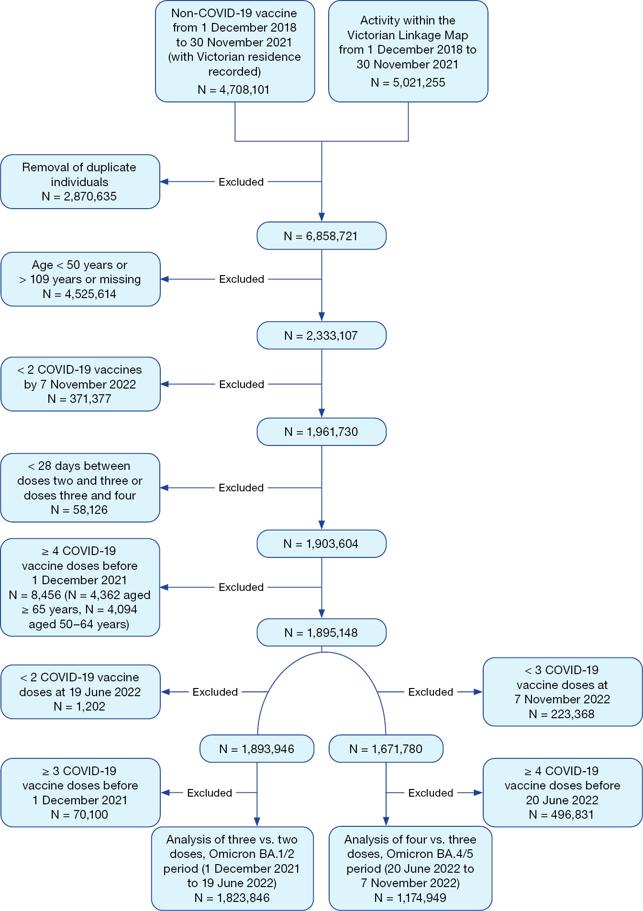
Table 1: Cohort characteristics when entering each follow-up period, Victoria, Australia, 1 December 2021 – 7 November 2022
Category | Characteristic | Omicron BA.1/2 period  (1 December 2021 – 19 June 2022)  N = 1,823,846 |  | Omicron BA.4/5 period  (20 June – 7 November 2022)  N = 1,174,949
Category | Characteristic | Number | Percentage | Number | Percentage
Age group | 50–64 years | 868,067 | 47.6 | 711,975 | 60.6
Age group | ≥ 65 years | 955,779 | 52.4 | 462,974 | 39.4
Gender | Female | 966,312 | 53.0 | 630,661 | 53.7
Gender | Male | 857,439 | 47.0 | 544,226 | 46.3
Gender | Missing | 95 | 0.0 | 62 | 0.0
Aboriginal and/or Torres Strait Islander identity | Not Aboriginal or Torres Strait Islander | 1,798,424 | 98.6 | 1,159,174 | 98.7
Aboriginal and/or Torres Strait Islander identity | Aboriginal and/or Torres Strait Islander | 24,794 | 1.4 | 15,454 | 1.3
Aboriginal and/or Torres Strait Islander identity | Missing | 628 | 0.0 | 321 | 0.0
Index of relative socio-economic disadvantage quintile | 1 | 241,016 | 13.2 | 154,628 | 13.2
Index of relative socio-economic disadvantage quintile | 2 | 292,753 | 16.1 | 187,958 | 16.0
Index of relative socio-economic disadvantage quintile | 3 | 346,435 | 19.0 | 227,085 | 19.3
Index of relative socio-economic disadvantage quintile | 4 | 475,438 | 26.1 | 307,663 | 26.2
Index of relative socio-economic disadvantage quintile | 5 | 460,373 | 25.2 | 292,512 | 24.9
Index of relative socio-economic disadvantage quintile | Missing | 7,831 | 0.4 | 5,103 | 0.4
Charlson comorbidity indexª | 0 | 1,288,814 | 70.7 | 871,544 | 74.2
Charlson comorbidity indexª | ≥ 1 | 535,032 | 29.3 | 303,405 | 25.8
Primary course included at least one mRNA vaccine | Yes | 452,977 | 24.8 | 318,436 | 27.1
Time since baseline dose^{b} | 0–89 days | 3,299 | 0.2 | 97,047 | 8.3
Time since baseline dose^{b} | ≥ 90 days | 1,820,617 | 99.8 | 1,077,902 | 91.7
COVID-19 vaccination status^{c} | 2 doses | 1,820,616 | 99.8 | 0 | 0.0
COVID-19 vaccination status^{c} | 3 doses | 3,230 | 0.2 | 1,168,271 | 99.4
COVID-19 vaccination status^{c} | 4 doses | 0 | 0.0 | 6,678 | 0.6
a From hospital admissions data (2007 onwards), with missing values reclassified as 0 for all analyses (n = 302,180 [16.6%] for analyses in the Omicron BA.1/2 period, n = 213,589 [18.2%] for analyses in the Omicron BA.4/5 period).
b For period one this is the time between dose two and entering the window, for period two this is the time between dose three and entering the window.
c When entering the window.
Figure 2: Hospitalisations and deaths due to COVID-19 and vaccine uptake, Victoria, Australia, 1 December 2021 – 7 November 2022
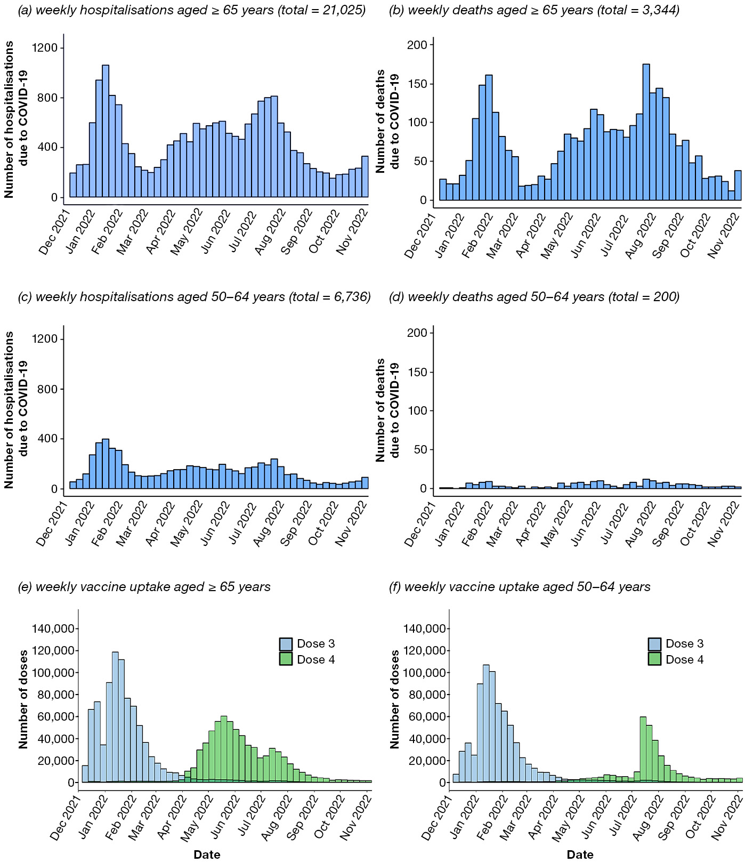
Figure 3: Relative vaccine effectiveness, adjusted for age, gender, socio-economic status, indigeneity, mRNA or non-mRNA primary vaccine course (in analyses of three vs. two doses), and Charlson comorbidity index
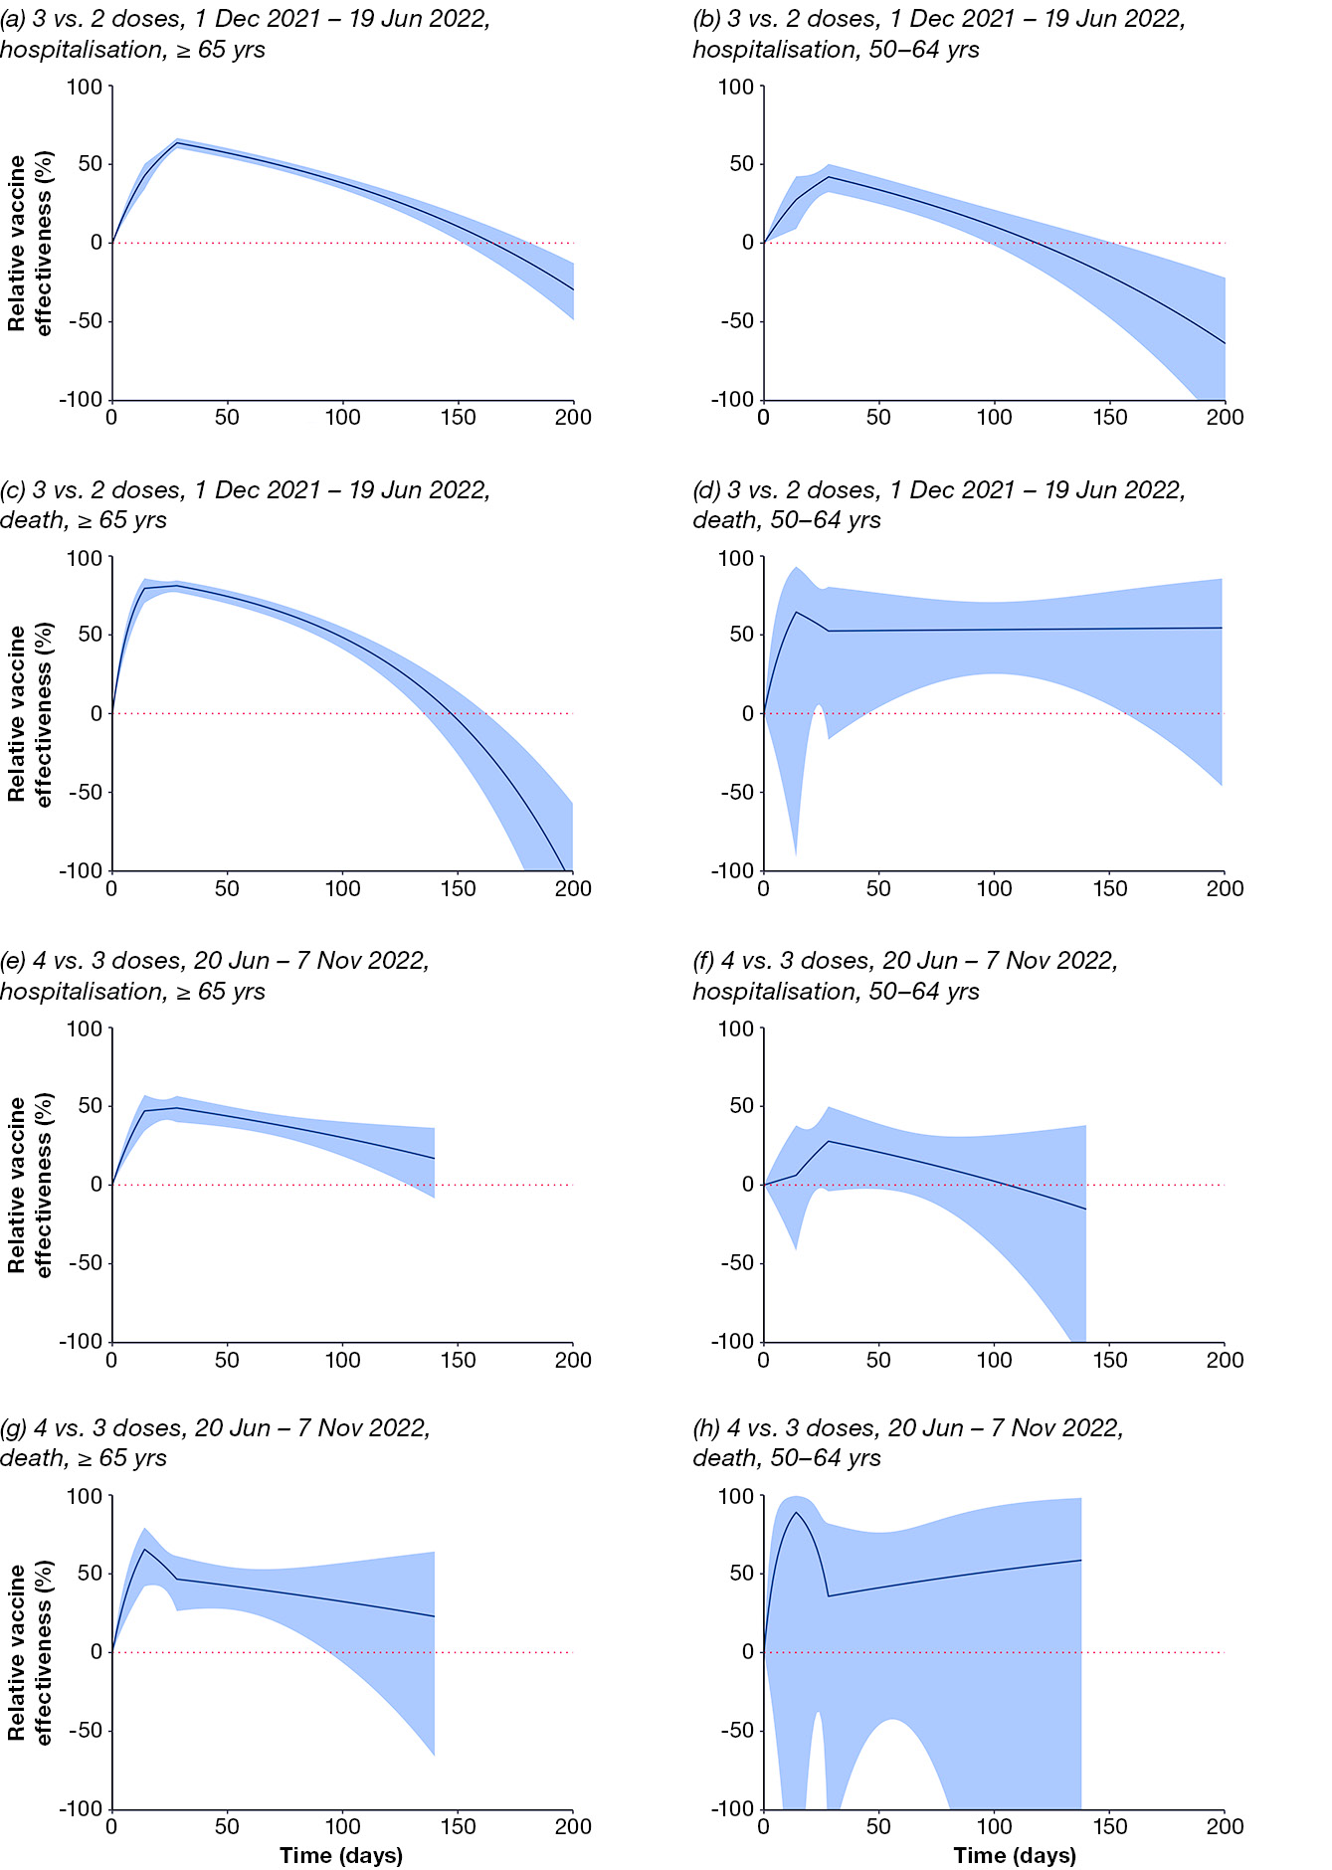
Table 2: Adjusted relative vaccine effectiveness and 95% confidence intervals from 14 to 180 days post-booster, stratified by outcome, analysis period, booster dose, and age,ª Victoria, Australia, 1 December 2021 – 7 November 2022
Days | ≥ 65 years^{b,c} |  |  |  |  |  |  |  | 50–64 years^{b,c}
Days | Hospitalisation |  |  |  | Death |  |  |  | Hospitalisation |  |  |  | Death
Days | 1 December 2021 to 19 June 2022  3 vs. 2 doses |  | 20 June 2022 to 7 November 2022  4 vs. 3 doses |  | 1 December 2021 to 19 June 2022  3 vs. 2 doses |  | 20 June 2022 to 7 November 2022  4 vs. 3 doses |  | 1 December 2021 to 19 June 2022  3 vs. 2 doses |  | 20 June 2022 to 7 November 2022  4 vs. 3 doses |  | 1 December 2021 to 19 June 2022  3 vs. 2 doses |  | 20 June 2022 to 7 November 2022  4 vs. 3 doses
Days | RVE (%) | 95% CI | RVE (%) | 95% CI | RVE (%) | 95% CI | RVE (%) | 95% CI | RVE (%) | 95% CI | RVE (%) | 95% CI | RVE (%) | 95% CI | RVE (%) | 95% CI
14 | 42.9 | 34.2–50.4 | 47.0 | 34.3–57.3 | 79.5 | 70.1–85.9 | 65.5 | 42.0–79.5 | 27.7 | 9–42.5 | 6.2 | -41.9–38 | 64.5 | -91.5–93.4 | 89.0 | -222.9–99.6
28 | 63.6 | 60.1–66.8 | 48.9 | 39.8–56.6 | 81.2 | 76.9–84.6 | 46.6 | 26.3–61.3 | 42.0 | 32.3–50.3 | 27.8 | -4.1–50 | 52.4 | -16.6–80.6 | 35.7 | -130.4–82.1
60 | 53.9 | 50.5–57 | 41.3 | 34.3–47.5 | 70.5 | 65.6–74.7 | 40.7 | 24.8–53.2 | 29.6 | 20.6–37.6 | 17.5 | -4.6–34.9 | 52.8 | 11.2–74.9 | 43.4 | -44.2–77.8
90 | 42.5 | 38.6–46 | 33.1 | 23.3–41.6 | 55.1 | 48.6–60.8 | 34.5 | 4–55.4 | 15.7 | 4.9–25.2 | 6.4 | -26.8–31 | 53.2 | 24.1–71.1 | 49.8 | -149.8–89.9
120 | 28.2 | 22.7–33.3 | 23.8 | 6.0–38.2 | 31.6 | 20.6–41.1 | 27.8 | -32.5–60.6 | -1.1 | -17.6–13.1 | -6.1 | -72–34.6 | 53.5 | 21.7–72.4 | 55.5 | -481.9–96.6
150 | 10.4 | 1.5–18.4 | N/A^{d} | — | -4.1 | -26.1–14.1 | N/A^{d} | — | -21.1 | -47.8–0.8 | N/A^{d} | — | 53.9 | 5.3–77.5 | N/A^{d} | —
180 | -11.9 | -26.2–0.8 | N/A^{d} | — | -58.4 | -103.0– -23.7 | N/A^{d} | — | -45.2 | -87.4– -12.5 | N/A^{d} | — | 54.2 | -22.5–82.9 | N/A^{d} | —
a Models are adjusted for age, gender, socio-economic status, Aboriginal and/or Torres Strait Islander identity, whether the individual’s primary vaccination course was with an mRNA or non-mRNA vaccine (for analyses of dose three vs. two), and Charlson comorbidity index.
b RVE: relative vaccine effectiveness.
c 95% CI: 95% confidence interval.
d N/A: not applicable.
Adjusted estimates of relative VE for three vs. two COVID-19 vaccine doses are shown in Figures 3a to 3d and Table 2. For hospitalisation, relative VE of three vs. two doses was highest 28 days following vaccination among individuals aged ≥ 65 years (63.6%; 95% CI: 60.1–66.8%) and 28 days following vaccination among individuals aged 50–64 years (42.0%; 95% CI: 32.3–50.3%), falling to zero by 165 and 119 days post-vaccination respectively. For death, relative VE was highest 28 days following vaccination among individuals aged ≥ 65 years (81.2%; 95% CI: 76.9–84.6%) and 14 days following vaccination among individuals aged 50–64 years (64.5%; 95%
CI: -91.5–93.4%). The former fell to zero by 148 days post-vaccination. Central estimates for those aged 50–64 years remained above zero for the duration of the analysis period, but fewer deaths occurred in this age group and confidence intervals were wide.
Adjusted estimates of relative VE for four vs. three COVID-19 vaccine doses are shown in Figures 3e to 3h and Table 2. For hospitalisation, relative VE was highest 28 days following vaccination among individuals aged ≥ 65 years (48.9%; 95% CI: 39.8–56.6%) and 28 days following vaccination among individuals aged 50–64 years (27.8%; 95% CI: -4.1–50.0%), although confidence intervals for the latter crossed zero throughout the duration of follow-up. For death, relative VE was highest 14 days following vaccination among individuals aged ≥ 65 years (65.5%; 95% CI: 42.0–79.5%) and 14 days following vaccination among individuals aged 50–64 years (89%; 95% CI: -222.9–99.6%), but again estimates for the latter were uncertain with wide confidence intervals.
Sensitivity analyses using the attack rate (rather than the hazard ratio) produced similar results to the primary analyses (Appendix A, Table A.4). In analyses stratified by the brand of booster, VE tended to be higher for Spikevax than Comirnaty, particularly in analyses of three vs. two doses (Appendix A, Figure A.1 and Tables A.5 to A.7). When changepoints were placed at 4, 8, 12, 16, 20, and 24 weeks, central estimates of relative VE were similar to those in the primary analyses but uncertainty in estimates increased over time since boosting (Appendix A, Figure A.2). Changing the hospitalisation outcome to only include COVID-19-related ICD-10 codes as principal diagnoses had the primary effect of widening the confidence intervals around VE estimates, which overlapped with those from the main analyses (data not shown).

Discussion
We found that the relative VE of COVID-19 vaccine booster doses varied depending on clinical outcome (hospitalisation or death); age; time since booster dose; and analysis period (Omicron BA.1/2-dominant period or Omicron BA.4/5-dominant period). The highest and most precise level of relative VE was observed against COVID-19 related death soon after boosting with a third dose in those aged ≥ 65 years in the Omicron BA.1/2-dominant period (peak relative VE > 80%), at a time when most older adults received the ancestral strain mRNA vaccine booster in Australia. This relative benefit fell over time since vaccination but persisted for approximately five months compared to receipt of only two doses. Similarly, a fourth ancestral strain monovalent booster dose in the Omicron BA.4/5 period conferred a relative VE of approximately 65% against death in this age group soon after administration compared to a third dose. There was also strong evidence for a benefit of a third and fourth dose against hospitalisation among ≥ 65-year-olds in the Omicron BA.1/2 and BA.4/5 periods, which persisted beyond 160 and 140 days respectively.
In contrast, the relative VE of booster doses in the 50–64 year age group were modest and highly imprecise. However, there were very few outcome events (particularly deaths), which may partially explain the imprecision in VE estimates in this age group. It should be noted that these results may underestimate the benefits of booster doses for immunocompromised people and people with chronic medical conditions that place them at higher risk of severe COVID-19 outcomes, who may have received booster doses earlier than the general population and prior to the follow-up time windows used in this study.
A small number of studies have evaluated COVID-19 VE in Australia. Our findings are comparable to a study of 2.1 million infection-naïve people aged ≥ 40 years residing in Sydney, which showed a relative VE for three vs. two doses of 65% (95% CI: 61–69%) for a composite outcome of hospitalisation or death soon after vaccination,¹ and an Australia-wide study using census and other linked data sources reporting relative VE of 64% (95% CI: 59–68%) for four vs. three doses against death between June and November 2022 among those aged ≥ 65 years.⁴ Similarly, a study of 1.1 million people aged ≥ 65 years in Victoria, assessing relative VE in the period from 1 June 2022 to 1 March 2023, reported that a fourth dose reduced hospitalisation or death by 51% (95% CI: 42–59%) relative to three doses, which waned to 17% (95% CI: 3–28%) once ≥ 25 weeks had elapsed.¹⁷ It is difficult to make direct comparisons with other Australian studies that report absolute, rather than relative, VE estimates.¹⁸ Similarly, comparisons to international VE studies are challenging due to variations in vaccine policy, circulating variants and methodological differences. However, our results are similar to those of a meta-analysis of international studies reporting relative VE of three doses vs. primary series of 65.4% (95% CI: 53.1–77.6%) against hospitalisation and 76.5% (95% CI: 68.2–84.8%) against death.¹⁹
Our study has several strengths, including reporting of VE estimates among people aged 50 years and older; the calculation of VE estimates for hospitalisation and death separately; clear delineation of the additional benefits of booster doses by reporting relative rather than absolute VE; and aligning analysis periods with Australian laboratory data on circulating variants. The statistical analysis estimated time-varying VE and accounted for changes over time in community SARS-CoV-2 transmission by considering calendar time.
However, our study has several limitations. Firstly, while substantial efforts were made to adjust for residual confounding, limitations in data availability and quality meant that prior SARS-CoV-2 infection, behavioural factors (for example, mask-wearing or healthcare-seeking behaviour), and the presence of pre-existing medical conditions that may influence the timing and likelihood of vaccine uptake and increase COVID-19-related morbidity and mortality were inadequately accounted for. Comorbidity is imperfectly captured by the Charlson index, which was calculated only from hospital data and included as a dichotomous variable (as statistical models with more categories generally failed to converge). We also replaced missing Charlson indices with a value of zero, which could have resulted in misclassification of this variable. More comprehensive comorbidity data from, for example, linked primary care records could improve future VE analyses.
Modest selection bias could have been introduced when attempting to restrict analysis to Victorian residents. Because we did not have access to a population spine, interaction with at least one of the Victorian Linkage Map data sets or receipt of a non-COVID-19 vaccination in the preceding three years were used as proxies for Victorian residence. While the range of data sets in the Victorian Linkage Map is broad (see Appendix A), many of these data sets relate to accessing health care services, and it is therefore possible that individuals at risk of more severe clinical outcomes could have been over-represented in the study cohort. Another possible selection bias is that individuals were only included if they received their booster during an analytic period (e.g. many ≥ 65-year-olds in the Omicron BA.4/BA.5 period received a fourth dose prior to 20 June 2022 and were therefore excluded from analyses of dose four vs. three). Furthermore, we cannot rule out non-differential misclassification of outcomes (e.g. unvaccinated people being more likely to have their hospitalisation attributed to COVID-19 than vaccinated people).
In our analyses, relative VE reduced over time, falling below zero in some instances. Negative VE estimates have been observed in other studies with extended follow-up, and are likely explained by sparse data at longer follow-up times, unmeasured confounding, and bias related to depletion of susceptibles rather than true negative biological effects.^{20–22} Infection-induced immunity also would have increased during the study period due to high levels of SARS-CoV-2 transmission. This could have lowered VE estimates, because the comparator population would have been more likely than the boosted cohort to acquire additional immunity from undocumented infection.
This study demonstrates the utility of industry, government and academia collaborating to conduct real-world VE studies, which has been identified as an important current gap in Australia’s pandemic preparedness and response capacity.⁵ To enable timely, evidence-based vaccine recommendations over the coming years and in the next pandemic, improved access to linked data is needed to facilitate more rapid assessment of VE in Australia.

Acknowledgments
The authors would like to thank Dr Driss Ait Ouakrim from the University of Melbourne; Dr Suman Majumdar, Daniel West, Sharon Williams, and Caroline Sumpton from the Victorian Department of Health; Dr Andree Hubber, Dr David Martin, Dr Daina Esposito, and Dr Morgan Marks from Moderna Inc.; and Dr Katie Mues from Aetion Inc., for their valuable inputs into the design and conduct of this study.

Author contributorship
Joshua Szanyi led the design, supervised analyses, and led the interpretation and writing of the manuscript.
Yue Yang undertook analyses, and contributed to the interpretation and writing of the manuscript.
Jiaxu Zeng advised on study design and analysis, and contributed to the interpretation and writing of the manuscript.
Chris Clarke advised on study design and analysis, and contributed to the interpretation and writing of the manuscript.
Amanda K Buttery advised on study design and analysis, and contributed to the interpretation and writing of the manuscript.
Tony Blakely conceived the study, obtained funding from Moderna, led study design, assisted Joshua Szanyi to oversee analyses and interpretation, and contributed to the writing of the manuscript.

Data sharing statement
Applications for access to the underlying data used in this study can be made to the Centre for Victorian Data Linkage. Data cannot be directly shared by the study authors, as this is not covered by ethics committee approval or agreements with data custodians.

Role of the funding source
This project was funded by Moderna. Data linkage was performed by the Centre for Victorian Data Linkage at the Victorian Department of Health. Both Moderna and the Victorian Department of Health provided technical advice to the University of Melbourne study team through a formal technical advisory committee. Project oversight and data analysis were conducted by the University of Melbourne study team.

Author details
Joshua Szanyi,¹
Yue Yang,¹
Jiaxu Zeng,^{1,2}
Chris Clarke,³
Amanda K Buttery,³
Tony Blakely¹
- Population Interventions Unit, Centre for Epidemiology and Biostatistics, Melbourne School of Population and Global Health, University of Melbourne, Melbourne, Victoria, Australia
- Department of Preventive and Social Medicine, Dunedin School of Medicine, University of Otago, Dunedin, New Zealand
- Moderna Australia, Melbourne, Victoria, Australia

Corresponding author
Professor Tony Blakely
Population Interventions Unit, Centre for Epidemiology and Biostatistics, Melbourne School of Population and Global Health, University of Melbourne, Melbourne, Victoria, Australia
Email: ablakely@unimelb.edu.au
Telephone: +61 466 850 095

References
- Liu B, Gidding H, Stepien S, Cretikos M, Macartney K. Relative effectiveness of COVID-19 vaccination with 3 compared to 2 doses against SARS-CoV-2 B.1.1.529 (Omicron) among an Australian population with low prior rates of SARS-CoV-2 infection. Vaccine. 2022;40(43):6288–94. doi: https://doi.org/10.1016/j.vaccine.2022.09.029.
- Smoll NR, Al Imam MH, Schulz C, Booy R, Khandaker G. The effectiveness of vaccination for preventing hospitalisation with COVID-19 in regional Queensland: a data linkage study. Med J Aust. 2023;219(4):162–5. doi: https://doi.org/10.5694/mja2.52019.
- Vogt F, Rebuli N, Cretikos M, Liu B, Macartney K, Kaldor J et al. Assessing the effects of SARS-CoV-2 vaccination on the risk of household transmission during delta variant circulation: a population-based data linkage cohort study. Lancet Reg Health West Pac. 2023:42:100930. doi: https://doi.org/10.1016/j.lanwpc.2023.100930.
- Liu B, Stepien S, Dobbins T, Gidding H, Henry D, Korda R et al. Effectiveness of COVID-19 vaccination against COVID-19 specific and all-cause mortality in older Australians: a population based study. Lancet Reg Health West Pac. 2023;40:100928. doi: https://doi.org/10.1016/j.lanwpc.2023.100928.
- Shearer FM, Edwards L, Kirk M, Eales O, Golding N, Hassall J et al. Opportunities to strengthen respiratory virus surveillance systems in Australia: lessons learned from the COVID-19 response. Commun Dis Intell (2018). 2024;48. doi: https://doi.org/10.33321/cdi.2024.48.47.
- Henry DA, Jones MA, Stehlik P, Glasziou PP. Effectiveness of COVID-19 vaccines: findings from real world studies. Med J Aust. 2021;215(4):149–51.e1. doi: https://doi.org/10.5694/mja2.51182.
- Australian Bureau of Statistics. National, state and territory population. Reference period: March 2024. [Webpage.] Canberra: Australian Bureau of Statistics; 19 September 2024. [Accessed on 23 October 2024.] Available from: https://www.abs.gov.au/statistics/people/population/national-state-and-territory-population/mar-2024.
- Australian COVID-19 Serosurveillance Network. Seroprevalence of SARS-CoV-2-specific antibodies among Australian blood donors: Round 4 update. Sydney: University of New South Wales, Kirby Institute; 8 February 2023. Available from: https://www.kirby.unsw.edu.au/sites/default/files/documents/COVID19-Blood-Donor-Report-Round4-Nov-Dec-2022%5B1%5D.pdf.
- Global Initiative on Sharing All Influenza Data (GISAID) via CoVariants.org. SARS-CoV-2 variants in analyzed sequences, Australia. [Website.] Oxford: Global Change Data Lab, Our World in Data; 2024. [Accessed on 18 June 2024.] Available from: https://ourworldindata.org/grapher/covid-variants-area?country=~AUS.
- Independent Health and Aged Care Pricing Authority (IHACPA). COVID-19 data in admitted patient care – guidance for data analysts using ICD-10-AM Eleventh Edition, 2022. [Publication.] Sydney: IHACPA; 2022. Available from: https://www.ihacpa.gov.au/sites/default/files/2022-12/How to classify COVID-19 %E2%80%93 Guidance for data analysts using ICD-10-AM Eleventh Edition.PDF.
- Lin D, Gu Y, Zeng D, Holloway S. DOVE: Durability of Vaccine Efficacy. [Software.] Vienna: Comprehensive R Archive Network (CRAN); 2022. [Accessed on 22 November 2024.] Available from: https://cran.r-project.org/web/packages/DOVE/index.html.
- Lin D-Y, Gu Y, Zeng D, Janes HE, Gilbert PB. Evaluating vaccine efficacy against severe acute respiratory syndrome coronavirus 2 infection. Clin Infect Dis. 2021;74(3):544–52. doi: https://doi.org/10.1093/cid/ciab630.
- Lin D-Y, Zeng D, Gilbert PB. Evaluating the long-term efficacy of coronavirus disease 2019 (COVID-19) vaccines. Clin Infect Dis. 2021;73(10):1927–39. doi: https://doi.org/10.1093/cid/ciab226.
- Lin DY, Du Y, Xu Y, Paritala S, Donahue M, Maloney P. Durability of XBB.1.5 vaccines against Omicron subvariants. N Engl J Med. 2024;390(22):2124–7. doi: https://doi.org/10.1056/NEJMc2402779.
- Australian Bureau of Statistics. Socio-Economic Indexes for Areas. [Internet.] Canberra: Australian Bureau of Statistics; 27 July 2023. [Accessed on 25 September 2024.] Available from: http://www.abs.gov.au/websitedbs/censushome.nsf/home/seifa.
- Ikuta KS, Swetschinski LR, Robles Aguilar G, Sharara F, Mestrovic T, Gray AP et al. Global mortality associated with 33 bacterial pathogens in 2019: a systematic analysis for the Global Burden of Disease Study 2019. Lancet. 2022;400(10369):2221–48. doi: https://doi.org/10.1016/S0140-6736(22)02185-7.
- Canevari JT, Cheng AC, Wu L, Rowe SL, Wollersheim DE, West D et al. The relative effectiveness of three and four doses of COVID-19 vaccine in Victoria, Australia: a data linkage study. Vaccine. 2024;42(1):53–8. doi: https://doi.org/10.1016/j.vaccine.2023.11.047.
- Bloomfield LE, Ngeh S, Cadby G, Hutcheon K, Effler PV. SARS-CoV-2 vaccine effectiveness against Omicron variant in infection-naive population, Australia, 2022. Emerg Infect Dis. 2023;29(6):1162–72. doi: https://doi.org/10.3201/eid2906.230130.
- Rahman MO, Kamigaki T, Thandar MM, Haruyama R, Yan F, Shibamura-Fujiogi M et al. Protection of the third-dose and fourth-dose mRNA vaccines against SARS-CoV-2 Omicron subvariant: a systematic review and meta-analysis. BMJ Open. 2023;13(12):e076892. doi: https://doi.org/10.1136/bmjopen-2023-076892.
- Ackerson BK, Bruxvoort KJ, Qian L, Sy LS, Qiu S, Tubert JE et al. Effectiveness and durability of mRNA-1273 BA.4/BA.5 bivalent vaccine (mRNA-1273.222) against SARS-CoV-2 BA.4/BA.5 and XBB sublineages. Hum Vaccin Immunother. 2024;20(1):2335052. doi: https://doi.org/10.1080/21645515.2024.2335052.
- Lin DY, Gu Y, Xu Y, Zeng D, Wheeler B, Young H et al. Effects of vaccination and previous infection on Omicron infections in children. N Eng J Med. 2022;387(12):1141–3. doi: https://doi.org/10.1056/NEJMc2209371.
- Bodner K, Irvine MA, Kwong JC, Mishra S. Observed negative vaccine effectiveness could be the canary in the coal mine for biases in observational COVID-19 studies. Int J Infect Dis. 2023;131:111–4. doi: https://doi.org/10.1016/j.ijid.2023.03.022.
- Australian Government, Services Australia. AIR vaccine code formats. [Webpage.] Canberra: Service Australia; 2024. [Accessed on 19 June 2024.] Available from: https://www.servicesaustralia.gov.au/air-vaccine-code-formats.

Appendix A: Supplementary material

Data sources
Data linkage was undertaken by the Centre for Victorian Data Linkage (CVDL) at the Victorian Department of Health. Using the Victorian Linkage Map (VLM), CVDL provided an encrypted identifier for each record in the databases. Access was then provided to the unit level record data within a secure computing environment. Deterministic linkage was undertaken between tables within the supplied database via the encrypted identifier.

Victorian Linkage Map
The VLM, a system of linked records across several databases, is maintained by CVDL. In this study, interaction with any of the datasets contained in the VLM during the study eligibility period (three years prior to 1 December 2021) was used as one proxy method for determining current residence in Victoria. These datasets include those related to alcohol and drug services; public and private hospital admissions; births; cancer; family services (including child protection services, family violence, and sexual assault support services); community health services; deaths; disability services; elective surgery waiting lists; emergency department presentations; non-admitted hospital services; home and community care; homelessness services; public housing; mental health services; perinatal services; notifiable infectious diseases; and radiotherapy services. Note no information is received from these datasets (except for those which are used to determine study outcomes) other than an indicator that signifies contact with one or more of the aforementioned services within the eligibility time window.

Australian Immunisation Register
The Australian Immunisation Register (AIR) is a national register recording vaccines administered to all people in Australia (including those provided under the National Immunisation Program, school programs, or privately). All COVID-19 vaccines are recorded by brand and type (e.g., monovalent, bivalent). For this study, COVID-19 vaccines were identified in the AIR using the following codes: ASTCOV (AstraZeneca Covishield); COVAST (AstraZeneca Vaxzevria); BHACOV (Bharat Biotech Covaxin); GAMSPU (Gamaleya Sputnik V); JANSSE (Janssen-Cilag COVID Vaccine); MODBIV (Moderna Spikevax Biv BA.1); MODBBA (Moderna Spikevax Biv BA.4-5); MODERN (Moderna Spikevax); NOVNUV (Novavax Nuvaxovid); COMBIV (Pfizer Comirnaty Biv BA.1); COMBBA (Pfizer Comirnaty Biv BA.4-5); COMIRN (Pfizer Comirnaty); SINBBI (Sinopharm BBIBP-CorV); SINCOR (Sinovac Coronavac); MODPED.²³
Note that only monovalent vaccines were included in the final analysis, with receipt of a bivalent vaccine (MODBIV, MODBBA, COMBIV, COMBBA) resulting in censoring.

Victorian Emergency Minimum Dataset
This dataset includes demographic, administrative and clinical data relating to presentations at Victorian public hospital emergency departments.

Victorian Admitted Episodes Dataset
This dataset includes a minimum set of data for each admitted patient episode in all Victorian public and private hospitals.

Victorian Deaths Index
This dataset contains data derived from the registry of births deaths and marriages regarding death (including date and cause of death).

Transmission and Response Epidemiology Victoria
This is a database containing data related to COVID-19 in Victoria, including SARS-CoV-2 test results and clinical outcomes such as death due to COVID-19.
Outcome definitions
- Hospitalisation: hospital admission with COVID-19 as a principal or additional diagnosis (ICD-10 codes U07.1, U07.2, U07.11, or U07.12).
- Death: death where the direct, antecedent or other cause of death is stated as COVID-19 by the notifying doctor, coroner or via Medical Certificate Cause of Death (1a, b, c, d or 2 in coroner report of death); or the direct cause of death (on the Medical Certificate Cause of Death) is pneumonia (excluding aspiration pneumonia), bronchopneumonia, pneumonitis, chest infection, lower respiratory tract infection, or respiratory failure and death has occurred within 35 days after diagnosis of COVID-19; or the cause of death does not specify COVID-19 on the Medical Certificate Cause of Death but the death occurs up to 35 days after diagnosis of COVID-19 from any cause except respiratory conditions (see above) or incidental conditions such as trauma (excluding falls in the elderly), suicide, motor vehicle accident, or other unrelated accident/injury including drowning, burns, drug, toxin, or poisoning. This definition aligns with the Victorian Department of Health’s surveillance definition of a COVID-19 death.
Table A.1: Median time (days) between COVID-19 vaccine doses, Victoria, Australia, 1 December 2021 – 7 November 2022
Age group | 1 December 2021 – 19 June 2022  Dose 2 to 3 | 20 June – 7 November 2022  Dose 3 to 4
50–64 years | 151 days | 195 days
≥ 65 years | 155 days | 175 days

Table A.2: Vaccine doses stratified by brand, for participants ≥ 65 years of age included in each analysis, Victoria, Australia, 1 December 2021 – 7 November 2022
Vaccine brand | 1 December 2021 – 19 June 2022  3 vs. 2 doses  N = 955,779 |  |  |  |  |  | 20 June – 7 November 2022  4 vs. 3 doses  N = 462,974
Vaccine brand | Dose 2 |  | Dose 3 |  | Dose 4 |  | Dose 2 |  | Dose 3 |  | Dose 4
Vaccine brand | Number | Percentage | Number | Percentage | Number | Percentage | Number | Percentage | Number | Percentage | Number | Percentage
Vaxzevria | 848,736 | 88.8 | 11,077 | 1.2 | N/A | — | 405,812 | 87.7 | 8,086 | 1.7 | 1,243 | 0.3
Comirnaty | 93,979 | 9.8 | 699,795 | 73.2 | N/A | — | 50,943 | 11.0 | 373,682 | 80.7 | 178,490 | 38.6
Spikevax | 11,758 | 1.2 | 143,333 | 15.0 | N/A | — | 5,830 | 1.3 | 78,865 | 17.0 | 44,431 | 9.6
Other | 1,306 | 0.1 | 1,777 | 0.2 | N/A | — | 389 | 0.1 | 2,341 | 0.5 | 4,707 | 1.0
Not received | 0 | 0.0 | 99,797 | 10.4 | N/A | — | 0 | 0.0 | 0 | 0.0 | 234,103 | 50.6
Table A.3: Vaccine doses stratified by brand, for participants 50–64 years of age included in each analysis, Victoria, Australia, 1 December 2021 – 7 November 2022
Vaccine brand | 1 December 2021 – 19 June 2022  3 vs. 2 doses  N = 868,067 |  |  |  |  |  | 20 June – 7 November 2022  4 vs. 3 doses  N = 711,975
Vaccine brand | Dose 2 |  | Dose 3 |  | Dose 4 |  | Dose 2 |  | Dose 3 |  | Dose 4
Vaccine brand | Number | Percentage | Number | Percentage | Number | Percentage | Number | Percentage | Number | Percentage | Number | Percentage
Vaxzevria | 519,710 | 59.9 | 6,871 | 0.8 | N/A | — | 450,184 | 63.2 | 6,958 | 1.0 | 702 | 0.1
Comirnaty | 328,082 | 37.8 | 561,610 | 64.7 | N/A | — | 254,335 | 35.7 | 555,489 | 78.0 | 177,571 | 24.9
Spikevax | 18,640 | 2.1 | 150,793 | 17.4 | N/A | — | 7,055 | 1.0 | 146,433 | 20.6 | 73,688 | 10.3
Other | 1,635 | 0.2 | 2,156 | 0.2 | N/A | — | 401 | 0.1 | 3,095 | 0.4 | 11,186 | 1.6
Not received | 0 | 0.0 | 146,637 | 16.9 | N/A | — | 0 | 0.0 | 0 | 0.0 | 448,828 | 63.0

Table A.4: Adjusted relative vaccine effectiveness and 95% confidence intervals (one minus the attack rate) from 14 to 180 days post-booster, stratified by outcome, analysis period, booster dose, and age,ª Victoria, Australia, 1 December 2021 – 7 November 2022
Days | ≥ 65 years^{b,c} |  |  |  |  |  |  |  | 50–64 years^{b,c}
Days | Hospitalisation |  |  |  | Death |  |  |  | Hospitalisation |  |  |  | Death
Days | 1 December 2021 to 19 June 2022  3 vs. 2 doses |  | 20 June 2022 to 7 November 2022  4 vs. 3 doses |  | 1 December 2021 to 19 June 2022  3 vs. 2 doses |  | 20 June 2022 to 7 November 2022  4 vs. 3 doses |  | 1 December 2021 to 19 June 2022  3 vs. 2 doses |  | 20 June 2022 to 7 November 2022  4 vs. 3 doses |  | 1 December 2021 to 19 June 2022  3 vs. 2 doses |  | 20 June 2022 to 7 November 2022  4 vs. 3 doses
Days | RVE (%) | 95% CI | RVE (%) | 95% CI | RVE (%) | 95% CI | RVE (%) | 95% CI | RVE (%) | 95% CI | RVE (%) | 95% CI | RVE (%) | 95% CI | RVE (%) | 95% CI
0–14 | 24.8 | 19.5–29.7 | 27.4 | 19.6–34.4 | 51.8 | 44.2–58.4 | 40.2 | 25.1–52.3 | 15.5 | 5.2–24.7 | 3.4 | -20.0–22.2 | 39.5 | -26.4–71 | 61.6 | -22.0–87.9
15–28 | 55.4 | 51.4–59.1 | 48.1 | 41.0–54.3 | 80.4 | 75.9–84.1 | 55.4 | 40.9–66.4 | 36.1 | 26.6–44.3 | 18.9 | -4.7–37.2 | 57.9 | 3.3–81.7 | 66.1 | -22.2–90.6
29–60 | 58.6 | 55.3–61.8 | 45 | 37.4–51.6 | 75.9 | 71.3–79.7 | 43.5 | 27.9–55.7 | 35.6 | 26.5–43.6 | 22.4 | -2.4–41.2 | 52.6 | -0.1–77.6 | 39.9 | -55.7–76.8
61–90 | 48 | 44.5–51.3 | 37 | 29.2–43.9 | 62.8 | 57.3–67.7 | 37.5 | 15.8–53.6 | 22.4 | 12.9–30.9 | 11.7 | -13.4–31.3 | 53 | 19.8–72.4 | 46.9 | -78.8–84.2
91–120 | 35.1 | 30.5–39.4 | 28.2 | 14.7–39.6 | 43.4 | 35.0–50.7 | 31 | -13.8–58.2 | 7 | -6.4–18.7 | -0.1 | -48.6–32.6 | 53.3 | 24.8–71.1 | 52.9 | -283.3–94.2
121–150 | 19.0 | 11.9–25.6 | N/A^{d} | — | 13.8 | -2.2–27.4 | N/A^{d} | — | -11.5 | -32.9–6.6 | N/A^{d} | — | 53.7 | 14.5–74.9 | N/A^{d} | —
151–180 | -1.1 | -12.7–9.3 | N/A^{d} | — | -31.2 | -63.9– -5.0 | N/A^{d} | — | -33.6 | -68.0– -6.2 | N/A^{d} | — | 54 | -8.1–80.5 | N/A^{d} | —
a Models are adjusted for age, gender, socio-economic status, Aboriginal and/or Torres Strait Islander identity, whether the individual’s primary vaccination course was with an mRNA or non-mRNA vaccine (for analyses of dose three vs. two), and Charlson comorbidity index.
b RVE: relative vaccine effectiveness.
c 95% CI: 95% confidence interval.
d N/A: not applicable.
Table A.5: Relative vaccine effectiveness for individuals aged ≥ 65 years stratified by brand of booster,ª Victoria, Australia, 1 December 2021 – 7 November 2022
Days | Comirnaty^{b,c} |  |  |  |  |  |  |  | Spikevax^{b,c}
Days | Hospitalisation |  |  |  | Death |  |  |  | Hospitalisation |  |  |  | Death
Days | 1 December 2021 to 19 June 2022  3 vs. 2 doses |  | 20 June 2022 to 7 November 2022  4 vs. 3 doses |  | 1 December 2021 to 19 June 2022  3 vs. 2 doses |  | 20 June 2022 to 7 November 2022  4 vs. 3 doses |  | 1 December 2021 to 19 June 2022  3 vs. 2 doses |  | 20 June 2022 to 7 November 2022  4 vs. 3 doses |  | 1 December 2021 to 19 June 2022  3 vs. 2 doses |  | 20 June 2022 to 7 November 2022  4 vs. 3 doses
Days | RVE (%) | 95% CI | RVE (%) | 95% CI | RVE (%) | 95% CI | RVE (%) | 95% CI | RVE (%) | 95% CI | RVE (%) | 95% CI | RVE (%) | 95% CI | RVE (%) | 95% CI
14 | 48.5 | 40.0–55.9 | 51.5 | 38.6–61.8 | 79.4 | 69.9–86.0 | 62.6 | 36.4–78.0 | 89.7 | 84.1–93.3 | 66.9 | 42.2–81.1 | 99.9 | 94.8–100.0 | 97.3 | 29.6–99.9
28 | 66.7 | 63.4–69.8 | 49.8 | 40.4–57.8 | 81.3 | 77.0–84.8 | 45.9 | 24.6–61.3 | 80.9 | 76.9–4.1 | 66.2 | 47.5–78.2 | 97.5 | 94.6–98.9 | 69.2 | 17.9–88.4
60 | 57.2 | 54.0–60.2 | 41.7 | 34.3–48.2 | 70.6 | 65.6–74.9 | 37.9 | 20.6–51.4 | 73.9 | 70.3–77.1 | 55.0 | 41.1–65.6 | 94.7 | 90.8–96.9 | 69.1 | 40.3–84.0
90 | 45.8 | 42.1–49.2 | 32.8 | 22.4–41.8 | 55.1 | 48.7–60.8 | 29.2 | -4.3–52.0 | 65.2 | 61.5–68.6 | 41.1 | 21.5–55.8 | 89.1 | 83.9–92.6 | 69.0 | 1.3–90.3
120 | 31.3 | 26.0–36.3 | 22.6 | 3.6–37.8 | 31.5 | 20.5–40.9 | 19.3 | -48.8–56.3 | 53.5 | 47.6–58.8 | 22.9 | -22.3–51.4 | 77.6 | 67.0–84.8 | 68.9 | -107.8–95.4
150 | 13 | 4.2–21.0 | N/A^{d} | — | -4.7 | -26.8–13.6 | N/A^{d} | — | 37.9 | 26.4–47.7 | N/A^{d} | — | 54 | 21.1–73.2 | N/A^{d} | —
180 | -10.2 | -24.8–2.7 | N/A^{d} | — | -59.9 | -105.1– -24.7 | N/A^{d} | — | 17.1 | -4.7–34.4 | N/A^{d} | — | 5.6 | -101.8–55.9 | N/A^{d} | —
a Models are adjusted for age, gender, socio-economic status, Aboriginal and/or Torres Strait Islander identity, whether the individual’s primary vaccination course was with an mRNA or non-mRNA vaccine (for analyses of dose three vs. two), and Charlson comorbidity index.
b RVE: relative vaccine effectiveness.
c 95% CI: 95% confidence interval.
d N/A: not applicable.
Table A.6: Number of outcome events among boosted and non-boosted individuals in each analysis, by age group, Victoria, Australia, 1 December 2021 – 7 November 2022
Age group | Hospitalisation |  |  |  | Death
Age group | 1 December 2021 – 19 June 2022  3 vs. 2 doses |  | 20 June – 7 November 2022  4 vs. 3 doses |  | 1 December 2021 – 19 June 2022  3 vs. 2 doses |  | 20 June – 7 November 2022  4 vs. 3 doses
Age group | Boosted participants | Non-boosted participants | Boosted participants | Non-boosted participants | Boosted participants | Non-boosted participants | Boosted participants | Non-boosted participants
50–64 years | 1,479 | 2,083 | 168 | 869 | 45 | 54 | 7 | 52
≥65 years | 5,051 | 5,204 | 712 | 2,485 | 786 | 850 | 142 | 502
Table A.7: Number of outcome events among boosted and non-boosted individuals in analyses, stratified by brand of booster, Victoria, Australia, 1 December 2021 – 7 November 2022
Boosterª | Hospitalisation |  |  |  | Death
Boosterª | 1 December 2021 – 19 June 2022  3 vs. 2 doses |  | 20 June – 7 November 2022  4 vs. 3 doses |  | 1 December 2021 – 19 June 2022  3 vs. 2 doses |  | 20 June – 7 November 2022  4 vs. 3 doses
Boosterª | Boosted participants | Non-boosted participants | Boosted participants | Non-boosted participants | Boosted participants | Non-boosted participants | Boosted participants | Non-boosted participants
Spikevax | 655 | 2,955 | 108 | 2,295 | 39 | 839 | 11 | 499
Comirnaty | 4,269 | 4,827 | 592 | 2,429 | 733 | 850 | 129 | 502
a Spikevax Australian Immunisation Register (AIR) code: MODERN; Comirnaty AIR code: COMIRN.
Figure A.1: Relative vaccine effectiveness (reduction in hazard) of three vs. two COVID-19 vaccine doses against hospitalisation (a) and death (b) in the Omicron BA.1/2 period,ª and four vs. three COVID-19 vaccine doses against hospitalisation (c) and death (d) in the Omicron BA.4/5 period,^{b} for individuals aged ≥ 65 years, stratified by brand of booster,^{c,d} Victoria, Australia, 1 December 2021 – 7 November 2022
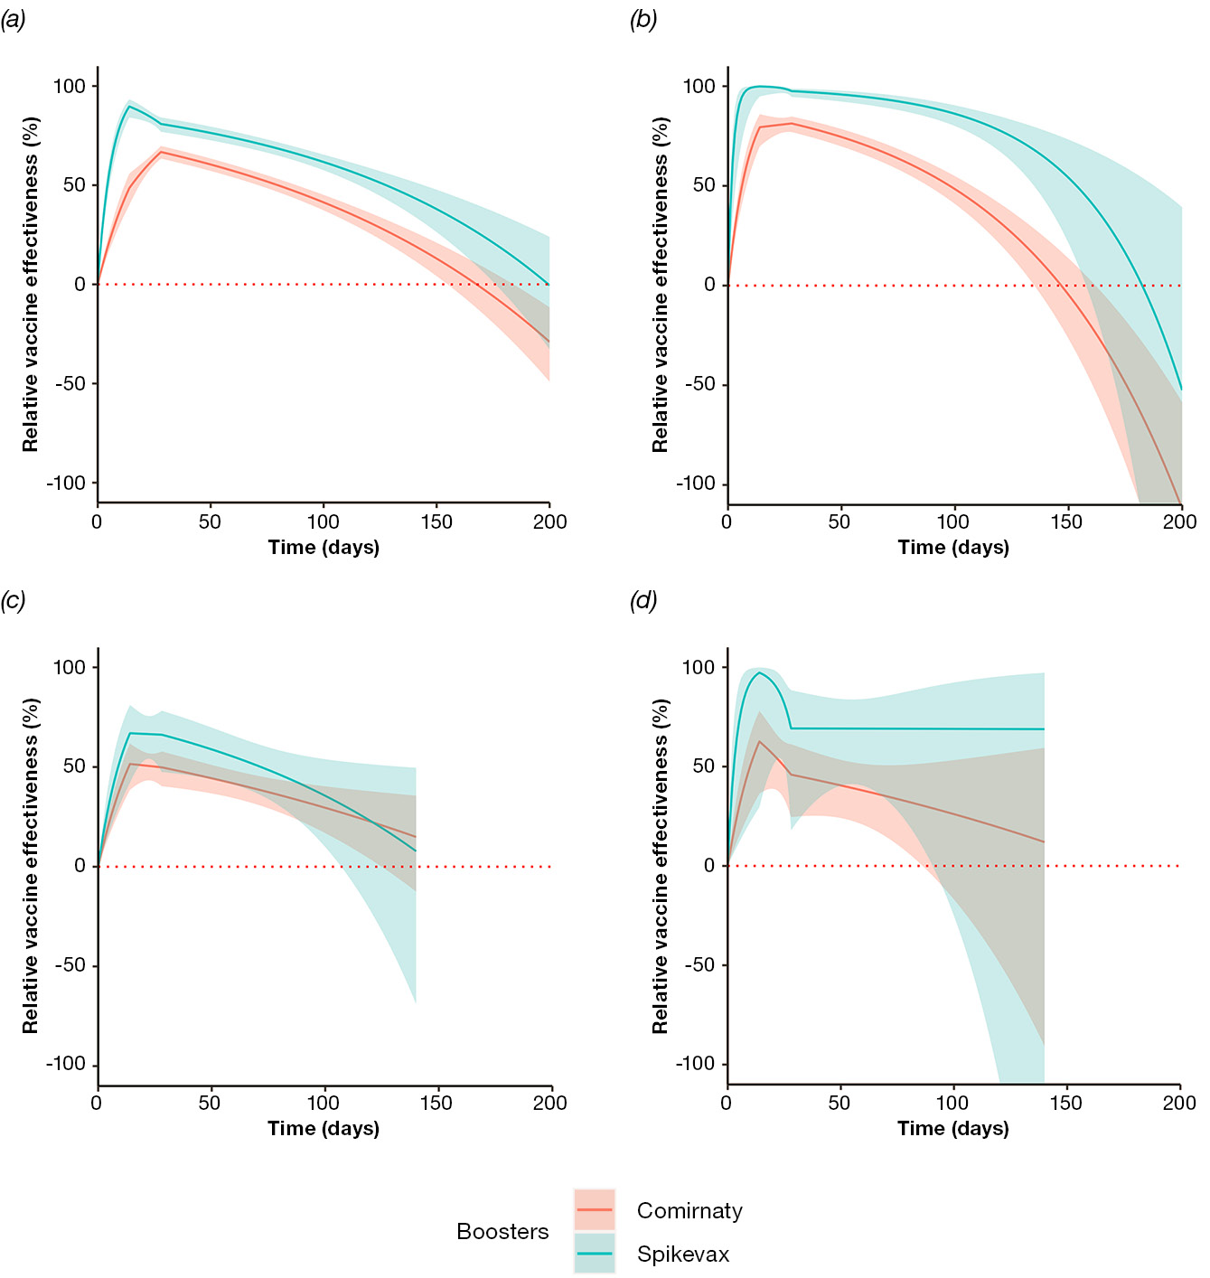
a 1 December 2021 – 19 June 2022.
b 20 June – 7 November 2022.
c Estimates in green correspond to Spikevax boosters; estimates in red correspond to Comirnaty boosters.
d Models are adjusted for age, gender, socio-economic status, Aboriginal and/or Torres Strait Islander identity, whether the individual’s primary vaccination course was with an mRNA or non-mRNA vaccine (for comparisons of three vs. two doses only), and Charlson comorbidity index.
Figure A.2: Adjusted relative vaccine effectiveness of three vs. two COVID-19 vaccine doses against hospitalisation for individuals aged ≥ 65 years (a) and 50–64 years (b), and death for individuals aged ≥ 65 years (c) and 50–64 years (d), with changepoints placed at 4, 8, 12, 16, 20, and 24 weeks compared to the primary analysis,^{a,b} Victoria, Australia, 1 December 2021 – 19 June 2022
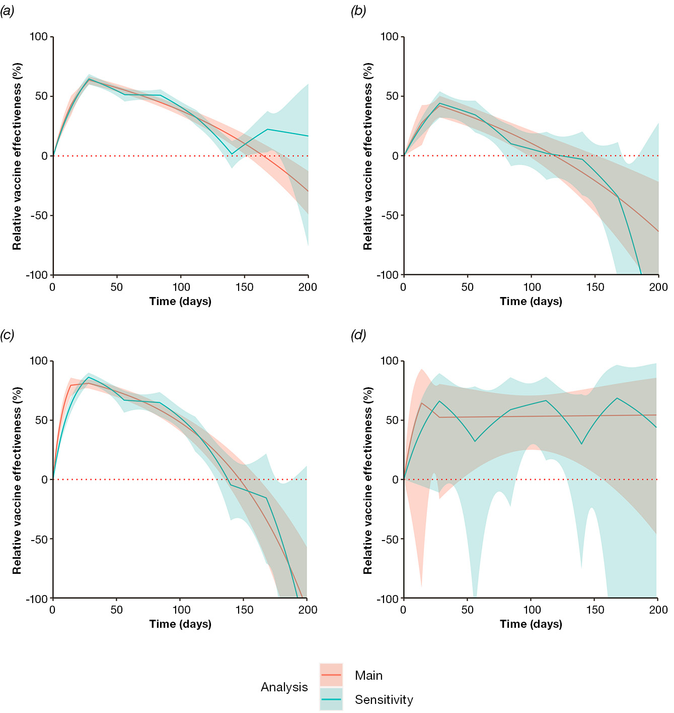
a Changepoints placed at 4, 8, 12, 16, 20, and 24 weeks are shown in green; the primary analysis is shown in red.
b Models are adjusted for age, gender, socio-economic status, Aboriginal and/or Torres Strait Islander identity, whether the individual’s primary vaccination course was with an mRNA or non-mRNA vaccine, and Charlson comorbidity index.

https://vahi.vic.gov.au/ourwork/data-linkage.

