
2026 • Volume 50 • cdc.gov.au/cdi • Epub date: 28.04.2026 • doi.org/10.33321/cdi.2026.50.002

Surveillance of adverse events following immunisation in Australia, 2023
Thuy Nguyen, Belinda Jones, Megan Hickie, Kristine Macartney, Nicholas Wood, Lucy Deng
© 2026 Commonwealth of Australia as represented by the Australian Centre for Disease Control
ISSN: 2209-6051 Online
This journal is indexed by Index Medicus and Medline.
Creative Commons Licence
This publication is licensed under a Creative Commons Attribution-NonCommercial-NoDerivatives 4.0 International Licence (Licence). You must read and understand the Licence before using any material from this publication.
Restrictions
The Licence does not cover, and there is no permission given for, use of any of the following material found in this publication (if any):
- the Commonwealth Coat of Arms (by way of information, the terms under which the Coat of Arms may be used can be found on the Department of Prime Minister and Cabinet website);
- any logos (including the Australian Centre for Disease Control’s logo) and trademarks;
- any photographs and images;
- any signatures; and
- any material belonging to third parties.
Disclaimer
Opinions expressed in Communicable Diseases Intelligence are those of the authors and not necessarily those of the Australian Government or the Australian Centre for Disease Control. Data may be subject to revision.
Enquiries
Enquiries regarding any other use of this publication should be addressed to the CDI Editor.
About CDI
Communicable Diseases Intelligence (CDI) is a peer-reviewed scientific journal published by the Australian Centre for Disease Control.
The journal aims to disseminate information on the epidemiology, surveillance, prevention and control of communicable diseases of relevance to Australia and the near region.
Editor: Dr Elise Firman • Deputy Editor: Simon Petrie • Design and Production: Lisa Thompson
Editorial Advisory Board: David Durrheim, Mark Ferson, Clare Huppatz, John Kaldor, Martyn Kirk and Meru Sheel
Submit an Article
Guidelines for authors and details on how to submit your publication is available on our website, or by email to the
CDI Editor.
Contact us
Communicable Diseases Intelligence (CDI)
Australian Centre for Disease Control
GPO Box 798, CANBERRA ACT 2601
Website: cdc.gov.au/cdi
Email: cdi.editor@cdc.gov.au

Contents
Summary 6
Introduction 7
Methods 9
AEFI data 9
Serious and non-serious AEFI 11
Data analysis 12
Notes on interpretation 12
Results 13
Reporting rates 13
Vaccines 34
Adverse events 38
Serious adverse events 42
New vaccines 43
Discussion 49
Limitations 51
Conclusion 52
Acknowledgments 53
Author details 54
References 55
Appendix A: Supplementary material 60

List of figures
Figure 1: Adverse event following immunisation reports in the Adverse Event Management System database from 2000 to 2023,ª Australia, by year 24
Figure 2: Reporting rates of adverse events following immunisation per 100,000 population in the Adverse Event Management System database from 2000 to 2023,ª Australia, by year and age group 26
Figure 3: Adverse event following immunisation (AEFI) reports for children aged < 5 years in the Adverse Event Management System database from 2000 to 2023,ª for selected vaccines,^{b,c,d} by year and vaccine, Australia, showing vaccines with first National Immunisation Program (NIP)-funded primary dose administered at under 6 months of age 27
Figure 4: Adverse event following immunisation (AEFI) reports for children aged < 5 years in the Adverse Event Management System database from 2000 to 2023,ª for selected vaccines,^{b,c,d} by year and vaccine, Australia, showing vaccines with first NIP-funded primary dose administered at or above 6 months of age 28
Figure 5: Adverse event following immunisation (AEFI) reports for children aged < 5 years in the Adverse Event Management System database from 2000 to 2023,ª for selected vaccines,^{b,c,d} by year and vaccine, Australia, showing (a) vaccines funded under NIP for specific population subgroups only; and (b) influenza vaccines 29
Figure 6: Adverse event following immunisation (AEFI) reports for people aged 5 to 11 years in the Adverse Event Management System database from 2000 to 2023,ª for selected vaccines only,^{b,c,d} by year and vaccine, Australia 30
Figure 7: Adverse event following immunisation (AEFI) reports for people aged 12 to 17 years in the Adverse Event Management System database from 2000 to 2023,ª for selected vaccines only,^{b,c,d} by year and vaccine, Australia 31
Figure 8: Adverse event following immunisation (AEFI) reports for people aged 18 to 64 years in the Adverse Event Management System database from 2000 to 2023,ª for selected vaccines only,^{b,c,d} by year and vaccine, Australia 32
Figure 9: Adverse event following immunisation (AEFI) reports for people aged 65+ years in the Adverse Event Management System database from 2000 to 2023,ª for selected vaccines only,^{b,c,d} by year and vaccine, Australia 33
Figure A.1: Reporting rates of adverse events following immunisation (AEFI) per 100,000 population in the Adverse Event Management System database from 2000 to 2023,ª by year and reporter type, Australia 77

List of tables
Table 1.1: Vaccines listed as ‘suspect’ in reports of adverse events following immunisation (AEFI) in the Adverse Event Management System database in 2023, Australia, for the < 5 years age group 14
Table 1.2: Vaccines listed as ‘suspect’ in reports of adverse events following immunisation (AEFI) in the Adverse Event Management System database in 2023, Australia, for the 5–11 years age group 16
Table 1.3: Vaccines listed as ‘suspect’ in reports of adverse events following immunisation (AEFI) in the Adverse Event Management System database in 2023, Australia, for the 12–17 years age group 18
Table 1.4: Vaccines listed as ‘suspect’ in reports of adverse events following immunisation (AEFI) in the Adverse Event Management System database in 2023, Australia, for the 18–64 years age group 20
Table 1.5: Vaccines listed as ‘suspect’ in reports of adverse events following immunisation (AEFI) in the Adverse Event Management System database in 2023, Australia, for the ≥ 65 years age group 22
Table 2: Adverse event following immunisation reports in the Adverse Event Management System database in 2023, Australia, by jurisdiction 25
Table 3: Vaccines listed as ‘suspect’ in reports of adverse events following immunisation in the Adverse Event Management System (AEMS) database, Australia, 2023 35
Table 4: The 50 most frequently reported adverse events classified by MedDRA Preferred Terms (PT) or Standardised MedDRA queries (SMQ) in reports of adverse events following immunisation (AEFI) in the Adverse Event Management System database, Australia, 2023 39
Table 5: Adverse event of special interest (AESI) reports in the Adverse Event Management System database for newly introduced vaccines, Australia, 2023 45
Table 6: The ten most frequently reported adverse events following immunisation (AEFI) classified by MedDRA Preferred Terms (PT) or Standardised MedDRA Queries (SMQ) in the Adverse Event Management System database for newly introduced vaccines, Australia, 2023 46
Table A.1: Notable changes in national or jurisdictional immunisation policy, and in the National Immunisation Program (NIP), Australia,ª 2005–2023 60
Table A.2: Description of MedDRA preferred term (PT) to standardised MedDRA query (SMQ) mapping 68
Table A.3: Narrow standardised MedDRA queries (SMQ) for tier 1 adverse events of special interest (AESI)ª 69
Table A.4: Most commonly reported medication errors by top five vaccines and age groups, Australia, 2023 72
Table A.5: MedDRA preferred terms (PT) mapped to specific SMQ (standardised MedDRA queries), Australia,ª 2023 74
Table A.6: Abbreviations of vaccine types and other terms 75

Summary
This report summarises Australia’s spontaneous surveillance data for adverse events following immunisation (AEFI) for all vaccines administered in 2023, reported to the Therapeutic Goods Administration (TGA). This report combines coronavirus disease 2019 (COVID-19) and non-COVID-19 AEFI that were previously reported separately in 2022 and 2021.
Overall, there were 5,534 AEFI reports for vaccines administered in 2023. This represents an annual AEFI reporting rate of 20.8 per 100,000 population, compared with 79.2 per 100,000 population in 2022. The sharp decrease in the AEFI reporting rate in 2023 was likely driven by a change in COVID-19 vaccination policy. This included limiting COVID-19 vaccine booster dose recommendation to high-risk populations rather than to the wider community, resulting in a steep decline in both the number of administered doses and the number of AEFIs reported. The most commonly reported adverse events were medication errors, injection site reaction, hypersensitivity, pyrexia, and gastrointestinal nonspecific symptoms. The most commonly reported adverse events for new vaccines introduced in 2023 were medication errors and headache for COVID-19 vaccines; hypersensitivity and pyrexia for DTPa-HepB-IPV-Hib vaccine (Vaxelis); and injection site reaction and hypersensitivity for recombinant zoster vaccine (Shingrix). There was reduction in deaths reported following vaccination in 2023 compared to 2022 and 2021. None of the 34 reported deaths in 2023 were determined to be causally related to the vaccine(s) received.
Keywords: AEFI; adverse events; vaccines; surveillance; immunisation; vaccine

Introduction
An adverse event following immunisation (AEFI) is defined as any untoward medical occurrence which follows immunisation and which does not necessarily have a causal relationship with the usage of the vaccine.¹ The AEFI may be an unfavourable or unintended sign, abnormal laboratory finding, symptom or disease. AEFI can be caused by the vaccine(s) or be a coincidental event, and can be classified into the following categories:
- vaccine product-related reaction;
- vaccine quality defect-related reaction;
- immunisation error-related reaction;
- immunisation anxiety-related reaction (also known as immunisation stress-related response); and
- coincidental event.
Ongoing post-marketing AEFI surveillance through a national spontaneous (passive) surveillance system is important in detecting AEFI that may not have been identified in pre-registration vaccine trials.
Anyone can report AEFI to the TGA, with the main categories of reporters being state and territory health departments, health professionals, vaccine companies, and consumers (members of the public).² All reported AEFI are entered into the Australian Adverse Event Management System (AEMS) database. Where the initial report contains insufficient information, the TGA may contact the reporter or relevant state or territory health department to elicit further information. The TGA continually analyses AEFI data to detect new potential safety issues or changes to known safety issues that may require regulatory or other action. The TGA may also review select serious adverse events, using internationally consistent methods to identify whether there may be a link between a vaccine and the adverse event involved.³
Reports summarising Australian national spontaneous AEFI surveillance data have been published regularly since 2003.^{4,5} Trends in reported AEFI are influenced by many factors, including changes to the National Immunisation Program (NIP); vaccine introduction and availability; media coverage; awareness campaigns; and efforts to facilitate reporting, such as safety alerts on the TGA website and social media channels, as well as programs targeted at increasing health professional reporting. Changes to the NIP since 2005 are summarised in Appendix A, Table A.1, and their impacts on reported AEFI trends are described in this and previous annual AEFI reports.
Immunisation recommendation changes in 2023,⁶ that impact on AEFI surveillance data presented in this report, are:
- (February 2023): 9vHPV vaccine for immunocompetent adolescents and young adults aged 9–25 years was changed from a two-dose to a single dose schedule; eligibility for catch-up of 9vHPV vaccine, and was also expanded to include people aged up to 25 years.
- (February 2023): A COVID-19 vaccine booster dose was recommended for adults aged ≥ 65 years and adults 18–64 years of age with medical comorbidities or disability if ≥ 6 months passed since the last vaccine dose or infection. This replaced the previous 2022 recommendation of a winter booster dose for adults > 50 years of age and people aged ≥ 16 years with medical risk conditions or disability if ≥ 3 months had passed since their last vaccine or infection.
- (March 2023): Vaxzevria (AstraZeneca COVID-19 vaccine) no longer available.
- (July 2023): Vaxelis was funded under NIP as an alternative vaccine to Infanrix hexa.
- (September 2023): A 2023 COVID-19 vaccine booster dose was recommended for all adults aged ≥ 75 years, and for adults aged 65–74 and those 18–64 with severe immunocompromise after consulting their healthcare provider, if 6 months had passed since their last dose.
- (November 2023): Shingrix replaced Zostavax under the NIP and was funded for adults aged ≥ 65 years, Aboriginal and Torres Strait Islander people aged ≥ 50 years and immunocompromised people aged ≥18 years at high risk of herpes zoster infection.
This report summarises national spontaneous (passive) surveillance data for all AEFI reported to the TGA, including coronavirus disease 2019 (COVID-19) and non-COVID-19 vaccines which were previously reported separately. The report focuses on AEFI reported for vaccines administered in 2023.

Methods

AEFI data
De-identified data on all AEFI reported to the TGA until 31 December 2023 and stored in the AEMS database were extracted in October 2024. Please refer to previous reports for a detailed description of the surveillance system.^{4,7} For abbreviations used throughout this report, please refer to Appendix A, Table A.6.

Vaccine data
Vaccines were identified by trade name (standardised term in the TGA reference dataset), and where the trade name was not specified, the generic name (active ingredients associated with a trade name) and reported product name (product name used by the reporter). Individual vaccines were grouped by antigen (or combination of antigens) and, for seasonal influenza and other specific vaccines, by type (for influenza: standard-formulation vs. high-dose or adjuvanted; for Japanese encephalitis and zoster, live vs. recombinant or inactivated). Only vaccines with a role in relation to the reported adverse event of ‘suspect’ were included in the analysis. To be accepted into the TGA AEMS database, the report must contain sufficient information to be valid, a condition requiring four key elements: a reporter; a patient; one or more suspected medicines or vaccines; and one or more reaction terms.⁸ Valid reports are accepted by the TGA with a default decision type of ‘causality possible’. More than one vaccine with a ‘suspect’ role can be included in a report, without implying that all vaccines were necessarily co-administered on the same occasion.

Adverse event data
AEFI reports included reaction terms that are symptoms, signs, and/or diagnoses coded by TGA staff from the reporter’s description into lower level terms (LLT), which were mapped to associated preferred terms (PT) using the Medical Dictionary for Regulatory Activities (MedDRA®).^{8,9}
Standardised MedDRA queries (SMQ) are sets of MedDRA terms that have been grouped after extensive testing, analysis, and expert discussion to facilitate pharmacovigilance investigation.¹⁰ For this analysis, the MedDRA Browser SMQ Analysis tool, running MedDRA version 27.1, was used to group related PT to SMQ to reduce the number of unique PT under analysis while providing meaningful results.¹¹ A narrow search was performed to increase the specificity of the PT to SMQ mapping. As individual PT may map to zero, one, or more than one SMQ, the term selected (PT or SMQ) was determined as described in Appendix A, Table A.2. Following the decision process, a one-to-one PT-SMQ mapping was performed to ensure that each PT was counted only once and there was no overlap in the included terms between different SMQ.

AEFI report data management
AEFI reports were defined by unique identifiers assigned by the TGA. In this analysis, the date assigned to each AEFI report was:
- the earliest vaccination date associated with the report; or where a vaccination date was missing:
- the earliest symptom onset date was used; or where dates for both vaccination and symptom onset were missing:
- the received date (the date when the reporter of the case first received the minimum valid information as described above from the primary source).
Reports with a 2023 date of vaccination, symptom onset or received date, based on the hierarchy above, were included in the analysis.
Reports were grouped by age into < 5 years; 5–11 years; 12–17 years; 18–64 years; and ≥ 65 years. Reports with a vaccination, symptom onset, or received date (as described above) prior to 2023 were excluded from the 2023 specific analysis.

Adverse events of special interest
Adverse events of special interest (AESI) are pre-specified, medically important events that warrant careful monitoring and potentially further investigation to characterise and understand, because they:
- have a known association with immunisation or a specific vaccine platform; or
- occur during wild-type disease as a result of viral replication and/or immunopathogenesis; or
- have a theoretical association with immunisation or a specific vaccine platform based on animal study models.
AESI reports for vaccines or vaccine formulations newly introduced in 2023 were based on AESI included in the Brighton Collaboration and Safety Platform for Emergency Vaccines (SPEAC) listing of Tier 1 AESIs;¹² this tabulation is used for all Coalition for Epidemic Preparedness Innovations (CEPI) vaccine development programs. Specifically, the included AESI were:
- anaphylaxis;¹³
- thrombocytopenia;¹⁴
- generalised convulsion;¹⁵
- aseptic meningitis;¹⁶
- encephalitis, myelitis, acute disseminated encephalomyelitis (ADEM);¹⁷
- Guillain Barré syndrome (GBS) and Miller Fisher syndrome;¹⁸ and
- peripheral facial nerve palsy.¹⁹
In addition, given the ongoing use of mRNA COVID-19 vaccines, noninfectious myocarditis and/or pericarditis²⁰ were also included as AESI for reporting.
The corresponding MedDRA LLT for these AESI were sourced from the guideline on Tier 1 AESI ICD9/10 and MedDRA Codes (Appendix A, Table A.3).¹² The narrow-search MedDRA LLT from the Brighton Collaboration and SPEAC guideline were mapped to the corresponding LLT in the AEMS database. AEMS AEFI reports containing a matched LLT were classified as having reported the corresponding AESI.

Serious and non-serious AEFI
AEFI reports were coded as ‘serious’ or ‘non-serious’ based on criteria used by the World Health Organization (WHO), where an adverse event report is defined as ‘serious’ if it involves one or more of the following outcomes:
- fatal or life-threatening condition(s);
- new or prolonged hospitalisation;
- persistent or significant disability;
- congenital anomaly or birth defect; and
- any medical event that requires an intervention to prevent the above outcomes.³
For AEFI reports submitted by sponsors (pharmaceutical companies), the seriousness classification is applied by sponsors to ensure they meet legislated requirements. For other AEFI reports submitted to the TGA, the seriousness classification either reflects the view of the reporter or may have been applied by the TGA following review.
All AEFI reports where a fatal outcome is reported, or where the individual was admitted to an intensive care unit (ICU), are reviewed by the TGA. This review is designed to assess whether the medical condition(s) that caused the ICU admission and/or death represents an emerging safety concern. The TGA reviews each of these reports and considers the strength of the evidence for a link between vaccination and the condition that caused the death using a standardised process based on the World Health Organization (WHO) causality assessment guidelines.²¹ When the cause for the event(s) that resulted in ICU admission and/or death is not medically obvious, not stated, or cannot be determined from the initial report, the TGA may request further information from the reporter, which may include the results of investigations relating to the ICU admission and/or death, past medical history, post-mortem examination findings, the death certificate, and/or results of a Coronial Office investigation.
In addition, the TGA can seek expert causality assessment advice from a Vaccine Safety Investigation Group (VSIG), which consists of clinical experts in domains including infectious diseases, vaccinology, haematology, respiratory medicine, immunology and public health, together with a consumer representative and often a communication expert.²² The purpose of the VSIG is to provide independent specialist immunisation (and other relevant) expertise to assist the TGA to investigate and undertake regulatory action for vaccine safety signals of concern. Where a VSIG is required, an internationally accepted method is used to determine the level of certainty of a link between the event and vaccine.²¹

Data analysis
Average annual population-based AEFI reporting rates were calculated for each state and territory, and by age group, using June 2023 population estimates obtained from the Australian Bureau of Statistics (ABS).²³ Comparisons with previous years were made using ABS mid-year estimated resident population (ERP) data for each year from 2000 to 2022.
AEFI reporting rates per 100,000 administered doses were estimated for 2023. The number of doses administered for each vaccine in 2023 was obtained in February 2024 from the Australian Immunisation Register (AIR), a national population-based register.²⁴ Vaccination providers are required by law to enter into the AIR every NIP-funded vaccine as well as COVID-19 vaccines administered from 21 December 2022, and are strongly encouraged to provide information to the AIR on all other vaccines given.²⁵ Vaccine doses can also be entered into the AIR retrospectively, including those administered overseas.²⁶
Confidence intervals presented are 95% exact binomial confidence intervals for proportions. All data cleaning and analyses were performed using R version 4.4.1.

Notes on interpretation
The data reported here are provisional, particularly for the fourth quarter of 2023 due to potential reporting delays. In addition, AEFI may have been reported in 2023 for vaccines administered in previous years. Therefore, statistics published in this report relating to AEFI reports from years prior to 2023, including accompanying figures, may not match those in previous reports.
It is possible for one case to be the subject of more than one AEFI report, where the reports have been submitted independently by multiple sources and there is insufficient information provided to confirm duplication.
As this report analysed data from the AEMS database, the numbers published in this report may be different to the numbers found in the Database of Adverse Event Notifications (DAEN) – medicines, a public online database maintained by the TGA that contains reports of adverse events for all medicines and vaccines.²⁷ The AEMS database includes more detailed information on each AEFI report and incorporates amendments and updates to reports when additional information is made available to the TGA. As the data for this analysis were extracted from AEMS in October 2024, there may be discrepancies with the DAEN – medicines, which is a live database that reflects new information made available to the TGA after October 2024.

Results
In the AEMS database, there were 5,534 AEFI reports where the date of vaccination (or onset of adverse event, or report received date, if the date of vaccination was not reported) was between 1 January and 31 December 2023. These AEFI reports, stratified by age group (< 5 years; 5–11 years; 12–17 years; 18–64 years; and ≥ 65 years) are respectively summarised in Tables 1.1 to 1.5.
Of the 5,340 reports (96.5% of total) with information on sex provided, 3,076 (57.6%) were for females and 2,261 (42.3%) were for males. Of the 3,311 reports (59.8% of total) with Indigenous status provided, 190 AEFI reports (5.7%) were for people who identified as Aboriginal and/or Torres Strait Islander. Of the 5,157 reports (93.2% of total) with age or date of birth provided, 1,893 (36.7%) were for children aged < 5 years (Table 1.1), and 1,178 (22.8%) were for people aged ≥ 65 years (Table 1.5).
Most AEFI reports (3,906, 70.6%) were sent by a state or territory health department (termed ‘regional pharmacovigilance centre’ in AEMS; Appendix A, Figure A.1), and 15.3% of reports (849) were direct submissions by health professionals or other organisation (including regulatory authorities) to the TGA. Consumers submitted 6.7% of AEFI reports (372), and 7.3% of reports (407) were sent by pharmaceutical companies. The proportion of pharmaceutical company reports was similar to that of 2022 (7.1% overall, 13% for non-COVID-19 vaccines²⁸ and 3.8% for COVID-19 vaccines).²⁹

Reporting rates

Dose-based reporting rates
The overall AEFI reporting rate for 2023 was 24.1 (95% confidence interval [95% CI]: 23.5–24.8) per 100,000 doses of vaccines administered and recorded in the AIR, compared with 50.6 (95% CI: 49.9–51.3) per 100,000 doses in 2022 (non-COVID-19 and COVID-19 vaccines combined; Table 1). When excluding COVID-19 vaccines, the AEFI rate for non-COVID-19 vaccines was 22.0 (95% CI: 21.3–22.7) per 100,000 doses. The rate for only COVID-19 vaccines was 32.0 (95% CI: 30.5–33.7) per 100,000 doses.
Table 1.1: Vaccines listed as ‘suspect’ in reports of adverse events following immunisation (AEFI) in the Adverse Event Management System database in 2023, Australia, for the < 5 years age group
Vaccine | AEFI reportsª  (n) | Vaccine doses^{b} | 2023 reporting rate^{c} |  | 2022 reporting rate^{e}
Vaccine | AEFI reportsª  (n) | Vaccine doses^{b} | Rate per 100,000 doses | 95% CI^{d} | Rate per 100,000 doses | 95% CI^{d}
13vPCV | 494 | 792,615 | 62.3 | 57.0–68.1 | 56.2 | 51.3–61.5
DTPa-HepB-IPV-Hib (all) | 466 | 770,323 | 60.8 | 55.4–66.5 | 47.0 | 42.4–51.8
DTPa-HepB-IPV-Hib (Infanrix hexa) | 369 | 673,457 | 54.8 | 49.3–60.7 | 47.0 | 42.4–51.8
DTPa-HepB-IPV-Hib (Vaxelis) | 97 | 96,038 | 101.0 | 81.9–123.2 | (Vaccine not available) | —
DTPa-IPV | 365 | 255,999 | 142.6 | 128.3–158.0 | 111.3 | 98.8–125
Rotavirus | 323 | 480,980 | 67.2 | 60.0–74.9 | 50.7 | 44.8–57.1
Influenza (seasonal – standard formulation) | 302 | 472,330 | 63.9 | 56.9–71.6 | 41.7 | 36.4–47.5
DTPa | 287 | 293,382 | 97.8 | 86.8–109.8 | 77.1 | 67.3–87.9
MMR | 256 | 288,176 | 88.8 | 78.3–100.4 | 78.3 | 68.7–89
Hib | 247 | 289,846 | 85.2 | 74.9–96.5 | 72.4 | 62.9–82.9
MMRV | 240 | 290,664 | 82.6 | 72.5–93.7 | 75.5 | 65.8–86.3
MenB | 230 | 321,116 | 71.6 | 62.7–81.5 | 62.9 | 54.2–72.5
MenACWY | 227 | 302,249 | 75.1 | 65.7–85.5 | 59.9 | 51.6–69.0
Tuberculosis | 34 | 12,410 | 274.0 | 189.8–382.6 | 137.4 | 73.2–234.8
Hepatitis A | 30 | 38,093 | 78.8 | 53.1–112.4 | 67.6 | 39.4–108.2
23vPPV | 23 | 8,421 | 273.1 | 173.2–409.5 | 167.1 | 89–285.5
Varicella | 20 | 11,901 | 168.1 | 102.7–259.4 | 95.5 | 45.8–175.6
Hepatitis B | 17 | 24,235 | 70.1 | 40.9–112.3 | 81.3 | 48.2–128.4
Typhoid | 5 | 12,651 | 39.5 | 12.8–92.2 | 22.0 | 2.7–79.5
Polio | 4 | 4,464 | 89.6 | 24.4–229.3 | 43.9 | 5.3–158.4
Japanese encephalitis (live) | 3 | 2,153 | 139.3 | 28.7–406.7 | 42.3 | 1.1–235.5
a Number of AEFI reports in which the vaccine was coded as ‘suspected’ of causal involvement in the reported adverse event and the vaccine was administered between 1 January and 31 December 2023. More than one vaccine may be coded as ‘suspected’ if several were administered or reported at the same time.
b Number of vaccine doses administered between 1 January and 31 December 2023 and recorded on the Australian Immunisation Register as at 4 February 2024.
c Only vaccines with more than 1,000 doses administered in the respective age group in 2023 are included in the table.
d 95% CI: 95% confidence interval.
e The number of AEFI reports for 2022 was obtained from the latest 2023 data, which included additional reports submitted in 2023 for vaccinations administered in 2022. As a result, the dose-based rate for 2022 in this table may differ from the figures published in the 2022 reports.
Table 1.2: Vaccines listed as ‘suspect’ in reports of adverse events following immunisation (AEFI) in the Adverse Event Management System database in 2023, Australia, for the 5–11 years age group
Vaccine | AEFI reportsª  (n) | Vaccine doses^{b} | 2023 reporting rate^{c} |  | 2022 reporting rate^{e}
Vaccine | AEFI reportsª  (n) | Vaccine doses^{b} | Rate per 100,000 doses | 95% CI^{d} | Rate per 100,000 doses | 95% CI^{d}
Influenza (seasonal - standard formulation) | 66 | 418,404 | 15.8 | 12.2–20.1 | 15.2 | 12.2–18.7
COVID-19 (all brands) | 41 | 28,814 | 142.3 | 102.1–193.0 | 81.8 | 77.9–85.9
COVID-19 (Comirnaty) | 37 | 28,587 | 129.4 | 91.1–178.4 | 80.8 | 76.9–84.8
dTpa | 8 | 4,830 | 165.6 | 71.5–326.1 | 103.8 | 28.3–265.7
MenACWY | 7 | 11,844 | 59.1 | 23.8–121.7 | 45.5 | 12.4–116.4
DTPa-HepB-IPV-Hib | 7 | 3,298 | 212.2 | 85.4–436.8 | 129.4 | 42.0–301.8
23vPPV | 6 | 2,880 | 208.3 | 76.5–452.9 | 340.0 | 146.9–668.8
Hepatitis A | 6 | 33,236 | 18.1 | 6.6–39.3 | 19.4 | 4.0–56.8
Japanese encephalitis (live) | 6 | 2,745 | 218.6 | 80.3–475.1 | No AEFI reported | —
DTPa-IPV | 4 | 39,843 | 10.0 | 2.7–25.7 | 27.9 | 13.4–51.2
Hepatitis B | 4 | 7,043 | 56.8 | 15.5–145.4 | 31.7 | 3.8–114.6
MenB | 4 | 9,866 | 40.5 | 11.0–103.8 | 83.0 | 26.9–193.5
13vPCV | 3 | 1,618 | 185.4 | 38.3–540.9 | 67.1 | 1.7–373.4
DTPa | 3 | 4,427 | 67.8 | 14.0–197.9 | 80.3 | 16.6–234.6
Typhoid | 3 | 29,452 | 10.2 | 2.1–29.8 | 11.7 | 1.4–42.2
MMR | 2 | 5,408 | 37.0 | 4.5–133.5 | 36.4 | 4.4–131.6
MMRV | 2 | 4,870 | 41.1 | 5.0–148.3 | 46.3 | 5.6–167
Typhoid-hepatitis A | 2 | 2,655 | 75.3 | 9.1–271.8 | 346.6 | 94.5–885.1
Varicella | 2 | 4,856 | 41.2 | 5.0–148.7 | No AEFI reported | —
DT | 1 | 2,371 | 42.2 | 1.1–234.8 | No AEFI reported | —
Hib | 1 | 1,218 | 82.1 | 2.1–456.6 | No AEFI reported | —
Influenza (seasonal - high-dose or adjuvanted) | 1 | 1,038 | 96.3 | 2.4–535.6 | 216.6 | 44.7–631.7
Polio | 1 | 3,950 | 25.3 | 0.6–141.0 | No AEFI reported | —
Yellow fever | 1 | 1,785 | 56.0 | 1.4–311.7 | No AEFI reported | —
a Number of AEFI reports in which the vaccine was coded as ‘suspected’ of causal involvement in the reported adverse event and the vaccine was administered between 1 January and 31 December 2023. More than one vaccine may be coded as ‘suspected’ if several were administered or reported at the same time.
b Number of vaccine doses administered between 1 January and 31 December 2023 and recorded on the Australian Immunisation Register as at 4 February 2024.
c Only vaccines with more than 1,000 doses administered in the respective age group in 2023 are included in the table.
d 95% CI: 95% confidence interval.
e The number of AEFI reports for 2022 was obtained from the latest 2023 data, which included additional reports submitted in 2023 for vaccinations administered in 2022. As a result, the dose-based rate for 2022 in this table may differ from the figures published in the 2022 reports.
Table 1.3: Vaccines listed as ‘suspect’ in reports of adverse events following immunisation (AEFI) in the Adverse Event Management System database in 2023, Australia, for the 12–17 years age group
Vaccine | AEFI reportsª  (n) | Vaccine doses^{b} | 2023 reporting rate^{c} |  | 2022 reporting rate^{e}
Vaccine | AEFI reportsª  (n) | Vaccine doses^{b} | Rate per 100,000 doses | 95% CI^{d} | Rate per 100,000 doses | 95% CI^{d}
dTpa | 113 | 293,201 | 38.5 | 31.8–46.3 | 28.0 | 22.2–35
HPV | 108 | 289,340 | 37.3 | 30.6–45.1 | 29.6 | 25.2–34.4
MenACWY | 82 | 240,116 | 34.2 | 27.2–42.4 | 23.4 | 17.7–30.4
COVID-19 (all brands) | 46 | 28,570 | 161.0 | 117.9–214.7 | 107.1 | 100.2–114.4
COVID-19 (Comirnaty) | 35 | 23,226 | 150.7 | 105–209.5 | 94.1 | 87.4–101.1
COVID-19 (Spikevax) | 11 | 4,136 | 266.0 | 132.8–475.4 | 296.8 | 248.7–351.4
Influenza (seasonal – standard formulation) | 24 | 293,572 | 8.2 | 5.2–12.2 | 10.8 | 7.9–14.3
MenB | 22 | 36,368 | 60.5 | 37.9–91.6 | 93.4 | 63.9–131.9
Hepatitis B | 7 | 11,972 | 58.5 | 23.5–120.4 | 77.0 | 33.2–151.6
MMR | 5 | 5,866 | 85.2 | 27.7–198.8 | 17.8 | 0.5–99.3
Hepatitis A | 4 | 18,502 | 21.6 | 5.9–55.3 | 55.1 | 15.0–140.9
Typhoid–hepatitis A | 4 | 9,515 | 42.0 | 11.5–107.6 | 31.4 | 0.8–174.6
23vPPV | 3 | 1,570 | 191.1 | 39.4–557.4 | 528.6 | 194.2–1147
Influenza (seasonal – high-dose or adjuvanted) | 3 | 1,123 | 267.1 | 55.1–778.7 | 58.8 | 1.5–326.9
Varicella | 3 | 7,299 | 41.1 | 8.5–120.1 | 46.6 | 9.6–136
Hepatitis A–hepatitis B | 1 | 1,307 | 76.5 | 1.9–425.5 | 124.1 | 3.1–689.3
MMRV | 1 | 1,947 | 51.4 | 1.3–285.8 | 108.9 | 13.2–392.9
Polio | 1 | 6,341 | 15.8 | 0.4–87.8 | No AEFI reported | —
Rabies | 1 | 4,044 | 24.7 | 0.6–137.7 | No AEFI reported | —
Typhoid | 1 | 19,685 | 5.1 | 0.1–28.3 | 10.3 | 0.3–57.5
Yellow fever | 1 | 1,676 | 59.7 | 1.5–332.0 | No AEFI reported | —
a Number of AEFI reports in which the vaccine was coded as ‘suspected’ of causal involvement in the reported adverse event and the vaccine was administered between 1 January and 31 December 2023. More than one vaccine may be coded as ‘suspected’ if several were administered or reported at the same time.
b Number of vaccine doses administered between 1 January and 31 December 2023 and recorded on the Australian Immunisation Register as at 4 February 2024.
c Only vaccines with more than 1,000 doses administered in the respective age group in 2023 are included in the table.
d 95% CI: 95% confidence interval.
e The number of AEFI reports for 2022 was obtained from the latest 2023 data, which included additional reports submitted in 2023 for vaccinations administered in 2022. As a result, the dose-based rate for 2022 in this table may differ from the figures published in the 2022 reports.
Table 1.4: Vaccines listed as ‘suspect’ in reports of adverse events following immunisation (AEFI) in the Adverse Event Management System database in 2023, Australia, for the 18–64 years age group
Vaccine | AEFI reportsª  (n) | Vaccine doses^{b} | 2023 reporting rate^{c} |  | 2022 reporting rate^{e}
Vaccine | AEFI reportsª  (n) | Vaccine doses^{b} | Rate per 100,000 doses | 95% CI^{d} | Rate per 100,000 doses | 95% CI^{d}
COVID-19 (all brands) | 733 | 1,931,733 | 37.9 | 35.2–40.8 | 92.8 | 91.1–94.6
COVID-19 (Comirnaty) | 457 | 1,324,806 | 34.5 | 31.4–37.8 | 85.1 | 83.1–87
COVID-19 (Spikevax) | 192 | 586,853 | 32.7 | 28.3–37.7 | 83.1 | 79.6–86.7
COVID-19 (Nuvaxovid) | 30 | 19,291 | 155.5 | 104.9–221.9 | 442.1 | 412.4–473.3
Influenza (seasonal - standard formulation) | 414 | 4,643,642 | 8.9 | 8.1–9.8 | 7.2 | 6.5–7.9
Influenza (seasonal - high-dose or adjuvanted) | 145 | 46,352 | 312.8 | 264.0–368.0 | 75.6 | 55.4–100.9
dTpa | 111 | 723,194 | 15.3 | 12.6–18.5 | 9.7 | 7.6–12.4
MVA-BN | 64 | 25,839 | 247.7 | 190.8–316.2 | 609.8 | 539.6–686.5
Zoster (RZV) | 63 | 78,138 | 80.6 | 62.0–103.1 | 81.0 | 55.1–115
Hepatitis B | 48 | 256,540 | 18.7 | 13.8–24.8 | 9.9 | 6.1–15.1
MMR | 25 | 104,485 | 23.9 | 15.5–35.3 | 18.4 | 10.7–29.4
Hepatitis A | 23 | 89,068 | 25.8 | 16.4–38.7 | 9.4 | 3.0–21.8
23vPPV | 22 | 13,456 | 163.5 | 102.5–247.4 | 144.0 | 85.4–227.5
Typhoid-hepatitis A | 17 | 154,961 | 11.0 | 6.4–17.6 | 13.5 | 6.2–25.6
Varicella | 17 | 36,655 | 46.4 | 27.0–74.2 | 30.7 | 14.7–56.5
DT | 15 | 267,810 | 5.6 | 3.1–9.2 | 3.8 | 1.7–7.6
MenB | 13 | 14,718 | 88.3 | 47.0–151.0 | 60.6 | 27.7–115
Hepatitis A-hepatitis B | 12 | 52,033 | 23.1 | 11.9–40.3 | 10.1 | 2.7–25.8
MenACWY | 11 | 29,723 | 37.0 | 18.5–66.2 | 16.1 | 4.4–41.2
Rabies | 10 | 40,650 | 24.6 | 11.8–45.2 | 20.1 | 5.5–51.4
DTPa-IPV | 9 | 1,460 | 616.4 | 282.3–1167.0 | 387.9 | 126.1–902.9
HPV | 8 | 37,711 | 21.2 | 9.2–41.8 | 22.2 | 10.1–42.0
Typhoid | 8 | 135,296 | 5.9 | 2.6–11.7 | 7.4 | 2.7–16.0
Polio | 6 | 31,363 | 19.1 | 7.0–41.6 | 13.2 | 2.7–38.4
13vPCV | 5 | 30,167 | 16.6 | 5.4–38.7 | 55.7 | 31.9–90.5
Japanese encephalitis (live) | 5 | 27,838 | 18.0 | 5.8–41.9 | 39.0 | 23.1–61.7
MMRV | 5 | 2,521 | 198.3 | 64.4–462.2 | 142.8 | 29.5–416.7
Zoster (ZVL) | 5 | 4,075 | 122.7 | 39.9–286.1 | 174.3 | 92.8–297.8
Yellow fever | 4 | 25,823 | 15.5 | 4.2–39.7 | No AEFI reported | —
DTPa | 3 | 2,880 | 104.2 | 21.5–304.1 | 137.4 | 44.6–320.4
Hib | 2 | 3,223 | 62.1 | 7.5–224.0 | No AEFI reported | —
dTpa-IPV | 2 | 12,746 | 15.7 | 1.9–56.7 | 17.5 | 2.1–63.1
Japanese encephalitis (inactivated) | 1 | 4,144 | 24.1 | 0.6–134.4 | 54.7 | 1.4–304.2
Rotavirus | 1 | 1,192 | 83.9 | 2.1–466.5 | No AEFI reported | —
a Number of AEFI reports in which the vaccine was coded as ‘suspected’ of causal involvement in the reported adverse event and the vaccine was administered between 1 January and 31 December 2023. More than one vaccine may be coded as ‘suspected’ if several were administered or reported at the same time.
b Number of vaccine doses administered between 1 January and 31 December 2023 and recorded on the Australian Immunisation Register as at 4 February 2024.
c Only vaccines with more than 1,000 doses administered in the respective age group in 2023 are included in the table.
d 95% CI: 95% confidence interval.
e The number of AEFI reports for 2022 was obtained from the latest 2023 data, which included additional reports submitted in 2023 for vaccinations administered in 2022. As a result, the dose-based rate for 2022 in this table may differ from the figures published in the 2022 reports.
Table 1.5: Vaccines listed as ‘suspect’ in reports of adverse events following immunisation (AEFI) in the Adverse Event Management System database in 2023, Australia, for the ≥ 65 years age group
Vaccine | AEFI reportsª  (n) | Vaccine doses^{b} | 2023 reporting rate^{c} |  | 2022 reporting rate^{e}
Vaccine | AEFI reportsª  (n) | Vaccine doses^{b} | Rate per 100,000 doses | 95% CI^{d} | Rate per 100,000 doses | 95% CI^{d}
COVID-19 (all brands) | 629 | 2,944,087 | 21.4 | 19.7–23.1 | 37.7 | 36.2–39.3
COVID-19 (Comirnaty) | 391 | 2,131,417 | 18.3 | 16.6–20.3 | 34.7 | 33.1–36.4
COVID-19 (Spikevax) | 191 | 798,094 | 23.9 | 20.7–27.6 | 36.8 | 33.5–40.4
COVID-19 (Nuvaxovid) | 5 | 13,980 | 35.8 | 11.6–83.4 | 153.0 | 121.1–190.6
Influenza (seasonal - high-dose or adjuvanted) | 175 | 3,079,542 | 5.7 | 4.9–6.6 | 5.9 | 5.1–6.8
Zoster (RZV) | 271 | 362,990 | 74.7 | 66.0–84.1 | 73.5 | 54.7–96.6
Zoster (ZVL) | 51 | 138,205 | 36.9 | 27.5–48.5 | 40.2 | 31.7–50.1
13vPCV | 45 | 312,321 | 14.4 | 10.5–19.3 | 20.5 | 16.1–25.7
Influenza (seasonal - standard formulation) | 45 | 210,450 | 21.4 | 15.6–28.6 | 18.2 | 13.5–24.0
23vPPV | 27 | 27,219 | 99.2 | 65.4–144.3 | 36.3 | 18.1–64.9
dTpa | 18 | 141,978 | 12.7 | 7.5–20.0 | 6.7 | 2.9–13.2
DT | 7 | 114,025 | 6.1 | 2.5–12.6 | 2.5 | 0.3–8.9
Japanese encephalitis (live) | 4 | 9,422 | 42.5 | 11.6–108.7 | 9.9 | 2.0–28.9
Hepatitis B | 3 | 24,312 | 12.3 | 2.5–36.1 | No AEFI reported | —
Polio | 3 | 3,174 | 94.5 | 19.5–276.0 | No AEFI reported | —
MVA-BN | 2 | 3,311 | 60.4 | 7.3–218.0 | 448.4 | 231.9–782.0
MenACWY | 2 | 4,947 | 40.4 | 4.9–146.0 | 29.6 | 0.7–164.9
Typhoid | 2 | 38,082 | 5.3 | 0.6–19.0 | No AEFI reported | —
Hepatitis A | 1 | 11,969 | 8.4 | 0.2–46.5 | No AEFI reported | —
Hib | 1 | 1,948 | 51.3 | 1.3–285.7 | No AEFI reported | —
MenB | 1 | 3,261 | 30.7 | 0.8–170.7 | No AEFI reported | —
Rabies | 1 | 4,842 | 20.7 | 0.5–115.0 | No AEFI reported | —
Typhoid-hepatitis A | 1 | 28,304 | 3.5 | 0.1–19.7 | 12.8 | 0.3–71.4
Yellow fever | 1 | 3,453 | 29.0 | 0.7–161.2 | No AEFI reported | —
a Number of AEFI reports in which the vaccine was coded as ‘suspected’ of causal involvement in the reported adverse event and the vaccine was administered between 1 January and 31 December 2023. More than one vaccine may be coded as ‘suspected’ if several were administered or reported at the same time.
b Number of vaccine doses administered between 1 January and 31 December 2023 and recorded on the Australian Immunisation Register as at 4 February 2024.
c Only vaccines with more than 1,000 doses administered in the respective age group in 2023 are included in the table.
d 95% CI: 95% confidence interval.
e The number of AEFI reports for 2022 was obtained from the latest 2023 data, which included additional reports submitted in 2023 for vaccinations administered in 2022. As a result, the dose-based rate for 2022 in this table may differ from the figures published in the 2022 reports.

Population-based reporting rates
The overall AEFI reporting rate for 2023 was 20.8 per 100,000 total population (95% CI: 20.2–21.3), compared with 79.2 per 100,000 in 2022 and 491.5 per 100,000 in 2021 during the peak of COVID-19 vaccine roll-out (Figure 1). In 2023, the AEFI reporting rate for non-COVID-19 vaccines was 14.8 (95% CI: 14.4–15.5) per 100,000 population and for COVID-19 vaccines it was 5.9 (95% CI: 5.6–6.2) per 100,000 population.
The highest age-specific population-based AEFI reporting rate was in children aged < 5 years (124.9 reports per 100,000 population; Table 2; Figure 2). Compared to 2022, the reporting rate in this group slightly increased but remained consistent with annual rates over the past decade. In contrast, AEFI reporting rates sharply declined in other age groups, returning to pre-pandemic levels.
By jurisdiction, the highest population-based AEFI reporting rates in 2023 were in Tasmania (38.4 reports per 100,000 population) and Western Australia (35.7 per 100,000 population). The lowest reporting rates were in Queensland (11.3 reports per 100,000 population) and New South Wales (12.0 per 100,000 population; Table 2).
Figures 1–9 show the annual trend in AEFI report counts and/or reporting rates per 100,000 population, including AEFI reports that had been entered into the AEMS database in the years subsequent to the year of an event’s occurrence. Therefore, there may be discrepancies between the numbers in Figures 1–9 and the numbers in previous annual reports.
Figure 1: Adverse event following immunisation reports in the Adverse Event Management System database from 2000 to 2023,ª Australia, by year
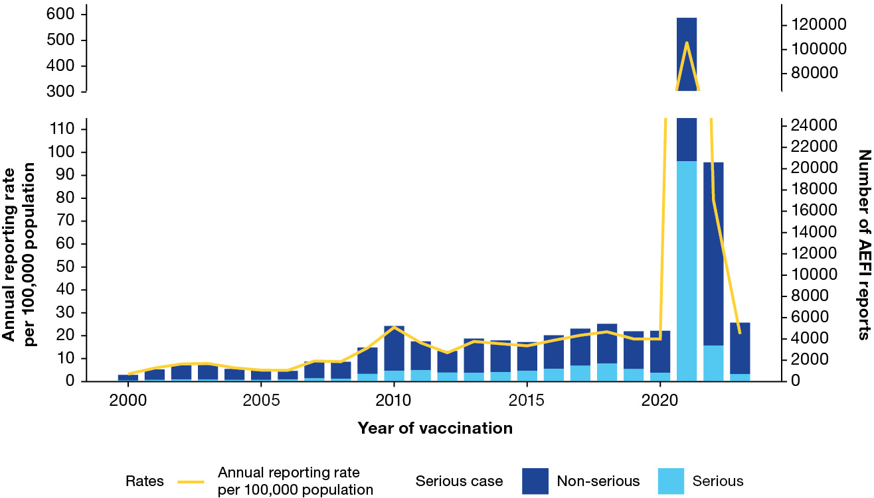
a For reports where the date of vaccination was not recorded, the date of symptom onset or the received date (when the event was reported to the sender of the case) was used. For more details on changes to the National Immunisation Program, please refer to Appendix A, Table A.1. Population data was sourced from the Australian Bureau of Statistics and represents the mid-year total Australian Estimated Resident Population for each calendar year.
Table 2: Adverse event following immunisation reports in the Adverse Event Management System database in 2023, Australia, by jurisdiction
Jurisdictionª | AEFI reports |  | Annual reporting rate per 100,000 population^{b}
Jurisdictionª | n | % | Overall (95% CI)^{c} | Serious AEFI^{d} | Aged < 5 years^{e} | Aged  5–11 years^{e} | Aged  12–17 years^{e} | Aged  18–64 years^{e} | Aged  65+ years^{e}
ACT | 89 | 1.6 | 19.1 (15.3–23.5) | 1.5 | 68.1 | 10.0 | 37.1 | 12.8 | 21.9
NSW | 1,004 | 18.1 | 12.0 (11.3–12.8) | 3.5 | 45.4 | 1.8 | 8.7 | 7.0 | 17.0
NT | 42 | 0.8 | 16.6 (12.0–22.5) | 1.2 | 41.2 | 4.1 | 15.2 | 12.5 | 42.8
Qld | 619 | 11.2 | 11.3 (10.5–12.3) | 1.0 | 74.7 | 3.4 | 7.4 | 5.8 | 15.4
SA | 284 | 5.1 | 15.3 (13.6–17.2) | 0.9 | 65.5 | 2.7 | 22.9 | 8.0 | 25.4
Tas. | 220 | 4.0 | 38.4 (33.5–43.8) | 2.3 | 159.3 | 20.2 | 19.5 | 23.5 | 59.7
Vic. | 2,042 | 36.9 | 30.0 (28.7–31.3) | 1.6 | 255.6 | 10.6 | 20.5 | 11.4 | 28.1
WA | 1,029 | 18.6 | 35.7 (33.6–38.0) | 1.4 | 185.1 | 18.2 | 32.2 | 18.8 | 53.5
Unknown | 205 | 3.7 | — | — | — | — | — | — | —
Australia | 5,534 | 100 | 20.8 (20.2–21.3) | 2.6 | 124.9 | 6.8 | 15.7 | 9.9 | 25.9
a ACT: Australian Capital Territory; NSW: New South Wales; NT: Northern Territory; Qld: Queensland; SA: South Australia; Tas.: Tasmania; Vic: Victoria; WA: Western Australia.
b Average annual rates per 100,000 population calculated using June 2023 jurisdiction and total ERP estimates from the Australian Bureau of Statistics.
c 95% CI: 95% confidence interval.
d An adverse event report is defined as ‘serious’ if it involves one or more of the following outcomes: (1) fatal or life-threatening condition(s); (2) new or prolonged hospitalisation; (3) persistent or significant disability; (4) congenital anomaly or birth defect; and (5) any medical event that requires an intervention to prevent the above outcomes. For AEFI reports submitted by sponsors (vaccine companies), the seriousness classification is applied by sponsors to ensure they meet legislated requirements. For other AEFI reports submitted to the TGA, the seriousness classification either reflects the view of the reporter or may have been applied by the TGA following review.
e Includes only AEFI reports where an age or date of birth was reported.
Figure 2: Reporting rates of adverse events following immunisation per 100,000 population in the Adverse Event Management System database from 2000 to 2023,ª Australia, by year and age group
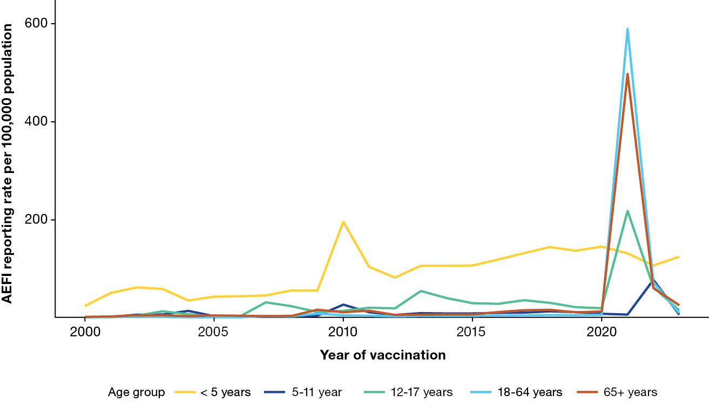
a For reports where the date of vaccination was not recorded, the date of symptom onset or the received date (when the event was reported to the sender of the case) was used. For more details on changes to the National Immunisation Program, please refer to Appendix A, Table A.1. Population data was sourced from the Australian Bureau of Statistics and represents the mid-year total Australian Estimated Resident Population for each calendar year.
Figure 3: Adverse event following immunisation (AEFI) reports for children aged < 5 years in the Adverse Event Management System database from 2000 to 2023,ª for selected vaccines,^{b,c,d} by year and vaccine, Australia, showing vaccines with first National Immunisation Program (NIP)-funded primary dose administered at under 6 months of age
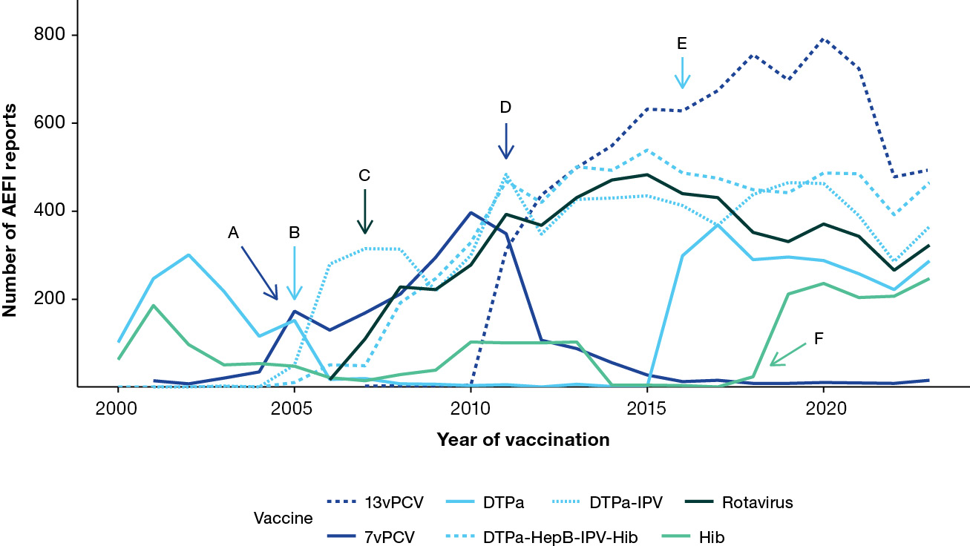
a For reports where the date of vaccination was not recorded, the date of symptom onset or the received date (when the event was reported to the sender of the case) was used. For more details on changes to the NIP, please refer to Appendix A, Table A.1. Population data was sourced from the Australian Bureau of Statistics and represents the mid-year total Australian Estimated Resident Population for each calendar year.
b Vaccines are selected for inclusion in figure if they have been in use in the selected age group for ≥ 2 consecutive years, and if they i) are funded under the NIP for any population subgroup within the selected age group in 2023; ii) are one of the five most common vaccines associated with spontaneous AEFI reports in 2023; or iii) have been implicated in a vaccine safety event of note from year 2000 onwards and/or have been implicated in a large proportion of historical spontaneous AEFI reports; or iv) provide useful information as a comparator to another vaccine included in the figure (example: RZV as a comparator to ZVL).
c Seasonal std: standard formulation of the seasonal influenza vaccine.
d Event markers shown represent the following events: A: 7vPCV and catch-up programs commenced; B: DTPa-IPV booster programs commenced; C: national rotavirus program commenced; D: 13vPCV and catch-up program commenced; E: DTPa booster program commenced; F: monovalent Hib booster program commenced.
Figure 4: Adverse event following immunisation (AEFI) reports for children aged < 5 years in the Adverse Event Management System database from 2000 to 2023,ª for selected vaccines,^{b,c,d} by year and vaccine, Australia, showing vaccines with first NIP-funded primary dose administered at or above 6 months of age
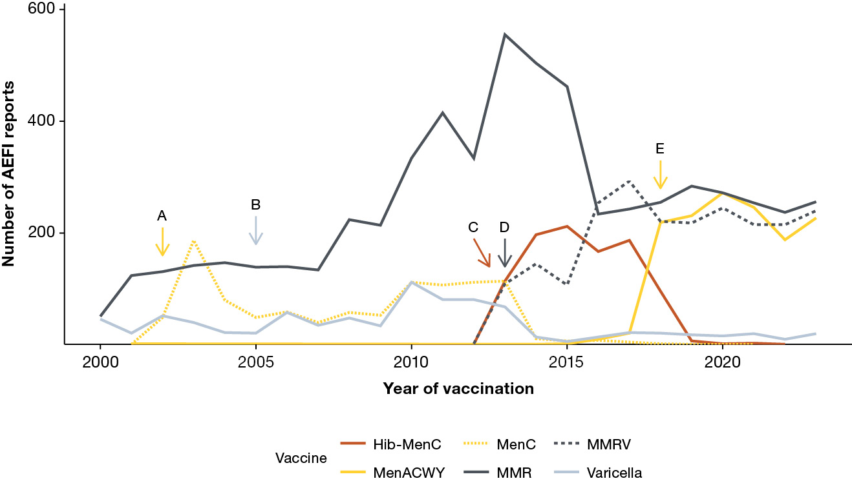
a For reports where the date of vaccination was not recorded, the date of symptom onset or the received date (when the event was reported to the sender of the case) was used. For more details on changes to the NIP, please refer to Appendix A, Table A.1. Population data was sourced from the Australian Bureau of Statistics and represents the mid-year total Australian Estimated Resident Population for each calendar year.
b Vaccines are selected for inclusion in figure if they have been in use in the selected age group for ≥ 2 consecutive years, and if they i) are funded under the NIP for any population subgroup within the selected age group in 2023; ii) are one of the five most common vaccines associated with spontaneous AEFI reports in 2023; or iii) have been implicated in a vaccine safety event of note from year 2000 onwards and/or have been implicated in a large proportion of historical spontaneous AEFI reports; or iv) provide useful information as a comparator to another vaccine included in the figure (example: RZV as a comparator to ZVL).
c Seasonal std: standard formulation of the seasonal influenza vaccine.
d Event markers shown represent the following events: A: meningococcal C and catch-up program commenced; B: varicella program commenced; C: Hib-meningococcal C program commenced; D: MMRV program commenced; E: meningococcal ACWY program commenced.
Figure 5: Adverse event following immunisation (AEFI) reports for children aged < 5 years in the Adverse Event Management System database from 2000 to 2023,ª for selected vaccines,^{b,c,d} by year and vaccine, Australia, showing (a) vaccines funded under NIP for specific population subgroups only; and (b) influenza vaccines
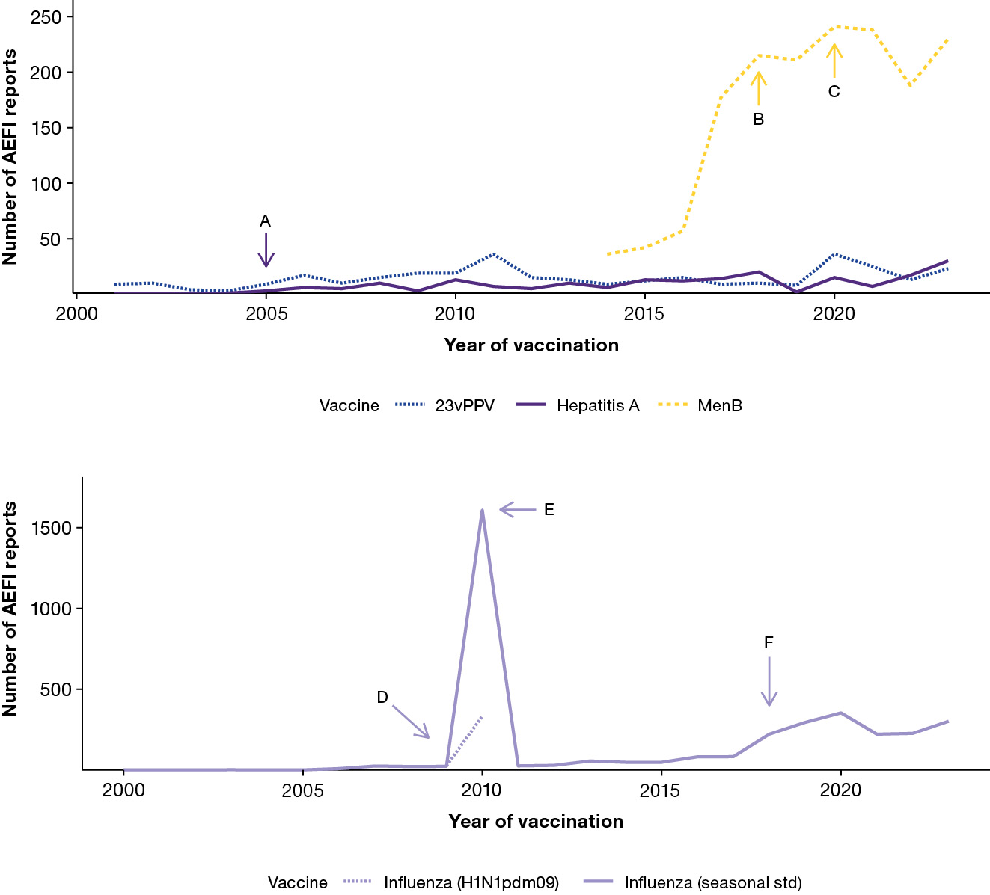
a For reports where the date of vaccination was not recorded, the date of symptom onset or the received date (when the event was reported to the sender of the case) was used. For more details on changes to the NIP, please refer to Appendix A, Table A.1. Population data was sourced from the Australian Bureau of Statistics and represents the mid-year total Australian Estimated Resident Population for each calendar year.
b Vaccines are selected for inclusion in figure if they have been in use in the selected age group for ≥ 2 consecutive years, and if they i) are funded under the NIP for any population subgroup within the selected age group in 2023; ii) are one of the five most common vaccines associated with spontaneous AEFI reports in 2023; or iii) have been implicated in a vaccine safety event of note from year 2000 onwards and/or have been implicated in a large proportion of historical spontaneous AEFI reports; or iv) provide useful information as a comparator to another vaccine included in the figure (example: RZV as a comparator to ZVL).
c Seasonal std: standard formulation of the seasonal influenza vaccine.
d Event markers shown represent the following events: A: hepatitis A program for Aboriginal and Torres Strait Islander children in specific jurisdictions commenced; B: South Australian meningococcal B program commenced; C: meningococcal B program for Aboriginal and Torres Strait Islander children commenced; D: pandemic H1N1 influenza program commenced; E: temporary seasonal influenza vaccine suspension in children due to safety concern; F: state/territory seasonal influenza programs commenced.
Figure 6: Adverse event following immunisation (AEFI) reports for people aged 5 to 11 years in the Adverse Event Management System database from 2000 to 2023,ª for selected vaccines only,^{b,c,d} by year and vaccine, Australia
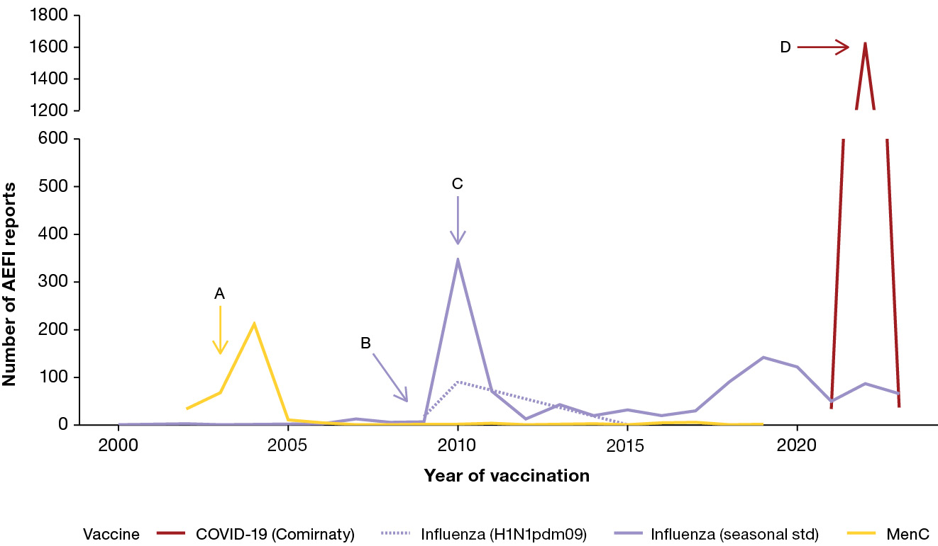
a For reports where the date of vaccination was not recorded, the date of symptom onset or the received date (when the event was reported to the sender of the case) was used. For more details on changes to the National Immunisation Program (NIP), please refer to Appendix A, Table A.1. Population data was sourced from the Australian Bureau of Statistics and represents the mid-year total Australian Estimated Resident Population for each calendar year.
b Vaccines are selected for inclusion in figure if they have been in use in the selected age group for ≥ 2 consecutive years, and if they i) are funded under the NIP for any population subgroup within the selected age group in 2023; ii) are one of the five most common vaccines associated with spontaneous AEFI reports in 2023; or iii) have been implicated in a vaccine safety event of note from year 2000 onwards and/or have been implicated in a large proportion of historical spontaneous AEFI reports; or iv) provide useful information as a comparator to another vaccine included in the figure (example: RZV as a comparator to ZVL).
c Seasonal std: standard formulation of the seasonal influenza vaccine.
d Event markers shown represent the following events: A: meningococcal C child/adolescent catch-up program commenced; B: pandemic H1N1 influenza program commenced (December 2010); C: temporary seasonal influenza vaccine suspension due to safety concern; D: start of COVID-19 vaccination program for children aged 5-11 years.
Figure 7: Adverse event following immunisation (AEFI) reports for people aged 12 to 17 years in the Adverse Event Management System database from 2000 to 2023,ª for selected vaccines only,^{b,c,d} by year and vaccine, Australia
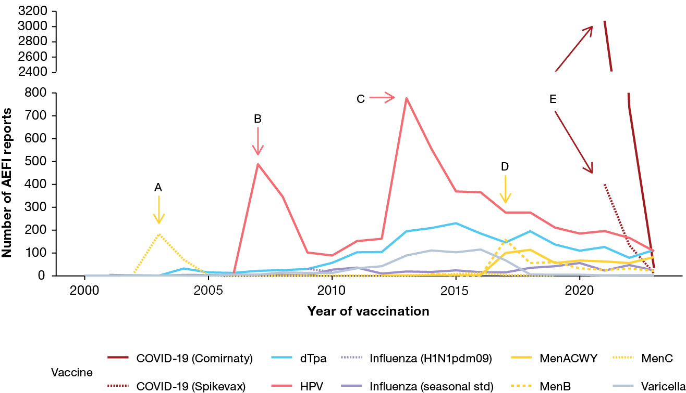
a For reports where the date of vaccination was not recorded, the date of symptom onset or the received date (when the event was reported to the sender of the case) was used. For more details on changes to the National Immunisation Program (NIP), please refer to Appendix A, Table A.1. Population data was sourced from the Australian Bureau of Statistics and represents the mid-year total Australian Estimated Resident Population for each calendar year.
b Vaccines are selected for inclusion in figure if they have been in use in the selected age group for ≥ 2 consecutive years, and if they i) are funded under the NIP for any population subgroup within the selected age group in 2023; ii) are one of the five most common vaccines associated with spontaneous AEFI reports in 2023; or iii) have been implicated in a vaccine safety event of note from year 2000 onwards and/or have been implicated in a large proportion of historical spontaneous AEFI reports; or iv) provide useful information as a comparator to another vaccine included in the figure (example: RZV as a comparator to ZVL).
c Seasonal std: standard formulation of the seasonal influenza vaccine.
d Event markers shown represent the following events: A: meningococcal C adolescent catch-up program commenced; B: HPV adolescent & catch-up programs commenced; C: HPV adolescent program (and catch-up) extended to males; D: jurisdictional meningococcal ACWY adolescent school-based program commenced; E: start of COVID-19 vaccination program.
Figure 8: Adverse event following immunisation (AEFI) reports for people aged 18 to 64 years in the Adverse Event Management System database from 2000 to 2023,ª for selected vaccines only,^{b,c,d} by year and vaccine, Australia
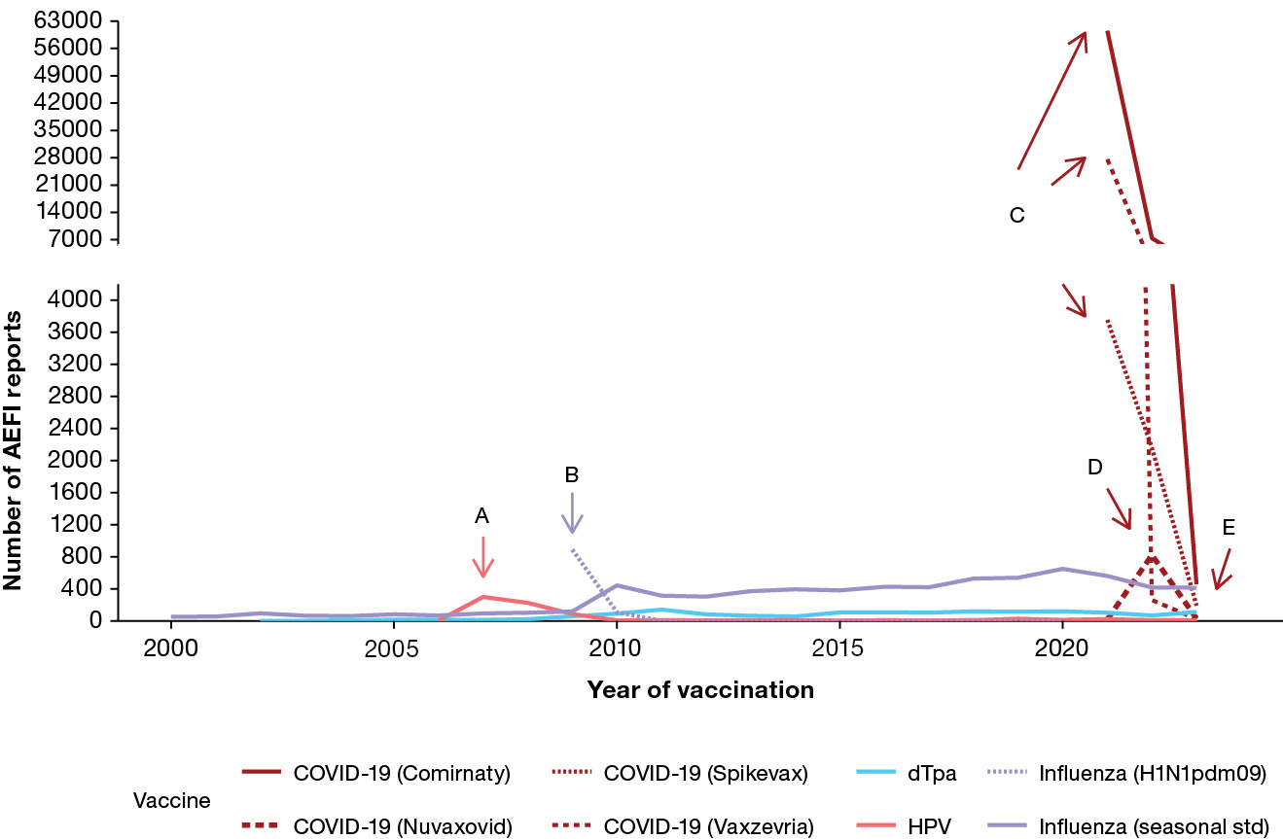
a For reports where the date of vaccination was not recorded, the date of symptom onset or the received date (when the event was reported to the sender of the case) was used. For more details on changes to the National Immunisation Program (NIP), please refer to Appendix A, Table A.1. Population data was sourced from the Australian Bureau of Statistics and represents the mid-year total Australian Estimated Resident Population for each calendar year.
b Vaccines are selected for inclusion in figure if they have been in use in the selected age group for ≥ 2 consecutive years, and if they i) are funded under the NIP for any population subgroup within the selected age group in 2023; ii) are one of the five most common vaccines associated with spontaneous AEFI reports in 2023; or iii) have been implicated in a vaccine safety event of note from year 2000 onwards and/or have been implicated in a large proportion of historical spontaneous AEFI reports; or iv) provide useful information as a comparator to another vaccine included in the figure (example: RZV as a comparator to ZVL).
c Seasonal std: standard formulation of the seasonal influenza vaccine.
d Event markers shown represent the following events: A: HPV adult catch-up program commenced; B: Pandemic H1N1 influenza program commenced; C: start of COVID-19 vaccination program; D: Nuvaxovid introduced; E: Vaxzevria is no longer available in Australia from 21 March 2023.
Figure 9: Adverse event following immunisation (AEFI) reports for people aged 65+ years in the Adverse Event Management System database from 2000 to 2023,ª for selected vaccines only,^{b,c,d} by year and vaccine, Australia
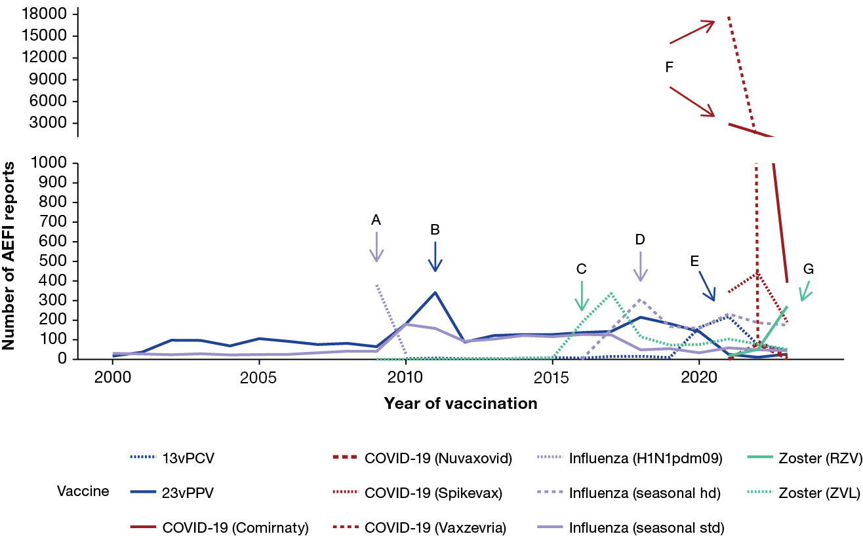
a For reports where the date of vaccination was not recorded, the date of symptom onset or the received date (when the event was reported to the sender of the case) was used. For more details on changes to the National Immunisation Program (NIP), please refer to Appendix A, Table A.1. Population data was sourced from the Australian Bureau of Statistics and represents the mid-year total Australian Estimated Resident Population for each calendar year.
b Vaccines are selected for inclusion in figure if they have been in use in the selected age group for ≥ 2 consecutive years, and if they i) are funded under the NIP for any population subgroup within the selected age group in 2023; ii) are one of the five most common vaccines associated with spontaneous AEFI reports in 2023; or iii) have been implicated in a vaccine safety event of note from year 2000 onwards and/or have been implicated in a large proportion of historical spontaneous AEFI reports; or iv) provide useful information as a comparator to another vaccine included in the figure (example: RZV as a comparator to ZVL).
c Seasonal std: standard formulation of the seasonal influenza vaccine; seasonal hd: high-dose or adjuvanted formulation of the seasonal influenza vaccine.
d Event markers shown represent the following events: A: pandemic H1N1 influenza program commenced; B: TGA issued recall for 23vPPV batch N3336; C: Zoster (ZVL) & catch-up programs commenced; D: high-dose and adjuvanted formulation added to seasonal influenza program; E: older adult 13vPCV program commenced; E: changes made to 23vPPV program; F:start of COVID-19 vaccination program; G: Zoster (RZV) replaced Zoster (ZVL) under the NIP from 1 Nov 2023.

Vaccines
The vaccine most frequently listed in 2023 AEFI reports was the COVID-19 (Comirnaty) vaccine (1,037 reports; 18.7% of total reports), followed by standard-formulation seasonal influenza vaccine (905 reports; 16.4%), 13vPCV (556 reports; 10.0%), DTPa-IPV-HepB-Hib (484 reports; 8.7%), and COVID-19 (Spikevax) vaccine (441 reports; 8.0%, Table 3). Of the 1,037 AEFI reports following COVID-19 (Comirnaty) vaccine, 238 (23%) were classified as serious; 457 (44.1%) were reported in adults aged 18–64 years; 391 (37.7%) in adults aged ≥ 65 years; 37 (3.6%) in children aged 5–11 years; 35 (3,4%) in children aged 12–17 years, and only 11 (1.1%) in children under 5 years (Table 3).
For each respective age group, the vaccines with the highest number of AEFI reports in 2023 were 13vPCV (in children aged < 5 years; Table 1.1); standard-formulation seasonal influenza vaccine (in children aged 5–11 years; Table 1.2); dTpa (in adolescents aged 12–17 years; Table 1.3); and COVID-19 (Comirnaty) vaccine (in people aged 18–64 years and those ≥ 65 years of age; Tables 1.4 and 1.5).
In relation to new vaccines introduced in 2023, there was a slight increase in the number of AEFI reports for DTPa-IPV-HepB-Hib in 2023 (484 reports across all brands, including 97 for Vaxelis) compared to 409 reports in 2022, following the introduction of Vaxelis. There was an increase in AEFI reporting for recombinant zoster vaccine (RZV) vaccine, with 372 reports in 2023 compared to 99 reports in 2022, following the replacement of zoster live-attenuated vaccine (ZLV) with RZV under the NIP. The number of AEFI reports following the COVID-19 (Vaxzevria) vaccine declined significantly in 2023 (53 reports), compared to 2022 (454 reports) and 2021 (47,825 reports), as the vaccine was no longer available in Australia from March 2023.
Table 3: Vaccines listed as ‘suspect’ in reports of adverse events following immunisation in the Adverse Event Management System (AEMS) database, Australia, 2023
Vaccineª | AEFI reports n (%)^{b} | Serious AEFI n (%)^{c,e} | Age group, n (%)^{d,e}
Vaccineª | AEFI reports n (%)^{b} | Serious AEFI n (%)^{c,e} | < 5 years | 5–11 years | 12–17 years | 18–64 years | ≥ 65 years
COVID-19 (Comirnaty) | 1,037 (18.7) | 238 (23.0) | 11 (1.1) | 37 (3.6) | 35 (3.4) | 457 (44.1) | 391 (37.7)
Influenza (seasonal - standard formulation) | 905 (16.4) | 82 (9.1) | 302 (33.4) | 66 (7.3) | 24 (2.7) | 414 (45.7) | 45 (5.0)
13vPCV | 556 (10.0) | 46 (8.3) | 494 (88.8) | 3 (0.5) | 1 (0.2) | 5 (0.9) | 45 (8.1)
DTPa-HepB-IPV-Hib | 484 (8.7) | 37 (7.6) | 466 (96.1) | 7 (1.4) | 0 (0) | 0 (0) | 0 (0)
COVID-19 (Spikevax) | 441 (8.0) | 57 (12.9) | 3 (0.7) | 4 (0.9) | 11 (2.5) | 192 (43.5) | 191 (43.3)
DTPa-IPV | 386 (7.0) | 8 (2.1) | 365 (94.6) | 4 (1.0) | 2 (0.5) | 9 (2.3) | 1 (0.3)
Zoster (RZV) | 372 (6.7) | 55 (14.8) | 0 (0) | 0 (0) | 1 (0.3) | 63 (16.9) | 271 (72.8)
Influenza (seasonal - high-dose or adjuvanted) | 336 (6.1) | 13 (3.9) | 5 (1.5) | 1 (0.3) | 3 (0.9) | 145 (43.2) | 175 (52.1)
MenACWY | 331 (6.0) | 16 (4.8) | 227 (68.6) | 7 (2.1) | 82 (24.8) | 11 (3.3) | 2 (0.6)
Rotavirus | 327 (5.9) | 37 (11.3) | 323 (98.8) | 0 (0) | 0 (0) | 1 (0.3) | 0 (0)
DTPa | 304 (5.5) | 9 (3.0) | 287 (94.4) | 3 (1.0) | 5 (1.6) | 3 (1.0) | 2 (0.7)
MMR | 292 (5.3) | 14 (4.8) | 256 (87.7) | 2 (0.7) | 5 (1.7) | 25 (8.6) | 0 (0)
MenB | 284 (5.1) | 20 (7.0) | 230 (81.0) | 4 (1.4) | 22 (7.7) | 13 (4.6) | 1 (0.4)
dTpa | 274 (5.0) | 4 (1.5) | 19 (6.9) | 8 (2.9) | 113 (41.2) | 111 (40.5) | 18 (6.6)
Hib | 251 (4.5) | 8 (3.2) | 247 (98.4) | 1 (0.4) | 0 (0) | 2 (0.8) | 1 (0.4)
MMRV | 248 (4.5) | 8 (3.2) | 240 (96.8) | 2 (0.8) | 1 (0.4) | 5 (2.0) | 0 (0)
HPV | 129 (2.3) | 4 (3.1) | 3 (2.3) | 9 (7.0) | 108 (83.7) | 8 (6.2) | 0 (0)
Hepatitis B | 84 (1.5) | 10 (11.9) | 17 (20.2) | 4 (4.8) | 7 (8.3) | 48 (57.1) | 3 (3.6)
23vPPV | 81 (1.5) | 5 (6.2) | 23 (28.4) | 6 (7.4) | 3 (3.7) | 22 (27.2) | 27 (33.3)
COVID-19 Vaccine (unspecified) | 72 (1.3) | 59 (81.9) | 0 (0) | 0 (0) | 0 (0) | 30 (41.7) | 23 (31.9)
MVA-BN | 66 (1.2) | 2 (3.0) | 0 (0) | 0 (0) | 0 (0) | 64 (97.0) | 2 (3.0)
Hepatitis A | 65 (1.2) | 2 (3.1) | 30 (46.2) | 6 (9.2) | 4 (6.2) | 23 (35.4) | 1 (1.5)
Zoster (ZVL) | 61 (1.1) | 1 (1.6) | 0 (0) | 1 (1.6) | 2 (3.3) | 5 (8.2) | 51 (83.6)
COVID-19 (Vaxzevria) | 53 (1.0) | 44 (83.0) | 0 (0) | 0 (0) | 0 (0) | 24 (45.3) | 19 (35.8)
Zoster (unspecified) | 47 (0.8) | 47 (100) | 0 (0) | 0 (0) | 0 (0) | 3 (6.4) | 1 (2.1)
Varicella | 45 (0.8) | 2 (4.4) | 20 (44.4) | 2 (4.4) | 3 (6.7) | 17 (37.8) | 0 (0)
Tuberculosis | 39 (0.7) | 4 (10.3) | 34 (87.2) | 2 (5.1) | 0 (0) | 1 (2.6) | 2 (5.1)
COVID-19 (Nuvaxovid) | 36 (0.7) | 12 (33.3) | 0 (0) | 0 (0) | 0 (0) | 30 (83.3) | 5 (13.9)
Q Fever | 30 (0.5) | 27 (90.0) | 0 (0) | 0 (0) | 0 (0) | 3 (10.0) | 0 (0)
DT | 26 (0.5) | 2 (7.7) | 1 (3.8) | 1 (3.8) | 0 (0) | 15 (57.7) | 7 (26.9)
Typhoid-hepatitis A | 25 (0.5) | 2 (8.0) | 1 (4.0) | 2 (8.0) | 4 (16.0) | 17 (68.0) | 1 (4.0)
Japanese encephalitis (live) | 19 (0.3) | 3 (15.8) | 3 (15.8) | 6 (31.6) | 0 (0) | 5 (26.3) | 4 (21.1)
Typhoid | 19 (0.3) | 1 (5.3) | 5 (26.3) | 3 (15.8) | 1 (5.3) | 8 (42.1) | 2 (10.5)
Polio | 15 (0.3) | 1 (6.7) | 4 (26.7) | 1 (6.7) | 1 (6.7) | 6 (40.0) | 3 (20.0)
Hepatitis A-hepatitis B | 14 (0.3) | 0 (0) | 0 (0) | 0 (0) | 1 (7.1) | 12 (85.7) | 0 (0)
Rabies | 12 (0.2) | 0 (0) | 0 (0) | 0 (0) | 1 (8.3) | 10 (83.3) | 1 (8.3)
Pneumococcal (unspecified) | 9 (0.2) | 1 (11.1) | 8 (88.9) | 0 (0) | 0 (0) | 0 (0) | 0 (0)
Yellow fever | 7 (0.1) | 3 (42.9) | 0 (0) | 1 (14.3) | 1 (14.3) | 4 (57.1) | 1 (14.3)
DTP | 6 (0.1) | 0 (0) | 2 (33.3) | 0 (0) | 1 (16.7) | 2 (33.3) | 1 (16.7)
Pertussis | 6 (0.1) | 3 (50.0) | 1 (16.7) | 0 (0) | 0 (0) | 3 (50.0) | 0 (0)
Hib-HepB | 4 (0.1) | 1 (25.0) | 4 (100) | 0 (0) | 0 (0) | 0 (0) | 0 (0)
Tetanus | 3 (0.1) | 2 (66.7) | 0 (0) | 0 (0) | 0 (0) | 1 (33.3) | 0 (0)
Japanese encephalitis (inactivated) | 2 (0.04) | 0 (0) | 1 (50.0) | 0 (0) | 0 (0) | 1 (50.0) | 0 (0)
dTpa-IPV | 2 (0.04) | 0 (0) | 0 (0) | 0 (0) | 0 (0) | 2 (100) | 0 (0)
Cholera | 1 (0.02) | 0 (0) | 0 (0) | 1 (100) | 0 (0) | 0 (0) | 0 (0)
DTPa-HepB | 1 (0.02) | 0 (0) | 1 (100) | 0 (0) | 0 (0) | 0 (0) | 0 (0)
DTPa-HepB-Hib | 1 (0.02) | 0 (0) | 1 (100) | 0 (0) | 0 (0) | 0 (0) | 0 (0)
a See Appendix A, Table A.6 for vaccine names.
b Number of AEFI reports in which the vaccine was coded as ‘suspected’ of causal involvement in the reported adverse event and the vaccination was administered between 1 January and 31 December 2023. More than one vaccine may be coded as ‘suspected’ if several were administered or reported at the same time.
c An adverse event report is defined as ‘serious’ if it involves one or more of the following outcomes: (1) fatal or life-threatening condition(s); (2) new or prolonged hospitalisation; (3) persistent or significant disability; (4) congenital anomaly or birth defect; and (5) any medical event that requires an intervention to prevent the above outcomes. For AEFI reports submitted by sponsors (vaccine companies), the seriousness classification is applied by sponsors to ensure they meet legislated requirements. For other AEFI reports submitted to the TGA, the seriousness classification either reflects the view of the reporter or may have been applied by the TGA following review.
d Includes only AEFI reports where an age or date of birth has been reported.
e Percentages are calculated for the number of AEFI reports where the vaccine was suspected of causal involvement in the event.

Adverse events
The most frequently reported MedDRA PT or SMQ in 2023 was ‘medication errors’ (1,278 reports; 23.1%; Table 4; further detail of terms included in Appendix A, Table A.3), which, in the context of AEFI, denotes vaccination errors. While the largest proportions of these reports were in children aged < 5 years (468 reports; 36.6% of all ‘medication errors’ reports) and adults aged 18–64 years (390 reports; 30.5%), ‘medication error’ was the most frequently reported PT/SMQ across all age groups in 2023. The most frequently reported errors included ‘inappropriate schedule of product administration’ (358 reports; 28% of all ‘medication error’ reports), ‘product administered to patient of inappropriate age’ (311; 24.3%), ‘wrong product administered’ (238; 18.6%), and ‘expired product administered’ (177; 13.8%; see Appendix A, Table A.4 for further details).
The number of reports involving ‘medication errors’ decreased in 2023 compared to previous years, with 2,032 reports in 2022 (9.9% of all AEFI reports) and 2,065 reports in 2021 (1.6%), but was significantly higher than in 2020 (245 reports; 5.1%). Between 2021 and 2023, the number of reports on ‘medication errors’ declined among individuals aged ≥ 5 years, but increased in children under 5 years over the same period (152 reports in 2021, 355 in 2022, and 468 in 2023).
The vaccines most frequently implicated in a report of ‘medication errors’ for all age groups were the high dose or adjuvanted seasonal influenza vaccine (192 reports; 15.0% of reports with ‘medication errors’ included), COVID-19 (Comirnaty) vaccine (177 reports; 13.8%), and standard-formulation seasonal influenza vaccine (166 reports; 13.0%). In 158 reports (12.4%), more than one vaccine was reported. Only 14 AEFI reports involving ‘medication errors’ were classified as serious (1.1%). Notably, in the majority of reports (1,144; 89.5%), no adverse event/s were reported in association with the error, noting that it is possible after the error has been reported for an associated adverse event to occur and not be captured in the error report.
Among children under 5 years in 2023, the most commonly reported medication errors were ‘inappropriate schedule of product administration’ (178 reports; 38.0% of all ‘medication error’ reports in this age group), ‘wrong product administered’ (111; 23.7%), and ‘product administered to patient of inappropriate age’ (98; 20.9%). The vaccines most commonly listed in a report of ‘medication errors’ for children under 5 years were the standard-formulation seasonal influenza vaccine (70 reports; 15.0% of reports with ‘medication errors’ included), DTPa-hepB-IPV-Hib (46 reports; 9.8%), and MMR vaccine (31 reports;, 6.6%; see Appendix A, Table A.4 for further details).
Following medication error, the next most frequently reported adverse events were injection site reaction (925 reports; 16.7%), hypersensitivity (904 reports; 16.3%), pyrexia (748 reports; 13.5%), and the SMQ grouping of ‘gastrointestinal non-specific symptoms and therapeutic procedures’ (701 reports; 12.7%; further detail of terms included in Appendix A, Table A.5).
Table 4: The 50 most frequently reported adverse events classified by MedDRA Preferred Terms (PT) or Standardised MedDRA queries (SMQ) in reports of adverse events following immunisation (AEFI) in the Adverse Event Management System database, Australia, 2023
PT or SMQ | AEFI reports n (%)ª | Serious AEFI n (%)^{b,c} | Age group, n (%)^{c,d}
PT or SMQ | AEFI reports n (%)ª | Serious AEFI n (%)^{b,c} | < 5 years | 5–11 years | 12–17 years | 18–64 years | ≥ 65 years
Medication errors | 1,278 (23.1) | 14 (1.1) | 468 (36.6) | 59 (4.6) | 83 (6.5) | 390 (30.5) | 230 (18.0)
Injection site reaction | 925 (16.7) | 9 (1.0) | 449 (48.5) | 27 (2.9) | 34 (3.7) | 193 (20.9) | 200 (21.6)
Hypersensitivity | 904 (16.3) | 69 (7.6) | 458 (50.7) | 24 (2.7) | 43 (4.8) | 194 (21.5) | 144 (15.9)
Pyrexia | 748 (13.5) | 59 (7.9) | 375 (50.1) | 20 (2.7) | 52 (7.0) | 171 (22.9) | 114 (15.2)
Gastrointestinal nonspecific symptoms and therapeutic procedures | 701 (12.7) | 59 (8.4) | 246 (35.1) | 24 (3.4) | 59 (8.4) | 201 (28.7) | 152 (21.7)
Headache | 511 (9.2) | 24 (4.7) | 23 (4.5) | 14 (2.7) | 66 (12.9) | 241 (47.2) | 148 (29.0)
Myalgia | 381 (6.9) | 16 (4.2) | 30 (7.9) | 11 (2.9) | 31 (8.1) | 173 (45.4) | 119 (31.2)
Fatigue | 367 (6.6) | 13 (3.5) | 73 (19.9) | 11 (3.0) | 31 (8.4) | 139 (37.9) | 104 (28.3)
Haemodynamic oedema, effusions and fluid overload | 273 (4.9) | 18 (6.6) | 128 (46.9) | 9 (3.3) | 10 (3.7) | 67 (24.5) | 52 (19.0)
Lethargy | 266 (4.8) | 26 (9.8) | 85 (32.0) | 6 (2.3) | 30 (11.3) | 81 (30.5) | 61 (22.9)
Arthralgia | 260 (4.7) | 8 (3.1) | 15 (5.8) | 5 (1.9) | 17 (6.5) | 128 (49.2) | 91 (35.0)
Pain in extremity | 230 (4.2) | 11 (4.8) | 19 (8.3) | 6 (2.6) | 12 (5.2) | 114 (49.6) | 68 (29.6)
Lack of efficacy/effect | 167 (3.0) | 158 (94.6) | 2 (1.2) | 0 (0) | 0 (0) | 50 (29.9) | 43 (25.7)
Dizziness | 164 (3.0) | 12 (7.3) | 3 (1.8) | 3 (1.8) | 39 (23.8) | 69 (42.1) | 44 (26.8)
Injection site pain | 164 (3.0) | 6 (3.7) | 14 (8.5) | 8 (4.9) | 17 (10.4) | 72 (43.9) | 48 (29.3)
Malaise | 163 (2.9) | 15 (9.2) | 11 (6.7) | 3 (1.8) | 12 (7.4) | 72 (44.2) | 55 (33.7)
Dyspnoea | 157 (2.8) | 25 (15.9) | 26 (16.6) | 5 (3.2) | 13 (8.3) | 77 (49.0) | 30 (19.1)
Cough | 145 (2.6) | 12 (8.3) | 63 (43.4) | 4 (2.8) | 16 (11.0) | 35 (24.1) | 26 (17.9)
Chills | 142 (2.6) | 9 (6.3) | 17 (12.0) | 6 (4.2) | 9 (6.3) | 57 (40.1) | 51 (35.9)
Oropharyngeal conditions (excl neoplasms, infections and allergies) | 141 (2.5) | 18 (12.8) | 14 (9.9) | 4 (2.8) | 12 (8.5) | 68 (48.2) | 38 (27.0)
Syncope | 134 (2.4) | 14 (10.4) | 15 (11.2) | 6 (4.5) | 44 (32.8) | 35 (26.1) | 30 (22.4)
Angioedema | 128 (2.3) | 8 (6.2) | 41 (32.0) | 6 (4.7) | 6 (4.7) | 48 (37.5) | 22 (17.2)
Convulsions | 122 (2.2) | 28 (23.0) | 80 (65.6) | 8 (6.6) | 13 (10.7) | 14 (11.5) | 5 (4.1)
Chest pain | 113 (2.0) | 30 (26.5) | 1 (0.9) | 1 (0.9) | 5 (4.4) | 69 (61.1) | 28 (24.8)
Herpes zoster | 110 (2.0) | 65 (59.1) | 0 (0) | 0 (0) | 0 (0) | 20 (18.2) | 37 (33.6)
Irritability | 107 (1.9) | 8 (7.5) | 101 (94.4) | 0 (0) | 2 (1.9) | 2 (1.9) | 1 (0.9)
Injection site erythema | 104 (1.9) | 1 (1.0) | 63 (60.6) | 4 (3.8) | 2 (1.9) | 20 (19.2) | 12 (11.5)
Paraesthesia | 101 (1.8) | 12 (11.9) | 1 (1.0) | 0 (0) | 5 (5.0) | 68 (67.3) | 22 (21.8)
Lymphadenopathy | 97 (1.8) | 5 (5.2) | 14 (14.4) | 2 (2.1) | 3 (3.1) | 62 (63.9) | 12 (12.4)
COVID-19 | 85 (1.5) | 73 (85.9) | 1 (1.2) | 0 (0) | 0 (0) | 34 (40.0) | 36 (42.4)
Erythema | 84 (1.5) | 2 (2.4) | 48 (57.1) | 0 (0) | 3 (3.6) | 18 (21.4) | 13 (15.5)
Influenza like illness | 84 (1.5) | 7 (8.3) | 11 (13.1) | 2 (2.4) | 4 (4.8) | 39 (46.4) | 25 (29.8)
Haemorrhage terms (excl laboratory terms) | 81 (1.5) | 8 (9.9) | 30 (37.0) | 0 (0) | 3 (3.7) | 24 (29.6) | 19 (23.5)
Decreased appetite | 79 (1.4) | 5 (6.3) | 42 (53.2) | 3 (3.8) | 3 (3.8) | 15 (19.0) | 13 (16.5)
Pruritus | 79 (1.4) | 1 (1.3) | 11 (13.9) | 0 (0) | 5 (6.3) | 41 (51.9) | 21 (26.6)
Shoulder injury related to vaccine administration | 75 (1.4) | 8 (10.7) | 0 (0) | 0 (0) | 0 (0) | 58 (77.3) | 11 (14.7)
Pain | 72 (1.3) | 18 (25.0) | 14 (19.4) | 1 (1.4) | 2 (2.8) | 27 (37.5) | 20 (27.8)
Pallor | 66 (1.2) | 8 (12.1) | 38 (57.6) | 4 (6.1) | 15 (22.7) | 7 (10.6) | 1 (1.5)
Palpitations | 65 (1.2) | 12 (18.5) | 0 (0) | 0 (0) | 3 (4.6) | 42 (64.6) | 17 (26.2)
Non-infectious myocarditis/pericarditis | 61 (1.1) | 46 (75.4) | 0 (0) | 0 (0) | 5 (8.2) | 35 (57.4) | 8 (13.1)
Hyperhidrosis | 57 (1.0) | 8 (14.0) | 3 (5.3) | 1 (1.8) | 2 (3.5) | 31 (54.4) | 19 (33.3)
Injection site mass | 50 (0.9) | 2 (4.0) | 20 (40.0) | 2 (4.0) | 1 (2.0) | 15 (30.0) | 9 (18.0)
Chest discomfort | 49 (0.9) | 8 (16.3) | 0 (0) | 1 (2.0) | 3 (6.1) | 37 (75.5) | 8 (16.3)
Hypotonic-hyporesponsive episode | 49 (0.9) | 7 (14.3) | 49 (100) | 0 (0) | 0 (0) | 0 (0) | 0 (0)
Tremor | 46 (0.8) | 3 (6.5) | 8 (17.4) | 0 (0) | 3 (6.5) | 20 (43.5) | 14 (30.4)
Hypertension | 45 (0.8) | 12 (26.7) | 0 (0) | 1 (2.2) | 0 (0) | 23 (51.1) | 17 (37.8)
Somnolence | 45 (0.8) | 4 (8.9) | 28 (62.2) | 1 (2.2) | 0 (0) | 8 (17.8) | 8 (17.8)
Tachycardia | 39 (0.7) | 13 (33.3) | 10 (25.6) | 0 (0) | 5 (12.8) | 19 (48.7) | 3 (7.7)
Crying | 38 (0.7) | 2 (5.3) | 38 (100) | 0 (0) | 0 (0) | 0 (0) | 0 (0)
Asthenia | 37 (0.7) | 7 (18.9) | 0 (0) | 0 (0) | 2 (5.4) | 14 (37.8) | 18 (48.6)
a Number of AEFI reports in which the PT or SMQ was reported. More than one PT/SMQ may be recorded on the same report.
b An adverse event report is defined as ‘serious’ if it involves one or more of the following outcomes: (1) fatal or life-threatening condition(s); (2) new or prolonged hospitalisation; (3) persistent or significant disability; (4) congenital anomaly or birth defect; and (5) any medical event that requires an intervention to prevent the above outcomes. For AEFI reports submitted by sponsors (vaccine companies), the seriousness classification is applied by sponsors to ensure they meet legislated requirements. For other AEFI reports submitted to the TGA, the seriousness classification either reflects the view of the reporter or may have been applied by the TGA following review.
c Percentages are calculated for the number of AEFI reports where the PT or SMQ was reported.
d Includes only AEFI reports where an age or date of birth has been reported.

Serious adverse events
In 2023, the majority of AEFI reports (4,836 reports; 87.4%) were classified as non-serious (Figure 1). The proportion of AEFI reports classified as serious was 12.6%, with 698 reports, representing a rate of 3.05 (95% CI: 2.82–3.28) serious AEFI reports per 100,000 doses administered, and 2.62 (95% CI: 2.43–2.82) serious AEFI reports per 100,000 population. This represents a decrease in both the proportion of AEFI reports classified as serious and the dose-based and population-based rates of serious AEFI compared to previous years. In 2022, the proportion of AEFI reports classified as serious was 16.4%, corresponding to 7.9 (95% CI: 7.6–8.2) per 100,000 doses administered, and 12.4 (95% CI: 12.0–12.8) per 100,000 population. Similarly, in 2021, the proportion of AEFI reports classified as serious was 16.4%, with higher rates of 29.2 (95% CI: 28.8–29.7) per 100,000 doses administered and 65.1 (95% CI: 64.1–66.1) per 100,000 population.
Vaccines with the highest counts of serious reports were COVID-19 (Comirnaty) vaccines (238 serious reports; 23% for vaccine), standard-formulation seasonal influenza (82; 9.1%), COVID-19 (Spikevax) vaccines (57; 12.9%), zoster (RZV) (55; 14.8%) and 13vPCV (46; 8.3%; Table 3).
The majority of serious reports were submitted to the TGA by pharmaceutical companies (398 reports; 57.0% of total serious reports), followed by state and territory health departments (128; 18.3%), health professionals (89; 12.8%), and by patients directly to the TGA (83; 11.9%).
The PT/SMQ category with the highest number and proportion of serious adverse event reports was ‘lack of efficacy/effect’, with 158 serious reports (94.6% of all reports with ‘lack of efficacy/effect’). Of the 158 serious reports under ‘lack of efficacy/effect’, 62 reports included the term ‘herpes zoster’ and 62 reported included the term ‘COVID-19’. All but two serious reports on ‘lack of efficacy/effect’ were from pharmaceutical companies, of which 55 reports identified a social media page or journal article as the source of information and generally contained little data. The other PT/SMQ categories with the highest number of serious reports were ‘COVID-19’ (73 serious reports; 85.9%), ‘hypersensitivity’ (69 reports; 7.6%), and ‘herpes zoster’ (65 reports; 59.1%).
Thirty-four adverse events with a fatal outcome were reported to the TGA following a vaccine in 2023. Among these, 20 (58.8%) were reported by pharmaceutical companies; 12 (35.3%) by state or territory health department or health professionals; and only two (5.9%) were reported by consumers. Following detailed review by the TGA, based on the information provided, none of the 34 reported deaths were determined to be causally related to the vaccine(s) received. Nine cases were assessed against the criteria for convening a VSIG, and none were determined to require VSIG for additional causality assessment or investigation.
Twenty-five deaths (71.4%) were following COVID-19 vaccines (Comirnaty: 19 reports; Vaxzevria: 2 reports; Spikevax: 1 report; and unspecified COVID-19 vaccine: 3 reports). Twenty cases had minimal information; 18 cases lacked both vaccination date and date of death, two cases lacked vaccination date and all had minimal clinical details. The majority of cases (18 out of 20) with minimal information were reported by pharmaceutical companies. The two reports following Vaxzevria were reported by pharmaceutical companies: one included a death date in 2021, while the other lacked a date of death. Neither report included a date of vaccination. Both cases are likely death cases following Vaxzevria vaccination in 2021 that have already been included in previous reports but due to the minimal data, they could not be matched to existing reports.^{28,30} Among the five fatal reports with a recorded date of death and date of COVID-19 vaccination, four were female, one was male, and ages ranged from 63 to 84 years (median age 78 years). Four reports followed Comirnaty, and one report followed Spikevax.
Of the nine deaths following vaccines other than COVID-19 vaccines, two were from pharmaceutical companies (one followed ZVL, and one followed standard-formulation seasonal influenza vaccine and unspecified zoster vaccine) with no date of death, date of vaccination, or age reported. Seven of the nine reports had a recorded date of death; two were reported in children under 18 years, including one infant (following 2-month NIP schedule vaccines) and one young adult with complex medical background (following RZV). Among adults, five deaths were recorded (four male, one female) aged 66 to 97 years (median age 83 years). Three followed high-dose or adjuvanted influenza vaccine (one also received live Japanese encephalitis vaccine [JE]); two followed standard-formulation seasonal influenza vaccine (one also received an unspecified zoster vaccine); and one followed RZV.

New vaccines
In 2023, several new vaccines were introduced to the NIP. In July, Vaxelis, a DTPa-HepB-IPV-Hib vaccine, was available as an alternative to Infanrix hexa. In November, RZV (Shingrix) replaced ZLV (Zostavax) on the NIP. Additionally, the bivalent COVID-19 vaccines (Comirnaty and Spikevax) replaced most of the original (ancestral virus-based) formulations used in 2022.³¹ This section presents the reported AEFI and AESI following the introduction of theses vaccines in 2023. The results for Comirnaty and Spikevax vaccines may include ancestral strains as we were unable to accurately differentiate these in all reports. However, Comirnaty bivalent vaccines were used from 8 February 2023 and bivalent Spikevax vaccines were used from 24 February 2023 in Australia.
The dose-based AEFI rate for Vaxelis (101.0 per 100,000 doses; 95% CI: 81.9–123.2; Table 5) was significantly higher than that of Infanrix hexa (54.9 per 100,000 doses; 95% CI: 49.5–60.8). However, the proportion of serious AEFI reports was lower for Vaxelis (4.1%) than for Infanrix hexa (9.2%). The AEFI rate for RZV (84.3 per 100,000 doses for all age groups; 95% CI: 76.0–93.3; Table 5) exceeded that of ZLV (42.9 per 100,000 doses; 95% CI: 32.8–55.1), with a higher proportion of serious reports (14.8% for RZV vs. 1.6% for ZLV). For COVID-19 vaccines, the reported AEFI rate per 100,000 doses in 2023 was lower than in 2022 for both Comirnaty and Spikevax. Specifically, Comirnaty had an AEFI rate of 29.6 per 100,000 doses (95% CI: 27.8–31.4) in 2023, compared to 73.6 per 100,000 doses (95% CI: 72.2–74.9) in 2022. Similarly, Spikevax had a rate of 31.7 per 100,000 doses (95% CI: 28.8–34.8) in 2023, down from 75.4 per 100,000 doses (95% CI: 72.7–78.2) in 2022.
The most reported PT/SMQs for each new vaccine were similar to those observed across all vaccines (Table 6). These included including injection site reaction; gastrointestinal nonspecific symptoms; headache; fatigue; pyrexia; and hypersensitivity. Overall, serious AEFI accounted for 12% or less of the top ten reported PT/SMQ for each new vaccine, except for ‘lack of efficacy/effect’ reports for Comirnaty (97.4% serious) and ‘herpes zoster’ for RZV (46.9%). However, these reports originated from pharmaceutical companies and contained minimal clinical details, as discussed in the ‘Serious adverse event’ section.
Overall, reports of any of the AESI following newly introduced vaccines were very rare. Following COVID-19 vaccines, the most frequently reported AESI were noninfectious myocarditis/pericarditis (Comirnaty: 27 reports [7.7 case per million doses]; Spikevax: 13 reports [9.3 per million doses]) and anaphylaxis (Comirnaty: 23 reports [6.5 per million doses]; Spikevax: 5 reports [3.6 per million doses; Table 5). Anaphylaxis was the most frequently reported AESI following RZV (10 reports [22.7 per million doses]) and Vaxelis (3 reports [31.2 per million doses]). Generalised convulsions were also reported for COVID-19, Vaxelis and RZV vaccines at a very rare rate (2.8–20.8 reports per million doses), with a small proportion classified as serious. Thrombocytopenia (5 reports [1.4 per million doses]) and encephalitis (2 reports [0.6 per million doses]) were reported at a very rare rate following COVID-19 Comirnaty vaccination. Only six cases of GBS were reported, all in adults following a bivalent COVID-19 vaccine or RZV. This corresponds to an estimated risk of 1.0 (95% CI: 0.3–2.4) GBS cases per million doses of mRNA COVID-19 vaccines and 2.3 (95% CI: 0.6–12.6) GBS cases per million RZV doses.
Table 5: Adverse event of special interest (AESI) reports in the Adverse Event Management System database for newly introduced vaccines, Australia, 2023
Report type | Reported effect | Vaccineª
Report type | Reported effect | COVID-19 (Comirnaty)^{b} (3,508,549 doses) |  |  |  | COVID-19 (Spikevax)^{b} (1,389,644 doses) |  |  |  | DTPa-HepB-IPV-Hib (Vaxzelis) (96,038 doses) |  |  |  | RZV (Shingrix)  (441,138 doses)
Report type | Reported effect | n | serious | rate^{c} | 95% CI^{c} | n | serious | rate^{c} | 95% CI^{c} | n | serious | rate^{c} | 95% CI^{c} | n | serious | rate^{c} | 95% CI^{c}
AEFI^{d} | any | 1,037 | 238 | 29.6 | 27.8–31.4 | 441 | 57 | 31.7 | 28.8–34.8 | 97 | 4 | 101.0 | 81.9–123.2 | 372 | 55 | 84.3 | 76.0–93.3
AESIe | Anaphylaxis | 23 | 6 | 6.5 | 4.2–9.8 | 5 | 0 | 3.6 | 1.2–8.4 | 3 | 0 | 31.2 | 6.4–91.3 | 10 | 2 | 22.7 | 10.9–41.7
AESIe | Encephalitis, myelitis and acute disseminated encephalomyelitis | 2 | 1 | 0.6 | 0.1–2.1 | — | — | — | — | — | — | — | — | — | — | — | —
AESIe | Generalised convulsion | 10 | 3 | 2.8 | 1.4–5.2 | — | — | — | — | 2 | 2 | 20.8 | 2.5–75.2 | 3 | 0 | 6.8 | 1.4–19.9
AESIe | Guillain Barré syndrome and Miller Fisher syndrome | 3 | 2 | 0.9 | 0.2–2.5 | 2 | 2 | 1.4 | 0.2–5.2 | — | — | — | — | 1 | 1 | 2.3 | 0.6–12.6
AESIe | Noninfectious myocarditis/pericarditis | 27 | 21 | 7.7 | 5.1–11.2 | 13 | 11 | 9.3 | 5.0–16.0 | — | — | — | — | 2 | 0 | 4.5 | 0.5–16.4
AESIe | Thrombocytopenia | 5 | 4 | 1.4 | 0.5–3.3 | — | — | — | — | — | — | — | — | — | — | — | —
a See Appendix A, Table A.6 for full vaccine names.
b Comirnaty and Spikevax vaccines may include ancestral strains as we were unable to accurately differentiate these in all reports. However, Comirnaty bivalent vaccines were used from 8 February 2023 and bivalent Spikevax vaccines were used from 24 February 2023 in Australia.
c Reporting rates and associated 95% confidence intervals (95% CI) are provided per 100,000 doses for AEFI, and per 1,000,000 doses for AESI.
d AEFI: adverse event following immunisation.
e See Appendix A, Table A.3 for the full list of MedDRA Lower level terms associated with the AESI.
Table 6: The ten most frequently reported adverse events following immunisation (AEFI) classified by MedDRA Preferred Terms (PT) or Standardised MedDRA Queries (SMQ) in the Adverse Event Management System database for newly introduced vaccines, Australia, 2023
Vaccineª | PT or SMQ | AEFI reports^{b} n (%) | Serious AEFI^{c,d} n (%) | Age group,^{d,e} n (%)
 |  |  |  | < 5 years | 5–11 years | 12–17 years | 18–64 years | ≥ 65 years
COVID-19 (Comirnaty)^{f} | Medication errors | 177 (3.2) | 5 (2.8) | 7 (4.0) | 30 (16.9) | 22 (12.4) | 52 (29.4) | 56 (31.6)
COVID-19 (Comirnaty)^{f} | Headache | 151 (2.7) | 9 (6.0) | 0 (0) | 0 (0) | 2 (1.3) | 89 (58.9) | 51 (33.8)
COVID-19 (Comirnaty)^{f} | Gastrointestinal nonspecific symptoms and therapeutic procedures | 145 (2.6) | 13 (9.0) | 4 (2.8) | 1 (0.7) | 3 (2.1) | 74 (51.0) | 53 (36.6)
COVID-19 (Comirnaty)^{f} | Myalgia | 124 (2.2) | 5 (4.0) | 0 (0) | 0 (0) | 2 (1.6) | 69 (55.6) | 46 (37.1)
COVID-19 (Comirnaty)^{f} | Fatigue | 101 (1.8) | 6 (5.9) | 0 (0) | 1 (1.0) | 1 (1.0) | 58 (57.4) | 39 (38.6)
COVID-19 (Comirnaty)^{f} | Pyrexia | 93 (1.7) | 10 (10.8) | 3 (3.2) | 2 (2.2) | 3 (3.2) | 56 (60.2) | 27 (29.0)
COVID-19 (Comirnaty)^{f} | Arthralgia | 85 (1.5) | 3 (3.5) | 0 (0) | 0 (0) | 1 (1.2) | 50 (58.8) | 33 (38.8)
COVID-19 (Comirnaty)^{f} | Hypersensitivity | 83 (1.5) | 9 (10.8) | 1 (1.2) | 1 (1.2) | 2 (2.4) | 46 (55.4) | 28 (33.7)
COVID-19 (Comirnaty)^{f} | Injection site reaction | 78 (1.4) | 1 (1.3) | 1 (1.3) | 0 (0) | 0 (0) | 45 (57.7) | 27 (34.6)
COVID-19 (Comirnaty)^{f} | Lack of efficacy/effect | 78 (1.4) | 76 (97.4) | 0 (0) | 0 (0) | 0 (0) | 33 (42.3) | 32 (41.0)
COVID-19 (Spikevax)^{f} | Medication errors | 107 (1.9) | 0 (0) | 0 (0) | 4 (3.7) | 10 (9.3) | 37 (34.6) | 44 (41.1)
COVID-19 (Spikevax)^{f} | Headache | 80 (1.4) | 4 (5.0) | 0 (0) | 0 (0) | 0 (0) | 49 (61.3) | 28 (35.0)
COVID-19 (Spikevax)^{f} | Pyrexia | 74 (1.3) | 4 (5.4) | 2 (2.7) | 1 (1.4) | 0 (0) | 37 (50.0) | 30 (40.5)
COVID-19 (Spikevax)^{f} | Gastrointestinal nonspecific symptoms and therapeutic procedures | 67 (1.2) | 5 (7.5) | 1 (1.5) | 1 (1.5) | 0 (0) | 36 (53.7) | 26 (38.8)
COVID-19 (Spikevax)^{f} | Myalgia | 50 (0.9) | 3 (6.0) | 0 (0) | 0 (0) | 0 (0) | 28 (56.0) | 20 (40.0)
 | Fatigue | 46 (0.8) | 3 (6.5) | 0 (0) | 0 (0) | 0 (0) | 22 (47.8) | 21 (45.7)
 | Arthralgia | 41 (0.7) | 2 (4.9) | 0 (0) | 0 (0) | 0 (0) | 18 (43.9) | 23 (56.1)
 | Hypersensitivity | 39 (0.7) | 3 (7.7) | 1 (2.6) | 0 (0) | 0 (0) | 21 (53.8) | 15 (38.5)
 | Injection site reaction | 39 (0.7) | 2 (5.1) | 0 (0) | 0 (0) | 0 (0) | 20 (51.3) | 18 (46.2)
 | Pain in extremity | 28 (0.5) | 1 (3.6) | 0 (0) | 0 (0) | 0 (0) | 19 (67.9) | 8 (28.6)
DTPa-HepB-IPV-Hib (Vaxelis) | Hypersensitivity | 33 (0.6) | 0 (0) | 32 (97.0) | 0 (0) | 0 (0) | 0 (0) | 0 (0)
DTPa-HepB-IPV-Hib (Vaxelis) | Pyrexia | 27 (0.5) | 2 (7.4) | 25 (92.6) | 1 (3.7) | 0 (0) | 0 (0) | 0 (0)
DTPa-HepB-IPV-Hib (Vaxelis) | Gastrointestinal nonspecific symptoms and therapeutic procedures | 25 (0.5) | 0 (0) | 25 (100) | 0 (0) | 0 (0) | 0 (0) | 0 (0)
DTPa-HepB-IPV-Hib (Vaxelis) | Medication errors | 15 (0.3) | 0 (0) | 13 (86.7) | 1 (6.7) | 0 (0) | 0 (0) | 0 (0)
DTPa-HepB-IPV-Hib (Vaxelis) | Hypotonic-hyporesponsive episode | 13 (0.2) | 0 (0) | 13 (100) | 0 (0) | 0 (0) | 0 (0) | 0 (0)
DTPa-HepB-IPV-Hib (Vaxelis) | Injection site reaction | 12 (0.2) | 0 (0) | 11 (91.7) | 1 (8.3) | 0 (0) | 0 (0) | 0 (0)
DTPa-HepB-IPV-Hib (Vaxelis) | Lethargy | 10 (0.2) | 1 (10) | 10 (100) | 0 (0) | 0 (0) | 0 (0) | 0 (0)
DTPa-HepB-IPV-Hib (Vaxelis) | Fatigue | 9 (0.2) | 0 (0) | 8 (88.9) | 1 (11.1) | 0 (0) | 0 (0) | 0 (0)
DTPa-HepB-IPV-Hib (Vaxelis) | Irritability | 9 (0.2) | 1 (11.1) | 9 (100) | 0 (0) | 0 (0) | 0 (0) | 0 (0)
DTPa-HepB-IPV-Hib (Vaxelis) | Crying | 5 (0.1) | 0 (0) | 5 (100) | 0 (0) | 0 (0) | 0 (0) | 0 (0)
Zoster (RZV) (Shingrix) | Injection site reaction | 121 (2.2) | 4 (3.3) | 0 (0) | 0 (0) | 0 (0) | 19 (15.7) | 96 (79.3)
Zoster (RZV) (Shingrix) | Hypersensitivity | 77 (1.4) | 8 (10.4) | 0 (0) | 0 (0) | 0 (0) | 16 (20.8) | 58 (75.3)
Zoster (RZV) (Shingrix) | Gastrointestinal nonspecific symptoms and therapeutic procedures | 59 (1.1) | 7 (11.9) | 0 (0) | 0 (0) | 0 (0) | 9 (15.3) | 50 (84.7)
Zoster (RZV) (Shingrix) | Headache | 55 (1.0) | 1 (1.8) | 0 (0) | 0 (0) | 0 (0) | 8 (14.5) | 44 (80.0)
Zoster (RZV) (Shingrix) | Pyrexia | 52 (0.9) | 6 (11.5) | 0 (0) | 0 (0) | 0 (0) | 10 (19.2) | 39 (75.0)
Zoster (RZV) (Shingrix) | Herpes zoster | 49 (0.9) | 23 (46.9) | 0 (0) | 0 (0) | 0 (0) | 7 (14.3) | 26 (53.1)
Zoster (RZV) (Shingrix) | Myalgia | 45 (0.8) | 1 (2.2) | 0 (0) | 0 (0) | 0 (0) | 7 (15.6) | 33 (73.3)
Zoster (RZV) (Shingrix) | Fatigue | 32 (0.6) | 1 (3.1) | 0 (0) | 0 (0) | 0 (0) | 2 (6.2) | 28 (87.5)
Zoster (RZV) (Shingrix) | Pain in extremity | 31 (0.6) | 2 (6.5) | 0 (0) | 0 (0) | 0 (0) | 4 (12.9) | 25 (80.6)
Zoster (RZV) (Shingrix) | Injection site reaction | 121 (2.2) | 4 (3.3) | 0 (0) | 0 (0) | 0 (0) | 19 (15.7) | 96 (79.3)
Zoster (RZV) (Shingrix) | Malaise | 29 (0.5) | 3 (10.3) | 0 (0) | 0 (0) | 0 (0) | 4 (13.8) | 21 (72.4)
a See Appendix A, Table A.6 for full vaccine names.
b Number of AEFI reports in which the PT or SMQ was reported. More than one PT/SMQ may be recorded on the same report.
c An adverse event report is defined as ‘serious’ if it involves one or more of the following outcomes: (1) fatal or life-threatening condition(s); (2) new or prolonged hospitalisation; (3) persistent or significant disability; (4) congenital anomaly or birth defect; and (5) any medical event that requires an intervention to prevent the above outcomes. For AEFI reports submitted by sponsors (vaccine companies), the seriousness classification is applied by sponsors to ensure they meet legislated requirements. For other AEFI reports submitted to the TGA, the seriousness classification either reflects the view of the reporter or may have been applied by the TGA following review.
d Percentages are calculated for the number of AEFI reports where the PT or SMQ was reported.
e Includes only AEFI reports where an age or date of birth has been reported.
f Comirnaty and Spikevax vaccines may include ancestral strains as we were unable to accurately differentiate these in all reports. However, Comirnaty bivalent vaccines were used from 8 February 2023 and bivalent Spikevax vaccines were used from 24 February 2023 in Australia.

Discussion
In 2023, the annual AEFI reporting rate was 24.1 per 100,000 doses, and 20.8 per 100,000 population. Both rates were significantly decreased from the 2021–2022 period, returning to pre-pandemic level across all age groups and vaccines.^{32–35}
The highest AEFI reporting rate per 100,000 population in 2023 was observed in children < 5 years of age, consistent with their receipt of multiple routine vaccine doses in early childhood.³⁶ By comparison, in 2022, adults aged 18–65 and ≥ 65 years had the highest reporting rates. The surge in overall and adult AEFI rates during 2021–2022 was driven by the widespread rollout of emergency COVID-19 vaccination, which included primary doses for those aged 5 and above, along with multiple booster doses.³¹ The decline in AEFI reporting rate following COVID-19 vaccination in 2023 aligns with the typical pattern observed after the introduction of a new vaccine, where an initial increase in AEFI reporting is followed by a return to baseline levels. Similar trends were seen during the early rollout of the HPV vaccine.^{37,38} Additionally, in 2023, fewer people were recommended a COVID-19 vaccine,³¹ resulting in decreases in both the number of doses administered and AEFI reported.^{28,30}
In 2023, the AEFI rate per 100,000 doses for non-COVID-19 vaccines (22.0 per 100,000 doses administered; 95% CI: 21.3–22.7) was significantly higher than that of 2022 (18.8 per 100,000 doses; 95% CI: 18.2–19.5).²⁹ Increases were observed across most vaccines and age groups in 2023 compared to 2022. However, in non-COVID-19 vaccines the highest AEFI reports in each age group remained largely consistent with 2022, except for the ≥ 65 age group, where Zoster (RZV) replaced adjuvanted or high-dose influenza vaccines as the most frequently reported AEFI (Figures 3–9). This change was not unexpected due to the introduction of RZV on the NIP in late 2022, replacing ZVL for adults aged ≥ 65 years; RZV is known to be more reactogenic than ZVL.³⁹ Reassuringly, the proportion of serious AEFI reported for RZV in 2023 (14.8%) was lower than that of 2022 (27.8%),²⁹ and aligned with clinical trial findings, where the pooled incidence of serious adverse event was 10.1% (95% CI: 9.6–10.6).⁴⁰
The higher rates observed in 2023 for non-COVID-19 vaccines may be attributed to the increased AEFI reporting practices following the COVID-19 era (increasing the numerator).^{41,42} Additionally, fewer reports of unspecified vaccines were observed in 2023 compared to 2022, reducing the number of AEFI reports without corresponding dose count denominators from the AIR.²⁹ This allowed for more reliable reporting rate calculations per 100,000 doses, resulting in a higher dose-based rate in 2023.
‘Medication error’ was the most frequently reported AEFI in 2023, accounting for 23.1% of all AEFI reports, which was higher than that of 2022 (18.6%: second among all non-COVID-19 AEFI reports; and 7.6%: tenth among COVID-19 AEFI reports). Most ‘medication error’ reports did not include accompanying adverse event reports (89.5%) and were not classified as serious, suggesting that these errors did not result in adverse outcomes at the time of reporting or later. Previously submitted reports can be updated as new information emerges, and health professionals are encouraged to do so. State and territory health departments investigate and address vaccination errors as needed. The increase in both the number and proportion of vaccination error reports may reflect greater awareness among health professionals of the importance of acknowledging and reporting errors, leading to more frequent reporting to the TGA.^{41,42}
Alternatively, as the two groups of vaccines that were the most frequently administered also had higher error rates, it is possible that challenges with the influenza and COVID-19 vaccines’ brand selection and age-specific recommendations resulted in added complexity and errors in administration.^{43,44} Importantly, immunisation provider education and training continues to be undertaken across a range of settings to reduce the likelihood of immunisation errors.
The most commonly reported serious AEFI was ‘lack of efficacy/effect,’ which was also the most frequently reported serious AEFI in 2022. These reports primarily originated from pharmaceutical sponsors, often based on consumer self-reports from social media channels monitored by the sponsor/s. In 2023, pharmaceutical companies also retrospectively submitted a large volume of serious AEFI reports of ‘lack of efficacy/effect’ for multiple vaccines between 2000 and 2022, most commonly pneumococcal vaccines (13vPCV, 23vPPV, 7vPCV) and COVID-19 vaccines (Comirnaty, Spikevax, Vaxzevria). The influx of retrospective reports has skewed overall analyses of serious AEFI trends. It is important to recognise that no vaccine is 100% effective, therefore reports of ‘lack of efficacy/effect’ are expected and do not inherently indicate a safety concern. Furthermore, most of these reports lacked sufficient clinical detail to confirm whether a clinically serious adverse event had occurred.
The most commonly reported AEFIs included injection site reaction; pyrexia; gastrointestinal nonspecific symptoms; headache; myalgia/arthralgia; and fatigue/lethargy. These findings were generally consistent with those from Australia’s national active participant-based surveillance system (AusVaxSafety).⁴⁵ Although differences in methodology between the TGA and AusVaxSafety preclude direct comparisons of rates, AusVaxSafety data has largely mirrored TGA’s spontaneous surveillance findings, indicating a high level of safety for NIP, influenza and COVID-19 vaccines, consistent with known profiles.
Of the AESIs examined for new vaccines and vaccine formulations introduced in 2023, it is reassuring that AESI were rare across all newly introduced vaccines. Finally, while there were reports of serious neurological conditions, the reporting rates of GBS for both COVID-19 vaccines and RZV were not significantly different from the expected background rate of the condition, estimated at 0.7 cases per million doses (95% CI: 0.4–1.1) for mRNA vaccines⁴⁶ and 3.0 cases per million RZV doses (95% CI: 0.6–5.6).⁴⁷
The number of reports of fatal events following immunisation declined in 2023 compared to 2022 for both COVID-19 (25 in 2023 and 160 in 2022)²⁸ and non-COVID-19 vaccines (9 in 2023 and 13 in 2022).²⁹ The majority of death reports came from pharmaceutical sponsors and contained minimal clinical information for verification.
Reporting of a death to the TGA does not mean that the vaccine caused the death, or that the individual completing the report considers that the death was caused by a vaccine. None of the deaths reported to the TGA in 2023 were determined to be causally related to the vaccines administered.
The TGA strongly encourages consumers and health professionals to report suspected adverse events, particularly serious or fatal events, regardless of the likelihood that the vaccine was the cause of an individuals’ death. All reports, including fatal reports, are de-identified and published in the Database of Adverse Event Notification (DAEN).²⁷ Publication of a report in the DAEN does not mean that the vaccine caused the adverse event. All reports of death are also included in the TGA safety monitoring data, even if a coroner or expert panel has concluded that the death is unrelated to vaccination.

Limitations
As with any spontaneous surveillance system, the TGA’s vaccine safety monitoring relies on adverse events being reported. Therefore, a limitation to this analysis is underreporting, which means that AEFI reporting rates cannot be used as proxy for AEFI incidence rates.^{8,48} Reporting rates may also be affected by external factors, such as media or social media attention. AEFI reports may vary significantly in completeness and quality of information and are not always verified against verifiable clinical data. Each AEFI report may include multiple vaccines, vaccination dates, AEFI, and/or AEFI onset dates, making it difficult to directly associate specific vaccines with particular AEFI and/or AEFI onset dates. Additionally, seriousness criteria may be applied inconsistently by different reporters and therefore may not necessarily be a reliable guide to the safety profile of a vaccine.
In addition, vaccination data from the AIR, used to calculate AEFI rates per 100,000 vaccine doses, may not be comprehensive. The legal requirement for vaccination providers to report vaccines administered was only applicable to NIP, influenza, COVID-19 and JE vaccines throughout 2023.²⁵ The AIR is also limited in its capture of demographic and clinical detail, meaning that it may not be possible to calculate dose-based AEFI reporting rates for specific subgroups.
Finally, it is important to note that the AEFI reported here are not necessarily causally related to vaccination. The TGA strongly encourages consumers and health professionals to report suspected adverse events, even if there is only a very small chance the event was caused by a vaccine.

Conclusion
Trends observed in spontaneous AEFI reporting in Australia in 2023 returned to pre-pandemic levels. Overall, the 2023 spontaneous AEFI reports demonstrate a high level of safety for vaccines, including for vaccines in the NIP schedule.

Acknowledgments
This report is a deliverable under contract with the Australian Government Department of Health, Disability and Ageing in relation to services for immunisation research and surveillance. We would also like to acknowledge and thank Alexandra Hendry at NCIRS for providing historical context and code and vaccine dose data from the Australian Immunisation Register.

Author details
Thuy Nguyen,^{1,2}
Belinda Jones,³
Megan Hickie,³
Kristine Macartney,^{1,2}
Nicholas Wood,^{1,2}
Lucy Deng^{1,2}
- National Centre for Immunisation Research and Surveillance, Westmead, New South Wales, Australia
- The University of Sydney Children's Hospital Westmead Clinical School, Westmead, New South Wales, Australia
- Therapeutic Goods Administration, Canberra, Australia Capital Territory, Australia

Corresponding author
Thuy Nguyen
National Centre for Immunisation Research and Surveillance (NCIRS), Kids Research, Sydney Children's Hospitals Network, Cnr Hawkesbury Road & Hainsworth St, Locked Bag 4001, Westmead, NSW 2145 Australia
Phone: +61 2 9391 9390
Email: thuy.nguyen8@health.nsw.gov.au

References
- Council for International Organizations of Medical Sciences (CIOMS) c/o World Health Organization (WHO). Definition and Application of Terms for Vaccine Pharmacovigilance: Report of CIOMS/WHO Working Group on Vaccine Pharmacovigilance. Geneva: CIOMS; 2012. Available from: https://www.who.int/vaccine_safety/initiative/tools/CIOMS_report_WG_vaccine.pdf.
- Therapeutic Goods Administration (TGA). Reporting adverse events. [Webpage.] Canberra: Australian Government Department of Health and Aged Care, TGA; 2024. [Accessed during 2024.] Available from: https://www.tga.gov.au/safety/reporting-problems/reporting-adverse-events.
- World Health Organization (WHO). Global manual on surveillance of adverse events following immunization: 2016 update. Geneva: WHO; 31 May 2016. Available from: https://www.who.int/publications/i/item/9789241507769.
- Lawrence G, Menzies R, Burgess M, McIntyre P, Wood N, Boyd I et al. Surveillance of adverse events following immunisation: Australia, 2000–2002. Commun Dis Intell Q Rep. 2003;27(3):307–23. doi: https://doi.org/10.33321/cdi.2003.27.56.
- Glover C, Deng L, Larter C, Brogan C, Richardson O, Huang YA et al. Surveillance of adverse events following immunisation in Australia annual report, 2021. Commun Dis Intell (2018). 2024;48. doi: https://doi.org/10.33321/cdi.2024.48.1.
- National Centre for Immunisation Research and Surveillance (NCIRS). History of immunisation in Australia. [Webpage.] Sydney: Sydney Children’s Hospitals Network, NCIRS; 2025. [Accessed in 2025.] Available from: https://ncirs.org.au/health-professionals/history-immunisation-australia.
- Lawrence G, Boyd I, McIntyre P, Isaacs D. Surveillance of adverse events following immunisation: Australia 2002 to 2003. Commun Dis Intell Q Rep. 2004;28(3):324–38. doi: https://doi.org/10.33321/cdi.2004.28.37.
- O’Moore M, Jones B, Hickie M, Glover C, Deng L, Huang Y et al. National pharmacovigilance of seasonal influenza vaccines in Australia. Med J Aust. 2024;221(4): 178–81. doi: https://doi.org/10.5694/mja2.52381.
- International Council for Harmonisation of Technical Requirements for Pharmaceuticals for Human Use (ICH). Introductory Guide MedDRA Version 27.1. Brussels: ICH; September 2024. Available from: https://admin.meddra.org/sites/default/files/guidance/file/intguide_27_1_English.pdf.
- Medical Dictionary for Regulatory Activities (MedDRA). Standardised MedDRA Queries. [Webpage.] Herndon VA: MedDRA: 2024. [Accessed during 2025.] Available from: https://www.meddra.org/standardised-meddra-queries.
- MedDRA. Introductory Guide for Standardised MedDRA Queries (SMQs) (Version 27.1). Geneva: International Council for Harmonisation of Technical Requirements for Pharmaceuticals for Human Use, MedDRA; September 2024. Available from: https://admin.meddra.org/sites/default/files/guidance/file/SMQ_intguide_27_1_English.pdf.
- Law B, Sturkenboom M, Safety Platform for Emergency vACcines (SPEAC). D2.3.1 Tier 1 AESI: ICD-9/10-CM and MedDRA Codes. Basel: Brighton Collaboration, SPEAC; 30 September 2020. [Accessed in 2025.] Available from: https://brightoncollaboration.org/wp-content/uploads/2023/05/SO2-D2.3.1_Tier-1-AESI-ICD-9-10-CM-and-MedDRA-Codes-.pdf.
- Law B, Huang WT , Sturkenboom M. AESI Case Definition Companion Guide: Anaphylaxis Version 2. Basel: Brighton Collaboration, SPEAC; September 2022. Available from: https://zenodo.org/records/17086390.
- Wise RP, Bonhoeffer J, Beeler J, Donato H, Downie P, Matthews D et al. Thrombocytopenia: case definition and guidelines for collection, analysis, and presentation of immunization safety data. Vaccine. 2007;25(31): 5717–24. doi: https://doi.org/10.1016/j.vaccine.2007.02.067.
- Bonhoeffer J, Menkes J, Gold MS, de Souza-Brito G, Fisher MC, Halsey N et al. Generalized convulsive seizure as an adverse event following immunization: case definition and guidelines for data collection, analysis, and presentation. Vaccine. 2004;22(5–6):557–62. doi: https://doi.org/10.1016/j.vaccine.2003.09.008.
- Tapiainen T, Prevots R, Izurieta HS, Abramson J, Bilynsky R, Bonhoeffer J et al. Aseptic meningitis: case definition and guidelines for collection, analysis and presentation of immunization safety data. Vaccine. 2007;25(31):5793–802. doi: https://doi.org/10.1016/j.vaccine.2007.04.058.
- Sejvar JJ, Kohl KS, Bilynsky R, Blumberg D, Cvetkovich T, Galama J et al. Encephalitis, myelitis, and acute disseminated encephalomyelitis (ADEM): case definitions and guidelines for collection, analysis, and presentation of immunization safety data. Vaccine. 2007;25(31):5771–92. doi: https://doi.org/10.1016/j.vaccine.2007.04.060.
- Sejvar JJ, Kohl KS, Gidudu J, Amato A, Bakshi N, Baxter R et al. Guillain–Barré syndrome and Fisher syndrome: case definitions and guidelines for collection, analysis, and presentation of immunization safety data. Vaccine. 2011;29(3):599–612. doi: https://doi.org/10.1016/j.vaccine.2010.06.003.
- Rath B, Gidudu JF, Anyoti H, Bollweg B, Caubel P, Chen YH et al. Facial nerve palsy including Bell's palsy: case definitions and guidelines for collection, analysis, and presentation of immunisation safety data. Vaccine. 2017;35(15):1972–83. doi: https://doi.org/10.1016/j.vaccine.2016.05.023.
- Law B, SPEAC. SO2 – D2.5.2.2 – AESI Case Definition Companion Guide for 2nd Tier AESI: Myocarditis and Pericarditis. Basel: Brighton Collaboration, SPEAC; 13 May 2022. Available from: https://brightoncollaboration.us/wp-content/uploads/2022/05/SPEAC_D2.5.2.2_Myocarditis-companion-guide_codes-updated_BL_2022_May12.pdf.
- WHO. Causality assessment of an adverse event following immunization (AEFI): user manual for the revised WHO classification, 2nd ed., 2019 update. Geneva: WHO; 16 April 2021. Available from: https://www.who.int/publications/i/item/9789241516990.
- TGA. Third Australian case of thrombosis likely linked to AstraZeneca ChAdOx1-S COVID-19 vaccine. [Webpage.] Canberra: Australian Government Department of Health and Aged Care, TGA; 16 April 2021. [Accessed during 2025.] Available from: https://www.tga.gov.au/news/safety-alerts/third-australian-case-thrombosis-likely-linked-astrazeneca-chadox1-s-covid-19-vaccine.
- Australian Bureau of Statistics. National, state and territory population. Reference period: June 2023. [Webpage.] Canberra: Australian Bureau of Statistics; 14 December 2023. [Accessed during 2024.] Available from: https://www.abs.gov.au/statistics/people/population/national-state-and-territory-population/jun-2023.
- Australian Government: Services Australia. Australian Immunisation Register. [Webpage.] Canberra: Services Australia; 2024. [Accessed during 2024.] Available from: https://www.servicesaustralia.gov.au/australian-immunisation-register.
- Australian Government Department of Health, Disability and Ageing. Mandatory reporting of Japanese encephalitis virus vaccines to the Australian Immunisation Register began on 21 December 2022. [Webpage.] Canberra: Australian Government Department of Health, Disability and Ageing; 13 January 2022. [Accessed during 2024.] Available from: https://www.health.gov.au/news/mandatory-reporting-of-japanese-encephalitis-virus-vaccines-to-the-australian-immunisation-register-began-on-21-december-2022.
- Hull B, Hendry A, Dey A, Brotherton J, Macartney K, Beard F. Annual Immunisation Coverage Report 2022. Commun Dis Intell (2018). 2025;49. doi: https://doi.org/10.33321/cdi.2025.49.023.
- TGA. Database of Adverse Event Notifications (DAEN). [Webpage.] Canberra: Australian Government Department of Health and Aged Care, TGA; 2023. [Accessed during 2024.] Available from: https://www.tga.gov.au/safety/database-adverse-event-notifications-daen.
- Huang YA, Larter C, Hickie M, O’Moore M, Jones B, Deng L et al. Surveillance of adverse events following immunisation in Australia, COVID-19 vaccines, 2022. Commun Dis Intell (2018). 2025;49. doi: https://doi.org/10.33321/cdi.2025.49.044.
- Huang YA, Larter C, Hickie M, O’Moore M, Jones B, Deng L et al. Surveillance of adverse events following immunisation in Australia, 2022. Commun Dis Intell (2018). 2025;49. doi: https://doi.org/10.33321/cdi.2025.49.043.
- Glover C, Deng L, Larter C, Brogan C, Richardson O, Huang YA et al. Surveillance of adverse events following immunisation in Australia, COVID-19 vaccines, 2021. Commun Dis Intell (2018). 2024;48. doi: https://doi.org/10.33321/cdi.2024.48.2.
- NCIRS. Significant events in COVID-19 vaccination practice in Australia. Sydney: Sydney Children’s Hospitals Network, NCIRS; 2025. [Accessed in 2025.] Available from: https://ncirs.org.au/sites/default/files/2025-09/COVID-19_July%202025%20update.pdf.
- Dey A, Wang H, Quinn H, Pillsbury A, Hickey M, Deng L et al. Surveillance of adverse events following immunisation in Australia annual report, 2020. Commun Dis Intell (2018). 2022;46. doi: https://doi.org/10.33321/cdi.2022.46.47.
- Dey A, Wang H, Quinn H, Pillsbury A, Glover C, Hickey M et al. Surveillance of adverse events following immunisation in Australia annual report, 2019. Commun Dis Intell (2018). 2021;45. doi: https://doi.org/10.33321/cdi.2021.45.23.
- Dey A, Wang H, Quinn H, Pillsbury A, Glover C, Hickey M et al. Surveillance of adverse events following immunisation in Australia: annual report, 2018. Commun Dis Intell (2018). 2020;44. doi: https://doi.org/10.33321/cdi.2020.44.12.
- Dey A, Wang H, Quinn H, Hiam R, Wood N, Beard F et al. Surveillance of adverse events following immunisation in Australia annual report, 2017. Commun Dis Intell (2018). 2019;43. doi: https://doi.org/10.33321/cdi.2019.43.29.
- Hull B, Hendry A, Macartney K, Beard F. Annual Immunisation Coverage Report 2023. Commun Dis Intell (2018). 2026;50. doi: https://doi.org/10.33321/cdi.2026.50.001.
- Phillips A, Hickie M, Totterdell J, Brotherton J, Dey A, Hill R et al. Adverse events following HPV vaccination: 11 years of surveillance in Australia. Vaccine. 2020;38(38):6038–46. doi: https://doi.org/10.1016/j.vaccine.2020.06.039.
- Egoavil CM, Tuells J, Carreras JJ, Montagud E, Pastor-Villalba E, Caballero E et al. Trends of adverse events following immunization (AEFI) reports of human papillomavirus vaccine in the Valencian community—Spain (2008–2018). Vaccines (Basel). 2020;8(1):117. doi: https://doi.org/10.3390/vaccines8010117.
- Tricco AC, Zarin W, Cardoso R, Veroniki AA, Khan PA, Nincic V et al. Efficacy, effectiveness, and safety of herpes zoster vaccines in adults aged 50 and older: systematic review and network meta-analysis. BMJ. 2018;363:k4029. doi: https://doi.org/10.1136/bmj.k4029.
- López-Fauqued M, Campora L, Delannois F, El Idrissi M, Oostvogels L, De Looze FJ et al. Safety profile of the adjuvanted recombinant zoster vaccine: pooled analysis of two large randomised phase 3 trials. Vaccine. 2019;37(18):2482–93. doi: https://doi.org/10.1016/j.vaccine.2019.03.043.
- Therapeutic Goods Administration - TGA. [‘Facebook’ social media post.] Facebook; 5 October 2021. Available from: https://www.facebook.com/TGAgovau/posts/pfbid0SUHvJqCSfi1tTNJTWjgVnasjVeDmgL6MzrSHPrH6M32zZXSFVn2rncDmjsaHNxBcl.
- Therapeutic Goods Administration - TGA. [‘Facebook’ social media post.] Facebook; 1 March 2022. Available from: https://www.facebook.com/TGAgovau/posts/pfbid02t48T1Ft8zoetjAkvUt6o8mK7TqUt4bf3vfE1S6oagGPhc2W1swftEgCa1jtRTbC1l.
- Australian Government Department of Health, Disability and Ageing, Australian Technical Advisory Group on Immunisation (ATAGI). ATAGI advice on seasonal influenza vaccines in 2023. Canberra: Australian Government Department of Health, Disability and Ageing; 28 February 2023. [Accessed during 2025.] Available from: https://www.health.gov.au/resources/publications/atagi-advice-on-seasonal-influenza-vaccines-in-2023.
- Australian Government Department of Health, Disability and Ageing, ATAGI. ATAGI Update on the COVID-19 Vaccination Program. [Media release.] Canberra: Australian Government Department of Health, Disability and Ageing; 1 September 2023. [Accessed during 2025.] Available from: https://www.health.gov.au/news/atagi-update-on-the-covid-19-vaccination-program.
- Australian Government Department of Health, Disability and Ageing. Vaccine safety in Australia AusVaxSafety – Summary report 2023. Canberra: Australian Government Department of Health, Disability and Ageing; 20 November 2024. [Accessed during 2025.] Available from: https://www.health.gov.au/resources/publications/vaccine-safety-in-australia-ausvaxsafety-summary-report-2023.
- Censi S, Bisaccia G, Gallina S, Tomassini V, Uncini A. Guillain-Barré syndrome and COVID-19 vaccination: a systematic review and meta-analysis. J Neurol. 2024;271(3):1063–71. doi: https://doi.org/10.1007/s00415-024-12186-7.
- Goud R, Lufkin B, Duffy J, Whitaker B, Wong HL, Liao J et al. Risk of Guillain-Barré syndrome following recombinant zoster vaccine in Medicare beneficiaries. JAMA Intern Med. 2021;181(12):1623–30. doi: https://doi.org/10.1001/jamainternmed.2021.6227.
- Shimabukuro TT, Nguyen M, Martin D, DeStefano F. Safety monitoring in the Vaccine Adverse Event Reporting System (VAERS). Vaccine. 2015;33(36):4398–405. doi: https://doi.org/10.1016/j.vaccine.2015.07.035.

Appendix A: Supplementary material
Table A.1: Notable changes in national or jurisdictional immunisation policy, and in the National Immunisation Program (NIP), Australia,ª 2005–2023
Year | Month | Change to immunisation policy and/or NIP^{b,c}
2023 | November | Queensland Government committed to providing ongoing free influenza vaccinations in 2024 flu season for all Queensland residents aged ≥ 6 months.
2023 | November | First recombinant neutralising human immunoglobulin G1 kappa (IgG1κ) long-acting monoclonal antibody, nirsevimab (Beyfortus), registered for use in neonates and children up to 24 months of age for RSV protection through passive immunisation.
2023 | November | Shingrix replaced Zostavax under the NIP and was funded for adults aged ≥ 65 years, Aboriginal and Torres Strait Islander people ≥ 50 years of age and immunocompromised people ≥ 18 years of age at high risk of herpes zoster infection.
2023 | November | The monovalent Omicron XBB.1.5 vaccines are preferred over other vaccines for use in individuals aged ≥ 5 years who are currently recommended primary or additional doses of COVID-19 vaccine according to the Australian Immunisation Handbook.
2023 | October | In the absence of confirmed detection of B Yamagata lineage virus circulating since 2020, the WHO recommended continued inclusion of this antigen in quadrivalent influenza vaccines no longer warranted. The Australian Influenza Vaccine Committee supported WHO’s position to exclude this component from influenza vaccines as soon as possible.
2023 | October | 15vPCV recommended as a non-preferential alternative to 13vPCV in children aged ≥ 6 weeks.
2023 | October | Spikevax (omicron XBB 1.5) granted full registration for individuals aged ≥ 12 years.
2023 | October | Comirnaty (omicron XBB 1.5) granted full registration for individuals aged ≥ 5 years.
2023 | October | Nuvaxovid vaccine (containing ancestral strain only) granted full registration for individuals aged ≥ 12 years.
2023 | September | ATAGI recommended that all adults aged ≥ 75 years receive an additional 2023 COVID-19 vaccine dose if 6 months had passed since their last dose.
2023 | September | ATAGI recommended an additional 2023 COVID-19 vaccine dose for adults aged 65–74 and those 18–64 with severe immunocompromise, if six months had passed since their last dose, after consulting their healthcare provider. The greatest benefit was expected for those without a history of SARS-CoV-2 infection, with high-risk comorbidities, significant disabilities, or living in residential aged care.
2023 | August | Spikevax bivalent (original/omicron BA.4/5) granted full registration for individuals aged ≥ 12 years.
2023 | July | Vaxelis eligible for funding under NIP as an alternative vaccine to Infanrix hexa.
2023 | July | Flucelvax Quad vaccine indication age extended to include use in children aged ≥ 6 months.
2023 | July | Queensland Government provided free influenza vaccinations from 17 July to 31 August 2023 for all Queensland residents aged ≥ 6 months.
2023 | July | Catch-up program of meningococcal B vaccine (Bexsero) available for all Aboriginal and Torres Strait Islander infants under 2 years of age (originally due to end on 30 June 2023).
2023 | July | Comirnaty vaccine (containing ancestral strain only) granted full registration for individuals aged ≥ 6 months.
 | June | 15vPCV and 20vPCV available on private prescription.
 | June | The original Comirnaty (12 years and over formulations) and Spikevax vaccines (containing ancestral strain only) no longer available.
 | May | 20vPCV recommended as a non-preferential alternative to 13vPCV in adults aged ≥ 18 years.
 | May | A BA.4/5-containing bivalent COVID-19 vaccine preferred over original (ancestral) vaccines for use as the primary course and for booster doses in people aged 12–17 years.
 | May | Either BA.1- or BA.4/5-containing COVID-19 vaccine recommended for use as the primary course and for booster doses in people aged ≥ 18 years.
 | April | Spikevax vaccine (containing ancestral strain only) granted full registration for individuals aged ≥ 6 years.
 | March | 15vPCV registered for use in children aged ≥ 6 weeks.
 | March | Vaxzevria (AstraZeneca COVID-19 vaccine) no longer available.
 | February | Recommended schedule of 9vHPV for immunocompetent adolescents and young adults aged 9–25 years becomes a single dose.
 | February | Eligibility for a catch-up program of 9vHPV expanded to include people aged up to 25 years.
 | February | A COVID-19 vaccine booster dose is recommended if ≥ 6 months have passed since the last vaccine or infection for adults aged ≥ 65 years and adults aged 18–64 years with medical comorbidities or disability. After a risk–benefit assessment, it may also be considered for adults aged 18–64 years without risk factors and children aged 5–17 years with high-risk conditions or disability.
 | February | Comirnaty bivalent (original/omicron BA.4/5) vaccine provisionally registered for use as a booster dose in adolescents and individuals aged ≥ 12 years.
 | February | Moderna bivalent (original/omicron BA.4/5) vaccine provisionally registered for use as a booster dose in adolescents and individuals aged ≥ 12 years.
 | January | 15vPCV recommended as a non-preferential alternative to 13vPCV in adults aged ≥ 18 years.
2022 | December | Mandatory reporting to AIR for all JE vaccines administered.
2022 | October | Spikevax approved as booster dose for individuals aged ≥ 12 years by TGA.
2022 | October | ATAGI recommends booster dose for individuals aged 5–11 years in high-risk groups.
2022 | October | Comirnaty bivalent (original/omicron BA.1) approved as booster dose for individuals ≥18 years by TGA.
2022 | September | Comirnaty approved as booster dose for individuals aged 5–11 years by TGA.
2022 | September | Comirnaty approved as primary dose for individuals aged ≥ 6 months by TGA.
2022 | August | Intradermal administration of MVA-BN added to recommendations as an alternative route for pre-exposure prophylaxis.
2022 | August | Nuvaxovid approved as primary dose for individuals aged 12–17 years by TGA.
2022 | August | Spikevax bivalent (original/omicron BA.1) approved as booster dose for individuals aged ≥18 years by TGA.
 | July | First replication-deficient modified vaccinia Ankara–Bavarian Nordic, MVA-BN vaccine made available via a special emergency pathway under section 18A of the Therapeutic Goods Act 1989.
 | July | MVA-BN recommended for both pre-exposure and post-exposure prophylaxis against mpox.
 | July | Nuvaxovid approved as booster dose for individuals aged ≥ 12 years by TGA.
 | July | Spikevax approved as primary dose for individuals aged ≥ 6 months by TGA.
 | July | ATAGI recommends a second booster dose for individuals aged ≥ 50 years; individuals aged 30–49 years can also receive a second booster dose.
 | June | New South Wales, Queensland, South Australia, Victoria and Western Australia state governments provided state-funded influenza vaccination program for all residents from 1 June–30 June 2022.
 | June | Nuvaxovid approved as booster dose for individuals aged ≥ 18 years by TGA.
 | June | ATAGI recommends booster dose for individuals aged 12–15 years in high-risk groups.
 | May | ATAGI expands population groups recommended to receive a second booster dose.
 | April | The recombinant zoster vaccine is recommended for use in immunocompromised adults aged ≥ 18 years.
 | April | Comirnaty approved as booster dose for individuals aged 12–15 years by TGA.
 | March | Due to changes in the epidemiology of Japanese encephalitis (JE) in Australia, JE vaccination recommended in individuals aged ≥ 2 months in high-risk settings (as advised by jurisdictional public health authorities).
 | March | ATAGI recommends a second booster dose for specific population groups aged ≥ 18 years.
 | February | ATAGI recommends booster dose for individuals aged 16–17 years.
 | February | Spikevax approved as primary dose for individuals aged ≥ 6 years by TGA.
 | February | Vaxzevria approved as booster dose for individuals aged ≥ 18 years by TGA.
 | January | Nuvaxovid approved as primary dose for individuals aged ≥ 18 years by TGA.
 | January | Comirnaty approved as booster dose for individuals aged 16–17 years by TGA.
 | January | COVID-19 vaccination commences for children aged 5–11 years.
2021 | December | Spikevax booster dose approved for individuals aged ≥ 18 years by TGA.
2021 | December | Comirnaty approved for individuals aged 5–11 years by TGA.^{d}
2021 | November | COVID-19 booster program commences.
2021 | October | Comirnaty booster dose approved for individuals aged ≥ 18 years by TGA.
2021 | September | Spikevax approved for individuals aged ≥ 12 years by TGA.
2021 | September | COVID-19 vaccination with Spikevax commences.
2021 | September | COVID-19 vaccination commences for Phase 3 population.
2021 | August | Spikevax approved for individuals aged ≥ 18 years by TGA.
2021 | August | COVID-19 vaccination commences for Phase 2b population.
2021 | July | Mandatory reporting to AIR for all NIP vaccines administered.
2021 | June | ATAGI recommends preferential use of Comirnaty to Vaxzevria in < 60-year-olds due to risk of TTS.
2021 | June | ATAGI/RANZCOG recommend COVID-19 vaccination for pregnant women Janssen approved for aged ≥ 18 years by TGA.^{d}
2021 | May | COVID-19 vaccination commences for Phase 2a population group.
2021 | May | First reports of myocarditis following Comirnaty in Australia.
2021 | April | First thrombosis with thrombocytopenia syndrome case reported in Australia.
2021 | April | ATAGI recommends preferential use of Comirnaty to Vaxzevria in < 50-year-olds due to risk of TTS.
2021 | March | Mandatory reporting to AIR for all influenza vaccines administered.
2021 | March | COVID-19 vaccination with Vaxzevria commences.
2021 | March | COVID-19 vaccination commences for Phase 1b population group.
2021 | February | Vaxzevria approved for individuals aged ≥ 18 years by TGA.
2021 | February | COVID-19 vaccination commences for Phase 1a population group, with Comirnaty.
2021 | January | Comirnaty approved for individuals aged ≥ 16 years by TGA.
2020 | July | Funded schedule expanded for Aboriginal and Torres Strait Islander children living in the Northern Territory, Queensland, South Australia and Western Australia from 13vPCV at 2, 4, 6 and 12 months (3+1) to include an additional dose of 23vPPV at 4 years of age and a second dose 5–10 years later.
2020 | July | A single dose of 13vPCV is recommended and funded for Aboriginal and Torres Strait Islander adults at 50 years of age, followed by a dose of 23vPPV 12 months later and a second dose of 23vPPV 5–10 years after that.
2020 | July | A single dose of 13vPCV is recommended and funded for non- Aboriginal and Torres Strait Islander adults at 70 years of age, replacing the previously funded dose of 23vPPV at 65 years of age.
2020 | July | Meningococcal B vaccine funded for all Aboriginal and Torres Strait Islander children (age < 12 months) and individuals of any age with specified high risk medical conditions. Catch-up available for all Aboriginal and Torres Strait Islander children < 2 years of age (up to 23 months) for three years, until 30 June 2023.
2020 | March | All children aged 6 months to < 5 years funded for influenza vaccine under NIP.
2020 | March | First enhanced quadrivalent influenza vaccine (adjuvanted) funded nationally for adults aged 65 years and over.
2019 | December | In South Australia, multicomponent recombinant meningococcal B vaccine catch-up for children from 12 months to < 4 years of age ceased on 31 December 2019.
2019 | April | Meningococcal ACWY conjugate vaccine funded under the NIP for adolescents aged 14–16 years delivered through a school-based program and adolescents aged 15 to 19 years delivered through primary care providers as part of an ongoing catch-up program.
2019 | March | In the Northern Territory, annual seasonal influenza vaccination program funded for all children aged 6 months to < 5 years.
2019 | February | Annual seasonal influenza vaccination funded on the national childhood vaccination schedule for all Australian children aged 6 months to < 5 years.
2019 | February | Aboriginal and Torres Strait Islander children and adolescents aged 5–14 years funded for influenza vaccine under NIP.
2018 | October | Multicomponent recombinant meningococcal B vaccine funded by SA for children 6 weeks to 12 months of age, with catch-up for children from 12 months to < 4 years of age.
2018 | July | Meningococcal ACWY conjugate vaccine funded for all children at 12 months of age, replacing combined Hib and meningococcal C-containing vaccine.
2018 | July | Hib dose moved to 18 months and given as monovalent Hib vaccine.
2018 | July | Schedule for routine childhood vaccination with 13vPCV changed from 2, 4 and 6 months of age to 2, 4 and 12 months of age.
2018 | April | Enhanced trivalent influenza vaccines (high-dose and adjuvanted) funded nationally for all adults aged ≥ 65 years.
2018 | April | Annual seasonal influenza vaccination funded by the Australian Capital Territory, New South Wales, Queensland, South Austraia, Tasmania and Victoria for all children aged 6 months to < 5 years.
2018 | April | Meningococcal ACWY conjugate vaccine funded by Soth Australia for Aboriginal and Torres Strait Islander children and adolescents aged 12 months to 19 years living in the Eyre and Far North, and Flinders and Upper North regions.
2018 | February | Meningococcal ACWY conjugate vaccine funded by the Australian Capital Territory for grade 10 students and persons aged 16–19 years who no longer attend school.
2018 | February | A two-dose schedule of 9vHPV funded for adolescents aged 12–14 years, delivered through a school-based program; 4vHPV ceased to be used in the program.
2018 | January | Meningococcal ACWY conjugate vaccine funded by Western Australia for children aged 12 months to < 5 years
2018 | January | Meningococcal ACWY school-based vaccination program funded for all New South Wales secondary school students in Years 10 and 11, as well as adolescents aged 15 to 19 years who have not received the vaccine at school.
2017 | April | Meningococcal B vaccine study commenced in South Australia for grade 10–12 students at participating schools.
2017 | January | Meningococcal ACWY conjugate vaccine funded until December 2017 in Western Australia, Victoria and Tasmania for grade 10–12 students; in New South Wales for grade 11–12 students; in Queensland for grade 10 students and persons aged 15–19 years who no longer attend school. The Northern Territory introduced the vaccine for at-risk people aged 1–19 years living in specified remote regions and for all children aged 12 months.
2016 | November | Zoster vaccine (Zostavax) provided free for people aged 70 years under the NIP with a five-year catch-up program for people aged 71–79 years.
2016 | September | The Australian Childhood Immunisation Register expands to become the Australian Immunisation Register (AIR).
2016 | March | Free booster dose of the diphtheria, tetanus, and acellular pertussis-containing vaccine (DTPa) at 18 months of age.
2015 | April | New immunisation requirements for family assistance payments were announced by the federal government (the ‘No Jab, No Pay’ policy), to come into effect on 1 January 2016. Only parents of children (aged less than 20 years) who are ‘fully immunised’ or on a recognised catch-up schedule remain eligible to receive the Child Care Benefit, Child Care Rebate, and/or the Family Tax Benefit Part A end-of-year supplement.
2015 | March | Seasonal influenza vaccine funded for Aboriginal and Torres Strait Islander children aged 6 months to < 5 years.
2015 | March | From March to June 2015, the dTpa vaccine for women during the third trimester of pregnancy was funded by the Australian Capital Territory, New South Wales, South Australia, Tasmania, Victoria and Western Australia. The Northern Territory had funded it since September 2013 and Queensland since July 2014.
2015 | March | A booster dose of DTPa vaccine recommended at 18 months of age (funded in March 2016).
2014 | December | 4vHPV vaccine catch-up program for males aged 14–15 years ceased.
2014 | July | dTpa vaccine was funded by Queensland for women during the third trimester of pregnancy.
2013 | December | Secondary school Year 7 hepatitis B vaccine catch-up program ceased, as all younger age cohorts were eligible for infant immunisation under the NIP (commenced 2000).
2013 | September | dTpa vaccine funded by the Northern Territory for women during the third trimester of pregnancy and for parents of infants aged < 7 months under cocoon strategy.
2013 | July | Second dose of MMR vaccine, previously given at 4 years, was brought forward to 18 months of age and delivered as MMRV vaccine.
2013 | July | Combined Haemophilus influenzae type b (Hib) and meningococcal serogroup C (MenC) vaccine, Menitorix, was funded for infants aged 12 months. This combination vaccine replaced the single dose of monovalent meningococcal C conjugate vaccine (MenCCV) and booster dose of monovalent Hib vaccine previously scheduled at 12 months of age.
2013 | February | 4vHPV vaccine was extended to males aged 12–13 years, delivered through a school-based program, with a catch-up program for males aged 14–15 years in 2013 and 2014.
2012 | October | A fourth dose of Prevenar 13 (13vPCV, a 13-valent pneumococcal conjugate vaccine) was listed on the NIP for Indigenous children, aged 12–18 months, residing in the Northern Territory, Queensland, South Australia and Western Australia. This replaced the booster dose of Pneumovax23, (23vPPV, a 23-valent pneumococcal polysaccharide vaccine) administered between 18 and 24 months of age for Indigenous children from these jurisdictions.
2012 | September | From 1 October 2011 to 30 September 2012: All children aged 12–35 months who had completed a primary pneumococcal vaccination course with 7vPCV were eligible to receive a free supplementary dose of Prevenar 13.
2011 | October | From 1 October 2011 to 30 September 2012: All children aged 12–35 months who had completed a primary pneumococcal vaccination course with 7vPCV were eligible to receive a free supplementary dose of Prevenar 13.
2011 | July | Prevenar 13 replaced Prevenar on the NIP for children at 2, 4 and 6 months of age in all states and territories except the Northern Territory which adopted 13vPCV from 1 October 2011.
2011 | March | On 25 March 2011: TGA issued a recall of Batch N3336 of the 23-valent pneumococcal polysaccharide vaccine 23vPPV, Pneumovax 23. April 2011: health professionals were advised not to administer a second or subsequent dose of Pneumovax 23 vaccine. December 2011: revised recommendations regarding which patients should be re-vaccinated under the NIP were provided.
2011 | March | Annual vaccination with seasonal trivalent influenza vaccine (TIV, containing 3 influenza strains: A/H1N1, A/H3N2 and B) was funded under the NIP for people aged ≥ 6 months with medical risk factors (previously subsidised through the Pharmaceutical Benefits Scheme) and all Indigenous people aged ≥ 15 years (previously all Indigenous adults aged ≥ 50 years and those aged 15–49 years with medical risk factors).
2010 | April | On 23 April 2010, the use of the 2010 seasonal TIV in children < 5 years of age was suspended by Australia’s Chief Medical Officer due to an increased number of reports of fever and febrile convulsions post vaccination. A subsequent investigation identified that Fluvax and Fluvax junior (CSL Biotherapies), but neither of the other two available brands registered for use in young children, were associated with an unacceptably high risk of febrile convulsions. The recommendation to resume the use of seasonal influenza vaccine in children aged 6 months to 5 years, using brands other than Fluvax and Fluvax junior, was made in August 2010.
2009 | (late) | All states and territories were using the single hexavalent DTPa-IPV-Hib-HepB (Infanrix hexa) vaccine for all children at 2, 4 and 6 months of age, due to an international shortage of Haemophilus influenzae type b (Hib) (PedvaxHib [monovalent] and Comvax [Hib-HepB]) vaccines.
2009 | September | Pandemic H1N1 2009 influenza vaccine (Panvax) was rolled out across Australia from 30 September 2009 for people aged ≥ 10 years. From December 2009, the pandemic vaccine was made available to children aged 6 months to 10 years.
2008 | April | Western Australia commenced a seasonal influenza vaccination program for all children aged 6 months to < 5 years (born after 1 April 2003).
2008 | March | Queensland, South Australia and Victoria changed from using two combination vaccines (quadrivalent DTPa-IPV and Hib-HepB) to the single hexavalent DTPa-IPV-HepB-Hib vaccine.
2007 | July | Universal funded immunisation against rotavirus at 2 and 4 months of age (Rotarix) or at 2, 4 and 6 months of age (Rotateq).
2007 | April | Funded immunisation against human papillomavirus for all Australian girls aged 12–13 years delivered through a school-based program from April 2007, with a temporary catch-up program through schools or primary care providers for females aged 13–26 years until December 2009.
2005 | November | Universal funded immunisation against varicella at 18 months of age with a school-based catch-up program for children at 10–13 years of age not previously vaccinated and without a history of varicella infection (no funded catch-up for children 2–10 years of age).
2005 | November | IPV was funded to replace OPV, in combination vaccines.
2005 | January | Universal funded infant 7-valent pneumococcal conjugate vaccine (7vPCV) program replaced the previous targeted childhood program, with a catch-up program for children aged < 2 years.
2005 | January | Universal 23-valent pneumococcal polysaccharide vaccine (23vPPV) for adults aged ≥ 65 years replaced previous subsidy through the Pharmaceutical Benefits Scheme.
a Reference 6.
b See Appendix A, Table A.6 for full vaccine names and explanation of other abbreviations.
c Includes immunisation-related policy and key recommendations from the Australian Technical Advisory Group on Immunisation (ATAGI).
d Vaccine not used or not in circulation.
Table A.2: Description of MedDRA preferred term (PT) to standardised MedDRA query (SMQ) mapping
Number of SMQ mapped | Term reported
0 | PT
1 | SMQ
> 1 | SMQ chosen by clinician, or PT if preferred SMQ could not be chosen

Table A.3: Narrow standardised MedDRA queries (SMQ) for tier 1 adverse events of special interest (AESI)ª
Tier 1 AESI | Medical concept | Narrow-search MedDRA lower level term^{b}
Anaphylaxis | Anaphylaxis | Anaphylactic reaction; Anaphylactic shock; Anaphylaxis; Systemic anaphylactic reaction; Systemic anaphylaxis; Allergic shock
Anaphylaxis | Anaphylactic transfusion reaction | Anaphylactic transfusion reaction
Anaphylaxis | Angioedema | Angio-edema; Angio-oedema; Angioedema; Angioedemas; Angioedema and urticaria; Giant hives; Giant urticaria; Hives giant; Urticaria giant
Anaphylaxis | Allergic urticaria | Allergic urticaria
Anaphylaxis | Hypersensitivity | Allergic reaction; Allergic reaction NOS; Allergy; Allergy NOS; Hypersensitivity; Hypersensitivity NOS; Hypersensitivity reaction; Hypersensitivity reaction (NOS); Hypersensitivity symptom; HYSN; Reaction allergic (NOS); Reaction hypersensitivity (NOS); Allergic reaction (NOS)
Anaphylaxis | Food anaphylaxis | Anaphylactic shock due to adverse food reaction; Anaphylactic reaction to food
Thrombocytopenia | Thrombocytopenia | Thrombocytopaenia; Thrombocytopenia; Thrombocytopenias; Thrombocytopenia, unspecified; Thrombopenia
Thrombocytopenia | Acquired thrombocytopenia | Secondary thrombocytopenia
Thrombocytopenia | Decreased platelet count | Low platelets; Platelet count decreased; Platelet count low; Platelets decreased; Reduced platelet count; Thrombocyte count decreased
Thrombocytopenia | Immune thrombocytopenic purpura | Immune thrombocytopenic purpura; Idiopathic purpura; Idiopathic thrombocytopenic purpura; ITP; Werlhof’s syndrome
Thrombocytopenia | Thrombocytopenic purpura | Thrombocytopaenic purpura; Thrombocytopenia purpura; Thrombocytopenic purpura; Purpura thrombocytopenic
Thrombocytopenia | Primary thrombocytopenia | Primary thrombocytopenia
Thrombocytopenia | Transient neonatal thrombocytopenia | Transient neonatal thrombocytopenia
Generalised convulsion | Generalised seizures | Convulsions generalised; Generalised convulsion
Generalised convulsion | Seizures | Convulsions; Unspecified convulsions; Convulsion; Convulsion (NOS); Convulsions (NOS); Seizure; Seizures; Fit; Fits NOS; Fitting
Generalised convulsion | Classic fit | Classic fit
Generalised convulsion | Convulsions aggravated | Convulsions aggravated; Convulsions NOS aggravated
Generalised convulsion | Convulsive seizures | Convulsive seizure
Generalised convulsion | Non-epileptic convulsion | Fit (non-epileptic)
Generalised convulsion | Epileptic drop attack | Atonic seizures; Drop seizures
Generalised convulsion | Epilepsy | Epileptic fit; Epileptic seizure
Generalised convulsion | Tonic-clonic seizures | Grand mal seizure; Grand mal fit; Grand mal epileptic fit; Seizure grand mal; Generalised tonic-clonic seizure; Generalised tonic-clonic seizures
Generalised convulsion | Seizures, Clonic | Clonic seizures; Clonic convulsion
Generalised convulsion | Seizures, Tonic | Tonic convulsion; Tonic seizure; Tonic seizures
 | Febrile convulsions | Febrile convulsions; Convulsion febrile; Febrile convulsion seizure; Febrile seizure; Febrile fits; Fever convulsions; Pyrexial fit; Grand mal status (epileptic); Status epilepticus grand mal; Convulsive status epilepticus; Petit mal status (epileptic); Status epilepticus petit mal; Afebrile seizure; Afebrile convulsion; Convulsions in newborn; Convulsion neonatal; Convulsions in newborn; Neonatal convulsion; Neonatal seizures; Neonatal fit
 | Epilepsy | Epilepsy, unspecified; Epilepsy NOS; Epilepsy; Epileptic fit; Epileptic seizure
 | Generalised convulsive epilepsy | Generalised convulsive epilepsy
 | Generalised convulsive epilepsy, without mention of intractable epilepsy | Generalised convulsive epilepsy, without mention of intractable epilepsy
 | Generalised nonconvulsive seizure disorder | Generalised non- convulsive epilepsy
 | Idiopathic generalised epilepsy | Idiopathic generalised epilepsy
 | Familial benign neonatal epilepsy | Benign familial neonatal convulsions
Aseptic meningitis | Aseptic meningitis | Aseptic meningitis; Meningitis aseptic
Aseptic meningitis | Non-pyogenic meningitis | Non-pyogenic meningitis
Aseptic meningitis | Viral meningitis | Viral meningitis; Viral meningitis, unspecified; Meningitis viral; Meningitis viral NOS
Aseptic meningitis | Mumps meningitis | Mumps meningitis; Mumps virus meningitis; Meningitis mumps; Meningitis due to mumps virus
Aseptic meningitis | Enterovirus meningitis | Meningitis due to enterovirus; Meningitis due to enterovirus, other; Meningitis due to other enterovirus; Meningitis due to enterovirus, unspecified; Meningitis due to unspecified enterovirus
Aseptic meningitis | Coxsackie meningitis | Meningitis due to coxsackie virus; Coxsackie aseptic meningitis; Meningitis coxsackie viral
Aseptic meningitis | Echovirus meningitis | Meningitis due to echo virus; Meningitis echo viral
Aseptic meningitis | Other specified viral meningitis | Other specified viral meningitis
Guillain Barré syndrome and Miller Fisher syndrome | Guillain-Barre syndrome | Guillain-Barre syndrome; Guillain Barre syndrome; Syndrome Guillain-Barre; Acute infective polyneuritis; Acute inflammatory demyelinating polyradiculoneuropathy; Paralysis ascending
Guillain Barré syndrome and Miller Fisher syndrome | Miller Fisher syndrome | Miller Fisher syndrome
Encephalitis, myelitis and acute disseminated encephalomyelitis | Encephalitis | Encephalitis; Encephalitis NOS
 | Post-vaccinal encephalitis | Encephalitis following immunization procedures
 | Post-immunization encephalitis | Encephalitis post immunization
 | Myelitis | Myelitis; Myelitis NOS
 | Myelitis, transverse | Myelitis, transverse
 | Encephalomyelitis, acute disseminated | Acute disseminated encephalomyelitis
Peripheral facial nerve palsy | Bell palsy | Bell’s palsy; Palsy Bells
Peripheral facial nerve palsy | Facial paralysis | Facial palsy; Facial paralysis; Paralysis facial
a Reference 12.
b NOS: not otherwise specified.
Table A.4: Most commonly reported medication errors by top five vaccines and age groups, Australia, 2023
Age group | Vaccinesª | Detailed preferred terms for the SMQ ‘Medication errors’,^{b} n (%)
Age group | Vaccinesª | Inappropriate schedule of product administration | Product administered to patient of inappropriate age | Wrong product administered | Expired product administered | Extra dose administered | Other preferred terms
< 5 years (N = 468) | All vaccines | 178 (38) | 98 (21) | 111 (24) | 23 (5) | 16 (3) | 50 (11)
< 5 years (N = 468) | Influenza (seasonal – standard formulation) | 17 (4) | 46 (10) | 7 (1) | 0 (0) | 0 (0) | 0 (0)
< 5 years (N = 468) | DTPa-hepB-IPV-Hib | 13 (3) | 2 (0) | 12 (3) | 0 (0) | 2 (0) | 16 (0)
< 5 years (N = 468) | MMR | 5 (1) | 1 (0) | 17 (4) | 5 (1) | 2 (0) | 1 (0)
< 5 years (N = 468) | MenB | 15 (3) | 3 (1) | 2 (0) | 5 (1) | 3 (0) | 4 (1)
< 5 years (N = 468) | DTPa-IPV | 12 (3) | 2 (0) | 10 (2) | 0 (0) | 4 (0) | 3 (1)
5–11 years (N = 59) | All vaccines | 7 (12) | 27 (46) | 10 (17) | 8 (14) | 2 (3) | 6 (10)
5–11 years (N = 59) | Comirnaty | 2 (3) | 16 (27) | 1 (2) | 8 (14) | 0 (0) | 2 (3)
5–11 years (N = 59) | HepA | 0 (0) | 2 (3) | 3 (5) | 0 (0) | 0 (0) | 1 (2)
5–11 years (N = 59) | Influenza (seasonal – standard formulation) | 0 (0) | 1 (2) | 2 (3) | 0 (0) | 0 (0) | 0 (0)
5–11 years (N = 59) | Spikevax | 0 (0) | 2 (3) | 1 (2) | 0 (0) | 0 (0) | 0 (0)
5–11 years (N = 59) | DTPa-hepB-IPV-Hib | 1 (2) | 1 (2) | 0 (0) | 0 (0) | 1 (2) | 0 (0)
12–17 years (N = 83) | All vaccines | 23 (28) | 25 (30) | 25 (30) | 3 (4) | 4 (5) | 1 (1)
12–17 years (N = 83) | Comirnaty | 4 (5) | 10 (12) | 9 (11) | 0 (0) | 0 (0) | 0 (0)
12–17 years (N = 83) | Spikevax | 0 (0) | 7 (8) | 1 (1) | 1 (1) | 0 (0) | 0 (0)
12–17 years (N = 83) | dTpa | 4 (5) | 0 (0) | 1 (1) | 1 (1) | 0 (0) | 0 (0)
12–17 years (N = 83) | DTPa | 0 (0) | 0 (0) | 5 (6) | 0 (0) | 0 (0) | 0 (0)
12–17 years (N = 83) | dTpa, HPV | 3 (4) | 0 (0) | 1 (1) | 0 (0) | 0 (0) | 0 (0)
18–64 years (N = 390) | All vaccines | 62 (16) | 146 (37) | 48 (12) | 70 (18) | 10 (3) | 35 (9)
18–64 years (N = 390) | Influenza (seasonal - high-dose or adjuvanted) | 4 (1) | 129 (33) | 7 (2) | 0 (0) | 0 (0) | 1 (0)
18–64 years (N = 390) | Comirnaty | 12 (3) | 0 (0) | 8 (2) | 18 (5) | 1 (0) | 6 (2)
18–64 years (N = 390) | Influenza (seasonal – standard formulation) | 9 (2) | 2 (1) | 2 (1) | 9 (2) | 1 (0) | 12 (3)
18–64 years (N = 390) | Spikevax | 6 (2) | 0 (0) | 1 (0) | 19 (5) | 0 (0) | 0 (0)
18–64 years (N = 390) | HepB | 7 (2) | 5 (1) | 1 (0) | 3 (1) | 1 (0) | 2 (1)
≥ 65 years (N = 230) | All vaccines | 79 (34) | 11 (5) | 41 (18) | 54 (23) | 7 (3) | 22 (10)
≥ 65 years (N = 230) | Comirnaty | 20 (9) | 1 (0) | 0 (0) | 18 (8) | 0 (0) | 2 (1)
≥ 65 years (N = 230) | Spikevax | 6 (3) | 1 (0) | 0 (0) | 31 (13) | 1 (0) | 0 (0)
≥ 65 years (N = 230) | Influenza (seasonal - high-dose or adjuvanted) | 25 (11) | 6 (3) | 3 (1) | 0 (0) | 1 (0) | 4 (2)
≥ 65 years (N = 230) | Influenza (seasonal – standard formulation) | 3 (1) | 1 (0) | 27 (12) | 0 (0) | 0 (0) | 0 (0)
≥ 65 years (N = 230) | Zoster (ZVL) | 8 (3) | 2 (1) | 2 (1) | 1 (0) | 2 (1) | 5 (2)
a See Appendix A, Table A.6 for full vaccine names.
b SMQ: standardised MedDRA query.
Table A.5: MedDRA preferred terms (PT) mapped to specific SMQ (standardised MedDRA queries), Australia,ª 2023
SMQ | PTs mapped
Gastrointestinal nonspecific symptoms and therapeutic procedures | Abdominal discomfort; Abdominal distension; Abdominal pain; Abdominal pain lower; Abdominal pain upper; Abdominal symptom; Abdominal tenderness; Abnormal faeces; Anorectal discomfort; Bowel movement irregularity; Change of bowel habit; Constipation; Defaecation disorder; Defaecation urgency; Diarrhoea; Discoloured vomit; Epigastric discomfort; Eructation; Faecal volume decreased; Faeces hard; Faeces soft; Flatulence; Frequent bowel movements; Gastrointestinal pain; Gastrointestinal sounds abnormal; Infrequent bowel movements; Nausea; Non-cardiac chest pain; Oesophageal discomfort; Oesophageal pain; Overflow diarrhoea; Vomiting
Medication errors | Accidental exposure to product; Accidental overdose; Accidental underdose; Circumstance or information capable of leading to medication error; Contraindicated product administered; Device use error; Drug monitoring procedure incorrectly performed; Expired product administered; Exposure via eye contact; Extra dose administered; Inadequate aseptic technique in use of product; Inappropriate schedule of product administration; Incomplete course of vaccination; Incorrect dosage administered; Incorrect dose administered; Incorrect dose administered by device; Incorrect product administration duration; Incorrect product dosage form administered; Incorrect product formulation administered; Incorrect route of product administration; Intercepted product storage error; Labelled drug-drug interaction medication error; Medication error; Multiple use of single-use product; Product administered at inappropriate site; Product administered to patient of inappropriate age; Product administration error; Product dispensing error; Product preparation error; Product prescribing error; Product storage error; Vaccination error; Wrong patient received product; Wrong product administered; Wrong schedule; Wrong technique in product usage process
a Table includes only those PTs found in the AEMS database, and not all possible MedDRA PTs that map to each MedDRA SMQ; mapping hierarchy in MedDRA version 27.1 used.
Table A.6: Abbreviations of vaccine types and other terms
Abbreviation | In full
13vPCV | 13-valent pneumococcal conjugate vaccine
23vPPV | 23-valent pneumococcal polysaccharide vaccine
7vPCV | 7-valent pneumococcal conjugate vaccine
ABS | Australian Bureau of Statistics
AEFI | adverse event following immunisation
AEMS | Adverse Event Management System
AESI | adverse event of special interest
AIR | Australian Immunisation Register
ATAGI | Australian Technical Advisory Group on Immunisation
CI | confidence interval
COVID-19 | coronavirus disease 2019
DAEN | Database of Adverse Event Notifications
DTP | diphtheria-tetanus-pertussis vaccine – formulation unspecified
DTPa | diphtheria-tetanus-pertussis (acellular) vaccine – paediatric formulation
dTpa | diphtheria-tetanus-pertussis (acellular) vaccine – adult formulation
DTPa-HepB | combined diphtheria-tetanus-pertussis (acellular) and hepatitis B vaccine
DTPa-Hib | combined diphtheria-tetanus-pertussis (acellular) and Haemophilus influenzae type b vaccine
DTPa-IPV | combined diphtheria-tetanus-pertussis (acellular) and inactivated poliovirus vaccine (quadrivalent) – paediatric formulation
DTPa-IPV-HepB-Hib | combined diphtheria-tetanus-pertussis (acellular), inactivated poliovirus, hepatitis B and Haemophilus influenzae type b vaccine (hexavalent)
dTpa-IPV | combined diphtheria-tetanus-pertussis (acellular) and inactivated poliovirus (quadrivalent) – adolescent and adult formulation
ERP | estimated resident population
GBS | Guillain Barré Syndrome
H1N1pdm09 | pandemic H1N1 influenza 2009 vaccine
Hep A | hepatitis A vaccine
HepB | hepatitis B vaccine
Hib | Haemophilus influenzae type b
Hib-MenC | combined Haemophilus influenzae type b and meningococcal C conjugate vaccine
Hib-MenCY | combined Haemophilus influenzae type b and meningococcal C and Y conjugate vaccine
Hib-HepB | combined Haemophilus influenzae type b and hepatitis B vaccine
HPV | human papillomavirus
ICU | intensive care unit
JE | Japanese encephalitis
LLT | lower level term(s)
MedDRA | Medical Dictionary for Regulatory Activities
MenACWY | quadrivalent meningococcal (serogroups A, C, W-135, Y) conjugate vaccine
MenB | meningococcal B vaccine
MenC | meningococcal C conjugate vaccine
MMR | measles-mumps-rubella vaccine
MMRV | measles-mumps-rubella-varicella vaccine
MVA-BN | modified vaccinia Ankara – Bavarian Nordic vaccine
NCIRS | National Centre for Immunisation Research and Surveillance
NIP | National Immunisation Program
PCV | pneumococcal conjugate vaccine – formulation unspecified
PI | product information
PT | preferred term(s)
RZV | recombinant zoster vaccine
SMQ | standardised MedDRA query
TGA | Therapeutic Goods Administration
VPD | vaccine preventable disease
WHO | World Health Organization
ZVL | live-attenuated zoster vaccine

Figure A.1: Reporting rates of adverse events following immunisation (AEFI) per 100,000 population in the Adverse Event Management System database from 2000 to 2023,ª by year and reporter type, Australia
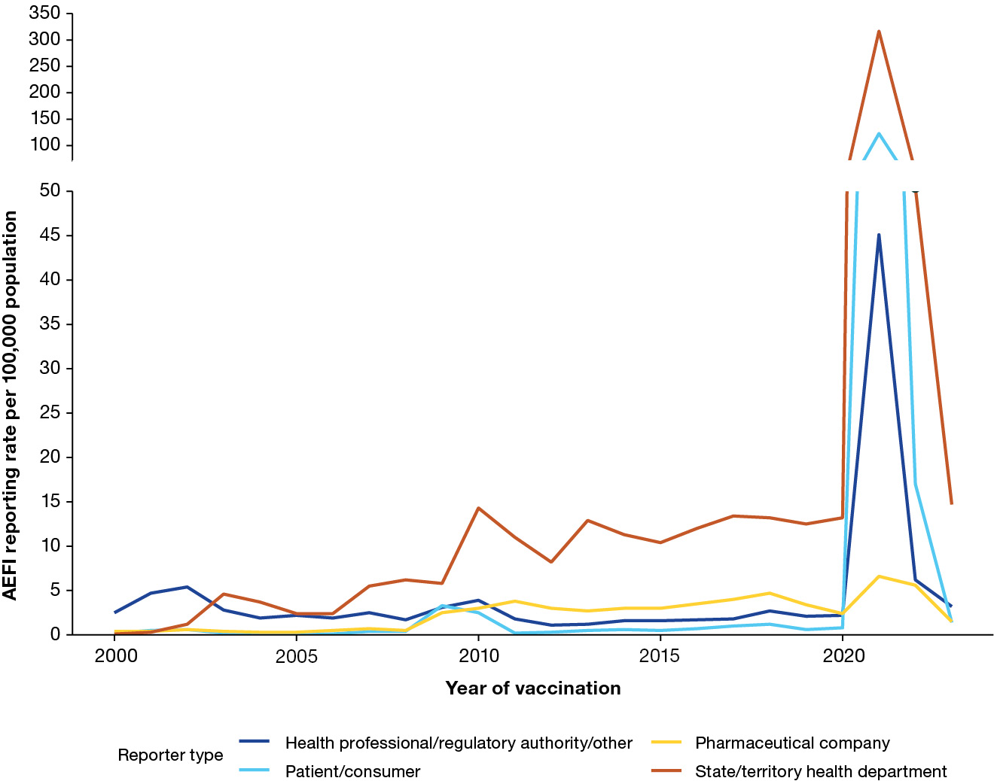
a For reports where the date of vaccination was not recorded, the date of symptom onset or the received date (when the event was reported to the sender of the case) was used. For more details on changes to the National Immunisation Program, please refer to Appendix A, Table A.1. Population data was sourced from the Australian Bureau of Statistics and represents the mid-year total Australian Estimated Resident Population for each calendar year.

