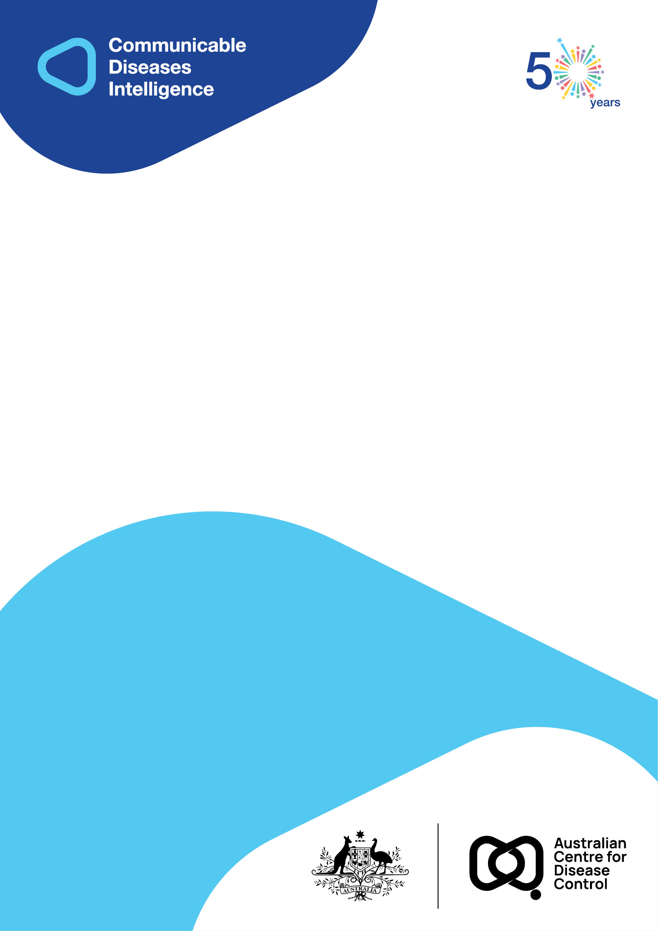
2026 • Volume 50 • cdc.gov.au/cdi • Epub date: 24.03.2026 • doi.org/10.33321/cdi.2026.50.026

Shigellosis: antibiotics should be strictly reserved for severe disease and cases at very high risk of onward transmission
Bhakti R Vasant, Mark Stickley, Megan Young, Kate Alexander, Robert Bell, Amy V Jennison, Rikki Graham, Asha Kakkanat, Russell Stafford
© 2026 Commonwealth of Australia as represented by the Australian Centre for Disease Control
ISSN: 2209-6051 Online
This journal is indexed by Index Medicus and Medline.
Creative Commons Licence
This publication is licensed under a Creative Commons Attribution-NonCommercial-NoDerivatives 4.0 International Licence (Licence). You must read and understand the Licence before using any material from this publication.
Restrictions
The Licence does not cover, and there is no permission given for, use of any of the following material found in this publication (if any):
- the Commonwealth Coat of Arms (by way of information, the terms under which the Coat of Arms may be used can be found on the Department of Prime Minister and Cabinet website);
- any logos (including the Australian Centre for Disease Control’s logo) and trademarks;
- any photographs and images;
- any signatures; and
- any material belonging to third parties.
Disclaimer
Opinions expressed in Communicable Diseases Intelligence are those of the authors and not necessarily those of the Australian Government or the Australian Centre for Disease Control. Data may be subject to revision.
Enquiries
Enquiries regarding any other use of this publication should be addressed to the CDI Editor.
About CDI
Communicable Diseases Intelligence (CDI) is a peer-reviewed scientific journal published by the Australian Centre for Disease Control.
The journal aims to disseminate information on the epidemiology, surveillance, prevention and control of communicable diseases of relevance to Australia and the near region.
Editor: Elise Firman • Deputy Editor: Simon Petrie • Design and Production: Lisa Thompson
Editorial Advisory Board: David Durrheim, Mark Ferson, Clare Huppatz, John Kaldor, Martyn Kirk and Meru Sheel
Submit an Article
Guidelines for authors and details on how to submit your publication is available on our website, or by email to the
CDI Editor.
Contact us
Communicable Diseases Intelligence (CDI)
Australian Centre for Disease Control
GPO Box 798, CANBERRA ACT 2601
Website: cdc.gov.au/cdi
Email: cdi.editor@cdc.gov.au

Contents
Abstract 4
Introduction 5
Methods 6
Results 7
Discussion and conclusions 10
Author details 11
References 12

Abstract
Increasing rates of multidrug-resistant (MDR) and extensively drug-resistant (XDR) Shigella have been detected worldwide. This retrospective review of shigellosis notifications in Southeast Queensland found that XDR Shigella accounted for 48% of notifications. Antimicrobial treatment should be reserved for individuals with severe disease, immunocompromise or high risk of onward transmission.
Keywords: antimicrobial resistance; public health; shigellosis

Introduction
Shigella species cause diarrhoeal illness that is usually self-limiting but may be life-threatening, particularly in children aged five years and under; in malnourished people; and in immunocompromised people.¹ Shigellosis may be foodborne or sexually acquired. Specific Shigella clones have emerged as an important cause of sexually transmitted infections circulating in communities of men who have sex with men (MSM) in Australia and elsewhere.¹ Antimicrobial treatment reduces symptom duration by two days and is indicated for individuals with severe diarrhoea or immunocompromise. Treatment may also be used to reduce onward transmission. Groups considered at higher risk of transmitting Shigella include MSM; children younger than six years; food handlers; healthcare workers; childcare workers; and people living in or working in residential care facilities.^{2,3} Among MSM, shigellosis is associated with having dense sexual networks; living with human immunodeficiency virus (HIV); using HIV pre-exposure prophylaxis; use of mobile phone applications to meet sexual partners; visiting sex on premises venues; chemsex (sex between men that occurs under the influence of drugs taken immediately before or during sex); and oral-anal sexual contact.^{3,4}
Globally, indiscriminate antimicrobial use has driven the emergence of Shigella isolates that are multidrug-resistant (MDR) and extensively drug-resistant (XDR).¹ MDR Shigella are resistant to three or more of the following antibiotic classes: azithromycin; fluoroquinolones; third generation cephalosporins; co-trimoxazole; and ampicillin.⁵ XDR Shigella are phenotypically resistant to third generation cephalosporins or have genotypic detection of an extended spectrum beta-lactamase (ESBL) gene. Our study aimed to describe the epidemiology, including antimicrobial resistance patterns, of shigellosis in Southeast Queensland in 2022 and 2023 to help inform future public health management.

Methods
We conducted a retrospective review of cases of shigellosis notified to the Gold Coast, Metro North and Metro South Public Health Units from 1 January 2022 to 31 December 2023. Cases were included if they met the Communicable Diseases Network Australia (CDNA) definition for confirmed shigellosis.⁶
Demographic, epidemiological, laboratory and clinical data were abstracted from Public Health Unit records and from Queensland Health’s Notifiable Conditions System (NoCS). Public and private pathology laboratories provided phenotypic antimicrobial resistance data to NoCS. Genotypic antimicrobial resistance data were obtained from the Public and Environmental Health Reference Laboratory (PEHRL). Whole genome sequencing was performed using accredited methods. ResFinder and PointFinder were used to detect acquired and chromosomal mutations.⁷
Data were analysed using Microsoft Excel’s descriptive statistics tools. Ethics approval was obtained from Metro South Health Human Research Ethics Committee (HREC/2024/QMS/105419).

Results
Of 98 cases of shigellosis notified to participating Public Health Units, 67 were male. Case ranged in age from 1 to 87 years (median 35 years; Table 1). Of notified cases, 56% were overseas acquired and 37% were in men who have sex with men. Groups traditionally considered at high risk for transmitting Shigella, including childcare attendees and workers, food handlers and healthcare workers, accounted for 13% of cases. Eighteen percent of cases were hospitalised.
Of notified cases, 95 were analysed for markers of genotypic resistance. Of these, 48.4% were XDR; 5.4% were MDR but sensitive to third generation cephalosporins; and 21.1% were resistant to all of ampicillin, ciprofloxacin, co-trimoxazole, ceftriaxone and azithromycin. XDR Shigella was more common in MSM cases than in overseas acquired cases. Eight cases identified as MSM and acquired Shigella infection overseas. No carbapenem resistance was detected. Sixty-one percent of cases were treated with antibiotics; 71.9% received appropriate antibiotics.
Table 1: Characteristics and treatment of cases of shigellosis notified to three Public Health Units in Southeast Queensland, 1 January 2022 – 31 December 2023
Characteristic | Category | Nª | Cases
Characteristic | Category | Nª | n | %
Age in years | — | 98 | 35^{b} | 1–87^{c}
Sex | male | 98 | 67 | 68.4%
Species | Shigella sonnei | 98 | 63 | 64.3%
Species | Shigella flexneri | 98 | 31 | 31.6%
Overseas acquired | — | 95 | 53 | 55.8%
Men who have sex with men (MSM) | — | 97 | 36 | 37.1%
Case is in groups traditionally listed as high-risk^{d} | — | 98 | 13 | 13.3%
Hospitalisation^{e} | — | 98 | 18 | 18.4%
Phenotypic antimicrobial resistance results | Ampicillin resistant | 79 | 52 | 65.8%
Phenotypic antimicrobial resistance results | Ciprofloxacin resistant | 76 | 41 | 53.9%
Phenotypic antimicrobial resistance results | Co-trimoxazole resistant | 80 | 60 | 75.0%
Phenotypic antimicrobial resistance results | Ceftriaxone resistant | 48 | 15 | 31.3%
Phenotypic antimicrobial resistance results | Azithromycin resistant | 52 | 33 | 63.5%
Genotypic antimicrobial resistance results | Ampicillin resistant | 95 | 62 | 65.3%
Genotypic antimicrobial resistance results | Ciprofloxacin resistant | 95 | 48 | 50.5%
Genotypic antimicrobial resistance results | Co-trimoxazole resistant | 95 | 67 | 70.5%
Genotypic antimicrobial resistance results | Ceftriaxone resistant | 95 | 46 | 48.4%
Genotypic antimicrobial resistance results | Azithromycin resistant | 95 | 42 | 44.2%
Extended spectrum beta-lactamase (ESBL) gene detected | — | 84 | 32 | 38.1%
Summary of antimicrobial resistance^{f} | XDR^{g} | 95 | 46 | 48.4%
Summary of antimicrobial resistance^{f} | MDR^{h} but not XDR | 95 | 5 | 5.4%
Antimicrobial resistance in MSM | XDR | 35 | 28 | 80.0%
Antimicrobial resistance in MSM | MDR but not XDR | 35 | 4 | 11.4%
Antimicrobial resistance in overseas acquired cases | XDR | 51 | 17 | 33.3%
Antimicrobial resistance in overseas acquired cases | MDR but not XDR | 51 | 2 | 3.9%
Treated with antibiotics | — | 72 | 44 | 61.1%
Treated with antibiotics | Treated with a suitable antibiotic, based on phenotypic resistance patterns | 32 | 23 | 71.9%
a Total number of cases for which data on the category (or, where ‘category’ is blank, the characteristic) is available.
b Median age in years, from 98 cases.
c Range of ages in years, from 98 cases.
d Groups traditionally considered at high risk of transmitting Shigella include childcare attendees, childcare workers, healthcare workers and food handlers.
e Median duration of hospitalisation was 4 days, with a range of 1–9 days, from 18 hospitalised cases.
f Summary is based on genotypic antimicrobial resistance and ESBL gene detection.
g XDR (extensively drug resistant): isolate that is phenotypically resistant to any third generation cephalosporin (e.g. ceftriaxone/cefotaxime/ceftazidime) or with genotypic detection of an ESBL gene.
h MDR (multidrug resistant): isolate that is resistant to three or more of the following antibiotic classes: ampicillin; fluoroquinolones; co-trimoxazole; third generation cephalosporin; azithromycin.

Discussion and conclusions
Our study found high levels of antimicrobial resistance, with XDR Shigella accounting for nearly 50% of all cases of shigellosis and 80% of MSM cases. Where drug susceptibility testing results were available and antibiotics were administered, 72% of cases received an appropriate antibiotic as assessed by susceptibility testing results.
Our findings are consistent with other reports of shigellosis showing high rates of antimicrobial resistance in Australia, particularly among MSM.^{8,9} To our knowledge, this is the first Australian study to assess appropriateness of antibiotics administered, based on drug susceptibility testing. Clinical guidelines should be updated to recommend antimicrobial treatment is reserved for cases with severe illness, immunocompromise, or following a case-by-case risk assessment of onward transmission. All cases should be provided with education to prevent transmission, including hand hygiene and abstinence from sexual contact until no longer infectious. Cases in high-risk groups (including food handlers) should be excluded from higher-risk work duties until they have microbiological evidence of clearance, defined as one negative stool culture or PCR, collected at least 48 hours after diarrhoea has ceased and no sooner than 48 hours after finishing antibiotics.¹⁰ If provided, treatment should preferably be based on antibiotic susceptibility. Where empiric treatment is required, carbapenems may be the only effective option.
Among MSM populations, health promotion is required to prevent sexually transmitted shigellosis. Messaging should be integrated into pre-exposure prophylaxis (PrEP) for HIV prevention and routine HIV care.¹¹ Potential harm reduction strategies should be considered, including washing hands, sex toys, genitals and anus before and after sexual contact.¹²
This study has potential limitations. Not all cases receive a microbiological diagnosis due to the self-limiting nature of the illness. Some cases of Shigella may have been excluded because they were PCR positive but not culture positive. Genotypic data were not available for three of the 98 cases and some data were missing from Public Health Unit records, particularly regarding antibiotic use. Data about antibiotic use were missing for 26/98 cases.
Shigella spp. that are resistant to almost all antimicrobial classes are increasing.¹ A nationally coordinated approach across expert groups (laboratories, foodborne disease epidemiologists, STI experts) is required to manage the public health risks associated with XDR Shigella.¹³ Currently, case-level data submitted to the National Notifiable Disease Surveillance System (NNDSS) do not include antimicrobial resistance data. Phenotypic antimicrobial susceptibility testing data submitted to the Critical Antimicrobial Resistance Alert System (CARAlert) should be connected to case-level data in NNDSS to identify risk factors for XDR Shigella.¹³ A national genomic surveillance program may enhance our ability to respond to the threat of XDR Shigella.¹³
Our findings contribute to the understanding of drug-resistant Shigella in Southeast Queensland. A multifaceted approach is required to respond to the public health threats of MDR and XDR Shigella, including improved national surveillance of antimicrobial-resistant shigellosis, judicious use of antibiotics and integrating harm reduction messaging into PrEP.

Author details
Dr Bhakti R Vasant,^{1,2,3}
Dr Mark Stickley,^{1,4}
Assoc. Prof. Megan Young,^{2,3,5}
Dr Kate Alexander,⁶
Mr Robert Bell,⁷
Assoc. Prof. Amy V Jennison,⁸
Dr Rikki Graham,⁸
Dr Asha Kakkanat,⁸
Dr Russell Stafford⁷
- Metro South Public Health Unit, Building 5, 2404 Logan Road, Eight Mile Plains, QLD 4113
- School of Public Health, University of Queensland, 266 Herston Road, Herston, QLD 4006
- School of Medicine and Dentistry, Griffith University, 1 Parkland Drive, Southport, QLD 4215
- School of Medicine, University of Queensland, 288 Herston Road, Herston, QLD 4006
- Metro North Public Health Unit, Building 4, Rosemount Campus, Bryden St, Windsor, QLD 4030
- Gold Coast Public Health Unit, Building 1, Carrara Health Precinct, Carrara, QLD 4217
- Public Health Intelligence Branch, Queensland Health, 15 Butterfield Street, Herston, QLD 4006
- Public and Environmental Health Reference Laboratories, Queensland Health. 39 Kessels Road, Coopers Plains, QLD 4108

Corresponding author
Dr Bhakti R Vasant
Metro South Public Health Unit
PO Box 333
Archerfield QLD 4108
Phone: +61 7 3156 4000
Email: Bhakti.Vasant@health.qld.gov.au

References
- Baker S, Scott TA. Antimicrobial-resistant Shigella: where do we go next? Nat Rev Microbiol. 2023;21(7):409–10. doi: https://doi.org/10.1038/s41579-023-00906-1.
- Therapeutic Guidelines. Shigella enteritis (shigellosis). Antibiotic. [Webpage.] Melbourne: Therapeutic Guidelines; March 2025. [Accessed in April 2025.] Available from: https://app.tg.org.au/viewTopic?etgAccess=true&guidelinePage=Antibiotic&topicfile=c_ABG_Shigella-enteritis-shigellosis_topic_1.
- Siddiq M, O’Flanagan H, Richardson D, Llewellyn CD. Factors associated with sexually transmitted shigella in men who have sex with men: a systematic review. Sex Transm Infect. 2023;99(1):58–63. doi: https://doi.org/10.1136/sextrans-2022-055583.
- Bourne A. Chemsex / party and play: challenging assumptions, responding to need. [Weblog article.] Sydney: Health Equity Matters website; 27 June 2018. [Accessed in January 2026.] Available from: https://www.healthequitymatters.org.au/resources/chemsex-party-and-play-challenging-assumptions-responding-to-need.
- Australian Commission on Safety and Quality in Health Care (ACSQHC). National Alert System for Critical Antimicrobial Resistances (CARAlert) Laboratory Handbook. Sydney: ACSQHC; December 2022. [Accessed in April 2025.] Available from: https://www.safetyandquality.gov.au/publications-and-resources/resource-library/caralert-laboratory-handbook.
- Communicable Diseases Network Australia (CDNA), Australian Centre for Disease Control (Australian CDC). Shigellosis – Surveillance case definition. Canberra: Australian CDC; 1 July 2018. [Accessed in May 2025.] Available from: https://www.cdc.gov.au/resources/publications/surveillance-case-definition-shigellosis.
- Bortolaia V, Kaas RS, Ruppe E, Roberts MC, Schwarz S, Cattoir V et al. ResFinder 4.0 for predictions of phenotypes from genotypes. J Antimicrob Chemother. 2020;75(12):3491–500. doi: https://doi.org/10.1093/jac/dkaa345.
- Baumgart S, Phan T, McKew G. Epidemiology and antimicrobial resistance rates for Shigella species in a resource-rich setting. Pathology. 2025;57(1):94–9. doi: https://doi.org/10.1016/j.pathol.2024.07.004.
- Williamson D, Ingle D, Howden B. Extensively drug-resistant shigellosis in Australia among men who have sex with men. N Engl J Med. 2019;381(25):2477–9. doi: https://doi.org/10.1056/NEJMc1910648.
- Queensland State Government Department of Health (Queensland Health). Shigella Infection (Shigellosis). Queensland Health Guidelines for Public Health Units. [Webpage.] Brisbane: Queensland Health; July 2018. [Accessed in January 2026.] Available from: https://www.health.qld.gov.au/cdcg/index/shigellosis.
- Charles H, Prochazka M, Thorley K, Crewdson A, Greig DR, Jenkins C et al. Outbreak of sexually transmitted, extensively drug-resistant Shigella sonnei in the UK, 2021–2022: a descriptive epidemiological study. Lancet Infect Dis. 2022;22(10):1503–10. doi: https://doi.org/10.1016/S1473-3099(22)00370-X.
- Burns-Lynch C, Garcia-Williams A, Besrat B, Kachur R, Rosenberger J, Rutt C et al. A qualitative evaluation of the acceptability of shigellosis prevention recommendations among gay, bisexual, and other men who have sex with men. Sex Transm Dis. 2024;51(8):534–9. doi: https://doi.org/10.1097/OLQ.0000000000001968.
- Jennison AV, Sherry NL, Howden BP. Enhanced data sharing and coordination to ensure Australia can address the threat of extensively drug-resistant Shigella – a case study for consideration by the Australian Centre for Disease Control. Commun Dis Intell (2018). 2025;49. doi: https://doi.org/10.33321/cdi.2025.49.064.

R. Wright, Australian Government Department of Health, Disability and Ageing; email communication, March 2022.

