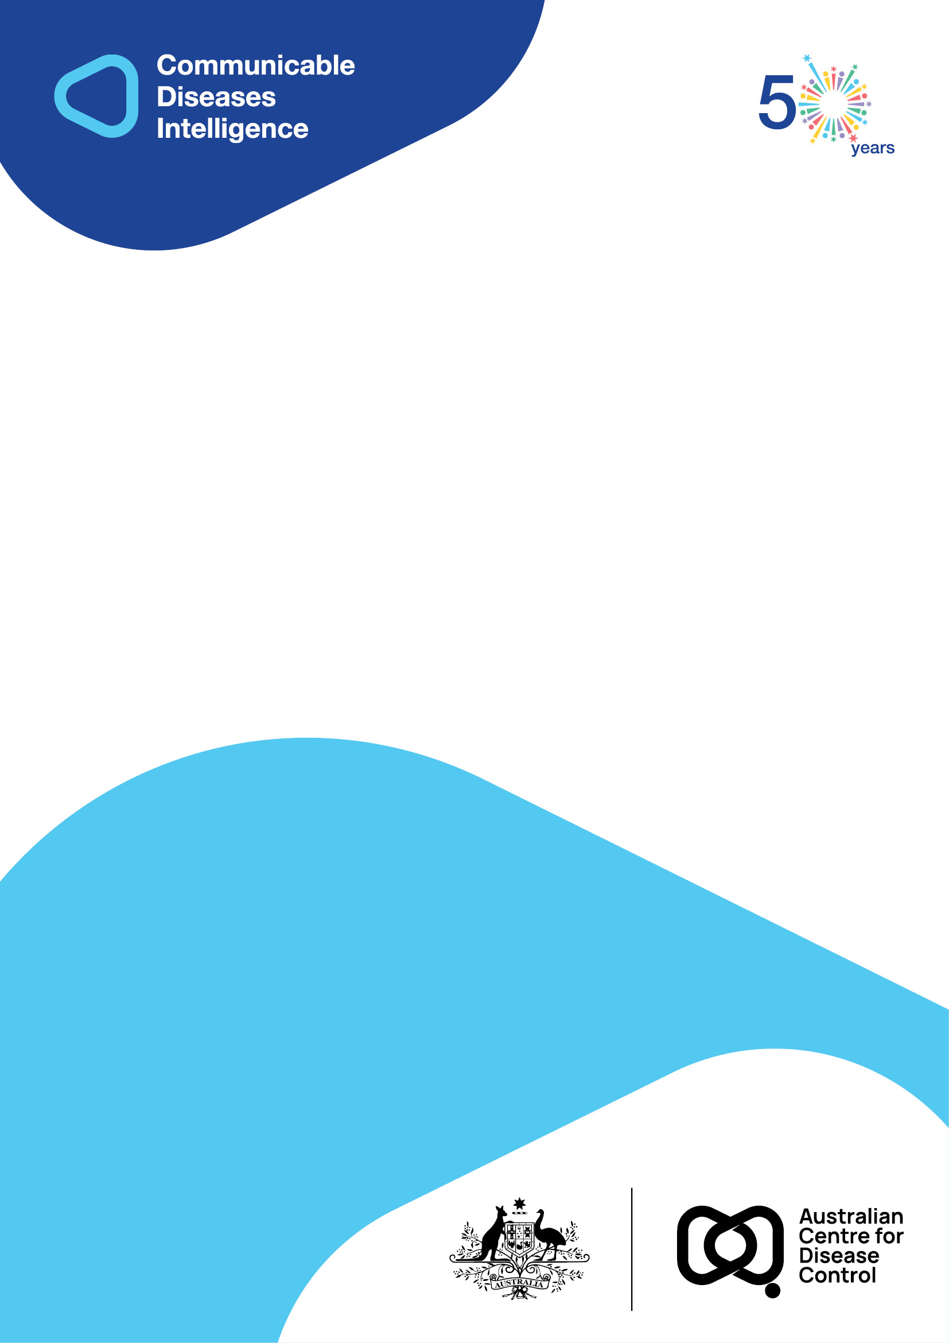
2026 • Volume 50 • cdc.gov.au/cdi • Epub date: 24.03.2026 • doi.org/10.33321/cdi.2026.50.019

Identifying missing links – an ongoing outbreak of a novel tuberculosis strain in regional Queensland
Bridget A O’Connor, Arnold Bainomugisa, Sushil Pandey, Gemma L Devlin, Christopher Coulter
© 2026 Commonwealth of Australia as represented by the Australian Centre for Disease Control
ISSN: 2209-6051 Online
This journal is indexed by Index Medicus and Medline.
Creative Commons Licence
This publication is licensed under a Creative Commons Attribution-NonCommercial-NoDerivatives 4.0 International Licence (Licence). You must read and understand the Licence before using any material from this publication.
Restrictions
The Licence does not cover, and there is no permission given for, use of any of the following material found in this publication (if any):
- the Commonwealth Coat of Arms (by way of information, the terms under which the Coat of Arms may be used can be found on the Department of Prime Minister and Cabinet website);
- any logos (including the Australian Centre for Disease Control’s logo) and trademarks;
- any photographs and images;
- any signatures; and
- any material belonging to third parties.
Disclaimer
Opinions expressed in Communicable Diseases Intelligence are those of the authors and not necessarily those of the Australian Government or the Australian Centre for Disease Control. Data may be subject to revision.
Enquiries
Enquiries regarding any other use of this publication should be addressed to the CDI Editor.
About CDI
Communicable Diseases Intelligence (CDI) is a peer-reviewed scientific journal published by the Australian Centre for Disease Control.
The journal aims to disseminate information on the epidemiology, surveillance, prevention and control of communicable diseases of relevance to Australia and the near region.
Editor: Elise Firman • Deputy Editor: Simon Petrie • Design and Production: Lisa Thompson
Editorial Advisory Board: David Durrheim, Mark Ferson, Clare Huppatz, John Kaldor, Martyn Kirk and Meru Sheel
Submit an Article
Guidelines for authors and details on how to submit your publication is available on our website, or by email to the
CDI Editor.
Contact us
Communicable Diseases Intelligence (CDI)
Australian Centre for Disease Control
GPO Box 798, CANBERRA ACT 2601
Website: cdc.gov.au/cdi
Email: cdi.editor@cdc.gov.au

Contents
Abstract 4
Background 4
Methods 4
Results 4
Conclusion 4
Introduction 5
Methods 6
Results 8
Discussion 14
Acknowledgments 16
Author details 17
References 18

Abstract

Background
Tuberculosis (TB) is a global public health problem, and community outbreaks occur. We report an outbreak of TB with an unusual MPT64 negative status, first detected in North Queensland, Australia, in 2017–2018.

Methods
A retrospective epidemiological and laboratory investigation into potentially linked cases was undertaken. Whole genome sequencing (WGS) phylogenetic and cluster analysis was performed. A confirmed outbreak case was defined as genomically closely related and a probable case as epidemiologically linked to a confirmed case, in the absence of WGS. Demographic characteristics and risk factors of outbreak cases were compared to other Australian-born cases in Queensland using univariate analysis. The aim of this study was to describe the outbreak, identify any associated risk factors and compare the epidemiological and genomic links between cases.

Results
Between 2002–2023, a total of 47 outbreak cases were identified: 44 (94%) were genomically linked and three (6%) were epidemiologically linked. Cases were all adults; 29 (64%) were male; 40 (89%) had pulmonary TB, of whom 30 (75%) were sputum smear positive. Compared to other Australian born cases, outbreak cases were more likely to be aged 25–44 years; to be Aboriginal and Torres Strait Islander peoples (First Nations peoples); to be residents of Central and Northern Queensland; and to experience a less successful TB treatment outcome (p < 0.05). Homelessness, previous incarceration, and substance use were significantly associated with being an outbreak case (p < 0.01). WGS analysis provided links for ten cases (24%) where no epidemiological links were identified.

Conclusion
Ongoing local transmission of a unique TB strain has persisted in Queensland’s First Nations communities and presents an opportunity to reconfigure TB prevention and care efforts in partnership with local communities. This study demonstrates the importance of integrating genomic data with traditional case investigation and contact tracing information, enhancing public health surveillance and targeted interventions to optimise TB management in high-risk populations.
Keywords: tuberculosis; outbreak; MPT64 negative TB strain; whole genome sequencing

Introduction
Tuberculosis (TB) remains a major public health problem, with a global incidence rate in 2023 of 134 cases per 100,000 population per year and in excess of a million TB deaths reported.¹ Australia is a low TB burden country, sustaining a notification rate of 5–7 cases per 100 000 population per year for the last three decades.² Most of the TB burden is within the overseas-born population and there are TB elimination targets in place to progress towards zero TB transmission in Australia.^{2,3} Queensland has one of the lowest notification rates of TB in Australia, although it shares a similar challenge in achieving equality in TB burden among all Queenslanders.^{2,4} Of TB notifications in Australian-born Queenslanders, a third are in Aboriginal and Torres Strait Islander (First Nations) peoples who currently comprise less than 5% of the state’s population.^{5,6}
According to an assessment of the TB burden in vulnerable populations, Indigenous peoples worldwide have a higher prevalence of TB which can vary due to geographical, cultural, sociopolitical, and biomedical reasons.⁷ Similar to global findings, Australia experiences higher rates of TB in First Nations peoples and has renewed focus on reducing the disparity in TB incidence between Australia’s First Nations peoples and other Australians.³
In Australia, whole genome sequencing (WGS) is increasingly being used to determine drug susceptibility, to identify clustering, and to inform local transmission patterns when combined with epidemiological information.^{8,9} However, few reported outbreaks of TB have been clearly defined using WGS and epidemiological methods. An extensive WGS analysis of TB in the Northern Territory showed that, although the number of clusters decreased overtime, several were longstanding, more likely to involve First Nations peoples and to occur in remote areas.⁸
In Queensland, WGS has previously been used to provide evidence of cross-border importation of multi-drug resistant TB (MDR-TB) from Papua New Guinea across the Torres Strait.¹⁰ The routine use of WGS in Queensland had not yet been established when the identification of three epidemiologically linked patients was notified during late 2017; a distinguishing feature shared by these patients was that their strain of Mycobacterium tuberculosis had tested negative to the MPT64 antigen test which is usually positive when TB is diagnosed.¹¹ This prompted an epidemiological investigation of potentially linked cases and the use of WGS to determine the genomic links between cases. In this study, we aim to describe the ongoing outbreak, to identify any associated risk factors, and to assess epidemiological and genomic links among the cases.

Methods
In Queensland, TB services are provided free of charge and are delivered by six regional and one metropolitan TB unit to cover the expansive geographical area. These TB units are responsible for management of active cases, contact management, collection of clinical and epidemiological information, and the initiation of local public health initiatives for TB control.
Data were extracted from the Notifiable conditions register (NoCS) in Queensland where, under the Public Health Act 2005, TB is notifiable by laboratories and diagnosing clinicians based on laboratory confirmation (of positive culture and nucleic acid test results) or clinical diagnosis. Surveillance data is added to NoCS by TB units based on nationally agreed definitions. For this investigation, TB units collected additional information from patients’ medical records on clinical presentation, TB risk factors and whether a likely source case had been identified. A likely source case was identified when there had been known contact with a person diagnosed with active TB, prior to the onset of symptoms in the outbreak case. Epidemiological links between cases were considered where local transmission was plausible based on geospatial and temporal association.¹² This information, along with TB surveillance data from NoCS, was collated using a purposely designed data collection form in Microsoft Excel for historical cases. As prospective cases were identified, data was entered directly into the expanded data collection in NoCS.
A confirmed outbreak case was defined as genomically closely related (≤ 5 single nucleotide polymorphism [SNP] difference) via WGS, consistent with national TB outbreak definitions.¹² A probable outbreak case was epidemiologically linked to a confirmed case where WGS data was not available (either without laboratory confirmation or where the diagnostic isolate was not available to sequence).
The national guidelines for TB case management and contact follow up were followed for all cases. Where assessment showed evidence of likely transmission in a particular setting such as a homeless shelter, extended contact screening and local community engagement was undertaken. TB nurses worked locally with First Nations health workers to engage with communities in the public health response.
Descriptive analysis was undertaken in Microsoft Excel and Stata version 16. Treatment outcomes were categorised into treatment success, no treatment success, treatment outcome unknown or pending (when still under treatment).¹³ Comparison was made between outbreak cases and other Australian-born non-outbreak cases notified during the same period 2002–2023, using routinely collected TB data in NoCS. Demographic characteristics, disease presentation, risk factors and treatment outcome were compared using logistic regression or Wilcoxon rank sum (for diagnosis delay) and a p value less than 0.05 was considered significant. The comparison of risk factors and potential diagnosis delay was limited to 2018–2023 as the collection of data was consistent for both outbreak and comparison groups during this period.
TB isolates were retrospectively compared using Variable number of tandem repeats-Mycobacterium interspersed repetitive unit (VNTR-MIRU), which was the typing method used by the Queensland Mycobacterial Reference Laboratory (QMRL) from 2001. A laboratory typing database (Bionumerics v6.7, Applied Maths, Belgium) identified historical isolates with VNTR-MIRU consistent with the outbreak strain.¹⁴ For those with consistent VNTR-MIRU, all retrievable isolates were tested for MPT64 antigen. Those testing MPT64 antigen negative underwent WGS. Any laboratory confirmed cases with the same typing profile were requested from other Australian jurisdictions.
WGS phylogenetic and cluster analysis was performed by QMRL for all isolates.¹⁴ We compared the outcomes of known epidemiological links (confirmed and possible links as noted at the time of diagnosis and treatment) between cases with the WGS analysis.
This investigation was in accordance with the Public Health Act 2005 in response to a notifiable condition in Queensland. In addition, low risk research ethics approval was granted by the Forensic and Scientific Services Human Ethics Committee, Queensland Health, for the use of WGS combined with epidemiological data, which was not routine at the time of the investigation.

Results
A total of 47 outbreak cases were identified from 1 January 2002 to 31 December 2023. Of these, 44 (94%) were confirmed cases linked by WGS and three (6%) were probable cases: two cases with clinical diagnoses and one laboratory confirmed diagnosis where the diagnostic isolate was no longer available to sequence. Two of the confirmed cases were notified in New South Wales with earlier visits to Queensland. The epidemiological analysis was performed on 45 Queensland cases where data were available.
Case numbers ranged within 0–6 cases per year since 2002 (median 2 cases per year), with a peak in cases notified during 2012 corresponding to a previously known cluster of cases in Central and Northern Queensland regions (Figures 1 and 2). A secondary peak was also seen in 2019 following confirmation of the outbreak in 2018. The regional cities of Cairns and Townsville were the two areas of residence for nearly 60% of outbreak cases (26/45; Figure 2).
Cases were all adults, aged between 18–68 years with a median age of 42 years. Sixty-four percent of cases (29/45) were male. Eighty-seven percent (39/45) were First Nations Queenslanders, including 87% (34/39) identifying as Aboriginal peoples, 10% (4/39) as Torres Strait Islander peoples and one person identifying as both an Aboriginal and Torres Strait Islander person. There were two cases born overseas; one was exposed to a confirmed outbreak case as a healthcare worker.
Most cases presented with symptoms consistent with TB (29/45; 64%), whereas 20% (9/45) had TB diagnosed incidentally when presenting for an unrelated illness, 11% (5/45) were identified through contact tracing and information was not known for 4% (2/45).
Eighty-nine percent of cases (40/45) had pulmonary TB, including 13% (6/45) with extrapulmonary sites involved. Of those with pulmonary disease, 75% (30/40) were sputum smear positive. Eleven percent (5/45) had extrapulmonary disease only, affecting lymph nodes, pleura, abdomen, bone/joint and central nervous system.
Figure 1: Tuberculosis outbreak cases by year of diagnosis and outbreak case definition, Queensland, 2002–2023
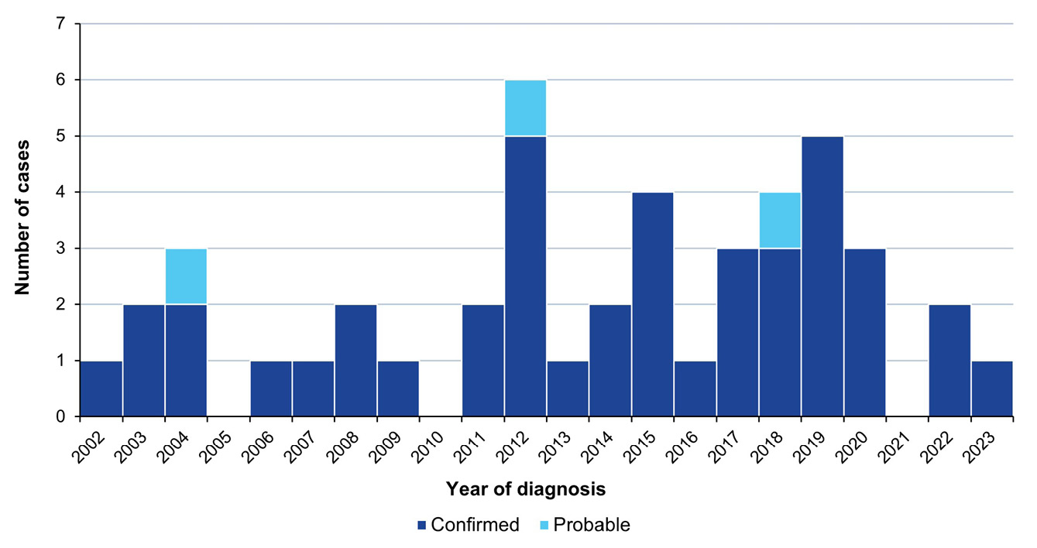
Figure 2: Outbreak cases by Local Government Area of residence at the time of diagnosis,ª Queensland, 2002–2023
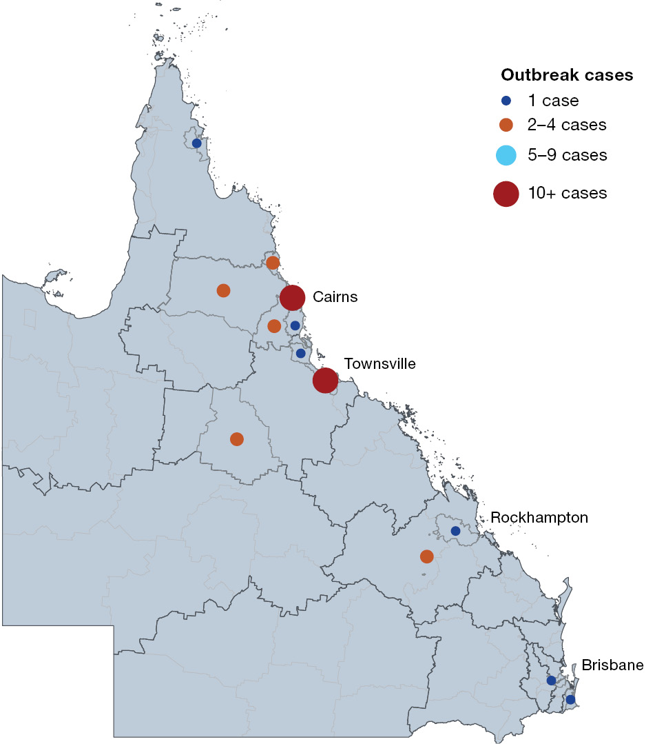
a Circles are placed in the centre of the relevant local government area; they do not represent the precise location of cases.
Of the 45 Queensland cases, 84% (38/45) completed a recommended course of TB treatment; 11% of cases (5/45) died, with four of these dying of TB and one of another cause. Four percent of cases (2/45) were lost to follow up and did not complete treatment. There were no outbreak cases with TB-HIV co-infection, and all were susceptible to first-line TB drugs.
A measure of possible patient delay (days from symptom onset to presentation for medical assessment) was the same for outbreak cases (median: 8 days; interquartile range [IQR]: 3–16 days) and the comparison group (median: 8 days; IQR: 1–20 days) during 2018–2023. A measure of health system delay (days from presentation to diagnosis) during the same time period was shorter for outbreak cases (median: 3.5 days; IQR: 3–10 days) than for the comparison group (median: 10 days; IQR: 4.5–17 days).
Compared to Australian-born cases notified with TB during 2002–2023, outbreak cases were more likely to be aged 25–44 years; to be First Nations peoples; to be residents of central, north, and far north Queensland compared to southeast Queensland; and to have a less successful outcome of their TB treatment than other Australian-born cases (Table 1).
Table 1: Characteristics of tuberculosis (TB) outbreak cases and comparison group, Queensland, 2002–2023
Characteristic | Variable | Outbreak cases  (N = 45) |  | Australian-born non outbreak cases  (N = 535) |  | p value
Characteristic | Variable | Number | Percentage | Number | Percentage | p value
Sex | Male | 29 | 64 | 337 | 63 | 0.85
Sex | Female | 16 | 36 | 198 | 37 | reference
Age group | 0–24 years | 4 | 9 | 73 | 14 | reference
Age group | 25–44 years | 22 | 49 | 125 | 23 | 0.04
Age group | 45–64 years | 18 | 40 | 191 | 36 | 0.34
Age group | 65+ years | 1 | 2 | 146 | 27 | 0.06
First Nations status | First Nations peoples | 39 | 87 | 172 | 32 | < 0.01
First Nations status | Other Queenslanders | 6 | 13 | 363 | 68 | reference
Queensland geographical regionª | Torres & Cape and Cairns | 22 | 49 | 128 | 24 | < 0.01
Queensland geographical regionª | Townsville and North West Queensland | 16 | 36 | 69 | 13 | < 0.01
Queensland geographical regionª | Mackay, Central and South West Queensland | 5 | 11 | 43 | 8 | < 0.01
Queensland geographical regionª | South East Queensland | 2 | 4 | 294 | 55 | reference
Queensland geographical regionª | Overseas resident | 0 | 0 | 1 | 0 | —
TB site of disease | Pulmonary involvement | 40 | 89 | 410 | 77 | 0.15
TB site of disease | Extrapulmonary TB only | 5 | 11 | 103 | 19 | reference
TB site of disease | Unknown | 0 | 0 | 22 | 4 | —
Bacteriological status (pulmonary TB) | Acid-fast bacilli (AFB) smear positive | 30 | 75 | 192 | 50 | 0.29
Bacteriological status (pulmonary TB) | AFB smear negative | 8 | 20 | 147 | 38 | reference
Bacteriological status (pulmonary TB) | Unknown | 2 | 5 | 46 | 12 | —
Treatment outcome | Successful (cured; completed treatment) | 38 | 84 | 452 | 84 | reference
Treatment outcome | Not successful (treatment failure; died of TB) | 6 | 13 | 28 | 5 | 0.05
Treatment outcome | Unknown^{b} | 1 | 2 | 53 | 10 | 0.15
Treatment outcome | Pending (still on treatment) | 0 | 0 | 2 | 0 | —
a Geographical region is based on residential health service region.
b Unknown outcomes: interrupted treatment; lost to follow up; transferred overseas; died from other cause; unknown.

Table 2: Tuberculosis (TB) risk factors in outbreak and comparison group, Queensland, 2018–2023
Variable | Outbreak cases (N = 15) |  | Australian-born non outbreak cases (N = 119) |  | p value
Variable | Number | Percentage | Number | Percentage | p value
Known close contact with TB | 12 | 80 | 33 | 28 | 0.001
Lived or travelled in high TB incidence country | 1 | 7 | 39 | 33 | 0.068
Ever experienced homelessness | 12 | 80 | 5 | 4 | < 0.001
Ever resided in a correctional centre | 3 | 20 | 3 | 3 | 0.009
Excessive alcohol consumption | 14 | 93 | 8 | 7 | < 0.001
Non intravenous drug use | 10 | 67 | 9 | 8 | < 0.001
The risk factors were compared during the time period where data collection was consistent for both groups: 2018–2023. The risk factors significantly associated with the outbreak included known close contact with TB; being homeless; being previously incarcerated; and excessive alcohol use or using non-injectable drugs (Table 2). The type of non-injectable drugs reported by outbreak cases was marijuana in the form of ‘bong-smoking’ where the drug is used via a shared water pipe, inhaled through the mouth.¹⁵
Other details collected by TB clinics on epidemiological links included residence in homeless shelters and a small family cluster. There were no epidemiological links identified for nine cases, and only possible epidemiological links identified for a further six cases. For three cases, their TB infection was picked up postmortem; however, epidemiological links were identified posthumously for two of these cases.
WGS results demonstrated the outbreak strain to be a globally unique sub-lineage 4.1.1.1 with limited genomic diversity demonstrated by 98% genomic clustering at 5 SNP threshold. As previously described,¹⁴ a molecular clock tree identified six plausible transmission pathways consisting of 3–14 cases per branch (Figure 3). Only three of the six branches demonstrated alignment between epidemiological and genomic links. Of the 42 Queensland cases that were sequenced, 98% (41/42) formed one genomic cluster at 5 SNP threshold, and 32 had epidemiological links identified with other outbreak cases (n = 26 confirmed epidemiological links, n = 6 possible epidemiological links), while 10 had no epidemiological links identified. However, two of these cases had a known epidemiological link to a family member who was not identified in the outbreak. The comparison of epidemiological links and genomic links indicate that 88% (28/32) of cases had epidemiological links confirmed by the genomic links; this confirmation improved to 100% (12/12) in the more recent period, 2018–2023 (Table 3). However, nearly a quarter of outbreak cases with genomic links (10/42) had no known or confirmed epidemiological links. Overall, WGS provided links between one third of cases (14/42) where an epidemiological link was not known; a small number of these had known epidemiological links to other cases which were not confirmed by WGS.
Figure 3: Whole genome sequencing cluster analysis of outbreak cases, Queensland 2002–2023ª
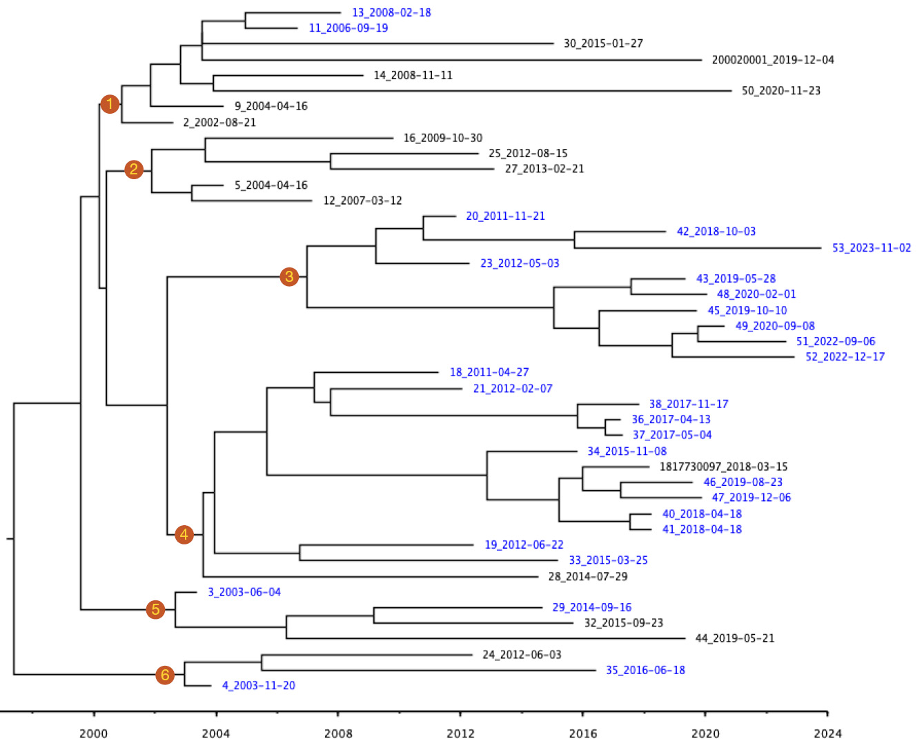
a Blue highlighting indicates where epidemiological and genomic links align within the numbered branches.
Table 3: Comparison of genomic and epidemiological links between cases for total and recent (2018–2023) outbreak cases, Queensland, 2002–2023
Category | Variable | Location on WGSª cluster analysis |  |  |  |  |  | Total
Category | Variable | Branch 1 | Branch 2 | Branch 3 | Branch 4 | Branch 5 | Branch 6 | Number | Percentage
Total confirmed outbreak cases (2002–2023) | Number | 7 | 5 | 10 | 13 | 4 | 3 | 42 | —
Total confirmed outbreak cases (2002–2023) | Number with epidemiological links and genomic links available | 2 | 3 | 10 | 13 | 2 | 2 | 32 | 76
Total confirmed outbreak cases (2002–2023) | Number with epidemiological links in same branch | 2 | 0 | 10 | 12 | 2 | 2 | 28 | 67
Recent confirmed outbreak cases (2018–2023) | Number | 1 | 0 | 8 | 4 | 1 | 0 | 14 | —
Recent confirmed outbreak cases (2018–2023) | Number with epidemiological links and genomic links available | 0 | 0 | 8 | 4 | 0 | 0 | 12 | 86
Recent confirmed outbreak cases (2018–2023) | Number with epidemiological links in same branch | 0 | 0 | 8 | 4 | 0 | 0 | 12 | 86
a WGS: whole genome sequencing.

Discussion
This investigation confirms ongoing transmission of a unique TB strain over two decades in Queensland, predominately impacting First Nations peoples in Central and Northern Queensland. This outbreak is ongoing, and its prolonged nature may be enabled by a combination of both TB strain and individual characteristics. The outbreak strain is part of a lineage involved in previously reported TB outbreaks,^{9,16} but this outbreak is larger than any earlier reported in Australia. The mutation behind the MPT64 negative result may cause reduced immune response and may potentially add to sustained transmission.¹⁴ Although measured only in more recent cases, there was a shorter time from presentation to diagnosis for outbreak cases, which reduces the likelihood that health system delays played a role in presentations of advanced disease and related mortality seen in outbreak cases. It also raises the possibility that the MPT64 negative strain may be associated with more severe disease.
The risk profile of the outbreak cases indicates a lack of stable housing may contribute to transmission in communal and sometimes crowded settings such as homeless shelters. The findings for First Nations peoples in Queensland are consistent with global findings showing that social determinants of health remain important drivers of high TB burden.⁷
Although previous reviews have found only weak evidence to associate cannabis use with TB disease,¹⁷ this outbreak supports an association between bong smoking and TB transmission with two-thirds of cases during 2018–2023 reporting bong smoking in addition to excessive alcohol use.
It is notable that no children have been involved in this outbreak to date. Queensland has a policy of recommending and funding Bacillus Calmette–Guérin (BCG) vaccination to First Nations infants, consistent with accepted efficacy in preventing severe TB disease in this age group. Although it is difficult to estimate the degree of vaccine coverage in communities affected by this outbreak, this finding aligns with the current recommendations for BCG vaccine in Queensland.¹⁹ Other factors may be important in contributing to the lack of childhood cases within the outbreak, such as a lack of exposure to the specific risk behaviours associated with the outbreak. While under-diagnosis of TB in children is possible, previous studies from Queensland have highlighted the over-representation of First Nations children in notifications of paediatric TB, suggesting high clinician awareness of the condition.¹⁸
This outbreak confirmed the benefit WGS added in identifying the extent and ongoing nature of the outbreak, in contrast to earlier typing methods. Additionally, WGS supported the identification of likely transmission pathways, particularly for historical cases. WGS results also indicated where more recent chains of transmission have occurred and can be used to inform the public health response.²¹ This highlights the importance of ongoing culturally appropriate communication to share information regarding settings for transmission where genomic linkage is close but epidemiological links are not initially apparent.
The likelihood of missing cases is very high, as suggested by WGS analysis,¹⁴ and earlier outbreak cases with known exposure to family members with TB that were not able to be linked to the outbreak. While used as a diagnostic test elsewhere, the MPT64 antigen test in Queensland and Australia is supplemented by molecular methods; this has ensured these strains were not missed once laboratory testing was available.
The limitations of this study include retrospective data collection on epidemiological links and risk factors. It is possible that links were missed for historical cases, either at the time of diagnosis or at the time of the outbreak investigation. This may explain why prospective collection of epidemiological links was better aligned to genomically supported transmission pathways. The collection of risk factor information in statewide and national datasets has also expanded over the duration of the outbreak, resulting in a shorter period to be analysed (2018–2023) with consistent data across both outbreak and comparison groups.
An increased incidence of TB in First Nations peoples in Far North Queensland has been identified since the 1990s.^{22,23} Although there is evidence that the proportion of TB in First Nations residents of Far North Queensland has reduced, probably as a result of changes in service areas,²⁴ rates of TB remain the highest in these regions where the extent of this outbreak remained unidentified for a long time.⁵ The risk factors associated with this outbreak, such as homelessness and substance use, present local challenges, and exemplify the need for renewed efforts to address social determinants of health and to reconfigure TB prevention and care in Australia and enable a community-led approach.^{3,25–27}
The outbreak also highlights that local transmission of TB remains an issue in Australia, although most TB disease burden is attributed to reactivation of latent TB infection in overseas-born cases.² An important challenge remains to reduce local transmission and the disparity in incidence of TB between First Nations peoples and other Australian-born people, as we work towards the goal of zero transmission as a low incidence country.^{3,28}
In conclusion, this outbreak presents some key challenges for TB management in Queensland and Australia. The ongoing nature of the outbreak presents an opportunity for health services to adapt and adopt First Nations community-led and empowered approaches²⁹ to reduce TB transmission in Queensland. For TB elimination to progress, comprehensive surveillance that integrates case investigation data (and incorporates epidemiological links and contact tracing information) with whole genome sequencing will allow for more timely identification of transmission chains and management of persons at risk for infection.

Acknowledgments
We thank the TB nursing staff including Trevor Knight, Cheryl Oats and Diane Jones and First Nations health workers in Cairns, Townsville, and Central Queensland Hospital and Health Service areas. We would also like to acknowledge the assistance of previous staff of Communicable Diseases Branch, especially Denise Jenkins.

Author details
Bridget A O’Connor,¹
Dr Arnold Bainomugisa,²
Dr Sushil Pandey,²
Ms Gemma L Devlin,^{3,4}
Dr Christopher Coulter^{2,3}
- Public Health Intelligence Branch, Queensland Public Health and Scientific Services
- Queensland Mycobacterium Reference Laboratory, Pathology Queensland
- Communicable Diseases Branch, Queensland Public Health and Scientific Services
- National Centre for Epidemiology and Population Health, Australian National University, Canberra, ACT, Australia.

Corresponding author
Bridget A O’Connor
Public Health Intelligence Branch, Queensland Public Health and Scientific Services, Queensland Health, 15 Butterfield Street, Herston, Queensland 4006
Email: bridget.oconnor2@health.qld.gov.au

References
- World Health Organization (WHO). Global Tuberculosis Report 2024. Geneva: WHO; 29 October 2024. Available from: https://www.who.int/teams/global-programme-on-tuberculosis-and-lung-health/tb-reports/global-tuberculosis-report-2024.
- Bright A, Denholm J, Coulter C, Waring J, Stapledon R. Tuberculosis notifications in Australia, 2015–2018. Commun Dis Intell (2018). 2020;44. doi: https://doi.org/10.33321/cdi.2020.44.88.
- National Tuberculosis Advisory Committee for the Communicable Diseases Network Australia. The strategic plan for control of tuberculosis in Australia, 2021–2025. Commun Dis Intell (2018). 2022;46. doi: https://doi.org/10.33321/cdi.2022.46.48.
- Australian Government Department of Health, Disability and Ageing, National Notifiable Disease Surveillance System. National Communicable Disease Surveillance Dashboard. [Internet.] Canberra: Australian Government Department of Health, Disability and Ageing; 2024. [Accessed on 16 November 2024.] Available from: https://nindss.health.gov.au/pbi-dashboard/.
- Queensland State Government Department of Health (Queensland Health). Tuberculosis in Queensland 2017–2019. Brisbane: Queensland Health; 2021. Available from: https://www.health.qld.gov.au/__data/assets/pdf_file/0020/1130555/report-tb-qld-2017-2019.pdf.
- Australian Bureau of Statistics. Snapshot of Queensland: High level summary data for Queensland in 2021. [Webpage.] Canberra: Australian Bureau of Statistics; 28 June 2022. [Accessed on 30 November 2024.] Available from: https://www.abs.gov.au/articles/snapshot-qld-2021.
- Litvinjenko S, Magwood O, Wu S, Wei X. Burden of tuberculosis among vulnerable populations worldwide: an overview of systematic reviews. Lancet Infect Dis. 2023;23(12):1395–407. doi: https://doi.org/10.1016/S1473-3099(23)00372-9.
- Meumann EM, Horan K, Ralph AP, Farmer B, Globan M, Stephenson E et al. Tuberculosis in Australia’s tropical north: a population-based genomic epidemiological study. Lancet Reg Health West Pac. 2021;15:100229. doi: https://doi.org/10.1016/j.lanwpc.2021.100229.
- Dale K, Globan M, Horan K, Sherry N, Ballard S, Tay EL et al. Whole genome sequencing for tuberculosis in Victoria, Australia: a genomic implementation study from 2017 to 2020. Lancet Reg Health West Pac. 2022;28:100556. doi: https://doi.org/10.1016/j.lanwpc.2022.100556.
- Bainomugisa A, Pandey S, Donnan E, Simpson G, Foster J, Lavu E et al. Cross-border movement of highly drug-resistant Mycobacterium tuberculosis from Papua New Guinea to Australia through Torres Strait Protected Zone, 2010–2015. Emerg Infect Dis. 2019;25(3):406–15. doi: https://doi.org/10.3201/eid2503.181003.
- Cao XJ, Li YP, Wang JY, Zhou J, Guo XG. MPT64 assays for the rapid detection of Mycobacterium tuberculosis. BMC Infect Dis. 2021;21(1):336. doi: https://doi.org/10.1186/s12879-021-06022-w.
- Denholm J, Coulter C, Bastian I, National Tuberculosis Advisory Committee. Defining a tuberculosis cluster or outbreak. Commun Dis Intell Q Rep. 2016;40(3):E356–9. doi: https://doi.org/10.33321/cdi.2016.40.37.
- Camphor HS, Viney K, Polkinghorne B, Pennington K. Retrospective analysis of multidrug-resistant tuberculosis case notifications in Australia (1999-2018). Commun Dis Intell (2018). 2020;44. doi: https://doi.org/10.33321/cdi.2020.44.68.
- Bainomugisa A, Pandey S, O’Connor B, Syrmis M, Whiley D, Sintchenko V et al. Sustained transmission over two decades of a previously unrecognised MPT64 negative Mycobacterium tuberculosis strain in Queensland, Australia: a whole genome sequencing study. Lancet Reg Health West Pac. 2024;47:101105. doi: https://doi.org/10.1016/j.lanwpc.2024.101105.
- Munckhof WJ, Konstantinos A, Wamsley M, Mortlock M, Gilpin C. A cluster of tuberculosis associated with use of a marijuana water pipe. Int J Tuberc Lung Dis. 2003;7(9):860–5.
- Żukowska L, Zygała-Pytlos D, Struś K, Zabost A, Kozińska M, Augustynowicz-Kopeć E et al. An overview of tuberculosis outbreaks reported in the years 2011–2020. BMC Infect Dis. 2023;23(1):253. doi: https://doi.org/10.1186/s12879-023-08197-w.
- French CE, Coope CM, McGuinness LA, Beck CR, Newitt S, Ahyow L et al. Cannabis use and the risk of tuberculosis: a systematic review. BMC Public Health. 2019;19(1):1006. doi: https://doi.org/10.1186/s12889-019-7127-0.
- Donnan EJ, Coulter C, Simpson G, Clark J, Nourse C. Paediatric tuberculosis in Queensland, Australia: overrepresentation of cross-border and Indigenous children. Int J Tuberc Lung Dis. 2017;21(3):263–9. doi: https://doi.org/10.5588/ijtld.16.0313.
- Queensland Health. BCG vaccination. [Internet.] Brisbane: Queensland Health; 8 March 2017. [Accessed on 16 November 2024.] Available from: https://www.health.qld.gov.au/clinical-practice/guidelines-procedures/diseases-infection/diseases/tuberculosis/treatment/bcg-vaccination.
- Australian Government Department of Health, Disability and Ageing, Australian Immunisation Handbook. Tuberculosis. [Internet.] Canberra: Australian Government Department of Health, Disability and Ageing; 2023. [Accessed on 16 November 2024.] Available from: https://immunisationhandbook.health.gov.au/contents/vaccine-preventable-diseases/tuberculosis.
- Donnan EJ, Marais BJ, Coulter C, Waring J, Bastian I, Williamson DA et al. The use of whole genome sequencing for tuberculosis public health activities in Australia: a joint statement of the National Tuberculosis Advisory Committee and Communicable Diseases Genomics Network. Commun Dis Intell (2018). 2023;47. doi: https://doi.org/10.33321/cdi.2023.47.8.
- Plant AJ, Krause VL, Condon JR, Kerr C. Aborigines and tuberculosis: why they are at risk. Aust J Public Health. 1995;19(5):487–91.
doi: https://doi.org/10.1111/j.1753-6405.1995.tb00416.x.
- Simpson G, Knight T. Tuberculosis in Far North Queensland, Australia. Int J Tuberc Lung Dis. 1999;3(12):1096–100.
- Wilson M, Weston J, Mullen A, Knight T, Simpson G. Tuberculosis in Far North Queensland, Australia: a retrospective clinical audit. Intern Med J. 2019;49(3):333–8. doi: https://doi.org/10.1111/imj.13994.
- Tibbetts KK, Ottoson RA, Tsukayama DT. Public health response to tuberculosis outbreak among persons experiencing homelessness, Minneapolis, Minnesota, USA, 2017–2018. Emerg Infect Dis. 2020;26(3):420–6. doi: https://doi.org/10.3201/eid2603.190643.
- Devlin S, MacLaren D, Massey PD, Widders R, Judd JA. The missing voices of Indigenous Australians in the social, cultural and historical experiences of tuberculosis: a systematic and integrative review. BMJ Glob Health. 2019;4(6):e001794.
doi: https://doi.org/10.1136/bmjgh-2019-001794.
- Laird P, Schultz A. Tuberculosis in Australia’s Top End First Nations highlights health and life expectancy gaps: a call to arms. Lancet Reg Health West Pac. 2021;15:100253. doi: https://doi.org/10.1016/j.lanwpc.2021.100253.
- Marais BJ, Walker TM, Cirillo DM, Raviglione M, Abubakar I, van der Werf MJ et al. Aiming for zero tuberculosis transmission in low-burden countries. Lancet Respir Med. 2017;5(11):846–8. doi: https://doi.org/10.1016/S2213-2600(17)30382-X.
- Inauen J, Storken A, Gill C, Brigham M, Kelly M, Barry S. Overcoming barriers in tuberculosis control: a case study from a remote community of South Australia. Lancet Reg Health West Pac. 2025;60:101604. doi: https://doi.org/10.1016/j.lanwpc.2025.101604.

