
2026 • Volume 50 • cdc.gov.au/cdi • Epub date: 24.03.2026 • doi.org/10.33321/cdi.2026.50.016

Measles epidemiology in Australia: 2014 to 2024
Lizzie Gorrell, Benjamin G Polkinghorne, David N Durrheim
© 2026 Commonwealth of Australia as represented by the Australian Centre for Disease Control
ISSN: 2209-6051 Online
This journal is indexed by Index Medicus and Medline.
Creative Commons Licence
This publication is licensed under a Creative Commons Attribution-NonCommercial-NoDerivatives 4.0 International Licence (Licence). You must read and understand the Licence before using any material from this publication.
Restrictions
The Licence does not cover, and there is no permission given for, use of any of the following material found in this publication (if any):
- the Commonwealth Coat of Arms (by way of information, the terms under which the Coat of Arms may be used can be found on the Department of Prime Minister and Cabinet website);
- any logos (including the Australian Centre for Disease Control’s logo) and trademarks;
- any photographs and images;
- any signatures; and
- any material belonging to third parties.
Disclaimer
Opinions expressed in Communicable Diseases Intelligence are those of the authors and not necessarily those of the Australian Government or the Australian Centre for Disease Control. Data may be subject to revision.
Enquiries
Enquiries regarding any other use of this publication should be addressed to the CDI Editor.
About CDI
Communicable Diseases Intelligence (CDI) is a peer-reviewed scientific journal published by the Australian Centre for Disease Control.
The journal aims to disseminate information on the epidemiology, surveillance, prevention and control of communicable diseases of relevance to Australia and the near region.
Editor: Elise Firman • Deputy Editor: Simon Petrie • Design and Production: Lisa Thompson
Editorial Advisory Board: David Durrheim, Mark Ferson, Clare Huppatz, John Kaldor, Martyn Kirk and Meru Sheel
Submit an Article
Guidelines for authors and details on how to submit your publication is available on our website, or by email to the
CDI Editor.
Contact us
Communicable Diseases Intelligence (CDI)
Australian Centre for Disease Control
GPO Box 798, CANBERRA ACT 2601
Website: cdc.gov.au/cdi
Email: cdi.editor@cdc.gov.au

Contents
Abstract 4
Background 4
Methods 4
Results 4
Conclusion 4
Introduction 5
Global context 5
Australian context 5
Methods 6
Notifications 6
Population estimates 6
Data analyses 6
Results 7
Seasonality 7
Trends by jurisdiction 8
Trends by age and sex 10
Genotype trends 12
Vaccination status 12
Country of acquisition 15
Discussion and conclusion 22
Acknowledgments 23
Author details 24
References 25

Abstract

Background
Endemic measles was verified as eliminated in Australia in 2014. We describe Australian measles epidemiology, 2014–2024.

Methods
National measles notification data were analysed by age; sex; state/territory of residence; genotype; place of acquisition (overseas/Australia); vaccination status (number of doses); and outbreak reference ID (for clusters).

Results
Between 2014 and 2024, there were 1,095 measles notifications (average annual notification rate 0.4 per 100,000 population per year). The highest annual notification rates were recorded in 2014 (1.4 per 100,000 per year) and 2019 (1.1 per 100,000 per year), when rates in the Northern Territory were 21.4 and 12.6 per 100,000 population per year, respectively. Although notification rates were highest among infants < 1 year of age (average 3.8 notifications per 100,000 population per year), people aged 20–49 accounted for 57.2% of total notifications (n = 626). Of cases with a known immunisation status (n = 766), there were 513 cases (66.9%) who reported being unvaccinated; 20.1% (n = 154) reported having received one dose of MMR vaccine prior to infection; and 12.1% (n = 93) reported two or more doses. For notifications where country of acquisition was available (n =1,077), just over half of cases (55.1%) were acquired in Australia. Where measles was acquired overseas (n = 493), the most common countries of acquisition were Indonesia (n = 99; 20.1%), the Philippines (n = 82; 16.6%) and India (n = 52; 10.5%). There were 47 clusters during the reporting period, of which the largest involved 74 linked cases in 2019. Of recorded clusters, 44 (93.6%) had a source country outside of Australia. Notifications tended to peak each year in the months coinciding with the end of Australian school holiday periods.

Conclusion
Australia has sustained measles elimination since 2014; this review of measles epidemiology, demonstrating a predominance of unvaccinated returning international travellers 20–49 years of age, provides strong motivation for maintaining high routine two-dose coverage and promoting measles vaccination to adults travelling internationally.
Keywords: Measles; measles epidemiology; measles elimination; vaccine preventable disease; measles surveillance; measles importation; vaccination; immunisation

Introduction
Measles virus is a highly infectious paramyxovirus; infection is characterised by coryza, cough, fever, and a maculopapular rash.¹ Complications of infection can include otitis media, diarrhoea, pneumonia, encephalitis, death, and, rarely, subacute sclerosing panencephalitis.¹ Despite being vaccine-preventable, measles remains a significant global public health concern, and in 2023 there were an estimated 107,500 measles deaths globally, mostly among unvaccinated or under-vaccinated children below 5 years of age.²
The last detailed review of measles epidemiology in Australia covered the period 2012–2019.³ The current analysis provides an updated description of the epidemiology of measles in Australia from 1 January 2014 to 31 December 2024, from verification of endemic measles elimination by the Regional Verification Commission through the COVID-19 pandemic, and in the context of global outbreaks and falling immunisation coverage.⁴

Global context
Following a period of declining international incidence, global measles cases surged more than fivefold between 2016 and 2019, with endemic transmission re-established in several countries across the Americas and Europe.³
Major outbreaks occurred in many countries including the Philippines, China, Democratic Republic of Congo (DRC), India, and Madagascar, with the DRC alone reporting over 333,000 cases in 2019. These outbreaks resulted in major global surges of cases in 2019 and again in 2024.^{5,6} According to the World Health Organization (WHO), there were over 3.6 million reported measles cases globally between 2014 and 2024, with an estimated 477,000 cases and 95,000 deaths in 2024 alone.^{5,7}
Routine immunisation and campaign interruptions associated with the COVID-19 pandemic, and decreased routine vaccination coverage in the post-pandemic period, are driving the current global surge in cases, with more than 22 million children estimated to have missed their first dose of measles vaccine in 2023, and only an estimated 74% of children ever receiving their second dose.⁸
A formal commitment to measles eradication has been postponed by the World Health Assembly (WHA)⁹ and replaced by a goal of achieving elimination in all six WHO regions by 2030.¹⁰

Australian context
Australia, declared free of endemic measles in 2014, has largely maintained low case numbers due to high vaccination coverage and effective public health responses. However, imported cases continue to pose a risk. Measles notifications dropped significantly during the years when COVID-19 pandemic control measures were in place, with zero cases reported in 2021. However, in the post-pandemic control period, cases have risen again, with 26 cases notified in 2023 and 57 in 2024. This rise in notifications was primarily linked to the reintroduction of overseas travel, underscoring the importance of maintaining high vaccination rates and vigilant surveillance.
No changes were made to the two-dose Measles Mumps Rubella (MMR) vaccine schedule under the National Immunisation Program (NIP) during the reporting period. However, national MMR vaccination coverage rates have declined year-on-year since 2020 (from 94.0% to 91.4% in 2024), with two-dose coverage at 24 months as low as 85% in some geographic areas in 2024.^{11–13}

Methods

Notifications
Notification data were extracted from the National Notifiable Diseases Surveillance System (NNDSS) on 7 April 2025. Data are collected by state and territory health departments under the provisions of the public health legislation in each jurisdiction and are submitted daily to the Australian Government Department of Health, Disability and Ageing for inclusion in the NNDSS. Data included all notifications for confirmed or probable measles, as per the national case definition,¹⁴ with a diagnosis date between 1 January 2014 and 31 December 2024.

Population estimates
Mid-year resident population estimates by age, sex and jurisdiction of residence for each year were obtained from the Australian Bureau of Statistics (ABS).

Data analyses
A descriptive analysis of the data was performed. Notifications were analysed by variables including age; sex; state/territory of residence; genotype; place of acquisition (overseas/Australia); vaccination status (number of doses) and outbreak reference ID (for clusters). Rates were calculated per 100,000 population per year using mid-year ABS resident population data, age-specific or jurisdiction-specific mid-year resident population data.
For the purposes of some analyses in this report, the ‘pre-pandemic period’ is defined as between 1 January 2014 and 31 December 2019 and the ‘COVID-19 post-emergence period’ is defined as between 1 January 2020 and 31 December 2024 (i.e., the period from which COVID-19 began impacting communicable disease notifications in Australia, noting there were no measles notifications in 2021).
Data tables concerning vaccination status exclude cases whose date of vaccination was after their onset date and cases where vaccine dose date was less than 14 days to onset date.
Analysis was performed using Microsoft Excel (Version 2508 Build 16.0.19127.20314) and RStudio 4.3.1 (Posit Software, PBC, Boston, Massachusetts).

Results
Between 2014 and 2024, there were a total of 1,095 cases of measles notified to the NNDSS. In 2019, there were 284 notifications reported, mainly imported by Australians returning from countries affected by large outbreaks. In 2020, measles notifications decreased because of international travel restrictions in response to the COVID-19 pandemic. No measles notifications were reported in 2021 in Australia. Following the lifting of travel restrictions in 2022, measles notifications increased in Australia; however, notifications remained lower than pre-pandemic levels until 2024.

Seasonality
Across the study period, notifications tended to peak in February, followed by some smaller peaks in August, October and November (Figure 1). This seasonal pattern aligns with Australian school holiday periods and peak tourism times for Australians travelling and returning from overseas.^{15,16}
Figure 1: Notifications of measles by month and year, Australia, 1 January 2014 – 30 December 2024
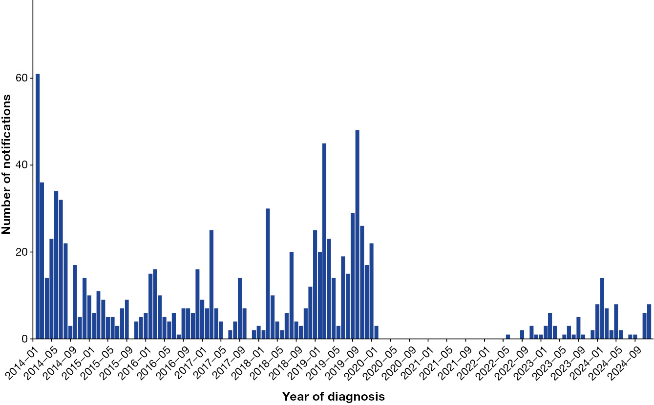

Trends by jurisdiction
During the reporting period, most measles cases were notified in Victoria (n = 282; 25.7%), New South Wales (n = 241; 22.0%), Queensland (n = 224; 20.5%) and Western Australia (n = 185; 16.9%). However, the Northern Territory had the highest rate of notification (32.6 per 100,000 population across the reporting period), followed by Western Australia (11.9 per 100,000 population across the reporting period), with some variation in rates by year (Table 1, Figure 2). While rates are overall low in most states compared to other communicable diseases, the impact of COVID-19 pandemic measures is demonstrated in the pre-pandemic and COVID-19 post-emergence period mean rate ratio, with mean rates in some states up to 11 times higher in the pre-pandemic period.
Figure 2: Notifications of measles by year and jurisdiction of residence, Australia, 2014–2024
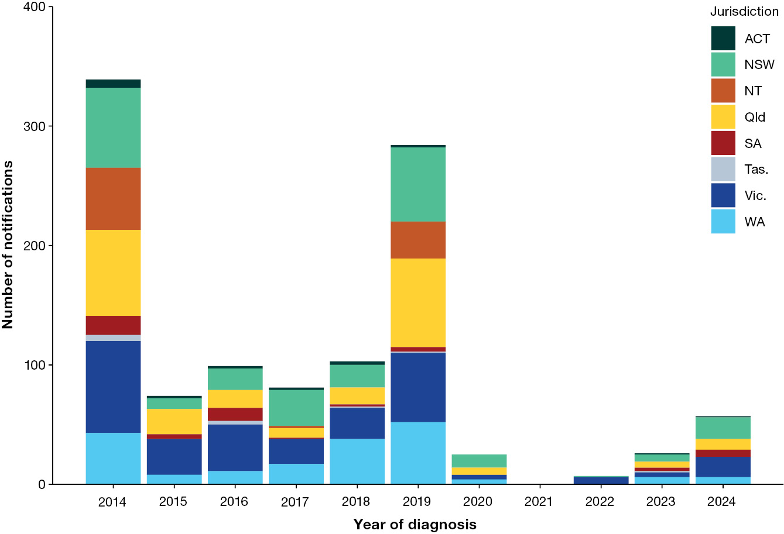
Table 1: Number of measles notifications and notification rates by year and jurisdiction with averages,^{a,b} Australia, 2014–2024
Jurisdiction^{d} | 2014 |  | 2015 |  | 2016 |  | 2017 |  | 2018 |  | 2019 |  | 2020 |  | 2022 |  | 2023 |  | 2024 |  | Total |  | Pre-pandemic and COVID-19  post-emergence period means^{c}
Jurisdiction^{d} | n | rate | n | rate | n | rate | n | rate | n | rate | n | rate | n | rate | n | rate | n | rate | n | rate | n | rate | 2014–2019 mean rate | 2020–2024 mean rateª | Two period rate ratio^{a,e}
ACT | 7 | 1.8 | 2 | 0.5 | 2 | 0.5 | 2 | 0.5 | 3 | 0.7 | 2 | 0.5 | 0 | 0.0 | 0 | 0.0 | 1 | 0.2 | 1 | 0.2 | 20 | 4.2 | 0.75 | 0.08 | 9.38
NSW | 67 | 0.9 | 9 | 0.1 | 18 | 0.2 | 30 | 0.4 | 19 | 0.2 | 62 | 0.8 | 11 | 0.1 | 1 | 0.0 | 6 | 0.1 | 18 | 0.2 | 241 | 2.8 | 0.43 | 0.08 | 5.42
NT | 52 | 21.4 | 0 | 0.0 | 0 | 0.0 | 2 | 0.8 | 0 | 0.0 | 31 | 12.6 | 0 | 0.0 | 0 | 0.0 | 0 | 0.0 | 0 | 0.0 | 85 | 32.6 | 5.80 | 0.00 | —
Qld | 72 | 1.5 | 21 | 0.4 | 15 | 0.3 | 8 | 0.2 | 14 | 0.3 | 74 | 1.5 | 6 | 0.1 | 0 | 0.0 | 5 | 0.1 | 9 | 0.2 | 224 | 4.0 | 0.70 | 0.08 | 8.75
SA | 16 | 0.9 | 4 | 0.2 | 11 | 0.6 | 1 | 0.1 | 2 | 0.1 | 4 | 0.2 | 0 | 0.0 | 0 | 0.0 | 3 | 0.2 | 6 | 0.3 | 47 | 2.5 | 0.35 | 0.10 | 3.50
Tas. | 5 | 1.0 | 0 | 0.0 | 3 | 0.6 | 0 | 0.0 | 1 | 0.2 | 1 | 0.2 | 0 | 0.0 | 0 | 0.0 | 1 | 0.2 | 0 | 0.0 | 11 | 1.9 | 0.33 | 0.04 | 8.33
Vic. | 77 | 1.3 | 30 | 0.5 | 39 | 0.6 | 21 | 0.3 | 26 | 0.4 | 58 | 0.9 | 4 | 0.1 | 6 | 0.1 | 4 | 0.1 | 17 | 0.2 | 282 | 4.1 | 0.66 | 0.10 | 6.67
WA | 43 | 1.7 | 8 | 0.3 | 11 | 0.4 | 17 | 0.7 | 38 | 1.5 | 52 | 2.0 | 4 | 0.1 | 0 | 0.0 | 6 | 0.2 | 6 | 0.2 | 185 | 6.2 | 1.10 | 0.10 | 11.0
Australia | 339 | 1.4 | 74 | 0.3 | 99 | 0.4 | 81 | 0.3 | 103 | 0.4 | 284 | 1.1 | 25 | 0.1 | 7 | 0.0 | 26 | 0.1 | 57 | 0.2 | 1,095 | 4.0 | 0.65 | 0.08 | 8.12
a Note that, since no measles cases were notified in 2021, case numbers and rates for 2021 are not displayed. Nonetheless, calculations of the 2020–2024 mean rate and of the two period rate ratio are inclusive of 2021.
b Rates per 100,000 population per year have been calculated using populations as at 30 June of each year.
c Pre-pandemic period: 2014–2019. COVID-19 post-emergence period: 2020–2024.
d ACT: Australian Capital Territory; NSW: New South Wales; NT: Northern Territory; Qld: Queensland; SA: South Australia; Tas.: Tasmania; Vic.: Victoria; WA: Western Australia.
e Two period rate ratio = 2014–2019 mean rate/2020–2024 mean rate.

Trends by age and sex
Over the entire period, the median age of measles notifications was 22 years. The number of notifications was highest among people aged 20–49 years (n = 626; 57.2%); however, the rate was highest (40.5 per 100,000 population across the reporting period) among children aged < 1 year, who were too young to be fully vaccinated against measles under the NIP.¹⁷ This pattern did not vary greatly year by year during the reporting period (Table 2). The most significant mean rate change when comparing the pre-pandemic and COVID-19 post-emergence periods was observed in 10–14 year olds, a group for whom the mean rate in the pre-pandemic period was over 19 times higher than the mean rate for the COVID-19 post-emergence period.
The year 2022 is the only year where the 50–64 age group accounted for an equal proportion of cases as 20–49 year olds. This is likely reflective of the small number of notifications reported in that year (n = 7) (Figure 3).
Figure 3: Proportion of measles cases by age group and year, Australia,ª 2014–2024
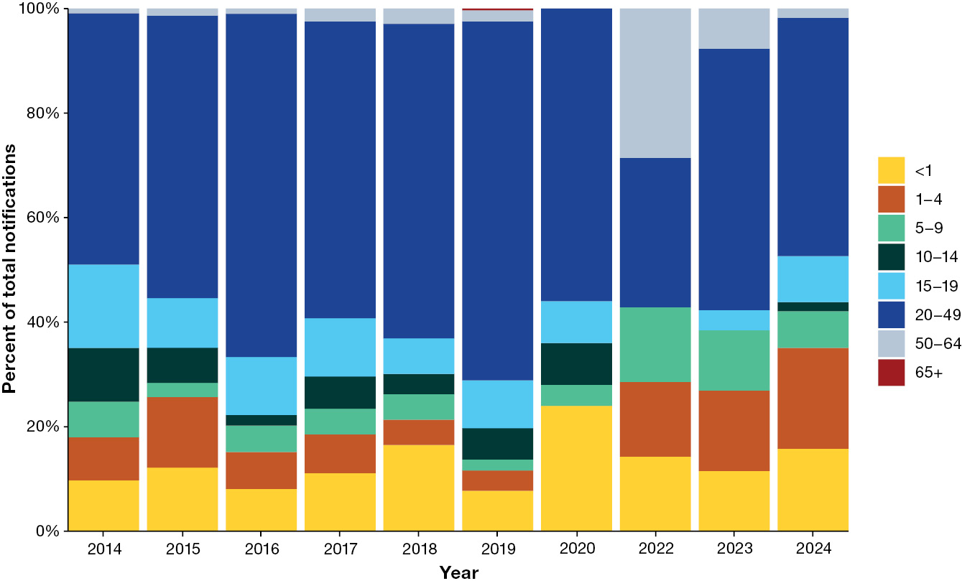
a Note that, since no measles cases were notified in 2021, case numbers by age group for 2021 are not displayed.

Table 2: Numbers of measles notifications and notification rates by year and age group with averages,^{a,b} 2014–2024
Age group (years) | 2014 |  | 2015 |  | 2016 |  | 2017 |  | 2018 |  | 2019 |  | 2020 |  | 2022 |  | 2023 |  | 2024 |  | Total |  | Pre-pandemic and COVID-19  post-emergence period means^{c}
Age group (years) | n | rate | n | rate | n | rate | n | rate | n | rate | n | rate | n | rate | n | rate | n | rate | n | rate | n | rate | 2014–2019 mean rate | 2020–2024 mean rateª | Two period rate ratio^{a,d}
< 1 | 33 | 10.8 | 9 | 2.9 | 8 | 2.5 | 9 | 2.9 | 17 | 5.6 | 22 | 7.3 | 6 | 2.0 | 1 | 0.3 | 3 | 1.0 | 9 | 3.1 | 117 | 40.5 | 5.33 | 1.28 | 4.17
1–4 | 28 | 2.3 | 10 | 0.8 | 7 | 0.6 | 6 | 0.5 | 5 | 0.4 | 11 | 0.9 | 0 | 0.0 | 1 | 0.1 | 4 | 0.3 | 11 | 0.9 | 83 | 6.8 | 0.91 | 0.26 | 3.53
5–9 | 23 | 1.5 | 2 | 0.1 | 5 | 0.3 | 4 | 0.3 | 5 | 0.3 | 6 | 0.4 | 1 | 0.1 | 1 | 0.1 | 3 | 0.2 | 4 | 0.2 | 54 | 3.4 | 0.48 | 0.12 | 4.03
10–14 | 35 | 2.5 | 5 | 0.4 | 2 | 0.1 | 5 | 0.3 | 4 | 0.3 | 17 | 1.1 | 2 | 0.1 | 0 | 0.0 | 0 | 0.0 | 1 | 0.1 | 71 | 4.2 | 0.78 | 0.04 | 19.58
15–19 | 54 | 3.7 | 7 | 0.5 | 11 | 0.7 | 9 | 0.6 | 7 | 0.5 | 26 | 1.7 | 2 | 0.1 | 0 | 0.0 | 1 | 0.1 | 5 | 0.3 | 122 | 7.3 | 1.28 | 0.10 | 12.83
20–49 | 163 | 1.6 | 40 | 0.4 | 65 | 0.6 | 46 | 0.4 | 62 | 0.6 | 195 | 1.8 | 14 | 0.1 | 2 | 0.0 | 13 | 0.1 | 26 | 0.2 | 626 | 5.5 | 0.90 | 0.08 | 11.25
50–64 | 3 | 0.1 | 1 | 0.0 | 1 | 0.0 | 2 | 0.0 | 3 | 0.1 | 6 | 0.1 | 0 | 0.0 | 2 | 0.0 | 2 | 0.0 | 1 | 0.0 | 21 | 0.4 | 0.05 | 0.00 | —
65+ | 0 | 0.0 | 0 | 0.0 | 0 | 0.0 | 0 | 0.0 | 0 | 0.0 | 1 | 0.0 | 0 | 0.0 | 0 | 0.0 | 0 | 0.0 | 0 | 0.0 | 1 | 0.0 | 0.00 | 0.00 | —
a Note that, since no measles cases were notified in 2021, case numbers and rates for 2021 are not displayed. Nonetheless, calculations of the 2020–2024 mean rate and of the two period rate ratio are inclusive of 2021.
b Rates per 100,000 population per year have been calculated using populations as at 30 June of each year.
c Pre-pandemic period: 2014–2019. COVID-19 post-emergence period: 2020–2024.
d Two period rate ratio = 2014–2019 mean rate/2020–2024 mean rate.

Genotype trends
The most common genotype notified in the reporting period was D8, followed by B3 and ‘unknown’. No genotypes other than B3 and D8 were reported in Australia after 2017 (Table 3).
Table 3: Number of measles notifications by year and genotype, Australia, 2014–2024
Genotype | 2014 | 2015 | 2016 | 2017 | 2018 | 2019 | 2020 | 2021 | 2022 | 2023 | 2024 | Total
B3 | 153 | 9 | 5 | 7 | 27 | 63 | 5 | 0 | 1 | 6 | 24 | 300
D4 | 1 | 1 | 2 | 0 | 0 | 0 | 0 | 0 | 0 | 0 | 0 | 4
D8 | 52 | 40 | 70 | 56 | 58 | 153 | 16 | 0 | 6 | 19 | 27 | 497
D9 | 24 | 0 | 0 | 1 | 0 | 0 | 0 | 0 | 0 | 0 | 0 | 25
G3 | 1 | 0 | 0 | 0 | 0 | 0 | 0 | 0 | 0 | 0 | 0 | 1
H1 | 9 | 5 | 0 | 0 | 0 | 0 | 0 | 0 | 0 | 0 | 0 | 14
Unknown | 99 | 19 | 22 | 17 | 18 | 68 | 4 | 0 | 0 | 1 | 6 | 254
Total | 339 | 74 | 99 | 81 | 103 | 284 | 25 | 0 | 7 | 26 | 57 | 1,095

Vaccination status
Over the total reporting period, just under half of all cases reported being unvaccinated prior to their infection (n = 513; 46.8%). Of those unvaccinated, around 17% (90/513; 17.5%) were cases among children aged less than 1 year, with this age group either too young (< 6 months) to have received any doses of MMR under the NIP schedule or having variable funded access to vaccination (6–11 months). Approximately one-seventh of cases reported having received one dose of MMR vaccine prior to their infection (n = 154; 14.1%) and 8.5% reported having two or more doses of MMR vaccine prior to their infection (n = 93). Note that self-reported or parent-reported recall of vaccination is considered validated vaccine information for the purposes of the NNDSS. Almost one-third of total cases (n = 329; 30%) were notified with unknown or missing vaccination status; a handful of cases (n = 6) reported being vaccinated but with an unknown number of doses received prior to infection (Table 4).
When comparing the COVID-19 post-emergence period (2020–2024) to the pre-pandemic period (2014–2019), the proportion of notified cases reporting an unvaccinated status rose 14.7% and the proportion reporting receipt of one dose prior to infection fell by 11.8%, while the proportion reporting two or more doses remained consistent between periods.
Table 4: Number of measles notifications by year and number of reported MMR doses prior to infection, Australia, 2014–2024
Number of doses | 2014 | 2015 | 2016 | 2017 | 2018 | 2019 | 2014–2019 % | 2020 | 2021 | 2022 | 2023 | 2024 | 2020–2024 % | Percent change | Total
0 doses | 169 | 31 | 53 | 34 | 46 | 111 | 45.3 | 12 | 0 | 3 | 13 | 41 | 60.0 | 14.7 | 513
1 dose | 54 | 14 | 8 | 15 | 7 | 52 | 15.3 | 0 | 0 | 0 | 2 | 2 | 3.5 | -11.8 | 154
2+ doses | 14 | 4 | 7 | 3 | 14 | 41 | 8.5 | 3 | 0 | 1 | 2 | 4 | 8.7 | 0.2 | 93
Missing | 31 | 10 | 16 | 6 | 15 | 12 | 9.2 | 1 | 0 | 0 | 1 | 0 | 1.7 | -7.4 | 92
Unknown | 71 | 14 | 15 | 23 | 20 | 64 | 21.1 | 9 | 0 | 3 | 8 | 10 | 26.1 | 5.0 | 237
Vaccinated, unknown number of doses | 0 | 1 | 0 | 0 | 1 | 4 | 0.6 | 0 | 0 | 0 | 0 | 0 | 0.0 | -0.6 | 6
Total | 339 | 74 | 99 | 81 | 103 | 284 | 100 | 25 | 0 | 7 | 26 | 57 | 100 | 0.0 | 1,095

When analysed by age group, the most common vaccination status for all cases aged 19 and under was ‘unvaccinated’, though almost one in five notifications among 15–19 year-olds (n = 22/122; 18.0%) reported having had one dose of MMR vaccine prior to their infection.
Among people aged 20–49 years:
- almost one in five notifications reported one dose of vaccine prior to infection (n = 111/626; 17.7%);
- just under one in ten reported receipt of two or more doses (n = 57/626; 9.1%);
- almost a third reported being unvaccinated (n = 196/626; 31.3%); and
- 41% were notified with unknown or missing vaccination status (n = 256/626) (Figure 4).
Figure 4: Number of measles cases by age group and vaccination status, Australia, 2014–2024
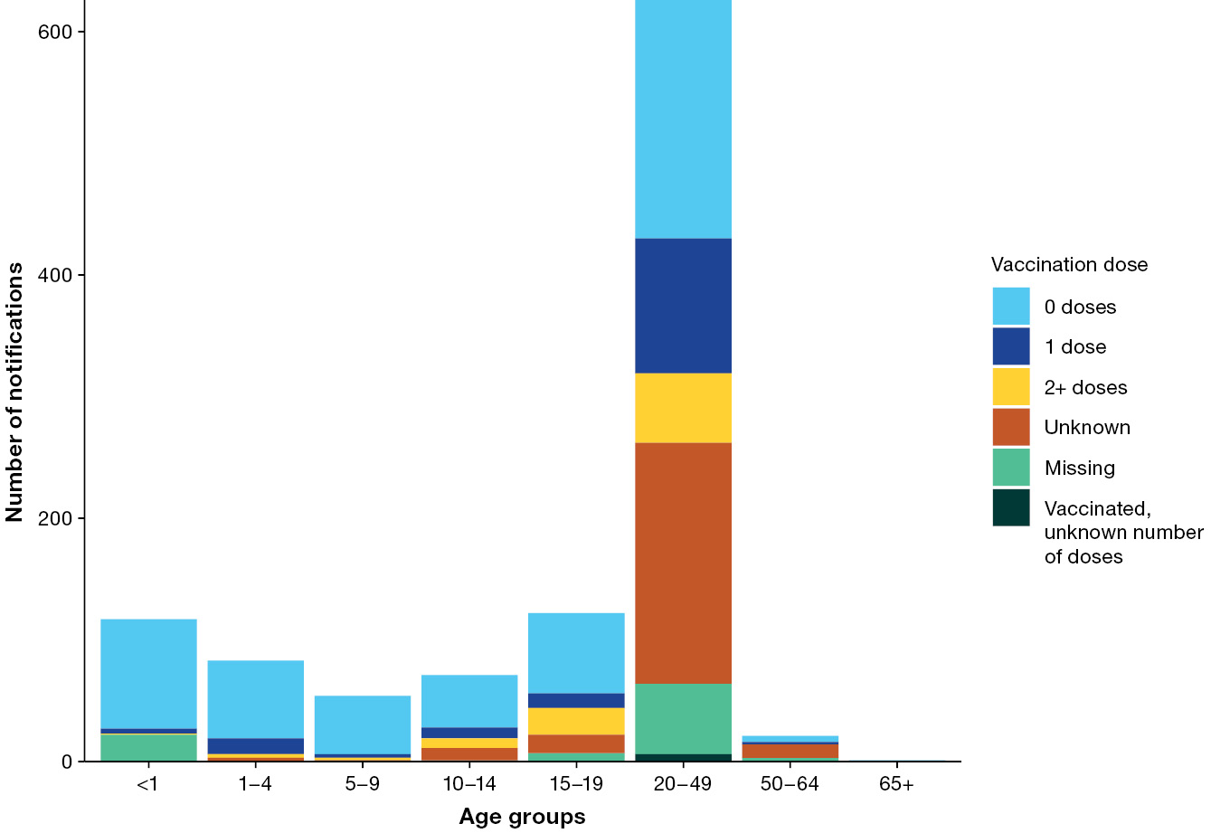

Country of acquisition
Over the total reporting period, just over half of notifications (n = 593; 54.1%) acquired their infection in Australia, and almost all of these were import-related (Table 5).
Table 5: Number of measles notifications by year and place of acquisition, Australia, 2014–2024
Type of acquisition | 2014 | 2015 | 2016 | 2017 | 2018 | 2019 | 2020 | 2021 | 2022 | 2023 | 2024 | Total
Import relatedª | 198 | 39 | 62 | 41 | 46 | 172 | 12 | 0 | 0 | 6 | 17 | 593
Overseas acquired | 140 | 35 | 33 | 39 | 56 | 111 | 12 | 0 | 7 | 20 | 40 | 493
Unknown | 1 | 0 | 4 | 1 | 1 | 1 | 1 | 0 | 0 | 0 | 0 | 9
Total | 339 | 74 | 99 | 81 | 103 | 284 | 25 | 0 | 7 | 26 | 57 | 1,095
a Cases where the NNDSS country of acquisition field was Australia.
Across the total period, the most common WHO region of importation was the Western Pacific Region (WPR) (221 cases acquired in this region; 44.8% of total overseas-acquired cases), followed by the South East Asian Region (SEAR) (204 cases; 41.4%) (Table 6).
The most common countries of acquisition from each of these regions varied year to year, with Indonesia the top contributor from the SEAR in 2014, 2016, 2017 and 2023; India in 2015 and 2024; and Thailand in 2018 and 2019. From the WPR, the top countries of acquisition were the Philippines in 2014 and 2018 and New Zealand in 2019 (followed very closely by the Philippines in the same year).
Only two cases were acquired from the WPR in 2022 (from Malaysia), and no cases were acquired from the WPR in 2023. Finally, in 2024, Viet Nam accounted for the highest proportion of cases acquired from the WPR (9/40, 22.5%). These patterns generally coincide with peaks in cases within SEAR and WPR countries. For example, both Indonesia and the Philippines were among the top 10 countries globally for measles notifications in 2014, and Thailand was in the top 20 in 2018 and 2019.⁵
These countries from the WPR and SEAR are popular for overseas travel by Australians, with New Zealand, Indonesia, Thailand, Indonesia and Viet Nam in the top ten travel destinations in 2019,¹⁸ and Indonesia overtaking New Zealand as the top destination for Australians in 2025 for the first time in 50 years.¹⁹
Table 6: Numbers of overseas acquired measles cases by WHO region and country of acquisition, Australia 2014–2024
WHO region | Country of acquisition | 2014 | 2015 | 2016 | 2017 | 2018 | 2019 | 2020 | 2021 | 2022 | 2023 | 2024 | Total 2014–2024
 |  |  |  |  |  |  |  |  |  |  |  |  | by country | by region
Africa | Somalia | 1 | 0 | 0 | 0 | 0 | 0 | 0 | 0 | 0 | 0 | 0 | 1 | 4
Africa | Ethiopia | 0 | 1 | 0 | 0 | 0 | 0 | 0 | 0 | 0 | 0 | 1 | 2 | 4
Africa | Tanzania | 0 | 0 | 0 | 0 | 0 | 0 | 0 | 0 | 0 | 1 | 0 | 1 | 4
Americas | Brazil | 0 | 0 | 0 | 0 | 1 | 0 | 0 | 0 | 0 | 0 | 0 | 1 | 2
Americas | Chile | 0 | 0 | 0 | 0 | 0 | 1 | 0 | 0 | 0 | 0 | 0 | 1 | 2
Eastern Mediterranean | Afghanistan | 0 | 1 | 0 | 0 | 1 | 0 | 0 | 0 | 0 | 0 | 2 | 4 | 30
Eastern Mediterranean | Pakistan | 0 | 0 | 3 | 1 | 2 | 2 | 0 | 0 | 0 | 3 | 7 | 18 | 30
Eastern Mediterranean | Lebanon | 0 | 0 | 0 | 0 | 1 | 1 | 0 | 0 | 0 | 0 | 1 | 3 | 30
Eastern Mediterranean | United Arab Emirates | 0 | 0 | 0 | 0 | 1 | 1 | 0 | 0 | 1 | 0 | 0 | 3 | 30
Eastern Mediterranean | Saudi Arabia | 0 | 0 | 0 | 0 | 0 | 0 | 0 | 0 | 1 | 0 | 1 | 2 | 30
Europe | Germany | 1 | 1 | 0 | 0 | 0 | 0 | 0 | 0 | 0 | 0 | 0 | 2 | 23
Europe | Netherlands | 2 | 0 | 0 | 0 | 0 | 0 | 0 | 0 | 0 | 0 | 0 | 2 | 23
Europe | Azerbaijan | 0 | 1 | 0 | 0 | 0 | 0 | 0 | 0 | 0 | 0 | 0 | 1 | 23
Europe | Norway | 0 | 1 | 0 | 0 | 0 | 0 | 0 | 0 | 0 | 0 | 0 | 1 | 23
Europe | Switzerland | 0 | 1 | 0 | 0 | 0 | 0 | 0 | 0 | 0 | 0 | 0 | 1 | 23
Europe | Italy | 0 | 0 | 0 | 2 | 0 | 1 | 1 | 0 | 0 | 0 | 0 | 4 | 23
Europe | Romania | 0 | 0 | 0 | 1 | 0 | 1 | 0 | 0 | 0 | 2 | 0 | 4 | 23
Europe | Spain | 0 | 0 | 0 | 1 | 0 | 0 | 0 | 0 | 0 | 0 | 0 | 1 | 23
Europe | Croatia | 0 | 0 | 0 | 0 | 0 | 1 | 0 | 0 | 0 | 0 | 0 | 1 | 23
Europe | England | 0 | 0 | 0 | 0 | 0 | 1 | 0 | 0 | 0 | 0 | 1 | 2 | 23
Europe | Ireland | 0 | 0 | 0 | 0 | 0 | 1 | 0 | 0 | 0 | 0 | 0 | 1 | 23
Europe | United Kingdom, Channel Islands and Isle of Man | 0 | 0 | 0 | 0 | 0 | 0 | 0 | 0 | 0 | 1 | 1 | 2 | 23
Europe | Western Europe, nfd | 0 | 0 | 0 | 0 | 0 | 0 | 0 | 0 | 0 | 0 | 1 | 1 | 23
South East Asia | India | 4 | 13 | 6 | 4 | 10 | 1 | 2 | 0 | 1 | 3 | 8 | 52 | 204
South East Asia | Indonesia | 31 | 7 | 14 | 21 | 10 | 3 | 0 | 0 | 2 | 9 | 2 | 99 | 204
South East Asia | Myanmar | 2 | 0 | 0 | 0 | 2 | 2 | 0 | 0 | 0 | 0 | 0 | 6 | 204
South East Asia | Sri Lanka | 1 | 0 | 0 | 0 | 0 | 2 | 0 | 0 | 0 | 0 | 1 | 4 | 204
South East Asia | Thailand | 1 | 0 | 1 | 2 | 11 | 14 | 2 | 0 | 0 | 1 | 2 | 34 | 204
South East Asia | Nepal | 0 | 0 | 2 | 0 | 0 | 0 | 1 | 0 | 0 | 0 | 0 | 3 | 204
South East Asia | Bangladesh | 0 | 0 | 0 | 0 | 0 | 1 | 0 | 0 | 0 | 0 | 0 | 1 | 204
South East Asia | South East Asia, nfd | 0 | 0 | 1 | 1 | 1 | 2 | 0 | 0 | 0 | 0 | 0 | 5 | 204
Western Pacific | Brunei Darussalam | 1 | 0 | 0 | 0 | 0 | 0 | 0 | 0 | 0 | 0 | 0 | 1 | 221
Western Pacific | China (excludes SARs and Taiwan) | 1 | 1 | 0 | 0 | 0 | 0 | 0 | 0 | 0 | 0 | 0 | 2 | 221
Western Pacific | Malaysia | 1 | 2 | 1 | 2 | 4 | 0 | 0 | 0 | 2 | 0 | 2 | 14 | 221
Western Pacific | New Zealand | 1 | 0 | 1 | 0 | 0 | 21 | 0 | 0 | 0 | 0 | 0 | 23 | 221
Western Pacific | Papua New Guinea | 20 | 1 | 0 | 0 | 0 | 0 | 0 | 0 | 0 | 0 | 0 | 21 | 221
Western Pacific | Philippines | 50 | 1 | 0 | 0 | 9 | 20 | 2 | 0 | 0 | 0 | 0 | 82 | 221
Western Pacific | Singapore | 7 | 1 | 0 | 0 | 0 | 4 | 2 | 0 | 0 | 0 | 0 | 14 | 221
Western Pacific | Solomon Islands | 1 | 0 | 0 | 0 | 0 | 0 | 0 | 0 | 0 | 0 | 0 | 1 | 221
Western Pacific | Taiwan | 1 | 0 | 0 | 0 | 0 | 0 | 0 | 0 | 0 | 0 | 0 | 1 | 221
Western Pacific | Vietnam | 13 | 1 | 0 | 1 | 2 | 12 | 1 | 0 | 0 | 0 | 9 | 39 | 221
Western Pacific | Hong Kong (SAR of China) | 0 | 1 | 0 | 0 | 0 | 1 | 0 | 0 | 0 | 0 | 0 | 2 | 221
Western Pacific | Vanuatu | 0 | 1 | 0 | 0 | 0 | 0 | 0 | 0 | 0 | 0 | 0 | 1 | 221
Western Pacific | Japan | 0 | 0 | 2 | 1 | 0 | 0 | 0 | 0 | 0 | 0 | 0 | 3 | 221
Western Pacific | Cambodia | 0 | 0 | 0 | 1 | 0 | 1 | 1 | 0 | 0 | 0 | 1 | 4 | 221
Western Pacific | Korea, Republic of (South) | 0 | 0 | 0 | 1 | 0 | 0 | 0 | 0 | 0 | 0 | 0 | 1 | 221
Western Pacific | Samoa | 0 | 0 | 0 | 0 | 0 | 11 | 0 | 0 | 0 | 0 | 0 | 11 | 221
Western Pacific | Tonga | 0 | 0 | 0 | 0 | 0 | 1 | 0 | 0 | 0 | 0 | 0 | 1 | 221
Unknown | Overseas acquired: country unknown | 1 | 0 | 2 | 0 | 1 | 5 | 0 | 0 | 0 | 0 | 0 | 9 | 9
Total | —ª | 140 | 35 | 33 | 39 | 56 | 111 | 12 | 0 | 7 | 20 | 40 | 493 | 493
a Total overseas acquired minus overseas acquired country unknown.

Clusters
Clusters are identified in the NNDSS when more than one case is assigned a unique outbreak reference ID by the state or territory of notification. All cases sharing the outbreak reference ID are considered part of the cluster.
Of the total case clusters reported to the NNDSS in 2014–2024, forty-four clusters (93.6%) had an overseas source country (i.e., at least one case linked in the cluster by NNDSS outbreak reference ID had a country of acquisition that was not Australia). Clusters without an identified overseas source country (i.e. all cases in the cluster had a place of acquisition country of Australia in the NNDSS) did not exceed 4 linked cases (Table 7).
The largest cluster occurred in 2019 in New South Wales (n = 74) and lasted nine months. The most common genotypes of clusters (where genotype information was available for at least one case in the cluster) were B3 and D8 (Table 7).
Table 7: Measles clusters,^{a,b} Australia, 2014–2024
Year | Jurisdiction^{c} | Number of linked cases^{d} | First onset date | Last onset date | Source country | Genotype^{e}
2014 | SA | 11 | 2014-01-01 | 2014-06-04 | Philippines | B3
2014 | Vic. | 56 | 2014-01-01 | 2014-12-29 | Vietnam, Germany | B3
2014 | WA | 43 | 2014-01-03 | 2014-12-19 | Vietnam | D9
2014 | NSW | 64 | 2014-01-06 | 2014-08-19 | Vietnam | D8
2014 | NT | 38 | 2014-01-12 | 2014-12-28 | Singapore | B3
2014 | Qld | 72 | 2014-01-13 | 2014-12-29 | Vietnam | B3
2014 | Tas. | 5 | 2014-07-06 | 2014-07-28 | Singapore, Taiwan | D8
2014 | ACT | 4 | 2014-07-18 | 2014-07-25 | Imported, index case unknown^{f} | B3
2015 | Qld | 21 | 2015-01-04 | 2015-09-13 | Papua New Guinea | H1
2015 | Vic. | 21 | 2015-01-08 | 2015-09-09 | Indonesia | D8
2015 | WA | 8 | 2015-01-12 | 2015-12-17 | Switzerland | D8
2015 | NSW | 3 | 2015-01-13 | 2015-02-09 | India | D8
2015 | SA | 3 | 2015-12-03 | 2015-12-14 | Indonesia | D8
2016 | Vic. | 34 | 2016-01-29 | 2016-12-29 | Malaysia | D8
2016 | Qld | 15 | 2016-02-24 | 2016-12-30 | Pakistan | D8
2016 | NSW | 3 | 2016-03-27 | 2016-04-10 | Imported, index case unknown^{f} | D8
2016 | Tas. | 3 | 2016-04-29 | 2016-05-12 | Nepal | D8
2016 | SA | 8 | 2016-05-18 | 2016-09-22 | Thailand | D8
2016 | WA | 11 | 2016-07-02 | 2016-12-28 | South-East Asia, nfd^{g} | D8
2017 | WA | 17 | 2017-01-06 | 2017-08-19 | Italy | D8
2017 | Vic. | 18 | 2017-01-08 | 2017-12-01 | South-East Asia, nfd^{g} | D8
2017 | Qld | 8 | 2017-02-25 | 2017-04-13 | Japan | D8
2017 | NSW | 23 | 2017-03-02 | 2017-10-11 | Thailand | D8
2017 | NT | 2 | 2017-03-21 | 2017-03-22 | Indonesia | D8
2018 | WA | 38 | 2018-01-02 | 2018-12-31 | Vietnam | D8
2018 | Qld | 14 | 2018-02-26 | 2018-12-31 | Vietnam | D8
2018 | Vic. | 17 | 2018-03-03 | 2018-12-24 | Thailand | B3
2018 | NSW | 8 | 2018-08-02 | 2018-12-25 | Thailand | Unknown
2019 | Qld | 74 | 2019-01-04 | 2019-12-29 | Vietnam | D8
2019 | SA | 3 | 2019-01-05 | 2019-04-16 | Myanmar | Unknown
2019 | NSW | 30 | 2019-01-06 | 2019-12-28 | United Arab Emirates | D8
2019 | WA | 52 | 2019-01-09 | 2019-10-17 | Vietnam | Unknown
2019 | Vic. | 37 | 2019-01-10 | 2019-12-31 | Thailand | B3
2019 | NT | 31 | 2019-02-06 | 2019-12-16 | Vietnam | D8
2020 | WA | 4 | 2020-01-03 | 2020-01-28 | Vietnam | D8
2020 | NSW | 4 | 2020-01-06 | 2020-02-01 | Imported, index case unknown^{f} | D8
2020 | Qld | 5 | 2020-01-06 | 2020-01-23 | Singapore | Unknown
2021^{h} | — | 0 | — | — | — | —
2022 | Vic. | 3 | 2022-11-04 | 2022-11-15 | Saudi Arabia, Malaysia | D8
2023 | Qld | 3 | 2023-03-16 | 2023-04-04 | Pakistan | B3
2023 | SA | 3 | 2023-03-19 | 2023-04-03 | Indonesia | D8
2023 | NSW | 2 | 2023-07-13 | 2023-09-24 | United Kingdom, Channel Islands and Isle of Man | D8
2023 | WA | 2 | 2023-09-19 | 2023-09-30 | Indonesia | D8
2024 | Vic. | 7 | 2024-01-16 | 2024-12-27 | Vietnam | D8
2024 | Qld | 2 | 2024-02-05 | 2024-02-18 | Thailand | Unknown
2024 | NSW | 11 | 2024-02-08 | 2024-12-12 | Vietnam | D8
2024 | WA | 2 | 2024-03-01 | 2024-03-16 | Pakistan | B3
2024 | SA | 4 | 2024-03-17 | 2024-04-08 | England | B3
a Clusters are defined as per outbreak reference IDs entered by reporting states and territories to the NNDSS.
b Excludes clusters with less than 2 linked cases.
c ACT: Australian Capital Territory; NSW: New South Wales; NT: Northern Territory; Qld: Queensland; SA: South Australia; Tas.: Tasmania; Vic.: Victoria; WA: Western Australia.
d Number of linked cases includes 1 source case per cluster.
e Genotype is based on the most common genotype associated with the cluster, which may not be complete for every case linked by a given outbreak reference number.
f All cases within cluster have a country of acquisition of Australia in the NNDSS, though this does not represent endemic virus transmission in country.
g nfd: not further differentiated.
h No measles cases were notified in 2021.

Discussion and conclusion
Over the reporting period 1 January 2014 – 31 December 2024, measles cases in Australia:
- were most commonly notified among people aged 20–49 years;
- when acquired overseas, were most commonly imported from popular tourist destination countries in the Western Pacific and South East Asian regions;
- were most commonly notified among people who were unvaccinated or whose vaccination status was unknown (72%); and
- were most commonly notified in months coinciding with Australian school holidays.
The age distribution of cases is in stark contrast to that of endemic countries, where most cases, with attendant morbidity and mortality, are among children under 5 years of age.
The findings of this report indicate that the greatest contributors to measles notifications in Australia in 2014 to 2024 were young adults who were either unvaccinated or were unaware of their vaccination status and who likely imported their infection to Australia when they returned from seasonal overseas travel. These importations pose a threat to vulnerable populations such as immunocompromised people, pregnant people, and children who are too young to receive the MMR vaccine. In Australia, two-dose vaccination coverage of the measles-containing vaccine at 2 years has declined since the COVID-19 pandemic from 94.0% in 2020 to 91.4% in 2024, further increasing the risk to young children from imported cases as coverage drops below levels required for herd immunity.
High routine vaccination coverage, heightened vigilance by clinicians, appropriate testing and rapidly responding to suspected cases is essential for the early detection and management of cases and ongoing prevention of outbreaks in Australia. Named strain analysis capability also remains critical, as there have been only two genotypes detected globally since 2021 (B3 and D8).^{4,6} The results of this report reflect this reduction in genotype diversity. Tracking named strains within these remaining genotypes allows public health authorities to identify specific transmission chains, detect importation events, and verify elimination status at both regional and global levels.
Young adults who may have missed catch-up vaccines in childhood, or who are unaware of their vaccination status before travel, should be targeted by public health messaging and encouraged to seek vaccination prior to leaving Australia, particularly when visiting countries with current measles outbreaks. Every effort should also be made to increase MMR vaccine coverage at 2 years back to 95%.

Acknowledgments
We wish to acknowledge the state and territory health departments through the Communicable Diseases Network Australia for their provision and endorsement of data to the National Notifiable Diseases Surveillance System, and the public health officers in states and territories responsible for the primary collection of the data used.

Author details
Ms Lizzie Gorrell,¹
Dr Benjamin G Polkinghorne,^{1,2}
Prof. David N Durrheim^{3,4,5}
- Australian Centre for Disease Control, Canberra, Australian Capital Territory, Australia
- Australian National University, Canberra, Australian Capital Territory, Australia
- University of Newcastle, Callaghan New South Wales, Australia
- Hunter New England Health, Newcastle, New South Wales, Australia
- James Cook University, Townsville, Queensland, Australia

Corresponding author
Ms Lizzie Gorrell
Australian Centre for Disease Control, GPO Box 798, Canberra ACT 2601, Australia
Email: Lizzie.Gorrell@cdc.gov.au

References
- Strebel PM, Orenstein WA. Measles. N Engl J Med. 2019;381(4):349–57. doi: https://doi.org/10.1056/NEJMcp1905181.
- World Health Organization (WHO). Fact sheets: Measles. [Internet.] Geneva: WHO; 14 November 2024. [Accessed on 4 October 2025.] Available from: https://www.who.int/news-room/fact-sheets/detail/measles.
- Patel MK, Goodson JL, Alexander JP, Kretsinger K, Sodha SV, Steulet C et al. Progress toward regional measles elimination – worldwide, 2000–2019. MMWR Morb Mortal Wkly Rep. 2020;69(45):1700–5. doi: https://doi.org/10.15585/mmwr.mm6945a6.
- Bankamp B, Kim G, Hart D, Beck A, Mamou MB, Penedos A et al. Global update on measles molecular epidemiology. Vaccines (Basel). 2024;12(7):810. doi: https://doi.org/10.33960/vaccines12070810.
- WHO. Measles reported cases and incidence. [Webpage.] Geneva: WHO; 2026. [Accessed on 12 January 2026.] Available from: https://immunizationdata.who.int/global/wiise-detail-page/measles-reported-cases-and-incidence.
- Rota PA, Evans R, Ben Mamou MC, Ray-Benito G, Sangal L, Dosseh A et al. The Global Measles and Rubella Laboratory Network supports high-quality surveillance. Vaccines (Basel). 2024;12(8):946. doi: https://doi.org/10.3390/vaccines12080946.
- WHO. Measles deaths down 88% since 2000, but cases surge. [Media release.] Geneva: WHO; 28 November 2025. [Accessed on 12 January 2025.] Available from: https://www.who.int/news/item/28-11-2025-measles-deaths-down-88--since-2000--but-cases-surge.
- WHO. Measles cases surge worldwide, infecting 10.3 million people in 2023. [Media release.] Geneva: WHO; 14 November 2024. [Accessed on 5 November 2025.] Available from: https://www.who.int/news/item/14-11-2024-measles-cases-surge-worldwide--infecting-10.3-million-people-in-2023.
- Durrheim DN. Measles eradication—retreating is not an option. Lancet Infect Dis. 2020;20(6):e138–41. doi: https://doi.org/10.1016/S1473-3099(20)30052-9.
- WHO. Measles and rubella strategic framework: 2021–2030. Geneva: WHO; 8 November 2020. [Accessed on 5 November 2025.] Available from: https://www.who.int/publications/i/item/measles-and-rubella-strategic-framework-2021-2030.
- Australian Government Department of Health, Disability and Ageing. 2024 PHN Childhood immunisation coverage data. [Webpage.] Canberra; Australian Government Department of Health, Disability and Ageing; 31 December 2024. [Accessed on 5 November 2025.] Available from: https://www.health.gov.au/resources/publications/2024-phn-childhood-immunisation-coverage-data.
- Hull B, Hendry A, Macartney K, Beard F. Annual Immunisation Coverage Report 2024. Sydney: Sydney Children’s Hospitals Network, National Centre for Immunisation Research and Surveillance; 27 October 2025. [Accessed on 14 January 2026.] Available from: https://ncirs.org.au/sites/default/files/2025-10/Annual%20Immunisation%20Coverage%20Report%202024.pdf.
- Hull B, Hendry A, Dey A, Brotherton J, Macartney K, Beard F. Annual immunisation coverage report 2021. Commun Dis Intell (2018). 2022;46. doi: https://doi.org/10.33321/cdi.2023.47.47.
- Australian Government Department of Health, Disability and Ageing. Measles – surveillance case definition. [Webpage.] Canberra; Australian Government Department of Health, Disability and Ageing; 12 March 2004. [Accessed on 5 November 2025.] Available from: https://www.health.gov.au/resources/publications/measles-surveillance-case-definition.
- Tourism Australia. Australian school holidays. [Internet.] Sydney: Department of Foreign Affairs and Trade, Tourism Australia; 2025. [Accessed on 5 November 2025.] Available from: https://www.australia.com/en/facts-and-planning/when-to-go/australian-school-holidays.html.
- Australian Bureau of Statistics. Overseas arrivals and departures, Australia – 2024–25 financial year. [Webpage.] Canberra: Australian Bureau of Statistics; 14 August 2025. [Accessed on 5 November 2025.] Available from: https://www.abs.gov.au/articles/overseas-arrivals-and-departures-australia-2024-25-financial-year.
- Australian Government Department of Health, Disability and Ageing. Australian Immunisation Handbook – Measles. [Webpage.] Canberra: Australian Government Department of Health, Disability and Ageing; 24 October 2025. [Accessed on 5 November 2025.] Available from: https://immunisationhandbook.health.gov.au/contents/vaccine-preventable-diseases/measles.
- Australian Bureau of Statistics. Most popular countries for Aussie travellers in 2019. [Webpage.] Canberra: Australian Bureau of Statistics; 18 February 2020. [Accessed on 5 November 2025.] Available from: https://www.abs.gov.au/articles/most-popular-countries-aussie-travellers-2019.
- Australian Bureau of Statistics. Overseas Arrivals and Departures, Australia. Reference period: August 2025. [Webpage.] Canberra: Australian Bureau of Statistics; 14 October 2025. [Accessed on 5 November 2025.] Available from: https://www.abs.gov.au/statistics/industry/tourism-and-transport/overseas-arrivals-and-departures-australia/aug-2025.

Diagnosis date is a derived field in the NNDSS. It will be the true onset date if known; otherwise it will be earliest of the specimen date, the notification date or the notification received date.
Import-related cases are locally acquired infections occurring from transmission by a case who acquired their infection overseas, or from another import-related case, as supported by epidemiological and/or virological evidence.
Indonesia became part of the WPR in May 2025.

