
2026 • Volume 50 • cdc.gov.au/cdi • Epub date: 24.02.2026 • doi.org/10.33321/cdi.2026.50.014

Report on influenza viruses received and tested by the Melbourne WHO Collaborating Centre for Reference and Research on Influenza during 2024
Jessica E Miller, Tanya R Diefenbach-Elstob, Rachel Wordsworth, Nikita Deshpande, Sally Soppe, Joelle Dharmakumara, Malet Aban, Heidi Peck, Saira Hussain, Yi-Mo Deng, Clyde Dapat, Ian G Barr, Patrick Reading
© 2026 Commonwealth of Australia as represented by the Australian Centre for Disease Control
ISSN: 2209-6051 Online
This journal is indexed by Index Medicus and Medline.
Creative Commons Licence
This publication is licensed under a Creative Commons Attribution-NonCommercial-NoDerivatives 4.0 International Licence (Licence). You must read and understand the Licence before using any material from this publication.
Restrictions
The Licence does not cover, and there is no permission given for, use of any of the following material found in this publication (if any):
- the Commonwealth Coat of Arms (by way of information, the terms under which the Coat of Arms may be used can be found on the Department of Prime Minister and Cabinet website);
- any logos (including the Australian Centre for Disease Control’s logo) and trademarks;
- any photographs and images;
- any signatures; and
- any material belonging to third parties.
Disclaimer
Opinions expressed in Communicable Diseases Intelligence are those of the authors and not necessarily those of the Australian Government or the Australian Centre for Disease Control. Data may be subject to revision.
Enquiries
Enquiries regarding any other use of this publication should be addressed to the CDI Editor.
About CDI
Communicable Diseases Intelligence (CDI) is a peer-reviewed scientific journal published by the Australian Centre for Disease Control.
The journal aims to disseminate information on the epidemiology, surveillance, prevention and control of communicable diseases of relevance to Australia and the near region.
Editor: Elise Firman • Deputy Editor: Simon Petrie • Design and Production: Lisa Thompson
Editorial Advisory Board: David Durrheim, Mark Ferson, Clare Huppatz, John Kaldor, Martyn Kirk and Meru Sheel
Submit an Article
Guidelines for authors and details on how to submit your publication is available on our website, or by email to the
CDI Editor.
Contact us
Communicable Diseases Intelligence (CDI)
Australian Centre for Disease Control
GPO Box 798, CANBERRA ACT 2601
Website: cdc.gov.au/cdi
Email: cdi.editor@cdc.gov.au

Contents
Abstract 4
Introduction 5
Methods 6
Virus isolation 6
Antigenic analysis 6
Genetic analysis 7
Antiviral drug susceptibility testing 8
Candidate vaccine strains 8
Results 9
A(H1N1)pdm09 viruses 12
A(H3N2) viruses 14
Influenza B viruses 16
A(H5N1) viruses 16
Discussion 18
Acknowledgments 20
Author details 21
References 22

Abstract
As part of its role in the World Health Organization (WHO) Global Influenza Surveillance and Response System (GISRS), the WHO Collaborating Centre for Reference and Research on Influenza in Melbourne received 12,180 human influenza-positive samples during 2024. Viruses were analysed for their antigenic, genetic, and antiviral susceptibility properties. Selected viruses were propagated in qualified cells or embryonated hens’ eggs for potential use in seasonal influenza virus vaccines. During 2024, influenza A(H1N1)pdm09 and A(H3N2) viruses predominated, accounting for 33% and 42%, respectively, of all viruses received, compared to 5% for influenza B/Victoria. Of note, one influenza A(H5N1) virus was also received in 2024. The majority of A(H1N1)pdm09 (98%), A(H3N2) (88%) and influenza B (100%) viruses analysed at the Centre were found to be antigenically and genetically similar to the respective WHO recommended vaccine strains for the Southern Hemisphere in 2024. Of 4,007 samples tested for susceptibility to the neuraminidase inhibitors oseltamivir and zanamivir, twelve A(H1N1)pdm09 viruses and one B/Victoria virus showed highly reduced inhibition against oseltamivir or zanamivir. Of 3,294 total samples sequenced for baloxavir susceptibility, 18 of the 1,825 A(H3N2) samples were identified with genetic evidence of reduced susceptibility to baloxavir marboxil in the PA gene.
Keywords: influenza, vaccine, GISRS, surveillance, laboratory, annual report, WHO

Introduction
The WHO Collaborating Centre for Reference and Research on Influenza in Melbourne (the Centre) is part of the World Health Organization (WHO) Global Influenza Surveillance and Response System (GISRS). GISRS is a global network of laboratories that was established in 1952 to monitor changes in influenza viruses circulating in the human population, with the aim of reducing the impact of influenza through the use of vaccines and antiviral drugs.^{1,2} The Centre in Melbourne, designated by WHO in 1992, is one of five Collaborating Centres, with the others located in Atlanta, Beijing, London, and Tokyo. These Centres monitor antigenic and genetic changes in circulating human influenza viruses and contribute to the WHO biannual recommendations on which influenza strains should be included in the vaccine for the upcoming influenza season in the Northern or Southern Hemisphere. This report summarises the results of virological surveillance activities undertaken at the Centre in Melbourne during 2024. Following the sharp reduction in influenza activity and laboratory-confirmed influenza notifications to the Australian National Notifiable Diseases Surveillance System (NNDSS) during the COVID-19 pandemic in 2020–2021, influenza activity substantially increased in 2022–2023 with a record high number of notifications reported in 2024, surpassing the previous high seen in the pre-pandemic 2019 notifications.^{3,4}
Two types of influenza viruses (A and B) cause significant disease in humans. Influenza A viruses are further classified into subtypes based on their haemagglutinin (HA) and neuraminidase (NA) surface proteins. Globally, there are currently two influenza A subtypes circulating in the human population: A(H1N1)pdm09 and A(H3N2). Influenza B viruses have been classified into lineages rather than subtypes, based on the genetic and antigenic features of the viral HA protein. In previous years there have been two distinct co-circulating lineages: B/Victoria/2/1987 (B/Victoria lineage) and B/Yamagata/16/1988 (B/Yamagata lineage). However, no confirmed cases of B/Yamagata viruses have been reported globally since March 2020, and it has been postulated that during the COVID-19 pandemic this lineage may have become extinct.⁵ Influenza C viruses are also detected each year from humans, but these viruses do not cause severe disease and are not a major focus of influenza surveillance. Highly pathogenic avian influenza (HPAI) viruses, including A(H5N1), cause severe disease in wild birds and in poultry and have been associated with sporadic infections in humans with various levels of severity. Most reported cases of human infection have occurred in people who have had close contact with infected birds and no cases from human-to-human transmission have been reported to date.

Methods
The Centre receives influenza-positive samples for surveillance purposes from submitting laboratories predominantly in Australia as well as other countries in the Asia-Pacific region. This report includes all surveillance samples received by the Centre in 2024, noting that a small number of viruses collected in 2023 were therefore also included.

Virus isolation
All original influenza positive clinical specimens (that were not supplied in inactivation media) and influenza virus isolates containing A(H1N1)pdm09 and influenza B viruses received at the Centre were passaged in cell culture using Madin-Darby Canine Kidney (MDCK) cells, while all A(H3N2) viruses were passaged in MDCK-SIAT-1 cells.⁶ Untyped influenza A viruses were passaged in MDCK-SIAT-1 cells. A subset of influenza-positive original clinical samples were also directly inoculated into eggs and/or a qualified cell line (MDCK 33016PF) to generate potential influenza candidate vaccine viruses.

Antigenic analysis
The antigenic properties of influenza viral isolates were analysed using the haemagglutination inhibition (HI) assay as previously described,⁷ and a subset of A(H3N2) viruses were additionally analysed by the focus reduction assay (FRA). HI assays were performed manually or using the TECAN Freedom EVO200 robot platform which incorporates a camera (SciRobotics, Kfar Saba, Israel) and imaging software (FluHemaTM) for analysis. In HI assays, viruses were tested for their ability to agglutinate red blood cells (RBC) in the presence of receptor-destroying enzyme (RDE)-treated post-infection ferret antisera raised against several reference viruses. Turkey RBCs were used for A(H1N1)pdm09 and B viruses, and guinea pig RBCs were used for A(H3N2) viruses. Isolates were identified as antigenically similar to the reference strain if the test samples had a titre that was no more than fourfold lower than the titre of the homologous reference strain. In 2024, results were reported with reference to the viruses that were recommended for inclusion in the 2024 Southern Hemisphere influenza vaccine (Table 1).
Table 1: Southern hemisphere influenza vaccine reference strains used for reporting purposes by the Centre, 2024
Subtype/lineage | 2024 cell | 2024 egg
A(H1N1)pdm09 | A/Victoria/4897/2022  (H1N1pdm09)-like | A/Victoria/4897/2022  (H1N1pdm09)-like
A(H3N2) | A/Thailand/8/2022  (H3N2)-like | A/Thailand/8/2022  (H3N2)-like
B/Victoria-lineage | B/Austria/1359417/2021  (B/Victoria lineage)-like | B/Austria/1359417/2021  (B/Victoria lineage)-like
B/Yamagata-lineage | B/Phuket/3073/2013  (B/Yamagata lineage)-like | B/Phuket/3073/2013  (B/Yamagata lineage)-like
In recent years (including 2024), HI assays involving A(H3N2) viruses have been performed in the presence of 20 nM oseltamivir carboxylate (OC) to reduce non-specific binding of the NA protein.⁸ The addition of OC can reduce the number of influenza virus isolates that could be tested by HI, as viruses may lose the ability to bind RBC. This was not the case in 2024, as none of the H3N2 viruses lost their ability to bind to RBC, and all isolates with sufficient titre were able to be tested using the HI assay. The Centre still tested a subset of H3N2 viruses using the FRA, a microneutralisation assay which is more sensitive than the HI assay and does not require binding to RBCs.⁶ The FRA utilised the same ferret antisera as the HI assay and was performed as previously described,⁷ but with 1.2% Avicell RC591 (IMCD Mulgrave, Australia) replacing carboxymethyl cellulose.

Genetic analysis
For influenza-positive samples that failed to grow in MDCK cells, real-time reverse transcription polymerase chain reaction (RT-PCR) was performed to determine the influenza type/subtype/lineage using the CDC Influenza Virus Real-Time RT-PCR PCR kit.^{,9,10} A subset of influenza viruses (virus isolates and/or original clinical specimens) underwent genetic analysis by sequencing of viral RNA, usually HA and NA genes as well as the matrix gene for influenza A viruses. Whole genome sequencing (WGS) of a smaller subset of viruses was performed by next generation sequencing (NGS) using Illumina iSeq100 or Oxford Nanopore Technology (ONT) MinION platforms according to the manufacturer’s recommendations.
For sequencing, RNA was extracted from isolates or original clinical specimens using either a manual QIAGEN QIAamp Viral RNA kit or the automated QIAGEN QIAXtractor platform. A small number of samples were analysed by Sanger sequencing following RT-PCR with the BIOLINE MyTaq One Step Reverse Transcription PCR kit; gene-specific primers (primer sequences available on request) were used to amplify the HA, NA, and matrix protein (MP) genes, and then sequencing was carried out on purified PCR products using an Applied Biosystems 3500XL Genetic Analyzer (Applied Biosystems, Foster City, CA, United States of America) as previously described.¹¹ Sequence assembly was performed using Geneious Prime software version 9.0.4 (Biomatters Ltd, Auckland, New Zealand).
Samples were sequenced using the multi-fragment RT-PCR (mRT-PCR) for either WGS or targeted sequencing of the HA, NA, MP, and polymerase acidic protein (PA) genes for influenza A, or the HA, NA, and PA genes for influenza B, using the SuperScriptIV one-step RT-PCR System (ThermoFisher) with primer sets as described previously.^{12,13} NGS was conducted using an Illumina iSeq 100 or ONT MinION Mk1b system according to the manufacturer’s recommendations. Sequence data was analysed using an adaption of the IRMA pipeline.^{12,14} Phylogenetic analyses were performed using the Augur pipeline,¹⁵ and trees constructed using the IQ-TREE 2,¹⁶ with 1,000 bootstrap replicates and generalized-time reversible (GTR) model, and visualised using ggtree.¹⁷
HA clade nomenclature was determined using the Nextclade tool, version 3.13.2.¹⁸ Some viruses were sequenced externally and these results were provided by the submitting laboratory.

Antiviral drug susceptibility testing
Circulating viruses were tested for their susceptibility to the currently used neuraminidase inhibitors oseltamivir (Tamiflu) and zanamivir (Relenza). Virus isolates were tested for antiviral susceptibility using a fluorescence-based neuraminidase inhibition assay (NAI) with the substrate 2’-(4-methylumbelliferyl)-α-D-N-acetylneuraminic acid (MUNANA). The susceptibility of test viruses to the antiviral drugs was measured in terms of the drug concentration needed to reduce the influenza neuraminidase enzymatic activity by 50% (IC₅₀) and compared to values obtained with reference viruses of the same subtype or lineage. NAI assays were performed as previously described,¹⁹ either manually or with the incorporation of a robotic platform by TECAN EVO200 and Infinite 200 Pro for liquid handling and fluorescence measurements, respectively (Tecan Australia). For reporting purposes, highly reduced susceptibility of influenza A viruses has been defined by WHO as a ≥ 100-fold increase in IC₅₀ compared to results for influenza A virus controls which show the expected IC₅₀ values in an NAI assay.²⁰ For influenza B viruses, highly reduced susceptibility is defined as a ≥ 50-fold increase in IC₅₀ values compared to influenza B control viruses.²⁰ However, it should be noted that the relationship between the IC₅₀ value and the clinical effectiveness of a neuraminidase inhibitor is not fully understood and a small or moderate reduction in inhibition may not be clinically significant.
Viruses found to have highly-reduced susceptibility to either oseltamivir or zanamivir underwent genetic analysis using Sanger sequencing or NGS to determine the presence of amino acid substitutions in the NA protein that are likely to be associated with reduced inhibition by neuraminidase inhibitors. For example, a change from histidine to tyrosine at position 275 (H275Y) of the NA protein of A(H1N1)pdm09 viruses is known to significantly reduce inhibition by oseltamivir, as does the H273Y NA substitution in B viruses.¹⁹ Genetic evidence of reduced susceptibility to baloxavir marboxil was identified using Sanger sequencing or NGS of the PA gene, as well as from mutations identified in external sequencing results provided by submitting laboratories.

Candidate vaccine strains
The viruses used to produce human influenza vaccines are required by regulatory authorities to be isolated and passaged in embryonated hens’ eggs or qualified cell lines, directly from human clinical respiratory samples.^{21–23} The Centre has undertaken primary isolation of selected viruses from clinical samples directly into eggs, using previously described methods.²⁴ Briefly, the viruses were inoculated into the amniotic cavity of embryonated eggs and once virus growth was established, isolates were passaged in the allantoic cavity until a sufficient titre (as determined by haemagglutination of turkey or guinea pig RBC) was obtained. For A(H1N1)pdm09 and A(H3N2) viruses, eggs were incubated at 35 ºC for three days, whereas eggs inoculated with influenza B viruses were incubated at 33 ºC for three days. In addition, selected clinical samples were inoculated into the qualified cell line MDCK 33016PF (Seqirus Limited, Holly Springs, NC, United States of America)²⁵ and incubated at 35 ºC for three days, with viral growth monitored by haemagglutination of turkey or guinea pig RBC. These isolates were then analysed by HI assay, real time RT-PCR and/or genetic sequencing using the methods described above.

Results
During 2024, the Centre received 12,180 samples (including 11,109 clinical specimens, 574 virus isolates, 495 specimen and isolate pairs, and two tissue samples) from 47 laboratories in 23 countries (Figure 1). Australian laboratories sent the highest number of samples to the Centre (n = 9,862; 81%), followed by laboratories in Fiji (n = 330; 2.7%), Brunei (n = 330; 2.7%), and Timor-Leste (n = 301; 2.5%). Of the 12,180 samples received, 11,091 (91%) were collected in 2024. The majority of samples collected in 2024 were received by the Centre during the May–September period (n = 7,897/11,091; 71%). Figure 2 depicts the weekly temporal distribution of samples sent to the Centre in 2024 by type and subtype/lineage. During 2024, A(H3N2) viruses predominated in Australia, closely followed by A(H1N1)pdm09, with less B/Victoria received throughout the year. No influenza B samples were identified as B/Yamagata viruses.
Figure 1: Geographic distribution of influenza laboratories sending viruses to the Centre in 2024
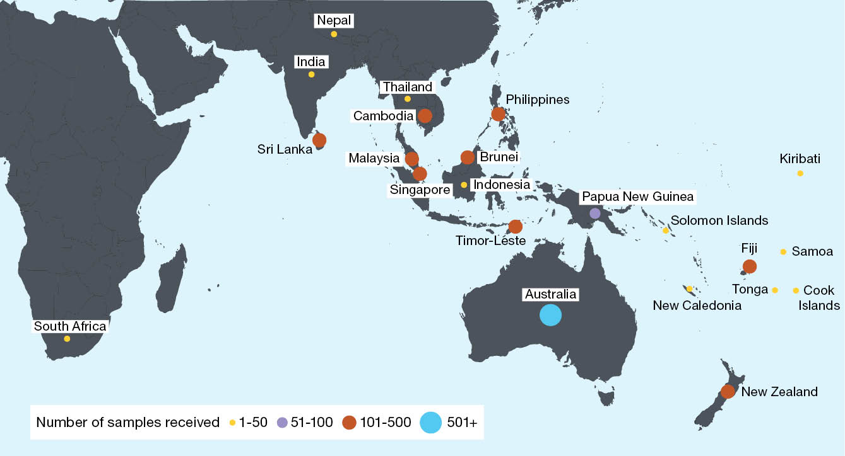
Figure 2: Number of samples received at the Centre during 2024 by week of sample receipt
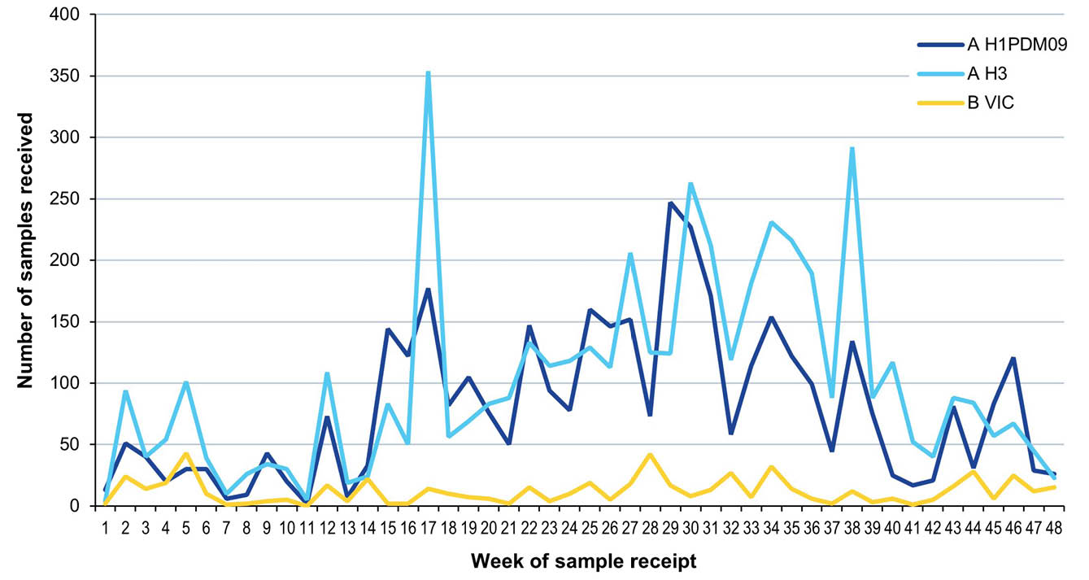
Overall, isolation and re-passaging was attempted for 8,950 (74%) of the samples received, yielding 6,686 isolates (overall isolation rate of 75%). Isolation rates were lower for clinical specimens (72%) compared to recovery of virus isolates (100%). Of the viruses for which type and subtype could be confirmed, isolation rates by cell propagation were 81% (2,847/3,498) for A(H1N1)pdm09, 85% (3,393/3,988) for A(H3N2), and 74% (444/597) for B/Victoria positive samples. There were no isolates with a known subtype or lineage that did not reach sufficient titres for antigenic analysis.
A total of 5,416 viral isolates were successfully characterised by HI assay and compared to the 2024 reference viruses (Table 2). In addition, real-time RT-PCR was attempted on 1,842 samples to determine their type/subtype or lineage. Sanger, ONT, and/or NGS techniques were used to attempt sequencing of the HA genes of 4,008 viruses. The full genomes of 411 viruses were obtained using NGS. Of the samples for which antigenic or genetic analysis was undertaken (n = 7,841), influenza A(H3N2) viruses predominated, comprising 49% (n = 3,866) of viruses received and analysed, followed by A(H1N1)pdm09 with 39% (n = 3,059) and B/Victoria with 7% (n = 568). One A(H5N1) virus was also received and analysed.
Table 2: Antigenic analysis of viruses received by the Centre in 2024, by geographic region of origin
Region | A(H1N1)pdm09 reference strain:ª A/Victoria/4897/2022 (cell) |  | A(H3N2) reference strain:ª A/Thailand/8/2022 (cell) |  | B/Victoria reference strain: B/Austria/1359417/2021 (cell) |  | B/Yamagata reference strain: B/Phuket/3073/2013 (cell)
Region | Like | Low reactor (%) | Like | Low reactor (%) | Like | Low reactor (%) | Like | Low reactor (%)
Africa | 26 | 0 (0) | 2 | 0 (0) | 10 | 0 (0) | — | —
Australasia | 1,866 | 25 (1.3) | 1,734 | 291 (14.4) | 291 | 0 (0) | — | —
South Asia | 44 | 2 (4.3) | 20 | 4 (16.7) | 12 | 0 (0) | — | —
South East Asia | 269 | 9 (3.2) | 418 | 13 (3.0) | 122 | 0 (0) | — | —
South Pacific | 75 | 0 (0) | 173 | 3 (1.7) | 9 | 0 (0) | — | —
Total | 2,280 | 36 (1.6) | 2,347 | 311 (11.7) | 444 | 0 (0) | — | —
a A small number of A(H1N1)pdm09 and A(H3N2) virus isolates that were obtained could not be analysed by HI assay due to low haemagglutination assay (HA) titre in turkey red blood cells (for A(H1N10pdm09)) or guinea pig red blood cells in the presence of oseltamivir (for A(H3N2)).

A(H1N1)pdm09 viruses
Of the 2,314 A(H1N1)pdm09 isolates analysed by HI assay using ferret antisera in 2024, the majority (98.4%) were antigenically similar to the cell-propagated vaccine reference strain A/Victoria/4897/2022 (Table 2). There were no A(H1N1)pdm09 viruses isolated by cell culture that did not reach sufficient titres for antigenic analysis.
Sequencing was attempted on 1,515 viruses, with results obtained for 1,468. Sequencing and phylogenetic analysis of HA genes from 1,641 viruses (including a small number of viruses sequenced externally) showed that the A(H1N1)pdm09 viruses which were received during 2024, and which were able to be sequenced, fell into clades 6B.1A.5a.2a (n = 1,486; 90.6%) and 6B.1A.5a.2a.1 (n = 155; 9.4%) (Figure 3), compared to the 2024 Southern Hemisphere vaccine reference strain, A/Victoria/4897/2022, that was in clade 6B.1A.5a.2a.1.
Thirty A(H1N1)pdm09 viruses were inoculated into eggs for isolation of candidate vaccine viruses, with 16 (53%) successfully isolated. Successful isolations included 14 from genetic clade 6B.1A.5a.2a and two from 6B.1A.5a.2a.1. Seventy-three A(H1N1)pdm09 viruses were inoculated into the qualified cell line MDCK 33016PF, of which 25 (34%) grew successfully, consisting of 24 viruses from genetic clade 6B.1A.5a.2a, and one from 6B.1A.5a.2a.1.
Of the 1,715 A(H1N1)pdm09 viruses tested, 12 viruses (one from Singapore; one from Thailand; one from South Africa; and nine from Australia) exhibited highly reduced inhibition by oseltamivir, with all carrying the NA-H275Y substitution known to cause high level inhibition. No viruses exhibited highly reduced susceptibility to zanamivir. Furthermore, no viruses were identified with genetic evidence of reduced susceptibility to baloxavir marboxil (based on sequencing of 1,218 viruses for PA gene and screening for known antiviral resistance markers at amino acid positions I38, E23, K34, A37, and E199).
Figure 3: Phylogenetic tree of haemagglutinin (HA) genes of A(H1N1)pdm09 viruses received by the Centre during 2024
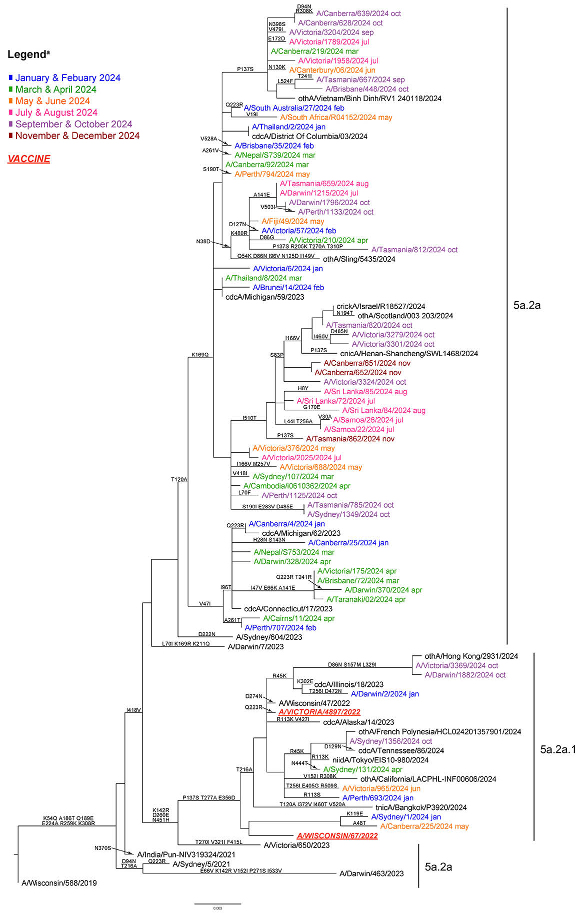
a Viruses from 2024 sequenced by the WHO Centre are coloured according to the month in which they were collected.

A(H3N2) viruses
Antigenic analysis of 2,658 A(H3N2) isolates using the HI assay showed that 88% were antigenically similar to the cell-propagated reference strain A/Thailand/8/2022 (Table 2). There were no A(H3N2) viruses isolated by cell culture that did not reach sufficient titres for antigenic analysis.
A total of 82 A(H3N2) viruses were analysed using FRA. The FRA indicated that 6 of these viruses (7%) showed greater than fourfold difference in titre compared to the cell-propagated reference strain A/Thailand/8/2022, while 41 (50%) had a greater than fourfold difference in titre compared to the egg-propagated reference strain A/Thailand/8/2022.
Sequencing was attempted on the HA genes of 2,093 A(H3N2) viruses, with 2,053 yielding results. Phylogenetic analysis of the HA genes of 2,217 viruses received by the Centre (including viruses sequenced externally) indicated that the majority of circulating viruses fell into clade 3C.2a1b.2a.2a.3a.1 (n = 2,212; 99.8%), which included the 2024 Southern Hemisphere vaccine reference strain A/Thailand/8/2022. The remaining viruses fell into clades 3C.2a1b.2a.2a.3a (n = 1; 0.05%) and 3C.2a1b.2a.2a.3b (n = 4; 0.2%; Figure 4).
Twenty-eight A(H3N2) viruses were inoculated into eggs, of which 18 (64%) grew successfully, all from genetic clade 3C.2a1b.2a.2a.3a.1. Fifty-three A(H3N2) viruses were inoculated into the qualified cell line MDCK 33016PF, of which 29 (55%) grew successfully, all from genetic clade 3C.2a1b.2a.2a.3a.1.
None of the 2,001 A(H3N2) viruses tested with the NAI assay showed highly-reduced susceptibility to oseltamivir or zanamivir. Seventeen viruses were identified with a genetic marker for reduced susceptibility to baloxavir marboxil, PA-A37T, and one virus was identified with the marker PA-I38T (based on sequencing of 1,825 viruses for the PA gene with screening for known antiviral resistance markers at amino acid positions I38, E23, K34, A37, A36, E119, E198, and E199).
Figure 4: Phylogenetic tree of haemagglutinin (HA) genes of A(H3N2) viruses received by the Centre during 2024
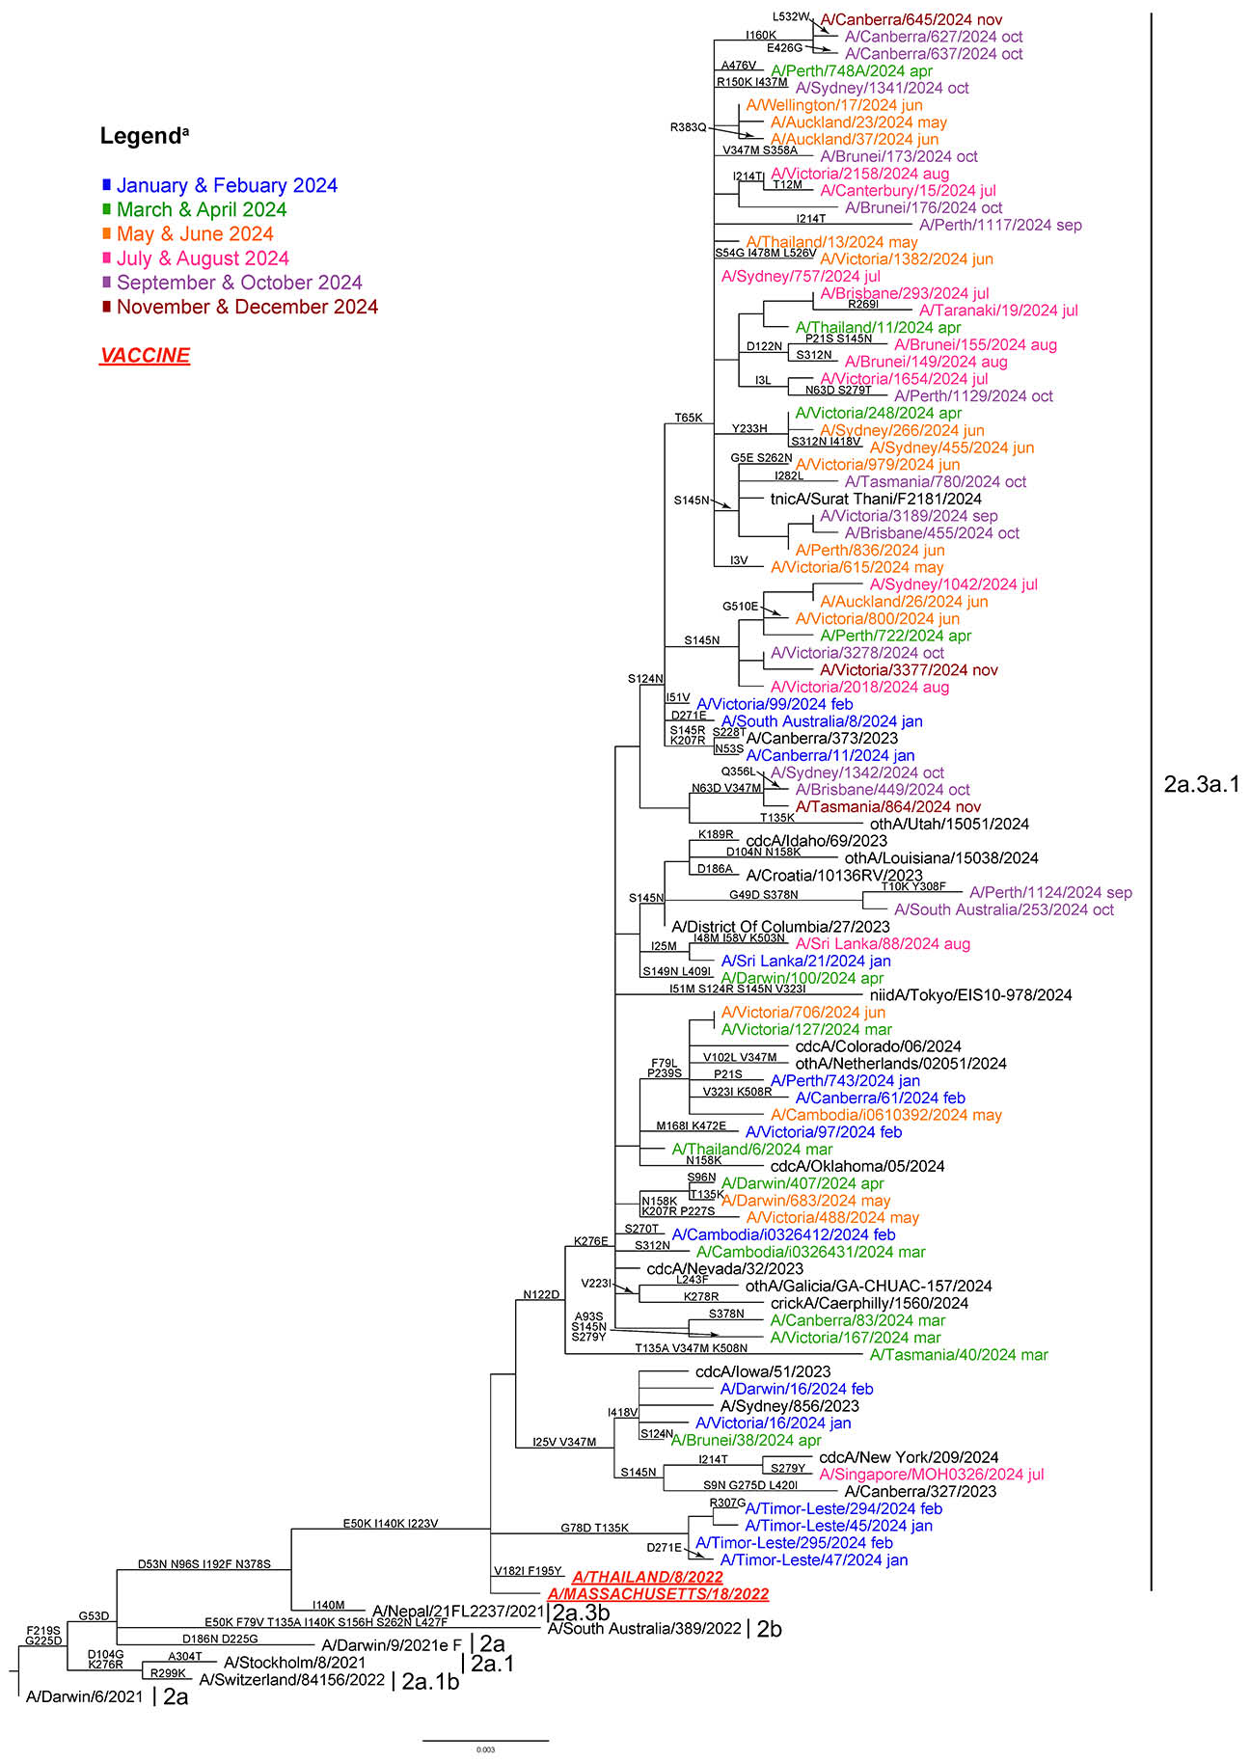
a Viruses from 2024 sequenced by the WHO Centre are coloured according to the month in which they were collected.

Influenza B viruses
A total of 444 B/Victoria viruses were characterised by HI assay (Table 2), with 100% (n = 444) found to be antigenically similar to the cell-propagated B/Austria/1359417/2021 vaccine virus.
Sequencing was attempted on 380 B/Victoria viruses, with 348 yielding results. Phylogenetic analysis on the HA genes of 401 viruses (including viruses sequenced externally) indicated that all circulating B/Victoria viruses received by the Centre fell into clade V1A.3a.2, which included the 2024 vaccine strain B/Austria/1359417/2021 (Figure 5).
Four B/Victoria viruses were inoculated into eggs, of which four (100%) grew successfully, all from genetic clade V1A.3a.2. No B/Victoria viruses were inoculated into the qualified cell line MDCK 33016PF.
Of the 291 B/Victoria viruses tested with the NAI assay, one (from Brunei) showed highly-reduced susceptibility to zanamivir, carrying the NA H275Y substitution. No viruses were identified with genetic evidence of resistance to baloxavir marboxil (based on sequencing of 251 viruses for the PA gene with screening for known antiviral resistance markers at amino acid position I38).

A(H5N1) viruses
A clinical specimen obtained from a traveller returning to Australia from India was received by the Centre and identified as A(H5N1) HPAI by routine NGS. Phylogenetic analysis indicated that the virus was a reassortant with four segments most similar to clade 2.3.2.1a H5N1 viruses circulating in Bangladesh poultry and wild birds.²⁶
Figure 5: Phylogenetic tree of haemagglutinin (HA) genes of B/Victoria-lineage viruses received by the Centre during 2024
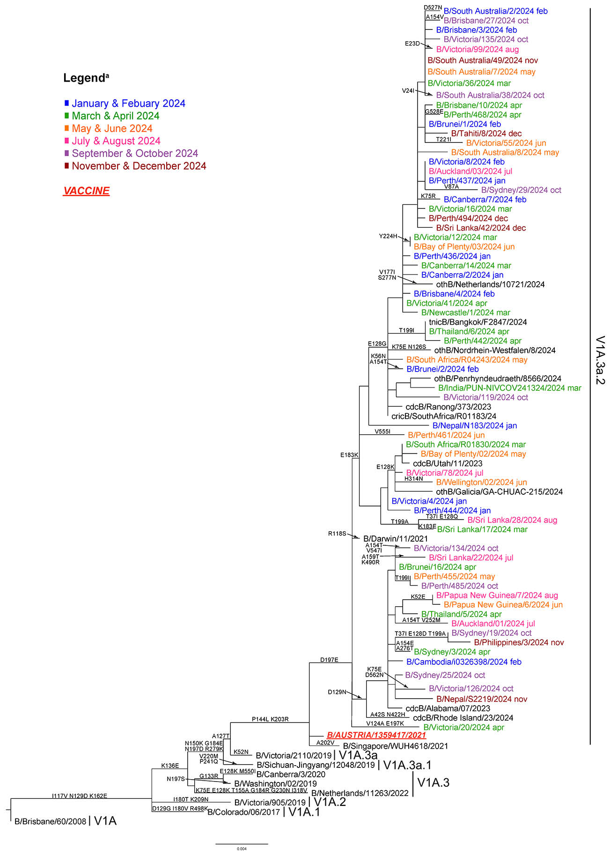
a Viruses from 2024 sequenced by the WHO Centre are coloured according to the month in which they were collected.

Discussion
During 2024, the Centre received one of its highest numbers of samples (n = 12,180) since annual reporting commenced in 1997, with the highest number of samples received in 2023 (n = 15,014).^{27–50} In Australia, the 2024 influenza season marked the third year where influenza activity returned to pre-pandemic levels following the global reduction in influenza activity observed in 2020/2021.^{4,47,49,51} The high number of samples received at the Centre correlated with the high number of laboratory-confirmed influenza notifications (n = 365,589) to the NNDSS during the 2024 Australian influenza season.³ The number of influenza notifications to the NNDSS in 2024 was 26% more than the number recorded in 2023 (n = 289,154) and 57% more than in 2022 (n = 233,455).⁵² The 2024 Australian influenza season was characterised by low and stable activity early in the year that increased in May and then peaked in July, similar to the pattern observed in 2023. The number of influenza notifications per week remained elevated for a longer period of time in 2024 than in previous years.⁵² This activity was reflected in the timing of samples received by the Centre, with 49% of samples collected in 2024 received at the Centre during the June–August period.
Geographically, most notifications of laboratory-confirmed influenza were made in New South Wales, which had the highest annual influenza notification rate in 2024 (1,904 cases per 100,000 population) and which saw 132,901 notifications during the May–August period.^{3,52} Lower numbers of influenza notifications were made in Queensland (n = 59,252) and Victoria (n = 54,401) for the same period, with annual influenza notification rates of 1,428 and 1,034 cases per 100,000 population, respectively.³ In general, peak influenza activity occurred during the June–August period in all jurisdictions except the Northern Territory, where a first peak occurred in April and May, followed by a second peak in August.³
The predominant circulating virus reported to the NNDSS was influenza A (93%), with A(H3N2) viruses predominating in influenza samples that could be subtyped.⁵² Influenza B accounted for only 4% of all notifications.⁵² This is in agreement with samples from Australia received by the Centre, where A(H3N2) and A(H1N1)pmd09 accounted for the majority of viruses analysed. Globally, influenza A(H1N1)pdm09, A(H3N2), and influenza B viruses co-circulated in varying proportions throughout the year. During the February–August 2024 period, influenza A virus detections outnumbered influenza B virus detections with no predominance of influenza B viruses in the majority of regions.⁵³ During the September 2024 – January 2025 period, detections of influenza A were also higher, however, influenza B predominated in Tropical and Temperate South America and in Eastern and Southern Africa.⁵⁴
Overall, the highest notification rates were observed among children (3,314 notifications per 100,000 population among those aged 0–4 years; 3,240 per 100,000 among those aged 5–9 years; and 2,018 per 100,000 among those aged 10–14 years); the lowest notification rate was among adults aged 65–69 years (787 per 100,000 population).⁵² Compared to 2023, notification rates in 2024 for children aged 0–4 years and adults aged 65–69 years increased by 41% and 59%, respectively, whereas notification rates among children aged 5–9 and 10–14 years remained stable. There were 1,002 deaths involving influenza that were reported to the Australian Bureau of Statistics Provisional Mortality Statistics in 2024.⁵²
Antigenic analysis of A(H1N1)pdm09 viruses indicated that the majority of viruses (98%) displayed similar antigenic characteristics to the cell-propagated vaccine strain, A/Victoria/4897/2022. Most circulating A(H1N1)pdm09 viruses were in the genetic clade 6B.1A.5a.2a, with a small percentage of viruses in the 6B.1A.5a.2a.1 clade.
Of A(H3N2) viruses received by the Centre, 88% were antigenically like the cell-propagated vaccine reference strain A/Thailand/8/2022 and were part of the same overall genetic group 3C.2a1b.2a.2a.3a.1, with only a few clade 3C.2a1b.2a.2a.3b viruses detected. Genetic diversity was evident among A(H3N2) viruses characterised, and the recommended vaccine strain for the Southern Hemisphere in 2025 was therefore updated to an egg-based A/Croatia/10136RV/2023-like virus and a cell- or recombinant-protein-based A/District of Columbia/27/2023-like virus.
All influenza B isolates that were analysed at the Centre belonged to the B/Victoria-lineage. All of these viruses were antigenically similar to the B/Austria/1359417/2021 vaccine strain, and all belonged to the same genetic subgroup V1A.3a.2. There was no change to the recommended vaccine strain for B/Victoria for 2025. Globally, no B/Yamagata viruses have been detected since March 2020, and it is hypothesised that this strain is now extinct.^{5,55,56}
During this reporting period the Centre also identified a single case of influenza A(H5N1) HPAI in a young child returning from travel in India who was admitted to a Melbourne hospital with a severe infection.²⁶ After a period in intensive care and treatment with an antiviral drug, they made a complete recovery. This case highlights the need for influenza A subtyping to be performed in diagnostic laboratories so that these rare cases can be appropriately managed and treated.
With the ongoing evolution of seasonal influenza viruses and the absence of an effective universal vaccine, it is essential that influenza surveillance and regular updating of seasonal influenza vaccines continues. The work performed at the Centre in Melbourne contributes to the ongoing efforts of the WHO GISRS to better control the disease burden of influenza, and to provide effective countermeasures, such as vaccines, to reduce the impact of influenza on the human population.

Acknowledgments
The authors would like to thank all the National Influenza Centres and other contributing laboratories who sent influenza positive samples to the Centre during 2024. The Melbourne WHO Collaborating Centre for Reference and Research on Influenza is supported by the Australian Government Department of Health, Disability and Ageing.

Author details
Dr Jessica E Miller, Head - Epidemiology,¹
Dr Tanya R Diefenbach-Elstob, Epidemiologist,¹
Ms Rachel Wordsworth, Medical Scientist,¹
Dr Nikita Deshpande, Medical Scientist,¹
Ms Sally Soppe, Medical Scientist,¹
Ms Joelle Dharmakumara, Medical Scientist,¹
Ms Malet Aban, Medical Scientist,¹
Ms Heidi Peck, Head – Serology,¹
Dr Saira Hussain, Head – Antiviral drug sensitivity,¹
Dr Yi-Mo Deng, Head – Genetic analysis,¹
Dr Clyde Dapat, Head – Bioinformatics,¹
Prof. Ian G Barr, Deputy Director,¹
Prof. Patrick Reading, Director¹
- WHO Collaborating Centre for Reference and Research on Influenza, 792 Elizabeth Street, Melbourne VIC 3001, Australia

Corresponding author
Dr Jessica E Miller
WHO Collaborating Centre for Reference and Research on Influenza, 792 Elizabeth Street, Melbourne VIC 3001, Australia
email: jessica.miller@influenzacentre.org
Phone: +61 3 9342 9300

References
- Hay AJ, McCauley JW. The WHO global influenza surveillance and response system (GISRS)—a future perspective. Influenza Other Respir Viruses. 2018;12(5):551–7. doi: https://doi.org/10.1111/irv.12565.
- Monto AS. Reflections on the global influenza surveillance and response system (GISRS) at 65 years: an expanding framework for influenza detection, prevention and control. Influenza Other Respir Viruses. 2018;12(1):10–2. doi: https://doi.org/10.1111/irv.12511.
- Australian Government Department of Health, Disability and Ageing. National communicable disease surveillance dashboard. [Webpage.] Canberra: Australian Government Department of Health, Disability and Ageing; 2025. [Accessed on 28 April 2025.] Available from: https://nindss.health.gov.au/pbi-dashboard/.
- Sullivan SG, Carlson S, Cheng AC, Chilver MB, Dwyer DE, Irwin M et al. Where has all the influenza gone? The impact of COVID-19 on the circulation of influenza and other respiratory viruses, Australia, March to September 2020. Euro Surveill. 2020;25(47):2001847. doi: https://doi.org/10.2807/1560-7917.ES.2020.25.47.2001847.
- Koutsakos M, Wheatley AK, Laurie K, Kent SJ, Rockman S. Influenza lineage extinction during the COVID-19 pandemic? Nat Rev Microbiol. 2021;19(12):741–2. doi: https://doi.org/10.1038/s41579-021-00642-4.
- Oh DY, Barr IG, Mosse JA, Laurie KL. MDCK-SIAT1 cells show improved isolation rates for recent human influenza viruses compared to conventional MDCK cells. J Clin Microbiol. 2008;46(7):2189–94. doi: https://doi.org/10.1128/JCM.00398-08.
- Hobson D, Curry RL, Beare AS, Ward-Gardner A. The role of serum haemagglutination-inhibiting antibody in protection against challenge infection with influenza A2 and B viruses. J Hyg (Lond). 1972;70(4):767–77. doi: https://doi.org/10.1017/s0022172400022610.
- Lin YP, Gregory V, Collins P, Kloess J, Wharton S, Cattle N et al. Neuraminidase receptor binding variants of human influenza A(H3N2) viruses resulting from substitution of aspartic acid 151 in the catalytic site: a role in virus attachment? J Virol. 2010;84(13):6769–81. doi: https://doi.org/10.1128/JVI.00458-10.
- Shu B, Kirby MK, Davis WG, Warnes C, Liddell J, Liu J et al. Multiplex real-time reverse transcription PCR for influenza A virus, influenza B virus, and severe acute respiratory syndrome coronavirus 2. Emerg Infect Dis. 2021;27(7):1821–30. doi: https://doi.org/10.3201/eid2707.210462.
- Shu B, Wu KH, Emery S, Villanueva J, Johnson R, Guthrie E et al. Design and performance of the CDC real-time reverse transcriptase PCR swine flu panel for detection of 2009 A (H1N1) pandemic influenza virus. J Clin Microbiol. 2011;49(7):2614–9. doi: https://doi.org/10.1128/JCM.02636-10.
- Deng YM, Spirason N, Iannello P, Jelley L, Lau H, Barr IG. A simplified Sanger sequencing method for full genome sequencing of multiple subtypes of human influenza A viruses. J Clin Virol. 2015;68:43–8. doi: https://doi.org/10.1016/j.jcv.2015.04.019.
- Zhou B, Deng YM, Barnes JR, Sessions OM, Chou TW, Wilson M et al. Multiplex reverse transcription-PCR for simultaneous surveillance of influenza A and B viruses. J Clin Microbiol. 2017;55(12):3492–501. doi: https://doi.org/10.1128/JCM.00957-17.
- Zhou B, Donnelly ME, Scholes DT, St George K, Hatta M, Kawaoka Y et al. Single-reaction genomic amplification accelerates sequencing and vaccine production for classical and swine origin human influenza A viruses. J Virol. 2009;83(19):10309–13. doi: https://doi.org/10.1128/JVI.01109-09
- Shepard SS, Meno S, Bahl J, Wilson MM, Barnes J, Neuhaus E. Viral deep sequencing needs an adaptive approach: IRMA, the iterative refinement meta-assembler. BMC Genomics. 2016;17(1):708. doi: https://doi.org/10.1186/s12864-016-3030-6.
- Hadfield J, Megill C, Bell SM, Huddleston J, Potter B, Callender C et al. Nextstrain: real-time tracking of pathogen evolution. Bioinformatics. 2018;34(23):4121–3. doi: https://doi.org/10.1093/bioinformatics/bty407.
- Minh BQ, Schmidt HA, Chernomor O, Schrempf D, Woodhams MD, von Haeseler A et al. IQ-TREE 2: new models and efficient methods for phylogenetic inference in the genomic era. Mol Biol Evol. 2020;37(5):1530–4. doi: https://doi.org/10.1093/molbev/msaa015.
- Yu G. Using ggtree to visualize data on tree-like structures. Curr Protoc Bioinformatics. 2020;69(1):e96. doi: https://doi.org/10.1002/cpbi.96.
- Aksamentov I, Cornelius R, Hodcroft EB, Neher RA. Nextclade: clade assignment, mutation calling and quality control for viral genomes. J Open Source Softw. 2021;6(67):3773. doi: https://doi.org/10.21105/joss.03773.
- Hurt AC, Besselaar TG, Daniels RS, Ermetal B, Fry A, Gubareva L et al. Global update on the susceptibility of human influenza viruses to neuraminidase inhibitors, 2014–2015. Antiviral Res. 2016;132:178–85. doi: https://doi.org/10.1016/j.antiviral.2016.06.001.
- World Health Organization (WHO) Global Influenza Programme. Laboratory methodologies for testing the antiviral susceptibility of influenza viruses: Neuraminidase inhibitor (NAI). [Webpage.] Geneva: WHO; 2023. [Accessed on 29 March 2023.] Available from: https://www.who.int/teams/global-influenza-programme/laboratory-network/quality-assurance/antiviral-susceptibility-influenza/neuraminidase-inhibitor.
- Gerdil C. The annual production cycle for influenza vaccine. Vaccine. 2003;21(16):1776–9. doi: https://doi.org/10.1016/s0264-410x(03)00071-9.
- Stöhr K, Bucher D, Colgate T, Wood J. Influenza virus surveillance, vaccine strain selection, and manufacture. Methods Mol Biol. 2012;865:147–62.
doi: https://doi.org/10.1007/978-1-61779-621-0_9.
- Weir JP, Gruber MF. An overview of the regulation of influenza vaccines in the United States. Influenza Other Respir Viruses. 2016;10(5):354–60. doi: https://doi.org/10.1111/irv.12383.
- WHO Global Influenza Surveillance Network. Manual for the laboratory diagnosis and virological surveillance of influenza. Geneva: WHO; I January 2011. Available from: https://www.who.int/publications/i/item/manual-for-the-laboratory-diagnosis-and-virological-surveillance-of-influenza
- Roth B, Mohr H, Enders M, Garten W, Gregersen JP. Isolation of influenza viruses in MDCK 33016PF cells and clearance of contaminating respiratory viruses. Vaccine. 2012;30(3):517–22. doi: https://doi.org/10.1016/j.vaccine.2011.11.063.
- Deng YM, Wille M, Dapat C, Xie R, Lay O, Peck H et al. Influenza A(H5N1) virus clade 2.3.2.1a in traveler returning to Australia from India, 2024. Emerg Infect Dis. 2025;31(1):135–8. doi: https://doi.org/10.3201/eid3101.241210.
- Curran M, Hampson A. National influenza surveillance 1997. Commun Dis Intell. 1998;22(5):69–74.
- Halliday L, Roberts L, Hampson A. Annual report of the National Influenza Surveillance Scheme, 1998. Commun Dis Intell. 1999;23(7):185–92.
- Thomson J, Lin M, Hampson A. Annual report of the National Influenza Surveillance Scheme, 1999. Commun Dis Intell. 2000;24(6):145–52.
- Firestone SM, Barr IG, Roche PW, Walker JC. Annual report of the National Influenza Surveillance Scheme, 2005. Commun Dis Intell Q Rep. 2006;30(2):189–200.
- Li J, Hampson A, Roche PW, Yohannes K, Spencer JD. Annual report of the National Influenza Surveillance Scheme, 2004. Commun Dis Intell Q Rep. 2005;29(2):125–36.
- Roche P, Spencer J, Hampson A. Annual report of the National Influenza Surveillance Scheme, 2001. Commun Dis Intell Q Rep. 2002;26(2):204–13.
- Roche P, Spencer J, Merianos A, Hampson A. Annual report of the National Influenza Surveillance Scheme, 2000. Commun Dis Intell Q Rep. 2001;25(3):107–12.
- Yohannes K, Roche P, Hampson A, Miller M, Spencer J. Annual report of the National Influenza Surveillance Scheme, 2003. Commun Dis Intell Q Rep. 2004;28(2):160–8.
- Yohannes K, Roche P, Spencer J, Hampson A. Annual report of the National Influenza Surveillance Scheme, 2002. Commun Dis Intell Q Rep. 2003;27(2):162–72.
- O'Brien K, Barr IG. Annual report of the National Influenza Surveillance Scheme, 2006. Commun Dis Intell Q Rep. 2007;31(2):167–79.
- Owen R, Barr IG, Pengilley A, Liu C, Paterson B, Kaczmarek M et al. Annual report of the National Influenza Surveillance Scheme, 2007. Commun Dis Intell Q Rep. 2008;32(2):208–26.
- Kaczmarek M, Owen R, Barr IG. Annual report of the National Influenza Surveillance Scheme, 2008. Commun Dis Intell Q Rep. 2010;34(1):8–22.
- Pennington K, Owen R, Mun J. Annual report of the National Influenza Surveillance Scheme, 2009. Commun Dis Intell Q Rep. 2017;41(4):E383–454.
- Gavin K, Owen R, Barr IG. Annual report of the National Influenza Surveillance Scheme, 2010. Commun Dis Intell Q Rep. 2017;41(4):E348–68.
- Sullivan SG, Chow MK, Barr IG, Kelso A. Influenza viruses received and tested by the Melbourne WHO Collaborating Centre for Reference and Research on Influenza annual report, 2014. Commun Dis Intell Q Rep. 2015;39(4):E602–11.
- Leung VK, Deng YM, Kaye M, Buettner I, Lau H, Leang SK et al. Annual report on influenza viruses received and tested by the Melbourne WHO Collaborating Centre for Reference and Research on Influenza in 2016. Commun Dis Intell (2018). 2019;43. doi: http://doi.org/10.33321/cdi.2019.43.3.
- Leung VK, Spirason N, Lau H, Buettner I, Leang SK, Chow MK. Influenza viruses received and tested by the Melbourne WHO Collaborating Centre for Reference and Research on Influenza annual report, 2015. Commun Dis Intell Q Rep. 2017;41(2):E150–60.
- Peck H, Moselen J, Brown SK, Triantafilou M, Lau H, Grau M et al. Report on influenza viruses received and tested by the Melbourne WHO Collaborating Centre for Reference and Research on Influenza in 2019. Commun Dis Intell (2018). 2021;45. doi: https://doi.org/10.33321/cdi.2021.45.43.
- Roe M, Kaye M, Iannello P, Lau H, Buettner I, Tolosa MX et al. Report on influenza viruses received and tested by the Melbourne WHO Collaborating Centre for Reference and Research on Influenza in 2017. Commun Dis Intell (2018). 2019;43. doi: https://doi.org/10.33321/cdi.2019.43.25.
- Price OH, Spirason N, Rynehart C, Brown SK, Todd A, Peck H et al. Report on influenza viruses received and tested by the Melbourne WHO Collaborating Centre for Reference and Research on Influenza in 2018. Commun Dis Intell (2018). 2020;44. doi: https://doi.org/10.33321/cdi.2020.44.16.
- O’Neill G, Aziz A, Kuba M, Brown SK, Lau H, Soppe S et al. Report on influenza viruses received and tested by the Melbourne WHO Collaborating Centre for Reference and Research on Influenza during 2020–2021. Commun Dis Intell (2018). 2022;46. doi: https://doi.org/10.33321/cdi.2022.46.63.
- Communicable Disease Epidemiology and Surveillance Section. Report of the National Influenza Surveillance Scheme, 2011 to 2018. Commun Dis Intell (2018). 2022;46. doi: https://doi.org/10.33321/cdi.2022.46.12.
- Diefenbach-Elstob TR, Chanthalavanh P, Bobbitt ME, Brown SK, Rynehart C, Spirason N et al. Report on influenza viruses received and tested by the Melbourne WHO Collaborating Centre for Reference and Research on Influenza during 2022. Commun Dis Intell (2018). 2023;47. doi: https://doi.org/10.33321/cdi.2023.47.43.
- Diefenbach-Elstob TR, Lay O, Zakis T, Deshpande N, Soppe S, Peck H et al. Report on influenza viruses received and tested by the Melbourne WHO Collaborating Centre for Reference and Research on Influenza during 2023. Commun Dis Intell (2018). 2025;49. doi: https://doi.org/10.33321/cdi.2025.49.028.
- WHO Global Influenza Programme. Influenza Update N° 384: 04 January 2021, based on data up to 20 December 2020. Geneva: WHO; 4 January 2021. Available from: https://cdn.who.int/media/docs/default-source/influenza/influenza-updates/2020/2021_01_04_surveillance_update_384.pdf.
- Australian Centre for Disease Control. 2024 Annual Australian Respiratory Surveillance Report. Canberra: Canberra: Australian Centre for Disease Control; 4 April 2025. Available from: https://www.cdc.gov.au/resources/publications/annual-arsr-2024.
- WHO. Recommended composition of influenza virus vaccines for use in the 2025 southern hemisphere influenza season. Geneva: WHO; 27 September 2024. Available from: https://cdn.who.int/media/docs/default-source/vcm-southern-hemisphere-recommendation-2025/sep-2024-sh-recommendations_seasonal_final.pdf.
- WHO. Recommended composition of influenza virus vaccines for use in the 2025–2026 northern hemisphere influenza season. Geneva: WHO; 28 February 2025. Available from: https://cdn.who.int/media/docs/default-source/influenza/who-influenza-recommendations/vcm-northern-hemisphere-recommendation-2025-2026/recommended-composition-of-influenza-virus-vaccines-for-use-in-the-2025-2026-northern-hemisphere-influenza-season.pdf.
- Dhanasekaran V, Sullivan S, Edwards KM, Xie R, Khvorov A, Valkenburg SA et al. Human seasonal influenza under COVID-19 and the potential consequences of influenza lineage elimination. Nat Commun. 2022;13(1):1721. doi: https://doi.org/10.1038/s41467-022-29402-5.
- Paget J, Caini S, Del Riccio M, van Waarden W, Meijer A. Has influenza B/Yamagata become extinct and what implications might this have for quadrivalent influenza vaccines? Euro Surveill. 2022;27(39):2200753. doi: https://doi.org/10.2807/1560-7917.ES.2022.27.39.2200753.

The CDC Influenza Virus Real-Time RT-PCR Influenza A/B Typing Panel (RUO) (Catalog No. FluRUO-01), FR-198, was obtained through the International Reagent Resource, Influenza Division, WHO Collaborating Center for Surveillance, Epidemiology and Control of Influenza, Centers for Disease Control and Prevention, Atlanta, GA, United States of America. Available from: https://www.internationalreagentresource.org/.

