
2026 • Volume 50 • cdc.gov.au/cdi • Epub date: 24.02.2026 • doi.org/10.33321/cdi.2026.50.012

SAEFVIC: Surveillance of adverse events following immunisation (AEFI) in Victoria, Australia, 2019–2020
Jesse J Fryk, Hazel J Clothier, Daneeta Hennessy, Georgina Lewis, Emma Roney, Nigel W Crawford, Jim P Buttery
© 2026 Commonwealth of Australia as represented by the Australian Centre for Disease Control
ISSN: 2209-6051 Online
This journal is indexed by Index Medicus and Medline.
Creative Commons Licence
This publication is licensed under a Creative Commons Attribution-NonCommercial-NoDerivatives 4.0 International Licence (Licence). You must read and understand the Licence before using any material from this publication.
Restrictions
The Licence does not cover, and there is no permission given for, use of any of the following material found in this publication (if any):
- the Commonwealth Coat of Arms (by way of information, the terms under which the Coat of Arms may be used can be found on the Department of Prime Minister and Cabinet website);
- any logos (including the Australian Centre for Disease Control’s logo) and trademarks;
- any photographs and images;
- any signatures; and
- any material belonging to third parties.
Disclaimer
Opinions expressed in Communicable Diseases Intelligence are those of the authors and not necessarily those of the Australian Government or the Australian Centre for Disease Control. Data may be subject to revision.
Enquiries
Enquiries regarding any other use of this publication should be addressed to the CDI Editor.
About CDI
Communicable Diseases Intelligence (CDI) is a peer-reviewed scientific journal published by the Australian Centre for Disease Control.
The journal aims to disseminate information on the epidemiology, surveillance, prevention and control of communicable diseases of relevance to Australia and the near region.
Editor: Elise Firman • Deputy Editor: Simon Petrie • Design and Production: Lisa Thompson
Editorial Advisory Board: David Durrheim, Mark Ferson, Clare Huppatz, John Kaldor, Martyn Kirk and Meru Sheel
Submit an Article
Guidelines for authors and details on how to submit your publication is available on our website, or by email to the
CDI Editor.
Contact us
Communicable Diseases Intelligence (CDI)
Australian Centre for Disease Control
GPO Box 798, CANBERRA ACT 2601
Website: cdc.gov.au/cdi
Email: cdi.editor@cdc.gov.au

Contents
Abstract 5
Background 5
Methods 5
Results 5
Conclusion 5
Introduction 6
Methods 7
AEFI data 7
Definitions 7
Data categories 8
Analyses 8
Ethical approval 9
Results 10
AEFI reporting 10
SAEFVIC clinical services and education 25
Discussion 27
MVEC resources 28
Conclusion 30
Acknowledgments 30
Conflicts of interest 30
Author details 31
References 32

List of figures
Figure 1: Adverse events following immunisation (AEFI) reports and reporting rate per 100,000 population, by year, SAEFVIC, Victoria, Australia, 2015–2020 11
Figure 2: Adverse events following immunisation (AEFI) reports by reporting modality and year, SAEFVIC, Victoria, Australia, 2015–2020 12
Figure 3: Adverse events following immunisation (AEFI) reports by reporter type and year, SAEFVIC, Victoria, Australia, 2015–2020 13
Figure 4: Adverse events following immunisation (AEFI) reports (A) and rate per 100,000 population (B) by age group and year reported, SAEFVIC, Victoria, Australia, 2015–2020 14
Figure 5: Vaccine administration errors reported to SAEFVIC, Victoria, Australia, 2015–2020 22
Figure 6: Type of clinic consultation attendance at Monash Health and the Royal Children’s Hospital, SAEFVIC, Victoria, Australia, 2015–2020 25

List of tables
Table 1: Description of adverse events following immunisation (AEFI) reported to the SAEFVIC surveillance system, Victoria, Australia, 2019–2020 10
Table 2: Serious adverse event following immunisation (AEFI) reports by age group,ª SAEFVIC, Victoria, Australia, 2019–2020 15
Table 3: Adverse event following immunisation (AEFI) reports by sex,ª Indigenous status, and age group,^{b} SAEFVIC, Victoria, Australia, 2019–2020 15
Table 4: Adverse event following immunisation (AEFI) reports by national immunisation program (NIP) age group and vaccine antigen, SAEFVIC, Victoria, Australia, 2019–2020 17
Table 5: Most frequently reported adverse events (> 20 reports) and selected conditions of interest, by age group, SAEFVIC, Victoria, Australia,^{a,b} 2019–2020 19
Table 6: Targeted monitoring for vaccine pharmacovigilance, SAEFVIC, Victoria, Australia,
2019–2020 24

Abstract

Background
Adverse event following immunisation (AEFI) surveillance in Victoria is conducted through Surveillance of Adverse Events Following Vaccination in the Community (SAEFVIC), an enhanced surveillance system integrated with clinical services for vaccinees experiencing an AEFI. This report summarises SAEFVIC’s surveillance and vaccine pharmacovigilance activities in 2019 and 2020.

Methods
A retrospective cohort study approach was used to analyse AEFI reports submitted in 2019 and 2020, compared to those since 2015. Data were categorised by vaccinee demographics (age; sex; pregnancy; and Indigenous status), vaccines administered and reported AEFI. Age cohorts were defined as best fit to the National Immunisation Program age groups. Proportional reporting ratio was determined for perceived signals being investigated. Clinical services and educational activities were described.

Results
There were 3,828 AEFI reports received in 2019 and 2020 (28.8 per 100,000 population), with 7.6% defined as serious; 52% of all reports were female vaccinees; 56 of 464 reports among adult females (12.1%) were pregnant vaccinees; and 29 reports (0.9%) were Indigenous Australians. Reporting trends by age group were similar across all cohorts. No vaccine safety signals were confirmed. Telehealth consultations at Specialist Immunisation Clinics increased in 2020 in-line with Medicare eligibility criteria changes. Educational resources on various vaccine safety topics were published, particularly the anticipated coronavirus disease 2019 (COVID-19) vaccination program.

Conclusion
AEFI surveillance in Victoria continues to be robust through the SAEFVIC model and provides confidence in informing the safety profile of vaccines administered in Australia. These data provide a baseline for AEFI surveillance for comparison to the COVID-19 vaccination program commenced in 2021.
Keywords: adverse events; vaccine safety; pharmacovigilance; surveillance; immunisation;
post-licensure

Introduction
Victoria’s vaccine safety services ‘Surveillance of Adverse Events Following Vaccination in the Community’ (SAEFVIC) comprise enhanced adverse event following immunisation (AEFI) surveillance through passive, active, and sentinel reporting pathways, integrated with clinical services and an online immunisation education portal.¹ SAEFVIC commenced operations in May 2007, funded by the Victorian Government Department of Health to ensure safe pathways to vaccination for all.
This model of integrated surveillance and clinical services has demonstrated improvement in AEFI reporting rates, with Victoria contributing 43.2% of national AEFI reports in 2019.^{2,3} Clinical services facilitate assessment of reports to enrich detail and quality through follow-up of individual cases, capturing more comprehensive clinical information, and offering expert advice and support for subsequent vaccination through specialist immunisation services where appropriate. Educational materials for healthcare worker and consumer audiences are developed collaboratively between SAEFVIC and the Melbourne Vaccine Education Centre (MVEC) and published on the MVEC website.⁴
Previous descriptive reviews of SAEFVIC in 2012 and 2018 provide background for comparison.^{5,6}
AEFI reported to SAEFVIC are forwarded to the Australian Therapeutic Goods Administration (TGA), and are included in both the publicly accessible national Database of Adverse Event Notifications (DAEN) and the collated national reports of AEFI, published annually.⁷ We report on SAEFVIC surveillance activity from 1 January 2019 to 31 December 2020, examining all AEFI reported in Victoria, and summarise the clinical and educational activities that SAEFVIC provides in supporting the Victorian Department of Health to deliver a safe and equitable immunisation program.

Methods
A retrospective cohort study approach was used to describe AEFI reported to SAEFVIC from 1 January 2019 to 31 December 2020, with AEFI reports from the previous four years used as a comparison. Data for these previous four years may differ from previous publications, due to records being continually updated following clinical review processes.

AEFI data
AEFI reporting is encouraged, but not mandated in Victoria. SAEFVIC is an integrated AEFI reporting system receiving spontaneous reports from vaccinees or their health care providers, as well as reports from active surveillance initiatives such as the Paediatric Active Enhanced Disease Surveillance (PAEDS) hospital sentinel system⁸ and national AusVaxSafety active AEFI surveillance (reports where the vaccinee sought medical care only).⁹ SAEFVIC’s system design and AEFI reporting processes have been previously described.^{1,10}
All reports of adverse events temporally associated with vaccination, regardless of time elapsed, are accepted. The SAEFVIC database also contains reports of vaccine administration errors such as administration of a contraindicated or expired vaccine, and retrospective reports of historical events that may seek counselling around future vaccination.
SAEFVIC surveillance is integrated with clinical service delivery. All submitted AEFI reports are reviewed by an immunisation nurse and coded using a combination of case definitions from the Brighton Collaboration and the Australian Immunisation Handbook. Follow-up contact to the reporter and vaccinee (or their parent/guardian) is undertaken to discuss the adverse event and to provide counselling, including concerns around future vaccination. A specialist clinical review is offered for serious AEFI (SAEFI) and/or if there is reduced confidence in future vaccinations.
Melbourne Vaccine Education Centre (MVEC) provides up-to-date resources on immunisation and vaccine safety topics through a website that can be accessed by health professionals and the public.⁴ Education packages, eLearning modules, and reference pages developed in 2019–2020 covered information on vaccine administration errors and on shoulder injury related to vaccine administration (SIRVA) for immunisation providers in response to increased reporting of these events.

Definitions
An AEFI is defined as any untoward medical occurrence that follows immunisation though does not necessarily have a causal relationship with the administration of the vaccine.¹¹
AEFI described by the reporter are categorised using general medical terminology and more than one event may be reported per individual case. Categorisation of AEFI is aligned with standard case definitions as determined by the Brighton Collaboration, Australian Immunisation Handbook, or SAEFVIC in that hierarchical order of availability.^{12,13}
A serious AEFI (SAEFI) is defined as an adverse event that is reported as life threatening; resulting in hospitalisation or the prolongation of current hospital stay; disability or incapacitation that is persistent or significant; a congenital anomaly/defect; death; or deemed to be medically important by the clinicians at SAEFVIC.¹⁴ A life-threatening event requires the vaccinee to have been at risk of death at the time of the event or reaction, rather than a reaction or event that could have hypothetically resulted in death if it was more severe.
SIRVA is a rare complication of incorrect vaccine administration, when the vaccine is given too high into the shoulder joint instead of the deltoid muscle, resulting in shoulder pain and restricted range of movement.¹⁵
Serious adverse neurological events (SANE) include acute disseminated encephalomyelitis (ADEM), Guillain-Barré syndrome (GBS) and its variants, multiple sclerosis, optic neuritis, and transverse myelitis.
A vaccine safety signal is defined as an increase in AEFI reporting above an expected threshold determined from statistical calculations such as the proportional reporting ratio (outlined later), or an AEFI where clinical concerns have been raised.

Data categories
The reporter type is recorded as either a healthcare professional or as the consumer (vaccinee self-report or the vaccinee’s parent/guardian). The type of immunisation provider (nurse, doctor, pharmacist) is also captured, including provider setting.
Vaccines administered are recorded in SAEFVIC by vaccine brand name and are grouped by antigen for analysis. Vaccinees may receive multiple vaccines concomitantly, thus any AEFI described are recorded against all vaccines received at the same encounter.
Age groups were determined as best fit to the National Immunisation Program (NIP) age groups of infant (0–12 months); young child (1–4 years); school-aged (5–17 years); adult (18–64 years); and older person (65+ years).¹³

Analyses
Data were described as counts, proportions by vaccinee demographics, reporter type, reporting channel and vaccine antigen using Microsoft Power BI (Microsoft Power BI Desktop version 2.95.983.0 July 2021), and Microsoft Power BI on Office 365 (Microsoft Corporation, Redmond, WA, USA) for data visualisation. Statistical calculations of 95% confidence intervals (95% CI) and proportional reporting ratio were calculated using STATA 16.0 (StataCorp, College Station, TX, USA) with p values < 0.05 considered statistically significant.
Reporting rates per 100,000 population were calculated using the Victorian mid-year population estimates obtained from the Australian Bureau of Statistics (ABS) for 2019 and 2020 respectively.^{16,17}
The proportion of SAEFI reported were calculated for 2019 and 2020 and compared against the average proportion for the preceding four years, calculated as the summation of SAEFI reports from 2015 to 2018 inclusive.
Data requests were submitted to Services Australia to obtain vaccine doses recorded in the Australian Immunisation Register (AIR)¹⁸ for Victoria in 2019 and 2020. Each extract contained the number of vaccine doses administered for 2019 or 2020 by vaccine brand in single-year, five-year or ten-year age groups for collation into the respective age cohorts defined earlier. Reporting rates per 100,000 vaccine doses administered were calculated by vaccine brand using the collated vaccine doses for the relevant NIP vaccines in 2019 and 2020.
Investigation methods used for vaccine safety signals included a comparison of reporting frequency trends and the calculation of proportional reporting ratio (PRR).¹⁹ Briefly, PRR is a signal detection algorithm used in pharmacovigilance that measures disproportionality of adverse events following specific vaccines compared to other vaccines and AEFI.²⁰ The PRR is calculated for vaccine-adverse event pairs using the 2 × 2 table convention. Thresholds for detecting vaccine safety signals were defined as PRR ≥ 2.0 and chi-squared ≥ 4.0.

Ethical approval
Approval was granted by the Royal Children’s Hospital Human Research Ethics Committee for this registered database (Number 37194).

Results

AEFI reporting

Reports received
SAEFVIC received 3,927 reports during 2019 and 2020 (1,956 in 2019 and 1,971 in 2020) (Table 1). Reports of historic AEFI—that is, AEFI following vaccinations received before 1 January 2019—seeking clinical assessment prior to current vaccination (n = 99) were excluded from analyses. Thus 3,828 reports (1,920 in 2019 and 1,908 in 2020), were available for analysis, an approximately 11% increase on the previous two years (Figure 1). At a population level, reporting to SAEFVIC was similar in 2019 and 2020 (viz., 29.1 and 28.5 reports per 100,000 population respectively).
Table 1: Description of adverse events following immunisation (AEFI) reported to the SAEFVIC surveillance system, Victoria, Australia, 2019–2020
Characteristic | Category | Year
Characteristic | Category | 2019 |  | 2020
Characteristic | Category | Number | Percentageª | Number | Percentageª
Reports received | Total | 1,956 | — | 1,971 | —
Reports received | Excluded (historical AEFI) | 36 | — | 63 | —
Reports received | Available for analysis | 1,920 | — | 1,908 | —
Data completeness | Sex | 1,915 | > 99 | 1,904 | > 99
Data completeness | Indigenous status | 1,535 | 80 | 1,656 | 87
Reports | Number of vaccines | 3,269 | — | 3,326 | —
Reports | Number of reactions | 3,023 | — | 3,050 | —
Reports | Pregnant | 242 | 13 | 222 | 12
Reports | Serious AEFI | 155 | 8 | 135 | 7
Spontaneous reports: source | Total | 1,897 | 99 | 1,889 | 99
Spontaneous reports: source | Healthcare workers | 1,243 | — | 1,320 | —
Spontaneous reports: source | Consumers | 537 | — | 491 | —
Spontaneous reports: source | Pharmacists | 20 | — | 15 | —
Spontaneous reports: source | Other | 97 | — | 63 | —
Active surveillance: source | Total | 23 | 1 | 19 | 1
Active surveillance: source | AusVaxSafety^{b} | 8 | — | 6 | —
Active surveillance: source | PAEDS^{c} | 15 | — | 13 | —
Attended for clinical review | — | 363 | — | 442 | —
a Percentage calculated using reports available for analysis as the denominator.
b AusVaxSafety surveillance system, National Centre for Immunisation Research and Surveillance, Sydney Children’s Hospital Network.
c Paediatric Active Enhanched Disease Surveillance system.
Figure 1: Adverse events following immunisation (AEFI) reports and reporting rate per 100,000 population, by year, SAEFVIC, Victoria, Australia, 2015–2020
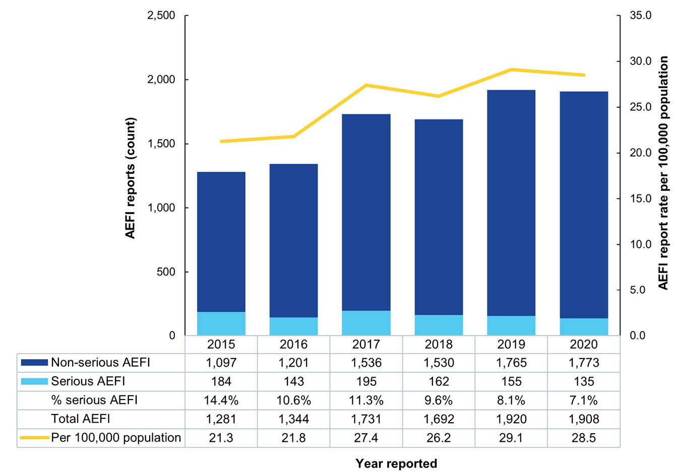

Serious AEFI (SAEFI)
Of the reports submitted in 2019 and 2020, there were respectively 155 (8.1%) and 135 (7.1%) which met the definition of SAEFI. The proportion of SAEFI reported has declined from an average reporting proportion of 11.3% during 2015–2018 to 7.1% in 2020 (p < 0.001) (Figure 1). In 2019, ninety-two of 155 SAEFI reports (59.4%) indicated a hospital admission and a further 30 (19.4%) indicated attending a hospital emergency department without admission. In 2020, seventy-six of 135 SAEFI reports (56.3%) were admitted to hospital and 27 (20.0%) attended a hospital emergency department without admission.

Reporting modality
Online reporting to SAEFVIC remained the most common method of reporting AEFIs, accounting for 48.7% and 55.8% of reports in 2019 and 2020 respectively, followed by telephone (32.7% in 2019 and 27.0% in 2020) and fax (17.7% in 2019 and 16.2% in 2020) (Figure 2).
Figure 2: Adverse events following immunisation (AEFI) reports by reporting modality and year, SAEFVIC, Victoria, Australia, 2015–2020
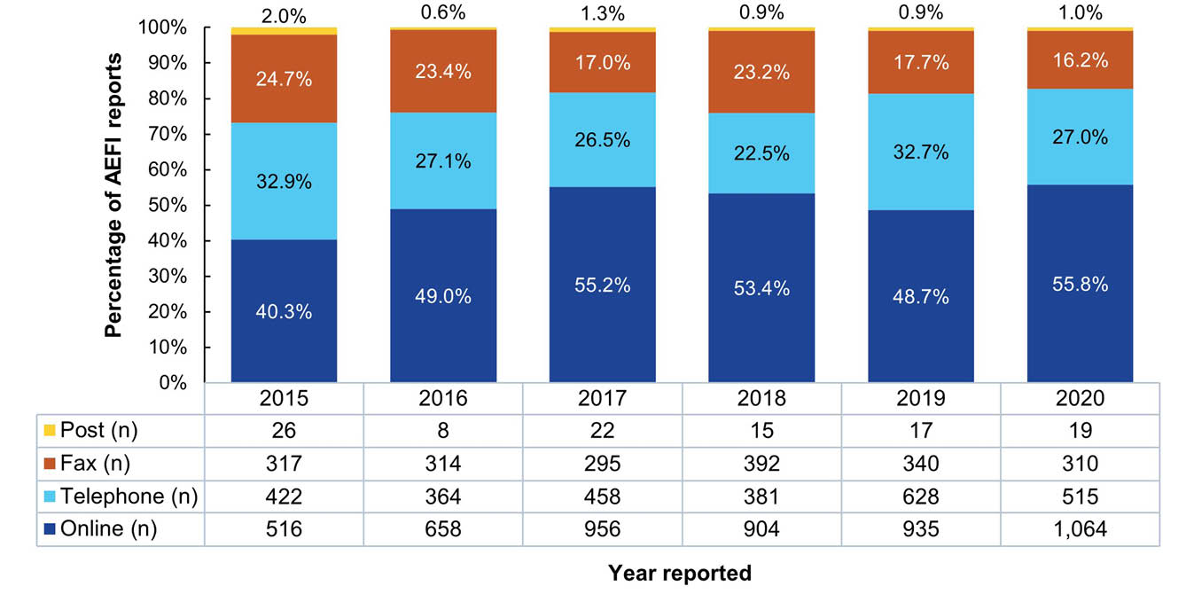

Active surveillance
The proportion of reports originating from active surveillance decreased from 3% in 2015 to 1% in 2020. However, a high proportion of these reports are defined as SAEFI (13/23: 57% in 2019; 13/19: 68% in 2020) arising from provision of medically attended reports to SAEFVIC from AusVaxSafety for the purpose of clinical follow-up, and from cases identified from PAEDS that contain a relevant vaccination history.

Reporter type
Reporter type has remained consistent, with approximately two-thirds of all reports submitted by healthcare providers; one-third by consumers (vaccinees or their parent/guardian); and a small proportion of reports submitted by pharmacists (Victorian Pharmacist-Administered Vaccination Program commenced in 2016) (Figure 3). The remainder in the category of ‘other’ included immunisation coordinators, clinic management, and friends and relatives of the vaccinee. More than half of the reports made by healthcare providers were from the primary care setting (53.6%); 19.6% were from a hospital setting; with the remainder comprising reports from other settings such as council programs and school programs, or reports where insufficient information was provided to identify the setting.
Figure 3: Adverse events following immunisation (AEFI) reports by reporter type and year, SAEFVIC, Victoria, Australia, 2015–2020
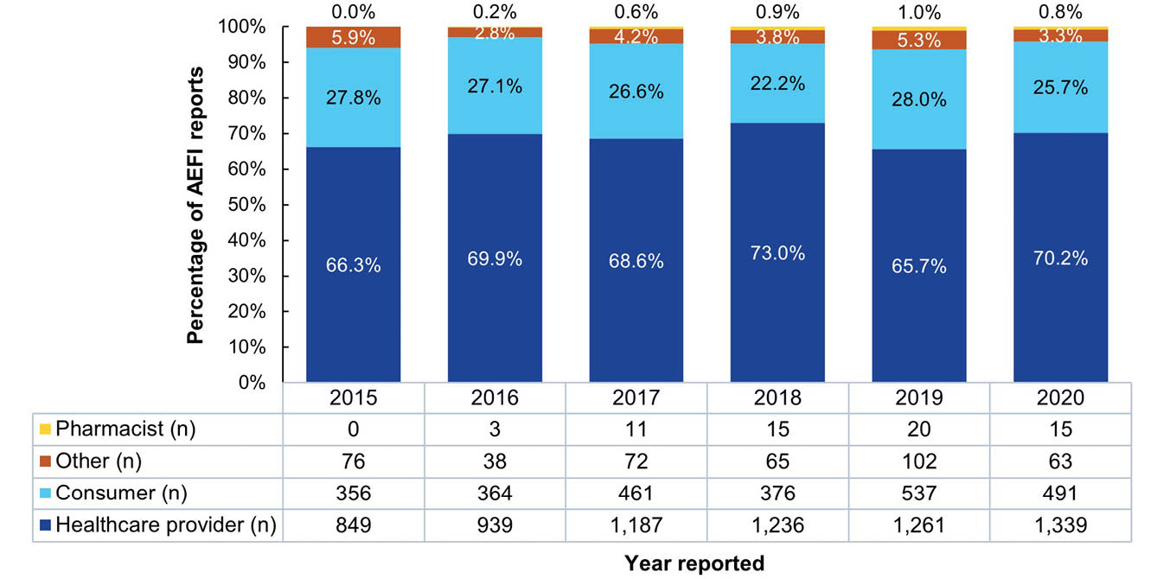

Age and sex distribution
Young children (age group 1–4 years) comprised the largest proportion of AEFI reports received in 2019 and 2020, consistent with reporting in previous years. At a population level, AEFI reporting for young children showed an increasing trend between 2016 and 2020 (Chi-squared test for trend p < 0.001, Figure 4). Reporting volume and rate per population for school-aged children (5–17 years) decreased in 2020 compared to 2019. Reporting trend differences for school-aged children, adults (18–64 years) and older persons (65+ years) for 2015 and 2016 are consistent with historical changes to vaccines offered in these age groups (Figure 4).²¹ The largest numbers of SAEFI reported were in young children (2019: 69/155 [44.8%]; 2020: 67/135 [49.6%]), whereas the proportions of AEFI which were SAEFI, by age group, were highest in infants for both years (13.3% in 2019; 10.2% in 2020) (Table 2).
Over half of all AEFI reporting in 2019 and 2020 were for female vaccinees (51.9% in 2019; 53.0% in 2020), with the greatest sex differences seen in adults (84.0% female in 2019; 82.5% in 2020) and older persons (65.3% in 2019; 75.8% in 2020) (Table 3).

Specific populations
Aboriginal and/or Torres Strait Islander (Indigenous Australian) status was reported for 79.9% of AEFI reports in 2019 and 86.8% in 2020, with approximately 0.9% of reports being for vaccinees identifying as Indigenous Australians in both years (2019: 13/1,535 [0.8%]; 2020: 16/1,656 [1.0%]).
Of the reports received for adult females in 2019 and 2020, there were respectively 35 (14.5%) and 21 (9.5%) for adverse events following vaccines administered during the vaccinee’s pregnancy.
Figure 4: Adverse events following immunisation (AEFI) reports (A) and rate per 100,000 population (B) by age group and year reported, SAEFVIC, Victoria, Australia, 2015–2020
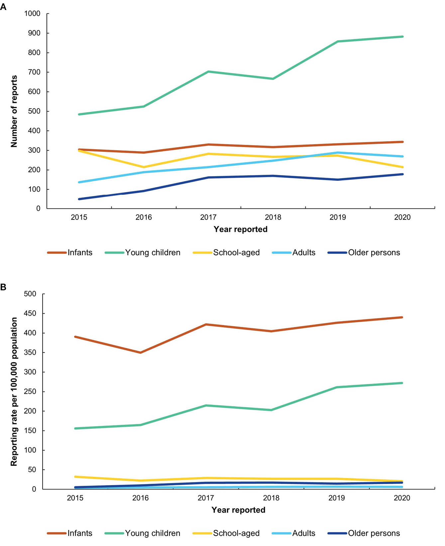

Table 2: Serious adverse event following immunisation (AEFI) reports by age group,ª SAEFVIC, Victoria, Australia, 2019–2020
Age group | Age category | AEFI: 2019 |  |  |  | AEFI: 2020
Age group | Age category | Total | Serious (SAEFI) |  |  | Total | Serious (SAEFI)
Age group | Age category | Total | Number | Percentage | 95% CI^{b} | Total | Number | Percentage | 95% CI^{b}
< 12 months | Infants | 331 | 44 | 13.3 | 11.8–14.8 | 343 | 35 | 10.2 | 8.9–11.6
1–4 years | Young children | 857 | 69 | 8.1 | 6.8–9.3 | 882 | 67 | 7.6 | 6.4–8.8
5–17 years | School-aged | 273 | 19 | 7.0 | 5.8–8.1 | 214 | 11 | 5.1 | 4.2–6.1
18–64 years | Adults | 288 | 13 | 4.5 | 3.6–5.4 | 269 | 12 | 4.5 | 3.5–5.4
65+ years | Older persons | 150 | 9 | 6.0 | 4.9–7.1 | 178 | 10 | 5.6 | 4.6–6.6
Total | — | 1,899 | 154 | 8.1 | 6.9–9.3 | 1,886 | 135 | 7.2 | 6.0–8.3
a Age was not recorded for 23 cases.
b 95% confidence interval, expressed as a percentage.
Table 3: Adverse event following immunisation (AEFI) reports by sex,ª Indigenous status, and age group,^{b} SAEFVIC, Victoria, Australia, 2019–2020
Age group | Age category | Males |  |  |  | Females |  |  |  | Rate ratio, male:female |  | Indigenous Australians
Age group | Age category | 2019 |  | 2020 |  | 2019 |  | 2020 |  |  |  | 2019 |  | 2020
Age group | Age category | Number | Rate^{c} | Number | Rate^{c} | Number | Rate^{c} | Number | Rate^{c} | 2019 | 2020 | Number | Rate^{c,d} | Number | Rate^{c,d}
< 12 months | Infants | 176 | 441.6 | 183 | 456.0 | 154 | 407.3 | 159 | 420.5 | 1.1 | 1.1 | 2 | — | 2 | —
1–4 years | Young children | 497 | 294.1 | 495 | 297.0 | 359 | 225.1 | 386 | 245.3 | 1.3 | 1.2 | 6 | — | 9 | —
5–17 years | School-aged | 128 | 24.6 | 104 | 19.6 | 144 | 29.2 | 110 | 21.9 | 0.8 | 0.9 | 2 | — | 3 | —
18–64 years | Adults | 45 | 2.2 | 47 | 2.3 | 242 | 11.6 | 222 | 10.5 | 0.2 | 0.2 | 2 | — | 1 | —
65+ years | Older persons | 51 | 10.8 | 43 | 8.8 | 98 | 17.9 | 135 | 23.8 | 0.6 | 0.4 | 1 | — | 1 | —
Total | — | 897 | 27.5 | 872 | 26.3 | 997 | 29.9 | 1,012 | 29.9 | 0.9 | 0.9 | 13 | 20.9 | 16 | 25.1
a Sex was not recorded for 5 cases.
b Age was not recorded for 23 cases.
c Reporting rate per 100,000 population per year.
d Rate was not calculated for groups with fewer than 10 reports.

Vaccines
A vaccinee may receive more than one vaccine per encounter: therefore, there were 3,269 vaccines associated with the 1,908 AEFI reports in 2019 and 3,326 with the 1,920 AEFI reports in 2020, a median of one vaccine (range: one to six vaccines) per encounter for both years. The reporting rate increased in 2020 compared to 2019 for vaccines to protect young children against meningococcal B and influenza (Table 4), at the same time as changes were made to the national schedule to include Bexsero® for at-risk groups as well as additional influenza vaccines.²² Additionally, the rate of AEFI reporting increased for vaccines to protect the same cohort against meningococcal (ACWY) and tuberculosis in 2020 compared to 2019. However, AEFI reporting rates significantly decreased in 2020 compared to 2019 for several vaccines, including those to protect school children against meningococcal (ACWY) disease; school children and adults against influenza; adults and older persons against pneumococcal disease; and adults against diphtheria, tetanus and pertussis (Table 4). No changes were made to the NIP schedule for these vaccines in 2019 or 2020; however, there were changes in the school-based vaccination program due to the coronavirus disease 2019 (COVID-19) pandemic.²³

Adverse events
More than one adverse event may be described per vaccinee AEFI report. Of the 1,920 AEFI reports in 2019, there were 2,968 adverse events described; and of the 1,908 AEFI reports in 2020, there were 3,050 adverse events described.
Minor injection site reaction was the most frequently reported adverse event across 2019–2020 overall (14.0%) and for each age group, except infants for whom rash was the most frequently reported adverse event (12.8%) (Table 5). Notable variation was observed in the types of reaction reported by age groups, with higher proportions of severe injection site reaction in young children (17.1%) and older persons (9.4%), and vasovagal episodes in school-aged children (8.3%). Hypotonic-hyporesponsive episode (HHE)—only diagnosed in toddlers under two years of age—was predominantly reported in infants, and for vaccines scheduled at two and four months of age.
Table 4: Adverse event following immunisation (AEFI) reports by national immunisation program (NIP) age group and vaccine antigen, SAEFVIC, Victoria, Australia, 2019–2020
Age group | Vaccine antigen^{a,b} | 2019 |  |  | 2020 |  |  | Rate ratio^{e} | p value
Age group | Vaccine antigen^{a,b} | Number of reports | Reporting rate^{c} | 95% CI^{d} | Number of reports | Reporting rate^{c} | 95% CI^{d} | Rate ratio^{e} | p value
< 12 months (infants) | Total for age group | 331 | — | — | 342 | — | — | — | —
< 12 months (infants) | HepB (at birth) | 1 | 39.1 | 0–115.8 | 3 | 143.5 | 0–305.8 | 3.67 | 0.282
< 12 months (infants) | DTP HepB Hib Polio | 239 | 106.4 | 92.9–119.9 | 252 | 115.2 | 101.0–129.4 | 1.08 | 0.377
< 12 months (infants) | Rotavirus^{f} | 195 | 133.7 | 114.9–152.5 | 195 | 138.0 | 118.6–157.4 | 1.03 | 0.755
< 12 months (infants) | Pneumococcal | 201 | 129.2 | 111.4–147.1 | 205 | 137.8 | 118.9–156.7 | 1.07 | 0.518
< 12 months (infants) | Meningococcal B^{g} | 41 | 168.0 | 116.6–219.5 | 46 | 172.4 | 122.6–222.2 | 1.03 | 0.907
< 12 months (infants) | Influenza | 37 | 70.4 | 47.7–93.1 | 36 | 75.6 | 50.9–100.2 | 1.07 | 0.762
1–4 years (young children) | Total for age group | 863 | — | — | 906 | — | — | — | —
1–4 years (young children) | Pneumococcal | 120 | 161.7 | 132.8–190.7 | 150 | 205.2 | 172.3–238.0 | 1.27 | 0.052
1–4 years (young children) | Meningococcal B^{g} | 50 | 169.5 | 122.5–216.5 | 70 | 296.8 | 227.3–366.3 | 1.75 | 0.002
1–4 years (young children) | Influenza | 148 | 78.7 | 66.0–91.4 | 176 | 99.4 | 84.7–114.1 | 1.26 | 0.036
1–4 years (young children) | MMR/MMRV | 333 | 212.1 | 189.3–234.9 | 339 | 225.9 | 201.8–249.9 | 1.06 | 0.415
1–4 years (young children) | Meningococcal | 126 | 152.2 | 125.6–178.8 | 147 | 193.9 | 162.6–225.3 | 1.27 | 0.046
1–4 years (young children) | DTP ± polio | 508 | 319.1 | 291.4–346.9 | 483 | 312.2 | 284.4–340.1 | 0.98 | 0.730
1–4 years (young children) | Hib | 166 | 218.6 | 185.4–251.9 | 184 | 247.5 | 211.8–283.3 | 1.13 | 0.246
1–4 years (young children) | TB | 13 | 834.4 | 380.8–1,288.0 | 24 | 3380.3 | 2,027.9–4,732.7 | 4.05 | < 0.001
5–17 years (school aged) | Total for age group | 273 | — | — | 214 | — | — | — | —
5–17 years (school aged) | Influenza | 90 | 43.0 | 34.1–51.9 | 75 | 29.9 | 23.1–36.7 | 0.70 | 0.020
5–17 years (school aged) | Meningococcal | 26 | 287.1 | 176.8–397.5 | 28 | 127.7 | 80.4–175.1 | 0.44 | 0.004
5–17 years (school aged) | DTP | 80 | 109.0 | 85.1, 132.9 | 62 | 88.6 | 66.5–110.6 | 0.81 | 0.220
5–17 years (school aged) | HPV | 96 | 69.9 | 55.9, 83.9 | 77 | 60.4 | 46.9–73.9 | 0.86 | 0.340
18–64 years (adults) | Total for age group | 288 | — | — | 269 | — | — | — | —
18–64 years (adults) | Pneumococcal^{g} | 17 | 206.6 | 108.4–304.8 | 14 | 56.8 | 27.1–86.6 | 0.28 | 0.001
18–64 years (adults) | Influenza^{h} | 137 | 17.4 | 14.5–20.3 | 137 | 7.0 | 5.8–8.2 | 0.40 | < 0.001
18–64 years (adults) | DTP^{i} | 44 | 20.3 | 14.3–26.3 | 49 | 11.2 | 8.1–14.3 | 0.55 | 0.005
65+ years (older persons) | Total for age group | 150 | — | — | 178 | — | — | — | —
65+ years (older persons) | Pneumococcal | 54 | 73.8 | 54.1–93.5 | 34 | 38.2 | 25.3–51.0 | 0.52 | 0.002
65+ years (older persons) | Influenza | 6 | 7.3 | 1.4–13.1 | 49 | 14.7 | 10.6–18.8 | 2.03 | 0.086
65+ years (older persons) | Zoster | 29 | 73.5 | 46.8–100.3 | 40 | 118.3 | 81.6–155.0 | 1.61 | 0.051
a HepB: hepatitis B; DTP: diphtheria, tetanus, pertussis; Hib: Haemophilus influenzae b; MMR: measles, mumps, rubella; MMRV: measles, mumps, rubella, varicella; TB: tuberculosis; HPV: Human papilloma virus.
b Vaccine antigens in bold text reflect a statistically significant difference in the reporting rate for 2020 when compared to 2019.
c Reporting rate per 100,000 doses administered per year.
d 95% confidence interval for calculated reporting rate.
e Rate ratio for 2020:2019.
f Rotavirus vaccine (Rotarix) delivered in two doses (at 2 and 4 months), with last dose recommended by 24 weeks of age.
g Indigenous Australians or those at risk medically.
h Not in NIP, but recommended for at-risk healthcare professionals.
i Pregnant women.
Table 5: Most frequently reported adverse events (> 20 reports) and selected conditions of interest, by age group, SAEFVIC, Victoria, Australia,^{a,b} 2019–2020
Adverse event | < 12 months  (infants) |  | 1–4 years (young children) |  | 5–17 years (school aged) |  | 18–64 years  (adults) |  | 65+ years (older persons) |  | Total  adverse events
Adverse event | Number | Percentage | Number | Percentage | Number | Percentage | Number | Percentage | Number | Percentage | Number | Percentage
Injection site reaction – minor | 43 | 4.1% | 474 | 19.3% | 97 | 12.2% | 111 | 10.3% | 105 | 18.6% | 830 | 14.0%
Injection site reaction – severe^{b} | 13 | 1.2% | 420 | 17.1% | 34 | 4.3% | 34 | 3.2% | 53 | 9.4% | 554 | 9.3%
Rash | 134 | 12.8% | 269 | 10.9% | 49 | 6.1% | 45 | 4.2% | 29 | 5.1% | 526 | 8.8%
Vaccine administration errors | 119 | 11.3% | 193 | 7.8% | 64 | 8.0% | 79 | 7.3% | 63 | 11.2% | 518 | 8.7%
Vomiting | 68 | 6.5% | 89 | 3.6% | 38 | 4.8% | 24 | 2.2% | 8 | 1.4% | 227 | 3.8%
Fever (38 °C ≤ T < 40 °C) | 52 | 5.0% | 125 | 5.1% | 28 | 3.5% | 15 | 1.4% | 3 | 0.5% | 223 | 3.8%
Fever (unspecified) | 31 | 3.0% | 119 | 4.8% | 26 | 3.3% | 28 | 2.6% | 17 | 3.0% | 221 | 3.7%
Urticaria/hives | 37 | 3.5% | 76 | 3.1% | 25 | 3.1% | 24 | 2.2% | 7 | 1.2% | 169 | 2.8%
Pain in limb | 1 | 0.1% | 12 | 0.5% | 23 | 2.9% | 81 | 7.5% | 44 | 7.8% | 161 | 2.7%
Lethargy | 28 | 2.7% | 37 | 1.5% | 22 | 2.8% | 27 | 2.5% | 21 | 3.7% | 135 | 2.3%
Irritable | 76 | 7.2% | 48 | 2.0% | 0 | 0.0% | 0 | 0.0% | 0 | 0.0% | 124 | 2.1%
Diarrhoea | 64 | 6.1% | 29 | 1.2% | 7 | 0.9% | 16 | 1.5% | 3 | 0.5% | 119 | 2.0%
Vasovagal episode^{b} | 0 | 0.0% | 24 | 1.0% | 66 | 8.3% | 16 | 1.5% | 2 | 0.4% | 108 | 1.8%
Angioedema | 20 | 1.9% | 40 | 1.6% | 16 | 2.0% | 24 | 2.2% | 4 | 0.7% | 104 | 1.7%
Headache | 0 | 0.0% | 4 | 0.2% | 29 | 3.6% | 44 | 4.1% | 17 | 3.0% | 94 | 1.6%
Respiratory symptoms | 14 | 1.3% | 21 | 0.9% | 12 | 1.5% | 31 | 2.9% | 11 | 2.0% | 89 | 1.5%
Nausea | 0 | 0.0% | 6 | 0.2% | 17 | 2.1% | 39 | 3.6% | 7 | 1.2% | 69 | 1.2%
Pruritus | 1 | 0.1% | 22 | 0.9% | 10 | 1.3% | 22 | 2.0% | 13 | 2.3% | 68 | 1.1%
Restricted movement^{c} | 2 | 0.2% | 2 | 0.1% | 8 | 1.0% | 40 | 3.7% | 14 | 2.5% | 66 | 1.1%
Paresthesia | 0 | 0.0% | 0 | 0.0% | 10 | 1.3% | 47 | 4.4% | 8 | 1.4% | 65 | 1.1%
Nodule at injection site | 19 | 1.8% | 35 | 1.4% | 2 | 0.3% | 6 | 0.6% | 2 | 0.4% | 64 | 1.1%
Hypotonic hyporesponsive episode (HHE)^{b,d} | 55 | 5.2% | 5 | 0.2% | 0 | 0.0% | 0 | 0.0% | 0 | 0.0% | 60 | 1.0%
Seizure-febrile | 6 | 0.6% | 53 | 2.2% | 0 | 0.0% | 0 | 0.0% | 0 | 0.0% | 59 | 1.0%
Lymphadenopathy | 3 | 0.3% | 13 | 0.5% | 20 | 2.5% | 18 | 1.7% | 4 | 0.7% | 58 | 1.0%
Influenza-like-illness | 0 | 0.0% | 1 | 0.0% | 0 | 0.0% | 35 | 3.3% | 10 | 1.8% | 46 | 0.8%
Pallor | 15 | 1.4% | 17 | 0.7% | 11 | 1.4% | 2 | 0.2% | 0 | 0.0% | 45 | 0.8%
Dizziness | 0 | 0.0% | 0 | 0.0% | 13 | 1.6% | 26 | 2.4% | 5 | 0.9% | 44 | 0.7%
Abdominal pain | 14 | 1.3% | 10 | 0.4% | 8 | 1.0% | 6 | 0.6% | 1 | 0.2% | 39 | 0.7%
Behaviour change^{e} | 9 | 0.9% | 26 | 1.1% | 3 | 0.4% | 0 | 0.0% | 1 | 0.2% | 39 | 0.7%
Myalgia | 0 | 0.0% | 0 | 0.0% | 12 | 1.5% | 14 | 1.3% | 12 | 2.1% | 38 | 0.6%
Fever (T ≥ 40 °C) | 5 | 0.5% | 26 | 1.1% | 3 | 0.4% | 2 | 0.2% | 0 | 0.0% | 36 | 0.6%
Abscess | 8 | 0.8% | 18 | 0.7% | 4 | 0.5% | 4 | 0.4% | 0 | 0.0% | 34 | 0.6%
Altered throat sensation | 0 | 0.0% | 0 | 0.0% | 3 | 0.4% | 22 | 2.0% | 5 | 0.9% | 30 | 0.5%
Eczema flare | 18 | 1.7% | 8 | 0.3% | 3 | 0.4% | 0 | 0.0% | 0 | 0.0% | 29 | 0.5%
Seizure-syncopal | 0 | 0.0% | 2 | 0.1% | 23 | 2.9% | 1 | 0.1% | 0 | 0.0% | 26 | 0.4%
Abnormal movements | 8 | 0.8% | 12 | 0.5% | 4 | 0.5% | 0 | 0.0% | 0 | 0.0% | 24 | 0.4%
Blood in stool | 22 | 2.1% | 2 | 0.1% | 0 | 0.0% | 0 | 0.0% | 0 | 0.0% | 24 | 0.4%
Coryza | 2 | 0.2% | 17 | 0.7% | 0 | 0.0% | 2 | 0.2% | 0 | 0.0% | 21 | 0.4%
Anaphylaxis^{f} | 1 | 0.1% | 6 | 0.2% | 2 | 0.3% | 5 | 0.5% | 0 | 0.0% | 14 | 0.2%
Bell's palsy^{f} | 0 | 0.0% | 1 | 0.0% | 0 | 0.0% | 4 | 0.4% | 0 | 0.0% | 5 | 0.1%
Status epilepticus^{f} | 1 | 0.1% | 4 | 0.2% | 0 | 0.0% | 0 | 0.0% | 0 | 0.0% | 5 | 0.1%
Guillain-Barré syndrome (GBS)^{f} | 0 | 0.0% | 2 | 0.1% | 0 | 0.0% | 2 | 0.2% | 0 | 0.0% | 4 | 0.1%
Kawasaki disease^{f} | 0 | 0.0% | 4 | 0.2% | 0 | 0.0% | 0 | 0.0% | 0 | 0.0% | 4 | 0.1%
Total | 1,049 | — | 2,460 | — | 797 | — | 1,076 | — | 564 | — | 5,946 | —
% of all adverse events | 17.6% |  | 41.4% |  | 13.4% |  | 18.1% |  | 9.5%
a This table presents counts and percentages of reported adverse events whereby one person may report more than one adverse event. Percentage is calculated based on all adverse events reported in that age group.
b Values with dark grey shading indicate higher reporting of adverse events of interest within specific age-group variations.
c Restricted movement, also known as restricted movement of the shoulder, is a symptom that forms part of the clinical assessment of shoulder pain related to vaccine administration (SIRVA).
d Hypotonic-hyporesponsive episode (HHE); definition is restricted to children aged < 2 years.
e Behaviour change refers to a change in the vaccinee’s normal interaction with other people (including parents/carers) and their surroundings.
f Highlighted as a selected condition of interest.

Vaccine administration errors
Vaccine administration errors were reported for 13.8% of AEFI reports: 14.2% (272/1,920) in 2019 and 13.5% (257/1,908) in 2020. This proportion of all reports was consistent at approximately 13.5% from 2018 to 2020 but was an observed increase on the preceding four-year average of 9.9% (2015–2018), p < 0.001 (Figure 5); this is consistent with an overall increase in reporting associated with additions to the NIP and no change to the type of error reported. Forty-six of the reports associated with vaccine administration error (9.6% [26/272] in 2019 and 7.8% [20/257] in 2020) described associated AEFI of localised injection site reaction, generalised or allergy-related reactions following the vaccination, but were not considered related to the vaccine administration error as likely due to symptoms/side effects associated with coadministered vaccines. Two reports described pregnancy-related outcomes: one of miscarriage (unable to determine if considered related to vaccination) and the other of congenital cataracts in the newborn following inadvertent maternal vaccination with a live MMR vaccine.
Administration of vaccines outside of recommendations were consistently the most frequently reported type of error (2019: 227/272 [83.5%] and 2020: 191/257 [74.3%]), including: wrong vaccine given; vaccine given at wrong age; repeat dose given; and incorrect interval between vaccine doses.
Figure 5: Vaccine administration errors reported to SAEFVIC, Victoria, Australia, 2015–2020
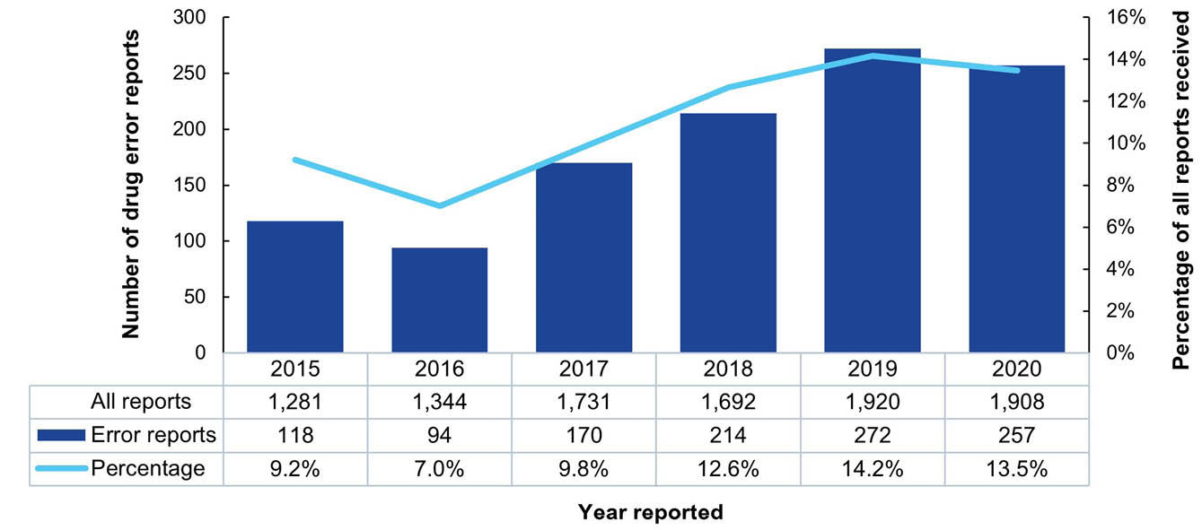

Targeted monitoring
SAEFVIC conducts enhanced surveillance of new vaccines or immunisation program changes to monitor for potential vaccine safety signals. Vaccines and vaccination programs under enhanced surveillance during 2019 and 2020 are detailed in Table 6.

Signal investigations
No safety signals were detected or investigated in 2019.
An investigation into seizures (febrile and afebrile) following influenza vaccination was undertaken after a perceived increase in reporting during the early portion of the 2020 influenza season (March–October). The investigation determined the signal was likely attributable to increased vaccine administration, with the PRR of seizure-related AEFI, compared against previous years, never crossing the threshold for signal detection (Table 6). Monitoring of the remaining 2020 influenza season for additional reports did not reveal any further signals. Detailed analysis was conducted at the conclusion of the season, in collaboration with the Australian national regulator, the Therapeutic Goods Administration (TGA).
Enhanced surveillance of SANE and SIRVA continued in 2019 and 2020 following detection of potential vaccine safety signals in 2018, with no further signals detected.^{6,26}
Table 6: Targeted monitoring for vaccine pharmacovigilance, SAEFVIC, Victoria, Australia, 2019–2020
Vaccines/population | Monitoring period | Reason for targeted monitoring | Findings
Influenza | Annual seasonal (March to October) | Seasonal changes to strain with past history of AEFI signal eventsª | Perceived increase in reporting of seizures with seasonal influenza vaccines in 2020. Investigation determined the signal as likely attributable to increased vaccine administration earlier in the season. Detailed analysis undertaken at the conclusion of the season in collaboration with TGA concluded no signal indicated.
Meningococcal ACWY Nimenrix® | 2019 | New vaccine introduced to the Victorian school-based program for nationally funded ACWY meningococcal vaccine | 22 AEFI reports received. No safety signals detected.
Pharmacist administered | 2016-2019 | Implementation of Victorian Pharmacist-Administered Vaccination Program in 2016 | Small numbers of reports were submitted during 2019, with most common adverse events being pain in limb of injection site. This is consistent with the volume of reports documented for 2016—2018 previously.^{b}
a References 24,25.
b Reference 6.

SAEFVIC clinical services and education

Clinical review
Across 2019–2020, approximately one fifth (22%; 832/3,828) of persons reported with an AEFI accepted specialist clinical review. Services were accessed as on-site clinics at either one of the two tertiary hospitals (Monash Health or the Royal Children’s Hospital), via Telehealth, or at other metropolitan/rural services by arrangement (357/1,920: 18.6% in 2019 and 475/1,908: 24.9% in 2020). Consultations following reported AEFI in 2019 declined compared to the 2015–2018 four-year average: 18.6% vs. 22.8%; p = 0.003, with the type of consultation remaining steady. Consultations in 2020 were stable compared to the 2015–2018 four-year average (24.9% vs. 22.8%), albeit with a significant increase in Telehealth consultations (149%; p < 0.001) (Figure 6). Of those attending a specialist service in 2020, the proportion who received subsequent vaccination through the service was 44.8% (198/442)—a decrease of 45% compared to 2019 (259/363; 71.3%; p < 0.001)—with 84 being admitted for day (n = 67) or overnight (n = 17) supervision. The decrease in in-clinic attendance and supervised vaccination in 2020 was coincident with Victorian COVID-19 pandemic movement restrictions²⁷ and may not be indicative of an ongoing trend. It is noted that not all clinic attendees would require further vaccination at the time of their clinic visit.
Figure 6: Type of clinic consultation attendance at Monash Health and the Royal Children’s Hospital, SAEFVIC, Victoria, Australia, 2015–2020
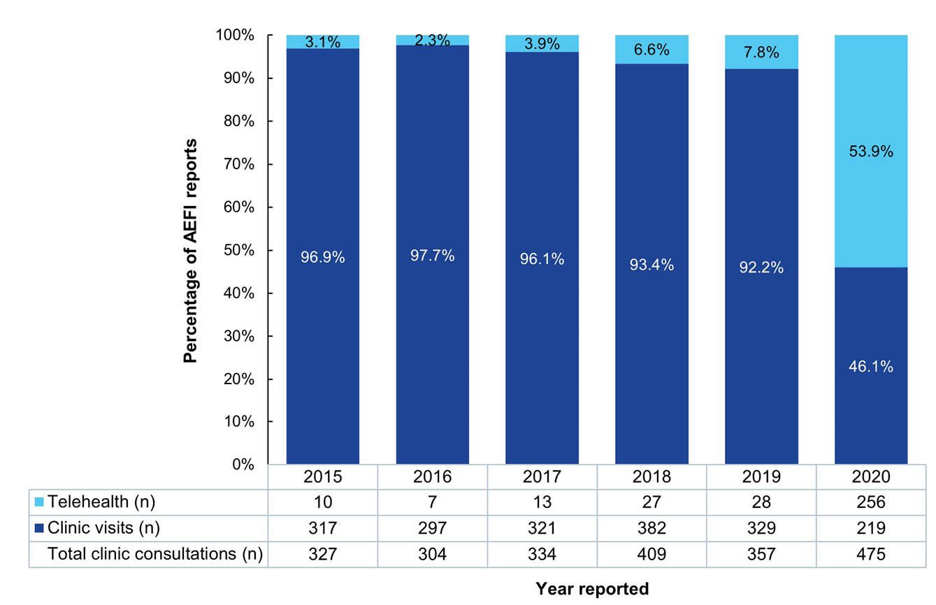

Immunisation advice
The SAEFVIC clinical team attended to 2,158 phone calls during 2020, which was a 31% decrease compared to 2019 (n = 2,974), noting that online enquiry and automated email responses had been implemented in early 2020 in response to COVID-19 pandemic measures.^{27,28}
In collaboration with MVEC, SAEFVIC provided access to online resources for advice and information on specific vaccines, including at-risk populations. Tailored advice included influenza, zoster and meningococcal vaccines, and for Indigenous Australians, those with underlying chronic diseases, and those receiving treatment where certain vaccines (live) may be contraindicated.⁴

Melbourne Vaccine Education centre (MVEC) activities
The Clinical Vaccinology Update (CVU) is a series of educational conferences providing immunisation providers and healthcare professionals the opportunity to gather and discuss vaccine preventable disease epidemiology, vaccines, and vaccine safety.
In 2019, a total of 398 healthcare professionals attended the two symposiums held in April and November, covering a breadth of updates that included travel immunisations; immunisation errors and SIRVA; NIP schedule changes and immunisation policy; maternal immunisation; vaccine-preventable diseases; and immunisation in vulnerable groups.
The 2020 CVU symposium was held virtually due to the COVID-19 pandemic, with 426 individuals from around Australia and New Zealand attending. A considerable focus was placed on COVID-19 vaccines, but the symposium also covered updates on zoster, measles and influenza vaccines; immunisation by pharmacists; and vaccine communication and confidence. The most recent presentations were made available to healthcare professionals and the public on the MVEC website.²⁹
A mobile phone application for easy reference of the NIP was also created for immunisation providers (VicVax); however, this application was removed for review given changes to the NIP in July 2020.³⁰ Information packages were published online covering vaccine safety topics (Guillain-Barre syndrome, Kawasaki disease, and HHE), and vaccination recommendations on specific vaccines (such as Zostavax® and immunocompromised individuals) or for specific at-risk groups.
A designated section of the MVEC website was allocated for information on COVID-19 vaccines and the anticipated commencement of the vaccination program in Australia. This section catered for increased traffic accessing this topic, and for additional resources to be added including the special podcast series ‘COVID-19 Road to a vaccine,’ capturing information on vaccine development, safety and efficacy, and managing trials and obstacles.³¹

Discussion
SAEFVIC continues to provide robust AEFI surveillance with an annual reporting rate of approximately 28 per 100,000 population, the highest AEFI reporting ascertainment nationwide.^{2,32} Uptake of online reporting has stabilised at approximately half of reports submitted, highlighting a continued demand for personalised telephone enquiry response. The distribution of AEFI reporting by age (with the exception of school-aged children in 2020, due to school-based vaccination delivery changes in line with pandemic public health measures),²³ sex, Indigenous Australian status, type of reporter, adverse events defined as serious, and the most frequently reported adverse events remained stable into the 2019–2020 period, with any observed variations consistent with NIP schedule changes occurring at the time.
This is the first Victorian report to determine vaccine-specific AEFI reporting rates for all ages groups by doses administered, using vaccination encounter records in AIR as a denominator. The continued improvements to the national register has ranged from merging records from the Australian Childhood Immunisation Register to incentivising immunisation providers to electronically record vaccination encounters, all aimed at providing an accurate record of vaccination for all age groups.^{33,34} These improvements have allowed exploration of reporting trends as a rate per doses administered over time, as well as an improved ability to investigate potential safety signals that could inform risk mitigation through policy change.
The sex distribution of AEFI reports received in 2019 and 2020 was comparable to that seen in previous years, with a higher female proportional reporting noted in adult and older person age groups. This was surmised to be due to increased vaccine uptake in target groups of health workers, older persons and in pregnancy, which have female predominance. The potential for sex inequity of safe vaccination, either through higher rates of AEFI in females, or through under-reporting in males, requires further investigation.
With the exception for the school-aged children age group, the reporting volume of AEFI remained stable through 2019 into 2020, where the latter was a year that saw a significant public health response to the COVID-19 pandemic by instigating personal movement restrictions to curtail transmission of SARS-CoV-2 in the community, prior to the availability of COVID-19 vaccines^{23,27} School closures causing disruption to the school-based vaccination programs during the start of the pandemic may have contributed to the decline in AEFI reporting volume for school-aged children.²³
Undertaking targeted enhanced surveillance for new or current vaccines administered through a new provider type or to an at-risk population allows SAEFVIC to effectively detect and investigate vaccine safety issues. Any vaccine safety issues identified from the enhanced surveillance informs evidence-based recommendations for policy change, which is aimed at reducing risk of harm and at keeping vaccination in the community safe. For example, the scope of pharmacists participating in the Victorian Pharmacist-Administered Vaccination program expanded in 2019 to provide additional vaccines to a wider age range of vaccinees. Additionally, the replacement of Menactra® with Nimenrix® in the Victorian school-based immunisation program introduced a routine childhood vaccine given to young children at the age of 12 months to an older at-risk age group. Findings for both initiatives showed the enhanced surveillance approaches were appropriate, along with the low reporting and no signals detected providing reassurance these vaccines are safe.
Similarly, enhanced surveillance of AEFI known to be associated with vaccination, such as SIRVA, allows SAEFVIC to provide an evidence base to influence updating vaccination recommendations or risk mitigation. In 2020, there was an anticipated increased risk of SIRVA cases due to the positioning of vaccinees who attended ‘drive-through vaccination clinics’ for their seasonal influenza vaccines. However, enhanced surveillance identified there was no increased risk of SIRVA, supporting the benefit-risk profile of these clinics.
Vaccine administration errors continued to represent a substantial volume of all AEFI reports during 2019 and 2020.⁶ Reporting of vaccine administration errors is encouraged for risk assessment and mitigation to prevent further errors in the future. Effective surveillance requires analyses of categorised errors to inform on potential areas for risk mitigation. Given the increased volume of reported errors and the need for an efficient method for analysis, a systematised process to review and categorise vaccine administration errors that meet international definitions is being explored.
Passive AEFI surveillance has known limitations, which have been covered in detail in previous reports.^{5,6} In addition, the current process of access to AIR data through static extracts from Services Australia restricts SAEFVIC from determining reported AEFI rates in real time, impacting the capture of vaccine delivery fluctuations that could be affected by external factors.^{35,36} Authorisation for real-time access is being negotiated. Moreover, the frequency of concomitant vaccinations restricts the capability of attributing specific AEFI to a specific vaccine given at a specific encounter.
Active surveillance platforms such as PAEDS and AusVaxSafety provide an additional data source on AEFI reporting. During 2019–2020, PAEDS identified paediatric hospital admissions for certain conditions that may be associated with vaccination and AusVaxSafety solicited surveys indicating medical attendance being sought.^{37,38} The contribution of active surveillance to the reporting volume is small (1%). Passive surveillance continues to be critical for capturing data on uncommon and rare AEFI.
The potential for COVID-19 pandemic lockdowns²⁷ to impact on ability to provide Specialist Immunisation Clinics in 2020 was minimised as changes to the Medicare eligibility for medical consultations allowed for in-person consultations to be moved to Telehealth.³⁹ There was strong uptake of Telehealth, which facilitated continued access to specialist consultation for all Victorians; however, capacity to provide onsite vaccination under specialist supervision was reduced.

MVEC resources
MVEC, a member of the World Health Organization’s Vaccine Safety Net of verified sources for credible information on vaccine safety, continued to provide accessible, accurate and trusted education resources supporting healthcare professionals and community to make informed decisions.
With the COVID-19 vaccination program due to commence in early 2021,⁴⁰ the MVEC website provided the ideal platform to host accessible materials developed by the SAEFVIC/Victorian Government Department of Health collaboration for healthcare workers and the public to better understand vaccine development and the risk-benefit of being vaccinated. Additionally, MVEC developed and hosted eLearning modules to facilitate immuniser training in preparation to equip a surge workforce to meet the anticipated COVID-19 vaccination demand. Expanding the MVEC website to host these materials provided a readiness platform for MVEC to respond to community vaccine safety concerns, or for new vaccination programs which might be implemented in response to an outbreak.
The overarching goal of harmonising AEFI data collation and surveillance has continued to be a vision for SAEFVIC’s SAFEVAC data platform, with the Western Australia Vaccine Safety Service (WAVSS) and ACT Health coming on board to utilise their unique database ‘silo’ for the purposes of clinical and passive AEFI surveillance. Improvements to the database were being undertaken to facilitate management of the anticipated influx of AEFI reports with commencement of the COVID-19 vaccine program.

Conclusion
AEFI reporting in Victoria has continued to support safe immunisation in the state and in Australia during 2019 and 2020, with Victoria’s the highest reporting rates nationally. A potential signal event of febrile and afebrile seizures was closely monitored during 2020 in collaboration with the TGA; however, no further signals were verified. AEFI reporting patterns for 2019 and 2020 provided a baseline prior to commencement of the COVID-19 vaccination program in early 2021. This baseline incorporates the current structure and model of spontaneous reporting and AEFI surveillance integrated with clinical services, enhanced with additional active surveillance to provide a detailed vaccine safety profile for the COVID-19 vaccines.

Acknowledgments
We would like to acknowledge healthcare providers, vaccinees and parents/caregivers for submitting reports to SAEFVIC; the SAEFVIC clinical team for providing clinical advice, assessment and support; and the MVEC team for their assistance with developing and publishing educational materials for immunisation providers and the public. SAEFVIC is funded by the Victorian Government Department of Health.

Conflicts of interest
All authors report no conflict of interest.

Author details
Jesse J Fryk,^{1,2}
Hazel J Clothier,^{1,2,3,4}
Daneeta Hennessy,^{1,2}
Georgina Lewis,¹
Emma Roney,^{1,2}
Nigel W Crawford,^{1,4,5}
Jim P. Buttery^{1,2,4,5}
- SAEFVIC, Murdoch Children's Research Institute, Melbourne, Victoria, Australia
- Epidemiology-Informatics, Centre for Health Analytics, Melbourne Children’s Campus, Melbourne, Victoria, Australia
- School of Population and Global Health, University of Melbourne, Parkville, Victoria, Australia
- Department Paediatrics, University of Melbourne, Parkville, Victoria, Australia
- Immunisation Service, Royal Children's Hospital, Parkville, Victoria, Australia

Corresponding author
Daneeta Hennessy
50 Flemington Road, Parkville, Victoria, Australia, 3052
Email: daneeta.hennessy@mcri.edu.au

References
- Clothier HJ, Crawford NW, Kempe A, Buttery JP. Surveillance of adverse events following immunisation: the model of SAEFVIC, Victoria. Commun Dis Intell Q Rep. 2011;35(4):294–8. doi: https://doi.org/10.33321/cdi.2011.35.28.
- Dey A, Wang H, Quinn H, Pillsbury A, Glover C, Hickie M et al. Surveillance of adverse events following immunisation in Australia annual report, 2019. Commun Dis Intell (2018). 2021;45. doi: https://doi.org/10.33321/cdi.2021.45.23.
- Dey A, Wang H, Quinn H, Pillsbury A, Glover C, Hickie M et al. Surveillance of adverse events following immunisation in Australia: annual report, 2018. Commun Dis Intell (2018). 2020;44. doi: https://doi.org/10.33321/cdi.2020.44.12.
- Melbourne Vaccine Education Centre (MVEC). Melbourne Vaccine Education Centre. [Webpage.] Melbourne: SAEFVIC, MVEC; 2021. [Accessed on 8 September 2021.] Available from: https://mvec.mcri.edu.au/.
- Clothier HJ, Selvaraj G, McMinn A, Lewis G, Crawford NW, Buttery JP. SAEFVIC: surveillance of adverse events following immunisation (AEFI) in Victoria, 2012. Vic Infect Dis Bull. 2013;16(4):2–9.
- Clothier HJ, Lawrie J, Lewis G, Russell M, Crawford NW, Buttery JP. SAEFVIC: surveillance of adverse events following immunisation (AEFI) in Victoria, Australia, 2018. Commun Dis Intell (2018). 2020;44. doi: https://doi.org/10.33321/cdi.2020.44.46.
- National Centre for Immunisation Research & Surveillance (NCIRS). Vaccine Safety. [Internet.] Sydney: Sydney Children’s Hospitals Network, NCIRS; 2021. [Accessed on 9 September 2021.] Available from: https://www.ncirs.org.au/health-professionals/vaccine-safety.
- NCIRS. Paediatric Active Enhanced Disease Surveillance (PAEDS). [Internet.] Sydney: Sydney Children’s Hospitals Network, NCIRS, PAEDS; 2024. [Accessed on 8 May 2024.] Available from: https://paeds.org.au/.
- NCIRS. AusVaxSafety. [Internet.] Sydney: Sydney Children’s Hospitals Network, NCIRS, AusVaxSafety; 2022. [Accessed on 8 May 2024.] Available from: https://ausvaxsafety.org.au/.
- Clothier HJ, Crawford NW, Russell M, Kelly H, Buttery JP. Evaluation of 'SAEFVIC', a pharmacovigilance surveillance scheme for the spontaneous reporting of adverse events following immunisation in Victoria, Australia. Drug Saf. 2017;40(6):483–95. doi: https://doi.org/10.1007/s40264-017-0520-7.
- World Health Organization (WHO). Global Vaccine Safety Blueprint 2.0 (GVBSB2.0) 2021–2023. Geneva: WHO; 2021. [Accessed on 8 May 2024.] Available from: https://iris.who.int/bitstream/handle/10665/348966/9789240036963-eng.pdf.
- Brighton Collaboration. Case Definitions. [Webpage.] Decatur (GA): Task Force for Global Health, Brighton Collaboration; 2021. [Accessed on 8 September 2021.] Available from: https://brightoncollaboration.us/category/pubs-tools/case-definitions/.
- Australian Government Department of Health, Disability and Ageing; Australian Technical Advisory Group on Immunisation (ATAGI). Australian Immunisation Handbook. [Online resource.] Canberra: Australian Government Department of Health, Disability and Ageing; 2021. [Accessed on 9 September 2021.] Available from: immunisationhandbook.health.gov.au.
- WHO Collaborating Centre for International Drug Monitoring, Uppsala Monitoring Centre (UMC). Pharmacovigilance communications: glossary. [Webpage.] Uppsala: WHO UMC; 2021. [Accessed on 8 May 2024.] Available from: https://who-umc.org/pharmacovigilance-communications/glossary/.
- Marshall T, Addison M, Crawford NW, Buttery JP, Cheng DR. Aiming too high: shoulder injury related to vaccine administration (SIRVA): a case series. Vaccine. 2022;40(52):7505–9. doi: https://doi.org/10.1016/j.vaccine.2022.10.086.
- Australian Bureau of Statistics. Regional population by age and sex. Reference period: 2020. [Webpage.] Canberra: Australian Bureau of Statistics; 27 August 2021. [Accessed on 7 September 2021.] Available from: https://www.abs.gov.au/statistics/people/population/regional-population-age-and-sex/2020.
- Australian Bureau of Statistics (ABS). Regional population. Reference period: 2019-20 financial year. [Webpage.] Canberra: Australian Bureau of Statistics; 30 March 2021. [Accessed on 9 September 2021.] Available from: https://www.abs.gov.au/statistics/people/population/regional-population/2019-20.
- Australian Government Services Australia. Australian Immunisation Register. [Website.] Canberra: Australian Government; 2021. [Accessed on 8 May 2024.] Available from: https://www.servicesaustralia.gov.au/individuals/services/medicare/australian-immunisation-register.
- Clothier HJ, Lawrie J, Russell MA, Kelly H, Buttery JP. Early signal detection of adverse events following influenza vaccination using proportional reporting ratio, Victoria, Australia. PLoS One. 2019;14(11):e0224702. doi: https://doi.org/10.1371/journal.pone.0224702.
- Hauben M, Madigan D, Gerrits CM, Walsh L, Van Puijenbroek EP. The role of data mining in pharmacovigilance. Expert Opin Drug Saf. 2005;4(5):929–48. doi: https://doi.org/10.1517/14740338.4.5.929.
- Victorian State Government Department of Health (Victoria Health). Vaccine history timeline. [Internet.] Melbourne: Victoria Health; 2024. [Accessed on 8 May 2024.] Available from: https://www.health.vic.gov.au/immunisation/vaccine-history-timeline.
- Australian Government Department of Health, Disability and Ageing, ATAGI. Australian Immunisation Handbook: Bexsero [Internet]. Canberra: Australian Government Department of Health, Disability and Ageing; 4 June 2018. [Accessed on 8 May 2024.] Available from: https://immunisationhandbook.health.gov.au/vaccines/bexsero.
- Victorian Department of Health COVID-19 writing group. Population-based analysis of the epidemiological features of COVID-19 epidemics in Victoria, Australia, January 2020 – March 2021, and their suppression through comprehensive control strategies. Lancet Reg Health West Pac. 2021;17:100297. doi: https://doi.org/10.1016/j.lanwpc.2021.100297.
- Clothier HJ, Crawford N, Russell MA, Buttery JP. Allergic adverse events following 2015 seasonal influenza vaccine, Victoria, Australia. Euro Surveill. 2017;22(20):30535. doi: https://doi.org/10.2807/1560-7917.Es.2017.22.20.30535.
- Gold MS, Effler P, Kelly H, Richmond PC, Buttery JP. Febrile convulsions after 2010 seasonal trivalent influenza vaccine: implications for vaccine safety surveillance in Australia. Med J Aust. 2010;193(9):492–3. doi: https://doi.org/10.5694/j.1326-5377.2010.tb04029.x
- Therapeutic Goods Administration (TGA). Advisory Committee on Vaccines meeting statement, meeting 11, 5 December 2018. [Internet.] Canberra: Australian Government Department of Health, Disability and Ageing, TGA; 8 October 2019. [Accessed on 20 October 2021.] Available from: https://www.tga.gov.au/committee-meeting-info/acv-meeting-statement-meeting-11-5-december-2018.
- Basseal JM, Bennett CM, Collignon P, Currie BJ, Durrheim DN, Leask J et al. Key lessons from the COVID-19 public health response in Australia. Lancet Reg Health West Pac. 2023;30:100616. doi: https://doi.org/10.1016/j.lanwpc.2022.100616.
- Laemmle-Ruff I, Lewis G, Clothier HJ, Dimaguila GL, Wolthuizen M, Buttery J et al. Vaccine safety in Australia during the COVID-19 pandemic: lessons learned on the frontline. Front Public Health. 2022;10:1053637. doi: https://doi.org/10.3389/fpubh.2022.1053637.
- MVEC. Clinical Vaccinology Update (CVU) – December 2020. [Webpage.] Melbourne: SAEFVIC, MVEC; December 2020. [Accessed on 20 October 2021.] Available from: https://mvec.mcri.edu.au/events/clinical-vaccinology-update-cvu-monday-7th-december-2020/.
- MVEC. VicVax (Victorian Immunisation Schedule) app- currently undergoing review. [Webpage.] Melbourne: SAEFVIC, MVEC; 28 July 2020. [Accessed on 20 October 2021.] Available from: https://mvec.mcri.edu.au/vicvax-victorian-immunisation-schedule-app-currently-undergoing-review/.
- MVEC, Crawford N. COVID-19 Road to a vaccine. [Webpage; podcasts.] Melbourne: SAEFVIC, MVEC; 2020. [Accessed on 20 October 2021.] Available from: https://mvec.mcri.edu.au/podcasts/covid19-podcast-road-to-a-vaccine/.
- Dey A, Wang H, Quinn H, Pillsbury A, Hickie M, Deng L et al. Surveillance of adverse events following immunisation in Australia annual report, 2020. Commun Dis Intell (2018). 2022;46. doi: https://doi.org/10.33321/cdi.2022.46.47.
- Hull B, Hendry A, Dey A, Macartney K, Beard F. Immunisation Coverage Annual Report 2019. Commun Dis Intell (2018). 2021;45. doi: https://doi.org/10.33321/cdi.2020.45.18.
- Hull B, Hendry A, Dey A, Macartney K, McIntyre P, Beard F. Exploratory analysis of the first 2 years of adult vaccination data recorded on AIR. Sydney: Sydney Children’s Hospital Network, NCIRS; November 2019. [Accessed on 27 October 2021.] Available from: https://ncirs.org.au/sites/default/files/2019-12/Analysis%20of%20adult%20vaccination%20data%20on%20AIR_Nov%202019.pdf.
- Gibbons CL, Mangen MJ, Plass D, Havelaar AH, Brooke RJ, Kramarz P et al. Measuring underreporting and under-ascertainment in infectious disease datasets: a comparison of methods. BMC Public Health. 2014;14:147. doi: https://doi.org/10.1186/1471-2458-14-147.
- Hazell L, Shakir SA. Under-reporting of adverse drug reactions : a systematic review. Drug Saf. 2006;29(5):385–96. doi: https://doi.org/10.2165/00002018-200629050-00003.
- Australian Government Department of Health, Disability and Ageing. Vaccine safety in Australia: AusVaxSafety summary report 2019. Canberra: Australian Government Department of Health, Disability and Ageing; 2020. [Accessed on 8 May 2024.] Available from: https://www.health.gov.au/sites/default/files/documents/2020/11/vaccine-safety-in-australia-ausvaxsafety-summary-report-2019.pdf.
- Westphal DW, Williams SA, Leeb A, Effler PV. Continuous active surveillance of adverse events following immunisation using SMS technology. Vaccine. 2016;34(29):3350–5. doi: https://doi.org/10.1016/j.vaccine.2016.05.015.
- Australian Government Department of Health, Disability and Ageing. COVID-19 Temporary MBS Telehealth Services. [Internet.] Canberra: Australian Government Department of Health, Disability and Ageing; 19 December 2022. [Accessed on 8 May 2024.] Available from: http://www.mbsonline.gov.au/internet/mbsonline/publishing.nsf/Content/Factsheet-TempBB.
- Australian Government Department of Health, Disability and Ageing. COVID-19 vaccination – Australia's COVID-19 vaccine national roll-out strategy. [Internet.] Canberra: Australian Government Department of Health, Disability and Ageing; 7 January 2021. [Accessed on 8 May 2024.] Available from: https://www.health.gov.au/resources/publications/covid-19-vaccination-australias-covid-19-vaccine-national-roll-out-strategy.

