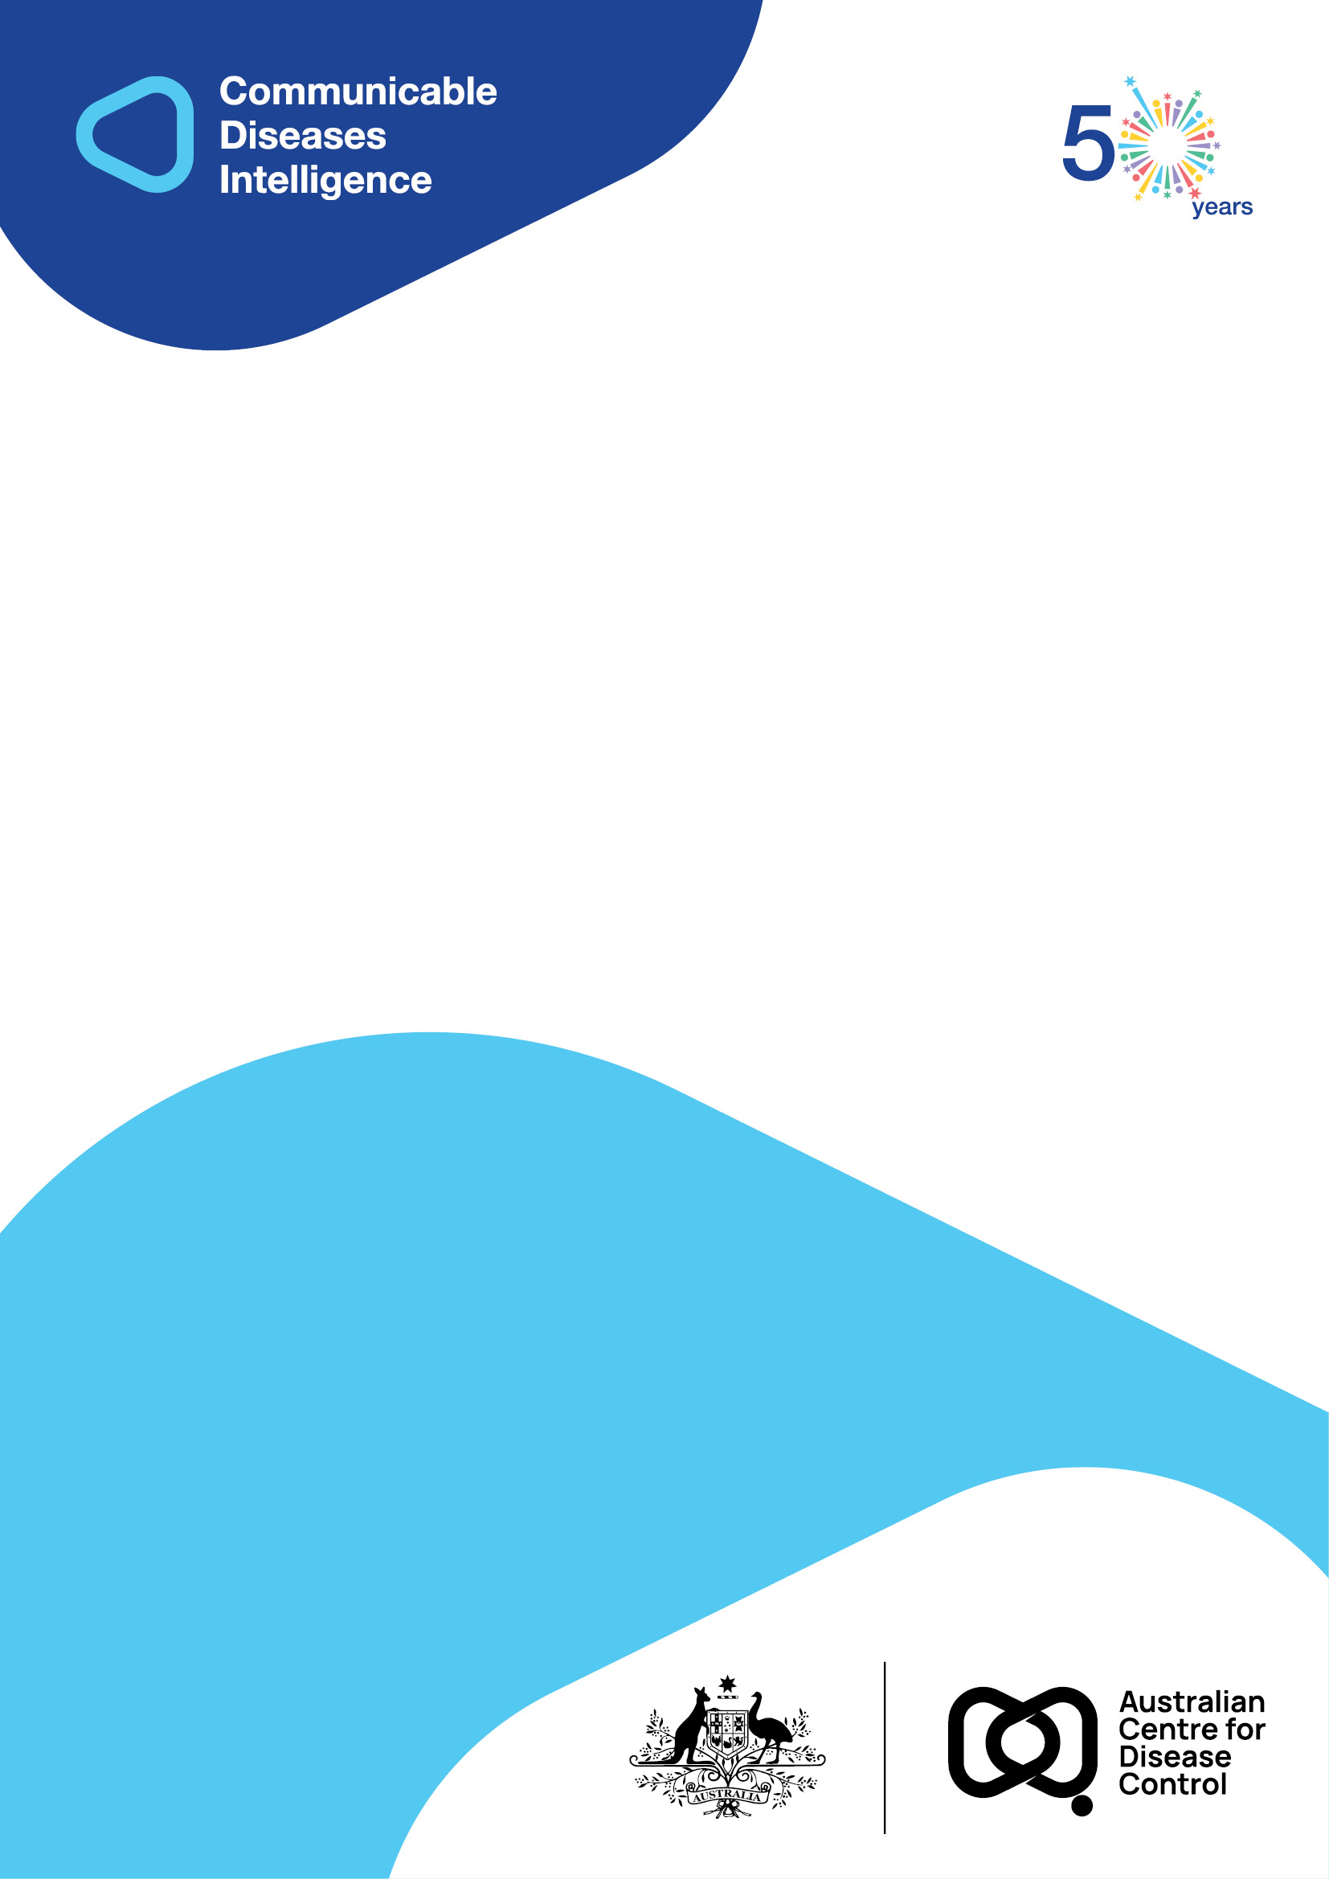
2026 • Volume 50 • cdc.gov.au/cdi • Epub date: 24.02.2026 • doi.org/10.33321/cdi.2026.50.009

Australian Trachoma Surveillance Report 2023
Alison Jaworski, Carleigh Cowling, Gordana C Popovic, Absar Noorul, Sergio Sandler, Susana Vaz Nery, John Kaldor
© 2026 Commonwealth of Australia as represented by the Australian Centre for Disease Control
ISSN: 2209-6051 Online
This journal is indexed by Index Medicus and Medline.
Creative Commons Licence
This publication is licensed under a Creative Commons Attribution-NonCommercial-NoDerivatives 4.0 International Licence (Licence). You must read and understand the Licence before using any material from this publication.
Restrictions
The Licence does not cover, and there is no permission given for, use of any of the following material found in this publication (if any):
- the Commonwealth Coat of Arms (by way of information, the terms under which the Coat of Arms may be used can be found on the Department of Prime Minister and Cabinet website);
- any logos (including the Australian Centre for Disease Control’s logo) and trademarks;
- any photographs and images;
- any signatures; and
- any material belonging to third parties.
Disclaimer
Opinions expressed in Communicable Diseases Intelligence are those of the authors and not necessarily those of the Australian Government or the Australian Centre for Disease Control. Data may be subject to revision.
Enquiries
Enquiries regarding any other use of this publication should be addressed to the CDI Editor.
About CDI
Communicable Diseases Intelligence (CDI) is a peer-reviewed scientific journal published by the Australian Centre for Disease Control.
The journal aims to disseminate information on the epidemiology, surveillance, prevention and control of communicable diseases of relevance to Australia and the near region.
Editor: Elise Firman • Deputy Editor: Simon Petrie • Design and Production: Lisa Thompson
Editorial Advisory Board: David Durrheim, Mark Ferson, Clare Huppatz, John Kaldor, Martyn Kirk and Meru Sheel
Submit an Article
Guidelines for authors and details on how to submit your publication is available on our website, or by email to the
CDI Editor.
Contact us
Communicable Diseases Intelligence (CDI)
Australian Centre for Disease Control
GPO Box 798, CANBERRA ACT 2601
Website: cdc.gov.au/cdi
Email: cdi.editor@cdc.gov.au

Contents
Abstract 5
Introduction 6
Ethics statement 7
Methods 8
Trachoma screening 8
Trachoma prevalence 8
Facial cleanliness 9
Treatment distribution and coverage 9
Trachomatous trichiasis 9
Results 10
Trachoma screening 10
Trachoma prevalence 11
Facial cleanliness 13
Treatment distribution and coverage 13
Trachomatous trichiasis 15
Discussion 17
Conclusion 18
Acknowledgments 19
Funding statement 19
Author details 20
References 21

List of figures
Figure 1: Number of communities designated as at risk for trachoma by jurisdiction, Australia, 2014 – 2023 10
Figure 2: Overall trachoma prevalence in Indigenous children aged 5–9 years by jurisdiction, Australia 2014–2023ª 12
Figure 3: Proportion of screened Indigenous children aged 5–9 years who had a clean face by jurisdiction, Australia, 2014–2023 13
Figure 4: Number of doses of azithromycin administered for the treatment of trachoma by jurisdiction, Australia, 2014 – 2023 14
Figure 5: Proportion of trachomatous trichiasis (TT) in Indigenous persons aged 15+ years screened,ª and surgery cases, by jurisdiction, Australia, 2014–2023 16

List of tables
Table 1: Trachoma screening coverage and prevalence by jurisdiction,^{a,b} Australia, 2023 11
Table 2: Number and proportion of screened at-risk communities according to the level of observed trachoma prevalence in Indigenous children aged 5–9 years Australia, 2019–2023 12
Table 3: Azithromycin treatment for trachoma by jurisdiction,ª Australia, 2023 14

Abstract
Trachoma is the world’s leading infectious cause of preventable blindness and is linked to poor living conditions. Australia has remained the only high-income country where trachoma is endemic, primarily in remote Indigenous communities in the Northern Territory, South Australia and Western Australia. The Australian Government funds the National Trachoma Surveillance and Reporting Unit to analyse surveillance data annually to assess progress against World Health Organization (WHO) criteria for the elimination of trachoma as a public health problem. These criteria include (i) prevalence of trachomatous inflammation–follicular less than 5% in children aged 1–9 years; and (ii) prevalence of trachomatous trichiasis ‘unknown to the health system’ of less than 0.2% in persons aged 15 years and above. Australia first reached these thresholds in 2022 and must maintain these levels in each formerly endemic jurisdiction (state/territory) for a further two years before being eligible to apply to the WHO for validation of elimination of trachoma as a public health problem. In 2023, screening staff used WHO grading criteria to assess trachoma in 67 at-risk communities. Overall prevalence, which includes estimates from all communities ever considered at risk, remained below 5% in 2023 at 2.3% in the Northern Territory; 0% in South Australia; and 1.6% in Western Australia. The proportion of new trachomatous trichiasis cases was 0.01% in the Northern Territory; 0% in South Australia; and 0.2% in Western Australia. Australia is on track to eliminate trachoma as a public health problem; however, the disease remains a health issue in some remote Indigenous communities.
Keywords: trachoma; SAFE control strategy; surveillance; elimination

Introduction
Trachoma is the world’s leading infectious cause of preventable blindness.¹ It is characterised by two linked processes. Infection with serovars A–C of the bacterium Chlamydia trachomatis leads to inflammation of the conjunctiva known as active trachoma, characterised by the presence of multiple follicles or lumps (trachomatous inflammation–follicular or TF) on the upper tarsal conjunctiva (upper inner eyelid), or pronounced thickening where the tarsal conjunctiva appears red and rough (trachomatous inflammation–intense or TI). Repeated infection, particularly during childhood, drives chronic scarring and the second, non-communicable stage. Scarring can cause eyelashes to rotate inward (trachomatous trichiasis or TT) to scratch the outer surface of the cornea. The resulting damage to the cornea by TT is the main pathway by which trachoma leads to vision loss and blindness.^{2–5}
Trachoma is a disease of poverty and is linked to poor living conditions, including overcrowding and inadequate water and sanitation facilities to prevent C. trachomatis transmission.^{6,7} Transmission occurs person to person via infected hands, eyes and fomites (e.g., clothing and bedding), and by eye-seeking flies.^{8,9} Children under 10 years of age generally have the highest prevalence of trachoma and are believed to be the main reservoirs of infection.¹⁰
Australia remains the only high-income country with endemic trachoma. It has primarily been found in remote Indigenous communities in the Northern Territory, South Australia and Western Australia.¹¹ New South Wales and Queensland were endorsed as non-endemic for trachoma in 2017 and 2022 respectively. Cases of TT have been identified in areas not currently considered at risk of trachoma, likely due to outward migration from historically endemic regions.^{11,12}
Australia is a part of the World Health Organization’s (WHO) Alliance for the Global Elimination of Trachoma initiative, which has set a global target for the elimination of trachoma as a public health problem by 2030.¹³ In order to achieve validation as having eliminated trachoma as a public health problem, Australia is required to maintain for a period of at least two years in each formerly endemic jurisdiction (state/territory) a prevalence of TF of less than 5% in children. Australia is also required to demonstrate a prevalence of TT ‘unknown to the health system’ (e.g., cases not previously identified among persons who have received, refused or who are awaiting surgical treatment to correct the condition) of less than 0.2% in persons aged 15 years old or older, as well as evidence of the health system’s ability to manage incident TT cases.¹⁴
Australia initiated the National Trachoma Management Program in 2006 and has adopted the WHO’s recommended package of interventions for trachoma control known as the SAFE strategy.^{15–19} SAFE refers to: Surgery to correct TT; Antibiotic treatment for C. trachomatis; Facial cleanliness and Environmental improvements to reduce transmission and prevent reinfection. Jurisdictions with areas historically at risk of trachoma receive funding from the Australian Government to deliver control programs. Programs must be conducted in accordance with the WHO SAFE strategy and the Communicable Diseases Network Australia (CDNA) national guidelines for the public health management of trachoma in Australia.²⁰
The Australian Government funds the National Trachoma Surveillance and Reporting Unit (NTSRU) to provide a national mechanism for data collection, analysis and annual reporting of surveillance results and SAFE activities. This report presents data submitted by jurisdictional health departments and other parties involved in trachoma control activities from 1 January 2023 to 31 December 2023.

Ethics statement
The collection, analysis, and reporting of Australia’s jurisdictional trachoma surveillance data is approved by the University of New South Wales (UNSW) Sydney Human Research Ethics Committee (Committee B), number: HC200882.

Methods

Trachoma screening
A community is defined as a specific geographic location where people reside and where there is at least one school. Communities are classified by jurisdictional health departments as ‘at risk’ of trachoma if at least once within the past five years, prevalence of active trachoma (defined as the presence of TF and/or TI) has been 5% or more in screened children aged 5–9 years.²⁰
Screening is conducted during a dedicated visit by jurisdictional control programs or primary health services. An update to the CDNA guidelines published in 2014 provides the option of not screening all at-risk communities every year, allowing jurisdictions the opportunity to concentrate efforts on control activities in high prevalence communities, or alternatively to make more efficient use of resources in communities with low levels of trachoma that would otherwise benefit little from annual screening.
Whilst WHO guidance for trachoma control focuses on children aged 1–9 years,²¹ the target group for surveillance activities in Australia since 2006 has been children aged 5–9 years.²⁰ This narrower age group was chosen because of ready accessibility through schools and greater feasibility of eye examination. Previous research has demonstrated that trachoma prevalence in 1–4 year olds in Australia is no higher than in those aged 5–9 years.²² Children aged 0–4 years or 10–14 years, however, may be examined opportunistically during regular screening activities.
Screening coverage is defined as the proportion of resident children aged 5–9 years who were screened. Estimated resident populations in each community are derived by health programs using Australian Bureau of Statistics census data, enrolment lists from schools and health clinics, supplemented by local advice on movement into and out of communities. CDNA guidelines set a community screening coverage target at a minimum of 85% of resident children aged 5–9 years.²⁰

Trachoma prevalence
In the Northern Territory, South Australia, and Western Australia, trachoma is classified in accordance with WHO simplified grading criteria via visual inspection by trained personnel.²³ In Queensland, screening for trachoma has also involved examination for Herbert’s pits and corneal pannus that are considered highly specific for trachoma, as well as laboratory confirmation of C. trachomatis infection biomarkers.
Two prevalence figures are presented in this report. Observed prevalence of active trachoma is calculated using only the data from at-risk communities requiring and receiving screening during 2023. The denominator for this measure changes yearly according to variations in communities requiring (and receiving) screening as per CDNA guidelines. As such, an overall prevalence is calculated by combining observed prevalence from at-risk communities screened during the calendar year, estimated prevalence from communities that were not screened that year but still considered at risk, and the most recent observed prevalence carried forward from formerly at-risk communities. Overall prevalence is the measure used to assess Australia’s progress towards elimination of trachoma as a public health problem.

Facial cleanliness
During screening, children are also examined for clean faces, as ocular and nasal secretions have been linked to C. trachomatis transmission and auto-reinfection.¹⁵ Facial cleanliness is defined as the absence of nasal and ocular discharge, and no dirt, dust and crusting on cheeks and forehead. CDNA guidelines also provide a target of at least 85% of children in a community at any one time to have a clean face.²⁰

Treatment distribution and coverage
Trachoma is usually treated by a single dose of the antibiotic azithromycin. In Australia, alongside treatment of active cases and household contacts, community-wide treatment is recommended in endemic communities where there is no obvious case clustering within households. Treatment coverage is defined as the proportion of active cases plus household/community contacts requiring treatment according to CDNA guidelines who received azithromycin.

Trachomatous trichiasis
TT is defined as where at least one eyelash from the upper eyelid touches the eyeball, or where there is evidence of recent removal of in-turned eyelashes from the upper eyelid.²³ In November 2018, the fourth global scientific meeting on trachoma amended the definition of TT to exclude trichiasis affecting only the lower eyelid due to the potential for misclassification.³ As such, time trends for TT data are not commented on in this report. Data sources for TT cases vary by jurisdiction, and include screening undertaken during routine trachoma surveillance, visiting regional optometrist service assessments, and opportunistic screening during the annual health assessment for Aboriginal and Torres Strait Islander people (also called the 715 health check).

Results

Trachoma screening
The total number of communities at risk of trachoma nationally declined 50% from 177 communities in 2014 to 88 in 2023 (Figure 1). Of the communities identified as at risk of trachoma in 2023, almost half were in the Northern Territory (n = 43; 49%), followed by Western Australia (n = 34; 39%), then South Australia (n = 11; 13%). No screening was undertaken in New South Wales and Queensland in 2023, as these jurisdictions do not have any communities considered at risk. Between 2014 and 2023, the number of communities at risk of trachoma declined by 45% in the Northern Territory, 48% in in South Australia, and 50% in Western Australia.
Figure 1: Number of communities designated as at risk for trachoma by jurisdiction, Australia, 2014 – 2023
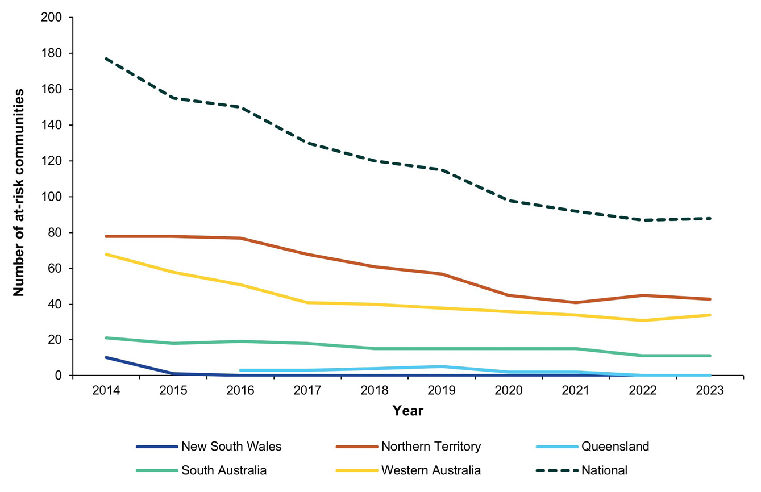

Trachoma prevalence
According to current CDNA guidelines, 74 of the 88 at-risk communities required screening in 2023. In total, 67 communities were screened for trachoma, or 91% of those requiring screening (Table 1). Screening coverage of the estimated resident target population was broadly consistent, within the range 89–91%, at the jurisdictional level. There were 74 cases of active trachoma reported among the 1,300 children aged 5–9 years screened. This represents a 15% decline from the 87 cases reported in 2022. Cases in 2023 were reported either in the Northern Territory or Western Australia, with 77% of all cases identified in the Northern Territory.
Table 1: Trachoma screening coverage and prevalence by jurisdiction,^{a,b} Australia, 2023
Category | Jurisdiction
Category | NT | SA | WA | Total
Communities at risk of trachoma | 43 | 11 | 34 | 88
Requiring screening | 37 | 11 | 26 | 74
Not requiring screening | 6 | 0 | 8 | 14
Communities screened | 31 | 11 | 25 | 67
Estimated resident population Indigenous children 5–9 years | 753 | 240 | 443 | 1,436
Children screened for trachoma | 684 | 213 | 403 | 1,300
Trachoma screening coverage (%) | 91 | 89 | 91 | 91
Children with active trachoma | 57 | 0 | 17 | 74
Observed trachoma prevalence (%) | 8.3 | 0.0 | 4.2 | 5.7
Overall trachoma prevalence (%) | 2.3 | 0.0 | 1.6 | 1.8
a NT: Northern Territory; SA: South Australia; WA: Western Australia.
b No screening was required in New South Wales and Queensland in 2023.
The overall prevalence of trachoma in Indigenous children aged 5–9 years, among all current and former at-risk communities nationally, decreased slightly from 2.0% in 2022 to 1.8% in 2023 (Figure 2). This was led by a decline in overall prevalence in Western Australia from 2.9% in 2022 to 1.6% in 2023. Overall prevalence remained at 0% in South Australia and rose slightly in the Northern Territory from 2.1% in 2022 to 2.3% in 2023.
Figure 2: Overall trachoma prevalence in Indigenous children aged 5–9 years by jurisdiction, Australia 2014–2023ª
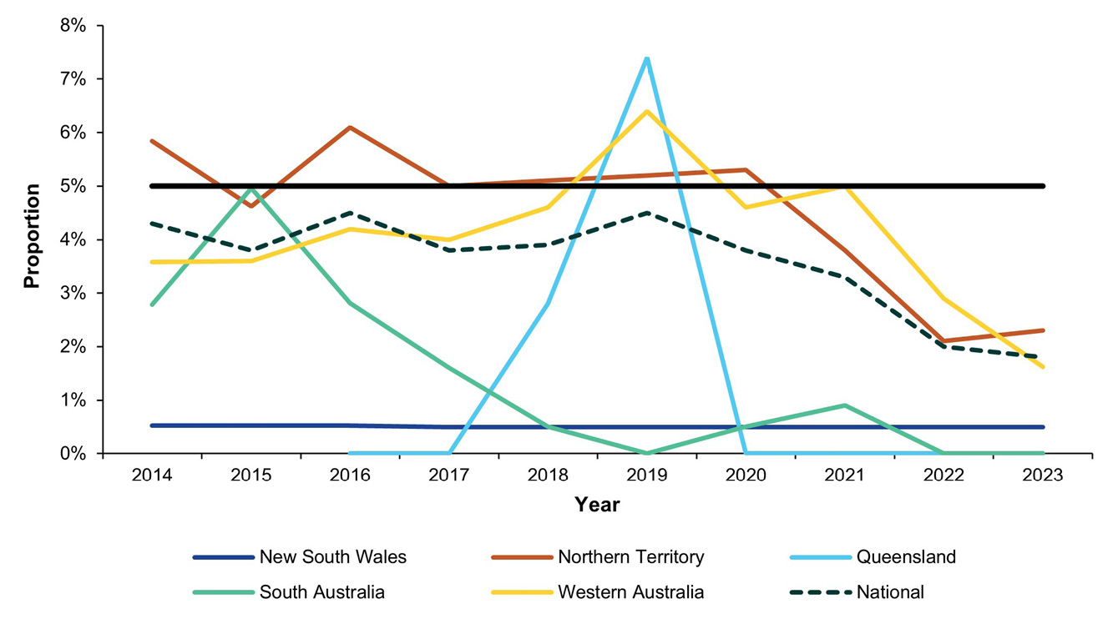
a The horizontal black line shows the 5% trachoma prevalence threshold required to be maintained in each formerly endemic jurisdiction for at least two successive years, as one of the criteria set by WHO for validation of elimination of trachoma as a public health problem.
The median number of children aged 5–9 years examined in communities was 13 (interquartile range [IQR]: 6–27 children). The majority of communities screened in 2023 reported no trachoma (48/67; 72%). Observed prevalence of active trachoma cases was 5% or more in 25% (17/67) of communities screened, with 7% (5/67) reporting hyper-endemic trachoma, i.e. prevalence at or above 20% (Table 2).
Table 2: Number and proportion of screened at-risk communities according to the level of observed trachoma prevalence in Indigenous children aged 5–9 years Australia, 2019–2023
Year | 2019 |  | 2020 |  | 2021 |  | 2022 |  | 2023
Communities screened | 111 |  | 96 |  | 82 |  | 79 |  | 67
Prevalence | n | (%) | n | (%) | n | (%) | n | (%) | n | (%)
≥ 20% | 24 | (22%) | 16 | (17%) | 9 | (11%) | 10 | (13%) | 5 | (7%)
10–19% | 13 | (12%) | 27 | (28%) | 18 | (22%) | 12 | (14%) | 8 | (12%)
5–9% | 8 | (7%) | 10 | (10%) | 12 | (15%) | 9 | (11%) | 4 | (6%)
> 0–4% | 8 | (7%) | 12 | (13%) | 13 | (16%) | 4 | (5%) | 2 | (3%)
0% | 58 | (52%) | 31 | (32%) | 30 | (37%) | 44 | (56%) | 48 | (72%)

Facial cleanliness
In conjunction with trachoma screening in 2023, surveillance teams assessed 1,335 children for facial cleanliness. The proportion of children with clean faces was 74% in the Northern Territory, 85% in South Australia, and 70% in Western Australia. Since 2014, clean face proportions have tended to fluctuate around or below the target of 85% at the jurisdictional level in the Northern Territory and South Australia, whilst proportions have generally risen over time in Western Australia (Figure 3).
Figure 3: Proportion of screened Indigenous children aged 5–9 years who had a clean face by jurisdiction, Australia, 2014–2023
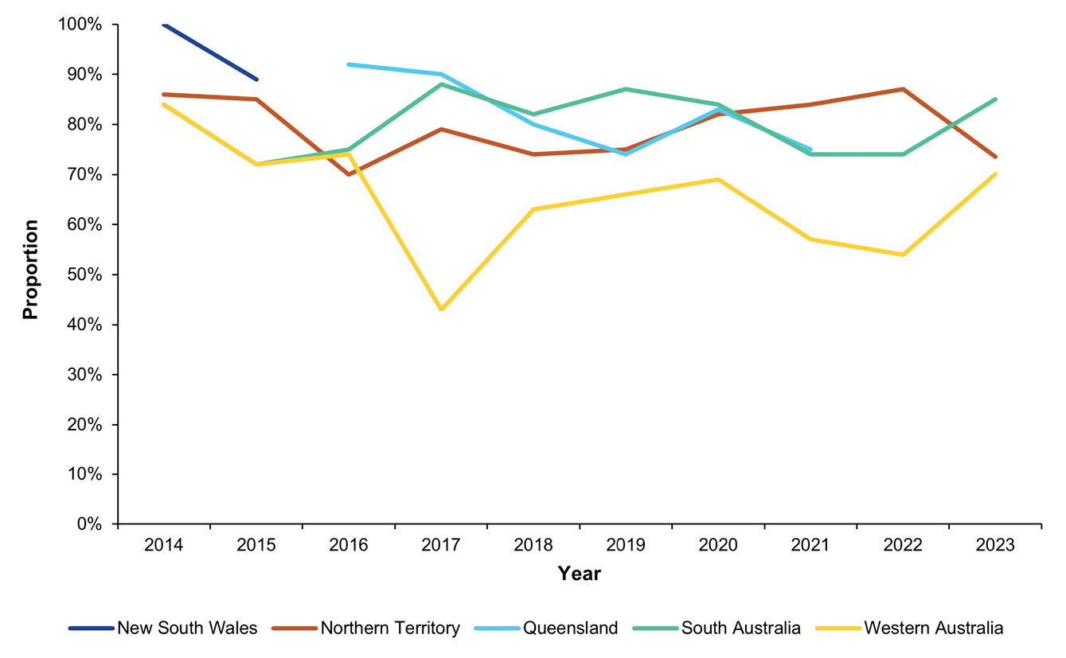

Treatment distribution and coverage
Antibiotics to treat trachoma were distributed in 18 out of the 19 communities across the Northern Territory and Western Australia in which treatment was required according to CDNA guidelines (Table 3). No communities required treatment in South Australia. The most common treatment required was household-based treatment (treatment of active case(s) and those living in the same household), which occurred in 72% of communities (13/18). This proportion was somewhat lower than 2022, when almost all communities delivered household-based treatment (94%; 33/35). In 2023, all community-wide treatment occasions (treatment of all people over 3 kg living in any household with a child under 15 years of age) took place in the Northern Territory (28% of all communities treated; 5/18).
Treatment coverage was higher for cases detected in screening activities (99%) than for household and community contacts also requiring treatment under CDNA Guidelines (81%). Overall treatment coverage was lower in 2023 at 82% versus 2022 at 95%, due to a decline in coverage among household and community contacts from 94% in 2022.
Table 3: Azithromycin treatment for trachoma by jurisdiction,ª Australia, 2023
Category | NT | WA | Total
Communities requiring treatment | 10 | 9 | 19
Communities receiving treatment | 10 | 8 | 18
Household-based treatment | 5 | 8 | 13
Community-wide treatment | 5 | 0 | 5
Children requiring treatment for active trachoma | 57 | 17 | 74
Children who received treatment for active trachoma | 57 | 16 | 73
Estimated community contacts requiring treatment^{b} | 1,834 | 136 | 1,970
Community contacts who received treatment | 1,511 | 93 | 1,604
Estimated overall treatment coverage (%) | 83 | 71 | 82
a NT: Northern Territory; WA: Western Australia.
b As per CDNA guidelines.
Jurisdictional trachoma programs delivered 1,677 doses of azithromycin in 2023, with nearly all doses (94%) distributed in the Northern Territory. Since 2016, dose distribution numbers have generally declined; 2023 presents a reversal of this trend, with approximately twice the number of doses administered compared to 2022, when 828 doses were administered (Figure 4).
Figure 4: Number of doses of azithromycin administered for the treatment of trachoma by jurisdiction, Australia, 2014 – 2023
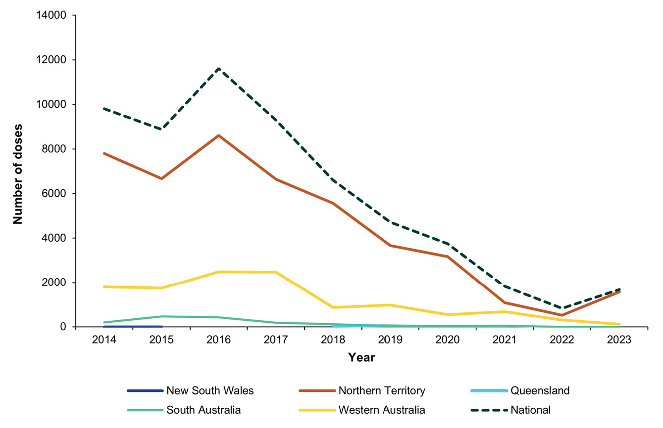

Trachomatous trichiasis
In total, 13,219 persons aged 15 years and over in 150 at-risk and previously at-risk communities or services were screened for TT in 2023, with nine new cases of TT reported. The proportion of cases reported in the population screened was 0.01% in the Northern Territory, 0% in South Australia and 0.2% in Western Australia (Figure 5). Surgery to correct TT was undertaken for seven persons nationally in 2023.
Figure 5: Proportion of trachomatous trichiasis (TT) in Indigenous persons aged 15+ years screened,ª and surgery cases, by jurisdiction, Australia, 2014–2023
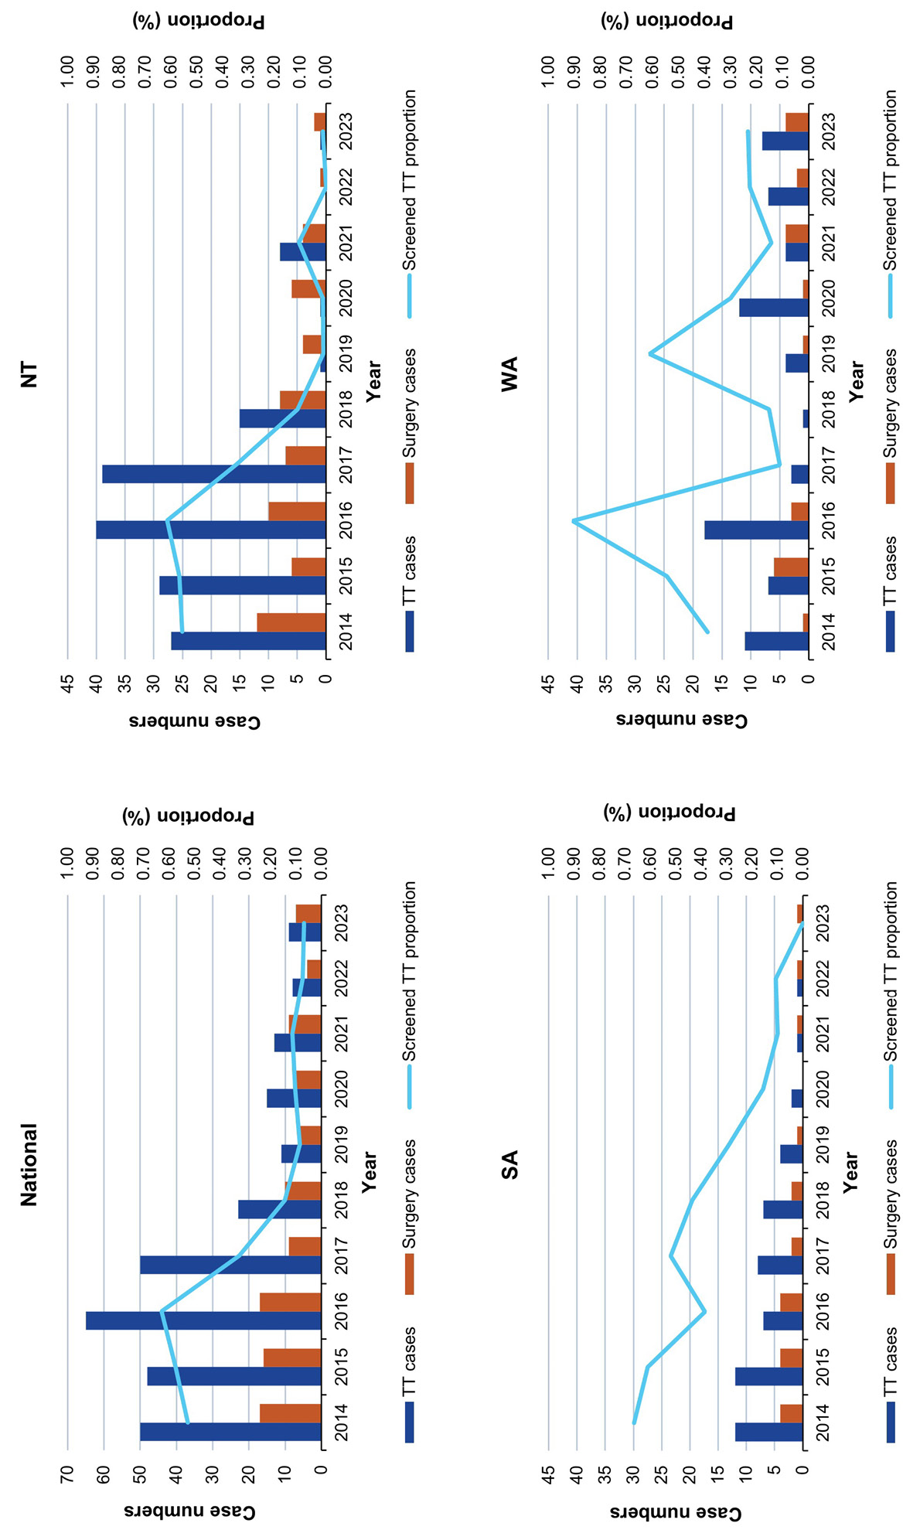
a TT cases identified are those ‘unknown to the health system’. Surgery cases may include TT cases identified in previous years.

Discussion
In 2023, overall trachoma prevalence in each jurisdiction remains below the WHO threshold for elimination as a public health problem. Sustaining low disease prevalence relies on strengthening health promoting environments, including improving the provision of appropriate housing in remote areas and ongoing maintenance of home health hardware, water and sanitation facilities. Close partnerships with community-controlled health organisations and local communities are critical to ensure these strategies are relevant, culturally safe and accountable to Indigenous people.
It is important to note that ‘elimination as a public health problem’, as defined by WHO, does not equate to the complete absence of new infections. In addition, there are a number of communities that continue to report endemic levels of trachoma. This indicates that even once elimination of trachoma as a public health problem is confirmed at the jurisdictional level, ongoing surveillance and treatment activities will be needed to manage disease pockets and prevent re-emergence. Surveillance systems that are effective, feasible and acceptable as case numbers continue to decline are currently being explored.
Whilst the number of cases reported during screening declined 15% between 2022 and 2023, treatment numbers approximately doubled. This may reflect year-to-year variation in the proportion of areas undertaking community-wide treatment versus treatment of immediate household contacts only, recommended under CDNA guidelines according to the observance of case clustering. In 2023, community-wide treatment was undertaken in 28% of communities (5/18), compared to 6% in 2022 (2/35). In a context where the number of communities requiring treatment is generally declining, such yearly variations may have notable impacts.
In Australia, TT screening activities are predominately aligned to current and former trachoma endemic regions. This is likely to overestimate the true population-level prevalence of TT in jurisdictions, as the broader Indigenous population does not have the same exposure risk. Other sources also indicate that prevalence is likely to be under the threshold for elimination as a public health problem. The National Indigenous Eye Health Survey in 2008 reported TT in 1.4% (16/1,171) in those surveyed, indicating an adjusted population prevalence of 0.2%;¹² whilst in the 2015–2016 survey the TT proportion was 0.17% (3/1,738), representing an estimated 0.03% among Indigenous Australians aged 40 years and over.²⁴ As scarring and development of TT can progress in individuals even after trachoma prevalence falls below endemicity levels,²⁵ the identification and treatment of TT cases will need to continue post-validation.

Conclusion
Australia is on track to be eligible for the validation of the elimination of trachoma as a public health problem. For progress to be maintained, efforts are needed to sustainably address known environmental risk factors; to ensure surveillance methods can identify and respond to areas with ongoing need and potential recrudescence; and to maintain TT surgery pathways. Principles of local ownership and accountability to Indigenous communities must underpin post-elimination strategies developed.

Acknowledgments
The authors would like to thank all jurisdictions that contribute to the Australian Trachoma Surveillance Reports, including: Northern Territory Department of Health Central Australia Public Health Unit; Katherine West Health Board; Queensland Health Communicable Diseases Branch; South Australia Health Eyre and Far North Local Health Network; Aboriginal Health Council of South Australia; Nganampa Health Council; Western Australia Country Health Service Population Health Units; Aboriginal Health Council of Western Australia; and Western New South Wales Local Health District Population Health Unit.

Funding statement
The Australian Government Department of Health, Disability and Ageing funds Australia’s trachoma surveillance program and the National Trachoma Surveillance and Reporting Unit (AusTender CN3790302).

Author details
Alison Jaworski,¹
Carleigh Cowling,¹
Gordana C Popovic,²
Absar Noorul,¹
Sergio Sandler,¹
Susana Vaz Nery,¹
John Kaldor¹
- The Kirby Institute, UNSW Sydney, Australia
- Stats Central, Mark Wainwright Analytical Centre, UNSW Sydney, Australia

Corresponding author
National Trachoma Surveillance and Reporting Unit
(secretariat to the National Trachoma Surveillance and Control Reference Group).
email: NTSRU_SMB@kirby.unsw.edu.au

References
- World Health Organization (WHO), WHO Alliance for the Global Elimination of Trachoma. Progress report on elimination of trachoma, 2023. Wkly Epidemiol Rec. 2024;99(28):363–80. Available from: https://www.who.int/publications/i/item/who-wer9928-363-380.
- Wolle MA, Muñoz BE, Mkocha H, West SK. Constant ocular infection with Chlamydia trachomatis predicts risk of scarring in children in Tanzania. Ophthalmology. 2009;116(2):243–7. doi: https://doi.org/10.1016/j.ophtha.2008.09.011.
- WHO. Report of the 4th global scientific meeting on trachoma: Geneva, 27–29 November 2018. Geneva: WHO; 4 June 2019. Available from: https://www.who.int/publications/i/item/who-htm-ntd-pct-2019.03.
- Elwell C, Mirrashidi K, Engel J. Chlamydia cell biology and pathogenesis. Nat Rev Microbiol. 2016;14(6):385–400. doi: https://doi.org/10.1038/nrmicro.2016.30.
- Solomon AW, Burton MJ, Gower EW, Harding-Esch EM, Oldenburg CE, Taylor HR et al. Trachoma. Nat Rev Dis Primers. 2022;8(1):32.
doi: https://doi.org/10.1038/s41572-022-00359-5.
- Habtamu E, Wondie T, Aweke S, Tadesse Z, Zerihun M, Zewdie Z et al. Trachoma and relative poverty: a case-control study. PLoS Negl Trop Dis. 2015;9(11):e0004228. doi: https://doi.org/10.1371/journal.pntd.0004228.
- Stocks ME, Ogden S, Haddad D, Addiss DG, McGuire C, Freeman MC. Effect of water, sanitation, and hygiene on the prevention of trachoma: a systematic review and meta-analysis. PLoS Med. 2014;11(2):e1001605. doi: https://doi.org/10.1371/journal.pmed.1001605.
- Last A, Versteeg B, Shafi Abdurahman O, Robinson A, Dumessa G, Abraham Aga M et al. Detecting extra-ocular Chlamydia trachomatis in a trachoma-endemic community in Ethiopia: identifying potential routes of transmission. PLoS Negl Trop Dis. 2020;14(3):e0008120. doi: https://doi.org/10.1371/journal.pntd.0008120.
- Miller K, Pakpour N, Yi E, Melese M, Alemayehu W, Bird M et al. Pesky trachoma suspect finally caught. Br J Ophthalmol. 2004;88(6):750–1. doi: https://doi.org/10.1136/bjo.2003.038661.
- Solomon AW, Holland MJ, Burton MJ, West SK, Alexander ND, Aguirre A et al. Strategies for control of trachoma: observational study with quantitative PCR. Lancet. 2003;362(9379):198–204. doi: https://doi.org/10.1016/S0140-6736(03)13909-8.
- Cowling CS, Liu BC, Snelling TL, Ward JS, Kaldor JM, Wilson DP. Australian trachoma surveillance annual report, 2013. Commun Dis Intell Q Rep. 2016;40(2):E255–66. doi: https://doi.org/10.33321/cdi.2016.40.21.
- Taylor HR, Fox SS, Xie J, Dunn RA, Arnold ALMR, Keeffe JE. The prevalence of trachoma in Australia: the National Indigenous Eye Health Survey. Med J Aust. 2010;192(5):248–53. doi: https://doi.org/10.5694/j.1326-5377.2010.tb03501.x.
- WHO Alliance for the Global Elimination of Trachoma. Progress report, 2019. Wkly Epidemiol Rec. 2020;95(30):349–60. Available from: https://iris.who.int/handle/10665/333443.
- WHO. Ending the neglect to attain the Sustainable Development Goals: a road map for neglected tropical diseases 2021–2030. Geneva: WHO; 28 January 2021. Available from: https://www.who.int/publications/i/item/9789240010352.
- Kuper H, Solomon AW, Buchan J, Zondervan M, Foster A, Mabey D. A critical review of the SAFE strategy for the prevention of blinding trachoma. Lancet Infect Dis. 2003;3(6):372–81. doi: https://doi.org/10.1016/s1473-3099(03)00659-5.
- Liu B, Cowling C, Hayen A, Watt G, Mak DB, Lambert S et al. Relationship between community drug administration strategy and changes in trachoma prevalence, 2007 to 2013. PLoS Negl Trop Dis. 2016;10(7):e0004810. doi: https://doi.org/10.1371/journal.pntd.0004810.
- Warren JM, Birrell AL. Trachoma in remote Indigenous Australia: a review and public health perspective. Aust N Z J Public Health. 2016;40(Suppl 1):S48–52. doi: https://doi.org/10.1111/1753-6405.12396.
- Ewald DP, Hall GV, Franks CC. An evaluation of a SAFE-style trachoma control program in Central Australia. Med J Aust. 2003;178(2):65–8.
doi: https://doi.org/10.5694/j.1326-5377.2003.tb05065.x.
- Wright HR, Keeffe JE, Taylor HR. Barriers to the implementation of the SAFE strategy to combat hyperendemic trachoma in Australia. Ophthalmic Epidemiol. 2010;17(6):349–59. doi: https://doi.org/10.3109/09286586.2010.528135.
- Communicable Diseases Network Australia (CDNA). CDNA national guidelines for the public health management of trachoma. Canberra: Australian Government Department of Health, Disability and Ageing, CDNA; 31 January 2014. Available from: https://www.health.gov.au/sites/default/files/documents/2020/02/trachoma-cdna-national-guidelines-for-public-health-units.pdf.
- WHO. Trachoma control: a guide for programme managers. Geneva: WHO; 20 July 2006. Available from: https://www.who.int/publications/i/item/9241546905.
- The National Trachoma Surveillance and Reporting Unit. Australian Trachoma Surveillance Report 2021. Sydney: University of New South Wales, The Kirby Institute, WHO Collaborating Centre in Neglected Tropical Diseases; 2022. Available from: https://www.kirby.unsw.edu.au/sites/default/files/documents/TRACHOMA_2021.pdf.
- Solomon AW, Kello AB, Bangert M, West SK, Taylor HR, Tekeraoi R et al. The simplified trachoma grading system, amended. Bull World Health Organ. 2020;98(10):698–705. doi: https://doi.org/10.2471/BLT.19.248708.
- Dirani M, Keel S, Foreman J, van Wijngaarden P, Taylor HR. Prevalence of trachomatous trichiasis in Australia: the National Eye Health Survey. Clin Exp Ophthalmol. 2018;46(1):13–7. doi: https://doi.org/10.1111/ceo.13003.
- Wolle MA, Muñoz BE, Naufal F, Kashaf MS, Mkocha H, West SK. Risk factors for the progression of trachomatous scarring in a cohort of women in a trachoma low endemic district in Tanzania. PLoS Negl Trop Dis. 2021;15(11):e0009914. doi: https://doi.org/10.1371/journal.pntd.0009914.

The term ‘Indigenous’ is used respectfully throughout this document to refer to the collective of individual people from different Aboriginal and Torres Strait Islander Nations across Australia for consistency with previous reports. The terms ‘Aboriginal’ or ‘Torres Strait Islander’ have been retained in discussion of relevant program, policy or organisational names.

