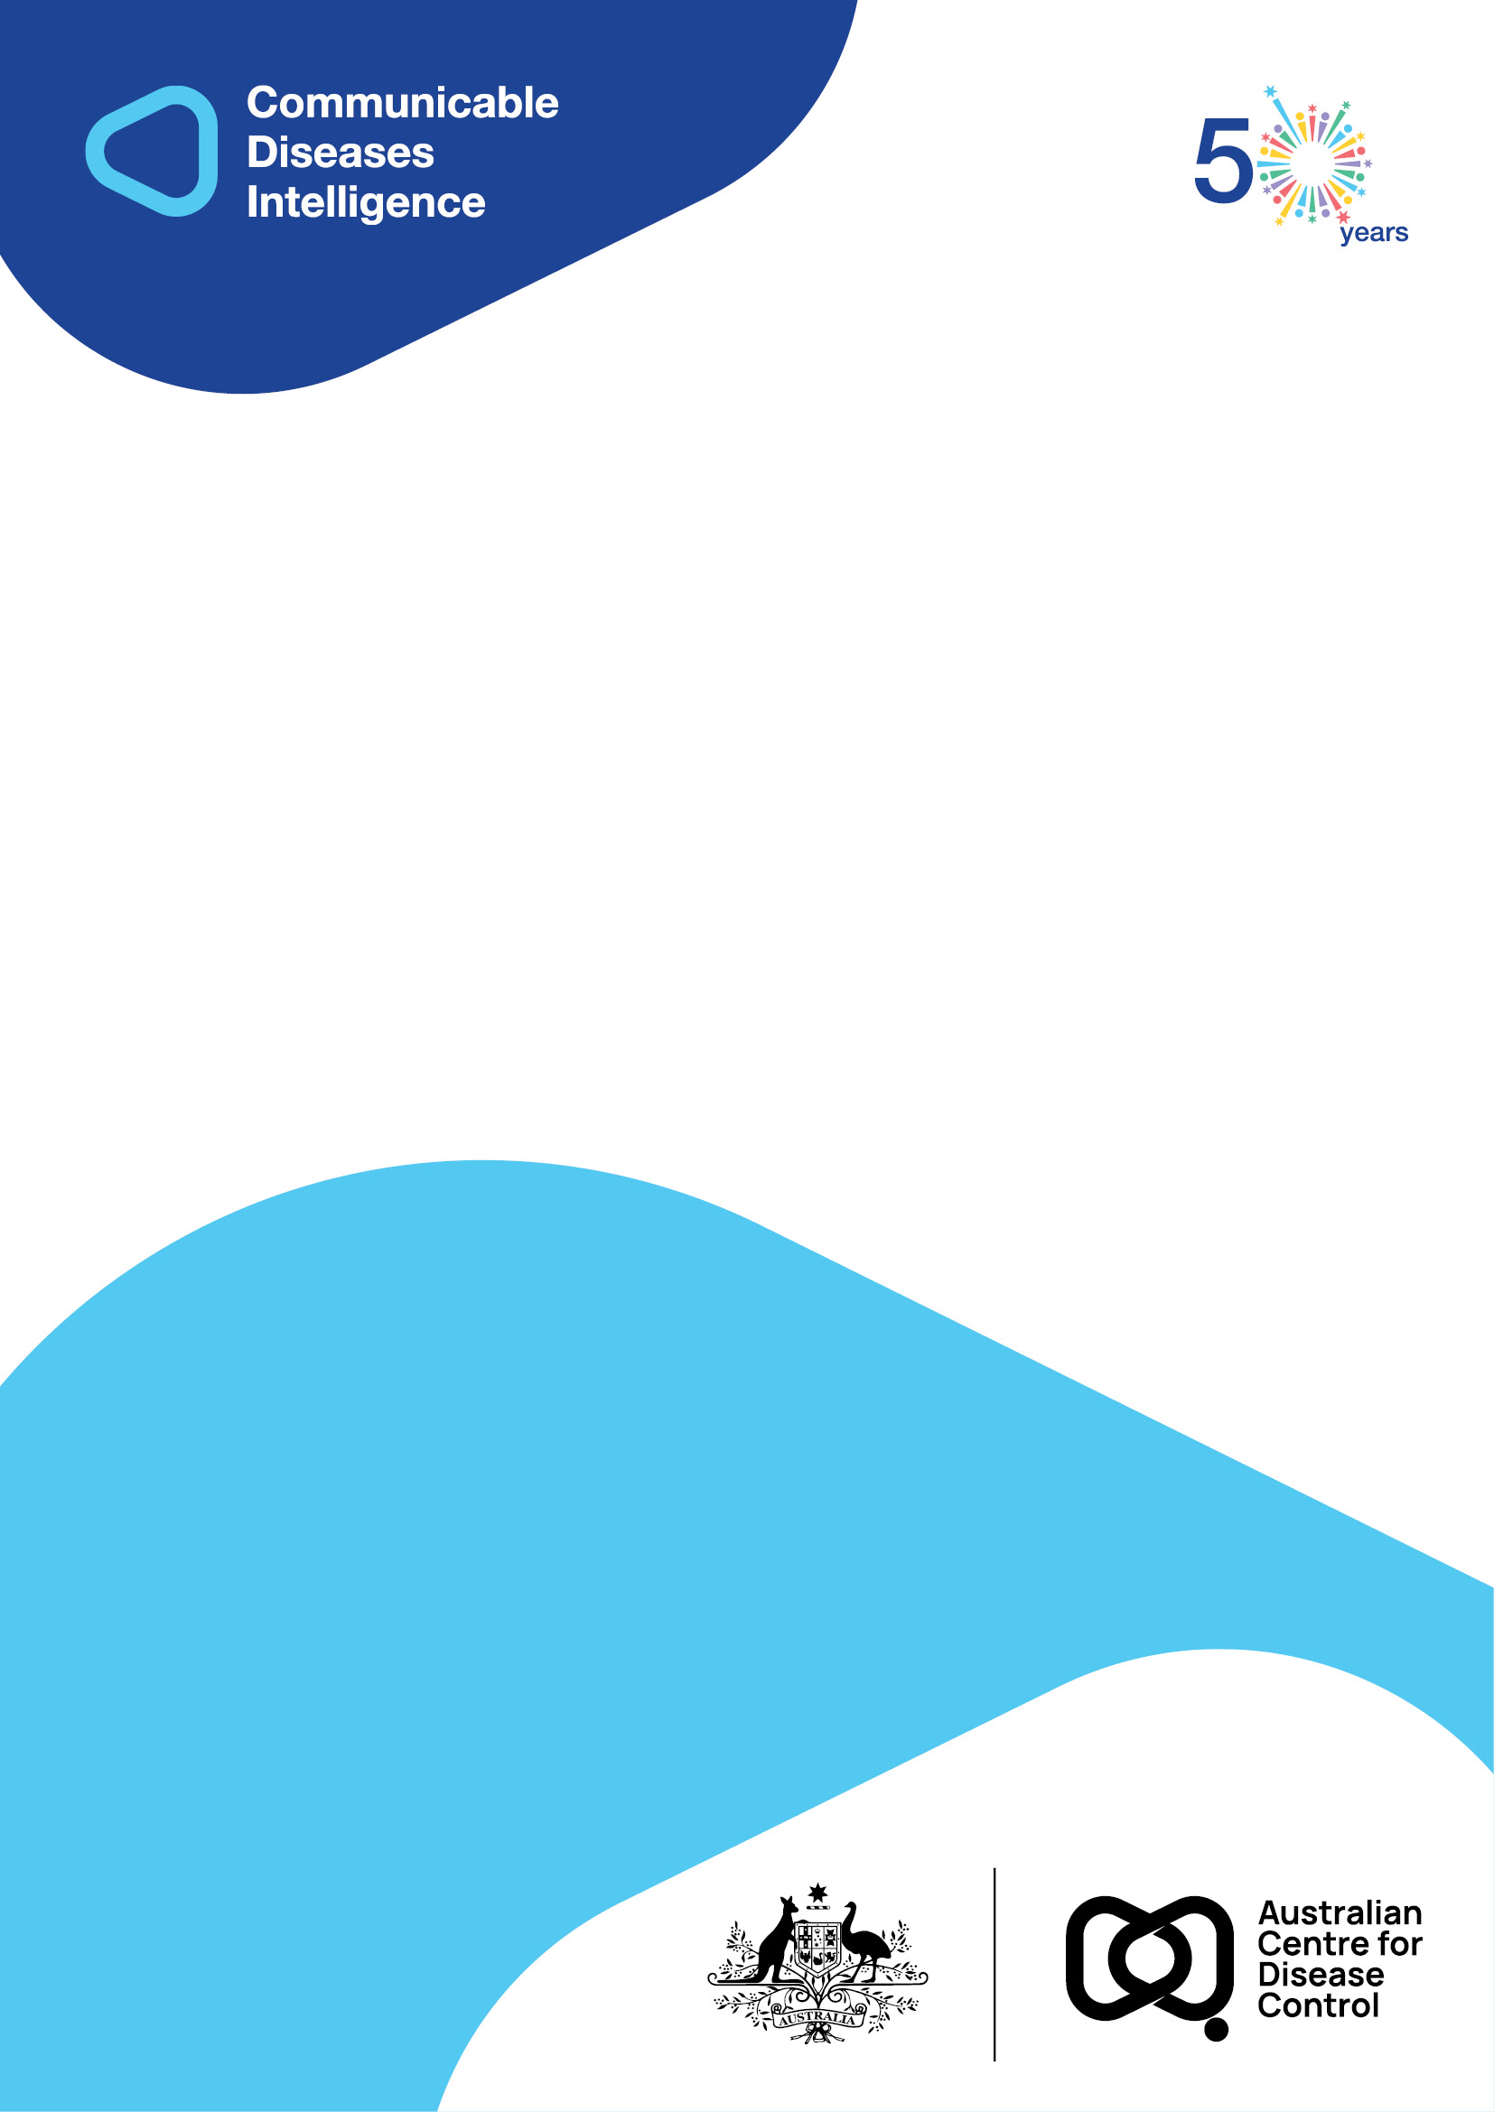
2026 • Volume 50 • cdc.gov.au/cdi • Epub date: 24.02.2026 • doi.org/10.33321/cdi.2026.50.001

Annual Immunisation Coverage Report 2023
Brynley Hull, Alexandra Hendry, Kristine Macartney, Frank Beard
© 2026 Commonwealth of Australia as represented by the Australian Centre for Disease Control
ISSN: 2209-6051 Online
This journal is indexed by Index Medicus and Medline.
Creative Commons Licence
This publication is licensed under a Creative Commons Attribution-NonCommercial-NoDerivatives 4.0 International Licence (Licence). You must read and understand the Licence before using any material from this publication.
Restrictions
The Licence does not cover, and there is no permission given for, use of any of the following material found in this publication (if any):
- the Commonwealth Coat of Arms (by way of information, the terms under which the Coat of Arms may be used can be found on the Department of Prime Minister and Cabinet website);
- any logos (including the Australian Centre for Disease Control’s logo) and trademarks;
- any photographs and images;
- any signatures; and
- any material belonging to third parties.
Disclaimer
Opinions expressed in Communicable Diseases Intelligence are those of the authors and not necessarily those of the Australian Government or the Australian Centre for Disease Control. Data may be subject to revision.
Enquiries
Enquiries regarding any other use of this publication should be addressed to the CDI Editor.
About CDI
Communicable Diseases Intelligence (CDI) is a peer-reviewed scientific journal published by the Australian Centre for Disease Control.
The journal aims to disseminate information on the epidemiology, surveillance, prevention and control of communicable diseases of relevance to Australia and the near region.
Editor: Elise Firman • Deputy Editor: Simon Petrie • Design and Production: Lisa Thompson
Editorial Advisory Board: David Durrheim, Mark Ferson, Clare Huppatz, John Kaldor, Martyn Kirk and Meru Sheel
Submit an Article
Guidelines for authors and details on how to submit your publication is available on our website, or by email to the
CDI Editor.
Contact us
Communicable Diseases Intelligence (CDI)
Australian Centre for Disease Control
GPO Box 798, CANBERRA ACT 2601
Website: cdc.gov.au/cdi
Email: cdi.editor@cdc.gov.au

Contents
Vaccine abbreviations 8
Abstract 9
Children 9
Adolescents 9
Adults 10
Conclusions 10
Introduction 11
Results 12
Children 12
Adolescents 28
Adults 39
Provider setting 49
Discussion 50
Vaccination coverage in population overall 50
Vaccination coverage in Indigenous people 53
Conclusions 56
Acknowledgments 57
Author details 58
References 59
Appendix A 64
Detailed methods 69
Additional data 77

Information correct as at 8 July 2025.

List of figures
Figure 1: Coverage of the first dose of measles-mumps-rubella (MMR)-containing vaccine at 24 months of age by Statistical Area 3, Australia and major capital cities^{,a,b} 2023 16
Figure 2: Coverage of the second dose of measles-mumps-rubella (MMR)-containing vaccine at 24 months of age by Statistical Area 3, Australia and major capital cities,^{a,b} 2023 17
Figure 3: Coverage of seasonal influenza vaccine in children aged 6–59 months, by jurisdiction, Australia,^{a,b,c} 2022 versus 2023 18
Figure 4: Coverage of seasonal influenza vaccine by age group, Australia,^{a,b} 2022 versus 2023 19
Figure 5: Coverage of seasonal influenza vaccine, in children aged 6–59 months, by Statistical Area 3, Australia,^{a,b} 2023 20
Figure 6: Coverage of seasonal influenza vaccine in Indigenous children aged 6–59 months, by jurisdiction, Australia,^{a,b,c} 2022 versus 2023 22
Figure 7: Coverage of seasonal influenza vaccine in Indigenous people by age group, Australia,^{a,b} 2022 versus 2023 23
Figure 8: Coverage of meningococcal B vaccine for Indigenous children, dose number and course completion, by jurisdiction, Australia,^{a,b,c,d} 2023 24
Figure 9: Trends in on-time vaccination coverage for the second dose of DTPa-containing vaccine, by Indigenous status and quarter, Australia,^{a,b,c} 2019–2023 25
Figure 10: Trends in on-time vaccination coverage for the first dose of MMR-containing vaccine, by Indigenous status and quarter, Australia,^{a,b,c} 2019–2023 26
Figure 11: On-time vaccination coverage of first dose of MMR-containing vaccine assessed at 13 months of age by Statistical Area 3, Australia,^{a,b,c,d} 2023 27
Figure 12: Coverage of at least one dose of HPV vaccine for females by birth cohort/age and Indigenous status, Australia,^{a,b} 2023 31
Figure 13: Coverage of at least one dose of HPV vaccine for males by birth cohort/age and Indigenous status, Australia,^{a,b} 2023 32
Figure 14: Coverage of an adolescent dose of diphtheria-tetanus-pertussis vaccine by birth cohort/age and Indigenous status, Australia,^{a,b,c} 2023 33
Figure 15: Coverage of an adolescent dose of meningococcal ACWY vaccine by birth cohort/age and Indigenous status, Australia,^{a,b} 2023 34
Figure 16: Vaccination coverage using composite measure (dose of HPV and adolescent dose of diphtheria-tetanus-pertussis vaccine) in adolescents turning 15 years, by jurisdiction,
Australia,^{a,b,c,d} 2021–2023 35
Figure 17: Vaccination coverage using composite measure (dose of HPV and adolescent dose of diphtheria-tetanus-pertussis vaccine) in Indigenous adolescents turning 15 years, by jurisdiction, Australia,^{a,b,c,d} 2021–2023 36
Figure 18: Vaccination coverage using composite measure (dose of HPV and adolescent doses of diphtheria-tetanus-pertussis and meningococcal ACWY vaccine) in adolescents turning 18 years, by jurisdiction, Australia,^{a,b,c,d} 2021–2023 37
Figure 19: Vaccination coverage using composite measure (dose of HPV and adolescent doses of diphtheria-tetanus-pertussis and meningococcal ACWY vaccine) in Indigenous adolescents turning 18 years, by jurisdiction, Australia,^{a,b,c,d} 2021–2023 38
Figure 20: Zoster vaccination coverage for adults turning 71 years of age in the year of interest, by jurisdiction, Australia,^{a,b,c,d,e} 2019–2023 40
Figure 21: Zoster vaccination coverage for Indigenous adults turning 71 years of age in the year of interest, by jurisdiction, Australia,^{a,b,c,d,e} 2019–2023 41
Figure 22: Zoster vaccination coverage in adults by birth cohort and age at vaccination, Australia,^{a,b} 2023 42
Figure 23: Zoster vaccination coverage in Indigenous adults by birth cohort and age at vaccination, Australia,^{a,b} 2023 42
Figure 24: Coverage of an adult dose of 13vPCV in the cohort of adults turning 71 years of age in the year of interest, by jurisdiction, Australia,^{a,b,c,d,e} 2020–2023 43
Figure 25: Coverage of an adult dose of 13vPCV in the cohort of Indigenous adults turning 71 years of age in the year of interest, by jurisdiction, Australia,^{a,b,c,d} 2020–2023 44
Figure 26: Coverage of an adult dose of 13vPCV by birth cohort and age at vaccination, Australia,^{a,b} 2023 45
Figure 27: Coverage of an adult dose of 13vPCV in Indigenous adults by birth cohort and age at vaccination, Australia,^{a,b} 2023 45
Figure 28: Coverage of seasonal influenza vaccine by adult age group, Australia,^{a,b,c}
2019–2023 46
Figure 29: Coverage of seasonal influenza vaccine in adults aged ≥ 65 years, by Statistical Area 3, Australia,^{a,b,c,d} 2023 47
Figure 30: Vaccination coverage using composite measure (influenza vaccine dose in calendar year of interest and an adult dose of 13vPCV), adults turning 71 years of age in relevant year, by jurisdiction, Australia,^{a,b,c,d} 2021–2023 48
Figure 31: Vaccination coverage using composite measure (influenza vaccine dose in past 12 months and an adult dose of 13vPCV), Indigenous adults turning 71 years of age in relevant year, by jurisdiction, Australia,^{a,b,c,d} 2021–2023 49
Figure A.1: Trends in fully vaccinated coverage by quarter, Australia,^{a,b,c} 2014–2023 77
Figure A.2: Trends in vaccination coverage at 12 months of age, by vaccine/antigen and quarter, Australia,^{a,b,c,d} 2014–2023 78
Figure A.3: Trends in vaccination coverage at 24 months of age by vaccine/antigen and quarter, Australia,^{a,b,c,d} 2014–2023 79
Figure A.4: Trends in vaccination coverage at 60 months of age by vaccine/antigen and quarter, Australia,^{a,b,c,d} 2014–2023 80
Figure A.5: Trends in fully vaccinated coverage at 12 months of age by Indigenous status and quarter, Australia,^{a,b} 2014–2023 81
Figure A.6: Trends in fully vaccinated coverage at 24 months of age by Indigenous status and quarter, Australia,^{a,b} 2014–2023 81
Figure A.7: Trends in fully vaccinated coverage at 60 months of age by Indigenous status and quarter, Australia,^{a,b} 2014–2023 82
Figure A.8: Trends in coverage for hepatitis A vaccine by 30 months of age for Indigenous children by jurisdiction, Australia,^{a,b,c} 2014–2023 82
Figure A.9: Trends in coverage for pneumococcal vaccine for Indigenous children by jurisdiction, Australia,^{a,b,c,d} 2014–2023 83
Figure A.10: Proportion of all vaccinations given to people of all ages by provider setting and jurisdiction, Australia,^{a,b,c} 2023 83

List of tables
Table 1: Vaccination coverage in children by age assessment milestone, vaccine/antigen and Indigenous status, Australia,ª 2022 versus 2023 13
Table 2: Coverage of at least one dose of HPV vaccine, received before fifteenth birthday, in adolescents turning 15 years of age in the relevant year, by gender, Indigenous status and jurisdiction, Australia,^{a,b,c} 2022 and 2023 29
Table 3: Coverage of at least one dose of HPV vaccine, received before fifteenth birthday, in adolescents turning 15 years of age in the relevant year, by gender, Indigenous status and socioeconomic status, Australia,^{a,b,c,d} 2022 and 2023 30
Table 4: Coverage of at least one dose of HPV vaccine, received before fifteenth birthday, in adolescents turning 15 years of age in relevant year, by gender, Indigenous status and remoteness of area of residence, Australia,^{a,b,c,d} 2022 and 2023 30
Table A.1.1: Australian National Immunisation Program (NIP) schedule in 2023, for children (≤ 9 years of age)ª 64
Table A.1.2: Australian National Immunisation Program (NIP) schedule in 2023, for adolescents (9 –≤ 20 years of age)ª 65
Table A.1.3: Australian National Immunisation Program (NIP) schedule in 2023, for adults (≥ 20 years of age)ª 66
Table A.2: Vaccinations required to be deemed fully vaccinated by each assessment milestone, Australia, 2023 72
Table A.3: Fully vaccinated coverage assessed at standard age milestones (12, 24 and 60 months) and earlier (9, 15, 21, 51 months) milestones, all children, by Primary Health Network (PHN) and jurisdiction, Australia,ª 2023 84
Table A.4: Fully vaccinated coverage assessed at standard age milestones (12, 24 and 60 months) and earlier (9, 15, 21, 51 months) milestones, Indigenous children, by Primary Health Network (PHN) and jurisdiction, Australia,ª 2023 86
Table A.5: Coverage of at least one dose of HPV vaccine in females by birth cohort/age, Indigenous status and jurisdiction, Australia,^{a,b,c,d,e} 2023 88
Table A.6: Coverage of at least one dose of HPV vaccine in males by birth cohort/age, Indigenous status and jurisdiction, Australia,^{a,b,c,d,e} 2023 89
Table A.7: Coverage of a dose of diphtheria-tetanus-acellular pertussis vaccine in adolescents by age, Indigenous status and jurisdiction, Australia,^{a,b,c,d} 2023 90
Table A.8: Coverage of a dose of meningococcal ACWY vaccine in adolescents by age, Indigenous status and jurisdiction, Australia,^{a,b,c,d} 2023 91
Table A.9.1: Recorded coverage of seasonal influenza vaccine by age group, jurisdiction and Indigenous status, Australia,^{a,b} 2022 92
Table A.9.2: Recorded coverage of seasonal influenza vaccine by age group, jurisdiction and Indigenous status, Australia,^{a,b} 2023 93

Vaccine abbreviations
13vPCV 13-valent pneumococcal conjugate vaccine
DTPa diphtheria-tetanus-acellular pertussis (children aged under 10 years formulation)
DT5aP diphtheria-tetanus-pertussis (children aged under 10 years formulation)
dTpa diphtheria-tetanus-acellular pertussis (individuals aged 10 years and over formulation)
23vPPV 23-valent pneumococcal polysaccharide vaccine
Flu influenza
Hep A hepatitis A
Hep B hepatitis B
Hib Haemophilus influenzae type b
HPV human papillomavirus
IPV inactivated polio vaccine
MenACWY meningococcal ACWY
MenC meningococcal C
MMR measles-mumps-rubella
MMRV measles-mumps-rubella-varicella

Abstract
We analysed Australian Immunisation Register (AIR) data, predominantly for National Immunisation Program (NIP) funded vaccines, as at 4 February 2024 for children, adolescents and adults, focusing on the calendar year 2023 and trends from previous years.
This report aims to provide comprehensive analysis and interpretation of vaccination coverage data to inform immunisation policy and programs.

Children
Fully vaccinated coverage in Australian children in 2023 was lower than in 2022 at the 12-month (92.8%, down from 93.3%), 24-month (90.8%, down from 91.0%) and 60-month (93.3%, down from 93.4%) age assessment milestones. This follows the 1.1–1.5 percentage point decrease at these three milestones between the 2020 and 2022 reports, which came after eight years of generally increasing coverage. Fully vaccinated coverage in Aboriginal and Torres Strait Islander (hereafter, respectfully, Indigenous) children was also slightly lower in 2023 than in 2022 at the 12-month (89.7%, down from 90.0%), 24-month (87.8%, down from 87.9%) and 60-month (95.0%, down from 95.1%) milestones, following a 1.9–3.3 percentage point decrease between the 2020 and 2022 reports.
Due to the lag time involved in assessment, fully vaccinated coverage figures for 2023 predominantly reflect vaccinations due in 2022, when COVID-19 pandemic-related restrictions had largely been removed. Factors contributing to this ongoing decline in coverage in children include a combination of acceptance and access issues.

Adolescents
Among adolescents turning 15 years in 2023, 84.2% of girls and 81.8% of boys (80.9% and 75.0% of Indigenous girls and boys) had received at least one dose of human papillomavirus (HPV) vaccine by their fifteenth birthday, 1.1 and 1.3 percentage points lower than in 2022, respectively (2.1–3.1 percentage points lower for Indigenous adolescents). Coverage of an adolescent dose of meningococcal ACWY vaccine in adolescents turning 17 years in 2023 was 72.8% overall and 62.3% in Indigenous adolescents, 3.1 and 3.3 percentage points lower than in 2022, respectively. These decreases reflect impacts of the pandemic on school-based programs in 2020–2021. To provide an early insight into any immediate impacts on coverage of moving to the NIP single-dose HPV vaccine schedule in 2023 (offered in Year 7 in all jurisdictions), we calculated coverage of at least one dose of HPV vaccine by 31 December in adolescents turning 13 years, with South Australia excluded due to change of delivery from Year 8 in 2022, and found it to be around 3 percentage points lower in 2023 than 2022, and 6 percentage points lower in Indigenous girls, with patterns of diphtheria-tetanus-pertussis vaccination (also single-dose at this age) and HPV vaccination coverage broadly similar. This decrease in vaccinations due in school programs after pandemic restrictions had been removed could be due to impacts of the single-dose HPV transition (i.e. if fewer opportunities for vaccination are provided due to fewer school visits) or may be due to other factors that have changed or disrupted previous school immunisation program operations or reduced parental confidence in vaccination. It is important to promote catch-up vaccination and to monitor renewed efforts to ensure equitable coverage is achieved, particularly given HPV vaccine coverage by 15 years of age in 2023 was 4–8 percentage points lower in adolescents residing in socio-economically disadvantaged and remote areas.

Adults
Zoster vaccination coverage in adults turning 71 years was 41.0% overall in 2023, down from 41.3% in 2022, and 36.1% in Indigenous adults, down from 36.5%. However, the availability of the new (non-live) protein-based herpes zoster vaccine (Shingrix) from 1 November 2023 has resulted in increased uptake for the larger eligible cohort. Coverage of 13-valent pneumococcal conjugate vaccine (13vPCV) in adults turning 71 years was 37.6% in 2023, up from 33.8% in 2022, and 43.0% in Indigenous adults, up from 37.7%. Coverage of 13vPCV was lower among Indigenous adults turning 50–59 years (17.5%) and 60–69 years (23.4%) in 2023, despite this vaccine being funded under the NIP. Influenza vaccination coverage decreased across all adult age groups in 2023, both overall and in Indigenous adults, with decreases ranging from 5–11 percentage points.

Conclusions
There have continued to be modest but concerning declines in vaccination coverage in children and adolescents relative to pre-pandemic peaks, with decreases greater in Indigenous children and adolescents. Evidence suggests that the factors contributing to these ongoing declines are complex and variable but include both vaccine acceptance and access issues. The picture for adult coverage is more mixed, with coverage increasing for 13vPCV, stable for zoster and decreasing for influenza vaccination, though consistently suboptimal across all vaccines. Ongoing monitoring of vaccination coverage, and further exploration of the reasons underpinning these decreases and suboptimal coverage, are needed to inform approaches to address barriers effectively and to increase vaccine uptake and equity of coverage.

Introduction
This is the seventeenth annual Australian immunisation coverage report, and these reports now cover the years 2007–2023.^{1–15} This 2023 report is the fourth in the series to report ‘whole-of-life’ vaccination coverage—that is, vaccinations for children, adolescents and adults—using data from the Australian Immunisation Register (AIR), following the expansion of the AIR in 2016. This report complements and extends upon other vaccination coverage data published by the Australian Government Department of Health, Disability and Ageing¹⁶ and provides a comprehensive analysis of trends and interpretation of their relationship to factors including policy and program changes. It includes detailed analyses of coverage data for the calendar year 2023, with a particular focus on vaccines included on the National Immunisation Program (NIP) and on changes in coverage since 2022, and presents trend data from 2014 onwards.
This report uses the longstanding international practice of reporting at key milestone ages to measure coverage—including against national targets, where applicable—and to track trends over time. Vaccination coverage and timeliness for 2023 were measured using AIR data as at 4 February 2024. Childhood cohort vaccination status was assessed for fully vaccinated (as defined by the Australian Government Department of Health, Disability and Ageing, including certain specific vaccine or antigen [component of vaccine] doses that should have been received by the relevant age milestone) and for individual vaccines at the standard milestones—12 months of age (for vaccines due at 6 months), 24 months of age (for vaccines due at 6, 12 and 18 months) and 60 months of age (for vaccines due at 48 months)—including by Aboriginal and Torres Strait Islander (hereafter referred to, respectfully, as Indigenous) status and at small area levels (Primary Health Network [PHN] and Australian Bureau of Statistics Statistical Area 3 [SA3]). Coverage for vaccines included in the NIP for Indigenous children only was also assessed for relevant jurisdictions using appropriate milestones and cohorts. Timeliness of childhood vaccination was assessed by calculating on-time vaccination (within 30 days of recommended age) for selected vaccine doses, by Indigenous status, as well as by calculating fully vaccinated coverage at age milestones earlier than the standard ones (i.e. 9, 15, 21 and 51 months) by PHN and jurisdiction. Coverage for vaccines included in the NIP for adolescents and adults was assessed using appropriate milestones and cohorts. We assessed coverage of at least one dose of human papillomavirus (HPV) vaccine for adolescents and young adults aged 13–25 years (noting the NIP schedule changed in January 2023 from two doses to one dose of HPV vaccine); of an adolescent dose of diphtheria-tetanus-pertussis (dTpa) vaccine for adolescents aged 13–19 years; and of an adolescent dose of meningococcal ACWY vaccine for adolescents aged 15–19 years, by jurisdiction, Indigenous status, age and sex. We assessed zoster vaccination coverage (including for the inactivated recombinant vaccine Shingrix, which became available through private prescription in June 2021 and on the NIP from November 2023) for adults turning 50 years and over in 2023 by jurisdiction, Indigenous status and age, as well as 13-valent pneumococcal conjugate vaccine (13vPCV) coverage for adults turning 50 years and over by Indigenous status and age. Influenza vaccination coverage for 2023, compared to 2022, was assessed across all ages by Indigenous status. We also calculated composite measures of vaccination coverage for vaccines included on the NIP for adolescents and adults.¹⁷ A more detailed description of the methods used in this report is provided in Appendix A.
The NIP schedule in 2023 is summarised in Appendix A, Table A.1.1, Table A.1.2 and Table A.1.3. Important recent and relevant changes to vaccination policy and fully vaccinated coverage algorithms are shown in Appendix A, Box A.1. Methods used in this report are summarised in the ‘Detailed methods’ section of Appendix A.

Results

Children

Coverage at 12, 24 and 60 months of age

Fully vaccinated
Fully vaccinated coverage decreased between 2022 and 2023 at all three age milestones: 12 months (from 93.3% to 92.8%); 24 months (from 91.0% to 90.8%); and 60 months (from 93.4% to 93.3%; Table 1). Trends in fully vaccinated coverage by quarter from 2014 to 2023 are shown in Appendix A, Figure A.1. Fully vaccinated coverage for 2023 at the three age milestones is also provided by PHN and jurisdiction in Appendix A, Table A.3. It should be noted that coverage estimates in this report may differ slightly from estimates published elsewhere that are calculated using rolling annualised quarterly coverage data.

Coverage by individual vaccines/antigens
Coverage for all individual vaccines/antigens at 12 months of age decreased between 2022 and 2023, by 0.5–1.1 percentage points (Table 1). Coverage for vaccines/antigens included in the fully vaccinated algorithm (see Appendix A, Table A.2 for definition) was 93.2–95.0% in 2023. Coverage for the second dose of rotavirus vaccine, which is not included in the fully vaccinated algorithm due to upper age limits, decreased by 1.1 percentage points, from 90.5% to 89.4%. Trends in individual vaccine/antigen coverage at 12 months of age by quarter from 2014 to 2023 are shown in Appendix A, Figure A.2.
Coverage for all individual vaccines/antigens included in the fully vaccinated algorithm at 24 months of age (see Appendix A, Table A.2 for definition) decreased between 2022 and 2023 by 0.2–0.5 of a percentage point to be 91.9–95.8% in 2023 (Table 1). Trends in individual vaccine/antigen coverage at 24 months of age by quarter from 2014 to 2023 are shown in Appendix A, Figure A.3.
Coverage for antigens included in the fully vaccinated algorithm at 60 months of age (see Appendix A, Table A.2 for definition) decreased between 2022 and 2023, from 93.6% to 93.5% for the fourth (or fifth) dose of DTPa and from 93.8% to 93.6% for the fourth dose of polio vaccine (Table 1). Trends in individual vaccine/antigen coverage at 60 months of age by quarter from 2014 to 2023 are shown in Appendix A, Figure A.4.
Table 1: Vaccination coverage in children by age assessment milestone, vaccine/antigen and Indigenous status, Australia,ª 2022 versus 2023
Vaccine/antigen | Milestone age | Indigenous children (%) |  | All children (%)
Vaccine/antigen | Milestone age | 2022 | 2023 | 2022 | 2023
Fully vaccinated^{b} | 12 months^{c} | 90.0 | 89.7 | 93.3 | 92.8
Fully vaccinated^{b} | 24 months^{d} | 87.9 | 87.8 | 91.0 | 90.8
Fully vaccinated^{b} | 60 months^{e} | 95.1 | 95.0 | 93.4 | 93.3
Diphtheria-tetanus-pertussis | 12 months^{c} (dose 3) | 90.2 | 89.9 | 93.9 | 93.3
Diphtheria-tetanus-pertussis | 24 months^{d} (dose 4) | 89.1 | 89.1 | 92.3 | 91.9
Diphtheria-tetanus-pertussis | 60 months^{e} (dose 4 or 5) | 95.4 | 95.3 | 93.6 | 93.5
Polio | 12 months^{c} (dose 3) | 90.2 | 89.9 | 93.9 | 93.3
Polio | 24 months^{d} (dose 3) | 96.1 | 95.6 | 96.1 | 95.8
Polio | 60 months^{e} (dose 4) | 95.2 | 95.1 | 93.8 | 93.6
Haemophilus influenzae type b | 12 months^{c} (dose 3) | 90.2 | 89.9 | 93.9 | 93.3
Haemophilus influenzae type b | 24 months^{d} (dose 4) | 91.5 | 91.1 | 93.2 | 92.7
Haemophilus influenzae type b | 60 months^{e} (dose 4) | 98.2 | 98.1 | 95.8 | 95.8
Hepatitis B | 12 months^{c} (dose 3) | 90.2 | 89.9 | 93.8 | 93.2
Hepatitis B | 24 months^{d} (dose 3) | 96.1 | 95.5 | 95.9 | 95.6
Hepatitis B | 60 months^{e} (dose 3) | 98.5 | 98.4 | 96.5 | 96.6
Measles-mumps-rubella | 12 months^{f} | N/A | N/A | N/A | N/A
Measles-mumps-rubella | 24 months^{d} (dose 1) | 95.3 | 94.9 | 95.1 | 94.7
Measles-mumps-rubella | 24 months^{d} (dose 2) | 90.2 | 90.7 | 92.7 | 92.5
Measles-mumps-rubella | 60 months^{e} (dose 2) | 98.3 | 98.3 | 96.3 | 96.4
Varicella | 12 months^{f} | N/A | N/A | N/A | N/A
Varicella | 24 months^{d} (dose 1) | 90.0 | 90.6 | 92.7 | 92.5
Varicella | 60 months^{e} (dose 1) | 98.3 | 98.3 | 96.3 | 96.3
Meningococcal C-containing | 12 months^{f} | N/A | N/A | N/A | N/A
Meningococcal C-containing | 24 months^{d} (dose 1) | 95.7 | 95.4 | 95.0 | 94.7
Meningococcal C-containing | 60 months^{e} (dose 1) | N/A | N/A | N/A | N/A
Meningococcal ACWY | 24 months^{d} (dose 1) | 95.7 | 95.4 | 94.7 | 94.4
13vPCV | 12 months^{c} (dose 2 or 3) | 95.3 | 94.9 | 95.5 | 95.0
13vPCV | 24 months^{d} (dose 3 or 4) | 95.4 | 94.7 | 94.8 | 94.4
13vPCV | 60 months^{e} (dose 3 or 4) | 97.4 | 97.3 | 95.4 | 95.3
Rotavirus | 12 months (dose 2) | 83.7 | 82.5 | 90.5 | 89.4
Rotavirus | 24 months^{f} | N/A | N/A | N/A | N/A
Rotavirus | 60 months^{f} | N/A | N/A | N/A | N/A
a Source: Australian Immunisation Register data as at 2 April 2023 (for 2022 coverage) and 4 February 2024 (for 2023 coverage).
b Refer to Appendix A, Table A.2 for details of fully vaccinated assessment algorithms used in this report. Coverage estimates in this table are calculated using 12-month-wide cohorts and may differ slightly from estimates published elsewhere that use rolling annualised quarterly coverage data.
c Cohort born 1 January 2021 – 31 December 2021 (2022 estimate: i.e., vaccines due from mid-2021 to mid-2022) and 1 January 2022 – 31 December 2022 (2023 estimate: i.e., vaccines due from mid-2022 to mid-2023).
d Cohort born 1 January 2020 – 31 December 2020 (2022 estimate: i.e., vaccines due from mid-2020 [6-month doses] to mid-2022 [18-month doses]) and 1 January 2021 – 31 December 2021 (2023 estimate: i.e., vaccines due from mid-2021 [6-month doses] to mid-2023 [18-month doses]).
e Cohort born 1 January 2017 – 31 December 2017 (2022 estimate: i.e., vaccines due in 2021) and 1 January 2018 – 31 December 2018 (2023 estimate: i.e., vaccines due in 2022).
f N/A: not applicable; vaccine either not given prior to this milestone or contraindicated after previous milestone.

Small area coverage analysis
Childhood vaccination coverage in 2023 at SA3 level varied across Australia. Coverage in some areas was substantially below the national average, especially in the North Coast region of New South Wales and the Gold Coast region of Queensland (Figure 1 and Figure 2). For example, coverage of 95% or higher at 24 months of age was achieved for 49.7% of SA3 areas (164/330) for the first dose of measles-mumps-rubella (MMR)-containing vaccine (Figure 1) and for 11.5% of SA3 areas (38/330) for the second dose of MMR-containing vaccine (Figure 2).

Influenza vaccination coverage
Influenza vaccination coverage in children aged 6–59 months decreased from 34.1% in 2022 to 30.3% in 2023 (Figure 3); in children aged 5–9 years, it decreased from 24.1% to 17.9% (Figure 4). Coverage for children aged 6–59 months decreased in all jurisdictions, with the largest decrease seen in South Australia (from 35.8% in 2022 to 30.5% in 2023). There was substantial variation in recorded coverage for children aged 6–59 months by jurisdiction in 2023, ranging from 26.0% in Queensland to 55.0% in the Australian Capital Territory (Figure 3). Influenza vaccination coverage in children aged 6–59 months in 2023 at the SA3 level varied across Australia (Figure 5). Coverage was highest in SA3s in the Northern Territory, as high as 74.2% in the Daly–Tiwi-West Arnhem SA3 and 64.7% in Barkly, and also relatively high in many SA3s in inner areas of major capital cities compared with more outer SA3s (Figure 5). Some SA3s had influenza vaccination coverage estimates below 15%, including Whitsunday (9.6%) and Gympie-Colloola (10.6%) in Queensland and Merrylands-Guildford (12.1%) in Sydney (Figure 5).
Figure 1: Coverage of the first dose of measles-mumps-rubella (MMR)-containing vaccine at 24 months of age by Statistical Area 3, Australia and major capital cities^{,a,b} 2023
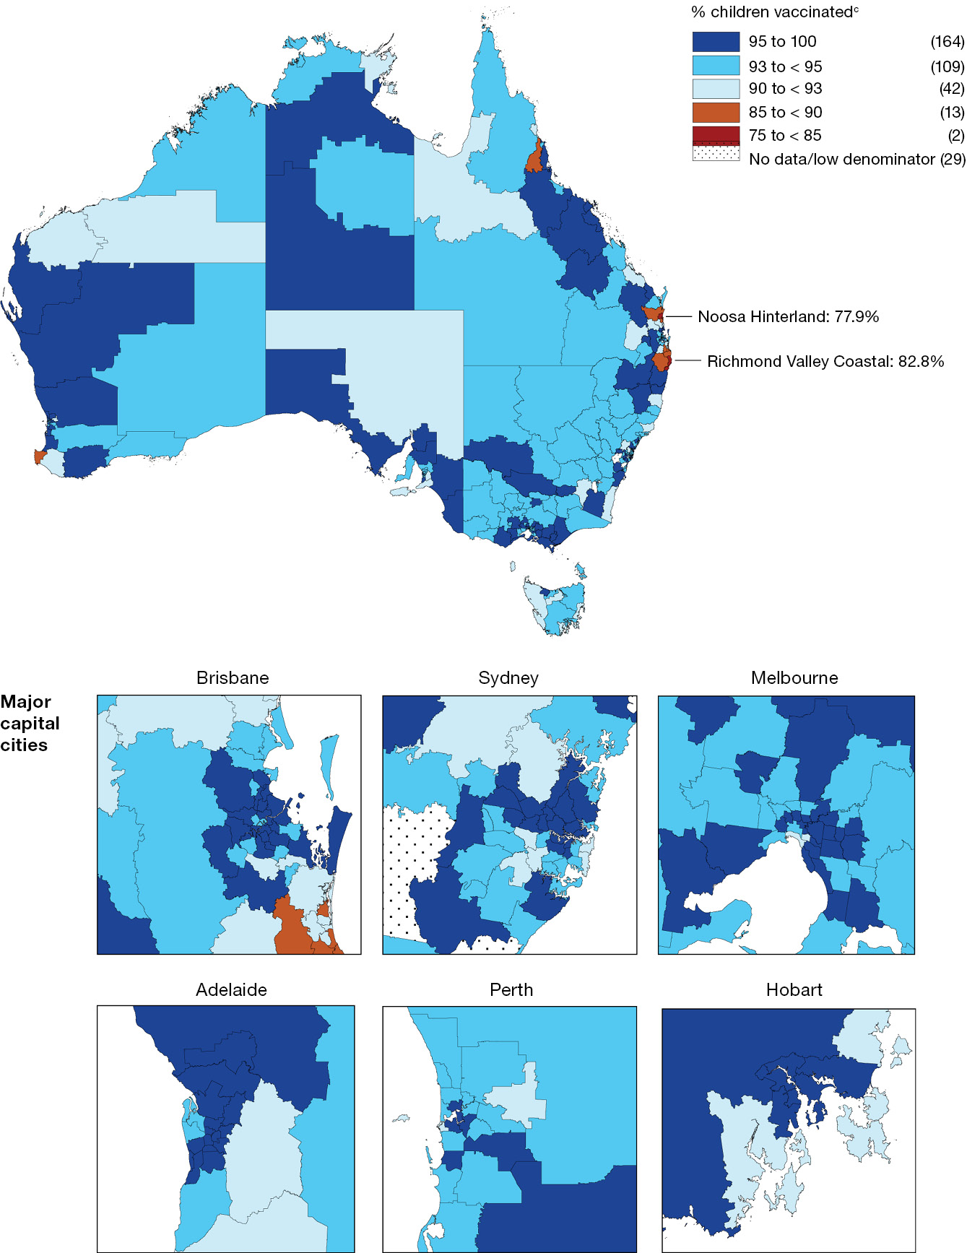
a Source: Australian Immunisation Register data as at 4 February 2024.
b Cohort born 1 January 2021 – 31 December 2021 (i.e. due for their first dose of MMR during 2022).
c Number in parentheses: number of Statistical Area 3s in each on-time category.
Figure 2: Coverage of the second dose of measles-mumps-rubella (MMR)-containing vaccine at 24 months of age by Statistical Area 3, Australia and major capital cities,^{a,b} 2023
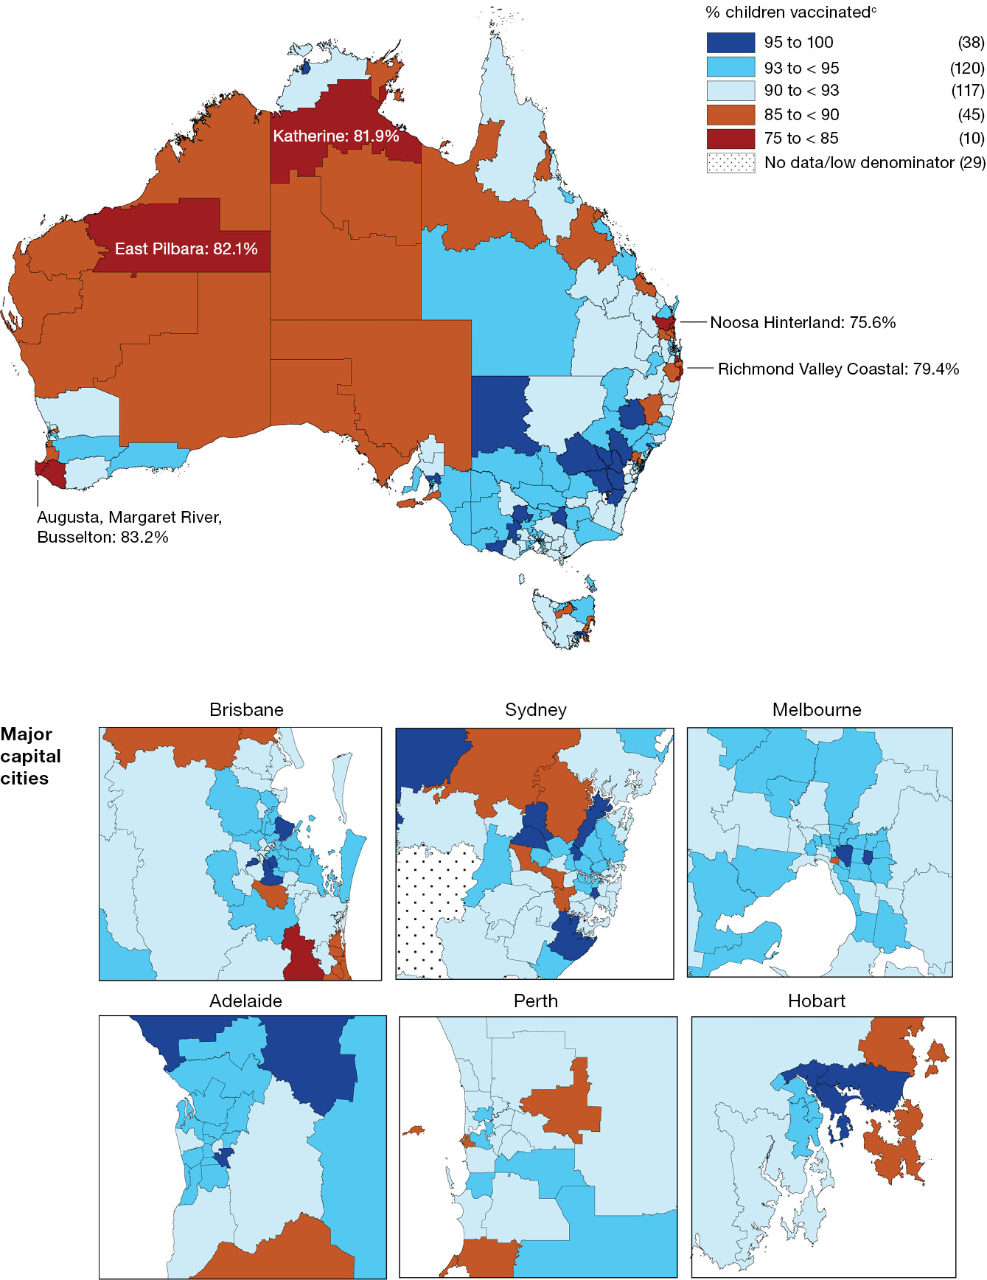
a Source: Australian Immunisation Register data as at 4 February 2024.
b Cohort born 1 January 2021 – 31 December 2021 (i.e. due for their second dose of MMR during 2022 and 2023).
c Number in parentheses: number of Statistical Area 3s in each on-time category.
Figure 3: Coverage of seasonal influenza vaccine in children aged 6–59 months, by jurisdiction, Australia,^{a,b,c} 2022 versus 2023
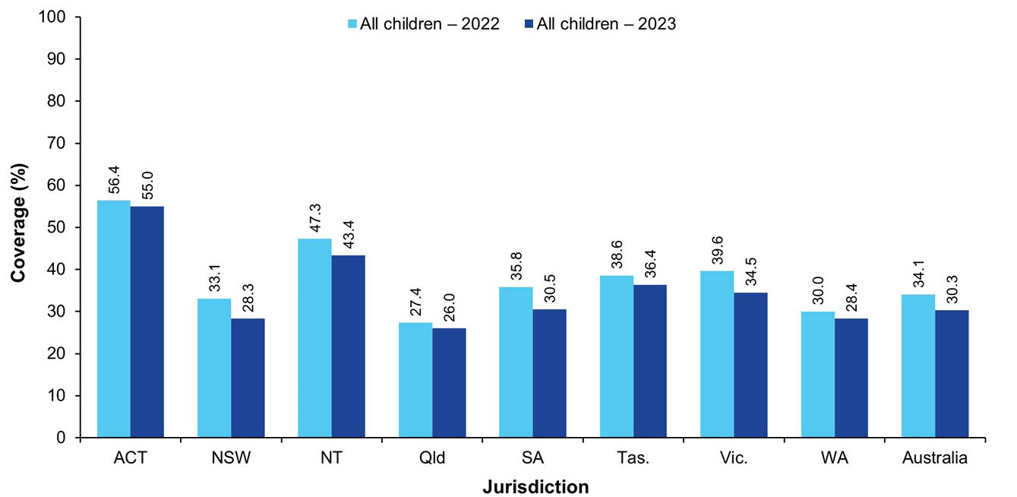
a Source: Australian Immunisation Register data as at 2 April 2023 (for 2022 data) and as at 4 February 2024 (for 2023 data).
b Coverage calculated by dividing the number of Medicare-registered children aged 6–59 months with at least one dose of influenza vaccine administered in the calendar year of interest by the total number of Medicare-registered children in the 6–59 months age group. Vaccination numerators based on age at vaccination and age group denominators based on age at 30 June in relevant year. Coverage data in this table may differ slightly from estimates published elsewhere due to differences in calculation methodologies and/or the AIR data being used in the calculation having been downloaded on different dates.
c ACT: Australian Capital Territory; NSW: New South Wales; NT: Northern Territory; Qld: Queensland; SA: South Australia; Tas.: Tasmania; Vic.: Victoria; WA: Western Australia.
Figure 4: Coverage of seasonal influenza vaccine by age group, Australia,^{a,b} 2022 versus 2023
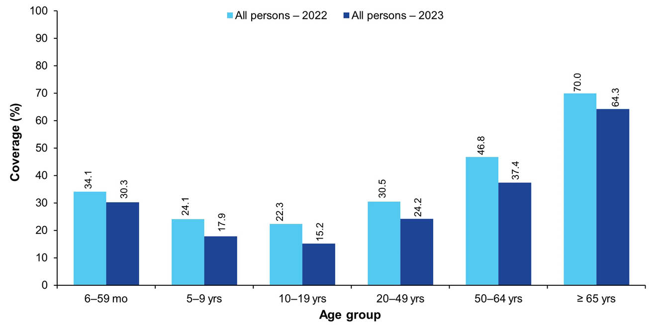
a Source: Australian Immunisation Register data as at 2 April 2023 (for 2022 data) and as at 4 February 2024 (for 2023 data).
b Coverage calculated by dividing the number of Medicare-registered people with at least one dose of influenza vaccine administered in the calendar year of interest by the total number of Medicare-registered people registered in each age group. Vaccination numerators based on age at vaccination and age group denominators based on age at 30 June in relevant year. Coverage data in this table may differ slightly from estimates published elsewhere due to differences in calculation methodologies and/or the AIR data being used in the calculation having been downloaded on different dates.
Figure 5: Coverage of seasonal influenza vaccine, in children aged 6–59 months, by Statistical Area 3, Australia,^{a,b} 2023
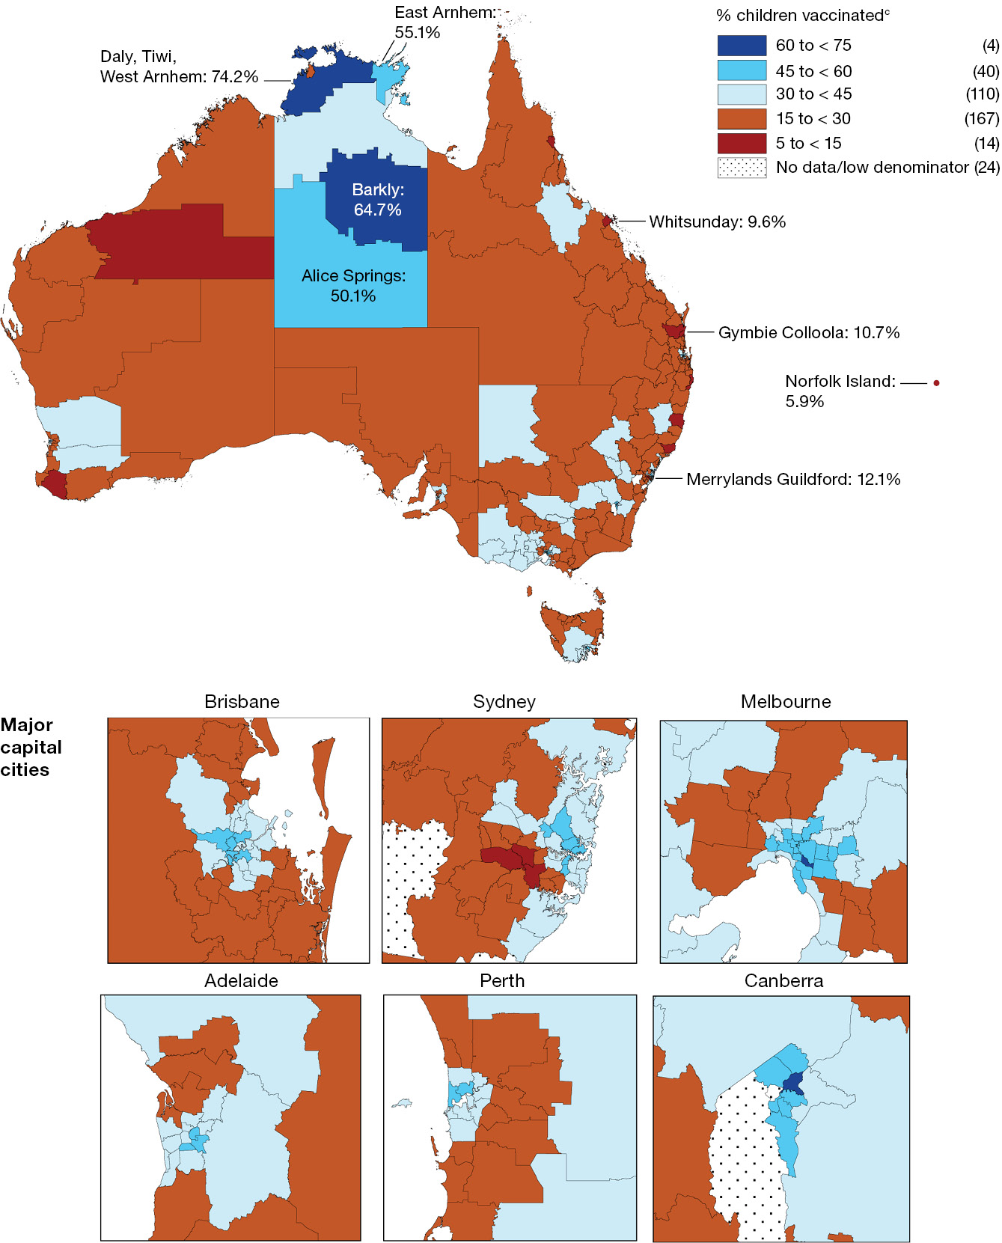
a Source: Australian Immunisation Register data as at 4 February 2024.
b Coverage calculated by dividing the number of Medicare-registered children aged 6–59 months with at least one dose of influenza vaccine administered in the calendar year of interest by the total number of Medicare-registered children in the 6–59 months age group. Vaccination numerators based on age at vaccination and age group denominators based on age at 30 June in relevant year.
c Number in parentheses: number of Statistical Area 3s in each on-time category.

Coverage by Indigenous status

Fully vaccinated at 12, 24 and 60 months of age
Between 2022 and 2023, fully vaccinated coverage for Indigenous children decreased at all three age milestones: 12 months (from 90.0% to 89.7%), 24 months (from 87.9% to 87.8%) and 60 months (95.1% to 95.0%; Table 1.)
The disparity in fully vaccinated coverage between Indigenous children and children overall decreased slightly at 12 months of age, from 3.3 percentage points in 2022 to 3.1 percentage points in 2023, and at 24 months, from 3.1 percentage points in 2022 to 3.0 percentage points in 2023 (Table 1). Fully vaccinated coverage at 60 months of age in 2023 remained higher in Indigenous children than in children overall, by 1.7 percentage points.
Trends in fully vaccinated coverage by Indigenous status by quarter from 2013 to 2022 are shown in Appendix A, Figure A.5, Figure A.6 and Figure A.7.

Coverage by individual vaccines/antigens at 12, 24 and 60 months of age
Coverage at 12 months of age in Indigenous children decreased for all individual vaccines/antigens between 2022 and 2023, by 0.3–1.2 percentage points (Table 1).
Between 2022 and 2023, coverage at 24 months of age in Indigenous children decreased for individual vaccines/antigens, by 0.3–0.7 percentage points, except for coverage of the fourth dose of DTPa, which remained the same, and the second dose of MMR and varicella vaccines, for which coverage increased by 0.5 and 0.6 percentage points, respectively (Table 1). Coverage in Indigenous children in 2023 was 0.2–0.7 of a percentage point higher than in children overall for the first dose of MMR, meningococcal C-containing vaccine and the third dose of 13vPCV, but 0.1–2.8 percentage points lower for the fourth dose of DTPa and Haemophilus influenzae type b (Hib), the third dose of polio, the third dose of hepatitis B, the second dose of MMR and the dose of varicella vaccine (Table 1).
Coverage at 60 months of age in Indigenous children in 2023 remained very high (over 95%) for all vaccines/antigens and was higher than in children overall (Table 1). However, coverage decreased marginally, by 0.1 of a percentage point, for all individual vaccines/antigens from 2022 to 2023, except for the second dose of MMR and the dose of varicella, which remained the same.

Influenza vaccination coverage
Influenza vaccination coverage in Indigenous children decreased from 24.6% in 2022 to 23.1% in 2023 in those aged 6–59 months (Figure 6) and from 18.1% to 14.6% in those aged 5–9 years (Figure 7). Coverage in both of these age groups was lower for Indigenous children than for children overall. Coverage in Indigenous children aged 6–59 months decreased in all jurisdictions except Queensland and Tasmania, with the largest decreases seen in the Northern Territory (from 54.6% in 2022 to 49.9% in 2023). There was substantial variation in coverage for Indigenous children aged 6–59 months by jurisdiction in 2023, ranging from 19.8% in South Australia to 49.9% in the Northern Territory (Figure 6). Coverage for Indigenous children was lower than for children overall in all jurisdictions except the Northern Territory, where it was 6.5 percentage points higher for Indigenous children (Table 1 and Table 4).
Figure 6: Coverage of seasonal influenza vaccine in Indigenous children aged 6–59 months, by jurisdiction, Australia,^{a,b,c} 2022 versus 2023
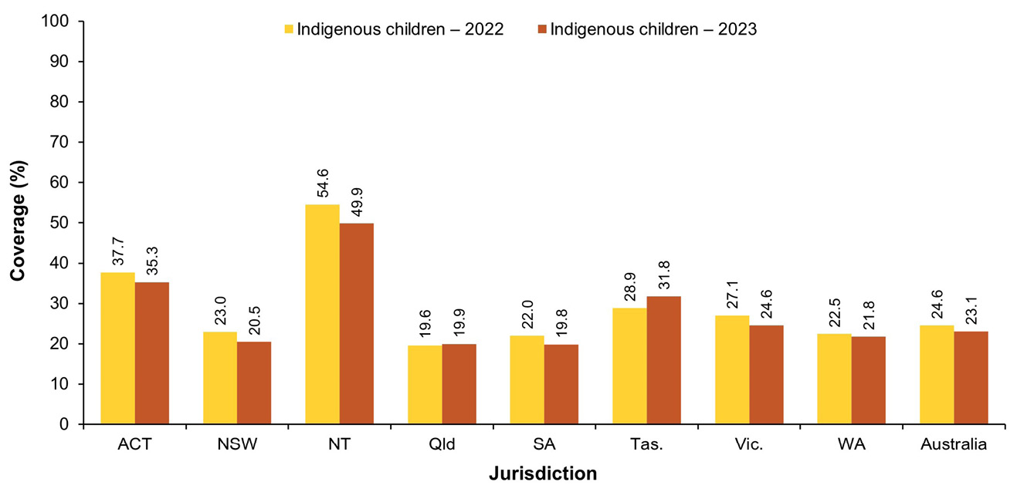
a Source: Australian Immunisation Register data as at 2 April 2023 (for 2022 data) and as at 4 February 2024 (for 2023 data).
b Coverage calculated by dividing the number of Medicare-registered Indigenous children aged 6–59 months with at least one dose of influenza vaccine administered in the calendar year of interest by the total number of Medicare-registered Indigenous children in the 6–59 months age group. Vaccination numerators based on age at vaccination and age group denominators based on age at 30 June in relevant year. Coverage data in this table may differ slightly from estimates published elsewhere due to differences in calculation methodologies and/or the AIR data being used in the calculation having been downloaded on different dates.
c ACT: Australian Capital Territory; NSW: New South Wales; NT: Northern Territory; Qld: Queensland; SA: South Australia; Tas.: Tasmania; Vic.: Victoria; WA: Western Australia.
Figure 7: Coverage of seasonal influenza vaccine in Indigenous people by age group, Australia,^{a,b} 2022 versus 2023
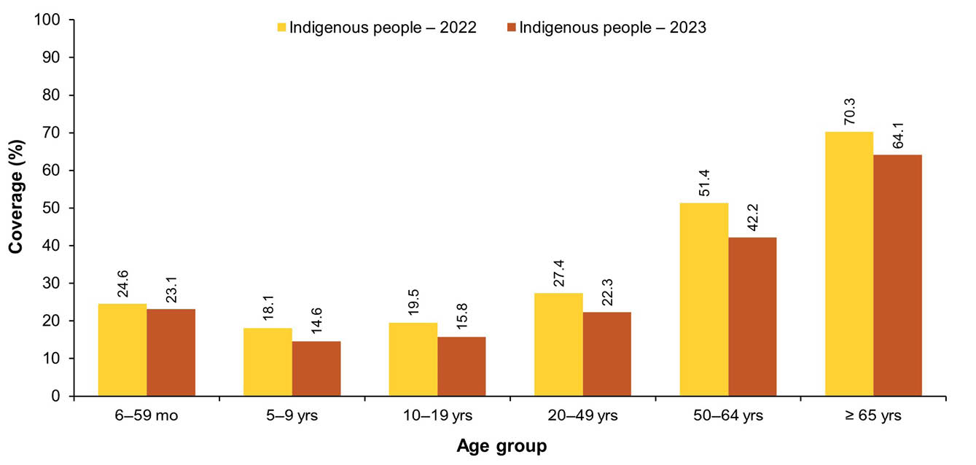
a Source: Australian Immunisation Register data as at 2 April 2023 (for 2022 data) and as at 4 February 2024 (for 2023 data).
b Coverage calculated by dividing the number of Medicare-registered Indigenous people with at least one dose of influenza vaccine administered in the calendar year of interest by the total number of Medicare-registered Indigenous people registered in each age group. Vaccination numerators based on age at vaccination and age group denominators based on age at 30 June in relevant year. Coverage data in this table may differ slightly from estimates published elsewhere due to differences in calculation methodologies and/or the AIR data being used in the calculation having been downloaded on different dates.

Meningococcal B vaccination coverage for Indigenous children
Meningococcal B vaccination coverage in 2023, for the cohort of Indigenous children born in 2021 and eligible to have received doses at 2, 4 and 12 months of age by 24 months of age, is shown in Figure 8. Nationally, 80.8% of this cohort had received their first dose of meningococcal B vaccine, 79.5% their second dose and 71.0% their third dose. Coverage of each dose was highest in South Australia and the Northern Territory and lowest in Victoria and Tasmania (Figure 8). Completion of the meningococcal B vaccination schedule (i.e. receipt of three doses if dose 1 was received before 12 months of age or receipt of two doses if dose 1 was received after 12 months of age) was 67.7% nationally and varied substantially by jurisdiction, ranging from 44.8% in Victoria to 88.0% in South Australia (Figure 8).
Figure 8: Coverage of meningococcal B vaccine for Indigenous children, dose number and course completion, by jurisdiction, Australia,^{a,b,c,d} 2023
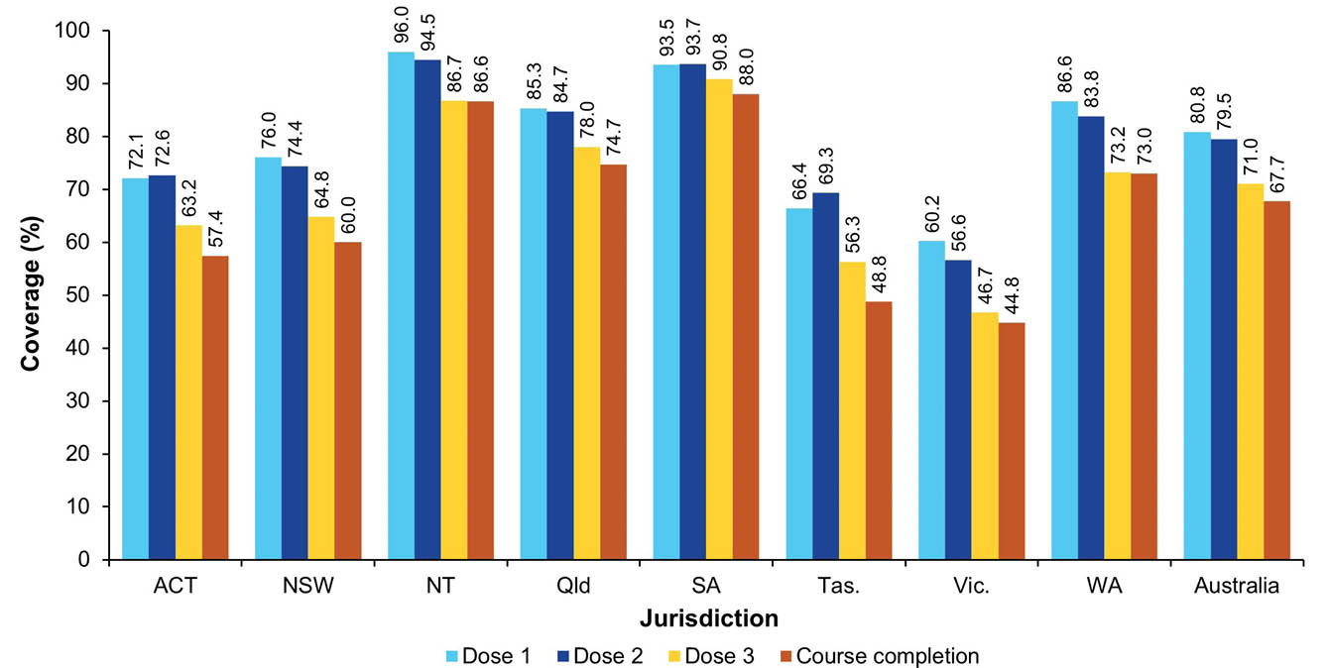
a Source: Australian Immunisation Register data as at 4 February 2024.
b Coverage assessed by 24 months of age for cohort of Indigenous children born 1 January – 31 December 2021. Only two doses of meningococcal B vaccine are required if the first dose is administered after 12 months of age.
c Coverage may be underestimated, particularly for dose 1, due to under-reporting to the AIR of doses given prior to children being registered on Medicare.
d ACT: Australian Capital Territory; NSW: New South Wales; NT: Northern Territory; Qld: Queensland; SA: South Australia; Tas.: Tasmania; Vic.: Victoria; WA: Western Australia.

Hepatitis A vaccination coverage for Indigenous children
Coverage for the first dose of hepatitis A vaccine by 30 months of age for the four jurisdictions (combined) where it is funded under the NIP (Northern Territory, Queensland, South Australia and Western Australia) was 79.2% in December 2023, down one percentage point from December 2022, with coverage for the second dose under the new schedule (due at 4 years of age) not yet able to be assessed. Longer-term trends in hepatitis A vaccination coverage (Appendix A, Figure A.8) show that the highest coverage levels are consistently achieved in the Northern Territory (89.6% for dose 1 in the June 2023 quarter).

Pneumococcal vaccination coverage for Indigenous children
Coverage for the additional fourth dose of 13vPCV by 30 months of age for the four jurisdictions (combined) where it is funded for Indigenous children (Northern Territory, Queensland, South Australia and Western Australia) increased from 79.9% in December 2022 to 80.5% in December 2023. Longer-term trends in 13vPCV fourth-dose coverage (Appendix A, Figure A.9) show that the highest coverage levels are consistently achieved in the Northern Territory (86.9% in the March 2023 quarter).

Timeliness of vaccination
The proportion of non-Indigenous children vaccinated on time (i.e. within 30 days of the recommended age) with the second dose of DTPa-containing vaccine, while exhibiting some fluctuations, decreased from 90.1% in the second quarter of 2020 to 83.5% in the last quarter of 2023 (Figure 9). On-time vaccination coverage for Indigenous children followed a similar pattern but was approximately 10 percentage points lower than for non-Indigenous children, decreasing from 80.3% in the second quarter of 2020 to 74.6% in the last quarter of 2023 (Figure 9). Similarly, the proportion of those vaccinated on time with the first dose of MMR-containing vaccine decreased for non-Indigenous children, from 77.3% in the first quarter of 2020 to 67.2% in the last quarter of 2023, and for Indigenous children, from 69.5% to 56.0% (Figure 10).
Figure 9: Trends in on-time vaccination coverage for the second dose of DTPa-containing vaccine, by Indigenous status and quarter, Australia,^{a,b,c} 2019–2023
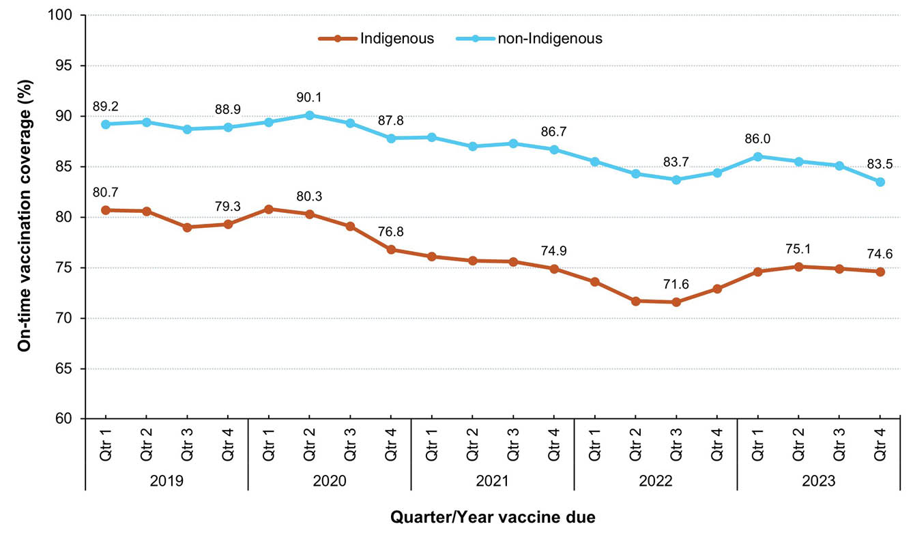
a Source: Australian Immunisation Register data as at 4 February 2024.
b On-time vaccination coverage calculated using 3-month-wide birth cohorts due to have received the second dose of DTPa-containing vaccine in the relevant quarter/year. To be considered on-time, a child must have received the second dose of DTPa-containing vaccine by 5 months of age.
c The quarter in which the vaccine dose is due is used to define the birth cohorts (e.g. if the second dose of DTPa-containing vaccine was due in 2023: children born 1 September – 30 November 2022 were due in Quarter 1; children born 1 December 2022 – 28 February 2023 were due in Quarter 2; children born 1 March – 31 May 2023 were due in Quarter 3; and children born 1 June – 31 August 2023 were due in Quarter 4).
Figure 10: Trends in on-time vaccination coverage for the first dose of MMR-containing vaccine, by Indigenous status and quarter, Australia,^{a,b,c} 2019–2023
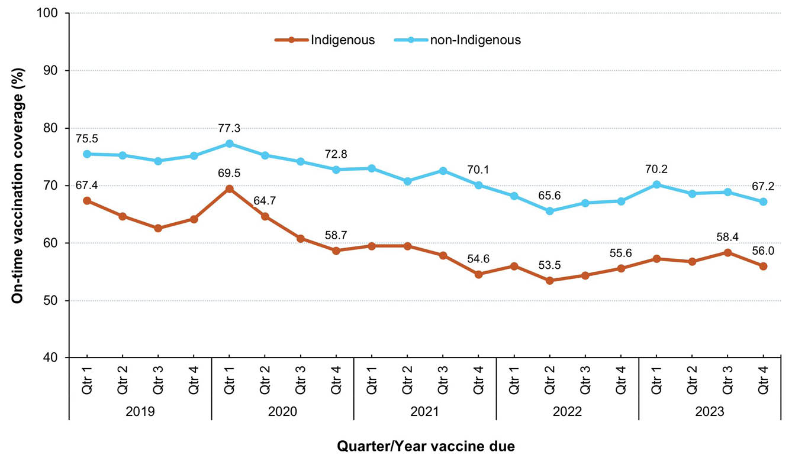
a Source: Australian Immunisation Register data as at 4 February 2024.
b On-time vaccination coverage calculated using 3-month-wide birth cohorts due to have received the first dose of MMR-containing vaccine in the relevant quarter/year. To be considered on-time, a child must have received the first dose of MMR-containing vaccine by 13 months of age.
c The quarter in which the vaccine dose is due is used to define the birth cohorts (e.g. if first dose of MMR-containing vaccine was due in 2023: children born 1 January – 31 March 2022 were due in Quarter 1; children born 1 April – 30 June 2022 were due in Quarter 2; children born 1 July – 30 September 2022 were due in Quarter 3; and children born 1 October – 31 December 2022 were due in Quarter 4).
On-time vaccination coverage for the first dose of MMR-containing vaccine, assessed at 13 months of age in 2023 at SA3 level, varied across Australia (Figure 11). Coverage in many remote areas of Western, Central and Far North Australia was substantially lower than in Southeast Australia, with 49.8% on-time vaccination in East Pilbara, 50.2% in Katherine and 52.0% in Kimberley. Fully vaccinated coverage assessed at the standard (12, 24 and 60 months) and earlier (9, 15, 21 and 51 months) age milestones in 2023, by PHN, are provided in Appendix A, Table A.3.
Figure 11: On-time vaccination coverage of first dose of MMR-containing vaccine assessed at 13 months of age by Statistical Area 3, Australia,^{a,b,c,d} 2023
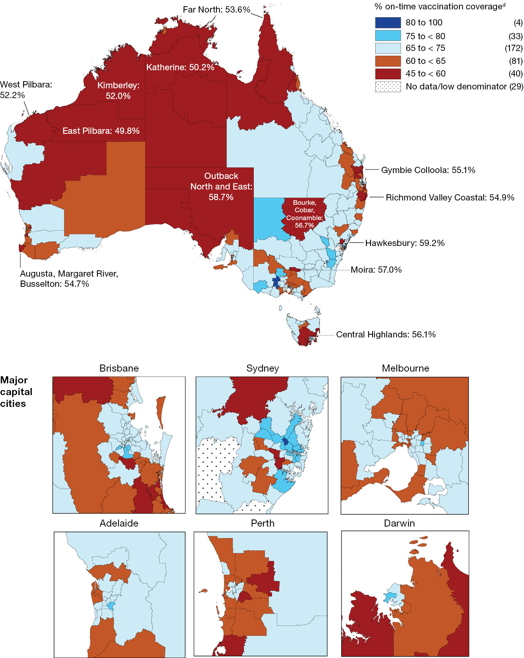
a Source: Australian Immunisation Register data as at 4 February 2024.
b Cohort born 1 January 2021 – 31 December 2021 (i.e. due for their first dose of MMR during 2022).
c On-time vaccination: receipt of a scheduled vaccine dose within 30 days of the recommended age (i.e. by 13 months of age as first dose of MMR vaccine is due at 12 months of age).
d Number in parentheses: number of Statistical Area 3s in each on-time category.

Adolescents

Human papillomavirus (HPV) vaccination coverage: cohorts turning 15 years of age
Among adolescents turning 15 years of age in 2023, 84.2% of girls and 81.8% of boys had received at least one dose of HPV vaccine before their fifteenth birthday, down from 85.3% and 83.1%, respectively, in 2022 (Table 2). Coverage decreased between 2022 and 2023 for girls and boys in all jurisdictions, except in the Australian Capital Territory (for girls and boys) and Tasmania (for boys only). In 2023, coverage for girls and boys ranged from 78.3% and 72.5%, respectively, in the Northern Territory to 90.5% and 87.9%, respectively, in the Australian Capital Territory (Table 2).
Among Indigenous adolescents turning 15 years of age in 2023, 80.9% of girls and 75.0% of boys had received at least one dose of HPV vaccine before their fifteenth birthday, down from 83.0% and 78.1%, respectively, in 2022 (Table 2). Coverage decreased between 2022 and 2023 for Indigenous girls and boys in all jurisdictions except the Australian Capital Territory (girls only) and Tasmania (boys only). In 2023, coverage for Indigenous girls and boys ranged from 66.4% and 59.2%, respectively, in South Australia to 91.7% for girls in the Australian Capital Territory and 82.2% for boys in Tasmania (Table 2).
In girls, coverage of at least one dose of HPV vaccine by the fifteenth birthday in 2023 was 5.3 percentage points higher overall (and 12.1 percentage points higher in Indigenous girls) in those living in the most socioeconomically advantaged (fifth quintile) areas than in those living in the least advantaged (first quintile) areas (overall: 86.6% versus 81.3%; Indigenous: 88.9% versus 76.8%), and these disparities were greater than in 2022 (0.3 of a percentage point more for girls overall and 5.7 percentage points more for Indigenous girls; Table 3).
In boys, coverage of at least one dose of HPV vaccine by the fifteenth birthday in 2023 was 7.7 percentage points higher overall (and 13.6 percentage points higher in Indigenous boys) in those living in the most socioeconomically advantaged areas than in those living the least advantaged areas (overall: 85.2% versus 77.5%; Indigenous 84.5% versus 70.9%), and these disparities were greater than in 2022 (1.1 percentage points more for boys overall and 5.7 percentage points more for Indigenous boys; Table 3).
Coverage of at least one dose of HPV vaccine by the fifteenth birthday in 2023 was lower in adolescents who resided in remote and very remote areas compared to major cities, with the disparity greater for boys than girls (4.8 and 7.9 percentage points more for boys overall and Indigenous boys, respectively, compared to 4.0 and 6.8 points for girls overall and Indigenous girls, respectively) and greater than in 2022 (2.0 percentage points more for boys overall and 4.6 percentage points for Indigenous boys, and 0.8 percentage points more for girls, both overall and Indigenous; Table 4).
Table 2: Coverage of at least one dose of HPV vaccine, received before fifteenth birthday, in adolescents turning 15 years of age in the relevant year, by gender, Indigenous status and jurisdiction, Australia,^{a,b,c} 2022 and 2023
Jurisdiction^{d} | All girls |  | Indigenous girls |  | All boys |  | Indigenous girls
Jurisdiction^{d} | 2022 | 2023 | 2022 | 2023 | 2022 | 2023 | 2022 | 2023
ACT | 89.8 | 90.5 | 88.5 | 91.7 | 87.5 | 87.9 | 82.7 | 75.3
NSW | 86.7 | 86.1 | 88.1 | 86.9 | 84.2 | 82.7 | 81.7 | 80.2
NT | 81.6 | 78.3 | 78.4 | 72.7 | 78.3 | 72.5 | 75.2 | 65.6
Qld | 82.4 | 81.7 | 80.3 | 79.5 | 80.5 | 79.0 | 76.4 | 74.2
SA | 85.1 | 83.1 | 74.6 | 66.4 | 83.3 | 80.5 | 65.6 | 59.2
Tas. | 84.0 | 83.5 | 84.6 | 81.2 | 80.3 | 80.7 | 79.5 | 82.2
Vic. | 86.8 | 85.2 | 82.5 | 80.4 | 84.2 | 83.4 | 78.8 | 75.9
WA | 84.5 | 82.4 | 81.4 | 78.5 | 83.1 | 82.0 | 78.6 | 73.4
Australia | 85.3 | 84.2 | 83.0 | 80.9 | 83.1 | 81.8 | 78.1 | 75.0
a Source: Australian Immunisation Register data as at 2 April 2023 (for 2022 data) and as at 4 February 2024 (for 2023 data).
b Coverage calculated using the number of Medicare-registered adolescents in each year-wide birth cohort with an AIR record of having received at least one dose of HPV vaccine after their ninth birthday (since HPV is registered to be given from 9 years of age) but before their fifteenth birthday as the numerator and the total number of Medicare-registered adolescents in the relevant birth cohort as the denominator, expressed as a percentage.
c Cohort born 1 January – 31 December 2007 for 2022 coverage estimates (i.e. vaccines due from early 2019 to late 2020) and cohort born 1 January – 31 December 2008 for 2023 coverage estimates (i.e. vaccines due from early 2020 to late 2021).
d ACT: Australian Capital Territory; NSW: New South Wales; NT: Northern Territory; Qld: Queensland; SA: South Australia; Tas.: Tasmania; Vic.: Victoria; WA: Western Australia.
Table 3: Coverage of at least one dose of HPV vaccine, received before fifteenth birthday, in adolescents turning 15 years of age in the relevant year, by gender, Indigenous status and socioeconomic status, Australia,^{a,b,c,d} 2022 and 2023
SEIFA quintile^{d} | All girls |  | Indigenous girls |  | All boys |  | Indigenous girls
SEIFA quintile^{d} | 2022 | 2023 | 2022 | 2023 | 2022 | 2023 | 2022 | 2023
First (least advantaged) | 82.7 | 81.3 | 79.0 | 76.8 | 79.4 | 77.5 | 74.9 | 70.9
Second | 85.0 | 84.0 | 84.6 | 82.1 | 82.6 | 80.9 | 78.7 | 74.6
Third | 85.2 | 83.9 | 83.6 | 81.9 | 82.9 | 81.3 | 79.9 | 77.0
Fourth | 85.4 | 84.5 | 85.5 | 84.1 | 83.7 | 82.7 | 81.3 | 80.0
Fifth (most advantaged) | 87.7 | 86.6 | 89.3 | 88.9 | 86.0 | 85.2 | 82.8 | 84.5
a Source: Australian Immunisation Register data as at 2 April 2023 (for 2022 data) and as at 4 February 2024 (for 2023 data).
b Coverage calculated using the number of Medicare-registered adolescents in each year-wide birth cohort with an AIR record of having received at least one dose of HPV vaccine after their ninth birthday (since HPV is registered to be given from 9 years of age) but before their fifteenth birthday as the numerator and the total number of Medicare-registered adolescents in the relevant birth cohort as the denominator, expressed as a percentage.
c Cohort born 1 January – 31 December 2007 for 2022 coverage estimates (i.e. vaccines due from early 2019 to late 2020) and cohort born 1 January – 31 December 2008 for 2023 coverage estimates (i.e. vaccines due from early 2020 to late 2021).
d Socio-Economic Indexes for Areas Index of Economic Resources.
Table 4: Coverage of at least one dose of HPV vaccine, received before fifteenth birthday, in adolescents turning 15 years of age in relevant year, by gender, Indigenous status and remoteness of area of residence, Australia,^{a,b,c,d} 2022 and 2023
Remoteness category^{d} | All girls |  | Indigenous girls |  | All boys |  | Indigenous girls
Remoteness category^{d} | 2022 | 2023 | 2022 | 2023 | 2022 | 2023 | 2022 | 2023
Major cities | 85.4 | 84.3 | 84.9 | 82.7 | 83.1 | 82.0 | 80.1 | 77.5
Inner and outer regional | 85.4 | 84.4 | 82.8 | 81.0 | 83.4 | 81.4 | 76.9 | 74.8
Remote and very remote | 82.2 | 80.3 | 78.7 | 75.9 | 80.3 | 77.2 | 76.8 | 69.6
a Source: Australian Immunisation Register data as at 2 April 2023 (for 2022 data) and as at 4 February 2024 (for 2023 data).
b Coverage calculated using the number of Medicare-registered adolescents in each year-wide birth cohort with an AIR record of having received at least one dose of HPV vaccine after their ninth birthday (since HPV is registered to be given from 9 years of age) but before their fifteenth birthday as the numerator and the total number of Medicare-registered adolescents in the relevant birth cohort as the denominator, expressed as a percentage.
c Cohort born 1 January – 31 December 2007 for 2022 coverage estimates (i.e. vaccines due from early 2019 to late 2020) and cohort born 1 January – 31 December 2008 for 2023 coverage estimates (i.e. vaccines due from early 2020 to late 2021).
d Accessibility/Remoteness Index of Australia (ARIA++).

HPV vaccination coverage: cohorts turning 13–25 years of age
Assessing a broader range of year-wide birth cohorts and including vaccine doses received by the end of 2023 (i.e. rather than before the relevant birthday), 74.2% of girls turning 13 years of age in 2023 had received at least one dose of HPV vaccine by 31 December 2023. Coverage increased with age: 80.0% of those turning 14 years and 84.7% of those turning 15 years of age had received at least one dose, with marginal increases seen in each successive age group up to those turning 18 years of age (Figure 12). Coverage then decreased with increasing age, down to 74.5% for those turning 25 years of age. Coverage in Indigenous females was 14 percentage points lower than overall coverage in those turning 13 years of age in 2023, but this disparity decreased with increasing age, with coverage higher in Indigenous females than overall in all cohorts turning 17–25 years of age (Figure 12). Coverage of at least one dose of HPV vaccine by birth cohort/age turning in 2023, Indigenous status and jurisdiction is provided in Appendix A, Table A.5. National coverage for girls turning 13 years of age, recalculated with South Australia excluded (as HPV vaccination in its school-based program moved from Year 8 in 2022 to Year 7 in 2023) decreased from 77.4% in 2022 to 74.3% in 2023 overall and from 66.7% to 60.8% for Indigenous girls (data not shown).
Figure 12: Coverage of at least one dose of HPV vaccine for females by birth cohort/age and Indigenous status, Australia,^{a,b} 2023
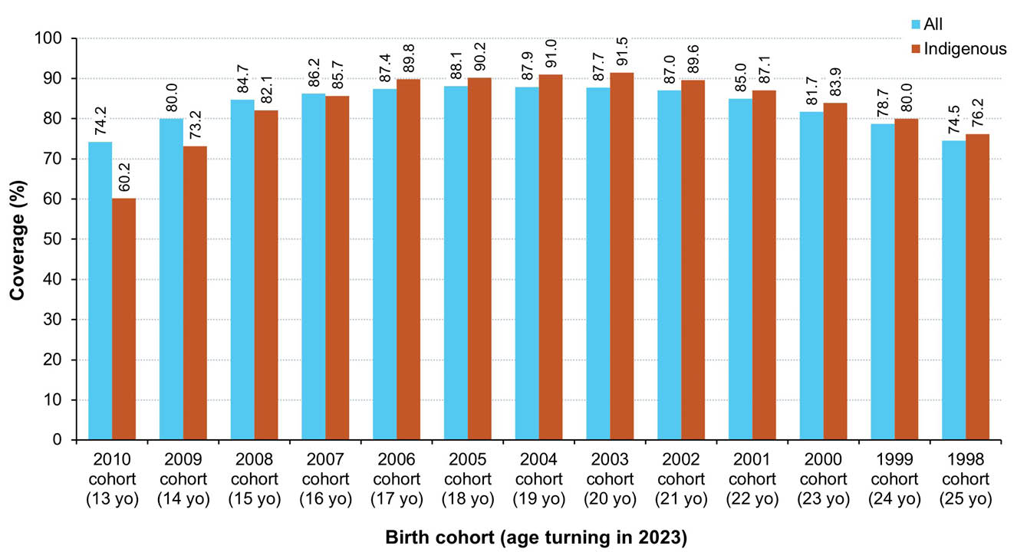
a Source: Australian Immunisation Register data as at 4 February 2024.
b Coverage calculated using the number of Medicare-registered individuals in each year-wide cohort with an AIR record of having received at least one dose of HPV vaccine after their ninth birthday (since HPV is registered to be given from 9 years of age) and given by 31 December 2023 as the numerator and the total number of Medicare-registered individuals in the relevant cohort as the denominator, expressed as a percentage.
Figure 13 shows a similar pattern for males, with 70.1% of adolescent boys turning 13 years of age in 2023 having received at least one dose of HPV vaccine by 31 December 2023. Coverage increased with age: 76.5% of those turning 14 years and 82.3% of those turning 15 years of age had received at least one dose, with marginal increases in each successive age group up to those turning 18 years of age (Figure 13). Coverage then decreased with increasing age, down to 57.8% for those turning 25 years of age, noting that HPV vaccination was only funded for males from 2013 (i.e. from the 1998 cohort onwards). Coverage in Indigenous males was 15.8 percentage points lower than overall coverage in those turning 13 years of age in 2023, but the disparity decreased with increasing age in cohorts turning up to 18 years of age, with coverage higher in Indigenous males than overall in those turning 19–21 years but lower in those turning 22–25 years (Figure 13). Coverage of at least one dose of HPV vaccine in males by birth cohort/age turning in 2023, Indigenous status and jurisdiction is provided in Appendix A, Table A.6. National coverage for boys turning 13 years of age, recalculated with South Australia excluded (as HPV vaccination in its school-based program moved from Year 8 in 2022 to Year 7 in 2023) decreased from 73.1% in 2022 to 70.1% in 2023 overall and from 58.3% to 54.9% for Indigenous boys (data not shown).
Figure 13: Coverage of at least one dose of HPV vaccine for males by birth cohort/age and Indigenous status, Australia,^{a,b} 2023
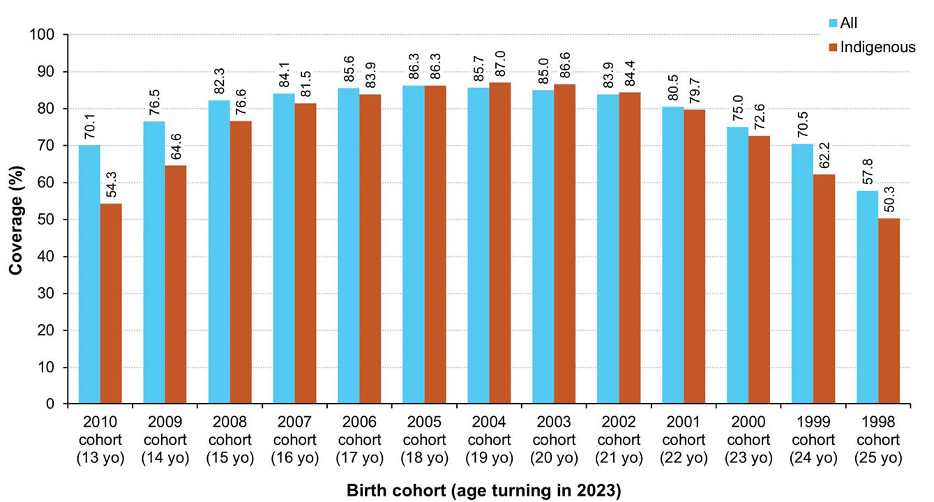
a Source: Australian Immunisation Register data as at 4 February 2024.
b Coverage calculated using the number of Medicare-registered individuals in each year-wide cohort with an AIR record of having received at least one dose of HPV vaccine after their ninth birthday (since HPV is registered to be given from 9 years of age) and given by 31 December 2023 as the numerator and the total number of Medicare-registered individuals in the relevant cohort as the denominator, expressed as a percentage.

Diphtheria-tetanus-pertussis vaccination coverage: cohorts turning 13–19 years of age
Assessing a broad range of year-wide birth cohorts, 73.9% of adolescents turning 13 years of age in 2023 had received an adolescent dose of diphtheria-tetanus-pertussis vaccine by 31 December 2023. Coverage increased with age: 79.8% of those turning 14 years and 85.5% of those turning 15 years of age had received a dose, with marginal increases seen in each successive age group up to those turning 18 years of age (Figure 14). Coverage in Indigenous adolescents was 15.6 percentage points lower than overall coverage in those turning 13 years of age in 2023, but the disparity decreased with increasing age, with coverage 0.1 of a percentage point higher than overall in Indigenous adolescents turning 19 years of age (Figure 14). Coverage of an adolescent dose of diphtheria-tetanus-pertussis vaccine in adolescents by birth cohort/age turning in 2023, Indigenous status and jurisdiction is provided in Appendix A, Table A.7. National coverage for adolescents turning 13 years of age, recalculated with South Australia excluded (as dTpa vaccination in their school-based program moved from Year 8 in 2022 to Year 7 in 2023) decreased from 76.2% in 2022 to 73.9% in 2023 overall and from 62.9% to 58.8% for Indigenous adolescents (data not shown).
Figure 14: Coverage of an adolescent dose of diphtheria-tetanus-pertussis vaccine by birth cohort/age and Indigenous status, Australia,^{a,b,c} 2023
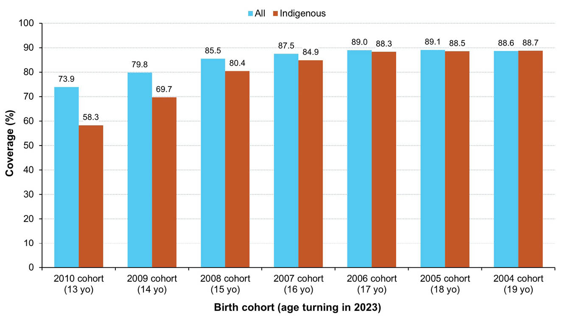
a Source: Australian Immunisation Register data as at 4 February 2024.
b dTpa: diphtheria–tetanus–pertussis – formulation for individuals aged ≥ 10 years; DTPa = diphtheria–tetanus–pertussis – paediatric formulation.
c Coverage calculated using the number of Medicare-registered adolescents in each year-wide cohort with an AIR record of having received an adolescent (i.e. ≥ 10 years of age) dose of a diphtheria-tetanus-pertussis vaccine (recorded as either dTpa or DTPa) by 31 December 2023 as the numerator and the total number of Medicare-registered adolescents in the relevant cohort as the denominator, expressed as a percentage.

Meningococcal ACWY vaccination coverage: cohorts turning 15–19 years of age
Figure 15 shows 66.7% of adolescents turning 16 years of age in 2023 had received an adolescent dose of meningococcal ACWY vaccine by 31 December 2023. Coverage increased with age: 72.8% of those turning 17 years, 77.6% of those turning 18 years and 79.5% of those turning 19 years of age had received a dose. Coverage in Indigenous adolescents was 12.7 percentage points lower than overall coverage in those turning 16 years of age in 2023, but the disparity decreased with increasing age and had almost halved to a 7.0 percentage point difference in those turning 19 years of age in 2023 (Figure 15). Coverage of an adolescent dose of meningococcal ACWY vaccine varied by jurisdiction, and coverage in adolescents by birth cohort/age turning in 2023, Indigenous status and jurisdiction is provided in Appendix A, Table A.8.
Figure 15: Coverage of an adolescent dose of meningococcal ACWY vaccine by birth cohort/age and Indigenous status, Australia,^{a,b} 2023
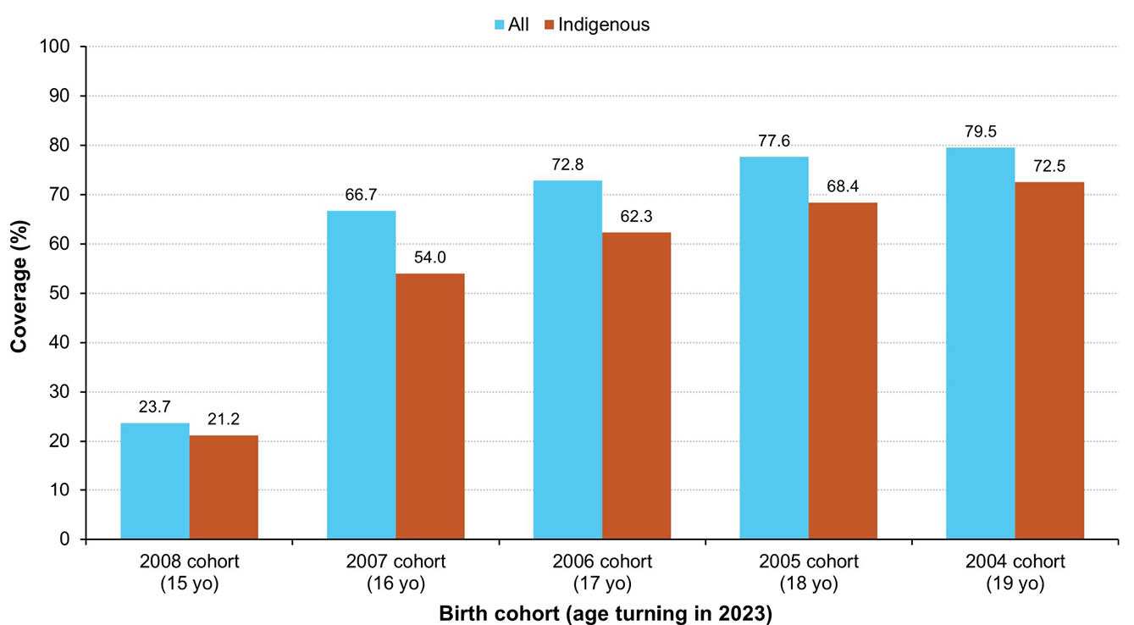
a Source: Australian Immunisation Register data as at 4 February 2024.
b Coverage calculated using the number of Medicare-registered adolescents in each year-wide cohort with an AIR record of having received an adolescent (i.e. ≥ 10 years of age) dose of a meningococcal ACWY vaccine given by 31 December 2023 as the numerator and the total number of Medicare-registered adolescents in the relevant cohort as the denominator, expressed as a percentage.

Adolescent composite measures of vaccination coverage

HPV + diphtheria-tetanus-pertussis
Using a composite measure—receipt of both an HPV vaccine dose and an adolescent dose of diphtheria-tetanus-pertussis vaccine by 31 December 2023—coverage was 82.6% for adolescents turning 15 years of age in 2023, down from 83.7% in 2022 and 84.5% in 2021 (Figure 16). Coverage in 2023 varied by jurisdiction, ranging from 74.6% in the Northern Territory to 85.1% in the Australian Capital Territory (Figure 16). Coverage using this composite measure was 4.7 percentage points lower than overall in Indigenous adolescents turning 15 years of age in 2023, at 77.9%, down from 80.1% in 2022 and 82.3% in 2021, and ranged from 63.0% in South Australia to 83.5% in New South Wales (Figure 17).
Figure 16: Vaccination coverage using composite measure (dose of HPV and adolescent dose of diphtheria-tetanus-pertussis vaccine) in adolescents turning 15 years, by jurisdiction, Australia,^{a,b,c,d} 2021–2023
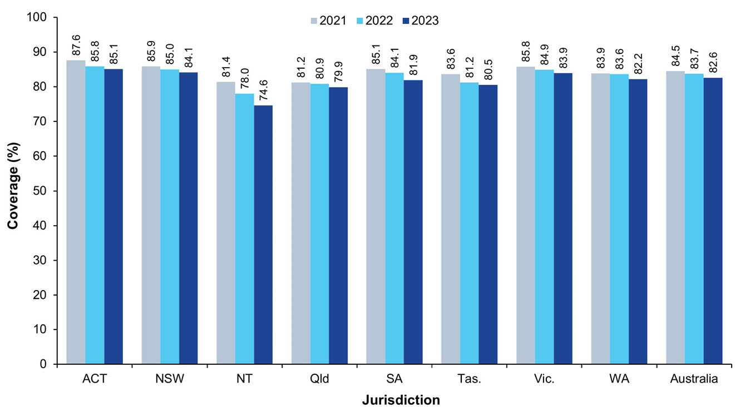
a Source: Australian Immunisation Register data as at 3 April 2022 for 2021; as at 2 April 2023 for 2022; and as at 2 February 2024 for 2023..
b Coverage calculated using the number of Medicare-registered adolescents in each year-wide cohort with an AIR record of having received at least one dose of HPV vaccine ≥ 9 years of age and an adolescent (i.e. ≥ 10 years of age) dose of diphtheria-tetanus-pertussis vaccine (recorded as either dTpa or DTPa) by 31 December of the relevant year as the numerator and the total number of Medicare-registered adolescents in the relevant cohort as the denominator, expressed as a percentage.
c Cohorts: 1 January – 31 December 2006 for 2021; 1 January – 31 December 2007 for 2022; 1 January – 31 December 2008 for 2023.
d ACT: Australian Capital Territory; NSW: New South Wales; NT: Northern Territory; Qld: Queensland; SA: South Australia; Tas.: Tasmania; Vic.: Victoria; WA: Western Australia.
Figure 17: Vaccination coverage using composite measure (dose of HPV and adolescent dose of diphtheria-tetanus-pertussis vaccine) in Indigenous adolescents turning 15 years, by jurisdiction, Australia,^{a,b,c,d} 2021–2023
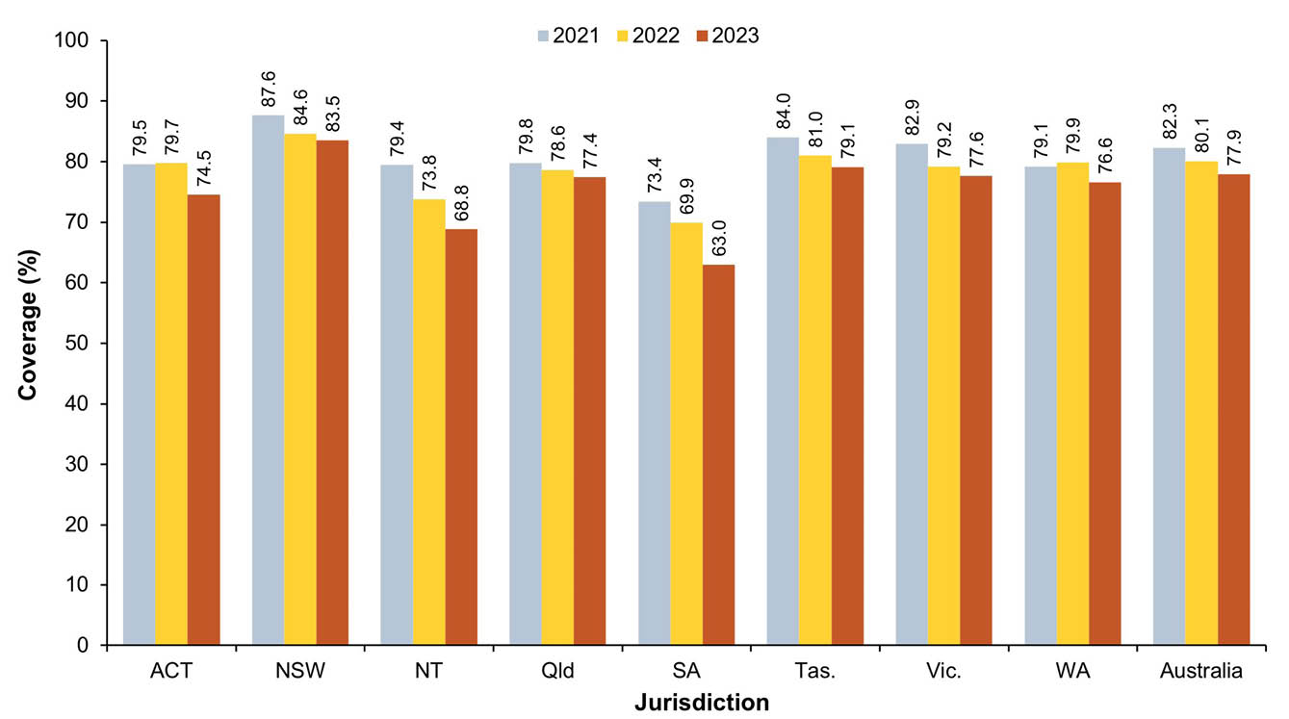
a Source: Australian Immunisation Register data as at 3 April 2022 for 2021; as at 2 April 2023 for 2022; and as at 2 February 2024 for 2023.
b Coverage calculated using the number of Medicare-registered Indigenous adolescents in each year-wide cohort with an AIR record of having received at least one dose of HPV vaccine ≥ 9 years of age and an adolescent (i.e. ≥ 10 years of age) dose of diphtheria-tetanus-pertussis vaccine (recorded as either dTpa or DTPa) by 31 December of the relevant year as the numerator and the total number of Medicare-registered Indigenous adolescents in the relevant cohort as the denominator, expressed as a percentage.
c Cohorts: 1 January – 31 December 2006 for 2021; 1 January – 31 December 2007 for 2022; 1 January – 31 December 2008 for 2023.
d ACT: Australian Capital Territory; NSW: New South Wales; NT: Northern Territory; Qld: Queensland; SA: South Australia; Tas.: Tasmania; Vic.: Victoria; WA: Western Australia.

HPV + diphtheria-tetanus-pertussis + meningococcal ACWY vaccine
Using another composite measure—receipt of an HPV vaccine dose and adolescent doses of both diphtheria-tetanus-pertussis and meningococcal ACWY vaccine by 31 December 2023—coverage was 73.0% for adolescents turning 18 years of age in 2023, down from 73.4% in 2022 and 71.7%% in 2021 (Figure 18). Coverage in 2023 varied by jurisdiction and ranged from 69.7% in Queensland to 79.9% in the Australian Capital Territory (Figure 18). Coverage using this composite measure was 9.4 percentage points lower than overall in Indigenous adolescents turning 18 years of age in 2023, at 63.6%, down from 65.4% in 2022 and 65% in 2021, and ranged from 57.4% in South Australia to 81.1% in the Northern Territory (Figure 19).
Figure 18: Vaccination coverage using composite measure (dose of HPV and adolescent doses of diphtheria-tetanus-pertussis and meningococcal ACWY vaccine) in adolescents turning 18 years, by jurisdiction, Australia,^{a,b,c,d} 2021–2023
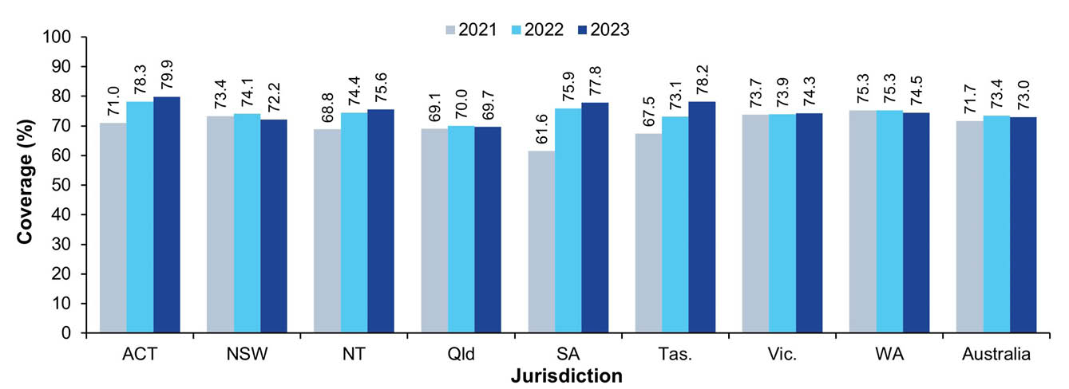
a Source: Australian Immunisation Register data as at 3 April 2022 for 2021; as at 2 April 2023 for 2022; and as at 4 February 2024 for 2023.
b Coverage calculated using the number of Medicare-registered adolescents in each year-wide cohort with an AIR record of having received at least one dose of HPV vaccine ≥ 9 years of age and an adolescent (i.e. ≥ 10 years of age) dose of both diphtheria-tetanus-pertussis vaccine (recorded as either dTpa or DTPa) and meningococcal ACWY vaccine by 31 December of the relevant year as the numerator and the total number of Medicare-registered adolescents in the relevant cohort as the denominator, expressed as a percentage.
c Cohorts: 1 January – 31 December 2003 for 2021; 1 January – 31 December 2004 for 2022; 1 January – 31 December 2005 for 2023.
d ACT: Australian Capital Territory; NSW: New South Wales; NT: Northern Territory; Qld: Queensland; SA: South Australia; Tas.: Tasmania; Vic.: Victoria; WA: Western Australia.
Figure 19: Vaccination coverage using composite measure (dose of HPV and adolescent doses of diphtheria-tetanus-pertussis and meningococcal ACWY vaccine) in Indigenous adolescents turning 18 years, by jurisdiction, Australia,^{a,b,c,d} 2021–2023
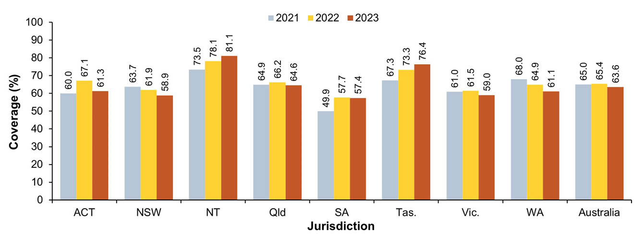
a Source: Australian Immunisation Register data as at 3 April 2022 for 2021; as at 2 April 2023 for 2022; and as at 4 February 2024 for 2023.
b Coverage calculated using the number of Medicare-registered Indigenous adolescents in each year-wide cohort with an AIR record of having received at least one dose of HPV vaccine ≥ 9 years of age and an adolescent (i.e. ≥ 10 years of age) dose of both diphtheria-tetanus-pertussis vaccine (recorded as either dTpa or DTPa) and meningococcal ACWY vaccine by 31 December of the relevant year as the numerator and the total number of Medicare-registered Indigenous adolescents in the relevant cohort as the denominator, expressed as a percentage.
c Cohorts: 1 January – 31 December 2003 for 2021; 1 January – 31 December 2004 for 2022; 1 January – 31 December 2005 for 2023.
d ACT: Australian Capital Territory; NSW: New South Wales; NT: Northern Territory; Qld: Queensland; SA: South Australia; Tas.: Tasmania; Vic.: Victoria; WA: Western Australia.

Influenza vaccination coverage
Influenza vaccination coverage in adolescents aged 10–19 years decreased by 7.1 percentage points between 2022 and 2023, to 15.2% (Figure 2), with decreases seen in all jurisdictions (Appendix A, Table A.9.1 and Table A.9.2).
Influenza vaccination coverage in Indigenous adolescents aged 10–19 years in 2023 was 0.6 of a percentage point higher than overall, at 15.8%, but 3.7 percentage points lower than in 2022 (Figure 5), with decreases seen in all jurisdictions (Appendix A, Table A.9.1 and Table A.9.2).

Adults

Zoster vaccination coverage
Zoster vaccination coverage (i.e. receipt of one dose of Zostavax or two doses of Shingrix, given at least four weeks apart) for Australian adults turning 71 years of age was 41.0% in 2023, down from 41.3% in 2022, with coverage in 2023 ranging from 21.5% in the Northern Territory to 48.4% in South Australia (Figure 20). Coverage in Indigenous adults turning 71 years of age was 36.1% in 2023, down from 36.5% in 2022 (Figure 21), with coverage in 2023 ranging from 22.0% in the Northern Territory to 52.7% in Tasmania.
Assessing a broad range of age cohorts, zoster vaccination coverage increased with age, reaching 57.6% in those turning 76 years of age in 2023. The majority of adults turning 70–75 years of age in 2023, who were considered covered for zoster vaccine by 31 December 2023, were vaccinated at the 70-year schedule point, although a substantial proportion were vaccinated through the catch-up program offered to adults aged 71–79 years; adults turning 77–79 years were predominantly vaccinated through the catch-up program (Figure 22). In the entire cohort of adults turning 70 years and older in 2023, overall zoster vaccination coverage was 42.3%. Coverage patterns for Indigenous adults were similar (Figure 23), with coverage for the entire cohort of Indigenous adults turning 70 years and older in 2023 higher than overall coverage at 43.6%.
Figure 20: Zoster vaccination coverage for adults turning 71 years of age in the year of interest, by jurisdiction, Australia,^{a,b,c,d,e} 2019–2023
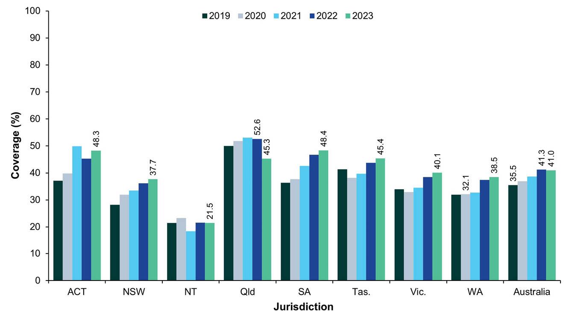
a Source: Australian Immunisation Register data as at 3 April 2022 (for 2019–2021 coverage); as at 2 April 2023 (for 2022 coverage); and as at 4 February 2024 (for 2023 coverage).
b Coverage calculated using the number of Medicare-registered adults in each year-wide cohort with an AIR record of having received one dose of Zostavax or two doses of Shingrix (given at least four weeks apart) by 31 December of the relevant year as the numerator and the total number of Medicare-registered adults in the relevant cohort as the denominator, expressed as a percentage.
c The 2020 and 2021 data points differ to what was presented in the 2021 report due to vaccinations given after 71 years of age now being included in the coverage calculations.
d Cohorts born: 1 January – 31 December 1948 for 2019 coverage; 1 January – 31 December 1949 for 2020 coverage; 1 January – 31 December 1950 for 2021 coverage; 1 January – 31 December 1951 for 2022 coverage; and 1 January – 31 December 1952 for 2023 coverage.
e ACT: Australian Capital Territory; NSW: New South Wales; NT: Northern Territory; Qld: Queensland; SA: South Australia; Tas.: Tasmania; Vic.: Victoria; WA: Western Australia.
Figure 21: Zoster vaccination coverage for Indigenous adults turning 71 years of age in the year of interest, by jurisdiction, Australia,^{a,b,c,d,e} 2019–2023
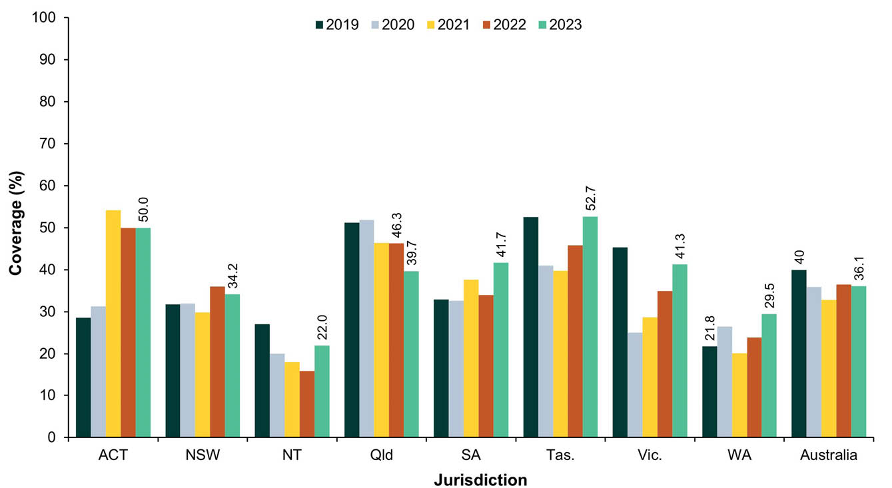
a Source: Australian Immunisation Register data as at 3 April 2022 (for 2019–2021 coverage); as at 2 April 2023 (for 2022 coverage); and as at 4 February 2024 (for 2023 coverage).
b Coverage calculated using the number of Medicare-registered Indigenous adults in each year-wide cohort with an AIR record of having received one dose of Zostavax or two doses of Shingrix (given at least four weeks apart) by 31 December of the relevant year as the numerator and the total number of Medicare-registered Indigenous adults in the relevant cohort as the denominator, expressed as a percentage.
c The 2020 and 2021 data points differ to what was presented in the 2021 report due to vaccinations given after 71 years of age now being included in the coverage calculations.
d Cohorts born: 1 January – 31 December 1948 for 2019 coverage; 1 January – 31 December 1949 for 2020 coverage; 1 January – 31 December 1950 for 2021 coverage; 1 January – 31 December 1951 for 2022 coverage; and 1 January – 31 December 1952 for 2023 coverage.
e ACT: Australian Capital Territory; NSW: New South Wales; NT: Northern Territory; Qld: Queensland; SA: South Australia; Tas.: Tasmania; Vic.: Victoria; WA: Western Australia.
Figure 22: Zoster vaccination coverage in adults by birth cohort and age at vaccination, Australia,^{a,b} 2023
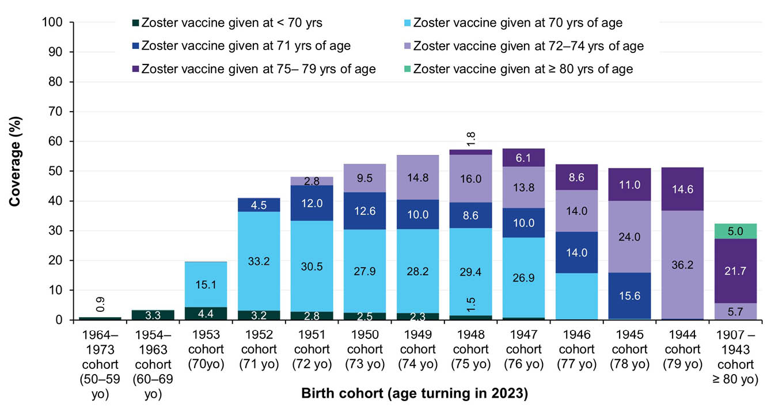
a Source: Australian Immunisation Register data as at 4 February 2024.
b Coverage calculated using the number of Medicare-registered adults in each cohort with an AIR record of having received either one dose of Zostavax or two doses of Shingrix (given at least four weeks apart) as the numerator and the total number of Medicare-registered adults in the relevant cohort as the denominator, expressed as a percentage. Vaccinations given up to 31 December 2023 are included in the numerator.
Figure 23: Zoster vaccination coverage in Indigenous adults by birth cohort and age at vaccination, Australia,^{a,b} 2023
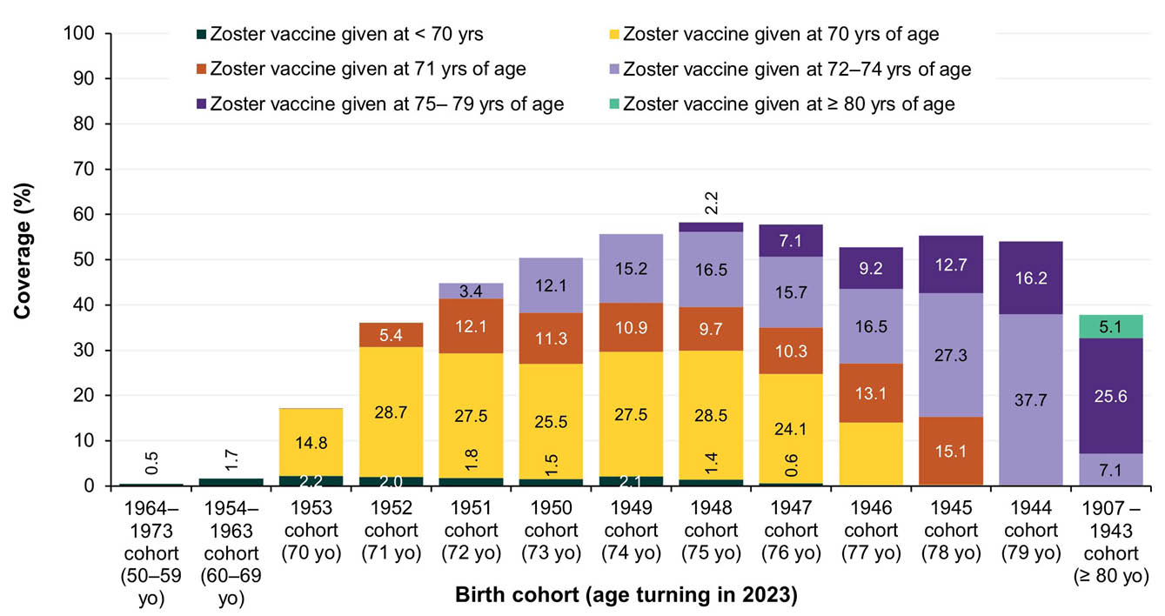
a Source: Australian Immunisation Register data as at 4 February 2024.
b Coverage calculated using the number of Medicare-registered Indigenous adults in each cohort with an AIR record of having received either one dose of Zostavax or two doses of Shingrix (given at least four weeks apart) as the numerator and the total number of Medicare-registered Indigenous adults in the relevant cohort as the denominator, expressed as a percentage. Vaccinations given up to 31 December 2023 are included in the numerator.

Pneumococcal vaccination coverage
Coverage of an adult dose of 13vPCV in the cohort of Australian adults turning 71 years of age in 2023 was 37.6% overall, up from 33.8% in 2022, with coverage ranging from 24.5% in the Northern Territory to 47.8% in Tasmania (Figure 24). Coverage in the cohort of Indigenous adults turning 71 years of age in 2023 was 43.0% in 2023, up from 37.7% in 2022, and ranged from 39.4% in the Northern Territory to 60.3% in Tasmania (Figure 25).
Figure 24: Coverage of an adult dose of 13vPCV in the cohort of adults turning 71 years of age in the year of interest, by jurisdiction, Australia,^{a,b,c,d,e} 2020–2023
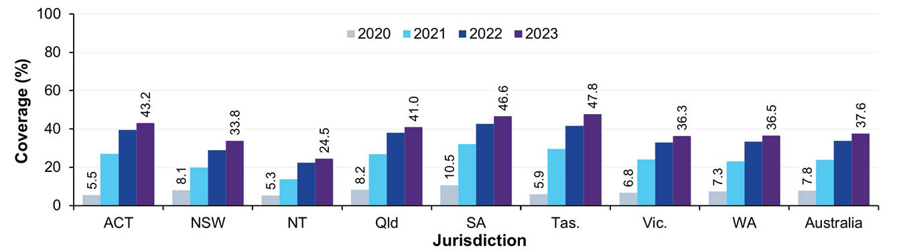
a Source: Australian Immunisation Register data as at 3 April 2022 (for 2020–2021 coverage); as at 2 April 2023 (for 2022 coverage); and as at 4 February 2024 (for 2023 coverage).
b Coverage calculated using the number of Medicare-registered adults in each year-wide cohort with an AIR record of having received an adult dose of 13vPCV by 31 December of the relevant year as the numerator and the total number of Medicare-registered adults in the relevant cohort as the denominator, expressed as a percentage.
c The 2020 and 2021 data points differ to what was presented in the 2021 report due to vaccinations given after 71 years of age now being included in the coverage calculations.
d Cohorts born: 1 January – 31 December 1949 for 2020 coverage; 1 January – 31 December 1950 for 2021 coverage; 1 January – 31 December 1951 for 2022 coverage; and 1 January – 31 December 1952 for 2023 coverage.
e ACT: Australian Capital Territory; NSW: New South Wales; NT: Northern Territory; Qld: Queensland; SA: South Australia; Tas.: Tasmania; Vic.: Victoria; WA: Western Australia.
Figure 25: Coverage of an adult dose of 13vPCV in the cohort of Indigenous adults turning 71 years of age in the year of interest, by jurisdiction, Australia,^{a,b,c,d} 2020–2023
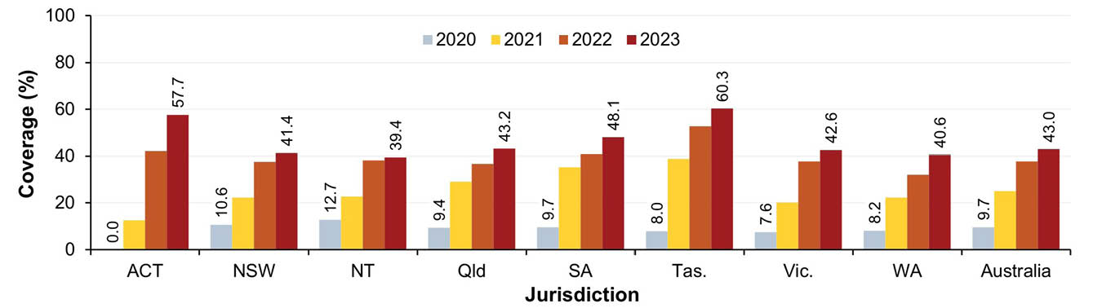
a Source: Australian Immunisation Register data as at 3 April 2022 (for 2020–2021 coverage); as at 2 April 2023 (for 2022 coverage); and as at 4 February 2024 (for 2023 coverage).
b Coverage calculated using the number of Medicare-registered Indigenous adults in each year-wide cohort with an AIR record of having received an adult dose of 13vPCV by 31 December of the relevant year as the numerator and the total number of Medicare-registered Indigenous adults in the relevant cohort as the denominator, expressed as a percentage.
c The 2020 and 2021 data points differ to what was presented in the 2021 report due to vaccinations given after 71 years of age now being included in the coverage calculations.
d Cohorts born: 1 January – 31 December 1949 for 2020 coverage; 1 January – 31 December 1950 for 2021 coverage; 1 January – 31 December 1951 for 2022 coverage; and 1 January – 31 December 1952 for 2023 coverage.
e ACT: Australian Capital Territory; NSW: New South Wales; NT: Northern Territory; Qld: Queensland; SA: South Australia; Tas.: Tasmania; Vic.: Victoria; WA: Western Australia.
Assessing a broad range of age cohorts, coverage of an adult dose of 13vPCV was highest for adults turning 72 years of age (41.7% overall). The majority of adults turning 70–72 years of age in 2023 who had received an adult dose of 13vPCV by 31 December 2023 were vaccinated at 70 years of age, whereas adults turning 73 years and over in 2023 were predominantly vaccinated at 71 years of age or older (Figure 26). In the entire cohort of adults turning 70 years or older in 2023, overall coverage of an adult dose of 13vPCV was 34.6%. Coverage patterns for Indigenous adults aged 70 years and over were similar (Figure 27), with coverage for the entire cohort of Indigenous adults turning 70 years or older in 2023 higher than for adults overall at 39.7%. Coverage for Indigenous adults turning 50–59 years of age in 2023 was 17.5% and coverage for those turning 60–69 years of age was 23.4%. This was substantially higher than overall coverage (by 1.1 and 2.5 percentage points, respectively) but lower than coverage in older age groups. Coverage for the entire cohort of Indigenous adults turning 50 years or older in 2023 was 23.9%.
Figure 26: Coverage of an adult dose of 13vPCV by birth cohort and age at vaccination, Australia,^{a,b} 2023
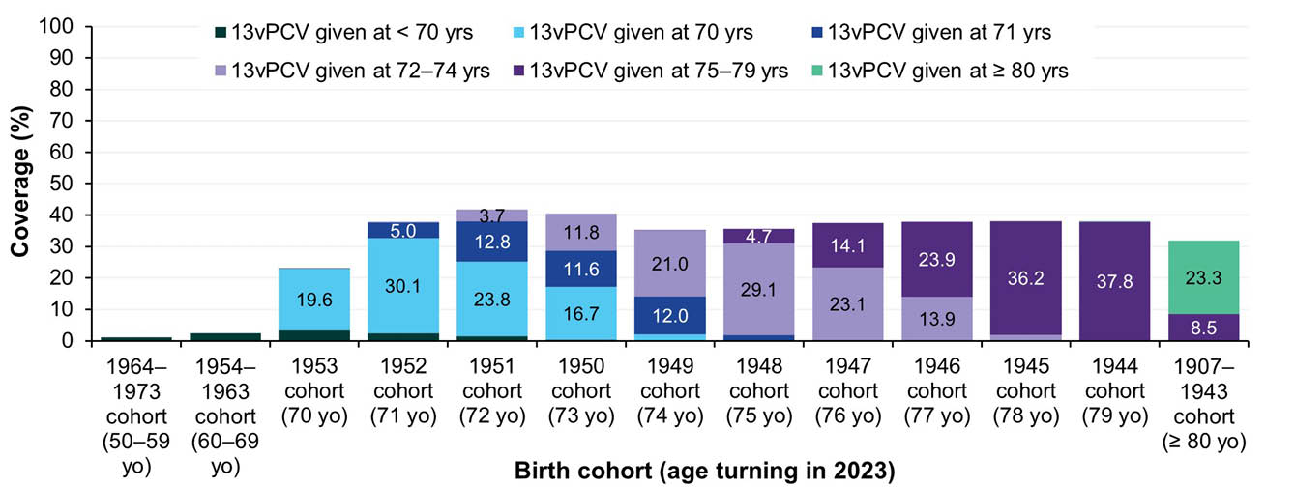
a Source: Australian Immunisation Register data as at 4 February 2024.
b Coverage calculated using the number of Medicare-registered adults in each cohort with an AIR record of having received an adult dose of 13vPCV as the numerator and the total number of Medicare-registered adults in the relevant cohort as the denominator, expressed as a percentage. Vaccinations given up to 31 December 2023 are included in the numerator.
Figure 27: Coverage of an adult dose of 13vPCV in Indigenous adults by birth cohort and age at vaccination, Australia,^{a,b} 2023
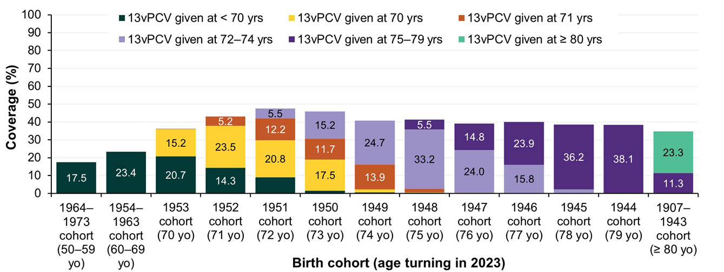
a Source: Australian Immunisation Register data as at 4 February 2024.
b Coverage calculated using the number of Medicare-registered Indigenous adults in each cohort with an AIR record of having received an adult dose of 13vPCV as the numerator and the total number of Medicare-registered Indigenous adults in the relevant cohort as the denominator, expressed as a percentage. Vaccinations given up to 31 December 2023 are included in the numerator.

Influenza vaccination coverage
After increasing each year between 2019 and 2022, influenza vaccination coverage in adults decreased from 2022 to 2023 across all three adult age groups, from 30.5% to 24.2% in the 20–49 years age group; from 46.8% to 37.4% in the 50–64 years age group; and from 70.0% to 64.3% in the ≥ 65 years age group (Figure 4 and Figure 28). Coverage was lower in 2023 than in 2022 in all adult age groups in all jurisdictions (Appendix A, Table A.9.1 and Table A.9.2).
Similarly, influenza vaccination coverage in Indigenous adults in 2023 was lower than in 2022 for all adult age groups, decreasing from 27.4% to 22.3% in the 20–49 years age group; from 51.4% to 42.2% in the 50–64 years age group; and from 70.3% to 64.1% in the ≥ 65 years age group (Figure 7). Coverage by jurisdiction is shown in Appendix A, Table A.9.1 and Table A.9.2.
Influenza vaccination coverage for adults aged ≥ 65 years in 2023 varied across Australia (Figure 29). Coverage in many remote areas of Western, Central and Far North Australia was substantially lower than in Southeast Australia, with only 12.8% coverage in East Arnhem, 23.4% in the West Pilbara region, 24.4% in Katherine and 29.4% in Alice Springs. There were also certain inner areas of some capital cities, notably Sydney, Melbourne and Brisbane, where influenza coverage was lower than the national average of 64.3% and lower than in adjacent areas (Figure 29).
Figure 28: Coverage of seasonal influenza vaccine by adult age group, Australia,^{a,b,c} 2019–2023
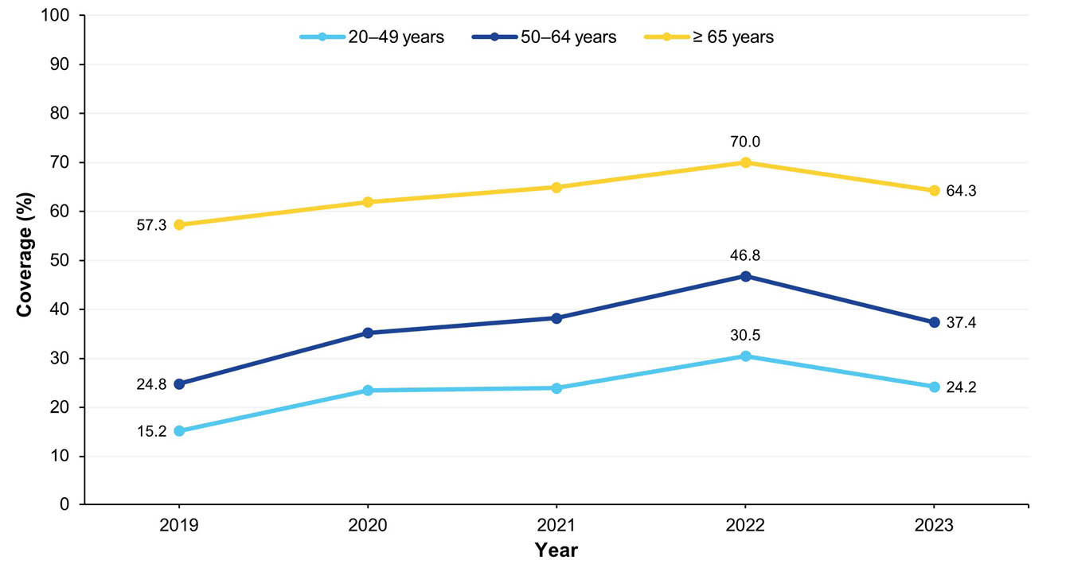
a Source: Australian Immunisation Register data as at 31 March 2020 (for 2019 data); 31 March 2021 (for 2020 data); 3 April 2022 (for 2021 data); 2 April 2023 (for 2022 data); and 2 February 2024 (for 2023 data).
b Receipt of at least one dose of any influenza vaccine in the calendar year of interest.
b Categorised into age groups based on age at vaccination.
Figure 29: Coverage of seasonal influenza vaccine in adults aged ≥ 65 years, by Statistical Area 3, Australia,^{a,b,c,d} 2023
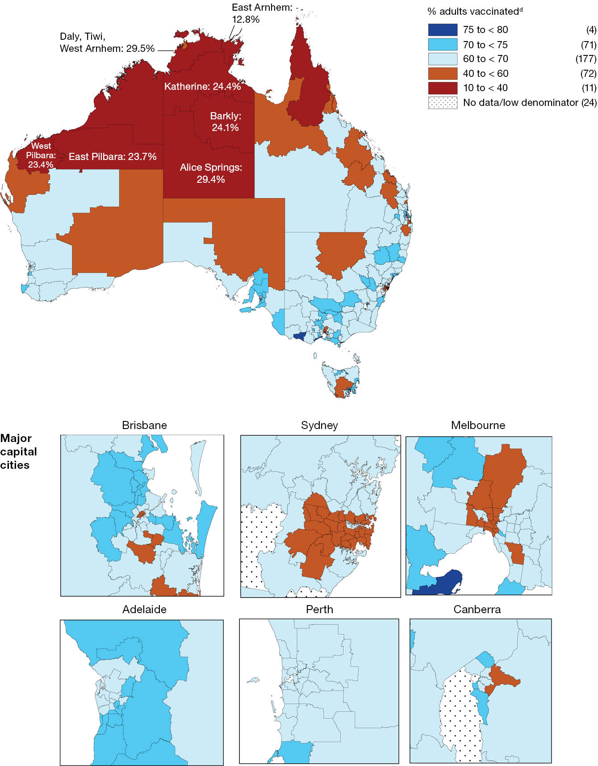
a Source: Australian Immunisation Register data as at 4 February 2024.
b Receipt of at least one dose of any influenza vaccine in 2023.
c Influenza vaccine received at age ≥ 65 years.
d Number in parentheses: number of Statistical Area 3s in each on-time category.

Adult composite measure of vaccination coverage
Using a composite measure—a dose of influenza vaccine in the calendar year of interest and an adult dose of 13vPCV—coverage was 33.1% overall in adults turning 71 years of age in 2023; this was 1.8 and 11.6 percentage points higher than the corresponding figures for 2022 and 2021, respectively (Figure 30). Coverage in Indigenous adults turning 71 years of age in 2023 was 3.0 percentage points higher than overall, at 36.1%, and was 2.5 and 14.8 percentage points higher than in 2022 and 2021, respectively (Figure 31). Coverage using the composite measure varied by jurisdiction, with overall coverage in 2023 ranging from 20.0% in the Northern Territory to 42.4% in Tasmania (Figure 30) and coverage for Indigenous adults ranging from 31.4% in the Northern Territory to 55.0% in Tasmania (Figure 31).
Figure 30: Vaccination coverage using composite measure (influenza vaccine dose in calendar year of interest and an adult dose of 13vPCV), adults turning 71 years of age in relevant year, by jurisdiction, Australia,^{a,b,c,d} 2021–2023
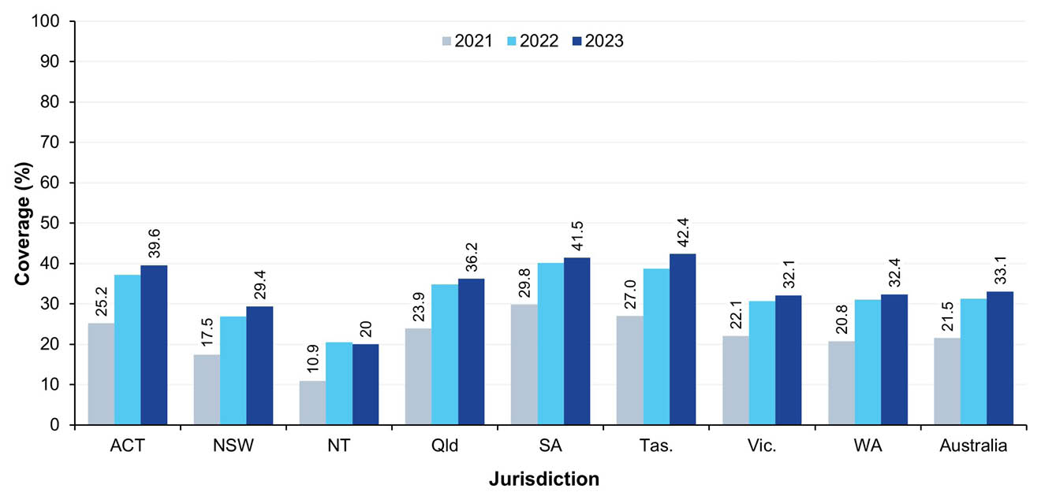
a Source: Australian Immunisation Register data as at 3 April 2022 (for 2021 coverage); 2 April 2023 (for 2022 coverage); and 2 February 2024 (for 2023 coverage).
b Coverage calculated using the number of Medicare-registered adults in each cohort with an AIR record of a dose of influenza vaccine in the calendar year of interest and an adult dose of 13vPCV by the end of the relevant year as the numerator and the total number of Medicare-registered adults in the relevant cohort as the denominator, expressed as a percentage.
c Cohorts born 1 January–31 December 1950 for 2021 coverage, 1 January–31 December 1951 for 2022 coverage and 1 January–31 December 1952 for 2023 coverage.
d ACT: Australian Capital Territory; NSW: New South Wales; NT: Northern Territory; Qld: Queensland; SA: South Australia; Tas.: Tasmania; Vic.: Victoria; WA: Western Australia.
Figure 31: Vaccination coverage using composite measure (influenza vaccine dose in past 12 months and an adult dose of 13vPCV), Indigenous adults turning 71 years of age in relevant year, by jurisdiction, Australia,^{a,b,c,d} 2021–2023
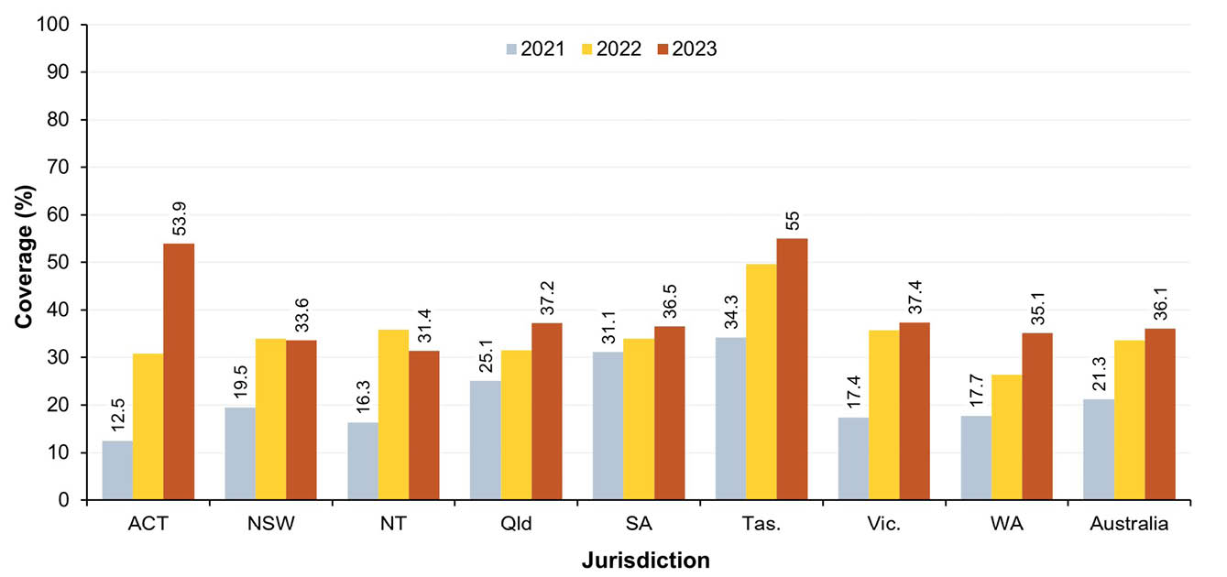
a Source: Australian Immunisation Register data as at 3 April 2022 (for 2021 coverage); 2 April 2023 (for 2022 coverage); and 2 February 2024 (for 2023 coverage).
b Coverage calculated using the number of Medicare-registered Indigenous adults in each cohort with an AIR record of a dose of influenza vaccine in the calendar year of interest and an adult dose of 13vPCV by the end of the relevant year as the numerator and the total number of Medicare-registered Indigenous adults in the relevant cohort as the denominator, expressed as a percentage.
c Cohorts born 1 January–31 December 1950 for 2021 coverage, 1 January–31 December 1951 for 2022 coverage and 1 January–31 December 1952 for 2023 coverage.
d ACT: Australian Capital Territory; NSW: New South Wales; NT: Northern Territory; Qld: Queensland; SA: South Australia; Tas.: Tasmania; Vic.: Victoria; WA: Western Australia.

Provider setting
In 2023, the majority of vaccinations given to people of all ages in Australia (60.9%) were administered in general practice settings, with the Northern Territory the only jurisdiction in which a minority of vaccinations (28.0%) were given in general practice (Appendix A, Figure A.10). Overall, 18.2% of vaccinations were given in pharmacies (with the proportion highest in the Australian Capital Territory and Western Australia, both at 26.7%); 13.4% were given in local council clinic settings (highest in Victoria, at 19.6%); 2.9% were given in community health service settings (highest in the Northern Territory, at 22.4%); 0.6% were given in Indigenous health service settings (highest in the Northern Territory, at 22.8%); and 3.1% were given in hospitals (Appendix A, Figure A.10).

Discussion
This report documents relatively high vaccination coverage in Australia, by global standards, in line with NIP and World Health Organization (WHO) Immunization Agenda 2030 (IA2030)¹⁹ aims to reduce vaccine preventable disease burden across the life course. Opportunities for improvement, particularly in the context of modest but concerning declines in coverage since the advent of the coronavirus disease 2019 (COVID-19) pandemic in 2020, are discussed below.

Vaccination coverage in population overall

Children
Fully vaccinated coverage in Australian children in this 2023 report was 0.1–0.5 of a percentage point lower than in our 2022 report at the 12-month (92.8%, down from 93.3%), 24-month (90.8%, down from 91.0%), and 60-month (93.3%, down from 93.4%) age assessment milestones.¹⁵ This follows the 1.1–1.5 percentage points decrease at these three milestones between the 2020 and 2022 reports,^{14,20} which came after approximately eight years of generally increasing coverage.⁸⁻¹⁴ Due to the lag time involved in fully vaccinated coverage assessment, fully vaccinated childhood coverage figures in this 2023 report predominantly represent vaccinations due in 2022, when COVID-19 pandemic-related restrictions such as border closures, physical distancing and mask wearing requirements had largely been removed. Decreases of similar magnitude have been seen in comparable developed countries, such as the United Kingdom²¹ and New Zealand.²² Factors contributing to the ongoing decline in coverage in Australian children include a combination of acceptance issues (concerns regarding the safety of vaccines and the increasing number of vaccines on the NIP schedule, ‘vaccine fatigue’, reduced confidence in the importance of childhood vaccination, and increased polarisation related to the intense attention given to COVID-19 vaccination and associated mandates) and access issues (such as difficulty obtaining GP appointments, reduced bulk-billing and reduced parental/carer prioritisation of vaccination in relation to competing priorities).²³⁻²⁷
We also found ongoing impacts on on-time vaccination (within 30 days of recommended age) in young children, with on-time coverage in 2023 approximately 5 percentage points lower than in 2019 for the second dose of DTPa and 10 percentage points lower for the first dose of MMR-containing vaccine.
Coverage was lower in 2023 than in 2022 for all individual vaccines/antigens assessed at the 12-, 24- and 60-month age milestones, other than for Hib at 60 months. The largest decrease was for rotavirus assessed at 12 months of age (1.1 percentage points lower). In the context of Australia’s 95% coverage targets—which are particularly critical to measles control—coverage was slightly lower at 24 months of age in 2023 than in 2022 for both the first dose of measles-containing vaccine (94.7% versus 95.1%, respectively) and the second dose (92.5% versus 92.7%), but slightly higher for the second dose assessed at 60 months of age (96.4% versus 96.3%). A global resurgence in measles and increasing importations to Australia increase the risk of local transmission, especially to more vulnerable unvaccinated young children, underpinning the need to improve timely and more complete vaccine uptake.
Influenza vaccination coverage in children aged 6 months to 4 years continued to decline, reaching 30.3% in 2023, down from 34.1% in 2022.²⁰ Conversely, the achievement of high coverage of 74.2% in the Daly–Tiwi–West Arnhem SA3 and 64.7% in the Barkly SA3 area, both of which have a majority Indigenous population, provides an important example to other parts of Australia. Strategies are needed to address the ongoing slide in coverage in young children, noting that influenza vaccination coverage in children aged 6 months to 4 years was over 40% in both 2019 and 2020,¹⁴ following inclusion of influenza vaccination on the NIP in 2018.²⁸

Adolescents
In 2023, a total of 84.2% of Australian girls had received at least one dose of HPV vaccine by 15 years of age, down from 85.3% in 2022 and 86.6% in 2020,¹⁴ and 81.8% of boys, down from 83.1% in 2022 and 84.9% in 2020.¹⁴ These figures compare relatively favourably with coverage in 2023 in similar high-income countries using the same WHO-recommended assessment methodology—80% and 75% in girls and boys, respectively, in the United Kingdom; 80% and 78% in the United States of America; and 86% and 81% in Canada—but are below the 90% coverage target.²⁹ Modelling indicates that sustained coverage of at least 80% is required in a both-sex program to eventually achieve elimination of targeted HPV types in the population;³⁰ the downward trend with coverage in some subpopulations below 80% is concerning. Reaching and maintaining goals, such as for cervical cancer elimination in 2030, as committed to by the Australian Government,³¹ requires higher ongoing coverage levels. Australian coverage figures by 15 years in this report reflect vaccinations predominantly due in school-based programs in 2020 and 2021 i.e. at the height of COVID-19 pandemic restrictions when many school closures occurred, with extent and duration varying by jurisdiction, suggesting additional catch-up strategies for these cohorts are required.
Assessment of coverage of at least one dose of HPV vaccine by 31 December 2023 across broader year-wide birth cohorts showed that coverage in Australia was highest in adolescents turning 18 years in 2023, at 88.1% in girls and 86.3% in boys, approximately half a percentage point higher than in the same age cohorts in 2022 for both girls and boys.²⁰ However, while national coverage in adolescents turning 13 years in 2023 was superficially similar to that in 2022,²⁰ when recalculated with South Australia excluded (due to change in delivery of HPV [and dTpa] vaccination in that state from Year 8 in 2022 to Year 7 in 2023) it was around three percentage points lower in 2023 than 2022. While the issues noted above in relation to declining childhood coverage may have contributed to this, the greater decrease suggests possible impacts of the switch to a single-dose HPV vaccine schedule in 2023 such as through the reduction in number of school visits, which may have reduced opportunities for catch-up vaccination in students absent at initial visits, in the context of school absenteeism levels that have not yet returned to pre-pandemic levels.³² It will be important to further investigate the reasons underpinning these declines and to design and implement additional catch-up vaccination strategies. In particular, such strategies should ensure equitable coverage across disadvantaged groups, given we found that coverage of at least one dose of HPV vaccine in 2023 by 15 years of age was 4–8 percentage points lower in adolescents residing in socio-economically disadvantaged and remote areas. Australia’s national strategy for the elimination of cervical cancer calls for a focus on equity in elimination and has an HPV vaccination target of 90% for both females and males, building on WHO’s global target of 90% coverage for all girls by age 15 by 2030, in the context of our gender-neutral vaccination program.³¹
With HPV vaccine now funded under the NIP up to 26 years of age, there is also substantial scope for catch-up vaccination in older adolescents and young adults, given that we found coverage of at least one dose of HPV vaccine to be below 80% in females turning 24–25 years and males turning 23–25 years in 2023.
Coverage of an adolescent dose of diphtheria-tetanus-pertussis vaccine in adolescents turning 15 years of age in 2023 was 85.5%, 1.4 percentage points lower than in 2022.²⁰ National coverage in adolescents turning 13 years of age in 2023, recalculated with South Australia excluded, was 2.3 percentage points lower overall in 2023 than 2022, and 4.1 percentage points lower in Indigenous adolescents. Coverage of an adolescent dose of meningococcal ACWY vaccine in adolescents turning 17 years of age in 2023 was 72.8%, which was 3.1 percentage points lower than in 2022.²⁰ It will be important to investigate and address the factors underlying these declines and to promote catch-up vaccination, which for these vaccines is funded on the NIP up to 20 years of age.
For the second time in this series of annual reports, we also calculated adolescent coverage using composite measures, as previously recommended,¹⁷ to assess overall uptake in the adolescent immunisation program. Coverage for adolescents turning 15 years of age, using a composite measure comprising at least one dose of HPV vaccine and an adolescent dose of diphtheria-tetanus-pertussis vaccine, was 82.6% in 2023, down from 83.7% in 2022 and 84.5% in 2021.²⁰ Coverage for adolescents turning 18 years of age using a composite measure comprising at least one dose of HPV vaccine, an adolescent dose of diphtheria-tetanus-pertussis vaccine and an adolescent dose of meningococcal ACWY was 73.0% in 2023, down slightly from 2022 (73.4%) but higher than in 2021 (71.7%).²⁰ While these figures show relatively high overall adolescent coverage, there is room for improvement, given one in five 15-year-olds and one in four 18-year-olds had not received all the adolescent doses recommended under the NIP.

Adults
Zoster vaccination coverage in adults turning 71 years of age in 2023 was 41.0% in 2023, which was 0.3 of a percentage point lower than in 2022.¹⁵ Zoster coverage in 2023 was highest in adults turning 76 years of age (57.6%), reflecting a combination of vaccinations given both at the 70-year NIP schedule point and from 71 years onwards via the catch-up vaccination program, and overall coverage for adults aged 70 years and above was 42.3%. True zoster vaccination coverage is likely higher—particularly in older cohorts—given previously documented under-reporting to the AIR,³³⁻³⁵ but is still likely suboptimal. Following the replacement of Zostavax on the NIP with Shingrix from November 2023 for all adults aged 65 years and over, for Indigenous adults aged 50 years and over, and for immunocompromised people aged 18 years and over at high risk,³⁶ we are monitoring zoster vaccination coverage quarterly to evaluate the uptake of Shingrix in these populations.³⁷
Coverage of 13vPCV—which was introduced onto the NIP for all adults aged 70 years and over in July 2020—was 37.6% in adults turning 71 years of age in 2023, 3.8 percentage points higher than in 2022, with overall coverage of 34.6% for adults aged 70 years and above.³⁵
Influenza vaccination coverage in adults, after increasing across all age groups over several years, likely due in part to greater completeness of reporting (including from commercial immunisation providers and others previously unable to report to the AIR), decreased in 2023, with the largest decrease in the 50–64 years age group, down from 46.8% in 2022 to 37.4% in 2023.^{38,39} This may reflect ‘vaccine fatigue’ and other acceptance and access-related issues, as discussed above.
We also calculated adult coverage using a composite measure (influenza vaccine dose in past 12 months and a previous adult dose of 13vPCV), as previously recommended,¹⁷ to assess overall uptake in the adult immunisation program. Coverage for adults turning 71 years of age using this measure was 33.1% in 2023, up from 31.3% in 2022 but clearly suboptimal. We plan to calculate coverage in the 2024 report using an expanded composite measure that includes Shingrix, now that it is on the NIP.

Vaccination coverage in Indigenous people

Children
Fully vaccinated coverage for Indigenous children decreased marginally between 2022 and 2023 at all three standard age milestones: 12 months (from 90.0% to 89.7%); 24 months (from 87.9% to 87.8%); and 60 months (from 95.1% to 95.0%). This follows the 1.9–3.3 percentage point decrease at these three milestones between the 2020 and 2022 reports.^{14,20} Coverage in Indigenous children in 2023 remained around three percentage points lower at 12 and 24 months than in children overall, reflecting longstanding timeliness issues^{1,9} exacerbated by the COVID-19 pandemic, but was around two percentage points higher at the 60-month milestone. While on-time vaccination coverage for the second dose of DTPa and first dose of MMR-containing vaccines in Indigenous children stabilised in 2023, it remained around five to 10 percentage points lower than prior to the pandemic and around 10 percentage points lower than in non-Indigenous children. Timeliness of vaccination in Indigenous children is particularly an issue in relation to vaccines/antigens due 6 months before the standard assessment milestones, whereas coverage of individual vaccines/antigens due at 6 or 12 months of age with no further doses required at 18 months (meningococcal ACWY, polio and hepatitis B vaccines) was 95.4% or greater in Indigenous children at 24 months in 2023. Similarly, although coverage in 2023 for the second dose of MMR and varicella (usually given as measles-mumps-rubella-varicella [MMRV] vaccine at 18 months) in Indigenous children was 90.7% at 24 months, it was 98.3% at 60 months.
Coverage of meningococcal B vaccine—which was introduced onto the NIP for all Indigenous children in July 2020—was higher in 2023 than 2022: 81.0% versus 80.4% for the first dose, 80.0% versus 78.6% for the second dose and 71.7% versus 69.8% for the third dose.²⁰ Third-dose coverage figures likely underestimate course completion, as only two doses are required if the first dose is administered after 12 months of age.
Influenza vaccination coverage was 1.5 percentage points lower in 2023 (23.1%) than in 2022 (24.6%) in Indigenous children aged 6–59 months, and 3.8 percentage points lower in those aged 5–9 years (14.6% in 2023 versus 18.4% in 2023). Coverage was 7.2 percentage points lower in Indigenous children aged 6–59 months than overall coverage, and 3.3 percentage points lower in those aged 5–9 years, despite influenza vaccination being funded under the NIP for all Indigenous age groups.
Coverage by 30 months of age for the first dose of hepatitis A vaccine and the fourth dose of 13vPCV – funded under the NIP for Indigenous children in four jurisdictions only (South Australia, Northern Territory, Queensland and Western Australia) – remained largely stable in 2023 at around 80%. Improving uptake for both of these additional vaccines is important, but particularly so for the fourth dose of 13vPCV, as invasive pneumococcal disease notification rates are twice as high in Indigenous children as in other children and 5–10 times as high in Indigenous adults.⁴⁰ In contrast, despite relatively modest hepatitis A vaccine coverage through the targeted NIP program, hepatitis A notification rates have remained consistently lower in Indigenous people of all ages than others since 2007.⁴⁰

Adolescents
Coverage of at least one dose of HPV vaccine for Indigenous girls and boys by 15 years of age was 2–3 percentage points lower in 2023 than 2022 (80.9% versus 83.0%, respectively, for girls and 75.0% versus 78.1% for boys). These decreases were larger than the decreases in adolescents overall, leading to coverage in 2023 being 3.3 percentage points lower than overall for Indigenous girls and 6.8 percentage points lower for Indigenous boys. National coverage in Indigenous adolescents turning 13 years of age in 2023, recalculated with South Australia excluded due to aforementioned program changes, was three percentage points lower in 2023 than in 2022 for boys and six percentage points lower for girls. These decreases, which were larger than those observed overall, suggest possible greater impacts on Indigenous adolescents of the switch to a single-dose HPV vaccine schedule and any associated reduction in number of school visits, potentially due to higher levels of absenteeism among Indigenous students.^{32,41}
As a result, coverage of at least one dose of HPV vaccine by the end of 2023 was 14 percentage points lower in Indigenous girls turning 13 years of age in 2023 than overall, and 15.8 percentage points lower in Indigenous boys. While the disparity decreased with increasing age, with coverage higher than overall in Indigenous girls turning 17 years and Indigenous boys turning 19 years of age in 2023, more than two-fifths of Indigenous women and men turning 24–25 years in 2023 had not been vaccinated, indicating substantial scope for catch-up vaccination. Efforts to address declines and improve HPV vaccination coverage across all eligible Indigenous age groups are crucial, given the much higher rates of cervical cancer in Indigenous women.⁴² A stronger focus on ensuring equitable HPV vaccine coverage is particularly needed given the increasing disparities in coverage we document in socio-economically disadvantaged and remote areas, where Indigenous adolescents are more likely to live than their non-Indigenous counterparts.^{43,44}
Patterns of diphtheria-tetanus-pertussis vaccination coverage among Indigenous adolescents were broadly similar to those for HPV vaccination coverage, which was as expected, given the two vaccines are usually given together at the same school visit. National diphtheria-tetanus-pertussis coverage in Indigenous adolescents turning 13 years of age in 2023, with South Australia excluded, was four percentage points lower in 2023 (58.8%) than in 2022 (62.9%) and 15 percentage points lower than overall coverage. The disparity decreased with increasing age, with coverage 0.1 of a percentage point higher than overall in Indigenous adolescents turning 19 years of age in 2023.
Coverage of meningococcal ACWY vaccination in Indigenous adolescents turning 17 years of age was 3.1 percentage points lower in 2023 (62.3%) than 2022 (65.6%)²⁰ and 10.5 percentage points lower than overall coverage. This disparity decreased with increasing age, but not to the extent seen with HPV and diphtheria-tetanus-pertussis vaccination, with coverage reaching 72.5% in Indigenous adolescents turning 19 years of age in 2023, seven percentage points below overall coverage. Strategies to improve meningococcal ACWY coverage in Indigenous adolescents are particularly needed, given the elevated risk of meningococcal disease in this age group and in view of serogroup W outbreaks in Indigenous communities in recent years.⁴⁰

Adults
Zoster vaccination coverage in Indigenous adults turning 71 years of age in 2023 was 36.1%, which was 0.4 of a percentage point lower than in 2022, with coverage highest for those turning 75 years of age (58.3%) and coverage for the entire cohort of Indigenous adults turning 70 years or older in 2023 higher than overall coverage (43.6% versus 42.3%).
Coverage of an adult dose of 13vPCV in Indigenous adults turning 71 years of age in 2023 was 43.0%, 5.3 percentage points higher than in 2022, with coverage highest for those turning 72 years of age (47.5%) and coverage for the entire cohort of Indigenous adults turning 70 years or older in 2023 five percentage points higher than for adults overall in this age range (39.7% versus 34.6%). However, only 17.5% of Indigenous adults aged 50–59 years in 2023, and 23.4% of those aged 60–69 years, were recorded as having received an adult dose of 13vPCV, despite the vaccine being funded under the NIP for all Indigenous adults in this age group since July 2020. The funding of Shingrix on the NIP for Indigenous adults aged 50 years and older from November 2023 may provide opportunities to increase coverage of both 13vPCV and zoster vaccine in younger Indigenous adults, including through promotion of concomitant vaccination.
Influenza vaccination coverage was 5–11 percentage points lower in 2023 than 2022 across Indigenous adult age groups. While relatively high for those aged ≥ 65 years (64.1%), coverage was considerably lower for those aged 20–49 years (22.3%) and 50–64 years (42.2%), despite influenza vaccine being funded on the NIP for all Indigenous adults due to the increased risk of severe disease. However, coverage in these age groups in the Australian Capital Territory and the Northern Territory was substantially higher than in other jurisdictions.

Conclusions
Vaccination coverage in Australia is relatively high by global standards, in line with NIP and IA2030 aims to reduce the vaccine preventable disease burden across the life course. However, this report shows that in the fourth year of the COVID-19 pandemic, and after the removal of COVID-19 pandemic related restrictions, there have continued to be modest but concerning declines in vaccination coverage in children and adolescents relative to pre-pandemic peaks, with decreases greater in Indigenous children and adolescents. Factors contributing to these ongoing declines likely include a combination of acceptance issues (concerns about and reduced confidence in vaccination) and access issues (actual or perceived barriers to vaccination, including prioritisation by parents and carers in relation to other competing priorities). Declines in adolescent coverage of HPV and diphtheria-tetanus-pertussis vaccines, potentially influenced by a reduced number of school visits and thus opportunities for catch-up vaccination, in the context of the new one-dose HPV vaccine schedule and school absenteeism levels that have not yet returned to pre-pandemic levels, also need to be addressed. The picture for adult coverage in 2023 is more mixed, with coverage increasing for 13vPCV, stable for zoster and decreasing for influenza vaccination, though consistently suboptimal across all vaccines. Ongoing monitoring of vaccination coverage and further exploration of the reasons underpinning these decreases and suboptimal coverage are needed. Evidence-based approaches to effectively address barriers and increase uptake and equity of coverage are needed to close growing immunity gaps and to improve protection against the wide range of vaccine preventable diseases.

Acknowledgments
This study was undertaken under the funding agreement between the National Centre for Immunisation Research and Surveillance and the Australian Government Department of Health, Disability and Ageing. The authors wish to acknowledge useful feedback from Julia Brotherton, Aditi Dey, and state and territory immunisation program coordinators on study design and draft versions of the report. We would like to also acknowledge Annabeth Simpson for her assistance with data analysis.

Author details
Brynley Hull
Alexandra Hendry
Kristine Macartney
Frank Beard

Corresponding author
Brynley Hull
National Centre for Immunisation Research and Surveillance, The Children’s Hospital at Westmead and The University of Sydney, Locked Bag 4001, Westmead, NSW 2145
Telephone: +61 2 9845 1435
Email: brynley.hull@health.nsw.gov.au

References
- Hull B, Deeks S, Menzies R, McIntyre P. Immunisation coverage annual report, 2007. Commun Dis Intell Q Rep. 2009;33(2):170–87. doi: https://doi.org/10.33321/cdi.2009.33.16.
- Hull BP, Mahajan D, Dey A, Menzies RI, McIntyre PB. Immunisation coverage annual report, 2008. Commun Dis Intell Q Rep. 2010;34(3):241–58. doi: https://doi.org/10.33321/cdi.2010.34.25.
- Hull B, Dey A, Mahajan D, Menzies RI, McIntyre PB. Immunisation coverage annual report, 2009. Commun Dis Intell Q Rep. 2011;35(2):132–48. doi: https://doi.org/10.33321/cdi.2011.35.9.
- Hull B, Dey A, Menzies R, McIntyre P. Annual immunisation coverage report, 2010. Commun Dis Intell Q Rep. 2013;37(1):E21–39. doi: https://doi.org/10.33321/cdi.2013.37.2.
- Hull BP, Dey A, Menzies RI, Brotherton JM, McIntyre PB. Immunisation coverage annual report, 2011. Commun Dis Intell Q Rep. 2013;37(4):E291–312. doi: https://doi.org/10.33321/cdi.2013.37.48.
- Hull BP, Dey A, Menzies RI, Brotherton JM, McIntyre PB. Immunisation coverage, 2012. Commun Dis Intell Q Rep. 2014;38(3):E208–31. doi: https://doi.org/10.33321/cdi.2014.38.37.
- Hull BP, Dey A, Beard FH, Menzies RI, Brotherton JM, McIntyre PB. Immunisation coverage annual report, 2013. Commun Dis Intell Q Rep. 2016;40(1):E146–69. doi: https://doi.org/10.33321/cdi.2016.40.5.
- Hull BP, Hendry AJ, Dey A, Beard FH, Brotherton JM, McIntyre PB. Immunisation coverage annual report, 2014. Commun Dis Intell Q Rep. 2017;41(1):E68–90. doi: https://doi.org/10.33321/cdi.2017.41.10.
- Hull B, Hendry A, Dey A, Beard F, Brotherton J, McIntyre P. Immunisation coverage annual report, 2015. Commun Dis Intell (2018). 2019;43. doi: https://doi.org/10.33321/cdi.2019.43.11.
- Hull B, Hendry A, Dey A, Beard F, Brotherton J, McIntyre P. Annual immunisation coverage report, 2016. Commun Dis Intell (2018). 2019;43. doi: https://doi.org/10.33321/cdi.2019.43.44.
- Hull B, Hendry A, Dey A, Brotherton J, Macartney K, Beard F. Annual Immunisation Coverage Report, 2017. Commun Dis Intell (2018). 2019;43. doi: https://doi.org/10.33321/cdi.2019.43.47.
- Hull B, Hendry A, Dey A, McIntyre P, Macartney K, Beard F. Annual Immunisation Coverage Report, 2018. Commun Dis Intell (2018). 2021;45. doi: https://doi.org/10.33321/cdi.2020.45.17.
- Hull B, Hendry A, Dey A, Macartney K, Beard F. Immunisation Coverage Annual Report, 2019. Commun Dis Intell (2018). 2021;45. doi: https://doi.org/10.33321/cdi.2020.45.18.
- Hull B, Hendry A, Dey A, Brotherton J, Macartney K, Beard F. Annual immunisation coverage report, 2020. Commun Dis Intell (2018). 2022;46. doi: https://doi.org/10.33321/cdi.2022.46.60.
- Hull B, Hendry A, Dey A, Brotherton J, Macartney K, Beard F. Annual immunisation coverage report, 2021. Commun Dis Intell (2018). 2023;47. doi: https://doi.org/10.33321/cdi.2023.47.47.
- Australian Government Department of Health, Disability and Ageing. Childhood immunisation coverage. [Webpage.] Canberra: Australian Government Department of Health, Disability and Ageing; 2023. [Accessed on 19 September 2023.] Available from: https://www.health.gov.au/topics/immunisation/immunisation-data/childhood-immunisation-coverage.
- National Centre For Immunisation Research and Surveillance (NCIRS). Optimising adolescent and adult coverage rate methodologies. Sydney: Sydney Children’s Hospitals Network, NCIRS; 22 June 2023. [Accessed on 13 September 2023.] Available from: https://ncirs.org.au/optimising-adolescent-and-adult-coverage-rate-methodologies.
- NCIRS. Optimising childhood coverage rate assessment and reporting methodologies. Final report. Sydney: Sydney Children’s Hospitals Network, NCIRS; 30 May 2022. [Accessed on 16 August 2023.] Available from: https://ncirs.org.au/optimising-childhood-coverage-rate-assessment-and-reporting-methodologies.
- World Health Organization (WHO). Immunization Agenda 2030: A global strategy to leave no one behind. Geneva: WHO; 1 April 2020. [Accessed on 19 September 2023.] Available from: https://www.who.int/teams/immunization-vaccines-and-biologicals/strategies/ia2030.
- Hull B, Hendry A, Dey A, Beard F. Annual Immunisation Coverage Report 2022. Commun Dis Intell (2018). 2025;49. doi: https://doi.org/10.33321/cdi.2025.49.023.
- United Kingdom Government National Health Service, NHS Digital. Childhood Vaccination Coverage Statistics, England, 2022–23. [Webpage.] London: NHS Digital; 28 September 2023. [Accessed on 6 August 2024.] Available from: https://digital.nhs.uk/data-and-information/publications/statistical/nhs-immunisation-statistics/england-2022-23.
- Aotearoa New Zealand Government Ministry of Health (Health New Zealand / Te Whatu Ora). Immunisation coverage. National immunisation data - summary. [Webpage.] Wellington: Health New Zealand / Te Whatu Ora; 2023. [Accessed on 6 August 2024.] Available from: https://www.tewhatuora.govt.nz/health-services-and-programmes/vaccine-information/immunisation-coverage/#national-immunisation-data-summary.
- Bolsewicz KT, Steffens MS, King C, Abdi I, Bullivant B, Beard F. A qualitative study on COVID-19 pandemic impacts on parental attitudes and intentions for routine adolescent vaccinations: the role of trust. Vaccine. 2023;41(28):4138–43. doi: https://doi.org/10.1016/j.vaccine.2023.05.037.
- Wolstenholme A, Smith C. Community Attitude Research on Childhood Immunisation: Research Report. Canberra: Australian Government Department of Health, Disability and Ageing; April 2022. [Accessed on 6 August 2024.] Available from: https://www.health.gov.au/sites/default/files/documents/2022/09/community-attitude-research-on-childhood-vaccination-2022-research-report.pdf.
- Kaufman J, Hoq M, Rhodes AL, Measey MA, Danchin MH. Misperceptions about routine childhood vaccination among parents in Australia, before and after the COVID-19 pandemic: a cross-sectional survey study. Med J Aust. 2024;220(10):530–2. doi: https://doi.org/10.5694/mja2.52304.
- Australian Government Department of Health, Disability and Ageing. Strengthening Medicare Taskforce Report. Canberra: Australian Government Department of Health, Disability and Ageing; December 2022. [Accessed on 6 August 2024.] Available from: https://www.health.gov.au/resources/publications/strengthening-medicare-taskforce-report.
- United Nations Children’s Fund UNICEF). The State of the World’s Children 2023: For every child, vaccination. Florence: UNICEF; April 2023. Available from: https://www.unicef.org/media/108161/file/SOWC-2023-full-report-English.pdf.
- NCIRS. History of immunisation in Australia. [Webpage.] Sydney: Sydney Children’s Hospitals Network, NCIRS; 2023. [Accessed on 19 September 2023.] Available from: https://ncirs.org.au/health-professionals/history-immunisation-australia.
- WHO. Human Papillomavirus (HPV) vaccination coverage. [Webpage.] Geneva: WHO; 2023. [Accessed on 7 August 2024.] Available from: https://immunizationdata.who.int/global/wiise-detail-page/human-papillomavirus-(hpv)-vaccination-coverage.
- Brisson M, Bénard É, Drolet M, Bogaards JA, Baussano I, Vänskä S et al. Population-level impact, herd immunity, and elimination after human papillomavirus vaccination: a systematic review and meta-analysis of predictions from transmission-dynamic models. Lancet Public Health. 2016;1(1):e8–17. doi: https://doi.org/10.1016/S2468-2667(16)30001-9.
- Australian Government Department of Health and Aged Care. National Strategy for the Elimination of Cervical Cancer in Australia. Canberra: Australian Government Department of Health, Disability and Ageing; 17 November 2023. [Accessed on 6 August 2024.] Available from: https://www.health.gov.au/resources/publications/national-strategy-for-the-elimination-of-cervical-cancer-in-australia.
- Australian Curriculum Assessment and Reporting Authority (ACARA). ACARA National Student Attendance Data Collection. Sydney: ACARA; 2024. [Accessed on 26 August 2024.] Available from: https://www.acara.edu.au/reporting/national-report-on-schooling-in-australia/student-attendance.
- Lin J, Wood JG, Bernardo C, Stocks NP, Liu B. Herpes zoster vaccine coverage in Australia before and after introduction of a national vaccination program. Vaccine. 2020;38(20):3646–52. doi: https://doi.org/10.1016/j.vaccine.2020.03.036.
- Rashid H, Dey A, Manocha R, Tashani M, Macartney K, Beard F. Australia's national zoster vaccination program: knowledge, attitudes and behaviour of general practitioners. Commun Dis Intell (2018). 2020;44. doi: https://doi.org/10.33321/cdi.2020.44.59.
- Australian Government Department of Health, Disability and Ageing. Building a stronger Australian Immunisation Register. [Media release.] Canberra: Australian Government Department of Health, Disability and Ageing; 5 February 2021. [Accessed on 9 September 2021.] Available from: https://www.health.gov.au/ministers/the-hon-greg-hunt-mp/media/building-a-stronger-australian-immunisation-register.
- Australian Government Department of Health, Disability and Ageing. National Immunisation Program – changes to shingles vaccination from 1 November 2023. [Media release.] Canberra: Australian Government Department of Health, Disability and Ageing; 8 October 2023. [Accessed on 7 November 2023.] Available from: https://www.health.gov.au/news/national-immunisation-program-changes-to-shingles-vaccination-from-1-november-2023.
- NCIRS. Zoster (shingles) vaccination data. [Webpage.] Sydney: Sydney Children’s Hospitals Network, NCIRS; 2024. [Accessed on 26 August 2024.] Available from: https://ncirs.org.au/immunisation-coverage-data-and-reports/zoster-shingles-vaccination-data.
- Beard F, Hendry A, Macartney K. Influenza vaccination uptake in Australia in 2020: impact of the COVID-19 pandemic? Commun Dis Intell (2018) 2021;45. doi: https://doi.org/10.33321/cdi.2021.45.10.
- Hull B, Hendry A, Dey A, Macartney K, McIntyre P, Beard F. Exploratory analysis of the first 2 years of adult vaccination data recorded on AIR. Sydney: Sydney Children’s Hospitals Network, NCIRS; November 2019. [Accessed on 24 June 2020.] Available from: http://ncirs.org.au/sites/default/files/2019-12/Analysis%20of%20adult%20vaccination%20data%20on%20AIR_Nov%202019.pdf.
- Jackson J, Sonneveld N, Rashid H, Karpish L, Wallace S, Whop L et al. Vaccine preventable diseases and vaccination coverage in Aboriginal and Torres Strait Islander people, Australia, 2016–2019. Commun Dis Intell (2018). 2023;47. doi: https://doi.org/10.33321/cdi.2023.47.32.
- Australian Government. Closing The Gap Report 2020 - School attendance. Canberra: Australian Government; 2020. [Accessed on 7 August 2024.] Available from: https://ctgreport.niaa.gov.au/school-attendance.
- Australian Institute of Health and Welfare (AIHW). National Cervical Screening Program monitoring report 2020. Canberra: AIHW; 1 December 2020. [Accessed on 9 September 2021.] Available from: https://www.aihw.gov.au/reports/cancer-screening/national-cervical-screening-monitoring-report-2020/contents/summary.
- Australian Bureau of Statistics. Estimates of Aboriginal and Torres Strait Islander Australians. Reference period: 30 June 2021. Canberra: Australian Bureau of Statistics; 31 August 2023. [Accessed on 7 August 2024.] Available from: https://www.abs.gov.au/statistics/people/aboriginal-and-torres-strait-islander-peoples/estimates-aboriginal-and-torres-strait-islander-australians/latest-release.
- Biddle N, Markham F. Area Level Socioeconomic Outcomes for Aboriginal and Torres Strait Islander Australians in the 2016 and 2021 Censuses. Canberra: Australian National University, College of Arts & Social Sciences, Centre for Aboriginal Economic Policy Research; 2023. [Accessed on 7 August 2024.] Available from: https://openresearch-repository.anu.edu.au/server/api/core/bitstreams/0ab58084-d53b-40e6-a018-0885550e43f9/content.
- Gidding HF, Quinn HE, Hueston L, Dwyer DE, McIntyre PB. Declining measles antibodies in the era of elimination: Australia's experience. Vaccine. 2018;36(4):507–13. doi: https://doi.org/10.1016/j.vaccine.2017.12.002.
- Hull BP, McIntyre PB, Heath TC, Sayer GP. Measuring immunisation coverage in Australia: a review of the Australian Childhood Immunisation Register. Aust Fam Physician. 1999;28(1):55–60. Available (abstract only) from: https://pubmed.ncbi.nlm.nih.gov/9988916/.
- Australian Government, Australian Digital Health Agency. Australian Immunisation Register. [Online resource.] Canberra: Australian Digital Health Agency; 2019. [Accessed on 27 August 2019.] Available from: https://developer.digitalhealth.gov.au/products/australian-immunisation-register.
- Hull BP, Deeks SL, McIntyre PB. The Australian Childhood Immunisation Register – a model for universal immunisation registers? Vaccine. 2009;27(37):5054–60. doi: https://doi.org/10.1016/j.vaccine.2009.06.056.
- O'Brien ED, Sam GA, Mead C. Methodology for measuring Australia's childhood immunisation coverage. Commun Dis Intell. 1998;22(3):36–7. doi: https://doi.org/10.33321/cdi.1998.22.7.
- Hugo Centre for Migration and Population Research. Accessibility/Remoteness Index of Australia - ARIA++(2011). [Internet.] Adelaide: University of Adelaide, Hugo Centre for Migration and Population Research, 2011. [Accessed on 17 November 2017.] Available from: https://www.adelaide.edu.au/hugo-centre/spatial_data/.
- Australian Bureau of Statistics. Socio-Economic Indexes for Areas. [Internet.] Canberra: Australian Bureau of Statistics; 2013. [Accessed on 26 August 2023.] Available from: http://www.abs.gov.au/websitedbs/censushome.nsf/home/seifa.
- Australian Bureau of Statistics. Australian Statistical Geography Standard (ASGS). Canberra: Australian Bureau of Statistics; 2021. [Accessed on 17 November 2022.] Available from: http://www.abs.gov.au/websitedbs/d3310114.nsf/home/australian+statistical+geography+standard+%28asgs%29.
- MapInfo. MapInfo Pro version 15.0. [Software.] Pitney Bowes Software, Stamford, Connecticut, USA; 2015.
- Australian Bureau of Statistics. Correspondences: Australian Statistical Geography Standard (ASGS) Edition 3. [Webpage.] Canberra: Australian Bureau of Statistics; 20 July 2021. [Accessed on 16 August 2023.] Available from: https://www.abs.gov.au/statistics/standards/australian-statistical-geography-standard-asgs-edition-3/jul2021-jun2026/access-and-downloads/correspondences.
- Australian Government Department of Health, Disability and Ageing. COVID-19 vaccine rollout update – 8 December 2023. Canberra: Australian Government Department of Health, Disability and Ageing; 8 December 2023. [Accessed on 7 August 2024.] Available from: https://www.health.gov.au/resources/publications/covid-19-vaccine-rollout-update-8-december-2023.

Appendix A
Table A.1.1: Australian National Immunisation Program (NIP) schedule in 2023, for children (≤ 9 years of age)ª
Age | Vaccineª
Age | Hep B | DTPa/ dTpa | Hib | Polio | MMR | MMRV | Men ACWY | Hep A | 13vPCV/ 23vPPV | Rotavirus | Flu | Other
Birth | Scheduled
2 months | Scheduled | DTPa | Scheduled | Scheduled |  |  |  |  | 13vPCV | Scheduled |  | MenB^{b}
4 months | Scheduled | DTPa | Scheduled | Scheduled |  |  |  |  | 13vPCV | Scheduled |  | MenB^{b}
6 months | Scheduled | DTPa | Scheduled | Scheduled |  |  |  |  | 13vPCV^{c} |  |  | MenB^{b}
12 months |  |  |  |  | Scheduled |  | Scheduled |  | 13vPCV |  |  | MenB^{b}
18 months |  | DTPa | Scheduled |  |  | Scheduled |  | Scheduled^{d}
24 months
48 months |  | DTPa |  | Scheduled |  |  |  | Scheduled^{d} | 23vPPVe
6 months – 9 years |  |  |  |  |  |  |  |  |  |  | Scheduled^{f}
a Hep B: hepatitis B; DTPa: diphtheria-tetanus-pertussis (acellular) – paediatric formulation; dTpa: diphtheria-tetanus-pertussis (acellular) – adolescent/adult formulation; Hib: Haemophilus influenzae type b; IPV: inactivated polio vaccine; MMR: measles-mumps-rubella; MMRV: measles-mumps-rubella-varicella; Men ACWY: meningococcal ACWY conjugate vaccine; Hep A: hepatitis A; 13vPCV: 13-valent pneumococcal conjugate vaccine; 23vPPV: 23-valent pneumococcal polysaccharide vaccine; Flu: influenza; MenB: meningococcal B vaccine; HPV: human papilloma virus; HZ: herpes zoster.
b Indigenous children only (since July 2020) receive a dose of meningococcal B vaccine at 2, 4 and 12 months of age, with an additional dose at 6 months of age for those with specific medical risk conditions.
c Indigenous children living in the Northern Territory, Western Australia, Queensland and South Australia, and children with specified underlying medical conditions that predispose them to invasive pneumococcal disease.
d Indigenous children: doses at 18 months and 4 years of age in the Northern Territory, Western Australia, Queensland and South Australia.
e Medically at-risk children and Indigenous children living in the Northern Territory, South Australia, Queensland and Western Australia
f Annual vaccination: all Indigenous persons aged over 6 months; non-Indigenous children aged 6 months to < 5 years.
Table A.1.2: Australian National Immunisation Program (NIP) schedule in 2023, for adolescents (9 –≤ 20 years of age)ª
Age | Vaccineª
Age | Hep B | DTPa/ dTpa | Hib | Polio | MMR | MMRV | Men ACWY | Hep A | 13vPCV/ 23vPPV | Rotavirus | Flu | Other
9–14 years |  |  |  |  |  |  |  |  | 23vPPV^{b}
12–15 years |  | dTpa |  |  |  |  |  |  |  |  |  | HPV
14–19 years |  |  |  |  |  |  | Scheduled
10–19 years |  |  |  |  |  |  |  |  |  |  | Scheduled^{c}
a Hep B: hepatitis B; DTPa: diphtheria-tetanus-pertussis (acellular) – paediatric formulation; dTpa: diphtheria-tetanus-pertussis (acellular) – adolescent/adult formulation; Hib: Haemophilus influenzae type b; IPV: inactivated polio vaccine; MMR: measles-mumps-rubella; MMRV: measles-mumps-rubella-varicella; Men ACWY: meningococcal ACWY conjugate vaccine; Hep A: hepatitis A; 13vPCV: 13-valent pneumococcal conjugate vaccine; 23vPPV: 23-valent pneumococcal polysaccharide vaccine; Flu: influenza; MenB: meningococcal B vaccine; HPV: human papilloma virus; HZ: herpes zoster.
b Indigenous adolescents living in the Northern Territory, Western Australia, Queensland and South Australia, and those with specified underlying medical conditions that predispose them to invasive pneumococcal disease.
c Annual vaccination: all Indigenous persons aged over 6 months.
Table A.1.3: Australian National Immunisation Program (NIP) schedule in 2023, for adults (≥ 20 years of age)ª
Age | Vaccineª
Age | Hep B | DTPa/ dTpa | Hib | Polio | MMR | MMRV | Men ACWY | Hep A | 13vPCV/ 23vPPV | Rotavirus | Flu | Other
20–49 years |  |  |  |  |  |  |  |  |  |  | Scheduled^{b}
≥ 50 years |  |  |  |  |  |  |  |  | 13vPCV, 23vPPV^{c} |  | Scheduled^{b}
≥ 65 years |  |  |  |  |  |  |  |  |  |  | Scheduled^{b}
Pregnant women (any age) |  | dTpa^{d} |  |  |  |  |  |  |  |  | Scheduled^{e}
70 years |  |  |  |  |  |  |  |  | 13vPCV^{f} |  |  | HZ^{g}
a Hep B: hepatitis B; DTPa: diphtheria-tetanus-pertussis (acellular) – paediatric formulation; dTpa: diphtheria-tetanus-pertussis (acellular) – adolescent/adult formulation; Hib: Haemophilus influenzae type b; IPV: inactivated polio vaccine; MMR: measles-mumps-rubella; MMRV: measles-mumps-rubella-varicella; Men ACWY: meningococcal ACWY conjugate vaccine; Hep A: hepatitis A; 13vPCV: 13-valent pneumococcal conjugate vaccine; 23vPPV: 23-valent pneumococcal polysaccharide vaccine; Flu: influenza; MenB: meningococcal B vaccine; HPV: human papilloma virus; HZ: herpes zoster.
b Annual vaccination: all Indigenous persons aged over 6 months; non-Indigenous adults aged ≥ 65 years.
c Indigenous adults aged ≥ 50 years. 13vPCV vaccine replaced 23vPPV vaccine in mid-2020.
d During the third trimester of pregnancy.
e At any stage of pregnancy.
f A 13vPCV vaccine for non-Indigenous elderly adults (≥ 70 years of age) from mid-2020.
g A single dose of HZ vaccine was funded for adults aged 70 years (with catch up for 71–79 year olds to 2021) who had not previously received a dose of HZ vaccine. In November 2023, Shingrix replaced Zostavax on the NIP and was funded for adults aged ≥ 65 years, Indigenous people aged ≥ 50 years and immunocompromised people aged ≥ 18 years at high risk of herpes zoster infection.

Box A.1: Significant changes in immunisation policy and coverage calculation algorithms, Australia,ª 2019–2023
November 2023
Shingrix replaced Zostavax on the NIP and funded for adults aged ≥ 65 years, Indigenous people aged ≥ 50 years and immunocompromised people aged ≥ 18 years at high risk of herpes zoster infection.
July 2023
Combined DT5aP-hepB-IPV-Hib(PRP-OMP) vaccine (Vaxelis) funded under the NIP as an alternative vaccine to Infanrix Hexa.
Catch-up program of meningococcal B vaccine (Bexsero) available for all Aboriginal and Torres Strait Islander infants under 2 years of age (originally due to end on 30 June 2023).
February 2023
Funded schedule of 9vHPV, routinely offered to adolescents in Year 7 (around the age of 12−13 years), changed from two doses to a single dose.
Funded catch-up 9vHPV program extended to young adults up to and including 25 years of age, increasing from 19 years of age.
October 2021
The Australian Technical Advisory Group on Immunisation recommends first inactivated recombinant zoster vaccine (Shingrix) over first live zoster vaccine (Zostavax) in individuals aged ≥ 50 years for prevention of herpes zoster and its complications because of the higher efficacy of Shingrix.
May 2021
First recombinant quadrivalent influenza vaccine registered for use in people aged ≥ 18 years.
July 2020
Funded schedule expanded for Indigenous children living in the Northern Territory, Queensland, South Australia and Western Australia from 13vPCV at 2, 4, 6 and 12 months (3+1) to include an additional dose of 23-valent pneumococcal polysaccharide vaccine (23vPPV) at 4 years of age and a second dose 5–10 years later.
A single dose of 13vPCV is recommended and funded for Indigenous adults at 50 years of age, followed by a dose of 23vPPV 12 months later and a second dose of 23vPPV 5–10 years after that.
A single dose of 13vPCV is recommended and funded for non-Indigenous adults at 70 years of age, replacing the previously funded dose of 23vPPV at 65 years of age.
Meningococcal B vaccine funded for all Indigenous children aged < 12 months and individuals of any age with specified high-risk medical conditions. Catch-up available for all Indigenous children aged < 2 years (up to 23 months).
Scheduled ages for funded hepatitis A vaccination (2 doses) for Indigenous children in the Northern Territory, Queensland, South Australia and Western Australia changed to 18 months and 4 years.

March 2020
All children aged 6–59 months funded for influenza vaccine under NIP.
First enhanced quadrivalent influenza vaccine (adjuvanted) funded nationally for adults aged 65 years and over.
April 2019
Meningococcal ACWY conjugate vaccine funded under NIP for adolescents aged 14–16 years, delivered through school-based vaccination programs, and for adolescents aged 15–19 years, delivered through primary care providers as part of an ongoing catch-up program.
March 2019
Annual seasonal influenza vaccination funded by the NT for all children aged 6–59 months.
February 2019
Indigenous children and adolescents aged 5–14 years funded for influenza vaccine under NIP (all Indigenous people aged 6 months and older now eligible for a funded annual influenza vaccine).
a Reference 45.

Detailed methods

The Australian Immunisation Register
The Australian Childhood Immunisation Register (ACIR) was established on 1 January 1996 by transferring demographic data from Medicare on all enrolled children aged < 7 years.⁴⁶ On 30 September 2016, the ACIR expanded to become the Australian Immunisation Register (AIR), which collects data on all vaccinations given from birth to death.⁴⁷ All people registered with Medicare are automatically added to the AIR and assigned a unique Personal Identification Number (PIN) that then travels with that person for life, across all relevant Medicare card numbers (e.g. where there are multiple cards due to family circumstances or maturity). Participation in the AIR is ‘opt-out’, and so the AIR constitutes a nearly complete population register for Australian residents.⁴⁶ Individuals who are not Medicare-registered but for whom a vaccination encounter is reported to the AIR are assigned a Supplementary Identification Number (SIN),⁴⁸ with subsequent assignment of a PIN where the individual is identified to be Medicare-registered. Since 2001, vaccinations given overseas can be recorded if an Australia-based provider endorses their validity. Data are transferred to the AIR when a recognised Australia-based immunisation provider supplies details of an eligible vaccination. This occurs predominantly via medical practice management software or direct data entry on the AIR website. A person remains active on the AIR until Medicare is notified that they have either died or permanently left Australia, after which an ‘end date’ is applied to their AIR record. All vaccination encounter records for a person remain on the register indefinitely. Mandatory reporting to the AIR was introduced from 1 July 2021 for all vaccines given to people of any age under the NIP, as well as earlier for COVID-19 vaccines (from 20 February 2021) and influenza vaccines (from 1 March 2021).

Data source
The AIR contains limited information for each individual (PIN/SIN status; date of birth; gender; Indigenous status; postcode) and regarding vaccinations received (brand/type; dose number; encounter date; immunisation provider). Individuals with a SIN (i.e. not Medicare-registered) are excluded from all coverage analyses in this report, along with those whose records have an ‘end date’. Prior to analysis, NCIRS removes duplicate AIR person records (i.e. where the PIN is identical), retaining only the most up-to-date record based on Medicare registration date, as well as duplicate vaccination records (i.e. where the PIN, vaccine type, vaccine dose and encounter date are identical). To allow for known data entry errors at the time of reporting to AIR, NCIRS uses statistical programs to calculate coverage for particular vaccines that look for vaccine dose numbers greater than the nominal last dose (e.g. for second MMR dose coverage, the programs look for doses 2, 3 or 4 of MMR).

Indigenous status
Indigenous status on the AIR is recorded as ‘Indigenous’, ‘non-Indigenous’ or ‘unknown’. For this report, individuals whose Indigenous status was not specified (0.6% of persons on the AIR, as at 4 February 2024) were classified as non-Indigenous for the purposes of analysis. While Indigenous status is available in AIR, other demographic parameters such as country of birth, ethnicity and medical conditions (including pregnancy) are not.

Provider setting
The proportion of all vaccinations recorded as administered in 2023 in the AIR was calculated by provider setting and by jurisdiction, for people of all ages combined.

Vaccination coverage – children
This report predominantly uses AIR data as at 4 February 2024. The cohort method has been used for calculating coverage at the population level (national and state/territory) since the inception of the ACIR.⁴⁹ Vaccine/antigen doses included in the algorithms to assess whether a child is fully vaccinated are set by the Australian Government Department of Health, Disability and Ageing (‘the Department’). The standard methodology used by Services Australia/the Department and NCIRS assesses coverage at 6–12 months after vaccines are due, to allow time for delayed vaccination. Cohort vaccination status is assessed at 12 months of age (for vaccines due at 6 months), 24 months of age (for vaccines due at 6, 12 and 18 months) and 60 months of age (for vaccines due at 48 months). Only vaccines given on or before a child’s first, second, or fifth birthday, respectively, are included in coverage calculations.⁴⁹ If a child’s records indicate receipt of the last dose of a vaccine that required more than one dose to complete the series, it is assumed that earlier vaccines in the sequence were given.
For most analyses in this report, 12 month-wide cohorts were used; specifically, children born between 1 January and 31 December 2022 for the 12-month milestone, between 1 January and 31 December 2021 for the 24-month milestone, and between 1 January and 31 December 2018 for the 60-month milestone. However, to assess fully vaccinated trends over time, we used three-month-wide birth cohorts, with children aged 12 to < 15 months for the 12-month assessment age, children aged 24 to < 27 months for the 24 month assessment age and children aged 60 to < 63 months for the 60-month assessment age.
The proportion of children fully vaccinated was calculated using the number of Medicare-registered children fully vaccinated with the vaccines of interest by the designated age as the numerator and the total number of Medicare-registered children in the relevant age cohort as the denominator. Definitions of fully vaccinated coverage are provided in Appendix A, Table A.2; definitions for the 12-, 24- and 60-month milestones have been developed by the Department for the purpose of standardised reporting. However, vaccination coverage estimates in this report may differ slightly from estimates published elsewhere that are calculated using rolling annualised quarterly coverage data.
Vaccination coverage was also calculated for individual NIP vaccines/antigens, including those given in early childhood but not routinely reported on and not part of fully vaccinated calculations at 12, 24 and 60 months of age. This additional coverage assessment included the second dose of rotavirus vaccine by 12 months of age, the first dose of hepatitis A vaccine in Indigenous children by 30 months of age, and the fourth dose of 13vPCV in Indigenous children by 30 months of age. Coverage of doses 1–3 of meningococcal B vaccine by 24 months of age, as well as course completion (defined as receipt of three doses if the first meningococcal B vaccine dose was received prior to 1 year of age or receipt of two doses if the first dose was received after having turned 1 year of age) was assessed for the cohort of Indigenous children born in 2021. The proportion of children vaccinated with the relevant vaccine/antigen dose was calculated using the number of Medicare-registered children vaccinated with the relevant vaccine/antigen dose by the designated age as the numerator and the total number of Medicare-registered children in the relevant age cohort as the denominator.
Influenza vaccination coverage for children aged 6–59 months and 5–9 years was calculated using the number of children in the relevant age group with at least one dose of influenza vaccine recorded on the AIR in the calendar year of interest (i.e. 2022 or 2023) as the numerator and the total number of children registered on the AIR in each relevant age group as the denominator. Vaccination numerators were based on age at vaccination, and age group denominators were based on age at 30 June in the year of interest. Analyses were undertaken by age group, Indigenous status, jurisdiction and year.

On-time vaccination coverage
On-time vaccination was defined as receipt of the scheduled vaccine dose within 30 days of the recommended age. Specifically, children who received the second dose of DTPa-containing vaccine (due at 4 months of age under the NIP) before they were more than 5 months of age were classified as on time for that dose, and children who received the first dose of MMR-containing vaccine (due at 12 months of age under the NIP) before they were more than 13 months of age were classified as on-time for that dose. On-time vaccination was measured in three-month-wide birth cohorts, defined by the quarter and year in which the children in each cohort were due to receive the vaccine dose being assessed. The proportion of each cohort vaccinated on time was calculated using the number of Medicare-registered children vaccinated within 30 days of the recommended age of the vaccine of interest as the numerator and the total number of Medicare-registered children in the relevant cohort as the denominator. This is a more timely way to assess on-time vaccination (as children due for the relevant vaccines in 2023 were included in the analysis) and differs to how timeliness of vaccination has been calculated in previous reports prior to the 2022 report, where the denominator was the number of Medicare-registered children in the relevant cohort who had ever received the vaccine of interest and required assessment of timeliness at up to 3 years after doses were due, to allow time for very late vaccinations to be included in the analysis.
To capture other aspects of timeliness, fully vaccinated coverage was also assessed at 3 months after last vaccine dose due—that is, earlier than the standard assessment milestones, at 9, 15, 21 and 51 months of age—by Indigenous status, PHN and jurisdiction. The definitions of fully vaccinated coverage used are provided in Appendix A, Table A.2.

Table A.2: Vaccinations required to be deemed fully vaccinated by each assessment milestone, Australia, 2023
Milestone | Cohort born during | Vaccinationsª
9 months/12 months | 1 January – 31 December 2022 | Dose 3 DTPa (due at 6 months)
9 months/12 months | 1 January – 31 December 2022 | Dose 3 polio (due at 6 months)
9 months/12 months | 1 January – 31 December 2022 | Dose 3 HepB (due at 6 months)
9 months/12 months | 1 January – 31 December 2022 | Dose 3 Hib (due at 6 months)^{b}
9 months/12 months | 1 January – 31 December 2022 | Dose 2 or 3 13vPCV (due at 4 or 6 months)
15 months | 1 January – 31 December 2021 | Dose 3 DTPa (due at 6 months)
15 months | 1 January – 31 December 2021 | Dose 3 polio (due at 6 months)
15 months | 1 January – 31 December 2021 | Dose 3 HepB (due at 6 months)
15 months | 1 January – 31 December 2021 | Dose 3 Hib (due at 6 months)^{b}
15 months | 1 January – 31 December 2021 | Dose 3 or 4 13vPCV (due at 6 or 12 months)
15 months | 1 January – 31 December 2021 | Dose 1 meningococcal C-containing vaccine (due at 12 months)
15 months | 1 January – 31 December 2021 | Dose 1 MMR (due at 12 months)
21 months/24 months | 1 January – 31 December 2021 | Dose 4 DTPa (due at 18 months)
21 months/24 months | 1 January – 31 December 2021 | Dose 3 polio (due at 6 months)
21 months/24 months | 1 January – 31 December 2021 | Dose 3 HepB (due at 6 months)
21 months/24 months | 1 January – 31 December 2021 | Dose 4 Hib (due at 18 months)^{b}
21 months/24 months | 1 January – 31 December 2021 | Dose 1 meningococcal C-containing vaccine (due at 12 months)
21 months/24 months | 1 January – 31 December 2021 | Dose 1 varicella (due at 18 months)
21 months/24 months | 1 January – 31 December 2021 | Dose 2 MMR (due at 18 months)
21 months/24 months | 1 January – 31 December 2021 | Dose 3 or 4 13vPCV (due at 6 or 12 months)
51 months/60 months | 1 January – 31 December 2018 | Dose 4 or 5 DTPa (due at 48 months)
51 months/60 months | 1 January – 31 December 2018 | Dose 4 polio (due at 48 months)
a DTPa: diphtheria-tetanus-pertussis paediatric formulation; Hep B: hepatitis B; Hib: Haemophilus influenzae type b; 13vPCV: 13-valent pneumococcal conjugate vaccine; MMR: measles-mumps-rubella.
b Children who had Comvax, Generic HIB and/or PedvaxHIB recorded on the AIR only require dose 2 Hib to be deemed fully vaccinated by 12 months and dose 3 or 4 to be deemed fully vaccinated by 24 months. Children who had ActHIB, Hexaxim, Hiberix, HibTITER, Infanrix Hexa, Menitorix, Pediacel, ProHIBit and Poliacel recorded on the AIR only require dose 3 if it was given at over 15 months of age to be deemed fully vaccinated by 24 months.

Remoteness status
Areas of residence of children were defined as ‘major cities’, ‘inner regional’, ‘outer regional’, ‘remote’ and ‘very remote’ using the Accessibility/Remoteness Index of Australia (ARIA++).⁵⁰ ARIA++ is a continuous varying index with values ranging from 0 (high accessibility) to 15 (high remoteness) and is based on road distance measurements from over 12,000 populated localities to the nearest service centres in five categories based on population size. For analysis in this report, we combined the two ‘regional’ categories (‘inner regional’ and ‘outer regional’) into one category and the two ‘remote’ categories (‘remote’ and ‘very remote’) into one category. ARIA++ Accessibility/Remoteness categories were assigned to each child using their recorded postcode of residence on the AIR.

Socio-economic status
Vaccination coverage and timeliness were assessed by area level socio-economic status using the Australian Bureau of Statistics Socio-Economic Indexes for Areas (SEIFA) Index of Economic Resources.⁵¹ The SEIFA index category was assigned for each individual using their recorded postcode of residence on the AIR. For this analysis, we compared vaccination coverage for children living in postcodes classified as being in the top quintile of all postcodes with regard to economic resources with vaccination coverage for children living in postcodes classified as being in the bottom quintile of postcodes with regard to economic resources.

Small area analysis

SA3
Analysis of coverage was undertaken at the small area level using the Australian Bureau of Statistics-defined Statistical Area Level 3 (SA3),⁵² which was chosen because each SA3 is small enough to show differences within jurisdictions but not so small as to render maps unreadable. For reasons of both confidentiality and precision of coverage estimates, SA3s with denominators of fewer than 26 children were not included in any small area coverage analysis. Maps were created using version 15 of the MapInfo mapping software⁵³ and the Australian Bureau of Statistics Census Boundary Information. As postcode is the only geographical data field available on the AIR, the Australian Bureau of Statistics Postcode to SA3 Concordance 2021 file was used to match residential postcodes on AIR to SA3s.⁵⁴

PHN
Analysis of coverage was also undertaken at the Primary Health Network (PHN) level. PHNs are organisations that work to improve coordination of healthcare in their area. There are 31 PHNs in Australia.

Vaccination coverage – adolescents
The WHO recommends assessing HPV vaccination coverage by 15 years of age for the purpose of comparison internationally and over time. In the cohorts of Medicare-registered adolescents turning 15 years of age during 2023 or 2022 (i.e. cohorts born in 2008 or 2007, respectively), the proportion who had received at least one dose of HPV vaccine after their ninth birthday (as HPV vaccine is registered from 9 years of age) but before their fifteenth birthday was calculated. Analysis of HPV vaccination coverage by 15 years of age was undertaken by year, gender, Indigenous status, jurisdiction, and socio-economic status and remoteness category of area of residence. It should be noted that adolescent coverage estimates in this report may differ slightly from estimates published elsewhere that are calculated using rolling annualised quarterly coverage data.
Vaccination coverage of individual adolescent vaccines—namely, at least one dose of HPV vaccine given at ≥ 9 years of age, a dose of diphtheria-tetanus-pertussis vaccine (recorded on the AIR as either dTpa or DTPa) given at ≥ 10 years of age, and a dose of meningococcal ACWY vaccine given at ≥ 10 years of age—were also calculated using single year-wide birth cohorts of Medicare-registered individuals, with reference to the age the cohorts were turning in 2023. These vaccines are predominantly given under the NIP as part of the state/territory school-based vaccination programs: HPV and dTpa vaccines are provided to students in Year 7 (typically around the age of 12–13 years) and meningococcal ACWY vaccine is provided to students in Year 10 (typically around the age of 15–16 years). However, adolescents who miss or opt out of receiving these vaccines at school can be vaccinated by other providers, with dTpa and meningococcal vaccine funded up to 19 years of age and HPV vaccine funded up to 25 years of age. Coverage was therefore assessed in single year-wide cohorts turning 13–25 years of age (for HPV vaccine), 13–19 years of age (for adolescent dose of diphtheria-tetanus-pertussis vaccine) and 15–19 years of age (for adolescent dose of meningococcal ACWY vaccine). Analysis was undertaken by gender (HPV vaccine only), birth cohort/age, Indigenous status and jurisdiction.
To assess full coverage of the adolescent vaccinations funded under the NIP, two adolescent composite measures of vaccination coverage were calculated, as previously recommended.¹⁷ One composite measure—receipt of both an HPV vaccine dose and an adolescent dose of diphtheria-tetanus-pertussis vaccine by 31 December of the relevant year—was assessed in the cohort of Medicare-registered adolescents turning 15 years of age in 2023 or 2022. Another composite measure—receipt of an HPV vaccine dose and adolescent doses of diphtheria-tetanus-pertussis and meningococcal ACWY vaccine by 31 December of the relevant year—was assessed in the cohort of Medicare-registered adolescents turning 18 years of age in 2023 or 2022. Analysis of both adolescent composite measures was undertaken by Indigenous status and jurisdiction.
Influenza vaccination coverage for adolescents aged 10–19 years was calculated using the number of Medicare-registered adolescents in the relevant age group with at least one dose of influenza vaccine recorded on the AIR in the calendar year of interest (i.e. 2023 or 2022) as the numerator and the total number of adolescents registered on the AIR in each relevant age group as the denominator. Vaccination numerators were based on age at vaccination, and age group denominators were based on age at 30 June in the year of interest. Analysis was undertaken by age group, Indigenous status, jurisdiction and year.

Vaccination coverage – adults
Adult zoster vaccination coverage was calculated using the cohort method for Medicare-registered adults turning 71 years of age during 2023, 2022, 2021, 2020 or 2019 (i.e. cohorts born in 1952, 1951, 1950, 1949 or 1948, respectively) and for a broader range of age cohorts among adults turning 50−70 years and ≥ 72 years of age in 2023. The proportion of these cohorts that had received either one dose of Zostavax vaccine or two doses of Shingrix vaccine (given at least 4 weeks apart) by 31 December of the relevant year was calculated. Analysis was undertaken by Indigenous status, cohort/single year of age, age at vaccination and jurisdiction. Zoster vaccination coverage was also calculated for the entire cohort of adults turning ≥ 70 years of age in 2023 by Indigenous status.
Adult 13vPCV vaccination coverage was calculated using the cohort method for Medicare-registered adults turning 71 years of age during 2023, 2022, 2021 or 2020 (i.e. cohorts born in 1952, 1951, 1950 or 1949, respectively) and for a broader range of age cohorts among adults turning 50−70 years and ≥ 72 years of age in 2023. The proportion of these cohorts that had received an adult dose of 13vPCV by 31 December of the relevant year was calculated. Analysis for each year was undertaken by Indigenous status, cohort/single year of age, age at vaccination and jurisdiction. Adult 13vPCV vaccination coverage was also calculated for the entire cohort of adults turning ≥ 70 years of age in 2023 by Indigenous status and for the entire cohort of Indigenous adults turning ≥ 50 years of age in 2023.
Influenza vaccination coverage for adults aged 20–49 years, 50–64 years and ≥ 65 years was calculated using the number of Medicare-registered adults in the relevant age group with at least one dose of influenza vaccine recorded on the AIR in the calendar year of interest (i.e. 2023 or 2022) as the numerator and the total number of adults registered on the AIR in each relevant age group as the denominator. Vaccination numerators were based on age at vaccination and age group denominators based on age at 30 June in the year of interest). Analysis was undertaken by age group, Indigenous status, jurisdiction and year.
An adult composite measure of vaccination coverage, as previously recommended¹⁷ (receipt of a dose of influenza vaccine in the calendar year of interest and a dose of 13vPCV by 31 December of the relevant year) was assessed in the cohort of Medicare-registered adults turning 71 years of age in 2023, 2022 or 2021 by Indigenous status and jurisdiction.
COVID-19 vaccination data are not included in this report but are available elsewhere.⁵⁵

Additional data
Figure A.1: Trends in fully vaccinated coverage by quarter, Australia,^{a,b,c} 2014–2023
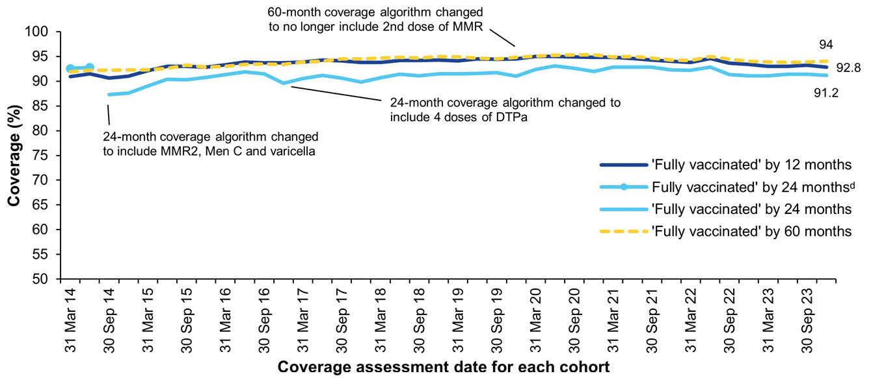
a Source: Australian Immunisation Register.
b MMR2: second dose of MMR vaccine; MenC: meningococcal C-containing vaccine; DTPa: diphtheria-tetanus-pertussis vaccine.
c By three-month birth cohorts born between 1 January 2009 and 31 December 2022. Coverage assessment date was 12, 24 or 60 months after the last birthdate of each cohort. Vaccination coverage estimates are calculated by quarter and may differ slightly from estimates published elsewhere using rolling annualised data.
d Coverage algorithm before 1 July 2014.
Figure A.2: Trends in vaccination coverage at 12 months of age, by vaccine/antigen and quarter, Australia,^{a,b,c,d} 2014–2023
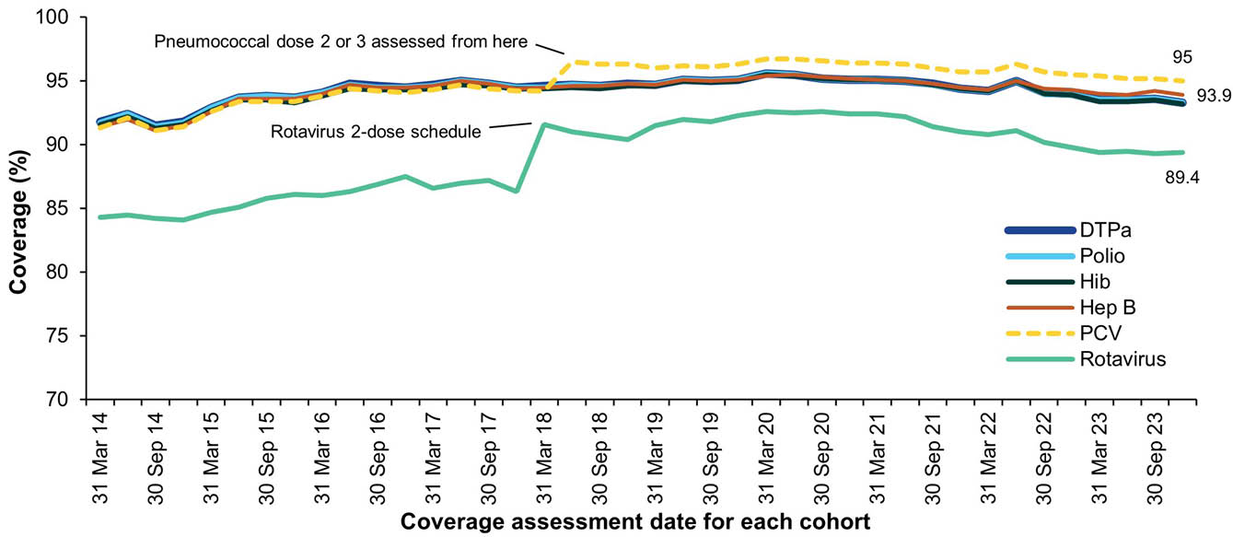
a Source: Australian Immunisation Register.
b Third dose of DTPa vaccine, polio vaccine and hepatitis B vaccine, second or third dose of 13vPCV and Hib vaccines and second dose of rotavirus vaccine (vaccines included in the 12-month definition of fully vaccinated coverage + rotavirus vaccine).
c DTPa: diphtheria-tetanus-pertussis; Hib: Haemophilus influenzae type b; Hep B: hepatitis B; 13vPCV: pneumococcal conjugate vaccine.
d By three-month birth cohorts born between 1 January 2013 and 31 December 2022. Coverage assessment date was 12 months after the last birthdate of each cohort. Vaccination coverage estimates are calculated by quarter and may differ slightly from estimates published elsewhere using rolling annualised data.
Figure A.3: Trends in vaccination coverage at 24 months of age by vaccine/antigen and quarter, Australia,^{a,b,c,d} 2014–2023
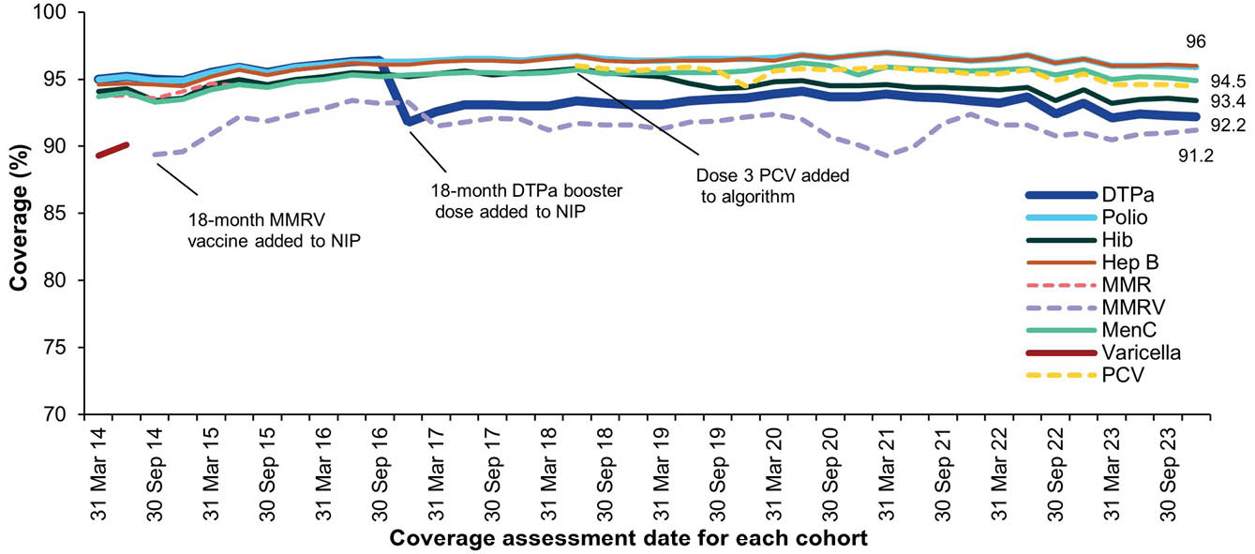
a Source: Australian Immunisation Register.
b Fourth dose of DTPa, third dose of polio, third or fourth dose of Hib, third dose of hepatitis B, second dose of MMR, dose 2 of MMRV, first dose of MenC, one dose of varicella and third or fourth dose of 13vPCV (vaccines included in the 24-month definition of fully vaccinated coverage).
c DTPa: diphtheria-tetanus-pertussis; Hib: Haemophilus influenzae type b; Hep B: hepatitis B; MMR: measles-mumps-rubella; MenC: meningococcal C-containing; MMRV: measles-mumps-rubella-varicella; 13vPCV: pneumococcal conjugate vaccine.
d By three-month birth cohorts born between 1 January 2012 and 31 December 2021. Coverage assessment date was 24 months after the last birthdate of each cohort. Vaccination coverage estimates are calculated by quarter and may differ slightly from estimates published elsewhere using rolling annualised data.
Figure A.4: Trends in vaccination coverage at 60 months of age by vaccine/antigen and quarter, Australia,^{a,b,c,d} 2014–2023
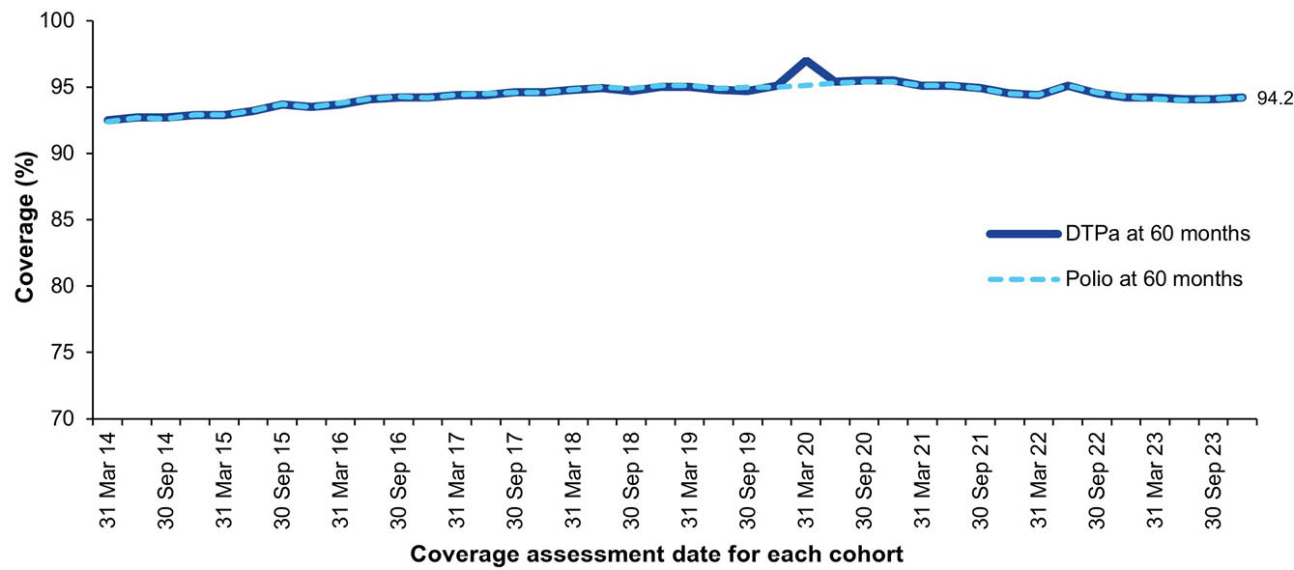
a Source: Australian Immunisation Register.
b Fourth or fifth dose of DTPa and fourth dose of polio, second dose of MMR (included in fully vaccinated algorithm until June 2017).
c DTPa: diphtheria-tetanus-pertussis; MMR: measles-mumps-rubella (vaccines included in the 60-month definition of fully vaccinated coverage).
d By three-month birth cohorts born between 1 January 2009 and 31 December 2018. Coverage assessment date was 60 months after the last birth date of each cohort. Vaccination coverage estimates are calculated by quarter and may differ slightly from estimates published elsewhere using rolling annualised data.
Figure A.5: Trends in fully vaccinated coverage at 12 months of age by Indigenous status and quarter, Australia,^{a,b} 2014–2023
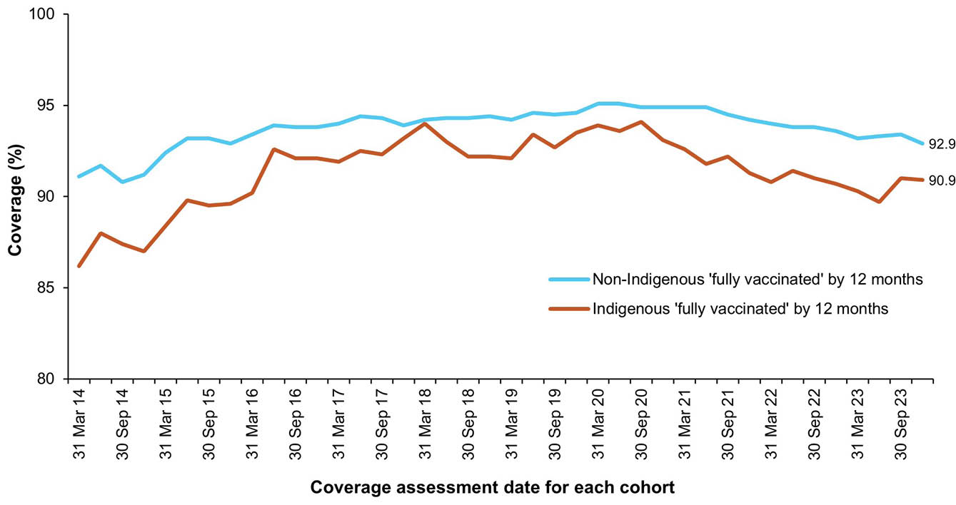
a Source: Australian Immunisation Register.
b Vaccination coverage estimates are calculated using three-month-wide birth cohorts by quarter and may differ slightly from estimates published elsewhere using rolling annualised data.
Figure A.6: Trends in fully vaccinated coverage at 24 months of age by Indigenous status and quarter, Australia,^{a,b} 2014–2023
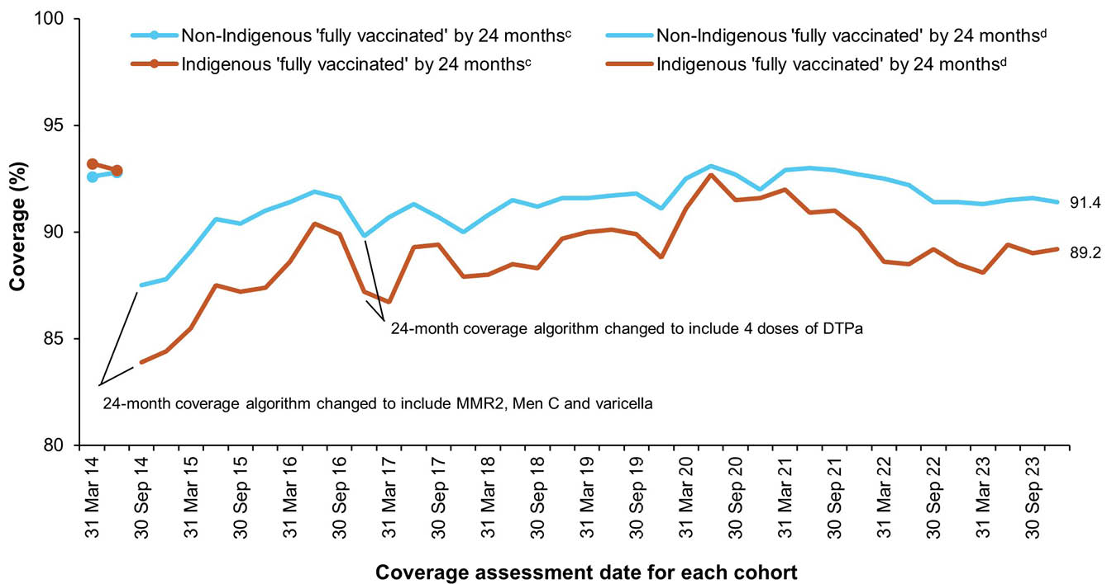
a Source: Australian Immunisation Register.
b Vaccination coverage estimates are calculated using three-month-wide birth cohorts by quarter and may differ slightly from estimates published elsewhere using rolling annualised data.
c Coverage algorithm before 1 July 2014.
d Coverage algorithm from 1 July 2014.
Figure A.7: Trends in fully vaccinated coverage at 60 months of age by Indigenous status and quarter, Australia,^{a,b} 2014–2023
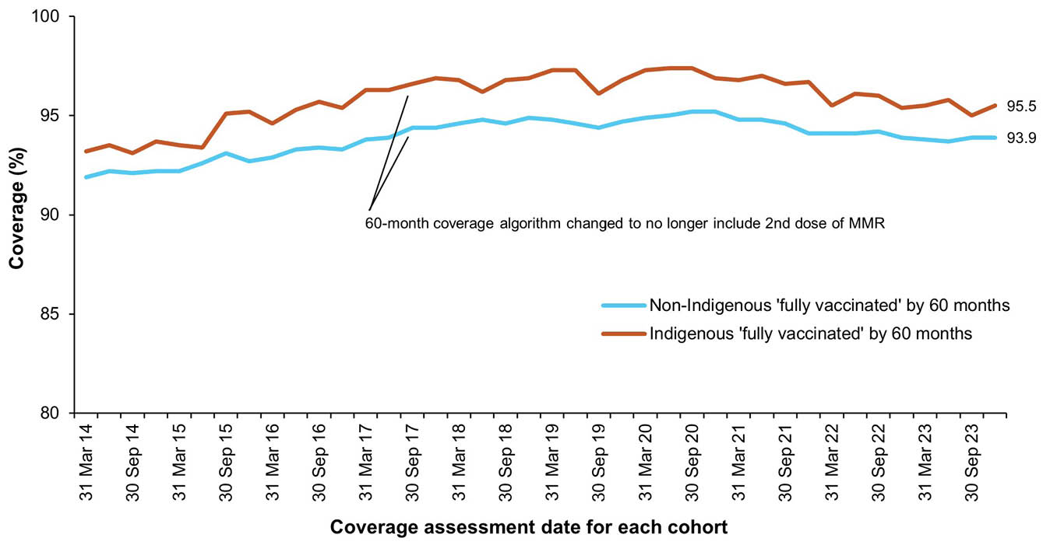
a Source: Australian Immunisation Register.
b Vaccination coverage estimates are calculated using three-month-wide birth cohorts by quarter and may differ slightly from estimates published elsewhere using rolling annualised data.
Figure A.8: Trends in coverage for hepatitis A vaccine by 30 months of age for Indigenous children by jurisdiction, Australia,^{a,b,c} 2014–2023
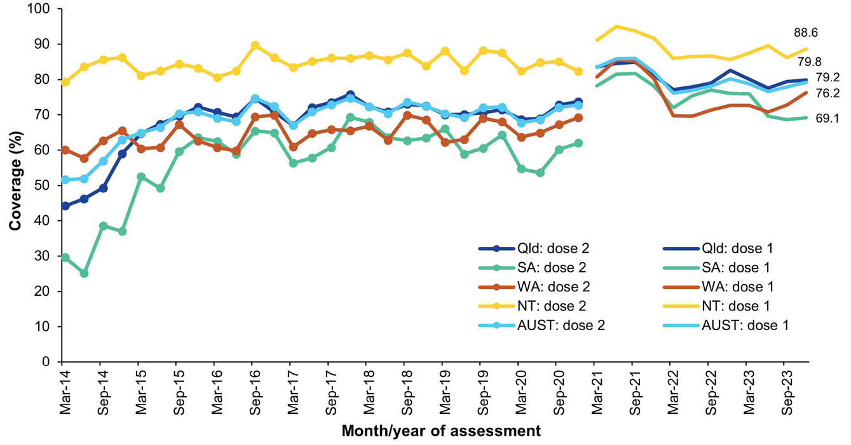
a Source: Australian Immunisation Register.
b Vaccination coverage estimates are calculated using three-month-wide birth cohorts by quarter.
c 18-month dose assessed (NT, Qld, SA and WA only):^{d} scheduled ages for hepatitis A vaccination changed from 12 to 18 months (dose 1) and from 18 months to 4 years (dose 2) from July 2020.
d NT: Northern Territory; Qld: Queensland; SA: South Australia; WA: Western Australia; AUST: Australia. Note that ‘AUST’ here indicates the total for the four jurisdictions covered.
Figure A.9: Trends in coverage for pneumococcal vaccine for Indigenous children by jurisdiction, Australia,^{a,b,c,d} 2014–2023
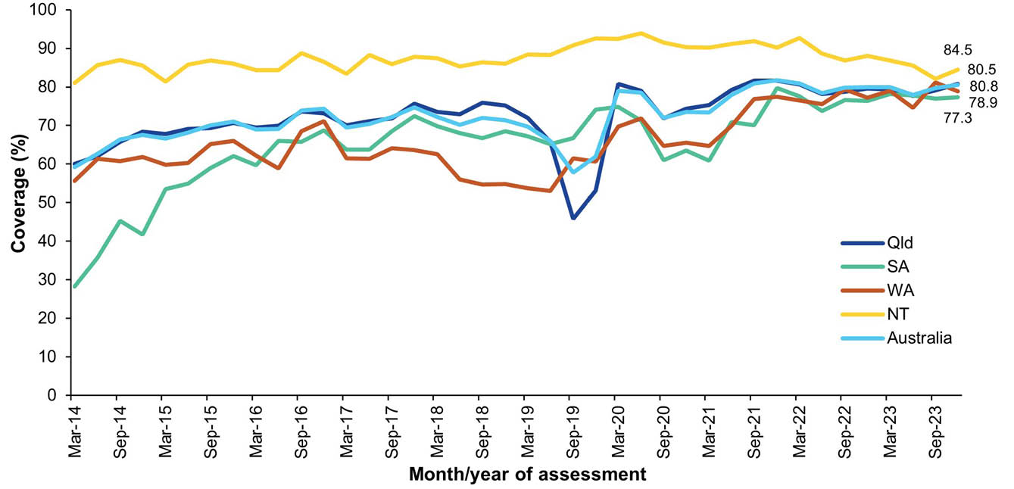
a Source: Australian Immunisation Register.
b Vaccination coverage estimates are calculated using three-month-wide birth cohorts by quarter.
c 12-month booster dose (4th dose) assessed at 30 months of age in all four jurisdictions (NT, Qld, SA and WA only)^{e}
d 13vPCV: 13-valent pneumococcal conjugate vaccine.
e NT: Northern Territory; Qld: Queensland; SA: South Australia; WA: Western Australia. Note that ‘Australia’ here indicates the total for the four jurisdictions covered.
Figure A.10: Proportion of all vaccinations given to people of all ages by provider setting and jurisdiction, Australia,^{a,b,c} 2023
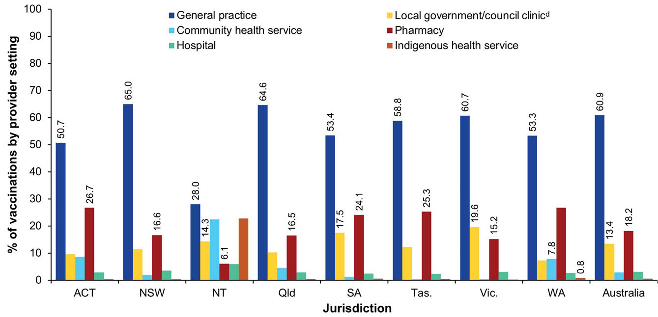
a Source: Australian Immunisation Register data as at 4 February 2024.
b Includes all vaccine encounters administered in 2023 and reported to the AIR (i.e. both NIP and non-NIP vaccines) for all Medicare- registered people of all ages.
c ACT: Australian Capital Territory; NSW: New South Wales; NT: Northern Territory; Qld: Queensland; SA: South Australia; Tas.: Tasmania; Vic.: Victoria; WA: Western Australia.
d Includes Public Health Units and State Health.
Table A.3: Fully vaccinated coverage assessed at standard age milestones (12, 24 and 60 months) and earlier (9, 15, 21, 51 months) milestones, all children, by Primary Health Network (PHN) and jurisdiction, Australia,ª 2023
Jurisdiction and PHN | Age milestone
Jurisdiction and PHN | 9 mo^{b} | 12 mo^{b} | 15 mo^{c} | 21 mo^{c} | 24 mo^{c} | 51 mo^{d} | 60 mo^{d}
Australian Capital Territory | 94.6 | 96.1 | 93.8 | 92.1 | 94.1 | 90.0 | 95.1
Australian Capital Territory | 94.6 | 96.1 | 93.8 | 92.1 | 94.1 | 90.0 | 95.1
New South Wales | 89.7 | 93.0 | 89.2 | 87.3 | 90.9 | 86.0 | 93.4
Central and Eastern Sydney | 90.4 | 93.2 | 89.0 | 86.9 | 90.1 | 84.0 | 91.4
Hunter New England and Central Coast | 91.2 | 94.1 | 91.1 | 89.3 | 92.9 | 88.1 | 94.9
Murrumbidgee | 90.0 | 93.1 | 91.1 | 89.0 | 92.2 | 88.9 | 95.3
Nepean Blue Mountains | 90.4 | 93.6 | 89.7 | 88.0 | 91.6 | 87.0 | 95.0
North Coast | 83.8 | 87.3 | 83.7 | 81.8 | 86.0 | 80.2 | 88.4
Northern Sydney | 92.5 | 94.7 | 90.5 | 89.2 | 91.8 | 85.9 | 92.8
South Eastern NSW | 91.8 | 94.6 | 90.7 | 89.1 | 92.3 | 87.7 | 94.8
South Western Sydney | 87.3 | 91.6 | 87.7 | 85.8 | 89.9 | 85.6 | 93.7
Western NSW | 91.5 | 94.9 | 91.4 | 89.2 | 93.4 | 88.6 | 96.0
Western Sydney | 88.3 | 92.3 | 88.1 | 86.2 | 90.2 | 86.3 | 94.0
Northern Territory | 85.3 | 91.6 | 84.9 | 81.6 | 88.1 | 77.2 | 90.9
Northern Territory | 85.3 | 91.6 | 84.9 | 81.6 | 88.1 | 77.2 | 90.9
Queensland | 87.8 | 92.0 | 87.8 | 85.9 | 90.2 | 83.7 | 92.0
Brisbane North | 90.8 | 94.4 | 89.8 | 88.1 | 92.0 | 86.1 | 93.4
Brisbane South | 89.1 | 92.9 | 88.6 | 87.0 | 90.9 | 84.3 | 92.2
Central Queensland, Wide Bay, Sunshine Coast | 85.1 | 89.3 | 85.5 | 83.5 | 87.9 | 81.4 | 90.1
Darling Downs and West Moreton | 88.7 | 92.8 | 88.4 | 86.7 | 90.9 | 85.2 | 93.0
Gold Coast | 84.2 | 88.5 | 84.6 | 83.0 | 87.6 | 80.7 | 89.6
Northern Queensland | 87.1 | 92.4 | 88.7 | 85.7 | 90.9 | 84.1 | 93.3
Western Queensland | 84.0 | 90.9 | 85.7 | 82.1 | 88.9 | 76.7 | 92.1
South Australia | 89.2 | 93.0 | 89.8 | 87.7 | 91.5 | 87.1 | 94.6
Adelaide | 89.8 | 93.4 | 90.1 | 88.1 | 91.9 | 87.4 | 94.7
Country SA | 86.8 | 91.7 | 88.4 | 85.6 | 89.8 | 85.2 | 94.2
Tasmania | 90.1 | 94.1 | 90.5 | 88.0 | 92.2 | 85.6 | 93.9
Tasmania | 90.1 | 94.1 | 90.5 | 88.0 | 92.2 | 85.6 | 93.9
Victoria | 89.1 | 93.4 | 89.2 | 87.7 | 91.3 | 86.9 | 94.2
Eastern Melbourne | 89.8 | 93.9 | 89.9 | 88.3 | 91.9 | 87.1 | 94.5
Gippsland | 87.6 | 91.8 | 88.6 | 86.6 | 90.7 | 87.8 | 94.6
Murray | 89.6 | 93.9 | 90.5 | 88.9 | 92.6 | 86.8 | 94.8
North Western Melbourne | 88.2 | 93.0 | 88.0 | 86.5 | 90.2 | 86.5 | 93.9
South Eastern Melbourne | 88.8 | 93.2 | 88.9 | 87.5 | 91.1 | 86.5 | 93.8
Western Victoria | 90.5 | 94.4 | 90.9 | 89.6 | 92.8 | 88.4 | 95.3
Western Australia | 86.4 | 91.5 | 87.3 | 84.3 | 89.3 | 82.2 | 92.3
Country WA | 82.0 | 88.8 | 84.1 | 79.6 | 86.4 | 78.0 | 91.1
Perth North | 88.1 | 92.6 | 88.3 | 85.5 | 90.0 | 82.8 | 92.3
Perth South | 87.1 | 91.8 | 87.9 | 85.5 | 90.2 | 83.7 | 92.7
Australia | 88.8 | 92.8 | 88.8 | 86.8 | 90.8 | 85.4 | 93.3
a Coverage algorithm used for 9-, 21- and 51-month milestones same as for 12-,24- and 60-month milestones, respectively; algorithm used for 15 months same as for 24 months but excludes doses due at 18 months. For further detail on algorithms, refer to Appendix A, Table A.2.
b Cohort born 1 January – 31 December 2022.
c Cohort born 1 January – 31 December 2021.
d Cohort born 1 January – 31 December 2018.
Table A.4: Fully vaccinated coverage assessed at standard age milestones (12, 24 and 60 months) and earlier (9, 15, 21, 51 months) milestones, Indigenous children, by Primary Health Network (PHN) and jurisdiction, Australia,ª 2023
Jurisdiction and PHN | Age milestone
Jurisdiction and PHN | 9 mo^{b} | 12 mo^{b} | 15 mo^{c} | 21 mo^{c} | 24 mo^{c} | 51 mo^{d} | 60 mo^{d}
Australian Capital Territory | 86.3 | 91.6 | 90.0 | 87.4 | 92.6 | 87.7 | 96.1
Australian Capital Territory | 86.3 | 91.6 | 90.0 | 87.4 | 92.6 | 87.7 | 96.1
New South Wales | 86.1 | 92.0 | 87.4 | 84.5 | 90.6 | 86.3 | 96.2
Central and Eastern Sydney | 87.2 | 93.2 | 80.8 | 81.1 | 87.0 | 81.3 | 93.8
Hunter New England and Central Coast | 87.6 | 92.4 | 89.0 | 85.4 | 91.6 | 87.1 | 96.5
Murrumbidgee | 83.7 | 92.3 | 90.3 | 87.1 | 92.3 | 90.9 | 97.6
Nepean Blue Mountains | 88.1 | 93.1 | 88.4 | 86.5 | 90.5 | 87.9 | 96.9
North Coast | 84.5 | 90.2 | 85.6 | 83.1 | 89.0 | 84.2 | 93.8
Northern Sydney | 86.4 | 93.2 | 83.9 | 82.1 | 88.4 | 89.9 | 97.5
South Eastern NSW | 84.8 | 90.5 | 88.9 | 84.3 | 91.5 | 85.3 | 96.1
South Western Sydney | 84.8 | 91.1 | 85.2 | 83.3 | 89.2 | 83.9 | 95.6
Western NSW | 86.7 | 93.1 | 87.8 | 83.4 | 90.5 | 85.9 | 97.3
Western Sydney | 83.6 | 91.0 | 84.6 | 83.4 | 89.2 | 85.9 | 96.2
Northern Territory | 74.4 | 87.3 | 76.9 | 71.0 | 82.4 | 70.9 | 92.0
Northern Territory | 74.4 | 87.3 | 76.9 | 71.0 | 82.4 | 70.9 | 92.0
Queensland | 79.5 | 89.3 | 83.7 | 80.5 | 88.3 | 81.3 | 94.8
Brisbane North | 81.8 | 91.0 | 83.5 | 81.6 | 88.8 | 84.6 | 96.7
Brisbane South | 78.9 | 88.6 | 83.9 | 82.3 | 88.0 | 82.4 | 93.5
Central Queensland, Wide Bay, Sunshine Coast | 82.2 | 89.8 | 83.3 | 81.5 | 87.6 | 80.6 | 94.1
Darling Downs and West Moreton | 81.9 | 89.9 | 84.8 | 83.2 | 90.2 | 84.7 | 95.1
Gold Coast | 79.8 | 85.1 | 86.9 | 83.8 | 90.3 | 84.6 | 93.5
Northern Queensland | 76.7 | 88.9 | 83.7 | 78.0 | 88.3 | 79.9 | 95.5
Western Queensland | 75.7 | 88.3 | 78.5 | 73.8 | 83.8 | 72.4 | 93.3
South Australia | 79.1 | 88.2 | 84.1 | 79.4 | 86.9 | 81.8 | 95.5
Adelaide | 79.3 | 88.4 | 85.4 | 80.7 | 87.3 | 82.7 | 95.0
Country SA | 75.0 | 87.2 | 79.4 | 73.3 | 83.2 | 76.4 | 95.4
Tasmania | 87.6 | 94.6 | 88.2 | 87.1 | 92.2 | 86.5 | 96.0
Tasmania | 87.6 | 94.6 | 88.2 | 87.1 | 92.2 | 86.5 | 96.0
Victoria | 84.9 | 91.8 | 84.9 | 83.2 | 88.5 | 83.8 | 95.1
Eastern Melbourne | 84.6 | 90.7 | 79.2 | 80.4 | 85.0 | 83.2 | 94.6
Gippsland | 79.7 | 88.1 | 84.1 | 81.9 | 89.1 | 81.3 | 92.7
Murray | 82.4 | 90.0 | 87.1 | 83.3 | 88.9 | 81.4 | 95.1
North Western Melbourne | 87.8 | 93.3 | 85.0 | 82.8 | 87.4 | 85.0 | 96.5
South Eastern Melbourne | 85.8 | 93.3 | 83.9 | 82.5 | 88.8 | 90.7 | 96.7
Western Victoria | 86.4 | 93.6 | 86.3 | 87.1 | 90.7 | 83.3 | 94.6
Western Australia | 68.2 | 83.5 | 75.5 | 68.3 | 80.1 | 72.1 | 93.9
Country WA | 67.1 | 83.4 | 72.2 | 65.1 | 78.1 | 69.8 | 93.8
Perth North | 69.6 | 83.7 | 76.2 | 69.4 | 81.3 | 71.8 | 92.6
Perth South | 70.6 | 83.7 | 80.3 | 72.3 | 82.2 | 76.1 | 94.6
Australia | 80.8 | 89.7 | 83.9 | 80.2 | 87.8 | 81.4 | 95.0
a Coverage algorithm used for 9-, 21- and 51-month milestones same as for 12-,24- and 60-month milestones, respectively; algorithm used for 15 months same as for 24 months but excludes doses due at 18 months. For further detail on algorithms, refer to Appendix A, Table A.2.
b Cohort born 1 January – 31 December 2022.
c Cohort born 1 January – 31 December 2021.
d Cohort born 1 January – 31 December 2018.

Table A.5: Coverage of at least one dose of HPV vaccine in females by birth cohort/age, Indigenous status and jurisdiction, Australia,^{a,b,c,d,e} 2023
Cohort^{d} | Indigenous status
Cohort^{d} | All |  |  |  |  |  |  |  | Indigenous
Cohort^{d} | ACT | NSW | NT | Qld | SA | Tas. | Vic. | WA | ACT | NSW | NT | Qld | SA | Tas. | Vic. | WA
2010 cohort (13 yo) | 84.0 | 75.3 | 63.9 | 71.2 | 72.5 | 74.4 | 76.3 | 73.0 | 75.0 | 63.6 | 55.0 | 59.3 | 50.8 | 70.7 | 63.0 | 57.1
2009 cohort (14 yo) | 86.9 | 81.4 | 73.1 | 77.0 | 77.9 | 77.8 | 81.9 | 79.3 | 83.3 | 79.1 | 69.0 | 70.2 | 59.4 | 75.1 | 75.2 | 71.9
2008 cohort (15 yo) | 90.9 | 86.4 | 79.5 | 82.1 | 83.8 | 84.4 | 85.7 | 83.0 | 91.7 | 87.3 | 75.5 | 81.0 | 68.7 | 82.2 | 81.6 | 80.1
2007 cohort (16 yo) | 90.9 | 87.4 | 84.2 | 83.3 | 86.1 | 85.9 | 87.6 | 85.4 | 90.4 | 89.4 | 84.1 | 83.0 | 79.0 | 86.2 | 85.1 | 85.9
2006 cohort (17 yo) | 91.5 | 88.7 | 89.6 | 84.4 | 87.6 | 89.5 | 88.8 | 85.5 | 91.4 | 92.9 | 92.7 | 87.5 | 81.2 | 91.4 | 89.9 | 87.1
2005 cohort (18 yo) | 91.3 | 88.8 | 89.7 | 85.5 | 88.5 | 90.8 | 89.6 | 86.6 | 88.9 | 92.9 | 93.9 | 89.0 | 83.5 | 89.9 | 88.9 | 86.8
2004 cohort (19 yo) | 90.7 | 88.6 | 91.3 | 85.6 | 88.6 | 90.5 | 89.4 | 85.9 | 91.6 | 92.7 | 95.5 | 89.9 | 82.9 | 90.9 | 91.5 | 88.6
2003 cohort (20 yo) | 89.7 | 88.4 | 91.0 | 85.1 | 88.7 | 89.9 | 88.9 | 86.7 | 90.1 | 92.8 | 94.6 | 89.9 | 91.3 | 91.6 | 90.7 | 90.1
2002 cohort (21 yo) | 88.9 | 87.2 | 91.8 | 85.2 | 88.2 | 89.0 | 88.3 | 85.9 | 89.2 | 89.6 | 95.6 | 88.9 | 87.7 | 87.3 | 88.8 | 87.5
2001 cohort (22 yo) | 87.5 | 84.7 | 90.6 | 83.7 | 87.4 | 87.2 | 85.4 | 84.7 | 93.2 | 85.8 | 94.3 | 86.4 | 80.6 | 88.5 | 87.6 | 86.9
2000 cohort (23 yo) | 83.1 | 81.8 | 86.7 | 81.0 | 83.8 | 82.9 | 82.0 | 80.3 | 85.3 | 85.4 | 93.6 | 81.8 | 74.8 | 81.3 | 82.1 | 82.6
1999 cohort (24 yo) | 80.9 | 77.7 | 82.4 | 77.8 | 82.8 | 78.8 | 79.4 | 78.4 | 85.7 | 79.0 | 89.0 | 77.4 | 80.9 | 80.2 | 80.8 | 79.7
1998 cohort (25 yo) | 76.9 | 71.6 | 78.6 | 74.6 | 78.9 | 74.8 | 76.0 | 75.5 | 82.7 | 73.8 | 87.8 | 72.9 | 71.6 | 78.3 | 77.1 | 82.2
a Source: Australian Immunisation Register data as at 4 February 2024.
b Coverage calculated using the number of Medicare-registered females in each year-wide cohort with an AIR record of having received at least one dose of HPV vaccine by 31 December 2023 as the numerator and the total number of Medicare-registered females in the relevant age cohort as the denominator, expressed as a percentage.
c Note: Coverage data for the cohort of 15-year-olds presented in this table include doses given before and after their fifteenth birthday. Data may therefore differ slightly from data presented in Table 2, where coverage only includes doses given before the fifteenth birthday (in line with WHO recommendations for international reporting).
d Birth/age cohort based on age turning in 2023.
e ACT: Australian Capital Territory; NSW: New South Wales; NT: Northern Territory; Qld: Queensland; SA: South Australia; Tas.: Tasmania; Vic.: Victoria; WA: Western Australia.
Table A.6: Coverage of at least one dose of HPV vaccine in males by birth cohort/age, Indigenous status and jurisdiction, Australia,^{a,b,c,d,e} 2023
Cohort^{d} | Indigenous status
Cohort^{d} | All |  |  |  |  |  |  |  | Indigenous
Cohort^{d} | ACT | NSW | NT | Qld | SA | Tas. | Vic. | WA | ACT | NSW | NT | Qld | SA | Tas. | Vic. | WA
2010 cohort (13 yo) | 83.4 | 70.7 | 57.7 | 66.8 | 69.3 | 69.9 | 72.1 | 69.9 | 75.8 | 57.8 | 47.0 | 53.3 | 42.7 | 64.7 | 57.8 | 51.9
2009 cohort (14 yo) | 86.5 | 76.5 | 63.9 | 74.0 | 72.9 | 73.7 | 79.0 | 77.8 | 80.5 | 68.2 | 54.6 | 63.3 | 47.8 | 68.7 | 69.4 | 68.2
2008 cohort (15 yo) | 88.5 | 83.1 | 74.5 | 79.5 | 81.1 | 81.5 | 84.0 | 82.5 | 75.3 | 81.3 | 69.1 | 75.9 | 60.5 | 83.7 | 77.0 | 74.9
2007 cohort (16 yo) | 88.7 | 85.0 | 81.2 | 81.5 | 84.3 | 81.7 | 85.3 | 84.0 | 83.1 | 84.4 | 80.1 | 80.1 | 69.1 | 82.7 | 83.0 | 81.9
2006 cohort (17 yo) | 90.0 | 86.3 | 82.9 | 82.9 | 85.7 | 85.5 | 87.3 | 85.0 | 84.6 | 87.9 | 83.7 | 81.3 | 76.7 | 85.2 | 84.9 | 81.9
2005 cohort (18 yo) | 88.8 | 87.1 | 87.2 | 83.8 | 87.2 | 87.6 | 87.5 | 85.4 | 80.3 | 88.4 | 88.8 | 86.0 | 80.6 | 87.1 | 84.3 | 82.5
2004 cohort (19 yo) | 89.6 | 85.9 | 89.1 | 83.0 | 86.2 | 88.5 | 87.1 | 85.2 | 87.9 | 86.4 | 93.0 | 86.9 | 79.0 | 87.7 | 89.5 | 84.4
2003 cohort (20 yo) | 88.4 | 85.3 | 88.3 | 82.0 | 86.4 | 88.0 | 86.7 | 84.3 | 86.3 | 87.8 | 91.9 | 84.7 | 80.9 | 84.4 | 87.3 | 84.9
2002 cohort (21 yo) | 88.0 | 83.8 | 88.1 | 81.3 | 85.5 | 85.9 | 85.6 | 83.3 | 80.3 | 83.8 | 92.4 | 82.4 | 80.5 | 82.8 | 86.2 | 85.0
2001 cohort (22 yo) | 81.8 | 79.1 | 85.4 | 79.3 | 83.9 | 80.9 | 81.7 | 81.7 | 80.3 | 77.2 | 91.4 | 77.7 | 78.4 | 79.3 | 80.1 | 79.5
2000 cohort (23 yo) | 77.8 | 72.8 | 81.3 | 74.9 | 79.2 | 75.7 | 76.9 | 73.6 | 67.7 | 69.0 | 86.5 | 73.8 | 70.5 | 74.5 | 70.6 | 68.1
1999 cohort (24 yo) | 75.2 | 69.0 | 73.1 | 69.1 | 75.5 | 72.6 | 73.6 | 65.8 | 66.7 | 60.0 | 74.6 | 62.8 | 59.5 | 66.9 | 63.7 | 55.3
1998 cohort (25 yo) | 59.1 | 49.7 | 57.5 | 63.9 | 53.2 | 63.9 | 60.8 | 62.8 | 43.5 | 47.3 | 58.3 | 53.1 | 46.3 | 55.4 | 53.9 | 44.6
a Source: Australian Immunisation Register data as at 4 February 2024.
b Coverage calculated using the number of Medicare-registered males in each year-wide cohort with an AIR record of having received at least one dose of HPV vaccine by 31 December 2023 as the numerator and the total number of Medicare-registered males in the relevant age cohort as the denominator, expressed as a percentage.
c Note: Coverage data for the cohort of 15-year-olds presented in this table include doses given before and after their fifteenth birthday. Data may therefore differ slightly from data presented in Table 2, where coverage only includes doses given before the fifteenth birthday (in line with WHO recommendations for international reporting).
d Birth/age cohort based on age turning in 2023.
e ACT: Australian Capital Territory; NSW: New South Wales; NT: Northern Territory; Qld: Queensland; SA: South Australia; Tas.: Tasmania; Vic.: Victoria; WA: Western Australia.
Table A.7: Coverage of a dose of diphtheria-tetanus-acellular pertussis vaccine in adolescents by age, Indigenous status and jurisdiction, Australia,^{a,b,c,d} 2023
Cohort^{c} | Indigenous status
Cohort^{c} | All |  |  |  |  |  |  |  | Indigenous
Cohort^{c} | ACT | NSW | NT | Qld | SA | Tas. | Vic. | WA | ACT | NSW | NT | Qld | SA | Tas. | Vic. | WA
2010 cohort (13 yo) | 82.6 | 74.2 | 61.9 | 71.5 | 73.5 | 72.7 | 75.7 | 74.1 | 73.7 | 61.5 | 52.1 | 57.4 | 48.7 | 70.4 | 61.0 | 56.0
2009 cohort (14 yo) | 82.0 | 80.3 | 69.5 | 77.5 | 78.2 | 76.1 | 81.6 | 81.0 | 70.1 | 74.6 | 62.6 | 67.9 | 55.4 | 71.5 | 72.7 | 71.0
2008 cohort (15 yo) | 86.8 | 86.7 | 77.7 | 83.1 | 85.2 | 83.5 | 86.5 | 85.8 | 76.6 | 85.8 | 72.3 | 79.8 | 65.7 | 81.6 | 79.4 | 79.1
2007 cohort (16 yo) | 89.2 | 88.4 | 83.2 | 85.2 | 88.1 | 85.4 | 88.2 | 87.9 | 85.3 | 88.2 | 81.1 | 83.7 | 76.6 | 86.1 | 84.7 | 84.8
2006 cohort (17 yo) | 91.0 | 89.8 | 86.7 | 86.5 | 89.9 | 88.9 | 90.0 | 88.8 | 84.5 | 91.8 | 87.6 | 86.4 | 81.4 | 91.1 | 88.8 | 86.3
2005 cohort (18 yo) | 89.7 | 89.7 | 88.5 | 87.1 | 90.6 | 88.1 | 89.9 | 89.3 | 78.2 | 90.7 | 88.9 | 87.8 | 85.1 | 87.7 | 88.1 | 86.6
2004 cohort (19 yo) | 88.5 | 89.0 | 87.6 | 86.7 | 89.7 | 86.5 | 89.3 | 88.8 | 84.7 | 89.1 | 89.3 | 90.0 | 82.1 | 86.7 | 88.6 | 87.4
a Source: Australian Immunisation Register data as at 4 February 2024.
b Coverage calculated using the number of Medicare-registered individuals in each year-wide cohort with an AIR record of having received an adolescent (i.e. ≥ 10 years of age) dose of diphtheria-tetanus-acellular pertussis vaccine (recorded as either dTpa or DTPa) by 31 December 2023 as the numerator and the total number of Medicare-registered adolescents in the relevant age cohort as the denominator, expressed as a percentage.
c Birth/age cohort based on age turning in 2023.
d ACT: Australian Capital Territory; NSW: New South Wales; NT: Northern Territory; Qld: Queensland; SA: South Australia; Tas.: Tasmania; Vic.: Victoria; WA: Western Australia.
Table A.8: Coverage of a dose of meningococcal ACWY vaccine in adolescents by age, Indigenous status and jurisdiction, Australia,^{a,b,c,d} 2023
Cohort^{d} | Indigenous status
Cohort^{d} | All |  |  |  |  |  |  |  | Indigenous
Cohort^{d} | ACT | NSW | NT | Qld | SA | Tas. | Vic. | WA | ACT | NSW | NT | Qld | SA | Tas. | Vic. | WA
2008 cohort (15 yo) | 22.1 | 19.8 | 51.6 | 28.7 | 24.9 | 49.6 | 16.1 | 33.2 | 16.1 | 12.8 | 36.6 | 23.7 | 14.8 | 55.0 | 11.8 | 25.6
2007 cohort (16 yo) | 77.9 | 65.1 | 74.2 | 63.1 | 72.4 | 84.3 | 68.0 | 66.4 | 71.3 | 45.8 | 78.7 | 54.6 | 51.5 | 82.8 | 48.4 | 51.9
2006 cohort (17 yo) | 82.5 | 70.5 | 81.1 | 69.4 | 77.5 | 85.4 | 74.9 | 74.2 | 68.6 | 62.3 | 88.4 | 69.8 | 64.0 | 86.4 | 62.5 | 64.7
2005 cohort (18 yo) | 85.4 | 76.0 | 81.8 | 75.2 | 82.7 | 86.4 | 78.4 | 79.0 | 68.6 | 62.3 | 88.4 | 69.8 | 64.0 | 86.4 | 62.5 | 64.7
2004 cohort (19 yo) | 87.2 | 79.4 | 81.8 | 77.0 | 82.4 | 86.4 | 79.2 | 81.1 | 73.0 | 68.0 | 87.3 | 73.0 | 68.6 | 87.4 | 67.3 | 70.7
a Source: Australian Immunisation Register data as at 4 February 2024.
b Coverage calculated using the number of Medicare-registered individuals in each year-wide cohort with an AIR record of having received an adolescent (i.e. ≥ 10 years of age) dose of meningococcal ACWY vaccine by 31 December 2023 as the numerator and the total number of Medicare-registered adolescents in the relevant age cohort as the denominator, expressed as a percentage.
c Birth/age cohort based on age turning in 2023.
d ACT: Australian Capital Territory; NSW: New South Wales; NT: Northern Territory; Qld: Queensland; SA: South Australia; Tas.: Tasmania; Vic.: Victoria; WA: Western Australia.
Table A.9.1: Recorded coverage of seasonal influenza vaccine by age group, jurisdiction and Indigenous status, Australia,^{a,b} 2022
Age group | Jurisdiction^{c}
Age group | ACT |  | NSW |  | NT |  | Qld |  | SA |  | Tas. |  | Vic. |  | WA
Age group | All | Indigenous | All | Indigenous | All | Indigenous | All | Indigenous | All | Indigenous | All | Indigenous | All | Indigenous | All | Indigenous
6–59 mo | 56.4 | 37.7 | 33.1 | 23.0 | 47.3 | 54.6 | 27.4 | 19.6 | 35.8 | 22.0 | 38.6 | 28.9 | 39.6 | 27.1 | 30.0 | 22.5
5–9 yrs | 31.1 | 22.2 | 24.5 | 17.6 | 20.2 | 32.7 | 19.9 | 14.6 | 25.6 | 17.4 | 25.3 | 20.5 | 28.0 | 18.5 | 20.7 | 18.3
10–19 yrs | 25.6 | 21.2 | 21.6 | 18.2 | 21.0 | 32.4 | 19.7 | 16.8 | 26.2 | 20.1 | 24.9 | 22.0 | 25.3 | 20.5 | 19.7 | 18.4
20–49 yrs | 38.8 | 31.1 | 29.2 | 24.1 | 29.7 | 45.2 | 27.0 | 23.2 | 36.9 | 29.7 | 34.6 | 30.5 | 33.7 | 27.2 | 27.5 | 27.3
50–64 yrs | 52.9 | 54.3 | 44.6 | 50.4 | 34.6 | 58.8 | 44.9 | 47.7 | 54.7 | 55.3 | 55.3 | 62.4 | 48.8 | 51.8 | 45.4 | 50.8
65+ yrs | 72.4 | 74.3 | 67.5 | 73.4 | 43.3 | 59.7 | 69.4 | 68.2 | 76.7 | 72.7 | 76.5 | 82.1 | 71.3 | 74.1 | 70.3 | 65.4
a Source: Australian Immunisation Register data as at 2 April 2023.
b Coverage calculated by dividing the number of Medicare-registered people with at least one dose of influenza vaccine administered in 2022 by the total number of Medicare-registered people registered in each age group. Vaccination numerators based on age at vaccination and age group denominators based on age at 30 June 2022. Coverage data in this table may differ slightly from estimates published elsewhere due to differences in calculation methodologies and/or the AIR data being used in the calculation having been downloaded on different dates.
c ACT: Australian Capital Territory; NSW: New South Wales; NT: Northern Territory; Qld: Queensland; SA: South Australia; Tas.: Tasmania; Vic.: Victoria; WA: Western Australia.
Table A.9.2: Recorded coverage of seasonal influenza vaccine by age group, jurisdiction and Indigenous status, Australia,^{a,b} 2023
Age group | Jurisdiction^{c}
Age group | ACT |  | NSW |  | NT |  | Qld |  | SA |  | Tas. |  | Vic. |  | WA
Age group | All | Indigenous | All | Indigenous | All | Indigenous | All | Indigenous | All | Indigenous | All | Indigenous | All | Indigenous | All | Indigenous
6–59 mo | 55.0 | 35.3 | 28.3 | 20.5 | 43.4 | 49.9 | 26.0 | 19.9 | 30.5 | 19.8 | 36.4 | 31.8 | 34.5 | 24.6 | 28.4 | 21.8
5–9 yrs | 28.4 | 18.3 | 16.9 | 12.8 | 17.0 | 28.1 | 15.9 | 12.7 | 17.0 | 12.8 | 17.5 | 15.9 | 19.2 | 13.1 | 20.1 | 16.7
10–19 yrs | 20.6 | 16.5 | 13.8 | 13.6 | 18.4 | 29.9 | 14.7 | 14.7 | 15.5 | 14.3 | 15.7 | 14.7 | 16.0 | 13.8 | 17.5 | 15.7
20–49 yrs | 35.1 | 26.3 | 22.3 | 19.2 | 26.0 | 39.5 | 22.1 | 19.8 | 27.4 | 22.8 | 26.8 | 24.0 | 26.8 | 21.4 | 23.1 | 20.5
50–64 yrs | 46.8 | 45.2 | 34.7 | 40.7 | 29.4 | 51.4 | 36.7 | 40.7 | 41.3 | 43.0 | 45.0 | 51.1 | 39.1 | 41.2 | 37.9 | 39.1
65+ yrs | 68.2 | 70.2 | 61.5 | 66.3 | 38.5 | 53.4 | 64.8 | 63.9 | 69.4 | 64.5 | 71.4 | 76.9 | 65.2 | 66.8 | 65.4 | 58.5
a Source: Australian Immunisation Register data as at 4 February 2024.
b Coverage calculated by dividing the number of Medicare-registered people with at least one dose of influenza vaccine administered in 2023 by the total number of Medicare-registered people registered in each age group. Vaccination numerators based on age at vaccination and age group denominators based on age at 30 June 2023. Coverage data in this table may differ slightly from estimates published elsewhere due to differences in calculation methodologies and/or the AIR data being used in the calculation having been downloaded on different dates.
c ACT: Australian Capital Territory; NSW: New South Wales; NT: Northern Territory; Qld: Queensland; SA: South Australia; Tas.: Tasmania; Vic.: Victoria; WA: Western Australia.

