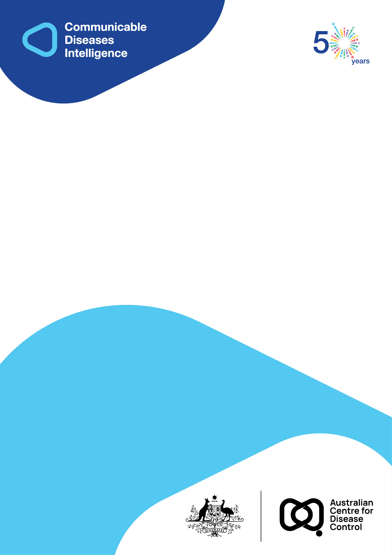
2026 • Volume 50 • cdc.gov.au/cdi • Epub date: 28.01.2026 • doi.org/10.33321/cdi.2026.50.004

Investigation and response to an outbreak of mpox cases linked to a high-risk group event in Southeast Queensland in May 2024
Maggie Miller, Deena Malloy, Megan Young, Alyssa Pyke, James Smith, Sanmarie Schlebusch, Mark Stickley, Davoud Pourmarzi
© 2026 Commonwealth of Australia as represented by the Australian Centre for Disease Control
ISSN: 2209-6051 Online
This journal is indexed by Index Medicus and Medline.
Creative Commons Licence
This publication is licensed under a Creative Commons Attribution-NonCommercial-NoDerivatives 4.0 International Licence (Licence). You must read and understand the Licence before using any material from this publication.
Restrictions
The Licence does not cover, and there is no permission given for, use of any of the following material found in this publication (if any):
- the Commonwealth Coat of Arms (by way of information, the terms under which the Coat of Arms may be used can be found on the Department of Prime Minister and Cabinet website);
- any logos (including the Australian Centre for Disease Control’s logo) and trademarks;
- any photographs and images;
- any signatures; and
- any material belonging to third parties.
Disclaimer
Opinions expressed in Communicable Diseases Intelligence are those of the authors and not necessarily those of the Australian Government or the Australian Centre for Disease Control. Data may be subject to revision.
Enquiries
Enquiries regarding any other use of this publication should be addressed to the CDI Editor.
About CDI
Communicable Diseases Intelligence (CDI) is a peer-reviewed scientific journal published by the Australian Centre for Disease Control.
The journal aims to disseminate information on the epidemiology, surveillance, prevention and control of communicable diseases of relevance to Australia and the near region.
Editor: Elise Firman • Deputy Editor: Simon Petrie • Design and Production: Lisa Thompson
Editorial Advisory Board: David Durrheim, Mark Ferson, Clare Huppatz, John Kaldor, Martyn Kirk and Meru Sheel
Submit an Article
Guidelines for authors and details on how to submit your publication is available on our website, or by email to the
CDI Editor.
Contact us
Communicable Diseases Intelligence (CDI)
Australian Centre for Disease Control
GPO Box 798, CANBERRA ACT 2601
Website: cdc.gov.au/cdi
Email: cdi.editor@cdc.gov.au

Contents
Abstract 4
Objective 4
Background 4
Methods 4
Findings 4
Introduction 5
Methods 6
Case and contact definitions 6
Vaccination status 6
Study design, data collection and analysis 7
Laboratory investigation 7
Results 8
Epidemiological investigation 8
Cohort formation and laboratory investigations 9
Vaccination as a protective factor 9
Incubation periods and symptomology 10
Contact tracing and flow of transmission 12
Discussion 13
Limitations 14
Closing statement 15
Acknowledgments 16
Ethics 16
Author details 17
References 18

Abstract

Objective
The primary aim of this paper is to describe the outbreak investigation and public health response to a cluster of mpox cases that occurred in Southeast Queensland; and to investigate transmission dynamics to inform contact management.

Background
The transmission of mpox in Australia has continued to circulate among the men who have sex with men community, since the declaration of the global outbreak of clade IIb in 2022. In May 2024, an outbreak investigation was carried out following the admission of an mpox case to a Queensland hospital, which precipitated a response coordinated by two metropolitan public health units (Metro North and Metro South) in Brisbane.

Methods
A prospective cohort study was conducted to follow up attendees of an intimate group event over a 21-day period. From 21 event attendees, 16 were able to be contacted by public health clinicians, and were included in the cohort. Case histories and their respective contacts were identified and classified as high, medium or low risk. Descriptive statistics were conducted, and relative risk was determined for developing infection after attendance at the group event, when accounting for the level of vaccination against mpox. Whole genome sequencing was performed on collected pathology specimens, and phylogenetic analysis was conducted to support epidemiological investigations.

Findings
A total of ten cases of mpox were detected, among a cohort of 16 males with differing levels of vaccination. Transmission of mpox occurred exclusively among high-risk contacts; no transmission was observed to medium- or low-risk contacts. Laboratory investigations revealed that all cases were of human MPXV clade IIb. Complete vaccination was a protective factor against development of mpox (relative risk = 0.33; 95% confidence interval: 0.06–1.88), compared with partial or no vaccination, after attendance at the high-risk exposure event.
This outbreak resulted in 34 contacts, of which one high-risk contact became a secondary case. Findings from this investigation suggest there is less urgency for follow-up of household contacts and other medium- and low-risk contacts of mpox, compared with high-risk contacts. Fostering a rapport during telephone interviews with cases and contacts was found to be crucial to the overall attainment of accurate case histories, highlighting the need for the development of trust when interacting with members of priority groups. This outbreak investigation describes a comprehensive public health response attributed to the coordination of a range of public health workers in the Southeast Queensland area.
Keywords: infectious diseases; public health; sexually transmitted infections; emerging infectious diseases; applied epidemiology; virology

Introduction
Monkeypox virus (MPXV) is a member of the Poxviridae family and the Orthopox genus. Mpox (formerly known as monkeypox) is a transmissible disease via multiple modes, including direct contact with infected mucosal membranes, lesions and sores, as well as through respiratory droplets, fomites and percutaneous routes.^{1,2}
The 2022 global outbreak of human MPXV clade IIb, and subsequent ongoing transmission in numerous countries including Australia, has largely affected gay, bisexual, and other men who have sex with men (GBMSM), and is transmitted through close, intimate contact, such as sexual activity.³ In contrast to previous reports, a predominant symptom that emerged during the 2022 and 2023 global outbreak was the presence of localised anogenital skin lesions and the rarity of generalised disseminated lesions, most likely reflecting the route of infection.^{4–9} In addition to close contact, there is further evidence implicating seminal fluid in the transmission of the virus, indicating that MPXV is sexually transmissible.^{3,10,11}
Mpox is a notifiable condition in Queensland, Australia under the Public Health Act 2005,¹² obligating laboratories to notify test requests received and positive test results in accordance with legislative requirements. The first notified case of mpox in Australia was detected in Sydney in May 2022, in an Australian male traveller returning from Europe.¹³ Within a year (by June 2023), Australia had recorded 145 cases of mpox, predominantly acquired abroad, with some local secondary transmission.¹³ Queensland recorded eight cases of mpox over the years 2022 and 2023, seven of which were acquired overseas in the United Kingdom, Europe, Hawaii, New Zealand and Southeast Asia.¹⁴ The remaining Queensland mpox case during this period likely acquired the MPXV infection within Australia, as they reported no travel history abroad during the incubation period.¹⁴ Mpox notifications remained relatively scarce in Queensland over the subsequent year, with only a few isolated cases imported from overseas.¹⁴
Disruption to this trend occurred in mid-2024, when a cluster of mpox cases arose in the Southeast Queensland (SEQ) region. All cases had attended a group event that occurred in the SEQ vicinity in May 2024. Two Brisbane metropolitan Public Health Units (PHUs), the Metro North and Metro South PHUs, received notice of a probable mpox case admitted to a Queensland hospital in mid-May 2024.¹⁴ An interview with the case revealed that the group event involved a high level of intimate contact between 21 male attendees. The objective of this report is to describe the public health response, and to inform subsequent investigations of similar nature, as mpox becomes an established infection within the Australian context.

Methods

Case and contact definitions
A confirmed primary case was defined as any person who attended the group event and had MPXV detected through (i) nucleic acid testing, such as polymerase chain reaction (PCR); (ii) genomic sequencing; or (iii) isolation of MPXV via culture of clinical specimens. Secondary cases were defined as persons who had not attended the group event but who had an MPXV detection via pathological sampling, after exposure through direct contact with a confirmed primary case.
Contacts were classified as high, medium, or low risk, according to their level of exposure to an infectious case. All event attendees were considered to have maintained direct contact via mucosal membranes and contact with potentially contaminated materials such as bodily fluids and bed linen. Classification was completed in reference to the version of the Communicable Diseases Network Australia (CDNA) National Guidelines for Monkeypox Virus Infection current at the time of the event.¹⁵ Definitions of levels of contact are presented in Table 1.
Table 1: Contact definitions for each level of contact, including high, medium and low risk
Contact level | Definition
High risk | Any person sharing a household with an mpox case,  or  Any person who had come into physical contact with a case during their infectious period, where there occurred direct contact with MPXV lesions, such as through sexual or intimate activities.
Medium risk | Any person having direct contact with potentially MPXV-contaminated materials, such as bed linen and seats, whilst not using appropriate personal protective equipment (PPE).
Low risk | Persons having indirect contact with a case of mpox in a setting where there was potential for transmission, whilst appropriate PPE was not upheld, for instance within a mass gathering event.

Vaccination status
Attendees of the group event were stratified according to their vaccination status against MPXV. Classification of status was based upon level of vaccination prior to attendance at the group-event, with status informed by the Australian Immunisation Handbook.¹⁶ Definitions of vaccination status are summarised in Table 2.
Table 2: Definitions of mpox vaccination status
Vaccination status | Definition
Fully vaccinated/complete vaccination | Receipt of two doses of a vaccine approved for the prevention of mpox, with a minimum four-week interval between the doses.
Partially vaccinated | Receipt of one dose of either of the smallpox vaccines available in Australia.
Unvaccinated | No previous smallpox vaccination.

Study design, data collection and analysis
A prospective cohort study design was used, and contacts were followed up for 21 days, as directed by the CDNA guidelines,¹⁵ to encapsulate the maximum incubation period.
The first known case of mpox was interviewed by a public health physician and contact details of the event organiser were obtained. The event organiser was then contacted to collect data on the nature of the event and activities involved. The event organiser also provided details of attendees where consent was obtained to do so. Subsequently, the attendees of the event were contacted and interviewed, using a standardised questionnaire specific for mpox,¹⁷ by public health unit nurses. During all communications, public health unit staff addressed event attendees with deference and respect, in an effort to promote a space where sensitive information could be comfortably shared. Information around sexual behaviour and contact during the group-exposure event was not recorded, and the same level of exposure was assumed for all attendees of the event.
All event attendees were screened for symptoms and mpox testing was arranged where indicated. All medium- and high-risk contacts were followed up with by public health nurses, and were advised to present for clinical testing only upon development of mpox symptoms, as per the national guidelines.¹⁵ Contacts were also provided with information and recommended to receive vaccination as a means of post-exposure prophylaxis; however, reception of vaccination was not followed up with.
Sample sites for pathological testing included swabs of anogenital, skin and other mucous membrane lesions, as well as upper respiratory tract swabs for suspected cases with respiratory symptoms. Self-reported symptomology data, including onset dates of first symptoms, were obtained for all contactable symptomatic attendees. With this information, incubation periods and a comprehensive symptom profile for the outbreak were obtained.
Descriptive and inferential statistics were used to analyse the data using Microsoft Excel (version 2402) and STATA (17th edition). Data were stored securely in a Microsoft Excel spreadsheet, with access limited to relevant workers from PHUs involved in the outbreak management.

Laboratory investigation
Positive Orthopoxvirus PCR pathology results, from swabs collected from symptomatic contacts upon presentation to general practitioners (GPs), were sent to the Public Health Virology (PHV) laboratory and Public and Environmental Health Reference Laboratories (PEHRL), at Queensland Health, for confirmation of MPXV species. Confirmation was conducted via PCR testing and partial genome nucleic acid sequencing. Throat, anal, and lesion swabs were used as samples for PCR testing. Whole genome sequencing (WGS) and phylogenetic analysis were conducted to support epidemiological investigations and to provide insight into the potential origins of the cluster of cases.

Results

Epidemiological investigation
Of the 21 individuals who attended the group event, 16 (76%) were able to be contacted during the outbreak investigation and were subsequently included within a closed cohort for prospective follow up. All non-contactable event attendees (n = 5) and secondary contacts of contactable event attendees (n = 34) were excluded from the defined cohort. An alert was also circulated amongst local hospital emergency departments (EDs) and general medical practices, to advise pathology testing of at-risk groups for mpox among people with compatible symptoms.
All members of the closed cohort were male. The median age was 30 years (range: 22–61 years). Among the 16 cohort members, four (25%) were fully vaccinated; one (6%) was partially vaccinated (with a childhood smallpox vaccination); and eleven (69%) were unvaccinated. Table 3 presents a demographic summary and descriptive analyses of the vaccination coverage among the cohort.
Table 3: Demographic summary and MPXV detection rates among 16 contactable event attendees stratified by vaccination status, Queensland, 2024
Category | Characteristic | n | %
Demographic details | Number of malesª | 16 | 100
Demographic details | Median age in years | 30 | —
Demographic details | Age range in years | 22–61
Vaccination status | Fully vaccinated^{b} | 4 | 25
Vaccination status | Partially vaccinated^{c} | 1 | 6
Vaccination status | Not vaccinated | 11 | 69
MPXV detected (N = 10 attendees) | Fully vaccinated | 1 | 10
MPXV detected (N = 10 attendees) | Partially vaccinated | 1 | 10
MPXV detected (N = 10 attendees) | Not vaccinated | 8 | 80
MPXV not detected (N = 6 attendees)^{d} | Fully vaccinated | 3 | 50
MPXV not detected (N = 6 attendees)^{d} | Partially vaccinated | 0 | 0
MPXV not detected (N = 6 attendees)^{d} | Not vaccinated | 3 | 50
MPXV detected by vaccination group | Fully vaccinated | 1 | 25
MPXV detected by vaccination group | Partially vaccinated | 1 | 100
MPXV detected by vaccination group | Not vaccinated | 8 | 73
a Calculations are based on a denominator of 16 attendees, as the index case was unidentified.
b Fully vaccinated persons were those who had completed both doses of mpox vaccination.
c Partially vaccinated persons were those had completed one dose of mpox vaccination or had received a childhood smallpox vaccination.
d From the six cohort members without MPXV detected, one reported symptoms consistent with mpox but had no MPXV detected upon clinical testing. The remaining five did not report symptoms and did not undergo clinical testing.

Cohort formation and laboratory investigations
Specimens for pathological testing were collected for eleven cohort members. From these eleven specimens, MPXV was detected in ten (91%), while one person, who had symptoms consistent with mpox, did not have the virus detected. The remaining five (31%) cohort members did not report symptoms during their 21 day follow-up and testing was not recommended, as they were considered free from MPXV.
The outbreak resulted in one secondary case of mpox, in a male who had high-risk exposure to a cohort member case. This secondary case was not considered part of the cohort and was excluded from the cohort study. Figure 1 is a flow chart presenting a summary of the cohort members, along with vaccination status and occurrence of testing.
Figure 1: Flow chart summarising the formation of the study cohort, as well as vaccination status and occurrence of testing among cohort members, Queensland, 2024
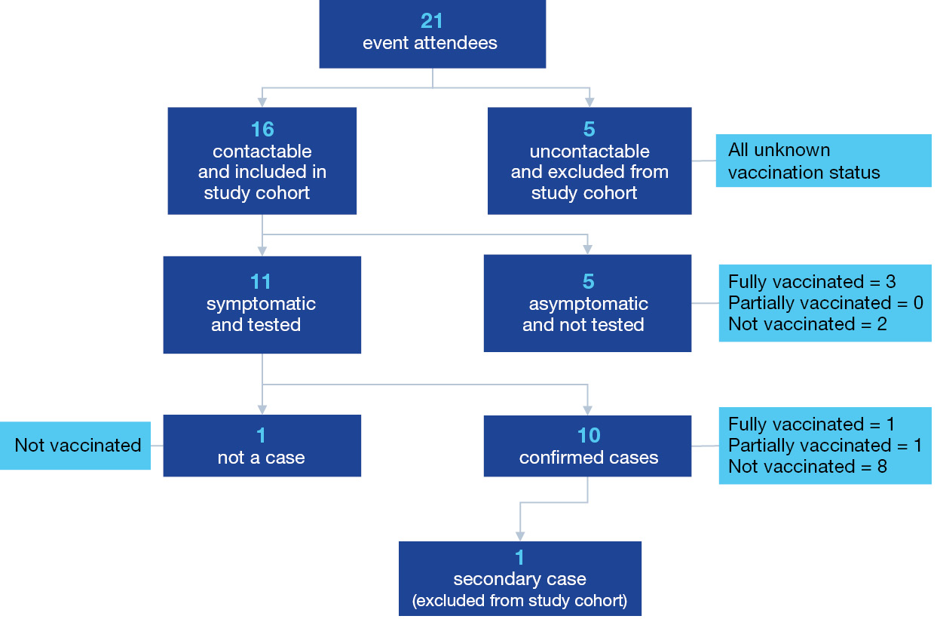
WGS revealed a high level of genetic relatedness in all pathological samples from cases within this cluster, supporting epidemiological findings of the direction of transmission among cases. Phylogenetic analysis indicated all sequences belonged to the human MPXV clade IIb and demonstrated possible links to infections occurring concurrently in other jurisdictions of Australia.

Vaccination as a protective factor
Among the 10 cohort members with MPXV detectable results, eight (80%) were not vaccinated; one (10%) was partially vaccinated; and one was fully vaccinated (10%). Among those who did not report symptoms of mpox during their 21 day follow-up period after attendance at the event (n = 5), three were fully vaccinated (60%) and two were unvaccinated (40%). The total attack rate (based on a MPXV detection) among the cohort was 63%, while the attack rate among those who presented for clinical testing (n = 11) was above 90%. Vaccination status of cohort members is presented in Table 3.
The relative risk (RR) for development of mpox, if vaccinated fully, was 0.33 (95% confidence interval [95% CI]: 0.06–1.88), indicating that the risk of developing infection was possibly reduced by almost 70% in those having received a complete course of vaccinations, compared with attendees who were not vaccinated or had received only partial vaccination. Data on administration of post-exposure prophylaxis was not collected.

Incubation periods and symptomology
Median incubation period for all mpox cases was nine days (interquartile range [IQR] = 5; range: 5–14 days). Figure 2 demonstrates the epidemic curve of case onset dates, showing that 30% of cases had an incubation period of 5 days, while 80% of cases had an incubation period of less than 13 days.
Figure 2: Epidemic curve showing frequency of self-reported symptom onset per day relative to group exposure event (n = 10 confirmed cases), Queensland, 2024
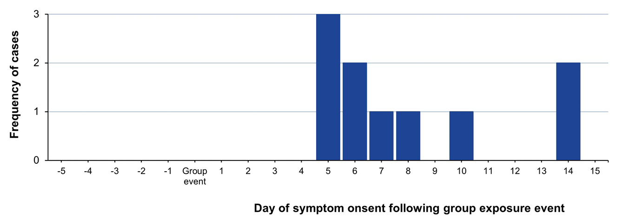
From the ten mpox cases, all (100%) were symptomatic. One case (10%) required hospitalisation, while the remaining nine cases (90%) were able to self-manage their symptoms from home. Among cases within the study cohort, the most frequently reported symptoms were fatigue and generalised skin lesions on the body (each n = 8; 80%); rash (n = 7; 70%); and headache, rash, and lesions on the thorax (each n = 5; 50%). The least commonly reported symptoms were myalgia, nausea and vomiting, lesions on the lower limbs, and lesions on the hands (all n = 1; 10%), as described in Figure 3. No cohort member reported being immunocompromised.
Figure 3: Column graph illustrating the number of people who reported each symptom from the ten confirmed mpox cases, Queensland, 2024
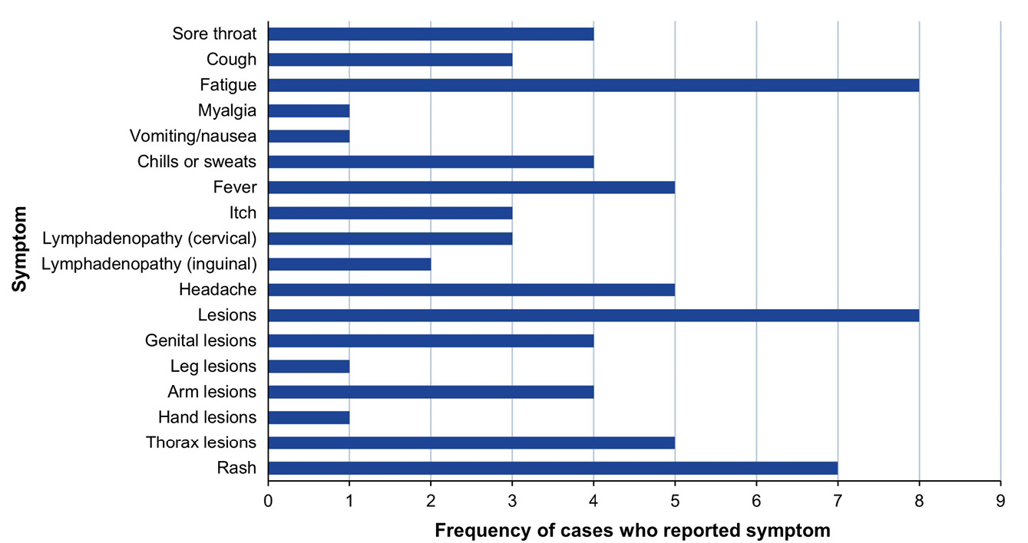

Contact tracing and flow of transmission
From the ten mpox cases, seven cases (70%) generated contacts, while three cases (30%) reported having no high, medium or low-risk contacts. The number of contacts generated by the seven cases ranged from one to eleven. There was one instance of a secondary case, which was the result of a high-risk intimate encounter.
In total, 34 contacts arose from the outbreak, eight of which were considered low risk, 20 were considered medium risk and six were categorised as high risk. All high-risk contacts were sexual contacts. One high-risk contact subsequently developed mpox, while no low- or medium-risk contacts developed symptoms or became cases. No index case could be identified within this outbreak.
The successful identification of contacts was largely attributed to a high level of rapport built between public health unit staff and event attendees. The flow of transmission among event attendees and generation of contacts is illustrated in Figure 4.
Figure 4: Flow diagram demonstrating the number of attendees present at the group event, and the subsequent transmission of MPXV to high, medium, and low risk contacts from the event attendees, Queensland, 2024
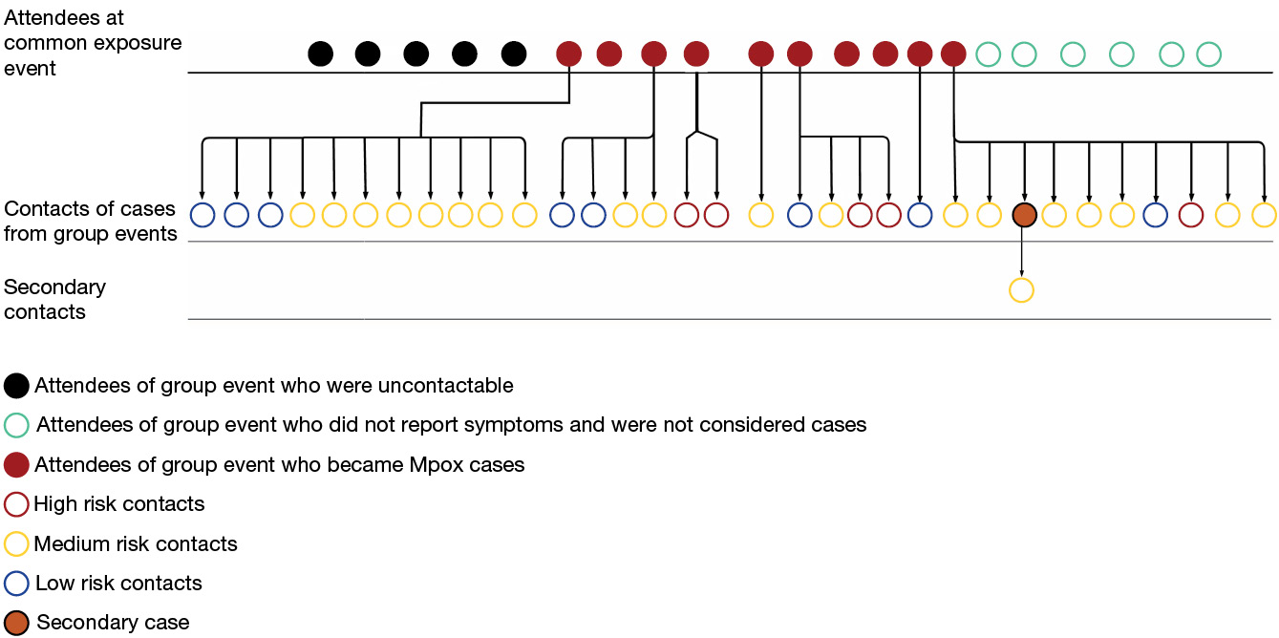

Discussion
In this outbreak, complete vaccination against mpox was a strong protective factor against infection. This was demonstrated by an almost 70% reduced risk of developing mpox after attendance at the group event, compared with those who had been partially vaccinated (with childhood smallpox vaccination) or not vaccinated at all. This finding, whilst observed only within a small cohort, is fairly consistent with previous literature where complete mpox vaccination efficacy among immunocompetent people has been shown to be between 77% and 90% (adjusted 95% CI: 57.7–97.2%) in a large-scale case-control study conducted in the United States of America.¹⁸
Whilst complete mpox vaccination demonstrated a considerable reduction in risk of the development of infection, the chance for confounding to have overestimated this finding cannot be ruled out. For example, there was an assumption that all attendees of the group event had the same level of exposure to MPXV, regardless of their actual level of exposure to the virus at the event. This is partly the result of a lack of a feasible method to stratify the attendees by exposure levels, due to incomplete accounts of the event, as well as uncertainty around the identity of the index case. Additionally, it was challenging to obtain accurate exposure histories from cases, given the intimate nature of physical contact involved and potential concerns about stigma. In this regard, it is uncertain whether all event attendees were subject to a viral load with sufficient titre to result in clinical disease. Previous findings have suggested a link between reduced viral load and a reduction in infectivity, and it is therefore uncertain as to the impact of this factor on the overall rate of transmission within the cohort.^{19–21}
Whilst partial vaccination (less than two doses of a vaccine approved for the prevention of mpox), offers a level of protection against infection,¹⁸ this was not observed within this small outbreak study, where the sole partially vaccinated cohort member (who had received a childhood smallpox vaccine) was among those who tested positive for MPXV. Smallpox vaccination has been shown to prevent mpox, presumably due to the high genomic homology between the two viruses.^{16,22–24} There is documented evidence, however, that vaccine-acquired immunity wanes with time,^{25,26} which could have partially explained the failure to prevent infection in the case who was vaccinated against smallpox in childhood.
The symptomology of the cases within this outbreak was consistent with those of previous case reports of MPXV Clade IIb, with fatigue, skin lesions, headache and rash being the most frequently reported symptoms.⁵ Cohort members not exhibiting symptoms of illness were not tested; accordingly, the potential for asymptomatic infection was not assessed. Among those exhibiting symptoms, varying severity of illness was reported, with some cases reporting mild illness, and one requiring hospital admission. The global outbreak of clade IIb has been frequently described as self-limiting in immunocompetent persons,²⁷ and observations from this local outbreak are reflective of this finding. This local outbreak also demonstrates similarities with previous outbreaks in relation to the observed incubation periods (median 9 days compared with a typical 8.5-day median).²⁸
Within this cohort, transmission of MPXV occurred exclusively through physical intimate and sexual contact, with no account of transmission to medium or low-risk contacts following the group event. The lack of transmission observed between household and other low-risk contacts supports the interpretation that clade IIb MPXV infection is primarily transmitted by sexual contact, with routes including household and fomite contact playing a lesser role in its spread.^{29,30}
Sampling methods used for detection of MPXV included oropharyngeal and anal swabs, and swabbing of cutaneous lesions, all of which methods were sufficient for the detection of viral DNA through PCR analysis. The evidence for efficacy of oropharyngeal swabbing for the diagnosis of mpox is limited, and absence of detection of MPXV by PCR from such specimens should be interpreted with caution, as advised by the World Health Organization.^{31.32} The finding of MPXV detection by PCR from throat swab specimens within this outbreak is therefore a contribution to this growing body of evidence.
Whilst mpox is now considered a sexually transmitted disease,³³ this outbreak investigation did not incorporate PCR analysis of seminal fluid specimens. Therefore, this outbreak investigation was not designed to indicate whether transmission occurred through intimate contact with lesions, or through sexual transmission, or a combination of the two.
Interestingly within this outbreak, one person who exhibited symptoms consistent with mpox did not have MPXV detected by PCR analysis. Whilst PCR is considered the laboratory gold standard for mpox diagnosis, it could be hypothesised that this male had a clinically false negative result, possibly because of low viral load at the time of collection, or as a result of compromised sample collection or handling, transport or storage.³⁴
Regarding the origins of this local outbreak of mpox cases in Southeast Queensland, no index case could be identified; however, genomic analysis revealed that all specimens within this cohort were of a genetically indistinguishable MPXV strain. Concurrent cases occurring in other jurisdictions of Australia, at the time of this outbreak, also demonstrated high genetic relatedness to this cluster, despite no disclosed recent travel from event attendees. Moreover, cases of mpox that have occurred within the SEQ region following this outbreak have shown high genomic linkages to this outbreak from May 2024. This suggests the possibility of ongoing transmission, potentially generated by event attendees who were unable to be contacted and their subsequent sexual partners.

Limitations
A distinct limitation of this outbreak investigation is the reliance on self-reported data, and the willingness of individuals to disclose information. In this regard, some event attendees may have withheld details due to concerns about stigma. It must be highlighted that only 16 of the 21 event attendees were able to be contacted, and of these, 11 developed symptoms and met the criterion to be recommended for testing. Furthermore, the figure of 21 event attendees was derived from anecdotal reports, and there is potential for this number to have been misreported. This raises the possibility that additional transmission occurred during the outbreak but went undetected, highlighting a shortcoming in the public health follow up. Furthermore, data on vaccination status among contacts was not collected, despite the recommendation of post-exposure prophylaxis. Accordingly, it is unknown whether vaccination of contacts played a role in the subsequent development of infection.
Whilst public health units were, at the time of this outbreak, required to follow up all contacts of mpox, regardless of risk level,¹⁵ there was no report of transmission occurring to medium or low-risk contacts during this outbreak. In consideration of the ever-increasing workload for public health units in Australia, this investigation suggests less urgency for following up contacts of low and medium risk levels and supports the need to contact trace those who are deemed at high risk of illness, primarily through sexual or similar intimate contact. This finding, of an absence of transmission to low- or medium-risk contacts, has since contributed to the modification of contact definitions for exposure to mpox clade IIb within the national guidelines.³⁵

Closing statement
This study highlights the importance of building trust and rapport with infectious disease cases and contacts. There was a high level of skill demonstrated by public health nurses and physicians who were able to liaise with contacts and cases and were therefore able to elucidate a great deal of information about the event and case histories, which was crucial to the overall public health investigation and response, as well as for the interpretation of the genomics within epidemiological context. The adoption of a classification framework to assess contacts, laboratory investigations and a rapid public health response are among the salient features of this study. WGS played an important role in supporting the outbreak investigation, including provision of insights beyond what traditional epidemiological findings could offer. The cooperation of the event organiser who contacted the attendees and disseminated public health information and recommendations was also essential to the success of the investigation.

Acknowledgments
The authors would sincerely like to the thank the staff from the Metro North and Metro South PHUs whose efforts were crucial to the swift and comprehensive public health response. In addition, sincere thanks are owed to the staff at Public Health Virology and Q-PHIRE Genomics, Public and Environmental Health Reference Laboratories, Pathology Queensland for sample processing, sequencing and data analysis.

Ethics
This article was ethically cleared for publication by the Coronial and Public Health Sciences Ethics Committee reference HEC 25-08.

Author details
Miss Maggie Miller,^{1,2}
Mrs Deena Malloy,²
Dr Megan Young,²
Dr Alyssa Pyke,³
Dr James Smith,²
Dr Sanmarie Schlebusch,³
Dr Mark Stickley,⁴
Dr Davoud Pourmarzi¹
- National Centre for Epidemiology and Population Health, Australian National University
- Metro North Public Health Unit, Queensland Health
- Microbiology, Virology, and Genomics. Public and Environmental Health Reference Laboratories. Pathology, Queensland
- Metro South Public Health Unit, Queensland Health

Corresponding author
Miss Maggie Miller
Address: Rosemount Campus, Cartwright St, Windsor, QLD
Phone: +61 7 3624 1111
Email: maggie.miller@anu.edu.au, maggie.miller2@health.qld.gov.au

References
- Kuehn R, Fox T, Guyatt G, Lutje V, Gould S. Infection prevention and control measures to reduce the transmission of mpox: a systematic review. PLOS Glob Public Health. 2024;4(1):e0002731. doi: https://doi.org/10.1371/journal.pgph.0002731.
- Isidro J, Borges V, Pinto M, Sobral D, Santos JD, Nunes A et al. Phylogenomic characterization and signs of microevolution in the 2022 multi-country outbreak of monkeypox virus. Nat Med. 2022;28(8):1569–72. doi: https://doi.org/10.1038/s41591-022-01907-y.
- Sah R, Abdelaal A, Reda A, Katamesh BE, Manirambona E, Abdelmonem H et al. Monkeypox and its possible sexual transmission: where are we now with its evidence? Pathogens. 2022;11(8):924. doi: https://doi.org/10.3390/pathogens11080924.
- Thornhill JP, Barkati S, Walmsley S, Rockstroh J, Antinori A, Harrison LB et al. Monkeypox virus infection in humans across 16 countries – April–June 2022. N Engl J Med. 2022;387(8):679–91. doi: https://doi.org/10.1056/NEJMoa2207323.
- Patel A, Bilinska J, Tam JCH, Da Silva Fontoura D, Mason CY, Daunt A et al. Clinical features and novel presentations of human monkeypox in a central London centre during the 2022 outbreak: descriptive case series. BMJ. 2022;378:e072410.
doi: https://doi.org/10.1136/bmj-2022-072410.
- Tarín-Vicente EJ, Alemany A, Agud-Dios M, Ubals M, Suñer C, Antón A et al. Clinical presentation and virological assessment of confirmed human monkeypox virus cases in Spain: a prospective observational cohort study. Lancet. 2022;400(10353):661–9. doi: https://doi.org/10.1016/S0140-6736(22)01436-2.
- Català A, Clavo-Escribano P, Riera-Monroig J, Martín-Ezquerra G, Fernandez-Gonzalez P, Revelles-Peñas L et al. Monkeypox outbreak in Spain: clinical and epidemiological findings in a prospective cross-sectional study of 185 cases. Br J Dermatol. 2022;187(5):765–72. doi: https://doi.org/10.1111/bjd.21790.
- Gupta AK, Talukder M, Rosen T, Piguet V. Differential diagnosis, prevention, and treatment of mpox (monkeypox): a review for dermatologists. Am J Clin Dermatol. 2023;24(4):541–56. doi: https://doi.org/10.1007/s40257-023-00778-4.
- Mitjà O, Ogoina D, Titanji BK, Galvan C, Muyembe JJ, Marks M et al. Monkeypox. Lancet. 2023;401(10370):60–74. doi: https://doi.org/10.1016/S0140-6736(22)02075-X.
- Raccagni AR, Castagna A, Nozza S. Detection of mpox virus in seminal fluids: implications for sexual transmission. New Microbiol. 2024;46(4):317–21.
- Barboza JJ, León-Figueroa DA, Saldaña-Cumpa HM, Valladares-Garrido MJ, Moreno-Ramos E, Sah R et al. Virus identification for monkeypox in human seminal fluid samples: a systematic review. Trop Med Infect Dis. 2023;8(3):173. doi: https://doi.org/10.3390/tropicalmed8030173.
- Queensland State Government Register of Legislation (Queensland Legislation). Public Health Act 2005. [Legislation.] Brisbane: Queensland Legislation; 2024. Available from: https://www.legislation.qld.gov.au/view/html/inforce/current/act-2005-048.
- Liyanage R, Lusk J. Mpox and primary syphilis co-infection in a newly arrived traveller from South America. Med J Aust. 2023;219(3):101–2. doi: https://doi.org/10.5694/mja2.52005.
- Queensland State Government Department of Health (Queensland Health). Notifiable Conditions System. [Internet.] Brisbane: Queensland Health; 2024. Available from: https://nocs.wdc.qlh.sunquestaws.com/NOCSWCUI/pages/search/sys_search.aspx.
- Australian Government Department of Health and Aged Care, Communicable Diseases Network Australia (CDNA). Monkeypox Virus Infection – CDNA Interim National Guidelines for Public Health Units, v2.0. Canberra: Australian Government Department of Health and Aged Care; 8 September 2022. Available from: https://www.health.gov.au/resources/publications/monkeypox-virus-infection-cdna-national-guidelines-for-public-health-units.
- Australian Government Department of Health, Disability and Ageing. Australian Technical Advisory Group on Immunisation (ATAGI). [Webpage.] Canberra: Australian Government Department of Health, Disability and Ageing; 28 January 2025. Available from: https://www.health.gov.au/committees-and-groups/atagi.
- Queensland Health. Mpox Case Report Form. Brisbane: Queensland Health; 2024. Available from: https://www.health.qld.gov.au/__data/assets/pdf_file/0031/1159177/cr-monkeypox.pdf.
- Dalton AF, Diallo AO, Chard AN, Moulia DL, Deputy NP, Fothergill A et al. Estimated effectiveness of JYNNEOS vaccine in preventing mpox: a multijurisdictional case-control study – United States, August 19, 2022–March 31, 2023. MMWR Morb Mortal Wkly Rep. 2023;72(20):553–8. doi: https://doi.org/10.15585/mmwr.mm7220a3.
- Rani I, Satapathy P, Goyal A, Shamim MA, Pal A, Squitti R et al. Viral loads in skin samples of patients with monkeypox virus infection: a systematic review and meta-analysis. Viruses. 2023;15(6):1386. doi: https://doi.org/10.3390/v15061386.
- Paran N, Yahalom-Ronen Y, Shifman O, Lazar S, Ben-Ami R, Yakubovsky M et al. Monkeypox DNA levels correlate with virus infectivity in clinical samples, Israel, 2022. Euro Surveill. 2022;27(35):2200636. doi: https://doi.org/10.2807/1560-7917.ES.2022.27.35.2200636.
- Lim CK, McKenzie C, Deerain J, Chow EPF, Towns J, Chen MY et al. Correlation between monkeypox viral load and infectious virus in clinical specimens. J Clin Virol. 2023;161:105421. doi: https://doi.org/10.1016/j.jcv.2023.105421.
- Gong Q, Wang C, Chuai X, Chiu S. Monkeypox virus: a re-emergent threat to humans. Virol Sin. 2022;37(4):477–82. doi: https://doi.org/10.1016/j.virs.2022.07.006.
- Jezek Z, Marennikova SS, Mutumbo M, Nakano JH, Paluku KM, Szczeniowski M. Human monkeypox: a study of 2,510 contacts of 214 patients. J Infect Dis. 1986;154(4):551–5. doi: https://doi.org/10.1093/infdis/154.4.551.
- Bertran M, Andrews N, Davison C, Dugbazah B, Boateng J, Lunt R et al. Effectiveness of one dose of MVA-BN smallpox vaccine against mpox in England using the case-coverage method: an observational study. Lancet Infect Dis. 2023;23(7):828–35. doi: https://doi.org/10.1016/S1473-3099(23)00057-9.
- Amanna IJ, Slifka MK, Crotty S. Immunity and immunological memory following smallpox vaccination. Immunol Rev. 2006;211(1):320–37.
doi: https://doi.org/10.1111/j.0105-2896.2006.00392.x.
- Heffernan JM, Keeling MJ. Implications of vaccination and waning immunity. Proc Biol Sci. 2009;276(1664):2071–80. doi: https://doi.org/10.1098/rspb.2009.0057.
- Huang Y, Mu L, Wang W. Monkeypox: epidemiology, pathogenesis, treatment and prevention. Signal Transduct Target Ther. 2022;7(1):373.
doi: https://doi.org/10.1038/s41392-022-01215-4.
- Miura F, van Ewijk CE, Backer JA, Xiridou M, Franz E, Op de Coul E et al. Estimated incubation period for monkeypox cases confirmed in the Netherlands, May 2022. Euro Surveill. 2022;27(24):2200448. doi: https://doi.org/10.2807/1560-7917.ES.2022.27.24.2200448.
- Akingbola A, Adegbesan CA, Adewole O, Idahor C, Odukoya T, Nwaeze E et al. Understanding the resurgence of mpox: key drivers and lessons from recent outbreaks in Africa. Trop Med Health. 2025;53(1):47. doi: https://doi.org/10.1186/s41182-024-00678-1.
- Beiras CG, Malembi E, Escrig-Sarreta R, Ahuka S, Mbala P, Mavoko HM et al. Concurrent outbreaks of mpox in Africa—an update. Lancet. 2025;405(10472):86–96. doi: https://doi.org/10.1016/S0140-6736(24)02353-5.
- World Health Organization (WHO). Laboratory testing for the monkeypox virus: interim guidance, 23 May 2022. Geneva: WHO; 23 May 2022. Available from: https://www.who.int/publications/i/item/WHO-MPX-laboratory-2022.1.
- Ribeiro da Silva SJ, Kohl A, Pena L, Pardee K. Clinical and laboratory diagnosis of monkeypox (mpox): current status and future directions. iScience. 2023;26(6):106759. doi: https://doi.org/10.1016/j.isci.2023.106759.
- Allan-Blitz LT, Gandhi M, Adamson P, Park I, Bolan G, Klausner JD. A position statement on mpox as a sexually transmitted disease. Clin Infect Dis. 2022;76(8):1508–12. doi: https://doi.org/10.1093/cid/ciac960.
- Zhou Y, Chen Z. Mpox: a review of laboratory detection techniques. Arch Virol. 2023;168(8):221. doi: https://doi.org/10.1007/s00705-023-05848-w.
- Australian Government Department of Health, Disability and Ageing, Communicable Diseases Network Australia (CDNA). Mpox – CDNA National Guidelines for Public Health Units. Canberra: Australian Government Department of Health, Disability and Ageing; 14 October 2024. Available from: https://www.health.gov.au/resources/publications/mpox-cdna-national-guidelines-for-public-health-units.

