
2025 • Volume 49 • cdc.gov.au/cdi • Epub date: 17.12.2025 • doi.org/10.33321/cdi.2025.49.063

Where the cooling water drifts: an outbreak of Legionella pneumophila serogroup 1 in the central business district of Sydney, December 2023 – January 2024
Eunice Stiboy, Misha Klingstrom, Karen Chee, Mark J Ferson, Sandra Chaverot, Brian Huang, Toby Hannan, Philip Pershen, Kirsty Hope, Zoe Baldwin, Geoffrey Prendergast, Kristy McCreadie, Anita Smojver, Catherine Pitman, Anna Smith, Keira Glasgow, Vitali Sintchenko, Geraldine Sullivan, Qinning Wang, Amy E Parry, Jeremy McAnulty, Vicky Sheppeard, Anthea L Katelaris
© 2025 Commonwealth of Australia as represented by the Department of Health, Disability and Ageing
ISSN: 2209-6051 Online
This journal is indexed by Index Medicus and Medline.
Creative Commons Licence
This publication is licensed under a Creative Commons Attribution-NonCommercial-NoDerivatives 4.0 International Licence (Licence). You must read and understand the Licence before using any material from this publication.
Restrictions
The Licence does not cover, and there is no permission given for, use of any of the following material found in this publication (if any):
- the Commonwealth Coat of Arms (by way of information, the terms under which the Coat of Arms may be used can be found on the Department of Prime Minister and Cabinet website;
- any logos (including the interim Australian Centre for Disease Control and the Department of Health, Disability and Ageing’s logos) and trademarks;
- any photographs and images;
- any signatures; and
- any material belonging to third parties.
Disclaimer
Opinions expressed in Communicable Diseases Intelligence are those of the authors and not necessarily those of the Australian Government, the interim Australian Centre for Disease Control or the Department of Health, Disability and Ageing. Data may be subject to revision.
Enquiries
Enquiries regarding any other use of this publication should be addressed to the CDI Editor.
About CDI
Communicable Diseases Intelligence (CDI) is a peer-reviewed scientific journal published by the interim Australian Centre for Disease Control within the Department of Health, Disability and Ageing.
The journal aims to disseminate information on the epidemiology, surveillance, prevention and control of communicable diseases of relevance to Australia and the near region.
Editor: Christina Bareja • Deputy Editor: Simon Petrie • Design and Production: Lisa Thompson
Editorial Advisory Board: David Durrheim, Mark Ferson, Clare Huppatz, John Kaldor, Martyn Kirk and Meru Sheel
Submit an Article
Guidelines for authors and details on how to submit your publication is available on our website, or by email to the
CDI Editor.
Contact us
Communicable Diseases Intelligence (CDI)
interim Australian Centre for Disease Control, Department of Health, Disability and Ageing
GPO Box 9848, CANBERRA ACT 2601
Website: cdc.gov.au/cdi
Email: cdi.editor@health.gov.au

Contents
Abstract 4
Background 4
Methods 4
Results 4
Conclusions 4
Introduction 5
Methods 6
Clinical and epidemiological investigations 6
Environmental health investigation 6
Laboratory investigations 7
Results 8
Clinical and epidemiological investigations 8
Environmental health investigation 12
Genomic investigation 12
Discussion 14
Conclusions 16
Acknowledgments 17
Author details 18
References 19

Abstract

Background
Legionnaires’ disease causes severe pneumonia. Outbreaks are infrequent in Australia, with cooling water systems (CWS) regulated to reduce risk. In summer 2024, a Legionella pneumophila serogroup 1 (Lp1) outbreak was detected in visitors to the Sydney central business district (CBD). We investigated to identify cases and to control the source.

Methods
Case-patients were detected through routine laboratory notifications and classified as per surveillance case definitions. Case-patients were interviewed to determine symptoms, and environmental exposures 2–10 days prior to symptom onset. We mapped exposures sites and walking routes to identify areas for investigation. CWS in shared exposure areas were inspected and tested for Legionella. Historical results from routine CWS testing were reviewed. Genomic sequencing was performed on environmental and patient isolates. Clinician and public alerts were issued, and CBD building managers were reminded to maintain CWS.

Results
The investigation identified 15 legionellosis case-patients: two had Lp1 positive sputum cultures, 14 were hospitalised, and six required intensive care. All case-patients visited the CBD during the period 12–26 December 2023. Between 3–12 January 2024, testing was performed on 166 CWS across 118 CBD sites, and on three water fountains. Lp1 was cultured from one CWS. Genomic sequencing from five environmental and two clinical isolates showed a probable link. The positive CWS was decontaminated but continued to have Lp1 detected, possibly due to ongoing dust contamination, necessitating additional maintenance.
Weeks later, a case-patient diagnosed in Europe, who had visited key exposure locations in the CBD during 21–23 December 2023, was epidemiologically linked to the outbreak; this took the total number of case-patients to 16.

Conclusions
Our investigation indicated that a contaminated CWS may have been the source of this outbreak, with contamination potentially precipitated by nearby construction. This emphasises the importance of strengthening Australian CWS regulations to reduce Lp1 outbreak risk, and of timely reporting under International Health Regulations to identify additional outbreak cases.
Keywords: legionnaires disease; legionellosis; Legionella pneumophila; Legionella outbreak

Introduction
Legionellosis refers to a group of lung infections, caused by Legionella bacteria, that can lead to pneumonia.^{1,2} Legionella bacteria are ubiquitous in the environment in low levels in aquatic habitats and soil.² Most Legionella bacteria thrive in warm water (20–45 °C) and are often associated with warm water systems and cooling water systems (CWS).³ In Australia, Legionella pneumophila serogroup 1 (Lp1) causes the majority of outbreaks of legionellosis.² L. pneumophila (L.p) thrives in engineered water systems that can produce inhalable water aerosols, such as air conditioning CWS, evaporative condensers, humidifiers, decorative fountains, hot tubs and showers.^{2,4} In these built environments, warm temperatures combined with accumulated nutrients or contaminants and microbial growth on surfaces (known as biofilm) create ideal conditions for L.p to multiply, especially when environmental controls are inadequate.² The accumulation of dust and debris in cooling water systems can further reduce the effectiveness of biocides, creating favourable conditions for Legionella growth.⁵
CWS have previously been associated with outbreaks in the Sydney central business district (CBD).^{1,6–8} In response to two significant outbreaks in the Sydney CBD in 2016, the New South Wales (NSW) health regulations were updated.^{8,9} Preventative measures for CWS focus on minimising the growth of the bacteria within the CWS. These measures are governed by the NSW Public Health Act 2010¹⁰ and the NSW Public Health Regulation 2022,⁴ requiring all CWS to be equipped with a disinfectant procedure that is in operation at all times to ensure the concentration of Legionella in the system is < 10 colony-forming units per millilitre (cfu/mL) and the heterotrophic colony count (HCC) is < 100,000 cfu/mL. The NSW Guidelines for Legionella control in cooling water systems outline the requirements for maintaining CWS as per the NSW Public Health Act and Public Health Regulation; each system must be assigned a distinct identifying number registered with the local government authority.¹¹ Additionally, the guidelines outline the development of a risk management plan (RMP) and annual audits, with certificates of completion submitted to the local government authority.¹¹
Monthly sampling and testing of CWS for Legionella and HCC are mandatory under the Public Health Regulation, with any results exceeding 1,000 cfu/mL for Legionella and 5,000,000 cfu/mL for HCC to be reported to the local government authority, as outlined in the NSW Guidelines for Legionella control in cooling water systems.^{4,9,11} In NSW, building managers are responsible for routine testing and maintenance of CWS in accordance with the guidelines.
In NSW, all confirmed and probable legionellosis cases should be investigated to identify any potential exposure sources, with environmental assessments considered, particularly if multiple cases share a common exposure, indicating a cluster or outbreak.² A cluster refers to two or more cases linked by location (e.g. residence or workplace) and with sufficient proximity in illness onset (e.g., six months) as to warrant further investigation, while an outbreak involves two or more cases with closely linked illness onset (typically weeks) and epidemiological evidence of a shared source.² In January 2024 the South Eastern Sydney Public Health Unit (SESPHU) were notified by Health Protection NSW of several Lp1 patients, with illness onset within seven days of one another, who had all visited the Sydney CBD during their exposure period, prompting an investigation by SESPHU.

Methods

Clinical and epidemiological investigations
Case-patients were detected through routine laboratory notifications to local NSW Health public health units. A confirmed case of Lp1 is defined in the NSW Health Legionellosis Control Guidelines² and requires laboratory and clinical evidence. Laboratory evidence includes isolation of Legionella or detection of Lp1 urinary antigen; clinical evidence includes symptoms of fever or cough or pneumonia. Following notification, the investigation team proactively followed up with clinicians to request sputum samples from case-patients for culture. Case-patients were interviewed via phone using the Communicable Disease Network of Australia Legionellosis Investigation Form,² and verbal consent was obtained to collect information on clinical symptoms, risk factors (underlying medical conditions and smoking history) and locations of potential environmental exposures, including walking routes, 2–10 days prior to symptom onset. Where a walking route could not be recalled precisely, the most direct route was presumed to be the route taken. Descriptive analysis was performed on case-patients’ demographic and characteristic details.
Reported case-patient locations in the Sydney CBD during their exposure period, including walking and other travel routes, were geocoded in R v4.3.2, using tidygeocoder.¹² These geocoded locations were then mapped using QGIS v3.34.3.¹³ Targeted environmental investigation areas were defined using case locations and walking routes. These investigation areas were modified and expanded as additional case-patients and case-patient locations were identified.
An alert for hospital clinicians was distributed, advising of the outbreak and prompting testing, using the NSW Health Safety Alert Broadcast System (SABS). An alert to general practitioners was also distributed via email. A media release was issued to inform the public and to prompt medical review for symptomatic people who may have been in the Sydney CBD. A letter was emailed to all building managers responsible for CWS on their premises within the CBD, informing them of the outbreak investigation, reminding them of regulatory requirements for maintenance/operation, and noting the possible effect of construction dust on disinfection systems.
This investigation is covered by the Australian National University Human Research Ethics Committee standing approval for outbreak investigations involving staff and students (Protocol 2017/909) and formed part of a public health response under the NSW Public Health Act 2010.

Environmental health investigation
Due to the high density of CWS in the CBD (approximately 1,000), we used the case-patient exposure locations to guide the environmental investigation area. The environmental investigation areas were determined based on mapped case locations and walking routes; all cases had at least one exposure within the same block near a train station in the CBD. This common exposure site formed the centre point for the investigation, and street boundaries to the north, east, south, and west were set to allocate inspection areas to the environmental health team. All these areas fell within 500 metres of this central site. CWS within the investigation area were then prioritised for inspection and sampling using a risk matrix of low, medium or high (determined by the CWS RMP). These risk classifications were adjusted based on previous noted non-compliances in an unsatisfactory audit or recent reportable Legionella or HCC. CWS were further prioritised for inspection and sampling based on the expert knowledge of environmental health officers and local factors identified during field work. All high-risk CWS within the key exposure area were inspected and sampled, in addition to some lower-risk towers, based on field work or prior detection of Legionella or elevated HCC. Audit reports, cleaning, maintenance, and microbial sampling results from the three months prior to case-patient detection were also reviewed to ascertain if any CWS had previous high HCC or Legionella growth below the reportable limits, so we could perform additional targeted inspection and sampling for CWS not previously identified by the targeted investigation area or the RMP prioritisation. A minimum of one water sample was collected per CWS. Repeat sampling was only undertaken for systems that initially returned positive results. CWS water samples were sent to the Forensic and Analytical Science Service (FASS) for culture.
Case-patient exposure locations outside the Sydney CBD were investigated by the case-patient’s local public health unit of residence as per NSW Health Legionellosis Control Guidelines.

Laboratory investigations
Environmental and clinical isolates underwent confirmatory Lp1 typing and whole genome sequencing to examine relatedness. Isolates were cultured and serotyped as previously described.¹⁴ Genomic DNA was extracted using the DNeasy UltraClean Microbial Kit (QIAGEN) with modifications.¹⁵ Sequencing libraries were prepared using Illumina DNA Prep (Illumina) and sequenced on an Illumina NextSeq2000 instrument. Sequencing reads were quality controlled and assembled as previously described.¹⁶ Subsequently, L. pneumophila sequence-based typing (SBT) was performed on the assembled genomes using legsta v0.4.0.¹⁷ Core Single Nucleotide Polymorphism (SNP) analysis was conducted using snippy v4.3.5¹⁸ against a ST211 reference genome, AUSMDU00010536 (GenBank accession: CP045974.1).¹⁹ A core SNP maximum likelihood phylogenetic tree was constructed using IQ-TREE v1.6.7²⁰ running the GTR+G4 substitution model and visualised in R using ggtree v1.99.1.²¹

Results

Clinical and epidemiological investigations
There were 15 confirmed case-patients (Table 1) of legionellosis, identified through notification of positive Lp1 urinary antigen tests between 28 December 2023 and 15 January 2024, who had visited Sydney CBD during their exposure period (Figure 1). Four case-patients (27%) were female and 11 (73%) were male. The age of case-patients ranged from 28 to 81 years; the median age was 66 years. Fourteen case-patients (93%) required hospital admission, of whom six (43%) required high dependency unit (HDU) or intensive care unit (ICU) admission. Eight case-patients had a sputum sample collected, of which two were successfully cultured for Lp1.
Table 1: Demographic characteristics, hospitalisation, and prevalence of legionellosis risk factors among case-patients associated with the Sydney central business district Lp1 outbreak, December 2023 – January 2024
Characteristic | Category | n | Percentageª | Median | Range
Sex | Male | 12 | 75% | — | —
Sex | Female | 4 | 25% | — | —
Age (years) | — | — | — | 64.5 | 28–81
Hospitalisation | Admitted to hospital | 15 | 94% | — | —
Hospitalisation | HDU/ICU^{b} | 7 | 47% | — | —
Hospitalisation | Length of hospital stay (days)^{c} | — | — | 5 | 2–59
Deaths | — | 0 | 0% | — | —
Risk factors | Medical conditions^{c,d} | 11 | 73% | — | —
Risk factors | > 50 years of age | 11 | 69% | — | —
Risk factors | Smoking^{c} | 2 | 13% | — | —
a Calculated for a denominator N = 16 unless otherwise indicated.
b HDU: high dependency unit; ICU: intensive care unit.
c Details were unavailable for one case-patient; N = 15.
d This category comprises medical comorbidities, including immunosuppression or respiratory conditions, which could have contributed to a case-patient’s disease severity.
Figure 1: Epidemiological curve of Legionella pneumophila case-patients (N = 15), with exposures in the Sydney central business district during the period 12–26 December 2023, by date of symptom onset
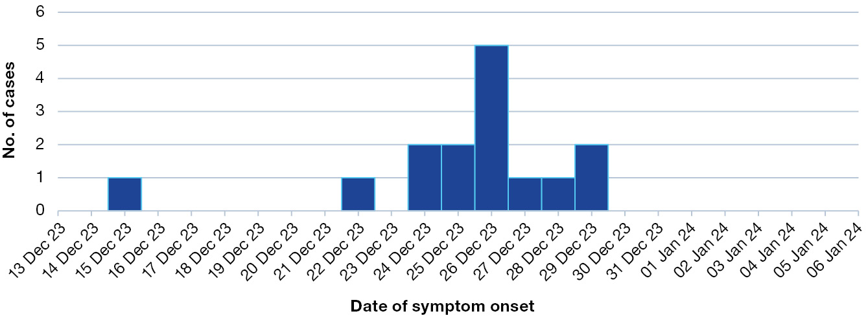
All case-patients had visited the Sydney CBD during the period 12–26 December 2023, with some patients visiting the Sydney CBD on more than one occasion during their exposure period (Figure 2). Fourteen of the 15 patients (93%) spent time in the CBD in the narrow window during 19–21 December 2023 and all visited locations in proximity to one another. Case-patients spent extended periods in the CBD, undertaking activities such as attending events, visiting businesses, dining, and using public transport hubs. Figure 2 shows the dates of case-patients’ visits to the CBD, and indicates those who visited the CBD on more than one occasion. Most case-patients—including those with Lp1 isolates—had repeated, prolonged CBD exposures within the three-day period 19–21 December 2023, with mapped locations situated near the implicated CWS (Figure 3).
An additional case-patient, included in the total count, was identified several weeks after the outbreak through the National Incident Centre (NIC). This individual, who had stayed in the Sydney CBD during the key exposure period, developed legionellosis due to Lp1 upon returning to their home country and required intensive care. This case-patient was epidemiologically linked to the outbreak based on travel and exposure history.
Figure 2: Legionella pneumophila patients and the date(s) they visited the Sydney central business district during their exposure period, 12–27 December 2023
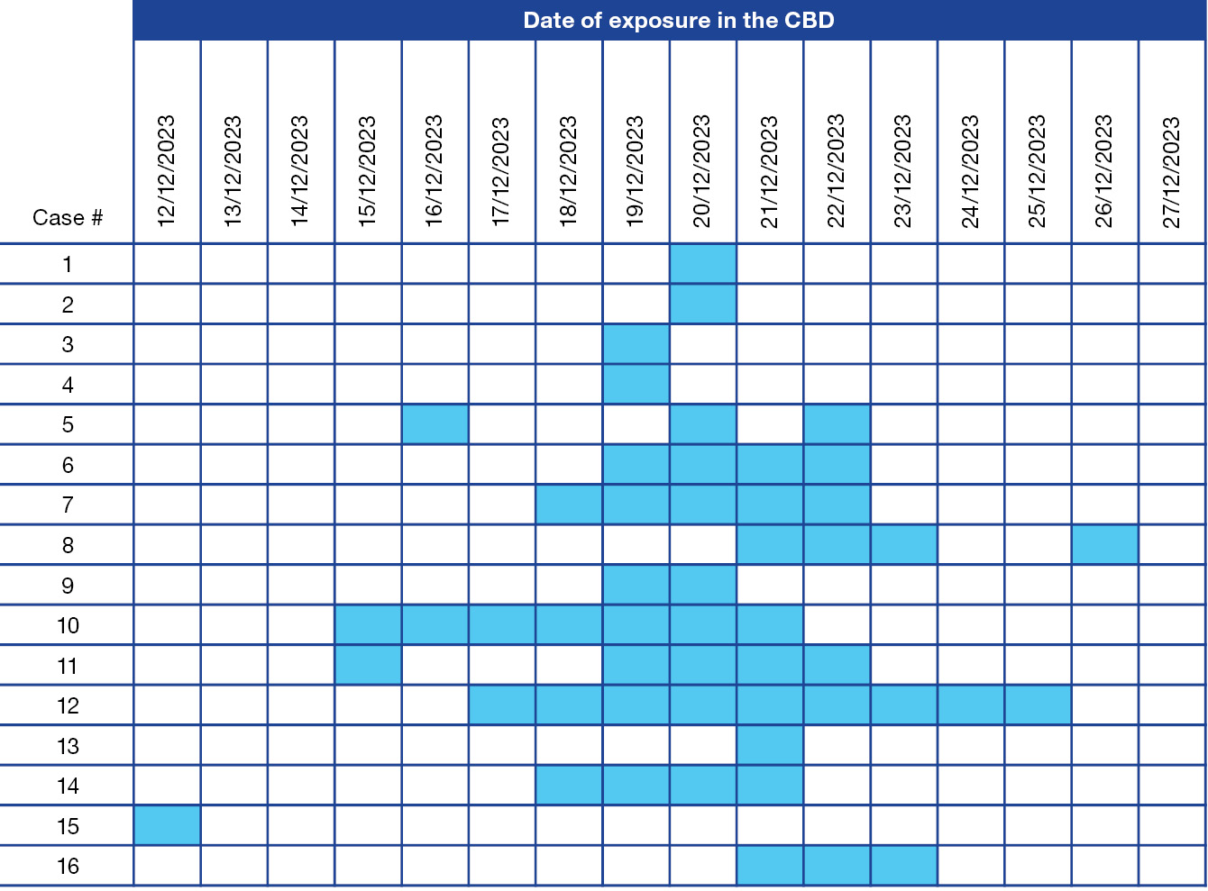

Figure 3: Map of the locations visited by, and walking routes of, the Legionella pneumophila case-patients, and the areas of the focused environmental health investigations, including a 500 metre buffer around the positive cooling water system (CWS), Sydney central business district, December 2023 – January 2024
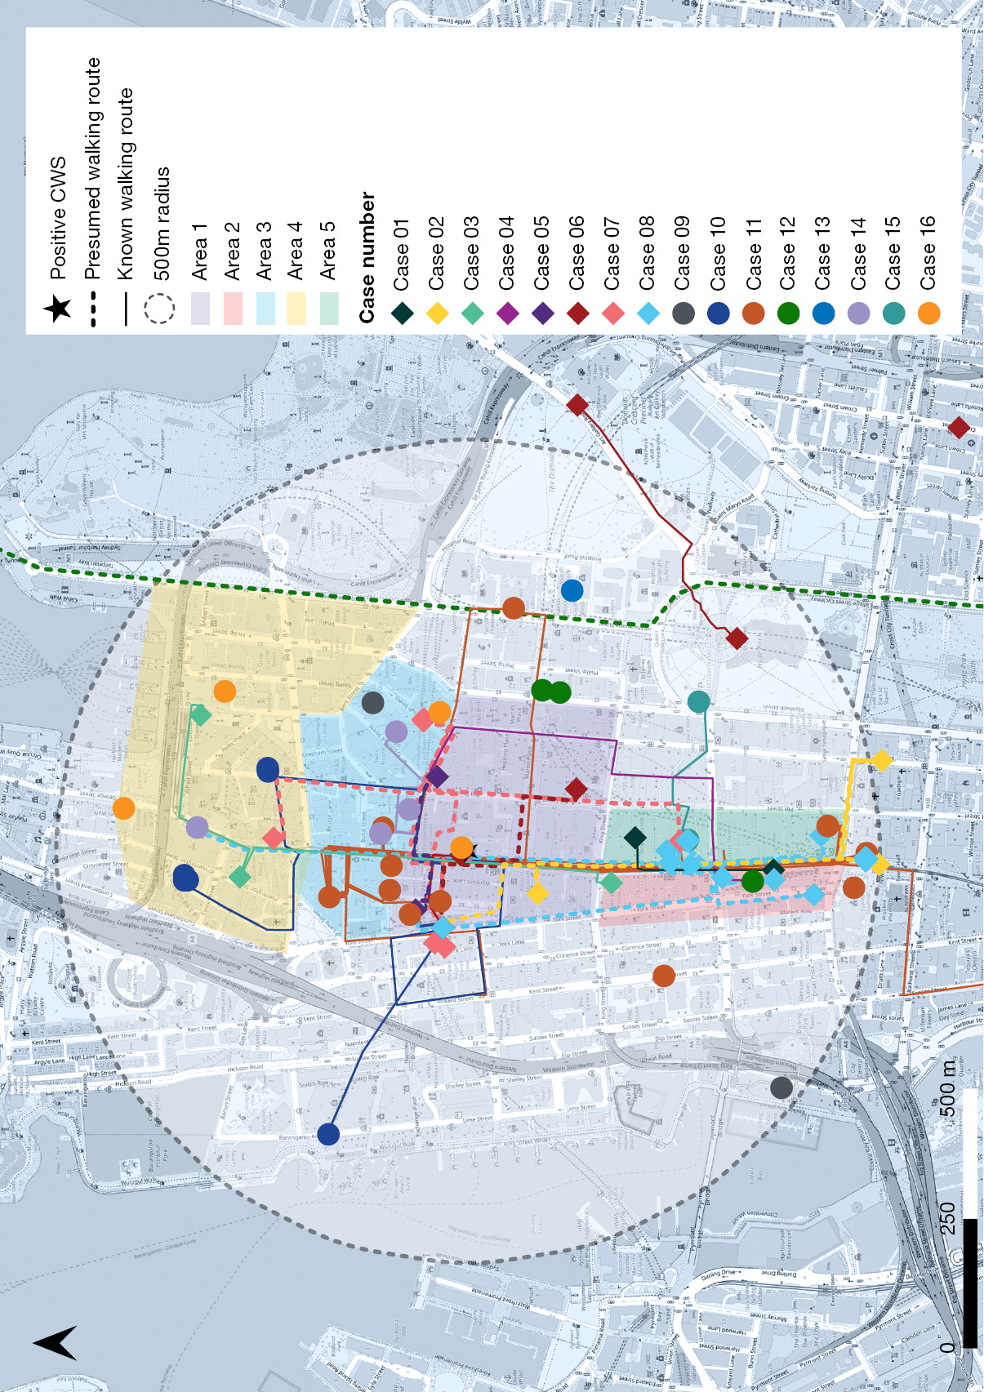

Environmental health investigation
Over the period 3–12 January 2024, sampling was done on 166 CWS across 118 sites, and on three water fountains. Figure 3 shows the targeted environmental investigation areas where CWS were inspected and sampled across the five days of testing. Local factors identified during fieldwork, which influenced inspection and sampling plans, included prioritising CWS in proximity to active construction sites, and finding decorative fountains, water features, and other potential sources of Legionella exposure in the investigation area that were not identifiable through CWS records or case-patient interviews. These potential sources were assessed through on-site observations and sampling by environmental health officers.
Review of audit reports and microbial testing results from the preceding three months found no CWS with elevated HCC or Legionella below reportable limits.
Other potential exposures outside the CBD, investigated by the relevant local public health units, identified no alternative sources for case-patients’ infections.
One CWS (1/166; 0.6%) was positive for Lp1 at a level of 150 cfu/ml. Following initial decontamination, the CWS continued to test positive at levels of > 500 cfu/ml, requiring additional decontamination, investigation, and management strategies.

Genomic investigation
Five environmental isolates from one CWS. and two clinical Lp1 isolates from two case-patients, were available for whole genome sequencing. All seven genomes belonged to ST211 which is a common Lp1 sequence type found in Sydney.^{6,14} Isolates were 0 to 5 SNPs apart, suggesting a probable link between the environmental source and clinical cases (Figure 4), which is well supported by the epidemiological investigation. The five environmental isolates were collected from different sampling points within the same CWS over multiple days, demonstrating low but notable genomic diversity within the system. Notably, one clinical isolate (Case 12) and one environmental isolate (Environmental 5) were genomically indistinguishable (i.e. showed 0 SNP difference).
Figure 4: Maximum likelihood phylogenetic tree of sequenced Lp1 genomes in the Sydney central business district cluster, December 2023 – January 2024^{a,b,c}
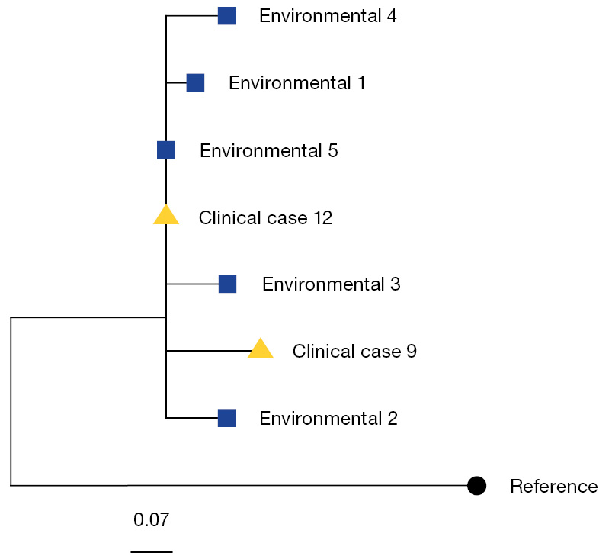
a Clinical cases 9 and 12 are listed in the figure and represented by yellow triangles. Environmental isolates are listed in the figure and represented by blue squares. The reference genome is AUSMDU00010536 (GenBank accession: CP045974.1).
b The phylogenetic tree was generated using IQ-TREE running the GTR+G4 substitution model and visualised in R using ggtree.
c The scale bar represents the number of nucleotide substitutions per site.

Discussion
Between late December 2023 and early January 2024, sixteen people who had visited the Sydney CBD during their exposure period were identified with Legionnaires’ disease (LD) due to Lp1. All were epidemiologically linked to the outbreak. A thorough investigation of possible sources related to case-patients’ movements took place. Lp1 was isolated from one CWS, with genomic sequencing from five environmental and two clinical isolates showing a probable link between the environmental source and case-patients within 5 SNPs. Previous outbreaks of Lp1 have demonstrated relatedness at a 5 SNP threshold.²²
A key strength in this outbreak investigation was the rapid collection of exposure information from case-patients and the ability to coordinate swiftly with the local government authority to define the environmental investigation area. Despite staffing limitations over the Christmas holiday period, a timely and extensive field investigation was undertaken. Strong collaboration between stakeholders enabled rapid communication with building managers in the CBD, prompting immediate CWS disinfection to mitigate ongoing Legionella exposure to the community. This early action may have limited further cases, although it also likely impacted our ability to detect all contaminated CWS, as it is possible that some CWS were disinfected prior to environmental sampling. Additionally, prompt public and clinical communication facilitated testing, supporting active case finding. These coordinated efforts reflect a robust, multidisciplinary response that allowed for effective mitigation of risk during a period of high public activity in the CBD during the Christmas-New Year period.
Despite this, challenges remained in obtaining specimens for culture and genomic sequencing. The time between illness onset and public health notification limited the ability to collect sputum samples, which are essential for culture and genomic sequencing. In addition, the timing of antibiotic administration relative to sputum collection was not recorded, which may have further reduced the likelihood of successfully culturing Legionella from clinical specimens. While detection of Lp1 urinary antigen is a rapid and widely used diagnostic method for legionellosis, particularly when sputum is unavailable, it still has some limitations, including inability to detect non-Lp1 serogroups or to perform genomic analysis.²³ Given that many patients with Lp1 do not spontaneously produce sputum, there is evidence supporting the use of induced sputum collection to improve diagnostic yield and facilitate genomic sequencing.²³
This investigation was also limited by the number of CWS able to be tested in the investigation area due to the density of CWS in the CBD. Therefore, it remains possible that a CWS classified as low risk may have contributed to this outbreak but was not tested. The positive CWS identified by the investigation may not have been the source for some or all cases, as another CWS may have been positive but effectively decontaminated prior to testing and the CWS we identified was secondarily contaminated.²⁴ Only two clinical isolates were available for sequencing, and while a genomic link to the environmental source was supported, the limited number of clinical samples constrains the strength of this association. Taken together, these factors highlight the inherent limitations of definitively attributing the outbreak to a single source and underscore the importance of a cautious interpretation of the environmental and genomic findings.
We suspect that dust from a nearby construction site contributed to the contamination by, and persistence of, Lp1 in the implicated CWS, even after disinfection. Construction dust was observed by environmental health officers in and around the CWS adjacent to an active demolition site. Construction-related contamination of water systems has been recognised in previous studies. In the United States of America, the Centre for Disease Control and Prevention found that 43% of Legionella outbreaks linked to external sources between 2000 and 2014 were associated with nearby construction.²⁵ A 2010 study reported widespread contamination of hospital potable water during major construction works, with exposure occurring shortly after.²⁶ These findings highlight the need for enhanced monitoring and maintenance of CWS located near construction sites, where excess dust may reduce the effectiveness of biocidal control and increase the risk of Legionella proliferation.⁵
There is evidence that weather conditions can influence Legionella contamination.^{27,28} In Sydney, as in other regions globally, legionellosis cases tend to peak during autumn or summer, particularly following periods of increased rainfall and humidity, with a typical lag of 1–2 weeks between weather conditions and symptom onset.¹⁶ In the two weeks preceding the outbreak, Sydney experienced unusually warm and humid conditions, including a heatwave with temperatures reaching 40 °C and relatively humidity averaging 81% during December 2023, higher than typical for that time of year.^{29,30}
Such conditions provide an optimal environment for Legionella proliferation and survival in systems.^{27,31} Several studies have linked elevated temperatures and humidity to increased risk of legionellosis. A 2023 study from Switzerland found a strong association with elevated daily mean temperature 6–14 days before LD onset,³¹ while another found that disease risk increased when temperature rose at high humidity, suggesting airborne L.p can persist longer in the environment, particularly in moist areas such as pooled water after rain.²⁷ A recent 2024 Sydney-based study also showed significant associations between LD incidence and relative humidity and temperature at 9 am and 3 pm.¹⁶ Taken together, these findings suggest that the exceptional weather conditions in the lead-up to the outbreak may have contributed to the proliferation and persistence of Legionella within CWS. These conditions should prompt enhanced CWS monitoring and maintenance.
Consideration should also be given to reviewing the current reporting threshold for Legionella detections in CWS. Under existing regulations, when L.p is detected below the reporting threshold of 1,000 cfu/ml, building managers are required to undertake decontamination and conduct follow-up testing to confirm clearance. In this outbreak, the implicated CWS did not exceed the reporting threshold, yet based on epidemiological, spatial, and genomic evidence, it was the most likely source of exposure. Similar findings were observed in a 1998 outbreak in western Sydney, where the CWS contamination did not meet the reporting threshold, but still resulted in an outbreak among the community.³² While these findings are based on real-time outbreak response rather than a formal risk assessment, our outbreak demonstrated that Legionella transmission can occur at levels below the current reportable limit, providing a clear rationale for amending guidelines to lower the reporting threshold to strengthen prevention and control efforts.

Conclusions
Our investigation indicates a contaminated CWS may have been the source of this outbreak, potentially precipitated by nearby construction and preceding hot humid weather. This emphasises the importance of proactive surveillance, including the revision of risk management plans by building occupiers and having mitigation measures in place to address increased contamination from external sources. These findings support strengthening the current regulations to reduce the risk of Lp1 contamination of CWS, for example through lowering the Legionella notification threshold to identify and address increased Legionella levels as a proactive public health measure.

Acknowledgments
The authors thank pathology service providers in NSW for their contribution to legionellosis surveillance and to Eby Sim (University of Sydney) and Basel Suliman (NSW Health Pathology) for their expert assistance in the typing and genotyping of Lp1 isolates.

Author details
Ms Eunice Stiboy,^{1,2}
Ms Misha Klingstrom,²
Dr Karen Chee,²
Prof. Mark J Ferson,^{2,3}
Ms Sandra Chaverot,²
Mr Brian Huang,²
Mr Toby Hannan,²
Mr Philip Pershen,²
Dr Kirsty Hope,⁴
Ms Zoe Baldwin,⁴
Mr Geoffrey Prendergast,⁴
Ms Kristy McCreadie,⁴
Ms Anita Smojver,⁵
Dr Catherine Pitman,⁶
Ms Anna Smith,⁷
Ms Keira Glasgow,⁴
Prof. Vitali Sintchenko,^{8,9}
Dr Geraldine Sullivan,⁸
Dr Qinning Wang,⁸
Dr Amy E Parry,¹
Dr Jeremy McAnulty,⁴
Dr Vicky Sheppeard,^{10,11}
Dr Anthea L Katelaris¹⁰
- National Centre for Epidemiology and Population Health, Australian National University, Canberra, Australia
South Eastern Sydney Local Health District, Randwick, New South Wales, Australia
School of Population Health, UNSW Medicine, University of New South Wales, Sydney, Australia
Health Protection NSW, St Leonards, Australia
City of Sydney, New South Wales, Australia
NSW Health Pathology, Public Health Pathology, Sydney, Australia
NSW Health Pathology, Forensic and Analytical Science Service, Lidcombe, Australia
NSW Health Pathology, Westmead, Australia
Centre for Infectious Diseases and Microbiology – Public Health, The University of Sydney, New South Wales, Australia
South Eastern Sydney Local Health District, Randwick, Australia
School of Public Health, University of Sydney, Australia

Corresponding author
Dr Anthea Katelaris
Randwick Hospitals Campus, Hut 'U' Easy Street, Locked Bag 88, Randwick, NSW 2031
Email: anthea.katelaris@health.nsw.gov.au
Phone: +61 2 9382 8333

References
- Australian Government Department of Health, Disability and Ageing, Communicable Diseases Network Australia (CDNA). Legionellosis – CDNA National Guidelines for Public Health Units. Canberra: Australian Government Department of Health, Disability and Ageing; 21 March 2017. Available from: https://www.health.gov.au/sites/default/files/2025-03/legionellosis-cdna-national-guidelines-for-public-health-units_0.pdf.
- New South Wales State Government Department of Health (NSW Health). Legionnaires' disease control guideline. [Webpage.] Sydney: NSW Health; 9 May 2023. Available from: https://www.health.nsw.gov.au/Infectious/controlguideline/Pages/legion.aspx.
- enHealth. Guidelines for Legionella control in the operation and maintenance of water distribution systems in health and aged care facilities. Canberra: Australian Government Department of Health, Disability and Ageing; 2015. Available from: https://www.health.gov.au/sites/default/files/documents/2022/07/enhealth-guidance-guidelines-for-legionella-control.pdf.
- New South Wales State Government Register of Legislation. Public Health Regulation 2022. [Legislation.] Sydney: New South Wales State Government; 2023. Available from: https://legislation.nsw.gov.au/view/html/inforce/current/sl-2022-0502.
- Victoria State Government Department of Health (Victoria Health). Legionella risks – identification and analysis: Section 6. [Webpage.] Melbourne: Victoria Health; 30 December 2024. Available from: https://www.health.vic.gov.au/water/legionella-risks-identification-and-analysis-section-6.
- Capon A, Cains T, Draper J, Sintchenko V, Ferson M, Sheppeard V. Investigation of a legionellosis outbreak in Sydney CBD – a brief report. Aust N Z J Public Health. 2023;47(2):100018. doi: https://doi.org/10.1016/j.anzjph.2023.100018.
- Quinn E, Johnstone T, Najjar Z, Cains T, Tan G, Huhtinen E et al. Lessons learned from implementing an incident command system during a local multiagency response to a Legionnaires’ disease cluster in Sydney, NSW. Disaster Med Public Health Prep. 2018;12(4):539–42. doi: https://doi.org/10.1017/dmp.2017.102.
- Griffiths E, Gilmour R, Carlin M, Adamson S, Timms V, Chen S et al. Summary: Public Health investigation into the Legionella outbreaks in Sydney CBD: March and May 2016. Sydney: NSW Health; 4 November 2016. Available from: https://www.health.nsw.gov.au/Infectious/Publications/legionella-cbd-report.pdf.
- NSW Health. Proposed changes to the regulation of water-cooling systems toprevent Legionnaires’ disease in NSW: Consultation Discussion Paper. Sydney: NSW Health; December 2016. Available from: https://www.health.nsw.gov.au/Infectious/Documents/legionnaires-disease-discussion-paper.pdf.
- New South Wales State Government Register of Legislation. Public Health Act 2010 No 127. [Legislation.] Sydney: New South Wales State Government; 2023. Available from: https://legislation.nsw.gov.au/view/html/inforce/current/act-2010-127.
- NSW Health. NSW Guidelines for Legionella Control in Cooling Water Systems. Sydney: NSW Health; 10 August 2018. Available from: https://www.health.nsw.gov.au/environment/legionellacontrol/Pages/guidelines-legionella-control.aspx.
- Cambon J, Hernangómez D, Belanger C, Possenriede D. tidygeocoder: an R package for geocoding. J Open Source Softw. 2021;6(65):3544. doi: https://doi.org/10.21105/joss.03544.
- QGIS Development Team. QGIS Resource Hub. [Software resource.] QGIS; 2024. Available from: https://qgis.org/resources/hub/.
- Timms VJ, Rockett R, Bachmann NL, Martinez E, Wang Q, Chen SC et al. Genome sequencing links persistent outbreak of legionellosis in Sydney (New South Wales, Australia) to an emerging clone of Legionella pneumophila sequence type 211. Appl Environ Microbiol. 2018;84(5):e02020-17. doi: https://doi.org/10.1128/AEM.02020-17.
- Sim E. DNA extraction for long-read sequencing of bacteria. Berkeley, California: Springer Nature, protocols.io; 3 November 2022. doi: https://doi.org/10.17504/protocols.io.4r3l2ox24v1y/v1.
- Timms VJ, Sim E, Pey K, Sintchenko V. Can genomics and meteorology predict outbreaks of legionellosis in urban settings? Appl Environ Microbiol. 2024;90(8):e0065824. doi: https://doi.org/10.1128/aem.00658-24.
- Seemann T, Gonçalves da Silva A, Buultjens A, Kwong J. Legsta. [Software.] GitHub repository; 26 February 2020. Available from: https://github.com/tseemann/legsta.
- Seemann T, Wirth W, Chaudhuri R, Maguire F, Monzón S, Gonçalves da Silva A et al. Snippy. [Software.] GitHub repository; 9 March 2020. Available from: https://github.com/tseemann/snippy.
- Gaia V, Fry NK, Afshar B, Lück PC, Meugnier H, Etienne J et al. Consensus sequence-based scheme for epidemiological typing of clinical and environmental isolates of Legionella pneumophila. J Clin Microbiol. 2005;43(5):2047–52. doi: https://doi.org/10.1128/JCM.43.5.2047-2052.2005.
- Nguyen LT, Schmidt HA, von Haeseler A, Minh BQ. IQ-TREE: a fast and effective stochastic algorithm for estimating maximum-likelihood phylogenies. Mol Biol Evol. 2015;32(1):268–74. doi: https://doi.org/10.1093/molbev/msu300.
- Yu G, Smith DK, Zhu H, Guan Y, Lam TTY. ggtree: an r package for visualization and annotation of phylogenetic trees with their covariates and other associated data. Methods Ecol Evol. 2017;8(1):28–36. doi: https://doi.org/10.1111/2041-210X.12628.
- Raphael BH, Baker DJ, Nazarian E, Lapierre P, Bopp D, Kozak-Muiznieks NA et al. Genomic resolution of outbreak-associated Legionella pneumophila serogroup 1 isolates from New York State. Appl Environ Microbiol. 2016;82(12):3582–90.
doi: https://doi.org/10.1128/AEM.00362-16.
- von Baum H, Ewig S, Marre R, Suttorp N, Gonschior S, Welte T et al. Community-acquired Legionella pneumonia: new insights from the German competence network for community acquired pneumonia. Clin Infect Dis. 2008;46(9):1356–64. doi: https://doi.org/10.1086/586741.
- European Centre for Disease Prevention and Control (ECDC). Legionnaires’ Disease Annual Epidemiological Report for 2021. Solna: ECDC; June 2023. Available from: https://www.ecdc.europa.eu/sites/default/files/documents/legionnaires-disease-annual-epidemiological-report-2021.pdf.
- Garrison LE, Kunz JM, Cooley LA, Moore MR, Lucas C, Schrag S et al. Vital signs: deficiencies in environmental control identified in outbreaks of Legionnaires' disease — North America, 2000–2014. MMWR Morb Mortal Wkly Rep. 2016;65(22):576–84. doi: https://doi.org/10.15585/mmwr.mm6522e1.
- Mermel LA, Josephson SL, Giorgio CH, Dempsey J, Parenteau S. Association of Legionnaires' disease with construction: contamination of potable water? Infect Control Hosp Epidemiol. 1995;16(2):76–81. doi: https://doi.org/10.1086/647060.
- Pampaka D, Gómez-Barroso D, López-Perea N, Carmona R, Portero RC. Meteorological conditions and Legionnaires’ disease sporadic cases—a systematic review. Environ Res. 2022;214(4):114080. doi: https://doi.org/10.1016/j.envres.2022.114080.
- Cains T, Shalak H, Timms VJ, Kiss A, Smith A, Sintchenko V et al. Legionella pneumophila serogroup 1 infection associated with the use of an apartment building spa pool. Commun Dis Intell (2018). 2022;46. doi: https://doi.org/10.33321/cdi.2022.46.82.
- Australian Government Bureau of Meteorology (BoM). Daily maximum temperature: Sydney (Observatory Hill). Canberra: BoM; 2023. Available from: http://www.bom.gov.au/tmp/cdio/IDCJAC0010_066214_2023.pdf.
- BoM. Sydney, New South Wales: December 2023 Daily Weather Observations. [Webpage.] Canberra: BoM; 2024. Available from: http://www.bom.gov.au/climate/dwo/202312/html/IDCJDW2124.202312.shtml.
- Fischer FB, Saucy A, Vienneau D, Hattendorf J, Fanderl J, de Hoogh K et al. Impacts of weather and air pollution on Legionnaires’ disease in Switzerland: a national case-crossover study. Environ Res. 2023;233:116327. doi: https://doi.org/10.1016/j.envres.2023.116327.
- Brown J, Hort K, Bouwman R, Capon A, Bansal N, Goldthorpe I et al. Investigation and control of a cluster of cases of Legionnaires disease in western Sydney. Commun Dis Intell Q Rep. 2001;25(2):63–6. doi: https://doi.org/10.33321/cdi.2001.25.13.

