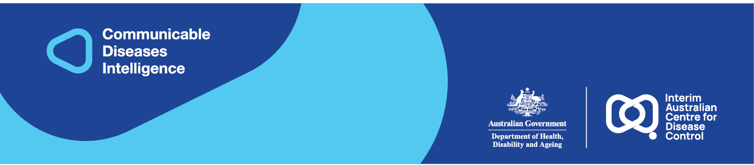
2025 • Volume 49 • cdc.gov.au/cdi • Epub date: 17.12.2025 • doi.org/10.33321/cdi.2025.49.062

Comparing two acute post-streptococcal glomerulonephritis outbreaks in the Torres Strait and Northern Peninsula Area, Queensland
Allison Hempenstall, Darien Payne, Caroline Taunton, Nancy Lui-Gamia, Debra Nona, Nishila Moodley, Malcolm McDonald

Abstract
In late 2023, an outbreak report of acute post-streptococcal glomerulonephritis (APSGN) in the Torres Strait documented seven confirmed cases and one probable case. This prompted an island-wide mass drug administration of oral trimethoprim/sulfamethoxazole to children aged 12 months to 17 years of age, possibly the first of its kind in response to an APSGN outbreak. In early 2024, an APSGN outbreak was declared with one confirmed and two probable cases, in the nearby Northern Peninsula Area of Cape York. The public health response to this outbreak included screening all children between 12 months and < 17 years of age for skin sores and sore throats, with treatment provided as deemed clinically appropriate. Both outbreaks reported nil further cases in the four months following each response. The relative merits of the different approaches will be discussed.
Keywords: acute post-streptococcal glomerulonephritis; glomerulonephritis; Streptococcus pyogenes; Indigenous health; First Nations health; Aboriginal and Torres Strait Islander health; kidney disease

Background and methods
Waiben (Thursday Island) is the administrative hub of the Torres Strait in Far North Queensland (FNQ) and traditional home to the Kaurareg people (Figure 1). It has a population approximating 2,800 people with 69% identifying as First Nations.¹ The community has a primary healthcare centre and a 31-bed hospital and is the referral hub for the Torres Strait outer islands.²
New Mapoon is one of five remote communities in the Northern Peninsula Area (NPA) of Cape York on mainland Australia, 36 km south of Waiben (Figure 1). New Mapoon was established in 1963 by the Queensland Government to house residents from ‘old’ Mapoon after they were relocated following the closure of Mapoon Mission and the opening of a bauxite mine.³ New Mapoon has a population of 360 people, with 88% identifying as First Nations. It is serviced by one primary healthcare centre.⁴
Figure 1: Map of the Torres Strait and Northern Peninsula Area, Australia, showing Waiben (Thursday Island) and New Mapoon, the locations of the two APSGN outbreaks with cases notified during October 2023 – January 2024
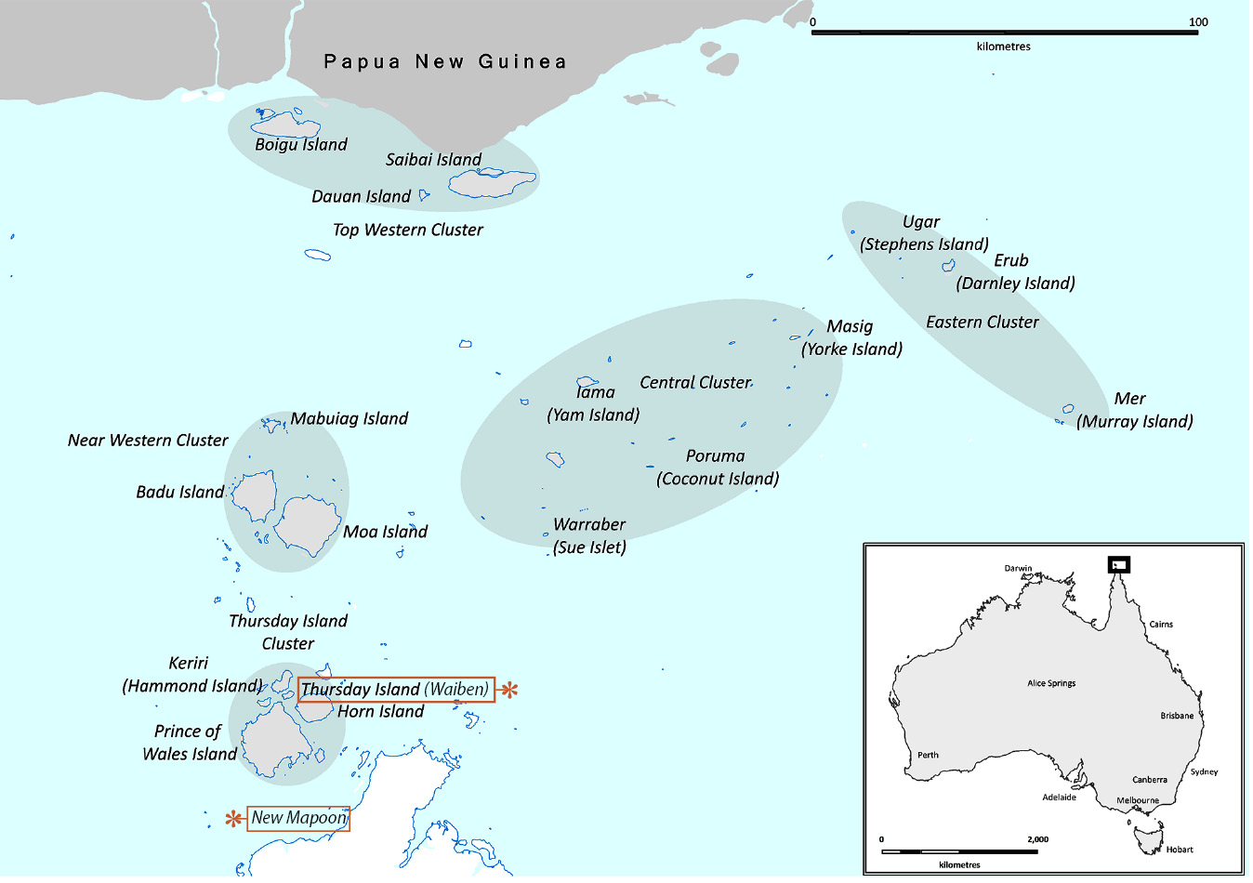
Acute post-streptococcal glomerulonephritis (APSGN) is an immune-mediated kidney disease and a well-established complication of Streptococcus pyogenes (Strep A) infection, usually impetigo or pharyngitis.⁵ Children are most susceptible and clinically present with oedema and/or haematuria and are often found to be hypertensive (the nephritic triad). APSGN is a disease of socioeconomic disadvantage and disproportionally affects First Nations people, especially in remote Australia with some regions reporting an incidence of ≥ 150 per 100,000 person years.⁶ Specific genotypes (emm-types) of Strep A are ‘nephritogenic’ and some, notably emm55, have been implicated in several large Australian and global outbreaks.⁷ This report describes the Torres and Cape Public Health Unit response and laboratory findings from two outbreaks in FNQ. An ethics exemption was granted by the FNQ Human Research Ethics Committee (1906 OR).

Description of outbreaks

Case definition
Under the Queensland Health Guidelines for Public Health Units, APSGN is classified as either a confirmed, probable, or possible case.⁸ A confirmed case requires definitive laboratory evidence in the form of a kidney biopsy, or laboratory suggestive evidence (microscopic haematuria and evidence of recent streptococcal infection and reduced C3 complement level), plus clinical evidence (at least two of the following: facial and/or peripheral oedema, moderate haematuria and/or hypertension). A probable case requires clinical evidence only and a possible case requires laboratory suggestive evidence only (Appendix A).⁸

Waiben (Thursday Island)
On 9 October 2023, the Torres and Cape Public Health Unit (TCPHU) was notified of a confirmed APSGN case on Waiben. Several notifications followed in the coming weeks, and an outbreak was declared following an expert advisory group discussion on 17 November 2023 (Figure 2). The expert advisory group comprised of public health physicians across Queensland public health units. The event met the Queensland Health Guidelines for an APSGN outbreak, defined by at least three probable or confirmed cases (with at least one confirmed) from a defined community within a four-week period and not household-like contacts of each other.⁸ A total of eight cases (seven confirmed and one probable) were ultimately associated with the outbreak. The median age of cases was six years (range 2–13 years) and 6/8 cases (75%) were male. Cultured Strep A isolates from four cases were genotyped as emm-55, with no isolate recovered from the other four cases. Six of the eight cases were hospitalised. There were no deaths.

New Mapoon
On 12 January 2024, the TCPHU was notified of a probable APSGN case in New Mapoon. Two additional cases (one confirmed and one probable) were later notified, on 22 and 24 January 2024 respectively, and an outbreak declared (Figure 2). No further cases were identified (Figure 2). Cases were aged 1, 3 and 10 years respectively; two of the three cases were hospitalised. A cultured Strep A isolate from one case was genotyped as emm-53, with no isolate recovered from the other two cases.
Figure 2: APSGN outbreak curve, Waiben and New Mapoon, October 2023 to April 2024
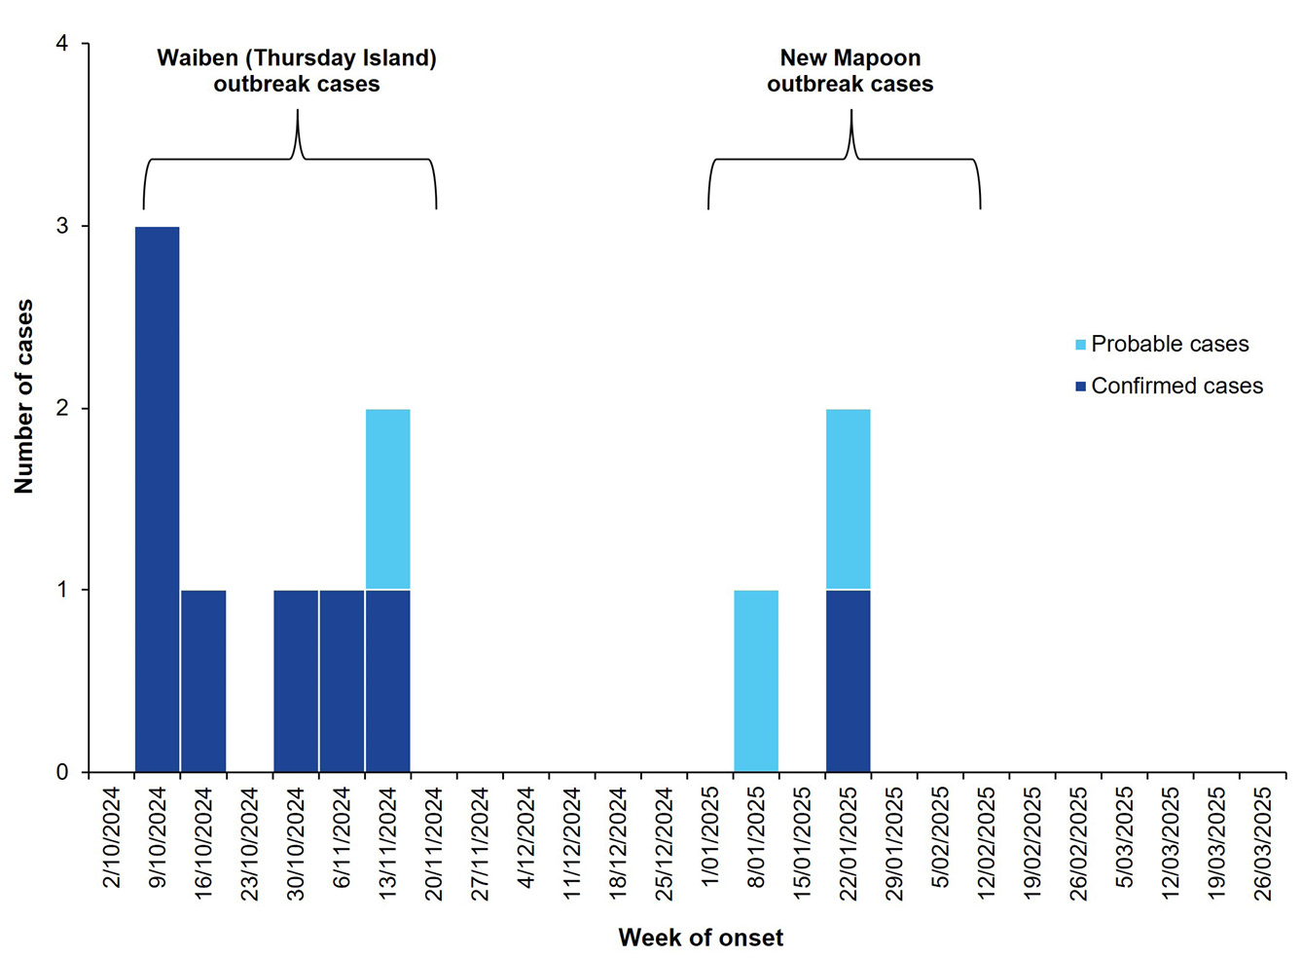

Public health response
In both outbreaks, case identification triggered comprehensive contact tracing, which included screening all household and household-like contacts for skin sores or sore throats. All children 12 months to 17 years of age were additionally assessed for oedema, hypertension, and haematuria (with urine dipstick), as per the guidelines.⁸ The cohort of children included in both public health responses was determined through local primary healthcare centre electronic medical record lists of children between 12 months and 17 years of age with a residential address of either outbreak location (Waiben or New Mapoon). Each list was updated throughout the public health response to remove children no longer residing in the region and to add in further children who were not captured through the local primary healthcare centre data.
The public health response on Waiben was determined by the state-wide public health advisory group. The group recommended a prompt mass drug administration (MDA) program to be rolled out to all children between 12 months and < 17 years of age, in order to rapidly mitigate further community spread of the pathogen, which was known to be the emm-55 strain. The approach was selected over the guideline-recommended approach (screening the same cohort for skin sores and sore throats), as there were heightened concerns that this outbreak could quickly spread across the outer Torres Strait islands with extensive school holiday travel, which was due to commence soon after the commencement of the public health response. The outbreak coincided with a global shortage of intramuscular benzathine penicillin G injection; the advisory group recommended a course of trimethoprim/sulfamethoxazole (TMP/SMX) twice daily for three days as an appropriate MDA alternative.⁹ The in-community response took place during 20 November – 1 December 2023. The outbreak response team was comprised of a public health physician, public health registrar, clinical nurse consultant, Indigenous public health officer and data officer. The team partnered with local staff at the Sibuwani Ngurpay Meta Primary Healthcare Centre on Waiben to conduct the MDA and to provide APSGN health education at local primary schools, daycare centres, and door-to-door. Among children aged 12 months to 17 years on Waiben during the in-community response, 811/981 (82.7%) identified as First Nations Australians. Of the total 981 children, 681 (69.4%) received TMP/SMX, 43 (4.4%) had a course of recent antibiotics that covered for Strep A, and 65 (6.6%) declined medication, with the remainder, 192 (19.6%), uncontactable during the response. MDA uptake was similar for First Nations children (71.0%; 95% confidence interval (95% CI): 65.2–76.8%) and non-Indigenous children (59.6%; 95% CI: 30.4–88.8%). Two of the 681 individuals (0.3%) who received TMP/SMX reported mild, self-resolving medication adverse events. No further APSGN cases were identified on Waiben in the four months following the response.
In contrast, the public health response at New Mapoon, occurring between 5 February 2024 and 9 February 2024, involved screening all children between 12 months and < 17 years of age for skin sores and sore throats, as per state guidelines. Opportunistic education was provided to the community about Strep A prevention through good hand hygiene and APSGN symptoms. All 102 children aged 12 months to < 17 years in New Mapoon during the in-community response identified as First Nations. A total of 98/102 children (96.1%) were screened for skin sores and sore throats, with 17/98 (17.3%) found to have one or more skin sores and 1/98 (1.0%) reporting a sore throat. All 18/18 symptomatic children (100%) received appropriate oral antibiotics, with none reporting oedema or requiring further APSGN screening. No further APSGN cases were identified in New Mapoon in the four months following the response.
Enhanced genomic surveillance was conducted after the first known emm55 isolate was identified, with the TCPHU requesting opportunistic typing of strep A isolates recovered from patients resident on Waiben or in New Mapoon between November 2023 and March 2024. Strep A emm-typing takes at least one week to be completed after a Strep A isolate is detected. This is therefore a helpful tool in the early establishment of an APSGN outbreak, but does not change the overall public health response. In addition to the emm-types reported from five APSGN cases, 28 further Strep A isolates were typed. Of these, 16/28 (57.1%) were emm-55, with detections continuing throughout the enhanced surveillance period. In total, emm-55 was detected from a further 15 skin swabs (from eight APSGN contacts: seven local residents and one APSGN case on an outer-island) and one blood specimen from a local resident diagnosed with Invasive StrepA disease. The remaining 12/28 isolates returned seven different emm-types (emm-11, emm-53, emm-95, emm-103, emm-119, emm-270, and stG-653). APSGN is predominantly a pathogen driven disease. Emm-55 has long been documented as the most common genotype responsible for APSGN outbreaks in Australia. There are also other well-known nephritogenic genotypes. StrepA genotypes constantly move through communities; each may stay in community for several months before being replaced.

Discussion and conclusion
This paper describes two APSGN outbreaks in neighbouring remote FNQ First Nations communities with contrasting public health responses. To our knowledge, this is the first described MDA approach with TMP/SMX for prevention of Strep A infection in the context of an APSGN outbreak. An MDA approach has proven to be an effective public health intervention in reducing the incidence of tropical diseases such as scabies, lymphatic filariasis and trachoma,^{10–12} with a previous MDA of ivermectin in the treatment of scabies reporting a relative reduction of 66% in impetigo prevalence.¹⁰ However, it is important to acknowledge that those MDA interventions were treating acute infections, whereas in this setting, MDA was used to prevent the non-suppurative complications of a prior Strep A infection. The decision by the expert advisory group to conduct an MDA on Waiben was driven by previously retired guidelines supporting MDA in APSGN outbreak settings and by concern within the advisory group’s membership that, if not aggressively managed just prior to the Christmas school holidays, a more widespread outbreak would occur across the Torres Strait.
The authors involved in both public health responses anecdotally found that the parents/guardians were more hesitant of this MDA approach, as reflected in the Waiben update rate compared with that seen in the New Mapoon response. Although the use of TMP/SMX may be a more acceptable medication for children than intramuscular benzathine benzylpenicillin G, the use of such a broad-spectrum antibiotic to cover for Strep A (known to be exquisitely sensitive to penicillin) does come with increased risk of side effects and antibiotic resistance.
The New Mapoon response followed the Queensland Health APSGN Guidelines: these recommend screening all children in the community, aged 12 months to < 17 years, for Strep A, and treating those with evidence of skin sores and/or sore throats.⁸ This aligns with evidence supporting targeted treatment of children with skin sores as distinct from treatment of all children within a community, where the aim is to curb the spread of Strep A.¹³ The population-level screening approach also identifies mildly symptomatic cases who may not otherwise present to the healthcare centre and allows for conversations with community to increase APSGN awareness. Perhaps unsurprisingly, emm-55 detections continued throughout the enhanced surveillance period. While both MDA and guideline screening proved successful in halting APSGN case numbers and may have curbed some Strep A transmission, neither approach intends to eliminate a particular Strep A strain from a region. Despite this, both public health responses appeared successful, with no further cases notified in either community during the following four months. Progressive community childhood immunity to a specific emm-type is thought to eventually limit its stay in a community. Reappearance of an emm-type would therefore require a new cohort of children with absent immunity to that specific strain.^{14,15} However, it is worth noting that the natural course of an APSGN outbreak is not well established in the literature, although the outbreaks tend to be self-limiting over a number of months. As such, it is unclear if this public health response prevented further cases or if, in both instances, a natural APSGN outbreak resolution occurred.
Strengths of both responses included utilising multidisciplinary teams, a culturally sensitive approach, and partnerships with local primary healthcare centres. A perceived risk of the MDA on Waiben was the risk of medication adverse events, although only two mild adverse events were ultimately reported. Screening in New Mapoon was higher than MDA uptake on Waiben (96.1% vs 69.4%), which may suggest the screening as a more acceptable community response. New Mapoon is a much smaller community and, hence, a more feasible population size to engage during the time-limited response. It is important to note that there are advantages in customising the public health responses depending on location, community sizes and available resources. In summary, the halting of both outbreaks may suggest that population screening yields a similar outcome as the mass drug administration of antibiotics during an APSGN outbreak.

Acknowledgments
The authors would like to sincerely thank the Torres and Cape Hospital and Health Service staff, Torres Shire Council and Northern Peninsula Area Regional Council for their partnership and support throughout this response.

Author details
Allison Hempenstall,¹
Darien Payne,²
Caroline Taunton,³
Nancy Lui-Gamia,⁴
Debra Nona,⁴
Nishila Moodley,⁵
Malcolm McDonald,⁶
- Public Health Physician, Torres and Cape Public Health Unit, 120 Bunda Street, Cairns, Queensland
- Clinical Nurse Consultant, Torres and Cape Public Health Unit, 120 Bunda Street, Cairns, Queensland
- Public Health Epidemiologist, Torres and Cape Public Health Unit, 120 Bunda Street, Cairns, Queensland
- Indigenous Public Health Officer, Public Health Medical Officer, Torres and Cape Public Health Unit, 120 Bunda Street, Cairns, Queensland
- Public Health Physician, Townsville Public Health Unit, 242 Walker Street, Townsville, Queensland
- Adjunct Professor, Division of Tropical Health and Medicine, James Cook University, Nguma-bada Campus, Cairns, Queensland

Corresponding author
Allison Hempenstall
Public Health Physician, Torres and Cape Public Health Unit, 120 Bunda Street, Cairns, Queensland
Phone: +61 438 755 738
Email: allison.hempenstall@health.qld.gov.au

References
- Australian Bureau of Statistics. Thursday Island: 2021 Census All persons QuickStats. [Webpage.] Canberra: Australian Bureau of Statistics; 2021. Available from: https://abs.gov.au/census/find-census-data/quickstats/2021/SAL32823.
- Queensland State Government Department of Health (Queensland Health), Torres and Cape Hospital and Health Service. Thursday Island Hospital. [Internet.] Cairns: Torres and Cape Hospital and Health Service; October 2023. Available from: https://www.torres-cape.health.qld.gov.au/hospitals-and-health-centres/thursday-island-hospital.
- Queensland Government. New Mapoon. [Internet.] Brisbane: Queensland Government; 2 March 2017. Available from: https://www.qld.gov.au/firstnations/cultural-awareness-heritage-arts/community-histories/community-histories-n-p/community-histories-new-mapoon.
- Australian Bureau of Statistics. New Mapoon: 2021 Census Aboriginal and/or Torres Strait Islander people QuickStats. [Webpage.] Canberra: Australian Bureau of Statistics; 2021. Available from: https://abs.gov.au/census/find-census-data/quickstats/2021/ILOC30300803.
- Brant Pinheiro SV, de Freitas VB, de Castro GV, Rufino Madeiro BC, de Araújo SA, Silva Ribeiro TF et al. Acute post-streptococcal glomerulonephritis in children: a comprehensive review. Curr Med Chem. 2022;29(34):5543–59. doi: https://doi.org/10.2174/0929867329666220613103316.
- Chaturvedi S, Boyd R, Krause V. Acute post-streptococcal glomerulonephritis in the Northern Territory of Australia: a review of data from 2009 to 2016 and comparison with the literature. Am J Trop Med Hyg. 2018;99(6):1643–8. doi: https://doi.org/10.4269/ajtmh.18-0093.
- Worthing KA, Lacey JA, Price DJ, McIntyre L, Steer AC, Tong SYC et al. Systematic review of group A streptococcal emm types associated with acute post-streptococcal glomerulonephritis. Am J Trop Med Hyg. 2019;100(5):1066–70. doi: https://doi.org/10.4269/ajtmh.18-0827.
- Queensland Health. Acute Post-Streptococcal Glomerulonephritis (APSGN). [Webpage.] Brisbane: Queensland Health; December 2023. Available from: https://www.health.qld.gov.au/cdcg/index/acute-post-streptococcal-glomerulonephritis-apsgn.
- Bowen AC, Tong SY, Andrews RM, O'Meara IM, McDonald MI, Chatfield MD et al. Short-course oral co-trimoxazole versus intramuscular benzathine benzylpenicillin for impetigo in a highly endemic region: an open-label, randomised, controlled, non-inferiority trial. Lancet. 2014;384(9960):2132–40. doi: https://doi.org/10.1016/S0140-6736(14)60841-2.
- Lake SJ, Kaldor JM, Hardy M, Engelman D, Steer AC, Romani L. Mass drug administration for the control of scabies: a systematic review and meta-analysis. Clin Infect Dis. 2022;75(6):959–67. doi: https://doi.org/10.1093/cid/ciac042.
- Ramaiah KD, Ottesen EA. Progress and impact of 13 years of the global programme to eliminate lymphatic filariasis on reducing the burden of filarial disease. PLoS Negl Trop Dis. 2014;8(11):e3319. doi: https://doi.org/10.1371/journal.pntd.0003319.
- (No authors listed). WHO Alliance for the Global Elimination of Trachoma by 2020: progress report on elimination of trachoma, 2014–2016. Wkly Epidemiol Rec. 2017;92(26):359–68. Available from: https://iris.who.int/bitstream/handle/10665/255778/WER9226.pdf.
- Johnston F, Carapetis J, Patel MS, Wallace T, Spillane P. Evaluating the use of penicillin to control outbreaks of acute poststreptococcal glomerulonephritis. Pediatr Infect Dis J. 1999;18(4):327–32. doi: https://doi.org/10.1097/00006454-199904000-00003.
- McDonald MI, Towers RJ, Andrews R, Benger N, Fagan P, Currie BJ et al. The dynamic nature of group A streptococcal epidemiology in tropical communities with high rates of rheumatic heart disease. Epidemiol Infect. 2008;136(4):529–39. doi: https://doi.org/10.1017/S0950268807008655.
- Chisholm RH, Lacey JA, Kokko J, Campbell PT, McDonald MI, Corander J et al. Global and local epidemiology of Group A Streptococcus indicates that naturally-acquired immunity is enduring and strain-specific. [Preprint.] arXiv. 2021:2111.06498. doi: https://doi.org/10.48550/arXiv.2111.06498.

Appendix A: APSGN case definitions from the Queensland Health APSGN Guidelines for Public Health Units

Case definitions

Confirmed
Laboratory definitive evidence
OR
Laboratory suggestive evidence AND clinical evidence

Probable
Clinical evidence only and APSGN is considered the most likely cause by a treating clinician

Possible
Laboratory suggestive evidence only

Laboratory definitive evidence
Renal biopsy suggestive of APSGN

Laboratory suggestive evidence
- Microscopic haematuria (RBC > 10/ul)
AND
- Evidence of recent streptococcal infection (Isolation or detection of GAS by culture, NAAT or rapid antigen detection test from skin or throat or elevated/rising ASO or Anti-DNase B titre, as defined by Steer et al, 2019
AND
- Reduced C3 complement level (< 0.7 g/L)

Clinical evidence
At least two of the following:
- Facial and/or peripheral oedema
- Macroscopic and/or moderate haematuria (≥ 2+ red blood cells on urine dipstick)
- Hypertension, according to age/sex/height percentiles from the American Academy of Paediatrics, 2017.
© 2025 Commonwealth of Australia as represented by the Department of Health, Disability and Ageing
ISSN: 2209-6051 Online
This journal is indexed by Index Medicus and Medline.
Creative Commons Licence
This publication is licensed under a Creative Commons Attribution-NonCommercial-NoDerivatives 4.0 International Licence (Licence). You must read and understand the Licence before using any material from this publication.
Restrictions
The Licence does not cover, and there is no permission given for, use of any of the following material found in this publication (if any):
- the Commonwealth Coat of Arms (by way of information, the terms under which the Coat of Arms may be used can be found on the Department of Prime Minister and Cabinet website;
- any logos (including the interim Australian Centre for Disease Control and the Department of Health, Disability and Ageing’s logos) and trademarks;
- any photographs and images;
- any signatures; and
- any material belonging to third parties.
Disclaimer
Opinions expressed in Communicable Diseases Intelligence are those of the authors and not necessarily those of the Australian Government, the interim Australian Centre for Disease Control or the Department of Health, Disability and Ageing. Data may be subject to revision.
Enquiries
Enquiries regarding any other use of this publication should be addressed to the CDI Editor.
About CDI
Communicable Diseases Intelligence (CDI) is a peer-reviewed scientific journal published by the interim Australian Centre for Disease Control within the Department of Health, Disability and Ageing.
The journal aims to disseminate information on the epidemiology, surveillance, prevention and control of communicable diseases of relevance to Australia and the near region.
Editor: Christina Bareja • Deputy Editor: Simon Petrie • Design and Production: Lisa Thompson
Editorial Advisory Board: David Durrheim, Mark Ferson, Clare Huppatz, John Kaldor, Martyn Kirk and Meru Sheel
Submit an Article
Guidelines for authors and details on how to submit your publication is available on our website, or by email to the
CDI Editor.
Contact us
Communicable Diseases Intelligence (CDI)
interim Australian Centre for Disease Control, Department of Health, Disability and Ageing
GPO Box 9848, CANBERRA ACT 2601
Website: cdc.gov.au/cdi
Email: cdi.editor@health.gov.au

