
2025 • Volume 49 • cdc.gov.au/cdi • Epub date: 17.12.2025 • doi.org/10.33321/cdi.2025.49.060

An outbreak of genomically clustered group A Streptococcus in a school community, Victoria, 2023
Aaron Osborne, Julia Marshall, Janet Strachan, Amy Parry, Annaliese van Diemen, Hazel J Clothier
© 2025 Commonwealth of Australia as represented by the Department of Health, Disability and Ageing
ISSN: 2209-6051 Online
This journal is indexed by Index Medicus and Medline.
Creative Commons Licence
This publication is licensed under a Creative Commons Attribution-NonCommercial-NoDerivatives 4.0 International Licence (Licence). You must read and understand the Licence before using any material from this publication.
Restrictions
The Licence does not cover, and there is no permission given for, use of any of the following material found in this publication (if any):
- the Commonwealth Coat of Arms (by way of information, the terms under which the Coat of Arms may be used can be found on the Department of Prime Minister and Cabinet website;
- any logos (including the interim Australian Centre for Disease Control and the Department of Health, Disability and Ageing’s logos) and trademarks;
- any photographs and images;
- any signatures; and
- any material belonging to third parties.
Disclaimer
Opinions expressed in Communicable Diseases Intelligence are those of the authors and not necessarily those of the Australian Government, the interim Australian Centre for Disease Control or the Department of Health, Disability and Ageing. Data may be subject to revision.
Enquiries
Enquiries regarding any other use of this publication should be addressed to the CDI Editor.
About CDI
Communicable Diseases Intelligence (CDI) is a peer-reviewed scientific journal published by the interim Australian Centre for Disease Control within the Department of Health, Disability and Ageing.
The journal aims to disseminate information on the epidemiology, surveillance, prevention and control of communicable diseases of relevance to Australia and the near region.
Editor: Christina Bareja • Deputy Editor: Simon Petrie • Design and Production: Lisa Thompson
Editorial Advisory Board: David Durrheim, Mark Ferson, Clare Huppatz, John Kaldor, Martyn Kirk and Meru Sheel
Submit an Article
Guidelines for authors and details on how to submit your publication is available on our website, or by email to the
CDI Editor.
Contact us
Communicable Diseases Intelligence (CDI)
interim Australian Centre for Disease Control, Department of Health, Disability and Ageing
GPO Box 9848, CANBERRA ACT 2601
Website: cdc.gov.au/cdi
Email: cdi.editor@health.gov.au

Contents
Abstract 4
Introduction 5
Aims and objectives 6
Methods 7
Study design 7
Outbreak setting 7
Investigation team 7
Epidemiological investigation 7
Outbreak definitions 7
Laboratory investigation 9
Ethics approval 9
Results 10
Public health measures 14
Discussion 15
Conclusion 17
Acknowledgments 18
Author contributions 18
Author details 19
References 20
Appendix A – Investigation Survey 24
Section 1: GAS related questions 24
Section 2: respiratory illness related questions 24

Abstract
In 2023, a global increase in invasive group A streptococcal disease (GAS) caused serious illness and death. The North Eastern Public Health Unit (NEPHU) in Victoria, Australia, identified an outbreak of GAS in a school in July 2023; we investigated to describe the epidemiology, to identify risk factors for severe disease, and to implement control measures. We defined confirmed cases as those with laboratory, clinical and epidemiological evidence. Probable cases had clinical evidence with an epidemiological link to a confirmed case but no laboratory evidence. Absentee data were collated for students preceding the onset of the index case. We developed an online, self-administered survey for all students to identify contacts with clinically compatible illnesses. Cultures were genomically sequenced. We identified 11 cases (five confirmed, six probable) among the cohort of 38 (a 29% attack rate), with onset dates from 24 July to 27 August 2023. The index case had a severe invasive GAS infection requiring hospitalisation; eight of 11 cases (73%) reported sore throat and one reported scarlet fever as their primary syndrome. Fifteen of 28 students (54%) were absent from the school during the period preceding the index case’s onset. We monitored for two incubation periods following the onset of the last case to 5 September 2023 (six days), with no further cases identified. Isolates all typed as emm1, with genomic clustering consistent with localised transmission. This outbreak demonstrated group A Streptococcus (GAS) transmissibility in a school with multiple clinical manifestations.
Keywords: disease outbreak; streptococcal infections; invasive group A Streptococcus; Streptococcus pyogenes; scarlet fever; genomic cluster

Introduction
Group A Streptococcus (GAS), or Streptococcus pyogenes, is a human pathogen associated with significant mortality and morbidity globally.¹ GAS is a gram-positive bacterium that colonises both the skin and pharynx and can cause a wide range of clinical manifestations.² These include mild infections, such as pharyngitis and impetigo, and serious infections known as invasive group A streptococcal (iGAS), with presentations including necrotising fasciitis and streptococcal toxic shock syndrome.² Following infection, complications can occur, such as acute rheumatic fever and post-streptococcal glomerulonephritis which, while rare, are important causes of mortality and morbidity globally.¹
Invasive group A streptococcal infection occurs when GAS infects a normally sterile site.³ Invasive infections are often severe, with case fatality as high as 15% in high-income countries.^{4,5} Several risk factors increase the likelihood of a severe invasive GAS infection. Older (> 65 years) and younger (< 5 years) age groups are at greater risk of developing invasive GAS infections.⁶ Studies have identified an increased risk of secondary invasive GAS cases in household contacts of cases when compared to the general population.^{7–9} Viral co-infection, such as influenza or varicella, may increase the risk of invasive GAS disease.^{10–12}
In early to mid-2022, there was an increase in hospital admissions and deaths due to invasive GAS in Europe and the United States of America (USA), particularly among children under ten years old.^{13–16} Similar increases were noted in Australia.¹⁷ Invasive GAS was made a notifiable condition in the Australian state of Victoria in 2022 under the Public Health and Wellbeing Regulations (2019).¹⁸ The North Eastern Public Health Unit (NEPHU) is one of nine public health units in Victoria, serving a population of 1.8 million, accounting for 28% of the total Victorian population.¹⁹ We describe an outbreak investigation of GAS in a school setting conducted by the North Eastern Public Health Unit (NEPHU).
On 31 July 2023, NEPHU received a laboratory notification of invasive GAS in a 10-year-old male. Through routine follow-up with the principal of the school that the case attended, it was reported that two students from the same classroom as the index case had symptoms consistent with non-invasive GAS infections. This principal also reported higher than usual levels of absenteeism in the week preceding the notification of the index case. This prompted the public health unit to conduct an outbreak investigation in an effort to prevent secondary cases of invasive GAS in this setting.

Aims and objectives
This study aimed to describe the outcomes of the investigation into an outbreak of GAS in a Victorian school. The key objectives were:
- to describe the outbreak setting, investigation and associated public health actions;
- to epidemiologically analyse the outbreak to describe transmission and the extent of the outbreak's spread; and
- to provide evidence to inform future GAS public health responses.

Methods

Study design
A retrospective cohort study was conducted. All analyses were performed using R statistical software.²⁰

Outbreak setting
The setting of this outbreak was a grade five/six class of students aged 10 to 12 years old at a primary school in Melbourne, Victoria. The class under investigation comprised 28 students and one teacher in a school of 64 students and 19 staff. A social event held at a public venue on 22 July 2023, attended by eight students from the class and four additional household members, was included in the investigation.

Investigation team
The NEPHU Incident Management Team was established on 1 August 2023, comprising public health physicians, epidemiologists, public health officers, a communications lead, and infection prevention and control specialists. The United States Centers for Disease Control and Prevention (CDC) guidelines for outbreak investigation (10 steps) and state incident management guidelines were used to investigate and manage the outbreak.²¹

Epidemiological investigation
School enrolment, an attendance list, and details of the social event attendees were obtained on 3 August 2023. This included all staff and students in the class and data on who reported a clinically compatible illness, attendance at the social event, and absenteeism data for the period preceding the notification of the index case.

Outbreak definitions

Confirmed outbreak case
An individual with positive detection of group A streptococci (Streptococcus pyogenes) by culture or molecular methods on or after 24 June 2023 to 5 September 2023
AND
an individual with clinical evidence of GAS infection on or after 24 June 2023 to 5 September 2023
AND
epidemiological evidence

Probable outbreak case
An individual with clinical evidence of GAS infection on or after 24 June 2023 to 5 September 2023
AND
epidemiological evidence
Epidemiological evidence
An individual who either attended the grade five/six class at the school for cumulatively more than 24 hours from 24 June 2023 to 5 September 2023
OR
an individual who attended the social event on 22 July 2023
Clinical evidence
Clinical symptoms consistent with streptococcal sore throat (pharyngitis) OR scarlet fever OR skin sores (impetigo) OR invasive GAS. Symptoms, as documented from a medical examination or reported by the child’s parents, included:
- sore throat;
- skin rash – fine erythematous, punctate, blanching on pressure and with a sandpaper texture and predominantly truncal distribution;
- superficial skin infection typically presenting as small blisters;
- strawberry tongue;
- flushing of cheeks and circumoral pallor;
- desquamation of the skin in convalescence;
- streptococcal toxic shock syndrome that includes both hypotension and multi-organ failure;
- necrotising fasciitis;
- puerperal sepsis.

Contact
An individual who attended either the grade five/six class at the school for cumulatively more than 24 hours from 22 June 2023 to 5 September 2023
OR
an individual who attended the social event on 22 July 2023
OR
a household contact of an invasive GAS case.

Case finding
Students who reported a clinically compatible illness were reported to the investigation team by the school and followed up. Active case finding was conducted using a survey sent to the school community on 22 August (Appendix A). The survey aimed to identify any additional cases in the one month prior to the index case and to assess any ongoing transmission following the administration of antibiotic prophylaxis. The survey was administered to all students and staff not already identified as cases in the investigation.

Laboratory investigation
All suspected cases were requested to visit a healthcare facility for laboratory confirmation and treatment. Positive samples were sent to the Microbiological Diagnostic Unit Public Health Laboratory (MDU PHL) at the University of Melbourne for whole genome sequencing (WGS) and multi-locus sequence typing (MLST) as part of the outbreak investigation. Phylogenetic trees were generated using a maximum-likelihood method based on the core genome alignment of all isolates analysed in this report and interpreted in context with available epidemiological data.

Ethics approval
This investigation was carried out under the powers of the Victorian Public Health and Wellbeing Act 2008 and associated Public Health and Wellbeing Regulations (2019) in response to an acute threat to public health.^{18,22} The Australian National University (ANU) Human Research Ethics Committee (HREC) has a standing authorisation for staff and student outbreak investigations (Protocol Number 2017/909).

Results
Eleven cases (five confirmed, six probable) were identified amongst the cohort (n = 38), which comprised staff (n = 1), students (n = 28) and household members (n = 9), with a 29% attack rate. The index case attended school while infectious (defined as up to seven days before symptom onset)²³ on 24 July 2023 and was reported to the NEPHU on 31 July 2023; illness onset dates ranged for cases from 24 July to 27 August 2023 (Figure 1). Eight cases were students from a single class group at the school (8/29; 29% attack rate).
Figure 1: The epidemiological curve of cases in a school outbreak of group A Streptococcus, Victoria, Australia, July–September 2023
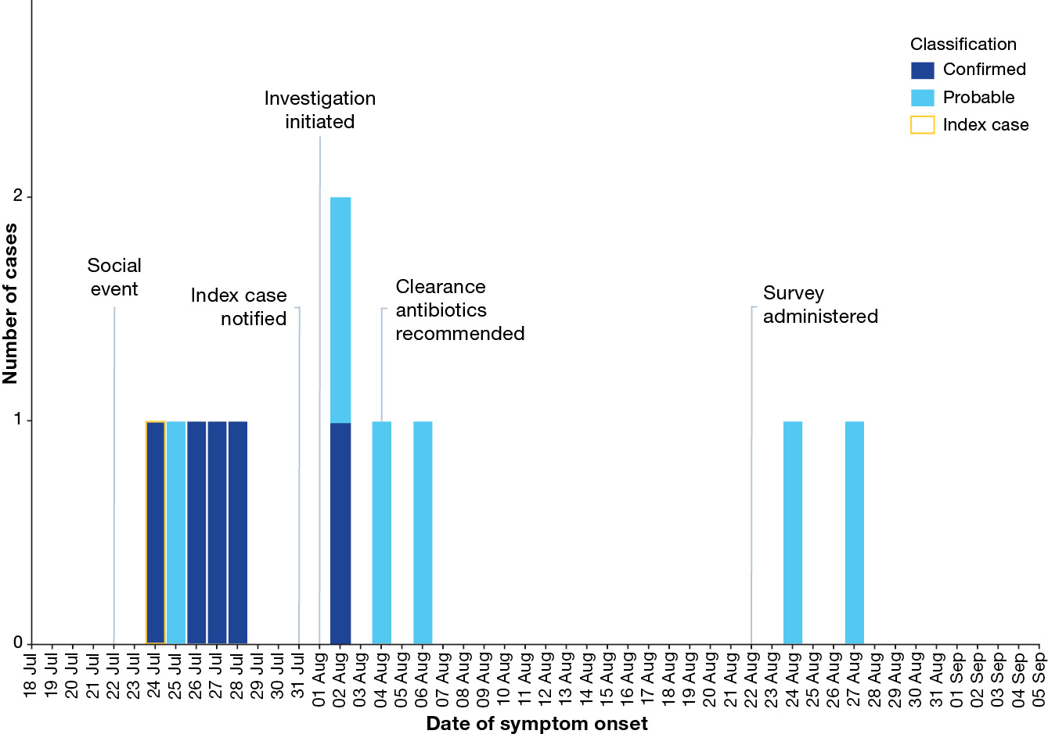
The investigation included a social event held on 22 July 2023, attended by the index case. Eight students from the same class and four household contacts participated in the event. Five of the 12 attendees were identified as cases (Figure 2), with an attack rate of 41%. Four cases attended the social event while potentially infectious. One additional case, who was also a household contact of a case, was identified from attendees.
Figure 2: Summary of exposure events in a school outbreak of group A Streptococcus, Victoria, Australia, July–September 2023
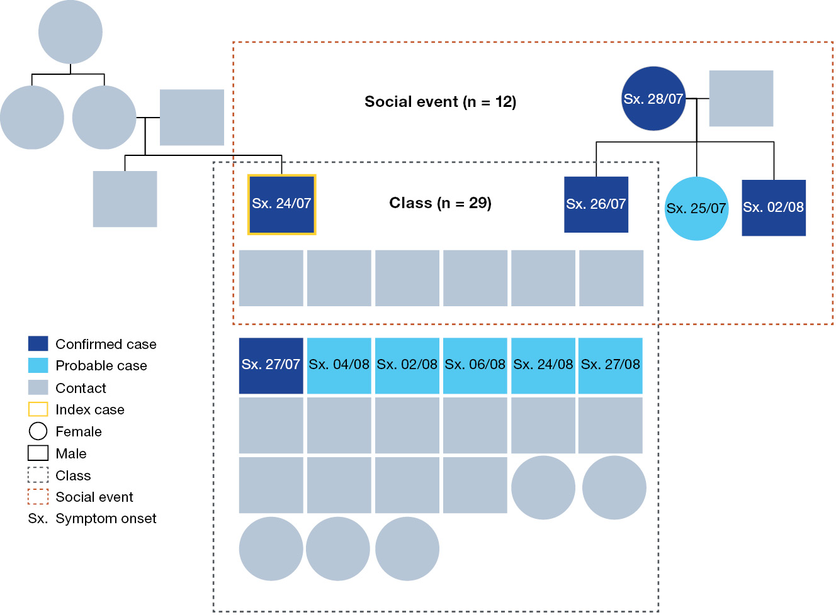
Twenty-six investigation surveys were distributed amongst contacts in the class cohort; twelve contacts (46%) responded, of whom five (42%) reported symptoms consistent with GAS (Table 1). Reported symptom onset, among survey respondents, ranged from 2 to 27 August 2023; two probable cases reported symptoms of sore throat after the administration of antibiotic prophylaxis on 24 and 27 August 2023. The two probable cases reported seeking medical care and received alternate diagnoses; no diagnostic tests were performed. No swabs were taken for the cases identified through the active case finding survey and all met the probable case definition. No cases were identified with a symptom onset date preceding the index case. Fifty–five investigation surveys were sent to individuals in other class cohorts in the broader school setting, to assess the risk of further transmission outside the class cohort; 17 responses were received (31% response rate). No additional cases were identified in other class cohorts.
The median age of cases was 11 years, with an overall age range of 10–52 years (Table 1). During the outbreak, males showed a higher attack rate (38%) than did females (24%). The index case had a severe invasive group A Streptococcus infection that required hospitalisation for a period of ten days. Eight cases (73%) reported pharyngitis as their clinical manifestation, while one case reported scarlet fever as their primary clinical manifestation. There were no deaths during the outbreak.
Table 1: Demographic characteristics, clinical illness, and outcomes of cases linked to the outbreak of group A Streptococcus in a school setting, Victoria, Australia, July–September 2023
Category | Characteristic | Cohort |  | Probable cases |  | Confirmed cases |  | Attack rate
Category | Characteristic | Number | Percentage | Number | Percentage | Number | Percentage | Attack rate
Cohort composition | Total | 38 | — | 6 | — | 5 | — | 29%
Cohort composition | Students | 28 | 74% | 5 | 83% | 3 | 60% | 29%
Cohort composition | Staff | 1 | 3% | 0 | 0% | 0 | 0% | 0%
Cohort composition | Household | 9 | 24% | 1 | 17% | 2 | 40% | 33%
Demographics | Median age, years | 11 | (10–11)ª | 11 | (10–12)ª | 11 | (11–20)ª | —
Demographics | Male | 13 | 34% | 3 | 50% | 2 | 40% | 38%
Demographics | Female | 25 | 66% | 3 | 50% | 3 | 60% | 24%
Clinical manifestation | Invasive GAS | — | — | 0 | 0% | 1 | 20% | —
Clinical manifestation | Fever | — | — | 0 | 0% | 1 | 20% | —
Clinical manifestation | Pharyngitis | — | — | 6 | 100% | 2 | 40% | —
Clinical manifestation | Scarlet fever | — | — | 0 | 0% | 1 | 20% | —
a Interquartile range (IQR) in years.
Data from the school administration system identified high levels of absenteeism at the school prior to the index case, from 24 June 2023. Across the investigation period, 15 of 28 students (54%) were reported absent during the period 24 June to 1 August 2023 (Figure 3). Five of 28 students (18%) were absent during the week preceding the index case; the school did not record a specific reason for their absences. These students were included in the subsequent active case-finding survey; among respondents, none reported symptoms consistent with GAS infection and no additional cases were identified. Students were asked about symptoms of other respiratory illnesses, such as influenza or respiratory syncytial virus, in the month before the index case; no contacts reported other respiratory diseases.
Figure 3: Weekly percentage of students absent and cases by week of symptom onset for a school outbreak of group A Streptococcus, Victoria, Australia, July–September 2023
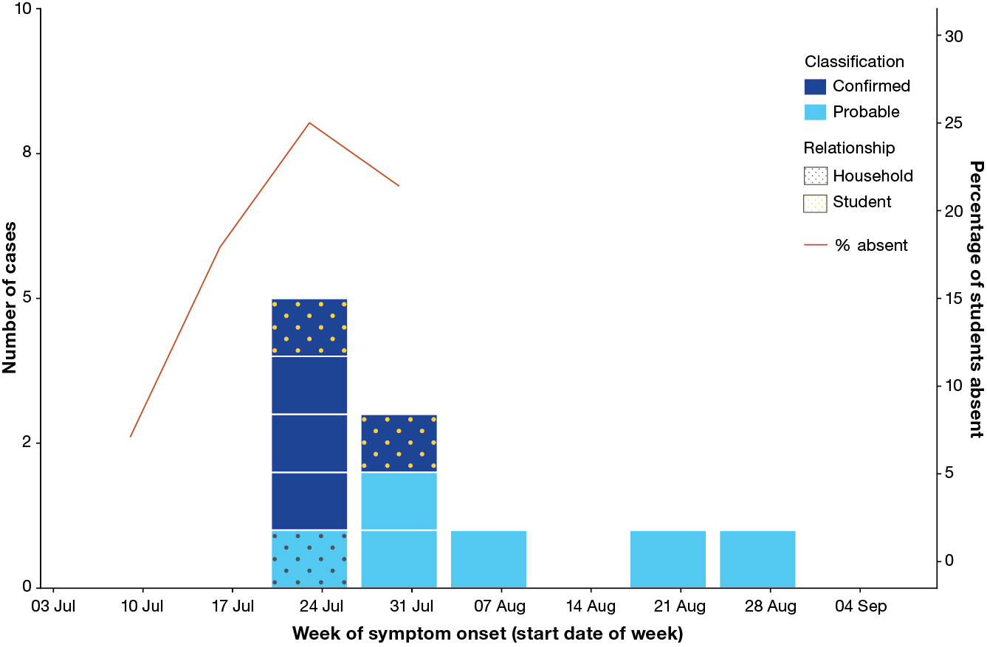
Four of the five isolates were available for typing and genomic analysis. Typing results from isolates were all found to be emm1, a common subtype in Victoria. The strain was genomically distinct from other emm1 circulating in Victoria at the time. Clustering based on single nucleotide polymorphism (SNP) thresholds found that all four cases appeared closely related (0 SNPs) and consistent with potential transmission between cases or from a common source. The isolates within the cluster were greater than 10 SNPs from all other Victorian sequenced isolates. One additional isolate from a Victorian case outside this cluster was found to be closely related (0 SNPs) to isolates in this school outbreak. The case was a female aged in her 40s with a specimen collected on 21 June 2023. Follow-up identified no clear epidemiological link to the outbreak.

Public health measures
Probable cases were requested to not attend school from symptoms onset until 24 hours after the commencement of treatment. Following laboratory confirmation of the second GAS case within the cluster, prophylactic antibiotics were recommended for all contacts. A letter was sent to parents on 4 August 2023, advising contacts to seek medical attention to receive prophylactic antibiotics and continue monitoring for symptoms. The letter advised the treating clinician to refer to the relevant therapeutic guidelines for additional information on appropriate prophylactic regimens. Sixteen of 24 contacts (67%) were confirmed to have received prophylactic antibiotics.
Recommendations were provided to the school principal on reducing GAS transmission in the school. These included education resources on how GAS is spread and strategies to prevent GAS transmission.²³ It was advised that staff and students were educated in hand hygiene techniques and that hand hygiene products (soap and water in bathrooms, alcohol-based hand rubs in the classroom) were made readily available. It was recommended that a cleaning process be implemented daily for applicable classrooms, including detergent and disinfection steps for high-touch surfaces. In the situation where the classroom had access to air purifiers, it was advised that they were on during school hours. The outbreak was monitored for two incubation periods following the onset date of the last case to 5 September 2023 (six days), with no further cases identified.

Discussion
This report describes an outbreak of group A Streptococcus (GAS) in a school with multiple clinical manifestations, including pharyngitis, scarlet fever and iGAS. This occurred during a period of increased iGAS notifications in Victoria and globally.^{13–17} Within the classroom setting, eight of 28 students were identified as cases in this outbreak, with a 28% attack rate. This attack rate is comparable to the other published GAS attack rates in school settings, which range from 23% to 72%.^{24–28} However, because the survey response rate was low, the actual attack rate may differ; these comparisons should therefore be interpreted with caution. The investigation was supported by genomic phylogenetic analysis, which highlighted the transmission of the outbreak. The outbreak strain was identified as the emm1 strain, consistent with the most prevalent strain associated with invasive GAS in Victoria.²⁹
At the time of the investigation, no national or state jurisdiction guidelines existed to control invasive GAS clusters. This outbreak included both invasive and non-invasive forms of GAS; potentially, more could be done to prevent transmission of both invasive and non-invasive GAS infections. As non-invasive forms of GAS, such as scarlet fever, are not notifiable in Victoria, the extent of transmission is not known. During the rise in GAS cases in December 2022 in the UK, more than 700 outbreaks were recorded by local health protection teams in England.³⁰ Reducing transmission from less severe infections, such as scarlet fever, can reduce the risk of severe invasive infection in close contacts, given the crossover of strains causing both mild and severe presentations.^{31,32}
There were no additional cases of invasive GAS in this outbreak. Prophylactic antibiotics were recommended to all contacts in this outbreak to prevent secondary invasive GAS infections. The risk of secondary invasive GAS infections among close contacts is higher than the sporadic invasive GAS infection rate, ranging from 19 to 200 fold higher.^{8,33} However, a recent systematic review found that the evidence for antibiotic prophylaxis was based on studies with small sample sizes and with weak study designs, so definitive conclusions cannot be drawn.³⁴ These findings must also be taken in the context of new and evolving practices in response to antimicrobial stewardship.
High absenteeism in the class before the onset of the index case indicated there were possibly circulating pathogens before the onset of the index case. This outbreak occurred during winter when there were higher levels of other circulating respiratory viruses; however, no respiratory symptoms were reported amongst survey respondents over this time, so it is unclear what the cause was for this absenteeism. A preceding or concurrent viral respiratory tract infection can increase the risk of invasive GAS.^{35–39}
The investigation survey identified two probable cases with symptom onset dates after the administration of antibiotic prophylaxis and 19 days after the most recent cases in the class cohort. While their sore throats could have been caused by an unrelated infection, both individuals had already received prophylactic antibiotics, so it remains possible they were infected with S. pyogenes despite prophylaxis. As probable cases were not followed up and swabbed for confirmation at this point in the investigation, they were not laboratory tested for GAS infection, and an alternative diagnosis with symptoms consistent with GAS could not be determined.
This investigation had several limitations. Not all cases were swabbed, and given the non-specific nature of pharyngitis, we could not definitively determine GAS as the causative agent in these cases. Asymptomatic contacts were not swabbed; the role of asymptomatic carriage on transmission dynamics in this outbreak is unknown. Recent findings suggest asymptomatic shedding by children of S. pyogenes might perpetuate outbreaks in schools settings.⁴⁰ In addition, this investigation did not evaluate the contribution of co-infections with other circulating viruses; this may have provided additional insights, especially based on the high absenteeism prior to the index case.
There were limitations to the investigation survey in identifying additional cases. The survey had low response rates across both the class cohort (46%) and the broader school cohort (31%). We asked about GAS-related symptoms and other respiratory infections over a 2-month period and, given the similarities between these in terms of clinical presentation, respondents were unable to definitively identify the cause of any illnesses. Delays in implementing the survey likely impacted response rates and respondents’ recall.

Conclusion
This outbreak demonstrated the likely transmission of GAS in a school setting during a period of high levels of circulating GAS in the community. Multiple clinical manifestations, including both invasive and non-invasive infections, were identified through this investigation, and transmission was supported by genomic phylogenetic analysis. These findings highlight the need for further research into the transmission of GAS in school settings and to evaluate the effectiveness of control measures in preventing additional invasive GAS cases during outbreaks.

Acknowledgments
We wish to acknowledge the school principal for his proactive cooperation and thank all staff, students, and families for their support during the investigation and management of the outbreak. We wish to acknowledge the medical practitioners and pathology services who diagnosed and notified the cases. We also acknowledge the public health officers, medical officers, epidemiologists and systems specialists who have also contributed to the collection and curation of this dataset. Thank you to the Microbiological Diagnostic Unit Public Health Laboratory for performing genotyping and genomic analysis.

Author contributions
AO was responsible for data collection and curation and for data analysis; AO, JM, AP, AVD and HC participated in the interpretation of results; AO, AP, AVD and HC wrote the initial draft. All authors participated in research design and conceptualisation and in review and editing of the manuscript.
Aaron Osborne is a Master of Philosophy in Applied Epidemiology (MAE) Scholar with the Australian National University and is supported by a MAE scholarship funded by the North Eastern Public Health Unit.

Author details
Aaron Osborne,^{1,2}
Julia Marshall,^{1,3}
Janet Strachan,⁴
Amy Parry,²
Annaliese van Diemen,^{1,3,}
Hazel J Clothier,^{2,5,6,i}
- North Eastern Public Health Unit, Austin Health, Melbourne, Victoria, Australia
- National Centre for Epidemiology and Population Health, Australian National University, Acton, ACT, Australia
- Department of Infectious Diseases, Peter Doherty Institute for Infection and Immunity, The University of Melbourne, Victoria, Australia
- Community and Public Health, Department of Health, Victoria, Australia
- Epidemiology-Informatics, Centre for Health Analytics, Melbourne Children's Campus, Parkville, Victoria, Australia
- Melbourne School of Population and Global Health, University of Melbourne, Victoria, Australia

Corresponding author
Dr Annaliese van Diemen
North Eastern Public Health Unit, Austin Health, 145 Studley Road, Heidelberg, Victoria, 3084, Australia
Email: annaliese.vandiemen@austin.org.au

References
- Carapetis JR, Steer AC, Mulholland EK, Weber M. The global burden of group A streptococcal diseases. Lancet Infect Dis. 2005;5(11):685–94.
doi: https://doi.org/10.1016/S1473-3099(05)70267-X.
- Walker MJ, Barnett TC, McArthur JD, Cole JN, Gillen CM, Henningham A et al. Disease manifestations and pathogenic mechanisms of group A streptococcus. Clin Microbiol Rev. 2014;27(2):264–301. doi: https://doi.org/10.1128/CMR.00101-13.
- Steer AC, Lamagni T, Curtis N, Carapetis JR. Invasive group A streptococcal disease: epidemiology, pathogenesis and management. Drugs. 2012;72(9):1213–27. doi: https://doi.org/10.2165/11634180-000000000-00000.
- Thomson TN, Campbell PT, Gibney KB. The epidemiology of invasive group A streptococcal disease in Victoria, 2007–2017: an analysis of linked datasets. Aust N Z J Public Health. 2022;46(6):878–83. doi: https://doi.org/10.1111/1753-6405.13290.
- O’Loughlin RE, Roberson A, Cieslak PR, Lynfield R, Gershman K, Craig A et al. The epidemiology of invasive group A streptococcal infection and potential vaccine implications: United States, 2000–2004. Clin Infect Dis. 2007;45(7):853–62. doi: https://doi.org/10.1086/521264.
- Nelson GE, Pondo T, Toews KA, Farley MM, Lindegren ML, Lynfield R et al. Epidemiology of invasive group A streptococcal infections in the United States, 2005–2012. Clin Infect Dis. 2016;63(4):478–86. doi: https://doi.org/10.1093/cid/ciw248.
- Carapetis JR, Jacoby P, Carville K, Ang SJJ, Curtis N, Andrews R. Effectiveness of clindamycin and intravenous immunoglobulin, and risk of disease in contacts, in invasive group a streptococcal infections. Clin Infect Dis. 2014;59(3):358–65. doi: https://doi.org/10.1093/cid/ciu304.
- Robinson KA, Rothrock G, Phan Q, Sayler B, Stefonek K, Van Beneden C et al. Risk for severe group A streptococcal disease among patients’ household contacts. Emerg Infect Dis. 2003;9(4):443–7. doi: https://doi.org/10.3201/eid0904.020369.
- Mearkle R, Saavedra-Campos M, Lamagni T, Usdin M, Coelho J, Chalker V et al. Household transmission of invasive group A Streptococcus infections in England: a population-based study, 2009, 2011 to 2013. Euro Surveill. 2017;22(19):30532. doi: https://doi.org/10.2807/1560-7917.ES.2017.22.19.30532.
- Herrera AL, Huber VC, Chaussee MS. The association between invasive group A streptococcal diseases and viral respiratory tract infections. Front Microbiol. 2016;7:342. doi: https://doi.org/10.3389/fmicb.2016.00342.
- Tyrrell GJ, Lovgren M, Kress B, Grimsrud K. Varicella-associated invasive group A streptococcal disease in Alberta, Canada—2000–2002. Clin Infect Dis. 2005;40(7):1055–7. doi: https://doi.org/10.1086/428614.
- Goldsmith JJ, Vu C, Zhu Z, MacLachlan JH, Thomson TN, Campbell PT et al. The associations between invasive group A streptococcal disease and infection with influenza, varicella, or hepatitis C viruses: a data linkage study, Victoria, Australia. Int J Infect Dis. 2024;141:106969. doi: https://doi.org/10.1016/j.ijid.2024.02.012.
- Guy R, Henderson KL, Coelho J, Hughes H, Mason EL, Gerver SM et al. Increase in invasive group A streptococcal infection notifications, England, 2022. Euro Surveill. 2023;28(1):2200942. doi: https://doi.org/10.2807/1560-7917.ES.2023.28.1.2200942.
- de Gier B, Marchal N, de Beer-Schuurman I, te Wierik M, Hooiveld M, de Melker HE et al. Increase in invasive group A streptococcal (Streptococcus pyogenes) infections (iGAS) in young children in the Netherlands, 2022. Euro Surveill. 2023;28(1):2200941. doi: https://doi.org/10.2807/1560-7917.ES.2023.28.1.2200941.
- World Health Organization (WHO). Increased incidence of scarlet fever and invasive Group A Streptococcus infection - multi-country. [Internet.] Geneva: WHO; 15 December 2022. Available from: https://www.who.int/emergencies/disease-outbreak-news/item/2022-DON429.
- Barnes M, Youngkin E, Zipprich J, Bilski K, Gregory CJ, Dominguez SR. Notes from the Field: increase in pediatric invasive group A Streptococcus infections — Colorado and Minnesota, October–December 2022. MMWR Morb Mortal Wkly Rep. 2023;72(10):265–7. doi: https://doi.org/10.15585/mmwr.mm7210a4.
- Abo YN, Oliver J, McMinn A, Osowicki J, Baker C, Clark JE et al. Increase in invasive group A streptococcal disease among Australian children coinciding with northern hemisphere surges. Lancet Reg Health West Pac. 2023;41:100873. doi: https://doi.org/10.1016/j.lanwpc.2023.100873.
- Victoria State Government Department of Health. Public Health and Wellbeing Regulations 2019. [Webpage.] Melbourne: Victoria State Government Department of Health; 26 February 2024. Available from: https://www.health.vic.gov.au/legislation/public-health-and-wellbeing-regulations-2019.
- Australian Bureau of Statistics. Regional population by age and sex: reference period 2023. [Webpage.] Canberra; Australian Bureau of Statistics; 29 August 2024. Available from: https://www.abs.gov.au/statistics/people/population/regional-population-age-and-sex/2023.
- R Core Team. R: A Language and Environment for Statistical Computing. [Application.] Vienna: R Foundation for Statistical Computing; 2021. Available from: https://www.R-project.org/.
- King ME, Bensyl DM, Goodman RA, Rasmussen SA. The CDC Field Epidemiology Manual: Conducting a Field Investigation. [Webpage.] Atlanta: United States Government Department of Health and Human Resources, Centers for Disease Control and Prevention, Epidemic Intelligence Service; 13 December 2018. Available from: https://www.cdc.gov/eis/field-epi-manual/chapters/Field-Investigation.html.
- Victoria State Government Department of Health. Public Health and Wellbeing Act 2008. [Webpage.] Melbourne: Victoria State Government Department of Health; 2 January 2025. Available from: https://www.health.vic.gov.au/legislation/public-health-and-wellbeing-act-2008.
- Victoria State Government Department of Health. Streptococcal disease (Group A beta-haemolytic streptococcus). [Webpage.] Melbourne: Victoria State Government Department of Health; 26 February 2024. Available from: https://www.health.vic.gov.au/infectious-diseases/streptococcal-disease-group-a-beta-haemolytic-streptococcus.
- Falck G, Kjellander J. Outbreak of group A streptococcal infection in a day-care center. Pediatr Infect Dis J. 1992;11(11):914–9. doi: https://doi.org/10.1097/00006454-199211110-00002.
- Feeney KT, Dowse GK, Keil AD, Mackaay C, McLellan D. Epidemiological features and control of an outbreak of scarlet fever in a Perth primary school. Commun Dis Intell Q Rep. 2005;29(4):386–90.
- Hoebe CJ, Wagenvoort JH, Schellekens JF. [An outbreak of scarlet fever, impetigo and pharyngitis caused by the same Streptococcus pyogenes type T4M4 in a primary school]. Ned Tijdschr Geneeskd. 2000;144(45):2148–52.
- Lamden KH. An outbreak of scarlet fever in a primary school. Arch Dis Child. 2011;96(4):394–7. doi: https://doi.org/10.1136/adc.2010.189944.
- Saad NJ, Muller N, Walter J, Murajda L. Scarlet fever outbreak in a primary and middle school in Germany: importance of case ascertainment and risk communication. Epidemiol Infect. 2020;148:e278. doi: https://doi.org/10.1017/S0950268820002642.
- Oliver J, Wilmot M, Strachan J, St George S, Lane CR, Ballard SA et al. Recent trends in invasive group A Streptococcus disease in Victoria. Commun Dis Intell (2018). 2019;43. doi: https://doi.org/10.33321/cdi.2019.43.8.
- Lamagni T, McGregor C, Guy RL, Whitworth J, Efstratiou A. Seizing opportunities for prevention of group A streptococcal infection. Lancet Microbe. 2024;5(5):e415. doi: https://doi.org/10.1016/S2666-5247(23)00404-4.
- Chalker V, Jironkin A, Coelho J, Al-Shahib A, Platt S, Kapatai G et al. Genome analysis following a national increase in scarlet fever in England 2014. BMC Genomics. 2017;18(1):224. doi: https://doi.org/10.1186/s12864-017-3603-z.
- Watts V, Balasegaram S, Brown CS, Mathew S, Mearkle R, Ready D et al. Increased risk for invasive group A Streptococcus disease for household contacts of scarlet fever cases, England, 2011–2016. Emerg Infect Dis. 2019;25(3):529–37. doi: https://doi.org/10.3201/eid2503.181518.
- Davies HD, McGeer A, Schwartz B, Green K, Cann D, Simor AE et al. Invasive group A streptococcal infections in Ontario, Canada. Ontario Group A Streptococcal Study Group. N Engl J Med. 1996;335(8):547–54. doi: https://doi.org/10.1056/NEJM199608223350803.
- Khan F, Bai Z, Kelly S, Skidmore B, Dickson C, Nunn A et al. Effectiveness and safety of antibiotic prophylaxis for persons exposed to cases of invasive group A streptococcal disease: a systematic review. Open Forum Infect Dis. 2022;9(8):ofac244. doi: https://doi.org/10.1093/ofid/ofac244.
- Laupland KB, Davies HD, Low DE, Schwartz B, Green K, McGeer A. Invasive group A streptococcal disease in children and association with varicella-zoster virus infection. Ontario Group A Streptococcal Study Group. Pediatrics. 2000;105(5):E60. doi: https://doi.org/10.1542/peds.105.5.e60.
- Aebi C, Ahmed A, Ramilo O. Bacterial complications of primary varicella in children. Clin Infect Dis. 1996;23(4):698–705. doi: https://doi.org/10.1093/clinids/23.4.698.
- Scaber J, Saeed S, Ihekweazu C, Efstratiou A, McCarthy N, O’Moore E. Group A streptococcal infections during the seasonal influenza outbreak 2010/11 in South East England. Euro Surveill. 2011;16(5):19780. doi: https://doi.org/10.2807/ese.16.05.19780-en.
- Jean C, Louie JK, Glaser CA, Harriman K, Hacker JK, Aranki F et al. Invasive group A streptococcal infection concurrent with 2009 H1N1 influenza. Clin Infect Dis. 2010;50(10):e59–62. doi: https://doi.org/10.1086/652291.
- Aebi T, Weisser M, Bucher E, Hirsch HH, Marsch S, Siegemund M. Co-infection of influenza B and streptococci causing severe pneumonia and septic shock in healthy women. BMC Infect Dis. 2010;10(1):308. doi: https://doi.org/10.1186/1471-2334-10-308.
- Cordery R, Purba AK, Begum L, Mills E, Mosavie M, Vieira A et al. Frequency of transmission, asymptomatic shedding, and airborne spread of Streptococcus pyogenes in schoolchildren exposed to scarlet fever: a prospective, longitudinal, multicohort, molecular epidemiological, contact-tracing study in England, UK. Lancet Microbe. 2022;3(5):e366–75. doi: https://doi.org/10.1016/S2666-5247(21)00332-3.

Appendix A – Investigation Survey
- First Name:
- Surname:
- Relationship to child:
- Has the child received antibiotic prophylaxis for exposure to group A streptococcus (GAS)?

Section 1: GAS related questions
- Select any of the following symptoms of group A streptococcal infection the child has experienced since the 24th June 2023 (24/06/2023):
- Sore throat (may include pus or redness on throat/tonsils)
- Pink/red skin rash on the face and body
- Flushed face with paleness around the mouth
- A bright red and bumpy tongue
- Sores on the skin that tend to form blisters
- Fever and chills
- No symptoms
If yes, then complete:
- When did the first symptom begin? Select estimated date if exact date is unknown.
- Did you seek medical treatment/advice for any of the above symptoms?
- Did the health professional provide a diagnosis? If yes, please best describe:
- Describe any treatment or advice that was recommended:

Section 2: respiratory illness related questions
- Since the 24th of June, has the child had a respiratory illness such as flu or cold? e.g. cough, sore throat, runny nose, muscles aches and pain or fevers
If yes, then complete:
- When did the symptoms for the respiratory illness first start? Select estimated date if exact date is unknown.
- When did the symptoms resolve? If can not recall the exact date, please leave blank
- Did you seek medical treatment/advice for the respiratory illness?
- Did the health professional provide a diagnosis? If yes, please best describe:
- Describe any treatment or advice that was recommended:

Joint supervising authors.

