
2025 • Volume 49 • cdc.gov.au/cdi • Epub date: 17.12.2025 • doi.org/10.33321/cdi.2025.49.059

Epidemiology of invasive group A streptococcal disease in the North East of Melbourne: insights from surveillance data
Safiya Rahman Ateekur Rahman, Clarissa Moreira, Aaron Osborne, Hibaq Ahmed, Annaliese van Diemen

Abstract
Invasive group A streptococcal disease (iGAS) was made a notifiable condition in Australia in July 2021 and in Victoria in February 2022. The North Eastern Public Health Unit (NEPHU) in metropolitan Melbourne began managing iGAS cases in May 2023 with little prior knowledge of local epidemiology. Case numbers in NEPHU increased by 139% from 64 in 2022 to 153 in 2023. The incidence rate increased from 3.5 per 100,000 population in 2022 to 8.4 per 100,000 population in 2023. The case fatality rate in NEPHU during this period was 6.9%, with almost half of all deaths among individuals aged 70 years and above. Chronic conditions were commonly reported in the cases’ clinical histories, with 29% of NEPHU cases reporting an underlying illness. International trends of increased incidence of iGAS have been reflected in the NEPHU catchment, albeit with only two years of surveillance data. Monitoring trends in iGAS is an ongoing priority for NEPHU, to better understand disease patterns within the catchment area and to inform public health actions.
Keywords: invasive group A streptococcal disease; disease epidemiology; surveillance data; iGAS epidemiology; disease trends

Background
Group A streptococcal disease (GAS) is a bacterial infection caused by Streptococcus pyogenes, a gram-positive bacterium.¹ The bacterium, commonly found in the throat and skin, is usually associated with streptococcal sore throat and scarlet fever.² In rare cases, the bacterium can enter sterile environments in the body, such as blood, muscle, or compartments in the lungs, causing invasive GAS disease (iGAS) and leading to life-threatening complications.¹ The annual incidence rate is low in high-income countries, with estimates of around 2–5 cases per 100,000 population per year.^{3–5} Prompt antibiotic therapy is required for iGAS cases, and most require admission to hospital for therapeutic treatment.^{6,7} In high-income countries, the case fatality ratio can be up to 15%.^{7,8}
In the last two years, an increase in the incidence of iGAS notifications and deaths due to iGAS has been reported by the World Health Organization (WHO).⁹ Significant increases have been seen in children under ten years of age and in older adults.⁹ In Victoria, Australia, the mean annual incidence of iGAS between 2007 and 2017 ranged from 2.1 to 3.2 cases per 100,000 population per year based on laboratory and hospitalisation data.^{10,11} International and Australian studies have reported a range of environmental and health risk factors for iGAS, including co-infection with other viruses, chronic illness, socioeconomic status and ethnicity.^{12–15} However, the evidence on the association for some risk factors is less well-established.
In Australia, iGAS was made nationally notifiable in July 2021. It became a routine notifiable condition in Victoria in February 2022 and collection of enhanced surveillance data commenced in January 2023 (see Figure 1 for definitions).¹ The condition was upgraded from routine to urgent in March 2024 (Figure 1).¹ Presently, there is limited research describing iGAS disease epidemiology in Victoria. Considering the changes in disease incidence reported globally and with the novel availability of local surveillance data, this study aimed to describe local trends in iGAS epidemiology and case characteristics in the North Eastern Public Health Unit (NEPHU) catchment for the first time, to inform and monitor public health actions.
NEPHU is one of nine local public health units in Victoria. The NEPHU catchment includes 12 local government areas (LGAs) in the North and East of Melbourne with a population of 1.81 million, corresponding to 28% of the Victorian population. NEPHU began managing iGAS cases in May 2023 (Figure 1).
Figure 1: Overview of changes to legislative reporting requirements for iGAS in Victoria and across Australia, July 2021 – March 2024
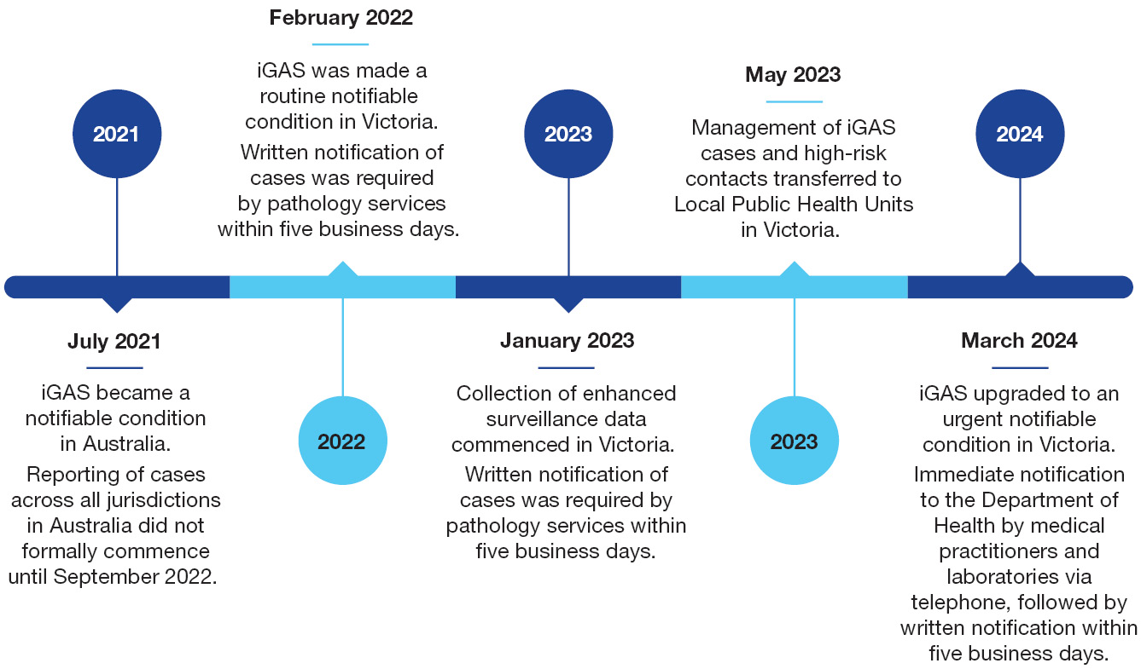

Methods
Confirmed and probable iGAS cases notified in Victoria during the period 1 January 2022 – 31 December 2023 were extracted from the Victorian Public Health Events Surveillance System (PHESS). A confirmed case of iGAS was defined as an individual who has Streptococcus pyogenes detected by culture or molecular methods from a normally sterile site.¹ A probable case of iGAS was defined as an individual who has Streptococcus pyogenes detected by culture or molecular methods from a non-sterile site and has clinical presentation consistent with iGAS infection.¹ Clinical presentations of iGAS include severe complications such as toxic shock syndrome, necrotising fasciitis and sepsis.¹
Descriptive analyses were conducted of demographic and clinical data. The Australian Bureau of Statistics (ABS) 2022 population data was used for population estimates.¹⁶ Disease incidence rates were calculated for the NEPHU catchment in Victoria, and age standardised incidence rates were calculated for each LGA in NEPHU. Direct age standardisation was used with the 2001 Australian standard population as the reference population.¹⁷ emm-typing is performed for the majority of iGAS samples by the Microbiological Diagnostic Unit (MDU) in Victoria.¹ emm-type distribution was analysed for all cases from 2022 and 2023 combined. emm-types with fewer than five isolates were grouped into an ‘other’ category. Analysis was conducted using Excel and the R statistical program.¹⁸
This research was approved by the Austin Health Human Research Ethics Committee (ID: 103992).

Results
Between 1 January 2022 and 31 December 2023, there were 217 iGAS notifications reported in NEPHU (Table 1 and Figure 2). The annual incidence rate was 3.5 per 100,000 population in 2022, increasing to 8.4 per 100,000 population in 2023. Only 21% of cases in NEPHU had country of birth recorded; 97% of notifications had Indigenous status reported, with a small number of cases (n < 5) identifying as Aboriginal and/or Torres Strait Islander.
By age, the highest incidence rates in NEPHU were in the 0–9 year age group at 19.1 cases per 100,000 population and in the 80+ year age group at 24.2 cases per 100,000 population (Table 1). Similar trends were seen in the rest of Victoria, with the same age groups having the highest incidence rates. There was no major difference between the incidence rate by sex in NEPHU. However, a higher incidence rate was seen for males (12.7 cases per 100,000 population) in the rest of Victoria compared to females (9.0 cases per 100,000 population) (Table 1).
The case fatality rate in NEPHU was lower than in the rest of Victoria (6.9% vs 7.9%) (Table 1). A total of 15 deaths due to iGAS were notified in NEPHU during this period; 53% of deaths (n = 8) were within individuals aged between 30–69 years and 47% (n = 7) were within the 70+ age group. Of the reported deaths, 73% (n = 11) also reported a chronic condition and 1–4 deaths were in immunocompromised persons. Among all cases, comorbidities were common; 29% reported having a chronic condition such as heart/cardiac disease, diabetes (1 or 2), thyroid problems or hypertension. Additionally, 11% of NEPHU cases reported being a smoker or living in a household with individuals who smoke and 8% reported being immunocompromised due to a health condition (Appendix A, Table A.1).
The two LGAs in NEPHU with the highest age standardised incidence rates were Hume LGA at 19.0 cases per 100,000 population, followed by Darebin LGA at 15.0 cases per 100,000 population (Figure 3).
The most common emm-types in NEPHU between 1 January 2022 and 31 December 2023 were emm-1 (n = 78; 36%), emm-12 (n = 26; 12%) and emm-28 (n = 15; 7%). Similar to NEPHU, the most common emm-types in the rest of Victoria were emm-1 (n = 171; 33%), emm-12 (n = 64; 12%), emm-77 (n = 27; 5%) and emm-28 (n = 27; 5%).
Table 1: Demographics of iGAS cases notified between 1 January 2022 and 31 December 2023, in NEPHU and the rest of Victoria, Australiaª
Category | Characteristic | NEPHU |  |  | Rest of Victoria
Category | Characteristic | Number of cases | Percentage^{b} | Incidence rate^{c} | Number of cases | Percentage^{b} | Incidence rate^{c}
Sex | Male | 112 | 52 | 12.5 | 302 | 58 | 12.7
Sex | Female | 105 | 48 | 11.3 | 219 | 42 | 9.0
Age group (years) | 0–9 | 41 | 19 | 19.1 | 108 | 21 | 19.0
Age group (years) | 10–19 | 14 | 7 | 6.4 | 25 | 5 | 4.4
Age group (years) | 20–29 | 9 | 4 | 3.6 | 26 | 5 | 4.0
Age group (years) | 30–39 | 38 | 18 | 13.5 | 70 | 13 | 9.5
Age group (years) | 40–49 | 37 | 17 | 15.3 | 53 | 10 | 8.7
Age group (years) | 50–59 | 22 | 10 | 9.7 | 50 | 10 | 8.7
Age group (years) | 60–69 | 22 | 10 | 12.1 | 79 | 15 | 15.7
Age group (years) | 70–79 | 15 | 7 | 11.7 | 53 | 10 | 14.5
Age group (years) | 80+ | 19 | 9 | 24.2 | 57 | 11 | 27.5
Deaths | Deaths | 15 | 7 | 0.8 | 41 | 8 | 0.9
Total cases | Total cases | 217 | 100 | 11.9 | 521 | 100 | 10.9
a iGAS: invasive group A streptococcal disease; NEPHU: North East Public Health Unit.
b Proportion calculated as the number of cases/deaths per category.
c Incidence rate was calculated as the number of cases/deaths per 100,000 population across the two-year period 1 January 2022 to 31 December 2023.
Figure 2: iGAS notifications and incidence rate per 100,000 population between 1 January 2022 and 31 December 2023, in NEPHU and in the rest of Victoria, Australia, by quarter and year^{a,b}
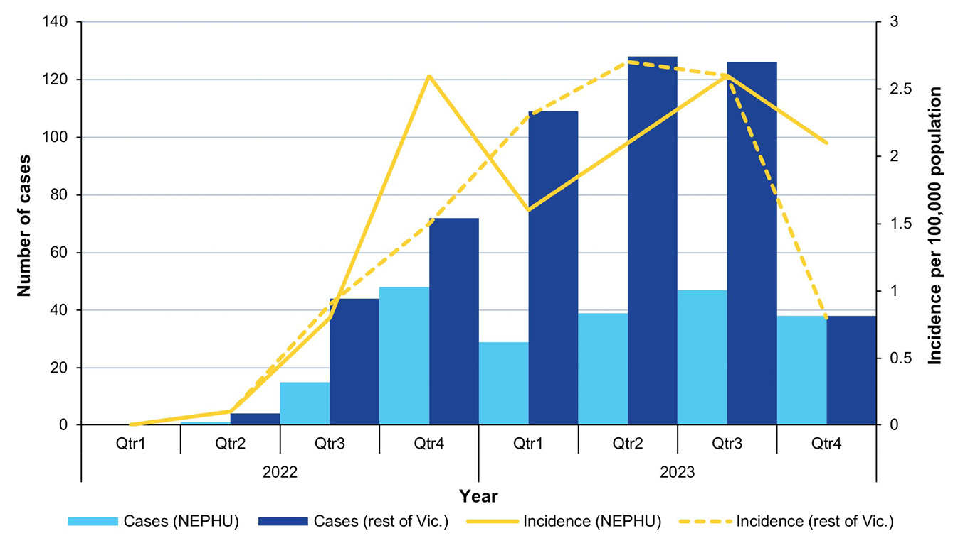
a iGAS: invasive group A streptococcal disease; NEPHU: North East Public Health Unit; Vic.: Victoria.
b Under-reporting of iGAS notifications may have occurred during Quarter 1 2022, as notification of cases commenced in February 2022.
Figure 3: Age-standardised incidence rate of iGAS cases notified between 1 January 2022 and 31 December 2023, per local government area (LGA) in NEPHUª
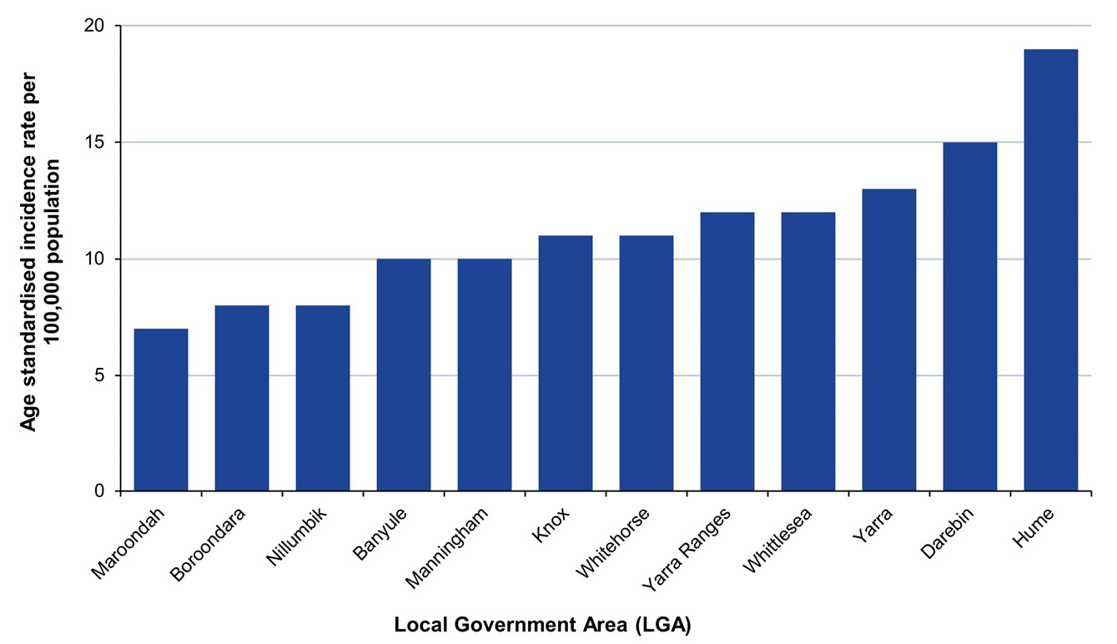
a iGAS: invasive group A streptococcal disease; NEPHU: North East Public Health Unit, Victoria, Australia.

Discussion and conclusion
An increased incidence of iGAS, particularly among young children and older adults, was observed within the NEPHU catchment and across the rest of Victoria between 1 January 2022 and 31 December 2023, consistent with international trends. The aggregated two-year incidence rate across 2022 and 2023 was more than double that reported in 2017.¹¹ Minimal variation of emm-types was identified in this study compared to those reported in the years prior in Victoria from hospital and laboratory data. emm-1 continues to be the dominant strain within the NEPHU population and across the rest of Victoria.^{10,11} Apart from emm-1, one study in British Columbia, Canada, found an increased prevalence of emm-92, emm-49 and emm-83, which were previously rare.¹⁹
Incidence rates of iGAS varied by geography in the NEPHU catchment, suggesting potential interplay of external factors affecting risk at a population level. Given the NEPHU has a large culturally and linguistically diverse population, the high incidence rates in certain LGAs could be explored through factors such as ethnicity and other socioeconomic factors, noting these have previously been identified as attributes which increase risk of iGAS disease.^{3,20,21} The current dataset had limited availability of cultural demographic information, which precluded further investigation of these factors.
To compare incidence rate of iGAS by LGAs in the NEPHU catchment, direct age standardisation was applied to account for the differences in age distribution between populations. However, there are limitations which need to be considered when interpreting the results. iGAS is a rare condition, which resulted in small case numbers for some age groups. This has potential implications on the accuracy of the age-specific incidence rates, resulting in an over- or underestimation of iGAS incidence for LGAs within the NEPHU catchment.²² Further analysis is recommended, with a larger pool of data to determine the true prevalence of iGAS by age group at a population level. A final limitation is the potential for under-reporting of cases during quarter 1, 2022, given that iGAS became notifiable in Victoria in February 2022.
Chronic conditions were commonly reported in the clinical history of NEPHU cases, especially among those who died. These findings align with trends seen internationally, where factors such as diabetes, drug use and clinical complications, for example chronic skin diseases or wounds, were associated with iGAS disease.²³ However, missing data was the major limitation of this study, which precluded further analysis of environmental and health risk factors of iGAS to determine any associations in this context. Additionally, potential reporting bias due to the recent changes in case notification requirements, and increased testing and reporting from pathology services, may be contributing to the high numbers seen in this study period.
This study provides preliminary findings on the trends in iGAS epidemiology in North East Melbourne using local surveillance data. With iGAS now being an urgent notifiable condition in Victoria, it is crucial to consider how we collect and manage the data. Reviewing enhanced surveillance data and clinical history of cases, and ensuring that relevant information is collected, will build on current knowledge, and will provide an opportunity to address the limitations with the current surveillance data as outlined in this study. Continued monitoring of cases and risk factors will assist in determining the true disease burden and in identifying high risk groups, to target public health interventions such as contact prophylaxis and newly developed vaccinations. This will ultimately facilitate the implementation of better public health practices, which are evidence-based and tailored to the population at risk.

Acknowledgments
We wish to acknowledge the Public Health Officers, Health Protections Team Leaders, Medical Professionals, Epidemiologists and other LPHU and Victorian Department of Health staff members for their contributions to the collection of data and management of cases included in this dataset. We acknowledge also the work and contributions of the Microbiological Diagnostic Unit Public Health Laboratory (MDU) for performing further analyses on test samples to determine genotypes.

Author details
Ms Safiya Rahman Ateekur Rahman,¹
Dr Clarissa Moreira,¹
Mr Aaron Osborne,^{1,2}
Ms Hibaq Ahmed,¹
Dr Annaliese van Diemen^{1,3}
- North Eastern Public Health Unit, Austin Health, Victoria, Australia
- National Centre for Epidemiology and Population Health, Australian National University, Canberra, Australian Capital Territory, Australia
- Department of Infectious Disease, The Peter Doherty Institute for Infection and Immunity, The University of Melbourne, Victoria, Australia

Corresponding author
Dr Annaliese van Diemen
North Eastern Public Health Unit, Austin Health, 145 Studley Road, Heidelberg, Victoria, 3084, Australia
Email: annaliese.vandiemen@austin.org.au

References
- Australian Government Department of Health, Disability and Ageing, Communicable Diseases Network Authority (CDNA). Invasive Group A Streptococcal (iGAS) Disease – CDNA National guidelines for Public Health Units. Canberra: Australian Government Department of Health, Disability and Ageing; 15 January 2024. Available from: https://www.health.gov.au/resources/publications/invasive-group-a-streptococcal-igas-disease-cdna-national-guidelines-for-public-health-units.
- Brouwer S, Rivera-Hernandez T, Curren BF, Harbison-Price N, De Oliveira DMP, Jespersen MG et al. Pathogenesis, epidemiology and control of group A Streptococcus infection. Nat Rev Microbiol. 2023;21(7):431–47. doi: https://doi.org/10.1038/s41579-023-00865-7.
- Avire NJ, Whiley H, Ross K. A review of Streptococcus pyogenes: public health risk factors, prevention and control. Pathogens. 2021;10(2):248. doi: https://doi.org/10.3390/pathogens10020248.
- Dunne EM, Hutton S, Peterson E, Blackstock AJ, Hahn CG, Turner K et al. Increasing incidence of invasive group A Streptococcus disease, Idaho, USA, 2008–2019. Emerg Infect Dis. 2022;28(9):1785–95. doi: https://doi.org/10.3201/eid2809.212129.
- Meehan M, Murchan S, Bergin S, O'Flanagan D, Cunney R. Increased incidence of invasive group A streptococcal disease in Ireland, 2012 to 2013. Euro Surveill. 2013;18(33):20556. doi: https://doi.org/10.2807/1560-7917.es2013.18.33.20556.
- Victorian State Government Department of Health (Victoria Health). Invasive group A streptococcal disease (iGAS). [Webpage.] Melbourne: Victoria Health; 26 February 2024. Available from: https://www.health.vic.gov.au/infectious-diseases/invasive-group-a-streptococcal-disease-igas.
- Williamson KM, Varadhan H, Taylor K, Crooks K, Brett K, Law C et al. Epidemiology of group A streptococcal bacteraemia in Hunter New England Local Health District, 2008 to 2019. Commun Dis Intell (2018). 2023;47. doi: https://doi.org/10.33321/cdi.2023.47.49.
- Carapetis JR, Steer AC, Mulholland EK, Weber M. The global burden of group A streptococcal diseases. Lancet Infect Dis. 2005;5(11):685–94.
doi: https://doi.org/10.1016/S1473-3099(05)70267-X.
- World Health Organization (WHO). Increase in invasive Group A streptococcal infections among children in Europe, including fatalities. [Media release.] Geneva: WHO, Regional Office for Europe; 12 December 2022. Available from: https://www.who.int/europe/news-room/12-12-2022-increase-in-invasive-group-a-streptococcal-infections-among-children-in-europe--including-fatalities.
- Oliver J, Wilmot M, Strachan J, St George S, Lane CR, Ballard SA et al. Recent trends in invasive group A Streptococcus disease in Victoria. Commun Dis Intell (2018). 2019;43. doi: https://doi.org/10.33321/cdi.2019.43.8.
- Thomson TN, Campbell PT, Gibney KB. The epidemiology of invasive group A streptococcal disease in Victoria, 2007–2017: an analysis of linked datasets. Aust N Z J Public Health. 2022;46(6):878–83. doi: https://doi.org/10.1111/1753-6405.13290.
- Tyrrell GJ, Lovgren M, Kress B, Grimsrud K. Varicella-associated invasive group A streptococcal disease in Alberta, Canada—2000–2002. Clin Infect Dis. 2005;40(7):1055–7. doi: https://doi.org/10.1086/428614.
- Herrera AL, Huber VC, Chaussee MS. The association between invasive group A streptococcal diseases and viral respiratory tract infections. Front Microbiol. 2016;7:342. doi: https://doi.org/10.3389/fmicb.2016.00342.
- Vugia DJ, Peterson CL, Meyers HB, Kim KS, Arrieta A, Schlievert PM et al. Invasive group A streptococcal infections in children with varicella in Southern California. Pediatr Infect Dis J. 1996;15(2):146–50. doi: https://doi.org/10.1097/00006454-199602000-00011.
- Lesko SM, O'Brien KL, Schwartz B, Vezina R, Mitchell AA. Invasive group A streptococcal infection and nonsteroidal antiinflammatory drug use among children with primary varicella. Pediatrics. 2001;107(5):1108–15. doi: https://doi.org/10.1542/peds.107.5.1108.
- Australian Bureau of Statistics. Regional population by age and sex. Reference period 2022. [Webpage.] Canberra: Australian Bureau of Statistics; 28 September 2023. Available from: https://www.abs.gov.au/statistics/people/population/regional-population-age-and-sex/2022.
- Australian Bureau of Statistics. National, state and territory population. Reference period June 2024. [Webpage.] Canberra: Australian Bureau of Standards; 12 December 2024. [Accessed in 2024.] Available from: https://www.abs.gov.au/statistics/people/population/national-state-and-territory-population/latest-release#cite-window1.
- R Core Team. R: A Language and Environment for Statistical Computing. [Application.] Vienna: R Foundation for Statistical Computing; 2024. Available from:
https://www.R-project.org/.
- Nwosu A, Schut A, Wood CA, Urquhart C, Bachman C, Thompson K et al. Invasive group A streptococcal (iGAS) surveillance in Island Health, British Columbia, 2022. Can Commun Dis Rep. 2023;49(7–8):342–50. doi: https://doi.org/10.14745/ccdr.v49i78a06.
- Steer AC, Lamagni T, Curtis N, Carapetis JR. Invasive group A streptococcal disease: epidemiology, pathogenesis and management. Drugs. 2012;72(9):1213–27. doi: https://doi.org/10.2165/11634180-000000000-00000.
- Valenciano SJ, Onukwube J, Spiller MW, Thomas A, Como-Sabetti K, Schaffner W et al. Invasive group A streptococcal infections among people who inject drugs and people experiencing homelessness in the United States, 2010–2017. Clin Infect Dis. 2021;73(11):e3718–26. doi: https://doi.org/10.1093/cid/ciaa787.
- Australian Institute of Health and Welfare (AIHW). Principles on the use of direct age-standardisation in administrative data collections: for measuring the gap between Indigenous and non-Indigenous Australians. Canberra: AIHW; 7 October 2011. Available from: https://www.aihw.gov.au/reports/indigenous-australians/principles-on-the-use-of-direct-age-standardisatio/summary.
- Zangarini L, Martiny D, Miendje Deyi VY, Hites M, Maillart E, Hainaut M et al. Incidence and clinical and microbiological features of invasive and probable invasive streptococcal group A infections in children and adults in the Brussels–Capital Region, 2005–2020. Eur J Clin Microbiol Infect Dis. 2023;42(5):555–67. doi: https://doi.org/10.1007/s10096-023-04568-y.

Appendix A
Table A.1: Reported clinical history and comorbidities for NEPHU iGAS cases notified during 2022–2023ª
Risk factors | Number of cases | Percentage^{b}
Other | 65 | 30
Chronic condition | 63 | 29
Smoking risk/smoker in household | 24 | 11
Unknown | 18 | 8
Immunocompromised | 17 | 8
Respiratory infection | 11 | 5
Travel | 10 | 5
Intravenous drug use | 9 | 4
None reported | 125 | 58
a NEPHU: North East Public Health Unit, Victoria, Australia; iGAS: invasive group A streptococcal disease.
b ‘Percentage’ represents the proportion of the 217 NEPHU cases that reported each clinical history or comorbidity. Cases that report more than one risk factor are counted more than once.
© 2025 Commonwealth of Australia as represented by the Department of Health, Disability and Ageing
ISSN: 2209-6051 Online
This journal is indexed by Index Medicus and Medline.
Creative Commons Licence
This publication is licensed under a Creative Commons Attribution-NonCommercial-NoDerivatives 4.0 International Licence (Licence). You must read and understand the Licence before using any material from this publication.
Restrictions
The Licence does not cover, and there is no permission given for, use of any of the following material found in this publication (if any):
- the Commonwealth Coat of Arms (by way of information, the terms under which the Coat of Arms may be used can be found on the Department of Prime Minister and Cabinet website;
- any logos (including the interim Australian Centre for Disease Control and the Department of Health, Disability and Ageing’s logos) and trademarks;
- any photographs and images;
- any signatures; and
- any material belonging to third parties.
Disclaimer
Opinions expressed in Communicable Diseases Intelligence are those of the authors and not necessarily those of the Australian Government, the interim Australian Centre for Disease Control or the Department of Health, Disability and Ageing. Data may be subject to revision.
Enquiries
Enquiries regarding any other use of this publication should be addressed to the CDI Editor.
About CDI
Communicable Diseases Intelligence (CDI) is a peer-reviewed scientific journal published by the interim Australian Centre for Disease Control within the Department of Health, Disability and Ageing.
The journal aims to disseminate information on the epidemiology, surveillance, prevention and control of communicable diseases of relevance to Australia and the near region.
Editor: Christina Bareja • Deputy Editor: Simon Petrie • Design and Production: Lisa Thompson
Editorial Advisory Board: David Durrheim, Mark Ferson, Clare Huppatz, John Kaldor, Martyn Kirk and Meru Sheel
Submit an Article
Guidelines for authors and details on how to submit your publication is available on our website, or by email to the
CDI Editor.
Contact us
Communicable Diseases Intelligence (CDI)
interim Australian Centre for Disease Control, Department of Health, Disability and Ageing
GPO Box 9848, CANBERRA ACT 2601
Website: cdc.gov.au/cdi
Email: cdi.editor@health.gov.au

