
2025 • Volume 49 • cdc.gov.au/cdi • Epub date: 17.12.2025 • doi.org/10.33321/cdi.2025.49.044

Surveillance of adverse events following immunisation in Australia annual report, COVID-19 vaccines, 2022
Yuanfei Anny Huang, Claire Larter, Megan Hickie, Megan O’Moore, Belinda Jones, Lucy Deng, Sophie Russell, Elspeth Kay, Kristine Macartney, Nicholas Wood
© 2025 Commonwealth of Australia as represented by the Department of Health, Disability and Ageing
ISSN: 2209-6051 Online
This journal is indexed by Index Medicus and Medline.
Creative Commons Licence
This publication is licensed under a Creative Commons Attribution-NonCommercial-NoDerivatives 4.0 International Licence (Licence). You must read and understand the Licence before using any material from this publication.
Restrictions
The Licence does not cover, and there is no permission given for, use of any of the following material found in this publication (if any):
- the Commonwealth Coat of Arms (by way of information, the terms under which the Coat of Arms may be used can be found on the Department of Prime Minister and Cabinet website;
- any logos (including the interim Australian Centre for Disease Control and the Department of Health, Disability and Ageing’s logos) and trademarks;
- any photographs and images;
- any signatures; and
- any material belonging to third parties.
Disclaimer
Opinions expressed in Communicable Diseases Intelligence are those of the authors and not necessarily those of the Australian Government, the interim Australian Centre for Disease Control or the Department of Health, Disability and Ageing. Data may be subject to revision.
Enquiries
Enquiries regarding any other use of this publication should be addressed to the CDI Editor.
About CDI
Communicable Diseases Intelligence (CDI) is a peer-reviewed scientific journal published by the interim Australian Centre for Disease Control within the Department of Health, Disability and Ageing.
The journal aims to disseminate information on the epidemiology, surveillance, prevention and control of communicable diseases of relevance to Australia and the near region.
Editor: Christina Bareja • Deputy Editor: Simon Petrie • Design and Production: Lisa Thompson
Editorial Advisory Board: David Durrheim, Mark Ferson, Clare Huppatz, John Kaldor, Martyn Kirk and Meru Sheel
Submit an Article
Guidelines for authors and details on how to submit your publication is available on our website, or by email to the
CDI Editor.
Contact us
Communicable Diseases Intelligence (CDI)
interim Australian Centre for Disease Control, Department of Health, Disability and Ageing
GPO Box 9848, CANBERRA ACT 2601
Website: cdc.gov.au/cdi
Email: cdi.editor@health.gov.au

Contents
Abstract 6
Introduction 7
Methods 9
AEFI data 9
Serious and non-serious AEFI 11
Safety monitoring 12
Data analysis 12
Notes on interpretation 13
Results 14
Reporting rates 16
Adverse events 19
Adverse events of special interest 28
Serious adverse events 31
Safety monitoring 33
Discussion 37
Conclusion 41
Acknowledgments 42
Author details 43
References 44
Appendix A 50

List of figures
Figure 1: Adverse event following immunisation reports for COVID-19 vaccines administered in 2021–2022 in the Adverse Event Management System databaseª 17
Figure 2: Adverse event following immunisation reports for COVID-19 vaccines administered in 2021–2022 in the Adverse Event Management System (AEMS) database, by age group and brand^{a,b,c} 26
Figure 3: AEFI reporting rates per 100,000 COVID-19 vaccine doses administered in 2022 recorded in the Adverse Event Management System database, by age group and vaccine brandª 27
Figure 4: Selected AESI reporting rates per 100,000 COVID-19 vaccine doses administered in 2022 recorded in the Adverse Event Management System (AEMS) database, by age group and vaccine brand^{a,b} 30
Figure A.1: AEFI reports and reporting rates per 100,000 COVID-19 vaccine doses administered in 2021-2022, by reporter type 54

List of tables
Table 1: Adverse event following immunisation (AEFI) reporting rates per 100,000 doses administered for COVID-19 vaccines administered in 2022 in the Adverse Event Management System database, by age group 15
Table 2: COVID-19 vaccines listed as ‘suspect’ in reports of adverse events following immunisation for vaccines administered in 2022 in the Adverse Event Management System databaseª 16
Table 3: Adverse event following immunisation reports in the Adverse Event Management System database for COVID-19 vaccines administered in 2022, by jurisdiction 18
Table 4: The 30 most frequently reported adverse events classified by MedDRA preferred terms (PTs) or standardised MedDRA queries (SMQs) in reports of adverse events following immunisation with COVID-19 vaccines administered in 2022 in the Adverse Event Management System databaseª 20
Table 5: The 30 most frequently reported adverse events classified by MedDRA Preferred Terms (PTs) or Standardised MedDRA queries (SMQs) in reports of adverse events following immunisation with COVID-19 vaccines administered in 2022 in the Adverse Event Management System database, by brandª 23
Table 6: Adverse events of special interest (AESI) reported in reports of adverse events following immunisation (AEFI) with COVID-19 vaccines in 2022 in the Adverse Event Management System database 29
Table 7: Age distribution and median time to death for reports of death following immunisation with COVID-19 vaccines in 2022 in the Adverse Event Management System databaseª 32
Table 8: Safety topics investigated for COVID-19 vaccines undertaken by the TGA in 2022ª 34
Table A.1: Changes in COVID-19 immunisation policy and program in 2022² 50
Table A.2: Description of MedDRA preferred term (PT) to standardised MedDRA query (SMQ) mapping – overall process 51
Table A.3: MedDRA preferred terms (PTs) mapped to specific standardised MedDRA queries (SMQs)^{a,8,10} 51
Table A.4: MedDRA terms (LLTs and PTs) included in specific AESI, as per Brighton Collaboration Case Definition Companion Guides^{a,21,23} 52
Table A.5: Abbreviations of vaccine types and other terms 53

Abstract
This report summarises Australia’s spontaneous surveillance data for adverse events following immunisation (AEFI) for COVID-19 vaccines given in 2022 reported to the Therapeutic Goods Administration (TGA). The TGA strongly promoted and facilitated adverse event reporting in preparation for and during the COVID-19 vaccine rollout as a core component of the most intensive vaccine safety monitoring ever conducted in Australia.
There were 18,398 AEFI reports for COVID-19 vaccines administered in 2022, corresponding to an annual AEFI reporting rate of 89.6 per 100,000 doses of COVID-19 vaccines administered. The annual AEFI reporting rate for non-COVID-19 vaccines in 2022 was 18.8 per 100,000 doses administered to people of all ages.
Overall, the most frequently reported symptoms were adverse events consistent with the expected side effects from vaccines, as reported in clinical trials. These were classified as ‘gastrointestinal nonspecific symptoms and therapeutic procedures’, headache, chest pain, myalgia and pyrexia. The most frequently reported adverse events of special interest were myocarditis and/or pericarditis, followed by thrombosis and thromboembolism, and anaphylaxis. Of all COVID-19 vaccine AEFI reports, 160 (0.9%) included a fatal outcome, of which over 60% were in people aged ≥ 60 years. Of these 160 reports, only one was assessed by a Vaccine Safety Investigation Group (VSIG) as a death likely to be causally linked to vaccination.
This report confirms the value of spontaneous post-marketing vaccine pharmacovigilance, especially in the context of new vaccines using novel technologies and a near whole-of-population pandemic vaccination program. Ongoing safety monitoring continued to review and respond to reports of rare, unexpected conditions, such as myocarditis/pericarditis, with investigations resulting in changes to vaccine recommendations and product information. Overall, COVID-19 vaccine safety monitoring continued to demonstrate a reassuring safety profile for these vaccines, especially among children and adolescents aged 11 years and below, in whom COVID-19 vaccines were used for the first time in 2022 in Australia.
Keywords: AEFI; coronavirus disease 2019; COVID-19; adverse events; vaccines; surveillance; immunisation; vaccine

Introduction
In 2022, the Australian coronavirus disease 2019 (COVID-19) vaccination program continued to adapt to the COVID-19 pandemic and to the evolution of SARS-CoV-2, including the emergence of new viral variants. There was an expansion of age groups recommended to receive vaccination, and new vaccine types (protein subunit) and formulations were administered: Comirnaty for those in the 6 months – 4 years and 5–11 years age groups, and bivalent Original/Omicron BA.1; and Spikevax for those in the 6 months – 4 years age group.^{1,2} Four COVID-19 vaccine brands—Comirnaty (Pfizer-BioNTech BNT162b2), Nuvaxovid (Novavax; NVX-CoV2373), Spikevax (Moderna; mRNA-1273) and Vaxzevria (Oxford-AstraZeneca; AZD1222)—were available as part of the COVID-19 vaccination program in 2022, with an eligible population from 6 months of age upwards. Details of population eligibility, time interval between doses, and access to vaccines and brands evolved over time according to changes in national vaccination policies and vaccine availability, as outlined in Appendix A, Table A.1.
As with all vaccines used in Australia, post-marketing surveillance of adverse events following immunisation (AEFI) occurred through a national spontaneous (passive) surveillance system managed by the Therapeutic Goods Administration (TGA). The TGA’s monitoring relied on regularly reviewing and analysing adverse event report data, working with international regulators, and reviewing medical literature, media, and other potential sources of new safety information. The system can rapidly detect, investigate and respond to emerging vaccine safety issues identified, including rare and unexpected AEFI that may not have been detected in pre-registration vaccine trials.
An AEFI is defined as any untoward medical occurrence that follows immunisation, noting that the event does not necessarily have a causal relationship with the usage of the vaccine.³ The AEFI may be an unfavourable or unintended sign, abnormal laboratory finding, symptom, or disease. AEFI can be caused by the vaccine(s) or can be a coincidental event, and can be classified into the following categories:
- vaccine product-related reaction;
vaccine quality defect-related reaction;
immunisation error-related reaction;
immunisation anxiety-related reaction (also known as immunisation stress-related response); and
coincidental event.
Anyone can report AEFI to the TGA; the main categories of reporters are state and territory health departments, health professionals, vaccine companies, and consumers (members of the public).⁴ All reported AEFI are entered into the Australian Adverse Event Management System (AEMS) database. Where the initial report contains insufficient information, the TGA may contact the reporter or relevant state or territory health department to elicit further information. The TGA continually analyses AEFI data to detect new potential safety issues, or changes to known safety issues, that may require regulatory or other action.
This report summarises national spontaneous surveillance data for COVID-19 vaccine AEFI reported to the TGA in 2022. AEFI reports following non-COVID-19 vaccines in 2022 are analysed and presented in a separate companion report.

Methods

AEFI data
De-identified data on all AEFI for vaccines administered up to 28 February 2023, reported to the TGA and stored in the AEMS database, were extracted and provided to the National Centre for Immunisation Research and Surveillance (NCIRS) on 12 October 2023. Please refer to previous reports for a detailed description of the surveillance system.^{5,6}

AEFI report data management
Only accepted AEFI reports were included in this analysis, meaning that the report must contain sufficient information pertaining to four key elements: a reporter; a patient; one or more suspected vaccines; and one or more reaction terms.⁷ Reports accepted by the TGA are assigned a default decision type of ‘causality possible’ due to the event being reported to occur after the vaccine was given.
AEFI reports were defined by unique identifiers assigned by the TGA. In this analysis, each AEFI report was assigned a date based on:
- the earliest COVID-19 vaccination date associated with the report; or, where a vaccination date was missing:
- the earliest symptom onset date was used; or, where dates for both vaccination and symptom onset were missing:
- the received date (the date when the reporter of the case first received the minimum valid information as described above from the primary source).
Reports with a 2022 date of vaccination, symptom onset or received date, based on the hierarchy above, were included in the 2022-specific sections of this analysis.
Where the date of birth was available, it was used to calculate age at time of COVID-19 vaccination, symptom onset, or received date; where date of birth was missing, the age at symptom onset provided to the TGA by the reporter was used. Reports were grouped by age (< 5; 5–11; 12–15; 16–59; and ≥ 60 years) according to broad policy recommendations for vaccination.

Vaccine data
Vaccines were identified by trade name (standardised term in the TGA reference dataset); where the trade name was not specified, the generic name (active ingredients associated with a trade name) and reported product name (product name used by the reporter) were used. Formulations of vaccines were grouped by brand, meaning that, for example, the paediatric and bivalent Original/Omicron BA.1 formulations of the Comirnaty vaccine were included in the data for all Comirnaty vaccines. All AEFI reports that included COVID-19 vaccines with a role in relation to the reported adverse event of ‘suspect’ were included in analysis, including reports with both non-COVID-19 and COVID-19 vaccines. More than one vaccine with a ‘suspect’ role can be included in a report, without implying that all vaccines were necessarily co-administered on the same occasion.

Adverse event data
AEFI reports included reaction terms that were symptoms, signs, and/or diagnoses; these were coded by TGA staff from the reporter’s description into lower level terms (LLT), which were then mapped to associated preferred terms (PT) using the Medical Dictionary for Regulatory Activities (MedDRA®).⁸
Standardised MedDRA queries (SMQ) are sets of MedDRA terms that have been grouped after extensive testing, analysis, and expert discussion to facilitate pharmacovigilance investigation.⁹ For this analysis, the MedDRA Browser SMQ Analysis tool, running MedDRA version 26.1, was used to group related PT to SMQ to reduce the number of unique PT under analysis while providing meaningful results.¹⁰ A narrow search was performed to increase the specificity of the PT to SMQ mapping. As individual PT may map to zero, one, or more than one SMQ, the term selected (PT or SMQ) was determined as described in Appendix A, Table A.2. Following the decision process, a one-to-one PT-SMQ mapping was performed to ensure that each PT was counted only once and that there was no overlap in terms between SMQ.

Adverse events of special interest data
Adverse events of special interest (AESI), defined as pre-specified, medically important events potentially associated with a vaccine requiring careful monitoring and confirmation by specialised studies, were reviewed using the same methods as those used for the 2021 AEFI surveillance report for COVID-19 vaccines to allow comparability.⁶ The AESI list was sourced from the Brighton Collaboration and Safety Platform for Emergency Vaccines list of COVID-19 AESI, and refined to include only AESI where Brighton Collaboration Companion Guides specifying narrow-search MedDRA LLT and PT codes were available:¹¹
- acute disseminated encephalomyelitis;¹²
- anaphylaxis;¹³
- acute respiratory distress syndrome;¹⁴
- aseptic meningitis;¹⁵
- Bell’s palsy and facial nerve palsy;¹⁶
- encephalitis/encephalomyelitis;¹⁷
- generalised convulsion;¹⁸
- Guillain-Barré syndrome;¹⁹
- multisystem inflammatory syndrome in children/adults;²⁰
- myocarditis and/or pericarditis;²¹
- thrombocytopenia;²² and
- thrombosis and thromboembolism.²³
Thrombosis and thromboembolism is an AESI term that covers a range of adverse events, as specified by its Brighton Collaboration Companion Guide listing the MedDRA LLT/PT that fall within this grouping (further details in Appendix A, Table A.4).²³ This AESI term does not specifically include the PT ‘thrombosis with thrombocytopenia syndrome’ (TTS), but includes a range of thrombotic events that may occur in association with TTS.
The AESI ‘acute respiratory distress syndrome’ (ARDS) and ‘multisystem inflammatory syndrome in children/adults’ (MIS-C/A) were new additions in 2022, meeting the inclusion criteria as outlined above after their Brighton Collaboration Companion Guides became available.^{14,20}
The narrow-search MedDRA LLT codes from the Brighton Collaboration Companion Guide were mapped to the corresponding PT, generating a PT search list for each AESI. AEMS AEFI reports containing a PT found in a particular search list were classified as having reported the corresponding AESI.
Relevant additional information from TGA investigations into specific AESI was also included in this report, including information on the TTS cases assessed for classification by the TGA.

Serious and non-serious AEFI
AEFI reports were coded as ‘serious’ or ‘non-serious’ based on criteria used by the World Health Organization (WHO), where an adverse event report is defined as ‘serious’ if it involves one or more of the following outcomes:
- fatal or life-threatening condition(s);
- new or prolonged hospitalisation;
- persistent or significant disability;
- congenital anomaly or birth defect; or
- any medical event that requires an intervention to prevent the above outcomes.²⁴
For AEFI reports submitted by sponsors (vaccine companies), the seriousness classification was applied by sponsors to ensure they meet legislated requirements. For other AEFI reports submitted to the TGA, the seriousness classification either reflected the view of the reporter or may have been applied by the TGA following review.
All AEFI reports where a fatal outcome is reported, or the individual was admitted to an intensive care unit (ICU; including paediatric intensive care), are reviewed by the TGA. This review is designed to assess whether the medical condition(s) that caused the ICU admission and/or death is causally related to the vaccine and whether it represents an emerging safety concern. The TGA reviews each of these reports and considers the strength of the evidence for a link between vaccination and the condition that caused the death, using a standardised process based on the WHO causality assessment guidelines.²⁵ When the cause for the events that resulted in ICU admission and/or death is not medically obvious, not stated, or cannot be determined from the initial report, the TGA may request further information from the reporter, which may include the results of investigations relating to the ICU admission and/or death, past medical history, post-mortem examination findings, the death certificate, and/or results of a Coronial Office investigation.
In addition, the TGA can seek expert causality assessment advice from a Vaccine Safety Investigation Group (VSIG), which consists of clinical experts in domains including infectious diseases, vaccinology, haematology, respiratory medicine, immunology and public health, together with a consumer representative and, often, a communication expert.²⁶ The purpose of the VSIG is to provide independent specialist immunisation (and other relevant) expertise to assist the TGA in investigating and undertaking regulatory action for vaccine safety signals of concern. Where a VSIG is required, an internationally accepted method is used to determine the level of certainty of a link between the event and vaccine.²⁵

Deaths data
For this analysis, the age at death for AEFI reports that included a fatal outcome was calculated using date of birth and date of death, where available. Where date of death was not recorded, the most recent COVID-19 vaccination date prior to death was used. Where no COVID-19 vaccination date was recorded, the age in years on the report form was used.

Safety monitoring
The TGA conducts analyses across all AEFI reports to detect safety signals. Medical literature, media, and other potential sources of new safety information are reviewed and considered in relation to national data in AEMS. The TGA also collaborates with international regulators to consider global safety data. This process is in addition to other safety monitoring processes, including the safety monitoring responsibilities of vaccine sponsors.

Safety investigations
The TGA safety monitoring processes are used to identify potential new safety issues for a vaccine. When the TGA detects a potential new safety issue, an investigation is undertaken to identify the strength of evidence between the adverse event and a vaccine product. In the context of rapidly emerging evidence in the COVID-19 pandemic, the TGA investigation process is considered a ‘point in time’ assessment of known information, and is repeated when new evidence becomes available. This allows the TGA investigation process to be responsive and adaptive in a rapidly changing environment. A targeted investigation may be initiated by the TGA following a preliminary assessment of information arising from spontaneous reporting patterns observed, international regulators, published literature and other sources of safety data. Safety data may also be reviewed through other processes, such as a TGA review of sponsor safety data. As new information arises about a potential issue, multiple sequential targeted investigations may be undertaken.
If the TGA identifies a new vaccine safety issue through the processes outlined, it responds with appropriate regulatory action. Actions can include negotiating with the vaccine sponsor to add warnings to the product information; providing safety information to vaccine providers; changing labelling or packaging; or, if required in very serious circumstances, suspending use of the vaccine if the benefits of vaccination no longer outweigh the risks. In addition, safety data informs clinical guidance and actions on the use of the vaccines in Australia, as provided by the Australian Technical Advisory Group on Immunisation (ATAGI) and published in immunisation program guidelines (such as the Australian Immunisation Handbook and ATAGI COVID-19 vaccination guidance). This report summarises the main safety topics that underwent a TGA-initiated targeted investigation in 2022 and the outcomes of investigations at the end of 2022.

Data analysis
AEFI reporting rates per 100,000 administered doses were estimated for the year 2022. The number of doses administered for each vaccine in 2022 was obtained on 2 April 2023 from the Australian Immunisation Register (AIR), a national population-based register.²⁷ Vaccination providers were required by law to enter into the AIR every dose of COVID-19 vaccine administered.²⁸ Vaccine doses that had been administered overseas could also be entered into the AIR retrospectively.²⁹
Average annual population-based AEFI reporting rates were calculated for each state and territory, and by age group, using June 2022 population estimates obtained from the Australian Bureau of Statistics (ABS).³⁰ Comparisons with the previous year were made using ABS mid-year estimated resident population (ERP) data for 2021. While dose-based AEFI reporting rates are generally more reliable, both dose-based and population-based reporting rates are included in this report to allow comparability with previous reports and with other local and international data.
All data cleaning and analyses were performed using R version 4.3.1.³¹ Confidence intervals presented are 95% exact binomial confidence intervals for proportions (95% CI).

Notes on interpretation
The data reported here are provisional, particularly for the fourth quarter of 2022, due to reporting delays and a longer time to onset of some reported AEFI. In addition, AEFI may have been reported in 2022 for COVID-19 vaccines administered in 2021. Therefore, statistics published in this report relating to AEFI reports from 2021 may not match those in the 2021 report.
As this report analysed data from the AEMS database, the numbers published in this report may be different to the numbers found the Database of Adverse Event Notifications (DAEN) – medicines, a public online database maintained by the TGA that contains reports of adverse events for medicines and vaccines.³² Differences in case numbers between the DAEN—medicines and AEMS can be due to rejected reports, for example those with insufficient information, which remain in the Adverse Event Management System (AEMS) and are updated and added to the DAEN—medicines as and when sufficient information is provided.³³ There is also a 14-day time lag between cases being entered in AEMS and then added to the DAEN—medicines. As the data for this analysis were extracted from AEMS in October 2023, there may be discrepancies with the DAEN—medicines, which would reflect any new information made available to the TGA after October 2023.

Results
In the AEMS database, there were 18,398 AEFI reports where the date of COVID-19 vaccination (or onset of adverse event or report received date, if the date of vaccination was not reported) was between 1 January and 31 December 2022 (Table 1). Of all COVID-19 AEFI reports, 13,859 (75.3%) included Comirnaty, 3,002 (16.3%) included Spikevax, 948 (5.2%) included Nuvaxovid, and 680 (3.7%) included Vaxzevria. There were 168 reports (0.9%) which nominated a COVID-19 vaccine but did not provide a vaccine name (Table 2). Note that more than one COVID-19 vaccine (of the same or a different brand) may be included in one AEFI report; where this occurs, it does not necessarily indicate concomitant administration of the vaccines.
Of the 17,986 COVID-19 AEFI reports (97.8% of total) with sex provided, 11,388 (63.3%) described AEFI in females and 6,598 (36.7%) were in males. A response to a question on Indigenous status was provided in 10,451 reports (56.8% of total), out of which 393 AEFI reports (3.8%) were for people who identified as Aboriginal and/or Torres Strait Islander.
Of the 17,384 reports (94.5% of total) with age or date of birth provided, 29 (0.2%) were for children aged under 5 years; 1,648 (9.5%) were for children aged 5–11 years; 621 (3.6%) were for adolescents aged 12–15 years; 11,524 (66.3%) were for people aged 16–59 years; and 3,650 (20.5%) were for adults aged ≥ 60 years (Table 1).
Over half of AEFI reports (11,909/18,398; 64.7%) were submitted to the TGA by a state or territory health department (termed ‘regional pharmacovigilance centre’ in AEMS); 24.4% of reports (4,482/18,398) were sent by consumers; 7.1% were submitted by health professionals (1,302/18,398), including coroners courts; and 3.8% (705/18,398) were sent by pharmaceutical companies (Appendix A, Figure A.1). Please note that it is possible for one case to be the subject of more than one AEFI report, where the reports have been submitted independently by multiple sources and where there is insufficient information provided to confirm duplication.
This report includes 121 AEFI reports where non-COVID-19 vaccines were listed together with COVID-19 vaccines, which have been excluded from the companion report describing 2022 AEFI reports in AEMS involving all other (non-COVID-19) vaccines.³⁴
Table 1: Adverse event following immunisation (AEFI) reporting rates per 100,000 doses administered for COVID-19 vaccines administered in 2022 in the Adverse Event Management System database, by age group
Age groupª | Vaccine^{b,c} | AEFI reports^{d} | Vaccine doses^{e} | Reporting rate per 100,000 doses (95% CI)^{f}
< 5 years | COVID-19 (all brands) | 29 | 1,187 | 2,443.1 (1642.2–3490.0)
5–11 years | Comirnaty | 1,621 | 2,004,711 | 80.9 (77.0–84.9)
5–11 years | Spikevax | 14 | 3,515 | 398.3 (217.9–667.4)
5–11 years | COVID-19 (all brands) | 1,648 | 2,008,240 | 82.1 (78.1–86.1)
12–15 years | Comirnaty | 555 | 557,400 | 99.6 (91.5–108.2)
12–15 years | Spikevax | 60 | 25,967 | 231.1 (176.4–297.3)
12–15 years | COVID-19 (all brands) | 621 | 584,008 | 106.3 (98.1–115.0)
16–59 years | Comirnaty | 8,420 | 7,731,163 | 108.9 (106.6–111.3)
16–59 years | Spikevax | 2,085 | 2,171,546 | 96.0 (91.9–100.2)
16–59 years | Nuvaxovid | 765 | 165,696 | 461.7 (429.6–495.5)
16–59 years | Vaxzevria | 310 | 50,217 | 617.3 (550.7–689.8)
16–59 years | COVID-19 (all brands) | 11,660 | 10,118,605 | 115.2 (113.2–117.3)
≥ 60 years | Comirnaty | 2,547 | 6,030,471 | 42.2 (40.6–43.9)
≥ 60 years | Spikevax | 689 | 1,644,890 | 41.9 (38.8–45.1)
≥ 60 years | Vaxzevria | 252 | 66,792 | 377.3 (332.2–426.8)
≥ 60 years | Nuvaxovid | 125 | 72,472 | 172.5 (143.6–205.5)
≥ 60 years | COVID-19 (all brands) | 3,643 | 7,814,598 | 46.6 (45.1–48.2)
All ages | COVID-19 (all brands) | 18,398 | 20,535,954 | 89.6 (88.3–90.9)
a ‘All ages’ includes AEFI reports where age was not provided.
b ‘COVID-19 (all brands)’ includes AEFI reports with specified COVID-19 brands as well as reports where the brand was not specified.
c Only vaccine brands where more than 1,000 doses were administered in each specific age group in 2022, or where there were more than 10 AEFI reports in each specific age group in 2022, were included in this table.
d Number of AEFI reports in which the vaccine was coded as ‘suspect’ in relation to causal involvement in the reported adverse event, and the vaccine was administered between 1 January and 31 December 2022. More than one vaccine may be coded as ‘suspect’ if several were administered or reported at the same time.
e Number of COVID-19 vaccine doses administered between 1 January and 31 December 2022 and recorded on the Australian Immunisation Register as at 2 April 2023. Only vaccine brands and formulations available in Australia in 2022 were included in dose count (i.e. excludes vaccines known to have been administered overseas).
f 95% CI: 95% confidence interval.
Table 2: COVID-19 vaccines listed as ‘suspect’ in reports of adverse events following immunisation for vaccines administered in 2022 in the Adverse Event Management System databaseª
Vaccine | AEFI reports n (%)ª | Reports with a single vaccine coded as ‘suspect’ n (%)^{b,e} | Serious AEFI n (%)^{c,e} | Aged < 5 years n (%)^{d,e} | Aged  5–11 years n (%)^{d,e} | Aged  12–15 years n (%)^{d,e} | Aged  16–59 years n (%)^{d,e} | Aged ≥ 60 years n (%)^{d,e}
Comirnaty | 13,859 (75.3) | 12,496 (90.2) | 1,849 (13.3) | 26  (0.2) | 1,621 (11.7) | 555  (4.0) | 8,420 (60.8) | 2,547 (18.4)
Spikevax | 3,002 (16.3) | 2,755 (91.8) | 397  (13.2) | 2  (0.1) | 14  (0.5) | 60  (2.0) | 2,085 (69.5) | 689  (23.0)
Nuvaxovid | 948  (5.2) | 848  (89.5) | 133  (14.0) | 0  (0) | 2  (0.2) | 4  (0.4) | 765  (80.7) | 125  (13.2)
Vaxzevria | 680  (3.7) | 433  (63.7) | 231  (34.0) | 1  (0.1) | 2  (0.3) | 0  (0) | 310  (45.6) | 252  (37.1)
COVID-19 (unspecified) | 168  (0.9) | 111  (66.1) | 55  (32.7) | 0  (0) | 9  (5.4) | 2  (1.2) | 80  (47.6) | 28  (16.7)
a Number of AEFI reports in which the vaccine was coded as ‘suspect’ in relation to causal involvement in the reported adverse event, and the vaccine was administered between 1 January and 31 December 2022. Reports are included in this analysis only if the date of vaccination occurred in 2022 (or where the date of vaccination is unavailable, the date of symptom onset occurring in 2022; or when both the date of vaccination and date of symptom onset are unavailable, the date of adverse event reporting occurring in 2022). Therefore, there may be discrepancies with the numbers in this table and those published in other TGA outputs, where reports are included if the date of reporting falls within 2022, regardless of the year of vaccination or symptom onset.
b AEFI reports where only one vaccine was coded as ‘suspect’ in relation to causal involvement in a reported adverse event.
c An adverse event report is defined as ‘serious’ if it involves one or more of the following outcomes: (1) fatal or life-threatening condition(s); (2) new or prolonged hospitalisation; (3) persistent or significant disability; (4) congenital anomaly or birth defect; and (5) any medical event that requires an intervention to prevent the above outcomes. For AEFI reports submitted by sponsors (vaccine companies), the seriousness classification is applied by sponsors to ensure they meet legislated requirements. For other AEFI reports submitted to the TGA, the seriousness classification either reflects the view of the reporter or may have been applied by the TGA following review.
d Includes only AEFI reports where an age or date of birth has been provided.
e Percentages are calculated for the number of AEFI reports where the vaccine was suspected of causal involvement in the event.

Reporting rates

Dose-based reporting rates
The overall COVID-19 vaccine AEFI reporting rate for 2022 was 89.6 [95% CI: 88.3–90.9] per 100,000 doses of COVID-19 vaccines administered (Table 1). The reporting rate was highest in the first quarter of the year, and remained stable for the remainder of 2022 (Figure 1).
The AEFI reporting rate per 100,000 doses was notably the highest in children aged < 5 years (2,443.1 per 100,000 doses; Table 1), for whom COVID-19 vaccines were first approved for use in 2022. A large proportion of AEFI reports in this age group (72%) described vaccination errors, which did not result in adverse events other than transient mild symptoms in some individuals (further details in Adverse events section of Results). Additionally, reporting rates in this age group are likely to be unreliable due to the low total number of COVID-19 vaccine doses administered. The next highest reporting rates were in people aged 16–59 years (115.2 per 100,000 doses), followed by adolescents aged 12–15 years (106.3 per 100,000 doses). People aged ≥ 60 years had the lowest AEFI reporting rate at 46.6 per 100,000 doses (Table 1), a marked reduction from the dose-based reporting rate in 2021 (228.4 reports per 100,000 doses in people aged ≥ 60 years).⁶
In the age groups of 16–59 years and ≥ 60 years, AEFI reporting rates were highest for Vaxzevria (617.3 and 377.3 reports per 100,000 doses, respectively), followed by Nuvaxovid (461.7 and 172.5 reports per 100,000 doses, respectively; Table 1). AEFI reporting rates following Comirnaty and Spikevax were similar within these two age groups. Relatively few doses of certain vaccine brands were administered in the paediatric and younger adolescent age groups, precluding meaningful brand-based analyses of AEFI reporting rates in these age groups. Comirnaty was the only vaccine with more than 500,000 doses administered in the 5–11 and 12–15 year age groups, with AEFI reporting rates of 80.9 and 99.6 per 100,000 doses, respectively.
Figure 1: Adverse event following immunisation reports for COVID-19 vaccines administered in 2021–2022 in the Adverse Event Management System databaseª
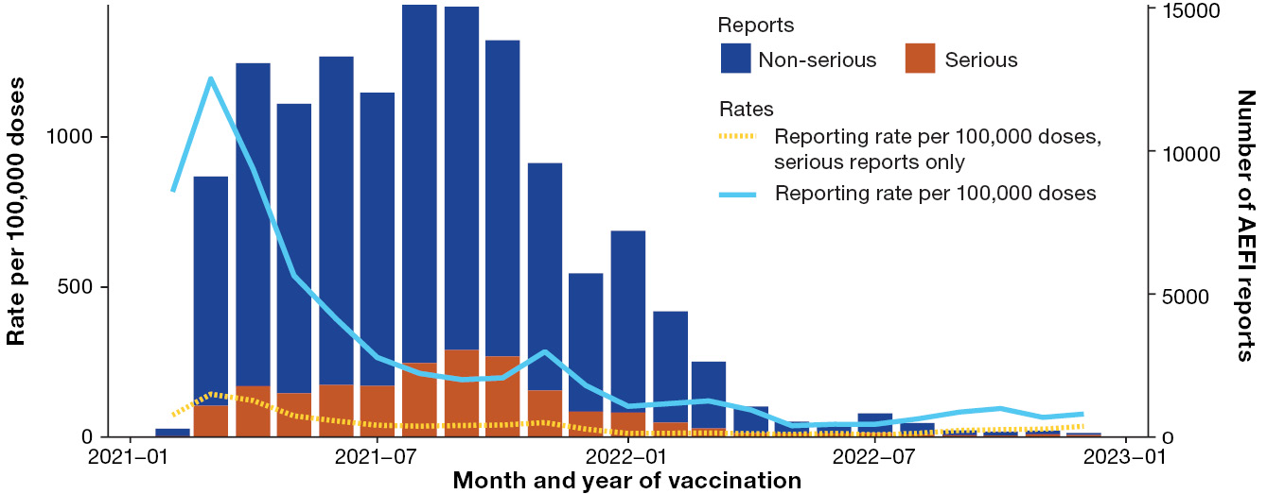
a Reports for the 6 months– 4 years age group were excluded from the figure due to small numbers of AEFI reports. Reports were also excluded from the figure under the following criteria: (i) where the date of vaccination was not recorded; (ii) where vaccination was recorded for January 2021; (iii) where Vaxzevria vaccination before March 2021 was reported; (iv) where Spikevax vaccination before September 2021 was reported; and (v) where Nuvaxovid vaccination before January 2022 was reported.

Population-based reporting rates
The population-based COVID-19 AEFI reporting rate in Australia was 70.8 [95% CI: 69.8–71.9] per 100,000 total population (Table 3). By jurisdiction, the highest rates were in Western Australia (153.6 reports per 100,000 population), the Northern Territory (112.1 per 100,000 population) and Victoria (98.8 per 100,00 population). The lowest 2022 COVID-19 AEFI reporting rates were in New South Wales (33.0 reports per 100,000 population), Queensland (39.0 per 100,000 population), and the Australian Capital Territory (62.0 per 100,000). The rate of serious adverse events was 9.9 per 100,000 population across Australia, ranging from 5.9 in Queensland to 17.7 in Western Australia.
Table 3: Adverse event following immunisation reports in the Adverse Event Management System database for COVID-19 vaccines administered in 2022, by jurisdiction
Jurisdictionª | AEFI reports n (%) | Annual reporting rate per 100,000 population^{b}
Jurisdictionª | AEFI reports n (%) | Overall (95% CI)^{c} | Serious AEFI^{d} | Aged  5–11 years^{e} | Aged 12–15 years^{e} | Aged 16–59 years^{e} | Aged ≥ 60 years^{e}
ACT | 283 (1.5) | 62.0 (55.0–69.6) | 7.2 | 44.6 | 32.6 | 64.7 | 71.8
NSW | 2,692 (14.6) | 33.0 (31.8–34.3) | 11.5 | 51.0 | 14.0 | 30.4 | 31.7
NT | 281 (1.5) | 112.1 (99.4–126.0) | 7.6 | 72.1 | 7.5 | 146.6 | 72.4
Qld | 2,077 (11.3) | 39.0 (37.4–40.7) | 5.9 | 31.6 | 40.6 | 45.3 | 32.6
SA | 1,368 (7.4) | 75.1 (71.2–79.2) | 8.0 | 68.0 | 40.2 | 93.1 | 54.4
Tas. | 471 (2.6) | 82.4 (75.1–90.2) | 10.0 | 194.9 | 54.4 | 82.7 | 63.6
Vic. | 6,535 (35.5) | 98.8 (96.4–101.2) | 6.4 | 105.2 | 62.2 | 104.4 | 98.2
WA | 4,277 (23.2) | 153.6 (149.0–158.2) | 17.7 | 121.7 | 131.8 | 183.5 | 103.9
Unknown | 414 (2.3) | — | — | — | — | — | —
Australia | 18,398 (100) | 70.8 (69.8–71.9) | 9.9 | 72.7 | 47.5 | 77.0 | 60.1
a ACT: Australian Capital Territory; NSW: New South Wales; NT: Northern Territory; Qld: Queensland; SA: South Australia; Tas.: Tasmania; Vic.: Victoria; WA: Western Australia.
b Annual rates per 100,000 population calculated using June 2022 population estimates from the Australian Bureau of Statistics; rates for the 6 months to < 5 year age group were excluded from the table due to small numbers of AEFI reports.
c 95% CI: 95% confidence interval.
d An adverse event report is defined as ‘serious’ if it involves one or more of the following outcomes: (1) fatal or life-threatening condition(s); (2) new or prolonged hospitalisation; (3) persistent or significant disability; (4) congenital anomaly or birth defect; and (5) any medical event that requires an intervention to prevent the above outcomes. For AEFI reports submitted by sponsors (vaccine companies), the seriousness classification is applied by sponsors to ensure they meet legislated requirements. For other AEFI reports submitted to the TGA, the seriousness classification either reflects the view of the reporter or may have been applied by the TGA following review.
e Includes only AEFI reports where an age or date of birth has been reported.

Adverse events
Overall, the most frequently reported MedDRA PT/SMQ for all COVID-19 vaccines in 2022 were ‘gastrointestinal nonspecific symptoms and therapeutic procedures’ (2,886 reports; 15.7%; hereafter abbreviated to ‘gastrointestinal nonspecific symptoms’; further details in Appendix A, Table A.3), headache (2,832 reports; 15.4%), chest pain (2,743 reports; 14.9%), myalgia (1,848 reports; 10.0%) and pyrexia (1,820 reports; 9.9%) (Table 4).
Among children < 5 years, ‘medication errors’, which in the context of AEFI denotes vaccination errors, was the most frequently reported PT/SMQ (Table 4; Appendix A, Table A.3). In children 5–11 years, ‘gastrointestinal nonspecific symptoms’ was most frequent. In adolescents 12–15 years, ‘medication errors’ was also the most frequently reported PT/SMQ. Among adults, chest pain was the most frequently reported PT/SMQ in people aged 16–59 years, and headache was the most frequent for people aged ≥ 60 years.
The most frequently reported PT/SMQ following Comirnaty and Spikevax for all age groups was ‘gastrointestinal nonspecific symptoms’ (Table 5). For Nuvaxovid, chest pain was reported most frequently, and for Vaxzevria, headache was the most frequent.
Table 4: The 30 most frequently reported adverse events classified by MedDRA preferred terms (PTs) or standardised MedDRA queries (SMQs) in reports of adverse events following immunisation with COVID-19 vaccines administered in 2022 in the Adverse Event Management System databaseª
Adverse event  PT or SMQ | AEFI reports n (%)^{b} | Reports with a single reported adverse event n (%)^{c,d,e} | Serious AEFI  n (%)^{d,e} | Aged < 5 years n (%)^{d,f} | Aged  5–11 years n (%)^{d,f} | Aged  12–15 years n (%)^{d,f} | Aged  16–59 years n (%)^{d,f} | Aged ≥ 60 years n (%)^{d,f}
Gastrointestinal nonspecific symptoms and therapeutic procedures | 2,886 (15.7) | 149 (5.2) | 320 (11.1) | 1 (0.0) | 423 (14.7) | 79 (2.7) | 1,872 (64.9) | 404 (14.0)
Headache | 2,832 (15.4) | 54 (1.9) | 256 (9.0) | 1 (0.0) | 172 (6.1) | 59 (2.1) | 2,011 (71.0) | 450 (15.9)
Chest pain | 2,743 (14.9) | 326 (11.9) | 474 (17.3) | 1 (0.0) | 231 (8.4) | 67 (2.4) | 2,094 (76.3) | 249 (9.1)
Myalgia | 1,848 (10.0) | 14 (0.8) | 112 (6.1) | 1 (0.1) | 78 (4.2) | 37 (2.0) | 1,385 (74.9) | 268 (14.5)
Pyrexia | 1,820 (9.9) | 22 (1.2) | 169 (9.3) | 1 (0.1) | 192 (10.5) | 47 (2.6) | 1,285 (70.6) | 221 (12.1)
Fatigue | 1,789 (9.7) | 16 (0.9) | 243 (13.6) | 0 (0) | 69 (3.9) | 44 (2.5) | 1,268 (70.9) | 311 (17.4)
Dyspnoea | 1,703 (9.3) | 52 (3.1) | 342 (20.1) | 0 (0) | 136 (8.0) | 28 (1.6) | 1,273 (74.8) | 199 (11.7)
Hypersensitivity | 1,470 (8.0) | 478 (32.5) | 111 (7.6) | 0 (0) | 255 (17.3) | 33 (2.2) | 837 (56.9) | 267 (18.2)
Lymphadenopathy | 1,411 (7.7) | 258 (18.3) | 56 (4.0) | 0 (0) | 47 (3.3) | 13 (0.9) | 1,170 (82.9) | 106 (7.5)
Medication errors | 1,406 (7.6) | 991 (70.5) | 9 (0.6) | 21 (1.5) | 182 (12.9) | 305 (21.7) | 470 (33.4) | 336 (23.9)
Dizziness | 1,376 (7.5) | 112 (8.1) | 159 (11.6) | 0 (0) | 90 (6.5) | 33 (2.4) | 1,014 (73.7) | 185 (13.4)
Arthralgia | 1,372 (7.5) | 44 (3.2) | 104 (7.6) | 0 (0) | 47 (3.4) | 24 (1.7) | 994 (72.4) | 242 (17.6)
Lethargy | 1,323 (7.2) | 5 (0.4) | 93 (7.0) | 2 (0.2) | 136 (10.3) | 28 (2.1) | 916 (69.2) | 186 (14.1)
Injection site reaction | 1,179 (6.4) | 126 (10.7) | 24 (2.0) | 1 (0.1) | 79 (6.7) | 33 (2.8) | 876 (74.3) | 153 (13.0)
Noninfectious myocarditis/pericarditis | 1,043 (5.7) | 188 (18.0) | 351 (33.7) | 2 (0.2) | 40 (3.8) | 26 (2.5) | 837 (80.2) | 101 (9.7)
Palpitations | 1,026 (5.6) | 72 (7.0) | 161 (15.7) | 0 (0) | 50 (4.9) | 18 (1.8) | 791 (77.1) | 112 (10.9)
Injection site pain | 833 (4.5) | 26 (3.1) | 45 (5.4) | 2 (0.2) | 34 (4.1) | 17 (2.0) | 594 (71.3) | 159 (19.1)
Pain in extremity | 797 (4.3) | 33 (4.1) | 83 (10.4) | 2 (0.3) | 33 (4.1) | 6 (0.8) | 536 (67.3) | 145 (18.2)
Paraesthesia | 763 (4.1) | 48 (6.3) | 98 (12.8) | 0 (0) | 12 (1.6) | 7 (0.9) | 611 (80.1) | 93 (12.2)
Chest discomfort | 699 (3.8) | 26 (3.7) | 127 (18.2) | 0 (0) | 40 (5.7) | 20 (2.9) | 555 (79.4) | 56 (8.0)
Haemodynamic oedema, effusions and fluid overload | 688 (3.7) | 49 (7.1) | 124 (18.0) | 1 (0.1) | 19 (2.8) | 6 (0.9) | 470 (68.3) | 156 (22.7)
Oropharyngeal conditions (excl neoplasms, infections and allergies) | 621 (3.4) | 51 (8.2) | 70 (11.3) | 0 (0) | 64 (10.3) | 11 (1.8) | 403 (64.9) | 108 (17.4)
Chills | 614 (3.3) | 4 (0.7) | 47 (7.7) | 0 (0) | 24 (3.9) | 16 (2.6) | 436 (71.0) | 116 (18.9)
Malaise | 607 (3.3) | 5 (0.8) | 99 (16.3) | 0 (0) | 49 (8.1) | 17 (2.8) | 344 (56.7) | 149 (24.5)
COVID-19 | 606 (3.3) | 119 (19.6) | 383 (63.2) | 0 (0) | 65 (10.7) | 11 (1.8) | 311 (51.3) | 94 (15.5)
Syncope | 475 (2.6) | 108 (22.7) | 41 (8.6) | 0 (0) | 105 (22.1) | 22 (4.6) | 289 (60.8) | 48 (10.1)
Concomitant disease aggravated | 454 (2.5) | 143 (31.5) | 118 (26.0) | 0 (0) | 25 (5.5) | 4 (0.9) | 283 (62.3) | 122 (26.9)
Influenza like illness | 449 (2.4) | 40 (8.9) | 28 (6.2) | 0 (0) | 19 (4.2) | 5 (1.1) | 351 (78.2) | 57 (12.7)
Haemorrhage terms (excl laboratory terms) | 445 (2.4) | 55 (12.4) | 58 (13.0) | 0 (0) | 25 (5.6) | 13 (2.9) | 314 (70.6) | 59 (13.3)
Hyperhidrosis | 420 (2.3) | 2 (0.5) | 68 (16.2) | 0 (0) | 21 (5.0) | 9 (2.1) | 301 (71.7) | 63 (15.0)
a Reports are included in this analysis only if the date of vaccination occurred in 2022 (or where the date of vaccination is unavailable, the date of symptom onset occurring in 2022; or when both the date of vaccination and date of symptom onset are unavailable, the date of adverse event reporting occurring in 2022). Therefore, there may be discrepancies between the numbers in this table and those published in other TGA outputs, where reports are included if the date of reporting falls within 2022, regardless of the year of vaccination or symptom onset.
b Number of AEFI reports in which the PT or SMQ was reported. More than one PT/SMQ may be recorded on the same report.
c AEFI reports where only one AEFI (coded as MedDRA PT or SMQ) was reported.
d Percentages are calculated for the number of AEFI reports where the PT or SMQ was reported.
e An adverse event report is defined as ‘serious’ if it involves one or more of the following outcomes: (1) fatal or life-threatening condition(s); (2) new or prolonged hospitalisation; (3) persistent or significant disability; (4) congenital anomaly or birth defect; and (5) any medical event that requires an intervention to prevent the above outcomes. For AEFI reports submitted by sponsors (vaccine companies), the seriousness classification is applied by sponsors to ensure they meet legislated requirements. For other AEFI reports submitted to the TGA, the seriousness classification either reflects the view of the reporter or may have been applied by the TGA following review.
f Includes only AEFI reports where an age or date of birth has been reported.
Table 5: The 30 most frequently reported adverse events classified by MedDRA Preferred Terms (PTs) or Standardised MedDRA queries (SMQs) in reports of adverse events following immunisation with COVID-19 vaccines administered in 2022 in the Adverse Event Management System database, by brandª
Adverse event  PT or SMQ | AEFI reports  n (%)^{b} | Comirnaty  n (%)^{c,d} | Nuvaxovid  n (%)^{c,d} | Spikevax  n (%)^{c,d} | Vaxzevria  n (%)^{c,d}
Gastrointestinal nonspecific symptoms and therapeutic procedures | 2,886 (15.7) | 2,106 (73.0) | 168 (5.8) | 535 (18.5) | 80 (2.8)
Headache | 2,832 (15.4) | 1,985 (70.1) | 204 (7.2) | 562 (19.8) | 88 (3.1)
Chest pain | 2,743 (14.9) | 2,011 (73.3) | 237 (8.6) | 435 (15.9) | 68 (2.5)
Myalgia | 1,848 (10.0) | 1,312 (71.0) | 101 (5.5) | 397 (21.5) | 50 (2.7)
Pyrexia | 1,820 (9.9) | 1,260 (69.2) | 93 (5.1) | 433 (23.8) | 40 (2.2)
Fatigue | 1,789 (9.7) | 1,227 (68.6) | 130 (7.3) | 387 (21.6) | 55 (3.1)
Dyspnoea | 1,703 (9.3) | 1,256 (73.8) | 114 (6.7) | 289 (17.0) | 56 (3.3)
Hypersensitivity | 1,470 (8.0) | 1,077 (73.3) | 94 (6.4) | 263 (17.9) | 56 (3.8)
Lymphadenopathy | 1,411 (7.7) | 1,131 (80.2) | 40 (2.8) | 226 (16.0) | 13 (0.9)
Medication errors | 1,406 (7.6) | 1,148 (81.7) | 22 (1.6) | 201 (14.3) | 31 (2.2)
Dizziness | 1,376 (7.5) | 988 (71.8) | 108 (7.8) | 248 (18.0) | 38 (2.8)
Arthralgia | 1,372 (7.5) | 982 (71.6) | 83 (6.0) | 263 (19.2) | 48 (3.5)
Lethargy | 1,323 (7.2) | 990 (74.8) | 77 (5.8) | 235 (17.8) | 34 (2.6)
Injection site reaction | 1,179 (6.4) | 819 (69.5) | 72 (6.1) | 277 (23.5) | 14 (1.2)
Noninfectious myocarditis/pericarditis | 1,043 (5.7) | 787 (75.5) | 47 (4.5) | 194 (18.7) | 23 (2.2)
Palpitations | 1,026 (5.6) | 729 (71.1) | 102 (9.9) | 180 (17.5) | 26 (2.5)
Injection site pain | 833 (4.5) | 591 (70.9) | 63 (7.6) | 164 (19.7) | 17 (2.0)
Pain in extremity | 797 (4.3) | 538 (67.5) | 70 (8.8) | 157 (19.7) | 31 (3.9)
Paraesthesia | 763 (4.1) | 486 (63.7) | 123 (16.1) | 130 (17.0) | 28 (3.7)
Chest discomfort | 699 (3.8) | 509 (72.8) | 70 (10.0) | 112 (16.0) | 11 (1.6)
Haemodynamic oedema, effusions and fluid overload | 688 (3.7) | 469 (68.2) | 45 (6.5) | 152 (22.1) | 26 (3.8)
Oropharyngeal conditions (excl neoplasms, infections and allergies) | 621 (3.4) | 447 (72.0) | 56 (9.2) | 109 (17.6) | 21 (3.4)
Chills | 614 (3.3) | 413 (67.3) | 25 (4.1) | 162 (26.4) | 17 (2.8)
Malaise | 607 (3.3) | 405 (66.7) | 46 (7.6) | 132 (21.7) | 24 (4.0)
COVID-19 | 606 (3.3) | 540 (89.1) | 16 (2.6) | 61 (10.1) | 25 (4.1)
Syncope | 475 (2.6) | 377 (79.4) | 14 (2.9) | 80 (16.8) | 6 (1.3)
Concomitant disease aggravated | 454 (2.5) | 317 (69.8) | 51 (11.2) | 77 (17.0) | 19 (4.2)
Influenza like illness | 449 (2.4) | 315 (70.2) | 29 (6.5) | 83 (18.5) | 18 (4.0)
Haemorrhage terms (excl laboratory terms) | 445 (2.4) | 310 (69.7) | 27 (6.1) | 82 (18.4) | 29 (6.5)
Hyperhidrosis | 420 (2.3) | 302 (71.9) | 21 (5.0) | 84 (20.0) | 15 (3.6)
a Reports are included in this analysis only if the date of vaccination occurred in 2022 (or where the date of vaccination is unavailable, the date of symptom onset occurring in 2022; or when both the date of vaccination and date of symptom onset are unavailable, the date of adverse event reporting occurring in 2022). Therefore, there may be discrepancies between the numbers in this table and those published in other TGA outputs, where reports are included if the date of reporting falls within 2022, regardless of the year of vaccination or symptom onset.
b Number of AEFI reports in which the PT or SMQ was reported. More than one PT/SMQ may be recorded on the same report.
c Includes AEFI reports with the listed vaccine brand; more than one vaccine may be reported on the same report.
d Percentages are calculated for the number of AEFI reports where the PT or SMQ was reported.

Adverse events in the < 5 year age group
Of the 29 COVID-19 AEFI reports in the < 5 year age group, four were categorised as serious, of which two described adverse events in infants after in utero exposure to COVID-19 vaccines administered to the mother during pregnancy. Another of the serious reports appeared to indicate in the case narrative that the adverse event in the infant related to an indirect exposure through breastfeeding after the mother was given a COVID-19 vaccine. If these three serious reports related to maternal exposure were excluded from the calculation, the remaining 26 reports gave an AEFI reporting rate of 2,186.7 per 100,000 doses of COVID-19 vaccines administered to the < 5 age group.
Furthermore, 21/29 AEFI reports in the < 5 year age group (72%) included the MedDRA PT ‘medication errors’ (denoting vaccination errors), with 18 of these reports describing the administration, to children aged 4 years, of a 5–11 year formulation of the COVID-19 vaccine. In five reports of ‘medication errors’, an additional mild transient adverse event was also included (four reports of injection site pain and one report of abdominal discomfort), meaning that at the time of reporting, none of the errors were known to have resulted in adverse events of clinical concern.
Excluding maternal exposure as above (three reports) and vaccination error without any accompanying adverse events (16 reports), the remaining 10 reports give an AEFI reporting rate in the < 5 year age group of 842.5 per 100,000 doses.

Adverse events in the 5–11 year age group
There were 1,648 COVID-19 AEFI reports in the 5–11 year age group, of which 116 (7.0%) were categorised as serious. Most AEFI reports (688 reports) described events related to vaccination in January, at the commencement of the COVID-19 vaccination program for the 5–11 year age group (Figure 2), while the highest AEFI reporting rate (144.0 reports per 100,000 doses) occurred in February 2022, the following month (Figure 3). The most frequently reported MedDRA PT/SMQ reported in 2022 were ‘gastrointestinal nonspecific symptoms’ (423 reports), hypersensitivity (255 reports), chest pain (231 reports), pyrexia (192 reports) and ‘medication errors’ (182 reports; Table 4). ‘Gastrointestinal nonspecific symptoms’ was also the PT/SMQ most frequently associated with serious AEFI reports in this age group (40 reports), followed by pyrexia (20 reports). Notably, no reports of medication errors were categorised as serious.
Figure 2: Adverse event following immunisation reports for COVID-19 vaccines administered in 2021–2022 in the Adverse Event Management System (AEMS) database, by age group and brand^{a,b,c}
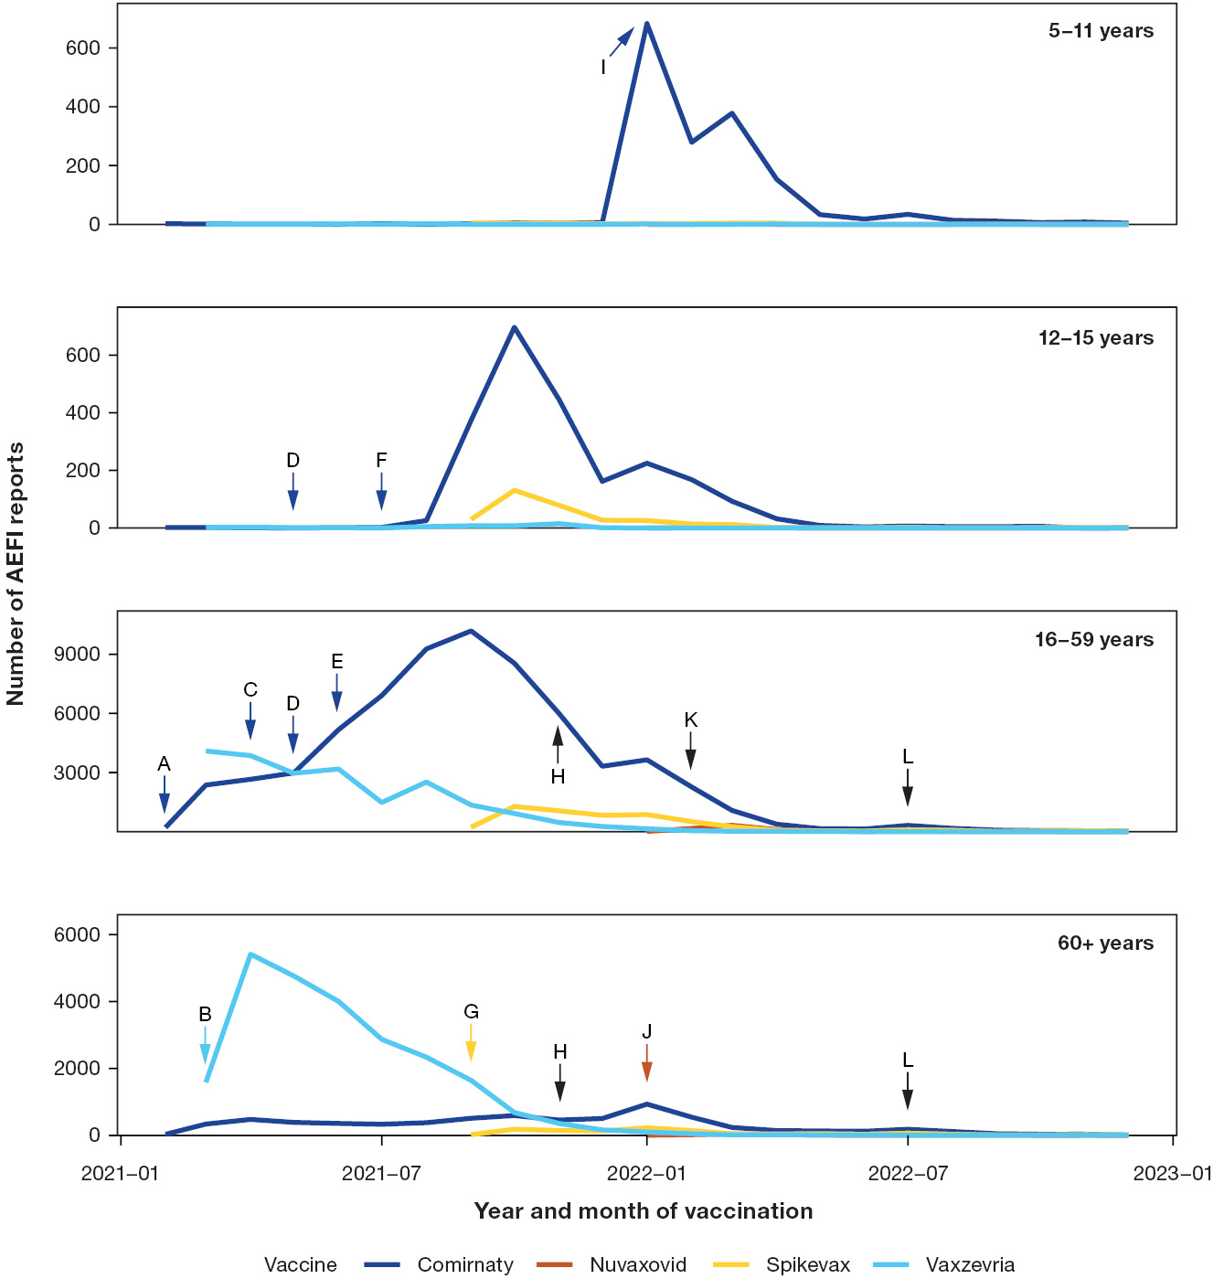
a Reports for the 6 months to < 5 year age group were excluded from the figure due to small numbers of AEFI reports. Reports were also excluded from the figure under the following criteria: i) where the date of vaccination was not recorded; ii) where vaccination was recorded for January 2021; iii) where Vaxzevria vaccination before March 2021 was reported; iv) where Spikevax vaccination before September 2021 was reported; and v) where Nuvaxovid vaccination before January 2022 was reported.
b A notable difference from the 2021 COVID AEFI report is that reports for COVID-19 vaccines administered to the 12–15 year age group before August 2021 were not excluded from the figure, as they may represent vaccination errors. Similarly, reports of COVID-19 vaccines administered to the 5–11 year age group before January 2022 were not excluded.
c Event markers shown represent the following events: A: start of COVID-19 vaccination program (with Comirnaty); B Vaxzevria introduced; C: preferential recommendation for Comirnaty over Vaxzevria in people aged < 50 years (thrombosis with thrombocytopenia syndrome [TTS] concern); D: myocarditis concern; E: preferential recommendation for Comirnaty over Vaxzevria in people aged < 60 years (TTS concern); F: start of COVID-19 vaccination program for 12–15 year olds (with Comirnaty); G: Spikevax introduced; H: booster program commenced for people ≥ 18 years old; I: start of COVID-19 vaccination program for 5–11 year olds (with Comirnaty); J: Nuvaxovid introduced; K: booster program commenced for people 16–17 years old; L: second booster dose recommended for people ≥ 50 years old.
Figure 3: AEFI reporting rates per 100,000 COVID-19 vaccine doses administered in 2022 recorded in the Adverse Event Management System database, by age group and vaccine brandª
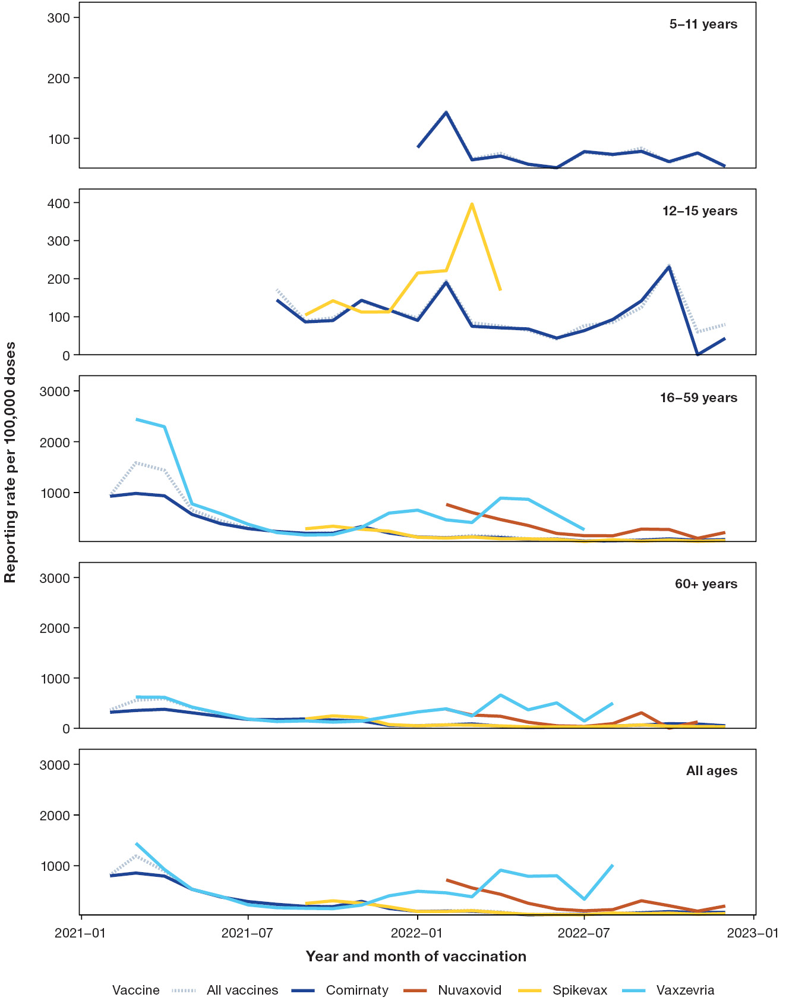
a Rates for the 6 months to < 5 year age group were excluded from the figure due to small numbers of AEFI reports. Reports were also excluded from the data informing the figure under the following criteria: i) where the date of vaccination was not recorded; ii) where vaccination was recorded for January 2021; iii) where Vaxzevria vaccination before March 2021 was reported; iv) where Spikevax vaccination before September 2021 was reported; and v) where Nuvaxovid vaccination before January 2022 was reported. Denominators were calculated using AIR data for each vaccine brand and age group. Rates were excluded for months where fewer than 1,000 doses of a specific vaccine brand were administered to a particular age group.

Chest pain and other cardiac-related adverse events
There were 2,743 reports of chest pain, with 474 reports (17.3%) categorised as serious (Table 4). The median age at COVID-19 vaccination was 35 years (interquartile range, IQR: 25–48 years). Of the 2,713 reports where the sex was provided, 1,515 (55.8%) were female and 1,198 (44.2%) were male. Of the 2,732 reports where the vaccine brand was provided, Comirnaty was the most frequently associated vaccine, included in 2,011/2,732 reports of chest pain (73.6%), followed by Spikevax (435/2,732 reports, 15.9%; Table 5). Please note that reports specifically assigned the PT ‘non-cardiac chest pain’ were mapped to the gastrointestinal nonspecific symptoms SMQ, and were not included within chest pain (Appendix A, Table A.3).
Included in 2,417/2,743 reports of chest pain (88.1%), there were additional PT/SMQ. The PT/SMQ most frequently occurring with chest pain were dyspnoea (875 reports), noninfectious myocarditis/pericarditis (639 reports; see section below) and ‘gastrointestinal nonspecific symptoms’ (523 reports).
Additionally, there were 699 COVID-19 AEFI reports coded with the PT/SMQ ‘chest discomfort’, which encompasses symptoms such as chest heaviness or tightness. In 279 of these chest discomfort reports, chest pain was also recorded. There were also 1,026 reports of palpitations, 461 of which included chest pain as an additional PT/SMQ.

Adverse events of special interest
The order of reporting frequency for the most common Brighton Collaboration-listed COVID-19 vaccine AESI in the AEMS database in 2022 remained the same as that in 2021. Myocarditis and/or pericarditis was the most frequently reported AESI, with 1,049 reports (5.7% of all COVID-19 AEFI reports; Table 6). The next most frequently reported AESI was thrombosis and thromboembolism (a Brighton Collaboration-defined grouping of LLT and PT, which does not specifically include the PT ‘thrombocytosis with thrombocytopenia syndrome’ but may capture cases of TTS through including thrombotic events at any anatomical site; details in Appendix A, Table A.4), followed by anaphylaxis. For most AESI, there were fewer than 5 reports per 100,000 doses administered of each COVID-19 vaccine brand in each age group, with the notable exception of four AESI: myocarditis and/or pericarditis, thrombosis and thromboembolism, thrombocytopenia, and anaphylaxis (Figure 4).
Overall in all age groups, the reporting rate for myocarditis and/or pericarditis, as identified using Brighton Collaboration guidance, was 5.1 per 100,000 doses administered. Of the 1,041 myocarditis and/or pericarditis reports where sex was provided, 460 (44.2%) were female and 581 (55.8%) were male. The median age at vaccination was 34 years (IQR: 25–48 years). Of the 1,046 reports where the vaccine brand was known, 795 (76.0%) included Comirnaty, followed by 195 (18.6%) reports including Spikevax. In the 16–59 age group, the reporting rate for myocarditis and/or pericarditis ranged from 7.5 per 100,000 doses for Spikevax to 26.6 per 100,000 doses following Nuvaxovid. However, the highest vaccine brand- and age group-specific reporting rate for myocarditis and/or pericarditis was 28.4 per 100,000 doses of Spikevax administered to children aged 5–11 years. Spikevax was also associated with a rate of myocarditis and/or pericarditis reports of 19.3 per 100,000 doses in the 12–15 year age group. Notably, 455 (45.1%) of the 1,009 myocarditis and/or pericarditis reports where the jurisdiction was known originated from Western Australia.
Table 6: Adverse events of special interest (AESI) reported in reports of adverse events following immunisation (AEFI) with COVID-19 vaccines in 2022 in the Adverse Event Management System database
AESI | AEFI reports n (%)^{a,b} | Reports with a single vaccine coded as suspect  n (%)^{c,d} | Serious AEFI  n (%)^{d,e} | Aged < 5 years n (%)^{d,f} | Aged  5–11 years n (%)^{d,f} | Aged  12–15 years n (%)^{d,f} | Aged  16–59 years n (%)^{d,f} | Aged ≥ 60 years n (%)^{d,f}
Myocarditis and/or pericarditis | 1,049 (5.7) | 925 (88.2) | 369 (35.2) | 2 (0.2) | 39 (3.7) | 26 (2.5) | 834 (79.5) | 112 (10.7)
Thrombosis and thromboembolism | 307 (1.7) | 244 (79.5) | 158 (51.5) | 0 (0) | 1 (0.3) | 0 (0) | 143 (46.6) | 121 (39.4)
Anaphylaxis | 164 (0.9) | 153 (93.3) | 46 (28.0) | 0 (0) | 5 (3.0) | 4 (2.4) | 130 (79.3) | 23 (14.0)
Bell's palsy and facial nerve palsy | 161 (0.9) | 153 (95.0) | 32 (19.9) | 0 (0) | 2 (1.2) | 1 (0.6) | 105 (65.2) | 47 (29.2)
Generalised convulsion | 151 (0.8) | 139 (92.1) | 44 (29.1) | 0 (0) | 37 (24.5) | 4 (2.6) | 90 (59.6) | 17 (11.3)
Thrombocytopenia | 82 (0.4) | 55 (67.1) | 52 (63.4) | 0 (0) | 8 (9.8) | 1 (1.2) | 33 (40.2) | 22 (26.8)
Guillain-Barré Syndrome | 34 (0.2) | 27 (79.4) | 25 (73.5) | 0 (0) | 1 (2.9) | 0 (0) | 17 (50) | 13 (38.2)
Multisystem inflammatory syndrome | 8 (0.04) | 6 (75.0) | 7 (87.5) | 0 (0) | 6 (75.0) | 0 (0) | 2 (25.0) | 0 (0)
Aseptic meningitis | 5 (0.03) | 5 (100) | 3 (60.0) | 0 (0) | 0 (0) | 0 (0) | 5 (100) | 0 (0)
Encephalitis / encephalomyelitis | 4 (0.02) | 4 (100) | 3 (75.0) | 0 (0) | 0 (0) | 0 (0) | 2 (50.0) | 0 (0)
Acute disseminated encephalomyelitis | 2 (0.01) | 1 (50.0) | 1 (50.0) | 0 (0) | 0 (0) | 1 (50.0) | 1 (50.0) | 0 (0)
Acute respiratory distress syndrome | 0 (0) | 0 (0) | 0 (0) | 0 (0) | 0 (0) | 0 (0) | 0 (0) | 0 (0)
a Number of AEFI reports in which the AESI was reported. More than one AESI may be recorded in the same report. Note that any discrepancies between AEFI reports for similar conditions in Table 3 and Table 6 are due to differences in methodology used to identify AEFI reports to be included.
b Percentages are calculated for the total number of COVID-19 AEFI reports in 2022.
c AEFI reports where only one vaccine was coded as ‘suspect’ with relation to causal involvement in a reported adverse event.
d Percentages are calculated for the number of AEFI reports where the AESI was reported.
e An adverse event report is defined as ‘serious’ if it involves one or more of the following outcomes: (1) fatal or life-threatening condition(s); (2) new or prolonged hospitalisation; (3) persistent or significant disability; (4) congenital anomaly or birth defect; and (5) any medical event that requires an intervention to prevent the above outcomes. For AEFI reports submitted by sponsors (vaccine companies), the seriousness classification is applied by sponsors to ensure they meet legislated requirements. For other AEFI reports submitted to the TGA, the seriousness classification either reflects the view of the reporter or may have been applied by the TGA following review.
f Includes only AEFI reports where an age or date of birth has been provided.

Figure 4: Selected AESI reporting rates per 100,000 COVID-19 vaccine doses administered in 2022 recorded in the Adverse Event Management System (AEMS) database, by age group and vaccine brand^{a,b}
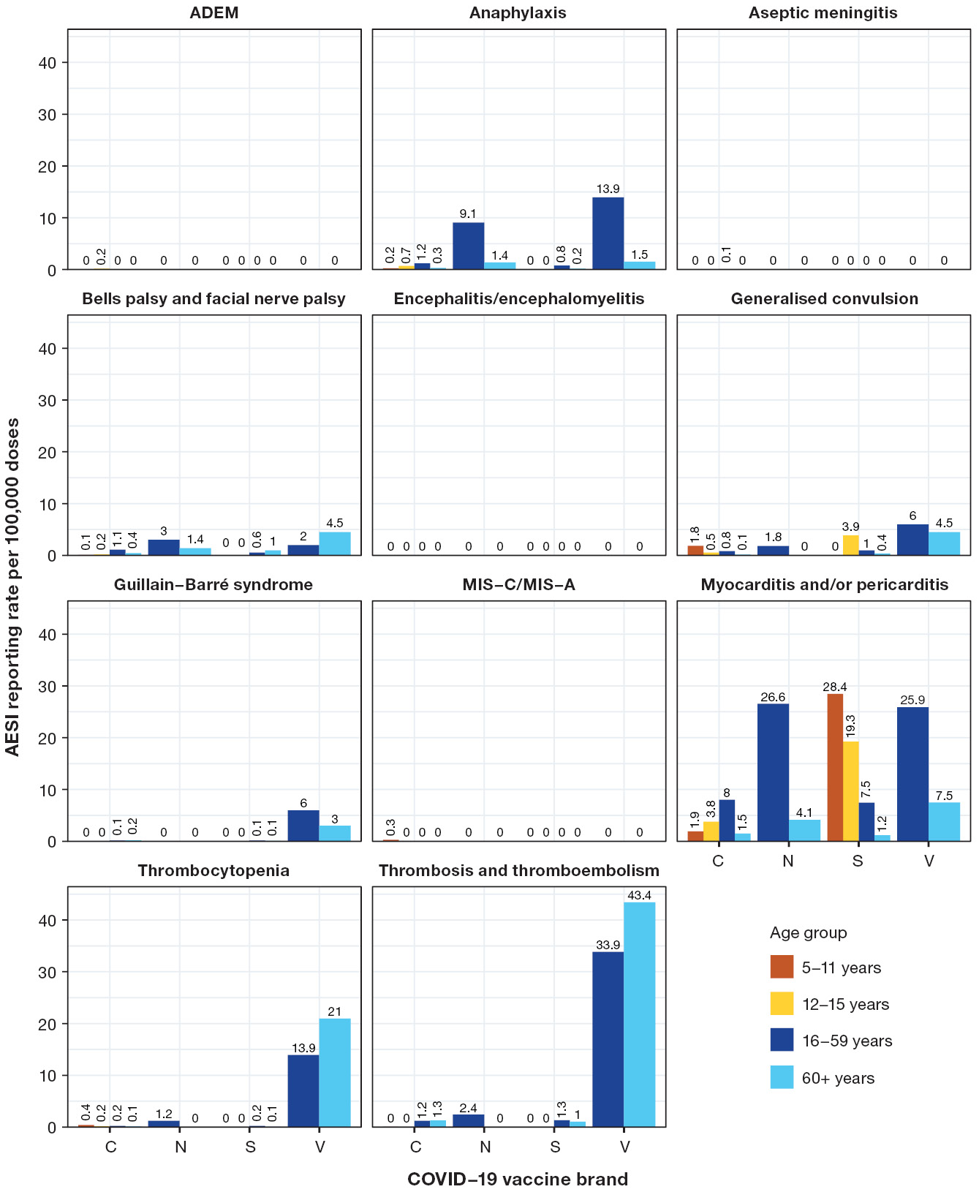
a Rates for the 6 months to < 5 year age group were excluded from the figure due to small numbers of AEFI reports. Denominators were calculated using AIR data for each vaccine brand and age group. Rates were excluded for months where fewer than 1,000 doses of a specific vaccine brand were administered to a specific age group. See Methods section for process of selecting specific AESI for inclusion for analysis. Acute respiratory distress syndrome (ARDS) was excluded from this figure as there were zero reports of this AESI in 2022.
b Abbreviations used in figure: ADEM: acute disseminated encephalomyelitis; MIS-C/MIS-A: multisystem inflammatory syndrome in children/adults; C: Comirnaty; N: Nuvaxovid; S: Spikevax; V: Vaxzevria.
Across all age groups and brands, thrombosis and thromboembolism was 1.5 per 100,000 doses. Of the 282 reports of thrombosis and thromboembolism where sex was provided, 161 (57.1%) were female and 121 (42.9%) were male. The median age at vaccination was 56 years (IQR: 43–68 years), noting that in 42 reports (13.7%), age was not provided. Comirnaty was associated with most reports of thrombosis and thromboembolism (186 reports, 60.6%) followed by Vaxzevria (72 reports, 23.5%).
For thrombocytopenia, there was a reporting rate of 21.0 per 100,000 doses of Vaxzevria in the ≥ 60 year age group, and 13.9 per 100,000 doses of Vaxzevria in the 16–59 year age group. For anaphylaxis, reporting rates of 13.9 per 100,000 doses of Vaxzevria and 9.1 per 100,000 doses of Nuvaxovid were observed in the 16–59 year age group. Additionally, the reporting rate for both generalised convulsion and Guillain-Barré syndrome was 6.0 per 100,000 Vaxzevria doses administered to the 16–59 year age group.
Focusing on the specific syndrome of TTS, from 1 January 2022 to 31 December 2022, there were 26 reports of TTS reported to the TGA involving Vaxzevria. Of these, five were cases reported in the published academic literature, with a single case classified as probable by the TGA, noting this case involved a vaccine administered in 2021. The remainder of cases reported in 2022 had insufficient information for classification or were assessed as unlikely to be TTS.

Serious adverse events
Of the COVID-19 vaccine AEFI reports in AEMS in 2022, there were 2,559 (13.9%) which were categorised as serious, representing a rate of 12.5 serious AEFI reports per 100,000 doses administered, and 9.9 serious AEFI reports per 100,000 population (Table 3). Excluding the < 5 year age group due to low dose numbers, the 16–59 year age group had the highest serious adverse event reporting rate, at 14.6 serious reports per 100,000 COVID-19 doses administered. The 5–11 year age group had the lowest reporting rate of 5.8 serious reports per 100,000 doses administered.
The PT/SMQ most frequently included in serious AE reports were chest pain (474 serious reports, 18.5% of all serious reports; Table 4), COVID-19 (383, 15.0%), noninfectious myocarditis/pericarditis (351, 13.7%), dyspnoea (342, 13.4%), and ‘gastrointestinal nonspecific symptoms’ (320, 12.5%). Please note that more than one PT/SMQ may be included in each serious adverse event report.
The proportion of AEFI reports where the outcome was categorised as serious was highest for Vaxzevria (34.0%); amongst other vaccine brands, the proportion was similar for Nuvaxovid (14.0%), Comirnaty (13.3%) and Spikevax (13.2%; Table 2).

Deaths following vaccination
Of the 18,398 AEFI reports for COVID-19 vaccines in 2022, there were 160 (0.9%) which reported an outcome of death following vaccination (Table 7), of which only one was determined as likely to be linked to vaccination, as assessed by the TGA and reviewed by an expert panel (see Methods section for more details).
Table 7: Age distribution and median time to death for reports of death following immunisation with COVID-19 vaccines in 2022 in the Adverse Event Management System databaseª
Age at death (years) | AEFI reports n (%)^{b} | Median time to death (days)
0–17 | 6 (3.9%) | 4.5
18–29 | 5 (3.3%) | 3
30–49 | 25 (16.3%) | 13
50–69 | 37 (24.2%) | 16
70–89 | 66 (43.1%) | 10.5
90+ | 14 (9.2%) | 3
Unknown | 7 | No information
a An outcome of death following vaccination does not mean that the vaccine caused the death. Only one death following a COVID-19 vaccine administered in 2022 was assessed by TGA as likely to be causally linked to vaccination.
b Percentages are calculated for the number of reports of death following COVID-19 vaccination where age at death can be determined.
Reporting a death to the TGA does not mean that the vaccine caused the death, or that the individual completing the report considers that the death was caused by a vaccine. The TGA strongly encourages consumers and health professionals to report suspected adverse events, particularly serious or fatal events, even if there is only a very small chance a vaccine was the cause. Many deaths reported are likely of a coincidental nature, due to other causes. All reports containing sufficient information, including fatal reports, are de-identified and published in the DAEN—medicines.³³ Publication of a report in the DAEN—medicines does not mean that the vaccine caused the adverse event. All reports of death are also included in the TGA safety monitoring data, even if a coroner or expert panel has concluded that the death is unrelated to vaccination.
More than 60% of these 160 reports were in people aged ≥ 60 years (Table 7). The median age at death was 72 years and the median time between the most recent COVID-19 vaccination and death was 13 days (range: 0–375 days).
Most of the reports of death following COVID-19 vaccination were submitted to the TGA by state and territory health departments (102 reports; 63.8%), followed by consumers (29 reports; 18.1%). Sixteen reports (10.0%) originated from pharmaceutical companies; thirteen reports (8.1%) were submitted directly by health professionals including coroners courts.
For both age groups of < 60 years and ≥ 60 years, the most commonly reported PT/SMQ with a fatal outcome was ‘adverse event following immunisation’ (34% among < 60 years; 25% among ≥ 60 years). This MedDRA PT was used by the TGA for adverse event reports with fatal outcomes where limited additional clinical information was provided. The second most commonly reported PT/SMQ with a fatal outcome for people aged < 60 years was ‘shock-associated circulatory or cardiac conditions (excl torsade de pointes)’; followed, in order of frequency, by ‘gastrointestinal nonspecific symptoms and therapeutic procedures’; myocardial infarction; noninfectious myocarditis/pericarditis; and ‘haemodynamic oedema, effusions and fluid overload’. The second most commonly reported PT/SMQ with a fatal outcome for people aged ≥ 60 years was myocardial infarction; followed, in order of frequency, by ‘shock-associated circulatory or cardiac conditions (excl torsade de pointes)’; ‘embolic and thrombotic events, venous’; concomitant disease aggravated; and cerebrovascular accident.
It is important to note that while there have been AEFI reports with an outcome of death among children, none have been determined to be causally linked to COVID-19 vaccines after expert assessment by the TGA.

VSIG meetings
Two VSIG meetings were convened to discuss two fatal AEFI cases following COVID-19 vaccination that occurred in 2022. The VSIG found that one death was likely to be linked to vaccination. This death occurred in a woman who developed myocarditis following a booster dose of Spikevax.³⁵ The second case was of myocarditis which occurred approximately one month after a booster dose of Comirnaty.³⁶ The VSIG concluded that this death was unlikely to have a causal link to the vaccine.

Safety monitoring
Table 8 summarises the safety topics that were the focus of TGA-initiated investigations for COVID-19 vaccines in 2022, and some of the specific actions taken consequent to these investigations. Ten safety topics underwent multiple separate investigations as new evidence emerged, including topics that were initially investigated in 2021 and reopened for further investigation in 2022. Additional actions, including updating COVID-19 vaccine product information, were undertaken as a result of TGA investigations for 10 separate safety topics in 2022.
Table 8 includes data until 31 December 2022 and does not capture the total number of investigations performed by the TGA, or the regulatory action that occurred subsequently for these safety topics in 2023 or beyond.
Table 8: Safety topics investigated for COVID-19 vaccines undertaken by the TGA in 2022ª
 | Potential adverse event investigated | Outcome/status at the end of 2022^{b} | Topic reviewed multiple times
Comirnaty | Anti-glomerular basement membrane disease | Returned to routine monitoring | No
Comirnaty | Appendicitis | Returned to routine monitoring | Yes
Comirnaty | Bronchitis / lower respiratory tract infection | Returned to routine monitoring | No
Comirnaty | Cardiomyopathy | Returned to routine monitoring | Yes
Comirnaty | Central serous chorioretinopathy | Returned to routine monitoring | No
Comirnaty | Chilblains | Returned to routine monitoring | No
Comirnaty | Guillain-Barré syndrome | Returned to routine monitoring | No
Comirnaty | Laryngitis, tonsilitis, and tonsillar inflammation | Returned to routine monitoring | No
Comirnaty | Multisystem inflammatory syndrome in children (MIS-C) | Returned to routine monitoring and referral to external organisation for enhanced surveillance | Yes
Comirnaty | Neuralgic amyotrophy | Returned to routine monitoring | No
Comirnaty | Neutropenia | Returned to routine monitoring | No
Comirnaty | Oral herpes and mouth ulcers | Returned to routine monitoring | No
Comirnaty | Sjögren’s syndrome | Returned to routine monitoring | No
Comirnaty and Spikevax | Myocarditis / pericarditis | Product information updated | Yes
Comirnaty and Spikevax | Heavy menstrual bleeding | Product information updated | Yes
Comirnaty and Vaxzevria | Arterial thromboses | Returned to routine monitoring | No
Comirnaty and Vaxzevria | Heart rate / rhythm disorders | Returned to routine monitoring | No
Comirnaty and Vaxzevria | Iritis / uveitis | Returned to routine monitoring | Yes
Comirnaty and Vaxzevria | Type 1 diabetes mellitus | Returned to routine monitoring | No
Comirnaty and Vaxzevria | Vitreous detachment / floaters | Returned to routine monitoring | No
Nuvaxovid | Hypoaesthesia and paraesthesia | Product information updated | No
Nuvaxovid | Myocarditis / pericarditis | Product information updated | No
Nuvaxovid | Tinnitus, hypoacusis and ear discomfort | Product information updated | No
Spikevax | Urticaria | Returned to routine monitoring | No
Spikevax | Capillary leak syndrome | Product information updated | No
Vaxzevria | Acute disseminated encephalomyelitis, encephalitis, and encephalopathy | Product information updated | Yes
Vaxzevria | Acute macular neuroretinopathies | Returned to routine monitoring | No
Vaxzevria | Acute myocardial infarction | Returned to routine monitoring | No
Vaxzevria | Transverse myelitis | Product information updated | No
All COVID-19 vaccines | Acute kidney injury | Returned to routine monitoring | No
All COVID-19 vaccines | Acute mental state change | Returned to routine monitoring | No
All COVID-19 vaccines | Alopecia | Returned to routine monitoring | No
All COVID-19 vaccines | Arterial dissection | Returned to routine monitoring | No
All COVID-19 vaccines | Encephalitis | Returned to routine monitoring | No
All COVID-19 vaccines | Mastitis (Including breast swelling) | Under negotiation with sponsor | No
All COVID-19 vaccines | Menstrual cycle irregularities / disorders | Returned to routine monitoring | Yes
All COVID-19 vaccines | Multisystem inflammatory syndrome in adults (MIS-A) and Multisystem inflammatory syndrome in children (MIS-C) | Returned to routine monitoring | Yes
All COVID-19 vaccines | Polymyalgia rheumatica | Returned to routine monitoring | No
All COVID-19 vaccines | Uveitis | Returned to routine monitoring | Yes
All COVID-19 vaccines | Vulvovaginal ulcerations (Lipschutz ulcers) in adolescent girls | Product information updated | No
a A targeted investigation may be initiated by the TGA following a preliminary assessment of information arising from reporting patterns, overseas regulators, published literature and other sources of safety data. As new information arises about a potential issue, multiple targeted investigations may be undertaken and investigations may occur through other processes such as a TGA review of sponsor safety data. Regardless of the number of times the TGA reviewed a safety topic, it will only appear once in Table 8.
b Includes regulatory action undertaken by the TGA only; does not include actions undertaken by the COVID-19 vaccination program.

Discussion
In 2022, Australia entered its second year of COVID-19 vaccination. The annual AEFI reporting rate for all COVID-19 vaccines was 89.6 per 100,000 doses administered. This reporting rate was markedly reduced (by 67.0%) from a rate of 271.4 reports per 100,000 COVID-19 vaccine doses in 2021.⁶ However, it was still higher than the corresponding rate for non-COVID-19 vaccines of 18.8 reports per 100,000 doses administered.³⁴ This difference may relate to the public focus on COVID-19 vaccine safety remaining relatively higher than that for more routine vaccines.
The highest monthly reporting rate occurred in March, with 120.6 AEFI reports per 100,000 doses of COVID-19 vaccines administered (Figure 1). This represents almost one tenth of the all-time peak monthly AEFI reporting rate of 1,194.1 per 100,000 doses, which occurred in March 2021, predominantly driven by reports involving Vaxzevria (Figure 3). While the highest monthly count of AEFI reports in 2022 was for vaccines administered in January, there was no corresponding increase in the reporting rate per 100,000 doses administered.
The population-based reporting rate was also significantly lower in 2022, at 70.8 reports per 100,000 population, which represents a decrease from 507.8 reports per 100,000 population in 2021. However, these rates are not directly comparable, as the 2021 rate was calculated with a denominator of the Australian population over the age of 12, reflecting eligibility for COVID-19 vaccines at the time; the 2022 rate uses an all-age denominator. Additionally, on average each individual in the population received fewer doses of COVID-19 vaccines over the course of the year in 2022 than in 2021.
The proportion of AEFI reports submitted by consumers was higher for COVID-19 vaccines than for all other vaccines in 2022 (24.4% and 5.4% respectively) and was similar to that observed in 2021 (26.5%; Appendix A, Figure A.1).^{6,34} This may reflect a sustained higher level of publicity, awareness of and interest in COVID-19 vaccine safety in the community.
The serious adverse event reporting rate of 12.5 per 100,000 COVID-19 vaccine doses administered was lower than the corresponding rate of 46.3 serious reports per 100,000 doses in 2021. Most of the events most frequently associated with serious adverse event reports remained similar across the two years, with the exception of an increase in reports of COVID-19 infection in 2022. This finding likely represents a higher level of SARS-CoV-2 transmission in the community in 2022, leading to an increase in the incidence of COVID-19 infection overall.³⁷
COVID-19 vaccines were administered to children aged below 12 years for the first time in 2022. AEFI reporting rates were substantially higher in the < 5 age group compared to all others, at 2,443.1 reports per 100,000 doses administered, with four of the 29 reports (13.8%) classified as serious. However, this rate is derived from a small total number of doses (1,189) administered to this age group, which limits meaningful interpretation of the reporting rate. In addition, vaccines were only recommended for children in this age group with pre-existing medical conditions, who may experience higher background rates of adverse health events from their disease, or from other medications or other causes.³⁸ Furthermore, this rate also includes 21 reports of vaccination error, and three reports where vaccines were not administered to infants, but involved indirect in utero or breastmilk exposures of infants to COVID-19 vaccines given to the mother. Importantly, no serious pregnancy-related safety concerns have been identified with COVID-19 vaccines. The Royal Australian and New Zealand College of Obstetricians and Gynaecologists (RANZCOG) and ATAGI recommended COVID-19 vaccination for all people trying to conceive, who are pregnant, and who are breastfeeding.³⁹⁻⁴¹
AEFI reporting rates were the second lowest of all age groups among children aged 5–11 years, with a lower proportion of serious AEFI reports compared to other age groups. With the exceptions of chest pain and vaccination error, the most commonly reported events were expected common AEFI, such as ‘gastrointestinal nonspecific symptoms’ and hypersensitivity. These findings are consistent with the international experience in relation to the safety of COVID-19 vaccines in the 5–11 year age group, including the higher relative frequency of vaccination errors being reported, as observed in the US VAERS spontaneous surveillance system.⁴²⁻⁴⁵
Vaccination errors were among the five most frequently occurring reports in each of the paediatric age groups (< 5 years, 5–11 years, 12–15 years), and the tenth most frequently reported COVID-19 AEFI overall, appearing in 7.6% of COVID-19 AEFI reports in 2022. This represents a relative increase in reports describing errors compared to 2021, where ‘medication errors’ was the forty-eighth most frequently reported term (1.2% of all COVID-19 AEFI reports). Across all age groups, 1,282 (91.2%) of vaccination errors were reported either without another term in the same report, or in conjunction with another term that provided additional information about the error reported (for example, ‘underdose’, ‘product expiration date issue’). Therefore, in most cases, reports of vaccination errors were not accompanied by reports of adverse sequelae from the error. The classification of ‘serious’ was applied to 0.6% of all AEFI reports featuring vaccination errors (9/1,282). The increase in the relative frequency of reported vaccination errors may reflect more errors occurring or more proactive reporting of errors. In 2022, there were frequent changes to COVID-19 vaccination policy and programs, leading to a greater potential for error. The concurrent use of multiple standard and paediatric formulations may have led to errors related to the formulation administered, as evident in reports of children aged four and twelve receiving the 5–11 year formulation, which was also observed internationally.⁴²⁻⁴⁵ The TGA, ATAGI and the COVID-19 vaccination program responded to error reports of incorrect formulations administered to children through issuing reminders and visual aids targeted to health professionals, with ATAGI also publishing guidance on the appropriate actions for health professionals to take after an error has occurred.^{38,46-48} However, a review of the case narrative field of a sample of vaccination error reports in AEMS also demonstrated that many of these reports were related to incorrect interpretation of funding eligibility (such as the number of booster doses an individual was recommended to receive), rather than an error that related to vaccination technique, off-label administration or product quality.
Myocarditis and/or pericarditis remained the most frequently reported AESI in 2022. The overall reporting rate of 5.1 per 100,000 COVID-19 vaccine doses in 2022 was lower than the rate of 9.8 reports per 100,000 doses observed in 2021. The proportion of myocarditis and/or pericarditis categorised as serious was similar across the two years, with 35.2% in 2022 compared to 35.4% in 2021. A disproportionate number of myocarditis and/or pericarditis reports originated from Western Australia, and may be related to the jurisdictional implementation of additional surveillance methods, such as data linkage.⁴⁹ It is important to note that this report summarises myocarditis and/or pericarditis differently to the COVID-19 vaccine safety reports available from the TGA website.⁵⁰ Firstly, the website data separates myocarditis cases from pericarditis cases, and secondly, the cases of myocarditis and pericarditis reported on the website have undergone clinical review, and only cases of likely myocarditis or pericarditis are included on the website, not all reports received. Both of these differences in methodology would lead to rates reported on the TGA website to be lower than those calculated for this report.
The 2022 reporting rate for the AESI thrombosis and thromboembolism, of 1.5 per 100,000 doses of all COVID-19 vaccines administered, was lower than the 8.2 reports per 100,000 doses in 2021. While the reporting rates of thrombosis and thromboembolism following Vaxzevria in the 16–59 age group and the ≥ 60 year age group were higher in 2022 (33.9 and 43.4 reports per 100,000 doses respectively) than in 2021 (14.7 and 20.9 reports per 100,000 doses respectively), this rate could be impacted by the substantially fewer doses of Vaxzevria administered in 2022. The continued media coverage in 2022 of blood clots associated with Vaxzevria may have also contributed to higher reporting rates. The serious adverse event reporting rate for thrombosis and thromboembolism in 2022 was 0.8 per 100,000 doses of COVID-19 vaccines administered in all age groups, lower than that of 3.3 per 100,000 doses in 2021.
The 160 COVID-19 vaccine AEFI reports with a fatal outcome represent 0.8 fatal reports per 100,000 doses administered, markedly lower than in 2021, where there were 1.9 reports with a fatal outcome per 100,000 doses administered. This may reflect a greater proportion of COVID-19 vaccine doses being given to younger age groups in 2022. The median age in reports with a fatal outcome following COVID-19 vaccination was 72 years in 2022, compared to 76 years in 2021. The official diagnosed cause of death is not always included in the TGA AEFI report. However, the most common adverse events that feature in COVID-19 AEFI reports with fatal outcomes are predominantly cardiovascular in nature, aligning with ischaemic heart diseases and cerebrovascular diseases being among the top five leading causes of death in Australia overall.⁵¹ Specific fatal AEFI cases were reviewed by VSIG, with the conclusion that only one was likely to be linked to a COVID-19 vaccine.
Australia benefits from having more than one surveillance modality for COVID-19 vaccine AEFI. National sentinel active safety surveillance, using a self-reported digital survey of COVID-19 vaccine recipients, was undertaken throughout 2022 by the AusVaxSafety system.^{52,53} The differences in methodology preclude direct comparison of findings between the two systems. However, AusVaxSafety data generally corroborate TGA spontaneous surveillance data in that the proportion of participants who reported seeking medical assistance following COVID-19 vaccination was low. The most frequently reported solicited adverse events after COVID-19 vaccines in 2022 AusVaxSafety data were injection site reactions, followed by fatigue and headache, in both adult and paediatric populations.
As is the case with any spontaneous surveillance system, vaccine safety monitoring by the TGA relies on adverse events being reported. Therefore, a limitation to this analysis is underreporting, which also means that AEFI reporting rates cannot be used as a proxy for AEFI incidence rates.^{7,54} In the context of gradually subsiding public and media attention on COVID-19 vaccines since the initial rollout, there may be more underreporting in 2022 than in 2021. However, despite this relative reduction in reporting activity, the spontaneous AEFI surveillance system was able to detect a range of new safety signals, leading to investigation to verify any association, followed by corresponding regulatory and programmatic action, as needed.
AEFI reports may vary significantly in completeness and quality of information, and are not always verified against clinical notes. Each AEFI report can include multiple vaccines, vaccination dates, AEFI, and AEFI onset dates. Therefore, it is not always possible to associate specific vaccines with specific AEFI and AEFI onset dates. Seriousness criteria may be applied inconsistently by different reporters, and is therefore not necessarily a reliable guide to the safety profile of a vaccine. The dose numbers of COVID-19 vaccines are also not systematically captured or recorded within the AEMS database, meaning that AEFI reporting rates for a specific dose of a vaccine cannot be determined. Additionally, the analytical decision to include 121 adverse event reports where both COVID-19 and non-COVID-19 vaccines were nominated in this COVID-19 vaccines report, and not the report for all other vaccines, would have led to an increase, albeit nominal, in AEFI reporting rates for COVID-19 vaccines.
Additionally, vaccination data from the AIR, which has been utilised to calculate AEFI rates per 100,000 vaccine doses, may include COVID-19 vaccines administered overseas when COVID-19 vaccines or specific brands were not available in Australia. The AIR is also limited in its capture of demographic and clinical detail, meaning that it may not be possible to calculate dose-based AEFI reporting rates for specific subgroups.⁵⁵ Finally, it is essential to reiterate that the AEFI reported here are not necessarily causally related to vaccination, as only a temporal, not casual, association is necessary for an AEFI to be reported. The TGA strongly encourages consumers and health professionals to report suspected adverse events, even if in their view, there is only a very small chance the event was caused by a vaccine.

Conclusion
The second year of COVID-19 vaccination in Australia afforded further opportunities to improve our understanding of the safety profile of the relatively new COVID-19 vaccines, juxtaposed against a background of changes in the COVID-19 vaccine recommendations. Despite the introduction of new vaccines and new age groups receiving vaccines, the AEFI reporting rates observed in 2022 for COVID-19 vaccines were significantly lower than those in 2021, likely reflecting greater familiarity with these vaccines over time. However, reporting rates for COVID-19 vaccines remained above those for other vaccines. Notably, with greater doses of COVID-19 doses administered to children and adolescents, the safety profile of COVID-19 vaccines in these age groups was shown to be reassuring, particularly among the 5–11 year age group to whom COVID-19 vaccines were introduced in 2022. The spontaneous monitoring and analysis of AEFI reports by the TGA was reinforced by the TGA’s investigation into potential safety issues, including the identification and confirmation of new and evolving safety signals, and regulatory action in response to the confirmation of specific safety concerns.

Acknowledgments
This report is a deliverable under contract with the Australian Government Department of Health, Disability and Ageing in relation to services for immunisation research and surveillance, and has been prepared by Yuanfei Anny Huang, Nicholas Wood, Lucy Deng and Kristine Macartney at the National Centre for Immunisation Research and Surveillance (NCIRS), and Claire Larter, Megan Hickie, Megan O’Moore, Belinda Jones, Sophie Russell and Elspeth Kay at the Therapeutic Goods Administration. We would also like to acknowledge and thank Alexandra Hendry and Tristan Franks at NCIRS for providing vaccine dose data from the Australian Immunisation Register.

Author details
Yuanfei Anny Huang,¹
Claire Larter,²
Megan Hickie,²
Megan O’Moore,²
Belinda Jones,²
Lucy Deng,¹
Sophie Russell,²
Elspeth Kay,²
Kristine Macartney,¹
Nicholas Wood¹
- National Centre for Immunisation Research and Surveillance, The University of Sydney and The Children’s Hospital at Westmead, Sydney, Australia
- Pharmacovigilance Branch, Therapeutic Goods Administration, Department of Health, Canberra, Australia

Corresponding author
Dr Yuanfei Anny Huang
National Centre for Immunisation Research and Surveillance, Locked Bag 4001, Westmead NSW 2145, Sydney, Australia
Phone: +61 2 9845 1416
Fax: +61 2 9845 1418
Email: yuanfei.huang@health.nsw.gov.au

References
- Valeri M, Durrani S, Tran C, Chiu C, Macartney KK, Giles ML et al. ATAGI 2023 annual statement on immunisation. Commun Dis Intell (2018). 2023;47. doi: https://doi.org/10.33321/cdi.2023.47.42.
- National Centre for Immunisation Research and Surveillance (NCIRS). Significant events in COVID-19 vaccination practice in Australia. Sydney: Sydney Children’s Hospital Network, NCIRS; 2024. [Accessed in 2024.] Available from: https://ncirs.org.au/sites/default/files/2025-04/COVID-19_March%202025.pdf.
- Council for International Organizations of Medical Sciences (CIOMS) c/o World Health Organization (WHO). Definition and Application of Terms for Vaccine Pharmacovigilance: Report of CIOMS/WHO Working Group on Vaccine Pharmacovigilance. Geneva: CIOMS; 2012. Available from: https://www.who.int/publications/m/item/9789290360834.
- Therapeutic Goods Administration (TGA). Reporting adverse events. [Webpage.] Canberra: Australian Government Department of Health, Disability and Ageing, TGA; 2024. [Accessed during 2024.] Available from: https://www.tga.gov.au/safety/reporting-problems/reporting-adverse-events.
- Lawrence G, Boyd I, McIntyre P, Isaacs D. Surveillance of adverse events following immunisation: Australia 2002 to 2003. Commun Dis Intell Q Rep. 2004;28(3):324–38.
- Glover C, Deng L, Larter C, Brogan C, Richardson O, Huang YA et al. Surveillance of adverse events following immunisation in Australia, COVID-19 vaccines, 2021. Commun Dis Intell (2018). 2024;48. doi: https://doi.org/10.33321/cdi.2024.48.2.
- O’Moore M, Jones B, Hickie M, Glover C, Deng L, Huang Y et al. National pharmacovigilance of seasonal influenza vaccines in Australia. Med J Aust. 2024;221(4):178–81. doi: https://doi.org/10.5694/mja2.52381.
- International Council for Harmonisation of Technical Requirements for Pharmaceuticals for Human Use (ICH). Introductory Guide MedDRA Version 26.1. Brussels: ICH; September 2023. Available from: https://admin.meddra.org/sites/default/files/guidance/file/intguide_26_1_English.pdf.
- Medical Dictionary for Regulatory Activities (MedDRA). Standardised MedDRA Queries. [Webpage.] Herndon VA: MedDRA: 2023. [Accessed during 2024.] Available from: https://www.meddra.org/standardised-meddra-queries.
- MedDRA. Introductory Guide for Standardised MedDRA Queries (SMQs) (Version 26.1). Geneva: International Council for Harmonisation of Technical Requirements for Pharmaceuticals for Human Use, MedDRA; September 2023. Available from: https://admin.meddra.org/sites/default/files/guidance/file/SMQ_intguide_26_1_English.pdf.
- Safety Platform for Emergency vACcines (SPEAC). Updated (October 2022) COVID-19 AESI including status of associated Brighton case definitions. Basel: Brighton Collaboration, SPEAC; 31 October 2022. [Accessed during 2023–2024.] Available from: https://brightoncollaboration.us/wp-content/uploads/2022/11/Updated-COVID-19-AESI-list_Oct2022.pdf.
- Law B, SPEAC. SO2 – D2.5.2.1 – AESI Case Definition Companion Guide for 1st Tier AESI: Acute Disseminated Encephalomyelitis (ADEM). Basel: Brighton Collaboration, SPEAC; 11 February 2021. Available from: https://brightoncollaboration.us/wp-content/uploads/2021/03/SPEAC_D2.5.2.1_ADEM-Case-Definition-Companion-Guide_V1.0_format12063-1.pdf.
- Law B, SPEAC. SO2 – D2.5.2.1 – AESI Case Definition Companion Guide for 1st Tier AESI: Anaphylaxis. Basel: Brighton Collaboration, SPEAC; 5 February 2021. Available from: https://brightoncollaboration.us/wp-content/uploads/2021/03/SPEAC_D2.5.2.1_Anaphylaxis-Case-Definition-Companion-Guide_V1.0-12070-1.pdf.
- Law B, Rojo Villaescusa M, SPEAC. SO2 – D2.5.2.2 – AESI Case Definition Companion Guide: Acute Respiratory Distress Syndrome (ARDS). Basel: Brighton Collaboration, SPEAC; 17 October 2022. Available from: https://brightoncollaboration.org/wp-content/uploads/2023/06/SPEAC_D2.5.2.2_ARDS-Case-Definition-Companion-Guide-V1.0-17Oct2022-1.pdf.
- Law B, SPEAC. SO2 – D2.5.2.1 – AESI Case Definition Companion Guide for 1st Tier AESI: Aseptic Meningitis. Basel: Brighton Collaboration, SPEAC; 21 February 2021. Available from: https://brightoncollaboration.us/wp-content/uploads/2021/03/SPEAC_D2.5.2.1_Aseptic-Meningitis-Case-Definition-Companion-Guide_V1.0_format12069-1.pdf.
- Law B, SPEAC. SO2 – D2.5.2.1 – AESI Case Definition Companion Guide for 1st Tier AESI: Facial Nerve Palsy. Basel: Brighton Collaboration; 11 February 2021. Available from: https://brightoncollaboration.us/wp-content/uploads/2021/10/SPEAC_D2.5.2.1_Facial-Nerve-Palsy-Case-Definition-Companion-Guide_V1.0_format12067-1.pdf.
- Law B, SPEAC. SO2 – D2.5.2.1 – AESI Case Definition Companion Guide for 1st Tier AESI: Acute Encephalitis. Basel: Brighton Collaboration, SPEAC; 21 February 2021. Available from: https://brightoncollaboration.us/wp-content/uploads/2021/03/SPEAC_D2.5.2.1_Encephalitis-Case-Definition-Companion-Guide_V1.0_format12064-1.pdf.
- Law B, SPEAC. SO2 – D2.5.2.1 – AESI Case Definition Companion Guide for 1st Tier AESI: Generalized Convulsion. Basel: Brighton Collaboration, SPEAC; 15 February 2021. Available from: https://brightoncollaboration.us/wp-content/uploads/2021/03/SPEAC_D2.5.2.1_Generalised-Convulsion-Case-Definition-Companion-Guide-V1.0_format12068-1.pdf.
- Law B, SPEAC. SO2 – D2.5.2.1 – AESI Case Definition Companion Guide for 1st Tier AESI: Guillain Barré and Miller Fisher Syndromes. Basel: Brighton Collaboration, SPEAC; 9 February 2021. Available from: https://brightoncollaboration.us/wp-content/uploads/2021/03/SPEAC_D2.5.2.1-GBS-Case-Definition-Companion-Guide_V1.0_format12062-1.pdf.
- Law B, SPEAC. AESI Case Definition Companion Guide: Multisystem Inflammatory Syndrome In Children and Adults (MIS-C/A). Basel: Brighton Collaboration, SPEAC; 19 October 2022. Not available online.
- Law B, SPEAC. SO2 – D2.5.2.2 – AESI Case Definition Companion Guide for 2nd Tier AESI: Myocarditis and Pericarditis. Basel: Brighton Collaboration, SPEAC; 13 May 2022. Available from: https://brightoncollaboration.us/wp-content/uploads/2022/05/SPEAC_D2.5.2.2_Myocarditis-companion-guide_codes-updated_BL_2022_May12.pdf.
- Law B, SPEAC. SO2 – D2.5.2.1 – AESI Case Definition Companion Guide for 1st Tier AESI: Thrombocytopenia. Basel: Brighton Collaboration, SPEAC; 8 February 2021. Available from: https://brightoncollaboration.us/wp-content/uploads/2021/03/SPEAC_D2.5.2.1-Thrombocytopenia-Case-Definition-Companion-Guide_V1.0_format12065-1.pdf.
- Law B, Villaescusa MR, SPEAC. AESI Case Definition Companion Guide: Thrombosis and Thromboembolism. Basel: Brighton Collaboration, SPEAC; 10 October 2022. Available from: https://zenodo.org/records/7181081.
- World Health Organization (WHO). Global manual on surveillance of adverse events following immunization: 2016 update. Geneva: WHO; 31 May 2016. Available from: https://www.who.int/publications/i/item/9789241507769.
- WHO. Causality assessment of an adverse event following immunization (AEFI): user manual for the revised WHO classification, 2nd ed., 2019 update. Geneva: WHO; 16 April 2021. Available from: https://www.who.int/publications/i/item/9789241516990.
- TGA. Third Australian case of thrombosis likely linked to AstraZeneca ChAdOx1-S COVID-19 vaccine. [Webpage.] Canberra: Australian Government Department of Health, Disability and Ageing, TGA; 16 April 2021. [Accessed during 2025.] Available from: https://www.tga.gov.au/news/safety-alerts/third-australian-case-thrombosis-likely-linked-astrazeneca-chadox1-s-covid-19-vaccine.
- Australian Government: Services Australia. Australian Immunisation Register. [Webpage.] Canberra: Services Australia; 2024. [Accessed during 2024.] Available from: https://www.servicesaustralia.gov.au/australian-immunisation-register.
- Australian Government Department of Health, Disability and Ageing. Mandatory reporting of National Immunisation Program vaccines to the Australian Immunisation Register began on 1 July 2021. [Webpage.] Canberra: Australian Government Department of Health, Disability and Ageing; 8 July 2021. [Accessed during 2024.] Available from: https://www.health.gov.au/news/mandatory-reporting-of-national-immunisation-program-vaccines-to-the-australian-immunisation-register-began-on-1-july-2021.
- Hull B, Hendry A, Dey A, Brotherton J, Macartney K, Beard F. Annual Immunisation Coverage Report 2022. Commun Dis Intell (2018). 2025;49. doi: https://doi.org/10.33321/cdi.2025.49.023.
- Australian Bureau of Statistics. National, state and territory population. Reference period: June 2022. [Webpage.] Canberra: Australian Bureau of Statistics; 15 December 2022. [Accessed during 2023.] Available from: https://www.abs.gov.au/statistics/people/population/national-state-and-territory-population/jun-2022.
- R Core Team. R: A Language and Environment for Statistical Computing. [Application.] Vienna: R Foundation for Statistical Computing; 2020. Available from: https://www.R-project.org/.
- TGA. Database of Adverse Event Notifications (DAEN). [Webpage.] Canberra: Australian Government Department of Health, Disability and Ageing, TGA; 2023. [Accessed during 2024.] Available from: https://www.tga.gov.au/safety/database-adverse-event-notifications-daen.
- TGA. DAEN - medicines: Information for consumers. [Webpage.] Canberra: Australian Government Department of Health, Disability and Ageing, TGA; 2023. [Accessed during 2025.] Available from: https://www.tga.gov.au/resources/resource/reference-material/daen-medicines-information-consumers#what-the-tga-does-with-information-in-the-database.
- Huang YA, Larter C, Hickie M, O’Moore M, Jones B, Deng L et al. Surveillance of adverse events following immunisation in Australia, 2022. Commun Dis Intell (2018). 2025;49. doi: https://doi.org/10.33321/cdi.2025.49.043.
- TGA. COVID-19 vaccine weekly safety report - 23-09-2022. [Webpage.] Canberra: Australian Government Department of Health, Disability and Ageing, TGA; 23 September 2022. [Accessed during 2025.] Available from: https://www.tga.gov.au/news/covid-19-vaccine-safety-reports/covid-19-vaccine-safety-report-23-09-2022.
- TGA. COVID-19 vaccine weekly safety report - 19-05-2022. [Webpage.] Canberra: Australian Government Department of Health, Disability and Ageing, TGA; 19 May 2022. [Accessed during 2025.] Available from: https://www.tga.gov.au/news/covid-19-vaccine-safety-reports/covid-19-vaccine-weekly-safety-report-19-05-2022.
- Australian Institute of Health and Welfare (AIHW). COVID-19. [Webpage.] Canberra: Australian Government, AIHW; 16 July 2024. [Accessed during 2025.] Available from: https://www.aihw.gov.au/reports/australias-health/covid-19.
- Australian Government Department of Health, Disability and Ageing. ATAGI recommendations on COVID-19 vaccine use in children aged 6 months to < 5 years. [Webpage.] Canberra: Australian Government Department of Health, Disability and Ageing; 3 August 2022. [Accessed during 2025.] Available from: https://www.health.gov.au/news/atagi-recommendations-on-covid-19-vaccine-use-in-children-aged-6-months-to.
- Royal Australian and New Zealand College of Obstetricians and Gynaecologists (RANZCOG). COVID-19 vaccination in pregnant and breastfeeding women and those planning pregnancy. [Webpage.] Melbourne: RANZCOG; 10 July 2024. [Accessed during 2024.] Available from: https://ranzcog.edu.au/news/covid-19-vaccination-pregnant-breastfeeding/.
- Australian Government Department of Health, Disability and Ageing. COVID-19 vaccination decision guide for women who are pregnant, breastfeeding or planning pregnancy (Version 8.8). Canberra: Australian Government Department of Health, Disability and Ageing; 12 January 2024. [Accessed during 2024.] Available from: https://www.health.gov.au/sites/default/files/2024-01/covid-19-vaccination-shared-decision-making-guide-for-women-who-are-pregnant-breastfeeding-or-planning-pregnancy.pdf.
- Australian Government Department of Health, Disability and Ageing, Australian Immunisation Handbook. Vaccinated pregnant women may consider a further dose during pregnancy. [Webpage.] Canberra: Australian Government Department of Health, Disability and Ageing; 22 November 2024. Available from: https://immunisationhandbook.health.gov.au/recommendations/vaccinated-pregnant-women-may-consider-a-further-dose-during-pregnancy.
- Hause AM, Baggs J, Marquez P, Myers TR, Su JR, Hugueley B et al. Safety monitoring of Pfizer-BioNTech COVID-19 vaccine booster doses among children aged 5–11 years – United States. MMWR Morb Mortal Wkly Rep. 2022;71(33):1047–51. doi: https://doi.org/10.15585/mmwr.mm7133a3.
- Hause AM, Shay DK, Klein NP, Abara WE, Baggs J, Cortese MM et al. Safety of COVID-19 vaccination in United States children ages 5 to 11 years. Pediatrics. 2022;150(2):e2022057313. doi: https://doi.org/10.1542/peds.2022-057313.
- Piechotta V, Siemens W, Thielemann I, Toews M, Koch J, Vygen-Bonnet S et al. Safety and effectiveness of vaccines against COVID-19 in children aged 5–11 years: a systematic review and meta-analysis. Lancet Child Adolesc Health. 2023;7(6):379–91. doi: https://doi.org/10.1016/S2352-4642(23)00078-0.
- WHO. GACVS statement regarding COVID-19 immunization errors in children. [Webpage.] Geneva: WHO; 30 August 2022. [Accessed during 2025.] Available from: https://www.who.int/news/item/30-08-2022-statement-covid-19-immunization-errors-children.
- TGA. COVID-19 vaccine weekly safety report - 10-02-2022. [Webpage.] Canberra: Australian Government Department of Health, Disability and Ageing, TGA; 10 February 2022. [Accessed during 2025.] Available from: https://www.tga.gov.au/news/covid-19-vaccine-safety-reports/covid-19-vaccine-weekly-safety-report-10-02-2022#vaccination-errors-in-children.
- Australian Government Department of Health, Disability and Ageing. COVID-19 vaccination (as of 14 November 2024). Canberra: Australian Government Department of Health, Disability and Ageing; 14 November 2024. [Accessed during 2025.] Available from: https://www.health.gov.au/sites/default/files/2024-11/covid-19-vaccines-in-australia-a3-poster.pdf.
- Australian Government Department of Health, Disability and Ageing, ATAGI. ATAGI Clinical Guidance on COVID-19 Vaccine Administration Errors (Version 2.2). Canberra: Australian Government Department of Health, Disability and Ageing, ATAGI; 8 August 2024. Available from: https://www.health.gov.au/sites/default/files/2024-08/atagi-clinical-guidance-on-covid-19-vaccine-administration-errors.pdf.
- State Government of Western Australia Department of Health (WA Health), Communicable Disease Control Directorate. Western Australian Vaccine Safety Surveillance – Annual Report 2022. Perth: WA Health; 2023. Available from: https://www.health.wa.gov.au/~/media/Corp/Documents/Health-for/Immunisation/Western-Australia-Vaccine-Safety-Surveillance-Annual-Report-2022.pdf.
- TGA. COVID-19 vaccine safety report - 29-06-2023. [Webpage.] Canberra: Australian Government Department of Health, Disability and Ageing, TGA; 29 June 2023. [Accessed during 2025.] Available from: https://www.tga.gov.au/news/covid-19-vaccine-safety-reports/covid-19-vaccine-safety-report-29-06-2023.
- Australian Bureau of Statistics. Causes of Death, Australia. Reference period: 2022. [Webpage.] Canberra: Australian Bureau of Statistics; 29 September 2023. [Accessed during 2024.] Available from: https://www.abs.gov.au/statistics/health/causes-death/causes-death-australia/2022.
- Australian Government Department of Health, Disability and Ageing. Vaccine safety in Australia AusVaxSafety – Summary report 2022. Canberra: Australian Government Department of Health, Disability and Ageing; 23 February 2024. Available from: https://www.health.gov.au/resources/publications/vaccine-safety-in-australia-ausvaxsafety-summary-report-2022.
- Reynolds R, Tay E, Dymock M, Deng L, Glover C, Lopez LK et al. Short-term active safety surveillance of the Spikevax and Nuvaxovid priming doses in Australia. Vaccines. 2024;12(9):971. doi: https://doi.org/10.3390/vaccines12090971.
- Shimabukuro T, Nguyen M, Martin D, DeStefano F. Safety monitoring in the Vaccine Adverse Event Reporting System (VAERS). Vaccine. 2015;33(36):4398–405. doi: https://doi.org/10.1016/j.vaccine.2015.07.035.
- Tuckerman J, Blyth CC, Beard FH, Danchin MH. COVID-19 and changes in the National Immunisation Program: a unique opportunity to optimise the Australian Immunisation Register (AIR). Med J Aust. 2021;214(6):247–9. doi: https://doi.org/10.5694/mja2.50971.

Appendix A
Table A.1: Changes in COVID-19 immunisation policy and program in 2022²
Month | Change
January | Nuvaxovid approved as primary dose for individuals ≥ 18 years by TGA
January | Comirnaty approved as booster dose for individuals 16–17 years by TGA
January | COVID–19 vaccination commences for children 5–11 years
February | ATAGI recommends booster dose for individuals aged 16–17 years
February | Spikevax approved as primary dose for individuals ≥ 6 years by TGA
February | Vaxzevria approved as booster dose for individuals ≥ 18 years by TGA
March | ATAGI recommends a second booster dose for specific population groups ≥ 18 years
April | Comirnaty approved as booster dose for individuals 12–15 years by TGA
May | ATAGI expands population groups recommended to receive a second booster dose
June | Nuvaxovid approved as booster dose for individuals ≥ 18 years by TGA
June | ATAGI recommends booster dose for individuals aged 12–15 years in high–risk groups
July | Nuvaxovid approved as booster dose for individuals ≥ 12 years by TGA
July | Spikevax approved as primary dose for individuals ≥ 6 months by TGA
July | ATAGI recommends a second booster dose for individuals ≥ 50 years; individuals 30–49 years can also receive a second booster dose
August | Nuvaxovid approved as primary dose for individuals 12–17 years by TGA
August | Spikevax bivalent (Original/Omicron BA.1) approved as booster dose for individuals ≥ 18 years by TGA
September | Comirnaty approved as booster dose for individuals 5–11 years by TGA
September | Comirnaty approved as primary dose for individuals ≥ 6 months by TGA
October | Spikevax approved as booster dose for individuals ≥ 12 years by TGA
October | ATAGI recommends booster dose for individuals aged 5–11 years in high–risk groups
October | Comirnaty bivalent (Original/Omicron BA.1) approved as booster dose for individuals ≥ 18 years by TGA
November | (Nil major changes)
December | (Nil major changes)
Table A.2: Description of MedDRA preferred term (PT) to standardised MedDRA query (SMQ) mapping – overall process
Number of SMQ mapped | Term reported
0 | PT
1 | SMQ
> 1 | SMQ chosen by clinician, or PT if preferred SMQ could not be chosen
Table A.3: MedDRA preferred terms (PTs) mapped to specific standardised MedDRA queries (SMQs)^{a,8,10}
SMQ | PTs mapped
Gastrointestinal nonspecific symptoms and therapeutic procedures | Abdominal discomfort; Abdominal distension; Abdominal pain; Abdominal pain lower; Abdominal pain upper; Abdominal symptom; Abdominal tenderness; Abnormal faeces; Anorectal discomfort; Bowel movement irregularity; Change of bowel habit; Constipation; Defaecation disorder; Defaecation urgency; Diarrhoea; Discoloured vomit; Epigastric discomfort; Eructation; Faecal volume decreased; Faeces hard; Faeces soft; Flatulence; Frequent bowel movements; Gastrointestinal pain; Gastrointestinal sounds abnormal; Infrequent bowel movements; Nausea; Non-cardiac chest pain; Oesophageal discomfort; Oesophageal pain; Overflow diarrhoea; Vomiting
Medication errors | Accidental exposure to product; Accidental overdose; Accidental underdose; Circumstance or information capable of leading to medication error; Contraindicated product administered; Device use error; Drug monitoring procedure incorrectly performed; Expired product administered; Exposure via eye contact; Extra dose administered; Inadequate aseptic technique in use of product; Inappropriate schedule of product administration; Incomplete course of vaccination; Incorrect dosage administered; Incorrect dose administered; Incorrect dose administered by device; Incorrect product administration duration; Incorrect product dosage form administered; Incorrect product formulation administered; Incorrect route of product administration; Intercepted product storage error; Labelled drug-drug interaction medication error; Medication error; Multiple use of single-use product; Product administered at inappropriate site; Product administered to patient of inappropriate age; Product administration error; Product dispensing error; Product preparation error; Product prescribing error; Product storage error; Vaccination error; Wrong patient received product; Wrong product administered; Wrong schedule; Wrong technique in product usage process
a Table includes only those PTs found in the AEMS database, and not all possible MedDRA PTs that map to each MedDRA SMQ; mapping hierarchy in MedDRA version 26.1 used.
Table A.4: MedDRA terms (LLTs and PTs) included in specific AESI, as per Brighton Collaboration Case Definition Companion Guides^{a,21,23}
AESI | Corresponding MedDRA terms
Myocarditis / pericarditis | Acute myocarditis; Acute myocarditis, unspecified; Acute pericarditis; Acute pericarditis, unspecified; Idiopathic myocarditis; Infectious myocarditis; Infectious pericarditis; Myocarditis; Myocarditis infectious; Myocarditis interstitial; Myocarditis NOS; Myocarditis septic; Myocarditis, unspecified; Myocarditis/pericarditis; Other acute myocarditis; Other acute pericarditis; Other and unspecified acute myocarditis; Pericardial disease; Pericardial disease NOS; Pericardial disorders; Pericarditis; Pericarditis infective; Pericarditis NOS; Septic myocarditis; Toxic myocarditis; Unspecified disease of pericardium
Thrombosis and thromboembolism | Acute embolism & thrombosis of deep veins of lower extremity; Arterial embolism and thrombosis; Budd-Chiari syndrome; Deep vein thrombosis; Embolism and thrombosis; Embolism and thrombosis of other specified veins; Embolism and thrombosis of renal vein; Embolism and thrombosis of unspecified site; Embolism and thrombosis of vena cava; Embolism and thrombosis of vena cava and other thoracic veins; Embolism venous; Hepatic vein obstruction; Hepatic venous outflow obstruction; Other venous embolism and thrombosis; Other venous embolism and thrombosis of renal vein; Other venous embolism and thrombosis of unspecified site; Portal vein thrombosis; Pyelethrombosis; Renal vein embolism; Renal vein thrombosis; Syndrome Budd-Chiari; Thromboembolism NOS; Thromboembolus; Vena cava thrombosis and embolism; Venous embolism; Venous embolism NOS; Venous embolism and thrombosis, other
a MedDRA version 24.1 used in the Thrombosis and Thromboembolism Companion Guide; MedDRA version not specified in the Myocarditis and Pericarditis Companion Guide.
Table A.5: Abbreviations of vaccine types and other terms
Abbreviation | In full
ABS | Australian Bureau of Statistics
AEFI | adverse event following immunisation
AEMS | Adverse Event Management System
AESI | adverse event of special interest
AIR | Australian Immunisation Register
ARDS | acute respiratory distress syndrome
ATAGI | Australian Technical Advisory Group on Immunisation
CI | confidence interval
DAEN | Database of Adverse Event Notifications
ERP | estimated residence population
GBS | Guillain-Barré syndrome
ICU | intensive care unit
ITP | immune thrombocytopenia
LLT | lower level term(s)
MedDRA | Medical Dictionary for Regulatory Activities
MIS-C | multisystem inflammatory syndrome in children
mRNA | messenger ribonucleic acid
NCIRS | National Centre for Immunisation Research and Surveillance
PT | preferred term(s)
RANZCOG | Royal Australian and New Zealand College of Obstetricians and Gynaecologists
SMQ | standardised MedDRA query
TGA | Therapeutic Goods Administration
TTS | thrombosis with thrombocytopenia syndrome
VAERS | Vaccine Adverse Event Reporting System
VSIG | Vaccine Safety Investigation Group
WHO | World Health Organization
Figure A.1: AEFI reports and reporting rates per 100,000 COVID-19 vaccine doses administered in 2021-2022, by reporter type
a. Count of COVID-19 AEFI reports
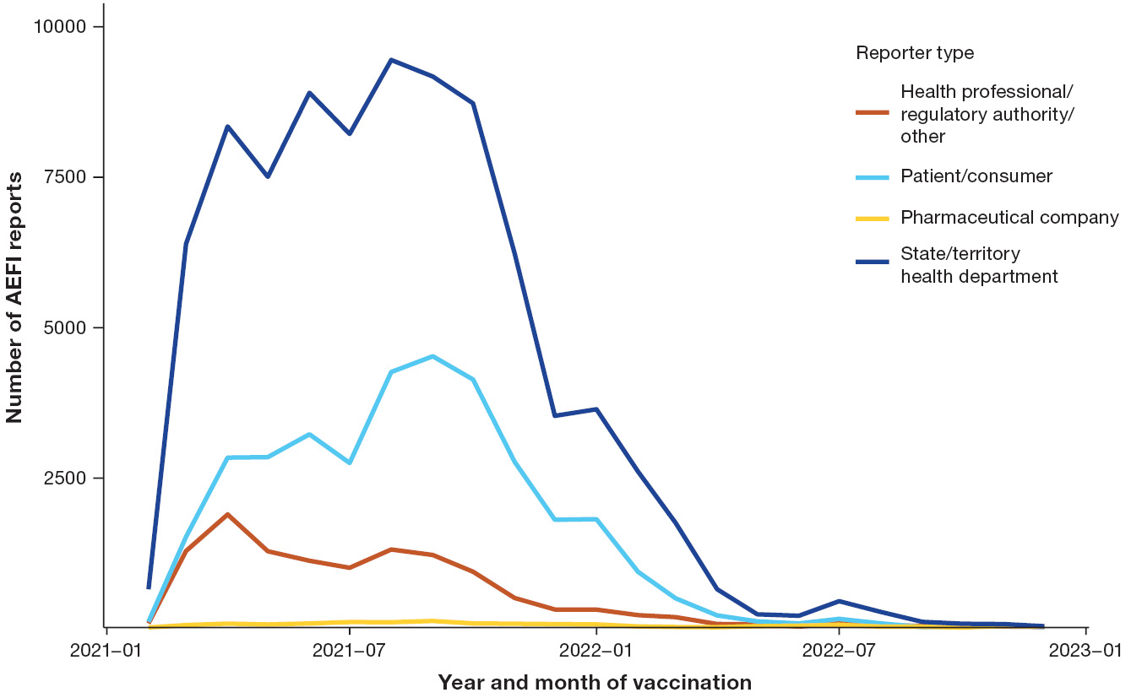
b. AEFI reporting rates per 100,000 doses of COVID-19 vaccines administered
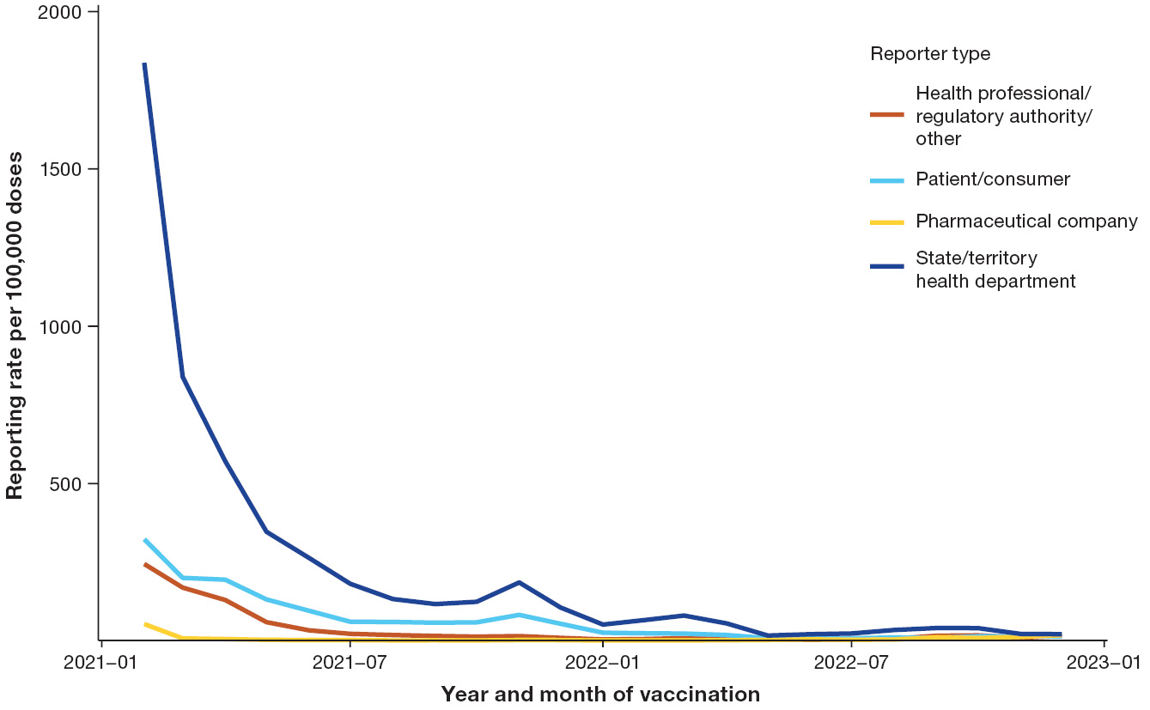

Abbreviations used in this report are defined in Appendix A, Table A.5.

