
2025 • Volume 49 • cdc.gov.au/cdi • Epub date: 17.12.2025 • doi.org/10.33321/cdi.2025.49.043

Surveillance of adverse events following immunisation in Australia annual report, 2022
Yuanfei Anny Huang, Claire Larter, Megan Hickie, Megan O’Moore, Belinda Jones, Lucy Deng, Sophie Russell, Elspeth Kay, Kristine Macartney and Nicholas Wood
© 2025 Commonwealth of Australia as represented by the Department of Health, Disability and Ageing
ISSN: 2209-6051 Online
This journal is indexed by Index Medicus and Medline.
Creative Commons Licence
This publication is licensed under a Creative Commons Attribution-NonCommercial-NoDerivatives 4.0 International Licence (Licence). You must read and understand the Licence before using any material from this publication.
Restrictions
The Licence does not cover, and there is no permission given for, use of any of the following material found in this publication (if any):
- the Commonwealth Coat of Arms (by way of information, the terms under which the Coat of Arms may be used can be found on the Department of Prime Minister and Cabinet website;
- any logos (including the interim Australian Centre for Disease Control and the Department of Health, Disability and Ageing’s logos) and trademarks;
- any photographs and images;
- any signatures; and
- any material belonging to third parties.
Disclaimer
Opinions expressed in Communicable Diseases Intelligence are those of the authors and not necessarily those of the Australian Government, the interim Australian Centre for Disease Control or the Department of Health, Disability and Ageing. Data may be subject to revision.
Enquiries
Enquiries regarding any other use of this publication should be addressed to the CDI Editor.
About CDI
Communicable Diseases Intelligence (CDI) is a peer-reviewed scientific journal published by the interim Australian Centre for Disease Control within the Department of Health, Disability and Ageing.
The journal aims to disseminate information on the epidemiology, surveillance, prevention and control of communicable diseases of relevance to Australia and the near region.
Editor: Christina Bareja • Deputy Editor: Simon Petrie • Design and Production: Lisa Thompson
Editorial Advisory Board: David Durrheim, Mark Ferson, Clare Huppatz, John Kaldor, Martyn Kirk and Meru Sheel
Submit an Article
Guidelines for authors and details on how to submit your publication is available on our website, or by email to the
CDI Editor.
Contact us
Communicable Diseases Intelligence (CDI)
interim Australian Centre for Disease Control, Department of Health, Disability and Ageing
GPO Box 9848, CANBERRA ACT 2601
Website: cdc.gov.au/cdi
Email: cdi.editor@health.gov.au

Contents
Abstract 6
Introduction 7
Methods 9
AEFI data 9
Serious and non-serious AEFI 10
Data analysis 11
Notes on interpretation 11
Results 12
Reporting rates 12
Vaccines 19
Adverse events 19
Discussion 31
Conclusion 34
Acknowledgments 35
Author details 36
References 37
Appendix A 40

List of figures
Figure 1: Adverse event following immunisation reports in the Adverse Event Management System database from 2000 to 2022 (excluding COVID-19 vaccines),^{a,b} by year 18
Figure 2: Reporting rates of adverse events following immunisation per 100,000 population in the Adverse Event Management System database from 2000 to 2022 (excluding COVID-19 vaccines),^{a,b} by year and age group 18
Figure 3: Adverse event following immunisation reports for selected vaccines,^{a,b} for children aged < 7 years in the Adverse Event Management System database from 2000 to 2022, by year and vaccine – vaccines with first National Immunisation Program (NIP)-funded primary dose administered at under 6 months of age, for (a) pneumococcal, dipththeria-tetanus-pertussis, Hib and rotavirus vaccines and (b) meningococcal and measles-mumps-rubella/varicella vaccines 24
Figure 4: Adverse event following immunisation reports for selected vaccines,^{a,b} for children aged < 7 years in the Adverse Event Management System database from 2000 to 2022, by year and vaccine, for (a) vaccines funded under National Immunisation Program (NIP) for specific population subgroups only and (b) influenza vaccines 25
Figure 5: Adverse event following immunisation reports for selected vaccines only,^{a,b} for people aged 7 to 17 years in the Adverse Event Management System database from 2000 to 2022, by year and vaccine 26
Figure 6: Adverse event following immunisation reports for selected vaccines only,^{a,b} for people aged 18 to 64 years in the Adverse Event Management System database from 2000 to 2022, by year and vaccine 27
Figure 7: Adverse event following immunisation reports, for selected vaccines only,^{a,b} for people aged ≥ 65 years in the Adverse Event Management System database from 2000 to 2022, by year and vaccine 28
Figure A.1: Reporting rates of adverse events following immunisation per 100,000 population in the Adverse Event Management System database from 2000 to 2022 (excluding COVID-19 vaccines),ª by year and reporter type 48

List of tables
Table 1: Vaccines administered in 2022 listed as ‘suspect’ in reports of adverse events following immunisation (AEFI) in the Adverse Event Management System database (excluding COVID-19 vaccines), by age group 13
Table 2: Adverse event following immunisation reports in the Adverse Event Management System database for vaccines administered in 2022 (excluding COVID-19 vaccines), by jurisdiction 17
Table 3: Vaccines administered in 2022 listed as ‘suspect’ in reports of adverse events following immunisation in the Adverse Event Management System (AEMS) database (excluding COVID-19 vaccines) 20
Table 4: The 30 most frequently reported adverse events classified by MedDRA Preferred Terms (PTs) or Standardised MedDRA queries (SMQs), in reports of adverse events following immunisation in the Adverse Event Management System database for vaccines administered in 2022 (excluding COVID-19 vaccines) 22
Table A.1: Notable changes in national or jurisdictional immunisation policy, and in the National Immunisation Program (2005–2022), excluding COVID-19 vaccines^{18,25} 40
Table A.2: Description of preferred term (PT) to standardised MedDRA query (SMQ) mapping 45
Table A.3: Preferred terms (PTs) mapped to specific standardised MedDRA queries (SMQs)ª 45
Table A.4: Abbreviations of vaccine types and other terms 46

Abstract
This report summarises Australia’s spontaneous surveillance data for non-COVID-19 vaccine adverse events following immunisation (AEFI) for 2022, reported to the Therapeutic Goods Administration (TGA). National spontaneous (passive) surveillance data for coronavirus disease 2019 (COVID-19) vaccine AEFI reported to the TGA are analysed and discussed in a separate companion publication.
There were 3,642 AEFI reports for non-COVID-19 vaccines administered in 2022, representing an annual AEFI reporting rate of 14.0 per 100,000 population, compared with 13.4 per 100,000 population in 2021. This very small increase in the AEFI reporting rate in 2022 could potentially be related to the combination of several factors: a gradual return to pre-pandemic AEFI reporting patterns; new vaccination programs in response to outbreaks of emergent vaccine preventable diseases (Japanese encephalitis and mpox); and a change in the reporting activities of pharmaceutical sponsors. AEFI reporting rates for individual vaccines in 2022 were similar to 2021.
Keywords: AEFI; adverse events; vaccines; surveillance; immunisation; vaccine

Introduction
An adverse event following immunisation (AEFI) is defined as any untoward medical occurrence which follows immunisation and which does not necessarily have a causal relationship with the usage of the vaccine.¹ The AEFI may be an unfavourable or unintended sign, abnormal laboratory finding, symptom or disease. AEFI can be caused by the vaccine(s) or can be a coincidental event. Events can be classified into the following categories:
- vaccine product-related reaction;
- vaccine quality defect-related reaction;
- immunisation error-related reaction;
- immunisation anxiety-related reaction (also known as immunisation stress-related response); or
- coincidental event.
Ongoing post-marketing AEFI surveillance through a national spontaneous (passive) surveillance system is important in detecting AEFI that may not have been identified in pre-registration vaccine trials.
Anyone can report AEFI to the Therapeutic Goods Administration (TGA); the main categories of reporters are state and territory health departments, health professionals, vaccine companies, and consumers (members of the public).² All reported AEFI are entered into the Australian Adverse Event Management System (AEMS) database. Where the initial report contains insufficient information, the TGA may contact the reporter or relevant state or territory health department to elicit further information. The TGA continually analyses AEFI data to detect new potential safety issues, or changes to known safety issues, that may require regulatory or other action. The TGA may also review select serious adverse events, using internationally consistent methods, to identify whether there may be a link between a vaccine and the adverse event involved.³
Reports summarising Australian national spontaneous AEFI surveillance data have been published regularly since 2003.^{4,5} Trends in reported AEFI are influenced by many factors, including changes to the National Immunisation Program (NIP), vaccine introduction and availability, media coverage, awareness campaigns, and efforts to facilitate reporting, such as safety alerts on the TGA website and social media channels, as well as programs targeted at increasing health professional reporting. Changes to the NIP since 2005 are summarised in Appendix A, Table A.1, and the impacts of these NIP changes on reported AEFI trends are described in previous annual AEFI reports.
There were no changes to the NIP in 2022 to highlight. However, in response to the Japanese encephalitis outbreak across mainland Australia, various states and territories rolled out targeted Japanese encephalitis vaccination programs.^{6,7} Additionally, the mpox outbreak resulted in the MVA-BN smallpox/mpox vaccine being made available in Australia through Section 18A of the Therapeutic Goods Act 1989, a special emergency pathway that ensures a vaccine is urgently available to deal with critical threats to public health.^{7,8} Despite the unavailability of some components of the usual pharmacovigilance processes through the Section 18A access pathway, such as specific legislated requirements of pharmaceutical sponsors, spontaneous AEFI reporting to the TGA was encouraged for the MVA-BN vaccine and reports were entered into the AEMS database.
This report summarises national spontaneous (passive) surveillance data for non-COVID-19 vaccine AEFI reported to the TGA. The report focuses on AEFI reported for vaccines administered in 2022.

Methods

AEFI data
De-identified data on all AEFI for vaccines administered up to 28 February 2023 reported to the TGA and stored in the AEMS database were extracted and provided to the National Centre for Immunisation Research and Surveillance (NCIRS) on 12 October 2023. Please refer to previous reports for a detailed description of the surveillance system.^{4,9}

AEFI report data management
Only accepted AEFI reports were included in this analysis, meaning that the report must contain sufficient information pertaining to four key elements: a reporter; a patient; one or more suspected vaccines; and one or more reaction terms.¹⁰ Reports accepted by the TGA are assigned a default decision type of ‘causality possible’ due to the event being reported to occur after the vaccine was given.
AEFI reports were defined by unique identifiers assigned by the TGA. In this analysis, each AEFI report was assigned a date based on:
- the earliest vaccination date associated with the report; or, where a vaccination date was missing:
- the earliest symptom onset date was used; or, where dates for both vaccination and symptom onset were missing:
- the received date (the date when the reporter of the case first received the minimum valid information as described above from the primary source).
Reports with a 2022 date of vaccination, symptom onset or received date, based on the hierarchy above, were included in the 2022-specific sections of this analysis.
Where the date of birth was available, it was used to calculate age at time of vaccination, symptom onset, or received date; where date of birth was missing, the age at symptom onset provided to the TGA by the reporter was used. Reports were grouped by age into < 7 years, 7–17 years, 18–64 years, and ≥ 65 years age groups, in alignment with reports from previous years.

Vaccine data
Vaccines were identified by trade name (standardised term in the TGA reference dataset); where the trade name was not specified, the generic name (active ingredients associated with a trade name) and reported product name (product name used by the reporter) were used. Individual vaccines were grouped by antigen (or combination of antigens) and, for seasonal influenza and specific other vaccines, by type (for influenza, standard-formulation vs high-dose or adjuvanted; for Japanese encephalitis and zoster, live vs recombinant or inactivated). More than one vaccine with a ‘suspect’ role can be included in a report, without implying that all vaccines were necessarily co-administered on the same occasion. Reports that included both non-COVID-19 and COVID-19 vaccines as ‘suspect’ were included in the companion COVID-19 vaccine AEFI report and were excluded from this analysis.¹¹

Adverse event data
AEFI reports included reaction terms that were symptoms, signs, and/or diagnoses; these were coded by TGA staff from the reporter’s description into lower level terms (LLT), which were then mapped to associated preferred terms (PT) using the Medical Dictionary for Regulatory Activities (MedDRA®).^{10,12}
Standardised MedDRA queries (SMQ) are sets of MedDRA terms that have been grouped after extensive testing, analysis, and expert discussion to facilitate pharmacovigilance investigation.¹³ For this analysis, the MedDRA Browser SMQ Analysis tool, running MedDRA version 26.1, was used to group related PT to SMQ to reduce the number of unique PT under analysis while providing meaningful results.¹⁴ A narrow search was performed to increase the specificity of the PT to SMQ mapping. As an individual PT may map to zero, one, or more than one SMQ, the term selected (PT or SMQ) was determined as described in Appendix A, Table A.2. Following the decision process, a one-to-one PT–SMQ mapping was performed to ensure that each PT was counted only once and that there was no overlap between different SMQ in the included terms.

Serious and non-serious AEFI
AEFI reports were coded as ‘serious’ or ‘non-serious’ based on criteria used by the World Health Organization (WHO), where an adverse event report is defined as ‘serious’ if it involves one or more of the following outcomes:
- fatal or life-threatening condition(s);
- new or prolonged hospitalisation;
- persistent or significant disability;
- congenital anomaly or birth defect; or
- any medical event that requires an intervention to prevent the above outcomes.³
For AEFI reports submitted by sponsors (pharmaceutical companies), the seriousness classification was applied by sponsors to ensure they meet legislated requirements. For other AEFI reports submitted to the TGA, the seriousness classification either reflected the view of the reporter or may have been applied by the TGA following review.
All AEFI reports where a fatal outcome is reported, or where the individual was admitted to an intensive care unit (ICU; including paediatric intensive care), are reviewed by the TGA. This review is designed to assess whether the medical condition(s) that caused the ICU admission and/or death is causally related to the vaccine and whether it represents an emerging safety concern. The TGA reviews each of these reports and considers the strength of the evidence for a link between vaccination and the condition that caused the death, using a standardised process based on the WHO causality assessment guidelines.¹⁵ When the cause for the events that resulted in ICU admission and/or death is not medically obvious, not stated, or cannot be determined from the initial report, the TGA may request further information from the reporter, which may include the results of investigations relating to the ICU admission and/or death, past medical history, post-mortem examination findings, the death certificate, and/or results of a Coronial Office investigation.

Data analysis
Average annual population-based AEFI reporting rates were calculated for each state and territory, and by age group, using June 2022 population estimates obtained from the Australian Bureau of Statistics (ABS).¹⁶ Comparisons with previous years were made using ABS mid-year estimated resident population (ERP) data for each year from 2000 to 2021.
AEFI reporting rates per 100,000 administered doses were estimated for the year 2022. The number of doses administered for each vaccine in 2022 was obtained on 2 April 2023 from the Australian Immunisation Register (AIR), a national population-based register.¹⁷ Vaccination providers were required by law to enter into the AIR every dose of NIP and influenza vaccines administered, as well as Japanese encephalitis vaccines from 21 December 2022, and were strongly encouraged to provide information on other vaccines given.¹⁸ Vaccine doses could also be entered into the AIR retrospectively, including those administered overseas.¹⁹
All data cleaning and analyses were performed using R version 4.3.1.²⁰ Confidence intervals presented are 95% exact binomial confidence intervals for proportions (95% CI). AEFI reports following COVID-19 vaccination are analysed and presented in a separate report.¹¹

Notes on interpretation
The data reported here are provisional, particularly for the fourth quarter of 2022, due to reporting delays and the late onset of some reported AEFI. In addition, AEFI may have been reported in 2022 for vaccines administered in previous years. Therefore, statistics published in this report relating to AEFI reports from years prior to 2022, including accompanying figures, may not match those in previous reports.
As this report analysed data from the AEMS database, the numbers published in this report may be different to the numbers found in the Database of Adverse Event Notifications (DAEN) – medicines, a public online database maintained by the TGA that contains reports of adverse events for medicines and vaccines.²¹ Differences in case numbers between the DAEN—medicines and AEMS can be due to rejected reports, for example those with insufficient information, which remain in the Adverse Event Management System (AEMS) and are updated and added to the DAEN—medicines as and when sufficient information is provided.²² There is also a 14-day time lag between cases being entered in AEMS and then added to the DAEN—medicines. As the data for this analysis were extracted from AEMS in October 2023, there may be discrepancies with the DAEN—medicines, which would reflect any new information made available to the TGA after October 2023.

Results
In the AEMS database, there were 3,642 non-COVID-19 vaccine AEFI reports where the date of vaccination (or onset of adverse event or report received date, if the date of vaccination was not reported) was between 1 January and 31 December 2022.
Of the 3,245 reports (89.1% of total) with information on sex provided, 1,675 (51.6%) were for females and 1,570 (48.4%) were for males. Of the 1,920 reports (52.7% of total) with Indigenous status provided, 125 AEFI reports (6.5%) were for people who identified as Aboriginal and/or Torres Strait Islander. Of the 3,155 reports (86.6% of total) with age or date of birth provided, 1,491 (47.3%) were for children aged < 7 years and 1,664 (52.7%) were for people aged ≥ 7 years.
Most AEFI reports (2,629; 72.2%) were sent by a state or territory health department (termed ‘regional pharmacovigilance centre’ in AEMS; Appendix A, Figure A.1); 9.5% of reports (345/3,642) were direct submissions by health professionals or other organisations (including regulatory authorities) to the TGA. Consumers submitted 5.4% (195) of AEFI reports (195/3,642), and 13.0% of reports (473/3,642) were sent by pharmaceutical companies. The proportion of pharmaceutical company reports increased from 2021, when this group accounted for 1.9% of all non-COVID-19 AEFI reports. However, the pharmaceutical company AEFI reporting rate of 1.8 per 100,000 total population was still within the range observed over the previous decade. In 2022, most of the pharmaceutical company reports (366/473; 77.4%) were from one company relaying consumer comments pertaining to experiences of AEFI from social media sites, with all reports classified as serious by the sender. Pharmaceutical companies were the only reporter type submitting AEFI reports where the source was cited to be social media. Please note that it is possible for one case to be the subject of more than one AEFI report, where the reports have been submitted independently by multiple sources and there is insufficient information provided to confirm duplication.
Excluded from this analysis were 121 AEFI reports where non-COVID-19 vaccines were listed together with COVID-19 vaccines, which are included in the companion 2022 COVID-19 vaccine AEFI report.¹¹

Reporting rates

Dose-based reporting rates
The overall non-COVID-19 vaccine AEFI reporting rate for 2022 was 18.8 [95% CI: 18.2–19.5] per 100,000 doses of non-COVID-19 vaccines administered and recorded in the AIR (Table 1).
Table 1: Vaccines administered in 2022 listed as ‘suspect’ in reports of adverse events following immunisation (AEFI) in the Adverse Event Management System database (excluding COVID-19 vaccines), by age group
Age groupª | Vaccine^{b} | AEFI reports (n)^{c} | Vaccine doses^{d} | Reporting rate per 100,000 doses (95% CI)^{e}
< 7 years | 13vPCV | 397 | 851,421 | 46.6 (42.2–51.4)
< 7 years | DTPa-HepB-IPV-Hib | 360 | 835,432 | 43.1 (38.8–47.8)
< 7 years | DTPa-IPV | 287 | 290,382 | 98.8 (87.7–111.0)
< 7 years | Influenza (seasonal—standard formulation) | 250 | 716,743 | 34.9 (30.7–39.5)
< 7 years | Rotavirus | 246 | 525,062 | 46.9 (41.2–53.1)
< 7 years | DTPa | 211 | 285,908 | 73.8 (64.2–84.5)
< 7 years | MMR | 204 | 304,708 | 66.9 (58.1–76.8)
< 7 years | MMRV | 204 | 286,478 | 71.2 (61.8–81.7)
< 7 years | Hib | 198 | 286,710 | 69.1 (59.8–79.4)
< 7 years | MenB | 178 | 302,152 | 58.9 (50.6–68.2)
< 7 years | MenACWY | 163 | 317,584 | 51.3 (43.7–59.8)
< 7 years | Hepatitis B | 17 | 83,860 | 20.3 (11.8–32.5)
< 7 years | Hepatitis A | 16 | 30,684 | 52.1 (29.8–84.7)
< 7 years | 23vPPV | 14 | 9,598 | 145.9 (79.8–244.6)
< 7 years | Tuberculosis | 11 | 9,738 | 113.0 (56.4–202.0)
< 7 years | Varicella | 10 | 11,841 | 84.5 (40.5–155.3)
< 7 years | Influenza (seasonal—high-dose or adjuvanted) | 6 | 407 | 1,474.2 (542.9–3,181.0)
< 7 years | Typhoid-hepatitis A | 5 | 941 | 531.3 (172.7–1,235.6)
< 7 years | Typhoid | 3 | 14,261 | 21.0 (4.3–61.5)
< 7 years | Japanese encephalitis (live) | 1 | 3,398 | 29.4 (0.7–163.9)
< 7 years | Yellow fever | 1 | 1,644 | 60.8 (1.5–338.4)
< 7 years | All non-COVID-19 vaccines | 1,491 | 5,170,395 | 28.8 (27.4–30.3)
7–17 years | HPV | 157 | 562,446 | 27.9 (23.7–32.6)
7–17 years | Influenza (seasonal—standard formulation) | 91 | 838,104 | 10.9 (8.7–13.3)
7–17 years | dTpa | 81 | 285,645 | 28.4 (22.5–35.2)
7–17 years | MenACWY | 54 | 244,114 | 22.1 (16.6–28.9)
7–17 years | MenB | 34 | 37,187 | 91.4 (63.3–127.7)
7–17 years | Hepatitis B | 8 | 14,807 | 54.0 (23.3–106.4)
7–17 years | 23vPPV | 7 | 1,672 | 418.7 (168.5–860.7)
7–17 years | Hepatitis A | 7 | 17,158 | 40.8 (16.4–84.0)
7–17 years | Influenza (seasonal—high-dose or adjuvanted) | 4 | 2,836 | 141.0 (38.4–360.7)
7–17 years | Typhoid-hepatitis A | 4 | 4,002 | 100.0 (27.2–255.7)
7–17 years | MMRV | 3 | 4,276 | 70.2 (14.5–204.9)
7–17 years | Varicella | 3 | 9,011 | 33.3 (6.9–97.3)
18–64 years | MMR | 2 | 8,882 | 22.5 (2.7–81.3)
18–64 years | Typhoid | 2 | 21,625 | 9.2 (1.1–33.4)
18–64 years | 13vPCV | 1 | 1,511 | 66.2 (1.7–368.2)
18–64 years | Japanese encephalitis (live) | 1 | 5,190 | 19.3 (0.5–107.3)
18–64 years | DT | 1 | 6,365 | 15.7 (0.4–87.5)
18–64 years | All non-COVID-19 vaccines | 381 | 2,071,040 | 18.4 (16.6–20.3)
18–64 years | Influenza (seasonal—standard formulation) | 373 | 5,813,915 | 6.4 (5.8–7.1)
18–64 years | MVA-BN | 266 | 44,606 | 596.3 (527.0–672.2)
18–64 years | dTpa | 65 | 697,722 | 9.3 (7.2–11.9)
18–64 years | Influenza (seasonal—high-dose or adjuvanted) | 40 | 60,812 | 65.8 (47–89.6)
18–64 years | Zoster (RZV) | 26 | 38,254 | 68.0 (44.4–99.6)
18–64 years | Hepatitis B | 21 | 211,038 | 10 (6.2–15.2)
18–64 years | Japanese encephalitis (live) | 17 | 46,132 | 36.9 (21.5–59.0)
18–64 years | MMR | 17 | 92,442 | 18.4 (10.7–29.4)
18–64 years | 23vPPV | 16 | 12,500 | 128.0 (73.2–207.8)
18–64 years | Varicella | 10 | 32,539 | 30.7 (14.7–56.5)
18–64 years | Zoster (ZVL) | 11 | 7,460 | 147.5 (73.6–263.7)
18–64 years | DT | 9 | 207,700 | 4.3 (2–8.2)
18–64 years | HPV | 9 | 40,626 | 22.2 (10.1–42.0)
18–64 years | 13vPCV | 7 | 28,706 | 24.4 (9.8–50.2)
18–64 years | Typhoid-hepatitis A | 6 | 66,830 | 9 (3.3–19.5)
18–64 years | Hepatitis A | 5 | 53,431 | 9.4 (3–21.8)
18–64 years | MenB | 5 | 14,857 | 33.7 (10.9–78.5)
18–64 years | Hepatitis A-hepatitis B | 4 | 39,676 | 10.1 (2.7–25.8)
18–64 years | Typhoid | 4 | 81,516 | 4.9 (1.3–12.6)
18–64 years | MMRV | 3 | 2,101 | 142.8 (29.5–416.7)
18–64 years | Rabies | 3 | 19,912 | 15.1 (3.1–44)
18–64 years | dTpa-IPV | 2 | 11,454 | 17.5 (2.1–63.1)
18–64 years | MenACWY | 2 | 24,615 | 8.1 (1–29.3)
18–64 years | Japanese encephalitis (inactivated) | 1 | 2,365 | 42.3 (1.1–235.4)
18–64 years | All non-COVID-19 vaccines | 908 | 7,673,117 | 11.8 (11.1–12.6)
≥ 65 years | Influenza (seasonal—high-dose or adjuvanted) | 143 | 3,187,272 | 4.5 (3.8–5.3)
≥ 65 years | Zoster (ZVL) | 76 | 194,245 | 39.1 (30.8–49)
≥ 65 years | Zoster (RZV) | 47 | 69,402 | 67.7 (49.8–90.0)
≥ 65 years | 13vPCV | 43 | 366,319 | 11.7 (8.5–15.8)
≥ 65 years | Influenza (seasonal—standard formulation) | 33 | 269,348 | 12.3 (8.4–17.2)
≥ 65 years | 23vPPV | 11 | 30,302 | 36.3 (18.1–64.9)
≥ 65 years | MVA-BN | 11 | 2,676 | 411.1 (205.4–734.3)
≥ 65 years | dTpa | 8 | 119,154 | 6.7 (2.9–13.2)
≥ 65 years | Japanese encephalitis (live) | 3 | 30,289 | 9.9 (2–28.9)
≥ 65 years | Varicella | 3 | 812 | 369.5 (76.3–1,075.9)
≥ 65 years | DT | 2 | 80,957 | 2.5 (0.3–8.9)
≥ 65 years | MenACWY | 1 | 3,347 | 29.9 (0.8–166.4)
≥ 65 years | Typhoid-hepatitis A | 1 | 7,798 | 12.8 (0.3–71.4)
≥ 65 years | All non-COVID-19 vaccines | 375 | 4,412,768 | 8.5 (7.7–9.4)
All ages | All non-COVID-19 vaccines | 3,642 | 19,327,320 | 18.8 (18.2–19.5)
a ‘All ages’ includes AEFI reports where age was not provided.
b ‘All non-COVID-19 vaccines’ includes AEFI reports where the vaccine was not specified and a general vaccine category (for example, ‘pneumococcal vaccine’) was coded as ‘suspect’.
c Number of AEFI reports in which the vaccine was coded as ‘suspect’ with regard to causal involvement in the reported adverse event and the vaccine was administered between 1 January and 31 December 2022. More than one vaccine may be coded as ‘suspect’ in the same report if several were administered or reported at the same time.
d Number of vaccine doses administered between 1 January and 31 December 2022 and recorded on the Australian Immunisation Register as at 2 April 2023.
e 95% CI: 95% confidence interval.

Population-based reporting rates
The overall AEFI reporting rate for 2022 was 14.0 [95% CI: 13.6–14.5] per 100,000 total population, compared with 13.4 per 100,000 in 2021 and 14.9 per 100,000 in 2020 (Table 2). By comparison, the highest annual reporting rate during 2000–2021 was observed in 2010 (17.4 per 100,000 total population).
Figure 1 shows the annual trend in AEFI report counts and reporting rates per 100,000 population, including AEFI reports that had been entered into the AEMS database in the years subsequent to their occurrence. Therefore, there may be discrepancies between Figure 1 and the numbers in previous annual reports.
The highest age group-specific population-based AEFI reporting rate was observed in children aged < 7 years (69.5 reports per 100,000 population < 7 years; Table 2). Compared with 2021, reporting rates of AEFI decreased in the < 7 years and ≥ 65 years age groups (Figure 2). While reporting rates increased slightly in the 7–17 years and 18–64 years age groups from 2021, they were still below 2020 rates.
By jurisdiction, the highest population-based AEFI reporting rates in 2022 were in Victoria (19.9 reports per 100,000 population), Western Australia (18.4 per 100,000 population) and Tasmania (18.2 per 100,000 population). The lowest reporting rates were in Queensland (4.2 reports per 100,000 population), South Australia (7.3 per 100,000 population), and New South Wales (9.8 per 100,000 population; Table 2).
Table 2: Adverse event following immunisation reports in the Adverse Event Management System database for vaccines administered in 2022 (excluding COVID-19 vaccines), by jurisdiction
Jurisdictionª | AEFI reports  n (%) | Annual reporting rate per 100,000 population^{b}
Jurisdictionª | AEFI reports  n (%) | Overall  (95% CI)^{c} | Aged < 7 years^{d} | Aged ≥ 7 years^{d} | Serious  AEFIe
ACT | 71 (1.9) | 15.5 (12.1–19.6) | 65.5 | 10.8 | 2.2
NSW | 802 (22.0) | 9.8 (9.2–10.5) | 39.0 | 6.6 | 1.7
NT | 43 (1.2) | 17.2 (12.4–23.1) | 44.7 | 14.2 | 0.8
Qld | 225 (6.2) | 4.2 (3.7–4.8) | 26.0 | 2.2 | 0.4
SA | 132 (3.6) | 7.3 (6.1–8.6) | 44.5 | 4.0 | 0.3
Tas. | 104 (2.9) | 18.2 (14.9–22.0) | 69.2 | 13.6 | 0.2
Vic. | 1,319 (36.2) | 19.9 (18.9–21.0) | 139.9 | 8.4 | 0.8
WA | 513 (14.1) | 18.4 (16.9–20.1) | 89.7 | 11.2 | 0.5
Unknown | 433 (11.9) | — | — | — | —
Australia | 3,642 (100) | 14.0 (13.6–14.5) | 69.5 | 7.0 | 2.5
a ACT: Australian Capital Territory; NSW: New South Wales; NT: Northern Territory; Qld: Queensland; SA: South Australia; Tas.: Tasmania; Vic: Victoria; WA: Western Australia.
b Average annual rates per 100,000 population calculated using June 2022 jurisdiction and total ERP estimates from the Australian Bureau of Statistics.
c 95% CI: 95% confidence interval.
d Includes only AEFI reports where an age or date of birth was reported.
e An adverse event report is defined as ‘serious’ if it involves one or more of the following outcomes: (1) fatal or life-threatening condition(s); (2) new or prolonged hospitalisation; (3) persistent or significant disability; (4) congenital anomaly or birth defect; and (5) any medical event that requires an intervention to prevent the above outcomes. For AEFI reports submitted by sponsors (vaccine companies), the seriousness classification is applied by sponsors to ensure they meet legislated requirements. For other AEFI reports submitted to the TGA, the seriousness classification either reflects the view of the reporter or may have been applied by the TGA following review.
Figure 1: Adverse event following immunisation reports in the Adverse Event Management System database from 2000 to 2022 (excluding COVID-19 vaccines),^{a,b} by year
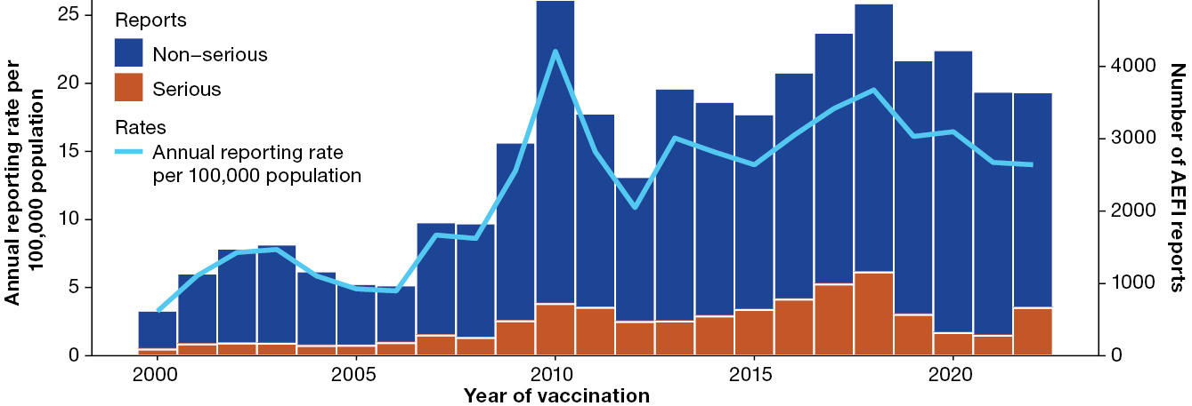
a For reports where the date of vaccination was not recorded, the date of symptom onset or the received date (when the event was reported to the sender of the case) was used. Please note that Figure 1 was generated from all reports in AEMS, including those for previous years that may have been entered into the database in subsequent years due to delays in reporting. Of note, there were a large number of 2021 AEFI reports for reported in 2022, which had resulted in a corresponding increase in reporting rates per 100,000 population since the 2021 annual report. Therefore, there may be discrepancies between the numbers shown in Figure 1 and those stated in the annual report of the corresponding year. For more details on changes to the National Immunisation Program, please refer to Appendix A, Table A.1.
b Population data was sourced from the Australian Bureau of Statistics, and represents the mid-year total Australian estimated resident population (ERP) for each calendar year.
Figure 2: Reporting rates of adverse events following immunisation per 100,000 population in the Adverse Event Management System database from 2000 to 2022 (excluding COVID-19 vaccines),^{a,b} by year and age group
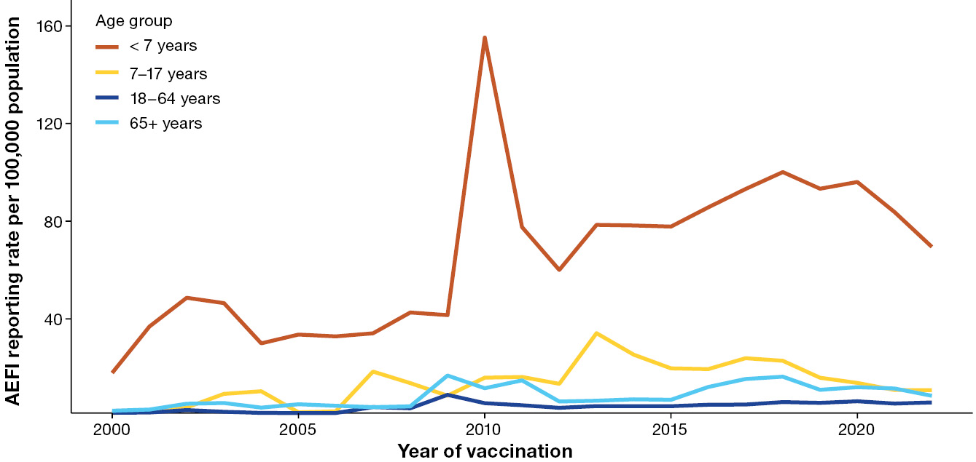
a For reports where the date of vaccination was not recorded, the date of symptom onset or the received date (when the event was reported to the sender of the case) was used. For more details on changes to immunisation programs (including the National Immunisation Program), please refer to Appendix A, Table A.1.
b Population data was sourced from the Australian Bureau of Statistics, and represents the mid-year total Australian estimated resident population (ERP) for each calendar year.

Vaccines
The non-COVID-19 vaccine most frequently listed in 2022 AEFI reports was the standard-formulation seasonal influenza vaccine (786 reports; 21.6% of total 2022 reports), followed by 13vPCV (454 reports; 12.5%), DTPa-IPV-HepB-Hib (373 reports; 10.2%), DTPa-IPV (311 reports; 8.5%) and MVA-BN (280 reports; 7.7%) (Table 3). Of the 786 AEFI reports following standard-formulation seasonal influenza vaccination, 74 (9.4%) were classified as serious and 250 (31.8%) were reported in children aged < 7 years (Table 3).
For each respective age group, the vaccines with the highest number of AEFI reports in 2022 were 13vPCV (in children aged < 7 years), HPV vaccine (in children and adolescents aged 7–17 years), standard-formulation seasonal influenza vaccine (in people aged 18–64 years), and high-dose or adjuvanted seasonal influenza vaccine (in people aged ≥ 65 years; Table 1). These trends remained the same as 2021 (Figures 3–7).⁵
Reflecting vaccination activities in response to significant public health events in 2022, there was a corresponding increase in AEFI reporting for Japanese encephalitis vaccines (23 reports in total across vaccine brands in 2022, compared to one report in 2021), and AEFI reports for the MVA-BN smallpox/mpox vaccine were recorded in AEMS for the first time (280 reports).

Adverse events
The most frequently reported PT or SMQ in 2022 was hypersensitivity (691 reports; 19.0%; Table 4), with 8.5% classified as serious. Most reports of hypersensitivity were in children aged < 7 years (398 reports, 57.6% of the reports of hypersensitivity), most commonly following 13vPCV (85 reports, 21.3% of the reports of hypersensitivity in the < 7 years age group).
In order of frequency, the next most frequently reported adverse events were the MedDRA PT/SMQ ‘medication errors’ (678 reports; 18.6%; further detail of terms included in Appendix A, Table A.3); injection site reaction (567 reports; 15.6%); pyrexia (512 reports; 14.1%); and the MedDRA SMQ grouping of ‘gastrointestinal non-specific symptoms and therapeutic procedures’ (490 reports; 13.5%; Appendix A, Table A.3 provides further details regarding terms included).
In the context of AEFI, the term ‘medication errors’ denotes vaccination errors, and in the ≥ 7 age group, this was the most frequently reported PT / SMQ (310 reports). Notably, in 78.8% of reports of ‘medication errors’ (534/678), there were no adverse events reported in association with the error, noting that it is possible after the error has been reported for an associated adverse event to occur (and not be captured in the error report). Six AEFI reports involving ‘medication errors’ were classified as serious, and in 22.6% of reports of ‘medication errors’ (153/678), more than one vaccine was reported. Compared to 2021, there was an increase in reports of vaccination errors, across all age groups and vaccines (from 380 reports, representing 11.3% of all 2021 AEFI reports, to 678 [18.6% of reports] in 2022). There was an increase in the reporting of errors both from health professionals directly to the TGA (from 17 reports of errors in 2021 to 88 reports in 2022) and to the TGA from jurisdictional health departments (from 353 reports in 2021 to 578 reports in 2022). The vaccine most frequently implicated in a report of ‘medication errors’ was the standard formulation seasonal influenza vaccine, with 129 reports (19.0% of reports with ‘medication errors’ included), followed by the high dose or adjuvanted influenza vaccine, with 78 reports (11.5%).
Table 3: Vaccines administered in 2022 listed as ‘suspect’ in reports of adverse events following immunisation in the Adverse Event Management System (AEMS) database (excluding COVID-19 vaccines)
Vaccineª | AEFI reports n (%)^{b,c} | Reports with a single suspected vaccine n (%)^{c,d} | Serious AEFI n (%)^{c,e} | Aged < 7 years n (%)^{c,f} | Aged ≥ 7 years n (%)^{c,f}
Influenza (seasonal—standard formulation) | 786 (21.6) | 656 (83.5) | 74 (9.4) | 250 (31.8) | 497 (63.2)
13vPCV | 454 (12.5) | 43 (9.5) | 50 (11.0) | 397 (87.4) | 51 (11.2)
DTPa-HepB-IPV-Hib | 373 (10.2) | 91 (24.4) | 39 (10.5) | 360 (96.5) | 2 (0.5)
DTPa-IPV | 310 (8.5) | 269 (86.8) | 13 (4.2) | 287 (92.6) | 14 (4.5)
MVA-BN | 282 (7.7) | 262 (92.9) | 4 (1.4) | 0 (0) | 279 (98.9)
Rotavirus | 279 (7.7) | 55 (19.7) | 67 (24.0) | 246 (88.2) | 0 (0)
Zoster (unspecified) | 279 (7.7) | 279 (100) | 278 (99.6) | 0 (0) | 18 (6.5)
MMR | 226 (6.2) | 56 (24.8) | 17 (8.5) | 204 (90.3) | 19 (8.4)
MenACWY | 223 (6.1) | 52 (23.3) | 12 (5.4) | 163 (73.1) | 58 (26.0)
MenB | 223 (6.1) | 118 (52.9) | 25 (11.2) | 178 (79.8) | 43 (19.3)
DTPa | 222 (6.1) | 34 (15.3) | 6 (2.7) | 211 (95.0) | 7 (3.2)
MMRV | 211 (5.8) | 27 (12.8) | 6 (2.8) | 204 (96.7) | 6 (2.8)
Hib | 200 (5.5) | 14 (7.0) | 8 (4.0) | 198 (99.0) | 1 (0.5)
Influenza (seasonal—high-dose or adjuvanted) | 198 (5.4) | 178 (89.9) | 26 (13.1) | 6 (3.0) | 187 (94.4)
dTpa | 184 (5.1) | 92 (50.0) | 7 (3.8) | 24 (13.0) | 154 (83.7)
HPV | 169 (4.6) | 95 (56.2) | 6 (3.6) | 1 (0.6) | 166 (98.2)
Zoster (ZVL) | 117 (3.2) | 101 (86.3) | 33 (28.2) | 0 (0) | 89 (76.1)
Zoster (RZV) | 90 (2.5) | 80 (88.9) | 25 (27.8) | 0 (0) | 73 (81.1)
Varicella | 81 (2.2) | 74 (91.4) | 58 (71.6) | 10 (12.3) | 16 (19.8)
23vPPV | 51 (1.4) | 29 (56.9) | 1 (2.0) | 14 (27.5) | 34 (66.7)
Hepatitis B | 50 (1.4) | 32 (64.0) | 8 (16.0) | 17 (34.0) | 29 (58.0)
Hepatitis A | 30 (0.8) | 15 (50.0) | 4 (13.3) | 16 (53.3) | 12 (40.0)
Japanese encephalitis (live) | 22 (0.6) | 20 (90.9) | 1 (4.5) | 1 (4.5) | 21 (95.5)
Typhoid-hepatitis A | 21 (0.6) | 12 (57.1) | 3 (14.3) | 5 (23.8) | 14 (66.7)
DT | 15 (0.4) | 11 (73.3) | 3 (20.0) | 0 (0) | 11 (73.3)
Tuberculosis | 14 (0.4) | 11 (78.6) | 1 (7.1) | 11 (78.6) | 2 (14.3)
Pneumococcal (unspecified) | 9 (0.2) | 1 (11.1) | 6 (66.7) | 1 (11.1) | 2 (22.2)
Typhoid | 11 (0.3) | 4 (36.4) | 1 (9.1) | 3 (27.3) | 8 (72.7)
Hepatitis A-hepatitis B | 7 (0.2) | 5 (71.4) | 2 (28.6) | 0 (0) | 4 (57.1)
Polio (unspecified) | 5 (0.1) | 1 (20.0) | 0 (0) | 2 (40.0) | 3 (60.0)
Q fever | 5 (0.1) | 4 (80.0) | 0 (0) | 0 (0) | 5 (100)
Tetanus (unspecified) | 4 (0.1) | 1 (25.0) | 4 (100) | 0 (0) | 0 (0)
DTP | 3 (0.1) | 2 (66.7) | 0 (0) | 2 (66.7) | 1 (33.3)
Meningococcal (unspecified) | 3 (0.1) | 1 (33.3) | 1 (33.3) | 1 (33.3) | 2 (66.7)
Pertussis | 3 (0.1) | 1 (33.3) | 0 (0) | 2 (66.7) | 1 (33.3)
Rabies | 3 (0.1) | 1(33.3) | 2 (66.7) | 0 (0) | 3 (100)
dTpa-IPV | 2 (0.1) | 1 (50.0) | 1 (50.0) | 0 (0) | 2 (100)
Cholera | 1 (0.03) | 0 (0) | 0 (0) | 0 (0) | 1 (100)
Hib-MenCY | 1 (0.03) | 0 (0) | 1 (100) | 1 (100) | 0 (0)
Japanese encephalitis (inactivated) | 1 (0.03) | 1 (100) | 0 (0) | 0 (0) | 1 (100)
PCV (unspecified) | 1 (0.03) | 1 (100) | 0 (0) | 1 (100) | 0 (0)
Yellow Fever | 1 (0.03) | 1 (100) | 0 (0) | 1 (100) | 0 (0)
Hib-MenC | 1 (0.03) | 0 (0) | 1 (100) | 0 (0) | 0 (0)
a See Appendix A, Table A.4 for full vaccine names.
b Number of AEFI reports in which the vaccine was coded as ‘suspect’ with regard to causal involvement in the reported adverse event and the vaccination was administered between 1 January and 31 December 2022. More than one vaccine may be coded as “suspect” if several were administered or reported at the same time.
c Percentages are calculated for the number of AEFI reports where the vaccine was coded as ‘suspect’ with regard to causal involvement in the event.
d AEFI reports where only one vaccine was coded as ‘suspect’ with regard to causal involvement in a reported adverse event; note that in reports where more than one vaccine was nominated, this does not necessarily imply concomitant administration of nominated vaccines.
e An adverse event report is defined as ‘serious’ if it involves one or more of the following outcomes: (1) fatal or life-threatening condition(s); (2) new or prolonged hospitalisation; (3) persistent or significant disability; (4) congenital anomaly or birth defect; and (5) any medical event that requires an intervention to prevent the above outcomes. For AEFI reports submitted by sponsors (vaccine companies), the seriousness classification is applied by sponsors to ensure they meet legislated requirements. For other AEFI reports submitted to the TGA, the seriousness classification either reflects the view of the reporter or may have been applied by the TGA following review.
f Includes only AEFI reports where an age or date of birth has been reported.
Table 4: The 30 most frequently reported adverse events classified by MedDRA Preferred Terms (PTs) or Standardised MedDRA queries (SMQs), in reports of adverse events following immunisation in the Adverse Event Management System database for vaccines administered in 2022 (excluding COVID-19 vaccines)
Adverse event PT or SMQ | AEFI reports n (%)ª | Reports with a single reported adverse event n (%)^{b,c} | Serious AEFI n (%)^{c,d} | Aged < 7 years n (%)^{c,e} | Aged ≥ 7 years n (%)^{c,e}
Hypersensitivity | 691 (19.0) | 198 (28.7) | 59 (8.5) | 398 (57.6) | 264 (38.2)
Medication errors | 678 (18.6) | 534 (78.9) | 6 (0.9) | 334 (49.3) | 310 (45.8)
Injection site reaction | 567 (15.6) | 220 (38.8) | 8 (1.4) | 254 (44.8) | 302 (53.3)
Pyrexia | 512 (14.1) | 7 (1.4) | 49 (9.6) | 303 (59.2) | 202 (39.5)
Gastrointestinal nonspecific symptoms and therapeutic procedures | 490 (13.5) | 29 (5.9) | 55 (11.2) | 211 (43.1) | 271 (55.3)
Lack of efficacy/effect | 375 (10.3) | 2 (0.5) | 370 (98.7) | 4 (1.1) | 32 (8.5)
Herpes zoster | 365 (10.0) | 11 (3.0) | 353 (96.7) | 0 (0) | 38 (10.4)
Haemodynamic oedema, effusions and fluid overload | 277 (7.6) | 54 (19.5) | 22 (7.9) | 172 (62.1) | 98 (35.4)
Headache | 259 (7.1) | 1 (0.4) | 23 (8.9) | 15 (5.8) | 235 (90.7)
Fatigue | 237 (6.5) | 2 (0.8) | 16 (6.8) | 52 (21.9) | 179 (75.5)
Myalgia | 187 (5.1) | 2 (1.1) | 6 (3.2) | 16 (8.6) | 169 (90.4)
Dyspnoea | 165 (4.5) | 3 (1.8) | 17 (10.3) | 33 (20.0) | 130 (78.8)
Lethargy | 157 (4.3) | 0 (0) | 16 (10.2) | 74 (47.1) | 83 (52.9)
Arthralgia | 142 (3.9) | 1 (0.7) | 11 (7.7) | 5 (3.5) | 134 (94.4)
Pain | 131 (3.6) | 2 (1.5) | 90 (68.7) | 8 (6.1) | 48 (36.6)
Injection site erythema | 112 (3.1) | 9 (8.0) | 6 (5.4) | 74 (66.1) | 36 (32.1)
Injection site pain | 112 (3.1) | 15 (13.4) | 5 (4.5) | 15 (13.4) | 93 (83.0)
Cough | 111 (3.0) | 1 (0.9) | 5 (4.5) | 50 (45.0) | 61 (55.0)
Convulsions | 108 (3.0) | 41 (38.0) | 34 (31.5) | 67 (62.0) | 27 (25.0)
Chills | 105 (2.9) | 0 (0) | 3 (2.9) | 18 (17.1) | 86 (81.9)
Chest pain | 98 (2.7) | 8 (8.2) | 9 (9.2) | 0 (0) | 96 (98.0)
Oropharyngeal conditions (excl neoplasms, infections and allergies) | 95 (2.6) | 4 (4.2) | 6 (6.3) | 16 (16.8) | 76 (80.0)
Angioedema | 89 (2.4) | 9 (10.1) | 6 (6.7) | 44 (49.4) | 43 (48.3)
Erythema | 85 (2.3) | 1 (1.2) | 6 (7.1) | 48 (56.5) | 36 (42.4)
Dizziness | 83 (2.3) | 2 (2.4) | 10 (12.0) | 1 (1.2) | 78 (94.0)
Syncope | 76 (2.1) | 29 (38.2) | 10 (13.2) | 6 (7.9) | 69 (90.8)
Malaise | 73 (2.0) | 0 (0) | 8 (11.0) | 7 (9.6) | 65 (89.0)
Pain in extremity | 73 (2.0) | 4 (5.5) | 4 (5.5) | 15 (20.5) | 55 (75.3)
Palpitations | 71 (1.9) | 2 (2.8) | 4 (5.6) | 0 (0) | 70 (98.6)
Influenza like illness | 67 (1.8) | 13 (19.4) | 5 (7.5) | 16 (23.9) | 44 (65.7)
a Number of AEFI reports in which the PT or SMQ was reported. More than one PT/SMQ may be recorded on the same report.
b AEFI reports where only one PT or SMQ was reported.
c Percentages are calculated for the number of AEFI reports where the PT or SMQ was reported.
d An adverse event report is defined as ‘serious’ if it involves one or more of the following outcomes: (1) fatal or life-threatening condition(s); (2) new or prolonged hospitalisation; (3) persistent or significant disability; (4) congenital anomaly or birth defect; and (5) any medical event that requires an intervention to prevent the above outcomes. For AEFI reports submitted by sponsors (vaccine companies), the seriousness classification is applied by sponsors to ensure they meet legislated requirements. For other AEFI reports submitted to the TGA, the seriousness classification either reflects the view of the reporter or may have been applied by the TGA following review.
e Includes only AEFI reports where an age or date of birth has been reported.
Figure 3: Adverse event following immunisation reports for selected vaccines,^{a,b} for children aged < 7 years in the Adverse Event Management System database from 2000 to 2022, by year and vaccine – vaccines with first National Immunisation Program (NIP)-funded primary dose administered at under 6 months of age, for (a) pneumococcal, dipththeria-tetanus-pertussis, Hib and rotavirus vaccines and (b) meningococcal and measles-mumps-rubella/varicella vaccines
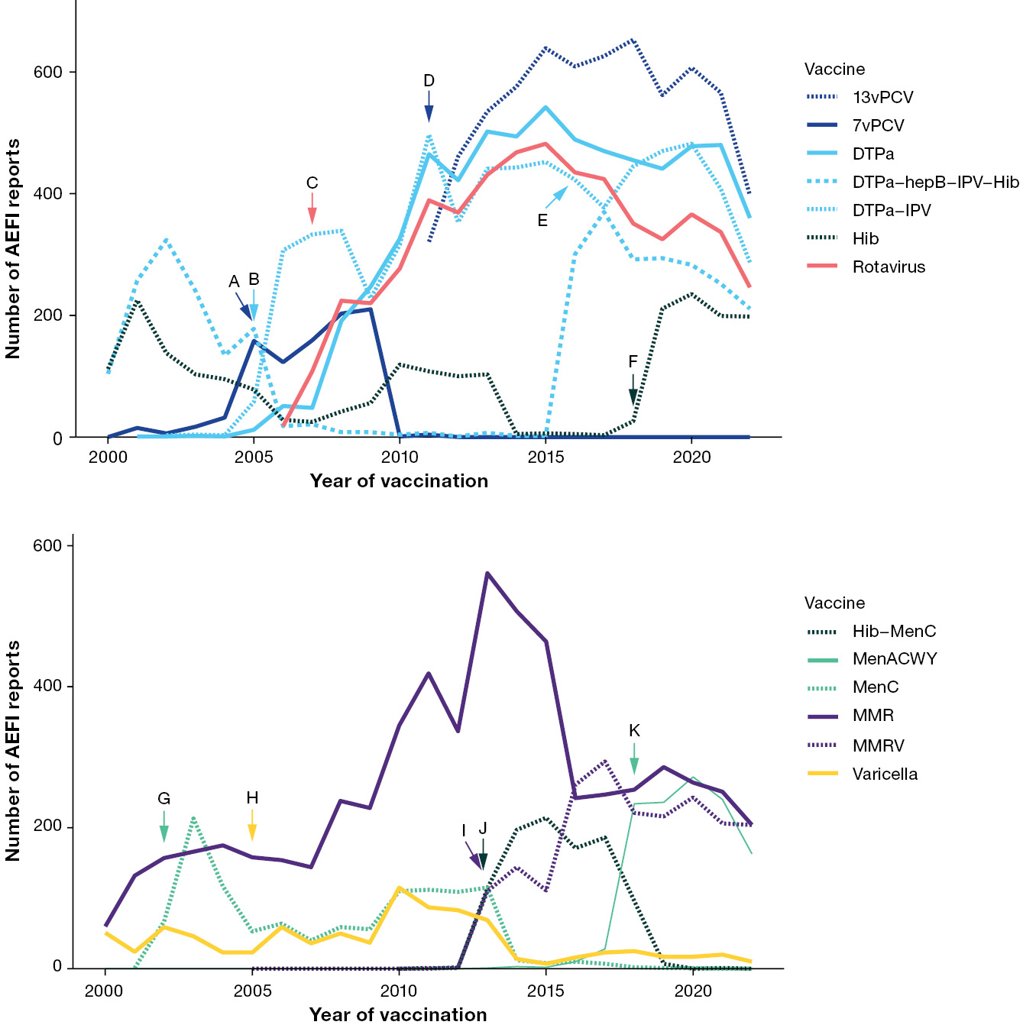
a Vaccines are selected for inclusion in figure 3 overall if they have been in use in the selected age group for ≥ 2 consecutive years, and if they are a) funded under the NIP for any population subgroup within the selected age group in 2022; b) one of the five most common vaccines associated with spontaneous AEFI reports in 2022; or c) have been implicated in a vaccine safety event of note from year 2000 onwards and/or have been implicated in a large proportion of historical spontaneous AEFI reports. For reports where the date of vaccination was not recorded, the date of symptom onset or the received date (when the event was reported to the sender of the case) was used. For more details on changes to immunisation programs (including the National Immunisation Program), please see Appendix A, Table A.1.
b Event markers shown represent the following events: A: 7vPCV and catch-up programs commenced; B: DTPa-IPV booster programs commenced; C: national rotavirus program commenced; D: 13vPCV and catch-up program commenced; E: DTPa booster program commenced; F: monovalent Hib booster program commenced; G: MenC and catch-up program commenced; H: varicella program commenced; I: MMRV program commenced; J: Hib-MenC program commenced; K: MenACWY program commenced.
Figure 4: Adverse event following immunisation reports for selected vaccines,^{a,b} for children aged < 7 years in the Adverse Event Management System database from 2000 to 2022, by year and vaccine, for (a) vaccines funded under National Immunisation Program (NIP) for specific population subgroups only and (b) influenza vaccines
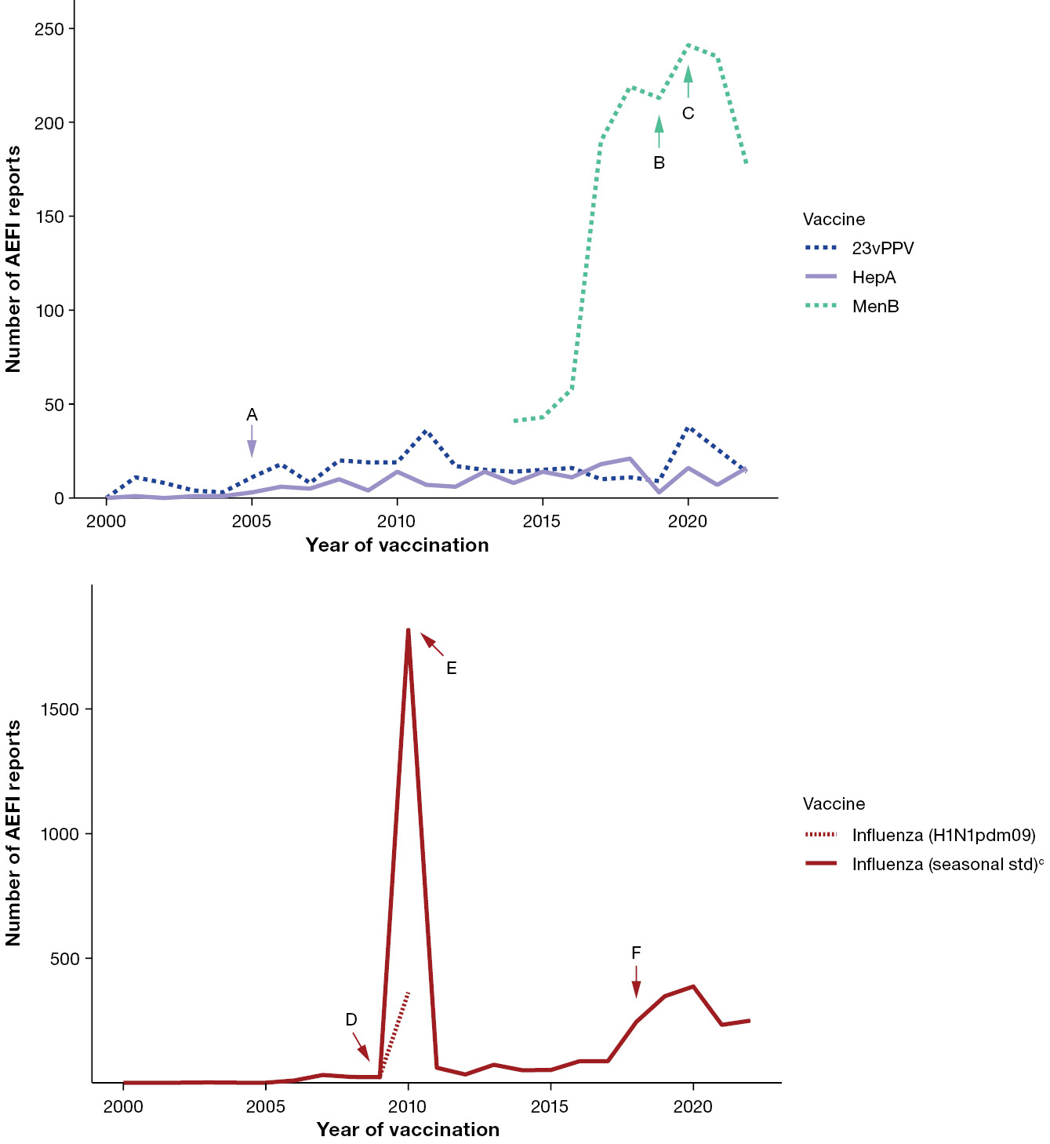
a Vaccines are selected for inclusion in figure 4 overall if they have been in use in the selected age group for ≥ 2 consecutive years, and if they are a) funded under the NIP for any population subgroup within the selected age group in 2022; b) one of the five most common vaccines associated with spontaneous AEFI reports in 2022; or c) have been implicated in a vaccine safety event of note from year 2000 onwards and/or have been implicated in a large proportion of historical spontaneous AEFI reports. For reports where the date of vaccination was not recorded, the date of symptom onset or the received date (when the event was reported to the sender of the case) was used. For more details on changes to immunisation programs (including the National Immunisation Program), please see Appendix A, Table A.1.
b Event markers shown represent the following events: A: HepA program, for Aboriginal and Torres Strait Islander children in specific jurisdictions, commenced; B: South Australian MenB program commenced; C: MenB program for Aboriginal and Torres Strait Islander children commenced; D: pandemic H1N1 influenza program commenced; E: temporary seasonal influenza vaccine suspension in children due to safety concern; F: state/territory seasonal influenza programs commenced.
c Seasonal std: standard formulation of the seasonal influenza vaccine.
Figure 5: Adverse event following immunisation reports for selected vaccines only,^{a,b} for people aged 7 to 17 years in the Adverse Event Management System database from 2000 to 2022, by year and vaccine
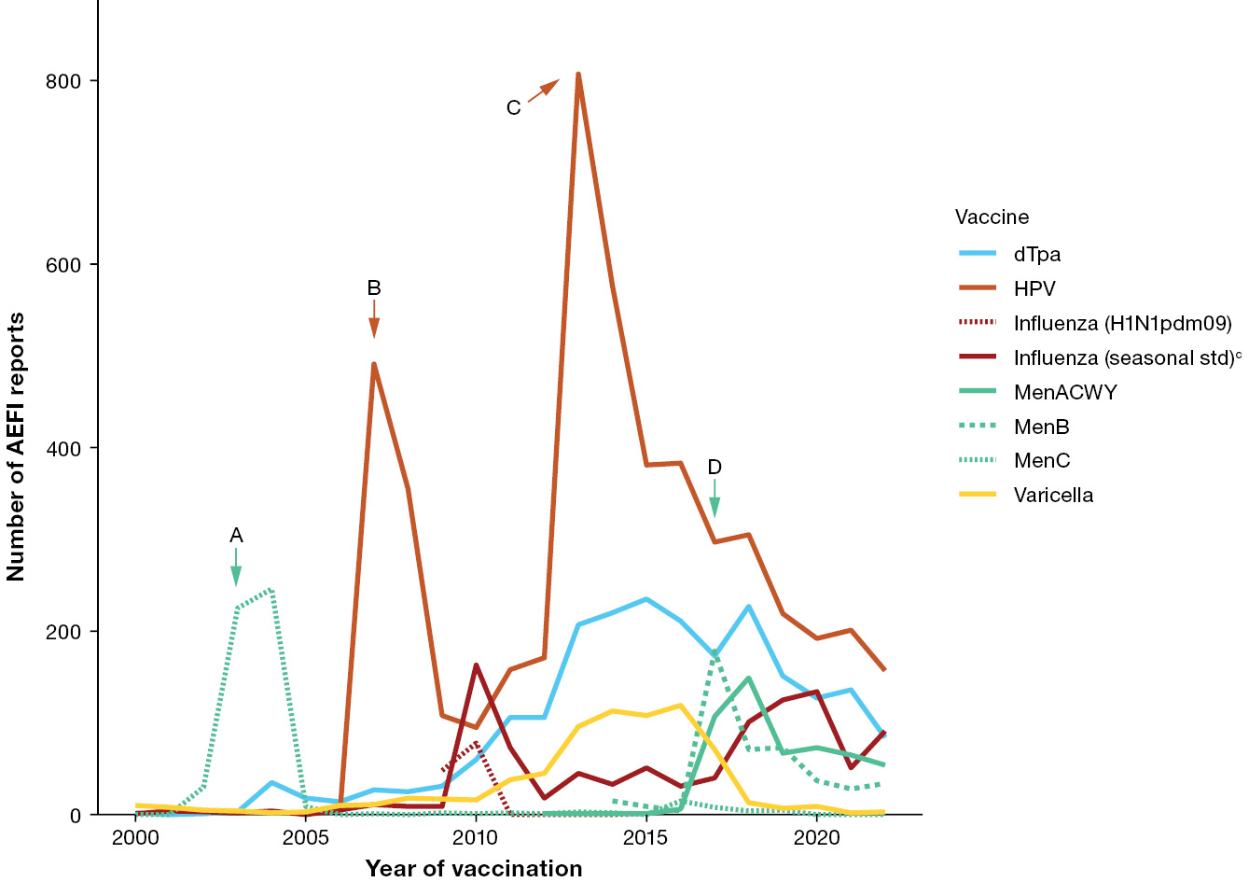
a Vaccines are selected for inclusion in figure 5 overall if they have been in use in the selected age group for ≥ 2 consecutive years, and if they are a) funded under the NIP for any population subgroup within the selected age group in 2022; b) one of the five most common vaccines associated with spontaneous AEFI reports in 2022; or c) have been implicated in a vaccine safety event of note from year 2000 onwards and/or have been implicated in a large proportion of historical spontaneous AEFI reports. For reports where the date of vaccination was not recorded, the date of symptom onset or the received date (when the event was reported to the sender of the case) was used. For more details on changes to immunisation programs (including the National Immunisation Program), please see Appendix A, Table A.1.
b Event markers shown represent the following events: A: MenC child/adolescent catch-up program commenced; B: HPV adolescent and catch-up programs commenced; C: HPV adolescent program (and catch-up) extended to males; D: state/territory MenACWY adolescent school-based programs commenced.
c Seasonal std: standard formulation of the seasonal influenza vaccine.
Figure 6: Adverse event following immunisation reports for selected vaccines only,^{a,b} for people aged 18 to 64 years in the Adverse Event Management System database from 2000 to 2022, by year and vaccine
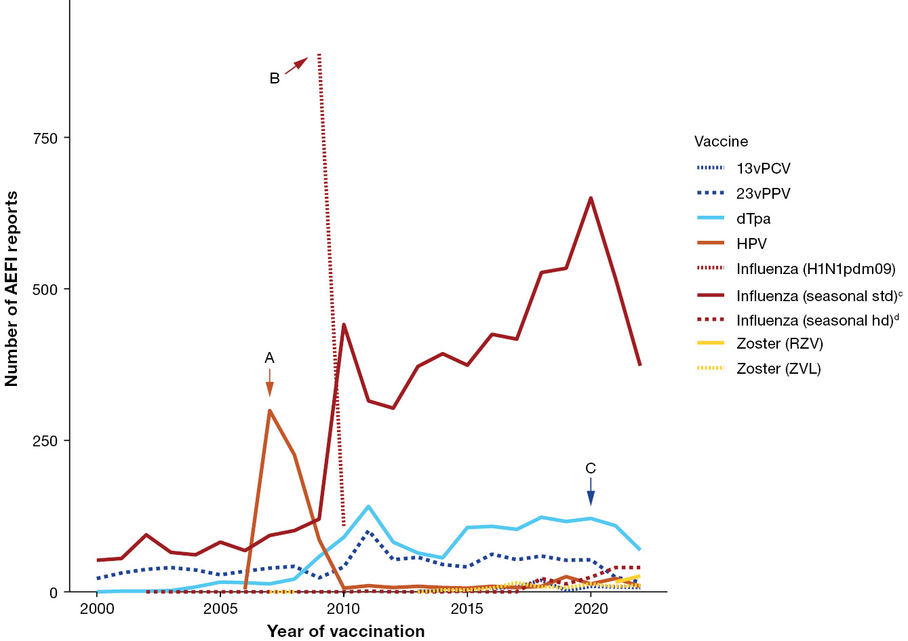
a Vaccines are selected for inclusion in figure 6 overall if they have been in use in the selected age group for ≥ 2 consecutive years, and if they are a) funded under the NIP for any population subgroup within the selected age group in 2022; b) one of the five most common vaccines associated with spontaneous AEFI reports in 2022; c) have been implicated in a vaccine safety event of note from year 2000 onwards and/or have been implicated in a large proportion of historical spontaneous AEFI reports; or d) provides useful information as a comparator to another vaccine included in the figure (for example: RZV as a comparator to ZVL). For reports where the date of vaccination was not recorded, the date of symptom onset or the received date (when the event was reported to the sender of the case) was used. For more details on changes to immunisation programs (including the National Immunisation Program), please see Appendix A, Table A.1.
b Event markers shown represent the following events: A: HPV adult catch-up program commenced; B: pandemic H1N1 influenza program commenced; C: older adult 13vPCV program commenced.
c Seasonal std: standard formulation of the seasonal influenza vaccine.
d Seasonal hd: high-dose or adjuvanted formulation of the seasonal influenza vaccine.
Figure 7: Adverse event following immunisation reports, for selected vaccines only,^{a,b} for people aged ≥ 65 years in the Adverse Event Management System database from 2000 to 2022, by year and vaccine
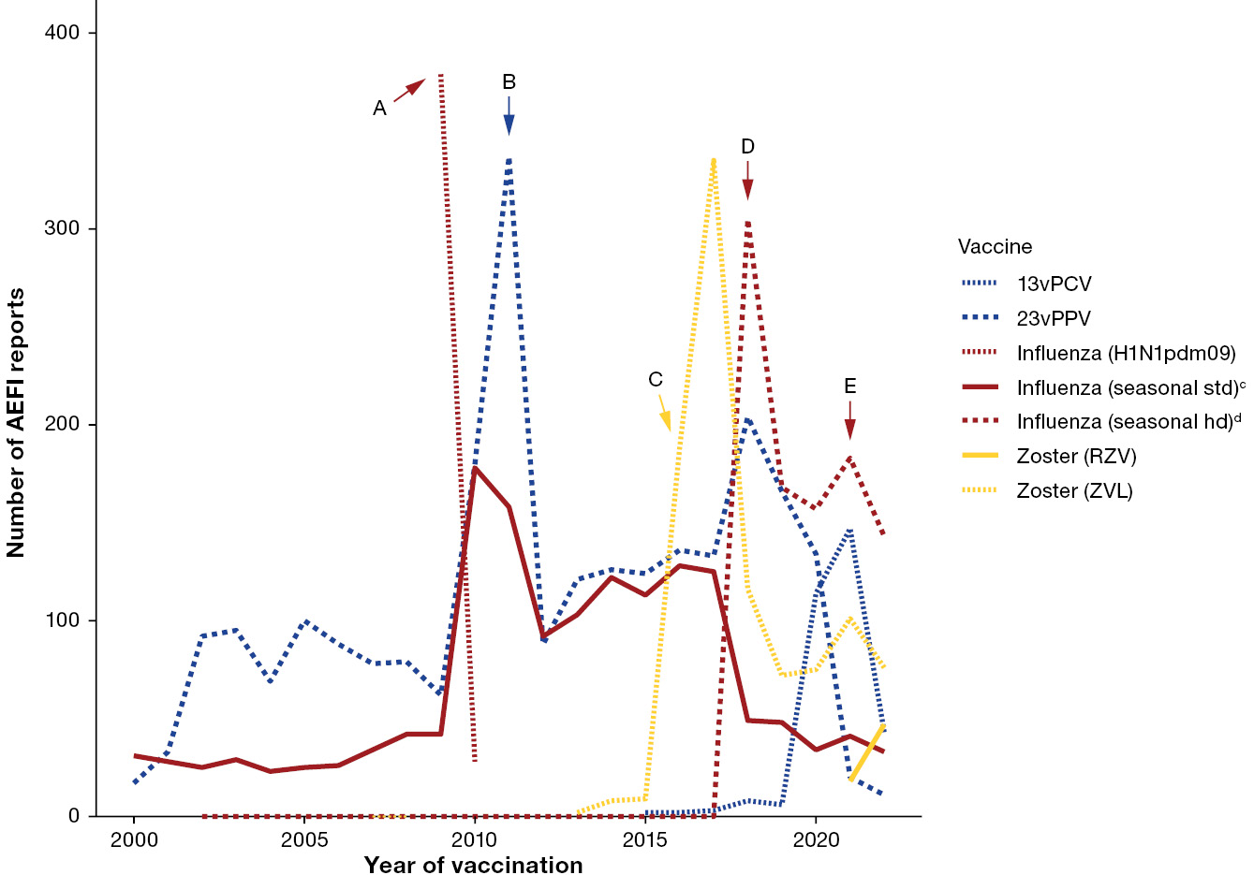
a Vaccines are selected for inclusion in figure 7 overall if they have been in use in the selected age group for ≥ 2 consecutive years, and if they are a) funded under the NIP for any population subgroup within the selected age group in 2022; b) one of the five most common vaccines associated with spontaneous AEFI reports in 2022; c) have been implicated in a vaccine safety event of note from year 2000 onwards and/or have been implicated in a large proportion of historical spontaneous AEFI reports; or d) provides useful information as a comparator to another vaccine included in the figure (for example: RZV as a comparator to ZVL). For reports where the date of vaccination was not recorded, the date of symptom onset or the received date (when the event was reported to the sender of the case) was used. For more details on changes to immunisation programs (including the National Immunisation Program), please see Appendix A, Table A.1.
b Event markers shown represent the following events: A: pandemic H1N1 influenza program commenced; B: TGA issued recall for 23vPPV batch N3336; C: zoster (ZVL) and catch-up programs commenced; D: high-dose and adjuvanted formulations added to seasonal influenza program; E: older adult 13vPCV program commenced, changes made to 23vPPV program.
c Seasonal std: standard formulation of the seasonal influenza vaccine.
d Seasonal hd: high-dose or adjuvanted formulation of the seasonal influenza vaccine.

Serious adverse events
Most AEFI reports in 2022 (2,983 reports; 81.9%) were coded as non-serious (Figure 1). However, the remaining 659 (18.1%) AEFI reports, classified as serious, represented an increase compared to 2021, where 6.5% of all AEFI reports received a serious designation.⁵
Vaccines with the highest counts of serious reports were unspecified zoster (278 serious reports; 99.6% for vaccine; Table 3), standard-formulation seasonal influenza (74; 9.4%), rotavirus (67; 16.5%), varicella (58; 71.6%) and 13vPCV (50; 11.0%; Table 3). Of note, all 278 reports of serious adverse events following an unspecified zoster vaccine were reported by a pharmaceutical company, with the accompanying free text case narrative nominating a social media page as the source of information. This was also the case for 54 of the 58 serious adverse events following varicella vaccine.
The PT/SMQ associated with the highest count of serious adverse events was ‘lack of efficacy / effect’ (370 serious reports, 98.7% of reports for this PT/SMQ; Table 4). Notably, 341 of these reports also contained the term ‘herpes zoster’, and were submitted by the same pharmaceutical company as above, with the source of information attributed to social media.
When all reports with a social media source were excluded, the remaining 293 serious AEFI reports represented 8.0% of all AEFI reported in 2022, which was more closely aligned with the 2021 findings. The standard-formulation seasonal influenza vaccine then became the vaccine associated with the highest count of serious adverse event reports (73 reports). With the exclusion of reports originating from social media, the PT/SMQ associated with the highest count of serious adverse events was the MedDRA SMQ grouping of ‘gastrointestinal non-specific symptoms and therapeutic procedures’ (54 serious reports; 11.0% of reports for this PT/SMQ) followed by pyrexia (49 serious reports; 9.6% for this PT/SMQ), reflecting both the total number of AEFI reported (both serious and non-serious) for each PT/SMQ in 2022, and the trends observed in 2021.
Thirteen adverse events with a fatal outcome were reported to the TGA following a non-COVID-19 vaccine in 2022. The reports involved a range of combinations of child and adult vaccines. Five deaths occurred in infants (all aged less than 12 months), five deaths occurred in adults (age range 55 to 78 years, median age 74 years), and three deaths occurred in individuals whose age and date of birth were not known. None of the 13 deaths were determined, following detailed TGA review, to be causally related to the vaccine(s) received.
Of the five reports with a fatal outcome in infants, three were referred to the coroner, who did not identify a link to vaccination. The fourth case was reported as having occurred in the 1980s, with insufficient information available for further assessment by the TGA. The final case was submitted by a pharmaceutical sponsor, with the cited source being a case report published in the academic literature, and occurred in a child with medical comorbidities that were already listed within the ‘Special warnings and precautions for use’ section of the product information (PI) for the vaccine that was nominated in the adverse event report.
Of the five reports with a fatal outcome in adults, two described deaths from conditions not associated with the vaccine(s) administered, two described deaths from conditions with other possible causes for the event, and one contained insufficient information to fully assess the case and determine an association with the vaccine.
All three of the reports involving individuals without a documented age or date of birth were identified from a social media service and contained insufficient information to fully assess the case and determine an association with the vaccine.
Reporting of a death to the TGA does not mean that the vaccine caused the death, or that the individual completing the report considers that the death was caused by a vaccine. The TGA strongly encourages consumers and health professionals to report suspected adverse events, particularly serious or fatal events, regardless of the likelihood that the vaccine was the cause of an individual’s death. The TGA reviews all AEFI reports where a fatal outcome is reported (additional details in Methods section).
All reports, including fatal reports, are de-identified and published in the Database of Adverse Event Notification (DAEN)—medicines.²¹ Publication of a report in the DAEN—medicines does not mean that the vaccine caused the adverse event. All reports of death are also included in the TGA safety monitoring data, even if a coroner or expert panel has concluded that the death is unrelated to vaccination.

Discussion
In 2022, the annual AEFI reporting rate for non-COVID-19 vaccines was 14.0 per 100,000 population. This population-based rate represented a slight increase from 2021, but remained below the rates observed in the years immediately preceding the COVID-19 pandemic.
As was the case in previous years, the highest AEFI reporting rate per 100,000 population was observed in children < 7 years of age, reflecting the fact that more doses of vaccines are typically administered to each individual in this age group.
The vaccines with the highest counts of AEFI reports in each age group remained the same in 2022 as in 2021. However, the reporting rates per 100,000 doses were lower in 2022 for most vaccines. This may be related to more doses of vaccines being administered in the ≥ 7 years age groups. Additionally, there were larger than usual numbers of reports where the vaccine was not clearly identified (such as unspecified zoster, pneumococcal and tetanus-containing vaccines), which do not correspond to specific dose count denominators from the AIR to allow calculation of reliable reporting rates per 100,000 doses.
Many of the reports of unspecified vaccines arose from pharmaceutical sponsors, where sources such as consumer self-reports on social media channels monitored by the sponsor may have led to onward AEFI reporting to the TGA. All reports sourced in this manner in 2022 were classified as serious, however, this was based on limited information which was generally unable to be further verified. Reporting from social media sources resulted in an inflation of serious adverse events for specific vaccines and MedDRA terms. While pharmaceutical companies are required to report any AEFI detected through their surveillance mechanisms, including social media channels, to the TGA, reports from social media sources tend to be of lower quality as they often contain limited information, and it is not possible to identify and contact either the patient or a treating clinician to obtain missing information.
The events of 2022 also included two outbreaks of vaccine-preventable diseases (VPDs) that had not previously had significant circulation in Australia: mpox and Japanese encephalitis. Vaccination was used as a prevention and control strategy for both outbreaks, resulting in the introduction of the MVA-BN vaccine to Australia, and an increased use of existing Japanese encephalitis vaccines. The rollout of MVA-BN vaccination programs was reflected in the adverse event reporting observed in the age groups where most vaccine doses were administered. The most frequently reported adverse events for the MVA-BN vaccine were injection site reaction, headache, chest pain, dyspnoea, and nonspecific gastrointestinal symptoms. Of these, injection site reaction, headache, and nonspecific gastrointestinal symptoms were identified as very common in clinical trial data and included in the PI for MVA-BN.²³ Chest pain and dyspnoea were not listed in the PI as pre-licensure adverse events. A review of global post-marketing data undertaken by the pharmaceutical sponsor showed that with more than 1.7 million doses of vaccine administered worldwide, the frequencies of acute myocardial infarction, myocarditis, and pericarditis were each lower than 1 event per 100,000 doses, which was consistent with rates observed in clinical trials.²⁴
While there was a slight increase in the number of AEFI reports for the live and inactivated Japanese encephalitis vaccines compared to previous years, there were insufficient reports for either vaccine for useful analysis of the frequencies of each reported adverse event. Additionally in 2022, there was an expansion in jurisdictional eligibility for funded influenza vaccines.^{7,25} This change was reflected in corresponding increases, both in the number of influenza vaccine doses administered, and in AEFI reports following influenza vaccines, resulting in similar or lower AEFI reporting rates per 100,000 doses administered in each age group (Table 1).
Hypersensitivity was the most frequently reported non-COVID-19 AEFI in 2022 (19.0% of all AEFI reports), moving from being second most frequent in 2021. Notably, medication (vaccination) errors were in second place, featuring in 18.6% of all non-COVID-19 AEFI reports, and relatively evenly spread across the < 7 years and ≥ 7 years age groups. Most vaccine error reports were not associated with reports of accompanying adverse events, potentially indicating that most errors did not result in adverse outcomes at the time of reporting the vaccination error (we note nonetheless that this does not preclude AEFI developing subsequently; it is possible to update a previously submitted report with emerging developments, and health professionals are encouraged to do so). State and territory health departments investigate and address vaccination error reports where necessary.
The increase in both the number and proportion of vaccination error reports may represent an increased general awareness among health professionals to be alert to vaccination errors, and to report errors to the TGA either directly or indirectly via jurisdictional health departments. Additionally, during the COVID-19 vaccination rollout, the TGA conducted awareness campaigns (including the use of several social media channels) targeting health professionals and the public, with the aim of reminding and encouraging reporting of all AEFI, which may have also indirectly contributed to an increase in AEFI reporting for non-COVID-19 vaccines.^{26,27} While the vaccines associated with the most vaccination error reports were the standard formulation and the high dose or adjuvanted formulation influenza vaccines, this finding likely represented that in 2022, these two groups of vaccines were the most frequently and second most frequently administered vaccines respectively (excluding COVID-19 vaccines; Table 1). Potential additional challenges with the influenza vaccine were that the lower registered ages for the Influvac Tetra and Flucelvax Quad vaccines were extended in 2022, and the Fluzone high-dose quadrivalent influenza vaccine formulation was introduced as a privately available vaccine for older adults.²⁸ However, the latter vaccine was not implicated in any reports of vaccination error.
Safety data for influenza and NIP vaccines were also collected throughout 2022 by AusVaxSafety, the national active participant-based surveillance system for AEFI using digital survey methods.²⁹ AusVaxSafety surveillance also commenced during 2022 for the MVA-BN vaccine, concurrent with its initial availability in Australia.³⁰ The differences in TGA and AusVaxSafety methodology preclude direct comparison of findings between the two systems. However, AusVaxSafety data has generally corroborated TGA spontaneous surveillance findings throughout this period, and reported a high level of safety for these vaccines, consistent with known profiles.
As is the case with any spontaneous surveillance system, vaccine safety monitoring by the TGA relies on adverse events being reported. Therefore, a limitation to this analysis is underreporting, which also means that AEFI reporting rates cannot be used as proxy for AEFI incidence rates.^{10,31} Reporting rates may also be affected by external factors, such as media or social media attention. AEFI reports may vary significantly in completeness and quality of information, and are not always verified against verifiable clinical data. Each AEFI report can include multiple vaccines, vaccination dates, AEFI, and AEFI onset dates. Therefore, it is not always possible to associate specific vaccines to specific AEFI and AEFI onset dates. Seriousness criteria may be applied inconsistently by different reporters, and is therefore not necessarily a reliable guide to the safety profile of a vaccine. Additionally, the analytical decision to include 121 adverse event reports where both COVID-19 and non-COVID-19 vaccines were nominated in the companion COVID-19 vaccines report, and not this report for all other vaccines, would have led to a decrease, albeit nominal, in AEFI reporting rates for specific vaccines in this report.¹¹
In addition, vaccination data from the AIR, used to calculate AEFI rates per 100,000 vaccine doses, may not be comprehensive, in that the legal requirement for vaccination providers to report vaccines administered was only applicable to NIP, influenza, and COVID-19 vaccines throughout 2022, and to JE vaccines from 21 December 2022.^{18,32} The AIR is also limited in its capture of demographic and clinical detail, meaning that it may not be possible to calculate dose-based AEFI reporting rates for specific subgroups.
Finally, it is essential to reiterate that the AEFI reported here are not necessarily causally related to vaccination, as only a temporal, not causal, association is necessary for an AEFI to be reported. The TGA strongly encourages consumers and health professionals to report suspected adverse events, even if in their view, there is only a very small chance the event was caused by a vaccine.

Conclusion
Trends observed in spontaneous AEFI reporting in Australia in 2022 were similar to those in 2021. The slight increases in some overall reporting rates, and rates within particular age groups, may be due to a combination of increased pharmaceutical sponsor reporting, additional vaccines administered in response to novel outbreaks of VPDs (mpox and Japanese encephalitis), and as part of a gradual return to pre-pandemic AEFI reporting patterns. Overall, the 2022 spontaneous AEFI reports demonstrate a high level of safety of non-COVID-19 vaccines, including vaccines in the NIP schedule.

Acknowledgments
We would like to acknowledge and thank Alexandra Hendry and Tristan Franks at NCIRS for providing historical context and code and vaccine dose data from the Australian Immunisation Register.
This report is a deliverable under contract with the Australian Government Department of Health, Disability and Ageing in relation to services for immunisation research and surveillance, and has been prepared by Yuanfei Anny Huang, Nicholas Wood, Lucy Deng, and Kristine Macartney at the National Centre for Immunisation Research and Surveillance (NCIRS), and Claire Larter, Megan Hickie, Megan O’Moore, Belinda Jones, Sophie Russell, and Elspeth Kay at the Therapeutic Goods Administration.

Author details
Yuanfei Anny Huang,¹
Claire Larter,²
Megan Hickie,²
Megan O’Moore,²
Belinda Jones,²
Lucy Deng,¹
Sophie Russell,²
Elspeth Kay,²
Kristine Macartney,¹
Nicholas Wood¹
- National Centre for Immunisation Research and Surveillance, The University of Sydney and The Children’s Hospital at Westmead, Sydney, Australia
- Pharmacovigilance Branch, Therapeutic Goods Administration, Department of Health, Disability and Ageing, Canberra, Australia

Corresponding author
Dr Yuanfei Anny Huang
National Centre for Immunisation Research and Surveillance, Locked Bag 4001, Westmead NSW 2145, Sydney, Australia
Phone: +61 2 9845 1416
Fax: +61 2 9845 1418
Email: yuanfei.huang@health.nsw.gov.au

References
- Council for International Organizations of Medical Sciences (CIOMS) c/o World Health Organization (WHO). Definition and Application of Terms for Vaccine Pharmacovigilance: Report of CIOMS/WHO Working Group on Vaccine Pharmacovigilance. Geneva: CIOMS; 2012. Available from: https://www.who.int/publications/m/item/9789290360834.
- Therapeutic Goods Administration (TGA). Reporting adverse events. [Webpage.] Canberra: Australian Government Department of Health, Disability and Ageing, TGA; 2024. [Accessed during 2024.] Available from: https://www.tga.gov.au/safety/reporting-problems/reporting-adverse-events.
- World Health Organization (WHO). Global manual on surveillance of adverse events following immunization: 2016 update. Geneva: WHO; 31 May 2016. Available from: https://www.who.int/publications/i/item/9789241507769.
- Lawrence G, Menzies R, Burgess M, McIntyre P, Wood N, Boyd I et al. Surveillance of adverse events following immunisation: Australia, 2000–2002. Commun Dis Intell Q Rep. 2003;27(3):307–23.
- Glover C, Deng L, Larter C, Brogan C, Richardson O, Huang YA et al. Surveillance of adverse events following immunisation in Australia annual report, 2021. Commun Dis Intell (2018). 2024;48. doi: https://doi.org/10.33321/cdi.2024.48.1.
- National Centre for Immunisation Research and Surveillance (NCIRS). Significant events in Japanese encephalitis vaccination practice in Australia. Sydney: Sydney Children’s Hospital Network, NCIRS; March 2024. [Accessed during 2024.] Available from: https://ncirs.org.au/sites/default/files/2024-03/Japanese%20encephalitis_History%20table.pdf.
- Valeri M, Durrani S, Tran C, Chiu C, Macartney KK, Giles ML et al. ATAGI 2023 annual statement on immunisation. Commun Dis Intell (2018). 2023; 47 doi: https://doi.org/10.33321/cdi.2023.47.42.
- Australian Government Federal Register of Legislation. Therapeutic Goods Act 1989. [Legislation.] Canberra: Australian Government; 2024. [Accessed during 2024.] Available from: https://www.legislation.gov.au/C2004A03952/latest/versions.
- Lawrence G, Boyd I, McIntyre P, Isaacs D. Surveillance of adverse events following immunisation: Australia 2002 to 2003. Commun Dis Intell Q Rep. 2004;28(3):324–38.
- O’Moore M, Jones B, Hickie M, Glover C, Deng L, Huang Y et al. National pharmacovigilance of seasonal influenza vaccines in Australia. Med J Aust. 2024;221(4):178–81. doi: https://doi.org/10.5694/mja2.52381.
- Huang YA, Larter C, Hickie M, O’Moore M, Jones B, Deng L et al. Surveillance of adverse events following immunisation in Australia, COVID-19 vaccines, 2022. Commun Dis Intell (2018). 2025;49. doi: https://doi.org/10.33321/cdi.2025.49.044.
- International Council for Harmonisation of Technical Requirements for Pharmaceuticals for Human Use (ICH). Introductory Guide MedDRA Version 26.1. Brussels: ICH; September 2023. Available from: https://admin.meddra.org/sites/default/files/guidance/file/intguide_26_1_English.pdf.
- Medical Dictionary for Regulatory Activities (MedDRA). Standardised MedDRA Queries. [Webpage.] Herndon VA: MedDRA: 2023. [Accessed during 2024.] Available from: https://www.meddra.org/standardised-meddra-queries.
- MedDRA. Introductory Guide for Standardised MedDRA Queries (SMQs) (Version 26.1). Geneva: International Council for Harmonisation of Technical Requirements for Pharmaceuticals for Human Use, MedDRA; September 2023. Available from: https://admin.meddra.org/sites/default/files/guidance/file/SMQ_intguide_26_1_English.pdf.
- WHO. Causality assessment of an adverse event following immunization (AEFI): user manual for the revised WHO classification, 2nd ed., 2019 update. Geneva: WHO; 16 April 2021. Available from: https://www.who.int/publications/i/item/9789241516990.
- Australian Bureau of Statistics. National, state and territory population. Reference period: June 2022. [Webpage.] Canberra: Australian Bureau of Statistics; 15 December 2022. [Accessed during 2023.] Available from: https://www.abs.gov.au/statistics/people/population/national-state-and-territory-population/jun-2022.
- Australian Government: Services Australia. Australian Immunisation Register. [Webpage.] Canberra: Services Australia; 2024. [Accessed during 2024.] Available from: https://www.servicesaustralia.gov.au/australian-immunisation-register.
- Australian Government Department of Health, Disability and Ageing. Mandatory reporting of Japanese encephalitis virus vaccines to the Australian Immunisation Register began on 21 December 2022. [Webpage.] Canberra: Australian Government Department of Health, Disability and Ageing; 13 January 2022. [Accessed during 2024.] Available from: https://www.health.gov.au/news/mandatory-reporting-of-japanese-encephalitis-virus-vaccines-to-the-australian-immunisation-register-began-on-21-december-2022.
- Hull B, Hendry A, Dey A, Brotherton J, Macartney K, Beard F. Annual Immunisation Coverage Report 2022. Commun Dis Intell (2018). 2025;49. doi: https://doi.org/10.33321/cdi.2025.49.023.
- R Core Team. R: A Language and Environment for Statistical Computing. [Application.] Vienna: R Foundation for Statistical Computing; 2020. Available from: https://www.R-project.org/.
- TGA. Database of Adverse Event Notifications (DAEN). [Webpage.] Canberra: Australian Government Department of Health, Disability and Ageing, TGA; 2023. [Accessed during 2024.] Available from: https://www.tga.gov.au/safety/database-adverse-event-notifications-daen.
- TGA. DAEN – medicines: Information for consumers. [Webpage.] Canberra: Australian Government Department of Health, Disability and Ageing, TGA; 2023. [Accessed during 2025.] Available from: https://www.tga.gov.au/resources/resource/reference-material/daen-medicines-information-consumers#what-the-tga-does-with-information-in-the-database.
- European Medicines Agency (EMA). Imvanex: smallpox and monkeypox vaccine (Live Modified Vaccinia Virus Ankara). [Webpage.] Amsterdam: EMA; 2024. [Accessed during 2024.] Available from: https://www.ema.europa.eu/en/medicines/human/EPAR/imvanex.
- Weidenthaler H, Vidojkovic S, Martin BK, De Moerlooze L. Real-world safety data for MVA-BN: increased frequency of syncope following intradermal administration for immunization against mpox disease. Vaccine. 2024;42(22):126024. doi: https://doi.org/10.1016/j.vaccine.2024.05.072.
- NCIRS. History of immunisation in Australia. [Webpage.] Sydney: Sydney Children’s Hospital Network, NCIRS; 2024.[Accessed during 2024.] Available from: https://ncirs.org.au/health-professionals/history-immunisation-australia.
- Therapeutic Goods Administration - TGA. [‘Facebook’ social media post.] Facebook; 5 October 2021. Available from: https://www.facebook.com/TGAgovau/posts/pfbid0SUHvJqCSfi1tTNJTWjgVnasjVeDmgL6MzrSHPrH6M32zZXSFVn2rncDmjsaHNxBcl.
- Therapeutic Goods Administration - TGA. [‘Facebook’ social media post.] Facebook; 1 March 2022. Available from: https://www.facebook.com/TGAgovau/posts/pfbid02t48T1Ft8zoetjAkvUt6o8mK7TqUt4bf3vfE1S6oagGPhc2W1swftEgCa1jtRTbC1l.
- Australian Government Department of Health, Disability and Ageing. Australian Technical Advisory Group on Immunisation (ATAGI) Clinical Advice. Statement on the administration of seasonal influenza vaccines in 2022. Canberra: Australian Government Department of Health, Disability and Ageing; March 2022. [Accessed during 2024.] Available from: https://www.health.gov.au/sites/default/files/documents/2022/02/atagi-advice-on-seasonal-influenza-vaccines-in-2022.pdf.
- Australian Government Department of Health, Disability and Ageing. Vaccine safety in Australia AusVaxSafety – Summary report 2022. Canberra: Australian Government Department of Health, Disability and Ageing; 23 February 2024. Available from: https://www.health.gov.au/resources/publications/vaccine-safety-in-australia-ausvaxsafety-summary-report-2022.
- Deng L, Lopez L, Glover C, et al. Short-term adverse events following immunization with modified vaccinia Ankara-Bavarian Nordic (MVA-BN) vaccine for Mpox. JAMA. 2023;329(23):2091–4. doi: https://doi.org/10.1001/jama.2023.7683.
- Shimabukuro T, Nguyen M, Martin D, DeStefano F. Safety monitoring in the Vaccine Adverse Event Reporting System (VAERS). Vaccine. 2015;33(36):4398–405. doi: https://doi.org/10.1016/j.vaccine.2015.07.035.
- Tuckerman J, Blyth CC, Beard FH, Danchin MH. COVID-19 and changes in the National Immunisation Program: a unique opportunity to optimise the Australian Immunisation Register (AIR). Med J Aust. 2021;214(6):247–9. doi: https://doi.org/10.5694/mja2.50971.

Appendix A
Table A.1: Notable changes in national or jurisdictional immunisation policy, and in the National Immunisation Program (2005–2022), excluding COVID-19 vaccines^{18,25}
Year | Change
2022 | December 2022  Mandatory reporting to AIR for all JE vaccines administered.
2022 | August 2022  Intradermal administration of MVA-BN added to recommendations as an alternative route for pre-exposure prophylaxis.
2022 | July 2022  First replication-deficient modified vaccinia Ankara–Bavarian Nordic, MVA-BN vaccine made available via a special emergency pathway under section 18A of the Therapeutic Goods Act 1989.  MVA-BN recommended for both pre-exposure and post-exposure prophylaxis against mpox.
2022 | June 2022  NSW, Qld, Vic, SA and WA governments provided state-funded influenza vaccination program for all residents from 1 June – 30 June 2022.
2022 | April 2022  The recombinant zoster vaccine is recommended for use in immunocompromised adults aged ≥ 18 years.
2022 | March 2022  Due to changes in the epidemiology of JE in Australia, JE vaccination recommended in individuals aged ≥ 2 months in high-risk settings (as advised by jurisdictional public health authorities).
2021 | July 2021  Mandatory reporting to AIR for all NIP vaccines administered.
2021 | March 2021  Mandatory reporting to AIR for all influenza vaccines administered.
2020 | July 2020  Funded schedule expanded for Aboriginal and Torres Strait Islander children living in the NT, SA, QLD and WA from 13vPCV at 2, 4, 6 and 12 months (3+1) to include an additional dose of 23vPPV at 4 years of age and a second dose 5–10 years later.  A single dose of 13vPCV is recommended and funded for Aboriginal and Torres Strait Islander adults at 50 years of age, followed by a dose of 23vPPV 12 months later and a second dose of 23vPPV 5–10 years after that.  A single dose of 13vPCV is recommended and funded for non-Aboriginal and Torres Strait Islander adults at 70 years of age, replacing the previously funded dose of 23vPPV at 65 years of age.  Meningococcal B vaccine funded for all Aboriginal and Torres Strait Islander children (age < 12 months) and individuals of any age with specified high risk medical conditions. Catch-up available for all Aboriginal and Torres Strait Islander children < 2 years of age (up to 23 months) for three years – until 30 June 2023.
2020 | March 2020  All children aged 6 months to < 5 years funded for influenza vaccine under NIP.  First enhanced quadrivalent influenza vaccine (adjuvanted) funded nationally for adults aged 65 years and over.
2019 | December 2019  In SA, multicomponent recombinant meningococcal B vaccine catch-up for children from 12 months to < 4 years of age ceased on 31 December 2019.
2019 | April 2019  Meningococcal ACWY conjugate vaccine funded under the NIP for adolescents aged 14–16 years delivered through a school-based program and adolescents aged 15 to 19 years delivered through primary care providers as part of an ongoing catch-up program.
2019 | March 2019  NT: annual seasonal influenza vaccination program funded for all children aged 6 months to < 5 years.
2019 | February 2019  Annual seasonal influenza vaccination funded on the national childhood vaccination schedule for all Australian children aged 6 months – < 5 years.  Aboriginal and Torres Strait Islander children and adolescents aged 5–14 years of age funded for influenza vaccine under NIP.
2018 | October 2018  Multicomponent recombinant meningococcal B vaccine funded by SA for children 6 weeks to 12 months of age, with catch-up for children from 12 months to < 4 years of age.
2018 | July 2018  Meningococcal ACWY conjugate vaccine funded for all children at 12 months of age, replacing combined Hib and meningococcal C-containing vaccine.  Hib dose moved to 18 months and given as monovalent Hib vaccine.  Schedule for routine childhood vaccination with 13vPCV changed from 2, 4 and 6 months of age to 2, 4 and 12 months of age.
2018 | April 2018  Enhanced trivalent influenza vaccines (high-dose and adjuvanted) funded nationally for all adults aged ≥ 65 years.  Annual seasonal influenza vaccination funded by ACT, NSW, QLD, SA, TAS and VIC for all children aged 6 months – < 5 years.  Meningococcal A, C, Y, W-135 conjugate vaccine funded by SA for Aboriginal and Torres Strait Islander children and adolescents aged 12 months to 19 years living in the Eyre and Far North, and Flinders and Upper North regions.
2018 | February 2018  Meningococcal A, C, W, Y-135 conjugate vaccine funded by ACT for grade 10 students and persons aged 16–19 years who no longer attend school.  A 2-dose schedule of 9vHPV funded for adolescents aged 12–14 years, delivered through a school-based program; 4vHPV ceased to be used in the program.
2018 | January 2018  Meningococcal A, C, Y, W-135 conjugate vaccine funded by WA for children aged 12 months to <5 years.  Meningococcal ACWY school-based vaccination program funded for all NSW secondary school students in Years 10 and 11, as well as adolescents aged 15 to 19 years who have not received the vaccine at school.
2017 | April 2017  Meningococcal B vaccine study commenced in South Australia for grade 10–12 students at participating schools.
2017 | January 2017  Meningococcal ACWY conjugate vaccine funded until December 2017in Western Australia, Victoria and Tasmania for grade 10-12 students; New South Wales for grade 11-12; Queensland grade 10 students and persons aged 15-19 years who no longer attend school. The Northern Territory introduced the vaccine for at-risk people aged 1–19 years living in specified remote regions and all children aged 12 months. For more details see the meningococcal vaccination history table at http://ncirs.org.au/sites/default/files/2019-04/Meningococcal-history-April-2019.pdf
2016 | November 2016  Zoster vaccine (Zostavax®) provided free for people aged 70 years under the National Immunisation Program (NIP) with a five year catch-up program for people aged 71–79 years.
2016 | September 2016  The Australian Childhood Immunisation Register expands to become the Australian Immunisation Register (AIR).
2016 | March 2016  Free booster dose of the diphtheria, tetanus, and acellular pertussis-containing vaccine (DTPa) at 18 months of age.
2015 | April 2015  New immunisation requirements for family assistance payments were announced by the federal government (the ‘No Jab, No Pay’ policy), to come into effect on 1 January 2016. Only parents of children (aged less than 20 years) who are ‘fully immunised’ or on a recognised catch-up schedule remain eligible to receive the Child Care Benefit, Child Care Rebate, and/or the Family Tax Benefit Part A end-of-year supplement.
2015 | March 2015  Seasonal influenza vaccine funded for Aboriginal and Torres Strait Islander children aged 6 months to less than 5 years.  From March to June 2015, the dTpa vaccine for women during the third trimester of pregnancy was funded by New South Wales, South Australia, Western Australia, the Australian Capital Territory, Victoria and Tasmania. The Northern Territory had funded it since September 2013 and Queensland since July 2014.  A booster dose of DTPa vaccine recommended at 18 months of age (funded in March 2016).
2014 | December 2014  4vHPV vaccine catch-up program for males aged 14–15 years ceased
2014 | July 2014  dTpa vaccine was funded by Queensland for women during the third trimester of pregnancy.
2013 | December 2013  Secondary school Year 7 hepatitis B vaccine catch-up program ceased, as all younger age cohorts were eligible for infant immunisation under the NIP (commenced 2000).
2013 | September 2013  dTpa vaccine funded by NT for women during the third trimester of pregnancy and for parents of infants aged < 7 months under cocoon strategy.
2013 | July 2013  Second dose of MMR vaccine, previously given at 4 years, was brought forward to 18 months of age and delivered as MMRV vaccine.  Combined Haemophilus influenzae type b (Hib) and meningococcal serogroup C (MenC) vaccine, Menitorix®, was funded for infants aged 12 months. This combination vaccine replaced the single dose of monovalent meningococcal C conjugate vaccine (MenCCV) and booster dose of monovalent Hib vaccine previously scheduled at 12 months of age.
2013 | February 2013  4vHPV vaccine was extended to males aged 12–13 years, delivered through a school-based program, with a catch-up program for males aged 14–15 years in 2013 and 2014.
2012 | October 2012  A fourth dose of Prevenar 13®, (13vPCV, a 13-valent pneumococcal conjugate vaccine) was listed on the National Immunisation Program (NIP) for Indigenous children, aged 12-18 months, residing in Queensland, South Australia, Western Australia and the Northern Territory. This replaced the booster dose of Pneumovax23®, (23vPPV, a 23-valent pneumococcal polysaccharide vaccine) administered between 18 and 24 months of age for Indigenous children from these jurisdictions.
2011 | 1 October 2011 to 30 September 2012  All children aged between 12–35 months who had completed a primary pneumococcal vaccination course with 7vPCV were eligible to receive a free supplementary dose of Prevenar 13®.
2011 | July 2011  Prevenar 13® replaced Prevenar® on the NIP for children at 2, 4 and 6 months of age in all states and territories except the Northern Territory which adopted 13vPCV from 1 October 2011.
2011 | 25 March 2011  TGA issued a recall of Batch N3336 of the 23-valent pneumococcal polysaccharide vaccine 23vPPV, Pneumovax23®. April 2011: health professionals were advised not to administer a second or subsequent dose of Pneumovax23 vaccine. December 2011: revised recommendations regarding which patients should be re-vaccinated under the NIP were provided.
2010 | Annual vaccination with seasonal trivalent influenza vaccine (TIV, containing three influenza strains: A/H1N1, A/H3N2 and B) was funded under the NIP for people aged ≥ 6 months with medical risk factors (previously subsidised through the Pharmaceutical Benefits Scheme) and all Indigenous people aged ≥ 15 years (previously all Indigenous adults ≥ 50 years and 15–49 years with medical risk factors).  On 23 April 2010, the use of the 2010 seasonal TIV in children < 5 years of age was suspended by Australia’s Chief Medical Officer due to an increased number of reports of fever and febrile convulsions post vaccination. A subsequent investigation identified that Fluvax® and Fluvax junior® (CSL Biotherapies), but neither of the other two available brands registered for use in young children, were associated with an unacceptably high risk of febrile convulsions. The recommendation to resume the use of seasonal influenza vaccine in children aged 6 months to 5 years, using brands other than Fluvax® and Fluvax junior®, was made in August 2010.
2009 | Late 2009  All states and territories were using the single hexavalent DTPa-IPV-Hib-HepB (Infanrix hexa®) vaccine for all children at 2, 4 and 6 months of age, due to an international shortage of Haemophilus influenzae type b (Hib) (PedvaxHib® [monovalent] and Comvax® [Hib-HepB]) vaccines.
2009 | September 2009  Pandemic H1N1 2009 influenza vaccine (Panvax®) was rolled out across Australia from 30 September 2009 for people aged ≥ 10 years. From December 2009, the pandemic vaccine was made available to children aged 6 months to 10 years.
2008 | April 2008  Western Australia commenced a seasonal influenza vaccination program for all children aged 6 months to <5 years (born after 1 April 2003).
2008 | March 2008  Queensland, South Australia and Victoria changed from using two combination vaccines (quadrivalent DTPa-IPV and Hib-HepB) to the single hexavalent DTPa-IPV-HepB-Hib vaccine.
2007 | July 2007  Universal funded immunisation against rotavirus at 2 and 4 months of age (Rotarix®) or at 2, 4 and 6 months of age (Rotateq®).
2007 | April 2007  Funded immunisation against human papillomavirus for all Australian girls aged 12–13 years delivered through a school-based program from April 2007, with a temporary catch-up program through schools or primary care providers for females aged 13–26 years until December 2009.
2005 | November 2005  Universal funded immunisation against varicella at 18 months of age with a school-based catch-up program for children at 10–13 years of age not previously vaccinated and without a history of varicella infection (no funded catch-up for children 2–10 years of age).  IPV was funded to replace OPV, in combination vaccines.
2005 | January 2005  Universal funded infant 7-valent pneumococcal conjugate vaccine (7vPCV) program replaced the previous targeted childhood program, with a catch-up program for children aged < 2 years.  Universal 23-valent pneumococcal polysaccharide vaccine (23vPPV) for adults aged ≥ 65 years replaced previous subsidy through the Pharmaceutical Benefits Scheme.
a Includes immunisation-related policy and key recommendations from the Australian Technical Advisory Group on Immunisation (ATAGI).
Table A.2: Description of preferred term (PT) to standardised MedDRA query (SMQ) mapping
Number of SMQ mapped | Term reported
0 | PT
1 | SMQ
> 1 | SMQ chosen by clinician, or PT if preferred SMQ could not be chosen
Table A.3: Preferred terms (PTs) mapped to specific standardised MedDRA queries (SMQs)ª
SMQ | PTs mapped
Gastrointestinal nonspecific symptoms and therapeutic procedures | Abdominal discomfort; Abdominal distension; Abdominal pain; Abdominal pain lower; Abdominal pain upper; Abdominal symptom; Abdominal tenderness; Abnormal faeces; Anorectal discomfort; Bowel movement irregularity; Change of bowel habit; Constipation; Defaecation disorder; Defaecation urgency; Diarrhoea; Discoloured vomit; Epigastric discomfort; Eructation; Faecal volume decreased; Faeces hard; Faeces soft; Flatulence; Frequent bowel movements; Gastrointestinal pain; Gastrointestinal sounds abnormal; Infrequent bowel movements; Nausea; Non-cardiac chest pain; Oesophageal discomfort; Oesophageal pain; Overflow diarrhoea; Vomiting
Medication errors | Accidental exposure to product; Accidental overdose; Accidental underdose; Circumstance or information capable of leading to medication error; Contraindicated product administered; Device use error; Drug monitoring procedure incorrectly performed; Expired product administered; Exposure via eye contact; Extra dose administered; Inadequate aseptic technique in use of product; Inappropriate schedule of product administration; Incomplete course of vaccination; Incorrect dosage administered; Incorrect dose administered; Incorrect dose administered by device; Incorrect product administration duration; Incorrect product dosage form administered; Incorrect product formulation administered; Incorrect route of product administration; Intercepted product storage error; Labelled drug-drug interaction medication error; Medication error; Multiple use of single-use product; Product administered at inappropriate site; Product administered to patient of inappropriate age; Product administration error; Product dispensing error; Product preparation error; Product prescribing error; Product storage error; Vaccination error; Wrong patient received product; Wrong product administered; Wrong schedule; Wrong technique in product usage process
a Table includes only those PTs found in the AEMS database, and not all possible MedDRA PTs that map to each MedDRA SMQ; mapping hierarchy in MedDRA version 26.1 used.
Table A.4: Abbreviations of vaccine types and other terms
Abbreviation | In full
13vPCV | 13-valent pneumococcal conjugate vaccine
23vPPV | 23-valent pneumococcal polysaccharide vaccine
7vPCV | 7-valent pneumococcal conjugate vaccine
ABS | Australian Bureau of Statistics
AEFI | adverse event following immunisation
AEMS | Adverse Event Management System
AIR | Australian Immunisation Register
ATAGI | Australian Technical Advisory Group on Immunisation
CI | confidence interval
DAEN | Database of Adverse Event Notifications
DTP | diphtheria-tetanus-pertussis vaccine – formulation unspecified
DTPa | diphtheria-tetanus-pertussis (acellular) – paediatric formulation
dTpa | diphtheria-tetanus-pertussis (acellular) – adolescent and adult formulation
DTPa-Hib | combined diphtheria-tetanus-pertussis (acellular) and Haemophilus influenzae type b vaccine
DTPa-IPV | combined diphtheria-tetanus-pertussis (acellular) and inactivated poliovirus (quadrivalent) – paediatric formulation
DTPa-IPV-HepB-Hib | combined diphtheria-tetanus-pertussis (acellular), inactivated poliovirus, hepatitis B and Haemophilus influenzae type b vaccine (hexavalent)
dTpa-IPV | combined diphtheria-tetanus-pertussis (acellular) and inactivated poliovirus (quadrivalent) – adolescent and adult formulation
ERP | estimated residence population
H1N1pdm09 | pandemic H1N1 influenza 2009
Hep A | hepatitis A
HepB | hepatitis B
Hib | Haemophilus influenzae type b
Hib-MenC | combined Haemophilus influenzae type b and meningococcal C conjugate vaccine
Hib-MenCY | combined Haemophilus influenzae type b and meningococcal C and Y conjugate vaccine
Hib-HepB | combined Haemophilus influenzae type b and hepatitis B
HPV | human papillomavirus
ICU | intensive care unit
JE | Japanese encephalitis
MedDRA | Medical Dictionary for Regulatory Activities
MenACWY | quadrivalent meningococcal (serogroups A, C, W-135, Y) conjugate vaccine
MenB | meningococcal B vaccine
MenC | meningococcal C conjugate vaccine
MMR | measles-mumps-rubella
MMRV | measles-mumps-rubella-varicella
MVA-BN | modified vaccinia Ankara – Bavarian Nordic vaccine
NCIRS | National Centre for Immunisation Research and Surveillance
NIP | National Immunisation Program
PCV | pneumococcal conjugate vaccine – formulation unspecified
PI | product information
PT | preferred term(s)
SMQ | standardised MedDRA query
TGA | Therapeutic Goods Administration
VPD | vaccine preventable disease
WHO | World Health Organization
Zoster (RZV) | recombinant zoster vaccine
Zoster (ZVL) | live-attenuated zoster vaccine
Figure A.1: Reporting rates of adverse events following immunisation per 100,000 population in the Adverse Event Management System database from 2000 to 2022 (excluding COVID-19 vaccines),ª by year and reporter type
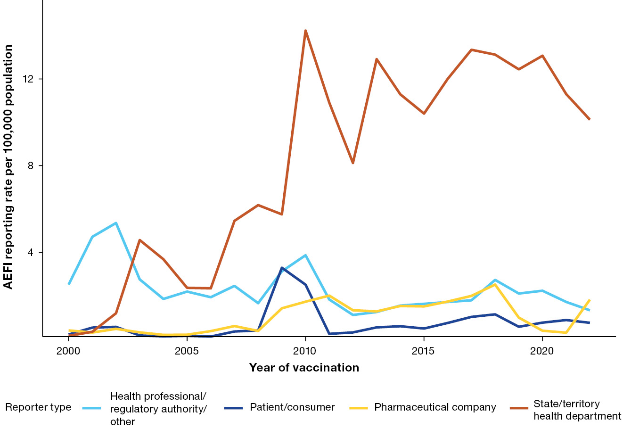
a For reports where the date of vaccination was not recorded, the date of symptom onset or the received date (when the event was reported to the sender of the case) was used. For more details on changes to immunisation programs (including the National Immunisation Program), please see Table A.1. Population data was sourced from the Australian Bureau of Statistics, and represents the mid-year total Australian Estimated Residential Population (ERP) for each calendar year.

