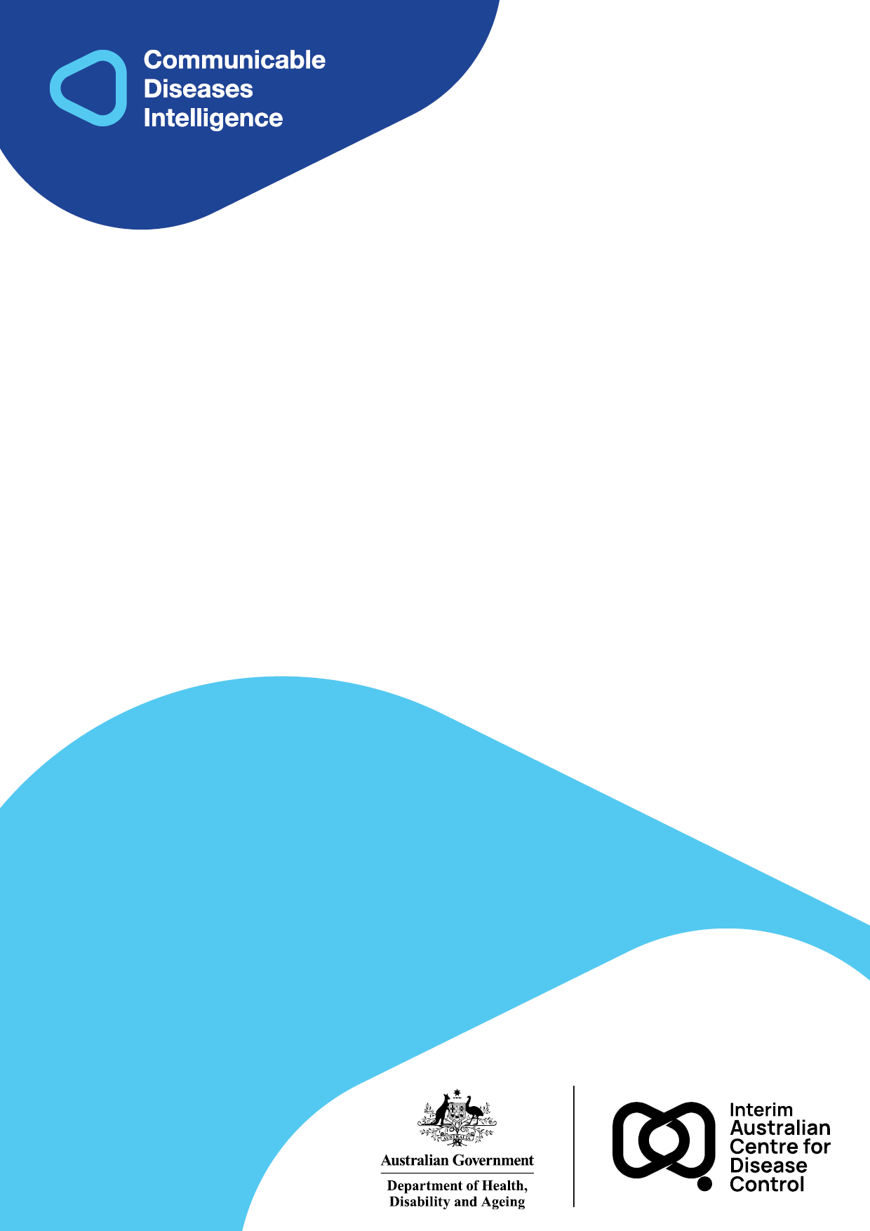
2025 • Volume 49 • cdc.gov.au/cdi • Epub date: 18.11.2025 • doi.org/10.33321/cdi.2025.49.057

Australian Meningococcal Surveillance Programme Annual Report, 2024
Monica M Lahra, Siobhan M. Hurley, C R Robert George, Sebastiaan J van Hal and Tiffany R Hogan for the National Neisseria Network
© 2025 Commonwealth of Australia as represented by the Department of Health, Disability and Ageing
ISSN: 2209-6051 Online
This journal is indexed by Index Medicus and Medline.
Creative Commons Licence
This publication is licensed under a Creative Commons Attribution-NonCommercial-NoDerivatives 4.0 International Licence (Licence). You must read and understand the Licence before using any material from this publication.
Restrictions
The Licence does not cover, and there is no permission given for, use of any of the following material found in this publication (if any):
- the Commonwealth Coat of Arms (by way of information, the terms under which the Coat of Arms may be used can be found on the Department of Prime Minister and Cabinet website;
- any logos (including the interim Australian Centre for Disease Control and the Department of Health, Disability and Ageing’s logos) and trademarks;
- any photographs and images;
- any signatures; and
- any material belonging to third parties.
Disclaimer
Opinions expressed in Communicable Diseases Intelligence are those of the authors and not necessarily those of the Australian Government, the interim Australian Centre for Disease Control or the Department of Health, Disability and Ageing. Data may be subject to revision.
Enquiries
Enquiries regarding any other use of this publication should be addressed to the CDI Editor.
About CDI
Communicable Diseases Intelligence (CDI) is a peer-reviewed scientific journal published by the interim Australian Centre for Disease Control within the Department of Health, Disability and Ageing.
The journal aims to disseminate information on the epidemiology, surveillance, prevention and control of communicable diseases of relevance to Australia and the near region.
Editor: Christina Bareja • Deputy Editor: Simon Petrie • Design and Production: Lisa Thompson
Editorial Advisory Board: David Durrheim, Mark Ferson, Clare Huppatz, John Kaldor, Martyn Kirk and Meru Sheel
Submit an Article
Guidelines for authors and details on how to submit your publication is available on our website, or by email to the
CDI Editor.
Contact us
Communicable Diseases Intelligence (CDI)
interim Australian Centre for Disease Control, Department of Health, Disability and Ageing
GPO Box 9848, CANBERRA ACT 2601
Website: cdc.gov.au/cdi
Email: cdi.editor@health.gov.au

Contents
List of figures 4
List of tables 4
Abstract 5
Introduction 6
Methods 7
Case confirmation of invasive meningococcal disease 7
Serogroup and genotyping of Neisseria meningitidis 7
Antimicrobial susceptibility testing 7
Results 8
Laboratory diagnosis of IMD 9
Notifications by jurisdiction 10
IMD age and serogroup distribution 11
IMD and genotyping 13
Antimicrobial susceptibility testing 15
Discussion 16
Acknowledgments 18
Author details 20
References 21

List of figures
Figure 1: Number of invasive meningococcal disease cases reported to the National Notifiable Diseases Surveillance System, compared with laboratory-confirmed data from the Australian Meningococcal Surveillance Programme, Australia,ª 1991–2024 8
Figure 2: Proportion of serogroups of laboratory-confirmed invasive meningococcal disease, Australia, 2000 – 2024 by year 11
Figure 3: Number of serogroup B, C, Y and W cases of laboratory-confirmed invasive meningococcal disease, Australia, 2024, by age 12
Figure 4: The number of porA types represented in serogroup B, W and Y invasive meningococcal disease notifications in Australia in 2024 13
Figure 5: Proportion of invasive meningococcal disease isolates with susceptibility (S), intermediate susceptibility (I) and resistance (R) to penicillin, Australia in 2021 to 2024⁸ 15

List of tables
Table 1: Laboratory-confirmed cases of invasive meningococcal disease, Australia, 2024 by quarter 9
Table 2: Number of laboratory-confirmed cases of invasive meningococcal disease, Australia, 2024, by specimen type and method of confirmation 9
Table 3: Number of laboratory-confirmed cases of invasive meningococcal disease, Australia, 2024, by jurisdiction and by serogroup 10
Table 4: Laboratory-confirmed cases of invasive meningococcal disease, Australia, 2024, by age and serogroup, and the proportion of IMD attributable to MenB 12
Table 5: Distribution of porA types in isolates of invasive meningococcal disease, Australia, 2024, by state or territory (n = 92/130) 14
Table 6: Penicillin MIC distribution of laboratory-confirmed invasive meningococcal disease isolates, Australia, 2024 15

Abstract
In Australia, both probable and laboratory-confirmed cases of invasive meningococcal disease (IMD) are reported to the National Notifiable Diseases Surveillance System (NNDSS). When compared to 2023, the number of IMD notifications in 2024 decreased by 5% to 136. IMD was confirmed by laboratory testing in 136/136 (100%) of 2024 IMD cases, with 63% (86/136) diagnosed by bacterial culture and 37% (50/136) by nucleic acid amplification testing. The serogroup was determined for 96% of laboratory-confirmed cases (130/136): serogroup B (MenB) accounted for 84% of infections (109/130); MenY for 14% (18/130); MenW for 1.5% (2/130) and MenC for 0.8% (1/130). Finetyping was available on 71% of the cases for which the serogroup was determined (92/130). In MenB isolates, 21 porA types were detected, the most prevalent of which were P1.7-2,4 (38%; 29/76) and P1.7,16-26 (11%; 8/76). In MenY infections, 6 porA types were detected, with P1.5-1,10-1 the dominant porA type (60%; 9/15); where typed, this was of multilocus sequence type MLST (ST) 1655 and from clonal complex 23 (8/9). One of the two MenW isolates in 2024 was finetyped and identified as porA type P1.5,2, MLST (ST) 11 and belonging to the clonal complex 11, the hypervirulent strain reported in outbreaks in Australia and overseas. The MenC isolate was not typed.
Peaks of IMD occurred in children aged less than 5 years, and in those aged 15–24 years, accounting for 20% (27/136) and 28% (38/136) of laboratory-confirmed cases respectively. In children aged under 5 years, 92% (24/26) of IMD was MenB; in those aged 15–24 years, 94% (33/35) of IMD was MenB, with serogroup not determined for one case in those aged < 5 years and three cases aged 15–24 years. IMD was reported in all age groups: < 5 years (20%; 27/136); 5–9 years (6%; 8/136); 10–14 years (5%; 7/136); 15–24 years (28%; 38/136); 25–44 years (12%; 16/136); 45–64 years (18%; 25/136); and in those aged 65 years and older (11%; 15/136). Whilst MenB predominated in all age groups, the majority of MenY IMD cases were reported in adults aged 45 years and older (14/18; 78%).
All cultured IMD isolates (n = 86) had antimicrobial susceptibility testing performed with ceftriaxone and penicillin. Minimum inhibitory concentration (MIC) values were reported using Clinical Laboratory Standards Institute (CLSI) interpretative criteria: 7% (6/86) were defined as penicillin resistant (MIC value, ≥ 0.5mg/L); 60% (52/86) had intermediate susceptibility to penicillin (MIC values, 0.125 and 0.25 mg/L); and 33% (28/86) were susceptible to penicillin (MIC values, ≤ 0.064 mg/L). All isolates tested susceptible to ceftriaxone, ciprofloxacin and rifampicin.
Keywords: antimicrobial resistance; disease surveillance; invasive meningococcal disease; Neisseria meningitidis

Introduction
Established in 1979, the National Neisseria Network (NNN) is a network of reference laboratories in each Australian state and territory that collaboratively undertakes laboratory surveillance of the pathogenic Neisseria species: N. meningitidis and N. gonorrhoeae. Since 1994, the NNN has coordinated laboratory data from cases of invasive meningococcal disease (IMD) for the Australian Meningococcal Surveillance Programme (AMSP), supported by the Australian Government Department of Health, Disability and Ageing and the jurisdictions.¹ The NNN laboratories supplement notification data from the National Notifiable Diseases Surveillance System (NNDSS), which includes cases of probable and laboratory-confirmed IMD.
Historically, IMD notifications in Australia peaked in 2002 at 3.5 cases per 100,000 persons per year,² with the majority of disease caused by serogroups B and C (MenB and MenC).³ The introduction of the conjugate serogroup C meningococcal vaccine to the National Immunisation Program (NIP) in 2003 led to a significant and sustained reduction in serogroup C IMD notifications, and a reduction in overall notifications to a nadir of 0.6 cases per 100,000 persons in 2013.^{4,5} However, from 2013 an increase in both MenW and MenY IMD in Australia was reported, and the IMD notification rate increased to 1.5 cases per 100,000 persons in 2017,² when MenACWY immunisation programmes were implemented across jurisdictions in targeted age groups. In 2018, the change from monovalent serogroup C to MenACWY vaccination expanded coverage on the national immunisation programme for infants and then adolescents.³ Following the introduction nationally of the quadrivalent MenACWY vaccine in 2018, IMD notifications declined further from 1.1 per 100,000 in 2018 to 0.8 per 100,000 in 2019. In 2020, there were 0.4 cases per 100,000 recorded and a continued reduction was recorded in 2021, to 0.3 cases per 100,000 persons. This reduction in disease rate was beyond the expected vaccine impact and was likely attributable to the impact of public health measures implemented in response to the SARS-CoV-2 pandemic. In 2022, with easing of infection control containment measures, IMD notifications rose to 0.5 cases per 100,000 persons per year and has remained stable in 2023 and 2024.
IMD is a rare disease in Australia but remains a public health concern; continued monitoring of phenotypic and genotypic features of IMD strains is critical to planning and informing clinical management of cases, case clusters and outbreaks of IMD locally and nationally, and to informing and monitoring public health interventions.

Methods

Case confirmation of invasive meningococcal disease
Case confirmation is based on the culture of N. meningitidis, or molecular diagnoses from a normally sterile site, defined as laboratory-definitive evidence of IMD according to national case definitions.⁶ Information regarding the site of infection and the age and sex of the patients is collated by the NNN for the AMSP. Patient outcome data was not available for the report.
Invasive N. meningitidis infections are categorised according to the site of isolation, or the specimen type from which meningococcal DNA was detected (cerebrospinal fluid, blood, joint fluid). For a given patient, when N. meningitidis is detected from both blood and cerebrospinal fluid (CSF), it is classified as meningitis.

Serogroup and genotyping of Neisseria meningitidis
Serogroup determination is performed through the detection of soluble polysaccharide antigens,⁷ but most reference laboratories use genotypic methodology. Most jurisdictions perform or refer isolates for genomic analysis.

Antimicrobial susceptibility testing
Antimicrobial susceptibility testing (AST) of IMD isolates is routinely conducted to support patient care. AST is performed to determine the minimum inhibitory concentration (MIC) values for antibiotics used for treatment (ceftriaxone and penicillin) and for clearance of carriage (ciprofloxacin and rifampicin). In this report, antibiotic susceptibilities are reported according to the Clinical Laboratory Standards Institute’s (CLSI) M100 guidelines;⁸ a change from historical reporting by the AMSP. By CLSI guidelines, MIC breakpoints are as follows: for penicillin: susceptible (MIC values ≤ 0.064 mg/L); intermediate susceptibility (MIC values 0.125 and 0.25 mg/L); and resistant (MIC values, ≥ 0.5 mg/L); for ceftriaxone: susceptible (MIC values ≤ 0.125 mg/L); for ciprofloxacin: susceptible (MIC values ≤ 0.032 mg/L); intermediate susceptibility (MIC value 0.064 mg/L); and resistant (MIC values ≥ 0.125 mg/L); and for rifampicin: susceptible (MIC values ≤ 0.5 mg/L); intermediate susceptibility (MIC value 1.0 mg/L); and resistant (MIC values ≥ 2 mg/L). Antimicrobial resistance to ciprofloxacin in N. meningitidis has been reportable to the national alert system for critical antimicrobial resistances (CARAlert) since January 2023.⁹

Results
In 2024, there were 136 IMD cases notified to the NNDSS, of which all were laboratory confirmed.² Laboratory data were available to the AMSP for all 136 laboratory-confirmed IMD cases, as shown in Figure 1. In 2024, an increase in the number of IMD notifications was observed in Queensland, South Australia and most notably in Western Australia, where IMD notifications doubled compared to 2023. IMD notifications in 2024 were lower in New South Wales and Victoria than in 2023, and with few notifications from the Northern Territory and Tasmania, and nil from the Australian Capital Territory. In 2024, the peak incidence of IMD occurred in winter through early spring (1 July to 30 September), followed by equal numbers of IMD incidences reported in autumn through early winter (1 April to 30 June) and spring through early summer (1 October to 31 December), as shown in Table 1.
Figure 1: Number of invasive meningococcal disease cases reported to the National Notifiable Diseases Surveillance System, compared with laboratory-confirmed data from the Australian Meningococcal Surveillance Programme, Australia,ª 1991–2024
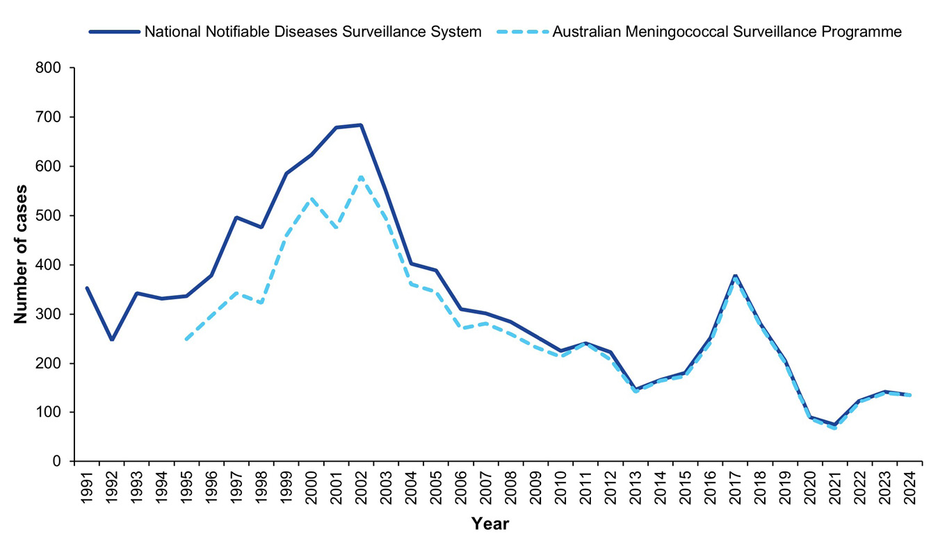
a Source: National Communicable Diseases Surveillance Dashboard. Data extracted on 20 January 2025. https://nindss.health.gov.au/pbi-dashboard/.
Table 1: Laboratory-confirmed cases of invasive meningococcal disease, Australia, 2024 by quarter
IMD serogroup | 1 January – 31 March | 1 April – 30 June | 1 July – 30 September | 1 October – 31 December | 2024  total
B | 16 | 29 | 39 | 25 | 109
C | 0 | 0 | 1 | 0 | 1
W | 1 | 1 | 0 | 0 | 2
Y | 2 | 3 | 7 | 6 | 18
NDª | 2 | 0 | 2 | 2 | 6
Total | 21 | 33 | 49 | 33 | 136
a ND: not determined.

Laboratory diagnosis of IMD
In 2024, a total of 63% of laboratory-confirmed cases were by bacterial culture (86/136) and 37% (50/136) by molecular testing (Table 2) of blood (89/136), CSF (41/136) and joint fluid (6/136).
Table 2: Number of laboratory-confirmed cases of invasive meningococcal disease, Australia, 2024, by specimen type and method of confirmation
Specimen | Bacterial culture | Nucleic acid amplification test | Total
Blood | 68 | 21 | 89
CSF ± blood | 14 | 27 | 41
Joint aspirate | 4 | 2 | 6
Total | 86 | 50 | 136

Notifications by jurisdiction
In 2024, Queensland reported the highest number of IMD notifications nationally (35%; 47/136), followed by South Australia (21%; 29/136) and New South Wales (18%; 24/136). An increase in IMD notifications, both in number and proportionality, was reported in Western Australia from 2023 (5%; 7/140) to 2024 (10%; 14/136); in South Australia from 2023 (14%; 20/140) to 2024 (21%; 29/136); and in Queensland from 2023 (30%; 42/140) to 2024 (35%; 47/136). In 2024, IMD notifications were lower in number and proportion than in 2023 in New South Wales (2024: 18%, 24/136 cf. 2023: 25%, 35/140) and in Victoria (2024: 14%, 19/136 cf. 2023: 19%, 26/140). Notifications of IMD from the Northern Territory and Tasmania remained low in 2024, and there were no notifications from the Australian Capital Territory. Jurisdictional case numbers are shown in Table 3.
Table 3: Number of laboratory-confirmed cases of invasive meningococcal disease, Australia, 2024, by jurisdiction and by serogroup
Jurisdiction | Serogroup
Jurisdiction | B | C | W | Y | NDª | Total
Australian Capital Territory | 0 | 0 | 0 | 0 | 0 | 0
New South Wales | 20 | 0 | 0 | 4 | 0 | 24
Northern Territory | 2 | 0 | 0 | 0 | 0 | 2
Queensland | 36 | 1 | 0 | 5 | 5 | 47
South Australia | 26 | 0 | 0 | 3 | 0 | 29
Tasmania | 1 | 0 | 0 | 0 | 0 | 1
Victoria | 14 | 0 | 0 | 4 | 1 | 19
Western Australia | 10 | 0 | 2 | 2 | 0 | 14
Australia | 109 | 1 | 2 | 18 | 6 | 136
% serogroup, where determined (n = 130) | 83.8 | 0.8 | 1.5 | 13.8 | — | —
a ND: serogroup not determined.
Historically, from 2006 through 2014, the proportion of IMD attributable to MenB ranged from 73 to 84% nationwide, falling to 62% in 2015, and then 37% in 2016–2017. Subsequently, there has been an overall increase in the proportion of IMD attributable to MenB, rising to 44% in 2018, 50% in 2019, and 62% in 2020, with a temporally limited decrease to 52% observed in 2021. From 2022, MenB has accounted for more than 84% of IMD in Australia, and MenB IMD was reported across all age groups in 2024.
MenY accounted for 1–5% IMD in 2000–2010 before increasing to 6–13% in 2011–2015, rising to 16–21% in the years 2016–2021, then decreasing to 10% in 2022 and 8% in 2023 (see Figure 2). In 2024, fourteen percent of IMD (18/130) was MenY in Australia: Queensland (5), New South Wales (4), Victoria (4), South Australia (3) and Western Australia (2).
Figure 2: Proportion of serogroups of laboratory-confirmed invasive meningococcal disease, Australia, 2000 – 2024 by year
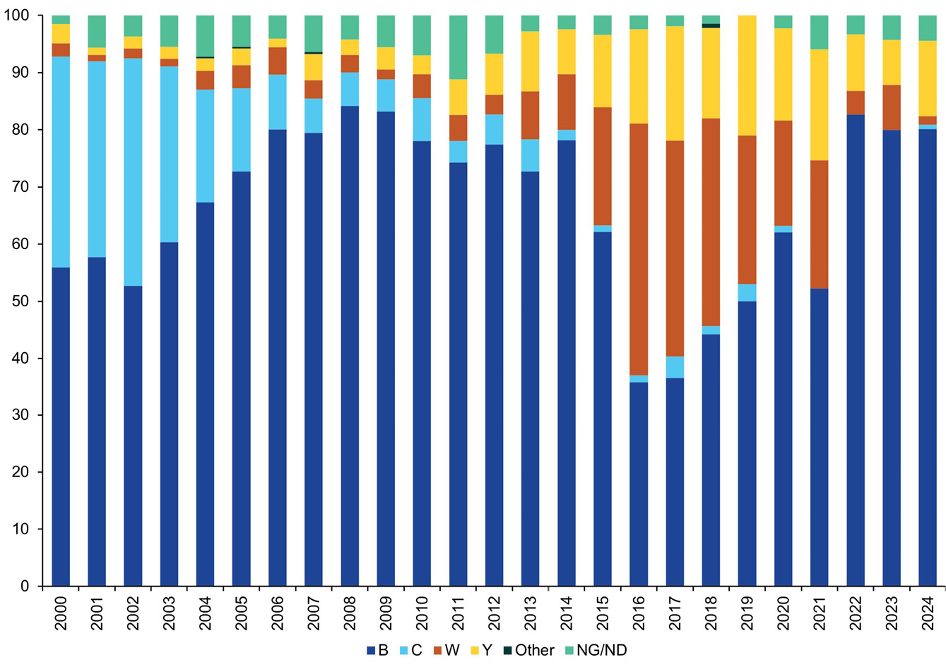
MenW was responsible for a relatively low proportion of IMD prior to 2015 (1–5% in 2000–2012). Increases to 8–10% were observed in 2013–2014, to 21% in 2015, and a peak proportion of 44% observed in 2016; the proportion progressively declined, coincident with vaccination changes, from 36–38% in 2017–2018, to 18–26% in 2019–2021, then 4–8% in 2022–2023 and to 1% in 2024 (Figure 2). MenW IMD (2/130) was only reported from Western Australia in 2024.
In 2024, one MenC IMD was reported from Queensland, the first reported nationally since 2020.
For IMD isolates where a serogroup could not be determined (6/136, 4%), this was due to insufficient DNA concentration available for nucleic acid amplification testing. Of note, there were very few cases of IMD reported from Tasmania (1) and the Northern Territory (2) and none were reported from the Australian Capital Territory (Table 3).

IMD age and serogroup distribution
In 2024, IMD notifications were reported in all age groups. Disease peaks occurred in children less than 5 years of age (27/136 cases; 20%), with 41% of these children (11/27) aged less than one year. A second peak was observed in persons aged 15–24 years, accounting for 28% of laboratory-confirmed cases (38/136). The serogroup was determined for 130/136 cases of IMD (96%). Where the serogroup was determined, in children aged under 5 years, 92% of IMD was MenB (24/26); and in those aged 15–24 years, 94% of IMD was MenB (33/35). Of note, 11–18% of IMD occurred in each of the older age groups reported: in adults 25–44 years (12%; 16/136) and 45–64 years (18%; 25/136), and in those aged 65 years and older (11%: 15/136), with MenB predominating across all age groups, excepting those aged 65 years and older. IMD attributed to MenY was largely reported in those aged 45 years and older (78%; 14/18 of MenY IMD), with sporadic reports in those aged less than 5 years old, 15–19 years and 25–44 years. MenW accounted for two IMD in 2024, involving adults aged 25–44 years and 45–64 years, with both notifications reported from Western Australia. MenC IMD was notified in one case from Queensland, in an adult aged 20–24 years. The serogroup distribution for IMD nationally in 2024 is shown in Table 4 and Figure 3; MenB accounted for 84% (109/130) of IMD overall, and was the majority serogroup in all age groups, except in those aged 65 years and over. MenY IMD accounted for 14 % (18/130) of IMD nationally and occurred sporadically in those aged less than 19 years, and was more commonly observed in adults aged 25 years and older.
Table 4: Laboratory-confirmed cases of invasive meningococcal disease, Australia, 2024, by age and serogroup, and the proportion of IMD attributable to MenB
Serogroup | Age group (years) |  |  |  |  |  |  |  |  | Total
Serogroup | < 1 | 1–4 | 5–9 | 10–14 | 15–19 | 20–24 | 25–44 | 45–64 | 65+ | Total
B | 10 | 14 | 8 | 7 | 23 | 10 | 13 | 17 | 7 | 109
C | 0 | 0 | 0 | 0 | 0 | 1 | 0 | 0 | 0 | 1
W | 0 | 0 | 0 | 0 | 0 | 0 | 1 | 1 | 0 | 2
Y | 1 | 1 | 0 | 0 | 1 | 0 | 1 | 6 | 8 | 18
NDª | 0 | 1 | 0 | 0 | 1 | 2 | 1 | 1 | 0 | 6
Total | 11 | 16 | 8 | 7 | 25 | 13 | 16 | 25 | 15 | 136
% MenB IMD within age group (where a serogroup was determined) | 91% | 93% | 100% | 100% | 96% | 91% | 87% | 71% | 47% | 84%
a ND: serogroup not determined.
Figure 3: Number of serogroup B, C, Y and W cases of laboratory-confirmed invasive meningococcal disease, Australia, 2024, by age
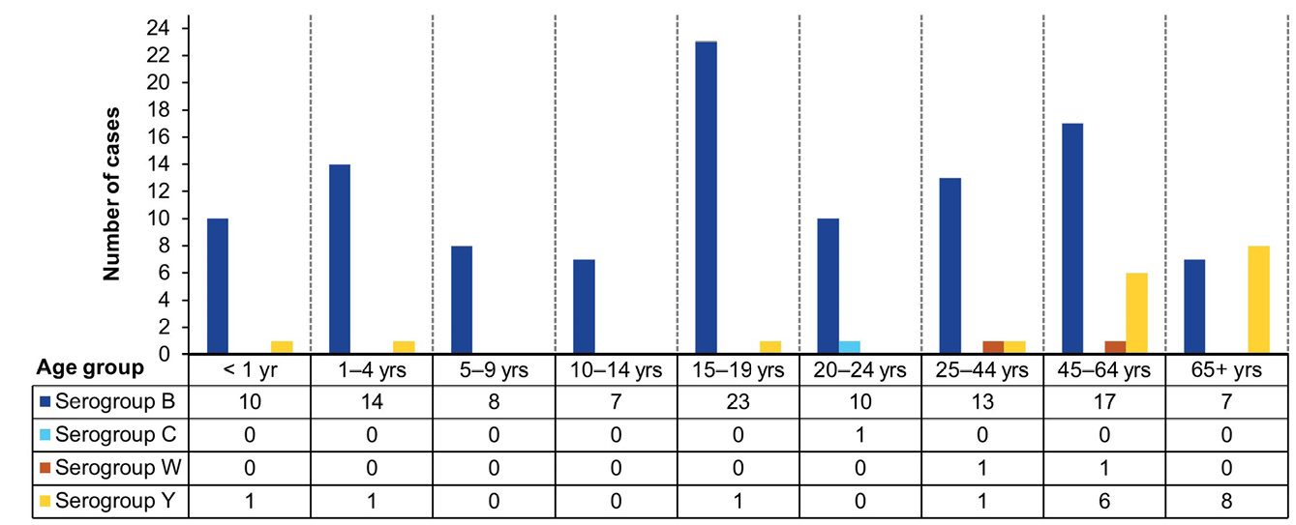

IMD and genotyping
Finetyping was performed on 76 of 109 MenB isolates (70%) and this serogroup showed the greatest variability. There were 21 porA types reported nationally, with one dominant porA type identified: P1.7-2,4 (29/76; 38%), as shown in Figure 4 and Table 5; this was also the dominant MenB porA type detected in 2023 (26/86; 32%). The next most abundant MenB porA type in both 2023 and 2024 was P1.7,16-26, accounting for 11% of finetyped MenB isolates (8/76) in 2024, a reduction from 16% in 2023. In 2024, the porA type B:P1.7-2,4 continues to be notably prevalent in Queensland (48%; 14/29) and South Australia (24%; 7/29); these two jurisdictions together represented 72% (21/29) of national isolates of this porA type.
Of the two MenW isolates reported in 2024, one had finetyping and was a porA type, P1.5,2, MLST (ST)-11 belonging to clonal complex 11 (see Figure 4 and Table 5). This porA type P1.5,2 has been in circulation in recent years and is the same as the hypervirulent serogroup W strain reported in the United Kingdom and South America since 2009.^{10,11}
Of MenY isolates, 15/18 had finetyping, among which six porA types were detected. The porA type P1.5-1,10-1 was the most prevalent (9/15, 60%) (see Figure 4 and Table 5), and, where data was available, was identified as MLST (ST) 1655 from clonal complex 23 (8/9). The porA type P1.5-1,10-1 has remained the predominant MenY genotype circulating in Australia since 2015, marking the year when the increase in serogroup Y IMD was first observed.
Figure 4: The number of porA types represented in serogroup B, W and Y invasive meningococcal disease notifications in Australia in 2024
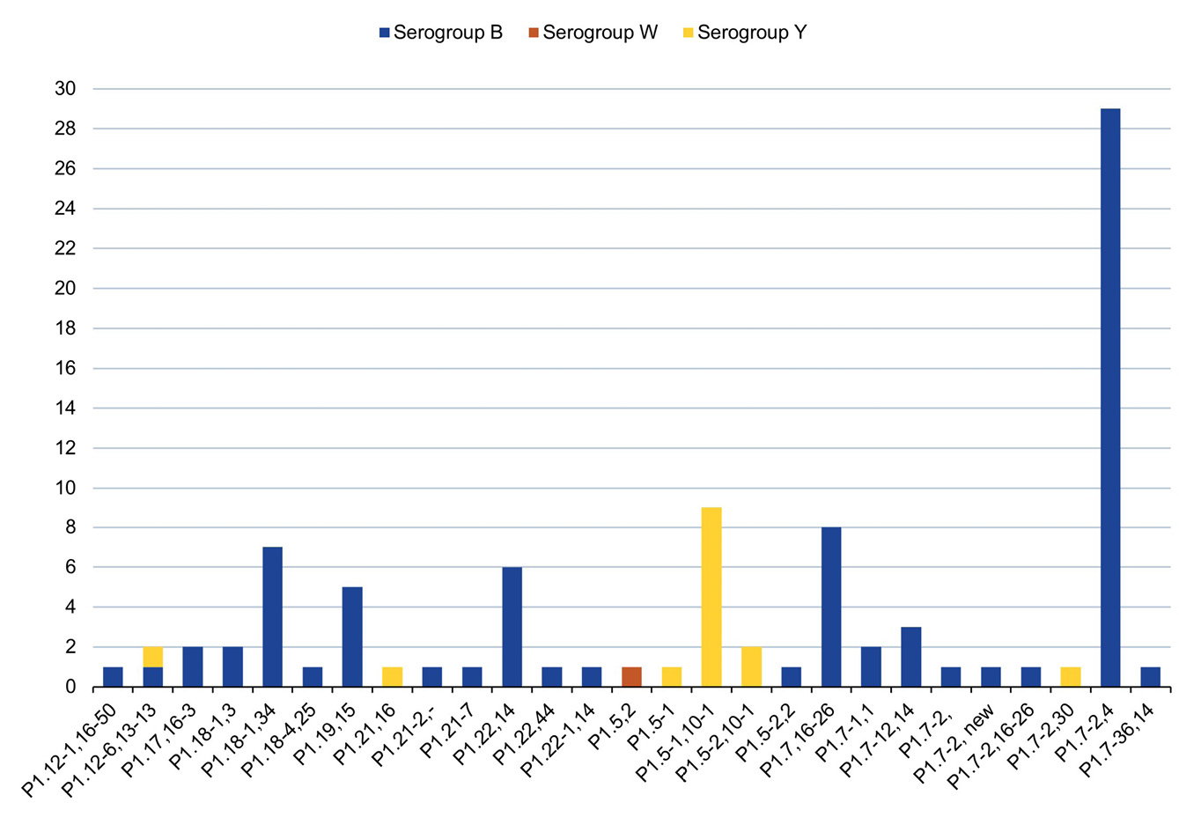
Table 5: Distribution of porA types in isolates of invasive meningococcal disease, Australia, 2024, by state or territory (n = 92/130)
2024 AMSP |  | Number per serogroup per state/territoryª |  |  |  |  |  |  |  | Total
Serogroup | porA types | ACT | NSW | NT | Qld | SA | Tas. | Vic. | WA | Total
B | P1.12-1,16-50 | 0 | 0 | 0 | 0 | 0 | 0 | 1 | 0 | 1
B | P1.12-6,13-13 | 0 | 0 | 0 | 0 | 1 | 0 | 0 | 0 | 1
B | P1.17,16-3 | 0 | 1 | 0 | 1 | 0 | 0 | 0 | 0 | 2
B | P1.18-1,3 | 0 | 1 | 0 | 0 | 0 | 0 | 0 | 1 | 2
B | P1.18-1,34 | 0 | 3 | 1 | 2 | 0 | 1 | 0 | 0 | 7
B | P1.18-4,25 | 0 | 1 | 0 | 0 | 0 | 0 | 0 | 0 | 1
B | P1.19,15 | 0 | 0 | 0 | 5 | 0 | 0 | 0 | 0 | 5
B | P1.21-2,- | 0 | 1 | 0 | 0 | 0 | 0 | 0 | 0 | 1
B | P1.21-7 | 0 | 0 | 0 | 1 | 0 | 0 | 0 | 0 | 1
B | P1.22,14 | 0 | 1 | 0 | 2 | 1 | 0 | 0 | 2 | 6
B | P1.22,44 | 0 | 0 | 0 | 0 | 1 | 0 | 0 | 0 | 1
B | P1.22-1,14 | 0 | 1 | 0 | 0 | 0 | 0 | 0 | 0 | 1
B | P1.5-2,2 | 0 | 0 | 0 | 1 | 0 | 0 | 0 | 0 | 1
B | P1.7,16-26 | 0 | 3 | 0 | 0 | 3 | 0 | 2 | 0 | 8
B | P1.7-1,1 | 0 | 0 | 0 | 1 | 0 | 0 | 1 | 0 | 2
B | P1.7-12,14 | 0 | 0 | 0 | 2 | 0 | 0 | 0 | 1 | 3
B | P1.7-2 | 0 | 0 | 0 | 1 | 0 | 0 | 0 | 0 | 1
B | P1.7-2, new | 0 | 0 | 0 | 0 | 1 | 0 | 0 | 0 | 1
B | P1.7-2,16-26 | 0 | 0 | 0 | 0 | 0 | 0 | 1 | 0 | 1
B | P1.7-2,4 | 0 | 2 | 1 | 14 | 7 | 0 | 3 | 2 | 29
B | P1.7-36,14 | 0 | 0 | 0 | 1 | 0 | 0 | 0 | 0 | 1
W | P1.5,2 | 0 | 0 | 0 | 0 | 0 | 0 | 0 | 1 | 1
Y | P1.12-6,13-13 | 0 | 1 | 0 | 0 | 0 | 0 | 0 | 0 | 1
Y | P1.21,16 | 0 | 1 | 0 | 0 | 0 | 0 | 0 | 0 | 1
Y | P1.5-1 | 0 | 0 | 0 | 1 | 0 | 0 | 0 | 0 | 1
Y | P1.5-1,10-1 | 0 | 1 | 0 | 4 | 0 | 0 | 3 | 1 | 9
Y | P1.5-2,10-1 | 0 | 0 | 0 | 0 | 1 | 0 | 1 | 0 | 2
Y | P1.7-2,30 | 0 | 1 | 0 | 0 | 0 | 0 | 0 | 0 | 1
Totals with typing results |  | 0 | 18 | 2 | 36 | 15 | 1 | 12 | 8 | 92
a ACT: Australian Capital Territory; NSW: New South Wales; NT: Northern Territory; Qld: Queensland; SA: South Australia; Tas.: Tasmania; Vic.: Victoria; WA: Western Australia.

Antimicrobial susceptibility testing
Sixty-three percent of laboratory-confirmed IMD (86/136) had N. meningitidis cultures, permitting AST by NNN laboratories. Ceftriaxone AST was performed on all 86 isolates, with all testing susceptible. The distribution of penicillin MIC values is shown in Table 6. Regarding penicillin, 33% of IMD isolates (28/86) tested susceptible; 60% (52/86) demonstrated intermediate susceptibility; and 7% (6/86) were resistant (Figure 5, Table 6). The proportion of penicillin-resistant isolates in 2024 was lower than that reported in 2023 (9%, 8/90). Of the isolates that tested penicillin-resistant, there were four MenB isolates; one MenC isolate; and one MenW isolate. In recent years, MenW has demonstrated higher penicillin MIC values and higher proportions of resistance. In 2024, there was one resistant MenB isolated from Queensland with a penicillin MIC value of 1.0 mg/L, identified as porA type P1.22,14 and belonging to clonal complex 32. All isolates tested in 2024 were susceptible to ciprofloxacin and rifampicin.
Table 6: Penicillin MIC distribution of laboratory-confirmed invasive meningococcal disease isolates, Australia, 2024
MIC mg/L | Penicillin MIC distribution
MIC mg/L | ≤ 0.032 | 0.064 | 0.125 | 0.25 | 0.5 | 1 | 2 | ≥ 4 | Total
Number of isolates | 12 | 16 | 23 | 29 | 5 | 1 | 0 | 0 | 86
% | 14% | 19% | 27% | 34% | 6% | 1% | 0% | 0% | 100%
Figure 5: Proportion of invasive meningococcal disease isolates with susceptibility (S), intermediate susceptibility (I) and resistance (R) to penicillin, Australia in 2021 to 2024⁸
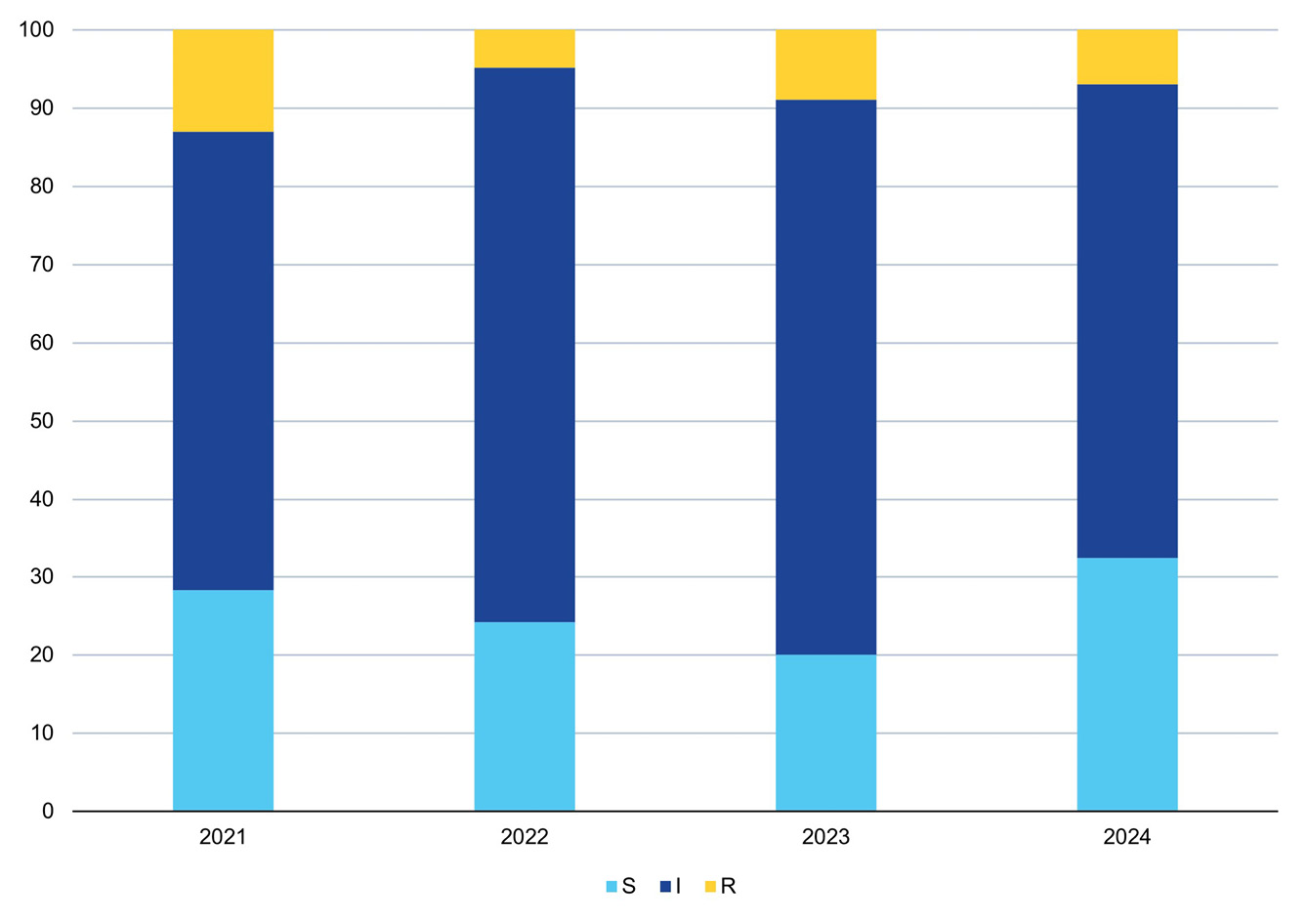

Discussion
In 2024, there were 136 IMD notifications nationally, a 5% decrease from 2023, coincident with changes in the National Immunisation Programme (NIP) to quadrivalent MenACWY vaccine.^{12,13} The reports of the AMSP also suggest that the NIP has had an impact on the prevailing serogroup in IMD:³ from 2022, MenB has accounted for more than 84% of IMD in Australia.
In 2024, all IMD notifications in Australia were laboratory-confirmed. The distribution of IMD notifications across jurisdictions was proportionally higher than in 2023 for Queensland (30% to 35%), South Australia (14% to 21%) and Western Australia (5% to 10%), but lower for New South Wales (25% to 18%) and Victoria (19% to 14%). IMD notifications from the Northern Territory and Tasmania remained low, and there were no notifications from the Australian Capital Territory in 2024.
In 2024, IMD notifications were reported in all age groups. By age group, the highest proportions of cases occurred in children less than 5 years of age (27/136 cases; 20%) and in people aged 15–24 years (38/136 cases; 28%), with the proportion in this latter age group more than double the proportion of IMD cases in this age group reported in 2018 (13%). Similarly, the proportion of MenB IMD in the 15–24 years age group has increased from 57% in 2018 to 94% in 2024. In the United Kingdom (UK), following easing of pandemic restrictions, it was observed that IMD serogroup versus age distributions provide evidence that vaccination programmes are maintaining low rates of MenC, MenW and MenY disease.¹⁶ Further, in the UK, low rates of immunity against MenB combined with high transmission of meningococci among young people have resulted in increases in MenB disease, particularly in university students.¹⁴
Finetyping of MenB isolates in 2024 revealed the continued diversity of porA types in Australia, with 21 different MenB porA types identified. There was an increase in the predominant MenB porA genotype (P1.7-2,4) in Australia from 32% (26/82) in 2023 to 38% (29/76) in 2024. The majority of instances of this porA type were detected in Queensland (14/29, 48%) and South Australia (7/29, 24%). The next most prevalent MenB porA type, P1.7,16-26 (reported in NSW, SA and Victoria in 2024) has declined from 16% (13/82) in 2023 to 11% (8/76) in 2024.
In 2024, fourteen percent of IMD (18/130) was attributable to MenY, increasing from 8% (11/134) in 2023, and predominantly affecting adults aged 45 years and above (77%; 14/18). MenY accounted for 25% of notifications (6/24) in individuals aged 45–64 years, and 53% of notifications (8/15) in individuals aged 65 years and greater.
The predominant MenY genotype since 2014 continues to be P1.5-1,10-1, whereas previously the MenY genotype distribution had been more varied.¹⁵ In 2024, of the MenY with typing data available, there were 6 porA types, displaying more heterogeneity than in 2023.
Of note, from 2023 Australia has reported an increased number of urogenital and anorectal infections with MenY ST-1466. The majority of infections were from New South Wales, but cases have also been reported from South Australia and Victoria; genomic analysis shows limited sequence diversity and is indicative of a multijurisdictional outbreak.¹⁶ Urogenital and anorectal meningococcal infections continue to be reported, but the true incidence remains unknown due to varied testing and reporting practices within and across jurisdictions in Australia. Concurrently an outbreak of MenY ST-1466 IMD was reported in the United States of America (USA), with an increase in the number and proportion of MenY IMD cases overall, compared to the previous year, and 68% of 2024 MenY cases (101/148) identified as ST-1466.¹⁷ To assess relatedness, and to examine for genomic changes associated with meningococcal adaptation, the MenY ST-1466 sequences from the urogenital outbreak in Australia and those from the MenY ST-1466 IMD isolates from the USA were compared in the global context.¹⁸ The Australian isolates’ MenY ST-1466 sequences formed a distinct clade, most closely related genomically to recent USA IMD MenY ST-1466 isolates. No specific genomic changes suggested niche adaptation or associated clinical manifestations.¹⁸ The MenY ST1466 N. meningitidis isolates circulating in Australia and the USA are capable of causing both urethritis and IMD.¹⁸ In 2024 there was one MenY ST-1466 IMD isolate reported from NSW.
MenW IMD continued to decline, from 38% of IMD in 2017 to 1.5% (2/130) in 2024. These two cases were reported in the 25–44 and 45–64 year age groups. One MenW IMD isolate in 2024 had genotyping data available: porA type P1.5,2, MLST (ST) 11, clonal complex 11. This strain emerged in the UK and South America in 2009, is hypervirulent and associated with atypical clinical presentations, more severe disease, and a higher case fatality rate.^{10,11} The initial increase in MenW both overseas and in Australia was reported in older adults but subsequently was reported across all ages, particularly in adolescents and infants.¹⁵
Whole genome sequencing (WGS) continues to be a useful tool in both surveillance and outbreak settings. Although tools have been developed to predict vaccine escape from genomic data, these should not be seen as definitive, due to several limitations including the inability to take into account synergistic effects of multiple antigens.
Antimicrobial susceptibility testing of IMD isolates in 2024 detected 7% (6/86) penicillin resistance (MIC values ≥ 0.5 mg/L). All IMD isolates tested in 2024 were susceptible to ceftriaxone, ciprofloxacin and rifampicin. There are reports from the USA of increased notifications of IMD caused by ciprofloxacin-resistant strains since 2019 in some jurisdictions, and this has required a change in recommended prophylactic agents in some areas.¹⁹ Since January 2023, ciprofloxacin-resistant N. meningitidis has been notifiable to the National Alert System for Critical Antimicrobial Resistances (CARAlert), a component of the Antimicrobial Use and Resistance in Australia (AURA) Surveillance System.⁹
In 2024, the key findings of the AMSP Annual Report include a 5% decrease in IMD notifications nationally; continued predominance of MenB disease; and an increase in MenY IMD disease. Notifications of IMD, all MenB, in adolescents and young people have doubled since 2019. Reports of urogenital MenY ST-1466 continue in Australia, coincident with a MenY ST-1466 IMD outbreak in the USA. One case of MenY ST-1466 IMD was reported in Australia in 2024. The NNN is continuing to lead further investigations in collaboration with the Australian Government Department of Health, Disability and Ageing, closely monitoring the phenotypic and genotypic features of N. meningitidis causing IMD in Australia, including AMR. Additional investigations by the NNN, including whole genome sequencing of IMD isolates, are underway to enhance IMD surveillance in Australia. The AMSP data are utilized for informing treatment guidelines and disease prevention strategies; and to monitor the effects of interventions.

Acknowledgments
Meningococcal isolates were received in the reference centres from many laboratories throughout Australia. The considerable time and effort involved in forwarding these isolates is recognised and these efforts are greatly appreciated. These data could not have been provided without this assistance and the help of clinical colleagues and public health personnel. The Australian Government Department of Health, Disability and Ageing provided funding for the National Neisseria Network.
Members of the AMSP in 2024, to whom isolates and samples should be referred, and enquiries directed, are listed below.
Australian Capital Territory
K Kennedy, S Bradbury, C O’Brien and M McKeown
Microbiology Department, The Canberra Hospital, Gilmore Crescent, Garran ACT 2605
Telephone: +61 2 5124 2510
Facsimile: +61 2 5124 4646
Email: karina.kennedy@act.gov.au
New South Wales
MM Lahra, EA Limnios, TR Hogan, RL Kundu, and J, Bastakoti
Microbiology Department, New South Wales Health Pathology, The Prince of Wales Hospital, Barker Street, Randwick NSW 2031
Telephone: +61 2 9382 3689
Facsimile: +61 2 9382 3719
Email: monica.lahra@health.nsw.gov.au
M Maley, K Thapa, Y Kwok
Department of Microbiology and Infectious Diseases, New South Wales Health Pathology, Liverpool Hospital, Liverpool NSW 2170
Telephone: +61 8738 5124
Facsimile: +61 2 8738 5129
Email: Michael.maley@health.nsw.gov.au
Northern Territory
R Baird, K Freeman
Microbiology Department, Territory Pathology, Royal Darwin Hospital, Rocklands Drive, Tiwi NT 0810
Telephone: +61 8 8922 8685
Facsimile: +61 8 8922 7788
Email: rob.baird@nt.gov.au
Queensland
S Schlebusch, R Graham, A Jennison and K Le
Public Health Microbiology, Queensland Health Forensic and Scientific Services, 39 Kessels Road, Coopers Plains Qld 4108
Telephone: +61 7 3096 2919
Facsimile: +61 7 3096 2973, +61 7 3274 9175
Email: Amy.Jennison@health.qld.gov.au
South Australia
M Warner, L Leong, M Hodgson
SA Pathology, Royal Adelaide Hospital Site, Microbiology and Infectious Diseases, Royal Adelaide Hospital, North Terrace, Adelaide, SA 5000
Telephone: +61 8 8222 3382
Facsimile: +61 8 222 3543
Email: Lex.Leong@sa.gov.au
Tasmania
L Cooley, B McEwan
Department of Microbiology and Infectious Diseases, Royal Hobart Hospital, 48 Liverpool Street, Hobart Tasmania 7000
Telephone: +61 3 6166 8417
Email: belinda.mcewan@ths.tas.gov.au
Victoria
B Howden, P Roydhouse, S. Tawil, M Sait
Microbiological Diagnostic Unit Public Health Laboratory, Department of Microbiology and Immunology, The Peter Doherty Institute, 792 Elizabeth Street, Melbourne, Victoria 3000
Telephone: +61 3 8344 5713
Facsimile: +61 3 8344 7833
Email: kerries@unimelb.edu.au
Western Australia
D Speers, R Ferdinand
Department of Microbiology, QEII Medical Centre, PP Block Level 5, PathWest Laboratory Medicine, Hospital Avenue, Nedlands, WA 6009
Telephone: +61 8 6383 4501
Facsimile: +61 8 9382 8046
Email: Rebecca.Ferdinand@health.wa.gov.au

Author details
Monica M Lahra^{1,2}
Siobhan M Hurley¹
C R Robert George³
Sebastiaan J van Hal^{4,5}
Tiffany R Hogan¹
- NSW Health Pathology World Health Organisation Collaborating Centre for STI and AMR, Sydney and Neisseria Reference Laboratory, Department of Microbiology, The Prince of Wales Hospital, Randwick, 2031, NSW Australia
- School of Medical Sciences, Faculty of Medicine, The University of New South Wales, NSW, 2052 Australia
- NSW Health Pathology, John Hunter Hospital, Newcastle, 2300, NSW Australia
- NSW Health Pathology, Microbiology, Royal Prince Alfred Hospital Camperdown, NSW, Australia
- School of Medicine, University of Sydney

Corresponding author
Professor Monica M. Lahra
Director, Microbiology Department Neisseria Reference Laboratory and
WHO Collaborating Centre for STI and AMR,
NSW Health Pathology, Level 4, Campus Centre, The Prince of Wales Hospital, Randwick NSW, 2031
Telephone: +61 2 9382 3689
Facsimile: +61 2 9382 3719
Email: monica.lahra@health.nsw.gov.au

References
- National Neisseria Network. Meningococcal Isolate Surveillance Australia 1994. Commun Dis Intell. 1995;19(12):286–9.
- Australian Government Department of Health, Disability and Ageing. National Notifiable Diseases Surveillance System (NNDSS) data visualisation tool. [Webpage.] Canberra: Australian Government Department of Health, Disability and Ageing; 14 December 2022. [Accessed on 20 January 2025.] Available from: https://www.health.gov.au/resources/apps-and-tools/national-notifiable-diseases-surveillance-system-nndss-data-visualisation-tool.
- George CR, Booy R, Nissen MD, Lahra MM. The decline of invasive meningococcal disease and influenza in the time of COVID-19: the silver linings of the pandemic playbook. Med J Aust. 2022. doi: https://doi.org/10.5694/mja2.51463.
- National Notifiable Diseases Surveillance System (NNDSS). Number of notifications of Meningococcal disease (invasive), received from State and Territory health authorities in the period of 1991 to 2012 and year-to-date notifications for 2014–2021. [Accessed on 20 January 2025.] Available from: http://www9.health.gov.au/cda/source/rpt_4_sel.cfm.
- Australian Government Department of Health, Disability and Ageing. Invasive meningococcal disease. [Internet.] Canberra: Australian Government Department of Health, Disability and Ageing; 12 July 2022. [Accessed on 20 January 2025.] Available from: https://www.health.gov.au/internet/main/publishing.nsf/Content/ohp-meningococcal-W.htm.
- Australian Government Department of Health, Disability and Ageing, Communicable Diseases Network Australia (CDNA). Invasive Meningococcal Disease: CDNA National Guidelines for Public Health Units. Canberra: Australian Government Department of Health, Disability and Ageing; July 2024. [Accessed on 20 January 2025.] Available from: https://www.health.gov.au/sites/default/files/2024-07/invasive-meningococcal-disease-cdna-national-guidelines-for-public-health-units.pdf.
- George CRR, Smith HV, Lahra MM. Neisseria meningitidis. In de Filippis I, ed. Molecular Typing in Bacterial Infections, Volume I. London: Springer International Publishing, Springer Cham, 2022;85–99.
- Clinical and Laboratory Standards Institute (CLSI). Performance standards for antimicrobial susceptibility testing. 34th ed. CLSI supplement M100. Wayne, PA: CLSI; 2024.
- Australian Commission on Safety and Quality in Health Care (ACSQHC). National Alert System for Critical Antimicrobial Resistances (CARAlert). [Internet.] Sydney: ACSQHC; 23 Apr 2024. Available from: https://www.safetyandquality.gov.au/our-work/antimicrobial-resistance/antimicrobial-use-and-resistance-australia-aura/hospital-and-community-antimicrobial-resistance/national-alert-system-critical-antimicrobial-resistances-caralert.
- Abad R, López EL, Debbag R, Vázquez JA. Serogroup W meningococcal disease: global spread and current affect on the Southern Cone in Latin America. Epidemiol Infect. 2014;142(12):2461–70. doi: https://doi.org/10.1017/S0950268814001149.
- Ladhani SN, Beebeejaun K, Lucidarme J, Campbell H, Gray S, Kaczmarski E et al. Increase in endemic Neisseria meningitidis capsular group W sequence type 11 complex associated with severe invasive disease in England and Wales. Clin Infect Dis. 2015;60(4):578–85. doi: https://doi.org/10.1093/cid/ciu881.
- Australian Government Department of Health, Disability and Ageing. Immunise Australia Program. Meningococcal Disease. [Internet.] Canberra: Australian Government Department of Health, Disability and Ageing; 20 April 2015. Available from: https://www.health.gov.au/internet/immunise/publishing.nsf/Content/immunise-meningococcal.
- Chiu C, Dey A, Wang H, Menzies R, Deeks S, Mahajan D et al. Vaccine preventable diseases in Australia, 2005 to 2007. Commun Dis Intell Q Rep. 2010;34(Suppl):S1–167. doi: https://doi.org/10.33321/cdi.2010.34.48.
- Clark S, Campbell H, Mensah AA, Lekshmi A, Walker A, Ribeiro S et al. An increase in group B invasive meningococcal disease among adolescents and young adults in England following easing of COVID-19 containment measures. [Online preprint.] Amsterdam: Elsevier, Social Science Research Network (SSRN); 8 January 2022. doi: https://doi.org/10.2139/ssrn.3998164.
- Bröker M, Jacobsson S, Kuusi M, Pace D, Simões MJ, Skoczynska A et al. Meningococcal serogroup Y emergence in Europe: update 2011. Hum Vaccin Immunother. 2012;8(12):1907–11. doi: https://doi.org/10.4161/hv.21794.
- Lahra MM, Latham NH, Templeton DJ, Read P, Carmody C, Ryder N et al. Investigation and response to an outbreak of Neisseria meningitidis serogroup Y ST-1466 urogenital infections, Australia. Commun Dis Intell (2018). 2024;48. doi: https://doi.org/10.33321/cdi.2024.48.20.
- Health Alert Network. Increase in invasive serogroup Y meningococcal disease in the United States. [Online health advisory.] Atlanta: United States Government Department of Health and Human Resources, Centers for Disease Control and Prevention (CDC), CDC Health Alert Network; 28 March 2024. [Accessed on 31 March 2024.] Available from: https://emergency.cdc.gov/han/2024/han00505.asp.
- van Hal SJ, Le T, Jenkins F, Kundu RL, Limnios EA, McNamara LA et al. Neisseria meningitidis serogroup Y sequence type 1466 and urogenital infections. Emerg Infect Dis. 2025;31(1):86–93. doi: https://doi.org/10.3201/eid3101.240940.
- Berry I, Rubis AB, Howie RL, Sharma S, Marasini D, Marjuki H et al. Selection of antibiotics as prophylaxis for close contacts of patients with meningococcal disease in areas with ciprofloxacin resistance — United States, 2024. MMWR Morb Mortal Wkly Rep. 2024;73(5):99–103. doi: http://dx.doi.org/10.15585/mmwr.mm7305a2.

