
2025 • Volume 49 • cdc.gov.au/cdi • Epub date: 22.10.2025 • doi.org/10.33321/cdi.2025.49.050

Creutzfeldt-Jakob disease surveillance in Australia: update to 31 December 2024
Christiane Stehmann, Matteo Senesi, Shannon Sarros, Amelia McGlade, Victoria Lewis, Priscilla Agustina, Daniel Barber, Genevieve Klug, Sarah Holper, Catriona McLean, Colin L Masters, Steven Collins
© 2025 Commonwealth of Australia as represented by the Department of Health, Disability and Ageing
ISSN: 2209-6051 Online
This journal is indexed by Index Medicus and Medline.
Creative Commons Licence
This publication is licensed under a Creative Commons Attribution-NonCommercial-NoDerivatives 4.0 International Licence (Licence). You must read and understand the Licence before using any material from this publication.
Restrictions
The Licence does not cover, and there is no permission given for, use of any of the following material found in this publication (if any):
- the Commonwealth Coat of Arms (by way of information, the terms under which the Coat of Arms may be used can be found on the Department of Prime Minister and Cabinet website;
- any logos (including the interim Australian Centre for Disease Control and the Department of Health, Disability and Ageing’s logos) and trademarks;
- any photographs and images;
- any signatures; and
- any material belonging to third parties.
Disclaimer
Opinions expressed in Communicable Diseases Intelligence are those of the authors and not necessarily those of the Australian Government, the interim Australian Centre for Disease Control or the Department of Health, Disability and Ageing. Data may be subject to revision.
Enquiries
Enquiries regarding any other use of this publication should be addressed to the CDI Editor.
About CDI
Communicable Diseases Intelligence (CDI) is a peer-reviewed scientific journal published by the interim Australian Centre for Disease Control within the Department of Health, Disability and Ageing.
The journal aims to disseminate information on the epidemiology, surveillance, prevention and control of communicable diseases of relevance to Australia and the near region.
Editor: Christina Bareja • Deputy Editor: Simon Petrie • Design and Production: Lisa Thompson
Editorial Advisory Board: David Durrheim, Mark Ferson, Clare Huppatz, John Kaldor, Martyn Kirk and Meru Sheel
Submit an Article
Guidelines for authors and details on how to submit your publication is available on our website, or by email to the
CDI Editor.
Contact us
Communicable Diseases Intelligence (CDI)
interim Australian Centre for Disease Control, Department of Health, Disability and Ageing
GPO Box 9848, CANBERRA ACT 2601
Website: cdc.gov.au/cdi
Email: cdi.editor@health.gov.au

Contents
Abstract 4
Introduction 5
Surveillance methods 7
Results 9
Discussion 15
Acknowledgments 17
Author details 18
References 19
Appendix A 21
EUROCJD diagnostic criteria for surveillance of sporadic CJD from 1 January 2017 21

Abstract
Nationwide surveillance of Creutzfeldt-Jakob disease (CJD) and other human prion diseases is performed by the Australian National Creutzfeldt-Jakob Disease Registry (ANCJDR). National surveillance encompasses the period since 1 January 1970, with prospective surveillance occurring from 1 October 1993. Over this prospective surveillance period, considerable improvements have been developed in pre-mortem diagnostics; in the delineation of new disease subtypes; and in heightened awareness of prion diseases in healthcare settings. Surveillance practices of the ANCJDR have evolved and adapted accordingly. This report summarises the activities of the ANCJDR during 2024.
Since the ANCJDR began offering diagnostic cerebrospinal fluid (CSF) 14-3-3 protein testing in Australia in September 1997, the annual number of referrals has steadily increased. In 2024, a total of 760 domestic CSF specimens were referred for diagnostic testing and 88 persons with suspected human prion disease were formally added to the national register. As of 31 December 2024, approximately half (42) of the 83 initial case notifications for 2024 remain classified as ‘incomplete’; 21 cases were classified as ‘definite’ and 17 as ‘probable’ prion disease; three cases were excluded through neuropathological examination. For 2024, seventy-two percent of all suspected human-prion-disease-related deaths in Australia underwent neuropathological examination. No cases of variant or iatrogenic CJD were identified in Australia during 2024.
Keywords: Creutzfeldt-Jakob disease; prion disease; transmissible spongiform encephalopathy; disease surveillance

Introduction
Of the human prion diseases (also known as transmissible spongiform encephalopathies), the most common phenotype is Creutzfeldt-Jakob disease (CJD). As described previously,¹ human prion disease mostly arises sporadically (~85%) but can occur through person-to-person transmission or from a genetic aetiology due to pathogenic sequence variations in the prion protein gene (PRNP). The Australian National Creutzfeldt-Jakob Disease Registry (ANCJDR) was established in 1993 as part of the response to four people dying from CJD related to fertility treatment utilising cadaveric pituitary hormones. In the following year, the Allars inquiry² released its findings into the use of cadaver-derived pituitary hormones under the Australian Human Pituitary Hormone Program and the association with four medically-acquired (iatrogenic) CJD (iCJD) deaths, recommending a broadening of the responsibilities of the then nascent ANCJDR. In addition to monitoring for further cases of iCJD in Australia, related to cadaveric pituitary hormone treatment for infertility or short stature and contaminated dura mater grafts, the ANCJDR’s activities have evolved to encompass the surveillance of all types of CJD, including sporadic, genetic and variant CJD (vCJD: the zoonosis related to bovine spongiform encephalopathy [BSE]), as well as other prion diseases such as Gerstmann-Sträussler-Scheinker syndrome and fatal sporadic or familial insomnia. Human prion disease became a notifiable disease in all states and territories of Australia as of June 2006.
Initial case awareness at the ANCJDR mostly arises through diagnostic testing requests; this occurs prior to Health Department notification. After a preliminary review of referred cases, those deemed to be genuine suspected human prion disease undergo further detailed evaluation and formal addition to the national surveillance register, to determine whether a case can be excluded from suspicion or can be classified as ‘definite’, ‘probable’ or ‘possible’ prion disease according to diagnostic criteria endorsed by the Creutzfeldt-Jakob Disease International Surveillance Network (colloquially EUROCJD) and to determine the aetiology of the illness.³
The incidence of sporadic CJD (sCJD) is commonly reported to be approximately one case per million per year; however, in most countries with longstanding national surveillance systems in place, annual incidence rates have been consistently reported above this quoted figure.⁴ A multi-national surveillance study showed that intensity of surveillance correlates with reported incidence rates.⁵ Temporally, human prion disease incidence rates have increased in most countries, including Australia, as surveillance mechanisms have been optimised and diagnostic testing capabilities improved, in parallel with a generally greater awareness of this rare disease in the healthcare setting.
In this report, updated national surveillance figures to 31 December 2024 are provided for all retrospective (to 1970) and prospective (from 1993) cases ascertained (Table 1), including a discussion on case notifications, classifications and overall incidence.
Table 1: Overall summary of Australian human prion disease, 1 January 1970 to 31 December 2024
Classification | Sporadic | Familial | Iatrogenic | Variant CJD | Unclassified/ indeterminate | Total
Definite | 785 | 76 | 5ª | 0 | 0 | 865
Probable | 509 | 40 | 4 | 0 | 0 | 553
Possible | 15 | 2 | 1 | 0 | 0 | 18
Incomplete |  | 9 | 0 | 0 | 199 | 208
Total | 1,309 | 127 | 9 | 0 | 199 | 1,644
a Includes one definite iatrogenic case who received pituitary hormone treatment in Australia, but disease onset and death occurred while a resident of the United Kingdom. This case is not included in statistical analysis since morbidity and mortality did not occur within Australia.

Surveillance methods
Patients with suspected human prion disease have been prospectively notified to the ANCJDR since October 1993. From 1997, suspected cases have been increasingly notified through referral for diagnostic cerebrospinal fluid (CSF) biomarker (especially 14-3-3 protein) testing, which has over time become the predominant source of initial ANCJDR awareness of suspected CJD cases. Other ascertainment mechanisms include, or have included, personal communications from clinicians, families, hospitals and CJD-related groups, as well as health record searches through hospitals and health departments.
Once referred to the ANCJDR, referrals undergo a prima facie assessment and, if the suspicion of prion disease is supported, the case is notified to the appropriate health department and added to the ANCJDR register as a formal ‘suspected case’ for continued surveillance and evaluation with the aim of exclusion or classification according to EUROCJD-endorsed diagnostic criteria. Investigation of registered cases can be prolonged, as the ANCJDR requires next-of-kin consent to access and compile the appropriate clinical information from various health information sources to facilitate a comprehensive review. Response times can vary, as the information can be extensive or sources numerous. Medico-demographic questionnaires are offered and forwarded to families, if they are willing to contribute, providing valuable information for analysis and evaluation.
Classification of registered cases remains as ‘incomplete’ until all known available information is gathered and reviewed, or until a definitive result from neuropathological assessment is obtained. Cases may be excluded from the register based on neuropathological examination or after thorough clinical evaluation. A ‘definite’ classification requires brain neuropathological examination, including immunochemical analysis; ‘probable’ and ‘possible’ cases are reliant on a specific clinical profile and diagnostic test outcomes as previously described.³ As of 1 January 2017, the diagnostic criteria for ‘probable sCJD’ were amended to include a positive result in the real-time quaking-induced conversion (RT-QuIC) assay using CSF or other tissues in a person with a progressive neurological syndrome. The updated EUROCJD diagnostic criteria for surveillance of sCJD are listed in Appendix A. In keeping with previous reports, the total number of confirmed prion disease cases for 2024 included in the statistical analyses are those that have been classified as ‘definite’ or ‘probable’ cases.
To support surveillance responsibilities, the ANCJDR provides diagnostic platforms for ante- and post-mortem testing for human prion diseases. The testing of CSF for the presence of a family of low-molecular-weight proteins (14-3-3) has been performed weekly by the ANCJDR since 1997. This test has been readily utilised by clinicians. In 2023, the ANCJDR replaced the semi-quantitative 14-3-3 protein western blot analysis with a more accurate and quantitative technology, estimation of 14-3-3 protein concentrations using an Enzyme Linked Immunosorbent Assay (ELISA) (certified by the National Association of Testing Authorities [NATA]/International Laboratory Accreditation Cooperation [ILAC]).⁶ Since 2021, the RT-QuIC assay has been routinely performed by ANCJDR on all CSF specimens referred for diagnostic testing. This diagnostic platform is also NATA/ILAC certified. The ANCJDR also undertakes western blot analysis for misfolded, protease-resistant prion protein in brain and tonsil tissue from biopsies or autopsies for supplementary immunochemical assessments, as required for diagnostic and sub-classification purposes. The ANCJDR recently developed RT-QuIC assays using frozen and fixed brain tissue, which confirms minute amounts of PrP^{Sc} seeding, to aid the classification of complex cases. PRNP testing for sequence variations in the open reading frame, particularly for proven disease-causing mutations, is performed by an external independent provider as appropriate. Upon request, the ANCJDR performs DNA extractions from frozen post-mortem brain tissue, which can be used for PRNP testing. The ANCJDR actively promotes all diagnostic tests to clinicians and families to achieve the most accurate diagnosis and classification of persons suspected to suffer from prion disease.
Annual human prion disease incidence rates are calculated using direct age-standardisation, based on the 1970–2024 Australian Bureau of Statistics estimated resident population data for Australia and for each state and territory. Health information is collected through a combination of public health and surveillance responsibilities, based on the national notification of communicable diseases in observance of the National Health Security Act 2007 and Privacy Act 1988 (Cth) 16B. ANCJDR surveillance activities for 2024 were approved by the University of Melbourne Human Research Ethics Committee (#20361).

Results
In 2024, the ANCJDR received 760 domestic CSF specimens for diagnostic testing. This number reflects a continuing positive trend in annual CSF referral numbers and represents an increased awareness and perceived utility of CSF diagnostic testing by clinicians (Figure 1). In 2024, non-domestic CSF referrals made up 5% of the total diagnostic CSF specimens received by the ANCJDR; the total number of non-domestic CSF test referrals has also steadily increased over time. The majority of domestic CSF referrals comes from the most populous states, in which there has been a noticeable steady increase in test referrals, while CSF referrals from the Australian Capital Territory, the Northern Territory and Tasmania have remained relatively unchanged. Notably, diagnostic test referrals from New South Wales have increased more rapidly over the last decade than those from all other states, increasing from an average referral rate of 12/million/year (1997–2012) to 25/million/year (2013–2024). The national average CSF referral rate for the period of 1997–2024 is 15/million/year; the Northern Territory has the lowest rate of CSF referrals (4/million/year), while all other states range between 11/million/year (Western Australia) to 17/million/year (Tasmania).
Figure 1: Annual number of CSF specimens referred to the ANCJDR for diagnostic testing, from 1997 to 2024
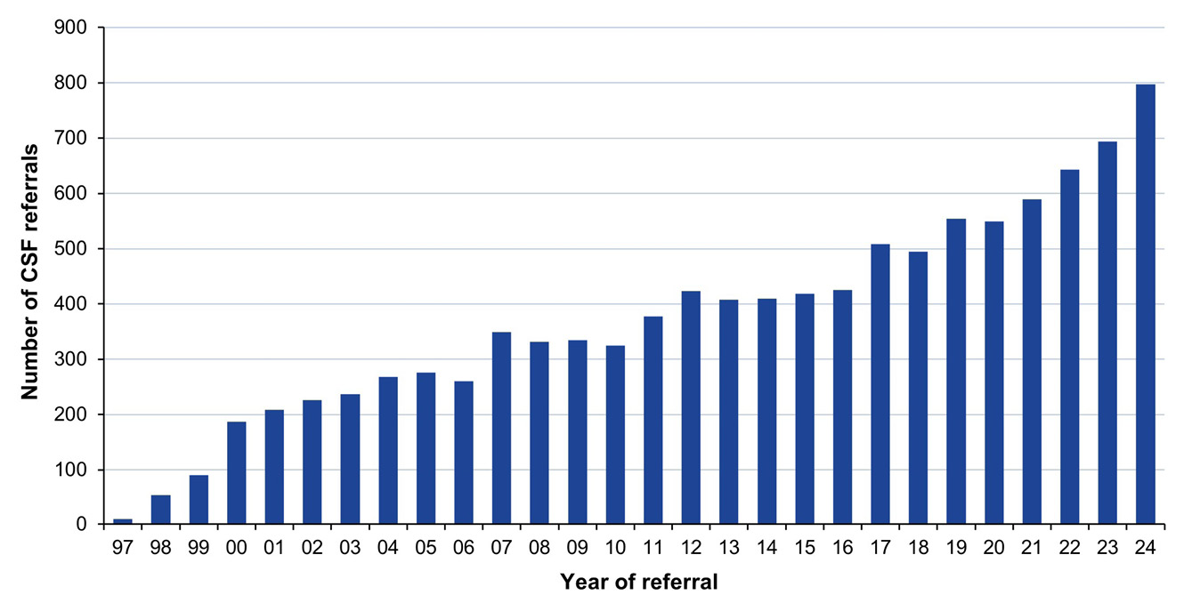
During 2024, eighty-eight persons with suspected human prion disease were formally added to the national CJD surveillance register following prima facie review. Of these, five cases were known to the ANCJDR prior to 2024 through CSF referrals (2), treating clinicians (2) or the CJD Support Group Network (1). At the time of their initial notification in 2021 and 2023, these cases were not added to the register due to a low level of suspicion for prion disease after initial case review. Further information ascertained in 2024 increased the likelihood of prion disease, resulting in their formal notification and the addition of the cases to the register. These five cases therefore contribute to the total numbers of suspect case notifications arising in 2021 and 2023.
The remaining 83 suspected cases for 2024 were initially notified via: request for CSF diagnostic testing (49 cases); communications from clinicians (22 cases); the CJD Support Group Network (7 cases); neuropathology services (3 cases); and health departments (2 cases). While there is still a predominance of initial case awareness through referrals for CSF diagnostic testing, there has been in recent years a noticeable increase in case notifications through treating clinicians, neuropathologists, health departments and families seeking expert advice and guidance from the ANCJDR. Some previous proactive ANCJDR surveillance mechanisms (e.g. mortality database searches and reply-paid mailouts to clinicians) have been discontinued over time due to human resource constraints.
The number of suspected cases added to the ANCJDR register in 2024 follows the trend of increasing case notification rates. The average annual number of prospective, formal suspect prion disease cases notified to the ANCJDR for the period 1997–2024 (i.e. since the introduction of diagnostic testing of CSF) is 74. States and territories exhibited modest fluctuations in the annual number of suspect case notifications for 2024, compared to both the previous year and the longer-term average (Table 2).
Table 2: ‘Definite’ and ‘probable’ cases of human prion disease from 1993 to 2024, by year and state or territory
Jurisdiction^{b} | 2024ª |  | 1993–2024
Jurisdiction^{b} | Cases | ASMR^{c} (dths/mill/yr) | Total cases | Long term average cases | Average ASMR (dths/mill/yr)
ACT | 1 | 1.27 | 18 | 0.6 | 1.28
NSW | 18 | 1.79 | 383 | 12.0 | 1.48
NT | 0 | 0 | 7 | 0.2 | 0.72
Qld | 11 | 1.56 | 213 | 6.7 | 1.27
SA | 3 | 1.38 | 103 | 3.2 | 1.72
Tas. | 2 | 2.17 | 27 | 0.8 | 1.23
Vic. | 10 | 1.30 | 304 | 9.5 | 1.60
WA | 4 | 0.89 | 150 | 4.7 | 1.77
Australia | 49 | 1.49 | 1,205 | 37.7 | 1.50
a The figures for 2024 are provisional and almost certainly an underestimate, as 18 neuropathology reports are pending.
b ACT: Australian Capital Territory; NSW: New South Wales; NT: Northern Territory; Qld: Queensland; SA: South Australia; Tas.: Tasmania; Vic.: Victoria; WA: Western Australia.
c ASMR: age-standardised mortality rate, in deaths per million population per year.
Of the 83 formal suspect case notifications added for 2024, there were 21 cases confirmed as ‘definite’ by neuropathological examination and 17 cases were classified as ‘probable’ following detailed review of clinical information. Three cases were confirmed as non-prion disease following neuropathological assessment, while 26 cases were still alive and considered ‘incomplete’ at the end of 2024; neuropathology reports were pending for 16 deceased suspected cases. It is typical for several months to elapse between performance of a post-mortem and completion of the neuropathology report.
Since 1993, there has been an overall positive trend in the annual number of suspected cases of human prion disease undergoing post-mortem brain examination, or less commonly brain biopsies, albeit with relative plateauing over the last 15 years; beginning with twelve such cases in 1993 and increasing to between 30 and 50 brain autopsy referrals per year for the period from 2005 to 2024 (Figure 2). In 2024, of the 72 suspected CJD case deaths, 52 were referred for a brain post-mortem examination.
Figure 2: Number of brain-only post-mortem (PM) examinations and brain biopsies (BBx) completed relative to suspect case deaths from 1993 to 2024, by year
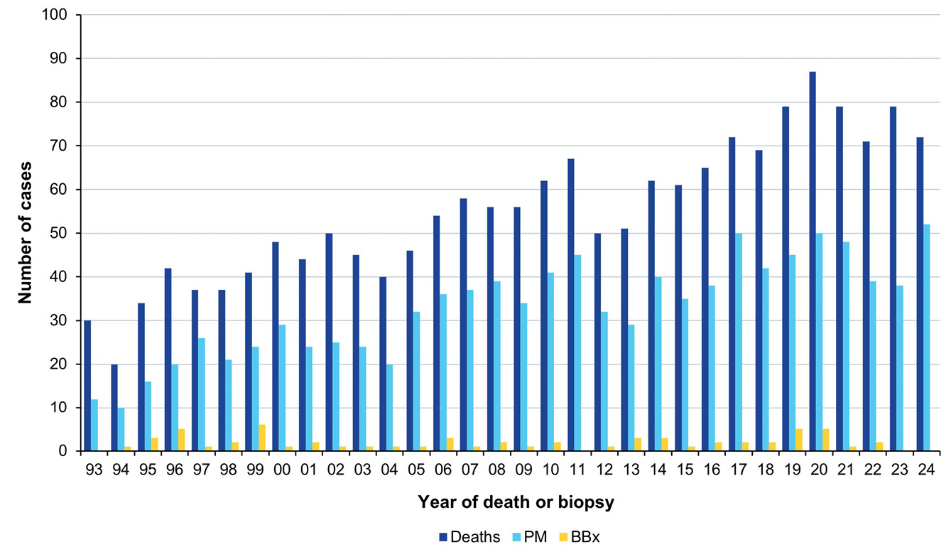
Of suspected prion disease cases added to the register between 1993 and 2024, the average annual proportion undergoing post-mortem brain examination is 59% (range 40–72%); the provisional proportion for 2024 is 72%. Annual suspected prion disease brain autopsy referrals by states and territories over the period 1993–2024 display considerable fluctuation in each jurisdiction. In the more populous states, there has generally been an overall temporal increase in brain autopsy referrals. In regions with smaller populations, this positive trend is also present but less robust due to the relative impact of variation in the annual brain autopsy referrals caused by small population sizes and case numbers.
As of 31 December 2024, there were 1,644 cases on the ANCJDR register with 1,418 of these classified as ‘probable’ or ‘definite’ prion disease cases. An additional ‘definite’ iatrogenic case, who was treated in Australia but died in the United Kingdom (UK), is included in Table 1; this case is not classified as an Australian case due to their location at death and is thereby excluded from the overall statistical analysis of Australian prion disease cases. Since the start of prospective surveillance in 1993, a total of 896 suspected prion disease cases have been removed from the register through neuropathological assessment or after detailed clinical review.
In 2024, there were 51 cases re-classified from ‘incomplete’ to ‘definite’ prion disease and 34 cases to ‘probable’ prion disease. In 2024, the total number of ‘incomplete’ cases under evaluation was slightly lower than in 2023. Seven cases were assigned the label of ‘indeterminate’ as they could not be classified confidently using the EUROCJD-endorsed diagnostic criteria after detailed clinical review. Impediments to timely and complete access to all clinical information, especially MR brain imaging, can limit confident case classifications.
The age-standardised mortality rate (ASMR) for prion disease for 2024 was 1.49 deaths per million per year. This figure is provisional and almost certainly an underestimate, as 18 neuropathology reports are pending. Annual ASMR values for human prion disease in Australia during the period of 1970 to 2024 have generally increased. The mean annual ASMR during the period from 1970 to 2024 is 1.15 death per million (range 0.1–2.3). For the prospective surveillance period of 1993 to 2024, the annual mean ASMR is 1.50 deaths per million (range 0.7–2.3). By state and territory, most regions in Australia have an annual mean ASMR equivalent to or above one case per million per year between 1993 and 2024 (Table 2), except for the Northern Territory. The lower rates of ascertainment in the Northern Territory may be partly explained by geographical challenges relating to proximity to specialised health care and post-mortem services, as illustrated by CSF diagnostic test referral rates and autopsy referral rates being well below the national average.
A breakdown of annual case numbers and mortality rates is shown in Figure 3 and Table 2. The highest annual number of ‘probable’ and ‘definite’ prion disease cases reported, since surveillance commenced in 1993, was 73 in 2020, resulting in an annual ASMR of 2.28 deaths per million. Higher mortality rates, ranging between 1.7 and 2.3, have been recorded since 2016; this coincides with the introduction of new diagnostic tools, such as CSF total-tau protein assay, the RT-QUIC assay and improved understanding of suggestive MR brain imaging findings.
Figure 3: Human prion disease in Australia from 1993 to 2024; number of cases and age-standardised mortality rates (ASMR), by year
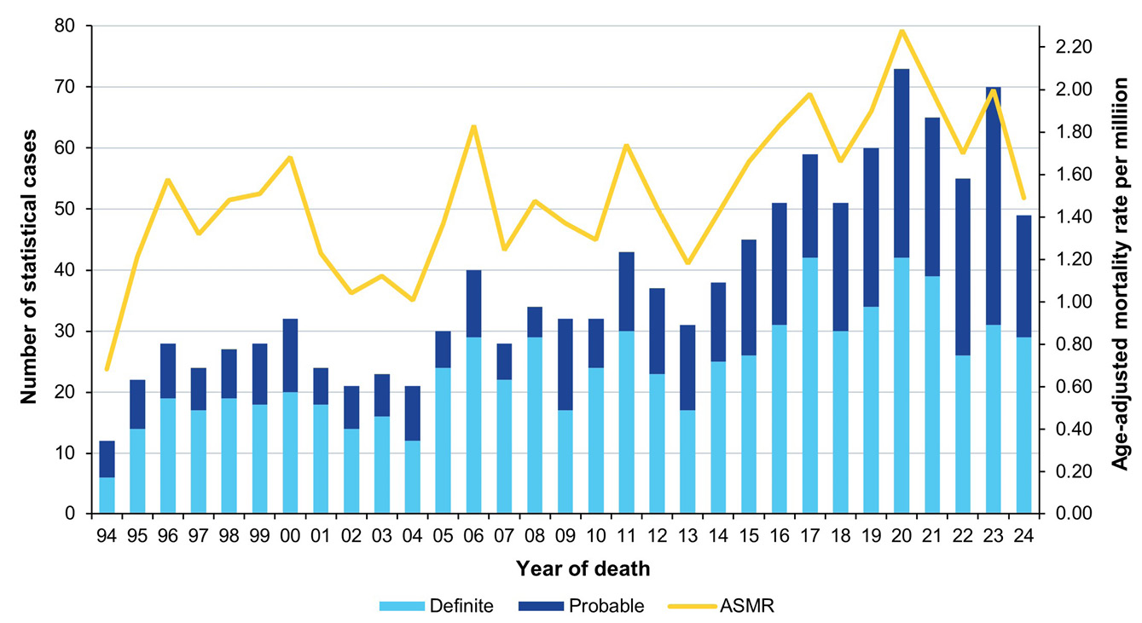
The proportions of human prion disease aetiologies on the ANCJDR register for 2024 remains similar to previous years (Figure 4); the vast majority of the 1,418 statistical cases of human prion disease are ‘sporadic’ (91.3%) while genetic and iatrogenic cases represent 8.2% and < 1%, respectively, of all ‘definite’ and ‘probable’ cases. No case of vCJD has yet been confirmed in Australia, including during 2024.
Figure 4: ‘Definite’ and ‘probable’ human prion disease cases 1970 to 2024,ª by year and aetiology
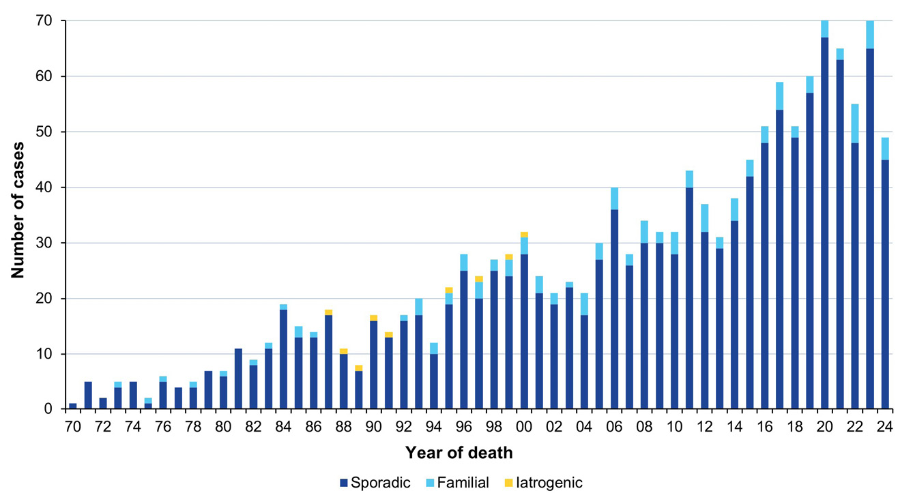
a Includes one definite iatrogenic case who received pituitary hormone treatment in Australia but disease onset and death occurred while a resident of the United Kingdom.
There are currently 1,294 ‘definite’ and ‘probable’ sporadic prion disease cases on the ANCJDR register. The distribution is almost equal between males (48.6%) and females (51.4%), with the slight predominance in females reflecting their longer life expectancy. The average age at death is 67.6 years, with a median of 69 years, ranging in age from 19 to 91 years. The average duration of illness is 6.3 months, with a median of 3.9 months, ranging from 0.7 to 60 months.
There are currently 70 families affected by genetic prion disease on the ANCJDR register, comprising 116 individuals (76 ‘definite’ and 40 ‘probable’ cases) with a confirmed genetic aetiology, 55% of whom are female. The average age at death for genetic prion disease is approximately a decade younger than in sporadic prion disease, at 57.7 years, with the median of 59 years, ranging from 18 to 83 years; the average duration of illness is approximately 9 months longer than in sporadic prion disease, at 16.3 months, with a median of 5.9 months, ranging from 1.3 to 192 months. Age of onset and duration of illness depend on the mutation present and its resulting phenotype: fatal familial insomnia and Gerstmann-Sträussler-Scheinker syndrome are often associated with younger age of onset and longer durations than mutations resulting in CJD-like presentations.
To date, three PRNP mutation carriers have been excluded from the register after brain autopsy. They died aged 70, 88 and 91 years old, well above the average age at death of their pedigrees. Nine incomplete cases remain under investigation on the register without a neuropathological or clinical case classification outcome; however, there is documented concern for genetic prion disease. Four families are of unspecified PRNP status, although there is a recorded family history of prion disease. The range of PRNP mutations in Australian genetic prion disease cases is shown in Table 3. In 2024, eleven cases of genetic prion disease were confirmed neuropathologically or by clinical case evaluation. The utility of diagnostic biomarkers for genetic prion disease, especially those found in CSF, continues to be defined.⁷
Previously mis-diagnosed cases, displaying very subtle or negligible neuropathological changes of spongiform encephalopathy, were demonstrated to harbour octapeptide repeat insertion (OPRI) mutations and were confirmed as prion disease utilising a combination of techniques centred on an adapted RT-QUIC methodology. These cases highlight the utility of comprehensive diagnostic testing, including genetic testing and brain tissue analysis, in less typical neurodegenerative diseases to accurately diagnose the aetiology in cases of progressive dementias when a clear causal explanation has not been uncovered.^{8,9}
Table 3: Prion protein gene (PRNP) sequence variations/mutations identified in Australian cases
Mutation/polymorphism | Definite/probable cases | Cases  PM proven, not CJDª
E200K | 56 | 3
D178N | 18 | 0
V210I | 9 | 0
P105T | 6 | 0
P102L | 7 | 0
Insert mutations/OPRI^{b} | 7 | 0
Other mutations^{c} | 8 | 0
Not determined | 5 | 0
Total | 116 | 3
a In known mutation carrier.
b OPRI - abbreviation for octapeptide repeat insertion.
c A133V, E200D, E211D, G131V, T188A, V176G, V180I, V189I.

Discussion
In 2024, the number of suspected prion disease referrals and confirmed cases broadly matched the long-term prospective surveillance period (1993–2023) averages. Australia continued to be free of vCJD and no further cases of iCJD were detected in Australia in 2024. By state and territory, the numbers of suspected case referrals showed generally only modest fluctuations during 2024 compared to previous years; the fluctuations seen in 2024 are within previously observed ranges.
Long-term national surveillance units report differing annual prion disease mortality rates, ranging from 0.24 to 4.56 per million population.⁴ Higher rates of human prion disease over short time frames have also been recognised and investigated in various global settings with inconclusive outcomes.¹⁰ The underlying basis for fluctuations and differences in national mortality rates is uncertain, although variation in case ascertainment is one potentially contributing factor.⁵ Spatio-temporal clustering of CJD has previously been recognised in New South Wales and Victoria.^{11,12} Detailed epidemiological assessment by the ANCJDR did not disclose any likely horizontal transmission event but instead uncovered a heightened intensity of surveillance. This more intense level of surveillance was reflected by the significantly higher rates of referrals of suspect prion disease cases for evaluation and diagnostic testing to the ANCJDR, as well as higher neuropathological examination rates in suspected patients. Monitoring of the geographical distribution of suspected case referrals and confirmed cases remains an important facet of ANCJDR national surveillance. An overall increase in sCJD cases has also been observed in Australia and is most likely due to a combination of an ageing population, improved case ascertainment and diagnostic capacity, and greater awareness of prion disease in the healthcare sector. The gradual increase in the incidence of sCJD, but not that of genetic prion disease, has also been reported in other countries with longstanding national prion disease surveillance and supports the notion that it is at least partly a result of the globally ageing population.^{13,14}
Ascertainment mechanisms in 2024 were unchanged compared to recent years, with a majority of initial referrals coming through requests for diagnostic CSF testing. Some proactive ascertainment mechanisms (such as state health department and tertiary hospital mortality data base searches) have ceased, while other case detection methods have increased. The number of CSF referrals to the ANCJDR for diagnostic testing remained high for 2024. A 20% increase in diagnostic test referrals coincided with the introduction of CSF total-tau protein assay and the identification of misfolded prion protein in CSF by RT-QuIC assay in 2017. Since 2021, the ANCJDR, as per an amended contract with the Australian Government Department of Health, Disability and Ageing, ceased its cost recovery for CSF diagnostic testing for domestic specimens, which may contribute to a maintained increase in domestic test referrals. The ANCJDR continues to evaluate optimal diagnostic investigations and their specific parameters; a recent study confirming that the suggested amendments to criteria for an MRI to be supportive of sporadic CJD being at least as good as extant criteria.¹⁵
The proportion of post-mortem examinations being performed in suspected prion disease cases remains high and aligns with the long-term mean brain autopsy percentage of approximately 60% (of suspected case deaths) between 1993 and 2024. This contrasts with the findings of an Australian healthcare setting survey where the national hospital post-mortem rate was 12% in 2002–2003;¹⁶ more recently, a major Australian tertiary centre audit of hospital autopsy data has described an autopsy rate of 6.6% in 2011–2013.¹⁷ The high suspected prion disease-related post-mortem rate underpins the high and consistent number of confirmed Australian human prion disease cases recorded over the more recent prospective surveillance epoch and provides confident understanding of the cause of death in suspected cases ultimately determined as non-prion disease. On occasion the ANCJDR receives requests from neuropathologists around Australia to test for the presence of PrP^{Sc} to confirm or rule out prion disease on neuropathologically challenging or atypical cases. In the past the ANCJDR required fresh/frozen brain tissue for increased sensitivity (NaPTA) western blotting;¹⁸ however, with the adoption of an RT-QuIC assay, using either fixed or fresh/frozen brain tissue, the ANCJDR has expanded its ability to assist in more complex and historical cases.¹⁹
A study by the ANCJDR of prion disease in Indigenous Australians has confirmed that sporadic CJD occurs in Indigenous Australians throughout Australia with a phenotype and incidence rate equivalent to non-Indigenous Australians, supporting the adequacy of national human prion disease surveillance.²⁰
No further iCJD cases were confirmed in Australia during 2024. The most recent human cadaveric pituitary gonadotrophin-related CJD death occurred in 1991, while the most recent Lyodura-related CJD death occurred in 2000. Globally, iCJD is still being detected, the latest cases occurring in 2023; the United States of America and United Kingdom each reported one iCJD death associated with growth hormone treatment,, while Japan reported in 2023 one Lyodura-related case of iCJD.
Since vCJD was first reported in 1996, a total of 233 patients, from 12 countries, have been identified with this disease. Case 178 from the UK was methionine-valine heterozygous at codon 129 of the PRNP gene;²¹ all cases previously had been methionine homozygous at codon 129. The patient was 36 years old when he presented with psychiatric symptoms prior to onset of neurological features that included cognitive decline, ataxia and myoclonus, dying after an illness duration of 20 months. CSF 14-3-3 and RT-QuIC were negative. Brain magnetic resonance imaging (MRI) revealed features more typical of sCJD (bilateral high signal in basal ganglia) without any posterior thalamic high signal (‘pulvinar sign’). The patient did not meet the epidemiologic diagnostic surveillance criteria for ‘probable’ or ‘possible’ vCJD, although fulfilled criteria for ‘probable’ sCJD; neuropathology, including western blot glycotyping, was typical of vCJD. It remains uncertain whether this case marks the start of a second wave of vCJD affecting those heterozygous for methionine-valine at codon 129. This case also underscores the importance of performing suspect CJD brain autopsy examinations and the benefits of maintaining high-level surveillance within Australia. The most recent three vCJD cases, who died in France in 2019 and 2021 and Italy in 2016, are plausibly related to accidental occupational exposure incidents in laboratory settings.^{14,22}

Acknowledgments
The ANCJDR wishes to thank families, as well as medical practitioners and associated staff, for their generous support of Australian CJD surveillance. The ANCJDR also thanks Associate Professor Handan Wand, Professor Matthew Law and Professor John Kaldor (The Kirby Centre; formerly the National Centre in HIV Epidemiology and Clinical Research at the University of New South Wales) for their expert ad hoc epidemiological and statistical support, as well as the CJD Support Group Network for their assistance in surveillance activities.

Author details
Dr Christiane Stehmann – Coordinator, Australian National Creutzfeldt-Jakob Disease Registry (ANCJDR)¹
Dr Matteo Senesi – Research Fellow, ANCJDR²
Ms Shannon Sarros – Research Assistant, ANCJDR¹
Ms Amelia McGlade – Research Assistant, ANCJDR¹
Dr Victoria Lewis – Research Fellow, ANCJDR²
Ms Priscilla Agustina – Research Assistant, ANCJDR¹
Dr Daniel Barber – Neurologist, ANCJDR¹
Ms Genevieve Klug – Research Assistant, ANCJDR²
Dr Sarah Holper – Neurologist, ANCJDR¹
Professor Catriona A McLean – Neuropathologist, ANCJDR^{1,3}
Professor Colin L Masters – Director, ANCJDR¹
Professor Steven J Collins – Director, ANCJDR^{1,2}
- The Florey Institute, The University of Melbourne, Victoria, 3010, Australia
- Department of Medicine, The University of Melbourne, Victoria, 3010, Australia
- The Alfred Hospital, Department of Anatomical Pathology, 55 Commercial Rd, Melbourne Vic 3004 Australia

Corresponding author
Prof Steven Collins
Australian National Creutzfeldt-Jakob Disease Registry, Department of Medicine, The University of Melbourne, Victoria, 3010, Australia
Telephone: +61 3 8344 1949
Facsimile: +61 3 9349 5105
Email: s.collins@unimelb.edu.au

References
- Klug GM, Boyd A, Sarros S, Stehmann C, Simpson M, McLean CA et al. Creutzfeldt-Jakob disease surveillance in Australia, update to December 2013. Commun Dis Intell Q Rep. 2014;38(4):E348–55.
- Allars M. Report of the inquiry into the use of pituitary derived hormones in Australia and Creutzfeldt-Jakob disease. Canberra: AGPS, 1994.
- Zerr I, Kallenberg K, Summers DM, Romero C, Taratuto A, Heinemann U et al. Updated clinical diagnostic criteria for sporadic Creutzfeldt-Jakob disease. Brain. 2009;132(10):2659–68. doi: https://doi.org/10.1093/brain/awp191.
- Uttley L, Carroll C, Wong R, Hilton DA, Stevenson M. Creutzfeldt-Jakob disease: a systematic review of global incidence, prevalence, infectivity, and incubation. Lancet Infect Dis. 2020;20(1):e2–10. doi: https://doi.org/10.1016/S1473-3099(19)30615-2.
- Klug GM, Wand H, Simpson M, Boyd A, Law M, Masters CL et al. Intensity of human prion disease surveillance predicts observed disease incidence. J Neurol Neurosurg Psychiatry. 2013;84(2):1372–7. doi: https://doi.org/10.1136/jnnp-2012-304820.
- Senesi M, Lewis V, Varghese S, Stehmann C, McGlade A, Doecke JD et al. Diagnostic performance of CSF biomarkers in a well-characterized Australian cohort of sporadic Creutzfeldt-Jakob disease. Front Neurol. 2023;14:1072952. doi: https://doi.org/10.3389/fneur.2023.1072952.
- Schmitz M, Villar-Piqué A, Hermann P, Escaramís G, Calero M, Chen C et al. Diagnostic accuracy of cerebrospinal fluid biomarkers in genetic prion diseases. Brain. 2022;145(2):700–12. doi: https://doi.org/10.1093/brain/awab350.
- Chen ZY, Chu M, Liu L, Zhang J, Kong Y, Xie K et al. Genetic prion diseases presenting as frontotemporal dementia: clinical features and diagnostic challenge. Alzheimers Res Ther. 2022;14(1):90. doi: https://doi.org/10.1186/s13195-022-01033-4.
- Nan H, Liu L, Chen Z, Chu M, Li J, Jing D et al. Octapeptide repeat alteration mutations of the prion protein gene in clinically diagnosed Alzheimer's disease and frontotemporal dementia. Clin Genet. 2023;104(3):350–5. doi: https://doi.org/10.1111/cge.14354
- Glatzel M, Rogivue C, Ghani A, Streffer JR, Amsler L, Aguzzi A. Incidence of Creutzfeldt-Jakob disease in Switzerland. Lancet. 2002;360(9327):139–41. doi: https://doi.org/10.1016/S0140-6736(02)09384-4.
- Collins S, Boyd A, Fletcher A, Kaldor J, Hill A, Farish S et al. Creutzfeldt-Jakob disease cluster in an Australian rural city. Ann Neurol. 2002;52(1):115–8. doi: https://doi.org/10.1002/ana.10224.
- Klug GM, Wand H, Boyd A, Law M, Whyte S, Kaldor J et al. Enhanced geographically restricted surveillance simulates sporadic Creutzfeldt-Jakob disease cluster. Brain. 2009:132(2);493–501. doi: https://doi.org/10.1093/brain/awn303.
- Stevenson M, Uttley L, Oakley JE, Carroll C, Chick SE, Wong R. Interventions to reduce the risk of surgically transmitted Creutzfeldt-Jakob disease: a cost-effective modelling review. Health Technol Assess. 2020;24(11):1–150. doi: https://doi.org/10.3310/hta24110.
- Watson N, Brandel JP, Green A, Hermann P, Ladogana A, Lindsay T et al. The importance of ongoing international surveillance for Creutzfeldt-Jakob disease. Nat Rev Neurol. 2021;17(6):362–79. doi: https://doi.org/10.1038/s41582-021-00488-7.
- Barber D, Trost N, Stehmann C, Lewis V, Doecke J, Jhamb A et al. Assessing the newly proposed MRI criteria for diagnosing sporadic Creutzfeldt-Jakob disease. Neuroradiology. 2024;66(11):1907–15. doi: https://doi.org/10.1007/s00234-024-03440-w.
- The Royal College of Pathologists of Australasia Autopsy Working Party. The decline of the hospital autopsy: a safety and quality issue for healthcare in Australia. Med J Aust. 2004;180(6):281–5. doi: https://doi.org/10.5694/j.1326-5377.2004.tb05926.x.
- Jackett L, McLean C. Hospital autopsy remains a vital instrument for quality assurance of clinical diagnosis. Pathology. 2014;46(Suppl 1):S56. doi: https://doi.org/10.1097/01.PAT.0000443521.56495.1a.
- Wadsworth JD, Joiner S, Hill AF, Campbell TA, Desbruslais M, Luthert PJ et al. Tissue distribution of protease resistant prion protein in variant Creutzfeldt-Jakob disease using a highly sensitive immunoblotting assay. Lancet. 2001;358(9277):171–80. doi: https://doi.org/10.1016/s0140-6736(01)05403-4.
- Lewis V, Ellett L, Lei E, Stehmann C, Birchall I, Senesi M et al. A fixed brain seeded amplification assay to complement neuropathological prion disease diagnosis. J Neuropathol Exp Neurol. 2025:nlaf105. doi: https://doi.org/10.1093/jnen/nlaf105.
- Panegyres PK, Stehmann C, Klug GM, Masters CL, Collins S. Prion disease in Indigenous Australians. Intern Med J. 2021;51(7):1101–5. doi: https://doi.org/10.1111/imj.14835.
- Mok T, Jaunmuktane Z, Joiner S, Campbell T, Morgan C, Wakerley B et al. Variant Creutzfeldt–Jakob disease in a patient with heterozygosity at PRNP codon 129. N Engl J Med. 2017;376(3):292–4. doi: https://doi.org/10.1056/NEJMc1610003.
- Brandel JP, Vlaicu MB, Culeux A, Belondrade M, Bougard D, Grznarova K et al. Variant Creutzfeldt–Jakob disease diagnosed 7.5 years after occupational exposure. N Engl J Med. 2020;383(1):83–5. doi: https://doi.org/10.1056/NEJMc2000687.

Appendix A

EUROCJD diagnostic criteria for surveillance of sporadic CJD from 1 January 2017
Definite:
Progressive neurological syndrome AND Neuropathologically or immunohistochemically or biochemically confirmed
Probable:
I + two of II and typical EEGª
OR
1.2.2 I + two of II and typical MRI brain scan^{b}
OR
1.2.3 I + two of II and positive CSF 14-3-3
OR
1.2.4 Progressive neurological syndrome and positive RT-QuIC in CSF or other tissues
Possible:
I + two of II + duration < 2 years
I Rapid progressive cognitive impairment
II A Myoclonus
B Visual or cerebellar problems
C Pyramidal or extrapyramidal features
D Akinetic mutism
a EEG: electroencephalogram; generalised periodic complexes.
b High signal in caudate/putamen and MRI brain scan or at least two cortical regions (temporal, parietal, occipital) either on diffusion-weighted imaging (DWI) or fluid attenuated inversion recovery (FLAIR).

Australian Bureau of Statistics. 3101.0 National, state and territory population - June 2024. Tables 51-59. [Accessed on 1 April 2025.] Available from: https://www.abs.gov.au/statistics/people/population/national-state-and-territory-population/latest-release#data-download.
Personal communication, Centers for Disease Control and Prevention (United States Government Department of Health and Human Services, Atlanta, Georgia, United States of America).
Personal communication, National Creutzfeldt-Jakob Disease Research and Surveillance Unit (Western General Hospital; Edinburgh, Scotland, United Kingdom).
Personal communication, Utsunomiya City Public Health Centre (Utsunomiya, Tochigi, Japan).

