
2025 • Volume 49 • cdc.gov.au/cdi • Epub date: 22.10.2025 • doi.org/10.33321/cdi.2025.49.048

Australian Rotavirus Surveillance Program: Annual Report, 2024
Sarah Thomas, Nada Bogdanovic-Sakran, Daniel Pavlic, Julie E Bines, Celeste M Donato, and the Australian Rotavirus Surveillance Group
© 2025 Commonwealth of Australia as represented by the Department of Health, Disability and Ageing
ISSN: 2209-6051 Online
This journal is indexed by Index Medicus and Medline.
Creative Commons Licence
This publication is licensed under a Creative Commons Attribution-NonCommercial-NoDerivatives 4.0 International Licence (Licence). You must read and understand the Licence before using any material from this publication.
Restrictions
The Licence does not cover, and there is no permission given for, use of any of the following material found in this publication (if any):
- the Commonwealth Coat of Arms (by way of information, the terms under which the Coat of Arms may be used can be found on the Department of Prime Minister and Cabinet website;
- any logos (including the interim Australian Centre for Disease Control and the Department of Health, Disability and Ageing’s logos) and trademarks;
- any photographs and images;
- any signatures; and
- any material belonging to third parties.
Disclaimer
Opinions expressed in Communicable Diseases Intelligence are those of the authors and not necessarily those of the Australian Government, the interim Australian Centre for Disease Control or the Department of Health, Disability and Ageing. Data may be subject to revision.
Enquiries
Enquiries regarding any other use of this publication should be addressed to the CDI Editor.
About CDI
Communicable Diseases Intelligence (CDI) is a peer-reviewed scientific journal published by the interim Australian Centre for Disease Control within the Department of Health, Disability and Ageing.
The journal aims to disseminate information on the epidemiology, surveillance, prevention and control of communicable diseases of relevance to Australia and the near region.
Editor: Christina Bareja • Deputy Editor: Simon Petrie • Design and Production: Lisa Thompson
Editorial Advisory Board: David Durrheim, Mark Ferson, Clare Huppatz, John Kaldor, Martyn Kirk and Meru Sheel
Submit an Article
Guidelines for authors and details on how to submit your publication is available on our website, or by email to the
CDI Editor.
Contact us
Communicable Diseases Intelligence (CDI)
interim Australian Centre for Disease Control, Department of Health, Disability and Ageing
GPO Box 9848, CANBERRA ACT 2601
Website: cdc.gov.au/cdi
Email: cdi.editor@health.gov.au

Contents
Abstract 4
Introduction 5
Methods 7
Results 10
Sample description 10
Demographics of the sample population 11
Temporal trends across 2024 13
Genotype distribution of rotavirus positive samples 17
Discussion and conclusion 19
Acknowledgments 22
Author details 23
References 25

Abstract
This report from the Australian Rotavirus Surveillance Program describes the circulating rotavirus genotypes identified in children and adults during the period 1 January to 31 December 2024. In 2024, we saw a continuation of a high burden of rotavirus disease in the Australian population. During this period, 2,118 faecal specimens were referred to the National Rotavirus Reference Centre (NRRC), for rotavirus G- and P-genotype analysis; of these samples, 1,880 were confirmed as rotavirus positive. This is the second highest number of samples referred to the NRRC over the past 20+ years of operation. Of the 1,880 samples confirmed rotavirus positive, 1,610 (85.6%) were identified as wildtype rotavirus; 268 (14.3%) were identified as the Rotarix vaccine-like strain; and two G1P[8] samples could not be confirmed as wildtype or vaccine-like due to inadequate sequence quality. The equine-like G3P[8] variant was the dominant genotype nationally (n = 1,297/1,610; 80.6%). Other genotypes were identified at low frequencies including G1P[8] (n = 9/1,610; 0.6%); G2P[4] (n = 34/1,610; 2.1%); G3P[8] (n = 77/1,610; 4.8%); G8P[8] (n = 46/1,610; 2.9%); G9P[4] (n = 9/1,610; 0.6%); G9P[8] (n = 6/1,610; 0.4%); and G12P[8] (n = 8/1,610; 0.5%). Genotype distribution was consistent nationally, with equine-like G3P[8] the dominant genotype in all jurisdictions. Consistent with observations in recent years, a small number of samples with unusual genotypes were identified (n = 70/1,610; 4.3%). Of these unusual genotypes, the most frequently detected was G2P[8], which accounted for 52.9% of unusual samples (n = 37/70) and 2.3% of all positive wildtype samples (n = 37/1,610).
The high number of rotavirus positive samples received by the program reflected the notifications for rotavirus disease reported to the National Notifiable Disease Surveillance Service (NNDSS). Across Australia, there were 10,108 notifications recorded, the highest reported in any year since establishment of the national rotavirus notification.
The ability to monitor the genotypes of rotavirus strains causing disease across ages and across jurisdictions provides important data to aid in assessing the performance of the national rotavirus vaccination program and to inform public health interventions during outbreaks. The Australian Rotavirus Surveillance Program also provides important data to monitor annual variations in genotypes circulating in the population. Understanding the diversity of genotypes in circulation, and the emergence of variants, provides important context for any changes observed in disease epidemiology in the community. The Australian Rotavirus Surveillance Program provides diagnostic laboratories with valuable feedback on laboratory data quality, by reporting incidences of wildtype, vaccine-like, and/or false positive rotavirus results.
Keywords: rotavirus; gastroenteritis; genotype; surveillance; Australia; vaccine; equine-like G3P[8]

Introduction
Group A rotavirus infections were identified as the cause of 128,500 deaths and 258 million episodes of diarrhoea among children < 5 years of age in 2016.¹ To address this burden, there are now four World Health Organization (WHO) pre-qualified rotavirus vaccines introduced nationally or regionally into routine Immunisation Programs of over 131 countries; these vaccines are Rotarix [GSK, Belgium], RotaTeq [Merck, United States of America], Rotavac [Bharat Biotech, India], and RotaSIIL, [Serum Institute of India, India].^{2–5}
In Australia, rotavirus vaccines were first introduced into the routine infant immunisation schedule in the Northern Territory in 2006 and then nationally on July 1, 2007, with the decision on vaccine choice, Rotarix [GSK] or RotaTeq [Merck], initially made at the state or territory level. RotaTeq was administered in Queensland, South Australia and Victoria, whereas Rotarix was administered in the Australian Capital Territory, New South Wales, the Northern Territory, and Tasmania. Western Australia initially administered Rotarix and changed to RotaTeq in May 2009. On 1 July 2017, all jurisdictions which had previously administered RotaTeq changed to Rotarix, making national vaccine administration uniform across all states and territories in Australia.^{6,7} Following the introduction of rotavirus vaccines, there was a significant reduction in rotavirus-coded and non-rotavirus-coded acute gastroenteritis hospitalisations of children ≤ 5 years of age.^{3–5} Several post-licensure studies have shown that rotavirus vaccines are safe and effective and associated with significant reduction in the rotavirus burden of disease in Australia.^{3–5} Within the first six years of vaccine introduction, an estimated 77,000 hospitalisations were prevented, 90% of which were in children ≤ 5 years of age, with indications of herd protection occurring in older age groups.⁵
In Australia, rotavirus gastroenteritis has been a notifiable disease since 2010, with all jurisdictions reporting through the National Notifiable Disease Surveillance Service (NNDSS) with national representation since 2018.⁸ This service monitors the reports of rotavirus disease across each jurisdiction on a month-by-month basis and according to age cohorts. Over the past decade, the clinical presentations of rotavirus disease have followed a pattern of a low baseline incidence across months punctuated by outbreaks, particularly notable in regional areas. In 2021, outbreaks were reported in Western Australia and the Northern Territory in September and continued through to December, as many parts of Australia emerged from a prolonged period of social distancing due to coronavirus disease 2019 (COVID-19) restrictions.⁹ The increased rate of rotavirus notifications observed in 2021 persisted into 2022 and 2023.^{10,11}
Since 1999, the Australian Rotavirus Surveillance Program (ARSP) has characterised rotavirus genotypes causing severe disease in Australian children ≤ 5 years of age.⁶ From 2010 onwards, surveillance was extended to children ≥ 5 years of age and adults. The ARSP receives rotavirus positive samples from collaborating laboratories across all states and territories, which have screened samples for rotavirus positivity. Positive samples are then sent from jurisdictional collaborating laboratories to the National Rotavirus Reference Centre, in Melbourne, for confirmatory testing and genotyping. Rotavirus genotypes are defined by a binary classification system based on the two outer capsid proteins, VP7 (G, glycoprotein) and VP4 (P, protease-sensitive).¹² Globally, there are five common genotype combinations identified in humans: G1P[8], G2P[4], G3P[8], G4P[8], and G9P[8], although G8P[8] and G12P[8] have also been described as globally important genotypes in recent years.^{13–15} Additionally, whole genome classification assigns genotypes to each of the 11 genes: Gx-P[x]-Ix-Rx-Cx-Mx-Ax-Nx-Tx-Ex-Hx, denoting the VP7-VP4-VP6-VP1-VP2-VP3-NSP1-NSP2-NSP3-NSP4-NSP5/6 genes.¹⁶ The majority of human rotavirus genomes fall under two genotype constellations: Wa-like (genogroup 1: G1/3/4/9/12-P[8]-I1-R1-C1-M1-A1-N1-T1-E1-H1), and DS-1-like (genogroup 2: G2-P[4]-I2-R2-C2-M2-A2-N2-T2-E2-H2).¹⁶ A third genogroup, AU-1-like, is also detected in humans, but less frequently (genogroup 3: G3-P[9]-I3-R3-C3-M3-A3-N3-T3-E3-H3).¹⁶ Numerous mechanisms contribute to rotavirus diversity including genetic drift, reassortment and zoonotic transmission. The segmented genome allows for reassortment both within and between human and animal strains, leading to the emergence of novel strains and unusual genotype combinations.¹⁷
The genotype data provided by the Australian Rotavirus Surveillance Program has revealed changes in rotavirus genetic diversity, as well as temporal and geographic fluctuations.^{6,18} Furthermore, differences in genotype diversity and dominance were observed when comparing vaccines by jurisdictions, suggesting that RotaTeq and Rotarix exerted different immunological pressures on circulating rotavirus strains in Australia.^{6,18} The continued surveillance and characterisation of rotavirus genotypes circulating in Australia will provide important insights into whether changes in vaccine immunisation programs could impact virus epidemiology and alter genotype diversity, which could have ongoing consequences for the success of current and future vaccination programs. This report describes the G- and P- genotype distribution of rotavirus strains causing severe gastroenteritis in Australia for the period 1 January to 31 December 2024.

Methods
Faecal samples were tested for the presence of rotavirus by quantitative polymerase chain reaction (qPCR) or enzyme immunoassay (EIA) by collaborating laboratories Australia-wide. Positive samples were frozen and sent to the National Rotavirus Reference Centre (NRRC), Melbourne, together with available metadata including date of collection (DOC), date of birth (DOB), sex, postcode, and the qPCR cycle threshold (Ct) values generated by the collaborating laboratory (where possible). Specimens were received from 12 collaborating centres located in the Australian Capital Territory, New South Wales, Northern Territory, Queensland, South Australia, Tasmania, Victoria, and Western Australia) (Table 1).
Table 1: Number of samples provided by each collaborating laboratory
Healthcare facility | Department | Jurisdictionª | n
Canberra Hospital | Microbiology Department | ACT | 57
Prince of Wales Hospital | Serology, Virology and OTDS Laboratories (SAViD), NSW Health Pathology | NSW | 353
Liverpool Hospital, Liverpool | Department of Microbiology & Infectious Diseases | NSW | 98
The Children’s Hospital, Westmead | Virology Department | NSW | 107
Douglass Hanly Moir Pathology | Infectious Serology Department | NSW | 53
Alice Springs Hospital, Alice Springs | The Microbiology Department | NT | 93
Royal Brisbane & Women’s Hospital, Herston | Pathology Queensland | Qld | 555
SA Pathology, Adelaide | Microbiology and Infectious diseases laboratory | SA | 163
Royal Hobart Hospital, Hobart | Molecular Medicine, Pathology Services | Tas. | 72
Monash Medical Centre, Clayton | Department of Microbiology | Vic. | 173
Royal Children’s Hospital, Parkville | Laboratory Services | Vic. | 130
PathWest Laboratory Medicine, Nedlands | QEII Microbiology Department | WA | 264
a ACT: Australian Capital Territory; NSW: New South Wales; NT: Northern Territory; Qld: Queensland; SA: South Australia; Tas.: Tasmania; Vic.: Victoria; WA: Western Australia.

Samples were allocated a unique laboratory code and entered into the ARSP database (Excel and REDCap). Samples were stored at -30 °C until analysed.
Viral RNA was extracted from 10–20% faecal extracts using the QIAamp Viral RNA mini extraction kit (QIAGEN), according to the manufacturer’s instructions, with the exception of eluting in 50 µl of nuclease-free water. Rotavirus G- and P- genotypes were determined using an in-house hemi-nested multiplex RT-PCR assay. The first-round RT-PCR reactions were performed using the One Step RT-PCR kit (QIAGEN), in conjunction with VP7 (VP7F/VP7R) or VP4 (VP4F/VP4R) conserved primers.^{19,20} The second-round genotyping PCR reactions were conducted using specific oligonucleotide primers for G types G1, G2, G3, G4, G8, and G9, or P types P[4], P[6], P[8], P[9], P[10], and P[11].^{19–22} The G- and P- genotype was determined using agarose gel electrophoresis of second-round PCR products. Samples failing to generate a second-round PCR amplicon were further tested by VP6-specific RT-PCR using the Superscript III One-Step RT-PCR System with Platinum Taq DNA Polymerase (Invitrogen) and primers Rot3 and Rot5 as described previously.^{23,24}
Sanger sequencing was used to determine the VP7 and/or VP4 nucleotide sequence for PCR non-typeable samples. The current set of primers used in the second-round G-typing protocol are not able to detect genotypes to equine-like G3, G12, and unusual rotavirus strains. Due to non-specific binding of the G9 primer to equine-like G3 strains, all G9 samples were further characterised using equine-like G3 primers as described previously.²⁵ All non-typeable P[8] samples were further characterised using G12 specific primers as described previously.²⁶ The VP7 gene of each G1P[8] sample was sequenced to determine if wildtype or Rotarix vaccine-like strain was detected. The VP7 gene of any sample which was negative by equine-like G3 PCR (potentially G9) was sequenced. Samples which had no first-round PCR amplicon (but were VP6 positive) were re-amplified using the Superscript III One-Step RT-PCR System with Platinum Taq DNA Polymerase (Invitrogen), in conjunction with VP7 (Beg9/End9) or VP4 (Con2/Con3) primers, as described previously.^{22,24,27} The generated VP7 and VP4 amplicons were purified using the Wizard SV Gel for PCR Clean-Up System (Promega) or the QIAquick Gel Extraction Kit (QIAGEN), according to the manufacturer’s protocol with the exception of eluting in 30 µl of nuclease-free water. Purified DNA and oligonucleotide primers (VP7F/VP7R, VP4F/VP4R, Beg9/End9, or Con2/Con3) were sent to the Australian Genome Research Facility (AGRF), Melbourne, and sequenced using an ABI PRISM BigDye Terminator Cycle Sequencing Reaction Kit (Applied Biosystems) in an Applied Biosystems 3730xl DNA Analyzer (Applied Biosystems). Electropherograms were visually analysed and edited using Geneious Prime 2025.1.2. Genotype assignment was determined using BLAST and Rotavirus A Genotyping Tool Version 0.1.

Results

Sample description
A total of 2,118 specimens determined to be rotavirus positive by collaborating laboratories were referred to the NRRC during the period 1 January to 31 December 2024 (Figure 1). A subset of samples (n = 238) were not analysed further due to: being a duplicate sample (n = 45), missing sample (not received; n = 1), having insufficient sample volume (n = 19) or not confirmed as rotavirus positive by VP6 PCR analysis by NRRC methods (n = 173).
A total of 1,880 samples were successfully genotyped. Samples were then classified as wildtype (no vaccine VP7 gene identified) or vaccine-like (Rotarix vaccine VP7 gene identified), based on genotype and the analysis of the top BLAST hits of any G1 VP7 sequence.
Figure 1: NRRC workflow diagram reflecting the number of rotavirus positive stool samples received from 1 January to 31 December 2024
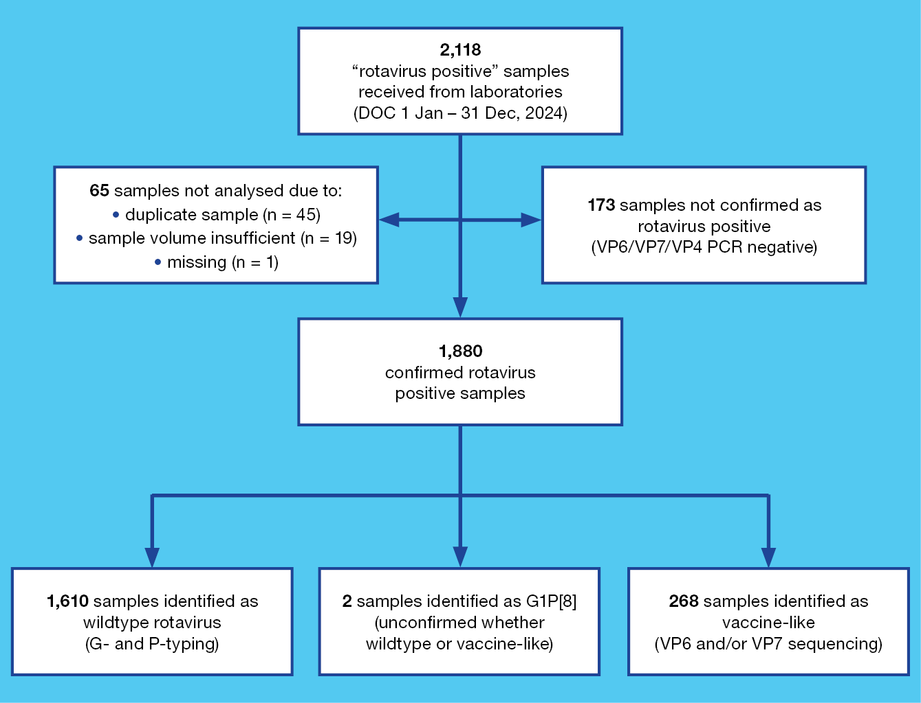

Demographics of the sample population

Age distribution of wildtype rotavirus samples
Of the 1,610 samples confirmed as wildtype, 739 (45.9%) were collected from children < 5 years of age, and 871 (54.1%) were obtained from children ≥ 5 years of age and from adults (Table 2).
Table 2: Age distribution of wildtype rotavirus gastroenteritis cases referred to the NRRC, Australia, 1 January to 31 December 2024
Age (months) | Age (years) | n | % of total | % < 5 years of age
0–6 | — | 89 | 5.5 | 12.0
7–12 | ≤ 1 | 104 | 6.5 | 14.1
13–24 | 1 –≤ 2 | 224 | 13.9 | 30.3
25–36 | 2 –≤ 3 | 163 | 10.1 | 22.1
37–48 | 3 –≤ 4 | 89 | 5.5 | 12.0
49–59 | 4 –< 5 | 70 | 4.4 | 9.5
Subtotal | — | 739 | 45.9 | 100
60–120 | 5 –≤ 10 | 211 | 13.1 | —
121–240 | 10 –≤ 20 | 106 | 6.6 | —
241–960 | 20 –≤ 80 | 497 | 30.9 | —
961+ | > 80 | 57 | 3.5 | —
Subtotal | — | 871 | 54.1 | —
Total | — | 1,610 | 100.0 | —

Age distribution of rotavirus vaccine-like samples
All G1P[8] samples (n = 279) were analysed by VP7 sequencing to identify vaccine-like strains. Overall, 277 samples were successfully sequenced, of which 268 were Rotarix vaccine-like and 9 were wildtype. Two samples genotyped as G1P[8] could not be determined as wildtype or vaccine-like due to repeated failed attempts to generate adequate sequencing results.
Of the samples found to have a vaccine-like VP7 gene, 97.3% (n = 256/268) were from the 0–6 months of age group (Table 3), reflecting the vaccination schedule. Samples with vaccine-like VP7 genes were found in infants 7 months (n = 2) and 8 months of age (n = 2), and in young children aged 13 months, 15 months, and 4 years. The five vaccine-like samples detected in individuals over 5 years of age were from individuals 10, 16, 27, 31 and 39 years old (Table 3).
Table 3: Age distribution of samples referred to the NRRC found to have a vaccine-like VP7 gene identified, Australia, 1 January to 31 December 2024
Age (months) | Age (years) | n | % of total | % < 5 years of age
0–6 | — | 256 | 95.5 | 97.3
7–12 | ≤ 1 | 4 | 1.5 | 1.5
13–24 | 1 –≤ 2 | 2 | 0.7 | 0.8
25–36 | 2 –≤ 3 | 0 | 0.0 | 0.0
37–48 | 3 –≤ 4 | 0 | 0.0 | 0.0
49–59 | 4 –< 5 | 1 | 0.4 | 0.4
Subtotal | — | 263 | 98.1 | 100.0
60–120 | 5 –≤ 10 | 0 | 0.0 | —
121–240 | 10 –≤ 20 | 2 | 0.8 | —
241–960 | 20 –≤ 80 | 3 | 1.1 | —
961+ | > 80 | 0 | 0.0 | —
Subtotal | — | 5 | 1.9 | —
Total | — | 268 | 100 | —

Temporal trends across 2024

National trends of rotavirus positive samples categorised as wildtype and vaccine-like strains
Wildtype and vaccine-like rotavirus positive samples were analysed by date of collection (DOC: month) and then compared to monthly national rotavirus notifications reported by the NNDSS (Figure 2).⁸ The peak of notifications reported by the NNDSS correlated with the number of samples received by the NRRC. Wildtype samples received by the NRRC and notifications reported by the NNDSS were relatively steady across January to May, with a moderate increase observed in June and July. From August, a notable increase was observed in the NNDSS notifications which continued into September and October, tapering in November to December. This pattern was largely reflected in the samples received by the NRRC; however, the pronounced increase observed in August was not captured, as the number of samples received remained comparable to those in July. As expected, there was no seasonal association for samples with a vaccine-like strain (Figure 2).
Figure 2: Number of analysed wildtype and vaccine-like samples with respect to NNDSS number of rotavirus notifications, 1 January to 31 December 2024
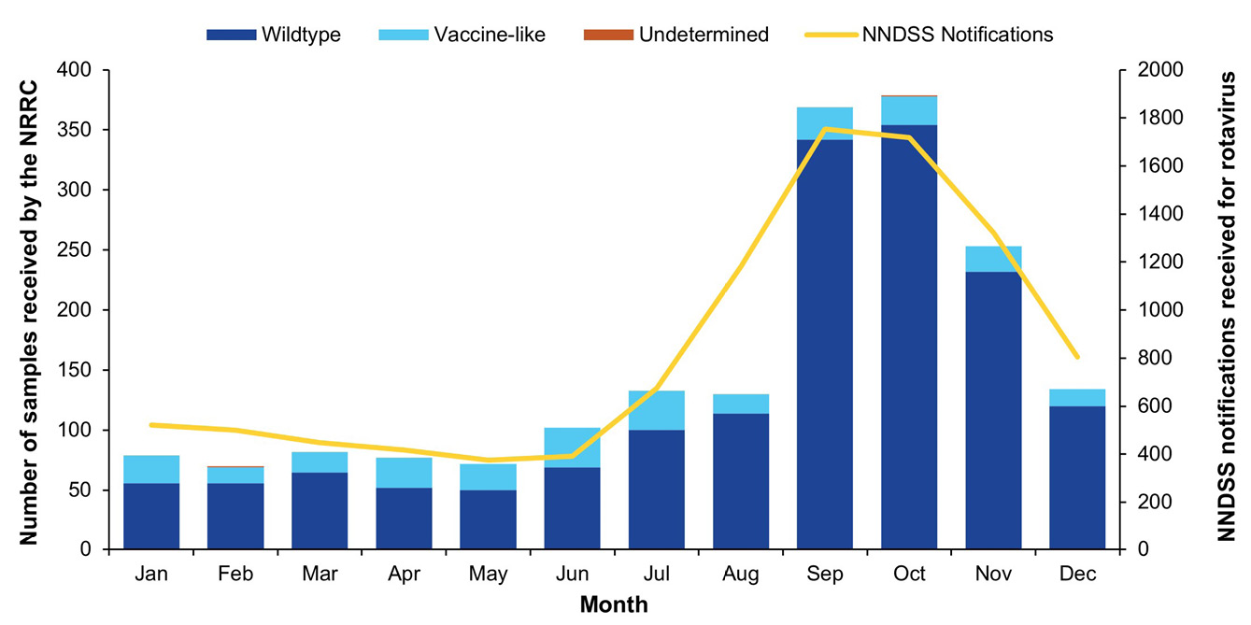

Seasonal trends of wildtype rotavirus positive samples across jurisdictions
Rotavirus positive specimens were received from all jurisdictions for the 2024 surveillance period. The highest numbers of wildtype samples for this surveillance period were from New South Wales (27.7%; n = 446/1,610) and Queensland (27.6%; n = 445/1,610), followed by Victoria (15.7%; n = 252/1,610) and Western Australia (12.2%; n = 197/1,610) (Table 4).
Jurisdiction-based notification reports per 100,000 population suggested differing patterns of rotavirus activity across the country in 2024 (Figure 3).⁸ The Northern Territory had the highest cumulative annual notification reports at 48 per 100,000 population, followed by New South Wales (47 per 100,000); Queensland (45 per 100,000); the Australian Capital Territory (42 per 100,000); South Australia (36 per 100,000); Western Australia (28 per 100,000); Victoria (25 per 100,000) and Tasmania (23 per 100,000). The unprecedented burden of disease in 2024, compared to recent years, was highlighted when reviewing the annual notification data per 100,000 population since 2018. The notifications for 2024 were the highest observed for most jurisdictions including the Australian Capital Territory, New South Wales, Tasmania and Victoria, and the second highest for Western Australia and Queensland (2024 equal with 2019). The Northern Territory reports frequent outbreaks of rotavirus, with 2024 notifications the fourth highest in recent years (Figure 3).
Figure 3: Rotavirus NNDSS notifications per 100,000 population by jurisdiction annually between 2018 and 2024
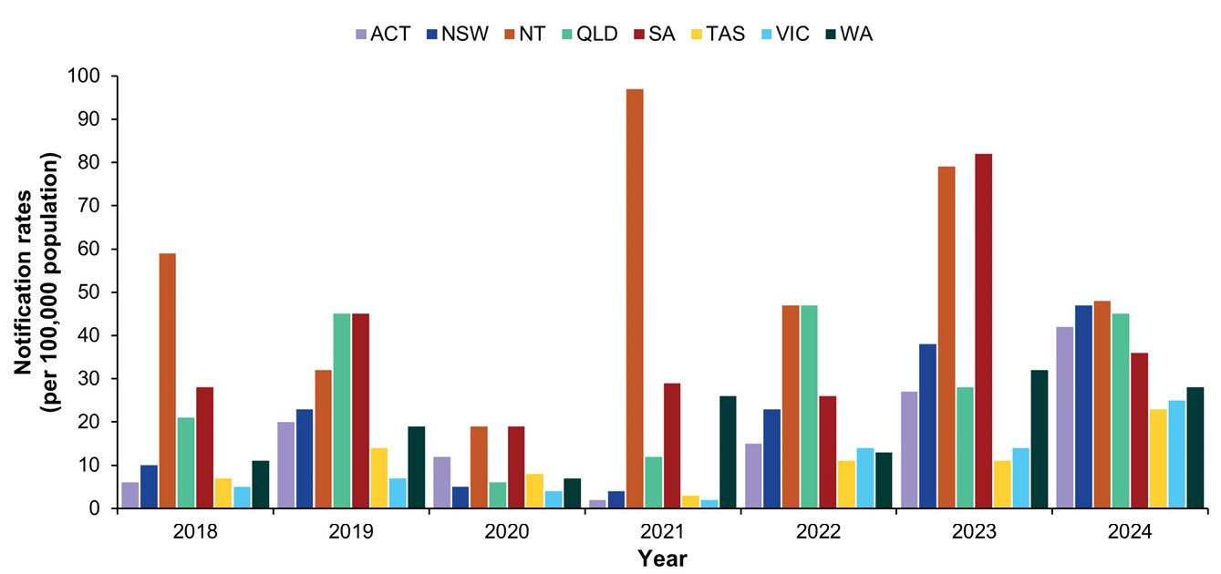
The peak of rotaviruses cases varied across Australia, with the majority of notifications in the latter months in most jurisdictions (Figure 4). The Northern Territory reported bimodal peaks in March and November of similar magnitudes; South Australia also exhibited bimodal peaks, with high notifications in January reflecting the tapering of the 2023 season which saw high notification rates in 2023 Quarter 4, with the second peak in November and December 2024. The peak of notifications for New South Wales and the Australian Capital Territory was across September, October and November. The highest monthly notification rate was reported for New South Wales in September and October. Notification rates for Queensland were stable for the first half of the year, with a peak in August and September, tapering off from October to December. Western Australia exhibited relatively stable notification rates across the year, while Tasmania also exhibited relatively stable notification rates across the year with a moderate increase in March. Notifications in Victoria were relatively stable across Quarters 1, 2 and 3 with a moderate increase in Quarter 4.
Figure 4: Rotavirus NNDSS notifications per 100,000 population by jurisdiction, 1 January to 31 December 2024
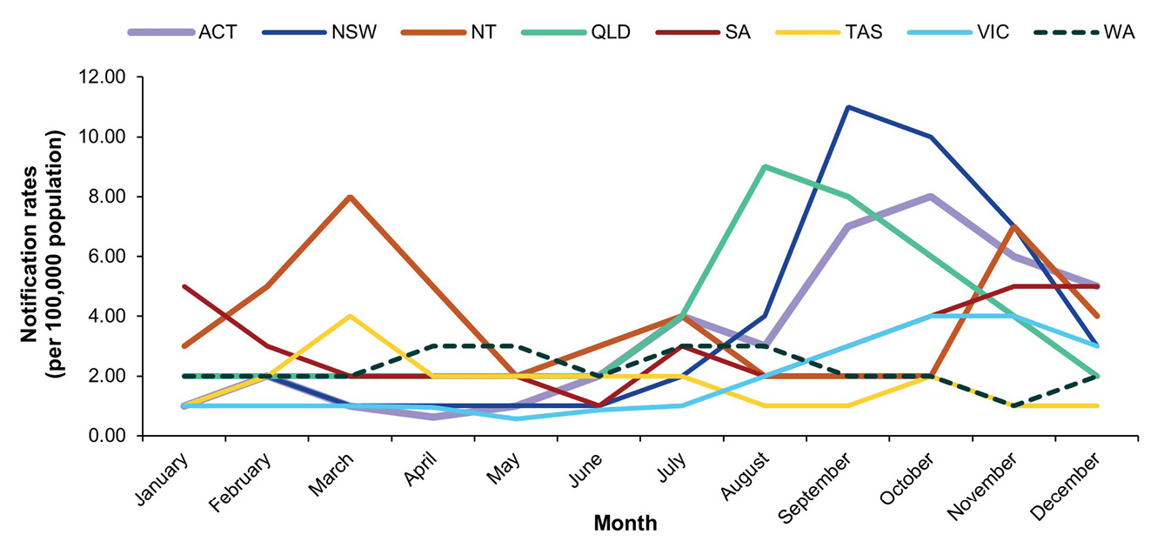

Table 4: Rotavirus G and P genotype distribution observed across jurisdictions during the period 1 January to 31 December 2024
Jurisdiction^{a,b} | Age (years) | Total | G1P[8] |  | G2P[4] |  | G3P[8] |  | Eq G3P[8]^{c} |  | G8P[8] |  | G9P[4] |  | G9P[8] |  | G12P[8] |  | Mixed |  | Other^{d} |  | Non-type^{e}
Jurisdiction^{a,b} | Age (years) | n | n | % | n | % | n | % | n | % | n | % | n | % | n | % | n | % | n | % | n | % | n | %
ACT | < 5 | 27 | 0 | 0.0 | 0 | 0.0 | 0 | 0.0 | 22 | 81.5 | 4 | 14.8 | 0 | 0.0 | 0 | 0.0 | 0 | 0.0 | 0 | 0.0 | 0 | 0.0 | 1 | 3.7
ACT | ≥ 5 | 14 | 0 | 0.0 | 0 | 0.0 | 0 | 0.0 | 11 | 78.6 | 3 | 21.4 | 0 | 0.0 | 0 | 0.0 | 0 | 0.0 | 0 | 0.0 | 0 | 0.0 | 0 | 0.0
NSW | < 5 | 214 | 0 | 0.0 | 4 | 1.9 | 6 | 2.8 | 179 | 83.6 | 7 | 3.3 | 1 | 0.5 | 0 | 0.0 | 1 | 0.5 | 0 | 0.0 | 6 | 2.8 | 10 | 4.7
NSW | ≥ 5 | 232 | 1 | 0.4 | 6 | 2.6 | 6 | 2.6 | 194 | 83.6 | 2 | 0.9 | 1 | 0.4 | 2 | 0.9 | 1 | 0.4 | 0 | 0.0 | 10 | 4.3 | 9 | 3.9
NT | < 5 | 26 | 1 | 3.8 | 0 | 0.0 | 0 | 0.0 | 20 | 76.9 | 0 | 0.0 | 0 | 0.0 | 0 | 0.0 | 0 | 0.0 | 0 | 0.0 | 1 | 3.8 | 4 | 15.4
NT | ≥ 5 | 18 | 1 | 5.6 | 0 | 0.0 | 0 | 0.0 | 13 | 72.2 | 0 | 0.0 | 0 | 0.0 | 0 | 0.0 | 1 | 5.6 | 0 | 0.0 | 0 | 0.0 | 3 | 16.7
Qld | < 5 | 196 | 0 | 0.0 | 0 | 0.0 | 8 | 4.1 | 171 | 87.2 | 2 | 1.0 | 0 | 0.0 | 0 | 0.0 | 1 | 0.5 | 0 | 0.0 | 12 | 6.1 | 2 | 1.0
Qld | ≥ 5 | 249 | 3 | 1.2 | 1 | 0.4 | 8 | 3.2 | 210 | 84.3 | 2 | 0.8 | 0 | 0.0 | 2 | 0.8 | 1 | 0.4 | 0 | 0.0 | 22 | 8.8 | 0 | 0.0
SA | < 5 | 47 | 0 | 0.0 | 3 | 6.4 | 4 | 8.5 | 36 | 76.6 | 1 | 2.1 | 0 | 0.0 | 0 | 0.0 | 1 | 2.1 | 0 | 0.0 | 1 | 2.1 | 1 | 2.1
SA | ≥ 5 | 81 | 0 | 0.0 | 5 | 6.2 | 6 | 7.4 | 62 | 76.5 | 3 | 3.7 | 2 | 2.5 | 0 | 0.0 | 0 | 0.0 | 0 | 0.0 | 2 | 2.5 | 1 | 1.2
Tas. | < 5 | 21 | 0 | 0.0 | 0 | 0.0 | 1 | 4.8 | 16 | 76.2 | 1 | 4.8 | 0 | 0.0 | 0 | 0.0 | 0 | 0.0 | 0 | 0.0 | 0 | 0.0 | 3 | 14.3
Tas. | ≥ 5 | 36 | 0 | 0.0 | 1 | 2.8 | 2 | 5.6 | 31 | 86.1 | 0 | 0.0 | 1 | 2.8 | 0 | 0.0 | 0 | 0.0 | 0 | 0.0 | 0 | 0.0 | 1 | 2.8
Vic. | < 5 | 110 | 0 | 0.0 | 7 | 6.4 | 5 | 4.5 | 73 | 66.4 | 10 | 9.1 | 2 | 1.8 | 0 | 0.0 | 0 | 0.0 | 0 | 0.0 | 7 | 6.4 | 6 | 5.5
Vic. | ≥ 5 | 142 | 2 | 1.4 | 5 | 3.5 | 11 | 7.7 | 96 | 67.6 | 11 | 7.7 | 1 | 0.7 | 1 | 0.7 | 1 | 0.7 | 0 | 0.0 | 3 | 2.1 | 11 | 7.7
WA | < 5 | 98 | 0 | 0.0 | 0 | 0.0 | 11 | 11.2 | 84 | 85.7 | 0 | 0.0 | 1 | 1.0 | 0 | 0.0 | 1 | 1.0 | 0 | 0.0 | 1 | 1.0 | 0 | 0.0
WA | ≥ 5 | 99 | 1 | 1.0 | 2 | 2.0 | 9 | 9.1 | 79 | 79.8 | 0 | 0.0 | 0 | 0.0 | 1 | 1.0 | 0 | 0.0 | 0 | 0.0 | 5 | 5.1 | 2 | 2.0
Subtotal | < 5 | 739 | 1 | 0.1 | 14 | 1.9 | 35 | 4.7 | 601 | 81.3 | 25 | 3.4 | 4 | 0.5 | 0 | 0.0 | 4 | 0.5 | 0 | 0.0 | 28 | 3.8 | 27 | 3.7
Subtotal | ≥ 5 | 871 | 8 | 0.9 | 20 | 2.3 | 42 | 4.8 | 696 | 79.9 | 21 | 2.4 | 5 | 0.6 | 6 | 0.7 | 4 | 0.5 | 0 | 0.0 | 42 | 4.8 | 27 | 3.1
Total | — | 1,610 | 9 | 0.6 | 34 | 2.1 | 77 | 4.8 | 1,297 | 80.6 | 46 | 2.9 | 9 | 0.6 | 6 | 0.4 | 8 | 0.5 | 0 | 0.0 | 70 | 4.3 | 54 | 3.4
a Samples sorted based on sample postcode, not collection location.
b ACT: Australian Capital Territory; NSW: New South Wales; NT: Northern Territory; Qld: Queensland; SA: South Australia; Tas.: Tasmania; Vic.: Victoria; WA: Western Australia.
c Equine-like G3P[8].
d Other: unusual and rarely detected genotypes, as detailed in Table 5.
e Specimen where G or P genotype was not determined.

Genotype distribution of rotavirus positive samples

Rotavirus G and P genotype distribution patterns
Genotype analysis was performed on all 1,610 confirmed wildtype rotavirus positive samples (Table 4). The lack of genotype diversity was notable, with equine-like G3P[8] representing the dominant genotype nationally (n = 1,297/1,610; 80.6%). Equine-like G3P[8] was the dominant genotype in all jurisdictions; accounting for 80.5% of samples in the Australian Capital Territory; 83.6% in New South Wales; 75.0% in the Northern Territory; 85.6% in Queensland; 76.6% in South Australia; 82.5% in Tasmania; 67.1% in Victoria and 82.7% in Western Australia. Age distribution did not impact genotype distribution, with equine-like G3P[8] dominant in the population < 5 years of age (81.3%; n = 601/739) and ≥ 5 years of age (79.9%; n = 696/871) in all jurisdictions.
Given the overwhelming predominance of equine-like G3P[8], other genotypes were detected in decreased frequencies compared to previous years; given the low detection of these other genotypes, limited trends can be deduced. Human G3P[8] was a dominant national genotype in 2023, accounting for 42.6% of samples (n = 662/1,554).¹¹ Whilst human G3P[8] was the second-most commonly identified genotype nationally in 2024, the frequency had decreased to represent 4.8% of samples nationally (n = 77/1,610); this genotype accounted for 4.7% of samples from the population < 5 years of age (n = 35/739) and 4.8% of samples from the population ≥ 5 years of age (n = 42/871). In most jurisdictions, the second-most commonly identified genotype was the same in the population < 5 years of age and ≥ 5 years of age, with similar proportions observed. However, the small numbers of samples identified for other genotypes impact this interpretation.
G8P[8] accounted for only 2.9% of wildtype samples nationally (n = 46/1,610) and was not detected in the Northern Territory or Western Australia. In the Australian Capital Territory, G8P[8] was the second-most commonly identified genotype (17.1%; n = 7/41), accounting for 14.8% of samples from the population < 5 years of age (n = 4/27) and 21.4% of samples from the population ≥ 5 years of age (n = 3/14). G8P[8] was also the second-most commonly identified genotype in Victoria, accounting for 8.3% of samples (n = 21/252).
Of other genotypes, wildtype G1P[8] was infrequently detected, representing 0.6% of samples (n = 9/1,610), and was almost exclusively detected in the population ≥ 5 years of age (n = 8/9). G2P[4] has continued to decrease in frequency recent years, accounting for 9.4% of all wildtype specimens analysed in 2023 (n = 146/1,554) and only 2.1% of wildtype samples nationally in 2024 (n = 34/1,610).¹¹ G9P[4] continued to decrease in frequency, from a recent peak of 22.3% of samples in 2022 (n = 249/1,119); this genotype accounted for 2.1% of samples in 2023 (n = 32/1,554) and only 0.6% of samples in 2024 (n = 9/1,610).^{10,11} G9P[8] was similarly infrequently identified, representing only 0.4% of samples in 2024 (n = 6/1,610) and was only detected in the ≥ 5 years population. G12P[8] has also decreased in recent years. G12P[8] was the most frequently detected genotype in the 2022 surveillance period, representing 28.2% of samples genotyped (n = 315/1,119) but decreased to 6.4% of samples in 2023 (n = 100/1,554), and further decreased to only 0.5% of samples in 2024 (n = 8/1,610).^{10,11}

Unusual genotypes and genotype combinations observed
Certain rotavirus genotypes, including G1P[8], G2P[4], G3P[8], G9P[8], G8P[8] and G12P[8], represent the most commonly detected genotypes globally.^{13–15} Unusual genotypes may be detected that represent reassortment events between commonly circulating strains, minor variants, or sporadic zoonotic transmissions. Some samples with unusual genotypes were identified in 2024 (n = 70) (Tables 4, 5). Similar to what was observed in 2023, G2P[8] was the most commonly identified unusual genotype (n = 37) and was detected in New South Wales, Queensland, South Australia, Victoria and Western Australia, suggesting this reassortant strain circulates nationally at a low frequency. Not detected in 2023, G1P[6] was detected in 2024 in eight samples in New South Wales, Queensland, Victoria and Western Australia, further highlighting the low-level circulation of unusual variants at a national level. The highly unusual G11 genotype was identified, with four G11P[25] samples detected in Queensland, all from adults. The cases were identified in different months and, based on postcode, the individuals resided in different regions across the state of Queensland. Many genotype combinations were sporadically detected as a single sample, including equine-like G3P[6], G3P[14], G4P[8], and G12P[4].
Table 5: Unusual genotypes and genotype combinations observed during the period 1 January to 31 December 2024
Genotype | Total
G1P[6] | 8
G2P[8] | 37
G3P[3] | 2
Equine-like G3P[6] | 1
Feline-like G3P[8] | 2
G3P[9] | 2
G3P[14] | 1
G4P[8] | 1
G6P[9] | 3
G8P[14] | 2
G9P[6] | 4
G11P[25] | 4
G12P[4] | 1
G12P[6] | 2
Total | 70

Discussion and conclusion
This Australian Rotavirus Surveillance Program Report describes the distribution of rotavirus genotypes identified in Australia for the period 1 January to 31 December 2024. This marks 17 years since the national introduction of rotavirus vaccines (Rotarix [GSK] and RotaTeq [Merck]) in the National Immunisation Program for all Australian infants, and the seventh year since the exclusive use of Rotarix across all jurisdictions.^{6,28,29} Of the 2,118 samples submitted as rotavirus positive by collaborating laboratories across all jurisdictions, a total of 2,053 were tested by the NRRC; 65 samples were excluded, due either to being a duplicate of a tested sample, or the sample was missing, or required metadata was not provided. In total, 91.6% of samples tested in 2024 (n = 1,880/2,053) were confirmed to be rotavirus positive by the NRRC. This provides acknowledgement and confidence that collaborating laboratories are accurately identifying rotavirus.
A total of 2,118 samples were sent from collaborating laboratories, which is the second highest number of samples received by the NRRC to date. The highest number of samples was in 2017, when 2,285 samples were received. However, in 2017 only 62.2% of samples (n = 1,422/2,285) were processed due to programmatic constraints at the time.²⁹ Thus, the 2024 surveillance period represents the highest number of samples tested by the NRRC (96.9%; n = 2,053/2,118). In March and April of 2024, an outbreak was reported in Darwin and Alice Springs by the Northern Territory Centre for Disease Control. At the time of the public health alert, 58% of cases were aged 10 years or younger, and 41% of those cases were not up to date with rotavirus vaccinations for their age.³⁰ Notifications in Western Australia were also highest in April, but no recognised outbreaks were reported by the Western Australia Department of Health.³¹ In New South Wales, the peak of rotavirus notifications in September and October was associated with multiple outbreaks of rotavirus and norovirus in the community. During this period, over 224 outbreaks of viral gastroenteritis were reported in early childhood and school settings.³²
The 2024 surveillance period is notable as it is the first time a single genotype has predominated to this extent in Australia. Historically, the dominant genotype detected in a given year has accounted for 27.6% to 52.0% of samples in that year, reflecting the dynamic co-circulation of genotypes nationally. Prior exceptions to this historical trend have been two seasons where sampling bias impacted the interpretation of genotype distribution. In 2002/2003, G9P[8] accounted for 74.7% of samples, but only Western Australia, the Northern Territory, and Victoria contributed samples. In 2021, localised outbreaks in the Northern Territory and Western Australia were attributed to G8P[8], and G8P[8] was the dominant genotype nationally accounting for 87.5% of samples (n = 294/336). However, due to the small number of samples collected, and compounded by the fact that no samples from Tasmania or South Australia were collected (collaborating laboratories had reduced capacity to participate in the program due to ongoing impacts of SARS-CoV-2 testing), it is unknown if the dominance of G8P[8] during this period was truly reflective of the genotype distribution in the population nationally.
Typically, geographic differences are also observed with genotype distributions differing between jurisdictions. In recent years, when high rates of community cases and outbreaks were reported in multiple jurisdictions, differences in genotype distribution were observed. For example, in 2017 multiple outbreaks were recorded across Australia due to diverse genotypes, including G2P[4] (Northern Territory, Western Australia, and South Australia), equine-like G3P[8] (New South Wales), and G8P[8] (New South Wales and Victoria).²⁹ Differences in genotype distribution have also been noted between the population < 5 years and ≥ 5 years of age.¹⁸ These nuanced differences in epidemiology were lacking in 2024, due to the overwhelming dominance of equine-like G3P[8] in all jurisdictions and across all ages.
G3 strains are recognised to exhibit considerable diversity, as this genotype is endemic in humans as well as in a range of host species such as cats, dogs, rabbits, goats, sheep, pigs, horses, cattle, and rodents.³³ Certain G3 variants have crossed the species barrier into humans including canine-like and feline-like G3P[3], G3P[6] and G3P[9] strains, which have become established as minor human variants and are thus sporadically detected in many countries.^{34–37}
Equine-like G3P[8] represents a zoonotic variant that has become established in the human population following reassortment events between equine-like G3 strains and endemic human strains. Australia was one of the first countries to report the emergence of this variant and it has spread globally over the past decade.²⁵ Equine-like G3P[8] has been reported in high frequencies in a number of countries, including Brazil where it accounted for 84% and 65% of samples genotyped in 2018 and 2019 respectively.³⁸ Equine-like G3P[8] was also reported as a predominant genotype in Indonesia during 2015–2016.³⁹ Equine-like G3P[8] has not been reported as the predominant genotype nationally in Australia prior to 2024. Equine-like G3P[8] was detected in Australia in 2013, accounting for 15.0% of samples genotyped; differentiation between human and equine-like G3P[8] was routinely conducted from 2015 onwards. Detection has varied over the last decade: 13% in 2015, 19% in 2016, peaking at 25% in 2017 associated with an outbreak in New South Wales. Detection was subsequently low in 2018 and 2019, representing 5% and 6% of samples respectively, before re-emerging in 2020, accounting for 19% of samples; however, this surveillance period was significantly impacted by the COVID-19 pandemic. Detection was again low in 2021 and 2022, at 1.2% and 1.3% respectively, before re-emerging in 2023 at 29.3% and ultimately reaching the unprecedented detection rate of 80.6% in 2024. This cyclical pattern may suggest that the re-emergence of this genotype is driven by the accumulation of immunologically naïve people in the population. During 2013 to 2017, when both Rotarix and RotaTeq vaccines were used in Australia, genotype data was stratified based on jurisdiction and vaccine use, and equine-like G3P[8] was more commonly detected in jurisdictions using Rotarix than in those using RotaTeq.^{6,18}
Current genotyping methods do not accurately detect the equine-like G3 variant. The current G9 primer used in the hemi-nested multiplex RT-PCR method incorrectly binds to equine-like G3 strains, so secondary testing via specific primers for the equine-like G3 variant or sequence analysis is required to differentiate between equine-like G3 and G9 strains. This issue of mis-priming is notable as it may lead to inaccurate reporting of G9 strains; secondary confirmation of equine-like G3 via single-plex genotyping assays or sequencing is costly and labour-intensive. Thus, differentiation between equine-like G3P[8] and other G3P[8] strains is not routinely done in all settings, which makes it difficult to ascertain the accurate global distribution of the equine-like variant. Given the global circulation of equine-like G3P[8] strains, there have been minor differences detected in strains harbouring the equine-like VP7 G3 gene, with different genome constellations circulating endemically in some regions. It would be of great benefit to conduct full genome sequencing on the strains circulating in 2024 to establish whether they represent the original variant detected in 2013, which may have circulated endemically across the intervening years, or whether the 2024 peak was seeded by a variant introduced from globally circulating variants.
Differentiating G1P[8] strains as either wildtype or vaccine-like is needed to understand observed trends in rotavirus detection in the younger population. A total of 256 samples collected from infants 0 to 6 months of age had rotavirus vaccine-like G1P[8] detected (74.2%; n = 256/345). This most likely reflects the increasing use of multiplex PCR panels in the collaborating laboratories. This highly sensitive assay does not distinguish between wildtype and vaccine-like rotavirus strains, and sequencing is required to make this distinction.^{40,41} Therefore, a rotavirus-positive result in an infant less than eight months of age needs to be interpreted with caution, as it may reflect vaccine virus shedding that is expected within the days following administration of a live oral rotavirus vaccine.^{40,41} Given the infrequent detection of G1P[8] in the population, all G1P[8] samples should routinely be sequenced, as vaccine-like strains are occasionally detected in unvaccinated or older individuals.
As reported in prior years, a small number of unusual genotypes were detected in 2024. Whilst the majority of these unusual genotypes are sporadically detected as a single occurrence or in small numbers, characterisation of these strains can provide insights into the diversity of strains circulating in the population. Over time, genotypes that have been considered rare or unusual have emerged as more dominant genotypes. Rare genotypes can also give indications of variants that may circulate in particular geographic regions at low frequencies, which then emerge in new regions. For instance, the highly unusual G11 genotype was identified in 2024, with four G11P[25] samples identified in Qld, all from adults. The only G11 previously identified in Australia was a G11P[25] identified in a four-year-old in 2022 from Victoria.¹⁰ G11 strains are proposed to have porcine origins and are rarely detected in humans, with reports primarily from Pakistan, India, Nepal and Bangladesh and an outbreak in older children in Korea.^{42–45} G2P[8] was the most frequently identified unusual genotype in 2023 (n = 18) and 2024 (n = 37) and was detected nationally. Whole genome sequencing would be beneficial to determine if these are sporadic reassortment events or if a conserved G2P[8] strain with either a Wa-like or DS-1-like genome constellation is circulating.
In conclusion, in this 2024 Annual Rotavirus Surveillance Report, we describe the incidence of both wildtype and vaccine-like rotavirus strains detected in Australia for the period of 1 January to 31 December 2024. A high burden of disease was reported across many jurisdictions, with 10,108 notifications recorded by the NNDSS. This is the highest recorded since rotavirus became nationally notifiable, and outbreaks were reported in the Northern Territory and New South Wales. A total of 2,118 samples were received for testing in 2024, which is the second highest number of samples referred to the NRRC over the past 20+ years of operation. It is also notable that 2024 represents the highest number of samples processed by the NRRC (as not all 2017 samples were processed due to programmatic constraints), and that 91.5% of rotavirus positive samples (n = 1,721/1,880) required secondary confirmation of genotype results such as sequencing to differentiate between wildtype and vaccine G1P[8] or subsequent testing to accurately determine G12 or equine-like G3P[8] strains. Equine-like G3P[8] was the dominant genotype nationally, representing 80.6% of rotavirus positive samples; the significant predominance of a single genotype has not been previously observed. Documenting genotype distribution and changes over time is key to understanding vaccine performance and herd immunity across different age groups and jurisdictions. Consistent with observations in prior years, a small number of unusual genotypes were identified. In 2024, the Australian Rotavirus Surveillance Program was strongly supported by a network of collaborating laboratories with the aim to provide accurate surveillance data to support the public health response and vaccination programs.

Acknowledgments
The Australian Rotavirus Surveillance Program is supported by a Service Contract from the Australian Government Department of Health, Disability and Ageing (Reference ID: HEALTH/D24-1546688) and by a research grant from GlaxoSmithKline Biologicals SA [Study#209328].
The Murdoch Children’s Research Institute (MCRI) is supported by the Victorian Government’s Operational Infrastructure Support program.
We thank H Tran for providing technical assistance.
Rotavirus positive specimens were collected from numerous centres throughout Australia. We acknowledge and appreciate the significant time and effort involved in the collection, storage, packaging, compiling data and forwarding of specimens.

Author details
Mrs Sarah Thomas, Research Assistant,¹
Mrs Nada Bogdanovic-Sakran, Research Assistant,¹
Mr Daniel Pavlic, Research Assistant,¹
Prof. Julie E Bines, Group Leader,^{1,2,3}
Dr Celeste M Donato, Senior Research Officer,^{1,2}
and the Australian Rotavirus Surveillance Group
- Enteric Diseases, Murdoch Children’s Research Institute, Parkville, Victoria
- Department of Paediatrics, University of Melbourne, Parkville, Victoria
- Department of Gastroenterology and Clinical Nutrition, Royal Children’s Hospital, Parkville, Victoria

Corresponding author
Dr Celeste Donato
Murdoch Children's Research Institute
The Royal Children's Hospital, 50 Flemington Road, Parkville, Victoria 3052 Australia
Email: celeste.donato@mcri.edu.au
The Australian Rotavirus Surveillance Program involves:
National Rotavirus Reference Centre
Mrs Sarah Thomas; Coordinator Australian Rotavirus Surveillance Program, Research Assistant, Enteric Diseases, MCRI
Mrs Nada Bogdanovic-Sakran, Research Assistant, Enteric Diseases, MCRI
Mr Daniel Pavlic, Research Assistant, Enteric Diseases, MCRI
Prof. Julie E Bines, Director, Australian Rotavirus Surveillance Program; Leader, Enteric Diseases, MCRI; Department of Paediatrics, University of Melbourne; Department of Gastroenterology and Clinical Nutrition, Royal Children’s Hospital
Dr Celeste M Donato, Senior Research Officer, Enteric Diseases, MCRI; Department of Paediatrics, University of Melbourne
Australian Capital Territory
Assoc Prof K Kennedy, S Bradbury and members of the Microbiology Department, Canberra Hospital
New South Wales
P Huntington, Prof M Lahra and members of the Serology, Virology and OTDS Laboratories (SAViD), NSW Health Pathology, Prince of Wales Hospital
Dr A Outhred, I Tam, A Howard-Jones and members of the Virology Department, The Children’s Hospital, Westmead
Dr M Wehrhahn, and members of Douglass Hanly Moir Pathology, New South Wales
F Jozwiak, J Merif and members of the Department of Microbiology and Infectious Diseases, Liverpool Hospital, Liverpool
Northern Territory
Dr R Baird, K Freeman, D Menouhos, J Harbidge, T Eapen, and members of Territory Pathology, Royal Darwin Hospital, Tiwi
Queensland
Dr C Bletchly, Dr R Gupta and department members, Pathology Queensland Central
South Australia
M Turra, Dr J Arthur, and members of the Microbiology and Infectious Diseases Laboratory, SA Pathology, Adelaide
Tasmania
Assoc Prof Louise Cooley, J Maskell, and members of Molecular Medicine, Pathology Services, Royal Hobart Hospital, Hobart
Victoria
Dr T Korman, K Cisera, D Kotsanas, and members of the Department of Microbiology, Monash Medical Centre, Clayton
K Rautenbacher, P Adamopoulos, and members of Laboratory Services, Royal Children’s Hospital, Parkville
Western Australia
Dr D Speers, D Bradford, D Tennant, and members of QEII Microbiology Department, PathWest Laboratory Medicine WA, Perth

References
- Troeger C, Khalil IA, Rao PC, Cao S, Blacker BF, Ahmed T et al. Rotavirus vaccination and the global burden of rotavirus diarrhea among children younger than 5 years. JAMA Pediatr. 2018;172(10):958–65. doi: https://doi.org/10.1001/jamapediatrics.2018.1960.
- International Vaccine Access Center (IVAC). VIEW-hub by IVAC. [Website.] Baltimore: Johns Hopkins Bloomberg School of Public Health, IVAC; 2023. [Accessed on 29 April 2024.] Available from: https://view-hub.org.
- Buttery JP, Lambert SB, Grimwood K, Nissen MD, Field EJ, Macartney KK et al. Reduction in rotavirus-associated acute gastroenteritis following introduction of rotavirus vaccine into Australia's National Childhood vaccine schedule. Pediatr Infect Dis J. 2011;30(1 Suppl):S25–9. doi: https://doi.org/10.1097/INF.0b013e3181fefdee.
- Macartney KK, Porwal M, Dalton D, Cripps T, Maldigri T, Isaacs D et al. Decline in rotavirus hospitalisations following introduction of Australia's national rotavirus immunisation programme. J Paediatr Child Health. 2011;47(5):266–70.
doi: https://doi.org/10.1111/j.1440-1754.2010.01953.x.
- Reyes JF, Wood JG, Beutels P, Macartney K, McIntyre P, Menzies R et al. Beyond expectations: post-implementation data shows rotavirus vaccination is likely cost-saving in Australia. Vaccine. 2017;35(2):345–52. doi: https://doi.org/10.1016/j.vaccine.2016.11.056.
- Roczo-Farkas S, Kirkwood CD, Cowley D, Barnes GL, Bishop RF, Bogdanovic-Sakran N et al. The impact of rotavirus vaccines on genotype diversity: a comprehensive analysis of 2 decades of Australian surveillance data. J Infect Dis. 2018;218(4):546–54. doi: https://doi.org/10.1093/infdis/jiy197.
- Thomas S, Donato CM, Roczo-Farkas S, Hua J, Bines JE. Australian Rotavirus Surveillance Program: Annual Report, 2019. Commun Dis Intell (2018). 2021;45. doi: https://doi.org/10.33321/cdi.2021.45.4.
- Australian Government Department of Health, Disability and Ageing. National Communicable Disease Surveillance Dashboard. [Website.] Canberra: Australian Government Department of Health, Disability and Ageing; 2025. Available from: https://nindss.health.gov.au/pbi-dashboard/.
- Roczo-Farkas S, Thomas S, Bogdanovic-Sakran N, Donato CM, Lyons EA, Bines J et al. Australian Rotavirus Surveillance Program: Annual Report, 2021. Commun Dis Intell (2018). 2022;46. doi: https://doi.org/10.33321/cdi.2022.46.75.
- Donato CM, Roczo-Farkas S, Thomas S, Bogdanovic-Sakran N, Lyons E, Bines JE. Australian Rotavirus Surveillance Program: Annual Report, 2022. Commun Dis Intell (2018). 2024;48. doi: https://doi.org/10.33321/cdi.2024.48.27.
- Thomas S, Bogdanovic-Sakran N, Donato CM, Sriraman A, Pavlic D, Bines J et al. Australian Rotavirus Surveillance Program Annual Report, 2023. Commun Dis Intell (2018). 2025;49. doi: https://doi.org/10.33321/cdi.2025.49.027.
- Desselberger U. Rotaviruses. Virus Res. 2014;190:75–96. doi: https://doi.org/10.1016/j.virusres.2014.06.016.
- Bányai K, László B, Duque J, Steele AD, Nelson EA, Gentsch JR et al. Systematic review of regional and temporal trends in global rotavirus strain diversity in the pre rotavirus vaccine era: insights for understanding the impact of rotavirus vaccination programs. Vaccine. 2012;30(Suppl 1):A122–30. doi: https://doi.org/10.1016/j.vaccine.2011.09.111.
- Dóró R, László B, Martella V, Leshem E, Gentsch J, Parashar U et al. Review of global rotavirus strain prevalence data from six years post vaccine licensure surveillance: is there evidence of strain selection from vaccine pressure? Infect Genet Evol. 2014;28:446–61. doi: https://doi.org/10.1016/j.meegid.2014.08.017.
- Kondo K, Tsugawa T, Ono M, Ohara T, Fujibayashi S, Tahara Y et al. Clinical and molecular characteristics of human rotavirus G8P[8] outbreak strain, Japan, 2014. Emerg Infect Dis. 2017;23(6):968–72. doi: https://doi.org/10.3201/eid2306.160038.
- Matthijnssens J, Ciarlet M, McDonald SM, Attoui H, Bányai K, Brister JR et al. Uniformity of rotavirus strain nomenclature proposed by the Rotavirus Classification Working Group (RCWG). Arch Virol. 2011;156(8):1397–413. doi: https://doi.org/10.1007/s00705-011-1006-z.
- Iturriza-Gómara M, Isherwood B, Desselberger U, Gray J. Reassortment in vivo: driving force for diversity of human rotavirus strains isolated in the United Kingdom between 1995 and 1999. J Virol. 2001;75(8):3696–705. doi: https://doi.org/10.1128/JVI.75.8.3696-3705.2001.
- Donato CM, Roczo-Farkas S, Kirkwood CD, Barnes GL, Bines JE. Rotavirus disease and genotype diversity in older children and adults in Australia. J Infect Dis. 2022;225(12):2116–26. doi: https://doi.org/10.1093/infdis/jiaa430.
- Simmonds MK, Armah G, Asmah R, Banerjee I, Damanka S, Esona M et al. New oligonucleotide primers for P-typing of rotavirus strains: strategies for typing previously untypeable strains. J Clin Virol. 2008;42(4):368–73. doi: https://doi.org/10.1016/j.jcv.2008.02.011.
- Gómara MI, Cubitt D, Desselberger U, Gray J. Amino acid substitution within the VP7 protein of G2 rotavirus strains associated with failure to serotype. J Clin Microbiol. 2001;39(10):3796–8. doi: https://doi.org/10.1128/JCM.39.10.3796-3798.2001.
- Gentsch JR, Glass RI, Woods P, Gouvea V, Gorziglia M, Flores J et al. Identification of group A rotavirus gene 4 types by polymerase chain reaction. J Clin Microbiol. 1992;30(6):1365–73. doi: https://doi.org/10.1128/jcm.30.6.1365-1373.1992.
- Gouvea V, Glass RI, Woods P, Taniguchi K, Clark HF, Forrester B et al. Polymerase chain reaction amplification and typing of rotavirus nucleic acid from stool specimens. J Clin Microbiol. 1990;28(2):276–82. doi: https://doi.org/10.1128/jcm.28.2.276-282.1990.
- Donato CM, Ch'ng LS, Boniface KF, Crawford NW, Buttery JP, Lyon M et al. Identification of strains of RotaTeq rotavirus vaccine in infants with gastroenteritis following routine vaccination. J Infect Dis. 2012;206(3):377–83. doi: https://doi.org/10.1093/infdis/jis361.
- Elschner M, Prudlo J, Hotzel H, Otto P, Sachse K. Nested reverse transcriptase-polymerase chain reaction for the detection of group A rotaviruses. J Vet Med B Infect Dis Vet Public Health. 2002;49(2):77–81. doi: https://doi.org/10.1046/j.1439-0450.2002.00510.x.
- Cowley D, Donato CM, Roczo-Farkas S, Kirkwood CD. Emergence of a novel equine-like G3P[8] inter-genogroup reassortant rotavirus strain associated with gastroenteritis in Australian children. J Gen Virol. 2016;97(2):403–10. doi: https://doi.org/10.1099/jgv.0.000352.
- Banerjee I, Ramani S, Primrose B, Iturriza-Gomara M, Gray JJ, Brown DW et al. Modification of rotavirus multiplex RT-PCR for the detection of G12 strains based on characterization of emerging G12 rotavirus strains from South India. J Med Virol. 2007;79(9):1413–21. doi: https://doi.org/10.1002/jmv.20872.
- Roczo-Farkas S, Kirkwood CD, Bines JE, Enteric Virus Group. Australian Rotavirus Surveillance Program: Annual Report, 2016. Commun Dis Intell Q Rep. 2017;41(4):E455–71. doi: https://doi.org/10.33321/cdi.2017.41.48.
- Australian Government Department of Health, Disability and Ageing. Clinical update: ATAGI advice on Rotarix® to replace RotaTeq®. [Internet.] Canberra: Australian Government Department of Health, Disability and Ageing; 20 December 2017. Available from: https://beta.health.gov.au/news-and-events/news/clinical-update-atagi-advice-on-rotarixr-to-replace-rotateqr.
- Roczo-Farkas S, Cowley D, Bines JE, the Australian Rotavirus Surveillance Group. Australian Rotavirus Surveillance Program: Annual Report, 2017. Commun Dis Intell (2018). 2019;43. doi: https://doi.org/10.33321/cdi.2019.43.28.
- Northern Territory Government Department of Health (NT Health). Health Alert: Rotavirus. Darwin: NT Health, Centre for Disease Control. Available from: https://health.nt.gov.au/__data/assets/pdf_file/0013/1216102/health-alert-rotavirus.pdf.
- Government of Western Australia Department of Health (WA Health). Notifiable infectious disease dashboard. [Online resource.] Perth: WA Health; 2025. Available from: https://www.health.wa.gov.au/articles/n_r/notifiable-infectious-disease-dashboard.
- New South Wales State Government Department of Health (NSW Health). Viral gastroenteritis update: information for early childhood and vacation care directors. Sydney: NSW Health; 26 September 2024. Available from: https://www.health.nsw.gov.au/Infectious/alerts/Documents/2024/viral-gastro-update-for-childcare-providers-september.pdf.
- Martínez-Laso J, Román A, Rodriguez M, Cervera I, Head J, Rodríguez-Avial I et al. Diversity of the G3 genes of human rotaviruses in isolates from Spain from 2004 to 2006: cross-species transmission and inter-genotype recombination generates alleles. J Gen Virol. 2009;90(Pt 4):935–43. doi: https://doi.org/10.1099/vir.0.007807-0.
- Cao M, Yuan F, Zhang W, Wang X, Ma J, Ma X et al. Genomic analysis of two rare human G3P[9] rotavirus strains in Ningxia, China. Infect Genet Evol. 2023;116:105518. doi: https://doi.org/10.1016/j.meegid.2023.105518.
- Mijatovic-Rustempasic S, Roy S, Sturgeon M, Rungsrisuriyachai K, Esona MD, Degroat D et al. Full-genome sequence of a rare human G3P[9] rotavirus strain. Genome Announc. 2014;2(2):e00143-14. doi: https://doi.org/10.1128/genomeA.00143-14.
- Grant L, Esona M, Gentsch J, Watt J, Reid R, Weatherholtz R et al. Detection of G3P[3] and G3P[9] rotavirus strains in American Indian children with evidence of gene reassortment between human and animal rotaviruses. J Med Virol. 2011;83(7):1288–99. doi: https://doi.org/10.1002/jmv.22076.
- Jeong S, Than VT, Lim I, Kim W. Whole-genome analysis of a rare human Korean G3P rotavirus strain suggests a complex evolutionary origin potentially involving reassortment events between feline and bovine rotaviruses. PLoS One. 2014;9(5):e97127. doi: https://doi.org/10.1371/journal.pone.0097127.
- Gutierrez MB, Fialho AM, Maranhão AG, Malta FC, Andrade J, Assis RMS et al. Rotavirus A in Brazil: molecular epidemiology and surveillance during 2018–2019. Pathogens. 2020;9(7):515. doi: https://doi.org/0.3390/pathogens9070515.
- Utsumi T, Wahyuni RM, Doan YH, Dinana Z, Soegijanto S, Fujii Y et al. Equine-like G3 rotavirus strains as predominant strains among children in Indonesia in 2015–2016. Infect Genet Evol. 2018;61:224–8. doi: https://doi.org/10.1016/j.meegid.2018.03.027.
- Whiley DM, Ye S, Tozer S, Clark JE, Bletchly C, Lambert SB et al. Over-diagnosis of rotavirus infection in infants due to detection of vaccine virus. Clin Infect Dis. 2020;71(5):1324–6. doi: https://doi.org/10.1093/cid/ciz1196.
- Ye S, Whiley DM, Ware RS, Kirkwood CD, Lambert SB, Grimwood K. Multivalent rotavirus vaccine and wild-type rotavirus strain shedding in Australian infants: a birth cohort study. Clin Infect Dis. 2018;66(9):1411–8. doi: https://doi.org/10.1093/cid/cix1022.
- Ali S, Khan S, Khan SN, Rauf M, Khan MF, Majid A et al. Molecular detection and prevalence of Rotavirus with acute gastroenteritis among the children of rural and urban areas. Braz J Biol. 2021;83:e244365. doi: https://doi.org/10.1590/1519-6984.244365.
- Banerjee I, Iturriza-Gomara M, Rajendran P, Primrose B, Ramani S, Gray JJ et al. Molecular characterization of G11P[25] and G3P[3] human rotavirus strains associated with asymptomatic infection in South India. J Med Virol. 2007;79(11):1768–74. doi: https://doi.org/10.1002/jmv.20988.
- Chawla-Sarkar M, Banerjee A, Lo M, Mitra S, Okamoto K, Deb A et al. A decade-long temporal analyses of human group-A rotavirus among children with gastroenteritis: prevaccination scenario in West Bengal, eastern India. J Med Virol. 2020;92(8):1334–42. doi: https://doi.org/10.1002/jmv.25712.
- Chae SJ, Jung S, Cho SR, Choi W, Lee DY. Outbreak associated with Rotavirus G11,P[25] in Korea in 2018. Infect Chemother. 2020;52(4):616–20. doi: https://doi.org/10.3947/ic.2020.52.4.616.

https://www.geneious.com.
http://blast.ncbi.nlm.nih.gov/Blast.cgi.
https://www.rivm.nl/mpf/typingtool/rotavirusa/.

