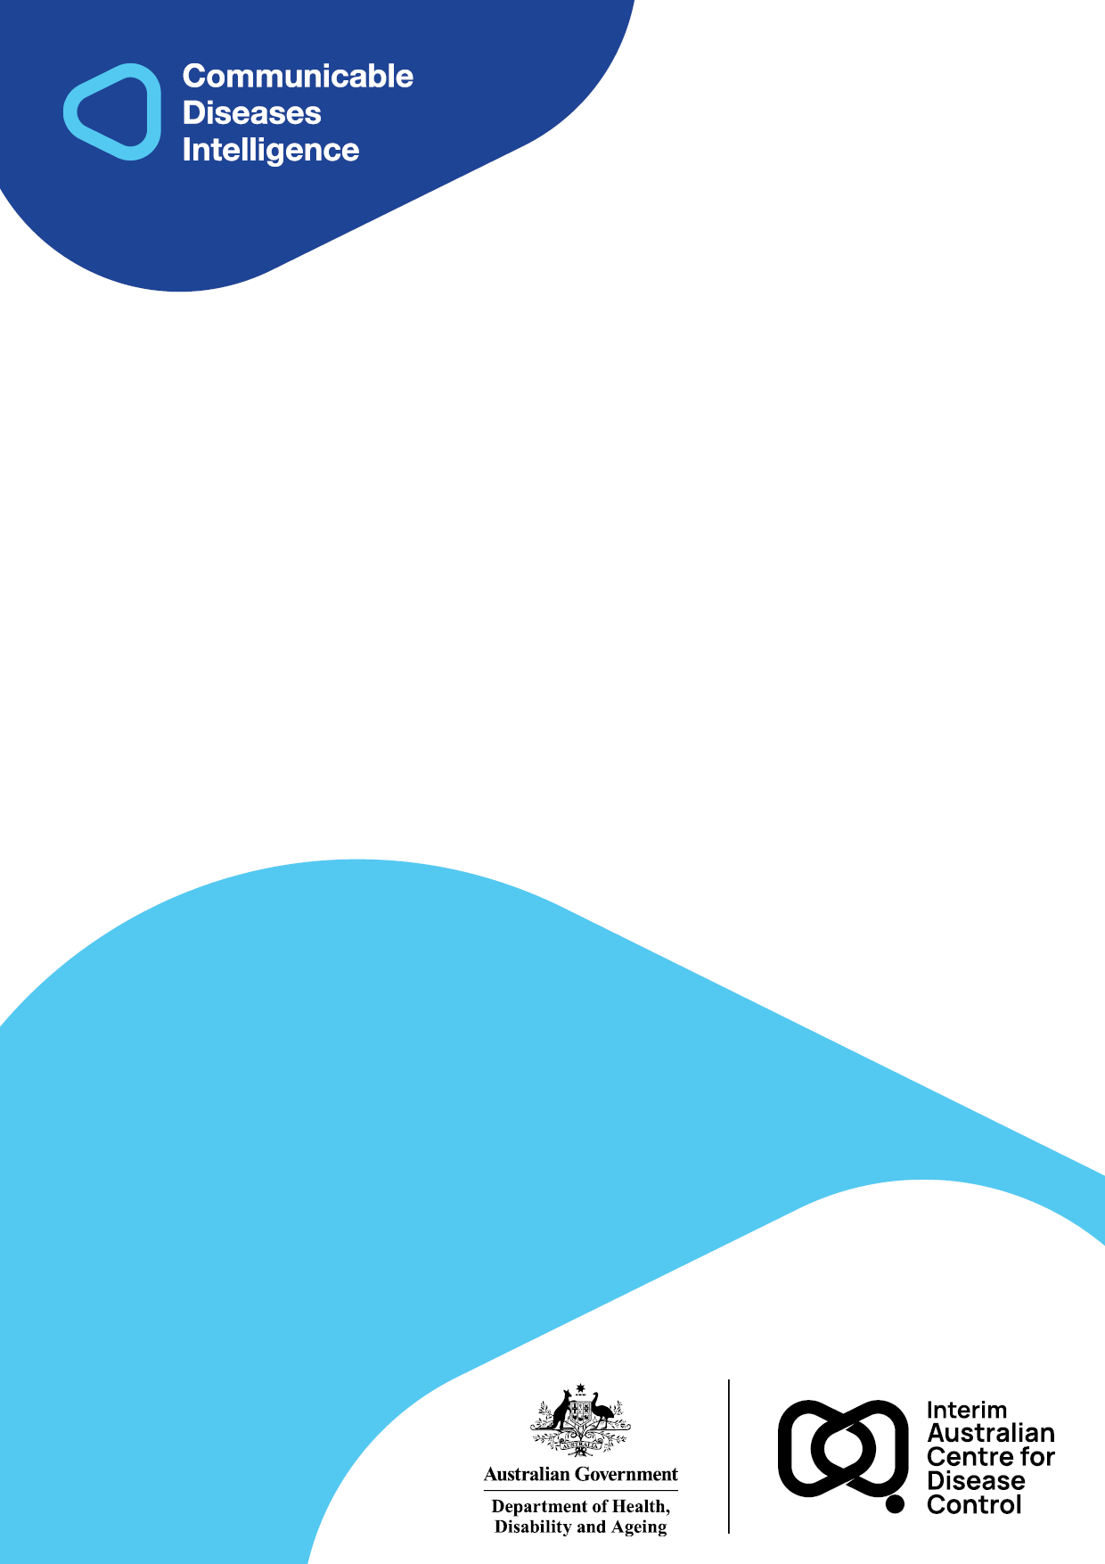
2025 • Volume 49 • cdc.gov.au/cdi • Epub date: 22.10.2025 • doi.org/10.33321/cdi.2025.49.038

Invasive pneumococcal disease in Australia: 2013 and 2014
Kate Pennington, Sanjay Jayasinghe, and the Enhanced Invasive Pneumococcal Disease Surveillance Working Group, for the Communicable Diseases Network Australia
© 2025 Commonwealth of Australia as represented by the Department of Health, Disability and Ageing
ISSN: 2209-6051 Online
This journal is indexed by Index Medicus and Medline.
Creative Commons Licence
This publication is licensed under a Creative Commons Attribution-NonCommercial-NoDerivatives 4.0 International Licence (Licence). You must read and understand the Licence before using any material from this publication.
Restrictions
The Licence does not cover, and there is no permission given for, use of any of the following material found in this publication (if any):
- the Commonwealth Coat of Arms (by way of information, the terms under which the Coat of Arms may be used can be found on the Department of Prime Minister and Cabinet website;
- any logos (including the interim Australian Centre for Disease Control and the Department of Health, Disability and Ageing’s logos) and trademarks;
- any photographs and images;
- any signatures; and
- any material belonging to third parties.
Disclaimer
Opinions expressed in Communicable Diseases Intelligence are those of the authors and not necessarily those of the Australian Government, the interim Australian Centre for Disease Control or the Department of Health, Disability and Ageing. Data may be subject to revision.
Enquiries
Enquiries regarding any other use of this publication should be addressed to the CDI Editor.
About CDI
Communicable Diseases Intelligence (CDI) is a peer-reviewed scientific journal published by the interim Australian Centre for Disease Control within the Department of Health, Disability and Ageing.
The journal aims to disseminate information on the epidemiology, surveillance, prevention and control of communicable diseases of relevance to Australia and the near region.
Editor: Christina Bareja • Deputy Editor: Simon Petrie • Design and Production: Lisa Thompson with support from Sehaj Dhillon
Editorial Advisory Board: David Durrheim, Mark Ferson, Clare Huppatz, John Kaldor, Martyn Kirk and Meru Sheel
Submit an Article
Guidelines for authors and details on how to submit your publication is available on our website, or by email to the
CDI Editor.
Contact us
Communicable Diseases Intelligence (CDI)
interim Australian Centre for Disease Control, Department of Health, Disability and Ageing
GPO Box 9848, CANBERRA ACT 2601
Website: cdc.gov.au/cdi
Email: cdi.editor@health.gov.au

Contents
List of figures 4
List of tables 5
Abstract 6
Introduction 7
Methods 8
Data collection 8
Case definition 9
Serotype identification 9
Indigenous status 10
Vaccination status 10
Data analysis 11
Results 12
Overall trends 12
Seasonality 13
Age and sex distribution 13
Incidence rate by Indigenous status 15
Mortality 20
Risk factors 22
Clinical category 23
Serotypes causing IPD 24
Vaccinated cases 29
Antibiotic resistance 29
Diagnosis method data 30
Discussion 31
Acknowledgments 34
Author details 35
References 36
Appendix A 40

List of figures
Figure 1: Invasive pneumococcal disease notification case counts and rates 2002 to 2014, Australia^{a,b} 12
Figure 2: Notified cases of invasive pneumococcal disease, Australia, 2013 and 2014, by year and month of diagnosis and age groupª 13
Figure 3: Notification rates of invasive pneumococcal disease, Australia, 2013 and 2014, by age group and sexª 14
Figure 4: Notification rates of invasive pneumococcal disease, Australia, 2002 to 2014, by age groupª 15
Figure 5: Notified cases and rates of invasive pneumococcal disease in the Indigenous population, Australia, 2002 to 2014ª 16
Figure 6: Number and rate per 100,000 population per year of invasive pneumococcal disease notifications in Indigenous children aged less than 15 years, Australia, 2002 to 2014, by age groupª 17
Figure 7: Number and rate per 100,000 population per year of invasive pneumococcal disease notifications in non-Indigenous children, Australia, 2002 to 2014, by age group^{a,b} 18
Figure 8: Notification rates of invasive pneumococcal disease in the Indigenous population aged 15 years and over, Australia, 2002 to 2014, by age groupª 19
Figure 9: Notification rates of invasive pneumococcal disease in the non-Indigenous population aged 15 years and over, Australia, 2002 to 2014, by age groupª 19
Figure 10: Notifications of invasive pneumococcal disease, Australia, 2005 to 2014, by age group and vaccine serotypes 25
Figure 11: Notifications and rates of invasive pneumococcal disease caused by 13vPCV and
non-13vPCV serotypes in children aged less than 5 years, Australia, 2002 to 2014, by Indigenous status 25
Figure 12: Notifications and rates of invasive pneumococcal disease caused by 13vPCV-
non-7vPCV serotypes in children aged less than 5 years, Australia, 2002 to 2014, by Indigenous status 27
Figure 13: Notifications and rates of invasive pneumococcal disease caused by 23vPPV and
on-23vPPV serotypes in Indigenous adults 50 years or over and non-Indigenous adults aged 65 years or over, Australia, 2002 to 2014, by Indigenous status 28

List of tables
Table 1: Age groups of invasive pneumococcal cases followed-up for collection of enhanced data by Australian states and territories in 2013 and 2014 8
Table 2: Streptococcus pneumoniae serotypes contained in pneumococcal vaccines used in Australia 9
Table 3: Pneumococcal vaccinations offered to Australians under the National Immunisation Program (NIP) in 2013 and 2014ª 11
Table 4: Definitions used for vaccination status and vaccine failures for invasive pneumococcal disease cases in children notified in 2013 and 2014, Australia 11
Table 5: Characteristics of deaths from invasive pneumococcal disease in children aged less than 5 years, Australia, 2013 and 2014 21
Table 6: Number of risk factors reported for invasive pneumococcal disease notifications, Australia, 2013 and 2014, by risk factor and targeted population subgroup 23
Table A.1: Notified cases and rates of invasive pneumococcal disease, Australia, 2013 and 2014, by state or territory,ª age group and Indigenous status 40
Table A.2: Notified cases and rates of invasive pneumococcal disease, Australia, 2005 to 2014, by age group and Indigenous status 42
Table A.3: Deaths and case fatality rates (CFR) for invasive pneumococcal disease, Australia, 2013 and 2014, by age group, Indigenous status and state or territory 44
Table A.4: Notifications of invasive pneumococcal disease, Australia, 2008 to 2014, by clinical categoryª and age group 46
Table A.5: Notified cases of invasive pneumococcal disease, Australia, 2013, by serotype, age group and National Immunisation Program (NIP) targeted age groups 48
Table A.6: Notified cases of invasive pneumococcal disease, Australia, 2014, by serotype, age group and National Immunisation Program (NIP) targeted age groups 52
Table A.7: Notified cases of invasive pneumococcal disease, Australia, 2013 and 2014, by pneumococcal vaccine serotypes, age group and Indigenous statusª 56
Table A.8: Characteristics of pneumococcal vaccine failures in children aged less than 5 years, Australia, 2013 58
Table A.9: Characteristics of pneumococcal vaccine failures in children aged less than 5 years, Australia, 2014 60

Abstract
In Australia, there were 1,552 cases (6.7 per 100,000 population per year) of invasive pneumococcal disease (IPD) notified to the National Notifiable Diseases Surveillance System (NNDSS) in 2013, and 1,564 cases (6.7 per 100,000 population per year) in 2014. The non-age standardised rate of IPD in Indigenous Australians was six times the rate of IPD in non-Indigenous Australians in both 2013 and 2014. Following the July 2011 introduction of the 13-valent pneumococcal conjugate vaccine (13vPCV) to the National Immunisation Program (NIP), the overall rate of IPD in children aged less than 5 years decreased from 19.8 per 100,000 population per year in 2011 to 12.5 per 100,000 population per year in 2013. In 2014 there was a slight increase in the overall rate of IPD in children aged less than 5 years to 14.1 per 100,000 population per year in 2014. In both 2013 and 2014, the rate of IPD caused by serotypes included 23-valent pneumococcal polysaccharide vaccine (23vPPV) declined in Indigenous adults aged 50 years or older (40.5 per 100,000 population per year and 35.2 per 100,000 population per year, respectively) after displaying a gradual increase between 2002 and 2012. Rates of IPD in non-Indigenous adults aged 65 years or older caused by serotypes included in the 23vPPV also declined in both 2013 and 2014 (9.5 per 100,000 population per year and 8.3 per 100,000 population per year, respectively) compared to 2011 (11.8 per 100,000 population per year). There were 134 deaths attributable to IPD in 2013 (a case fatality rate of 8.6%) and 118 in 2014 (a case fatality rate of 7.5%).
Keywords: Australia; invasive pneumococcal disease; communicable disease surveillance; epidemiology; annual report

Introduction
Invasive pneumococcal disease (IPD) has been nationally notifiable in Australia since 2001. This report describes the epidemiology of IPD in Australia for the years 2013 and 2014. Pneumococcal disease, caused by Streptococcus pneumoniae, is a major cause of morbidity and mortality worldwide.¹ Clinically, pneumococcal disease includes a group of conditions classified as either non-invasive or invasive. IPD is the severe end of the spectrum and occurs when the pathogen enters the bloodstream or other normally sterile sites, resulting in clinical manifestations such as pneumonia with bacteraemia, septicaemia, and meningitis.^{1,2} Non-invasive forms of the disease include otitis media, sinusitis, and bronchitis, and are generally more common and less severe than IPD. Non-invasive forms of the disease are not notifiable and therefore are not included in this report.
The incidence of pneumococcal disease is highest in infants and the elderly; for that reason, these groups are targeted for the universal pneumococcal vaccination under the National Immunisation Program (NIP). Indigenous Australians and people with select underlying conditions also have an increased risk of pneumococcal disease. In 1999, the 23-valent pneumococcal polysaccharide vaccine (23vPPV) was first funded under the NIP for Aboriginal and Torres Strait Islander adults aged 50 years and over. NIP-funded 23vPPV has since been extended to all adults aged 65 years or over and to children with underlying at-risk comorbidities. The 7-valent pneumococcal conjugate vaccine (7vPCV) was registered for use in Australia in late 2000 and was first funded on the NIP in mid-2001 for all Aboriginal and Torres Strait Islander infants and children with underlying at-risk medical conditions. In 2001, administration of a dose of 23vPPV was funded for Aboriginal and Torres Strait Islander children living in the Northern Territory, Queensland, South Australia and Western Australia at 18–24 months of age following the three doses of 7vPCV. In January 2005, NIP-funded 7vPCV was extended to all infants nationally, in addition to a catch-up program for all children up to 2 years of age. In 2009, the Northern Territory Government funded the 10-valent pneumococcal conjugate vaccine (10vPCV) for children residing in the Northern Territory, replacing the 7vPCV and the 23vPPV booster offered to Indigenous children. In 2011, the 13-valent pneumococcal conjugate vaccine (13vPCV) replaced both the 7vPCV on the NIP and the 10vPCV in the Northern Territory, with a catch-up single supplementary dose of 13vPCV offered to eligible children who had completed a course of 7vPCV or 10vPCV. From 2012 a booster dose of 13vPCV was funded for Aboriginal and Torres Strait Islander children in the Northern Territory, Queensland, South Australia and Western Australia, replacing the 23vPPV dose.^{3,4}
IPD surveillance data are published regularly in Communicable Diseases Intelligence as annual and quarterly reports. In addition, a subset of IPD notification data, including serotype, age, sex, Indigenous status, clinical categories and vaccination history, is publicly available in the Australian National Notifiable Diseases Surveillance System (NNDSS) IPD Public Dataset.⁵

Methods

Data collection
Under state and territory public health legislation, medical practitioners, laboratories, and other health professionals are required to report cases of laboratory confirmed IPD to the relevant state and territory health authorities. The National Health Security Act 2007 provides the legislative basis for the national notification of communicable diseases and authorises the exchange of health information between the state and territory governments and the Commonwealth. State and territory health departments transfer these notifications regularly to the NNDSS.
Core data, including serotype, sex, age, Indigenous status, pneumococcal vaccination history, and ‘died of disease’ status, are collected for all notifiable cases of IPD. In addition to the core data, enhanced surveillance data on notified cases of IPD are collected and can include information relating to underlying risk factors, clinical category, antibiotic susceptibilities and, when relevant, date died. In 2013 and 2014, the majority of core data were available for all notified cases of IPD. However, the completeness of Indigenous status, vaccination status and enhanced surveillance data varied across states and territories due to follow-up practices (Table 1).
Mortality data in this report includes all cases that were assessed by the state or territory public health unit as having died due to IPD. Due to varying case follow-up practices (Table 1), and the timing of case follow-up, it is likely that these data do not represent an accurate estimate of mortality associated with IPD.
The clinical category data field requires an isolate cultured from a sterile site (e.g., blood or cerebrospinal fluid) associated with the reported site of infection, and supportive clinical evidence. The single exception to this requirement is for cases of pneumonia and meningitis, where a clinically compatible illness and an accompanying blood culture or positive polymerase chain reaction test result from blood are sufficient. More than one clinical category may be reported for an IPD episode, except if primarily reported as bacteraemia.
Table 1: Age groups of invasive pneumococcal cases followed-up for collection of enhanced data by Australian states and territories in 2013 and 2014
Age group | Jurisdiction
Under 5 years | New South Wales; Victoria;ª Queensland (Metro South and Gold Coast Public Health Units)
50 years and over | New South Wales; Victoria
All ages | Australian Capital Territory; Northern Territory; Queensland (except Metro South and Gold Coast Public Health Units); Tasmania; South Australia; Western Australia
a Prior to 30 June 2012, Victoria followed up the collection of enhanced data for all ages. Since 1 July 2012, Victoria has followed up the collection of enhanced data in the under 5 years and the 50 years and over age groups.
The Enhanced Invasive Pneumococcal Disease Surveillance Working Group (EIPDSWG), a working group of the Communicable Diseases Network Australia (CDNA), ensures routine and standardised reporting of trends and emerging issues relating to IPD.

Case definition
According to the national IPD case definition,⁶ only laboratory confirmed cases of IPD are notifiable and therefore reported to the NNDSS. A laboratory confirmed case of IPD is defined as the detection of S. pneumoniae from a normally sterile site, such as blood or cerebrospinal fluid, either by culture or by nucleic acid amplification testing (NAAT). Cases that meet this definition are referred to a pneumococcal reference laboratory for serotype identification.

Serotype identification
The serotype information included in this report is based on two laboratory methods. For culture positive specimens, which are the majority of cases, serotyping is based on the Quellung reaction, the gold standard method for serotyping that uses antisera produced by the Statens Serum Institut, Denmark. Where pneumococcus has been detected by NAAT, the serotype is inferred from molecular serotyping. Molecular serotyping may also be employed to supplement equivocal or indeterminate results from the standard serotyping method. The Australian Government, through the National IPD Laboratory Surveillance Project, funds the serotyping of all S. pneumoniae isolates causing invasive disease.
In this report, serotype analysis has been categorised according to those covered in each of the individual pneumococcal vaccines, taking into account both the composition of vaccines funded under the NIP (Table 2) and the relevance of these serotype groupings to the populations specifically targeted.
Table 2: Streptococcus pneumoniae serotypes contained in pneumococcal vaccines used in Australia
Vaccine type | Valency | Common serotypes across vaccines | Additional pneumococcal serotypes contained in the specified vaccine
Conjugate (PCV) | 7-valent | 4, 6B, 9V, 14, 18C, 19F, 23F | –
Conjugate (PCV) | 10-valent | 4, 6B, 9V, 14, 18C, 19F, 23F | 1, 5, 7F
Conjugate (PCV) | 13-valent | 4, 6B, 9V, 14, 18C, 19F, 23F | 1, 5, 7F, 3, 19A, 6A
Polysaccharide (PPV) | 23-valent | 4, 6B, 9V, 14, 18C, 19F, 23F | 1, 5, 7F, 3, 19A, 2, 8, 9N, 10A, 11A, 12F, 15B, 17F, 20, 22F, 33F

Indigenous status
The definition used for an Aboriginal or Torres Strait Islander person in the NNDSS aligns with that of the Commonwealth: that is, an Aboriginal or Torres Strait Islander is determined by descent, self-identification, and community acceptance. Cases are considered ‘Indigenous’ where Indigenous status was reported as either:
- Aboriginal but not Torres Strait Islander,
- Torres Strait Islander but not Aboriginal; or
- Aboriginal and Torres Strait Islander.
Where Indigenous status was reported as ‘unknown’, cases were grouped with those reported as non-Indigenous. Completeness of Indigenous status reporting in cases is described in the results section of this report.

Vaccination status
There are four pneumococcal vaccines that have historically been available and funded in Australia, each targeting selected pneumococcal serotypes (Table 2).⁴ In 2013 and 2014, the 13vPCV and 23vPPV vaccines were available on the NIP for certain age and at-risk population subgroups (Table 3).^{3,4}
More information on the current scheduling of the pneumococcal vaccination can be found in the digital Australian Immunisation Handbook. A summary of significant events in pneumococcal vaccination in Australia is found in immunisation history tables from the National Centre for Immunisation Research and Surveillance (NCIRS).³
The definitions for vaccination status and vaccine failures used in the NNDSS (agreed by EIPDSWG) are described in Table 4. Of note, when 13vPCV replaced 7vPCV in 2011, children who had started on 7vPCV were recommended to complete the schedule using 13vPCV. This led to these children receiving schedules of mixed vaccine. Therefore, in such instances, an IPD case in a child who had received a mixed 7vPCV and 13vPCV schedule was considered a failure if the serotype causing IPD was covered by both vaccines.
Table 3: Pneumococcal vaccinations offered to Australians under the National Immunisation Program (NIP) in 2013 and 2014ª
Vaccine type | NIP pneumococcal vaccination schedule
13-valent pneumococcal conjugate vaccine (13vPCV) | Three doses for all infants (at 2, 4 and 6 months of age);
13-valent pneumococcal conjugate vaccine (13vPCV) | For infants with underlying risk conditions, a fourth booster dose (at 12 months of age); and
13-valent pneumococcal conjugate vaccine (13vPCV) | For Aboriginal and Torres Strait Islander infants living in the Northern Territory, Queensland, South Australia and Western Australia, a fourth booster dose (at 12–18 months of age).
23-valent pneumococcal polysaccharide vaccine (23vPPV) | For medically at-risk children, a dose at 4 to 5 years of age;
23-valent pneumococcal polysaccharide vaccine (23vPPV) | For all adults aged 65 years and over, a single dose;
23-valent pneumococcal polysaccharide vaccine (23vPPV) | For all Aboriginal and Torres Strait Islander people aged 50 years and over, two doses (5 years apart); and
23-valent pneumococcal polysaccharide vaccine (23vPPV) | For medically at risk Aboriginal and Torres Strait Islander people aged 15 to 49 years, two doses (with a third dose at age 50 years or 5 years after previous dose, whichever is later).
a References 3,4.
Table 4: Definitions used for vaccination status and vaccine failures for invasive pneumococcal disease cases in children notified in 2013 and 2014, Australia
Category | Definition
Fully vaccinated | Those who have completed the primary course of the relevant vaccine(s) recommended for their age according to the 2013 edition of the Australian Immunisation Handbook,⁴ at least two weeks prior to disease onset with at least 28 days between doses of vaccine.
Fully vaccinated | NB: A young child who has had all the required doses for their age but is not old enough to have completed the primary course would not be classified as fully vaccinated.
Vaccination validation | Written confirmation of vaccination through the Australian Childhood Immunisation Register, state or territory immunisation register or health record.
Vaccine failure | Where a fully vaccinated child (as defined above) is diagnosed with IPD due to a serotype covered by all vaccine doses administered as part of the primary schedule.

Data analysis
The data in this report represent a point in time analysis of notified cases of IPD in Australia. Cases with a date of diagnosis from 1 January 2013 to 31 December 2014 inclusive were extracted from the NNDSS in February 2018 and for analysis. The date of diagnosis is a derived field within the NNDSS and represents the onset date of illness, or, where the onset date was not known, the earliest date of the specimen collection date, the notification date, or the notification received date. Due to the dynamic nature of the NNDSS, data in this report may vary from data reported in other NNDSS reports and in reports of IPD notifications at the state or territory level. Australian Bureau of Statistics mid-year estimated resident populations at the time of writing were used to estimate the IPD notification rates per 100,000 population per year.^{7,8}

Results

Overall trends
In 2013, there were 1,552 cases of IPD reported to the NNDSS, representing a rate of 6.7 per 100,000 population per year. This represents a 16.3% decrease compared to the rate of IPD per 100,000 population per year in 2012 (n = 1,823; 8.0 per 100,000 population per year). In 2014, there were 1,564 cases of IPD reported to the NNDSS and the rate remained unchanged from 2013. Similar to previous years, the largest number of IPD cases in 2013 and 2014 were notified by New South Wales (2013: n = 472; 2014: n = 515), while the Northern Territory recorded the highest jurisdiction specific rate of IPD (2013: 23.9 per 100,000 population per year; 2014: 17.6 per 100,000 population per year). Notified cases and rates of IPD by state or territory, age group and Indigenous status for the years 2013 and 2014 are presented in the Appendix (Appendix A, Table A.1).
The rate of overall IPD notifications in 2013 and 2014 was the lowest since 2001, when IPD became nationally notifiable. The rate in 2013 and 2014 represents a continuation of the steady decline of IPD notifications in Australia since the introduction of the 13vPCV vaccine for children in July 2011 (Figure 1).
Figure 1: Invasive pneumococcal disease notification case counts and rates 2002 to 2014, Australia^{a,b}
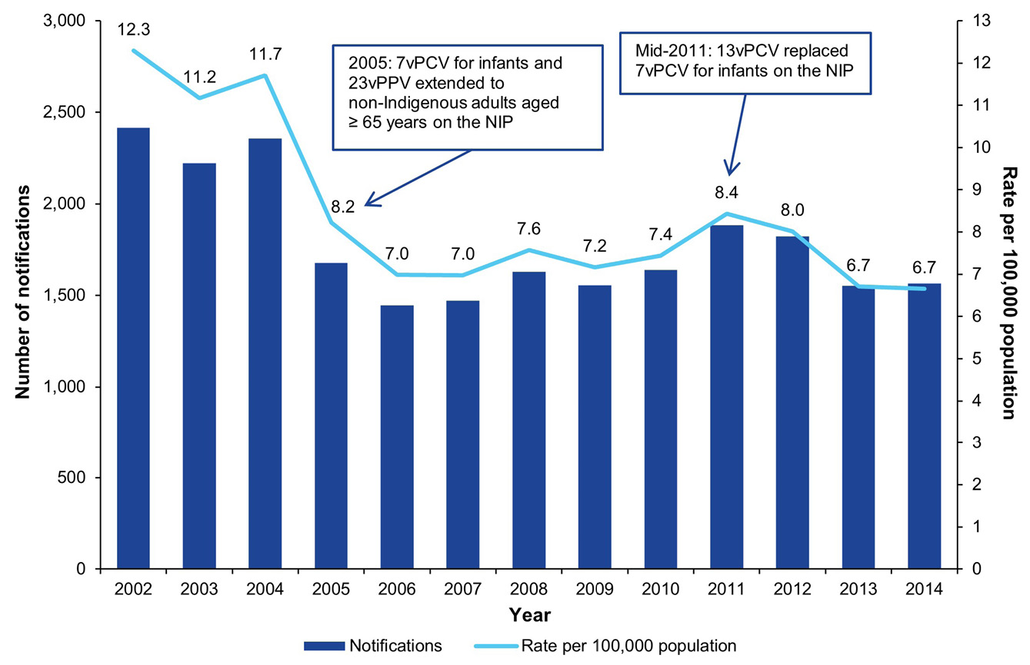
a Source: NNDSS, extracted February 2018.
b NIP: National Immunisation Program.

Seasonality
As in previous years, the number of cases of notified IPD was greatest in the winter months, with notifications peaking in August in 2013 (n = 230) and July in 2014 (n = 218) (Figure 2). Notifications of IPD in the winter months were higher among adults aged 50 years and over, whilst notifications in children aged less than 5 years were relatively stable all year round (Figure 2).
Figure 2: Notified cases of invasive pneumococcal disease, Australia, 2013 and 2014, by year and month of diagnosis and age groupª
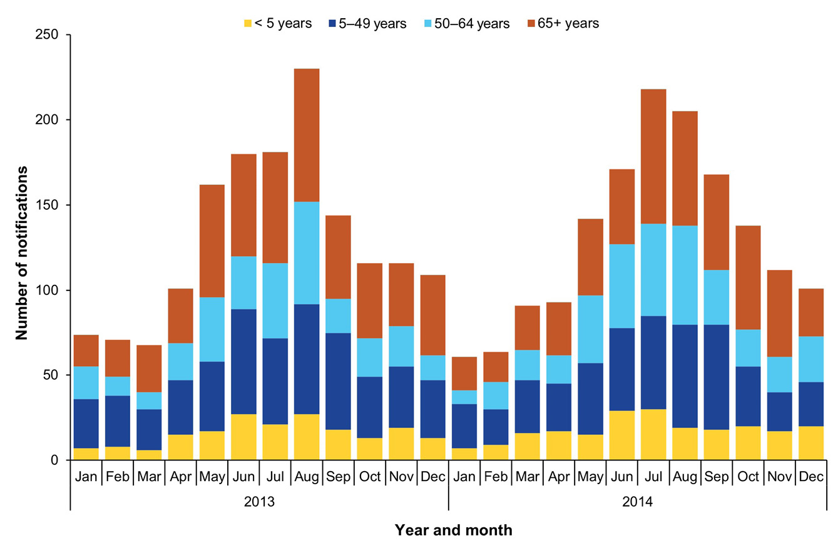
a Source: NNDSS, extracted February 2018.

Age and sex distribution
In 2013 and 2014, there were approximately 15% more notifications among males than females. By age group, IPD notification rates were substantially higher in males than in females, especially in the highest and lowest age-groups. In both 2013 and 2014, the lowest notification rates were in those aged 15 to 29 years for males and females (Figure 3).
In 2013, there were 191 cases of IPD notified in children aged less than 5 years, representing a rate of 12.5 per 100,000 population per year, which was the same as the rate in 2012 (Appendix A, Table A.2). In 2014, the rate of IPD in children aged less than 5 years increased by 12% (n = 217; 14.1 per 100,000 population per year) compared to that in 2013. Among cases notified in children aged less than 5 years, notification rates were highest in those aged 1 year (2013 and 2014: 21.5 per 100,000 population per year) and those aged less than 1 year (2013: 12.6 per 100,000 population per year; 2014: 18.9 per 100,000 population per year).
In the annual age-specific IPD notification rate trends (Figure 4), the rates among children aged less than 5 years have declined by 77% between 2002 (60.0 per 100,000 population per year) and 2014 (14.1 per 100,000 population per year). This decline is especially marked from 2002–2004 to 2005–2006, corresponding to the introduction of universal childhood 7vPCV vaccination on the NIP. There was a further decline in IPD notifications in children aged less than 5 years between 2010 and 2012, corresponding to the changeover from 7vPCV to 13vPCV on the NIP. Notification rates among people aged 5 to 64 years are relatively lower than rates among other age groups, and remained relatively stable between 2002 and 2014. There has been a gradual decline of 42% in the notification rate among people aged 65 years and over between 2002 (26.1 per 100,000 population per year) and 2014 (15.3 per 100,000 population per year).
Figure 3: Notification rates of invasive pneumococcal disease, Australia, 2013 and 2014, by age group and sexª
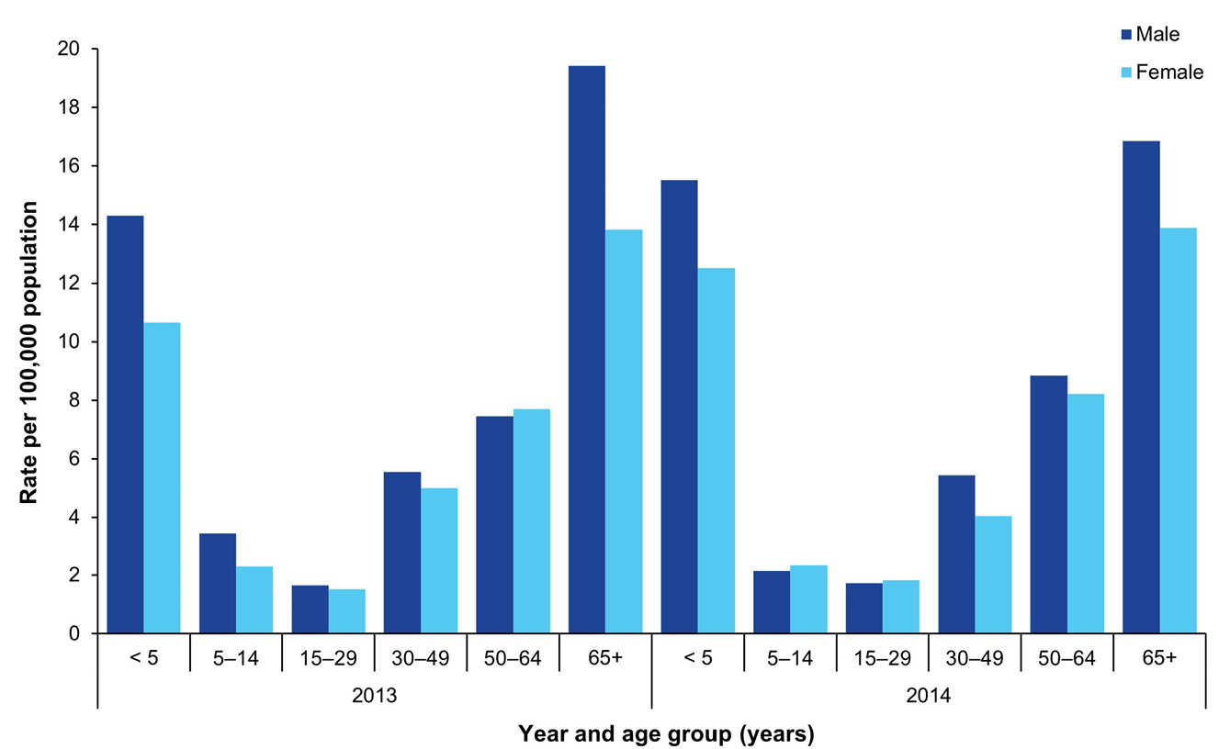
a Source: NNDSS, extracted February 2018.
Figure 4: Notification rates of invasive pneumococcal disease, Australia, 2002 to 2014, by age groupª
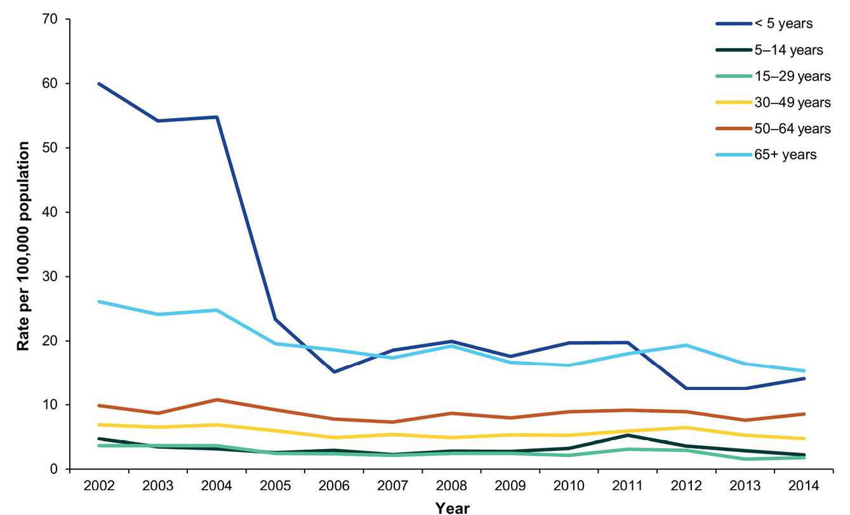
a Source: NNDSS, extracted February 2018.

Incidence rate by Indigenous status
Total and age-specific case counts and rates of IPD notifications by Indigenous status between the years 2005 and 2014 are presented in Appendix A, Table A.2.
In both 2013 and 2014, Indigenous status was reported for approximately 89% of notifications. In 2013, there were 194 cases of IPD notified in Aboriginal and Torres Strait Islander people, representing a rate of 32.2 per 100,000 population per year and accounted for 12.5% of all notifications. The rate in 2013 was a 24% decrease on the rate for Indigenous people in 2012 (42.3 per 100,000 population per year; n = 249) (Figure 5). In 2014, there were 193 cases reported in the Indigenous population, representing a rate of 31.4 per 100,000 population per year and accounting for 12.3% of all notifications, similar to 2013. In 2013 and 2014, the rate of IPD in the Indigenous population was respectively 5.4 and 5.2 times the rate in the non-Indigenous population. It should be noted that completeness of Indigenous status reporting has improved from 75% in 2003 to approximately 89% of notifications in 2013 and 2014.
Figure 5: Notified cases and rates of invasive pneumococcal disease in the Indigenous population, Australia, 2002 to 2014ª
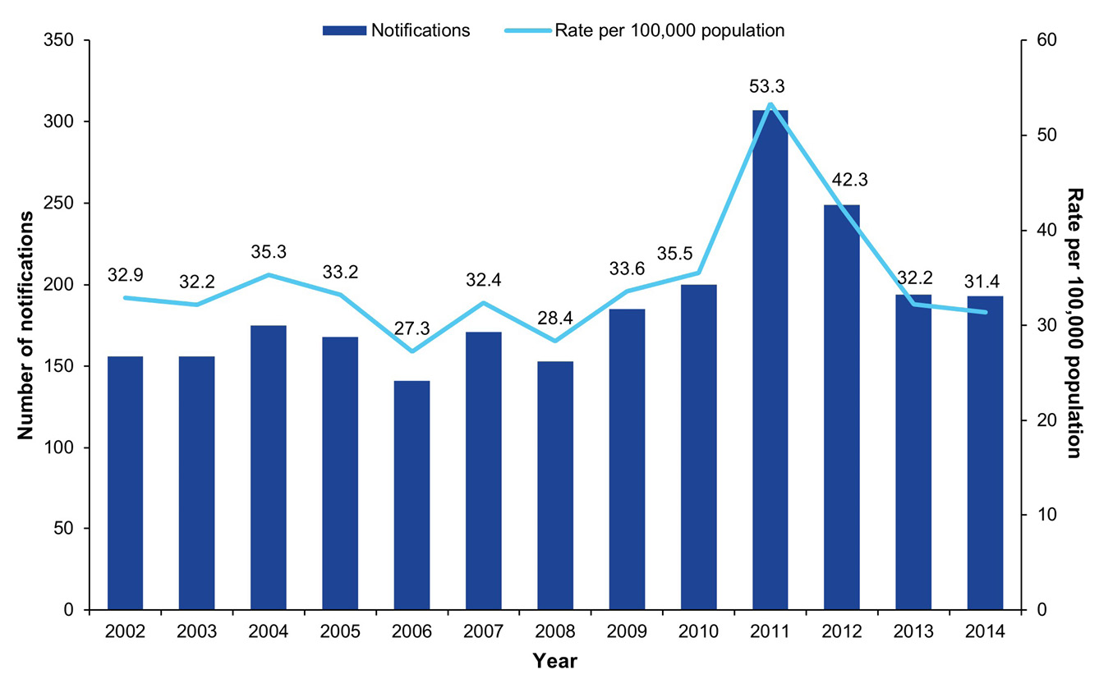
a Source: NNDSS, extracted February 2018.

Notifications among children aged less than 15 years, by Indigenous status
In 2013 and 2014, the IPD notification rate among Indigenous children aged less than 15 years (2013: 24.8 per 100,000 population per year; 2014: 23.0 per 100,000 population per year) was 4.2 to 4.3 times the rate among non-Indigenous children of the same age group (2013: 5.8 per 100,000 population per year; 2014: 5.5 per 100,000 population per year). In the preceding ten years (2003 to 2012) the rate of IPD notifications among Indigenous children aged less than 15 years old was, on average, three times higher than the rate among non-Indigenous children of the same age group (range 1.0 to 4.4 times higher).
The notification rate of IPD in Indigenous children aged less than 15 years has fluctuated over the last decade, mostly due to the small number of notifications. Similar to previous years, the highest rate of IPD in Indigenous children in 2013 and 2014 was in those aged less than 2 years (2013: 67.2 per 100,000 population per year; 2014: 65.3 per 100,000 population per year). When compared with 2012 (49.4 per 100,000 population per year), the rate of IPD notifications in this age group has increased by approximately 34% (Figure 6 and Appendix A, Table A.2).
The impact of the introduction of new pneumococcal vaccines is more evident in non-Indigenous children. There were marked decreases in IPD notification rates in the 2–4 years and the less than 2 years age groups following the 2005 introduction of the 7vPCV vaccine, and in the less than 2 years age group following introduction of the 13vPCV vaccine in 2011 (Figure 7). Comparatively, in 2013 and 2014, there was an increase in the rates of IPD in non-Indigenous children aged less than 2 years. Compared with the notification rate in 2012 (13.9 per 100,000 population per year), the IPD rates among children aged less than 2 years in 2013 (14.3 per 100,000 population per year) were marginally higher. However, in 2014 the rate of IPD in non-Indigenous children aged less than 2 years was 28% higher (17.8 per 100,000 population per year) than in 2013. Although there has been an increase in IPD notifications rates amongst this age group, the rates reported remain well below those observed prior to the introduction of the vaccines on the NIP. Among non-Indigenous children aged 2–4 years, the rate of IPD was around 9 per 100,000 population per year in both 2013 and 2014, similar to the rate in 2012.
Over the last decade, the notification rate of IPD in non-Indigenous children aged 5–14 years has remained reasonably low, with a peak in 2011 of 3.4 per 100,000 population per year. Following the introduction of the 13vPCV vaccine in 2011, the rate of IPD in this age group in 2014 has halved (1.8 per 100,000 population per year; Figure 7 and Appendix A, Table A.2).
Figure 6: Number and rate per 100,000 population per year of invasive pneumococcal disease notifications in Indigenous children aged less than 15 years, Australia, 2002 to 2014, by age groupª
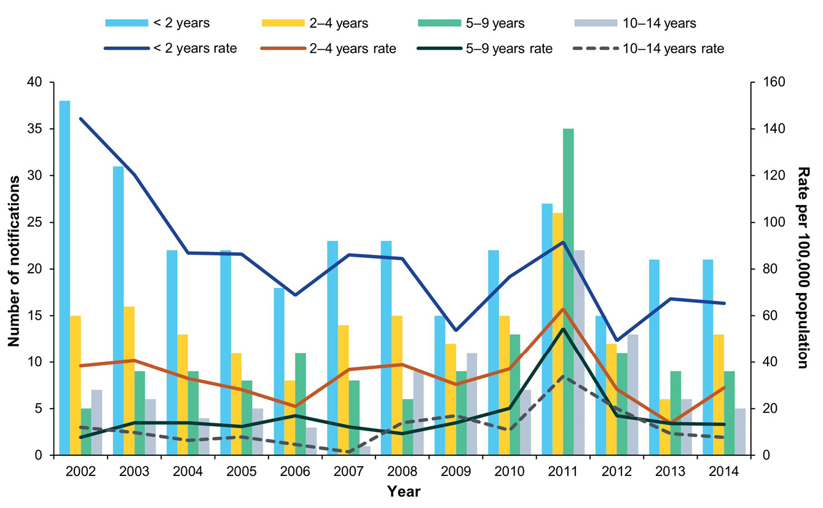
a Source: NNDSS, extracted February 2018.
Figure 7: Number and rate per 100,000 population per year of invasive pneumococcal disease notifications in non-Indigenous children, Australia, 2002 to 2014, by age group^{a,b}
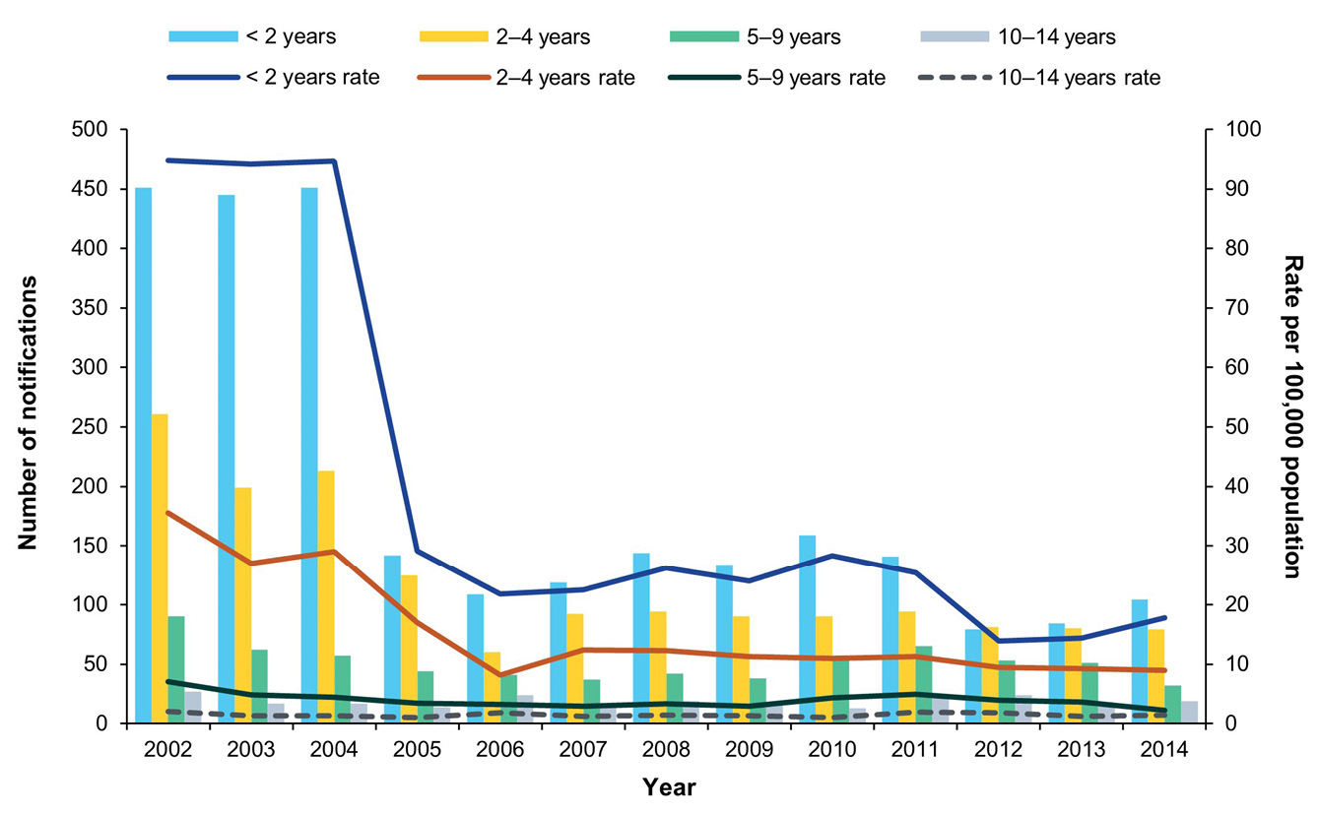
a Source: NNDSS, extracted February 2018.
b Non-Indigenous cases include cases whose Indigenous status was reported as unknown.

Notifications among those aged 15 years and over by Indigenous status
Overall, in 2013 and 2014, the highest notification rate of IPD among Australians aged 15 years and over was in Indigenous adults aged 50 years and over. However, compared to 2012, rates across all age groups over 15 years declined in 2013, with the greatest decline observed in those aged 15 to 29 years (36%; 2012: 22.6 per 100,000 population per year; 2013: 14.5 per 100,000 population per year; Figure 8 and Appendix A, Table A.2). In 2014, IPD notification rates among adults aged over 15 years continued to decline or were similar in all but those aged 50 to 64 years, where an increase of 9% was observed.
Compared with 2012, IPD notification rates in non-Indigenous adults aged 15 years or older were lower in 2013 for all age groups (Figure 9 and Appendix A, Table A.2). The greatest decline in notification rates between 2012 and 2013 was observed in those aged 15 to 29 years (50%; 2012: 2.2 per 100,000 population per year; 2013: 1.1 per 100,000 population per year). In 2014, whilst rates remained low in comparison to 2012, notification rates for non-Indigenous adults aged 15 years or older increased slightly, in comparison to 2013, among those aged 15–29 and 50–64 years.
Figure 8: Notification rates of invasive pneumococcal disease in the Indigenous population aged 15 years and over, Australia, 2002 to 2014, by age groupª
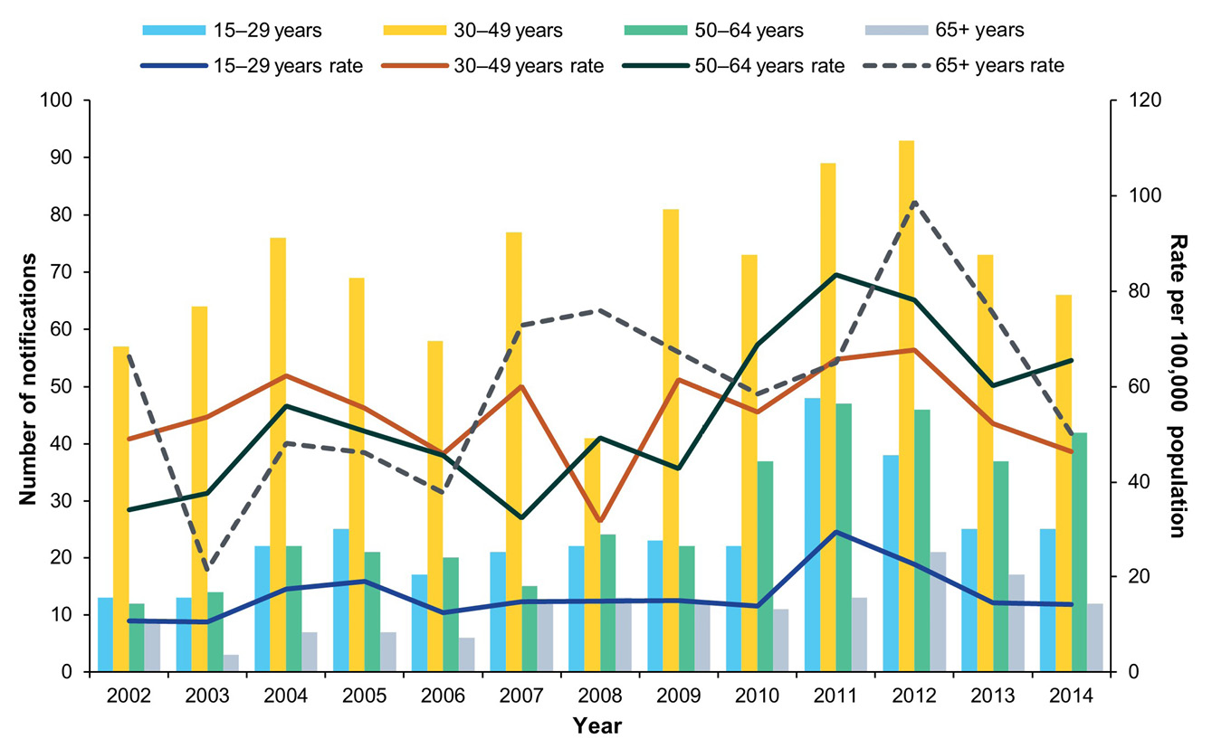
a Source: NNDSS, extracted February 2018.
Figure 9: Notification rates of invasive pneumococcal disease in the non-Indigenous population aged 15 years and over, Australia, 2002 to 2014, by age groupª
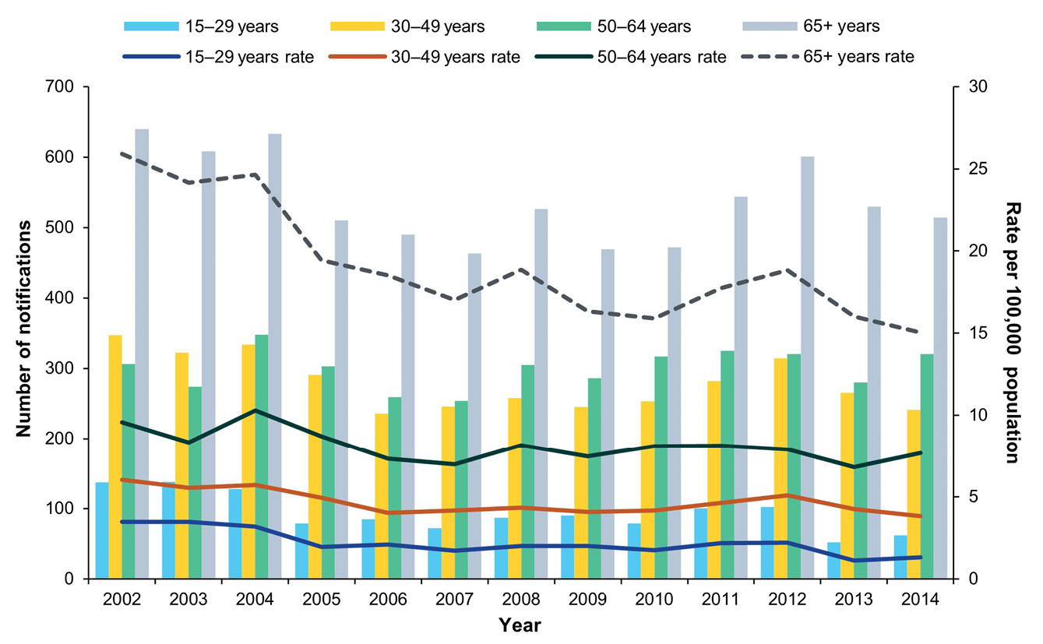
a Source: NNDSS, extracted February 2018.

Mortality
Mortality status was reported for 79% of notifications in 2013 and 85% of notifications in 2014, with the levels of completeness close to 100% in the age groups for which follow-up is undertaken across all jurisdictions (Table 1).
In 2013, there were 134 notifications of IPD where the case died of their disease, giving a case fatality rate (CFR) of 8.6%. Among notifications in 2014, there were 118 deaths recorded, giving a CFR of 7.5%. The median age of notified cases who died due to IPD was 69 years in 2013 (range: 1 to 94 years) and 69.5 years in 2014 (range: 0 to 94 years).
Around 7.5% of deaths in 2013 (n = 10/134) and 5.9% of deaths in 2014 (n = 7/118) were reported as being in Indigenous persons, representing a CFR of 5.2% and 3.6%, respectively, among Indigenous IPD notifications. Whilst the CFR rate associated with Indigenous deaths attributable to IPD does fluctuate annually due to small numbers, the CFRs observed in 2013 and 2014 were similar to previous years (range 4.0% to 5.2% between 2009 and 2012). In both Indigenous and non-Indigenous populations, the highest CFRs were in adults aged 65 years and over. The number of deaths and CFRs for 2013 and 2014 by age group, Indigenous status and state or territory are presented in Appendix A, Table A.3.
In those aged less than 5 years, there were four deaths associated with IPD in 2013 and seven deaths in 2014, a CFR of 2.4% and 2.7%, respectively (Table 5). Serotypes associated with IPD in these 11 deaths included 13vPCV types (n = 1), 23v-non-13vPCV types (n = 3) and non-vaccine types (n = 6) and one IPD case where the serotype was unknown. One of the deaths in 2013 (case 2) is classified as a vaccine failure based on the definitions in Table 4. Further details of these deaths in children aged less than 5 years, including Indigenous status, serotype and vaccination history, are shown in Table 5.
In Indigenous adults aged 50 years or older, there were four deaths associated with IPD in 2013 and three deaths in 2014, giving a CFR of 7.4% and 5.6%, respectively. One death each in 2013 and 2014 was attributable to a serotype included in the 23vPPV vaccine (2013: serotype 3; 2014: serotype 22F). Both of these cases were reportedly vaccinated with 23vPPV, and deaths occurred 10 and 4 years after vaccination, respectively.
In non-Indigenous adults aged 65 years or older, there were 81 deaths associated with IPD in 2013 and 68 in 2014, giving a CFR of 15.3% and 13.2%, respectively. IPD due to non-vaccine serotypes accounted for 36% of deaths in this population group in 2013 (n = 29/81) and for 37% of such deaths in 2014 (n = 25/68) in 2014, with 6C, 16F and 35B the most common serotypes. Additionally, serotypes in the 23vPPV vaccine caused disease in 62% of IPD deaths in this population group in 2013 (50/81) and in 62% of such deaths in 2014 (42/68), with serotypes 3, 19A, and 22F the most common. Of the deaths due to a serotype included in the 23vPPV vaccine, vaccination history was known for 56% of cases in 2013 (n = 28/50) and for 71% of cases in 2014 (n = 30/42). Of the 656 IPD deaths reported between 2010 and 2014, there were 430 (66%) which were caused by a serotype covered by 23vPPV vaccination, of which 29% (n = 124) had received at least one dose of 23vPPV. In 2013, among IPD deaths due to a 23vPPV serotype, the median time interval between the diagnosis date and the last relevant serotype-covering vaccine receipt date was 7.0 years (range: 1.2–10.2 years), while in 2014, the median time was 6.6 years (range: 22 days to 10.9 years).

Table 5: Characteristics of deaths from invasive pneumococcal disease in children aged less than 5 years, Australia, 2013 and 2014
Case | Year | Sex | Age (months) | Indigenous status | Serotype | Serotype coverage by available vaccines | Vaccine type (doses) | Clinical category | Risk factors
1 | 2013 | Female | 19 | non-Indigenous | 15C | Non-vaccine serotype | 7vPCV (2 doses); 13vPCV (1 dose) | Bacteraemia | Information not supplied
2 | 2013 | Male | 26 | non-Indigenous | 19A | 13vPCV non-7vPCV | 13vPCV (3 doses) | Pneumonia | No risk factor identified
3 | 2013 | Female | 26 | non-Indigenous | 10F | Non-vaccine serotype | No vaccine received | Unknown | No risk factor identified
4 | 2013 | Male | 15 | non-Indigenous | 15B | 23vPPV non-13vPCV | 13vPCV (3 doses) | Meningitis | Chronic illness and childcare attendee
5 | 2014 | Male | 19 | non-Indigenous | 23B | Non-vaccine serotype | 13vPCV (3 doses) | Meningitis | Information not supplied
6 | 2014 | Male | 10 | Indigenous | 23B | Non-vaccine serotype | 13vPCV (2 doses) | Unknown | Premature (< 37 weeks gestation)
7 | 2014 | Male | 7 | non-Indigenous | 9N | 23vPPV non-13vPCV | No vaccine received | Unknown | Otherª
8 | 2014 | Female | 54 | non-Indigenous | 6C | Non-vaccine serotype | 7vPCV (3 doses) | Unknown | Information not supplied
9 | 2014 | Female | 56 | non-Indigenous | Not viable | Serotype not specified | 7vPCV (3 doses); 13vPCV (1 dose) | Unknown | Information not supplied
10 | 2014 | Male | 8 | non-Indigenous | 23A | Non-vaccine serotype | 13vPCV (3 doses) | Bacteraemia | Premature (< 37 weeks gestation)
11 | 2014 | Female | 8 | Indigenous | 10A | 23vPPV non-13vPCV | 13vPCV (3 doses) | Meningitis | Information not supplied
a Other risk factors include, but are not limited to, asthma, previous pneumonia, excessive alcohol consumption and exposure to smoke.

Risk factors
Risk factor data were available for 76% (n = 374/1,552) and 75% (n = 394/1,564) of notifications in 2013 and 2014, respectively. Of the notifications with risk factor data, 88% (n = 2,060/2,348) had at least one risk factor. Table 6 shows the number of risk factors for IPD among children (aged less than 5 years) and among older adults (aged 50 years and over for Indigenous peoples and 65 years and over for non-Indigenous peoples) for 2013 and 2014.
For the combined period of 2013 and 2014, risk factor data was only complete for 58% of cases in children aged less than 5 years (n = 240/408). Amongst these cases, the most frequently reported risk factor in Indigenous children was ‘other’ (59%; 23/39), which includes asthma, previous pneumonia, or exposure to smoke, followed by being born prematurely at less than 37 weeks gestation (41%; 16/39). In 13% of these cases (5/39), there was no reported risk factor. In comparison, in cases among non-Indigenous children aged less than 5 years, childcare attendance (34%; 68/201) and ‘other’ (30%; 60/201) were the most frequently reported risk factors. The proportion of cases with no identified risk factors was higher in non-Indigenous (28%; 57/201) than Indigenous children (13%, 5/39).
For both adult population groups shown in Table 6, the most frequently reported risk factor was chronic illness: 78% (83/106) among Indigenous Australians aged 50 years and over, and 74% (696/938) among non-Indigenous Australians aged 65 years and over, followed by ‘other’ (64%: 68/106 and 40%: 373/938, respectively). In comparison to children aged less than 5 years, older adults had a much lower proportion of cases with no risk factors reported (1.9%: 2/106 and 3.7%: 35/938, respectively).
Table 6: Number of risk factors reported for invasive pneumococcal disease notifications, Australia, 2013 and 2014, by risk factor and targeted population subgroup
Risk factorª | Children aged less than 5 years |  |  |  | Indigenous aged 50 years and over |  | Non-Indigenous^{b} aged 65 years and over
Risk factorª | Indigenous |  | Non-Indigenous^{b}
Risk factorª | 2013 | 2014 | 2013 | 2014 | 2013 | 2014 | 2013 | 2014
Premature (< 37 weeks gestation) | 9 | 7 | 11 | 14 | 0 | 0 | 0 | 0
Congenital or chromosomal abnormality | 0 | 3 | 2 | 1 | 0 | 0 | 1 | 0
Anatomic or functional asplenia | 0 | 0 | 0 | 0 | 0 | 2 | 11 | 10
Immunocompromised | 0 | 1 | 15 | 9 | 10 | 8 | 119 | 132
Chronic illness | 4 | 3 | 15 | 18 | 44 | 39 | 359 | 337
Other^{c} | 10 | 13 | 37 | 23 | 32 | 36 | 185 | 188
Childcare attendee | 2 | 3 | 34 | 34 | 0 | 0 | 0 | 0
Previous episode of IPD | 0 | 0 | 1 | 0 | 6 | 3 | 7 | 3
No risk factor identified | 2 | 3 | 30 | 27 | 0 | 2 | 20 | 15
Total cases with risk factor data | 16 | 23 | 102 | 99 | 53 | 53 | 478 | 460
Total cases | 27 | 34 | 164 | 183 | 54 | 54 | 530 | 514
a Cases may be reported with more than one risk factor.
b Non-Indigenous includes cases whose Indigenous status was reported as unknown.
c Other risk factors include, but are not limited to, asthma, previous pneumonia, excessive alcohol consumption and exposure to smoke.

Clinical category
Clinical category information was available for 88% of all notifications in both years (2013: 1,365/1,552; 2014: 1,370/1,564), with completeness of this data higher in cases among individuals aged less than 5 years and those aged 50 years and over (Appendix A, Table A.4). Of the notifications with clinical category information, pneumonia was most commonly reported in both 2013 and 2014 (69.1% and 64.1%, respectively), followed by bacteraemia (21.8% and 22.6%, respectively), meningitis (6.6% and 10.1%, respectively) and ‘other’ IPD presentations (6.0% and 8.9%, respectively). The category ‘other’ included: septic arthritis (17 cases in 2013 and 21 in 2014); pleural effusion (16 in 2013 and 40 in 2014); and cellulitis (11 in 2013 and 11 in 2014). The proportion of cases with more than one clinical presentation was 3.4% in 2013 and 5.6% in 2014.
For the pneumonia cases with pleural effusion in 2013 and 2014, the predominant causative serotypes were 3 (11/56) and 19A (12/56). Around 40% of all pneumonia with pleural effusion cases were in children aged less than 5 years (43% in 2013 and 38% in 2014). There was an increase from 19% in 2013 to 30% in 2014 in the proportion of pleural effusion cases diagnosed by nucleic acid testing only. The most common clinical categories of IPD among those aged less than 5 years were bacteraemia and pneumonia, while in those aged 5 years and over the most common clinical category was pneumonia.
Among the ten most common serotypes reported in 2013 and 2014, serotypes 19A, 3, 22, 6C, and 9N were most commonly associated with pneumonia; serotypes 23B, 11A and 15A with bacteraemia; and serotypes 19F and 23B with meningitis.

Serotypes causing IPD
Notified cases by serotype, age group and targeted population groups for the years 2013 and 2014 are presented in Appendix A, Tables A.5 to A.7. The causative serotypes were identified for approximately 95% of IPD cases in both 2013 (1,479/1,552) and 2014 (1,485/1,564). Following is the distribution of vaccine and non-vaccine serotypes of IPD cases in 2013 and 2014:
- 13vPCV serotypes:
- 7vPCV serotypes: 7.3% (114/1,552) of all cases in 2013 and 8.8% (138/1,564) in 2014 were attributed to serotypes common to 7vPCV and 13vPCV.
- 13v-non-7vPCV serotypes: 32% of cases in 2013 (503/1,552) and 28% of cases in 2014 (445/1,564) were attributed to serotypes in 13vPCV but not in 7vPCV.
- 23vPPV-non-13vPCV serotypes: 27% of cases in 2013 (419/1,552) and 27% of cases in 2014 (424/1,564) were attributed to serotypes in 23vPPV, but not in 13vPCV.
- Non-vaccine serotypes: 29% of cases in 2013 (443/1,552) and 31% of cases in 2014 (478/1,564) were attributed to serotypes not covered in currently available pneumococcal vaccines.
Across 2013 and 2014, the ten most common serotypes in order of frequency were: 19A, 7F, 3, 22F, 6C, 19F, 23B, 15A, 9N, and 8. These serotypes accounted for 61% of all cases with a known serotype (1,802/2,964) across this period.

7vPCV serotypes
Of IPD cases with a known serotype, the serotypes that are common to 7vPCV and 13vPCV were associated with 7.7% of notifications in 2013 (114/1,479) and 9.3% of notifications in 2014 (138/1,485). The most frequently reported 7vPCV serotype causing IPD across this period was 19F (Appendix A, Tables A.5 and A.6). Since 2005, there has been a marked decrease in the notification rate of 7vPCV type IPD across all age groups (Figure 10). However, in recent years this rate of decline appears to have plateaued across all age groups.
Numbers of IPD cases due to 7vPCV serotypes in Indigenous children aged less than 5 years have declined from 10 cases in 2004 to an average of 1.3 cases per annum since 2009. Amongst non-Indigenous children in this age group, cases have declined from 554 in 2004 to an average of 11.8 cases per annum since 2009, representing a 98% decline (Figure 11).
Figure 10: Notifications of invasive pneumococcal disease, Australia, 2005 to 2014, by age group and vaccine serotypes
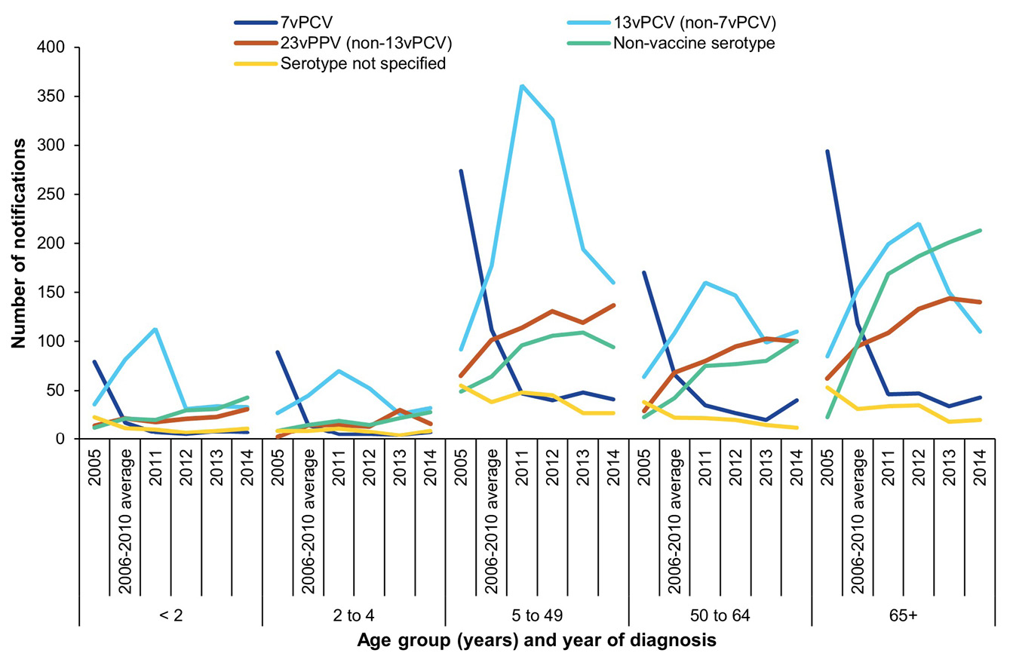
Figure 11: Notifications and rates of invasive pneumococcal disease caused by 13vPCV and non-13vPCV serotypes in children aged less than 5 years, Australia, 2002 to 2014, by Indigenous status
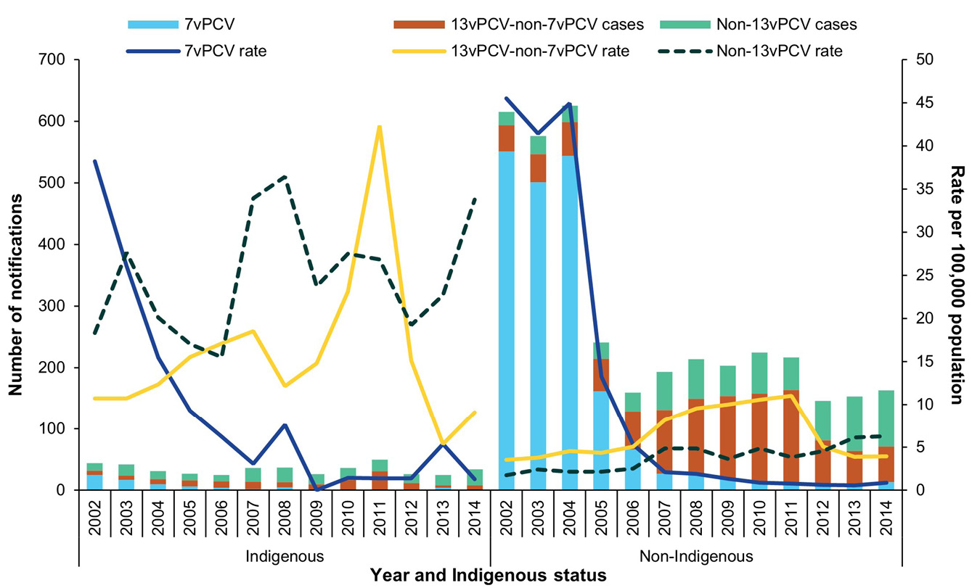

13vPCV-non-7vPCV serotypes
The rate of IPD due to 13vPCV-non-7vPCV serotypes in children aged less than 5 years showed an increasing trend from 4.9 per 100,000 population per year in 2005 to 12.6 per 100,000 population per year in 2011. From 2011, IPD due to 13vPCV-non-7vPCV serotypes started to decrease with an overall reduction of 66% between 2011 and 2014 in children aged less than 5 years. Of IPD cases with a known serotype, 13vPCV-non-7vPCV serotypes were associated with 34% of notifications across all age groups in 2013 (503/1,479) and 30% of notifications in 2014 (445/1,485). The most frequently reported 13vPCV-non-7vPCV serotypes causing IPD across this period were 3, 7F and 19A (Appendix A, Tables A.5 and A.6).
In 2013, there were 60 cases of IPD in children aged less than 5 years associated with 13vPCV-non-7vPCV serotypes, representing a rate of 3.9 per 100,000 population per year. Similarly, in 2014 there were 65 cases of IPD in children aged less than 5 years due to 13vPCV-non-7vPCV serotypes, representing a rate of 4.2 per 100,000 population per year. Compared with the rates of IPD in children aged less than 5 years associated with these serotypes in 2011 (12.6 per 100,000 population per year), there has been a 69% reduction in 2013 and a 67% reduction in 2014. This decrease has primarily been driven by the reduction in IPD caused by serotype 19A. However, since 2011, notifications of IPD due to serotype 3 have increased. In the last decade, there have been no cases of IPD due to serotype 5 in children aged less than 5 years.
In Indigenous children aged less than 5 years, since 2011 there was an overall reduction in the number of IPD cases caused by 13vPCV-non-7vPCV serotypes, in particular serotypes 1 and 19A (Figure 12). Overall, the rate of IPD in Indigenous children due to 13vPCV-non-7vPCV serotypes has reduced from 42.3 per 100,000 population per year in 2011 to 5.3 per 100,000 population per year in 2013 and 9.1 per 100,000 population per year in 2014.
Similarly, in non-Indigenous children aged less than 5 years, since 2011 there was an overall reduction in IPD cases caused by 13vPCV-non-7vPCV serotypes (Figure 12). This decrease was mostly due to the reduction in 19A disease. Overall, the rate of IPD in non-Indigenous children due to 13vPCV-non-7vPCV serotypes has reduced from 11.0 per 100,000 population per year in 2011 to 3.9 per 100,000 population per year in 2013 and 4.0 per 100,000 population per year in 2014.
Figure 12: Notifications and rates of invasive pneumococcal disease caused by 13vPCV-non-7vPCV serotypes in children aged less than 5 years, Australia, 2002 to 2014, by Indigenous status
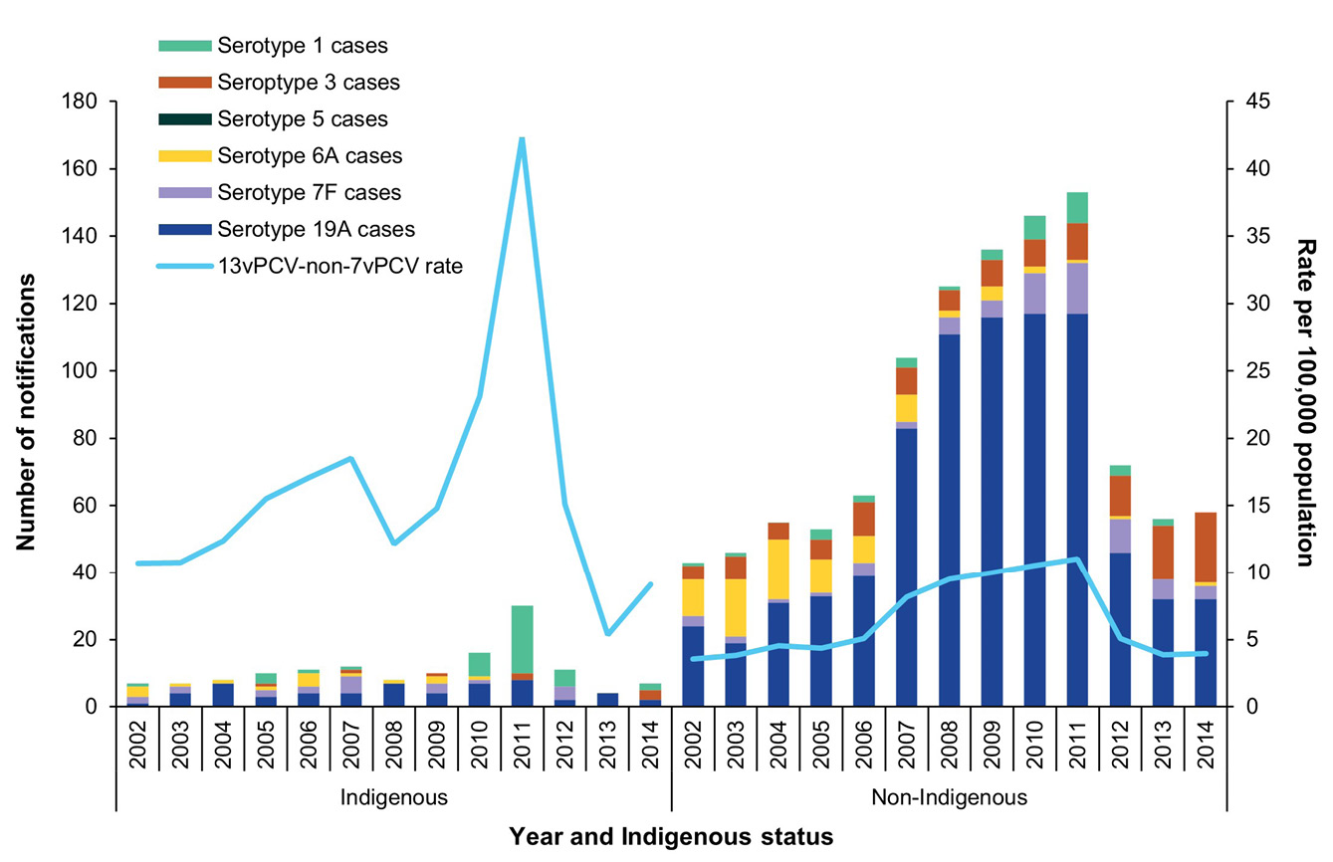

23vPPV serotypes
The incidence of IPD caused by serotypes included in 23vPPV that are not in 13vPCV have steadily increased over the period from 2005 to 2014 across all age group (Figure 10). In both 2013 and 2014, IPD caused by 23vPPV-non-13vPCV serotypes constituted around 28% of cases with a known serotype (2013: 419/1,479 cases; 2014: 424/1,485 cases). The most frequently reported 23vPPV-non-13vPCV serotype was 22F (Appendix A, Tables A.5 and A.6).
In Indigenous adults aged 50 years and over, the number of notifications of IPD due to all 23vPPV serotypes combined shows a gradual increase from 2002 to 2012, followed by declines in 2013 and 2014. (Figure 13). In 2013 and 2014 there were respectively 34 cases (40.5 per 100,000 population per year) and 31 cases (35.2 per 100,000 population per year) of IPD due to 23vPPV serotypes. A similar increase is also seen in the number of notifications due to non-23vPPV serotypes in the same population. In 2013 there were 16 cases (19.1 per 100,000 population per year) and in 2014 there were 21 cases (23.9 per 100,000 population per year) of IPD due to non-23vPPV serotypes.
In 2013 and 2014, the most frequent 23vPPV-non-13vPCV serotypes causing IPD in Indigenous adults aged 50 years or over were serotype 12F in 2013 (n = 6) and serotype 8 in 2014 (n = 6) (Appendix A, Tables A.5 and A.6). The most frequent serotypes across both 2013 and 2014, within this population group, were 8 (n = 9); 12F (n = 8) and 22F (n = 8).
In non-Indigenous adults aged 65 years and over, the number of notifications due to 23vPPV serotypes declined in both 2013 (n = 315; 9.5 per 100,000 population per year) and 2014 (n = 285; 8.3 per 100,000 population per year) in comparison to 2012 (n = 378; 11.8 per 100,000 population per year; Figure 13). The number of notifications caused by non-23vPPV serotypes in non-Indigenous adults aged 65 years and over has continued to increase with 199 cases in 2013 (6.0 per 100,000 population per year) and 210 cases in 2014 (6.1 per 100,000 population per year).
In 2013 and 2014, the most frequent 23vPPV-non-13vPCV serotypes causing disease in non-Indigenous adults aged 65 years or over were 22F (2013: n = 61; 2014: n = 53), followed by 9N (2013: n = 19; 2014: n = 15) and 11A (2013: n = 13; 2014: n = 22).
Figure 13: Notifications and rates of invasive pneumococcal disease caused by 23vPPV and non-23vPPV serotypes in Indigenous adults 50 years or over and non-Indigenous adults aged 65 years or over, Australia, 2002 to 2014, by Indigenous status
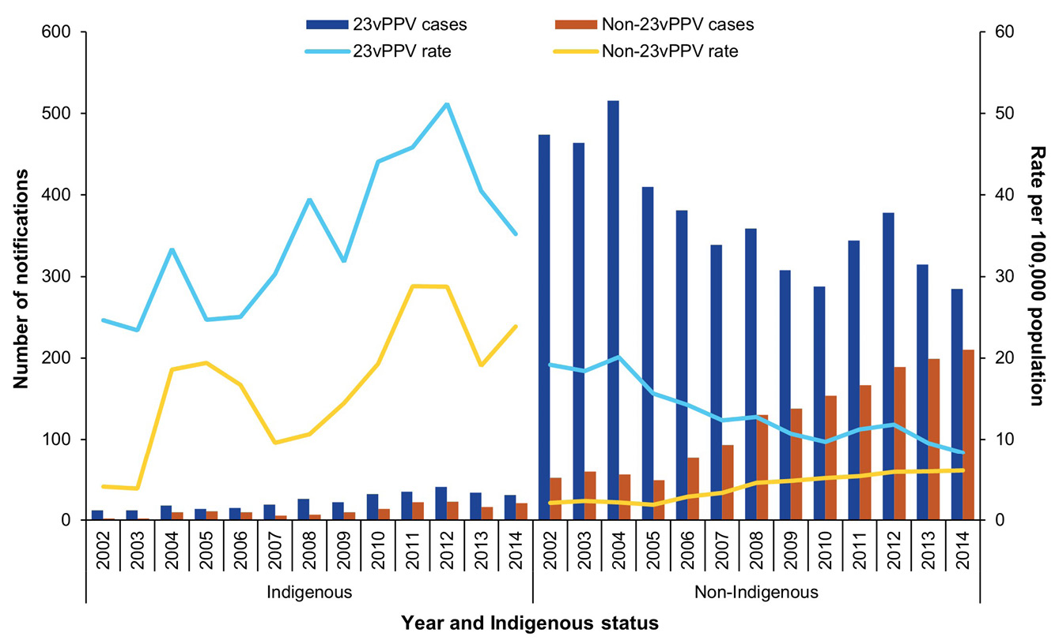

Non-vaccine serotypes
Cases of IPD due to serotypes not covered in available vaccines represented 30% of those with serotype known in 2013 (443/1,479) and 32% in 2014 (478/1,485). Rates of IPD associated with these non-vaccine serotypes were highest amongst those aged less than 2 years, and among those aged 65 years and over (Figure 10). In both 2013 and 2014, serotype 6C (2013: n = 74; 2014: n = 66) was the most frequently reported non-vaccine serotype, followed by 23B (2013: n = 55; 2014: n = 53) (Appendix A, Tables A.5 and A.6). Amongst targeted population groups, the following non-vaccine associated serotypes were prominent:
- Children aged less than 5 years (2013: n = 53; 2014: n = 71 total non-vaccine serotype cases): serotypes 15C (2013: n = 14; 2014: n = 19) and 23B (2013: n = 14; 2014: n = 18).
- Indigenous adults aged 50 years and over (2013: n = 16; 2014: n = 21 total non-vaccine serotype cases): serotypes 38 (2013: n = 4; 2014: n = 4), 10F (2013: n = 1; 2014: n = 4) and 23A (2013: n = 0; 2014: n = 4).
- Non-Indigenous adults aged 65 years and over (2013: n = 195; 2014: n = 208 total non-vaccine serotype cases): serotypes 6C (2013: n = 45; 2014: n = 37), 16F (2013: n = 24; 2014: n = 24), 15A (2013: n = 21; 2014: n = 25) and 23A (2013: n = 12; 2014: n = 34).

Vaccinated cases
Among children aged less than 5 years who were considered fully vaccinated and were diagnosed with IPD due to any serotype covered in PCVs they had received, there were 32 cases in 2013 (Appendix A, Table A.8) and 40 cases in 2014 (Appendix A, Table A.9) that were classified as vaccine failures according to the definition in Table 4. Compared with 2012 (n = 10), this represents an increase in the number of vaccine failures. These vaccine failures represented 17% of cases in children aged less than 5 years (72/408) across the 2013 and 2014 period.
In 2013 and 2014 combined (n = 72), there were 64 cases that were 13vPCV failures and 8 cases that were 7vPCV failures. Serotype 19A was the most frequently reported cause of IPD among 13vPCV failures (58%; 37/64), followed by serotype 3 (31%; 20/64) and 19F (6.3%; 4/64) (Appendix A, Tables A.8 and A.9).
Of the 72 cases considered vaccine failures across the 2013 and 2014 period, 64% (46/72) had pneumonia as the clinical presentation, with pleural effusion or pleural empyema in more than a quarter of those cases (12/46). Further, almost a quarter of vaccine failure cases in this age group (24%; 17/72) had bacteraemia; 5.6% (4/72) had meningitis; and 4.2% (3/72) did not have either pneumonia, bacteraemia or meningitis, but were reported as having another clinical presentation such as septic arthritis or cellulitis. Of the 42% (30/72) of vaccine failure cases who had risk factors for IPD, 60% (18/30) attended childcare; 23% (7/30) were born prematurely at less than 37 weeks gestation; 20% (6/30) were immunocompromised; 10% (3/30) had chronic illness; and 50% (15/30) had other risk factors.

Antibiotic resistance
Penicillin and ceftriaxone/cefotaxime susceptibility data were captured in NNDSS in two separate fields in 2013 and 2014: summary susceptibility data from primary diagnostic laboratories and minimum inhibitory concentration (MIC) values from reference laboratories. As the summary susceptibility data are based on the differing use of either the European Committee on Antimicrobial Susceptibility Testing (EUCAST) or Clinical and Laboratory Standards Institute (CLSI) breakpoint, interpretive criteria for S. pneumoniae by a diagnostic laboratory to describe their MIC results as being ‘susceptible’, ‘intermediate’ or ‘resistant’ in the NNDSS fields are difficult to interpret. Whilst MIC values from reference laboratories can provide comparable data to assess antimicrobial resistance, the completeness of this field in NNDSS, including by clinical presentation, is currently poor nationally (2013: 3.8%; 2014: 14%).

Diagnosis method data
Site of the sterile specimen and laboratory diagnosis method (culture and/or NAAT) data were reported for 96% of cases (1,495/1,552) in 2013 and 97% (1,518/1,564) in 2014. Whilst a case could be reported with more than one sterile site specimen being positive by culture and/or NAAT, most cases continue to be reported as diagnosed by culture: 97% (1,448/1,495) in 2013 and 94% (1,420/1,518) in 2014. The proportion of identified cases diagnosed with a positive NAAT using the specimen obtained from a sterile site was 4.1% (61/1,495) in 2013, increasing to 7.6% (116/1,518) in 2014. Approximately 1.9% of cases (28/1,495) in 2013 and 2.9% (44/1,518) in 2014 were diagnosed with both a positive culture and NAAT. In comparison, in 2004 the proportion of positive culture cases was 99%, diagnosed by NAAT 0.7% and both culture and NAAT positive was 0.3%.
Amongst cases diagnosed by culture, the most frequently reported sterile specimen site was blood (2013: 97%; 1,409/1,448; 2014: 96%; 1,366/1,420). Amongst cases diagnosed by NAAT, cerebrospinal fluid (2013: 54%; 33/61; 2014: 47%; 55/116) was the most frequent sterile specimen site reported, followed by blood (2013: 21%; 13/61; 2014: 24%; 28/116).

Discussion
This report describes the epidemiology of IPD for 2013 and 2014 based on cases notified to the national laboratory based enhanced passive notifications system. The total number of cases of IPD per annum notified in each of the two years of 2013 and 2014 was approximately 1,500, which translates to an overall rate of 6.7 per 100,000 population per year. This overall incidence rate of IPD is the lowest observed since 2001 when IPD became nationally notifiable in Australia. The observation period in this report reflects the changes of IPD epidemiology after three and a half years of 13vPCV use in the infant pneumococcal vaccination program in Australia. Of note, following the changeover to 13vPCV from 7vPCV, there has been a clear reduction, across all age groups, of IPD caused by the main serotypes that were responsible for serotype replacement following 7vPCV introduction, such as 19A and 7F, that are included in 13vPCV. The incidence rate of IPD in children aged less than 5 years in 2014 was 14 per 100,000 population per year which was a 77% reduction from that in 2002. Among older adults, aged greater than 65 years, the incidence of IPD in 2014 was 15 per 100,000 population per year, a 42% reduction from that in 2002.
Among children aged less than 5 years, IPD caused by 7vPCV types continues to remain low, and cases due to 13vPCV-non7vPCV types have declined over 60% since 13vPCV introduction in 2011, which rapidly achieved high vaccine coverage.⁹ This decline is primarily driven by profound reductions in serotype 19A that accounted for approximately 30% of all IPD in children in Australia when 13vPCV replaced 7vPCV.¹⁰ This is consistent with high immunogenicity seen in pre-licensure trials of 13vPCV against 19A and confirmed by post-licensure effectiveness assessments.^{11–15} However, the impact of 13vPCV from the infant vaccination program in Australia, where the schedule used was three primary doses, is somewhat lower compared to that in comparable populations that had a booster dose in their vaccination schedules.^{16–19} The waning vaccine effectiveness resulting in reduced vaccine induced protection among children beyond infancy is likely to cause this difference.^{15,20} Effectiveness waning for 13vPCV could also explain the predominance of children older than 12 months of age accounting for vaccine failures in Australian children, as highlighted by the elevated notification rate in children over 12 months, compared with those aged 12 months or younger (see Vaccinated cases).²¹ In contrast to serotype 19A, 13vPCV has not had any discernible impact on IPD due to 13vPCV-non7vPCV type serotype 3 across all age groups, consistent with limited effect of 13vPCV against this serotype in immunogenicity and vaccine effectiveness studies.^{11,14,22,23} Serotype 3 has been identified as an important cause of pneumonia with empyema in children.^{24,25} In 2014, thirty percent of residual IPD in children was 13vPCV types.
Cases of IPD among those identified as Indigenous accounted for 12.5% (approximately 190 cases each year) of all the IPD notifications in this period. Although there has been a decline in IPD incidence rates in Indigenous children following PCV use, the disparity in IPD incidence between Indigenous and non-Indigenous populations has progressively widened, particularly in young children and older adults. Among Indigenous Australians, the overall IPD notification rate declined sharply from that observed in the previous IPD report of 2011 and 2012.²⁶ The 2011 peak in IPD in Indigenous Australians evident across all age groups was due to a serotype 1 outbreak in North and Central Australia.^{27,28} By 2013, following the use of PCVs that cover serotype 1, namely 10vPCV in the NT and 13vPCV in all jurisdictions from 2011, this outbreak appeared to have resolved with no notified cases of serotype 1 IPD among Indigenous children. Similar observations of the impact of PCVs against IPD caused by outbreak serotypes such as 1 and 5 have been reported in other populations that experienced such periodic IPD outbreaks.²⁹
Despite the remarkable impact due to the successive PCV vaccination programs implemented for Indigenous children since 2002, the disparities of IPD incidence rate between the Indigenous and the non-Indigenous populations have continued to widen in 2013 and 2014.^{30–32} The total IPD incidence rate in the Indigenous population compared to the non-Indigenous population was fivefold higher in 2002, and almost sixfold higher in 2014. In 2013, the rates of IPD due to 13vPCV-non7vPCV types in Indigenous children was only marginally higher than that in non-Indigenous children. This is consistent with similarly high coverage of 13vPCV infant doses and relatively lower 19A serotype replacement in Indigenous children compared to the non-Indigenous children.^{9,33} Additionally, for all Indigenous children a fourth dose of 13vPCV replaced the 23vPPV dose has been administered in the second year of life from 2012 onwards.³ This 13vPCV booster dose would have extended protection in Indigenous children into toddler years when the carriage rates are shown to rise.³⁴ However, the timeliness of this 13vPCV booster dose needs to improve, in order to achieve better disease control in older children and also the herd benefit in adults, by maximising vaccine induced protection when pneumococcal carriage rates peak in Indigenous children.
Among the Indigenous population, the rate of IPD notifications increased at a much younger age compared to their non-Indigenous counterparts. In 2014, the incidence rate of IPD among the Indigenous population aged 15–29 years (14 per 100,000 population per year) was similar to that of Indigenous adults aged 65 years and older. A number of risk factors may have contributed to this, such as a higher incidence of underlying health conditions, as well as smoking and harmful alcohol consumption that are known to increase the risk of pneumococcal disease in Indigenous adult populations at a younger age.^{34–36} Even at the time of the commencement of PCV programs, Indigenous children and adults had a substantially lower proportion of pneumococcal disease caused by the PCV types, consistent with the wide distribution of colonising serotypes among Indigenous children.^{37–39} The increase in these non-vaccine serotypes that occurred concomitant to high PCV coverage in children was considerably steeper among the Indigenous population.³⁰ Although there have been programs offering funded doses of 23vPPV to Indigenous children and young adults for more than a decade, their impact on non-PCV type disease has been limited.
Three quarters of IPD notifications in 2013 and 2014 had risk factor status identified. However, the pre-defined risk factors currently captured in this surveillance system only broadly match those conditions where risk-based pneumococcal vaccination is recommended. Due to variability in the follow-up practices for notified IPD cases across jurisdictions, risk factor data was not available for the majority of cases across the 5–50 years age group; this is the age group where most IPD cases would likely have underlying risk conditions. The potency of pneumococcal vaccines is reduced in individuals with these risk conditions, particularly for those with immunosuppression. As a result, in the face of mature population-based pneumococcal vaccination programs, these risk factors would increasingly account for residual IPD. Therefore, identification of risk factors in routine surveillance data, with data definitions aligning closely with that of immunisation guidelines, would assist in evaluating differential vaccine impact and disease characterisation in this particularly vulnerable group.
Though the enhanced IPD surveillance system is designed to capture antimicrobial susceptibility, at present testing is not undertaken routinely for isolates in reference laboratories; this precludes identifying any emerging resistance patterns. Antibiotic resistance complicates treatment decisions for pneumococcal disease by causing treatment failures and increasing health care costs.⁴⁰ The World Health Organization ranks Streptococcus pneumoniae in the top 12 pathogens resistant to antimicrobials. Changes to antimicrobial resistance patterns, with declines in the overall proportions of pneumococcal isolates non-susceptible, have been reported in other countries with established PCV programs.⁴¹ However, concomitant increases in resistance with emergent replacement serotypes complicates interpretation of impacts of PCV programs.⁴² In Australia, antimicrobial data for pneumococci are available from ad-hoc studies and Antibiotic Use and Resistance Australia (AURA) surveillance that covers a network of selected public and private hospitals.^{43,44} For ongoing monitoring of resistance patterns correlating to serotype dynamics and other ecological factors, improved capture of antimicrobial susceptibility, using a consistent approach nationally, would be vital.
The national surveillance of IPD in Australia, that has been in place with uniform sensitivity for over several years, relies on dedicated public health resources and capacity. The EIPDSWG and the public and private laboratories, including the four reference laboratories, play the pivotal role in ensuring the collection, quality and availability of these data for national analysis and reporting. This surveillance data plays a crucial role in the monitoring of disease trends, identifying susceptible population groups and underpinning the impact assessments of vaccination and other interventions. This data has been a critical part of local pneumococcal disease epidemiology that guides vaccination policy and practice, including changes, in terms of choice of vaccine and schedules to adopt and target populations, to optimise vaccine driven protection.

Acknowledgments
EIPDSWG members (in alphabetical order): Frank Beard, Rebecca Beazley, Kimberly McMahon, Carolien Giele, Anna Glynn-Robinson, Michelle Harlock, Christine Harvey, Ben Howden, Sanjay Jayasinghe, Vicki Krause (Chair), Erica Lambert, Kimberley McMahon, Shahin Oftadeh, Mohana Rajmokan, Stacey Rowe, Vitali Sintchenko, Helen Smith, Julia Smythe, Megan Staples, Janet Strachan, and Mathilda Wilmot.
EIPDSWG Secretariat: Kimberley McMahon, Centre for Disease Control, Territory Wide Services, Northern Territory Department of Health, Darwin, Northern Territory. Secretariat services are jointly funded by the Australian Government and the Northern Territory Government.
The EIPDSWG would like to thank past members and the Australian Government NNDSS data managers – Mark Trungove and Rachael Corvisy – for their contribution in leading national improvements in data quality and reporting. We would also like to thank public health officers involved in the collection of surveillance data; state and territory public health communicable disease surveillance units; and the public and private laboratories that support pneumococcal laboratory surveillance, in particular those laboratories involved in the National IPD Laboratory Surveillance Project.

Author details
Kate Pennington¹
Sanjay Jayasinghe^{2,3}
- Enhanced IPD Surveillance Working Group, Australian Government Department of Health, Disability and Ageing, Canberra, Australian Capital Territory, Australia
- National Centre for Immunisation Research and Surveillance, Sydney, New South Wales, Australia
- The Children’s Hospital at Westmead Clinical School, University of Sydney, Sydney, New South Wales, Australia

Corresponding author
Lizzie Gorrell
Communicable Diseases Epidemiology and Surveillance Section, Australian Government Department of Health, Disability and Ageing, Canberra, Australian Capital Territory, Australia
Email: cdess@health.gov.au

References
- World Health Organization (WHO). Pneumococcal Disease. [Internet.] Geneva: WHO. Available from: https://www.who.int/teams/health-product-policy-and-standards/standards-and-specifications/vaccine-standardization/pneumococcal-disease.
- Dey A, Knox S, Wang H, Beard FH, McIntyre PB. Summary of National Surveillance Data on Vaccine Preventable Diseases in Australia, 2008–2011. Commun Dis Intell Q Rep. 2016;40(Suppl):S1–70.
- National Centre for Immunisation Research and Surveillance (NCIRS). Significant events in pneumococcal vaccination practice in Australia. Sydney: NCIRS; July 2018. Available from: http://www.ncirs.org.au/sites/default/files/2018-11/Pneumococcal-history-August-2018.pdf.
- Australian Technical Advisory Group on Immunisation (ATAGI). Australian Immunisation Handbook. Canberra: Australian Government Department of Health and Aged Care, ATAGI; 18 May 2022. Available from: https://immunisationhandbook.health.gov.au/about-the-handbook.
- Pennington K, Enhanced Invasive Pneumococcal Disease Surveillance Working Group. Invasive Pneumococcal Disease Surveillance, 1 July to 30 September 2019. Commun Dis Intell (2018). 2020;44. doi: https://doi.org/10.33321/cdi.2020.44.40.
- Communicable Diseases Network Australia (CDNA). Invasive pneumococcal disease case definition. Canberra: Australian Government Department of Health and Aged Care, CDNA; 12 March 2004. Available from: https://www.health.gov.au/resources/publications/invasive-pneumococcal-disease-surveillance-case-definition.
- Australian Bureau of Statistics (ABS). 3101.0 - Australian Demographic Statistics, Jun 2017. [Webpage.] Canberra: ABS; 14 December 2017. Available from: https://www.abs.gov.au/AUSSTATS/abs@.nsf/Lookup/3101.0Main+Features1Jun%202017.
- ABS. 3238.0.55.001 – Estimates of Aboriginal and Torres Strait Islander Australians, June 2011. [Webpage.] Canberra: ABS; 30 August 2013. Available from: https://www.abs.gov.au/AUSSTATS/abs@.nsf/Lookup/3238.0.55.001Main+Features1June%202011.
- Hull B, Hendry A, Dey A, Beard F, Brotherton J, McIntyre P. Immunisation coverage annual report, 2015. Commun Dis Intell (2018). 2019;43. doi: https://doi.org/10.33321/cdi.2019.43.11.
- Bareja C, Toms C, Lodo K, de Kluyver R, Enhanced Invasive Pneumococcal Disease Surveillance Working Group. Invasive pneumococcal disease in Australia, 2009 and 2010. Commun Dis Intell Q Rep. 2015;39(2):E265–79.
- Andrews NJ, Waight PA, Burbidge P, Pearce E, Roalfe L, Zancolli M et al. Serotype-specific effectiveness and correlates of protection for the 13-valent pneumococcal conjugate vaccine: a postlicensure indirect cohort study. Lancet Infect Dis. 2014;14(9):839–46. doi: https://doi.org/10.1016/S1473-3099(14)70822-9.
- Esposito S, Tansey S, Thompson A, Razmpour A, Liang J, Jones TR et al. Safety and immunogenicity of a 13-valent pneumococcal conjugate vaccine compared to those of a 7-valent pneumococcal conjugate vaccine given as a three-dose series with routine vaccines in healthy infants and toddlers. Clin Vaccine Immunol. 2010;17(6):1017–26. doi: https://doi.org/10.1128/CVI.00062-10.
- Moore MR, Link-Gelles R, Schaffner W, Lynfield R, Holtzman C, Harrison LH et al. Effectiveness of 13-valent pneumococcal conjugate vaccine for prevention of invasive pneumococcal disease in children in the USA: a matched case-control study. Lancet Respir Med. 2016;4(5):399–406. doi: https://doi.org/10.1016/S2213-2600(16)00052-7.
- Yeh SH, Gurtman A, Hurley DC, Block SL, Schwartz RH, Patterson S et al. Immunogenicity and safety of 13-valent pneumococcal conjugate vaccine in infants and toddlers. Pediatrics. 2010;126(3):e493–505. doi: https://doi.org/10.1542/peds.2009-3027.
- Jayasinghe S, Chiu C, Quinn H, Menzies R, Gilmour R, McIntyre P. Effectiveness of 7- and 13-valent pneumococcal conjugate vaccines in a schedule without a booster dose: a 10-year observational study. Clin Infect Dis. 2018;67(3):367–74. doi: https://doi.org/10.1093/cid/ciy129.
- Jayasinghe S, Menzies R, Chiu C, Toms C, Blyth CC, Krause V et al. Long-term impact of a "3 + 0" schedule for 7- and 13-valent pneumococcal conjugate vaccines on invasive pneumococcal disease in Australia, 2002–2014. Clin Infect Dis. 2017;64(2):175–83. doi: https://doi.org/10.1093/cid/ciw720.
- Miller E, Andrews NJ, Waight PA, Slack MPE, George RC. Effectiveness of the new serotypes in the 13-valent pneumococcal conjugate vaccine. Vaccine. 2011;29(49):9127–31. doi: https://doi.org/10.1016/j.vaccine.2011.09.112.
- Moore MR, Link-Gelles R, Schaffner W, Lynfield R, Lexau C, Bennett NM et al. Effect of use of 13-valent pneumococcal conjugate vaccine in children on invasive pneumococcal disease in children and adults in the USA: analysis of multisite, population-based surveillance. Lancet Infect Dis. 2015;15(3):301–9. doi: https://doi.org/10.1016/S1473-3099(14)71081-3.
- Waight PA, Andrews NJ, Ladhani SN, Sheppard CL, Slack MPE, Miller E. Effect of the 13-valent pneumococcal conjugate vaccine on invasive pneumococcal disease in England and Wales 4 years after its introduction: an observational cohort study. Lancet Infect Dis. 2015;15(5):535–43. doi: https://doi.org/10.1016/S1473-3099(15)70044-7.
- Zimmermann P, Perrett KP, Berbers G, Curtis N. Persistence of pneumococcal antibodies after primary immunisation with a polysaccharide-protein conjugate vaccine. Arch Dis Child. 2019;104(7):680–4. doi: https://doi.org/10.1136/archdischild-2018-316254.
- Blyth CC, Jayasinghe S, Andrews RM. A rationale for change: an increase in invasive pneumococcal disease in fully vaccinated children. Clin Infect Dis. 2020;70(4):680–3. doi: https://doi.org/10.1093/cid/ciz493.
- Sings HL, De Wals P, Gessner BD, Isturiz R, Laferriere C, McLaughlin JM et al. Effectiveness of 13-valent pneumococcal conjugate vaccine against invasive disease caused by serotype 3 in children: a systematic review and meta-analysis of observational studies. Clin Infect Dis. 2019;68(12):2135–43. doi: https://doi.org/10.1093/cid/ciy920.
- Kandasamy R, Voysey M, Collins S, Berbers G, Robinson H, Noel I et al. Persistent circulation of vaccine serotypes and serotype replacement after 5 years of infant immunization with 13-valent pneumococcal conjugate vaccine in the United Kingdom. J Infect Dis. 2020;221(8):1361–70. doi: https://doi.org/10.1093/infdis/jiz178.
- De Wals P, Lefebvre B, Deceuninck G, Longtin J. Incidence of invasive pneumococcal disease before and during an era of use of three different pneumococcal conjugate vaccines in Quebec. Vaccine. 2018;36(3):421–6. doi: https://doi.org/10.1016/j.vaccine.2017.11.054.
- Haggie S, Fitzgerald DA, Pandit C, Selvadurai H, Robinson P, Gunasekera H et al. Increasing rates of pediatric empyema and disease severity with predominance of serotype 3 S. pneumonia: an Australian single-center, retrospective cohort 2011 to 2018. Pediatr Infect Dis J. 2019;38(12):e320–5. doi: https://doi.org/10.1097/INF.0000000000002474.
- Toms C, de Kluyver R, Enhanced Invasive Pneumococcal Disease Surveillance Working Group. Invasive pneumococcal disease in Australia, 2011 and 2012. Commun Dis Intell Q Rep. 2016;40(2):E267–84.
- Cook H, Markey P, O'Hare S, Smith HV, Tindall H, Yip TW et al. Lengthy widespread outbreak of serotype-1 invasive pneumococcal disease shows protection with the 10-valent conjugate vaccine and increased pneumonia complications. [Conference proceedings.] 8th International Symposium on Pneumococci and Pneumococcal Diseases, 11–15 March 2012; Iguacu Falls, Brazil.
- Lai JY, Cook H, Yip TW, Berthelsen J, Gourley S, Krause V et al. Surveillance of pneumococcal serotype 1 carriage during an outbreak of serotype 1 invasive pneumococcal disease in central Australia 2010–2012. BMC Infect Dis. 2013;13:409. doi: https://doi.org/10.1186/1471-2334-13-409.
- Zivich PN, Grabenstein JD, Becker-Dreps S, Webber DJ. Streptococcus pneumoniae outbreaks and implications for transmission and control: a systematic review. Pneumonia (Nathan). 2018;10:11. doi: https://doi.org/10.1186/s41479-018-0055-4.
- Naidu L, Chiu C, Habig A, Lowbridge C, Jayasinghe S, Wang H et al. Vaccine preventable diseases and vaccination coverage in Aboriginal and Torres Strait Islander people, Australia 2006–2010. Commun Dis Intell Q Rep. 2013;37(Suppl):S1–95.
- Meder KN, Jayasinghe S, Beard F, Dey A, Kirk M, Cook H et al. Long-term impact of pneumococcal conjugate vaccines on invasive disease and pneumonia hospitalizations in Indigenous and non-Indigenous Australians. Clin Infect Dis. 2020;70(12):2607–15. doi: https://doi.org/10.1093/cid/ciz731.
- Ioannides S, Beard F, Larter N, Clark K, Wang H, Hendry A et al. Vaccine preventable diseases and vaccination coverage in Aboriginal and Torres Strait Islander People, Australia, 2011–2015. Commun Dis Intell (2018). 2019;43. doi: https://doi.org/10.33321/cdi.2019.43.36.
- Jayasinghe S, Chiu C, Menzies R, Lehmann D, Cook H, Giele C et al. Evaluation of impact of 23 valent pneumococcal polysaccharide vaccine following 7 valent pneumococcal conjugate vaccine in Australian Indigenous children. Vaccine. 2015;33(48):6666–74. doi: https://doi.org/10.1016/j.vaccine.2015.10.089.
- Einsiedel LJ, Fernandes LA, Woodman RJ. Racial disparities in infection-related mortality at Alice Springs Hospital, Central Australia, 2000–2005. Med J Aust. 2008;188(10):568-71. doi: https://doi.org/10.5694/j.1326-5377.2008.tb01791.x.
- ABS. 4727.0.55.001 – Australian Aboriginal and Torres Strait Islander Health Survey: First Results, Australia, 2012-13. [Webpage.] Canberra: ABS; 27 November 2013. Available from: https://www.abs.gov.au/ausstats/abs@.nsf/mf/4727.0.55.001.
- Menzies R, McIntyre P. Vaccine preventable diseases and vaccination policy for Indigenous populations. Epidemiol Rev. 2006;28(1):71–80. doi: https://doi.org/10.1093/epirev/mxj005.
- Krause VL, Reid SJ, Merianos A. Invasive pneumococcal disease in the Northern Territory of Australia, 1994–1998. Med J Aust. 2000;173(S2):S27–31.
doi: https://doi.org/10.5694/j.1326-5377.2000.tb139410.x.
- Hanna JN, Humphreys JL, Murphy DM. Invasive pneumococcal disease in Indigenous people in north Queensland, 1999-2004. Med J Aust. 2006;184(3):118–21. doi: https://doi.org/10.5694/j.1326-5377.2006.tb00149.x.
- Lehmann D, Willis J, Moore HC, Giele C, Murphy D, Keil AD et al. The changing epidemiology of invasive pneumococcal disease in Aboriginal and non-Aboriginal Western Australians from 1997 through 2007 and emergence of nonvaccine serotypes. Clin Infect Dis. 2010;50(11):1477–86. doi: https://doi.org/10.1086/652440.
- Kyaw MH, Lynfield R, Schaffner W, Craig AS, Hadler J, Reingold A et al. Effect of introduction of the pneumococcal conjugate vaccine on drug-resistant Streptococcus pneumoniae. N Engl J Med. 2006;354(14):1455–63. doi: https://doi.org/10.1056/NEJMoa051642.
- Dagan R. Impact of pneumococcal conjugate vaccine on infections caused by antibiotic-resistant Streptococcus pneumoniae. Clin Microbiol Infect. 2009;15(Suppl 3):16–20. doi: https://doi.org/10.1111/j.1469-0691.2009.02726.x.
- Cherazard R, Epstein M, Doan TL, Salim T, Bharti S, Smith MA. Antimicrobial resistant Streptococcus pneumoniae: prevalence, mechanisms, and clinical implications. Am J Ther. 2017;24(3):e361–9. doi: https://doi.org/10.1097/MJT.0000000000000551.
- Australian Commission on Safety and Quality in Health Care (ACSQHC). AURA 2017: second Australian report on antimicrobial use and resistance in human health. Sydney: ACSQHC; 2017. Available from: https://www.safetyandquality.gov.au/publications-and-resources/resource-library/aura-2017-second-australian-report-antimicrobial-use-and-resistance-human-health.
- Oftadeh S, Gidding HF, Gilbert GL. Laboratory surveillance of invasive pneumococcal disease in New South Wales, Australia, before and after introduction of 7-valent conjugate vaccine: reduced disease, but not antibiotic resistance rates. Epidemiol Infect. 2013;141(9):1797–806. doi: https://doi.org/10.1017/S095026881200218X.

Appendix A
Table A.1: Notified cases and rates of invasive pneumococcal disease, Australia, 2013 and 2014, by state or territory,ª age group and Indigenous status
Age group | Indigenous status^{b} | 2013 |  |  |  |  |  |  |  |  | 2014
Age group | Indigenous status^{b} | ACT | NSW | NT | Qld | SA | Tas. | Vic. | WA | Total | ACT | NSW | NT | Qld | SA | Tas. | Vic. | WA | Total
< 5 years | Indigenous | — | 2 | 10 | 6 | — | — | 1 | 8 | 27 | — | 6 | 6 | 6 | 2 | — | 2 | 12 | 34
< 5 years | Non-Indigenous | 2 | 58 | 1 | 37 | 7 | 2 | 33 | 19 | 159 | 1 | 63 | — | 26 | 16 | 2 | 51 | 21 | 180
< 5 years | Unknown | — | — | — | — | — | — | 5 | — | 5 | — | — | — | — | — | — | 3 | — | 3
< 5 years | Total | 2 | 60 | 11 | 43 | 7 | 2 | 39 | 27 | 191 | 1 | 69 | 6 | 32 | 18 | 2 | 56 | 33 | 217
5–14 years | Indigenous | — | 1 | 3 | 4 | 1 | — | — | 6 | 15 | — | 1 | 7 | 3 | — | — | — | 3 | 14
5–14 years | Non-Indigenous | — | 6 | 3 | 13 | 6 | 2 | 9 | 9 | 48 | — | 13 | — | 6 | 2 | 1 | 3 | 7 | 32
5–14 years | Unknown | — | 9 | — | — | — | — | 10 | — | 19 | — | 3 | — | — | — | — | 15 | 1 | 19
5–14 years | Total | — | 16 | 6 | 17 | 7 | 2 | 19 | 15 | 82 | — | 17 | 7 | 9 | 2 | 1 | 18 | 11 | 65
15–29 years | Indigenous | — | 3 | 2 | 10 | 1 | — | — | 9 | 25 | — | 4 | 3 | 5 | 1 | — | — | 12 | 25
15–29 years | Non-Indigenous | 3 | 4 | — | 5 | 6 | 1 | 9 | 5 | 33 | — | 9 | — | 8 | 7 | 1 | 4 | 7 | 36
15–29 years | Unknown | — | 11 | — | 1 | — | — | 7 | — | 19 | — | 14 | — | — | — | — | 12 | — | 26
15–29 years | Total | 3 | 18 | 2 | 16 | 7 | 1 | 16 | 14 | 77 | — | 27 | 3 | 13 | 8 | 1 | 16 | 19 | 87
30–49 years | Indigenous | — | 3 | 20 | 17 | 2 | — | 2 | 29 | 73 | — | 4 | 16 | 8 | 7 | — | — | 31 | 66
30–49 years | Non-Indigenous | 2 | 35 | 1 | 41 | 22 | 4 | 33 | 32 | 170 | 5 | 44 | — | 36 | 21 | 10 | 10 | 25 | 151
30–49 years | Unknown | — | 38 | — | 4 | — | — | 53 | — | 95 | — | 38 | — | 2 | — | — | 50 | — | 90
30–49 years | Total | 2 | 76 | 21 | 62 | 24 | 4 | 88 | 61 | 338 | 5 | 86 | 16 | 46 | 28 | 10 | 60 | 56 | 307
50–64 years | Indigenous | — | 3 | 11 | 6 | 3 | 1 | 2 | 11 | 37 | 1 | 6 | 5 | 8 | 4 | 2 | — | 16 | 42
50–64 years | Non-Indigenous | 3 | 99 | 1 | 43 | 22 | 9 | 65 | 24 | 266 | 1 | 109 | 5 | 50 | 31 | 13 | 74 | 23 | 306
50–64 years | Unknown | — | 1 | — | 3 | 1 | — | 9 | — | 14 | — | 1 | — | — | — | — | 13 | — | 14
50–64 years | Total | 3 | 103 | 12 | 52 | 26 | 10 | 76 | 35 | 317 | 2 | 116 | 10 | 58 | 35 | 15 | 87 | 39 | 362
65+ years | Indigenous | — | 7 | 4 | 3 | — | — | 1 | 2 | 17 | — | 4 | 1 | 4 | — | 1 | — | 2 | 12
65+ years | Non-Indigenous | 4 | 192 | 2 | 78 | 40 | 18 | 141 | 39 | 514 | 7 | 196 | — | 65 | 42 | 9 | 136 | 47 | 502
65+ years | Unknown | — | — | — | 1 | — | — | 15 | — | 16 | — | — | — | 3 | — | — | 9 | — | 12
65+ years | Total | 4 | 199 | 6 | 82 | 40 | 18 | 157 | 41 | 547 | 7 | 200 | 1 | 72 | 42 | 10 | 145 | 49 | 526
All cases | Indigenous | — | 19 | 50 | 46 | 7 | 1 | 6 | 65 | 194 | 1 | 25 | 38 | 34 | 14 | 3 | 2 | 76 | 193
All cases | Non-Indigenous | 14 | 394 | 8 | 217 | 103 | 36 | 290 | 128 | 1,190 | 14 | 434 | 5 | 191 | 119 | 36 | 278 | 130 | 1,207
All cases | Unknown | — | 59 | — | 9 | 1 | — | 99 | — | 168 | — | 56 | — | 5 | — | — | 102 | 1 | 164
All cases | Total | 14 | 472 | 58 | 272 | 111 | 37 | 395 | 193 | 1,552 | 15 | 515 | 43 | 230 | 133 | 39 | 382 | 207 | 1,564
All cases | Rate per 100,000 population | 3.6 | 6.4 | 23.9 | 5.8 | 6.6 | 7.2 | 6.8 | 7.7 | 6.7 | 3.9 | 6.9 | 17.6 | 4.9 | 7.9 | 7.6 | 6.5 | 8.2 | 6.7
a ACT: Australian Capital Territory; NSW: New South Wales; NT: Northern Territory; Qld: Queensland; SA: South Australia; Tas.: Tasmania; Vic.: Victoria; WA: Western Australia.
b Please refer to Table 1 for a description of the active follow-up practices of jurisdictions with respect to the collection of Indigenous data.
Table A.2: Notified cases and rates of invasive pneumococcal disease, Australia, 2005 to 2014, by age group and Indigenous status
Age group | Indigenous statusª | Number of notifications |  |  |  |  |  |  |  |  |  | Rate per 100,000 population per year
Age group | Indigenous statusª | 2005 | 2006 | 2007 | 2008 | 2009 | 2010 | 2011 | 2012 | 2013 | 2014 | 2005 | 2006 | 2007 | 2008 | 2009 | 2010 | 2011 | 2012 | 2013 | 2014
< 5 years | Indigenous | 33 | 26 | 37 | 38 | 27 | 37 | 53 | 27 | 27 | 34 | 51.2 | 40.4 | 57.0 | 57.6 | 40.0 | 53.5 | 74.8 | 37.1 | 36.1 | 44.1
< 5 years | Non-Indigenous | 263 | 166 | 208 | 231 | 218 | 239 | 225 | 156 | 159 | 180 | 21.9 | 13.7 | 16.6 | 18.1 | 16.5 | 18.0 | 16.9 | 11.3 | 11.3 | 12.5
< 5 years | Unknown | 4 | 3 | 3 | 7 | 6 | 10 | 10 | 4 | 5 | 3 | — | — | — | — | — | — | — | — | — | —
< 5 years | Total | 300 | 195 | 248 | 276 | 251 | 286 | 288 | 187 | 191 | 217 | 23.3 | 15.1 | 18.6 | 20.0 | 17.6 | 19.7 | 19.8 | 12.5 | 12.5 | 14.1
5–14 years | Indigenous | 13 | 14 | 9 | 15 | 20 | 20 | 57 | 24 | 15 | 14 | 10.1 | 10.8 | 6.9 | 11.6 | 15.5 | 15.5 | 44.1 | 18.5 | 11.5 | 10.6
5–14 years | Non-Indigenous | 41 | 44 | 39 | 51 | 45 | 54 | 71 | 60 | 48 | 32 | 2.2 | 2.5 | 2.1 | 2.4 | 2.1 | 2.6 | 3.4 | 2.9 | 2.5 | 1.8
5–14 years | Unknown | 17 | 21 | 14 | 10 | 10 | 15 | 19 | 17 | 19 | 19 | — | — | — | — | — | — | — | — | — | —
5–14 years | Total | 71 | 79 | 62 | 76 | 75 | 89 | 147 | 101 | 82 | 65 | 2.6 | 2.9 | 2.3 | 2.8 | 2.7 | 3.2 | 5.3 | 3.6 | 2.9 | 2.2
15–29 years | Indigenous | 25 | 17 | 21 | 22 | 23 | 22 | 48 | 38 | 25 | 25 | 19.0 | 12.4 | 14.8 | 14.9 | 15.0 | 13.9 | 29.3 | 22.6 | 14.5 | 14.2
15–29 years | Non-Indigenous | 55 | 58 | 54 | 66 | 61 | 62 | 71 | 64 | 33 | 36 | 1.9 | 2.1 | 1.7 | 2.0 | 2.0 | 1.7 | 2.2 | 2.2 | 1.1 | 1.3
15–29 years | Unknown | 24 | 27 | 18 | 21 | 29 | 17 | 29 | 38 | 19 | 26 | — | — | — | — | — | — | — | — | — | —
15–29 years | Total | 104 | 102 | 93 | 109 | 113 | 101 | 148 | 140 | 77 | 87 | 2.5 | 2.4 | 2.1 | 2.4 | 2.4 | 2.2 | 3.1 | 2.9 | 1.6 | 1.8
30–49 years | Indigenous | 69 | 58 | 77 | 41 | 81 | 73 | 89 | 93 | 73 | 66 | 55.5 | 45.9 | 60.1 | 31.5 | 61.5 | 54.7 | 65.7 | 67.7 | 52.2 | 46.4
30–49 years | Non-Indigenous | 192 | 143 | 179 | 165 | 189 | 179 | 200 | 198 | 170 | 151 | 4.9 | 4.0 | 4.2 | 4.3 | 4.1 | 4.2 | 4.6 | 5.1 | 4.2 | 3.8
30–49 years | Unknown | 99 | 93 | 67 | 93 | 56 | 74 | 82 | 116 | 95 | 90 | — | — | — | — | — | — | — | — | — | —
30–49 years | Total | 360 | 294 | 323 | 299 | 326 | 326 | 371 | 407 | 338 | 307 | 6.0 | 4.9 | 5.4 | 4.9 | 5.3 | 5.3 | 5.9 | 6.4 | 5.3 | 4.8
50–64 years | Indigenous | 21 | 20 | 15 | 24 | 22 | 37 | 47 | 46 | 37 | 42 | 50.6 | 45.5 | 32.4 | 49.2 | 42.9 | 68.8 | 83.4 | 78.2 | 60.2 | 65.5
50–64 years | Non-Indigenous | 289 | 255 | 244 | 291 | 271 | 301 | 301 | 310 | 266 | 306 | 8.7 | 7.3 | 7.0 | 8.2 | 7.5 | 8.1 | 8.1 | 7.9 | 6.8 | 7.7
50–64 years | Unknown | 14 | 4 | 10 | 14 | 15 | 16 | 24 | 10 | 14 | 14 | — | — | — | — | — | — | — | — | — | —
50–64 years | Total | 324 | 279 | 269 | 329 | 308 | 354 | 372 | 366 | 317 | 362 | 9.2 | 7.8 | 7.3 | 8.7 | 7.9 | 8.9 | 9.2 | 8.9 | 7.6 | 8.5
65+ years | Indigenous | 7 | 6 | 12 | 13 | 12 | 11 | 13 | 21 | 17 | 12 | 46.2 | 37.7 | 72.8 | 76.0 | 67.2 | 58.5 | 65.0 | 98.8 | 75.4 | 50.2
65+ years | Non-Indigenous | 495 | 479 | 455 | 513 | 436 | 444 | 503 | 590 | 514 | 502 | 19.4 | 18.5 | 17.0 | 18.9 | 16.3 | 15.9 | 17.7 | 18.8 | 16.0 | 15.0
65+ years | Unknown | 15 | 11 | 8 | 13 | 33 | 28 | 41 | 11 | 16 | 12 | — | — | — | — | — | — | — | — | — | —
65+ years | Total | 517 | 496 | 475 | 539 | 481 | 483 | 557 | 622 | 547 | 526 | 19.6 | 18.6 | 17.4 | 19.2 | 16.6 | 16.2 | 18.0 | 19.4 | 16.4 | 15.3
All cases | Indigenous | 168 | 141 | 171 | 153 | 185 | 200 | 307 | 249 | 194 | 193 | 33.2 | 27.3 | 32.4 | 28.4 | 33.6 | 35.5 | 53.3 | 42.3 | 32.2 | 31.4
All cases | Non-Indigenous | 1,335 | 1,145 | 1,179 | 1,317 | 1,220 | 1,279 | 1,371 | 1,378 | 1,190 | 1,207 | 7.6 | 6.5 | 6.4 | 7.1 | 6.5 | 6.7 | 7.2 | 7.1 | 6.0 | 6.0
All cases | Unknown | 173 | 159 | 120 | 158 | 149 | 160 | 205 | 196 | 168 | 164 | — | — | — | — | — | — | — | — | — | —
All cases | Total | 1,676 | 1,445 | 1,470 | 1,628 | 1,554 | 1,639 | 1,883 | 1,823 | 1,552 | 1,564 | 8.2 | 7.1 | 7.1 | 7.7 | 7.2 | 7.4 | 8.4 | 8.0 | 6.7 | 6.7
a Please refer to Table 1 for a description of the active follow-up practices of jurisdictions with respect to the collection of Indigenous data.
Table A.3: Deaths and case fatality rates (CFR) for invasive pneumococcal disease, Australia, 2013 and 2014, by age group, Indigenous status and state or territory
Year | Category | Classificationª | Jurisdiction^{b,c}
Year | Category | Classificationª | ACT | NSW | NT | Qld | SA | Tas. | Vic. | WA | Total
2013 | Notified cases aged < 5 years | Deaths | — | 2 | — | — | 1 | — | — | 1 | 4
2013 | Notified cases aged < 5 years | CFR (%) | — | 3.3 | — | — | 14.3 | — | — | 3.7 | 2.1
2013 | Notified cases aged 5–49 years | Deaths | — | 2 | — | 7 | — | 1 | 5 | 4 | 19
2013 | Notified cases aged 5–49 years | CFR (%) | — | N/A | — | 7.4 | — | 14.3 | N/A | 4.4 | N/A
2013 | Notified cases aged 50–64 years | Deaths | — | 8 | 1 | 3 | — | — | 11 | 4 | 27
2013 | Notified cases aged 50–64 years | CFR (%) | — | 7.8 | 8.3 | 5.8 | — | — | 14.5 | 11.4 | 8.5
2013 | Notified cases aged ≥ 65 years | Deaths | 1 | 25 | 2 | 10 | 6 | 3 | 32 | 5 | 84
2013 | Notified cases aged ≥ 65 years | CFR (%) | 25.0 | 12.6 | 33.3 | 12.2 | 15.0 | 16.7 | 20.4 | 12.2 | 15.4
2013 | Deaths by Indigenous status | Indigenous | — | 2 | 2 | 4 | — | — | 1 | 1 | 10
2013 | Deaths by Indigenous status | Non-Indigenous | 1 | 35 | 1 | 16 | 7 | 4 | 36 | 13 | 113
2013 | Deaths by Indigenous status | Unknown | — | — | — | — | — | — | 11 | — | 11
2013 | Total | Total deaths | 1 | 37 | 3 | 20 | 7 | 4 | 48 | 14 | 134
2013 | Total | Total notifications | 14 | 472 | 58 | 272 | 111 | 37 | 395 | 193 | 1,552
2013 | Total | CFR (%) | 7.1 | 7.8 | 5.2 | 7.4 | 6.3 | 10.8 | 12.2 | 7.3 | 8.6
2013 | Total | Completeness (%) | 100 | 77 | 100 | 65 | 98 | 100 | 71 | 100 | 79
2014 | Notified cases aged < 5 years | Deaths | — | 1 | — | 2 | — | — | 3 | 1 | 7
2014 | Notified cases aged < 5 years | CFR (%) | — | 1.4 | — | 6.3 | — | — | 5.4 | 3.0 | 3.2
2014 | Notified cases aged 5–49 years | Deaths | — | 4 | 1 | 4 | 2 | 2 | 1 | 4 | 18
2014 | Notified cases aged 5–49 years | CFR (%) | — | N/A | 3.8 | 5.9 | 5.3 | 16.7 | N/A | 4.7 | 3.9
2014 | Notified cases aged 50–64 years | Deaths | — | 9 | 1 | 1 | — | 3 | 7 | 1 | 22
2014 | Notified cases aged 50–64 years | CFR (%) | — | 7.8 | 10.0 | 1.7 | — | 20.0 | 8.0 | 2.6 | 6.1
2014 | Notified cases aged ≥ 65 years | Deaths | 1 | 27 | — | 8 | 1 | 2 | 25 | 7 | 71
2014 | Notified cases aged ≥ 65 years | CFR (%) | 14.3 | 13.5 | — | 11.1 | 2.4 | 20.0 | 17.2 | 14.3 | 13.5
2014 | Deaths by Indigenous status | Indigenous | — | 1 | 1 | 3 | — | — | — | 2 | 7
2014 | Deaths by Indigenous status | Non-Indigenous | 1 | 40 | 1 | 12 | 3 | 7 | 31 | 11 | 106
2014 | Deaths by Indigenous status | Unknown | — | — | — | — | — | — | 5 | — | 5
2014 | Total | Total deaths | 1 | 41 | 2 | 15 | 3 | 7 | 36 | 13 | 118
2014 | Total | Total notifications | 15 | 515 | 43 | 230 | 133 | 39 | 382 | 207 | 1,564
2014 | Total | CFR (%) | 6.7 | 8.0 | 4.7 | 6.5 | 2.3 | 17.9 | 9.4 | 6.3 | 7.5
2014 | Total | Completeness (%) | 100 | 76 | 100 | 90 | 100 | 100 | 76 | 100 | 85
a Case fatality rates (CFR) are presented for those jurisdictions reporting a 50% or greater completeness of death data in that age group.
b ACT: Australian Capital Territory; NSW: New South Wales; NT: Northern Territory; Qld: Queensland; SA: South Australia; Tas.: Tasmania; Vic.: Victoria; WA: Western Australia.
c N/A: not applicable.
Table A.4: Notifications of invasive pneumococcal disease, Australia, 2008 to 2014, by clinical categoryª and age group
Age group of notified cases | Clinical category | Year
Age group of notified cases | Clinical category | 2008 | 2009 | 2010 | 2011 | 2012 | 2013 | 2014
< 5 years | Pneumonia | 108 | 103 | 113 | 131 | 85 | 78 | 88
< 5 years | Meningitis | 33 | 23 | 27 | 31 | 19 | 16 | 36
< 5 years | Bacteraemia | 111 | 102 | 111 | 97 | 71 | 84 | 78
< 5 years | Other^{b} | 21 | 23 | 31 | 38 | 16 | 23 | 32
< 5 years | Unknown | 16 | 13 | 15 | 12 | 6 | 4 | 10
< 5 years | Total cases | 276 | 251 | 286 | 288 | 187 | 191 | 217
5–49 years | Pneumonia | 203 | 239 | 250 | 379 | 319 | 227 | 196
5–49 years | Meningitis | 28 | 25 | 37 | 31 | 26 | 28 | 29
5–49 years | Bacteraemia | 68 | 78 | 60 | 90 | 85 | 63 | 48
5–49 years | Other^{b} | 13 | 25 | 22 | 46 | 38 | 27 | 26
5–49 years | Unknown | 178 | 152 | 160 | 142 | 199 | 160 | 167
5–49 years | Total cases | 484 | 514 | 516 | 666 | 648 | 497 | 459
50–64 years | Pneumonia | 201 | 184 | 222 | 236 | 236 | 232 | 250
50–64 years | Meningitis | 30 | 17 | 25 | 28 | 38 | 25 | 41
50–64 years | Bacteraemia | 38 | 63 | 56 | 72 | 67 | 49 | 64
50–64 years | Other^{b} | 23 | 17 | 21 | 20 | 21 | 11 | 26
50–64 years | Unknown | 49 | 34 | 44 | 25 | 13 | 8 | 3
50–64 years | Total cases | 329 | 308 | 354 | 372 | 366 | 317 | 362
65+ years | Pneumonia | 365 | 305 | 299 | 390 | 445 | 400 | 342
65+ years | Meningitis | 16 | 14 | 22 | 22 | 30 | 21 | 32
65+ years | Bacteraemia | 90 | 99 | 86 | 99 | 111 | 101 | 120
65+ years | Other^{b} | 19 | 27 | 27 | 29 | 32 | 21 | 38
65+ years | Unknown | 62 | 48 | 55 | 34 | 19 | 15 | 14
65+ years | Total cases | 539 | 481 | 483 | 557 | 622 | 547 | 526
All notified cases | Pneumonia | 877 | 831 | 884 | 1136 | 1085 | 937 | 876
All notified cases | Meningitis | 107 | 79 | 111 | 112 | 113 | 90 | 138
All notified cases | Bacteraemia | 307 | 342 | 313 | 358 | 334 | 297 | 310
All notified cases | Other^{b} | 76 | 92 | 101 | 133 | 107 | 82 | 122
All notified cases | Unknown | 305 | 247 | 274 | 213 | 237 | 187 | 194
All notified cases | Total cases | 1,628 | 1,554 | 1,639 | 1,883 | 1,823 | 1,552 | 1,564
a Case may be reported with more than one clinical category.
b Other clinical categories, where a sterile specimen is positive from the site of infection, include: septic arthritis, pleural empyema, pleural effusion, pericarditis, peritonitis, ascites, cellulitis, endophthalmitis and other.
Table A.5: Notified cases of invasive pneumococcal disease, Australia, 2013, by serotype, age group and National Immunisation Program (NIP) targeted age groups
Serotype classification | Serotype | NIP targeted population groupª |  |  |  | Age group |  |  |  |  | Total
Serotype classification | Serotype | < 5 years, Indigenous | < 5 years, non-Indigenous | 50+ years, Indigenous | 65+ years, non-Indigenous | < 5 years | 5-14 years | 15-49 years | 50-64 years | 65+ years | Total
7vPCV | 4 | 0 | 0 | 0 | 0 | 0 | 0 | 8 | 4 | 0 | 12
7vPCV | 6B | 0 | 0 | 0 | 7 | 0 | 1 | 1 | 0 | 7 | 9
7vPCV | 9V | 1 | 0 | 0 | 5 | 1 | 0 | 4 | 1 | 5 | 11
7vPCV | 14 | 1 | 0 | 0 | 4 | 1 | 1 | 6 | 2 | 4 | 14
7vPCV | 18C | 1 | 1 | 1 | 0 | 2 | 1 | 2 | 2 | 0 | 7
7vPCV | 19F | 1 | 6 | 1 | 15 | 7 | 4 | 14 | 10 | 16 | 51
7vPCV | 23F | 0 | 1 | 1 | 2 | 1 | 1 | 5 | 1 | 2 | 10
13vPCV-non-7vPCV | 1 | 0 | 2 | 2 | 0 | 2 | 6 | 18 | 4 | 0 | 30
13vPCV-non-7vPCV | 3 | 0 | 16 | 7 | 45 | 16 | 5 | 31 | 25 | 49 | 126
13vPCV-non-7vPCV | 5 | 0 | 0 | 0 | 0 | 0 | 0 | 0 | 0 | 0 | 0
13vPCV-non-7vPCV | 6A | 0 | 0 | 0 | 4 | 0 | 0 | 0 | 5 | 4 | 9
13vPCV-non-7vPCV | 7F | 0 | 6 | 0 | 31 | 6 | 11 | 90 | 31 | 31 | 169
13vPCV-non-7vPCV | 19A | 4 | 32 | 2 | 66 | 36 | 6 | 27 | 34 | 66 | 169
23vPPV-non-13vPCV | 2 | 0 | 0 | 0 | 0 | 0 | 0 | 0 | 0 | 0 | 0
23vPPV-non-13vPCV | 8 | 0 | 2 | 3 | 7 | 2 | 3 | 21 | 12 | 7 | 45
23vPPV-non-13vPCV | 9N | 0 | 3 | 0 | 19 | 3 | 1 | 11 | 12 | 19 | 46
23vPPV-non-13vPCV | 10A | 0 | 7 | 3 | 10 | 7 | 0 | 6 | 6 | 10 | 29
23vPPV-non-13vPCV | 11A | 0 | 7 | 2 | 13 | 7 | 3 | 5 | 14 | 15 | 44
23vPPV-non-13vPCV | 12F | 2 | 3 | 6 | 0 | 5 | 3 | 9 | 7 | 0 | 24
23vPPV-non-13vPCV | 15B | 0 | 6 | 0 | 11 | 6 | 2 | 6 | 4 | 11 | 29
23vPPV-non-13vPCV | 17F | 0 | 1 | 0 | 9 | 1 | 2 | 2 | 1 | 9 | 15
23vPPV-non-13vPCV | 20 | 0 | 1 | 1 | 1 | 1 | 0 | 2 | 3 | 1 | 7
23vPPV-non-13vPCV | 22F | 1 | 8 | 5 | 61 | 9 | 3 | 30 | 35 | 63 | 140
23vPPV-non-13vPCV | 33F | 5 | 7 | 0 | 9 | 12 | 1 | 9 | 9 | 9 | 40
Non-vaccine serotypes | 3 AND 16F | 0 | 0 | 0 | 0 | 0 | 0 | 0 | 0 | 0 | 0
Non-vaccine serotypes | 6C | 0 | 1 | 0 | 45 | 1 | 2 | 11 | 15 | 45 | 74
Non-vaccine serotypes | 6D | 0 | 0 | 1 | 0 | 0 | 0 | 0 | 1 | 0 | 1
Non-vaccine serotypes | 7A OR 7F | 0 | 0 | 0 | 0 | 0 | 0 | 0 | 0 | 0 | 0
Non-vaccine serotypes | 7B | 3 | 0 | 1 | 0 | 3 | 0 | 0 | 1 | 0 | 4
Non-vaccine serotypes | 7C | 0 | 1 | 0 | 1 | 1 | 0 | 0 | 0 | 1 | 2
Non-vaccine serotypes | 9L | 0 | 0 | 0 | 2 | 0 | 0 | 0 | 0 | 2 | 2
Non-vaccine serotypes | 10A OR 10B | 0 | 0 | 0 | 0 | 0 | 0 | 0 | 0 | 0 | 0
Non-vaccine serotypes | 10F | 0 | 1 | 1 | 0 | 1 | 0 | 0 | 1 | 0 | 2
Non-vaccine serotypes | 11B | 0 | 0 | 0 | 0 | 0 | 0 | 0 | 0 | 0 | 0
Non-vaccine serotypes | 11B AND 11C | 0 | 0 | 0 | 0 | 0 | 0 | 0 | 0 | 0 | 0
Non-vaccine serotypes | 13 | 2 | 0 | 0 | 1 | 2 | 0 | 3 | 1 | 1 | 7
Non-vaccine serotypes | 15A | 0 | 1 | 1 | 21 | 1 | 1 | 12 | 13 | 21 | 48
Non-vaccine serotypes | 15C | 1 | 13 | 0 | 3 | 14 | 1 | 3 | 1 | 3 | 22
Non-vaccine serotypes | 15F | 0 | 0 | 0 | 0 | 0 | 0 | 0 | 0 | 0 | 0
Non-vaccine serotypes | 16F | 0 | 0 | 2 | 24 | 0 | 3 | 5 | 9 | 24 | 41
Non-vaccine serotypes | 18A | 0 | 0 | 2 | 1 | 0 | 1 | 7 | 3 | 1 | 12
Non-vaccine serotypes | 18B | 0 | 0 | 0 | 0 | 0 | 0 | 0 | 1 | 0 | 1
Non-vaccine serotypes | 18F | 0 | 0 | 0 | 0 | 0 | 0 | 0 | 0 | 0 | 0
Non-vaccine serotypes | 19B | 0 | 0 | 0 | 0 | 0 | 0 | 1 | 0 | 0 | 1
Non-vaccine serotypes | 21 | 0 | 0 | 0 | 0 | 0 | 0 | 0 | 1 | 0 | 1
Non-vaccine serotypes | 22A | 0 | 0 | 0 | 0 | 0 | 0 | 1 | 0 | 0 | 1
Non-vaccine serotypes | 22A OR 22F | 0 | 0 | 0 | 0 | 0 | 0 | 0 | 0 | 0 | 0
Non-vaccine serotypes | 23A | 0 | 1 | 0 | 12 | 1 | 0 | 6 | 7 | 12 | 26
Non-vaccine serotypes | 23B | 1 | 13 | 1 | 21 | 14 | 5 | 6 | 8 | 22 | 55
Non-vaccine serotypes | 24 | 0 | 0 | 0 | 0 | 0 | 0 | 0 | 0 | 0 | 0
Non-vaccine serotypes | 24B | 0 | 0 | 0 | 0 | 0 | 0 | 0 | 0 | 0 | 0
Non-vaccine serotypes | 24F | 0 | 3 | 0 | 1 | 3 | 0 | 0 | 0 | 1 | 4
Non-vaccine serotypes | 25A | 0 | 0 | 0 | 1 | 0 | 0 | 0 | 0 | 1 | 1
Non-vaccine serotypes | 25F OR 38 | 0 | 0 | 0 | 0 | 0 | 0 | 0 | 0 | 0 | 0
Non-vaccine serotypes | 29 | 0 | 1 | 2 | 0 | 1 | 0 | 1 | 1 | 1 | 4
Non-vaccine serotypes | 31 | 0 | 0 | 0 | 8 | 0 | 0 | 6 | 5 | 8 | 19
Non-vaccine serotypes | 33B | 0 | 0 | 0 | 0 | 0 | 0 | 1 | 0 | 0 | 1
Non-vaccine serotypes | 34 | 1 | 1 | 0 | 4 | 2 | 0 | 3 | 1 | 4 | 10
Non-vaccine serotypes | 35A | 0 | 0 | 0 | 0 | 0 | 0 | 0 | 0 | 0 | 0
Non-vaccine serotypes | 35B | 0 | 2 | 0 | 23 | 2 | 3 | 5 | 6 | 23 | 39
Non-vaccine serotypes | 35F | 0 | 0 | 1 | 13 | 0 | 1 | 7 | 3 | 14 | 25
Non-vaccine serotypes | 37 | 0 | 0 | 0 | 1 | 0 | 0 | 1 | 0 | 1 | 2
Non-vaccine serotypes | 38 | 1 | 6 | 4 | 13 | 7 | 1 | 12 | 2 | 16 | 38
Other | No isolate | 0 | 5 | 0 | 0 | 5 | 5 | 2 | 1 | 0 | 13
Other | Non typable | 1 | 4 | 3 | 11 | 5 | 2 | 8 | 9 | 13 | 37
Other | Not referred | 1 | 0 | 0 | 1 | 1 | 0 | 4 | 2 | 1 | 8
Other | Not viable | 0 | 2 | 1 | 1 | 2 | 2 | 1 | 3 | 1 | 9
Other | Untyped | 0 | 0 | 0 | 3 | 0 | 1 | 2 | 0 | 3 | 6
Total | — | 27 | 164 | 54 | 530 | 191 | 82 | 415 | 317 | 547 | 1,552
a ‘non-Indigenous’ includes cases with an unknown Indigenous status.
Table A.6: Notified cases of invasive pneumococcal disease, Australia, 2014, by serotype, age group and National Immunisation Program (NIP) targeted age groups
Serotype classification | Serotype | NIP targeted population groupª |  |  |  | Age group |  |  |  |  | Total
Serotype classification | Serotype | < 5 years, Indigenous | < 5 years, non-Indigenous | 50+ years, Indigenous | 65+ years, non-Indigenous | < 5 years | 5-14 years | 15-49 years | 50-64 years | 65+ years | Total
7vPCV | 4 | 0 | 0 | 0 | 0 | 0 | 1 | 5 | 7 | 13 | 13
7vPCV | 6B | 0 | 1 | 0 | 3 | 1 | 0 | 0 | 1 | 4 | 5
7vPCV | 9V | 0 | 1 | 1 | 9 | 1 | 1 | 3 | 4 | 17 | 18
7vPCV | 14 | 0 | 1 | 0 | 9 | 1 | 0 | 5 | 6 | 20 | 21
7vPCV | 18C | 0 | 0 | 0 | 1 | 0 | 1 | 2 | 0 | 4 | 4
7vPCV | 19F | 1 | 10 | 1 | 20 | 11 | 6 | 12 | 20 | 58 | 69
7vPCV | 23F | 0 | 0 | 1 | 1 | 0 | 0 | 5 | 2 | 8 | 8
13vPCV-non-7vPCV | 1 | 2 | 0 | 0 | 0 | 2 | 5 | 3 | 0 | 8 | 10
13vPCV-non-7vPCV | 3 | 3 | 21 | 8 | 52 | 24 | 4 | 33 | 35 | 125 | 149
13vPCV-non-7vPCV | 5 | 0 | 0 | 0 | 0 | 0 | 0 | 2 | 0 | 2 | 2
13vPCV-non-7vPCV | 6A | 0 | 1 | 0 | 2 | 1 | 0 | 0 | 1 | 3 | 4
13vPCV-non-7vPCV | 7F | 0 | 4 | 3 | 19 | 4 | 7 | 70 | 29 | 127 | 131
13vPCV-non-7vPCV | 19A | 2 | 32 | 2 | 34 | 34 | 2 | 34 | 45 | 115 | 149
23vPPV-non-13vPCV | 2 | 0 | 0 | 0 | 0 | 0 | 0 | 0 | 1 | 1 | 1
23vPPV-non-13vPCV | 8 | 2 | 1 | 6 | 6 | 3 | 0 | 24 | 13 | 44 | 47
23vPPV-non-13vPCV | 9N | 0 | 2 | 0 | 15 | 2 | 2 | 14 | 15 | 46 | 48
23vPPV-non-13vPCV | 10A | 5 | 9 | 0 | 2 | 14 | 1 | 13 | 8 | 24 | 38
23vPPV-non-13vPCV | 11A | 0 | 4 | 2 | 22 | 4 | 3 | 9 | 10 | 44 | 48
23vPPV-non-13vPCV | 12F | 0 | 1 | 2 | 3 | 1 | 3 | 13 | 4 | 23 | 24
23vPPV-non-13vPCV | 15B | 0 | 7 | 0 | 9 | 7 | 2 | 3 | 6 | 20 | 27
23vPPV-non-13vPCV | 17F | 1 | 0 | 1 | 8 | 1 | 3 | 2 | 5 | 19 | 20
23vPPV-non-13vPCV | 20 | 0 | 0 | 0 | 3 | 0 | 0 | 5 | 2 | 10 | 10
23vPPV-non-13vPCV | 22F | 1 | 5 | 3 | 53 | 6 | 1 | 31 | 28 | 114 | 120
23vPPV-non-13vPCV | 33F | 3 | 6 | 1 | 16 | 9 | 0 | 8 | 8 | 32 | 41
Non-vaccine serotypes | 3 AND 16F | 1 | 0 | 0 | 0 | 1 | 0 | 0 | 0 | 0 | 1
Non-vaccine serotypes | 6C | 0 | 7 | 0 | 37 | 7 | 1 | 9 | 12 | 59 | 66
Non-vaccine serotypes | 6D | 0 | 0 | 0 | 1 | 0 | 0 | 0 | 0 | 1 | 1
Non-vaccine serotypes | 7A OR 7F | 0 | 0 | 0 | 0 | 0 | 1 | 0 | 0 | 1 | 1
Non-vaccine serotypes | 7B | 0 | 0 | 1 | 0 | 0 | 1 | 1 | 1 | 3 | 3
Non-vaccine serotypes | 7C | 0 | 0 | 0 | 1 | 0 | 0 | 0 | 0 | 1 | 1
Non-vaccine serotypes | 9L | 0 | 0 | 0 | 2 | 0 | 0 | 1 | 2 | 5 | 5
Non-vaccine serotypes | 10A OR 10B | 0 | 0 | 0 | 1 | 0 | 0 | 0 | 0 | 1 | 1
Non-vaccine serotypes | 10F | 0 | 0 | 4 | 0 | 0 | 0 | 4 | 3 | 8 | 8
Non-vaccine serotypes | 11B | 0 | 0 | 0 | 1 | 0 | 0 | 0 | 0 | 1 | 1
Non-vaccine serotypes | 11B AND 11C | 0 | 1 | 0 | 0 | 1 | 0 | 1 | 0 | 1 | 2
Non-vaccine serotypes | 13 | 0 | 1 | 0 | 2 | 1 | 0 | 2 | 4 | 8 | 9
Non-vaccine serotypes | 15A | 0 | 2 | 2 | 25 | 2 | 0 | 8 | 12 | 45 | 47
Non-vaccine serotypes | 15C | 2 | 17 | 0 | 6 | 19 | 2 | 4 | 4 | 16 | 35
Non-vaccine serotypes | 15F | 0 | 0 | 0 | 1 | 0 | 0 | 0 | 0 | 1 | 1
Non-vaccine serotypes | 16F | 2 | 1 | 1 | 24 | 3 | 1 | 9 | 8 | 42 | 45
Non-vaccine serotypes | 18A | 0 | 0 | 2 | 0 | 0 | 1 | 7 | 3 | 12 | 12
Non-vaccine serotypes | 18B | 0 | 0 | 0 | 0 | 0 | 0 | 0 | 0 | 0 | 0
Non-vaccine serotypes | 18F | 0 | 0 | 0 | 0 | 0 | 1 | 0 | 0 | 1 | 1
Non-vaccine serotypes | 19B | 0 | 0 | 0 | 0 | 0 | 0 | 0 | 0 | 0 | 0
Non-vaccine serotypes | 21 | 1 | 3 | 0 | 1 | 4 | 0 | 0 | 0 | 1 | 5
Non-vaccine serotypes | 22A | 0 | 0 | 0 | 1 | 0 | 0 | 1 | 0 | 2 | 2
Non-vaccine serotypes | 22A OR 22F | 0 | 1 | 0 | 0 | 1 | 0 | 0 | 0 | 0 | 1
Non-vaccine serotypes | 23A | 1 | 3 | 4 | 34 | 4 | 2 | 6 | 11 | 54 | 58
Non-vaccine serotypes | 23B | 6 | 12 | 0 | 17 | 18 | 3 | 5 | 10 | 35 | 53
Non-vaccine serotypes | 24 | 0 | 0 | 0 | 1 | 0 | 0 | 0 | 0 | 1 | 1
Non-vaccine serotypes | 24B | 1 | 0 | 0 | 0 | 1 | 0 | 0 | 0 | 0 | 1
Non-vaccine serotypes | 24F | 0 | 0 | 0 | 1 | 0 | 0 | 1 | 1 | 3 | 3
Non-vaccine serotypes | 25A | 0 | 0 | 0 | 0 | 0 | 0 | 0 | 1 | 1 | 1
Non-vaccine serotypes | 25F OR 38 | 0 | 1 | 0 | 0 | 1 | 0 | 0 | 0 | 0 | 1
Non-vaccine serotypes | 29 | 0 | 0 | 0 | 0 | 0 | 0 | 0 | 0 | 0 | 0
Non-vaccine serotypes | 31 | 0 | 0 | 1 | 9 | 0 | 0 | 6 | 4 | 19 | 19
Non-vaccine serotypes | 33B | 0 | 0 | 0 | 0 | 0 | 0 | 1 | 0 | 1 | 1
Non-vaccine serotypes | 34 | 0 | 0 | 0 | 2 | 0 | 0 | 1 | 2 | 5 | 5
Non-vaccine serotypes | 35A | 0 | 0 | 0 | 1 | 0 | 0 | 0 | 0 | 1 | 1
Non-vaccine serotypes | 35B | 0 | 4 | 2 | 23 | 4 | 0 | 2 | 10 | 35 | 39
Non-vaccine serotypes | 35F | 0 | 1 | 0 | 6 | 1 | 0 | 2 | 6 | 14 | 15
Non-vaccine serotypes | 37 | 0 | 0 | 0 | 0 | 0 | 0 | 0 | 0 | 0 | 0
Non-vaccine serotypes | 38 | 0 | 3 | 4 | 11 | 3 | 2 | 8 | 6 | 29 | 32
Other | No isolate | 0 | 5 | 1 | 11 | 5 | 1 | 4 | 3 | 12 | 17
Other | Non typable | 0 | 8 | 1 | 24 | 8 | 3 | 6 | 6 | 25 | 33
Other | Not referred | 0 | 1 | 0 | 14 | 1 | 1 | 8 | 1 | 14 | 15
Other | Not viable | 0 | 6 | 0 | 8 | 6 | 3 | 1 | 2 | 8 | 14
Other | Untyped | 0 | 0 | 0 | 0 | 0 | 0 | 0 | 0 | 0 | 0
Total | — | 34 | 183 | 54 | 552 | 217 | 65 | 394 | 362 | 1,347 | 1,564
a ‘non-Indigenous’ includes cases with an unknown Indigenous status.
Table A.7: Notified cases of invasive pneumococcal disease, Australia, 2013 and 2014, by pneumococcal vaccine serotypes, age group and Indigenous statusª
Age group of notified cases | Vaccine type | 2013 |  |  |  |  |  | 2014
Age group of notified cases | Vaccine type | Indigenous |  |  | non-Indigenous |  |  | Indigenous |  |  | non-Indigenous
Age group of notified cases | Vaccine type | Count | Proportion (%) | Cumulative proportion (%) | Count | Proportion (%) | Cumulative proportion (%) | Count | Proportion (%) | Cumulative proportion (%) | Count | Proportion (%) | Cumulative proportion (%)
< 5 years | 7vPCV | 4 | 15 | 15 | 8 | 5 | 5 | 1 | 3 | 3 | 13 | 7 | 7
< 5 years | 13vPCV-non-7vPCV | 4 | 15 | 30 | 56 | 34 | 39 | 7 | 21 | 24 | 58 | 32 | 39
< 5 years | 23vPPV-non-13vPCV | 8 | 30 | 59 | 45 | 27 | 66 | 12 | 35 | 59 | 35 | 19 | 58
< 5 years | Non-vaccine serotype | 9 | 33 | 93 | 44 | 27 | 93 | 14 | 41 | 100 | 57 | 31 | 89
< 5 years | Unknown serotype | 2 | 7 | 100 | 11 | 7 | 100 | 0 | 0 | 100 | 20 | 11 | 100
< 5 years | Total | 27 | 100 | — | 164 | 100 | — | 34 | 100 | — | 183 | 100 | —
5–49 years | 7vPCV | 10 | 9 | 9 | 38 | 10 | 10 | 5 | 5 | 5 | 36 | 10 | 10
5–49 years | 13vPCV-non-7vPCV | 26 | 23 | 32 | 168 | 44 | 54 | 21 | 20 | 25 | 139 | 39 | 49
5–49 years | 23vPPV-non-13vPCV | 36 | 32 | 64 | 83 | 22 | 75 | 40 | 38 | 63 | 97 | 27 | 77
5–49 years | Non-vaccine serotype | 39 | 35 | 98 | 70 | 18 | 93 | 39 | 37 | 100 | 55 | 16 | 92
5–49 years | Unknown serotype | 2 | 2 | 100 | 25 | 7 | 100 | 0 | 0 | 100 | 27 | 8 | 100
5–49 years | Total | 113 | 100 | — | 384 | 100 | — | 105 | 100 | — | 354 | 100 | —
50–64 years | 7vPCV | 2 | 5 | 5 | 18 | 6 | 6 | 3 | 7 | 7 | 37 | 12 | 12
50–64 years | 13vPCV-non-7vPCV | 7 | 19 | 24 | 92 | 33 | 39 | 10 | 24 | 31 | 100 | 31 | 43
50–64 years | 23vPPV-non-13vPCV | 16 | 43 | 68 | 87 | 31 | 70 | 12 | 29 | 60 | 88 | 28 | 70
50–64 years | Non-vaccine serotype | 10 | 27 | 95 | 70 | 25 | 95 | 16 | 38 | 98 | 84 | 26 | 97
50–64 years | Unknown serotype | 2 | 5 | 100 | 13 | 5 | 100 | 1 | 2 | 100 | 11 | 3 | 100
50–64 years | Total | 37 | 100 | — | 280 | 100 | — | 42 | 100 | — | 320 | 100 | —
65+ years | 7vPCV | 1 | 6 | 6 | 33 | 6 | 6 | 0 | 0 | 0 | 43 | 8 | 8
65+ years | 13vPCV-non-7vPCV | 4 | 24 | 29 | 146 | 28 | 34 | 3 | 25 | 25 | 107 | 21 | 29
65+ years | 23vPPV-non-13vPCV | 4 | 24 | 53 | 140 | 26 | 60 | 3 | 25 | 50 | 137 | 27 | 56
65+ years | Non-vaccine serotype | 6 | 35 | 88 | 195 | 37 | 97 | 5 | 42 | 92 | 208 | 40 | 96
65+ years | Unknown serotype | 2 | 12 | 100 | 16 | 3 | 100 | 1 | 8 | 100 | 19 | 4 | 100
65+ years | Total | 17 | 100 | — | 530 | 100 | — | 12 | 100 | — | 514 | 100 | —
All | 7vPCV | 17 | 9 | 9 | 97 | 7 | 7 | 9 | 5 | 5 | 129 | 9 | 9
All | 13vPCV-non-7vPCV | 41 | 21 | 30 | 462 | 34 | 41 | 41 | 21 | 26 | 404 | 29 | 39
All | 23vPPV-non-13vPCV | 64 | 33 | 63 | 355 | 26 | 67 | 67 | 35 | 61 | 357 | 26 | 65
All | Non-vaccine serotype | 64 | 33 | 96 | 379 | 28 | 95 | 74 | 38 | 99 | 404 | 29 | 94
All | Unknown serotype | 8 | 4 | 100 | 65 | 5 | 100 | 2 | 1 | 100 | 77 | 6 | 100
All | Total | 194 | 100 | — | 1,358 | 100 | — | 193 | 100 | — | 1,371 | 100 | —
a ‘non-Indigenous’ includes cases with an unknown Indigenous status.
Table A.8: Characteristics of pneumococcal vaccine failures in children aged less than 5 years, Australia, 2013
Case | Age | Indigenous statusª | Serotype | Prevenar (7vPCV) | Prevenar 13 (13vPCV) | Pneumovax 23 (23vPPV) | Clinical category^{b} | Risk factors^{c}
1 | 12 months | non-Indigenous | 19A | — | 3 | — | Pneumonia | Yes
2 | 22 months | non-Indigenous | 19A | — | 3 | — | Pneumonia and other | No
3 | 16 months | non-Indigenous | 3 | — | 3 | — | Pneumonia | Unknown
4 | 22 months | non-Indigenous | 19A | — | 3 | — | Pneumonia | Unknown
5 | 15 months | non-Indigenous | 19A | — | 3 | — | Pneumonia and other | Yes
6 | 4 years | non-Indigenous | 23F | 3 | — | — | Bacteraemia | Yes
7 | 26 months | non-Indigenous | 19A | — | 3 | — | Pneumonia | No
8 | 15 months | non-Indigenous | 19A | — | 3 | — | Bacteraemia | Yes
9 | 18 months | non-Indigenous | 3 | — | 3 | — | Pneumonia | Yes
10 | 17 months | non-Indigenous | 19A | — | 3 | — | Bacteraemia | Yes
11 | 15 months | non-Indigenous | 19A | — | 3 | — | Other | Yes
12 | 16 months | non-Indigenous | 19A | — | 3 | — | Bacteraemia | Yes
13 | 23 months | non-Indigenous | 19A | — | 3 | — | Pneumonia | Yes
14 | 22 months | non-Indigenous | 19A | — | 3 | — | Pneumonia | No
15 | 18 months | non-Indigenous | 19F | — | 3 | — | Pneumonia | No
16 | 21 months | non-Indigenous | 19A | — | 3 | — | Other | Yes
17 | 13 months | Indigenous | 19A | — | 3 | — | Bacteraemia | Yes
18 | 27 months | non-Indigenous | 3 | — | 3 | — | Pneumonia | Yes
19 | 29 months | non-Indigenous | 3 | — | 3 | — | Pneumonia | Unknown
20 | 20 months | non-Indigenous | 19A | — | 3 | — | Pneumonia | Unknown
21 | 16 months | non-Indigenous | 3 | — | 3 | — | Bacteraemia | Unknown
22 | 14 months | non-Indigenous | 19A | — | 3 | — | Pneumonia | Unknown
23 | 16 months | non-Indigenous | 3 | — | 3 | — | Pneumonia | Unknown
24 | 25 months | non-Indigenous | 19A | — | 3 | — | Pneumonia | Unknown
25 | 29 months | non-Indigenous | 19A | — | 3 | — | Pneumonia | Unknown
26 | 3 years | non-Indigenous | 19F | 3 | — | — | Pneumonia | Unknown
27 | 14 months | non-Indigenous | 3 | — | 3 | — | Pneumonia | Unknown
28 | 13 months | Indigenous | 19A | — | 3 | — | Pneumonia | Yes
29 | 8 months | Indigenous | 19F | — | 3 | — | Bacteraemia | Yes
30 | 4 years | non-Indigenous | 19F | 3 | — | — | Meningitis | Unknown
31 | 15 months | non-Indigenous | 19A | — | 3 | — | Pneumonia and other | Unknown
32 | 17 months | non-Indigenous | 7F | — | 3 | — | Pneumonia | Unknown
a Non-Indigenous cases include cases whose Indigenous status was reported as unknown.
b Other reported clinical categories include septic arthritis, pleural empyema, pleural effusion and cellulitis.
c Reported risk factors include prematurity (< 37 weeks gestation); immunocompromised; chronic illness; childcare attendee; and other risk factor(s).
Table A.9: Characteristics of pneumococcal vaccine failures in children aged less than 5 years, Australia, 2014
Case | Age | Indigenous statusª | Serotype | Prevenar (7vPCV) | Prevenar 13 (13vPCV) | Pneumovax 23 (23vPPV) | Clinical category^{b} | Risk factors^{c}
1 | 14 months | Indigenous | 3 | — | 3 | — | Meningitis | Yes
2 | 4 years | Indigenous | 19F | 3 | — | — | Pneumonia | Yes
3 | 3 years | non-Indigenous | 14 | 3 | 1 | — | Bacteraemia | Yes
4 | 22 months | non-Indigenous | 3 | — | 3 | — | Pneumonia and other | Yes
5 | 16 months | Indigenous | 19A | — | 3 | — | Pneumonia and other | Unknown
6 | 19 months | non-Indigenous | 19A | — | 3 | — | Pneumonia | Unknown
7 | 19 months | non-Indigenous | 19A | — | 3 | — | Pneumonia and other | Unknown
8 | 16 months | non-Indigenous | 19A | — | 3 | — | Bacteraemia | No
9 | 23 months | non-Indigenous | 19A | — | 3 | — | Other | Unknown
10 | 22 months | non-Indigenous | 19A | — | 3 | — | Pneumonia | No
11 | 3 years | non-Indigenous | 19F | 3 | 1 | — | Pneumonia | Yes
12 | 12 months | non-Indigenous | 19A | — | 3 | — | Bacteraemia | Unknown
13 | 31 months | non-Indigenous | 19F | 2 | 1 | — | Bacteraemia | Yes
14 | 30 months | non-Indigenous | 19A | — | 3 | — | Meningitis | Yes
15 | 22 months | non-Indigenous | 19A | — | 3 | — | Pneumonia | Yes
16 | 24 months | non-Indigenous | 19A | — | 3 | — | Bacteraemia | Yes
17 | 15 months | non-Indigenous | 19A | — | 3 | — | Bacteraemia | No
18 | 27 months | non-Indigenous | 3 | — | 3 | — | Pneumonia and other | Yes
19 | 24 months | Indigenous | 3 | — | 3 | 1 | Pneumonia and other | Yes
20 | 3 years | non-Indigenous | 19A | — | 3 | — | Bacteraemia | Yes
21 | 9 months | non-Indigenous | 3 | — | 3 | — | Pneumonia | No
22 | 27 months | non-Indigenous | 6A | — | 3 | — | Bacteraemia | Yes
23 | 29 months | non-Indigenous | 3 | — | 3 | — | Pneumonia and other | Unknown
24 | 14 months | non-Indigenous | 3 | — | 3 | — | Pneumonia | Unknown
25 | 20 months | non-Indigenous | 19A | — | 3 | — | Bacteraemia | Unknown
26 | 31 months | non-Indigenous | 19F | — | 3 | — | Pneumonia | Unknown
27 | 29 months | non-Indigenous | 3 | — | 3 | — | Pneumonia | No
28 | 25 months | non-Indigenous | 3 | — | 3 | — | Pneumonia | Unknown
29 | 31 months | non-Indigenous | 19A | — | 3 | — | Pneumonia | Unknown
30 | 26 months | non-Indigenous | 19A | — | 3 | — | Pneumonia | Unknown
31 | 22 months | non-Indigenous | 3 | — | 3 | — | Pneumonia | Unknown
32 | 12 months | non-Indigenous | 19A | — | 3 | — | Pneumonia | Unknown
33 | 13 months | non-Indigenous | 19F | — | 3 | — | Meningitis | Yes
34 | 13 months | non-Indigenous | 19A | — | 3 | — | Bacteraemia | Unknown
35 | 15 months | non-Indigenous | 3 | — | 3 | — | Pneumonia and other | Unknown
36 | 3 years | non-Indigenous | 3 | — | 3 | — | Pneumonia and other | Unknown
37 | 19 months | non-Indigenous | 3 | — | 3 | — | Pneumonia and other | Unknown
38 | 26 months | Indigenous | 1 | — | 3 | 1 | Meningitis | Yes
39 | 3 years | non-Indigenous | 19F | 2 | 1 | — | Bacteraemia | Yes
40 | 3 years | non-Indigenous | 19A | — | 3 | — | Pneumonia | Unknown
a Non-Indigenous cases include cases whose Indigenous status was reported as unknown.
b Other reported clinical categories include septic arthritis, pleural empyema, pleural effusion and cellulitis.
c Reported risk factors include prematurity (< 37 weeks gestation); immunocompromised; chronic illness; childcare attendee; and other risk factor(s).

Available online at: https://www.legislation.gov.au/C2007A00174/latest/text.
Available online: https://immunisationhandbook.health.gov.au/.
Non-Indigenous rates include cases reported with an unknown Indigenous status.

