
2025 • Volume 49 • cdc.gov.au/cdi • Epub date: 01.10.2025 • doi.org/10.33321/cdi.2025.49.037

FluTracking: Weekly online community-based surveillance of respiratory illness in Australia, 2023 Report
Alexandra Kerr, Sandra Carlson, Stuart Adams, Tom McKenzie, David Boettiger, Craig Dalton
© 2025 Commonwealth of Australia as represented by the Department of Health, Disability and Ageing
ISSN: 2209-6051 Online
This journal is indexed by Index Medicus and Medline.
Creative Commons Licence
This publication is licensed under a Creative Commons Attribution-NonCommercial-NoDerivatives 4.0 International Licence (Licence). You must read and understand the Licence before using any material from this publication.
Restrictions
The Licence does not cover, and there is no permission given for, use of any of the following material found in this publication (if any):
- the Commonwealth Coat of Arms (by way of information, the terms under which the Coat of Arms may be used can be found on the Department of Prime Minister and Cabinet website;
- any logos (including the interim Australian Centre for Disease Control and the Department of Health, Disability and Ageing’s logos) and trademarks;
- any photographs and images;
- any signatures; and
- any material belonging to third parties.
Disclaimer
Opinions expressed in Communicable Diseases Intelligence are those of the authors and not necessarily those of the Australian Government, the interim Australian Centre for Disease Control or the Department of Health, Disability and Ageing. Data may be subject to revision.
Enquiries
Enquiries regarding any other use of this publication should be addressed to the CDI Editor.
About CDI
Communicable Diseases Intelligence (CDI) is a peer-reviewed scientific journal published by the interim Australian Centre for Disease Control within the Department of Health, Disability and Ageing.
The journal aims to disseminate information on the epidemiology, surveillance, prevention and control of communicable diseases of relevance to Australia and the near region.
Editor: Christina Bareja • Deputy Editor: Simon Petrie • Design and Production: Lisa Thompson with support from Sehaj Dhillon
Editorial Advisory Board: David Durrheim, Mark Ferson, Clare Huppatz, John Kaldor, Martyn Kirk and Meru Sheel
Submit an Article
Guidelines for authors and details on how to submit your publication is available on our website, or by email to the
CDI Editor.
Contact us
Communicable Diseases Intelligence (CDI)
interim Australian Centre for Disease Control, Department of Health, Disability and Ageing
GPO Box 9848, CANBERRA ACT 2601
Website: cdc.gov.au/cdi
Email: cdi.editor@health.gov.au

Contents
List of figures 4
List of tables 6
Abstract 7
Introduction 8
Methods 9
Surveillance period 9
Participant recruitment 9
Survey revisions 9
Case definitions 9
Additional notes on analyses 10
Results 11
Recruitment and participation 11
Socio-demographic characteristics of 2023 participants 12
Time to respond to survey each week 13
Influenza vaccination 13
COVID-19 vaccination 13
Percentage of participants reporting incident FC symptoms by influenza vaccination status 14
Comparison with national laboratory-confirmed influenza notifications 15
Percentage of self-reported laboratory influenza tests 16
Burden of illness activity 16
COVID-19 vaccination and FC percentages 17
Weekly FC incidence by age group 18
Period cumulative incidence of FC by age group 18
Mild illness: runny nose and sore throat 19
Period cumulative incidence of RNST by age group 20
SARS-CoV-2 testing in participants with respiratory illness 21
First Nations analyses 22
Comparisons with other surveillance systems 24
Discussion 26
Acknowledgments 28
Author details 29
References 30
Appendix A 33

List of figures
Figure 1: Significant FluTracking recruitment events and impact, Australia, 2023 11
Figure 2: Number of participants who completed at least one survey, Australia, 2006–2023,
by year 11
Figure 3: Percentage of participants who reported receiving the seasonal influenza vaccine at the final survey of each participant, by participant characteristics, Australia, 2020–2023,
by year 13
Figure 4: Age-standardised percentage of participants reporting incident fever and cough (FC) symptoms by influenza vaccination status, Australia, 2020–2023, by weekª 15
Figure 5: Age-standardised percentage of participants reporting incident fever and cough (FC) symptoms versus national influenza laboratory-confirmed notifications, Australia, 2020–2023, by week 15
Figure 6: Mean weekly percentage of FluTracking participants who reported incident fever and cough (FC) symptoms and being tested for influenza, Australia, 2020–2023, by jurisdiction, epidemiological weeks 23–41^{a,b} 16
Figure 7: Percentage of participants reporting incident fever and cough (FC) symptoms by
COVID-19 vaccination status, Australia, 2022–2023, by week^{a,b} 17
Figure 8: Weekly fever and cough (FC) incidence by age group, Australia, 2022–2023,
by week 18
Figure 9: Period cumulative incidence of fever and cough (FC) symptoms by age group, Australia, 2021–2023, epidemiological weeks 1–52^{a,b} 19
Figure 10: Age-standardised incident fever and cough (FC) versus incident runny nose and
sore throat (RNST) symptoms, Australia, 2020–2023, by week 19
Figure 11: Period cumulative incidence of runny nose and sore throat (RNST) symptoms by age group, Australia, 2021–2023, epidemiological weeks 1–52^{a,b} 20
Figure 12: SARS-CoV-2 testing via polymerase chain reaction (PCR) and/or rapid antigen test (RAT) among participants with incident fever and cough (FC) versus incident runny nose and sore throat (RNST) symptoms, Australia, 2020–2023, by week 21
Figure 13: First Nations participants incident fever and cough (FC) symptoms, Australia,
2020–2023, by week 22
Figure 14: Period cumulative incidence of fever and cough (FC) versus runny nose and sore throat (RNST) symptoms for First Nations participants, Australia, 2021–2023, epidemiological weeks 1–52^{a,b} 23
Figure 15: Influenza and SARS-CoV-2 testing among participants reporting incident fever and cough (FC) symptoms, Australia, November 2021 – December 2023, by week 23
Figure 16: Influenza and SARS-CoV-2 test (polymerase chain reaction [PCR] and/or rapid antigen test [RAT]) percent positivity among participants reporting incident fever and cough (FC) symptoms, Australia, 2020–2023, by week 24
Figure 17: FluTracking weekly incident fever and cough (FC) symptoms versus National Notifiable Diseases Surveillance System (NNDSS) confirmed COVID-19 polymerase chain reaction (PCR) notifications, Australia, 2023, by week 25
Figure 18: FluTracking SARS-CoV-2 test percent positivity by test type in participants reporting incident fever and cough (FC) symptoms versus National Notifiable Diseases Surveillance System (NNDSS) COVID-19 laboratory-confirmed notifications, Australia, 2023, by week 25
Figure A.1: Age-standardised FC incidence by jurisdiction, Australia, 2020–2023, by week 38
Figure A.2: FC incidence by sex, Australia, 2020–2023, by week 39
Figure A.3: FC incidence by highest education level, Australia, 2020-2023, by week 39

List of tables
Table 1: Summary of participation, Australia, 2021–2023 12
Table 2: COVID-19 vaccination uptake by number of doses at the final survey of each participant, Australia, 2023, by participant characteristicsª 14
Table 3: FluTracking burden of illness activity of participants with incident fever and cough symptoms, Australia, 2021–2023 (epidemiological weeks 1–52 of each survey year) 17
Table A.1: Survey questionnaire changes, 2023ª 33
Table A.2: Recruitment and participation in FluTracking by jurisdiction, Australia, 2020–2023ª 34
Table A.3: Survey weeks within traditional survey season and opt-out periods, Australia,
2020–2023 35
Table A.4: Socio-demographic characteristics of FluTracking participants who completed at least one survey, Australia, 2020–2023 36

We acknowledge the First Nations Peoples of Australia, who are the Custodians of the land and waters on which we live and work. We acknowledge the contributions, wisdoms, knowledges and experiences of the First Nations participants involved in FluTracking.
We respectfully refer to Aboriginal and Torres Strait Islander people as First Nations peoples, recognising Aboriginal and Torres Strait Islander people as the sovereign people of this land, and acknowledging the many cultures and nations across the country.

Abstract
FluTracking Australia, an online respiratory illness surveillance system, monitors self-reported symptoms, care-seeking, absence from normal duties, and testing and vaccination for influenza and coronavirus disease 2019 (COVID-19). From 2022 to 2023, the number of participants who completed at least one survey decreased by 16.8%, possibly due to participation fatigue and additional survey questions.
In 2023, FluTracking identified a 22% reduction in the peak weekly incidence of fever and cough (FC) compared to the 2022 season. The 2023 FC peak was similar in timing to the 2022 FC influenza peak but smaller in magnitude compared to most previous years documented by FluTracking.
From 2022 to 2023, FluTracking observed:
- A 36% decrease in influenza polymerase chain reaction (PCR) testing among participants reporting incident FC symptoms, largely influenced by a 57% decrease in New South Wales.
- A 25% decrease in SARS-CoV-2 testing, by PCR and/or rapid antigen test (RAT), among participants reporting incident runny nose and sore throat (RNST) symptoms.
- An 11% decrease in SARS-CoV-2 testing (PCR and/or RAT) among participants reporting incident FC symptoms.
Reduced testing accessibility coupled with modified testing practices likely contributed to these decreases. By June 2023, SARS-CoV-2 PCR testing rates among participants with incident FC symptoms aligned with influenza PCR testing rates.
Period cumulative incidence of RNST symptoms showed minimal variation across age groups in 2023. In contrast, FC period cumulative incidence inversely correlated with age, suggesting young individuals experience a higher cumulative incidence of FC symptoms.
Keywords: FluTracking; influenza; COVID-19; surveillance; SARS-CoV-2; testing; vaccination; respiratory illness; epidemiology

Introduction
FluTracking provides weekly community-level COVID-19-like and influenza-like illness (defined as fever and cough, or FC) surveillance that is not biased by health seeking behaviour, clinician testing practices or differences in jurisdictional surveillance methods.^{1–5} FluTracking provides an indication of the severity of respiratory disease at a community level and the FC incidence by age, geography and First Nations status.⁶ Since 2009, FluTracking has been incorporated into Australia’s National Influenza Surveillance Scheme and the Australian Influenza Surveillance Report, and since 2020, in the Australian COVID-19 Epidemiology Report.^{7,8}
The main aims of FluTracking are:
- to contribute to community level surveillance of COVID-19-like and influenza-like illness in Australia;
- to provide consistent surveillance of respiratory illness incidence and testing across all jurisdictions and over time; and
- to provide year-to-year comparisons of the timing and incidence of respiratory illness, health-seeking behaviour, laboratory testing, and severity of COVID-19-like and influenza-like illness in the community.
In this report, we:
- describe the performance characteristics of the FluTracking system, including participant recruitment and survey response timeliness;
- describe the epidemiology of COVID-19-like and influenza-like illness in the Australian community in 2023;
- describe self-reported influenza and COVID-19 vaccine coverage;
- describe self-reported influenza and SARS-CoV-2 testing;
- compare the percentage of FluTracking participants who reported FC with laboratory-confirmed influenza and COVID-19 notifications from the National Notifiable Diseases Surveillance System (NNDSS);^{9,10} and
- compare the percentage of FluTracking participants who reported FC and testing for SARS-CoV-2, and who also reported a positive SARS-CoV-2 polymerase chain reaction (PCR) test, with COVID-19 notifications from the NNDSS.

Methods

Surveillance period
FluTracking previously operated between April and October each year. However, since the emergence of COVID-19 in 2020, FluTracking has operated year-round. Since October 2020, participants have been offered the option to suspend participation annually during October–April to reduce survey fatigue and maintain survey completion rates.

Participant recruitment
A participant was defined as any individual who had a survey submitted for themselves or on their behalf. A respondent was anyone who submitted a survey either for themselves or on behalf of a household member. FluTracking uses the term ‘First Nations Peoples’ to refer to participants who identify as Aboriginal and/or Torres Strait Islander. This term respectfully encompasses the diversity of Aboriginal and Torres Strait Islander cultures and identifies and acknowledges First Nations Peoples as sovereign.
Recruitment methods were consistent with those used from 2007–2022.^{11,12} Recruitment initiatives took place before the influenza season to generate interest, and later in the year to capitalise on the momentum of recently joined participants. Participants could join FluTracking at any time during the year.

Survey revisions
The survey questions in 2023 were consistent with those used in 2022,¹² with several modifications of the survey occurring between 14 February 2023 and 27 September 2023 to reflect updates in COVID-19 vaccinations and survey format trials (Appendix A, Table A.1).

Case definitions

Weekly ‘fever and cough’ (FC) incidence
A participant with FC was defined as someone who self-reported both fever and cough in the same survey week.¹³
- Denominator: all participants who completed a survey for the current week.
- Numerator: all participants who reported FC symptoms in the current week, with the following exceptions:
- if FC symptoms were reported in consecutive weeks, only the first week was used to determine the weekly FC incidence; and
- if a participant reported FC symptoms, followed by at least one symptom-free week, and then reported symptoms again, the subsequent symptom report was included in the weekly FC incidence calculations.

Weekly ‘runny nose and sore throat’ (RNST) incidence
A participant with RNST was defined as someone who self-reported both runny nose and sore throat in the same survey week.
- Denominator: all participants who completed a survey for the current week.
- Numerator: all participants who reported RNST symptoms in the current week, with the following exceptions:
- if RNST symptoms were reported in consecutive weeks, only the first week was used to determine the weekly RNST incidence; and
- if a participant reported RNST symptoms, followed by at least one symptom-free week, and then reported symptoms again, the subsequent symptom report was included in the weekly RNST incidence calculations.
- If a participant reported ‘yes’ for ‘fever’ or ‘shortness of breath’, or time off work or normal duties in the current or prior week, they were excluded from the case definition but included in the denominator.

Additional notes on analyses
For the years 2020 to 2023, influenza vaccination data were excluded from 1 January each year until week ending 29 March 2020, week ending 25 April 2021, week ending 17 April 2022, and week ending 23 April 2023. The influenza vaccine question was hidden during these periods to reduce participant burden during periods of traditionally low influenza vaccine uptake. Vaccination data for the first four weeks after reintroducing the influenza vaccination question each year were also excluded, due to insufficient survey responses.
In prior annual reports,^{11,12} ‘don’t know’ responses for FC symptoms, time off work or normal duties, and influenza vaccination questions were excluded from incidence calculations. In this report, ‘don’t know’ responses for these questions are included in the denominator for FC incidence calculations across all years.
The mean weekly percentage of respondents who responded within 24 hours of survey distribution was summarised by age group. Responses submitted within the first four hours after survey distribution were excluded to maintain comparability of daily routines between states and territories (a mean 5.5% of participants were excluded weekly in 2023). Response times were adjusted to align each state/territory with Australian Eastern Standard Time and Australian Daylight Savings Time for the relevant time period.
Exploratory analyses were conducted to examine variations in FC incidence by sex and education level. These analyses found no substantial differences (Appendix A, Figures A.2 and A.3).

Results

Recruitment and participation
The most effective recruitment method in 2023 was an 'Invite 2 friends’ email campaign. On 16 May 2023, emails sent to 50,215 existing participants resulted in 3,318 new participants (Figure 1).
Surveys were completed for 75,078 participants in 2023, a 16.8% decrease from 90,257 participants in 2022 (Figure 2). This includes surveys completed by participants or on their behalf.
Figure 1: Significant FluTracking recruitment events and impact, Australia, 2023
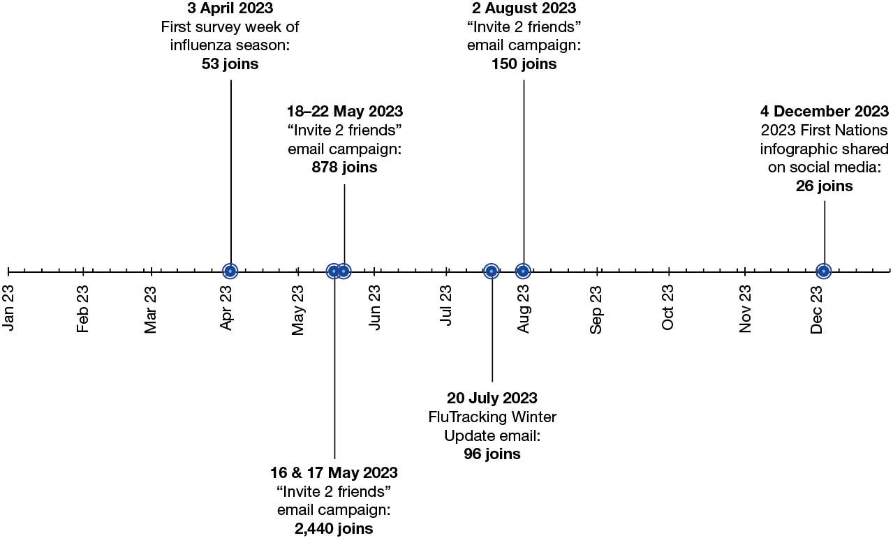
Figure 2: Number of participants who completed at least one survey, Australia, 2006–2023, by year
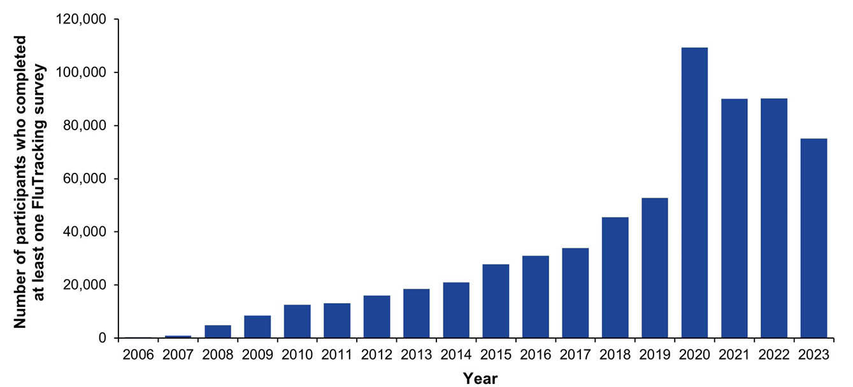
A lower retention rate was observed in 2023, with 77.2% of participants who completed at least one survey in 2022 having completed at least one survey in 2023, compared to 84.4% in 2022 and 70.8% in 2021 (Table 1).
Peak week participation decreased in all states and territories from 2022 to 2023, with the largest declines in the Northern Territory (18.5%), Western Australia (17.6%) and South Australia (15.0%). In 2023, participation rates per 100,000 population ranged from 142.2 in Queensland to 790.9 in the Australian Capital Territory (Appendix A, Table A.2).
Table 1: Summary of participation, Australia, 2021–2023
Type of participant | 2021 |  | 2022 |  | 2023
Type of participant | N = 90,089 |  | N = 90,257 |  | N = 75,078
Type of participant | n | % | n | % | n | %
Primary respondents | 53,360 | 59.2 | 54,662 | 60.6 | 47,476 | 63.2
Household members | 36,729 | 40.8 | 35,595 | 39.4 | 27,602 | 36.8
Completed survey during first four weeks of traditional seasonª | 74,269 | 82.4 | 73,332 | 81.2 | 65,614 | 87.4
Completed at least one survey during first four weeks of traditional seasonª and completed > 90% of all available surveys until beginning of opt-out period^{b} | 58,833 | 79.2 | 52,282 | 71.3 | 46,108 | 70.3
Completed at least one survey during first four weeks of traditional seasonª and completed all surveys until beginning of opt-out periodª | 46,420 | 62.5 | 37,263 | 50.8 | 33,620 | 51.2
Number of participants retained who completed at least one survey in prior year^{c} | 77,405 | 70.8 | 76,022 | 84.4 | 69,716 | 77.2
Number of new participants recruited^{d} | 12,920 | 14.3 | 13,736 | 15.2 | 6,001 | 8.0
a Refer to Appendix A, Table A.4 for survey weeks used.
b Denominator is the count of participants who completed a survey during the first four weeks of the traditional season.
c Denominator is the count of participants who completed a survey in the prior year.
d Refers to participants who may have joined FluTracking and not completed a survey in the respective survey year.

Socio-demographic characteristics of 2023 participants
Of the participants who completed at least one survey in 2023, complete demographic details were available for 72,307 participants. The largest percentage of participants were aged 40 to 64 years (41.1%); females comprised the majority of participants (59.9%); and the most common education level was a bachelor’s degree (25.9% completed or enrolled; Appendix A, Table A.4). Since 2020, the percentage of participants aged 65 years and over has increased. The percentage of participants who identified as First Nations decreased from 1.3% in 2022 to 1.1% in 2023 (compared to 3.8% of the Australian population).¹⁴

Time to respond to survey each week
In 2023, of responding participants, 80.0% responded within 24 hours on average. Those aged 65 years and over had the highest 24-hour response rate at 85.0%.

Influenza vaccination
By the final 2023 survey, 75.1% of participants reported receiving the annual influenza vaccine, decreasing from 79.2% in 2022 (Figure 3). The steepest decline in influenza vaccination coverage occurred in children aged 5–17. Influenza vaccination coverage was largely unaffected from 2020 to 2023 for participants aged over 65 years and over and those who identified as First Nations.
Figure 3: Percentage of participants who reported receiving the seasonal influenza vaccine at the final survey of each participant, by participant characteristics, Australia, 2020–2023, by year
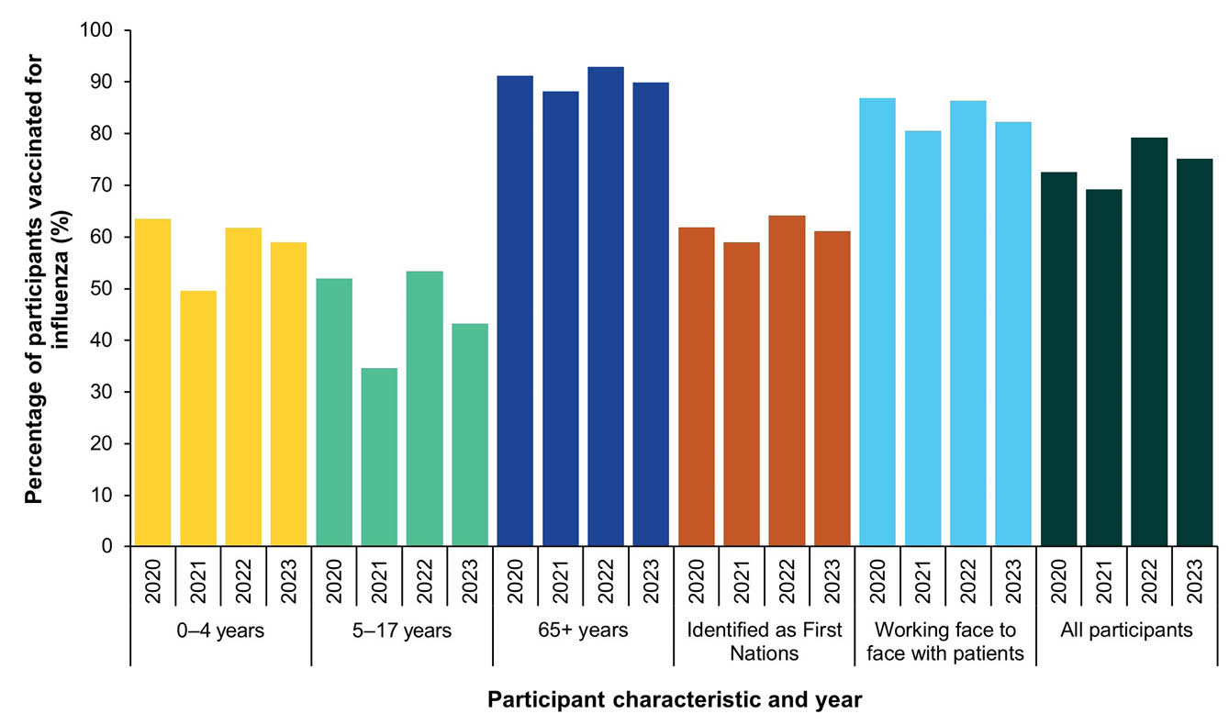

COVID-19 vaccination
Participants aged 18 years and older, as well as those who worked face-to-face with patients, reported higher vaccination coverage than other demographic groups across all doses (Table 2). As dose count increased, COVID-19 vaccine coverage decreased across all demographic groups.
Table 2: COVID-19 vaccination uptake by number of doses at the final survey of each participant, Australia, 2023, by participant characteristicsª
Participant group | Received at least
Participant group | One dose (%) | Two doses (%) | Three doses (%) | Four doses (%) | Five doses (%) | Six doses (%)
All participants (n = 75,078) | 97.5% | 96.9% | 88.1% | 70.2% | 50.7% | 13.9%
Participants who worked face to face with patients (n = 10,178) | 99.5% | 99.3% | 97.3% | 72.8% | 44.9% | 8.9%
Participants aged 0–4 years^{b} (n = 967) | 3.5% | 2.0% | NA | NA | NA | NA
Participants aged 5–11 years^{b} (n = 2,831) | 84.8% | 78.6% | 2.4% | NA | NA | NA
Participants aged 12–17 years (n = 2,982) | 97.2% | 95.3% | 23.0% | 2.8% | 0.5% | 0.1%
Participants aged 18–64 years (n = 40,405) | 99.3% | 99.0% | 94.1% | 65.4% | 38.5% | 6.0%
Participants aged 65+ years and over (n = 27,893) | 99.4% | 99.3% | 98.2% | 93.9% | 80.7% | 28.6%
Participants who identified as First Nations (n = 847) | 92.8% | 90.7% | 71.8% | 47.1% | 26.8% | 6.1%
a Self-reported COVID-19 vaccination status was defined at or before the participant’s last submitted survey of the year.
b NA: not applicable.

Percentage of participants reporting incident FC symptoms by influenza vaccination status
In 2023, there were several observed divergences in weekly FC incidence by influenza vaccination status. The greatest divergence occurred in the week ending 25 June 2023 (2.1% unvaccinated to 1.5% vaccinated, Figure 4).
Figure 4: Age-standardised percentage of participants reporting incident fever and cough (FC) symptoms by influenza vaccination status, Australia, 2020–2023, by weekª
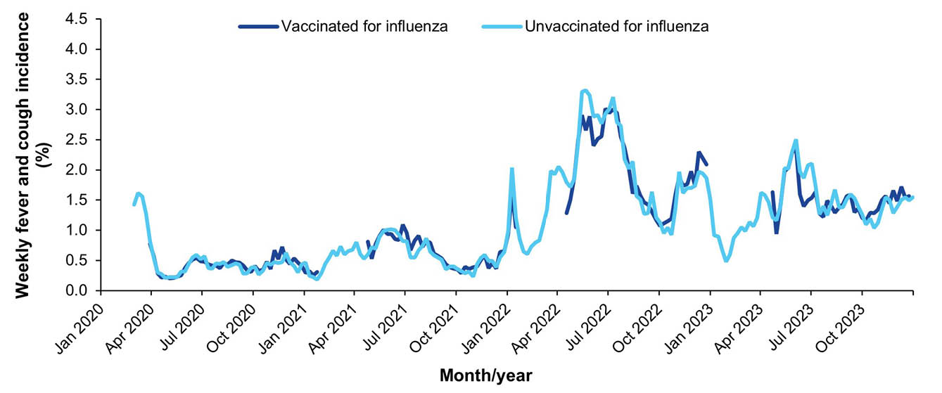
a Participants were defined as vaccinated for influenza two weeks after they reported being vaccinated. This was to allow time for immunity to develop following vaccination.¹⁵ This delay was not applied to participants who were already vaccinated at the time of their first FluTracking survey for the year.

Comparison with national laboratory-confirmed influenza notifications
NNDSS laboratory-confirmed influenza notifications peaked during the week ending 2 July 2023, four weeks after the peak in FluTracking FC activity (Figure 5). Four out of eight states and territories experienced peak weekly FC incidence in May 2023 (Appendix A, Figure A.1).
Figure 5: Age-standardised percentage of participants reporting incident fever and cough (FC) symptoms versus national influenza laboratory-confirmed notifications, Australia, 2020–2023, by week
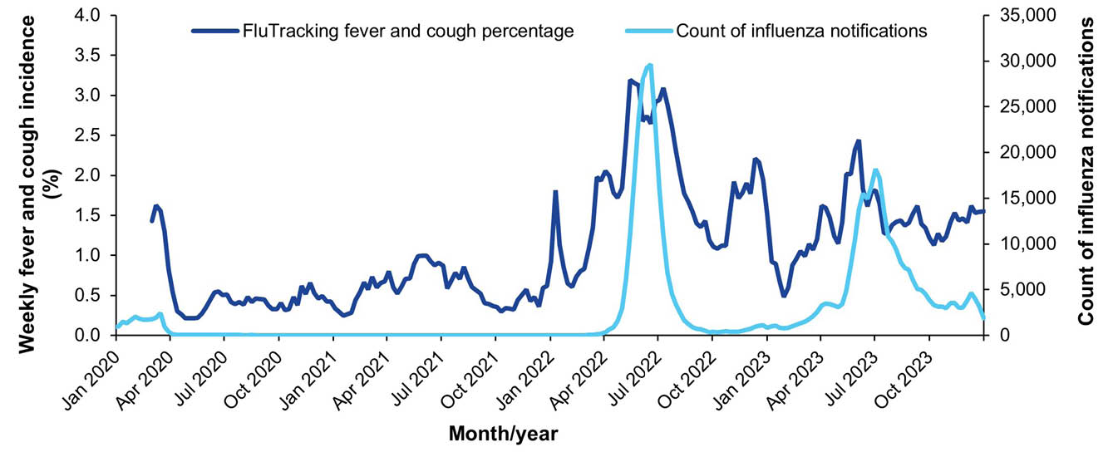

Percentage of self-reported laboratory influenza tests
The mean percentage of participants who reported incident FC symptoms and influenza testing decreased from 17.0% in 2022 to 10.9% in 2023. Declines were observed in all states/territories except for South Australia and the Australian Capital Territory (Figure 6).
Figure 6: Mean weekly percentage of FluTracking participants who reported incident fever and cough (FC) symptoms and being tested for influenza, Australia, 2020–2023, by jurisdiction, epidemiological weeks 23–41^{a,b}
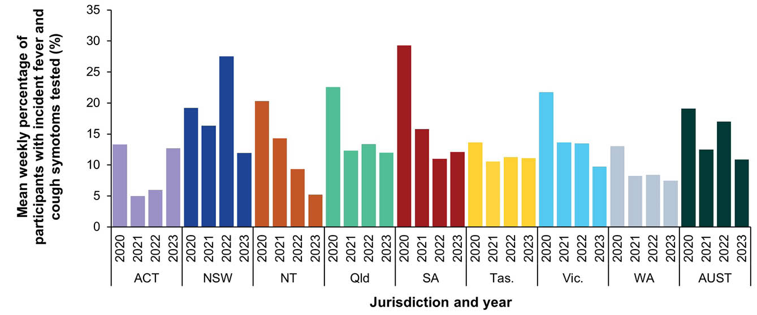
a Analyses including influenza testing data commence from epidemiological week 23 for each respective year due to survey modifications applied in 2020.¹²
b ACT: Australian Capital Territory; NSW: New South Wales; NT: Northern Territory; Qld: Queensland; SA: South Australia; Tas.: Tasmania; Vic.: Victoria; WA: Western Australia; AUST: Australia.

Burden of illness activity
In 2023, the proportion of participants who sought medical attention for incident FC symptoms was 40.6%, a decrease from 49.9% in 2022 (Table 3). Among those reporting FC symptoms, 14.2% underwent SARS-CoV-2 PCR testing (vs. 39.1% in 2022), and 83.4% were tested for SARS-CoV-2 via a RAT (vs. 88.6% in 2022).
Table 3: FluTracking burden of illness activity of participants with incident fever and cough symptoms, Australia, 2021–2023 (epidemiological weeks 1–52 of each survey year)
Health seeking behaviour and testingª | 2021 | 2022 | 2023
Health seeking behaviour and testingª | N = 10,730 (n; %) | N = 32,173 (n; %) | N = 20,211 (n; %)
Tested positive for SARS-CoV-2 (RAT)^{b} | 165 (1.5%) | 16,800 (52.2%) | 7,264 (35.9%)
Tested positive for SARS-CoV-2 (PCR) | 318 (3.0%) | 7,042 (21.9%) | 655 (3.2%)
Tested positive for influenza (PCR) | 90 (0.8%) | 792 (2.5%) | 725 (3.6%)
Tested for SARS-CoV-2 (RAT)^{b} | 451 (4.2%) | 28,505 (88.6%) | 16,862 (83.4%)
Tested for SARS-CoV-2 (PCR) | 6,428 (59.9%) | 12,580 (39.1%) | 2,871 (14.2%)
Tested for influenza (PCR) | 1,513 (14.1%) | 4,446 (13.8%) | 2,333 (11.5%)
Sought medical attention | 6,913 (64.4%) | 16,040 (49.9%) | 8,201 (40.6%)
a RAT: rapid antigen test; PCR: polymerase chain reaction.
b SARS-CoV-2 RATs were made available in Australia in November 2021.

COVID-19 vaccination and FC percentages
Participants who reported receiving fewer than three doses of a COVID-19 vaccine reported higher weekly FC incidence compared to those who reported receiving three or more doses in both 2022 and 2023 (Figure 7).
Figure 7: Percentage of participants reporting incident fever and cough (FC) symptoms by COVID-19 vaccination status, Australia, 2022–2023, by week^{a,b}
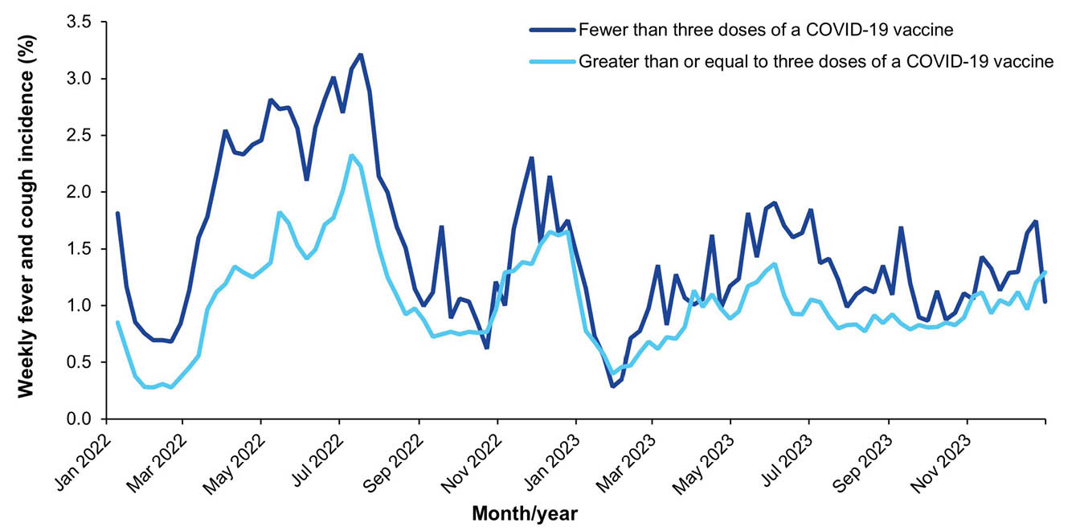
a Data are for participants aged 16 years and older, given children aged under 16 years were not recommended to receive a third COVID-19 vaccine unless immunocompromised or at risk of severe COVID-19 infection.¹⁶
b Participants were defined as vaccinated for COVID-19 two weeks after they reported being vaccinated.¹⁵

Weekly FC incidence by age group
Weekly FC incidence trends in 2023 were similar to those seen in 2022, with higher incidence observed in younger age groups (Figure 8).
Figure 8: Weekly fever and cough (FC) incidence by age group, Australia, 2022–2023, by week
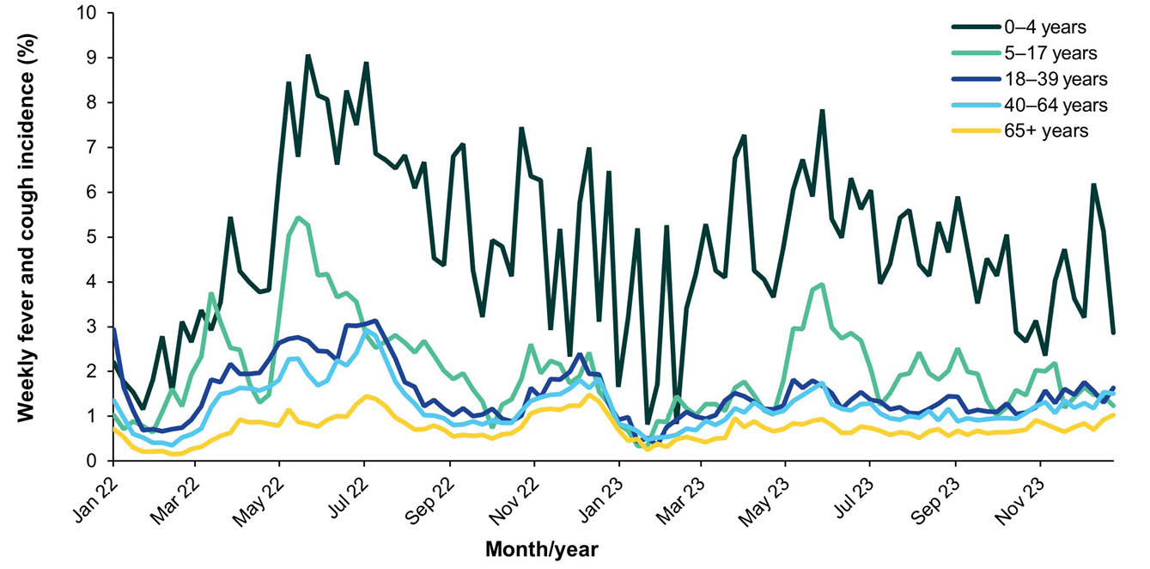

Period cumulative incidence of FC by age group
All age groups showed decreased cumulative incidence of FC by epidemiological week 52 from 2022 to 2023. Adults aged 18–64 years experienced the largest decrease, with a 22.7% decline (Figure 9).
Figure 9: Period cumulative incidence of fever and cough (FC) symptoms by age group, Australia, 2021–2023, epidemiological weeks 1–52^{a,b}
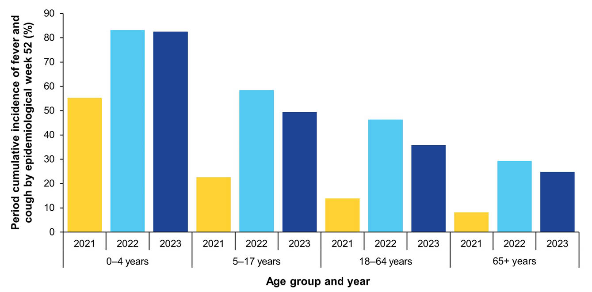
a Only the first incident of fever and cough symptoms for each participant per year was included.
b Excludes participants who did not complete all surveys during epidemiological weeks 1 to 52 in 2021–2023.

Mild illness: runny nose and sore throat
In 2023, weekly RNST incidence remained below 2.0% (Figure 10). The percentage of participants reporting incident RNST symptoms was consistently lower than the percentage of participants reporting incident FC symptoms.
Figure 10: Age-standardised incident fever and cough (FC) versus incident runny nose and sore throat (RNST) symptoms, Australia, 2020–2023, by week
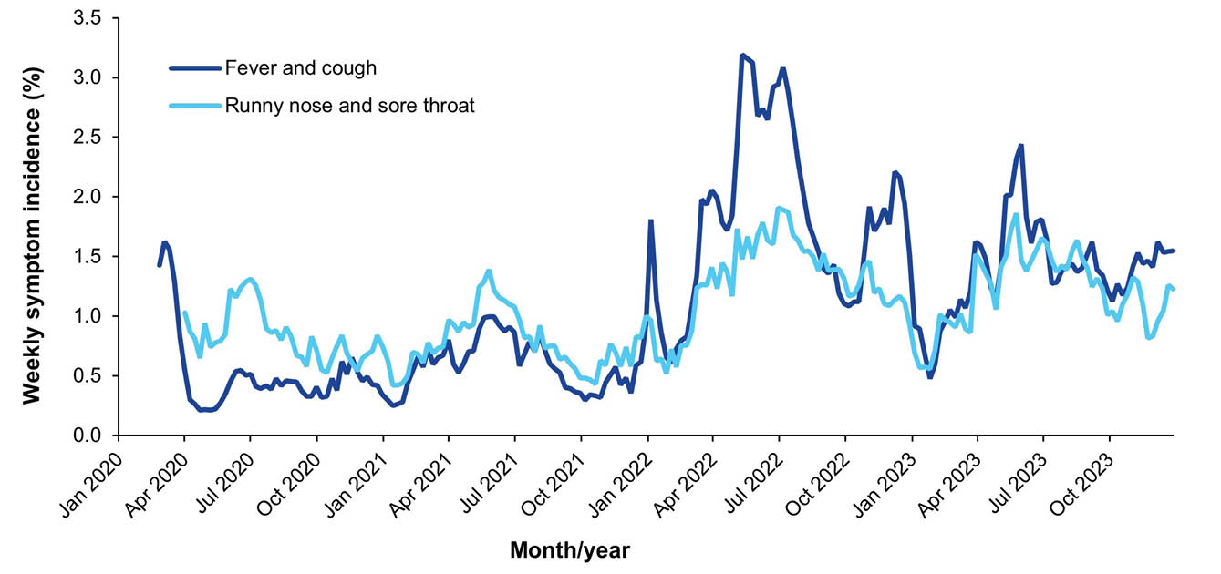

Period cumulative incidence of RNST by age group
The period cumulative incidence of RNST by epidemiological week 52 decreased across all demographic groups from 2022 to 2023 (Figure 11). Children aged 0-4 years had the largest decrease (16.7%).
Figure 11: Period cumulative incidence of runny nose and sore throat (RNST) symptoms by age group, Australia, 2021–2023, epidemiological weeks 1–52^{a,b}
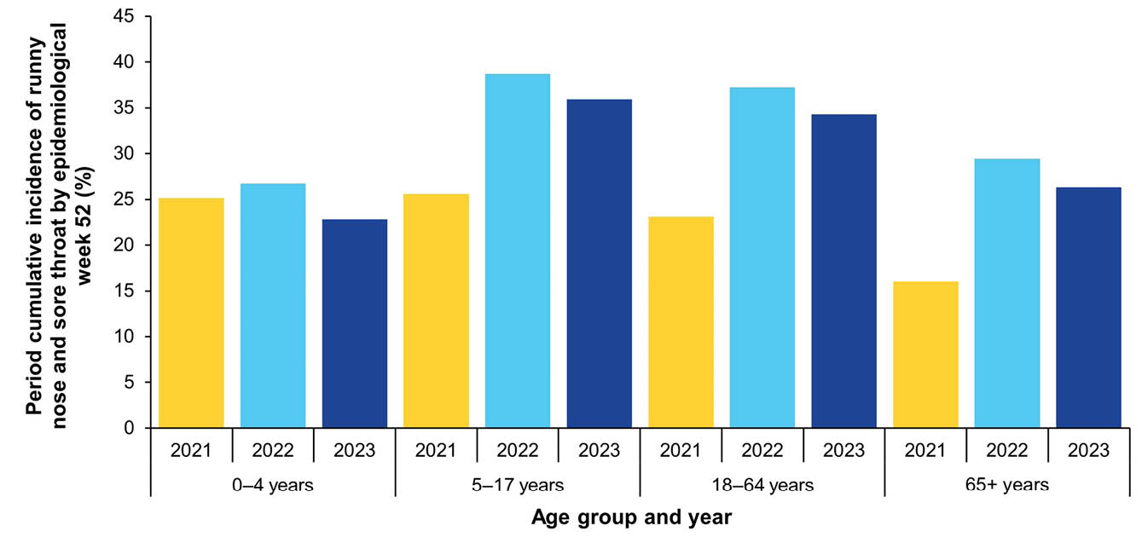
a Only the first incident of runny nose and sore throat symptoms for each participant per year was included.
b Excludes participants who did not complete all surveys during epidemiological weeks 1 to 52 in 2021–2023.

SARS-CoV-2 testing in participants with respiratory illness
Throughout 2023, SARS-CoV-2 testing percentages were consistently lower among participants reporting incident RNST symptoms compared to those reporting FC symptoms. Weekly SARS-CoV-2 testing percentages for both symptom groups increased in late 2023 during the JN.1 wave (Figure 12).
Figure 12: SARS-CoV-2 testing via polymerase chain reaction (PCR) and/or rapid antigen test (RAT) among participants with incident fever and cough (FC) versus incident runny nose and sore throat (RNST) symptoms, Australia, 2020–2023, by week
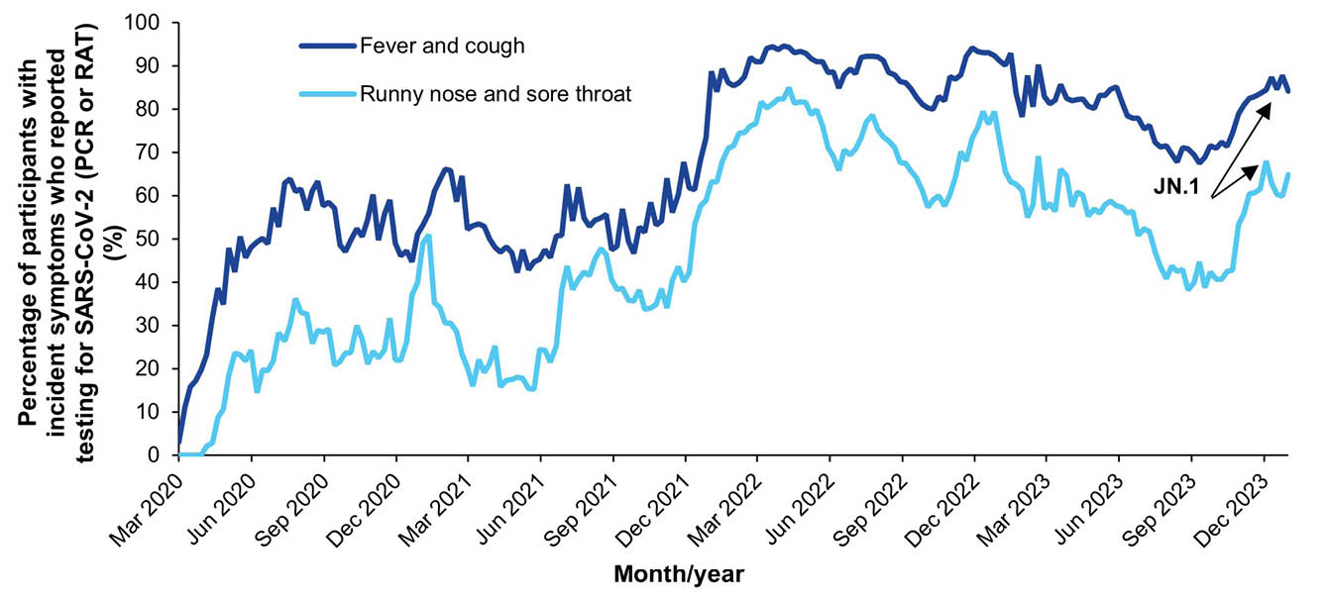

First Nations analyses

First Nations participants incident FC symptoms
Incident FC symptoms among First Nations participants fluctuated throughout 2023 with no clear trend, limited by a reduced sample size. Incidence of FC symptoms peaked at 2.7% during the week ending 21 May 2023 (Figure 13).
Figure 13: First Nations participants incident fever and cough (FC) symptoms, Australia, 2020–2023, by week
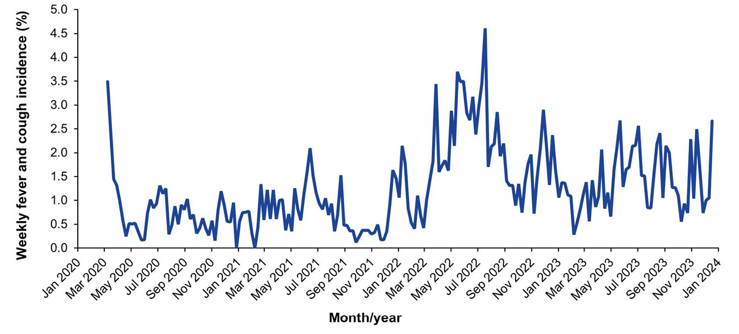

Period cumulative incidence of FC and RNST, First Nations participants
Among First Nations participants, the period cumulative incidence of FC at epidemiological week 52 decreased from 49.7% in 2022 to 36.5% in 2023 (Figure 14). The period cumulative incidence of RNST at epidemiological week 52 increased slightly from 29.2% in 2022 to 30.4% in 2023.
Figure 14: Period cumulative incidence of fever and cough (FC) versus runny nose and sore throat (RNST) symptoms for First Nations participants, Australia, 2021–2023, epidemiological weeks 1–52^{a,b}
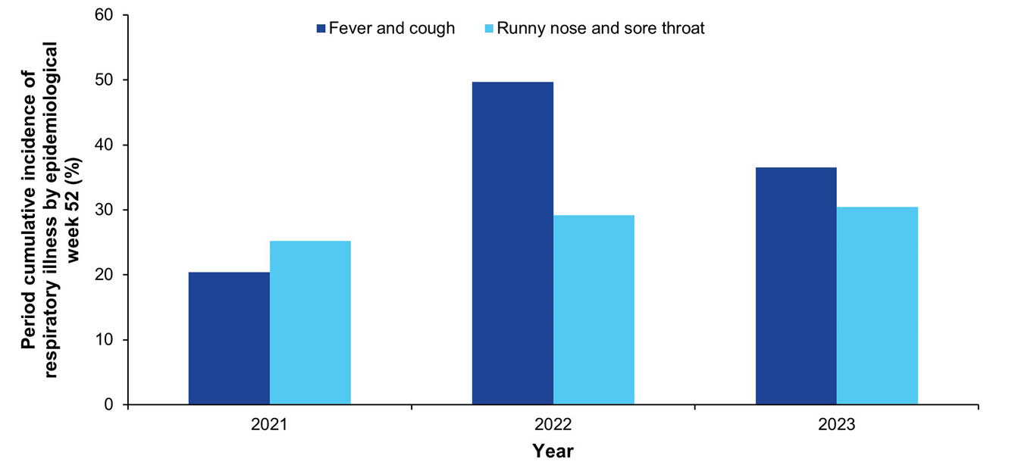
a Only the first incident of fever and cough, and of runny nose and sore throat, for each participant per year was included.
b Excludes participants who did not complete all surveys during epidemiological weeks 1 to 52 in 2021–2023.

Testing for influenza and SARS-CoV-2 in participants reporting incident FC symptoms
Influenza and SARS-CoV-2 PCR testing percentages among participants who reported incident FC symptoms converged in June and remained aligned thereafter (Figure 15).
Figure 15: Influenza and SARS-CoV-2 testing among participants reporting incident fever and cough (FC) symptoms, Australia, November 2021 – December 2023, by week
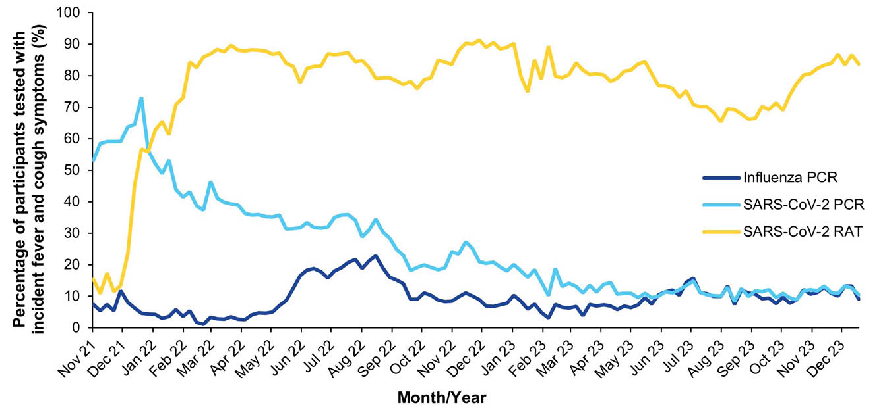

Percent positivity for influenza and SARS-CoV-2 in participants reporting incident FC symptoms
SARS-CoV-2 test percent positivity (PCR and/or RAT) decreased to 37.1% in the week ending 12 March 2023, before peaking at 49.2% in May 2023, lower than in previous Omicron waves. It increased again from 11.7% in the week ending 13 August 2023 to 59.6% in December 2023, marking the highest test percent positivity for 2023.
Influenza test percent positivity (PCR) peaked at 52.6% during the week ending 2 July 2023 (Figure 16).
Figure 16: Influenza and SARS-CoV-2 test (polymerase chain reaction [PCR] and/or rapid antigen test [RAT]) percent positivity among participants reporting incident fever and cough (FC) symptoms, Australia, 2020–2023, by week
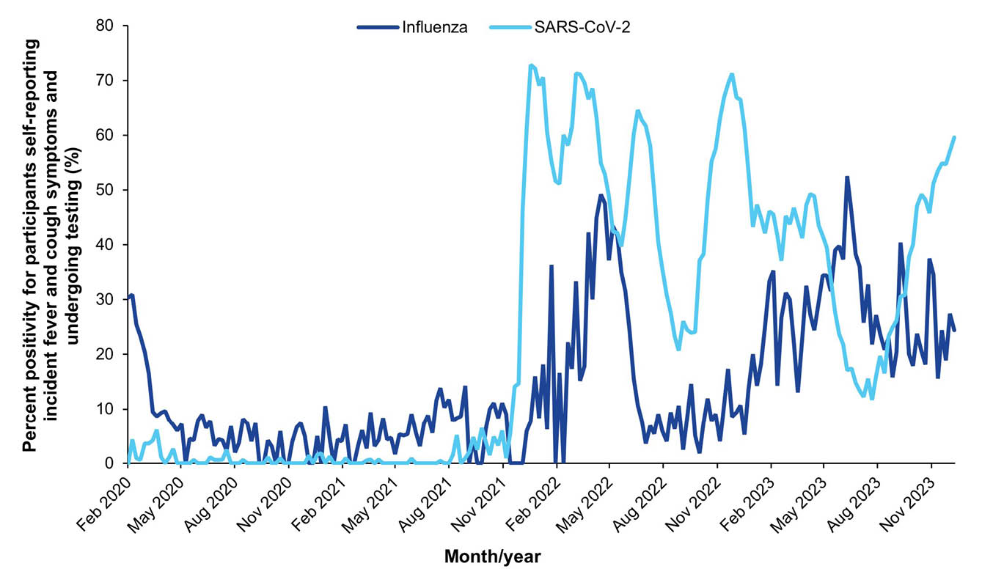

Comparisons with other surveillance systems

Comparison of FluTracking weekly FC incidence and weekly NNDSS COVID-19 laboratory-confirmed notifications
Peaks in the percentage of participants reporting incident FC symptoms closely aligned with the timing of peaks in NNDSS notifications during the Omicron waves in May–June 2023 (Figure 17).
Figure 17: FluTracking weekly incident fever and cough (FC) symptoms versus National Notifiable Diseases Surveillance System (NNDSS) confirmed COVID-19 polymerase chain reaction (PCR) notifications, Australia, 2023, by week
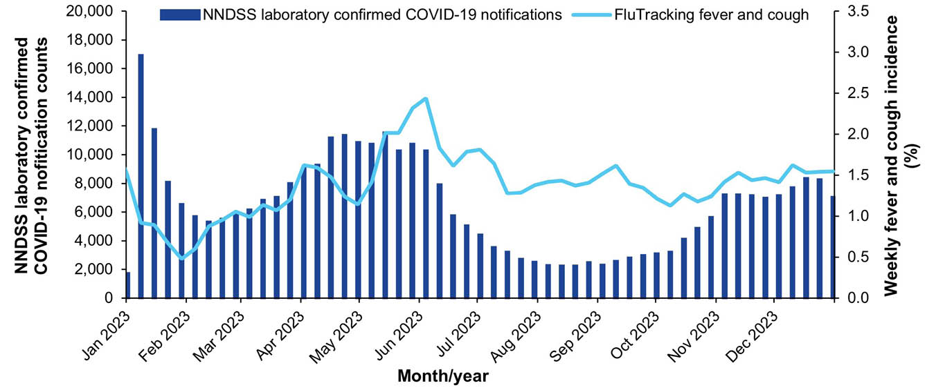

Comparison of FluTracking SARS-CoV-2 percent positivity with NNDSS COVID-19 laboratory-confirmed notifications
SARS-CoV-2 test percent positivity peaks among participants with incident FC symptoms closely aligned with the timing of peaks in NNDSS COVID-19 notifications (Figure 18). One exception was a peak in PCR-only test percent positivity during the week ending 19 February 2023.
Figure 18: FluTracking SARS-CoV-2 test percent positivity by test type in participants reporting incident fever and cough (FC) symptoms versus National Notifiable Diseases Surveillance System (NNDSS) COVID-19 laboratory-confirmed notifications, Australia, 2023, by week
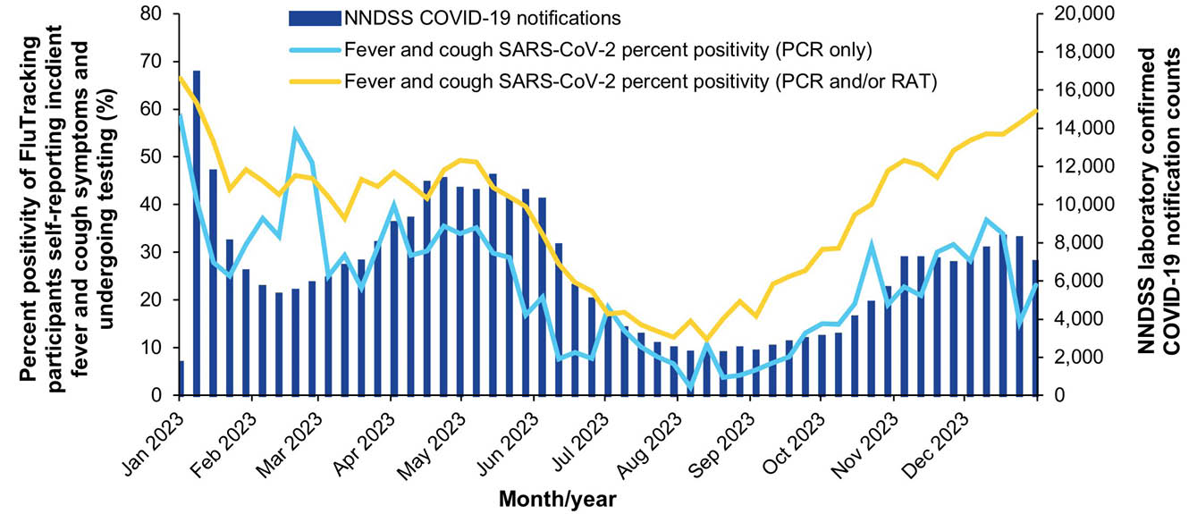

Discussion
FluTracking participation declined by 16.8% from 2022 to 2023. Despite this decline, participants maintained prompt survey responses in 2023, with a mean of 80% of participants completing surveys within 24 hours of distribution. The cohort retained from 2022 into 2023 exhibited lower retention rates compared to previous years.
In 2023, FluTracking detected an early, brief peak in weekly FC incidence, followed by consistently lower FC activity for the remainder of the year. This contrasted with increased activity and multiple Omicron-associated FC peaks observed in 2022. The 2023 FC incidence peak was lower than all preceding years documented by FluTracking since 2006, except for 2018, 2020 and 2021. It is important to note that influenza reached historically low levels in 2020 and 2021 due to the implementation of COVID-19 public health restrictions, and the 2018 influenza season was widely considered as mild.^{17,18} The highest weekly FC incidence in 2023 (2.4%) occurred during the week ending 4 June 2023. This occurred between peaks in NNDSS-confirmed COVID-19 and influenza notifications, suggesting concurrent circulation of both viruses. While marginally higher than the FC peaks corresponding to the BA.2 and mixed Omicron waves in 2022, this peak was smaller than the 2022 FC peak attributed to influenza and the 2022 BA.4/BA.5 FC wave.
From 2022 to 2023, SARS-CoV-2 testing (PCR and/or RAT) decreased by 25% among participants reporting incident RNST symptoms, and by 11% among those reporting incident FC symptoms. This decline coincided with evolving COVID-19 management approaches and a diminishing emphasis on PCR testing as the management of COVID-19 aligned with approaches for other respiratory illness. Contributing factors included the closure of drive-through testing clinics nationwide, new general practitioner (GP) referral requirements for PCR testing among low-risk individuals, and broader shifts in public health strategies.^{19–21} The impact was particularly pronounced for influenza testing, with mean weekly PCR testing percentages among those reporting FC symptoms decreasing by 35.9% from 2022 to 2023. This reduction was largely driven by New South Wales (56.7% decline) where, unlike other states that required GP referrals, influenza PCR testing had been freely available at COVID-19 drive-through clinics in 2022 before their closure in 2023.²²
FluTracking test percent positivity data suggests that influenza activity was similar in 2022 and 2023, with higher laboratory notifications in 2022 likely driven by increased testing accessibility. Despite decreases in reported FC incidence and SARS-CoV-2 PCR testing in 2023, SARS-CoV-2 PCR test percent positivity consistently aligned with NNDSS-confirmed COVID-19 case trends.
The disparity in period cumulative incidence for RNST and FC symptoms highlights distinct age-related differences. While RNST period cumulative incidence shows minimal variation across age groups, FC period cumulative incidence inversely correlates with age, indicating that younger participants experience a higher cumulative incidence of severe illness.
While FluTracking participants consistently demonstrate higher vaccination rates compared to the general Australian population, self-reported influenza vaccination coverage decreased from 2022 to 2023, particularly in children aged 5 to 17 years (19% decrease). This decrease aligns with findings from other sources.²³ Plausible explanations include disruptions to routine vaccination services due to COVID-19 and general vaccine hesitancy. Additionally, the absence of a no-cost influenza vaccine incentive, which was available in many states and territories during 2022 but not extended in 2023 (excluding Queensland and Western Australia), may have contributed to the reduced vaccine uptake.^{24,25}
In 2024, the COVID-19 vaccination survey question will be modified to align with COVID-19 vaccination guidelines focusing on recency of vaccination rather than cumulative dose count. FluTracking will also continue engaging in PREVENT (Pandemic Respiratory Virus Surveillance Trial), a community based self-swabbing pilot study, conducted in collaboration with Hunter Medical Research Institute (HMRI). This study enrolled 51 FluTracking participants residing in the Newcastle area to perform a weekly nasal self-swab for 12 months, with the swabs screened for respiratory pathogens on a 16-plex PCR panel. Results from this pilot study are currently under analysis.

Acknowledgments
We acknowledge the University of Newcastle for their continued support, and the Australian Government Department of Health, Disability and Ageing and the Hunter Medical Research Institute for their funding and support. We also acknowledge Stephen Clarke for software and database development, the First Nations Health Protection staff for their guidance and support, John Fejsa for his contribution to the design of the project, and the many thousands of FluTracking participants who freely give their time each week to contribute to influenza and COVID-19 surveillance.

Author details
Ms Alexandra G Kerr,¹ Analyst
Ms Sandra J Carlson,¹ Manager – FluTracking
Dr Stuart R Adams,¹ Analyst
Mr Tom C McKenzie,¹ Project Officer
Dr David C Boettiger,^{1,2,3} Epidemiologist
Dr Craig B Dalton,^{1,2,3} Public Health Physician
- Hunter New England Local Health District, NSW, Australia
- University of Newcastle, Callaghan, NSW, Australia
- Hunter Medical Research Institute, Lambton Heights, NSW, Australia

Corresponding author
Dr Craig B Dalton
Booth Building, Longworth Ave, Wallsend, NSW, Australia 2287
Phone: +61 2 4924 6499
Email: craig.dalton@health.nsw.gov.au

References
- Carlson SJ, Dalton CB, Tuyl FA, Durrheim DN, Fejsa J, Muscatello DJ et al. Flutracking surveillance: comparing 2007 New South Wales results with laboratory confirmed influenza notifications. Commun Dis Intell Q Rep. 2009;33(3);323–7.
- Dalton CB, Durrheim DN, Fejsa J, Francis L, Carlson SJ, d'Espaignet ET et al. Flutracking: a weekly Australian community online survey of influenza-like illness in 2006, 2007 and 2008. Commun Dis Intell Q Rep. 2009;33(3);316–22.
- Parrella A, Dalton CB, Pearce R, Litt JCB, Stocks N. ASPREN surveillance system for influenza-like illness: a comparison with FluTracking and the National Notifiable Diseases Surveillance System. Aust Fam Physician. 2009;38(11);932–6.
- Carlson SJ, Dalton CB, Durrheim DN, Fejsa J. Online Flutracking survey of influenza-like illness during pandemic (H1N1) 2009, Australia. Emerg Infect Dis. 2010;16(12):1960–2. doi: https://doi.org/10.3201/eid1612.100935.
- Dalton CB, Carlson SJ, Durrheim DN, Butler MT, Cheng AC, Kelly HA. Flutracking weekly online community survey of influenza-like illness annual report, 2015. Commun Dis Intell Q Rep. 2016;40(4);E512–20.
- World Health Organization (WHO). Pandemic Influenza Severity Assessment (PISA): a WHO guide to assess the severity of influenza epidemics and pandemic. Geneva: WHO; May 2017. Available from: https://apps.who.int/iris/bitstream/handle/10665/259392/WHO-WHE-IHM-GIP-2017.2-eng.pdf.
- Australian Government Department of Health and Aged Care. Australian influenza report 2009. Canberra: Australian Government Department of Health and Aged Care; 2009.
- National Incident Room Surveillance Team. 2019-nCoV acute respiratory disease, Australia: Epidemiology Report 1 (Reporting week 26 January - 1 February 2020). Commun Dis Intell (2018). 2020;44. doi: https://doi.org/10.33321/cdi.2020.44.13.
- Australian Government Department of Health and Aged Care. National Notifiable Diseases Surveillance System (NNDSS) public datasets. [Webpage.] Canberra: Australian Government Department of Health and Aged Care; 2023. [Accessed on 21 March 2023.] Available from: https://www.health.gov.au/resources/collections/nndss-public-datasets.
- Australian Government Department of Health and Aged Care. National Notifiable Diseases Surveillance System (NNDSS) fortnightly reports. [Webpage.] Canberra: Australian Government Department of Health and Aged Care; 2023. [Accessed on 22 March 2023.] Available from: https://www.health.gov.au/resources/collections/nndss-fortnightly-reports.
- Moberley S, Carlson SJ, Durrheim DN, Dalton CB. Flutracking: Weekly online community-based surveillance of influenza-like illness in Australia, 2017 Annual Report. Commun Dis Intell (2018). 2019;43. doi: https://doi.org/10.33321/cdi.2019.43.31.
- Kerr AG, Carlson SJ, Baldwin Z, Innes RJ, Howard ZL, Bennett M et al. FluTracking: Weekly online community-based surveillance of respiratory illness in Australia, 2020–2022 Report. Commun Dis Intell (2018). 2025; 49. doi: https://doi.org/10.33321/cdi.2025.49.024.
- World Health Organization (WHO). Global Influenza Programme: Surveillance and Monitoring. [Webpage.] Geneva: WHO; 2024. [Accessed on 10 October 2024.] Available from: https://www.who.int/teams/global-influenza-programme/surveillance-and-monitoring.
- Australian Bureau of Statistics (ABS). Aboriginal and Torres Strait Islander people: Census. Reference period: 2021. [Webpage.] Canberra: ABS; 28 June 2022. [Accessed on 3 March 2023.] Available from: https://www.abs.gov.au/statistics/people/aboriginal-and-torres-strait-islander-peoples/aboriginal-and-torres-strait-islander-people-census/latest-release.
- Siegrist CA. 2 – Vaccine immunology. In Plotkin SA, Orenstein WA, Offit PA, Edwards KM, eds. Plotkin's Vaccines (7th edition). Amsterdam: Elsevier, 2018;16–34.e7. doi: https//doi.org/10.1016/B978-0-323-35761-6.00002-X.
- Australian Government Department of Health and Aged Care. ATAGI statement on the administration of COVID-19 vaccines in 2024. Canberra: Australian Government Department of Health and Aged Care; Australian Technical Advisory Group on Immunisation; 1 March 2024. [Accessed on 21 March 2024.] Available from: https://www.health.gov.au/resources/publications/atagi-statement-on-the-administration-of-covid-19-vaccines-in-2024.
- Communicable Disease Epidemiology and Surveillance Section. Report of the National Influenza Surveillance Scheme, 2011 to 2018. Commun Dis Intell (2018). 2022;46. doi: https://doi.org/10.33321/cdi.2022.46.12.
- Australian Government Department of Health and Aged Care. National 2021 Influenza Season Summary. Canberra: Australian Government Department of Health and Aged Care; December 2021. [Accessed on 21 March 2024.] Available from: https://www.health.gov.au/sites/default/files/documents/2022/10/aisr-2021-national-influenza-season-summary.pdf.
- New South Wales State Government (NSW Government). NSW to transition away from COVID PCR testing. [Media release.] Sydney: NSW State Government; 19 April 2023. [Accessed on 21 March 2024.] Available from: https://www.nsw.gov.au/media-releases/nsw-to-transition-away-from-covid-pcr-testing.
- Beazley J. Testing times: workers’ three years on Covid frontline comes to an end as NSW clinics close. [Online news item.] Sydney: Guardian Media Group, Guardian Australia; 14 May 2023. [Accessed on 21 March 2024.] Available from: https://www.theguardian.com/australia-news/2023/may/14/testing-times-workers-three-years-on-covid-frontline-comes-to-an-end-as-nsw-clinics-close.
- Australian Government Department of Health and Aged Care. Access to PCR Testing from 1 January 2023. Canberra: Australian Government Department of Health and Aged Care; 15 December 2022. [Accessed on 21 March 2024.] Available from: https://www.health.gov.au/sites/default/files/2022-12/access-to-pcr-testing-from-1-january-2023_0.pdf.
- ABC News. Victoria Park drive-through COVID testing site will shut as more people access multi-virus tests. [Online news item.] Sydney: Australian Broadcasting Corporation, ABC News and Current Affairs; 17 June 2022. [Accessed on 10 October 2024.] Available from: https://www.abc.net.au/news/2022-06-17/more-multi-virus-testing-available-at-sa-drive-through-sites/101160646.
- National Centre for Immunisation Research and Surveillance (NCIRS). Influenza vaccination cumulative % coverage by age group - all people. [Webpage.] Sydney: Sydney Children’s Hospitals Network, NCIRS; 2024. [Accessed on 21 March 2024.] Available from: https://ncirs.org.au/influenza-vaccination-coverage-data/national-influenza-vaccination-coverage-all-people.
- Government of Western Australia. Free flu vaccines extended for June 2023 to help WA stay well this winter. [Media release.] Perth: Government of Western Australia; 5 July 2023. [Accessed on 21 March 2024.] Available from: https://www.wa.gov.au/government/announcements/free-flu-vaccines-extended-june-2023-help-wa-stay-well-winter.
- Miles J. All Queenslanders to get free flu vaccines after dozens of young people admitted to hospital. [Online news item.] Sydney: Australian Broadcasting Corporation, ABC News and Current Affairs; 17 July 2023. [Accessed on 21 March 2024.] Available from: https://www.abc.net.au/news/2023-07-17/qld-government-to-fund-free-flu-vaccines/102610448.
- Australian Bureau of Statistics. National, State and Territory Population. Reference period: June 2023. [Webpage.] Canberra: Australian Bureau of Statistics; 14 December 2023. [Accessed on 11 March 2024.] Available from: https://www.abs.gov.au/statistics/people/population/national-state-and-territory-population/jun-2023.
- Australian Bureau of Statistics. Education and training: Census 2021. Information on qualifications, educational attendance and type of educational institution. Reference period: 2021. [Webpage.] Canberra: Australian Bureau of Statistics; 28 June 2022. [Accessed on 3 March 2023.] Available from: https://www.abs.gov.au/statistics/people/education/education-and-training-census/2021.

Appendix A
Table A.1: Survey questionnaire changes, 2023ª
Date | Change to monitoring | Testing/COVID-19 vaccination questions asked in surveys
14 February 2023 | Participants were asked whether they have received a fifth dose of a COVID-19 vaccine for participants aged 16 years and over (including the nested question for vaccine brand). | COVID-19 vaccine dose 5  ‘Have you received the 5th dose of a COVID-19 vaccine? (This is a booster dose for the immunocompromised)’  (yes/no/don’t know)  - If yes, ‘What was the vaccine brand?’  (Pfizer/AstraZeneca/Moderna/Novavax/other/don’t know)
23 May 2023 | An express survey was developed that asked a single screening question about the presence of any symptoms, tests or vaccinations. It was made available for respondents who had completed at least 26 surveys in the last 12 months, and with at least one additional active household member at the time of survey. | Express survey  ‘For the week of <insert survey start period> to <insert survey end period> did you, <insert household member 1> or <insert household member 2> have any symptoms, tests or vaccinations?  - If ‘yes’ or ‘don’t know’, then survey questionnaire to be completed as normal  - If ‘no’, then survey questionnaire completed
27 September 2023 | Participants were asked whether they have received a sixth dose of a COVID-19 vaccine for participants aged 18 years and over (including the nested question for vaccine brand). | COVID-19 vaccine dose 6  ‘Have you received the 6th dose of a COVID-19 vaccine? (This is a booster dose for the immunocompromised)’  (yes/no/don’t know)  - If yes, ‘What was the vaccine brand?’  (Pfizer/AstraZeneca/Moderna/Novavax/other/don’t know)
18 October 2023 | For all COVID-19 vaccine questions, the vaccine brand was hidden. | —
a Changes to the way FluTracking Australia asks participants about COVID-19 vaccination were made and an express survey was implemented.
Table A.2: Recruitment and participation in FluTracking by jurisdiction, Australia, 2020–2023ª
Jurisdiction^{b} | 2020 |  |  | 2021 |  |  | 2022 |  |  | 2023 |  |  | Percent distribution of Australian population | Percent change 2022 to 2023
Jurisdiction^{b} | Number of participants (peak week) | FluTracking participation per 100,000 population | Percent of participants (peak week) | Number of participants (peak week) | FluTracking participation per 100,000 population | Percent of participants (peak week) | Number of participants (peak week | FluTracking participation per 100,000 population | Percent of participants (peak week) | Number of participants (peak week) | FluTracking participation per 100,000 population | Percent of participants (peak week) | Percent distribution of Australian population | Percent change 2022 to 2023
ACT | 4,377 | 958.4 | 5.0% | 4,168 | 912.6 | 5.6% | 4,260 | 932.8 | 5.8% | 3,692 | 790.9 | 5.8% | 1.8% | -13.3%
NSW | 29,796 | 365.4 | 34.0% | 26,080 | 319.9 | 34.7% | 25,946 | 318.2 | 35.2% | 22,655 | 271.7 | 35.8% | 31.3% | -12.7%
NT | 1,361 | 543.1 | 1.6% | 1,298 | 518.0 | 1.7% | 1,214 | 484.4 | 1.6% | 989 | 391.7 | 1.6% | 0.9% | -18.5%
Qld. | 11,835 | 222.4 | 13.5% | 9,255 | 173.9 | 12.3% | 9,043 | 169.9 | 12.3% | 7,765 | 142.2 | 12.3% | 20.5% | -14.1%
SA | 7,484 | 411.1 | 8.5% | 6,507 | 357.4 | 8.7% | 6,397 | 351.4 | 8.7% | 5,437 | 293.6 | 8.6% | 7.0% | -15.0%
Tas. | 5,293 | 926.2 | 6.0% | 4,846 | 847.9 | 6.5% | 4,681 | 819.1 | 6.4% | 4,001 | 698.5 | 6.3% | 2.2% | -14.5%
Vic. | 18,068 | 273.2 | 20.6% | 15,111 | 228.5 | 20.1% | 14,527 | 219.7 | 19.7% | 12,500 | 183.5 | 19.8% | 25.6% | -14.0%
WA | 9,471 | 340.0 | 10.8% | 7,802 | 280.1 | 10.4% | 7,580 | 272.1 | 10.3% | 6,245 | 216.9 | 9.9% | 10.8% | -17.6%
Total | 87,685  (+20 missing) | 329.2 | 100.0% | 75,067  (+19 missing) | 281.9 | 100.0% | 73,648  (+19 missing) | 276.5 | 100.0% | 63,284  (+2 missing) | 237.6 | 100.0% | 100.0% | -14.1%
a The peak week of participation refers to the week with the highest national survey submissions for the respective year.
b ACT: Australian Capital Territory; NSW: New South Wales; NT: Northern Territory; Qld: Queensland; SA: South Australia; Tas.: Tasmania; Vic.: Victoria; WA: Western Australia.

Table A.3: Survey weeks within traditional survey season and opt-out periods, Australia, 2020–2023
Year | Survey weeks within traditional FluTracking season | Survey weeks within  opt-out period
2020 | 23 March 2020 – 18 October 2020 | 25 October 2020 – 3 January 2021
2021 | 4 April 2021 – 24 October 2021 | 31 October 2021 – 2 January 2022
2022 | 3 April 2022 – 23 October 2022 | 30 October 2022 – 1 January 2023
2023 | 2 April 2023 – 22 October 2023 | 29 October 2023 – 31 December 2023

Table A.4: Socio-demographic characteristics of FluTracking participants who completed at least one survey, Australia, 2020–2023
Characteristic | Value or range | 2020 |  |  | 2021 |  |  | 2022 |  |  | 2023 |  |  | Percentage of Australian population
Characteristic | Value or range | Frequency | Percentage | Rateª | Frequency | Percentage | Rateª | Frequency | Percentage | Rateª | Frequency | Percentage | Rateª | Percentage of Australian population
Age in years | 0–4 | 4,187 | 3.8 | 277.3 | 2,110 | 2.3 | 139.7 | 1,732 | 1.9 | 114.7 | 967 | 1.3 | 63.8 | 5.7
Age in years | 5-17 | 13,055 | 11.9 | 315.5 | 8,875 | 9.9 | 214.5 | 8,442 | 9.4 | 204.0 | 5,813 | 7.7 | 137.1 | 15.9
Age in years | 18-39 | 23,203 | 21.2 | 297.7 | 15,216 | 16.9 | 195.2 | 13,690 | 15.2 | 175.6 | 9,552 | 12.7 | 116.3 | 30.8
Age in years | 40-64 | 47,538 | 43.5 | 599.3 | 39,871 | 44.3 | 502.7 | 38,658 | 42.8 | 487.4 | 30,853 | 41.1 | 380.2 | 30.5
Age in years | 65 and over | 21,417 | 19.6 | 496.5 | 24,017 | 26.7 | 556.8 | 27,735 | 30.7 | 642.9 | 27,893 | 37.2 | 612.1 | 17.1
Age in years | Total participants | 109,400 | 100 | 425.9 | 90,089 | 100 | 350.7 | 90,257 | 100 | 351.4 | 75,078 | 100 | 281.8 | 100
Sex | Male | 45,603 | 41.9 | 357.7 | 36,688 | 41.0 | 287.8 | 36,348 | 40.3 | 280.9 | 29,913 | 40.0 | 226.2 | 49.6
Sex | Female | 63,070 | 58 | 487.5 | 52,776 | 58.9 | 407.9 | 53,328 | 59.1 | 412.2 | 44,708 | 59.9 | 333.3 | 50.4
Sex | Other | 118 | 0.1 | — | 92 | 0.1 | — | 90 | 0.1 | — | 72 | 0.1 | — | —
Sex | Missing data on sex | 641 | — | — | 533 | — | — | 491 | — | — | 385 | — | — | —
Sex | Total reported^{b} | 108,761 | 100 | 423.4 | 89,556 | 100 | 348.6 | 89,766 | 100 | 351.0 | 74,693 | 100 | 280.4 | 100
Highest level of education completed by participant (15 years and over only) | Year 11 or below (or equivalent) or Certificate I/II/III/IV | 21,016 | 22.5 | 266.6 | 16,721 | 20.6 | 212.0 | 16,252 | 20.4 | 206.0 | 13,425 | 19.8 | 170.1 | 38.0%
 | Year 12 (or equivalent) | 8,214 | 8.8 | 264.6 | 6,493 | 8.0 | 209.2 | 6,335 | 7.9 | 204.1 | 5,145 | 7.6 | 165.7 | 14.9%
 | Diploma or Advanced Diploma | 9,069 | 9.7 | 465.9 | 7,885 | 9.7 | 405.0 | 8,029 | 10.1 | 412.4 | 6,955 | 10.3 | 357.3 | 9.4%
 | Enrolled in, or completed, Bachelor Degree | 25,162 | 27.0 | 697.2 | 20,951 | 25.8 | 580.5 | 21,053 | 26.4 | 583.3 | 17,527 | 25.9 | 485.6 | 17.4%
 | Graduate Diploma or Graduate Certificate | 9,695 | 10.4 | 1954.9 | 8,929 | 11.0 | 1800.4 | 9,178 | 11.5 | 1850.6 | 8,192 | 12.1 | 1651.8 | 2.4%
 | Postgraduate Degree | 20,134 | 21.6 | 1481.1 | 18,231 | 22.5 | 1341.1 | 18,963 | 23.8 | 1394.9 | 16,405 | 24.3 | 1206.8 | 6.5%
 | Did not nominate an ABS equivalent education level | 1,660 | — | — | 1,989 | — | — | 2,282 | — | — | 2,122 | — | — | —
 | Total reported^{b} | 90,839 | 100 | 437.0 | 79,210 | 100 | 381.1 | 79,810 | 100 | 384.0 | 67,649 | 100 | 335.7 | 100
Aboriginal and/or Torres Strait Islander status | Yes | 1,779 | 1.7 | 180.8 | 1,212 | 1.4 | 123.2 | 1,147 | 1.3 | 116.6 | 847 | 1.1 | 86.1 | 3.8
Aboriginal and/or Torres Strait Islander status | No | 105,233 | 97.7 | 426.0 | 86,985 | 98.2 | 352.1 | 87417 | 98.4 | 353.9 | 72,908 | 98.5 | 295.2 | 96.2
Aboriginal and/or Torres Strait Islander status | Prefer not to say | 664 | 0.6 | — | 362 | 0.4 | — | 305 | 0.3 | — | 231 | 0.3 | — | —
Aboriginal and/or Torres Strait Islander status | Missing data on Aboriginal and/or Torres Strait Islander status | 1,724 | — | — | 1,530 | — | — | 1,388 | — | — | 1,092 | — | — | —
Aboriginal and/or Torres Strait Islander status | Total reported^{b} | 107,676 | 100 | 419.2 | 88,559 | 100 | 344.7 | 88,869 | 100 | 346.0 | 73,986 | 100 | 288.0 | 100
a Rate per 100,000 population within the indicated category. Participant rates for age group and sex were calculated using the ABS June 2023 Estimated Resident Population.26 The participation rate for education level and First Nations status was calculated using the 2021 Australian Census data.^{14,27}
b Totals for these characteristics exclude those with missing data, or who did not nominate an educational level.

Figure A.1: Age-standardised FC incidence by jurisdiction, Australia, 2020–2023, by week
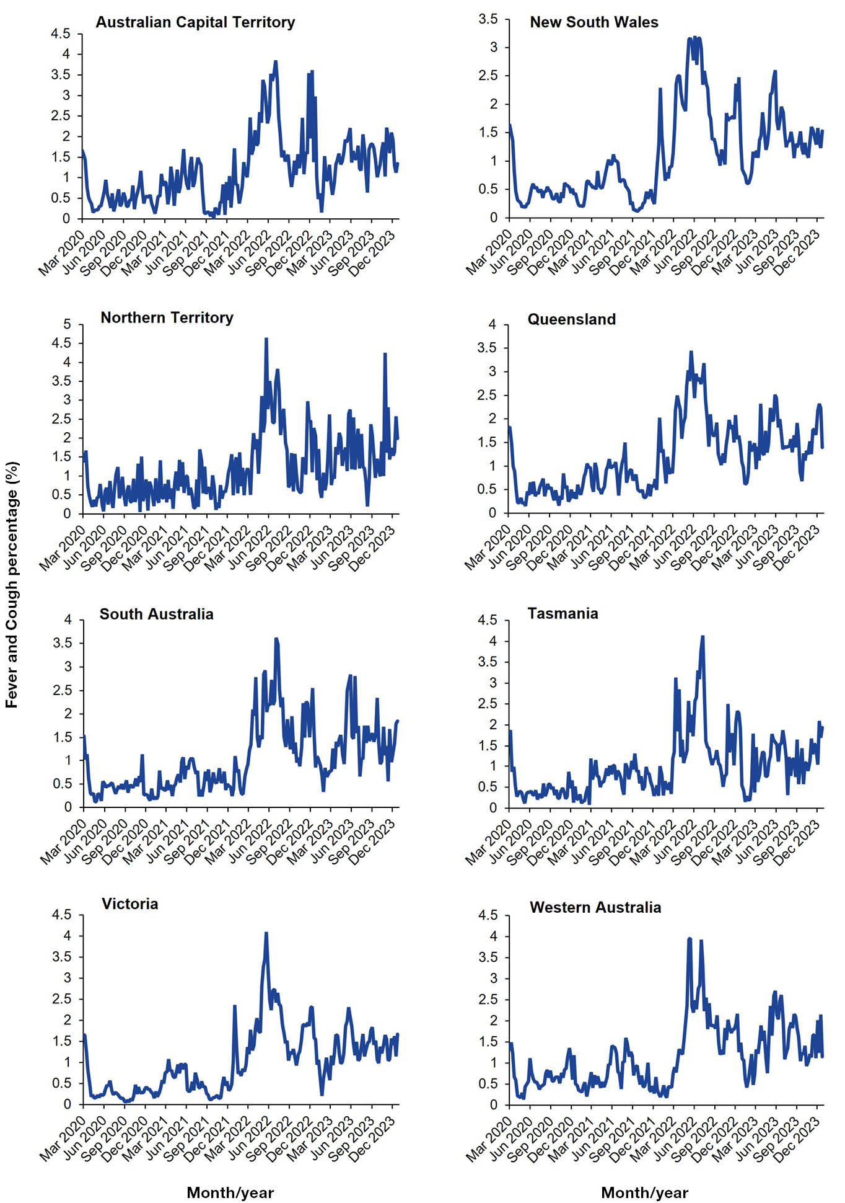
Figure A.2: FC incidence by sex, Australia, 2020–2023, by week
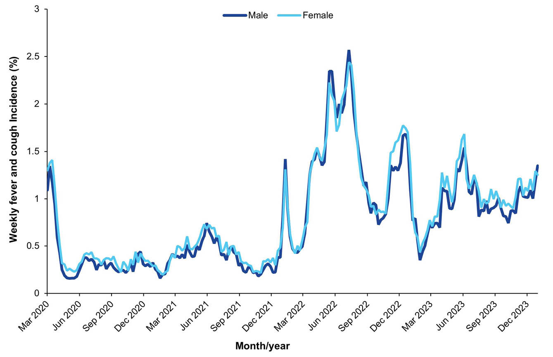
Figure A.3: FC incidence by highest education level, Australia, 2020-2023, by week
