
2025 • Volume 49 • cdc.gov.au/cdi • Epub date: 01.10.2025 • doi.org/10.33321/cdi.2025.49.033

Australian vaccine preventable disease epidemiological review series: mumps, 2013–2021
Sajani Nadeeka, Joanne Jackson, Aditi Dey, Shopna Bag, Stephen Lambert, Frank Beard
© 2025 Commonwealth of Australia as represented by the Department of Health, Disability and Ageing
ISSN: 2209-6051 Online
This journal is indexed by Index Medicus and Medline.
Creative Commons Licence
This publication is licensed under a Creative Commons Attribution-NonCommercial-NoDerivatives 4.0 International Licence (Licence). You must read and understand the Licence before using any material from this publication.
Restrictions
The Licence does not cover, and there is no permission given for, use of any of the following material found in this publication (if any):
- the Commonwealth Coat of Arms (by way of information, the terms under which the Coat of Arms may be used can be found on the Department of Prime Minister and Cabinet website;
- any logos (including the interim Australian Centre for Disease Control and the Department of Health, Disability and Ageing’s logos) and trademarks;
- any photographs and images;
- any signatures; and
- any material belonging to third parties.
Disclaimer
Opinions expressed in Communicable Diseases Intelligence are those of the authors and not necessarily those of the Australian Government, the interim Australian Centre for Disease Control or the Department of Health, Disability and Ageing. Data may be subject to revision.
Enquiries
Enquiries regarding any other use of this publication should be addressed to the CDI Editor.
About CDI
Communicable Diseases Intelligence (CDI) is a peer-reviewed scientific journal published by the interim Australian Centre for Disease Control within the Department of Health, Disability and Ageing.
The journal aims to disseminate information on the epidemiology, surveillance, prevention and control of communicable diseases of relevance to Australia and the near region.
Editor: Christina Bareja • Deputy Editor: Simon Petrie • Design and Production: Lisa Thompson
Editorial Advisory Board: David Durrheim, Mark Ferson, Clare Huppatz, John Kaldor, Martyn Kirk and Meru Sheel
Submit an Article
Guidelines for authors and details on how to submit your publication is available on our website, or by email to the
CDI Editor.
Contact us
Communicable Diseases Intelligence (CDI)
interim Australian Centre for Disease Control, Department of Health, Disability and Ageing
GPO Box 9848, CANBERRA ACT 2601
Website: cdc.gov.au/cdi
Email: cdi.editor@health.gov.au

Contents
Abstract 4
Introduction 5
Methods 6
Study period 6
Data sources 6
Data analyses 7
Ethics 8
Results 9
Secular trends, 2013 to 2021 9
State and territory variation 10
Age and sex distribution 12
Indigenous status 13
Severe morbidity 15
Mortality 15
Vaccination status of notified cases 16
Country of acquisition 18
Remoteness of area of residence 18
Small area analysis 18
Birth cohort analysis 20
Discussion 21
Acknowledgments 23
Funding 24
Author details 25
References 26
Appendix A 30

Abstract

Background
Mumps is a highly contagious acute viral disease. We describe Australian mumps epidemiology, 2013–2021.

Methods
National mumps notification, hospitalisation and death data were analysed by age group, Indigenous status, state/territory and vaccination status.

Results
There were 3,643 mumps notifications between 2013–2021 (average annual rate 1.65 per 100,000 population), with highest annual rates 2015–2018 (2.71–3.32 per 100,000 population). Average annual rates per 100,000 population for 2013–2021 and 2015–2018 were highest in the Northern Territory (15.8 and 35.2), Western Australia (4.7 and 9.5) and Queensland (2.6 and 5.0). Average annual rates per 100,000 population were higher in Indigenous people than other Australians in 2013–2021 (25.65 vs 0.82) and 2015–2018 (57.53 vs 1.10). Highest age-specific average annual rates per 100,000 population were in adolescents aged 10–19 years (overall 3.66, Indigenous 48.24 for 2013–2021; 7.60 and 108.52 for 2015–2018), followed by adults aged 20–29 years. Among mumps notifications with vaccination status recorded (n = 2,295 notifications), 64.2% had received ≥ 2 doses of mumps-containing vaccine and 18.1% had received one dose, with 17.7% unvaccinated. Between 2013–2021, 719 hospitalisations had mumps recorded as principal diagnosis (average annual rate, 0.34 per 100,000 population). There were 1–5 deaths coded with mumps as underlying cause of death.

Conclusion
Mumps epidemiology was dominated by large outbreaks predominantly in fully vaccinated Indigenous adolescents/young adults. Mumps outbreaks among highly vaccinated adolescent/young adult populations have occurred overseas related to waning of vaccine-induced immunity, reduced boosting from wild-type virus circulation and high force of infection in close contact settings. A third dose of mumps-containing vaccine is not warranted routinely, but should be considered in the context of outbreaks occurring in high two-dose coverage settings.
Keywords: mumps; notifications; hospitalisations; outbreaks; vaccination; immunisation

Introduction
Mumps is an acute viral infection caused by an RNA virus in the Paramyxoviridae family. Approximately one-third of individuals infected are asymptomatic.^{1,2} Clinical disease is characterised by fever and painful swelling of one or more salivary glands, most commonly the parotid, which occurs in 95% of symptomatic cases.² Orchitis, most commonly unilateral, occurs in 15–30% of cases in post-pubertal males, while approximately 5% of infected women develop oophoritis.² Clinical evidence of meningitis occurs in approximately 5% of cases and encephalitis, usually much more serious, in less than 1%.² Pancreatitis occurs in about 4% of cases. Other infrequent complications include myocarditis, nephritis, hepatitis, deafness and infertility. Complications are more common in adults than children.²
The incubation period for mumps ranges from 15 to 24 days, with transmission usually via respiratory droplets or saliva.¹ Mumps is highly contagious, with a reproduction number (R₀) of 10–12 in a susceptible population,^{3,4} and was a very common childhood disease in the pre-vaccine era.
Mumps-containing vaccine has been included on the Australian National Immunisation Program (NIP) since 1983, initially given as a single dose of measles-mumps vaccine at 12 months of age, then as combined measles-mumps-rubella vaccine (MMR) from 1989, with a second dose of MMR added in 1993.⁵ In July 2013, combination measles-mumps-rubella-varicella (MMRV) vaccine was added to the NIP at 18 months of age, replacing the MMR dose previously scheduled at 4 years of age and varicella vaccine dose previously scheduled at 18 months of age.⁵
After universal childhood mumps vaccination was introduced in Australia, incidence of the disease declined from an estimated 59,000 cases in 1969 to 66 cases in 1992.^{6,7} The last comprehensive review of mumps epidemiology in Australia covered the period to 2012, and documented a return to relatively low rates of disease after outbreaks in Aboriginal communities in the Northern Territory and Western Australia in 2007.⁸ Here we review the epidemiology of mumps in Australia from 2013 to 2021.

Methods

Study period
Data used in this analysis covered the period from 2013 to 2021.

Data sources

Notifications
In Australia, mumps cases are notified to the National Notifiable Disease Surveillance System (NNDSS) by each jurisdiction under the provisions of public health legislation.⁹ All notifications of mumps with a diagnosis date from 1 January 2013 to 31 December 2021 were eligible for inclusion. Data included all notifications for confirmed and probable mumps in accordance with the national case definition.¹⁰ Variables obtained from this dataset are listed in Table 1.

Hospitalisations
All hospital admissions with a principal or additional diagnosis of mumps from 1 January 2013 to 30 June 2021 were included in this review. The hospitalisation data for the year 2021 was available to 30 June 2021 at the time the study was undertaken and was therefore annualised. Eligible hospital admissions were identified using the International Statistical Classification of Diseases and Related Health Problems, 10th revision, Australian Modification [ICD-10-AM] codes B26.0 (mumps orchitis), B26.1 (mumps meningitis), B26.2 (mumps encephalitis), B26.3 (mumps pancreatitis), B26.8 (mumps with other complications) and B26.9 (mumps without complications).¹¹ Variables obtained from this dataset are listed in Table 1.

Mortality
Mortality data (line listed cause of death unit record file data) were obtained from the Australian Coordinating Registry (ACR). All deaths between 1 January 2013 and 31 December 2020 with mumps as an underlying (principal) cause of death, as defined by the International Statistical Classification of Diseases and Related Health Problems 10th Revision (ICD-10) code B26, were eligible for inclusion.¹² Variables obtained from this dataset are listed in Table 1. Counts between one and five are expressed as a range to comply with the data release condition that small counts be suppressed in published reports.

Population estimates
Mid-year resident population estimates by age and jurisdiction of residence were obtained from the Australian Bureau of Statistics (ABS). ABS mid-year resident population estimates at statistical area 3 (SA3) and remoteness level were also used. Annual population estimates used for Aboriginal and Torres Strait Islander peoples, hereafter referred to respectfully as Indigenous peoples, are the back-cast and projected population estimates as calculated from the 2016 Census by the ABS. Population estimates for the category ‘other’ (see below) were obtained by subtracting the Indigenous population estimates from the total Australian population estimates.
Table 1: Variables obtained for notification, hospitalisation and mortality data for mumps cases, Australia, 2013–2021
Notifications | Hospitalisations | Deaths
State or territory of residence | State or territory of usual residence | State or territory of usual residence
Sex | Sex | Sex
Indigenous status | Indigenous status | Indigenous status
Date of birth | Age group | Age
Date of diagnosis | Length of stay
Age at onset
Vaccination statusª
Country of acquisition^{b}
Postcode
a Depending on availability (due to change in definition during the report period), vaccination status includes either the variables vaccine type, vaccination date and age at time of vaccination, or vaccination status defined as fully vaccinated for age, partially vaccinated for age or not vaccinated.
b According to the Standard Australian Classification of Countries (SACC) 2011 code.

Data analyses
A descriptive analysis of the data was performed. Notification and hospitalisation rates were calculated per 100,000 population per year and as average annual rates over the study period, as well as by age group, sex, Indigenous status and state or territory.
Notification data were further analysed by Accessibility/Remoteness Index of Australia (ARIA++) and SA3, vaccination status, country of acquisition and birth cohort. Country of acquisition data were grouped into the following categories: Australia; New Zealand; other Oceania; North-West Europe; Southern and Eastern Europe; North Africa and the Middle East; South-East Asia; North-East Asia; Southern and Central Asia; the Americas; and sub-Saharan Africa. Birth cohorts were selected based on key changes in mumps vaccination recommendations (Table 2).
Table 2: Immunisation schedule of birth cohorts for mumps cases, Australia, 2013–2021
Birth cohort | Mumps vaccination recommendations
≤ 1965 | No recommendation for receipt of mumps vaccine
1966–1980 | Adults born since 1966 recommended to have received 2 doses of MMR (since 2003)
1981–1999 | Mumps vaccination recommended for use in children at 12 months in 1981 and included on NIP in 1983. Second dose recommended in 1992 and included on NIP in 1993 (initially given at 10–14 years, changed to 4–5 years in 1998)
2000–2011 | Eligible for two-dose schedule under NIP, with dose 2 moved to 4 year time point
≥ 2012 | Eligible for two-dose schedule under NIP, with dose 2 moved to 18 month time point
Hospitalisation data were further analysed by principal and additional diagnosis status, and length of hospital admission (principal diagnosis only). Length of hospital admission was summarised using medians.
Age groups were assigned as follows: < 1, 1–4, 5–9, 10–19, 20–29, 30–39, 40–49 and ≥ 50 years of age. Indigenous status was defined as either ‘Indigenous’ (Aboriginal and/or Torres Strait Islander), and the composite category ‘other’, which included those neither Aboriginal nor Torres Strait Islander, and where Indigenous status was unknown or not stated.
Data completeness in notification data was analysed for Indigenous status and vaccination status by calculating the percentage coded as other than unknown or not stated.
Analysis was performed using Microsoft Excel 2010, IBM SPSS Statistics 25, and Medcalc for Windows, version 19.4 (MedCalc Software, Ostend, Belgium). Maps were created using MapInfo version 15 mapping software.¹³

Ethics
Ethical approval for this epidemiological review was obtained from the Australian Capital Territory (ACT) Health Human Research Ethical Committee and site-specific approval was obtained from the research governance office of Sydney Children’s Hospitals Network (Westmead).

Results

Secular trends, 2013 to 2021
A total of 3,643 mumps cases were notified between 2013 and 2021, with an average annual notification rate of 1.65 per 100,000 population per year. The annual notification rate increased sharply to 2.71 per 100,000 population in 2015, peaked in 2016 and 2017 (3.32 and 3.30 per 100,000 population, respectively) and remained relatively high in 2018 (2.54 per 100,000 population) before sharply decreasing in 2019 and reaching 0.08 per 100,000 population in 2021 (Figure 1). The average annual notification rate between 2015 and 2018 was 2.97 per 100,000 population per year.
There were 919 hospitalisations between 2013 and 2021 with mumps recorded in any diagnosis field, of which 719 (78.2%) had mumps as the principal diagnosis. The average annual hospitalisation (principal diagnosis) rate was 0.34 per 100,000 population per year. The annual hospitalisation rate increased from 0.26 per 100,000 population in 2013 to 0.49 per 100,000 population in 2018, before declining to 0.22 per 100,000 population in 2021 (Figure 1).
The overall notification to hospitalisation rate ratio between 2013 and 2021 was 5.1; however, the annual rate ratio was higher between 2015 and 2018 (5.2–8.0) than 2013–2014 (2.7–3.6) and 2019–2020 (1.9–2.6) and dropped to 0.4 in 2021.
Figure 1: Annual number and rate of mumps notifications and hospitalisations,^{a,b} 2013–2021, Australia
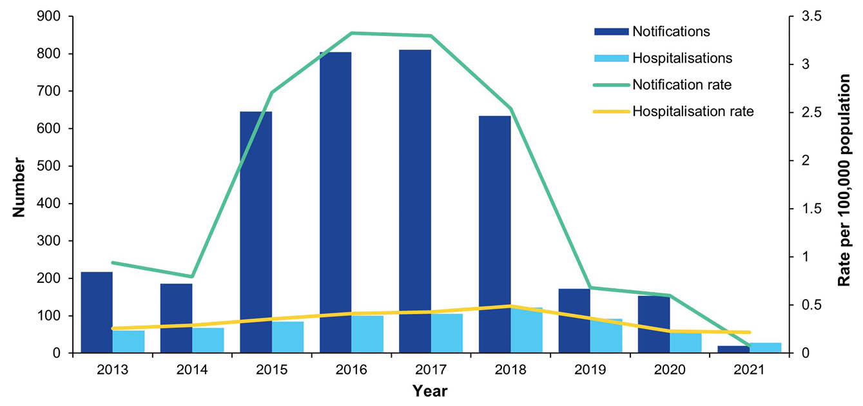
a Hospital admissions with a principal diagnosis of mumps.
b Hospitalisation data for the year 2021 was annualised based on data from 1 January – 30 June 2021.

State and territory variation
Average annual notification rates were highest in the Northern Territory (15.83 per 100,000 population per year for 2013–2021 and 34.15 per 100,000 population per year for 2015–2018), followed by Western Australia (4.65 and 9.48 per 100,000 population per year) and Queensland (2.61 per and 5.03 per 100,000 population per year) (Figure 2 and Appendix A, Figure A.1).
Average annual hospitalisation rates were also highest in the Northern Territory (1.71 per 100,000 population per year for 2013–2021 and 3.24 per 100,000 population per year for 2015–2018, with marked peaks in 2016 and 2018), with average rates for all other jurisdictions less than 0.45 per 100,000 population per year over the entire study period and less than 0.61 per 100,000 population per year for 2015–2018 (Figure 3).
Figure 2: Annual rate of mumps notifications, by jurisdiction,ª 2013–2021, Australia
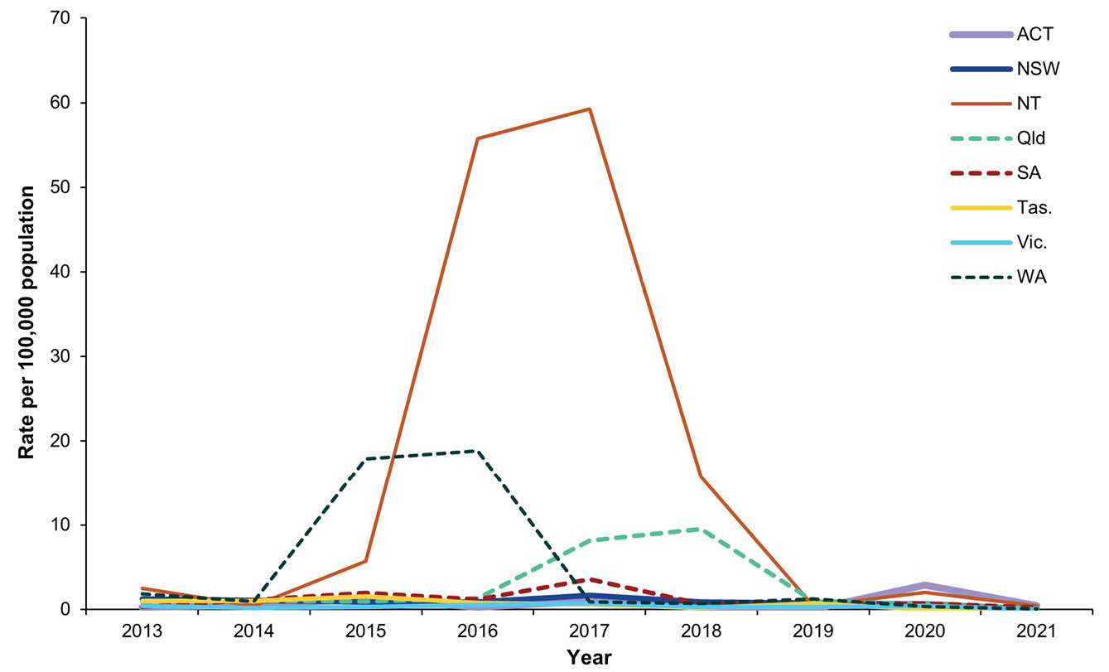
a ACT: Australian Capital Territory; NSW: New South Wales; NT: Northern Territory; Qld: Queensland; SA: South Australia; Tas.: Tasmania; Vic.: Victoria; WA: Western Australia.
Figure 3: Annual rate of mumps hospitalisations,^{a,b} by jurisdiction,^{c} 2013–2021, Australia
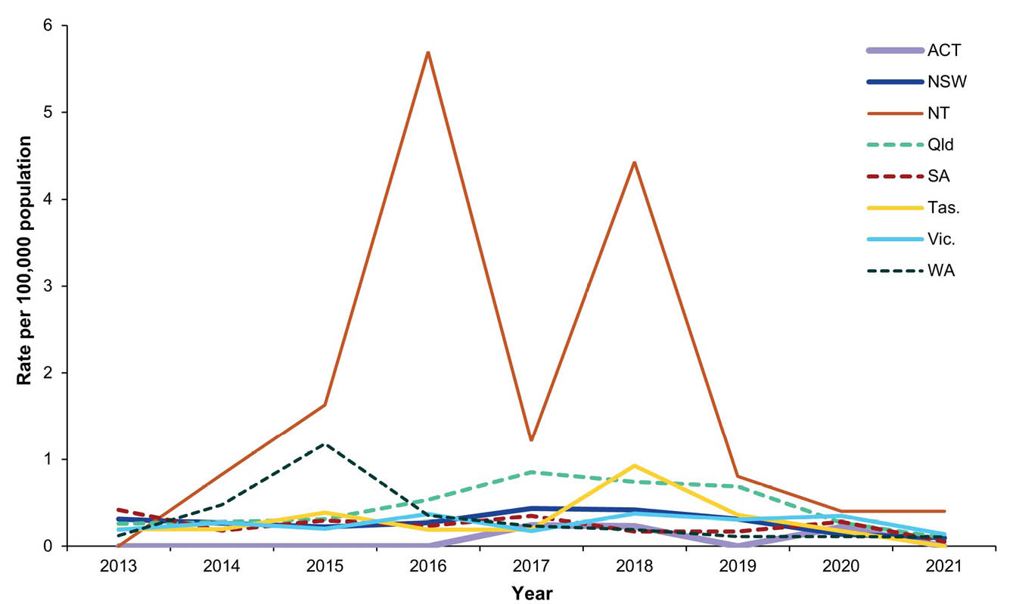
a Hospital admissions with a principal diagnosis of mumps.
b Hospitalisation data for the year 2021 was annualised based on data from 1 January – 30 June 2021.
c ACT: Australian Capital Territory; NSW: New South Wales; NT: Northern Territory; Qld: Queensland; SA: South Australia; Tas.: Tasmania; Vic.: Victoria; WA: Western Australia.
Figure 4: Annual rate of mumps notifications, by age group, 2013–2021, Australia
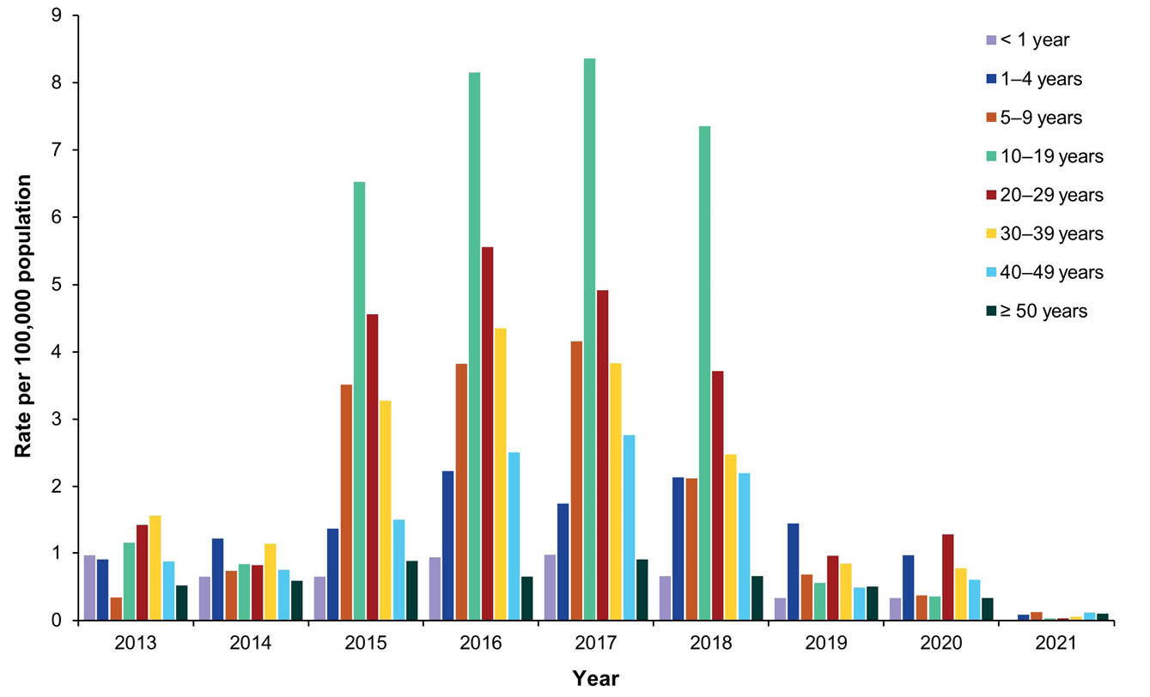

Age and sex distribution
The median age of notifications in the period 2013 to 2021 was 25 years (range 0–94 years).
The average annual rate of mumps notifications was highest in the 10–19 and 20–29 years age group, due to much higher rates in these age groups between 2015 and 2018 (Figure 4). Rates for the 10–19 years age group were 3.66 per 100,000 population per year for 2013–2021 and 7.60 for 2015–2018, followed by 20–29 years (2.59 and 4.68 per 100,000 population per year), and lowest in adults aged ≥ 50 years (0.56 and 0.77 per 100,000 population per year) (Appendix A, Table A.1).
The overall male to female ratio was 1.1:1 with some variation by year (lowest, 0.2:1 in 2021; highest, 1.4:1 in 2020) and age group (lowest, 0.7:1 in those aged ≥ 50 years; highest, 2.8:1 in those aged 1–4 years).
The highest average annual hospitalisation rate in the 2013 to 2021 period was in children aged 1–4 years (0.57 per 100,000 population per year) followed by those aged < 1 year (0.55 per 100,000 population per year), with the rate in all other age groups ≤ 0.40 per 100,000 population per year (Figure 5 and Appendix A, Table A.4).
There were 338 males and 381 females recorded with mumps as the principal diagnosis (male:female ratio = 0.9:1) with some variation by age group (lowest at 0.7:1 in those aged ≥ 50 years; highest at 1.9:1 in the 1–4 year age group).
Figure 5: Annual mumps hospitalisation rate,^{a,b} by age group, 2013–2021, Australia
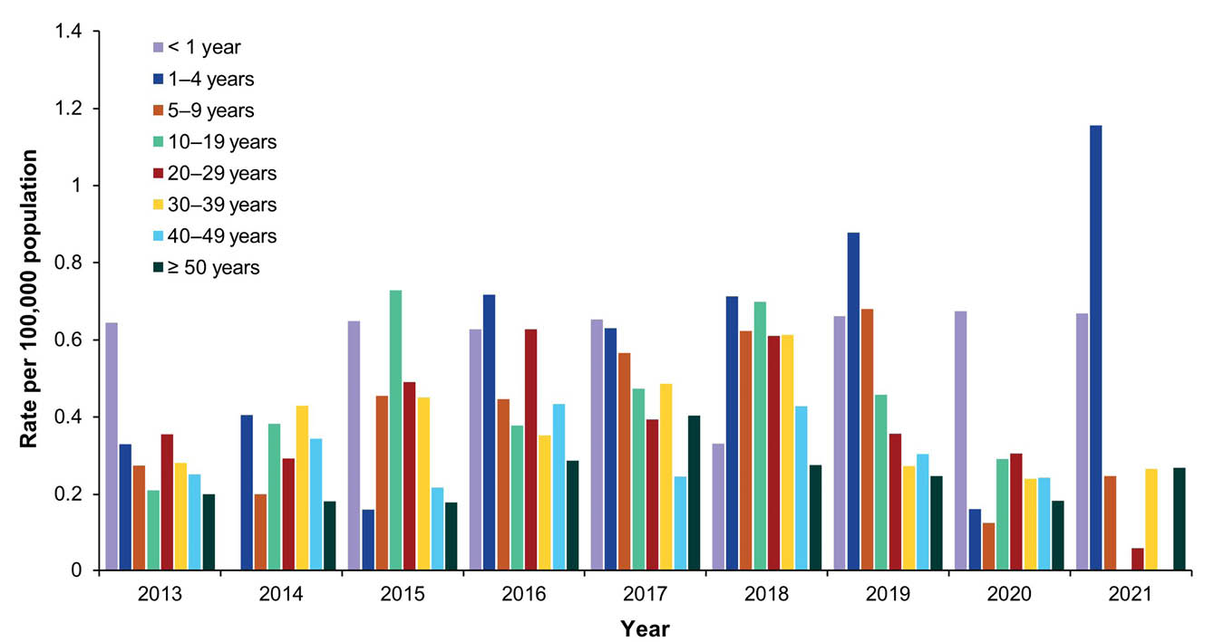
a Hospital admissions with a principal diagnosis of mumps.
b Hospitalisation data for the year 2021 was annualised based on data from 1 January – 30 June 2021.

Indigenous status
Of 3,643 notifications of mumps reported between 2013 and 2021, Indigenous status was known for 3,479 (95.5%). Completeness of Indigenous status was highest in 2018 (98.3%; 623/634) and lowest in 2020 (87.7%; 135/154). Over the 2013–2021 period, Indigenous status completeness by jurisdiction ranged between 100% and 76.8%.
A total of 1,882 (51.7%) mumps notifications reported between 2013 and 2021 were in Indigenous people. The average annual notification rate between 2013 and 2021 was 25.65 per 100,000 population per year for Indigenous people and 0.82 per 100,000 population per year for other people. The annual notification rate among Indigenous people was less than 0.80 per 100,000 population until 2014, rose sharply to 51.36 per 100,000 population in 2015, peaked at 68.89 per 100,000 population in 2016 and then decreased to 49.85 per 100,000 population in 2018 followed by a marked decrease, with the annual rate from 2019 to 2021 below 1.5 per 100,000 population (Figure 6). The highest annual notification rate among other people was 1.35 per 100,000 population in 2017.
During the 2015–2018 outbreak period, the average annual notification rate among Indigenous people and other people was 57.53 per 100,000 population per year and 1.10 per 100,000 population per year, respectively.
Figure 6: Annual mumps notification rate, by Indigenous status, 2013–2021, Australia
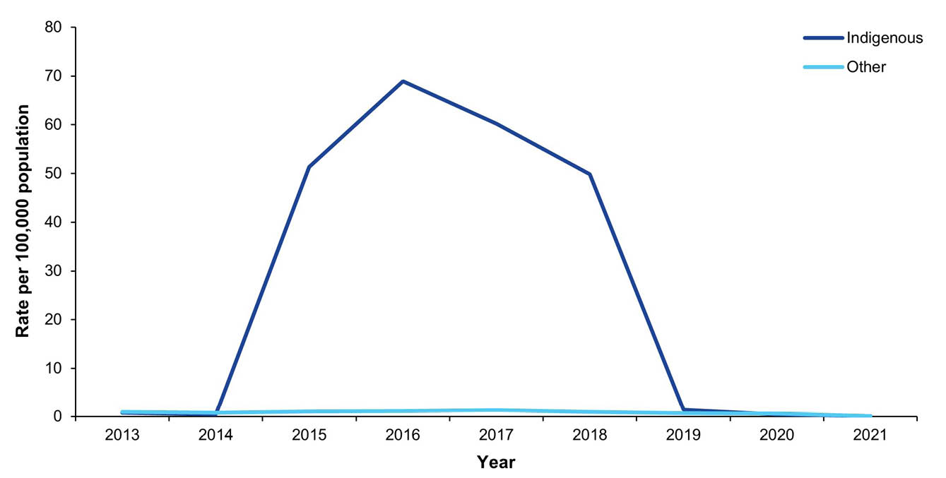
Among Indigenous people, average annual notification rates between 2013 and 2021 varied widely across age groups. The highest age-specific notification rate was among adolescents aged 10–19 years (48.24 per 100,000 population per year), followed by adults aged 20–29 years (37.45 per 100,000 population per year) and 30–39 years (34.94 per 100,000 population per year), with the lowest rate among infants aged < 1 year (1.73 per 100,000 population per year) (Figure 7 and Appendix A, Table A.2). Average annual age-specific notification rates among Indigenous people during the 2015–2018 outbreak period were higher but with a similar age distribution pattern, highest in adolescents aged 10–19 years (108.52 per 100,000 population per year), followed by adults aged 20–29 years (84.61 per 100,000 population per year) and 30–39 years (79.66 per 100,000 population per year) (Appendix A, Table A.3).
Average annual age-specific notification rates were substantially lower in other people during the 2013–2021 period, but with relatively similar age distribution pattern, highest in adults aged 20–29 years (1.15 per 100,000 population per year) and 30–39 years (1.04 per 100,000 population per year) followed by adolescents aged 10–19 years (0.94 per 100,000 population per year) (Appendix A, Table A.2).
Figure 7: Annual notification rate of mumps in Indigenous people, by age group, 2013–2021, Australia
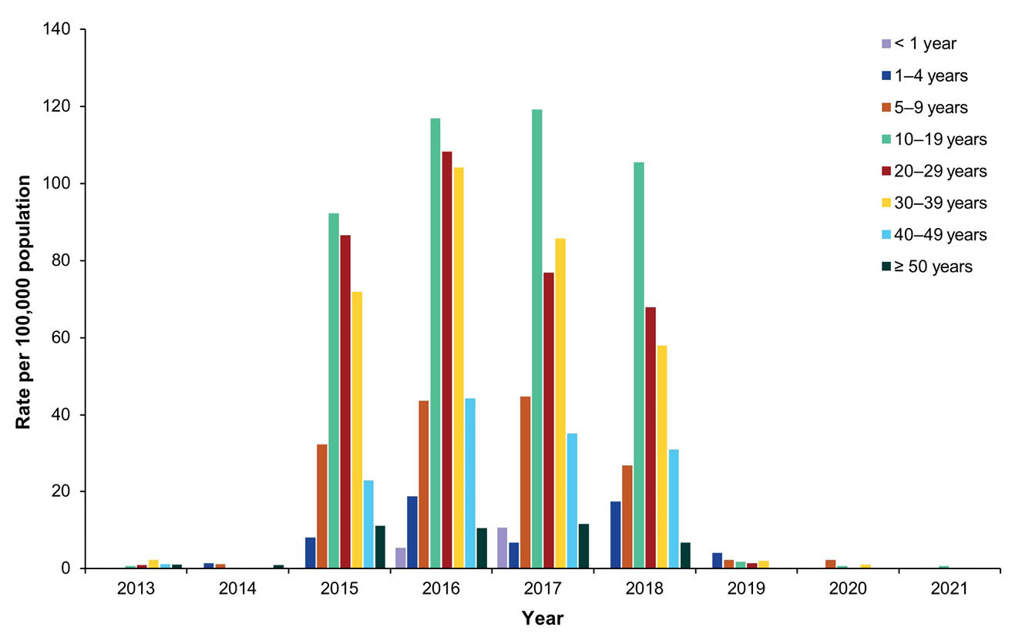
The jurisdictions with the highest average annual notification rates among Indigenous people in both the overall (2013–2021) and outbreak (2015–2018) periods were Western Australia (87.94 and 198.90 per 100,000 population per year, respectively), the Northern Territory (46.55 and 104.3 per 100,000 per year) and Queensland (33.64 and 75.5 per 100,000 per year). Rates in other people were also highest in these three jurisdictions (data not shown).
All hospital admissions for mumps between 2013 and 2021 had a known Indigenous status with 17% (122/719) recorded as Indigenous. The average annual hospitalisation rate was 1.70 per 100,000 population per year among Indigenous people and 0.29 per 100,000 per year among other people. The annual hospitalisation rate for Indigenous people was 0.40 per 100,000 population in 2013, rose to 3.19 per 100,000 population in 2015, declined somewhat in 2016 and 2017 before peaking at 4.09 per 100,000 population in 2018, then declined to 0.68 per 100,000 population in 2021 (Figure 8). The annual hospitalisation rate among other people fluctuated less, ranging from 0.20 to 0.36 per 100,000 population per year (Figure 8). The average annual hospitalisation rate in Indigenous people was highest in young adults aged 20–29 years (2.78 per 100,000 population per year) and lowest in children aged 5–9 years (0.12 per 100,000 population per year). In other people, average annual hospitalisation rates were highest in young children aged < 1 year and 1–4 years (0.54 and 0.59 per 100,000 population per year, respectively) and lowest in older adults aged ≥ 50 years (0.24 per 100,000 population per year).
Figure 8: Annual number and rate of mumps hospitalisations,^{a,b} by Indigenous status, 2013–2021, Australia
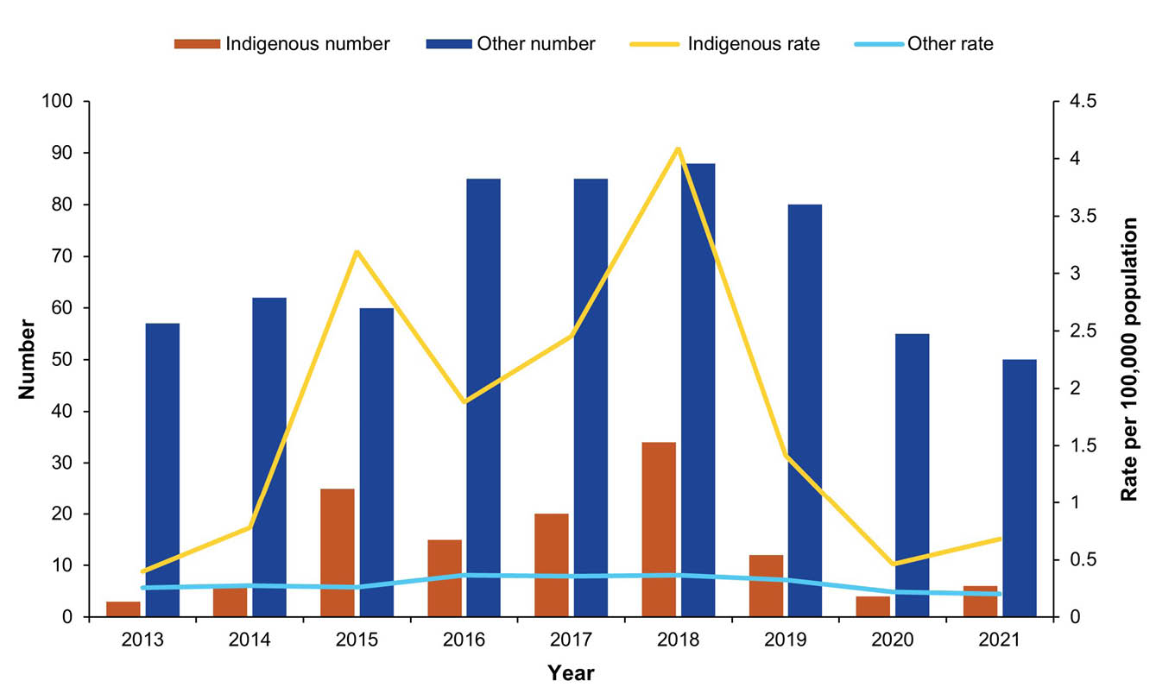
a Hospital admissions with a principal diagnosis of mumps.
b Hospitalisation data for the year 2021 was annualised based on data from 1 January – 30 June 2021.

Severe morbidity
For the period January 2013 to June 2021, there were 1,813 hospital bed days (average, 201.4 per year) reported for patients with a principal admission ICD-10-AM code for mumps. The overall median length of stay per admission was 1 day. Of the 719 hospitalisations, 619 (86.1%) were recorded as mumps without complications (B26.9). Complications arising from mumps were coded for 100 (13.9%) hospitalisations. The most common complication recorded was orchitis (6.7%, 48/719), with 8 (16.6%) cases occurring in children aged 1–4 years, 10 (20.8%) in adolescents aged 10–19 years, 16 (33.3%) in adults aged 20–49 years, and 17 (35.4%) in adults aged ≥ 50 years. Meningitis was a complication in 5 (0.7%) hospitalisations, pancreatitis in 5 (0.7%) and encephalitis in 1–4 hospitalisations, whilst hospitalisations recorded as having mumps with other complications accounted for the remainder.

Mortality
Between 2013 and 2020 there were 1–5 deaths coded with mumps as the underlying cause of death, all in adults aged 70 years or older. No deaths in Indigenous people were recorded.

Vaccination status of notified cases
Vaccination status was recorded for 2,295/3,643 notified cases (63.0%); the remaining cases (1,348/3,643; 37.0%) had vaccination status recorded as ‘unknown’ or left blank. The percentage of notified cases with a recorded vaccination status generally decreased with increasing age:
- < 12 months: 88.2% (15/17)
- 12–17 months: 95.2% (20/21)
- 18–59 months: 95.4% (124/130)
- 5–9 years: 95.2% (237/249)
- 10–19 years: 89.0% (871/979)
- 20–29 years: 65.0% (533/820)
- 30–39 years: 44.2% (278/629)
- 40–49 years: 24.8% (95/383)
- ≥ 50 years: 29.4% (122/415).
Of notifications where vaccination status was recorded, 17.7% were unvaccinated, 18.1% had received one dose of mumps-containing vaccine and 64.2% had received two or more doses (Table 3).
Of notifications in which vaccination status was recorded, aside from in children aged younger than five years, the proportion with two or more doses of mumps-containing vaccine decreased with increasing age (from 89.0% in children aged 5–9 years to 3.3% in adults aged ≥ 50 years), while the proportion unvaccinated increased from 5.9% to 85.3%, respectively (Table 3).
The proportion of Indigenous cases with two or more doses was significantly higher (p < 0.01) than in other cases across the 5–9 years (95.7% vs 79.4%), 10–19 (93.0% vs 57.9%), 20–29 (65.1% vs 34.2%) and 30–39 years (39.5% vs 21.8%) age groups.
Of the 1,474 notifications with two or more doses of mumps-containing vaccine, 1,408 had a recorded vaccination date of the most recent (last) dose. Of the 1,365 cases with diagnosis date recorded to be ≥ 14 days after the last dose of mumps-containing vaccine, the length of time between date of last dose and date of diagnosis was < 1 year in 6.8% of cases, 1–4 years in 19.1%, 5–9 years in 27.8%, 10–14 years in 26.4%, 15–19 years in 17.9% and ≥ 20 years in 1.9% (overall median time: 9.6 years).
Three or more doses of mumps-containing vaccine were recorded for 123/2,295 notifications (5.4%), 95.1% of which were from Western Australia, Queensland and Northern Territory; 85.4% were in those aged 10–19 years (48.0%) and 20–29 years (37.4%); and 90.2% were Indigenous. The time between last dose and diagnosis for these notified cases with three or more doses recorded was ≤ 14 days for 28.5%, 15–30 days for 13.8%, 1–5 months for 11.4%, 6–11 months for 5.7% and ≥ 1 year for 40.7% (median time: 80 days).
Table 3: Doses of mumps-containing vaccine recorded for notified mumps cases (where vaccination status known), by age group, Australia, 2013–2021
Age group | Nª | Number of doses
Age group | Nª | Not vaccinated |  | 1 |  | ≥ 2
Age group | Nª | n | % | n | % | n | %
< 12 months | 15 | 15 | 100.0 | 0 | 0.0 | 0 | 0.0
12–17 months | 20 | 8 | 40.0 | 7 | 35.0 | 5 | 25.0
18–59 months | 124 | 8 | 6.5 | 13 | 10.5 | 103 | 83.1
5–9 years | 237 | 14 | 5.9 | 12 | 5.1 | 211 | 89.0
10–19 years | 871 | 60 | 6.9 | 61 | 7.0 | 750 | 86.1
20–29 years | 533 | 70 | 13.1 | 163 | 30.6 | 300 | 56.3
30–39 years | 278 | 75 | 27.0 | 111 | 39.9 | 92 | 33.1
40–49 years | 95 | 52 | 54.7 | 34 | 35.8 | 9 | 9.5
≥ 50 years | 122 | 104 | 85.3 | 14 | 11.5 | 4 | 3.3
Total | 2,295 | 406 | 17.7 | 415 | 18.1 | 1,474 | 64.2
a N denotes the number of cases within each age group with known vaccination status.

Country of acquisition
Place of acquisition was recorded for 76.1% of notifications of mumps (2,773/3,643) between 2013 and 2021, with most (92.3%; 2,561/2,773) recorded as acquired in Australia. Notifications acquired overseas (n = 212) were most commonly acquired in the Western Pacific (36.3%; 77/212) and South-East Asia (32.1%; 68/212).

Remoteness of area of residence
Of 3,643 mumps notifications between 2013 and 2021, a postcode was recorded for 3,621 notifications. Of notifications with recorded postcode, 37.1% resided in major cities, 26.0% in very remote areas, 14.8% in remote areas, 14.6% in outer regional and 7.5% in inner regional areas. Analysis by jurisdiction and year found notification rates greater than 100 per 100,000 population per year in: Western Australia in very remote areas in 2015 and 2016 (228.4 and 445.3 per 100,000 population, respectively) and in remote areas in 2015 (236.2 per 100,000 population); the Northern Territory in very remote areas in 2016 and 2017 (215.8 and 195.3 per 100,000 population, respectively); Queensland in remote (145.1 per 100,000 population) and very remote (249.7 per 100,000 population) areas in 2017; and South Australia in very remote areas in 2017 (298.1 per 100,000 population).

Small area analysis
The highest average annual notification rate between 2013 and 2021 at SA3 level was in the Kimberley (Western Australia; 131.5 per 100,000 population per year), followed by the Barkly (Northern Territory; 120.6 per 100,000 population per year) and East Pilbara (Western Australia; 62.6 per 100,000 population per year) (Figure 9). During the 2015–2018 outbreak period, the highest average annual notification rates were reported from the same SA3 areas (302.3 per 100,000 population per year for the Kimberley, 272.3 per 100,000 population per year for the Barkly, and 141.2 per 100,000 population per year for East Pilbara) (Figure 10). Four other SA3 areas had average annual notification rates greater than 100 per 100,000 population per year during the outbreak period (Outback North and Innisfail in Queensland, and Katherine and Alice Springs in the Northern Territory).
Figure 9: Average annual mumps notification rate, by Statistical Area 3, 2013–2021,ª Australia
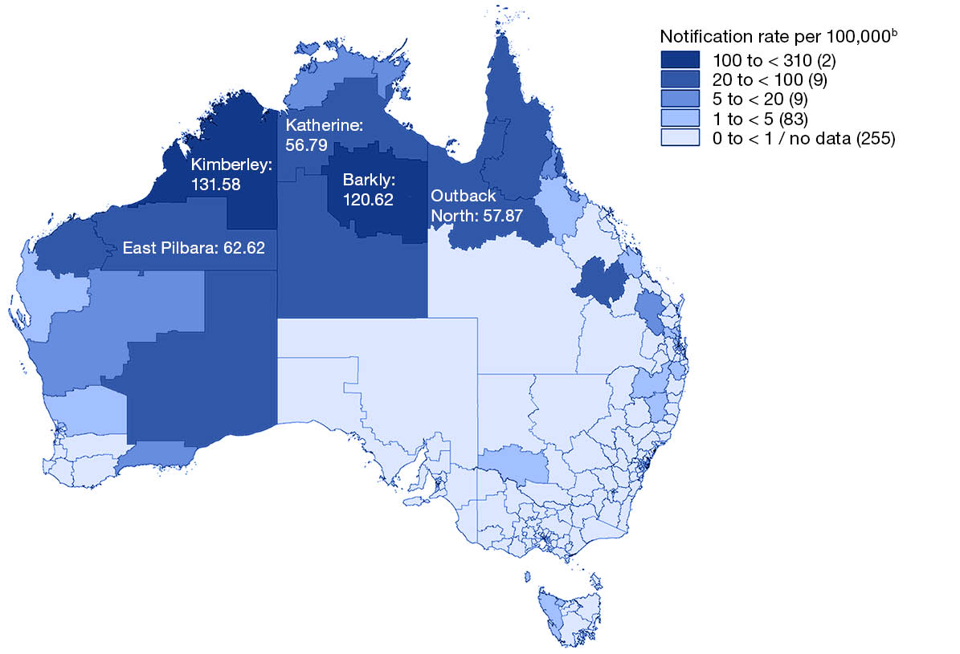
a Source: the National Notifiable Diseases Surveillance System.
b Number in parentheses is the number of Statistical Area 3s in each notification rate category.
Figure 10: Average annual mumps notification rate, by Statistical Area 3, 2015–2018,ª Australia
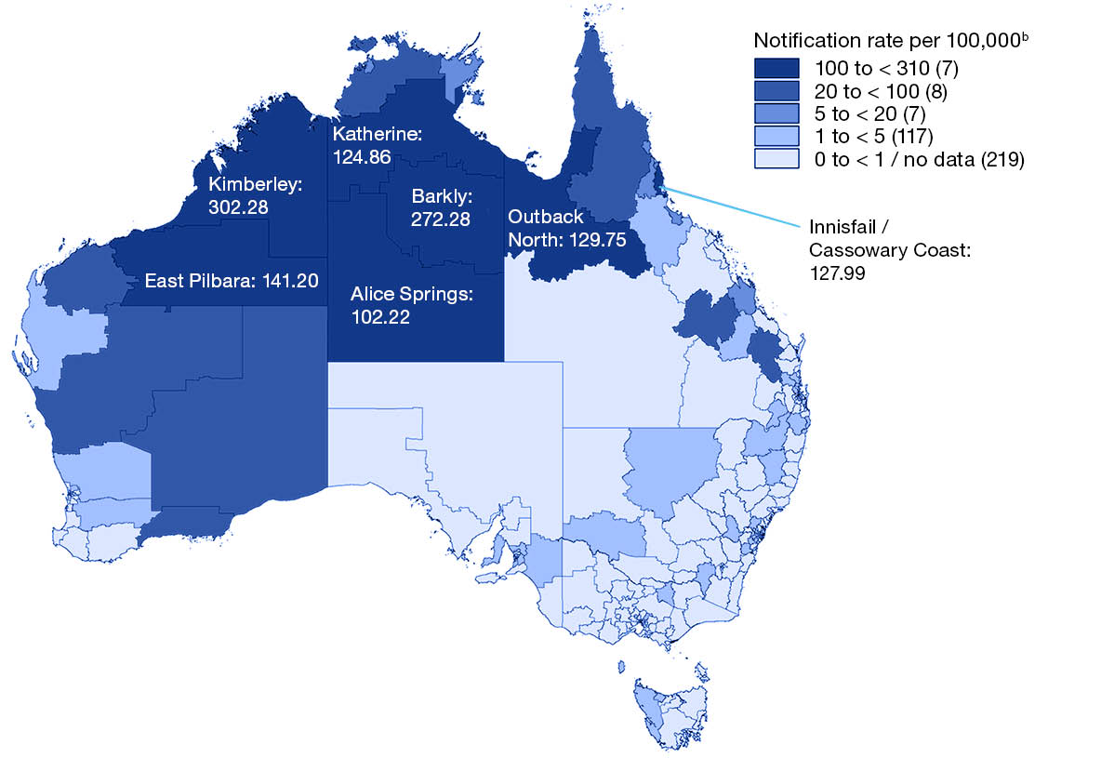
a Source: the National Notifiable Diseases Surveillance System.
b Number in parentheses is the number of Statistical Area 3s in each notification rate category.

Birth cohort analysis
The highest average annual notification rate was reported in the cohort born between 2000 and 2011 (2.9 per 100,000 population per year). This was seven times higher than the rate in the cohort born from 2012 onwards (0.4 per 100,000 population per year), which had the lowest rate over the study period. The average annual notification rate in other birth cohorts ranged from 0.8 per 100,000 population per year (cohort born in or before 1965) to 1.5 per 100,000 population per year (1966–1980) and 2.2 per 100,000 population per year (1981–1999). During the 2015–2018 outbreak period, notification rates increased most markedly in the 2000–2011 birth cohort, peaking at 7.06 per 100,000 population in 2017, followed by the 1981–1999 cohort, peaking at 5.07 per 100,000 population in 2016, and 1966–1980 cohort (peaking at 3.03 per 100,000 population in 2017) (Figure 11).
Figure 11: Annual mumps notification rate, by birth cohort and year of diagnosis, 2013–2021, Australia
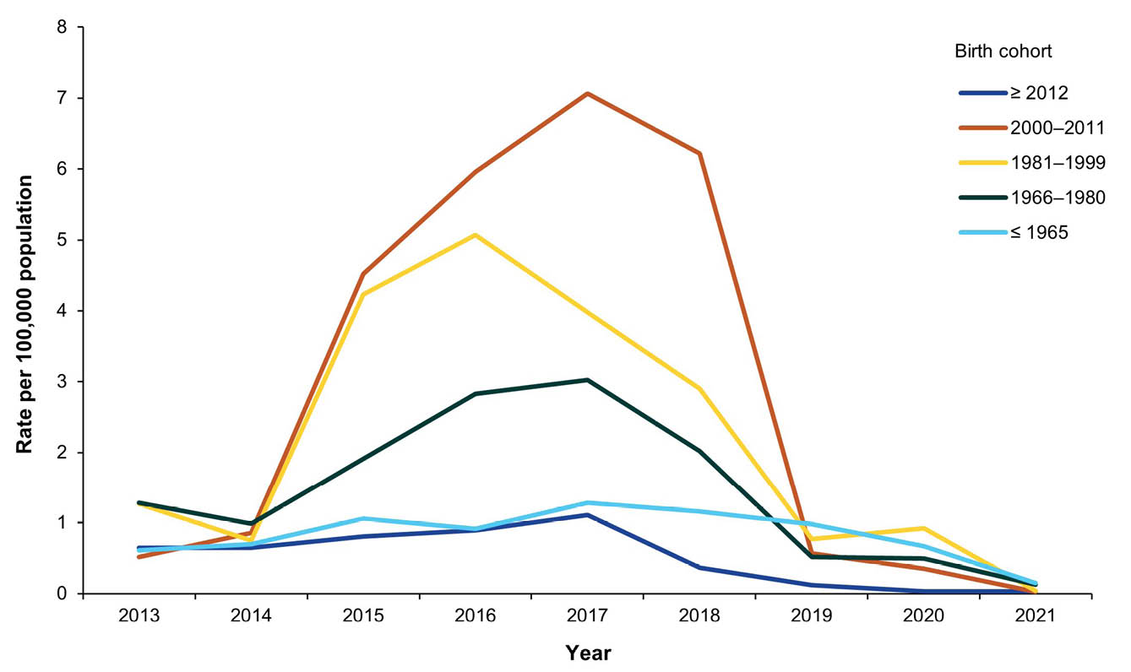

Discussion
In the nine-year period 2013–2021, the average annual mumps notification rate in Australia was 1.65 per 100,000 population per year, twice as high as for 2008–2012 (0.82 per 100,000 per year).⁸ This was due to a marked increase in the average annual mumps notification rate in Indigenous people over the 2013–2021 period, to 25.65 per 100,000 population per year, related to large outbreaks in remote Indigenous communities in Western Australia, Northern Territory, Queensland and South Australia,^{14–17} while the rate in other people remained at 0.82 per 100,000 population per year. The overall annual notification rate remained below 1.0 per 100,000 population in 2013 and 2014 but increased between 2015 and 2018 (average annual notification rate 2.97 per 100,000 population per year; 57.53 per 100,000 population in Indigenous people and 1.10 per 100,000 population in other). The overall mumps notification rate dropped sharply in 2019, to 0.68 per 100,000 population, and reached a low of 0.08 per 100,000 population in 2021, likely related to the public health measures implemented in response to the COVID-19 pandemic, which were associated with decreases in incidence of other communicable diseases, particularly those transmitted via the respiratory route.^{18–20}
The highest age-specific average annual notification rate over the 2013–2021 period was among adolescents aged 10–19 years at 3.66 per 100,000 population per year overall and 48.2 per 100,000 population per year for Indigenous adolescents (7.60 and 108.5 per 100,000 population per year, respectively, for the 2015–2018 outbreak period), followed by young adults aged 20–29 years at 2.59 per 100,000 population per year overall and 37.45 per 100,000 population per year for Indigenous people in this age group (4.68 and 84.61 per 100,000 population per year, respectively, for the 2015–2018 outbreak period). The median age of notifications over the 2013–2021 period (25 years) was five years younger than for the 2008–2012 period (30 years).⁸ Consistent with previous Australian serosurvey and epidemiological studies, the lowest notification rate over the study period was in adults aged ≥ 50 years, who would mostly have acquired immunity from wild type mumps infection.^{4,8,21}
Three-quarters of notified mumps cases over the 2013–2021 period with vaccination status recorded had received two or more doses of a mumps-containing vaccine. The proportion of Indigenous cases aged between 5 and 39 years with two or more doses recorded was significantly higher than for other Australians in the same age groups, and of particular note was 93.0% versus 57.9% in adolescents aged 10–19 years. This is consistent with previous reports describing mumps outbreaks in Australia between 2015 and 2018 among predominantly fully vaccinated Indigenous adolescents and young adults in high density living settings such as boarding schools, correction facilities and remote communities often experiencing household crowding.^{14–17} Outbreaks of mumps among highly vaccinated adolescent and young adult populations have also been reported over the past decade in the United States of America,^{22,23} the United Kingdom,^{24,25} and Europe,²⁶ related to a combination of waning of vaccine-induced immunity and high force of infection in close contact settings. Large mumps outbreaks in Indigenous adolescents and young adults also occurred in Australia in 2007 and 2008 in the Northern Territory and Western Australia, although in not quite as highly vaccinated populations.^{27,28} In the Australian context, the predominance of mumps outbreaks in Indigenous populations over the past two decades is likely due to social disadvantage and household crowding, which are prevalent downstream products of the historical, sociocultural and political factors that have affected Indigenous peoples since colonisation.^{29,30} It is important to address these determinants of health, which are also a key factor contributing to the higher rates of many other vaccine preventable diseases in Indigenous peoples.³¹
Maintaining high vaccination coverage is also important though not sufficient in the case of mumps, given that the mumps component of MMR vaccine has lower effectiveness compared to the measles and rubella components and documented issues with waning immunity.^{32–34} Immune escape due to mismatch between vaccine and wild-type strains is also a potential contributing factor to outbreaks among highly vaccinated populations, although its importance is unclear.^{35,36} Mumps vaccines used in Australia contain the Jeryl Lynn strain (genotype A), while genotype G was identified in the outbreaks over our study period.^{15–17} Coverage of two doses of MMR-containing vaccine by 5 years of age has been consistently higher than 95% in Indigenous children since 2015, and higher than in other children.^{37,38} Our birth cohort analysis found the lowest mumps notification rate over the 2013–2021 period to be in the cohort born from 2012 onwards, who were eligible for MMR-containing vaccine under the NIP at 12 and 18 months following the 2013 change from the previous schedule of 12 months and 4 years.⁵ However, this schedule change was driven primarily by the need for earlier protection against measles. With the earlier and more closely spaced schedule, this cohort could be at higher risk of mumps as they move into adolescence and adulthood, particularly in close contact settings associated with risk of outbreaks.³² As recommended in the Australian Immunisation Handbook, adolescents and adults at risk of acquiring mumps during an outbreak can receive a third dose of mumps-containing vaccine to maintain protection,³⁹ similar to United States guidelines.⁴⁰ Evidence from a range of settings, including Queensland during our review period, suggests that a third dose of mumps vaccine is of benefit in outbreak control.^{15,41,42} While a third dose of mumps-containing vaccine is not currently warranted at general population level, mumps epidemiology should continue to be closely monitored. The development of new and more effective vaccines would also be of benefit to reduce the likelihood of future mumps outbreaks.⁴³
In contrast to the higher notification rate in the 2013–2021 period compared to 2008–2012, the overall average annual mumps hospitalisation rate (0.34 per 100,000 population per year) was similar to that in the previous period, with a similar rate of recorded complications, most commonly orchitis (in 6.7% of hospitalisations).⁸ The notification to hospitalisation ratio increased markedly during the 2015–2018 outbreak period, consistent with active case finding and cases occurring predominantly in fully vaccinated (and more so for Indigenous) adolescents and young adults, who may present with milder disease.^{8,44} This likely explains why the population-level hospitalisation rate in the 2013–2021 period was only sixfold higher in Indigenous people than other people, compared to the 30-fold higher notification rate.
This review has several limitations. Notification rates may be an underestimate of true incidence as cases may not seek health care or may not be diagnosed/notified, although active case finding during the outbreak period would reduce this effect; and hospitalisation data may be affected by coding errors. Analyses were not undertaken by socio-economic status, which could influence both vaccination status⁴⁵ and likelihood of notification. Completeness and accuracy of fields within the notification dataset can vary due to different methods of collection used by jurisdictions.⁹ Vaccination status was missing for just over a third of notified cases, with completeness decreasing with increasing age, largely as a result of childhood vaccination in individuals born before 1996 not being captured in the Australian Immunisation Register. Completeness of Indigenous status varied across jurisdictions, but was high overall at 95.5% and substantially higher than in 2008–2012 (66%).⁸ Hospitalisation rates for the year 2021 were annualised, based on the first six months of the year, which may have resulted in overestimation of the number and rate of mumps hospitalisations in 2021.
In summary, epidemiology of mumps in the 2013–2021 study period was dominated by a large multi-jurisdictional outbreak among mostly fully vaccinated Indigenous adolescents and young adults in the Northern Territory, Western Australia, Queensland and South Australia.

Acknowledgments
We would like to acknowledge the Health Protection Policy and Surveillance Division, Australian Government Department of Health, Disability and Ageing, and state and territory health departments through the Communicable Diseases Network Australia for release of data from the NNDSS; the public health officers in states and territories responsible for the collection of NNDSS data; and the Hospitals Unit, Australian Institute of Health and Welfare for data from the National Hospital Morbidity Database. We thank the Australian Coordinating Registry, state and territory registries of births, deaths and marriages, state and territory coroners, and the National Coronial Information System, for providing access to cause of death data. We would like to thank Brynley Hull for generating maps and Kaitlyn Vette for reviewing an early draft of the manuscript.

Funding
There was no specific funding for this study. The National Centre for Immunisation Research and Surveillance (NCIRS) receives support, either financial or otherwise, from the Australian Government Department of Health, Disability and Ageing, the New South Wales Department of Health, the Sydney Children’s Hospitals Network, and the University of Sydney, Australia.

Author details
Dr Sajani Nadeeka,^{1,}
Dr Joanne Jackson,^{1,i}
Dr Aditi Dey,^{1,2}
Dr Shopna Bag,^{2,3}
Associate Professor Stephen Lambert,¹
Associate Professor Frank Beard^{1,2}
- National Centre for Immunisation Research and Surveillance, Westmead, New South Wales, Australia.
- The University of Sydney, New South Wales, Australia
- Western Sydney Local Health District Centre for Population Health, New South Wales, Australia

Corresponding author
Dr Joanne Jackson
National Centre for Immunisation Research and Surveillance, Locked Bag 4001, Westmead NSW 2145, Australia
Phone: +61 2 9845 1433
Email: joanne.jackson1@health.nsw.gov.au

References
- Hviid A, Rubin S, Mühlemann K. Mumps. Lancet. 2008;371(9616):932–44. doi: https://doi.org/10.1016/S0140-6736(08)60419-5.
- Rubin SA. 40 – Mumps vaccines. In Plotkin SA, Orenstein WA, Offit PA, Edwards KM, eds. Plotkin’s Vaccines (7th edition). Amsterdam: Elsevier, 2018;663–88.e11. doi: https//doi.org/10.1016/B978-0-323-35761-6.00039-0.
- Anderson RM, May RM. Immunisation and herd immunity. Lancet. 1990;335(8690):641–5. doi: https://doi.org/10.1016/0140-6736(90)90420-a.
- Aratchige PE, McIntyre PB, Quinn HE, Gilbert GL. Recent increases in mumps incidence in Australia: the “forgotten” age group in the 1998 Australian Measles Control Campaign. Med J Aust. 2008;189(8):434–7. doi: https://doi.org/10.5694/j.1326-5377.2008.tb02115.x.
- National Centre for Immunisation Research and Surveillance (NCIRS). Significant events in measles, mumps and rubella vaccination practice in Australia. Sydney: NCIRS; December 2019. [Accessed on 14 December 2023.] Available from: https://ncirs.org.au/sites/default/files/2019-12/Measles-mumps-rubella-history-Dec%202019.pdf.
- Guy RJ, Andrews RM, Kelly HA, Leydon JA, Riddell MA, Lambert SB et al. Mumps and rubella: a year of enhanced surveillance and laboratory testing. Epidemiol Infect. 2004;132(3):391–8. doi: https://doi.org/10.1017/s0950268804001955.
- Australian Government Department of Health and Aged Care, National Notifiable Disease Surveillance System. National Communicable Disease Surveillance Dashboard. [Webpage.] Canberra: Australian Government Department of Health and Aged Care; 2023. [Accessed on 23 February 2023.] Available from: https://nindss.health.gov.au/pbi-dashboard/.
- Bag SK, Dey A, Wang H, Beard F. Australian vaccine preventable disease epidemiological review series: mumps 2008–2012. Commun Dis Intell Q Rep. 2015;39(1):E10–8. doi: https://doi.org/10.33321/cdi.2015.39.2.
- Australian Government Department of Health and Aged Care. National Notifiable Diseases Surveillance System (NNDSS). [Webpage.] Canberra: Australian Government Department of Health and Aged Care; 1 March 2024. [Accessed on 13 October 2024.] Available from: https://www.health.gov.au/our-work/nndss.
- Australian Government Department of Health and Aged Care, Communicable Disease Network Australia. Mumps: Australian national notifiable diseases case definition. [Webpage.] Canberra: Australian Government Department of Health and Aged Care; 1 January 2022. [Accessed on 13 October 2024.] Available from: https://www.health.gov.au/sites/default/files/documents/2022/06/mumps-surveillance-case-definition.pdf.
- Independent Health and Aged Care Pricing Authority (IHACPA). ICD-10-AM/ACHI/ACS. [Online resource.] IHACPA; 2024. [Accessed on 7 November 2024.] Available from: https://www.ihacpa.gov.au/health-care/classification/icd-10-amachiacs.
- World Health Organization (WHO). International Statistical Classification of Diseases and Related Health Problems 10th Revision. [Online resource.] Geneva: WHO; 2019. Available from: https://icd.who.int/browse10/2019/en.
- MapInfo. MapInfo Pro, version 15.0. [Software.] Stamford, Connecticut: Precisely; 2015. Available from: https://www.precisely.com/product/precisely-mapinfo/mapinfo-pro.
- Greenwood-Smith B, Markey P, Burke J. Mumps outbreak in the Northern Territory 2015–2016. N T Dis Control Bull. 2016;23(4):9–14. Available from: https://digitallibrary.health.nt.gov.au/nthealthserver/api/core/bitstreams/e779c71b-7626-4654-9344-520c88b0cbe9/content.
- Walker J, Adegbija O, Smoll N, Khan A, Whicker J, Carroll H et al. Epidemiology of mumps outbreaks and the impact of an additional dose of MMR vaccine for outbreak control in regional Queensland, Australia, 2017–2018. Commun Dis Intell (2018). 2021;45. doi: https://doi.org/10.33321/cdi.2021.45.67.
- Westphal DW, Eastwood A, Levy A, Davies J, Huppatz C, Gilles M et al. A protracted mumps outbreak in Western Australia despite high vaccine coverage: a population-based surveillance study. Lancet Infect Dis. 2019;19(2):177–84. doi: https://doi.org/10.1016/S1473-3099(18)30498-5.
- Beazley R. Annual Report 2017: Communicable Disease Control Branch, Disease Surveillance & Investigation Section. Adelaide: State Government of South Australia Department of Health; June 2019. [Accessed on 31 October 2024.] Available from: https://www.sahealth.sa.gov.au/wps/wcm/connect/public+content/sa+health+internet/about+us/health+statistics/surveillance+of+notifiable+conditions.
- van der Kooi S, Beard F, Dey A, McIntyre P, Imai C, Amin J. Pertussis notifications decline in Australia during COVID-19 non-pharmaceutical interventions, 2020–2021. Commun Dis Intell (2018). 2024;18. doi: https://doi.org/10.33321/cdi.2024.48.24.
- Sullivan SG, Carlson S, Cheng AC, Chilver MB, Dwyer DE, Irwin M et al. Where has all the influenza gone? The impact of COVID-19 on the circulation of influenza and other respiratory viruses, Australia, March to September 2020. Euro Surveill. 2020;25(47):2001847. doi: https://doi.org/10.2807/1560-7917.ES.2020.25.47.2001847.
- El-Heneidy A, Ware RS, Robson JM, Cherian SG, Lambert SB, Grimwood K. Respiratory virus detection during the COVID-19 pandemic in Queensland, Australia. Aust N Z J Public Health. 2022;46(1):10–5. doi: https://doi.org/10.1111/1753-6405.13168.
- Patel C, Beard F, Hendry A, Quinn H, Dey A, Macartney K et al. Australian mumps serosurvey 2012-2013: any cause for concern? Commun Dis Intell (2018). 2020;44. doi: https://doi.org/10.33321/cdi.2020.44.67.
- Fields VS, Safi H, Waters C, Dillaha J, Capelle L, Riklon S et al. Mumps in a highly vaccinated Marshallese community in Arkansas, USA: an outbreak report. Lancet Infect Dis. 2019;19(2):185–92. doi: https://doi.org/10.1016/S1473-3099(18)30607-8.
- Shah M, Quinlisk P, Weigel A, Riley J, James L, Patterson J et al. Mumps outbreak in a highly vaccinated university-affiliated setting before and after a measles-mumps-rubella vaccination campaign—Iowa, July 2015–May 2016. Clin Infect Dis. 2018;66(1):81–8. doi: https://doi.org/10.1093/cid/cix718.
- Aasheim ET, Inns T, Trindall A, Emmett L, Bown KE, Williams CJ et al. Outbreak of mumps in a school setting, United Kingdom, 2013. Hum Vaccin Immunother. 2014;10(8):2446–9. doi: https://doi.org/10.4161/hv.29484.
- Willocks LJ, Guerendiain D, Austin HI, Morrison KE, Cameron RL, Templeton KE et al. An outbreak of mumps with genetic strain variation in a highly vaccinated student population in Scotland. Epidemiol Infect. 2017;145(15):3219–25. doi: https://doi.org/10.1017/S0950268817002102.
- Vygen S, Fischer A, Meurice L, Mounchetrou Njoya I, Gregoris M, Ndiaye B et al. Waning immunity against mumps in vaccinated young adults, France 2013. Euro Surveill. 2016;21(10):30156. doi: https://doi.org/10.2807/1560-7917.ES.2016.21.10.30156.
- Bangor-Jones RD, Dowse GK, Giele CM, van Buynder PG, Hodge MM, Whitty MM. A prolonged mumps outbreak among highly vaccinated Aboriginal people in the Kimberley region of Western Australia. Med J Aust. 2009;191(7):398–401. doi: https://doi.org/10.5694/j.1326-5377.2009.tb02850.x.
- Coleman K, Markey P, Krause V. Mumps in the NT. N T Dis Control Bull. 2008;15(4):11–17. Available from: https://digitallibrary.health.nt.gov.au/nthealthserver/api/core/bitstreams/e4b0f33a-8774-411a-ad81-a72a27db2df6/content.
- Marmot M. Social determinants and the health of Indigenous Australians. Med J Aust. 2011;194(10):512–3. doi: https://doi.org/10.5694/j.1326-5377.2011.tb03086.x.
- Sherwood J. Colonisation – it's bad for your health: the context of Aboriginal health. Contemp Nurse. 2013;46(1):28–40. doi: https://doi.org/10.5172/conu.2013.46.1.28.
- Jackson J, Sonneveld N, Rashid H, Karpish L, Wallace S, Whop L et al. Vaccine preventable diseases and vaccination coverage in Aboriginal and Torres Strait Islander people, Australia, 2016–2019. Commun Dis Intell (2018). 2023;47. doi: https://doi.org/10.33321/cdi.2023.47.32.
- Eriksen J, Davidkin I, Kafatos G, Andrews N, Barbara C, Cohen D et al. Seroepidemiology of mumps in Europe (1996–2008): why do outbreaks occur in highly vaccinated populations? Epidemiol Infect. 2013;141(3):651–66. doi: https://doi.org/10.1017/S0950268812001136.
- McLean HQ, Fiebelkorn AP, Temte JL, Wallace GS, Centers for Disease Control and Prevention. Prevention of measles, rubella, congenital rubella syndrome, and mumps, 2013: summary recommendations of the Advisory Committee on Immunization Practices (ACIP). MMWR Recomm Rep. 2013;62(RR-04):1–34. Available from: https://www.ncbi.nlm.nih.gov/pubmed/23760231.
- Di Pietrantonj C, Rivetti A, Marchione P, Debalini MG, Demicheli V. Vaccines for measles, mumps, rubella, and varicella in children. Cochrane Database Syst Rev. 2021;11(11):CD004407. doi: https://doi.org/10.1002/14651858.CD004407.pub5.
- Gokhale DV, Brett TS, He B, King AA, Rohani P. Disentangling the causes of mumps reemergence in the United States. Proc Natl Acad Sci U S A. 2023;120(3):e2207595120. doi: https://doi.org/10.1073/pnas.2207595120.
- Rubin SA, Link MA, Sauder CJ, Zhang C, Ngo L, Rima BK et al. Recent mumps outbreaks in vaccinated populations: no evidence of immune escape. J Virol. 2012;86(1):615–20. doi: https://doi.org/10.1128/JVI.06125-11.
- Hull B, Hendry A, Dey A, Brotherton J, Macartney K, Beard F. Annual immunisation coverage report 2021. Commun Dis Intell (2018). 2023;47. doi: https://doi.org/10.33321/cdi.2023.47.47.
- Hull BP, Hendry A, Dey A, Beard FH, Brotherton JM, McIntyre PB. Immunisation coverage annual report, 2015. Commun Dis Intell (2018). 2019;43. doi: https://doi.org/10.33321/cdi.2019.43.11.
- Australian Government Department of Health and Aged Care, Australian Technical Advisory Group on Immunisation. Australian Immunisation Handbook. [Online resource.] Canberra: Australian Government Department of Health and Aged Care; 2024. [Accessed on 13 October 2024.] Available from: https://immunisationhandbook.health.gov.au/.
- Marin M, Marlow M, Moore KL, Patel M. Recommendation of the advisory committee on immunization practices for use of a third dose of mumps virus–containing vaccine in persons at increased risk for mumps during an outbreak. MMWR Morb Mortal Wkly Rep. 2018;67(1):33–8. doi: https://doi.org/10.15585/mmwr.mm6701a7.
- Cardemil CV, Dahl RM, James L, Wannemuehler K, Gary HE, Shah M et al. Effectiveness of a third dose of MMR vaccine for mumps outbreak control. N Engl J Med. 2017;377(10):947–56. doi: https://doi.org/10.1056/NEJMoa1703309.
- Guo A, Leung J, Ayers T, Fields VS, Safi H, Waters C et al. Mumps vaccine effectiveness of a 3rd dose of measles, mumps, rubella vaccine in school settings during a mumps outbreak – Arkansas, 2016–2017. Public Health Pract (Oxf). 2023;6:100404. doi: https://doi.org/10.1016/j.puhip.2023.100404.
- Plotkin SA. We need a new mumps vaccine. Pediatr Infect Dis J. 2024;43(4):350. doi: https://doi.org/10.1097/INF.0000000000004241.
- Yung CF, Andrews N, Bukasa A, Brown KE, Ramsay M. Mumps complications and effects of mumps vaccination, England and Wales, 2002–2006. Emerg Infect Dis. 2011;17(4):661–7. doi: https://doi.org/10.3201/eid1704.101461.
- Fielding JE, Bolam B, Danchin MH. Immunisation coverage and socioeconomic status - questioning inequity in the 'No Jab, No Pay' policy. Aust N Z J Public Health. 2017;41(5):455–57. doi: https://doi.org/10.1111/1753-6405.12676.

Appendix A
Figure A.1: Mumps notification and hospitalisation rates per 100,000 population per year, by state and territory, Australia, 2013–2021^{a,b,c}
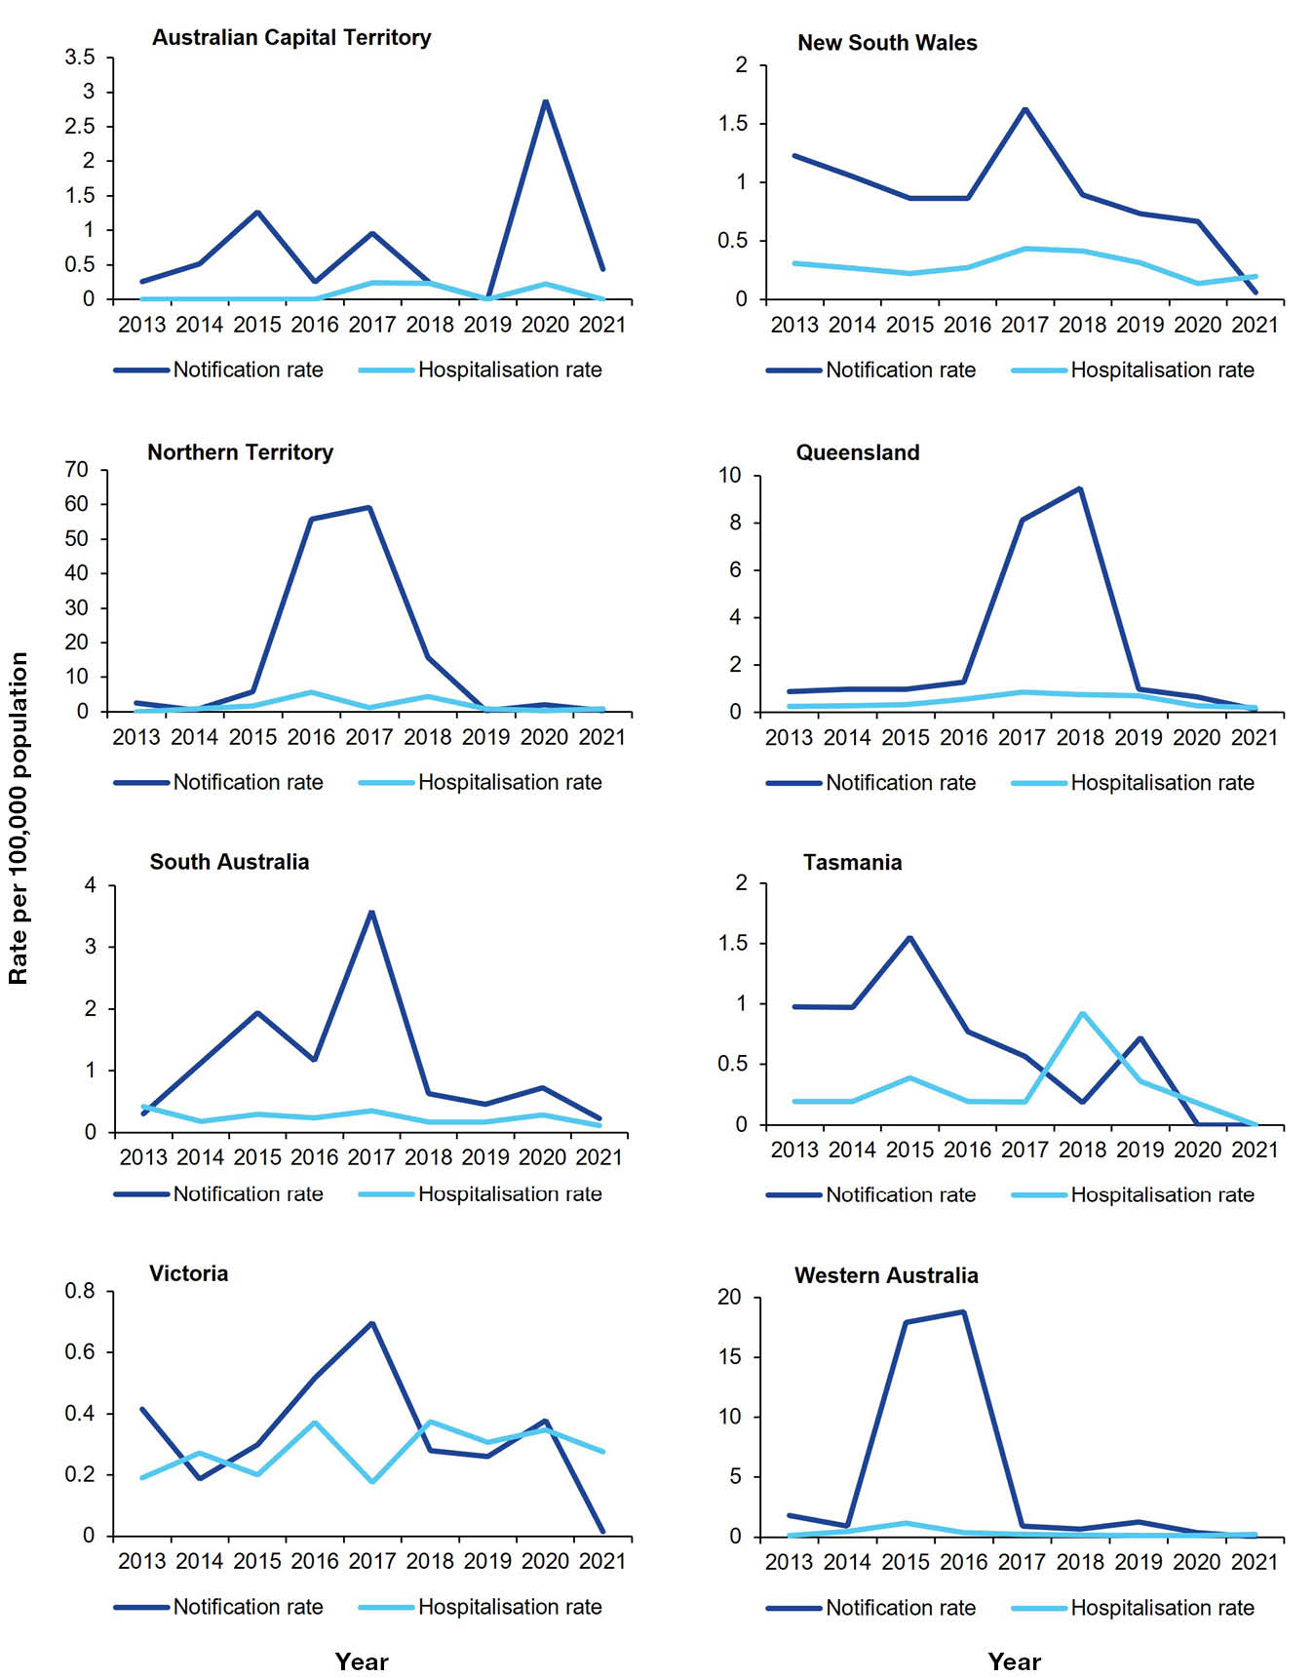
a Hospitalisation data for the year 2021 was annualised based on data from 1 January – 30 June 2021.
b Hospital admissions with a principal diagnosis of mumps.
c Note: Scales used on the y-axes differ by jurisdiction.
Table A.1: Average annual mumps notification rates, by age group and time period (2013–2021 and 2015–2018), Australia
Age group (years) | 2013–2021 |  | 2015–2018
Age group (years) | Rate per 100,000 population per year | 95% CIª | Rate per 100,000 population per year | 95% CIª
< 1 | 0.62 | 0.36–0.998 | 0.81 | 0.39–1.49
1–4 | 1.35 | 1.14–1.58 | 1.87 | 1.51–2.29
5–9 | 1.77 | 1.55–2.00 | 3.40 | 2.96–3.89
10–19 | 3.66 | 3.44–3.90 | 7.60 | 7.11–8.12
20–29 | 2.59 | 2.42–2.78 | 4.68 | 4.33–5.06
30–39 | 2.00 | 1.85–2.16 | 3.48 | 3.17–3.80
40–49 | 1.31 | 1.18–1.44 | 2.24 | 1.99–2.52
≥ 50 | 0.56 | 0.51–0.62 | 0.77 | 0.68–0.88
a CI: confidence interval.
Table A.2: Average annual mumps notification rates, by age group and Indigenous status, Australia, 2013–2021
Age group (years) | Indigenous peoples |  | Other people
Age group (years) | Rate per 100,000 population per year | 95% CIª | Rate per 100,000 population per year | 95% CIª
< 1 | 1.73 | 0.36–5.05 | 0.54 | 0.30–0.91
1–4 | 6.17 | 4.45–8.34 | 1.04 | 0.85–1.25
5–9 | 17.07 | 14.39–20.11 | 0.80 | 0.65–0.97
10–19 | 48.24 | 44.83–51.84 | 0.94 | 0.82–1.07
20–29 | 37.45 | 34.11–40.98 | 1.15 | 1.03–1.27
30–39 | 34.94 | 31.16–39.06 | 1.04 | 0.93–1.16
40–49 | 15.00 | 12.42–17.97 | 0.93 | 0.82–1.05
≥ 50 | 4.43 | 3.31–5.81 | 0.50 | 0.45–0.55
a CI: confidence interval.
Table A.3: Average annual mumps notification rates, by age group and Indigenous status, Australia, 2015–2018
Age group (years) | Indigenous peoples |  | Other people
Age group (years) | Rate per 100,000 population per year | 95% CIª | Rate per 100,000 population per year | 95% CIª
< 1 | 3.95 | 0.82–11.56 | 0.60 | 0.24–1.24
1–4 | 12.67 | 8.97–17.39 | 1.02 | 0.75–1.35
5–9 | 36.80 | 30.91–43.47 | 1.37 | 1.09–1.70
10–19 | 108.52 | 100.82–116.65 | 1.34 | 1.13–1.57
20–29 | 84.61 | 77.13–92.63 | 1.44 | 1.25–1.66
30–39 | 79.66 | 70.97–89.12 | 1.30 | 1.11–1.50
40–49 | 33.26 | 27.50–39.86 | 1.43 | 1.23–1.65
≥ 50 | 9.84 | 7.31–12.98 | 0.64 | 0.56–0.74
a CI: confidence interval.
Table A.4: Average annual mumps hospitalisation rates,^{a,b} by age group and time period (2013–2021 and 2015–2018), Australia
Age group (years) | 2013–2021ª |  | 2015–2018
Age group (years) | Rate per 100,000 population per year | 95% CI^{c} | Rate per 100,000 population per year | 95% CI^{c}
< 1 | 0.55 | 0.31–0.90 | 0.57 | 0.23–1.17
1–4 | 0.57 | 0.44–0.73 | 0.56 | 0.37–0.80
5–9 | 0.40 | 0.31–0.52 | 0.52 | 0.36–0.74
10–19 | 0.40 | 0.33–0.48 | 0.57 | 0.44–0.72
20–29 | 0.39 | 0.32–0.45 | 0.53 | 0.42–0.67
30–39 | 0.38 | 0.31–0.45 | 0.48 | 0.37–0.61
40–49 | 0.27 | 0.22–0.34 | 0.33 | 0.24–0.45
≥ 50 | 0.25 | 0.21–0.29 | 0.29 | 0.23 –0.35
a Hospitalisation data for the year 2021 was annualised based on data from 1 January – 30 June 2021.
b Hospital admissions with a principal diagnosis of mumps.
c CI: confidence interval.

These authors contributed equally to this work.

