
2025 • Volume 49 • cdc.gov.au/cdi • Epub date: 01.10.2025 • doi.org/10.33321/cdi.2025.49.024

FluTracking: Weekly online community-based surveillance of respiratory illness in Australia, 2020–2022 Report
Alexandra G Kerr, Sandra J Carlson, Zoe Baldwin, Reilly J Innes, Zachary L Howard, Murray Bennett, Tiffany Evans, Tom C McKenzie, Craig B Dalton
© 2025 Commonwealth of Australia as represented by the Department of Health, Disability and Ageing
ISSN: 2209-6051 Online
This journal is indexed by Index Medicus and Medline.
Creative Commons Licence
This publication is licensed under a Creative Commons Attribution-NonCommercial-NoDerivatives 4.0 International Licence (Licence). You must read and understand the Licence before using any material from this publication.
Restrictions
The Licence does not cover, and there is no permission given for, use of any of the following material found in this publication (if any):
- the Commonwealth Coat of Arms (by way of information, the terms under which the Coat of Arms may be used can be found on the Department of Prime Minister and Cabinet website;
- any logos (including the interim Australian Centre for Disease Control and the Department of Health, Disability and Ageing’s logos) and trademarks;
- any photographs and images;
- any signatures; and
- any material belonging to third parties.
Disclaimer
Opinions expressed in Communicable Diseases Intelligence are those of the authors and not necessarily those of the Australian Government, the interim Australian Centre for Disease Control or the Department of Health, Disability and Ageing. Data may be subject to revision.
Enquiries
Enquiries regarding any other use of this publication should be addressed to the CDI Editor.
About CDI
Communicable Diseases Intelligence (CDI) is a peer-reviewed scientific journal published by the interim Australian Centre for Disease Control within the Department of Health, Disability and Ageing.
The journal aims to disseminate information on the epidemiology, surveillance, prevention and control of communicable diseases of relevance to Australia and the near region.
Editor: Christina Bareja • Deputy Editor: Simon Petrie • Design and Production: Lisa Thompson with support from Sehaj Dhillon
Editorial Advisory Board: David Durrheim, Mark Ferson, Clare Huppatz, John Kaldor, Martyn Kirk and Meru Sheel
Submit an Article
Guidelines for authors and details on how to submit your publication is available on our website, or by email to the
CDI Editor.
Contact us
Communicable Diseases Intelligence (CDI)
interim Australian Centre for Disease Control, Department of Health, Disability and Ageing
GPO Box 9848, CANBERRA ACT 2601
Website: cdc.gov.au/cdi
Email: cdi.editor@health.gov.au

Contents
List of figures 4
List of tables 6
Abstract 7
Introduction 8
Methods 9
Surveillance period 9
Participant recruitment 9
Survey revisions 9
Epidemiological weeks included in analyses 10
Case definitions 10
Additional notes on analyses 11
Results 15
Participation and recruitment 15
Socio-demographic characteristics of 2020–2022 participants 16
Time to respond to survey each week 17
Percentage of participants vaccinated 17
COVID-19 vaccination 18
Field vaccine effectiveness 18
Percentage of participants reporting incident FC symptoms by vaccination status 19
Comparison with national laboratory-confirmed influenza notifications 20
Percentage of self-reported laboratory influenza tests 21
SARS-CoV-2 and influenza testing among symptomatic participants 22
COVID-19 vaccination and FC percentages 22
Period cumulative incidence of FC by age group 23
Mild illness: runny nose and sore throat 24
First Nations analyses 26
Comparisons with other surveillance systems 29
Discussion 32
Acknowledgments 34
Author details 35
References 36
Appendix A 39

List of figures
Figure 1: Significant FluTracking recruitment events and impact, Australia, 2020–2022 15
Figure 2: Number of participants who completed at least one survey, Australia, 2006–2022,
by year 15
Figure 3: Percentage of participants vaccinated with the seasonal influenza vaccine at the final survey of each participant, by participant characteristics, Australia, 2007–2022, by year 17
Figure 4: Age-standardised percentage of participants reporting incident ‘fever and cough’ symptoms (FC), stratified by self-reported influenza vaccination status, Australia, 2017–2022, by week 19
Figure 5: Age-standardised percentage of participants reporting incident ‘fever and cough’ symptoms (FC) versus national influenza laboratory-confirmed notifications, Australia, 2017–2022, by weekª 20
Figure 6: Mean weekly percentage of FluTracking participants who reported incident ‘fever and cough’ symptoms (FC) and being tested for influenza, Australia, 2020–2022, by jurisdiction,ª epi weeks 23–41 21
Figure 7: Percentage of participants reporting incident ‘fever and cough’ symptoms (FC), stratified by self-reported COVID-19 vaccination status, Australia, 2022,ª by week 23
Figure 8: Period cumulative incidence of ‘fever and cough’ symptoms (FC) stratified by age group, Australia, 2020–2022,ª epi weeks 14–52 23
Figure 9: Age-standardised percentage of participants self-reporting incident ‘fever and cough’ symptoms (FC) versus age-standardised percentage of participants self-reporting incident ‘runny nose and sore throat’ symptoms (RNST), Australia, 2020–2022, by week 24
Figure 10: Period cumulative incidence of ‘runny nose and sore throat’ symptoms (RNST) stratified by age group, Australia, 2020–2022,ª epi weeks 14–52 25
Figure 11: Percentage of participants self-reporting incident ‘fever and cough’ symptoms (FC) versus incident ‘runny nose and sore throat’ symptoms (RNST) who self-reported SARS-CoV-2 testing via a PCR test and/or RAT, Australia, 2020–2022, by week 25
Figure 12: Percentage of First Nations participants who self-reported incident ‘fever and cough’ symptoms (FC) symptoms, Australia, 2019–2022, by week 26
Figure 13: Period cumulative incidence of ‘fever and cough’ symptoms (FC) for First Nations participants, Australia, 2017–2022,ª epi weeks 17–41 27
Figure 14. Period cumulative incidence of ‘runny nose and sore throat’ symptoms (RNST) for First Nations participants, Australia, 2020–2022,ª epi weeks 14–52 27
Figure 15: Self-reported test percent positivity for influenza and SARS-CoV-2 among participants reporting incident ‘fever and cough’ symptoms (FC) symptoms undergoing testing, Australia,
2020–2022, by week 28
Figure 16: FluTracking weekly percentage of participants who self-reported incident ‘fever and cough’ symptoms (FC) symptoms versus NNDSS-confirmed COVID-19 (PCR) notifications, Australia, 2020–2022, by week 29
Figure 17: FluTracking SARS-CoV-2 test percent positivity by test type in participants reporting incident ‘fever and cough’ symptoms (FC) versus NNDSS COVID-19 laboratory-confirmed notifications, Australia, March 2020 – December 2022, by week 30
Figure 18: FluTracking age-standardised respiratory illness severity indicators versus ABS Influenza/Pneumonia age-standardised death rates, Australia, 2017–2022,ª by week 31
Figure 19: FluTracking age-standardised respiratory illness severity indicators versus ABS
COVID-19 age-standardised death rates, Australia, 2020–2022, by week 31
Figure A.1: Age-standardised weekly FC incidence by jurisdiction, Australia, March 2020 – December 2022, by week 47

List of tables
Table 1: Details of analyses performed 13
Table 2: Summary of participation, Australia, 2020–2022 16
Table 3: COVID-19 vaccination uptake by number of doses at the final survey of each participant, Australia, 2022, by participant characteristics 18
Table 4: Field vaccine effectiveness (FVE) against incident ‘fever and cough’ symptoms (FC), for peak four weeks during Omicron waves and 2022 influenza surge, Australia, December
2021 – December 2022 18
Table 5: FluTracking self-reported health seeking behaviour and testing among participants with incident ‘fever and cough’ symptoms (FC) in 2020, 2021 and 2022, Australia (epi weeks 23–52 of each survey year)ª 22
Table A.1: Changes to the way FluTracking Australia asks participants about symptoms,
COVID-19 vaccination and being tested for SARS-CoV-2 and influenza, 2020–2022 39
Table A.2: Recruitment and participation in FluTracking by jurisdiction,ª Australia, 2020–2022 43
Table A.3: Socio-demographic characteristics of FluTracking participants who completed at least one survey, Australia, 2020–2022 44
Table A.4: Survey weeks within traditional survey season and opt-out periods, Australia,
2020–2022 46

We acknowledge the First Nations Peoples of Australia, who are the Custodians of the land and waters on which we live and work. We acknowledge the contributions, wisdoms, knowledges and experiences of the First Nations participants involved in FluTracking.
We respectfully refer to Aboriginal and Torres Strait Islander people as First Nations peoples, recognising Aboriginal and Torres Strait Islander people as the sovereign people of this land, and acknowledging the many cultures and nations across the country.

Abstract
FluTracking, an online participatory respiratory surveillance system, revealed that the coronavirus disease 2019 (COVID-19) pandemic led to historically low levels of fever and cough (FC) in the 2020–2021 influenza seasons in Australia. In 2022, the influenza peak occurred earlier and was shorter compared to pre-pandemic seasons.
Based on weekly percentages of participants reporting FC, FluTracking identified four Omicron waves (BA.1, BA.2, BA.4/BA.5 and a mixed Omicron variant wave). These waves, while consistent with laboratory-confirmed COVID-19 trends, showed higher FC incidences in the BA.4/BA.5 and mixed variant waves.
During the Omicron waves in 2022, up to 60% of FluTracking participants with FC reported positive SARS-CoV-2 tests, a significant increase from the less than 10% positivity rate for most of 2020–2021. These trends mirrored the timing of rises in National Notifiable Disease Surveillance System (NNDSS) COVID-19 notifications, although peak magnitudes varied between the two systems.
Before November 2021, fewer than half (49.9% weekly mean) of participants with FC, and fewer than a third (27.7% weekly mean) with runny nose and sore throat reported being tested for SARS-CoV-2. Following the introduction of rapid antigen tests (RATs) in November 2021 and the spread of the Omicron variant of SARS-CoV-2 in early 2022, testing rates increased for both symptom profiles in 2022. Additionally, the reopening of international borders and the resurgence of influenza led to expanded respiratory panel testing in drive-through clinics, marked by a 36% increase in the mean weekly percentage of participants reporting an influenza polymerase chain reaction (PCR) test.
FluTracking's participation grew by 107% in 2020 compared to 2019, then declined by 17.7% in 2021, likely due to participation and pandemic fatigue. However, participation stabilised with a 0.2% increase in 2022 compared to 2021.
FluTracking offers valuable insights into respiratory illness trends, changes in testing behaviours, and positivity rates for influenza and SARS-CoV-2.
Keywords: FluTracking; influenza; COVID-19; surveillance; SARS-CoV-2; testing; vaccination; respiratory illness; epidemiology

Introduction
FluTracking provides weekly community-level COVID-19-like and influenza-like illness (defined as fever and cough or FC) surveillance that is not biased by health seeking behaviour, clinician testing practices or differences in jurisdictional surveillance methods.^{1–5} FluTracking provides an indication of the severity of respiratory disease at a community level and of the FC incidence by age, geography and First Nations status.⁶ The FluTracking surveillance system has been incorporated into Australia’s National Influenza Surveillance Scheme and the Australian Influenza Surveillance Report since 2009, and the COVID-19 Australia Epidemiology Report since 2020.^{7,8}
The main aims of FluTracking are:
- to contribute to community level COVID-19-like and influenza-like illness surveillance in Australia;
- to provide consistent surveillance of respiratory illness incidence and testing across all jurisdictions and over time; and
- to provide year-to-year comparison of the timing and incidence of respiratory illness, health-seeking behaviour of participants, laboratory testing, and severity of COVID-19-like and influenza-like illness in the community.
In this report, we:
- describe the epidemiology of COVID-19-like and influenza-like illness in the Australian community in 2020–2022;
- describe influenza and COVID-19 vaccine coverage, as self-reported by participants;
- describe laboratory influenza and SARS-CoV-2 testing, as self-reported by participants;
- compare the percentage of FluTracking participants who reported FC with notifications of laboratory-confirmed influenza and COVID-19 from the National Notifiable Diseases Surveillance System (NNDSS);^{9,10}
- compare the percentage of FluTracking participants who reported FC and testing for SARS-CoV-2, that also reported a positive SARS-CoV-2 polymerase chain reaction (PCR) test, with COVID-19 notifications from the NNDSS;
- compare FluTracking severity of illness measures with Australian Bureau of Statistics (ABS) age-standardised COVID-19 and influenza/pneumonia mortality rates; and
- describe the performance characteristics of the FluTracking system, including participant recruitment and timeliness in survey response rates.

Methods

Surveillance period
FluTracking surveillance usually operates between April and October each year. Due to the emergence of COVID-19, the FluTracking surveillance system initiated participant surveys eight weeks earlier than usual in 2020. These surveys persisted throughout the remainder of 2020 and continued for the entirety of 2021 and 2022. Participants were offered the opportunity to suspend their participation each year between October and April, commencing from October 2020 onwards, to minimise fatigue and facilitate higher completion rates in 2021, 2022 and 2023.

Participant recruitment
A participant was defined as any individual who had a survey submitted by themselves or on their behalf. A respondent was anyone who submitted a survey either for themselves or on behalf of a household member. FluTracking uses the term ‘First Nations Peoples’ to refer to participants who identify as Aboriginal and/or Torres Strait Islander. This term respectfully encompasses the diversity of Aboriginal and Torres Strait Islander cultures and identifies and acknowledges First Nations Peoples as sovereign.
Recruitment methods were similar to those used in 2007–2019.¹¹ Enhanced recruitment took place during specific periods to generate interest before the influenza season, or, in the case of 2020, to seize upon heightened interest due to the COVID-19 pandemic. These periods included February–March 2020 and April–May of 2021 and 2022, although participants had the option to join at any time during the year.

Survey revisions
Several iterations of the questionnaire occurred from 23 February 2020 until 31 March 2022 to capture SARS-CoV-2 testing, symptoms of COVID-19-like illness and COVID-19 vaccination (Appendix A, Table A.1). On 11 March 2020, the symptoms ‘runny nose’ and ‘shortness of breath’ were added, nested under the FC questions. From 29 March 2020, the symptom ‘change in sense of taste or smell’ was added, and the nesting of symptoms was removed, such that all symptoms were asked of all participants. On 8 October 2020, a ‘none-of-the-above’ option was added to the symptom list to shorten survey response time for participants. The symptom ‘headache’ was added in August 2021. All symptom questions added were in response to the COVID-19 pandemic.
From 12 November 2021, the laboratory testing question was amended to ask about SARS-CoV-2 rapid antigen tests (RATs), and the option to report ‘Other Illness Test’ was removed on 31 March 2022 to reduce cognitive load on participants.
First, second, third and fourth COVID-19 vaccine dose questions were implemented on 24 February 2021, 11 March 2021, 13 October 2021, and 9 February 2022, respectively. Upon the initial instatement of the COVID-19 first and second dose vaccination questions, all participants were able to respond to these questions. This was restricted to participants aged 16 years and older on 11 March 2021, and age restrictions on these questions were relaxed as COVID-19 vaccine recommendations changed throughout the pandemic.
On 14 April 2020, the option ‘prefer not to say’ was removed from the question on the sign-up form asking if the participant identified as First Nations.
All changes to surveys throughout 2020–2022 are detailed in Appendix A, Table A.1.

Epidemiological weeks included in analyses
Influenza testing data from surveys submitted in 2020, prior to 27 May, underestimated the true influenza testing rate due to survey modifications. Consequently, relevant analyses excluded the impacted survey weeks and commenced from the week ending 1 June 2020, which marked the initial week when all participants responded to the updated question phrasing (Appendix A, Table A.1).
For 2020–2022, influenza vaccination data collected from 1 January each year to week ending 8 March 2020; week ending 4 April 2021; and week ending 27 March 2022 could not be reliably reported on as the influenza vaccine question was hidden.

Case definitions

Weekly ‘fever and cough’ (FC) incidence
A participant with FC was defined as having self-reported both fever and cough in the same survey week.
The weekly FC case definition was defined as follows:
- The denominator was all participants who completed a survey for that week.
- The numerator was all participants who completed a survey for the current week and who reported FC symptoms, with the following exceptions:
- if there were consecutive weeks of reporting FC symptoms, only the first week was used to determine the weekly FC incidence; and
- if a person reported FC symptoms in one week, and then reported at least one week of no symptoms, followed by another report of symptoms, then this subsequent symptom report was included in the weekly FC incidence calculation.

Weekly ‘runny nose and sore throat’ (RNST) incidence:
A case definition consistent with common symptoms of a mild respiratory illness, defined as runny nose and sore throat (RNST), was utilised in several analyses. This case definition was primarily used to assess self-reported SARS-CoV-2 PCR testing activity for milder symptoms in FluTracking participants, compared to those who reported FC.
The RNST case definition was defined as follows:
- The denominator was all participants who completed a survey for that week.
- The numerator was all participants who completed a survey for the current week and who reported RNST symptoms, with the following exceptions:
- if there were consecutive weeks of reporting RNST symptoms, only the first week was used to determine the weekly RNST incidence; and
- if a person reported RNST symptoms in one week, and then reported at least one week of no symptoms, followed by another report of symptoms, then this subsequent symptom report was included in the weekly RNST incidence calculation.
- If a participant reported ‘yes’ for ‘fever’ or ‘shortness of breath’, or time off work or normal duties in the current or prior week, they were excluded from the case definition.

Additional notes on analyses
Participant rates for age group and sex were calculated using the ABS June 2022 Estimated Resident Population.¹² The participation rate for education level and First Nations status was calculated using the 2021 Australian Census data.^{13,14}
The peak week of participation refers to the week with highest national survey submissions for the respective year.
The mean weekly percentage of respondents who responded within 24 hours of survey distribution was summarised by age group. Survey responses that occurred within the first four hours after survey distribution were excluded to maintain comparability of daily routines between states and territories (a mean 4.6% of participants were excluded weekly in 2020–2022). Response times were adjusted to align each state/territory with Australian Eastern Standard Time and Australian Daylight Savings Time for the relevant time period.
Self-reported influenza and COVID-19 vaccination status was defined at or before the participant’s last submitted survey of the year. We reported the percentage of participants vaccinated against influenza and COVID-19 (by dose) overall, and for participants who worked face-to-face with patients, by age group and for participants who identified as First Nations.
Where the percentage of participants who reported incident FC was stratified by self-reported influenza vaccination status, participants were defined as ‘vaccinated for influenza’ two weeks after they reported being vaccinated. This was to allow time for immunity to develop following vaccination. This delay was not applied to participants who were already vaccinated at the time of their first FluTracking survey for the year. Analysis of the percentage of participants who reported incident FC stratified by influenza vaccination status was restricted to data from 2017 onwards for ease of graphical display, and data were age-standardised.
Similarly, where the percentage of participants who reported incident FC was stratified by self-reported COVID-19 vaccination status, participants were defined as ‘vaccinated for COVID-19’ two weeks after they reported being vaccinated.
Weekly FC incidence stratified by self-reported COVID-19 vaccination status was restricted to participants aged 16 years and over, given children aged under 16 years were not recommended to receive a third COVID-19 vaccine, or ‘winter booster’, in 2022 unless immunocompromised or at risk of severe COVID-19 infection.¹⁵
For period cumulative incidence analyses, a participant’s first incident of FC for each year was counted such that the cumulative incidence reflects, for each group, the percentage of individuals who experienced FC within the period.
For participants who completed all 39 surveys from epi weeks 14 to 52 in each year during 2020–2022, the period cumulative incidence of FC and RNST, in the final epidemiological week (hereafter referred to as ‘epi week’) of the year was calculated for each age group.
To assess the severity of illness from influenza and COVID-19, we utilised the weekly age-standardised percentage of participants who self-reported two or more days off work or normal duties due to FC symptoms, and those seeking medical advice due to FC symptoms. Participants who sought medical advice included those who visited a general practitioner, emergency department, hospital, or Aboriginal Medical Service, or sought medical advice from a general practitioner via a telehealth appointment. These measures were compared with age-standardised death rates in Australia for influenza and pneumonia, and COVID-19, during 2020–2022. Counts of doctor-certified deaths were obtained from the ABS.¹⁶
To examine the effectiveness of the COVID-19 and 2022 influenza vaccines, we computed field vaccine effectiveness (FVE) on FC in the peak four weeks of each Omicron wave and the peak four weeks of influenza in 2022. FVE was calculated as (1− RR) for each wave, where RR (the relative risk) was computed by dividing the weekly FC incidence for vaccinated participants (number vaccinated reporting weekly FC incidence / total vaccinated participants) by unvaccinated participants (number unvaccinated reporting weekly FC incidence / total unvaccinated participants). These calculations considered only the first incidence of FC during each discrete time period for each participant. COVID-19 FVE calculations considered participants as vaccinated if they had received three doses of a COVID-19 vaccine and excluded participants who reported receiving more than three doses of a COVID-19 vaccine.
We used only the peak four weeks of each wave to ensure the weekly FC incidence percentages could reasonably be assumed to reflect influenza and COVID-19 rather than other respiratory illnesses. For this analysis, a person was considered vaccinated against influenza two weeks after the reported vaccination. A person was considered vaccinated against COVID-19 two weeks after they reported receiving a third dose of a COVID-19 vaccine. A person was considered unvaccinated against influenza or COVID-19 if they had reported receiving no dose of an influenza or COVID-19 vaccine, respectively.
A summary of the analyses presented in this report is provided in Table 1.
Table 1: Details of analyses performed
Analysis performedª | Figure / table | Stratification | Time period | Data sources
Significant recruitment events | Figure 1 | — | 2020–2022 | FluTracking
Number of participants who completed at least one survey for the year | Figure 2 | — | 2006–2022 | FluTracking
Summary of participation | Table 2 | Participant characteristics | 2020–2022 | FluTracking
Influenza vaccination uptake at the final survey of each participant for the year | Figure 3 | Participant characteristics | 2007–2022 | FluTracking
COVID-19 vaccination uptake at the final survey of each participant for the year | Table 3 | Participant characteristics | 2022 | FluTracking
Field Vaccine Effectiveness during Omicron waves/influenza surge | Table 4 | — | December 2021 – December 2022 | FluTracking
Age-standardised percentage of participants reporting incident FC symptoms | Figure 4 | Self-reported influenza vaccination status | 2017–2022 | FluTracking
Age-standardised percentage of participants reporting incident FC symptoms versus Laboratory-confirmed influenza notifications | Figure 5 | — | 2017–2022 | FluTracking, NNDSS
Mean weekly percentage of participants who self-reported incident FC symptoms and being tested for influenza | Figure 6 | Jurisdiction | 2020–2022, epi weeks 23–41 | FluTracking
Self-reported health seeking behaviour and testing among participants with FC | Table 5 | — | 2020–2022, epi weeks 23–52 | FluTracking
Percentage of participants self-reporting incident FC symptoms for participants aged 16 years and over | Figure 7 | Self-reported COVID-19 vaccination status | 2022 | FluTracking
Period cumulative incidence of FC symptoms | Figure 8 | Age group | 2020–2022, epi weeks 14–52 | FluTracking
Age-standardised percentage of participants self-reporting incident FC symptoms versus Age-standardised percentage of participants self-reporting incident RNST symptoms | Figure 9 | — | 2020–2022 | FluTracking
Period cumulative incidence of RNST symptoms | Figure 10 | Age group | 2020–2022, epi weeks 14–52 | FluTracking
Self-reported weekly percentage of participants reporting a SARS-CoV-2 test (via PCR or RAT) for: Incident RNST versus Incident FC | Figure 11 | — | 2020–2022 | FluTracking
Age-standardised percentage of participants reporting incident FC symptoms in First Nations participants | Figure 12 | — | 2019–2022 | FluTracking
Period cumulative incidence of FC in First Nations participants | Figure 13 | — | 2017–2022, epi weeks 17–41 | FluTracking
Period cumulative incidence of RNST in First Nations participants | Figure 14 | — | 2020–2022, epi weeks 14–52 | FluTracking
Test percent positivity for participants self-reporting incident FC symptoms and being tested (PCR only) for: influenza versus SARS-CoV-2 | Figure 15 | — | 2020–2022 | FluTracking
Age-standardised percentage of participants reporting incident FC symptoms versus Laboratory-confirmed COVID-19 notifications (PCR only) | Figure 16 | — | 2020–2022 | FluTracking, NNDSS
Test percent positivity for SARS-CoV-2 in participants reporting incident FC symptoms and receiving a PCR only versus Test percent positivity for SARS-CoV-2 in participants reporting incident FC symptoms and receiving either a RAT or PCR versus Laboratory-confirmed COVID-19 case notifications (PCR only) | Figure 17 | — | 2020–2022 | FluTracking, NNDSS
Weekly age-standardised percentage of participants reporting incident FC symptoms and two or more days off work or normal duties versus Weekly age-standardised percentage of participants reporting incident FC symptoms and visited a general practitioner (GP) in person or via telehealth, Aboriginal and Torres Strait Islander health clinic, emergency department, or were admitted to hospital versus Weekly age-standardised death rates for influenza and pneumonia | Figure 18 | — | 2017–2022 | FluTracking, ABS
Weekly age-standardised percentage of participants reporting incident FC symptoms and two or more days off work or normal duties versus Weekly age-standardised percentage of participants reporting incident FC symptoms and visited a general practitioner (GP) in person or via telehealth, Aboriginal and Torres Strait Islander health clinic, emergency department, or were admitted to hospital versus Weekly age-standardised death rates for COVID-19 | Figure 19 | — | 2020–2022 | FluTracking, ABS
a FC: fever and cough symptoms; RNST: runny nose and sore throat symptoms; PCR: polymerase chain reaction test; RAT: rapid antigen test.

Results

Participation and recruitment
The most successful recruitment method throughout 2020–2022 was a national address by the Deputy Chief Medical Officer for Australia, Professor Paul Kelly, on 6 April 2020 encouraging all Australians to join FluTracking (Figure 1).
Figure 1: Significant FluTracking recruitment events and impact, Australia, 2020–2022
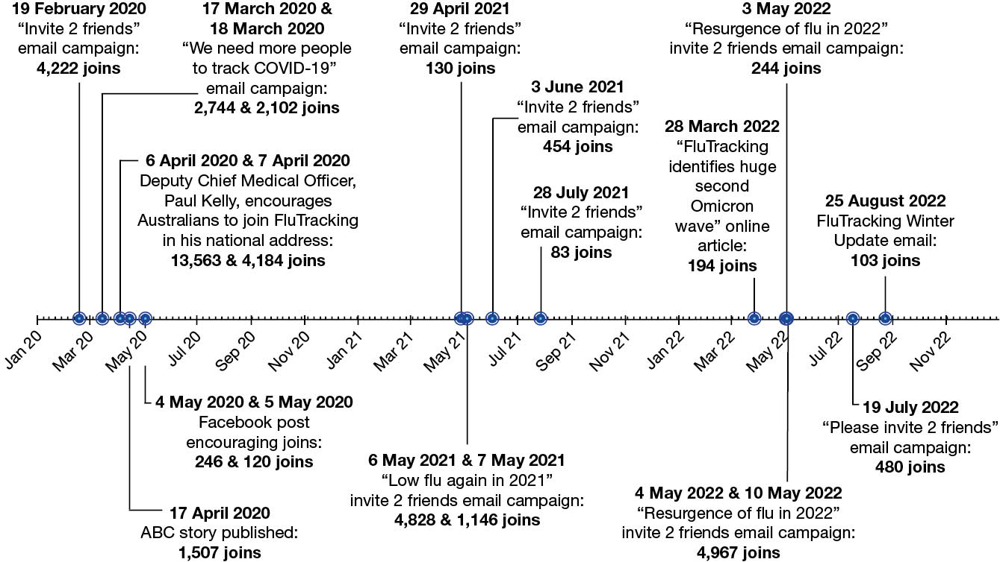
Figure 2: Number of participants who completed at least one survey, Australia, 2006–2022, by year
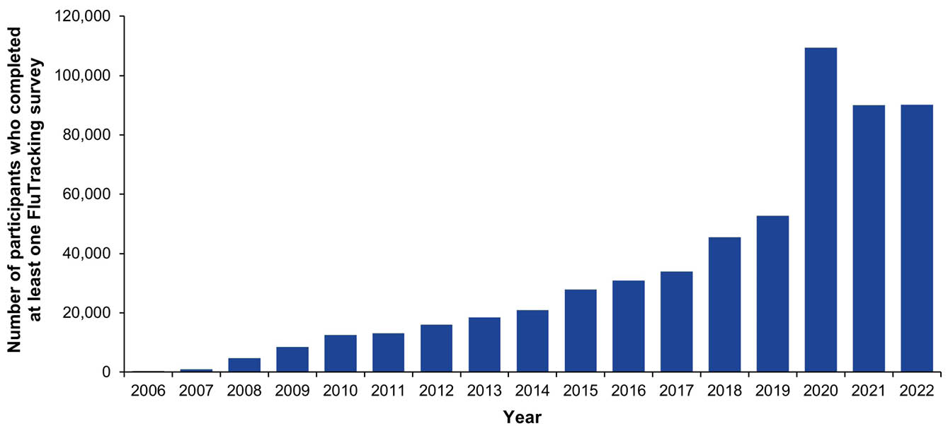
At least one survey was completed by 109,400 participants in 2020, representing a 107% increase from 2019 (52,801 participants). In 2021 and 2022, there were 90,089 and 90,257 participants, respectively (Figure 2).
In 2021 and 2022, the percentages of FluTracking participants who had also completed surveys in the prior year were respectively 85.9% and 84.2% (Table 2). A record number of new participants were recruited in 2020.
Decreases in peak week participation were observed in all states and territories from 2021 to 2022, and were most marked in the Northern Territory, Victoria and Tasmania (6.5%, 3.9% and 3.4% decreases, respectively). In 2022, Queensland had the lowest rate of FluTracking participation, and the Australian Capital Territory had the highest rate of FluTracking participation (169.9 and 932.8 per 100,000 population respectively: Appendix A, Table A.2).
Table 2: Summary of participation, Australia, 2020–2022
Type of participant | 2020 |  | 2021 |  | 2022
Type of participant | (N = 109,400) |  | (N = 90,089) |  | (N = 90,257)
Type of participant | Number | % | Number | % | Number | %
Primary respondents | 60,384 | 55.2 | 53,360 | 59.2 | 54,662 | 60.6
Household members | 49,016 | 44.8 | 36,729 | 40.8 | 35,595 | 39.4
Completed survey during first four weeks of traditional seasonª | 97,134 | 88.8 | 74,269 | 82.4 | 73,332 | 81.2
Completed survey during first four weeks of traditional seasonª and completed > 90% of all available surveys | 63,200 | 57.8 | 58,833 | 65.3 | 52,282 | 57.9
Completed survey during first four weeks of traditional season and completed all surveys until beginning of opt-out periodª | 48,319 | 44.2 | 46,420 | 51.5 | 37,263 | 41.3
Number of participants retained in respective year who completed at least one survey in prior year | 45,969 | 42.0 | 77,405 | 85.9 | 76,022 | 84.2
Number of new participants recruited^{b} | 65,525 | 59.9 | 12,920 | 14.3 | 13,736 | 15.2
a Refer to Appendix A, Table A.4 for survey weeks used.
b Refers to participants who may have joined FluTracking and not completed a survey in the respective survey year.

Socio-demographic characteristics of 2020–2022 participants
Of the participants who completed at least one survey in 2022, complete demographic details were available for 87,126 participants (96.5%). The largest percentage of participants in 2020, 2021 and 2022 were those aged 40 to 64 years (43.5%, 44.3% and 42.8% respectively: Appendix A, Table A.3). More participants were female (mean 58.8% from 2020–2022) than male in all years, and the largest education group consisted of those who had completed or were enrolled in a bachelor’s degree (mean 26.4% from 2020–2022). The percentage of participants who identified as First Nations decreased to 1.3% in 2022, from 1.7% in 2020 (compared to 3.8% of the Australian population).¹³

Time to respond to survey each week
Most participants responded within 24 hours of survey distribution, with a mean 24-hour response of 76.8% in 2020, 79.7% in 2021 and 79.4% in 2022. Participants aged 65 years or older had the highest mean 24-hour response, with 84.9% of participants on average responding within 24 hours throughout 2020–2022.

Percentage of participants vaccinated
By the final survey for 2022, 79.2% of FluTracking participants reported receiving the annual influenza vaccine, increasing from 69.2% in 2021 and 72.6%% in 2020 (Figure 3). Among First Nations participants, 64.1% self-reported receiving the seasonal influenza vaccine in 2022 compared to 59.0% and 61.8% in 2021 and 2020, respectively. Increases in influenza vaccination percentages in 2022 were also observed for other demographic groups, with the largest increase occurring in children aged younger than five years: 61.7% in 2022 compared to 49.6% in 2021. However, this remained lower than in 2019 and 2020 (69.3% and 63.5%, respectively).
Figure 3: Percentage of participants vaccinated with the seasonal influenza vaccine at the final survey of each participant, by participant characteristics, Australia, 2007–2022, by year
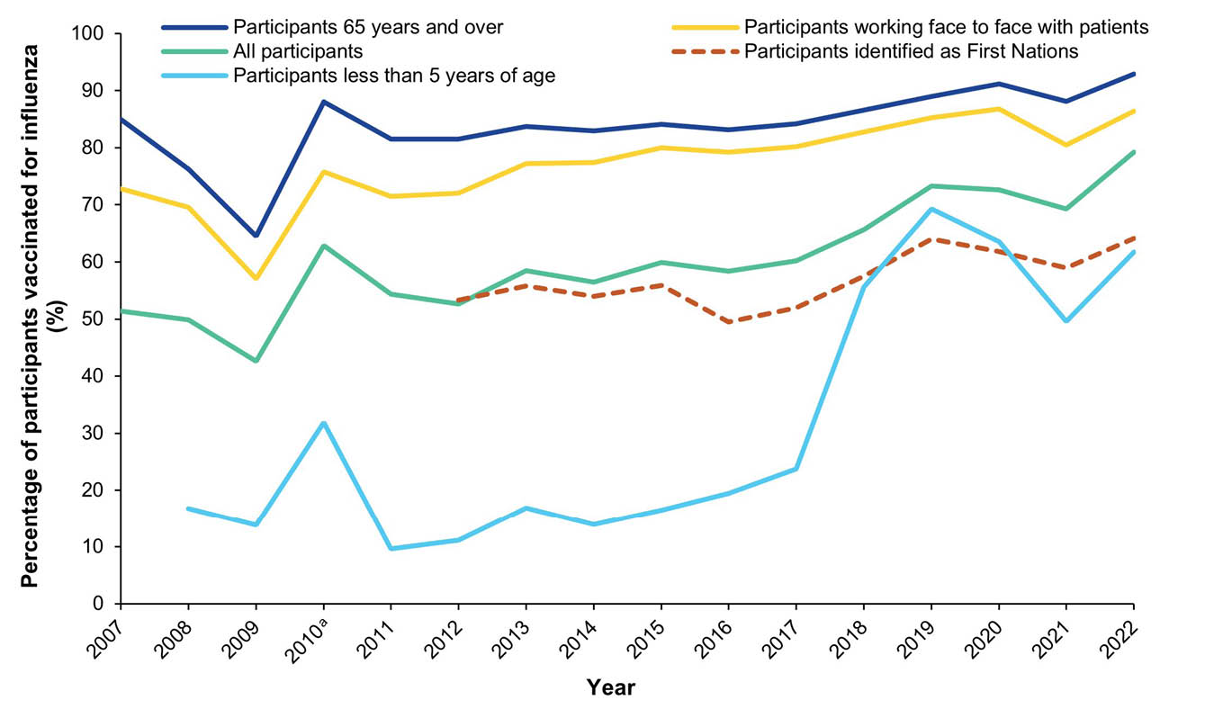
a 2010 calculation included participants who received either the monovalent (H1N1)pdm09 influenza vaccine throughout 2009 and 2010, or the 2010 seasonal influenza vaccine.

COVID-19 vaccination
By the final survey for 2022, the percentages of participants reported to have received at least one, two, three, or four doses of a COVID-19 vaccine were 96.8%, 94.1%, 82.7% and 53.2%, respectively (Table 3). Participants aged 18 years and older, as well as those who worked face-to-face with patients, reported higher vaccination coverage across all doses.
Table 3: COVID-19 vaccination uptake by number of doses at the final survey of each participant, Australia, 2022, by participant characteristics
Participant group | nª | Percentage of participants receiving at least
Participant group | nª | One  dose | Two doses | Three doses | Four doses
All participants | 90,257 | 96.8% | 94.1% | 82.7% | 53.2%
Participants working face-to-face with patients | 12,420 | 99.4% | 97.2% | 93.6% | 53.2%
Participants aged < 5 years | 1,732 | 9.6% | 6.4% | 0.1% | —
Participants aged 5–11 years | 4,268 | 88.5% | 75.0% | 1.5% | —
Participants aged 12–17 years | 4,174 | 97.6% | 93.1% | 28.1% | 1.1%
Participants aged 18–64 years | 52,348 | 99.0% | 96.3% | 89.1% | 45.5%
Participants aged 65+ years | 27,735 | 99.3% | 98.3% | 96.3% | 87.0%
Participants identifying as First Nations | 1,147 | 90.5% | 83.8% | 64.1% | 30.9%
a Number of participants within indicated group.

Field vaccine effectiveness
Field vaccine effectiveness (FVE) for three doses of a COVID-19 vaccine for the outcome of incident FC calculated during the Omicron waves decreased with each subsequent Omicron wave. FVE for influenza vaccination in 2022 for the outcome of FC was 40.0% (Table 4).
Table 4: Field vaccine effectiveness (FVE) against incident ‘fever and cough’ symptoms (FC), for peak four weeks during Omicron waves and 2022 influenza surge, Australia, December 2021 – December 2022
Vaccine | Wave | Peak four week period used for FVE calculations | Vaccinated (n) | Unvaccinated (n) | FVE estimate (%)
COVID-19 (three doses) | BA.1 | 2 January – 23 January 2022 | 21,363 | 35,159 | 52.2
COVID-19 (three doses) | BA.2 | 20 March – 10 April 2022 | 56,892 | 12,723 | 52.0
COVID-19 (three doses) | BA.4/BA.5 | 3 July – 26 July 2022 | 43,162 | 10,735 | 23.7
COVID-19 (three doses) | Mixed Omicron | 4 December – 25 December 2022 | 8,806 | 3,881 | 6.3
Annual 2022 influenza | 2022 influenza peak | 15 May – 5 June 2022 | 48,287 | 50,155 | 40.0

Percentage of participants reporting incident FC symptoms by vaccination status
Weekly FC incidence percentages stratified by self-reported influenza vaccination status were similar between vaccinated and unvaccinated participants across the 2020–2021 seasons. In 2022, several divergences were observed, and the greatest divergence occurred in week ending 22 May 2022 (3.2% unvaccinated to 2.5% vaccinated) during a resurgence of influenza activity (Figure 4).
Figure 4: Age-standardised percentage of participants reporting incident ‘fever and cough’ symptoms (FC), stratified by self-reported influenza vaccination status, Australia, 2017–2022, by week
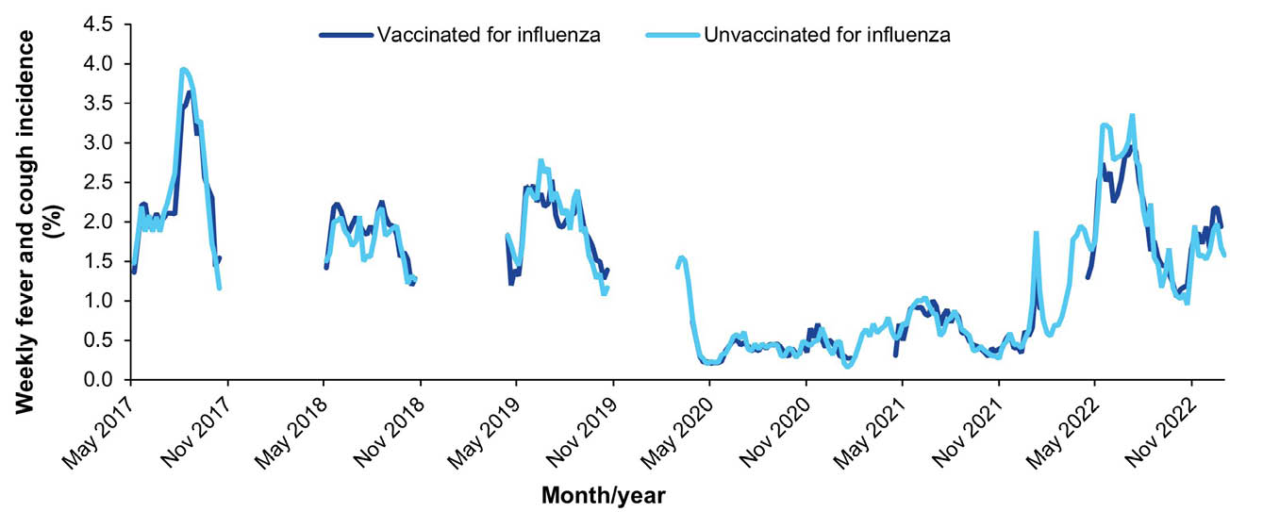

Comparison with national laboratory-confirmed influenza notifications
In 2021, the total number of laboratory-confirmed influenza notifications reported to the NNDSS (749) was considerably lower than the 21,690 notifications in 2020 (Figure 5). This increased substantially in 2022, to 234,556 laboratory-confirmed influenza notifications. In 2020, the highest notification count occurred in the week ending 15 March 2020, while the percentage of FluTracking participants reporting incident FC symptoms peaked one week earlier in the week ending 8 March 2020. Similarly, in 2021, the peak for laboratory-confirmed influenza notifications (the lowest such observed peak on record) occurred in the week ending 23 May 2021, one week prior to the peak percentage of FluTracking participants reporting incident FC symptoms in the week ending 30 May 2021. The peak in laboratory-confirmed influenza notifications observed in 2022 occurred in the week ending 12 June 2022, between the two peaks in FluTracking FC activity in 2022. Although timing varied slightly between jurisdictions, each state/territory generally saw similar peaks in weekly FC incidence for each Omicron variant and the influenza season (Appendix A, Figure A.1).
Figure 5: Age-standardised percentage of participants reporting incident ‘fever and cough’ symptoms (FC) versus national influenza laboratory-confirmed notifications, Australia, 2017–2022, by weekª
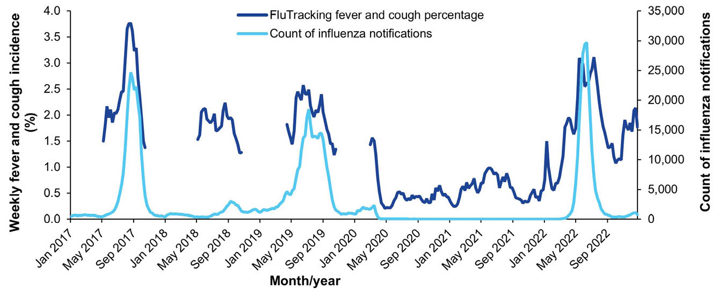
a Not stratified by vaccination status.

Percentage of self-reported laboratory influenza tests
The mean percentage of FluTracking participants who self-reported incident FC symptoms and being tested for influenza decreased from 19.1% in 2020 to 12.5% in 2021, with declines observed in all states/territories in 2021 (Figure 6). The overall mean percentage increased again in 2022 to 17.0%; however, not all states and territories identified an increase.
Figure 6: Mean weekly percentage of FluTracking participants who reported incident ‘fever and cough’ symptoms (FC) and being tested for influenza, Australia, 2020–2022, by jurisdiction,ª epi weeks 23–41
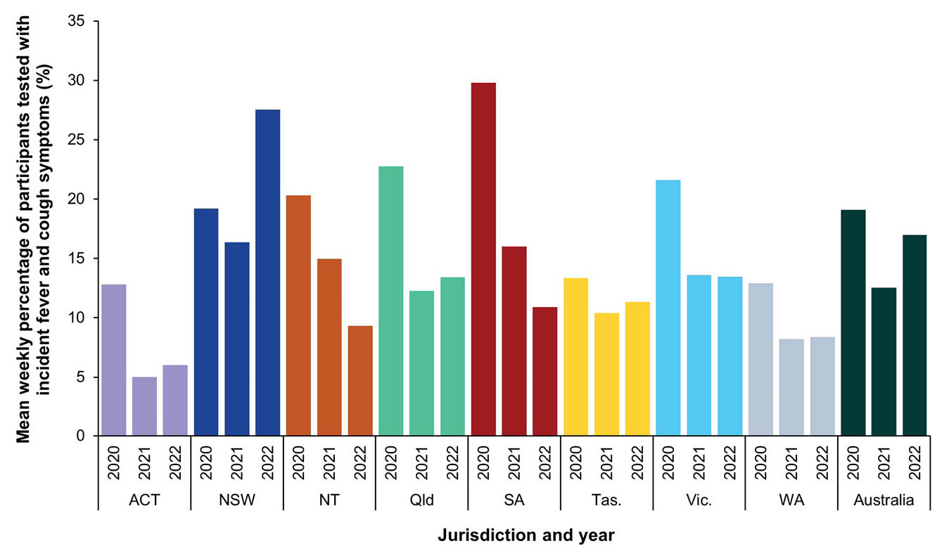
a ACT: Australian Capital Territory; NSW: New South Wales; NT: Northern Territory; Qld: Queensland: SA: South Australia; Tas.: Tasmania; Vic.: Victoria; WA: Western Australia.

SARS-CoV-2 and influenza testing among symptomatic participants
In 2022, of those FluTracking participants who completed at least one survey, 47.0% sought medical attention for incident FC symptoms, a decrease from 63.4% in 2021 and 67.3% in 2020 (Table 5). Of participants who reported FC symptoms, 60.5% were tested for SARS-CoV-2 via a PCR test in 2020 and 2021; this percentage decreased in 2022 after the introduction of RATs in November 2021 (32.4%). Following the introduction of RATs, 87.4% of participants who reported FC symptoms were tested for SARS-CoV-2 via a RAT in 2022. An increase in the percentage of participants with FC symptoms who reported testing positive for SARS-CoV-2 via a PCR test and RATs was also observed in 2022.
Table 5: FluTracking self-reported health seeking behaviour and testing among participants with incident ‘fever and cough’ symptoms (FC) in 2020, 2021 and 2022, Australia (epi weeks 23–52 of each survey year)ª
Self-reported health seeking behaviour and testing | 2020 |  | 2021 |  | 2022
Self-reported health seeking behaviour and testing | n | % | n | % | n | %
Tested positive for SARS-CoV-2 (RAT)^{b} | NA^{c} | — | 159 | 2.5% | 9,151 | 45.3%
Tested positive for SARS-CoV-2 (PCR) | 13 | 0.2% | 301 | 4.7% | 3,104 | 15.4%
Tested positive for influenza (PCR) | 56 | 1.0% | 57 | 0.9% | 470 | 2.3%
Tested for SARS-CoV-2 (RAT)^{b} | NA^{c} | — | 441 | 6.9% | 17,667 | 87.4%
Tested for SARS-CoV-2 (PCR) | 3,364 | 60.5% | 3,883 | 60.5% | 6,549 | 32.4%
Tested for influenza (PCR) | 1,156 | 20.8% | 820 | 12.8% | 3,599 | 17.8%
Sought medical attention | 3,745 | 67.3% | 4,069 | 63.4% | 9,490 | 47.0%
Incident fever and cough | 5,564 | 100% | 6,423 | 100% | 20,207 | 100%
a Self-reported polymerase chain reaction (PCR) tests for influenza or SARS-CoV-2, and self-reported rapid antigen tests (RATs) for SARS-CoV-2 are indicated. The FluTracking survey likely underestimated influenza testing percentages for the period 23 February 2020 to 1 June 2020, thus these results are restricted to data collected thereafter for 2020, and comparable epi weeks for 2021 and 2022.
b SARS-CoV-2 RATs were made available in Australia in November 2021. Their late introduction in 2021 may be reflected in the low percentage of FluTracking participants who tested via a SARS-CoV-2 RAT or tested positive via a SARS-CoV-2 RAT in 2021.
c NA: not applicable.

COVID-19 vaccination and FC percentages
In 2022, participants who self-reported receiving fewer than three doses of a COVID-19 vaccine reported higher weekly FC incidence compared to those who reported receiving three or more doses. The greatest divergence was observed in week ending 8 May 2022 (2.9% in participants with fewer than three doses compared to 1.4% in participants with three or more doses, Figure 7).
Figure 7: Percentage of participants reporting incident ‘fever and cough’ symptoms (FC), stratified by self-reported COVID-19 vaccination status, Australia, 2022,ª by week
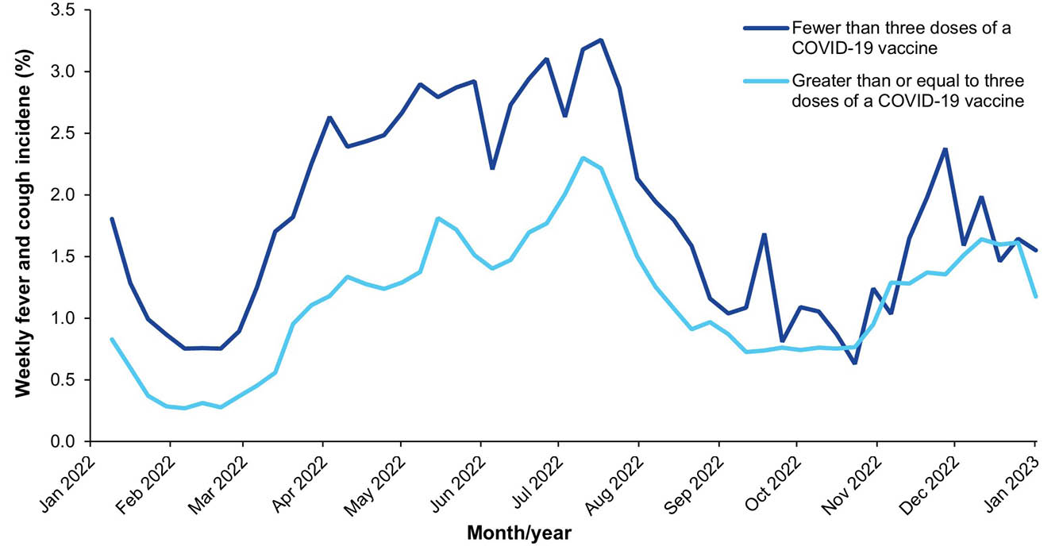
a Data are for participants aged 16 years and older.

Period cumulative incidence of FC by age group
All age groups demonstrated a year-to-year increase in the period cumulative incidence of FC calculated by epi week 52 for each respective year from 2020 to 2022. School-aged children (5–17 years) had the highest increase in cumulative incidence of FC from 2021–2022 (a 163.6% increase; Figure 8).
Figure 8: Period cumulative incidence of ‘fever and cough’ symptoms (FC) stratified by age group, Australia, 2020–2022,ª epi weeks 14–52
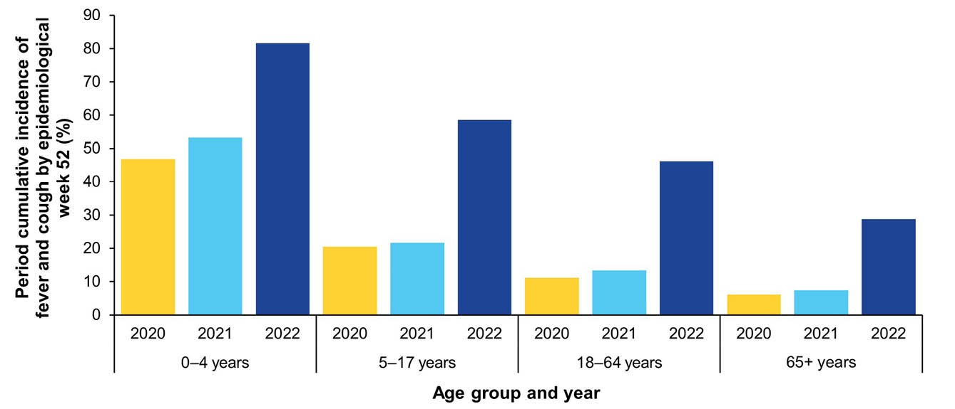
a Only the first incident of fever and cough symptoms of each participant per year was included.

Mild illness: runny nose and sore throat
Throughout 2020–2021, weekly RNST incidence remained mostly below 1%. During this period prior to the emergence of the Omicron variant, the percentage of participants reporting incident RNST symptoms consistently exceeded the percentage of participants reporting incident FC symptoms.
In 2022, the weekly FC incidence exceeded the weekly RNST incidence during several surges in activity. Unlike FC, RNST did not clearly identify the BA.2, influenza, or mixed Omicron variant peaks.
Figure 9: Age-standardised percentage of participants self-reporting incident ‘fever and cough’ symptoms (FC) versus age-standardised percentage of participants self-reporting incident ‘runny nose and sore throat’ symptoms (RNST), Australia, 2020–2022, by week
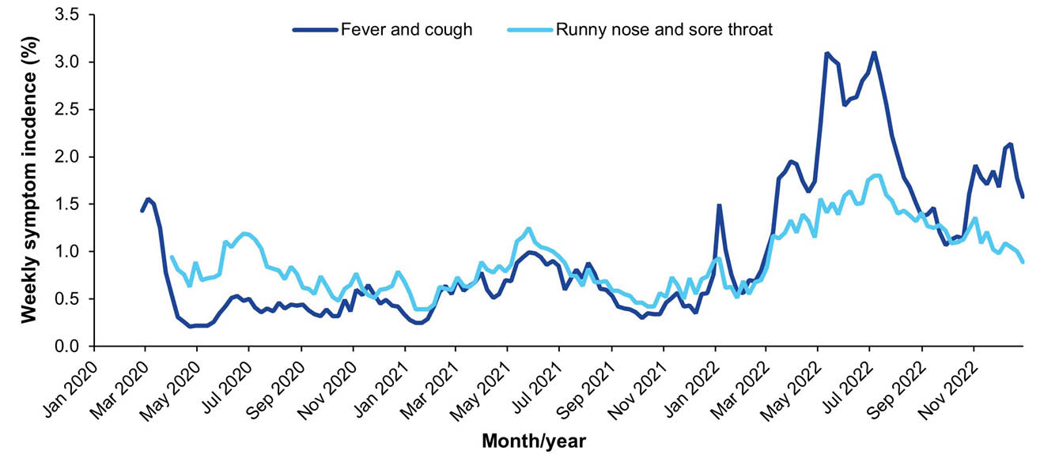

Period cumulative incidence of RNST by age group
The period cumulative incidence of RNST, as calculated by epi week 52 in each respective year from 2020–2022, was lower in 2021 than in 2020 in children aged under 17 years. Increases were observed for all demographic groups from 2021–2022, and the highest increase was observed in those aged 65 years and over (85.0% increase; Figure 10).
Figure 10: Period cumulative incidence of ‘runny nose and sore throat’ symptoms (RNST) stratified by age group, Australia, 2020–2022,ª epi weeks 14–52
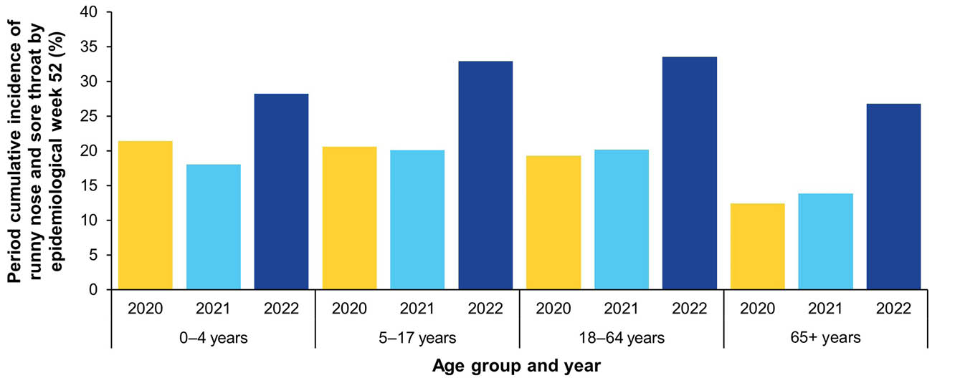
a Only the first incident of runny nose and sore throat symptoms of each participant per year was included.

SARS-CoV-2 self-reported testing in participants with respiratory illness
Self-reported SARS-CoV-2 testing was generally lower for participants reporting incident RNST symptoms than those reporting incident FC symptoms throughout 2020–2022, and trends were approximately parallel. The weekly percentage of participants self-reporting a SARS-CoV-2 test with FC and RNST symptoms experienced an initial surge in early 2020 and stabilised in August 2020. In 2021, testing trends reached their peaks during the Delta and Omicron BA.1 waves, with a notable sharp increase observed during the Omicron BA.1 wave. The escalation of self-reported SARS-CoV-2 testing persisted into early 2022, peaking during the BA.2 wave for both FC and RNST symptoms, with additional peaks noted during subsequent Omicron waves.
Figure 11: Percentage of participants self-reporting incident ‘fever and cough’ symptoms (FC) versus incident ‘runny nose and sore throat’ symptoms (RNST) who self-reported SARS-CoV-2 testing via a PCR test and/or RAT, Australia, 2020–2022, by week
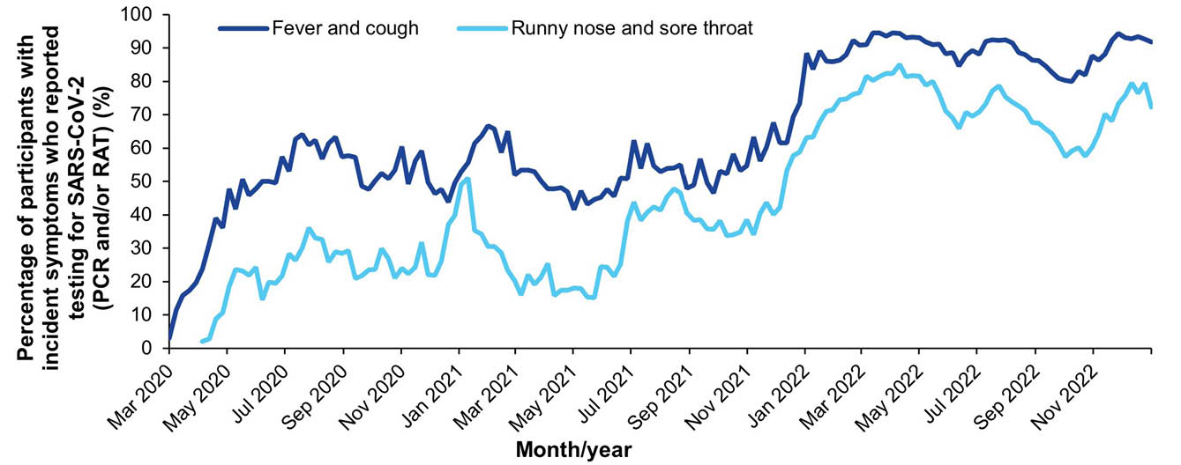

First Nations analyses

Percentage of First Nations participants who self-reported incident FC symptoms
The weekly percentage of First Nations participants who self-reported incident FC symptoms remained below pre-pandemic levels throughout 2020–2021. However, a sharp increase was observed in the week ending 6 June 2021 (2.2%; Figure 12). Multiple increases occurred from December 2021, aligning with Omicron case surges and an increase in influenza notifications from May 2022. The highest percentage of First Nations participants who reported incident FC symptoms was observed in the week ending 10 July 2022 (4.7%), aligning with the timing of the BA.4/BA.5 Omicron wave.
Figure 12: Percentage of First Nations participants who self-reported incident ‘fever and cough’ symptoms (FC) symptoms, Australia, 2019–2022, by week
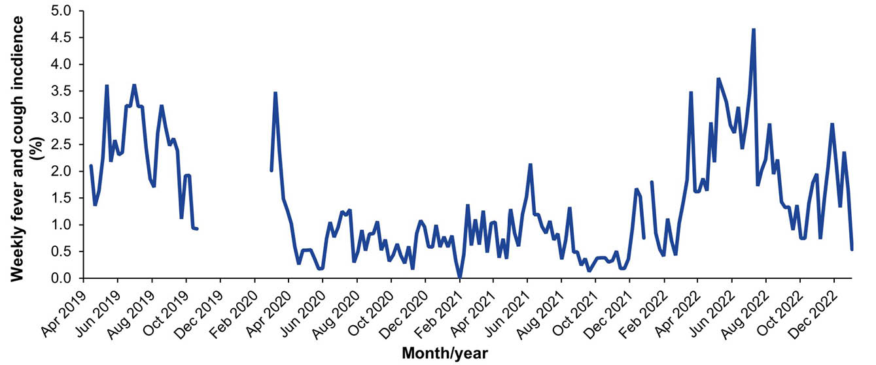

Period cumulative incidence of FC, First Nations participants
A decrease in period cumulative incidence as calculated by epi week 41 in each respective year was observed in 2020 and 2021 compared to pre-pandemic years (2017–2019; Figure 13). The period cumulative incidence in 2022 was similar to pre-pandemic levels.
Figure 13: Period cumulative incidence of ‘fever and cough’ symptoms (FC) for First Nations participants, Australia, 2017–2022,ª epi weeks 17–41
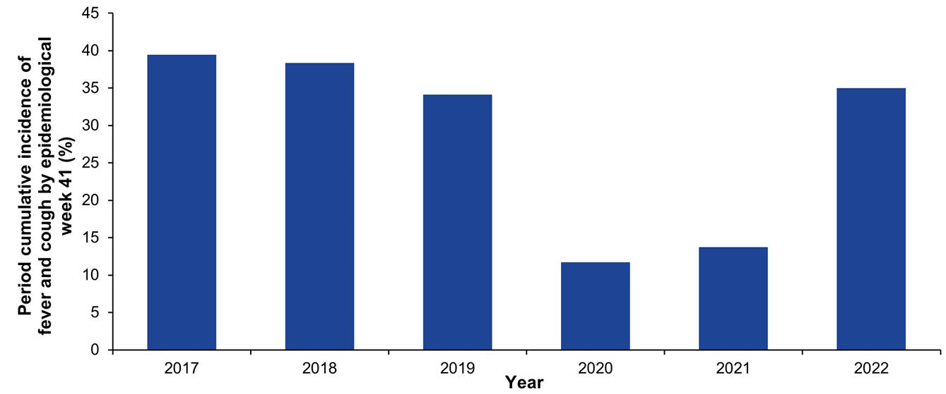
a Only the first incident of fever and cough symptoms for each participant per year was included.

Period cumulative incidence of RNST, First Nations participants
There was an increase in the period cumulative incidence of RNST in First Nations participants in 2022 compared to previous years, as calculated by epi week 52 across the three years (Figure 14).
Figure 14. Period cumulative incidence of ‘runny nose and sore throat’ symptoms (RNST) for First Nations participants, Australia, 2020–2022,ª epi weeks 14–52
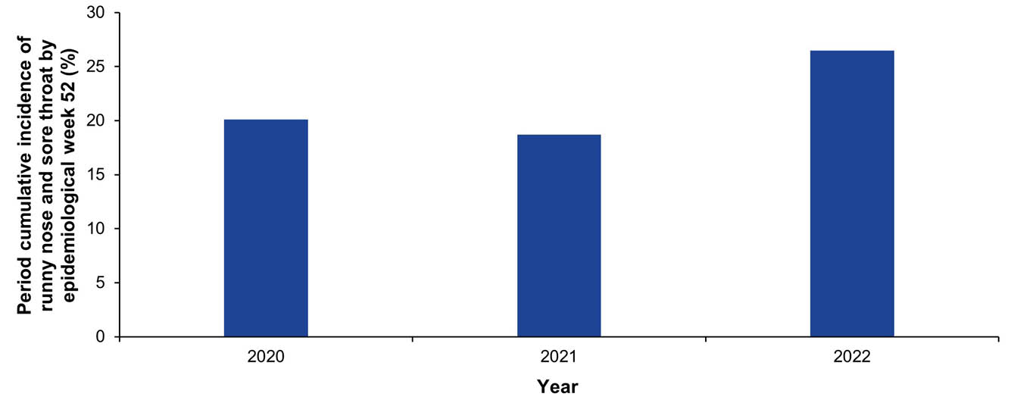
a Only the first incident of runny nose and sore throat symptoms for each participant per year was included.

Self-reported percent positivity for influenza and SARS-CoV-2 in participants reporting incident FC symptoms
Test percent positivity for SARS-CoV-2 was low from April 2020 to November 2021, compared to subsequent years, with a weekly mean of 0.8% in 2020 and 1.1% from January 2021-November 2021 (Figure 15). A sharp increase in SARS-CoV-2 test percent positivity was observed during the Omicron BA.1 wave in December 2021, which peaked at 72.8% in the week ending 9 January 2022. Increases were also observed during the BA.2, BA.4/BA.5 and mixed Omicron variant waves from March to December 2022 (peaking at 71.3%, 64.6% and 70.8%, respectively).
Influenza test percent positivity remained mostly below 15% throughout 2020–2021 but increased early in 2022 compared to prior influenza seasons and peaked in the week ending 15 May 2022 at 48.8%.
Figure 15: Self-reported test percent positivity for influenza and SARS-CoV-2 among participants reporting incident ‘fever and cough’ symptoms (FC) symptoms undergoing testing, Australia, 2020–2022, by week
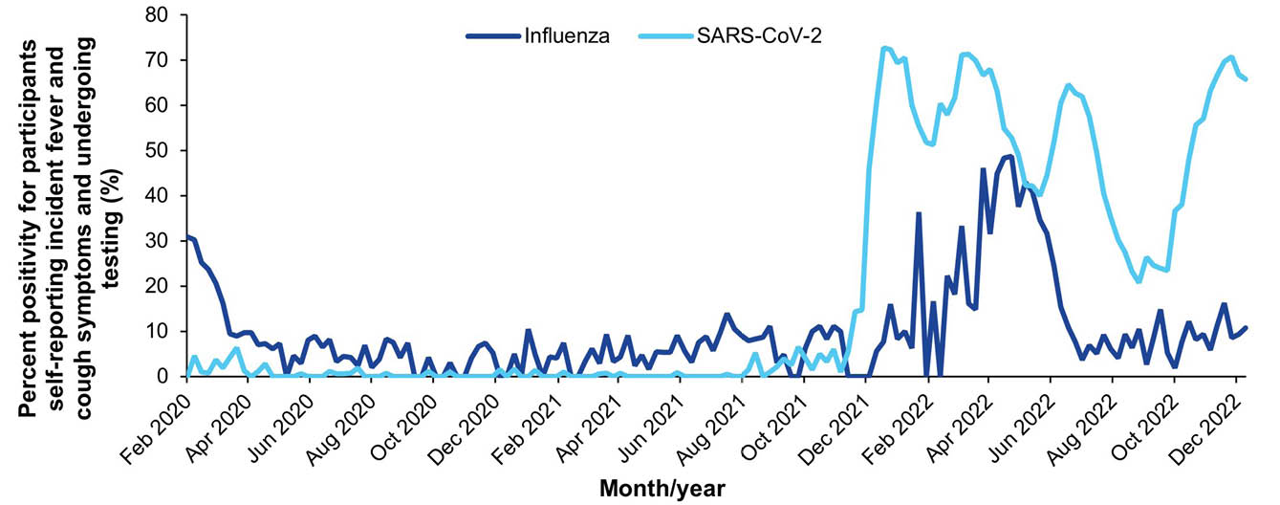

Comparisons with other surveillance systems

Comparison of FluTracking weekly FC incidence and weekly NNDSS COVID-19 PCR notifications
The peaks in the percentage of FluTracking participants who self-reported incident FC symptoms closely aligned with the timing of peaks in NNDSS notifications during the Omicron waves (Figure 16).
Figure 16: FluTracking weekly percentage of participants who self-reported incident ‘fever and cough’ symptoms (FC) symptoms versus NNDSS-confirmed COVID-19 (PCR) notifications, Australia, 2020–2022, by week
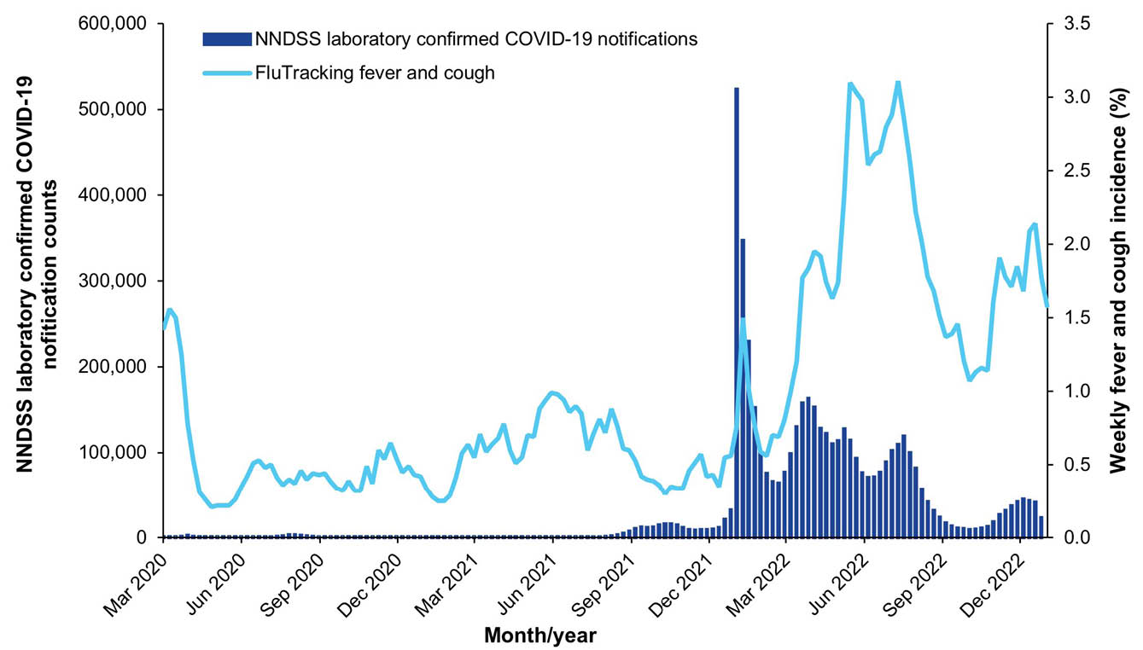

Comparison of FluTracking SARS-CoV-2 self-reported percent positivity with NNDSS COVID-19 laboratory-confirmed notifications
NNDSS COVID-19 weekly laboratory-confirmed notifications remained below 3,500 during 2020–2021 until July 2021. A sharp increase in COVID-19 weekly notifications during the week ending 9 January 2022 was observed (523,243 notifications with the arrival of the Omicron variant, Figure 17).
The first COVID-19 related signal in FluTracking was a small increase in SARS-CoV-2 PCR test percent positivity reported to FluTracking in May 2020, followed by the Delta wave in September 2021.
In the context of the BA.1 and BA.2 Omicron waves, among FluTracking participants who reported incident FC symptoms and underwent either a PCR test only or a RAT (with or without a PCR test), test percent positivity reached its highest point one to two weeks after the peak in weekly NNDSS laboratory-confirmed COVID-19 notifications (Figure 17). In contrast, during the BA.4/BA.5 and mixed Omicron waves, FluTracking test percent positivity peaked two weeks before NNDSS laboratory-confirmed COVID-19 notifications.
Figure 17: FluTracking SARS-CoV-2 test percent positivity by test type in participants reporting incident ‘fever and cough’ symptoms (FC) versus NNDSS COVID-19 laboratory-confirmed notifications, Australia, March 2020 – December 2022, by week
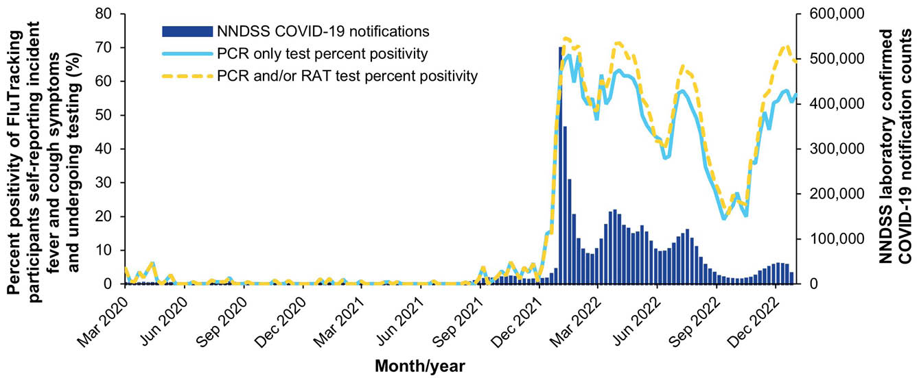

Comparison of FluTracking respiratory illness severity and ABS influenza/pneumonia and COVID-19 age-standardised death rates
The peak weekly percentage of participants reporting time off work or normal duties due to FC symptoms was much higher in 2022than in 2021 and 2020 (2.1%, 0.6% and 0.8%, respectively), and the peak weekly percentage of participants seeking medical attention due to FC symptoms was also higher in 2022 than in 2021 and 2020 (0.8%, 0.4% and 0.7%, respectively; Figure 18).
Influenza and pneumonia age-standardised death rates reported by the ABS peaked in the week ending 19 June 2022, three and four weeks after an increase in FluTracking respiratory illness severity indicators (FC and two or more days off work or normal duties, and FC and sought medical attention). A similar trend was observed in pre-pandemic years where the peak in ABS influenza and pneumonia death rates lagged the peak in FluTracking severity of illness indicators by two to eight weeks.
FluTracking severity of illness indicators peaks preceded the BA.1, BA.2 and BA.4/BA.5 Omicron COVID-19 wave peaks of age-standardised death rates by two to three weeks (Figure 19).
Figure 18: FluTracking age-standardised respiratory illness severity indicators versus ABS Influenza/Pneumonia age-standardised death rates, Australia, 2017–2022,ª by week
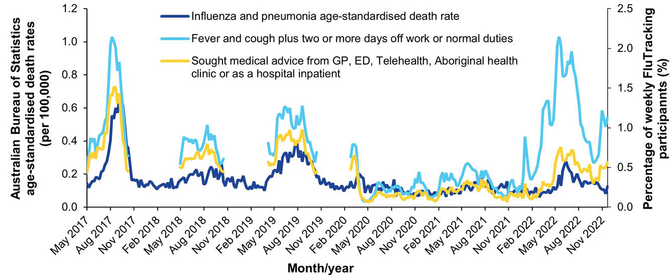
a The denominator for FluTracking respiratory illness severity indicators is the number of weekly participants.
Figure 19: FluTracking age-standardised respiratory illness severity indicators versus ABS COVID-19 age-standardised death rates, Australia, 2020–2022, by week
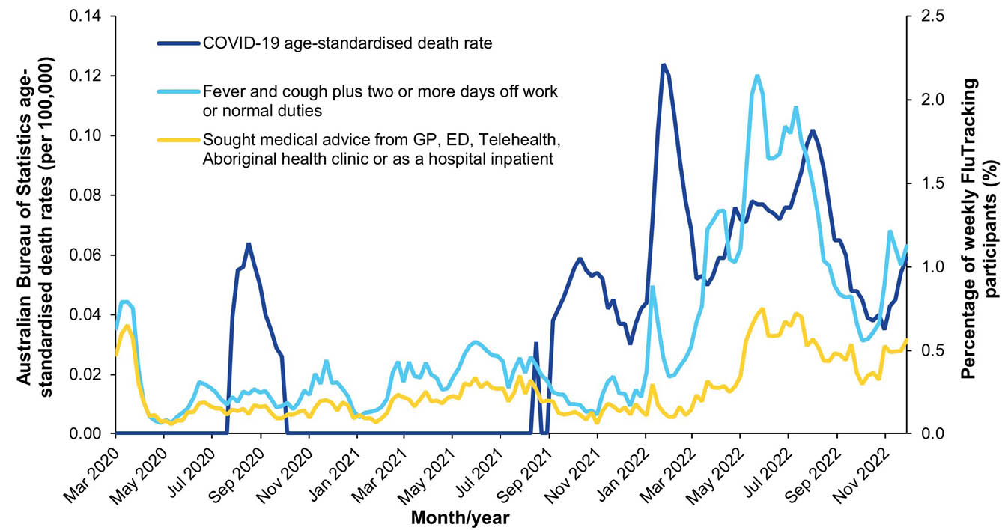

Discussion
Respiratory illness surveillance throughout 2020–2022 demonstrated the impact of public health measures in preventing the transmission of respiratory viruses. Extraordinary decreases in national influenza laboratory-confirmed case notifications attested to the near-elimination of influenza in Australia during 2020–2021, and the revocation of most COVID-19 mitigation measures in 2022 led to a surge in influenza notifications and multiple waves of COVID-19 transmission.¹⁷
Key highlights of FluTracking throughout 2020–2022 included:
- historically low levels of FC in 2020–2021 as a result of public health restrictions that were implemented from March 2020 to minimize the spread of COVID-19;
- multiple Omicron waves were clearly delineated in 2022;
- the adaptability of the FluTracking survey to capture and provide insight into changes in community wide SARS-CoV-2 testing behaviour and potential implications for case ascertainment;
- FluTracking SARS-CoV-2 percent positivity offering valuable trend insights when other surveillance systems scaled down COVID-19 reporting; and
- record participation growth in 2020.
The weekly percentage of participants self-reporting incident FC symptoms dropped dramatically from 1.6% at 8 March 2020 to 0.2% at 26 April 2020 and remained at historically low levels throughout 2020 and 2021. This was due to the introduction of COVID-19 public health restrictions in early 2020 (physical distancing, border controls and lock-down measures), demonstrating these measures were effective in minimising respiratory virus transmission.¹⁸ FluTracking FC trends in 2020–2021 were markedly different to pre-pandemic years, but were consistent with observations from other respiratory illness surveillance systems. FC activity returned in 2022, with an earlier peak than pre-pandemic years attributed to influenza. A reduction in immunity to influenza due to decreased community transmission, along with international borders re-opening and relaxed mask mandates in several states and territories in February 2022, may have contributed to an earlier influenza season.^{19,20} In addition, a lower vaccination rate early in the 2022 influenza season compared to previous years likely led to the rapid increase in notifications.²¹
Whilst similar COVID-19 and influenza activity trends were drawn between traditional surveillance systems and FluTracking throughout 2020–2021, FluTracking provided unique insights in 2022. The timing of the BA.1 and BA.2 Omicron wave peaks were similar in both FluTracking weekly SARS-CoV-2 self-reported percent positivity and laboratory-confirmed COVID-19 notifications. However, similar peak magnitudes in the FluTracking SARS-CoV-2 self-reported percent positivity (for PCR tests and RATs) were observed during the BA.2 wave as compared to the BA.1 wave, whereas a lower peak in COVID-19 laboratory-confirmed notifications was observed during the BA.2 wave than during the BA.1 wave.
FluTracking has also contributed to a deeper understanding of COVID-19 epidemiology in collecting negative and positive test results for SARS-CoV-2 PCR tests and RATs, noting that data on negative RAT results is not collected systemically for surveillance elsewhere in Australia. While mandates for reporting a positive RAT to government were introduced at the beginning of 2022, these mandates were lifted in multiple states and territories towards the end of 2022.^{22,23}
In comparison to ABS influenza/pneumonia age-standardised death rates, FluTracking severity of illness indicators peaked three to four weeks prior in 2022, and similar trends were observed in pre-pandemic years. This highlights that FluTracking severity of illness data may serve as a useful early indicator for increases in influenza and pneumonia related deaths, particularly when access to mortality data is delayed. To formally assess the association between the ABS influenza and pneumonia mortality rates and each of the FluTracking severity of illness indicators, a cross correlation analysis employing an autoregressive integrated moving average (ARIMA) model to adjust for seasonality and trend is being conducted using data from 2020–2022.
Differences in SARS-CoV-2 testing behaviours were observed as the pandemic evolved. Daily media headlines during 2020–2021 led with the message: ‘if you have symptoms, you must get tested’. However, the relatively low level of testing in FluTracking participants, who are typically health conscious, reporting symptoms suggests an even lower percentage of the general population with symptoms may have presented for a PCR test.²⁴ We acknowledge that there may have been legitimate reasons for participants not reporting testing, such as barriers to accessing testing and reported symptoms being due to chronic diseases. Given the public health communications for people with acute respiratory symptoms to be tested for SARS-CoV-2, further study is required to elucidate reasons for not being tested.
Participants reporting fewer than three doses of a COVID-19 vaccine exhibited higher weekly FC incidence, in contrast to those reporting three or more doses; however, the difference narrowed over time. This analysis, in addition to the COVID-19 FVE analysis, did not consider the impact of immunity from prior infections or time since last vaccination. Therefore, the calculated FVE is subject to several limitations.
FluTracking participation doubled from 2019 to 2020, representing the largest year on year growth (107%) since the program’s inception in 2006. This record recruitment resulted from a national COVID-19 press conference in which the Australian Deputy Chief Medical Officer, Professor Paul Kelly, promoted FluTracking. For the first time for FluTracking, in 2021, overall participation decreased from the prior year. This decline was likely influenced by historically low levels of FC in the community, additional questions in the weekly survey, and year-long participation for two-thirds of participants, all contributing to participation fatigue. In 2022, FluTracking was able to maintain similar participation numbers to those contributing in 2021. Retaining participants will be challenging and will be the subject of focus for future recruitment and retention campaigns.
During 2023, the FluTracking questionnaire will be restructured to accommodate further COVID-19 vaccine doses and changes to the sign-up form will allow for information on prior vaccine doses to be collected immediately at sign up. An express survey will be trialled in an effort to accelerate survey response times and reduce participant fatigue.
Three years after the onset of the COVID-19 pandemic, Australia continues to face possible new variants and waves of transmission. FluTracking provides valuable insights and situational awareness of respiratory illness and testing behaviours in the community.

Acknowledgments
We acknowledge the University of Newcastle for their continued support, and the Australian Government Department of Health, Disability and Ageing and the Hunter Medical Research Institute for their funding and support. We also acknowledge Stephen Clarke for software and database development, the First Nations Health Protection staff for their guidance and support, John Fejsa for his contribution to the design of the project, and the many thousands of FluTracking participants who freely give their time each week to contribute to influenza and COVID-19 surveillance.
To become a FluTracker, please visit www.flutracking.net.

Author details
Ms Alexandra G Kerr,¹ Analyst
Ms Sandra J Carlson,¹ Manager – FluTracking
Ms Zoe Baldwin,¹ MSc Student
Dr Reilly J Innes,¹ Analyst
Dr Zachary L Howard,¹ Analyst
Dr Murray Bennett,¹ Analyst
Ms Tiffany Evans,¹ Senior Analyst
Mr Tom C McKenzie,¹ Project Officer
Dr Craig B Dalton,^{1,2,3} Public Health Physician
- Hunter New England Local Health District, NSW, Australia
- University of Newcastle, Callaghan, NSW, Australia
- Hunter Medical Research Institute, Lambton Heights, NSW, Australia

Corresponding author
Dr Craig B Dalton
Booth Building, Longworth Ave, Wallsend, NSW, Australia 2287
Phone: +61 2 4924 6499
Email: craig.dalton@health.nsw.gov.au

References
- Carlson SJ, Dalton CB, Tuyl FA, Durrheim DN, Fejsa J, Muscatello DJ et al. Flutracking surveillance: comparing 2007 New South Wales results with laboratory confirmed influenza notifications. Commun Dis Intell Q Rep. 2009;33(3);323–7.
- Dalton CB, Durrheim DN, Fejsa J, Francis L, Carlson SJ, d'Espaignet ET et al. Flutracking: a weekly Australian community online survey of influenza-like illness in 2006, 2007 and 2008. Commun Dis Intell Q Rep. 2009;33(3);316–22.
- Parrella A, Dalton CB, Pearce R, Litt JCB, Stocks N. ASPREN surveillance system for influenza-like illness: a comparison with FluTracking and the National Notifiable Diseases Surveillance System. Aust Fam Physician. 2009;38(11);932–6.
- Carlson SJ, Dalton CB, Durrheim DN, Fejsa J. Online Flutracking survey of influenza-like illness during pandemic (H1N1) 2009, Australia. Emerg Infect Dis. 2010;16(12):1960–2. doi: https://doi.org/10.3201/eid1612.100935.
- Dalton CB, Carlson SJ, Durrheim DN, Butler MT, Cheng AC, Kelly HA. Flutracking weekly online community survey of influenza-like illness annual report, 2015. Commun Dis Intell Q Rep. 2016;40(4);E512–20.
- World Health Organization (WHO). Pandemic Influenza Severity Assessment (PISA): a WHO guide to assess the severity of influenza epidemics and pandemic. Geneva: WHO; May 2017. Available from: https://apps.who.int/iris/bitstream/handle/10665/259392/WHO-WHE-IHM-GIP-2017.2-eng.pdf.
- Australian Government Department of Health and Aged Care. Australian influenza report 2009. Canberra: Australian Government Department of Health and Aged Care; 2009.
- National Incident Room Surveillance Team. 2019-nCoV acute respiratory disease, Australia: Epidemiology Report 1 (Reporting week 26 January - 1 February 2020). Commun Dis Intell (2018). 2020;44. doi: https://doi.org/10.33321/cdi.2020.44.13.
- Australian Government Department of Health and Aged Care. National Notifiable Diseases Surveillance System (NNDSS) public datasets. [Webpage.] Canberra: Australian Government Department of Health and Aged Care; 2021. [Accessed on 21 March 2022.] Available from: https://www.health.gov.au/resources/collections/nndss-public-datasets.
- Australian Government Department of Health and Aged Care. National Notifiable Diseases Surveillance System (NNDSS) fortnightly reports. [Webpage.] Canberra: Australian Government Department of Health and Aged Care; 11 August 2021. [Accessed on 21 March 2022.] Available from: https://www.health.gov.au/resources/collections/nndss-fortnightly-reports.
- Moberley S, Carlson SJ, Durrheim DN, Dalton CB. Flutracking: Weekly online community-based surveillance of influenza-like illness in Australia, 2017 Annual Report. Commun Dis Intell (2018). 2019;43. doi: https://doi.org/10.33321/cdi.2019.43.31.
- Australian Bureau of Statistics (ABS). National, state and territory population. Reference period: June 2022. [Webpage.] Canberra: ABS; 15 December 2022. [Accessed on 3 March 2023.] Available from: https://www.abs.gov.au/statistics/people/population/national-state-and-territory-population/jun-2022.
- ABS. Education and training: Census. Reference period: 2021. [Webpage.] Canberra: ABS; 28 June 2022. [Accessed on 3 March 2023.] Available from: https://www.abs.gov.au/statistics/people/education/education-and-training-census/latest-release.
- ABS. Aboriginal and Torres Strait Islander people: Census. Reference period: 2021. [Webpage.] Canberra: ABS; 28 June 2022. [Accessed on 3 March 2023.] Available from: https://www.abs.gov.au/statistics/people/aboriginal-and-torres-strait-islander-peoples/aboriginal-and-torres-strait-islander-people-census/latest-release.
- Australian Government Department of Health and Aged Care. ATAGI recommendations on first booster dose in adolescents aged 12–15 years. [Webpage.] Canberra: Australian Government Department of Health and Aged Care; 9 June 2022. [Accessed on 12 October 2022.] Available from: https://www.health.gov.au/news/atagi-recommendations-on-first-booster-dose-in-adolescents-aged-12-15-years.
- ABS. Provisional mortality statistics. Reference period: Jan – Nov 2023. [Webpage.] Canberra: ABS; 27 February 2024. [Accessed on 3 March 2023.] Available from: https://www.abs.gov.au/statistics/health/causes-death/provisional-mortality-statistics/latest-release.
- Sullivan SG, Carlson S, Cheng AC, Chilver MBN, Dwyer DE, Irwin M et al. Where has all the influenza gone? The impact of COVID-19 on the circulation of influenza and other respiratory viruses, Australia, March to September 2020. Euro Surveill. 2020;25(47):2001847. doi: https://doi.org/10.2807/1560-7917.ES.2020.25.47.2001847.
- Storen R, Corrigan N. COVID-19: a chronology of state and territory government announcements (up until 30 June 2020). Canberra: Parliament of Australia, Parliamentary Library; 22 October 2020. [Accessed on 23 March 2023.] Available from: https://www.aph.gov.au/About_Parliament/Parliamentary_Departments/Parliamentary_Library/pubs/rp/rp2021/Chronologies/COVID-19StateTerritoryGovernmentAnnouncements.
- Australian Government Department of Home Affairs. Reopening to tourists and other international travellers to secure our economic recovery. [Media release.] Canberra: Australian Government Department of Home Affairs; 7 February 2022. [Accessed on 23 March 2023.] Available from: https://minister.homeaffairs.gov.au/KarenAndrews/Pages/reopening-to-tourists-and-other-international-travellers-to-secure-our-economic-recovery.aspx.
- ABC News Australia. COVID-19 mask rules explained for every state and territory. [Online news item.] Sydney: Australian Broadcasting Corporation, ABC News and Current Affairs; 25 February 2022. [Accessed on 23 March 2023.] Available from: https://www.abc.net.au/news/2022-02-25/covid-mask-rules-australian-states-territories/100854564.
- National Centre for Immunisation Research and Surveillance (NCIRS). National influenza vaccination coverage – all people. [Webpage.] Sydney: NCIRS. [Accessed on 23 March 2023.] Available from: https://ncirs.org.au/influenza-vaccination-coverage-data/national-influenza-vaccination-coverage-all-people.
- Lucas C, Ilanbey S. Mandatory testing to end along with forced COVID-19 isolation. [Online news item.] Melbourne: The Age; 9 October 2022. [Accessed on 23 March 2023.] Available from: https://www.theage.com.au/politics/victoria/mandatory-testing-to-end-along-with-forced-covid-19-isolation-20221008-p5bo8d.html.
- Abram M. Chief Minister Natasha Fyles announces the end of the Northern Territory's last remaining COVID-19 rules. [Online news item.] Sydney: Australian Broadcasting Corporation, ABC News and Current Affairs; 10 November 2022. [Accessed on 23 March 2023.] Available from: https://www.abc.net.au/news/2022-11-10/last-of-nt-covid-rules-to-lift/101640364.
- Victoria State Government. Statement from the Premier. [Media release.] Melbourne: Victoria State Government; 26 October 2020. [Accessed on 23 March 2023.] Available from: https://www.premier.vic.gov.au/sites/default/files/2020-10/201026%20-%20Statement%20From%20The%20Premier.pdf.

Appendix A
Table A.1: Changes to the way FluTracking Australia asks participants about symptoms, COVID-19 vaccination and being tested for SARS-CoV-2 and influenza, 2020–2022
Year | Date | Change to monitoring | Collection period for indicated survey questions | Testing/COVID-19 vaccination questions asked in surveys
2020 | 11 March | Symptoms ‘runny nose’ and ‘shortness of breath’ were added, nested under ‘fever and cough’ | 24 February – 27 May | For those with no symptoms:  ‘Did you have a nose or throat swab for COVID-19?’  (yes/no/don’t know)  - If yes, ‘What was the result of your test?’  (flu/COVID-19/flu & COVID-19/Have not received result yet/ None of the above/other/Don’t know)  For those with symptoms who sought medical advice:  ‘Did you have a nose or throat swab for these respiratory symptoms?’  (yes/no/don’t know)  - If yes, ‘Was it collected for any of the following tests?’  (flu/COVID-19/flu & COVID-19/Other respiratory virus testing)  - ‘What was the result of your test?’  (flu/ COVID-19/flu & COVID-19/Have not received result yet/ None of the above or other/Don’t know)
2020 | 25 March | All participants asked whether they received a SARS-CoV-2 swab | 24 February – 27 May
2020 | 29 March | Symptoms ‘runny nose’, ‘shortness of breath’, and (newly added) ‘change in taste or smell’ now asked of all participants | 24 February – 27 May
2020 | 27 May | Added categories:  Split ‘GP’ category into ‘in person visit’ and ‘by phone’;  First Nations health clinic;  COVID-19 test centre/drive-through;  Pharmacy | 24 February – 27 May
2020 | 19 June | For one in eight participants, a ‘none of the above’ option for symptoms was added | 1 June onwards | For all participants:  ‘Did you have a nose or throat swab during the week ending <insert survey end period>?’  (yes/no/don’t know)  - If yes, ‘Have you received the result yet?’ (yes/no/don’t know)  - If yes:  - ‘What was the result for COVID-19?’  - ‘What was the result for flu?’  - ‘What was the result for other illness?’  Options for each: positive; negative; don’t know result; not tested/not sure if tested
2020 | 8 October | The ‘none of the above’ option was added for all participants | 1 June onwards
2021 | 24 February | All participants asked whether they had received their first dose of a COVID-19 vaccine (for all age groups) | 24 February – 11 November | COVID-19 vaccine dose 1:  ‘Have you received the 1st dose of a COVID-19 vaccine?’  (yes/no/don’t know)  - If yes, ‘What was the vaccine brand?’  (Pfizer/AstraZeneca/Moderna/other/don’t know)  COVID-19 vaccine dose 2:  ‘Have you received the 2nd dose of a COVID-19 vaccine?’  (yes/no/don’t know)  - If yes, ‘What was the vaccine brand?’  (Pfizer/AstraZeneca/Moderna/other/don’t know)  COVID-19 vaccine dose 3:  ‘Have you received the 3rd dose (or booster) of a COVID-19 vaccine?’*  (yes/no/don’t know)  - If yes, ‘What was the vaccine brand?’  (Pfizer/AstraZeneca/Moderna/other/don’t know)  *For 13–18 October, this question was asked as ‘Have you received the 3rd dose of a COVID-19 vaccine?’ to encompass primary courses and booster shots  Note: prior to the addition of ‘Moderna’, the brands appeared as: (Pfizer/BioNTech(Comirnaty); AstraZeneca/Oxford; other; don’t know)
2021 | 4 March | All participants asked what brand of COVID-19 vaccine they received, nested under the COVID-19 ‘first dose’ question | 24 February – 11 November
2021 | 11 March | Participants asked whether they have received a second dose of a COVID-19 vaccine (including the nested question for vaccine brand)  Age limit applied for participants aged 16 years and older for first and second dose COVID-19 vaccination questions | 24 February – 11 November
2021 | 12 August | Age range for first and second dose of a COVID-19 vaccine relaxed to 12 years and older | 24 February – 11 November
2021 | 26 August | Headache symptom question added | 24 February – 11 November
2021 | 22 September | ‘Moderna’ vaccine brand added for COVID-19 vaccination questions (dose one and dose two) | 24 February – 11 November
2021 | 13 October | Participants aged 15 years and older asked whether they have received a third dose of a COVID-19 vaccine (including the nested question for vaccine brand) | 24 February – 11 November
 | 12 November | Testing question amended, now asking participants to report Rapid Antigen Tests (originally asked for PCR reports only) | 12 November onwards | For ALL participants:  ‘Did you have a COVID Rapid Antigen Test (RAT) or PCR test, or an influenza PCR test during <insert survey end period>?’  (yes/no/don’t know)  - If yes, ‘Have you received the result yet?’  (yes/no/don’t know)  - If yes:  - ‘COVID-19 Rapid Antigen Test? (e.g. at home; work; school etc)’  - ‘COVID-19 PCR Test? (e.g. at a drive-through, respiratory clinic or hospital that is sent to a lab)’  - ‘Influenza PCR Test?’  - Other Illness Test?  Options for each: positive; negative; don’t know result; not tested/not sure if tested
2022 | 17 January | Age range for first and second dose of a COVID-19 vaccine relaxed to 5 years and older | to 30 March | COVID-19 vaccine dose 4:  ‘Have you received the 4th dose of a COVID-19 vaccine? (This is a booster dose for the immunocompromised)’  (yes/no/don’t know)  - If yes, ‘What was the vaccine brand?’  (Pfizer/AstraZeneca/Moderna/other/don’t know)  *From 30 March, the question ‘Have you received a fourth dose of a COVID-19 vaccine?’ was asked, as the Australian Technical Advisory Group on Immunisation (ATAGI) expanded their recommendation for a wider range of the Australian population to receive a fourth dose (see reference 24)
2022 | 9 February | Participants were asked whether they have received a fourth dose of a COVID-19 vaccine for participants aged 16 years and over (including the nested question for vaccine brand) | to 30 March
2022 | 16 February | ‘Novavax’ vaccine brand added for COVID-19 vaccination questions (dose one, two, three and four) | to 30 March
 | 31 March | Removal of ‘Other Illness Test’ from testing question | 31 March onwards | For ALL participants:  ‘Did you have a COVID Rapid Antigen Test (RAT) or PCR test, or an influenza PCR test during <insert survey end period>?’  (yes/no/don’t know)  - If yes, ‘Have you received the result yet?’  (yes/no/don’t know)  - If yes:  - ‘COVID-19 Rapid Antigen Test? (e.g. at home; work; school etc)’  - ‘COVID-19 PCR Test? (e.g. at a drive-through, respiratory clinic or hospital that is sent to a lab)’  - ‘Influenza PCR Test?’  Options for each: positive; negative; don’t know result; not tested/not sure if tested

Table A.2: Recruitment and participation in FluTracking by jurisdiction,ª Australia, 2020–2022
Jurisdiction | 2020 |  |  | 2021 |  |  | 2022 |  |  | Percent distribution of Australian population | Percent change 2021 to 2022
Jurisdiction | Number of participants (peak week) | FluTracking participation per 100,000 population | Percent of participants (peak week) | Number of participants (peak week) | FluTracking participation per 100,000 population | Percent of participants (peak week) | Number of participants (peak week) | FluTracking participation per 100,000 population | Percent of participants (peak week) | Percent distribution of Australian population | Percent change 2021 to 2022
ACT | 4,377 | 958.4 | 5.0% | 4,168 | 912.6 | 5.6% | 4,260 | 932.8 | 5.8% | 1.8% | 2.2%
NSW | 29,796 | 365.4 | 34.0% | 26,080 | 319.9 | 34.7% | 25,946 | 318.2 | 35.2% | 31.4% | -0.5%
NT | 1,361 | 543.1 | 1.6% | 1,298 | 518.0 | 1.7% | 1,214 | 484.4 | 1.6% | 1.0% | -6.5%
Qld. | 11,835 | 222.4 | 13.5% | 9,255 | 173.9 | 12.3% | 9,043 | 169.9 | 12.3% | 20.5% | -2.3%
SA | 7,484 | 411.1 | 8.5% | 6,507 | 357.4 | 8.7% | 6,397 | 351.4 | 8.7% | 7.0% | -1.7%
Tas. | 5,293 | 926.2 | 6.0% | 4,846 | 847.9 | 6.5% | 4,681 | 819.1 | 6.4% | 2.2% | -3.4%
Vic. | 18,068 | 273.2 | 20.6% | 15,111 | 228.5 | 20.1% | 14,527 | 219.7 | 19.7% | 25.5% | -3.9%
WA | 9,471 | 340.0 | 10.8% | 7,802 | 280.1 | 10.4% | 7,580 | 272.1 | 10.3% | 10.7% | -2.8%
Total | 87,685 (+20 missing) | 337.6 | 100.0% | 75,067 (+19 missing) | 289.0 | 100.0% | 73,648 (+19 missing) | 283.6 | 100.0% | 100.0% | -1.9%
a ACT: Australian Capital Territory; NSW: New South Wales; NT: Northern Territory; Qld: Queensland: SA: South Australia; Tas.: Tasmania; Vic.: Victoria; WA: Western Australia.

Table A.3: Socio-demographic characteristics of FluTracking participants who completed at least one survey, Australia, 2020–2022
Characteristic | Value or range | 2020 |  |  | 2021 |  |  | 2022 |  |  | Percentage of Australian population
Characteristic | Value or range | Frequency | Percentage | Rateª | Frequency | Percentage | Rateª | Frequency | Percentage | Rateª | Percentage of Australian population
Age in years | 0–4 | 4,187 | 3.8 | 277.3 | 2,110 | 2.3 | 139.7 | 1,732 | 1.9 | 114.7 | 5.9
Age in years | 5-17 | 13,055 | 11.9 | 315.5 | 8,875 | 9.9 | 214.5 | 8,442 | 9.4 | 204.0 | 16.1
Age in years | 18-39 | 23,203 | 21.2 | 297.7 | 15,216 | 16.9 | 195.2 | 13,690 | 15.2 | 175.6 | 30.3
Age in years | 40-64 | 47,538 | 43.5 | 599.3 | 39,871 | 44.3 | 502.7 | 38,658 | 42.8 | 487.4 | 30.9
Age in years | 65 and over | 21,417 | 19.6 | 496.5 | 24,017 | 26.7 | 556.8 | 27,735 | 30.7 | 642.9 | 16.8
Age in years | Total participants | 109,400 | 100 | 425.9 | 90,089 | 100 | 350.7 | 90,257 | 100 | 351.4 | 100
Sex | Male | 45,603 | 41.9 | 357.7 | 36,688 | 41.0 | 287.8 | 36,348 | 40.3 | 280.9 | 49.6
Sex | Female | 63,070 | 58 | 487.5 | 52,776 | 58.9 | 407.9 | 53,328 | 59.1 | 412.2 | 50.4
Sex | Other | 118 | 0.1 | — | 92 | 0.1 | — | 90 | 0.001 | — | —
Sex | Missing data on sex | 641 | — | — | 533 | — | — | 491 | — | — | —
Sex | Total reported^{b} | 108,761 | 100 | 423.4 | 89,556 | 100 | 348.6 | 89,766 | 100 | 351.0 | 100
Highest level of education completed by participant (15 years and over only) | Year 11 or below (or equivalent) or Certificate I/II/III/IV | 21,016 | 22.5 | 266.6 | 16,721 | 20.6 | 212.0 | 16,252 | 20.4 | 206.0 | 38.0%
 | Year 12 (or equivalent) | 8,214 | 8.8 | 264.6 | 6,493 | 8.0 | 209.2 | 6,335 | 7.9 | 204.1 | 14.9%
 | Diploma or Advanced Diploma | 9,069 | 9.7 | 465.9 | 7,885 | 9.7 | 405.0 | 8,029 | 10.1 | 412.4 | 9.4%
 | Enrolled in, or completed, Bachelor Degree | 25,162 | 27.0 | 697.2 | 20,951 | 25.8 | 580.5 | 21,053 | 26.4 | 583.3 | 17.4%
 | Graduate Diploma or Graduate Certificate | 9,695 | 10.4 | 1954.9 | 8,929 | 11.0 | 1800.4 | 9,178 | 11.5 | 1850.6 | 2.4%
 | Postgraduate Degree | 20,134 | 21.6 | 1481.1 | 18,231 | 22.5 | 1341.1 | 18,963 | 23.8 | 1394.9 | 6.5%
 | Did not nominate an ABS equivalent education level | 1,660 | — | — | 1,989 | — | — | 2,282 | — | — | —
 | Total reported^{b} | 90,839 | 100 | 437.0 | 79,210 | 100 | 381.1 | 79,810 | 100 | 384.0 | 100
Aboriginal and/or Torres Strait Islander status | Yes | 1,779 | 1.7 | 180.8 | 1,212 | 1.4 | 123.2 | 1,147 | 1.3 | 116.6 | 3.8
Aboriginal and/or Torres Strait Islander status | No | 105,233 | 97.7 | 426.0 | 86,985 | 98.2 | 352.1 | 87417 | 98.4 | 353.9 | 96.2
Aboriginal and/or Torres Strait Islander status | Prefer not to say | 664 | 0.6 | — | 362 | 0.4 | — | 305 | 0.3 | — | —
Aboriginal and/or Torres Strait Islander status | Missing data on Aboriginal and/or Torres Strait Islander status | 1,724 | — | — | 1,530 | — | — | 1,388 | — | — | —
Aboriginal and/or Torres Strait Islander status | Total reported^{b} | 107,676 | 100 | 419.2 | 88,559 | 100 | 344.7 | 88,869 | 100 | 346.0 | 100
a Rate per 100,000 population within the indicated category.
b Totals for these characteristics exclude those with missing data, or who did not nominate an educational level.

Table A.4: Survey weeks within traditional survey season and opt-out periods, Australia, 2020–2022
Year | Survey weeks within traditional FluTracking season | Survey weeks within  opt-out period
2020 | 23 March – 18 October 2020 | 25 October 2020 – 3 January 2021
2021 | 4 April – 24 October 2021 | 31 October 2021 – 2 January 2022
2022 | 3 April – 23 October 2022 | 30 October 2022 – 1 January 2023

Figure A.1: Age-standardised weekly FC incidence by jurisdiction, Australia, March 2020 – December 2022, by week
