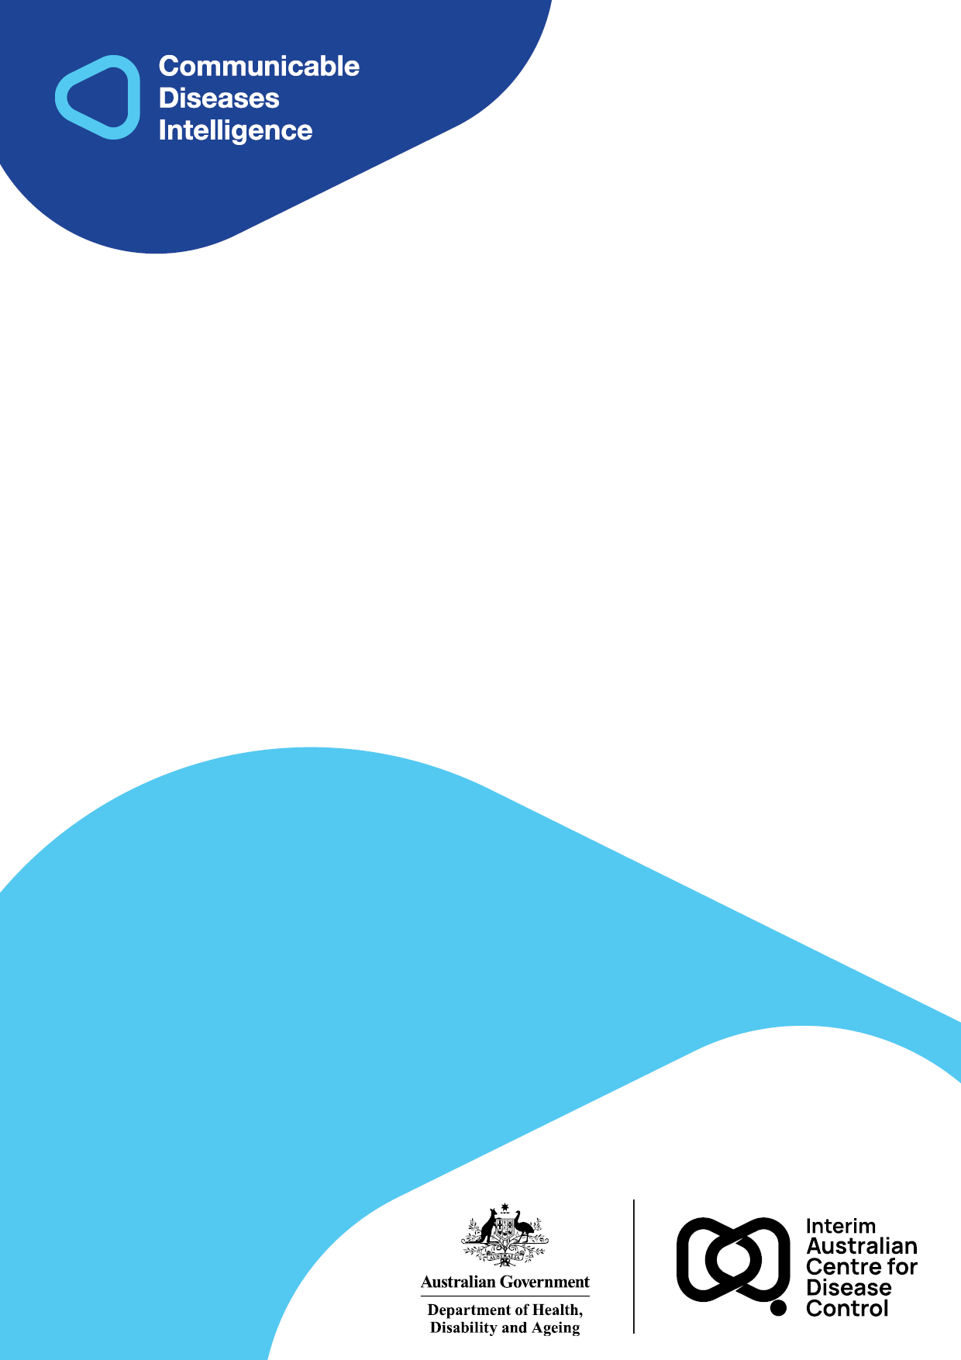
2025 • Volume 49 • cdc.gov.au/cdi • Epub date: 10.09.2025 • doi.org/10.33321/cdi.2025.49.051

Laboratory-based syphilis lateral flow immunoassay testing for maternity care at Alice Springs Hospital: a pilot study
Nerida Moore, Kevin Freeman, James Mcleod, Deepinder Singh, Sally Crispe, Stuart Campbell, Jennifer Yan, Manoji Gunathilake, Ella M Meumann, Rob Baird
© 2025 Commonwealth of Australia as represented by the Department of Health, Disability and Ageing
ISSN: 2209-6051 Online
This journal is indexed by Index Medicus and Medline.
Creative Commons Licence
This publication is licensed under a Creative Commons Attribution-NonCommercial-NoDerivatives 4.0 International Licence (Licence). You must read and understand the Licence before using any material from this publication.
Restrictions
The Licence does not cover, and there is no permission given for, use of any of the following material found in this publication (if any):
- the Commonwealth Coat of Arms (by way of information, the terms under which the Coat of Arms may be used can be found on the Department of Prime Minister and Cabinet website;
- any logos (including the interim Australian Centre for Disease Control and the Department of Health, Disability and Ageing’s logos) and trademarks;
- any photographs and images;
- any signatures; and
- any material belonging to third parties.
Disclaimer
Opinions expressed in Communicable Diseases Intelligence are those of the authors and not necessarily those of the Australian Government, the interim Australian Centre for Disease Control or the Department of Health, Disability and Ageing. Data may be subject to revision.
Enquiries
Enquiries regarding any other use of this publication should be addressed to the CDI Editor.
About CDI
Communicable Diseases Intelligence (CDI) is a peer-reviewed scientific journal published by the interim Australian Centre for Disease Control within the Department of Health, Disability and Ageing.
The journal aims to disseminate information on the epidemiology, surveillance, prevention and control of communicable diseases of relevance to Australia and the near region.
Editor: Christina Bareja • Deputy Editor: Simon Petrie • Design and Production: Lisa Thompson
Editorial Advisory Board: David Durrheim, Mark Ferson, Clare Huppatz, John Kaldor, Martyn Kirk and Meru Sheel
Submit an Article
Guidelines for authors and details on how to submit your publication is available on our website, or by email to the
CDI Editor.
Contact us
Communicable Diseases Intelligence (CDI)
interim Australian Centre for Disease Control, Department of Health, Disability and Ageing
GPO Box 9848, CANBERRA ACT 2601
Website: cdc.gov.au/cdi
Email: cdi.editor@health.gov.au

Contents
Abstract 4
Introduction 5
Methods 6
Results 7
Discussion 10
Author details 11
References 12

Abstract
Congenital syphilis is a preventable yet severe condition resulting from untreated maternal syphilis. Since 2016, Australia has recorded over 95 congenital syphilis cases, with 31/95 (33%) associated with perinatal death. Syphilis serology is complex and therefore performed in designated central laboratories. In the Northern Territory, specimen transport times associated with vast geographic distances lead to delayed results in remote regions. This study evaluates the introduction of the Abbott Determine™ Syphilis TP lateral flow immunoassay (LFI) at Alice Springs Hospital (ASH) to reduce turnaround times for maternal syphilis screening.
During the period 2 September – 1 December 2024, eighty-eight LFIs were performed on serum from 74 pregnant women at the ASH laboratory. LFI results were available within 24 hours for 99% of cases, with a median turnaround time of six hours compared to 61 hours for the screen done in Darwin (p < 0.001). No new syphilis cases were detected; all positive LFI results reflected past treated infections. LFI demonstrated 100% sensitivity and specificity compared to standard serology.
Although syphilis LFI cannot distinguish active from past infections, it significantly improves the timeliness of screening results, reducing risks of delayed treatment and of loss to follow-up. Implementing a syphilis LFI in remote laboratory settings offers a strategy to enhance syphilis diagnosis and prevention, with broader applicability in high-burden remote regions.
Keywords: syphilis; congenital syphilis; syphilis diagnostics

Introduction
Congenital syphilis is a preventable yet severe condition resulting from untreated maternal syphilis.¹ Since 2016, Australia has reported over 95 cases of congenital syphilis, with approximately one-third of cases (31/95; 33%) associated with perinatal death.² In the Northern Territory, 11 cases of congenital syphilis have been recorded since 2013, including one congenital syphilis-associated death.² Young First Nations people aged 15–29 years remain disproportionally impacted by the Northern Australian outbreak, reflecting higher rates of sexually transmitted infections, blood-borne viruses, and other communicable diseases among First Nations people, driven by long-standing structural inequities.³
Preventing congenital syphilis depends on timely access to syphilis diagnostics in pregnancy.¹ Due to the complexity of the testing algorithm, all syphilis serological testing within the Northern Territory public hospital system is performed centrally by Territory Pathology laboratory located within in the Royal Darwin Hospital (RDH). Long specimen transport times across vast geographic distances mean the turnaround time for results can be up to 7 days for samples collected outside of Darwin. This delay poses a serious problem for remote regions of the Northern Territory.
This study evaluates the introduction of the Abbott Determine™ Syphilis TP lateral flow immunoassay at Alice Springs Hospital (ASH) to reduce result turnaround times for maternal syphilis screening. This test is a treponemal test approved by the Therapeutic Goods Administration. It performs well compared to other high-throughput immunoassays used for serological screening of syphilis, and it has been extensively used in remote point-of-care testing (POCT) programs.⁴

Methods
On 2 September 2024, Territory Pathology altered the testing algorithm for pregnant women admitted to ASH to include the Abbott Determine Syphilis TP lateral flow immunoassay, referred to as the ‘syphilis lateral flow immunoassay’ (LFI). The syphilis LFI was introduced on site in the ASH laboratory as a screening step in parallel with standard serological testing performed in Darwin. It was made available seven days a week to be performed on all syphilis serology requests coming from the ASH Maternity Ward (AMAT) and was performed according to the manufacturer’s instructions. During the study, clinicians continued to request syphilis serology as per standard procedures. The collection of two serology tubes was required to ensure uninterrupted transport to RDH for standard syphilis serology. ASH laboratory staff performed a syphilis LFI using one of the serum tubes, and the second tube was referred to the RDH laboratory as per standard workflow. The syphilis LFI was embedded within laboratory workflow, rather than performed by clinicians at the bedside, so that positive results were notified to the Northern Territory Centre for Disease Control (NT CDC) through established laboratory reporting channels. Positive syphilis LFIs were also notified by the laboratory to the obstetric team via telephone. Decisions regarding serology testing of the newborn infant and consideration for empiric treatment were made by the paediatric team depending on the likelihood of the mother having untreated syphilis infection.
All positive and negative syphilis LFI results were confirmed in comparison to the gold standard syphilis screening assay performed at RDH laboratory, the Syphilis Treponema pallidum antibodies (TPA) assay (Ortho-Clinical Diagnostics), an immunometric immunoassay with chemiluminescent detection of syphilis antibodies, run on the VITROS 7600 platform. Samples that were positive on the Syphilis TPA underwent confirmatory testing with a T. pallidum haemagglutination assay (TPHA) and a non-treponemal rapid plasma reagin (RPR) test. The TPHA was performed with the NewBio TPHA kit (Newmarket Biomedical), and the RPR was done with the BD Macro-Vue™ RPR Card Test Kit.
A clinical audit of the revised syphilis serology workflow within the ASH laboratory was conducted from 2 September to 1 December 2024. The primary outcome was the availability of preliminary syphilis results within 24 hours. Result turnaround time was obtained from timestamps recorded in the laboratory information system (Labtrak, InterSystems USA), and was calculated as the time from specimen receipt to the time of result authorisation. The study duration was chosen based on an expected birth rate of roughly one birth per day at ASH, aiming for > 80 patients included in the study.
De-identified data was stored in a password-protected Microsoft Excel database, and statistical analysis was performed in Microsoft Excel 2019. The Mann-Whitney-Wilcoxon rank-sum test was performed to compare turnaround times. A significance threshold was set at p < 0.05.
This study was approved by the Human Research and Ethics Committee of the Northern Territory Department of Health and Menzies School of Health Research (Northern Territory HREC Reference Number 2024-4951).

Results
Eighty-eight syphilis LFIs were completed on serum collected from 74 women over the study period. Table 1 describes the age and setting of the women tested. There were 242 admissions to AMAT across the study period, including 161 women who delivered 162 infants. Amongst the 161 women delivering, 33% (53/161) had a syphilis LFI performed (plus standard syphilis serology) at the time of delivery. An additional eight women had only one serum tube collected at the time of delivery, so a LFI was not performed. In these instances, the serum tube was referred directly to RDH laboratory for standard syphilis serology. When including these additional eight women, a total of only 38% (61/161) of women received syphilis serology testing at the time of delivery.
Table 1: Women tested with Abbott Determine Syphilis lateral flow immunoassay (LFI) tests at Alice Springs Hospital laboratory, 2 September – 1 December 2024
Characteristicª | Value
Total pregnant women included in study | 74
Median age (interquartile range), years | 26 (21–31)
Total Abbott Determine Syphilis LFI performed^{b} | 88
Tests performed at time of delivery | 60% (53/88)
Tests performed during other ANC encounter^{c} | 40% (35/88)
Availability of results < 24 hours (n = 88): LFI^{d} | 87/88 (99%)
Availability of results < 24 hours (n = 88): standard serology^{e} | 0/88 (0%)
a ANC: antenatal care; LFI: lateral flow immunoassay.
b Twelve women had two POCTs, and one women had three POCTs, on different occasions of care over the three-month study period, accounting for a total of 14 repeat tests.
c Reasons for admission include complications of pregnancy, termination of pregnancy, miscarriage or stillbirth.
d Abbott Determine Syphilis lateral flow immunoassay performed at Alice Springs Hospital laboratory.
e Standard syphilis serology performed at Royal Darwin Hospital.
All but one of the syphilis LFIs performed at ASH Laboratory (87/88; 99%) met the primary outcome of availability of a preliminary syphilis result within 24 hours (Table 1). None of the RDH syphilis serology results were available within 24 hours. The fastest syphilis LFI was available in < 1 hour, whereas the fastest RDH syphilis serology was available at 30 hours. Figure 1 displays the turnaround time of syphilis LFI results conducted at the ASH laboratory, compared to standard syphilis serology performed at the RDH laboratory, with a median turnaround time of six hours (interquartile range, IQR: 3–13 hours) for the LFI, compared to 61 hours for RDH serology (IQR: 45–77 hours). A Mann-Whitney-Wilcoxon rank-sum test indicated the syphilis LFI had a significantly faster turnaround time than RDH syphilis serology, z = -11.46, p = < 0.001.
Figure 1: Turnaround time (hours) for all Alice Springs Hospital maternity ward requests for testing under the revised syphilis serology workflow, 2 September – 1 December 2024 (n = 88)ª
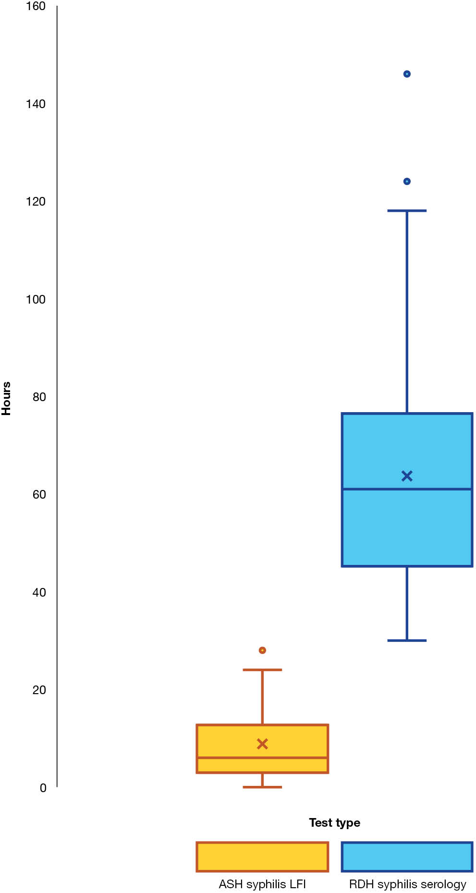
a ASH: Alice Springs Hospital; LFI: lateral flow immunoassay; RDH: Royal Darwin Hospital.
There were a total of eight positive syphilis LFIs in seven women across the study period, equating to a 9% test positivity rate (8/88). There were no new diagnoses of syphilis (maternal or congenital), with all positive syphilis LFIs representing past treated syphilis as confirmed by the NT CDC Syphilis registry, and all 8 had a negative RPR. All eight specimens positive by LFI were also positive by the RDH-based TPA and TPHA. Three specimens with negative LFI results were positive by TPA but negative by TPHA and RPR; all three were collected from patients with documented past treated syphilis.
Three patients were tested in the setting of miscarriage, stillbirth, or termination of pregnancy: none of these outcomes were attributable to congenital syphilis, with negative syphilis serology results in all instances.

Discussion
The syphilis LFI substantially reduced the time to preliminary syphilis results. By introducing a syphilis LFI in the ASH laboratory, the primary outcome of achieving preliminary results within 24 hours was met for 99% of pregnant women (87/88) included in the study. A notable major limitation to existing syphilis LFIs, including the one used in this study, is the inability to differentiate between active and past-treated infections.⁴ However, although a positive LFI would not have detected reinfection in women with a known history of syphilis, a positive LFI result in those with previously negative syphilis serology would have enabled prompt treatment of any new infections. It should also be noted that although < 24-hour turnaround is a marked improvement over conventional testing pathways, this timeframe remains relatively long for a Determine Syphilis TP test, which itself takes approximately 15 minutes to perform. If conducted at the point-of-care, the result could be available even sooner, and remains an option to consider.
Another limitation is that there is a window during early syphilis infection between infection and seroconversion, when both treponemal and non-treponemal assays are negative. In general, the treponemal specific tests become reactive within 2–4 weeks and the RPR becomes reactive within 3–4 weeks post infection.⁵ For this reason, Treponema pallidum polymerase chain reaction testing of any lesions plus repeat syphilis serology at 6 weeks postpartum (timed with the routine 6-week postpartum check) is recommended where primary syphilis, or reinfection, is possible.
Since the syphilis LFI test cannot distinguish between current and past syphilis infections, national guidelines recommend against using syphilis LFIs for individuals with a history of syphilis.⁵ Instead, standard syphilis serology is recommended.⁵ Additionally, national guidelines suggest limiting LFI use to populations with low rates of past syphilis.⁵ In this study, the syphilis LFI was integrated into an established screening pathway as a reflex test in a high-prevalence setting whenever clinicians ordered syphilis serology. This workflow meant that individuals with a history of syphilis were not identified before testing, leading to positive LFI results in those with past infections. For clinicians unfamiliar with the limitations of the syphilis LFI, there is a risk of overtreatment of past infections based on the misinterpretation of a positive result. There were no instances of treatment initiation for a positive LFI in the setting of known past infection across this study period.
The lack of new syphilis diagnoses during the study period prevented the prospective evaluation of the LFI's role in preventing congenital syphilis. This study did, however, demonstrate very low adherence to the national and Northern Territory recommendation for syphilis testing at delivery.^{5,6} This finding that has been fed back to the clinical unit and the NT CDC.
Implementation of a syphilis LFI in rural and remote Australian laboratories offers a potential solution to overcome delays associated with centralisation of laboratory resources, particularly in areas with a high burden of syphilis. The potential benefit of this approach extends beyond ASH to other rural and remote healthcare settings in the Northern Territory, where access to timely syphilis diagnostics remains a significant challenge.

Author details
Dr Nerida Moore,^{1,2}
Mr Kevin Freeman,¹
Mr James Mcleod,³
Mr Deepinder Singh,³
Dr Sally Crispe,⁴
Dr Stuart Campbell,¹
A/Prof. Jennifer Yan,^{2,5}
Dr Manoji Gunathilake,⁶
Dr Ella M Meumann,^{1, 5, 7}
A/Prof. Rob Baird¹
- Microbiology Department, Territory Pathology, Royal Darwin Hospital, Darwin, Australia
- Department of Paediatrics, Royal Darwin Hospital, Darwin, Australia
- Territory Pathology, Alice Springs Hospital, Alice Springs, Australia
- Department of Obstetrics and Gynaecology, Alice Springs Hospital, Alice Springs, Australia
- Global and Tropical Health Division, Menzies School of Health Research and Charles Darwin University, Darwin, Australia
- Sexual Health & Blood Borne Virus Unit, Centre for Disease Control, Public Health Division, NT Health
- Department of Infectious Diseases, Division of Medicine, Royal Darwin Hospital, Darwin, Australia

Corresponding author
Dr Nerida Moore
Royal Darwin Hospital
105 Rocklands Dr, Tiwi NT 0810
Phone: +61 8 8922 8888
Email: nerida.moore@nt.gov.au

References
- Stafford IA, Workowski KA, Bachmann LH. Syphilis complicating pregnancy and congenital syphilis. N Engl J Med. 2024;390(3):242–53. doi: https://doi.org/10.1056/NEJMra2202762.
- Australian Government Department of Health and Aged Care, Interim Australian Centre for Disease Control. National syphilis surveillance quarterly report. Quarter 2: 1 April - 30 June 2024. Canberra: Australian Government Department of Health and Aged Care; 18 September 2024. [Accessed on 5 November 2024.] Available from: https://www.health.gov.au/sites/default/files/2024-09/national-syphilis-surveillance-quarterly-report-april-to-june-2024.pdf.
- Equity Economics and development partners. Blueprint for the Future: Evaluation of NACCHO’s Role under the Enhanced Syphilis Response. A Report prepared for the National Aboriginal Community Controlled Health Organisation (NACCHO). Sydney: Equity Economics; February 2021. Available from: https://f.hubspotusercontent10.net/hubfs/5328468/NACCHO%20ESR%20Report%20-%20February%202021.pdf.
- Pérez Chacón G, Saha A, Phillips E, Guy R, Applegate TL, Causer L et al. Syphilis point-of-care tests: an Australian perspective. Microbiol Aust. 2024;45(3):127–31. doi: https://doi.org/10.1071/MA24036.
- Australian Government Department of Health and Aged Care, Interim Australian Centre for Disease Control. Syphilis CDNA National Guidelines for Public Health Units. Version 2.0: September 2024. Canberra: Australian Government Department of Health and Aged Care; September 2024. [Accessed on 6 November 2024.] Available from: https://www.health.gov.au/sites/default/files/2024-11/syphilis-cdna-national-guidelines-for-public-health-units.pdf.
- Northern Territory Centre for Disease Control (NT CDC). Public Health Alert. Increase in syphilis in the Top End and Katherine regions. Darwin: Northern Territory Government Department of Health, NT CDC; 28 October 2024. [Accessed on 2 January 2025.] Available from: https://health.nt.gov.au/__data/assets/pdf_file/0009/1456074/health-alert-increase-in-syphilis-in-top-end-and-katherine-regions.pdf.

